X
INDEX
NEW YORK POWER AUTHORITY TRANSMISSION REVENUE REQUIREMENT
Name Description
Cost-of-Service Summary TRANSMISSION REVENUE REQUIREMENT SUMMARY
Schedule A1 OPERATION & MAINTENANCE EXPENSE SUMMARY
Schedule A2 ADMINISTRATIVE AND GENERAL EXPENSES
Schedule B1 ANNUAL DEPRECIATION AND AMORTIZATION EXPENSES
Schedule B2 ADJUSTED PLANT IN SERVICE
Schedule B3 DEPRECIATION AND AMORTIZATION RATES
Schedule C1 TRANSMISSION - RATE BASE CALCULATION
Schedule D1 CAPITAL STRUCTURE AND COST OF CAPITAL
Schedule D2 PROJECT SPECIFIC CAPITAL STRUCTURE AND COST OF CAPITAL
Schedule E1 A&G AND GENERAL PLANT ALLOCATOR
Schedule F1 PROJECT REVENUE REQUIREMENT WORKSHEET
Schedule F2 INCENTIVES Schedule F3 PROJECT TRUE-UP
Work Paper-AA O&M AND A&G SUMMARY Work Paper-AB O&M AND A&G DETAIL
Work Paper-AC STEP-UP TRANSFORMERS O&M ALLOCATOR
Work Paper-AD FACTS O&M ALLOCATOR
Work Paper-AE MICROWAVE TOWER RENTAL INCOME
Work Paper-AF POSTRETIREMENT BENEFITS OTHER THAN PENSIONS (PBOP)
Work Paper-AG PROPERTY INSURANCE ALLOCATION
Work Paper-AH INJURIES & DAMAGES INSURANCE EXPENSE ALLOCATION
Work Paper-AI PROPERTY INSURANCE ALLOCATOR
Work Paper-BA DEPRECIATION AND AMORTIZATION EXPENSES (BY FERC ACCOUNT)
Work Paper-BB EXCLUDED PLANT IN SERVICE Work Paper-BC PLANT IN SERVICE DETAIL
Work Paper-BC (Support A) PLANT IN SERVICE DETAIL -- SUPPORT A Work Paper-BC (Support B) PLANT IN SERVICE DETAIL -- SUPPORT B
Work Paper-BD MARCY-SOUTH CAPITALIZED LEASE AMORTIZATION AND UNAMORTIZED BALANCE
Work Paper-BE FACTS PROJECT PLANT IN SERVICE AND ACCUMULATED DEPRECIATION
Work Paper-BE (Support) FACTS PROJECT PLANT IN SERVICE AND ACCUMULATED DEPRECIATION -- SUPPORT
Work Paper-BF GENERATOR STEP-UP TRANSFORMERS BREAKOUT
Work Paper-BF (Support) GENERATOR STEP-UP TRANSFORMERS BREAKOUT -- SUPPORT
Work Paper-BG RELICENSING/RECLASSIFICATION EXPENSES
Work Paper-BG (Support) RELICENSING/RECLASSIFICATION EXPENSES -- SUPPORT
Work Paper-BH ASSET IMPAIRMENT Work Paper-BI COST OF REMOVAL
Work Paper-BJ INDIVIDUAL PROJECTS - PLANT IN SERVICE AND DEPRECIATION
Work Paper-BJ (Support) INDIVIDUAL PROJECTS - PLANT IN SERVICE AND DEPRECIATION -- SUPPORT
Work Paper-CA MATERIALS AND SUPPLIES
Work Paper-CB PREPAYMENTS AND INSURANCE Work Paper-CC LAND HELD FOR FUTURE USE Work Paper-DA WEIGHTED COST OF CAPITAL
Work Paper-DB LONG-TERM DEBT AND RELATED INTEREST
Work Paper-EA CALCULATION OF A&G AND GENERAL PLANT ALLOCATOR
Work Paper-AR-IS STATEMENT OF REVENUES , EXPENSES, AND CHANGES IN NET POSITION
Work Paper-AR-BS STATEMENT OF NET POSITION
Work Paper-AR-Cap Assets CAPITAL ASSETS
Work Paper-Reconciliations RECONCILIATIONS BETWEEN ANNUAL REPORT & ATRR

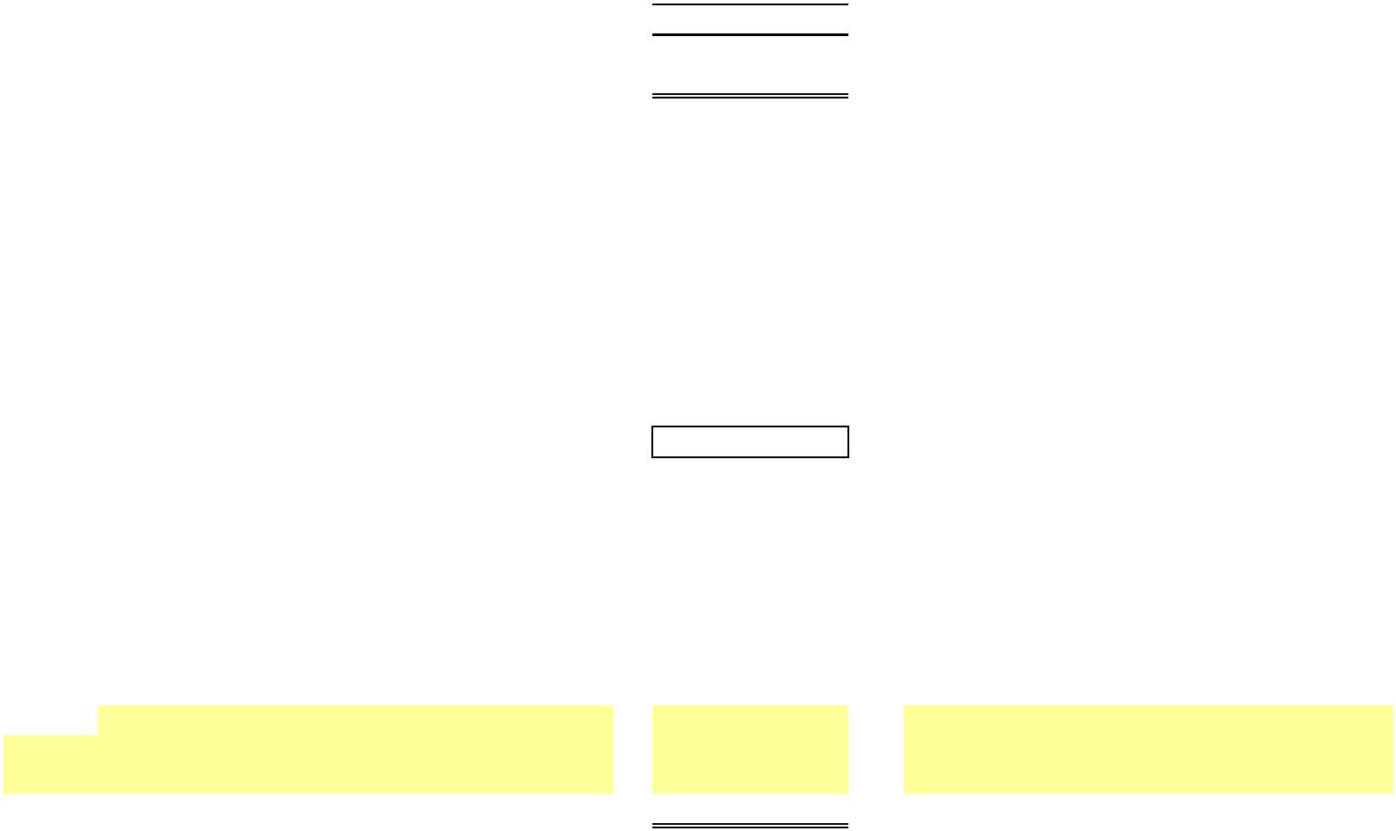X
NEW YORK POWER AUTHORITY TRANSMISSION REVENUE REQUIREMENT
YEAR ENDING DECEMBER 31, ____
TRANSMISSION REVENUE REQUIREMENT SUMMARY
Line No. A. OPERATING EXPENSES TOTAL $ SOURCE/COMMENTS
(1) (2)
1 Operation & Maintenance Expense - Schedule A1, Col 5, Ln 7
2 Administrative & General Expenses - Schedule A2, Col 5, Ln 5
3 Depreciation & Amortization Expense - Schedule B1, Col 6, Ln 6
4 TOTAL OPERATING EXPENSE - Sum lines 1, 2, & 3
5 B. RATE BASE - Schedule C1, Col 5, Ln 11
6 Return on Rate Base - Schedule C1, Col 7, Ln 11
6a Total Project Specific Return Adjustment - Schedule D2, Col 3, Ln A
7 TOTAL REVENUE REQUIREMENT - Line 4 + Line 6 + Line 6a
8 Incentive Return - Schedule F1, page 2, line 2, col. 13
9 True-up Adjustment - Schedule F3, page 1, line 3, col. 10
10 NET ADJUSTED REVENUE REQUIREMENT - Line 7 + line 8 + line 9
Breakout by Project
11 NTAC Facilities - Schedule F1, page 2, line 1a + line 1d, col. 17 11a Project 1 - Marcy South Series Compensation - Schedule F1, page 2, line 1b, col. 17
 | 11b |  | Project 2 - AC Project Segment A  (Central East Energy Connect) |  | - Schedule F1, page 2, line 1c, col. 17
11c Project 3 - Propel NY - Schedule F1, page 2, line 1e, col. 17 11d -
… … - … … -
12 Total Break out - Sum lines 11
Note 1 The revenue requirements shown on lines 11 and 11a et seq. are annual revenue requirements. If the first year is a partial year,
1/12 of the amounts should be recovered for every month of the Rate Year.

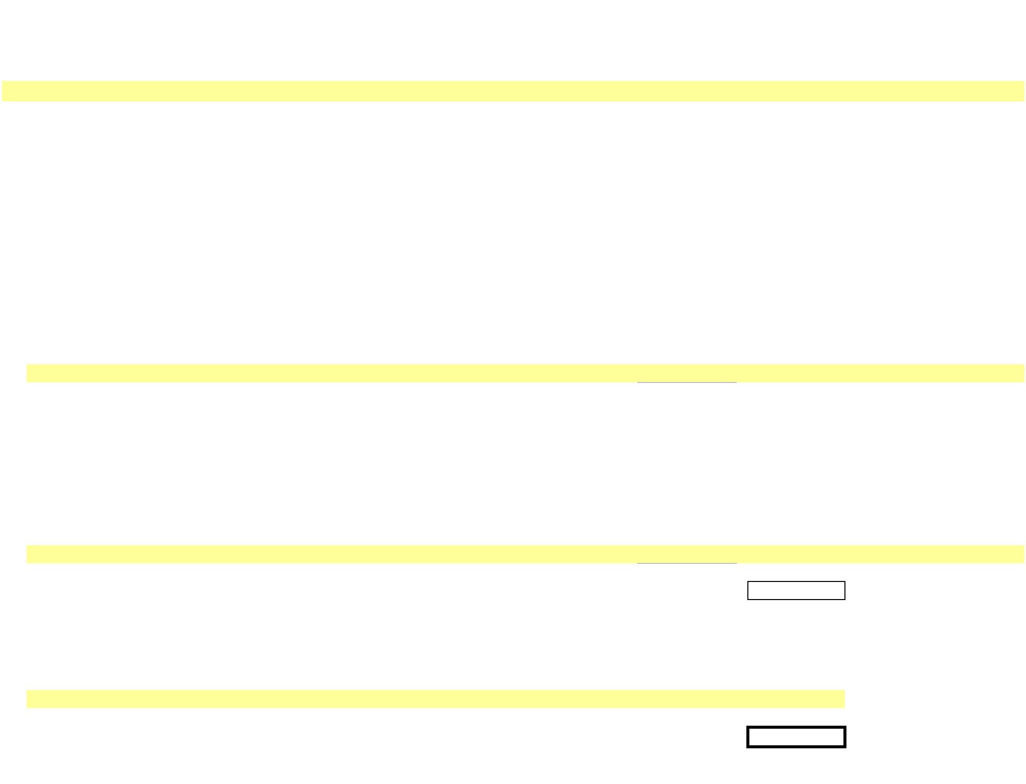X
NEW YORK POWER AUTHORITY
TRANSMISSION REVENUE REQUIREMENT
YEAR ENDING DECEMBER 31, ____
SCHEDULE A1
OPERATION & MAINTENANCE EXPENSE SUMMARY ($)
FERC
Line No Account FERC Account Description Source Total Grand Total NYPA Form 1 Equivalent
(1) (2) (3) (4) (5) (6)
Transmission:
OPERATION:
1a 560 Supervision & Engineering WP-AA, Col (5) - Page 321 line 83
1b 561 Load Dispatching WP-AA, Col (5) - Page 321 lines 85-92
1c 562 Station Expenses WP-AA, Col (5) - Page 321 line 93
1d 566 Misc. Trans. Expenses WP-AA, Col (5) - Page 321 line 97
… … … … …
2 Total Operation (sum lines 1) -
MAINTENANCE:
3a 568 Supervision & Engineering WP-AA, Col (5) - Page 321 line 101
3b 569 Structures WP-AA, Col (5) - Page 321 line 102-106
3c 570 Station Equipment WP-AA, Col (5) - Page 321 line 107
3d 571 Overhead Lines WP-AA, Col (5) - Page 321 line 108
3e 572 Underground Lines WP-AA, Col (5) - Page 321 line 109
3f 573 Misc. Transm. Plant WP-AA, Col (5) - Page 321 line 110
… … … … …
4 Total Maintenance (sum lines 3) -
5 TOTAL O&M TRANSMISSION (sum lines 2 & 4) -
Adjustments (Note 2)
6a Step-up Transformers WP-AC, Col (1) line 5 -
6b FACTS (Note 1) WP-AD,Col (1) line 5 -
6c Microwave Tower Rental Income WP-AE, Col (3) line 2 -
… … … …
7 TOTAL ADJUSTED O&M TRANSMISSION (sum lines 5-6) -
Note 1 Flexible Alternating Current Transmission System device
Note 2 Revenues that are credited in the NTAC are not revenue credited here.

X
NEW YORK POWER AUTHORITY
TRANSMISSION REVENUE REQUIREMENT
YEAR ENDING DECEMBER 31, ____
SCHEDULE A2 ADMINISTRATIVE AND GENERAL EXPENSES
FERC Unallocated Transmission Allocated to
Line No. Account FERC Account Description Source A&G ($) Allocator (%) Transmission ($) Source/Comments NYPA Form 1 Equivalent
(1) (2) (3) (4) (5) (6) (7)
Administrative & General Expenses
1a 920 A&G Salaries WP-AA, Col (5) - Page 323 line 181
1b 921 Office Supplies & Expenses WP-AA, Col (5) - Page 323 line 182
1c 922 Admin. Exp. Transferred-Cr WP-AA, Col (5) - Page 323 line 183
1d 923 Outside Services Employed WP-AA, Col (5) - Page 323 line 184
1e 924 Property Insurance WP-AA, Col (5) - - See WP-AG; Col (3) ,Ln 5 Page 323 line 185
1f 925 Injuries & Damages Insurance WP-AA, Col (5) - - See WP-AH; Col (3) ,Ln 4 Page 323 line 186
1g 926 Employee Pensions & Benefits WP-AA, Col (5) - Page 323 line 187
1h 928 Reg. Commission Expenses WP-AA, Col (5) - - See WP-AA; Col (3), Ln 2x Page 323 line 189
1i 930 Obsolete/Excess Inv WP-AA, Col (5) - Page 323 line 190.5
1j 930.1 General Advertising Expense WP-AA, Col (5) - Page 323 line 191
1k 930.2 Misc. General Expenses WP-AA, Col (5) - Page 323 line 192
1l 930.5 Research & Development 2/ - - 2/ Page 323 line 192.5
1m 931 Rents WP-AA, Col (5) - Page 323 line 193
1n 935 Maint of General Plant A/C 932 WP-AA, Col (5) - Page 323 line 196
… … … …
2 TOTAL (sum lines 1) -
3a Less A/C 924 Less line 1e - Page 323 line 185
3b Less A/C 925 Less line 1f - Page 323 line 186
3c Less EPRI Dues 1/ -
3d Less A/C 928 Less line 1h - Page 323 line 189
3e Less A/C 930.5 Less line 1l - 3/
3f PBOP Adjustment WP-AF -
… … …
4 TOTAL A&G Expense (sum lines 2 to 4) - - - - Allocated based on
transmission allocator 5 NET A&G TRANSMISSION EXPENSE (sum lines 1 to 4) - (Schedule E1)
1/ NYPA does not pay EPRI dues
2/ Column 5 is populated as 0 (zero) for data pertaining to calendar years ____ and 2015. It is populated as a sum of Transmission R&D Expense [Workpaper WP-AA Col (3) ln(2ab)] plus the portion of
Admin & General allocated to transmission [Workpaper WP-AA Col (4) ln (2ab) multiplied by Workpaper E1-Allocator Col (3) ln (2)] for data pertaining to calendar years 2016 and later.
3/ Populated as 0 (zero) for data pertaining to calendar years ____ and 2015. Populated as WP-AA Col (3) for data pertaining to calendar years 2016 and later.
…

X
NEW YORK POWER AUTHORITY
TRANSMISSION REVENUE REQUIREMENT
YEAR ENDING DECEMBER 31, ____
SCHEDULE B1
ANNUAL DEPRECIATION AND AMORTIZATION EXPENSES ($)
Total General Plant Annual
FERC Transmission Allocated to Depreciation Line No. Account FERC Account Description Source Transmission General Plant Allocator (%) Transm. Col (3)*(4) Col (2)+(5)
(1) (2) (3) (4) (5) (6)
1a 352 Structures & Improvements WP-BA, Col (4) -
1b 353 Station Equipment WP-BA, Col (4) -
1c 354 Towers & Fixtures WP-BA, Col (4) -
1d 355 Poles & Fixtures WP-BA, Col (4) -
1e 356 Overhead Conductors & Devices WP-BA, Col (4) -
1f 357 Underground Conduit WP-BA, Col (4) -
1g 358 Underground Conductors & Devices WP-BA, Col (4) -
1h 359 Roads & Trails WP-BA, Col (4) -
1i 351.1 Computer Hardware WP-BA, Col (4) -
1j 351.2 Computer Software WP-BA, Col (4) -
1k 351.3 Communications Equipment WP-BA, Col (4) -
… … … …
2 Unadjusted Depreciation -
3a 390 Structures & Improvements WP-BA, Col (4) -
3b 391 Office Furniture & Equipment WP-BA, Col (4) -
3c 392 Transportation Equipment WP-BA, Col (4) -
3d 393 Stores Equipment WP-BA, Col (4) -
3e 394 Tools, Shop & Garage Equipment WP-BA, Col (4) -
3f 395 Laboratory Equipment WP-BA, Col (4) -
3g 396 Power Operated Equipment WP-BA, Col (4) -
3h 397 Communication Equipment WP-BA, Col (4) -
3i 398 Miscellaneous Equipment WP-BA, Col (4) -
3j 399 Other Tangible Property WP-BA, Col (4) -
… … … …
4 Unadjusted General Plant Depreciation -
Adjustments
5a Capitalized Lease Amortization Schedule B2, Col 4, line 14 -
5b FACTS Schedule B2, Col 4, line 13 -
5c Windfarm Schedule B2, Col 4, line 11 -
5d Step-up Transformers Schedule B2, Col 4, line 12 -
5e Relicensing Reclassification WP-BG, Col 4 -
… … …
6 TOTAL (Sum lines 2-5) - - - 1/ - -
1/ See Schedule-E1, Col (3), Ln 2

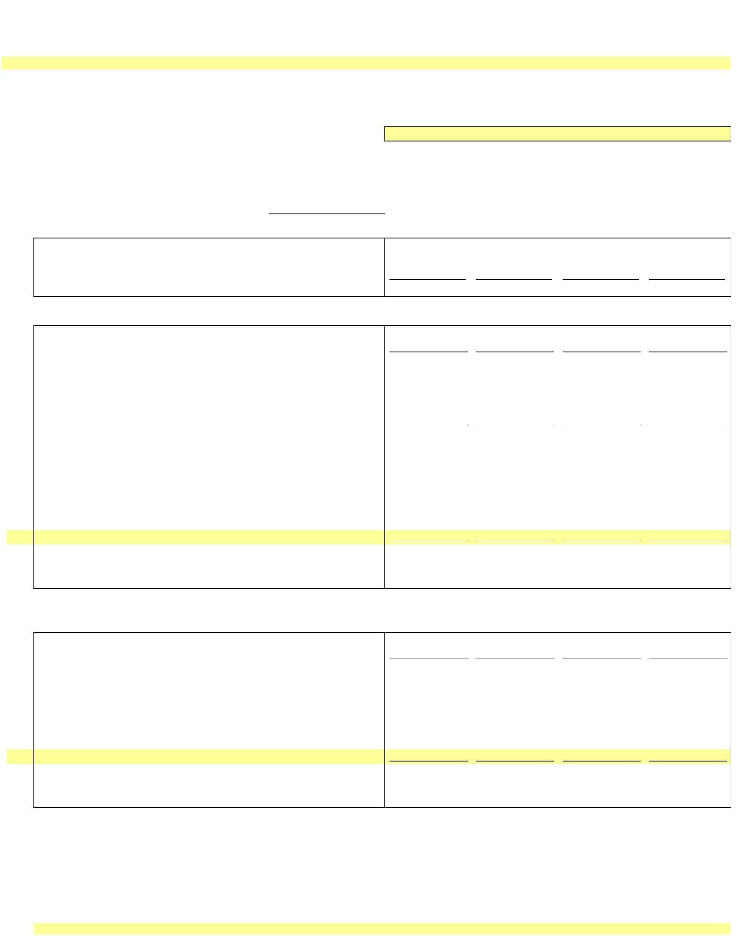X
NEW YORK POWER AUTHORITY
TRANSMISSION REVENUE REQUIREMENT
YEAR ENDING DECEMBER 31, ____
SCHEDULE B2 ADJUSTED PLANT IN SERVICE
13-Month Average
Line Plant in Accumulated Plant in Depreciation
No. Service ($) Depreciation ($) Service - Net ($) Expense ($)
(1) (2) (3) (4)
NYPA Form 1 Equivalent
PRODUCTION Source Depreciation (p.219)
1 Production - Land WP-BC - - - -
2 Production - Hydro WP-BC ln. 22 - Cost of Removal 5/ - - - -
3 Production - Gas Turbine / Combined Cycle WP-BC ln. 20 + ln. 23 - - - -
4 - - - -
TRANSMISSION
5 Transmission - Land WP-BC - - - -
6 Transmission WP-BC ln. 24 - Cost of Removal 5/ - - - -
7 - - - -
8 Transmission - Cost of Removal 1/ WP-BC - - - -
9 Excluded Transmission 2/ WP-BB - - - -
Adjustments to Rate Base
10 Transmission - Asset Impairment WP-BC - - - -
11 Windfarm WP-BC - - - -
12 Generator Step-ups WP-BF - - - -
13 FACTS WP-BE - - - -
14 Marcy South Capitalized Lease 3/ -
15 … - - - -
16 Total Adjustments - - - -
17
18 Net Adjusted Transmission - - - -
GENERAL
19 General - Land WP-BC - - - -
20 General WP-BC ln. 27 - Cost of Removal 5/ - - - -
21 - - - -
Adjustments to Rate Base
22 General - Asset Impairment - - - -
23 General - Cost of Removal WP-BC - - - -
24 Relicensing WP-BG - - - -
25 Excluded General 4/ WP-BC - - - -
26 … - - - -
27 Total Adjustments - - - -
28 Net Adjusted General Plant - - - -
Notes
1/ Cost of Removal: Bringing back to accumulated depreciation cost of removal which was reclassified to regulatory liabilities in annual report.
2/ Excluded Transmission: Assets not recoverable under ATRR, FERC Accounts 350 and 352-359 for 500 MW, AEII, Poletti, SCPPs, Small Hydro, and Flynn.
3/ Marcy South Capitalized Lease amount is added separately to the Rate Base.
4/ Excluded General: Assets not recoverable under ATRR, FERC Accounts 389-399 for 500 MW, AEII, Poletti, SCPPs, Small Hydro, and Flynn.
SCPPs include Brentwood, Gowanus, Harlem River, Hell Gate, Kent, Pouch and Vernon. Small Hydro includes Ashokan, Crescent, Jarvis and Vischer Ferry.
5/ The difference between the Accumulated Depreciation contained in the NYPA Form 1 Equivalent and the amount contained here is equal to the Cost of Removal.
…

Schedule B3 - Depreciation and Amortization Rates
NEW YORK POWER AUTHORITY
Based on Plant Data Year Ending December 31, 2019 for General and Intangible Plant and December 31, 2020 for Transmission Plant (as filed with FERC in 2022 in Docket ER22-2581)
Line No. FERC Account FERC Account Description  TRANSMISSION PLANT Headquarters  1 350 Land Rights |  | St.  Lawrence/FDR Niagara |  | Blenheim-  Gilboa |  | Rate (Annual) Percent 1/  J. A. Massena-  FitzPatrick Marcy |  | Marcy-  South |  | Long Island  Sound Cable |  | New Project  2/
2 351.1 Computer Hardware 20.00% 20.00% 20.00% 20.00% 20.00% 20.00% 20.00% 20.00% 20.00%
3 351.2 Computer Software 20.00% 20.00% 20.00% 20.00% 20.00% 20.00% 20.00% 20.00% 20.00%
4 351.3 Communications Equipment 10.00% 10.00% 10.00% 10.00% 10.00% 10.00% 10.00% 10.00% 10.00%
5 352 Structures and Improvements 1.87% 1.78% 1.60% 1.83% 0.89% 1.92%
6 353 Station Equipment 2.73% 2.80% 2.79% 2.83% 2.90% 1.67% 2.67%
7 354 Towers and Fixtures 1.63% 1.65% 1.65% 0.87% 1.84% 2.12% 2.27%
8 355 Poles and Fixtures 2.26% 2.30% 1.71% 1.75% 2.28% 2.65%
9 356 Overhead Conductor and Devices 2.32% 2.25% 1.95% 1.37% 2.83% 2.43% 2.45%
10 357 Underground Conduit 1.03% 1.76% 0.32% 1.69%
11 358 Underground Conductor and Devices 2.47% 2.91% 0.74% 2.44%
12 359 Roads and Trails 0.77% 0.53% 1.02% 0.11% 1.23% 1.42% 1.33%
GENERAL PLANT
13 390 Structures & Improvements 1.37% 1.69% 1.53% 1.61% 1.70% 1.75%
14 391 Office Furniture & Equipment 10.00% 10.00% 10.00% 10.00% 10.00% 10.00% 10.00% 10.00% 10.00%
15 391.2 Computer Equipment 5 yr 20.00% 20.00% 20.00% 20.00% 20.00% 20.00% 20.00% 20.00% 20.00%
16 391.3 Computer Equipment 10 yr 10.00% 10.00% 10.00% 10.00% 10.00% 10.00% 10.00% 10.00% 10.00%
17 392 Transportation Equipment 10.00% 4/ 5.58% 4.30% 6.30% 5.53% 10.00%
18 393 Stores Equipment 2.84% 3.08% 2.11% 3.33%
19 394 Tools, Shop & Garage Equipment 4.64% 3.92% 2.55% 5.11% 3.71% 5.00%
20 395 Laboratory Equipment 5.00% 4/ 5.17% 4.26% 5.11% 4.78% 5.00%
21 396 Power Operated Equipment 6.19% 5.68% 2.28% 3.55% 8.33% 4/ 8.33%
22 397 Communication Equipment 10.00% 10.00% 10.00% 10.00% 10.00% 10.00% 10.00% 10.00% 10.00%
23 398 Miscellaneous Equipment 4/ 4.000% 1.09% 4.42% 5.02% 5.00% 4/ 5.00%
24 399 Other Tangible Property 6.67% 6.67% 6.67% 6.67% 6.67% 6.67% 6.67% 6.67% 6.67%
INTANGIBLE PLANT
25 303 Miscellaneous Intangible Plant
26 5 Year Property 20.00% 20.00% 20.00% 20.00% 20.00% 20.00% 20.00% 20.00% 20.00%
27 7 Year Property 14.29% 14.29% 14.29% 14.29% 14.29% 14.29% 14.29% 14.29% 14.29%
28 10 Year Property 10.00% 10.00% 10.00% 10.00% 10.00% 10.00% 10.00% 10.00% 10.00%
29 Transmission facility Contributions in Aid of Construction 3/
Notes:
1/ Where no depreciation rate is listed for a transmission or general plant account for a particular project,
NYPA lacks depreciable plant as of 12/31/2019 or 2020 (or all plant has been fully depreciated). If new plant corresponding to these
accounts is subsequently added for the relevant projects, the "New Project" depreciation rate for the relevant account will apply.
2/ New Project transmission and general depreciation rates are equal to the life of the asset adjusted for salvage.
3/ In the event a Contribution in Aid of Construction (CIAC) is made for a transmission facility, the transmission
depreciation rates above will be weighted based on the relative amount of underlying plant booked to the accounts
shown in lines 1-9 above and the weighted average depreciation rate will be used to amortize the CIAC. The life of a
facility subject to a CIAC will be equivalent to the depreciation rate calculated above, i.e., 100% deprecation rate = life
in years. The estimated life of the facility or rights associated with the facility will not change over the life of a CIAC
without prior FERC approval.
4/ NYPA has replaced the anomalous rates for these assets with New Project rates.
These depreciation rates will not change absent the appropriate filing at FERC.

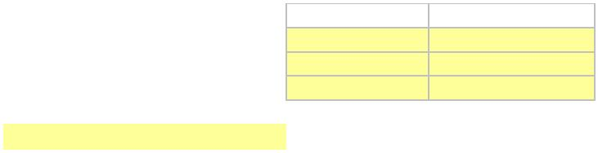X
NEW YORK POWER AUTHORITY TRANSMISSION REVENUE REQUIREMENT
YEAR ENDING DECEMBER 31, ____
SCHEDULE C1 TRANSMISSION - RATE BASE CALCULATION
GENERAL PLANT
TRANSMISSION ALLOCATED TO TOTAL RATE OF RETURN ON RATE BASE TRANSMISSION TOTAL ALLOCATOR TRANSMISSION ($) TRANSMISSION ($) RETURN RATE BASE
PLANT ($) GENERAL PLANT ($) [Schedule E1] (2) * (3) (1) + (4) [Schedule D1] (5) * (6)
(1) (2) (3) (4) (5) (6) (7)
1 A) Net Electric Plant in Service - 1/ - 2/ 0.00% - -
2 B) Rate Base Adjustments
3 * Cash Working Capital (1/8 O&M) - 3/ -
4 * Marcy South Capitalized Lease - 4/ -
5 * Materials & Supplies - 5/ - -
6 * Prepayments - 6/ - -
7 * Land Held for Future Use - 8/ - -
8 * CWIP - 7/ -
9 * Regulatory Asset - 7/
10 * Abandoned Plant - 7/
11 TOTAL (sum lines 1-10) - - - - - 5.23% -
1/ Schedule B2; Net Electric Plant in Service; Ln 18
2/ Schedule B2; Net Electric Plant in Service; Ln 28
3/ 1/8 of (Schedule A1; Col 5, Ln 7 + Schedule A2; Col 5, Ln 5) [45 days]
4/ WP-BD; Average of Year-end Unamortized Balances, Col 5
5/ Average of 13 month inventory Materials & Supplies (WP-CA). NYPA Form 1 Equivalent, page 227, Ln 12, year ending balance in columns b and c.
6/ WP-CB; Col 3, Ln 14
7/ CWIP, Regulatory Asset and Abandoned Plant are zero until an amount is authorized by FERC as shown below. Year end CWIP amount is shown in the NYPA Form 1 Equivalent, page 216, line 1
Docket Number Authorized Amount
… …
8/ WP-CC, Col. 16, Ln 2

X
NEW YORK POWER AUTHORITY TRANSMISSION REVENUE REQUIREMENT
YEAR ENDING DECEMBER 31, ____
SCHEDULE D1
CAPITAL STRUCTURE AND COST OF CAPITAL
CAPITALIZATION RATIO COST RATE WEIGHTED
Line No. TITLE from WP-DA 1/ from WP-DA 2/ AVERAGE SOURCE/COMMENTS
(1) (2) (3) (4)
1 LONG-TERM DEBT 49.00% - - Col (1) * Col (2)
2 COMMON EQUITY 51.00% 10.25% 5.23% Col (1) * Col (2)
3 TOTAL CAPITALIZATION 100.00% 5.23% Col (3); Ln (1) + Ln (2)
Notes
1/ The Common Equity share listed in Col (1) is 51%, which may only be changed pursuant to an FPA Section 205 or 206 filing to FERC. See settlement accepted by
FERC in Docket No. ER25-198. The Long-Term Debt share is calculated as 1 minus the Common Equity share.
2/ The ROE listed in Col (2) Ln (2) is the base ROE (established in the settlement accepted by FERC in Docket No. ER25-198) plus 50 basis-point incentive for RTO participation.
ROE may only be changed pursuant to an FPA Section 205 or 206 filing to FERC.

X
NEW YORK POWER AUTHORITY
TRANSMISSION REVENUE REQUIREMENT
YEAR ENDING DECEMBER 31, ____
SCHEDULE D2
PROJECT SPECIFIC CAPITAL STRUCTURE AND COST OF CAPITAL 3/
CAPITALIZATION RATIO COST RATE WEIGHTED
Line No. TITLE from WP-DA from WP-DA AVERAGE SOURCE/COMMENTS
(1) (2) (3) (4)
Project 1 - Marcy South Series Compensation - Capital Structure
1 LONG-TERM DEBT 47.00% 1/ - - Col (1) * Col (2)
2 COMMON EQUITY 53.00% 1/ 10.25% 2/ 5.43% Col (1) * Col (2)
3 TOTAL CAPITALIZATION 100.00% 5.43% Col (3); Ln (1) + Ln (2)
4 PROJECT NET PLANT - F1-Proj RR, Col (7), Ln (1b)
5 PROJECT BASE RETURN - Col (3) Ln (4) * WP-DA Col (6) Ln (4)
6 PROJECT ALLOWED RETURN - Col (3); Ln (3) * Ln (4)
1A PROJECT SPECIFIC RETURN ADJUSTMENT - Col (3); Ln (6) - Ln (5)
Project 2 - AC Project Segment A (Central East Energy Connect) - Capital Structure 4/
1 LONG-TERM DEBT 49.00% - - Col (1) * Col (2)
2 COMMON EQUITY 51.00% 10.75% 5.48% Col (1) * Col (2)
3 TOTAL CAPITALIZATION 100.00% 5.48% Col (3); Ln (1) + Ln (2)
4 PROJECT NET PLANT - F1-Proj RR, Col (7), Ln (1c)
5 PROJECT BASE RETURN - Col (3) Ln (4) * WP-DA Col (6) Ln (4)
6 PROJECT ALLOWED RETURN - Col (3); Ln (3) * Ln (4)
2B PROJECT SPECIFIC RETURN ADJUSTMENT - Col (3); Ln (6) - Ln (5)
Project 3 - SPC Project - Capital Structure 5/
1 LONG-TERM DEBT 49.00% - - Col (1) * Col (2)
2 COMMON EQUITY 51.00% 10.75% 5.48% Col (1) * Col (2)
3 TOTAL CAPITALIZATION 100.00% 5.48% Col (3); Ln (1) + Ln (2)
4 PROJECT NET PLANT - F1-Proj RR, Col (7), Ln (1d)
5 PROJECT BASE RETURN - Col (3) Ln (4) * WP-DA Col (6) Ln (4)
6 PROJECT ALLOWED RETURN - Col (3); Ln (3) * Ln (4)
3C PROJECT SPECIFIC RETURN ADJUSTMENT - Col (3); Ln (6) - Ln (5)
Project 4 - Propel NY Project - Capital Structure 6/
1 LONG-TERM DEBT 49.00% - - Col (1) * Col (2)
2 COMMON EQUITY 51.00% 11.00% 5.61% Col (1) * Col (2)
3 TOTAL CAPITALIZATION 100.00% 5.61% Col (3); Ln (1) + Ln (2)
4 PROJECT NET PLANT - F1-Proj RR, Col (7), Ln (1e)
5 PROJECT BASE RETURN - Col (3) Ln (4) * WP-DA Col (6) Ln (4)
6 PROJECT ALLOWED RETURN - Col (3); Ln (3) * Ln (4)
4C PROJECT SPECIFIC RETURN ADJUSTMENT - Col (3); Ln (6) - Ln (5)
A Total Project Adjustments -
Notes
1/ The MSSC Common Equity share listed in Col (1) is capped at 53%. The cap may only be changed pursuant to an FPA Section 205 or 206 filing to FERC.
The MSSC Long-Term Debt share is calculated as 1 minus the Common Equity share.
2/ The MSSC ROE listed in Col (2) Ln (2) is the base ROE plus 50 basis-point incentive Congestion Relief Adder. ROE may only be changed pursuant to an FPA Section 205 or 206 filing to FERC.
3/ Additional project-specific capital structures added to this Schedule D2 must be approved by FERC. The cost of long-term debt and common equity
for any such project shall reflect the cost rates in Col (2), Lns (1) and (2) unless a different cost rate is approved by FERC.
4/ The AC Project Segment A cost containment impacts, if any, will be computed on a workpaper and provided as supporting documentation for each applicable Annual Update
consistent with the NYPA Protocols. The ROE listed in Col (2) for AC Project Segment A consists of a 50 basis point ROE Risk Adder per the Commission's approval in Docket No. EL19-88,
added to the 10.25% ROE applicable to NYPA’s other transmission assets. See Schedule D1 and Project 1, above.
5/ The Smart Path Connect Project cost containment impacts, if any, will be computed on a workpaper and provided as supporting documentation for each applicable Annual Update,
consistent with the Commission's Order dated 07/05/22 in Docket No. ER22-1014. The ROE listed in Col (2) for the Smart Path Connect Project consists of a 50 basis point ROE Risk Adder
per the Commission's approval in Docket No. ER 22-1014 added to the 10.25% ROE applicable to NYPA's other transmission assets. See Schedule D1 and Project 1, above.
6/ The Propel NY Project cost containment impacts, if any, will be computed on a workpaper and provided as supporting documentation for each applicable Annual Update,
consistent with the Commission's Order dated 07/11/24 in Docket No. EL24-108. The ROE listed in Col (2) for the Propel NY Project consists of a 75 basis point ROE Risk Adder
per the Commission's approval in Docket No. EL24-108 added to the 10.25% ROE applicable to NYPA's other transmission assets. See Schedule D1 and Project 1, above.
...

X
NEW YORK POWER AUTHORITY TRANSMISSION REVENUE REQUIREMENT
YEAR ENDING DECEMBER 31, ____
SCHEDULE E1
A&G AND GENERAL PLANT ALLOCATOR
Line RATIO ALLOCATED TO SOURCE/
No. DESCRIPTION From WP-EA TRANSMISSION COMMENTS
(1) (2) (3) (4)
1 PRODUCTION 0.00%
2 INCLUDED TRANSMISSION 0.00% 0.00% Col (2); Ln (2)
3 TOTAL 0.00%

X
Schedule F1
Project Revenue Requirement Worksheet
NEW YORK POWER AUTHORITY
YEAR ENDING DECEMBER 31, ____
Line
No. Item Page, Line, Col. Transmission ($) Allocator
(1) (2) (3)
1 Gross Transmission Plant - Total Schedule B2, line 18, col 1 (Note A) -
1a Transmission Accumulated Depreciation Schedule B2, line 18, col 2 -
1b Transmission CWIP, Regulatory Asset and Abandoned Plant Schedule C1, lines 8, 9 & 10 (Note B) -
2 Net Transmission Plant - Total Line 1 minus Line 1a plus Line 1b -
O&M TRANSMISSION EXPENSE
3 Total O&M Allocated to Transmission Schedule A1, line 7, col 5 and Schedule A2, line 5, Col 5 -
GENERAL DEPRECIATION EXPENSE (Note G)
5 Total General Depreciation Expense Schedule B1 line 6, col 5 -
6 Annual Allocation Factor for Expenses ([line 3 + line 5] divided by line 1, col 2) 0.00% 0.00%
RETURN
7 Return on Rate Base Schedule C1 line 11, col 7 -
` 8 Annual Allocation Factor for Return on Rate Base (line 7 divided by line 2 col 2) 0.00% 0.00%

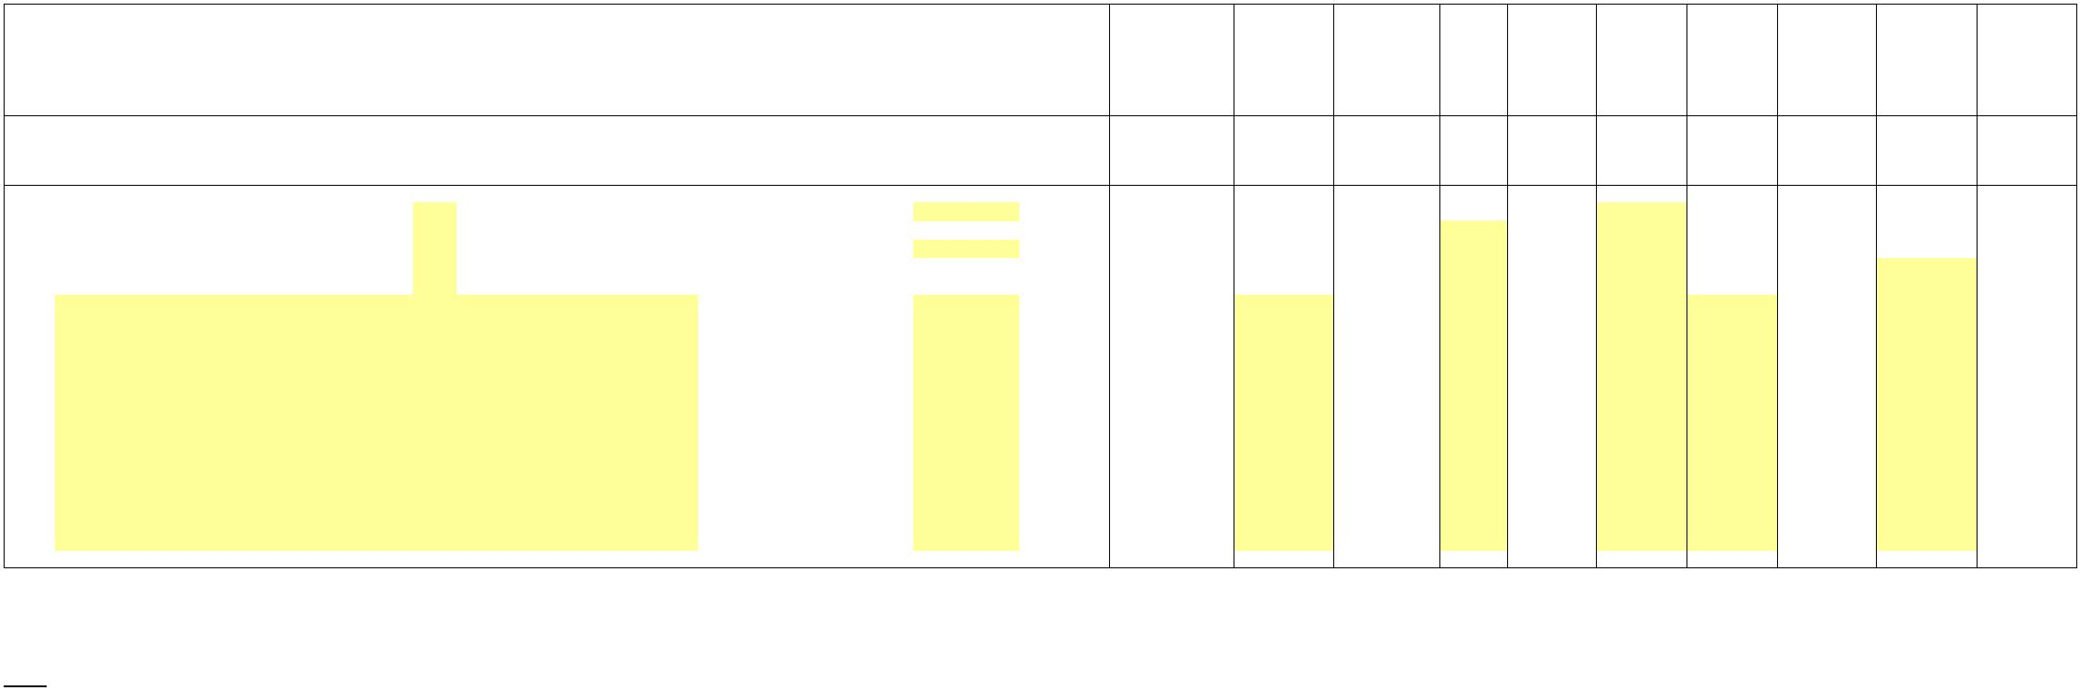Schedule F1
Project Revenue Requirement Worksheet
NEW YORK POWER AUTHORITY
(1) (2) (3) (4) (5) (6) (7) (8) (9) (10) (11) (12) (13) (14) (14a) (15) (16) (17)
 | Line  No. Project Name and # Type |  | Project Gross Plant  ($) |  | Project Accumulated  Depreciation ($) |  | Annual Allocation  Factor for Expenses |  | Annual  Allocation for  Expenses ($) |  | Project Net Plant  ($) |  | Annual  Allocation  Factor for  Return |  | Annual Return Charge  ($) |  | Project  Depreciation/  Amortization  Expense ($) |  | Annual Revenue  Requirement ($) |  | Incentive  Return in  basis  Points |  | Incentive  Return ($) Discount |  | PROJECT  SPECIFIC  CAPITAL  STRUCTURE  AND COST OF  CAPITAL |  | Total Annual  Revenue  Requirement ($) |  | True-Up  Adjustment ($) |  | Net Revenue  Requirement ($)
 | (Note C) Page 1 line 6 Col. 3 * Col. 5 (Note D) (Page 1, line 8) (Col. 7 * Col. 8) (Note E) |  | (Sum Col. 6, 9 &  10) |  | Per FERC  order (Note  H) |  | (Schedule F2,  Line 10 * (Col.  12/100)* Col. 7) (Note I) Schedule D2 |  | (Sum Col. 11 + 13  + 14 +14a) (Note F) Sum Col. 15 + 16
1a NTAC Facilities - - 0.0000% - - 0.0000% - - - - - - - -
1b MSSC - - 0.0000% - - 0.0000% - - - - - - - -
1c AC Project Segment A (Central East Energy Connect) - - 0.0000% - - 0.0000% - - - - - - - -
1d Smart Path Connect - NTAC - - 0.0000% - - 0.0000% - - - - - - - -
1e Propel NY - - 0.0000% - - 0.0000% - - - - - - - -
1f 0.0000% - 0.0000% - - - - -
1g 0.0000% - 0.0000% - - - - -
1h 0.0000% - 0.0000% - - - - -
1i 0.0000% - 0.0000% - - - - -
1j 0.0000% - 0.0000% - - - - -
1k 0.0000% - 0.0000% - - - - -
1l 0.0000% - 0.0000% - - - - -
1m 0.0000% - 0.0000% - - - - -
1n 0.0000% - 0.0000% - - - - -
1o 0.0000% - 0.0000% - - - - -
0.0000% - 0.0000% - - - - -
0.0000% - 0.0000% - - - - - 0.0000% - 0.0000% - - - - - 0.0000% - 0.0000% - - - - -
- 2 Total - - - - - - - - - -
Note Letter
A Gross Transmission Plant that is included on Schedule B2, Ln 18, Col 1.
B Inclusive of any CWIP, Unamortized Regulatory Asset or Unamortized Abandoned Plant balances included in rate base when authorized by FERC order.
C Project Gross Plant is the total capital investment for the project calculated in the same method as the gross plant value in page 1, line 1 . This value includes subsequent capital investments required to maintain the facilities to their original capabilities.
Gross plant does not include CWIP, Unamortized Regulatory Asset or Unamortized Abandoned Plant.
D Project Net Plant is the Project Gross Plant Identified in Column 3 less the associated Accumulated Depreciation in page 2, column 4. Net Plant includes any FERC approved CWIP, Unamortized Abandoned Plant and Regulatory Asset.
E Project Depreciation Expense is the amount in Schedule B1, Ln 6, Col. 2 that is associated with the specified project. Project Depreciation Expense includes the amortization of Abandoned Plant and any FERC approved Regulatory Asset.
However, if FERC grants accelerated depreciation for a project the depreciation rate authorized by FERC will be used instead of the rates shown on Schedule B3 for all other projects.
F Reserved
G The Total General and Common Depreciation Expense excludes any depreciation expense directly associated with a project and thereby included in page 2 column 8.
H Requires approval by FERC of incentive return applicable to the specified project(s). A negative number of basis points may be entered to reduce the ROE applicable to a project if a FERC order specifies a lower return for that project.
I The discount is the reduction in revenue, if any, that NYPA agreed to, for instance, to be selected to build facilities as the result of a competitive process and equals the amount by which the annual revenue requirement is reduced from the ceiling rate

X
Schedule F2
Incentives
NEW YORK POWER AUTHORITY YEAR ENDING DECEMBER 31, ____
Line
No. Item Reference $
1 Rate Base Schedule C1, line 11, Col. 5 -
2 100 Basis Point Incentive Return $
Weighted % Cost Cost
3 Long Term Debt (Schedule D1, line 1) 49.00% - -
Cost = Schedule E, line 2, Cost
4 Common Stock (Schedule D1, line 2) plus .01 51.00% 11.25% 5.74%
5 Total (sum lines 3-4) 5.74%
6 100 Basis Point Incentive Return multiplied by Rate Base (line 1 * line 5) -
7 Return (Schedule C1, line 11, Col. 7) -
8 Incremental Return for 100 basis point increase in ROE (Line 6 less line 7) -
9 Net Transmission Plant (Schedule C1, line 1, col. (1) -
10 Incremental Return for 100 basis point increase in ROE divided by Rate Base (Line 8 / line 9) -
Notes:
A Line 5 includes a 100 basis point increase in ROE that is used only to determine the increase in return and income taxes associated with
a 100 basis point increase in ROE. Any actual incentive is calculated on Schedule F1 and must be approved by FERC.
For example, if FERC were to grant a 137 basis point ROE incentive, the increase in return and taxes for a 100 basis point
increase in ROE would be multiplied by 137 on Schedule F1, Col. 13.

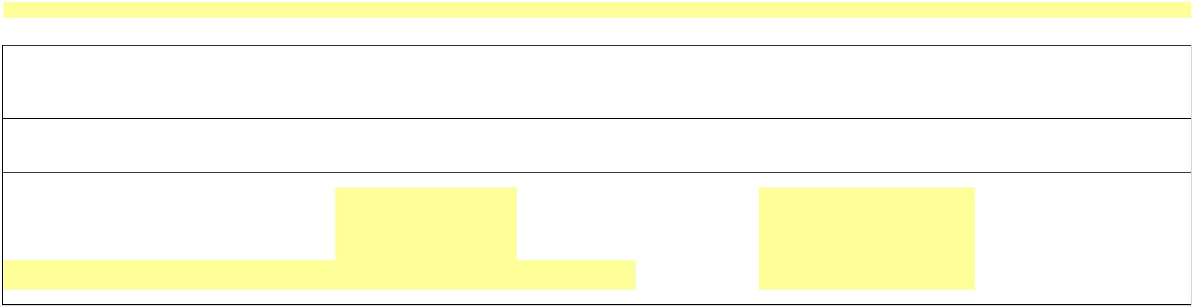X
Schedule F3
Project True-Up
Incentives
YEAR ENDING DECEMBER 31, ____
($)
(1) (2) (3) (4) (5) (6) (7) (8) (9) (10)
Actual True-Up Applicable True-Up
NTAC ATRR Net Adjustment Interest Adjustment Total
Line Project or Project Actual Revenues Revenue Principal Prior Period Rate on Interest True-Up
No. Name Number Received (Note 1) Requirement (Note 2) Under/(Over) Adjustment Under/(Over) Under/(Over) Adjustment
 | Received for  Transmission Service |  | (Note A) (Col. (6) + Col. (7)) x Col. (6) + Col. (7)  Schedule F2 Using Actual  Cost Data Col. (5) - Col. (4) Line 25, Col. (e) Line 24 Col. (8) x 24 months + Col. (9)
1a NTAC Facilities - - - -
1b MSSC - - - -
1c AC Project Segment A (Central East Energy Connect) - - - -
1d Smart Path Connect - NTAC - - - -
1e Propel NY - - - -
… …
2 Subtotal - - -
3 Under/(Over) Recovery -
Notes:
1) For all projects and NTAC ATRR, the Actual Revenues Received are the actual revenues NYPA receives from the NYISO in that calendar year. If NYISO does not break out the revenues per project,
the Actual Revenues Received will be allocated pro rata to each project based on their Actual Net Revenue Requirement in col (5).
2) Schedule F1, Page 2 of 2, col (15).

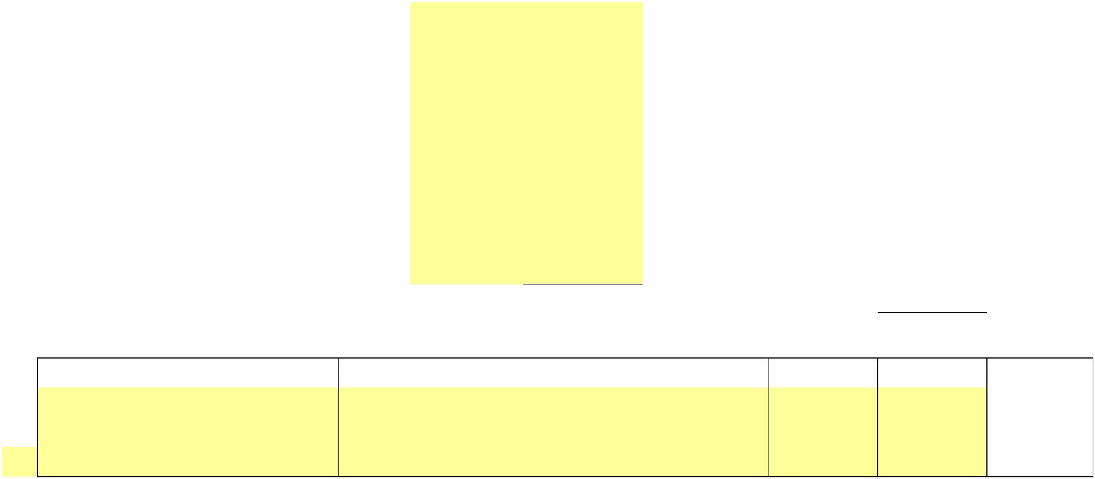 Schedule F3
Project True-Up
Incentives
FERC Refund Interest Rate
4 Interest Rate (Note A): Year  5 January  6 February  7 March  8 April  9 May  10 June  11 July  12 August  13 September  14 October  15 November  16 December  17 January  18 February  19 March  20 April  21 May  22 June |  | Interest Rates under  Section 35.19(a)
23 July
0.00%
24 Avg. Monthly FERC Rate 0.00% 0.00%
Prior Period Adjustments
(a) (b) (c) (d) (e)
Project or Adjustment Amount Interest Total Adjustment Schedule 1 A Description of the Adjustment In Dollars (Note A) Col. (c) + Col. (d)
25 -
25a -
25b -
25c -
… -
… -
26 Total -
Notes: A Prior Period Adjustments are when an error is discovered relating to a prior true-up or refunds/surcharges ordered by FERC. The interest on the Prior Period Adjustment excludes
interest for the current true up period, because the interest is included in Ln 25 Col (d).

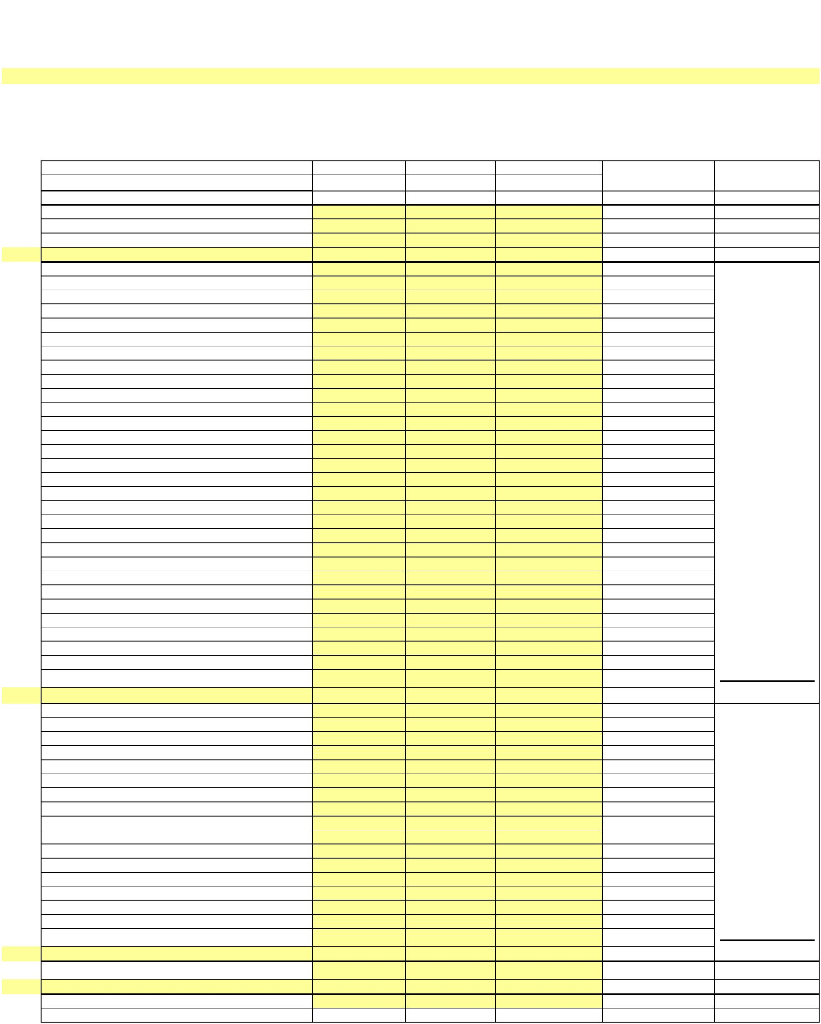X
NEW YORK POWER AUTHORITY TRANSMISSION REVENUE REQUIREMENT
YEAR ENDING DECEMBER 31, ____
WORK PAPER AA Operation and Maintenance Summary
(1) (2) (3) (4) (5) (6)
OVERALL Major
Line No.Amount ($) PRODUCTION TRANSMISSION ADMIN & GENERAL RESULT Category
1a 555 - OPSE-Purchased Power - -
1b 501 - Steam Product-Fuel - -
1c 565 - Trans-Xmsn Elect Oth - -
… … - -
2a 506 - SP-Misc Steam Power -
2b 535 - HP-Oper Supvr&Engrg -
2c 537 - HP-Hydraulic Expense -
2d 538 - HP-Electric Expenses -
2e 539 - HP-Misc Hyd Pwr Gen -
2f 546 - OP-Oper Supvr&Engrg -
2g 548 - OP-Generation Expens -
2h 549 - OP-Misc Oth Pwr Gen -
2i 560 - Trans-Oper Supvr&Eng -
2j 561 - Trans-Load Dispatcng -
2k 562 - Trans-Station Expens -
2l 566 - Trans-Misc Xmsn Exp -
2m 905 - Misc. Customer Accts. Exps -
2n Contribution to New York State -
2o 916 - Misc. Sales Expense -
2p 920 - Misc. Admin & Gen'l Salaries -
2q 921 - Misc. Office Supp & Exps -
2r 922 - Administrative Expenses Transferred -
2s 923 - Outside Services Employed -
2t 924 - A&G-Property Insurance -
2u 925 - A&G-Injuries & Damages Insurance -
2v 926 - A&G-Employee Pension & Benefits -
2w 926 - A&G-Employee Pension & Benefits(PBOP) -
2x 928 - A&G-Regulatory Commission Expense -
2y 930 - Obsolete/Excess Inv -
2z 930.1-A&G-General Advertising Expense -
2aa 930.2-A&G-Miscellaneous & General Expense -
2ab 930.5-R & D Expense -
2ac 931 - Rents -
2ad 935 - A&G-Maintenance of General Plant - Operations
… … - -
3a 545 - HP-Maint Misc Hyd Pl -
3b 512 - SP-Maint Boiler Plt -
3c 514 - SP-Maint Misc Stm Pl -
3d 541 - HP-Maint Supvn&Engrg -
3e 542 - HP-Maint of Struct -
3f 543 - HP-Maint Res Dam&Wtr -
3g 544 - HP-Maint Elect Plant -
3h 551 - OP-Maint Supvn & Eng -
3i 552 - OP-Maint of Struct -
3j 553 - OP-Maint Gen & Elect -
3k 554 - OP-Maint Oth Pwr Prd -
3l 568 - Trans-Maint Sup & En -
3m 569 - Trans-Maint Struct -
3n 570 - Trans-Maint St Equip -
3o 571 - Trans-Maint Ovhd Lns -
3p 572 - Trans-Maint Ungrd Ln -
3q 573 - Trans-Maint Misc Xmn - Maintenance
… … - -
4a 403 - Depreciation Expense -
… … - -
5 TOTALS - - - - -

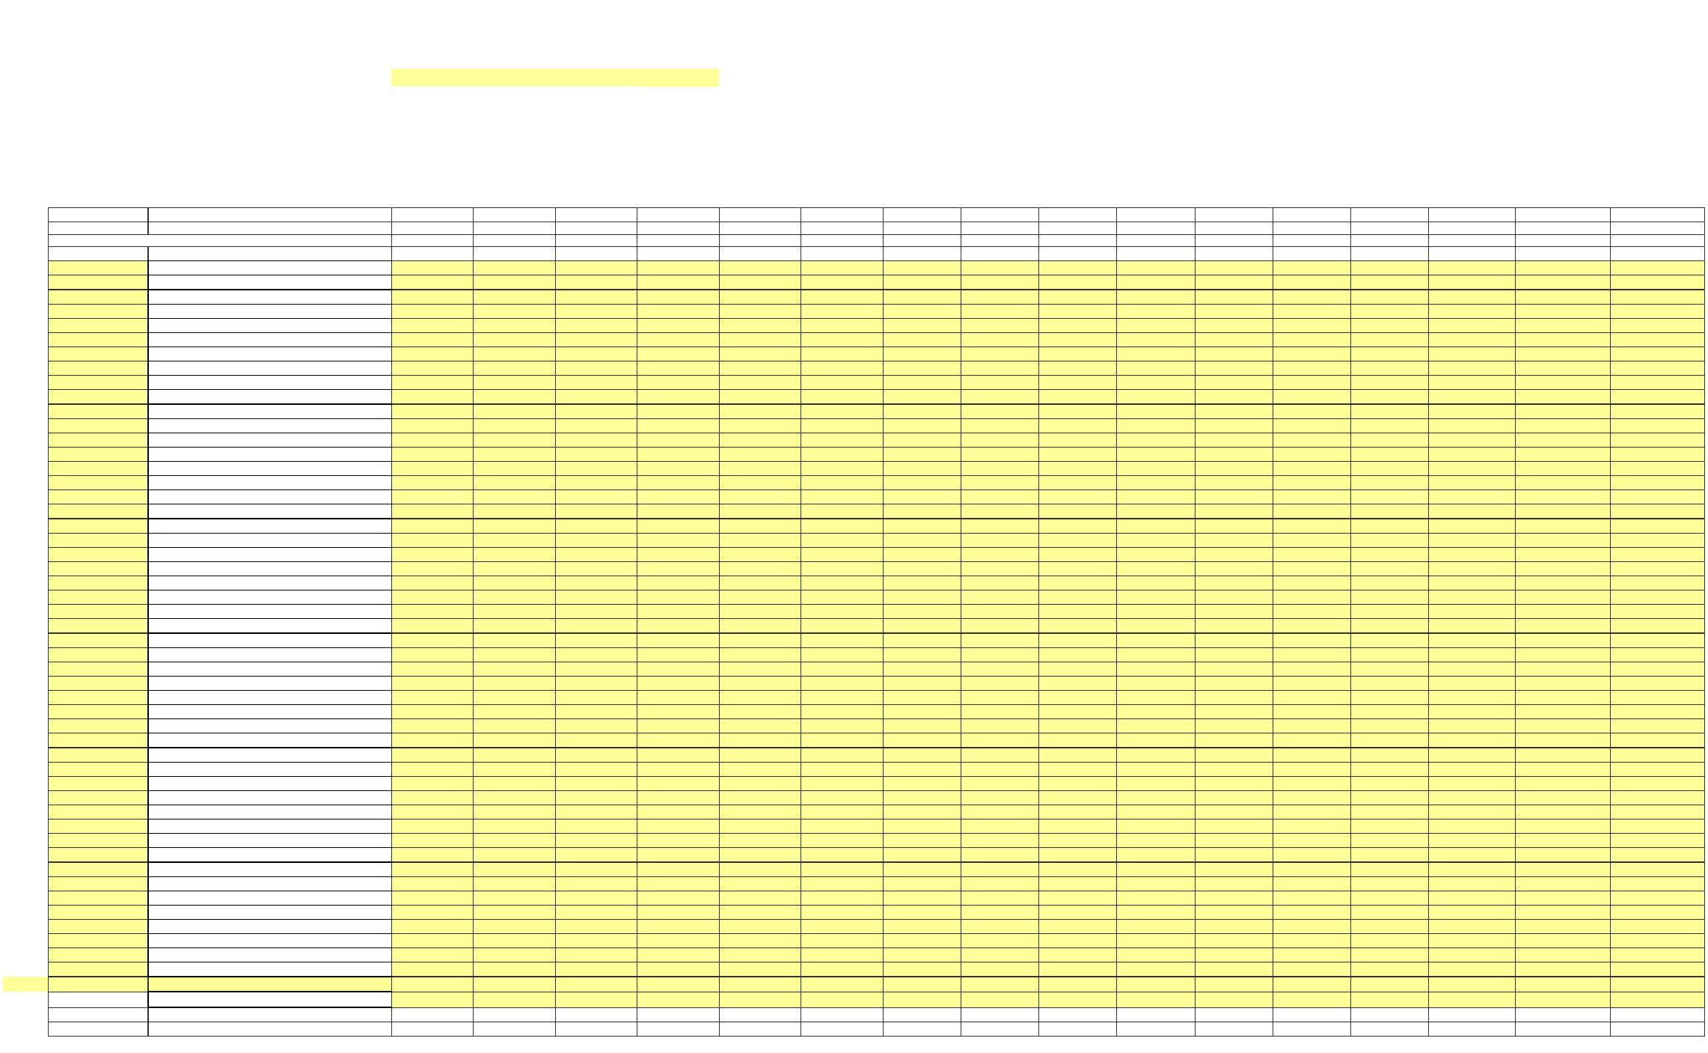X
NEW YORK POWER AUTHORITY
TRANSMISSION REVENUE REQUIREMENT
YEAR ENDING DECEMBER 31, ____
WORK PAPER AB Operation and Maintenance Detail
FERC by accounts and profit center
(1) (2) (3) (4) (5) (6) (7) (8) (9) (10) (11) (12) (13) (14) (15) (16) (17) (18)
Amount ($)
0100/105 0100/110 0100/115 0100/120 0100/122 0100/125 0100/130 0100/135 0100/140 0100/145 0100/150 0100/155 0100/156 0100/157 0100/158 0100/159
Line No. FERC G/L Accounts Blenheim-Gilboa St. Lawrence Niagara Poletti Astoria Energy II Flynn Jarvis Crescent Vischer Ferry Ashokan Kensico Hell Gate Harlem River Vernon Blvd. 23rd & 3rd (Gowanus) N 1st &Grand (Kent)
1a 403 - Depreciation Expense
1b 501 - Steam Product-Fuel
1c 506 - SP-Misc Steam Power
1d 512 - SP-Maint Boiler Plt
1e 514 - SP-Maint Misc Stm Pl
1f 535 - HP-Oper Supvr&Engrg
1g 537 - HP-Hydraulic Expense
1h 538 - HP-Electric Expenses
1i 539 - HP-Misc Hyd Pwr Gen
1j 541 - HP-Maint Supvn&Engrg
1k 542 - HP-Maint of Struct
1l 543 - HP-Maint Res Dam&Wtr
1m 544 - HP-Maint Elect Plant
1n 545 - HP-Maint Misc Hyd Pl
1o 546 - OP-Oper Supvr&Engrg
1p 548 - OP-Generation Expens
1q 549 - OP-Misc Oth Pwr Gen
1r 551 - OP-Maint Supvn & Eng
1s 552 - OP-Maint of Struct
1t 553 - OP-Maint Gen & Elect
1u 554 - OP-Maint Oth Pwr Prd
1v 555 - OPSE-Purchased Power
1w 560 - Trans-Oper Supvr&Eng
1x 561 - Trans-Load Dispatcng
1y 562 - Trans-Station Expens
1z 565 - Trans-Xmsn Elect Oth
1aa 566 - Trans-Misc Xmsn Exp
1ab 568 - Trans-Maint Sup & En
1ac 569 - Trans-Maint Struct 1ad 570 - Trans-Maint St Equip
1ae 571 - Trans-Maint Ovhd Lns
1af 572 - Trans-Maint Ungrd Ln
1ag 573 - Trans-Maint Misc Xmn
1ah 905 - Misc. Customer Accts. Exps
1ai 916 - Misc. Sales Expense
1ak 920 - Misc. Admin & Gen'l Salaries
1al 921 - Misc. Office Supp & Exps
1am 922 - Administrative Expenses Transferred
1an 923 - Outside Services Employed
1ao 924 - A&G-Property Insurance
1ap 925 - A&G-Injuries & Damages Insurance
1aq 926 - A&G-Employee Pension & Benefits(PBOP)
1ar 926 - A&G-Employee Pension & Benefits
1as 928 - A&G-Regulatory Commission Expense
1at 930 - Obsolete/Excess Inv
1au 931 - Rents
1av 930.5-R & D Expense
1aw 930.1-A&G-General Advertising Expense
1ax 930.2-A&G-Miscellaneous & General Expense
1ay 935 - A&G-Maintenance of General Plant
…
2 Contribution to New York State
3 Overall Result - - - - - - - - - - - - - - - -

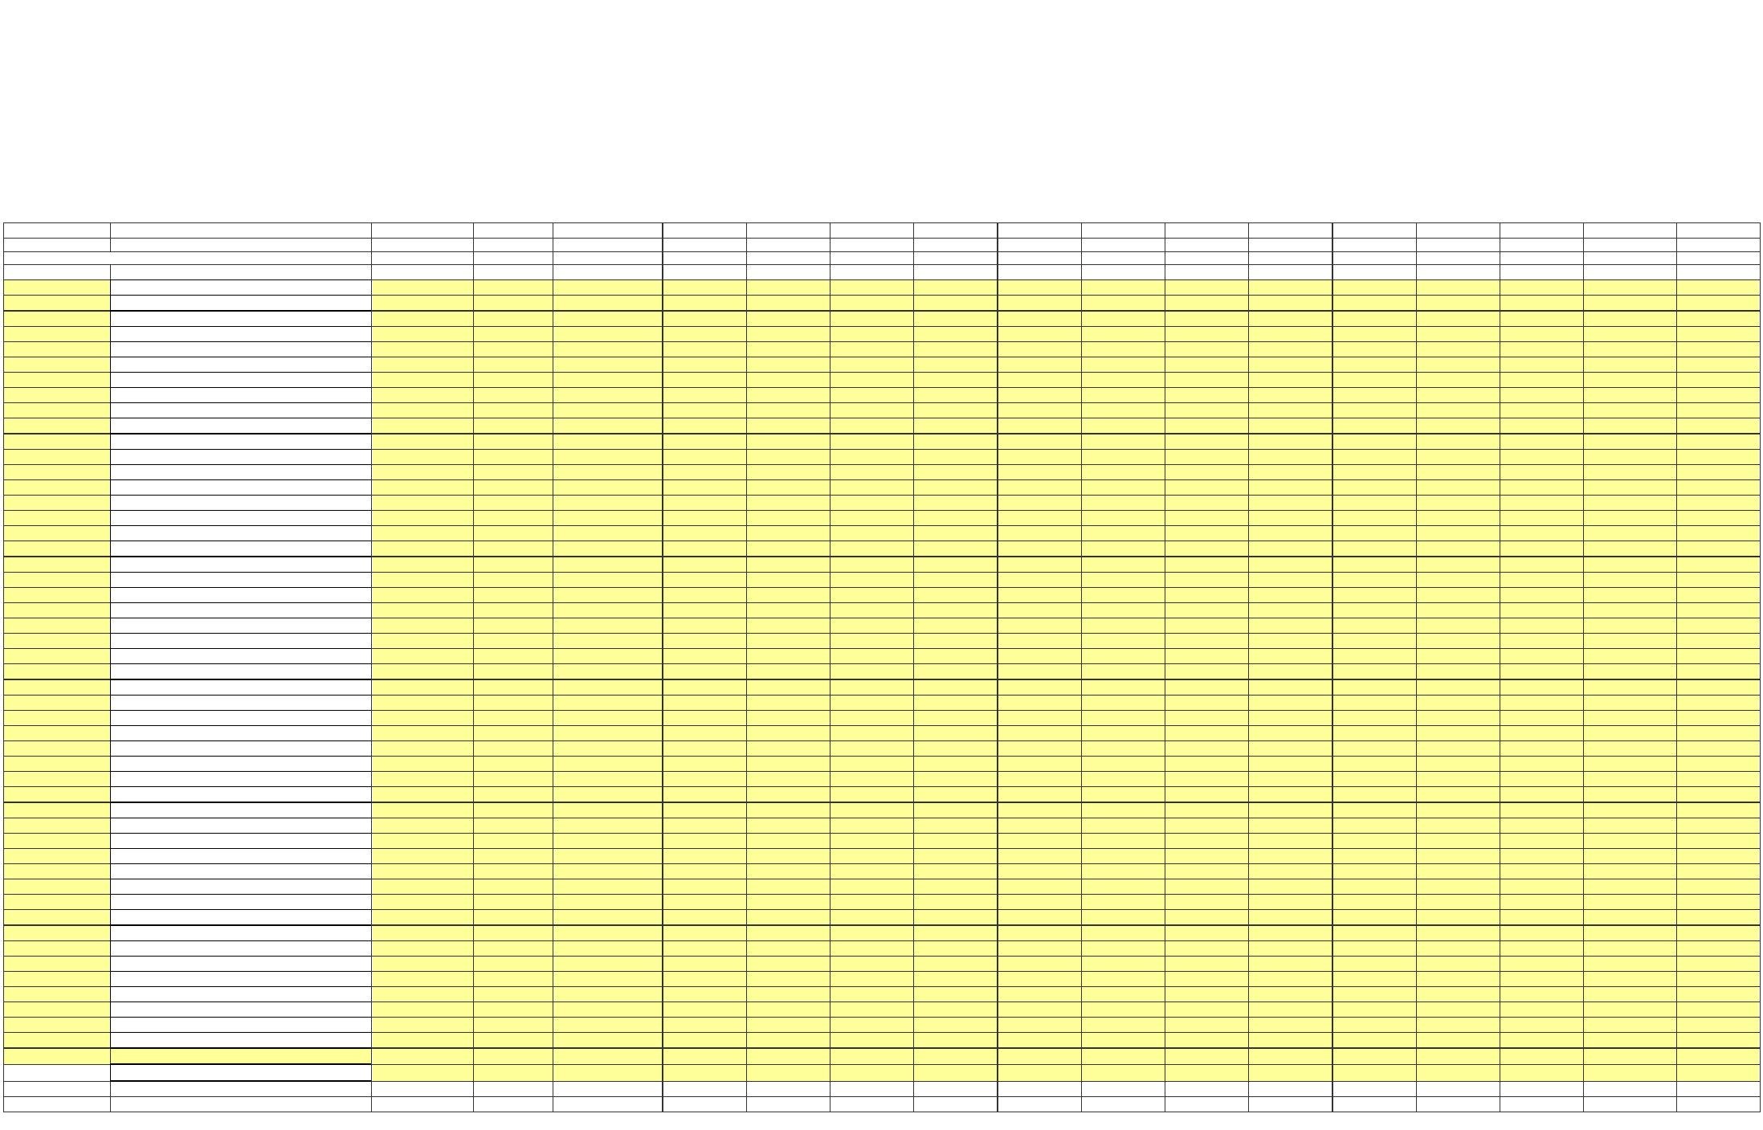X
 |  | FERC by accounts and profit center  (1) (2) |  |  |  | (19) (20) (21) (22) (23) (24) (25) (26) (27) (28) (29) (30) (31) (32) (33) (34)
 | FERC G/L Accounts |  |  | 0100/160 0100/161 0100/165 0100/205 0100/210 0100/215 0100/220 0100/225 0100/230 0100/235 0100/240 0100/245 0100/255 0100/305 0100/310 0100/320  Pouch Terminal Brentwood 500MW Combined Cycle BG Trans JAF Trans IP3/Pol Trans Marcy/Clark Trans Marcy South Trans Niagara Trans Sound Cable ST Law Trans 765 KV Trans HTP Trans DSM Headquarters Power for Jobs
403 - Depreciation Expense
501 - Steam Product-Fuel 506 - SP-Misc Steam Power
512 - SP-Maint Boiler Plt 514 - SP-Maint Misc Stm Pl
535 - HP-Oper Supvr&Engrg
537 - HP-Hydraulic Expense
538 - HP-Electric Expenses
539 - HP-Misc Hyd Pwr Gen
541 - HP-Maint Supvn&Engrg
542 - HP-Maint of Struct
543 - HP-Maint Res Dam&Wtr
544 - HP-Maint Elect Plant 545 - HP-Maint Misc Hyd Pl
546 - OP-Oper Supvr&Engrg
548 - OP-Generation Expens
549 - OP-Misc Oth Pwr Gen
551 - OP-Maint Supvn & Eng
552 - OP-Maint of Struct 553 - OP-Maint Gen & Elect
554 - OP-Maint Oth Pwr Prd
555 - OPSE-Purchased Power
560 - Trans-Oper Supvr&Eng
561 - Trans-Load Dispatcng
562 - Trans-Station Expens
565 - Trans-Xmsn Elect Oth
566 - Trans-Misc Xmsn Exp
568 - Trans-Maint Sup & En
569 - Trans-Maint Struct 570 - Trans-Maint St Equip 571 - Trans-Maint Ovhd Lns
572 - Trans-Maint Ungrd Ln
573 - Trans-Maint Misc Xmn
905 - Misc. Customer Accts. Exps
916 - Misc. Sales Expense
920 - Misc. Admin & Gen'l Salaries
921 - Misc. Office Supp & Exps
922 - Administrative Expenses Transferred
923 - Outside Services Employed 924 - A&G-Property Insurance
925 - A&G-Injuries & Damages Insurance
926 - A&G-Employee Pension & Benefits(PBOP)
926 - A&G-Employee Pension & Benefits
928 - A&G-Regulatory Commission Expense
930 - Obsolete/Excess Inv
931 - Rents
930.5-R & D Expense
930.1-A&G-General Advertising Expense
930.2-A&G-Miscellaneous & General Expense
935 - A&G-Maintenance of General Plant
Contribution to New York State
Overall Result - - - - - - - - - - - - - - - -

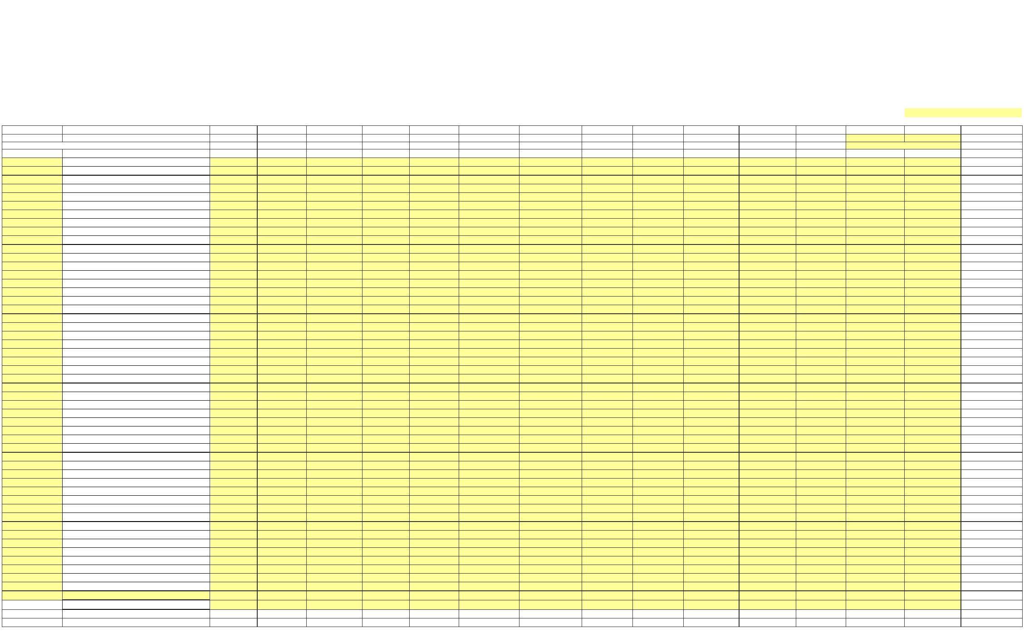X
 |  | FERC by accounts and profit center  (1) (2) |  |  |  |  | (35) (36) (37) (38) (39) (40) (41) (42) (43) (44) (45) (46) (47) (48) (49)
 | FERC G/L Accounts |  |  |  | 0100/321 0100/410 0100/600 0100/700 0100/800 0100/900 0100/901 0100/265 0100/322 0100/350 0100/550 0100/701 0100/902 Overall Result  Recharge NY JAF SENY CES Canal Corp EV Charging Stations Large Energy Storage AC Proceedings GPSP Canals Reimagined CANALS CAPITAL NYEM Lrg Scale Renewables
 |  |  | 403 - Depreciation Expense  501 - Steam Product-Fuel  506 - SP-Misc Steam Power  512 - SP-Maint Boiler Plt  514 - SP-Maint Misc Stm Pl  535 - HP-Oper Supvr&Engrg  537 - HP-Hydraulic Expense  538 - HP-Electric Expenses  539 - HP-Misc Hyd Pwr Gen  541 - HP-Maint Supvn&Engrg  542 - HP-Maint of Struct  543 - HP-Maint Res Dam&Wtr  544 - HP-Maint Elect Plant  545 - HP-Maint Misc Hyd Pl  546 - OP-Oper Supvr&Engrg  548 - OP-Generation Expens  549 - OP-Misc Oth Pwr Gen  551 - OP-Maint Supvn & Eng  552 - OP-Maint of Struct  553 - OP-Maint Gen & Elect  554 - OP-Maint Oth Pwr Prd  555 - OPSE-Purchased Power  560 - Trans-Oper Supvr&Eng  561 - Trans-Load Dispatcng  562 - Trans-Station Expens  565 - Trans-Xmsn Elect Oth  566 - Trans-Misc Xmsn Exp  568 - Trans-Maint Sup & En  569 - Trans-Maint Struct  570 - Trans-Maint St Equip  571 - Trans-Maint Ovhd Lns  572 - Trans-Maint Ungrd Ln  573 - Trans-Maint Misc Xmn  905 - Misc. Customer Accts. Exps  916 - Misc. Sales Expense  920 - Misc. Admin & Gen'l Salaries  921 - Misc. Office Supp & Exps  922 - Administrative Expenses Transferred  923 - Outside Services Employed  924 - A&G-Property Insurance  925 - A&G-Injuries & Damages Insurance  926 - A&G-Employee Pension & Benefits(PBOP)  926 - A&G-Employee Pension & Benefits  928 - A&G-Regulatory Commission Expense  930 - Obsolete/Excess Inv  931 - Rents  930.5-R & D Expense  930.1-A&G-General Advertising Expense  930.2-A&G-Miscellaneous & General Expense  935 - A&G-Maintenance of General Plant  Contribution to New York State |  |  |  |  |  |  | -  -  -  -  -  -  -  -  -  -  -  -  -  -  -  -  -  -  -  -  -  -  -  -  -  -  -  -  -  -  -  -  -  -  -  -  -  -  -  -  -  -  -  -  -  -  -  -  -  -  -  -
Overall Result - - - - - - - - - - - - - - -

X
NEW YORK POWER AUTHORITY TRANSMISSION REVENUE REQUIREMENT
YEAR ENDING DECEMBER 31, ____
WORK PAPER AC
STEP-UP TRANSFORMERS O&M ALLOCATOR
Amount ($) Ratio Notes Line No. (1) (2)
1 Avg. Transmission Plant in Service - Sch B2; Col 1, Sum Ln 5, 6 and 10
 | 2 |  | Generator Step-Up Transformer Plant-in-  Service - Sch B2, Line 12, Col 1
3 Ratio - Col 1, Ln 2 / Col 1, Ln 1
4 Transmission Maintenance - Sch A1; Col 4, Ln 4
5 Removed Step-up Transmission O&M - Col 1, Ln 4 x Col 2, Ln 3

X
NEW YORK POWER AUTHORITY TRANSMISSION REVENUE REQUIREMENT
YEAR ENDING DECEMBER 31, ____
WORK PAPER AD FACTS O&M ALLOCATOR
Amount ($) Ratio Notes Line No. (1) (2)
1 Avg. Transmission Plant in Service - Sch B2; Col 1, Sum Ln 5, 6 and 10
2 FACTS Plant-in-Service - Sch B2, Line 13, Col 1
3 Ratio - Col 1, Ln 2 / Col 1, Ln 1
4 Transmission Maintenance - Sch A1: Col 4, Ln 4
5 Reclassified FACTS Transmission Plant - Subtract Col 1, Ln 4 * Col 2, Ln 3

X
NEW YORK POWER AUTHORITY TRANSMISSION REVENUE REQUIREMENT
YEAR ENDING DECEMBER 31, ____
WORK PAPER AE MICROWAVE TOWER RENTAL INCOME
(1) (2) (3)
Posting Income Line No. Date Account Amount ($)
1a
1b
1c
1d
1e
1f 1g
1h
1i
1j
1k
1l
1m
…
2 -

X
NEW YORK POWER AUTHORITY TRANSMISSION REVENUE REQUIREMENT
YEAR ENDING DECEMBER 31, ____
WORK PAPER AF
POSTRETIREMENT BENEFITS OTHER THAN PENSIONS (PBOP)
(1) (2) Line No. Item Amount ($)
1 Total NYPA PBOP
2 PBOP Capitalized
3 PBOP contained in Cost of Service Line 1 less line 2 -
4 Base PBOP Amount 35,797,785
5 PBOP Adjustment Line 4 less line 3 -
This work paper includes total NYPA PBOP which is allocated to transmission by the allocator as shown on Schedule A2.

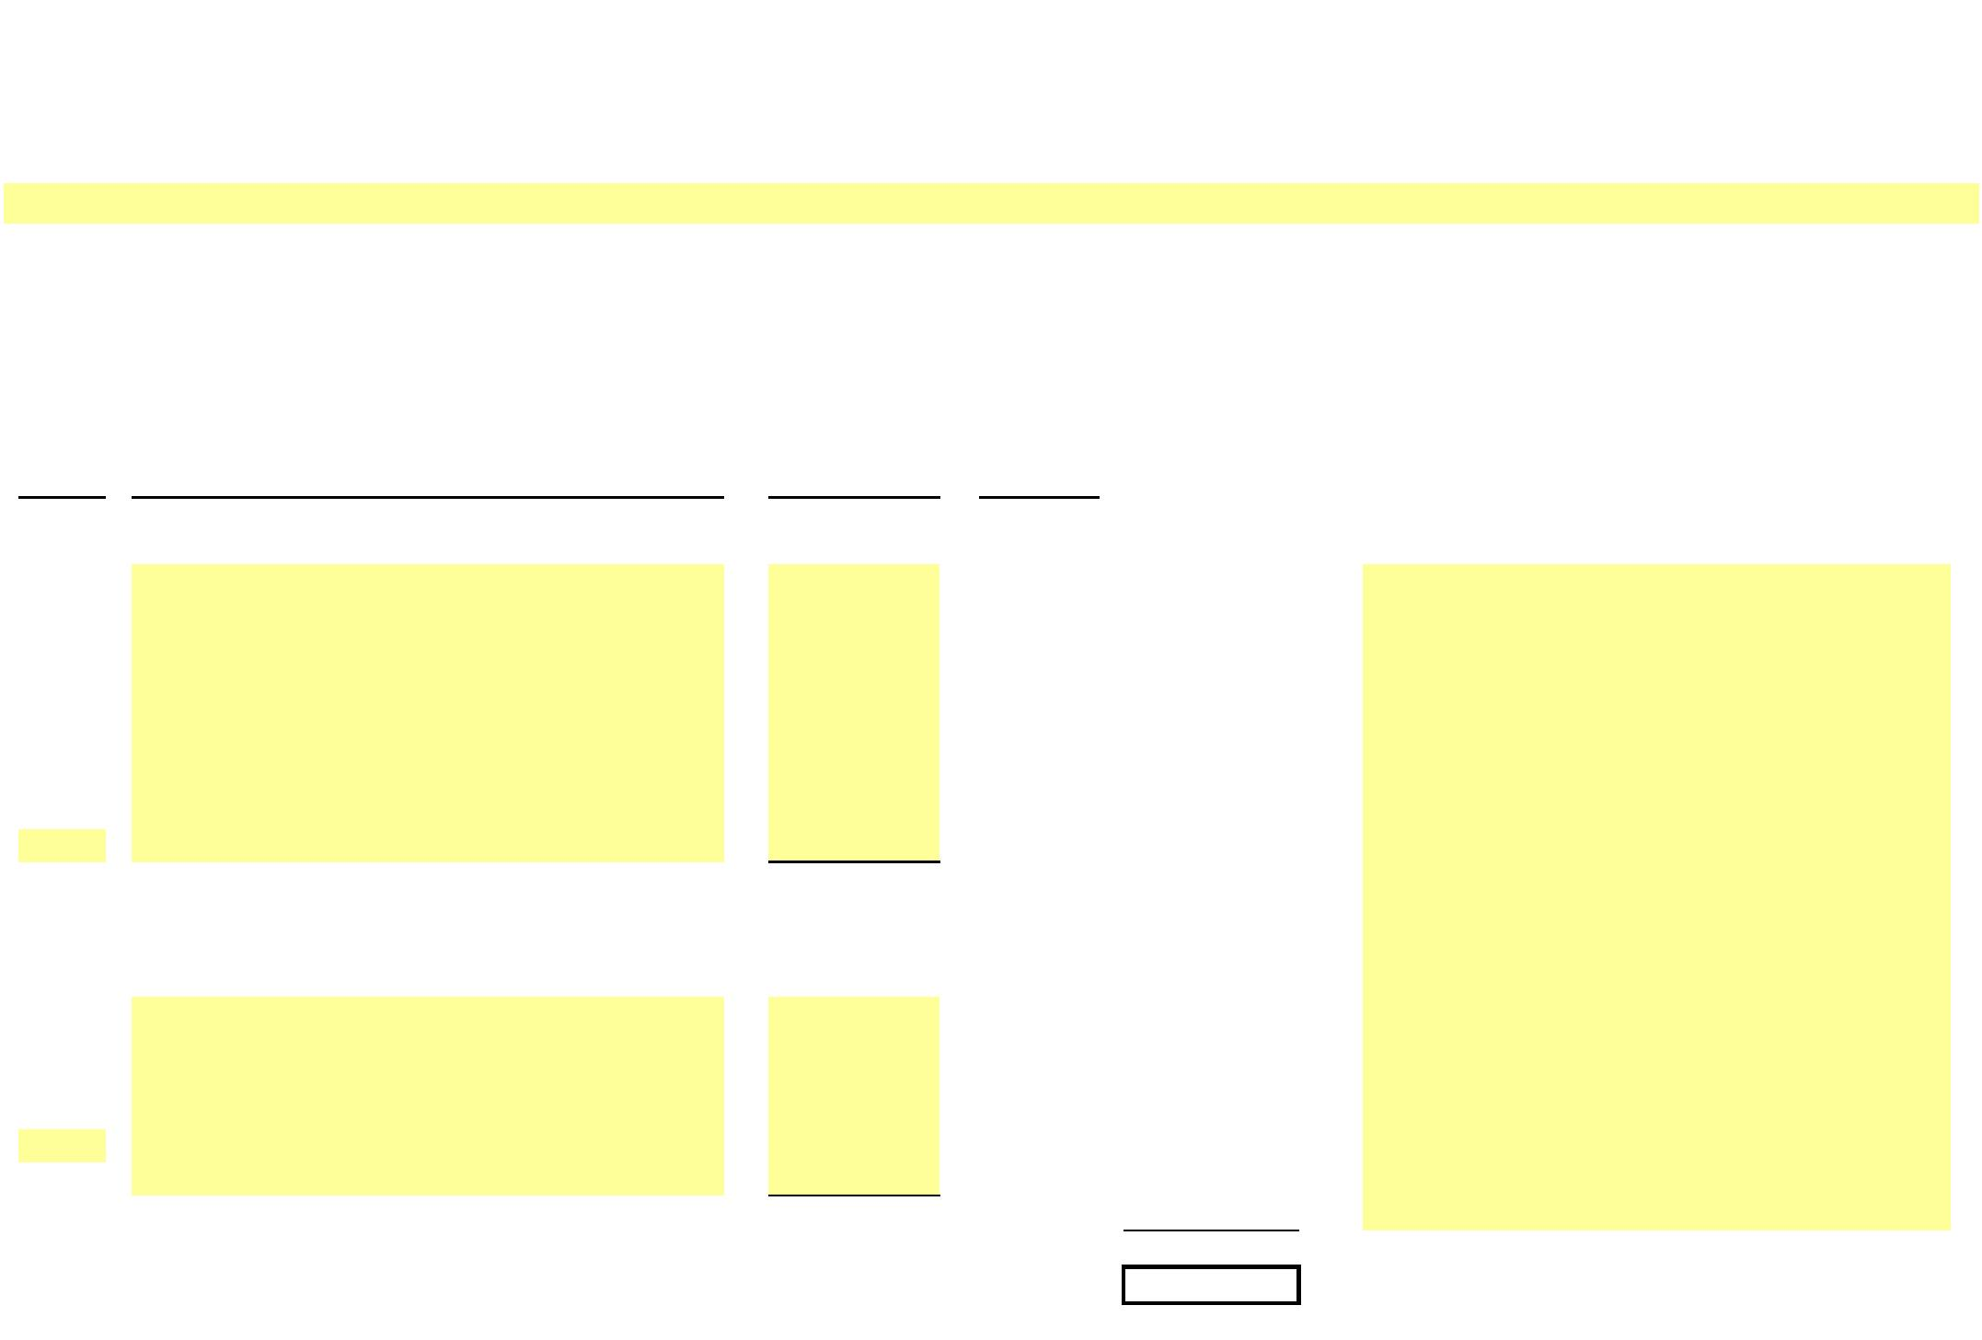X
NEW YORK POWER AUTHORITY TRANSMISSION REVENUE REQUIREMENT
YEAR ENDING DECEMBER 31, ____
WORK PAPER AG PROPERTY INSURANCE ALLOCATION
Allocated Insurance
Expense -
Line No. Site Amount ($) Ratio Transmission ($) Notes
(1) (2) (3) (4)
1a
1b
1c
1d
…
 | 2 Subtotal (Gross Transmission Plant Ratio) - - - |  | Allocated based on transmission gross plant ratio  from Work Paper AI
3a
3b
…
4 Subtotal (Full Transmission) - 100.00% -
5 Grand Total -

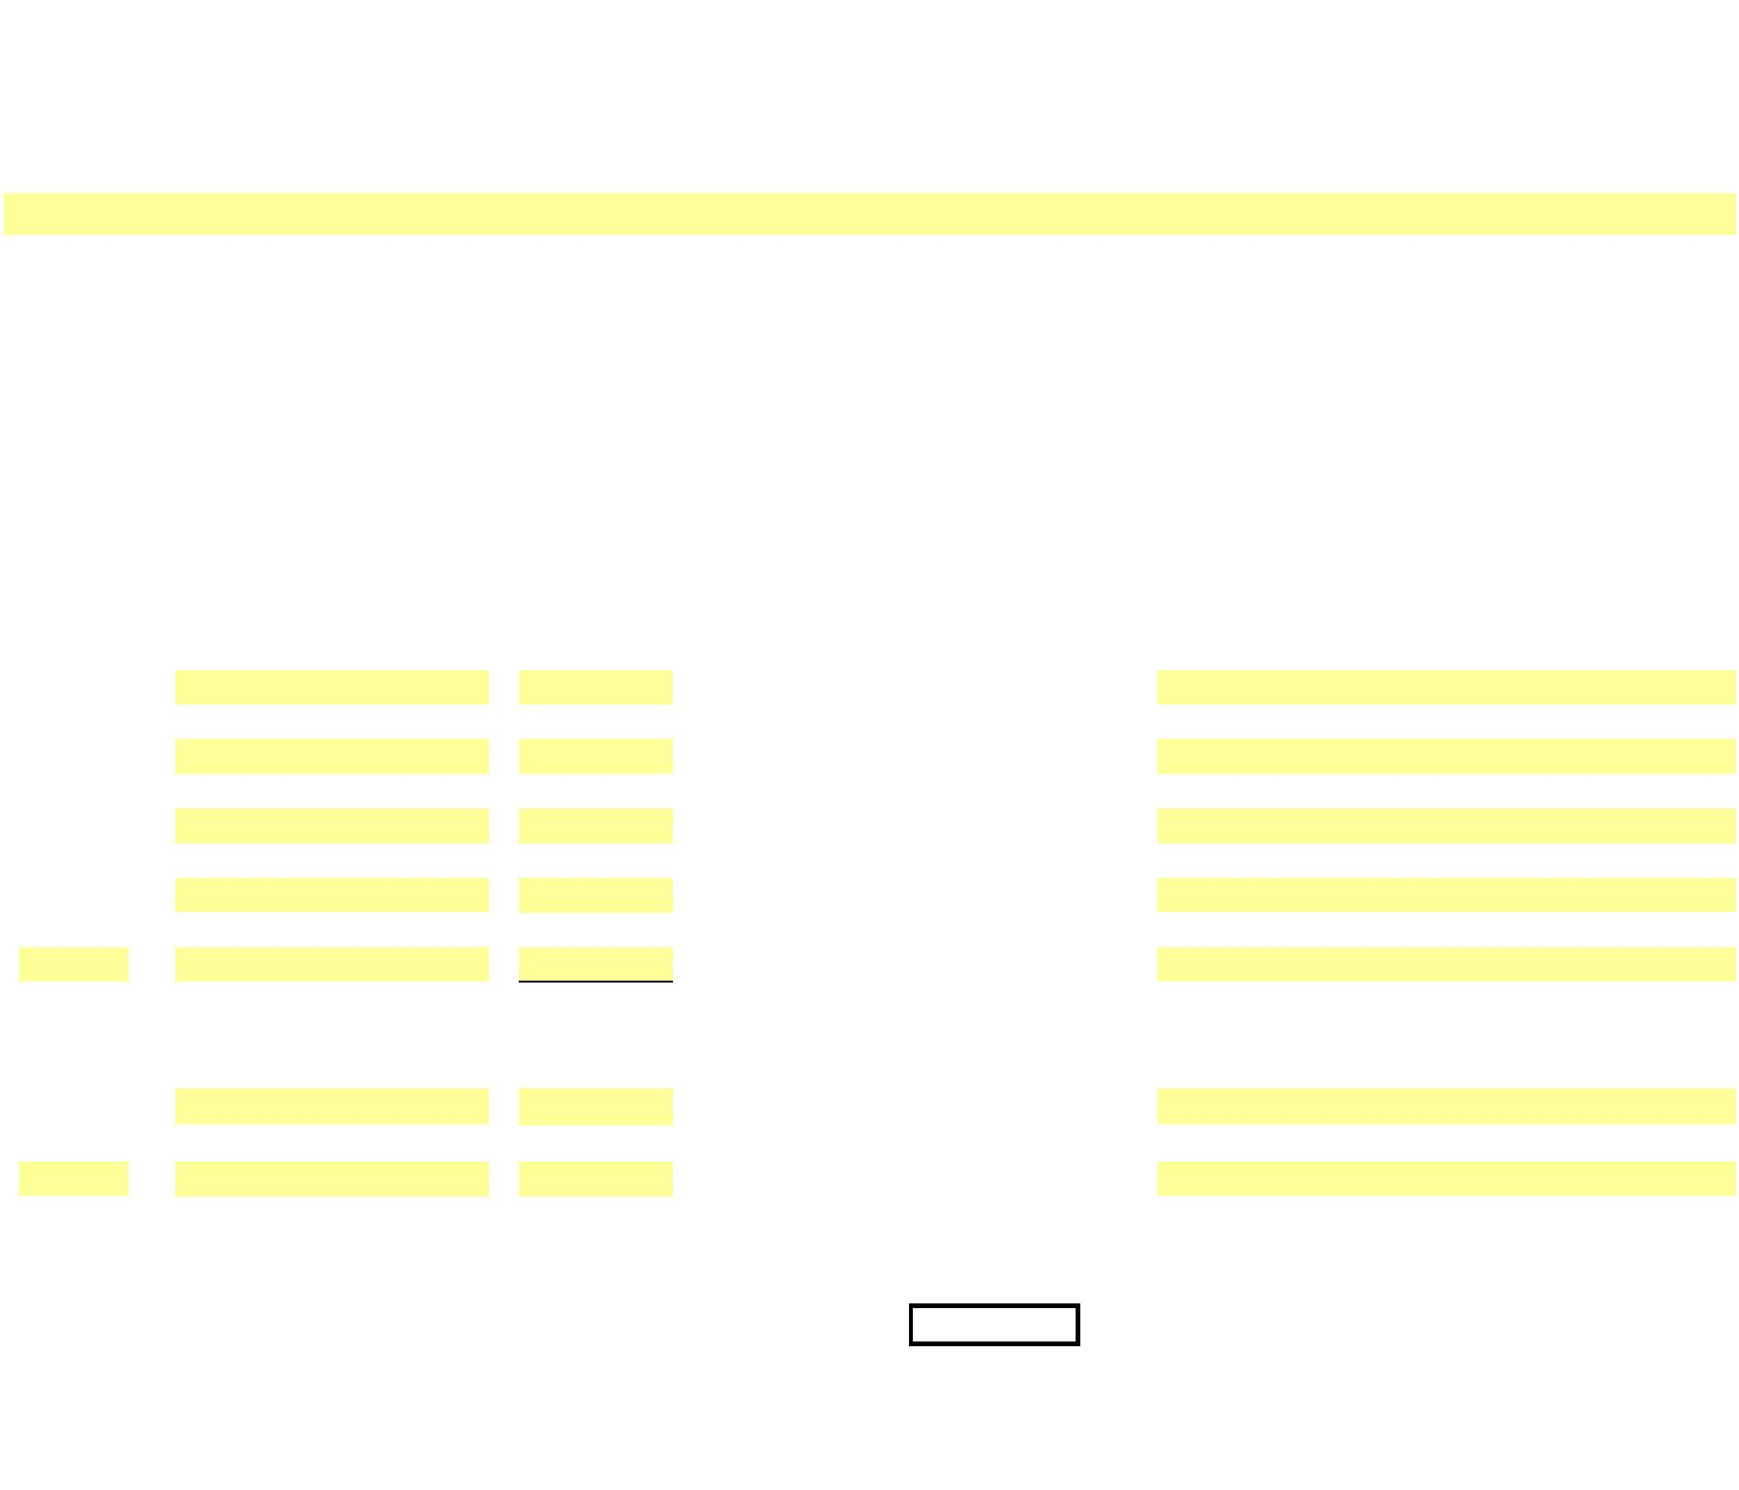X
NEW YORK POWER AUTHORITY TRANSMISSION REVENUE REQUIREMENT
YEAR ENDING DECEMBER 31, ____
WORK PAPER AH
INJURIES & DAMAGES INSURANCE EXPENSE ALLOCATION
Allocated Injury/Damage
Insurance
Expense -
Line No. Site Amount ($) Ratio (%) Transmission ($) Notes
(1) (2) (3) (4)
1a
1b
1c
1d
…
 | 2 Subtotal - - - |  | Allocated based on transmission allocator from  Schedule E1
3a
…
- 100.00 -
4 Grand Total - -

X
NEW YORK POWER AUTHORITY TRANSMISSION REVENUE REQUIREMENT
YEAR ENDING DECEMBER 31, ____
WORK PAPER AI PROPERTY INSURANCE ALLOCATOR
Gross Plant in
Line No. 13-Month Average ($) Service Ratio Source
(1) (2) (3)
1 PRODUCTION - - WP-BC
2 TRANSMISSION (353 Station Equip.) - - WP-BC
3 TOTAL - -

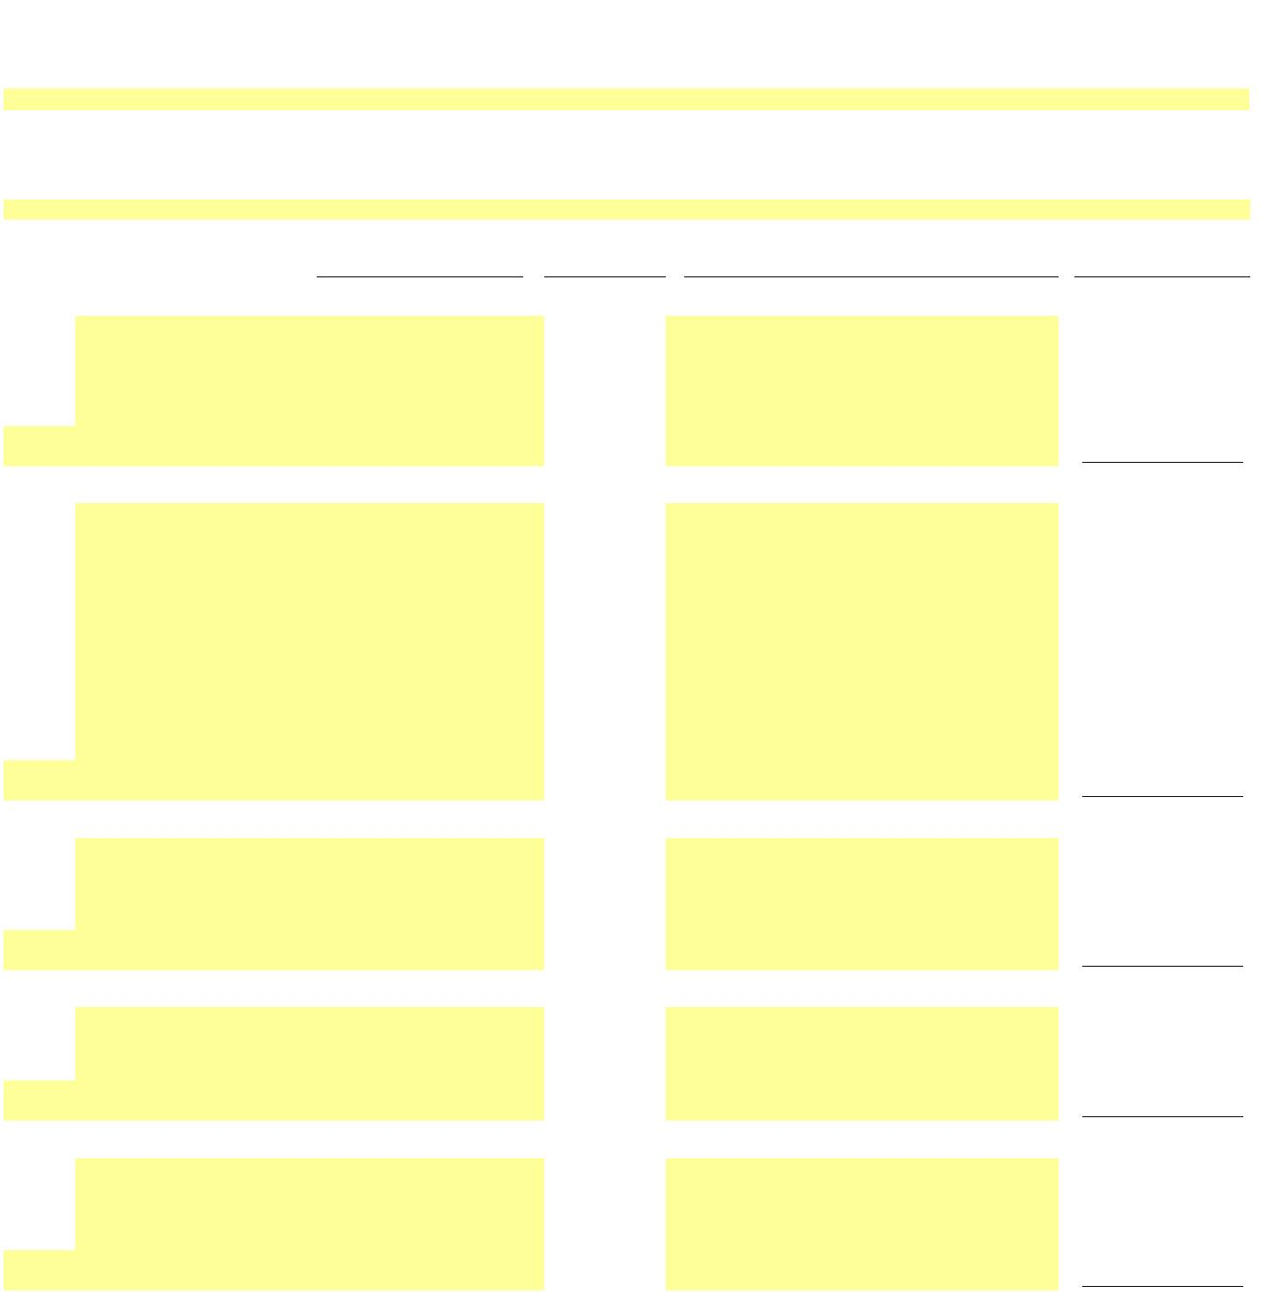X
NEW YORK POWER AUTHORITY
TRANSMISSION REVENUE REQUIREMENT
YEAR ENDING DECEMBER 31, ____
WORK PAPER BA
DEPRECIATION AND AMORTIZATION EXPENSES (BY FERC ACCOUNT)
Included General & Transmission Plant - Depreciation ____
(1) (2) (3) (4)
FERC
Site Acct # Item Depreciation ($)
Line No. Source/Comments Included General Plant
1a 390 -
1b 390 -
1c 390 -
1d 390 -
1e 390 -
1f 390 -
… 390 -
… 390 -
2 390 Subtotal General - Structures & Improvements -
3a 391 -
3b 391 -
3c 391 -
3d 391 -
3e 391 -
3f 391.2 -
3g 391.2 -
3h 391.2 -
3i 391.2 -
3j 391.2 -
3k 391.3 -
3l 391.3 -
3m 391.3 -
3n 391.3 -
… 391 -
… 391 -
4 391 Subtotal General - Office Furniture & Equipment -
5a 392 -
5b 392 -
5c 392 -
5d 392 -
5e 392 -
… 392 -
… 392 -
6 392 Subtotal General - Transportation Equipment -
7a 393 -
7b 393 -
7c 393 -
7d 393 -
… 393 -
… 393 -
8 393 Subtotal General - Stores Equipment -
9a 394 -
9b 394 -
9c 394 -
9d 394 -
9e 394 -
… 394 -
… 394 -
10 394 Subtotal General - Tools, Shop & Garage Equipment -

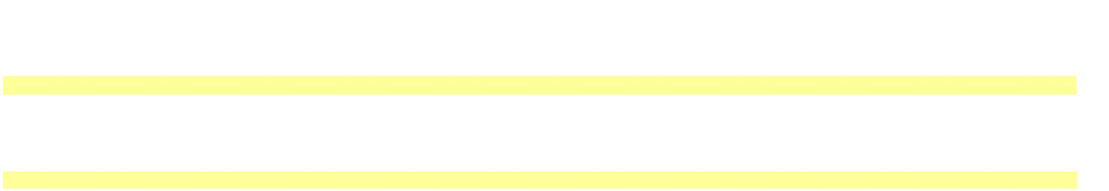X
NEW YORK POWER AUTHORITY
TRANSMISSION REVENUE REQUIREMENT
YEAR ENDING DECEMBER 31, ____
WORK PAPER BA
DEPRECIATION AND AMORTIZATION EXPENSES (BY FERC ACCOUNT)
Included General & Transmission Plant - Depreciation ____
(1) (2) (3) (4)
FERC
11a 395 -
11b 395 -
11c 395 -
11d 395 -
11e 395 -
… 395 -
… 395 -
12 395 Subtotal General - Laboratory Equipment -
13a 396 -
13b 396 -
13c 396 -
13d 396 -
13e 396 -
… 396 -
… 396 -
14 396 Subtotal General - Power Operated Equipment -
15a 397 -
15b 397 -
15c 397 -
15d 397 -
15e 397 -
15f 397 -
15g 397 -
… 397 -
… 397 -
16 397 Subtotal General - Communication Equipment -
17a 398 -
17b 398 -
17c 398 -
17d 398 -
17e 398 -
… 398 -
… 398 -
18 398 Subtotal General - Miscellaneous Equipment -
19a 399 -
19b 399 -
19c 399 -
… 399 -
… 399 -
20 399 Subtotal General - Other Tangible Property -
…
21 Total Included General Plant -
Included Transmission Plant
22a 352 -
22b 352 -
22c 352 -
22d 352 -
22e 352 -
22f 352 -
22g 352 -
… 352 -
… 352 -
23 352 Subtotal Transmission - Structures & Improvements -

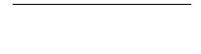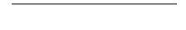X
NEW YORK POWER AUTHORITY
TRANSMISSION REVENUE REQUIREMENT
YEAR ENDING DECEMBER 31, ____
WORK PAPER BA
DEPRECIATION AND AMORTIZATION EXPENSES (BY FERC ACCOUNT)
Included General & Transmission Plant - Depreciation ____
(1) (2) (3) (4)
FERC
24a 353 -
24b 353 -
24c 353 -
24d 353 -
24e 353 -
24f 353 -
24g 353 -
24h 353 -
… 353 -
… 353 -
25 353 Subtotal Transmission - Station Equipment -
26a 354 -
26b 354 -
26c 354 -
26d 354 -
26e 354 -
26f 354 -
… 354 -
… 354 -
27 354 Subtotal Transmission - Towers & Fixtures -
28a 355 -
28b 355 -
28c 355 -
28d 355 -
28e 355 -
… 355 -
… 355 -
29 355 Subtotal Transmission - Poles & Fixtures -
30a 356 -
30b 356 -
30c 356 -
30d 356 -
30e 356 -
30f 356 -
… 356 -
… 356 -
31 356 Subtotal Transmission - Overhead Conductors & Devices -
32a 357 -
32b 357 -
32c 357 -
… 357 -
… 357 -
33 357 Subtotal Transmission - Underground Conduit -
34a 358 -
34b 358 -
34c 358 -
… 358 -
… 358 -
35 358 Subtotal Transmission - Underground Conductors & Devic -
36a 359 -
36b 359 -
36c 359 -
36d 359 -
36e 359 -
36f 359 -
… 359 -
… 359 -
37 359 Subtotal Transmission - Roads & Trails -
38a 351.1 -
38b 351.1 -
… 351.1 -
… 351.1 -
39 351.1 Subtotal Transmission - Computer Hardware -
40a 351.2 -
40b 351.2 -
… 351.2 -
… 351.2 -
41 351.2 Subtotal Transmission - Computer Software -
42a 351.3 -
42b 351.3 -
… 351.3 -
… 351.3 -
43 351.3 Subtotal Transmission - Communications Equipment -
…
44 Total Included Transmission Plant -

X
NEW YORK POWER AUTHORITY
TRANSMISSION REVENUE REQUIREMENT
YEAR ENDING DECEMBER 31, ____
WORK PAPER BB EXCLUDED PLANT IN SERVICE
13-Month Average
Electric Electric
Plant in Accumulated Plant in Depreciation Line No. Source/Comments EXCLUDED TRANSMISSION Service ($) Depreciation ($) Service (Net $) Expense ($)
(1) (2) (3) (4) (5) (6) (7)
1
1a - - - -
… - - - -
2 SUBTOTAL 500mW C - C at Astoria - - - -
3
3a - - - -
3b - - - -
3c - - - -
3d - - - -
3e - - - -
3f - - - -
3g - - - -
3h - - - -
3i - - - -
… - - - -
4 SUBTOTAL Astoria 2 (AE-II) Substation - - - -
5
5a - - - -
5b - - - -
5c - - - -
… - - - -
6 SUBTOTAL Small Hydro - - - -
7
7a - - - -
… - - - -
8 SUBTOTAL FLYNN (Holtsville) - - - -
8a - - - -
8b - - - -
8c - - - -
8d - - - -
8e - - - -
… - - - -
9 SUBTOTAL Poletti - - - -
10
10a - - - -
10b - - - -
10c - - - -
10d - - - -
10e - - - -
10f - - - -
10g - - - -
… - - - -
11 SUBTOTAL SCPP - - - -
12
… - - - -
… - - - -
SUBTOTAL - - - -
13 TOTAL EXCLUDED TRANSMISSION - - - -

X
NEW YORK POWER AUTHORITY
TRANSMISSION REVENUE REQUIREMENT
YEAR ENDING DECEMBER 31, ____
WORK PAPER BB EXCLUDED PLANT IN SERVICE
13-Month Average
Electric Electric
Plant in Accumulated Plant in Depreciation Line No. Source/Comments EXCLUDED TRANSMISSION Service ($) Depreciation ($) Service (Net $) Expense ($)
14 EXCLUDED GENERAL
14a - - - -
14b - - - -
14c - - - -
14d - - - -
14e - - - -
14f - - - -
14g - - - -
14h - - - -
… - - - -
15 SUBTOTAL 500Mw CC - - - -
16
16a - - - -
16b - - - -
… - - - -
17 SUBTOTAL Small Hydro - - - -
18
18a - - - -
18b - - - -
18c - - - -
18d - - - -
18e - - - -
18f - - - -
18g - - - -
18h - - - -
18i - - - -
… - - - -
19 SUBTOTAL Flynn - - - -
20
20a - - - -
20b - - - -
20c - - - -
20d - - - -
20e - - - -
20f - - - -
20g - - - -
20h - - - -
20i - - - -
20j - - - -
20k - - - -
… - - - -
21 SUBTOTAL Poletti - - - -
22
22a - - - -
22b - - - -
22c - - - -
22d - - - -
22e - - - -
22f - - - -
22g - - - -
22h - - - -
22i - - - -
22j - - - -
22k - - - -
22l - - - -
22m - - - -
… - - - -
23 SUBTOTAL SCPP - - - -
24
24a - - - -
24b - - - -
24c - - - -
… - - - -
SUBTOTAL - - - -
25 TOTAL EXCLUDED GENERAL - - - -

 NEW YORK POWER AUTHORITY
TRANSMISSION REVENUE REQUIREMENT
YEAR ENDING DECEMBER 31, ____
WORK PAPER BC PLANT IN SERVICE DETAIL
13-Month Average
Electric Plant in Accumulated Electric Plant in Depreciation
Service Depreciation Service Expense
P/T/G Plant Name A/C Description ($) ($) (Net $ ) ($)
(1) (2) (3) (4) (5) (6) (7) (8)
Capital assets, not being depreciated:
1 Land
1a - - -
1b - - -
1c - - -
1d - - -
1e - - -
1f - - -
1g - - -
1h - - -
1i - - -
1j - - -
1k - - -
1l - - -
1m - - -
1n - - -
1o - - -
1p - - -
1q - - -
1r - - -
1s - - -
1t - - -
1u - - -
1v - - -
1w - - -
1x - - -
1y - - -
1z - - -
1aa - - -
1ab - - -
1ac - - -
1ad - - -
1ae - - -
1af - - -
1ag - - -
1ah - - -
1ai - - - … …
2 Land Total - - - -
3 Construction in progress
3a Adjustments CWIP - - - -
3b CWIP - CEEC - - - -
4 Construction in progress Total - - - -
5 Total capital assets not being depreciated - - - -

 NEW YORK POWER AUTHORITY
TRANSMISSION REVENUE REQUIREMENT
YEAR ENDING DECEMBER 31, ____
WORK PAPER BC PLANT IN SERVICE DETAIL
13-Month Average
Electric Plant in Accumulated Electric Plant in Depreciation
Service Depreciation Service Expense
P/T/G Plant Name A/C Description ($) ($) (Net $ ) ($)
(1) (2) (3) (4) (5) (6) (7) (8)
Capital assets, being depreciated:
6 Production - Hydro
6a - - -
6b - - -
6c - - -
6d - - -
6e - - -
6f - - -
6g - - -
6h - - -
6i - - -
6j - - -
6k - - -
6l - - -
6m - - -
6n - - -
6o - - -
6p - - -
6q - - -
6r - - -
6s - - -
6t - - -
6u - - -
6v - - -
6w - - -
6x - - -
6y - - -
6z - - -
6aa - - -
6ab - - -
6ac - - -
6ad - - -
6ae - - -
6af - - -
6ag - - - … …
7 Production - Hydro Total - - - -

 NEW YORK POWER AUTHORITY
TRANSMISSION REVENUE REQUIREMENT
YEAR ENDING DECEMBER 31, ____
WORK PAPER BC PLANT IN SERVICE DETAIL
13-Month Average
Electric Plant in Accumulated Electric Plant in Depreciation
Service Depreciation Service Expense
P/T/G Plant Name A/C Description ($) ($) (Net $ ) ($)
(1) (2) (3) (4) (5) (6) (7) (8)
8 Production - Gas turbine/combined cycle
8a - - -
8b - - -
8c - - -
8d - - -
8e - - -
8f - - -
8g - - -
8h - - -
8i - - -
8j - - -
8k - - -
8l - - -
8m - - -
8n - - -
8o - - -
8p - - -
8q - - -
8r - - -
8s - - -
8t - - -
8u - - -
8v - - -
8w - - -
8x - - -
8y - - -
8z - - -
8aa - - -
8ab - - -
8ac - - -
8ad - - -
8ae - - -
8af - - -
8ag - - -
8ah - - -
8ai - - -
8aj - - -
8ak - - -
8al - - -
8am - - -
8an - - -
8ao - - -
8ap - - -
8aq - - -
8ar - - -
8as - - -
8at - - -
8au - - -
8av - - -
8aw - - -
8ax - - -
8ay - - -
8az - - -
8ba - - -
8bb - - -
8bc - - -
8bd - - -
…
…
9 Production - Gas turbine/combined cycle Total - - - -

 NEW YORK POWER AUTHORITY
TRANSMISSION REVENUE REQUIREMENT
YEAR ENDING DECEMBER 31, ____
WORK PAPER BC PLANT IN SERVICE DETAIL
13-Month Average
Electric Plant in Accumulated Electric Plant in Depreciation
Service Depreciation Service Expense
P/T/G Plant Name A/C Description ($) ($) (Net $ ) ($)
(1) (2) (3) (4) (5) (6) (7) (8)
10 Transmission
10a - - -
10b - - -
10c - - -
10d - - -
10e - - -
10f - - -
10g - - -
10h - - -
10i - - -
10j - - -
10k - - -
10l - - -
10m - - -
10n - - -
10o - - -
10p - - -
10q - - -
10r - - -
10s - - -
10t - - -
10u - - -
10v - - -
10w - - -
10x - - -
10y - - -
10z - - -
10aa - - -
10ab - - -
10ac - - -
10ad - - -
10ae - - -
10af - - -
10ag - - -
10ah - - -
10ai - - -
10aj - - -
10ak - - -
10al - - -
10am - - -
10an - - -
10ao - - -
10ap - - -
10aq - - -
10ar - - -
10as - - -
10at - - -
10au - - -
10av - - -
10aw - - -
10ax - - -
10ay - - -
10az - - -
10ba - - -
10bb - - -
10bc - - -
10bd - - -
10be - - -
10bf - - -
10bg - - -
10bh - - -
10bi - - -
10bj - - -
10bk - - -
10bl - - -
10bm - - -
10bn - - -
10bo - - -
10bp - - -
10bq - - -
10br - - -
… …
11 Transmission Total - - - -

 NEW YORK POWER AUTHORITY
TRANSMISSION REVENUE REQUIREMENT
YEAR ENDING DECEMBER 31, ____
WORK PAPER BC PLANT IN SERVICE DETAIL
13-Month Average
Electric Plant in Accumulated Electric Plant in Depreciation
Service Depreciation Service Expense
P/T/G Plant Name A/C Description ($) ($) (Net $ ) ($)
(1) (2) (3) (4) (5) (6) (7) (8)
12 General
12a - - -
12b - - -
12c - - -
12d - - -
12e - - -
12f - - -
12g - - -
12h - - -
12i - - -
12j - - -
12k - - -
12l - - -
12m - - -
12n - - -
12o - - -
12p - - -
12q - - -
12r - - -
12s - - -
12t - - -
12u - - -
12v - - -
12w - - -
12x - - -
12y - - -
12z - - -
12aa - - -
12ab - - -
12ac - - -
12ad - - -
12ae - - -
12af - - -
12ag - - -
12ah - - -
12ai - - -
12aj - - -
12ak - - -
12al - - -
12am - - -
12an - - -
12ao - - -
12ap - - -
12aq - - -
12ar - - -
12as - - -
12at - - -
12au - - -
12av - - -
12aw - - -
12ax - - -
12ay - - -
12az - - -
12ba - - -
12bb - - -
12bc - - -
12bd - - -
12be - - -
12bf - - -
12bg - - -
12bh - - -
12bi - - -
12bj - - -
12bk - - -
12bl - - -
12bm - - -
12bn - - -
12bo - - -

 NEW YORK POWER AUTHORITY
TRANSMISSION REVENUE REQUIREMENT
YEAR ENDING DECEMBER 31, ____
WORK PAPER BC PLANT IN SERVICE DETAIL
13-Month Average
Electric Plant in Accumulated Electric Plant in Depreciation
Service Depreciation Service Expense
P/T/G Plant Name A/C Description ($) ($) (Net $ ) ($)
(1) (2) (3) (4) (5) (6) (7) (8)
12bp - - -
12bq - - -
12br - - -
12bs - - -
12bt - - -
12bu - - -
12bv - - -
12bw - - -
12bx - - -
12by - - -
12bz - - -
12ca - - -
12cb - - -
12cc - - -
12cd - - -
12ce - - -
12cf - - -
12cg - - -
12ch - - -
12ci - - -
12cj - - -
12ck - - -
12cl - - -
12cm - - -
12cn - - -
12co - - -
12cp - - -
12cq - - -
12cr - - -
12cs - - -
12ct - - -
12cu - - -
12cv - - -
12cw - - -
12cx - - -
12cy - - -
12cz - - -
12da - - -
… …
13 General Total - - - -
14 Total capital assets, being depreciated - - - -
15 Net value of all capital assets - - - -

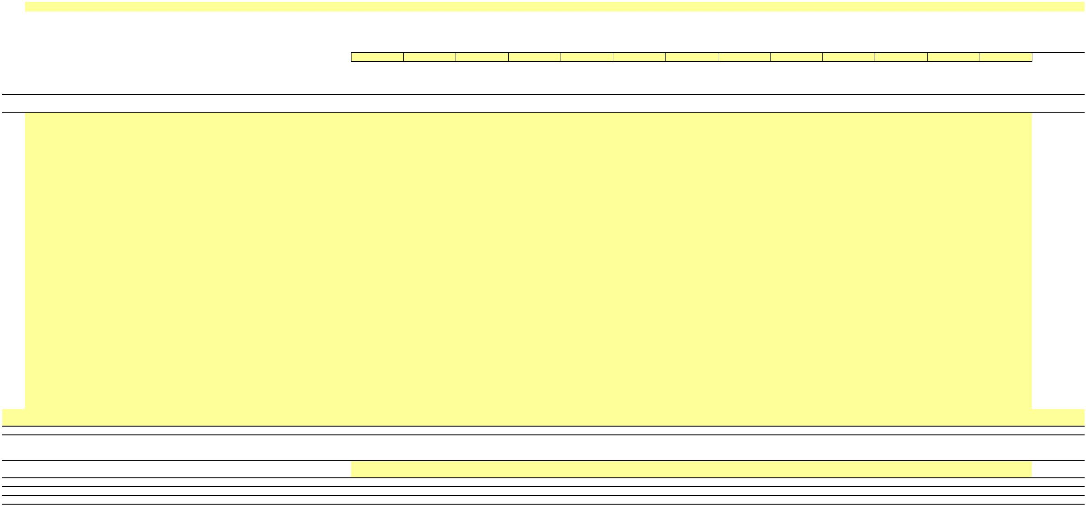 NEW YORK POWER AUTHORITY
TRANSMISSION REVENUE REQUIREMENT
YEAR ENDING DECEMBER 31, ____
WORK PAPER BC (SUPPORT A) GROSS ELECTRIC PLANT IN SERVICE DETAIL
____ ____ ____ ____ ____ ____ ____ ____ ____ ____ ____ ____ ____ 13-Month
P/T/G Plant Name A/C Description December January February March April May June July August September October November December Average
(1) (2) (3) (4) (5) (6) (7) (8) (9) (10) (11) (12) (13) (14) (15) (16) (17) (18)
Capital assets, not being depreciated:
1 Land
1a -
1b -
1c -
1d -
1e -
1f -
1g -
1h -
1i -
1j -
1k -
1l -
1m -
1n -
1o -
1p -
1q -
1r -
1s -
1t -
1u -
1v -
1w -
1x -
1y -
1z -
1aa -
1ab -
1ac -
1ad -
1ae -
1af -
1ag -
1ah -
1ai - … …
2 Land Total - - - - - - - - - - - - - -
3 Construction in progress
3a Adjustments CWIP -
3b CWIP - CEEC -
4 Construction in progress Total - - - - - - - - - - - - - -
5 Total capital assets not being depreciated - - - - - - - - - - - - - -

 NEW YORK POWER AUTHORITY
TRANSMISSION REVENUE REQUIREMENT
YEAR ENDING DECEMBER 31, ____
WORK PAPER BC (SUPPORT A) GROSS ELECTRIC PLANT IN SERVICE DETAIL
____ ____ ____ ____ ____ ____ ____ ____ ____ ____ ____ ____ ____ 13-Month
P/T/G Plant Name A/C Description December January February March April May June July August September October November December Average
(1) (2) (3) (4) (5) (6) (7) (8) (9) (10) (11) (12) (13) (14) (15) (16) (17) (18)
Capital assets, being depreciated:
6 Production - Hydro
6a -
6b -
6c -
6d -
6e -
6f -
6g -
6h -
6i -
6j -
6k -
6l -
6m -
6n -
6o -
6p -
6q -
6r -
6s -
6t -
6u -
6v -
6w -
6x -
6y -
6z -
6aa -
6ab -
6ac -
6ad -
6ae -
6af -
6ag - … …
7 Production - Hydro Total - - - - - - - - - - - - - -

 NEW YORK POWER AUTHORITY
TRANSMISSION REVENUE REQUIREMENT
YEAR ENDING DECEMBER 31, ____
WORK PAPER BC (SUPPORT A) GROSS ELECTRIC PLANT IN SERVICE DETAIL
____ ____ ____ ____ ____ ____ ____ ____ ____ ____ ____ ____ ____ 13-Month
P/T/G Plant Name A/C Description December January February March April May June July August September October November December Average
(1) (2) (3) (4) (5) (6) (7) (8) (9) (10) (11) (12) (13) (14) (15) (16) (17) (18)
8 Production - Gas turbine/combined cycle
8a -
8b -
8c -
8d -
8e -
8f -
8g -
8h -
8i -
8j -
8k -
8l -
8m -
8n -
8o -
8p -
8q -
8r -
8s -
8t -
8u -
8v -
8w -
8x -
8y -
8z -
8aa -
8ab -
8ac -
8ad -
8ae -
8af -
8ag -
8ah -
8ai -
8aj -
8ak -
8al -
8am -
8an -
8ao -
8ap -
8aq -
8ar -
8as -
8at -
8au -
8av -
8aw -
8ax -
8ay -
8az -
8ba -
8bb -
8bc -
8bd - … …
9 Total - - - - - - - - - - - - - -

 NEW YORK POWER AUTHORITY
TRANSMISSION REVENUE REQUIREMENT
YEAR ENDING DECEMBER 31, ____
WORK PAPER BC (SUPPORT A) GROSS ELECTRIC PLANT IN SERVICE DETAIL
____ ____ ____ ____ ____ ____ ____ ____ ____ ____ ____ ____ ____ 13-Month
P/T/G Plant Name A/C Description December January February March April May June July August September October November December Average
(1) (2) (3) (4) (5) (6) (7) (8) (9) (10) (11) (12) (13) (14) (15) (16) (17) (18)
10 Transmission
10a -
10b -
10c -
10d -
10e -
10f -
10g -
10h -
10i -
10j -
10k -
10l -
10m -
10n -
10o -
10p -
10q -
10r -
10s -
10t -
10u -
10v -
10w -
10x -
10y -
10z -
10aa -
10ab -
10ac -
10ad -
10ae -
10af -
10ag -
10ah -
10ai -
10aj -
10ak -
10al -
10am -
10an -
10ao -
10ap -
10aq -
10ar -
10as -
10at -
10au -
10av -
10aw -
10ax -
10ay -
10az -
10ba -
10bb -
10bc -
10bd -
10be -
10bf -
10bg -
10bh -
10bi -
10bj -
10bk -
10bl -
10bm -
10bn -
10bo -
10bp -
10bq -
10br -
… …
11 Transmission Total - - - - - - - - - - - - - -

 NEW YORK POWER AUTHORITY
TRANSMISSION REVENUE REQUIREMENT
YEAR ENDING DECEMBER 31, ____
WORK PAPER BC (SUPPORT A) GROSS ELECTRIC PLANT IN SERVICE DETAIL
____ ____ ____ ____ ____ ____ ____ ____ ____ ____ ____ ____ ____ 13-Month
P/T/G Plant Name A/C Description December January February March April May June July August September October November December Average
(1) (2) (3) (4) (5) (6) (7) (8) (9) (10) (11) (12) (13) (14) (15) (16) (17) (18)
12 General
12a -
12b -
12c -
12d -
12e -
12f -
12g -
12h -
12i -
12j -
12k -
12l -
12m -
12n -
12o -
12p -
12q -
12r -
12s -
12t -
12u -
12v -
12w -
12x -
12y -
12z -
12aa -
12ab -
12ac -
12ad -
12ae -
12af -
12ag -
12ah -
12ai -
12aj -
12ak -
12al -
12am -
12an -
12ao -
12ap -
12aq -
12ar -
12as -
12at -
12au -
12av -
12aw -
12ax -
12ay -
12az -
12ba -
12bb -
12bc -
12bd -
12be -
12bf -
12bg -
12bh -
12bi -
12bj -
12bk -
12bl -
12bm -
12bn -
12bo -

 NEW YORK POWER AUTHORITY
TRANSMISSION REVENUE REQUIREMENT
YEAR ENDING DECEMBER 31, ____
WORK PAPER BC (SUPPORT A) GROSS ELECTRIC PLANT IN SERVICE DETAIL
____ ____ ____ ____ ____ ____ ____ ____ ____ ____ ____ ____ ____ 13-Month
P/T/G Plant Name A/C Description December January February March April May June July August September October November December Average
(1) (2) (3) (4) (5) (6) (7) (8) (9) (10) (11) (12) (13) (14) (15) (16) (17) (18)
12bp -
12bq -
12br -
12bs -
12bt -
12bu -
12bv -
12bw -
12bx -
12by -
12bz -
12ca -
12cb -
12cc -
12cd -
12ce -
12cf -
12cg -
12ch -
12ci -
12cj -
12ck -
12cl -
12cm -
12cn -
12co -
12cp -
12cq -
12cr -
12cs -
12ct -
12cu -
12cv -
12cw -
12cx -
12cy -
12cz -
12da -
… …
13 General Total - - - - - - - - - - - - - -
14 Total capital assets, being depreciated - - - - - - - - - - - - - -
15 Net value of all capital assets - - - - - - - - - - - - - -
Notes
1/ Data source for monthly amounts is NYPA financial records.
…

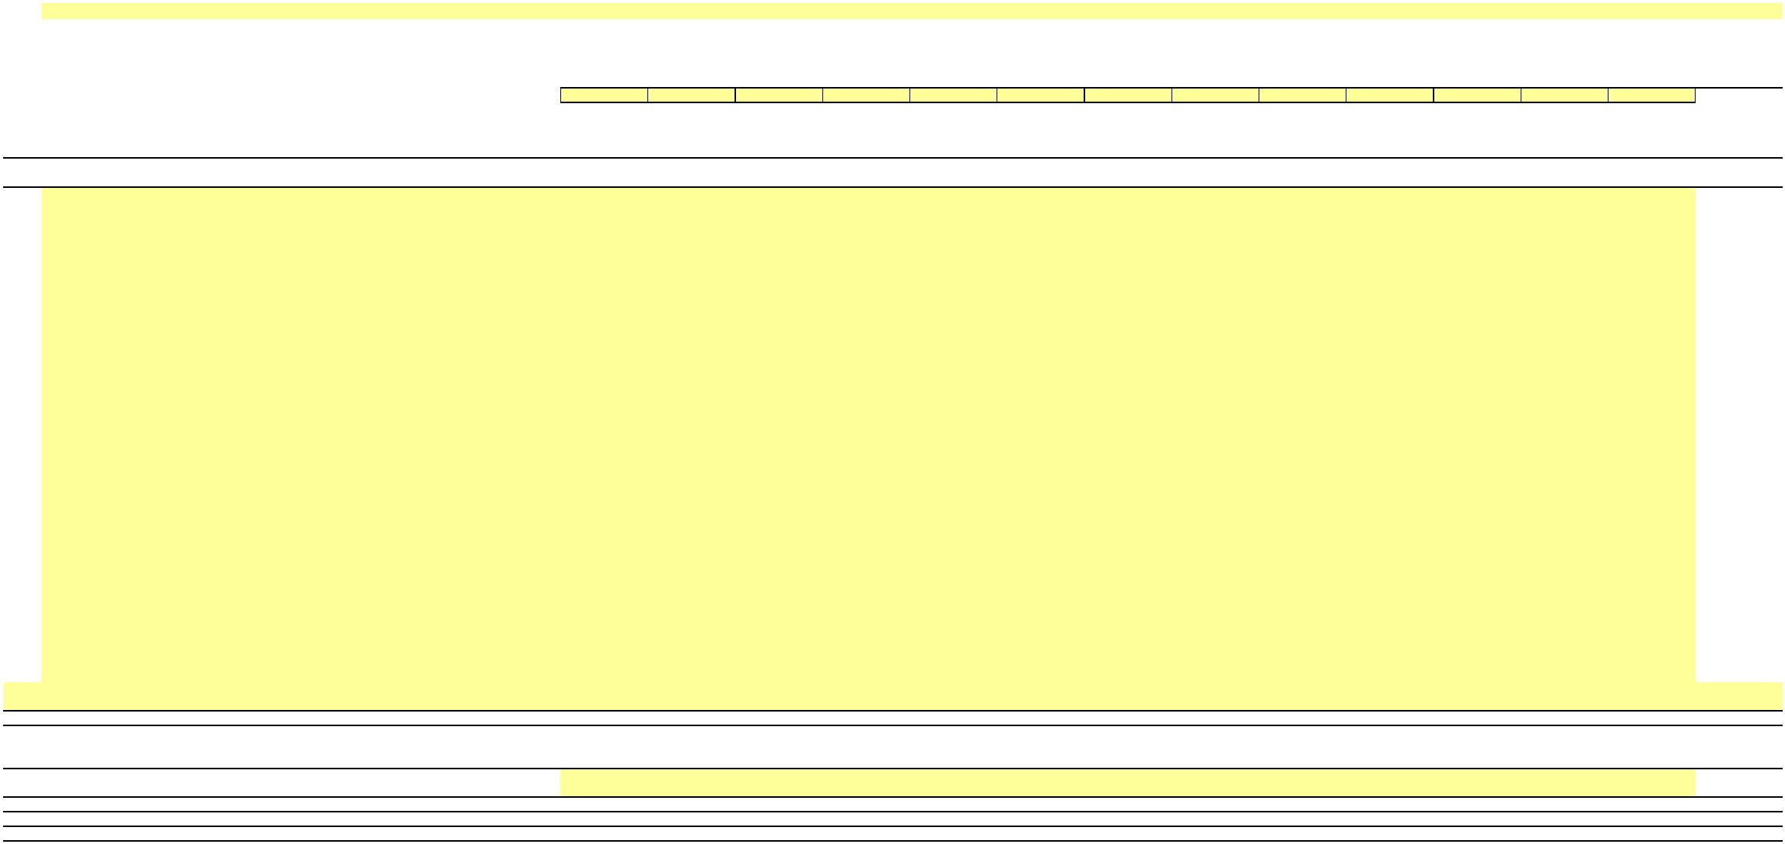 NEW YORK POWER AUTHORITY
TRANSMISSION REVENUE REQUIREMENT
YEAR ENDING DECEMBER 31, ____
WORK PAPER BC (SUPPORT B) ACCUMULATED DEPRECIATION DETAIL
____ ____ ____ ____ ____ ____ ____ ____ ____ ____ ____ ____ ____ 13-Month
P/T/G Plant Name A/C Description December January February March April May June July August September October November December Average
(1) (2) (3) (4) (5) (6) (7) (8) (9) (10) (11) (12) (13) (14) (15) (16) (17) (18)
Capital assets, not being depreciated:
1 Land
1a -
1b -
1c -
1d -
1e -
1f -
1g -
1h -
1i -
1j -
1k -
1l -
1m -
1n -
1o -
1p -
1q -
1r -
1s -
1t -
1u -
1v -
1w -
1x -
1y -
1z -
1aa -
1ab -
1ac -
1ad -
1ae -
1af -
1ag -
1ah -
1ai - … …
2 Land Total - - - - - - - - - - - - - -
3 Construction in progress
3a Adjustments CWIP -
3b CWIP - CEEC -
4 Construction in progress Total - - - - - - - - - - - - - -
5 Total capital assets not being depreciated - - - - - - - - - - - - - -

 NEW YORK POWER AUTHORITY
TRANSMISSION REVENUE REQUIREMENT
YEAR ENDING DECEMBER 31, ____
WORK PAPER BC (SUPPORT B) ACCUMULATED DEPRECIATION DETAIL
____ ____ ____ ____ ____ ____ ____ ____ ____ ____ ____ ____ ____ 13-Month
P/T/G Plant Name A/C Description December January February March April May June July August September October November December Average
(1) (2) (3) (4) (5) (6) (7) (8) (9) (10) (11) (12) (13) (14) (15) (16) (17) (18)
Capital assets, being depreciated:
6 Production - Hydro
6a -
6b -
6c -
6d -
6e -
6f -
6g -
6h -
6i -
6j -
6k -
6l -
6m -
6n -
6o -
6p -
6q -
6r -
6s -
6t -
6u -
6v -
6w -
6x -
6y -
6z -
6aa -
6ab -
6ac -
6ad -
6ae -
6af -
6ag - … …
7 Production - Hydro Total - - - - - - - - - - - - - -

 NEW YORK POWER AUTHORITY
TRANSMISSION REVENUE REQUIREMENT
YEAR ENDING DECEMBER 31, ____
WORK PAPER BC (SUPPORT B) ACCUMULATED DEPRECIATION DETAIL
____ ____ ____ ____ ____ ____ ____ ____ ____ ____ ____ ____ ____ 13-Month
P/T/G Plant Name A/C Description December January February March April May June July August September October November December Average
(1) (2) (3) (4) (5) (6) (7) (8) (9) (10) (11) (12) (13) (14) (15) (16) (17) (18)
8 Production - Gas turbine/combined cycle
8a -
8b -
8c -
8d -
8e -
8f -
8g -
8h -
8i -
8j -
8k -
8l -
8m -
8n -
8o -
8p -
8q -
8r -
8s -
8t -
8u -
8v -
8w -
8x -
8y -
8z -
8aa -
8ab -
8ac -
8ad -
8ae -
8af -
8ag -
8ah -
8ai -
8aj -
8ak -
8al -
8am -
8an -
8ao -
8ap -
8aq -
8ar -
8as -
8at -
8au -
8av -
8aw -
8ax -
8ay -
8az -
8ba -
8bb -
8bc -
8bd -
…
…
Production - Gas turbine/combined cycle
9 Total - - - - - - - - - - - - - -

 NEW YORK POWER AUTHORITY
TRANSMISSION REVENUE REQUIREMENT
YEAR ENDING DECEMBER 31, ____
WORK PAPER BC (SUPPORT B) ACCUMULATED DEPRECIATION DETAIL
____ ____ ____ ____ ____ ____ ____ ____ ____ ____ ____ ____ ____ 13-Month
P/T/G Plant Name A/C Description December January February March April May June July August September October November December Average
(1) (2) (3) (4) (5) (6) (7) (8) (9) (10) (11) (12) (13) (14) (15) (16) (17) (18)
10 Transmission
10a -
10b -
10c -
10d -
10e -
10f -
10g -
10h -
10i -
10j -
10k -
10l -
10m -
10n -
10o -
10p -
10q -
10r -
10s -
10t -
10u -
10v -
10w -
10x -
10y -
10z -
10aa -
10ab -
10ac -
10ad -
10ae -
10af -
10ag -
10ah -
10ai -
10aj -
10ak -
10al -
10am -
10an -
10ao -
10ap -
10aq -
10ar -
10as -
10at -
10au -
10av -
10aw -
10ax -
10ay -
10az -
10ba -
10bb -
10bc -
10bd -
10be -
10bf -
10bg -
10bh -
10bi -
10bj -
10bk -
10bl -
10bm -
10bn -
10bo -
10bp -
10bq -
10br -
… …
11 Transmission Total - - - - - - - - - - - - - -

 NEW YORK POWER AUTHORITY
TRANSMISSION REVENUE REQUIREMENT
YEAR ENDING DECEMBER 31, ____
WORK PAPER BC (SUPPORT B) ACCUMULATED DEPRECIATION DETAIL
____ ____ ____ ____ ____ ____ ____ ____ ____ ____ ____ ____ ____ 13-Month
P/T/G Plant Name A/C Description December January February March April May June July August September October November December Average
(1) (2) (3) (4) (5) (6) (7) (8) (9) (10) (11) (12) (13) (14) (15) (16) (17) (18)
12 General
12a -
12b -
12c -
12d -
12e -
12f -
12g -
12h -
12i -
12j -
12k -
12l -
12m -
12n -
12o -
12p -
12q -
12r -
12s -
12t -
12u -
12v -
12w -
12x -
12y -
12z -
12aa -
12ab -
12ac -
12ad -
12ae -
12af -
12ag -
12ah -
12ai -
12aj -
12ak -
12al -
12am -
12an -
12ao -
12ap -
12aq -
12ar -
12as -
12at -
12au -
12av -
12aw -
12ax -
12ay -
12az -
12ba -
12bb -
12bc -
12bd -
12be -
12bf -
12bg -
12bh -
12bi -
12bj -
12bk -
12bl -
12bm -
12bn -
12bo -

 NEW YORK POWER AUTHORITY
TRANSMISSION REVENUE REQUIREMENT
YEAR ENDING DECEMBER 31, ____
WORK PAPER BC (SUPPORT B) ACCUMULATED DEPRECIATION DETAIL
____ ____ ____ ____ ____ ____ ____ ____ ____ ____ ____ ____ ____ 13-Month
P/T/G Plant Name A/C Description December January February March April May June July August September October November December Average
(1) (2) (3) (4) (5) (6) (7) (8) (9) (10) (11) (12) (13) (14) (15) (16) (17) (18)
12bp -
12bq -
12br -
12bs -
12bt -
12bu -
12bv -
12bw -
12bx -
12by -
12bz -
12ca -
12cb -
12cc -
12cd -
12ce -
12cf -
12cg -
12ch -
12ci -
12cj -
12ck -
12cl -
12cm -
12cn -
12co -
12cp -
12cq -
12cr -
12cs -
12ct -
12cu -
12cv -
12cw -
12cx -
12cy -
12cz -
12da -
… …
13 General Total - - - - - - - - - - - - - -
14 Total capital assets, being depreciated - - - - - - - - - - - - - -
15 Net value of all capital assets - - - - - - - - - - - - - -
Notes
1/ Data source for monthly amounts is NYPA financial records.
…

X
NEW YORK POWER AUTHORITY
TRANSMISSION REVENUE REQUIREMENT
YEAR ENDING DECEMBER 31, ____
WORK PAPER BD
MARCY-SOUTH CAPITALIZED LEASE AMORTIZATION
AND UNAMORTIZED BALANCE
Beginning Current Year
Unamortized Ending Capitalized Average Lease Asset/ Unamortized Lease Unamortized
Line No. Year Obligation ($) Lease/Asset ($) Amortization ($) Balance
(1) (2) (3) (4) (5)
1 1988 - - -
2 1989 - - -
3 1990 - - -
4 1991 - - -
5 1992 - - -
6 1993 - - -
7 1994 - - -
8 1995 - - -
9 1996 - - -
10 1997 - - -
11 1998 - - -
12 1999 - - -
13 2000 - - -
14 2001 - - -
15 2002 - - -
16 2003 - - -
17 2004 - - -
18 2005 - - -
19 2006 - - -
20 2007 - - -
21 2008 - - -
22 2009 - - -
23 2010 - - -
24 2011 - - -
25 2012 - - -
26 2013 - - -
27 2014 - - -
28 2015 - - -
29 2016 - - -
30 2017 - - -
31 2018 - - -
32 2019 - - -
33 2020 - - -
34 2021 - - -
35 2022 - - -
36 2023 - - -
37 2024 - - -
38 2025 - - - -
39 2026 - - -
40 2027 - - -
41 2028 - - -
42 2029 - - -
43 2030 - - -
44 2031 - - -
45 2032 - - -
46 2033 - - -
47 2034 - - -
48 2035 - - -
49 2036 - - -
50 2037 - - -
51 Total - -

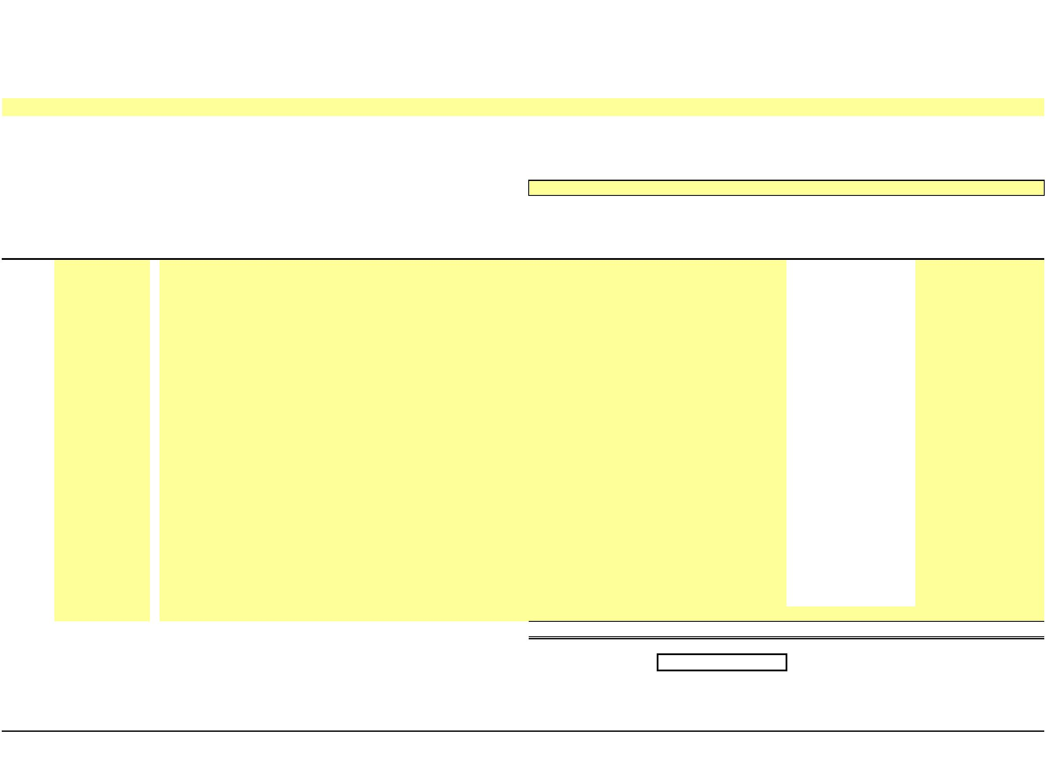X
NEW YORK POWER AUTHORITY
TRANSMISSION REVENUE REQUIREMENT
YEAR ENDING DECEMBER 31, ____
WORK PAPER BE
FACTS PROJECT PLANT IN SERVICE, ACCUMULATED DEPRECIATION AND DEPRECIATION EXPENSE
13-Month Average
(1) (2) (3) (4) Electric Electric
Plant in Accumulated Plant in Depreciation Line No. Cap.Date Asset Description Service ($) Depreciation ($) Service (Net $) Expense ($)
1a -
1b -
1c -
1d -
1e -
1f -
1g -
1h -
1i -
1j -
1k -
1l -
1m -
1n -
1o -
1p -
1q -
1r -
1s -
1t -
1u -
1v -
1w -
… …
2 Total Plant - - - -
3 Year-Over-Year Accumulated Depreciation -
Note: The FACTS project data is based on NYPA's financial records with adherence to FERC's Uniform System of Accounts and U.S. generally accepted accounting principles.

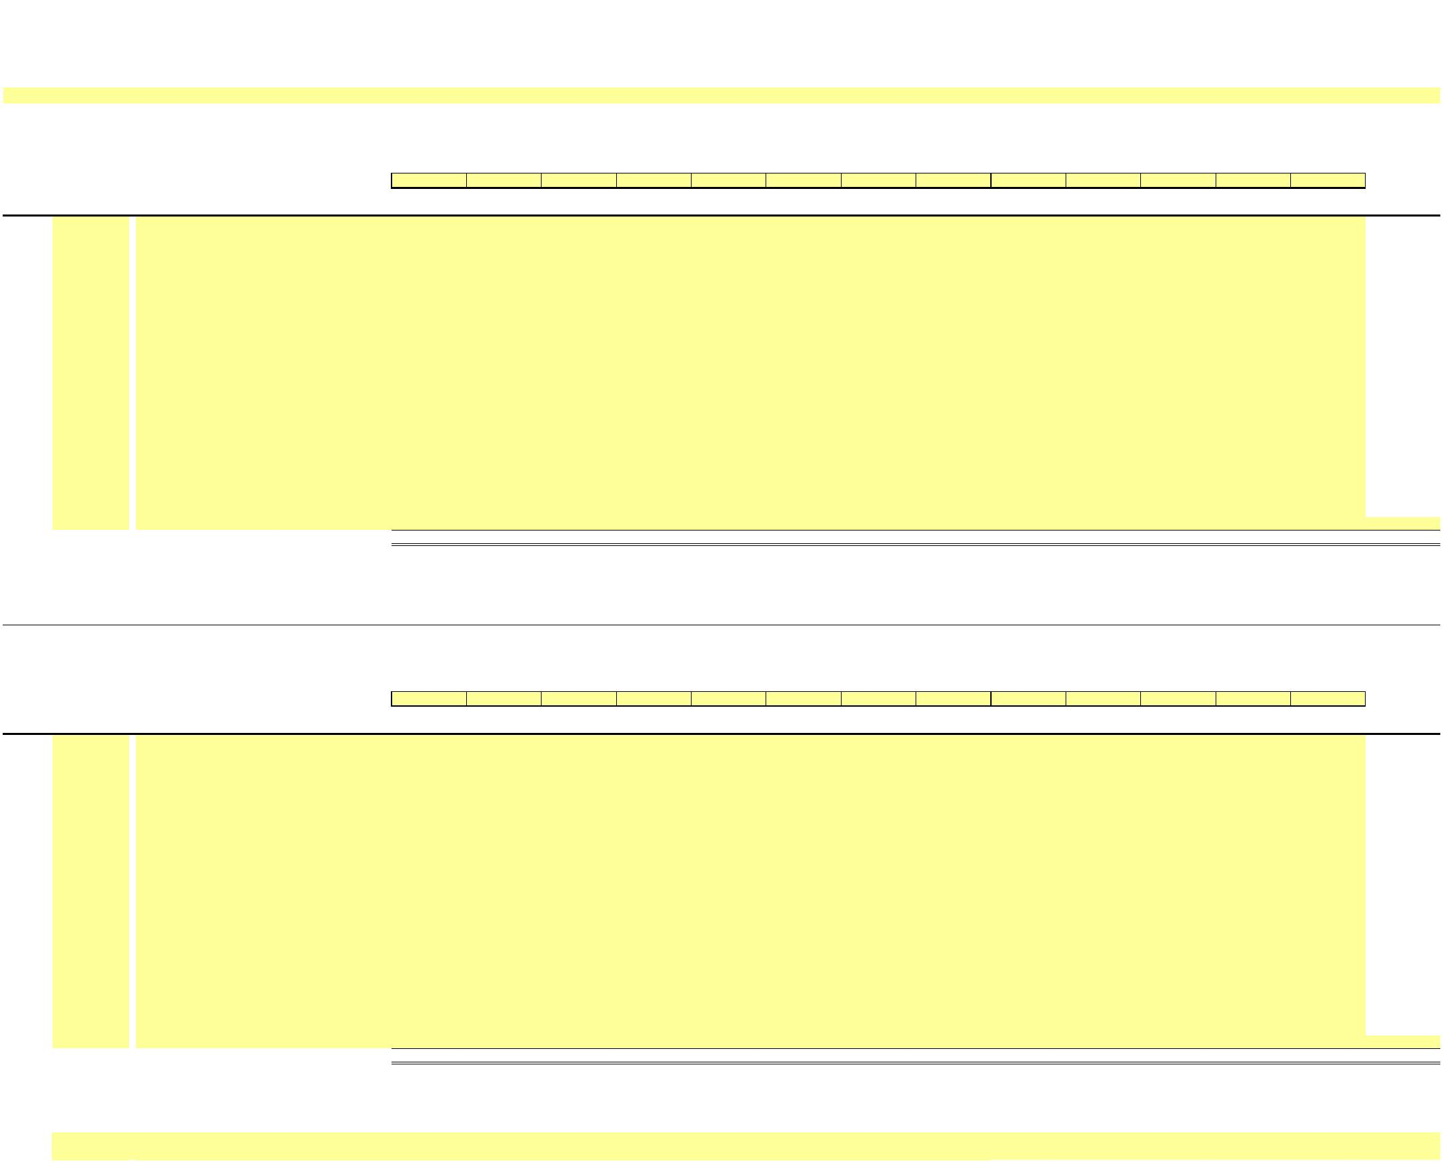X
NEW YORK POWER AUTHORITY
TRANSMISSION REVENUE REQUIREMENT
YEAR ENDING DECEMBER 31, ____
WORK PAPER BE (SUPPORT)
FACTS PROJECT PLANT IN SERVICE AND ACCUMULATED DEPRECIATION DETAILS
GROSS PLANT IN SERVICE
____ ____ ____ ____ ____ ____ ____ ____ ____ ____ ____ ____ ____ 13-Month Line No. Cap.Date Asset Description December January February March April May June July August September October November December Average
(1) (2) (3) (4) (5) (6) (7) (8) (9) (10) (11) (12) (13) (14) (15) (16)
1a -
1b -
1c -
1d -
1e -
1f -
1g -
1h -
1i -
1j -
1k -
1l -
1m -
1n -
1o -
1p -
1q -
1r -
1s -
1t -
1u -
1v -
1w -
1… …
2 Total Plant - - - - - - - - - - - - - -
Note: The FACTS project data is based on NYPA's financial records with adherence to FERC's Uniform System of Accounts and U.S. generally accepted accounting principles.
ACCUMULATED DEPRECIATION
____ ____ ____ ____ ____ ____ ____ ____ ____ ____ ____ ____ ____ 13-Month Line No. Cap.Date Asset Description December January February March April May June July August September October November December Average
(1) (2) (3) (4) (5) (6) (7) (8) (9) (10) (11) (12) (13) (14) (15) (16)
3a -
3b -
3c -
3d -
3e -
3f -
3g -
3h -
3i -
3j -
3k -
3l -
3m -
3n -
3o -
3p -
3q -
3r -
3s -
3t -
3u -
3v -
3w -
3… …
4 Total Accumulated Depreciation - - - - - - - - - - - - - -
Notes
1Data source for monthly amounts is NYPA financial records.
…

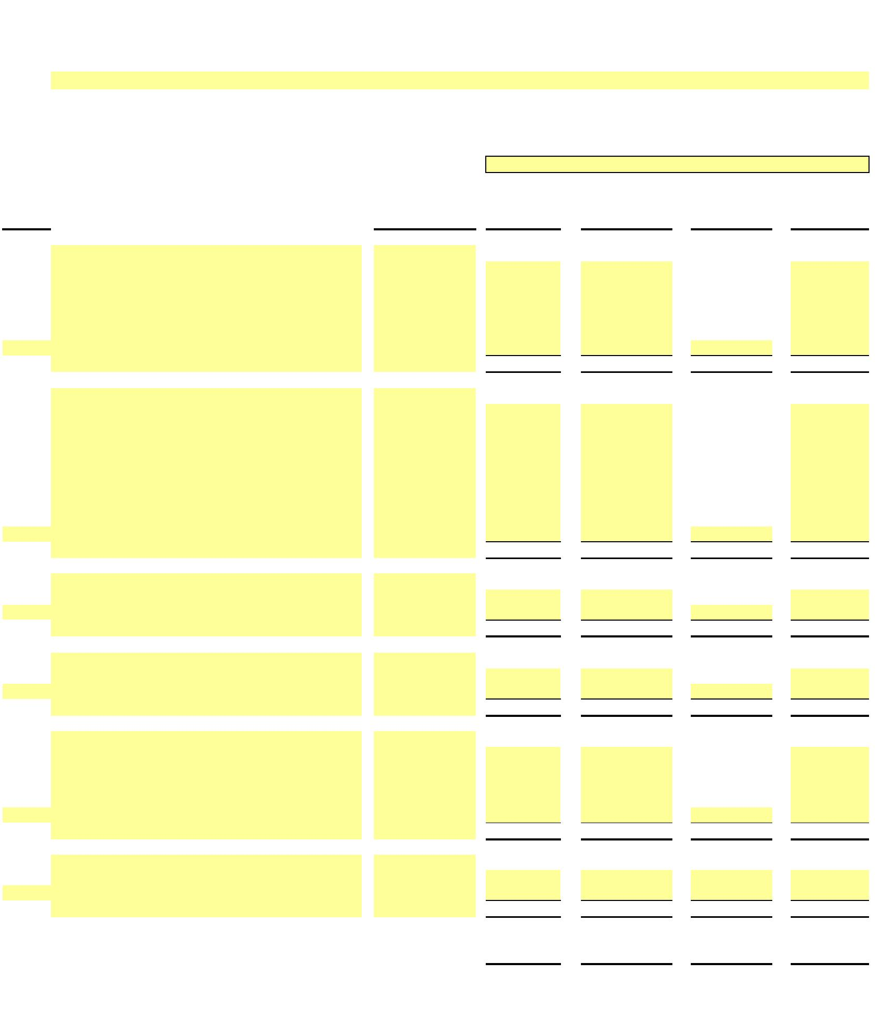X
NEW YORK POWER AUTHORITY
TRANSMISSION REVENUE REQUIREMENT
YEAR ENDING DECEMBER 31, ____
WORK PAPER BF
GENERATOR STEP-UP TRANSFORMERS BREAKOUT
13-Month Average
Electric
Plant in Accumulated Electric Plant Depreciation Line No. Asset No. Service ($) Depreciation ($) (Net $) Expense ($)
(1) (2) (3) (4) 1
1a -
1b -
1c -
1d -
1e -
…
- - - -
2
2a - 2b -
2c -
2d -
2e -
2f -
2g -
2h -
…
- - - -
3
3a -
…
- - - -
4
4a -
…
- - - -
5
5a -
5b -
5c -
5d -
…
- - - -
6 6a
…
- - - -
7 Grand Total - - - -
8 Adjusted Grand Total (Excludes 500MW C - C at Astoria) - - -

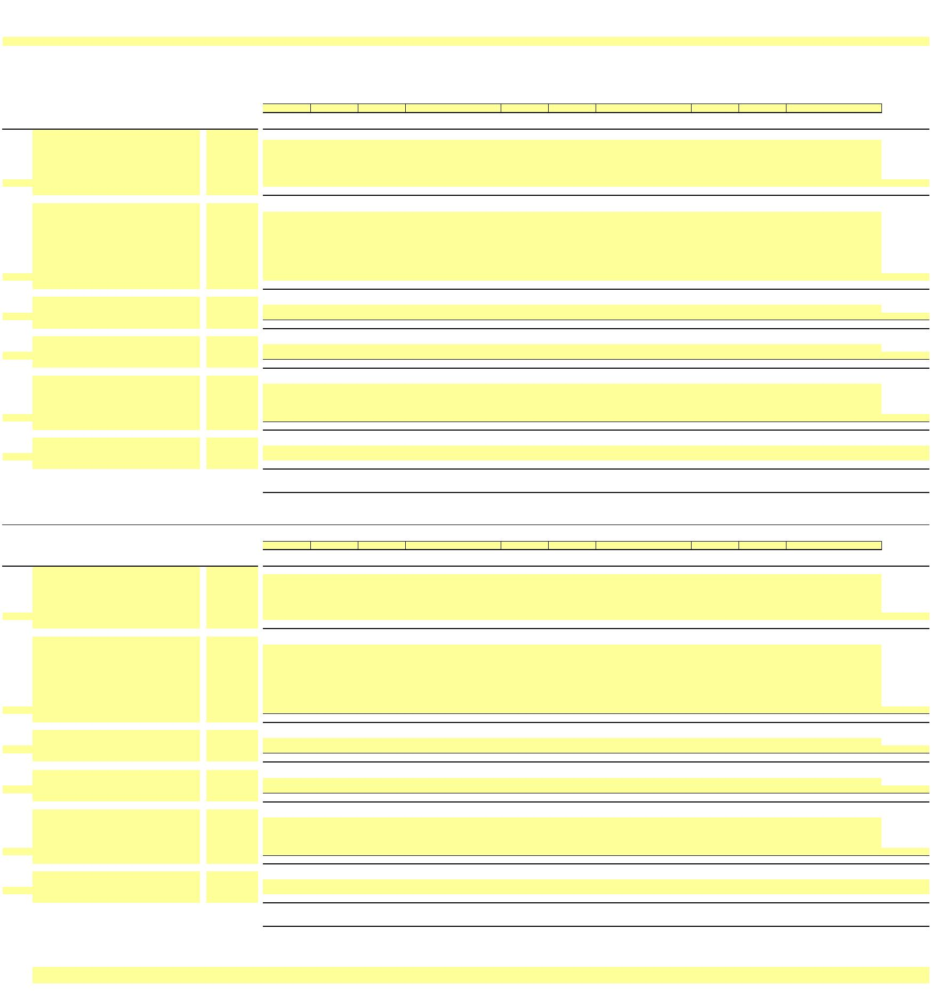X
NEW YORK POWER AUTHORITY
TRANSMISSION REVENUE REQUIREMENT
YEAR ENDING DECEMBER 31, ____
WORK PAPER BF (SUPPORT)
GENERATOR STEP-UP TRANSFORMERS BREAKOUT DETAILS
GROSS PLANT IN SERVICE
____ ____ ____ ____ ____ ____ ____ ____ ____ ____ ____ ____ ____ 13-Month
Line No. Asset No. December January February March April May June July August September October November December Average
(1) (2) (3) (4) (5) (6) (7) (8) (9) (10) (11) (12) (13) (14) (15) (16)
1
1a -
1b -
1c -
1d -
1e -
…
- - - - - - - - - - - - - -
2
2a -
2b -
2c -
2d -
2e -
2f -
2g -
2h -
…
- - - - - - - - - - - - - -
3
3a -
…
- - - - - - - - - - - - - -
4
4a -
…
- - - - - - - - - - - - - -
5
5a -
5b -
5c -
5d -
…
- - - - - - - - - - - - - -
6 6a
…
- - - - - - - - - - - - - -
7 Grand Total - - - - - - - - - - - - - -
8 Adjusted Grand Total (Excludes 500MW C - C at Astoria) - - - - - - - - - - - - - -
ACCUMULATED DEPRECIATION
____ ____ ____ ____ ____ ____ ____ ____ ____ ____ ____ ____ ____ 13-Month
Line No. Asset No. December January February March April May June July August September October November December Average
(1) (2) (3) (4) (5) (6) (7) (8) (9) (10) (11) (12) (13) (14) (15) (16)
9
9a -
9b -
9c -
9d -
9e -
…
- - - - - - - - - - - - - -
10
10a -
10b -
10c -
10d -
10e -
10f -
10g -
10h -
…
- - - - - - - - - - - - - -
11
11a -
…
- - - - - - - - - - - - - -
12
12a -
…
- - - - - - - - - - - - - -
13
13a -
13b -
13c -
13d -
…
- - - - - - - - - - - - - -
14
14a
…
- - - - - - - - - - - - - -
15 Grand Total - - - - - - - - - - - - - -
16 Adjusted Grand Total (Excludes 500MW C - C at Astoria) - - - - - - - - - - - - - -
Notes
1/ Data source for monthly amounts is NYPA financial records.
…

X
NEW YORK POWER AUTHORITY
TRANSMISSION REVENUE REQUIREMENT
YEAR ENDING DECEMBER 31, ____
WORK PAPER BG RELICENSING/RECLASSIFICATION EXPENSES
13-Month Average
Plant in Accumulated Plant in Depreciation Line No. NIAGARA Service ($) Depreciation ($) Service (Net $) Expense ($)
(1) (2) (3) (4)
1a -
1b -
1c -
…
1 - - - -
ST. LAWRENCE
2a -
2b -
2c -
2d -
2e -
2f -
2g -
2h -
…
2 - - - -
BLENHEIM GILBOA
3a -
3b -
3c -
3d -
…
3 - - - -
4a
…
…
…
4 - - - -
5 Total Expenses - - - -

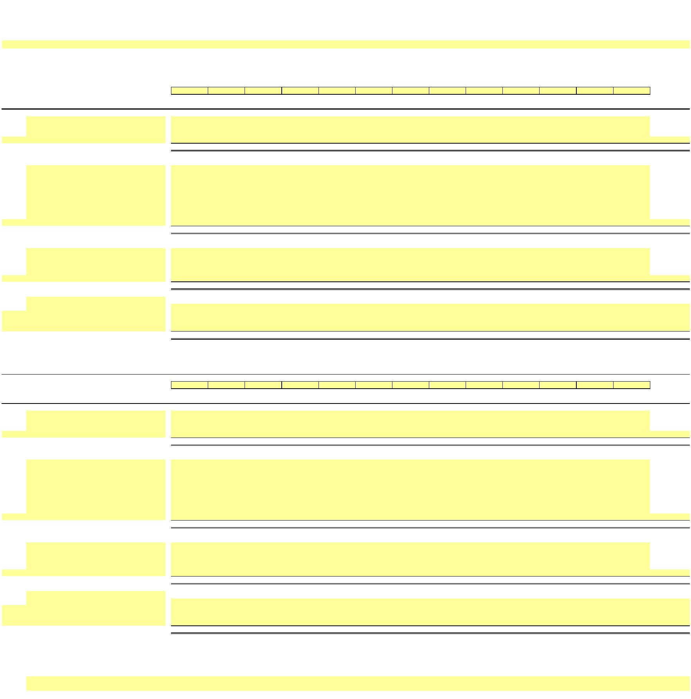X
NEW YORK POWER AUTHORITY
TRANSMISSION REVENUE REQUIREMENT
YEAR ENDING DECEMBER 31, ____
WORK PAPER BG (SUPPORT) RELICENSING/RECLASSIFICATION EXPENSES DETAILS
GROSS PLANT IN SERVICE
____ ____ ____ ____ ____ ____ ____ ____ ____ ____ ____ ____ ____ 13-Month December January February March April May June July August September October November December Average
Line No. (1) (2) (3) (4) (5) (6) (7) (8) (9) (10) (11) (12) (13) (14) (15)
NIAGARA
1a -
1b -
1c -
…
1 - - - - - - - - - - - - - -
ST. LAWRENCE
2a -
2b -
2c -
2d -
2e -
2f -
2g -
2h -
…
2 - - - - - - - - - - - - - -
BLENHEIM GILBOA
3a -
3b -
3c -
3d -
…
3 - - - - - - - - - - - - - -
4a
…
…
…
4 - - - - - - - - - - - - - -
5 Total Gross Plant in Service - - - - - - - - - - - - - -
ACCUMULATED DEPRECIATION
____ ____ ____ ____ ____ ____ ____ ____ ____ ____ ____ ____ ____ 13-Month December January February March April May June July August September October November December Average
Line No. (1) (2) (3) (4) (5) (6) (7) (8) (9) (10) (11) (12) (13) (14) (15)
NIAGARA
6a -
6b -
6c -
…
6 - - - - - - - - - - - - - -
ST. LAWRENCE
7a -
7b -
7c -
7d -
7e -
7f -
7g -
7h -
…
7 - - - - - - - - - - - - - -
BLENHEIM GILBOA
8a -
8b -
8c -
8d -
…
8 - - - - - - - - - - - - - -
9a
…
…
…
9 - - - - - - - - - - - - - -
10 Total Expenses - - - - - - - - - - - - - -
Notes
1/ Data source for monthly amounts is NYPA financial records.
…

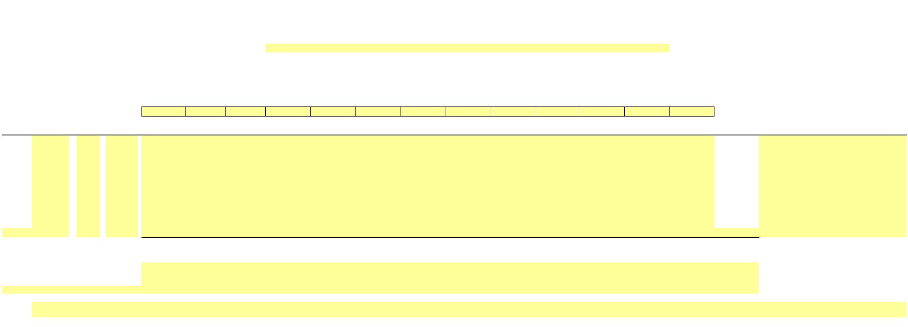X
NEW YORK POWER AUTHORITY
TRANSMISSION REVENUE REQUIREMENT
YEAR ENDING DECEMBER 31, ____
WORK PAPER BH ASSET IMPAIRMENT
Posting Profit ____ ____ ____ ____ ____ ____ ____ ____ ____ ____ ____ ____ ____
13-Month
Line No. Date Center Account December January February March April May June July August September October November December Average Facility
(1) (2) (3) (4) (5) (6) (7) (8) (9) (10) (11) (12) (13) (14) (15) (16) (17) (18)
1a -
1b - 1c -
1d - 1e - 1f -
1g - 1h - 1i - 1j -
…
2 - - - - - - - - - - - - - -
3 Total Impairment - Production - - - - - - - - - - - - - - 4 Total Impairment - Transmission - - - - - - - - - - - - - - 5 Total Impairment - General Plant - - - - - - - - - - - - - - …
Notes
1/ Data source for monthly amounts is NYPA financial records.
…

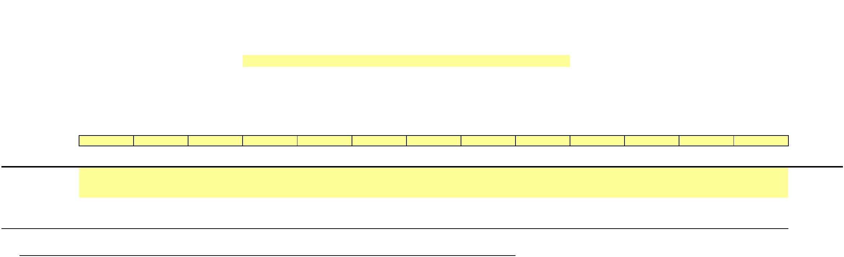X
NEW YORK POWER AUTHORITY
TRANSMISSION REVENUE REQUIREMENT
YEAR ENDING DECEMBER 31, ____
WORK PAPER BI COST OF REMOVAL
Cost of Removal to Regulatory Assets - Depreciation:
Line ____ ____ ____ ____ ____ ____ ____ ____ ____ ____ ____ ____ ____ 13-Month
No. December January February March April May June July August September October November December Average
(1) (2) (3) (4) (5) (6) (7) (8) (9) (10) (11) (12) (13) (14) (15)
1 Production -
2 Transmission -
3 General -
4 Total - - - - - - - - - - - - - -
Note: The Cost of Removal data is based on NYPA's accounting records under the provisions of FASB Accounting Standards Codification Topic 980.

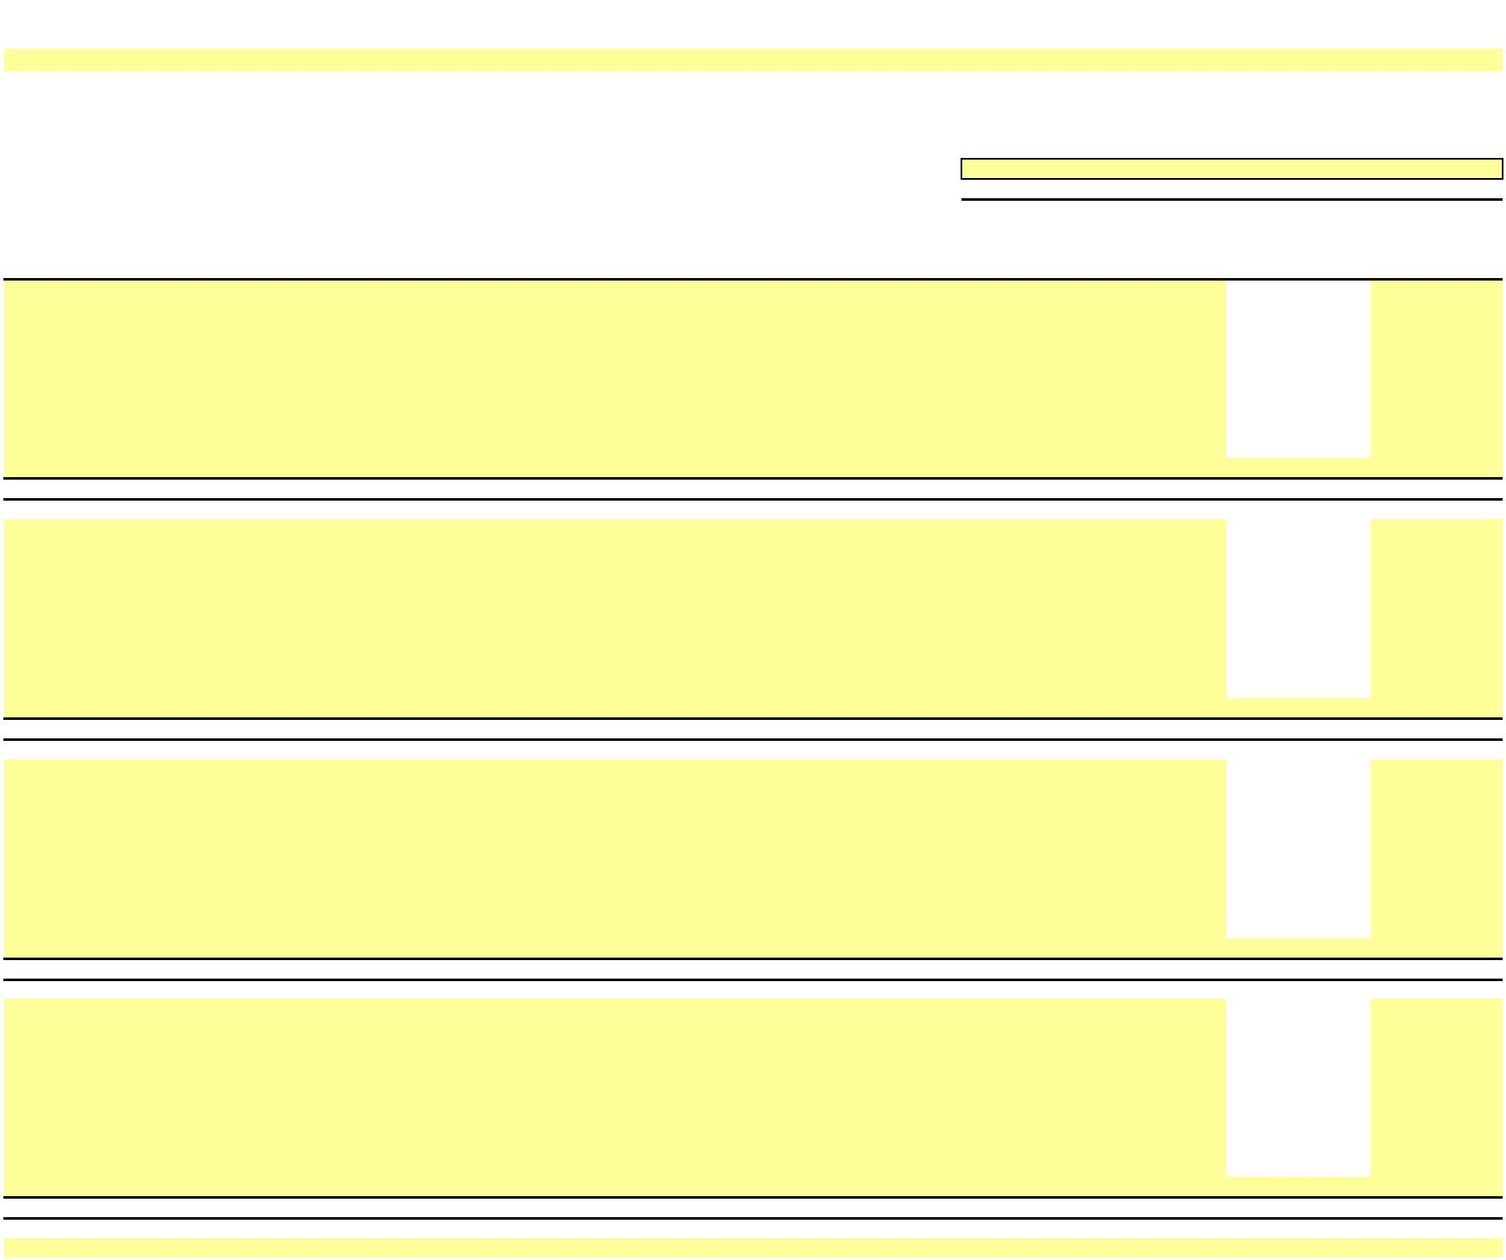 NEW YORK POWER AUTHORITY
TRANSMISSION REVENUE REQUIREMENT
YEAR ENDING DECEMBER 31, ____
WORKPAPER BJ
INDIVIDUAL PROJECTS - PLANT IN SERVICE and DEPRECIATION
13-Month Average
Electric Plant in Accumulated Electric Plant in Depreciation
Line No. P/T/G Plant Name A/C Description Service ($) Depreciation ($) Service (Net $) Expense ($)
(1) (2) (3) (4) (5) (6) (7) (8)
1a Transmission MARCY-SOUTH SERIES COMPENSATION 350 Land & Land Rights -
1b Transmission MARCY-SOUTH SERIES COMPENSATION 352 Structures & Improvements -
1c Transmission MARCY-SOUTH SERIES COMPENSATION 353 Station Equipment -
1d Transmission MARCY-SOUTH SERIES COMPENSATION 354 Towers & Fixtures -
1e Transmission MARCY-SOUTH SERIES COMPENSATION 355 Poles & Fixtures -
1f Transmission MARCY-SOUTH SERIES COMPENSATION 356 Overhead Conductors & Devices -
1g Transmission MARCY-SOUTH SERIES COMPENSATION 357 Underground Conduit -
1h Transmission MARCY-SOUTH SERIES COMPENSATION 358 Underground Conductors & Devices -
1i Transmission MARCY-SOUTH SERIES COMPENSATION 359 Roads & Trails -
…
1 MSSC Transmission Total - - - -
2a Transmission AC Project Segment A (CENTRAL EAST ENERGY CONNECT) 350 Land & Land Rights -
2b Transmission AC Project Segment A (CENTRAL EAST ENERGY CONNECT) 352 Structures & Improvements -
2c Transmission AC Project Segment A (CENTRAL EAST ENERGY CONNECT) 353 Station Equipment -
2d Transmission AC Project Segment A (CENTRAL EAST ENERGY CONNECT) 354 Towers & Fixtures -
2e Transmission AC Project Segment A (CENTRAL EAST ENERGY CONNECT) 355 Poles & Fixtures -
2f Transmission AC Project Segment A (CENTRAL EAST ENERGY CONNECT) 356 Overhead Conductors & Devices -
2g Transmission AC Project Segment A (CENTRAL EAST ENERGY CONNECT) 357 Underground Conduit -
2h Transmission AC Project Segment A (CENTRAL EAST ENERGY CONNECT) 358 Underground Conductors & Devices -
2i Transmission AC Project Segment A (CENTRAL EAST ENERGY CONNECT) 359 Roads & Trails -
…
2 AC Project Seg A (Central East Energy Connect) Total - - - -
3a Transmission Smart Path Connect 350 Land & Land Rights -
3b Transmission Smart Path Connect 352 Structures & Improvements -
3c Transmission Smart Path Connect 353 Station Equipment -
3d Transmission Smart Path Connect 354 Towers & Fixtures -
3e Transmission Smart Path Connect 355 Poles & Fixtures -
3f Transmission Smart Path Connect 356 Overhead Conductors & Devices -
3g Transmission Smart Path Connect 357 Underground Conduit -
3h Transmission Smart Path Connect 358 Underground Conductors & Devices -
3i Transmission Smart Path Connect 359 Roads & Trails -
…
3 SPC Project Total - - - -
4a Transmission Propel NY 350 Land & Land Rights -
4b Transmission Propel NY 352 Structures & Improvements -
4c Transmission Propel NY 353 Station Equipment -
4d Transmission Propel NY 354 Towers & Fixtures -
4e Transmission Propel NY 355 Poles & Fixtures -
4f Transmission Propel NY 356 Overhead Conductors & Devices -
4g Transmission Propel NY 357 Underground Conduit -
4h Transmission Propel NY 358 Underground Conductors & Devices -
4i Transmission Propel NY 359 Roads & Trails -
…
4 Propel NY Project Total - - - -
…

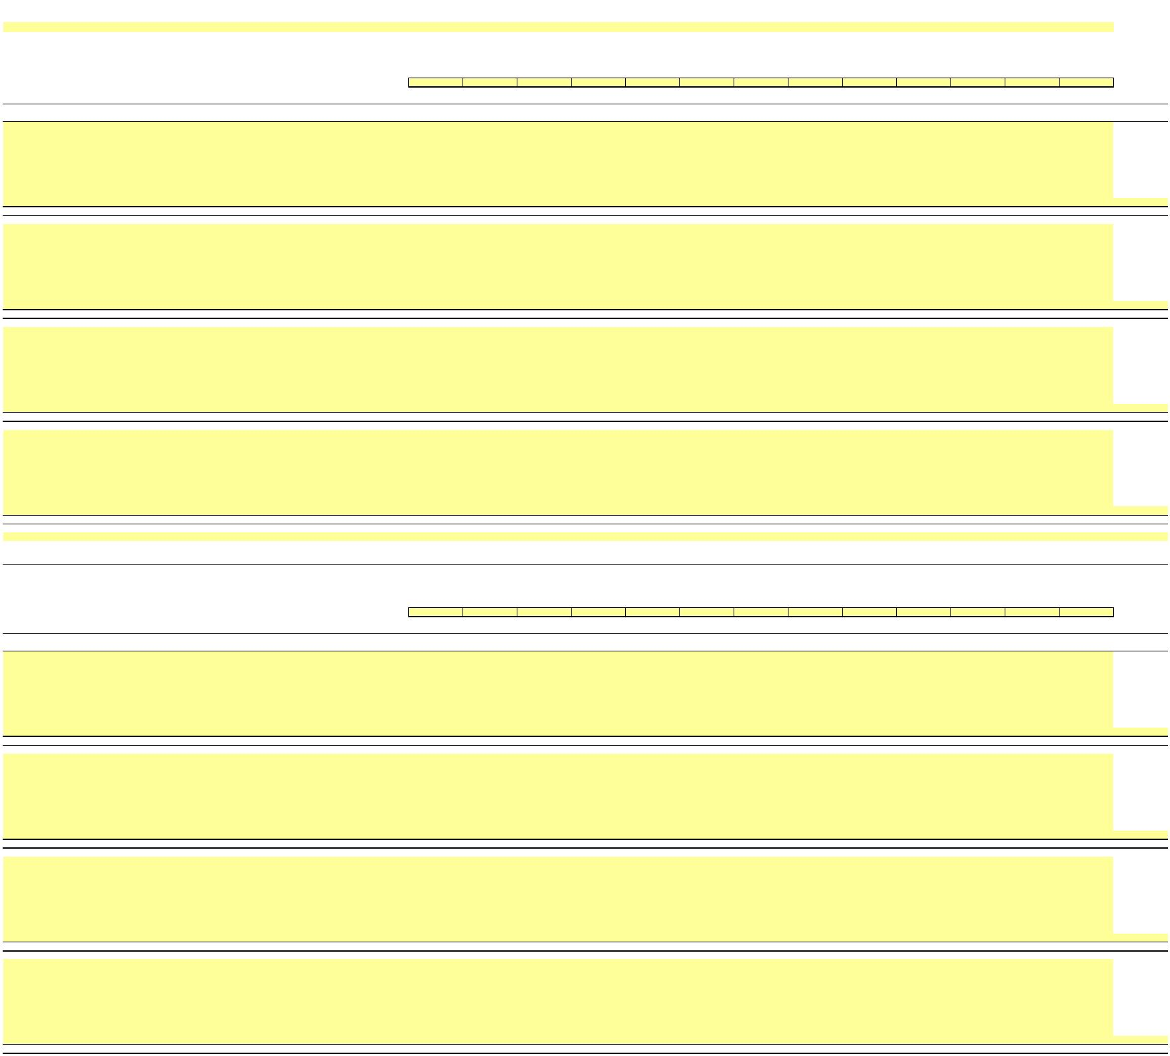 NEW YORK POWER AUTHORITY
TRANSMISSION REVENUE REQUIREMENT
YEAR ENDING DECEMBER 31, ____
WORKPAPER BJ (SUPPORT)
INDIVIDUAL PROJECTS - GROSS PLANT IN SERVICE
Line No. P/T/G Plant Name A/C Description ____ ____ ____ ____ ____ ____ ____ ____ ____ ____ ____ ____ ____ 13-Month
December January February March April May June July August September October November December Average
(1) (2) (3) (4) (5) (6) (7) (8) (9) (10) (11) (12) (13) (14) (15) (16) (17) (18)
1a Transmission MARCY-SOUTH SERIES COMPENSATION 350 Land & Land Rights -
1b Transmission MARCY-SOUTH SERIES COMPENSATION 352 Structures & Improvements -
1c Transmission MARCY-SOUTH SERIES COMPENSATION 353 Station Equipment -
1d Transmission MARCY-SOUTH SERIES COMPENSATION 354 Towers & Fixtures -
1e Transmission MARCY-SOUTH SERIES COMPENSATION 355 Poles & Fixtures -
1f Transmission MARCY-SOUTH SERIES COMPENSATION 356 Overhead Conductors & Devices -
1g Transmission MARCY-SOUTH SERIES COMPENSATION 357 Underground Conduit -
1h Transmission MARCY-SOUTH SERIES COMPENSATION 358 Underground Conductors & Devices -
1i Transmission MARCY-SOUTH SERIES COMPENSATION 359 Roads & Trails -
…
1 MSSC Transmission Total - - - - - - - - - - - - - -
2a Transmission AC Project Segment A (CENTRAL EAST ENERGY CONNECT) 350 Land & Land Rights -
2b Transmission AC Project Segment A (CENTRAL EAST ENERGY CONNECT) 352 Structures & Improvements -
2c Transmission AC Project Segment A (CENTRAL EAST ENERGY CONNECT) 353 Station Equipment -
2d Transmission AC Project Segment A (CENTRAL EAST ENERGY CONNECT) 354 Towers & Fixtures -
2e Transmission AC Project Segment A (CENTRAL EAST ENERGY CONNECT) 355 Poles & Fixtures -
2f Transmission AC Project Segment A (CENTRAL EAST ENERGY CONNECT) 356 Overhead Conductors & Devices -
2g Transmission AC Project Segment A (CENTRAL EAST ENERGY CONNECT) 357 Underground Conduit -
2h Transmission AC Project Segment A (CENTRAL EAST ENERGY CONNECT) 358 Underground Conductors & Devices -
2i Transmission AC Project Segment A (CENTRAL EAST ENERGY CONNECT) 359 Roads & Trails -
…
2 AC Project Seg A (Central East Energy Connect) Total - - - - - - - - - - - - - -
3a Transmission Smart Path Connect 350 Land & Land Rights -
3b Transmission Smart Path Connect 352 Structures & Improvements -
3c Transmission Smart Path Connect 353 Station Equipment -
3d Transmission Smart Path Connect 354 Towers & Fixtures -
3e Transmission Smart Path Connect 355 Poles & Fixtures -
3f Transmission Smart Path Connect 356 Overhead Conductors & Devices -
3g Transmission Smart Path Connect 357 Underground Conduit -
3h Transmission Smart Path Connect 358 Underground Conductors & Devices -
3i Transmission Smart Path Connect 359 Roads & Trails -
…
3 SPC Project Total - - - - - - - - - - - - - -
4a Transmission Propel NY 350 Land & Land Rights -
4b Transmission Propel NY 352 Structures & Improvements -
4c Transmission Propel NY 353 Station Equipment -
4d Transmission Propel NY 354 Towers & Fixtures -
4e Transmission Propel NY 355 Poles & Fixtures -
4f Transmission Propel NY 356 Overhead Conductors & Devices -
4g Transmission Propel NY 357 Underground Conduit -
4h Transmission Propel NY 358 Underground Conductors & Devices -
4i Transmission Propel NY 359 Roads & Trails -
…
4 Propel NY Project Total - - - - - - - - - - - - - -
…
WORKPAPER BJ
INDIVIDUAL PROJECTS - ACCUMULATED DEPRECIATION
Line No. P/T/G Plant Name A/C Description ____ ____ ____ ____ ____ ____ ____ ____ ____ ____ ____ ____ ____ 13-Month
December January February March April May June July August September October November December Average
(1) (2) (3) (4) (5) (6) (7) (8) (9) (10) (11) (12) (13) (14) (15) (16) (17) (18)
11a Transmission MARCY-SOUTH SERIES COMPENSATION 350 Land & Land Rights -
11b Transmission MARCY-SOUTH SERIES COMPENSATION 352 Structures & Improvements -
11c Transmission MARCY-SOUTH SERIES COMPENSATION 353 Station Equipment -
11d Transmission MARCY-SOUTH SERIES COMPENSATION 354 Towers & Fixtures -
11e Transmission MARCY-SOUTH SERIES COMPENSATION 355 Poles & Fixtures -
11f Transmission MARCY-SOUTH SERIES COMPENSATION 356 Overhead Conductors & Devices -
11g Transmission MARCY-SOUTH SERIES COMPENSATION 357 Underground Conduit -
11h Transmission MARCY-SOUTH SERIES COMPENSATION 358 Underground Conductors & Devices -
11i Transmission MARCY-SOUTH SERIES COMPENSATION 359 Roads & Trails -
…
11 MSSC Transmission Total - - - - - - - - - - - - - -
12a Transmission AC Project Segment A (CENTRAL EAST ENERGY CONNECT) 350 Land & Land Rights -
12b Transmission AC Project Segment A (CENTRAL EAST ENERGY CONNECT) 352 Structures & Improvements -
12c Transmission AC Project Segment A (CENTRAL EAST ENERGY CONNECT) 353 Station Equipment -
12d Transmission AC Project Segment A (CENTRAL EAST ENERGY CONNECT) 354 Towers & Fixtures -
12e Transmission AC Project Segment A (CENTRAL EAST ENERGY CONNECT) 355 Poles & Fixtures -
12f Transmission AC Project Segment A (CENTRAL EAST ENERGY CONNECT) 356 Overhead Conductors & Devices -
12g Transmission AC Project Segment A (CENTRAL EAST ENERGY CONNECT) 357 Underground Conduit -
12h Transmission AC Project Segment A (CENTRAL EAST ENERGY CONNECT) 358 Underground Conductors & Devices -
12i Transmission AC Project Segment A (CENTRAL EAST ENERGY CONNECT) 359 Roads & Trails -
…
12 AC Project Seg A (Central East Energy Connect) Total - - - - - - - - - - - - - -
13a Transmission Smart Path Connect 350 Land & Land Rights -
13b Transmission Smart Path Connect 352 Structures & Improvements -
13c Transmission Smart Path Connect 353 Station Equipment -
13d Transmission Smart Path Connect 354 Towers & Fixtures -
13e Transmission Smart Path Connect 355 Poles & Fixtures -
13f Transmission Smart Path Connect 356 Overhead Conductors & Devices -
13g Transmission Smart Path Connect 357 Underground Conduit -
13h Transmission Smart Path Connect 358 Underground Conductors & Devices -
13i Transmission Smart Path Connect 359 Roads & Trails -
…
13 SPC Project Total - - - - - - - - - - - - - -
14a Transmission Propel NY 350 Land & Land Rights -
14b Transmission Propel NY 352 Structures & Improvements -
14c Transmission Propel NY 353 Station Equipment -
14d Transmission Propel NY 354 Towers & Fixtures -
14e Transmission Propel NY 355 Poles & Fixtures -
14f Transmission Propel NY 356 Overhead Conductors & Devices -
14g Transmission Propel NY 357 Underground Conduit -
14h Transmission Propel NY 358 Underground Conductors & Devices -
14i Transmission Propel NY 359 Roads & Trails -
…
14 Propel NY Project Total - - - - - - - - - - - - - -
…
Notes
1/ Data source for monthly amounts is NYPA financial records.
…

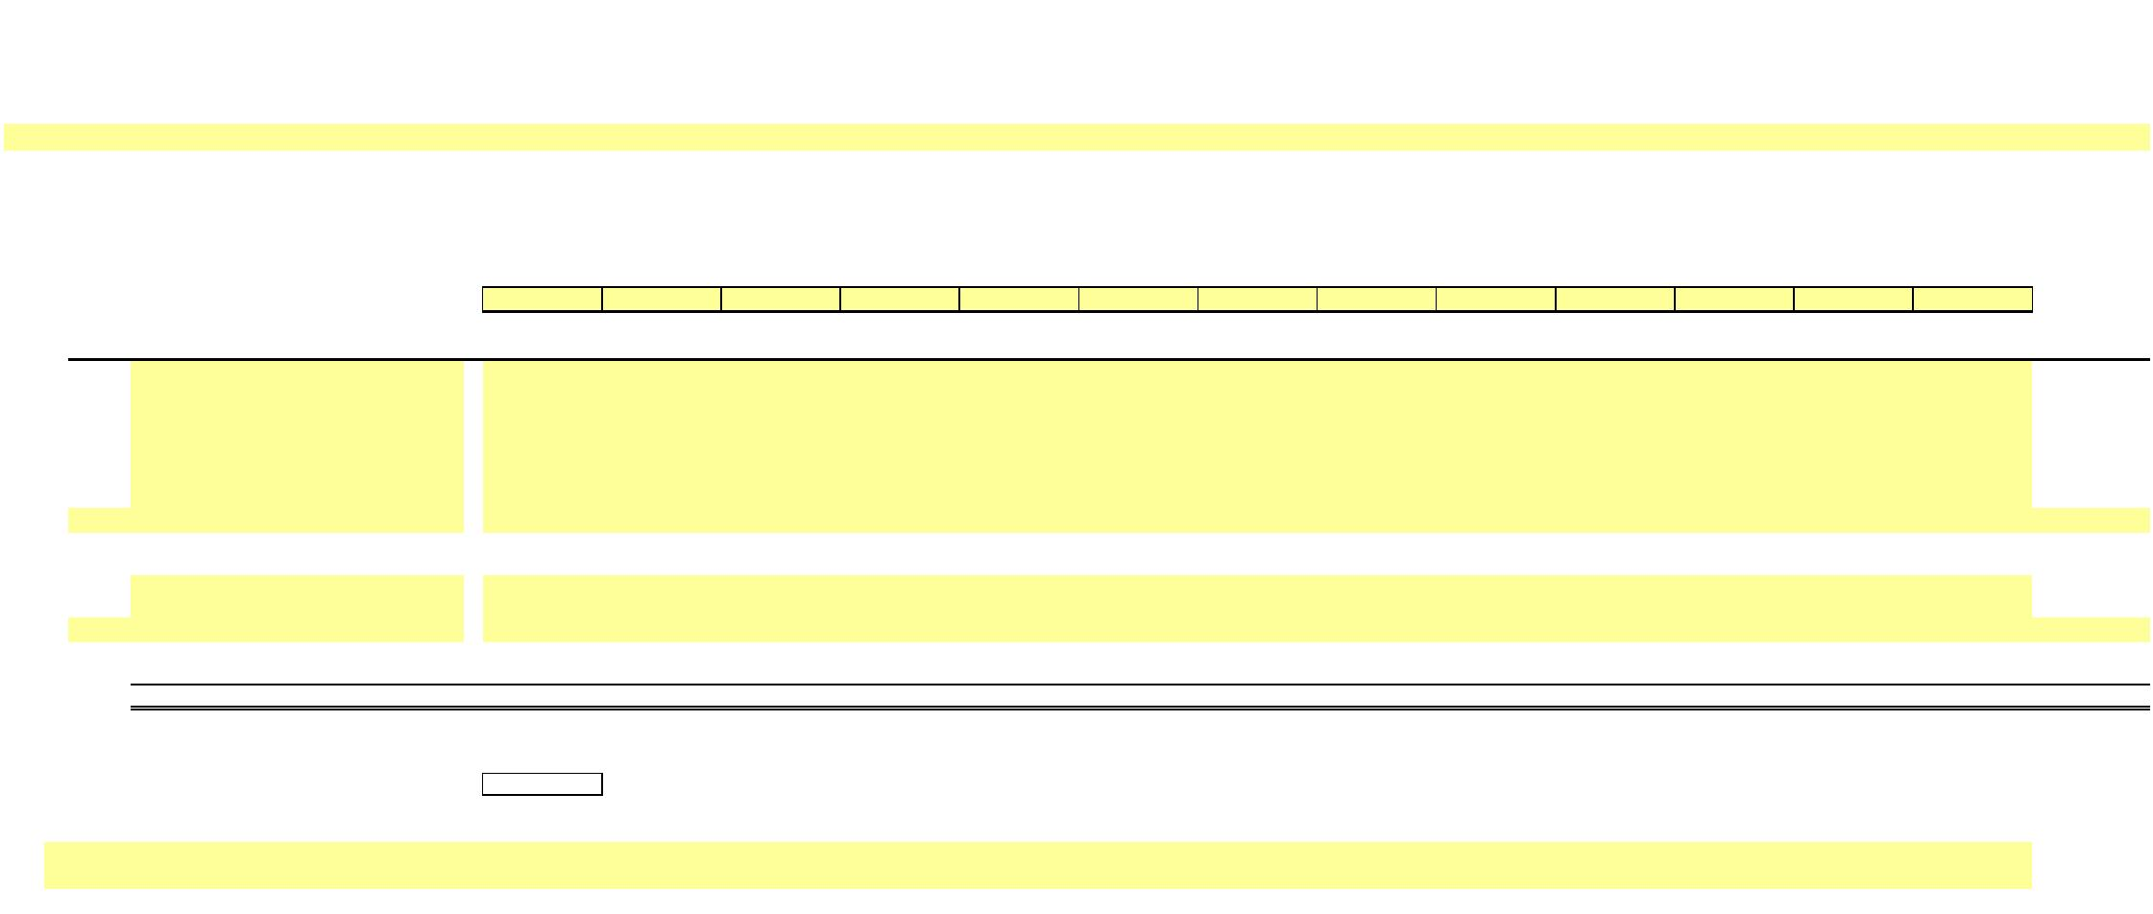X
NEW YORK POWER AUTHORITY
TRANSMISSION REVENUE REQUIREMENT
YEAR ENDING DECEMBER 31, ____
WORK PAPER CA MATERIALS AND SUPPLIES
Total M&S Inventory ($)
NYPA ____ ____ ____ ____ ____ ____ ____ ____ ____ ____ ____ ____ ____ 13-Month
Line No Acct # Facility December January February March April May June July August September October November December Average
(1) (2) (3) (4) (5) (6) (7) (8) (9) (10) (11) (12) (13) (14) (15) (16)
1a 1100 NIA -
1b 1200 STL -
1c 3100 POL -
1d 3200 Flynn -
1e 1300 B/G -
1f 3300 500MW -
1g 2100 CEC -
… - -
2 Facility Subtotal - - - - - - - - - - - - - -
3a Reserve for Degraded Materials -
3b Reserve for Excess and Obsolete Inventory -
… - -
4 Reserves Subtotal - - - - - - - - - - - - - -
5 Total - - - - - - - - - - - - - -
6 Transmission Allocator -
7 Allocated M&S ($) -
Notes
1/ Data source for monthly amounts is NYPA financial records.
…

X
NEW YORK POWER AUTHORITY TRANSMISSION REVENUE REQUIREMENT
YEAR ENDING DECEMBER 31, ____
WORK PAPER CB PREPAYMENTS AND INSURANCE
Property Other
Line No. Date Insurance ($) Prepayments ($)
(1) (2) (3)
1
2 3 4 5 6 7 8 9
10
11
12
13
14 13-Month Average - -
Notes
1/ Data source for monthly amounts is NYPA financial records.
…

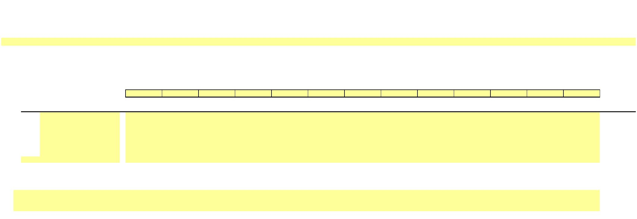X
NEW YORK POWER AUTHORITY
TRANSMISSION REVENUE REQUIREMENT
YEAR ENDING DECEMBER 31, ____
WORK PAPER CC
LAND HELD FOR FUTURE USE
____ ____ ____ ____ ____ ____ ____ ____ ____ ____ ____ ____ ____ 13-Month
Line No. Property Name (Note 2) December January February March April May June July August September October November December Average
(1) (2) (3) (4) (5) (6) (7) (8) (9) (10) (11) (12) (13) (14) (15) (16) 1a -
1b -
1c -
1d -
1e -
1f -
1g -
… -
2 Total - - - - - - - - - - - - - -
Notes
1/ Data source for monthly amounts is NYPA financial records.
2/ Identify property as transmission or general and intangible
…

X
NEW YORK POWER AUTHORITY
TRANSMISSION REVENUE REQUIREMENT
YEAR ENDING DECEMBER 31, ____
WORK PAPER DA WEIGHTED COST OF CAPITAL
Actual Applied Cost Weighted
Line No. Component Amount ($) Share Share Rate Cost
(1) (2) (3) (4) (5) (6)
1 Long-Term Debt - 6/ - 49.00% - 2/ -
2 Preferred Stock - - - - 3/ -
3 Common Equity - 1/ - 51.00% 4/ 10.25% 5/ 5.23%
4 Total - 0% 100% 5.23%
Notes
1/:
5 Total Proprietary Capital - Workpaper WP-DB Ln (5), Col (15) 6 less Preferred
7 less Acct. 216.1
8 Common Equity -
2/:
9 Total Long Term Debt Interest - Workpaper WP-DB Col (2) Ln (2)
10 Net Proceeds Long Term Debt - Workpaper WP-DB Ln (4), Col (15)
11 LTD Cost Rate - 7/
3/:
12 Preferred Dividends -
13 Preferred Stock -
14 Preferred Cost Rate -
15 4/: The capital structure listed in Col (3) is calculated based on the total capitalization amount listed in column (2). The Applied Equity Share in Col (4) Ln (3)
is fixed and cannot be modified or deleted absent an FPA Section 205 or 206 filing to FERC. The debt share is calculated as 1 minus the equity share.
16 5/: The ROE listed in Col (5), Ln (3) is the base ROE (established in the settlement accepted by FERC in Docket No. ER25-198) plus 50 basis-point incentive for RTO participation.
ROE may only be changed pursuant to an FPA Section 205 or 206 filing to FERC.
17 6/: The Long-Term Debt Amount ($) in Col (2) Ln (1) is the Gross Proceeds Outstanding Long Term Debt, the average of WP-DB Ln (3e), Col (15).
18 7/: The Long-Term Debt Cost Rate is calculated as the Total Long Term Debt Interest [Workpaper WP-DB Col (2) Ln (2)] divided by the Net Proceeds
Long Term Debt [Workpaper WP-DB row (4), Col (15)].

X
NEW YORK POWER AUTHORITY
TRANSMISSION REVENUE REQUIREMENT
YEAR ENDING DECEMBER 31, ____
WORK PAPER DB CAPITAL STRUCTURE
LONG-TERM DEBT AND RELATED INTEREST
(1) (2) (3) (4) (5) (6) (7) (8) (9) (10) (11) (12) (13) (14) (15) (16)
NYPA Form 1 Line No. 12/31/____ Equivalent
Amount ($)
1 Long Term Debt Cost
1a Interest on Long-Term Debt p. 117 ln. 62 c
1b Amort. of Debt Disc. and Expense p. 117 ln. 63 c
1c Amortization of Loss on Reacquired Debt p. 117 ln. 64 c
1d (Less) Amort. of Premium on Debt p. 117 ln. 65 c
1e (Less) Amortization of Gain on Reacquired Debt - p. 117 ln. 66 c
2 Total Long Term Debt Interest -
13-Month Average
3 Long Term Debt Amount ($) Amount ($) Amount ($) Amount ($) Amount ($) Amount ($) Amount ($) Amount ($) Amount ($) Amount ($) Amount ($) Amount ($) Amount ($) Amount ($)
3a Bonds - p. 112 ln. 18 c,d
3b (Less) Reacquired Bonds - p. 112 ln. 19 c,d
3d Other Long Term Debt - p. 112 ln. 21 c,d
3e Gross Proceeds Outstanding LT Debt - - - - - - - - - - - - - -
3f (Less) Unamortized Discount on Long-Term Debt - p. 112 ln. 23 c,d
3g (Less) Unamortized Debt Expenses - p. 111 ln. 69 c,d
3h (Less) Unamortized Loss on Reacquired Debt - p. 111 ln. 81 c,d
3i Unamortized Premium on Long-Term Debt - p. 112 ln. 22 c,d
3k Unamortized Gain on Reacquired Debt - p. 113 ln. 61 c,d
4 Net Proceeds Long Term Debt - - - - - - - - - - - - - -
5 Net Position - - -
Notes
1/ Data source for monthly amounts is NYPA financial records.
…

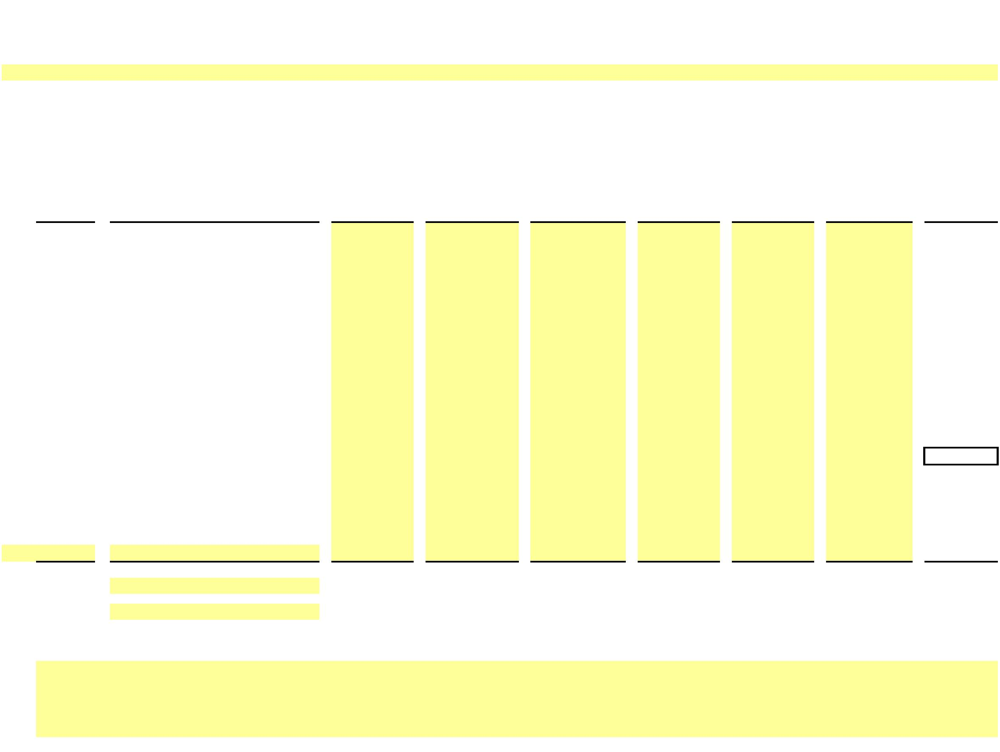X
NEW YORK POWER AUTHORITY
TRANSMISSION REVENUE REQUIREMENT
YEAR ENDING DECEMBER 31, ____
WORK PAPER EA
CALCULATION OF A&G AND GENERAL PLANT ALLOCATOR
(1) (2) (3) (4) (5) (6) (7) (8) (9) (10)
 | Profit Labor |  | 1/ Net Plant ^{2/} Net Revenue^{3/} Labor Net Plant Net Revenue Allocator
Center(s) Site $ $ $ % % % Ratio
1a 105 Blenheim-Gilboa 0.00% 1b 110 St. Lawrence 0.00% 1c 115 Niagara 0.00% 1d 120 Poletti 0.00% 1e 125 Flynn 0.00% 1f
1g 122 AE II 0.00% 1h
1i 130-150 Total Small Hydro 0.00% 1j
1k 155-161 Total Small Clean Power Plants 0.00% 1l
1m 165 500MW Combined Cycle 0.00% 1n
1o 205-245 Total Included Transmission 0.00%
1p
1q 321 Recharge New York 0.00% 1r
1s 600 SENY 0.00%
… - - 0.00%
Total - Production + Transmission - - - 0.00% 0.00% 0.00% 0.00%
Total - Production Only - - - 0.00% 0.00% 0.00% 0.00%
Notes
1/ Data source for Labor is NYPA Form 1 Equivalent and audited financials.
2/ Data source for Net Plant is NYPA audited financials. The balance at the end of the calendar year is used in determining the percentages for the Net Plant factor.
3/ Data source for Net Revenue is NYPA audited financials.
Net Revenue excludes fuel, purchased power and certain other charges that are passed through to direct service customers.
…

X
NEW YORK POWER AUTHORITY TRANSMISSION REVENUE REQUIREMENT
YEAR ENDING DECEMBER 31, ____
WORK PAPER AR- IS
STATEMENT OF REVENUES, EXPENSES AND CHANGES IN NET POSITION
($ Millions)
 | Description  (1) |  | Actual Actual  ____ ____  (2) (3)
1 Operating Revenues
1a Power Sales
1b Transmission Charges 1c Wheeling Charges
1d Other … -
2 Total Operating Revenues - -
3 Operating Expenses 3a Purchased Power
3b Fuel Oil and Gas
3c Wheeling 3d Operations 3e Maintenance 3f Depreciation
3g Impairment Cost … -
4 Total Operating Expenses - -
5 Operating Income - -
6 Nonoperating Revenues
6a Investment Income 6b Other
… -
7 Investments and Other Income - -
8 Nonoperating Expenses
8a Contribution to New York State
8b Interest on Long-Term Debt
8c Interest - Other
8d Interest Capitalized
8e Amortization of Debt Premium
8f Canal Reimbursement Agreement
… -
9 Investments and Other Income - -
10 Net Income Before Contributed Capital - -
11 Contributed Capital - Wind Farm Transmission Assets … -
13 Change in net position - -
14 Net position at January 1
15 Net position at December 31 - -

X
X
NEW YORK POWER AUTHORITY
TRANSMISSION REVENUE REQUIREMENT
YEAR ENDING DECEMBER 31, ____
WORK PAPER AR-BS
STATEMENT OF NET POSITION
($ Millions)
DESCRIPTION DECEMBER ____ DECEMBER ____
(1) (2) (3) 1 Assets and Deferred Outflows
1a Current Assets:
1b Cash and cash equivalents
1c Investment in securities
1d Investments in securities- restricted
1e Receivables - customers
1f Materials and supplies, at average Cost:
1g Plant and general
1h Fuel
1i Miscellaneous receivables and other
… -
2 Total current assets - -
3 Noncurrent Assets:
3a Restricted funds:
3b Cash and cash equivalents
3c Investment in securities
… -
4 Total restricted assets - -
5 Capital funds:
5a Cash and cash equivalents
5b Investment in securities
… -
6 Total capital funds - -
7 Capital Assets
7a Capital assets not being depreciated
7b Capital assets, net of accumulated depreciation
… -
8 Total capital assets - -
9 Other noncurrent assets:
9a Receivable - New York State
9b Notes receivable - nuclear plant sale
9c Other long-term assets
… -
10 Total other noncurrent assets - -
11 Total noncurrent assets - -
12 Total assets - -
13 Deferred outflows:
13a Accumulated decrease in fair value of hedging derivatives
13b Pensions
13c Postemployment benefits other than pensions (Note 11)
13d Asset retirement obligation
… -
14 Total Deferred outflows
15 Total assets and deferred outflows - -
1/ Source: Annual Financial Statements

X
X
NEW YORK POWER AUTHORITY
TRANSMISSION REVENUE REQUIREMENT
YEAR ENDING DECEMBER 31, ____
WORK PAPER AR-BS
STATEMENT OF NET POSITION
($ Millions)
DESCRIPTION DECEMBER ____ DECEMBER ____
16 Liabilities, Deferred Inflows and Net Position 16a Current Liabilities:
16b Accounts payable and accrued liabilities
16c Short-term debt
16d Long-term debt due within one year
16e Capital lease obligation due within one year
16f Risk management activities - derivatives
… -
17 Total current liabilities - -
18 Noncurrent liabilities: 18a Long-term debt: 18b Senior:
18c Revenue bonds
18d Adjustable rate tender notes
18e Subordinated:
18f Subordinated Notes, Series 2012
18g Commercial paper
… -
19 Total long-term debt - -
20 Other noncurrent liabilities: 20a Capital lease obligation
20b Liability to decommission divested nuclear facilities
20c Disposal of spent nuclear fuel
20d Relicensing
20e Risk management activities - derivatives
20f Other long-term liabilities
… -
21 Total other noncurrent liabilities - -
22 Total noncurrent liabilities - -
23 Total liabilities - -
24 Deferred inflows:
24a Cost of removal obligation
24b Accumulated increase in fair value of hedging
24c Pensions (Note 10)
24d Postemployment benefits other than pensions (Note 11)
… -
- - 25 Net position:
25a Net investment in capital assets
25b Restricted 25c Unrestricted
25d Postemployment benefits other than pensions (Note 11)
… -
26 Total net position - - 27 Total liabilities, deferred inflows and net position - -
1/ Source: Annual Financial Statements

X
NEW YORK POWER AUTHORITY
TRANSMISSION REVENUE REQUIREMENT
YEAR ENDING DECEMBER 31, ____
WORK PAPER AR-Cap Assets CAPITAL ASSETS - Note 5 ($ Millions)
New York Power Authority
Capital Assets - Note 5 ____ Annual Report
12/31/____ 12/31/____
Ending Ending
balance Additions Deletions balance (1) (2) (3) (4) (5)
1 Capital assets, not being depreciated:
1a Land -
1b Construction in progress -
1c Land-Canal System -
1d CIP- Canal System -
… - -
2 Total capital assets not being depreciated - - - -
3 Capital assets, being depreciated:
3a Production – Hydro -
3b Production – Gas
3c turbine/combined cycle -
3d Transmission -
3e General -
3f Canal System -
… - -
4 Total capital assets being depreciated -
5 Less accumulated depreciation for:
5a Production – Hydro -
5b Production – Gas
5c turbine/combined cycle -
5d Transmission -
5e General -
5f Canal System -
… - -
6 Total accumulated depreciation - - - -
7 Net value of capital assets being depreciate - - - -
8 Net value of all capital assets - - - -

X
NEW YORK POWER AUTHORITY
TRANSMISSION REVENUE REQUIREMENT
YEAR ENDING DECEMBER 31, ____
WORK PAPER Reconciliations RECONCILIATIONS BETWEEN ANNUAL REPORT & ATRR
 | Line  No. |  | ____  (1) (2) (3) (4) (5)
1 OPERATION & MAINTANANCE EXPENSES
Operations Maintenance Total O&M
1a Operations & Maintenance Expenses - as per Annual Report - - -
Excluded Expenses
1b Production -
1c A&G in FERC Acct 549 - OP-Misc Oth Pwr Gen - - -
1d FERC acct 905 (less contribution to New York State) - - -
1e FERC acct 916 - Misc Sales Expense - - -
… … -
… … -
1h A&G not allocated to Transmission -
Adjustments -
1i Less A/C 924 - Property Insurance - - -
1j Less A/C 925 - Injuries & Damages Insurance - - -
1k Less EPRI Dues - - -
1l Less A/C 928 - Regulatory Commission Expense - - -
1m Less A/C 930.5 - R&D Expense - - -
1n PBOP Adjustment - - -
1o 924 -Property Insurance as allocated - - -
1p 925 - Injuries & Damages Insurance as allocated - - -
1q 930.5 - R&D Expense -
1r Step-up Transformers - - -
1s FACTS - - -
1t Microwave Tower Rental Income - - -
… … -
… … -
1w Reclassifications (post Annual Report) -
1x Operations & Maintenance Expenses - as per ATRR - - -
check - - -

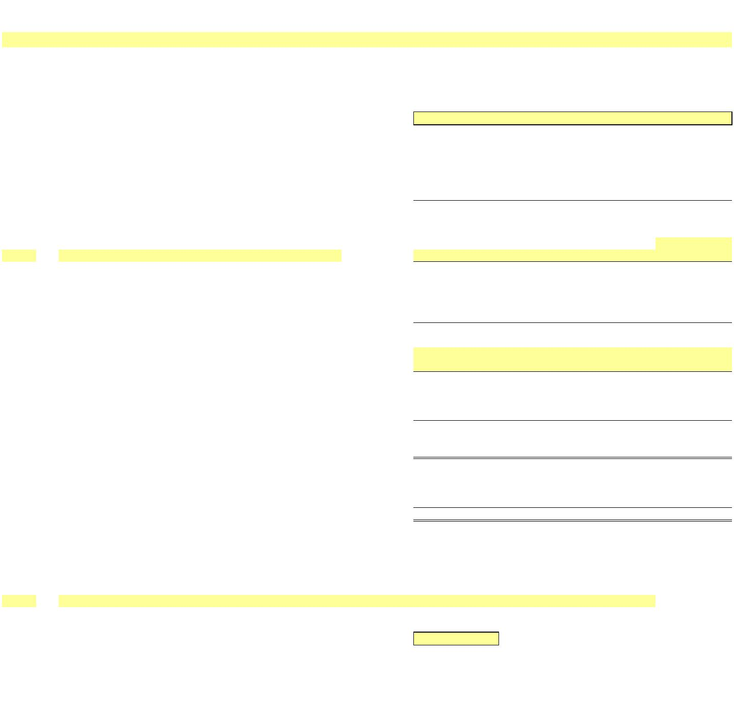 NEW YORK POWER AUTHORITY
TRANSMISSION REVENUE REQUIREMENT
YEAR ENDING DECEMBER 31, ____
WORK PAPER Reconciliations RECONCILIATIONS BETWEEN ANNUAL REPORT & ATRR
2 ELECTRIC PLANT IN SERVICE & DEPRECIATION
____
Electric Plant in Accumulated Electric Plant in Depreciation
Service ($) Depreciation ($) Service - Net ($) Expense ($)
2a Electric Plant in Service & Depreciation As per Annual Report
2b Capital Assets not being depreciated - - - -
2c Capital Assets being depreciated - - - -
2d Total Capital Assets - - - -
2e Less CWIP - - - -
2e Less Canal CIP - - - -
2f Less Canal Assets - - - -
… …
2g Total Assets in Service - - - -
2h Adjustments for ATRR
2i Cost of Removal (note 1)
2j Transmission - - - -
2k General - - - -
2l Total - - - -
2m Excluded (note 2)
2n Transmission -
2o General -
2p Total - - - -
2q Adjustments to Rate Base (note 3)
2r Transmission - - - -
2s General - - - -
2t Total - - - -
2u
2v Total Assets in Service - As per ATRR - - - -
2w Comprising:
2x Production - - - -
2y Transmission - - - -
2z General - - - -
2aa Total - - - -
check differences due to rounding - - - -
Notes
2ab 1 Cost of Removal: Bringing back to accumulated depreciation cost of removal which was reclassified to regulatory liabilities in annual report
2ac 2 Excluded: Assets not recoverable under ATRR
2ad 3 Adjustments to Rate Base: Relicensing, Windfarm, Step-up transformers, FACTS & Asset Impairment
… …
3 MATERIALS & SUPPLIES
____
3a As per Annual Report
3b Plant and General -
3c As per ATRR -
3d check -

 NEW YORK POWER AUTHORITY
TRANSMISSION REVENUE REQUIREMENT
YEAR ENDING DECEMBER 31, ____
WORK PAPER Reconciliations RECONCILIATIONS BETWEEN ANNUAL REPORT & ATRR
4 CAPITAL STRUCTURE
____
Long -Term Debt Common Equity
4a As per Annual Report
4b Long-Term -
4c Short-Term -
4d Unamortized Premium/Discount -
4e Total - -
4f As per ATRR (Note 4) - -
4g check - -
Notes
4h 4 Actual common equity amounts not used in weighted average cost of capital.
5 INTEREST ON LONG-TERM DEBT
____
5a As per Annual Report
5b Interest LTD (including Swaps, Deferred Refinancing) -
5c
5d Debt Discount/Premium -
5e Total -
5f As per ATRR
5g Interest LTD (including Swaps, Deferred Refinancing) -
5h Debt Discount/Premium -
5i Total -
5j check -
Notes
… …
6 REVENUE REQUIREMENT
____
6a As per Annual Report 6b SENY load (note 5)
6c FACTS revenue (note 6) 6d Timing differences
6e
6f 6g 6h 6i 6j 6k …
7a Subtotal - 7b FERC approved ATRR (line 6a + line 7a) - 7c check -
Notes
7d 5 Amount that NYPA will credit to its ATRR assessed to the SENY customer load. These revenues are included in the Annual Report within Production Revenues.
7e 6 Compensation for FACTS through the NYISO’s issuance of Transmission Congestion Contract (“TCC”) payments
…
8 OTHER POSTEMPLOYMENT BENEFIT PLANS
____
8a As per Annual Report 8b Annual OPEB Cost 8c 8d
8e Subtotal -
8f As per ATRR
8g Total NYPA PBOP - 8h check -

