X

**INDEX**

**NEW YORK POWER AUTHORITY**

**TRANSMISSION REVENUE REQUIREMENT**

**Name**

**Description**

Cost-of-Service Summary

Schedule A1

Schedule A2

Schedule B1

Schedule B2

TRANSMISSION REVENUE REQUIREMENT SUMMARY

OPERATION & MAINTENANCE EXPENSE SUMMARY

ADMINISTRATIVE AND GENERAL EXPENSES

ANNUAL DEPRECIATION AND AMORTIZATION EXPENSES

ADJUSTED PLANT IN SERVICE

Schedule B3

Schedule C1

Schedule D1

Schedule D2

DEPRECIATION AND AMORTIZATION RATES

TRANSMISSION - RATE BASE CALCULATION

CAPITAL STRUCTURE AND COST OF CAPITAL

PROJECT SPECIFIC CAPITAL STRUCTURE AND COST OF CAPITAL

A&G AND GENERAL PLANT ALLOCATOR

Schedule E1

Schedule F1

Schedule F2

PROJECT REVENUE REQUIREMENT WORKSHEET

INCENTIVES

Schedule F3

PROJECT TRUE-UP

Work Paper-AA

Work Paper-AB

Work Paper-AC

Work Paper-AD

Work Paper-AE

Work Paper-AF

Work Paper-AG

Work Paper-AH

Work Paper-AI

O&M AND A&G SUMMARY

O&M AND A&G DETAIL

STEP-UP TRANSFORMERS O&M ALLOCATOR

FACTS O&M ALLOCATOR

MICROWAVE TOWER RENTAL INCOME

POSTRETIREMENT BENEFITS OTHER THAN PENSIONS (PBOP)

PROPERTY INSURANCE ALLOCATION

INJURIES & DAMAGES INSURANCE EXPENSE ALLOCATION

PROPERTY INSURANCE ALLOCATOR

Work Paper-BA

Work Paper-BB

Work Paper-BC

Work Paper-BC (Support A)

Work Paper-BC (Support B)

Work Paper-BD

Work Paper-BE

Work Paper-BE (Support)

Work Paper-BF

Work Paper-BF (Support)

Work Paper-BG

Work Paper-BG (Support)

Work Paper-BH

Work Paper-BI

DEPRECIATION AND AMORTIZATION EXPENSES (BY FERC ACCOUNT)

EXCLUDED PLANT IN SERVICE

PLANT IN SERVICE DETAIL

PLANT IN SERVICE DETAIL -- SUPPORT A

PLANT IN SERVICE DETAIL -- SUPPORT B

MARCY-SOUTH CAPITALIZED LEASE AMORTIZATION AND UNAMORTIZED BALANCE

FACTS PROJECT PLANT IN SERVICE AND ACCUMULATED DEPRECIATION

FACTS PROJECT PLANT IN SERVICE AND ACCUMULATED DEPRECIATION -- SUPPORT

GENERATOR STEP-UP TRANSFORMERS BREAKOUT

GENERATOR STEP-UP TRANSFORMERS BREAKOUT -- SUPPORT

RELICENSING/RECLASSIFICATION EXPENSES

RELICENSING/RECLASSIFICATION EXPENSES -- SUPPORT

ASSET IMPAIRMENT

COST OF REMOVAL

Work Paper-BJ

INDIVIDUAL PROJECTS - PLANT IN SERVICE AND DEPRECIATION

INDIVIDUAL PROJECTS - PLANT IN SERVICE AND DEPRECIATION -- SUPPORT

MATERIALS AND SUPPLIES

PREPAYMENTS AND INSURANCE

LAND HELD FOR FUTURE USE

Work Paper-BJ (Support)

Work Paper-CA

Work Paper-CB

Work Paper-CC

Work Paper-DA

Work Paper-DB

Work Paper-EA

Work Paper-AR-IS

Work Paper-AR-BS

Work Paper-AR-Cap Assets

Work Paper-Reconciliations

WEIGHTED COST OF CAPITAL

LONG-TERM DEBT AND RELATED INTEREST

CALCULATION OF A&G AND GENERAL PLANT ALLOCATOR

STATEMENT OF REVENUES , EXPENSES, AND CHANGES IN NET POSITION

STATEMENT OF NET POSITION

CAPITAL ASSETS

RECONCILIATIONS BETWEEN ANNUAL REPORT & ATRR



X

**NEW YORK POWER AUTHORITY**

**TRANSMISSION REVENUE REQUIREMENT**

**YEAR ENDING DECEMBER 31, ____**

**TRANSMISSION REVENUE REQUIREMENT SUMMARY**

Line No. **A. OPERATING EXPENSES**

**TOTAL $**

**SOURCE/COMMENTS**

(2)

(1)

**1**

**2**

**3**

**4**

**5**

Operation & Maintenance Expense

Administrative & General Expenses

Depreciation & Amortization Expense

**TOTAL OPERATING EXPENSE**

**B. RATE BASE**

-

-

-

**-**

**-**

Schedule A1, Col 5, Ln 7

Schedule A2, Col 5, Ln 5

Schedule B1, Col 6, Ln 6

Sum lines 1, 2, & 3

Schedule C1, Col 5, Ln 11

**6**

**6a**

**7**

Return on Rate Base

**-**

**-**

**-**

-

-

**-**

Schedule C1, Col 7, Ln 11

Schedule D2, Col 3, Ln A

Total Project Specific Return Adjustment

**TOTAL REVENUE REQUIREMENT**

Incentive Return

Line 4 + Line 6 + Line 6a

**8**

Schedule F1, page 2, line 2, col. 13

Schedule F3, page 1, line 3, col. 10

Line 7 + line 8 + line 9

**9**

True-up Adjustment

**10**

**NET ADJUSTED REVENUE REQUIREMENT**

**Breakout by Project**

**11**

NTAC Facilities

-

-

Schedule F1, page 2, line 1a + line 1d, col. 17

Schedule F1, page 2, line 1b, col. 17

**11a** Project 1 - Marcy South Series Compensation

Project 2 - AC Project Segment A

**11b**

-

Schedule F1, page 2, line 1c, col. 17

Schedule F1, page 2, line 1e, col. 17

(Central East Energy Connect)

**11c**

**11d**

…

…

**12**

Project 3 - Propel NY

-

-

-

-

**-**

…

…

Total Break out

Sum lines 11

Note 1 The revenue requirements shown on lines 11 and 11a et seq. are annual revenue requirements. If the first year is a partial year,

1/12 of the amounts should be recovered for every month of the Rate Year.

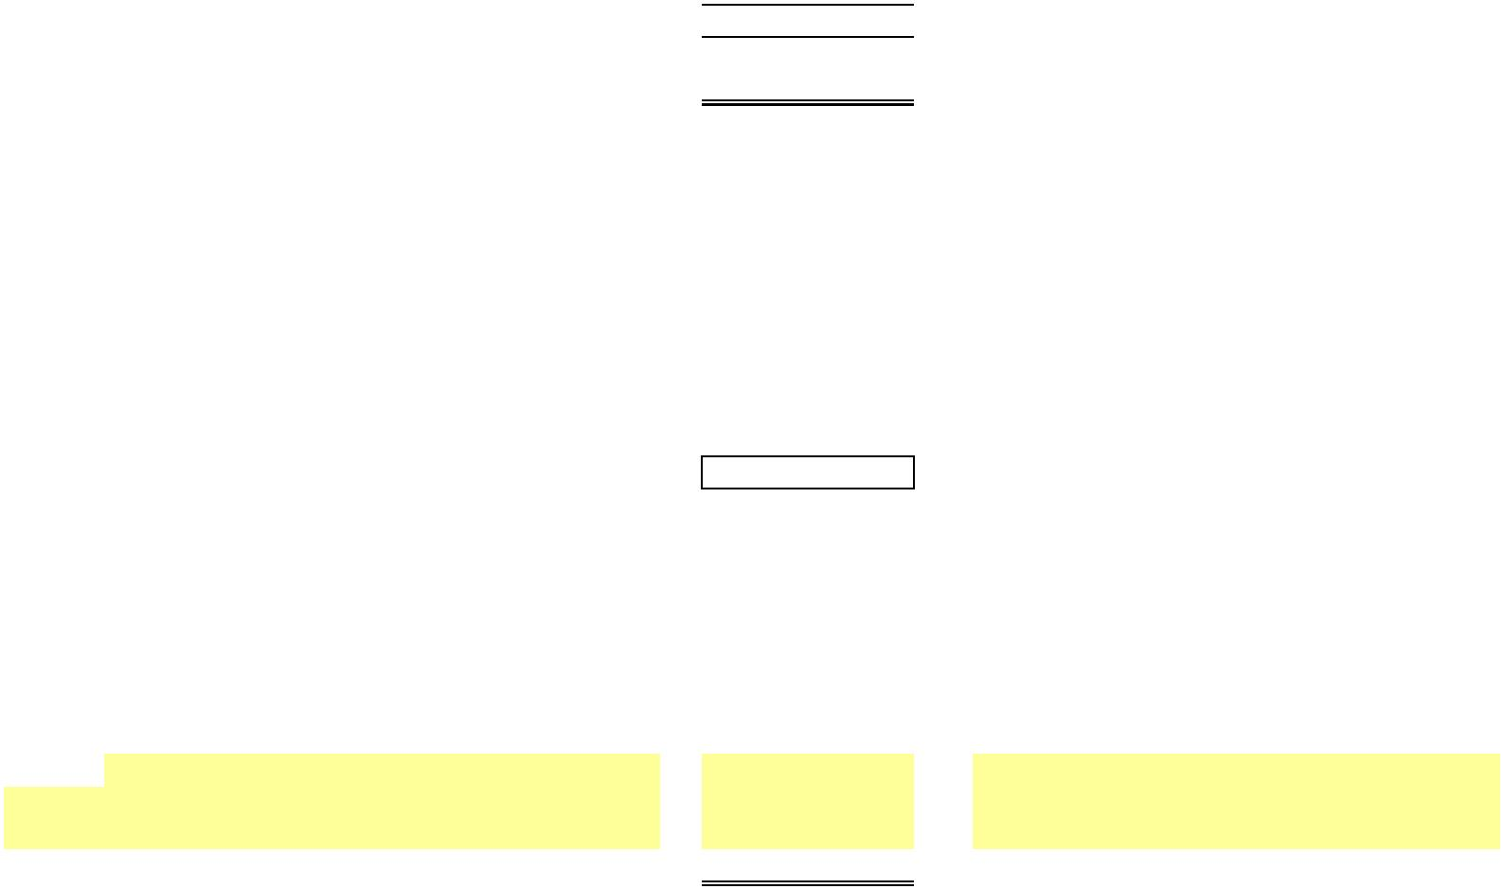

X

**NEW YORK POWER AUTHORITY**

**TRANSMISSION REVENUE REQUIREMENT**

**YEAR ENDING DECEMBER 31, ____**

**SCHEDULE A1**

**OPERATION & MAINTENANCE EXPENSE SUMMARY ($)**

**FERC**

**Line No. Account**

**(1)**

**FERC Account Description**

**(2)**

**Source**

**Total**

**(4)**

**Grand Total NYPA Form 1 Equivalent**

**(3)**

**(5)**

**(6)**

**Transmission:**

560

**OPERATION:**

Supervision & Engineering

Load Dispatching

Station Expenses

Misc. Trans. Expenses

…

**1a**

**1b**

**1c**

**1d**

**…**

**2**

WP-AA, Col (5)

WP-AA, Col (5)

WP-AA, Col (5)

WP-AA, Col (5)

…

-

-

-

-

Page 321 line 83

Page 321 lines 85-92

Page 321 line 93

Page 321 line 97

…

561

562

566

…

**Total Operation**

(sum lines 1)

**-**

**MAINTENANCE:**

Supervision & Engineering

Structures

Station Equipment

Overhead Lines

Underground Lines

Misc. Transm. Plant

…

**3a**

**3b**

**3c**

**3d**

**3e**

**3f**

**…**

**4**

568

569

570

571

572

573

…

WP-AA, Col (5)

WP-AA, Col (5)

WP-AA, Col (5)

WP-AA, Col (5)

WP-AA, Col (5)

WP-AA, Col (5)

…

-

-

-

-

-

-

Page 321 line 101

Page 321 line 102-106

Page 321 line 107

Page 321 line 108

Page 321 line 109

Page 321 line 110

…

**Total Maintenance**

**TOTAL O&M TRANSMISSION**

(sum lines 3)

(sum lines 2 & 4)

**-**

**5**

**-**

**Adjustments (Note 2)**

Step-up Transformers

FACTS (Note 1)

**6a**

**6b**

**6c**

**…**

WP-AC, Col (1) line 5

WP-AD,Col (1) line 5

WP-AE, Col (3) line 2

…

-

-

-

Microwave Tower Rental Income

…

…

**7**

**TOTAL ADJUSTED O&M TRANSMISSION**

(sum lines 5-6)

**-**

Note 1 Flexible Alternating Current Transmission System device

Note 2 Revenues that are credited in the NTAC are not revenue credited here.

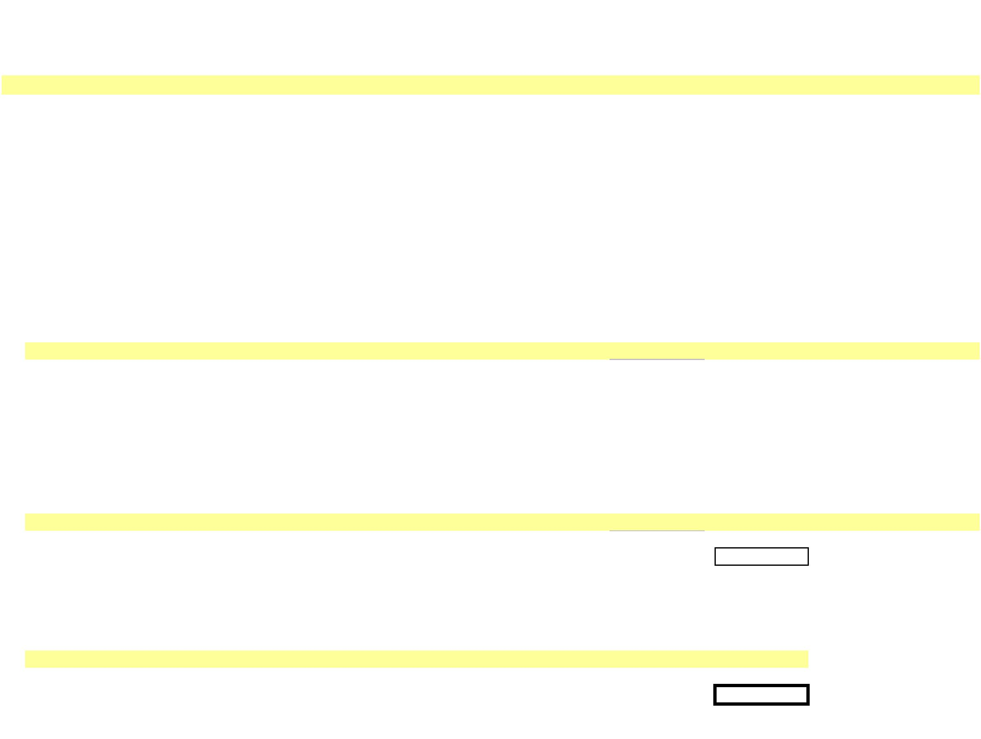

X

**NEW YORK POWER AUTHORITY**

**TRANSMISSION REVENUE REQUIREMENT**

**YEAR ENDING DECEMBER 31, ____**

**SCHEDULE A2**

**ADMINISTRATIVE AND GENERAL EXPENSES**

**FERC**

**Unallocated**

**A&G ($)**

(3)

**Transmission**

**Allocator (%)**

(4)

**Allocated to**

**Transmission ($)**

(5)

**Line No. Account FERC Account Description**

**Source**

**Source/Comments**

**NYPA Form 1 Equivalent**

(1)

(2)

(6)

(7)

**Administrative & General Expenses**

**1a**

**1b**

**1c**

**1d**

**1e**

**1f**

**1g**

**1h**

**1i**

**1j**

**1k**

**1l**

**1m**

**1n**

**…**

**2**

920

921

922

923

924

925

926

928

930

930.1

930.2

930.5

931

935

…

A&G Salaries

WP-AA, Col (5)

WP-AA, Col (5)

WP-AA, Col (5)

WP-AA, Col (5)

WP-AA, Col (5)

WP-AA, Col (5)

WP-AA, Col (5)

WP-AA, Col (5)

WP-AA, Col (5)

WP-AA, Col (5)

WP-AA, Col (5)

2/

-

Page 323 line 181

Page 323 line 182

Page 323 line 183

Page 323 line 184

Office Supplies & Expenses

Admin. Exp. Transferred-Cr

Outside Services Employed

Property Insurance

Injuries & Damages Insurance

Employee Pensions & Benefits

Reg. Commission Expenses

Obsolete/Excess Inv

General Advertising Expense

Misc. General Expenses

Research & Development

Rents

-

-

-

-

-

-

-

-

-

-

-

-

-

-

-

See WP-AG; Col (3) ,Ln 5 Page 323 line 185

See WP-AH; Col (3) ,Ln 4 Page 323 line 186

Page 323 line 187

See WP-AA; Col (3), Ln 2x Page 323 line 189

Page 323 line 190.5

-

Page 323 line 191

Page 323 line 192

Page 323 line 192.5

Page 323 line 193

Page 323 line 196

-

2/

WP-AA, Col (5)

WP-AA, Col (5)

…

Maint of General Plant A/C 932

…

**TOTAL**

(sum lines 1)

**-**

**3a**

**3b**

**3c**

**3d**

**3e**

**3f**

Less A/C 924

Less A/C 925

Less EPRI Dues

Less A/C 928

Less A/C 930.5

PBOP Adjustment

…

Less line 1e

Less line 1f

1/

Less line 1h

Less line 1l

WP-AF

-

-

-

-

-

-

Page 323 line 185

Page 323 line 186

Page 323 line 189

3/

**…**

**4**

…

**TOTAL A&G Expense**

(sum lines 2 to 4)

**-**

**-**

**-**

**-**

- Allocated based on

transmission allocator

(Schedule E1)

**5**

**NET A&G TRANSMISSION EXPENSE** (sum lines 1 to 4)

1/ NYPA does not pay EPRI dues

2/ Column 5 is populated as 0 (zero) for data pertaining to calendar years ____ and 2015. It is populated as a sum of Transmission R&D Expense [Workpaper WP-AA Col (3) ln(2ab)] plus the portion of

Admin & General allocated to transmission [Workpaper WP-AA Col (4) ln (2ab) multiplied by Workpaper E1-Allocator Col (3) ln (2)] for data pertaining to calendar years 2016 and later.

3/ Populated as 0 (zero) for data pertaining to calendar years ____ and 2015. Populated as WP-AA Col (3) for data pertaining to calendar years 2016 and later.

…



X

**NEW YORK POWER AUTHORITY**

**TRANSMISSION REVENUE REQUIREMENT**

**YEAR ENDING DECEMBER 31, ____**

**SCHEDULE B1**

**ANNUAL DEPRECIATION AND AMORTIZATION EXPENSES ($)**

**Total**

**Annual**

**Depreciation**

**Col (2)+(5)**

**(6)**

**General Plant**

**Allocated to**

**Transm. Col (3)*(4)**

**(5)**

**FERC**

**Line No. Account FERC Account Description**

**Transmission**

**Allocator (%)**

**(4)**

**Source**

**(1)**

**Transmission**

**(2)**

**General Plant**

**(3)**

**1a**

**1b**

**1c**

**1d**

**1e**

**1f**

**1g**

**1h**

**1i**

352

353

354

355

356

357

358

359

351.1

351.2

351.3

…

Structures & Improvements

Station Equipment

Towers & Fixtures

WP-BA, Col (4)

WP-BA, Col (4)

WP-BA, Col (4)

WP-BA, Col (4)

WP-BA, Col (4)

WP-BA, Col (4)

WP-BA, Col (4)

WP-BA, Col (4)

WP-BA, Col (4)

WP-BA, Col (4)

WP-BA, Col (4)

…

-

-

-

-

-

-

-

-

-

-

-

Poles & Fixtures

Overhead Conductors & Devices

Underground Conduit

Underground Conductors & Devices

Roads & Trails

Computer Hardware

Computer Software

Communications Equipment

…

**1j**

**1k**

**…**

**2**

**Unadjusted Depreciation**

**-**

**3a**

**3b**

**3c**

**3d**

**3e**

**3f**

**3g**

**3h**

**3i**

390

391

392

393

394

395

396

397

398

399

…

Structures & Improvements

Office Furniture & Equipment

Transportation Equipment

Stores Equipment

Tools, Shop & Garage Equipment

Laboratory Equipment

Power Operated Equipment

Communication Equipment

Miscellaneous Equipment

Other Tangible Property

…

WP-BA, Col (4)

WP-BA, Col (4)

WP-BA, Col (4)

WP-BA, Col (4)

WP-BA, Col (4)

WP-BA, Col (4)

WP-BA, Col (4)

WP-BA, Col (4)

WP-BA, Col (4)

WP-BA, Col (4)

…

-

-

-

-

-

-

-

-

-

-

**3j**

**…**

**4**

**Unadjusted General Plant Depreciation**

**-**

**Adjustments**

**5a**

**5b**

**5c**

**5d**

**5e**

**…**

Capitalized Lease Amortization Schedule B2, Col 4, line 14

-

-

-

-

FACTS

Windfarm

Step-up Transformers

Relicensing Reclassification

…

Schedule B2, Col 4, line 13

Schedule B2, Col 4, line 11

Schedule B2, Col 4, line 12

WP-BG, Col 4

-

…

**6**

**TOTAL**

(Sum lines 2-5)

**-**

**-**

**-**

**1/**

**-**

**-**

1/ See Schedule-E1, Col (3), Ln 2



X

**NEW YORK POWER AUTHORITY**

**TRANSMISSION REVENUE REQUIREMENT**

**YEAR ENDING DECEMBER 31, ____**

**SCHEDULE B2**

**ADJUSTED PLANT IN SERVICE**

**13-Month Average**

**Line**

**No.**

**Plant in**

**Accumulated**

**Plant in**

**Service - Net ($)**

**(3)**

**Depreciation**

**Expense ($)**

**(4)**

**Service ($)**

**Depreciation ($)**

**(2)**

**(1)**

NYPA Form 1 Equivalent

**PRODUCTION**

**Source**

**Depreciation (p.219)**

**1**

**2**

**3**

**4**

Production - Land

WP-BC

-

-

-

-

-

-

-

Production - Hydro

WP-BC ln. 22 - Cost of Removal 5/

WP-BC ln. 20 + ln. 23

-

-

-

-

-

-

-

-

-

Production - Gas Turbine / Combined Cycle

**TRANSMISSION**

**5**

**6**

Transmission - Land

Transmission

WP-BC

-

-

-

-

-

-

-

-

WP-BC ln. 24 - Cost of Removal 5/

**7**

-

-

-

-

**8**

**9**

Transmission - Cost of Removal 1/

Excluded Transmission 2/

WP-BC

WP-BB

-

-

-

-

-

-

-

-

Adjustments to Rate Base

Transmission - Asset Impairment

Windfarm

**10**

**11**

**12**

**13**

WP-BC

WP-BC

WP-BF

WP-BE

-

-

-

-

-

-

-

-

-

-

-

-

-

-

-

-

Generator Step-ups

FACTS

**14**

**15**

Marcy South Capitalized Lease 3/

…

-

-

-

-

-

-

-

-

**16**

**17**

**18**

Total Adjustments

-

**Net Adjusted Transmission**

-

-

-

-

**GENERAL**

**19**

**20**

General - Land

General

WP-BC

-

-

-

-

-

-

-

-

WP-BC ln. 27 - Cost of Removal 5/

**21**

-

-

-

-

Adjustments to Rate Base

General - Asset Impairment

General - Cost of Removal

Relicensing

**22**

**23**

**24**

-

-

-

-

-

-

-

-

-

-

-

-

WP-BC

WP-BG

WP-BC

**25**

**26**

Excluded General 4/

…

-

-

-

-

-

-

-

-

**27**

Total Adjustments

-

-

-

-

**28 Net Adjusted General Plant**

**-**

**-**

**-**

**-**

Notes

1/ Cost of Removal: Bringing back to accumulated depreciation cost of removal which was reclassified to regulatory liabilities in annual report.

2/ Excluded Transmission: Assets not recoverable under ATRR, FERC Accounts 350 and 352-359 for 500 MW, AEII, Poletti, SCPPs, Small Hydro, and Flynn.

3/ Marcy South Capitalized Lease amount is added separately to the Rate Base.

4/ Excluded General: Assets not recoverable under ATRR, FERC Accounts 389-399 for 500 MW, AEII, Poletti, SCPPs, Small Hydro, and Flynn.

SCPPs include Brentwood, Gowanus, Harlem River, Hell Gate, Kent, Pouch and Vernon. Small Hydro includes Ashokan, Crescent, Jarvis and Vischer Ferry.

5/ The difference between the Accumulated Depreciation contained in the NYPA Form 1 Equivalent and the amount contained here is equal to the Cost of Removal.

…

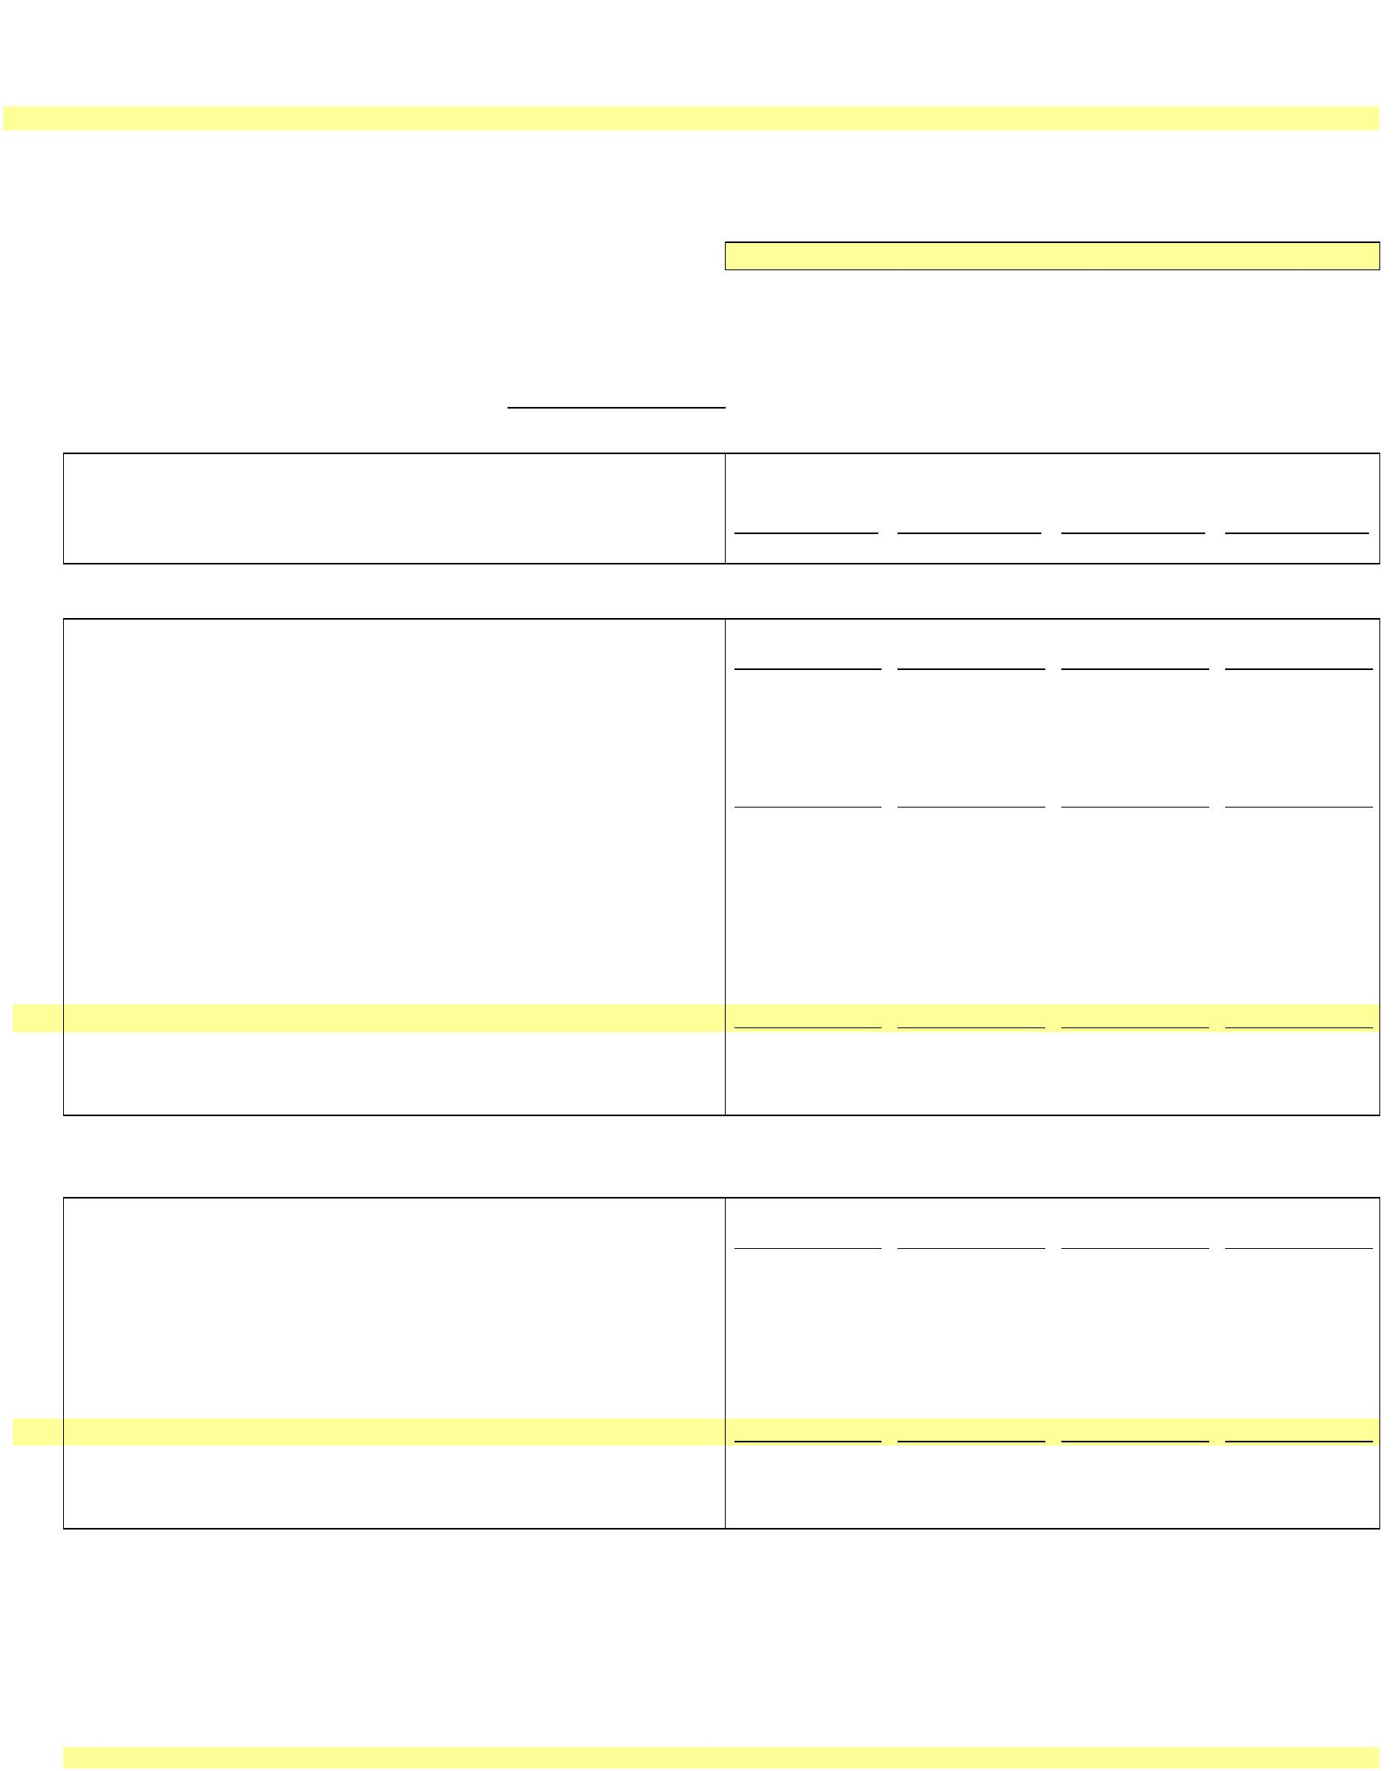

**Schedule B3 - Depreciation and Amortization Rates**

**NEW YORK POWER AUTHORITY**

**Based on Plant Data Year Ending December 31, 2019 for General and Intangible Plant and December 31, 2020 for Transmission Plant (as filed with FERC in 2022 in Docket ER22-2581)**

Line No.

FERC Account

FERC Account Description

Rate (Annual) Percent 1/

St.

Blenheim-

Gilboa

J. A.

FitzPatrick

Massena-

Marcy

Marcy-

South

Long Island

Sound Cable

New Project

2/

**TRANSMISSION PLANT**

Headquarters

Lawrence/FDR Niagara

1

350

Land Rights

2

3

351.1

Computer Hardware

20.00%

20.00%

10.00%

20.00%

20.00%

10.00%

1.87%

2.73%

1.63%

2.26%

2.32%

1.03%

2.47%

0.77%

20.00%

20.00%

10.00%

1.78%

2.80%

1.65%

2.30%

2.25%

20.00%

20.00%

20.00%

10.00%

20.00%

20.00%

20.00%

10.00%

20.00%

20.00%

20.00%

10.00%

1.92%

2.67%

2.27%

2.65%

2.45%

1.69%

2.44%

1.33%

351.2

Computer Software

20.00%

10.00%

1.60%

2.79%

1.65%

1.71%

1.95%

20.00%

10.00%

1.83%

2.83%

1.84%

1.75%

2.83%

20.00%

10.00%

0.89%

1.67%

4

351.3

Communications Equipment

Structures and Improvements

Station Equipment

5

352

6

353

2.90%

2.12%

2.28%

2.43%

1.76%

2.91%

1.42%

7

354

Towers and Fixtures

0.87%

1.37%

8

355

Poles and Fixtures

9

356

Overhead Conductor and Devices

Underground Conduit

Underground Conductor and Devices

Roads and Trails

10

11

12

357

0.32%

0.74%

358

359

0.53%

1.02%

0.11%

1.23%

**GENERAL PLANT**

13

14

15

16

17

18

19

20

21

22

23

24

390

391

391.2

391.3

392

393

394

395

396

397

398

Structures & Improvements

Office Furniture & Equipment

Computer Equipment 5 yr

Computer Equipment 10 yr

Transportation Equipment

Stores Equipment

1.37%

10.00%

20.00%

10.00%

1.69%

10.00%

20.00%

10.00%

5.58%

2.84%

3.92%

5.17%

6.19%

10.00%

1.09%

6.67%

1.53%

10.00%

20.00%

10.00%

4.30%

1.61%

10.00%

20.00%

10.00%

6.30%

3.08%

5.11%

5.11%

2.28%

10.00%

5.02%

6.67%

1.70%

10.00%

20.00%

10.00%

5.53%

1.75%

10.00%

20.00%

10.00%

10.00%

3.33%

5.00%

5.00%

8.33%

10.00%

5.00%

6.67%

10.00%

20.00%

10.00%

10.00%

20.00%

10.00%

10.00%

20.00%

10.00%

10.00% 4/

2.11%

Tools, Shop & Garage Equipment

Laboratory Equipment

4.64%

2.55%

4.26%

5.68%

10.00%

4.42%

6.67%

3.71%

5.00% 4/

4.78%

Power Operated Equipment

Communication Equipment

Miscellaneous Equipment 4/

3.55%

8.33% 4/

10.00%

4.000%

6.67%

10.00%

6.67%

10.00%

5.00% 4/

6.67%

10.00%

10.00%

6.67%

399

Other Tangible Property

6.67%

**INTANGIBLE PLANT**

25

26

27

28

29

303

Miscellaneous Intangible Plant

5 Year Property

20.00%

14.29%

10.00%

20.00%

14.29%

10.00%

20.00%

14.29%

10.00%

20.00%

14.29%

10.00%

20.00%

14.29%

10.00%

20.00%

14.29%

10.00%

20.00%

14.29%

10.00%

20.00%

14.29%

10.00%

20.00%

14.29%

10.00%

7 Year Property

10 Year Property

Transmission facility Contributions in Aid of Construction 3/

**Notes:**

1/ Where no depreciation rate is listed for a transmission or general plant account for a particular project,

NYPA lacks depreciable plant as of 12/31/2019 or 2020 (or all plant has been fully depreciated). If new plant corresponding to these

accounts is subsequently added for the relevant projects, the "New Project" depreciation rate for the relevant account will apply.

2/ New Project transmission and general depreciation rates are equal to the life of the asset adjusted for salvage.

3/ In the event a Contribution in Aid of Construction (CIAC) is made for a transmission facility, the transmission

depreciation rates above will be weighted based on the relative amount of underlying plant booked to the accounts

shown in lines 1-9 above and the weighted average depreciation rate will be used to amortize the CIAC. The life of a

facility subject to a CIAC will be equivalent to the depreciation rate calculated above, i.e., 100% deprecation rate = life

in years. The estimated life of the facility or rights associated with the facility will not change over the life of a CIAC

without prior FERC approval.

4/ NYPA has replaced the anomalous rates for these assets with New Project rates.

These depreciation rates will not change absent the appropriate filing at FERC.



X

**NEW YORK POWER AUTHORITY**

**TRANSMISSION REVENUE REQUIREMENT**

**YEAR ENDING DECEMBER 31, ____**

**SCHEDULE C1**

**TRANSMISSION - RATE BASE CALCULATION**

**GENERAL PLANT**

**TRANSMISSION**

**ALLOCATOR**

**[Schedule E1]**

(3)

**ALLOCATED TO**

**TRANSMISSION ($)**

**(2) * (3)**

**TOTAL**

**TRANSMISSION ($)**

**(1) + (4)**

**RATE OF**

**RETURN**

**[Schedule D1]**

(6)

**RETURN ON**

**RATE BASE**

**(5) * (6)**

**RATE BASE**

**TRANSMISSION**

**PLANT ($)**

(1)

**TOTAL**

**GENERAL PLANT ($)**

(2)

(4)

(5)

(7)

1

2

**A) Net Electric Plant in Service**

**B) Rate Base Adjustments**

-

1/

-

2/

-

-

-

3

4

5

6

7

8

9

10

**\* Cash Working Capital (1/8 O&M)**

**\* Marcy South Capitalized Lease**

**\* Materials & Supplies**

**\* Prepayments**

**\* Land Held for Future Use**

**\* CWIP**

-

-

-

-

-

-

-

-

3/

4/

5/

6/

8/

7/

7/

7/

-

-

-

-

-

-

-

-

-

**\* Regulatory Asset**

**\* Abandoned Plant**

11 **TOTAL**

**(sum lines 1-10)**

**-**

**-**

-

**-**

**-**

-

**-**

**1/ Schedule B2; Net Electric Plant in Service; Ln 18**

**2/ Schedule B2; Net Electric Plant in Service; Ln 28**

**3/ 1/8 of (Schedule A1; Col 5, Ln 7 + Schedule A2; Col 5, Ln 5) [45 days]**

**4/ WP-BD; Average of Year-end Unamortized Balances, Col 5**

**5/ Average of 13 month inventory Materials & Supplies (WP-CA). NYPA Form 1 Equivalent, page 227, Ln 12, year ending balance in columns b and c.**

**6/ WP-CB; Col 3, Ln 14**

**7/ CWIP, Regulatory Asset and Abandoned Plant are zero until an amount is authorized by FERC as shown below. Year end CWIP amount is shown in the NYPA Form 1 Equivalent, page 216, line 1**

Docket Number Authorized Amount

…

…

**8/ WP-CC, Col. 16, Ln 2**

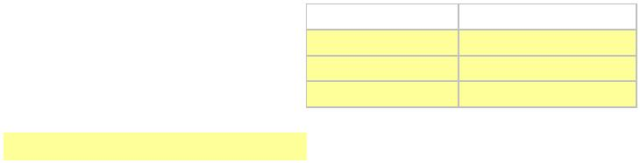

X

**NEW YORK POWER AUTHORITY**

**TRANSMISSION REVENUE REQUIREMENT**

**YEAR ENDING DECEMBER 31, ____**

**SCHEDULE D1**

**CAPITAL STRUCTURE AND COST OF CAPITAL**

**CAPITALIZATION RATIO**

**COST RATE**

**WEIGHTED**

**Line No.**

**TITLE**

**from WP-DA 1/**

**(1)**

**from WP-DA 2/**

**(2)**

**AVERAGE**

**(3)**

**SOURCE/COMMENTS**

**(4)**

**1**

**2**

**3**

**LONG-TERM DEBT**

**COMMON EQUITY**

**0.00%**

**0.00%**

**0.00%**

**-**

**-**

**-**

**-**

Col (1) * Col (2)

**9.45%**

Col (1) * Col (2)

**TOTAL CAPITALIZATION**

Col (3); Ln (1) + Ln (2)

Notes

1/ The Common Equity share listed in Col (1) is capped at 50%. The cap may only be changed pursuant to an FPA Section 205 or 206 filing to FERC.

The Long-Term Debt share is calculated as 1 minus the Common Equity share.

2/ The ROE listed in Col (2) Ln (2) is the base ROE plus 50 basis-point incentive for RTO participation. ROE may only be changed pursuant to an FPA

Section 205 or 206 filing to FERC.



X

**NEW YORK POWER AUTHORITY**

**TRANSMISSION REVENUE REQUIREMENT**

**YEAR ENDING DECEMBER 31, ____**

**SCHEDULE D2**

**PROJECT SPECIFIC CAPITAL STRUCTURE AND COST OF CAPITAL 3/**

**CAPITALIZATION RATIO**

**COST RATE**

**from WP-DA**

**(2)**

**WEIGHTED**

**AVERAGE**

**(3)**

**Line No.**

**TITLE**

**from WP-DA**

**(1)**

**SOURCE/COMMENTS**

**(4)**

Project 1 - Marcy South Series Compensation - Capital Structure

**1**

**2**

**LONG-TERM DEBT**

**-**

**-**

**-**

1/

1/

**-**

**-**

**-**

**-**

**-**

**-**

**-**

**-**

Col (1) * Col (2)

**COMMON EQUITY**

**9.45%**

2/

Col (1) * Col (2)

**3**

**TOTAL CAPITALIZATION**

**PROJECT NET PLANT**

Col (3); Ln (1) + Ln (2)

F1-Proj RR, Col (7), Ln (1b)

Col (3) Ln (4) * WP-DA Col (7) Ln (4)

Col (3); Ln (3) * Ln (4)

**4**

**5**

**PROJECT BASE RETURN**

**PROJECT ALLOWED RETURN**

**PROJECT SPECIFIC RETURN ADJUSTMENT**

**6**

**1A**

Col (3); Ln (6) - Ln (5)

Project 2 - AC Project Segment A (Central East Energy Connect) - Capital Structure 4/

**1**

**2**

**LONG-TERM DEBT**

**COMMON EQUITY**

**-**

**-**

**-**

**-**

**-**

Col (1) * Col (2)

Col (1) * Col (2)

**9.95%**

**3**

**4**

**TOTAL CAPITALIZATION**

**-**

**-**

**-**

**-**

**-**

**-**

Col (3); Ln (1) + Ln (2)

**PROJECT NET PLANT**

F1-Proj RR, Col (7), Ln (1c)

Col (3) Ln (4) * WP-DA Col (7) Ln (4)

Col (3); Ln (3) * Ln (4)

**5**

**PROJECT BASE RETURN**

**6**

**PROJECT ALLOWED RETURN**

**PROJECT SPECIFIC RETURN ADJUSTMENT**

**2B**

Col (3); Ln (6) - Ln (5)

Project 3 - SPC Project - Capital Structure 5/

**1**

**2**

**LONG-TERM DEBT**

**COMMON EQUITY**

**-**

**-**

**-**

**-**

**-**

Col (1) * Col (2)

Col (1) * Col (2)

**9.95%**

**3**

**4**

**TOTAL CAPITALIZATION**

**-**

**-**

**-**

**-**

**-**

**-**

Col (3); Ln (1) + Ln (2)

**PROJECT NET PLANT**

F1-Proj RR, Col (7), Ln (1d)

Col (3) Ln (4) * WP-DA Col (7) Ln (4)

Col (3); Ln (3) * Ln (4)

**5**

**PROJECT BASE RETURN**

**6**

**PROJECT ALLOWED RETURN**

**PROJECT SPECIFIC RETURN ADJUSTMENT**

**3C**

Col (3); Ln (6) - Ln (5)

Project 4 - Propel NY Project - Capital Structure 6/

**1**

**2**

**LONG-TERM DEBT**

**COMMON EQUITY**

**-**

**-**

**-**

**-**

**-**

Col (1) * Col (2)

Col (1) * Col (2)

**10.20%**

**3**

**4**

**TOTAL CAPITALIZATION**

**-**

**-**

**-**

**-**

**-**

**-**

Col (3); Ln (1) + Ln (2)

**PROJECT NET PLANT**

F1-Proj RR, Col (7), Ln (1e)

Col (3) Ln (4) * WP-DA Col (7) Ln (4)

Col (3); Ln (3) * Ln (4)

**5**

**PROJECT BASE RETURN**

**6**

**PROJECT ALLOWED RETURN**

**PROJECT SPECIFIC RETURN ADJUSTMENT**

**4C**

Col (3); Ln (6) - Ln (5)

**A**

**Total Project Adjustments**

**-**

Notes

1/ The MSSC Common Equity share listed in Col (1) is capped at 53%. The cap may only be changed pursuant to an FPA Section 205 or 206 filing to FERC.

The MSSC Long-Term Debt share is calculated as 1 minus the Common Equity share.

2/ The MSSC ROE listed in Col (2) Ln (2) is the base ROE plus 50 basis-point incentive Congestion Relief Adder. ROE may only be changed pursuant to an FPA

Section 205 or 206 filing to FERC.

3/ Additional project-specific capital structures added to this Schedule D2 must be approved by FERC. The cost of long-term debt and common equity

for any such project shall reflect the cost rates in Col (2), Lns (1) and (2) unless a different cost rate is approved by FERC.

4/ The AC Project Segment A cost containment impacts, if any, will be computed on a workpaper and provided as supporting documentation for each applicable Annual Update

consistent with the NYPA Protocols. The ROE listed in Col (2) for AC Project Segment A consists of a 50 basis point ROE Risk Adder per the Commission's approval in Docket No. EL19-88,

added to the 9.45% ROE applicable to NYPA’s other transmission assets. See Schedule D1 and Project 1, above.

5/ The Smart Path Connect Project cost containment impacts, if any, will be computed on a workpaper and provided as supporting documentation for each applicable Annual Update,

consistent with the Commission's Order dated 07/05/22 in Docket No. ER22-1014. The ROE listed in Col (2) for the Smart Path Connect Project consists of a 50 basis point ROE Risk Adder

per the Commission's approval in Docket No. ER 22-1014 added to the 9.45% ROE applicable to NYPA's other transmission assets. See Schedule D1 and Project 1, above.

6/ The Propel NY Project cost containment impacts, if any, will be computed on a workpaper and provided as supporting documentation for each applicable Annual Update,

consistent with the Commission's Order dated 07/11/24 in Docket No. EL24-108. The ROE listed in Col (2) for the Propel NY Project consists of a 75 basis point ROE Risk Adder

per the Commission's approval in Docket No. EL24-108 added to the 9.45% ROE applicable to NYPA's other transmission assets. See Schedule D1 and Project 1, above.

...



X

**NEW YORK POWER AUTHORITY**

**TRANSMISSION REVENUE REQUIREMENT**

**YEAR ENDING DECEMBER 31, ____**

**SCHEDULE E1**

**A&G AND GENERAL PLANT ALLOCATOR**

**Line**

**No.**

**RATIO**

**From WP-EA**

**ALLOCATED TO**

**TRANSMISSION**

**(3)**

**SOURCE/**

**COMMENTS**

**DESCRIPTION**

**(1)**

**(2)**

**(4)**

**1**

**2**

**3**

PRODUCTION

0.00%

0.00%

**0.00%**

INCLUDED TRANSMISSION

**0.00%**

Col (2); Ln (2)

**TOTAL**



X

**Schedule F1**

**Project Revenue Requirement Worksheet**

**NEW YORK POWER AUTHORITY**

**YEAR ENDING DECEMBER 31, ____**

**Line**

**No.**

**Item**

**Page, Line, Col.**

**Transmission ($)**

(2)

**Allocator**

(3)

(1)

1

1a

1b

2

Gross Transmission Plant - Total

Schedule B2, line 18, col 1 (Note A)

Schedule B2, line 18, col 2

Schedule C1, lines 8, 9 & 10 (Note B)

Line 1 minus Line 1a plus Line 1b

-

-

-

-

Transmission Accumulated Depreciation

Transmission CWIP, Regulatory Asset and Abandoned Plant

Net Transmission Plant - Total

O&M TRANSMISSION EXPENSE

Total O&M Allocated to Transmission

3

Schedule A1, line 7, col 5 and Schedule A2, line 5, Col 5

-

GENERAL DEPRECIATION EXPENSE

Total General Depreciation Expense

(Note G)

Schedule B1 line 6, col 5

5

6

-

**Annual Allocation Factor for Expenses**

([line 3 + line 5] divided by line 1, col 2)

**-**

**-**

**-**

RETURN

Return on Rate Base

7

8

Schedule C1 line 11, col 7

-

`

**Annual Allocation Factor for Return on Rate Base**

(line 7 divided by line 2 col 2)

**-**



**Schedule F1**

**Project Revenue Requirement Worksheet**

**NEW YORK POWER AUTHORITY**

**(1)**

**(2)**

**(3)**

**(4)**

**(5)**

**(6)**

**(7)**

**(8)**

**(9)**

**(10)**

**(11)**

**(12)**

**(13)**

**(14)**

**(14a)**

**(15)**

**(16)**

**(17)**

**PROJECT**

**SPECIFIC**

**Annual**

**Allocation**

**Factor for**

**Return**

**Project**

**Incentive**

**Return in**

**basis**

**CAPITAL**

**Annual**

**Allocation for**

**Expenses ($)**

**Depreciation/**

**Amortization**

**Expense ($)**

**STRUCTURE**

**AND COST OF**

**CAPITAL**

**Total Annual**

**Revenue**

**Line**

**No.**

**Project Gross Plant Project Accumulated**

**Annual Allocation**

**Factor for Expenses**

**Project Net Plant**

**($)**

**Annual Return Charge**

**($)**

**Annual Revenue**

**Requirement ($)**

**Incentive**

**Return ($)**

**True-Up**

**Net Revenue**

**Project Name and #**

**Type**

**($)**

**Depreciation ($)**

**Points**

**Discount**

**Requirement ($) Adjustment ($) Requirement ($)**

Per FERC

(Schedule F2,

order (Note Line 10 * (Col.

(Sum Col. 11 + 13

(Note C)

Page 1 line 6

Col. 3 * Col. 5

(Note D)

(Page 1, line 8)

(Col. 7 * Col. 8)

(Note E)

(Sum Col. 6, 9 & 10)

H)

12/100)* Col. 7)

(Note I)

Schedule D2

+ 14 +14a)

(Note F)

Sum Col. 15 + 16

**1a**

NTAC Facilities

MSSC

AC Project Segment A (Central East Energy Connect)

Smart Path Connect - NTAC

Propel NY

-

-

-

-

-

-

-

-

-

-

0.0000%

0.0000%

0.0000%

0.0000%

0.0000%

0.0000%

0.0000%

0.0000%

0.0000%

0.0000%

0.0000%

0.0000%

0.0000%

0.0000%

0.0000%

0.0000%

0.0000%

0.0000%

0.0000%

-

-

-

-

-

-

-

-

-

-

-

-

-

-

-

-

-

-

-

-

-

-

-

-

0.0000%

0.0000%

0.0000%

0.0000%

0.0000%

0.0000%

0.0000%

0.0000%

0.0000%

0.0000%

0.0000%

0.0000%

0.0000%

0.0000%

0.0000%

0.0000%

0.0000%

0.0000%

0.0000%

-

-

-

-

-

-

-

-

-

-

-

-

-

-

-

-

-

-

-

-

-

-

-

-

-

-

-

-

-

-

-

-

-

-

-

-

-

-

-

-

-

-

-

-

-

-

-

-

-

-

-

-

-

-

-

-

-

-

-

-

-

-

-

-

-

-

-

-

-

-

-

-

-

-

-

-

-

-

-

-

-

-

-

-

-

-

-

-

-

-

-

-

-

-

-

-

-

-

-

-

-

-

-

-

**1b**

**1c**

**1d**

**1e**

**1f**

**1g**

**1h**

**1i**

**1j**

**1k**

**1l**

**1m**

**1n**

**1o**

-

-

-

-

-

-

-

-

2

Total

-

-

-

-

-

-

-

-

-

Note

Letter

A

Gross Transmission Plant that is included on Schedule B2, Ln 18, Col 1.

Inclusive of any CWIP, Unamortized Regulatory Asset or Unamortized Abandoned Plant balances included in rate base when authorized by FERC order.

B

C

Project Gross Plant is the total capital investment for the project calculated in the same method as the gross plant value in page 1, line 1 . This value includes subsequent capital investments required to maintain the facilities to their original capabilities.

Gross plant does not include CWIP, Unamortized Regulatory Asset or Unamortized Abandoned Plant.

D

E

Project Net Plant is the Project Gross Plant Identified in Column 3 less the associated Accumulated Depreciation in page 2, column 4. Net Plant includes any FERC approved CWIP, Unamortized Abandoned Plant and Regulatory Asset.

Project Depreciation Expense is the amount in Schedule B1, Ln 6, Col. 2 that is associated with the specified project. Project Depreciation Expense includes the amortization of Abandoned Plant and any FERC approved Regulatory Asset.

However, if FERC grants accelerated depreciation for a project the depreciation rate authorized by FERC will be used instead of the rates shown on Schedule B3 for all other projects.

F

Reserved

G

The Total General and Common Depreciation Expense excludes any depreciation expense directly associated with a project and thereby included in page 2 column 8.

Requires approval by FERC of incentive return applicable to the specified project(s). A negative number of basis points may be entered to reduce the ROE applicable to a project if a FERC order specifies a lower return for that project.

The discount is the reduction in revenue, if any, that NYPA agreed to, for instance, to be selected to build facilities as the result of a competitive process and equals the amount by which the annual revenue requirement is reduced from the ceiling rate

H

I

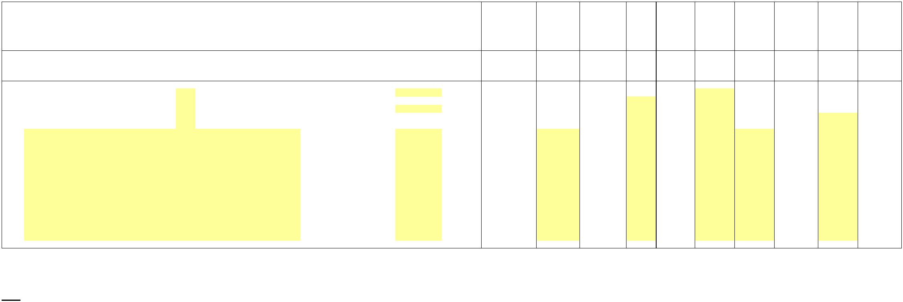

X

**Schedule F2**

**Incentives**

**NEW YORK POWER AUTHORITY**

**YEAR ENDING DECEMBER 31, ____**

**Line**

**No.**

**Item**

**Reference**

$

1

Rate Base

Schedule C1, line 11, Col. 5

-

2

100 Basis Point Incentive Return

$

**Weighted**

**Cost**

-

**%**

**Cost**

3

Long Term Debt

(Schedule D1, line 1)

-

-

-

Cost = Schedule E, line 2, Cost

plus .01

4

5

6

Common Stock

(Schedule D1, line 2)

10.45%

-

-

Total (sum lines 3-4)

100 Basis Point Incentive Return multiplied by Rate Base (line 1 * line 5)

-

7

8

9

Return (Schedule C1, line 11, Col. 7)

Incremental Return for 100 basis point increase in ROE

Net Transmission Plant

-

-

-

-

(Line 6 less line 7)

(Schedule C1, line 1, col. (1)

(Line 8 / line 9)

10 Incremental Return for 100 basis point increase in ROE divided by Rate Base

Notes:

A

Line 5 includes a 100 basis point increase in ROE that is used only to determine the increase in return and income taxes associated with

a 100 basis point increase in ROE. Any actual incentive is calculated on Schedule F1 and must be approved by FERC.

For example, if FERC were to grant a 137 basis point ROE incentive, the increase in return and taxes for a 100 basis point

increase in ROE would be multiplied by 137 on Schedule F1, Col. 13.



X

**Schedule F3**

**Project True-Up**

**Incentives**

**YEAR ENDING DECEMBER 31, ____**

($)

(1)

(2)

(3)

(4)

(5)

Actual

(6)

(7)

(8)

(9)

(10)

True-Up

Adjustment

Principal

Applicable

Interest

True-Up

NTAC ATRR

or Project

Number

Net

Adjustment

Interest

Total

Line

No.

Project

Name

Actual Revenues

Received (Note 1)

Revenue

Prior Period

Adjustment

Rate on

True-Up

Requirement (Note 2)

Under/(Over)

Under/(Over)

Under/(Over)

Adjustment

(Note A)

(Col. (6) + Col. (7)) x

Col. (8) x 24 months

Col. (6) + Col. (7)

+ Col. (9)

Amount Actually

Received for

Transmission Service

Schedule F2 Using Actual

Cost Data

Col. (5) - Col. (4)

Line 25, Col. (e)

Line 24

1a NTAC Facilities

1b MSSC

-

-

-

-

-

-

-

-

-

-

-

-

-

-

-

-

-

-

-

-

1c AC Project Segment A (Central East Energy Connect)

1d Smart Path Connect - NTAC

1e Propel NY

…

…

2

3

Subtotal

-

-

-

-

Under/(Over) Recovery

Notes:

1) For all projects and NTAC ATRR, the Actual Revenues Received are the actual revenues NYPA receives from the NYISO in that calendar year. If NYISO does not break out the revenues per project,

the Actual Revenues Received will be allocated pro rata to each project based on their Actual Net Revenue Requirement in col (5).

2) Schedule F1, Page 2 of 2, col (15).

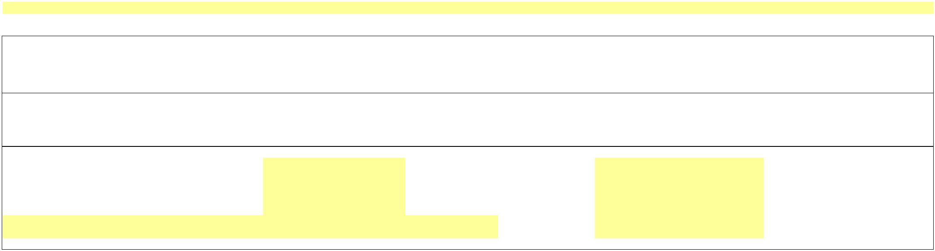

**Schedule F3**

**Project True-Up**

**Incentives**

**FERC Refund Interest Rate**

Interest Rates under

Section 35.19(a)

4

Interest Rate (Note A):

January

February

March

Year

5

6

7

8

April

9

May

10

11

12

13

14

15

16

17

18

19

20

21

22

23

June

July

August

September

October

November

December

January

February

March

April

May

June

July

-

-

24

Avg. Monthly FERC Rate

-

**Prior Period Adjustments**

(a)

(b)

(c)

(d)

(e)

Project or

Schedule 1

Adjustment

A Description of the Adjustment

Amount

In Dollars

Interest

(Note A)

Total Adjustment

Col. (c) + Col. (d)

25

-

-

-

-

-

-

-

25a

25b

25c

…

…

26

Total

Notes:

A

Prior Period Adjustments are when an error is discovered relating to a prior true-up or refunds/surcharges ordered by FERC. The interest on the Prior Period Adjustment excludes

interest for the current true up period, because the interest is included in Ln 25 Col (d).

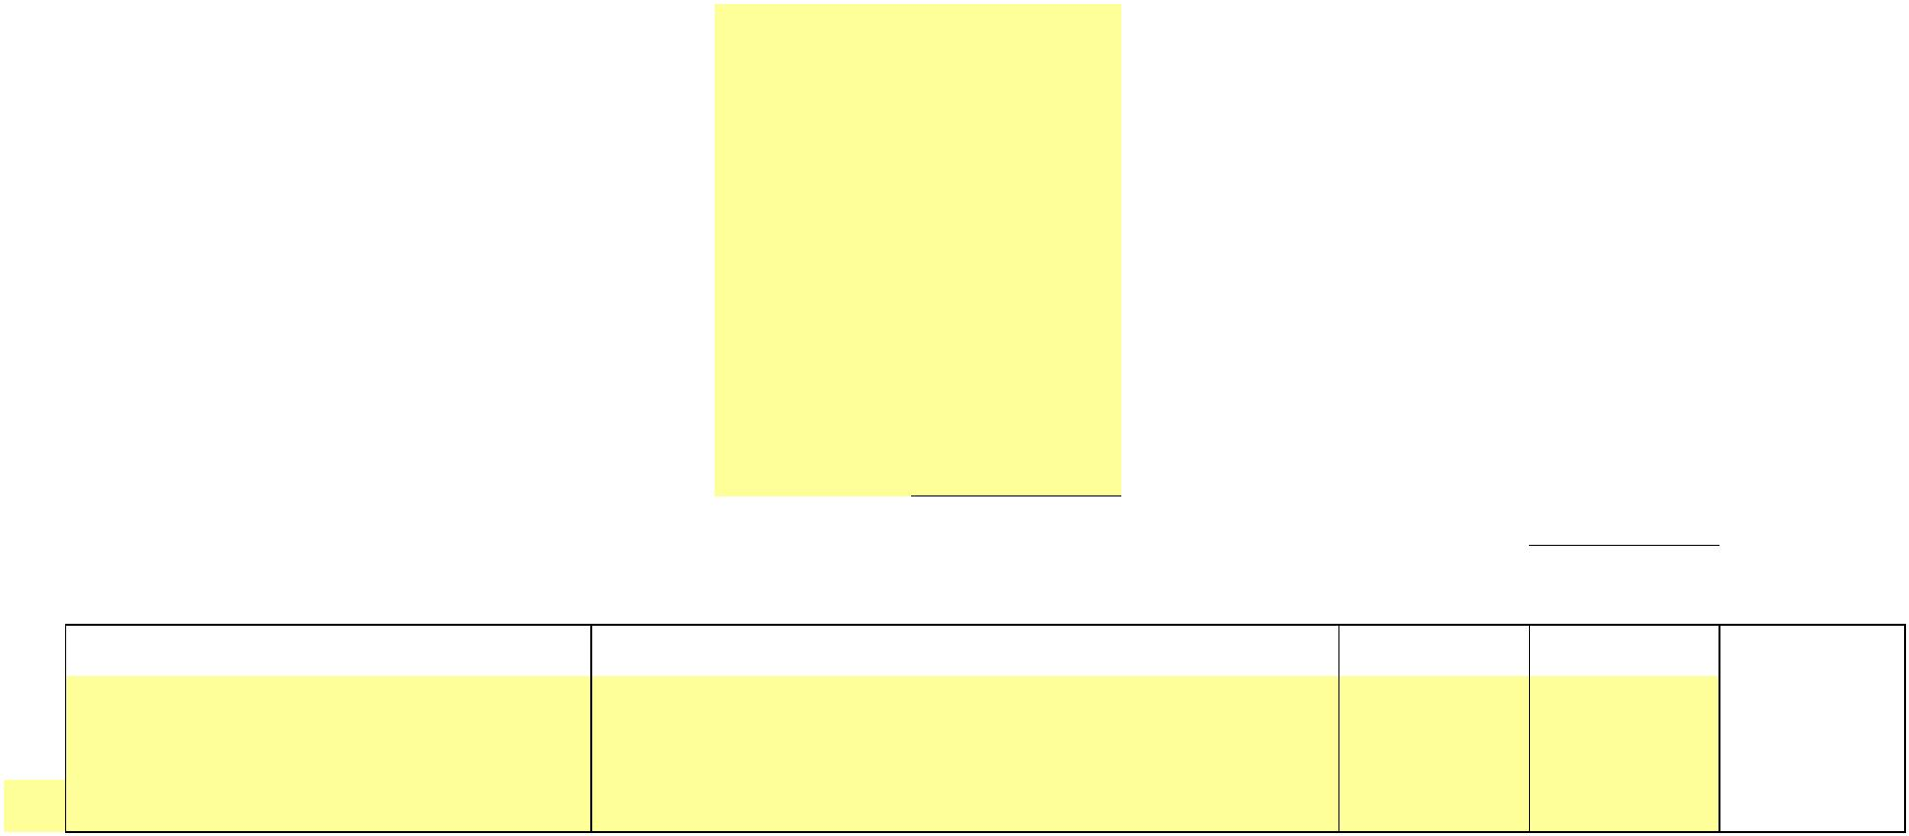

X

**NEW YORK POWER AUTHORITY**

**TRANSMISSION REVENUE REQUIREMENT**

**YEAR ENDING DECEMBER 31, ____**

**WORK PAPER AA**

**Operation and Maintenance Summary**

**(1)**

**(2)**

**(3)**

**(4)**

**(5)**

**(6)**

**OVERALL**

**RESULT**

**Major**

Line No.**Amount ($)**

**PRODUCTION**

**TRANSMISSION ADMIN & GENERAL**

**Category**

1a

1b

1c

…

**555 - OPSE-Purchased Power**

**501 - Steam Product-Fuel**

**565 - Trans-Xmsn Elect Oth**

**…**

-

-

-

-

-

-

-

-

-

-

-

-

-

-

-

-

-

-

-

-

-

-

-

-

-

-

-

-

-

-

-

-

-

-

**-**

**-**

**-**

**-**

2a

2b

2c

2d

2e

2f

2g

2h

2i

2j

2k

2l

2m

2n

2o

2p

2q

2r

**506 - SP-Misc Steam Power**

**535 - HP-Oper Supvr&Engrg**

**537 - HP-Hydraulic Expense**

**538 - HP-Electric Expenses**

**539 - HP-Misc Hyd Pwr Gen**

**546 - OP-Oper Supvr&Engrg**

**548 - OP-Generation Expens**

**549 - OP-Misc Oth Pwr Gen**

**560 - Trans-Oper Supvr&Eng**

**561 - Trans-Load Dispatcng**

**562 - Trans-Station Expens**

**566 - Trans-Misc Xmsn Exp**

**905 - Misc. Customer Accts. Exps**

**Contribution to New York State**

**916 - Misc. Sales Expense**

**920 - Misc. Admin & Gen'l Salaries**

**921 - Misc. Office Supp & Exps**

**922 - Administrative Expenses Transferred**

**923 - Outside Services Employed**

**924 - A&G-Property Insurance**

**925 - A&G-Injuries & Damages Insurance**

**926 - A&G-Employee Pension & Benefits**

**926 - A&G-Employee Pension & Benefits(PBOP)**

**928 - A&G-Regulatory Commission Expense**

**930 - Obsolete/Excess Inv**

2s

2t

2u

2v

2w

2x

2y

2z

2aa

2ab

2ac

2ad

**930.1-A&G-General Advertising Expense**

**930.2-A&G-Miscellaneous & General Expense**

**930.5-R & D Expense**

**931 - Rents**

**Operations**

**935 - A&G-Maintenance of General Plant**

…

3a

3b

3c

3d

3e

3f

3g

3h

3i

3j

3k

3l

3m

3n

3o

3p

3q

**…**

-

-

-

-

-

-

-

-

-

-

-

-

-

-

-

-

-

-

**-**

**545 - HP-Maint Misc Hyd Pl**

**512 - SP-Maint Boiler Plt**

**514 - SP-Maint Misc Stm Pl**

**541 - HP-Maint Supvn&Engrg**

**542 - HP-Maint of Struct**

**543 - HP-Maint Res Dam&Wtr**

**544 - HP-Maint Elect Plant**

**551 - OP-Maint Supvn & Eng**

**552 - OP-Maint of Struct**

**553 - OP-Maint Gen & Elect**

**554 - OP-Maint Oth Pwr Prd**

**568 - Trans-Maint Sup & En**

**569 - Trans-Maint Struct**

**570 - Trans-Maint St Equip**

**571 - Trans-Maint Ovhd Lns**

**572 - Trans-Maint Ungrd Ln**

**573 - Trans-Maint Misc Xmn**

**Maintenance**

…

4a

…

**…**

-

-

**-**

**-**

**403 - Depreciation Expense**

**…**

**-**

**-**

5

**TOTALS**

**-**

**-**

**-**

**-**

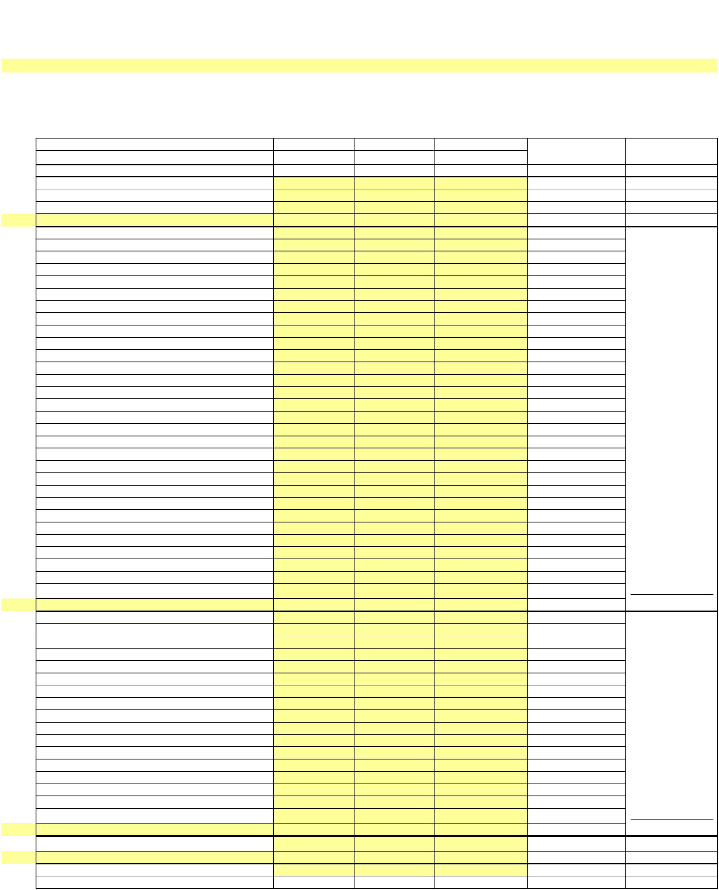

X

X

**NEW YORK POWER AUTHORITY**

**TRANSMISSION REVENUE REQUIREMENT**

**YEAR ENDING DECEMBER 31, ____**

**WORK PAPER AB**

**Operation and Maintenance Detail**

**FERC by accounts and profit center**

(1)

(2)

(3)

(4)

(5)

(6)

(7)

(8)

(9)

(10)

(11)

(12)

(13)

(14)

(15)

(16)

(17)

(18)

(19)

Amount ($)

0100/105

Blenheim-Gilboa

0100/110

St. Lawrence

0100/115

Niagara

0100/120

Poletti

0100/122

Astoria Energy II

0100/125

Flynn

0100/130

Jarvis

0100/135

Crescent

0100/140

Vischer Ferry

0100/145

Ashokan

0100/150

Kensico

0100/155

Hell Gate

0100/156

Harlem River

0100/157

Vernon Blvd.

0100/158

23rd & 3rd (Gowanus)

0100/159

N 1st &Grand (Kent)

0100/160

Pouch Terminal

Line No.

FERC G/L Accounts

403

1a

1b

-

-

-

-

-

-

-

-

-

-

-

-

-

-

-

-

-

-

-

-

-

-

-

-

-

-

-

-

-

-

-

-

-

-

-

-

-

-

-

-

-

-

-

-

-

-

Depreciation Expense

Steam Product-Fuel

SP-Misc Steam Power

SP-Maint Boiler Plt

501

506

512

514

535

537

538

539

541

542

543

544

545

546

548

549

551

552

553

554

555

560

561

562

565

566

568

569

570

571

572

573

905

916

920

921

922

923

924

925

926

926

928

930

931

1c

1d

1e

SP-Maint Misc Stm Pl

HP-Oper Supvr&Engrg

HP-Hydraulic Expense

HP-Electric Expenses

HP-Misc Hyd Pwr Gen

HP-Maint Supvn&Engrg

HP-Maint of Struct

1f

1g

1h

1i

1j

1k

1l

HP-Maint Res Dam&W tr

HP-Maint Elect Plant

HP-Maint Misc Hyd Pl

OP-Oper Supvr&Engrg

OP-Generation Expens

OP-Misc Oth Pwr Gen

1m

1n

1o

1p

1q

1r

OP-Maint Supvn

OP-Maint of Struct

OP-Maint Gen Elect

&

Eng

1s

1t

&

1u

OP-Maint Oth Pwr Prd

OPSE-Purchased Power

Trans-Oper Supvr&Eng

Trans-Load Dispatcng

Trans-Station Expens

Trans-Xmsn Elect Oth

Trans-Misc Xmsn Exp

1v

1w

1x

1y

1z

1aa

1ab

1ac

1ad

1ae

1af

1ag

1ah

1ai

1ak

1al

1am

1an

1ao

1ap

1aq

1ar

1as

1at

1au

1av

1aw

1ax

1ay

…

Trans-Maint Sup

&

En

Trans-Maint Struct

Trans-Maint St Equip

Trans-Maint Ovhd Lns

Trans-Maint Ungrd Ln

Trans-Maint Misc Xmn

Misc. Customer Accts. Exps

Misc. Sales Expense

Misc. Admin

&

Gen'l Salaries

Exps

Misc. Office Supp

&

Administrative Expenses Transferred

Outside Services Employed

A&G-Property Insurance

A&G-Injuries

&

Damages Insurance

A&G-Employee Pension

A&G-Employee Pension

A&G-Regulatory Commission Expense

Obsolete/Excess Inv

Rents

&

&

Benefits(PBOP)

Benefits

930.5-R

930.1-A&G-General Advertising Expense

930.2-A&G-Miscellaneous General Expense

935 A&G-Maintenance of General Plant

&

D

Expense

&

-

2

**Contribution to New York State**

3

Overall Result

-

-

-

-

-

-

-

-

-

-

-

-

-

-

-

-

-

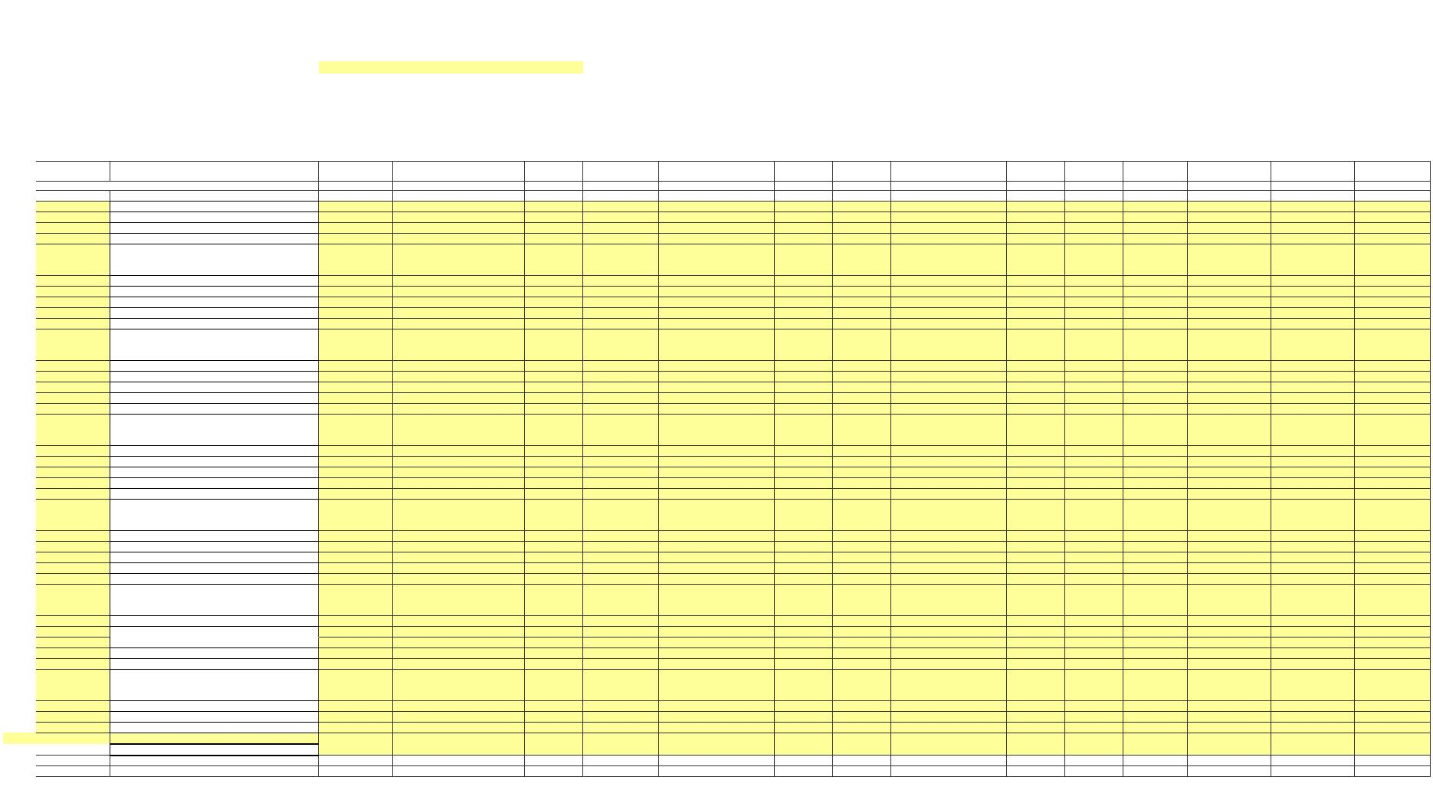

X

**FERC by accounts and profit center**

(1)

(2)

(20)

(21)

(22)

(23)

(24)

(25)

(26)

(27)

(28)

(29)

(30)

(31)

(32)

(33)

(34)

(35)

(36)

0100/161

Brentwood

0100/165

500MW Combined Cycle

0100/205

BG Trans

0100/210

JAF Trans

0100/215

0100/220

0100/225

0100/230

0100/235

Sound Cable

0100/240

ST Law Trans

0100/245

765 KV Trans

0100/255

HTP Trans

0100/305

DSM

0100/310

Headquarters

0100/320

Power for Jobs

0100/321

Recharge NY

0100/410

JAF

FERC G/L Accounts

403

IP3/Pol Trans Marcy/Clark TransMarcy South Trans Niagara Trans

-

-

-

-

-

-

-

-

-

-

-

-

-

-

-

-

-

-

-

-

-

-

-

-

-

-

-

-

-

-

-

-

-

-

-

-

-

-

-

-

-

-

-

-

-

-

Depreciation Expense

Steam Product-Fuel

SP-Misc Steam Power

SP-Maint Boiler Plt

501

506

512

514

535

537

538

539

541

542

543

544

545

546

548

549

551

552

553

554

555

560

561

562

565

566

568

569

570

571

572

573

905

916

920

921

922

923

924

925

926

926

928

930

931

SP-Maint Misc Stm Pl

HP-Oper Supvr&Engrg

HP-Hydraulic Expense

HP-Electric Expenses

HP-Misc Hyd Pwr Gen

HP-Maint Supvn&Engrg

HP-Maint of Struct

HP-Maint Res Dam&W tr

HP-Maint Elect Plant

HP-Maint Misc Hyd Pl

OP-Oper Supvr&Engrg

OP-Generation Expens

OP-Misc Oth Pwr Gen

OP-Maint Supvn

OP-Maint of Struct

OP-Maint Gen Elect

&

Eng

&

OP-Maint Oth Pwr Prd

OPSE-Purchased Power

Trans-Oper Supvr&Eng

Trans-Load Dispatcng

Trans-Station Expens

Trans-Xmsn Elect Oth

Trans-Misc Xmsn Exp

Trans-Maint Sup

&

En

Trans-Maint Struct

Trans-Maint St Equip

Trans-Maint Ovhd Lns

Trans-Maint Ungrd Ln

Trans-Maint Misc Xmn

Misc. Customer Accts. Exps

Misc. Sales Expense

Misc. Admin

&

Gen'l Salaries

Exps

Misc. Office Supp

&

Administrative Expenses Transferred

Outside Services Employed

A&G-Property Insurance

A&G-Injuries

&

Damages Insurance

A&G-Employee Pension

A&G-Employee Pension

A&G-Regulatory Commission Expense

Obsolete/Excess Inv

Rents

&

&

Benefits(PBOP)

Benefits

930.5-R

930.1-A&G-General Advertising Expense

930.2-A&G-Miscellaneous General Expense

935 A&G-Maintenance of General Plant

&

D

Expense

&

-

**Contribution to New York State**

Overall Result

-

-

-

-

-

-

-

-

-

-

-

-

-

-

-

-

-

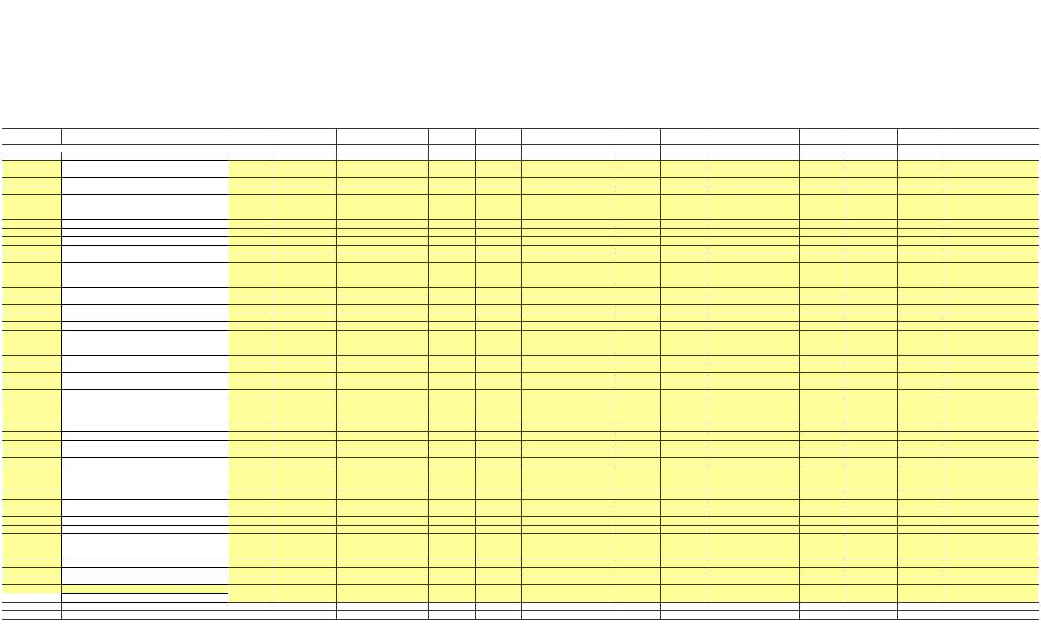

X

**FERC by accounts and profit center**

(1)

(2)

(37)

(38)

(39)

(40)

(41)

(42)

(43)

(44)

(45)

(46)

(47)

(48)

(49)

0100/600

SENY

0100/700

CES

0100/800

Canal Corp

0100/900

EV Charging Stations

0100/901

Large Energy Storage

0100/265

AC Proceedings

0100/322

GPSP

0100/350

Canals Reimagined

0100/550

CANALS CAPITAL

0100/701

NYEM

0100/902

Lrg Scale Renewables

**Overall Result**

FERC G/L Accounts

403

-

-

-

-

-

-

-

-

-

-

-

-

-

-

-

-

-

-

-

-

-

-

-

-

-

-

-

-

-

-

-

-

-

-

-

-

-

-

-

-

-

-

-

-

-

-

Depreciation Expense

Steam Product-Fuel

SP-Misc Steam Power

SP-Maint Boiler Plt

-

-

-

-

-

-

-

-

-

-

-

-

-

-

-

-

-

-

-

-

-

-

-

-

-

-

-

-

-

-

-

-

-

-

-

-

-

-

-

-

-

-

-

-

-

-

-

-

-

-

-

-

501

506

512

514

535

537

538

539

541

542

543

544

545

546

548

549

551

552

553

554

555

560

561

562

565

566

568

569

570

571

572

573

905

916

920

921

922

923

924

925

926

926

928

930

931

SP-Maint Misc Stm Pl

HP-Oper Supvr&Engrg

HP-Hydraulic Expense

HP-Electric Expenses

HP-Misc Hyd Pwr Gen

HP-Maint Supvn&Engrg

HP-Maint of Struct

HP-Maint Res Dam&W tr

HP-Maint Elect Plant

HP-Maint Misc Hyd Pl

OP-Oper Supvr&Engrg

OP-Generation Expens

OP-Misc Oth Pwr Gen

OP-Maint Supvn

OP-Maint of Struct

OP-Maint Gen Elect

&

Eng

&

OP-Maint Oth Pwr Prd

OPSE-Purchased Power

Trans-Oper Supvr&Eng

Trans-Load Dispatcng

Trans-Station Expens

Trans-Xmsn Elect Oth

Trans-Misc Xmsn Exp

Trans-Maint Sup

&

En

Trans-Maint Struct

Trans-Maint St Equip

Trans-Maint Ovhd Lns

Trans-Maint Ungrd Ln

Trans-Maint Misc Xmn

Misc. Customer Accts. Exps

Misc. Sales Expense

Misc. Admin

&

Gen'l Salaries

Exps

Misc. Office Supp

&

Administrative Expenses Transferred

Outside Services Employed

A&G-Property Insurance

A&G-Injuries

&

Damages Insurance

A&G-Employee Pension

A&G-Employee Pension

A&G-Regulatory Commission Expense

Obsolete/Excess Inv

Rents

&

&

Benefits(PBOP)

Benefits

930.5-R

930.1-A&G-General Advertising Expense

930.2-A&G-Miscellaneous General Expense

935 A&G-Maintenance of General Plant

&

D

Expense

&

-

**Contribution to New York State**

Overall Result

-

-

-

-

-

-

-

-

-

-

-

-

-

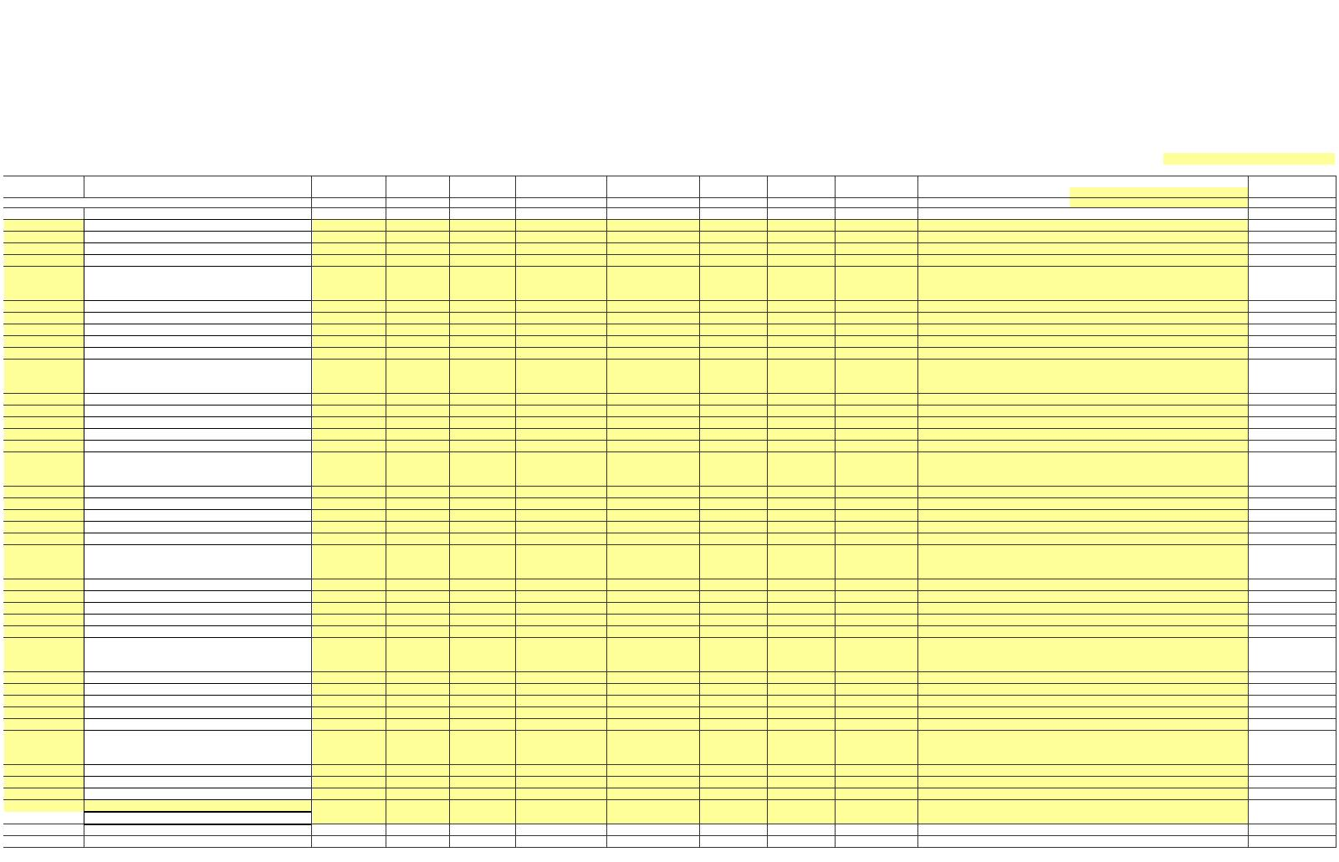

X

**NEW YORK POWER AUTHORITY**

**TRANSMISSION REVENUE REQUIREMENT**

**YEAR ENDING DECEMBER 31, ____**

**WORK PAPER AC**

**STEP-UP TRANSFORMERS O&M ALLOCATOR**

**Amount ($)**

**Ratio**

**Notes**

Line No.

(1)

(2)

**1**

Avg. Transmission Plant in Service

-

-

Sch B2; Col 1, Sum Ln 5, 6 and 10

Generator Step-Up Transformer Plant-in-

Service

**2**

**3**

**4**

**5**

Sch B2, Line 12, Col 1

Col 1, Ln 2 / Col 1, Ln 1

Sch A1; Col 4, Ln 4

**Ratio**

**-**

Transmission Maintenance

**Removed Step-up Transmission O&M**

-

**-**

Col 1, Ln 4 x Col 2, Ln 3



X

**NEW YORK POWER AUTHORITY**

**TRANSMISSION REVENUE REQUIREMENT**

**YEAR ENDING DECEMBER 31, ____**

**WORK PAPER AD**

**FACTS O&M ALLOCATOR**

**Amount ($)**

**Ratio**

**Notes**

Line No.

(1)

(2)

**1**

**2**

**3**

**4**

**5**

Avg. Transmission Plant in Service

-

-

Sch B2; Col 1, Sum Ln 5, 6 and 10

Sch B2, Line 13, Col 1

FACTS Plant-in-Service

**Ratio**

**-**

Col 1, Ln 2 / Col 1, Ln 1

Transmission Maintenance

**Reclassified FACTS Transmission Plant**

-

Sch A1: Col 4, Ln 4

**-**

Subtract Col 1, Ln 4 * Col 2, Ln 3



X

**NEW YORK POWER AUTHORITY**

**TRANSMISSION REVENUE REQUIREMENT**

**YEAR ENDING DECEMBER 31, ____**

**WORK PAPER AE**

**MICROWAVE TOWER RENTAL INCOME**

(1)

(2)

(3)

**Posting**

**Date**

**Income**

**Amount ($)**

**Line No.**

1a

1b

1c

**Account**

1d

1e

1f

1g

1h

1i

1j

1k

1l

1m

…

2

**-**



X

**NEW YORK POWER AUTHORITY**

**TRANSMISSION REVENUE REQUIREMENT**

**YEAR ENDING DECEMBER 31, ____**

**WORK PAPER AF**

**POSTRETIREMENT BENEFITS OTHER THAN PENSIONS (PBOP)**

(1)

(2)

**Line No.**

**Item**

**Amount ($)**

**1**

**2**

**3**

**4**

**5**

Total NYPA PBOP

PBOP Capitalized

PBOP contained in Cost of Service

Base PBOP Amount

**PBOP Adjustment**

Line 1 less line 2

Line 4 less line 3

**-**

**35,797,785**

**-**

This work paper includes total NYPA PBOP which is allocated to transmission by the allocator as shown on Schedule A2.



X

**NEW YORK POWER AUTHORITY**

**TRANSMISSION REVENUE REQUIREMENT**

**YEAR ENDING DECEMBER 31, ____**

**WORK PAPER AG**

**PROPERTY INSURANCE ALLOCATION**

**Allocated**

**Insurance**

**Expense -**

**Line No. Site**

**Amount ($)**

**Ratio Transmission ($)**

**Notes**

(1)

(2)

(3)

(4)

1a

1b

1c

1d

…

Allocated based on transmission gross plant ratio

from Work Paper AI

2

**Subtotal (Gross Transmission Plant Ratio)**

**-**

-

**-**

3a

3b

…

4

**Subtotal (Full Transmission)**

**Grand Total**

**-**

100.00%

**-**

**-**

5

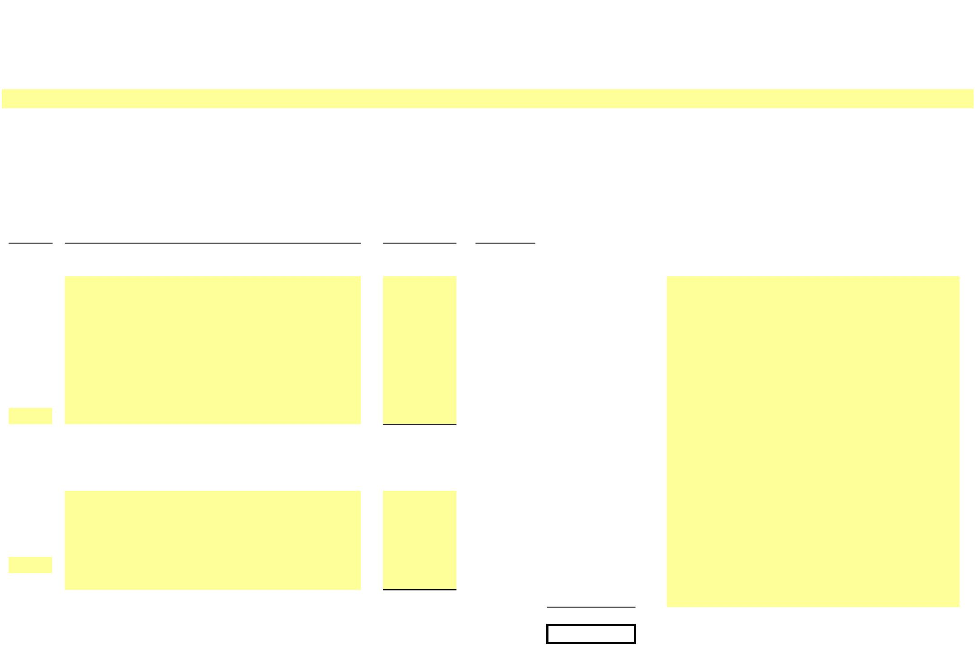

X

**NEW YORK POWER AUTHORITY**

**TRANSMISSION REVENUE REQUIREMENT**

**YEAR ENDING DECEMBER 31, ____**

**WORK PAPER AH**

**INJURIES & DAMAGES INSURANCE EXPENSE ALLOCATION**

**Allocated**

**Injury/Damage**

**Insurance**

**Expense -**

**Line No.**

**Site**

**Amount ($)**

**Ratio (%)**

**Transmission ($)**

**Notes**

(1)

(2)

(3)

(4)

1a

1b

1c

1d

…

2

Allocated based on transmission allocator from

Schedule E1

**Subtotal**

**-**

-

**-**

3a

…

**-**

**-**

100.00

**-**

**-**

4

**Grand Total**

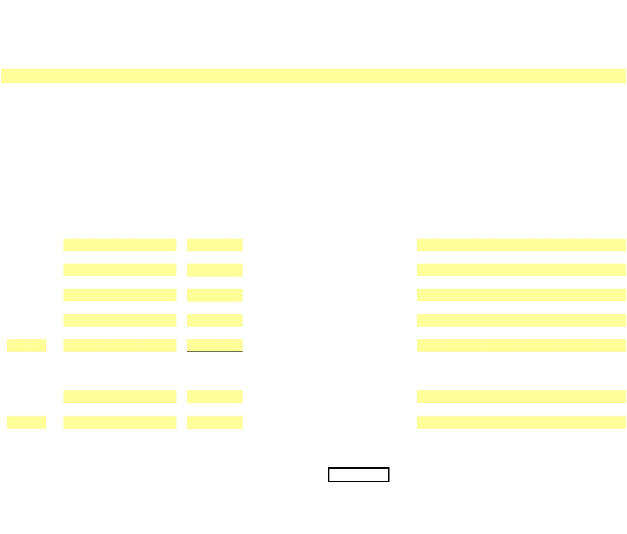

X

**NEW YORK POWER AUTHORITY**

**TRANSMISSION REVENUE REQUIREMENT**

**YEAR ENDING DECEMBER 31, ____**

**WORK PAPER AI**

**PROPERTY INSURANCE ALLOCATOR**

**Gross Plant in**

**Line No.**

**13-Month Average ($)**

**Service Ratio**

**Source**

(1)

(2)

(3)

1

**PRODUCTION**

**-**

**-**

**-**

**-**

**-**

**-**

WP-BC

WP-BC

2

3

**TRANSMISSION (353 Station Equip.)**

**TOTAL**



X

**NEW YORK POWER AUTHORITY**

**TRANSMISSION REVENUE REQUIREMENT**

**YEAR ENDING DECEMBER 31, ____**

**WORK PAPER BA**

**DEPRECIATION AND AMORTIZATION EXPENSES (BY FERC ACCOUNT)**

**Included General & Transmission Plant - Depreciation ____**

(1)

(2)

(3)

(4)

**FERC**

**Acct #**

**Site**

**Included General Plant**

**Item**

**Depreciation ($)**

**Line No. Source/Comments**

1a

1b

1c

1d

1e

1f

390

390

390

390

390

390

390

390

-

-

-

-

-

-

-

-

…

…

2

390

**Subtotal General - Structures & Improvements**

**-**

3a

3b

3c

3d

3e

3f

3g

3h

3i

3j

3k

3l

3m

3n

…

…

391

391

391

391

391

391.2

391.2

391.2

391.2

391.2

391.3

391.3

391.3

391.3

391

-

-

-

-

-

-

-

-

-

-

-

-

-

-

-

-

391

4

391

**Subtotal General - Office Furniture & Equipment**

**-**

5a

5b

5c

5d

5e

…

…

392

392

392

392

392

392

392

-

-

-

-

-

-

-

6

392

**Subtotal General - Transportation Equipment**

**-**

7a

7b

7c

7d

…

…

393

393

393

393

393

393

-

-

-

-

-

-

8

393

**Subtotal General - Stores Equipment**

**-**

9a

9b

9c

9d

9e

…

…

394

394

394

394

394

394

394

-

-

-

-

-

-

-

10

394

**Subtotal General - Tools, Shop & Garage Equipment**

**-**

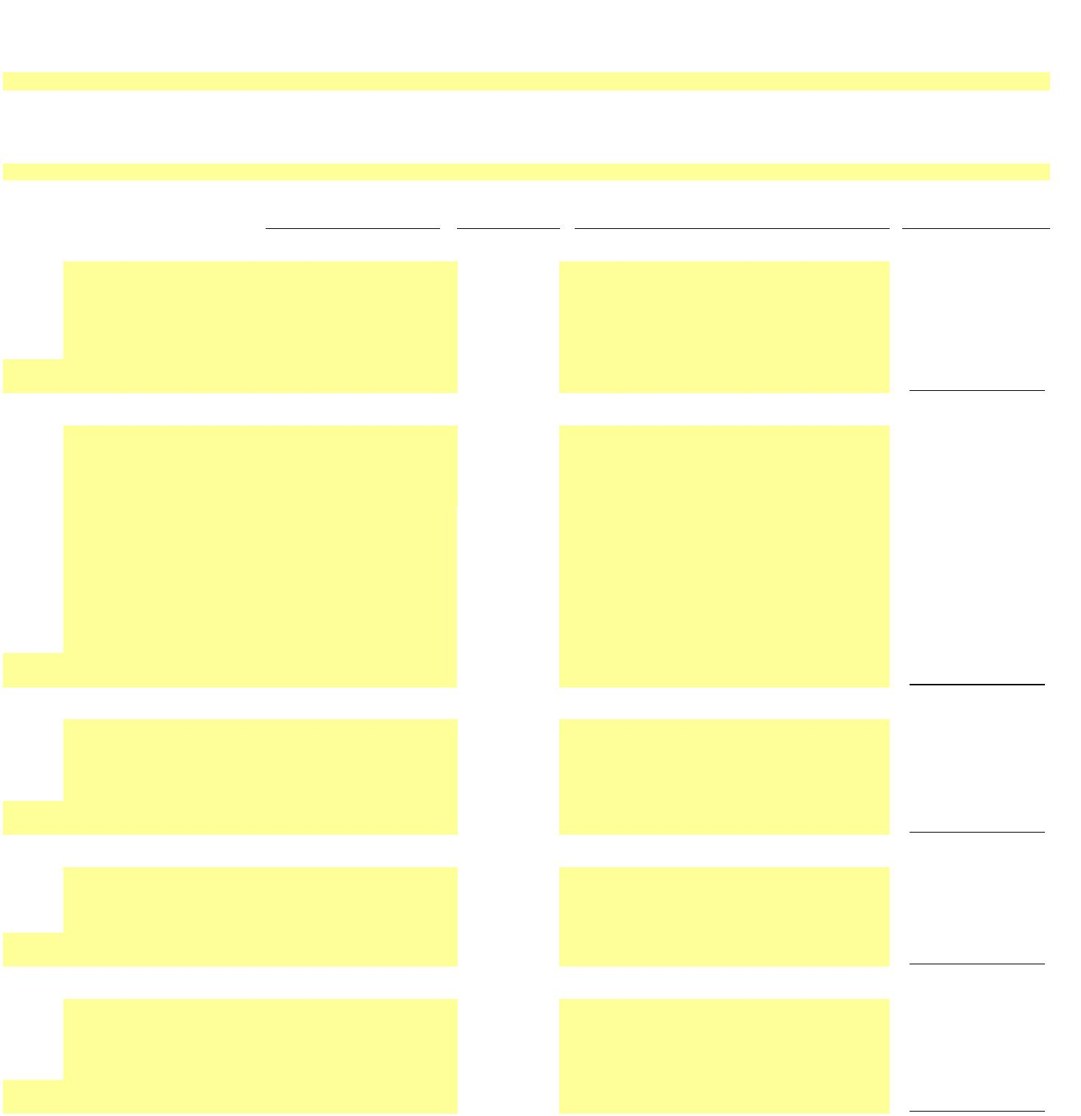

X

**NEW YORK POWER AUTHORITY**

**TRANSMISSION REVENUE REQUIREMENT**

**YEAR ENDING DECEMBER 31, ____**

**WORK PAPER BA**

**DEPRECIATION AND AMORTIZATION EXPENSES (BY FERC ACCOUNT)**

**Included General & Transmission Plant - Depreciation ____**

(1)

(2)

**FERC**

395

395

395

395

395

395

395

(3)

(4)

11a

11b

11c

11d

11e

…

-

-

-

-

-

-

-

…

12

395

**Subtotal General - Laboratory Equipment**

**-**

13a

13b

13c

13d

13e

…

396

396

396

396

396

396

396

-

-

-

-

-

-

-

…

14

396

**Subtotal General - Power Operated Equipment**

**-**

15a

15b

15c

15d

15e

15f

15g

…

397

397

397

397

397

397

397

397

397

-

-

-

-

-

-

-

-

-

…

16

397

**Subtotal General - Communication Equipment**

**-**

17a

17b

17c

17d

17e

…

398

398

398

398

398

398

398

-

-

-

-

-

-

-

…

18

398

**Subtotal General - Miscellaneous Equipment**

**-**

19a

19b

19c

…

399

399

399

399

399

-

-

-

-

-

…

20

…

21

399

**Subtotal General - Other Tangible Property**

**-**

**Total Included General Plant**

**Included Transmission Plant**

**-**

22a

22b

22c

22d

22e

22f

22g

…

352

352

352

352

352

352

352

352

352

-

-

-

-

-

-

-

-

-

…

23

352

**Subtotal Transmission - Structures & Improvements**

**-**

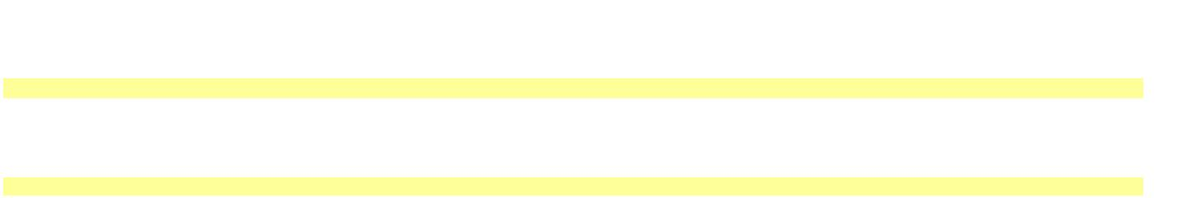

X

**NEW YORK POWER AUTHORITY**

**TRANSMISSION REVENUE REQUIREMENT**

**YEAR ENDING DECEMBER 31, ____**

**WORK PAPER BA**

**DEPRECIATION AND AMORTIZATION EXPENSES (BY FERC ACCOUNT)**

**Included General & Transmission Plant - Depreciation ____**

(1)

(2)

(3)

(4)

**FERC**

24a

24b

24c

24d

24e

24f

24g

24h

…

353

353

353

353

353

353

353

353

353

353

-

-

-

-

-

-

-

-

-

-

…

25

353

**Subtotal Transmission - Station Equipment**

**-**

26a

26b

26c

26d

26e

26f

…

354

354

354

354

354

354

354

354

-

-

-

-

-

-

-

-

…

27

354

**Subtotal Transmission - Towers & Fixtures**

**-**

28a

28b

28c

28d

28e

…

355

355

355

355

355

355

355

-

-

-

-

-

-

-

…

29

355

**Subtotal Transmission - Poles & Fixtures**

**-**

30a

30b

30c

30d

30e

30f

…

356

356

356

356

356

356

356

356

-

-

-

-

-

-

-

-

…

31

356

**Subtotal Transmission - Overhead Conductors & Devices**

**-**

32a

32b

32c

…

357

357

357

357

357

-

-

-

-

-

…

33

357

**Subtotal Transmission - Underground Conduit**

**-**

34a

34b

34c

…

358

358

358

358

358

-

-

-

-

-

…

35

358

**Subtotal Transmission - Underground Conductors & Devic**

**-**

36a

36b

36c

36d

36e

36f

…

359

359

359

359

359

359

359

359

-

-

-

-

-

-

-

-

…

37

359

**Subtotal Transmission - Roads & Trails**

**-**

38a

38b

…

351.1

351.1

351.1

351.1

-

-

-

-

…

39

351.1

**Subtotal Transmission - Computer Hardware**

**Subtotal Transmission - Computer Software**

**Subtotal Transmission - Communications Equipment**

-

40a

40b

…

351.2

351.2

351.2

351.2

-

-

-

-

…

41

351.2

-

42a

42b

…

351.3

351.3

351.3

351.3

-

-

-

-

…

43

…

44

351.3

-

**Total Included Transmission Plant**

**-**

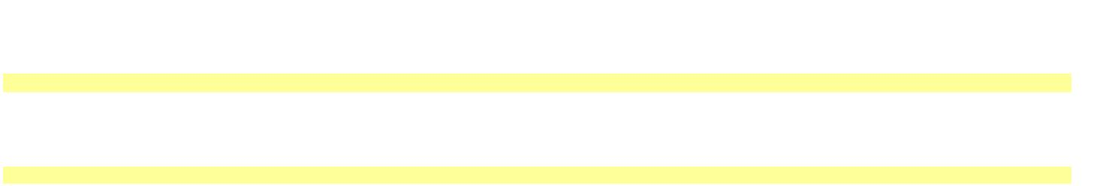

X

**NEW YORK POWER AUTHORITY**

**TRANSMISSION REVENUE REQUIREMENT**

**YEAR ENDING DECEMBER 31, ____**

**WORK PAPER BB**

**EXCLUDED PLANT IN SERVICE**

**13-Month Average**

**Electric**

**Plant in**

**Service ($)**

**Electric**

**Plant in**

**Service (Net $)**

(6)

**Accumulated**

**Depreciation ($)**

(5)

**Depreciation**

**Expense ($)**

(7)

**Line No. Source/Comments**

**EXCLUDED TRANSMISSION**

(1)

(2)

(3)

(4)

1

1a

…

-

-

-

-

-

-

-

-

2

**SUBTOTAL 500mW C - C at Astoria**

**-**

**-**

**-**

**-**

3

3a

3b

3c

3d

3e

3f

3g

3h

3i

-

-

-

-

-

-

-

-

-

-

-

-

-

-

-

-

-

-

-

-

-

-

-

-

-

-

-

-

-

-

-

-

-

-

-

-

-

…

-

-

-

-

-

-

4

5

5a

5b

5c

…

**SUBTOTAL Astoria 2 (AE-II) Substation**

**-**

**-**

**-**

**-**

-

-

-

-

-

-

-

-

-

-

-

-

-

6

**SUBTOTAL Small Hydro**

**-**

**-**

**-**

**-**

7

7a

…

-

-

-

-

-

-

-

-

8

**SUBTOTAL FLYNN (Holtsville)**

**-**

**-**

**-**

**-**

8a

8b

8c

8d

8e

…

-

-

-

-

-

-

-

-

-

-

-

-

-

-

-

-

-

-

-

-

-

-

-

-

9

**SUBTOTAL Poletti**

**-**

**-**

**-**

**-**

10

10a

10b

10c

10d

10e

10f

10g

…

-

-

-

-

-

-

-

-

-

-

-

-

-

-

-

-

-

-

-

-

-

-

-

-

-

-

-

-

-

-

-

-

11

**SUBTOTAL SCPP**

**-**

**-**

**-**

**-**

12

…

…

-

-

-

-

-

-

-

-

**-**

**-**

**-**

**-**

**-**

**-**

**-**

**-**

13

**TOTAL EXCLUDED TRANSMISSION**



X

**NEW YORK POWER AUTHORITY**

**TRANSMISSION REVENUE REQUIREMENT**

**YEAR ENDING DECEMBER 31, ____**

**WORK PAPER BB**

**EXCLUDED PLANT IN SERVICE**

**13-Month Average**

**Electric**

**Plant in**

**Service ($)**

**Electric**

**Plant in**

**Service (Net $)**

**Accumulated**

**Depreciation ($)**

**Depreciation**

**Expense ($)**

**Line No. Source/Comments**

**EXCLUDED TRANSMISSION**

**EXCLUDED GENERAL**

14

14a

14b

14c

14d

14e

14f

14g

14h

…

-

-

-

-

-

-

-

-

-

-

-

-

-

-

-

-

-

-

-

-

-

-

-

-

-

-

-

-

-

-

-

-

-

-

-

-

-

-

15

16

**SUBTOTAL 500Mw CC**

**SUBTOTAL Small Hydro**

**-**

**-**

**-**

**-**

16a

16b

…

-

-

-

-

-

-

-

-

-

-

17

**-**

**-**

**-**

**-**

18

18a

18b

18c

18d

18e

18f

18g

18h

18i

-

-

-

-

-

-

-

-

-

-

-

-

-

-

-

-

-

-

-

-

-

-

-

-

-

-

-

-

-

-

-

-

-

-

-

-

-

…

-

-

-

19

**SUBTOTAL Flynn**

**-**

**-**

**-**

**-**

20

20a

20b

20c

20d

20e

20f

20g

20h

20i

-

-

-

-

-

-

-

-

-

-

-

-

-

-

-

-

-

-

-

-

-

-

-

-

-

-

-

-

-

-

-

-

-

-

-

-

-

-

-

-

-

-

-

-

-

20j

20k

…

-

-

-

21

**SUBTOTAL Poletti**

**-**

**-**

**-**

**-**

22

22a

22b

22c

22d

22e

22f

22g

22h

22i

22j

22k

22l

22m

…

-

-

-

-

-

-

-

-

-

-

-

-

-

-

-

-

-

-

-

-

-

-

-

-

-

-

-

-

-

-

-

-

-

-

-

-

-

-

-

-

-

-

-

-

-

-

-

-

-

-

-

-

-

-

-

-

-

-

23

**SUBTOTAL SCPP**

**-**

**-**

**-**

**-**

24

24a

24b

…

-

-

-

-

-

-

-

-

-

-

**SUBTOTAL**

**-**

**-**

**-**

**-**

**-**

**-**

**-**

**-**

25

**TOTAL EXCLUDED GENERAL**

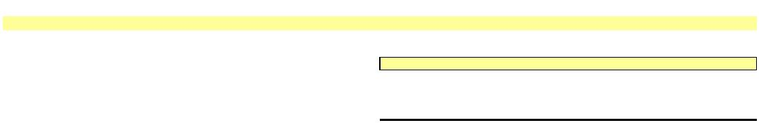

**NEW YORK POWER AUTHORITY**

**TRANSMISSION REVENUE REQUIREMENT**

**YEAR ENDING DECEMBER 31, ____**

**WORK PAPER BC**

**PLANT IN SERVICE DETAIL**

**13-Month Average**

**Electric Plant in**

**Service**

**($)**

**Accumulated**

**Depreciation**

**($)**

**Electric Plant in**

**Service**

**Depreciation**

**Expense**

**($)**

**P/T/G**

(1)

**Plant Name**

**A/C**

(3)

**Description**

**(Net $ )**

(2)

(4)

(5)

(6)

(7)

(8)

**Capital assets, not being depreciated:**

**Land**

1

1a

1b

1c

1d

1e

1f

-

-

-

-

-

-

-

-

-

-

-

-

-

-

-

-

-

-

-

-

-

-

-

-

-

-

-

-

-

-

-

-

-

-

-

1g

1h

1i

1j

1k

1l

1m

1n

1o

1p

1q

1r

1s

1t

1u

1v

1w

1x

1y

1z

1aa

1ab

1ac

1ad

1ae

1af

1ag

1ah

1ai

…

…

2

**Land Total**

-

-

-

-

3

3a

3b

4

**Construction in progress**

**CWIP**

**CWIP - CEEC**

***Adjustments***

-

-

-

-

-

-

-

-

-

-

-

-

**Construction in progress Total**

5

**Total capital assets not being depreciated**

**-**

**-**

**-**

**-**

**Capital assets, being depreciated:**

**Production - Hydro**

6

6a

6b

6c

6d

6e

6f

-

-

-

-

-

-

-

-

-

-

-

-

-

-

-

-

-

-

-

-

-

-

-

-

-

-

-

-

6g

6h

6i

6j

6k

6l

6m

6n

6o

6p

6q

6r

6s

6t

6u

6v

6w

6x

6y

6z

6aa

6ab



**NEW YORK POWER AUTHORITY**

**TRANSMISSION REVENUE REQUIREMENT**

**YEAR ENDING DECEMBER 31, ____**

**WORK PAPER BC**

**PLANT IN SERVICE DETAIL**

**13-Month Average**

**Electric Plant in**

**Service**

**($)**

**Accumulated**

**Depreciation**

**($)**

**Electric Plant in**

**Service**

**Depreciation**

**Expense**

**($)**

**P/T/G**

(1)

**Plant Name**

**A/C**

(3)

**Description**

**(Net $ )**

(2)

(4)

(5)

(6)

(7)

(8)

6ac

6ad

6ae

6af

6ag

…

-

-

-

-

-

…

7

**Production - Hydro Total**

-

-

-

-

8

8a

8b

8c

8d

8e

8f

8g

8h

8i

8j

8k

8l

8m

8n

8o

8p

8q

8r

8s

8t

8u

8v

8w

8x

8y

8z

8aa

8ab

8ac

8ad

8ae

8af

8ag

8ah

8ai

8aj

8ak

8al

8am

8an

8ao

8ap

8aq

8ar

8as

8at

8au

8av

8aw

8ax

8ay

8az

8ba

8bb

8bc

8bd

…

**Production - Gas turbine/combined cycle**

-

-

-

-

-

-

-

-

-

-

-

-

-

-

-

-

-

-

-

-

-

-

-

-

-

-

-

-

-

-

-

-

-

-

-

-

-

-

-

-

-

-

-

-

-

-

-

-

-

-

-

-

-

-

-

-

…

9

**Production - Gas turbine/combined cycle Total**

-

-

-

-



**NEW YORK POWER AUTHORITY**

**TRANSMISSION REVENUE REQUIREMENT**

**YEAR ENDING DECEMBER 31, ____**

**WORK PAPER BC**

**PLANT IN SERVICE DETAIL**

**13-Month Average**

**Electric Plant in**

**Service**

**($)**

**Accumulated**

**Depreciation**

**($)**

**Electric Plant in**

**Service**

**Depreciation**

**Expense**

**($)**

**P/T/G**

(1)

**Plant Name**

**A/C**

(3)

**Description**

**(Net $ )**

(2)

(4)

(5)

(6)

(7)

(8)

10

10a

10b

10c

10d

10e

10f

10g

10h

10i

10j

10k

10l

10m

10n

10o

10p

10q

10r

10s

10t

10u

10v

10w

10x

10y

10z

10aa

10ab

10ac

10ad

10ae

10af

10ag

10ah

10ai

10aj

10ak

10al

10am

10an

10ao

10ap

10aq

10ar

10as

10at

10au

10av

10aw

10ax

10ay

10az

10ba

10bb

10bc

10bd

10be

10bf

10bg

10bh

10bi

10bj

10bk

10bl

10bm

10bn

10bo

10bp

10bq

10br

…

**Transmission**

-

-

-

-

-

-

-

-

-

-

-

-

-

-

-

-

-

-

-

-

-

-

-

-

-

-

-

-

-

-

-

-

-

-

-

-

-

-

-

-

-

-

-

-

-

-

-

-

-

-

-

-

-

-

-

-

-

-

-

-

-

-

-

-

-

-

-

-

-

-

…

11

**Transmission Total**

-

-

-

-



**NEW YORK POWER AUTHORITY**

**TRANSMISSION REVENUE REQUIREMENT**

**YEAR ENDING DECEMBER 31, ____**

**WORK PAPER BC**

**PLANT IN SERVICE DETAIL**

**13-Month Average**

**Electric Plant in**

**Service**

**($)**

**Accumulated**

**Depreciation**

**($)**

**Electric Plant in**

**Service**

**Depreciation**

**Expense**

**($)**

**P/T/G**

(1)

**Plant Name**

**A/C**

(3)

**Description**

**General**

**(Net $ )**

(2)

(4)

(5)

(6)

(7)

(8)

12

12a

12b

12c

12d

12e

12f

12g

12h

12i

12j

12k

12l

12m

12n

12o

12p

12q

12r

12s

12t

12u

12v

12w

12x

12y

12z

12aa

12ab

12ac

12ad

12ae

12af

12ag

12ah

12ai

12aj

12ak

12al

12am

12an

12ao

12ap

12aq

12ar

12as

12at

12au

12av

12aw

12ax

12ay

12az

12ba

12bb

12bc

12bd

12be

12bf

12bg

12bh

12bi

12bj

12bk

12bl

12bm

12bn

12bo

12bp

12bq

12br

-

-

-

-

-

-

-

-

-

-

-

-

-

-

-

-

-

-

-

-

-

-

-

-

-

-

-

-

-

-

-

-

-

-

-

-

-

-

-

-

-

-

-

-

-

-

-

-

-

-

-

-

-

-

-

-

-

-

-

-

-

-

-

-

-

-

-

-

-

-



**NEW YORK POWER AUTHORITY**

**TRANSMISSION REVENUE REQUIREMENT**

**YEAR ENDING DECEMBER 31, ____**

**WORK PAPER BC**

**PLANT IN SERVICE DETAIL**

**13-Month Average**

**Electric Plant in**

**Service**

**($)**

**Accumulated**

**Depreciation**

**($)**

**Electric Plant in**

**Service**

**Depreciation**

**Expense**

**($)**

**P/T/G**

(1)

**Plant Name**

**A/C**

(3)

**Description**

**(Net $ )**

(2)

(4)

(5)

(6)

(7)

-

-

-

-

-

-

-

-

-

-

-

-

-

-

-

-

-

-

-

-

-

-

-

-

-

-

-

-

-

-

-

-

-

-

-

(8)

12bs

12bt

12bu

12bv

12bw

12bx

12by

12bz

12ca

12cb

12cc

12cd

12ce

12cf

12cg

12ch

12ci

12cj

12ck

12cl

12cm

12cn

12co

12cp

12cq

12cr

12cs

12ct

12cu

12cv

12cw

12cx

12cy

12cz

12da

…

…

13

**General Total**

-

-

-

-

14

15

**Total capital assets, being depreciated**

**Net value of all capital assets**

**-**

**-**

**-**

**-**

**-**

**-**

**-**

**-**



**NEW YORK POWER AUTHORITY**

**TRANSMISSION REVENUE REQUIREMENT**

**YEAR ENDING DECEMBER 31, ____**

**WORK PAPER BC (SUPPORT A)**

**GROSS ELECTRIC PLANT IN SERVICE DETAIL**

**____**

**December**

(5)

**____**

**January**

(6)

**____**

**February**

(7)

**____**

**March**

(8)

**____**

**April**

(9)

**____**

**May**

(10)

**____**

**June**

(11)

**____**

**July**

(12)

**____**

**August**

(13)

**____**

**September**

(14)

**____**

**October**

(15)

**____**

**November**

(16)

**____**

**December**

(17)

**13-Month**

**Average**

(18)

**P/T/G**

(1)

**Plant Name**

(2)

**A/C**

(3)

**Description**

(4)

**Capital assets, not being depreciated:**

**Land**

1

1a

1b

1c

1d

1e

1f

1g

1h

1i

1j

1k

1l

1m

1n

1o

1p

1q

1r

-

-

-

-

-

-

-

-

-

-

-

-

-

-

-

-

-

-

-

-

-

-

-

-

-

-

-

-

-

-

-

-

-

-

-

1s

1t

1u

1v

1w

1x

1y

1z

1aa

1ab

1ac

1ad

1ae

1af

1ag

1ah

1ai

…

…

2

**Land Total**

-

-

-

-

-

-

-

-

-

-

-

-

-

-

3

**Construction in progress**

3a

3b

4

***Adjustments***

**CWIP**

**CWIP - CEEC**

-

-

-

-

-

-

-

-

-

-

-

-

-

-

-

-

-

-

-

-

-

-

-

-

-

-

-

-

-

-

-

-

-

-

-

-

-

-

-

-

-

-

**Construction in progress Total**

5

**Total capital assets not being depreciated**

**-**

**-**

**-**

**-**

**-**

**-**

**-**

**-**

**-**

**-**

**-**

**-**

**-**

**-**

**Capital assets, being depreciated:**

**Production - Hydro**

6

6a

6b

6c

6d

6e

6f

-

-

-

-

-

-

-

-

-

-

-

-

-

-

-

-

6g

6h

6i

6j

6k

6l

6m

6n

6o

6p



**NEW YORK POWER AUTHORITY**

**TRANSMISSION REVENUE REQUIREMENT**

**YEAR ENDING DECEMBER 31, ____**

**WORK PAPER BC (SUPPORT A)**

**GROSS ELECTRIC PLANT IN SERVICE DETAIL**

**____**

**December**

(5)

**____**

**January**

(6)

**____**

**February**

(7)

**____**

**March**

(8)

**____**

**April**

(9)

**____**

**May**

(10)

**____**

**June**

(11)

**____**

**July**

(12)

**____**

**August**

(13)

**____**

**September**

(14)

**____**

**October**

(15)

**____**

**November**

(16)

**____**

**December**

(17)

**13-Month**

**Average**

**P/T/G**

(1)

**Plant Name**

(2)

**A/C**

(3)

**Description**

(4)

(18)

6q

6r

6s

6t

6u

6v

6w

6x

6y

6z

6aa

6ab

6ac

6ad

6ae

6af

6ag

…

-

-

-

-

-

-

-

-

-

-

-

-

-

-

-

-

-

…

7

**Production - Hydro Total**

-

-

-

-

-

-

-

-

-

-

-

-

-

-

8

8a

8b

8c

8d

8e

8f

8g

8h

8i

8j

8k

8l

8m

8n

8o

8p

8q

8r

8s

8t

8u

8v

8w

8x

8y

8z

8aa

8ab

8ac

8ad

8ae

8af

8ag

8ah

8ai

8aj

8ak

8al

8am

8an

8ao

8ap

8aq

8ar

8as

8at

8au

8av

8aw

**Production - Gas turbine/combined cycle**

-

-

-

-

-

-

-

-

-

-

-

-

-

-

-

-

-

-

-

-

-

-

-

-

-

-

-

-

-

-

-

-

-

-

-

-

-

-

-

-

-

-

-

-

-

-

-

-

-



**NEW YORK POWER AUTHORITY**

**TRANSMISSION REVENUE REQUIREMENT**

**YEAR ENDING DECEMBER 31, ____**

**WORK PAPER BC (SUPPORT A)**

**GROSS ELECTRIC PLANT IN SERVICE DETAIL**

**____**

**December**

(5)

**____**

**January**

(6)

**____**

**February**

(7)

**____**

**March**

(8)

**____**

**April**

(9)

**____**

**May**

(10)

**____**

**June**

(11)

**____**

**July**

(12)

**____**

**August**

(13)

**____**

**September**

(14)

**____**

**October**

(15)

**____**

**November**

(16)

**____**

**December**

(17)

**13-Month**

**Average**

**P/T/G**

(1)

**Plant Name**

(2)

**A/C**

(3)

**Description**

(4)

(18)

8ax

8ay

8az

8ba

8bb

8bc

8bd

…

-

-

-

-

-

-

-

…

**Production - Gas turbine/combined cycle**

**Total**

9

-

-

-

-

-

-

-

-

-

-

-

-

-

-

10

10a

10b

10c

10d

10e

10f

10g

10h

10i

10j

10k

10l

10m

10n

10o

10p

10q

10r

10s

10t

10u

10v

10w

10x

10y

10z

10aa

10ab

10ac

10ad

10ae

10af

10ag

10ah

10ai

10aj

10ak

10al

10am

10an

10ao

10ap

10aq

10ar

10as

10at

10au

10av

10aw

10ax

10ay

10az

10ba

10bb

10bc

10bd

10be

10bf

**Transmission**

-

-

-

-

-

-

-

-

-

-

-

-

-

-

-

-

-

-

-

-

-

-

-

-

-

-

-

-

-

-

-

-

-

-

-

-

-

-

-

-

-

-

-

-

-

-

-

-

-

-

-

-

-

-

-

-

-

-



**NEW YORK POWER AUTHORITY**

**TRANSMISSION REVENUE REQUIREMENT**

**YEAR ENDING DECEMBER 31, ____**

**WORK PAPER BC (SUPPORT A)**

**GROSS ELECTRIC PLANT IN SERVICE DETAIL**

**____**

**December**

(5)

**____**

**January**

(6)

**____**

**February**

(7)

**____**

**March**

(8)

**____**

**April**

(9)

**____**

**May**

(10)

**____**

**June**

(11)

**____**

**July**

(12)

**____**

**August**

(13)

**____**

**September**

(14)

**____**

**October**

(15)

**____**

**November**

(16)

**____**

**December**

(17)

**13-Month**

**Average**

**P/T/G**

(1)

**Plant Name**

(2)

**A/C**

(3)

**Description**

(4)

(18)

10bg

10bh

10bi

10bj

10bk

10bl

10bm

10bn

10bo

10bp

10bq

10br

…

-

-

-

-

-

-

-

-

-

-

-

-

…

11

**Transmission Total**

**General**

-

-

-

-

-

-

-

-

-

-

-

-

-

-

12

12a

-

-

-

-

-

-

-

-

-

-

-

-

-

-

-

-

-

-

-

-

-

-

-

-

-

-

-

-

-

-

-

-

-

-

-

-

-

-

-

-

-

-

-

-

-

-

-

-

-

-

-

-

-

-

12b

12c

12d

12e

12f

12g

12h

12i

12j

12k

12l

12m

12n

12o

12p

12q

12r

12s

12t

12u

12v

12w

12x

12y

12z

12aa

12ab

12ac

12ad

12ae

12af

12ag

12ah

12ai

12aj

12ak

12al

12am

12an

12ao

12ap

12aq

12ar

12as

12at

12au

12av

12aw

12ax

12ay

12az

12ba

12bb



**NEW YORK POWER AUTHORITY**

**TRANSMISSION REVENUE REQUIREMENT**

**YEAR ENDING DECEMBER 31, ____**

**WORK PAPER BC (SUPPORT A)**

**GROSS ELECTRIC PLANT IN SERVICE DETAIL**

**____**

**December**

(5)

**____**

**January**

(6)

**____**

**February**

(7)

**____**

**March**

(8)

**____**

**April**

(9)

**____**

**May**

(10)

**____**

**June**

(11)

**____**

**July**

(12)

**____**

**August**

(13)

**____**

**September**

(14)

**____**

**October**

(15)

**____**

**November**

(16)

**____**

**December**

(17)

**13-Month**

**Average**

**P/T/G**

(1)

**Plant Name**

(2)

**A/C**

(3)

**Description**

(4)

(18)

12bc

12bd

12be

12bf

12bg

12bh

12bi

-

-

-

-

-

-

-

12bj

12bk

-

-

12bl

12bm

12bn

12bo

12bp

12bq

12br

12bs

12bt

12bu

12bv

12bw

12bx

12by

12bz

12ca

12cb

12cc

12cd

12ce

12cf

12cg

12ch

12ci

-

-

-

-

-

-

-

-

-

-

-

-

-

-

-

-

-

-

-

-

-

-

-

-

-

-

-

-

-

-

-

-

-

-

-

-

-

-

-

-

-

-

12cj

12ck

12cl

12cm

12cn

12co

12cp

12cq

12cr

12cs

12ct

12cu

12cv

12cw

12cx

12cy

12cz

12da

…

…

13

**General Total**

-

-

-

-

-

-

-

-

-

-

-

-

-

-

14

15

**Total capital assets, being depreciated**

**Net value of all capital assets**

**-**

**-**

**-**

**-**

**-**

**-**

**-**

**-**

**-**

**-**

**-**

**-**

**-**

**-**

**-**

**-**

**-**

**-**

**-**

**-**

**-**

**-**

**-**

**-**

**-**

**-**

**-**

**-**

Notes

1/

Data source for monthly amounts is NYPA financial records.

…



**NEW YORK POWER AUTHORITY**

**TRANSMISSION REVENUE REQUIREMENT**

**YEAR ENDING DECEMBER 31, ____**

**WORK PAPER BC (SUPPORT B)**

**ACCUMULATED DEPRECIATION DETAIL**

**____**

**December**

(5)

**____**

**January**

(6)

**____**

**February**

(7)

**____**

**March**

(8)

**____**

**April**

(9)

**____**

**May**

(10)

**____**

**June**

(11)

**____**

**July**

(12)

**____**

**August**

(13)

**____**

**September**

(14)

**____**

**October**

(15)

**____**

**November**

(16)

**____**

**December**

(17)

**13-Month**

**Average**

**P/T/G**

(1)

**Plant Name**

(2)

**A/C**

(3)

**Description**

(4)

(18)

**Capital assets, not being depreciated:**

**Land**

1

1a

1b

1c

-

-

-

-

-

-

-

-

-

-

-

-

-

-

-

-

-

-

-

-

-

-

-

-

-

-

-

-

-

-

-

-

-

-

-

1d

1e

1f

1g

1h

1i

1j

1k

1l

1m

1n

1o

1p

1q

1r

1s

1t

1u

1v

1w

1x

1y

1z

1aa

1ab

1ac

1ad

1ae

1af

1ag

1ah

1ai

…

…

2

**Land Total**

-

-

-

-

-

-

-

-

-

-

-

-

-

-

3

**Construction in progress**

3a

3b

***Adjustments***

**CWIP**

**CWIP - CEEC**

-

-

-

-

-

-

-

-

-

-

-

-

-

-

-

-

-

-

-

-

-

-

-

-

-

-

-

-

4

**Construction in progress Total**

-

-

-

-

-

-

-

-

-

-

-

-

-

-

5

**Total capital assets not being depreciated**

**-**

**-**

**-**

**-**

**-**

**-**

**-**

**-**

**-**

**-**

**-**

**-**

**-**

**-**

**Capital assets, being depreciated:**

**Production - Hydro**

6

6a

6b

6c

6d

6e

6f

-

-

-

-

-

-

-

-

-

-

-

-

-

-

-

-

-

-

6g

6h

6i

6j

6k

6l

6m

6n

6o

6p

6q

6r

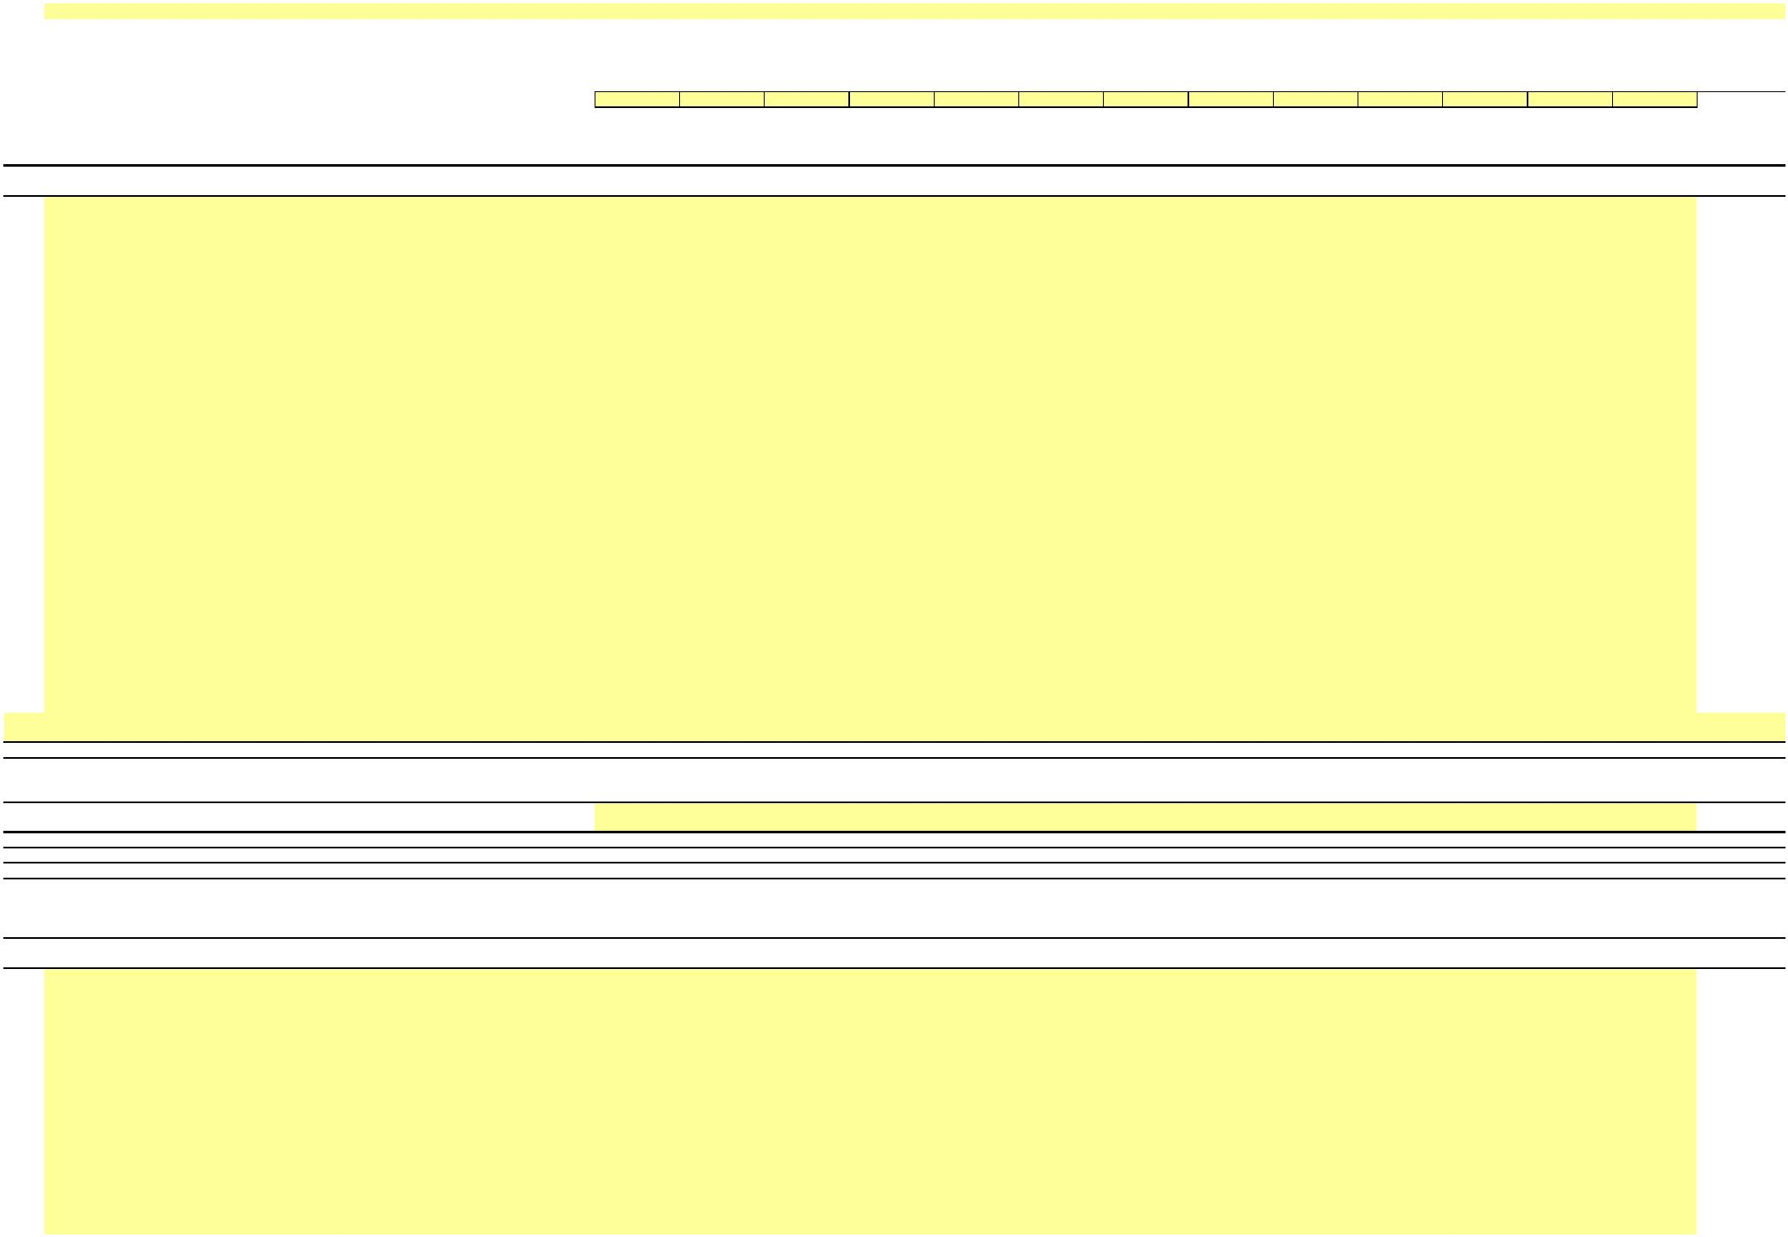

**NEW YORK POWER AUTHORITY**

**TRANSMISSION REVENUE REQUIREMENT**

**YEAR ENDING DECEMBER 31, ____**

**WORK PAPER BC (SUPPORT B)**

**ACCUMULATED DEPRECIATION DETAIL**

**____**

**December**

(5)

**____**

**January**

(6)

**____**

**February**

(7)

**____**

**March**

(8)

**____**

**April**

(9)

**____**

**May**

(10)

**____**

**June**

(11)

**____**

**July**

(12)

**____**

**August**

(13)

**____**

**September**

(14)

**____**

**October**

(15)

**____**

**November**

(16)

**____**

**December**

(17)

**13-Month**

**Average**

**P/T/G**

(1)

**Plant Name**

(2)

**A/C**

(3)

**Description**

(4)

(18)

6s

6t

6u

6v

6w

6x

-

-

-

-

-

-

-

-

-

-

-

-

-

-

-

6y

6z

6aa

6ab

6ac

6ad

6ae

6af

6ag

…

…

7

**Production - Hydro Total**

-

-

-

-

-

-

-

-

-

-

-

-

-

-

8

8a

8b

8c

8d

8e

8f

8g

8h

8i

8j

8k

8l

8m

8n

8o

8p

8q

8r

8s

8t

8u

8v

8w

8x

8y

8z

8aa

8ab

8ac

8ad

8ae

8af

8ag

8ah

8ai

8aj

8ak

8al

8am

8an

8ao

8ap

8aq

8ar

8as

8at

8au

8av

8aw

**Production - Gas turbine/combined cycle**

-

-

-

-

-

-

-

-

-

-

-

-

-

-

-

-

-

-

-

-

-

-

-

-

-

-

-

-

-

-

-

-

-

-

-

-

-

-

-

-

-

-

-

-

-

-

-

-

-



**NEW YORK POWER AUTHORITY**

**TRANSMISSION REVENUE REQUIREMENT**

**YEAR ENDING DECEMBER 31, ____**

**WORK PAPER BC (SUPPORT B)**

**ACCUMULATED DEPRECIATION DETAIL**

**____**

**December**

(5)

**____**

**January**

(6)

**____**

**February**

(7)

**____**

**March**

(8)

**____**

**April**

(9)

**____**

**May**

(10)

**____**

**June**

(11)

**____**

**July**

(12)

**____**

**August**

(13)

**____**

**September**

(14)

**____**

**October**

(15)

**____**

**November**

(16)

**____**

**December**

(17)

**13-Month**

**Average**

**P/T/G**

(1)

**Plant Name**

(2)

**A/C**

(3)

**Description**

(4)

(18)

8ax

8ay

8az

8ba

8bb

8bc

8bd

…

-

-

-

-

-

-

-

…

9

**Production - Gas turbine/combined cycle Total**

**Transmission**

-

-

-

-

-

-

-

-

-

-

-

-

-

-

10

10a

-

-

-

-

-

-

-

-

-

-

-

-

-

-

-

-

-

-

-

-

-

-

-

-

-

-

-

-

-

-

-

-

-

-

-

-

-

-

-

-

-

-

-

-

-

-

-

-

-

-

-

-

-

-

-

-

-

-

10b

10c

10d

10e

10f

10g

10h

10i

10j

10k

10l

10m

10n

10o

10p

10q

10r

10s

10t

10u

10v

10w

10x

10y

10z

10aa

10ab

10ac

10ad

10ae

10af

10ag

10ah

10ai

10aj

10ak

10al

10am

10an

10ao

10ap

10aq

10ar

10as

10at

10au

10av

10aw

10ax

10ay

10az

10ba

10bb

10bc

10bd

10be

10bf



**NEW YORK POWER AUTHORITY**

**TRANSMISSION REVENUE REQUIREMENT**

**YEAR ENDING DECEMBER 31, ____**

**WORK PAPER BC (SUPPORT B)**

**ACCUMULATED DEPRECIATION DETAIL**

**____**

**December**

(5)

**____**

**January**

(6)

**____**

**February**

(7)

**____**

**March**

(8)

**____**

**April**

(9)

**____**

**May**

(10)

**____**

**June**

(11)

**____**

**July**

(12)

**____**

**August**

(13)

**____**

**September**

(14)

**____**

**October**

(15)

**____**

**November**

(16)

**____**

**December**

(17)

**13-Month**

**Average**

**P/T/G**

(1)

**Plant Name**

(2)

**A/C**

(3)

**Description**

(4)

(18)

10bg

10bh

10bi

10bj

10bk

10bl

10bm

10bn

10bo

10bp

10bq

10br

-

-

-

-

-

-

-

-

-

-

-

-

…

…

11

**Transmission Total**

**General**

-

-

-

-

-

-

-

-

-

-

-

-

-

-

12

12a

-

-

-

-

-

-

-

-

-

-

-

-

-

-

-

-

-

-

-

-

-

-

-

-

-

-

-

-

-

-

-

-

-

-

-

-

-

-

-

-

-

-

-

-

-

-

-

-

-

-

-

-

-

-

12b

12c

12d

12e

12f

12g

12h

12i

12j

12k

12l

12m

12n

12o

12p

12q

12r

12s

12t

12u

12v

12w

12x

12y

12z

12aa

12ab

12ac

12ad

12ae

12af

12ag

12ah

12ai

12aj

12ak

12al

12am

12an

12ao

12ap

12aq

12ar

12as

12at

12au

12av

12aw

12ax

12ay

12az

12ba

12bb



**NEW YORK POWER AUTHORITY**

**TRANSMISSION REVENUE REQUIREMENT**

**YEAR ENDING DECEMBER 31, ____**

**WORK PAPER BC (SUPPORT B)**

**ACCUMULATED DEPRECIATION DETAIL**

**____**

**December**

(5)

**____**

**January**

(6)

**____**

**February**

(7)

**____**

**March**

(8)

**____**

**April**

(9)

**____**

**May**

(10)

**____**

**June**

(11)

**____**

**July**

(12)

**____**

**August**

(13)

**____**

**September**

(14)

**____**

**October**

(15)

**____**

**November**

(16)

**____**

**December**

(17)

**13-Month**

**Average**

**P/T/G**

(1)

**Plant Name**

(2)

**A/C**

(3)

**Description**

(4)

(18)

12bc

12bd

12be

12bf

12bg

12bh

12bi

-

-

-

-

-

-

-

12bj

12bk

-

-

12bl

12bm

12bn

12bo

12bp

12bq

12br

12bs

12bt

12bu

12bv

12bw

12bx

12by

12bz

12ca

12cb

12cc

12cd

12ce

12cf

12cg

12ch

12ci

-

-

-

-

-

-

-

-

-

-

-

-

-

-

-

-

-

-

-

-

-

-

-

-

-

-

-

-

-

-

-

-

-

-

-

-

-

-

-

-

-

-

12cj

12ck

12cl

12cm

12cn

12co

12cp

12cq

12cr

12cs

12ct

12cu

12cv

12cw

12cx

12cy

12cz

12da

…

…

13

**General Total**

-

-

-

-

-

-

-

-

-

-

-

-

-

-

14

15

**Total capital assets, being depreciated**

**Net value of all capital assets**

**-**

**-**

**-**

**-**

**-**

**-**

**-**

**-**

**-**

**-**

**-**

**-**

**-**

**-**

**-**

**-**

**-**

**-**

**-**

**-**

**-**

**-**

**-**

**-**

**-**

**-**

**-**

**-**

Notes

1/

Data source for monthly amounts is NYPA financial records.

…



X

**NEW YORK POWER AUTHORITY**

**TRANSMISSION REVENUE REQUIREMENT**

**YEAR ENDING DECEMBER 31, ____**

**WORK PAPER BD**

**MARCY-SOUTH CAPITALIZED LEASE AMORTIZATION**

**AND UNAMORTIZED BALANCE**

**Beginning**

**Current Year**

**Average**

**Unamortized**

**Balance**

**Unamortized**

**Lease Asset/**

**Obligation ($)**

**Ending**

**Unamortized**

**Lease/Asset ($)**

**Capitalized**

**Lease**

**Amortization ($)**

**Line No. Year**

(1)

(2)

(3)

(4)

(5)

**1**

**2**

**3**

**4**

**5**

**6**

**7**

**8**

1988

1989

1990

1991

1992

1993

1994

1995

1996

1997

1998

1999

2000

2001

2002

2003

2004

2005

2006

2007

2008

2009

2010

2011

2012

2013

2014

2015

2016

2017

2018

2019

2020

2021

2022

2023

2024

2025

2026

2027

2028

2029

2030

2031

2032

2033

2034

2035

2036

2037

-

-

-

-

-

-

-

-

-

-

-

-

-

-

-

-

-

-

-

-

-

-

-

-

-

-

-

-

-

-

-

-

-

-

-

-

-

-

-

-

-

-

-

-

-

-

-

-

-

-

-

-

-

-

-

-

-

-

-

-

-

-

-

-

-

-

-

-

-

-

-

-

-

-

-

-

-

-

-

-

-

-

-

-

-

-

-

-

-

-

-

-

-

-

-

-

-

-

-

-

-

-

-

-

-

-

-

-

-

-

-

-

-

-

-

-

-

-

-

-

-

-

-

-

-

-

-

-

-

-

-

-

-

-

-

-

-

-

-

-

-

-

-

-

-

-

-

-

-

**9**

**10**

**11**

**12**

**13**

**14**

**15**

**16**

**17**

**18**

**19**

**20**

**21**

**22**

**23**

**24**

**25**

**26**

**27**

**28**

**29**

**30**

**31**

**32**

**33**

**34**

**35**

**36**

**37**

**38**

**39**

**40**

**41**

**42**

**43**

**44**

**45**

**46**

**47**

**48**

**49**

**50**

**51**

**Total**

**-**

**-**

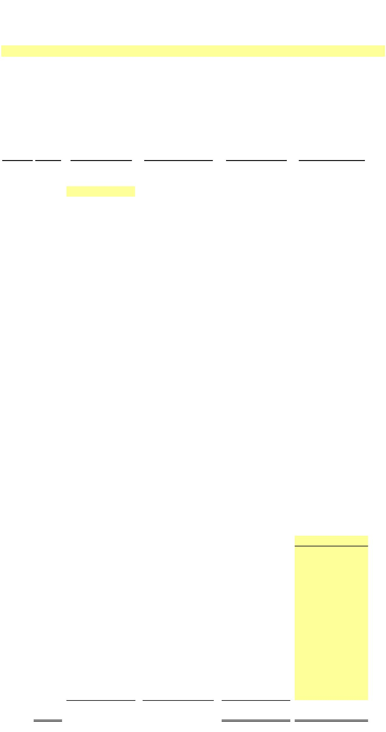

X

**NEW YORK POWER AUTHORITY**

**TRANSMISSION REVENUE REQUIREMENT**

**YEAR ENDING DECEMBER 31, ____**

**WORK PAPER BE**

**FACTS PROJECT PLANT IN SERVICE, ACCUMULATED DEPRECIATION AND DEPRECIATION EXPENSE**

**13-Month Average**

(1)

(2)

(3)

(4)

**Electric**

**Plant in**

**Service ($)**

**Electric**

**Plant in**

**Service (Net $)**

**Accumulated**

**Depreciation ($)**

**Depreciation**

**Expense ($)**

**Line No.s**

**Cap.Date**

**Asset Description**

1a

1b

1c

1d

1e

1f

1g

1h

1i

1j

1k

1l

1m

1n

1o

1p

1q

1r

-

-

-

-

-

-

-

-

-

-

-

-

-

-

-

-

-

-

-

-

-

-

-

1s

1t

1u

1v

1w

…

2

…

**Total Plant**

**Year-Over-Year Accumulated Depreciation**

**-**

**-**

**-**

**-**

**-**

3

**Note: The FACTS project data is based on NYPA's financial records with adherence to FERC's Uniform System of Accounts and U.S. generally accepted accounting principles.**

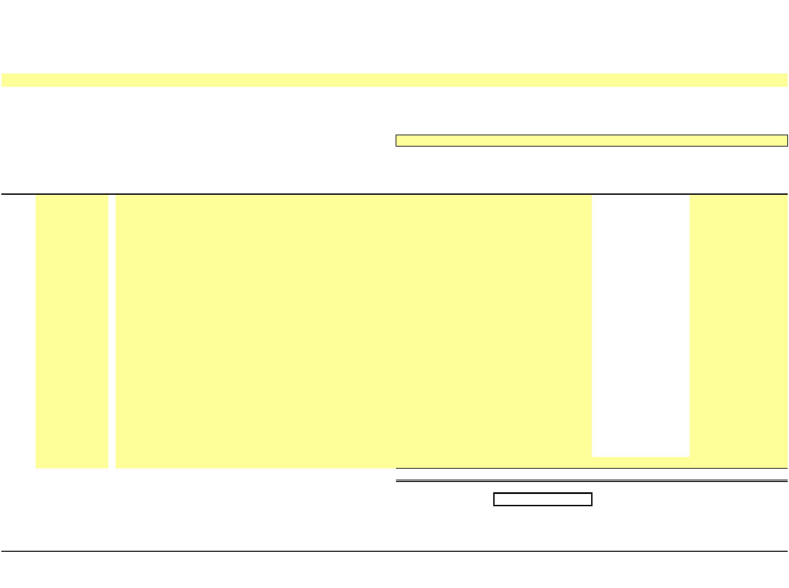

X

**NEW YORK POWER AUTHORITY**

**TRANSMISSION REVENUE REQUIREMENT**

**YEAR ENDING DECEMBER 31, ____**

**WORK PAPER BE (SUPPORT)**

**FACTS PROJECT PLANT IN SERVICE AND ACCUMULATED DEPRECIATION DETAILS**

**GROSS PLANT IN SERVICE**

**____**

**December**

(3)

**____**

**January**

(4)

**____**

**February**

(5)

**____**

**March**

(6)

**____**

**April**

(7)

**____**

**May**

(8)

**____**

**June**

(9)

**____**

**July**

(10)

**____**

**August**

(11)

**____**

**September**

(12)

**____**

**October**

(13)

**____**

**November**

(14)

**____**

**December**

(15)

**13-Month**

**Average**

Line No.

**Cap.Date**

(1)

**Asset Description**

(2)

(16)

1a

1b

1c

1d

1e

1f

1g

1h

1i

1j

1k

1l

1m

1n

1o

1p

1q

1r

-

-

-

-

-

-

-

-

-

-

-

-

-

-

-

-

-

-

-

-

-

-

-

1s

1t

1u

1v

1w

1…

2

…

**Total Plant**

**-**

**-**

**-**

**-**

**-**

**-**

**-**

**-**

**-**

**-**

**-**

**-**

**-**

**-**

Note: The FACTS project data is based on NYPA's financial records with adherence to FERC's Uniform System of Accounts and U.S. generally accepted accounting principles.

**ACCUMULATED DEPRECIATION**

**____**

**December**

(3)

**____**

**January**

(4)

**____**

**February**

(5)

**____**

**March**

(6)

**____**

**April**

(7)

**____**

**May**

(8)

**____**

**June**

(9)

**____**

**July**

(10)

**____**

**August**

(11)

**____**

**September**

(12)

**____**

**October**

(13)

**____**

**November**

(14)

**____**

**December**

(15)

**13-Month**

**Average**

Line No.

**Cap.Date**

(1)

**Asset Description**

(2)

(16)

3a

3b

3c

3d

3e

3f

3g

3h

3i

3j

3k

3l

3m

3n

3o

3p

3q

3r

-

-

-

-

-

-

-

-

-

-

-

-

-

-

-

-

-

-

-

-

-

-

-

3s

3t

3u

3v

3w

3…

4

…

**Total Accumulated Depreciation**

**-**

**-**

**-**

**-**

**-**

**-**

**-**

**-**

**-**

**-**

**-**

**-**

**-**

**-**

Data source for monthly amounts is NYPA financial records.

…

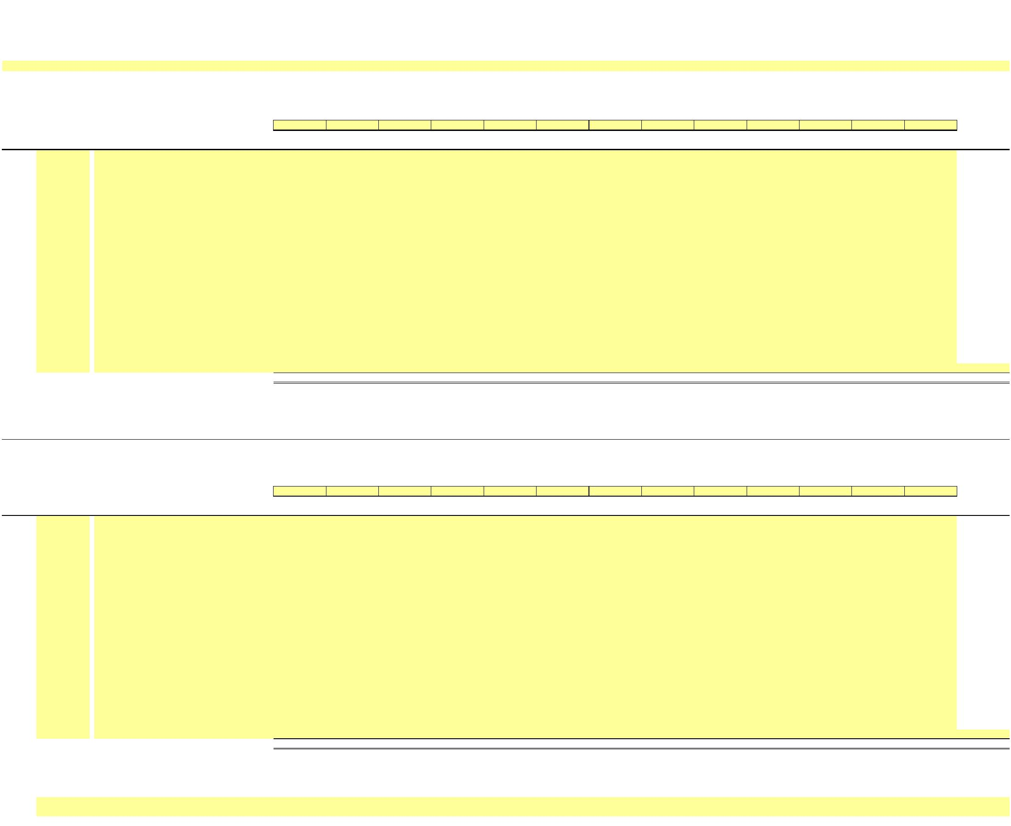

X

**NEW YORK POWER AUTHORITY**

**TRANSMISSION REVENUE REQUIREMENT**

**YEAR ENDING DECEMBER 31, ____**

**WORK PAPER BF**

**GENERATOR STEP-UP TRANSFORMERS BREAKOUT**

**13-Month Average**

**Electric**

**Plant in**

**Service ($)**

(1)

**Accumulated**

**Depreciation ($)**

(2)

**Electric Plant**

**(Net $)**

**Depreciation**

**Expense ($)**

(4)

**Line No.**

**Asset No.**

(3)

1

1a

1b

1c

1d

1e

…

-

-

-

-

-

**-**

**-**

**-**

**-**

2

2a

2b

2c

2d

2e

2f

2g

2h

…

-

-

-

-

-

-

-

-

**-**

**-**

**-**

**-**

**-**

**-**

**-**

**-**

**-**

**-**

3

3a

…

-

**-**

4

4a

…

-

**-**

5

5a

5b

5c

5d

…

-

-

-

-

**-**

**-**

**-**

**-**

**-**

**-**

**-**

6

6a

…

**-**

**-**

7

8

**Grand Total**

**-**

**-**

**-**

**-**

**-**

**-**

**Adjusted Grand Total (Excludes 500MW C - C at Astoria)**

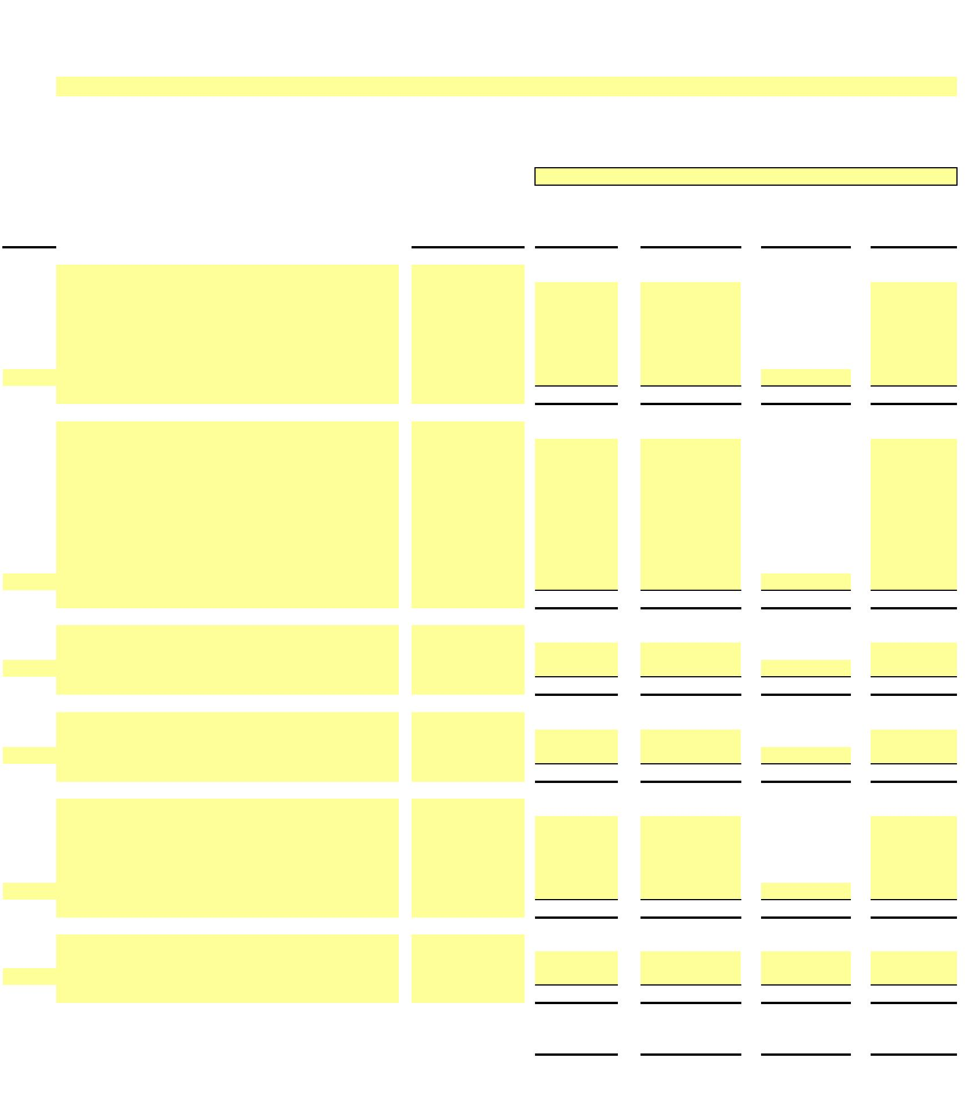

X

**NEW YORK POWER AUTHORITY**

**TRANSMISSION REVENUE REQUIREMENT**

**YEAR ENDING DECEMBER 31, ____**

**WORK PAPER BF (SUPPORT)**

**GENERATOR STEP-UP TRANSFORMERS BREAKOUT DETAILS**

**GROSS PLANT IN SERVICE**

**____**

**December**

**(3)**

**____**

**January**

**(4)**

**____**

**February**

**(5)**

**____**

**March**

**(6)**

**____**

**April**

**(7)**

**____**

**May**

**(8)**

**____**

**June**

**(9)**

**____**

**July**

**(10)**

**____**

**August**

**(11)**

**____**

**September**

**(12)**

**____**

**October**

**(13)**

**____**

**November**

**(14)**

**____**

**December**

**(15)**

**13-Month**

**Average**

**(16)**

**Line No.**

**Asset No.**

**(2)**

**(1)**

1

1a

1b

1c

1d

1e

…

-

-

-

-

-

**-**

**-**

**-**

**-**

**-**

**-**

**-**

**-**

**-**

**-**

**-**

**-**

**-**

**-**

2

2a

2b

2c

2d

2e

2f

2g

2h

…

-

-

-

-

-

-

-

-

**-**

**-**

**-**

**-**

**-**

**-**

**-**

**-**

**-**

**-**

**-**

**-**

**-**

**-**

**-**

**-**

**-**

**-**

**-**

**-**

**-**

**-**

**-**

**-**

**-**

**-**

**-**

**-**

**-**

**-**

**-**

**-**

**-**

**-**

**-**

**-**

**-**

**-**

**-**

**-**

**-**

**-**

3

3a

…

-

-

4

4a

…

5

5a

5b

5c

5d

…

-

-

-

-

**-**

**-**

**-**

**-**

**-**

**-**

**-**

**-**

**-**

**-**

**-**

**-**

**-**

**-**

**-**

**-**

**-**

**-**

**-**

**-**

**-**

**-**

**-**

**-**

**-**

**-**

**-**

**-**

6

6a

…

7

8

**Grand Total**

**-**

**-**

**-**

**-**

**-**

**-**

**-**

**-**

**-**

**-**

**-**

**-**

**-**

**-**

**-**

**-**

**-**

**-**

**-**

**-**

**-**

**-**

**-**

**-**

**-**

**-**

**-**

**-**

**Adjusted Grand Total (Excludes 500MW C - C at Astoria)**

**ACCUMULATED DEPRECIATION**

**____**

**December**

**(3)**

**____**

**January**

**(4)**

**____**

**February**

**(5)**

**____**

**March**

**(6)**

**____**

**April**

**(7)**

**____**

**May**

**(8)**

**____**

**June**

**(9)**

**____**

**July**

**(10)**

**____**

**August**

**(11)**

**____**

**September**

**(12)**

**____**

**October**

**(13)**

**____**

**November**

**(14)**

**____**

**December**

**(15)**

**13-Month**

**Average**

**(16)**

Line No.

**Asset No.**

**(2)**

**(1)**

9

9a

9b

9c

9d

9e

…

-

-

-

-

-

**-**

**-**

**-**

**-**

**-**

**-**

**-**

**-**

**-**

**-**

**-**

**-**

**-**

**-**

10

10a

10b

10c

10d

10e

10f

10g

10h

…

-

-

-

-

-

-

-

-

**-**

**-**

**-**

**-**

**-**

**-**

**-**

**-**

**-**

**-**

**-**

**-**

**-**

**-**

**-**

**-**

**-**

**-**

**-**

**-**

**-**

**-**

**-**

**-**

**-**

**-**

**-**

**-**

**-**

**-**

**-**

**-**

**-**

**-**

**-**

**-**

**-**

**-**

**-**

**-**

**-**

**-**

11

11a

…

-

-

12

12a

…

13

13a

13b

13c

13d

…

-

-

-

-

**-**

**-**

**-**

**-**

**-**

**-**

**-**

**-**

**-**

**-**

**-**

**-**

**-**

**-**

**-**

**-**

**-**

**-**

**-**

**-**

**-**

**-**

**-**

**-**

**-**

**-**

**-**

**-**

14

14a

…

15

16

**Grand Total**

**-**

**-**

**-**

**-**

**-**

**-**

**-**

**-**

**-**

**-**

**-**

**-**

**-**

**-**

**-**

**-**

**-**

**-**

**-**

**-**

**-**

**-**

**-**

**-**

**-**

**-**

**-**

**-**

**Adjusted Grand Total (Excludes 500MW C - C at Astoria)**

Notes

1/ Data source for monthly amounts is NYPA financial records.

…

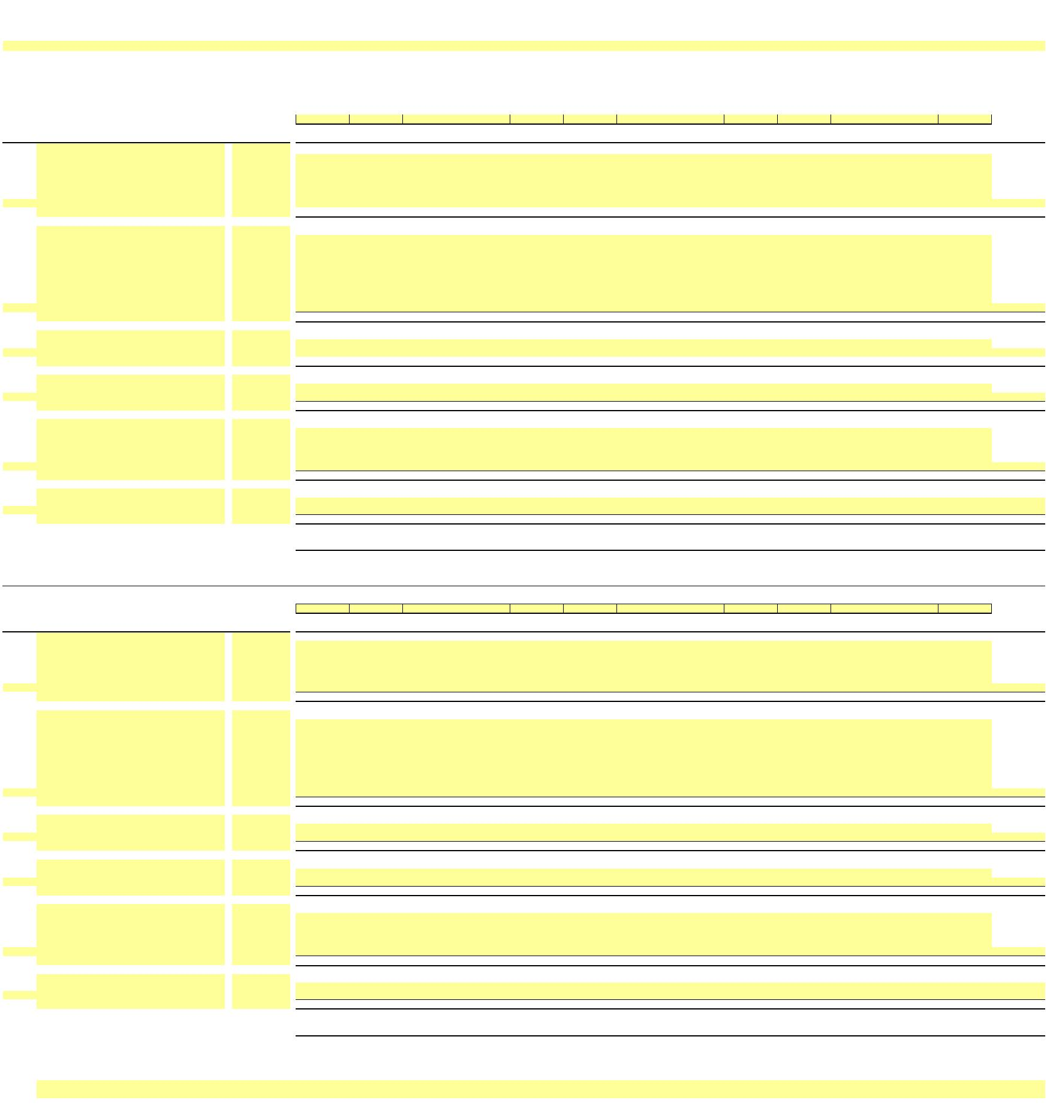

X

**NEW YORK POWER AUTHORITY**

**TRANSMISSION REVENUE REQUIREMENT**

**YEAR ENDING DECEMBER 31, ____**

**WORK PAPER BG**

**RELICENSING/RECLASSIFICATION EXPENSES**

**13-Month Average**

**Accumulated Plant in**

**Depreciation ($) Service (Net $) Expense ($)**

(2) (3) (4)

**Plant in**

**Service ($)**

**Depreciation**

**Line No.**

**NIAGARA**

(1)

1a

1b

1c

…

1

-

-

-

-

-

-

-

-

-

**-**

**-**

**-**

**-**

**ST. LAWRENCE**

2a

2b

2c

2d

2e

2f

2g

2h

…

2

-

-

-

-

-

-

-

-

-

-

-

-

-

-

-

-

-

-

-

-

-

-

-

-

**-**

**-**

**-**

**-**

**BLENHEIM GILBOA**

3a

3b

3c

3d

…

3

-

-

-

-

-

-

-

-

-

-

-

-

**-**

**-**

**-**

**-**

4a

…

…

…

4

**-**

**-**

**-**

**-**

**-**

**-**

**-**

**-**

5

**Total Expenses**



X

**NEW YORK POWER AUTHORITY**

**TRANSMISSION REVENUE REQUIREMENT**

**YEAR ENDING DECEMBER 31, ____**

**WORK PAPER BG (SUPPORT)**

**RELICENSING/RECLASSIFICATION EXPENSES DETAILS**

**GROSS PLANT IN SERVICE**

**____**

**December**

(2)

**____**

**January**

(3)

**____**

**February**

(4)

**____**

**March**

(5)

**____**

**April**

(6)

**____**

**May**

(7)

**____**

**June**

(8)

**____**

**July**

(9)

**____**

**August**

(10)

**____**

**September**

(11)

**____**

**October**

(12)

**____**

**November**

(13)

**____**

**December**

(14)

**13-Month**

**Average**

(15)

**Line No.**

(1)

**NIAGARA**

1a

1b

1c

…

1

-

-

-

**-**

**-**

**-**

**-**

**-**

**-**

**-**

**-**

**-**

**-**

**-**

**-**

**-**

**-**

**ST. LAWRENCE**

2a

2b

2c

2d

2e

2f

2g

2h

…

2

-

-

-

-

-

-

-

-

**-**

**-**

**-**

**-**

**-**

**-**

**-**

**-**

**-**

**-**

**-**

**-**

**-**

**-**

**BLENHEIM GILBOA**

3a

3b

3c

3d

…

3

-

-

-

-

**-**

**-**

**-**

**-**

**-**

**-**

**-**

**-**

**-**

**-**

**-**

**-**

**-**

**-**

4a

…

…

…

4

**-**

**-**

**-**

**-**

**-**

**-**

**-**

**-**

**-**

**-**

**-**

**-**

**-**

**-**

**-**

**-**

**-**

**-**

**-**

**-**

**-**

**-**

**-**

**-**

**-**

**-**

**-**

**-**

5

**Total Gross Plant in Service**

**ACCUMULATED DEPRECIATION**

**____**

**December**

**____**

**January**

(3)

**____**

**February**

(4)

**____**

**March**

(5)

**____**

**April**

(6)

**____**

**May**

(7)

**____**

**June**

(8)

**____**

**July**

(9)

**____**

**August**

(10)

**____**

**September**

**____**

**October**

(12)

**____**

**November**

**____**

**December**

**13-Month**

**Average**

(15)

**Line No.**

(1)

(2)

(11)

(13)

(14)

**NIAGARA**

6a

6b

6c

…

6

-

-

-

**-**

**-**

**-**

**-**

**-**

**-**

**-**

**-**

**-**

**-**

**-**

**-**

**-**

**-**

**ST. LAWRENCE**

7a

7b

7c

7d

7e

7f

7g

7h

…

7

-

-

-

-

-

-

-

-

**-**

**-**

**-**

**-**

**-**

**-**

**-**

**-**

**-**

**-**

**-**

**-**

**-**

**-**

**BLENHEIM GILBOA**

8a

8b

8c

8d

…

8

-

-

-

-

**-**

**-**

**-**

**-**

**-**

**-**

**-**

**-**

**-**

**-**

**-**

**-**

**-**

**-**

9a

…

…

…

9

**-**

**-**

**-**

**-**

**-**

**-**

**-**

**-**

**-**

**-**

**-**

**-**

**-**

**-**

**-**

**-**

**-**

**-**

**-**

**-**

**-**

**-**

**-**

**-**

**-**

**-**

**-**

**-**

10

**Total Expenses**

Notes

1/ Data source for monthly amounts is NYPA financial records.

…

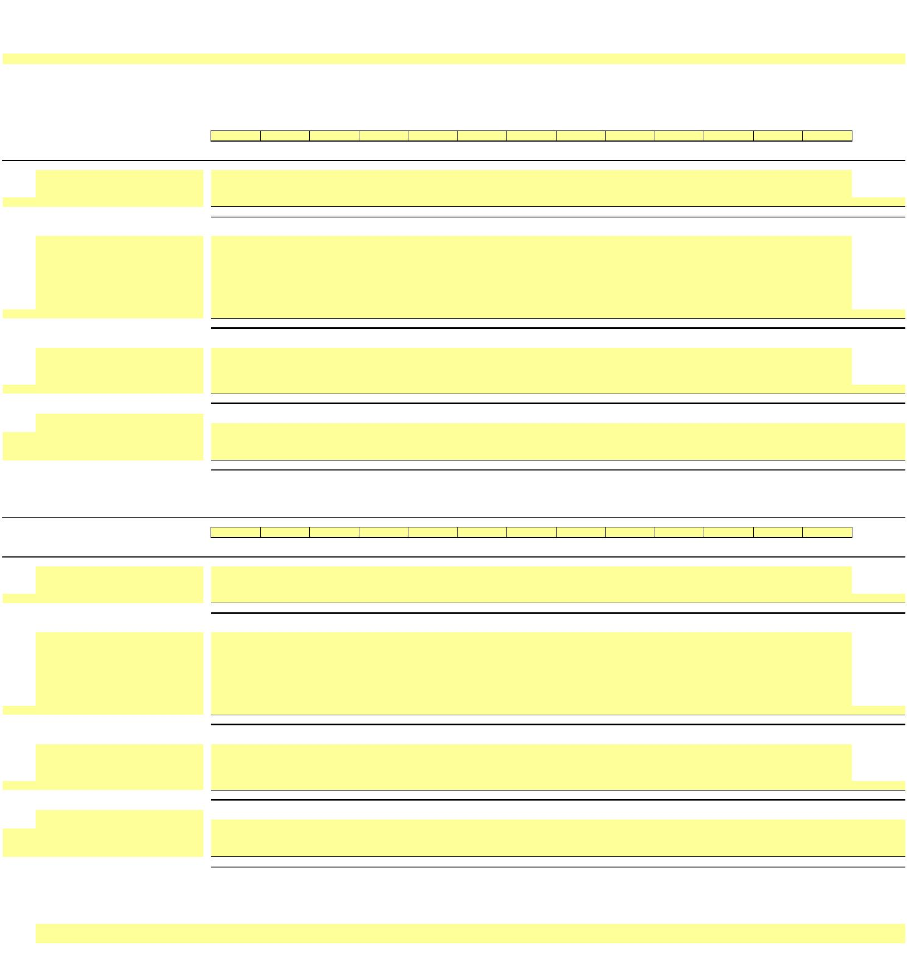

X

**NEW YORK POWER AUTHORITY**

**TRANSMISSION REVENUE REQUIREMENT**

**YEAR ENDING DECEMBER 31, ____**

**WORK PAPER BH**

**ASSET IMPAIRMENT**

**Posting**

**Date**

**Profit**

**____**

**____**

**____**

**____**

**____**

**April**

**____**

**May**

**____**

**June**

**____**

**July**

**____**

**____**

**____**

**____**

**____**

**13-Month**

**Average**

**Line No.**

**Center**

**Account**

**December**

**January**

**February**

**March**

**August**

**September**

**October**

**November**

**December**

**Facility**

(1)

(2)

(3)

(4)

(5)

(6)

(7)

(8)

(9)

(10)

(11)

(12)

(13)

(14)

(15)

(16)

(17)

(18)

1a

1b

1c

1d

1e

-

-

-

-

-

1f

-

-

1g

1h

1i

1j

…

2

-

-

-

**-**

**-**

**-**

**-**

**-**

**-**

**-**

**-**

**-**

**-**

**-**

**-**

**-**

**-**

3

4

5

Total Impairment - Production

Total Impairment - Transmission

Total Impairment - General Plant

**-**

**-**

**-**

**-**

**-**

**-**

**-**

**-**

**-**

**-**

**-**

**-**

**-**

**-**

**-**

**-**

**-**

**-**

**-**

**-**

**-**

**-**

**-**

**-**

**-**

**-**

**-**

**-**

**-**

**-**

**-**

**-**

**-**

**-**

**-**

**-**

**-**

**-**

**-**

**-**

**-**

**-**

…

Notes

1/

Data source for monthly amounts is NYPA financial records.

…

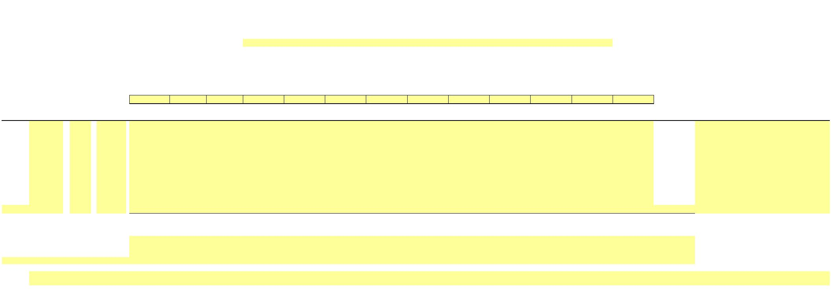

X

**NEW YORK POWER AUTHORITY**

**TRANSMISSION REVENUE REQUIREMENT**

**YEAR ENDING DECEMBER 31, ____**

**WORK PAPER BI**

**COST OF REMOVAL**

**Cost of Removal to Regulatory Assets - Depreciation:**

**Line**

**No.**

**____**

**December**

**____**

**January**

**____**

**February**

**____**

**March**

**____**

**April**

**____**

**May**

**____**

**June**

**____**

**July**

**____**

**August**

**____**

**September**

**____**

**October**

**____**

**November**

**____**

**December**

**13-Month**

**Average**

(1)

Production

Transmission

General

(2)

(3)

(4)

(5)

(6)

(7)

(8)

(9)

(10)

(11)

(12)

(13)

(14)

(15)

1

2

3

4

**-**

**-**

**-**

**-**

**Total**

**-**

**-**

**-**

**-**

**-**

**-**

**-**

**-**

**-**

**-**

**-**

**-**

**-**

**Note: The Cost of Removal data is based on NYPA's accounting records under the provisions of FASB Accounting Standards Codification Topic 980.**

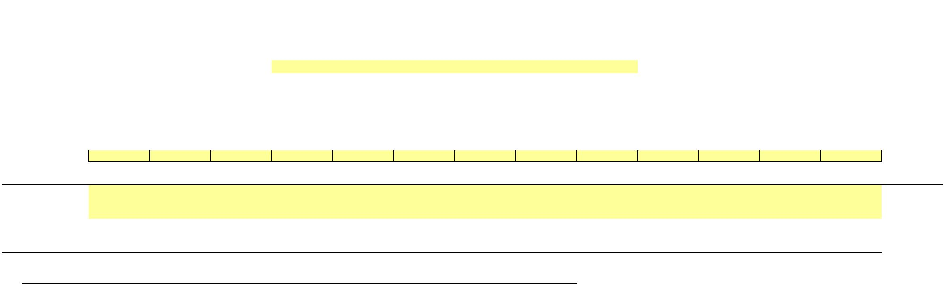

**NEW YORK POWER AUTHORITY**

**TRANSMISSION REVENUE REQUIREMENT**

**YEAR ENDING DECEMBER 31, ____**

**WORKPAPER BJ**

**INDIVIDUAL PROJECTS - PLANT IN SERVICE and DEPRECIATION**

**13-Month Average**

**Electric Plant in**

**Service ($)**

**Accumulated**

**Depreciation ($)**

**Electric Plant in**

**Service (Net $)**

**Depreciation**

**Expense ($)**

**Line No.**

**P/T/G**

**Plant Name**

**A/C**

**Description**

(1)

(2)

(3)

(4)

(5)

(6)

(7)

(8)

1a

1b

1c

1d

1e

1f

1g

1h

1i

Transmission

Transmission

Transmission

Transmission

Transmission

Transmission

Transmission

Transmission

Transmission

**MARCY-SOUTH SERIES COMPENSATION**

**MARCY-SOUTH SERIES COMPENSATION**

**MARCY-SOUTH SERIES COMPENSATION**

**MARCY-SOUTH SERIES COMPENSATION**

**MARCY-SOUTH SERIES COMPENSATION**

**MARCY-SOUTH SERIES COMPENSATION**

**MARCY-SOUTH SERIES COMPENSATION**

**MARCY-SOUTH SERIES COMPENSATION**

**MARCY-SOUTH SERIES COMPENSATION**

350 Land & Land Rights

352 Structures & Improvements

353 Station Equipment

354 Towers & Fixtures

355 Poles & Fixtures

356 Overhead Conductors & Devices

357 Underground Conduit

358 Underground Conductors & Devices

359 Roads & Trails

-

-

-

-

-

-

-

-

-

…

1

**MSSC Transmission Total**

**-**

**-**

**-**

**-**

**-**

**-**

**-**

**-**

**-**

**-**

2a

2b

2c

2d

2e

2f

2g

2h

2i

Transmission

Transmission

Transmission

Transmission

Transmission

Transmission

Transmission

Transmission

Transmission

**AC Project Segment A (CENTRAL EAST ENERGY CONNECT)**

**AC Project Segment A (CENTRAL EAST ENERGY CONNECT)**

**AC Project Segment A (CENTRAL EAST ENERGY CONNECT)**

**AC Project Segment A (CENTRAL EAST ENERGY CONNECT)**

**AC Project Segment A (CENTRAL EAST ENERGY CONNECT)**

**AC Project Segment A (CENTRAL EAST ENERGY CONNECT)**

**AC Project Segment A (CENTRAL EAST ENERGY CONNECT)**

**AC Project Segment A (CENTRAL EAST ENERGY CONNECT)**

**AC Project Segment A (CENTRAL EAST ENERGY CONNECT)**

350 Land & Land Rights

352 Structures & Improvements

353 Station Equipment

354 Towers & Fixtures

355 Poles & Fixtures

356 Overhead Conductors & Devices

357 Underground Conduit

358 Underground Conductors & Devices

359 Roads & Trails

-

-

-

-

-

-

-

-

-

…

2

**AC Project Seg A (Central East Energy Connect) Total**

**-**

**-**

**-**

**-**

3a

3b

3c

3d

3e

3f

3g

3h

3i

Transmission

Transmission

Transmission

Transmission

Transmission

Transmission

Transmission

Transmission

Transmission

**Smart Path Connect**

**Smart Path Connect**

**Smart Path Connect**

**Smart Path Connect**

**Smart Path Connect**

**Smart Path Connect**

**Smart Path Connect**

**Smart Path Connect**

**Smart Path Connect**

350 Land & Land Rights

352 Structures & Improvements

353 Station Equipment

354 Towers & Fixtures

355 Poles & Fixtures

356 Overhead Conductors & Devices

357 Underground Conduit

358 Underground Conductors & Devices

359 Roads & Trails

-

-

-

-

-

-

-

-

-

…

3

**SPC Project Total**

**-**

4a

4b

4c

4d

4e

4f

4g

4h

4i

Transmission

Transmission

Transmission

Transmission

Transmission

Transmission

Transmission

Transmission

Transmission

**Propel NY**

**Propel NY**

**Propel NY**

**Propel NY**

**Propel NY**

**Propel NY**

**Propel NY**

**Propel NY**

**Propel NY**

350 Land & Land Rights

352 Structures & Improvements

353 Station Equipment

354 Towers & Fixtures

355 Poles & Fixtures

356 Overhead Conductors & Devices

357 Underground Conduit

358 Underground Conductors & Devices

359 Roads & Trails

-

-

-

-

-

-

-

-

-

…

4

**Propel NY Project Total**

**-**

…

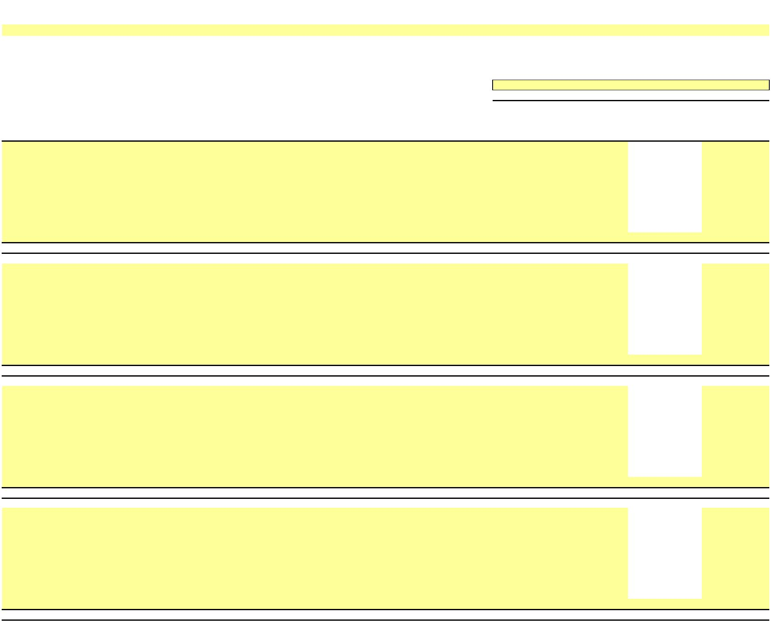

**NEW YORK POWER AUTHORITY**

**TRANSMISSION REVENUE REQUIREMENT**

**YEAR ENDING DECEMBER 31, ____**

**WORKPAPER BJ (SUPPORT)**

**INDIVIDUAL PROJECTS**

**-**

**GROSS PLANT IN SERVICE**

**Line No.**

**P/T/G**

**Plant Name**

**A/C**

**Description**

**____**

**December**

(5)

**____**

**January**

**____**

**February**

(7)

**____**

**March**

(8)

**____**

**April**

(9)

**____**

**May**

(10)

**____**

**June**

(11)

**____**

**July**

(12)

**____**

**August**

(13)

**____**

**September**

(14)

**____**

**October**

(15)

**____**

**November**

(16)

**____**

**December**

(17)

**13-Month**

**Average**

(18)

(1)

(2)

(3)

(4)

(6)

1a

1b

1c

1d

1e

1f

1g

1h

1i

Transmission

Transmission

Transmission

Transmission

Transmission

Transmission

Transmission

Transmission

Transmission

**MARCY-SOUTH SERIES COMPENSATION**

**MARCY-SOUTH SERIES COMPENSATION**

**MARCY-SOUTH SERIES COMPENSATION**

**MARCY-SOUTH SERIES COMPENSATION**

**MARCY-SOUTH SERIES COMPENSATION**

**MARCY-SOUTH SERIES COMPENSATION**

**MARCY-SOUTH SERIES COMPENSATION**

**MARCY-SOUTH SERIES COMPENSATION**

**MARCY-SOUTH SERIES COMPENSATION**

350 Land& LandRights

-

-

-

-

-

-

-

-

-

352 Structures & Improvements

353 StationEquipment

354 Towers & Fixtures

355 Poles & Fixtures

356 OverheadConductors & Devices

357 UndergroundConduit

358 UndergroundConductors & Devices

359 Roads & Trails

…

1

**MSSC Transmission Total**

**-**

**-**

**-**

**-**

**-**

**-**

**-**

**-**

**-**

**-**

**-**

**-**

**-**

**-**

**-**

**-**

**-**

**-**

**-**

**-**

**-**

**-**

**-**

**-**

**-**

**-**

**-**

**-**

**-**

**-**

**-**

**-**

**-**

**-**

**-**

**-**

**-**

**-**

**-**

**-**

**-**

**-**

**-**

**-**

**-**

**-**

**-**

**-**

**-**

**-**

2a

2b

2c

2d

2e

2f

2g

2h

2i

Transmission

Transmission

Transmission

Transmission

Transmission

Transmission

Transmission

Transmission

Transmission

**AC Project Segment A (CENTRAL EAST ENERGY CONNECT)**

**AC Project Segment A (CENTRAL EAST ENERGY CONNECT)**

**AC Project Segment A (CENTRAL EAST ENERGY CONNECT)**

**AC Project Segment A (CENTRAL EAST ENERGY CONNECT)**

**AC Project Segment A (CENTRAL EAST ENERGY CONNECT)**

**AC Project Segment A (CENTRAL EAST ENERGY CONNECT)**

**AC Project Segment A (CENTRAL EAST ENERGY CONNECT)**

**AC Project Segment A (CENTRAL EAST ENERGY CONNECT)**

**AC Project Segment A (CENTRAL EAST ENERGY CONNECT)**

350 Land& LandRights

352 Structures & Improvements

353 StationEquipment

354 Towers & Fixtures

355 Poles & Fixtures

356 OverheadConductors & Devices

357 UndergroundConduit

358 UndergroundConductors & Devices

359 Roads & Trails

-

-

-

-

-

-

-

-

-

…

2

**AC Project Seg A (Central East EnergyConnect) Total**

**-**

**-**

3a

3b

3c

3d

3e

3f

3g

3h

3i

Transmission

Transmission

Transmission

Transmission

Transmission

Transmission

Transmission

Transmission

Transmission

**Smart Path Connect**

**Smart Path Connect**

**Smart Path Connect**

**Smart Path Connect**

**Smart Path Connect**

**Smart Path Connect**

**Smart Path Connect**

**Smart Path Connect**

**Smart Path Connect**

350 Land& LandRights

352 Structures & Improvements

353 StationEquipment

354 Towers & Fixtures

355 Poles & Fixtures

356 OverheadConductors & Devices

357 UndergroundConduit

358 UndergroundConductors & Devices

359 Roads & Trails

-

-

-

-

-

-

-

-

-

…

3

**SPC Project Total**

**-**

**-**

4a

4b

4c

4d

4e

4f

4g

4h

4i

Transmission

Transmission

Transmission

Transmission

Transmission

Transmission

Transmission

Transmission

Transmission

**Propel NY**

**Propel NY**

**Propel NY**

**Propel NY**

**Propel NY**

**Propel NY**

**Propel NY**

**Propel NY**

**Propel NY**

350 Land& LandRights

352 Structures & Improvements

353 StationEquipment

354 Towers & Fixtures

355 Poles & Fixtures

356 OverheadConductors & Devices

357 UndergroundConduit

358 UndergroundConductors & Devices

359 Roads & Trails

-

-

-

-

-

-

-

-

-

…

4

**Propel NY Project Total**

**-**

**-**

…

**WORKPAPER BJ**

**INDIVIDUAL PROJECTS**

**-**

**ACCUMULATED DEPRECIATION**

**Line No.**

**P/T/G**

**Plant Name**

**A/C**

**Description**

**____**

**December**

(5)

**____**

**January**

(6)

**____**

**February**

(7)

**____**

**March**

(8)

**____**

**April**

(9)

**____**

**May**

(10)

**____**

**June**

(11)

**____**

**July**

(12)

**____**

**August**

(13)

**____**

**September**

(14)

**____**

**October**

(15)

**____**

**November**

(16)

**____**

**December**

(17)

**13-Month**

**Average**

(18)

(1)

(2)

(3)

(4)

11a

11b

11c

11d

11e

11f

11g

11h

11i

Transmission

Transmission

Transmission

Transmission

Transmission

Transmission

Transmission

Transmission

Transmission

**MARCY-SOUTH SERIES COMPENSATION**

**MARCY-SOUTH SERIES COMPENSATION**

**MARCY-SOUTH SERIES COMPENSATION**

**MARCY-SOUTH SERIES COMPENSATION**

**MARCY-SOUTH SERIES COMPENSATION**

**MARCY-SOUTH SERIES COMPENSATION**

**MARCY-SOUTH SERIES COMPENSATION**

**MARCY-SOUTH SERIES COMPENSATION**

**MARCY-SOUTH SERIES COMPENSATION**

350 Land& LandRights

-

-

-

-

-

-

-

-

-

352 Structures & Improvements

353 StationEquipment

354 Towers & Fixtures

355 Poles & Fixtures

356 OverheadConductors & Devices

357 UndergroundConduit

358 UndergroundConductors & Devices

359 Roads & Trails

…

11

**MSSC Transmission Total**

**-**

**-**

**-**

**-**

**-**

**-**

**-**

**-**

**-**

**-**

**-**

**-**

**-**

**-**

**-**

**-**

**-**

**-**

**-**

**-**

**-**

**-**

**-**

**-**

**-**

**-**

**-**

**-**

**-**

**-**

**-**

**-**

**-**

**-**

**-**

**-**

**-**

**-**

**-**

**-**

**-**

**-**

**-**

**-**

**-**

**-**

**-**

**-**

**-**

**-**

12a

12b

12c

12d

12e

12f

12g

12h

12i

Transmission

Transmission

Transmission

Transmission

Transmission

Transmission

Transmission

Transmission

Transmission

**AC Project Segment A (CENTRAL EAST ENERGY CONNECT)**

**AC Project Segment A (CENTRAL EAST ENERGY CONNECT)**

**AC Project Segment A (CENTRAL EAST ENERGY CONNECT)**

**AC Project Segment A (CENTRAL EAST ENERGY CONNECT)**

**AC Project Segment A (CENTRAL EAST ENERGY CONNECT)**

**AC Project Segment A (CENTRAL EAST ENERGY CONNECT)**

**AC Project Segment A (CENTRAL EAST ENERGY CONNECT)**

**AC Project Segment A (CENTRAL EAST ENERGY CONNECT)**

**AC Project Segment A (CENTRAL EAST ENERGY CONNECT)**

350 Land& LandRights

352 Structures & Improvements

353 StationEquipment

354 Towers & Fixtures

355 Poles & Fixtures

356 OverheadConductors & Devices

357 UndergroundConduit

358 UndergroundConductors & Devices

359 Roads & Trails

-

-

-

-

-

-

-

-

-

…

12

**AC Project Seg A (Central East EnergyConnect) Total**

**-**

**-**

**-**

**-**

13a

13b

13c

13d

13e

13f

13g

13h

13i

Transmission

Transmission

Transmission

Transmission

Transmission

Transmission

Transmission

Transmission

Transmission

**Smart Path Connect**

**Smart Path Connect**

**Smart Path Connect**

**Smart Path Connect**

**Smart Path Connect**

**Smart Path Connect**

**Smart Path Connect**

**Smart Path Connect**

**Smart Path Connect**

350 Land& LandRights

352 Structures & Improvements

353 StationEquipment

354 Towers & Fixtures

355 Poles & Fixtures

356 OverheadConductors & Devices

357 UndergroundConduit

358 UndergroundConductors & Devices

359 Roads & Trails

-

-

-

-

-

-

-

-

-

…

13

**SPC Project Total**

**-**

14a

14b

14c

14d

14e

14f

14g

14h

14i

Transmission

Transmission

Transmission

Transmission

Transmission

Transmission

Transmission

Transmission

Transmission

**Propel NY**

**Propel NY**

**Propel NY**

**Propel NY**

**Propel NY**

**Propel NY**

**Propel NY**

**Propel NY**

**Propel NY**

350 Land& LandRights

352 Structures & Improvements

353 StationEquipment

354 Towers & Fixtures

355 Poles & Fixtures

356 OverheadConductors & Devices

357 UndergroundConduit

358 UndergroundConductors & Devices

359 Roads & Trails

-

-

-

-

-

-

-

-

-

…

14

**Propel NY Project Total**

**-**

…

Notes

1/

Data source for monthly amounts is NYPA financial records.

…

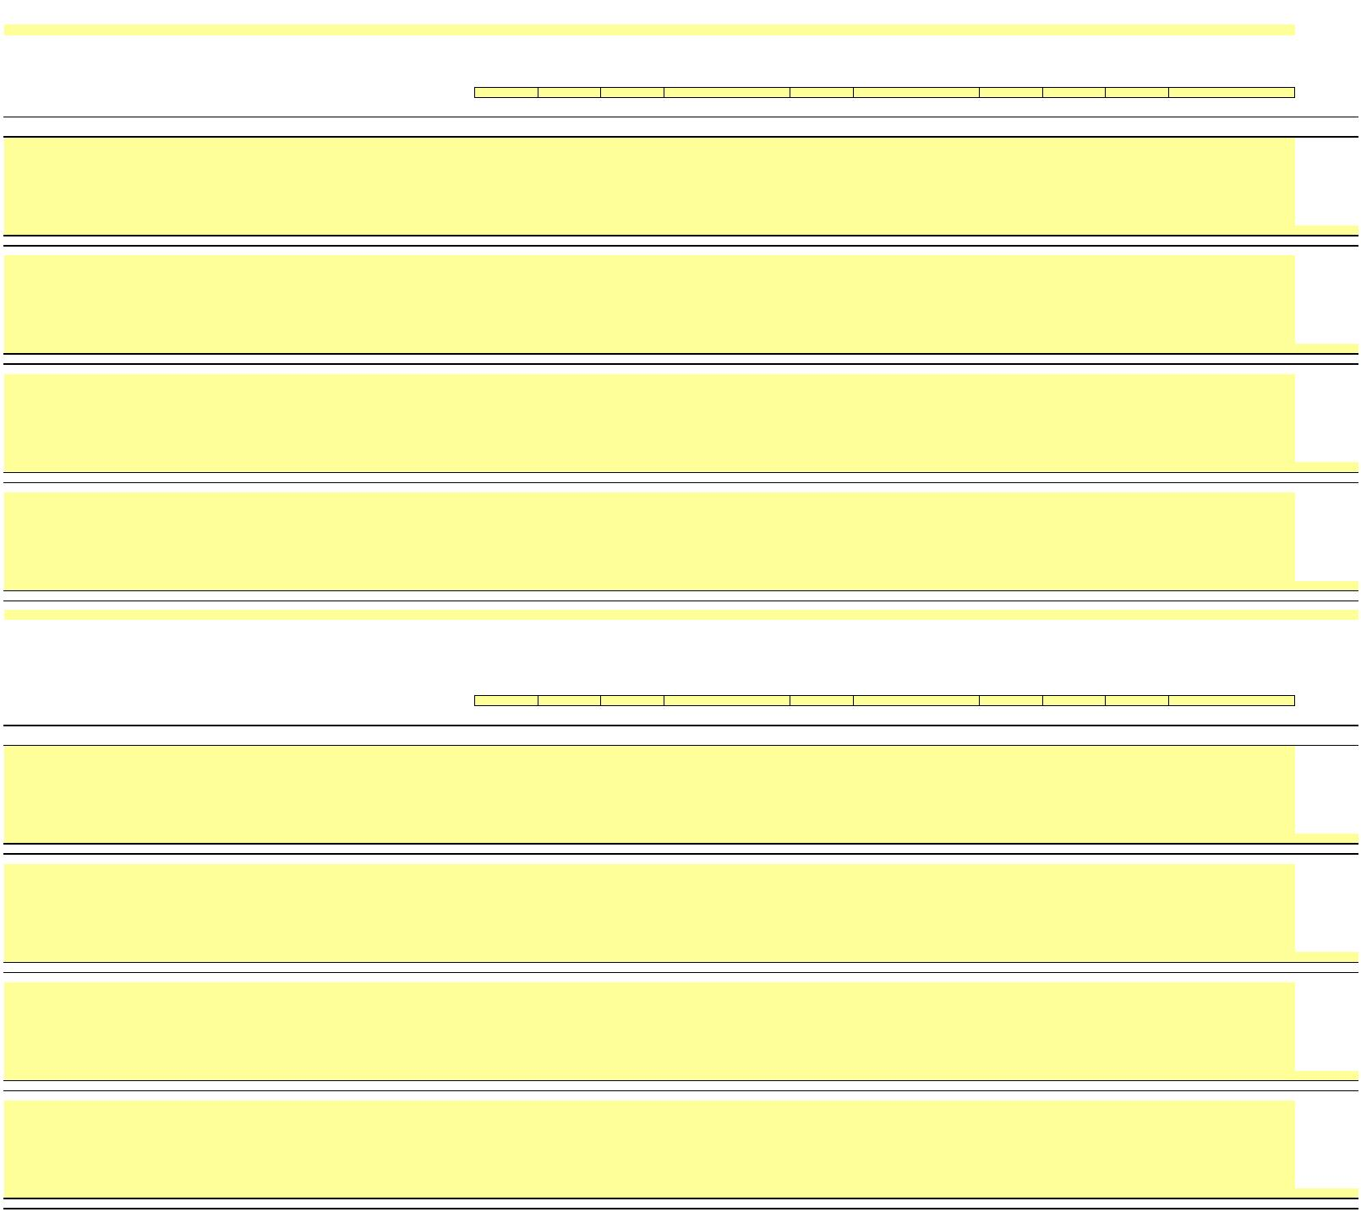

X

**NEW YORK POWER AUTHORITY**

**TRANSMISSION REVENUE REQUIREMENT**

**YEAR ENDING DECEMBER 31, ____**

**WORK PAPER CA**

**MATERIALS AND SUPPLIES**

**Total M&S Inventory ($)**

**____**

**NYPA**

**Line No Acct #**

(1)

**____**

**December**

(3)

**____**

**January**

(4)

**____**

**February**

(5)

**____**

**March**

(6)

**____**

**April**

(7)

**____**

**May**

(8)

**____**

**July**

(10)

**____**

**August**

(11)

**____**

**September**

(12)

**____**

**October**

(13)

**____**

**November**

(14)

**____**

**December**

(15)

**13-Month**

**Average**

(16)

**Facility**

**June**

(2)

(9)

1a

1b

1c

1d

1e

1f

1100

1200

3100

3200

1300

3300

2100

-

NIA

-

-

-

-

-

-

-

STL

POL

Flynn

B/G

500MW

CEC

-

1g

…

2

Facility Subtotal

-

-

-

-

-

-

-

-

-

-

-

-

-

-

-

-

-

-

-

-

-

-

-

-

-

-

3a Reserve for Degraded Materials

3b Reserve for Excess and Obsolete Inventory

…

-

-

-

-

4

Reserves Subtotal

-

-

5

6

7

**Total**

**-**

**-**

**-**

**-**

**-**

**-**

**-**

**-**

**-**

**-**

**-**

**-**

**-**

**-**

**Transmission Allocator**

**Allocated M&S ($)**

**-**

**-**

Notes

1/ Data source for monthly amounts is NYPA financial records.

…

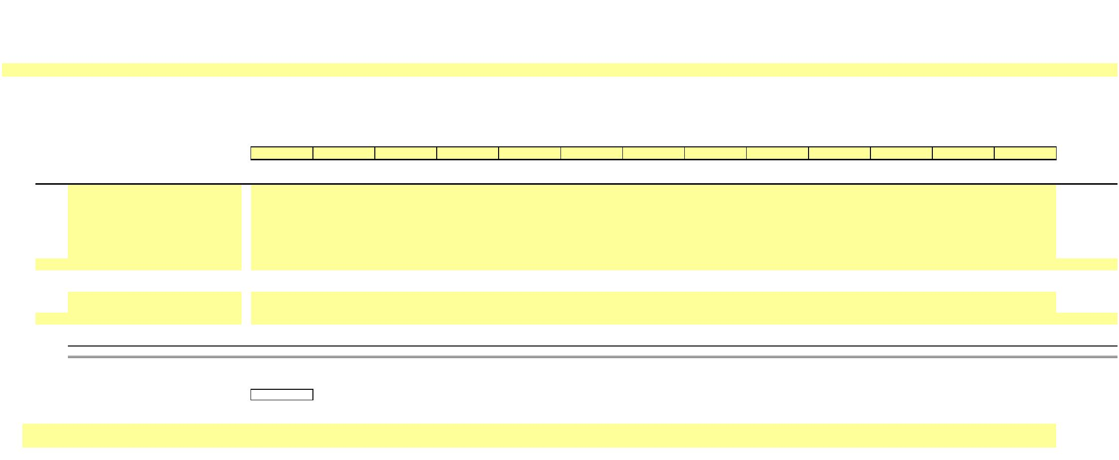

X

**NEW YORK POWER AUTHORITY**

**TRANSMISSION REVENUE REQUIREMENT**

**YEAR ENDING DECEMBER 31, ____**

**WORK PAPER CB**

**PREPAYMENTS AND INSURANCE**

**Property**

**Insurance ($)**

(2)

**Other**

**Prepayments ($)**

**Line No.**

**Date**

(1)

(3)

1

2

3

4

5

6

7

8

9

10

11

12

13

14

**13-Month Average**

**-**

**-**

Notes

1/ Data source for monthly amounts is NYPA financial records.

…



X

**NEW YORK POWER AUTHORITY**

**TRANSMISSION REVENUE REQUIREMENT**

**YEAR ENDING DECEMBER 31, ____**

**WORK PAPER CC**

**LAND HELD FOR FUTURE USE**

**____**

**December**

(3)

**____**

**January**

(4)

**____**

**February**

(5)

**____**

**March**

(6)

**____**

**April**

(7)

**____**

**May**

(8)

**____**

**June**

(9)

**____**

**July**

(10)

**____**

**August**

(11)

**____**

**September**

(12)

**____**

**October**

(13)

**____**

**November**

(14)

**____**

**December**

(15)

**13-Month**

**Average**

(16)

**Line No.**

(1)

**Property Name (Note 2)**

(2)

1a

1b

1c

1d

1e

1f

-

-

-

-

-

-

-

-

-

-

-

-

-

-

-

-

-

-

-

-

-

-

-

-

-

-

-

-

-

-

-

-

-

-

-

-

-

-

-

-

-

-

-

-

-

-

-

-

-

-

-

-

-

-

-

-

-

-

-

-

-

-

-

-

-

-

-

-

-

-

-

-

-

-

-

-

-

-

-

-

-

-

-

-

-

-

-

-

-

-

-

-

-

-

-

-

-

-

-

-

-

-

-

-

-

-

-

-

-

-

-

-

1g

…

2

Total

**-**

**-**

**-**

**-**

**-**

**-**

**-**

**-**

**-**

**-**

**-**

**-**

**-**

**-**

Notes

1/ Data source for monthly amounts is NYPA financial records.

2/ Identify property as transmission or general and intangible

…

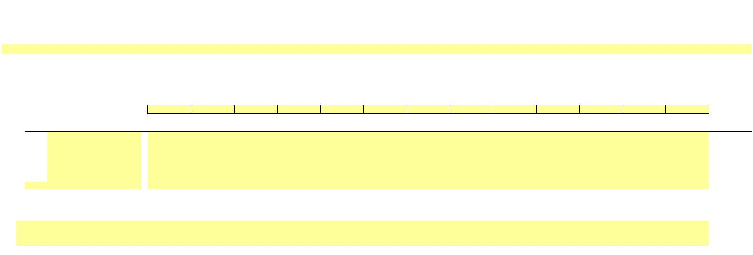

X

**NEW YORK POWER AUTHORITY**

**TRANSMISSION REVENUE REQUIREMENT**

**YEAR ENDING DECEMBER 31, ____**

**WORK PAPER DA**

**WEIGHTED COST OF CAPITAL**

**Actual**

**Share**

**(3)**

**Equity**

**Cap**

**(4)**

**Applied**

**Share**

**(5)**

**Cost**

**Rate**

**(6)**

**Weighted**

**Cost**

**Line No.**

**Component**

**(1)**

**Amount ($)**

**(2)**

**(7)**

1

Long-Term Debt

Preferred Stock

Common Equity

Total

-

-

-

-

6/

1/

-

50.00%

-

-

-

-

-

-

-

2/

3/

-

-

-

-

2

3

-

-

50.00%

100%

4/

9.45% 5/

4

0%

Notes

1/:

5

6

7

8

Total Proprietary Capital

less Preferred

less Acct. 216.1

-

-

Workpaper WP-DB Ln (5), Col (15)

Common Equity

2/:

9

10

Total Long Term Debt Interest

Net Proceeds Long Term Debt

LTD Cost Rate

-

-

-

Workpaper WP-DB Col (2) Ln (2)

Workpaper WP-DB Ln (4), Col (15)

11

7/

3/:

12

13

14

Preferred Dividends

Preferred Stock

Preferred Cost Rate

-

-

-

15

4/: The capital structure listed in Col (3) is calculated based on the total capitalization amount listed in column (2). The Equity Cap in Col (4) Ln (3)

is fixed and cannot be modified or deleted absent an FPA Section 205 or 206 filing to FERC. The Applied Equity Share in Col (5) Ln (3) will be the

actual common equity share, not to exceed the Equity Cap in Col (4) Ln (3). The debt share is calculated as 1 minus the equity share.

16

17

18

5/: The ROE listed in Col (6), Ln (3) is the base ROE plus 50 basis-point incentive for RTO participation. ROE may only be changed pursuant to an

FPA Section 205 or 206 filing to FERC.

6/: The Long-Term Debt Amount ($) in Col (2) Ln (1) is the Gross Proceeds Outstanding Long Term Debt, the average of WP-DB Ln (3e), Col (15).

7/: The Long-Term Debt Cost Rate is calculated as the Total Long Term Debt Interest [Workpaper WP-DB Col (2) Ln (2)] divided by the Net Proceeds

Long Term Debt [Workpaper WP-DB row (4), Col (15)].



X

**NEW YORK POWER AUTHORITY**

**TRANSMISSION REVENUE REQUIREMENT**

**YEAR ENDING DECEMBER 31, ____**

**WORK PAPER DB**

**CAPITAL STRUCTURE**

**LONG-TERM DEBT AND RELATED INTEREST**

(1)

(2)

(3)

(4)

(5)

(6)

(7)

(8)

(9)

(10)

(11)

(12)

(13)

(14)

(15)

(16)

**NYPA Form 1**

**Equivalent**

**Line No.**

**12/31/____**

**Amount ($)**

1

**Long Term Debt Cost**

1a

1b

1c

1d

1e

Interest on Long-Term Debt

p. 117 ln. 62 c

p. 117 ln. 63 c

p. 117 ln. 64 c

p. 117 ln. 65 c

p. 117 ln. 66 c

Amort. of Debt Disc. and Expense

Amortization of Loss on Reacquired Debt

(Less) Amort. of Premium on Debt

(Less) Amortization of Gain on Reacquired Debt

2

**Total Long Term Debt Interest**

**-**

**13-Month Average**

**Amount ($)**

3

**Long Term Debt**

**Amount ($)**

**Amount ($)**

**Amount ($)**

**Amount ($)**

**Amount ($)**

**Amount ($)**

**Amount ($)**

**Amount ($)**

**Amount ($)**

**Amount ($)**

**Amount ($)**

**Amount ($)**

**Amount ($)**

3a

3b

3d

Bonds

(Less) Reacquired Bonds

Other Long Term Debt

-

-

-

p. 112 ln. 18 c,d

p. 112 ln. 19 c,d

p. 112 ln. 21 c,d

3e

Gross Proceeds Outstanding LT Debt

**-**

**-**

**-**

**-**

**-**

**-**

**-**

**-**

**-**

**-**

**-**

**-**

**-**

**-**

3f

3g

3h

3i

(Less) Unamortized Discount on Long-Term Debt

(Less) Unamortized Debt Expenses

(Less) Unamortized Loss on Reacquired Debt

Unamortized Premium on Long-Term Debt

Unamortized Gain on Reacquired Debt

-

-

-

-

-

p. 112 ln. 23 c,d

p. 111 ln. 69 c,d

p. 111 ln. 81 c,d

p. 112 ln. 22 c,d

p. 113 ln. 61 c,d

3k

4

5

**Net Proceeds Long Term Debt**

**Net Position**

**-**

**-**

**-**

**-**

**-**

**-**

**-**

**-**

**-**

**-**

**-**

**-**

**-**

**-**

**-**

**-**

**-**

Notes

1/ Data source for monthly amounts is NYPA financial records.

…

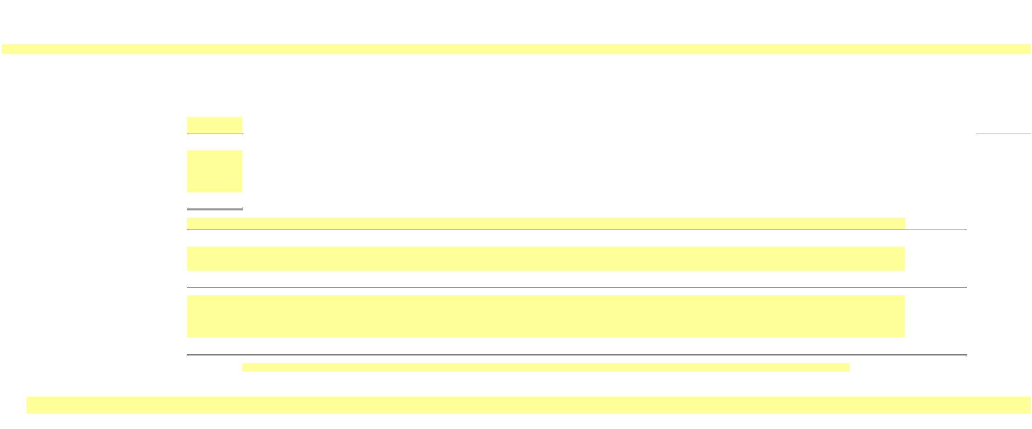

X

**NEW YORK POWER AUTHORITY**

**TRANSMISSION REVENUE REQUIREMENT**

**YEAR ENDING DECEMBER 31, ____**

**WORK PAPER EA**

**CALCULATION OF A&G AND GENERAL PLANT ALLOCATOR**

(1)

(2)

(3)

(4)

(5)

(6)

(7)

(8)

(9)

(10)

**1/**

**2/**

**Net Revenue3/**

**$**

**Profit**

**Labor**

**$**

**Net Plant**

**$**

**Labor**

**%**

**Net Plant**

**%**

**Net Revenue**

**%**

**Allocator**

**Ratio**

**Center(s)**

**Site**

1a

**105**

**110**

**115**

**120**

**125**

**Blenheim-Gilboa**

**0.00%**

1b

1c

1d

1e

1f

**St. Lawrence**

**Niagara**

**Poletti**

**0.00%**

**0.00%**

**0.00%**

**0.00%**

**Flynn**

1g

1h

1i

1j

1k

1l

1m

1n

1o

1p

1q

1r

**122**

**130-150**

**155-161**

**165**

**AE II**

**0.00%**

**0.00%**

**0.00%**

**0.00%**

**0.00%**

**0.00%**

**0.00%**

**0.00%**

**Total Small Hydro**

**Total Small Clean Power Plants**

**500MW Combined Cycle**

**Total Included Transmission**

**Recharge New York**

**SENY**

**205-245**

**321**

1s

**600**

…

**-**

**-**

**Total - Production + Transmission**

**Total - Production Only**

**-**

**-**

**-**

**0.00%**

0.00%

**0.00%**

0.00%

**0.00%**

**0.00%**

**0.00%**

-

-

-

0.00%

Notes

1/

Data source for Labor is NYPA Form 1 Equivalent and audited financials.

2/

3/

Data source for Net Plant is NYPA audited financials. The balance at the end of the calendar year is used in determining the percentages for the Net Plant factor.

Data source for Net Revenue is NYPA audited financials.

Net Revenue excludes fuel, purchased power and certain other charges that are passed through to direct service customers.

…

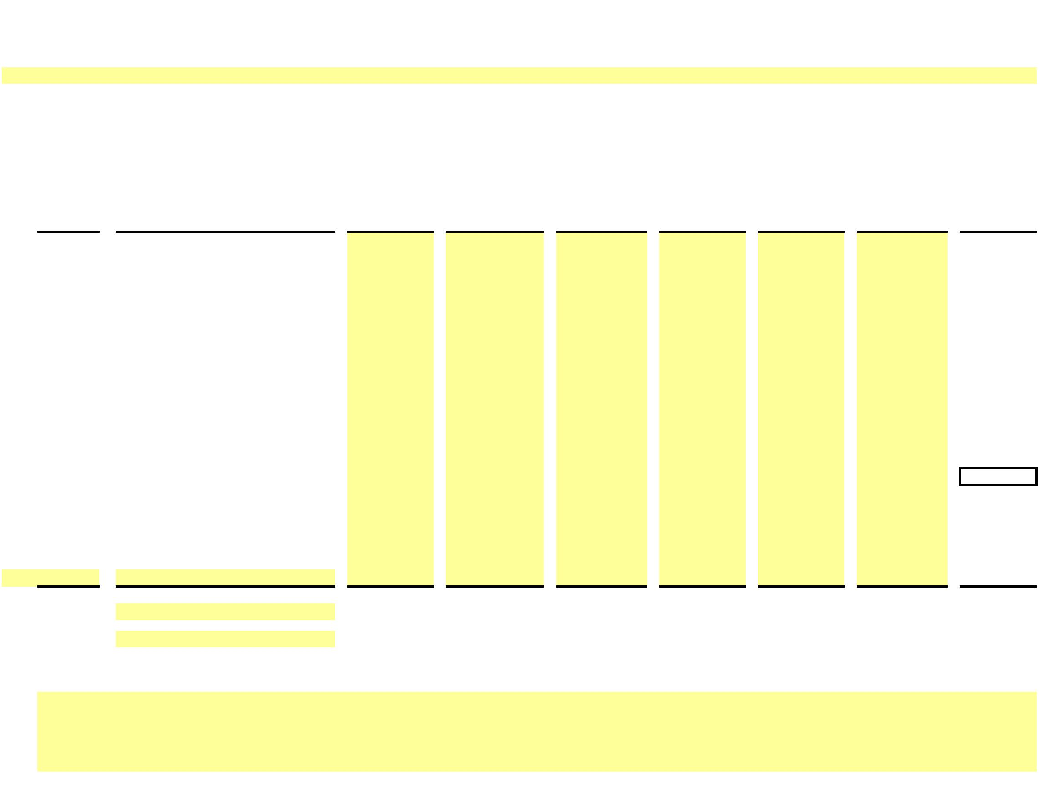

X

**NEW YORK POWER AUTHORITY**

**TRANSMISSION REVENUE REQUIREMENT**

**YEAR ENDING DECEMBER 31, ____**

**WORK PAPER AR- IS**

**STATEMENT OF REVENUES, EXPENSES AND CHANGES IN NET POSITION**

**($ Millions)**

**Actual**

**Actual**

**Description**

**____**

**____**

(1)

(2)

(3)

**1**

**Operating Revenues**

1a

1b

1c

1d

…

**2**

Power Sales

Transmission Charges

Wheeling Charges

Other

-

**Total Operating Revenues**

**-**

**-**

**3**

**Operating Expenses**

Purchased Power

Fuel Oil and Gas

Wheeling

3a

3b

3c

3d

3e

3f

Operations

Maintenance

Depreciation

3g

…

**4**

Impairment Cost

-

**Total Operating Expenses**

**-**

**-**

**-**

**-**

**5**

**Operating Income**

**6**

**Nonoperating Revenues**

6a

6b

…

**7**

Investment Income

Other

-

**Investments and Other Income**

**-**

**-**

**8**

**Nonoperating Expenses**

Contribution to New York State

Interest on Long-Term Debt

Interest - Other

8a

8b

8c

8d

8e

8f

Interest Capitalized

Amortization of Debt Premium

Canal Reimbursement Agreement

-

…

**9**

**Investments and Other Income**

**-**

**-**

**-**

**-**

**10**

**Net Income Before Contributed Capital**

**11**

**…**

Contributed Capital - Wind Farm Transmission Assets

-

-

-

-

-

**13**

**14**

**15**

Change in net position

Net position at January 1

Net position at December 31

-

-



X

X

**NEW YORK POWER AUTHORITY**

**TRANSMISSION REVENUE REQUIREMENT**

**YEAR ENDING DECEMBER 31, ____**

**WORK PAPER AR-BS**

**STATEMENT OF NET POSITION**

**($ Millions)**

**DESCRIPTION**

**DECEMBER ____ DECEMBER ____**

(2) (3)

(1)

**1**

**Assets and Deferred Outflows**

Current Assets:

Cash and cash equivalents

1a

1b

1c

1d

1e

1f

1g

1h

1i

Investment in securities

Investments in securities- restricted

Receivables - customers

Materials and supplies, at average Cost:

Plant and general

Fuel

Miscellaneous receivables and other

-

…

**2**

Total current assets

-

-

**3**

Noncurrent Assets:

3a

3b

3c

…

Restricted funds:

Cash and cash equivalents

Investment in securities

-

**4**

Total restricted assets

-

-

-

-

-

-

**5**

Capital funds:

5a

5b

…

Cash and cash equivalents

Investment in securities

-

**6**

Total capital funds

**7**

Capital Assets

7a

7b

…

Capital assets not being depreciated

Capital assets, net of accumulated depreciation

-

**8**

Total capital assets

9

Other noncurrent assets:

Receivable - New York State

Notes receivable - nuclear plant sale

Other long-term assets

-

9a

9b

9c

…

**10**

**11**

**12**

Total other noncurrent assets

Total noncurrent assets

Total assets

-

-

-

-

-

-

**13**

Deferred outflows:

13a

13b

13c

13d

…

Accumulated decrease in fair value of hedging derivatives

Pensions

Postemployment benefits other than pensions (Note 11)

Asset retirement obligation

-

**14**

Total Deferred outflows

**15**

**Total assets and deferred outflows**

**-**

**-**

1/ Source: Annual Financial Statements



X

X

**NEW YORK POWER AUTHORITY**

**TRANSMISSION REVENUE REQUIREMENT**

**YEAR ENDING DECEMBER 31, ____**

**WORK PAPER AR-BS**

**STATEMENT OF NET POSITION**

**($ Millions)**

**DESCRIPTION**

**DECEMBER ____ DECEMBER ____**

**16**

**Liabilities, Deferred Inflows and Net Position**

Current Liabilities:

16a

16b

16c

16d

16e

16f

…

Accounts payable and accrued liabilities

Short-term debt

Long-term debt due within one year

Capital lease obligation due within one year

Risk management activities - derivatives

-

**17**

Total current liabilities

-

-

18

Noncurrent liabilities:

Long-term debt:

Senior:

18a

18b

18c

18d

18e

18f

18g

…

Revenue bonds

Adjustable rate tender notes

Subordinated:

Subordinated Notes, Series 2012

Commercial paper

-

**19**

Total long-term debt

-

-

20

Other noncurrent liabilities:

Capital lease obligation

20a

20b

20c

20d

20e

20f

…

Liability to decommission divested nuclear facilities

Disposal of spent nuclear fuel

Relicensing

Risk management activities - derivatives

Other long-term liabilities

-

**21**

**22**

**23**

Total other noncurrent liabilities

Total noncurrent liabilities

Total liabilities

-

-

-

-

-

-

**24**

Deferred inflows:

24a

24b

24c

24d

…

Cost of removal obligation

Accumulated increase in fair value of hedging

Pensions (Note 10)

Postemployment benefits other than pensions (Note 11)

-

-

-

**25**

Net position:

25a

25b

25c

25d

…

Net investment in capital assets

Restricted

Unrestricted

Postemployment benefits other than pensions (Note 11)

-

**26**

**27**

Total net position

**Total liabilities, deferred inflows and net position**

-

**-**

-

**-**

1/ Source: Annual Financial Statements



X

**NEW YORK POWER AUTHORITY**

**TRANSMISSION REVENUE REQUIREMENT**

**YEAR ENDING DECEMBER 31, ____**

**WORK PAPER AR-Cap Assets**

**CAPITAL ASSETS - Note 5 ($ Millions)**

**New York Power Authority**

**Capital Assets - Note 5**

**____ Annual Report**

**12/31/____**

**Ending**

**balance**

**12/31/____**

**Ending**

**balance**

(5)

**Additions**

(3)

**Deletions**

(1)

(2)

(4)

**1**

Capital assets, not being depreciated:

1a

1b

1c

1d

…

Land

-

-

-

-

-

Construction in progress

Land-Canal System

CIP- Canal System

-

**2**

Total capital assets not being depreciated

-

-

-

-

-

**3**

Capital assets, being depreciated:

Production – Hydro

Production – Gas

turbine/combined cycle

Transmission

3a

3b

3c

3d

3e

3f

-

-

-

-

-

General

Canal System

…

-

**4**

Total capital assets being depreciated

-

-

**5**

Less accumulated depreciation for:

Production – Hydro

Production – Gas

turbine/combined cycle

Transmission

5a

5b

5c

5d

5e

5f

-

-

-

-

-

General

Canal System

…

-

**6**

**7**

**8**

Total accumulated depreciation

-

-

-

-

-

-

-

-

-

-

-

-

Net value of capital assets being depreciate

Net value of all capital assets



X

**NEW YORK POWER AUTHORITY**

**TRANSMISSION REVENUE REQUIREMENT**

**YEAR ENDING DECEMBER 31, ____**

**WORK PAPER Reconciliations**

**RECONCILIATIONS BETWEEN ANNUAL REPORT & ATRR**

**Line**

**No.**

**____**

(1)

(2)

(3)

(4)

(5)

**1**

**OPERATION & MAINTANANCE EXPENSES**

**Operations**

**Maintenance**

**Total O&M**

1a

Operations & Maintenance Expenses - as per Annual Report

-

-

-

Excluded Expenses

1b

1c

1d

1e

…

…

1h

Production

-

-

-

-

-

-

-

A&G in FERC Acct 549 - OP-Misc Oth Pwr Gen

FERC acct 905 (less contribution to New York State)

FERC acct 916 - Misc Sales Expense

…

-

-

-

-

-

-

…

A&G not allocated to Transmission

Adjustments

-

-

-

-

-

-

-

-

-

1i

1j

1k

1l

1m

1n

1o

1p

1q

1r

1s

1t

…

…

1w

1x

Less A/C 924 - Property Insurance

Less A/C 925 - Injuries & Damages Insurance

Less EPRI Dues

Less A/C 928 - Regulatory Commission Expense

Less A/C 930.5 - R&D Expense

PBOP Adjustment

924 -Property Insurance as allocated

925 - Injuries & Damages Insurance as allocated

930.5 - R&D Expense

Step-up Transformers

FACTS

Microwave Tower Rental Income

…

…

-

-

-

-

-

-

-

-

-

-

-

-

-

-

-

-

-

-

-

-

-

-

-

-

-

-

-

-

-

-

*-*

Reclassifications (post Annual Report)

Operations & Maintenance Expenses - as per ATRR

*check*

-

-

*-*

*-*



**NEW YORK POWER AUTHORITY**

**TRANSMISSION REVENUE REQUIREMENT**

**YEAR ENDING DECEMBER 31, ____**

**WORK PAPER Reconciliations**

**RECONCILIATIONS BETWEEN ANNUAL REPORT & ATRR**

**2**

**ELECTRIC PLANT IN SERVICE & DEPRECIATION**

**____**

**Electric Plant in**

**Service ($)**

**Accumulated Electric Plant in Depreciation**

**Depreciation ($) Service - Net ($) Expense ($)**

2a

2b

2c

2d

2e

2e

2f

…

2g

2h

2i

Electric Plant in Service & Depreciation As per Annual Report

Capital Assets not being depreciated

Capital Assets being depreciated

Total Capital Assets

Less CWIP

Less Canal CIP

Less Canal Assets

…

Total Assets in Service

Adjustments for ATRR

Cost of Removal (note 1)

Transmission

-

-

-

-

-

-

-

-

-

-

-

-

-

-

-

-

-

-

-

-

-

-

-

-

-

-

-

2j

2k

2l

-

-

-

-

-

-

-

-

-

-

-

-

General

Total

2m

2n

2o

2p

2q

2r

Excluded (note 2)

Transmission

General

-

-

-

-

-

-

-

-

-

-

-

-

Total

Adjustments to Rate Base (note 3)

Transmission

General

-

-

-

-

-

-

-

-

-

-

-

-

2s

2t

Total

2u

2v

Total Assets in Service - As per ATRR

-

-

-

-

2w

2x

2y

2z

2aa

Comprising:

Production

Transmission

General

-

-

-

-

*-*

-

-

-

-

*-*

-

-

-

-

*-*

-

-

-

-

*-*

Total

*check*

differences due to rounding

Notes

2ab

2ac

2ad

…

1

2

3

Cost of Removal: Bringing back to accumulated depreciation cost of removal which was reclassified to regulatory liabilities in annual report

Excluded: Assets not recoverable under ATRR

Adjustments to Rate Base: Relicensing, Windfarm, Step-up transformers, FACTS & Asset Impairment

…

**3**

**MATERIALS & SUPPLIES**

**____**

3a

3b

3c

3d

As per Annual Report

Plant and General

As per ATRR

-

-

*-*

*check*



**NEW YORK POWER AUTHORITY**

**TRANSMISSION REVENUE REQUIREMENT**

**YEAR ENDING DECEMBER 31, ____**

**WORK PAPER Reconciliations**

**RECONCILIATIONS BETWEEN ANNUAL REPORT & ATRR**

**4**

**CAPITAL STRUCTURE**

**____**

Long -Term Debt Common Equity

4a

4b

4c

4d

4e

4f

As per Annual Report

Long-Term

Short-Term

Unamortized Premium/Discount

Total

As per ATRR (Note 4)

*check*

-

-

-

-

-

*-*

-

-

*-*

4g

Notes

4h

4

Actual common equity amounts not used in weighted average cost of capital.

**5**

**INTEREST ON LONG-TERM DEBT**

**____**

5a

5b

5c

5d

5e

5f

As per Annual Report

Interest LTD (including Swaps, Deferred Refinancing)

-

Debt Discount/Premium

Total

As per ATRR

-

-

5g

5h

5i

Interest LTD (including Swaps, Deferred Refinancing)

Debt Discount/Premium

Total

*check*

Notes

…

-

-

-

*-*

5j

…

**6**

**REVENUE REQUIREMENT**

**____**

6a

6b

6c

6d

6e

6f

As per Annual Report

SENY load (note 5)

FACTS revenue (note 6)

Timing differences

6g

6h

6i

6j

6k

…

7a

7b

7c

…

Subtotal

**-**

-

-

**FERC approved ATRR** (line 6a + line 7a)

*check*

Notes

7d

7e

…

5

6

Amount that NYPA will credit to its ATRR assessed to the SENY customer load. These revenues are included in the Annual Report within Production Revenues.

Compensation for FACTS through the NYISO’s issuance of Transmission Congestion Contract (“TCC”) payments

**8**

**OTHER POSTEMPLOYMENT BENEFIT PLANS**

**____**

8a

8b

8c

8d

8e

8f

As per Annual Report

Annual OPEB Cost

Subtotal

As per ATRR

Total NYPA PBOP

*check*

-

8g

8h

-

*-*

