FERC rendition of the electronically filed tariff records in Docket No. ER19- -000

Filing Data:

CID: C000038

Filing Title: Section 205 NYPA-RGE LGIA No. 2433 for RARP

Company Filing Identifier: 1511

Type of Filing Code: 10

Associated Filing Identifier:

Tariff Title: NYISO Agreements

Tariff ID: 58

Payment Confirmation: N

Suspension Motion:

Tariff Record Data:

Record Content Description: Agreement No. 2433

Tariff Record Title: LGIA between NYPA and RG&E for RARP Interconnection

Record Version Number: 246

Option Code: A

Tariff Record ID: 246

Tariff Record Collation Value: 8083100

Tariff Record Parent Identifier: 2

Proposed Date: 2019-08-12

Priority Order: 500

Record Change Type: New

Record Content Type: 2

Associated Filing Identifier:

August 7,

2019 **Service Agreement No. 2433**

CUI//CEII – REDACTED VERSION

CUI//CEII – REDACTED VERSION

Service Agreement No. 2433

TRANSMISSION FACILITY INTERCONNECTION AGREEMENT

by and between

Rochester Gas and Electric Corporation

And

New York Power Authority

Dated as of ___, 20__



TABLE OF CONTENTS

ARTICLE 1. DEFINITIONS...........................................................................................................1

ARTICLE 2. EFFECTIVE DATE, TERM AND TERMINATION ...............................................6

ARTICLE 3. REGULATORY FILINGS ........................................................................................8

ARTICLE 4. SCOPE OF INTERCONNECTION SERVICE.........................................................8

ARTICLE 5. ATTACHMENT FACILITIES ENGINEERING, PROCUREMENT, AND

CONSTRUCTION ....................................................................................................9

ARTICLE 6. TESTING AND INSPECTION...............................................................................23

ARTICLE 7. METERING.............................................................................................................24

ARTICLE 8. COMMUNICATIONS.............................................................................................25

ARTICLE 9. OPERATIONS.........................................................................................................26

ARTICLE 10. MAINTENANCE ..................................................................................................31

ARTICLE 11. PERFORMANCE OBLIGATION ........................................................................32

ARTICLE 12. INVOICE ...............................................................................................................33

ARTICLE 13. EMERGENCIES....................................................................................................34

ARTICLE 14. REGULATORY REQUIREMENTS AND GOVERNING LAW........................36

ARTICLE 15. NOTICES...............................................................................................................36

ARTICLE 16. FORCE MAJEURE ...............................................................................................38

ARTICLE 17. DEFAULT .............................................................................................................38

ARTICLE 18. INDEMNITY, CONSEQUENTIAL DAMAGES AND INSURANCE ...............39

ARTICLE 19. ASSIGNMENT......................................................................................................42

ARTICLE 20. SEVERABILITY...................................................................................................43

ARTICLE 21. COMPARABILITY...............................................................................................43

ARTICLE 22. CONFIDENTIALITY............................................................................................43

ARTICLE 23. ENVIRONMENTAL RELEASES ........................................................................47

i

ARTICLE 24. INFORMATION REQUIREMENT......................................................................47

ARTICLE 25. INFORMATION ACCESS AND AUDIT RIGHTS.............................................48

ARTICLE 26. SUBCONTRACTORS...........................................................................................50

ARTICLE 27. DISPUTES.............................................................................................................50

ARTICLE 28. REPRESENTATIONS, WARRANTIES AND COVENANTS ...........................51

ARTICLE 29. MISCELLANEOUS ..............................................................................................52

APPENDIX A – ATTACHMENT FACILITIES, NETWORK UPGRADE FACILITIES AND

TRANSMISSION FACILITY ................................................................................58

APPENDIX B – MILESTONES ...................................................................................................92

APPENDIX C – INTERCONNECTION DETAILS.....................................................................96

APPENDIX D – SECURITY ARRANGEMENTS DETAILS.....................................................99

APPENDIX E – COMMERCIAL OPERATION DATE............................................................100

APPENDIX F – ADDRESSES FOR DELIVERY OF NOTICES AND BILLINGS.................101

**[Note: Other appendices may be added to reflect additional technical material and design,**

**construction, operating and maintenance procedures and protocols that are unique to the**

**Transmission Facility or to the Parties to this Agreement or both.]**

ii

**TRANSMISSION FACILITY INTERCONNECTION AGREEMENT**

**THIS TRANSMISSION FACILITY INTERCONNECTION AGREEMENT** (“Agreement”)

is made and entered into this ____ day of ________ 20__, by and between Rochester Gas and

Electric Corporation a corporation organized and existing under the laws of the State of New

York (“RG&E” or the “Company”) and New York Power Authority), a corporate municipal

instrumentality of the State of New York “NYPA” or “Connecting Transmission Owner”).

RG&E or Connecting Transmission Owner each may be referred to as a “Party” or collectively

referred to as the “Parties.”

**RECITALS**

**WHEREAS**, the New York Independent System Operator, Inc. (“NYISO”) operates the New

York State Transmission System and Connecting Transmission Owner owns certain facilities

included in the New York State Transmission System; and

**WHEREAS**, RG&E intends to own, lease and/or control and operate the Transmission Facility

identified in Appendices A and C to this Agreement; and,

**WHEREAS**, RG&E and Connecting Transmission Owner have agreed to enter into this

Agreement for the purpose of interconnecting the Transmission Facility with the New York State

Transmission System.

**NOW, THEREFORE**, in consideration of and subject to the mutual covenants contained herein,

it is agreed:

**ARTICLE 1. DEFINITIONS**

Whenever used in this Agreement with initial capitalization, the following terms shall have the

meanings specified in this Article 1. Terms used in this Agreement with initial capitalization that

are not defined in this Article 1 shall have the meanings specified in the NYISO Open-Access

Transmission Tariff (“OATT”).

**Affected System** shall mean an electric system other than the transmission system owned,

controlled or operated by Connecting Transmission Owner that may be affected by the proposed

interconnection.

**Affected System Operator** shall mean the entity that operates an Affected System.

**Affiliate** shall mean, with respect to a person or entity, any individual, corporation, partnership,

firm, joint venture, association, joint‐stock company, trust or unincorporated organization,

directly or indirectly controlling, controlled by, or under common control with, such person or

entity. The term “control” shall mean the possession, directly or indirectly, of the power to

direct the management or policies of a person or an entity. A voting interest of ten percent or

more shall create a rebuttable presumption of control.

**Applicable Laws and Regulations** shall mean all duly promulgated applicable federal, state and

local laws, regulations, rules, ordinances, codes, decrees, judgments, directives, or judicial or

administrative orders, permits and other duly authorized actions of any Governmental Authority,

including but not limited to Environmental Law.

**Applicable Reliability Councils** shall mean the NERC, the NPCC and the NYSRC.

**Applicable Reliability Standards** shall mean the requirements and guidelines of the Applicable

Reliability Councils, and the Transmission District to which the Transmission Facility is directly

interconnected, as those requirements and guidelines are amended and modified and in effect

from time to time; provided that no Party shall waive its right to challenge the applicability or

validity of any requirement or guideline as applied to it in the context of this Agreement.

**Attachment Facilities** shall mean the Connecting Transmission Owner Attachment Facilities

and RG&E Attachment Facilities. Collectively, Attachment Facilities include all facilities and

equipment between the Transmission Facility and the Point of Interconnection, including any

modifications, additions, or upgrades that are necessary to physically and electrically

interconnect the Transmission Facility to the New York State Transmission System. Attachment

Facilities are sole use facilities and shall not include Stand Alone Network Upgrade Facilities,

Distribution Upgrades, Network Upgrade Facilities.

**Breach** shall mean the failure of a Party to perform or observe any material term or condition of

this Agreement.

**Breaching Party** shall mean a Party that is in Breach of this Agreement.

**Business Day** shall mean Monday through Friday, excluding federal holidays.

**Calendar Day** shall mean any day including Saturday, Sunday or a federal holiday.

**Commercial Operation** shall mean the status of the Transmission Facility that has commenced

transmitting electricity, excluding electricity transmitted during Trial Operation.

**Commercial Operation Date** shall mean the date on which the Transmission Facility

commences Commercial Operation as agreed to by the Parties pursuant to Appendix E to this

Agreement.

**Confidential Information** shall mean any information that is defined as confidential by Article

22 of this Agreement.

**Connecting Transmission Owner** shall have the meaning set forth in the introductory

paragraph of this Agreement, and such entity owns, leases or otherwise possesses an interest in

the portion of the New York State Transmission System at the Point of Interconnection.

**Connecting Transmission Owner Attachment Facilities** shall mean all facilities and

equipment owned, controlled or operated by Connecting Transmission Owner from the Points of

Change of Ownership to the Points of Interconnection as identified in Appendix A to this

Agreement, including any modifications, additions or upgrades to such facilities and equipment

2

from time to time necessary to physically and electrically interconnect the Transmission Facility

to the New York State Transmission System.

**Control Area** shall mean an electric power system or combination of electric power systems to

which a common automatic generation control scheme is applied in order to: (1) match, at all

times, the power output of the generators within the electric power system(s) and capacity and

energy purchased from entities outside the electric power system(s), with the Load within the

electric power system(s); (2) maintain scheduled interchange with other Control Areas, within

the limits of Good Utility Practice; (3) maintain the frequency of the electric power system(s)

within reasonable limits in accordance with Good Utility Practice; and (4) provide sufficient

generating capacity to maintain Operating Reserves in accordance with Good Utility Practice. A

Control Area must be certified by the NPCC.

**Default** shall mean the failure of a Party in Breach of this Agreement to cure such Breach in

accordance with Article 17 of this Agreement.

**Dispute Resolution** shall mean the procedure described in Article 27 of this Agreement for

resolution of a dispute between the Parties.

**Effective Date** shall mean the date on which this Agreement becomes effective upon execution

by the Parties, subject to acceptance by the Commission, or if filed unexecuted, upon the date

specified by the Commission.

**Emergency State** shall mean the condition or state that the New York State Transmission

System is in when an abnormal condition occurs that requires automatic or immediate manual

action to prevent or limit loss of the New York State Transmission System or generators that

could adversely affect the reliability of the New York State Transmission System.

**Engineering & Procurement (E&P) Agreement** shall mean an agreement that authorizes

Connecting Transmission Owner to begin engineering and procurement of long lead time items

necessary for the establishment of the interconnection.

**Environmental Law** shall mean Applicable Laws or Regulations relating to pollution or

protection of the environment or natural resources.

**Federal Power Act or FPA** shall mean the Federal Power Act, as amended, 16 U.S.C. §§ 791a

et seq.

**FERC or Commission** shall mean the Federal Energy Regulatory Commission or its successor.

**Force Majeure** shall mean any act of God, labor disturbance, act of the public enemy, war,

insurrection, riot, fire, storm or flood, explosion, breakage or accident to machinery or

equipment, any order, regulation or restriction imposed by governmental, military or lawfully

established civilian authorities, or any other cause beyond a Party’s control. A Force Majeure

event does not include acts of negligence or intentional wrongdoing by the Party claiming Force

Majeure.

3

**Good Utility Practice** shall mean any of the practices, methods and acts engaged in or approved

by a significant portion of the electric industry during the relevant time period, or any of the

practices, methods and acts which, in the exercise of reasonable judgment in light of the facts

known at the time the decision was made, could have been expected to accomplish the desired

result at a reasonable cost consistent with good business practices, reliability, safety and

expedition. Good Utility Practice is not intended to be limited to the optimum practice, method,

or act to the exclusion of all others, but rather to delineate acceptable practices, methods, or acts

generally accepted in the region.

**Governmental Authority** shall mean any federal, state, local or other governmental regulatory

or administrative agency, court, commission, department, board, or other governmental

subdivision, legislature, rulemaking board, tribunal, or other governmental authority having

jurisdiction over any of the Parties, their respective facilities, or the respective services they

provide, and exercising or entitled to exercise any administrative, executive, police, or taxing

authority or power; provided, however, that such term does not include RG&E, Connecting

Transmission Owner, NYISO or any Affiliate thereof.

**Hazardous Substances** shall mean any chemicals, materials or substances defined as or

included in the definition of “hazardous substances,” “hazardous wastes,” “hazardous materials,”

“hazardous constituents,” “restricted hazardous materials,” “extremely hazardous substances,”

“toxic substances,” “radioactive substances,” “contaminants,” “pollutants,” “toxic pollutants” or

words of similar meaning and regulatory effect under any applicable Environmental Law, or any

other chemical, material or substance, exposure to which is prohibited, limited or regulated by

any applicable Environmental Law.

**Initial Energization Date** shall mean the date upon which the Transmission Facility is initially

interconnected and energized with the New York State Transmission System and upon which

Trial Operation begins.

**IRS** shall mean the Internal Revenue Service.

**Loss** shall mean any and all losses relating to injury to or death of any person or damage to

property, demand, suits, recoveries, costs and expenses, court costs, attorney fees, and all other

obligations by or to third parties, arising out of or resulting from the Indemnified Party’s

performance or non-performance of its obligations under this Agreement on behalf of the

Indemnifying Party, except in cases of gross negligence or intentional wrongdoing by the

Indemnified Party.

**Metering Equipment** shall mean all metering equipment installed or to be installed pursuant to

this Agreement at the Point of Interconnection, including but not limited to instrument

transformers, MWh‐meters, data acquisition equipment, transducers, remote terminal unit,

communications equipment, phone lines, and fiber optics.

**NERC** shall mean the North American Electric Reliability Corporation or its successor

organization.

4

**New York State Transmission System** shall mean the entire New York State electric

transmission system, which includes: (i) the transmission facilities under NYISO Operational

Control; (ii) the transmission facilities requiring NYISO Notification; and (iii) all remaining

transmission facilities within the New York Control Area.

**Network Upgrade Facilities** shall mean the least costly configuration of commercially available

components of electrical equipment that can be used, consistent with good utility practice and

Applicable Reliability Requirements, to make the modifications or additions to the New York State

Transmission System that are required for the proposed Transmission Project to connect reliably to

the system in a manner that meets the NYISO Transmission Interconnection Standard. (Transmission

Interconnection Procedures in Attachment P)

**Notice of Dispute** shall mean a written notice of a dispute or claim that arises out of or in

connection with this Agreement or its performance.

**NPCC** shall mean the Northeast Power Coordinating Council or its successor organization.

**NYSRC** shall mean the New York State Reliability Council or its successor organization.

**Party or Parties** shall mean Connecting Transmission Owner, or RG&E, or any combination of

the above.

**Point of Change in Ownership** shall mean the point, as set forth in Appendix A to this

Agreement, where the RG&E Attachment Facilities connect to the Connecting Transmission

Owner Attachment Facilities.

**Point of Interconnection** shall mean the point, as set forth in Appendix A to this Agreement,

where the Attachment Facilities connect to the New York State Transmission System.

**Reasonable Efforts** shall mean, with respect to an action required to be attempted or taken by a

Party under this Agreement, efforts that are timely and consistent with Good Utility Practice and

are otherwise substantially equivalent to those a Party would use to protect its own interests.

**Services Tariff** shall mean the NYISO Market Administration and Control Area Tariff, as filed

with the Commission, and as amended or supplemented from time to time, or any successor tariff

thereto.

**Stand Alone Network Upgrade Facilities** shall mean Network Upgrade Facilities that RG&E

may construct without affecting day-to-day operations of the New York State Transmission

System during their construction. Connecting Transmission Owner and RG&E must agree as to

what constitutes Stand Alone Network Upgrade Facilities and identify them in Appendix A to

this Agreement.

**System Protection Facilities** shall mean the equipment, including necessary protection signal

communications equipment, required to (1) protect the New York State Transmission System

from faults or other electrical disturbances occurring at the Transmission Facility and (2) protect

the Transmission Facility from faults or other electrical system disturbances occurring on the

5

New York State Transmission System or on other delivery systems or other generating systems

to which the New York State Transmission System is directly connected.

**Tariff** shall mean the NYISO Open Access Transmission Tariff (“OATT”), as filed with the

Commission, and as amended or supplemented from time to time, or any successor tariff.

**RG&E Attachment Facilities or RAF** shall mean all facilities and equipment owned,

controlled or operated by RG&E, as identified in Appendix A of this Agreement, that are located

between the Transmission Facility and the Points of Change of Ownership, including any

modification, addition, or upgrades to such facilities and equipment necessary to physically and

electrically interconnect the Transmission Facility to the New York State Transmission System.

**Transmission Facility** shall have the meaning set forth in Appendix A hereto.

**Trial Operation** shall mean the period during which RG&E is engaged in on‐site test operations

and commissioning of the Transmission Facility prior to Commercial Operation.

**ARTICLE 2. EFFECTIVE DATE, TERM AND TERMINATION**

**2.1 Effective Date.**

This Agreement shall become effective upon execution by the Parties, subject to

acceptance by FERC, or if filed unexecuted, upon the date specified by FERC. The Connecting

Transmission Owner and RG&E shall promptly file this Agreement with FERC upon execution

in accordance with Article 3.1.

**2.2 Term of Agreement.**

Subject to the provisions of Article 2.3, this Agreement shall remain in effect for a period

of twenty ( 20 ) years from the Effective Date and shall be automatically renewed for each

successive five‐year period thereafter.

**2.3 Termination.**

**2.3.1 Written Notice.**

Prior to the Commercial Operation Date, this Agreement may be terminated by RG&E

after giving the Connecting Transmission Owner ninety (90) Calendar Days advance written

notice or by Connecting Transmission Owner to the extent permitted by FERC. After the

Commercial Operation Date, this Agreement may be terminated by RG&E or Connecting

Transmission Owner notifying FERC after the Transmission Facility permanently ceases

Commercial Operation.

**2.3.2 Default.**

Either Party may terminate this Agreement in accordance with Article 17.

6

**2.3.3 Compliance.**

Notwithstanding Articles 2.3.1 and 2.3.2, no termination of this Agreement shall become

effective until the Parties have complied with all Applicable Laws and Regulations applicable to

such termination, including the filing with FERC of a notice of termination of this Agreement,

which notice has been accepted for filing by FERC.

**2.4 Termination Costs.**

If a Party elects to terminate this Agreement pursuant to Article 2.3.1 above, the

terminating Party shall pay all costs incurred (including any cancellation costs relating to orders

or contracts for Attachment Facilities and equipment) or charges assessed by the other Parties, as

of the date of the other Parties’ receipt of such notice of termination, that are the responsibility of

the terminating Party under this Agreement. In the event of termination by a Party, all Parties

shall use commercially Reasonable Efforts to mitigate the costs, damages and charges arising as

a consequence of termination. Upon termination of this Agreement, unless otherwise ordered or

approved by FERC:

**2.4.1** With respect to any portion of the Connecting Transmission Owner

Attachment Facilities that have not yet been constructed or installed, Connecting

Transmission Owner shall to the extent possible and with RG&E’s authorization cancel any

pending orders of, or return, any materials or equipment for, or contracts for construction of,

such facilities; provided that in the event RG&E elects not to authorize such cancellation,

RG&E shall assume all payment obligations with respect to such materials, equipment, and

contracts, and Connecting Transmission Owner shall deliver such material and equipment,

and, if necessary, assign such contracts, to RG&E as soon as practicable, at RG&E’s expense.

To the extent that RG&E has already paid Connecting Transmission Owner for any or all such

costs of materials or equipment not taken by RG&E, Connecting Transmission Owner shall

promptly refund such amounts to RG&E, less any costs, including penalties incurred by

Connecting Transmission Owner to cancel any pending orders of or to return such materials,

equipment, or contracts.

If RG&E terminates this Agreement, it shall be responsible for all costs incurred in

association with RG&E’s interconnection, including any cancellation costs relating to orders or

contracts for Attachment Facilities and equipment, and other expenses including any Network

Upgrade Facilities for which Connecting Transmission Owner has incurred expenses and has not

been reimbursed by RG&E.

**2.4.2** Connecting Transmission Owner may, at its option, retain any portion of

such materials, equipment, or facilities that RG&E chooses not to accept delivery of, in which

case Connecting Transmission Owner shall be responsible for all costs associated with

procuring such materials, equipment, or facilities.

**2.4.3** With respect to any portion of the Attachment Facilities, and any other

facilities already installed or constructed pursuant to the terms of this Agreement, RG&E shall

be responsible for all costs associated with the removal, relocation or other disposition or

retirement of such materials, equipment, or facilities, where applicable.

7

**2.5 Disconnection.**

Upon termination of this Agreement, RG&E and Connecting Transmission Owner will

take all appropriate steps to disconnect the Transmission Facility from the New York State

Transmission System. All costs required to effectuate such disconnection shall be borne by the

terminating Party, unless such termination resulted from the non‐terminating Party’s Default of

this Agreement or such non‐terminating Party otherwise is responsible for these costs under this

Agreement.

**2.6 Survival.**

This Agreement shall continue in effect after termination to the extent necessary to

provide for final billings and payments and for costs incurred hereunder; including billings and

payments pursuant to this Agreement; to permit the determination and enforcement of liability

and indemnification obligations arising from acts or events that occurred while this Agreement

was in effect; and to permit RG&E and Connecting Transmission Owner each to have access to

the lands of the other pursuant to this Agreement or other applicable agreements, to disconnect,

remove or salvage its own facilities and equipment.

**ARTICLE 3. REGULATORY FILINGS**

**3.1 Filing.**

Connecting Transmission Owner and RG&E shall file this Agreement (and any

amendment hereto) with the appropriate Governmental Authority, if required. Any information

related to studies for interconnection asserted by RG&E to contain Confidential Information

shall be treated in accordance with Article 22 of this Agreement and Attachment F to the NYISO

OATT. RG&E and Connecting Transmission Owner shall reasonably cooperate with one

another with respect to such filing and shall provide any information reasonably requested by the

other Party needed to comply with Applicable Laws and Regulations.

**ARTICLE 4. SCOPE OF INTERCONNECTION SERVICE**

**4.1 Provision of Service.**

Connecting Transmission Owner shall permit RG&E to interconnect its Transmission

Facility to the New York Transmission System in accordance with the terms and conditions of

this Agreement.

**4.2 No Transmission Delivery Service.**

The execution of this Agreement does not constitute a request for, nor agreement to

provide, any Transmission Service under the NYISO OATT, and does not convey any right to

deliver electricity to any specific customer or Point of Delivery. If RG&E wishes to obtain

Transmission Service on the New York State Transmission System, then RG&E must request

such Transmission Service in accordance with the provisions of the NYISO OATT.

8

**4.3 No Other Services.**

This Agreement does not in any way alter the Transmission Facility’s eligibility for

Unforced Capacity Deliverability Rights to the extent such Unforced Capacity Deliverability

Rights are requested by RG&E after execution of this Agreement.

**ARTICLE 5. ATTACHMENT FACILITIES ENGINEERING, PROCUREMENT, AND**

**CONSTRUCTION**

**5.1 Construction Dates/Description of Facilities.**

RG&E and Connecting Transmission Owner shall mutually select the Initial Energization

Date and the Commercial Operation Date for completion of the Connecting Transmission Owner

Attachment Facilities, Network Upgrade Facilities and Stand Alone Network Upgrade Facilities,

as set forth in Appendix A hereto, and such dates shall be set forth in Appendix B hereto.

**5.1.1 Construction of Attachment Facilities and Network Upgrade Facilities.**

The Connecting Transmission Owner shall design, procure, and construct the Connecting

Transmission Owner Attachment Facilities and, as permitted by Applicable Laws and

Regulations, the Network Upgrade Facilities, using Reasonable Efforts to complete the

Connecting Transmission Owner Attachment Facilities and Network Upgrade Facilities by the

dates set forth in Appendix B hereto. The Connecting Transmission Owner shall not be required

to undertake any action which is inconsistent with its standard safety practices, its material and

equipment specifications, its design criteria and construction procedures, its labor agreements,

and Applicable Laws and Regulations. In the event the Connecting Transmission Owner

reasonably expects that it will not be able to complete the Connecting Transmission Owner

Attachment Facilities and Network Upgrade Facilities by the specified dates, Connecting

Transmission Owner shall promptly provide written notice to RG&E, and shall undertake

Reasonable Efforts to meet the earliest dates thereafter.

RG&E shall design, procure, and construct the RG&E Attachment Facilities using

Reasonable Efforts to complete the RG&E Attachment Facilities by the dates set forth in

Appendix B hereto. RG&E shall not be required to undertake any action which is inconsistent

with its standard safety practices, its material and equipment specifications, its design criteria

and construction procedures, its labor agreements, and Applicable Laws and Regulations. In the

event RG&E reasonably expects that it will not be able to complete the RG&E Attachment

Facilities by the specified dates, RG&E shall promptly provide written notice to Connecting

Transmission Owner, and shall undertake Reasonable Efforts to meet the earliest dates thereafter.

**5.1.2 Option for Construction of CTO Attachment Facilities and Stand**

**Alone Network Upgrade Facilities.**

Pursuant to the mutual agreement of the Parties, RG&E may assume responsibility for the

design, procurement, construction and installation of Connecting Transmission Owner

Attachment Facilities and Stand Alone Network Upgrade Facilities on the dates specified in

9

Article 5.1, and set forth in Appendix B. Connecting Transmission Owner and RG&E must

agree as to what constitutes Stand Alone Network Upgrade Facilities and identify such Stand

Alone Network Upgrade Facilities in Appendix A hereto. Except for Stand Alone Network

Upgrade Facilities, RG&E shall have no right to construct Network Upgrade Facilities.

**5.2 General Conditions Applicable to RG&E Design, Procurement, and**

**Construction.**

If RG&E assumes responsibility for the design, procurement and construction of the

Connecting Transmission Owner Attachment Facilities or Stand Alone Network Upgrade

Facilities,

(1) RG&E shall engineer (consistent with applicable law), procure equipment, and

construct the Connecting Transmission Owner Attachment Facilities or Stand Alone Network

Upgrade Facilities (or portions thereof) using Good Utility Practice and using standards and

specifications provided in advance by Connecting Transmission Owner;

(2) RG&E’s engineering, procurement and construction of the Connecting Transmission

Owner Attachment Facilities or Stand Alone Network Upgrade Facilities shall comply with all

requirements of law to which Connecting Transmission Owner would be subject in the

engineering procurement or construction of the Connecting Transmission Owner Attachment

Facilities and Stand Alone Network Upgrade Facilities, and shall comply with the Connecting

Transmission Owner’s interconnection criteria;

(3) Connecting Transmission Owner shall review and approve the engineering design,

equipment acceptance tests and the construction of the Connecting Transmission Owner

Attachment Facilities or Stand Alone Network Upgrade Facilities;

(4) Prior to commencement of construction, RG&E shall provide to Connecting

Transmission Owner a schedule for construction of the Connecting Transmission Owner

Attachment Facilities or Stand Alone Network Upgrade Facilities, and shall promptly respond to

requests for information from Connecting Transmission Owner;

(5) At any time during construction, Connecting Transmission Owner shall have the

right to gain unrestricted access to the Connecting Transmission Owner Attachment Facilities or

Stand Alone Network Upgrade Facilities and to conduct inspections of the same;

(6) At any time during construction, should any phase of the engineering, equipment

procurement or construction of the Connecting Transmission Owner Attachment Facilities or

Stand Alone Network Upgrade Facilities not meet the standards and specifications provided by

Connecting Transmission Owner, RG&E shall be obligated to remedy deficiencies in that

portion of the Connecting Transmission Owner Attachment Facilities or Stand Alone Network

Upgrade Facilities;

(7) RG&E shall indemnify Connecting Transmission Owner for claims arising from

RG&E’s construction of Connecting Transmission Owner Attachment Facilities or Stand Alone

Network Upgrade Facilities under procedures applicable to Article 18.1 Indemnity;

10

(8) RG&E shall transfer ownership of Connecting Transmission Owner Attachment

Facilities to Connecting Transmission Owner;

(9) Connecting Transmission Owner shall approve and accept for operation and

maintenance the Connecting Transmission Owner Attachment Facilities to the extent engineered,

procured, and constructed in accordance with this Article 5.2; and

(10) RG&E shall deliver to Connecting Transmission Owner “as built” drawings,

information, and any other documents that are reasonably required by Connecting Transmission

Owner to assure that the Connecting Transmission Owner Attachment Facilities are built to the

standards and specifications required by Connecting Transmission Owner.

(11) RG&E agrees to comply with all applicable provisions of Section 220 of the New

York Labor Law (“Section 220”), as it may be amended from time to time. Pursuant to the

requirements of Section 220, RG&E as the Developer agrees that, for the work performed on

existing Connecting Transmission Owner’s facilities (i.e. “public work”):

(a) Each laborer, workman or mechanic shall be paid no less than the prevailing wage as

defined in Section 220,

(b) The filing of payrolls shall be made in a manner consistent with subdivision three-a

(3(a)) of Section 220; this is a condition precedent to payment of any sums due and owing to any

person for work done upon the project, and

(c) No laborer, worker, or mechanic shall be permitted or required to work more than

eight hours in any one calendar day or more than five days in any one week except in cases of

extraordinary emergency including fire, flood, or danger to life or property.1

**5.3 [Reserved]**

**5.4 [Reserved]**

**5.5 Equipment Procurement.**

If responsibility for construction of the Connecting Transmission Owner Attachment

Facilities or Network Upgrade Facilities is to be borne by Connecting Transmission Owner, then

Connecting Transmission Owner shall commence the design of the Connecting Transmission

Owner Attachment Facilities or Network Upgrade Facilities, and procure necessary equipment as

soon as practicable after all of the following conditions are satisfied, unless RG&E and

Connecting Transmission Owner otherwise agree in writing:

1 RG&E reserves its rights set forth is Section 220 to obtain dispensation permitting laborers, workers and

mechanics to work additional hours or days per week.

11



**5.5.1** The completion of the interconnection study pursuant to Sections 3.7 or 4.5

of the NYISO OATT, as applicable.

**5.5.2** Connecting Transmission Owner has received written authorization to

proceed with design and procurement from RG&E by the date specified in Appendix B

hereto.

**5.5.3** RG&E has provided security to the Connecting Transmission Owner in

accordance with Article 11.5 by the dates specified in Appendix B hereto.

**5.6** [Reserved]

**5.7 Work Progress.**

RG&E and Connecting Transmission Owner will keep each other advised periodically as

to the progress of their respective design, procurement and construction efforts. Either Party

may, at any time, request a progress report from the other Party. If, at any time, RG&E

determines that the completion of the Connecting Transmission Owner Attachment Facilities

will not be required until after the specified Commercial Operation Date, RG&E will provide

written notice to Connecting Transmission Owner of such later date upon which the completion

of the Connecting Transmission Owner Attachment Facilities will be required.

**5.8 Information Exchange.**

As soon as reasonably practicable after the Effective Date, RG&E and Connecting

Transmission Owner shall exchange information regarding the design and compatibility of their

respective Attachment Facilities and compatibility of the Attachment Facilities with the New

York State Transmission System, and shall work diligently and in good faith to make any

necessary design changes.

**5.9 Limited Operation.**

If any of the Connecting Transmission Owner Attachment Facilities or Network Upgrade

Facilities are not reasonably expected to be completed prior to the Commercial Operation Date

of the Transmission Facility, Connecting Transmission Owner shall request that RG&E perform

operating studies on a timely basis to determine the extent to which the Transmission Facility

and RG&E Attachment Facilities may operate prior to the completion of the Connecting

Transmission Owner Attachment Facilities or Network Upgrade Facilities consistent with

Applicable Laws and Regulations, Applicable Reliability Standards, Good Utility Practice, and

this Agreement. The Connecting Transmission Owner shall permit RG&E to operate the

Transmission Facility and RG&E Attachment Facilities in accordance with the results of such

studies.

**5.10 RG&E Attachment Facilities (“RAF”).**

RG&E shall, at its expense, design, procure, construct, own and install the RAF as set

forth in Appendix A hereto.

12

**5.10.1 RAF Specifications.**

RG&E shall submit initial specifications for the RAF, including System Protection

Facilities, to Connecting Transmission Owner at least one hundred eighty (180) Calendar Days

prior to the Initial Energization Date; and final specifications for review and comment at least

ninety (90) Calendar Days prior to the Initial Energization Date unless RG&E and Connecting

Transmission Owner agree on another mutually acceptable deadline. Connecting Transmission

Owner shall review such specifications to ensure that the RAF are compatible with the technical

specifications, operational control, and safety requirements of Connecting Transmission Owner

and comment on such specifications within thirty (30) Calendar Days of RG&E’s submission

unless RG&E and Connecting Transmission Owner agree on another mutually acceptable

deadline. All specifications provided hereunder shall be deemed to be Confidential Information.

**5.10.2 No Warranty.**

The review of RG&E’s final specifications by Connecting Transmission Owner shall not

be construed as confirming, endorsing, or providing a warranty as to the design, fitness, safety,

durability or reliability of the Transmission Facility, or the RAF. RG&E shall make such

changes to the RAF as may reasonably be required by Connecting Transmission Owner, or in

accordance with Good Utility Practice, to ensure that the RAF are compatible with the technical

specifications, operational control, and safety requirements of Connecting Transmission Owner.

**5.10.3 RAF Construction.**

The RAF shall be designed and constructed in accordance with Good Utility Practice.

Within one hundred twenty (120) Calendar Days after the Commercial Operation Date, unless

RG&E and Connecting Transmission Owner agree on another mutually acceptable deadline.

RG&E shall deliver to Connecting Transmission Owner “as‐built” drawings, information and

documents for the RAF, such as: a one‐line diagram, a site plan showing the Transmission

Facility and the RAF, plan and elevation drawings showing the layout of the RAF, a relay

functional diagram, relaying AC and DC schematic wiring diagrams and relay settings for all

facilities associated with RG&E’s step‐up transformers, the facilities connecting the

Transmission Facility to the step‐up transformers and the RAF, and the impedances (determined

by factory tests) for the associated step‐up transformers and the Transmission Facility. RG&E

shall provide to Connecting Transmission Owner, and coordinate with Connecting Transmission

Owner, with respect to proposed specifications for Transmission Facility control and protection

settings, transformer tap settings, and communications, if applicable. RG&E shall confer with

the NYISO regarding the transfer of operational control of the Transmission Facility and RG&E

Attachment Facilities to the NYISO upon completion of such facilities.

**5.11** Connecting Transmission Owner Attachment Facilities Construction.

The Connecting Transmission Owner Attachment Facilities shall be designed and

constructed in accordance with Good Utility Practice. Upon request, within one hundred twenty

(120) Calendar Days after the Commercial Operation Date, unless Connecting Transmission

Owner and RG&E agree on another mutually acceptable deadline, RG&E shall deliver to

Connecting Transmission Owner the following “as‐built” drawings, information and documents

13

for the Connecting Transmission Owner Attachment Facilities. Connecting Transmission Owner

shall confer with the NYISO regarding the transfer of operational control of the Connecting

Transmission Owner Attachment Facilities and Network Upgrade Facilities to the NYISO upon

completion of such facilities. RG&E shall confer with the NYISO regarding the transfer of

operational control of the RG&E Stand Alone Network Upgrade Facilities to the NYISO upon

completion of such facilities.

**5.12 Access Rights.**

**5.12.1 RG&E’s Access.** Upon reasonable notice and supervision by the

Connecting Transmission Owner, the Connecting Transmission Owner hereby authorizes the

authorized agents, representatives, contractors, and employees of RG&E to enter the facilities

of Connecting Transmission Owner at all reasonable times and subject to any required or

necessary regulatory approvals. Connecting Transmission Owner shall furnish to RG&E at no

cost any rights of use, licenses, rights of way and easements with respect to lands owned or

controlled by Connecting Transmission Owner to the extent reasonably required for RG&E to

obtain ingress and egress at the Point of Interconnection to construct, operate, maintain,

repair, test (or witness testing), inspect, replace or remove facilities and equipment to: (i)

interconnect the Transmission Facility with the New York State Transmission System; (ii)

operate and maintain the Transmission Facility, the Attachment Facilities and the New York

State Transmission System; and (iii) disconnect or remove the RG&E’s facilities and

equipment upon termination of this Agreement. Connecting Transmission Owner’s obligation

hereunder shall be to provide RG&E (and its agents, representatives, contractors and

employees) adequate and continuous access to all sites where access is authorized under this

Article 5.12. RG&E and its authorized agents, representatives, contractors and employees,

shall comply with Connecting Transmission Owner’s safety and security procedures,

switching and tagging rules, and escort and other applicable access requirements**,** including

NERC CIP requirements, in connection with exercising the rights of access granted hereby.

Connecting Transmission Owner shall give prompt notice to RG&E of any changes to

Connecting Transmission Owner’s safety and security procedures, switching and tagging

rules, and escort and other applicable access requirements.

RG&E must, prior to any access to Connecting Transmission Owner’s facilities, and

during the term of this Agreement, provide and maintain insurance in the kinds and amounts

referred in Article 18.

Connecting Transmission Owner reserves the right to deny access to RG&E’s authorized

agents, representatives, contractors and employees, in or around the Connecting Transmission

Owner’s facilities if, in Connecting Transmission Owner’s sole judgment, such authorized

agents, representatives, contractors and employees are:

(a) bringing, using, distributing, selling or possessing illegal drugs or

alcoholic beverages at the Connecting Transmission Owner’s facilities;

(b) unfit for duty at any time during their assignment and under the

influence of alcohol or other drugs; or

14

(c) otherwise engaged in any improper or unlawful activity.

Furthermore, Connecting Transmission Owner shall have the authority to suspend

RG&E’s access, work or operations (including access, work or operations of any of RG&E’s

agents, representatives, contractors and employees) in and around such Connecting Transmission

Owner facilities if, in its sole judgment, at any time hazardous conditions arise or any unsafe

practices are being followed by RG&E’s agents, representatives, contractors and employees and

RG&E fails to take immediate measures to correct such conditions or practices. In exercising its

access rights under this Article 5.12, RG&E shall not unreasonably disrupt or interfere with

normal operation of Connecting Transmission Owner’s business and shall adhere to the safety

rules and procedures established in advance, as may be changed from time to time, by

Connecting Transmission Owner and provided to RG&E. In accordance with Article 18, RG&E

shall indemnify Connecting Transmission Owner against all claims of injury or damage from

third parties resulting from the exercise of the access rights provided for herein.

**5.12.2 Connecting Transmission Owner’s Access.** Upon reasonable notice and

supervision by RG&E, RG&E hereby authorizes the authorized agents, representatives,

contractors, and employees of Connecting Transmission Owner to enter the facilities of

RG&E at all reasonable times and subject to any required or necessary regulatory approvals,

shall furnish to Connecting Transmission Owner at no cost any rights of use, licenses, rights

of way and easements with respect to lands owned or controlled by RG&E to the extent

reasonably required for Connecting Transmission Owner to obtain ingress and egress at the

Point of Interconnection to construct, operate, maintain, repair, test (or witness testing),

inspect, replace or remove facilities and equipment to: (i) interconnect the Transmission

Facility with the New York State Transmission System; (ii) operate and maintain the

Transmission Facility, the Attachment Facilities and the New York State Transmission

System; and (iii) disconnect or remove the Connecting Transmission Owner’s facilities and

equipment upon termination of this Agreement. RG&E’s obligation hereunder shall be to

provide Connecting Transmission Owner (and its agents, representatives, contractors and

employees) adequate and continuous access to all sites where access is authorized under this

Section 5.12. Connecting Transmission Owner and its authorized agents, representatives,

contractors and employees, shall comply with RG&E’s safety and security procedures,

switching and tagging rules, and escort and other applicable access requirements in

connection with exercising the rights of access granted hereby. RG&E shall give prompt

notice to Connecting Transmission Owner of any changes to RG&E’s safety and security

procedures, switching and tagging rules, and escort and other applicable access requirements.

Connecting Transmission Owner must, prior to any access to RG&E’s facilities, and

during the term of this Agreement, provide and maintain insurance in the kinds and amounts

referred in Article 18 hereof.

RG&E reserves the right to deny access to Connecting Transmission Owner’s authorized

agents, representatives, contractors and employees, in or around the RG&E’s facilities if, in

RG&E’s sole judgment, such authorized agents, representatives, contractors and employees are:

(a) bringing, using, distributing, selling or possessing illegal drugs or

alcoholic beverages at the RG&E’s facilities;

15

(b) unfit for duty at any time during their assignment and under the

influence of alcohol or other drugs; or

(c) otherwise engaged in any improper or unlawful activity.

Furthermore, RG&E shall have the authority to suspend Connecting Transmission

Owner’s access, work or operations (including access, work or operations of any of Connecting

Transmission Owner’s agents, representatives, contractors and employees) in and around such

RG&E facilities if, in its sole judgment, at any time hazardous conditions arise or any unsafe

practices are being followed by Connecting Transmission Owner’s agents, representatives,

contractors and employees and Connecting Transmission Owner fails to take immediate

measures to correct such conditions or practices. In exercising its access rights under this Article

5.12, Connecting Transmission Owner shall not unreasonably disrupt or interfere with normal

operation of RG&E’s business and shall adhere to the safety rules and procedures established in

advance, as may be changed from time to time, by RG&E and provided to Connecting

Transmission Owner. In accordance with Article 18, Connecting Transmission Owner shall

indemnify RG&E against all claims of injury or damage from third parties resulting from the

exercise of the access rights provided for herein.

**5.13 Lands of Other Property Owners.**

If any part of the Connecting Transmission Owner Attachment Facilities and/or Network

Upgrade Facilities is to be installed on property owned by persons other than RG&E or

Connecting Transmission Owner, Connecting Transmission Owner shall at RG&E’s expense use

efforts, similar in nature and extent to those that it typically undertakes for its own or affiliated

transmission, including use of its eminent domain authority, and to the extent consistent with

state law, to procure from such persons any rights of use, licenses, rights of way and easements

that are necessary to construct, operate, maintain, test, inspect, replace or remove the Connecting

Transmission Owner Attachment Facilities and/or Network Upgrade Facilities upon such

property. Pursuant to Section 1007 of the New York Public Authorities Law, NYPA has the

right to take real property through eminent domain when NYPA trustees, in their discretion,

deem an eminent domain taking necessary or convenient to acquire real property for the purpose

described in such statute. RG&E acknowledges that for projects involving NYPA as the

Connecting Transmission Owner, NYPA can only use efforts to acquire property by eminent

domain if and to the extent consistent with the New York Public Authorities Law (or any

amendments thereto).

If any part of the RG&E Attachment Facilities and/or Stand Alone Network Upgrade

Facilities are to be installed on property owned or controlled by persons other than RG&E or

Connecting Transmission Owner, RG&E shall use efforts, similar in nature and extent to those

that it typically undertakes for its own transmission or affiliated transmission, and, to the extent

consistent with state law, to procure from such persons any rights of use, licenses, rights-of-way,

and easements that are necessary to construct, operate, maintain, test, inspect, replace, or remove

the RG&E Attachment Facilities and/or Stand Alone Network Upgrade Facilities upon such

property.

16

**5.14 Permits.**

Connecting Transmission Owner and RG&E shall cooperate with each other in good faith

in obtaining all permits, licenses and authorizations that are necessary to accomplish the

interconnection in compliance with Applicable Laws and Regulations. With respect to this

paragraph, Connecting Transmission Owner shall provide permitting assistance to RG&E

comparable to that provided to Connecting Transmission Owner’s own, or an Affiliate’s,

generation or transmission facilities, if any, provided that RG&E shall pay Connecting

Transmission Owner’s costs in providing such permitting assistance**.**

**5.15 [Reserved].**

**5.16 Suspension.**

RG&E reserves the right, upon written notice to Connecting Transmission Owner, to

suspend at any time all work by Connecting Transmission Owner associated with the

construction and installation of Connecting Transmission Owner Attachment Facilities required

for RG&E under this Agreement with the condition that the New York State Transmission

System shall be left in a safe and reliable condition in accordance with Good Utility Practice and

the safety and reliability criteria of Connecting Transmission Owner. In such event, RG&E shall

be responsible for all reasonable and necessary costs and/or obligations in accordance with

applicable NYISO procedures, including those which Connecting Transmission Owner (i) has

incurred pursuant to this Agreement prior to the suspension and (ii) incurs in suspending such

work, including any costs incurred to perform such work as may be necessary to ensure the

safety of persons and property and the integrity of the New York State Transmission System

during such suspension and, if applicable, any costs incurred in connection with the cancellation

or suspension of material, equipment and labor contracts which Connecting Transmission Owner

cannot reasonably avoid; provided, however, that prior to canceling or suspending any such

material, equipment or labor contract, Connecting Transmission Owner shall obtain RG&E’s

authorization to do so.

Connecting Transmission Owner shall invoice RG&E for such costs pursuant to Article

12 and shall use due diligence to minimize its costs. In the event RG&E suspends work by

Connecting Transmission Owner required under this Agreement pursuant to this Article 5.16,

and has not requested Connecting Transmission Owner to recommence the work required under

this Agreement on or before the expiration of three (3) years following commencement of such

suspension, this Agreement shall be deemed terminated. The three‐year period shall begin on the

date the suspension is requested, or the date of the written notice to Connecting Transmission

Owner, if no effective date is specified.

**5.17 Taxes.**

**5.17.1 RG&E Payments Not Taxable.**

RG&E and Connecting Transmission Owner intend that all payments or property

transfers made by RG&E to Connecting Transmission Owner for the installation of the

Connecting Transmission Owner Attachment Facilities and the Network Upgrade Facilities, shall

17

be non‐taxable, either as contributions to capital, or as an advance, in accordance with the

Internal Revenue Code and any applicable state income tax laws and shall not be taxable as

contributions in aid of construction or otherwise under the Internal Revenue Code and any

applicable state income tax laws.

**5.17.2 Representations and Covenants.**

In accordance with IRS Notice 2001-82 and IRS Notice 88-129, as applicable to this

Transmission Facility, RG&E represents and covenants that (i) ownership of the electricity

transmitted at the Transmission Facility will pass to another party prior to the transmission of the

electricity on the New York State Transmission System, (ii) for income tax purposes, the amount

of any payments and the cost of any property transferred to the Connecting Transmission Owner

for the Connecting Transmission Owner Attachment Facilities will be capitalized by RG&E as

an intangible asset and recovered using the straight-line method over a useful life of twenty (20)

years, and (iii) any portion of the Connecting Transmission Owner Attachment Facilities that is a

“dual-use intertie,” within the meaning of IRS Notice 88-129, is reasonably expected to carry

only a de minimis amount of electricity in the direction of the Transmission Facility. For this

purpose, “de minimis amount” means no more than 5 percent of the total power flows in both

directions, calculated in accordance with the “5 percent test” set forth in IRS Notice 88-129.

This is not intended to be an exclusive list of the relevant conditions that must be met to conform

to IRS requirements for non-taxable treatment.

At Connecting Transmission Owner’s request, RG&E shall provide Connecting

Transmission Owner with a report from an independent engineer confirming its representation in

clause (iii), above. Connecting Transmission Owner represents and covenants that the cost of the

Connecting Transmission Owner Attachment Facilities and Network Upgrade Facilities paid for

by RG&E will have no net effect on the base upon which rates are determined.

**5.17.3**

**Indemnification for the Cost Consequences of Current Tax Liability**

**Imposed Upon Connecting Transmission Owner.**

Notwithstanding Article 5.17.1, RG&E shall protect, indemnify and hold harmless

Connecting Transmission Owner from the cost consequences of any current tax liability imposed

against Connecting Transmission Owner as the result of payments or property transfers made by

RG&E to Connecting Transmission Owner under this Agreement, as well as any interest and

penalties, other than interest and penalties attributable to any delay caused by Connecting

Transmission Owner.

Connecting Transmission Owner shall not include a gross‐up for the cost consequences

of any current tax liability in the amounts it charges RG&E under this Agreement unless (i)

Connecting Transmission Owner has determined, in good faith, that the payments or property

transfers made by RG&E to Connecting Transmission Owner should be reported as income

subject to taxation or (ii) any Governmental Authority directs Connecting Transmission Owner

to report payments or property as income subject to taxation; provided, however, that Connecting

Transmission Owner may require RG&E to provide security, in a form reasonably acceptable to

Connecting Transmission Owner (such as a parental guarantee or a letter of credit), in an amount

equal to the cost consequences of any current tax liability under this Article 5.17. RG&E shall

18

reimburse Connecting Transmission Owner for such costs on a fully grossed‐up basis, in

accordance with Article 5.17.4, within thirty (30) Calendar Days of receiving written notification

from Connecting Transmission Owner of the amount due, including detail about how the amount

was calculated.

This indemnification obligation shall terminate at the earlier of (1) the expiration of the

ten‐year testing period and the applicable statute of limitation, as it may be extended by

Connecting Transmission Owner upon request of the IRS, to keep these years open for audit or

adjustment, or (2) the occurrence of a subsequent taxable event and the payment of any related

indemnification obligations as contemplated by this Article 5.17.

**5.17.4 Tax Gross**‐**Up Amount.**

RG&E’s liability for the cost consequences of any current tax liability under this Article

5.17 shall be calculated on a fully grossed‐up basis. Except as may otherwise be agreed to by the

Parties, this means that RG&E will pay Connecting Transmission Owner, in addition to the

amount paid for the Connecting Transmission Owner Attachment Facilities and Network

Upgrade Facilities, an amount equal to (1) the current taxes imposed on Connecting

Transmission Owner (“Current Taxes”) on the excess of (a) the gross income realized by

Connecting Transmission Owner as a result of payments or property transfers made by RG&E to

Connecting Transmission Owner under this Agreement (without regard to any payments under

this Article 5.17) (the “Gross Income Amount”) over (b) the present value of future tax

deductions for depreciation that will be available as a result of such payments or property

transfers (the “Present Value Depreciation Amount”), plus (2) an additional amount sufficient to

permit Connecting Transmission Owner to receive and retain, after the payment of all Current

Taxes, an amount equal to the net amount described in clause (1).

For this purpose, (i) Current Taxes shall be computed based on Connecting Transmission

Owner’s composite federal and state tax rates at the time the payments or property transfers are

received and Connecting Transmission Owner will be treated as being subject to tax at the

highest marginal rates in effect at that time (the “Current Tax Rate”), and (ii) the Present Value

Depreciation Amount shall be computed by discounting Connecting Transmission Owner’s

anticipated tax depreciation deductions as a result of such payments or property transfers by

Connecting Transmission Owner’s current weighted average cost of capital. Thus, the formula

for calculating RG&E’s liability to Connecting Transmission Owner pursuant to this Article

5.17.4 can be expressed as follows: (Current Tax Rate x (Gross Income Amount ‐ Present Value

of Tax Depreciation))/(1 ‐ Current Tax Rate). RG&E’s estimated tax liability in the event taxes

are imposed shall be stated in Appendix A, Connecting Transmission Owner Attachment

Facilities and Network Upgrade Facilities.

**5.17.5 Private Letter Ruling or Change or Clarification of Law.**

At RG&E’s request and expense, Connecting Transmission Owner shall file with the IRS

a request for a private letter ruling as to whether any property transferred or sums paid, or to be

paid, by RG&E to Connecting Transmission Owner under this Agreement are subject to federal

income taxation. RG&E will prepare the initial draft of the request for a private letter ruling, and

will certify under penalties of perjury that all facts represented in such request are true and

19

accurate to the best of RG&E’s knowledge. Connecting Transmission Owner and RG&E shall

cooperate in good faith with respect to the submission of such request.

Connecting Transmission Owner shall keep RG&E fully informed of the status of such

request for a private letter ruling and shall execute either a privacy act waiver or a limited power

of attorney, in a form acceptable to the IRS, that authorizes RG&E to participate in all

discussions with the IRS regarding such request for a private letter ruling. Connecting

Transmission Owner shall allow RG&E to attend all meetings with IRS officials about the

request and shall permit RG&E to prepare the initial drafts of any follow‐up letters in connection

with the request.

**5.17.6 Subsequent Taxable Events.**

If, within 10 years from the date on which the relevant Connecting Transmission Owner

Attachment Facilities are placed in service, (i) RG&E Breaches the covenants contained in

Article 5.17.2, or (ii) this Agreement terminates and Connecting Transmission Owner retains

ownership of the Connecting Transmission Owner Attachment Facilities and Network Upgrade

Facilities, RG&E shall pay a tax gross‐up for the cost consequences of any current tax liability

imposed on Connecting Transmission Owner, calculated using the methodology described in

Article 5.17.4 and in accordance with IRS Notice 90‐60.

**5.17.7 Contests.**

In the event any Governmental Authority determines that Connecting Transmission

Owner’s receipt of payments or property constitutes income that is subject to taxation,

Connecting Transmission Owner shall notify RG&E, in writing, within thirty (30) Calendar Days

of receiving notification of such determination by a Governmental Authority. Upon the timely

written request by RG&E and at RG&E’s sole expense, Connecting Transmission Owner may

appeal, protest, seek abatement of, or otherwise oppose such determination. Upon RG&E’s

written request and sole expense, Connecting Transmission Owner may file a claim for refund

with respect to any taxes paid under this Article 5.17, whether or not it has received such a

determination. Connecting Transmission Owner reserves the right to make all decisions with

regard to the prosecution of such appeal, protest, abatement or other contest, including the

selection of counsel and compromise or settlement of the claim, but Connecting Transmission

Owner shall keep RG&E informed, shall consider in good faith suggestions from RG&E about

the conduct of the contest, and shall reasonably permit RG&E or an RG&E representative to

attend contest proceedings.

RG&E shall pay to Connecting Transmission Owner on a periodic basis, as invoiced by

Connecting Transmission Owner, Connecting Transmission Owner’s documented reasonable

costs of prosecuting such appeal, protest, abatement or other contest. At any time during the

contest, Connecting Transmission Owner may agree to a settlement either with RG&E’s consent

or after obtaining written advice from nationally‐recognized tax counsel, selected by Connecting

Transmission Owner, but reasonably acceptable to RG&E, that the proposed settlement

represents a reasonable settlement given the hazards of litigation. RG&E’s obligation shall be

based on the amount of the settlement agreed to by RG&E, or if a higher amount, so much of the

settlement that is supported by the written advice from nationally‐recognized tax counsel

20

selected under the terms of the preceding sentence. The settlement amount shall be calculated on

a fully grossed‐up basis to cover any related cost consequences of the current tax liability. Any

settlement without RG&E’s consent or such written advice will relieve RG&E from any

obligation to indemnify Connecting Transmission Owner for the tax at issue in the contest.

**5.17.8 Refund.**

In the event that (a) a private letter ruling is issued to Connecting Transmission Owner

which holds that any amount paid or the value of any property transferred by RG&E to

Connecting Transmission Owner under the terms of this Agreement is not subject to federal

income taxation, (b) any legislative change or administrative announcement, notice, ruling or

other determination makes it reasonably clear to Connecting Transmission Owner in good faith

that any amount paid or the value of any property transferred by RG&E to Connecting

Transmission Owner under the terms of this Agreement is not taxable to Connecting

Transmission Owner, (c) any abatement, appeal, protest, or other contest results in a

determination that any payments or transfers made by RG&E to Connecting Transmission

Owner are not subject to federal income tax, or (d) if Connecting Transmission Owner receives a

refund from any taxing authority for any overpayment of tax attributable to any payment or

property transfer made by RG&E to Connecting Transmission Owner pursuant to this

Agreement, Connecting Transmission Owner shall promptly refund to RG&E the following:

(i) Any payment made by RG&E under this Article 5.17 for taxes that is attributable to

the amount determined to be non‐taxable, together with interest thereon,

(ii) Interest on any amounts paid by RG&E to Connecting Transmission Owner for such

taxes which Connecting Transmission Owner did not submit to the taxing authority, calculated in

accordance with the methodology set forth in FERC’s regulations at 18 C.F.R. §35.19a(a)(2)(iii)

from the date payment was made by RG&E to the date Connecting Transmission Owner refunds

such payment to RG&E, and

(iii) With respect to any such taxes paid by Connecting Transmission Owner, any refund

or credit Connecting Transmission Owner receives or to which it may be entitled from any

Governmental Authority, interest (or that portion thereof attributable to the payment described in

clause (i), above) owed to Connecting Transmission Owner for such overpayment of taxes

(including any reduction in interest otherwise payable by Connecting Transmission Owner to any

Governmental Authority resulting from an offset or credit); provided, however, that Connecting

Transmission Owner will remit such amount promptly to RG&E only after and to the extent that

Connecting Transmission Owner has received a tax refund, credit or offset from any

Governmental Authority for any applicable overpayment of income tax related to the Connecting

Transmission Owner Attachment Facilities.

The intent of this provision is to leave both RG&E and Connecting Transmission Owner,

to the extent practicable, in the event that no taxes are due with respect to any payment for

Connecting Transmission Owner Attachment Facilities and Network Upgrade Facilities

hereunder, in the same position they would have been in had no such tax payments been made.

21

**5.17.9 Taxes Other Than Income Taxes.**

Upon the timely request by RG&E, and at RG&E’s sole expense, Connecting

Transmission Owner shall appeal, protest, seek abatement of, or otherwise contest any tax (other

than federal or state income tax) asserted or assessed against Connecting Transmission Owner

for which RG&E may be required to reimburse Connecting Transmission Owner under the terms

of this Agreement. RG&E shall pay to Connecting Transmission Owner on a periodic basis, as

invoiced by Connecting Transmission Owner, Connecting Transmission Owner’s documented

reasonable costs of prosecuting such appeal, protest, abatement, or other contest. RG&E and

Connecting Transmission Owner shall cooperate in good faith with respect to any such contest.

Unless the payment of such taxes is a prerequisite to an appeal or abatement or cannot be

deferred, no amount shall be payable by RG&E to Connecting Transmission Owner for such

taxes until they are assessed by a final, nonappealable order by any court or agency of competent

jurisdiction. In the event that a tax payment is withheld and ultimately due and payable after

appeal, RG&E will be responsible for all taxes, interest and penalties, other than penalties

attributable to any delay caused by Connecting Transmission Owner.

**5.18 Tax Status; Non**‐**Jurisdictional Entities.**

**5.18.1 Tax Status.**

Each Party shall cooperate with the other Parties to maintain the other Parties’ tax status.

Nothing in this Agreement is intended to adversely affect the tax status of any Party, or the status

of any Connecting Transmission Owner with respect to the issuance of bonds including, but not

limited to, Local Furnishing Bonds. Notwithstanding any other provisions of this Agreement,

Connected Transmission Owner shall not be required to comply with any provisions of this

Agreement that would result in the loss of tax‐exempt status of any of their Tax‐Exempt Bonds

or impair their ability to issue future tax‐exempt obligations. For purposes of this provision,

Tax‐Exempt Bonds shall include the obligations of the Connecting Transmission Owner, NYPA,

the interest on which is not included in gross income under the Internal Revenue Code.

**5.18.2 Non**‐**Jurisdictional Entities.**

NYPA does not waive its exemptions, pursuant to Section 201(f) of the FPA, from

Commission jurisdiction with respect to the Commission’s exercise of the FPA’s general

ratemaking authority.

**5.19 Modification.**

**5.19.1 General.**

Either RG&E or Connecting Transmission Owner may undertake modifications to its

facilities covered by this Agreement. If either RG&E or Connecting Transmission Owner plans

to undertake a modification that reasonably may be expected to affect the other Party’s facilities,

that Party shall provide to the other Party, sufficient information regarding such modification so

that the other Party may evaluate the potential impact of such modification prior to

commencement of the work. Such information shall be deemed to be Confidential Information

22

hereunder and shall include information concerning the timing of such modifications and

whether such modifications are expected to interrupt the transmission of electricity from the

Transmission Facility. The Party desiring to perform such work shall provide the relevant

drawings, plans, and specifications to the other Party at least ninety (90) Calendar Days in

advance of the commencement of the work or such shorter period upon which the Parties may

agree, which agreement shall not unreasonably be withheld, conditioned or delayed.

**5.19.2 Standards.**

Any additions, modifications, or replacements made to a Party’s facilities shall be

designed, constructed and operated in accordance with this Agreement, applicable NYISO

requirements and Good Utility Practice.

**5.19.3 Modification Costs.**

RG&E shall not be assigned the costs of any additions, modifications, or replacements

that Connecting Transmission Owner makes to Connecting Transmission Owner Attachment

Facilities or the New York State Transmission System to facilitate the interconnection of a third

party to the Connecting Transmission Owner Attachment Facilities or the New York State

Transmission System, or to provide Transmission Service to a third party under the NYISO

OATT, except in accordance with the cost allocation procedures in the NYISO OATT or as

approved by the appropriate Governmental Authority. RG&E shall be responsible for the costs

of any additions, modifications, or replacements to RG&E Attachment Facilities that may be

necessary to maintain or upgrade such RG&E Attachment Facilities consistent with Applicable

Laws and Regulations, Applicable Reliability Standards or Good Utility Practice.

**ARTICLE 6. TESTING AND INSPECTION**

**6.1 Pre**‐**Commercial Operation Date Testing and Modifications.**

Prior to the Commercial Operation Date, Connecting Transmission Owner shall test the

Connecting Transmission Owner Attachment Facilities and Network Upgrade Facilities, and

RG&E shall test the Transmission Facility and RG&E Attachment Facilities to ensure their safe

and reliable operation. Similar testing may be required after initial operation. RG&E and

Connecting Transmission Owner shall each make any modifications to its facilities that are

found to be necessary as a result of such testing. The Party requiring or requesting testing shall

bear the cost of all such testing and modifications. The Parties shall transmit test energy over the

Transmission Facility only if it has arranged for the injection of such test energy in accordance

with Connecting Transmission Owner and NYISO procedures.

**6.2 Post**‐**Commercial Operation Date Testing and Modifications.**

RG&E and Connecting Transmission Owner shall each at its own expense perform

routine inspection and testing of its facilities and equipment in accordance with Good Utility

Practice and Applicable Reliability Standards as may be necessary to ensure the continued

interconnection of the Transmission Facility with the New York State Transmission System in a

safe and reliable manner. RG&E and Connecting Transmission Owner shall each have the right,

23

upon advance written notice, to require reasonable additional testing of the other Party’s

facilities, at the requesting Party’s expense, as may be in accordance with Good Utility Practice.

**6.3 Right to Observe Testing.**

RG&E and Connecting Transmission Owner shall each notify the other Party in advance

of its performance of tests of its Attachment Facilities and the Transmission Facility. The other

Party shall have the right, at its own expense, to observe such testing.

**6.4 Right to Inspect.**

RG&E and Connecting Transmission Owner shall each have the right, but shall have no

obligation to: (i) observe the other Party’s tests and/or inspection of any of its System Protection

Facilities and other protective equipment; (ii) review the settings of the other Party’s System

Protection Facilities and other protective equipment; and (iii) review the other Party’s

maintenance records relative to the Attachment Facilities, the System Protection Facilities and

other protective equipment. A Party may exercise these rights from time to time as it deems

necessary upon reasonable notice to the other Party. The exercise or nonexercise by a Party of

any such rights shall not be construed as an endorsement or confirmation of any element or

condition of the Attachment Facilities or the System Protection Facilities or other protective

equipment or the operation thereof, or as a warranty as to the fitness, safety, desirability, or

reliability of same. Any information that a Party obtains through the exercise of any of its rights

under this Article 6.4 shall be treated in accordance with Article 22 of this Agreement.

**ARTICLE 7. METERING**

**7.1 General.**

RG&E and Connecting Transmission Owner shall each comply with applicable

requirements of NYISO and the New York Public Service Commission when exercising its

rights and fulfilling its responsibilities under this Article 7. Unless otherwise agreed by

Connecting Transmission Owner and RG&E, Connecting Transmission Owner shall install

Metering Equipment at the Point of Interconnection prior to any operation of the Transmission

Facility and shall own, operate, test and maintain such Metering Equipment. Net power flows

including MW and MVAR, MWHR and loss profile data to and from the Transmission Facility

shall be measured at the Point of Interconnection. Connecting Transmission Owner shall provide

metering quantities, in analog and/or digital form, as required, to RG&E upon request. RG&E

shall bear all reasonable documented costs associated with the purchase, installation, operation,

testing and maintenance of the Metering Equipment.

**7.2 Check Meters.**

RG&E, at its option and expense, may install and operate, on its premises and on its side

of the Point of Interconnection, one or more check meters to check Connecting Transmission

Owner’s meters. Such check meters shall be for check purposes only and shall not be used for

the measurement of power flows for purposes of this Agreement, except as provided in Article

24

7.4 below. The check meters shall be subject at all reasonable times to inspection and

examination by Connecting Transmission Owner or its designee. The installation, operation and

maintenance thereof shall be performed entirely by RG&E in accordance with Good Utility

Practice.

**7.3 Standards.**

Connecting Transmission Owner shall install, calibrate, and test revenue quality Metering

Equipment including potential transformers and current transformers in accordance with

applicable ANSI and PSC standards as detailed in the NYISO Control Center Communications

Manual and in the NYISO Revenue Metering Requirements Manual.

**7.4 Testing of Metering Equipment.**

Connecting Transmission Owner shall inspect and test all of its Metering Equipment

upon installation and at least once every two (2) years thereafter for metering accuracy test and

inspection of metering equipment. If requested to do so by RG&E, Connecting Transmission

Owner shall, at RG&E’s expense, inspect or test Metering Equipment more frequently than

every two (2) years. Connecting Transmission Owner shall give reasonable notice of the time

when any inspection or test shall take place, and RG&E may have representatives present at the

test or inspection. If at any time Metering Equipment is found to be inaccurate or defective, it

shall be adjusted, repaired or replaced at RG&E’s expense, in order to provide accurate metering,

unless the inaccuracy or defect is due to Connecting Transmission Owner’s failure to maintain,

then Connecting Transmission Owner shall pay. If Metering Equipment fails to register, or if the

measurement made by Metering Equipment during a test varies by more than two percent from

the measurement made by the standard meter used in the test, Connecting Transmission Owner

shall adjust the measurements by correcting all measurements for the period during which

Metering Equipment was in error by using RG&E’s check meters, if installed. If no such check

meters are installed or if the period cannot be reasonably ascertained, the adjustment shall be for

the period immediately preceding the test of the Metering Equipment equal to one‐half the time

from the date of the last previous test of the Metering Equipment.

**7.5 Metering Data.**

At RG&E’s expense, the metered data shall be telemetered to one or more locations

designated by Connecting Transmission Owner and RG&E. Such telemetered data shall be used,

under normal operating conditions, as the official measurement of the amount of energy

delivered from the Transmission Facility to the Point of Interconnection.

**ARTICLE 8. COMMUNICATIONS**

**8.1 RG&E Obligations.**

In accordance with NYISO applicable requirements, RG&E shall maintain satisfactory

operating communications with Connecting Transmission Owner. RG&E shall provide the

dedicated data circuit(s) necessary to provide RG&E data to Connecting Transmission Owner

25

and the NYISO as set forth in Appendix D hereto. The data circuit(s) shall extend from the

Transmission Facility to the location(s) specified by Connecting Transmission Owner. Any

required maintenance of such communications equipment shall be performed by RG&E.

Operational communications shall be activated and maintained under, but not be limited to, the

following events: system paralleling or separation, scheduled and unscheduled outages,

equipment clearances, and hourly and daily load data.

**8.2 Remote Terminal Unit.**

Prior to the Initial Energization Date of the Transmission Facility, a Remote Terminal

Unit, or equivalent data collection and transfer equipment acceptable to the Parties, shall be

installed by RG&E, or by Connecting Transmission Owner at RG&E’s expense, or an existing

Remote Terminal Unit shall be modified by Connecting Transmission Owner, to gather

accumulated and instantaneous data to be telemetered to the location(s) designated by

Connecting Transmission Owner through use of a dedicated point‐to‐point data circuit(s) as

indicated in Article 8.1. The communication protocol for the data circuit(s) shall be specified by

Connecting Transmission Owner. Instantaneous bi‐directional analog real power and reactive

power flow information must be telemetered directly to the location(s) specified by Connecting

Transmission Owner.

Each Party will promptly advise the appropriate other Party if it detects or otherwise

learns of any metering, telemetry or communications equipment errors or malfunctions that

require the attention and/or correction by that other Party. The Party owning such equipment

shall correct such error or malfunction as soon as reasonably feasible.

**8.3 No Annexation.**

Any and all equipment placed on the premises of a Party shall be and remain the property

of the Party providing such equipment regardless of the mode and manner of annexation or

attachment to real property, unless otherwise mutually agreed by the Party providing such

equipment and the Party receiving such equipment.

**ARTICLE 9. OPERATIONS**

**9.1 General.**

Each Party shall comply with Applicable Laws and Regulations and Applicable

Reliability Standards. Each Party shall provide to the other Parties all information that may

reasonably be required by the other Parties to comply with Applicable Laws and Regulations and

Applicable Reliability Standards.

**9.2 Connecting Transmission Owner Obligations.**

Connecting Transmission Owner shall cause the Connecting Transmission Owner

Attachment Facilities to be operated, maintained and controlled in a safe and reliable manner in

accordance with this Agreement.

26

**9.3 RG&E Obligations.**

RG&E shall at its own expense operate, maintain and control the Transmission Facility

and RG&E Attachment Facilities in a safe and reliable manner and in accordance with this

Agreement.

**9.4 Energization.**

Consistent with the mutually acceptable procedures of RG&E and Connecting

Transmission Owner, RG&E is responsible for the proper energization of the Transmission

Facility to the New York State Transmission System in accordance with Connecting

Transmission Owner procedures and requirements.

**9.5 [Reserved].**

**9.6 Outages and Interruptions.**

**9.6.1 Outages.**

**9.6.1.1**

**Outage Authority and Coordination.** RG&E and Connecting

Transmission Owner may each, in accordance with applicable NYISO procedures and Good

Utility Practice and in coordination with the other Party, remove from service any of its

respective Attachment Facilities or Network Upgrade Facilities that may impact the other Party’s

facilities as necessary to perform maintenance or testing or to install or replace equipment.

Absent an Emergency State, the Party scheduling a removal of such facility(ies) from service

will use Reasonable Efforts to schedule such removal on a date and time mutually acceptable to

both RG&E and Connecting Transmission Owner. In all circumstances either Party planning to

remove such facility (ies) from service shall use Reasonable Efforts to minimize the effect on the

other Party of such removal.

**9.6.1.2**

**Outage Schedules.** Connecting Transmission Owner and RG&E

shall post scheduled outages of its transmission facilities on the NYISO OASIS.

**9.6.1.3**

**Outage Restoration.** If an outage on the Attachment Facilities or

Network Upgrade Facilities of Connecting Transmission Owner or RG&E adversely affects the

other Party’s operations or facilities, the Party that owns the facility that is out of service shall

use Reasonable Efforts to promptly restore such facility(ies) to a normal operating condition

consistent with the nature of the outage. The Party that owns the facility that is out of service

shall provide the other Party, to the extent such information is known, information on the nature

of the Emergency State, an estimated time of restoration, and any corrective actions required.

Initial verbal notice shall be followed up as soon as practicable with written notice explaining the

nature of the outage.

**9.6.2 Interruption of Service.** If required by Good Utility Practice or

Applicable Reliability Standards to do so, Connecting Transmission Owner may require

RG&E to interrupt or reduce transmission of electricity over the Transmission Facility and

RG&E may require Connecting Transmission Owner to interrupt or reduce transmission of

27

electricity over its transmission facilities if either Connecting Transmission Owner or RG&E

deems the interruption of such transmission of electricity to be necessary (a) for purposes of

Good Utility Practice, to protect a Party’s facilities from physical damage or to prevent injury

or damage to persons or property, or (b) to comply with Applicable Reliability Standards.

The following provisions shall apply to any interruption or reduction permitted under this

Article 9.6.2:

**9.6.2.1**

The interruption or reduction shall continue only for so long as

reasonably necessary to: (a) protect its facilities from physical damage or to prevent injury or

damage to persons or property under Good Utility Practice; or (b) comply with Applicable

Reliability Standards;

**9.6.2.2**

Any such interruption or reduction shall be made on an equitable,

non-discriminatory basis with respect to all transmission facilities directly connected to that part

of the New York State Transmission System owned by Connecting Transmission Owner or

RG&E;

**9.6.2.3**

When the interruption or reduction must be made under

circumstances which do not allow for advance notice, Connecting Transmission Owner or

RG&E, as applicable, shall notify the other Party by telephone as soon as practicable of the

reasons for the curtailment, interruption, or reduction, and, if known, its expected duration.

Telephone notification shall be followed by written notification as soon as practicable;

**9.6.2.4**

Except during the existence of an Emergency State, when the

interruption or reduction can be scheduled without advance notice, Connecting Transmission

Owner or RG&E, as applicable, shall notify the other Party in advance regarding the timing of

such scheduling and further notify RG&E of the expected duration. Connecting Transmission

Owner and RG&E, as applicable, shall coordinate with the other Party using Good Utility

Practice to schedule the interruption or reduction during periods of least impact to both Parties

and the New York State Transmission System; and

**9.6.2.5**

The Parties shall cooperate and coordinate with each other and the

NYISO to the extent necessary in order to restore the Transmission Facility, Attachment

Facilities, and the New York State Transmission System to their normal operating state,

consistent with system conditions and Good Utility Practice, and in accordance with the

directives of the NYISO.

**9.6.3 Under/Frequency and Over Frequency Conditions.** The New York State

Transmission System is designed to automatically activate a load-shed program as required by

the NPCC in the event of an under frequency system disturbance. To the extent that such an

obligation is applicable to RG&E, RG&E shall implement under/frequency and over-

frequency relay set points for the Transmission Facility as required by the NPCC to ensure

“ride through” capability of the New York State Transmission System. Transmission Facility

response to frequency deviations of predetermined magnitudes, both under-frequency and

over-frequency deviations, shall be studied and coordinated with Connecting Transmission

Owner and the NYISO in accordance with Good Utility Practice. The term “ride through” as

used herein shall mean the ability of the Transmission Facility to stay connected to and

28

synchronized with the New York State Transmission System during system disturbances

within a range of under-frequency and over-frequency conditions, in accordance with Good

Utility Practice and with NPCC criteria A-3.

**9.6.4 System Protection and Other Control Requirements.**

**9.6.4.1**

**System Protection Facilities.** RG&E shall, at its expense, install,

operate and maintain System Protection Facilities as a part of the Transmission Facility or

RG&E Attachment Facilities. Connecting Transmission Owner shall install at RG&E’s expense

any System Protection Facilities that may be required on the Connecting Transmission Owner

Attachment Facilities or the New York State Transmission System as a result of the

interconnection of the Transmission Facility and RG&E Attachment Facilities.

**9.6.4.2**

The protection facilities of both RG&E and Connecting

Transmission Owner shall be designed and coordinated with other systems in accordance with

Good Utility Practice and Applicable Reliability Standards.

**9.6.4.3**

RG&E and Connecting Transmission Owner shall each be

responsible for protection of its respective facilities consistent with Good Utility Practice and

Applicable Reliability Standards.

**9.6.4.4**

The protective relay design of RG&E and Connecting

Transmission Owner shall each incorporate the necessary test switches to perform the tests

required in Article 6 of this Agreement. The required test switches will be placed such that they

allow operation of lockout relays while preventing breaker failure schemes from operating and

causing unnecessary breaker operations and/or the tripping of RG&E’s Transmission Facility, or

Connecting Transmission Owner Attachment Facilities.

**9.6.4.5**

RG&E and Connecting Transmission Owner will each test, operate

and maintain System Protection Facilities in accordance with Good Utility Practice and NPCC

criteria.

**9.6.4.6**

Prior to Commercial Operation Date, RG&E and Connecting

Transmission Owner shall each perform, or their agents shall perform, a complete calibration test

and functional trip test of the System Protection Facilities. At intervals suggested by Good

Utility Practice and following any apparent malfunction of the System Protection Facilities,

RG&E and Connecting Transmission Owner shall each perform both calibration and functional

trip tests of the System Protection Facilities in a manner and at intervals consistent with

Connecting Transmission Owner’s standard practice for performing such tests. These tests do

not require the tripping of any in-service generation unit. These tests do, however, require that

all protective relays and lockout contacts be activated.

**9.6.5 Requirements for Protection.**

In compliance with NPCC requirements and Good Utility Practice, each Party shall

provide, install, own, and maintain relays, circuit breakers and all other devices necessary to

remove any fault contribution of the Transmission Facility to any short circuit occurring on the

29

New York State Transmission System not otherwise isolated by the other Party’s equipment,

such that the removal of the fault contribution shall be coordinated with the protective

requirements of the New York State Transmission System. Such protective equipment shall

include, without limitation, a disconnecting device or switch with load‐interrupting capability

located between the Transmission Facility and the New York State Transmission System at a site

selected upon mutual agreement (not to be unreasonably withheld, conditioned or delayed) of

RG&E and Connecting Transmission Owner. RG&E shall be solely responsible to disconnect

the Transmission Facility and RG&E’s other equipment if conditions on the New York State

Transmission System could adversely affect the Transmission Facility.

**9.6.6 Power Quality.**

Neither the facilities of RG&E nor the facilities of Connecting Transmission Owner shall

cause excessive voltage flicker nor introduce excessive distortion to the sinusoidal voltage or

current waves as defined by ANSI Standard C84.1‐1989, in accordance with IEEE Standard 519,

or any applicable superseding electric industry standard. In the event of a conflict between ANSI

Standard C84.1‐1989, or any applicable superseding electric industry standard, ANSI Standard

C84.1‐1989, or the applicable superseding electric industry standard, shall control.

**9.7 Switching and Tagging Rules.**

RG&E and Connecting Transmission Owner shall each provide the other Party a copy of

its switching and tagging rules that are applicable to the other Party’s activities. Such switching

and tagging rules shall be developed on a nondiscriminatory basis. The Parties shall comply

with applicable switching and tagging rules, as amended from time to time, in obtaining

clearances for work or for switching operations on equipment.

**9.8 Use of Attachment Facilities by Third Parties.**

**9.8.1** Purpose of Attachment Facilities.

Except as may be required by Applicable Laws and Regulations, or as otherwise agreed to

among the Parties, the Attachment Facilities shall be constructed for the sole purpose as

described herein.

**9.8.2**

Third Party Users.

If required by Applicable Laws and Regulations or if the Parties mutually agree, such agreement

not to be unreasonably withheld, to allow one or more third parties to use the Connecting

Transmission Owner’s Attachment Facilities, or any part thereof, RG&E will be entitled to

compensation for the capital expenses it incurred in connection with the Attachment Facilities

based upon the pro rata use of the Attachment Facilities by Connecting Transmission Owner, all

third party users, and RG&E, in accordance with Applicable Laws and Regulations or upon some

other mutually-agreed upon methodology. In addition, cost responsibility for ongoing costs,

including operation and maintenance costs associated with the Attachment Facilities, will be

allocated between RG&E and any third party users based upon the pro rata use of the Attachment

Facilities by Connecting Transmission Owner, all third party users, and RG&E, in accordance

30

with Applicable Laws and Regulations or upon some other mutually agreed upon methodology.

If the issue of such compensation or allocation cannot be resolved through such negotiations, it

shall be submitted to FERC for resolution.

**9.9 Disturbance Analysis Data Exchange.**

The Parties will cooperate with one another in the analysis of disturbances to either the

Transmission Facility or the New York State Transmission System by gathering and providing

access to any information relating to any disturbance, including information from disturbance

recording equipment, protective relay targets, breaker operations and sequence of events records,

and any disturbance information required by Good Utility Practice.

**ARTICLE 10. MAINTENANCE**

**10.1 Connecting Transmission Owner Obligations.**

Connecting Transmission Owner shall maintain the Connecting Transmission Owner

Attachment Facilities in a safe and reliable manner and in accordance with this Agreement.

**10.2 RG&E Obligations.**

RG&E shall maintain its Transmission Facility and the RG&E Attachment Facilities in a

safe and reliable manner and in accordance with this Agreement.

**10.3 Coordination.**

RG&E and Connecting Transmission Owner shall confer regularly to coordinate the

planning, scheduling and performance of preventive and corrective maintenance on the

Transmission Facility and the Attachment Facilities. As required by Applicable Laws and

Regulations, RG&E and Connecting Transmission Owner shall keep NYISO fully informed of

the preventive and corrective maintenance that is planned, and shall schedule all such

maintenance in accordance with NYISO procedures.

**10.4 Secondary Systems.**

RG&E and Connecting Transmission Owner shall each cooperate with the other in the

inspection, maintenance, and testing of control or power circuits that operate below 600 volts,

AC or DC, including, but not limited to, any hardware, control or protective devices, cables,

conductors, electric raceways, secondary equipment panels, transducers, batteries, chargers, and

voltage and current transformers that directly affect the operation of RG&E or Connecting

Transmission Owner’s facilities and equipment which may reasonably be expected to impact the

other Party. RG&E and Connecting Transmission Owner shall each provide advance notice to

the other Party before undertaking any work on such circuits, especially on electrical circuits

involving circuit breaker trip and close contacts, current transformers, or potential transformers.

31

**10.5 Operating and Maintenance Expenses.**

Subject to the provisions herein addressing the use of facilities by others, and except for

operations and maintenance expenses associated with modifications made for providing

interconnection or transmission service to a third party and such third party pays for such

expenses, RG&E shall be responsible for all reasonable expenses including overheads,

associated with: (1) owning, operating, maintaining, repairing, and replacing RG&E Attachment

Facilities; and (2) operation, maintenance, repair and replacement of Connecting Transmission

Owner Attachment Facilities. The Connecting Transmission Owner shall be entitled to the

recovery of incremental operating and maintenance expenses that it incurs associated with

Network Upgrade Facilities.

**ARTICLE 11. PERFORMANCE OBLIGATION**

**11.1 RG&E Attachment Facilities.**

RG&E shall design, procure, construct, install, own and/or control RG&E Attachment

Facilities described in Appendix A hereto, at its sole expense.

**11.2 Connecting Transmission Owner Attachment Facilities.**

Connecting Transmission Owner shall design, procure, construct, install, own and/or

control the Connecting Transmission Owner Attachment Facilities described in Appendix A

hereto, at the sole expense of RG&E.

**11.3 Network Upgrade Facilities.**

Upon mutual agreement of the Parties, RG&E may design, procure, construct, install, and

own the Stand-Alone Network Upgrade Facilities described in Appendix A hereto, at its own

expense. RG&E shall design, procure, construct, and install the Network Upgrade Facilities

described in Appendix A hereto, at RG&E’s expense.

**11.4 Special Provisions for Affected Systems.**

For the re‐payment of amounts advanced to Affected System Operator for Network

Upgrade Facilities, RG&E and Affected System Operator shall enter into an agreement that

provides for such re‐payment. The agreement shall specify the terms governing payments to be

made by RG&E to the Affected System Operator as well as the re‐payment by the Affected

System Operator.

**11.5 Provision of Security.**

At least thirty (30) Calendar Days prior to the commencement of the procurement,

installation, or construction of a discrete portion of a Connecting Transmission Owner

Attachment Facilities or Network Upgrade Facilities, RG&E shall provide Connecting

Transmission Owner, at RG&E’s option, a guarantee, a surety bond, letter of credit or other form

of security that is reasonably acceptable to Connecting Transmission Owner and is consistent

32

with the Uniform Commercial Code of the jurisdiction identified in Article 14.2.1 of this

Agreement. Such security for payment shall be in an amount sufficient to cover the cost for

RG&E’s share of constructing, procuring and installing the applicable portion of Connecting

Transmission Owner Attachment Facilities or Network Upgrade Facilities, and shall be reduced

on a dollar-for-dollar basis for payments made to Connecting Transmission Owner for these

purposes.

In addition:

**11.5.1** The guarantee must be made by an entity that meets the commercially

reasonable creditworthiness requirements of Connecting Transmission Owner, and contains

terms and conditions that guarantee payment of any amount that may be due from RG&E, up

to an agreed maximum amount.

**11.5.2** The letter of credit must be issued by a financial institution reasonably

acceptable to Connecting Transmission Owner and must specify a reasonable expiration date.

**11.5.3** The surety bond must be issued by an insurer reasonably acceptable to

Connecting Transmission Owner and must specify a reasonable expiration date.

**11.6 RG&E Compensation for Emergency Services.**

If, during an Emergency State, RG&E provides services at the request or direction of the

NYISO or Connecting Transmission Owner, RG&E will be compensated for such services in

accordance with the Services Tariff.

**11.7 Line Outage Costs.**

Notwithstanding anything in Applicable Laws and Regulations to the contrary,

Connecting Transmission Owner may propose to recover line outage costs associated with the

installation of Connecting Transmission Owner Attachment Facilities or Network Upgrade

Facilities on a case‐by‐case basis.

**ARTICLE 12. INVOICE**

**12.1 General.**

RG&E and Connecting Transmission Owner shall each submit to the other Party, on a

monthly basis, invoices of amounts due for the preceding month. Each invoice shall state the

month to which the invoice applies and fully describe the services and equipment provided.

RG&E and Connecting Transmission Owner may discharge mutual debts and payment

obligations due and owing to each other on the same date through netting, in which case all

amounts one Party owes to the other Party under this Agreement, including interest payments or

credits, shall be netted so that only the net amount remaining due shall be paid by the owing

Party. The allocation of any costs, expenses, or charges to either RG&E or Connecting

Transmission Owner under this Agreement shall not in any way limit the right of RG&E or

33

Connecting Transmission Owner to collect such costs or charges in rates approved by the

appropriate Governmental Authority.

**12.2 [Reserved]**

**12.3 Payment.**

Invoices shall be rendered to the paying Party at the address specified in Appendix F

hereto. The Party receiving the invoice shall pay the invoice within thirty (30) Calendar Days of

receipt. All payments shall be made in immediately available funds payable to the other Party,

or by wire transfer to a bank named and account designated by the invoicing Party. Payment of

invoices will not constitute a waiver of any rights or claims the paying Party may have under this

Agreement.

**12.4 Disputes.**

In the event of a billing dispute between Connecting Transmission Owner and RG&E,

Connecting Transmission Owner shall continue to perform under this Agreement as long as

RG&E: (i) continues to make all payments not in dispute; and (ii) pays to Connecting

Transmission Owner or into an independent escrow account the portion of the invoice in dispute,

pending resolution of such dispute. If RG&E fails to meet these two requirements for

continuation of service, then Connecting Transmission Owner may provide notice to RG&E of a

Default pursuant to Article 17. Billing disputes shall be subject to resolution in accordance with

Article 27. Within thirty (30) Calendar Days after the resolution of the dispute, the Party that

owes money to the other Party shall pay the amount due with interest calculated in accord with

the methodology set forth in FERC’s Regulations at 18 C.F.R. § 35.19a(a)(2)(iii)**.**

**ARTICLE 13. EMERGENCIES**

**13.1 Obligations.**

Each Party shall comply with the Emergency State procedures of NYISO, the applicable

Reliability Councils, Applicable Laws and Regulations, and any emergency procedures agreed to

by the NYISO Operating Committee.

**13.2 Notice.**

Connecting Transmission Owner shall notify RG&E promptly when it becomes aware of

an Emergency State that affects the Connecting Transmission Owner Attachment Facilities or the

New York State Transmission System that may reasonably be expected to affect RG&E’s

operation of the Transmission Facility

or the RG&E Attachment Facilities. RG&E shall notify Connecting Transmission Owner

34

promptly when it becomes aware of an Emergency State that affects the Transmission Facility or

the RG&E Attachment Facilities that may reasonably be expected to affect the New York State

Transmission System or the Connecting Transmission Owner Attachment Facilities. To the

extent information is known, the notification shall describe the Emergency State, the extent of

the damage or deficiency, the expected effect on the operation of RG&E’s or Connecting

Transmission Owner’s facilities and operations, its anticipated duration and the corrective action

taken and/or to be taken. The initial notice shall be followed as soon as practicable with written

notice.

**13.3 Immediate Action.**

Unless, in RG&E’s reasonable judgment, immediate action is required, RG&E shall

obtain the consent of Connecting Transmission Owner, such consent to not be unreasonably

withheld, prior to performing any manual switching operations at the Transmission Facility or

RG&E Attachment Facilities in response to an Emergency State either declared by NYISO,

Connecting Transmission Owner or otherwise regarding New York State Transmission System.

Unless, in Connecting Transmission Owner’s reasonable judgment, immediate action is required,

Connecting Transmission Owner shall obtain the consent of RG&E, such consent not to be

unreasonably withheld, prior to performing any manual switching operations at the Connection

Transmission Owner Attachment Facilities in response to an Emergency State either declared by

NYISO, Connecting Transmission Owner, or otherwise regarding the New York State

Transmission System.

**13.4 Connecting Transmission Owner Authority.**

**13.4.1 General.**

Connecting Transmission Owner may take whatever actions with regard to the New York

State Transmission System or the Connecting Transmission Owner Attachment Facilities it

deems necessary during an Emergency State in order to (i) preserve public health and safety, (ii)

preserve the reliability of the New York State Transmission System or the Connecting

Transmission Owner Attachment Facilities, (iii) limit or prevent damage, and (iv) expedite

restoration of service.

**13.5 RG&E Authority.**

Consistent with Good Utility Practice and this Agreement, RG&E may take whatever

actions or inactions with regard to the Transmission Facility or the RG&E Attachment Facilities

during an Emergency State in order to (i) preserve public health and safety, (ii) preserve the

reliability of the Transmission Facility or the RG&E Attachment Facilities, (iii) limit or prevent

damage, and (iv) expedite restoration of service. RG&E shall use Reasonable Efforts to

minimize the effect of such actions or inactions on the New York State Transmission System and

the Connecting Transmission Owner Attachment Facilities. Connecting Transmission Owner

shall use Reasonable Efforts to assist RG&E in such actions.

35

**13.6 Limited Liability.**

Except as otherwise provided in Article 11.6 of this Agreement, no Party shall be liable

to another Party for any action it takes in responding to an Emergency State so long as such

action is made in good faith and is consistent with Good Utility Practice and the NYISO Tariffs.

**ARTICLE 14. REGULATORY REQUIREMENTS AND GOVERNING LAW**

**14.1 Regulatory Requirements.**

Each Party’s obligations under this Agreement shall be subject to its receipt of any

required approval or certificate from one or more Governmental Authorities in the form and

substance satisfactory to the applying Party, or the Party making any required filings with, or

providing notice to, such Governmental Authorities, and the expiration of any time period

associated therewith. Each Party shall in good faith seek and use its Reasonable Efforts to obtain

such other approvals. Nothing in this Agreement shall require Connecting Transmission Owner

or RG&E to take any action that could result in its inability to obtain, or its loss of, status or

exemption under the Federal Power Act, the Public Utility Holding Company Act of 2005 or the

Public Utility Regulatory Policies Act of 1978, as amended.

**14.2 Governing Law.**

**14.2.1** The validity, interpretation and performance of this Agreement and each of

its provisions shall be governed by the laws of the State of New York, without regard to its

conflicts of law principles.

**14.2.2** This Agreement is subject to all Applicable Laws and Regulations.

**14.2.3** Each Party expressly reserves the right to seek changes in, appeal, or

otherwise contest any law, orders, rules, or regulations of a Governmental Authority.

**14.2.4** Each Party acknowledges and agrees that the provisions of Attachments S

and Attachment X of the NYISO Open Access Transmission Tariff (“OATT”), including the

cost-allocation rules and procedures applicable to Attachment Facilities as defined in the

NYISO OATT, shall not be applicable to or binding upon the parties to this Agreement.

**ARTICLE 15. NOTICES**

**15.1 General.**

Unless otherwise provided in this Agreement, any notice, demand or request required or

permitted to be given by a Party to the other Parties and any instrument required or permitted to

be tendered or delivered by a Party in writing to the other Parties shall be effective when

delivered and may be so given, tendered or delivered, by recognized national courier, or by

depositing the same with the United States Postal Service with postage prepaid, for delivery by

36

certified or registered mail, addressed to the Party, or personally delivered to the Party, at the

address set out in Appendix F hereto.

A Party may change the notice information in this Agreement by giving five (5) Business

Days written notice prior to the effective date of the change.

**15.2 Billings and Payments.**

Billings and payments shall be sent to the addresses set out in Appendix F hereto.

**15.3 Alternative Forms of Notice.**

Any notice or request required or permitted to be given by a Party to the other Parties and

not required by this Agreement to be given in writing may be so given by telephone, facsimile or

email to the telephone numbers and email addresses set out in Appendix F hereto.

**15.4 Operations and Maintenance Notice.**

RG&E and Connecting Transmission Owner shall each notify the other Party in writing

of the identity of the person(s) that it designates as the point(s) of contact with respect to the

implementation of Articles 9 and 10 of this Agreement.

37

**ARTICLE 16. FORCE MAJEURE**

**16.1 Force Majeure.**

**16.1.1** Economic hardship is not considered a Force Majeure event.

**16.1.2** A Party shall not be responsible or liable, or deemed, in Default with

respect to any obligation hereunder, (including obligations under Article 4 of this Agreement)

, other than the obligation to pay money when due, to the extent the Party is prevented from

fulfilling such obligation by Force Majeure. A Party unable to fulfill any obligation hereunder

(other than an obligation to pay money when due) by reason of Force Majeure shall give

notice and the full particulars of such Force Majeure to the other Parties in writing or by

telephone as soon as reasonably possible after the occurrence of the cause relied upon.

Telephone notices given pursuant to this Article shall be confirmed in writing as soon as

reasonably possible and shall specifically state full particulars of the Force Majeure, the time

and date when the Force Majeure occurred and when the Force Majeure is reasonably

expected to cease. The Party affected shall exercise due diligence to remove such disability

with reasonable dispatch, but shall not be required to accede or agree to any provision not

satisfactory to it in order to settle and terminate a strike or other labor disturbance.

**ARTICLE 17. DEFAULT**

**17.1 Default.**

**17.1.1 General.**

No Breach shall exist where such failure to discharge an obligation (other than the

payment of money) is the result of Force Majeure as defined in this Agreement or the result of an

act or omission of the other Parties. Upon a Breach, the non‐Breaching Parties shall give written

notice of such to the Breaching Party. The Breaching Party shall have thirty (30) Calendar Days

from receipt of the Breach notice within which to cure such Breach; provided however, if such

Breach is not capable of cure within thirty (30) Calendar Days, the Breaching Party shall

commence such cure within thirty (30) Calendar Days after notice and continuously and

diligently complete such cure within ninety (90) Calendar Days from receipt of the Breach

notice; and, if cured within such time, the Breach specified in such notice shall cease to exist.

**17.1.2 Right to Terminate.**

If a Breach is not cured as provided in this Article 17, or if a Breach is not capable of

being cured within the period provided for herein, the non‐Breaching Parties acting together shall

thereafter have the right to declare a Default and terminate this Agreement by written notice at

any time until cure occurs, and be relieved of any further obligation hereunder and, whether or

not those Parties terminate this Agreement, to recover from the defaulting Party all amounts due

hereunder, plus all other damages and remedies to which they are entitled at law or in equity.

The provisions of this Article will survive termination of this Agreement.

38

**ARTICLE 18. INDEMNITY, CONSEQUENTIAL DAMAGES AND INSURANCE**

**18.1 Indemnity.**

Each Party (the “Indemnifying Party”) shall at all times indemnify, defend, and save

harmless, as applicable, the other Parties (each an “Indemnified Party”) from, any and all

damages, losses, claims, including claims and actions relating to injury to or death of any person

or damage to property, the alleged violation of any Environmental Law, or the release or

threatened release of any Hazardous Substance, demand, suits, recoveries, costs and expenses,

court costs, attorney fees, and all other obligations by or to third parties, arising out of or

resulting from (i) the Indemnified Party’s performance of its obligations under this Agreement

on behalf of the Indemnifying Party, except in cases where the Indemnifying Party can

demonstrate that the Loss of the Indemnified Party was caused by the gross negligence or

intentional wrongdoing of the Indemnified Party or (ii) the violation by the Indemnifying Party

of any Environmental Law or the release by the Indemnifying Party of any Hazardous Substance.

**18.1.1 Indemnified Party.**

If a Party is entitled to indemnification under this Article 18 as a result of a claim by a

third party, and the indemnifying Party fails, after notice and reasonable opportunity to proceed

under Article 18.1.3, to assume the defense of such claim, such Indemnified Party may at the

expense of the Indemnifying Party contest, settle or consent to the entry of any judgment with

respect to, or pay in full, such claim.

**18.1.2 Indemnifying Party.**

If an Indemnifying Party is obligated to indemnify and hold any Indemnified Party

harmless under this Article 18, the amount owing to the Indemnified Party shall be the amount of

such Indemnified Party’s actual Loss, net of any insurance or other recovery.

**18.1.3 Indemnity Procedures.**

Promptly after receipt by an Indemnified Party of any claim or notice of the

commencement of any action or administrative or legal proceeding or investigation as to which

the indemnity provided for in Article 18.1 may apply, the Indemnified Party shall notify the

Indemnifying Party of such fact. Any failure of or delay in such notification shall not affect a

Party’s indemnification obligation unless such failure or delay is materially prejudicial to the

Indemnifying Party.

Except as stated below, the Indemnifying Party shall have the right to assume the defense

thereof with counsel designated by such Indemnifying Party and reasonably satisfactory to the

Indemnified Party. If the defendants in any such action include one or more Indemnified Parties

and the Indemnifying Party and if the Indemnified Party reasonably concludes that there may be

legal defenses available to it and/or other Indemnified Parties which are different from or

additional to those available to the Indemnifying Party, the Indemnified Party shall have the right

to select separate counsel to assert such legal defenses and to otherwise participate in the defense

of such action on its own behalf. In such instances, the Indemnifying Party shall only be

39

required to pay the fees and expenses of one additional attorney to represent an Indemnified

Party or Indemnified Parties having such differing or additional legal defenses.

The Indemnified Party shall be entitled, at its expense, to participate in any such action,

suit or proceeding, the defense of which has been assumed by the Indemnifying Party.

Notwithstanding the foregoing, the Indemnifying Party (i) shall not be entitled to assume and

control the defense of any such action, suit or proceedings if and to the extent that, in the opinion

of the Indemnified Party and its counsel, such action, suit or proceeding involves the potential

imposition of criminal liability on the Indemnified Party, or there exists a conflict or adversity of

interest between the Indemnified Party and the Indemnifying Party, in such event the

Indemnifying Party shall pay the reasonable expenses of the Indemnified Party, and (ii) shall not

settle or consent to the entry of any judgment in any action, suit or proceeding without the

consent of the Indemnified Party, which shall not be unreasonably withheld, conditioned or

delayed.

**18.2 No Consequential Damages.**

Other than the indemnity obligations set forth in Article 18.1, in no event shall any Party

be liable under any provision of this Agreement for any losses, damages, costs or expenses for

any special, indirect, incidental, consequential, or punitive damages, including but not limited to

loss of profit or revenue, loss of the use of equipment, cost of capital, cost of temporary

equipment or services, whether based in whole or in part in contract, in tort, including

negligence, strict liability, or any other theory of liability; provided, however, that damages for

which a Party may be liable to another Party under separate agreement will not be considered to

be special, indirect, incidental, or consequential damages hereunder.

**18.3 Insurance.**

RG&E and Connecting Transmission Owner shall each, at its own expense, maintain in

force throughout the period of this Agreement, and until released by the other Parties, the

following minimum insurance coverages, with insurers authorized to do business in the state of

New York:

**18.3.1** Employers’ Liability and Workers’ Compensation Insurance providing

statutory benefits in accordance with the laws and regulations of New York State.

**18.3.2** Commercial General Liability Insurance including premises and operations,

personal injury, broad form property damage, broad form blanket contractual liability

coverage (including coverage for the contractual indemnification) products and completed

operations coverage, coverage for explosion, collapse and underground hazards, independent

contractors coverage, coverage for pollution to the extent normally available and punitive

damages to the extent normally available and a cross liability endorsement, with minimum

limits of Five Million Dollars ($5,000,000) per occurrence/Five Million Dollars ($5,000,000)

aggregate combined single limit for personal injury, bodily injury, including death and

property damage.

40

**18.3.3** Comprehensive Automobile Liability Insurance for coverage of owned and

non‐owned and hired vehicles, trailers or semi‐trailers designed for travel on public roads,

with a minimum, combined single limit of Five Million Dollars ($5,000,000) per occurrence

for bodily injury, including death, and property damage.

**18.3.4** Excess Public Liability Insurance over and above the Employers’ Liability

Commercial General Liability and Comprehensive Automobile Liability Insurance coverage,

with a minimum combined single limit of Twenty Million Dollars ($20,000,000) per

occurrence/Twenty Million Dollars ($20,000,000) aggregate.

**18.3.5** The Commercial General Liability Insurance, Comprehensive Automobile

Insurance and Excess Public Liability Insurance policies of RG&E and Connecting

Transmission Owner shall name the other Party, its parent, associated and Affiliate companies

and their respective directors, officers, agents, servants and employees (“Other Party Group”)

as additional insured. All policies shall contain provisions whereby the insurers waive all

rights of subrogation in accordance with the provisions of this Agreement against the Other

Party Group and provide thirty (30) Calendar days advance written notice to the Other Party

Group prior to anniversary date of cancellation or any material change in coverage or

condition.

**18.3.6** The Commercial General Liability Insurance, Comprehensive Automobile

Liability Insurance and Excess Public Liability Insurance policies shall contain provisions that

specify that the policies are primary and shall apply to such extent without consideration for

other policies separately carried and shall state that each insured is provided coverage as

though a separate policy had been issued to each, except the insurer’s liability shall not be

increased beyond the amount for which the insurer would have been liable had only one

insured been covered. RG&E and Connecting Transmission Owner shall each be responsible

for its respective deductibles or retentions.

41

**18.3.7** The Commercial General Liability Insurance, Comprehensive Automobile

Liability Insurance and Excess Public Liability Insurance policies, if written on a Claims First

Made Basis, shall be maintained in full force and effect for two (2) years after termination of

this Agreement, which coverage may be in the form of tail coverage or extended reporting

period coverage if agreed by RG&E and Connecting Transmission Owner.

**18.3.8** The requirements contained herein as to the types and limits of all insurance

to be maintained by RG&E and Connecting Transmission Owner are not intended to and shall

not in any manner, limit or qualify the liabilities and obligations assumed by those Parties

under this Agreement.

**18.3.9** Within ten (10) days following execution of this Agreement, and as soon as

practicable after the end of each fiscal year or at the renewal of the insurance policy and in

any event within ninety (90) days thereafter, RG&E and Connecting Transmission Owner

shall provide certification of all insurance required in this Agreement, executed by each

insurer or by an authorized representative of each insurer.

**18.3.10** Notwithstanding the foregoing, RG&E and Connecting Transmission

Owner may each self‐insure to meet the minimum insurance requirements of Articles 18.3.2

through 18.3.8 to the extent it maintains a self‐insurance program; provided that, such Party’s

senior debt is rated at investment grade, or better, by Standard & Poor’s and that its self‐

insurance program meets the minimum insurance requirements of Articles 18.3.2 through

18.3.8. For any period of time that a Party’s senior debt is unrated by Standard & Poor’s or is

rated at less than investment grade by Standard & Poor’s, such Party shall comply with the

insurance requirements applicable to it under Articles 18.3.2 through 18.3.9. In the event that

a Party is permitted to self‐insure pursuant to this Article 18.3.10, it shall notify the other

Party that it meets the requirements to self‐insure and that its self‐insurance program meets

the minimum insurance requirements in a manner consistent with that specified in Article

18.3.9.

**18.3.11** RG&E and Connecting Transmission Owner agree to report to each

other in writing as soon as practical all accidents or occurrences resulting in injuries to any

person, including death, and any property damage arising out of this Agreement.

**ARTICLE 19. ASSIGNMENT**

**19.1 Assignment.**

This Agreement may be assigned by a Party only with the written consent of the other

Party; provided that a Party may assign this Agreement without the consent of the other Party to

any Affiliate of the assigning Party with an equal or greater credit rating and with the legal

authority and operational ability to satisfy the obligations of the assigning Party under this

Agreement; provided further that a Party may assign this Agreement without the consent of the

other Party in connection with the sale, merger, restructuring, or transfer of a substantial portion

or all of its assets, including the Attachment Facilities it owns, so long as the assignee in such a

transaction directly assumes in writing all rights, duties and obligations arising under this

42

Agreement; and provided further that RG&E shall have the right to assign this Agreement,

without the consent of Connecting Transmission Owner, for collateral security purposes to aid in

providing financing for the Transmission Facility, provided that RG&E will promptly notify

Connecting Transmission Owner of any such assignment. Any financing arrangement entered

into by RG&E pursuant to this Article will provide that prior to or upon the exercise of the

secured party’s, trustee’s or mortgagee’s assignment rights pursuant to said arrangement, the

secured creditor, the trustee or mortgagee will notify Connecting Transmission Owner of the date

and particulars of any such exercise of assignment right(s) and will provide Connecting

Transmission Owner with proof that it meets the requirements of Articles 11.5 and 18.3. Any

attempted assignment that violates this Article is void and ineffective. Any assignment under

this Agreement shall not relieve a Party of its obligations, nor shall a Party’s obligations be

enlarged, in whole or in part, by reason thereof. Where required, consent to assignment will not

be unreasonably withheld, conditioned or delayed.

**ARTICLE 20. SEVERABILITY**

**20.1 Severability.**

If any provision in this Agreement is finally determined to be invalid, void or

unenforceable by any court or other Governmental Authority having jurisdiction, such

determination shall not invalidate, void or make unenforceable any other provision, agreement or

covenant of this Agreement.

**ARTICLE 21. COMPARABILITY**

**21.1 Comparability.**

The Parties will comply with all applicable comparability and code of conduct laws, rules

and regulations, as amended from time to time.

**ARTICLE 22. CONFIDENTIALITY**

**22.1 Confidentiality.**

Certain information exchanged by the Parties during the term of this Agreement shall

constitute confidential information (“Confidential Information”) and shall be subject to this

Article 22.

If requested by a Party receiving information, the Party supplying the information shall

provide in writing, the basis for asserting that the information referred to in this Article warrants

confidential treatment, and the requesting Party may disclose such writing to the appropriate

Governmental Authority. Each Party shall be responsible for the costs associated with affording

confidential treatment to its information.

43

**22.1.1 Term.**

During the term of this Agreement, and for a period of three (3) years after the expiration

or termination of this Agreement, except as otherwise provided in this Article 22, each Party

shall hold in confidence and shall not disclose to any person Confidential Information.

**22.1.2 Confidential Information.**

The following shall constitute Confidential Information any non‐public information that

is treated as confidential by the disclosing Party and which the disclosing Party identifies as

Confidential Information in writing at the time, or promptly after the time, of disclosure.

**22.1.3 Scope.**

Confidential Information shall not include information that the receiving Party can

demonstrate: (1) is generally available to the public other than as a result of a disclosure by the

receiving Party; (2) was in the lawful possession of the receiving Party on a non‐confidential

basis before receiving it from the disclosing Party; (3) was supplied to the receiving Party

without restriction by a third party, who, to the knowledge of the receiving Party after due

inquiry, was under no obligation to the disclosing Party to keep such information confidential;

(4) was independently developed by the receiving Party without reference to Confidential

Information of the disclosing Party; or (5) is, or becomes, publicly known, through no wrongful

act or omission of the receiving Party or Breach of this Agreement; or (6) is required, in

accordance with Article 22.1.8 of this Agreement, Order of Disclosure, to be disclosed by any

Governmental Authority or is otherwise required by law or subpoena, or is necessary in any legal

proceeding establishing rights and obligations under this Agreement. Information designated as

Confidential Information will no longer be deemed confidential if the Party that designated the

information as confidential notifies the other Party that it no longer is confidential.

**22.1.4 Release of Confidential Information.**

No Party shall release or disclose Confidential Information to any other person, except to

its Affiliates (limited by FERC Standards of Conduct requirements), subcontractors, employees,

consultants, or to parties who may be considering providing financing to or equity participation

with RG&E, or to potential purchasers or assignees of a Party, on a need‐to‐know basis in

connection with this Agreement, unless such person has first been advised of the confidentiality

provisions of this Article 22 and has agreed to comply with such provisions. Notwithstanding

the foregoing, a Party providing Confidential Information to any person shall remain primarily

responsible for any release of Confidential Information in contravention of this Article 22.

**22.1.5 Rights.**

Each Party retains all rights, title, and interest in the Confidential Information that each

Party discloses to the other Party. The disclosure by each Party to the other Parties of

Confidential Information shall not be deemed a waiver by any Party or any other person or

entity of the right to protect the Confidential Information from public disclosure.

44

**22.1.6 No Warranties.**

By providing Confidential Information, no Party makes any warranties or representations

as to its accuracy or completeness. In addition, by supplying Confidential Information, no Party

obligates itself to provide any particular information or Confidential Information to the other

Parties nor to enter into any further agreements or proceed with any other relationship or joint

venture.

**22.1.7 Standard of Care.**

Each Party shall use at least the same standard of care to protect Confidential Information

it receives as it uses to protect its own Confidential Information from unauthorized disclosure,

publication or dissemination. Each Party may use Confidential Information solely to fulfill its

obligations to the other Party under this Agreement or its regulatory requirements; including the

NYISO OATT and NYISO Service Tariff.

**22.1.8 Order of Disclosure.**

If a court or a Government Authority or entity with the right, power, and apparent

authority to do so requests or requires any Party, by subpoena, oral deposition, interrogatories,

requests for production of documents, administrative order, or otherwise (including compliance

with applicable provisions of the New York Public Officers Law), to disclose Confidential

Information, that Party shall provide the other Parties with prompt notice of such request(s) or

requirement(s) so that the other Parties may seek an appropriate protective order or waive

compliance with the terms of this Agreement. Notwithstanding the absence of a protective order

or waiver, the Party may disclose such Confidential Information which, in the opinion of its

counsel, the Party is legally compelled to disclose. Each Party will use Reasonable Efforts to

obtain reliable assurance that confidential treatment will be accorded any Confidential

Information so furnished.

**22.1.9 Termination of Agreement.**

Upon termination of this Agreement for any reason, each Party shall, within ten (10)

Calendar Days of receipt of a written request from the other Parties, use Reasonable Efforts to

destroy, erase, or delete (with such destruction, erasure, and deletion certified in writing to the

other Parties) or return to the other Parties, without retaining copies thereof, any and all written

or electronic Confidential Information received from the other Parties pursuant to this

Agreement.

**22.1.10 Remedies.**

The Parties agree that monetary damages would be inadequate to compensate a Party for

another Party’s Breach of its obligations under this Article 22. Each Party accordingly agrees

that the other Parties shall be entitled to equitable relief, by way of injunction or otherwise, if the

first Party Breaches or threatens to Breach its obligations under this Article 22, which equitable

relief shall be granted without bond or proof of damages, and the receiving Party shall not plead

in defense that there would be an adequate remedy at law. Such remedy shall not be deemed an

45

exclusive remedy for the Breach of this Article 22, but shall be in addition to all other remedies

available at law or in equity. The Parties further acknowledge and agree that the covenants

contained herein are necessary for the protection of legitimate business interests and are

reasonable in scope. No Party, however, shall be liable for indirect, incidental, or consequential

or punitive damages of any nature or kind resulting from or arising in connection with this

Article 22.

**22.1.11 Disclosure to FERC, its Staff, or a State.**

Notwithstanding anything in this Article 22 to the contrary, and pursuant to 18 C.F.R.

section 1b.20, if FERC or its staff, during the course of an investigation or otherwise, requests

information from one of the Parties that is otherwise required to be maintained in confidence

pursuant to this Agreement, the Party shall provide the requested information to FERC or its

staff, within the time provided for in the request for information. In providing the information to

FERC or its staff, the Party must, consistent with 18 C.F.R. section 388.112, request that the

information be treated as confidential and non‐public by FERC and its staff and that the

information be withheld from public disclosure. Parties are prohibited from notifying the other

Parties to this Agreement prior to the release of the Confidential Information to the Commission

or its staff. The Party shall notify the other Parties to the Agreement when it is notified by FERC

or its staff that a request to release Confidential Information has been received by FERC, at

which time the Parties may respond before such information would be made public, pursuant to

18 C.F.R. section 388.112. Requests from a state regulatory body conducting a confidential

investigation shall be treated in a similar manner if consistent with the applicable state rules and

regulations. A Party shall not be liable for any losses, consequential or otherwise, resulting from

that Party divulging Confidential Information pursuant to a FERC or state regulatory body

request under this paragraph.

**22.1.12 Required Notices Upon Requests or Demands for Confidential**

**Information.**

Except as otherwise expressly provided herein, no Party shall disclose Confidential

Information to any person not employed or retained by the Party possessing the Confidential

Information, except to the extent disclosure is: (i) required by law; (ii) reasonably deemed by the

disclosing Party to be required to be disclosed in connection with a dispute between or among

the Parties, or the defense of litigation or dispute; (iii) otherwise permitted by consent of the

other Party, such consent not to be unreasonably withheld; or (iv) necessary to fulfill its

obligations under this Agreement. Prior to any disclosures of a Party’s Confidential Information

under this subparagraph, or if any third party or Governmental Authority makes any request or

demand for any of the information described in this subparagraph, the disclosing Party agrees to

promptly notify the other Party in writing and agrees to assert confidentiality and cooperate with

the other Party in seeking to protect the Confidential Information from public disclosure by

confidentiality agreement, protective order or other reasonable measures.

46

**ARTICLE 23. ENVIRONMENTAL RELEASES**

**23.1 RG&E and Connecting Transmission Owner Notice.**

Subject to reporting requirements that may be imposed on RG&E and Connecting

Transmission Owner under Applicable Laws and Regulations, RG&E and Connecting

Transmission Owner shall each notify the other Party, first orally and then in writing, of the

release of any Hazardous Substances, any asbestos or lead abatement activities, or any type of

remediation activities related to the Transmission Facility or the Attachment Facilities, each of

which may reasonably be expected to affect the other Party. Subject to reporting requirements

that may be imposed on RG&E and Connecting Transmission Owner under Applicable Laws

and Regulations, the notifying Party shall: (i) provide the notice as soon as practicable, provided

such Party makes a good faith effort to provide the notice no later than twenty‐four hours after

such Party becomes aware of the occurrence; and (ii) promptly furnish to the other Party copies

of any publicly available reports filed with any Governmental Authorities addressing such

events.

**ARTICLE 24. INFORMATION REQUIREMENT**

**24.1 Information Acquisition.**

Connecting Transmission Owner and RG&E shall each submit specific information

regarding the electrical characteristics of their respective facilities to the other as described

below and in accordance with Applicable Reliability Standards.

**24.2 Information Submission by Connecting Transmission Owner.**

The initial information submission by Connecting Transmission Owner shall occur no

later than one hundred eighty (180) Calendar Days prior to Trial Operation and shall include

New York State Transmission System information necessary to allow RG&E to select equipment

and meet any system protection and stability requirements, unless otherwise mutually agreed to

by RG&E and Connecting Transmission Owner.

**24.3 Updated Information Submission by RG&E.**

The updated information submission by RG&E, including manufacturer information,

shall occur no later than one hundred eighty (180) Calendar Days prior to the Trial Operation.

RG&E shall submit a completed copy of the Transmission Facility data requirements.

Information in this submission shall be the most current Transmission Facility design.

Information submitted for stability models shall be compatible with applicable NYISO standard

models. If there is no compatible model, RG&E will work with a consultant mutually agreed to

by the Parties to develop and supply a standard model and associated information.

If RG&E’s data is different from what was originally provided to Connecting

Transmission Owner pursuant to an interconnection study undertaken in accordance with this

Agreement, and that difference may be reasonably expected to affect the Connecting

47

Transmission Owner’s facilities or the New York State Transmission System, as determined by

the Connecting Transmission Owner in consultation with the NYISO, then the Parties will

conduct the appropriate studies, in coordination with NYISO if required, to determine the impact

on the New York State Transmission System based on actual data submitted pursuant to this

Article 24.3. Such studies will provide an estimate of any additional modifications to the New

York State Transmission System, Connecting Transmission Owner’s Attachment Facilities or

Network Upgrade Facilities based on the actual data and a good faith estimate of the costs

thereof. RG&E shall not begin Trial Operation until such studies are completed. RG&E shall be

responsible for the cost of any modifications required by the actual data, including the cost of

any required studies.

**24.4 Information Supplementation.**

Prior to the Commercial Operation Date, RG&E and Connecting Transmission Owner

shall supplement their information submissions described above in this Article 24 with any and

all “as-built” Transmission Facility information or “as‐tested” performance information that

differs from the initial submissions or, alternatively, written confirmation that no such

differences exist. RG&E shall conduct tests on the Transmission Facility as required by Good

Utility Practice.

Subsequent to the Commercial Operation Date, RG&E shall provide the Connecting

Transmission Owner and the NYISO any information changes due to equipment replacement,

repair, or adjustment. Connecting Transmission Owner shall provide the RG&E and the NYISO

any information changes due to equipment replacement, repair or adjustment in the directly

connected substation or any adjacent Connecting Transmission Owner substation that may affect

RG&E Attachment Facilities equipment ratings, protection or operating requirements. RG&E

and Connecting Transmission Owner shall provide such information no later than thirty (30)

Calendar Days after the date of the equipment replacement, repair or adjustment.

**ARTICLE 25. INFORMATION ACCESS AND AUDIT RIGHTS**

**25.1 Information Access.**

Each Party (“Disclosing Party”) shall make available to the other Party (“Requesting

Party”) information that is in the possession of the Disclosing Party and is necessary in order for

the Requesting Party to: (i) verify the costs incurred by the Disclosing Party for which the

Requesting Party is responsible under this Agreement; and (ii) carry out its obligations and

responsibilities under this Agreement. The Parties shall not use such information for purposes

other than those set forth in this Article 25.1 of this Agreement and to enforce their rights under

this Agreement.

**25.2 Reporting of Non**‐**Force Majeure Events.**

Each Party (the “Notifying Party”) shall notify the other Party when the Notifying Party

becomes aware of its inability to comply with the provisions of this Agreement for a reason other

than a Force Majeure event (notice of which shall be governed by Section 16.1). The Parties

48

agree to cooperate with each other and provide necessary information regarding such inability to

comply, including the date, duration, reason for the inability to comply, and corrective actions

taken or planned to be taken with respect to such inability to comply. Notwithstanding the

foregoing, notification, cooperation or information provided under this Article shall not entitle

the Party receiving such notification to allege a cause for anticipatory breach of this Agreement.

**25.3 Audit Rights.**

Subject to the requirements of confidentiality under Article 22 of this Agreement, each

Party shall have the right, during normal business hours, and upon prior reasonable notice to the

other Party, to audit at its own expense the other Party’s accounts and records pertaining to the

other Party’s performance or satisfaction of its obligations under this Agreement. Such audit

rights shall include audits of the other Party’s costs, calculation of invoiced amounts, and each

Party’s actions in an Emergency State. Any audit authorized by this Article shall be performed

at the offices where such accounts and records are maintained and shall be limited to those

portions of such accounts and records that relate to the Party’s performance and satisfaction of

obligations under this Agreement. Each Party shall keep such accounts and records for a period

equivalent to the audit rights periods described in Article 25.4 of this Agreement.

**25.4 Audit Rights Periods.**

**25.4.1 Audit Rights Period for Construction**‐**Related Accounts and Records.**

Accounts and records related to the design, engineering, procurement, and construction of

Connecting Transmission Owner Attachment Facilities and Network Upgrade Facilities shall be

subject to audit for a period of twenty‐four months following Connecting Transmission Owner’s

issuance of a final invoice in accordance with Article 12.2 of this Agreement.

**25.4.2 Audit Rights Period for All Other Accounts and Records.**

Accounts and records related to a Party’s performance or satisfaction of its obligations

under this Agreement other than those described in Article 25.4.1 of this Agreement shall be

subject to audit as follows: (i) for an audit relating to cost obligations, the applicable audit rights

period shall be twenty-four months after the auditing Party’s receipt of an invoice giving rise to

such cost obligations; and (ii) for an audit relating to all other obligations, the applicable audit

rights period shall be twenty‐four months after the event for which the audit is sought.

**25.5 Audit Results.**

If an audit by a Party determines that an overpayment or an underpayment has occurred, a

notice of such overpayment or underpayment shall be given to the other Party together with

those records from the audit which support such determination.

49

**ARTICLE 26. SUBCONTRACTORS**

**26.1 General.**

Nothing in this Agreement shall prevent a Party from utilizing the services of any

subcontractor as it deems appropriate to perform its obligations under this Agreement; provided,

however, that each Party shall require its subcontractors to comply with all applicable terms and

conditions of this Agreement in providing such services and each Party shall remain primarily

liable to the other Party for the performance of such subcontractor.

**26.2 Responsibility of Principal.**

The creation of any subcontract relationship shall not relieve the hiring Party of any of its

obligations under this Agreement. The hiring Party shall be fully responsible to the other Party

for the acts or omissions of any subcontractor the hiring Party hires as if no subcontract had been

made; provided, however, that in no event shall Connecting Transmission Owner be liable for

the actions or inactions of RG&E or its subcontractors with respect to obligations of RG&E

under Article 5 of this Agreement. Any applicable obligation imposed by this Agreement upon

the hiring Party shall be equally binding upon, and shall be construed as having application to,

any subcontractor of such Party.

**26.3 No Limitation by Insurance.**

The obligations under this Article 26 will not be limited in any way by any limitation of

subcontractor’s insurance.

**ARTICLE 27. DISPUTES**

**27.1 Submission.**

In the event any Party has a dispute, or asserts a claim, that arises out of or in connection

with this Agreement or its performance (a “Dispute”), such Party shall provide the other Party

with written notice of the Dispute (“Notice of Dispute”). Such Dispute shall be referred to a

designated senior representative of each Party for resolution on an informal basis as promptly as

practicable after receipt of the Notice of Dispute by the other Party. In the event the designated

representatives are unable to resolve the Dispute through unassisted or assisted negotiations

within thirty (30) Calendar Days of the other Party’s receipt of the Notice of Dispute, such

Dispute may, upon mutual agreement of the Parties, be submitted to arbitration and resolved in

accordance with the arbitration procedures set forth below. In the event the Parties do not agree

to submit such Dispute to arbitration, each Party may exercise whatever rights and remedies it

may have in equity or at law consistent with the terms of this Agreement.

**27.2 External Arbitration Procedures.**

Any arbitration initiated under this Agreement shall be conducted before a single neutral

arbitrator appointed by the Parties. If the Parties fail to agree upon a single arbitrator within ten

50

(10) Calendar Days of the submission of the Dispute to arbitration, each Party shall choose one

arbitrator and those abritrators shall select a third arbitrator to sit on a three‐member arbitration

panel. In each case, the arbitrator(s) shall be knowledgeable in electric utility matters, including

electric transmission and bulk power issues, and shall not have any current or past substantial

business or financial relationships with any party to the arbitration (except prior arbitration). The

arbitrator(s) shall provide each of the Parties an opportunity to be heard and, except as otherwise

provided herein, shall conduct the arbitration in accordance with the Commercial Arbitration

Rules of the American Arbitration Association (“Arbitration Rules”) and any applicable FERC

regulations or RTO rules; provided, however, in the event of a conflict between the Arbitration

Rules and the terms of this Article 27, the terms of this Article 27 shall prevail.

**27.3 Arbitration Decisions.**

Unless otherwise agreed by the Parties, the arbitrator(s) shall render a decision within

ninety (90) Calendar Days of appointment and shall notify the Parties in writing of such decision

and the reasons therefor. The arbitrator(s) shall be authorized only to interpret and apply the

provisions of this Agreement and shall have no power to modify or change any provision of this

Agreement in any manner. The decision of the arbitrator(s) shall be final and binding upon the

Parties, and judgment on the award may be entered in any court having jurisdiction. The

decision of the arbitrator(s) may be appealed solely on the grounds that the conduct of the

arbitrator(s), or the decision itself, violated the standards set forth in the Federal Arbitration Act

or the Administrative Dispute Resolution Act. The final decision of the arbitrator must also be

filed with FERC if it affects jurisdictional rates, terms and conditions of service, Attachment

Facilities, or Network Upgrade Facilities.

**27.4 Costs.**

Each Party shall be responsible for its own costs incurred during the arbitration process

and for the following costs, if applicable: (1) one-half of the cost of the single arbitrator jointly

chosen by the Parties; or (2) the cost of the arbitrator chosen by a Party to sit on the three-

member arbitration panel; and (3) one-half the cost of the third arbitrator chosen by the chosen

by the other two arbitrators.

**27.5 Termination.**

Notwithstanding the provisions of this Article 27, any Party may terminate this

Agreement in accordance with its provisions or pursuant to an action at law or equity. The issue

of whether such a termination is proper shall not be considered a Dispute hereunder.

**ARTICLE 28. REPRESENTATIONS, WARRANTIES AND COVENANTS**

**28.1 General.**

Each Party makes the following representations, warranties and covenants:

51

**28.1.1 Good Standing.**

Such Party is duly organized, validly existing and in good standing under the laws of the

state in which it is organized, formed, or incorporated, as applicable; that it is qualified to do

business in the state or states in which the Transmission Facility, Attachment Facilities and

Network Upgrade Facilities, owned by such Party, as applicable, are located; and that it has the

corporate power and authority to own its properties, to carry on its business as now being

conducted and to enter into this Agreement and carry out the transactions contemplated hereby

and perform and carry out all covenants and obligations on its part to be performed under and

pursuant to this Agreement.

**28.1.2 Authority.**

Such Party has the right, power and authority to enter into this Agreement, to become a

Party hereto and to perform its obligations hereunder. This Agreement is a legal, valid and

binding obligation of such Party, enforceable against such Party in accordance with its terms,

except as the enforceability thereof may be limited by applicable bankruptcy, insolvency,

reorganization or other similar laws affecting creditors’ rights generally and by general equitable

principles (regardless of whether enforceability is sought in a proceeding in equity or at law).

**28.1.3 No Conflict.**

The execution, delivery and performance of this Agreement does not violate or conflict

with the organizational or formation documents, or bylaws or operating agreement, of such

Party, or any judgment, license, permit, order, material agreement or instrument applicable to or

binding upon such Party or any of its assets.

**28.1.4 Consent and Approval.**

Such Party has sought or obtained, or, in accordance with this Agreement will seek or

obtain, each consent, approval, authorization, order, or acceptance by any Governmental

Authority in connection with the execution, delivery and performance of this Agreement, and it

will provide to any Governmental Authority notice of any actions under this Agreement that are

required by Applicable Laws and Regulations.

**ARTICLE 29. MISCELLANEOUS**

**29.1 Binding Effect.**

This Agreement and the rights and obligations hereof, shall be binding upon and shall

inure to the benefit of the successors and permitted assigns of the Parties hereto.

**29.2 Conflicts.**

If there is a discrepancy or conflict between or among the terms and conditions of this

cover agreement and the Appendices hereto, the terms and conditions of this cover agreement

52

shall be given precedence over the Appendices, except as otherwise expressly agreed to in

writing by the Parties. **Please note that the Appendices to this Agreement may contain**

**management, design, interconnection, and operational procedures and criteria that are**

**unique to the Connecting Transmission Owner or RG&E, or both. In the event of a**

**conflict between the terms and conditions of an appendix and the remaining provisions of**

**this Agreement, the appendix shall control**

**29.3 Rules of Interpretation.**

This Agreement, unless a clear contrary intention appears, shall be construed and

interpreted as follows: (1) the singular number includes the plural number and vice versa; (2)

reference to any person includes such person’s successors and assigns but, in the case of a Party,

only if such successors and assigns are permitted by this Agreement, and reference to a person in

a particular capacity excludes such person in any other capacity or individually; (3) reference to

any agreement (including this Agreement), document, instrument or tariff means such

agreement, document, instrument, or tariff as amended or modified and in effect from time to

time in accordance with the terms thereof and, if applicable, the terms hereof; (4) reference to

any Applicable Laws and Regulations means such Applicable Laws and Regulations as

amended, modified, codified, or reenacted, in whole or in part, and in effect from time to time,

including, if applicable, rules and regulations promulgated thereunder; (5) unless expressly stated

otherwise, reference to any Article, Section or Appendix means such Article of this Agreement

or such Appendix to this Agreement, as the case may be; (6) “hereunder”, “hereof’, “herein”,

“hereto” and words of similar import shall be deemed references to this Agreement as a whole

and not to any particular Article or other provision hereof or thereof; (7) “including” (and with

correlative meaning “include”) means including without limiting the generality of any

description preceding such term; and (8) relative to the determination of any period of time,

“from” means “from and including”, “to” means “to but excluding” and “through” means

“through and including”.

**29.4 Compliance.**

Each Party shall perform its obligations under this Agreement in accordance with

Applicable Laws and Regulations, Applicable Reliability Standards, and Good Utility Practice.

To the extent a Party is required or prevented or limited in taking any action by such regulations

and standards, such Party shall not be deemed to be in Breach of this Agreement for its

compliance therewith. When any Party becomes aware of such a situation, it shall notify the

other Parties promptly so that the Parties can discuss the amendment to this Agreement that is

appropriate under the circumstances.

**29.5 Joint and Several Obligations.**

Except as otherwise stated herein, the obligations of RG&E and Connecting

Transmission Owner are several, and are neither joint nor joint and several.

53

**29.6 Entire Agreement.**

This Agreement, including all Appendices and Schedules attached hereto, constitutes the

entire agreement between the Parties with reference to the subject matter hereof, and supersedes

all prior and contemporaneous understandings or agreements, oral or written, between the Parties

with respect to the subject matter of this Agreement. Except as provided in Article 2.1, there are

no other agreements, representations, warranties, or covenants which constitute any part of the

consideration for, or any condition to, either Party’s compliance with its obligations under this

Agreement.

**29.7 No Third Party Beneficiaries.**

This Agreement is not intended to and does not create rights, remedies, or benefits of any

character whatsoever in favor of any persons, corporations, associations, or entities other than the

Parties, and the obligations herein assumed are solely for the use and benefit of the Parties, their

successors in interest and permitted their assigns.

**29.8 Waiver.**

The failure of a Party to this Agreement to insist, on any occasion, upon strict

performance of any provision of this Agreement will not be considered a waiver of any

obligation, right, or duty of, or imposed upon, such Party. Any waiver at any time by either

Party of its rights with respect to this Agreement shall not be deemed a continuing waiver or a

waiver with respect to any other failure to comply with any other obligation, right, duty of this

Agreement. Any waiver of this Agreement shall, if requested, be provided in writing.

**29.9 Headings.**

The descriptive headings of the various Articles of this Agreement have been inserted for

convenience of reference only and are of no significance in the interpretation or construction of

this Agreement.

**29.10 Multiple Counterparts.**

This Agreement may be executed in two or more counterparts, each of which is deemed

an original but all constitute one and the same instrument.

**29.11 Amendment.**

The Parties may by mutual agreement amend this Agreement, by a written instrument

duly executed by all the Parties.

**29.12 Modification by the Parties.**

The Parties may by mutual agreement amend the Appendices to this Agreement, by a

written instrument duly executed by the Parties. Such an amendment shall become effective and

a part of this Agreement upon satisfaction of all Applicable Laws and Regulations.

54

**29.13 Reservation of Rights.**

Connecting Transmission Owner and RG&E each shall have the right to make unilateral

filings with FERC to modify this Agreement with respect to any rates, terms and conditions,

charges, classifications of service, rule or regulation under section 205 or any other applicable

provision of the Federal Power Act and FERC’s rules and regulations thereunder; provided that

each Party shall have the right to protest any such filing by the other Party and to participate fully

in any proceeding before FERC in which such modifications may be considered. Nothing in this

Agreement shall limit the rights of the Parties or of FERC under sections 205 or 206 of the

Federal Power Act and FERC’s rules and regulations thereunder, except to the extent that the

Parties otherwise mutually agree as provided herein.

**29.14 No Partnership.**

This Agreement shall not be interpreted or construed to create an association, joint

venture, agency relationship, or partnership among the Parties or to impose any partnership

obligation or partnership liability upon any Party. No Party shall have any right, power or

authority to enter into any agreement or undertaking for, or act on behalf of, or to act as or be an

agent or representative of, or to otherwise bind, any other Party.

**29.15 Other Transmission Rights.**

Notwithstanding any other provision of this Agreement, nothing herein shall be construed

as relinquishing or foreclosing any rights, including but not limited to firm transmission rights,

capacity rights, or transmission congestion rights that RG&E shall be entitled to, now or in the

future under any other agreement or tariff as a result of, or otherwise associated with, the

transmission capacity, if any, created by the Network Upgrade Facilities.

55

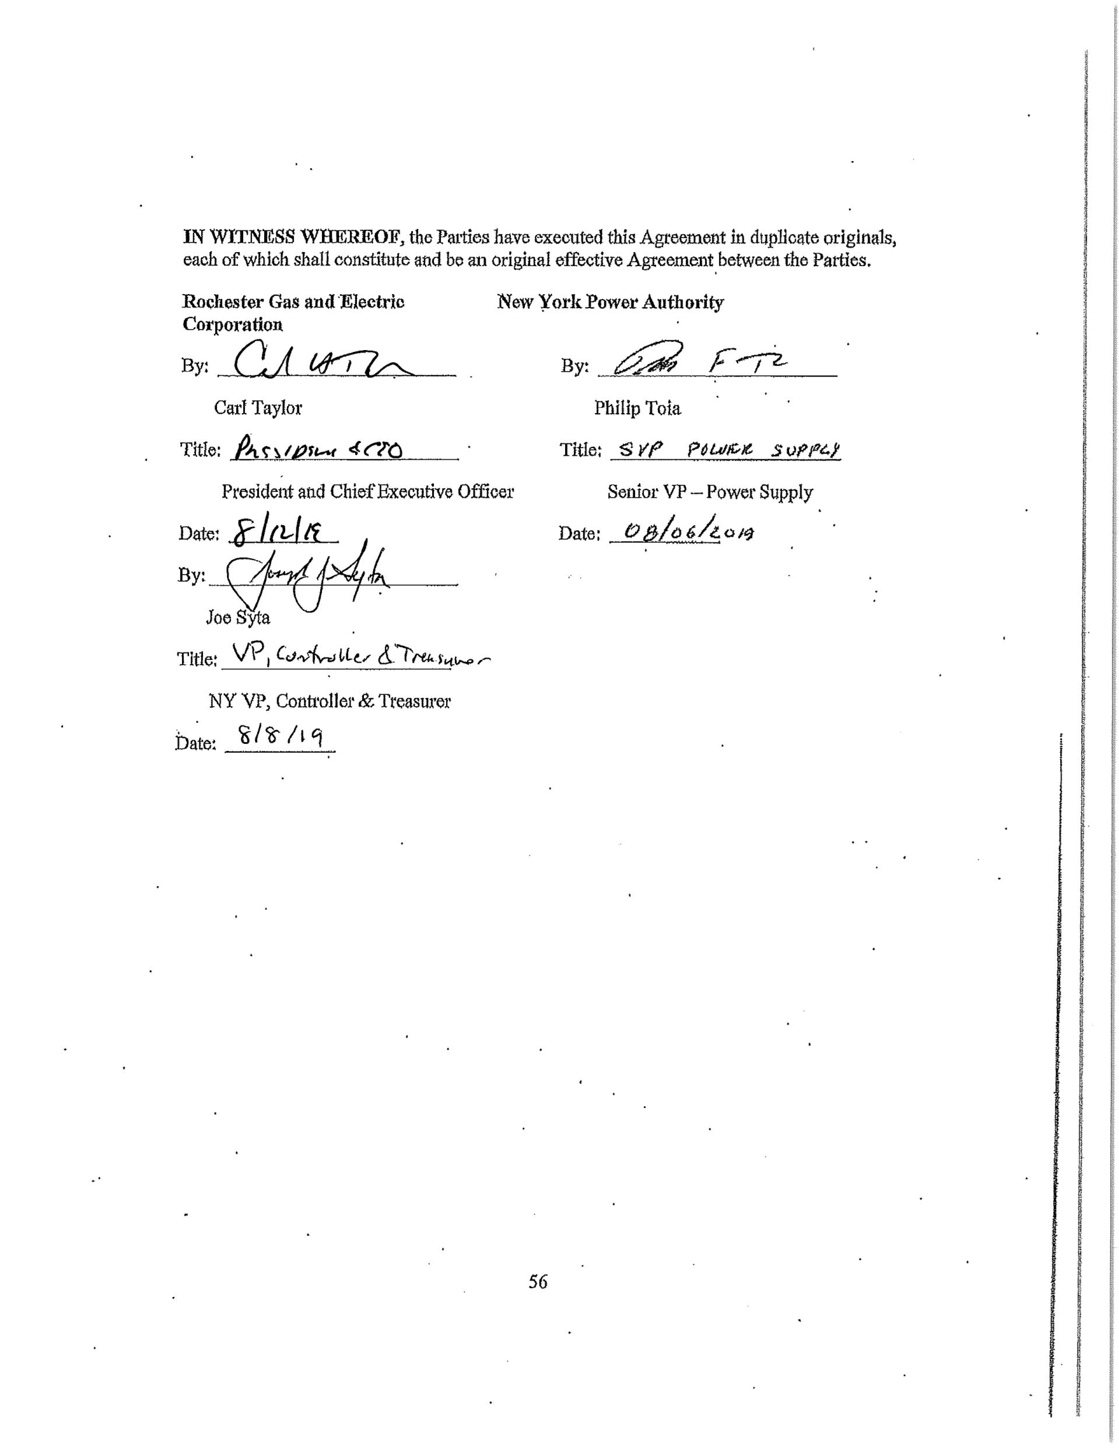

**APPENDICES** (for contract)

**[Please note that the Appendices to this Agreement may contain management, design,**

**interconnection, and operational procedures and criteria that are unique to the Connecting**

**Transmission Owner or RG&E, or both. In the event of a conflict between the terms and**

**conditions of an appendix and the remaining provisions of this Agreement, the appendix**

**shall control]**

57

**APPENDIX A – ATTACHMENT FACILITIES, NETWORK UPGRADE FACILITIES**

**AND TRANSMISSION FACILITY**

**MILEWOOD ROAD ACCESS ROAD**

Milewood Road is an existing private road that runs between Tax ID Numbers 174.03-1-

2 and 174.03-1-24 in the Town of Chili. RG&E will responsible for construction, maintenance

and repair of Milewood Road and the Milewood Road access portion.

**ACCESS ROAD THRU PROPERTY PREVIOUSLY OWNED BY JAYNES**

**RIVERVIEW LLC**

This access road runs thru the property previously owned by Jaynes Riverview, LLC, Tax

ID Number 174.03-2-1.21, now owned by RG&E. This access road shall be maintained and

repaired by RG&E.

**A.1 ATTACHMENT FACILITIES:**

**1. RG&E Attachment Facilities**

RG&E Attachment Facilities are described as the facilities and equipment located

between the Transmission Facility and the Points of Change of Ownership. This shall include but

isn’t limited to all associated 345 kV bus structures, conduit & cable required which comprise

the four terminal structures within Station 255.

**2. Connecting Transmission Owner Attachment Facilities**

Connecting Transmission Owner Facilities are described as the facilities between the

Point of Change of Ownership and the Point of Interconnection. The new Station 255 will be

supplied by breaking the two existing NYPA 345kV transmission lines (SR1-39 and NR-2) and

connecting them to the new substation. The Point of Interconnection will be located between

SR1-39 structures NR1-70-1 and NR1-69-4 and line NR-2 structures NR2-70-1 and NR2-69-4.

The Point of Change of Ownership will be located at the insulator string connections at the four

terminal structures located within Station 255. Reference Appendix VI for One-Line Diagram.

58

Pursuant to Article 5.1.2 of this Interconnection Agreement, RG&E has chosen the option

to build the Connecting Owner’s Attachment Facilities. RG&E will design and construct the

Connecting Owner’s Attachment Facilities in accordance with NYPA design criteria, including

applicable NERC Reliability Standards and NPCC Directories (including those NERC Standards

and Directories in effect or approved at the time of construction and that will be applicable to

Connecting Owner’s Attachment Facilities once they are placed in service).

**a. Connecting Transmission Owner Attachment Facility Cost Estimate**

The total estimated cost for the installation of the new and removal of the existing

transmission facilities to make the inter-connection is $8,332,323 in 2018 USD. For the

detailed estimate see Appendix A.IV.

**A.2 NETWORK UPGRADE FACILITIES:**

**1. RG&E Network Upgrade Facilities:**

**1.1 Station 80 – SP&C Upgrades**

The purpose of this scope of work is to make the necessary additions to Station 80 as a

part of the Rochester Area Reliability Project.

**1.2 Line HR-1 (Station 255 to Station 80)– SP&C Upgrades**

*“Appendix A.2.1.1.2 of this Interconnection Agreement Contains Critical Energy Infrastructure*

*Information -- Do Not Distribute to Unauthorized Individuals”*

59



**1.3 Line HR-2 (Station 255 to Station 80) – SP&C Upgrades**

*Appendix A.2.1.1.3 of this Interconnection Agreement Contains Critical Energy*

*Infrastructure Information -- Do Not Distribute to Unauthorized Individuals”*

**1.4 Line 40 – SP&C Upgrades**

*Appendix A.2.1.1.4 of this Interconnection Agreement Contains Critical Energy*

*Infrastructure Information -- Do Not Distribute to Unauthorized Individuals”*

60



**1.5 Kintigh (NYSEG) - SP&C Upgrades**

The scope of work is updates to the protection and control of existing line “SR1-39,”

which currently connects NYSEG’s Kintigh substation (Somerset) to Station 80. This line will

now connect Kintigh to the new Station 255, and be renamed to “SH1-39.”

**a. Protection and Communication Requirements**

*“Appendix A.2.1.1.5.a of this Interconnection Agreement Contains Critical*

*Energy Infrastructure Information -- Do Not Distribute to Unauthorized*

*Individuals”*

61



**2. CONNECTING TRANSMISSION OWNER STAND ALONE NETWORK**

**UPGRADE FACILITIES**

**1. Relocation of NYPA’s 345kV Lines SR1-39 and NR-2**

The project will require a relocation of NYPA’s 345kV SR1-39 and NR-2 Lines. With

the installation of Station 255 the line names of the existing lines between Niagara Station and

Station 80 and Kintigh Station and Station 80 will be renamed as follows:

**Line Name**

NH-2

HR-2

SH 1-39

HR-1

**Official Station Name**

Niagara to Station 255

Station 255 to Station 80

Kintigh to Station 255

Station 255 to Station 80

**Mnemonic**

Niagara to Henrietta

Henrietta to Rochester

Somerset to Henrietta

Henrietta to Rochester

The structure types to be used for lines SH1-39 and NH-2 will include three-pole dead-

end, H-frame & monopole structures indicated in Appendix A.I. Structures will be on average

approximately 100 feet above ground, maintaining proper clearances to the ground. A reinforced

concrete foundation will be used to support the steel poles. Depending on soils present,

62

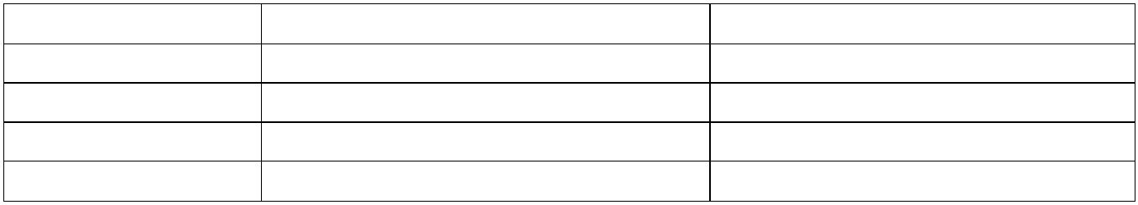

foundations will either be reinforced concrete drilled caissons or vibratory caissons. The drilled

caissons will range from about 6 to 12 feet in diameter and 10 to 50 feet in depth. The structures

will be located to maintain the phase spacing required per NYPA’s specifications and to maintain

the route defined in Exhibit 109 to the Amended Joint Proposal (Appendix A.III).

The transfer of ownership to NYPA will be the insulator string connections at the four terminal

structures located within Station 255.

**2. Circuit Information**

*Appendix A.2.2 of this Interconnection Agreement Contains Critical Energy*

*Infrastructure Information -- Do Not Distribute to Unauthorized Individuals”*

**3. Transmission Line Structures to be Retired**

A total of four NYPA-owned lattice towers will be removed by RG&E at RG&E’s cost in

coordination with NYPA. Two existing lattice towers and all associated hardware and insulators

will be removed from each of the NYPA 345kV lines SR1-39 and NR-2. The foundations

63



associated with each of the lattice towers will be removed completely. The removal, disposal

and potential sale of any NYPA assets must be in compliance with NYPA’s procedures and

standards, including, but not limited to the New York State Public Authorities Law. Unless

otherwise instructed by NYPA, RG&E shall, in coordination with NYPA, be responsible for the

removal, disposal and sale of any NYPA assets. NYPA shall be paid the entire salvage value of

any NYPA assets sold reduced only by the cost of removal for salvage. If costs of removal or

disposal exceed the salvage value any and all removal or disposal costs shall be the responsibility

of RG&E.

RG&E shall be responsible for restoration of the underlying real property to a condition

suitable for agricultural use. Any soil or backfill imported for this purpose must meet the

unrestricted use Soil Cleanup Objectives (6 NYCRR 375. Table 375-6.8). Imported soil should

be organic in nature (top soil) to a grade suitable for agricultural use.

All excavated soil/drill cuttings will be inspected for odors and staining. If visual

staining or odors are observed, the areas of suspected contamination will be screened for volatile

organic compound vapors with a photoionization detector.

Impacted soils must be sampled, analyzed and disposed of at a NYPA approved facility.

NYPA reserves the right to audit, inspect and perform its own testing to validate that the soil is

suitable for recycling, ultimate end-use or disposition.

NYPA’s Environmental, Health and Safety (EH&S) Division will confer with RG&E to

establish, on a project/activity-specific basis, which 6 NYCRR 375 Soil Cleanup Objective

Classification and/or NYSDEC CP-51 Supplemental Soil Cleanup Objectives parameters shall

be applied to the proposed activity’s imported “environmentally clean” soil and/or fill. This

shall apply to any fill materials documented as coming from a source other than New York State

Department of Transportation (NYSDOT) approved quarries and gravel/sand pits. RG&E shall

document that fill materials originated from a NYSDOT approved quarry and/or gravel/sand pit.

For any fill materials being imported from a source other than NYSDOT approved

quarries and gravel/sand pits, RG&E shall submit a certification letter, as defined by NYPA’s

EH&S on a project-specific basis, with supporting laboratory analysis demonstrating that the

64

materials are environmentally clean. If laboratory analysis is not available, then RG&E shall

collect and analyze representative samples of the material proposed for use on Authority

property, as specified in DEC’s DER-10 Technical Guidance for Site Investigations and

Remediation Table 5.4e(10) of fill/backfill proposed for use at the site and submit the laboratory

results to the Project Sponsor and EH&S. Each sample shall be analyzed for the complete list of

6 NYCRR Part 375 and NYSDEC CP-51 Supplemental Soil Cleanup Objectives parameters to

demonstrate that the soil complies with other requirements selected by EH&S and the Project

Sponsor for environmentally clean soil/fill for the proposed activity.

The following existing lattice structures and all associated hardware will be removed by

RG&E.

**LINE NUMBER STRUCTURE NUMBER**

SR1-39

SR1-39

NR-2

69-5

69-6

69-5

69-6

NR-2

**4. NIAGARA SUBSTATION**

In order for line NH-2 to interface with the protection and communication scheme at

Station 255, NYPA’s Niagara Substation protection and communication systems need to be

upgraded. The primary communication channel will be power line carrier which requires the

addition of a wave trap and line CCVT. After equipment has been installed/upgraded by RGE,

the transfer of ownership will include the wave trap, line CCVT, and protection and

communication upgrades at the Niagara Substation. In addition to the power line carrier, NYPA

will be installing OPGW, either before or after the power line carrier installation. The OPGW

will ultimately be the primary communication channel once installed, but in the case where the

power line carrier is installed prior to the OPGW, the power line carrier will need to be retired in

place.

**1. Site Development**

No substation expansion is required.

65

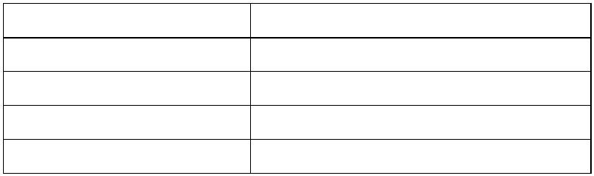

**2. Foundations**

The foundations used will match the existing construction per drawings 8E-1100. Below

is an estimate of the quantity needed for each foundation type.

(3) 345kV CCVT/VT structure support foundation type “4F1”

(1) 345kV Wave Trap structure support foundation type “4F1”

Soil borings will be performed in the area where new foundations are required. Soil boring

request needs to be coordinated between RG&E real estate and NYPA real estate to obtain a

permit for the soil boring work. All NYPA requirements will be included in the permit.

RG&E will include a drawing with the proposed locations in the permit application.

**3. Grounding**

Niagara’s grounding grid study will be updated

NYPA will provide existing grounding grid calculations

NYPA will provide new short circuit conditions

It is assumed that the copper taps can be made from the existing grid to the structures and

equipment.

**4. Conduit & Control Cable**

The existing conduit for the line CCVTs will be extended to the new CCVT location (to be

confirmed during detailed engineering). Otherwise new conduit will be routed from new

CCVT location to the NYPA Fan building.

New control cable will be installed from the new CCVT location, run into the existing cable

trench and into the lower level of the Fan Building and terminate in the termination cabinet.

Shielded control cable is required in the 345kV yard.

It is assumed that 2-2” Conduit and four cables are needed for “A” and “B” protection and

AC for junction box heaters. Actual cable types, quantity and more accurate lengths will

need to be determined during detailed engineering.

**5. Major Equipment**

345kV CCVT equipped with power line carrier

66

(2) 345kV CCVTs without power line carrier.

345kV, 3000A Line Trap for phase B

**6. Protection & Communication Requirements**

NYPA, at the expense of RG&E, will perform installation of protection relay panels.

**7. Structures**

Below is an estimate of the quantity of structures needed.

(3) 345kV CCVT structures

(1) 345kV Wave Trap structure

Control House

The existing control house has adequate space for the replacement protection and

communication equipment. No control house expansion is required.

Pursuant to Article 5.1.2 of this Interconnection Agreement, RG&E has chosen the option

to build the Connecting Transmission Owner Stand Alone System Upgrade Facility. RG&E will

design and construct the Connecting Transmission Owner Stand Alone System Upgrade Facility

in accordance with NYPA design criteria, including applicable NERC Reliability Standards and

NPCC Directories (including those NERC Standards and Directories in effect or approved at the

time of construction and that will be applicable to Connecting Transmission Owner Stand Alone

Network Upgrade Facilities once they are placed in service).

**8. Connecting Transmission Owner Stand Alone System**

**Upgrade Cost Estimate**

The total estimated cost for the installation of the new and removal of the existing

Connecting Transmission Owner Stand Alone System Upgrade Facility to make the

interconnection is $3,082,542 in 2018 USD. For the detailed estimate see Appendix A.V.

67

**a. OPGW INSTALLATION ALTERNATE OPTION**

NYPA has informed RGE of the potential of installing Optical Ground Wire (OPGW)

onto NYPA’s existing transmission circuits (Communications Backbone Program)

including NR-2 (Niagara to Station 80). The OPGW will be installed at the top of the

transmission circuit in place of the existing shield wire. OPGW has shielding around the fiber

cables to help with lightning strikes (as shield wire would) and the fiber would aid NYPA with

high-speed transmission of data. With the installation of OPGW, it would be a cleaner and more

efficient approach than the use of the power line carrier system planned to be installed at

Niagara. In the case the OPGW can be installed on NR-2 prior to the Niagara power line carrier

construction, it would be utilized instead, and thus eliminate the need to have work completed

for the installation of the power line carrier.

The cost of replacing/retiring the power line carrier with the OPGW will be addressed

through a separate agreement.

**A.3 TRANSMISSION FACILITY**

The Transmission Facility is defined as the new 345kV-115kV substation known as

RG&E Station 255 which is being constructed by RG&E as part of the Rochester Area

Reliability Project (“RARP”). Station 255 will be located in the Town of Henrietta, County of

Monroe between East River Road and the Genesee River. The Point of Interconnection is based

on the submitted design for the RARP Segment III, as indicated on the Plan & Profile drawings

in Appendix A.I.

**1. Station 255/Henrietta (New Substation)**

Station 255 will consist of a 345kV, 4 bay breaker and half arrangement with a total of

five (5) 345kV transmission lines. Three (3) 345kV transmission lines to Station 80, NYPA’s

HR-1 and HR-2 and RG&E’s Circuit 40. One (1) 345kV transmission line to NYSEG’s Kintigh

substation, NYPA’s SH1-39. One (1) 345kV transmission line, NYPA’s NH-2, to NYPA’s

Niagara substation, and two terminals for 345-115kV transformers. The 115kV portion of the

substation will consist of a 2 bay breaker and a half arrangement with RG&E line 940 to Station

418, RG&E line 941 to Station 23 and two underground connections to the 345-115 kV

68

transformers. The Transmission Facility work at Station 255 shall include but is not limited to

the design, procurement, construction, installation, and commissioning.

**1. Site Development**

The total project area within the fence line is approximately 12 acres, and is located in the

Town of Henrietta, New York. The proposed substation yard is located approximately 1350 feet

west of East River Road and 350 feet south of the existing NYPA transmission line. The yard is

approximately 350 feet east of the Genesee River. The substation yard will be accessed by an

approximately 1500 LF asphalt paved driveway from East River Road. The fenced substation

yard is 1024’ x 508’ and is located in agricultural field with a wooded area covering the

southeast corner of the yard.

The lowest elevation of the yard is 556.0’ (referenced to NAVD 1988) with a general

0.5%cross slope from east to west

Asphalt pavement access driveway from East River Road

Crushed stone yard and internal concrete access road

Installation of new underground filter to meet NYSDEC storm water treatment

requirements

Installation of 2 oil/water secondary containment tanks with a combined storage capacity

of a minimum of 130% of the largest volume of oil contained in a single transformer

Installation of a closed storm drainage system including drainage manholes, catch basins,

perforated and solid collection piping, and riprap outlet protection

**a. Access Road to new RG&E Station 255**

The conceptual location for the access road attempts to balance wetland impacts with the

constraints presented by the existing NYPA lattice structures, the Empire State Pipeline, the

topography and the right of-way boundaries.

Considering the proposed width of this access road and the constraints listed above, the

final alignment and resulting wetland impacts are depicted in Appendix A.1.

69

**2. Foundations**

Foundations will be required for major equipment and for structures. It is anticipated that

the foundations for the 345 and 115kV yards will be designed in accordance with

IUSA/Avangrid TM2.71.00 115KV & Above Reinforced Concrete Foundation Standards. The

34.kV foundation design will follow IUSA/Avangrid TM2.61.00 69KV & Below Reinforced

Concrete Foundation Standard. The transformer foundation will be designed with an oil

containment system in accordance with Avangrid standard TM 2.71.17 Substation Oil

Containment. The new control house foundation will be designed in accordance with

IUSA/Avangrid TM2.71.08.

**3. Grounding**

A complete Ground grid will be designed per IUSA/Avangrid TM2.71.77, IEEE80, &

IEEE81

New equipment and steel structures will be connected to the ground grid per

IUSA/Avangrid Technical Manual TM 2.71.77.

The ground grid will be designed with WinIGS during detailed engineering.

The WINIGS design will be verified by direct measurement using WINSGM after

construction of the ground grid

**4. Conduit**

An “A” and “B” trench/cable system will be installed for the 345kV,115kV, and 34.5kV

systems in accordance with Avangrid standard TM 2.71.13 and requirements outlined by

the NPCC.

New “A” and “B” conduits from each breaker, motor-op switches, CCVTs and

transformers will run into the “A” and “B” trench systems.

Conduit fill calculations to be performed in accordance with NEC requirements

**5. Major Equipment**

(2) 354/204Y- 118/68Y-34.5kV, 240/320/400//448 MVA (55//65 deg C) Auto-

transformer connected Y-Y- Delta. Equipped with the following CTs

. (1) 1200:2 on H2 345kV bushing

70

. (4) 2000:5MR on each 345kV bushing 1 - 3000:5 on X2 115kV bushing

. (4) 3000:5MR on each 115kV bushing 2 - 600:5MR on the neutral bushing

. (2) 2000:5MR on each 34.5kV bushing 2 - 2000:5MR on each 34.5kV Delta leg

(11) 345kV, 3000A, 63kA Breakers, equipped w/ 2- 3000:5MR CTs per bushing 25 -

345kV, 4000A TPST, double-side break, motor-operated switches

(5) 345kV 3000A, TPST, double-side break, motor-operated switches equipped w/

interlocked grounding switch

(42) 345kV CCVTs (2 equipped with line tuner (LMU); 1 for the line SH1-39 to Kintigh

and 1 for the line NH-2 to Niagara)

(6) 345kV VTs for Metering (device used needs to be on the NY PSC approved list.) 6 -

345kV CTs for Metering (device used needs to be on the PSC approved list.) 21 - 345kV

Station Class Surge Arresters- ratings: 276 kV /220kV MCOV

(2) 345kV Line Trap for phase B on the line to Kintigh (SH1-39) and the line to Niagara

NH-2)

(6) 115kV, 3000A, 40kA Breakers, equipped w/ 2- 3000:5MR CTs per bushing 16 -

115kV, 3000A, vertical break Switches

(24) 115kV CCVTs

(24) 115kV Station Class Surge Arresters- ratings: 96 kV /76kV MCOV

(2) 34.5kV, 1200A, 40kA Breakers, equipped w/ 2-1200:5MR CTs per bushing 4 -

34.5kV

(4) 34.5 kV, 1200A center break, motor operated switches

(18) 34.5kV Surge Arresters- ratings: 36 kV /29kV MCOV 2 - 34.5kV, 3ph Station

Service Transformers (500 kVA)

(6) 34.5 kV Voltage Transformers

(2) 125 VDC, 800A-H Batteries , 200A chargers

(2) SCADA Panels

71

(1) Fiber Patch Panel 6 – Control Panels

(14) Protection Panels

(1) Revenue Metering Panel

(6) Telecom Panels

(1) Telecom Backboard

(5) 125V DC Distribution Panels

(1) 208/120V AC Power Switchboard

(3) AC Wall mounted Distribution Boards

(2) Fire Alarm Panels

(1) Reserved IT Panel

(2) Reserved Panel board

**6. Protection and Communication Requirements**

*“Appendices A.3.6 of this Interconnection Agreement Contains Critical Energy*

*Infrastructure Information -- Do Not Distribute to Unauthorized Individuals”*

72

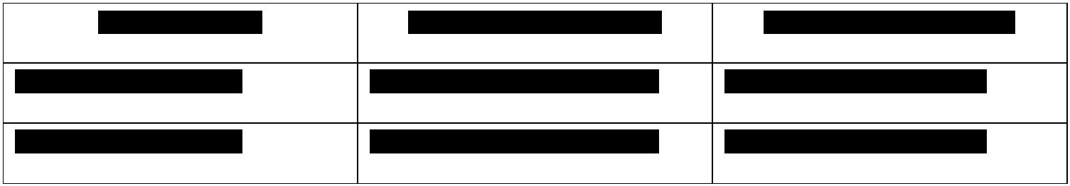

73

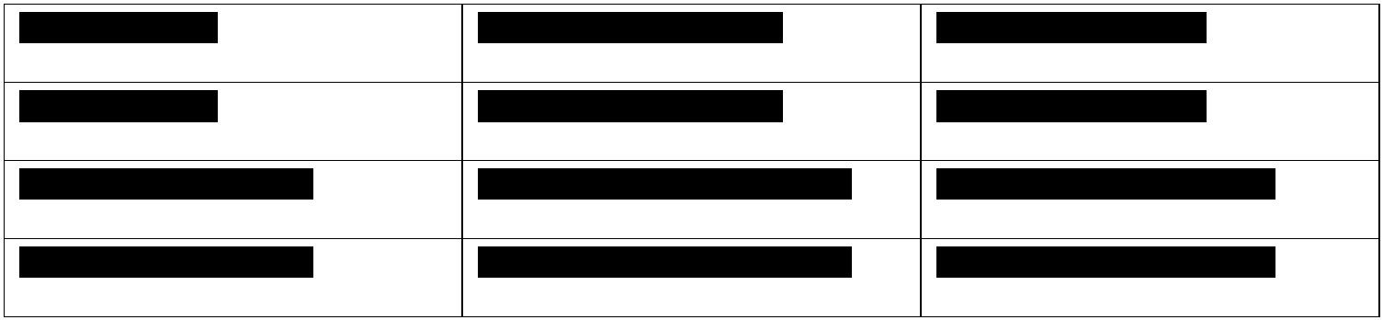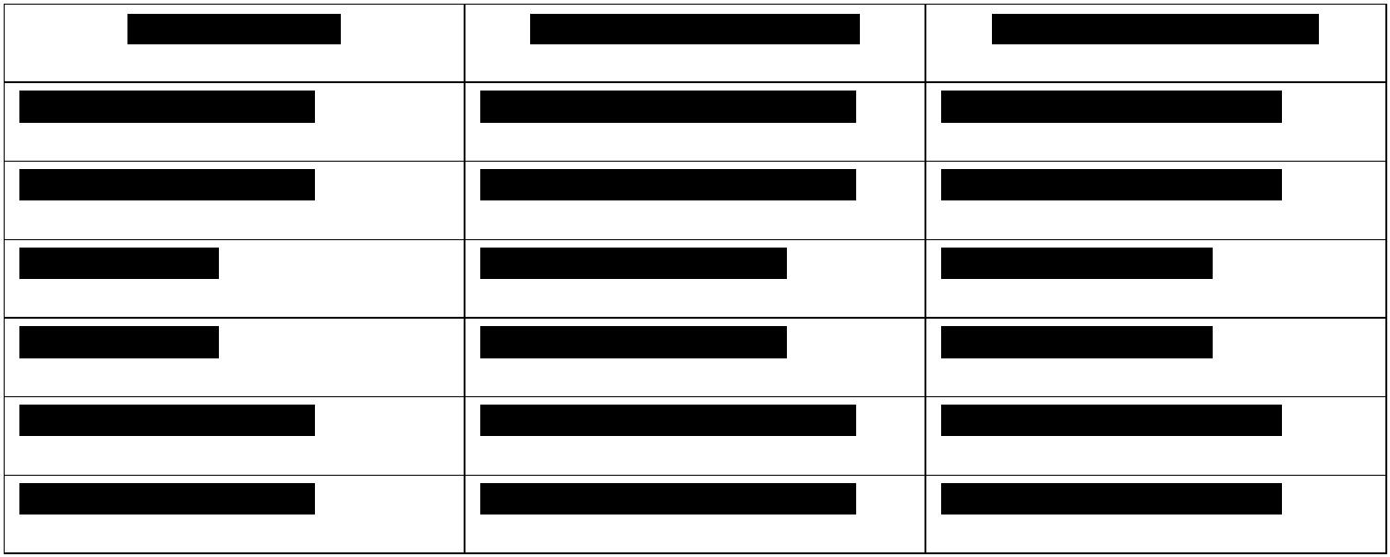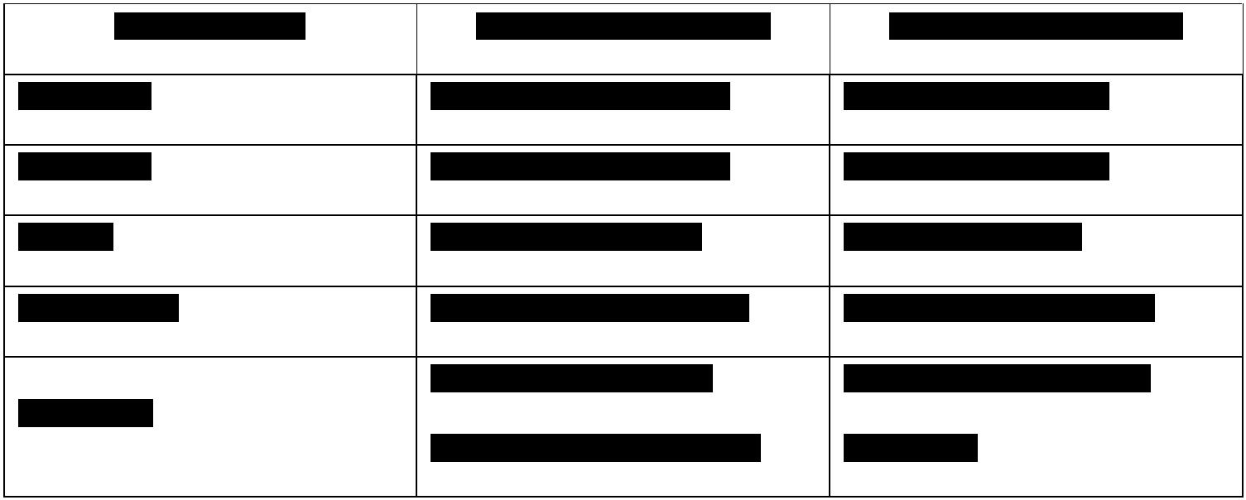

74

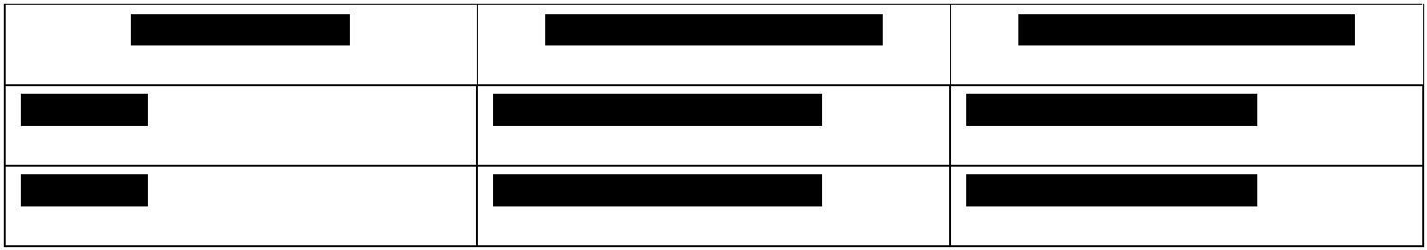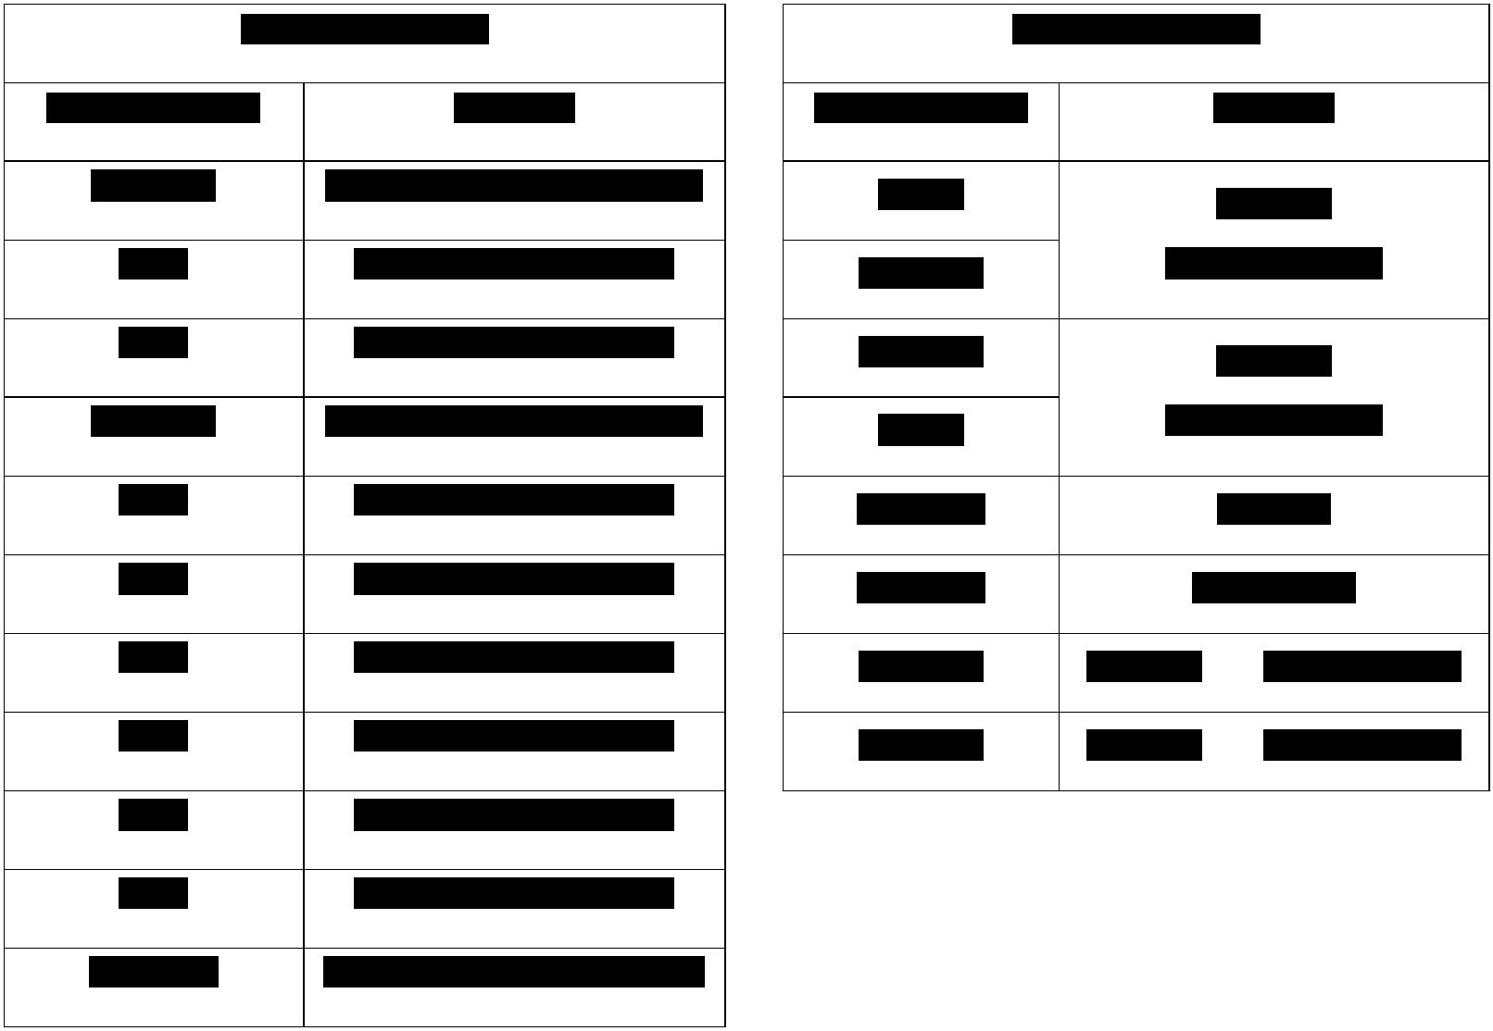

75

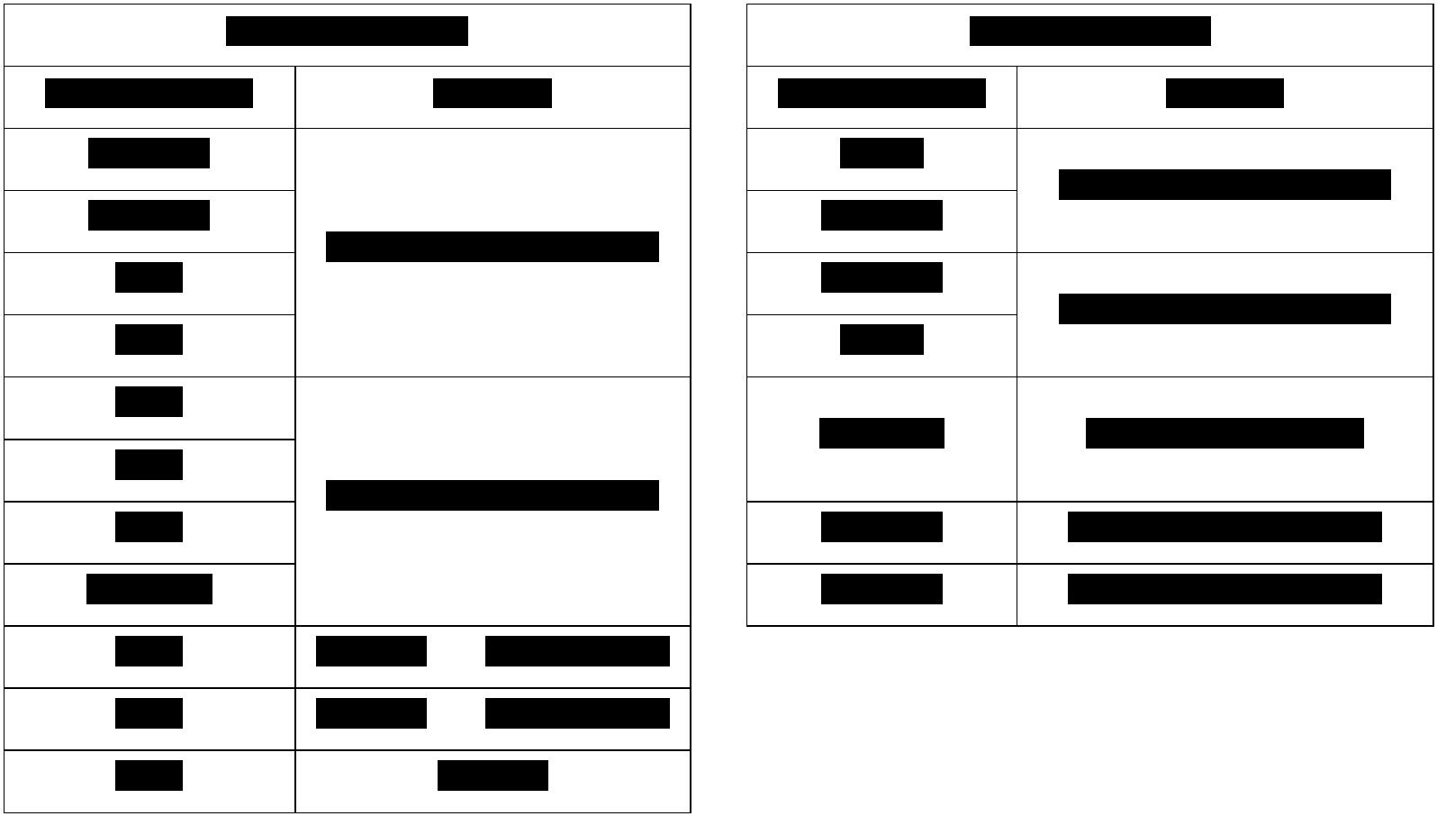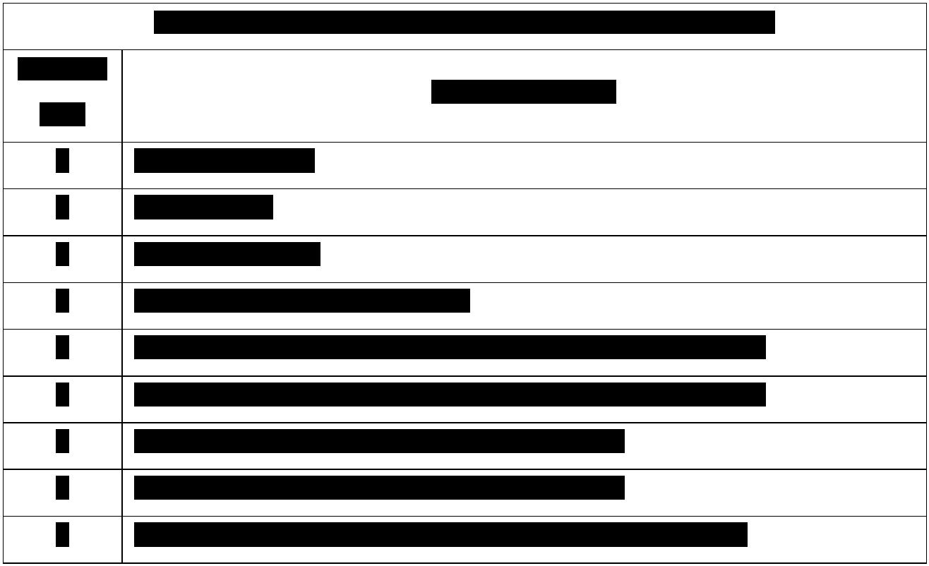

76

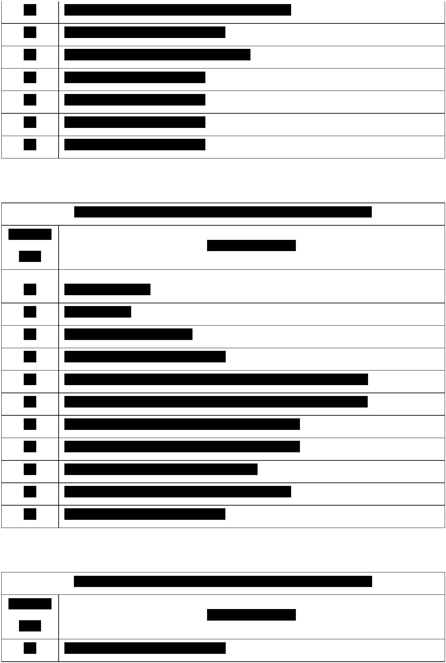

77

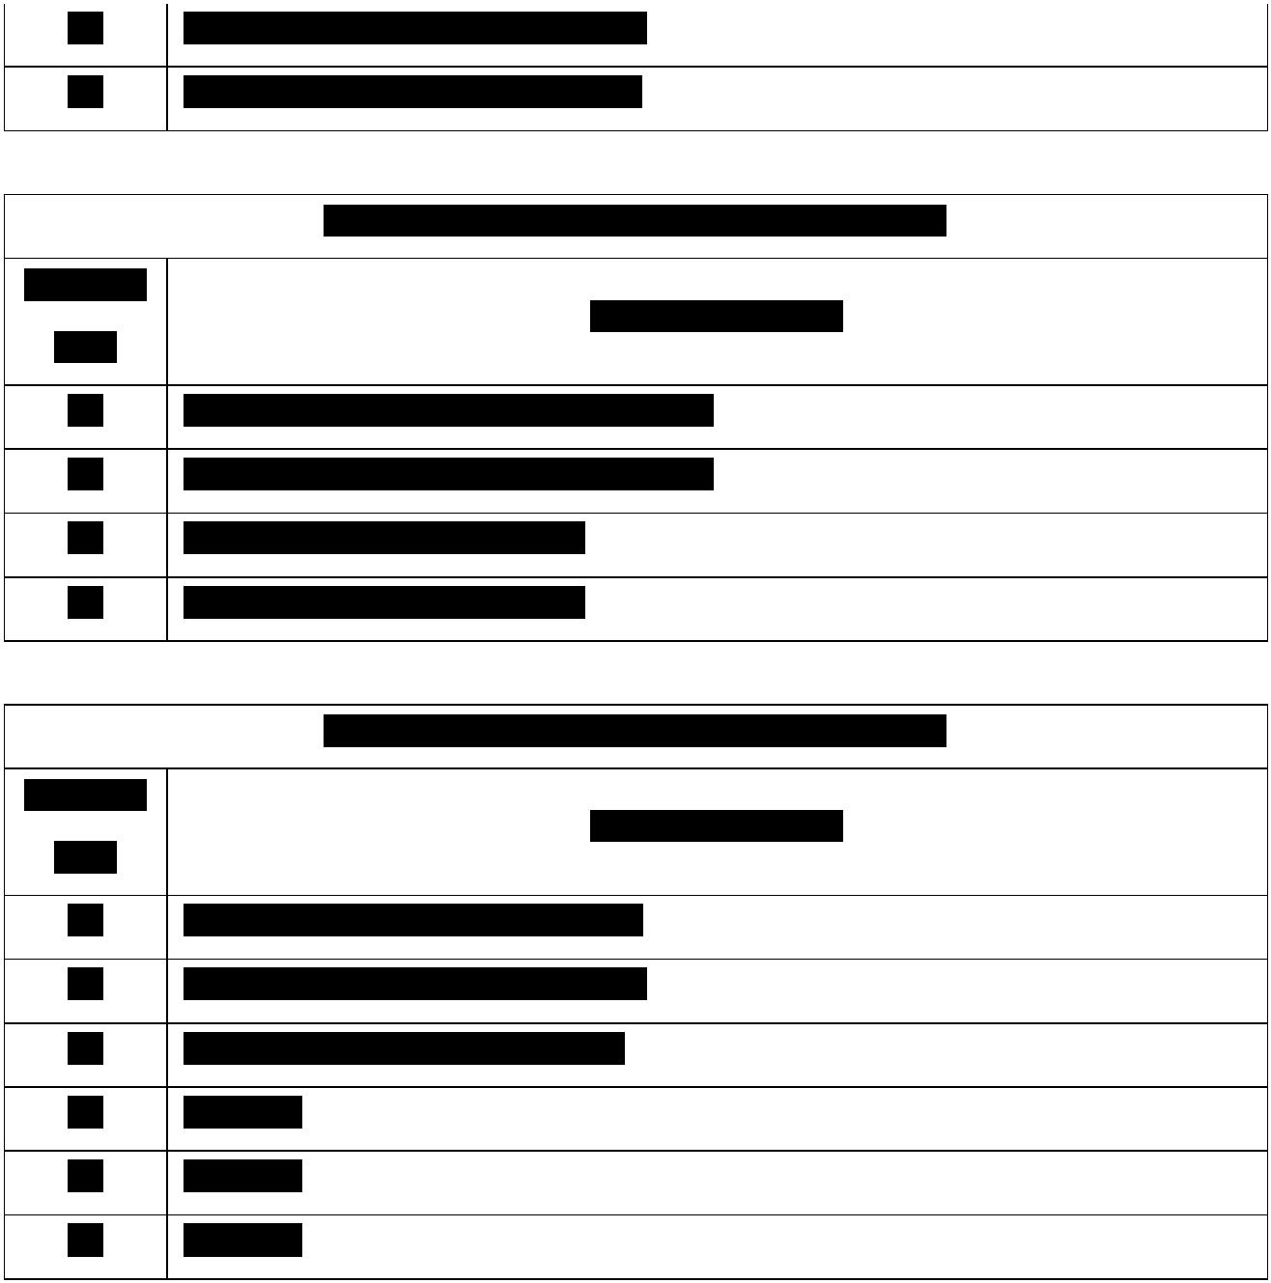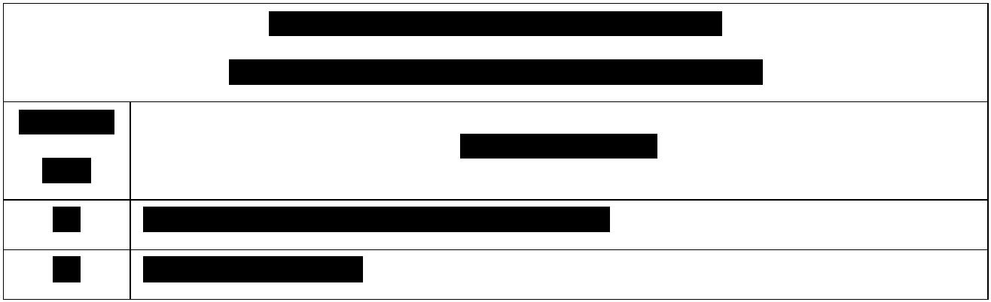

78

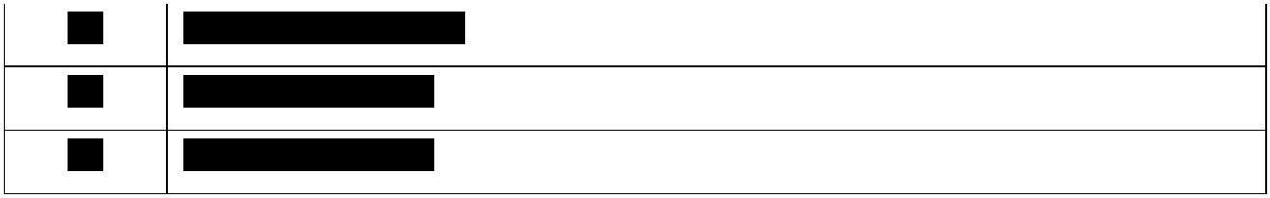

79

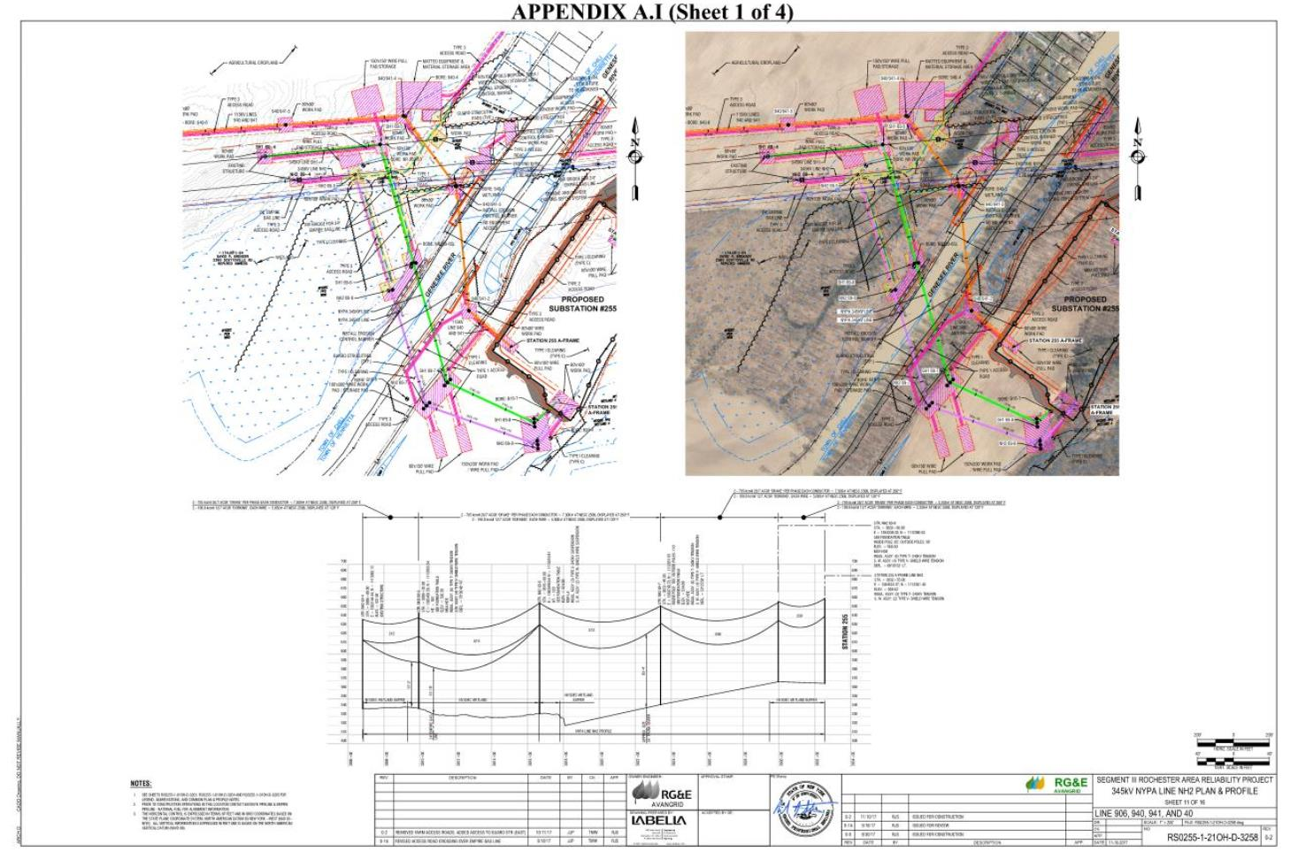

80

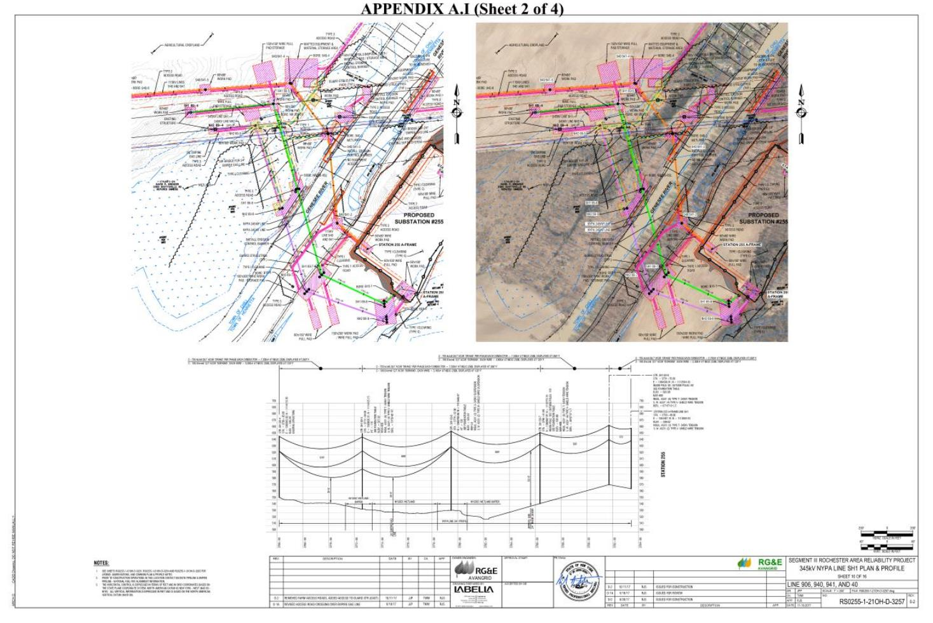

81

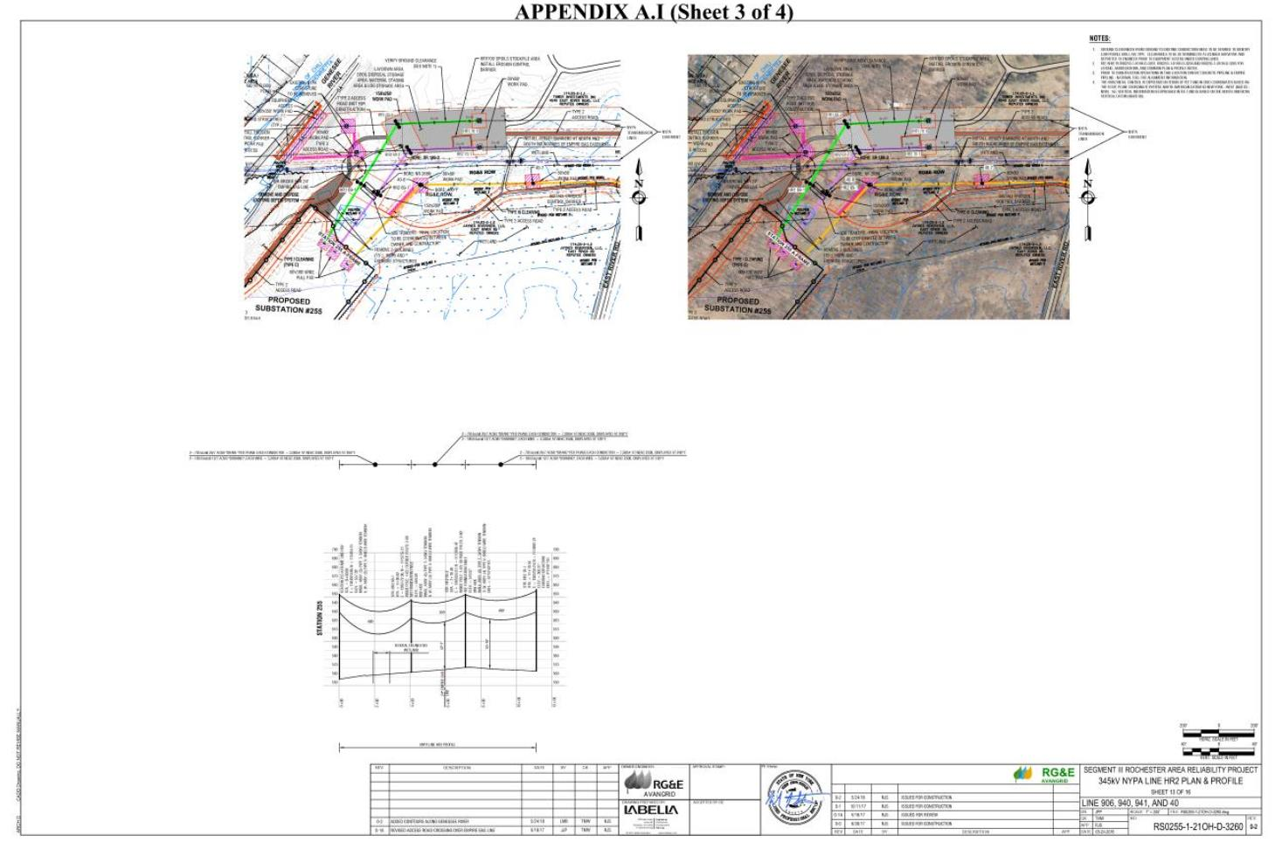

82

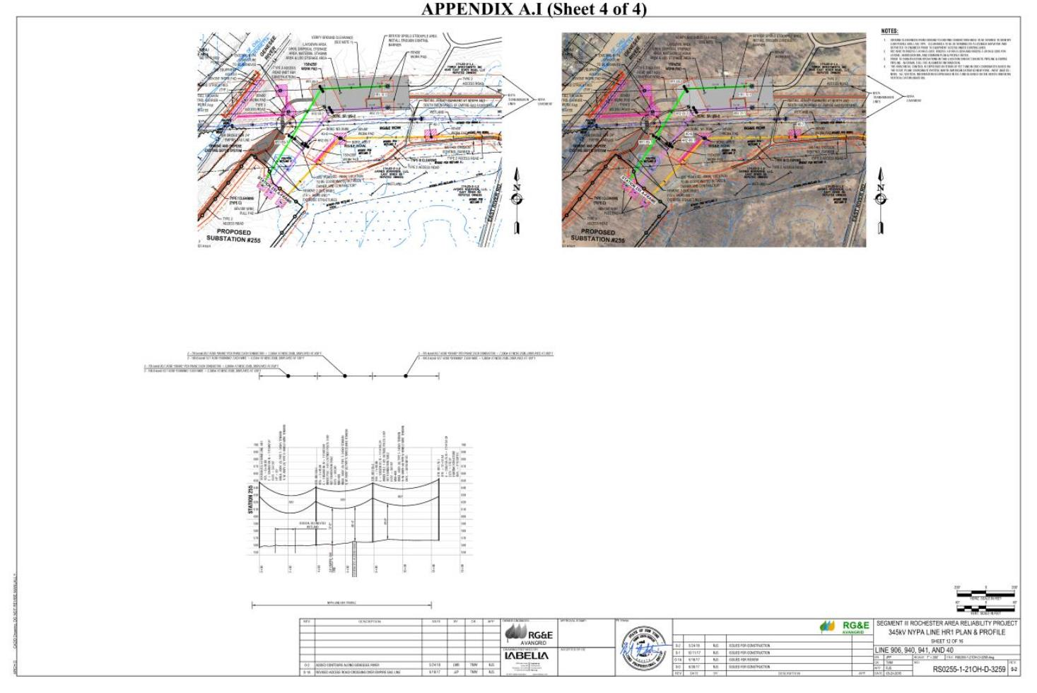

83

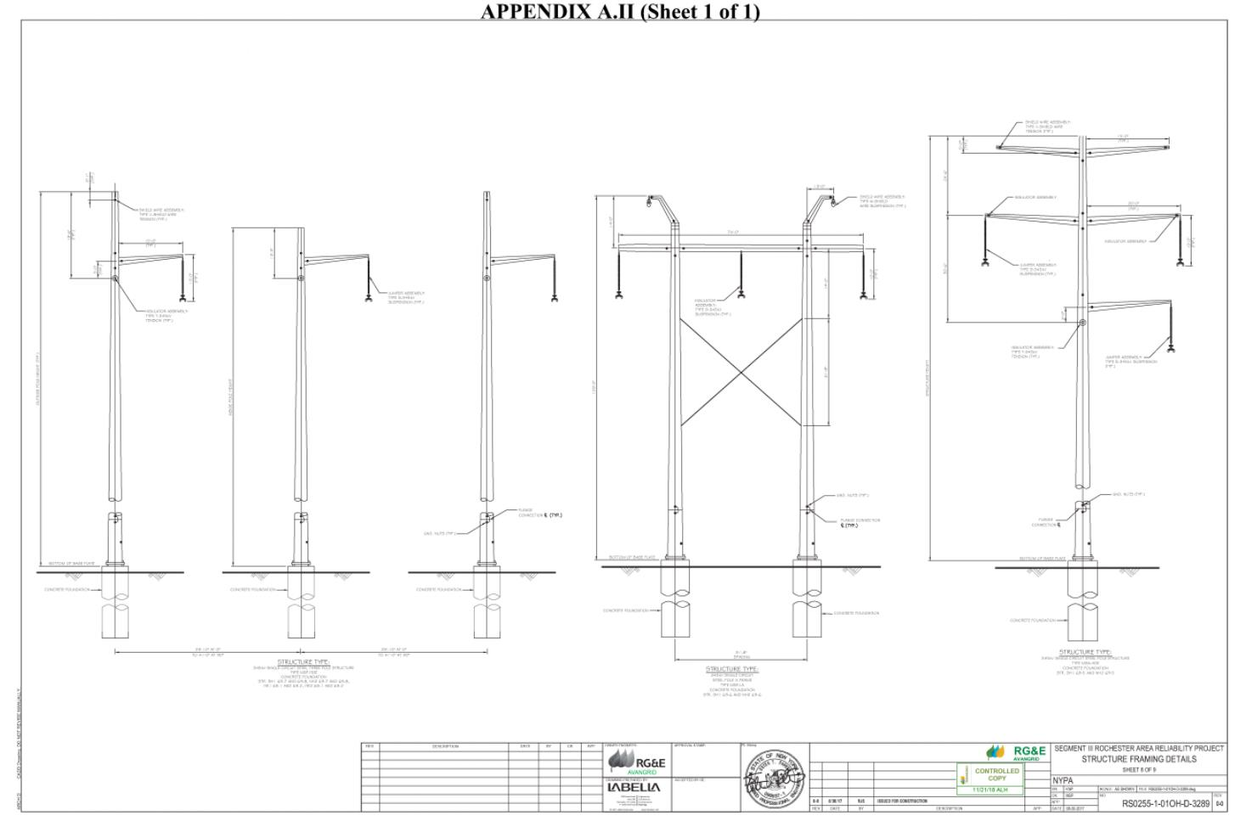

**Appendix A.III (Sheet 1 of 2)**

84

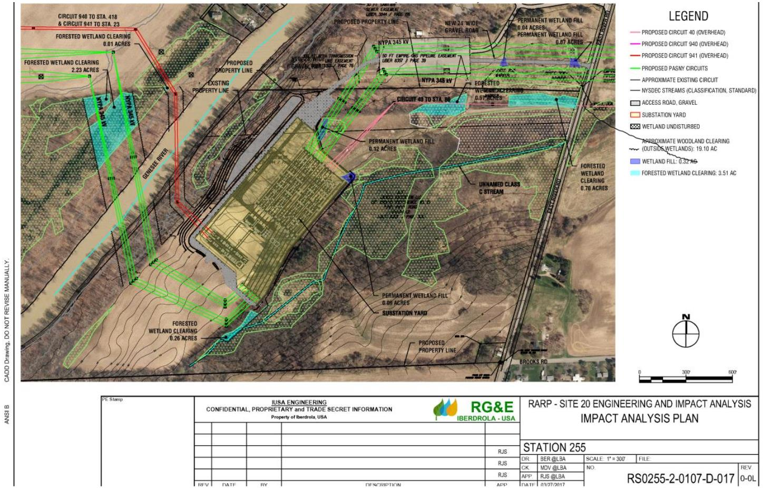

**Appendix A.III (Sheet 2 of 2)**

11-T-0534 EXHIBIT 109

85

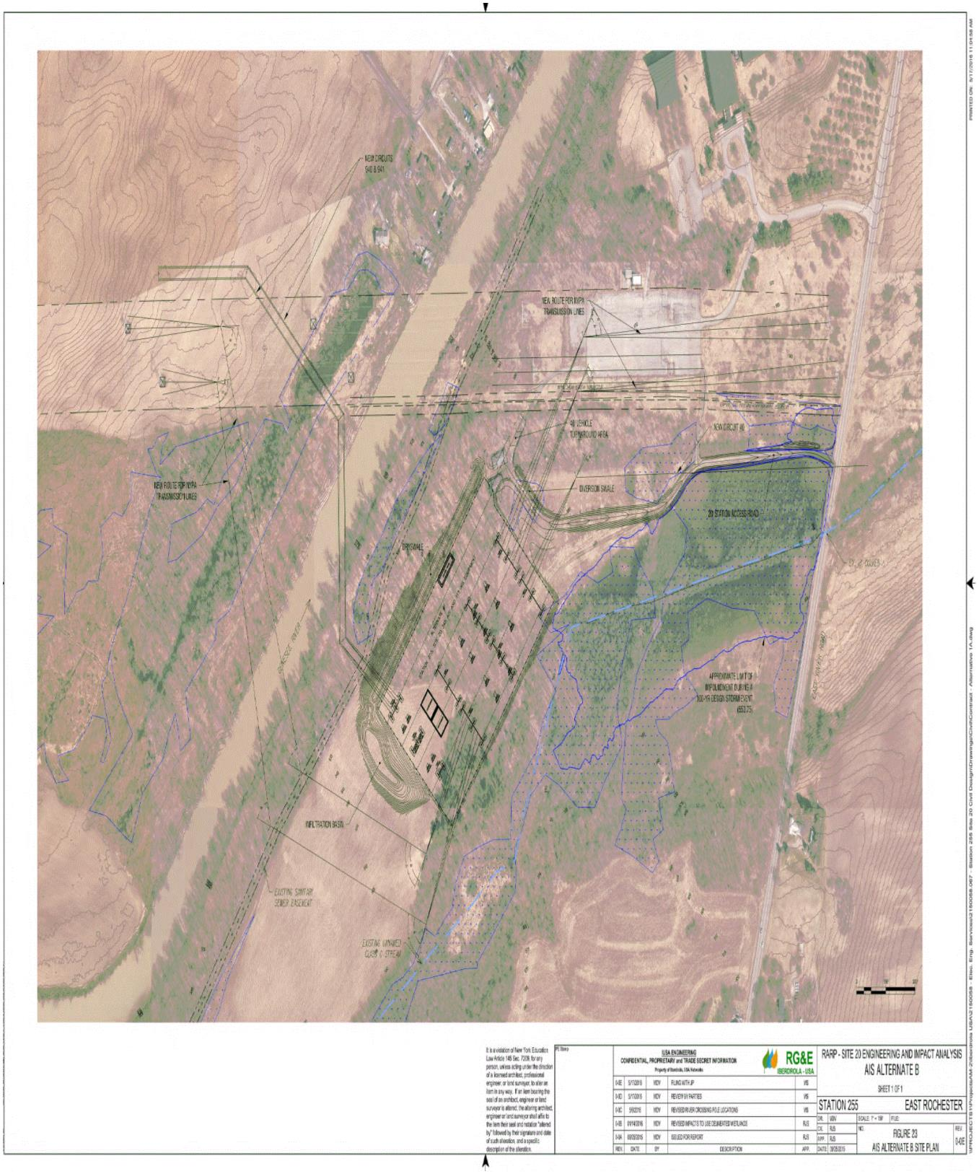

**Appendix A.IV (Sheet 1 of 2)**

Connecting Transmission Owner Facility Study

Rochester Area Reliability Project Article VII

NYPA 345kV Aerial Transmission Line POI

to New Proposed RG **Station 255**

Rev.2: 09-14-2018

2 @ 345kV Line: Circuit - (4 lines at 1000' 2 Bundled Cond. = 24,000' of phase conductor

Install 8 New Structures - 8 @ 3 Pole DE's (Dead-Ends) Structure:

Conductor. ACSR Drake, 765 kcmil 26/7 Strand, 2 Conductors (Bundled) per Phase

Static Wires: 2 - OPGW RGE Standard, 2 Per Line 1000' x 2 x 4 - 8,000

No Distribution Underbuild

Item

Description

Weight Lb 1

Structure

Price/#

Unit Cost

Quantity

Total Cost

679,680

Total Weight Lb

**New Poles**

**345kV**

1

2

3

Single Phase Steel Pole & Static 80' DE 90 Deg., SS, Concrete Foundation

Single Phase Steel Pole- No Static 80' DE 90 Deg., SS, Concrete Foundation

Steel Pole H-Frame - 80' Tangent, SS, Concrete Found

18,000

14,000

19,000

2.00

2.00

2.00

$

42,480

33,040

44,840

16

8

0

$

$

$

288,000

112,000

-

$

$

264,320

-

**Total Pole Cost & Weight**

24

**$**

**944,000**

**400,000**

Weight/Ft

Line Length Unit Cost

Length Ft

Total Cost

**Wire**

4

5

6

Bundled Drake Cond. 795 ACSR 26/7 Install Length Pls 5%, 2 per phase

3/8" EHS Steel Static Install Length Plus 5%

OPGW .638" Static Install Length Plus 10%, 2 per line

1.041

0.262

0.416

4,000

0

4,000

$

$

$

1.89

0.89

2.60

24,000

0

8,000

$

$

$

45,312

-

20,768

24,979

0

3,326

**Total Wire Cost & Weight**

**$**

**66,080**

**28,305**

Quantity

Per Str.

Cost Per

Str.

Total

Quantity

Cost Each

Total Cost

**Insulators & Hardware**

7

8

9

345 kV Suspension Porcelain Insulator AY I-String for Tangent Pole

3

2

3

3

3

0

2

1

1

2

1

1

1

1

1

$

$

$

$

$

$

$

$

$

$

$

$

$

$

$

2,124

4,366

4,366

2,596

2,596

177

354

2,950

89

177

89

100

83

$

$

$

$

$

$

$

$

$

$

$

$

$

$

$

6,372

0

48

12

24

12

0

20

8

16

0

$

$

$

$

$

$

$

$

$

$

$

$

$

$

$

-

209,568

52,392

62,304

31,152

-

7,080

23,600

1,416

-

345 KV Strain Porcelain Insulator AY for Single Phase Deadend Poles (4 Strings)

345 kV Strain Porcelain Insulator AY for Sub. Take-Off Frame

345 kV Jumper Insulator AY-Susp. Off Arm with Hold Down Wts, 2x3

345 kV Jumper Insulator AY-Susp. Off Arm Sub Take-Off Frame, 2x2

3/8" EHS Steel Static Wire Hardware

OPGW Static Wire Hardware DE's (12) include Take-Off Bays (8)

OPGW Splice Cases and Misc. Hardware 2 per line x 4 lines = 8

Misc Hardware Per Pole

8,732

13,098

7,788

7,788

-

708

2,950

89

354

89

100

83

10

11

12

13

14

15

16

17

18

19

20

21

Misc Hardware Per Pole H-Frame

Speed Grip Spaces Every 150' plus 3/loop = 27 + 72 + TO Bay Jumpers (24)

Dampers for Conductors - Stockbridge Type 1/Span/Phase x 2 Bundle

Dampers for Static & OPGW Wires 1/Span/Static/2 Statics

Grounding Hardware Per H-Frame 2-Pole

123

72

24

0

10,886

7,222

1,982

-

1,003

502

1,003

502

Grounding Hardware Per Single Pole

24

12,036

**Total Hardware Cost**

**$**

**419,638**

Cu Yards 1

Found

Unit Cost

Cu/Yd

Price Per Total Qty of

Total Found.

Installation Cost

Total Cu.Y Cond.

Found.

Found.

**Foundation Quantities (Includes 1' Reveal)**

22

23

24

25

Concrete Pier Foundation 6x20 H-Frame

Concrete Pier Foundation 6x25

Concrete Pier Foundation 8x20 Center Pole 3 Pole DE

Concrete Pier Foundation 8x25 Outside Poles 3 Pole De

21.0

26.3

37.2

46.6

$

$

$

$

1,003

$

$

$

$

21,063

0

0

8

$

$

$

$

-

-

0

0

1,003

1,003

1,003

26,379

37,312

46,740

298,493

747,837

297.6

745.6

16

**24**

**Total Foundation Material Cost & Cu. Yd.**

**$**

**1,046,330**

**1043.2**

Unit Cost

Quantity

Total Cost

**Aerial Construction Labor Costs**

26

27

28

29

30

31

32

33

34

35

36

37

38

39

40

Install H Frames on Pier Foundations - 2 Poles per structure

Install 3 Pole DE on Pier Foundations - 3 Poles per structure

Frame H Fame Structure

Frame 3 Pole DE Poles

Frame DE Take-Off Structures

Install/replace wire (Conductor) Drake ACSR 795 26/7 (Bundled)

Install/replace wire (Static) 3/8" EHS Steel

Install/replace (OPGW Static) 0.504 Dia

Clip-in & Sag wire (Conductor) Drake ACSR 795 Per Cond. (Per Str.)

Clip-in & Sag wire (Static) 7#8 AW (Per Str.)

Clip-in & Sag wire (OPGW Static) (Per Pole) x 2 Plus 8 TO Frame Loc. =32

Rock Drilling @ $500/Ft (Assume 75' x6' Dia) Plus $15,000 Equipment

Equipment Rentals

$

$

$

$

$

$

$

$

$

$

$

$

$

$

$

18,880

35,400

11,800

21,240

7,080

5

0

8

0

8

$

$

$

$

$

$

$

$

$

$

$

$

$

$

$

-

283,200

-

169,920

28,320

113,280

-

28,320

75,520

-

45,312

-

4

24000

0

8000

32

0

32

0

1

4

4

2,360

826

1,416

61,950

88,500

118,000

88,500

88,500

118,000

88,500

Miscellaneous Construction Costs Outages Considerations

Mobilization Cost

1

1

**Total Construction Labor Costs**

**$**

**1,038,872**

Unit Cost

Quantity

Total Cost

**Engineer & Survey Labor Costs**

41

42

43

44

45

46

47

48

49

50

Transmission Line Engineering

$

$

$

$

$

$

$

$

$

202,960

88,500

38,940

15,576

-

1

1

1

1

1

1

1

1

1

$

$

$

$

$

$

$

$

$

202,960

88,500

38,940

15,576

-

NYPA Engineering Supervision Meetings Coordinator

Survey & Mapping Requirements for the T-Line (LiDAR Plus Field Staking)

Geotechnical Borings & Report

Construction Yard Lease

Tree Trimming and/or removal. R/W Grubbing

Wetland matting costs (Estimated No. poles & length to mat=Pending)

R/W or Easement Costs Associated with Engineering Support

Ground Restoration per square foot @ 50' R/W

Construct/Remove Temporary Road

-

-

11,800

5,900

4,720

11,800

5,900

4,720

**Total Engineer & Survey Labor Costs**

**$**

**368,396**

86

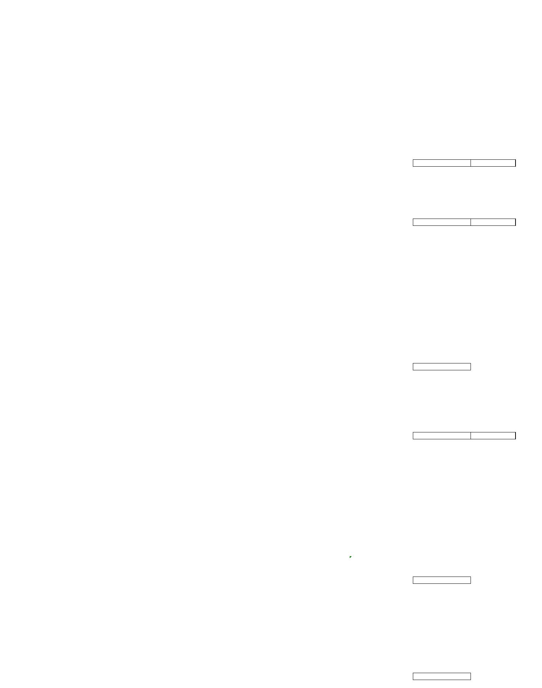

**Appendix A.IV (Sheet 2 of 2)**

Connecting Transmission Owner Facility Study

Rochester Area Reliability Project Article VII

NYPA 345kV Aerial Transmission Line POI

to New Proposed RG **Station 255**

Total Cost

**Overhead Expenses**

51

52

53

54

55

Sales Tax (0%)

Stones Expense (0%)

Indirect Payroll (50%)

Transportation (0%)

$

$

$

$

$

-

-

1,941,797.97

-

Overheads (tools & work equipment) 1%

38,835.96

**Total Overhead Expenses**

**$**

**$**

**1,980,634**

**5,863,949**

**Total Project Installed Cost**

**Temporary & Removal Costs**

Cost HR

MH

Cost

56

57

58

59

60

Remove 6 - 345 kV Towers - 7 Men 8 days with equipment

$

$

$

$

$

236

236

236

236

236

488

200

160

160

200

$

$

$

$

$

115,168

47,200

37,760

37,760

47,200

Remove 24 Foundations - 5 Men 5 days with equipment 4' below grade

Restore ground to condition of surrounding area - 5 Men 4 day with equipment

Remove 3 spans of 345 kV conductor - 5 Men 4 days with equipment

Temporary 345 kV Rearrangement - 5 Men 5 days with equipment

**Total Project Removal Costs**

**Total Work by RG&E**

**$**

**$**

**$**

**$**

**285,088**

**7,932,258**

**400,065**

**Total Work by NYPA**

**Total Porject - 2018 Dollars**

**8,332,323**

Assumptions:

1)

2)

3)

4)

5)

6)

7)

8)

No Permits Included in Estimate

No RGE Loadings included in this estimate

Soils Average Quality, Rock length as estimated, Water Table 15'-30' Below Grade. No Expansive Clay or Pumping Sand

TL Structures Galvanized Steel, All Str's. Self-Supporting with no Guys; Sub. TO Str. Mat & Found. Not Included but TL Hardware & Wire at TO is include

Off Cost Generation Not Included

Cost Based on Preliminary Layout Drawing-Any Modifications May Revise Cost

Fiber Optic Static Wires (2) Required on this Project

Construction Costs included in Lieu of Contractor Estimate-Substitute Contractor Cost for Numbers Provided Above if Possible

The estimate used the following rates provided by NYPA:

Sales Tax: …………………………………………………………….

Stores Expense: …………………….……………………..……

Indirect Payroll: …………..……………………………….……..

Transportation: …………..…………….………..………….….

Overheads & Contingencies: ……………………………

Overheads (Tools & Work Equipment)

0.0%

0.0%

50.0%

0.0%

30.0%

1.0%

29.0%

NA

Contingencies …………………………………….

AFDC: …………………………………………………………………..

87

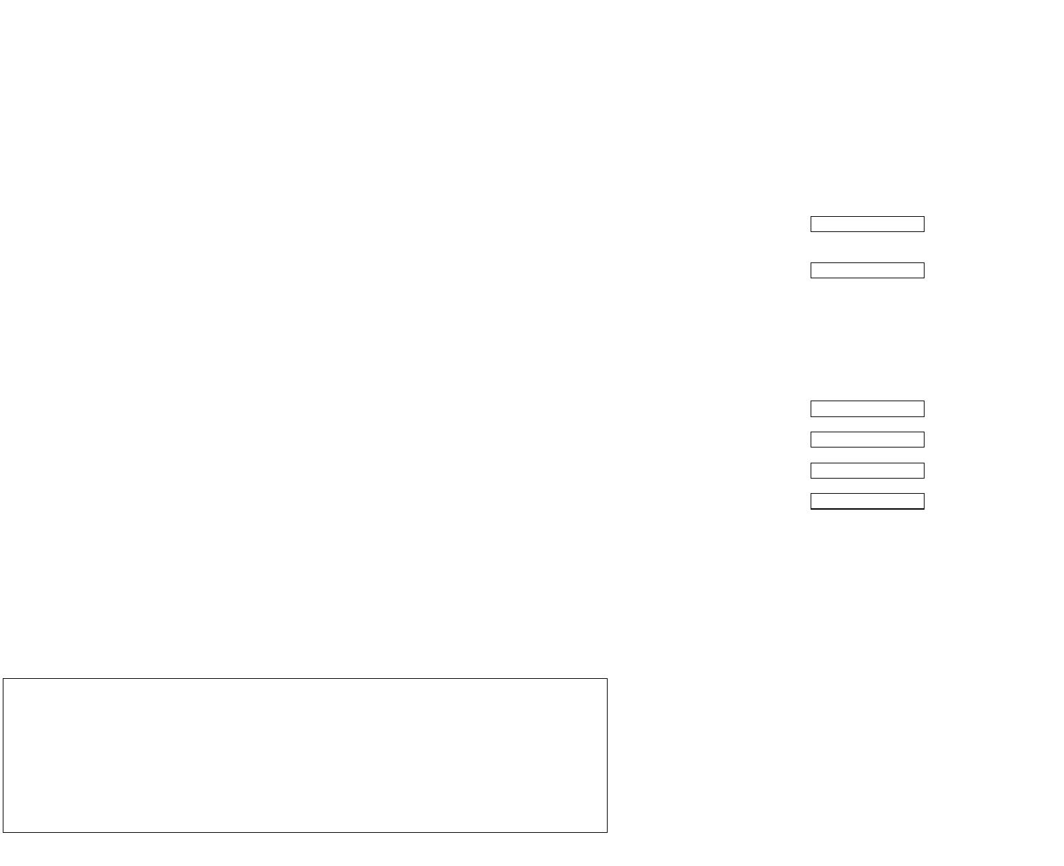

**Appendix A.V (Sheet 1 of 2)**

88

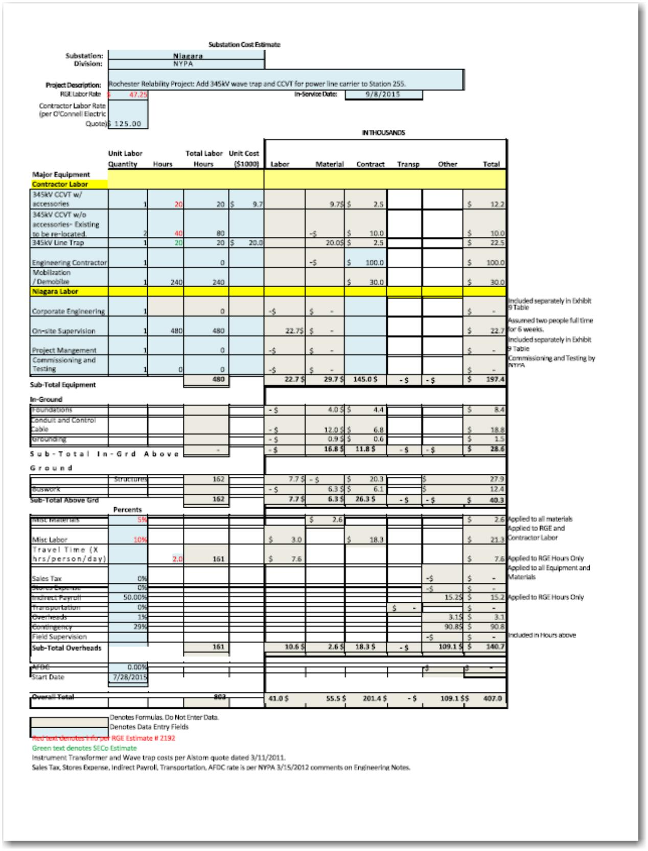

**Appendix A.V (Sheet 2 of 2)**

Restated

Work by RG&E $ 1,152,542

Work by NYPA $ 1,930,000

Total $ 3,082,542

89

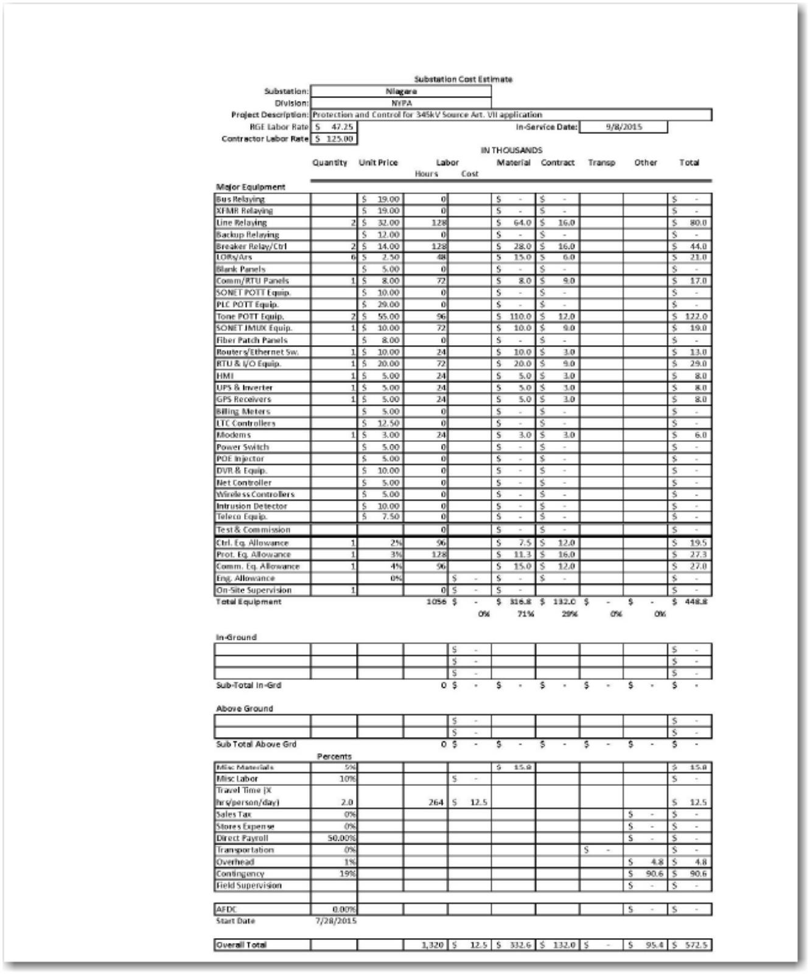

**Appendix A.VI**

**One-Line**

*“Appendix A.VI of this Interconnection Agreement Contains Critical Energy*

*Infrastructure Information -- Do Not Distribute to Unauthorized Individuals”*

90



**Operating and Maintenance Expenses**

Pursuant to Section 10.5 of this Agreement, RG&E shall pay the reasonable expenses

(including overheads) for the operation, maintenance, repair and replacement of Connecting

Transmission Owner’s Attachment Facilities. Such expenses are calculated as follows:

a) Contractor expenses for labor, equipment and materials. These expenses shall be

invoiced as the actual amount of the Contractors’ invoices. Connecting Transmission

Owner shall also be entitled to a fee of 5 % of such amount(s).

b) Connecting Transmission Owner’s labor, craft and salaried personnel directly working on

the operation, maintenance or repair of the Connecting Transmission Owner Attachment

Facilities. These expenses shall be invoiced on the basis of Connecting Transmission

Owner’s standard labor rate times the number of hours worked (including adjustment for

overtime hours, if applicable). Such standard rate is subject to change in accordance with

Connecting Transmission Owner’s normal budgeting practices.

c) Equipment and materials purchased by the Connecting Transmission Owner (other than

those covered under subsection (a), above). These expenses shall be invoiced on the

basis of the actual cost of such material. Connecting Transmission Owner shall also be

entitled to a fee of 15% of such amount(s).

d) Use of vehicles and construction equipment. These expenses shall be invoiced at

Connecting Transmission Owner’s cost. Connecting Transmission Owner shall also be

entitled to a fee of 10% of such amount(s).

e) Miscellaneous expenses (e.g. local utility charges for power; local

telephone/communication fees; other fees such as FAA licenses). These expenses shall

be invoiced at Connecting Transmission Owner’s cost. Connecting Transmission Owner

shall also be entitled to a fee of 5% of such amount(s).

**Transfer of Property:**

Upon completion of construction, testing, and acceptance by the Connecting

Transmission Owner of the CTOAFs and SUFs, RG&E will convey to the Connecting

Transmission Owner permanent easements or other agreements as required by the Connecting

Transmission Owner to the CTOAFs and SUFs constructed thereon, free and clear of any liens

and encumbrances.

91



**APPENDIX B – MILESTONES**

**MILESTONES**

**1. Selected Option Pursuant to Section 5.1.2**

RG&E exercises its Option to Build pursuant to Article 5.1.2 of the Interconnection

Agreement as memorialized in the Milestones schedule in this Appendix B.

**2. Milestones**

**Task Name**

**RARP - Interconnection Related Milestones**

**Start**

**Finish**

**Mon**

**Duration**

**1,176**

**Mon**

**10/9/17**

**12/28/20 days**

**Overall**

**Fri**

**Mon 1,165**

**10/20/17 12/28/20 days**

**File EMCP for Segment III**

**Fri**

**Fri**

**0 days**

**0 days**

**0 days**

**0 days**

**1,176**

**10/20/17 10/20/17**

**Receive Approval for EMCP Segment III**

**Execute Interconnection Agreement with NYPA**

**Mon**

**8/27/18**

**Mon**

**8/27/18**

**Fri**

**6/28/19**

**Fri**

**6/28/19**

**Final Connection and Energization of ST 255**

**and All Connecting Substations and Transmission Lines**

**Mon**

**Mon**

**12/28/20 12/28/20**

**Substation (Dates Focus on ST 255)**

**Mon**

**Mon**

**10/9/17**

**12/28/20 days**

**Start Substation Engineering Detailed Design**

**Finish Substation Engineering Detailed Design**

**Start Construction for Substation**

**Mon**

**10/9/17**

**Mon**

**10/9/17**

**0 days**

**Fri**

**7/29/19**

**Fri**

**7/29/19**

**0 days**

**0 days**

**0 days**

**Mon**

**Mon**

**10/15/18 10/15/18**

**Finish Construction for Substation**

**Mon**

**Mon**

**12/28/20 12/28/20**

92

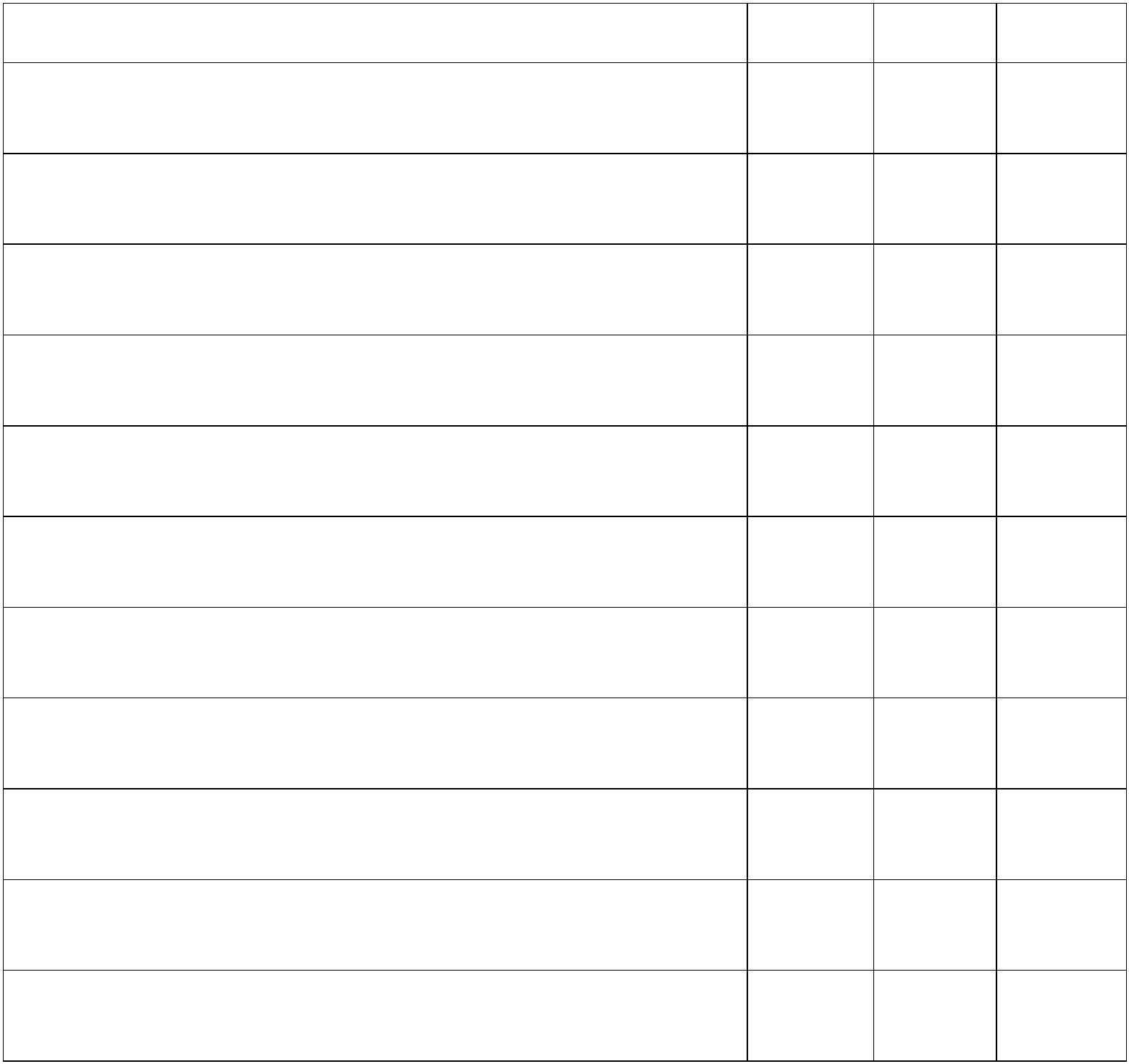

**Start Local Commissioning Activities for Substation**

**Tues**

**3/24/20**

**Tues**

**3/24/20**

**0 days**

**0 days**

**1,057**

**Finish Local Commissioning Activities & Energize**

**Substation (Connection to ST 80 via TL 40)**

**Mon**

**Mon**

**10/19/20 10/19/20**

**NYPA Transmission Lines (Interconnection)**

**Start Transmission Line Detailed Design**

**Finish Transmission Line Detailed Design**

**Mon**

**1/8/18**

**Mon**

**11/30/20 days**

**Mon**

**1/8/18**

**Mon**

**1/8/18**

**0 days**

**Fri**

**Fri**

**0 days**

**0 days**

**0 days**

**0 days**

**0 days**

**844 days**

**0 days**

**0 days**

**0 days**

**0 days**

**0 days**

**0 days**

**6/1/18**

**6/1/18**

**Start Construction for Interconnection Towers**

**(Outside NYPA ROW)**

**Mon**

**7/20/20**

**Mon**

**7/20/20**

**Finish Construction for Interconnection Towers**

**(Outside NYPA ROW)**

**Tues**

**12/08/20 12/08/20**

**Tues**

**Start Commissioning Activities for Transmission Lines Tues**

**Tues**

**(Includes Tower Construction Inside NYPA ROW)**

**10/20/20 10/20/20**

**Finish Commissioning Activities for Transmission**

**Lines**

**Mon**

**Mon**

**11/30/20 11/30/20**

**NYPA Niagara PLC Construction**

**Mon**

**9/3/18**

**Fri**

**11/27/20**

**Start Substation Engineering Detailed Design**

**RG&E Sends NYPA IFC drawings**

**Mon**

**9/3/18**

**Mon**

**9/3/18**

**Fri**

**6/28/19**

**Fri**

**6/28/19**

**Finish Substation Engineering Detailed Design (with**

**NYPA approval)**

**Fri**

**8/30/19**

**Fri**

**8/30/19**

**Start Construction for Substation**

**Finish Construction for Substation**

**NYPA Start Commissioning (Fan Building Work)**

93

**Tues**

**6/30/20**

**Tues**

**6/30/20**

**Fri**

**Fri**

**11/13/20 11/13/20**

**Mon**

**Mon**

**10/12/20 10/12/20**



**NYPA Complete Commissioning (Fan Building Work) Fri**

**Fri**

**0 days**

**11/27/20 11/27/20**

**The following notes apply to all work performed as required by this Agreement or**

**by Connecting Transmission Owner:**

A. Connecting Transmission Owner work durations do not include holiday work; if a

NYPA holiday occurs during an event on these Milestones, then effected dates shall be

extended day-for-day.

B. All Connecting Transmission Owner outage durations necessary to interconnect

Developer’s project are dependent on favorable weather conditions where the work is

being performed. Unfavorable weather conditions may extend the length of such

outage durations.

C. Transmission System emergencies take precedence over all work and could

significantly impact the schedule and durations.

D. Connecting Transmission Owner schedules its resources months in advance, and its

ability to reschedule manpower is limited by resource allocation to other Connecting

Transmission Owner projects and tasks. If Developer misses a scheduled Milestone

that directly affects performance of a Connecting Transmission Owner’s Milestone,

performance or completion of Connecting Transmission Owner’s relevant Milestone

may be delayed until the Connecting Transmission Owner can reschedule its

manpower to work on the assigned task.

E. The Closeout/Turnover Package shall consist of the following: As-built drawings,

Punchlist, Record Drawings, all equipment, QA/QC installation, commissioning,

Engineer of Record Professional Engineer certification, color markup of design,

drawings and warranties, and all documentation necessary for demonstrating

compliance with applicable NERC Reliability Standards and NPCC directories.

94



F. To the extent not inconsistent with the terms of this Agreement or the NYISO OATT,

RG&E shall be responsible for all fines and penalties imposed on Connecting

Transmission Owner by a Governmental Authority or Applicable Reliability Council

directly caused by RG&E action or inaction relating to, and occurring prior to the

transfer of care, custody, and control by RG&E to the Connecting Transmission

Owner of, the Connecting Transmission Owner’s Attachment Facilities or Stand Alone

Network Upgrade Facilities.

95

**APPENDIX C – INTERCONNECTION DETAILS**

The scope of the RARP involves the installation of a new Bulk Power Station

Transmission Reinforcement Project (the “Project”) to bring the NYPA 345kV cross-states lines

into the new Station 255. The new station will have a breaker-and-a-half setup for the 345kV

bus. Two 345/115kV 448MVA transformers will tie the 345kV bus into the 115kV breaker-and-

a-half bus. There will be two approximately 300MVA 115kV lines off of the 115kV bus. The

first line will tie into the western part of the RGE 115kV system at Station 418. The second line

will tie into the 115kV system toward downtown Rochester at Station 23. This project will

provide source capability into the RGE system to allow for the loss of other sources to the RGE

system, while also providing the targeted 115kV delivery points loading relief on existing 115kV

lines.

The Project as originally proposed reduced the thermal transfer limits of Dysinger East

and West Central interfaces by approximately 350 MW (~14% of interface thermal transfer

limit). To account for this impact, a third 345 kV line (Circuit 40) from the new Station 255 to

Station 80 was included. The Project as currently proposed decreases the thermal transfer limits

of Dysinger East and West Central interfaces by approximately 48 MW. Based on the System

Impact Study results the Dysinger East and West Central interface transfers are voltage limited,

and the addition of Project increases the voltage transfer limits by approximately 100 MW.

The Project’s transmission scope includes work for the construction of three new RG&E

Transmission Lines (345kV Circuit 40: 1.3 miles, 115kV Circuit 940: 10.5 miles & 115kV

Circuit 941: 12.0 miles) , the relocation of one 115 kV RG&E Transmission Line (Circuit 906:

2.5 miles) & the relocation of the aforementioned NYPA 345kV cross-states lines.

96

**Transfer of Ownership Matrix**

The following matrix is a broad overview of the transfer of ownership after the completion

of the project.

**TRANSFER OF OWNERSHIP**

**MATRIX**

**TITLE**

NYPA

RGE/AVNG

Niagara SP&C SOW

Niagara Communication & Protection

SOW

Niagara CCVT & Line Trap

Niagara In Ground & Above Ground

SOW

Circuit NH-2 from the Point of

Interconnection to St. 255.

HR-2 from the Point of

Interconnection to St. 255.

SH 1-39 from the Point of

Interconnection to St. 255.

HR-1 from the Point of

Interconnection to St. 255.

Circuit 40

Circuit 940

Circuit 941

St. 255

St. 80

97

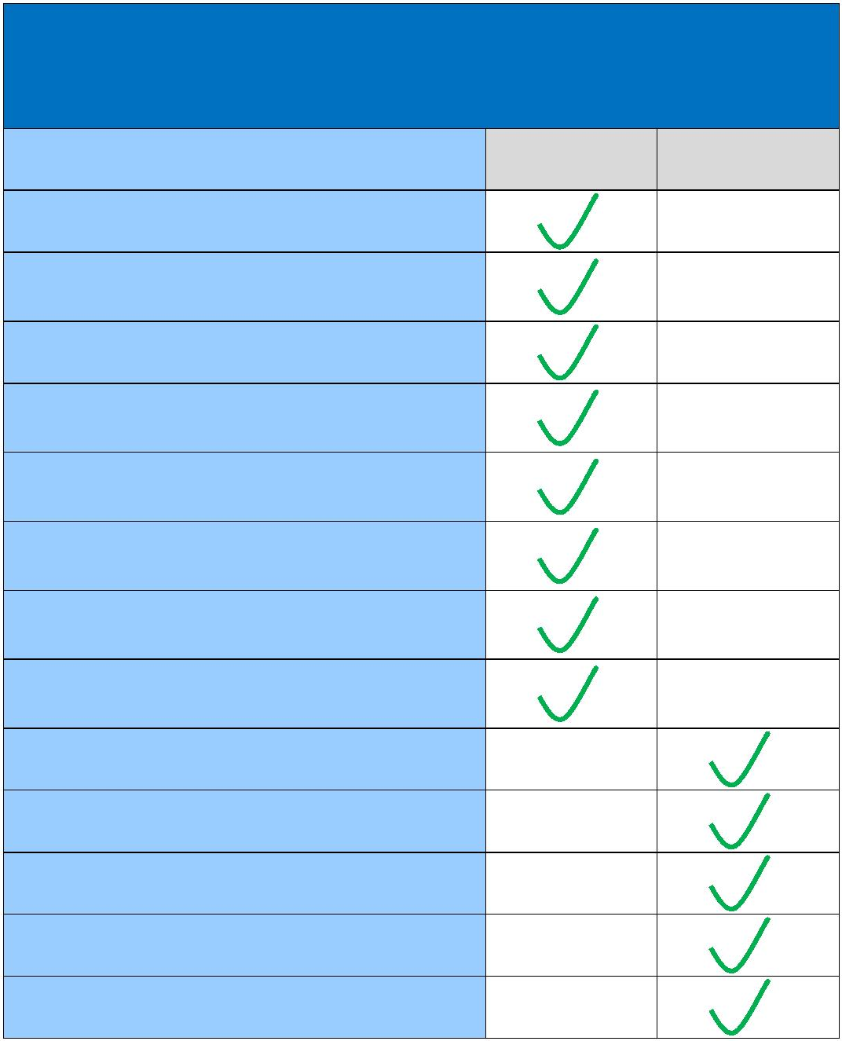

**Responsibility Matrix**

The following matrix is a broad overview of Project responsibilities.

**RESPONSIBILITY MATRIX**

**TITLE**

NYPA

RGE/AVNG

Niagara SP&C Engineering

Niagara Communication & Protection

Work

Niagara CCVT & Line Trap Installation

Niagara In Ground & Above Ground

Engineering

Installation of Communication Cable

(Fiber or Copper) at NIA between S&R

Bldg and Fan Bldg for the T1 connection

to JMUX in Fan Bldg

Switchyard Access Permit

Outage Coordination

Maintenance on Future Work

Specification(s) on Panels

Procurement & delivery of Panels

FERC Compliance

Transmission Line Design

Transmission line material supply

Transmission line construction

Transmission line future maintenance

98

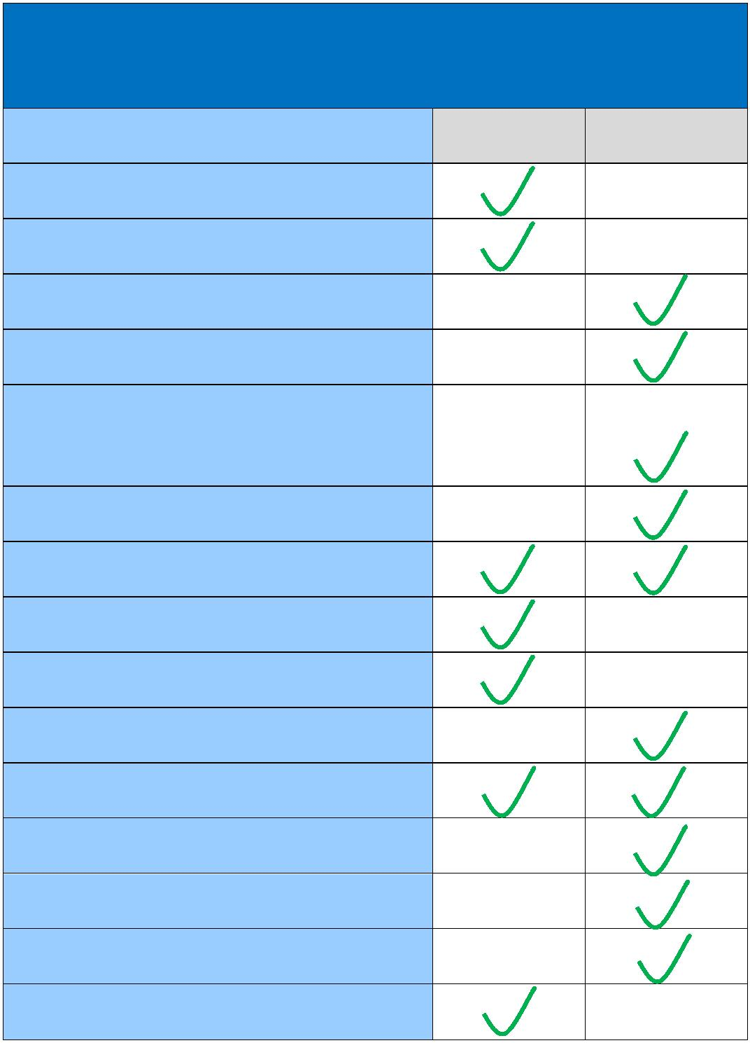

**APPENDIX D – SECURITY ARRANGEMENTS DETAILS**

Infrastructure security of New York State Transmission System equipment and

operations and control hardware and software is essential to ensure day‐to‐day New York State

Transmission System reliability and operational security. The Commission will expect the

NYISO, all Transmission Owners, and all other Market Participants to comply with the

recommendations offered by the President’s Critical Infrastructure Protection Board and,

eventually, best practice recommendations from the electric reliability authority. All public

utilities will be expected to meet basic standards for system infrastructure and operational

security, including physical, operational, and cyber‐security practices.

99

**APPENDIX E – COMMERCIAL OPERATION DATE**

**[Date]**

**[NYISO]**

**[Connecting Transmission Owner Address]**

Re: _____________ Transmission Facility

Dear __________________:

This letter confirms that **[RG&E]** commenced Commercial Operation of the Transmission

Facility, effective as of **[Date]**.

Thank you.

**[Signature]**

**[RG&E Representative]**

100

**APPENDIX F – ADDRESSES FOR DELIVERY OF NOTICES AND BILLINGS**

**Notices:**

Connecting Transmission Owner:

Philip Toia - Senior Vice President of Power Supply

New York Power Authority

Clark Energy Center

6250 Glass Factory Road

Marcy, NY 13403-8236

Phone: (315) 792 8236

Philip.toia@Nypa.gov

RG&E:

Rochester Gas and Electric Corporation

Timothy J. Lynch – Director

18 Link Drive

P.O. Box 5224

Binghamton, NY 13902-5224

(585) 484 6352

TJLynch@nyseg.com

101



**Billings and Payments:**

Connecting Transmission Owner:

Philip Toia - Senior Vice President of Power Supply

New York Power Authority

Clark Energy Center

6250 Glass Factory Road

Marcy, NY 13403-8236

Phone: (315) 792-8236

Philip.toia@Nypa.gov

Or wire payment to:

New York Power Authority

Operating Funds c/o

J.P. Morgan Chase, N.A.

ABA No. 021000021

Account No. 573-804206

102



RG&E:

Rochester Gas and Electric Corporation

Todd Foster – Manager – Billing and Risk Management

18 Link Drive

P.O. Box 5224

Binghamton, NY 13902-5224

(585) 484 6883

TLFoster@nyseg.com

103



**ALTERNATIVE FORMS OF DELIVERY OF NOTICES (TELEPHONE, FACSIMILE**

**OR EMAIL):**

Connecting Transmission Owner:

Philip Toia - Senior Vice President of Power Supply

New York Power Authority

Clark Energy Center

6250 Glass Factory Road

Marcy, NY 13403-2836

Phone: (315) 792 8236

Philip.toia@Nypa.gov

RG&E:

Rochester Gas and Electric Corporation

Julie Mahoney – Program/Project Manager

18 Link Drive

P.O. Box 5224

Binghamton, NY 13902-5224

(585) 484 6306

104

