AN

INTERCONNECTION AGREEMENT

BETWEEN

NIAGARA MOHAWK POWER CORPORATION

AND

EMPIRE GENERATING CO, LLC

INTERCONNECTION AGREEMENT (the “Agreement”) is made as of January 15, 2004, between Niagara Mohawk Power Corporation, a National Grid company (“Niagara Mohawk”), a New York Corporation, and Empire Generating Co, LLC, a New York limited liability company (the “Producer”). (Collectively, Producer and Niagara Mohawk may be referred to as the “Parties”, or individually, as a “Party.”)

WHEREAS, the Producer is developing a power production facility to be located in the City of Rensselaer, County of Rensselaer, New York (the “Production Facility”);

WHEREAS, the Producer and Niagara Mohawk desire to provide for the interconnection of the Production Facility to Niagara Mohawk’s Transmission System under the terms and   
conditions set forth herein; and,

WHEREAS, certain Upgrades to Niagara Mohawk’s system will be needed solely for Producer’s benefit and will not support any other transmission user.

NOW THEREFORE, in consideration of the mutual representations, covenants and agreements set forth herein, the Parties to this Agreement agree as follows:

ARTICLE I

DEFINITIONS

The following terms, when used herein with initial capitalization, shall have the meanings specified in this section.

1.1 “Agreement” shall mean this Interconnection Agreement between Niagara Mohawk and

the Producer, including all exhibits hereto, as the same may be amended, supplemented, revised, altered, changed, or restated in accordance with its terms.

1.2 “Bulletin No. 756” or “ESB 756” shall mean that certain internal Niagara Mohawk

document dated 2001, 2” printing June, entitled “Supplement to Specifications for

Electrical Installations; Parallel Generation Requirements” and designated Electric

System Bulletin No. 756 and its Appendix C, as amended or superseded, as available on Niagara Mohawk’s website.

1.3 “Commercial Operation Date” shall follow the Initial Synchronization Date and shall

mean the date after all pre-operational testing of the Interconnection Facility has been   
completed to Niagara Mohawk’s satisfaction, the Interconnection Facility has been   
energized, and the Producer has commenced selling energy or capacity into the   
wholesale power market administered by the NYISO pursuant to the NYISO OATT.   
Producer shall provide Niagara Mohawk written notice at least sixty (60) days in   
advance of the Commercial Operation Date and will reaffirm this date, or provide notice   
of a revised date, no less than twenty (20) days prior to the previously notified date.

1.4 “Commercially Reasonable Efforts” shall mean efforts which are designed to enable a

Party, directly or indirectly, to satisfy expeditiously a condition to, or otherwise assist in

1

the consummation of, the actions contemplated by this Agreement and which do not

require the performing Party to expend any finds or assume liabilities other than

expenditures and liabilities which are customary and reasonable in nature and amount in the context of the actions contemplated by this Agreement.

1.5 “Confidential Information” shall mean any plan, specification, pattern, procedure,

design, device, list, concept, policy or compilation relating to the present or planned

business of a Party which has not been released publicly by its authorized representatives   
and which has been designated as “Confidential” by the Party asserting a claim of   
confidentiality, whether such Confidential Information is conveyed orally, electronically,   
in writing, through inspection, or otherwise. Confidential Information as used herein also   
includes Confidential Information supplied by any Party to another Party prior to the   
execution of this Agreement, and such Confidential Information shall be considered in   
the same trimmer and be subject to the same treatment as the Confidential Information   
made available after the execution of this Agreement. Confidential Information shall also   
include Confidential Information observed by any Party while visiting the premises of   
another Party.

1.6 “Delivery Point” shall mean the point at which the Interconnection Facility is connected

to the Transmission System as indicated on Exhibit A. This point shall be at the jaw side   
of the disconnect switch (SW #599) connecting the Interconnection Facility, new breaker   
and switches to the existing bus work at the Niagara Mohawk Reynolds Road Substation

1.7 “Electricity” shall mean electric capacity as measured in MW or kW, energy as measured

in MWh or kWh, and/or ancillary services.

1.8 “Emergency Condition” shall mean a condition or situation which is deemed imminently

likely to (i) endanger life, property, or public health; or (ii) adversely affect or impair the   
Transmission System, the Production Facility, or the electrical or transmission systems   
of others to which Niagara Mohawk’s electrical systems are directly or indirectly   
connected.

1.9 “Facilities Study” shall mean the necessary studies performed by Producer, or its third

party designee, approved by Niagara Mohawk as set forth in Article IV, Section 4.1. The Facilities Study is attached hereto as Exhibit B.

1.10 “FERC” shall mean the United States of America’s Federal Energy Regulatory

Commission or any successor organization.

1.11 “Good Utility Practice” shall mean any of the practices, methods and acts engaged in or

approved by a significant portion of the electric utility industry during the relevant time   
period, or any of the practices, methods and acts which, in the exercise of reasonable   
judgment in light of the facts known at the time the decision was made, could have been   
expected to accomplish the desired result at a reasonable cost consistent with good   
business practices, reliability, safety and expedition. Good Utility Practice is not intended   
to be limited to the optimum practice, method, or act, to the exclusion of all others, but

2

rather to be acceptable practices, methods, or acts generally accepted in the region in   
which the Production Facility is located. Good Utility Practice shall include, but not be   
limited to, NERC (defined below) criteria, rules, guidelines and standards, NPCC   
(defined below) criteria, rules, guidelines and standards, New York State Reliability   
Council (defined below) criteria, rules, guidelines and standards, and NYISO (defined   
below) criteria, rules, guidelines and standards, where applicable, as they may be   
amended from time to time including the rules, guidelines and criteria of any successor   
organization to the foregoing entities. When applied to the Producer, the term Good   
Utility Practice shall also include standards applicable to a utility generator connecting to   
the distribution or transmission facilities or system of another utility.

1.12 “Greenbush #16 Line” shall mean the existing 115 kV circuit consisting of poles, wires,

insulators, conductors and other miscellaneous hardware between Rensselaer Cogen Facility and the existing Niagara Mohawk Greenbush Substation.

1.13 “Hazardous Substance(s)” shall mean those substances, materials, products or wastes

which are classified as hazardous or toxic under any applicable federal, state or local law,   
or any regulations promulgated thereunder, effective as of the date of execution of this   
Agreement, and the presence of which requires remediation, removal or cleanup under   
this Agreement.

1.14 “Initial Energization Date” shall mean the date upon which construction of the

Interconnection Facility and Upgrades have been completed and have been determined by Niagara Mohawk to be completed in accordance with Power Control Order 6-1   
(“PCO 6-1”) and the circuit breakers have been closed, thereby, permitting electricity to flow from Niagara Mohawk’s transmission system to the Production Facility.

1.15 “Initial Synchronization Date” shall mean a date that follows the Initial Energization

Date, and which date shall occur during the pre-operational testing of the Production   
Facility and is the first date that Electricity flows from the Production Facility through   
the Interconnection Facility to the Delivery Point without the need for any further major   
repairs or testing as determined by Niagara Mohawk and in accordance with PCO 6-1

1.16 “Interconnection Facility” shall include all those facilities located between the

Interconnection Point and the Delivery Point necessary to effect the transfer of

Electricity produced at the Production Facility to the Transmission System, as such

facilities are described in more particularity in Article II and in Exhibit A to this

Agreement, and shall include any Modifications, replacements or upgrades made to the Interconnection Facility, and any communications and/or protection equipment installed for the operation of the Interconnection Facility.

1.17 “Interconnection Point” shall mean the point at which the Production Facility is

connected to the Interconnection Facility, as indicated on Exhibit A. This point will be at the jaw side of the disconnect switch used to connect the Production Facility to the   
Interconnection Facility.

3

1.18 “Metering Point” shall mean that point at which the Electricity produced by the

Production Facility will be metered by Niagara Mohawk for purposes of billing and metering for NYISO transactions, as depicted in Exhibit A.

1.19 “Modification” shall mean any new construction, new facilities, additions,

reinforcements, alterations, improvements, appurtenances, replacements or upgrades

made to the Interconnection Facility, Upgrades, Transmission System, or the Production   
Facility as required by the NYISO or revised reliability standards, after the Commercial   
Operation Date. “Modification” as it applies to the Interconnection Facility, Upgrades or   
Transmission System shall also include Modifications which are required to support the   
operations of the Producer including those required by: (i) changes in the operations of   
the Production Facility after the Effective Date as hereinafter defined, or (ii) changes in   
the technology employed at the Production Facility after the Effective Date.

1.20 “NERC” shall mean the North American Electric Reliability Council or any successor

organization.

1.21 “New York Control Area” shall have the same meaning as in the Independent System

Operator Agreement establishing the New York ISO (as defined below).

1.22 “New York ISO” or “NYISO” shall mean the New York Independent System Operator,

Inc. or any successor thereto.

1.23 “Niagara Mohawk” shall mean Niagara Mohawk Power Corporation and its successors

and permitted assigns.

1.24 “Niagara Mohawk Properties” shall mean those parcels of and/or interest in real property

that Niagara Mohawk uses for its transmission facilities upon which portions of the Interconnection Facility will be constructed.

1.25 “NPCC” shall mean the Northeast Power Coordinating Council (a reliability council

under Section 202 of the Federal Power Act) or any successor organization.

1.26 “NYISO OATT” shall mean the FERC-approved Open Access Transmission Tariff for

the NYISO and/or the FERC-approved Service Tariff for the NYISO, as applicable, and as it may be amended from time to time.

1.27 “NYPSC” shall mean the New York Public Service Commission or any successor

thereto.

1.28 “NYSRC” shall mean the New York State Reliability Council or any successor

organization.

1.29 “Original Greenbush #16 Line” shall mean that portion of the Greenbush #16 Line to be

removed between the Rensselaer Cogen Facility generating facility and the existing Niagara Mohawk structure number 29.

4

1.30 “Permanent Greenbush #16 Line” shall mean that new portion of the Greenbush # 16

Line to be constructed and attached to the same structures supporting the Interconnection

Facility between the Rensselaer Cogen Facility generating facility and the existing

Niagara Mohawk structure number 29.

1.31 “Producer” shall mean Empire Generating Co, LLC, and its successors and permitted

assigns.

1.32 “Production Facility” shall mean Producer’s Electricity Production facility with a

maximum net Winter rating of 672 MW and with a maximum net Summer rating of 603 MW located in the City of Rensselaer, County of Rensselaer New York, to be owned, operated and maintained by Producer.

1.33 “Property” and “Properties” shall mean that aggregate real property interest necessary for

construction, operation and maintenance of the Interconnection Facility, which real

property interest may be acquired in fee ownership, via easement or option, or other

means of acquisition of property rights acceptable to Niagara Mohawk, or such real

property interest held by Niagara Mohawk to which Producer will be allowed access for the removal of the Original Greenbush #16 Line, construction and removal of the   
Temporary Greenbush #16 Line, construction of the Permanent Greenbush #16 Line, and for other necessary modifications to the Greenbush #16 Line.

1.34 “Rensselaer Cogen Facility” shall mean the 79 MW Rensselaer Cogeneration Facility,

located at 39 Riverside Avenue, Rensselaer, New York 12144, currently owned and   
operated by El Paso Merchant Energy, North America, or its successors or assigns.

1.35 “Retail Tariff” shall means Niagara Mohawk’s Retail Tariff, New York Public Service

Commission (“NYPSC”) No. 207 - Electricity as approved by the NYPSC and all subsequent revisions, as it may be amended from time to time.

1.36 “System Reliability Impact Study” or “SRIS” shall mean that study entitled

“Interconnection Study for the Empire State Newsprint Project,” authored by the

Washington Group and approved by the NYISO Operating Committee on November 14,   
2001.

1.37 “Temporary Greenbush #16 Line” shall mean that new temporary portion of the

Greenbush #16 Line to be constructed between the Rensselaer Cogen Facility generating facility and the existing Niagara Mohawk structure number 29.

1.38 “Transmission System” shall mean the properties, structures, facilities, equipment,

devices, and apparatus wholly or partly owned or leased by, or under contract to, or under the control of Niagara Mohawk or its Affiliates, other than the Interconnection Facility, which are necessary to interconnect the Production Facility to the New York Control Area, or are necessary for purposes of providing transmission and Retail Tariff services, including services under the NYISO Tariff.

5

1.39 “Upgrades” shall mean the modifications, reinforcements and additions to Niagara

Mohawk’s Transmission System and distribution facilities required or recommended to   
be constructed and installed prior to the Commercial Operation Date in order for Niagara   
Mohawk to interconnect the Production Facility to the Transmission System in   
accordance with NYISO Tariff rules and regulations, as identified in the Facilities Study   
(Exhibit B to this Agreement), and pursuant to this Agreement, and that will be needed   
solely for Producer’s benefit and will not support any other transmission user.

Interpretation. The following rules shall govern the interpretation of this Agreement, including its definitions. The terms “includes” or “including” shall not be limiting, whether or not   
followed by the words “without limitation.” References to an article or section shall mean an   
article or section of this Agreement unless the context requires otherwise. References to a given agreement or instrument shall be a reference to that agreement or instrument as modified,   
amended, supplemented and restated.

ARTICLE II

AGREEMENT TO INTERCONNECT

DESCRIPTION OF INTERCONNECTION FACILITY

2.1 The Parties agree to interconnect the Production Facility to the Transmission System in

accordance with the terms of this Agreement.

2.2 Term: This Agreement shall become effective as of the date first above written (the

“EFFECTIVE DATE”), subject to its approval or acceptance for filing by the FERC, and   
shall continue in effect for thirty (30) years thereafter and shall be automatically renewed   
for each successive one-year period thereafter. This Agreement may be terminated by   
the Producer after giving Niagara Mohawk ninety (90) Calendar Days advance written   
notice, or by Niagara Mohawk notifying FERC after the Production Facility is retired..

2.3 The Interconnection Facility shall consist generally of those facilities, including but not

limited to a new 345 kV high voltage transmission line and all associated equipment and upon which said facilities are located, necessary to effect the transfer of electricity   
produced at the Production Facility into the Transmission System. The Interconnection Facility shall connect with the Production Facility at the Interconnection Point and the Interconnection Facility shall connect with the Transmission System at the Delivery Point, as indicated on the one-line diagram in Exhibit A.

2.4 The Production Facility shall include all facilities and equipment up to and including the

Production Facility’s high side generator breaker, line-side disconnect switch jaws, as   
indicated on Exhibit A. Producer agrees that the installation of the electrical equipment   
and the operation of the Production Facility must meet or exceed the standards of Good   
Utility Practice, all requirements of Bulletin No. 756 and the NYISO; provided, however,   
that in the event of a conflict between the requirements, rules and regulations of the

6

NYISO and the requirements of Bulletin No. 756, the requirements, rules and regulations of the NYISO shall govern.

2.5 Producer recognizes that nothing in this Agreement or in the Producer’s financial support

of the Interconnection Facility confers upon the Producer any right to transmit electricity over the Transmission System. However, the interconnection of the Production Facility to the Transmission System contemplated herein will allow Producer to access the New York Control Area for purposes of Producer’s stated intent to participate in the wholesale market administered by the NYISO pursuant to the NYISO OATT.

2.6 Niagara Mohawk shall use Good Utility Practice to own, operate and maintain the

Interconnection Facility, Upgrades and Transmission System. Niagara Mohawk does not, however, guarantee or warrant uninterrupted availability of the Interconnection Facility, Upgrades or the Transmission System. Any curtailment of deliveries over the   
Interconnection Facility, Upgrades or the Transmission System shall be governed by Good Utility Practice, the terms and conditions of the NYISO OATT, ESB 756 and any other tariffs, approved by a regulatory body having jurisdiction.

2.7 Niagara Mohawk, in accordance with the rates, terms and conditions of the Retail Tariff,

shall provide Producer with station service power, if so requested or authorized. Producer   
agrees to complete all necessary applications and forms as required by the Retail Tariff.

2.8 Without limiting its rights hereunder, Niagara Mohawk reserves the right to operate the

primary means of disconnect on the Producer’s side of the Interconnection Point.

Niagara Mohawk shall exercise such right of disconnect (a) in accordance with Bulletin No. 756, (b) in the event of an Emergency Condition, (c) after giving Producer   
reasonable notice under the circumstances, (d) in a non-discriminatory manner, and (e) in accordance with Good Utility Practice.

2.9 If the Producer relies on Niagara Mohawk’s system protection equipment and practices

for protection of the Production Facility or if the Producer relies on any other of Niagara Mohawk’s equipment for support of its operations, the Producer agrees to release,   
indemnify, defend, and save harmless Niagara Mohawk, its agents and employees,   
officers, directors, parent(s) and affiliates, against any and all claims, judgments, cost,   
liability, damage, injury, penalties, fines (civil or criminal), or other costs arising from   
any damage or loss to the Production Facility, as a result of such reliance, whether the   
loss, damage or injury result to or be sustained by Producer or any other persons, firms or corporations. To the extent the Producer relies on any other of Niagara Mohawk’s   
equipment for support of Producer’s operations, Producer shall agree to indemnify   
Niagara Mohawk in accordance with this Section 2.9 except in the event of Niagara   
Mohawk’s gross negligence or willful misconduct.

7

ARTICLE III

REPRESENTATIONS AND WARRANTIES OF PARTIES

3.1 Producer is a Corporation duly organized and validly existing under the laws of the State

of New York. Producer is qualified to do business under the laws of the State of New York, is in good standing under the laws of the State of New York, has the power and authority to own its properties, to carry on its business as now being conducted, and to enter into this Agreement and the transactions contemplated herein and perform and carry out all covenants and obligations on its part to be performed under and pursuant to this Agreement, and is duly authorized to execute and deliver this Agreement and   
consummate the transactions contemplated herein.

3.2 Niagara Mohawk is a corporation duly organized, validly existing and qualified to do

business under the laws of the State of New York, is in good standing under its

certificate of incorporation and the laws of the State of New York, has the corporate authority to own its properties, to carry on its business as now being conducted, and to enter into this Agreement and the transactions contemplated herein and perform and carry out all covenants and obligations on its part to be performed under and pursuant to this Agreement, and is duly authorized to execute and deliver this Agreement and   
consummate the transactions contemplated herein.

3.3 The Producer and Niagara Mohawk each represents that: (a) upon receipt of all

governmental permits, licenses and approvals required to construct and operate the

Production Facility, Producer is not prohibited from entering into this Agreement and   
discharging and performing all covenants and obligations on its part to be performed   
under and pursuant to this Agreement; (b) upon the acceptance of the terms of this   
Agreement by FERC, the execution and delivery of this Agreement, the consummation   
of the transactions contemplated herein including the fulfillment of and compliance with   
the provisions of this Agreement will not conflict with or constitute a breach of or a   
default under any of the terms, conditions or provisions of any law, rule or regulation,   
any order, judgment, writ, injunction, decree, determination, award or other instrument   
or legal requirement of any court or other agency of government, or any contractual   
limitation, corporate restriction or outstanding trust indenture, deed of trust, mortgage,   
loan agreement, lease, other evidence of indebtedness or any other agreement or   
instrument to which it is a party or by which it or any of its property is bound and will   
not result in a breach of or a default under any of the foregoing; and (c) unless this   
Agreement is materially modified by any court or appropriate regulatory authority having   
jurisdiction and subsequently terminated, this Agreement shall be a legal, valid and   
binding obligation enforceable in accordance with its terms, except as limited by any   
subsequent order of any court or appropriate regulatory authority having jurisdiction, or   
by any applicable reorganization, insolvency, liquidation, readjustment of debt,   
moratorium, or other similar laws affecting the enforcement of rights of creditors   
generally as such laws may be applied in the event of a reorganization, insolvency,   
liquidation, readjustment of debt or other similar proceeding of or moratorium applicable   
to the Party and by general principles of equity (regardless of whether such enforceability   
is considered in a proceeding in equity or at law.)

8

ARTICLE IV

FACILITIES STUDY

4.1 A Facilities Study attached hereto as Exhibit B shall be performed by Producer, or a third

party selected by the Producer subject to Niagara Mohawk’s approval. The Facilities   
Study shall estimate the cost of the equipment, engineering, procurement and   
construction and a preliminary schedule for the work needed to implement the   
recommendations of the System Reliability Impact Study and, in accordance with Good   
Utility Practice, to physically and electrically connect the Production Facility to the   
Transmission System. The Facilities Study shall include those studies that, in the   
judgment of Niagara Mohawk, are necessary to determine (a) an appropriate   
Interconnection Point and Delivery Point, (b) equipment and the facilities necessary and   
desirable for the construction and operation of any new or additional or modified   
transmission and distribution facilities, including but not limited to the Interconnection   
Facility and Upgrades, the electrical switching configuration of the connection   
equipment, the transformer(s), switchgear, meters, and other station equipment, (c) the   
interconnection voltage and operational constraints, (d) the estimated costs of facilities   
and/or the costs for Niagara Mohawk’s and Producer’s design, review, assistance and   
inspection of facilities to be designed and constructed by Producer and/or Niagara   
Mohawk, (e) the estimated costs of any Upgrades, (f) the removal of the Original   
Greenbush #16 Line and Temporary Greenbush #16 Line, and the design, engineering,   
and construction of the Temporary Greenbush #16 Line, Permanent Greenbush #16 Line,   
and other necessary modifications to the Greenbush #16 Line (g) the estimated time   
required to complete construction, removal, and installation of such facilities, and (h) a   
mutually agreed upon schedule and estimated budget for the activities contemplated   
under this Agreement, including but not limited to, the design, engineering, procurement   
activities and construction of the Interconnection Facility, Temporary Greenbush #16   
Line, Permanent Greenbush #16 Line, other necessary modifications to the Greenbush   
#16 Line and Upgrades, and the removal of the Original Greenbush #16 Line and   
Temporary Greenbush #16 Line.

4.2 Niagara Mohawk shall review the Facilities Study as contracted and paid for by the

Producer. Niagara Mohawk retains the right to require modifications of any aspect of the   
proposal for the Interconnection Point, Interconnection Facility, Delivery Point, and any   
new or additional or modified transmission and distribution facilities, including, but not   
limited to the Greenbush #16 Line, Original Greenbush #16 Line, Temporary Greenbush   
#16 Line and Permanent Greenbush #16 Line, and Upgrades as presented in the Facilities   
Study, prior to Niagara Mohawk’s approval of the Facilities Study. Construction of the   
Interconnection Facility, Temporary Greenbush #16 Line, Permanent Greenbush #16

Line, other necessary modifications to the Greenbush #16 Line, and Upgrades, and

removal of the Original Greenbush #16 Line and Temporary Greenbush #16 Line, shall   
proceed only following: (a) Niagara Mohawk’s approval of the Facilities Study, (b)   
Producer’s satisfaction, as determined by Niagara Mohawk, of the pre-conditions set   
forth in Article VII, (c) execution of this Agreement, (d) the receipt by Niagara Mohawk

9

of a written notice from Producer to proceed with such activities and, (e) receipt by Niagara Mohawk of a money deposit per Article XV of this Agreement.

4.3 The Parties recognize that as of the Effective Date of this Agreement the Interconnection

Facility has not been authorized by the NYPSC, and, therefore, is subject to a certificate   
to be issued by the NYPSC pursuant to Article VII of the New York Public Service Law.

ARTICLE V

REAL PROPERTY

5.1 OBTAINING REAL PROPERTY INTERESTS, AND NECESSARY LICENSES,

PERMITS, AND APPROVALS

5.1.1 Producer will acquire all interests in real property that are necessary, in the

opinion of Niagara Mohawk, for the Producer and/or Niagara Mohawk, as

applicable, to construct, reconstruct, relocate, operate, repair, maintain, and

remove the Interconnection Facility, Greenbush #16 Line, Temporary Greenbush   
#16 Line, and Permanent Greenbush #16 Line in accordance with the terms and   
provisions of this Agreement. Such real property interests may be acquired by   
Producer in the form of an option acceptable to both parties. Sueh options which   
shall name Niagara Mohawk as the optionee and grantee of the real property   
interests and shall be exercised by the Producer in favor of Niagara Mohawk to   
provide permanent easements or fee title necessary for the construction,   
reconstruction, relocation, operation, repair, maintenance and removal of the   
Interconnection Facility, Greenbush #16 Line, Temporary Greenbush #16 Line,   
and Permanent Greenbush #16 Line.

5.1.2 Niagara Mohawk shall authorize Producer to place applicable portions of the

Interconnection Facility on existing Niagara Mohawk real property interests. The   
acreage and width of Niagara Mohawk’s fee-owned real property necessary for   
the Interconnection Facility shall be subject to Niagara Mohawk’s approval.

5.1.3 Producer shall be responsible for preparing applications for and obtaining all

government permits, authorizations, licenses, certificates and approvals necessary   
to construct, relocate, operate, repair, maintain, and remove the Interconnection   
Facility, Temporary Greenbush #16 Line, Permanent Greenbush #16 Line, other   
necessary modifications to the Greenbush #16 Line, and Upgrades on terms and   
conditions acceptable to Niagara Mohawk. Said applications shall be prepared by   
Producer for submittal by Niagara Mohawk and/or Producer, where appropriate.   
Niagara Mohawk, at Producer’s expense, shall be responsible for maintaining in   
full force and effect all permits, authorizations, licenses, certificates, and

approvals necessary to operate and maintain the Interconnection Facility and

Upgrades. Producer, at Producer’s expense, shall be responsible for maintaining   
in full force and effect all permits, authorizations, licenses, certificates, and   
approvals necessary to operate and maintain the Production Facility. Producer   
and Niagara Mohawk agree to comply in all material respects with all federal,

10

state and local environmental and other laws, ordinances, rules, regulations,   
permits, licenses, approvals, certificates and requirements thereunder as may   
apply to each Party in connection with the activities each performs pursuant to   
this Agreement.

5.1.4 Producer agrees that, prior to the transfer by Producer of any real property

interest to Niagara Mohawk under the terms of this Agreement, Producer shall   
conduct, or cause to be conducted, and be responsible for all costs of sampling,   
soil testing, and any other methods of investigation which would disclose the   
presence of any Hazardous Substance which has been released on the Property or   
which is present upon the Property by migration from an external source, and   
which existed on the Property prior to the transfer, and shall notify Niagara   
Mohawk in writing as soon as reasonably practicable after learning of the   
presence of Hazardous Substance upon said Property interest. Producer agrees to   
indemnify, defend, and save Niagara Mohawk, its agents and employees, officers,   
directors, parents and affiliates, harmless from and against any loss, damage,   
liability (civil or criminal), cost, suit, charge (including reasonable attorneys’   
fees), expense, or cause of action, for the removal or management of any   
Hazardous Substance and relating to any damages to any person or property   
resulting from presence of such Hazardous Substance.

5.1.5 Prior to transfer of control of the Interconnection Facility from Producer to

Niagara Mohawk, Niagara Mohawk shall be given the opportunity to inspect,

perform final testing and approve the Interconnection Facility and review all

appropriate approvals, certificates, permits, and authorizations. Prior to transfer of   
control of the Interconnection Facility from Producer to Niagara Mohawk,   
Producer shall be responsible for correcting within thirty (30) days of discovery   
any situations that are contrary, in Niagara Mohawk’s sole judgment, to Good   
Utility Practice, Bulletin No. 756, Niagara Mohawk’s standards, procedures,   
practices and functional specification requirements, standard Niagara Mohawk   
environmental, construction, forestry, and right-of-way management practices   
and procedures, Niagara Mohawk’s Standard Environmental Management and   
Construction Plan Protection Measures and Niagara Mohawk’s Transmission   
Right-of-Way Management Plans or any applicable NYISO, NYPSC, NYSRC,   
NPCC, NERC, or FERC standards and criteria requirements, which such   
requirements shall govern in the event of a conflict between NYISO, NYPSC,   
NYSRC, NPCC, NERC or FERC and the requirements of Bulletin No. 756,   
which, in Niagara Mohawk’s sole judgment, materially and adversely affect the   
operability of the Interconnection Facility or are contrary to applicable laws or   
permits, and for correcting any material deficiencies which could impede the   
transfer of control of the Interconnection Facility to Niagara Mohawk pursuant to   
this Agreement. Producer shall be responsible for the costs associated with   
making such corrections.

5.2 ACCESS RIGHTS

11

5.2.1 Niagara Mohawk hereby grants to Producer access and licenses, as necessary for   
 Producer to construct the Interconnection Facility, Temporary Greenbush #16   
 Line, Permanent Greenbush #16 Line, other necessary modifications to the   
 Greenbush #16 Line, and to remove both the Temporary Greenbush #16 Line and   
 the Original Greenbush #16 Line.

5.2.2 Producer hereby grants to Niagara Mohawk all necessary access, and licenses,   
 including adequate and continuing rights of access to Producer’s property, as   
 necessary for Niagara Mohawk to construct, operate, maintain, replace, or   
 remove the Interconnection Facility and to read meters in accordance with the   
 terms of this Agreement and to exercise any other of its obligations under this   
 Agreement. Producer hereby agrees to execute such grants, deeds, licenses,   
 instruments or other documents as Niagara Mohawk may require to enable it to   
 record such rights of way, easements, and licenses.

5.3 RIGHT OF WAY ACQUISITION AND EXPENSE

5.3.1 Producer shall pay and be solely liable for all expenditures and paying for all

activities incurred or engaged in by Producer and Niagara Mohawk in acquiring   
necessary real property interests and associated permits and authorizations   
required for Producer and Niagara Mohawk, as appropriate, to construct,   
reconstruct, relocate, operate, repair, maintain, as applicable, the Interconnection   
Facility, Temporary Greenbush #16 Line, Permanent Greenbush #16 Lines, other   
necessary modifications to the Greenbush #16 Line, and Upgrades, and to remove   
the Original Greenbush #16 Line, and Temporary Greenbush #16 Line, as   
required pursuant or related to this Agreement. Producer shall pay fair market   
value for the real property interests acquired as determined by an appraiser   
retained by Producer at Producer’s expense (a copy of the appraisal shall be   
provided to Niagara Mohawk free of charge) or such other value as the Parties   
may agree upon in writing. Producer shall pay and be solely liable for all costs   
associated with the transfer of real property rights to Niagara Mohawk, including,   
but not limited to, closing costs, subdivision costs, transfer taxes and recording   
fees. Producer shall reimburse Niagara Mohawk for all costs Niagara Mohawk   
incurs in connection with transfers of property and any associated permits and   
authorizations and in carrying out Niagara Mohawk’s responsibilities as provided   
in this Agreement, including but not limited to Article IX, except as to costs   
related to encroachments on existing Niagara Mohawk property, if any, that   
impede the siting or construction of facilities necessary to implement the   
interconnection under this Agreement.

5.3.2 Producer shall be responsible for defending and shall indemnify and hold

harmless Niagara Mohawk, its directors, officers, employees, agents and

affiliates, from and against all liabilities, expense (including litigation costs and   
attorney’s fees) damages, losses, penalties, claims, demands, actions and   
proceedings of any nature whatsoever for construction delays, construction or   
operations cessations, claims of trespass, or other events of any nature   
 12

whatsoever that arise from or are related to an issue as to the sufficiency of the   
real property interests acquired or utilized by the Producer (including, but not   
limited to, those real property interests from Niagara Mohawk) for the   
construction, reconstruction, relocation, operation, repair, and maintenance of the   
Interconnection Facility, Temporary Greenbush #16 Line, Permanent Greenbush   
#16 Line, other necessary modifications to the Greenbush #16 Line, and the   
removal of the Original Greenbush #16 Line and Temporary Greenbush #16   
Line. In no event, shall Niagara Mohawk be held liable to Producer or third   
parties for consequential, incidental or punitive damages arising from or any way   
relating to an issue as to the sufficiency of the real property interests acquired or   
utilized by the Producer (including, but not limited to, those real property   
interests from Niagara Mohawk) for the construction, reconstruction, relocation,   
operation, repair, and maintenance of the Interconnection Facility, Temporary   
Greenbush #16 Lines, Permanent Greenbush #16 Line, other necessary   
modifications to the Greenbush #16 Line, and removal of the Original Greenbush   
#16 Line and Temporary Greenbush #16 Line.

5.4 CONVEYANCE OF PROPERTY RIGHTS AND FACILITIES CONSTRUCTED

5.4.1 The real property interests necessary for the construction, reconstruction,

relocation, operation, repair, and maintenance of the Interconnection Facility,   
Permanent Greenbush #16 Line, Temporary Greenbush #16 Lines, other   
necessary modifications to the Greenbush #16 Line, and Upgrades, and removal   
of the Original Greenbush #16 Line and Temporary Greenbush #16 Line, that are   
not already owned or controlled by Niagara Mohawk, shall be conveyed to   
Niagara Mohawk in fee simple or by an easement approved by Niagara Mohawk,   
with good and marketable title free and clear of all liens, encumbrances, and   
exceptions to title for a sum of $1.00 at least thirty (30) days prior to the date   
scheduled for the commencement of construction or removal, as applicable, of   
any of the facilities described in Article VIII, Section 8.1 of this Agreement. With   
respect to any approved conveyance of easements, Producer shall subordinate   
pertinent mortgages to easement rights. Producer shall indemnify, defend, and   
hold harmless Niagara Mohawk, its agents and employees, officers, directors,   
parent(s) and affiliates, and successors in interest, from all liens and   
encumbrances against the property conveyed. Producer further agrees to provide   
to Niagara Mohawk a complete field survey with iron pin markers showing the   
centerline of the entire Interconnection Facility right-of-way, and a 40-year   
abstract of title, and a 10-year tax search for real property interests acquired by   
the Producer from third parties. Prior to the execution of an option, Producer shall   
be required to provide Niagara Mohawk a title insurance commitment with a   
complete title report issued by a reputable and independent title insurance   
company for any property rights, in fee or easement in the segment of the   
Interconnection Facility from the Production Facility to Niagara Mohawk’s   
existing fee-owned right-of-way, that are to be transferred to Niagara Mohawk.   
At the time of the execution of an option by Producer, Producer shall provide a

13

title insurance policy naming Niagara Mohawk as the insured covering the real   
property interest to be acquired for any property rights, in fee or easement in the   
segment of the Interconnection Facility from the Production Facility to Niagara   
Mohawk’s existing fee-owned right-of-way, that are to be transferred to Niagara   
Mohawk.

5.4.2 Producer shall provide to Niagara Mohawk conformed copies of all necessary

real property interests, environmental, engineering, and other permits,

authorizations, licenses, certificates, permits, approvals and as-built drawings not otherwise prepared by or directly for, or issued to Niagara Mohawk.

5.4.3 Upon completion of removal of the Original Greenbush #16 Line and Temporary   
 Greenbush #16 Line and the construction and testing of the Interconnection   
 Facility, Permanent Greenbush #16 Line, other necessary modifications to the   
 Greenbush #16 Line, and 60 days prior to Initial Synchronization Date of the   
 Interconnection Facility, in accordance with the Schedule provided in the   
 Facilities Study, Producer shall convey and transfer the Interconnection Facility,   
 Permanent Greenbush #16 Line, and, as required, other necessary modifications   
 to the Greenbush #16 Line, to Niagara Mohawk for a sum of $1.00.

ARTICLE VI

PILOT PROGRAM

6.1 Subject to the terms and conditions of this Agreement, Niagara Mohawk shall be the

owner and sole operator of the Interconnection Facility contemplated in this Agreement.   
The Production Facility may be subject to a Payment in Lieu of Taxes (“PILOT”)   
program with the Rensselaer County Industrial Development Agency (“RCIDA”). Any   
proposed RCIDA PILOT program by and between the RCIDA and the Parties shall   
provide that Niagara Mohawk be the owner and sole operator of the Interconnection   
Facility under this Agreement. Furthermore, such RCIDA PILOT program must be   
acceptable to Niagara Mohawk and Producer must obtain Niagara Mohawk’s prior   
written consent for a proposed RCIDA PILOT with respect to the Interconnection   
Facility.

6.2 PILOT Expenses: All costs and expenses (including attorneys’ fees) incurred by

Producer and Niagara Mohawk in connection with obtaining the RCIDA PILOT shall be   
paid by Producer. In the event that the PILOT is not acceptable to Niagara Mohawk, or   
in the event that the PILOT is in effect and acceptable to Niagara Mohawk but the   
PILOT terminates, Producer shall pay all applicable taxes under Section 15.2.3 of this   
Agreement.

14

ARTICLE VII

PRE-CONDITIONS OF DESIGN, ENGINEERING, PROCUREMENT AND   
 CONSTRUCTION ACTIVITIES

7.1 PRE-CONDITIONS OF DESIGN, ENGINEERING, PROCUREMENT AND

CONSTRUCTION ACTIVITIES

Producer agrees to complete to Niagara Mohawk’s satisfaction and prior to Niagara

Mohawk’s or Producer’s, as the case may be, respective commencement of any design, engineering, procurement, or construction activities, including preparation for   
construction, contemplated under this Agreement (a) all activities required in Articles IV (Facilities Study), V (Real Property), VI (PILOT Program), VIII (Section 8.1,   
Construction Financing; Section 8.2.1.1, Agreement with owner of Rennselaer Cogen   
Facility); (b) Niagara Mohawk and Producer have executed this Agreement; (c) Niagara Mohawk and Producer have established the Schedule, as required in Section 8.2.3; (d)   
Niagara Mohawk has received a written notice from Producer to proceed with the   
activities described in Article VIII, Section 8.2; and (e) Niagara Mohawk has received a money deposit per Article XV of this Agreement.

7.2 EFFECT OF FAILURE TO COMPLETE ALL PRE-CONDITIONS

In the event that Producer fails to timely and satisfactorily complete each of the pre-

conditions in this Article VII, Niagara Mohawk may terminate this agreement upon thirty

(30) days prior written notice to Producer subject to applicable NYISO and FERC requirements and Article XVII.

ARTICLE VIII

CONSTRUCTION

8.1 CONSTRUCTION FINANCING

Producer shall be responsible for arranging and securing all necessary construction

financing to support the construction activities contemplated under this Agreement.

Niagara Mohawk shall commence performance under this Agreement no earlier than the date of Producer’s closing on its construction loan financing in connection with activities related to or to be performed under this Agreement.

8.2 DESIGN, ENGINEERING AND CONSTRUCTION ACTIVITIES

8.2.1 At Producer’s expense, Producer shall design, engineer, and construct the

apparatuses, equipment and facilities located between the Production Facility and   
the final 345 kV structure outside of the Reynolds Road Substation, as Depicted   
in Exhibit A, and the Temporary Greenbush #16 Line, Permanent Greenbush #16   
Line, other necessary modifications to the Greenbush #16 Line, and removal of   
the Original Greenbush #16 Line and Temporary Greenbush #16 Line, and   
procure all equipment, construction materials and other materials necessary for

15

the activities described above, all in accordance with, as applicable, (a) the

Facilities Study, (b) Good Utility Practice, (c) Niagara Mohawk’s standards, and

(d) agreement reached between Producer and the owner of the Rensselaer Cogen   
Facility.

8.2.1.1 Producer, at Producer’s expense, shall negotiate and enter into an

agreement to secure the consent of the owner of the Rensselaer

Cogen Facility for Prouder to remove the Original Greenbush #16   
Line and Temporary Greenbush #16 Line, construct the   
Temporary Greenbush #16 Line, Permanent Greenbush #16 Line,   
other necessary modifications to the Greenbush #16 Line, which   
lines all are necessary for Niagara Mohawk to maintain the   
interconnection between the Rensselaer Cogen Facility and the   
Transmission System and for the payment by Producer to owner of   
the Rensselaer Cogen Facility for any outage related costs for   
which Niagara Mohawk would otherwise be responsible, if   
applicable. Such new lines shall be satisfactory to the owner of the   
Rensselaer Cogen Facility and shall, at a minimum, provide the   
Rensselaer Cogen Facility with at least as much output capacity as   
with the current interconnection facility. Producer shall provide   
Niagara Mohawk a conformed, written executed copy of the   
agreement Producer reaches with the owner of the Rensselaer   
Cogen Facility no less than thirty (30) days prior to the   
commencement of any removal or construction activities   
involving the Greenbush #16 Line, Original Greenbush #16 Line,   
Temporary Greenbush #16 Line or Permanent Greenbush #16   
Line.

8.2.2 At Producer’s expense, Niagara Mohawk shall design, engineer, and construct the

apparatuses, equipment and facilities located between the final 345 kV structure   
located outside of the Reynolds Road substation and the Delivery Point, as   
depicted in Exhibit A, and all Upgrades necessary to facilitate the interconnection   
of Producer’s Production Facility, and procure all equipment, construction   
materials and other materials necessary for the activities described above, all in   
accordance with (a) the Facilities Study, (b) Good Utility Practice and (c) Niagara   
Mohawk’s standards.

8.2.3 Within forty-five (45) days of the Parties’ execution of this Agreement, the

Parties shall use Commercially Reasonable Efforts to determine a mutual

Schedule (hereinafter the “Schedule”) for their respective design, engineering and   
construction responsibilities as set forth in the Facilities Study attached hereto as   
Exhibit B. However, the Parties shall adjust the Schedule, as necessary, to   
comply with the certificate issued by the NYPSC pursuant to Article VII of the   
New York Public Service Law. Said Schedule may only be revised by mutual   
written consent of both Parties. Completion of construction by either Party shall   
be subject to the Force Majeure events as provided in Article XVII, Section 18.1.   
 16

All design, engineering, procurement, and construction activities for which   
Producer or a third party selected by Producer, upon approval of Niagara   
Mohawk, is responsible shall be performed in accordance with the Schedule   
mutually agreed to by the Parties in advance of the commencement of such   
activities as set forth in the Facilities Study attached hereto as Exhibit B.   
Producer shall inform Niagara Mohawk, at the Producer’s expense, on the first   
business day of each month of the status of all such design, engineering,   
procurement, and construction activities, including, but not limited to, the   
following information: progress to date; a description of upcoming scheduled   
activities and events; the delivery status of all ordered equipment; and the   
identification of any event which Producer reasonably expects may delay   
construction of the Interconnection Facility Permanent Greenbush #16 Line,   
Temporary Greenbush #16 Line, other necessary modifications to the Greenbush   
#16 Line, and Upgrades, or removal of the Original Greenbush #16 Line, or the   
Temporary Greenbush #16 Line.

8.2.4 Niagara Mohawk shall inform Producer on the first business day of each month

of the status of all such design, engineering, procurement, and construction

activities, including, but not limited to, the following information: progress to

date; a description of upcoming scheduled activities and events; the delivery

status of all ordered equipment; and the identification of any event which Niagara   
Mohawk reasonably expects may delay Producer’s construction of the   
Interconnection Facility, Permanent Greenbush #16 Line, Temporary Greenbush   
#16 Line, other necessary modifications to the Greenbush #16 Line, or removal   
of the Original Greenbush #16 Line, or the Temporary Greenbush #16 Line.

8.2.5 If, for an excused reason, Niagara Mohawk completes its design, engineering and

construction responsibilities after the completion dates shown in the Schedule, as   
may be amended upon mutual written consent of the Parties, the Commercial   
Operation Date shall be automatically extended by the same length of time by   
which the scheduled completion dates of Niagara Mohawk’s responsibilities are   
delayed with no penalty or additional cost owing the Producer from Niagara   
Mohawk, and no penalty, additional cost owing Niagara Mohawk from Producer.

8.2.6 If Producer completes its design, engineering and construction responsibilities

after the completion dates shown in the Schedule, as may be amended upon

mutual written consent of the Parties, or if Niagara Mohawk’s completion dates cannot be met due to any revised or adjusted Schedule of the Producer’s design, engineering and construction responsibilities, Producer acknowledges and agrees to reimburse, in accordance with Article XV of this Agreement, Niagara Mohawk for all costs incurred by Niagara Mohawk, that cannot be avoided, due to   
Producer’s delaying said work.

8.2.7 Producer shall, at Producer’s expense, (a) with Niagara Mohawk representatives

present, test the Interconnection Facility, Temporary Greenbush #16 Line,   
Permanent Greenbush #16 Line, and other necessary modifications to the   
 17

Greenbush #16 Line, to ensure their safe and reliable operation in accordance

with Good Utility Practice and (b) correct, within thirty (30) days of testing, any situations contrary to Good Utility Practice.

8.2.8 Niagara Mohawk shall, at Producer’s expense, test the apparatuses, equipment   
 and facilities located between the final 345 kV structure located outside of the   
 Reynolds Road Substation and the Delivery Point as depicted in Exhibit A and   
 the Upgrades to ensure their safe and reliable operation in accordance with Good   
 Utility Practice and (b) correct, within thirty (30) days of testing, any situations   
 contrary to Good Utility Practice.

8.3 RISK OF LOSS

Producer shall bear all risk of loss with respect to the Interconnection Facility removal of   
the Original Greenbush #16 Line and the Temporary Greenbush #16 Line, the   
Temporary Greenbush #16 Line, Permanent Greenbush #16 Line, other necessary   
modifications to the Greenbush #16 Line until completion of construction of the   
Interconnection Facility and the Permanent Greenbush #16 Line, and other necessary   
modifications to the Greenbush #16 Line and all title and interest in the Interconnection   
Facility, Permanent Greenbush #16 Line, and other necessary modifications to the   
Greenbush #16 Line have been transferred to Niagara Mohawk in accordance with the   
terms and conditions of this Agreement and, until such transfer, Producer waives all   
rights of recovery against Niagara Mohawk regarding such risk.

ARTICLE IX

OPERATION AND MAINTENANCE

9.1 OPERATION AND MAINTENANCE OF INTERCONNECTION AND OTHER

FACILITIES

9.1.1 At Producer’s expense, Niagara Mohawk shall own, operate, maintain (maintain   
 includes right-of-way vegetation management activities apportioned to the   
 Interconnection Facility) and repair (repair includes, but is not limited to,   
 replacement of existing equipment when required due to failure) the   
 Interconnection Facility in accordance with Good Utility Practice.

9.1.2 At Niagara Mohawk’s expense, Niagara Mohawk shall own, operate, maintain   
 and repair the Upgrades in accordance with Good Utility Practice.

9.1.3 The Producer, at its own expense, shall own, and be responsible for operating,   
 maintaining and repairing (repairing includes, but is not limited to, replacement   
 of existing equipment when required due to failure) the Production Facility and   
 other apparatuses, equipment and facilities located between the Production   
 Facility and the Interconnection Point as Depicted in Exhibit A in accordance   
 with Good Utility Practice. The Producer will notify in writing no later than   
 December 1 of each year Niagara Mohawk of the schedule for scheduled outages

18

of the Production Facility for the next calendar year in accordance with Bulletin   
No. 756, Good Utility Practice, the Retail Tariff, NYISO practices and Niagara   
Mohawk standard practices and, upon making any changes to such schedules   
thereafter, shall promptly notify Niagara Mohawk of any such changes.

9.1.4 In furtherance of the Parties’ mutual objective to preserve and maintain the

reliability of the Transmission System, the Producer agrees, at the expense of the Producer, to coordinate with Niagara Mohawk, the planning and scheduling of any outages and any changes thereto in a manner that will preserve and maintain the reliability of, and minimize the effect on, the Transmission System, consistent with Good Utility Practice, Bulletin No. 756, the Retail Tariff, NYISO practices and Niagara Mohawk standard practices.

9.1.5 In furtherance of the Parties’ mutual objective to preserve and maintain the

reliability of the Transmission System, the Parties agree, at the expense of the

Producer, to coordinate the planning and scheduling of preventative and

corrective maintenance in a manner that will preserve and maintain the reliability   
of the Transmission System. The Parties shall conduct, at the expense of the   
Producer, preventative maintenance and corrective maintenance activities for the   
Interconnection Facility and the Production Facility, as scheduled and planned, or   
as they become necessary, consistent with Good Utility Practice. Niagara   
Mohawk shall conduct, at Niagara Mohawk’s expense, preventative maintenance   
and corrective maintenance activities for the Upgrades as scheduled and planned,   
or as they become necessary, consistent with Good Utility Practice.

9.1.6 If the Producer requests that Niagara Mohawk perform maintenance during a time

period other than as scheduled by Niagara Mohawk, Niagara Mohawk will use   
Commercially Reasonable Efforts to meet the Producer’s request as long as   
meeting the request would not reasonably be expected, as determined by Niagara   
Mohawk, to have an adverse impact upon Niagara Mohawk’s operations or the   
operations of Niagara Mohawk’s customers. Notwithstanding the foregoing,   
should the Producer request Niagara Mohawk to perform maintenance that   
Niagara Mohawk in good faith determines may have an adverse impact on   
Niagara Mohawk’s operations or the operations of Niagara Mohawk’s customers,   
and if such maintenance may be delayed until after such period, Niagara Mohawk   
may reject the Producer’s scheduling request. The Producer shall reimburse   
Niagara Mohawk for all costs incurred by Niagara Mohawk in satisfying the   
Producer’s request.

ARTICLE X

MODIFICATION OR RETIREMENT

10.1 MODIFICATION OF THE INTERCONNECTION FACILITY, UPGRADES OR

TRANSMISSION SYSTEM

19

10.1.1 Niagara Mohawk shall retain the discretion to determine whether, when, and in

what manner Modifications are required by Good Utility Practice and, as soon as reasonably practicable, shall advise Producer when it makes such a determination and whether performing the Modification, or the Modification itself, is expected to interrupt the flow of power over the Interconnection Facility. Niagara Mohawk shall provide Producer a written explanation of the need for Modifications,   
together with a cost estimate.

10.1.2 If Modification is required to support the operations of the Producer, Niagara

Mohawk shall construct, operate, maintain and repair, at the Producer’s expense,   
any such Modification, and the Producer shall reimburse Niagara Mohawk for all   
actual costs and expenses of constructing operating and maintaining the   
Modification.

10.1.3 Except in case of an Emergency Condition, the Producer shall give Niagara

Mohawk three months advance written notice of any planned Modifications to

the Production Facility that could reasonably be expected to affect the operations of the Transmission System or Interconnection Facility.

10.1.3.1 Such notice shall include plans, specifications, information and

operating instructions relating to the impact of planned

Modifications on the Transmission System, Interconnection   
Facility, and Upgrades or on Niagara Mohawk’s electric   
operations.

10.1.3.2 If Niagara Mohawk determines that such Modification would have

a material adverse effect upon Niagara Mohawk’s operations or   
the operations of Niagara Mohawk’s customers, then Niagara   
Mohawk shall so notify the Producer. In the event that the   
Producer elects to continue with such Modification, Niagara   
Mohawk shall be entitled to designate the earliest date upon which   
the Producer may begin operation of the Modification, provided   
however, that Niagara Mohawk shall not designate a beginning   
date that is later than eighteen (18) months after receipt of the   
notice mandated by subsection 10.1.3. The Producer shall be   
responsible for all costs associated with such Modification,   
including any costs incurred by Niagara Mohawk associated with   
ensuring that the Transmission System, Upgrades and   
Interconnection Facility would be compatible with such   
Modification.

10.1.3.3 Notwithstanding the foregoing, should the Producer propose a

schedule for performing a Modification that Niagara Mohawk in   
good faith determines may adversely affect Niagara Mohawk’s   
operations or the operations of Niagara Mohawk’s customers,   
Niagara Mohawk may reject such schedule; however, Niagara

20

Mohawk is amenable to working with Producer on developing a workable schedule.

10.1.4 All Modifications to the Production Facility, Interconnection Facility, Upgrades,   
 and Transmission System and any resulting effects on the Transmission System   
 shall meet the rules and requirements of NERC, NPCC, NYSRC, and the NYISO   
 or their respective successors, the standards of Good Utility Practice, the Retail   
 Tariff and the requirements of Bulletin No. 756; provided, however, that in the   
 event of a conflict between the rules and requirements of the NYISO and the   
 requirements of Bulletin No. 756, the rules and requirements of the NYISO shall   
 govern.

10.2 RELOCATION, REARRANGEMENT, ABANDONMENT OR RETIREMENT

10.2.1 If, during the term of this Agreement, Niagara Mohawk determines that it is

required by Good Utility Practice to relocate, rearrange, abandon, or retire the   
Transmission System and such relocation, rearrangement, abandonment, or   
retirement requires a change to the Interconnection Facility, Niagara Mohawk   
shall use good faith efforts to give the Producer no less than one (1) year advance   
written notice and shall, to the extent consistent with Good Utility Practice, defer   
such action, to the extent reasonably practicable, so that the Producer’s operation   
of the Production Facility may continue with minimal interruption.

10.2.2 If Niagara Mohawk is required or ordered by governmental authority or the

NYISO to relocate, rearrange, abandon, or retire the Transmission System and such relocation, rearrangement, abandonment, or retirement requires a change to the Interconnection Facility, Niagara Mohawk shall promptly give the Producer written notice of such requirement or order.

10.2.3 If relocation, rearrangement, abandonment, or retirement is required pursuant to

Paragraph 10.2.1 or .10.2.2 Niagara Mohawk shall perform or have performed, at   
the Producer’s expense, the studies necessary to identify any Modifications to the   
Interconnection Facility, or Upgrades necessary for the continued operation of the   
Production Facility and shall inform the Producer of the estimated costs. The   
Producer shall at its option either: (a) reimburse Niagara Mohawk for all actual   
costs and expenses of such Modification, studies and estimates in accordance   
with Section 10.1.2 of this Agreement; (b) construct, at its own expense, a new   
Interconnection Facility subject to the terms of this Agreement; provided,   
however, that design, engineering, and construction activities relating to the   
existing Transmission System, Interconnection Facility, and Upgrades shall be   
performed by Niagara Mohawk, or by a third party selected by Niagara Mohawk,   
at the Producer’s expense; or (c) terminate this Agreement, upon no less than   
sixty (60) days advance written notice to Niagara Mohawk.

21

ARTICLE XI

POWER DELIVERIES

11.1 METERING

11.1.1 Niagara Mohawk shall, at Producer’s expense, provide, own, and maintain

compatible revenue quality metering equipment at the Reynolds Road substation. Such metering equipment shall record the delivery of energy, including reactive power, in such a manner so as to measure total facility power output and   
consumption. Niagara Mohawk shall provide suitable space within its facilities for installation of such metering equipment.

11.1.2 Niagara Mohawk shall provide, at Producer’s expense, all necessary

communication equipment and transmission mediums such as telephone lines and   
any necessary protection for such communication equipment and related   
equipment. Producer shall be responsible for, at Producer’s expense, all   
communications required by Niagara Mohawk, the NYPSC or the NYISO. At   
Producer’s own expense, Producer shall purchase, own and maintain all   
telemetering equipment located at the Producer’s facilities required by Producer,   
Niagara Mohawk, the NYPSC or the NYISO. Producer shall provide, install and   
own Niagara Mohawk approved or specified test switches in the transducer   
circuits that have been approved or specified by Niagara Mohawk. Producer shall   
be responsible for any and all costs involved in the relocation of communication   
circuits and transmission mediums that may be required from time to time by   
Niagara Mohawk, the NYPSC, or the NYISO.

11.1.3 All metering equipment installed pursuant to this Agreement and associated with

the Production Facility may be routinely tested by Niagara Mohawk in

accordance with Good Utility Practice and applicable Niagara Mohawk, NYPSC   
and NYISO criteria, rules and standards. Each Party shall have the right at all   
reasonable times, upon giving not less than ten (10) days written notice to the   
other Party for the purpose of permitting the other Party to be present at the   
inspection, to inspect and test said meters and, if said meters or equipment are   
found to be defective, Niagara Mohawk shall adjust, repair or replace the same at   
the expense of the Producer, or if within one year of installation, at the expense of   
Niagara Mohawk. Any test or inspection requested by a Party shall be at the   
expense of that Party.

11.1.4 Electricity delivered to the Delivery Point by Producer hereunder shall be

measured by electric watt hour meters of a type approved by Niagara Mohawk   
and the NYPSC. These metering facilities will be installed, owned, and   
maintained by Niagara Mohawk and shall be sealed by Niagara Mohawk, with   
the seal broken only upon occasions when the meters are to be inspected, tested   
or adjusted and representatives of both Niagara Mohawk and Producer are   
present. Producer shall pay all metering, testing and installation costs. The meters

22

shall be maintained in accordance with the rules set forth in 16 NYCRR Part 92, as amended from time to time, and with Good Utility Practice.

11.1.5 Niagara Mohawk will guarantee the installation of any meter and its accuracy for

a period of one (1) year from the date that meter is installed; provided, however,   
that this guarantee does not cover any incidental or consequential damages that   
the Producer may suffer as a result of the failure of a meter to which this   
guarantee applies. Any repair or replacement, except for any repair or   
replacement occasioned by the negligence or willful misconduct of Producer,   
required during the initial year will be at the expense of Niagara Mohawk. In the   
event that any meter is found to be inaccurate after the initial year, Niagara   
Mohawk will repair or replace the same within a commercially reasonable time   
period at the expense of Producer.

11.1.6 Producer may elect to install at Producer’s expense its own metering equipment

in addition to Niagara Mohawk metering equipment. Such metering equipment

shall meet the requirements of 16 NYCRR Part 92, as may be amended from time to time. Should any metering equipment installed by Niagara Mohawk fail to   
register during the term of this Agreement, the Parties shall use Producer’s   
metering equipment, if installed. On any day or days on which neither Party’s   
metering equipment is in service, the quantity of energy delivered shall be   
determined in such manner as the Parties agree. Niagara Mohawk’s meter(s) shall be read on a schedule compatible with Niagara Mohawk’s normal meter reading schedule consistent with NYISO requirements.

11.1.7 In the event the Producer desires access to Niagara Mohawk meter information

related to the Production Facility and Interconnection Facility, the Producer, at its own expense, shall be responsible for purchasing and installing software,   
hardware and/or other technology that may be required to access such meter   
information. The software, hardware and/or other technology installed for this purpose shall be in compliance with any applicable NYPSC and Niagara   
Mohawk rules, requirements, or standards.

11.1.8 The Producer grants to the employees and agents of Niagara Mohawk the right of

access to Producer’s premises during regular business hours for purposes of the reading of Producer’s meters.

11.2 LOSSES

No loss calculations shall be necessary if the Metering Point is located in close proximity   
to the Delivery Point, as depicted in Exhibit A. However, if the Metering Point(s) are   
changed and the metering equipment and the Delivery Point are not at the same location,   
the metering equipment shall record delivery of Electricity in a manner that accounts for   
losses occurring between the Metering Point(s) and the Delivery Point(s), which shall be   
calculated by Niagara Mohawk in accordance with mutually acceptable loss calculations.

23

In addition, Producer will be responsible for all costs associated with the change in Metering Point(s).

11.3 REACTIVE POWER SUPPORT

The Producer agrees to provide, at no cost to Niagara Mohawk, reactive capability to

regulate and maintain system voltage at the Delivery Points in conformance with Bulletin   
No. 756 or any applicable NYISO tariff or agreement as they may be amended from time   
to time.

11.4 ISLANDING

Niagara Mohawk reserves the right to require, allow or prevent, with reference to

Bulletin No. 756, the islanding of the Production Facility during an Emergency. This Agreement is not intended to impair or supersede any rights of the NYISO to allow or prevent the islanding of the Production Facility.

11.5 NYISO OR REGULATORY PENALTIES AND CHARGES

The Producer shall be solely responsible and liable for any penalties or charges imposed by the NYISO or by other regulatory bodies and payment thereof, for any products   
derived or failures to provide such products from the Production Facility to the NYISO, or for any failures by the Producer to comply with the regulations, rules, or procedures of the NYISO or other regulatory bodies.

ARTICLE XII

INSURANCE PROVISIONS

12.1 By the date on which construction of the Interconnection Facility begins, each Party

agrees to maintain at its own expense insurance policies issued by reputable insurance companies reasonably acceptable to the other Party which provide insurance coverage which meets or exceeds the following requirements:

12.1.1 Workers Compensation and Employers Liability Insurance. Each Party shall   
 provide workers compensation and employers liability insurance coverages as   
 required by the State of New York. If required, such insurance coverage shall   
 include but not be limited to the levels of coverage required by the U.S.   
 Longshoremen’s Act, the Harbor Workers Compensation Act and the Jones Act.

12.1.2 Comprehensive Public Liability (Including Contractual Liability). Each Party   
 shall provide comprehensive public liability insurance, including contractual   
 liability insurance, covering all activities and operations to be performed by it   
 under this Agreement, with following minimum limits:

(A) Bodily Injury - $1,000,000/$1,000,000

Property Damage - $1,000,000/$1,000,000   
OR

24

(B) Combined Single Limit - $1,000,000   
 OR

(C) Bodily Injury and Property Damage per Occurrence - $1,000,000   
 General Aggregate & Product Aggregate - $2,000,000 each

12.1.3 Umbrella or Excess Liability. Each Party shall provide umbrella or excess   
 liability insurance coverage with a minimum limit of $ 4,000,000.

12.2 Each Party may elect to self-insure any and/or all of the above insurance requirements. In

addition, each Party shall name the other Party as an additional insured for all coverages except Workers Compensation and Employers Liability Insurance in order to provide the other Party protection from liability arising out of activities of the insured Party relating to the Interconnection Facility, the Party’s side of the Interconnection Point, and/or the Upgrades, as the case may be.

12.3 In the event that a Party uses subcontractors in connection with this Agreement, that

Party shall require all subcontractors to provide the same insurance coverages set forth in paragraphs 12.1.1, 12.1.2 and 12.13.

12.4 Upon request by either Party, the other Party shall promptly provide the requesting Party

with either evidence of insurance or certificates of insurance evidencing the insurance coverage required under sections 12.1.1, 12.1.2, 12.1.3 and 12.2. If so requested,   
Producer shall provide such certificates or evidence of insurance to Niagara Mohawk at the following address:

To: Niagara Mohawk Power Corporation

Attention: Risk Management, Bldg. A-1 300 Erie Boulevard West

Syracuse, NY 13202

If so requested, Niagara Mohawk shall provide such certificates or evidence of insurance to Producer at the following address:

To: Empire Generating Co, LLC   
 Attention: President

1151 Flatbush Road   
Kingston, NY 12401

Such certificates, and any renewals or extensions thereof, shall provide that at least thirty

(30) days prior written notice shall be given to the other Party in the event of any

cancellation or diminution of coverage and shall outline the amount of deductibles or self-insured retentions which shall be for the account of the insured Party.

12.5 If Producer fails to secure or maintain any insurance coverage, or any insurance coverage

is cancelled before the completion of all services provided under this Agreement, and

25

Producer fails immediately to procure such insurance as specified herein (the “uninsured Party”), then Niagara Mohawk has the right to procure such insurance and, at its option, either bill the cost thereof to the Producer or deduct the cost thereof from any sum due the Producer under this Agreement.

12.6 To the extent reasonably requested, Producer shall furnish to Niagara Mohawk copies of

any accidents report(s) sent to the Producer’s insurance carriers covering accidents or incidents occurring in connection with or as a result of the performance of the work under this Agreement.

12.7 Each Party shall comply with any governmental and/or site specific insurance

requirements even if not stated herein.

12.8 By the date that such coverage is required, Producer represents that it will have full

policy limits available and shall notify Niagara Mohawk in writing when coverages   
required herein have been reduced as a result of claim payments, expenses, or both.

12.9 Nothing contained in these insurance requirements is to be construed as (a) limiting the

extent, if any, to which either Party is responsible for payment of damages, or (b)

limiting, diminishing, or waiving the obligation of either Party to indemnify, defend and save harmless the other Party in accordance with this Agreement.

ARTICLE XIII

COMPLIANCE WITH LAWS AND REGULATIONS

13.1 Niagara Mohawk and Producer each agree to comply in all material respects with all

applicable federal, state and local laws, ordinances, rules, regulations, permits, licenses,   
approvals, certificates, and requirements thereunder in connection with all its activities   
performed pursuant to this Agreement, including, but not limited to all design,   
environmental, regulatory, engineering, construction, and property acquisition activities.

13.2 If either Party observes that any requirement specified in this Agreement is at variance

with any governing laws, ordinances, rules, regulations, permits, licenses, approvals, certificates and requirements thereunder, such Party shall promptly notify the other in writing before incurring any further liability, expense or obligation. Niagara Mohawk and Producer shall in good faith attempt to reform this Agreement to comply with the aforementioned laws, ordinances, rules, regulations, permits, approvals, or certificates. If Niagara Mohawk and Producer are unable to do so, either Party may terminate this   
agreement, subject to NYISO and FERC requirements.

13.3 Environmental Releases by Producer. The Producer shall notify Niagara Mohawk first

orally and then in writing, of the Release of Hazardous Substances by Producer or its   
agents, that could reasonably be expected to enter upon Niagara Mohawk property, as   
soon as possible but not later than twenty-four (24) hours after the incident, and shall   
promptly furnish to Niagara Mohawk copies of any reports filed with any governmental   
agencies addressing such events. If Hazardous Substances are released or reasonably

26

believed to have been released onto Niagara Mohawk property, the Producer, at its own   
expense, shall conduct, or cause to be conducted, sampling, soil testing, and any other   
methods of investigation which would disclose the presence and extent of contamination   
by any Hazardous Substance which has been released onto Niagara Mohawk property   
and shall notify Niagara Mohawk in writing as soon as reasonably practicable after   
learning of the presence of any Hazardous Substance upon Niagara Mohawk property.   
The Producer shall notify Niagara Mohawk immediately of any type of remediation   
activities it plans to undertake. The Producer shall provide Niagara Mohawk thirty (30)   
days written notice prior to conducting any asbestos or lead abatement activities on   
Niagara Mohawk property, and shall promptly furnish to Niagara Mohawk (i) copies of   
any reports filed with any governmental or regulatory agencies pertaining to such   
abatement activities, (ii) copies of applications for permits to conduct abatement   
activities, and (iii) copies of all permits authorizing abatement activities. Except for   
Hazardous Substances released by Niagara Mohawk or its agents, the Producer agrees to   
indemnify, defend, and save harmless Niagara Mohawk, its agents and employees, from   
and against any loss, damage, liability (civil or criminal), cost, suit, charge (including   
reasonable attorneys’ fees), expense, or cause of action, for the removal or management   
of any Hazardous Substance and/or relating to any damages to any person or property   
resulting from presence of such Hazardous Substance.

13.4 The Producer shall promptly provide to Niagara Mohawk, all relevant information,

documents, or data regarding the Production Facility which may reasonably be expected to pertain to the safety, security or reliability of the Transmission System. As may be necessary, the Parties agree to enter into a confidentiality agreement governing the   
provision and use of such information, documents or data.

13.5 Niagara Mohawk shall file this Agreement with the appropriate regulatory authorities. If

any such regulatory body materially modifies the terms and conditions of this Agreement   
and such modification(s) materially affect the benefits flowing to one or both of the   
Parties, the Parties agree to attempt in good faith to negotiate an amendment or   
amendments to this Agreement or take other appropriate action(s) so as to put each Party   
in effectively the same position in which the Parties would have been had such   
modification not been made. In the event that, within sixty (60) days or some other time   
period mutually agreed upon by the Parties after such modification has been made, the   
Parties are unable to reach agreement as to what, if any, amendments are necessary and   
fail to take other appropriate action to put each Party in effectively the same position in   
which the Parties would have been had such modification not been made, then either   
Party shall have the right to unilaterally terminate this Agreement, subject to applicable   
NYISO and FERC requirements.

13.6 In the event that it is determined that this Agreement is to be filed with the Federal

Energy Regulatory Commission or its successor, the Parties agree to support such filing   
and that, absent the agreement of all parties to any proposed change to this Agreement,   
the standard of review for changes to this Agreement proposed by a Party, a non-party or   
the Federal Energy Regulatory Commission acting sua sponte shall be the “public   
interest” standard of review set forth in United Gas Pipe Line Co. v. Mobile Gas Service   
 27

Corp., 350 U.S. 332 (1956) and Federal Power Commission v. Sierra Pacific Power Co., 350 U.S. 348 (1956) (the “Mobile-Sierra” doctrine).

ARTICLE XIV

CREDITWORTHINESS

14.1 Producer shall supply to Niagara Mohawk evidence of Producer’s compliance with the

“Creditworthiness Requirements for Customers” established by the NYISO in

Attachment K of NYISO’s FERC Electric Tariff, Original Volume No. 2, and with the

“Creditworthiness Requirements for Transmission Customers” established by the NYISO in Attachment W of NYISO’s FERC Electric Tariff, Original Volume No. 1, as such   
requirements may be amended from time to time. The currently effective NYISO tariffs, including the aforementioned Attachment K and Attachment W, are available on the   
NYISO Internet website.

14.2 Provision of Security. At least thirty (30) calendar days prior to the commencement of

the design, engineering, procurement, and construction of any of the facilities under this   
Agreement, including but not limited to the Interconnection Facility, Upgrades,   
Temporary Greenbush #16 Line, Permanent Greenbush #16 Line, other necessary   
modifications to the Greenbush #16 Line and for the removal of the Original Greenbush   
#16 Line and Temporary Greenbush #16 Line, Producer shall provide Niagara Mohawk,   
satisfactory assurances of creditworthiness. Such assurances include, but are not limited   
to, a minimum investment grade rating for senior securities issued by Producer of BBB-  
by Standard & Poor’s Ratings Group or of Baa3 by Moody’s Investors Service, a   
prepayment, a letter of credit in a form satisfactory to Niagara Mohawk, or a parent   
guarantee from an entity deemed creditworthy by Niagara Mohawk, or any alternate   
form of credit assurance, in an amount and form satisfactory to Niagara Mohawk.   
Furthermore, if at any time during the period of construction up to the Commercial   
Operation Date and for any Modifications made at the Producer’s expense after the   
Commercial Operation Date, in addition to satisfactory assurances required hereunder, if   
the Producer (i) makes an assignment or any general arrangement for the benefit of   
creditors; (ii) default in the payment or performance of any obligation to the other party   
under this Agreement; (iii) files a petition or otherwise commence, authorize, or   
acquiesce in the commencement of a proceeding or cause under any bankruptcy or   
similar law for the protection of creditors or have such petition filed or proceeding   
commenced against it; (iv) otherwise become bankrupt or insolvent (however   
evidenced); (v) is unable to pay its debts as they fall due or (vi) fail to give adequate   
security for or assurance of its ability to perform its further obligations under this   
Agreement within seventy-two (72) hours of a reasonable request by Niagara Mohawk,   
Niagara Mohawk shall, upon written notice to Producer, have the right to either (i)   
withhold or suspend performance under this Agreement upon three (3) days from the   
date of such notice, or the beginning of the next month, whichever is earlier, or (ii)   
terminate this Agreement, subject to NYISO and FERC requirements and the rights   
provided under Section 22.1.1 of this Agreement in addition to any and all other   
remedies available hereunder or pursuant to law or equity. Should the creditworthiness,   
financial responsibility or ability to perform of Producer become unsatisfactory to   
 28

Niagara Mohawk at any time during the period of construction up to the Commercial

Operation Date and for any Modifications made at the Producer’s expense after the

Commercial Operation Date, satisfactory assurances in the form of security or additional   
security may be required as a condition to further performance under the Agreement.

ARTICLE XV

COST PAYMENTS

15.1 Niagara Mohawk shall invoice Producer at the start of each calendar month in an amount

equal to Niagara Mohawk’s actual costs and expenses for which Niagara Mohawk is to be reimbursed under this Agreement. However, if and as requested by Niagara Mohawk, the Producer shall reimburse Niagara Mohawk for costs and expenses in advance of Niagara Mohawk incurring the aforementioned costs or expenses. In such case, Niagara Mohawk shall send Producer a Statement of Project Costs (“Statement”) specifying the required deposit for such estimated costs and expenses.

15.2 The Producer shall pay Niagara Mohawk within thirty (30) calendar days of Niagara

Mohawk invoicing or sending a Statement for all costs incurred or for costs estimated in   
advance by Niagara Mohawk under this Agreement, including, but not limited to, the   
cost of constructing Upgrades and Modifications; and the costs of relocations,   
rearrangements, abandonments, retirements or removals; operation, maintenance, repair   
and spare parts; metering, telemetering and communication media; and miscellaneous   
studies, testing, documentation and items relating to the Interconnection Facility,   
Upgrades and Modifications performed by Niagara Mohawk at the request of Producer.

15.2.1 The Producer shall be responsible for all actual costs of Niagara Mohawk,

including, but not limited to, capital costs, labor (direct and distributable); labor   
fringe benefits and payroll taxes; invoices for material, contractors, consultants,   
etc.; employee expenses; storeroom material and handling; any and all costs and   
expenses resulting from damage to Niagara Mohawk property not otherwise   
covered by insurance; sales and/or use taxes on invoices and material;   
transportation; Accumulated Funds Used During Construction (“AFUDC”);   
Capital Associated Distributable Charges (“CAD”); administrative and general   
expense (“A&G”) at Niagara Mohawk’s current rate at the time of invoicing   
applied to the total of all costs; and, unless Producer is exempt from such taxes   
and provides Niagara Mohawk with documentation supporting such exemption,   
state, county, local sales and use taxes applied to the total of all costs and   
expenses associated with, but not limited to, the acquisition, ownership,   
operation, maintenance, repair, spare parts, A&G, inspection, design review,   
engineering, surveying, project management and coordination, testing of   
electrical equipment and installation of energy management system remote   
terminal units and revenue meters, construction, construction monitoring,   
financing, maintenance, environmental and regulatory permitting and licensing   
of, taxes and transfer of title of the Interconnection Facility, Upgrades and   
Modifications, and any other cost or expense arising out of the Project.

29

15.2.2 The Producer shall be responsible for any and all costs or expenses that arc

incurred by Niagara Mohawk pursuant to this Agreement for the operation, and the maintenance and repair of the Interconnection Facility.

15.2.2.1 The Producer shall reimburse Niagara Mohawk on a monthly basis

for operation, maintenance, and repair costs and expenses.

However, if and as requested by Niagara Mohawk, the Producer shall reimburse Niagara Mohawk for operation, maintenance, and repair costs and expenses in advance of Niagara Mohawk   
incurring the aforementioned costs or expenses.

15.2.2.2 Operation, maintenance and repair costs and expenses shall

include, but not be limited to, all actual costs and expenses

associated with operation, maintenance (maintenance includes

right-of-way vegetation management activities apportioned to the   
Interconnection Facility), repair, spare parts, inspection,   
engineering and legal services, contract administration, right-of-  
way acquisition, A&G, working capital (including material adders,   
overhead charges, and transportation charges), and allowed   
earnings and/or rates of return approved by a regulatory body   
having jurisdiction, as related to the Interconnection Facility.

15.2.3 Except to the extent Producer is exempt from any one or more of the following

and provides Niagara Mohawk with documentation supporting such exemption,   
the Producer shall be responsible for any and all federal, state, local, and foreign   
taxes levied or assessed upon Niagara Mohawk for payments made to Niagara   
Mohawk by Producer for services provided under this Agreement including, but   
not limited to, the following: transfer tax, property tax, federal income tax, and   
New York State taxes, including New York income or gross receipts, sales and   
use taxes; provided, however, that Niagara Mohawk shall pay any applicable

interest or penalty incurred as a result of Niagara Mohawk’s delay in paying such   
taxes or seeking reimbursement from the Producer. If any form of tax, other than   
income or excess profits tax, under any present or future federal, state or other   
law different from or in addition to the taxes for which participation in or   
payment by Producer is provided herein or elsewhere in this Agreement, is   
required to be paid, levied or assessed against or incurred by Niagara Mohawk   
with respect to any property, property right, commodity, or service involved in,   
resulting from or accruing from Niagara Mohawk’s performance under this   
Agreement, which such different or additional tax would not be required to be   
paid by Niagara Mohawk in the absence of this Agreement and, with respect to   
such different or additional tax, no obligation of Producer to participate or pay   
would have attached under the provisions of this Agreement elsewhere than in   
this subsection, then in such event Producer shall fully reimburse Niagara   
Mohawk for the full amount of such different or additional tax paid by Niagara   
Mohawk.

30

15.2.3.1 If Niagara Mohawk receives a refund from the taxing authorities

of any amounts paid by Producer, Niagara Mohawk shall refund to   
Producer such amount refunded Niagara Mohawk (net of expenses   
related to obtaining the refund) within thirty (30) days of receiving   
such refund.

15.2.3.2 Notwithstanding the foregoing, Producer, at its own expense, shall

have the right to require Niagara Mohawk to seek a Private Letter   
Ruling from the Internal Revenue Service on whether any of the   
sums paid to Niagara Mohawk by Producer under the terms of this   
Agreement for the construction of the facilities contemplated   
herein are subject to U.S. federal taxation. To the extent that the   
Private Letter Ruling concludes that any such sums are taxable to   
Niagara Mohawk, Producer shall reimburse Niagara Mohawk for   
all such taxes consequently imposed upon Niagara Mohawk in   
accordance with the terms of this Agreement. Producer shall   
reimburse Niagara Mohawk for all costs, including but not limited   
to legal fees, associated with seeking the Private Letter Ruling.

15.2.4 Increased income tax to Niagara Mohawk arising from Producer’s payment or

reimbursement of tax under the preceding provisions will be addressed in the

following manner. Any net actual U.S. federal income tax or New York State tax   
(collectively, for this subsection 13.2.4, “Tax”), if any, arising out of any   
payment or reimbursement of any tax by Producer under this Article shall be   
reimbursed to Niagara Mohawk. The amount reimbursed to Niagara Mohawk   
under this subsection shall consist of (1) the Tax arising under this subsection   
(the “First Amount”); plus (2) the net actual Tax imposed on the First Amount   
(the “Second Amount”); plus (3) the net actual Tax imposed on the Second   
Amount (the “Third Amount”); and plus (4) the net actual Tax imposed on the   
Third Amount and on each succeeding amount until the final amount is less than   
one dollar.

15.3 Niagara Mohawk agrees to cooperate with the Producer in attempting to minimize

Niagara Mohawk’s costs under this Article, provided the Producer reimburses Niagara   
Mohawk for all costs incurred by Niagara Mohawk in connection with such cooperation,   
including reasonable attorneys’ fees and expenses, and provided further that the Producer   
shall indemnify, defend, and save harmless Niagara Mohawk, its agents and employees,   
officers, directors, parent(s) and affiliates, against any and all penalties, judgments, fines   
(civil or criminal), or other costs that may be imposed by any governmental authority as   
a result hereof, but only to the extent that such penalties, judgments, fines, or other costs   
are not attributable to Niagara Mohawk’s gross negligence or intentional misconduct.

15.4 Niagara Mohawk shall include with each invoice documentation supporting the costs,

expenses, and/or taxes incurred by Niagara Mohawk in the previous quarter, or to be   
incurred in the next quarter, as provided for in Section 15.2.2.1. Niagara Mohawk will   
provide such documentation from its standard accounting methods. Within thirty (30)

31

days from date of the invoice, Producer shall pay the invoice and/or notify Niagara

Mohawk that Producer disputes, in whole or in part, any of the costs, expenses, and/or   
taxes reflected in the invoice and shall specify with particularity the reasons for such   
dispute. If Producer disputes any invoice or portion thereof, the Producer shall   
immediately place into an independent escrow account an amount equal to the portion of   
the invoice it disputes. Such amount shall remain in escrow until the dispute between the   
Parties is resolved in accordance with Article XXVI of this Agreement. If any portion of   
any invoice the Producer has not disputed remains unpaid thirty (30) days from the   
invoice date, Niagara Mohawk shall apply to the unpaid balance, and Producer shall pay,   
a finance charge at the rate of one and one-half percent (1.5%) per month, but in no event   
more than the maximum allowed by law.

15.5 Producer acknowledges and agrees that Producer and/or Niagara Mohawk has

undertaken to construct the Interconnection Facility in a particular configuration solely at   
the request of the Producer and in reliance on the Producer’s commitment to pay all of   
the costs of constructing and of maintaining the Interconnection Facility. Accordingly,   
Producer and Niagara Mohawk agree that the Interconnection Facility and all of its   
components shall at all times be classified as generator leads that may be directly   
charged to Producer and not as improvements to Niagara Mohawk’s Transmission   
System, except to the extent that Niagara Mohawk hereafter voluntarily elects to   
reclassify those facilities as improvements to its Transmission System. Producer hereby   
waives its right to challenge any of the provisions of this Section 15.5 under Section 206   
of the Federal Power Act (“FPA”), and Producer and Niagara Mohawk hereby stipulate   
and agree that the provisions of this Section 15.5 may only be modified by the FERC   
under the public interest standard of Section 206 of the FPA. Nothing contained in this   
Section 15.5 shall be construed as limiting Producer’s rights under Section 206 of the   
FPA with respect to the appropriate treatment of costs attributable to any portion of the   
Interconnection Facility that Niagara Mohawk may hereafter voluntarily reclassify as   
improvements to its Transmission System rather than as generator leads.

ARTICLE XVI

NOTICES

16.1 All notices required or permitted under this Agreement shall be in writing and shall be

personally delivered or sent by certified or registered first class mail (return receipt

requested, postage prepaid), facsimile transmission, or overnight express mail or courier service addressed as follows:

32

To Producer: To Niagara Mohawk:

EMPIRE GENERATING NIAGARA MOHAWK POWER

CO, LLC CORPORATION

Attn: Chet Szymanski Attn: Vice President, Transmission

Plant Manager Commercial Services

75 Riverside Avenue 300 Erie Boulevard West

P.O. Box 350 Syracuse, NY 13202

Rensselaer, NY 12144 Tel: (315) 428-3159

Tel: (518) 694-8205 ext. 302 Fax: (315) 428-5114

cheseter.szymanski@naes.com

16.1.1 All notices required for billing purposes under this Agreement shall be in writing

and shall be delivered to the following address:

To Producer:

EMPIRE GENERATING CO, LLC Attn: Chet Szymanski

Plant Manager

75 Riverside Avenue P.O. Box 350

Rensselaer, NY 12144   
Tel: (518) 694-8205 ext. 302   
cheseter.szymanski@naes.com

To Niagara Mohawk:

NIAGARA MOHAWK POWER CORPORATION

Attn: Vice President, Transmission Commercial Services

300 Erie Boulevard West Syracuse, NY 13202

Tel: (315) 428-3159   
Fax: (315) 428-5114

16.1.2 If given by electronic transmission (including telex, facsimile or telecopy), notice   
 shall be deemed given on the date received and shall be confirmed by a written   
 copy sent by first class mail. If sent in writing by certified mail, notice shall be   
 deemed given on the second business day following deposit in the United States   
 mails, properly addressed, with postage prepaid. If sent by same-day or overnight   
 delivery service, notice shall be deemed given on the day of delivery.

16.2 Either Party may change its address for notices by notice to the other in the manner

provided above.

16.3 Notwithstanding paragraph 16.1, any notice hereunder, with respect to an Emergency

Condition or other occurrence requiring prompt attention, shall be communicated in an expedited manner and may be made by telephone provided that such notice is confirmed in writing promptly thereafter.

16.4 The representatives noted in paragraph 16.1, or their designees, shall be authorized to act

on behalf of the Parties, and their instructions, requests, and decisions will be binding

upon the Parties as to all matters pertaining to this Agreement and the performance of the   
Parties hereunder. Only these representatives shall have the authority to commit funds or   
make binding obligations on behalf of the Parties. The Parties shall be permitted to

33

change their respective representatives by providing notice to the other Party of the change of representative.

ARTICLE XVII

DEFAULT AND TERMINATION

17.1 In the event either Party (the “Defaulting Party”) abandons its work or facilities under

this Agreement; becomes insolvent; or assigns or sublets this Agreement in a manner   
inconsistent with this Agreement, or is violating any of the material conditions, terms,   
obligations, or covenants of this Agreement, or is not performing this Agreement in good   
faith, the Non-Defaulting Party may terminate this Agreement by providing written   
notice. Before instituting proceedings before FERC to terminate the Agreement, Niagara   
Mohawk must give Producer written notice of the reasons for termination. If, within a   
period of ten (10) days of receiving such notice, Defaulting Party cures the default or   
breach cited by the Non-Defaulting Party in such written notice, to the reasonable   
satisfaction of the Non-Defaulting Party that provided such notice, and shall have   
complied with the provisions of this Agreement, such notice shall become null and void   
and of no effect. Otherwise, such notice shall remain in effect and, except to the extent   
expressly provided for herein, the obligations of the Parties under this Agreement shall   
terminate ten (10) days after such notice was provided, or in accordance with regulations   
or rulings of FERC, whichever is later.

17.2 In the event of a billing dispute between Niagara Mohawk and the Producer, Niagara

Mohawk will not apply to remove the Interconnection Facility or any part of the

Transmission System from service or to terminate transmission service thereon as long as the Producer: (i) continues to make all undisputed payment amounts and (ii) adheres to the dispute resolution procedures set forth in Article XXVI of this Agreement and pays into an independent escrow account the portion of any invoice in dispute, pending   
resolution of such dispute. If the Producer fails to meet these two requirements, then a default shall be deemed to exist, to which the procedures set forth in this Article XVII for the removal of the Interconnection Facility from service shall apply.

17.3 Termination of this Agreement shall not relieve Producer or Niagara Mohawk of any of

its liabilities and obligations arising hereunder prior to the date termination becomes

effective, and Producer or Niagara Mohawk may take whatever judicial or administrative   
actions as appear necessary or desirable to enforce its rights hereunder. The rights   
specified herein are not exclusive and shall be in addition to all other remedies available   
to either Party, either at law or in equity, for default or breach of any provision of this   
Agreement; provided, however, that in no event shall Niagara Mohawk or Producer be   
liable for any incidental, special, indirect, exemplary or consequential costs, expenses, or   
damages sustained by the other, as provided for in Article XXVII hereto.

17.4 If a Non-Defaulting Party provides to the Defaulting Party written notice of termination

pursuant to paragraph 17.1 and, in accordance therewith, such notice remains in effect   
ten (10) days after such notice was provided, the Defaulting Party shall be liable to the   
Non-Defaulting Party for all costs, expenses, liabilities and obligations, including

34

reasonable attorneys’ fees, incurred by the other Non-Defaulting Party resulting from or relating to the termination of this Agreement.

17.5 In the event of termination of this Agreement, Niagara Mohawk, at its sole option and at

the Producer’s expense, will physically disconnect the Production Facility from the

Transmission System, return the Transmission System to its original state prior to this   
Agreement, and remove any or all of Niagara Mohawk’s Interconnection Facility   
equipment.

ARTICLE XVIII   
FORCE MAJEURE

18.1 Neither Party shall be considered to be in default or breach hereunder, and shall be

excused from performance hereunder, if and to the extent that it shall be delayed in or   
prevented from performing or carrying out any provisions of this Agreement by reason   
of flood, lightning strikes, earthquake, fire, epidemic, war, invasion, riot, civil   
disturbance, sabotage, explosion, insurrection, military or usurped power, strikes,   
stoppage of labor, labor dispute, failure of contractors or supplies of material, action of   
any court or governmental authority, or any civil or military authority de facto or de jure,   
change in law, act of God or the public enemy, or any other event or cause beyond such   
Party’s control, including, without limitation, disconnection or limited operation of   
Niagara Mohawk’s electric system, unscheduled repairs or maintenance, fuel or energy   
shortages, or equipment breakdown resulting, in spite of Good Utility Practices, which   
are beyond such Party’s reasonable control; provided, however, that neither Party may   
claim force majeure for any delay or failure to perform or carry out any provision of this   
Agreement to the extent that such Party has been negligent or engaged in intentional   
misconduct and such negligence or intentional misconduct contributed to that Party’s   
delay or failure to perform or carry out its duties and obligations under this Agreement.

18.2 The Party claiming force majeure shall give notice to the other Party of the occurrence of

force majeure no later than ten (10) business days after such occurrence and shall use due   
diligence to resume performance or the provision of service hereunder as soon as   
practicable.

ARTICLE XIX

INDEMNIFICATION

19.1 To the fullest extent allowed by law and to the extent not otherwise articulated in this

Agreement, each Party shall indemnify, defend, and save harmless the other Party, its   
agents and employees, officers, directors, parent(s) and affiliates, from and against any   
loss, damage, liability, cost, suit, charge, expense, or cause of action, whether   
unconditionally certain or otherwise, as they exist on the effective date of this Agreement   
or arise at anytime thereafter, (including but not limited to fees and disbursements of   
counsel incurred by the indemnified Party in any action or proceeding between   
indemnitor and the indemnified Party or between the indemnified Party and any third   
party or otherwise) arising out of any damage or injury to its property or property of third

35

parties (including real property, personal property and environmental damages), persons,   
(including injuries resulting in death), caused by or arising out of or in any way   
connected with this Agreement, or the work performed hereunder, or any equipment,   
property or facilities used by the other Party, its agents, employees, contractors, and   
suppliers; provided however, each Party shall be liable for all claims of the Party’s own   
employees arising out of any provision of the Workers’ Compensation Law.

19.2 Niagara Mohawk and Producer each agree to indemnify, defend, and save each other and

their agents and employees, officers, directors, parent(s) and affiliates, harmless from and   
against any loss, damage, liability (civil or criminal), cost, suit, charge, expense   
(including reasonable attorneys’ fees) or cause of action arising from violations by the   
other Party of said laws, ordinances, rules, regulations, permits, licenses, approvals,   
certificates and requirements thereunder. Niagara Mohawk and Producer each agree to   
bear filly all civil and criminal penalties that may arise from its own activities or from its   
own violations or from its own failure to comply with the aforementioned laws and   
requirements, whether such penalties are assessed against Producer or Niagara Mohawk.   
The provisions of this paragraph shall survive termination of this Agreement.

19.3 In the event that the claims, damages, losses, judgments, or settlements are the result of

the negligence of both Parties, each Party shall be liable to the extent or degree of their respective negligence, as determined by mutual agreement of both Parties, or in the absence thereof, as determined by the adjudication of comparative negligence.

19.4 The indemnifying Party shall initiate promptly action to defend and indemnify the other

Party against claims, actual or threatened, but in no event later than by the date the   
indemnifying Party receives notice by the indemnified Party of the service on the   
indemnified Party of notice, summons, complaint, petition to other service of process against the indemnified Party alleging damage, injury, liability, or expense attributed in any way to the Agreement, the work or acts, fault, negligence, equipment, materials,   
properties, facilities, personnel, or property of the indemnifying Party, its agents,   
employees, contractors or suppliers. The indemnifying Party shall defend any such claim or threatened claim, including as applicable, engagement of legal counsel, to respond to, defend, settle, or compromise any claim or threatened claim.

19.5 The indemnifying Party understands and agrees it is responsible for any and all costs and

expenses incurred by the indemnified Party to enforce this indemnification provision.

19.6 The obligations set forth in this Article shall survive the later of the completion of the

work, termination or expiration of the Agreement.

ARTICLE XX

RELATIONSHIP OF THE PARTIES

20.1 Nothing contained in this Agreement shall be construed or deemed to cause, create,

constitute, give effect to, or otherwise recognize Producer and Niagara Mohawk to be

36

partners, joint venturers, employer and employee, principal and agent, or any other business association, with respect to any matter.

20.2 Unless otherwise agreed to in writing signed by both Parties, neither Party shall have any

authority to create or assume in the other Party’s name or on its behalf any obligation, express or implied, or to act or purport to act as the other Party’s agent or legal   
empowered representative for any purpose whatsoever.

20.3 Neither Party shall be liable to any third party in any way for any engagement,

obligation, commitment, contract, representation or for any negligent act or omission of the other Party, except as expressly provided for herein.

20.4 The rights and obligations of the Parties shall be limited to those expressly set forth

herein.

ARTICLE XXI

THIRD PARTY BENEFICIARY

21.1 No person or party shall have any rights or interests, direct or indirect, in this Agreement

or the services or facilities to be provided hereunder, or both, except the Parties, their successors, and authorized assigns.

21.2 The Parties specifically disclaim any intent to create any rights in any person or party as

a third-party beneficiary to this Agreement.

ARTICLE XXII   
ASSIGNMENT

22.1 Except as provided for in paragraphs 22.1.1, 22.1.2 and 22.1.3, neither Party may assign

this Agreement or any of its rights, interests, or obligations hereunder without the prior   
written consent of the other Party, which such consent shall not be unreasonably   
withheld.

22.1.1 Producer may, upon prior written notice to Niagara Mohawk, assign, transfer,   
 pledge, or otherwise dispose of its rights and interests under this Agreement to   
 any lender or financial institution in connection with the financing or refinancing   
 of the Interconnection Facility, Production Facility or property acquisition   
 therefore. Niagara Mohawk hereby grants any such lender or financial institution   
 assignee the following under this Agreement:

(i) the right to cure occurrence of any event of default for the account

of Producer;

(ii) the same time period to cure any events of default granted to

Producer;

37

(iii) the option to assume Producer’s rights and obligations under the

and the right to maintain the Agreement by providing full

monetary compensation for any breach of Producer, which such   
assignee cannot cure other than paying monetary damages;

(iv) the option to transfer the Interconnection Agreement to a new

owner of the Production Facility in a foreclosure proceeding, or   
pursuant to a deed in lieu of foreclosure, which new owner shall   
be recognized as a Part to the Interconnection Agreement in   
replacement for Producer for all purposes under the   
Interconnection Agreement provided that such owner and owner’s   
creditworthiness is acceptable to Niagara Mohawk and new owner   
assumes all obligations under the Interconnection Agreement.

22.1.2 Niagara Mohawk may, upon prior written notice to the Producer, assign, transfer,

pledge, or otherwise dispose of Niagara Mohawk’s rights and interests under this   
Agreement to any lender or financial institution in connection with the financing   
or refinancing of the Transmission System or property acquisition therefore.

22.1.3 Any company or entity which succeeds by purchase, merger or consolidation of

the properties and assets, substantially or entirely, of Niagara Mohawk shall be entitled to the rights and shall be subject to the obligations of Niagara Mohawk under this Agreement.

22.2 Each Party agrees to reimburse the other Party for any costs and expenses (including

reasonable attorneys’ fees) incurred in connection with the other Party’s review,

execution and delivery of instruments, agreements or documents necessary in connection   
with the assigning Party’s assignment, transfer, sale or other disposition of this   
Agreement or any interest in the Interconnection Facility or the Transmission System.

22.3 Any attempt to assign or assignment in violation of this Article XXII shall be considered

null and void from its inception and Niagara Mohawk reserves the right to terminate this   
Agreement. Assignment contrary to the provisions of this Agreement shall make the   
assigning Party the indemnitor of the other Party and its successors against any liabilities   
and costs, including attorneys’ fees as to which the assigning Party’s transferee fails to   
indemnify, defend, and hold harmless the other Party, its agents, employees and its   
successors, from and against any loss, damage, liability, cost, suit, charge, expense   
(including reasonable attorneys’ fees) or cause of action, incurred by the other Party as a   
result of said assignment or as a result of any dispute between the assigning Party and its   
transferees, or between any subsequent transferees, that arises from or relates to any   
assignment by the assigning Party. The provisions of this paragraph shall survive   
termination of this Agreement.

22.4 Any authorized assignment shall not relieve the assigning Party of the responsibility of

full compliance with the requirements of this Agreement, unless the other Party consents   
and the assignee agrees in writing to be bound by all of the obligations and duties of the

38

assigning Party provided for in this Agreement and has provided written assurances to   
the other Party of continued performance and protection against liability upon   
assignment.

22.5 This Agreement shall bind and inure to the benefit of the Parties to this Agreement, their

successors and permitted assigns.

ARTICLE XXIII   
 WAIVER

23.1 No provision of this Agreement may be waived except by mutual agreement of the

Parties as expressed in writing and signed by both Parties.

23.2 Any waiver that is not in writing and signed by both Parties shall be null and void from

its inception.

23.3 No express waiver in any specific instance as provided in a required writing shall be

construed as a waiver of figure instances unless specifically so provided in the required

writing.

23.4 No express waiver of any specific default shall be deemed a waiver of any other default

whether or not similar to the default waived, or a continuing waiver of any other right or default by a Party.

23.5 The failure of either Party to insist in any one or more instances upon the strict

performance of any of the provisions of this Agreement, or to exercise any right herein, shall not be construed as a waiver or relinquishment for the future of such strict   
performance of such provision or the exercise of such right.

ARTICLE XXIV

AMENDMENT AND MODIFICATION

24.1 This Agreement may be amended or modified only if the amendment or modification is

in writing and executed by both Parties. Any amendment or modification that is not in writing and signed by both Parties shall be null and void from its inception.

24.2 No express amendment or modification in any specific instance as provided herein shall

be construed as an amendment or modification of future instances, unless specifically so provided in the required writing.

24.3 Except as provided for in paragraph 9.5, nothing in this Agreement shall be construed as

affecting in any way the right of Niagara Mohawk to unilaterally make application to   
FERC (or any successor agency) for a change in rates, terms and conditions, charges,   
classifications of service, rule or regulation under Section 205, of the Federal Power Act   
(“FPA”) and pursuant to FERC’s rules and regulations promulgated thereunder, provided   
that Niagara Mohawk provides Producer with copies at the time they are submitted to

39

FERC of such applications that if approved would affect Producer’s rights under this   
Agreement, and provided that Producer may intervene to oppose the proposed changes.

ARTICLE XXV

GOVERNING LAW

25.1 This Agreement and the rights and obligations of the Parties to this Agreement shall be

governed by and construed in accordance with the laws of the State of New York, without giving effect to the conflict of laws principles thereof.

25.2 Producer and Niagara Mohawk agree to submit to the jurisdiction of the courts in the

State of New York for the purposes of interpretation and enforcement of this Agreement.

25.3 Producer and Niagara Mohawk waive personal service by manual delivery and agree that

service of process on Producer or Niagara Mohawk in any action concerning or arising out of this Agreement may be made by registered or certified mail, return receipt   
requested, delivered to Producer or Niagara Mohawk at the addresses set forth in Article XIV of this Agreement.

ARTICLE XXVI

DISPUTE RESOLUTION

26.1 Should a claim or dispute among the Parties arise under this Agreement, the Parties shall

continue, in good faith, to perform their respective obligations hereunder. Notice of any claim or dispute that any Party may have against another Party, arising out of the   
Agreement shall be submitted in writing to the other Parties in a manner that clearly identifies the nature of the claim or dispute and requests that the Parties engage in   
negotiations to resolve the claim or dispute.

26.2 Upon receipt of the notice of claim or dispute under section 24.1, the Parties shall use

Commercially Reasonable Efforts to resolve any such dispute without resorting to

judicial resolution, through good faith negotiations between representatives with

authority to resolve or settle the claim or dispute. The Parties agree to keep confidential any documents or materials exchanged and/or confidential information revealed in   
furtherance of resolving or settling the claim or dispute under this Article XXVI of this Agreement and that such documents, materials, or information shall be considered   
confidential settlement information and that, pursuant to Rule 408 of the Federal Rules of Evidence and parallel doctrines of state law, shall not be admissible as evidence in any subsequent judicial or regulatory proceeding.

26.3 If the dispute remains unresolved for more than sixty (60) days after receipt of the notice

of claim or dispute under paragraph 26.1, any Party may seek resolution of its rights and remedies under this Agreement through any available forum in law or equity.

40

ARTICLE XXVII

LIMITATION OF LIABILITY

27.1 Notwithstanding any other provision of this Agreement, neither Party shall be

responsible to the other for incidental, indirect, exemplary, special or consequential   
damages (including punitive damages or loss of profits) in connection with this   
Agreement, except in cases of intentional misconduct, unless otherwise stated in this   
Agreement.

27.2 Third-Party Claims. Notwithstanding the provisions of Article XII as they may apply

with respect to an indemnifying Party’s responsibility for claims asserted against an

indemnified Party by a third-party, under no circumstances shall Niagara Mohawk, or its   
directors, officers, employees, agents and Affiliates, be liable to the Producer, its   
directors, officers, employees, agents or Affiliates, for third-party claims, actions or   
causes of action for direct, indirect, incidental, punitive, special, exemplary, indirect,   
treble, multiple or consequential damages of any kind (including attorneys’ fees,   
litigation costs, losses or damages caused by reason of the unavailability of the   
Production Facility, plant shutdowns or service interruptions, losses of use, profits or   
revenue, inventory or use charges, costs of purchased or replacement power, interest   
charges or costs of capital) resulting from or related to curtailments or interruptions of   
deliveries of Electricity over the Transmission System, including any such damages   
which are based upon causes of action for breach of contract, tort (including negligence   
and misrepresentation), breach of warranty or strict liability, that are alleged, filed or   
otherwise brought against Producer.

27.3 Survival. The provisions of this Article shall apply regardless of fault and shall survive

termination, cancellation, suspension, completion or expiration of this Agreement.

ARTICLE XXVIII

SEVERABILITY

28.1 If any term of this Agreement, or the interpretation or application of any term or

provision to any prior circumstance, is held to be unenforceable, illegal, or invalid by any   
governmental agency or court of competent jurisdiction, the remainder of this   
Agreement, or the interpretation or application of all other terms or provisions to persons   
or circumstances other than those that are unenforceable, illegal, or invalid, shall not be   
affected thereby and each term and provision shall be valid and be enforced to the fullest   
extent permitted by law.

ARTICLE XXIX   
 HEADINGS

29.1 The headings in this Agreement are included herein for convenience of reference only

and shall not constitute a part of this Agreement for any other purpose, or limit or be used as an aid in construing the provisions of this Agreement.

41

ARTICLE XXX

INTEGRATION/MERGER/SURVIVABILITY

30.1 This Agreement sets forth the entire understanding and agreement of the Parties as to the

subject matter of this Agreement. This Agreement merges and supersedes all prior

agreements, commitments, representations, writings and discussions between the Parties   
with respect to the Interconnection Facility except for those agreements, commitments,   
representations, writings, or discussions which by their terms survive termination.

30.2 This Agreement shall not merge with or be terminated or superseded by any future

agreement between the Parties that does not specifically and in writing so provide.

ARTICLE XXXI

COMPLIANCE WITH GOOD UTILITY PRACTICE

31.1 The Parties shall comply with Good Utility Practice.

ARTICLE XXXII

COUNTERPARTS

32.1 This Agreement may be executed in two or more counterparts, each of which shall be

deemed an original but all of which together shall constitute one and the same

instrument.

42

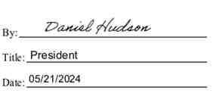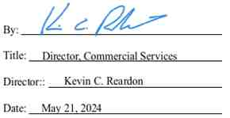

IN WITNESS WHEREOF, the Parties hereto have caused this instrument to be executed as of the day and year first above written.

Empire Generating Co, LLC Niagara Mohawk Power Corporation

43

Exhibit A

[One-Line Diagram]

44

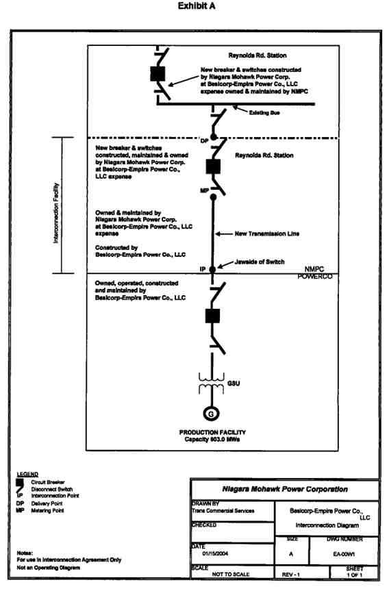

Exhibit B

[Facilities Study]

46

NIAGARA MOHAWK, A NATIONAL GRID COMPANY,

FACILITIES STUDY REPORT FOR

BESICORP - EMPIRE DEVELOPMENT COMPANY, LLC.

NM/NGRID UPGRADES ASSOCIATED WITH

THE 672 MW BESICORP - EMPIRE POWER COMPANY, LLC   
 COGENERATION POWER PLANT

IN RENSSELAER, NEW YORK

January 13, 2004

POWER CO. Project Initial facilities Study

Exhibit B to the Interconnection Agreement January 15, 2004

The Parties recognize that as of January 13, 2004, the Facilities Study has not been

finalized because the Interconnection Facility has not been authorized by the New York State Public Service Commission (“NYSPSC”) and, therefore, the scope of the Facility Study is subject to the certificate to be issued by the NYSPSC pursuant to Article VII of the New York Public Service Law and additional studies, as required.

This document was prepared by Niagara Mohawk Power Corporation.   
 It is made available to others upon express understanding that neither   
 NM/NGRID nor any of its affiliates, assumes any warranty or   
representation with respect to the contents of this document or its accuracy

or completeness.

NIAGARA MOHAWK POWER CORPORATION   
 300 Erie Boulevard West

Syracuse, New York 13202

POWER CO. Project Initial facilities Study

Exhibit B to the Interconnection Agreement January 15, 2004

TABLE OF CONTENTS

1 SUMMARY 1

2 POWER CO. PLANT 3

2.1 POWER CO. Plant Interconnection 8

2.1.1 Special Protection Scheme 8

3 SUBSTATION FACILITIES 9

3.1 Reynolds Road Substation 9

3.1.1 345 kV Switchyard 9

3.1.2 115 kV switchyard 9

3.1.3 Foundations 9

3.1.4 Grounding System 9

3.1.5 Station Service 10

3.1.6 Controls and Protection 10

3.1.7 EMS System 10

3.1.8 Digital Fault Recorder System 10

3.1.9 Interfaces with Transmission 10

3.1.10 Review of Reynolds Road Distribution Feeds 11

3.1.11 POWER CO. Power Plant Revenue Metering 11

3.1.12 POWER CO. 345 kV Metering 11

3.2 Alps Substation 11

3.3 Greenbush Substation 11

3.4 Menands Substation 11

3.5 Riverside Substation 11

3.6 Arsenal Substation 12

3.7 Wynantskill Substation 12

3.8 Rensselaer Waste Water Substation 12

3.9 North Troy Substation 12

3.10 Stephentown Substation 12

3.11 Feura Bush Substation 12

3.12 LG&E / El Paso Substation 12

3.13 POWER CO. Substation 13

3.13.1 POWER CO. Special Protection Scheme 13

3.13.2 Station Service Metering 13

4 Substation Cost Estimates and Construction Schedules 14

4.1 Related Interface Work at POWER CO. Power Plant Station 15

4.2 Related Interface Work at the Alps Station 15

5 POWER CO. TRANSMISSION LINE 16

5.1 ROW Segment Descriptions 16

5.1.1 Segment 1 16

5.1.2 Segment 2 16

5.1.3 Segment 2A 17

5.1.4 Segment 3 17

5.2 General Description of the Proposed Transmission Line 26

5.3 Monopole Structure Types 26

5.4 Power Conductor 26

i

POWER CO. Project Initial facilities Study

Exhibit B to the Interconnection Agreement January 15, 2004

5.5 Monopole Structure Locations 26

5.6 Right-of-Way Width 26

5.7 Electric and Magnetic Fields 27

5.7.1 Evaluation Criteria 27

5.7.2 Methodology 27

5.7.3 Results 27

5.7.4 Conclusions 27

5.8 Construct Segment One Temporary 115 kV Line 41

5.9 Removal of Existing Greenbush #16 115 kV Circuit along Segment One 41

5.10 Construct Segment One 345 kV Line and 115 kV Line 41

5.11 Construct Segment Two 345 kV Line 42

5.12 Construct Segment Three 345 kV Line 42

5.13 Other Infrastructure 42

5.13.1 Existing Utilities 42

5.13.2 Industrial Facilities 43

6 Review of other transmission lines 44

6.1 Review Line #9 from Greenbush to Reynolds Road Stations 44

6.2 Review Line #4 from Riverside to Reynolds Road Station 44

7 Transmission Line Cost Estimate and Construction Schedule 45

8 APPROVALS AND PERMITS 46

8.1 Article X 46

8.2 Article VII 46

8.3 NYISO 46

8.4 ACOE 46

APPENDIX 1 - REYNOLDS ROAD THERMAL RATING SHEETS 48

APPENDIX 2 - REYNOLDS ROAD STATION WORK LIST 69

APPENDIX 3 - NMPC POWER CO. STATION WORK LIST 71

APPENDIX 4 - TRANSMISSION LINE WORK LIST 73

APPENDIX 5 - PROJECT SCHEDULES 75

APPENDIX 6 - SYSTEM RELIABILITY IMPACT STUDY 77

ii

POWER CO. Project Initial facilities Study

Exhibit B to the Interconnection Agreement January 15, 2004

LIST OF FIGURES

Page

FIGURE 2-1 PROPOSED TRANSMISSION LINE LOCATION 4

FIGURE 2-2 REYNOLDS ROAD STATION CONCEPTUAL LAYOUT 5

FIGURE 2-3 REYNOLDS ROAD STATION CONCEPTUAL PROFILE 6

FIGURE 2-4 2003 ANNUAL TRANSMISSION LOAD FLOW REVIEW 7

FIGURE 2-5 CONCEPTUAL POWER CO. PLANT CONFIGURATION 8

FIGURE 5-1 TYPICAL TUBULAR MONOPOLE (SEGMENTS 2 & 3) 18

FIGURE 5-2 TYPICAL TUBULAR STEEL LARGE ANGLE MONOPOLE 19

FIGURE 5-3 TYPICAL TUBULAR STEEL DOUBLE CIRCUIT MONOPOLE 20

FIGURE 5-4 TYPICAL MONOPOLE FOUNDATIONS 21

FIGURE 5-5 SEGMENT IA ROW CONFIGURATION 22

FIGURE 5-6 SEGMENT IB ROW CONFIGURATION 23

FIGURE 5-7 SEGMENT 2 ROW CONFIGURATION 24

FIGURE 5-8 SEGMENT 3 ROW CONFIGURATION 25

FIGURE 5-9 SEGMENT 1 ELECTRIC FIELD PROFILE 29

FIGURE 5-10 SEGMENT 1 MAGNETIC FIELD PROFILE 30

FIGURE 5-11 SEGMENT 2 ELECTRIC FIELD PROFILE 31

FIGURE 5-12 SEGMENT 2 MAGNETIC FIELD PROFILE 32

FIGURE 5-13 SEGMENT 3 ELECTRIC FIELD PROFILE 33

FIGURE 5-14 SEGMENT 3 MAGNETIC FIELD PROFILE 34

FIGURE 5-15 SEGMENT 1 2002 PEAK LOAD ELECTRIC FIELD PROFILE 35

FIGURE 5-16 SEGMENT 1 2002 PEAK LOAD MAGNETIC FIELD PROFILE 36

FIGURE 5-17 SEGMENT 2 2002 PEAK LOAD ELECTRIC FIELD PROFILE 37

FIGURE 5-18 SEGMENT 2 2002 PEAK LOAD MAGNETIC FIELD PROFILE 38

FIGURE 5-19 SEGMENT 3 2002 PEAK LOAD ELECTRIC FIELD PROFILE 39

FIGURE 5-20 SEGMENT 3 2002 PEAK LOAD MAGNETIC FIELD PROFILE 40

LIST OF TABLES

Page

TABLE 4-1 TOTAL NMPC ESTIMATED SUBSTATION COSTS 14

TABLE 5-1 ROW PARALLELED BY OR INTERSECTING THE PROPOSED

TRANSMISSION LINE 17

TABLE 5-2 RESULTS OF ELECTRIC AND MAGNETIC STUDIES 28

TABLE 7-1 TOTAL NMPC ESTIMATED TRANSMISSION LINE COSTS 45

iii

POWER CO. Project Initial facilities Study

Exhibit B to the Interconnection Agreement January 15, 2004

NIAGARA MOHAWK, A NATIONAL GRID COMPANY   
 FACILITIES STUDY REPORT FOR

BESICORP - EMPIRE DEVELOPMENT COMPANY, LLC:   
 NM/NGRID Upgrades Associated With The

672 MW POWER CO. Power Plant   
 in Rensselaer, New York

1 SUMMARY

Besicorp - Empire Development Company, LLC (“BEDCO”) has proposed the development of a cogeneration power plant in the City of Rensselaer, Rensselaer County, New York. The project will consist of three main components:

(1) The Besicorp - Empire Power Company, LLC (“POWER CO.”) cogeneration power   
 plant (“Plant”)

(2) The connection of the Plant into the New York transmission grid

(3) The replacement of other system elements due to the presence of the proposed Plant

The proposed Plant will be located in the City of Rensselaer, New York. The Plant will have two   
161 MW gas-fired combined-cycle-generating units and one 297 MW steam turbine generators,   
for a total capability of 619 MW (603 MW after supplying the Plant’s auxiliary load), plus duct   
firing for a total of 672 MW (winter rating). The proposed plant will be adjacent to LG&E’s   
(“LG&E” or “El Paso”), Rensselaer Co-generation plant and approximately 8.1 miles from the   
Niagara Mohawk Power Corporation’s (“NMPC”) Reynolds Road Substation which will be   
used as the interconnection point. The POWER CO. Plant will operate mainly as a merchant   
plant with approximately 33 MW of electric energy and 160,000 lbs. of steam being supplied to   
the Empire State Newsprint Plant (“ESNP”) on an hourly basis, located adjacent to the plant site.   
The balance of the energy, its capacity and other ancillary services will be sold to the market.   
The proposed transmission facilities will be designed according to NMPC and Northeast Power   
Coordinating Council standards.

A System Reliability Impact Study (“SRIS”) identifying impacts to the NMPC system was

completed in November 2001.1 This study was conducted by Washington Group International   
(“WGI”) with coordinated input and review by NMPC, the New York Independent System   
Operator (“NYISO”), as well as being reviewed by the ISO-New England due to the   
interconnection at Reynolds Road, which is also directly connected to the transmission facilities   
to New England. Additionally, the study also reviewed the impacts to the NMPC local   
transmission system by the ESNP as purely a load on the NMPC transmission grid in the Capital   
Zone of the NYISO. This Facility Study includes the scope of work for potential upgrades   
associated with the surrounding NMPC transmission system and facilities resulting from the   
addition of the POWER CO. Plant. Subsequent to the approval by the NYISO, POWER CO.

1 Report on the Empire State Newsprint Project for the Besicorp — Empire Development Company’s 505 MW Plant

in Rensselaer, New York, dated November RELIABILITY IMPACT STUDY.

POWER CO. Project   
Exhibit B to the Interconnection Agreement

2001. This report is included as APPENDIX 6 — SYSTEM

1

Initial facilities Study   
 January 15, 2004

also received confirmation from the Substation and Protection Engineering Group of New York   
State Electric & Gas that the interconnection of the POWER CO. Plant would not over duty any   
breakers or equipment on the NYSEG system with the interconnection at Reynolds Road.

This report documents preliminary engineering and conceptual design of modification and/or

additions to NMPC’s facilities to accommodate the interconnection of POWER CO.’s proposed   
Plant based on a two-breaker 345 kV installation at the NMPC Reynolds Road Substation. The   
following is a summary of the NMPC facilities requiring upgrade to incorporate the POWER   
CO. Plant:

• Mitigation of the short circuit impact on the Reynolds Road Substation by the

replacement of the 115 kV breaker R63 at Reynolds Road with a new 50 kA

breaker. The addition of the POWER CO. Plant increases the short circuit levels of the R-63 115 kV breaker at the Reynolds Road Substation beyond its 40-kA rating requiring its replacement.

• Addition of one new 345 kV line breaker at the Reynolds Road Substation will be

required to accept the 345 kV generator leads from the POWER CO. substation switchyard to the Reynolds Road Substation.

• Addition of one new 345 kV bus breaker at the Reynolds Road Substation is

required to provide clearing capability for the loss of the 345 kV Reynolds Road

- Alps #1 transmission line, enabling the POWER CO. generators to remain connected to the 345 kV bus at Reynolds Road.

• Provide dual channel relaying at the Alps Substation. Extreme contingency

analysis results indicated that the POWER CO. Plant extends critical clearing

time of a three-phase fault at New Scotland on the New Scotland - Leeds circuit from 17 cycles to 19 cycles. This critical clearing time is considered acceptable because all 345 kV substations in the vicinity of the POWER CO. Plant, with the exception of Alps, have dual channel relaying, which provides backup clearing times comparable to primary clearing times.

• Modifications of the existing system protection schemes at Reynolds Road and

Alps 345 kV substations to adjust for network changes, increased transmission loading and critical clearing time requirements.

2

POWER CO. Project Initial facilities Study

Exhibit B to the Interconnection Agreement January 15, 2004

2 POWER CO. PLANT

The proposed site of the POWER CO. Plant is in the proximity of the LG&E/EI Paso Rensselaer   
Generating Plant, in Rensselaer, NY. The plant is transmitting its output on the NMPC LG&E -  
Greenbush #16 115 kV Circuit. The POWER CO. site is approximately 5 miles southwest of the   
NMPC Reynolds Road Substation. The use of existing ROWs will require the construction of an

8.1 mile 345 kV transmission line to transmit the output power from the plant to the Reynolds   
Road substation. The geographic area for location of the proposed POWER CO. Plant and the   
Reynolds Road substation is shown in Figure 2-1. A conceptual drawing of the expanded   
Reynolds Road substation is shown in Figure 2-2 and Figure 2-3. The summer 2003 annual   
transmission review load flow study information sheet is also included as Figure 2-4.

3

POWER CO. Project Initial facilities Study

Exhibit B to the Interconnection Agreement January 15, 2004

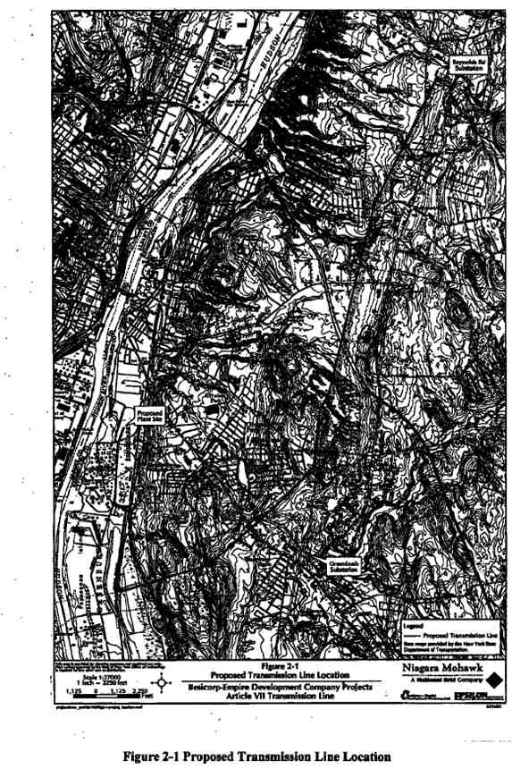

POWER CO. Project Initial facilities Study

Exhibit B to the Interconnection Agreement January 15, 2004

5

POWER CO. Project Initial facilities Study

Exhibit B to the Interconnection Agreement January 15, 2004

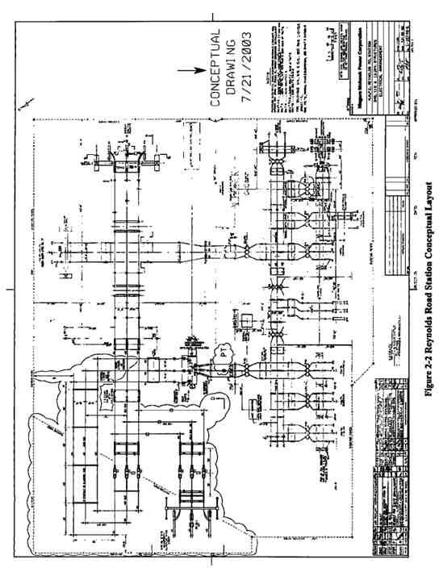

6

POWER CO. Project Initial facilities Study

Exhibit B to the Interconnection Agreement January 15, 2004

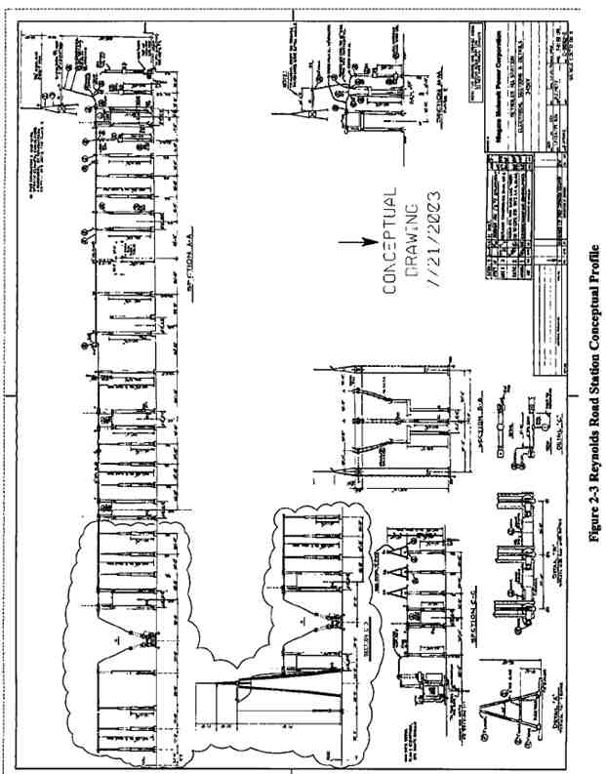

7

POWER CO. Project Initial facilities Study

Exhibit B to the Interconnection Agreement January 15, 2004

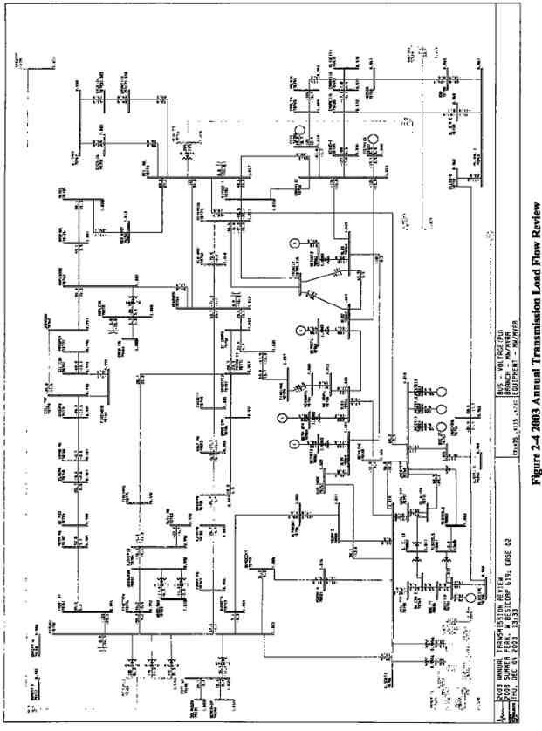

POWER CO. Project Initial facilities Study

Exhibit B to the Interconnection Agreement January 15, 2004

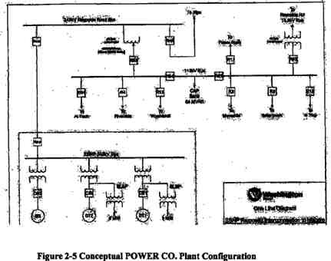

2.1. POWER CO. Plant Interconnection

Figure 2-5 illustrates the preliminary configuration to interconnect the proposed POWER CO.   
Plant to the 345 kV transmission system with a generator lead which extends from the POWER   
CO. Plant to the NMPC Reynolds Road Substation, through a single 345 kV breaker at Reynolds   
Road. The current configuration at Reynolds Road requires that a second 345 kV breaker also be   
installed as an isolation device such that the POWER CO. Plant can remain connected to the bus   
at Reynolds Road in the event of a line fault on the Reynolds Road - Alps #1 345 kV Circuit.   
The new 345 kV transmission line will be installed using 2-1192.5 kcmil ACSR conductors per   
phase for the entire length between the POWER CO. switchyard and the Reynolds Road

Substation. NMPC will have the responsibility to design, install and test all necessary equipment   
at the Reynolds Road to accommodate this interconnection. POWER CO. will have the   
responsibility for all transmission line construction between these same two points. NMPC will   
be responsible for the approval of the transmission line design prior to the beginning of   
construction.

2.1.1. Special Protection Scheme

An NPCC Type 111 Special Protection System (“SPS”) will be required to detect a fault, line trip or failure on the Reynolds Road - Alps #1 345 kV circuit and automatically runback the POWER CO. Plant generators.

9

POWER CO. Project Initial facilities Study

Exhibit B to the Interconnection Agreement January 15, 2004

3 SUBSTATION FACILITIES

This section documents the necessary review and/or modifications required at the NMPC substations to accommodate the interconnection, including estimated costs and preliminary schedule for these modifications.

This listing of substations and the affected equipment within a given substation requires field verification of ratings and protection schemes. Therefore this section is considered preliminary, as is this document.

3.1. Reynolds Road Substation

The upgrades at the Reynolds Road Substation are associated with the interconnection of the   
new 345 kV transmission facility, the installation of a second 345 kV isolation breaker, and the   
upgrading of an existing 115 kV circuit breaker which has been determined through the SRIS to   
be required to be replaced due to its current rating. The work at the Reynolds Road Substation   
will include the following additions/modifications (Reference Plan View: Appendix!, Figure 1-

1).

3.1.1. 345 kV Switchyard

The 345 kV switchyard work mainly consists of creating a new 345 kV bay by the addition of a 345 kV circuit breaker, associated disconnects and bus work, along with the required   
communications, controls and protection required for the interconnection. The following   
equipment will be installed at the Reynolds Road 345 kV substation:

• Two (2) dead tank breakers (CB) rated 50 kA, 3000 continuous amps will be   
 installed;

• Three (3) Disconnect switches, with Motor Operators will be installed;

• One (1) Line 345 kV Grounding Switch will be installed;

• One (I) Line 345 kV Line Trap and Tuning Equipment will be installed;

• One (1) Set of metering CT / VT Units; and

• One (1) Potential Transformer (PT) will be installed

3.1.2. 115 kV switchyard

The 115 kV switchyard work mainly consists of the replacement of an existing 115 kV circuit breaker (R63) which was determined to be beyond its normal rating through the SRIS analysis performed for the interconnection of the POWER CO. Plant.

• One live tank breaker rated 40 kA will be replaced with a new 50 kA live tank   
 breaker (R-63)

3.1.3. Foundations

10

POWER CO. Project Initial facilities Study

Exhibit B to the Interconnection Agreement January 15, 2004

It is proposed that new foundations will be poured for all new 345 kV equipment in the

Reynolds Road Substation. Such foundations will be required for the two (2) 345 kV circuit breakers, the 345 kV Grounding Switch, metering transformers and the one (1) Potential Transformer. The existing building foundation will need to be expanded to accommodate the additional required building space.

3.1.4. Grounding System

The grounding system will consist of a ground conductor grid and driven ground rods. All ground conductors will be copperweld.

3.1.5. Station Service

Station Service at the Reynolds Road Substation is not anticipated to need modifications or

replacement in order to serve the additional facilities. Additional analysis may be required

following specific specifications on the equipment are determined. The Station Service consists   
of two battery sets (125 VDC) and charger systems with _____AH batteries and a _____A   
chargers.

3.1.6. Controls and Protection

Control and protection additions/replacements will include:

a) Controls and indication for 345 kV breaker (#TBD-B1) and motor operated disconnect

(#TBD-D1) for the line interconnection of the POWER CO. Plant.

b) Controls and indication for 345 kV breaker (#TBD-B2) and motor operated disconnect

(#TBD-D2) for the isolation breaker on the Alps #1 345 kV connection at Reynolds

Road.

c) Synchronism check and reclosing relays for the new 345 kV breaker (#TBD-B1) and

(#TBD-B2)

d) Spare points on the existing annunciators will be used for the new alarms.

e) Protection packages (system 1 & 2) for the 345 kV POWER CO. line will be installed.

System 1 will be directional comparison carrier blocking (with on/off, and FSK power line carrier equipment) relaying system. System 1 cabinet will be located next to the   
existing panel ____. The new cabinet will be designated as #____. System 2 will be   
permissive over-reach transfer trip (with POTT communication equipment) relay   
system. System 2 cabinet will be located next to the existing panel . The new cabinet   
will be designated as # ____.

f) High speed and standard 345 kV breaker failure relaying for breaker (#TBD-BI) and for

345 kV breaker (#TBD-B2).

g) 345 kV bus differential relays for 345 kV bus #____ (system 1 and system 2). System 1

will be mounted on panel #____ and system 2 will be on panel #____.

h) Communication processor.

i) Digital fault recorder will be installed on panel #____.

j) Protective and controls associated with the replaced 115 kV circuit breaker R63 will be

revised accordingly, if required.

11

POWER CO. Project Initial facilities Study

Exhibit B to the Interconnection Agreement January 15, 2004

3.1.7. EMS System

Harris RTU exists at the station to monitor and control the 345 kV facilities from NMPC

Dispatch Center at ____. It is equipped for ____ status, ____ control pairs, and ____ analog

points. Spare points available in the RTU will be used to accommodate additional status, control, and sequence inputs associated with the new substation facilities.

3.1.8. Digital Fault Recorder System

A new Digital Fault Recorder (“DFR”) system will need to be installed in the control building.

3.1.9. Interfaces with Transmission

Transmission engineering will undertake the following interface with the substation equipment:

• 2 - 1192.5 kcmil ACSR conductors drops will be made from the 345 kV line to the

appropriate 345 kV breaker disconnect switches for the (#TBD-B1) breaker.

3.1.10. Review of Reynolds Road Distribution Feeds

A complete short circuit analysis will be reviewed/conducted to analyze the 13.2 kV distribution circuits. Those circuits, which will be analyzed through this study, are the 33451, 33452, 33453, and 33454 - 13.2 kV distribution circuits.

3.1.11. POWER CO. Plant Revenue Metering

NMPC will be responsible for providing all required metering equipment for the POWER CO.   
Plant revenue metering which will be installed at the Reynolds Road Substation. Such metering   
equipment will be in accordance with NMPC and NYISO revenue metering specifications.

3.1.12. POWER CO. 345 kV Metering

The meters provided for the Reynolds Road 345 kV interconnection will be capable of providing   
required billing quantities via dial-up telephone to the NMPC / POWER CO. or POWER CO.   
and the NYISO, using a UTS MV-90 in their standard format and protocol. With the location of   
the meters at Reynolds Road, there will be no need to be capable of being electronically   
compensated to reflect losses in the transmission line facilities. Any losses on transmission will   
be solely borne by POWER CO. The specific meters must also be capable of measuring bi-  
directional energy flow.

3.2. Alps Substation

The SRIS review of system condition indicated that modifications of the existing system

protection schemes at the Alps 345 kV substation is required to adjust for network changes

caused by increased transmission loading and critical clearing time requirements. It is also

necessary to coordinate breaker tripping and reclosing schemes to take into account the inclusion of the POWER CO. Plant input to the NMPC system.

12

POWER CO. Project Initial facilities Study

Exhibit B to the Interconnection Agreement January 15, 2004

An NPCC Type III Special Protection System (“SPS”) will be required to detect and runback the Plant for a Reynolds Road - Alps #1 345 kV line failure or breaker trip.

3.3. Greenbush Substation

The SRIS review for the interconnection of the POWER CO. Plant to the NMPC Reynolds Road Substation concluded there were no impacts on the equipment at the Greenbush 115 kV   
Substation. However, additional studies are required to look at the potential required   
modifications to the protection scheme and station hardware.

3.4. Menands Substation

The SRIS review for the interconnection of the POWER CO. Plant to the NMPC Reynolds Road Substation concluded there were no impacts on the equipment at the Menands 115 kV   
Substation. However, additional studies are required to look at the potential required   
modifications to the protection scheme and station hardware.

3.5. Riverside Substation

The SRIS review for the interconnection of the POWER CO. Plant to the NMPC Reynolds Road Substation concluded there were no impacts on the equipment at the Riverside 115 kV   
Substation. However, additional studies are required to look at the potential required   
modifications to the protection scheme and station hardware.

3.6. Arsenal Substation

The SRIS review for the interconnection of the POWER CO. Plant to the NMPC Reynolds Road Substation concluded there were no impacts on the equipment at the Arsenal 115 kV Substation. However, additional studies are required to look at the potential required modifications to the protection scheme and station hardware.

3.7. Wynantskill Substation

The SRIS review for the interconnection of the POWER CO. Plant to the NMPC Reynolds Road Substation concluded there were no impacts on the equipment at the Wynantskill 115 kV   
Substation. However, additional studies are required to look at the potential required   
modifications to the protection scheme and station hardware.

3.8. Rensselaer Waste Water Substation

The SRIS review for the interconnection of the POWER CO. Plant to the NMPC Reynolds Road Substation concluded there were no impacts on the equipment at the Rensselaer Water Tap.   
However, additional studies are required to look at the potential required modifications to the protection scheme and station hardware.

3.9. North Troy Substation

13

POWER CO. Project Initial facilities Study

Exhibit B to the Interconnection Agreement January 15, 2004

The SRIS review for the interconnection of the POWER CO. Plant to the NMPC Reynolds Road Substation concluded there were no impacts on the equipment at the North Troy 115 kV   
Substation. However, additional studies are required to look at the potential required   
modifications to the protection scheme and station hardware.

3.10. Stephentown Substation

The SRIS review for the interconnection of the POWER CO. Plant to the NMPC Reynolds Road Substation concluded there were no impacts on the equipment at the Stephentown 115 kV   
Substation. However, additional studies are required to look at the potential required   
modifications to the protection scheme and station hardware.

3.11. Feura Bush Substation

The SRIS review for the interconnection of the POWER CO. Plant to the NMPC Reynolds Road Substation concluded there were no impacts on the equipment at the Feura Bush 115 kV   
Substation. However, additional studies are required to look at the potential required   
modifications to the protection scheme and station hardware.

3.12. LG&E/ El Paso Substation

The SRIS review for the interconnection of the POWER CO. Plant to the NMPC Reynolds Road   
Substation concluded there were no impacts on the equipment at the LG&E / El Paso 115 kV   
Substation for the LG&E / El Paso Cogeneration Plant. However, additional studies are required   
to look at the potential required modifications to the protection scheme and station hardware.

3.13. POWER CO. Substation

3.13.1. POWER CO. Special Protection Scheme

The SRIS review for the interconnection of the POWER CO. Plant has indicated that there will   
be a need to install a NPCC Type 111 SPS equipment. This SPS equipment will automatically   
runback the output of the generation units at the POWER CO. Plant to an approximate ____%   
output, for the case of the loss of the Alps #1 345 kV Line between Reynolds Road and the Alps   
Substation, or for the loss of its associated breaker (#TBDB2) at the Reynolds Road Substation.

• Installation of an audio-tone transmitter at Alps, with a receiver at POWER CO.   
 Plant.

• It may be possible to share communications paths and equipment for different SPSs.

3.13.2. Station Service Metering

Dual Station Service supply will be provided for the POWER CO. 345 kV switchyard in

accordance with NPCC requirements, in accordance with NPCC Document A-5, Section 3.6.

The physical bus arrangement of the POWER CO. 345 kV switchyard enables the station service   
for the POWER CO. Plant to be supplied through the 345/13.8 kV step-down transformer, for a

14

POWER CO. Project Initial facilities Study

Exhibit B to the Interconnection Agreement January 15, 2004

complete shutdown of the cogeneration facility. A second source is being investigated using

nearby NMPC substation distribution or sub-transmission feeds. This second source may require modifications at the station selected as the source for the 2nd station service feed.

15

POWER CO. Project Initial facilities Study

Exhibit B to the Interconnection Agreement January 15, 2004

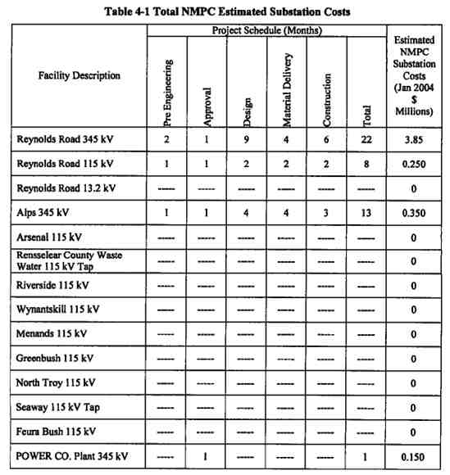

4 SUBSTATION COST ESTIMATES AND CONSTRUCTION   
 SCHEDULES

Project cost estimates (+/- 20% accuracy) for the substation work are summarized in Table 4-1.   
These are based on present day dollars. All substation facilities identified in Table 4-1 are   
considered Pool Transmission Facilities (“PTF”). No salvage value is included in the estimates.

The estimated project schedule for the POWER CO. substation is provided in Table 4-1. Project duration includes project commencement through completion for the additions/modifications detailed above for engineering, material delivery and construction of work. Costs associated with the POWER CO. Plant or the switchyard are not included. Only incremental costs   
attributed to the POWER CO. projects are included.

16

POWER CO. Project Initial facilities Study

Exhibit B to the Interconnection Agreement January 15, 2004

4.1. Related Interface Work at POWER CO. Plant Station

This report does not cover the interface facilities (switchgear, metering, protection, and SCADA, etc.) required at the Plant for the interconnection. This needs to be addressed at a later date after the Plant electrical one-line is finalized.

4.2. Related Interface Work at the Alps Station

This report addresses the need for an SPS system installation at the Alps 345 kV Substation, but   
does not address any interface facilities (switchgear, metering, other protection, and SCADA,   
etc.) which may be required at this facility, until such time as the final electrical interconnection   
is finalized.

17

POWER CO. Project Initial facilities Study

Exhibit B to the Interconnection Agreement January 15, 2004

5 POWER CO. TRANSMISSION LINE

This section will provide the details of the POWER CO. 8.1 mile transmission line

interconnection facility. Specifics along portions of the route vary according to the location; therefore the transmission line is described as three separate segments as follows:

• Segment One: POWER CO. Plant south approximately 1.7 miles along a 100-foot   
 NMPC ROW easement;

• Segment Two: From Segment One for approximately 2.3 miles (generally northeast)   
 along an existing 250-foot NMPC fee-owned ROW

• Segment Three: From Segment Two for approximately 4.1 miles (generally north)   
 along an existing 355-foot NMPC fee-owned ROW.

5.1. ROW Segment Descriptions

The following will describe the characteristics of the three segments of the Proposed Transmission Line.

5.1.1. Segment 1

The Proposed Transmission Line route starts at the proposed new POWER CO. Plant in the City   
of Rensselaer and travels south, along an existing 100-foot wide NMPC ROW into the Town of   
East Greenbush, to an intersection with another NMPC ROW, a distance of approximately 1.7   
miles. This portion of the ROW contains an existing 115 kV transmission line (Greenbush #16   
Circuit) for its entire length, and an 8-inch natural gas pipeline (NMPC Pipeline E-35) for 0.8   
miles from the POWER CO. Plant to the crossing of Teller Road (Sun Oil Road). (The portion   
of Segment 1 containing the natural gas line is referred to as Segment 1A.) The gas pipeline is

40 feet from the western edge of the ROW and the transmission line is 40 feet off the eastern

edge of the ROW, providing a 20-foot separation between the facilities. From Teller Road south   
(referred to as Segment 1B), the existing 115 kV transmission line is located in the center of the   
ROW.

For Segment 1, the Proposed Transmission Line route will be placed on double circuit steel   
monopole structures within the existing ROW. The existing Greenbush #16 Circuit will be   
placed on temporary structures on the western side of the ROW until the new steel monopoles   
are in place on the eastern side of the ROW. The existing Greenbush #16 Circuit will then be   
placed on the eastern side of the new monopoles. A cross section of the ROW is shown in Figure   
5-5 and Figure 5-6.

5.1.2. Segment 2

The Proposed Transmission Line route then follows an existing ROW (New Scotland -

Reynolds Road) in a northeasterly direction for approximately 2.3 miles, where additional

circuits enter the ROW. The ROW followed by Segment 2 is a 250-foot wide corridor and the   
Proposed Transmission Line will be located within the ROW along the northern side. The   
corridor contains two existing sets of structures: the Feura Bush - Reynolds Road #17 115 kV

18

POWER CO. Project Initial facilities Study

Exhibit B to the Interconnection Agreement January 15, 2004

Circuit (constructed for 230 kV), and the Greenbush #16 115 kV Circuit. The Proposed

Transmission Line will be constructed on a new set of single circuit steel monopoles located on the northern side of the ROW. A cross section of the ROW is shown in Figure 5-7.

5.1.3. Segment 2A

This is a short section of NMPC ROW that connects to the Greenbush substation. It is 0.7 miles long and ranges from 100 to 250 feet wide. Initially there is one existing circuit (Greenbush #16) and then two additional circuits (Reynolds Road - Greenbush #9 Circuit and Riverside - Reynolds Road #4 Greenbush station tap).

5.1.4. Segment 3

The Proposed Transmission Line will then continue approximately 4.1 miles in a northerly direction following an existing NMPC ROW, and will terminate at the NMPC Reynolds Road substation. The new circuit will be constructed along the western side of this   
combined 355-foot wide ROW. This portion of the ROW presently contains four electric circuits. These are (from east to west):

• Reynolds Road - Greenbush #9 115 kV Circuit;

• Riverside - Reynolds Road #4 115 kV Circuit;

• Distribution Circuit 13.2 kV (constructed for 34.5 kV); and

• Feura Bush - Reynolds Road #17 115 kV Circuit (constructed for 230 kV).

This ROW also accommodates a Dominion Telecom (formerly Telergy) fiber optic conduit, which enters the ROW north of 1-90 at MP 5.5 and exits just south of the Reynolds Road substation at MP 8. Also within this ROW are a Dominion Gas 12-inch natural gas pipeline and a NEON Communications fiber optic conduit. The Proposed Transmission Line will be constructed on a new set of single circuit steel monopoles (located on the western side of the ROW). A cross section of the ROW is shown in Figure 5-8.

19

POWER CO. Project Initial facilities Study

Exhibit B to the Interconnection Agreement January 15, 2004

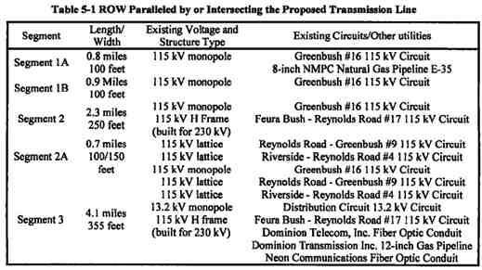

20

POWER CO. Project Initial facilities Study

Exhibit B to the Interconnection Agreement January 15, 2004

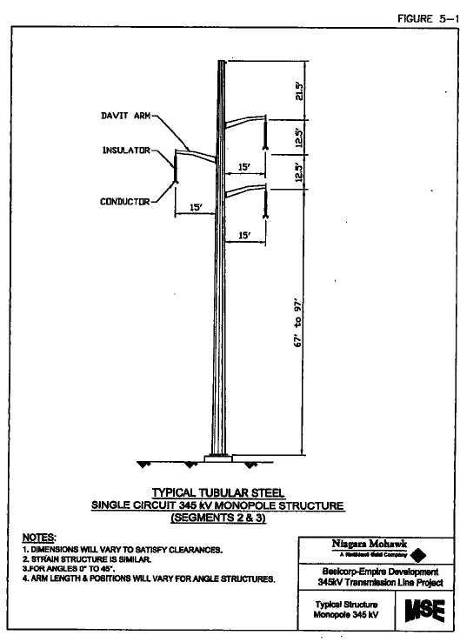

Figure 5-1 Typical Tabular Monopole (Segments 2 & 3)

21

POWER CO. Project Initial facilities Study

Exhibit B to the Interconnection Agreement January 15, 2004

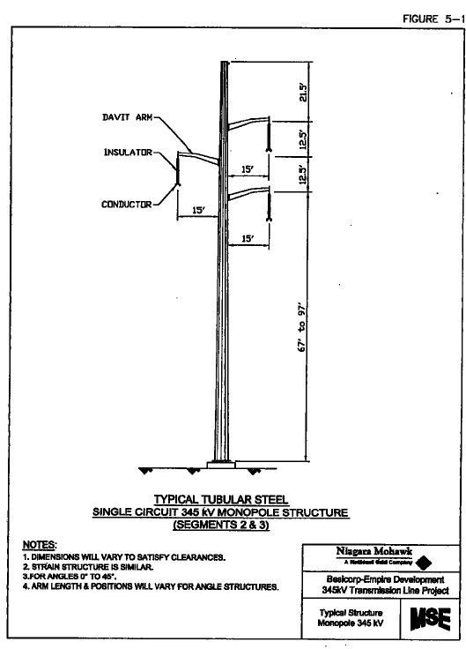

Figure 5-2 Typical Tabular Steel Large Angle Monopole

22

POWER CO. Project Initial facilities Study

Exhibit B to the Interconnection Agreement January 15, 2004

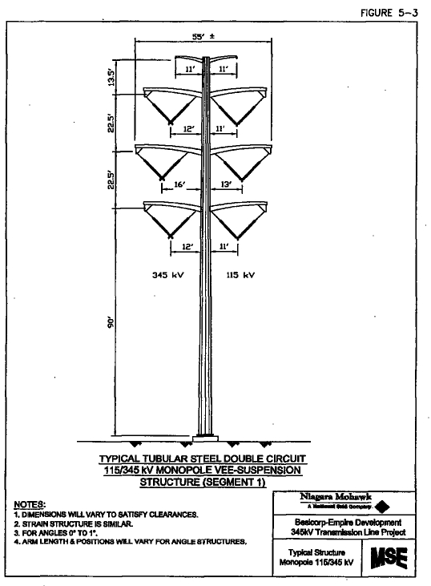

Figure 5-3 Typical Tabular Steel Double Circuit Monopole

23

POWER CO. Project Initial facilities Study

Exhibit B to the Interconnection Agreement January 15, 2004

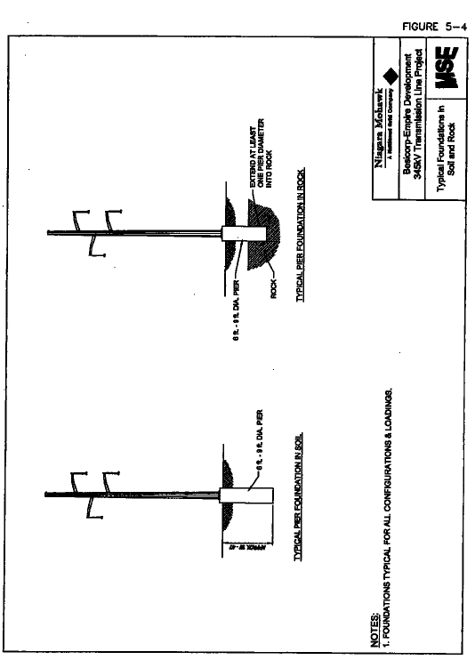

Figure 5-4 Typical Monopole Foundations

24

POWER CO. Project Initial facilities Study

Exhibit B to the Interconnection Agreement January 15, 2004

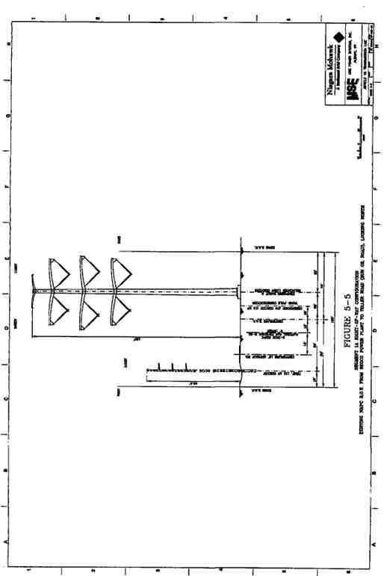

Figure 5-5 Segment 1A ROW Configuration

25

POWER CO. Project Initial facilities Study

Exhibit B to the Interconnection Agreement January 15, 2004

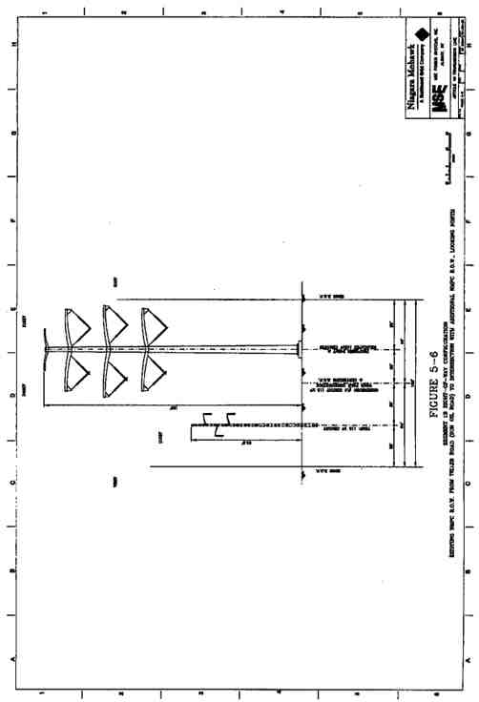

Figure 5-6 Segment 1B ROW Configuration

26

POWER CO. Project Initial facilities Study

Exhibit B to the Interconnection Agreement January 15, 2004

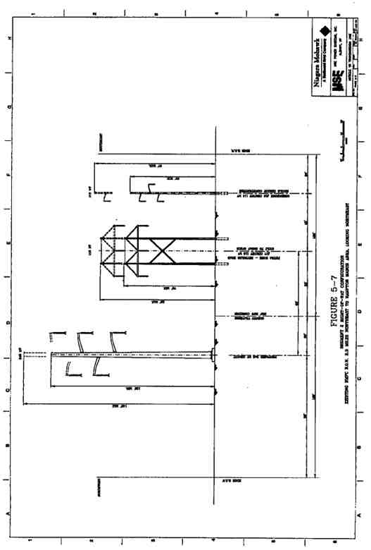

Figure 5-7 Segment 2 ROW Configuration

27

POWER CO. Project Initial facilities Study

Exhibit B to the Interconnection Agreement January 15, 2004

28

POWER CO. Project Initial facilities Study

Exhibit B to the Interconnection Agreement January 15, 2004

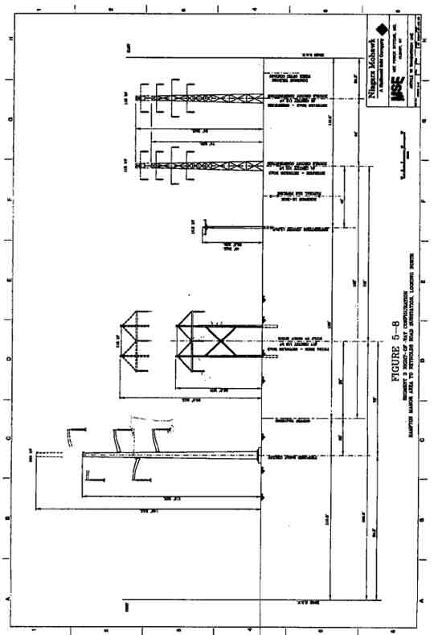

Figure 5-8 Segment 3 ROW Configuration

29

POWER CO. Project Initial facilities Study

Exhibit B to the Interconnection Agreement January 15, 2004

5.2. General Description of the Proposed Transmission Line

The NMPC proposed 345 kV transmission line will occupy existing NMPC ROWs for its entire length with one exception at the intersection of segments 1 & 2. The total length of the route is approximately 8.1 miles.

5.3. Monopole Structure Types

Steel monopole tubular structures are preferred for the Proposed Transmission Line. The

monopole structures will be approximately 112 feet to 160.5 feet in height and will be self-

supporting. The structures will be galvanized, and therefore neutral in color, with gray porcelain   
insulators. The following figures illustrate the type of monopole structures that will be required:

• tubular steel single circuit monopole structure (Figure 5-1);

• tubular steel circuit monopole structure for large angles (Figure 5-2); and

• tubular steel double circuit 115/345 kV Vee-suspension monopole structure (Figure 5-

3).

A single, reinforced concrete pier is proposed as the typical monopole foundation. The piers will   
be from 6 to 9 feet in diameter and nominally 30 to 40 feet in depth. Where solid rock is   
encountered, the piers will extend at least one pier diameter into the rock. Typical pier   
foundations in soil and rock are shown in Figure 5-4. The pier foundation size requirements will   
be determined by a detailed geotechnical analysis as part of a project specific EM&CS&P Plan   
that will be submitted to the NYSPSC for review and approval prior to construction.

5.4. Power Conductor

Two 1192.5 kcmil 45/7 ACSR power conductors will be used for each phase of the new 345 kV   
circuit. Single 795.0 kcmil 26/7 ACSR will be used for each phase of the 115 kV circuit on   
Segment 1.

5.5. Monopole Structure Locations

Exact monopole locations will depend on final design of the Proposed Transmission Line that will be provided in the EM&CS&P Plan. Structures will be approximately 600 to 1,000 feet apart. Actual spans will vary based on environmental factors, required clearance from the ground, and the adjacent transmission lines.

5.6. Right-of-Way Width

The Proposed Transmission Line will be constructed on existing ROWs for its entire length with   
one exception. For Segment 1, the first 1.7 miles of the project, the monopole structures will be   
placed within an existing 100-foot wide ROW. It is anticipated that additional ROW may be   
acquired at the intersection of Segment 1 and 2 where the alignment joins an existing NMPC   
ROW. For Segment 2, the next 2.3 miles of the Proposed Transmission Line, the structures will   
be placed within an existing 250-foot wide ROW. For Segment 3, approximately 4.1 miles, the

30

POWER CO. Project Initial facilities Study

Exhibit B to the Interconnection Agreement January 15, 2004

monopole structures will be placed within an existing 355-foot wide ROW. The ROW   
configurations proposed for each segment are shown in Figure 5-5 through Figure 5-8.

5.7. Electric and Magnetic Fields

This analysis demonstrates compliance with the NYSPSC Policy Statement dated September 11,   
1990, concerning electric and magnetic fields (“EMF”). The EMF strengths along were   
estimated along the edge of the existing NMPC ROW followed by the Proposed Transmission   
Line. The methodology used to model EMF and a summary of the results are presented below.

5.7.1. Evaluation Criteria

The EMF limits established by the NYSPSC include the following criteria for all Proposed Transmission Line segments:

1. The maximum electric field at 1 meter above ground along the edge of the ROW   
 shall be less than 1.6 kilovolts per meter (kV/m).

2. The maximum electric field at 1 meter above ground over public roads shall be less   
 than 7.0 kV/m in accordance with NYSPSC Opinion No. 78-13.

3. The magnetic field at 1 meter above ground at all locations along the edge of the

ROW shall be less than 200 mG in accordance with NYSPSC Policy Statement dated September 11, 1990.

4. Electric fields meeting the above criteria shall be calculated at maximum system   
 overvoltage of 1.05 per unit (p.u.).

5. Magnetic fields meeting the above criteria shall be calculated at winter normal   
 conductor rating for each line.

5.7.2. Methodology

The EMF strengths were calculated utilizing the industry accepted computer program

“ENVIRO”, Version 3.51, developed by the Electric Power Research Institute (“EPRI”). The

existing circuits within each segment of the ROW were identified. The configurations are shown   
in the cross sections presented in Figure 5-5 through Figure 5-8. Minimum conductor clearances   
to ground surface per National Electric Safety Code (“NESC”) are used in the EMF calculations   
for conservative results. A minimum vertical clearance of 37 feet is used for Segments 2 and 3   
for the new 345 kV construction. For Segment 1, the minimum vertical clearance was set at 55   
feet. All minimum clearances are assumed to take place at a maximum conductor operating

temperature of 257 degrees Fahrenheit. The winter normal conductor ampacities were obtained from the NMPC Transmission System Thermal Ratings Manual. Electric field calculations were performed for 1.05 p.u. overvoltage.

5.7.3. Results

Results of the EMF model runs are presented below in Table 5-2. Illustrations of the electric and   
magnetic field profiles for each segment of the Proposed Transmission Line are presented in   
Figure 5-9 through Figure 5-14. In addition to the conservative runs required by the NYSPSC,   
NMPC has also evaluated the EMF that would be experienced in the field based on actual 2002

31

POWER CO. Project Initial facilities Study

Exhibit B to the Interconnection Agreement January 15, 2004

peak loading of the existing facilities and normal peak load for the Proposed Transmission Line.   
Results from the peak load scenario are presented in Table 5-2. Illustrations of the EMF field   
profiles for each segment at the peak load are presented in Figure 5-15 through Figure 5-20.

5.7.4. Conclusions

Based on the calculated results, the required criterion are satisfied:

1. In all cases the calculated maximum electric field at the edge of ROW is less than the   
 required 1.6 kV/m.

2. In all cases the calculated maximum electric field within the ROW is less than the   
 required 7.0 kV/m.

3. In all cases the calculated maximum magnetic field at the edge of ROW is less than   
 the required 200 mG.

The centerline of the Proposed Transmission Line is based on preliminary data. These results may be subject to change as the detailed design is finalized. Detailed design plans will be submitted in the EM&CS&P Plan.

Table 5-2 Results of Electric and Magnetic Studies

Maximum Electric

Field @ ROW Edge Maximum Electric Field Maximum Magnetic Field at

ROW Segment (kV/m) in ROW (kV/m) ROW Edge (mG)

Maximum Conductor Rating

Segment 1 1.4 2.8 191.6

Segment 2 0.7 4.7 158.8

Segment 3 . 0.8 4.2 196.2

Actual 2002 Peak Loading

Segment 1 1.4 2.7 147.3

Segment 2 0.7 4.0 72.6

Segment 3 1.4 6.7 77.5

32

POWER CO. Project Initial facilities Study

Exhibit B to the Interconnection Agreement January 15, 2004

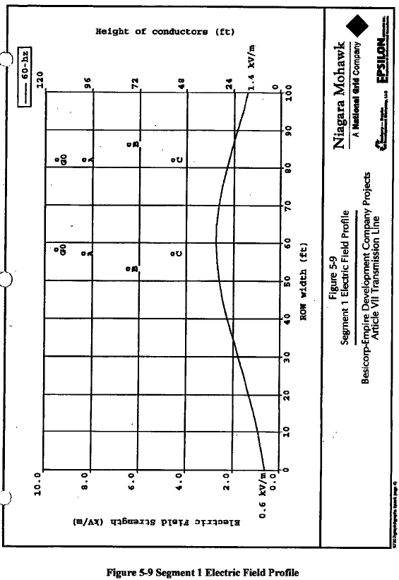

33

POWER CO. Project Initial facilities Study

Exhibit B to the Interconnection Agreement January 15, 2004

34

POWER CO. Project Initial facilities Study

Exhibit B to the Interconnection Agreement January 15, 2004

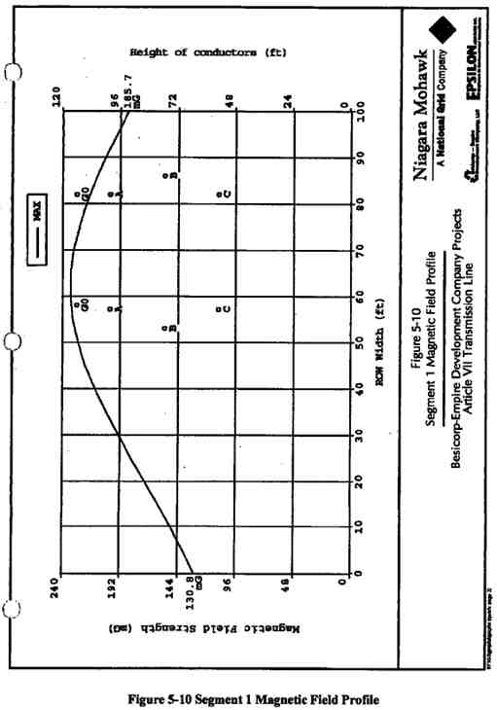

35

POWER CO. Project Initial facilities Study

Exhibit B to the Interconnection Agreement January 15, 2004

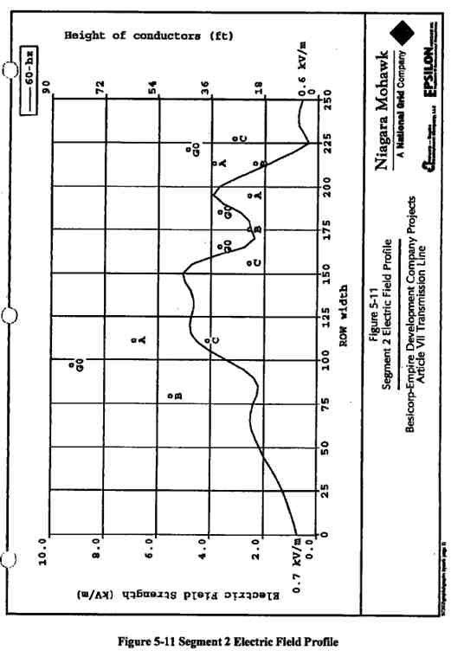

36

POWER CO. Project Initial facilities Study

Exhibit B to the Interconnection Agreement January 15, 2004

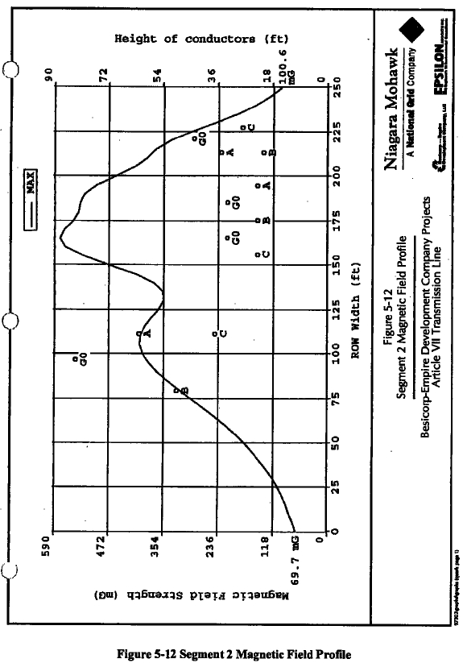

37

POWER CO. Project Initial facilities Study

Exhibit B to the Interconnection Agreement January 15, 2004

38

POWER CO. Project Initial facilities Study

Exhibit B to the Interconnection Agreement January 15, 2004

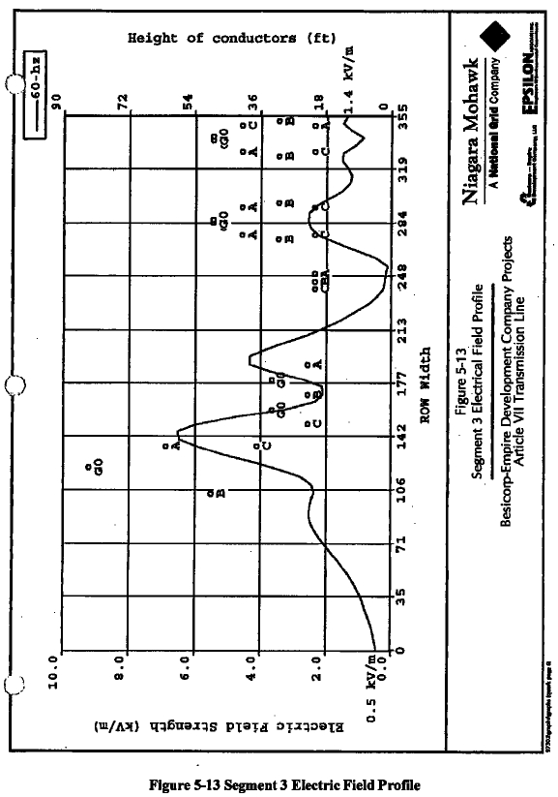

39

POWER CO. Project Initial facilities Study

Exhibit B to the Interconnection Agreement January 15, 2004

40

POWER CO. Project Initial facilities Study

Exhibit B to the Interconnection Agreement January 15, 2004

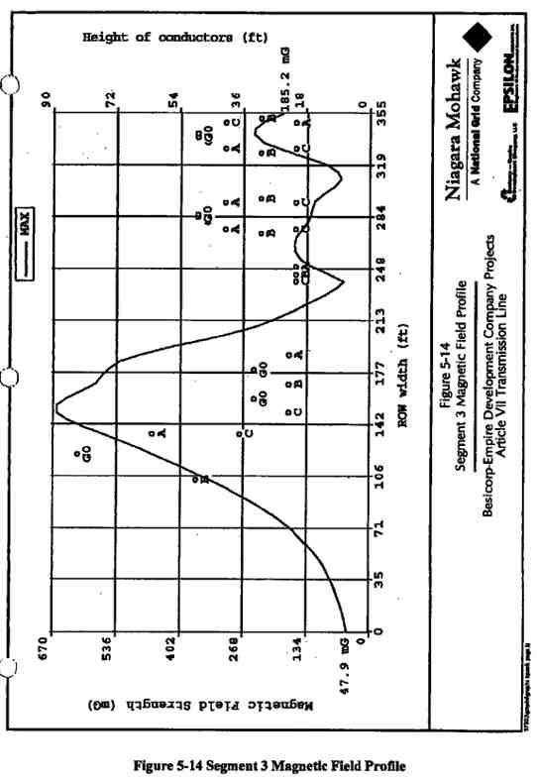

41

POWER CO. Project Initial facilities Study

Exhibit B to the Interconnection Agreement January 15, 2004

42

POWER CO. Project Initial facilities Study

Exhibit B to the Interconnection Agreement January 15, 2004

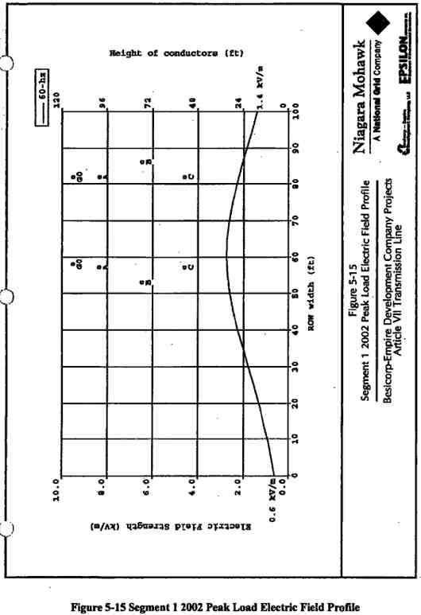

43

POWER CO. Project Initial facilities Study

Exhibit B to the Interconnection Agreement January 15, 2004

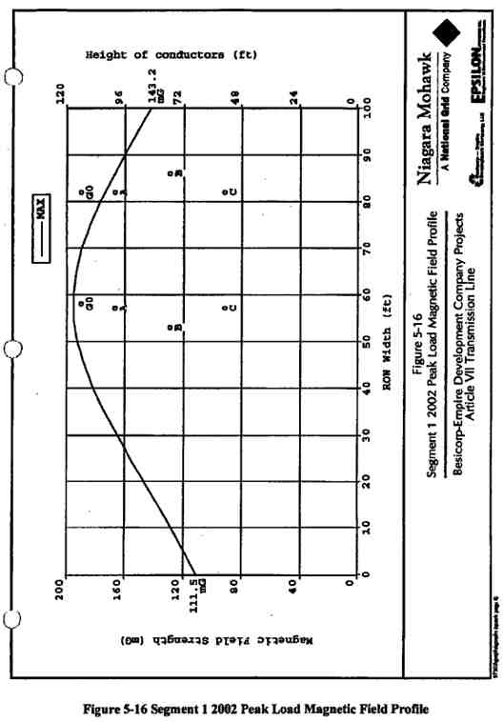

44

POWER CO. Project Initial facilities Study

Exhibit B to the Interconnection Agreement January 15, 2004

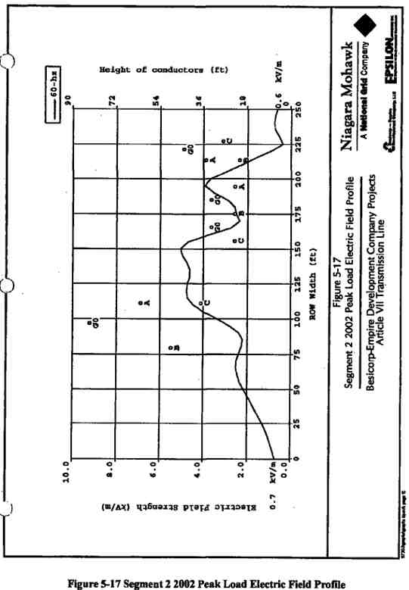

45

POWER CO. Project Initial facilities Study

Exhibit B to the Interconnection Agreement January 15, 2004

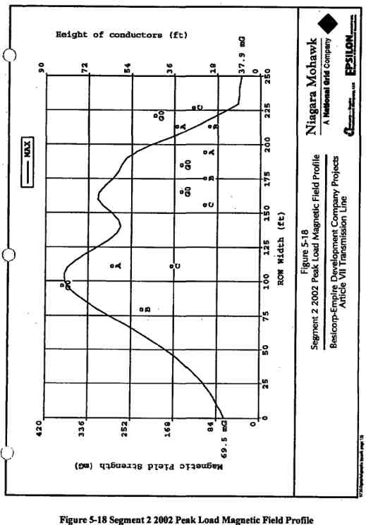

46

POWER CO. Project Initial facilities Study

Exhibit B to the Interconnection Agreement January 15, 2004

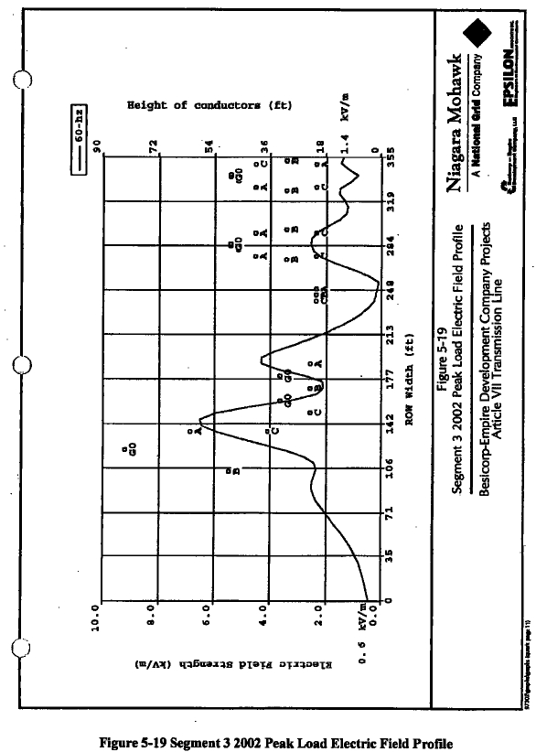

47

POWER CO. Project Initial facilities Study

Exhibit B to the Interconnection Agreement January 15, 2004

48

POWER CO. Project Initial facilities Study

Exhibit B to the Interconnection Agreement January 15, 2004

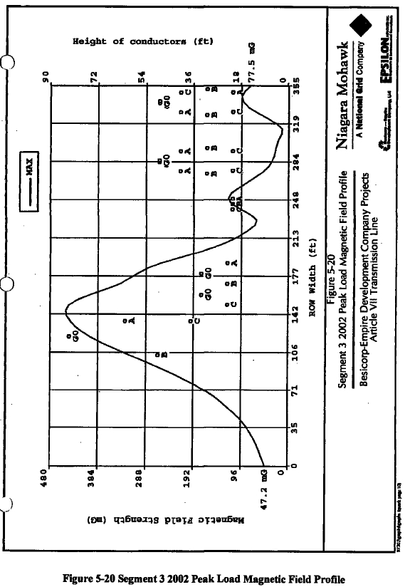

49

POWER CO. Project Initial facilities Study

Exhibit B to the Interconnection Agreement January 15, 2004

50

POWER CO. Project Initial facilities Study

Exhibit B to the Interconnection Agreement January 15, 2004

5.8. Construct Segment One Temporary 115 kV Line

POWER CO. will construct a temporary 115 kV circuit, consisting of engineered self-supporting   
structures, rather than wood poles with guys, along the western edge of the existing easement.   
Such structures will be placed within the current easement and so as not to interfere with the   
existing macadam service roadway. This roadway exists along the northern portion of this   
segment. On the southern portion, the self-supporting structures will be placed so as not to   
interfere with an agricultural field, as will be indicated on EM&CS&P drawings being prepared   
as part of the New York State Siting Board’s Article VII process. Installation of said temporary   
line will be coordinated with the local fanner and his growing season and associated activity.

The temporary line will be designed and constructed in accordance with NMPC approved

standards or as modified and approved by the NMPC Transmission Design Engineering Group.

The temporary facilities will be installed in parallel to those currently existing between poles #4 and #29 along the Greenbush #16 115 kV Circuit. This temporary 115 kV circuit will be   
constructed using 795 kcmil ACSR for its entire length.

Once this temporary line has been tested by NMPC personnel and declared ready for service,   
NMPC personnel will perform the necessary disconnection and reconnection at both poles #4   
and #29 from the existing structures, to the new temporary structures. At this point the   
temporary circuit will be capable of being energized and available for use by the LG&E/EI Paso   
Generating Plant.

5.9. Removal of Existing Greenbush #16115 kV Circuit along Segment One

Upon successful completion of NMPC’s transfer from the Original Greenbush #16 115 kV

Circuit to the Temporary Greenbush #16 115 kV Circuit facilities, POWER CO. will remove all existing poles, wires, insulators, guys, etc. which are currently used on the Original Greenbush #16 115 kV Circuit, between NMPC pole #4 and NMPC pole #29 on this Original Greenbush #16 Circuit. Caution will be used to not disturb the existing NMPC 8” natural gas line which exists in the northern portion of this ROW (between NMPC Greenbush #16 115 kV structure #4 and structure #14 in the vicinity of Teller Crossing Road (a.k.a. Sun Oil Road).

5.10. Construct Segment One 345 kV Line and 115 kV Line

POWER CO. will construct a series of steel monopole structures, designed in accordance with NMPC Standards or as modified and approved by NMPC Transmission Design Engineering Group, which will support both a 115 kV circuit to replace the Original Greenbush #16 115 kV Circuit, and a new 345 kV circuit for the transmission of the POWER CO. Plant output along this approximate 1.7 mile stretch of the transmission line.

A new three-pole structure will be constructed on the POWER CO. site to accommodate the   
rerouting of the Original Greenbush #16 115 kV Circuit to the eastern side of the new NMPC   
ROW on the POWER CO. site. The 115 kV New Greenbush #16 Circuit will be constructed by   
POWER CO. on the eastern side of the new double-circuit steel monopole structures and will

51

POWER CO. Project Initial facilities Study

Exhibit B to the Interconnection Agreement January 15, 2004

consist of one 795-kcmil ACSR conductor per phase. Vee-string insulators will be installed to support the conductors.

The 345 kV circuit will be constructed on the western side of the structures and will consist of two bundled 1192.5 kcmil ACSR conductors per phase. Vee-string insulators will be installed to support the conductors.

Static wires will be installed to on either side of the monopole structures to protect each circuit individually. The 345 kV circuit protection will consist of __________ and the 115 kV circuit protection will consist of __________.

5.11. Construct Segment Two 345 kV Line

POWER CO. will construct a series of single-circuit steel monopole structures, designed in

accordance with NMPC Standards or as modified and approved by NMPC Transmission Design   
Engineering Group, which will support a new 345 kV circuit for the transmission of the POWER   
CO. output along this approximate 2.3 mile stretch of the POWER CO. transmission line.

The 345 kV circuit will be constructed on the northern side of the current New Scotland -

Reynolds Road 250-foot wide ROW. The new 345 kV circuit will consist of two bundled 1192.5 kcmil ACSR conductors per phase. Vee-string insulators will be installed to support the   
conductors. In addition, __________ will be installed for system protection on this entire length of the transmission line.

5.12. Construct Segment Three 345 kV Line

POWER CO. will construct a series of single-circuit steel monopole structures, designed in

accordance with NMPC Standards or as modified and approved by NMPC Transmission Design   
Engineering Group, which will support a new 345 kV circuit for the transmission of the POWER   
CO. output along this approximate 2.3 mile stretch of the POWER CO. transmission line.

The 345 kV circuit will be constructed on the western side of the current New Scotland -

Reynolds Road 355-foot wide ROW. The new 345 kV circuit will consist of two bundled 1192.5 kcmil ACSR conductors per phase. Vee-string insulators will be installed to support the   
conductors. In addition, __________ will be installed for system protection on this entire length of the transmission line.

5.13. Other Infrastructure

5.13.1. Existing Utilities

Construction of the Proposed Transmission Line could potentially interfere with existing utilities   
in the ROW or utilities that cross the ROW at roads. The preliminary design completed for this   
Application has determined methods to avoid interference with these utilities. The only direct   
impact would be the relocation of a 1.7-mile section of an existing electric circuit (Greenbush   
#16 115 kV Circuit). This temporary relocation has been designed to minimize the downtime for   
the circuit to three-one weekend periods through construction of temporary structures within the

52

POWER CO. Project Initial facilities Study

Exhibit B to the Interconnection Agreement January 15, 2004

existing ROW. This circuit serves only one customer, the existing Coastal Power Plant and only   
operates when it is economical and there is a demand for electricity. Typically, the Plant does   
not operate on the weekends when electric demand is down. The type of disruption planned for   
temporary relocation of the transmission line will not have a substantial effect on this customer   
or any other NMPC customers. Development of the EM&CS&P Plan will include locating   
existing utilities that cross the ROW. Design of the Proposed Transmission Line will avoid   
conflicts with these existing utilities. The flexibility in the design will allow existing utilities to   
be avoided by adjusting the monopole locations or heights. The proposed construction plan also   
has limited excavation requirements that can easily avoid any underground utilities.

5.13.2. Industrial Facilities

Railroad Signals

The magnetic field produced by the Proposed Transmission Line produces a secondary electric field, generally referred to as the longitudinal electric field (“LEF”). Its magnitude is usually in the range of tens of millivolts (“mV”), about one million times smaller than the vertical electric field (“VEF”). The direction of this electric field is horizontal and parallel to the phase   
conductors on the transmission lines.

This secondary electric field can be the cause of electrical interference to railroad signaling. The Proposed Transmission Line would cross railroad tracks at two separate locations on Segment 2. At each of these locations, existing electric circuits cross the railroad within the existing ROW. There are currently no problems with the railroad signals in this area. This new circuit will also be designed to avoid any adverse impact to railroad signals.

As a detailed design is completed through the development of the EM&CS&P Plan, NMPC will consult with CSX and Amtrak. NMPC will define the scope of work required to study any   
potential impacts and seek to identify design solutions that avoid any impact to railroad signals prior to final design and construction.

Oil Tank Farm and Natural Gas Lines

The Proposed Transmission Line could affect the corrosion protection systems in the adjacent   
tank farm and adjacent gas lines by inducing a voltage in these metal objects. The induced   
voltages can compromise facility integrity and can be the source of corrosion activity for buried   
facilities or facilities in contact with the soil. The adjacent facilities have existing corrosion   
protection systems to prevent corrosion of the metal. The addition of the Proposed Transmission   
Line will change the character of the electric field and may require adjustment of corrosion   
protection systems.

NMPC has contracted with the same firm that completed the corrosion protection study for the installation of the Greenbush #16 115 kV Circuit to study the potential impact of the Proposed Transmission Line and issue recommendations to ensure protection of these facilities. The results will be included in the EM&CS&P Plan.

Radio Broadcast Signals

53

POWER CO. Project Initial facilities Study

Exhibit B to the Interconnection Agreement January 15, 2004

An additional potential effect of the Proposed Transmission Line includes interference with radio signals at certain frequencies.

6 REVIEW OF OTHER TRANSMISSION LINES

6.1.1. Review Line #9 from Greenbush to Reynolds Road Stations

The thermal analysis performed as part of the MS for this interconnection indicated that no

conductors would require replacement. As part of the final review of existing facilities along the POWER CO. transmission line corridor, the Reynolds Road - Greenbush #9 115 kV Circuit conductors will be reviewed to insure that there will be no adverse impact on the ratings of the circuit due to the final interconnection.

6.1.2. Review Line #4 from Riverside to Reynolds Road Station

The thermal analysis performed as part of the SKIS for this interconnection indicated that no

conductors would require replacement. As part of the final review of existing facilities along the POWER CO. transmission line corridor, the Reynolds Road - Greenbush #9 115 kV Circuit conductors will be reviewed to insure that there will be no adverse impact on the ratings of the circuit due to the final interconnection.

54

POWER CO. Project Initial facilities Study

Exhibit B to the Interconnection Agreement January 15, 2004

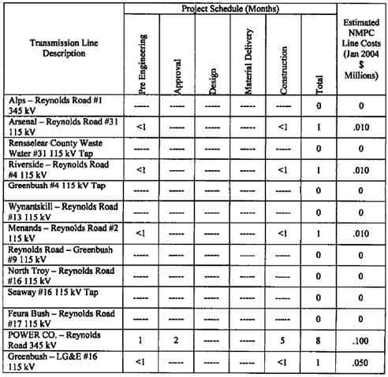

7 TRANSMISSION LINE COST ESTIMATE AND CONSTRUCTION   
 SCHEDULE

Project cost estimates (+/- 20% accuracy) for the transmission work is summarized in Table 7-1.   
These are based on present day dollars. All transmission facilities identified in Table 4.1 are   
considered Pool Transmission Facilities (“PTF”). No salvage value is included in the estimates.

The estimated project schedule for the NMPC Transmission Lines is also provided in Table 7-1. Project duration indicated includes project commencement through completion for the additions / modifications detailed above for preliminary engineering, material delivery and construction of work. Durations assume that the lines can be out of service for extended durations during   
stringing work. Material deliveries will not be done concurrent with permitting activities, but after POWER CO. has notified NMPC of the right to proceed. Costs associated with the   
POWER CO. switchyard are not included in this report.

Table 7-1 Total NMPC Estimated Transmission Line Costs

55

POWER CO. Project Initial facilities Study

Exhibit B to the Interconnection Agreement January 15, 2004

8 APPROVALS AND PERMITS

This section outlines the resource approvals and permit requirements for the transmission line replacement and installation.

8.1. Article X

On November 22, 2000, POWER CO. announced the filing of its Pre-Application for siting of a   
505 MW Power Plant and the Empire State Newsprint Recycling Plant in the City of Rensselaer,   
Rensselaer County, New York. On December 21, 2001, POWER CO. filed an Article X/SEQRA   
Application with the State of New York. On May 29, 2002 the Siting Board of New York   
determined the Application for the POWER CO. Plant was compliance with the regulations.   
Culminating settlement discussions that began in October 2002, in June 2003, a Joint Settlement   
Agreement was executed by POWER CO., New York State Department of Environmental   
Conservation (“NYS DEC”), New York State Department of Health, the Rensselaer County   
Environmental Management Council, the City of Rensselaer, the Sierra Club, and NMPC. Final   
Siting Board and NYS DEC Commissioner’s decisions for permitting of the projects are   
expected in February 2004.

8.2. Article VII

On April 29, 2003, NMPC filed the Article VII Application for the proposed POWER CO.

transmission line and all its components. On June 13, 2003, the New York State Public Service Commission (“NYS PSC”) deemed the Application to satisfy the minimum requirements under the Public Service Law 122. Public Statement hearings followed on July 14, 2003. On July 22, 2003, the Administrative Law Judge (“ALJ”) adopted a schedule whereby Reply Briefs are due by April 16, 2004. In October and November 2003, hearings on Direct Testimony occurred   
before all interested parties.

8.3. NYISO

In November 2001, the NYISO Transmission Planning Advisory Subcommittee approved the SRIS for the Empire State Newsprint Project (now known as the Besicorp - Empire Power   
Company’s POWER CO. Plant). Following this approval by the subcommittee, the NYISO staff presented the project to the Operating Committee for its approval. On November 14, 2001, the NYISO Operating Committee approved the SRIS for the POWER CO. Plant.

Subsequent to the approval by the NYISO, POWER CO. also received confirmation from the Substation and Protection Engineering Group of New York State Electric & Gas that the   
interconnection of the POWER CO. Plant would not overduty any breakers or equipment on the NYSEG system with the interconnection at Reynolds Road.

In conjunction with this approval by the NYISO, POWER CO. and WGI representatives presented the interconnection to representatives from the NE-ISO as well.

8.4. ACOE

56

POWER CO. Project Initial facilities Study

Exhibit B to the Interconnection Agreement January 15, 2004

The Army Corps of Engineers (“ACOE”) application for permission to construct certain

components associated with the proposed recycled newsprint manufacturing facility and the

proposed Cogeneration facility were filed by POWER CO. on April 25, 2003. This application   
relates to navigable waters and wetlands. Additional ACOE applications for the interconnection   
of the electric and the gas transmission lines associated with these facilities was filed by NMPC   
on July 3, 2003.

57

POWER CO. Project Initial facilities Study

Exhibit B to the Interconnection Agreement January 15, 2004

APPENDIX 1- REYNOLDS ROAD THERMAL RATING SHEETS

58

POWER CO. Project Initial facilities Study

Exhibit B to the Interconnection Agreement January 15, 2004

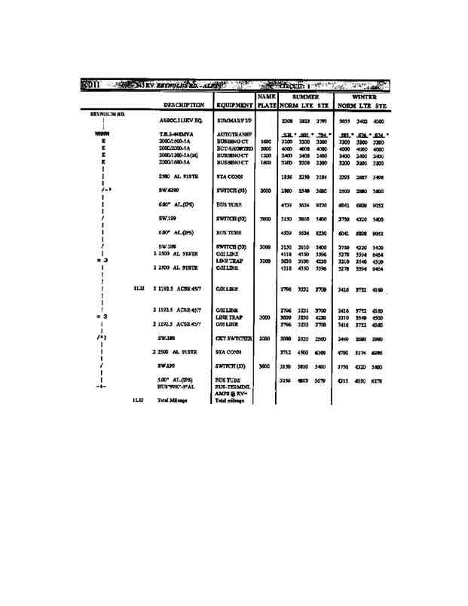

59

POWER CO. Project Initial facilities Study

Exhibit B to the Interconnection Agreement January 15, 2004

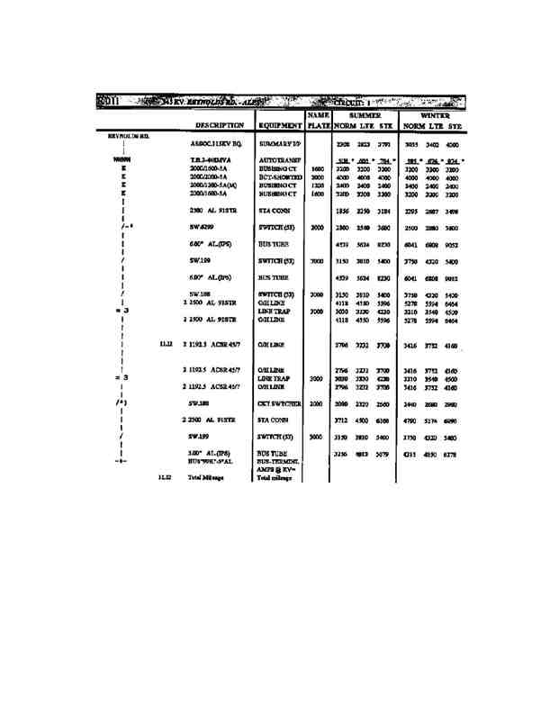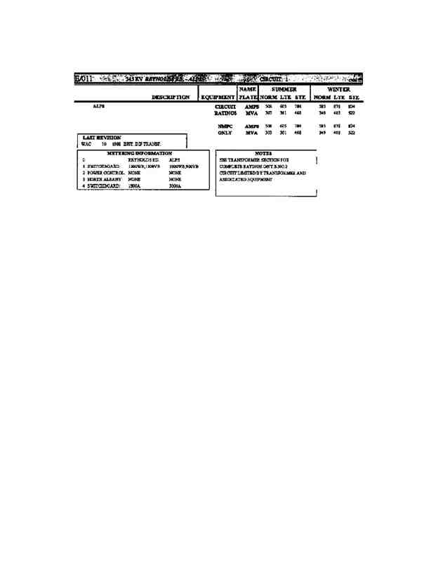

60

POWER CO. Project Initial facilities Study

Exhibit B to the Interconnection Agreement January 15, 2004

61

POWER CO. Project Initial facilities Study

Exhibit B to the Interconnection Agreement January 15, 2004

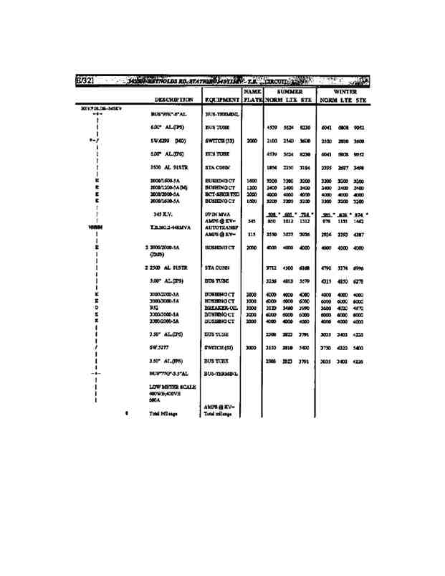

62

POWER CO. Project Initial facilities Study

Exhibit B to the Interconnection Agreement January 15, 2004

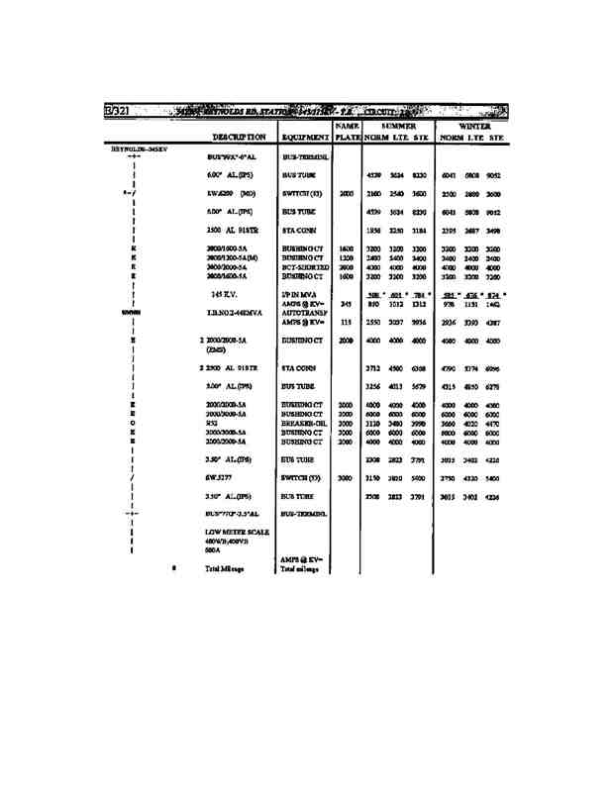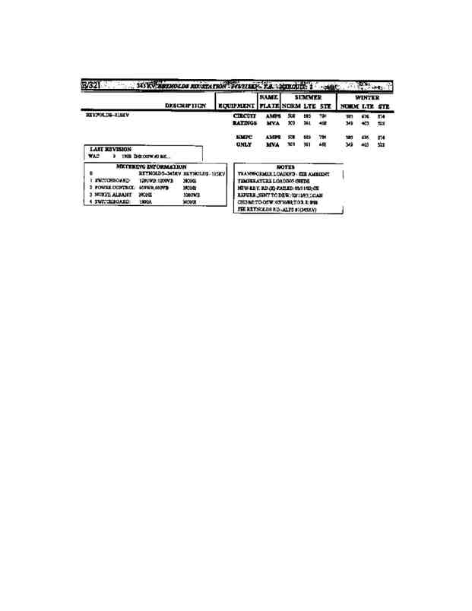

63

POWER CO. Project Initial facilities Study

Exhibit B to the Interconnection Agreement January 15, 2004

64

POWER CO. Project Initial facilities Study

Exhibit B to the Interconnection Agreement January 15, 2004

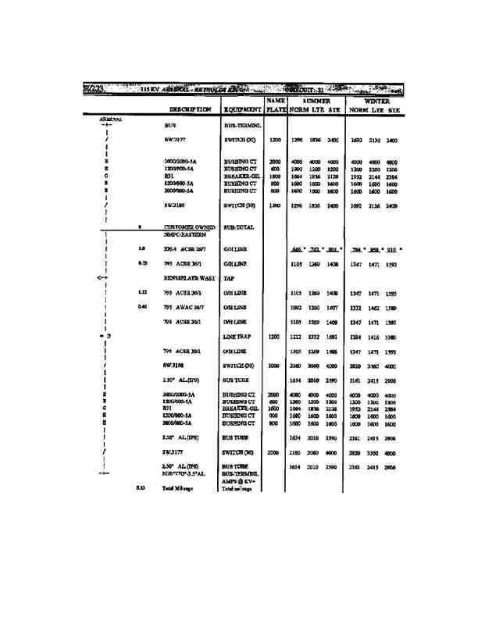

65

POWER CO. Project Initial facilities Study

Exhibit B to the Interconnection Agreement January 15, 2004

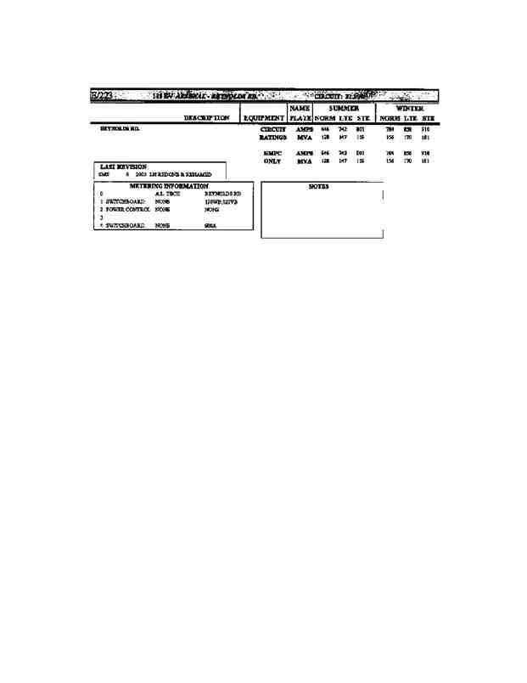

66

POWER CO. Project Initial facilities Study

Exhibit B to the Interconnection Agreement January 15, 2004

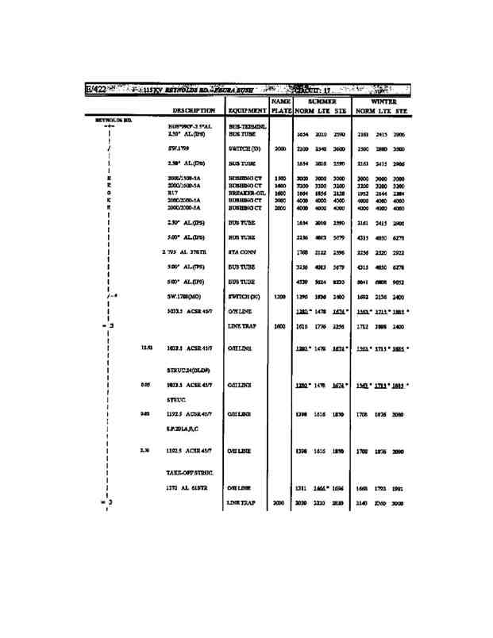

67

POWER CO. Project Initial facilities Study

Exhibit B to the Interconnection Agreement January 15, 2004

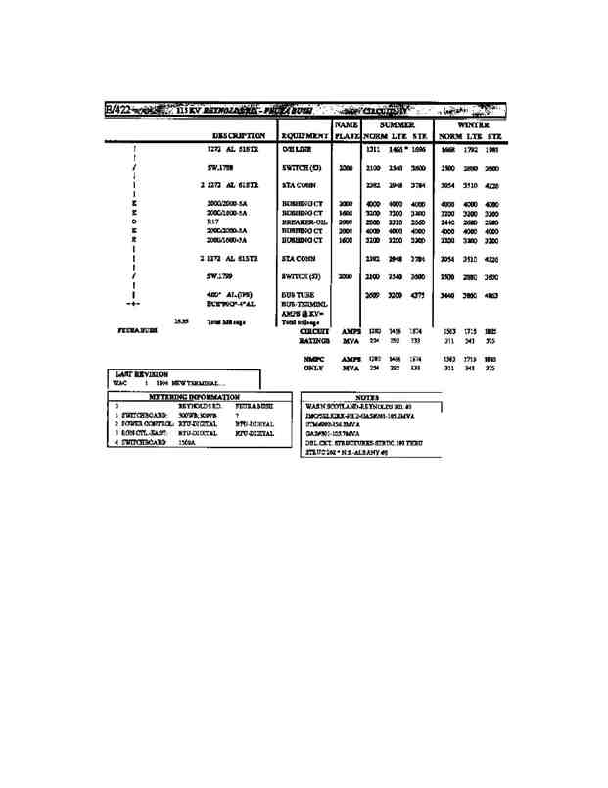

68

POWER CO. Project Initial facilities Study

Exhibit B to the Interconnection Agreement January 15, 2004

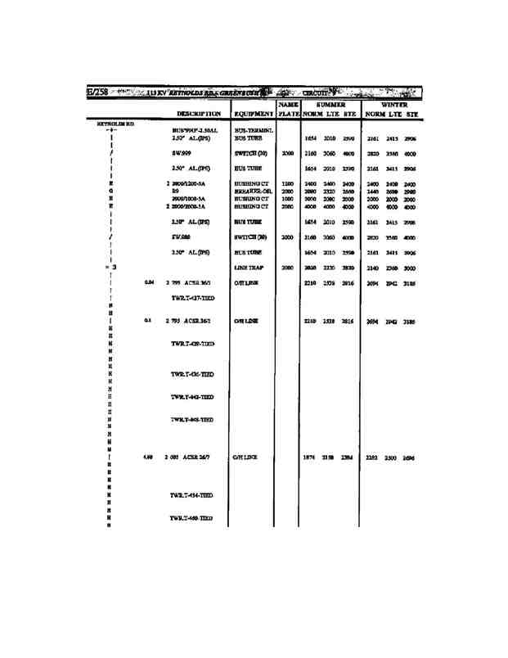

69

POWER CO. Project Initial facilities Study

Exhibit B to the Interconnection Agreement January 15, 2004

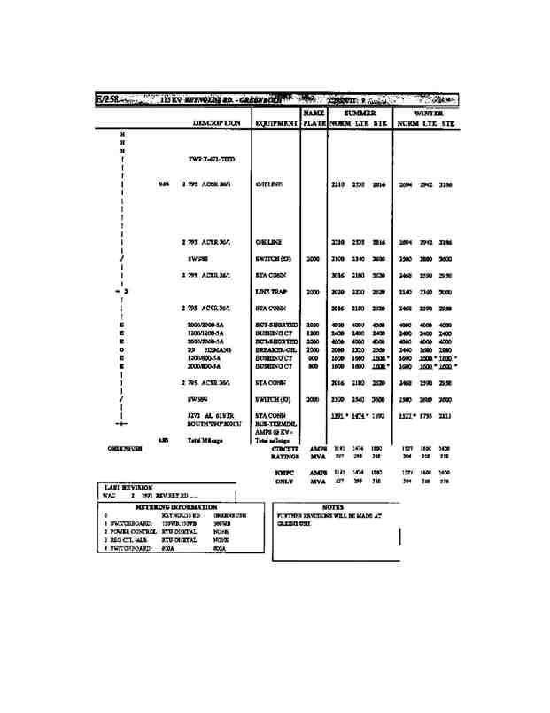

70

POWER CO. Project Initial facilities Study

Exhibit B to the Interconnection Agreement January 15, 2004

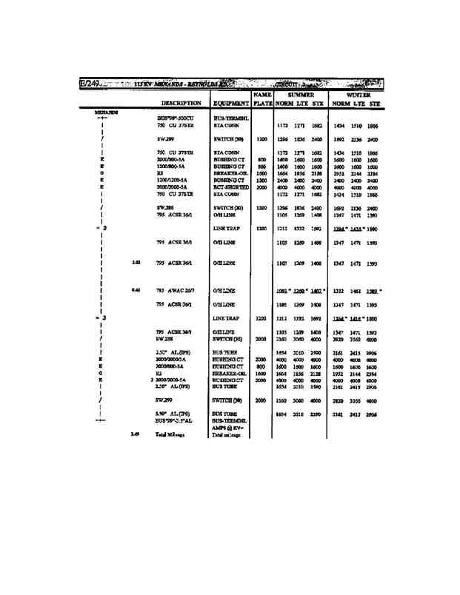

71

POWER CO. Project Initial facilities Study

Exhibit B to the Interconnection Agreement January 15, 2004

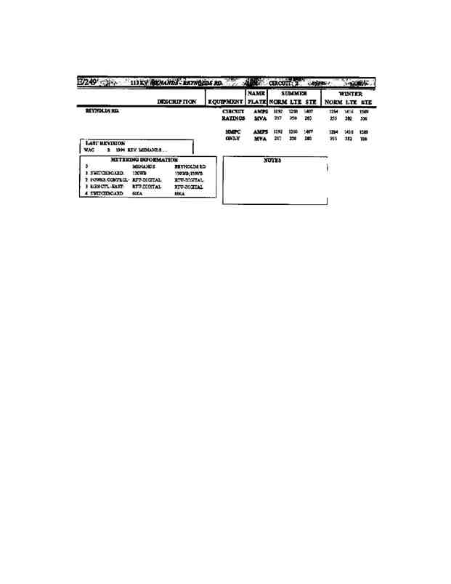

72

POWER CO. Project Initial facilities Study

Exhibit B to the Interconnection Agreement January 15, 2004

73

POWER CO. Project Initial facilities Study

Exhibit B to the Interconnection Agreement January 15, 2004

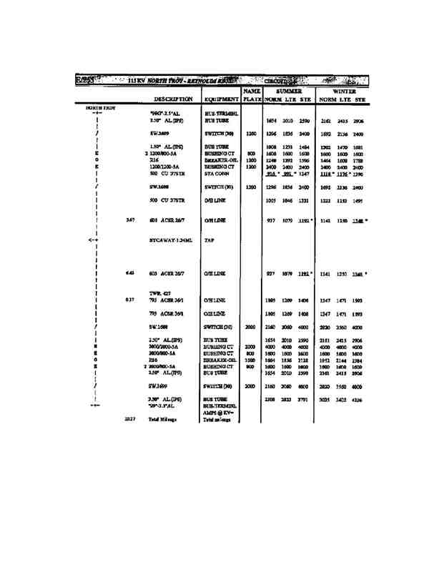

74

POWER CO. Project Initial facilities Study

Exhibit B to the Interconnection Agreement January 15, 2004

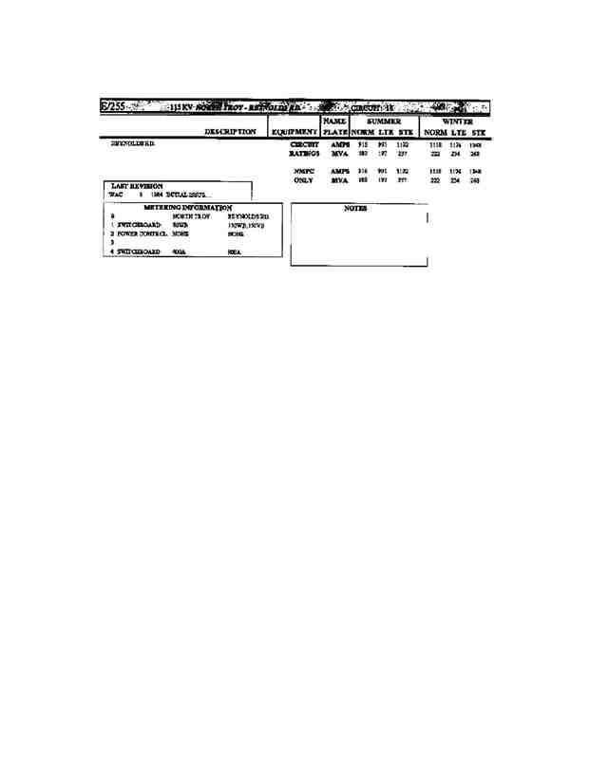

75

POWER CO. Project Initial facilities Study

Exhibit B to the Interconnection Agreement January 15, 2004

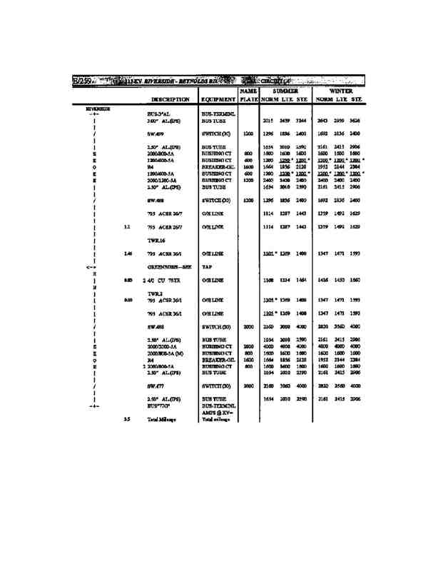

76

POWER CO. Project Initial facilities Study

Exhibit B to the Interconnection Agreement January 15, 2004

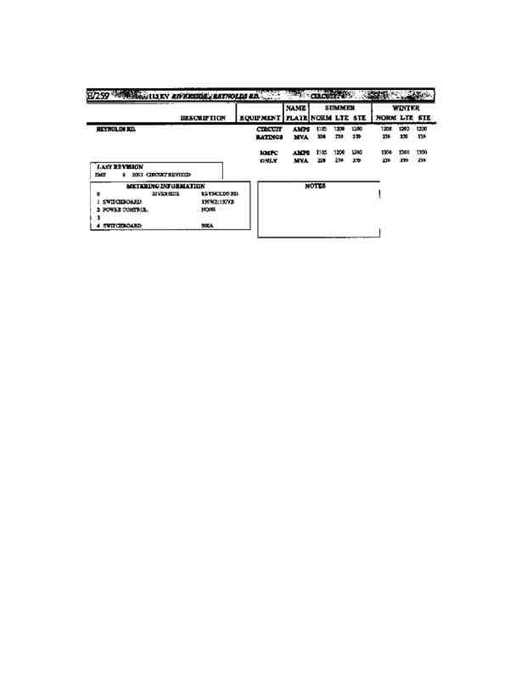

77

POWER CO. Project Initial facilities Study

Exhibit B to the Interconnection Agreement January 15, 2004

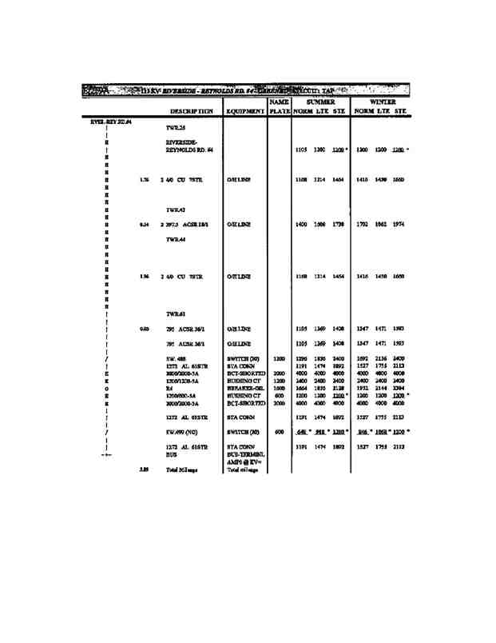

78

POWER CO. Project Initial facilities Study

Exhibit B to the Interconnection Agreement January 15, 2004

79

POWER CO. Project Initial facilities Study

Exhibit B to the Interconnection Agreement January 15, 2004

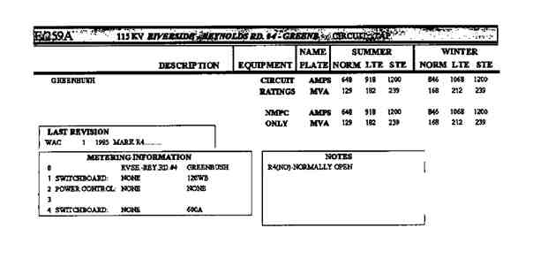

80

POWER CO. Project Initial facilities Study

Exhibit B to the Interconnection Agreement January 15, 2004

81

POWER CO. Project Initial facilities Study

Exhibit B to the Interconnection Agreement January 15, 2004

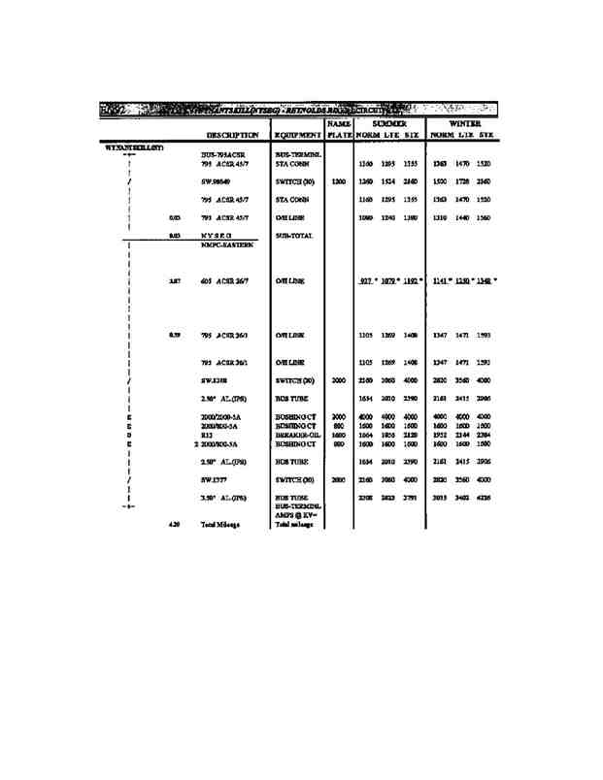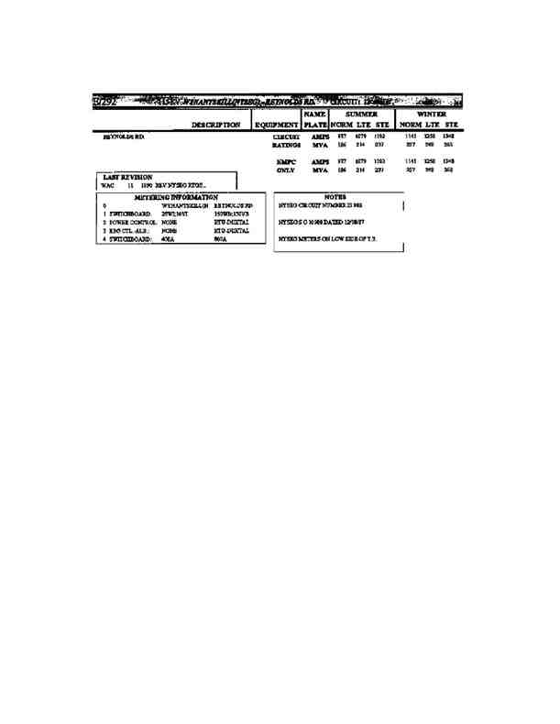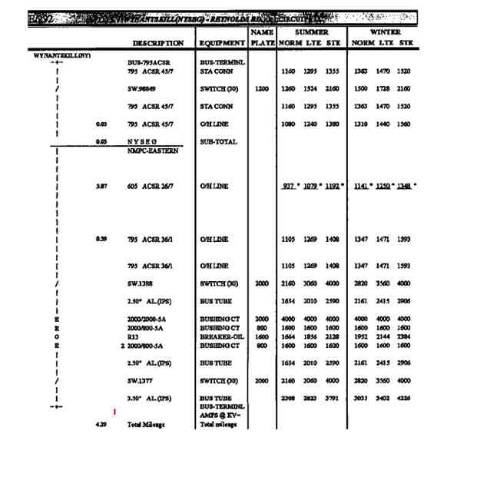

82

POWER CO. Project Initial facilities Study

Exhibit B to the Interconnection Agreement January 15, 2004

83

POWER CO. Project Initial facilities Study

Exhibit B to the Interconnection Agreement January 15, 2004

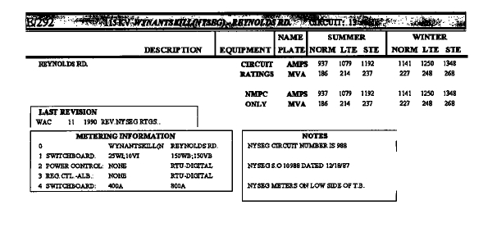

84

POWER CO. Project Initial facilities Study

Exhibit B to the Interconnection Agreement January 15, 2004

APPENDIX 2 - REYNOLDS ROAD STATION WORK LIST

85

POWER CO. Project Initial facilities Study

Exhibit B to the Interconnection Agreement January 15, 2004

APPENDIX 3 - NMPC POWER CO. STATION WORK LIST

86

POWER CO. Project Initial facilities Study

Exhibit B to the Interconnection Agreement January 15, 2004

APPENDIX 4 - TRANSMISSION LINE STATION WORK LIST

87

POWER CO. Project Initial facilities Study

Exhibit B to the Interconnection Agreement January 15, 2004

APPENDIX 5 - PROJECTS SCHEDULE

88

POWER CO. Project Initial facilities Study

Exhibit B to the Interconnection Agreement January 15, 2004

APPENDIX 6 - SYSTEM RELIABILITY IMPACT STUDY

89

POWER CO. Project Initial facilities Study

Exhibit B to the Interconnection Agreement January 15, 2004

Besicorp - Empire Development Company, LLC

Interconnection Study

For the Empire State Newsprint Project

Prepared by Dr. George A. Mulligan   
 Khin Swe

Reviewed by: Richard M. Bocci

November 2001

Washington Group International, Inc.

510 Carnegie Center

Princeton, NJ 08543

90

POWER CO. Project Initial facilities Study

Exhibit B to the Interconnection Agreement January 15, 2004

Table of Contents

EXECUTIVE SUMMARY V

1.0 INTRODUCTION 1

2.0 THE PROPOSED 2

FIGURE 1 - ONE LINE DIAGRAM- ESNP PROPOSED INTERCONNECTION

TO NIAGARA MOHAWK REYNOLDS ROAD SUBSTATION 4

3.0 STUDY METHODOLOGY AND ASSUMPTIONS 5

3.1 STUDY CASES 5

3.2 ANALYSES CONDUCTED 5

3.3 ASSUMPTIONS 6

4.0 ANALYSIS RESULTS 7

4.1 IMPACT ON BASE SYSTEM CONDITIONS 7

4.1.1 Impact on Generation Dispatch 7

4.1.2 Impact on Base Power Flows 8

4.1.3 Impact on Base Voltage Levels 8

4.1.4 Impact on PARS Settings 9

4.1.5 Impact on System Losses 9

4.2 IMPACT ON TRANSFER LIMITS 9

4.2.1 Thermal Analysis Results 10

4.22 Local Thermal Analysis Results 12

4.2.3 Voltage Analysis Results 13

4.2.4 Stability Analysis Results 14

4.2.5 Overall Impact on Transfer Limits 15

4.3 FAULT DUTY ANALYSIS 16

4.4 EXTREME CONTINGENCY ANALYSIS 16

5.0 CONCLUSIONS 17

6.0 REFERENCES 18

91

POWER CO. Project Initial facilities Study

Exhibit B to the Interconnection Agreement January 15, 2004

List of Tables

Table 4.1.1.51 Generation Redispatch for ESNP to SENY- Summer Peak Cases

Table 4.1.1.52 Generation Redispatch for ESNP to RIM - Summer Peak Cases

Table 4.1.1.33 Generation Redispatch for ESNP to NE - Summer Peak Cases

Table 4.1.1.W1 Generation Redispatch for ESNP to SENY - Winter Peak Cases

Table 4.1.1.W2 Generation Redispatch for ESNP to NM - Win Peak Cases

Table 4.1.1.W3 Generation Redispatch for ESNP to NE - Winter Peak Cases

Table 4.1.2.S Base System Conditions - Summer Peak Cases, Power Flows

Table 4.1.2.W Base System Conditions - Winter Peak Cases, Power Flows

Table 4.1.3.S Base system Conditions - Summer Peak Cases, Bus Voltages

Table 4.1.1W Base System Conditions - Winter Peak Cases, Bus Voltages

Table 4.1.4.5 Base System Conditions- Summer Peak Cases, Phase Angle Regulators

Table 4.1.4.W Base System Conditions - Winter Peak Cases, Phase Angle Regulators

Table 4.1.5 Summary System Losses for Summer and Winter Peak Cases

Table 4.2.1.51 NYCA Inter-Area Bulk Power System Normal Thal Transfer Limits- Summer Peak

Table 4.2.1.52 NYCA Inter-Area Bulk Power System Normal Thermal Transfer Limits- Summer Peak

Table 4.2.1.53 NYCA Intra-Area Bulk Power System Emergency Thermal Transfer Limits - Summer Peak

Table 4.2.1.54 NYCA Inter-Area Bulk Power System Emergency Thermal Transfer Limits - Winter Peak

92

POWER CO. Project Initial facilities Study

Exhibit B to the Interconnection Agreement January 15, 2004

Table 4.2.1.W1 NYCA Infra-Area Bulk Power System Normal Thermal Trawler Limits - Winter Peak

Table 4.2.1.W2 NYCA Inter-Area Bulk Poxes System Normal Thermal Transfer Limits - Winter Peak

Table 4.2.1.W3 NYCA lima-Area Bulk Power System Emergency Thermal Transfer Limits - Wirer Peak

Table 4.2.1.W4 NYCA Inter-Area Bulk Power System Emergency Thermal Transfer Limits - Witte Peak

Table 4.2.2.S1 Summer Peak 115 kV Line Flows - Case 1 (Without ESNP)

Table 4.2.2.S2 Summer Peak 115 kV Line Flows - Case 2 (ESNP to SENY)

Table 4.2.2.82 Summer Peak 115 kV Line Flows - Case 2 (ESNP to SENY)

Table 4.2.2.W1 Winter Peak 115 kV Line Flows - Case 1 (Without ESNP)

Table 4.2.2.W2 Winter Peak 115 kV Line Flows - Case 2 (ESNP to SENY)

Table 4.2.3 Voltage-Constrained Transfer Limit - Bus Voltages

Table 4.2A Design Requirement Stability Case List

Table 4.3 Sint Circuit Analysis

Table 4.4.1 Same Contingency Stability Case List

Table 4.4.2 Critical Clearing The from Stability Case List

93

POWER CO. Project Initial facilities Study

Exhibit B to the Interconnection Agreement January 15, 2004

Appendices

A. Study Scope (4 Sheets)

B. Load Flow Base Case One-Line Plots   
 B.1 Summer Peak (9 Sheds)

B.2 Winter Peak (9 Sheets)

C. Thermal Analysis TLTG Output

CA Summer Nouns’ (132 Sheds)

C.2 Summer Emergency (140 Sheds)   
C.3 Winter Nomad (135 Sheets)   
C.4 VAnter Emergency (124 Sheets)

D. Voltage Analysis Output (17 Sheds)

E. ESNP Plant Stability Data (4 Sheets)

F. Transient Stability System Response Plots (195 Sheets)

G. Interconnection Study for the Empire State Newsprint Project Newsprint

Manufacturing Plant Load

94

POWER CO. Project Initial facilities Study

Exhibit B to the Interconnection Agreement January 15, 2004

Executive Summary

Besicorp-Empire Development Company, LLC (Besicorp) engaged Washington Group

International, Inc. (WGI) to perform an Interconnection Study to assess the feasibility of

interconnecting a 603 MW net generating plant to be located at the BASF site in the city of   
Rensselaer, N.Y. Besicorp expects to commence commercial operation of the plant in the Summer   
of 2004.

The Empire State Newsprint Project (ESNP) is an integrated facility consisting of an electric   
generating plant and a recycled newsprint manufacturing plant. The generating plant will cost of   
two 161 MW gas turbine units and one 297 MW steam unit which will provide a net sumac   
maximum output of 603 MW after supplying the generating plant auxiliary load. A portion of the   
plant net output will tonally provide power to the newsprint manufacturing plant with a maxim   
load of approximately 66 MW. The newsprint manufacturing plant load is represented as off in   
these studies in order to model maximum output into the bulk power system. A separate analysis   
of the newsprint manufacturing plant load corrected to the system without the power plant is   
provided in Appendix G. The ESNP is proposed to be connected to the Niagara Mohawk Power   
Corporation (NMPC) Reynolds Road 345 kV substation by an approximately 9 mile long   
overhead 345 kV transmission line with two 1192 haul ACSR conductors per phase. The   
interconnection plan includes the addition of two new 345 kV circuit breakers at the Reynolds   
Road 345 kV substation.

This study evaluated the impact on the reliability of the bulk power system of the proposed   
interconnection to the Reynolds Road 345 kV Substation. The propose of the report is to evaluate   
the proposed interconnection and to recommend modifications, as may be required. The report   
addresses intra-area and inter-area transfer limit issues including thermal, voltage, and stability   
limits. The report also addresses local load flow, extreme contingency, and fault duty issues. WGI   
performed these studies with the exception of the fault duty study, which was performed by NMPC   
and provided to WGI for inclusion in this report. The studies evaluated the performance of the   
system with and without the proposed project using the latest FERC Form 715 power flow summer   
and winter peak base cases (filed by NYISO in April 2001) which are applicable to year 2004.   
Representations for the baseline units, databases for thermal transfer limit analysis, and dynamics   
databases were all provided by the New York Independent System Operator (NYISO).

When dispatched to Southeast New York (SENY), the impact of the ESNP Project on New Yolk   
State summer normal and agency transfer capability is a reduction of 475 MW on Central East   
and of 775 MW on Total East intakes. Upstate NY - Southeast NY (UPNY-SENY) intake transfer   
capability is minimally affected with a reduction of 25 MW normal from 4250 MW to 4225 MW   
and of 50 MW emergency from 4900 MW to 4850 MW. UPNY-Con Ed interface transfer   
capability actually increases by 175 MW nominal from 4125 MW to 4300 MW and by 150 MW   
emergency from 5975 MW to 6125 MW. The reductions in Central East and Total East at due to   
the power distribution of the additional 603 MW on the bulk power transmission system. For   
dispatches to SENY, approximately 12 percent (71 MV) of the additional generation from ESNP   
flows west across the Central East interface and east across the Marcy South transmission   
facilities. Approximately 51 percent (306 MW) of the additional generation from ESNP flows on

95

POWER CO. Project Initial facilities Study

Exhibit B to the Interconnection Agreement January 15, 2004

the New Scotland-Leeds 345 kV circuits which are the limiting elements for Central East and Total East.

The ESNP Project also impacts the Inter-Area transfer limits. The NY-NE summer limits increase by a range of 125 MW to 325 MW normal and by 150 MW to 300 MW emergency for the redispatch locations examined The NE-NY limits decrease byelaw of 150 MW to 250 MW normal and 150 MW to 275 MW allegory. The NY-PJM limits are unchanged for both normal and emergency conditions and the PJM-NY limits are affected by only a 25 MW increase under normal conditions for ESNP Project dispatched to PJM.

The winter Intra-area limits are higher than the simmer limits and are little changed by the addition of The ESNP Project Central East and Total East decrease by 125 MW and 50 MW, respectively, both normal and emergency for The ESNP Project dispatched to SENY, while UPNY/SENY and UPNY/Con Ed normal limits increase by 50 MW and 25 MW.

The transmission limitations may cause generators that contribute to the loading of the   
transmission lines to operate at lower levels of dispatch than they would otherwise for some part   
of the summer season. The ESNP Reject may at times have reduced output due to these transfer   
limitations, but this depends on other factors, such as unit bid prices, that may cause the NYISO   
to select other units to operate at reduced levels. This assumes that the plant will be operated in   
accordance with the NYISO’s operational procedures and limits through its day-ahead Security   
Constrained Unit Commitment (SCUC) and real time Security Constrained Dispatch (SCD). This   
is designed to dispatch The ESNP Project and other plants in a manner that maximizes reliability   
and minimizes energy costs.

The short circuit analysis performed shows a requirement to replace one 115 kV circuit breaker at Reynolds Road. All other circuit breakers remain within their rated capability.

This SRIS has been performed in accordance with all NYISO requirement All requited system   
upgrades have been identified herein. Approval of this SRIS does not preclude the possibility of   
figure conditions, as envisioned it NYISO requirements, which may, at times, limit output of the   
ESNP Project or any other generating plant in the system so that system reliability and security   
will be maintained.

This SRIS confirms that the ESNP Project results in no adverse material impact on the Niagara Mohawk transmission system or the New York Slate bulk power system. The conclusions, based on the results and assumptions of this analysis, are as follows:

1. The 345 kV interconnect into the NMPC Reynolds Road 345 kV substation ensures that

full output of the ESNP Project can be delivered to the New York State 345 kV system at Summer peak load. Of course, ESNP Project at other power plants may be subject to curtailment if NYISO Security Constrained Dispatch (SCD) attempts to optimize the Central East and Total East transfers during the summer peak load period. Additionally, the ESNP Project will be tripped for loss cite Reynolds Road-Alps 345 kV circuit to avoid overloading the Reynolds Road 345/115 kV bank.

96

POWER CO. Project Initial facilities Study

Exhibit B to the Interconnection Agreement January 15, 2004

2. The ESNP Project when dispatched to SENY reduces both summer normal and

emergency Central East transfer capability by 475 MW and decreases both the normal and emergency Total East transfer capability by 775 MW. The UPNY-SENY transfer capability is manually reduced by 25/50 MW normal/emergency, and the UPNY-Con Ed transfer capability is actually increased by 75 MW normal and decreased by 25 MW emergency. The impact of the ESNP Project on the Inter-Area transfer capabilities is less with NY-NE increasing by a range of 125 MW to 325 MW, NE-NY limit deafening by a range of 150 MW to 275 MW, and NY-PJM and NM-NY limits remaining unchanged (25 MW increase name in NM-NY for ESNP dispatched to NM).

3. Addition of the ESNP Project does not have any adverse impact to the transient stability

response of the overall transmission system.

4. The short circuit analysis shows that only one 115 kV circuit breaker at Reynolds Road

is required to be replaced.

5. The ESNP Project will not adversely impact bulk power system reliability, as the plant

will be operated in accordance with the NYISCPs operational procedures and limits through its day-ahead Security Constrained Unit Commitment (SCUC) and real time Security Constrained Dispatch (SCD). This conclusion also assumes that locational generation capacity requirements are met.

97

POWER CO. Project Initial facilities Study

Exhibit B to the Interconnection Agreement January 15, 2004

Interconnection Study

For the Empire State Newsprint Project

1.0 Introduction

This report presents the results of the thermal, stability, and voltage transfer limit analysis, local   
load flow and stability analysis, fault day analysis, and extreme contingency analysis performed   
by WGI for the proposed 603 MW (net) ESNP Project. The analysis is based on connection of   
the ESNP Project into the NMPC Reynolds Road 345 kV substation. The purpose of the   
analysis is to determine the impact of the ESNP Project on the reliability of the New York Bulk   
Power System and to ensure that the resulting bulk power system will conform to all applicable   
planning standards and design criteria including those of NYSRC[1], NPCC[2], NERC[3], and   
NYPSC[4]. The SRIS has been performed in accordance with the NYISO System Reliability   
Impact Study Criteria and Procedures [5]. The analysis included an assessment of the impact   
of the proposed ESNP Project on NYISO intra-area and inter-area transfer limits. The basic   
electrical system studies include load flow, thermal transfer limit, stability, voltage, and fault   
duty studies.

The ESNP Project is scheduled for commercial operation in the summer of 2004. The study   
evaluated the performance of the system with and without the proposed ESNP Project using the   
FERC Form No. 715 load flow cases submitted by NYISO to FERC in April 2001. The FERC   
filing contains representations of the Summer 2006 and Winter 2006,7 Peak Load conditions. It   
was agreed with NMPC and NYISO to use these cases as representative of the 2004 system   
conditions NYISO also provided representations for the baseline units, databases for thermal   
transfix limit analysis, and dynamics databases for transit stability analysis. The PSS/E computer   
program was used fix load flow, thermal transfer limit, voltage, and stability analysis. The fault   
duty analysis was performed by NMPC and provided to WGI for inclusion in this report. The   
Aspen One-Liner computer program was used for the fault duty analysis.

2.0 The Proposed Project

The proposed ESNP Project consists of two 161 MW gas turbine units and one 297 MW steam turbine unit to be located at the BASF site in Rensselaer, N.Y. The project will have and summer maximum output of 603 MW and a net winter maximum output of 660 MW, after providing the generating plant auxiliary load. A portion of the plant output will normally provide power to a recycled newsprint manufacturing plant with a maximum load of approximately 66 MW. This load is represented as 0 MW in all analyses to provide the maximum net output of 603 MW into the bulk power system. The plant is to be connected to the Reynolds Road substation by approximately 9 miles of overhead 345 kV line. A one-line diagram showing the planned interconnection scheme is shown on Figure 1. The input data for the ESNP Project, generator step-up transformers, and 345 kV overhead line are as follows:

Generator Data:

161 MW, 18 kV, 0.85 p.f. -Each of two gas turbine units.

98

POWER CO. Project Initial facilities Study

Exhibit B to the Interconnection Agreement January 15, 2004

297 MW, 18 kV, 0.85 p.f. - Steam turbine unit. Generator Step-up Transformer Data:

CT1 GSU: 120/160/200 MVA OA/FA/FA, 345-18 kV, Z=10% on 120 MVA base, X/R = 20.   
 Z - 0.00417 +j0.0833 p.u. on 100 MVA base.

CT2 GSU; 120/160/200 MVA OA/FA/FA, 345-18 kV, 1-10% on 120 MVA base, X/R = 20.   
 Z = 0.00417 +10.0833 p.u. on 100 MVA base.

Steam GSU: 200/266/332 MVA OA/FA/FA, 345-18 kV, Z=10% on 200 MVA base, X/R = 20.   
 Z = 0.0025 +j0.05 p.u. on 100 MVA base.

345 kV Overhead Line:

1192 kcmil ACSR, 2 conductors per phase, 1109 MVA, 9.1 miles.   
 Z = 0.00071 +j0.00706 p.u. on 100 MVA base. B - 0.12 p.u.

The above data is considered to be preliminary, as the proposed equipment has not yet been purchased.

The ESNP Project machine data for the stability analysis including machine, excitation system, and governor representations is provided in Appendix E.

99

POWER CO. Project Initial facilities Study

Exhibit B to the Interconnection Agreement January 15, 2004

3.0 Study Methodology and Assumptions

3.1 Study Cases

In accordance with the study scope, the impact of the proposed ESNP Project on the bulk power   
system was analyzed using a baseline set of assumptions. The basic set of power flow cases   
were:

Case 1 - Base Case without the ESNP Project The base case included the proposed   
PG&E Athens Facility, Bethlehem Energy Center, Heritage Energy Facility, Ramapo   
Energy Facility, Bowline Point Unit 3, Oakdale shunt capacitors/FACTS project,

Middletown Tap 345/138 kV substation, OH-Michigan Phase Shifters, 115 kV series reactor at North Catskill, and the CT-LI DC Tie-line. The Energy Facility is rot included as a baseline unit became it had not met regulatory milestones at the time this study began. The Article X Application had net been completed.

Case 2 - Case 1 with ESNP Project dispatched to SENY (80% to New Yak City and 20% to Long Island).

Case 3 - Case 1 with ESNP Project dispatched to PJM.

Case 4 - Case I with ESNP Project dispatched to New England.

The analyses were conducted under forecasted summer and winter peak load conditions.

Both the Summer and Winter Peak Load 2006 study cases were developed from the FERC Form No. 715 load flow case submitted by NYISO to FERC in April 2001. NYISO provided representations for the baseline units, which were added to form Case 1. NYISO provided necessary data bases for performing thermal transfer limit analysis and also provided the dynamics data base for performing transient wilily analysis. One-Ibee diagrams of the power flow eases teed in this study are provided in Appendix B.

3.2 Analyses Conducted

The analyses conducted for the SRLS included kernel, voltage, stability, and short circuit analyses. The PTI PSS/E software package was used for the thermal, voltage, and transient stability analyses, and Aspen One-Liner was used for the short circuit analyses.

The thermal, voltage and stability analyses were used to evaluate the performance of the bulk power system for the various study cases with respect to NYISO and NPCC criteria, and to determine the transfer limits for the cases. Thermal analysis was conducted on the Summer and Winter Peak Load cases using the PSS/E Power Flow and TLTO activity. The PSS/E Power Flow program was used to evaluate the base (pre-contingency) system conditions for all study cases. Voltage contingency analysis, also using the PSS/E Power Flow program, was conducted for the Summer Peak Load cases only. Stability analysis was also conducted for the Summer Peak Load cases only, using the PSS/E Dynamics program.

100

POWER CO. Project Initial facilities Study

Exhibit B to the Interconnection Agreement January 15, 2004

The short circuit analysis was conducted to determine whether the proposed ESNP Project would adversely impact the adequacy (e.g., exceed the capability) of existing circuit breakers in the area. The analysis assumed that all existing generators plus the facilities specifically noted in each case description of Section 3.1 were in-service. Additionally, the Glenville and Skygen’s Waterford projects were included in the short circuit analysis, although they are not included as baseline units in the Scope of Work. The generator impedances ate represented by their direct-axis subtransient reactance at rated voltage (X”dy), which mutes that the breaker duty levels are determined immediately after the occurrence of the fault at which time the garroter anent Contribution (into the fault) is at its maximum.

3.3 Assumptions

The study assumes that locational generation capacity requirements are met The ESNP Project adds generation to the system and it is, lathe, necessary to reduce generation output elsewhere to maintain the energy balance in the system. For each case of redispatch whether ESNP Project was dispatched to SENY, New England, or PJM the assumption used in the study was to reduce generation output according to the standard proportions used in the NYISO Operating Studies Task Force (OSTF) operating studies.

The other key assumptions used in this study include:

a) locations for increasing and decreasing generation to vary transfers across transmission

interfaces;

b) modeling of phase angle regulators (PARs) - All cases bad PARs maintained at the

scheduled MW as provided in the FERC load flow case; and

c) status of other proposed projects as discussed in the Study Scope contained in

Appendix A.

4.0 Analysis Results

4.1 Impact on Base System Conditions

Before considering contingencies, the impacts of the ESNP Project on base system conditions were evaluated by simply comparing various system parameters in the power flow cases used for the study. Summaries of these power flow cases for Summer and Winter peak load conditions are included in Appendix B.

4.1.1 Impact on Generation Dispatch

Tables 4.1.1.S1, 4.1.1.S2, and 4.1.1.S3 provide summaries of the assumed generation dispatch changes due to the ESNP Project for the Summer Peak Load cases. Tables 4.1.1.W1, 4.1.1.W2, and 4.1.1.W3 provide similar summaries for the Winter Peak Load cases.

101

POWER CO. Project Initial facilities Study

Exhibit B to the Interconnection Agreement January 15, 2004

4.1.2 Impact on Base Power Flows

Table 4.12.3 provides a summary of the normal ratings and base (pre-contingency) power flows of various transmission lines in the study area for the Summer Peak Load cases for comparison. Table 4.12.W provides a similar summary for the Winter Peak Load cases.

The summer table shows that the ESNP Project redispatched to SENY in Case 2, has little impact   
on the flow on the Total East interface for the assumed generation redispatch since the projects   
and the redispatched generation are located east of Total East. The distillation of flows on the   
lines that comprise Total East are shifted somewhat, slightly reducing flow across Central East,   
and increasing flow on the Marcy-South lines. The ESNP Project full output appears on the   
UPNY-SENY and UPNY-Con Ed interfaces. The distribution of flows on the circuits comprising   
these interfaces is acceptable and no circuit is overloaded There is no effect on the net flow   
across the NY-NE interface, of course. However, the distribution of flows on lines comprising   
the interface shifts somewhat, with decreased flow on the Pleasant Valley-Long Mountain tie   
and decreased flow corning back into New York on the Alps-Berkshire tie.

The table shows that when the ESNP Project is dispatched to PJM as in Case 3, the Central East   
and Total East transfers are reduced and loading on their circuits are reduced. In Case 4 with   
ESNP Project dispatched to New England, the four intra-area interface transfers remain   
relatively unchanged compared to Case 1. The circuits comprising these interfaces remain   
acceptably loaded. Fifty seven percent (57%) or 342 MW of the ESNP Project output flows to   
New England over the Alps/MANY-Berkshire tie and 28% or 167 MW flows over the Pleasant   
Valley-Long Mountain tie.

4.13 Impact on Base Voltage Levels

Table 4.1.3.S provides a summary of the normal (pro-contingency) high and low voltage limit   
and base voltage of various buses in the study area for the Summer Peak Load cases for   
comparison. Table 4.1.1W provides a similar summary for the Winter Peak Load cases. These   
tables show that wirer the ESNP Project is dispatched to SENY the result is a decrease in voltage   
of about 1% at Pleasant Valley and other buses on the southern end of lines that makeup the   
UPNY-SENY interface, for the Summer Peak Load case. The effect is even less when ESNP   
Project is dispatched to PJM or New England with Pleasant Valley 345 kV bus having a decrease   
of 0.5 to 1 kV, respectively.

4.1.4 Impact on PARS Settings

Table 4.1.4.S provides a summary of the tap ranges and tap positions of PARs in the study area for the Summer Peak Load cases for comparison. Table 4.1A.W provides a similar summary for the Winter Peak Load cases.

4.1.5 Impact on System Lessee

Table 4.1.5 provides a summary of the tap losses and changes in system losses due to the ESNP Project and the subsequent generation redispatch.

102

POWER CO. Project Initial facilities Study

Exhibit B to the Interconnection Agreement January 15, 2004

4.2 Impact on Transfer Limits

The planning study results reported in the following sections are based on individual interface limits (non-simultaneous). This optimization of the individual intake limits will be performed operationally under the NYISO security constrained dispatch procedures where system and economic impacts of generation dispatch are considered.

4.2.1 Thermal Analysis Results

Tables 42.1.S1, 4.2.1.S2, 4.2.1.W1, and 42.1.W2 provide summaries of the normal thermal   
transfer limits determined for the intra-Area and inter-Area transmission interfaces for the Summer   
and Winter Peak Load cases. Tables 4.2.1.S3 and 4.2.1.S4, 4.2.1.W3, and 4.2.1.W4 provide   
summaries of the emergency transfer limits for the intra-Area and inter-Area interfaces. Light load   
thermal analysis, although included in the scope of work provided in Appendix A, was not   
performed. It was cleaned not necessary in discussion with NMFC due to generally lower transfers   
that occur at light load Additional details regarding the thermal analysis results are provided in   
Appendix C.

These tables show that ESNP Project when dispatched to SENY reduce both the summer normal   
and emergency Central East trait capability by 475 MW to 2250 MW and 2525 MW respectively   
and decrease the Total East normal and emergency transfer capability by 775 MW to 4350 MW   
and 4875 MW, respectively. These changes are due to the power distribution of the additional 603   
MW on the bulk power transmission system. For dispatches to Southeast New York,   
approximately 12 percent (71 MW) of the additional generation from ESNP Project flows west   
across the Central East intake and east across the Marcy South transmission facilities.   
Approximately 51 percent (306 MW) of the additional generation from ESNP Project flows on   
the New Scotland-Leeds 345 kV circuits, which am the limiting dements for Central East and   
Total East. UPNY-SENY normal amen mobility is minimally affected with a normal reduction of

25 MW from 4250 MW to 4225 MW. UPNY-Con Ed normal transfer capability actually increases by 75 MW from 5350 MW to 5425 MW. The UPNY-SENY emergency transfer capability has a reduction of 50 MW from 4900 MW to 4850 MW, and the UPNY-Con Ed emergency trait capability has a reduction of 25 MW from 6275 MW to 6250 MW. Approximately 42 percent (253 MW) of the additional generation from ESNP Project flows on the Lads-Pleasant Valley 345 kV circuits which are the limiting dements fa UPNY-SENY.

These transmission limitations may cause generators that contribute to the loading of these lines to operate at lower levels of dispatch than they would otherwise for some part of the summer season. The ESNP Project may at times have reduced output due to these tender limitations, but this depends on other factors, such as unit bid prices, that may cause the NYISO to select other units to operate at reduced levels. This asserts that the plain WM be operated in accordance with the NYISCYs operational procedures and limits through its day-ahead Security Constrained Unit Commitment (SCUC) and real time Security Constrained Dispatch (SOD).

The four Intra-Area transfer limits remain about the same with ESNP Project dispatched to PJM   
as for dispatch to SENY. The change is no more than 75 MW normal and 25 MW emergency.   
With ESNP Project dispatched to New England, compared to SENY, the Central East transfer

103

POWER CO. Project Initial facilities Study

Exhibit B to the Interconnection Agreement January 15, 2004

capability increases by 300 MW normal and emergency. Total East increase by 450 MW normal and emergency. UPNY-SENY is reduced by 250 MW normal and 225 MW emergency. UPNYCon Ed is reduced by 75 MW normal and increased by 25 MW emergency.

In general the ESNP Project also has impact on the Inter-Area transfer limits. The inter-area limits   
shown in the summary tables are based on direct tie-line equipment limitations. Equipment   
limitations internal to NY, NE or NM can be found by examination of TLTG output in Appendix

C. The NY-NE limits increase by a range of 125 MW to 325 MW normal and by 150 MW to 300 MW emergency for the redispatch locations examined. The NE-NY limits decrease by a range of 150 MW to 250 MW normal and 150 MW to 275 MW emergency. With the exception of a 25 MW increase normal for ESNP dispatched to PJM, the NY-FSM limits are unchanged normal and emergency and the FSM-NY limits are also unchanged normal and emergency.

The four Intra-Area winter transfer limits are found to be higher than the corresponding summer   
transfer lines and the impact of ESNP dispatched to SENY is small. Central East normal and   
emergency transfer limits decrease by 125 MW and Total East decreases by 75 MW with ESNP   
dispatched to SENY. The ESNP redispatch increases UPNY-SENY normal and emergency   
transfer limits by 50 MW and UPNY-Con ED normal is unchanged and emergency decrease by

25 MW.

The NY-NE aid NM-NY winter transfer limits me higher than their summer limits and the NY-  
NE limit is increased by 350 MW by the addition of The ESNP Project and the PJM-NY limit   
is decreased by a small amount (25 MW). The NE-NY and NY-PJM winter transfer limits are   
lower than their summer limits and NE-NY limit is decreased by 400 MW by the addition of   
The ESNP Project and the NY-NM is increased by a small amount (25 MW). The Inter-Area   
transfix limits am influenced by the dispatch and PAR settings provided in the FERC case.   
These were left unchanged in the trait limit analyses Adjustment of the PAR settings or changes   
in dispatch could be utilized to increase the NE-NY and NY-NM transfer limits.

4.2.2 Local Thermal Analysis Results

Tables 4.22.S1, 4.2.2.S2, 4.22.W1, and 42.2.W2 provide summaries of summer and winter post   
contingency power flows for the Albany 115 kV transmission circuits for Cases 1 and 2. These   
circuits am acceptably loaded in the base cases Three contingencies in the summer cases result   
in a circuit loaded above long term emergency (LTE) rating in the base case without the ESNP   
Project These are for loss of either Albany-Greenbush circuit, the other Albany- Greenbush   
circuit mules 211 MW, which is in excess of its LTE rating of 197 MW. The other is for L/O   
Albany-Krumkill, the Albany-Bethlehem circuit carries 298 MW which is in excess of its LTE   
rating of 208 MW. With ESNP Project in service the loading of the Albany Greenbush circuit   
decreases for the that two contingencies and for the third contingency the loading of the Albany-  
Bethlehem circuit is the same. The overloads that occur are pre-existing conditions that are   
either lessened by ESNP Project in service, or remain unchanged, and are therefore not the   
responsibility of ESNP Project. Since the local flows are very similar in base Case 3 and 4   
(redispatch to PJM and N.E., respectively), these contingencies are not repeated for Case 3 and   
4.

104

POWER CO. Project Initial facilities Study

Exhibit B to the Interconnection Agreement January 15, 2004

The same three contingencies in the winter cases result in a circuit loaded above LTE rating in the base case without The ESNP Project. Two of the circuits are within LTE rating in the with ESNP case and the third has loading unchanged.

Additionally it is recognized that for loss of the Reynolds Road -Alps 345 kV circuit, all of the ESNP Project’s output would be on the Reynolds Road- 345/115 kV bank Wadi would overload. The ESNP Project and NMPC have agreed that the ESNP Project will be tripped for a fault on the Reynolds Road -Alps 345 kV circuit.

4.2.3 Voltage Analysis Results

Power flow analysis was conducted to evaluate the impact of the ESNP Project on the voltage performance of the men Appendix D provides one-line plots of the bulk power system without and with the ESNP Project.

The voltage analysis shows that the voltage limits for all for Inter-area transmission interfaces   
tested are less constraining than the thermal limits for summer peak conditions. Voltage collapse   
was tested without aid with the ESNP Project in-service for two contingencies. These were for the   
loss of the Marcy-South double-circuit and the loss of the New Scotland #99 bus. The highest   
transfer levels at which converged load flows resulted for these contingencies were determined.   
Applying the 95% safety margin to these transfer levels, the following voltage constrained trait   
limits were determined:

Case 1 Case 2

Central East 2783 MW 2434 MW

Total East 5169 MP/ 4462 MW

UPNY SENY 4405 MW 4439 MW

UPNY Con Ed 4192 MW 4482 MW

Load flow cases for Cases 1 and 2 were then examined for voltage violations at the voltage-  
constrained transfer limits reported above for all lines in-service and for the two contingencies   
described above. Table 4.2.3 provides voltages for various buses in the study area for these   
cases. Examination of these bus voltages shows that all voltages at within their post-contingency   
high and low voltage limits. Plots of these load flow cases are included in Appendix D.

The voltage-constrained transfer limits in all cases exceed the thermal transfer limits. Thus the thermal transfer limits predominate.

4.14 Stability Analysis Results

Stability testing was conducted for Cases 1 and 2 at the summer normal thermal transfer limits previously determined plus a 10% safety margin. The thermal trader limits plus 10% are shown in the following table.

105

POWER CO. Project Initial facilities Study

Exhibit B to the Interconnection Agreement January 15, 2004

Case (Normal Limits) Interface

Central-East Total East UPNY/SENY UPNY/CONED

1 - Base Case w/o ESNP Project 3010 MW 5638 MW 4768 MW 4413 MW

2 -ESNP Project In Service 2550 MW 4703 MW 4670 MW 4711 MW

Additional stability testing was conducted for Case 2 at the summer emergency thermal transfer

limit plus a 10% safety margin.

Case (Emergency Limits) Interface

Central-East Total East UPNY/SENY UPNY/CONED

2 -Ewe project in Service 2810 MW 5095 MW 4812 MW 4718 MW

System response plots for the following eight design requirement contingencies are provided in

Appendix F. A list of these cases is also provided in Table 4.2.4.

1. CE38 - LLG fault at Marcy, Marcy-Coopers/Edic-Fraser double circuit

2. TE32 - 3 Phase fault at New Scotland, New Scotland #77 bus fault

3. TE35 - 3 Phase fault at Leeds, Leeds-Athens #91

4. RottNscot - 3 Phase fault at Rotterdam 115 kV, Rotterdam-New Scotland 115 kV # 13

5. Nscot115 -3 Phase fault at New Scotland 115 kV, New Scotland-Bethlehem 115 kV #1

6. RottBsmp - 3 Phase fault at Rotterdam 230 kV, Rotterdam-Bear Swamp 230 kV #E205

7. NE10 - SLG at Northfield, Alps-Berkshire-Northfield 345 kV. Stuck 5T breaker, reject

Northfield #3 and #4.

8. Single phase fault at Leeds 345 kV Substation with stuck breaker. Backup cleared at 12

cycles.

All of the stability test were stable demonstrating that the thermal transfer limits we not strained by stability limits.

Auto-reclosing schemes are included in contingencies 1 and 2 above and the ESNP Project shows no adverse effect on the redosing schemes.

4.2.5 Overall Impact on Transfer Limits

106

POWER CO. Project Initial facilities Study

Exhibit B to the Interconnection Agreement January 15, 2004

It has been determined that thermal transfer limits are more constraining than either voltage or   
stability limits for the four transmission interfaces tested both without and with the ESNP   
Project.

As discussed in Section 4.1 1, Tables 4.2.1.1 and 42.12 show that the ESNP Project reduces the   
summer normal Central East transfer capability by 475 MW and decreases the Total East normal   
transfer capability by 775 MW. The UPNY-SENY normal transfer capability is minimally   
reduced and the UPNY-Con Ed normal transfer capability is increased by 75 MW. The ESNP   
Project will not adversely impact bulk power system reliability. The NYISO’s operational   
procedures and limits through its day-ahead SCUC and real time SCD is designed to dispatch   
the ESNP Project and other plants in a manner that maximizes reliability and minimizes energy   
costs.

4.3 Fault Duty Analysis

Table 4.3 provides a summary of the short-circuit analysis results in the vicinity of Reynolds Road 345 kV and significant Eastern New York 115 and 345 kV substations The analysis indicates that the addition of the ESNP Project increases the short circuit levels of the R-63 115 kV breaker at the Reynolds Road substation beyond its 40 kA rating and should be replaced. All other existing NMPC breakers have sufficient capability to meet the additional short circuit currents due to the ESNP Project.

4.4 Extreme Contingency Analysis

Extreme Contingency analysis with the ESNP Project was performed in conformance with   
NYSRC and NPCC criteria. Extreme contingency testing is done to understand the Units of the   
power system. Problems identified in extreme tests do not require remediation, but, if possible,   
low cost system improvements, generation dispatch impacts, or simple operating procedures   
should be identified.

A list of extreme contingencies tested is included in Table 4.4.1. Cases tested included plant and substation outages and a three phase fault with stuck breaker at the Leeds 345 kV substation. All extreme contingency cases tested were stable.

Critical clearing time analysis was also performed for substations in the vicinity of the ESNP   
Project. A list of critical clearing time cases is included in Table 4.4.2. The results of the   
analysis indicate that the ESNP Project extends the critical clearing times of a three phase fault   
at New Scotland on the New Scotland-Leeds 345 kV circuit from 17 cycles to 19 cycles (normal   
clearing time would be less than 5 cycles). This is acceptable because all 345 kV substations   
in the vicinity of the ESNP Project, except Alps, have dual channel relaying which provides   
backup clearing times comparable to primary clearing times. The ESNP Project plans to   
provide dual channel relaying at Alps. For a three phase lank on the Albany-Greenbush 115 kV   
#1 circuit, the critical chiming time is 13 cycles with or without ESNP Project. For a three   
phase fault on the Greenbush-Reynolds Road 115 kV circuit, the critical clearing time is 15   
cycles with or without ESNP Project. For a three phase fault on the 115 kV side of the Reynolds   
Road 345/115 kV bank, the critical clearing time is 17 cycles with or without the ESNP Project.

107

POWER CO. Project Initial facilities Study

Exhibit B to the Interconnection Agreement January 15, 2004

5.0 Conclusions

This study was undertaken to evaluate the impact of the proposed ESNP Project on the reliability of the bulk power system. Analysis was conducted to evaluate the impacts of the proposed ESNP Project on the New York infra-Area and inter-Area transfer limits. The conclusions, based on the results and assumptions of that analysis, are as follows:

1. The 345 kV interconnect into the NMPC Reynolds Road 345 kV substation ensures that

full output of the ESNP Project can be delivered to the NYISO 345 kV system at Summer peak load. Of course, ESNP Project and/or other power plants may be subject to curtailment if NYISO Security Constrained Dispatch (SCD) attempts to optimize the Canal East and Total East transfers dining the stunner peak load period. Additionally, the ESNP Project will be tripped for loss of the Reynolds Road-Alps 345 kV circuit to avoid overloading the Reynolds Road 345/115 kV bank.

2. The ESNP Project when dispatched to SENY reduces both summer normal and

emergency Central East transfer capability by 475 MW mid decreases both the normal   
and emergency Total East transfer capability by 775 MW. The UPNY-SENY transfer   
capability is minimally reduced by 25/50 MW normal/emergency and the UPNY-  
Con Ed transfer capability is actually increased by 75 MW normal and decreased by

25 MW emergency. The impact of the ESNP Project on the Inter-Area transfer   
capabilities is less with NY-NE increasing by a range of 125 MW to 325 MW, NE-NY   
limits decreasing by a range of 150 MW to 275 MW, and NY-NM and NM-NY limits   
remaining unchanged (25 MW increase normal in NM-NY for ESNP dispatched to   
NM).

3. Addition of the ESNP Project does not have any abase impact on the transient stability

response of the overall transmission system. All eight design requitement cases that was tested was stable both without and with ESNP Project.

4. The short circuit analysis shows that only one 115 kV circuit breaker at Reynolds Road

is required to be replaced.

5. The ESNP Project will not adversely impact bulk power system reliability as the plant

will be operated in accordance with the NYISO’s operational procedures and limits   
through its day-ahead Security Constrained Unit Commitment (SCUC) and real time   
Security Constrained Dispatch (SCD). This is designed to dispatch ESNP Project and   
other plants in a manner that maximizes reliability and minimizes energy costs.

The System Reliability Impact Study (SRIS) has been performed in accordance with all NYISO requirements. All required system upgrades have been identified herein. Approval of this SRIS does not preclude the possibility of future conditions, as envisioned under New York ISO requirements, which may, at fates, limit output of the ESNP Project or any other generating plant in the system and that system reliability and security will be maintained.

6.0 References

108

POWER CO. Project Initial facilities Study

Exhibit B to the Interconnection Agreement January 15, 2004

1. “Initial Ratability Rules For Planning and Operating the New York State Power System”,

New York State Reliability Council, September 10, 1999.

2. “Basic Criteria for Design and Operation of Interconnected Power Systems”; Northeast

Power Coordinating Council; August 9, 1995.

3. “NERC Planning Standards”; North American Electric Reliability Council; September

1997.

4. “Operating, Design, and Planning Criteria for Bulk Power Supply Systems of New York

State”; New York State Department of Public Service; March 4, 1981.

5. “System Reliability Impact Study Criteria and Procedures”, NYISO, July 19, 2000

109

POWER CO. Project Initial facilities Study

Exhibit B to the Interconnection Agreement January 15, 2004

TABLES

110

POWER CO. Project Initial facilities Study

Exhibit B to the Interconnection Agreement January 15, 2004

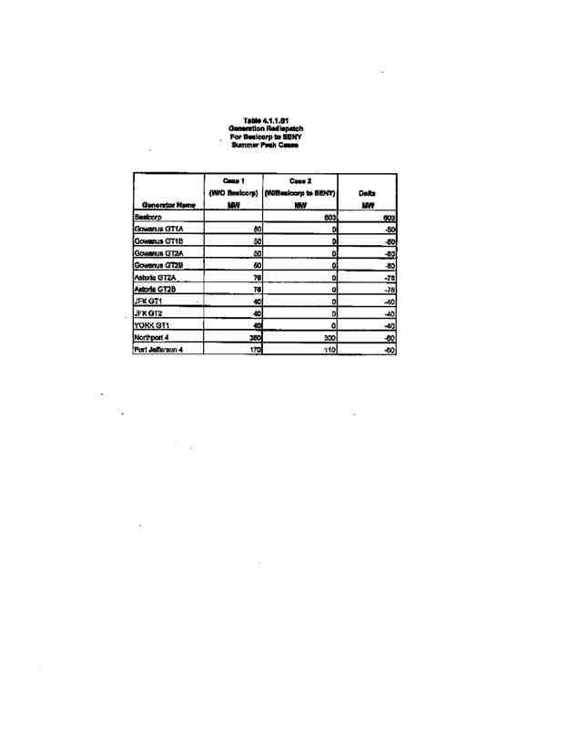

111

POWER CO. Project Initial facilities Study

Exhibit B to the Interconnection Agreement January 15, 2004

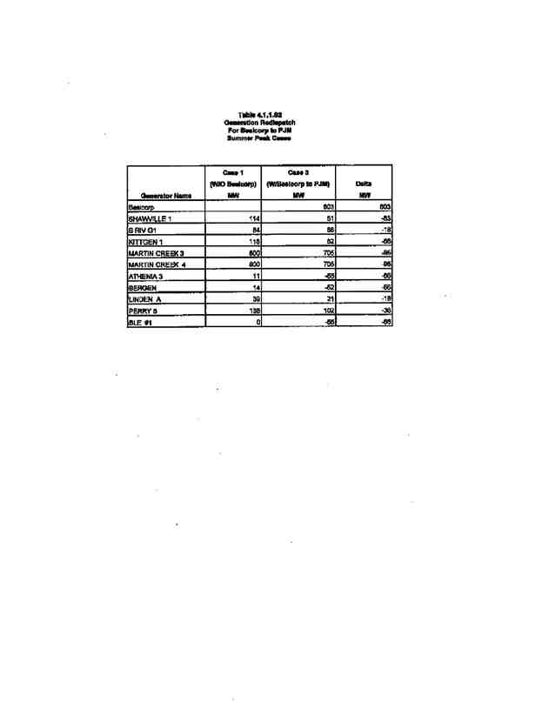

112

POWER CO. Project Initial facilities Study

Exhibit B to the Interconnection Agreement January 15, 2004

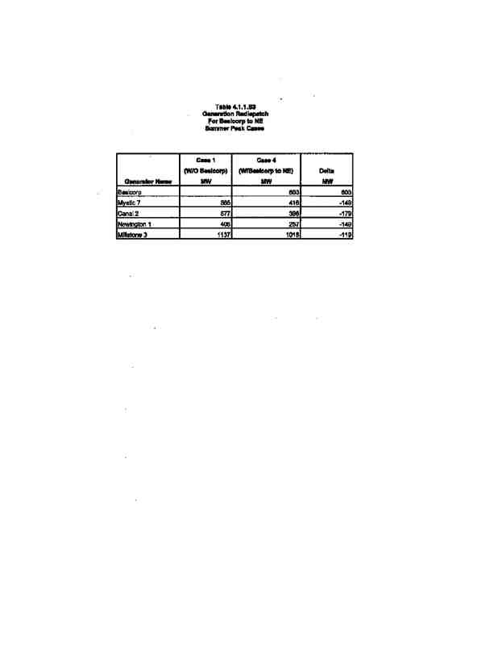

113

POWER CO. Project Initial facilities Study

Exhibit B to the Interconnection Agreement January 15, 2004

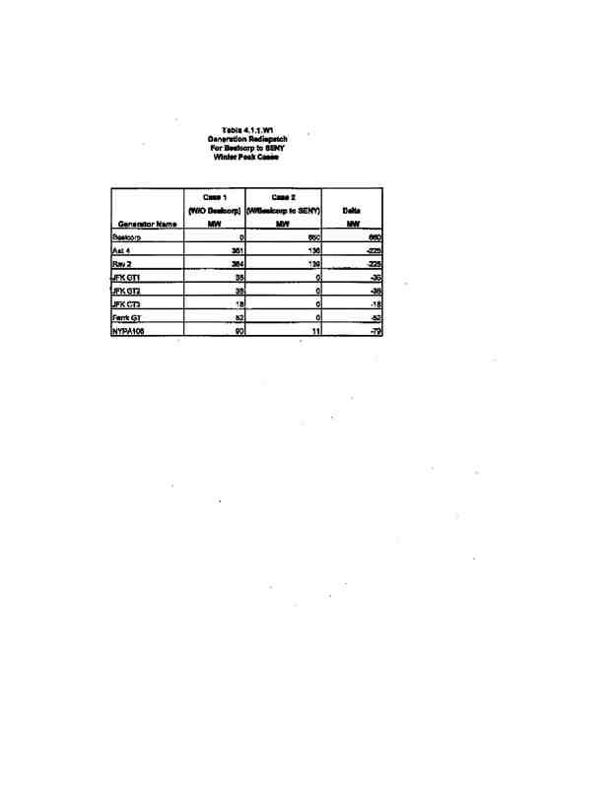

114

POWER CO. Project Initial facilities Study

Exhibit B to the Interconnection Agreement January 15, 2004

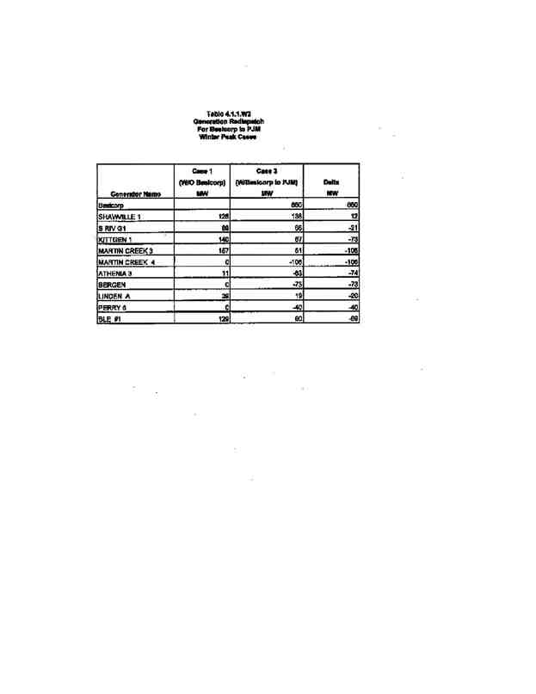

115

POWER CO. Project Initial facilities Study

Exhibit B to the Interconnection Agreement January 15, 2004

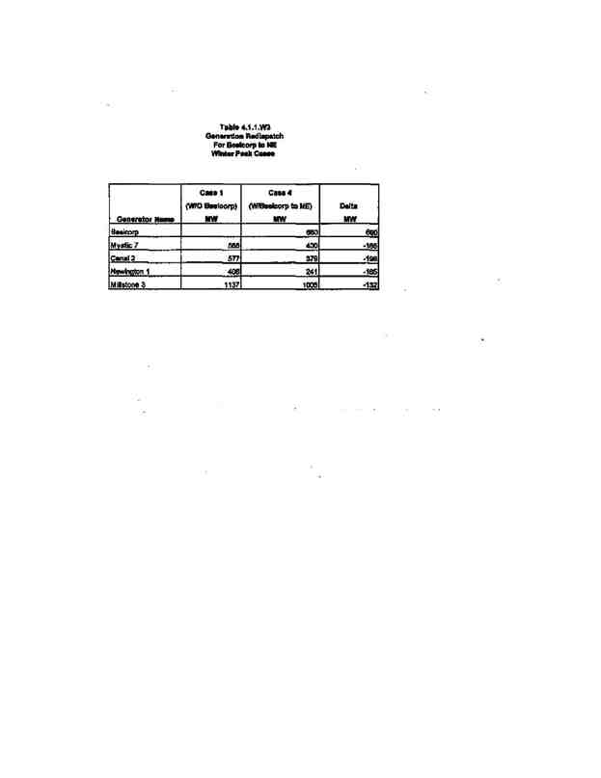

116

POWER CO. Project Initial facilities Study

Exhibit B to the Interconnection Agreement January 15, 2004

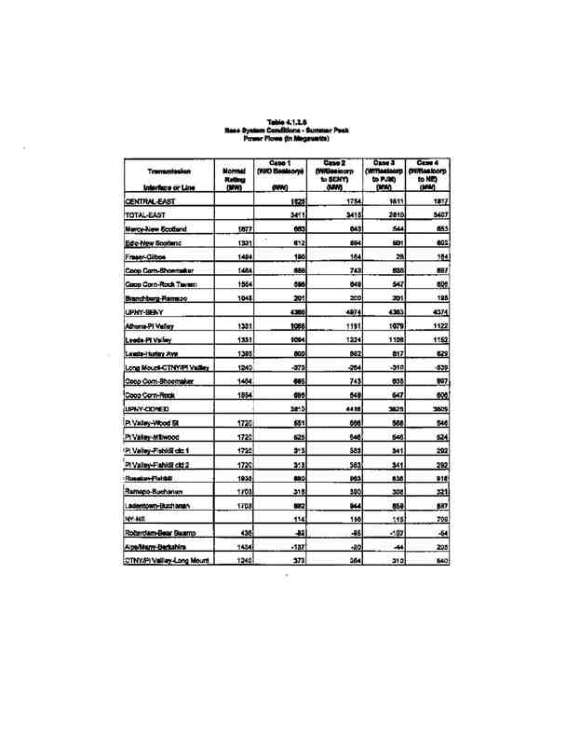

117

POWER CO. Project Initial facilities Study

Exhibit B to the Interconnection Agreement January 15, 2004

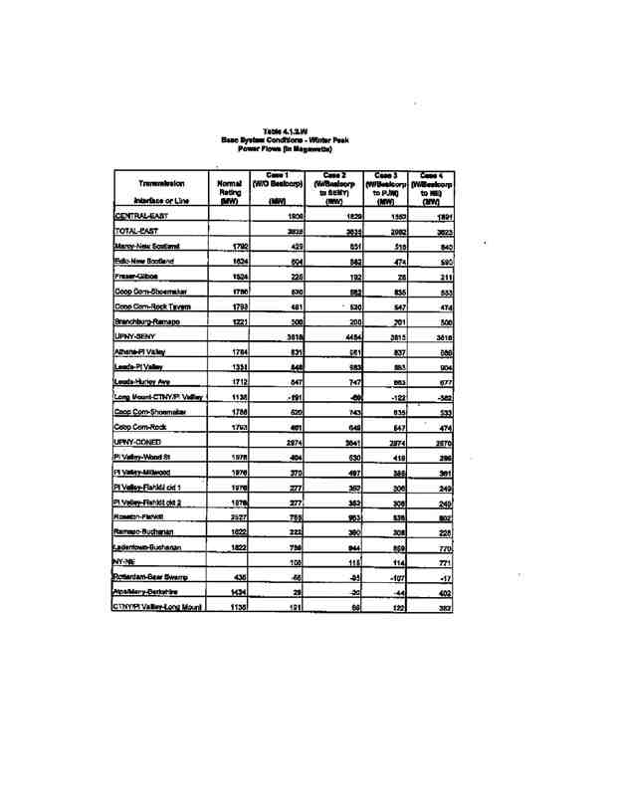

118

POWER CO. Project Initial facilities Study

Exhibit B to the Interconnection Agreement January 15, 2004

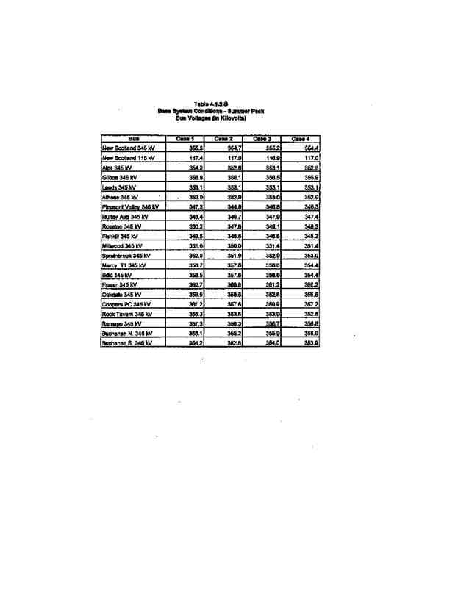

119

POWER CO. Project Initial facilities Study

Exhibit B to the Interconnection Agreement January 15, 2004

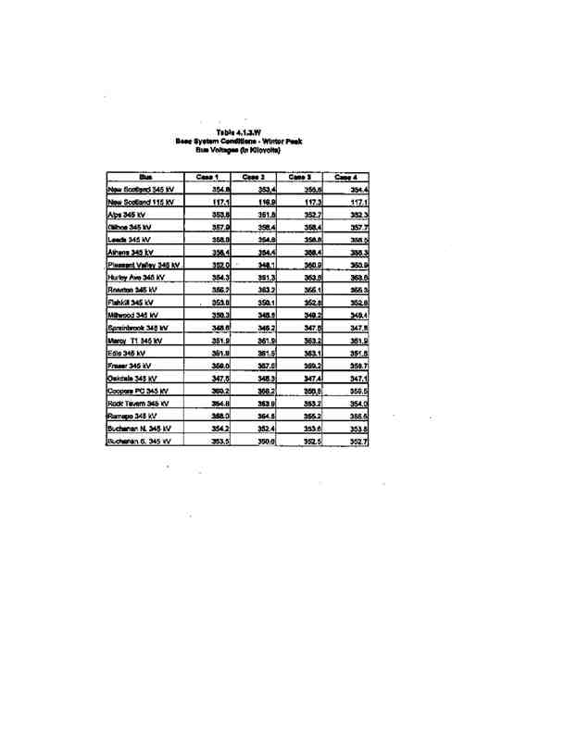

120

POWER CO. Project Initial facilities Study

Exhibit B to the Interconnection Agreement January 15, 2004

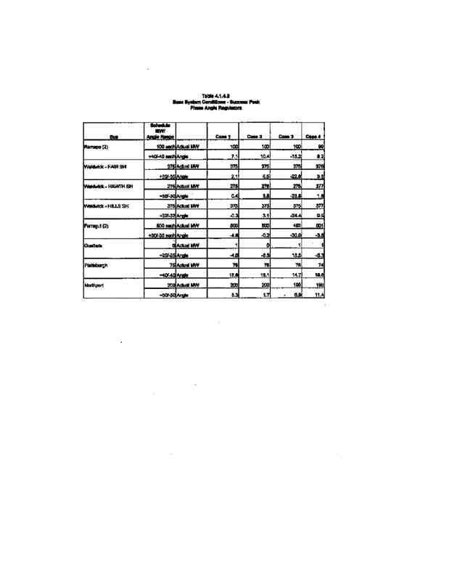

121

POWER CO. Project Initial facilities Study

Exhibit B to the Interconnection Agreement January 15, 2004

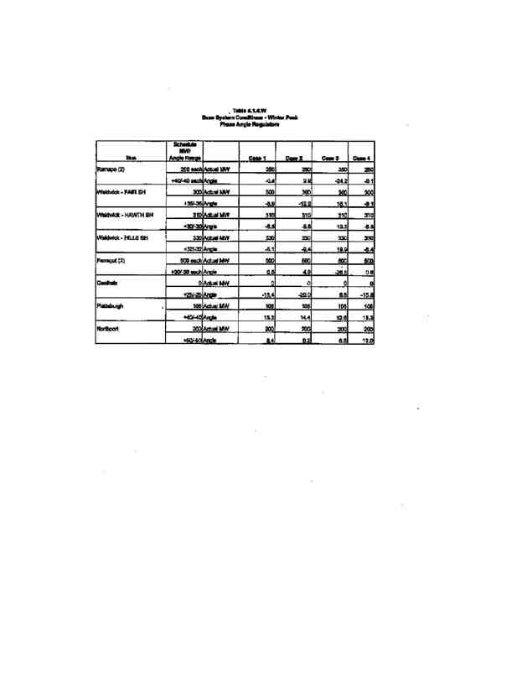

122

POWER CO. Project Initial facilities Study

Exhibit B to the Interconnection Agreement January 15, 2004

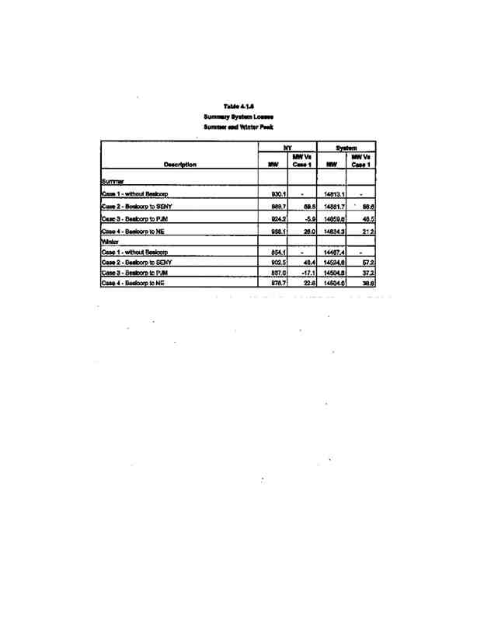

123

POWER CO. Project Initial facilities Study

Exhibit B to the Interconnection Agreement January 15, 2004

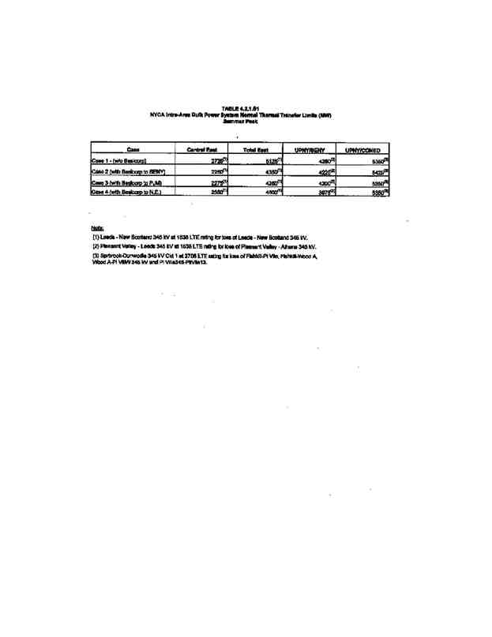

124

POWER CO. Project Initial facilities Study

Exhibit B to the Interconnection Agreement January 15, 2004

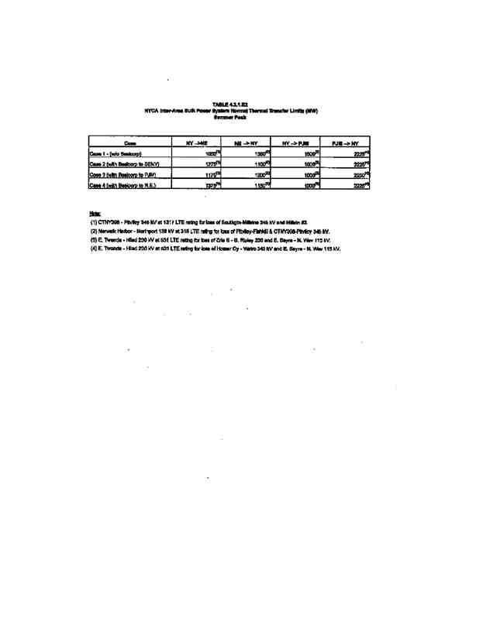

125

POWER CO. Project Initial facilities Study

Exhibit B to the Interconnection Agreement January 15, 2004

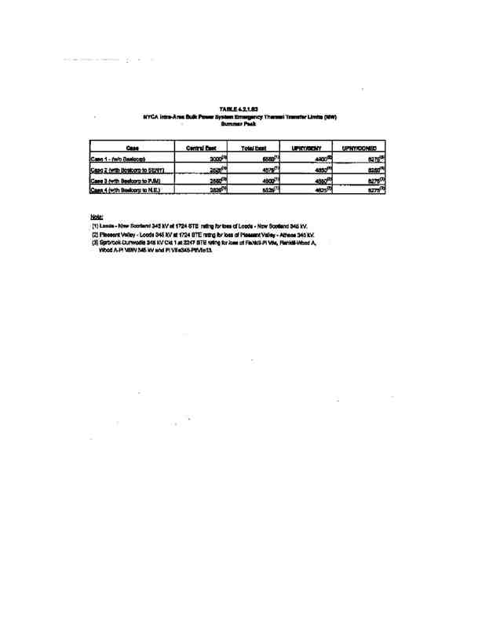

126

POWER CO. Project Initial facilities Study

Exhibit B to the Interconnection Agreement January 15, 2004

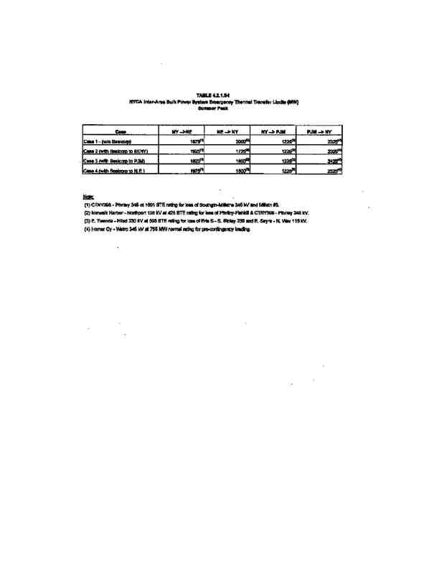

127

POWER CO. Project Initial facilities Study

Exhibit B to the Interconnection Agreement January 15, 2004

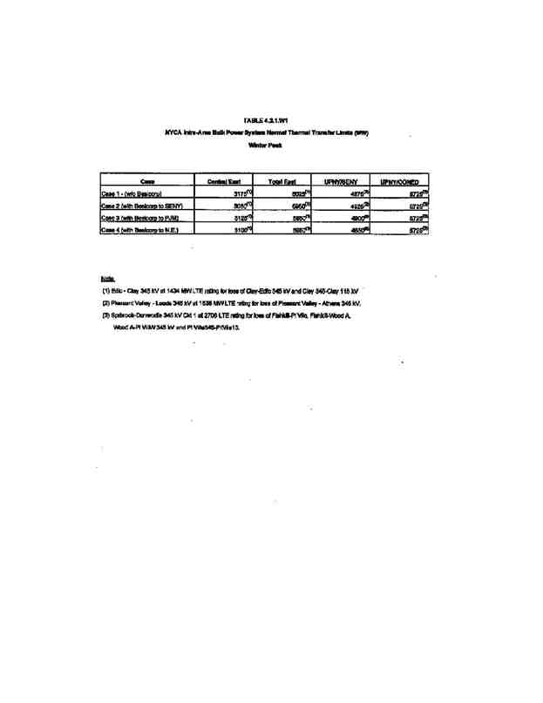

128

POWER CO. Project Initial facilities Study

Exhibit B to the Interconnection Agreement January 15, 2004

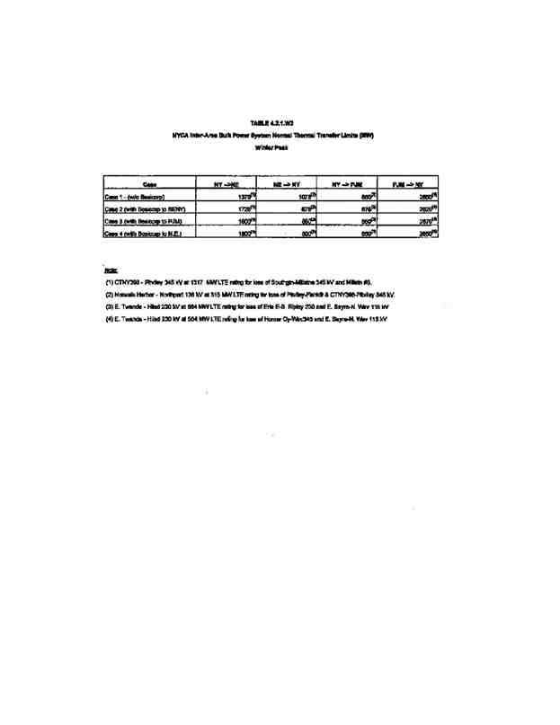

129

POWER CO. Project Initial facilities Study

Exhibit B to the Interconnection Agreement January 15, 2004

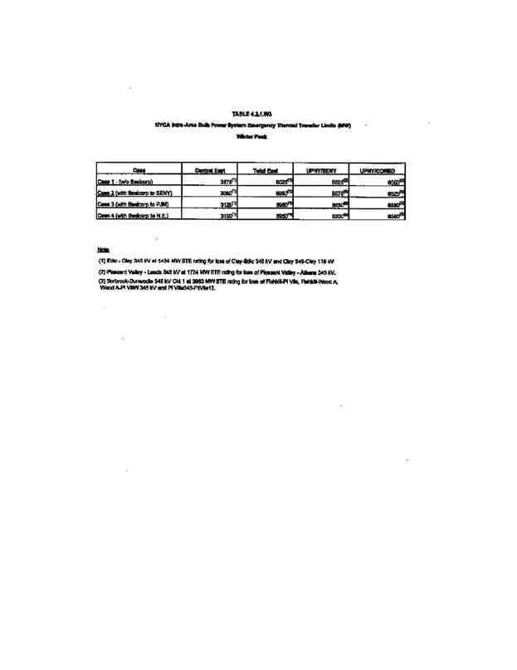

130

POWER CO. Project Initial facilities Study

Exhibit B to the Interconnection Agreement January 15, 2004

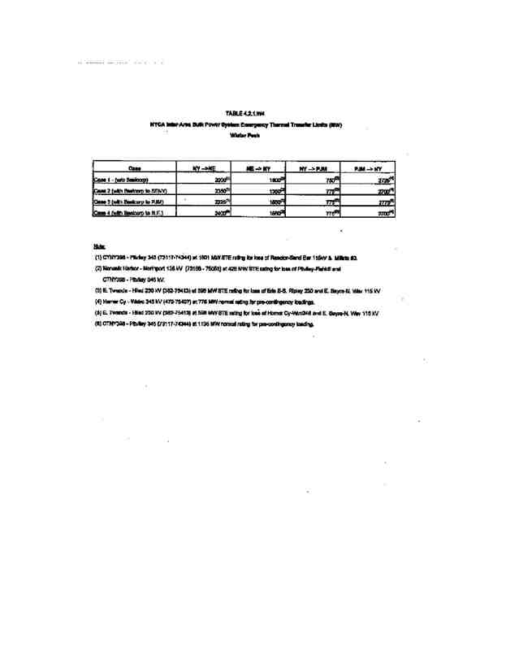

131

POWER CO. Project Initial facilities Study

Exhibit B to the Interconnection Agreement January 15, 2004

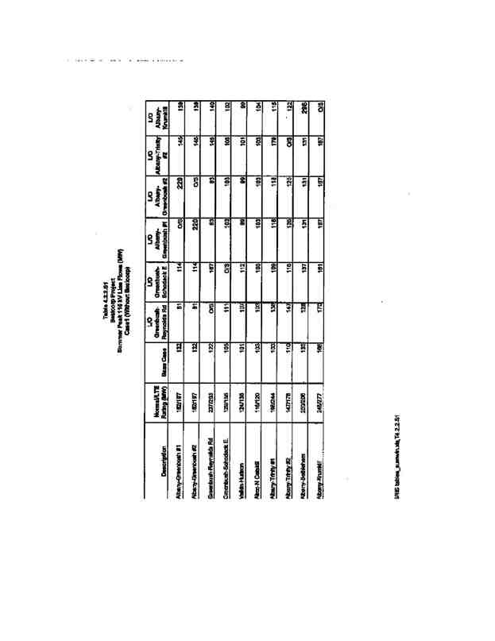

132

POWER CO. Project Initial facilities Study

Exhibit B to the Interconnection Agreement January 15, 2004

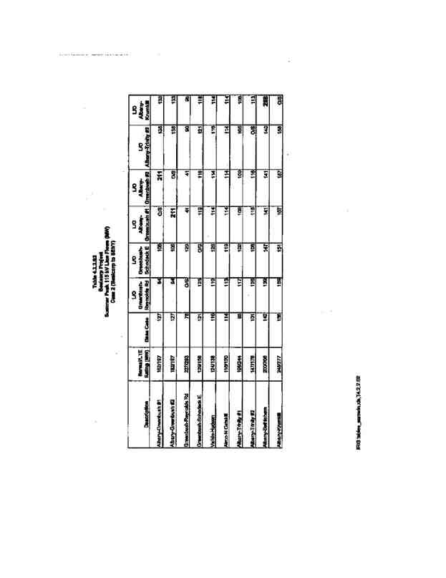

133

POWER CO. Project Initial facilities Study

Exhibit B to the Interconnection Agreement January 15, 2004

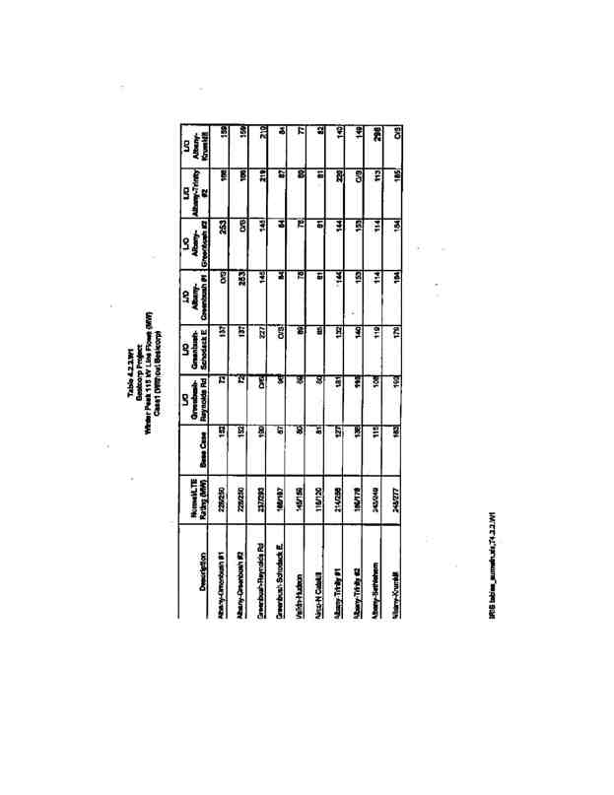

134

POWER CO. Project Initial facilities Study

Exhibit B to the Interconnection Agreement January 15, 2004

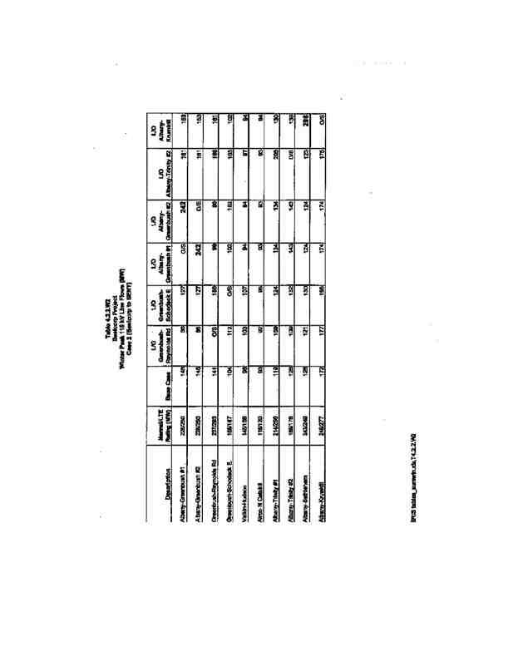

135

POWER CO. Project Initial facilities Study

Exhibit B to the Interconnection Agreement January 15, 2004

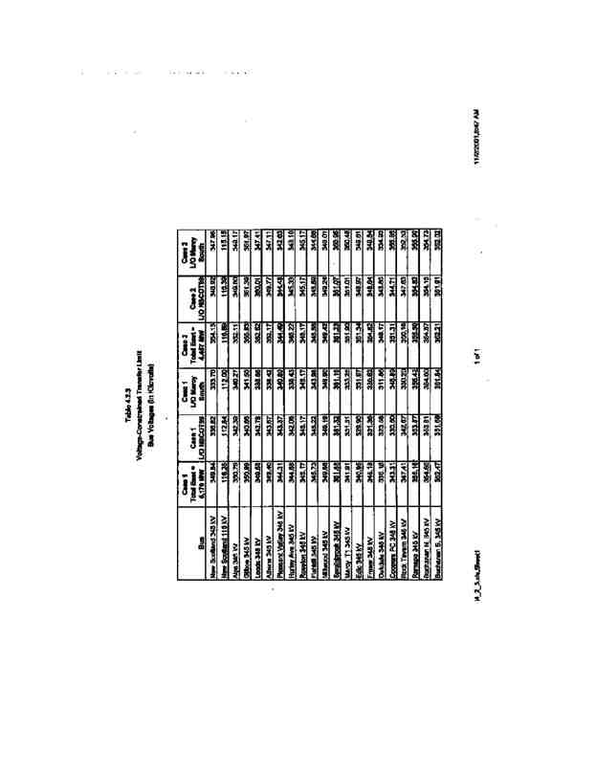

136

POWER CO. Project Initial facilities Study

Exhibit B to the Interconnection Agreement January 15, 2004

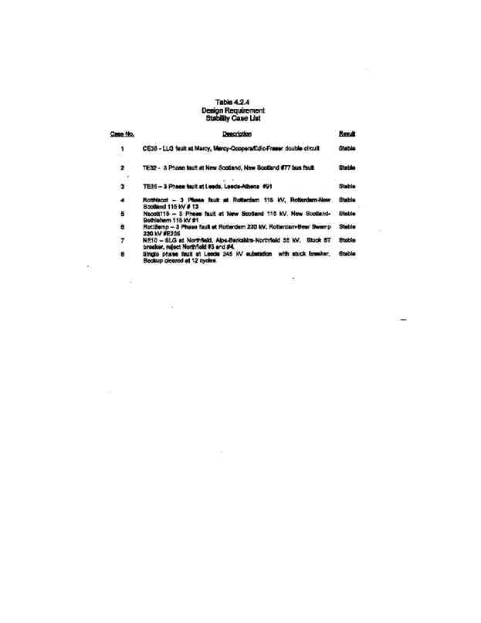

137

POWER CO. Project Initial facilities Study

Exhibit B to the Interconnection Agreement January 15, 2004

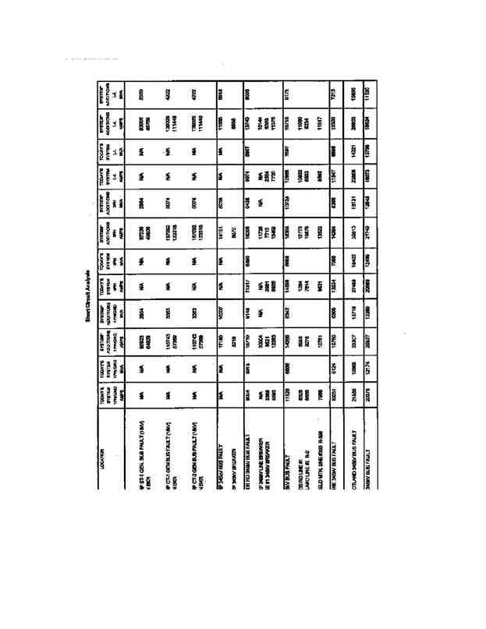

138

POWER CO. Project Initial facilities Study

Exhibit B to the Interconnection Agreement January 15, 2004

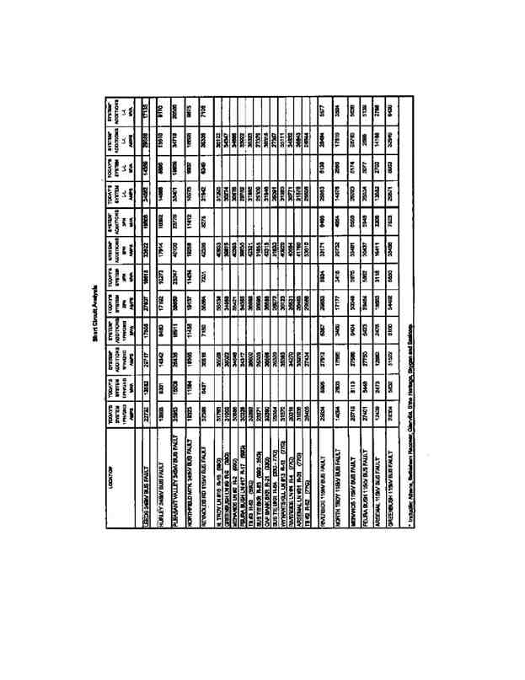

139

POWER CO. Project Initial facilities Study

Exhibit B to the Interconnection Agreement January 15, 2004

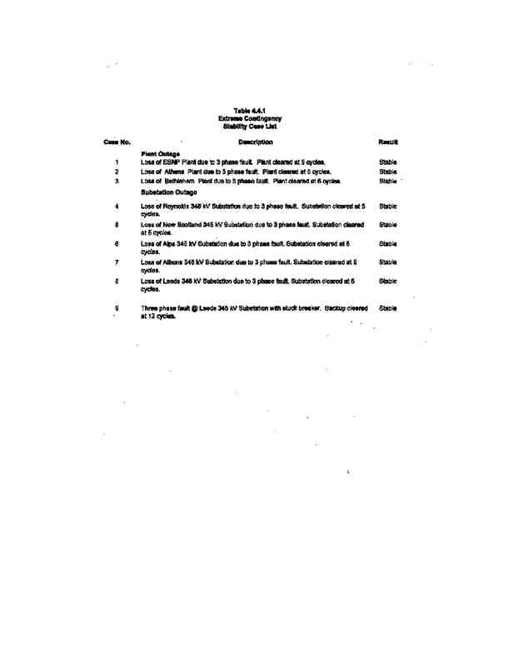

140

POWER CO. Project Initial facilities Study

Exhibit B to the Interconnection Agreement January 15, 2004

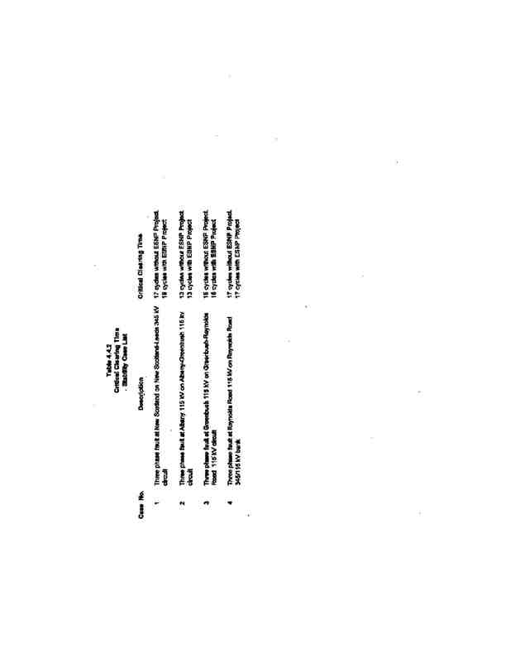

141

POWER CO. Project Initial facilities Study

Exhibit B to the Interconnection Agreement January 15, 2004

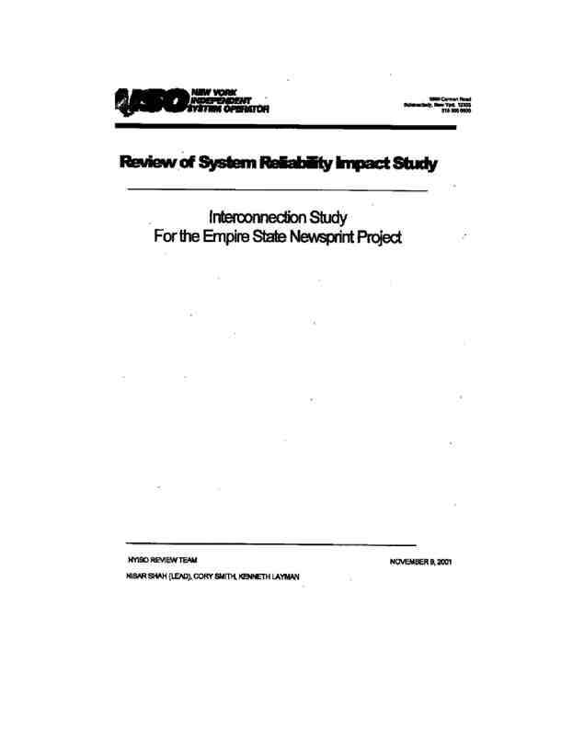

142

POWER CO. Project Initial facilities Study

Exhibit B to the Interconnection Agreement January 15, 2004



143

POWER CO. Project Initial facilities Study

Exhibit B to the Interconnection Agreement January 15, 2004

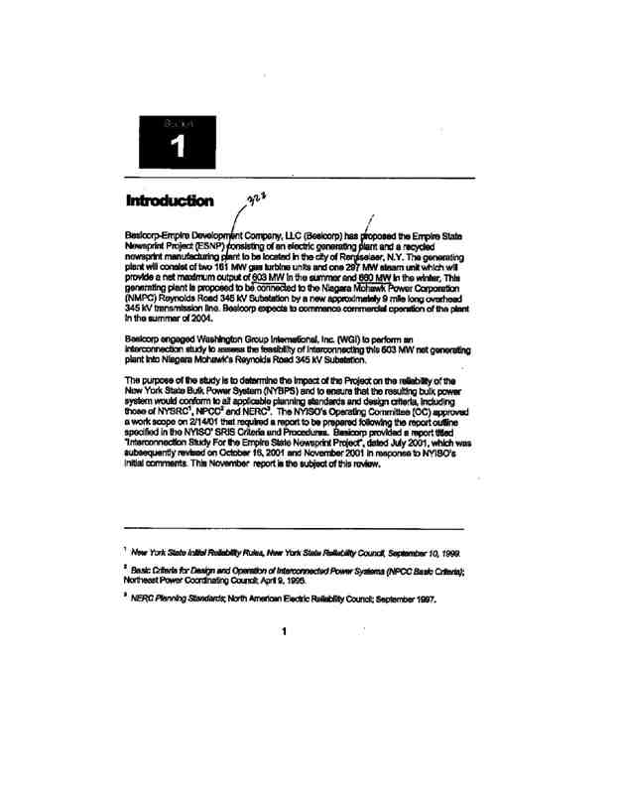

144

POWER CO. Project Initial facilities Study

Exhibit B to the Interconnection Agreement January 15, 2004

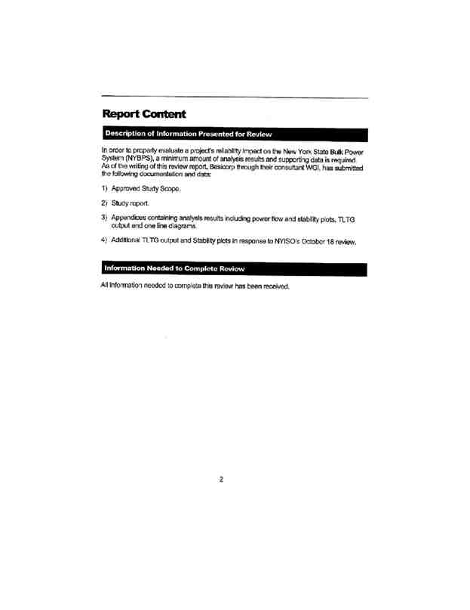

145

POWER CO. Project Initial facilities Study

Exhibit B to the Interconnection Agreement January 15, 2004

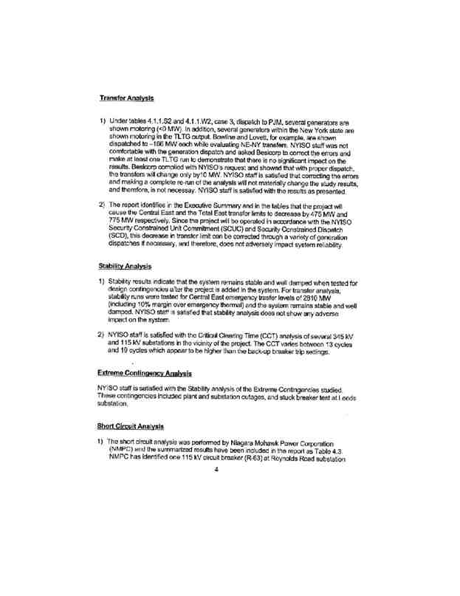

146

POWER CO. Project Initial facilities Study

Exhibit B to the Interconnection Agreement January 15, 2004

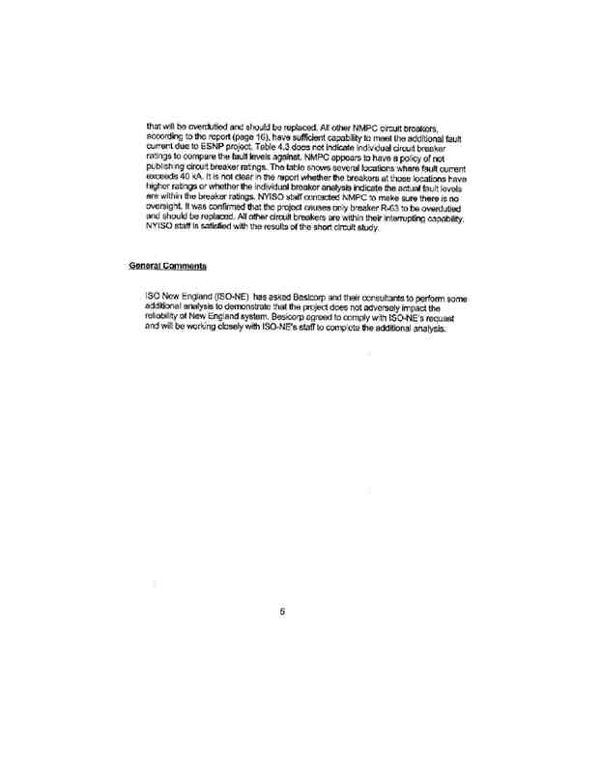

147

POWER CO. Project Initial facilities Study

Exhibit B to the Interconnection Agreement January 15, 2004

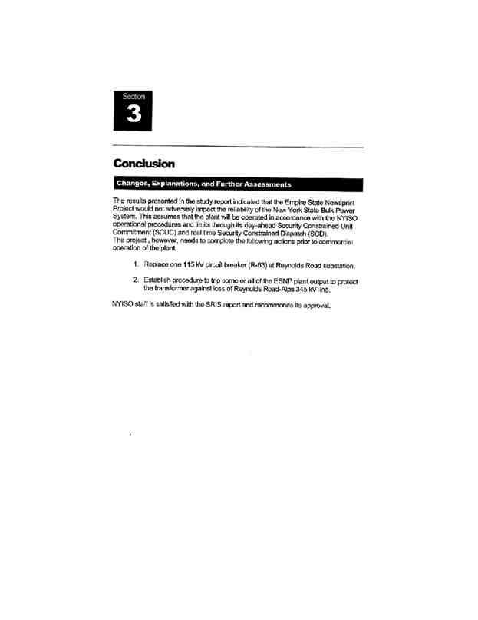

148

POWER CO. Project Initial facilities Study

Exhibit B to the Interconnection Agreement January 15, 2004