

SUPPLEMENT TO

SPECIFICATIONS FOR

ELECTRICAL INSTALLATIONS

SERVICE ABOVE 15,000 VOLTS

ELECTRIC SYSTEM BULLETIN No. 752

OCTOBER 1994, 2ND PRINTING APRIL 2002

(Supersedes issue dated June 1985 and incorporates Nov. 1999 Errata List)

ESB752-1994 2nd Printing 2002.doc/SEIC/mb

TABLE OF CONTENTS

Section Page

I. INTRODUCTION 4

A. PURPOSE 4

B. SCOPE 4

C. CUSTOMER'S RESPONSIBILITY 4

D. COOPERATION 4

E. CODES, STANDARDS AND WIRING ADEQUACY 5

F. INSPECTION 5

G. COMPLIANCE 6

4. Required Documents and Submission Process 6

II. DEFINITIONS 9

III. GENERAL 9

A. ACCESS 9

IV. SERVICE CONNECTIONS 9

A. GENERAL 9

B. OVERHEAD SERVICE CONNECTIONS 9

C. UNDERGROUND SERVICE CONNECTIONS 9

D. PHASE DESIGNATION 9

E. CONDUIT 10

V. CUSTOMER SERVICE EQUIPMENT 10

A. STATION REQUIREMENTS 10

1. Electrical Short Circuit Capability 10

2. Structural Design 10

3. Structural Materials 10

4. Foundation 10

5. Oil filled Equipment 11

6. Grading 11

7. Surfacing 11

8. Insulators and Connections 11

9. Station Fence or Wall 11

10. Signs 12

11. Illumination 12

12. Lightning Masts 12

B. SWITCHES & SWITCHGEAR 12

1. Disconnecting Switches 12

3. Panic Hardware 13

C. LIGHTNING ARRESTERS 13

D. FAULT PROTECTION EQUIPMENT 13

3. Power Fuses 13

4. Circuit Breakers 14

5. High Voltage Fault Interrupter 14

E. POWER TRANSFORMERS 15

1. Specification 15

2. Voltage Regulation 15

3. Grounding 15

4. Bushing Connections 15

5. Current Transformers 15

F. PROTECTIVE RELAYS AND COORDINATION 15

6. Phase Designation Coordination 16

7. Specific Relays 16

8. Location of Relays 16

9. Relay Test Facilities 16

April 2002 2 ESB 752-1994, 2nd Printing

TABLE OF CONTENTS (cont'd)

Section Page

10. Control Wiring 17

11. Exclusion of Current Transformer Selector Switches 17

G. OPERATION AND MAINTENANCE REQUIREMENTS 17

1. General Requirements 17

2. Specific Requirements 18

3. Switching 18

4. Maintenance 19

VI. GROUNDING 20

A. GROUND GRID 20

6. Ground Grid Resistance 20

B. CONNECTIONS TO GROUND GRID 21

5. Switches 21

VII. METERING 22

A. EQUIPMENT FURNISHED BY THE COMPANY 22

B. CUSTOMER'S RESPONSIBILITY 22

1. Meter Equipment Mounting 22

2. Secondary Connection Conduit 22

3. Meter Panel Specification 23

4. Meter Panel Location 23

C. REMOTE METERING 24

Figures

1 Application Diagram Electrical Clearances

2 Outdoor Structure Electrical Clearances

3 Safety Clearance Requirements

4 Indoor Structure Electrical Clearances

5 Station Grounding

6 Switch Mechanism Grounding

7 Fence Grounding Details

7A Alternative Fence Grounding Details

8 Meter House

9 Symbols for Service Equipment Diagrams

Illustrations

1 Typical 34.5kV Station

2 Typical 115kV Station

ESB 752-1994 2nd Printing 3 April 2002

I. INTRODUCTION

A. PURPOSE

1. This Supplement to Electrical System Bulletin (ESB) #750 provides general

requirements and recommendations for a Customer who is or will be supplied by a Niagara Mohawk, a National Grid Company (Company) designated voltage in excess of 15,000 volts.

2. Additional information specific to the particular installation will be furnished upon

determination of the station arrangement and station location as mutually agreed upon by the Customer and the Company.

3. It is important that the Customer and their engineer or contractor obtain and

refer to the Specifications for Electrical Installations booklet (ESB #750, latest

revision) in conjunction with this supplement.

B. SCOPE

1. These requirements are a guide to the Customer in making electrical installations

where the Company designates service voltage above 15,000 volts. The proper application of this guide will provide satisfactory service compatible with the electrical supply to others served by the Company System.

2. These requirements do not cover the Customer's complete electrical installation

design, but concern only those points in which the Customer, architect, their   
consulting engineer, electrical contractor, and the Company have a mutual interest.

3. The Company furnishes the incoming line either overhead or underground to the

Customer's electric station.

4. The Customer furnishes the complete electric station.

C. CUSTOMER'S RESPONSIBILITY

1. The Customer shall obtain building permits and/or zoning variances as required for

construction.

2. The Customer shall be responsible to ensure that provisions are included in any

station design for possible future expansion to accommodate additional Company interconnections, additional Customer interconnections or leads, and additional breaker, transformer or switching capability.

3. The Customer shall be responsible to have all electrical and physical design

documents prepared by a design professional, in accordance with Section 1.7 of

ESB 750, and as further detailed later in Section I.G of this bulletin.

D. COOPERATION

1. For a specific electric service installation, it is essential that the Company meet with

the Customer, their consulting engineer, contractor or equipment manufacturer to mutually establish the arrangement and location of the proposed facilities. As a result of this meeting,

a. The Customer will provide the Company with a single line diagram and station   
 location plan.

b. The Company will designate the supply voltage and provide available fault   
 values to the Customer.

April 2002 4 ESB 752-1994, 2nd Printing

2. If the Customer makes changes in the design or scheduling of the project, then any

previous specific information furnished by the Company shall be subject to review and possible change by the Company.

3. The information the Customer or their contractor furnishes to the Company in

regard to the Customer's proposed electrical installation shall be in writing.

4. The complexity of modern electrical installations makes it essential that there be

continuous close cooperation between all parties involved.

5. It is the Company's desire to assist the Customer in understanding details of their

electric service installation. When the information is not in this booklet, the Company invites inquiries from the Customer, their consulting engineer, their electrical contractor or their equipment manufacturer.

6. The Company's Consumer Relations Department will advise the Customer

concerning any contribution which may be required of them for materials supplied

and work performed by the Company.

E. CODES, STANDARDS AND WIRING ADEQUACY

1. The Customer's electric service equipment and its installation shall conform to the

requirements of the latest edition of the National Electrical Safety Code, National

Electrical Code (where Applicable), and all governmental ordinances, building

codes and Company requirements and specifications.

2. Components shall conform to the latest editions of the following national standards

and codes:

Component Applicable National Standard

Cable ICEA

Power Switchgear ANSI C37

Power and Instrument Transformers ANSI C57

Lightning Arresters ANSI C62

Insulators ANSI C29

Apparatus Bushings ANSI C76

Grounding IEEE 80

3. The Customer, their engineer, contractor and supplier should aim to provide a

modern, adequate electrical installation with ample provision for future needs.

4. IEEE Standard No. 1109 "Guide for the Interconnection of User-owned Substations

to Electric Utilities" is a publication that could be helpful.

F. INSPECTION

1. To protect the Customer's interest, as well as its own, the Company requires the

Customer to furnish satisfactory evidence from the local authority having jurisdiction as to the safe condition of their entire electrical installation before energizing the service to a new installation or re-energizing a service that has been disconnected for more than twelve (12) months.

2. This may be in the form of an approval or certificate from the New York Board of

Fire Underwriters, Factory Insurance Association, Factory Mutual Fire Insurance Company or other inspection organizations acceptable to the Company.

3. Catastrophic occurrences such as fire, flood, etc. shall require a new certificate as to

the safe condition of the entire electrical installation before re-energizing.

ESB 752-1994 2nd Printing 5 April 2002



4. Application for inspection should be made before the work is started.

5. When significant station alterations are made, a new approval or certificate is

required to assure compliance with safety requirements.

G. COMPLIANCE

1. THE CUSTOMER SHALL SUBMIT THEIR PLANS AND

SPECIFICATIONS TO THE COMPANY BEFORE ORDERING

EQUIPMENT OR STARTING WORK to insure that the proposed design for the

electric service installation conforms to Company requirements.

2. Before an order is placed for electrical equipment, three copies of the Customer's or

manufacturer's specifications shall be furnished to the Company for review and

acceptance.

3. Review and acceptance by the Company shall not be construed to be a certification

of the Customer's facilities. The Customer must obtain approval from a certified inspection agency.

4. Required Documents and Submission Process

The required delivery of the design documents shall be as described in submittal   
stages “a” through “d” below. Drawings shall be originals prepared by the

Customer’s retained design professional and comprehensively detail the design of the electrical facility on a single sheet to permit full interpretation and understanding of all aspects. The drawings shall be prepared in conformance with ANSI Y32.2, IEEE 141 and IEEE 446 symbol and drafting nomenclature. All devices specified shall be of power utility grade and not industrial grade.

In order to speed and efficiently facilitate review, no portion of a submission should   
be sent until every element of the package is complete, final and deliverable in a   
single package in any of the following stages. Unless otherwise requested and at the   
sole discretion of the Company, no individual document, or partial design, of a   
submission will be accepted for Company review until the Customer has declared   
that the package is complete. In all instances, six (6) complete sets of design   
documents shall be submitted for Company review and acceptance.

a. PRELIMINARY SUBMITTAL

Plot plan

Functional single line diagram with proposed ratings of disconnecting devices, over current protection, transformer size and impedance.

b. DETAILED ELECTRICAL DESIGN SUBMITTAL

Complete functional single line detailing all devices up to, and including, the Customer’s secondary protective device. It should include: all protective relays in sufficient detail to show intended operation; all instrument transformers with ratios, including excitation curves; power and station service transformers with ratios; etc.

List of proposed relay settings based on a formal relay coordination study. Settings shall not be shown on drawings.

Electrical AC ELEMENTARY in sufficient detail to show the functional   
control operation of the station. The elementary schematic diagram shall   
be in three-line format and show, by means of graphic symbols, all devices

April 2002 6 ESB 752-1994, 2nd Printing



having any interaction with the tripping function of the main protective   
device. Specifically, it shall include all individual items of equipment,   
devices within the equipment, their coils, contacts, windows, terminals,   
AC source, and each connection (wire, cable or bus) between equipment   
and devices.

Electrical DC ELEMENTARY, if required by protective device, in   
sufficient detail to show the functional control operation of the station.   
The D.C. elementary schematic diagram shall show, by means of graphic   
symbols, all devices having any interaction with the tripping function of   
the main protective device. Specifically, it shall include all individual   
items of equipment including batteries, battery charger, devices within the   
equipment, their coils, contacts, windows, terminals, and each connection   
(wire, cable or bus) between equipment and devices. (Note - Ladder-type

diagrams are not acceptable.)

Structural detail and foundation drawings of the high voltage receiving   
point.

Assembly plan and elevation details of the high voltage station and its safety structures including grounding plans.

Meter conduit drawings

Control house layout   
Relay panel drawings

Material lists of major components

Transformer nameplate and outline drawings

Main disconnect switch nameplate, showing ratings and certifications

Equipment specifications for lightning arresters; power fuses; main high   
voltage interrupter or breaker; main disconnect switch; switchgear; power   
transformer

c. FINAL, FOR-CONSTRUCTION SUBMITTAL

A complete set of all drawings and equipment specifications outlined above, marked final/for construction. Also, at this time the manufacturer’s test reports for the power transformer and circuit breaker or high voltage interrupter shall be submitted. This is the end of the design process. The full set of design professional sealed final documents shall then be submitted with the service application for review in total by the Company.

d. FINAL, AS-BUILT IN FIELD SUBMITTAL

Once construction is complete and the service energized, a full set of the drawings in item c above shall be submitted within 90 days. They shall accurately document the as-built status of the project, including any deviation from the final for-construction design drawings, and again be sealed by the Customer’s design professional.

5. Proposed location and arrangement of Company metering equipment shall be shown

on drawings submitted.

6. Relay diagrams shall always show relay contacts in the de-energized position.

ESB 752-1994 2nd Printing 7 April 2002

7. The Company will issue written instructions on operating procedures for the

Customer's service equipment directly involved with the Company's system. These   
instructions shall be followed in all operations involving the Customer's service   
equipment.

8. The following conditions are to be performed and/or maintained by the Customer's

contractor while working in the vicinity of the Company's overhead lines. This list shall be noted on the Customer's design drawings and posted at the work site.

a. No personnel or equipment or combination thereof shall come closer than the

following distances to any energized conductor: (From New York State High

Voltage Proximity Act - 1989.)

600V < 50kV >50kV<115kV 230kV 345kV

10 ft. 15 ft. 17 ft. 20 ft.

b. Equipment which is operated in the direct vicinity of the overhead lines shall be

effectively grounded.

c. Equipment which has the capability of extending within the wire clear zone

established above shall have a warning sign attached identifying the potential   
hazard.

d. No equipment utilized in site preparation grading, etc. shall be operated within

ten (10) feet of any electric line supporting structure.

e. There shall be no changes in grade within the Company's Right-of-Way unless

approved by the Company.

f. There shall be no excavation under the overhead lines within 15 feet of the

nearest wood member or guy anchor and/or 25 feet of the nearest steel member

of an electric line supporting structure.

g. All spoil not used to backfill the excavation shall be removed from the

Company's Right-of-Way.

h. There shall be no blasting on the Company's Right-of-Way.

i. The site preparation procedures shall include no activities which cause material

to flow off of the Company's Right-of Way.

j. No activities shall be permitted which compromise the electrical or structural

integrity of the overhead electric facilities.

k. No activities shall be permitted which prevent or inhibit the Company from

exercising reasonable ingress and egress along the Company's Right-of-Way.

l. The Company reserves the right to review and inspect for its purposes any

construction drawings, specifications, and activities being carried on within the

Company's Right-of-Way.

9. See Figures 1-4 for required electrical installation clearances.

10. The Company reserves the right to review and inspect the installation as it

progresses.

11. An authorized representative of the Company will examine the Customer's

installation before it is energized to insure compliance with these specifications.

April 2002 8 ESB 752-1994, 2nd Printing

II. DEFINITIONS

Note: Definitions as used in this specification are provided in the "Specifications for

Electrical Installations" book (ESB#750), Section 2.

III. GENERAL

A. ACCESS

1. Arrangements shall be provided so that authorized Company employees may have

access to the Customer's substation, switching facilities and metering at any time

and without delay.

2. A suitable driveway shall be provided by the Customer to permit truck or

maintenance vehicle access to the station area. This driveway should be adequate to

handle a crane and lowboy truck, if necessary, without additional work.

IV. SERVICE CONNECTIONS

A. GENERAL

1. The Customer shall provide a suitable receiving structure for attachment of the

Company's line, this attachment is the defined "service point."

2. The Company will provide a cable to flat terminal connector to connect the

Company's line to the Customer's equipment.

3. Service voltages above 15kV are unregulated. Voltage excursions of +10% are

possible. The Customer shall consider the installation of their own voltage

regulation equipment if necessary.

4. The Customer shall consult with the Company regarding right-of-way easements

required between the Company's line and the Customer's station.

B. OVERHEAD SERVICE CONNECTIONS

1. The Company will provide the incoming line dead end clamps, insulators, and

clevises for attachment of the Company's overhead line to the Customer's structure.

2. The Customer shall provide a suitable structural member for attachment of the

Company's hardware. This structural member shall have a hot dipped galvanized   
steel dead-end tee bracket mounted at each incoming conductor attachment point.   
This bracket shall have 13/16" mounting holes on 6" centers and the tab shall have a   
1" diameter hole with no less than 1-½" of material from the edge of the hole to the   
edge of the tab.

C. UNDERGROUND SERVICE CONNECTIONS

1. The Company will provide the incoming cable and terminations for attachment of

the Company's underground line to the Customer's equipment.

D. PHASE DESIGNATION

1. Phase Designation and Sequence

a. All the Company service circuits have the line leads designated with the phase   
 numbers 1, 2 and 3.

b. The Company will identify the phase number for each conductor at the point of   
 connection of the service circuit to the Customer's equipment; the Customer   
 shall mark their equipment accordingly.

ESB 752-1994 2nd Printing 9 April 2002

c. The phase sequence is 1-2-3 and rotation is counter-clockwise.

E. CONDUIT

1. Any conduit required for control circuits, metering circuits or power circuits shall be

furnished, installed, owned and maintained by the Customer. It shall be installed at

the following minimum depths:

Control circuits - 18"

Metering circuits - 18"

Power circuits below 600 V - 18"

Power circuits above 600 V - 30"

2. The conduit layout shall be approved by the Company before installation.

3. The installation of spare conduits is recommended.

4. Frost effects shall be taken into consideration when designing underground conduit

layouts.

V. CUSTOMER SERVICE EQUIPMENT

A. STATION REQUIREMENTS

1. Electrical Short Circuit Capability

The station equipment shall be suitable for the maximum fault current available at   
its supply terminals. The Company will provide the expected fault values available   
less the Customer contribution. Consideration for future system or load growth may   
require initial installation of service equipment having a larger interrupting rating.

2. Structural Design

a. Clearances:

(1) Standard electrical clearances shall be maintained, see Figures 1, 2, 3 and 4.

(2) Appropriate normal and minimal electrical clearances from energized parts   
 above walkways, roads, and railroads and in other special circumstances are   
 specified in the latest editions of ANSI C2 and IEEE Std. 1119.

(3) All clearances shall conform to state and local codes and ordinances.

b. Line Tensions:

(1) The structures shall be designed to withstand the conductor tensions   
 specified by the Company without exceeding the stresses specified in the   
 latest NEMA Standard SG-6 or latest superseding publication.

(2) Minimum tensions, spacings and heights for the service conductor attach-  
 ments will be provided by the Company for each installation.

3. Structural Materials

a. It is recommended that the substation structure be constructed of galvanized

structural steel conforming to NEMA and ANSI Standards.

b. Structures of other materials may be accepted if adequately designed.

4. Foundation

a. Foundation piers for the substation structure shall extend below the frost line

and shall withstand the overturning moment resulting from the specified

April 2002 10 ESB 752-1994, 2nd Printing

conductor tension and wind loads.

b. Foundations for transformers and other apparatus may be of the slab type resting   
 on 12" of #2 crushed stone. Soil pressures appropriate to the soil conditions in   
 the station area shall be used in designing foundations.

5. Oil filled Equipment

a. Spacing of oil filled equipment - the Customer should use NFPA 850 as a guide   
 and consult their insurance carrier for separation requirements.

b. Oil Containment

(1) The station must be designed and installed to comply with Title 40, Code of   
 Federal Regulations, Part 112 "Oil Pollution Prevention" (40CFR112).

(2) Compliance to 40CFR 112 shall be verified in writing by the Customer's   
 engineer from transformer design data and design data for any other oil-  
 filled electrical equipment at the station facility.

c. For further guidance on fire prevention and oil-spill containment, see IEEE Std.   
 979 and IEEE Std. 980.

6. Grading

a. The rough grade of the substation site should have a minimum slope of 1" in 10',   
 sloped toward drainage ditches or tile designed to carry the runoff of surface   
 water.

b. The design should insure a dry surface throughout the substation area.

7. Surfacing

The area of the substation, including 3' outside of the fence, should be surfaced with at least 6" of #2 crushed stone.

8. Insulators and Connections

a. All power connections shall be adequately supported to resist the mechanical   
 stresses including those imposed by short circuit current equal to the interrupting   
 current rating of the circuit protective means.

b. Where, because of atmospheric contamination or for other reasons, the   
 Customer's station switch insulators or bushings are rated for voltage higher than   
 actually supplied, appropriate coordinating gaps shall be installed.

9. Station Fence or Wall

a. At a minimum, outdoor installations shall be protected by an 8' high (minimum)   
 grounded wire mesh fence. This fence shall consist of at least 7' high wire fabric   
 of at least #9 gauge galvanized wire, 2" mesh, topped by 3 strands of barbed   
 wire; and such gates, removable sections, etc. as necessary.

b. Other fence materials or walls may be substituted where approved by the   
 Company.

c. All gates shall be provided with hasps with provisions for Customer and   
 Company padlocks so that only authorized persons have access into the fenced   
 area. Refer to Figure #3 for safety clearance to fence.

ESB 752-1994 2nd Printing 11 April 2002

10. Signs

a. The Customer shall provide signs, 12" x 17", installed on the outer sides of the   
 station fence with maximum of 50 feet apart or minimum of one on each side   
 and rear of fenced area, all personnel and vehicle gates, and on all entry doors to   
 station control rooms, each sign reading in large legible letters, "DANGER -  
 High Voltage Within - Keep Out - Access Restricted to Qualified Persons   
 Only".

b. In addition, there shall be a 20" x 28" sign mounted on the fence gate which   
 reads, "DANGER, Private Property, No Trespassing".

11. Illumination

a. The Customer shall provide suitable illumination for the substation area.

b. Appropriate minimum lighting levels for various circumstances of indoor,   
 outdoor, and roadway areas are given in the latest editions of NFPA 70 and   
 ANSI C2.

c. Emergency lighting shall be provided in attended areas in accordance with local   
 codes and regulations.

12. Lightning Masts

a. The substation structure shall be equipped with suitable lightning masts   
 providing the necessary cone of protection. The "rolling sphere" method is   
 acceptable for shielding against direct lightning strokes using a 250 ft. radius   
 sphere.

b. Other lightning protection measures may include:

shield wires, arrays, arresters, higher BIL levels, etc. However, overhead ground wires are not to be used over station equipment.

c. For more information on direct stroke lightning protection, see NFPA 780.

B. SWITCHES & SWITCHGEAR

1. Disconnecting Switches

a. One vertical break disconnecting switch shall be provided for each service   
 circuit at the point where the service circuit attaches to or enters the Customer's   
 station.

b. This switch shall be three pole, single throw, gang operated.

c. The switch shall be in accordance with ANSI Standard C37 for Power

Switching Equipment, NEMA and UL guidelines.

Note: The ice test shall pass for 1/2" ice loading, NESC Heavy.

d. The switch mechanism may be manually or electrically operated.

e. This mechanism shall be provided with a means for locking in both open and   
 closed position.

f. The operating handle shall be grounded and connected to a potential equalizing   
 grid.

g. It is recommended that where the station arrangement makes it practical, the

April 2002 12 ESB 752-1994, 2nd Printing

switch operating mechanism should be interlocked with the circuit breaker or fault interrupter so that the switch will not be used to interrupt load current.

h. Where the switch may be used to interrupt transformer magnetizing current, a   
 load break switch may be required.

i. For outdoor installations, this switch shall be horizontally upright mounted.

(1) The switch should be a vertical break rotating insulator type with three   
 insulator stacks per pole.

(2) The switch shall be complete with arcing horns.

(3) All non current carrying metal parts should be either hot-dipped galvanized   
 steel or corrosion resistant material of adequate strength.

(4) Other types of switches may be acceptable with prior Company approval.

j. Insulators shall be of the porcelain (ceramic) type; other types may be acceptable

with prior Company approval.

k. After installation and before being energized, the switch must be thoroughly   
 operationally tested in accordance with manufacturer's instructions.

2. Construction of the switchgear control building shall conform to National Fire

Protection Association (NFPA), U.L., and all local fire codes.

3. Panic Hardware

a. Doors to switchgear rooms or walk-in metal clad switchgear shall be equipped

with panic hardware.

b. The lock preventing access to these rooms shall not prevent egress.

C. LIGHTNING ARRESTERS

1. Recommended lightning arrester voltage rating in kV MCOV and type will be

provided by the Company.

2. Lightning arresters should normally be connected on the load side of the service

disconnecting switch.

3. Where lightning arresters must be connected on the supply side of the service

disconnecting switch, each arrester shall be provided with a separate isolating

switch.

4. Lightning arresters shall be mounted so that their bases are a minimum of 8'-6"

above grade or floor level; otherwise, a suitable guard fence or metal enclosure shall

be provided around them.

D. FAULT PROTECTION EQUIPMENT

1. Fault protection equipment shall be designed for the maximum voltage rating of the

service and shall be capable of interrupting the maximum short circuit current   
available from the system to isolate a short circuit from the supply, see Figure 2.

2. Circuit interrupting devices containing flammable materials shall be adequately

segregated from other equipment and buildings to limit damage in the event of an explosion or fire, see ANSI C2 NESC.

3. Power Fuses

a. Where fuses are applicable for protection of service installations and are desired

ESB 752-1994 2nd Printing 13 April 2002

by the Customer, their rating and time-current characteristics will be specified by the Company to coordinate with the supply system protective equipment.

b. Substitution of any fuse, other than that specified, must have Company approval.

c. The Customer should maintain a stock of at least four spare fuses, a spare set of   
 fuse clips, and fuse or switch operating poles as required; all in an accessible dry   
 storage space.

4. Circuit Breakers

a. Circuit breakers used in service installations shall be three pole and of a rating

acceptable to the Company.

b. Breakers may be oil or oil-less type (such as vacuum or SF6 (Sulfur

Hexafluoride) gas-insulated).

c. Breakers shall be in accordance with latest ANSI Standard C37 for Power

Circuit Breakers.

d. It is recommended that circuit breakers be tripped by direct current supplied

from a battery.

(1) Such a battery shall be rated not less than 48 volts, with ampere hour   
 capacity suitable for the application.

(2) Facilities shall be provided to maintain the battery in a fully charged   
 condition.

(3) Capacitor trip devices are not acceptable.

e. The Customer's circuit breaker source side bushings shall be equipped with

current transformers having characteristics as specified by the Company to   
supply protective relays associated with the circuit breaker. Potential

transformers may also be required. Relay data and transformer ratios shall be marked on the single line diagram.

f. The use of bypass switches around protective devices is not permitted.

Note: Using a transfer breaker and transfer bus can avoid this concern.

5. High Voltage Fault Interrupter

a. In locations where system conditions would normally require installation of a   
 circuit breaker, the use of other types of fault interrupters may be approved by   
 the Company.

b. The fault interrupter shall be furnished with a control pack approved by the   
 Company. The motor and control voltage shall not be less than 48 volt D-C.

c. Where a fault interrupter is provided, the source side bushing of each phase of   
 the Customer's power transformer shall be equipped with current transformers.

(1) These current transformers shall be the source for the relays which will   
 actuate tripping of the fault interrupter.

(2) The relay data and current transformer ratio shall be marked on the single   
 line diagram.

d. Where a fault interrupter is provided, a remotely located Company line circuit   
 breaker will normally interrupt faults in excess of the fault interrupter rating.

April 2002 14 ESB 752-1994, 2nd Printing

e. The Customer, in selecting this type of protection, runs the sole risk and   
 responsibility for damage to their own equipment as would be the case if they   
 supplied their own main circuit breaker.

E. POWER TRANSFORMERS

1. Specification

Power transformer specifications shall be mutually agreed upon by the Customer and Company in accordance with nationally accepted standards.

2. Voltage Regulation

a. Voltage taps should be specified to best deliver the rated low voltage over the   
 range or normal system operating voltages.

b. The Customer should consider the use of regulators or transformers with load   
 tap changing equipment if critical voltage control is required for their facility.

3. Grounding

a. It is the Customer's responsibility to specify the method for grounding the   
 transformer secondary neutral, i.e. - solidly grounded, resistance grounded,

impedance grounded, or ungrounded.

b. The Customer shall furnish, install, own and maintain any grounding equipment.

4. Bushing Connections

a. Connections to power transformers shall be non-rigid to guard against undue   
 thermal or mechanical stress on transformer bushings.

b. Adequate cable support is required to prevent undue stress on the transformer   
 bushings.

5. Current Transformers

a. For test purposes to pass current, current transformers in the Customer's power   
 transformer neutral circuit shall be externally mounted. This applies to the   
 neutral only.

b. Neutral current transformers shall be located on the transformer side of the   
 resistors or reactors etc., and shall be rated for full line-to-neutral voltage.

F. PROTECTIVE RELAYS AND COORDINATION

1. The Customer or their authorized representative shall be responsible for the proper

installation, adjustment and operation of protective relays and switchgear including periodic test procedures, as outlined in NFPA 70B - Electrical Equipment Maintenance, to maintain proper operation of service entrance equipment.

2. The Company may require some of these tests to be performed by Company

personnel to insure coordination with the electrical supply system.

3. The Company will seal the designated relay devices listed on the Company-supplied

relay setting sheets, verify accuracy of associated circuit wiring, and perform a functional test of the required interrupting devices, i.e. trip test.

4. Periodically, the Company will check the Company designated relay devices. The

check will consist of a visual/mechanical examination of the designated required

relay devices, seals and associated wiring. If seals are broken, the protective devices

shall be recalibrated, tested and re-sealed. Cost of corrections will be borne by the

ESB 752-1994 2nd Printing 15 April 2002

Customer.

5. The Customer is responsible for specifying the relay settings and performing the

calibration, testing, maintenance and trouble-shooting of the remainder of the Customer-owned protective system.

6. Phase Designation Coordination

a. Coordination of the Customer's low voltage phase designation with that of the   
 high voltage service circuit phase designation shall not be overlooked.

b. Customer's installation layouts shall provide phase designations fully   
 coordinated between high voltage and low voltage equipment.

c. The Company will assist the Customer to this end, providing the Company   
 receives composite wiring diagrams from the high voltage service circuits to the   
 low voltage load circuits.

d. Phase designation coordination will facilitate checking of protective relay   
 wiring, testing of relays, and proper installation and operation of all the   
 Customer's electrical facilities.

e. Isolated, fragmented and individual wiring diagrams for units of the Customer's   
 installation are not sufficient for checking phase arrangement.

7. Specific Relays

a. The Company's minimum requirements and recommendations for protective   
 relay facilities for a specific electric service installation will be provided upon   
 submission of the single line diagram.

b. If during the course of a project, changes and additions to the single line diagram   
 are identified, then such changes and additions shall be submitted to the   
 Company on a revised single line diagram for the Company's approval prior to   
 implementation or purchase of equipment.

8. Location of Relays

a. All relays for the Customer's service installation whose operation could affect   
 the Company's facilities should be readily accessible to authorized personnel of   
 both the Customer and the Company.

b. Relays should be located so as to be free of dust, dirt, dampness and corrosive   
 atmosphere.

9. Relay Test Facilities

a. All protective relay connections shall be provided with suitable test points to   
 facilitate initial, as well as periodic check and calibration.

b. Lockout auxiliary relays shall be provided with test devices. Draw-out case   
 design relays with built-in test facilities are recommended. If separate test   
 devices are used, they shall be General Electric type PK-2 or ABB

(Westinghouse) FT-1 test blocks with the wiring between the test block and the relay in accordance with Company standards. Information on these standards will be provided when requested by the Customer.

c. A 120/240 volt, 50 ampere, single phase, three wire, NEMA 10-50, convenience   
 receptacle (Hubbell #7963), or equal, located near the relay panel, shall be   
 provided for relay testing purposes.

April 2002 16 ESB 752-1994, 2nd Printing



d. Where three phase relaying and/or metering will be installed, a three phase   
 100A, 208Y/120V source is required.

10. Control Wiring

a. DC control wiring in locations subject to dampness, for individual conductors,   
 shall be ICEA Class "B", 600 volt rated.

b. All multiple conductor control cables shall be ICEA Class "C", 600 volts with   
 jacket thickness as specified by ICEA.

c. Cable systems required to interconnect protective relaying, metering,   
 instrumentation, control, communications, and low-voltage power equipment   
 systems should be in conformance with IEEE Std. 525.

d. Supervisory Control - Customers who wish to use Supervisory Control and Data   
 Acquisition (SCADA) systems shall follow the guidelines set forth in   
 ANSI/IEEE Std. C37.1.

11. Exclusion of Current Transformer Selector Switches

a. Meter selector switches or meters shall not be connected into the secondary   
 circuits of current transformers used with protective relays specified by the   
 Company.

b. If separate metering current transformers cannot be provided, the metering must   
 be isolated by suitable saturating auxiliary current transformers.

G. OPERATION AND MAINTENANCE REQUIREMENTS

The following is in the mutual interest of the Company and the Customer where   
the Customer's service equipment is directly involved with the Company's System.

1. General Requirements

a. The switching protocol procedure for the mutual interest of the Company and

the Customer will be provided by the Company based on the following information from the Customer:

Contact personnel and telephone numbers and

Single-line diagram from Section I.G above of the Customer’s primary and secondary equipment directly involved with the Company’s system.

b. The Customer is responsible for maintaining this information up-to-date and

notifying the Company of any changes.

c. All switching within the Customer's service equipment above 15 kV, shall be in

accordance with Company provided customer operating instructions. The Customer is responsible for developing operating instructions for the balance of their electrical system.

d. The Company can provide isolation and grounding guarantees at the Customer's

service disconnect or Company isolation point on the supply line ahead of the Customer's service equipment. However, the Customer is responsible for their grounding provisions to work on their de-energized equipment.

e. The Customer shall operate within established Company mark up rules in any

switching operations with the Company for their equipment that both the   
Company and the Customer have a mutual interest. It is expected the Customer

ESB 752-1994 2nd Printing 17 April 2002



will provide a qualified person as defined in the National Electrical Code and any other applicable codes.

f. The Customer must recognize and abide by the Company's mark up rules. The   
 Customer shall conduct their switching based on their switching practices   
 insuring that the Company's mark up is not jeopardized or modified.

g. References to minimum customer requirements for maintenance, operating, and   
 safety of their high voltage installation include but are not limited to:

NFPA 70B "Recommended Practice for Electrical Equipment Maintenance"

NETA-MTS "Maintenance Testing Specifications for Electrical Power Distribution Equipment and Systems"

NFPA 70E "Electrical Safety Requirements for Employee Workplaces" IEEE/ANSI C2 "National Electrical Safety Code"

OSHA 29 CFR 1910.269

2. Specific Requirements

a. Service Personnel and Safety:

The Customer is responsible for performing all switching and O&M functions for their equipment.

The Customer shall arrange to have qualified personnel available at all times for the proper and safe operation of their equipment.

"Qualified Personnel" training shall cover correct operating and safety procedures including, but not limited to:

distinguishing exposed live parts,

determining the nominal voltage of exposed live parts,   
determining of the minimum approach distance, and

the use of precautionary techniques, personal protective equipment, insulating and shielding materials, and insulated tools for working on or near exposed live parts of electrical equipment.

b. The Company does not provide any operating tools for the Customer's use.

The Customer shall provide their own operating equipment such as tongs,   
insulating switching sticks, insulated rubber gloves, grounds, ground bails,   
studs and grounding sticks; voltage detection equipment, etc. needed for the

safe performance of operating functions. This operating equipment shall be   
properly maintained and tested according to the manufacturer's instructions.

c. Line terminations and the metering transformer compartments of the

Customer's switchgear will be locked by the Company when the Company's work is completed and marked clear with the Controller.

3. Switching

a. All switching or other work on high voltage circuits shall be performed by

qualified personnel fully equipped with safety equipment tested for the circuit

voltage involved.

April 2002 18 ESB 752-1994, 2nd Printing

b. All Company directed switching within the Customer's station shall be done in

accordance with Company-provided switching instructions.

c. The Company will provide nomenclature for Customer's labeling of the main

disconnect switch and other electrical equipment referred to in the Company's switching instructions. The Customer shall make provisions for the labeling of this equipment and any necessary mark-up tag holder.

d. Tags shall be used to prohibit operation of electrical devices and shall indicate

that employees are at work. Equipment shall be locked and rendered   
inoperable by locking and tagging unless its design does not so permit. Tags   
alone may be used when the equipment can not be rendered inoperable by   
locking.

e. NO WORK SHALL BE DONE ON AN AIR BREAK SWITCH WHILE THE

INCOMING LINE IS ENERGIZED.

(1) Notify the Company and arrange for an interruption and a guarantee before   
 doing any work at or near this section. Also, if requested, a grounding   
 guarantee may also be requested.

(2) THE MAIN DISCONNECTING SWITCH SHALL BE LOCKED OPEN   
 PRIOR TO CHANGING FUSES OR WORKING ON HIGH VOLTAGE   
 EQUIPMENT.

(3) THE SAFETY PRECAUTIONS outlined in the NESC ANSI C2, OSHA   
 and local requirements shall be strictly adhered to. The Customer shall   
 ensure the circuit/equipment has been tested as deenergized and grounded   
 prior to work.

4. Maintenance

a. The Customer is responsible for maintaining all equipment under their

ownership.

b. Proper preventative maintenance is important to the operation of the

equipment and shall be performed.

c. NFPA Standard No. 70B on "Electrical Equipment Maintenance" and NETA-

MTS "Maintenance Testing Specifications for Electrical Power Distribution   
Equipment and Systems" are two publications that could be helpful in setting   
up a dynamic maintenance program. Copies of test records of major station   
equipment and protective devices that both the Company and the Customer   
have a mutual interest in shall be maintained on the premise and be made   
available to the Company upon request, e.g. breaker, transformer, outdoor   
switches, and relay devices.

d. The Company does not provide any spare parts for the Customer's installation.

The Customer should determine their inventory of spare parts for circuit breakers, fault interrupters, switchgear, and other electrical equipment essential to minimize their interruption time.

e. Customer access to Company controlled electrical spaces within Customer-

owned electric facilities:

The Company's control of electric spaces in Customer-owned electric facilities

is for the sole purpose of protecting the integrity of the Company's energy

supply and security of the utility metering equipment. Any costs shall be

ESB 752-1994 2nd Printing 19 April 2002

determined by the Company's filed tariff. In these requirements, "Customer"   
refers to the Customer or their agent. Under this and all other policies, it is   
expected and it is the Customer's responsibility to provide a qualified person   
as defined in the National Electrical Code and any other applicable codes.

(1) The Company can provide isolation and grounding guarantees at the   
 Customer's service disconnect or Company isolation point on the supply   
 line ahead of the Customer's service equipment. However, the Customer is   
 responsible for their grounding provisions to work on their de-energized   
 equipment.

(2) When the Customer does not require a guarantee on the supply line and   
 needs access to Company-controlled electrical spaces for their   
 maintenance purposes, the Company in its sole judgment may determine   
 the ability to grant access to the Customer for the duration established by   
 the Company. When granted, the Company will witness the Customer's   
 placement of their lock immediately after the removal of the Company's   
 lock. Upon notification by the Customer that their work is complete, the   
 Customer shall relinquish access back to the Company and the Company's   
 lock shall be placed immediately upon the removal of the Customer's lock.   
 In each case the transfer shall occur in the presence of both parties. The   
 Company will check it's electrical equipment for any signs of tampering.

In the event that the required access is of short duration and the Company's   
representative remains on site, to avoid a second trip, it is understood they are   
doing so without any supervisory or oversight capacity relative to the   
Customer.

VI. GROUNDING

A. GROUND GRID

1. Normally, the substation ground grid design should conform to the requirements of

IEEE Std. 80.

2. The ground grid shall not be closer than 25 feet from any buried fuel lines.

However, some instances may require greater distances. Consult the Company whenever buried fuel lines are in proximity to the station.

3. The Customer shall install a ground grid of #4/0 bare stranded copper conductor or

as specified by the Company, connected to an earthing means such as driven ground

rods.

4. Below grade connections shall be made with compression type connectors or by a

"Cadweld" or equivalent process.

5. For outdoor installations the ground grid shall form one or more closed loops, 18

inches below grade, surrounding the Customer's service equipment structure. One loop must be installed 2'-6" outside of the fenced area and swing gate path(s).

6. Ground Grid Resistance

a. A ground resistance test should be conducted in accordance with IEEE Std. 81.

b. The ground resistance of the ground grid shall be verified by the Company after   
 installation by the Customer prior to adding cover material (but before

connection to water pipe or overhead line ground wire) using a Biddle ground   
tester, or by other suitable means, to be assured that the ground resistance is no

April 2002 20 ESB 752-1994, 2nd Printing

greater than the value specified by the Company.

7. Connection of the ground grid to a continuous underground metallic water piping

system is recommended.

8. When connection is made to a water piping system, the connection shall be made on

the source side of the water meter where possible. Otherwise, the water meter shall

be provided with a bonded by-pass.

B. CONNECTIONS TO GROUND GRID

1. The following components should be solidly connected to the ground grid using

#4/0 copper conductor minimum:

a. Metallic conduits for power and control cables, including the entire run of   
 service lateral conduit if needed.

b. Bonds for metallic cable sheaths and terminals.

c. Metal supporting structures and frameworks.

d. Lightning arresters and protective gaps.\*

e. Tanks of power transformers.

f. Frames of circuit breakers and switchgear units.

g. Overhead static shield wires.\*

h. Lightning masts.\*

\*Note: These items shall be connected separately to the ground grid.

2. All non-current carrying metallic parts of the Customer's installation shall be

adequately grounded to the grid.

3. Disconnecting switch bases, fuse mount bases, insulator supports, and instrument

transformer frames or cases are normally adequately connected to the ground grid through their mechanical fastenings and the supporting structure if the structure is metal. If these items are installed on a non-conductive structure, these items shall be suitably grounded.

4. All fences enclosing the Customer's station shall be continuously grounded by being

solidly connected to the ground grid using not less than #4/0 AWG bare stranded copper conductor, at all corner posts, at not more than 50 foot intervals around the fence perimeter and immediately on each side of gates or removable sections. The gates themselves shall be grounded by a flexible copper braid.

5. Switches

a. Each group-operated air break disconnecting switch or fault interrupter device   
 remote operating mechanism shall be connected to the ground grid near the   
 operating handle by means of a flexible, tinned copper braid of at least 200   
 ampere rating.

b. For outdoor installations a potential equalizing grid of buried copper grid   
 (typical grid shown by Figure 6 in rear of booklet) shall be placed at the foot of   
 the column supporting the operating mechanism.

c. This potential equalizing grid shall be connected in two places to the switch   
 main grounding lead using at least #2 and preferably #4/0 bare stranded copper   
 conductor.

ESB 752-1994 2nd Printing 21 April 2002

d. NOTE:

EVEN WITH THE GROUND PRECAUTIONS SUGGESTED, IT IS IMPERATIVE THAT A PERSON OPERATING GROUP-OPERATED SWITCHES WEAR RUBBER GLOVES.

6. A #2AWG bare stranded copper conductor (minimum) connection from the ground

grid shall be made available at the meter panel for use by the Company to ground

the billing meter equipment.

VII. METERING

A. EQUIPMENT FURNISHED BY THE COMPANY

1. The Company will furnish all meters, metering instrument transformers, potential

transformer primary fuses and test devices required for billing purposes at the delivery voltage.

a. Metering Transformers

(1) The Company will specify the quantity, type, rating and primary connections   
 of all current and potential transformers for billing purposes.

(2) The current and potential transformers for the Company's billing meters   
 shall not be used to operate any other devices.

b. Potential Transformer Primary Fuses

(1) The Company will specify when potential transformer primary fuses are to   
 be used, together with the quantity, type, rating and connections of such   
 fuses and their mountings.

B. CUSTOMER'S RESPONSIBILITY

1. Meter Equipment Mounting

a. The Customer shall provide space and supports for the Company's current and   
 potential transformers as part of the service entrance equipment structure.

b. The supports shall be drilled for mounting bolts in accordance with dimension   
 information concerning this equipment furnished to the Customer for the design   
 of their installation.

c. The Customer's station service transformer shall be on the load side of the   
 billing metering transformers.

2. Secondary Connection Conduit

a. The Customer shall furnish, install and maintain conduit for the wiring from   
 metering transformers to the billing meter panel.

b. The conduit shall be at least 1-1/2" galvanized steel or an equivalent approved   
 by the Company.

c. The conduit shall be run by the shortest practicable route, using conduit bends   
 instead of conduit fittings.

d. The conduit shall normally not exceed 100 circuit feet and with no more than   
 two 90 degree bends.

e. This conduit shall be grounded.

f. A pull wire shall be installed in the completed conduit.

April 2002 22 ESB 752-1994, 2nd Printing

3. Meter Panel Specification

The Customer shall provide a panel for billing meters, together with mounting for the panel. The panel may be one of the following:

a. 3/4" thick painted or stained plywood panel, wall mounted, minimum of 48" x

48". For installation of 2000kW and above, a minimum of 48" wide x 60" high panel shall be provided.

(1) The wall-mounted plywood panel shall be located with lower edge 30" from   
 the floor and so that there is a clear working space of not less than 48" from   
 the panel front.

b. 3/4" minimum thickness Benelex #70 panel, or other approved insulating

material, switchgear mounted a minimum of 30" wide and 60" high. The switchgear cubicle must be 36" wide minimum.

(1) The switchgear mounted panel should have offset hinges and a meter   
 projection clearance of at least 16" from the front of the panel and stud   
 projection clearance of at least 10" from the rear of the panel. This type of   
 panel can only be furnished in an indoor location or walk-in aisle type   
 switchgear.

4. Meter Panel Location

a. The billing meter panel should be located indoors in a heated and lighted   
 location conveniently and safely accessible to authorized Company employees.

b. The location should be clean, dry and free of corrosive atmospheres.

c. A 20 ampere, 120 volt, single phase convenience receptacle, served from the   
 Customer's distribution panel, shall be installed at the meter panel location.

5. For outdoor service equipment installations where a suitable indoor metal panel

location cannot otherwise be provided, the Customer may be required to erect a   
meter house as shown in Figure 8 in the rear of this booklet. This house must be   
provided with heating facilities, one light outlet and one 20 ampere, 120 volt, single

phase convenience receptacle served from the Customer's distribution panel.

6. Where the Customer elects to install outdoor metalclad switchgear not of the walk-

in aisle type, the Customer may provide a separate walk-in cubicle, 36" wide minimum, to be used solely for the billing meters.

a. The billing meters shall be located on a Benelex #70, or other approved

insulating material panel furnished and installed on the back wall of the cubicle by the Customer.

b. The panel shall be in one piece and a minimum of 3/4" thick x 30" wide x 60"   
 high, mounted with the center point 48" above the floor.

c. The cubicle shall be safely and conveniently accessible to authorized Company   
 employees, clear of all obstructions, clean, dry, free of corrosive atmosphere,   
 heated, ventilated, lighted and with a 20 ampere, 120 volt, single phase

convenience receptacle, served from the Customer's distribution panel and installed at the meter panel location.

d. The cubicle shall have a hinged door capable of being opened from the inside of   
 the cubicle.

ESB 752-1994 2nd Printing 23 April 2002

e. The door shall be locked with a Company padlock.

7. At an outdoor substation with a single transformer and where a control building is

not otherwise needed, a weatherproof metal metering cabinet may be acceptable to the Company.

a. Cabinet dimensions shall normally be 48" x 48" x 18"; larger dimensions may   
 be required for certain applications.

b. It may be mounted on a column of the metering transformers support structure   
 with its lower edge 30" above finished grade.

c. The door shall be equipped with a doorstop to secure the door in open position   
 and shall have padlock provision.

d. A 3/4" painted plywood panel normally 42" x 42" shall be mounted in the rear   
 of the cabinet with 1" clear space between the rear wall and the plywood panel.

e. A thermostat controlled heater and a 20 ampere, 120 volt, single phase ground   
 fault protected receptacle shall be provided in the panel, to be supplied from the   
 Customer's station service transformer.

f. Cabinet shall be cross vented top and bottom with filters.

C. REMOTE METERING

1. The Company will specify when a telephone conduit and circuit is required to the

metering facilities.

2. Where the Customer desires control or metering facilities other than billing metering

located remote from the main substation location, consideration should be given to   
the use of isolating and/or neutralizing transformers in the low voltage circuits from   
substation to the control or meter equipment. In each case the peculiarities of each   
installation must be specifically studies to determine the advisability of such   
protective measures.

April 2002 24 ESB 752-1994, 2nd Printing

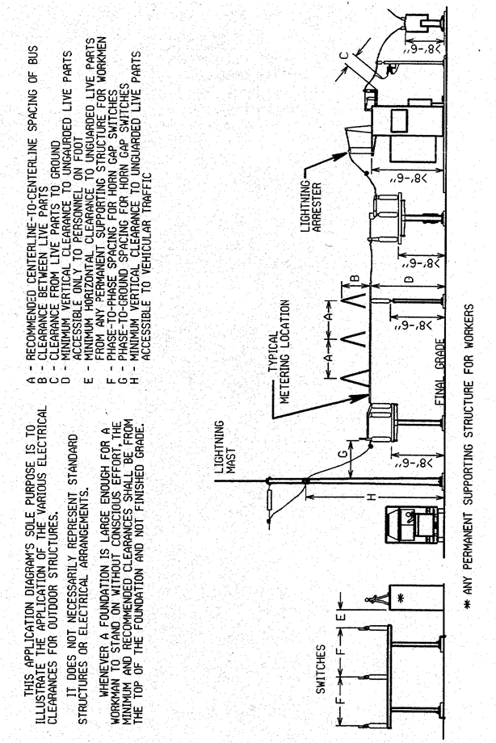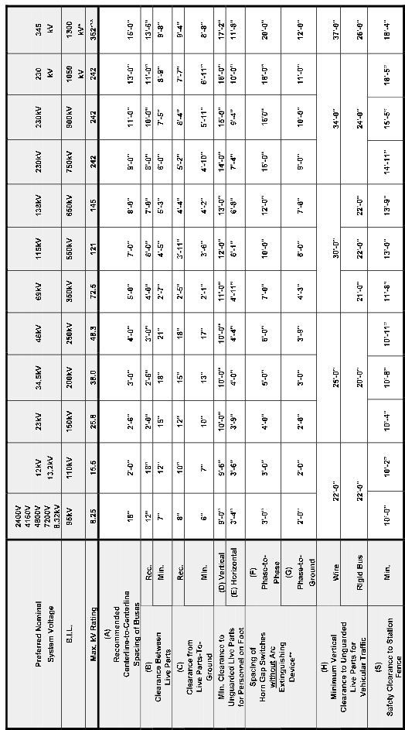

1. Safety Clearance to Substation Fences

A. Dimension "H" is the Minimum Vertical Clearance to Unguarded Live Parts for   
 Vehicular Traffic from Figure 2.

B. Dimension "D" is the Minimum Vertical Clearance of Unguarded Live Parts for   
 Personnel on Foot from Figure 2.

C. Dimension "S" is the Safety Clearance determined from Figure 2.

D. The Safety Clearance boundary is located by constructing an arc with Radius "S"   
 from a point on the centerline of the station fence (without regard to fence height)   
 such that the arc intersects the horizontal line defined by Dimension "D" and is   
 tangent to the horizontal line Defined by Dimension "H" and to the vertical line   
 defined by Dimension "S" measured horizontally from the fence center line. All   
 exposed live parts shall be outside this Safety Clearance boundary shown above.

2. Minimum Vertical Clearance in Areas Accessible to Vehicular Traffic

The vertical clearance is measured vertically from finished crushed stone surface   
to the lowest conductor or live part. The tabulated clearances are based on   
National Electrical Safety Code clearances for highways, roads, streets and fields   
subject to truck traffic with voltage adder and allowance for sag due to   
temperature.

3. Access Clearance to Substation Fences

Normal design practice is to provide adequate drive space between the perimeter   
fence and the structure for maintenance trucks. However, when the drive space   
cannot be provided, the minimum fence to live part clearance shall not be less   
than the safety Clearance dimension determined by use of sketch shown above.

The intent of these safety clearance requirements is to prevent unqualified or public personnel from coming into accidental contact with live parts by inserting sticks or poles, etc., over or through a fence or wall.

SAFETY CLEARANCE REQUIREMENTS   
 FIGURE 3

April 2002 ESB 752-1994, 2nd Printing

TABLE of INDOOR SEPARATIONS\*

Max. kV Class Rating 5.08 8.25 15 25.8 38 38

2400V 6900V 8320V

Nominal System Voltage 4160V 7620V 12kV 23kV 34.5kV 34.5kV

4800V 13.2kV

BIL in kV 60 75 95 125 150 200

Spacing of Rec. 12" 14" 18" 20" 24" 26”

Buses Min. 9" 10" 12" 14" 18" 20”

Spacing of

Live Part-to-Live Min. 4.5" 5.5" 7.5" 13" 14.5" 18”

Part

Spacing of

Live Parts-to- Min. 3" 4" 5" 8" 10.5" 13”

Ground

Minimum

Clearance To   
 Unguarded   
 Live Parts

Vert. 9'-0" 9'-6"

Horiz. 4’-0" 4’-0"

9'-6" 10'-0" 10'-0" 10'-0"

5’-0" 5’-0" 6’-0" 6’-0"

\*Note: These separations are minimums and should not be considered recommended design. The   
 Company recommends exceeding minimums where space permits.

INDOOR STRUCTURE

ELECTRICAL CLEARANCES

FIGURE 4

ESB 752-1994, 2nd Printing April 2002

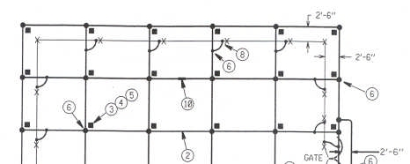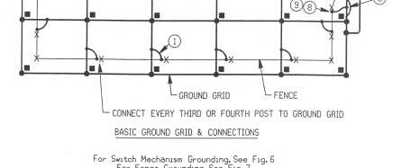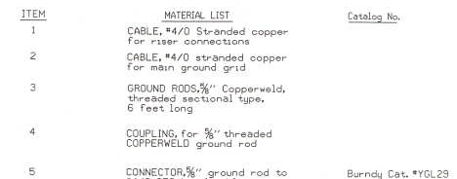

STATION GROUNDING   
 FIGURE 5

April 2002 ESB 752-1994, 2nd Printing

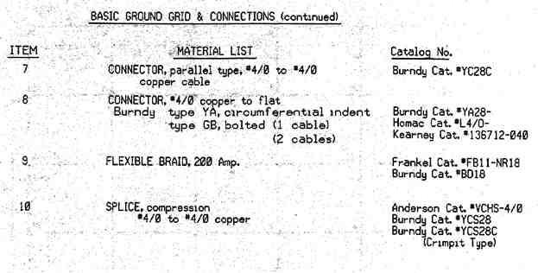

STATION GROUNDING   
FIGURE 5 (CONT’D)

April 2002 ESB 752-1994, 2nd Printing

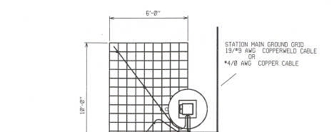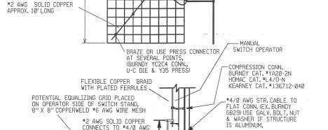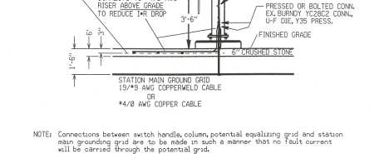

SWITCH MECHANISM GROUNDING   
 FIGURE 6

ESB 752-1994, 2nd Printing April 2002

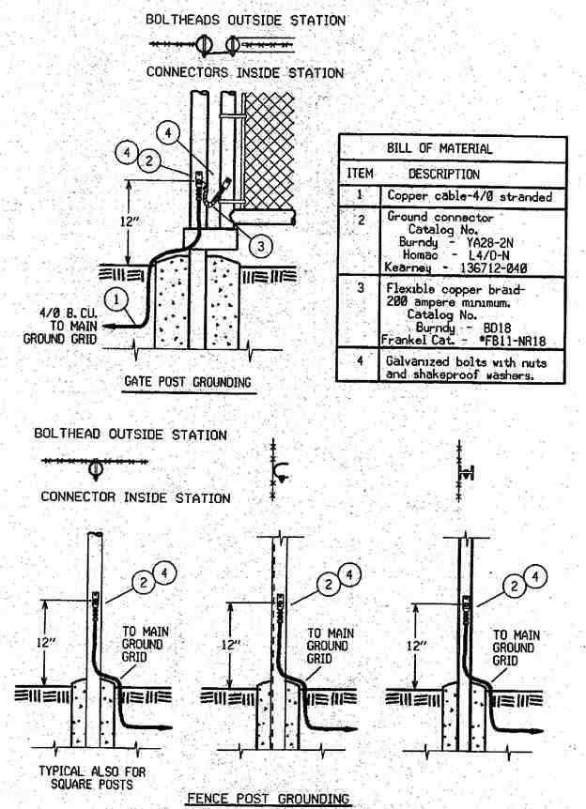

FENCE GROUNDING DETAILS   
 FIGURE 7

April 2002 ESB 752-1994, 2nd Printing

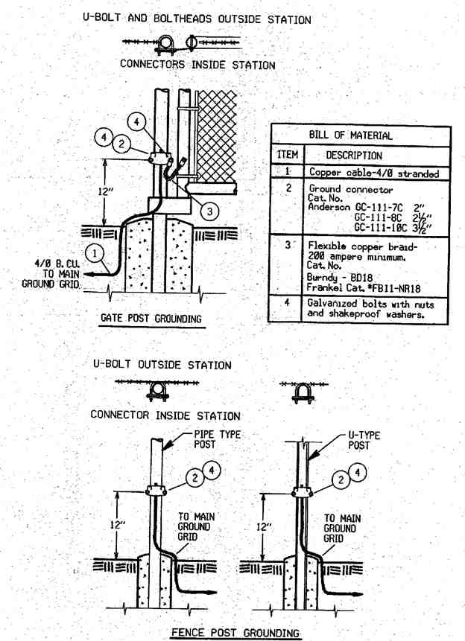

ALTERNATIVE FENCE GROUNDING DETAILS   
 FIGURE 7A

ESB 752-1994, 2nd Printing April 2002

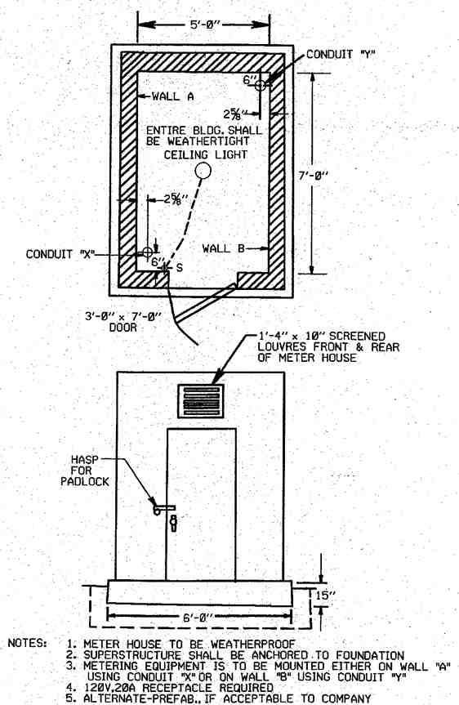

METER HOUSE   
 FIGURE 8

April 2002 ESB 752-1994, 2nd Printing

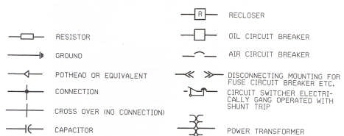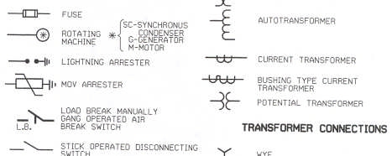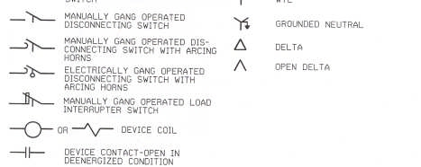

SYMBOLS FOR SERVICE EQUIPMENT DIAGRAMS   
 FIGURE 9

ESB 752-1994, 2nd Printing April 2002

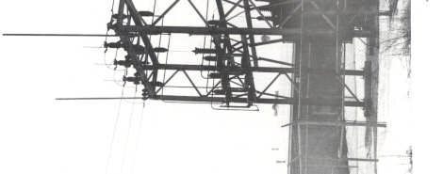

ILLUSTRATION 1

April 2002 ESB 752-1994, 2nd Printing

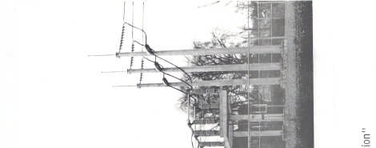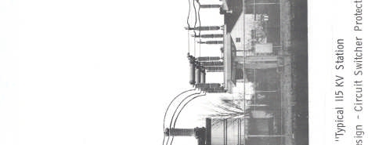

ILLUSTRATION 2

ESB 752-1994, 2nd Printing April 2002