FERC rendition of the electronically filed tariff records in Docket No. ER13-762-

Filing Data:

CID: C000038

Filing Title: Correction to Reimbursement Agreement No. 1949 between Nat'l Grid and Edge Corp. Company Filing Identifier: 654

Type of Filing Code: 130

Associated Filing Identifier: 556   
Tariff Title: NYISO Agreements   
Tariff ID: 58

Payment Confirmation: N   
Suspension Motion:

Tariff Record Data:

Record Content Description: Agreement No. 1949

Tariff Record Title: SA No. 1949 NiMo and EDGE Corp. re: reimbursement costs Record Version Number: 0.1.0

Option Code: A

Tariff Record ID: 116

Tariff Record Collation Value: 6065000

Tariff Record Parent Identifier: 2 Proposed Date: 2012-10-19 Priority Order: 600

Record Change Type: Change   
Record Content Type: 2   
Associated Filing Identifier: 556

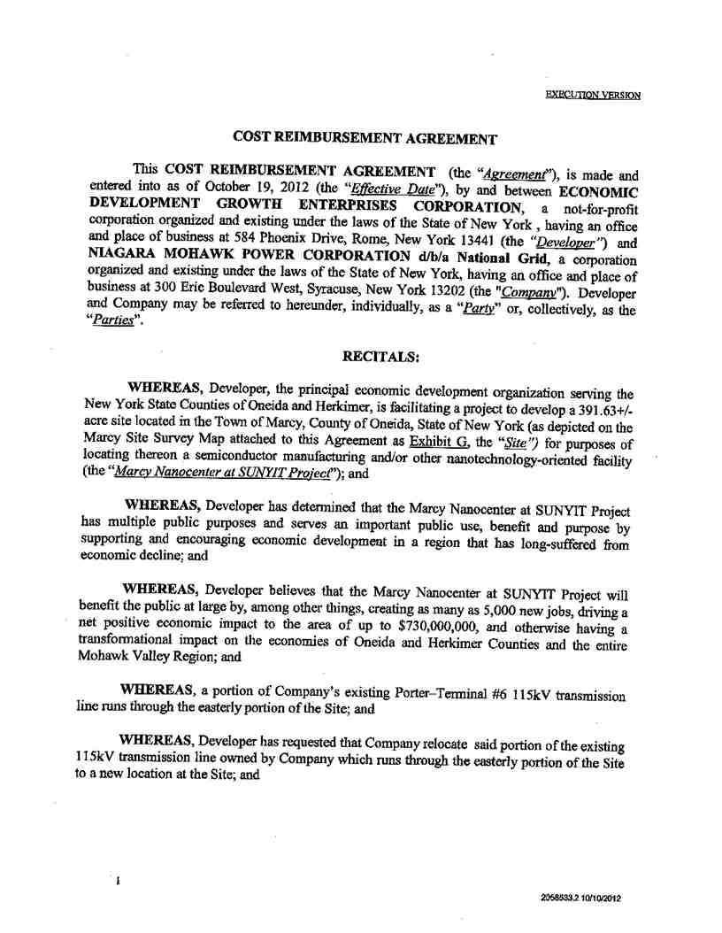

Service Agreement No. 1949

1

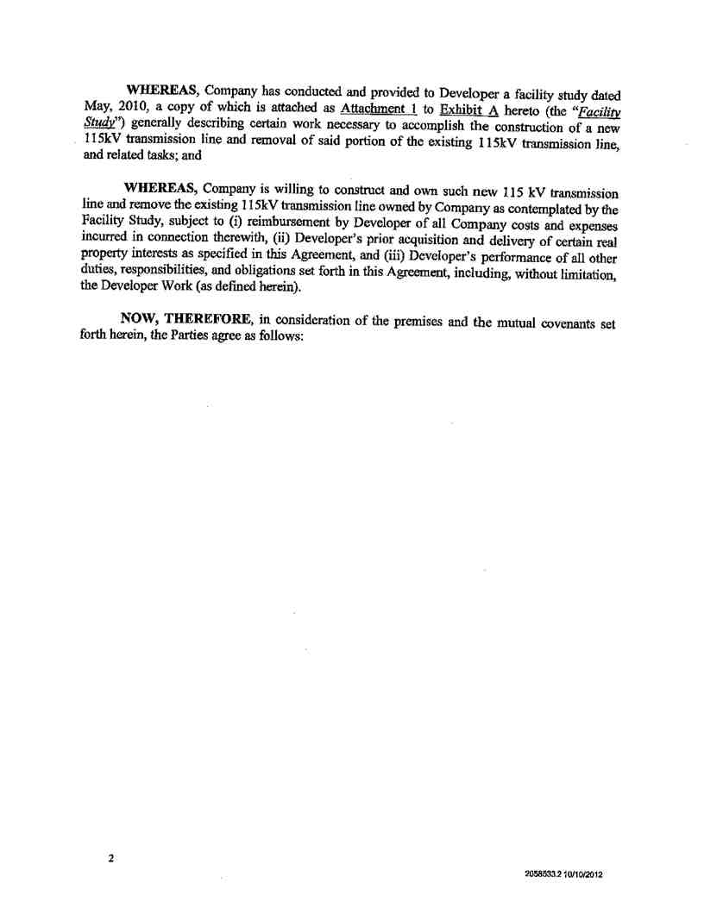

Service Agreement No. 1949

2

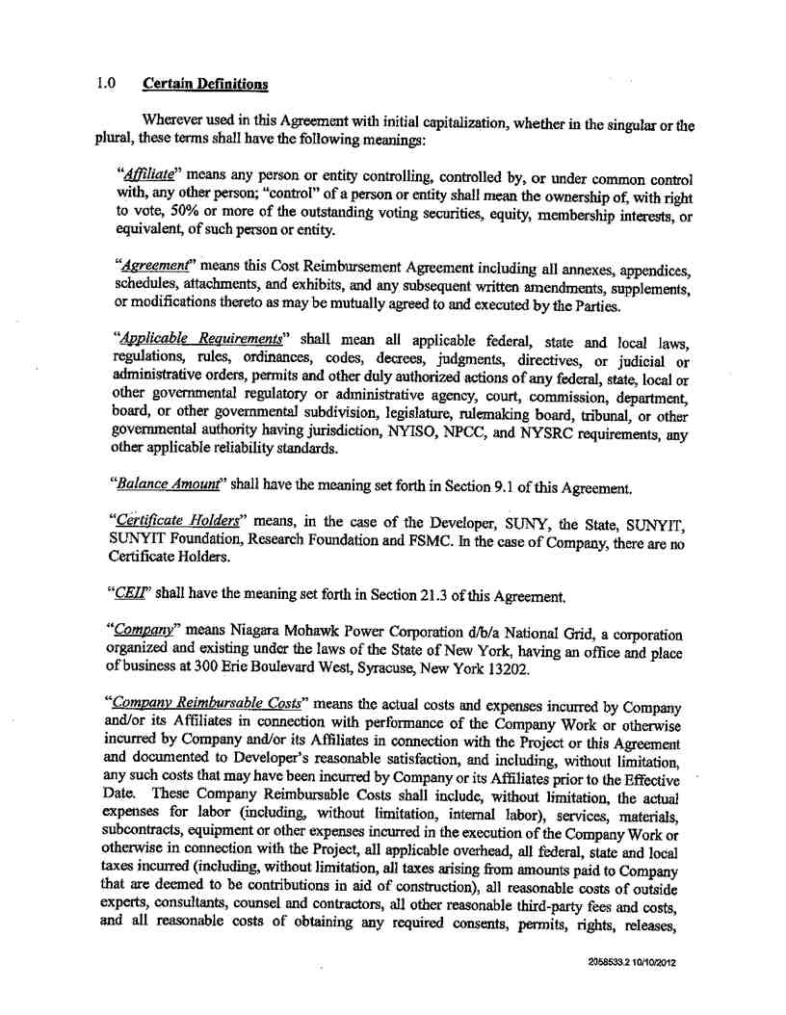

Service Agreement No. 1949

3

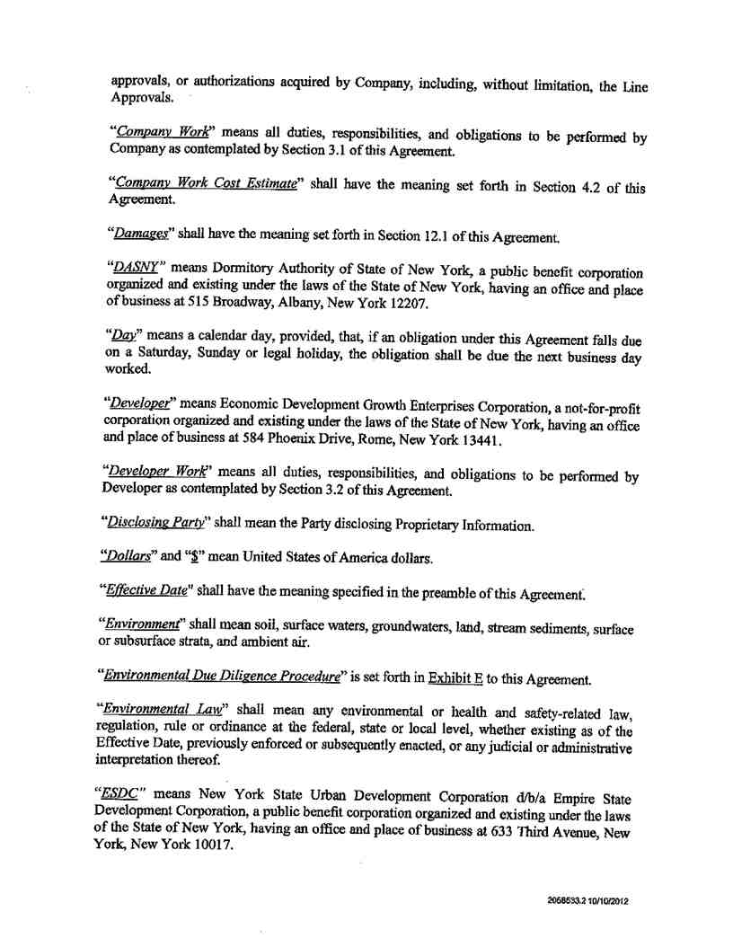

Service Agreement No. 1949

4

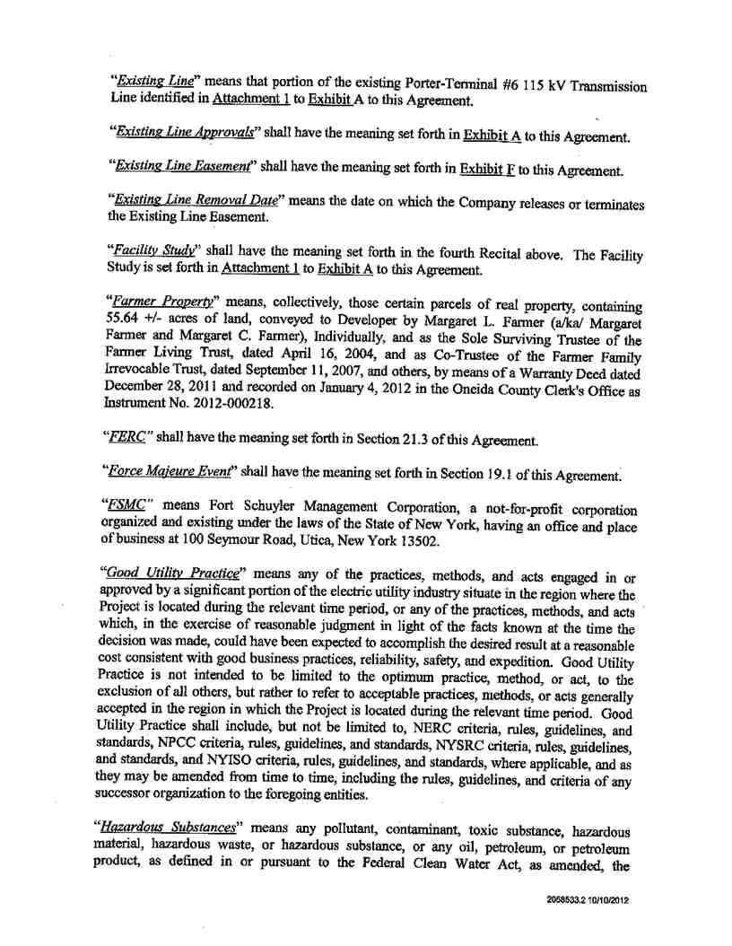

Service Agreement No. 1949

5

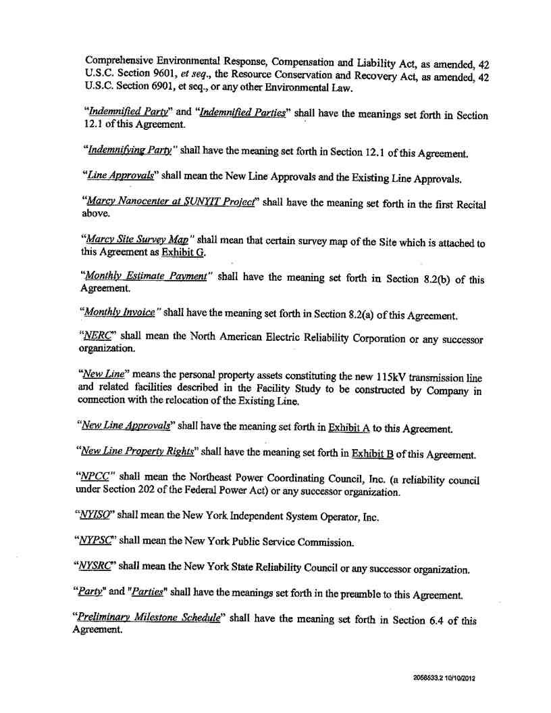

Service Agreement No. 1949

6

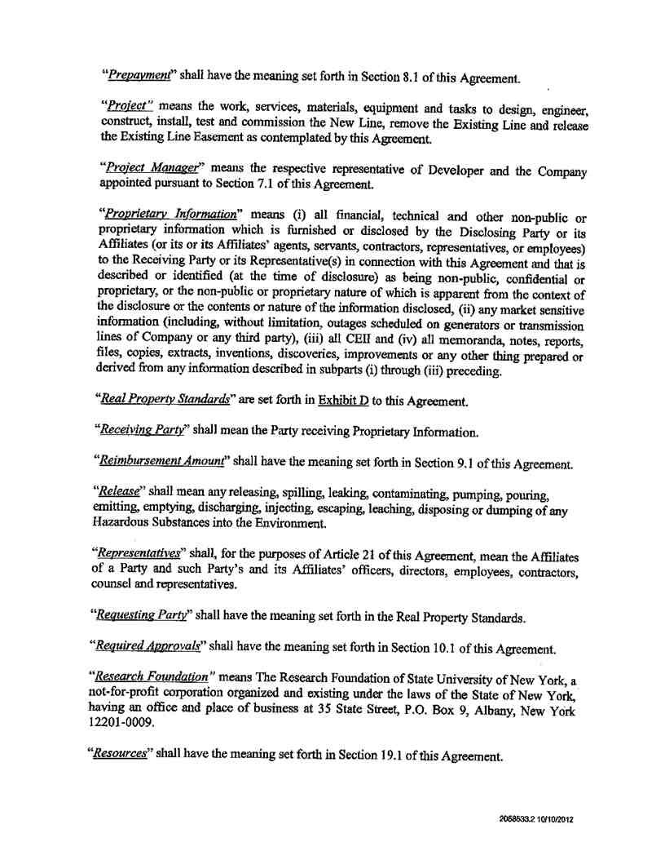

Service Agreement No. 1949

7

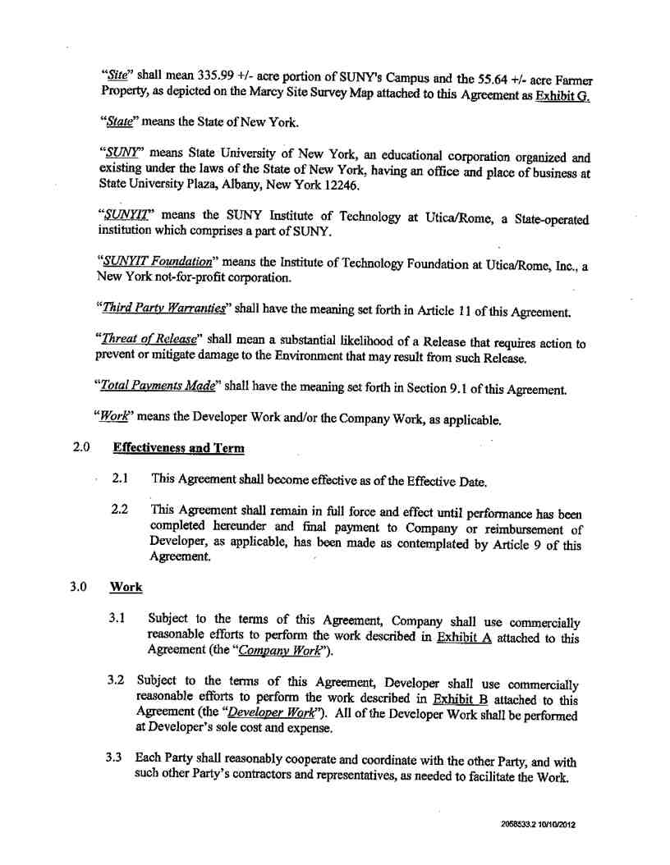

Service Agreement No. 1949

8

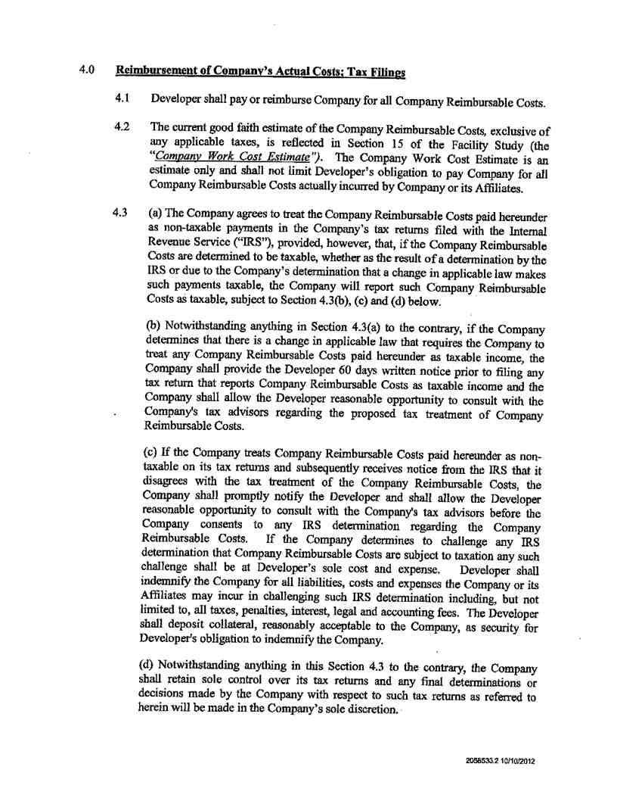

Service Agreement No. 1949

9

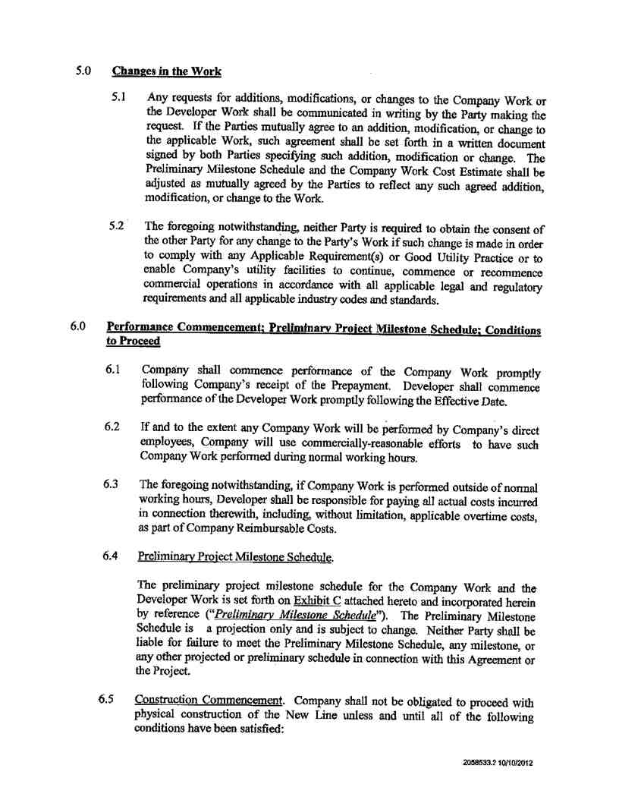

Service Agreement No. 1949

10

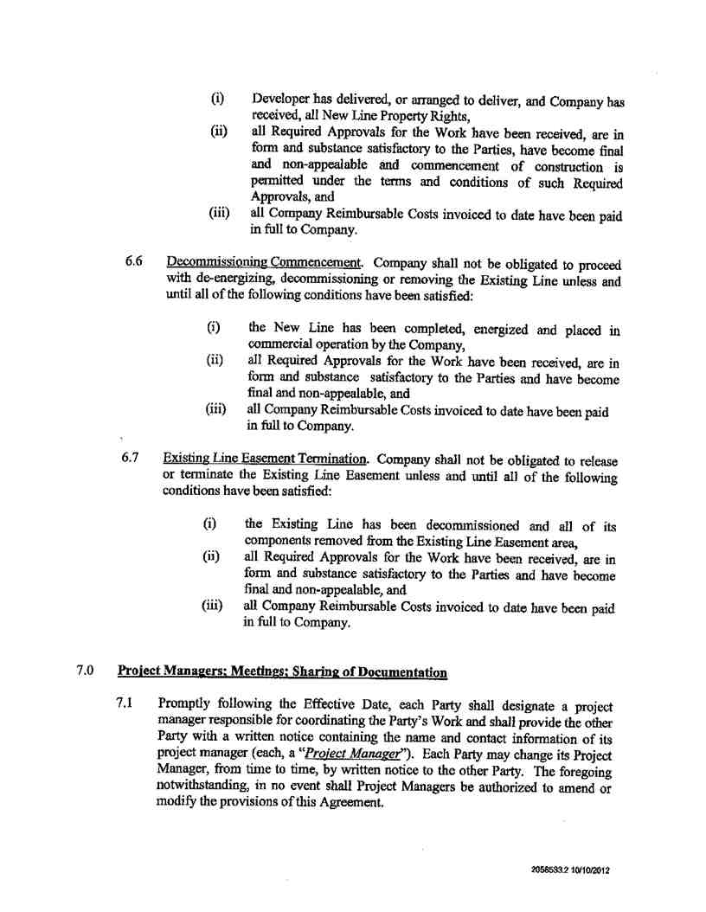

Service Agreement No. 1949

11

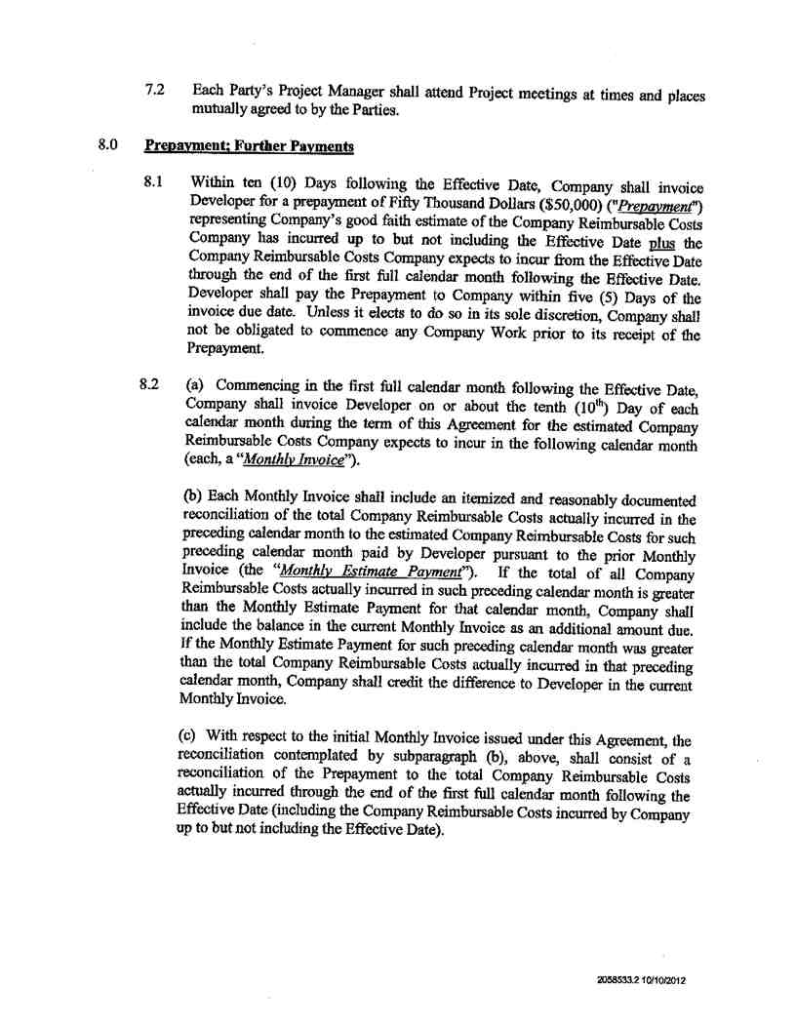

Service Agreement No. 1949

12

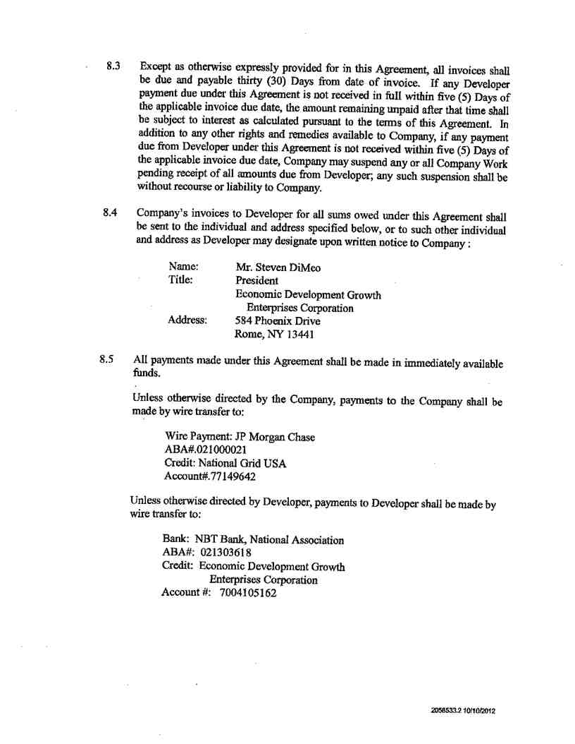

Service Agreement No. 1949

13

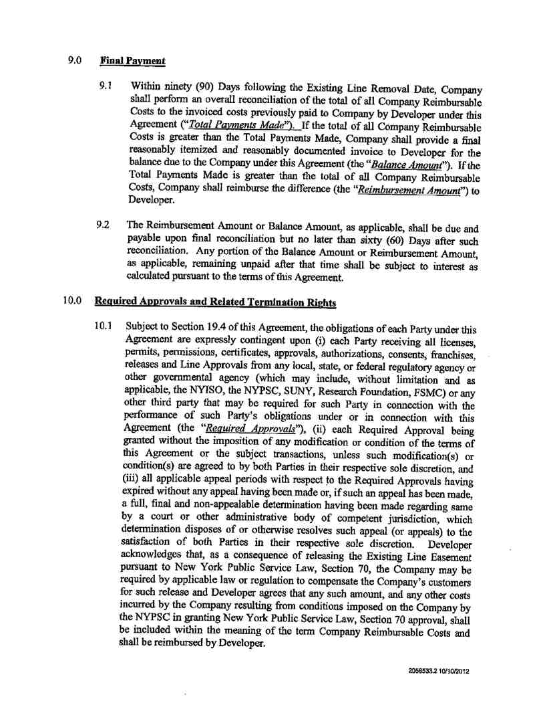

Service Agreement No. 1949

14

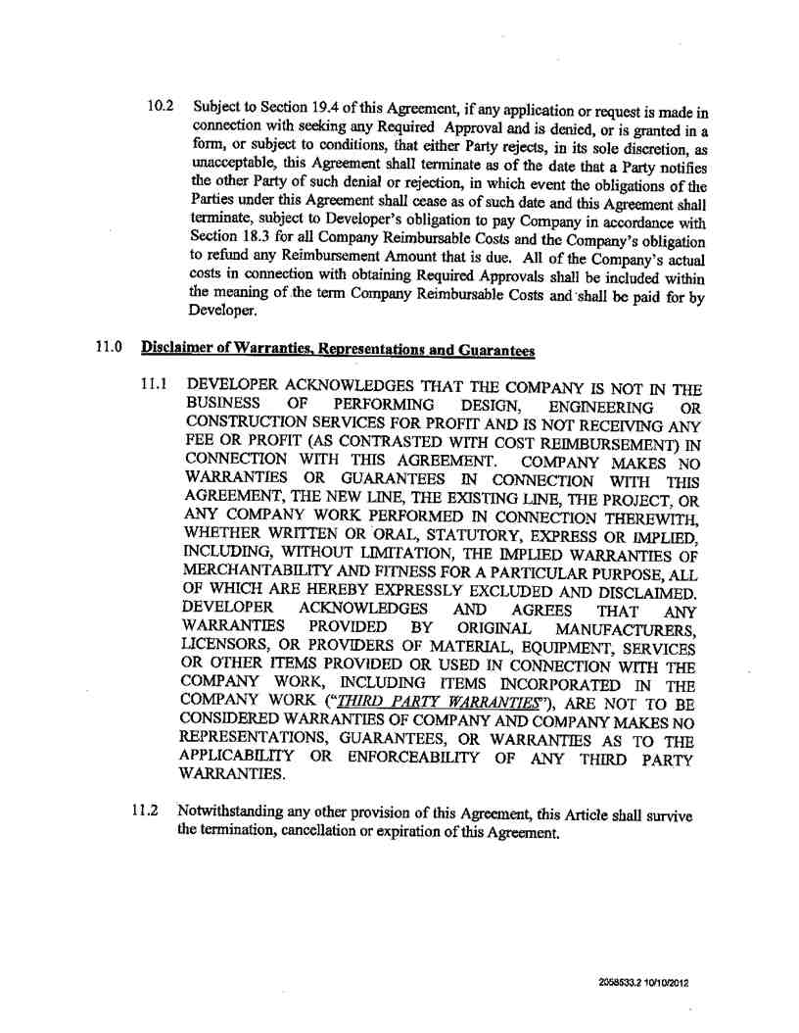

Service Agreement No. 1949

15

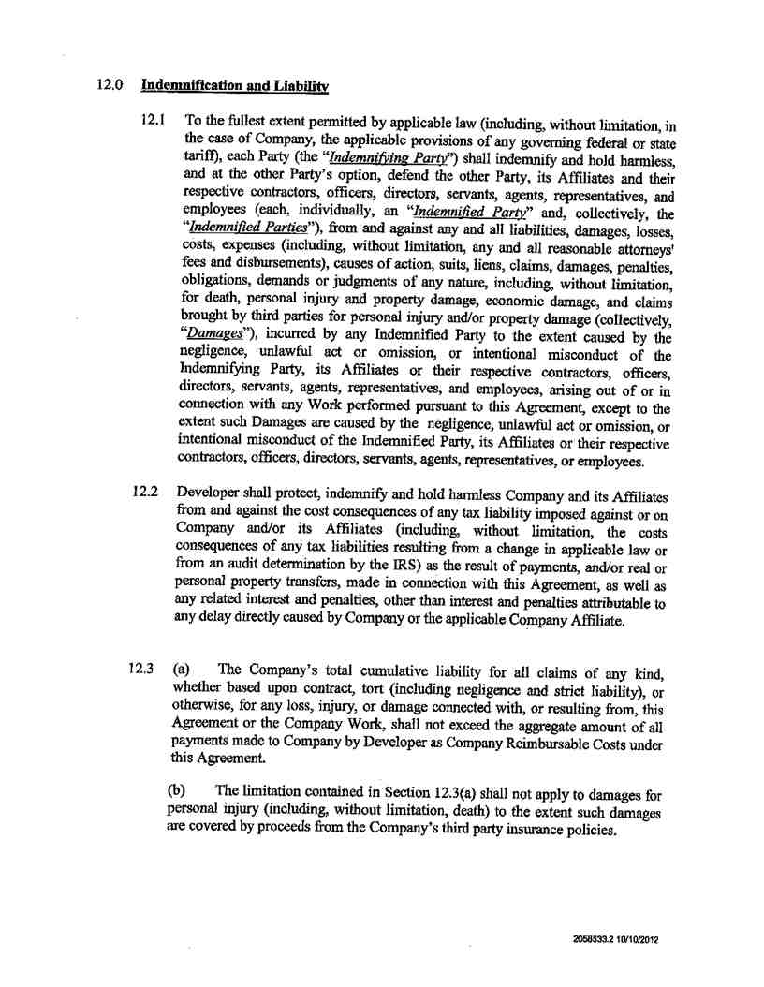

Service Agreement No. 1949

16

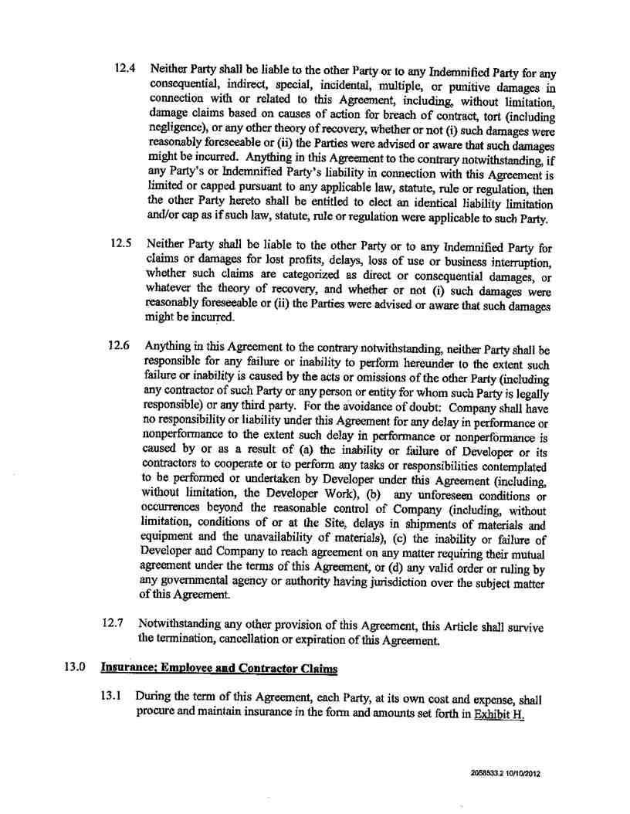

Service Agreement No. 1949

17

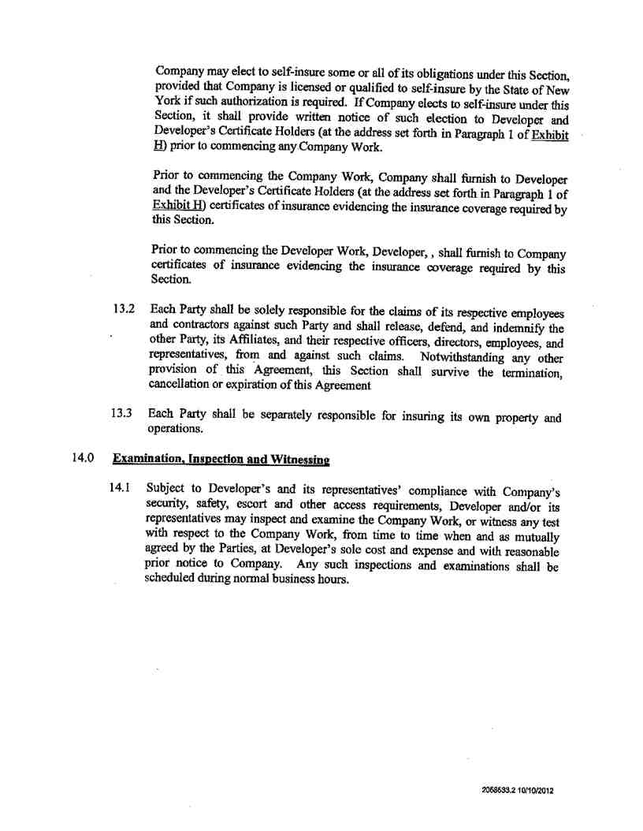

Service Agreement No. 1949

18

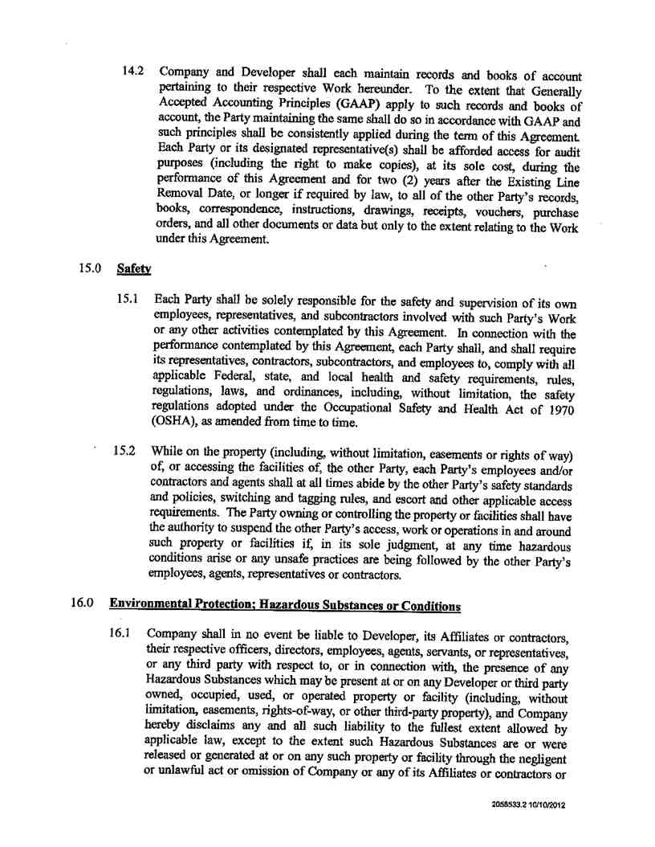

Service Agreement No. 1949

19

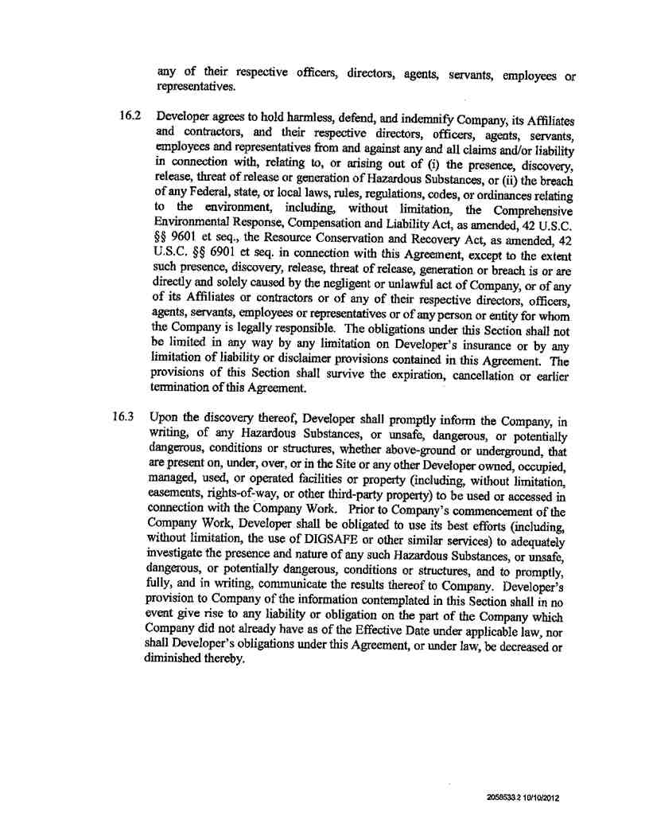

Service Agreement No. 1949

20

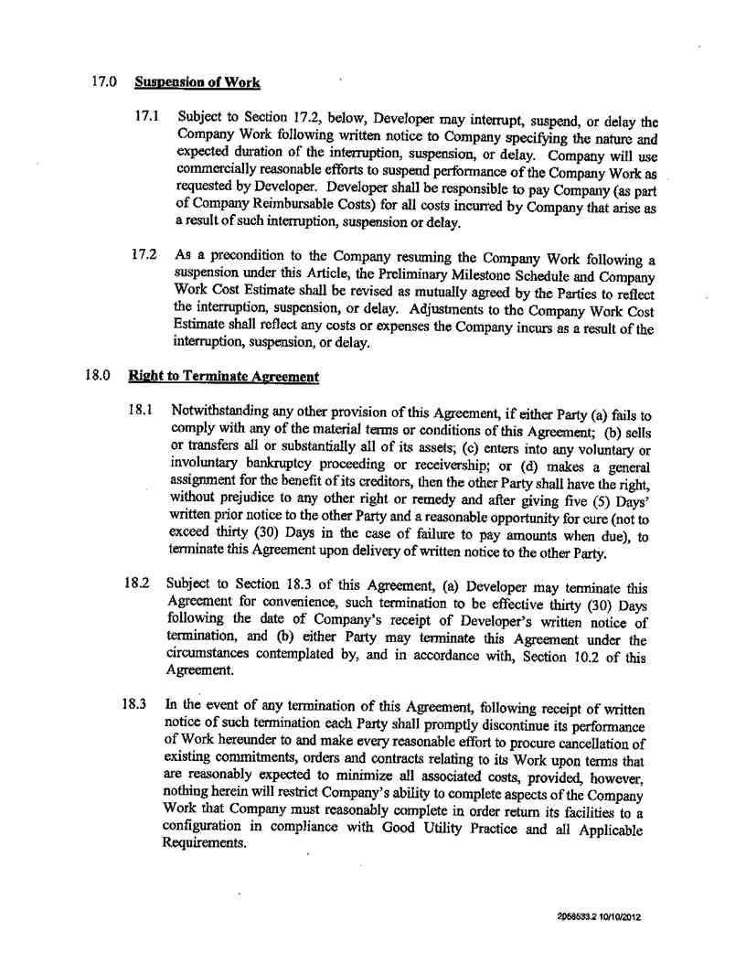

Service Agreement No. 1949

21

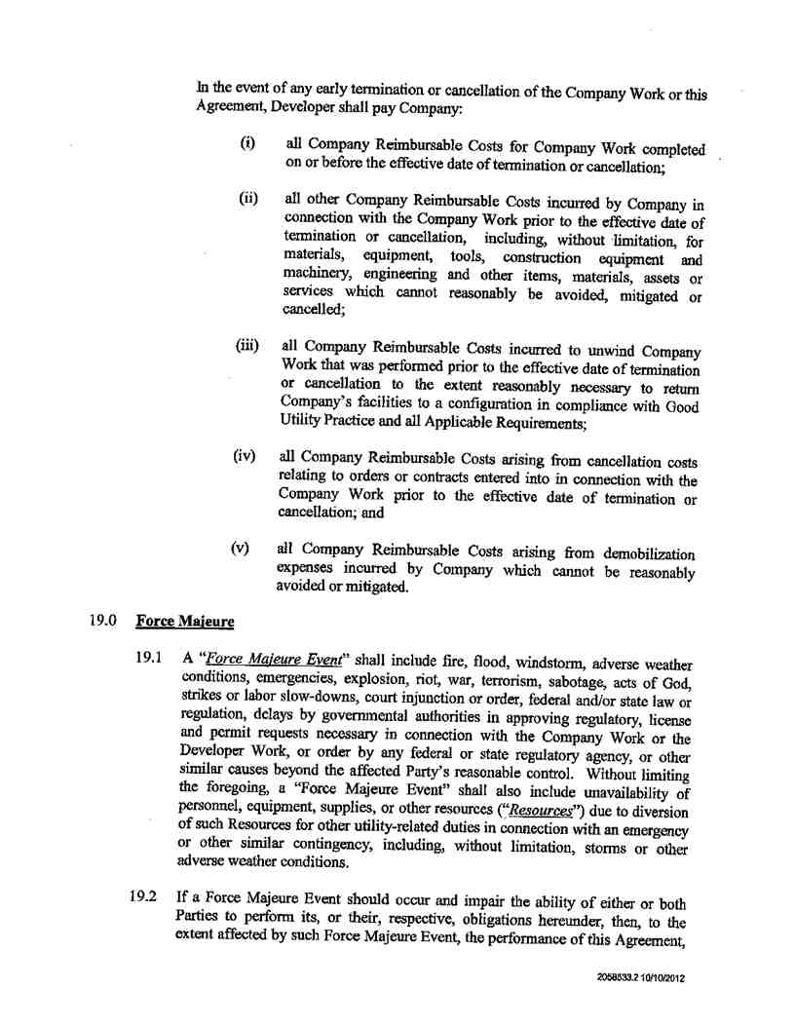

Service Agreement No. 1949

22

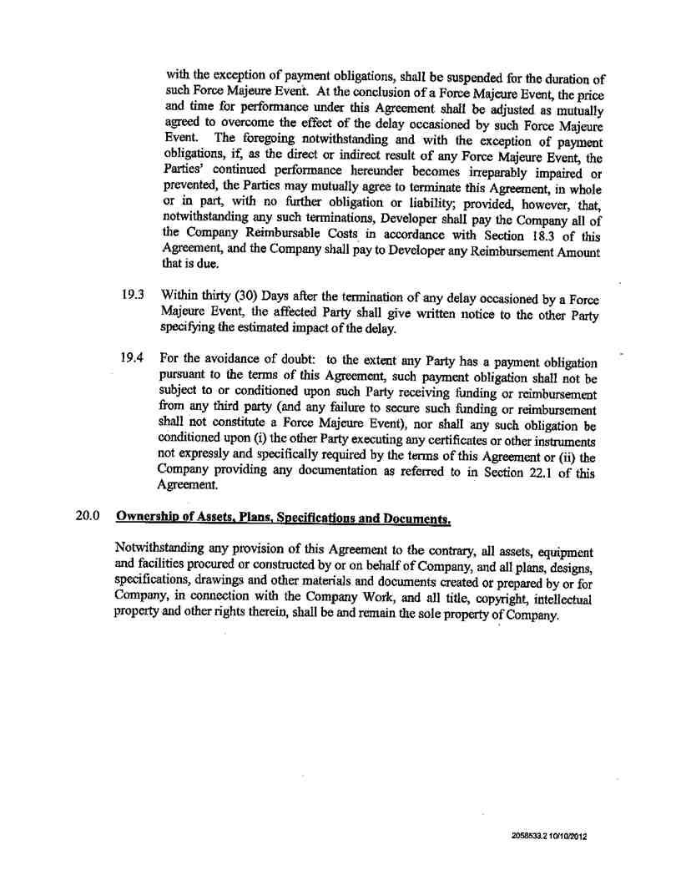

Service Agreement No. 1949

23

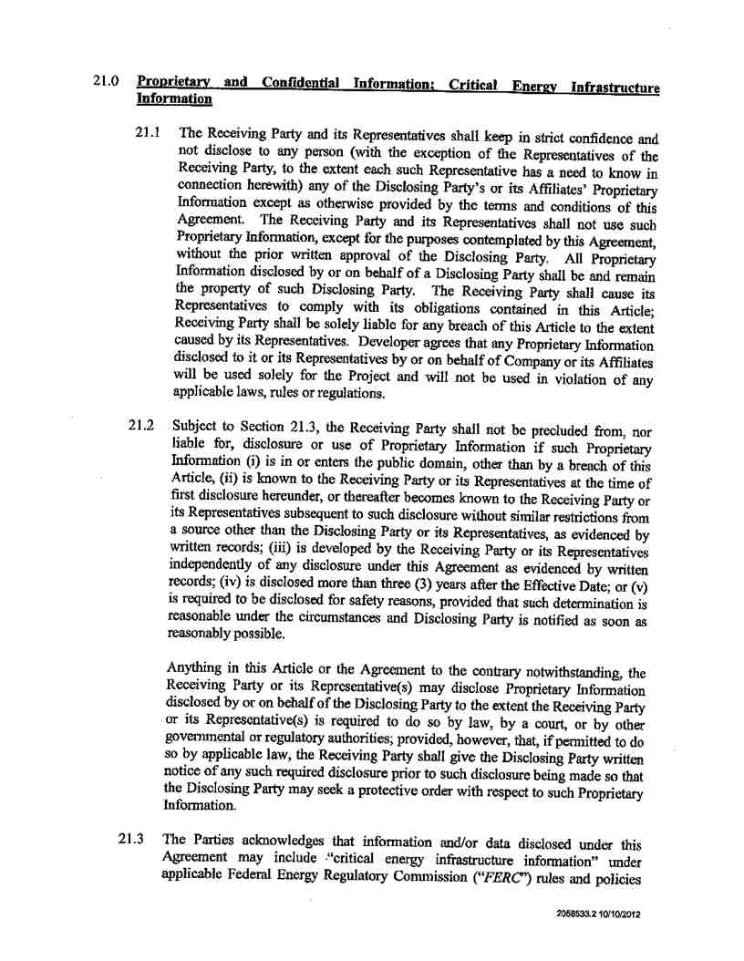

Service Agreement No. 1949

24

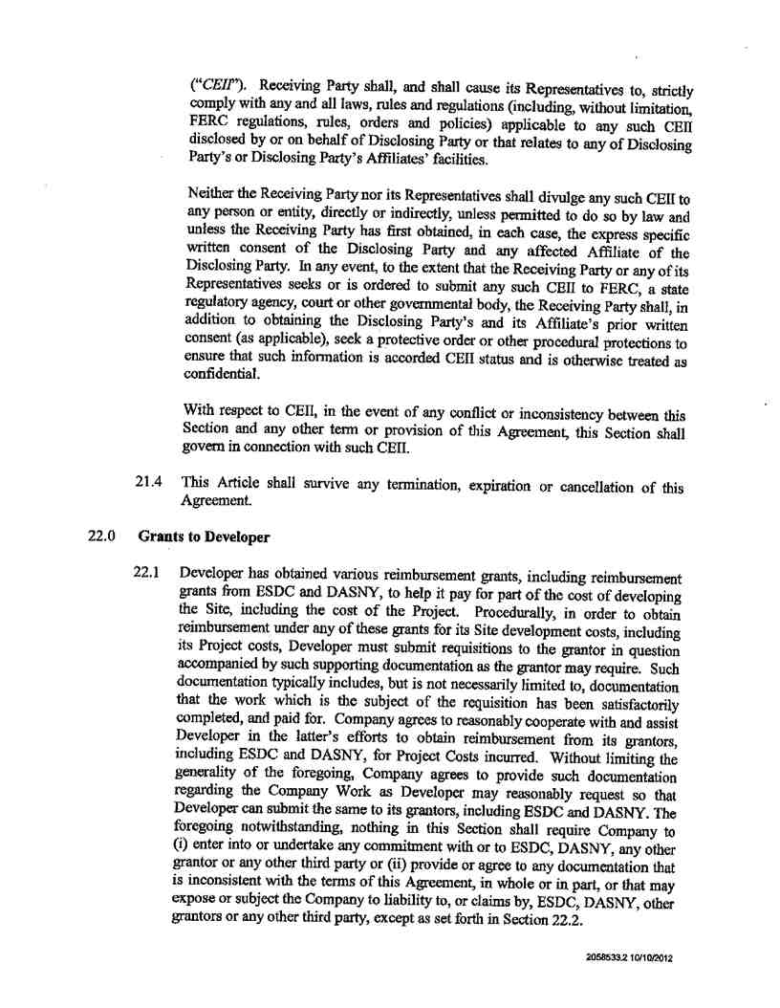

Service Agreement No. 1949

25

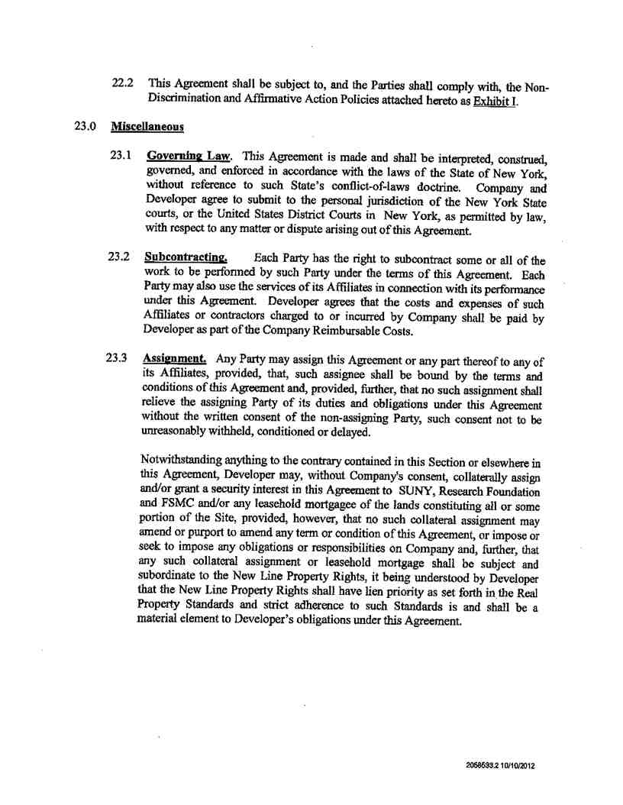

Service Agreement No. 1949

26

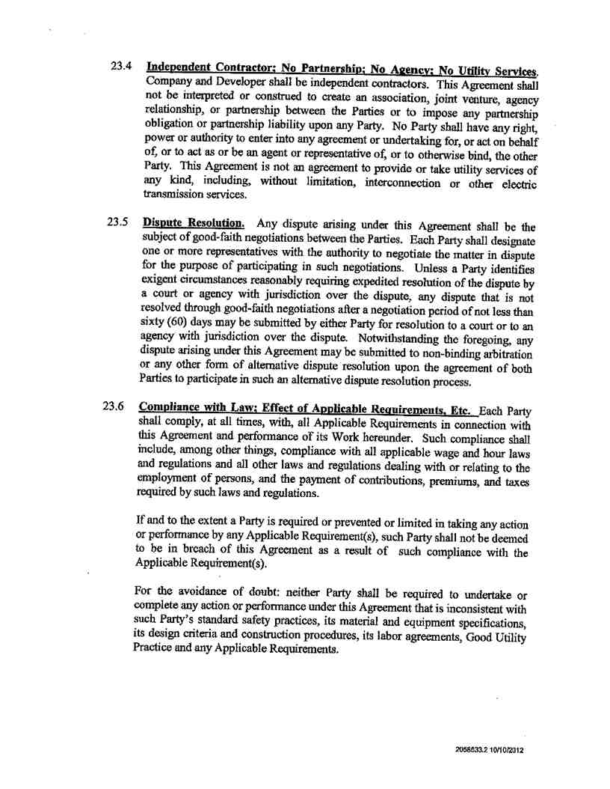

Service Agreement No. 1949

27

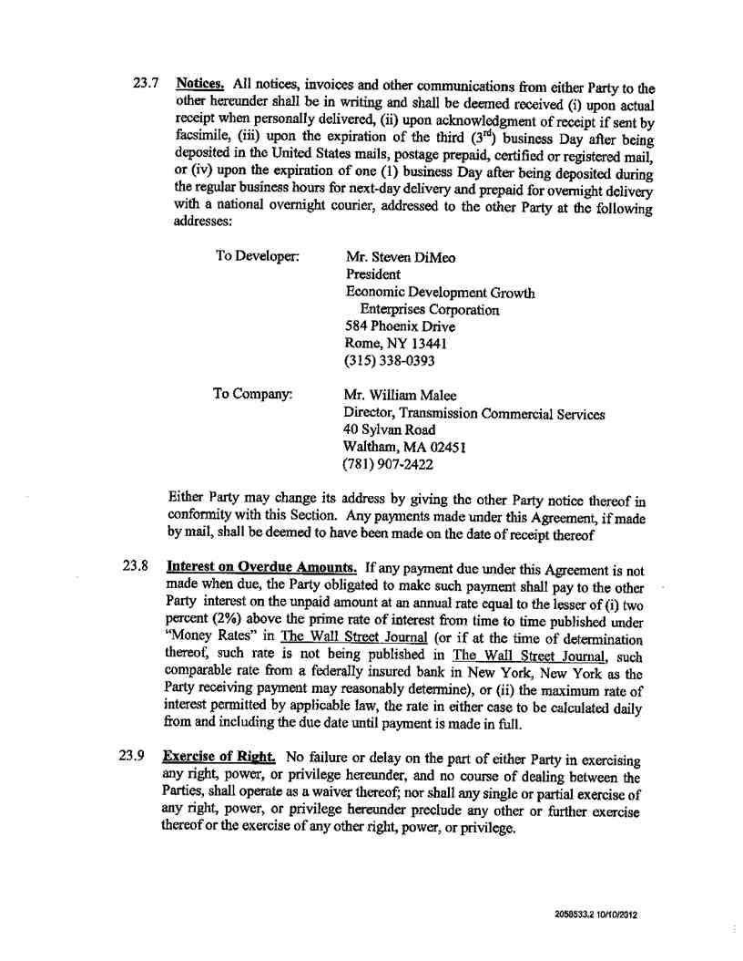

Service Agreement No. 1949

28

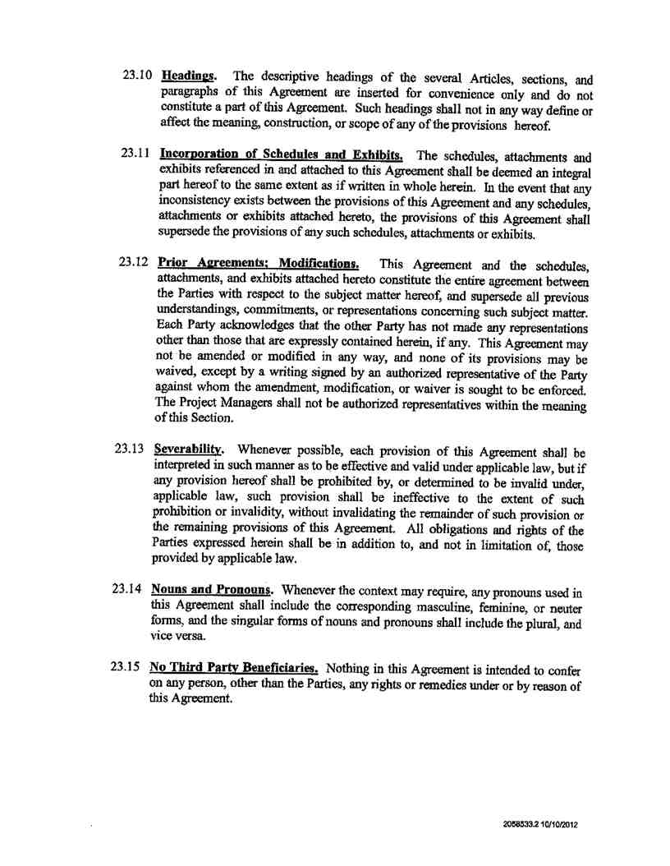

Service Agreement No. 1949

29

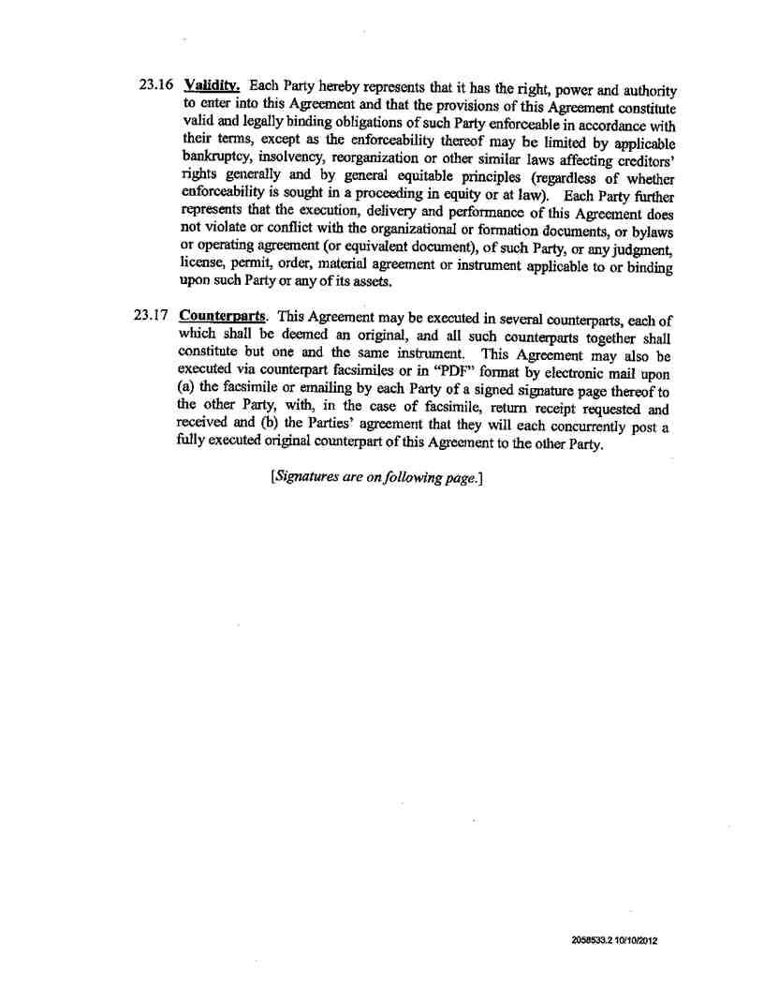

Service Agreement No. 1949

30

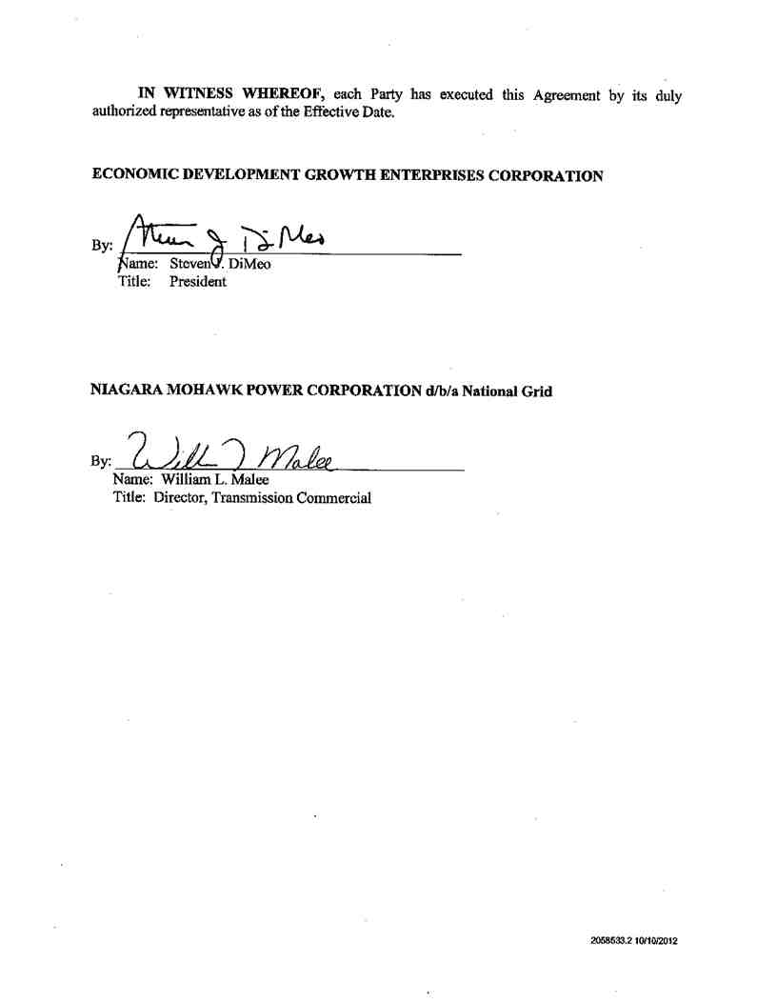

Service Agreement No. 1949

31

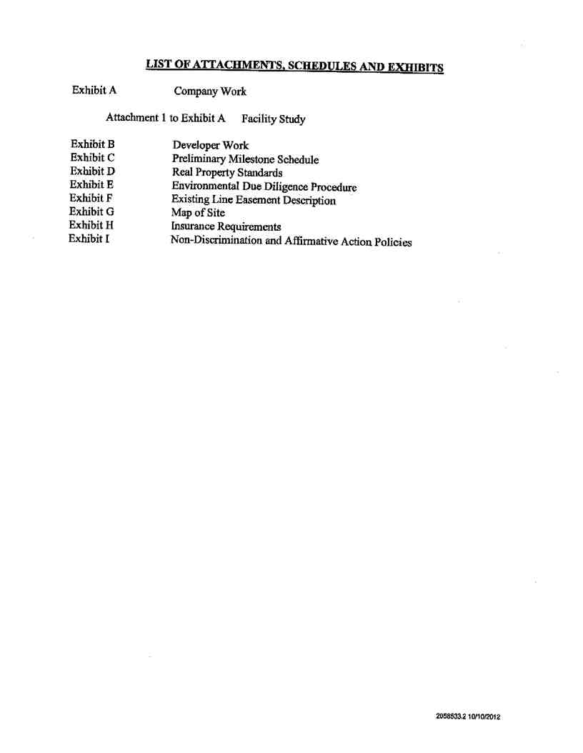

Service Agreement No. 1949

32

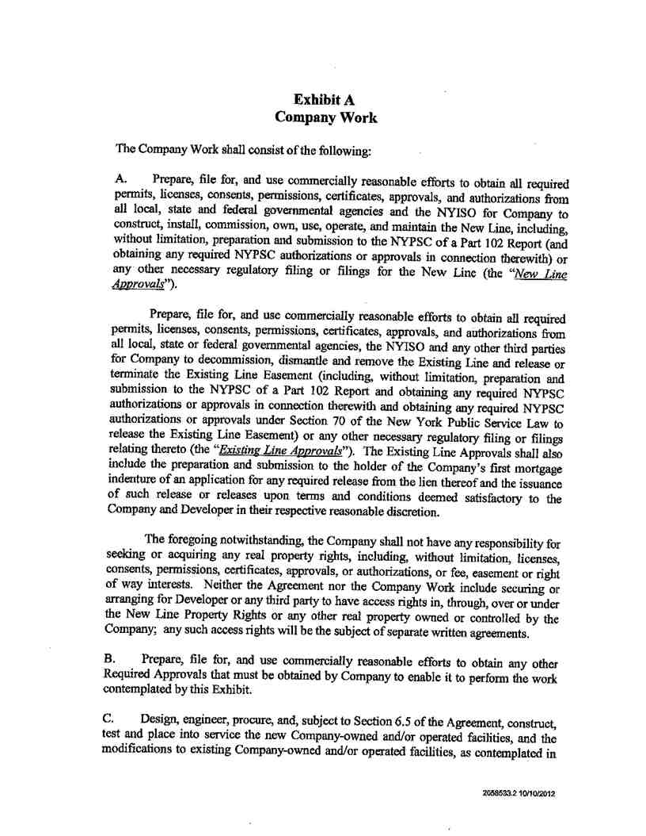

Service Agreement No. 1949

33

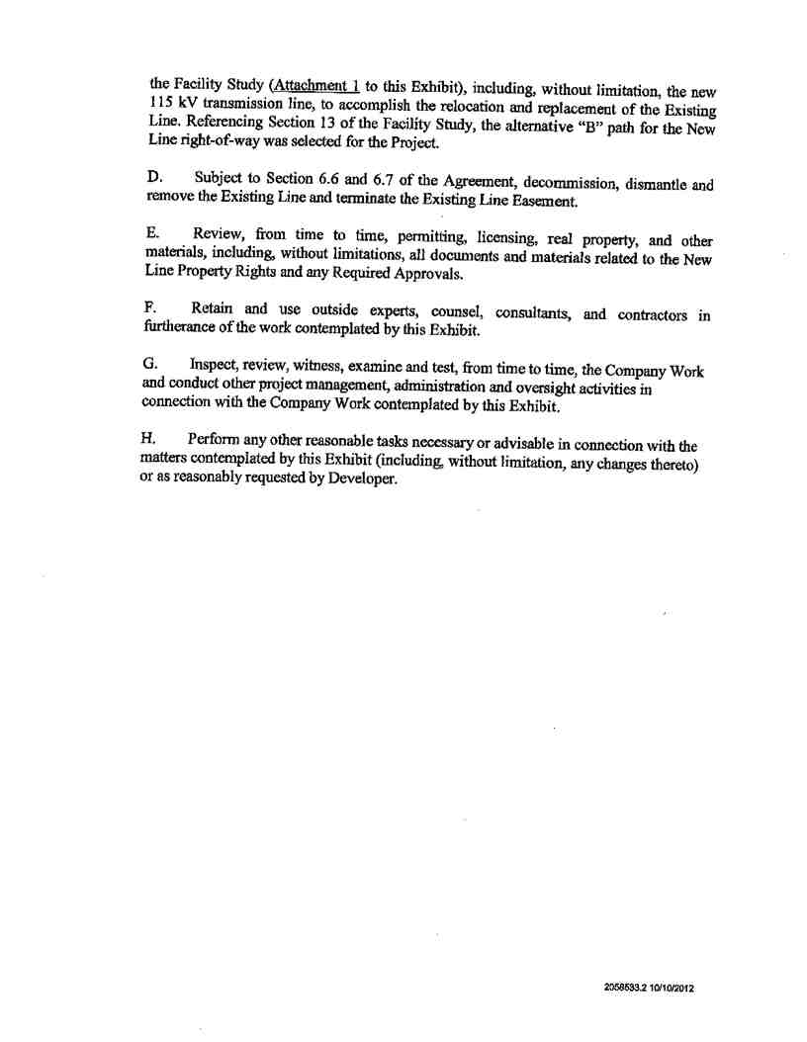

Service Agreement No. 1949

34

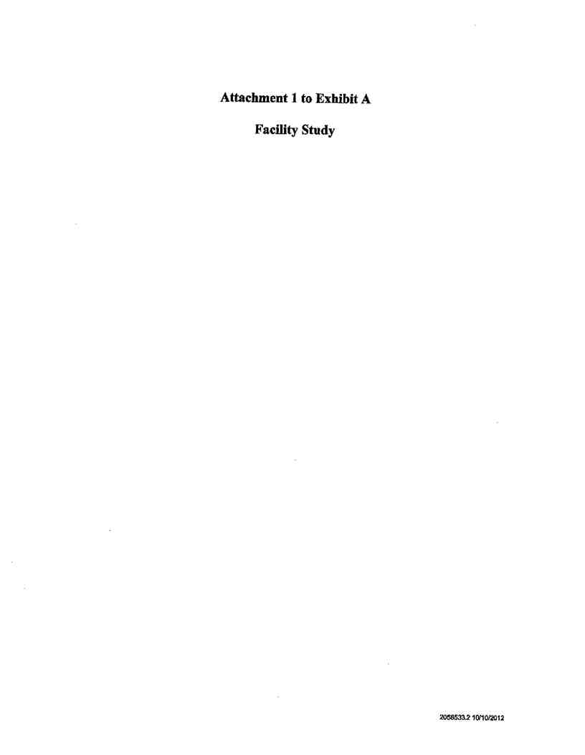

Service Agreement No. 1949

35

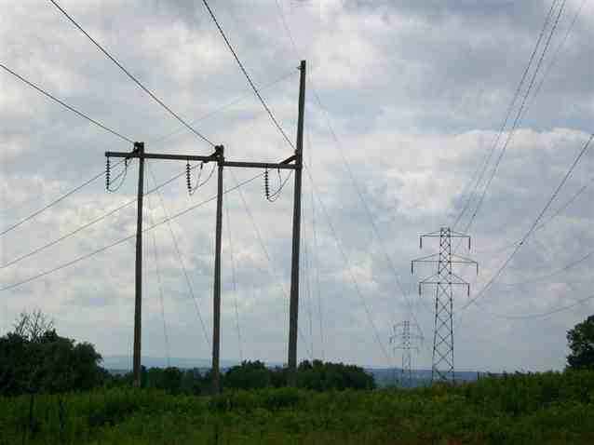

Service Agreement No. 1949

Preliminary Study Report - Alternative #2

Marcy Nanocenter 115kV Transmission Line Relocation

Prepared for: Mohawk Valley EDGE

153 Brooks Road

Rome, NY 13441-4105

May, 2010

36

Service Agreement No. 1949

Marcy Nanocenter

Preliminary Study Report

Table of Contents

1. BACKGROUND 3

2. EXECUTIVE SUMMARY 3

3. PROJECT OBJECTIVES 4

4. EXISTING CONDITIONS 4

5. PROPOSED ARRANGEMENT 4

6. SCOPE OF WORK 5

7. PROJECT DURATION 5

8. SAFETY ASSESSMENT 5

9. ENVIRONMENTAL ANALYSIS 5

10. ENVIRONMENTAL REGULATORY LICENSING AND AGENCY REVIEW REQUIREMENTS 6

11. EMF 7

12. LOCAL PERMITTING 8

13. RIGHT OF WAY 8

14. SITE SERVICE STUDY 10

15. COST ESTIMATE 11

16. ATTACHMENTS 12

Site Photos

Map of Proposed Project Site

ROW Cross Section through all Three Lines

ROW Cross Section through One Line (Porter - Terminal #6) Electric Field Graph

Magnetic Field Graph

Detail Drawing - Single Circuit Steel Deadend Structure   
Detail Drawing - Single Circuit Suspension Wood Pole

2

37

Service Agreement No. 1949

Marcy Nanocenter

Preliminary Study Report

1. Background

• In accordance with Mohawk Valley Edge’s request, National Grid hereby submits this

Preliminary Study Report - Alternative #2 for the Marcy Nanocenter 115kV line

relocation.

o This study was performed under a support services agreement between Mohawk   
 Valley Edge and National Grid.

o This study determined the cost and schedule to relocate the 115kV Porter -  
 Terminal #6 Line as close as possible to the existing Oneida - Porter #7 /   
 Yahnundasis - Porter #3 ROW and the edge of the Marcy Nanocenter property.   
 This approach maximizes the property available for development of the Marcy   
 Nanocenter site.

• Note: This report provides an alternate approach (as requested by MVE) to the original   
 Preliminary Study Report dated November, 2009.

2. Executive Summary

•  National Grid has determined the following:

o The Porter - Terminal #6 Line that runs through the Marcy Nanocenter site can

be re-located to run along the existing ROW for the Oneida - Porter #7 and the Yahnundasis - Porter #3 Lines. With current information known, there does not appear to be any difficulties in doing this work.

o No special line outages will be required to move the circuits, other than those

outages required to do line cutovers to existing energized circuits.

o Permitting and regulatory work will be required prior to construction. These

requirements are not un-common or necessarily difficult to do, but do impact the project schedule and must be planned for.

o National Grid is willing to work with Mohawk Valley Edge (MVE) to accommodate

this move from a right of way perspective. This assumes that MVE is willing to provide new right-of-way properties, as outlined below, to accommodate the relocated line. In like fashion, National Grid will surrender the existing Porter -  
Terminal #6 right-of-way property. Note that with these adjustments, MVE must still deal with fiber optic cables (Verizon and Elantic) that currently follow the existing transmission lines and traverse the property.

o Environmental assessments performed under the November study, did not

produce any particularly unusual challenges from the information gathered. It is   
anticipated that this will remain this way and that no significant wetlands,   
archeological, endangered species or other concerns will be encountered on this   
project. This must be verified with additional analysis (delineation, involvement   
of agencies, etc).

o Electric and Magnetic field simulations show that future line relocation will be

below PSC established limits at the edges of the right-of-way.

o Schedule for doing this work is 27 months from contract agreements between

NG and MVE. Approximately 8 months of this schedule are associated with the necessary permitting and regulatory approvals. Note that there may be opportunities to improve upon this schedule (no permitting/regulatory problems encountered, running key activities in parallel, etc).

o Cost for doing this work is estimated at $5,220,000 (in 2009 dollars). As with the

schedule, this is a conservative estimate that may be improved upon as more detailed engineering and analysis is performed.

3

38

Service Agreement No. 1949

Marcy Nanocenter

Preliminary Study Report

3. Project Objectives

• The main objective of the project is to relocate the existing 115kV Porter - Terminal #6   
 Line which is located on Marcy Nanocenter’s property so that the property can be   
 developed.

• The Porter - Terminal #6 Line is to be relocated along the existing Oneida - Porter #7   
 and Yahnundasis - Porter #3 ROW. The ROW may need to be expanded to provide   
 enough spacing between the lines.

• A new 100’ ROW will need to be developed at the western edge of the Marcy   
 Nanocenter site and the Porter - Terminal #6 Line will continue for about 3/4 of a mile   
 before reconnecting into the existing line.

• New structures will conform to National Grid Standards. Conductors and shieldwires are   
 to be consistent with National Grid standards.

• Run an EMF check on the proposed spacing to make sure it meets code and does not   
 exceed reasonable levels.

• Perform a right of way and environmental assessment of site conditions with focus on   
 relocation of the NG lines.

• Provide a site service evaluation on how best to serve the Marcy Nanocenter site.

o A cost estimate for this work will be created in a separate report, if requested by   
 the developer.

4. Existing Conditions

• The 115kV line to be relocated is Porter - Terminal #6. In the section to be relocated,

Porter - Terminal #6 is currently supported by fourteen single circuit wood pole

structures, eleven suspension and three deadend, as shown in the table below. The

length of the section to be removed is about 1 mile.

Structure Types Number

Single Circuit 2-Pole Suspension Wood H-Frame Structure 11

Single Circuit 3-Pole Deadend Wood Pole Structure 3

Total 14

Existing Conductor Information

Conductor 795kcm ACSR “Drake”

5. Proposed Arrangement

• The first mile of the relocated 115kV Porter - Terminal #6 Line will be within a shared   
 150’ ROW, with 50’ between the two structures.

• The Porter - Terminal #6 Line will continue for another 3/4 mile in a 100’ ROW, before   
 reconnecting into the existing line. The new segment is to be supported by thirteen   
 single circuit, wood pole suspension structures with davit arms, and six single circuit,

4

39

Service Agreement No. 1949

Marcy Nanocenter

Preliminary Study Report

steel pole deadend structures. The relocated segment of the Porter - Terminal #6 will span a total of 1 3/4 miles before connecting back into the existing line.

6. Scope of Work

• Relocate the existing 115kV Porter - Terminal #6 Line into new ROW to run alongside   
 the Oneida - Porter #7 and Yahnundasis - Porter #3 Lines. The line relocation will be   
 with the addition of nineteen new single circuit, single pole structures.

• Install new 795kcm ACSR “Drake” conductor and new 3/8” EHS shieldwire.

• Remove the existing fourteen structures running through the Marcy Nanocenter   
 property.

7. Project Duration

Phase Start Finish Total Duration

Preliminary Engineering 1 2 2 Months

Detailed Design 2 5 3 Months

Procurement 5 11 6 Months

Permitting and Licensing 11 19 8 Months

Construction 19 25 6 Months

Closeout 25 27 2 Months

Project 1 27 27 Months

8. Safety Assessment

• Design and construction of this project should be performed in accordance with   
 applicable codes, regulations, bylaws and National Grid Standards. Construction of this   
 project will require work to be performed in close proximity to energized 115kV lines   
 during cutovers.

• The absence of any safety issues, not cited herein, does not exclude them from   
 possibility.

9. Environmental Analysis

• A preliminary environmental analysis was performed during the site visits to the MVE   
 site. In addition, National Wetlands Inventory (NWI) and New York State Department of   
 Environmental Conservation (NYSDEC) databases were assessed to determine

potential issues that may be encountered due to project impacts to regulated wetlands and protected streams. Field delineations of wetlands were not made.

• Based upon a review of these databases and the visual analysis performed, there are no   
 NYSDEC-regulated wetlands or protected streams that will be impacted by the project.   
 There is one unregulated stream within the southern portion of the project site that will   
 be crossed by the relocated Porter-Terminal #6 Line, but this should not be an issue.   
 Federal wetlands within the project area are mapped but these maps are not available   
 from online information sources. During the more extensive data gathering phase of the   
 project that will be required to support the licensing and permitting filings for the project,

5

40

Service Agreement No. 1949

Marcy Nanocenter

Preliminary Study Report

a right-of-way walkdown will be required to identify federal wetlands, if any, that may be impacted by the project.

10. Environmental Regulatory Licensing and Agency Review Requirements

• Part 102 Report

o Pursuant to New York State Public Service Commission (NYSPSC) utility regulatory

requirements established in Title 16 of the Public Service Law, Part 102 - Installation   
of Non-Article VII Electric Transmission Facilities, any utility proposing to construct   
115 kV transmission facilities one mile or longer but less than ten miles in length   
must report the proposed construction to the NYSPSC at least 60 days before the   
proposed commencement of construction. The purpose of this reporting requirement   
is to afford the agency an opportunity to review the project to determine whether the   
transmission facility may be placed overhead or whether all or a portion of the facility   
should be placed underground. The “Part 102 Report” is also used to provide   
evidence to the commission that NG has considered and addressed key   
environmental and outreach areas and that the Company has complied with all   
applicable local, state and federal laws.

o Areas that are typically addressed in the Part 102 filing include, but are not limited to:

Project Description and Need

Justification for Overhead Construction Community Outreach Activities

Environmental Issues/Impacts and Agency Consultation (New York State Office of Parks, Recreation and Historic Preservation; NYSDEC; US Fish & Wildlife Service; New York Natural Heritage Program; NYS Department of Agriculture and Markets

Project Aesthetics - potential requirement for a visual/view shed analysis

o The Part 102 report is typically prepared by an environmental consultant under

contract to NG’s Environmental Department. Gathering of information and report   
preparation and filing are usually completed in 4-6 months. The NYSPSC review   
process is typically completed within 2-4 months following the filing of the report.

•  New York State Office of Parks, Recreation and Historic Preservation (OPRHP)

o Preliminary review of this project against OPRHP’s online database indicates that the   
 project will not impact any state or federal listed resources or resources eligible for   
 such listing. However, the project area is within a mapped Archaeological Sensitive   
 Area and consultation with OPRHP is recommended. Such consultation could result   
 in a requirement to complete an archaeological and cultural resource survey of the   
 project area (3-4 months to complete the report, submit to OPRHP, and obtain   
 OPRHP response).

•  Stormwater Pollution Prevention Plan (SWPPP)

o Total site disturbance associated with the relocated transmission line, transmission   
 line removals, and related activities will exceed the one acre threshold which triggers   
 the requirements of NYSDEC’s SWPPP program. Therefore, a SWPPP must be   
 prepared for this project and construction cannot begin until the SWPPP has been   
 completed, a Notice of Intent (NOI) form filed with the NYSDEC, and a SWPPP   
 acknowledgment letter received from the agency. The SWPPP program will also

6

41

Service Agreement No. 1949

Marcy Nanocenter

Preliminary Study Report

require a pre-construction site inspection, weekly inspections over the duration of the construction period, a post-construction inspection and the filing of a Notice of Termination (NOT) form upon completion of construction and site restoration and stabilization. The SWPPP, NOI filing, and receipt of NYSDEC coverage letter typically can be completed within 3-4 months.

• NYSDEC Permits

o As noted above, there do not appear to be any NYSDEC-regulated resources   
 impacted by the project, so NYSDEC permits for the project are not believed to be   
 required.

•  US Army Corps of Engineers (ACOE)

o Although the extent of the project impact on federal wetlands is not currently known,   
 such impacts, if any, will be identified during the information gathering that is   
 required to prepare the Part 102 report and the SWPPP. Typically, such impacts are   
 small and project impacts would be tailored in accordance with NG’s environmental   
 guidance procedures (i.e. use of appropriate erosion and sediment controls, no   
 permanent fill in wetlands, use of swamp mats or other suitable temporary methods   
 to cross wetlands, restoration of disturbed areas to pre-construction conditions, etc.)   
 so as to avoid ACOE permitting requirements.

• Other Agencies

o Other environmental agencies including the NYS Department of Agriculture and   
 Markets, the NYSDEC’s New York Natural Heritage Program, and the US Fish &   
 Wildlife Service may be contacted to determine, respectively, whether the project   
 may impact sensitive agricultural areas and state- or federal-listed threatened or   
 endangered species. Although these agencies do not have specific permitting   
 authority, evidence of agency consultation is required as part of the NYSPSC and   
 ACOE review and SWPPP preparation process. If project-related impacts are   
 identified, appropriate measures will be incorporated into the project design and   
 construction to mitigate the identified impacts.

11. EMF

• Electric and magnetic field levels were calculated at the New York state standard height   
 of one meter above ground level at the edge of right of way, using the PLS-CADD EMF   
 calculator. These calculations are based upon EPRI “red book” methods.

• All calculations were based upon winter normal loading conditions (1500 amps Drake   
 conductor)

• For the line configuration modeled (graphs shown in the appendix of this report) both the   
 electric and magnetic field are below the NYS PSC edge of right of way requirements of

1.6 kV/m (electric) and 200 mG (magnetic).

• As can be seen by looking at the graph, the EMF values continue to “trail off” past the   
 edge of the right of way. These low values will be key to attracting chip fabrication   
 industry to this site.

7

42

Service Agreement No. 1949

Marcy Nanocenter

Preliminary Study Report

12. Local Permitting

• No formal assessment has been done. As a part of any construction on any site, local   
 permitting requirements must be adhered to. Specific zoning requirements and local   
 building codes may control design and construction on the site. Due to the fact that   
 transmission structures are all ready present on the site, this is not for-seen as a   
 problem; however local requirements must be investigated and may come into play.

13. Right of Way

•  The right-of-way work for the Marcy Site falls into two categories. That right-of-way that

will need to be widened to relocate the existing 115kV Porter - Terminal #6 Line and the 100’ right-of-way that will be developed to the west side of the Marcy Site (Marcy Site Relocation Right-of-Way). New right-of-way will also be required for two new 115kV lines that are needed to provide dual service to the customer owned station (Marcy Site New Service Right-of-Way).

•  Marcy Site Relocation Right-of-Way

o To accommodate the proposed 115kV relocations a combination of fee and easement

right-of-way must be conveyed to Niagara Mohawk Power Corporation (NG) in order to   
replace ‘like with like” property rights. Currently the double circuit Oneida-Porter #7 /   
Yahnundasis-Porter #3 Line (#7/#3 Line) occupies a 100 foot wide fee owned right-of-  
way (Tax Parcel 293-1-80, Town of Marcy) and the single circuit Porter-Terminal #6 Line   
occupies a 100 foot wide easement. A fee strip will be required for only that portion of   
the relocation that includes the #7/#3 Line as shown on attached Exhibit SUP-A. It will   
be necessary for the new fee strip to expand the existing ROW to 150 feet in width since   
the right-of-way for this portion of the relocation must accommodate the existing 115 kV   
double circuit and single circuit structures (see attached cross sections). As shown on   
Exhibit SUP-A, the remaining portion of the relocation right-of-way will be a 100 foot   
wide easement strip which will accommodate one single circuit structure. Both   
instruments (deeds and easements) will be required to have additional language to   
cover “guying rights” and “danger tree rights” outside the primary strip. It is noted that   
there are two alternatives shown for the easement portion of the right-of-way. The   
shorter alternative “B” is located entirely on the Marcy Site while the longer alternative   
“A” would leave the Marcy Site and traverse private property to the south. The shorter   
“B” alternative was shown in the event that MARCY NANOCENTER decides not to   
attempt to acquire easement rights from private landowners. The longer “A” alternative   
was the route used for purposes of the cost estimate.

o For the purposes of this report, it is assumed that MVE will acquire all fee parcels and

easements and convey all fee parcels and easements to NG at no cost. NG   
administrative, legal and closing costs are included in the estimated cost. National Grid   
will release any portions of the existing easements across MVE property that are no   
longer necessary as a result of the relocations. NG will retain title of the existing 100 foot   
wide fee strip unless MARCY NANOCENTER arranges to have the two buried fiber optic   
cables (Elantic and Verizon) that currently occupy the existing fee strip moved to the   
new fee strip.

8

43



Service Agreement No. 1949

Marcy Nanocenter

Preliminary Study Report

• Marcy Site New Service Right-of-Way

• As noted in the site service study section of this report, two alternatives have been   
 considered to provide dual 115kV service to the Marcy Site. Both alternatives require   
 obtaining right-of-way from private landowners along the entire length of the respective   
 routes. The right-of-way requirements for either of the alternatives, and for any other   
 alternatives that might be considered in the future, will be a 100 foot wide easement in   
 locations where one line occupies the right-of-way and a 150 foot wide easement in   
 locations where two lines occupy the right-of-way. The easement instruments will be   
 required to have additional language to cover “guying rights” and “danger tree rights”   
 outside the primary strip. If MVE determines to select either of these alternatives, it is   
 assumed that MVE will procure all necessary easement rights as required by NG and   
 convey those rights to NG at no cost.

EXHIBIT SUP-A

EXISTING

#3 / #7 LINES

EXISTING   
#6 LINE

OPTION B

OPTION A

9

44

Service Agreement No. 1949

Marcy Nanocenter

Preliminary Study Report

14. Site Service Study

• Study Overview

o National Grid has undertaken a preliminary planning review of likely alternatives to

provide redundant 115kV service to a 50 MVA load at the Marcy Site. This work will be additional and is not included in the cost estimate. To provide this redundant service, two separate pathways would be required, including separate structures, to avoid the potential for a single failure removing both services simultaneously. National Grid has identified three likely alternatives, which are outlined as follows:

• Option 1:

o Option 1 includes two single 115 kV line taps, originating at Porter Substation, which

would serve just the Marcy Site. An individual breaker would serve each line at Porter. Each line would be a dedicated feed to the project site. It is anticipated that this solution would require new RIGHT-of-Way (ROW) and new structures between Porter and the Marcy Site for one of the lines; and for the second line, removal of the existing PorterTerminal H-frame structures, and replacement with a double circuit towers. All this would have to be accomplished in an area already congested with existing ROW and limited egress. An investigation into potential availability of property for new ROW would have to be conducted before this option could be selected.

• Option 2:

o Option 2 has one single line tap at a breaker position originating at Porter Substation,

similar to those proposed in Option 1, plus an additional tap from the (to be relocated) 115kV Porter-Terminal transmission circuit. This would again provide two separate and independent services. There would still be a need to install new towers for the Porter tap, plus an additional single breaker station will be needed at the Marcy Site to handle the additional line tap. This option may require new ROW as in Option 1.

• Option 3:

o Option 3 would split the existing Porter-Terminal 115kV line into two parts, there by

making one line into two and providing redundant service from two directions. A new   
station with a 3 breaker ring configuration would be constructed on the Marcy Site at the   
split point. With this configuration, one end of the line can be out of service, while other   
would still remain to serve the Nanocenter. With Option 3 most, if not all, work would be   
located on the Marcy Site, and not involve other existing ROW or outside property   
owners.

• Recommendation:

o It is National Grid’s current recommendation that Option 3 to pursued. Since the work is

primarily limited to the Marcy Site, this provides for better project transparency and control. And this avoids the potential property/political issues associated with ROW expansion and/or expansion on our existing ROW.

• Disclaimer:

o The cost estimate included in this Preliminary Study Report is for the Porter - Terminal

#6 Line relocation only.

o A cost estimate for completing this Nanocenter Site Service will be completed in a

separate report if requested by Marcy Edge.

10

45

Service Agreement No. 1949

Marcy Nanocenter

Preliminary Study Report

15. Cost Estimate

•  The following represents National Grid estimate to do the following work:

o Relocate the existing Porter - Terminal #6 Line between structure number 12 and

26. The new segment is to be supported by nineteen single circuit structures. Six   
single steel pole deadend structures and thirteen wood pole suspensions   
structures will run parallel to the Oneida - Porter #7 and Yahnundasis - Porter #3   
Lines on an expanded ROW. The ROW will have to be widened to provide   
enough spacing between lines. The Porter - Terminal #6 Line will continue by   
itself for another 3/4 mile on a 100 foot ROW, before reconnecting into the

existing line.

• Estimate assumptions:

o No right-of-way “real property” cost. Lands will be transferred between National

Grid and Marcy Nanocenter for consideration of 1 dollar. Costs are included for

labor associated with land transfers, closing costs and legal costs.

o All cost estimates in 2009 dollars. No escalation included.

o Allowance for funds used during construction (AFUDC) charges are NOT

included in these costs, because NG is assuming that upfront payments will be   
made by MVE. AFUDC charges represent interest on monies that National Grid   
“borrows” to fund our projects and represent a relatively large amount of the total   
amount. Accordingly to avoid these charges, prompt payments must be made by   
MVE to NG.

o It is assumed that the Marcy Nanocenter project is tax exempt.

o Project costs estimates are conceptual in nature. It is likely that this amount can

be reduced further with more detailed engineering, site investigation, wetland

delineation, permitting etc is performed.

o Lines will be worked on concurrently, except during cutovers.

o No environmental cleanup will be required.

o Estimates assume that a filing is required under NYS PSC Part 102. Costs for

this filing are included in the estimate.

o No special local permitting required (i.e. zoning variance, subdivisions, etc).

Costs are included to attend local planning board meetings with towns. (2

meetings)

o This estimate is based on the project taking 27 months from start of preliminary

engineering until final closeout.

o Site Service Study will be a separate project, and is not included in this estimate.

Project Edge

Summary - Cost Breakdown

Labor, Expenses and Fringes $ 2,740,000.00

Materials and Handling $ 570,000.00

Transportation $ 20,000.00

Overheads $ 680,000.00

SUB TOTAL $ 4,010,000.00

Sales Tax (0%) $ -

SUB TOTAL $ 4,010,000.00

Contingency (30%) $ 1,210,000.00

TOTAL $ 5,220,000.00

11

46

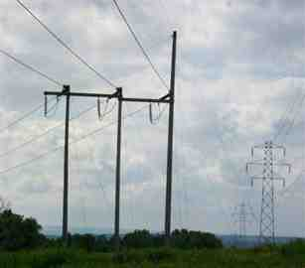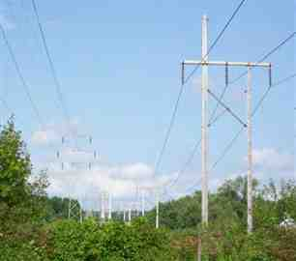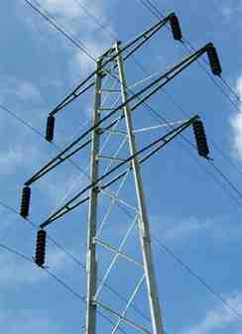

Service Agreement No. 1949

Marcy Nanocenter

Preliminary Study Report

16. Attachments

Site Photos

Image #1: From Hazard Road Image #2: From Hazard Road

Looking Towards Nanocenter Site Looking Towards Porter Substation

Image #3: Double Circuit Steel Flex Tower

12

47

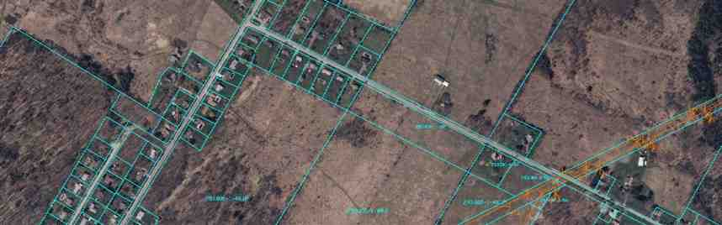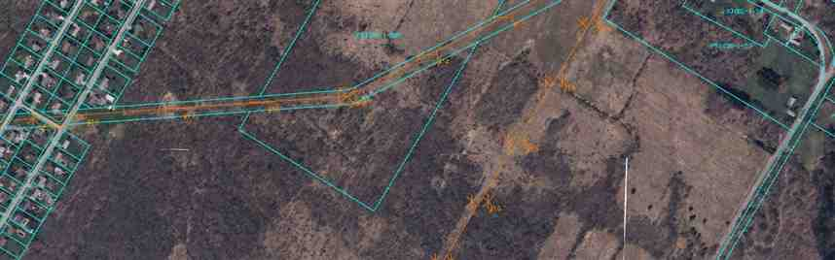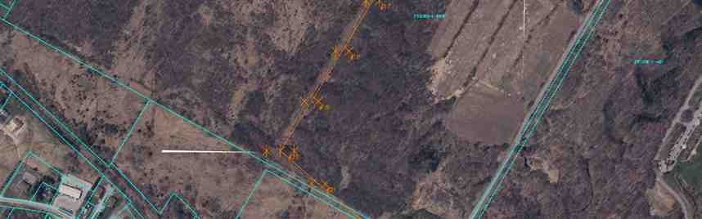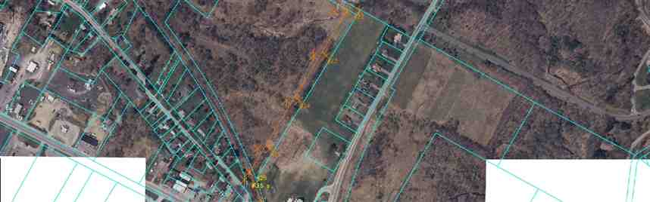

Service Agreement No. 1949

MARCY 115kV RELOCATION

EXISTING #3/#7 ROW

TO BE EXPANDED

NEW #6 ROW EXISTING #6 ROW

SINGLE CIRCUIT DEADEND STRUCTURE

SINGLE CIRCUIT SUSPENSION STRUCTURE PROPOSED ROW

NEW 115kV LINE

EXISTING 115kV LINES

PROPOSED PROJECT SITE

48

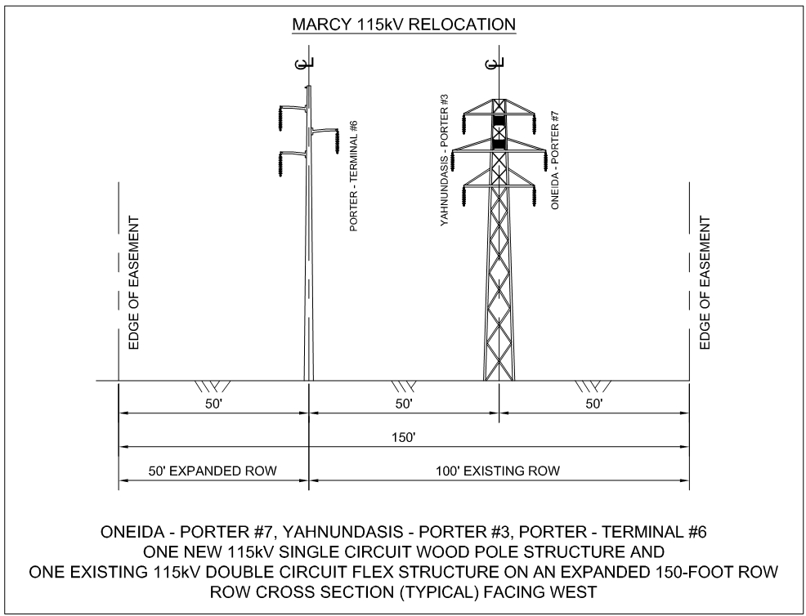

Service Agreement No. 1949

49

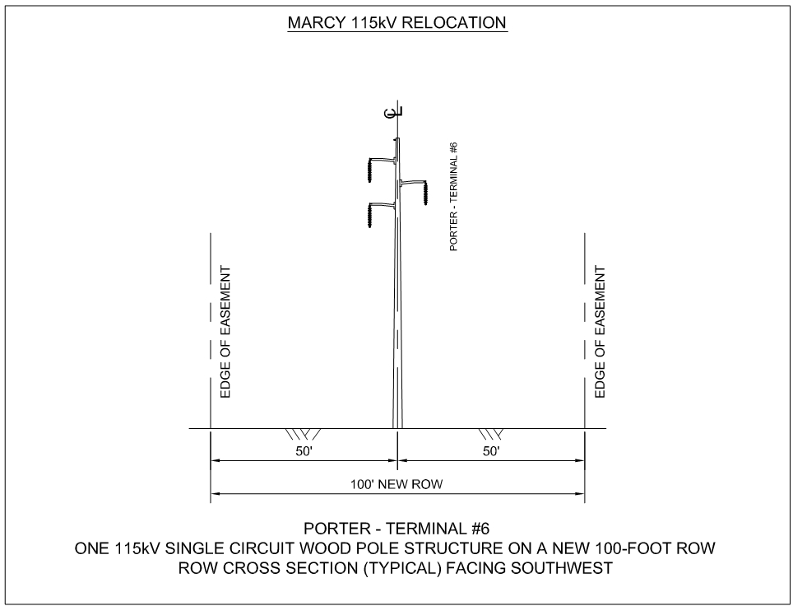

Service Agreement No. 1949

50

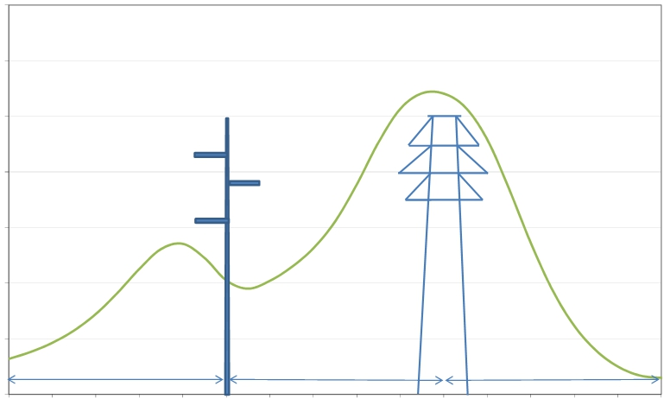

Service Agreement No. 1949

ELECTRIC FIELD PROFILE - MARCY 115KV RELOCATION

3.5

115kV Oneida - Porter #7

115kV Yahnundasis - Porter #3

Conductor: 795kcmil ACSR "DRAKE"

3

2.5

2

1.5

1

0.5

0

0

115kV Porter - Terminal #6   
Conductor: 795kcmil ACSR "DRAKE"

Winter Normal Rating: 1395A   
 Min Midspan Clearance: 23'

1

3

2

50' to edge of ROW

10 20 30 40 50 60 70

Winter Normal Rating: 1395A   
 Min Midspan Clearance: 23'

1 1

3 3

2 2

50' 50' to edge of ROW

80 90 100 110 120 130 140 150

ROW (feet)

Based on the State of New York, Public Safety Comission, Statement of Interim Policu on Magnetic Fields of Major Electric Transmission Facilities: Electric Field @ Winter Normal Load: 1.6kV/m @ edge ROW

51

Electric Field (kV/m)

Edge of ROW

Edge of ROW

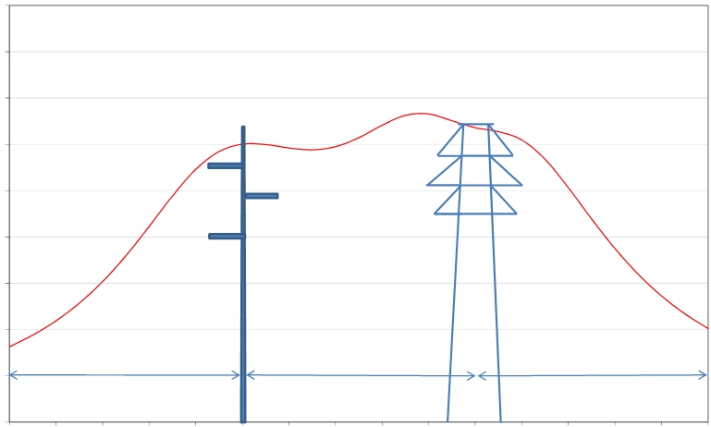

Service Agreement No. 1949

MAGNETIC FIELD PROFILE - MARCY 115KV RELOCATION

450

115kV Oneida - Porter #7

115kV Yahnundasis - Porter #3

400

350

300

250

200

150

100

50

0

0

115kV Porter - Terminal #6   
Conductor: 795kcmil ACSR "DRAKE"

Winter Normal Rating: 1395A   
 Min Midspan Clearance: 23'

1

3

2

50' to edge of ROW

10 20 30 40 50 60 70

Conductor: 795kcmil ACSR "DRAKE"   
 Winter Normal Rating: 1395A

Min Midspan Clearance: 23'

1 1

3 3

2 2

50' 50' to edge of ROW

80 90 100 110 120 130 140 150

ROW (feet)

Based on the State of New York, Public Safety Comission, Statement of Interim Policu on Magnetic Fields of Major Electric Transmission Facilities: Magnetic Field @ Winter Normal Load: 200mG @ edge ROW

52

Magnetic Field (mG)

Edge of ROW

Edge of ROW

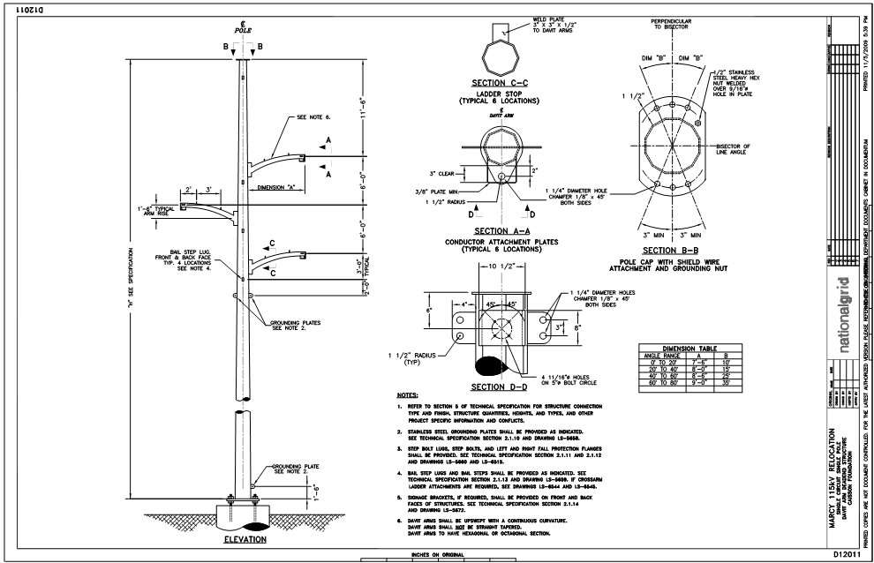

Service Agreement No. 1949

53

Service Agreement No. 1949

54

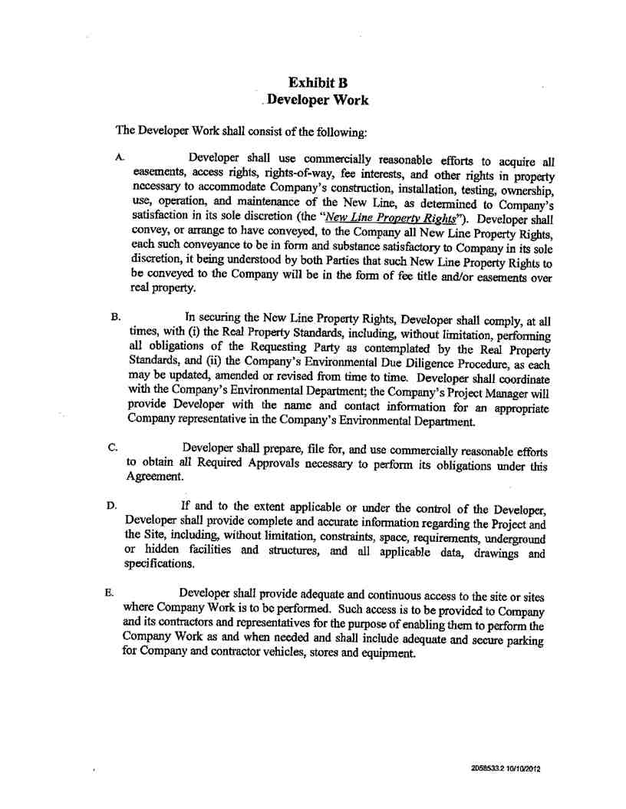

Service Agreement No. 1949

55

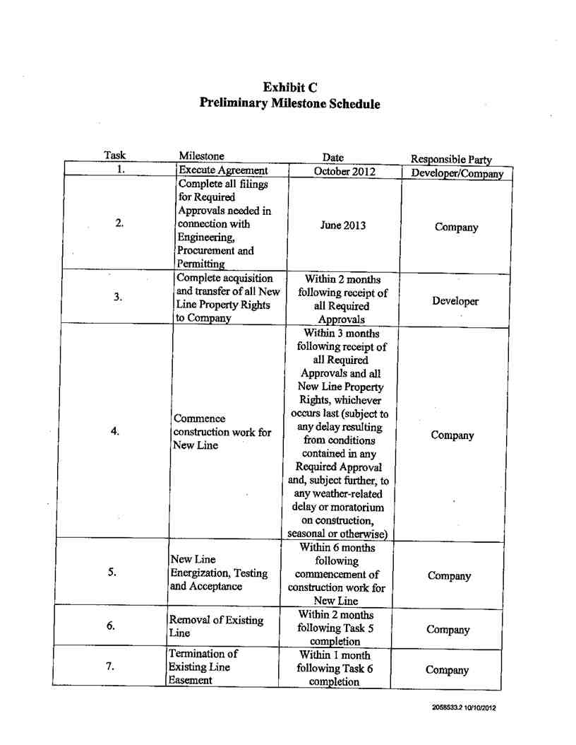

Service Agreement No. 1949

56

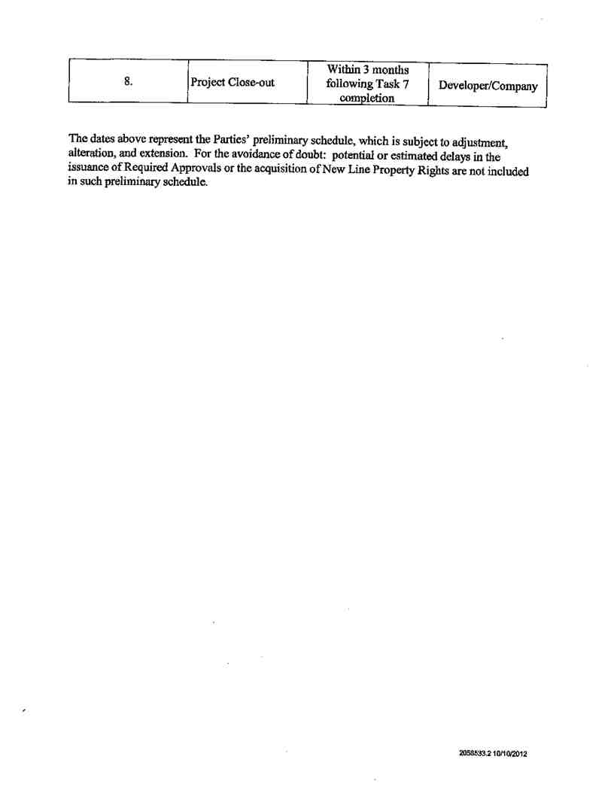

Service Agreement No. 1949

57



Service Agreement No. 1949

58

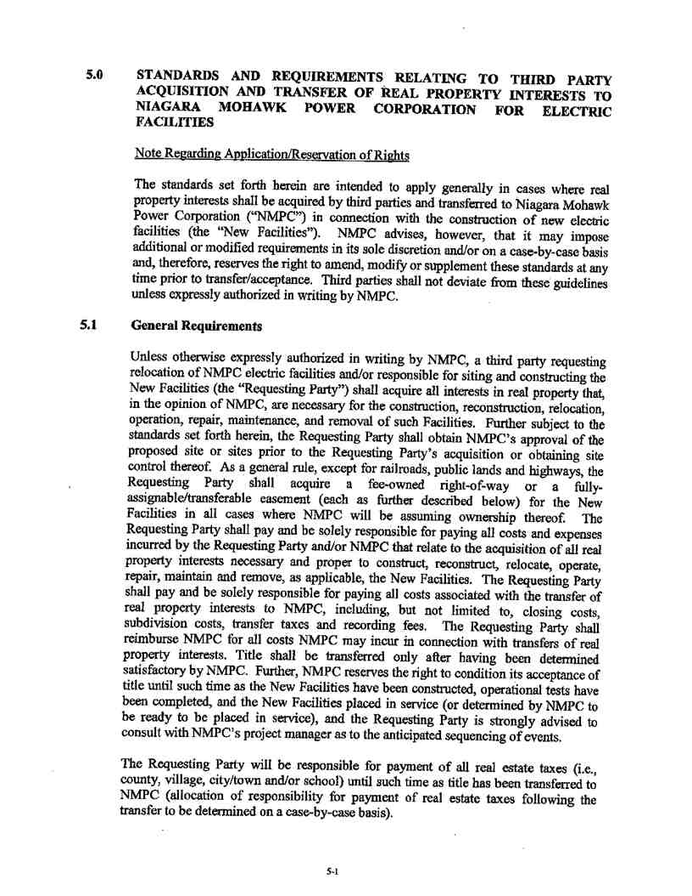

Service Agreement No. 1949

59

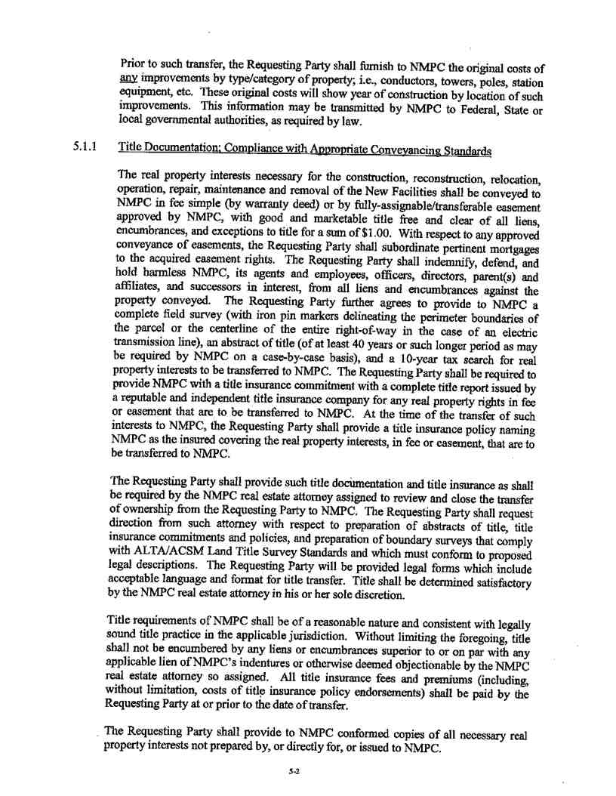

Service Agreement No. 1949

60

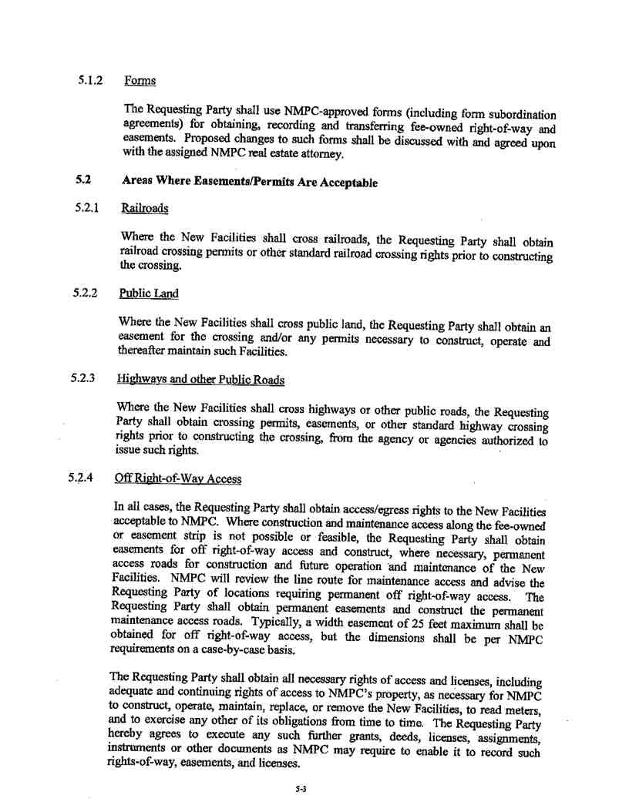

Service Agreement No. 1949

61

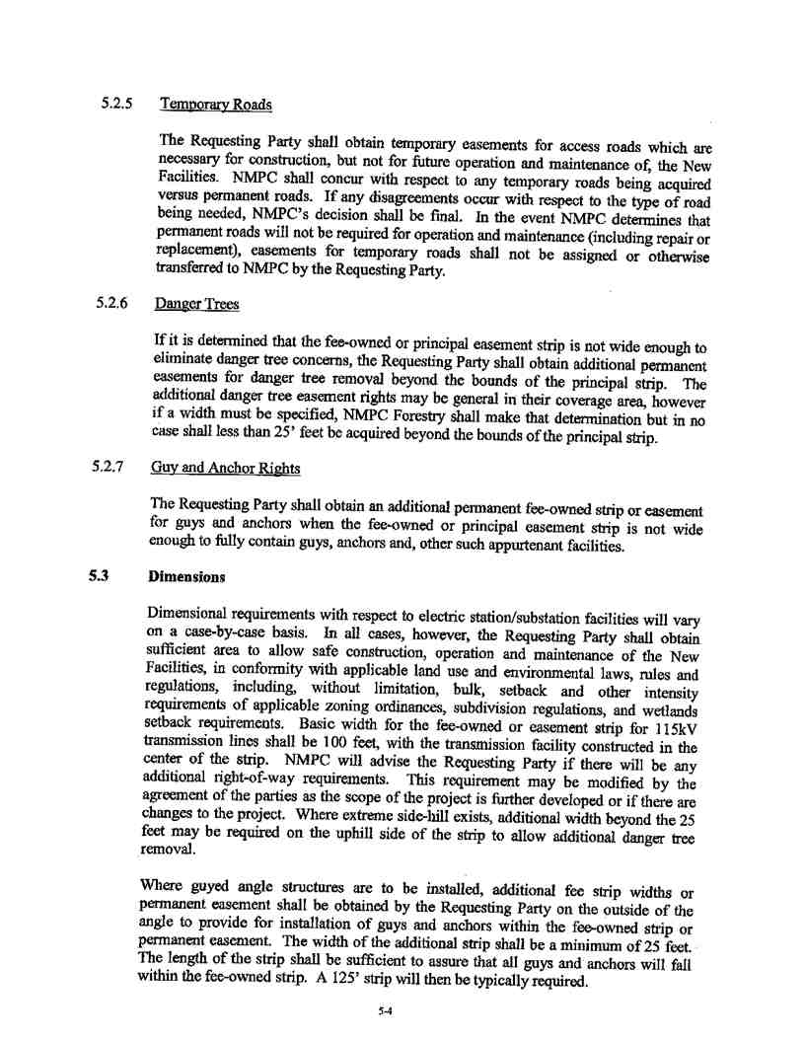

Service Agreement No. 1949

62

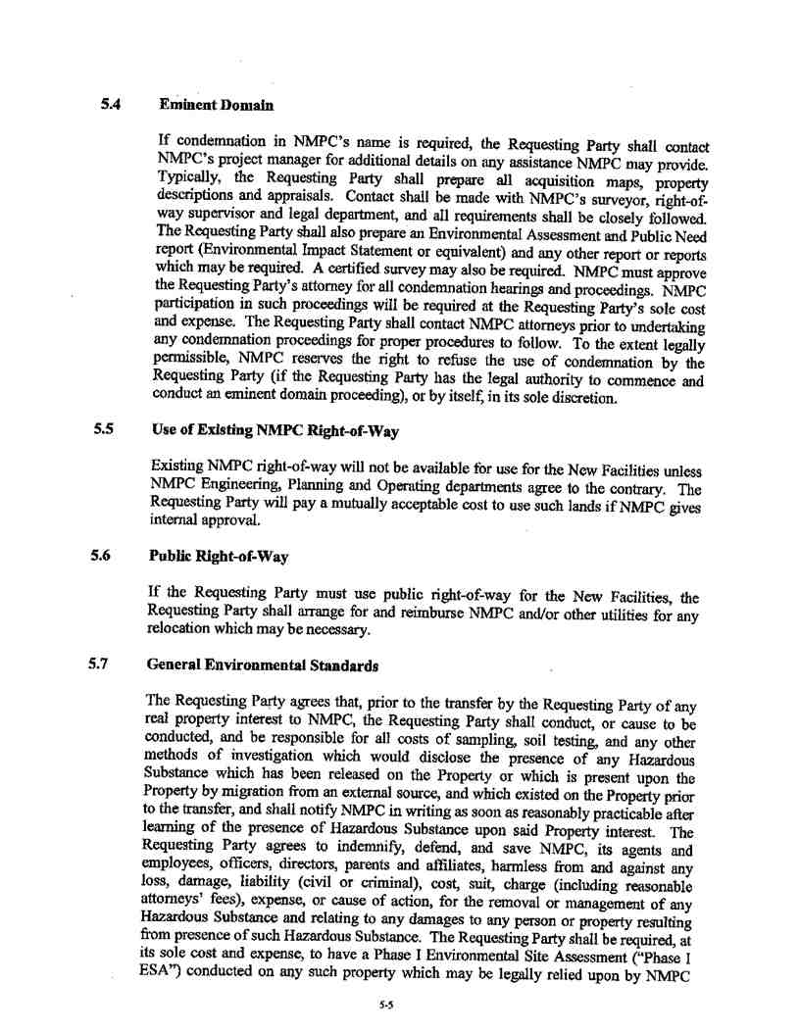

Service Agreement No. 1949

63

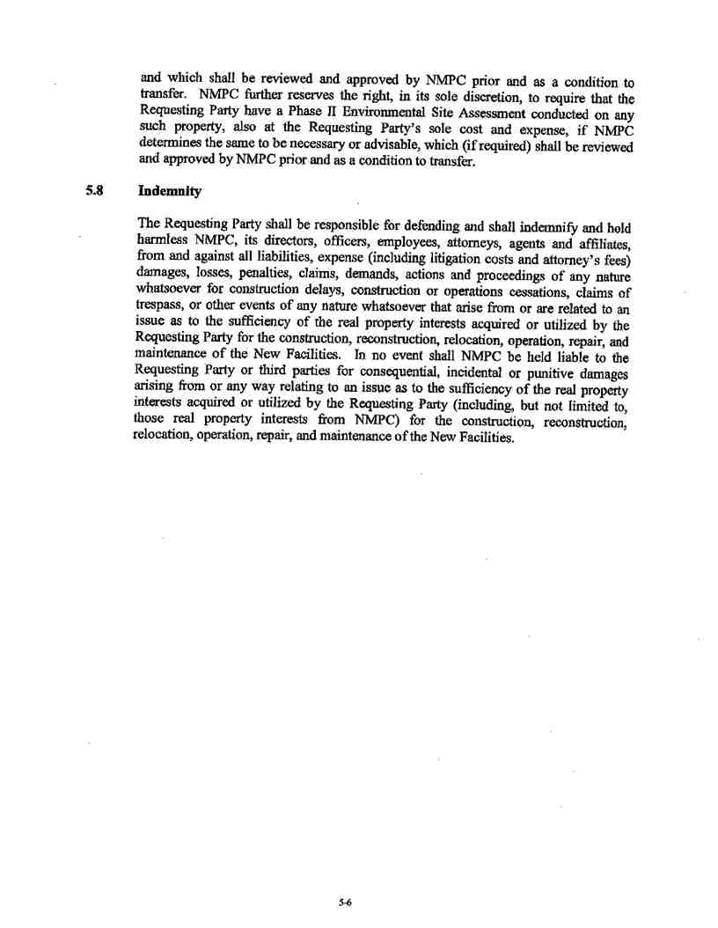

Service Agreement No. 1949

64

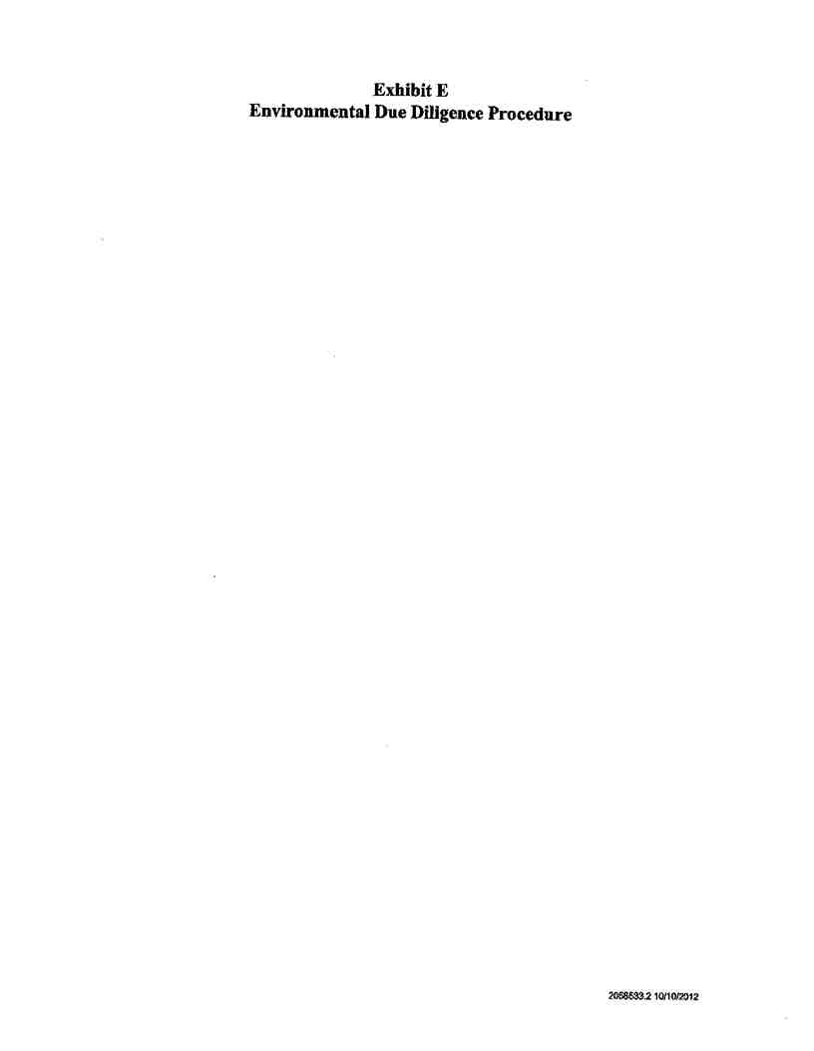

Service Agreement No. 1949

65

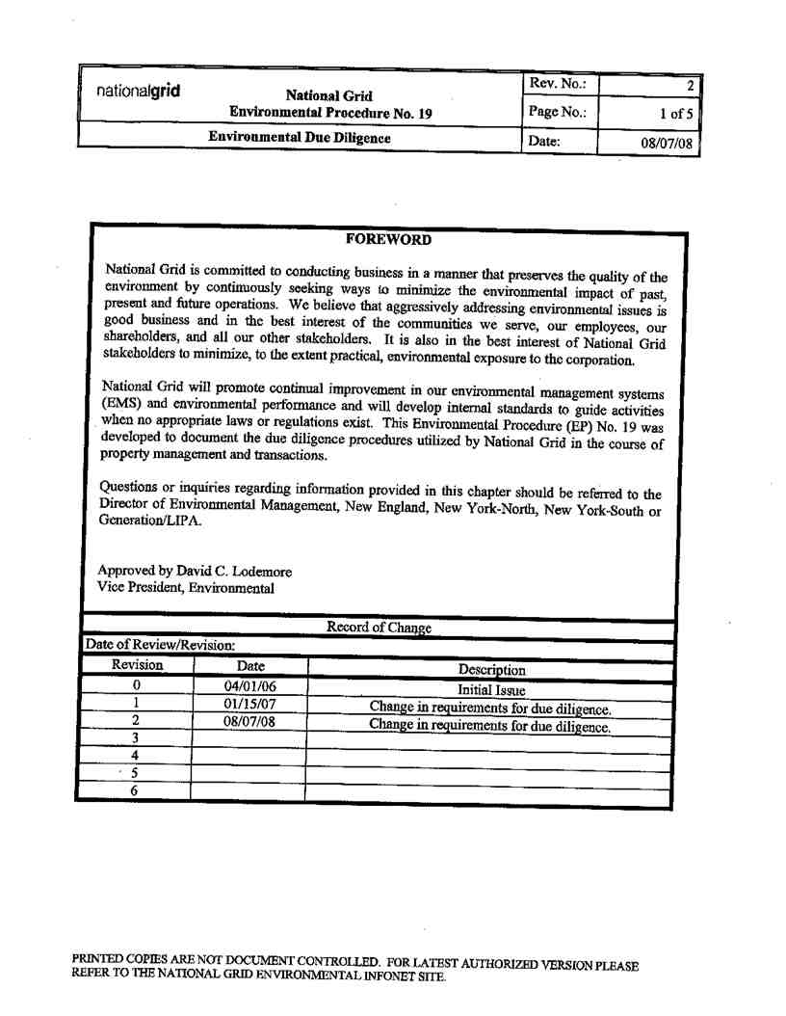

Service Agreement No. 1949

66

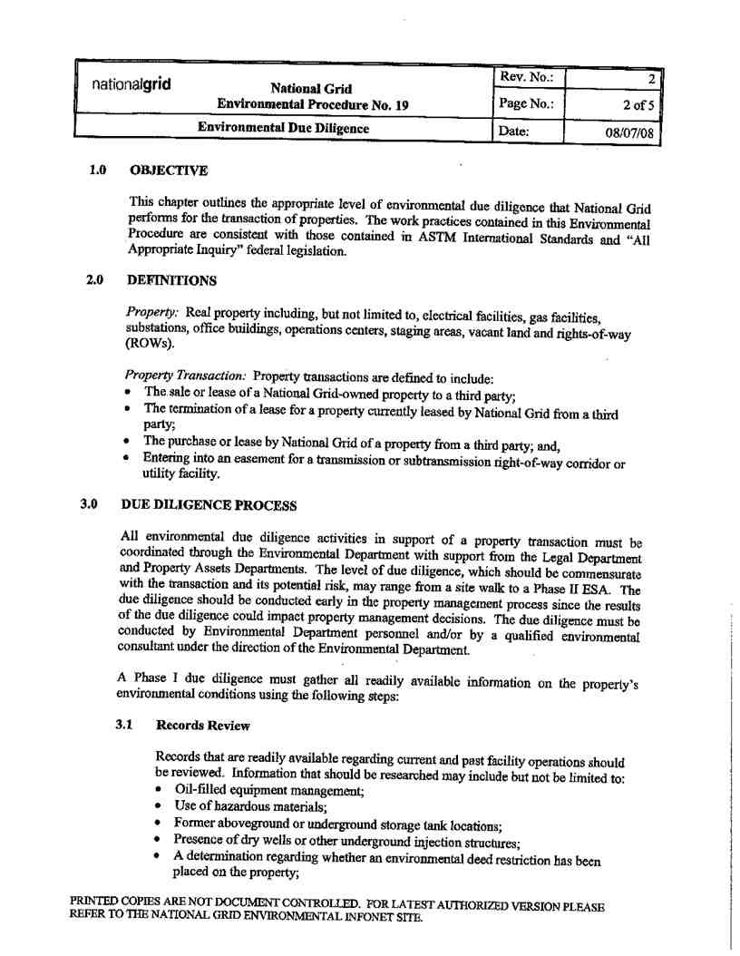

Service Agreement No. 1949

67

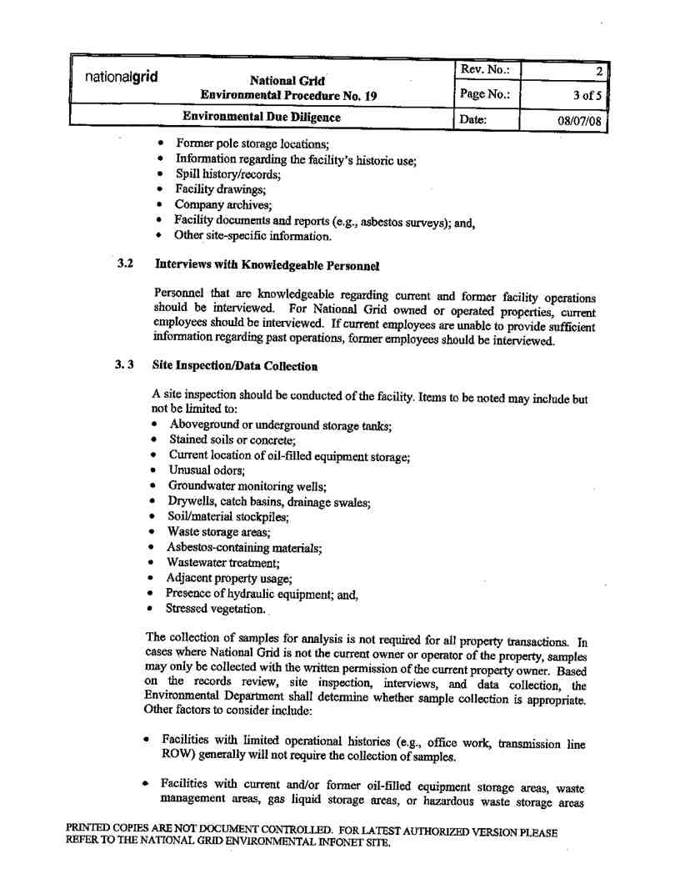

Service Agreement No. 1949

68

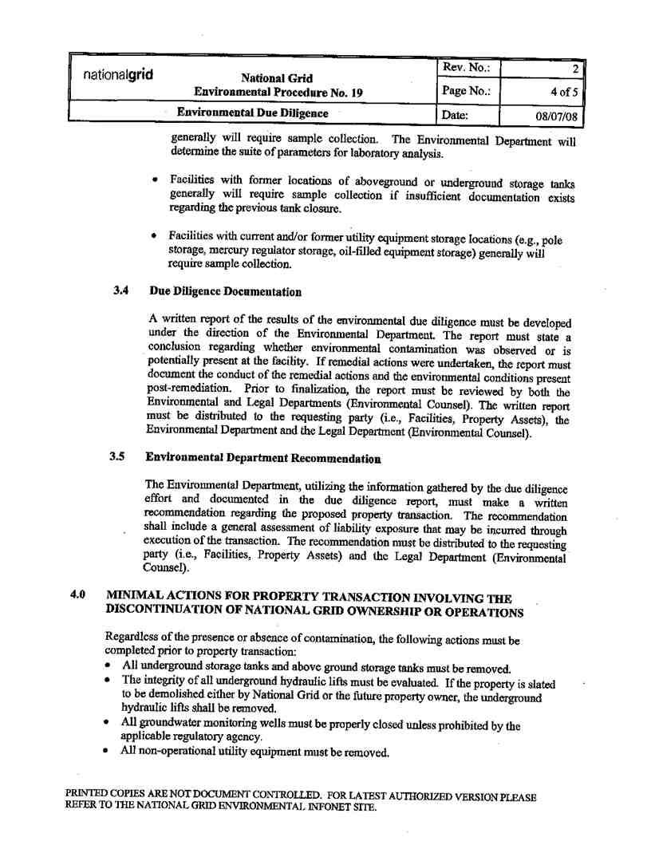

Service Agreement No. 1949

69

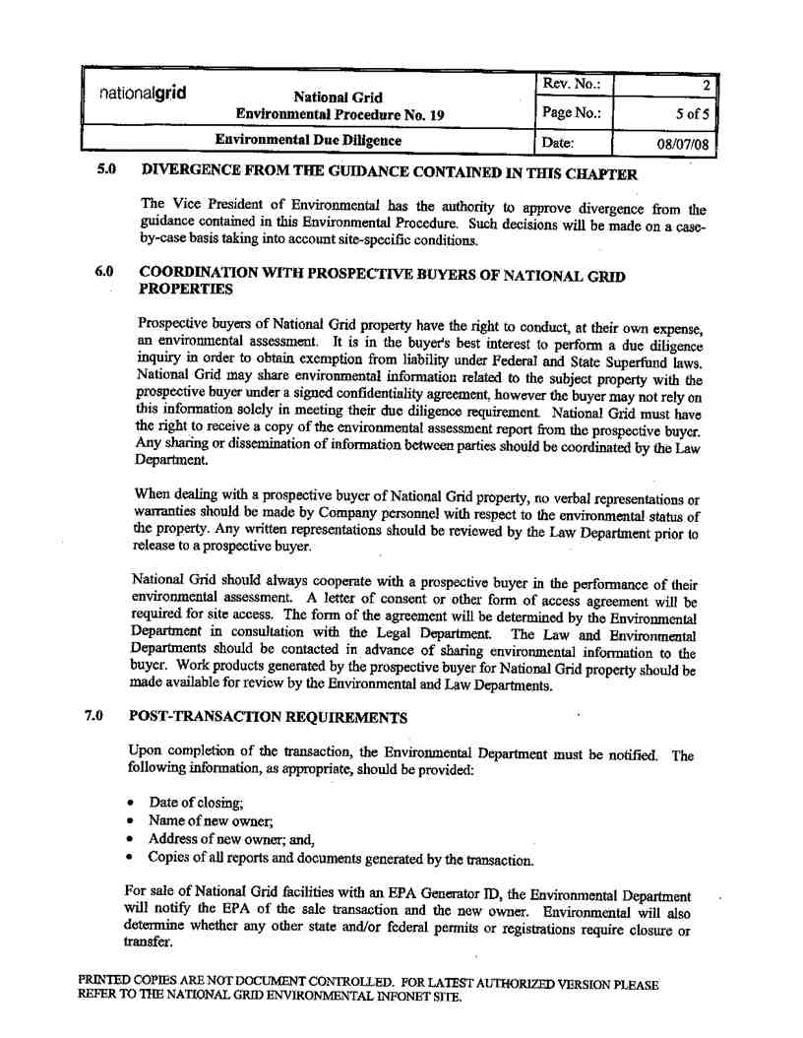

Service Agreement No. 1949

70

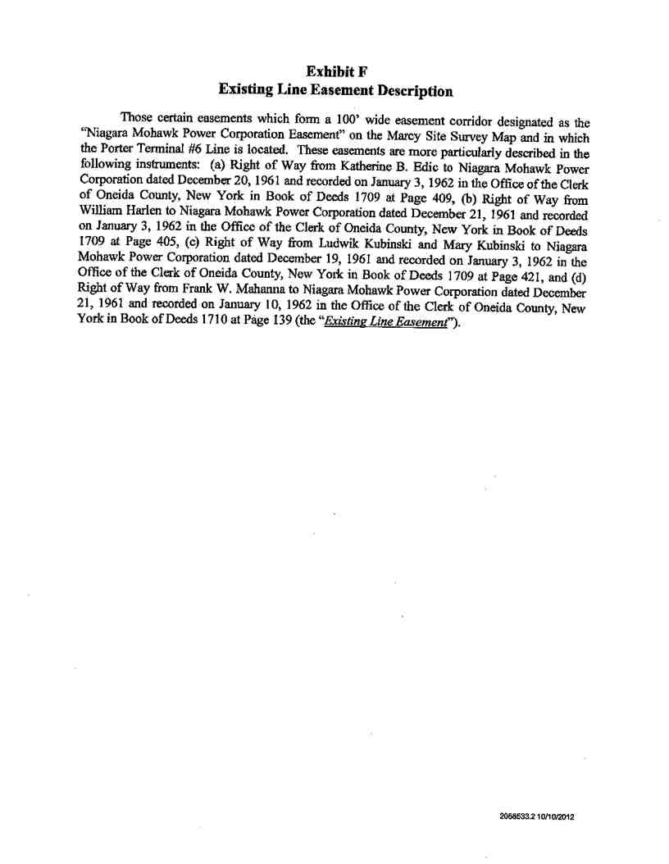

Service Agreement No. 1949

71



Service Agreement No. 1949

72



Service Agreement No. 1949

73

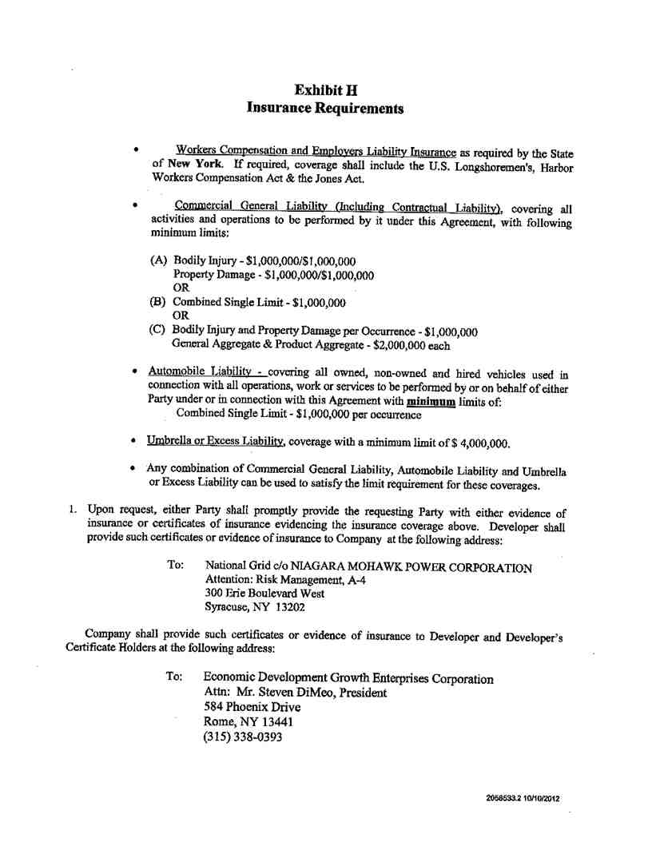

Service Agreement No. 1949

74

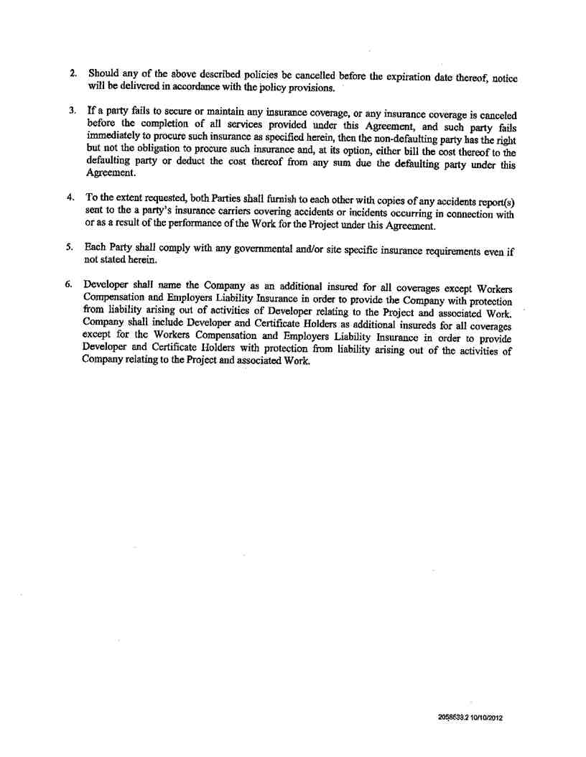

Service Agreement No. 1949

75

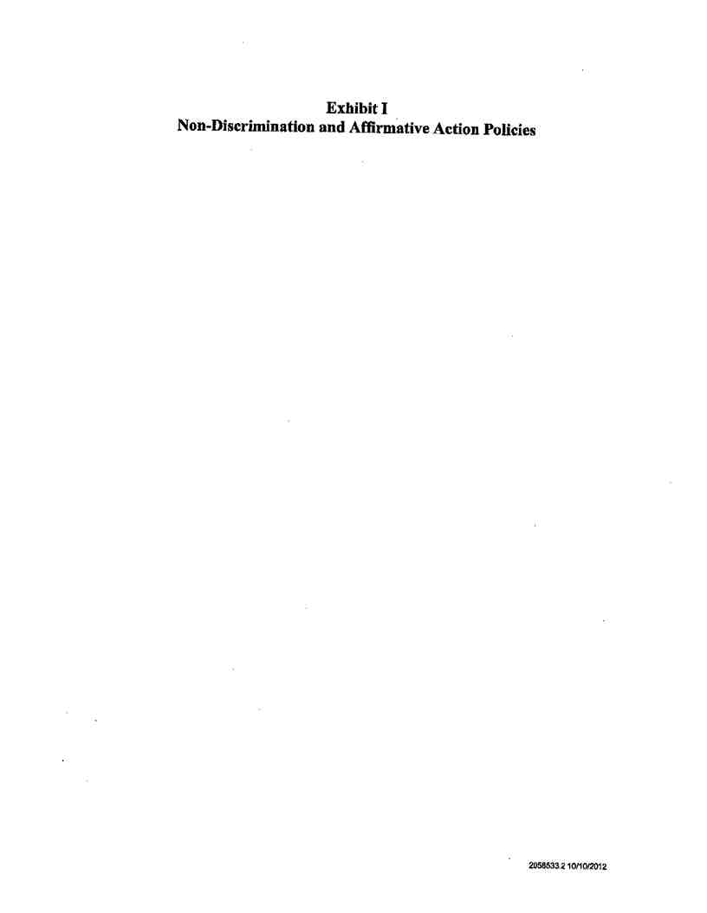

Service Agreement No. 1949

76

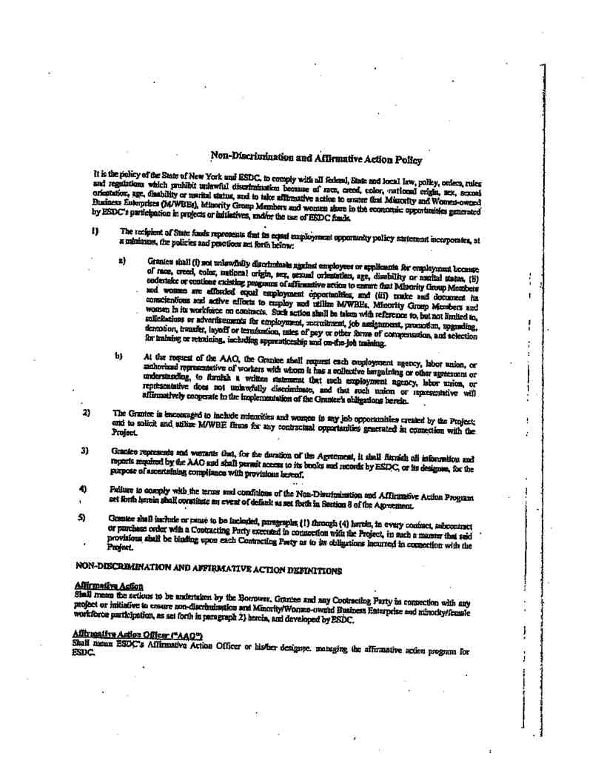

Service Agreement No. 1949

77

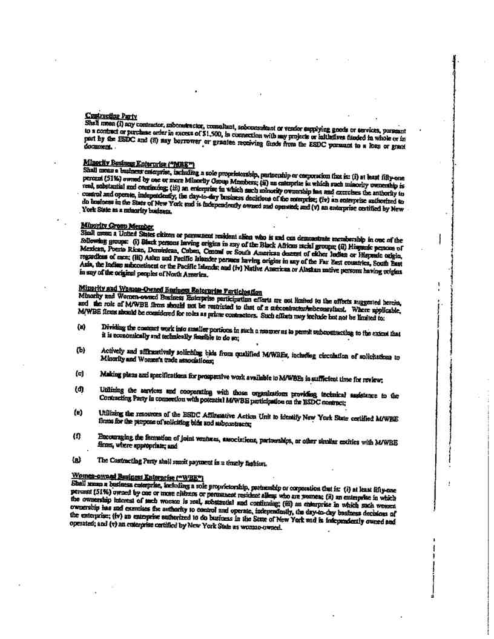

Service Agreement No. 1949

78

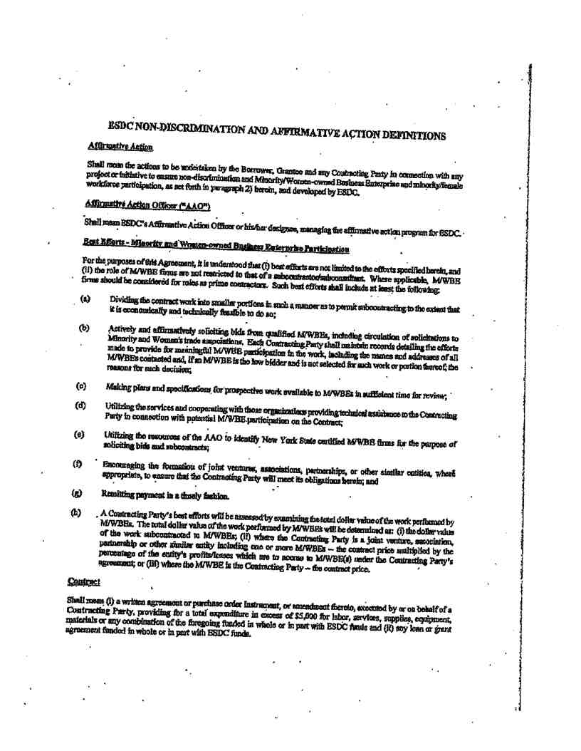

Service Agreement No. 1949

79

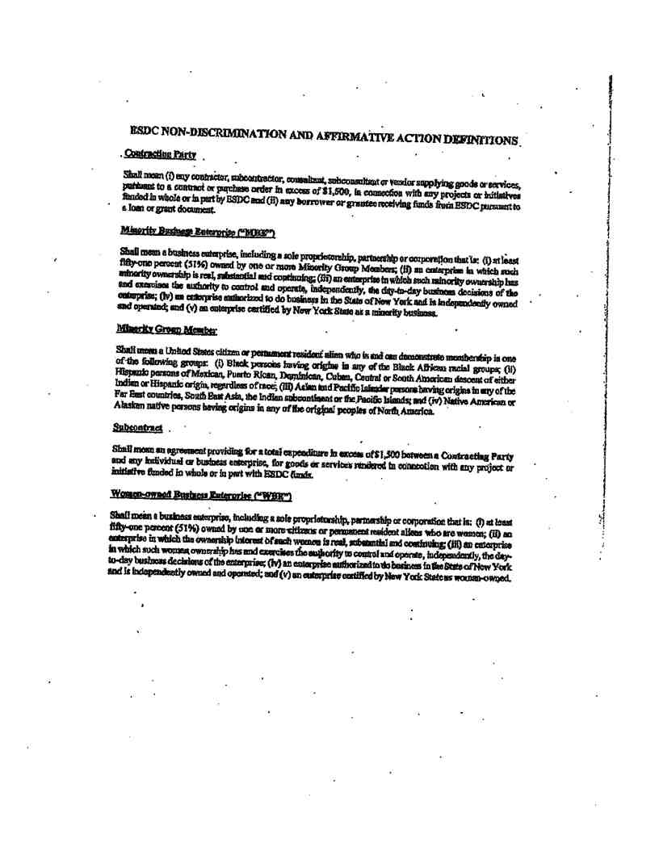

Service Agreement No. 1949

80