FERC rendition of the electronically filed tariff records in Docket No.
Filing Data:
CID: C000038
Filing Title: Con Edison and O&R Transco Agreements Company Filing Identifier: 1170
Type of Filing Code: 10
Associated Filing Identifier:
Tariff Title: NYISO Agreements Tariff ID: 58
Payment Confirmation: N
Suspension Motion:

Tariff Record Data:
Record Content Description: Agreement No. 2287
Tariff Record Title: Project Services Agreement 2287, Con Edison and Transco Record Version Number: 0.0.0
Option Code: A
Tariff Record ID: 202
Tariff Record Collation Value: 8080700
Tariff Record Parent Identifier: 2
Proposed Date: 2016-05-27
Priority Order: 500
Record Change Type: New
Record Content Type: 2
Associated Filing Identifier:

ATTACHMENT B

AMENDED AND RESTATED PROJECT SERVICES AGREEMENT

EXECUTION COPY
SERVICE AGREEMENT NUMBER 2287

AMENDED AND RESTATED
PROJECT SERVICES AGREEMENT

BETWEEN
CONSOLIDATED EDISON OF NEW YORK, INC.

AND
NEW YORK TRANSCO LLC

Dated
JUNE 23, 2016

- i -

TABLE OF CONTENTS

ARTICLE I DEFINITIONS AND INTERPRETATION 1
§1.01 DEFINITIONS 1
§1.02 INTERPRETATION 5
ARTICLE II SCOPE OF SERVICES 6
§2.01 Services to be Provided 6
§2.02 Estimated Cost and Schedule of Services 6
§2.03 Use of Subcontractors and Affiliates 6
§2.04 Standard of Performance 6
§2.05 Suspension of Services 7
ARTICLE III COMPENSATION AND PAYMENT 8
§3.01 Compensation 8
§3.02 Payment 9
ARTICLE IV REPORTING REQUIREMENTS 9
§4.01 Monthly Reports 9
§4.02 Immediately Reportable Events 9
§4.03 Other Information 10
ARTICLE V TERM AND TERMINATION 10
§5.01 Term 10
§5.02 Termination 10
ARTICLE VI TITLE TO PLANS AND SPECIFICATIONS 11
ARTICLE VII BOOKS AND RECORDS 11
ARTICLE VIII ACCESS RIGHTS 11
§8.01 Transmission Owner’s Access 11
§8.02 Transco’s Access 13
§8.03 Drawings 14

- ii -

ARTICLE IX SAFETY 14
§9.01 Safety Standards 14
§9.02 Employees and Subcontractors 14
§9.03 Safety Reporting 14
ARTICLE X PROJECT PERMITS 14
§10.01 Consequential and Indirect Damages 15
§10.02 Disclaimers/Exclusivity of Warranties 16
§10.03 Survival 16
ARTICLE XI INDEMNIFICATION 17
§11.01 Indemnification 17
§11.02 Notification of Claim 17
§11.03 Indemnification Procedures; Defense of Claims 17
§11.04 Indemnification Amount 18
§11.05 Survival 18
ARTICLE XII INSURANCE 19
§12.01 Required Coverage 19
§12.02 Proof of Coverage 19
§12.03 Right to Inspect 19
§12.04 Term of Coverage 19
§12.05 Subrogation Waivers 19
§12.06 Contractors, Etc 19
ARTICLE XIII CONFIDENTIALITY 20
§13.01 General 20
§13.02 Required Disclosure 20
§13.03 Termination of the Agreement 21
§13.04 Survival 21

- iii -

§13.05 Remedies 21
ARTICLE XIV DISPUTE RESOLUTION 21
§14.01 Negotiation 21
§14.02 Non-Binding Mediation 22
§14.03 Continuation of Work 22
ARTICLE XV REPRESENTATIONS AND WARRANTIES 23
ARTICLE XVI FORCE MAJEURE 23
§16.01 Excused Performance 23
§16.02 Alternate Contractors 24
ARTICLE XVII MISCELLANEOUS 24
§17.01 Governing Law 24
§17.02 Waiver of Jury Trial 24
§17.03 Required Regulatory Approvals 24
§17.04 Notices 25
§17.05 Entire Agreement 25
§17.06 Amendment 25
§17.07 Third Party Beneficiaries 25
§17.08 Relationship of the Parties 26
§17.09 Waiver 26
§17.10 Severability 26
§17.11 Assignment 26
§17.12 Transfers 26
§17.13 Relationship with the Interconnection Agreement 27
§17.14 Binding Effect 27
§17.15 Counterparts 27

- iv -

SCHEDULES
Schedule 1 Description of Projects
Schedule 2 Scope of Services, Principal Contributors, Estimated Cost and Schedule of
Services
Schedule 3 Assigned Contracts
Schedule 4 Insurance Requirements
Schedule 5 Addresses for Notice
Schedule 6 Interconnection Agreements

AMENDED AND RESTATED PROJECT SERVICES AGREEMENT
This AMENDED AND RESTATED PROJECT SERVICES AGREEMENT (together
with all Exhibits and Schedules attached hereto, as hereafter amended in accordance with its terms,
this “Agreement”) is made and entered into as of this 23rd day of June, 2016, by and between New
York Transco LLC, a New York limited liability company (“Transco”) and Consolidated Edison
of New York, Inc., a New York corporation (“Transmission Owner”) (each, a “Party” and,
together, the “Parties”).
RECITALS
A. Transco was formed for the purpose of developing, constructing, owning and
operating certain proposed high voltage electric transmission lines and associated facilities in New
York State.
B. On May 24, 2016, Transco acquired from Transmission Owner, certain electric
transmission facilities and related assets (including assignment of all applicable contracts and
permits) comprising the 2nd Ramapo to Rock Tavern Line (the “RRT Project”) and the Staten
Island Unbottling Project, Phase I (the “SIU Project”; and, together with the RRT Project, the
“Projects”) that Transmission Owner had been developing and constructing, as more specifically
described in Schedule I attached hereto in and pursuant to the terms of those certain asset purchase
agreements between the Parties, dated as of January 7, 2016 (the “Acquisition Agreements”).
C. The Projects were substantially developed and their construction was nearly
completed on the date of their acquisition, but certain additional construction work remained to be
performed both prior to and following their energization, which occurred on or about May 27,
2016.
D. Transco and Transmission Owner entered into this Agreement on May 24, 2016 (the “Effective Date”), to contract for the performance of certain work by Transmission Owner to complete construction of the Projects on the terms set forth herein.
E. The Parites are now amending and restating this Agreement for the sole purpose of removing a provision that would allow this Agreement to supersede one or more Interconnection Agreements described on Schedule 6 and including certain definitions that had previously referenced definitions contained in other documents.
NOW, THEREFORE, in consideration of the mutual covenants and agreements specified
in this Agreement, and for other good and valuable consideration, the receipt and sufficiency of
which is hereby acknowledged, the Parties, intending to be legally bound, hereby agree as follows:
ARTICLE I DEFINITIONS AND INTERPRETATION
§1.01 Definitions. Capitalized terms used and not defined herein have the meanings
given thereto in the Limited Liability Company Agreement of Transco (the “LLC Agreement”).
The following capitalized terms, as used in this Agreement shall have the following meanings:
“AAA” has the meaning specified in §15.02.
1
4845-2993-5922, v. 1

“Accounting Practice” means United States generally accepted accounting principles in accordance, as applicable, with FERC’s “Uniform System of Accounts Prescribed for Public Utilities and Licensees Subject to the Provisions of the Federal Power Act”, as the same may be modified, amended or supplemented from time to time.
‘Acquisition Agreements” has the meaning specified in the Recitals.
“Affiliate” means, with respect to any Person, any other Person who, directly or indirectly,
through one or more intermediaries, controls, is controlled by, or is under common control with,
such Person. The term “control” means the possession, directly or indirectly, of the power to
direct or cause the direction of the management and policies of a Person, whether through the
ownership of voting securities, by contract, or otherwise, and the terms “controlled” and
“controlling” have meanings correlative thereto.
“Agreement” has the meaning specified in the Preamble.
“Assigned Contracts” has the meaning specified in §2.01
“Alternate Contractor” has the meaning specified in §17.02. “Applicable IA” has the meaning specified in §18.14.
“Business Day” means a day other than a Saturday, Sunday or other day on which commercial banks in New York, New York are authorized or required by law to close.
“Cause” means a material breach of a covenant, obligation or warranty under this Agreement by a Party, which breach remains uncured for a period of thirty (30) days after notice thereof is sent to such Party.
“CEII” means critical energy infrastructure information as defined under applicable FERC rules and policies.
“Confidential Information” has the meaning specified in §14.01.
“Direct Costs” has the meaning specified in §3.01(a).
“Disclosing Party” has the meaning specified in §14.01.
“Dispute” has the meaning specified in §15.01(a).
“Dispute Notice” has the meaning specified in §15.01(a).
“Effective Date” has the meaning specified in the Recitals.
“Environmental Law” means all applicable current and future federal, state, local and
foreign laws (including common law), treaties, regulations, rules, ordinances, codes, decrees,
judgments, directives, orders (including consent orders), Environmental Permits (as defined
below) and New York State Department of Environmental Conservation Technical Administrative
Guidance Memoranda and other guidance documents issued or published by any Governmental
2
4845-2993-5922, v. 1

Authority, in each case, relating to pollution, protection of the indoor or outdoor environment, natural resources, human health and safety, the presence, Release of, threatened Release of, or exposure to, Hazardous Substances, or the generation, manufacture, processing, distribution, use, treatment, storage, transport, recycling or handling of, or arrangement for such activities with respect to, Hazardous Substances.
“Environmental Permit” means any permit, license, consent, approval, identification number, manifest and other authorization or certification required by any Governmental Authority with respect to or under Environmental Law.
“Federal Funds Rate” means, for any period, a fluctuating interest rate per annum equal
for each day during such period to the weighted average of the rates on overnight federal funds
transactions with members of the Federal Reserve System arranged by federal funds brokers, as
published for such day (or, if such day is not a Business Day, for the next preceding Business Day)
by the Federal Reserve Bank of New York, or, if such rate is not so published for any date that is a
Business Day, the average of the quotations for such day on such transactions received by the
Parties from three (3) unaffiliated federal funds brokers of recognized standing selected by them.
“FERC” means the Federal Energy Regulatory Commission, or any successor to its responsibilities and functions.
“Force Majeure Event” means an event, condition or circumstance beyond the reasonable
control of the party asserting such Force Majeure Event to excuse performance, and which could
not have been avoided by due diligence and use of reasonable efforts, which prevents the
performance by the party asserting such Force Majeure Event of any or all of its obligations
hereunder. Subject to the foregoing, “Force Majeure Event” includes, acts of God, war, riots,
strikes, civil disturbances, lockouts or industrial disputes or disturbances, labor or material
shortages, epidemics, landslides, earthquakes, fire, storms, floods, inclement weather necessitating
extraordinary measures or expense, and acts or omissions of Governmental Authorities preventing
or delaying performance.
“Good Utility Practice” means any of the practices, methods and acts engaged in or approved by a significant portion of the electric industry during the relevant time period, or any of the practices, methods and acts which, in the exercise of reasonable judgment in light of the facts known at the time the decision was made, could have been expected to accomplish the desired result at a reasonable cost consistent with good business practices, reliability, safety and expedition. Good Utility Practice is not intended to be limited to the optimum practice, method, or act to the exclusion of all others, but rather to delineate acceptable practices, methods, or acts generally accepted in the region in which the Services are to be performed.
“Governmental Authority” means, any: (i) nation, state, commonwealth, province,
territory, county, municipality, district or other jurisdiction of any nature; (ii) federal, state, county,
local, municipal, tribal, foreign or other government; or (iii) governmental or quasi-governmental
authority of any nature (including any independent system operator, regional transmission
organization, governmental division, department, agency, commission, instrumentality, official,
organization unit or entity and any court or other tribunal), in each case of (i), (ii) or (iii), with
jurisdiction over (A) all or a portion of the Projects (including their design, engineering,
3
4845-2993-5922, v. 1

construction, permitting, ownership, financing, testing, use, operation or maintenance), or (B) this Agreement, or (C) any Party.
“Hazardous Substances” means (i) any petroleum, petroleum products or by products and
all other hydrocarbons (including, without limitation, petro chemicals and crude oil) or any
fraction thereof, coal ash, radon gas, radioactive materials, asbestos, asbestos-containing material,
urea formaldehyde, polychlorinated biphenyls, chlorofluorocarbons and other ozone-depleting
substances, and (ii) any pollutant, contaminant, chemical, material, substance, product, waste
(including thermal discharges) or electromagnetic emissions that (x) is capable of causing harm to
the indoor or outdoor environment, natural resources or human health and safety, (y) is, has been,
or hereafter shall be listed, regulated, classified or defined as hazardous, toxic, or dangerous under
any Environmental Law (including, without limitation, 40 C.F.R. 302.4 (or its successor)), or (z)
is otherwise prohibited, limited or regulated by or pursuant to, or for which liability may arise under, any Environmental Law.
“Indemnified Party” or “Indemnified Parties” have the meanings specified in §12.02. “Indemnifying Party” has the meaning specified in §12.02.
“Indirect Costs” has the meaning specified in §3.01(b).
“Law” means any applicable constitutional provision, statute, act, code, law, regulation, rule, ordinance, order, decree, ruling, proclamation, resolution, judgment, decision, declaration, or interpretative or advisory opinion or letter of a Governmental Authority.
“Lease” means that certain lease agreement between Transmission Owner, as landlord,
and Transco, as tenant, dated as of February 23, 2016, as amended and in effect from time to time.
“Losses” has the meaning specified in §12.01.
“Mediation Request” has the meaning specified in §15.02.
“NERC” means the North American Electric Reliability Corporation, or any successor to its responsibilities or functions.
“NPCC” means the Northeast Power Coordinating Council.
“NYISO” means the New York Independent System Operator, Inc., or any successor to its responsibilities or functions.
“NYPSC” means the New York State Public Service Commission or any successor thereto. “OSHA” has the meaning specified in §9.01.
“Party” or “Parties” has the meaning specified in the Preamble.

4
4845-2993-5922, v. 1

“Permits” means the governmental approvals, permits, licenses, rights of way,
concessions, consents, waivers, authorizations and other permissions required to own, develop,
finance, construct, test, operate or maintain the Projects in compliance with all applicable Law.
“Person” means any natural person, corporation, limited partnership, general partnership, limited liability company, joint stock company, joint venture, association, company, estate, trust, bank trust company, land trust, business trust, or other organization, whether or not a legal entity, custodian, trustee-executor, administrator, nominee or entity in a representative capacity and any Governmental Authority.
“Plans and Specifications” has the meaning specified in Article VI. “Projects” has the meaning specified in the Recitals.
“Project Manager” has the meaning specified in §2.01.
“Property” means the parcels of real property identified on Exhibits A and B to the Lease. “Receiving Party” has the meaning specified in §14.01.
“Release” means any release, threatened release, spilling, emitting, discharging, leaking, pumping, pouring, emptying, escaping, dumping, injecting, depositing, disposing, dispersing, leaching or migrating of any Hazardous Substance.
“Remediation” means the investigation, cleanup, removal, transportation, disposal,
treatment (including in-situ treatment), management, stabilization, neutralization, collection, or
containment of Hazardous Substances, in each case, including, without limitation, any monitoring,
operations and maintenance activities that may be required by any Government Authority after the
completion of such investigation, cleanup, removal, transportation, disposal, treatment,
management, stabilization, neutralization, collection, or containment activities as well as the
performance of any and all obligations imposed by any Governmental Authority in connection
with such investigation, cleanup, removal, transportation, disposal, treatment (including in situ
treatment), management, stabilization, neutralization, collection, or containment (including any
such obligation that may be imposed on Landlord under a brownfield cleanup agreement or a
consent order).
“Representatives” has the meaning specified in §14.01.
“Required Approvals” has the meaning specified in §18.03. “Rules” has the meaning specified in §15.02.
“Services” has the meaning specified in §2.01.
“Substation Upgrade Facilities” means the electric substations and associated equipment known as the Sugarloaf, Ramapo, and Goethals, substations and identified in the Acquisition Agreements, as to which legal title is held by Transmission Owner or its affiliate, Orange & Rockland Utilities, Inc. but the right to earn a return is held by Transco.
5
4845-2993-5922, v. 1

“Suspension Notice” has the meaning specified in §2.05. “Term” has the meaning specified in §5.01.
“Termination Costs” means all documented Direct Costs and Indirect Costs incurred by
Transmission Owner in connection with the performance of the Services (i) prior to the effective
date of termination, including such costs incurred for materials, equipment, tools, construction
equipment and machinery, engineering and other items, materials, assets or services that cannot
reasonably be avoided, mitigated or cancelled, (ii) to unwind any work undertaken prior to or after
the effective date of termination to the extent reasonably necessary to return the Projects to a
configuration or condition in compliance with Good Utility Practice and applicable Law, and (iii)
arising from cancellation costs relating to orders or contracts entered into in connection with the
performance of Services by Transmission Owner prior to the effective date of the termination.
“Third Party Claim” has the meaning specified in §12.03(a).
“Third Party Warranties” has the meaning specific in §11.02.
“TO Lead” has the meaning specified in §2.01.
“Transco” has the meaning specified in the Preamble.
“Transco Parties” has the meaning specified in §12.01(b).
“Transferee” has the meaning specified in §18.13.
“Transferor” has the meaning specific in §18.13.
“Transmission Owner” has the meaning specified in the Preamble.
“Transmission Owner Parties” has the meaning specified in §12.01(a). §1.02 Interpretation.
(a) Headings. Titles, captions and headings in this Agreement are
inserted for convenience only and will not be used for the purposes of construing or interpreting this Agreement.
(b) References in this Agreement. In this Agreement, unless the context
clearly requires otherwise: (i) the singular includes the plural and vice versa; (ii) reference
to any Person includes such Person’s successors and assigns but, in the case of a Party, only
if such assigns are permitted by this Agreement, and reference to a Person in a particular
capacity excludes such Person in any other capacity; (iii) reference to any gender includes
each other gender; (iv) reference to any agreement (including this Agreement), document
or instrument means such agreement, document or instrument as amended or modified and
in effect from time to time in accordance with the terms thereof and, if applicable, hereof;
(v) reference to any Law means such Law as amended, modified, codified or reenacted, in
whole or in part, and in effect from time to time, including, if applicable, rules and
6
4845-2993-5922, v. 1

regulations promulgated thereunder; (vi) reference to any Section or Article means such
Section or Article of this Agreement, and references in any Section, Article or definition to
any clause means such clause of such Section, Article or definition; (vii) “hereunder,”
“hereof,” “hereto” and words of similar import will be deemed references to this
Agreement as a whole and not to any particular Article, Section or other provision of this
Agreement; (viii) “including” (and with correlative meaning “include”) means including
without limiting the generality of any description preceding such term; (ix) relative to the
determination of any period of time, “from” means “from and including”, “to” means “to
but excluding” and “through” means “through and including”; (x) the word “or” is not
exclusive; (xi) this Agreement shall be interpreted without reference to any prior drafts;
and (xii) accounting terms used in this Agreement will have the meanings assigned to them
under Accounting Practice.
(c) Industry Meanings. Words and abbreviations not defined in this
Agreement that have well-known electric power industry meanings in the United States are used in this Agreement in accordance with those recognized meanings.
(d) Joint Responsibility for Drafting. The Parties hereto have
participated jointly in the negotiation and drafting of this Agreement. In the event of any
ambiguity or question of intent or interpretation arises, this Agreement shall be construed
as if drafted jointly by the Parties and no presumption or burden of proof shall arise
favoring or disfavoring any Party by virtue of authorship or any provision of this
Agreement. This Agreement shall be interpreted without reference to prior drafts.
ARTICLE II SCOPE OF SERVICES
§2.01 Services to be Provided. During the Term, Transmission Owner shall perform those services necessary to do the work described on Schedule 2 attached hereto (the “Services”). Such Services may include administering, and overseeing and paying for the work performed under, those contracts (as Transco’s agents) described on Schedule 3 attached hereto (and may be amended by mutual agreement of the Parties)., (the “Assigned Contracts”). Schedule 2 also identifies the Projects’ Project Manager at Transmission Owner (the “TO Lead”), as well as at Transco (the “Project Manager”) who will serve as the principal point of contact between the Parties with respect to the Services.
§2.02 Estimated Cost and Schedule of Services. Schedule 2 sets forth an estimated cost
of the Services, together with an estimated timeline for the completion of the Services. Transco
will compensate Transmission Owner for the Services in accordance with the provisions of §3.01.
§2.03 Use of Subcontractors and Affiliates. Other than those contractors and vendors
that are counterparties to the Assigned Contracts (which, for clarity, are Transco’s contractors and
not subcontractors of Transmission Owner and as to whose performance risk resides with
Transco), Transmission Owner will not engage any subcontractors to perform any of the Services
without first obtaining Transco’s written consent, which consent shall not be unreasonably
withheld, delayed or conditioned, and, if required by Transco, procuring such subcontractor’s
written agreement to comply with any applicable Interconnection Agreement identified on
Schedule 6 hereto, provided, however, Transmission Owner shall be responsible and liable for the
7
4845-2993-5922, v. 1

acts and omissions of each such subcontractor (including such subcontractor’s subcontractors and
its employees) it engages to the same extent as if such acts or omissions were by Transmission
Owner or its employees. Each Party may use the services of its Affiliates in connection with its
performance under this Agreement without obtaining the written consent of the other Party. All
third party contract or Affiliate work used to provide Services under this Agreement shall be
charged directly to Transco at actual cost; it being acknowledged that Transmission Owner will
pay for work under the Assigned Contracts and seek reimbursement from Transco.
§2.04 Standard of Performance. The Parties shall perform their duties and obligations
hereunder in a commercially reasonable manner consistent with Good Utility Practice, and in
accordance with all applicable Law, and, to the extent not inconsistent with the foregoing, in
accordance with their then applicable practices. Services hereunder will be performed by
personnel who have the knowledge, skills, training and experience necessary to perform the same
and Transmission Owner will use reasonable efforts to perform the same within the estimates set
forth in Schedule 2 (which estimates the Parties acknowledge have been incorporated into the
Closing Assumed Liability Amount (as defined in the Acquisition Agreements)). Notwithstanding
anything in this Agreement to the contrary, subject to §5.02 hereof, Transco hereby acknowledges
that the estimates set forth in Schedule 2 are good faith estimates of the funds reasonably required
to pay Transmission Owner to perform the Services hereunder and does not limit Transco’s
responsibility to pay Transmission Owner all actual documented reasonable Direct Costs and
Indirect Costs incurred by Transmission Owner in performance of the Services.
§2.05 Suspension of Services. Transco may at its sole discretion suspend Transmission
Owner’s performance of all or any part of the Services hereunder for any reason whatsoever (other
than related to a Force Majeure Event) upon written notice to Transmission Owner (the
“Suspension Notice”). The Suspension Notice shall specify the nature, effective date, and
expected duration of the suspension. The Suspension Notice shall also designate what Services, if
any, are to be continued. Transmission Owner shall use commercially reasonable efforts to
promptly resume suspended Services when directed to do so by Transco in writing, subject to the
requirements of Good Utility Practice. Notwithstanding anything in §4.01 to the contrary, if the
Transmission Owner reasonably concludes (based on information available to it at the time) that
such suspension would result in substantially increased Direct Cost and/or Indirect Cost, the
Transmission Owner shall promptly notify Transco in writing. If the suspension of all or any part
of the Services impacts the estimated cost and timeline for the completion of the Services,
Schedule 2 will be amended to reflect the same. Upon receipt of the Suspension Notice
Transmission Owner shall, unless otherwise directed by Transco and subject to the requirements
of Good Utility Practice:
(a) Promptly suspend the Services on the date and to the extent specified in the
Suspension Notice;
(b) Place no further order or subcontracts with the Transmission Owner for or in connection with the suspended Services other than to the extent required in the Suspension Notice;

8
4845-2993-5922, v. 1

(c) Promptly make every commercially reasonable effort to obtain suspension
upon terms reasonably satisfactory to Transco of all orders and subcontracts to the extent
required by the suspension; and
(d) Continue to protect and preserve the Projects subject to and in accordance
with the terms and conditions of this Agreement.
Notwithstanding anything in this Agreement to the contrary, Transmission Owner shall not
be obligated to suspend Services, in whole or in part, to the extent such suspension (a) would cause
Transmission Owner to breach any provision of this Agreement or of any other contract pertaining
to one or both Projects to which Transmission Owner is party (which either was not capable of
assignment to Transco at the time of closing under the Acquisition Agreements or was not so
assigned in error), unless, in each case, Transco assumes in writing full liability therefor, (b) would
result in the violation of any applicable Law, (c) in the reasonable judgment of the Transmission
Owner, may endanger the safety of the Transmission Owner’s or Transco’s employees or
contractors, other persons or property, or would otherwise require an act or omission not in
accordance with Good Utility Practice, or (d) would leave the Projects in an unsafe condition.
If the Services are suspended in whole or in part by Transco pursuant to this §2.05, then Transco’s obligation to compensate Transmission Owner under this Agreement shall include all documented Direct and Indirect costs arising from such suspension.
ARTICLE III COMPENSATION AND PAYMENT
§3.01 Compensation. In consideration of Transmission Owner’s provision of the Services, Transco shall pay to Transmission Owner all of the documented reasonable Direct and Indirect costs incurred by Transmission Owner in performing such Services in each case to the extent applicable or allocable to such performance.
(a) Direct costs (the “Direct Costs”) include the following:
(i) all of Transmission Owner’s internal costs of labor
and services associated with the Services;
(ii) all costs and expenses associated with materials,
supplies, tools, machinery, apparatus and equipment, including rental charges and energy usage, including properly allocated overheads normally included in Transmission Owner’s charges for services billed to collect costs orders (excludes overhead charges as part of Indirect Costs);
(iii) costs and expenses for contract labor, outside
services and subcontractors, including outside consultants (subject to any consent requirements set forth herein);
(iv) federal, state or local taxes of any character,
including sales, use, ad valorem or similar taxes, imposed in connection with the Services performed under this Agreement, excluding any taxes on income;

9
4845-2993-5922, v. 1

(v) costs and expenses of travel and related
transportation, meals, lodging costs;
(vi) costs of insurance for insurance requirements as set
forth in Schedule 4 hereof, including premiums paid and amounts deductible from insured claims;
(vii) all costs of enforcing or attempting to enforce the
provisions of applicable insurance policies for insurance requirements as set forth in Schedule 4 hereof, payment and performance bonds, contracts, warranties and any other rights held by Transmission Owner as a consequence of its provision of Services hereunder; and
(viii) any other costs or expenses, to the extent applicable
or allocable to the performance of Services that are listed in this Agreement,
including the implicit equivalents of such Services.
(b) Indirect costs (the “Indirect Costs”) include the following:
(i) labor overheads (excluding overheads as part of
Direct Costs) directly associated with any and all of the Direct Costs, including
pensions, other post-retirement benefits and health care costs; and
(ii) administrative and general expenses.
(c) Direct Costs and Indirect Costs shall be accounted for by
Transmission Owner in accordance with applicable Accounting Practices and shall be consistent with FERC’s affiliate accounting rules.
§3.02 Payment Transmission Owner shall provide monthly invoices to Transco, setting
forth the costs incurred by Transmission Owner to provide the Services during the most recent
period for which costs are available (up to 120 days prior). Invoices shall contain reasonable detail
and, upon request, shall be accompanied by reasonably necessary supporting documentation.
Transco shall pay all invoices within thirty (30) days of receipt by wire transfer of immediately
available funds, except to the extent that Transco disputes any amount in good faith, in which
event Transco shall provide written notice of such Dispute (and an explanation of the basis for it as
described in Article XV) and pay the disputed amount into an independent escrow account chosen
by Transco pending resolution of the Dispute (the costs of which escrow account shall be borne
exclusively by Transco). Billing and payment Disputes not resolved in the normal course of
business shall, upon the request of either Party, be subject to the Dispute resolution procedures
described in Article XV. Any undisputed amounts not timely paid timely shall carry a finance
charge accruing at the prime rate of interest (as announced by the Wall Street Journal from time to
time) plus 2% per year.
ARTICLE IV REPORTING REQUIREMENTS
§4.01 Monthly Reports. Transmission Owner shall furnish such monthly progress reports
to Transco as Transco shall reasonably request, showing (a) actual spending on the Projects
10
4845-2993-5922, v. 1

compared to estimated spending, (b) any known increase in the cost estimates set forth in Schedule
2 and (c) a progress update on tasks that have been completed during such preceding month, including the achievement of any major milestones.
§4.02 Immediately Reportable Events. Transmission Owner will verbally notify Transco
immediately, or as soon as is reasonably practicable thereafter, and promptly follow such verbal
notification with a written report, upon the occurrence of any of the following in connection with
the Services:
(a) any OSHA recordable injuries that occur while performing
Services, provided that Transmission Owner shall also notify appropriate agencies as set
forth in Article IX;
(b) discovery or Release of any Hazardous Substances within the
Substation Upgrade Facilities or Property, as applicable (including, without limitation, related Remediation of such Hazardous Substances located within or outside of the Substation Upgrade Facilities or Property).
(c) any litigation, claims, disputes or actions, threatened or filed,
concerning the Services;
(d) any refusal or threatened refusal to grant, renew or extend (or any
action pending or threatened that might affect the granting, renewal or extension of) any
license, permit, approval, authorization or consent relating to the Services; and
(e) any dispute with any Governmental Authority relating to the
Services.
Transmission Owner agrees to provide to Transco drafts of any and all written reports required to be submitted to Governmental Authorities in connection with or arising from the events listed in Section 4.2(a)-(e) above with respect to the Services; Transco, however, shall have sole responsibility for the submittal or filing of such reports.
§4.03 Other Information. Transmission Owner shall prepare and submit to Transco such other reports and other information, as Transco may reasonably request regarding the Services to remain compliant with applicable Law.
ARTICLE V TERM AND TERMINATION
§5.01 Term. The term of this Agreement (the “Term”) shall commence as of the Effective Date and continue until the work described on Schedule 2 has been fully performed or waived, unless earlier terminated in accordance with §5.02.
§5.02 Termination. The Parties may terminate this Agreement with respect to any or all of the Projects at any time by mutual agreement in writing. Either Party may terminate this Agreement with respect to any or all of the Projects for (a) Cause, or (b) convenience by giving the other Party ninety (90) days’ prior written notice of such termination.

11
4845-2993-5922, v. 1

If this Agreement is terminated pursuant to Section 5.02, then Transmission Owner shall be
compensated for all documented Direct and Indirect costs it incurred to and including the date of
termination and for all Termination Costs; provided, however, that if this Agreement is terminated
by Transco for Cause, then (i) Transmission Owner shall not be entitled to reimbursement for its
Termination Costs and (ii) Transco shall be entitled to set off against any amount due
Transmission Owner hereunder any claims for damages it may have hereunder. All payments due by Transco upon termination shall be made within thirty (30) days of receipt of a final invoice from Transmission Owner.
ARTICLE VI TITLE TO PLANS AND SPECIFICATIONS
All information, analyses, reports, plans and specifications developed or prepared by
Transmission Owner in its performance of the Services under this Agreement (collectively, the
“Plans and Specifications”) shall belong exclusively to Transco and shall, to the extent possible,
be considered a work made by Transmission Owner for hire for Transco within the meaning of
Title 17 of the United States Code. To the extent the Plans and Specifications may not be
considered work made by Transmission Owner for hire for Transco, Transmission Owner agrees
to assign, and automatically assigns at the time of creation of the Plans and Specifications, to
Transco without any requirement of further consideration, any right, title, or interest Transmission
Owner may have in and to such Plans and Specifications. Upon request of Transco, Transmission
Owner shall take such further actions, including execution and delivery of instruments of
conveyance, as Transco may deem reasonably necessary or appropriate to give full and proper
effect to such assignment. Transmission Owner may retain one or more copies of the Plans and
Specifications, but may not disclose them to any third party without the prior written consent of
Transco.
ARTICLE VII BOOKS AND RECORDS
Transmission Owner will maintain complete and accurate books and records of all of its
material activities performed in connection with the Services during the Term in accordance with
Good Utility Practice and Accounting Practice. Transmission Owner shall also maintain and
retain for such time as Transco may reasonably direct, but, unless required by applicable Law or
Accounting Practice, not for longer than six (6) years, the books and other records needed to
document the Direct Costs and Indirect Costs Transmission Owner incurs as a result of fulfilling
its obligations under this Agreement. Each Party shall respond to the other’s reasonable request
for information related to a cost charged by Transmission Owner to Transco by providing the other
Party with the information reasonably needed by the other Party to verify the cost in question.
Transco, including its agents, consultants, accountants and attorneys, at Transco’s expense,
will have the right, upon reasonable prior notice and during regular business hours, to review and
audit such books and records of Transmission Owner that relate solely to the Services provided
under this Agreement. Transmission Owner will cooperate with Transco and its auditors, at
Transco’s expense, in connection with an audit of Transco’s assets and records relating to the
Services.

12
4845-2993-5922, v. 1

ARTICLE VIII ACCESS RIGHTS
§8.01 Transmission Owner’s Access. (i) Records Inspection: Transco hereby authorizes
the authorized agents, representatives, contractors, and employees of Transmission Owner, at
Transmission Owner's sole cost and expense, to access any documents, materials, records,
accountings, operating logs or other operating data in the possession of Transco at all reasonable
times, upon reasonable prior notice to Transco, to the extent that such access is reasonably related
to the performance of the Services. Upon reasonable request of Transmission Owner and upon
such persons or entities agreeing to be bound by the terms of Article XIV, Transco shall make such
records available to such persons or entities, and provide them with such access upon reasonable
terms and conditions set forth by Transco, and further subject to the requirements of §8.01(iii)
below.
(ii) Access to Project Locations. Transco hereby authorizes the authorized agents,
representatives, contractors, and employees of Transmission Owner access to the Project locations
at all reasonable times, upon reasonable prior notice to Transco, to the extent that such access is
reasonably related to the performance of the Services. Upon the reasonable request of
Transmission Owner and upon such persons or entities agreeing to be bound by the terms of
Article XIV, Transco shall provide such access to its Project locations upon reasonable terms and
conditions set forth by Transco, and further subject to the requirements of §8.01(iii).
(iii) General Conditions for Access. Transco’s obligation hereunder shall be to provide
the authorized agents, representatives, contractors and employees of Transmission Owner
adequate and continuous access to all sites where Services are to be performed. Transmission
Owner shall use commercially reasonable efforts to cause its authorized agents, representatives,
contractors and employees to comply with Transco’s safety and security procedures, switching
and tagging rules, and escort and other applicable access requirements in connection with
exercising the rights of access granted hereby. Transco shall use commercially reasonable efforts
to give prompt notice to Transmission Owner of any changes to Transco’s safety and security
procedures, switching and tagging rules, and escort and other applicable access requirements.
Transmission Owner shall, prior to any access to Transco’s Project locations for the purposes set forth above, and during the Term of this Agreement, provide and maintain insurance in the kinds and amounts specified in Article XIII hereof.
Notwithstanding anything in this Agreement to the contrary, Transco reserves the right to deny access to Transmission Owner’s authorized agents, representatives, contractors and employees, in or around the Project locations if, in Transco’s sole judgment, such authorized agents, representatives, contractors and employees are:
(a) bringing, using, distributing, selling or possessing illegal drugs or alcoholic
beverages at the Project locations;
(b) unfit for duty at any time during their assignment for any reason, including
for being under the influence of alcohol or other drugs; or
(c) otherwise engaged in any improper or unlawful activity.

13
4845-2993-5922, v. 1

Furthermore, Transco shall have the authority to suspend Transmission Owner’s access, work or operations (including access, work or operations of any of Transmission Owner’s agents, representatives, contractors and employees) in and around such Projects locations if, in Transco’s sole judgment, at any time, hazardous conditions arise or any unsafe practices are being followed by Transmission Owner’s agents, representatives, contractors and employees and Transmission Owner fails to correct such conditions or practices.
§8.02 Transco’s Access. (i) Records Inspection. Transmission Owner hereby authorizes the authorized agents, representatives, contractors, and employees of Transco to access any documents, materials, records, accountings, operating logs or other operating data in the possession of Transmission Owner at all reasonable times, upon reasonable prior notice to Transmission Owner, to the extent such access is reasonably related to the performance of the Services or otherwise reasonably required for the purpose of monitoring or inspecting work performed for Transco or otherwise affecting Transco’s assets. Upon reasonable request of Transco and upon such persons or entities agreeing to be bound by the terms of Article XIV, Transmission Owner shall make such records available to such persons or entities, and provide them with such access upon reasonable terms and conditions set forth by the Transmission Owner, and further subject to the requirements of §8.02(iii) below.
(ii) Property and Facility Access. Transmission Owner hereby authorizes the
authorized agents, representatives, contractors, and employees of Transco (subject, in the case of
the Substation Upgrade Facilities, to Transmission Owner’s consent, which consent shall not be
unreasonably withheld) to access real property and electric facilities owned by the Transmission
Owner at all reasonable times, upon reasonable prior notice to Transmission Owner and upon such
persons or entities agreeing to be bound by the terms of Article XIV, to the extent that such access
is reasonably related to the performance of the Services or otherwise required for the purpose of
monitoring or inspecting work performed for Transco or otherwise affecting Transco’s assets, or
for purposes of assessing potential future operational needs of Transco. Upon the reasonable
request of Transco, Transmission Owner shall provide such access to its real property and electric
facilities upon reasonable terms and conditions set forth by the Transmission Owner, and further
subject to the requirements of §8.02(iii) below.
(iii) General Conditions for Access. Transco shall use its commercially reasonable
efforts to cause its authorized agents, representatives, contractors and employees to comply with
Transmission Owner’s safety and security procedures, switching and tagging rules, and escort and
other applicable access requirements in connection with exercising the rights of access granted
hereby and to conduct any inspection and review in a manner which causes minimal interference
with Transmission Owner’s activities. Transmission Owner shall use commercially reasonable
efforts to give prompt notice to Transco of any changes to Transmission Owner’s safety and
security procedures, switching and tagging rules, and escort and other applicable access
requirements.
Transco shall, prior to any access to Transmission Owner’s real property or facilities for the purposes set forth above, and during the Term of this Agreement, provide and maintain insurance in the kinds and amounts specified in Article XIII hereof.

14
4845-2993-5922, v. 1

Notwithstanding anything in this Agreement to the contrary, Transmission Owner reserves
the right to deny access to Transco’s authorized agents, representatives, contractors and
employees, in or around Transmission Owner’s real property or facilities and to any documents,
materials, records and accountings relating to the performance of the Services if, in Transmission
Owner’s sole judgment, such authorized agents, representatives, contractors and employees are:
(a) bringing, using, distributing, selling or possessing illegal drugs or
alcoholic beverages in or around Transmission Owner’s property, facilities and transmission line rights-of-way;
(b) unfit for duty at any time during their assignment for any reason,
including for being under the influence of alcohol or other drugs; or
(c) otherwise engaged in any improper or unlawful activity.
Furthermore, Transmission Owner shall have the authority to suspend Transco’s access, work or operation (including the access, work or operations of any of Transco’s agents, representatives, contractors or employees) in and around Transmission Owner’s real property or facilities, if in Transmission Owner’s sole judgment, at any time, hazardous conditions arise or any unsafe practices are being followed by any of Transco’s agents, representatives, contractors or employees and Transco fails to correct such conditions or practices.
§8.03 Drawings. Each Party shall make available to the other Party all such plans, and
drawings as are necessary to enable the Parties to perform their obligations under this Agreement.
Each Party shall promptly notify the other Party of any field changes to any such plans and
drawings.
ARTICLE IX SAFETY
§9.01 Safety Standards. Each Party agrees that all work performed by it under this Agreement shall be performed in accordance with all applicable Law, rules, and regulations pertaining to the safety of persons or property, including compliance with safety regulations and standards adopted under the rules and regulations of the Occupational Safety and Health Act of 1970 (“OSHA”) as amended from time to time, the National Electric Safety Code (NESC), as amended from time to time, and Good Utility Practice.
§9.02 Employees and Subcontractors. Each Party shall be solely responsible for, and assumes all liability for, the safety and supervision of its own employees, agents, representatives, and subcontractors.
§9.03 Safety Reporting. Transmission Owner shall notify Transco of all safety “near misses”, OSHA recordables and OSHA reportables as set forth in §4.02(a). Transmission Owner shall provide Transco a copy of all written reports made to OSHA.
ARTICLE X PROJECT PERMITS
Transmission Owner shall reasonably cooperate with Transco in obtaining any permits,
including renewals, revisions or modifications thereof, that Transco may be required by law to
15
4845-2993-5922, v. 1

obtain directly from or file with any Governmental Authority regarding the Services as set forth in Schedule 2. The Parties shall comply with all terms and conditions of such permits.
ARTICLE XI LIMITATION OF LIABILITY
§11.01 Consequential and Indirect Damages. NOTWITHSTANDING ANYTHING IN
THIS AGREEMENT TO THE CONTRARY, AND EXCEPT TO THE EXTENT OF AN
INDEMNIFYING PARTY’S OBLIGATIONS UNDER ARTICLE 12 TO INDEMNIFY THE OTHER
PARTY FOR DAMAGES ACTUALLY PAID TO AN UNAFFILIATED THIRD PARTY IN
RESPECT OF A CLAIM SUBJECT TO INDEMNIFICATON UNDER ARTICLE XII, SUBJECT
TO, IN THE CASE OF TRANSMISSION OWNER, THE CAP IN THIS SECTION 11.01, NO
PARTY OR ITS AFFILIATES, NOR ITS OR THEIR DIRECTORS, TRUSTEES, MEMBERS,
OFFICERS, MANAGERS, EMPLOYEES, AGENTS OR REPRESENTATIVES, WILL BE
LIABLE UNDER OR IN CONNECTION WITH THIS AGREEMENT FOR ANY PUNITIVE,
SPECIAL, LOST PROFIT, EXEMPLARY, MULTIPLE, INCIDENTAL, INDIRECT OR
CONSEQUENTIAL DAMAGES INCLUDING IN CONNECTION WITH OR ARISING FROM
ANY PERFORMANCE OR LACK OF PERFORMANCE UNDER THIS AGREEMENT,
REGARDLESS OF WHETHER (A) ANY SUCH DAMAGES CLAIM IS BASED ON
CONTRACT, WARRANTY, TORT (INCLUDING NEGLIGENCE), STRICT LIABILITY,
VIOLATION OF ANY APPLICABLE DECEPTIVE TRADE PRACTICES ACT OR ANY
OTHER LEGAL OR EQUITABLE PRINCIPLE, OR (B) SUCH DAMAGES WERE
REASONABLY FORESEEABLE, OR (C) THE PARTIES WERE ADVISED OR AWARE
THAT SUCH DAMAGES MIGHT BE INCURRED.
Notwithstanding anything in this Agreement to the contrary, neither Party shall be responsible for any failure or inability to perform hereunder to the extent such failure or inability is caused by the acts or omissions of the other Party (including any contractor of such Party or any Person or entity for whom such Party is legally responsible) or of any third party (other than a subcontractor or agent of the Party that is unable or failing to perform hereunder).
Transmission Owner shall have no responsibility or liability under this Agreement for any
delay in performance or nonperformance to the extent such delay in performance or
nonperformance is caused by or as a result of (a) the inability or failure of Transco or its
contractors (including, but not limited to, those under Assigned Contracts) to reasonably cooperate
or to perform any tasks or responsibilities contemplated to be performed or undertaken by Transco
under this Agreement. or (b) any valid order or ruling by any Governmental Authority having
jurisdiction over the subject matter of this Agreement except to the extent such order or ruling is
the result of the Transmission Owner’s failure to perform its obligations under this Agreement.
If and to the extent a Party is required or prevented or limited in taking any action or
performance with respect to this Agreement by any applicable Law(s), such Party shall not be
deemed to be in breach of this Agreement as a result of such compliance with the applicable
Law(s).
TRANSMISSION OWNER’S MAXIMUM LIABILITY UNDER THIS AGREEMENT,
INCLUDING UNDER §12.01(b), FOR ALL CLAIMS OF ANY KIND WHETHER BASED
UPON CONTRACT, TORT, OR OTHERWISE, SHALL NOT EXCEED THE AGGREGATE
16
4845-2993-5922, v. 1

AMOUNT PAYABLE TO TRANSMISSION OWNER BY TRANSCO FOR SERVICES
UNDER ARTICLE III OF THIS AGREEMENT; PROVIDED, HOWEVER, THAT THE
FOREGOING LIMITATIONS SHALL NOT APPLY TO ANY AMOUNTS RECEIVED OR
ARE RECEIVABLE BY TRANSCO PURSUANT TO ANY INSURABLE CLAIM MADE BY
TRANSCO AGAINST ANY INSURANCE POLICY REQUIRED UNDER, OR MAINTAINED
PURSUANT TO, ARTICLE XIII OR SCHEDULE 4 (INCLUDING ANY FORM OF
SELF-INSURANCE PROVIDED IN SATISFACTION OF SUCH SECTION OR SCHEDULE)
AND SHALL NOT OTHERWISE LIMIT THE RIGHT OF TRANSCO TO MAKE ANY SUCH
INSURABLE CLAIMS.
§11.02 Disclaimers/Exclusivity of Warranties. TRANSMISSION OWNER IS NOT IN
THE BUSINESS OF PROVIDING THE SERVICES HEREUNDER FOR PROFIT AND IS NOT
RECEIVING ANY FEE OR PROFIT (AS CONTRASTED WITH REIMBURSEMENT FOR
ACTUAL DOCUMENTED DIRECT OR INDIRECT COSTS) FOR ITS PERFORMANCE OF
THE WORK HEREUNDER. THE EXCLUSIVE REMEDY GRANTED TO TRANSCO FOR
ANY ALLEGED FAILURE OF TRANSMISSION OWNER TO MEET THE PERFORMANCE
STANDARDS OR REQUIREMENTS CONTAINED IN THIS AGREEMENT IS AS SET
FORTH IN §2.04 HEREOF. EACH PARTY ACKNOWLEDGES AND AGREES THAT ANY
EQUIPMENT, MATERIALS OR OTHER ASSETS THAT MAY BE TRANSFERRED UNDER
THIS AGREEMENT ARE BEING TRANSFERRED “AS IS, WHERE IS”. TRANSMISSION
OWNER, AND IN THE CASE OF A TRANSFER OF ANY EQUIPMENT, MATERIALS OR
ASSETS BY TRANSCO HEREUNDER, TRANSCO, MAKES NO WARRANTIES,
REPRESENTATIONS (EXCEPT AS NOTED IN ARTICLE 16 HEREOF), OR GUARANTEES
IN CONNECTION WITH THIS AGREEMENT, ANY EQUIPMENT, MATERIALS OR
ASSETS TRANSFERRED, OR ANY SERVICES PERFORMED IN CONNECTION WITH
THIS AGREEMENT, WHETHER WRITTEN OR ORAL, STATUTORY, EXPRESS OR
IMPLIED, INCLUDING ANY WARRANTIES, REPRESENTATIONS (EXCEPT AS NOTED
IN ARTICLE 16XVI HEREOF), OR GUARANTEES WITH RESPECT TO QUALITY,
WORKMANSHIP, CONDITION OR SAFETY OF ANY EQUIPMENT, MATERIALS OR
ASSETS TRANSFERRED UNDER THIS AGREEMENT, AND ANY IMPLIED
WARRANTIES OF MERCHANTABILITY OR FITNESS FOR A PARTICULAR PURPOSE,
ALL OF WHICH ARE HEREBY EXPRESSLY EXCLUDED AND DISCLAIMED. EACH
PARTY ACKNOWLEDGES AND AGREES THAT ANY WARRANTIES PROVIDED BY
ORIGINAL MANUFACTURERS, LICENSORS, OR TRANSMISSION OWNERS OF
MATERIAL, EQUIPMENT, SERVICES OR OTHER ITEMS PROVIDED OR USED IN
CONNECTION WITH THE SERVICES PERFORMED HEREUNDER OR TRANSFERRED
HEREUNDER, INCLUDING ITEMS INCORPORATED IN THE SERVICES (“THIRD
PARTY WARRANTIES”) ARE NOT TO BE CONSIDERED WARRANTIES OF EITHER
TRANSMISSION OWNER OR TRANSCO AND NEITHER MAKES ANY
REPRESENTATIONS, GUARANTIES OR WARRANTIES AS TO THE APPLICABILITY OR
ENFORCEMENT OF ANY SUCH THIRD PARTY WARRANTIES.
§11.03 Survival.
The provisions expressed in this Article XI will survive the termination, cancellation or expiration of this Agreement.

17
4845-2993-5922, v. 1

ARTICLE XII INDEMNIFICATION
§12.01 Indemnification.
(a) Indemnification of Transmission Owner. To the fullest extent permitted by
applicable Law and except to the extent Transco or Transco Parties are entitled to indemnification
under §12.01(b), Transco shall defend, indemnify and hold harmless Transmission Owner, its
Affiliates and its and their respective members, partners, trustees, directors, managers, officers,
employees, agents and representatives (the “Transmission Owner Parties”) from and against any
and all liabilities, damages, losses, costs, expenses (including reasonable attorneys’ fees and
disbursements), claims, demands, suits, causes of action, liens, penalties, obligations or judgments
of any nature, including for death, personal injury, and property damage (collectively, “Losses”)
incurred or sustained by Transmission Owner or any Transmission Owner Party to the extent
arising from or related to (i) any act or omission of Transco or any Transco Party related to the
Services or this Agreement or (ii) the performance of Services by Transmission Owner; except, in
either case, to the extent such Losses arise from or relate to the gross negligence, fraud or willful
misconduct of Transmission Owner or any Transmission Owner Party as finally determined by a
court of competent jurisdiction.
(b) Indemnification by Transmission Owner. To the fullest extent permitted by
applicable Law, Transmission Owner shall indemnify, defend and hold harmless Transco, its
Affiliates and its and their respective members, partners, trustees, directors, managers, officers,
employees, agents and representatives, including any Alternate Contractor (the “Transco
Parties”) from and against any and all Losses incurred or sustained by Transco or any Transco Party to the extent arising from or related to (i) the gross negligence, fraud or willful misconduct of Transmission Owner or any Transmission Owner Party in connection with the Services as finally determined by a court of competent jurisdiction and (ii) acts of discrimination, harassment, retaliation, defamation or other intentional torts committed by Transmission Owner or any Transmission Owner Party.
§12.02 Notification of Claim. As soon as is reasonably possible following receipt of any
claim or notice of the commencement of any action, administrative or legal proceeding or
investigation or any other discovery of facts or conditions that could reasonably be expected to
give rise to a Loss or Losses for which indemnification is provided hereunder, the indemnitee (the
“Indemnified Party” or the “Indemnified Parties”) shall promptly notify the party or parties liable
for such indemnification (the “Indemnifying Party”) in writing of the facts and circumstances
relating to such Loss or Losses and the amount (or good faith estimate of the amount) thereof;
provided, however, that the failure to provide such notice shall not release the Indemnifying Party
from its obligations under this Article XII, except to the extent that the Indemnifying Party is
actually prejudiced by such failure.
§12.03 Indemnification Procedures; Defense of Claims Third Party Claims. Upon receipt
of notice of a claim by the office of the General Counsel or such other chief legal officer of the
Indemnifying Party for indemnity from an Indemnified Party pursuant to §12.02, the Indemnifying
Party shall have the right to assume the defense and control any claim arising out of or involving a
claim or demand made by a third party against an Indemnified Party (a “Third Party Claim”), but
shall allow the Indemnified Party a reasonable opportunity to participate in the defense of such
18
4845-2993-5922, v. 1

Third Party Claim with its own counsel and at its own expense; provided, that if the Indemnifying
Party and the Indemnified Party are both named parties to the proceedings and, in the reasonable
opinion of counsel to the Indemnified Party, representation of both parties by the same counsel
would be inappropriate due to actual or potential conflict between them, then the applicable
Indemnified Parties shall be entitled to participate in, but not control, any such defense with one
separate counsel at the reasonable expense of the Indemnifying Party. The Indemnifying Party
shall select counsel of recognized standing and competence after consultation with the
Indemnified Party and shall take all reasonably necessary steps in the defense or settlement of such
Third Party Claim. The Indemnifying Party shall be authorized to consent to a settlement of, or the
entry of any judgment arising from, any Third Party Claim, without the consent of any Indemnified
Party (not to be unreasonably withheld, delayed or conditioned), provided, that the Indemnifying
Party shall (i) pay or cause to be paid all amounts arising out of such settlement or judgment
concurrently with the effectiveness of such settlement, (ii) ensure that such settlement does not
encumber any of the material assets of any Indemnified Party or agree to any restriction or
condition that would apply to or materially adversely affect any Indemnified Party or the conduct
of any Indemnified Party’s business, (iii) obtain, as a condition of any settlement or other
resolution, a complete release of any Indemnified Party potentially affected by such Third Party
Claim, and (iv) ensure that the settlement does not include any admission of wrongdoing or
misconduct.
(b) Non-Third Party Claims. In the event any Indemnifying Party receives a
notice of a claim by the office of the General Counsel or such other chief legal officer of the
Indemnifying Party for indemnity from an Indemnified Party pursuant to §12.02 that does not
involve a Third Party Claim, the Indemnifying Party shall notify the Indemnified Party within
thirty (30) days following its receipt of such notice if the Indemnifying Party disputes its liability
to the Indemnified Party under this §12.03(b). If the Indemnifying Party does not so notify the
Indemnified Party, then the claims specified by the Indemnified Party in such notice shall be
conclusively deemed to be a liability of the Indemnifying Party under this §12.03(b), and the
Indemnifying Party shall pay the amount of such liability to the Indemnified Party on demand or,
in the case of any notice in which the amount of the claim (or any portion of the claim) is
estimated, on such later date when the amount of such claim (or such portion of such claim)
becomes finally determined, subject in all cases to any maximum limitation applicable thereto as
set forth herein. If the Indemnifying Party has timely disputed its liability with respect to such
claim as provided above, then the Indemnifying Party and the Indemnified Party shall resolve such
Dispute in accordance with Article XV.
§12.04 Indemnification Amount.
Any amount owing to an Indemnified Party for Losses under this Article XII shall be
determined net of any insurance or other recovery by an Indemnified Party with respect to such
Losses (net of all reasonable expenses incurred by the Indemnified Party in recovering such
proceeds).
§12.05 Survival.
The provisions expressed in this Article XII shall survive termination of this Agreement.

19
4845-2993-5922, v. 1

ARTICLE XIII INSURANCE
§13.01 Required Coverage. During the Term, each Party shall maintain, at its own cost and expense, commercial general liability, automobile liability, worker’s compensation, and other forms of insurance relating to its operations in connection with the Projects and the Services, in the manner and in amounts equal to or in excess of the amounts set forth in Schedule 4 issued by reputable insurance companies with an A.M. Best Rating of at least B+.
§13.02 Proof of Coverage. Within fifteen (15) days of the Effective Date, and each anniversary of the Effective Date, during the Term, each Party shall provide to the other Party, properly executed and current certificates of insurance with respect to all insurance policies required to be maintained by such Party under this Agreement. Certificates of insurance shall provide the following information:
(a) Name of insurance company, policy number and expiration date; and
(b) The coverage required and the limits on each, including the amount of deductibles
or self-insured retentions, which shall be for the account of either Transmission Owner or Transco, as applicable, as the party maintaining such policy;
At the other Party’s request, in addition to the foregoing certificates, a Party shall deliver to the requesting Party a copy of the applicable sections of each insurance policy.
A Party will provide at least thirty (30) days’ notice of a reduction of liability limits or cancellation or non-renewal of a policy to the other Party.
§13.03 Right to Inspect. Each Party shall have the right to inspect the original policies of
insurance applicable to this Agreement at each other’s place of business during regular business
hours.
§13.04 Term of Coverage. If any insurance is written on a “claims made” basis, the Party shall maintain the coverage for a minimum of three (3) years after the termination or expiration of this Agreement.
§13.05 Subrogation Waivers. To the extent permitted by the insurer and commercially reasonable, a Party shall obtain waivers of subrogation in favor of the other Party from any insurer providing coverage that is required to be maintained under this ARTICLE XIII .
§13.06 Contractors, Etc. Each Party shall require all contractors, subcontractors,
professional service providers, and equipment suppliers or manufacturers to maintain insurance in
amounts, with carriers and policy amounts approved by it, for workers compensation, liability,
contractors’ liability and such other hazards as set forth in Schedule 4. Each Party shall be an
additional insured on all policies (other than workers’ compensation and professional liability
policies) procured by the other Party’s contractors, subcontractors, professional service providers,
and equipment suppliers or manufacturers. To the extent permitted by insurer and commercially
reasonable, a Party’s contractors, subcontractors, professional service providers, and equipment
suppliers or manufacturers shall obtain waivers of subrogation in favor of the Parties from any
insurer providing coverage that is required to be maintained under this Article XIII.
20
4845-2993-5922, v. 1

ARTICLE XIV CONFIDENTIALITY
§14.01 General. Except to the extent permitted under §14.02, each Party will not itself use
or disclose (and will not permit the use or disclosure by any of its directors, trustees, managers,
officers, employees, agents, Affiliates or advisers, consultants, counsel and public accountants
(collectively, “Representatives”)), directly or indirectly, and shall keep (and shall cause its
Representatives, to keep) in strictest confidence and trust any Confidential Information of the
other Party. “Confidential Information” means any and all information, including CEII, prepared
or delivered to the receiving Party (the “Receiving Party”) by the disclosing Party (the
“Disclosing Party”) or its Representatives (including information or data received by the
Disclosing Party from a third party and as to which the Disclosing Party has confidentiality
obligations), that is (a) marked or designated by the Disclosing Party as “confidential” or
“proprietary;” (b) disclosed orally or visually; provided that such information is identified at the
time of such disclosure as proprietary or confidential, and that within 30 days thereafter a written
summary of such oral or visual disclosure bearing the aforesaid type of label or legend, is provided
to the Receiving Party; or (c) known to the Receiving Party, or should be known to a reasonable
person given the facts and circumstances of the disclosure, as being treated as confidential or
proprietary by the Disclosing Party. Confidential Information shall not include information that
the Receiving Party can demonstrate: (a) is generally available to the public other than as a result
of a disclosure by the Receiving Party, (b) was in the lawful possession of the Receiving Party on a
non-confidential basis receiving it from the Disclosing Party, (c) was independently developed by
the Receiving Party without use or knowledge of the Disclosing Party’s information, or (d) is, or
becomes, publicly known, through no wrongful act or omission of the Receiving Party.
§14.02 Required Disclosure. Notwithstanding the obligations of each Party with respect to
the Confidential Information pursuant to §14.01, (i) the Receiving Party and its Representatives
may use, retain and disclose any such Confidential Information to any Governmental Authority,
including FERC, the Securities and Exchange Commission, the NYPSC, NPCC, NERC and
NYISO but such Receiving Party and its Representatives will first, as soon as practicable afford
the Disclosing Party reasonable opportunity, at the Disclosing Party’s cost and expense, to seek a
protective order or other reasonably satisfactory assurance of confidential treatment for the
Confidential Information required to be disclosed (in the case of CEII, ensuring that such
Confidential Information is accorded CEII status and is otherwise treated as confidential), (ii) the
Receiving Party and its Representatives may use, retain and disclose any such Confidential
Information that has been publicly disclosed (other than by such Receiving Party or any of its
Representatives in breach of §14.01 or this §14.02) or has rightfully come into the possession of
the Receiving Party or any of its Representatives other than from the other Party or a Person acting
on such other Party’s behalf, (iii) to the extent that the Receiving Party or its Representatives may
have received a subpoena or other written demand under color of legal right for such Confidential
Information, such Party or its Representatives may disclose such Confidential Information, but
such Party will first, as soon as practicable upon receipt of such demand and unless otherwise
prohibited by applicable Law, furnish a copy thereof to the other Party and, if practicable so long
as such Party or its Representatives will not be in violation of such subpoena or demand or likely to
become liable to any penalty or sanctions thereunder, afford the other Party reasonable
opportunity, at such other Party’s cost and expense, to seek a protective order or other reasonably
satisfactory assurance of confidential treatment for the Confidential Information required to be
disclosed, (iv) the Receiving Party or its Representatives may disclose any such Confidential
21
4845-2993-5922, v. 1

Information, and make such filings, as may be required by this Agreement, (v) the Receiving Party or its Representative may disclose any such Confidential Information if approved by the Disclosing Party for disclosure, and (vi) nothing in §14.01 and this §14.02 will prevent the Receiving Party from using such Confidential Information for its own internal purposes solely in connection with the exercise of its rights and remedies and performance of its obligations under this Agreement. Notwithstanding anything in this Agreement to the contrary, a Party may disclose Confidential Information to its Representatives in accordance with this Agreement if such Persons have agreed to maintain the confidentiality of confidential information on terms at least as restrictive as those provided for in this Agreement.
§14.03 Termination of the Agreement. Upon termination of this Agreement for any reason, such Party shall, within ten days of receipt of a written request from the other Party destroy, erase and/or delete (with such destruction, erasure and/or deletion certified in writing to the other Party) or return to the other Party, without retaining copies thereof (other than those maintained in the ordinary course through electronic backup or archival information management processes, which may continue to be maintained subject to the confidentiality restrictions contained herein for the survival period specified below), any and all written or electronic Confidential Information received from the other Party pursuant to this Agreement.
§14.04 Survival. The restrictions contained in this Article XIV will survive the termination
or expiration of this Agreement for a period of two (2) years from the date of such termination;
provided, however, that (i) Confidential Information that is subject to a confidentiality obligation
imposed by a third party on the Disclosing Party or its Affiliates by such third party shall be kept
confidential by the Receiving Party so long as such third party confidentiality obligations remain
effective, and, provided, that the Receiving Party has received a copy of the written instrument
imposing the confidentiality obligation on the Disclosing Party or its Affiliates; and (ii) the
restrictions contained in this Article XIV shall not expire or terminate with respect to CEII or, with
respect to trade secrets, until such time as the information is no longer a trade secret.
§14.05 Remedies. The Parties agree that monetary damages would be inadequate to compensate a Party for another Party’s breach of its obligations under this Article XIV. Each Party accordingly agrees that the other Party shall be entitled to equitable relief, by way of injunction or otherwise, if such Party breaches or threatens to breach its obligations under this Article XIV, which equitable relief shall be granted without bond or proof of damages, and the Receiving Party shall not plead in defense that there would be an adequate remedy at law. Such remedy shall not be deemed an exclusive remedy for the breach of this Article ,XIV, but shall be in addition to all other remedies available at law or in equity.
ARTICLE XV DISPUTE RESOLUTION
§15.01 Negotiation. The Parties will attempt, in good faith, to resolve or cure any dispute, controversy or claim (a “Dispute”) before initiating any formal legal action at law or in equity to resolve the same. If either Party believes that a Dispute has arisen, such Party will give written notice thereof to the other Party, which notice will describe in reasonable detail the basis and specifics of the claimed Dispute (the “Dispute Notice”). Within five (5) days after delivery of the Dispute Notice, the Project Manager and the TO Lead will meet (in person or via telephone) to discuss and attempt to resolve or cure such Dispute.
22
4845-2993-5922, v. 1

(b) If the Project Manager and the TO Lead are unable to resolve the Dispute
within fifteen (15) days after delivery of the Dispute Notice, the matter will be referred to the President or Chief Executive Officer (or similar position) of each Party (or such other executive officer designated by the relevant Party with the power and authority to represent such Person). The President or Chief Executive Officer of each Party (or such other executive officer designated by the relevant Party with the power and authority to represent such Person) shall negotiate for a reasonable period of time to settle the Dispute after the Dispute Notice is referred to them; provided that such reasonable period shall not, unless otherwise agreed by the Parties in writing, exceed fifteen (15) days from the time of receipt of the Dispute Notice by the President or Chief Executive Officer of each Party (or such other executive officer designated by the relevant Party with the power and authority to represent such Person).
§15.02 Non-Binding Mediation.
(a) If any Dispute has not been resolved for any reason after thirty (30) days
have elapsed from the receipt by a Party of a Dispute Notice, such Dispute may, on the written
request (a “Mediation Request”) of a Party thereof, be referred to non-binding mediation pursuant
to the Commercial Mediation Rules (the “Rules”) of the American Arbitration Association
(“AAA”) then in effect. The Parties shall attempt to agree on a mediator for a period of fifteen
(15) days following a Party’s issuance of a Mediation Request. If the Parties fail timely to agree on a mediator, either Party may request the AAA to appoint a mediator.
(b) If a Dispute is not resolved for any reason within sixty (60) days of receipt
of the Mediation Request, any Party may bring suit on the Dispute in accordance with §15.01
hereof.
(c) In the event of any Dispute with respect to which a Dispute Notice has been
delivered in accordance with §15.01, and if mediation proceedings are initiated pursuant to this §15.02, during sixty (60) days following receipt of the Dispute Notice (i) a Party shall not assert the defenses of statute of limitations and laches with respect to the period beginning after the date of receipt of the Dispute Notice, and (ii) any contractual time period or deadline under this Agreement to which such Dispute relates occurring after the Dispute Notice is received shall not be deemed to have passed until such Dispute has been resolved. Nothing said or disclosed, nor any document produced, in the course of any negotiations, conferences and discussion in connection with efforts to settle a Dispute that is not otherwise independently discoverable shall be offered or received as evidence or used for impeachment or for any other purposes in any suit, but shall be considered as to have been disclosed for settlement purposes.
§15.03 Continuation of Work. Pending resolution of any Dispute pursuant to §15.01 or
§14.02, or pursuant to a binding award or determination of a court or in an arbitral proceeding, the
Parties will continue to fulfill their respective obligations under this Agreement; provided that the
applicable Party may withhold any amount that is the subject of the Dispute from any payment
otherwise due under this Agreement during the pendency of any Dispute resolution proceeding.
Upon resolution of the Dispute, any Party found owing an amount will promptly pay to the other
Party any amount determined to be due, plus interest on the outstanding amount computed at the
Federal Funds Rate plus 150 basis points from the date the amount should have been paid until the
amount is paid in full. A Party’s undertaking to continue to fulfill its obligations under this
23
4845-2993-5922, v. 1

Agreement pursuant to this §15.03 shall not override its right to terminate this Agreement as provided in Article V5 hereto.
ARTICLE XVI REPRESENTATIONS AND WARRANTIES
Each Party represents and warrants to each other Party that, as of the date of this
Agreement: (a) such Party is duly organized, validly existing and in good standing under the laws
of the State of New York, and has full power and authority to own its own properties and to carry
on its business as it is now being conducted and as proposed to be conducted, (b) such Party has the
full power and authority to execute, deliver and perform this Agreement and to carry out the
transactions contemplated hereby; (c) the execution, delivery and performance of this Agreement
by such Party and the carrying out by such Party of the transactions contemplated by this
Agreement have been duly authorized by all requisite corporate or limited liability company
action, as applicable, and this Agreement has been duly executed and delivered by such Party and
constitutes the legal, valid and binding obligation of such Party, enforceable against the Party in
accordance with its terms, subject to applicable bankruptcy, insolvency, fraudulent conveyance,
reorganization, moratorium, and other similar laws now or hereafter in effect affecting creditors’
rights and remedies generally and subject, as to enforceability, to general principles of equity,
including principles of commercial reasonableness, good faith and fair dealing (regardless of
whether enforcement is sought in a proceeding at law or in equity); (d) except for those required in
connection with the development, construction, financing, operation and ownership of the Projects
(including as provided in §18.03, no authorization, consent, notice to or registration or filing with
any Governmental Authority is required for the execution, delivery and performance by such Party
of this Agreement; (e) none of the execution, delivery and performance by such Party of this
Agreement conflicts with or will result in a breach or violation of any material Law, contract or
instrument by which such Party is bound or its assets affected; and (f) there are no legal or arbitral
proceedings by or before any Governmental Authority, now pending or (to the knowledge of such
Party) threatened, that if adversely determined would reasonably be expected to have a material
adverse effect on such Party’s ability to perform its obligations under this Agreement.
ARTICLE XVII FORCE MAJEURE
§17.01 Excused Performance. If either Transco or Transmission Owner is rendered
wholly or partially unable to perform some or all of its obligations under this Agreement (other
than payment obligations) due to a Force Majeure Event, then the Party affected by such Force
Majeure Event shall be excused from whatever performance is impaired by such Force Majeure
Event, provided that the affected Party promptly, upon learning of such Force Majeure Event and
ascertaining that it will affect its performance hereunder, (i) gives written notice to the other Party
stating the nature of the Force Majeure Event, its anticipated duration, and any action being taken
to avoid or minimize its effect, and (ii) uses its commercially reasonable efforts to remedy its
inability to perform. A Force Majeure Event shall not be deemed to have occurred or to be
continuing unless the party claiming Force Majeure complies with the requirements of this Article
XVII. The suspension of performance shall be for the duration of the applicable Force Majeure
Event. No obligations of either Party which arose before the Force Majeure Event causing the
suspension of performance and which could and should have been fully performed before such
Force Majeure Event occurred shall be excused as a result of such Force Majeure Event. The
burden of proof shall be on the Party asserting excuse from performance due to a Force Majeure.
24
4845-2993-5922, v. 1

§17.02 Alternate Contractors.
Except with respect to work regarding Substation Upgrade Facilities (which in all events
shall be performed and/or controlled by Transmission Owner), Transco shall have the right, upon
written notice to Transmission Owner and at its sole cost and expense, to obtain alternate
contractors to perform the Services during any Force Majeure Event that prevents or delays
Transmission Owner’s performance hereunder if the Force Majeure Event has or, in Transco’s
reasonable judgment, threatens to have an adverse effect on Transco’s ability to conduct its
operations (an “Alternate Contractor”); provided that Transmission Owner shall have no liability
to Transco in respect of Services performed by an Alternate Contractor, and provided, further that
any such Alternate Contractor satisfies and otherwise complies with Transmission Owner’s
requirements, policies and procedures and with the requirements, if applicable, of the Lease.
Transco shall ensure that any Alternate Contractor obtained pursuant to this agrees to comply with
the terms and conditions of Article XIV hereof applicable to Transmission Owner while
performing the Services in a Transmission Owner’s facility and shall remain liable to
Transmission Owner in respect of any Alternate Contractor’s performance in accordance with
§12.01.

ARTICLE XVIII MISCELLANEOUS
§18.01 Governing Law. This Agreement will be governed by and interpreted in
accordance with applicable federal Law and the Laws of the State of New York without regard to
such State’s conflicts of law principles. Each of the Parties hereto hereby irrevocably consents to
non-exclusive jurisdiction of the courts of the State of New York and of any federal court located
therein in connection with any suit, action or other proceeding arising out of or relating to this
Agreement or the transactions contemplated hereby; agrees to waive any objection to venue in the
State of New York; and agrees that, to the extent permitted by law, service of process in
connection with any such proceeding may be effected by mailing same in the manner provided in
§18.04.
§18.02 Waiver of Jury Trial. EACH PARTY HEREBY IRREVOCABLY WAIVES,
TO THE FULLEST EXTENT PERMITTED BY LAW, ANY RIGHT TO HAVE A JURY
PARTICIPATE IN RESOLVING ANY DISPUTE ARISING OUT OF, IN CONNECTION
WITH, RELATED TO, OR INCIDENTAL TO THE RELATIONSHIP BETWEEN THEM
BY THIS AGREEMENT OR THE TRANSACTIONS CONTEMPLATED HEREBY.
§18.03 Required Regulatory Approvals. The obligations of each Party under this Agreement are contingent upon each Party having received all necessary licenses, permits, permissions, certificates, approvals, authorizations, consents, franchises and/or releases from applicable Governmental Authorities, if any (the “Required Approvals”).
§18.04 Notices. Any notice given under this Agreement will be in writing and delivered by personal service, by certified or registered first class mail, return receipt requested, by nationally recognized overnight courier, or by facsimile or email with a copy, in the case of facsimile or email, by first class mail, to the addresses specified on Schedule5.
25
4845-2993-5922, v. 1

Either Party may change the addresses provided on Schedule 5 by notifying the other Party
in the manner provided above. In the case of personal delivery, certified or registered first class
mail, or nationally recognized overnight courier, such transmittal will be deemed to have been
received by the recipient party on the date of such delivery. In the case of delivery via facsimile or
electronic mail, the transmittal shall be deemed to have been received on the date of transmission
by facsimile or electronic mail. Any notice received on a day that is not a Business Day, or after
5:00 p.m. (New York City time) on a Business Day, shall be deemed to be received on the next
following Business Day.
§18.05 Entire Agreement. This Agreement (including all Schedules and Exhibits hereto,
as may be amended from time to time), together with the other documents referenced herein,
constitutes the entire agreement and understanding of the Parties with respect to the subject matter
hereof and supersedes all prior written and oral agreements and understandings with respect to
such subject matter.
§18.06 Amendment. The Parties agree that the Exhibits and Schedules attached hereto may be revised by mutual agreement by the duly authorized representative of the Parties from time to time without the necessity of an amendment to this Agreement. Except as expressly set forth in this §18.06, this Agreement may not be modified or amended except in a writing signed on behalf of each Party by its duly authorized representative.
§18.08 Third Party Beneficiaries. Except as expressly set forth in Article XII, this Agreement is intended to be solely for the benefit of the Parties and their successors and permitted assignees and is not intended to and will not confer any rights or benefits to the general public or any other third party not a signatory to this Agreement.
§18.09 Relationship of the Parties. It is not the intention of the Parties to create, nor will
this Agreement be deemed to create, any partnership, agency, joint venture or trust, or to authorize
any Party or its subcontractor to act as an agent, servant or employee for any other Party. Each
Party shall remain solely responsible for the actions of its own employees, subcontractors and
agents. Each Party shall be responsible for its own covenants, obligations and liabilities as herein
provided. No Party shall be under the control of or shall be deemed to control any other Party. No
Party shall be the agent of or have a right or power to bind any other Party without its express
written consent.
§18.10 Waiver. No right under this Agreement may be waived by a Party, except pursuant to a writing signed by the Party against which enforcement of the waiver is sought. Without limitation, no failure or delay on the part of any Party in exercising any of its rights under this Agreement, no partial exercise by any Party of any of its rights under this Agreement, and no course of dealing among the Parties, will constitute a waiver of the rights of a Party.
§18.11 Severability. Any provision of this Agreement that will be prohibited or
unenforceable in any jurisdiction shall, as to such jurisdiction, be ineffective to the extent of such
prohibition or unenforceability without invalidating the remaining provisions of this Agreement
and any such prohibition or unenforceability in any jurisdiction will not invalidate or render
unenforceable such provision in any other jurisdiction. To the extent permitted by applicable Law,

26
4845-2993-5922, v. 1

the Parties hereby waive any provision of Law that renders any provision of this Agreement prohibited or unenforceable in any respect.
§18.12 Assignment. Neither Party may assign its rights or obligations under this
Agreement without the prior written consent of the other Party hereto, which consent shall not be
unreasonably withheld, delayed or conditioned, except that (a) Transco may assign its rights or
obligations hereunder to a purchaser (including an Affiliate) who will own all or substantially all
of the Projects and who agrees in writing to assume and be bound by all of the provisions of this
Agreement, and (b) Transmission Owner may assign its rights or obligations hereunder to a
purchaser (including an Affiliate) who will own all or substantially all of Transmission Owner’s
transmission assets and who agrees in writing to assume and be bound by all of the provisions of
this Agreement provided that the proposed assignee is: (1) a reputable entity of good character,
capable of providing the Services in accordance with this Agreement and having a net worth
computed in accordance with generally acceptable accounting principles which evidences, in
Owner’s reasonable discretion, the assignee’s financial ability to meet the obligations of the
Transmission Owner hereunder and (2) not entitled, directly or indirectly, to diplomatic or
sovereign immunity and shall be subject to the service of process in, and the jurisdiction of the
courts of, New York State. Notwithstanding anything to the contrary contained in this §18.12 or
elsewhere in this Agreement, Transco may, without Transmission Owner's consent, collaterally
assign and/or grant a security interest in this Agreement to any holder of a mortgage or any other
security instrument encumbering the Projects, provided, however, that no such collateral
assignment may amend or purport to amend any term or condition of this Agreement, or impose or
seek to impose any additional obligations or responsibilities on Transmission Owner.
§18.13 Transfers.
During the Term of this Agreement, from time to time in connection with the Services and
subject to the receipt of any Required Approvals, title to equipment, materials or assets may be
transferred from Transco to Transmission Owner, or from Transmission Owner to Transco, (the
entity making such transfer, the “Transferor” and the entity to which the transfer is made, the
“Transferee”). The Transferor warrants and represents to the Transferee that title to all such
transferred equipment, materials and assets shall pass free and clear of any and all liens, claims,
rights, charges, or encumbrances of any nature whatsoever. The Transferor hereby covenants and
agrees, for the benefit of the Transferee, that the Transferor will, for the Transferee and its
successors and assigns, warrant and forever defend, at the Transferor’s sole cost and expense, the
right, title, and interest of the Transferee and its successors and assigns in and to the transferred
equipment, materials and assets against the lawful claims and demands of all persons. Matters
relating to warranties, representations and guarantees in connection with the transfer of equipment,
materials and assets under this Agreement shall be governed by §11.02 hereof.
§18.14 [Intentionally Omitted].
§18.15 Binding Effect. The terms of this Agreement will be binding upon, and inure to the benefit of, the Parties and their successors and permitted assigns.
§18.16 Counterparts. This Agreement may be executed in one or more counterparts, each
of which will be deemed to be an original copy of this Agreement and all of which, when taken
27
4845-2993-5922, v. 1

together, will be deemed to constitute one and the same agreement. The exchange of copies of this
Agreement and of signature pages by facsimile or other electronic transmission (including
exchange of PDFs by electronic mail) shall constitute effective execution and delivery of this
Agreement as to the Parties and may be used in lieu of the original Agreement for all purposes.
Signatures of the Parties transmitted by facsimile or other electronic means shall be deemed to be
their original signatures for all purposes. In proving this Agreement it shall not be necessary to
produce or account for more than one such counterpart signed by the Party against whom
enforcement is sought.

[SIGNATURE PAGE FOLLOWS]

28
4845-2993-5922, v. 1
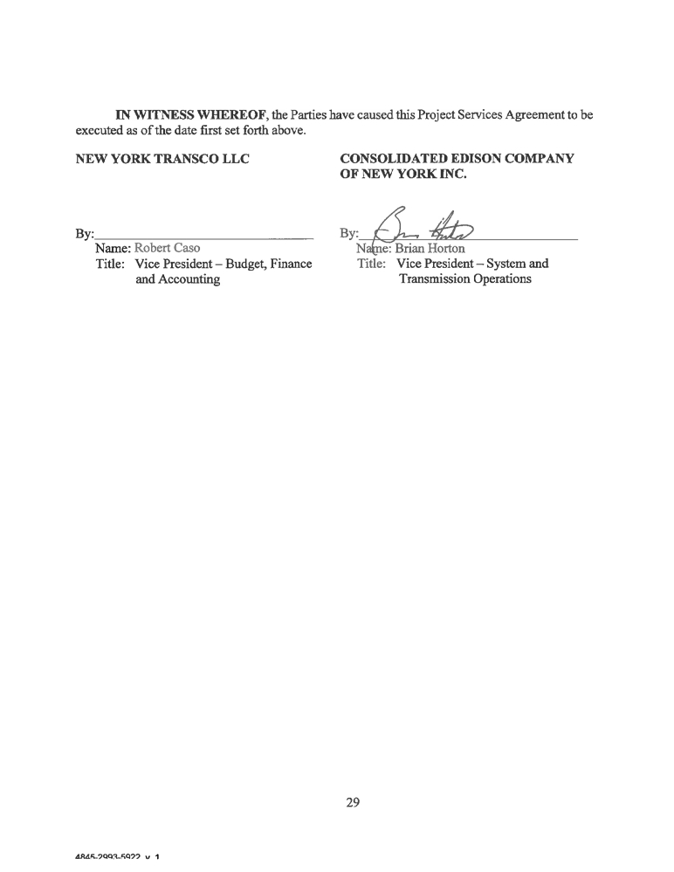


- 1 -

Schedule 1
DESCRIPTION OF PROJECTS
RRT Project -Feeder 76
The project adds a second parallel 345 kV circuit, feeder 76, to the existing double circuit
structures currently supporting 345 kV feeder 77 between CECONY Ramapo substation and
Central Hudson Gas and Electric Corporation’s (“Central Hudson”) Rock Tavern substation. The
existing 345 kV circuit feeder 77 runs approximately 27.4 miles inside Orange and Rockland
Counties, New York. The approximate 27.4 mile length between the Ramapo and Rock Tavern
substations includes towers 1 to 178, which are double circuit steel lattice towers. The 345 kV
feeder line was built in 1974. Some towers may have cell phone appurtenances, fiber optic lines or
other attachments. Access to the line and structure locations is via existing transmission line
service roads. The route traverses a mountainous terrain with numerous steep slopes and is mostly
covered with dense vegetation and sporadic rock outcrops. The majority of the right-of-way
(ROW) is 100’ to 125’ wide with the center line of the towers generally situated at the centerline of
the ROW.
The new 345 kV feeder 76 connects the 345 kV Ramapo substation (owned by Transmission Owner) to the Central Hudson 345 kV Rock Tavern substation by performing three concurrent system upgrades:
The first upgrade converts the 138 kV feeder 28 between Orange and Rockland Utilities, Inc.’s (“O&R”) 138 kV Ramapo substation and O&R 138 kV Sugarloaf substation to 345 kV feeder 76 by reconnecting it to a new Bay 1 at the 345 kV Ramapo substation.
The second upgrade installs a new, O&R 345 kV Sugarloaf substation in the vicinity of the
existing 138 kV Sugarloaf substation. The new 345 kV Sugarloaf substation consists of a
step-down 345/138 kV transformer, associated new 345 kV switching equipment and ancillary
facilities. The 345 kV connections to the transformer taps off 345 kV feeder 76. The 138 kV side of the new 345/138 kV step-down transformer is connected to the existing spare feeder position in the 138 kV Sugarloaf substation.
The third upgrade installs approximately 11.8 miles of additional 345 kV feeder 76 between the 345 kV Sugarloaf substation and the 345 kV Rock Tavern substation utilizing existing double circuit structures currently supporting 345 kV feeder 77. New 345 kV feeder 76 is connected at 345 kV Rock Tavern substation to an existing position currently occupied by 345 kV feeder 77. The existing 345 kV feeder 77 is re-connected to a new 345 kV Bay.
SIU Project
The Goethals Switching Station on Staten Island has an existing transmission cable, G23L/M, that
connects to the Linden Cogeneration Station in Linden, New Jersey. The Linden Cogeneration
Station is owned by [East Coast Power (GE) (or a third party to whom GE transferred title)] and
the G23L/M cable is jointly owned. This cable is a 345 kV, dual circuit and rated for 1345 MW
(normal rating). The Linden Cogeneration Station connects directly to Goethals and has a capacity
of 745 MW. The cable serves as the generation exit to the Goethals Station. There is also a variable
4845-2993-5922, v. 1

- 2 -

frequency transformer (acts like a phase shifter to control power flow) located upstream of the Linden generation ring bus that has a capacity of 315 MW.
This Project reconfigures feeder G23 L/M as two separate and independent cable circuits with separate bus sections at each terminal end. This will allow power transfers to continue in the event of a single cable trip of outage. The expected nominal power transfer of a single cable is approximately half of the single circuit or 672 MW.
The work of this Project at Goethals station to relocate the G23L feeder includes:
1. Installing a new bus section with 345 kV circuit breaker and disconnect switches
2. Relocating/retrifurcating the G23L cable to the new bus section & potheads
3. Installing new control and protection including a new relay enclosure
4. Removing existing G23 pothead and cable components
The work of this Project at the Linden Cogeneration station to relocate G23L feeder includes:
1. Installing a new GIS bus section with 345kV circuit breaker and disconnect switch
2. Modifying the G23L potheads and install new GIS incoming bus
3. Installing new control and protection including new relay panels
4. Removing existing GIS equipment as required by the modifications
4845-2993-5922, v. 1

- 1 -

Schedule 2
SCOPE OF SERVICES, PRINCIPAL CONTRIBUTORS,
ESTIMATED COST AND SCHEDULE OF SERVICES

RRT Project: Feeder 76

1. Central Hudson annunciator upgrade
2. Right-of-Way rut repair
3. Sugarloaf Substation sound wall (if required)
4. Ramapo Y-bus relay upgrade
5. Final phasing, commissioning, testing, etc.
(through June 1, 2016)
Estimate
$ 25, 000 Mid-August 2016 $200,000 Late July 2016 $250,000 *
$200,000 (Con Edison Electric Construction Bureau; Early November 2016)

$50,000 (Con Edison Electric System Testing; 6/1/16)
$725,000

*Sound test to be completed within 45 days of Feeder 76 energization. If found necessary, wall will be

completed within 180 days thereafter.

SIU Project : Separate Feeder G23 L&M

1. G23M relay upgrade

2. Final phasing, commissioning, testing, etc.
(through June 1, 2016)
Estimate Both Projects
$200,000 (Con Edison Electric Construction Bureau/ Early November 2016)

$50,000 (Con Edison Electric System Testing; 6/1/16)
$250,000

Upon completion of the projects, Transmission Owner is to deliver to Transco final as built drawings for proper plant recording that is normally prepared by Transmission Owner for like kind projects (Expected delivery is November 2017. Time and material charges will apply).
Transmission Owner Lead:

James Mooney, Jr.
Project Manager - Substation Operations
Consolidated Edison Company of New York, Inc.
1610 Mathews Avenue
Bronx, NY 10462
Phone: 914 789-0567
Mobile: 347 203-3998
Email: MOONEYJ@coned.com
4845-2993-5922, v. 1

- 2 -

Transco Project Manager:
Nabil Hitti
VP Operations
NY Transco LLC
Nabil.Hitti@nytransco.com 781-907-2657
4845-2993-5922, v. 1

- 3 -

Schedule 3
ASSIGNED CONTRACTS

See Attached.
4845-2993-5922, v. 1
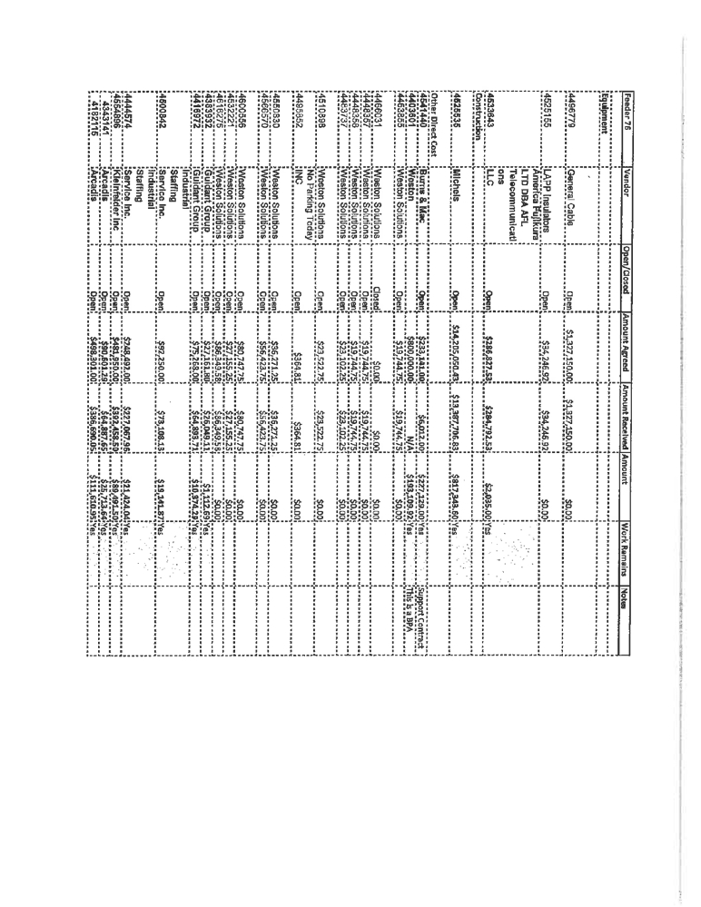
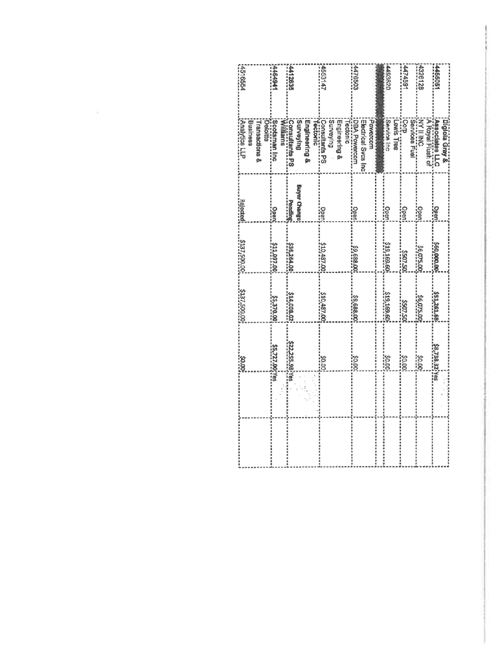
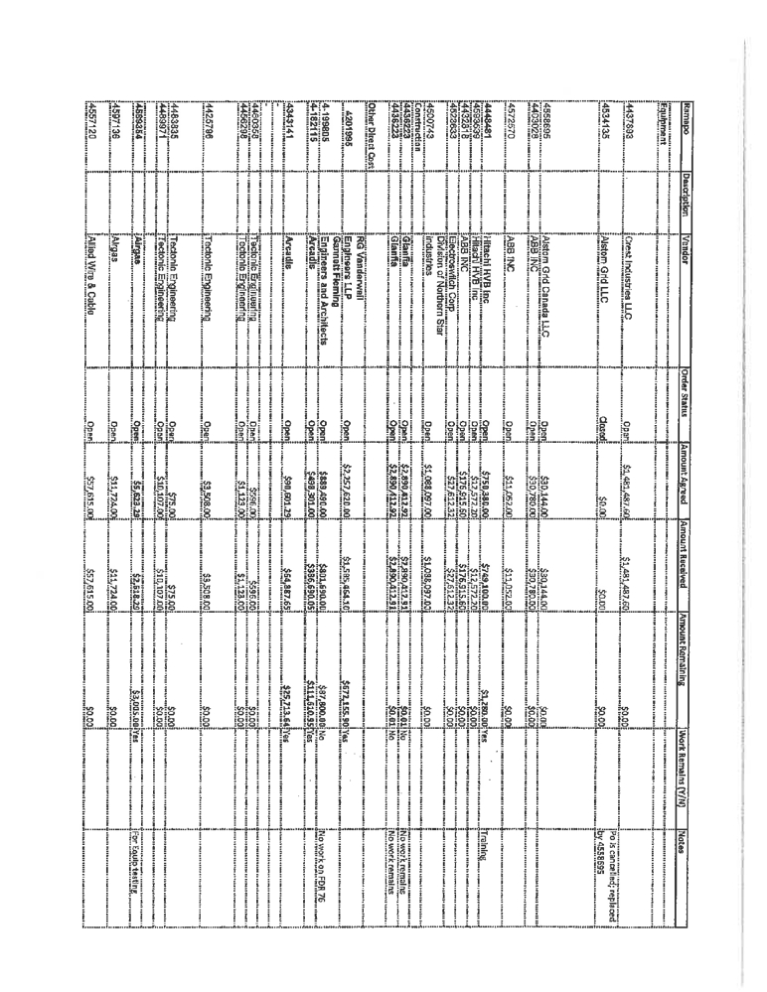
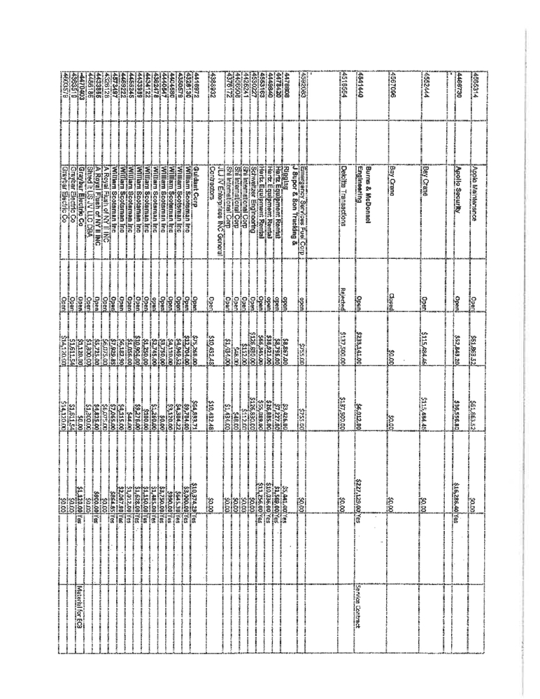
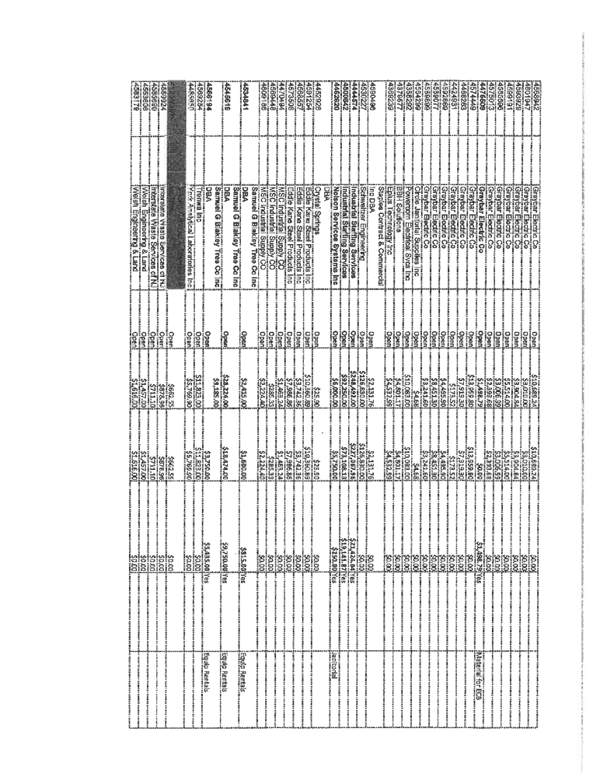
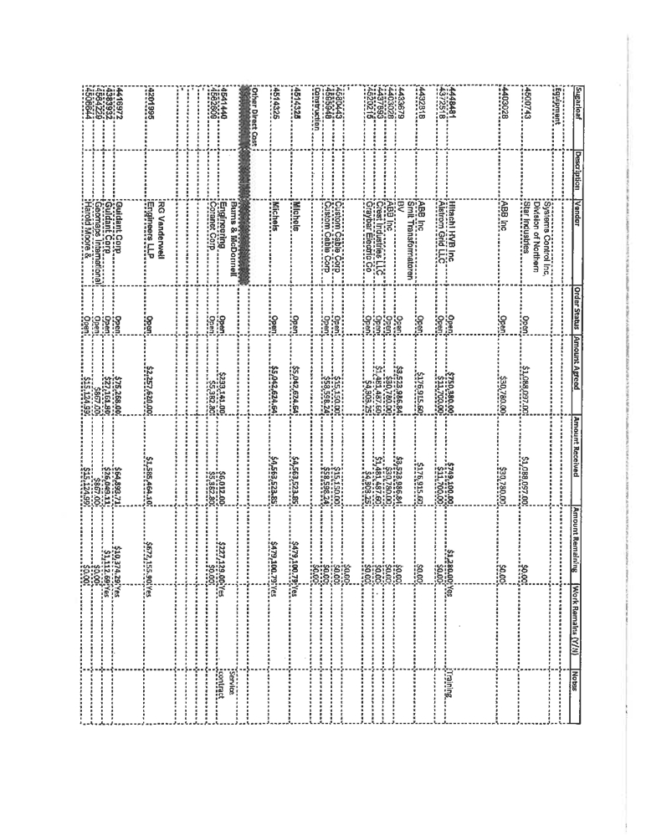
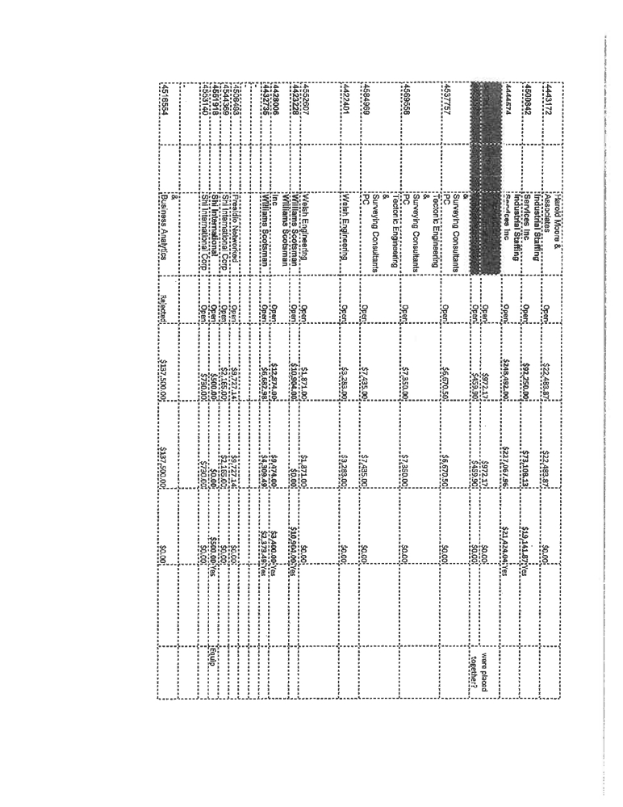
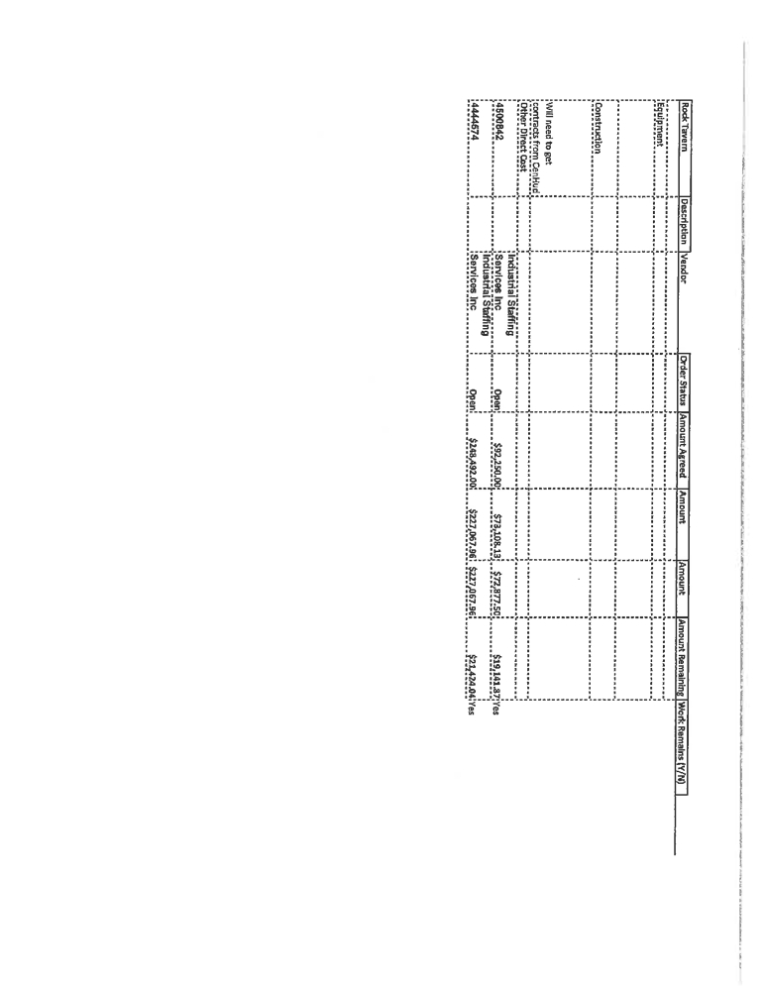

- 4 -

Schedule 4

INSURANCE REQUIREMENTS

TRANSCO’S INSURANCE REQUIREMENTS
(a) Workers’ Compensation Insurance in accordance with all applicable state,
federal and maritime law, including Employer’s Liability Insurance in the amount of $1,000,000
per accident;
(b) Commercial General Liability Insurance, including contractual liability
coverage for liabilities assumed under this Agreement with limits of not less than $5,000,000 per
occurrence for bodily injury, including death and property damage, and Products/Completed
Operations Liability Insurance. The insurance shall contain no exclusions for explosion, collapse
of a building or structure, or underground hazards. Transco’s policy shall include Transmission
Owner as additional insured for Transco’s full policy limits required herein and such insurance
shall be primary and non-contributory coverage as to such additional insured, including claims
caused by Transmission Owner’s ordinary negligence while performing work for Transco;
(c) Automobile Liability Insurance for all owned, non-owned, and hired
vehicles with bodily injury limits of no less than $1,000,000 combined single limit per occurrence. Transco’s policy shall include Transmission Owner as an additional insured. If Transco does not have vehicles, it may purchase Non-Owned Automobile Liability Insurance;
(d) Professional Liability Insurance in the amount of $1,000,000 per incident, if
applicable, relating to Transco’s activities in connection with the Projects.
Additional insurance coverage may be required relating to Transco’s
operations. Transmission Owner shall have the right to require Transco to provide reasonable increases to the policy limits of insurance policies required herein.

TRANSMISSION OWNER’S INSURANCE REQUIREMENTS
(a) Workers’ Compensation Insurance in accordance with all applicable state,
federal and maritime law, including Employer’s Liability Insurance in the amount of $1,000,000
per accident;
(b) Commercial General Liability Insurance-None.
(c) Automobile Liability Insurance for all owned, non-owned, and hired
vehicles with bodily injury limits of no less than $1,000,000 combined single limit per occurrence.
(d) Transmission Owner shall have the right to self-insure all or part of the
insurances required under this Agreement, to the extent authorized or licensed to do so under the
applicable laws of the State of New York. Transmission Owner agrees that all other provisions of
this Agreement, including waiver of subrogation and waiver of rights of recourse which provide or
are intended to provide protection to Transco and its affiliated and associated companies under this
Agreement, shall remain enforceable if it exercises its right to self-insure all or part of the
4845-2993-5922, v. 1

- 5 -

insurance required under this Agreement. Transmission Owner’s election to self-insure shall not impair, limit, or in any manner result in a reduction of rights and/or benefits otherwise available to Transco and its affiliated and associated companies through formal insurance policies and endorsements as specified in Article XII of this Agreement. Transmission Owner shall be solely responsible for all amounts of self-insurance, retentions and/or deductibles.

CONTRACTORS’ AND SUBCONTRACTORS’ INSURANCE REQUIREMENTS
(a) Transco’s contractors’ (and their respective subcontractors, if any)
(provided that Transmission Owner shall not be deemed a Transco contractor for purposes of hereof) shall be required to procure and maintain Workers’ Compensation and Employer’s Liability Insurance with limits not less than $1,000,000 per injury or disease, Automobile Liability Insurance for all owned, non-owned or hired automobiles with limits not less than $1,000,000 per occurrence and Commercial General Liability Insurance with limits not less than $5,000,000 per occurrence. Such insurance may be satisfied through primary and excess policies, shall name Transco and Transmission Owner and their respective Affiliates as additional insureds and shall be primary and non-contributory to any insurance carried by the Parties. Additional insurance coverage may be required depending on the Services to be provided.
(b) Transmission Owner’s contractors’ (and their respective subcontractors, if
any) shall be required to procure and maintain Workers’ Compensation and Employer’s Liability Insurance with limits not less than $1,000,000 per injury or disease, Automobile Liability Insurance for all owned, non-owned or hired automobiles with limits not less than $1,000,000 per occurrence and Commercial General Liability Insurance with limits not less than $5,000,000 per occurrence. Such insurance may be satisfied through primary and excess policies, shall name Transco and Transmission Owner and their respective Affiliates as additional insureds and shall be primary and non-contributory to any insurance carried by the Parties. Additional insurance coverage may be required depending on the Services to be provided.
The Parties shall furnish to each other copies of any accident or incident report(s) sent to their respective insurance carriers covering accidents or incidents occurring in connection with or as a result of the performance of the Services. In addition, if required, the Parties shall promptly provide copies of all insurance policies relevant to any accident or incident. These requirements are in addition to any requirements contained elsewhere in this Agreement.
4845-2993-5922, v. 1

Schedule 5
ADDRESSES FOR NOTICE
For Transco:
Kathleen Carrigan
General Counsel New York Transco LLC Carrigan & Associates LLC
P.O. 5905
6 Elm Street Unit C
Salisbury Ma. 01952
617-455-5329
Kathleen.Carrigan@NYTransco.com

For Con Edison:

Brian Horton
VP System & Transmission Operations
Consolidated Edison Company of New York, Inc.
hortonb@coned.com
212.460.1210

With a copy to:
Deputy General Counsel
Consolidated Edison Company of New York, Inc.
crayb@coned.com
212.460.3245

Schedule 6

INTERCONNECTION AGREEMENTS

Transmission Facility Interconnection Agreement (Service Agreement No. 2217) by and
between Consolidated Edison Company of New York, Inc., as developer and Orange &
Rockland Utilities, Inc., as connecting transmission owner, dated as of May 27, 2015.
Transmission Facility Interconnection Agreement (Service Agreement No. 2216) by and
between Consolidated Edison Company of New York, Inc., as connecting transmission
owner and Orange & Rockland Utilities, Inc., as developer, dated as of May 27, 2015.

