FERC rendition of the electronically filed tariff records in Docket No.
Filing Data:
CID: C000038
Filing Title: NYISO 205 filing Executed Non-Conforming Interconnection Facilities Study Agrmnt Company Filing Identifier: 1011
Type of Filing Code: 10
Associated Filing Identifier:
Tariff Title: NYISO Non-conforming Interconnection Study Agreements Tariff ID: 58
Payment Confirmation: N
Suspension Motion:

Tariff Record Data:
Record Content Description: Study Agreement Est Rvr2
Tariff Record Title: Increased CRIS CY2015 FSA East River2 Record Version Number: 0.0.0
Option Code: A
Tariff Record ID: 173
Tariff Record Collation Value: 1500700
Tariff Record Parent Identifier: 164
Proposed Date: 4/23/2015
Priority Order: 500
Record Change Type: New
Record Content Type: 2
Associated Filing Identifier:
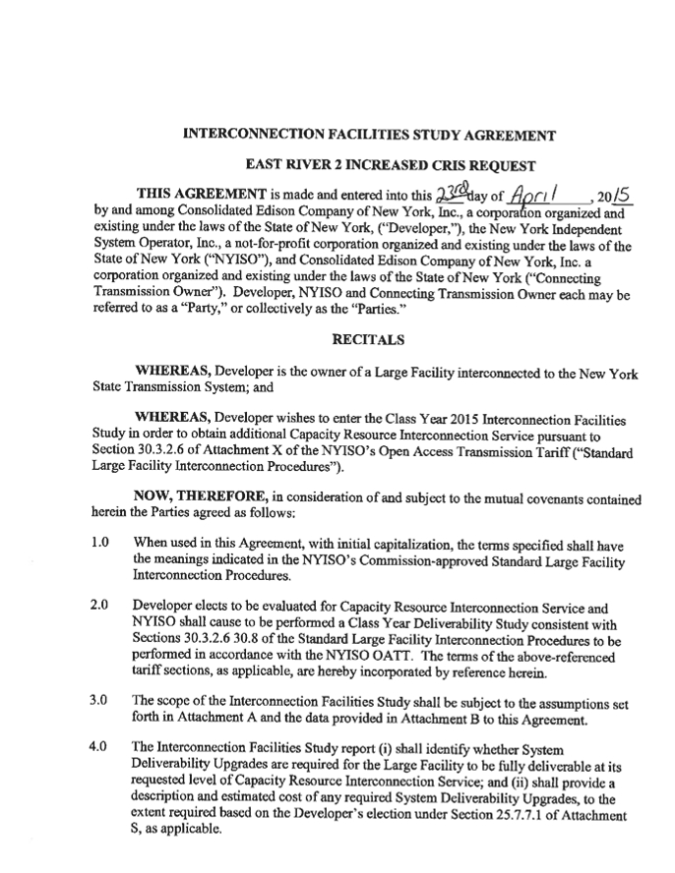
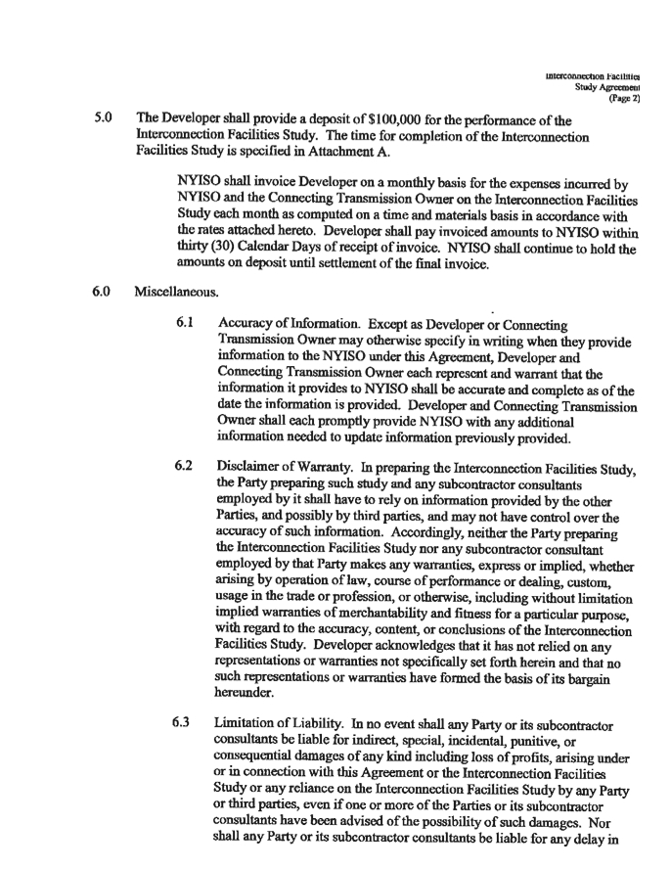
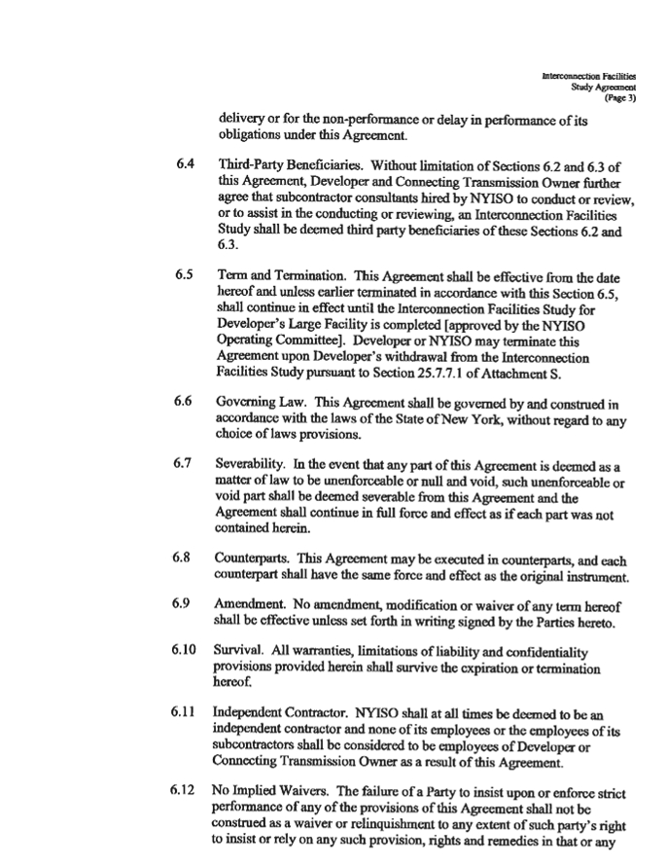
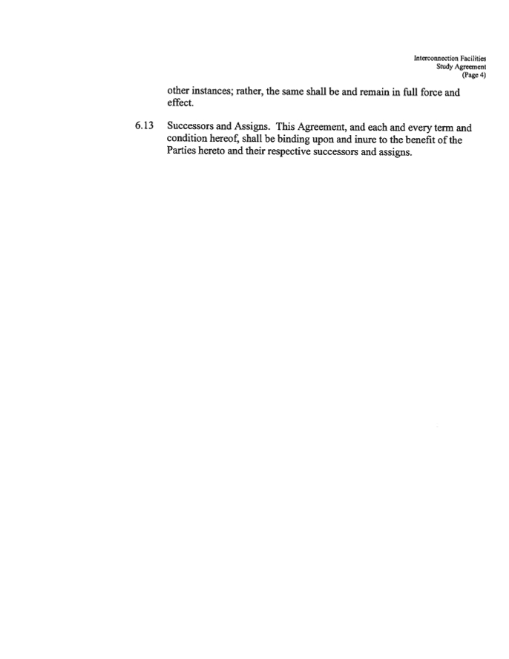
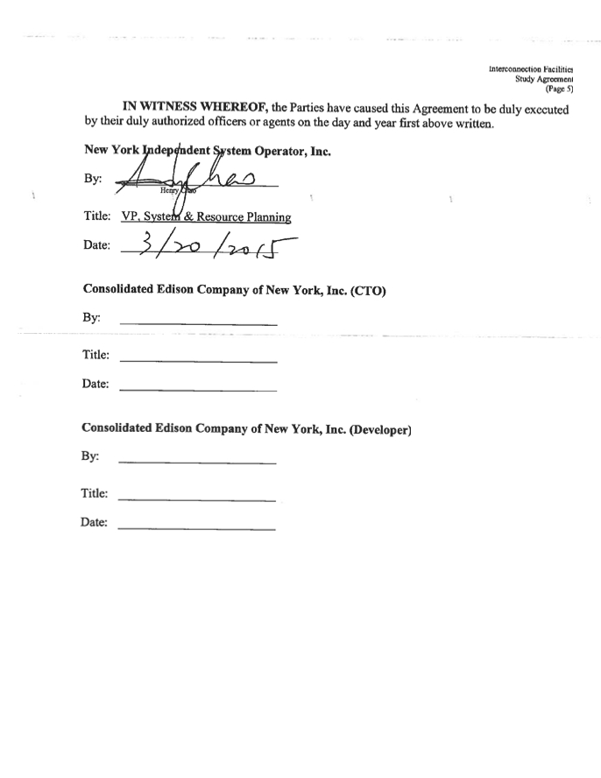
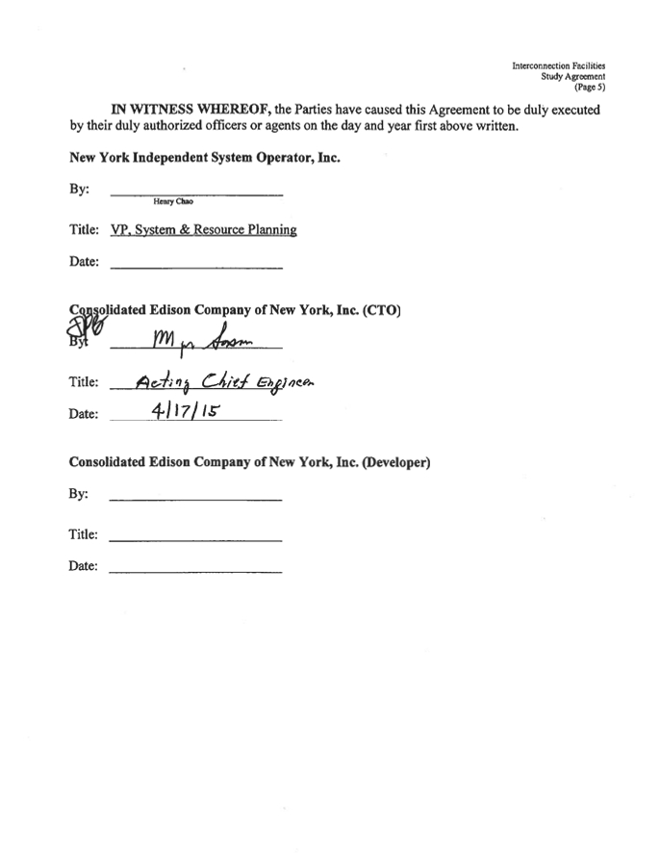
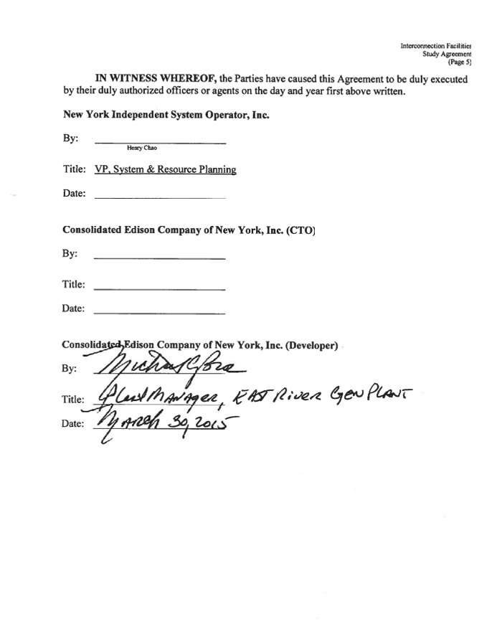
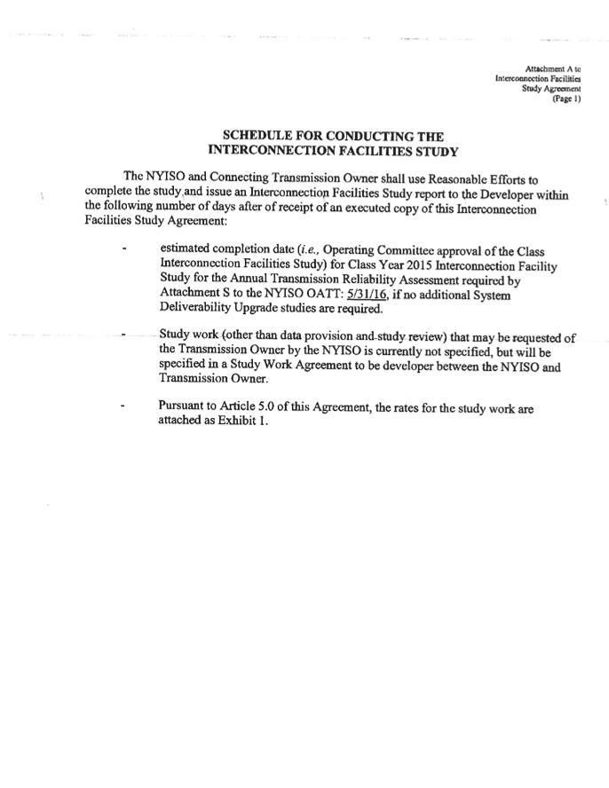
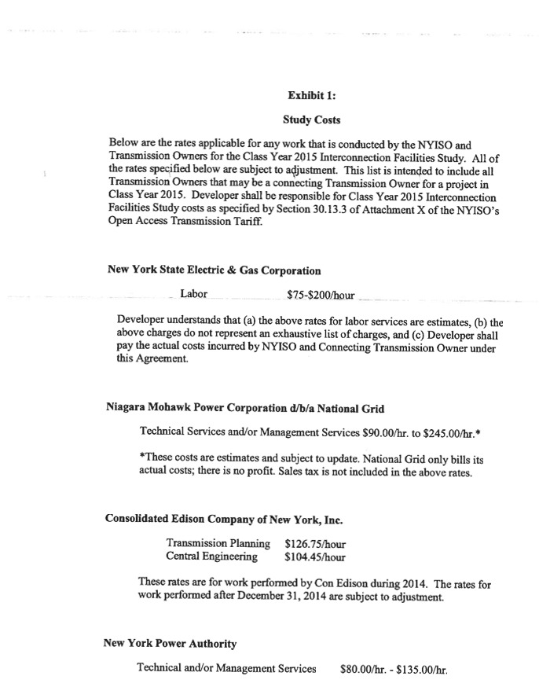
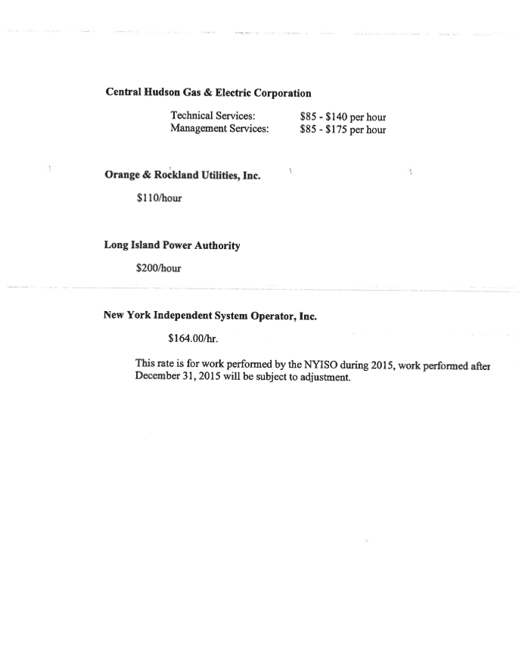
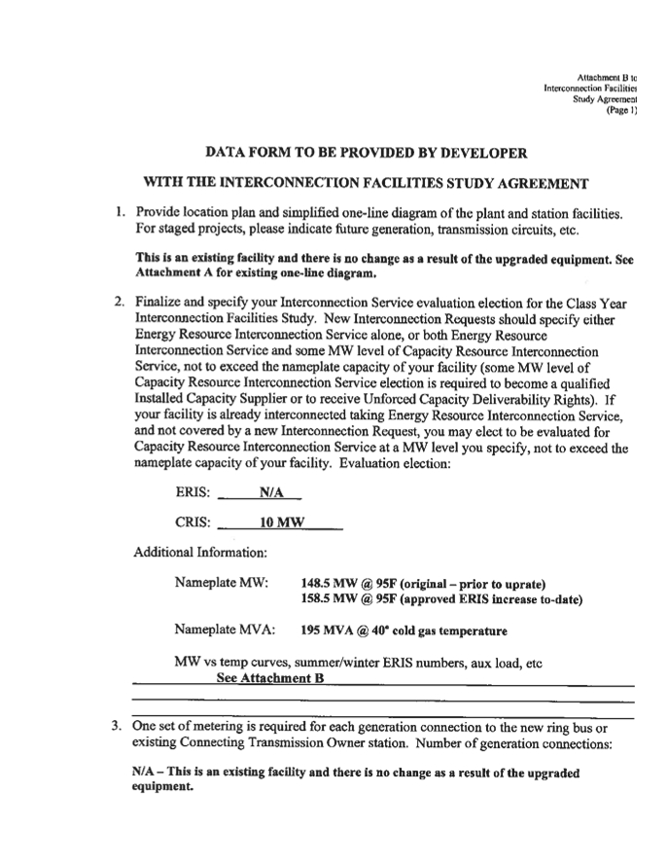
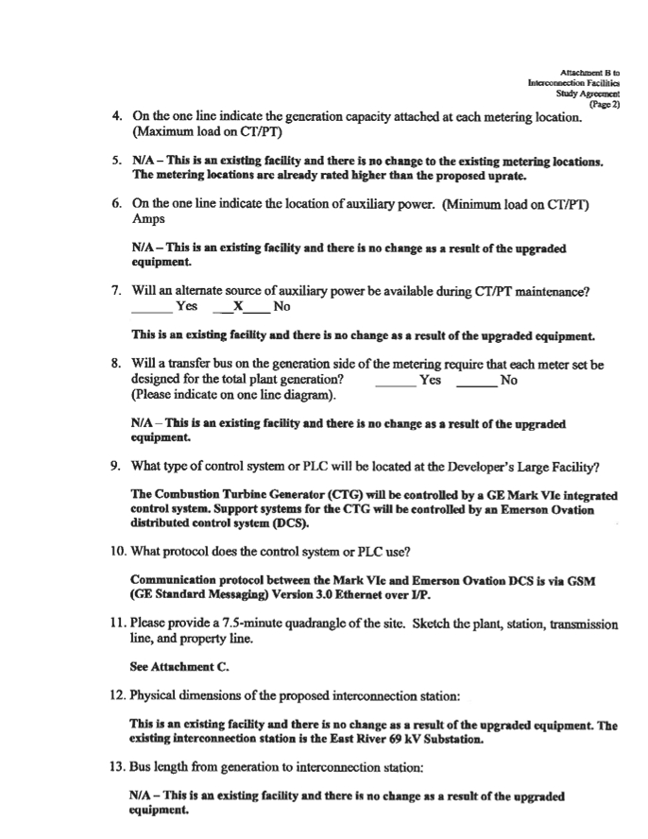
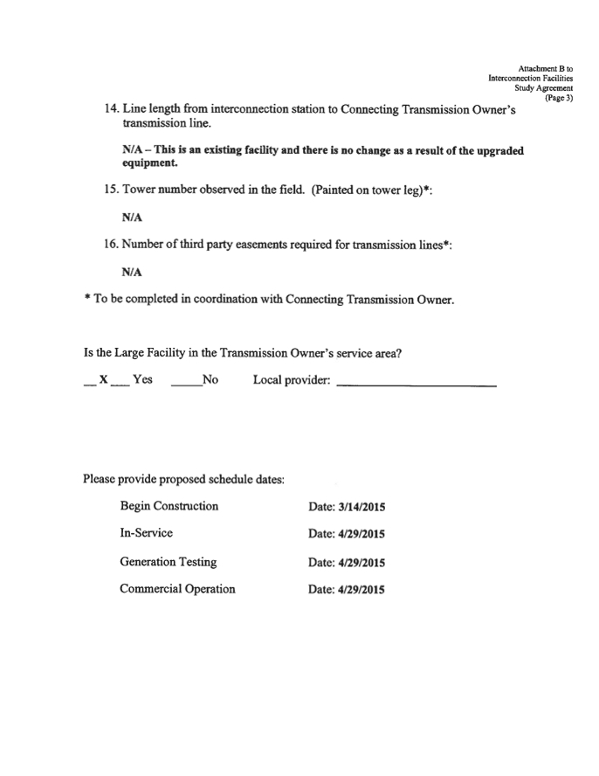

This page contains Critical Energy Infrastructure Information "CEII"
and has been removed from the public version
