EXHIBIT A

System Impact Study for the Special Protection System for the Athens Power Plant” report dated
October 16, 2006


R64-06

System Impact Study for the Special
Protection System for the Athens Power
Plant

Prepared for
New Athens Generation Company,
LLC

Submitted by:
James W. Feltes, Senior Manager
Xiaokang Xu, Senior Staff Consultant Lengcheng Huang, Consultant

October 16, 2006

Siemens PTI Project P/21-113051

Siemens Power Transmission & Distribution, Inc. Power Technologies International
1482 Erie Boulevard • P.O. Box 1058
Schenectady, New York 12301-1058 US
Tel: 518-395-5000 • Fax: 518-346-2777
www.usa.siemens.com/PTI

This page intentionally left blank.

Contents

Legal Notice iii

Executive Summary v

Section 1 Introduction 1-1

Section 2 Project Discription and Study Data 2-1
2.1 Project Description 2-1
2.2 Load Flow Data 2-2
2.3 Dynamic Simulation Data 2-2

Section 3 Criteria, Methodology, Assumptions 3-1
3.1 Study Scope 3-1
3.2 Study Area 3-1
3.3 Methodology 3-1
3.4 Study Cases 3-2
3.5 Assumptions 3-2

Section 4 Power Flow Analysis 4-1
4.1 Analysis of the System Condition Following SPS Operation 4-1
4.2 Analysis of Voltage Constraints 4-9

Section 5 Impact on Transfer Limits 5-1
5.1 Thermal Analysis 5-1
5.1.1 Methodology 5-1
5.1.2 Criteria 5-1
5.1.3 Model Development 5-2
5.1.4 Results 5-2
5.2 Voltage Analysis 5-2
5.2.1 Methodology 5-2
5.2.2 Criteria 5-3
5.2.3 Model Development 5-4

Siemens Power Transmission & Distribution, Inc.
Power Technologies International i

Contents

5.2.4 Results 5-4
5.3 Stability Analysis 5-7
5.3.1 Methodology 5-7
5.3.2 Criteria 5-7
5.3.3 Model Development 5-8
5.3.4 Results 5-8

Section 6 Extreme Contingency Analysis 6-1

Section 7 SPS Misoperation and Failed Operation Analysis 7-1
7.1 SPS Misoperation 7-1
7.2 Failure of the SPS to Operate 7-11
7.3 Potential for Interaction with Other Existing New York Special Protection Systems7-11

Section 8 SPS Type Analysis 8-1

Section 9 Conclusions 9-1

Appendix A SIS Scope A-1

Appendix B Results of Analysis of Voltage Constraints B-1

Appendix C Detailed Results of Thermal Transfer Limit Analysis C-1
C.1 Benchmark Case without SPS C-1
C.2 Case with SPS C-2

Appendix D Stability Simulation Plots D-1
D.1 Case A (Benchmark Case without the SPS, UPNY-Con Ed Transfer at 4032 MW)D-2
D.2 Case B0 (Case with the SPS, UPNY-Con Ed Transfer at 4330 MW) D-25
D.3 Case B (Case with the SPS, UPNY-Con Ed Transfer at 4550 MW) D-48

Siemens Power Transmission & Distribution, Inc.
ii Power Technologies International

Legal Notice

This document was prepared by Siemens Power Transmission & Distribution, Inc., Power Technologies International (Siemens PTI), solely for the benefit of New Athens Generation Company, LLC. Neither Siemens PTI, nor parent corporation or its or their affiliates, nor New Athens Generation Company, LLC, nor any person acting in their behalf (a) makes any
warranty, expressed or implied, with respect to the use of any information or methods
disclosed in this document; or (b) assumes any liability with respect to the use of any
information or methods disclosed in this document.
Any recipient of this document, by their acceptance or use of this document, releases
Siemens PTI, its parent corporation and its and their affiliates, and New Athens Generation Company, LLC from any liability for direct, indirect, consequential or special loss or damage whether arising in contract, warranty, express or implied, tort or otherwise, and irrespective of fault, negligence, and strict liability.

Siemens Power Transmission & Distribution, Inc.
Power Technologies International iii

Legal Notice

This page intentionally left blank.

Siemens Power Transmission & Distribution, Inc.
iv Power Technologies International

Executive Summary

New Athens Generating Company (“Athens”) is proposing to install a Special Protection
System (SPS) and other system reinforcements to reduce the frequency of Athens
curtailments by the NYISO due to system constraints during transmission system peak power flow conditions. Athens proposes to allow the NYISO to secure the jointly owned National
Grid and Con-Edison Leeds-Pleasant Valley transmission lines (Lines 91 and 92 ) for loss of one or the other, with the subsequent rejection of its Athens’ generating facility and
subsequent NYISO’s control area re-dispatch. As such, the SPS would require an exception to the NYSRC Reliability Rules. Athens further proposes an SPS that will allow the
generation rejection to be completed within a two minute time frame following an initiating
event. The planned in-service date of the SPS is 2007.
The SPS will be operational only during periods of heavy transfer across the UPNY-Con Ed
interface. The operation of the SPS will allow post-contingency loading of either the Leeds to
Pleasant Valley or Athens to Pleasant Valley 345 kV lines (Lines 91 and 92) up to their STE
ratings for outage of the other line. Generation at Athens will be automatically tripped to
reduce the flow on the remaining circuit to less than its LTE rating. Under worst case
conditions, this will require trip of two combined cycle trains (one gas turbine and one steam
turbine each) with a full load value of 720 MW. Trip of two combined cycle trains may not be
required under other conditions.
Siemens Power Transmission & Distribution, Inc., Power Technologies International
(Siemens PTI) has performed a System Impact Study (SIS) for the SPS for the Athens Power Plant. The purpose of the SIS is to demonstrate the improvement in the UPNY-Con Ed
interface transfer capability that would result from the installation and operation of the SPS and other possible associated mitigative measures such as the installation of shunt capacitive compensation at one or more Con Edison substations.
NYISO provided a PSS™E power flow base case representing the summer peak operating conditions for 2006 and used for RNA analysis, and a separate power flow base case for stability simulations and corresponding set of stability setup files. NYISO also provided a full contingency list, a subsystem file and a monitor file for thermal analysis.
The base case models the Athens Power Plant dispatched with two combine cycle trains (one gas turbine and one steam turbine each) on at a total power output of 700 MW. This case is referred to as the Benchmark Case without SPS.
Siemens PTI developed a case with the SPS. In this case, Athens was increased to its full
capacity i.e., 1080 MW in three combine cycle trains, to increase flow on the Athens-Pleasant Valley and Leeds-Pleasant Valley (Lines 91 and 92) path. The additional Athens generation was dispatched against existing units in Con Ed.
For stability simulations, flow on the UPNY-Con Ed interface was further stressed to 11% higher than its transfer limit determined in the steady-state analysis in both the Benchmark Case without the SPS and the Case with the SPS.

Siemens Power Transmission & Distribution, Inc.
Power Technologies International v

Executive Summary

The study shows that the SPS is effective. With the SPS, the transfer across the UPNY-Con Ed Interface can be increased by 466 MW while abiding by applicable reliability rules and
criteria. This allows the Athens plant to be dispatched at full capacity, i.e., 1080 MW, during peak load conditions.
The operation without and with the SPS was analyzed using thermal, voltage and stability
analysis. The thermal analysis shows that with Athens dispatched at full capacity and the
SPS, the UPNY-Con Ed thermal transfer limit is increased by 466 MW, from 3633 MW to
4099 MW. Both without and with the SPS, the transfer is limited by flow on the Leeds to
Pleasant Valley 345 kV line due to loss of the Athens to Pleasant Valley 345 kV line. Without
the SPS, the post-contingency flow is limited to the line’s LTE rating of 1538 MW while the
SPS increases the allowable post-contingency flow to the line’s STE rating of 1724 MW. The
operation of the SPS reduces the line flow to below the LTE rating within a period of two
minutes.
The thermal transfer limit on the UPNY-SENY interface was also analyzed. The analysis
shows that with Athens dispatched at full capacity and the SPS, the UPNY-SENY thermal
transfer limit is increased by 466 MW, from 4502 MW to 4968 MW. Both without and with the SPS, the limiting element is the same as that for the UPNY-Con Ed interface.
The voltage analysis indicated that transfer across the UPNY-Con Ed interface would be
limited by the pre-contingency voltage limit of 348 kV at four lower Hudson Valley 345 kV
buses. Therefore a 240 MVAr capacitor bank was modeled at Millwood which is sufficient to maintain the steady-state pre-contingency voltage at these stations above 348 kV. Millwood was selected as the potential location for the capacitor back due to concerns that space may be limited in other possible stations.
The voltage contingency analysis indicated that with Athens dispatched at full capacity and the SPS in-service, there was no significant incremental impact on bulk system voltages compared to operation without the SPS. The voltages on several 115 kV buses decreased by less than 1% under certain contingencies.
Two contingencies may trigger the SPS, loss of the Athens to Pleasant Valley 345 kV (Line 91) and the Leeds to Pleasant Valley 345 kV line (Line 92). The loss of Line 91 is slightly more severe. For the peak load level and system dispatch modeled in the power flow case supplied by the NYISO, this contingency would require the trip of two Athens combined cycle trains, for a total of 720 MW. The loading on Line 92 after this contingency and SPS
operation would be 1520 MW, lower than the LTE rating of 1538 MW.
The P-V analysis showed that with Athens dispatched at full capacity and the SPS, the
voltage-based UPNY-Con Ed transfer limit is increased by 245 MW. The voltage-based
transfer limits for both without and with the SPS are higher than the respective thermal limits, as follows:

Siemens Power Transmission & Distribution, Inc.
vi Power Technologies International

Executive Summary

Case Case
UPNY-Con Ed Transfer Without SPS With SPS Change
Pre-Contingency Low 3880^{A} 4125^{A} 245
Post-Contingency Low 4279^{B} 4383^{B} 104
95% Voltage Collapse (5% MW 4092^{C} 4190^{C} 98
Margin)
Voltage-Based Transfer Limit 3880^{A} 4125^{C} 245
Thermal Transfer Limit 3633^{D} 4099E 466
A Pre-contingency voltage at Dunwoodie 345 kV
B Post-contingency voltage at Pleasant Valley 345 kV for loss of tower Coopers Corners-Rock Tavern 34/42
C 95% of voltage collapse criteria limit for loss of tower Coopers Corners-Rock Tavern 34/42
D Limited by Leeds - Pleasant Valley 345 kV (LTE: 1538 MW) for loss of Athens-Pleasant Valley 345 kV
E Limited by Leeds - Pleasant Valley 345 kV (STE: 1724 MW) for loss of Athens-Pleasant Valley 345 kV

Stability analysis was performed. All stability simulations exhibited a stable response with positive damping. Stability is thus not the limiting constraint on the transfer level on the UPNY-Con Ed interface either without or with the SPS.
The extreme contingency analysis demonstrates that the case with SPS shows incremental overload and voltage impacts on several 115 kV facilities. Additionally, for the case with the SPS, the loss of the Right-of-Way of Lines 91 & 92 would overload the Leeds to Hurley 345 kV line by 1%. There are no widespread overloads or voltage violations found on the bulk power system under the extreme contingencies tested.
The analysis demonstrates that misoperation of the SPS will not result in severe system
problems or widespread effects on the system, that is, it does not cause a significant adverse impact outside of the local area.
Failure of the SPS to operate under maximum transfer conditions would result in Line 91 or
92 being loaded above its LTE rating following the outage of the other, but below its STE
rating. For the peak condition analyzed, all other elements are within post-contingency limits. Since the STE rating is a 15 minute rating, there is ample time for manual operator action to either manually trip generation at Athens or perform other actions.
The study results demonstrate that the misoperation or failed operation of this SPS would not have a significant adverse impact outside of the local area, that is, there are no widespread
overloads or voltage violations found outside the local area. Thus the SPS should be
classified as a Type III SPS according to the NPCC Special Protection System Criteria
(NPCC Document A-11).
The NYISO will calculate the actual Transmission Congestion Contracts (TCCs) awarded as a result of this proposed SPS. However, the results of this SIS indicate a potential TCC
award estimate of 466 MW for the Athens' SPS.

Siemens Power Transmission & Distribution, Inc.
Power Technologies International vii

Executive Summary

This page intentionally left blank.

Siemens Power Transmission & Distribution, Inc.
viii Power Technologies International

Section
1
Introduction
New Athens Generating Company (“Athens”) is proposing to install a Special Protection
system (SPS) and other system reinforcements to reduce the frequency of Athens
curtailments by the NYISO due to system constraints during transmission system peak power flow conditions. Athens proposes to allow the NYISO to secure the jointly owned National
Grid and Con-Edison Leeds-Pleasant Valley transmission lines (Lines 91 and 92 ) for loss of one or the other, with the subsequent rejection of its Athens’ generating facility and
subsequent NYISO’s control area re-dispatch. As such, the SPS would require an exception to the NYSRC Reliability Rules. Athens further proposes an SPS that will allow the
generation rejection to be completed within a two minute time frame following an initiating
event. The planned in-service date of the SPS is 2007.
Siemens Power Transmission & Distribution, Inc., Power Technologies International
(Siemens PTI) has performed a System Impact Study (SIS) for the SPS for the Athens Power
Plant. The purpose of the SIS is to demonstrate the improvement in the UPNY-Con Ed
interface transfer capability that would result from the installation and operation of the SPS
and other possible associated mitigative measures such as the installation of shunt capacitive
compensation at one or more Con Edison substations. The objectives of the SIS are to:
1. Analyze the thermal transfer limit on the UPNY-Con Ed Interface and the UPNY-
SENY Interface, without and with the SPS.
2. Analyze voltage constraints on the transfer limit on the UPNY-Con Ed Interface,
without and with the SPS.
3. Conduct P-V analysis on the UPNY-Con Ed interface, without and with the SPS.
4. Evaluate the effectiveness of the SPS under extreme contingencies.
5. Analyze the type and the effect of misoperation or failed operation of the SPS.
The SIS was performed using Siemens PTI’s proprietary, commercial software PSS™E and
PSS™MUST, in accordance with the requirements of the NYISO Open Access Transmission
Tariff Sections 19.1 through 19.3 and Attachment D as well as applicable NPCC, NYSRC,
NYISO and Transmission Owner’s (TO) reliability criteria, rules and design standards.
The Scope of the SIS was approved by the NYISO Operating Committee on October 12, 2006 and is included in Appendix A of this report.

Siemens Power Transmission & Distribution, Inc.
Power Technologies International 1-1

Introduction

This page intentionally left blank.

Siemens Power Transmission & Distribution, Inc.
1-2 Power Technologies International

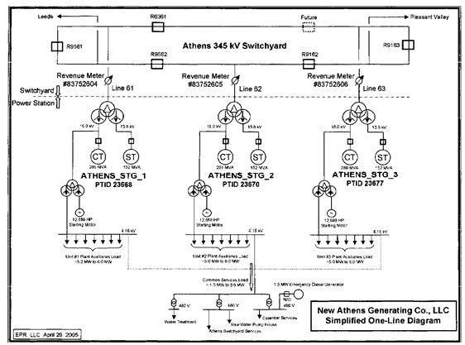

Section
2
Project Discription and Study Data

2.1 Project Description
The Athens Power Plant (“Athens”) is comprised of three combined cycle trains (GT/CT sets) with a total capacity of 1080 MW. A one-line of the power system in the area of the Athens plant is shown in Figure 1-1. The proposed SPS will be operational only during periods of
heavy transfer across the UPNY-Con Ed interface. The operation of the SPS will allow postcontingency loading of either the Leeds to Pleasant Valley or Athens to Pleasant Valley 345 kV lines (Lines 91 and 92) up to their STE ratings for outage of the other line. Generation at Athens will be automatically tripped to reduce the flow on the remaining circuit to less than its LTE rating. Under worst case conditions, this will require trip of two combined cycle trains
(one gas turbine and one steam turbine each) with a full load value of 720 MW. Trip of two combined cycle trains may not be required under other conditions.

Figure 2-1: One-Line Diagram of Athens Plant

Siemens Power Transmission & Distribution, Inc.
Power Technologies International 2-1

Project Discription and Study Data

2.2 Load Flow Data
NYISO provided a PSS™E power flow base case representing the summer peak operating conditions for 2006 and used for RNA analysis. NYISO also provided a full contingency list and a subsystem file and monitor file for thermal analysis.
The base case models Athens dispatched with two GT/CT sets on at a total power output of 700 MW. This case is referred to as the Benchmark Case without SPS.
Siemens PTI developed a case with the SPS. In this case, Athens was increased to its full
capacity i.e., 1080 MW, to increase flow on the Athens-Pleasant Valley and Leeds-Pleasant
Valley (Lines 91 and 92) path. The additional Athens generation was dispatched against
existing units in Con Ed. In setting up this case, tap settings of phase angle regulators and
autotransformers were adjusted, within their capabilities, to regulate power flow and voltage.
Similarly, switched shunt capacitors and reactors were allowed to regulate voltage.
Additionally, the Leeds SVC, Frasier SVC and Marcy FACTS device were held near zero
output.

2.3 Dynamic Simulation Data
NYISO provided a separate power flow base case for stability simulations and a set of
stability setup files. In this power flow case, Athens was dispatched at 800 MW on three
CT/GT sets. For consistency with the case used in steady-state analysis, Siemens PTI
reduced the dispatch of the Athens plant from 800 MW to 700 MW on two CT/GT sets. The MW reduction was balanced by units in Ontario. This case is referred to as the Benchmark Case without SPS.
Siemens PTI developed a stability power flow case with the SPS using the same approach
as that in Section 2.1. In this case, Athens was increased to its full capacity i.e., 1080 MW, to
increase flow on the Athens-Pleasant Valley and Leeds-Pleasant Valley (Lines 91 and 92)
path. The additional Athens generation was dispatched against existing units in Con Ed.
In both cases, flow on the UPNY-Con Ed interface was stressed to 11% higher than its transfer limit determined in the steady-state analysis. Details of the stressed cases are discussed in detail in Section 5.
The dynamic model for stability simulation was obtained from the NYISO stability database and setup files.

Siemens Power Transmission & Distribution, Inc.
2-2 Power Technologies International

Section
3
Criteria, Methodology, Assumptions

3.1 Study Scope
The scope of the SRIS, which is included in Appendix A, was approved by the NYISO Operating Committee on October 12, 2006.

3.2 Study Area
The study area focused on the Bulk Power System in South-Eastern New York between Albany and New York City, and voltages underlying systems at 115 kV and above in the lower Hudson Valley (Zones G, H & I).
In the PSS™E power flow base case provided by NYISO, facilities rated at 115 kV and
above in PSS™E designated areas 6 through 11 are monitored in the study. These areas
are:
• Capital District
• Hudson
• Millwood
• Dunwoodie
• Con Ed
• Long Island
3.3 Methodology
NYISO provided a PSS™E power flow base case representing the summer peak operating conditions for 2006 and used for RNA analysis. The base case models Athens dispatched with two GT/CT sets on at a total power output of 700 MW. This case is referred to as the Benchmark Case without SPS. Siemens PTI developed a case with the SPS. In this case, Athens was increased to its full capacity i.e., 1080 MW in three combine cycle trains, to
increase flow on the Athens-Pleasant Valley and Leeds-Pleasant Valley (Lines 91 and 92) path. Steady state and stability analyses were performed to develop a comparative
assessment of the system state without and with the SPS. The following analyses were conducted and are further described in later sections of the report:
 Power flow and contingency analyses to assess and compare branch loadings and
bus voltages in the study area for the cases without and with the SPS.
 Stability analysis to determine system performance within the study area for the
cases without and with the SPS.

Siemens Power Transmission & Distribution, Inc.
Power Technologies International 3-1

Criteria, Methodology, Assumptions

 Transfer limit analysis to determine thermal and voltage transfer limits of the UPNY-
Con Ed and UPNY-SENY interfaces for the cases without and with the SPS.
 Extreme contingency assessment to evaluate the system performance within the
study area under representative extreme contingencies for the cases without and with the SPS.
 Evaluation of the type and the effect of misoperation or failed operation of the SPS.

3.4 Study Cases
The analysis summarized in this report used the power flow cases described below. When
setting up the cases, tap settings of phase angle regulators and autotransformers were
adjusted, within their capabilities, to regulate power flow and voltage. Similarly, switched
shunt capacitors and reactors were switched were allowed to regulate voltage. Additionally,
the Leeds SVC, Frasier SVC and Marcy FACTS device were held near zero output.
The effectiveness of the SPS has been evaluated for summer peak load for two base system conditions described below.
Case 1 - Benchmark Case without the SPS. In this case, Athens was dispatched with two GT/CT sets on at a total power output of 700 MW.
Case 2 - Case 1 with the SPS modeled. In this case, Athens was increased to its full
capacity i.e., 1080 MW in three combine cycle trains to increase flow on the Athens-Pleasant Valley and Leeds-Pleasant Valley (Lines 91 and 92) path. Additionally, a 240 MVAr capacitor bank was added to maintain the voltages at the Pleasant Valley, Millwood, Sprain Brook and Dunwoodie stations above below 348 kV (a recently updated pre-contingency low voltage
limit for these stations).
It is noted that Dunwoodie has the lowest voltage in the base case with the SPS. The
capacitor bank could be installed at Dunwoodie or Sprain Brook but there are concerns that
space may be limited in those two stations. Therefore, Millwood was chosen to be the
installation location and the capacitor bank size was installed to maintain the steady-state
pre-contingency voltage at the four stations above 348 kV while keeping the Athens
generator scheduled voltage 1.04 pu as modeled in the Benchmark case without the SPS.

3.5 Assumptions
Generation redispatch for transfers are performed according to the standard proportions used
in NYISO operating studies. Athens will be dispatched at full output for the case with the
SPS.
Phase angle regulators (PARs) are modeled according to the standard NYISO practice for operating studies as regulating pre-contingency and free-flowing, post-contingency.

The Leeds SVC, Frasier SVC and Marcy FACTS device are set to zero pre-contingency and allowed to operate to full range post-contingency.

Siemens Power Transmission & Distribution, Inc.
3-2 Power Technologies International

Section
4
Power Flow Analysis

4.1 Analysis of the System Condition Following SPS Operation
The operation of the SPS will allow post-contingency loading of either the Leeds to Pleasant Valley or Athens to Pleasant Valley 345 kV lines (Lines 91 and 92) up to their STE ratings for outage of the other line. The system condition following SPS operation can be illustrated by comparing load flow results representing two conditions:
1. Operation without the SPS (Benchmark Case without SPS). This is the base case
supplied by the NYISO and has Athens dispatched at 700 MW
2. Operation with the SPS (Case with SPS). This case has Athens dispatched at 1080
MW, and other changes as described below.
In the case with the SPS, the redispatch performed to increase flow on the Athens-Pleasant
Valley and Leeds-Pleasant Valley (Lines 91 and 92) path to determine the thermal transfer
limit first increased Athens to full power output. The subsequent generation shifts were
performed from Ontario to Con Ed to increase the transfer level on the interface concerned.
The generation shifts are show in Table 4-1. In addition, the SPS permits the allowable post
contingency loading on the 91/92 lines to go to STE. All other lines use their standard (LTE)
post-contingency ratings.
A 240 MVAr capacitor bank was added at the Millwood 345 kV bus in the case with the SPS.
Without this capacitor bank, the voltages at the Pleasant Valley, Millwood, Sprain Brook and
Dunwoodie stations are below 348 kV (a recently updated pre-contingency low voltage limit
for these stations). Dunwoodie has the lowest voltage. The capacitor bank could be installed
at Dunwoodie or Sprain Brook but there are concerns that space may be limited in those two
stations. Therefore, Millwood was chosen to be the installation location and the capacitor
bank size was installed to maintain the steady-state pre-contingency voltage at the four stations above 348 kV while keeping the Athens generator scheduled voltage 1.04 pu as modeled in the Benchmark case without the SPS.
Table 4-2 shows power transfer levels on the NYISO interfaces of UPNY-Con Ed, UPNY-
SENY, Central East and Total East, for the Benchmark Case without SPS and the Case with
SPS.

Siemens Power Transmission & Distribution, Inc.
Power Technologies International 4-1

Power Flow Analysis

Table 4-1: Generation Shifts for Thermal Transfer Limits
Increase Athens Generation from 700 MW to 1080 MW
Case w/ Case w/o
SPS SPS
Bus (Step 1) Change
Number Bus Name (MW) (MW) (MW)
78706 [ATHENSC116.0] 250 239.8 10.2
78707 [ATHENSS113.8] 110 110.2 -0.2
78708 [ATHENSC216.0] 250 243.1 6.9
78709 [ATHENSS213.8] 110 106.9 3.1
78710 [ATHENSC316.0] 250 0 250
78711 [ATHENSS313.8] 110 0 110
74705 [AST 4 20.0] 250 350 -100
74706 [AST 5 20.0] 243 333 -90
74707 [RAV 1 20.0] 240 330 -90
74907 [NRTPTG2 22.0] 268 368 -100
Additional Generation Shifts from Ontario to Downstate NY
Case w/ Case w/
SPS SPS
Bus (Step 2) (Step 1) Change
Number Bus Name (MW) (MW) (MW)
74705 [AST 4 20.0] 210 250 -40
74706 [AST 5 20.0] 223 243 -20
74707 [RAV 1 20.0] 220 240 -20
74907 [NRTPTG2 22.0] 248 268 -20
81425 [LENNOXG420.0] 145 125 20
81767 [NANTICG422.0] 495 475 20
81769 [NANTICG222.0] 495 475 20
81770 [NANTICG122.0] 252 232 20
81771 [NANTICG822.0] 495 475 20
Step 1: Perform generation shifts by dispatching Athens at full capacity.
Step 2: With Athens at full capacity, perform additional generation shifts.

Table 4-2: Power Transfers Across NYISO Interfaces in the Base Cases (MW)

Case Case
Interface Without SPS With SPS
UPNY-Con Ed 3630 4096
UPNY-SENY 4507 4974
Central East 2398 2423
Total East 4297 4410

Siemens Power Transmission & Distribution, Inc.
4-2 Power Technologies International

Power Flow Analysis

The steady state condition following the operation of the SPS was calculated for two contingencies that may trigger it, i.e.:
1. Loss of Line 91
2. Loss of Line 92
Loss of Line 95 would not cause the loadings on Lines 91 & 92 (1080 MW and 1244 MW
respectively) to exceed the LTE rating of 1538 MW and therefore would not trigger the SPS.
Loss of Line 92 would increase the flow on Line 91 to 1693 MW which is higher than the LTE
rating of 1538 MW but lower than the STE rating of 1724 MW. However, the worst
contingency is loss of Line 91, which would increase the flow on Line 92 to its STE rating
1724 MW. This contingency requires rejecting two Athens generation trains, for a total of 720
MW. The loading of Line 92 after this contingency and rejection of 720 MW is 1520 MW,
which is lower than the LTE rating of 1538 MW. Tripping only one set and 300 MW from the
second set (total 660 MW), the loading of Line 92 is 1538.2 MW, or basically at the LTE
rating. This calculation is based on the load flow case where the UPNY-Con Ed interface
value is initially at the thermal limit, about 4099 MW as determined in the thermal analysis
described in Section 5. The calculation uses an inertial redispatch to replace the lost Athens
generation and LTC transformer taps, phase shifters, and switched shunts are held at their
pre-contingency settings, per NYISO practice. All other line flows and bus voltages are within
their respective post-contingency limits.
Figures 4-1 to 4-5 show flows on Lines 91, 92 & 95, the Athens generation dispatches and
some of the surrounding system, without and with the SPS under normal and contingency
conditions:
 Figure 4-1: Benchmark Case without SPS
 Figure 4-2: Benchmark Case Following Line 91 Contingency  Figure 4-3: Case with SPS, All Equipment In-Service
 Figure 4-4: Case with SPS Following Line 91 Contingency but before SPS Operation  Figure 4-5: Case with SPS Following Line 91 Contingency and SPS Operation
In similar manner, rejection of two Athens generation trains for a total of 720 MW would also bring the flow on Line 91 back below its LTE ratings following the loss of Line 92.

Siemens Power Transmission & Distribution, Inc.
Power Technologies International 4-3
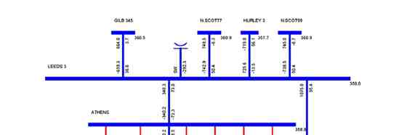
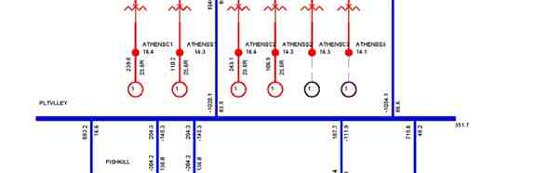
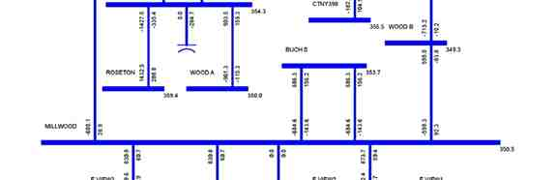
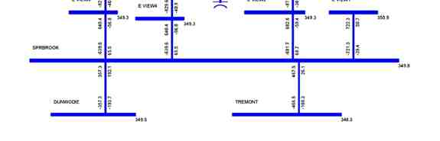

Power Flow Analysis

Figure 4-1: Benchmark Case without SPS

Siemens Power Transmission & Distribution, Inc.
4-4 Power Technologies International
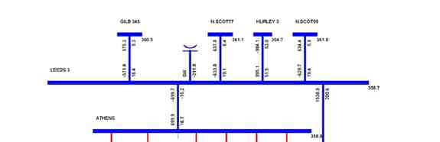
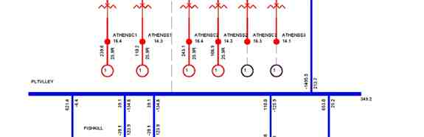
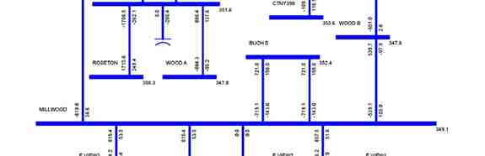
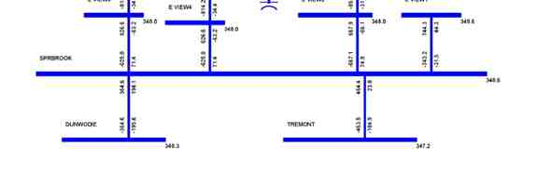

Power Flow Analysis

Figure 4-2: Benchmark Case Following Line 91 Contingency

Siemens Power Transmission & Distribution, Inc.
Power Technologies International 4-5
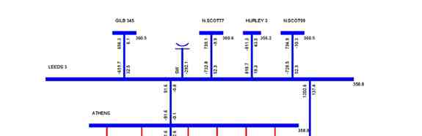
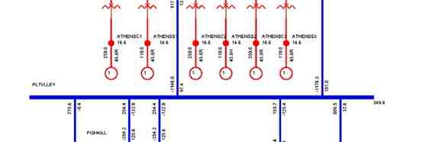
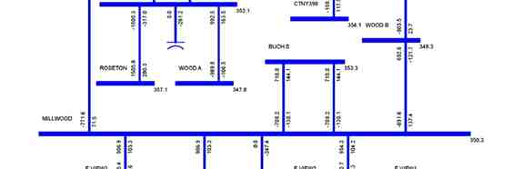
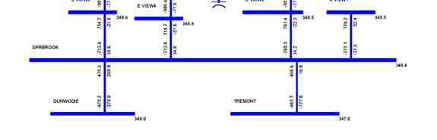

Power Flow Analysis

Figure 4-3: Case with SPS, All Equipment In-Service

Siemens Power Transmission & Distribution, Inc.
4-6 Power Technologies International
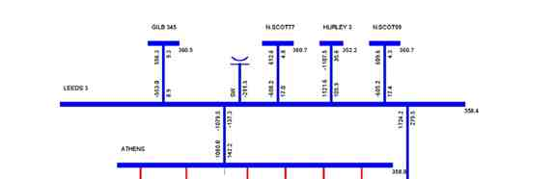
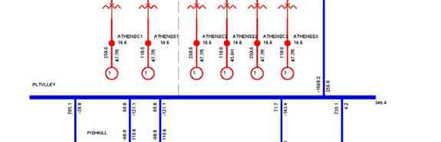
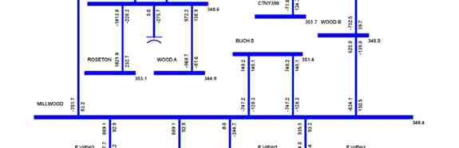
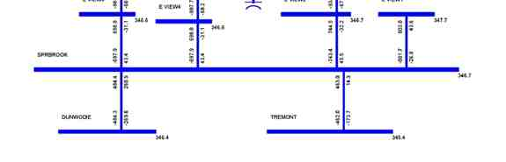

Power Flow Analysis

Figure 4-4: Case with SPS Following Line 91 Contingency but before SPS Operation

Siemens Power Transmission & Distribution, Inc.
Power Technologies International 4-7
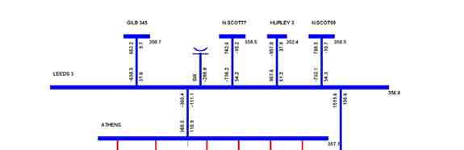
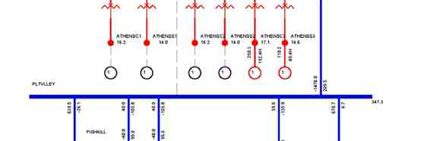
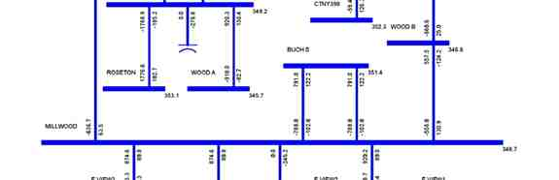
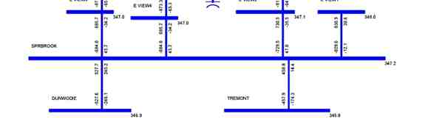

Power Flow Analysis

Figure 4-5: Case with SPS Following Line 91 Contingency and SPS Operation

Siemens Power Transmission & Distribution, Inc.
4-8 Power Technologies International

Power Flow Analysis

4.2 Analysis of Voltage Constraints
Voltage contingency analysis was performed for the Benchmark Case without the SPS and
the Case with the SPS with the UPNY-Con Ed interface at the normal thermal transfer limit,
i.e., 3633 MW and 4099 MW respectively, as determined in the thermal analysis described in
Section 5. The Case with the SPS has a 240 MVAR capacitor bank added at Millwood as
described above.
The full contingency set provided by the NYISO were simulated and bus voltages were
monitored for violations of the limits in Exhibit A-3 of the NYISO Emergency Operation
Manual and for bus voltages on the 115 kV system in the Lower Hudson area less than 95%
of nominal. Taps and phase shifter positions were fixed for the post-contingency calculation.
The Leeds and Fraser SVCs and Marcy FACTS devices are held at or near zero output in
the pre-contingency power flows, but are allowed to regulate voltage, within their capabilities, in the post-contingency power flows.
The detailed voltage analysis results are included in Appendix B. It is noted that with Athens dispatched at full capacity and the SPS, the voltages of several 115 kV buses decrease by less than 1%. The case with the SPS does not have significant incremental impact on the voltage at any other bus.

Siemens Power Transmission & Distribution, Inc.
Power Technologies International 4-9

Power Flow Analysis

This page intentionally left blank.

Siemens Power Transmission & Distribution, Inc.
4-10 Power Technologies International

Section
5
Impact on Transfer Limits
Transfer limit analysis was performed to determine and compare thermal, voltage and
stability limits of the UPNY-Con Ed and UPNY-SENY interfaces for the cases without and
with the SPS. Analysis of the UPNY-SENY interface is limited to thermal conditions only.
This analysis was performed for the summer peak condition per the SIS scope.

5.1 Thermal Analysis

5.1.1 Methodology
Thermal analysis was performed using the PSS™E subsystem, contingency and monitor
files provided by the NYISO, to determine the incremental impact of the SPS on the normal
transfer limit of the UPNY-Con Ed and UPNY-SENY interfaces. The full contingency set, as
supplied by the NYISO, was used in the analysis. The normal transfer limit of the UPNY -
Con Ed and UPNY-SENY interfaces was determined for the following two cases:
1. Case without SPS (Benchmark) with Athens dispatched at 700 MW
2. Case with SPS with Athens dispatched at 1080 MW
The redispatch performed to increase flow on the Athens-Pleasant Valley and Leeds-
Pleasant Valley (Lines 91 and 92) path to determine the thermal transfer limit first increased Athens to full power output with subsequent generation shifts from Ontario to Con Ed to increase the transfer level on the interface concerned as shown in Table 4-1. The SPS
permits the allowable post contingency loading on the 91/92 lines to go to STE. All other lines use their standard (LTE) post-contingency ratings.

5.1.2 Criteria
In accordance with NPCC criteria and NYSRC Reliability rules, several types of contingencies were simulated for this analysis:
1. Opening of lines connected between buses with base voltage greater than 100 kV
2. Multiple element
3. Generator
4. Common structure
5. HVDC
6. Stuck circuit breaker

Siemens Power Transmission & Distribution, Inc.
Power Technologies International 5-1

Impact on Transfer Limits

Phase angle regulators maintain scheduled power flow in pre-contingency conditions but are fixed at pre-contingency angle in post-contingency conditions.
The normal transfer limit is the transfer level at which:
 a branch has reached its normal rating for pre-contingency conditions, or
 a branch has reached its LTE rating following a contingency, except that the SPS will
allow post-contingency loading of either the Leeds to Pleasant Valley or Athens to
Pleasant Valley 345 kV lines (Lines 91 and 92) up to their STE ratings for outage of
the other line.

5.1.3 Model Development
Thermal transfer limits were calculated for summer peak load conditions without and with the
SPS. The cases without the SPS (Case 1) and with the SPS (Case 2) are described in
Section 3.4.

5.1.4 Results
Normal thermal transfer limits are summarized in Table 5-1. The detailed results are included in Appendix C.

It is noted from the table that the operation of the SPS increases UPNY-Con Ed and UPNYSENY thermal transfer limits by 466 MW respectively.

Table 5-1: Thermal Normal Transfer Limits (MW)

Case Case
Interface Without SPS With SPS Change
UPNY-Con Ed 3633^{A} 4099^{B} 466
UPNY-SENY 4502^{A} 4968^{B} 466
A Limited by Leeds - Pleasant Valley 345 kV (LTE: 1538 MW) for loss of Athens-Pleasant Valley 345 kV
B Limited by Leeds - Pleasant Valley 345 kV (STE: 1724 MW) for loss of Athens-Pleasant Valley 345 kV

5.2 Voltage Analysis

5.2.1 Methodology
Voltage transfer limit analysis (or P-V analysis) was performed for the UPNY-Con Ed
interface. Voltage-constrained limits were evaluated in accordance with the NYISO
Transmission Planning Guideline #2-0 and with consideration of the voltage criteria in Exhibit A-3 of the NYISO Emergency Operation Manual.

P-V curves were produced to examine the UPNY-Con Ed power transfers versus voltage at the New Scotland, Leeds, Pleasant Valley, Millwood, Dunwoodie and Sprainbrook 345kV stations for the two cases:
1. Case without SPS (Benchmark) with Athens dispatched at 700 MW

Siemens Power Transmission & Distribution, Inc.
5-2 Power Technologies International

Impact on Transfer Limits

2. Case with SPS with Athens dispatched at 1080 MW and a 240 MVAr capacitor bank
installed at Millwood

A series of power flow cases were created with increasing transfer levels on Leeds -
Pleasant Valley using generation shifts similar to those used for the thermal analysis.
Contingencies were simulated on each case to identify violations of the voltage criteria.

5.2.2 Criteria
Per the SIS scope, the following contingencies were simulated on each case to identify violations of the voltage criteria:
 Leeds - Athens #95
 Athens - Pleasant Valley #91  Leeds - Pleasant Valley #92  Leeds - Hurley #301
 New Scotland - Leeds #93 (or #94)


(Tower) Coopers Corners - Rock Tavern 34 and 42

The voltage criteria use the limits in Exhibit A-3 of the NYISO Emergency Operation Manual
with the following 345 kV stations using an updated limit of 348 kV as a pre-contingency low
voltage limit:
 Pleasant Valley  Millwood
 Sprain Brook
 Dunwoodie
Tap settings of phase angle regulators and autotransformers are adjusted (within their
capabilities) to regulate power flow and voltage in the pre-contingency power flows but are fixed at their corresponding pre-contingency settings in the post-contingency power flows. Similarly, switched shunt capacitors and reactors are switched according to their defined
setup in the pre-contingency power flows but are held at their corresponding pre-contingency position in the post-contingency power flows. The reactive power of generators is regulated, within the reactive capabilities of the units, to hold scheduled voltage in both the pre-
contingency and post-contingency power flows.
In accordance with the NYISO operating practice, the Leeds and Fraser SVCs and Marcy
FACTS devices are held at or near zero output in the pre-contingency power flows, but are
allowed to regulate voltage, within their capabilities, in the post-contingency power flows.
Inertial pickup is assumed for contingencies involving a loss of generation or HVDC.
The voltage-constrained transfer limits of the UPNY-Con Ed interface are determined in
accordance with the NYISO Transmission Planning Guideline #2-0. As the transfer across
an interface is increased, the voltage-constrained transfer limit is determined as the lesser of
(a) the pre-contingency power flow at which the post contingency voltage falls below the post-

Siemens Power Transmission & Distribution, Inc.
Power Technologies International 5-3

Impact on Transfer Limits

contingency limit, or (b) 95% of the pre-contingency power flow at the "nose" of the postcontingency voltage vs. pre-contingency flow curve.

5.2.3 Model Development
Voltage transfer limits were calculated for summer peak load conditions without and with the
SPS. The cases without the Project (Case 1) and with the Project (Case 2) are described in
Section 3.4.

5.2.4 Results
Voltage transfer limits are summarized in Table 5-2. The P-V curves for the Benchmark
Case and the Case with the SPS are plotted in Figures 5-1 and 5-2. There are three potential limiting conditions:
1. Pre-contingency (base case) voltage limits
2. Post-contingency voltage limits
3. Voltage collapse (limit is 95% of the interface flow at which collapse occurs.)
For both the cases without the SPS and with the SPS, the pre-contingency voltage transfer
limit on the UPNY-Con Ed interface is the lowest, 3880 MW and 4125 MW respectively in
both cases.
Comparing with the thermal analysis results, it is noted that the voltage-based transfer limits
are higher than the corresponding thermal transfer limits on the UPNY-Con Ed interface.

Table 5-2: Approximate Voltage Transfer Limit on UPNY-Con Ed (MW)

Case Case
UPNY-Con Ed Transfer Without SPS With SPS Change
Pre-Contingency Low 3880^{A} 4125^{A} 245
Post-Contingency Low 4279^{B} 4383^{B} 104
95% Voltage Collapse (5% MW 4092^{C} 4190^{C} 98
Margin)
Voltage-Based Transfer Limit 3880^{A} 4125^{C} 245
Thermal Transfer Limit 3633^{D} 4099E 466
A Pre-contingency voltage at Dunwoodie 345 kV
B Post-contingency voltage at Pleasant Valley 345 kV for loss of tower Coopers Corners-Rock Tavern 34/42
C 95% of voltage collapse criteria limit for loss of tower Coopers Corners-Rock Tavern 34/42
D Limited by Leeds - Pleasant Valley 345 kV (LTE: 1538 MW) for loss of Athens-Pleasant Valley 345 kV
E Limited by Leeds - Pleasant Valley 345 kV (STE: 1724 MW) for loss of Athens-Pleasant Valley 345 kV

Siemens Power Transmission & Distribution, Inc.
5-4 Power Technologies International
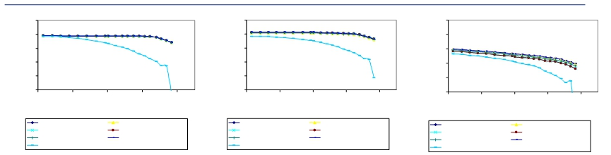
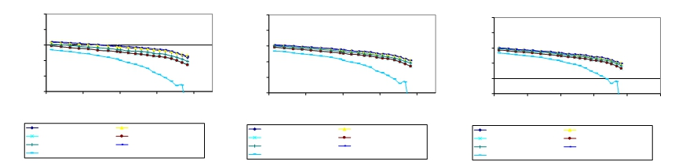

Impact on Transfer Limits

370

360

350

340

330

320
3600 3800 4000 4200 4400
UPNY-CONED MW

PRE-FAULT L/O LEEDS-ATHENS #95
L/O ATHENS-PLEASANT V. #91 L/O LEEDS-PLEASANT V. #92
L/O LEEDS-HURLEY #301 L/O N. SCOTLAND-LEEDS #93 TWR C. CORNERS-R. T. 34 & 42

370

360

350

340

330

320
3600 3800 4000 4200 4400
UPNY-CONED MW

PRE-FAULT L/O LEEDS-ATHENS #95
L/O ATHENS-PLEASANT V. #91 L/O LEEDS-PLEASANT V. #92
L/O LEEDS-HURLEY #301 L/O N. SCOTLAND-LEEDS #93 TWR C. CORNERS-R. T. 34 & 42

370

360

350

340

330

320
3600 3800 4000 4200 4400
UPNY-CONED MW

PRE-FAULT L/O LEEDS-ATHENS #95
L/O ATHENS-PLEASANT V. #91 L/O LEEDS-PLEASANT V. #92
L/O LEEDS-HURLEY #301 L/O N. SCOTLAND-LEEDS #93 TWR C. CORNERS-R. T. 34 & 42

370

360

350

340

330

320
3600 3800 4000 4200 4400
UPNY-CONED MW

PRE-FAULT L/O LEEDS-ATHENS #95
L/O ATHENS-PLEASANT V. #91 L/O LEEDS-PLEASANT V. #92
L/O LEEDS-HURLEY #301 L/O N. SCOTLAND-LEEDS #93 TWR C. CORNERS-R. T. 34 & 42

Figure 5-1: P-V Curves for the Case without SPS

370

360

350

340

330

320
3600 3800 4000 4200 4400
UPNY-CONED MW

PRE-FAULT L/O LEEDS-ATHENS #95
L/O ATHENS-PLEASANT V. #91 L/O LEEDS-PLEASANT V. #92
L/O LEEDS-HURLEY #301 L/O N. SCOTLAND-LEEDS #93 TWR C. CORNERS-R. T. 34 & 42

370

360

350

340

330

320
3600 3800 4000 4200 4400 4600
UPNY-CONED MW

PRE-FAULT L/O LEEDS-ATHENS #95
L/O ATHENS-PLEASANT V. #91 L/O LEEDS-PLEASANT V. #92
L/O LEEDS-HURLEY #301 L/O N. SCOTLAND-LEEDS #93 TWR C. CORNERS-R. T. 34 & 42

Siemens Power Transmission & Distribution, Inc.

Power Technologies International 5-5
LEEDS 345 KV VOLTAGE
PLEASANT V. 345 KV
VOLTAGE
N. SCOTLAND 345 KV
VOLTAGE
MILLWOOD 345 KV
VOLTAGE
DUNWOODIE 345 KV
VOLTAGE
SPRAINBROOK 345 KV
VOLTAGE

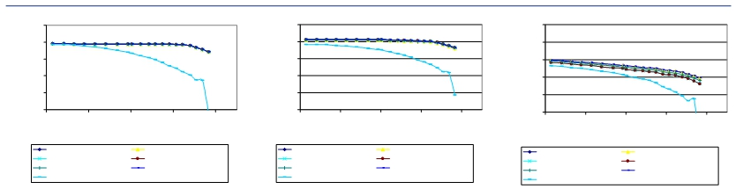
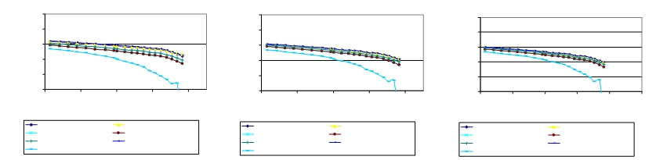

Impact on Transfer Limits

370 370 370

360 360 360

350 350 350
340 340 340

330 330 330

320 320 320
3600 3800 4000 4200 4400 3600 3800 4000 4200 4400 3600 3800 4000 4200 4400
UPNY-CONED MW UPNY-CONED MW UPNY-CONED MW

PRE-FAULT L/O LEEDS-ATHENS #95 PRE-FAULT L/O LEEDS-ATHENS #95 PRE-FAULT L/O LEEDS-ATHENS #95
L/O ATHENS-PLEASANT V. #91 L/O LEEDS-PLEASANT V. #92 L/O ATHENS-PLEASANT V. #91 L/O LEEDS-PLEASANT V. #92 L/O ATHENS-PLEASANT V. #91 L/O LEEDS-PLEASANT V. #92
L/O LEEDS-HURLEY #301 L/O N. SCOTLAND-LEEDS #93 L/O LEEDS-HURLEY #301 L/O N. SCOTLAND-LEEDS #93 L/O LEEDS-HURLEY #301 L/O N. SCOTLAND-LEEDS #93
TWR C. CORNERS-R. T. 34 & 42 TWR C. CORNERS-R. T. 34 & 42 TWR C. CORNERS-R. T. 34 & 42

370 370 370

360 360 360

350 350 350

340 340 340

330 330 330

320 320 320
3600 3800 4000 4200 4400 3600 3800 4000 4200 4400 3600 3800 4000 4200 4400 4600
UPNY-CONED MW UPNY-CONED MW UPNY-CONED MW

PRE-FAULT L/O LEEDS-ATHENS #95 PRE-FAULT L/O LEEDS-ATHENS #95 PRE-FAULT L/O LEEDS-ATHENS #95
L/O ATHENS-PLEASANT V. #91 L/O LEEDS-PLEASANT V. #92 L/O ATHENS-PLEASANT V. #91 L/O LEEDS-PLEASANT V. #92 L/O ATHENS-PLEASANT V. #91 L/O LEEDS-PLEASANT V. #92
L/O LEEDS-HURLEY #301 L/O N. SCOTLAND-LEEDS #93 L/O LEEDS-HURLEY #301 L/O N. SCOTLAND-LEEDS #93 L/O LEEDS-HURLEY #301 L/O N. SCOTLAND-LEEDS #93
TWR C. CORNERS-R. T. 34 & 42 TWR C. CORNERS-R. T. 34 & 42 TWR C. CORNERS-R. T. 34 & 42

Figure 5-2: P-V Curves for the Case with SPS

Siemens Power Transmission & Distribution, Inc.
5-6 Power Technologies International
LEEDS 345 KV VOLTAGE
PLEASANT V. 345 KV
VOLTAGE
N. SCOTLAND 345 KV
VOLTAGE
MILLWOOD 345 KV
VOLTAGE
DUNWOODIE 345 KV
VOLTAGE
SPRAINBROOK 345 KV
VOLTAGE

Impact on Transfer Limits

5.3 Stability Analysis

5.3.1 Methodology
Stability transfer limits were tested for the UPNY-Con Ed interface. Stability analysis was performed in accordance with the NYISO Transmission Planning Guideline #3-0 to confirm that the UPNY-Con Ed power transfer level is not restricted by a stability constraint due to operation of the SPS.

5.3.2 Criteria
Per the SIS scope, stability simulations were performed for the buses/substations associated
with the SPS as well as a couple of other stability tests requested. The contingencies include
three-phase faults on all 345 kV buses in the Leeds, Athens and Pleasant Valley substations
and also stuck breaker faults on each bus section. The contingencies simulated are shown in
Table 5-3.

Table 5-3: Stability Contingency List
Location Type Line Stuck Breaker Additional Equipment Lost
Leeds 3 Phase 95
3 Phase 92
3 Phase 301
3 Phase 93
1 Phase 95 R95 Capacitor Bank
1 Phase 95 R395 GL-3 to Gilboa
1 Phase 92 R92 Capacitor Bank
1 Phase 92 R9293 93 to New Scotland

Athens 3 Phase 95
3 Phase 91
1 Phase 95 R9561
1 Phase 95 R9562 Athens 2
1 Phase 91 R9163
1 Phase 91 R9162 Athens 2

Pleasant Valley 3 Phase 91
3 Phase 92
1 Phase 91 RN4
1 Phase 91 RNS4 F31/W81 to Millwood
1 Phase 92 RN5
1 Phase 92 RNS5 F30/W80 to Millwood

Ravenswood 3 Phase Loss of Ravenswood 3

Marcy South LLG Marcy-Coopers & Edic-Fraser

Siemens Power Transmission & Distribution, Inc.
Power Technologies International 5-7

Impact on Transfer Limits

5.3.3 Model Development
The contingencies shown in Table 5-3 were simulated for the cases without and with the
SPS.
1. Case without SPS (Benchmark) with Athens dispatched at 700 MW
2. Case with SPS with Athens dispatched at 1080 MW and a 240 MVAr capacitor bank
installed at Millwood
In preparing the above cases, Siemens PTI used a power flow base case provided by the
NYISO, which differed somewhat from the case used in the steady state analysis. In the
power flow case provided for stability analysis, Athens was dispatched at 800 MW on three
combined cycle trains. For consistency with the case used in steady-state analysis, Siemens
PTI reduced Athens dispatch from 800 MW to 700 MW on two combined cycle trains. The
MW reduction was balanced by units in Ontario. This case is referred to as the Benchmark
Case without SPS.
Then, Siemens PTI developed a stability power flow case with the SPS. In this case, Athens was increased to its full capacity i.e., 1080 MW, to increase flow on the Athens-Pleasant Valley and Leeds-Pleasant Valley (Lines 91 and 92) path. The additional Athens generation was dispatched against existing units in Con Ed. For consistency with the case used in
steady-state analysis, a 240 MVAR capacitor was added at Millwood.
Consistent with NYISO practice, the UPNY - Con Ed interface flow was further stressed by increasing it to 11 % higher than that determined in the steady state analysis (Table 5-1), that is, 4032 (3633*1.11) MW for the Benchmark case without SPS and 4550 MW (4099*1.11) for the case with SPS. The interface loadings were accomplished using the same generation shifts as used the steady-state analysis.
However, the load flow case with the SPS would not converge at the 4550 MW transfer level due to voltage collapse. The highest achievable UPNY-Con Ed interface flow is 4330 MW before the case fails to converge. This value is higher than the voltage-based transfer limit 4125 MW as determined in the steady-state analysis (Table 5-2).
To overcome this collapse problem, an “artificial” 350 Mvar capacitor was added at
Dunwoodie. With this capacitor, the case converges and the transfer level of 4550 MW on the UPNY-Con Ed interface is reached. This is necessary to allow for the stability analysis to be performed at the prescribed 11% higher transfer. This approach is consistent with NYISO practice (NYISO Transmission Planning Guideline #3-0).

5.3.4 Results
Stability simulations were performed on the contingencies in Table 5-3 for the three transfer
levels:

 Case A: 4032 MW (111% of the transfer limit in the Benchmark case without the
SPS)
 Case B0: 4330 MW (Highest achievable voltage-constrained transfer in the case with
the SPS)

Siemens Power Transmission & Distribution, Inc.
5-8 Power Technologies International

Impact on Transfer Limits

 Case B: 4550 MW (111% of the transfer limit in the case with the SPS and an
“artificial” reactive compensation of 350 Mvar added at Dunwoodie)
Simulations were performed to address the two periods of interest. First, a simulation was
performed at the higher loading resulting from the presence of the SPS. Second, after it was
verified that the simulation of the contingency was stable, the post-contingency steady state
condition (using NYISO post-contingency calculation methodology) was used as the initial
condition to simulate the operation of the SPS to show the effect of the loss of generation on
the system.
All the simulated contingencies exhibited a stable response with positive damping. Stability is thus not the limiting constraint either without or with the SPS.
Figures 5-3 to 5-6 show comparative machine rotor angels at Athens, voltages at Athens and Pleasant Valley, and branch flow on Line 92 following a 3-phase fault at Athens with normal clearing and tripping of Line 91, for the three cases (4032 MW, 4330 MW and 4550 MW) during the first period of time, i.e., before the operation of the SPS.

Figures 5-7 to 5-10 show the same quantities compared for the 4330 MW and 4550 MW cases during the second period of time, i.e., after the operation of the SPS.
All other stability plots of representative machine quantities and other system quantities are included in Appendix D.

Siemens Power Transmission & Distribution, Inc.
Power Technologies International 5-9

Impact on Transfer Limits

0.0 3.0000
1.5000 4.5000

6.0000 9.0000 12.000
7.5000 10.500
TIME (SECONDS)

15.000
13.500
WED, AUG 16 2006 9:03
ATHENS RELATIVE ANGLES

Figure 5-3: CT Machine Angle at Athens Following Fault, Pre-SPS Operation

Siemens Power Transmission & Distribution, Inc.
5-10 Power Technologies International

Impact on Transfer Limits

0.0 3.0000
1.5000 4.5000

6.0000 9.0000 12.000
7.5000 10.500
TIME (SECONDS)

15.000
13.500
THU, MAY 25 2006 8:54
ATHENS 345 KV VOLTAGE

Figure 5-4: Voltage at Athens Following Fault, Pre-SPS Operation

Siemens Power Transmission & Distribution, Inc.
Power Technologies International 5-11

Impact on Transfer Limits

0.0 3.0000
1.5000 4.5000

6.0000 9.0000 12.000
7.5000 10.500
TIME (SECONDS)

15.000
13.500
THU, MAY 25 2006 8:54
PLEASANT VALLEY VOLTAGE

Figure 5-5: Voltage at Pleasant Valley Following Fault, Pre-SPS Operation

Siemens Power Transmission & Distribution, Inc.
5-12 Power Technologies International

Impact on Transfer Limits

0.0 3.0000
1.5000 4.5000

6.0000 9.0000 12.000 15.000
7.5000 10.500 13.500
TIME (SECONDS)

THU, MAY 25 2006 8:54
LINE 92 FLOW

Figure 5-6: Branch Flow on Line 92 Following Fault, Pre-SPS Operation

Siemens Power Transmission & Distribution, Inc.
Power Technologies International 5-13

Impact on Transfer Limits

0.0 3.0000
1.5000 4.5000

6.0000 9.0000 12.000
7.5000 10.500
TIME (SECONDS)

15.000
13.500
FRI, JUN 02 2006 9:22
ATHENS RELATIVE ANGLES

Figure 5-7: Machine Angle at Athens Following SPS Operation

Siemens Power Transmission & Distribution, Inc.
5-14 Power Technologies International

Impact on Transfer Limits

0.0 3.0000
1.5000 4.5000

6.0000 9.0000 12.000
7.5000 10.500
TIME (SECONDS)

15.000
13.500
THU, MAY 25 2006 12:40
ATHENS 345 KV VOLTAGE

Figure 5-8: Voltage at Athens Following SPS Operation

Siemens Power Transmission & Distribution, Inc.
Power Technologies International 5-15

Impact on Transfer Limits

0.0 3.0000
1.5000 4.5000

6.0000 9.0000 12.000
7.5000 10.500
TIME (SECONDS)

15.000
13.500
THU, MAY 25 2006 12:40
PLEASANT VALLEY VOLTAGE

Figure 5-9: Voltage at Pleasant Valley Following SPS Operation

Siemens Power Transmission & Distribution, Inc.
5-16 Power Technologies International

Impact on Transfer Limits

0.0 3.0000
1.5000 4.5000

6.0000 9.0000 12.000 15.000
7.5000 10.500 13.500
TIME (SECONDS)

THU, MAY 25 2006 12:40
LINE 92 FLOW

Figure 5-10: Branch Flow on Line 92 Following SPS Operation

Siemens Power Transmission & Distribution, Inc.
Power Technologies International 5-17

Impact on Transfer Limits

This page intentionally left blank.

Siemens Power Transmission & Distribution, Inc.
5-18 Power Technologies International

Section
6
Extreme Contingency Analysis
Certain extreme contingencies were analyzed to assess the effect of the increased flow on
the UPNY-Con Ed interface on the system steady state performance. The assessment was
performed on the cases at the UPNY- Con Ed interface limit without and with the SPS, as
determined in the steady state analysis (Table 5-1), that is, 3633 MW and 4099 MW
respectively. Loading on a branch was calculated as a percent of its short term emergency
(STE) rating for post contingency system conditions. The following extreme contingencies
were analyzed:
Contingency Name Contingency Description
EC18 Loss of New Scotland Substation
EC19 Loss of Leeds Substation
EC16 Loss of Fraser Substation
EC91&92 Loss of 91/92 ROW
EC92&95 Loss of 92/95 ROW
EC27 Loss of Astoria Substation

For EC91&92 and EC92&95 which may or may not trigger the SPS depending on the event sequence, pre-SPS and post-SPS branch flows and bus voltages were calculated.
Table 6-1 and Table 6-2 show branch loading and voltage differences under extreme
contingencies for the cases without and with the SPS. It is noted that the case with SPS
shows incremental overload and voltage impacts on several 115 kV facilities. Additionally, for the case with the SPS, the loss of the Right-of-Way of Lines 91 & 92 would overload the
Leeds to Hurley 345 kV line by 1%. There are no widespread overloads or voltage violations found on the bulk power system under the extreme contingencies tested.

Siemens Power Transmission & Distribution, Inc.
Power Technologies International 6-1

Extreme Contingency Analysis

Table 6-1: Branch Loading Differences under Extreme Contingencies
Case With SPS Case Without SPS
Monitored Branch Pre-SPS Operation Post-SPS Operation
** From bus * To bus ** STE Extreme Delta
CKT Rating MW flow Loading% MW flow Loading% Contingency MW flow Loading% Flow (%)
78757 BOC 2T 115 74040 N.CAT. 1 115 2 145 189 130.3 N/A N/A EC19 185.6 128 2.3
75435 CHURC115 115 78739 BL STR E 115 120 150.4 125.4 N/A N/A EC19 146.6 122.2 3.2
78731 JMC1+7TP 115 78740 BLUECIRC 115 145 174.5 120.4 N/A N/A EC19 171.1 118 2.4
78755 HUDSON 115 78799 VALKIN 115 159 165.8 104.3 N/A N/A EC19 162.2 102 2.3
78757 BOC 2T 115 78760 JMC2+9TP 115 145 194.7 134.3 N/A N/A EC19 190.9 131.7 2.6
78766 N.SCOT1 115 78798 UNVL 7TP 115 145 199.7 137.7 N/A N/A EC19 196 135.2 2.5
78769 OW CRN E 115 78798 UNVL 7TP 115 145 199.7 137.7 N/A N/A EC19 196 135.2 2.5
78769 OW CRN E 115 78806 BOC 7T 115 145 197.8 136.4 N/A N/A EC19 194.2 133.9 2.5
78701 LEEDS 3 345 74000 HURLEY 3 345 1870 1900.5 101.6 NV NV EC91&92 1689.2 90.3 11.3
78766 N.SCOT1 115 78798 UNVL 7TP 115 145 168.6 116.3 161.8 111.6 EC91&92 159.3 109.9 6.4
78769 OW CRN E 115 78798 UNVL 7TP 115 145 168.6 116.3 161.8 111.6 EC91&92 159.3 109.9 6.4
78769 OW CRN E 115 78806 BOC 7T 115 145 166.7 115 159.9 110.2 EC91&92 157.4 108.6 6.4
78766 N.SCOT1 115 78798 UNVL 7TP 115 145 148.6 102.5 155.1 107 EC92&95 146.3 100.9 1.6
78769 OW CRN E 115 78798 UNVL 7TP 115 145 148.6 102.5 155.1 107 EC92&95 146.3 100.9 1.6
78769 OW CRN E 115 78806 BOC 7T 115 145 146.6 101.1 153.1 105.6 EC92&95 144.4 99.6 1.5

Note: "N/A" means SPS does not operate under those contingencies
Note: "NV" means there is no violation.

Siemens Power Transmission & Distribution, Inc.
6-2 Power Technologies International

Extreme Contingency Analysis

Table 6-2: Voltage Differences under Extreme Contingencies

Case With SPS Case Without
Pre-SPS Post-SPS SPS
Operation Operation
Contingent Contingent Extreme Contingent Voltage
Bus # Bus Name KV Voltage Voltage Contingency Voltage Difference
74040 N.CAT. 1 115 0.941 N/A EC18 0.9466 -0.0055
79124 CENTER-S 115 0.940 N/A EC18 NV N/A
79127 CLINTON 115 0.944 N/A EC18 NV N/A
79141 MARSH115 115 0.944 N/A EC18 NV N/A
79155 ST JOHNS 115 0.945 N/A EC18 NV N/A
79156 STONER 115 0.941 N/A EC18 NV N/A
79159 TAP T79 115 0.949 N/A EC18 NV N/A
79161 VAIL TAP 115 0.942 N/A EC18 NV N/A
79162 VAIL 115 115 0.939 N/A EC18 0.9492 -0.0100
74040 N.CAT. 1 115 0.881 N/A EC19 0.8924 -0.0113
78702 N.SCOT77 345 1.051 N/A EC19 1.0535 0.0026
78703 N.SCOT99 345 1.051 N/A EC19 1.0534 0.0026
78742 BLUES-8 115 0.944 N/A EC19 NV N/A
78756 INDC+BKL 115 0.937 N/A EC19 0.9459 -0.0092
74040 N.CAT. 1 115 0.906 0.921 EC91&92 0.923 -0.0171
75492 PAWLN115 115 0.949 NV EC91&92 NV N/A
74040 N.CAT. 1 115 0.934 0.931 EC92&95 0.9376 -0.0037
74040 N.CAT. 1 115 0.944 N/A EC27 0.9475 -0.0036
74040 N.CAT. 1 115 0.938 N/A EC28 0.944 -0.0058

Note: "N/A" means SPS does not operate under those contingencies or comparison is not available.
Note: "NV" means there is no violation.

Siemens Power Transmission & Distribution, Inc.
Power Technologies International 6-3

Extreme Contingency Analysis

This page intentionally left blank.

Siemens Power Transmission & Distribution, Inc.
6-4 Power Technologies International

Section
7
SPS Misoperation and Failed Operation
Analysis

7.1 SPS Misoperation
The Athens SPS is designed to operate only for post-contingency conditions, namely the loss
of Line 91 with subsequent flow on line 92 exceeding its LTE rating or alternately loss of Line
92 with subsequent flow on line 91 exceeding its LTE rating. Operation of the SPS will trip Athens generation to bring the post-contingency flows below the line’s LTE rating.
There are several potential misoperation scenarios, not all of which may actually be able to occur depending on the design details of the actual equipment and logic involved:
 Failure to operate when it should
 Operation without the initiating event, i.e., a false trip
 Partial operation, i.e., not tripping enough generation
 Overtripping, i.e., tripping too much generation
Failure of the SPS to operate when it should is covered in the following subsection.
Operation without the initiating event, that is, a false trip of two Athens combined cycle trains
(720 MW at full load) is not an insignificant event, but does not result in system conditions
outside post-contingency limits. The effect of this misoperation was evaluated by both load
flow calculation and stability simulation. Figure 7-1 shows the local system conditions
following the loss of 720 MW at Athens. Loadings on all lines are below LTE rating and all
bulk system voltages with-in post-contingency limits. Figures 7-2 to 7-5 show results of a
stability simulation of the trip of 720 MW of Athens generation. A stable response is exhibited
with positive damping.
Partial operation, that is tripping for example one combined cycle train instead of two, would result in an intermediate condition between normal operation and failure to operate. The system condition would be stable, but manual operator action to adjust generation at Athens may be required to reduce the flow on the 91 or 92 line to below LTE rating.
The fourth possibility is overtripping. The effect of this misoperation was evaluated by both
load flow calculation and stability simulation. Figure 7-6 shows the local system conditions
following the trip of line 91 and misoperation of the SPS with trip of all generation (1080 MW)
at Athens. Loadings on all lines are below LTE rating and all bulk system voltages within
post-contingency limits. Figures 7-7 to 7-8 show results of a stability simulation of the trip of

Siemens Power Transmission & Distribution, Inc.
Power Technologies International 7-1

SPS Misoperation and Failed Operation Analysis

1080 MW of Athens generation following the line outage. A stable response is exhibited with positive damping.
This analysis demonstrates that misoperation of the SPS will not result in severe system
problems or widespread effects on the system, that is, it does not cause a significant adverse impact outside of the local area.

Siemens Power Transmission & Distribution, Inc.
7-2 Power Technologies International
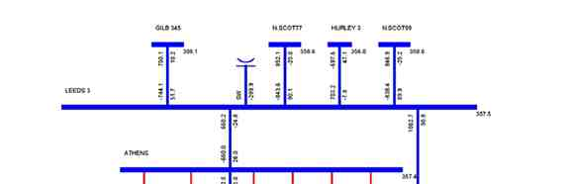
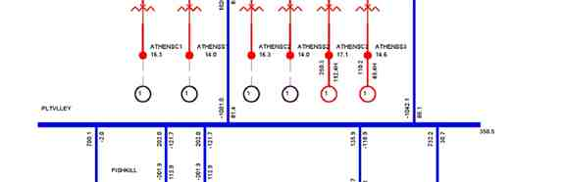
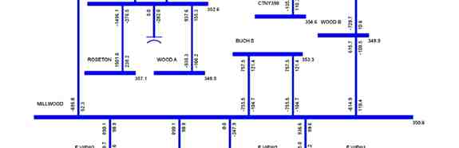
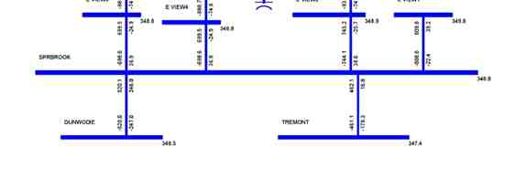

SPS Misoperation and Failed Operation Analysis

Figure 7-1: Branch Loadings with Misoperation of SPS,
Tripping 2 Combined Cycle Trains at Athens.

Siemens Power Transmission & Distribution, Inc.
Power Technologies International 7-3

SPS Misoperation and Failed Operation Analysis

0.0 3.0000
1.5000 4.5000

6.0000 9.0000 12.000
7.5000 10.500
TIME (SECONDS)

15.000
13.500
WED, MAY 31 2006 9:13
ATHENS RELATIVE ANGLES

Figure 7-2: Athens Machine Angle with Misoperation of SPS, Tripping 2 Combined Cycle Trains at Athens

Siemens Power Transmission & Distribution, Inc.
7-4 Power Technologies International

SPS Misoperation and Failed Operation Analysis

0.0 3.0000
1.5000 4.5000

6.0000 9.0000 12.000
7.5000 10.500
TIME (SECONDS)

15.000
13.500
WED, MAY 31 2006 9:13
ATHENS POWER OUTPUTS

Figure 7-3: Athens Machine Power with Misoperation of SPS, Tripping 2 Combined Cycle Trains at Athens

Siemens Power Transmission & Distribution, Inc.
Power Technologies International 7-5

SPS Misoperation and Failed Operation Analysis

0.0 3.0000
1.5000 4.5000

6.0000 9.0000 12.000 15.000
7.5000 10.500 13.500
TIME (SECONDS)

THU, MAY 25 2006 12:56
345 KV VOLTAGES

Figure 7-4: 345 kV Voltages at Leeds, Athens, Pleasant Valley, Dunwoodie, Millwood and New Scotland,
with Misoperation of SPS, Tripping 2 Combined Cycle Trains at Athens

Siemens Power Transmission & Distribution, Inc.
7-6 Power Technologies International

SPS Misoperation and Failed Operation Analysis

0.0 3.0000
1.5000 4.5000

6.0000 9.0000 12.000
7.5000 10.500
TIME (SECONDS)

15.000
13.500
THU, MAY 25 2006 12:56
LINE 91,92,&95 MW FLOW

Figure 7-5: Flows on 91, 92 & 95 with Misoperation of SPS, Tripping 2 Combined Cycle Trains at Athens

Siemens Power Transmission & Distribution, Inc.
Power Technologies International 7-7

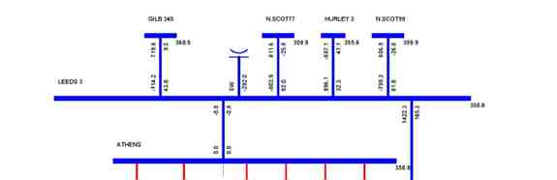
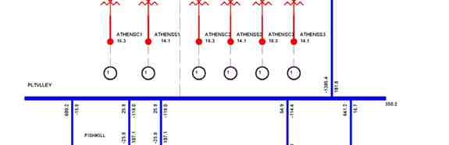
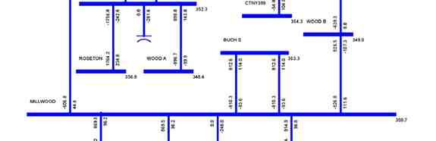
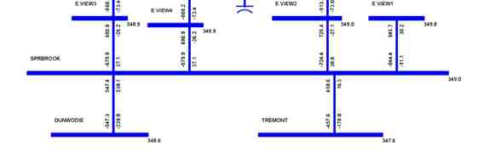

SPS Misoperation and Failed Operation Analysis

Figure 7-6: Branch Loadings Following Line 91 Outage, with Misoperation
of SPS Tripping 3 Combined Cycle Trains at Athens

Siemens Power Transmission & Distribution, Inc.
7-8 Power Technologies International

SPS Misoperation and Failed Operation Analysis

0.0 3.0000
1.5000 4.5000

6.0000 9.0000 12.000
7.5000 10.500
TIME (SECONDS)

15.000
13.500
THU, JUN 01 2006 11:22
LINE 91,92,&95 MW FLOW

Figure 7-7: Flows on Lines 91, 92 & 95 Loadings Following Line 91 Outage,
with Misoperation of SPS Tripping 3 Combined Cycle Trains at Athens

Siemens Power Transmission & Distribution, Inc.
Power Technologies International 7-9

SPS Misoperation and Failed Operation Analysis

0.0 3.0000
1.5000 4.5000

6.0000 9.0000 12.000 15.000
7.5000 10.500 13.500
TIME (SECONDS)

WED, MAY 31 2006 16:46
345 KV VOLTAGES

Figure 7-8: 345 kV Voltages at Leeds, Athens, Pleasant Valley, Dunwoodie, Millwood
and New Scotland with Misoperation of SPS Tripping 3 Combined Cycle Trains at Athens

Siemens Power Transmission & Distribution, Inc.
7-10 Power Technologies International

SPS Misoperation and Failed Operation Analysis

7.2 Failure of the SPS to Operate
The effect of the failure of the SPS to operate to reduce generation at Athens for an outage of either Line 91 or 92 under heavy UPNY-Con Ed transfer can be determined from the analysis described in Section 6. This analysis looked at three time periods:
1. Pre-contingency steady state
2. Post-contingency, pre-SPS operation
3. Post-contingency, post-SPS operation
Operation of the SPS is expected to occur within two minutes following the outage of either
line 91 or 92 if the loading on the remaining line is over LTE. The outage of Line 91 is slightly
more severe than the outage of line 92 so will be discussed here, although the comments
also apply for the opposite scenario. The analysis in Section 6 demonstrated that for the
outage of line 91, except for line 92 on the same ROW, all other lines remain within their LTE
limits and all bulk system bus voltages within their post-contingency limits (time period 2).
The local area flows and voltages are shown in Figure 6-4. Following operation of the SPS,
all lines including line 92 are within their LTE limits and all bulk system bus voltages within
their post-contingency limits (time period 3). The local area flows and voltages are shown in
Figure 6-5.
If the SPS fails to operate, the system does not automatically transition from the second
condition to the third within two minutes. The system condition is such that one line is
overloaded above its LTE rating, but below its STE rating. All other elements are within postcontingency limits. Since the STE rating is a 15 minute rating, there is ample time for manual operator action to either manually trip generation at Athens or perform other actions.
Note that the likelihood of such a failure would be quite low due to the redundancy built into the SPS design and also the fact that the SPS will only be operational at periods of high transfer and will only operate for permanent faults (i.e., unsuccessful reclosing).

7.3 Potential for Interaction with Other Existing New York Special
Protection Systems
Consideration was given to the potential for interaction with other existing Special Protection Systems in New York. A listing of such Systems and procedures is given in Exhibit A-2 of the NYISO System Operation Procedures, Exception to Operating Criteria for Pre-Contingency & Post-Contingency Transmission Facility Flows and Voltages.
None of the exceptions listed in that document should have an interaction. The only three in the general vicinity of the Athens SPS are Exceptions 1, 3, and 5, each of which will be
addressed below.
Exception 1: The post-contingency flow on the Marcy-New Scotland 18 line is allowed
to exceed its LTE rating for the loss of the Edic-New Scotland 14 line by the amount
of relief that can be obtained by tripping the Gilboa pumping load as a single
corrective action. Also, the post-contingency flow on the Edic-New Scotland 14 line is
allowed to exceed its LTE rating for either the loss of the Marcy-New Scotland 18 line

Siemens Power Transmission & Distribution, Inc.
Power Technologies International 7-11

SPS Misoperation and Failed Operation Analysis

alone, or the double-circuit loss of the Marcy-New Scotland 18 and Adirondack-Porter
12 lines, by the amount of relief that can be obtained by tripping the Gilboa pumping load as a single corrective action.
This exception deals with time periods where Gilboa is in a pumping mode. The
Athens SPS is designed for heavy UPNY-Con Ed transfer periods such as during
peak load. These two conditions do not occur simultaneously as the Gilboa station
would not be pumping at peak load or under conditions requiring heavy UPNY-Con
Ed transfers.
Exception 3: The post-contingency flow on the NS-Leeds line is allowed to reach its STE rating for transfers to NE & SENY, with sufficient generation at Gilboa.
This exception is not an SPS but a generation runback procedure under operator control. Hence, since operator control is used and not automatic action, there is no possibility of interaction.

Exception 5: The post-contingency flow on the Gilboa-Leeds (GL-3) line is allowed to reach its STE rating with four generators on at Gilboa.

This exception is not an SPS but a generation runback procedure under operator control. Hence, since operator control is used and not automatic action, there is no possibility of interaction.
Thus these three Exceptions do not pose a concern of interaction with the Athens SPS.
Another point to note is that Exceptions 3 and 5 are examples of how operator actions can be applied in the 15 minute time period associated with the STE rating of a line, consistent with the ability of operator action to manually trip Athens generation in the unlikely event of an SPS failure as discussed above.

Siemens Power Transmission & Distribution, Inc.
7-12 Power Technologies International

Section
8
SPS Type Analysis

The NPCC Document A-11, Special Protection System Criteria defines three types of special protection Systems:
Type I - An SPS which recognizes or anticipates abnormal system conditions
resulting from design and operating criteria contingencies, and whose misoperation or
failure to operate would have a significant adverse impact outside of the local area.
The corrective action taken by the SPS along with the actions taken by other
protection systems are intended to return power system parameters to a stable and
recoverable state.
Type II - An SPS which recognizes or anticipates abnormal system conditions
resulting from extreme contingencies or other extreme causes, and whose
misoperation or failure to operate would have a significant adverse impact outside of the local area.
Type III - An SPS whose misoperation or failure to operate results in no significant adverse impact outside the local area.

The SPS in this study is designed to recognize abnormal system conditions resulting from design and operating criteria contingencies and therefore it is not a Type II SPS, which by definition recognizes or anticipates extreme contingencies.
The study results presented in the previous sections have shown that the misoperation or
failed operation of this SPS would not have a significant adverse impact outside of the local
area, that is, there are no widespread overloads or voltage violations found outside the local
area. Therefore the Athens SPS should be classified as a Type III SPS according to the
above criteria.

Siemens Power Transmission & Distribution, Inc.
Power Technologies International 8-1

SPS Type Analysis

This page intentionally left blank.

Siemens Power Transmission & Distribution, Inc.
8-2 Power Technologies International

Section
9
Conclusions
The purpose of this SIS is to demonstrate the improvement in the UPNY-Con Ed interface transfer capability that would result from the installation and operation of the SPS and other possible associated mitigative measures such as the installation of shunt capacitive
compensation at one or more Con Edison substations.
The study shows that the SPS is effective. With the SPS, the transfer across the UPNY-Con Ed Interface can be increased by 466 MW while abiding by applicable reliability rules and
criteria. This allows the Athens plant to be dispatched at full capacity, i.e., 1080 MW, during peak load conditions.
The operation without and with the SPS was analyzed using thermal, voltage and stability
analysis. The thermal analysis shows that with Athens dispatched at full capacity and the
SPS, the UPNY-Con Ed thermal transfer limit is increased by 466 MW, from 3633 MW to
4099 MW. Both without and with the SPS, the transfer is limited by flow on the Leeds to
Pleasant Valley 345 kV line due to loss of the Athens to Pleasant Valley 345 kV line. Without
the SPS, the post-contingency flow is limited to the line’s LTE rating of 1538 MW while the
SPS increases the allowable post-contingency flow to the line’s STE rating of 1724 MW. The
operation of the SPS reduces the line flow to below the LTE rating within a period of two
minutes.
Two contingencies may trigger the SPS, loss of the Athens to Pleasant Valley 345 kV (Line 91) and the Leeds to Pleasant Valley 345 kV line (Line 92). The loss of Line 91 is slightly more severe. For the peak load level and system dispatch modeled in the power flow case supplied by the NYISO, this contingency would require the trip of two Athens combined cycle trains, for a total of 720 MW. The loading on Line 92 after this contingency and SPS
operation would be 1520 MW, lower than the LTE rating of 1538 MW.
The thermal transfer limit on the UPNY-SENY interface was also analyzed. The analysis
shows that with Athens dispatched at full capacity and the SPS, the UPNY-SENY thermal
transfer limit is increased by 466 MW, from 4502 MW to 4968 MW. Both without and with the SPS, the limiting element is the same as that for the UPNY-Con Ed interface.
The voltage analysis indicated that transfer across the UPNY-Con Ed interface would be
limited by the pre-contingency voltage limit of 348 kV at four lower Hudson Valley 345 kV
buses. Therefore a 240 MVAr capacitor bank was modeled at Millwood which is sufficient to maintain the steady-state pre-contingency voltage at these stations above 348 kV. Millwood was selected as the potential location for the capacitor back due to concerns that space may be limited in other possible stations.
The voltage contingency analysis indicated that with Athens dispatched at full capacity and
the SPS in-service, there was no significant incremental impact on bulk system voltages

Siemens Power Transmission & Distribution, Inc.
Power Technologies International 9-1

Conclusions

compared to operation without the SPS. The voltages on several 115 kV buses decreased by less than 1% under certain contingencies.
The P-V analysis showed that with Athens dispatched at full capacity and the SPS, the
voltage-based UPNY-Con Ed transfer limit is increased by 245 MW. The voltage-based
transfer limits for both without and with the SPS are higher than the respective thermal limits, as follows:

Case Case
UPNY-Con Ed Transfer Without SPS With SPS Change
Pre-Contingency Low 3880^{A} 4125^{A} 245
Post-Contingency Low 4279^{B} 4383^{B} 104
95% Voltage Collapse (5% MW 4092^{C} 4190^{C} 98
Margin)
Voltage-Based Transfer Limit 3880^{A} 4125^{C} 245
Thermal Transfer Limit 3633^{D} 4099E 466
A Pre-contingency voltage at Dunwoodie 345 kV
B Post-contingency voltage at Pleasant Valley 345 kV for loss of tower Coopers Corners-Rock Tavern 34/42
C 95% of voltage collapse criteria limit for loss of tower Coopers Corners-Rock Tavern 34/42
D Limited by Leeds - Pleasant Valley 345 kV (LTE: 1538 MW) for loss of Athens-Pleasant Valley 345 kV
E Limited by Leeds - Pleasant Valley 345 kV (STE: 1724 MW) for loss of Athens-Pleasant Valley 345 kV

Stability analysis was performed. All stability simulations exhibited a stable response with positive damping. Stability is thus not the limiting constraint on the transfer level on the UPNY-Con Ed interface either without or with the SPS.
The extreme contingency analysis demonstrates that the case with SPS shows incremental overload and voltage impacts on several 115 kV facilities. Additionally, for the case with the SPS, the loss of the Right-of-Way of Lines 91 & 92 would overload the Leeds to Hurley 345 kV line by 1%. There are no widespread overloads or voltage violations found on the bulk power system under the extreme contingencies tested.
The analysis demonstrates that misoperation of the SPS will not result in severe system
problems or widespread effects on the system, that is, it does not cause a significant adverse impact outside of the local area.
Failure of the SPS to operate under maximum transfer conditions would result in Line 91 or
92 being loaded above its LTE rating following the outage of the other, but below its STE
rating. For the peak condition analyzed, all other elements are within post-contingency limits. Since the STE rating is a 15 minute rating, there is ample time for manual operator action to either manually trip generation at Athens or perform other actions.
The study results demonstrate that the misoperation or failed operation of this SPS would not have a significant adverse impact outside of the local area, that is, there are no widespread
overloads or voltage violations found outside the local area. Thus the SPS should be
classified as a Type III SPS according to the NPCC Special Protection System Criteria
(NPCC Document A-11).

Siemens Power Transmission & Distribution, Inc.
9-2 Power Technologies International

Conclusions

The NYISO will calculate the actual Transmission Congestion Contracts (TCCs) awarded as a result of this proposed SPS. However, the results of this SIS indicate a potential TCC
award estimate of 466 MW for the Athens' SPS.

Siemens Power Transmission & Distribution, Inc.
Power Technologies International 9-3

