**Appendix A**

**Attachment facilities and System Upgrade Facilities**

**1. Attachment Facilities:**

1. **[insert Developer's Attachment Facilities]:**
2. **[insert Transmission Owner's Attachment Facilities]:**

**2. System Upgrade Facilities:**

1. **[insert Stand Alone System Upgrade Facilities]:**
2. **[insert Other System Upgrade Facilities]:**

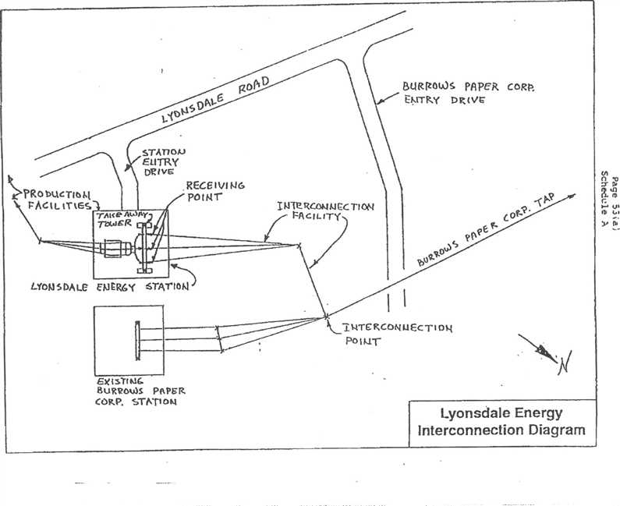

1..:114TERC061 Ec TioN

Po K.11-

**LYON DA LC El.) ER6`f STATION**

***EX* t**

BURROWS **Pek PER CORP. STATI of4**

**Lyonsdale Energy  
interconnection Diagram**

BORRoWs PAPER coR15.

**EtsAT** Ky **(V**

*STA-nolo ELI* **TRY**

**DR *'VG***

rActt_ **trIES,**

**I N1E r(Cot.1),1 CC TI 01,4**

**PR crLITY**

RECEIVING

porwr

Lyonsdale Biomass, LLC Energy Facility

23.5MVA Parallel Generation

Interconnection System

with National Grid

NatGrid  
Taylorville Station

115kV  
Bus

NatGrid  
Bremen Station

Northbrook  
Lyons Falls

Moose Lyonsdale Hydro

River Hydro Burrows Paper

8104

R60

-sk

64 /- ***or--*** 63

'I "1 X6-3 115kV Lyons Falls Tap

r

|  |  |
| --- | --- |
| 115kV Taylorville-Boonville #6 | X6-1 X6.2 |

R60

115kV  
Bus

NatGrid  
Boonville Station

Point of  
Interconnection  
(POI)

Transmission  
Owner (T.O.)

Attachment  
Facility (TOAF)



T.O.  
I.C.

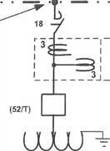

115kV Station

T.O.  
Metering

115kV Tap (by T.0.)

**• ◼11•••1**

13.8kV, 1200A Bus

Station Auxi iary

52/G Loads

Point of  
Ownership  
Change

R60

T.B. No.1

I 115-13.8kV 20/26.67MVA , OA/FA

Interconnection  
Customer (I.C.)  
Facilities

|  |  |  |
| --- | --- | --- |
| INFORMATION ONLY NOT ALL DETAILS SHOWN  Lyonsdale Biomass 115kV System Interconnection 07 31 2008.vsd |  | Large Generator Facility (LGF)  GENERATOR UNIT #1 13.8kV wye, 21.15MW, 0.9 p.f. 23.5MVA  = 18.5%  xd" = 11.5% |

**Appendix B**

Milestones

**Appendix C  
Interconnection Details**

**1. Owner:**

**Project:**

**Point of Interconnection:** (refer to one-line diagram that should be attached in Appendix A)

1. **Electrical Equipment Requirements:** The installation of electrical equipment and operation of the facility must meet or exceed the requirements of Niagara Mohawk's Electric System Bulletin No.ESB 756.
2. **Metering Requirements:** Electricity transferred to the transmission system shall be measured by electric watt-hour meters of a type approved by the Public Service Commission of the State of New York. The meter and installation costs shall be borne by Lyonsdale Biomass, LLC. The meters shall be maintained with the rules set forth in 16 NYCRR Part 92.
3. **Reference:**
4. **Reference:**

**Appendix D  
Security Arrangements Details**

Infrastructure security of New York State Transmission System equipment and operations and control hardware and software is essential to ensure day-to-day New York State Transmission System reliability and operational security. The Commission will expect the NYISO, all Transmission Owners, all Developers and all other Market Participants to comply with the recommendations offered by the President's Critical Infrastructure Protection Board and, eventually, best practice recommendations from the electric reliability authority. All public utilities will be expected to meet basic standards for system infrastructure and operational security, including physical, operational, and cyber-security practices.

**Appendix E  
Commercial Operation Date**

For purposes of this Agreement, the Commercial Operation Date shall be treated as 2-27- 1992.

**Appendix F**

**Addresses for Delivery of Notices and Billings**

Notices:

NYISO:

New York Independent System Operator Attn: Vice President, Operations

3890 Carman Rd.

Schenectady, NY 12303

Transmission Owner:

Vice President , Transmission Commercial Services National Grid

40 Sylvan Road

Waltham, MA 02451

Phone: (781) 907-5706

[Email: mary.ellen.paravalos@us.ngrid.com](mailto:mary.ellen.paravalos@us.ngrid.com)

Developer:

Michael Voltz

Lyonsdale Biomass, LLC

c/o Central Hudson Enterprises Corporation 284 South Avenue

Poughkeepsie, NY 12601

Billings and Payments: Transmission Owner:

Vice President , Transmission Commercial Services National Grid

40 Sylvan Road

Waltham, MA 02451

Phone: (781) 907-5706

[Email: mary.ellen.paravalos@us.ngrid.com](mailto:mary.ellen.paravalos@us.ngrid.com)

Developer:

Michael Voltz

Lyonsdale Biomass, LLC

c/o Central Hudson Enterprises Corporation 284 South Avenue

Poughkeepsie, NY 12601

**Alternative Forms of Delivery of Notices (telephone, facsimile or email):**

**NYISO:**

New York Independent System Operator Attn: Vice President, Operations

3890 Carman Rd.

Schenectady, NY 12303

Transmission Owner:

Vice President Transmission Commercial Services National Grid

40 Sylvan Road

Waltham, MA 02451

Phone: (781) 907-5706

[Email: mary.ellen.paravalos@us.ngrid.com](mailto:mary.ellen.paravalos@us.ngrid.com)

Developer:

Michael Voltz

Lyonsdale Biomass, LLC

c/o Central Hudson Enterprises Corporation

284 South Avenue

Poughkeepsie, NY 12601

**APPENDIX G**

**INTERCONNECTION REQUIREMENTS FOR A WIND GENERATING PLANT**

Appendix G sets forth requirements and provisions specific to a wind generating plant. All other requirements of this LGIA continue to apply to wind generating plant interconnections.

**A. Technical Standards Applicable to a Wind Generating Plant**

i. **Low Voltage Ride-Through (LVRT) Capability**

A wind generating plant shall be able to remain online during voltage disturbances up to the time periods and associated voltage levels set forth in the standard below. The LVRT standard provides for a transition period standard and a post-transition period standard.

Transition Period LVRT Standard

The transition period standard applies to wind generating plants subject to FERC Order 661 that have either: (i) interconnection agreements signed and filed with the Commission, filed with the Commission in unexecuted form, finally executed as conforming agreements, or filed with the Commission as non-conforming agreements between January I, 2006 and December 31, 2006, with a scheduled in-service date no later than December 31, 2007, or (ii) wind generating turbines subject to a wind turbine procurement contract executed prior to December 31, 2005, for delivery through 2007.

Wind generating plants are required to remain in-service during three-phase faults with

normal clearing (which is a time period of approximately 4 - 9 cycles) and single line to

ground faults with delayed clearing, and subsequent post-fault voltage recovery to prefault

voltage unless clearing the fault effectively disconnects the generator from the system. The clearing time requirement for a three-phase fault will be specific to the wind generating plant substation location, as determined by and documented by the Transmission Owner for the Transmission District to which the wind generating plant will be interconnected. The maximum clearing time the wind generating plant shall be required to withstand for a three-phase fault shall be 9 cycles at a voltage as low as 0.15 p.u., as measured at the high side of the wind generating plant step-up transformer (i.e. the transformer that steps the voltage up to the transmission interconnection voltage or "GSU"), after which, if the fault remains following the location-specific normal clearing time for three-phase faults, the wind generating plant may disconnect from the transmission system.

1. This requirement does not apply to faults that would occur between the wind generator terminals and the high side of the GSU or to faults that would result in a voltage lower than 0.15 per unit on the high side of the GSU serving the facility.
2. Wind generating plants may be tripped after the fault period if this action is intended as part of a special protection system.
3. Wind generating plants may meet the LVRT requirements of this standard by the performance of the generators or by installing additional equipment (e.g., Static VAr Compensator, etc.) within the wind generating plant or by a combination of generator performance and additional equipment.

5. Existing individual generator units that are, or have been, interconnected to the network at

the same location at the effective date of the Appendix G LVRT Standard are exempt from meeting the Appendix G LVRT Standard for the remaining life of the existing generation equipment. Existing individual generator units that are replaced are required to meet the Appendix G LVRT Standard.

**Post-transition Period LVRT Standard**

All wind generating plants subject to FERC Order No. 661 and not covered by the transition period described above must meet the following requirements:

I . Wind generating plants are required to remain in-service during three-phase faults with

normal clearing (which is a time period of approximately 4 - 9 cycles) and single line to ground faults with delayed clearing, and subsequent post-fault voltage recovery to prefault voltage unless clearing the fault effectively disconnects the generator from the system. The clearing time requirement for a three-phase fault will be specific to the wind generating plant substation location, as determined by and documented by the Transmission Owner for the Transmission District to which the wind generating plant will be interconnected. The maximum clearing time the wind generating plant shall be required to withstand for a three-phase fault shall be 9 cycles after which, if the fault remains following the location-specific normal clearing time for three-phase faults, the wind generating plant may disconnect from the transmission system. A wind generating plant shall remain interconnected during such a fault on the transmission system for a voltage level as low as zero volts, as measured at the high voltage side of the wind GSU.

1. This requirement does not apply to faults that would occur between the wind generator terminals and the high side of the GSU.
2. Wind generating plants may be tripped after the fault period if this action is intended as part of a special protection system.

Transmission District to which the wind generating plant will be interconnected, or a combination of the two. The Developer shall not disable power factor equipment while the wind plant is in operation. Wind plants shall also be able to provide sufficient dynamic voltage support in lieu of the power system stabilizer and automatic voltage regulation at the generator excitation system if the System Reliability Impact Study shows this to be required for system safety or reliability.

iii. Supervisory **Control and Data Acquisition (SCADA) Capability**

The wind plant shall provide SCADA capability to transmit data and receive instructions from the ISO and/or the Transmission Owner for the Transmission District to which the wind generating plant will be interconnected, as applicable, to protect system reliability. The Transmission Owner for the Transmission District to which the wind generating plant will be interconnected and the wind plant Developer shall determine what SCADA information is essential for the proposed wind plant, taking into account the size of the plant and its characteristics, location, and importance in maintaining generation resource adequacy and transmission system reliability in its area.

**Appendix H  
List of Non-Applicable Pro-Forma LGIA Provisions**

Transmission Owner and Developer are already interconnected, pursuant to a pre-existing interconnection agreement. Therefore, certain terms of the pro-forma New York ISO LGIA are not applicable to this LGIA, because they relate solely to new interconnections. The parties to this LGIA have nevertheless agreed to use the pro-forma New York ISO LGIA with almost no modifications, in accordance with FERC policy promoting the use of pro-forma interconnection agreements wherever possible. The parties, however, believe that the following provisions of the pro-forma New York ISO LGIA are not applicable to the current LGIA:

Section 5.1 (Option), including all subsections thereof

Section 5.2 (General Conditions Applicable to Option to Build)

Section 5.3 (Liquidated Damages)

Section 5.5 (Equipment Procurement), including all subsections thereof

Section 5.6 (Construction Commencement), including all subsections thereof Section 5.7 (Work Progress)

Section 5.8 (Information Exchange)

Section 5.9 (Limited Operation)

Section 5.10 (Developer Attachment Facilities), including all subsections thereof

Section 5.11 (Transmission Owner Attachment Facilities), including all subsections thereof Section 5.14 (Permits)

Section 5.15 (Early Construction of Base Case Facilities)

Section 6.1 (Pre Commercial Operation Date Testing and Modification)

Section 11.4 (Special Provisions for Affected Systems)

Section 11.5 (Provision of Security), including all subsections thereof

Section 12.2 (Final Invoice)

Section 24.1 (Information Acquisition)

Section 24.2 (Information Submission by Transmission Owner) Section 24.3 (Updated Information Submission by Developer) Section 24.4 (Information Supplementation)

Section 25.4.1 (Audit Rights Period for Construction Related Accounts)

Appendix B (Milestones)

Appendix G (Interconnection Requirements for a Wind Generating Plant)