Appendix A

Attachment facilities and System Upgrade Facilities

1. Attachment Facilities:
- [insert Developer's Attachment Facilities]:
- [insert Transmission Owner's Attachment Facilities]:
2. System Upgrade Facilities:
- [insert Stand Alone System Upgrade Facilities]:
- [insert Other System Upgrade Facilities]:
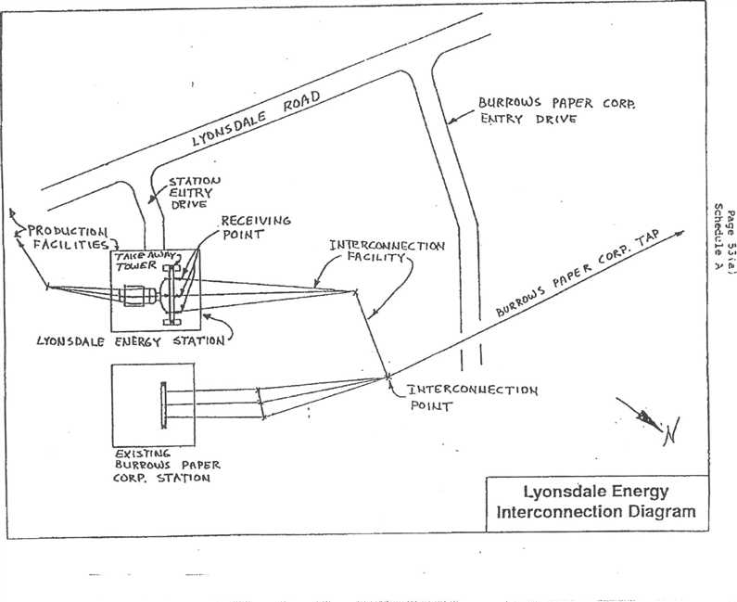
¹..:114TERC061 Ec TioN
Po K.11⁻
LYON DA LC El.) ER6`f STATION
EX t
BURROWS Pek PER CORP. STATI of4
Lyonsdale Energy
interconnection Diagram
BORRoWs PAPER coR15.
EtsAT Ky (V
STA⁻nolo ELI TRY
DR 'VG
rActt_ trIES,
I N1E r(Cot.1),1 CC TI 01,4

PR crLITY
RECEIVING
porwr
Lyonsdale Biomass, LLC Energy Facility
23.5MVA Parallel Generation
Interconnection System
with National Grid

NatGrid
Taylorville Station
115kV
Bus
NatGrid
Bremen Station
Northbrook
Lyons Falls
Moose Lyonsdale Hydro
River Hydro Burrows Paper

8104
R60
⁻sk
64 /- or-- 63
'I "1 X6-3 115kV Lyons Falls Tap
r

115kV Taylorville-Boonville #6 | X6-1 X6.2

R60
115kV
Bus
NatGrid
Boonville Station
Point of
Interconnection
(POI)
Transmission
Owner (T.O.)
Attachment
Facility (TOAF)
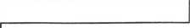

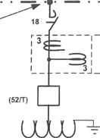
T.O.
I.C.

115kV Station
T.O.
Metering
115kV Tap (by T.0.)
• 11•••1
13.8kV, 1200A Bus
Station Auxi iary
52/G Loads
Point of
Ownership
Change
R60
T.B. No.1
I 115-13.8kV 20/26.67MVA , OA/FA
Interconnection
Customer (I.C.)
Facilities

INFORMATION ONLY  NOT ALL DETAILS SHOWN  Lyonsdale Biomass 115kV System Interconnection 07 31 2008.vsd | 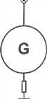 | Large Generator Facility (LGF)  GENERATOR UNIT #1  13.8kV wye, 21.15MW, 0.9 p.f.  23.5MVA  = 18.5%  x_{d}" = 11.5%

Appendix B
Milestones

Appendix C
Interconnection Details
1. Owner:
Project:
Point of Interconnection: (refer to one-line diagram that should be attached in Appendix A)
- Electrical Equipment Requirements: The installation of electrical equipment and operation of the facility must meet or exceed the requirements of Niagara Mohawk's Electric System Bulletin No.ESB 756.
- Metering Requirements: Electricity transferred to the transmission system shall be measured by electric watt-hour meters of a type approved by the Public Service Commission of the State of New York. The meter and installation costs shall be borne by Lyonsdale Biomass, LLC. The meters shall be maintained with the rules set forth in 16 NYCRR Part 92.
- Reference:
- Reference:

Appendix D
Security Arrangements Details
Infrastructure security of New York State Transmission System equipment and operations and control hardware and software is essential to ensure day-to-day New York State Transmission System reliability and operational security. The Commission will expect the NYISO, all Transmission Owners, all Developers and all other Market Participants to comply with the recommendations offered by the President's Critical Infrastructure Protection Board and, eventually, best practice recommendations from the electric reliability authority. All public utilities will be expected to meet basic standards for system infrastructure and operational security, including physical, operational, and cyber-security practices.

Appendix E
Commercial Operation Date
For purposes of this Agreement, the Commercial Operation Date shall be treated as 2-27- 1992.

Appendix F

Addresses for Delivery of Notices and Billings
Notices:
NYISO:
New York Independent System Operator Attn: Vice President, Operations
3890 Carman Rd.
Schenectady, NY 12303
Transmission Owner:
Vice President , Transmission Commercial Services National Grid
40 Sylvan Road
Waltham, MA 02451
Phone: (781) 907-5706
Email: mary.ellen.paravalos@us.ngrid.com
Developer:
Michael Voltz
Lyonsdale Biomass, LLC
c/o Central Hudson Enterprises Corporation 284 South Avenue
Poughkeepsie, NY 12601
Billings and Payments: Transmission Owner:
Vice President , Transmission Commercial Services National Grid
40 Sylvan Road
Waltham, MA 02451
Phone: (781) 907-5706
Email: mary.ellen.paravalos@us.ngrid.com
Developer:
Michael Voltz
Lyonsdale Biomass, LLC
c/o Central Hudson Enterprises Corporation 284 South Avenue
Poughkeepsie, NY 12601
Alternative Forms of Delivery of Notices (telephone, facsimile or email):
NYISO:
New York Independent System Operator Attn: Vice President, Operations
3890 Carman Rd.
Schenectady, NY 12303
Transmission Owner:
Vice President Transmission Commercial Services National Grid
40 Sylvan Road
Waltham, MA 02451
Phone: (781) 907-5706
Email: mary.ellen.paravalos@us.ngrid.com
Developer:
Michael Voltz
Lyonsdale Biomass, LLC
c/o Central Hudson Enterprises Corporation
284 South Avenue
Poughkeepsie, NY 12601

APPENDIX G
INTERCONNECTION REQUIREMENTS FOR A WIND GENERATING PLANT
Appendix G sets forth requirements and provisions specific to a wind generating plant. All other requirements of this LGIA continue to apply to wind generating plant interconnections.
A. Technical Standards Applicable to a Wind Generating Plant
i. Low Voltage Ride-Through (LVRT) Capability
A wind generating plant shall be able to remain online during voltage disturbances up to the time periods and associated voltage levels set forth in the standard below. The LVRT standard provides for a transition period standard and a post-transition period standard.
Transition Period LVRT Standard
The transition period standard applies to wind generating plants subject to FERC Order 661 that have either: (i) interconnection agreements signed and filed with the Commission, filed with the Commission in unexecuted form, finally executed as conforming agreements, or filed with the Commission as non-conforming agreements between January I, 2006 and December 31, 2006, with a scheduled in-service date no later than December 31, 2007, or (ii) wind generating turbines subject to a wind turbine procurement contract executed prior to December 31, 2005, for delivery through 2007.
Wind generating plants are required to remain in-service during three-phase faults with
normal clearing (which is a time period of approximately 4 - 9 cycles) and single line to
ground faults with delayed clearing, and subsequent post-fault voltage recovery to prefault
voltage unless clearing the fault effectively disconnects the generator from the system. The clearing time requirement for a three-phase fault will be specific to the wind generating plant substation location, as determined by and documented by the Transmission Owner for the Transmission District to which the wind generating plant will be interconnected. The maximum clearing time the wind generating plant shall be required to withstand for a three-phase fault shall be 9 cycles at a voltage as low as 0.15 p.u., as measured at the high side of the wind generating plant step-up transformer (i.e. the transformer that steps the voltage up to the transmission interconnection voltage or "GSU"), after which, if the fault remains following the location-specific normal clearing time for three-phase faults, the wind generating plant may disconnect from the transmission system.
- This requirement does not apply to faults that would occur between the wind generator terminals and the high side of the GSU or to faults that would result in a voltage lower than 0.15 per unit on the high side of the GSU serving the facility.
- Wind generating plants may be tripped after the fault period if this action is intended as part of a special protection system.
- Wind generating plants may meet the LVRT requirements of this standard by the performance of the generators or by installing additional equipment (e.g., Static VAr Compensator, etc.) within the wind generating plant or by a combination of generator performance and additional equipment.
5. Existing individual generator units that are, or have been, interconnected to the network at
the same location at the effective date of the Appendix G LVRT Standard are exempt from meeting the Appendix G LVRT Standard for the remaining life of the existing generation equipment. Existing individual generator units that are replaced are required to meet the Appendix G LVRT Standard.
Post-transition Period LVRT Standard
All wind generating plants subject to FERC Order No. 661 and not covered by the transition period described above must meet the following requirements:
I . Wind generating plants are required to remain in-service during three-phase faults with
normal clearing (which is a time period of approximately 4 - 9 cycles) and single line to ground faults with delayed clearing, and subsequent post-fault voltage recovery to prefault voltage unless clearing the fault effectively disconnects the generator from the system. The clearing time requirement for a three-phase fault will be specific to the wind generating plant substation location, as determined by and documented by the Transmission Owner for the Transmission District to which the wind generating plant will be interconnected. The maximum clearing time the wind generating plant shall be required to withstand for a three-phase fault shall be 9 cycles after which, if the fault remains following the location-specific normal clearing time for three-phase faults, the wind generating plant may disconnect from the transmission system. A wind generating plant shall remain interconnected during such a fault on the transmission system for a voltage level as low as zero volts, as measured at the high voltage side of the wind GSU.
- This requirement does not apply to faults that would occur between the wind generator terminals and the high side of the GSU.
- Wind generating plants may be tripped after the fault period if this action is intended as part of a special protection system.
Transmission District to which the wind generating plant will be interconnected, or a combination of the two. The Developer shall not disable power factor equipment while the wind plant is in operation. Wind plants shall also be able to provide sufficient dynamic voltage support in lieu of the power system stabilizer and automatic voltage regulation at the generator excitation system if the System Reliability Impact Study shows this to be required for system safety or reliability.
iii. Supervisory Control and Data Acquisition (SCADA) Capability
The wind plant shall provide SCADA capability to transmit data and receive instructions from the ISO and/or the Transmission Owner for the Transmission District to which the wind generating plant will be interconnected, as applicable, to protect system reliability. The Transmission Owner for the Transmission District to which the wind generating plant will be interconnected and the wind plant Developer shall determine what SCADA information is essential for the proposed wind plant, taking into account the size of the plant and its characteristics, location, and importance in maintaining generation resource adequacy and transmission system reliability in its area.
Appendix H
List of Non-Applicable Pro-Forma LGIA Provisions
Transmission Owner and Developer are already interconnected, pursuant to a pre-existing interconnection agreement. Therefore, certain terms of the pro-forma New York ISO LGIA are not applicable to this LGIA, because they relate solely to new interconnections. The parties to this LGIA have nevertheless agreed to use the pro-forma New York ISO LGIA with almost no modifications, in accordance with FERC policy promoting the use of pro-forma interconnection agreements wherever possible. The parties, however, believe that the following provisions of the pro-forma New York ISO LGIA are not applicable to the current LGIA:
Section 5.1 (Option), including all subsections thereof
Section 5.2 (General Conditions Applicable to Option to Build)
Section 5.3 (Liquidated Damages)
Section 5.5 (Equipment Procurement), including all subsections thereof
Section 5.6 (Construction Commencement), including all subsections thereof Section 5.7 (Work Progress)
Section 5.8 (Information Exchange)
Section 5.9 (Limited Operation)
Section 5.10 (Developer Attachment Facilities), including all subsections thereof
Section 5.11 (Transmission Owner Attachment Facilities), including all subsections thereof Section 5.14 (Permits)
Section 5.15 (Early Construction of Base Case Facilities)
Section 6.1 (Pre Commercial Operation Date Testing and Modification)
Section 11.4 (Special Provisions for Affected Systems)
Section 11.5 (Provision of Security), including all subsections thereof
Section 12.2 (Final Invoice)
Section 24.1 (Information Acquisition)
Section 24.2 (Information Submission by Transmission Owner) Section 24.3 (Updated Information Submission by Developer) Section 24.4 (Information Supplementation)
Section 25.4.1 (Audit Rights Period for Construction Related Accounts)
Appendix B (Milestones)
Appendix G (Interconnection Requirements for a Wind Generating Plant)

