FERC rendition of the electronically filed tariff records in Docket No. ER14-1822-00-

Filing Data:

CID: C000038

Filing Title: Minimum Oil Burn Settlement Agreement No.2178 TC Ravenswood, et. al. Company Filing Identifier: 954

Type of Filing Code: compliance filing   
Associated Filing Identifier: 871   
Tariff Title: NYISO Agreements   
Tariff ID: 58

Payment Confirmation: N   
Suspension Motion:

Tariff Record Data:

Record Content Description: Agreement No. 2178

Tariff Record Title: Minimum Oil Burn Agreement No. 2178 TC Ravenswood, et.al. Record Version Number: 2.0.0

Option Code: A

Tariff Record ID: 138

Tariff Record Collation Value: 7074000

Tariff Record Parent Identifier: 2   
Proposed Date: 2014-05-01

Priority Order: 700

Record Change Type: Change

Record Content Type: 2

Associated Filing Identifier: 871

UNITED STATES OF AMERICA   
 BEFORE THE

FEDERAL ENERGY REGULATORY COMMISSION

)

TC Ravenswood, LLC

New York Independent System Operator, Inc.

) Docket No. ER14-1711-___   
)

)

) Docket No. ER14-1822-___   
)

Not Consolidated

OFFER OF SETTLEMENT

Pursuant to Rule 602 of the Rules of Practice and Procedure of the Federal Energy

Regulatory Commission (“Commission” or “FERC”), 18 C.F.R. § 385.602 (2013), TC

Ravenswood, LLC (“TC Ravenswood”), the New York Independent System Operator, Inc.   
(“NYISO”), Consolidated Edison Company of New York, Inc. (“Con Edison”), the City of New   
York, New York Power Authority (“NYPA”), and the New York State Public Service   
Commission (individually “Party” and collectively the “Settling Parties” or “Parties”) hereby   
submit this Offer of Settlement fully resolving issues related to the compensation and terms and   
conditions under which TC Ravenswood will generate electric energy using 0.3% sulfur High   
Pour (“HP”) No. 6 Fuel Oil (“Fuel Oil”) in lieu of natural gas in furtherance of New York State   
Reliability Council’s Local Reliability Rule I-R3 (Loss of Generator Gas Supply - New York City)   
(“Rule I-R3”) (“Fuel Oil Burn for I-R3”) during a three-year period beginning May 1, 2014 and   
ending April 30, 2017. Payments made by the NYISO for commodity, emissions and fuel oil   
taxes, as applicable, shall be in accordance with its Market Administration and Control Area   
Services Tariff (“Services Tariff”).

WAS:216499.5

As fully described herein, with the exception of certain issues that are identified in Section

6.1 hereof, this Offer of Settlement, if approved by the Commission, resolves all issues that were   
raised, or could have been raised, in Docket Nos. ER14-1711 and ER14-1822 related to the   
compensation, terms and conditions under which TC Ravenswood will respond to requests for it to   
provide Fuel Oil Burn for I-R3 for the period May 1, 2014 through April 30, 2017. The Settling   
Parties are not asking the Commission to address the issues identified in Section 6.1 in the context   
of these dockets. As this Offer of Settlement is fair and reasonable, is in the public interest and, to   
the best of the Settling Parties’ knowledge, is unopposed, the Parties urge prompt approval by the   
Commission of this Offer of Settlement without condition or modification to be effective as of   
May 1, 2014.

SECTION ONE

PROVISION OF FUEL OIL BURN FOR I-R3

1.1 During the term of this Offer of Settlement, in return for the payments described in Section

2, in response to requests from NYISO and/or Con Edison, TC Ravenswood will burn Fuel   
Oil for I-R3 needs, unless it would cause steam generating units 10, 20 or 30 (collectively   
“Units” or individually “Unit”) to be considered “oil-fired electric utility steam generating   
units” as defined under the U.S. Environmental Protection Agency’s (“EPA”) Mercury and   
Air Toxics Standards (“MATS”) or cause a violation of EPA MATS. In the event TC   
Ravenswood forecasts in any notice required by Section 1.2 hereof that one or more of its   
Units is likely to be considered at a future date to be an “oil-fired electric utility steam   
generating units” as defined under MATS, TC Ravenswood will make a good faith effort to   
obtain a waiver from EPA from MATS compliance obligations for the applicable unit(s).   
However, this Offer of Settlement does not require TC Ravenswood to invest in any   
improvements, changes or upgrades to its Units to reduce emissions and enable it to

-2-

WAS:216499.5

operate as a “oil-fired electric utility steam generating unit” as defined under MATS, and   
TC Ravenswood is not seeking compensation in this Settlement Agreement in order to   
make such improvements, changes or upgrades. TC Ravenswood reserves all rights it may   
have to seek separate recovery of such costs in a new proceeding if and when any TC   
Ravenswood unit is required to be MATS compliant, provided, however, that the Settling   
Parties reserve the right to protest the recovery of such costs. In the event that TC   
Ravenswood receives a request to provide Fuel Oil Burn for I-R3 and TC Ravenswood is   
forecasting that such burn is likely to cause one or more of its Units to be considered   
“oil-fired electric utility steam generating units” as defined under MATS, TC Ravenswood   
will notify the NYISO and Con Edison System Operations that continued operation of the   
Unit(s) will be limited to burning natural gas unless and until an applicable waiver request   
is granted that fully relieves TC Ravenswood from MATS compliance obligations for the   
applicable Unit(s) or TC Ravenswood no longer is forecasting that additional use of Fuel   
Oil will result in the units being classified as “oil-fired electric utility steam generating   
units” under MATS. TC Ravenswood will notify the NYISO and Con Edison System   
Operations when it submits its waiver request to the EPA and/or, if applicable, the New   
York State Department of Environmental Conservation and will provide a copy of such   
waiver request to the NYISO and Con Edison System Operations on a confidential basis   
subject to limited distribution as described in Section 1.2 below.

1.2 TC Ravenswood shall provide the NYISO and Con Edison System Operations, on a

confidential basis, the following notifications and communications related to its actual and   
forecast Fuel Oil burn percentages applicable to each Unit individually. Con Edison,   
including inter alia Con Edison System Operations, shall not disclose any of the

-3-

WAS:216499.5

information TC Ravenswood provides in such confidential notifications and communications to any “marketing function employee” as that term is defined in 18 C.F.R §358.3, and TC Ravenswood’s confidential notifications and communications will reference this non-disclosure provision. To the extent the forecasts provided by TC Ravenswood as described below cause it to believe that one or more Units is likely to be considered “oil-fired electric utility steam generating units” as defined under MATS, TC Ravenswood shall specifically identify such forecast in the Notice.

Monthly Average Annual Heat Input Forecast Notice: TC Ravenswood will   
advise the NYISO and Con Edison System Operations monthly as to the percentage   
of its average annual heat input that was derived from burning oil as of the end of   
the immediately previous month and the percentage of its average annual heat input   
that is forecast to be derived from burning oil by the end of the following month.   
Quarterly Average Annual Heat Input Forecast Notice: TC Ravenswood will   
advise the NYISO and Con Edison System Operations quarterly as to the   
percentage of its average annual heat input that was derived from burning oil as of   
the end of the immediately previous quarter and the percentage of its average   
annual heat input that is forecast to be derived from burning oil by the end of the   
following quarter. TC Ravenswood will also advise the NYISO and Con Edison   
System Operations of actions it will be taking, if any, to reduce its average annual   
heat input for the balance of the year to remain within legal limits.

Immediate Average Annual Heat Input Notice: TC Ravenswood will advise the   
NYISO and Con Edison System Operations immediately when the percentage of its   
average annual heat input that was derived from burning oil for the month, exceeds

-4-

WAS:216499.5

the percentage of its average annual heat input that was forecast to be derived from burning oil for the month and provide explanatory details. TC Ravenswood will also advise the NYISO and Con Edison System Operations of actions it will be taking, if any, to reduce its average annual heat input for the balance of the year to remain within legal limits.

1.3 In order to efficiently provide Fuel Oil Burn for I-R3 and satisfy its Fuel Oil procurement,

storage, handling, and delivery obligations for all Fuel Oil use at the Ravenswood site   
during the period of May 1, 2014 through April 30, 2017, TC Ravenswood and TC   
Ravenswood Services Corp. will co-mingle the use of their Fuel Oil storage and delivery   
facilities as well as Operation and Maintenance activities and administrative services with   
the use of other Fuel Oil customers served from the Ravenswood site (“co-mingling”).   
Accordingly, during the period May 1, 2014 through April 30, 2017, TC Ravenswood will   
provide Fuel Oil Burn for I-R3 using a portion of the following oil storage and delivery   
facilities: (i) one and one-half (1½) offsite storage tanks (which equates to approximately   
250,000 barrels of working storage); (ii) one (1) large (approximately 40,000 barrel)   
annual time chartered barge; the Lemon Creek barge; and (iii) TC Ravenswood’s existing   
onsite storage at its Ravenswood facility, subject to the minimum reserve quantity required   
by the existing agreement between TC Ravenswood and Con Edison Steam. In addition,   
TC Ravenswood will provide certain associated acquisition and transport administrative   
services.

SECTION TWO

PAYMENT FOR THE PERIOD MAY 1, 2014 THROUGH APRIL 30, 2017

2.1 TC Ravenswood will be paid by the NYISO Demand Charges, Premium Costs and

Operation and Maintenance (“O&M”) Costs as set forth below in furtherance of its

-5-

WAS:216499.5

provision of Fuel Oil Burn for I-R3. The term Demand Charges as used herein refers to a   
charge that will enable TC Ravenswood to recover costs for transporting, maintaining,   
storing and handling Fuel Oil to provide Fuel Oil Burn for I-R3 that TC Ravenswood

incurs regardless of the amount of Fuel Oil Burn for I-R3 it provides. A list of the   
categories of costs that comprise the basis for the Demand Charge is contained in   
Appendix A. Confidential Appendix B contains an itemization of the costs that form the

basis for the Demand Charges. The term Premium Costs has the meaning set forth in   
Section 2.3.1 hereof. The term O&M Costs has the meaning set forth in Section 2.3.3   
hereof. For purposes of this Offer of Settlement, “Year 1” shall be the period May 1, 2014

through April 30, 2015, “Year 2” shall be the period May 1, 2015 through April 30, 2016, and “Year 3” shall be the period May 1, 2016 through April 30, 2017.

2.2 Demand Charges

2.2.1 For Year 1, NYISO shall pay to TC Ravenswood a Demand Charge of $4.075   
 million.

2.2.2 In Year 2 and Year 3, the NYISO shall pay to TC Ravenswood the Demand Charge   
 payable in Year 1, provided however the costs of certain elements contributing to   
 the Demand Charge shall be escalated by 3% in Year 2 and again in Year 3.   
 Confidential Appendix B shows which items contributing to the Demand Charge   
 will be escalated by 3%.

2.2.3 Accordingly, the following Demand Charges will be payable in each of the three   
 years of the term of this Offer of Settlement:

For Year 1 $4,075, 000.00

Year 2 $4,162,545.20

-6-

WAS:216499.5

Year 3 $4,252,716.75

The NYISO shall pay TC Ravenswood the Demand Charges for Years 1 through 3   
regardless of: (i) whether Fuel Oil has been burned in furtherance of I-R3; (ii) the   
relative cost of the Fuel Oil compared to natural gas reflected in the reference levels   
for TC Ravenswood’s generating units; and (iii) any revisions to the Services Tariff   
or Rule I-R3 that occur after the date this Offer of Settlement is executed.

2.3 Premium Costs and O&M Costs

2.3.1 In addition to the Demand Charges, for every barrel of Fuel Oil burned in   
 furtherance of I-R3 that is eligible for commodity cost compensation in accordance   
 with Section 4.1.9.2 of the Services Tariff, the NYISO shall pay TC Ravenswood a   
 premium of $3.50 per barrel over the commodity cost eligible for compensation in   
 accordance with Section 4.1.9.2 of the Services Tariff (“Premium Cost”) which   
 Premium Cost payments shall be subject to a true-up pursuant to Section 2.4 of this   
 Offer of Settlement provided that the invoiced premiums, as described in Section

2.4, are separately shown on TC Ravenswood’s Fuel Oil invoices.

2.3.2 TC Ravenswood shall provide Con Edison written notification within one business   
 day when it incurs a premium equal to, or greater than, $3.50 per barrel of Fuel Oil   
 pursuant to Section 2.3.1 above.

2.3.3 For every barrel of Fuel Oil burned in furtherance of I-R3 that is eligible for   
 commodity cost compensation in accordance with Section 4.1.9.2 of the Services   
 Tariff, the NYISO shall pay TC Ravenswood an O&M Cost of $0.45/bbl for Fuel   
 Oil Burn for IR-3 associated with the use of the on-site tanks and equipment at the

-7-

WAS:216499.5

TC Ravenswood Generating Station. The O&M Cost of $0.45/bbl shall be fixed for the term of this Offer of Settlement and shall not be subject to escalation.

2.4 Reconciliation of Premium Cost payable pursuant to Section 2.3.1

2.4.1 To obtain a true-up of the invoiced premiums to the Premium Cost payments for

Years 1, 2, and/or 3, TC Ravenswood shall provide to the NYISO all Fuel Oil   
invoices for Year 1 by June 15, 2015, for Year 2 by June 15, 2016, and for Year 3   
by June 15, 2017. Should the invoiced premiums paid by TC Ravenswood for Fuel   
Oil burned in furtherance of I-R3 in Years 1, 2 and/or 3, respectively, exceed the   
Premium Cost payment made in Years 1, 2, and/or 3, respectively, by more than   
$25,000, the NYISO shall reimburse TC Ravenswood for the total excess of the   
invoiced premiums over the Premium Cost payment made. Should the Premium   
Cost payment made in Years 1, 2 and/or 3, respectively, exceed the invoiced   
premiums paid by TC Ravenswood for Fuel Oil burned in furtherance of I-R3 in   
Years 1, 2, and/or 3, respectively, by more than $25,000, TC Ravenswood shall   
reimburse the NYISO for the total excess of the Premium Costs paid over the   
invoiced premiums.

2.4.2 True-up payments to or from TC Ravenswood, if any, shall be included on the

NYISO invoices to TC Ravenswood for the months of July 2015, July 2016 and July 2017 respectively.

2.5 The NYISO shall pay TC Ravenswood the Demand Charge for Years 1, 2 and 3 in five

equal amounts using the NYISO’s normal billing cycle for the months of May through   
September, for the time period covered by this Offer of Settlement, provided however,   
payment and appropriate interest, calculated pursuant to Section 2.6, for May 2014 will be

-8-

WAS:216499.5

made on the first initial invoice issued following a Commission Order accepting this Offer   
of Settlement; payment for June 2014 and appropriate interest, calculated pursuant to   
Section 2.6 will be made on the second initial invoice issued following a Commission   
Order accepting this Offer of Settlement and payment for July, 2014 and appropriate   
interest, calculated pursuant to Section 2.6 shall be made on the third initial invoice issued   
following a Commission Order accepting this Offer of Settlement. Payments for August,   
2014 and September 2014 and for Years 2 and 3 will be made in the normal course of the   
NYISO’s billing cycles. The per barrel Premium Cost and O&M Cost paid pursuant to   
Section 2.3 of this Offer of Settlement shall be paid by the NYISO in the billing cycle   
immediately after the cycle in which costs were incurred and billed to the NYISO,   
provided however, payment and interest, if any, of a per barrel Premium Cost or O&M   
Cost pursuant to Section 2.3 for fuel oil burn in May, June or July, 2014 will be made with   
interest and on the invoices specified above.

2.6 Payments made pursuant to Section 2.5 shall include interest, calculated in accordance

with 18 CFR § 35.19a, from the disbursement date of the first monthly invoice after service was rendered to the disbursement of payment as specified in the NYISO’s normal billing cycle, provided, however, interest on the payments for May, June and July 2014 shall be due from the disbursement date of the May, June and July 2014 initial monthly invoices, respectively, to the disbursement date of the monthly invoice on which the amounts to be paid for May, June and July 2014, pursuant to Paragraph 2.5, appear.

2.7 NYISO will allocate Demand Charges, per barrel Premium Costs and O&M Costs paid to

TC Ravenswood pursuant to this Offer of Settlement, under the provisions of Section 6.1.7   
of the NYISO’s Open Access Transmission Tariff (“OATT”), that are in effect at the time

-9-

WAS:216499.5

this Offer of Settlement is executed, to all load withdrawals in the Con Edison Transmission District (Load Zones H, I and J) based on each Load Serving Entity’s (“LSE’s”) load ratio share.

2.7.1 Demand Charges, paid pursuant to Section 2.2 and 2.5 of the Offer of Settlement,

will be allocated among all load withdrawals in the Con Edison Transmission   
District (Load Zones H, I and J) based on each LSE’s load ratio share for months of   
May through September during Years 1, 2 and 3, except as provided in Section

2.7.3.

2.7.2 All per barrel Premium Cost and O&M Costs paid pursuant to Section 2.3 of the

Offer of Settlement shall be allocated among all load withdrawals in the Con   
Edison Transmission District (Load Zones H, I and J) based on each LSE’s load   
ratio share for Years 1, 2, and 3, in the billing cycle immediately after the cycle in   
which costs were incurred and billed to the NYISO, except as provided in Section

2.7.3.

2.7.3 With respect to May, June and July of 2014, the Demand Charges, per barrel

Premium Costs and O&M Costs paid pursuant to Sections 2.2, 2.3 and 2.5, will be allocated among all load withdrawals in the Con Edison Transmission District (Load Zones H, I and J) based on each LSE’s load ratio share for the same month for which the payments to TC Ravenswood of the Demand Charges and per barrel Premium Costs and O&M Costs are invoiced.

2.8 To the extent that TC Ravenswood determines during the term of this Offer of Settlement

that it needs to obtain a spot barge to provide Oil Burn for I-R3 beyond those initially   
designated in this Offer of Settlement, TC Ravenswood will inform NYISO, Con Edison

-10-

WAS:216499.5

Steam and Con Edison Electric and other active parties in these Dockets, of the need and its   
attempt to obtain the spot barge, and negotiate the cost of the spot barge which includes the   
costs of heating, tugging, booming, testing and inspections to the extent they can be   
procured (hereinafter referred to as “Supplemental Costs”). If such spot barge is obtained,   
TC Ravenswood shall bear one-third (1/3) of such Supplemental Costs and the NYISO   
shall pay to TC Ravenswood and recover two-thirds (2/3) of such Supplemental Costs as a   
cost for Fuel Oil Burn for I-R3 pursuant to Section 6.1.7 of the OATT unless Con Edison   
Steam determines that it needs Fuel Oil that would be procured pursuant to this Section. If   
Con Edison Steam determines that it does need additional Fuel Oil that would be procured   
pursuant to this Section, and it provides written notice to TC Ravenswood of such   
determination no later than five business days following notice from TC Ravenswood that   
it needs to obtain a spot barge to provide Fuel Oil Burn for I-R3, the NYISO shall pay to   
TC Ravenswood and recover one-third (1/3) of such Supplemental Costs as a cost for Fuel   
Oil Burn for I-R3 pursuant to Section 6.1.7 of the OATT; Con Ed Steam shall bear   
one-third (1/3) of such Supplemental Costs; and TC Ravenswood shall bear one-third (1/3)   
of such Supplemental Costs. The NYISO shall pay TC Ravenswood all Supplemental   
Costs for which the NYISO is responsible under this Section in the billing cycle   
immediately after the cycle in which such costs were incurred and billed to the NYISO and   
shall allocate such payments to TC Ravenswood among all load withdrawals in the Con   
Edison Transmission District (Load Zones H, I and J) pursuant to Section 6.1.7 of the   
OATT as a cost for Fuel Oil Burn for I-R3 based on each LSE’s load ratio share for the   
month for which the payments to TC Ravenswood of the Supplemental Costs are invoiced.

-11-

WAS:216499.5

Payments of interest, if any, shall be paid in accordance with the NYISO’s normal billing   
cycles.

2.9 The Settling Parties understand that the components comprising the Demand Charge, and

the determination of the on-site O&M Costs, reflect estimated costs, and the Settling Parties agree that such estimates are reasonable. In the event TC Ravenswood’s actual costs making up the Demand Charges and O&M Costs differ from the estimates, there will be no true-up for these costs in either direction. Thus, TC Ravenswood shall not be entitled to impose a surcharge, and neither any party nor any market participant shall be entitled to a refund with respect to the Demand Charges and O&M Costs.

2.10 Consideration for Offer of Settlement

2.10.1 In consideration of the terms agreed to herein, TC Ravenswood will: (a) (i) arrange   
 for, operate, and maintain the facilities outlined in Section 1.3 and (ii) generate   
 electric energy using Fuel Oil for I-R3 under the terms of this Offer of Settlement   
 for the period May 1, 2014 through April 30, 2017; (b) withdraw its rate schedule   
 filed in Docket ER14-1711 with prejudice; (c) waive any claims it may have with   
 respect to compensation for Fuel Oil Burn for I-R3 for the period May 1, 2014   
 through April 30, 2017 other than under the terms of this Offer of Settlement; and

(d) not submit a filing under Section 205 of the Federal Power Act (“FPA”) seeking a rate or tariff for TC Ravenswood’s provision of Fuel Oil Burn for I-R3 for the period of May 1, 2014 through April 30, 2017.

2.10.2 Also in consideration of the terms agreed to herein, the NYISO shall withdraw its   
 Unexecuted Implementation Agreement in Docket No. ER14-1822 with prejudice.

-12-

WAS:216499.5

2.10.3 Also in consideration of the terms agreed to herein, no Settling Party shall file a   
 complaint under FPA Section 206 seeking rates, or terms and conditions, for Fuel   
 Oil Burn for I-R3 for the period May 1, 2014 through April 30, 2017 that differ   
 from those agreed to in this Offer of Settlement.

SECTION THREE

TERMINATION/AMENDMENT

3.1 Except for outstanding payment obligations under Section Two hereof, this Offer of

Settlement shall terminate on April 30, 2017. Notwithstanding the immediately preceding   
sentence, the Parties are free to enter into negotiations to extend the termination date of this   
Offer of Settlement and/or negotiate a new agreement for TC Ravenswood’s provision of   
Fuel Oil Burn for I-R3 subsequent to April 30, 2017, in each instance subject to   
Commission approval. If any such negotiations are not concluded by January 1, 2017,   
subject to Sections Six and Seven hereof, the Parties reserve all rights they may have to   
make filings with the Commission, or oppose such filings, as each Party deems   
appropriate, with respect to TC Ravenswood’s provision of Fuel Oil Burn for I-R3 for the   
period subsequent to April 30, 2017, including but not limited to TC Ravenswood filing a   
rate schedule under FPA Section 205, and/or the NYISO filing an unexecuted

Implementation Agreement under Section 4.1.9 of its Services Tariff, or a Party filing a complaint under FPA Section 206.

3.2 Parties shall retain all rights under the FPA, under Section 4.1.9 of the Services Tariff, and

under all other provisions in the Services Tariff, to the extent applicable, as discussed in Sections Six and Seven of this Offer of Settlement.

-13-

WAS:216499.5

SECTION FOUR

SECTION 4.1.9 OF THE NYISO SERVICES TARIFF AND PRE-EXISTING

AGREEMENTS

4.1 This Offer of Settlement constitutes the full and complete agreement of the Settling Parties

with respect to the subject matter addressed herein for TC Ravenswood’s provision of Fuel   
Oil Burn for I-R3 for the period May 1, 2014 through April 30, 2017 and supersedes all   
prior negotiations, understandings, and agreements, whether written or oral, between the   
Settling Parties with respect to the subject matter described herein. The Settling Parties   
agree that the Offer of Settlement and Minimum Oil Burn Agreement entered into in   
settlement of Docket No. EL10-70 have expired and are no longer in force or effect. The   
Settling Parties also agree that this Offer of Settlement does not affect or change the   
provisions of the Services Tariff, including Section 4.1.9. They further agree that TC   
Ravenswood’s compensation for the provision of Fuel Oil Burn for I-R3 for the period   
May 1, 2014 through April 30, 2017, as specified in Section 1 hereof, shall be pursuant to   
this Offer of Settlement.

4.2 Except as otherwise noted herein, for the period May 1, 2014 through April 30, 2017,

where there are differences between Section 4.1.9 of the Services Tariff and the terms of this Offer of Settlement, the terms of this Offer of Settlement govern.

4.3 All references within this Offer of Settlement to Section 4.1.9 of the Services Tariff refer to

the provisions of Section 4.1.9 as they exist as of the date this Offer of Settlement is

executed.

-14-

WAS:216499.5

SECTION FIVE

WITHDRAWAL OF FILINGS

5.1 Within 10 business days of a Final Order (as defined below) accepting this Offer of

Settlement without condition or modification (unless mutually acceptable to all Settling   
Parties), TC Ravenswood will withdraw its rate schedule filed in Docket No. ER14-1711   
and the NYISO shall withdraw the Unexecuted Minimum Oil Burn Agreement it filed in   
Docket No. ER14-1822 respectively. Each such withdrawal shall be with prejudice for the   
period May 1, 2014 through April 30, 2017, but shall have no effect on the Parties’ rights to   
make filings for a period after April 30, 2017, except as discussed in Sections Six and   
Seven hereof. For purposes of this Offer of Settlement, a Commission order shall be   
deemed a Final Order when the last date for filing a request for rehearing with the   
Commission has expired if no rehearing request is filed by that date and there are no other   
matters pending either in Docket No. ER14-1711 and Docket No. ER14-1822. To the   
extent the Commission accepts this Offer of Settlement subject to a condition or   
modification and any Settling Party files a request for rehearing, each Settling Party shall   
have the right to withdraw from this Offer of Settlement, which withdrawal may be   
exercised in such Party’s sole discretion.

SECTION SIX

FILING RIGHTS

6.1 This Offer of Settlement does not address (1) TC Ravenswood’s legal authority, if any, to

have its own rate schedule on file under FPA Section 205 to provide Fuel Oil Burn for   
I-R3, i.e., burn Fuel Oil in lieu of natural gas in furtherance of Rule I-R3, or (2) TC   
Ravenswood’s obligation, if any, to provide Fuel Oil Burn for I-R3 and to be compensated   
for doing so, pursuant to an unexecuted Implementation Agreement under Section 4.1.9 of

-15-

WAS:216499.5

its Services Tariff. These issues are contested and unresolved, however, the Settling Parties agree that the Commission can and should accept this Offer of Settlement without addressing them.

6.2 In signing this Offer of Settlement, other than as outlined in Sections 6.3 and 7.2 of this

Offer of Settlement, no Settling Party waives any rights it may possess to have rates on file under Section 205 of the FPA, or to make FPA Section 205 or 206 filings.

6.3 No Settling Party will make a Section 205 filing or a Section 206 filing seeking a rate or a

revised rate to compensate TC Ravenswood for burning Fuel Oil in furtherance of Rule   
I-R3 for the period May 1, 2014 through April 30, 2017 or to modify the terms and   
conditions in this Offer of Settlement, unless the Settling Parties, by mutual consent, agree   
to modify the terms and conditions in this Offer of Settlement. Nevertheless, the Settling   
Parties specifically reserve the right to raise all arguments in support of, or in opposition to,   
TC Ravenswood’s provision of Fuel Oil Burn for I-R3 under TC Ravenswood’s own FPA   
Section 205 rate schedule and/or pursuant to an unexecuted Implementation Agreement   
under Section 4.1.9 of the NYISO Services Tariff, including in each instance proposed   
terms and conditions and compensation for Fuel Oil Burn for I-R3, for a period subsequent   
to April 30, 2017.

6.4 The Parties hereby reserve all rights to which they are entitled under Sections 205 and 206

of the FPA, except as set forth herein.

6.5 For the sole purpose of settling the compensation matters described herein, this Offer of

Settlement represents a fair and reasonable negotiated settlement that is in the public   
interest. The term of this Offer of Settlement shall not limit or restrict the arguments that

-16-

WAS:216499.5

the Settling Parties may put forth or the positions that the Settling Parties may take in any future proceeding before the Commission.

SECTION SEVEN

EFFECTIVE DATE AND GENERAL RESERVATIONS

7.1 This Offer of Settlement shall become effective as of May 1, 2014 upon an order approving

the Offer of Settlement becoming a Final Order as defined in Paragraph 4.1 herein. If the   
Commission accepts the Offer of Settlement without modification, no Settling Party will   
request rehearing or otherwise appeal or support rehearing requests or appeals by others.

7.2 No Party shall use this Offer of Settlement, or the terms hereof, as evidence to support, or

oppose, an argument that TC Ravenswood is obligated to provide Fuel Oil Burn for IR-3, or to be compensated for doing so, under Section 4.9.1 of the Services Tariff, or that TC Ravenswood has the right to have its own rate schedule for Fuel Oil Burn for I-R3 under Section 205 of the FPA.

7.3 This Offer of Settlement is an integrated whole and is expressly conditioned on the

Commission’s acceptance of all provisions herein without modification or condition.   
Notwithstanding the foregoing, if the Commission’s approval of this Offer of Settlement is   
conditioned on a modification of this Offer of Settlement or on any other condition, such   
modification or condition shall be considered to be accepted unless a Settling Party   
objecting to such condition or modification serves written notice on the other Settling   
Parties of its intent to seek rehearing of the order approving the Offer of Settlement as   
modified or conditioned within a period of ten days from the date of such order. Should   
Commission approval be subject to condition or modification of this Offer of Settlement,   
and should one or more of the Settling Parties file a request for rehearing of the   
Commission’s order, the other Settling Parties will confer and determine whether to

-17-

WAS:216499.5

support the Offer of Settlement as modified or conditioned. Each Settling Party shall then have the right, as determined in its sole discretion, to withdraw as a signatory of the Offer of Settlement. In the event TC Ravenswood withdraws as a signatory, the Offer of Settlement shall not constitute any part of the record in Docket No. ER14-1711 and shall not be used for any purpose in that docket. In the event the NYISO withdraws as a signatory, the Offer of Settlement shall not constitute any part of the record in Docket No. ER14-1822 and shall not be used for any purpose in that docket.

7.4 Commission approval of this Offer of Settlement shall constitute the requisite waiver of

any and all otherwise applicable Commission regulations, to the extent necessary, to permit implementation of the provisions of this Offer of Settlement.

7.5 This Offer of Settlement is made upon the express understanding that it constitutes a

negotiated settlement and, except as otherwise expressly provided for herein, no Settling Party shall be deemed to have approved, accepted, agreed to, or consented to any principle or policy relating to rate design, rate calculation, or any other matter affecting or relating to any of the compensation, charges, classifications, terms, conditions, principles, or issues associated with this Offer of Settlement. This Offer of Settlement shall not be deemed to be a “settled practice” as that term was interpreted and applied in Public Service Commission of New York v. FERC, 642 F.2d 1335 (D.C. Cir. 1980), and shall not be the basis for any decision with regard to the burden of proof in any future litigation. This Offer of Settlement shall not be cited as precedent, nor shall it be deemed to bind any Settling Party in any future proceeding including, but not limited to, any Commission proceeding, except in any proceeding to enforce this Offer of Settlement.

-18-

WAS:216499.5

7.6 The discussions among the Parties that have produced this Offer of Settlement have been

conducted on the explicit understanding, pursuant to Rules 602(e) and 606 of the

Commission’s Rules of Practice and Procedures, that all offers of settlement and any   
comments on these offers are privileged and not admissible as evidence against any   
participant who objects to their admission and that any discussions of the Parties with

respect to offers of settlement is not subject to discovery or admissible in evidence.

7.7 The Offer of Settlement is subject to the “public interest” standard of review set forth in

United Gas Pipe Line Co. v. Mobile Gas Service Corp., 350 U.S. 332 (1956) and Federal Power Commission v. Sierra Pacific Power Co., 350 U.S. 348 (1956) (“Mobile Sierra doctrine”) to the full extent legally permissible and as interpreted in Morgan Stanley Capital Group Inc. v. Pub. Util District No. 1, 128 S. Ct. 2733 (2008), NRG Power Marketing LLC v. Me. Pub. Utils, Comm’n, 130 S. Ct. 693 (2010) and Dominion Transmission Inc. v. FERC, 533 F.3d 845 (2008).

7.8 Headings in this Offer of Settlement are included for convenience only and are not

intended to have any significance in interpretation of this Offer of Settlement.

7.9 Signatures may occur by counterparts. Such signatures shall have the same effect as if all

signatures were on the same document.

SECTION EIGHT

SUPPORT OF FULL SETTLEMENT

8.1 The Parties agree that this Offer of Settlement resolves all issues related to the manner in

which TC Ravenswood will be compensated for providing Fuel Oil Burn for I-R3 for the period May 1, 2014 through April 30, 2017.

-19-

WAS:216499.5

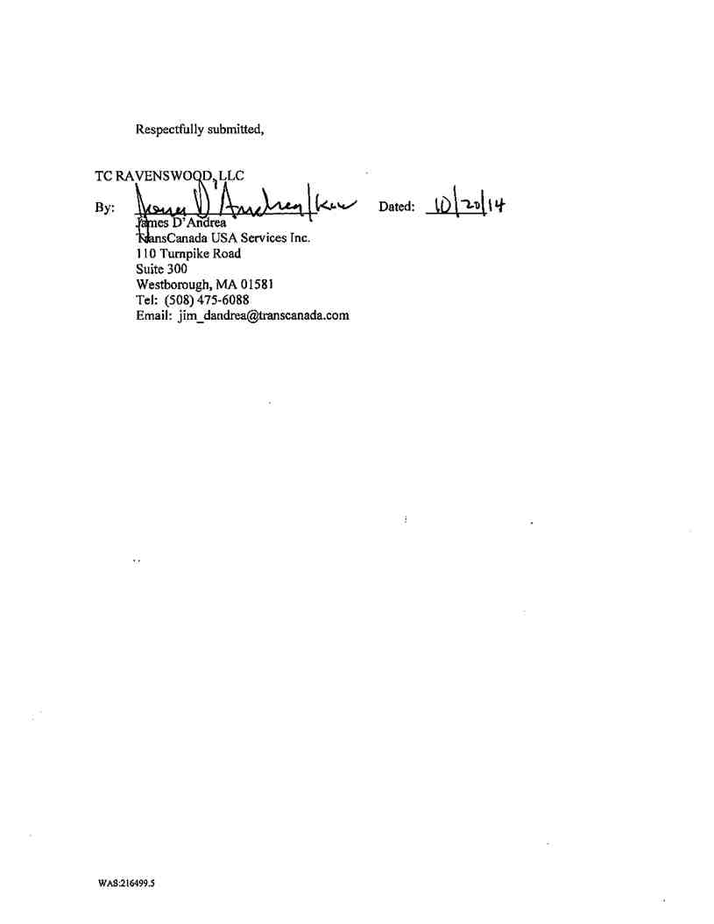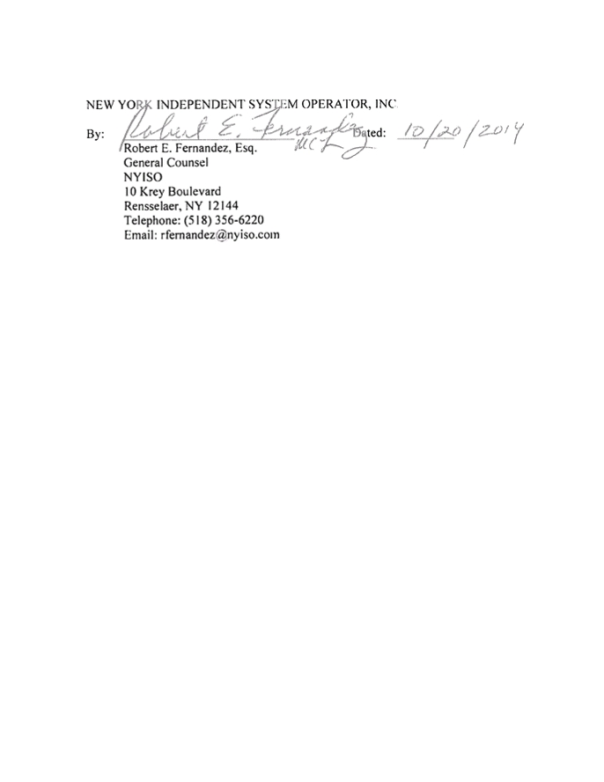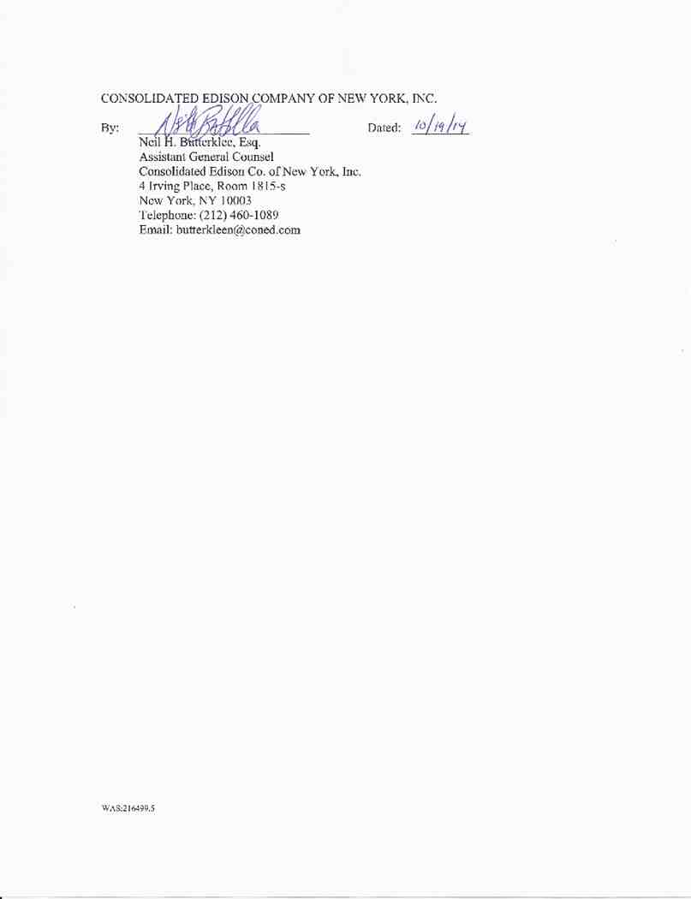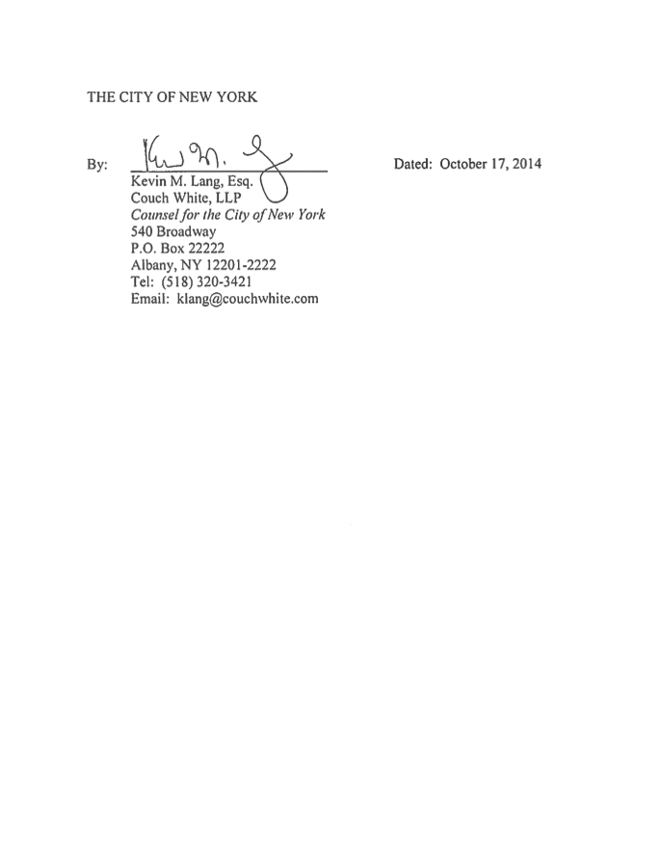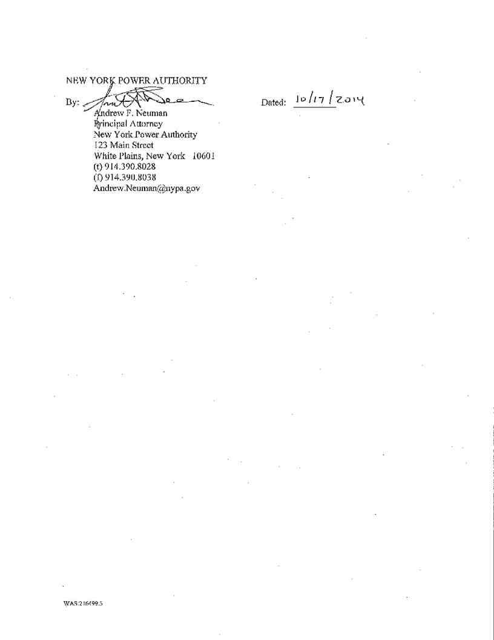

APPENDIX A

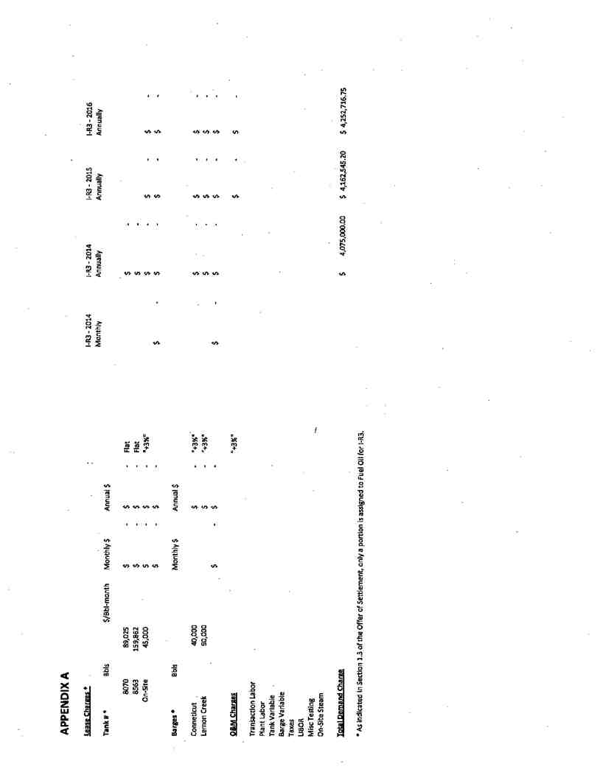

APPENDIX B

[REDACTED]