SERVICE AGREEMENT NO. 1668

LARGE GENERATOR INTERCONNECTION AGREEMENT
BY AND AMONG
NEW YORK INDEPENDENT SYSTEM OPERATOR, INC.
AND
CONSOLIDATED EDISON COMPANY OF NEW YORK, INC.
AND
BAYONNE ENERGY CENTER, LLC

Dated As Of November 10, 2010

SERVICE AGREEMENT NO. 1668

TABLE OF CONTENTS
Page No.
ARTICLE 1. DEFINITIONS 1
ARTICLE 2. EFFECTIVE DATE, TERM AND TERMINATION 12
2.1 Effective Date 12
2.2 Term of Agreement 12
2.3 Termination 12
2.4 Termination Costs 13

2.5 Disconnection 14
2.6 Survival 14
ARTICLE 3. REGULATORY FILINGS 14
3.1 Filing 14
ARTICLE 4. SCOPE OF INTERCONNECTION SERVICE 15
4.1 Provision of Service 15
4.2 No Transmission Delivery Service 15
4.3 No Other Services 15

ARTICLE 5. INTERCONNECTION FACILITIES ENGINEERING, PROCUREMENT,
AND CONSTRUCTION 16
5.1 Options 16
5.2 General Conditions Applicable to Option to Build 17
5.3 Liquidated Damages 19
5.4 Power System Stabilizers 20
5.5 Equipment Procurement 20
5.6 Construction Commencement 20
5.7 Work Progress 21
5.8 Information Exchange 21

i

SERVICE AGREEMENT NO. 1668

5.9 Limited Operation 21
5.10 Developer’s Attachment Facilities (“DAF”) 22
5.11 Connecting Transmission Owner’s Attachment Facilities Construction 23
5.12 Access Rights 23
5.13 Lands of Other Property Owners 23
5.14 Permits 24
5.15 Early Construction of Base Case Facilities 24
5.16 Suspension 24
5.17 Taxes 25
5.18 Tax Status; Non-Jurisdictional Entities 30
5.19 Modification 31
ARTICLE 6. TESTING AND INSPECTION 31
6.1 Pre-Commercial Operation Date Testing and Modifications 32
6.2 Post-Commercial Operation Date Testing and Modifications 32
6.3 Right to Observe Testing 32
6.4 Right to Inspect 32

ARTICLE 7. METERING 32
7.1 General 32
7.2 Check Meters 33

7.3 Standards 33
7.4 Testing of Metering Equipment 33
7.5 Metering Data 34
ARTICLE 8. COMMUNICATIONS 34
8.1 Developer Obligations 34

ii

SERVICE AGREEMENT NO. 1668

8.2 Remote Terminal Unit 34
8.3 No Annexation 35
ARTICLE 9. OPERATIONS 35
9.1 General 35
9.2 NYISO and Connecting Transmission Owner Obligations 35
9.3 Developer Obligations 35
9.4 Start-Up and Synchronization 36
9.5 Real and Reactive Power Control 36
9.6 Outages and Interruptions 37
9.7 Switching and Tagging Rules 40
9.8 Use of Attachment Facilities by Third Parties 41
9.9 Disturbance Analysis Data Exchange 41

ARTICLE 10. MAINTENANCE 41
10.1 Connecting Transmission Owner Obligations 41

10.2 Developer Obligations 42
10.3 Coordination 42
10.4 Secondary Systems 42
10.5 Operating and Maintenance Expenses 42
ARTICLE 11. PERFORMANCE OBLIGATION 43
11.1 Developer Attachment Facilities 43
11.2 Connecting Transmission Owner’s Attachment Facilities 43
11.3 System Upgrade Facilities and System Deliverability Upgrades 43
11.4 Special Provisions for Affected Systems 43

11.5 Provision of Security 43

iii

SERVICE AGREEMENT NO. 1668

11.6 Developer Compensation for Emergency Services 44
11.7 Line Outage Costs 44
ARTICLE 12. INVOICE 44
12.1 General 44
12.2 Final Invoice 45
12.3 Payment 45
12.4 Disputes 45
ARTICLE 13. EMERGENCIES 45
13.1 Obligations 45
13.2 Notice 46

13.3 Immediate Action 46
13.4 NYISO and Connecting Transmission Owner Authority 46
13.5 Developer Authority 47
13.6 Limited Liability 47

ARTICLE 14. REGULATORY REQUIREMENTS AND GOVERNING LAW 48
14.1 Regulatory Requirements 48

14.2 Governing Law 48
ARTICLE 15. NOTICES 48
15.1 General 48
15.2 Billings and Payments 49
15.3 Alternative Forms of Notice 49

15.4 Operations and Maintenance Notice 49
ARTICLE 16. FORCE MAJEURE 49
16.1 Force Majeure 49
ARTICLE 17. DEFAULT 50

iv

SERVICE AGREEMENT NO. 1668

17.1 Default 50
ARTICLE 18. INDEMNITY, CONSEQUENTIAL DAMAGES AND INSURANCE 50
18.1 Indemnity 50
18.2 No Consequential Damages 52
18.3 Insurance 52
ARTICLE 19. ASSIGNMENT 54
19.1 Assignment 54

ARTICLE 20. SEVERABILITY 54
20.1 Severability 54
ARTICLE 21. COMPARABILITY 55
21.1 Comparability 55
ARTICLE 22. CONFIDENTIALITY 55
22.1 Confidentiality 55
ARTICLE 23. ENVIRONMENTAL RELEASES 58
23.1 Developer and Connecting Transmission Owner Notice 58
ARTICLE 24. INFORMATION REQUIREMENT 59
24.1 Information Acquisition 59
24.2 Information Submission by Connecting Transmission Owner 59
24.3 Updated Information Submission by Developer 59
24.4 Information Supplementation 60
ARTICLE 25. INFORMATION ACCESS AND AUDIT RIGHTS 60
25.1 Information Access 60
25.2 Reporting of Non-Force Majeure Events 61
25.3 Audit Rights 61
25.4 Audit Rights Periods 61
25.5 Audit Results 62

v

SERVICE AGREEMENT NO. 1668

ARTICLE 26. SUBCONTRACTORS 62
26.1 General 62
26.2 Responsibility of Principal 62
26.3 No Limitation by Insurance 62
ARTICLE 27. DISPUTES 63
27.1 Submission 63
27.2 External Arbitration Procedures 63

27.3 Arbitration Decisions 63
27.4 Costs 64
27.5 Termination 64

ARTICLE 28. REPRESENTATIONS, WARRANTIES AND COVENANTS 64
28.1 General 64

ARTICLE 29. MISCELLANEOUS 65
29.1 Binding Effect 65

29.2 Conflicts 65
29.3 Rules of Interpretation 65

29.4 Compliance 66
29.5 Joint and Several Obligations 66
29.6 Entire Agreement 66
29.7 No Third Party Beneficiaries 67
29.8 Waiver 67

29.9 Headings 67
29.10 Multiple Counterparts 67
29.11 Amendment 67
29.12 Modification by the Parties 67

vi

SERVICE AGREEMENT NO. 1668

29.13 Reservation of Rights 68
29.14 No Partnership 68
29.15 Other Transmission Rights 68
APPENDICES 70

vii

SERVICE AGREEMENT NO. 1668

STANDARD LARGE GENERATOR INTERCONNECTION AGREEMENT

THIS STANDARD LARGE GENERATOR INTERCONNECTION AGREEMENT
(“Agreement”) is made and entered into this 10th day of November 2010, by and among
Bayonne Energy Center, LLC, a limited liability corporation organized and existing under the
laws of the State/Commonwealth of Delaware (“Developer” with a Large Generating Facility),
the New York Independent System Operator, Inc., a not-for-profit corporation organized and
existing under the laws of the State of New York (“NYISO”), and Consolidated Edison
Company of New York, Inc., a transportation corporation organized and existing under the laws
of the State of New York (“Connecting Transmission Owner”). Developer, the NYISO, or
Connecting Transmission Owner each may be referred to as a “Party” or collectively referred to
as the “Parties.”

RECITALS

WHEREAS, NYISO operates the Transmission System and Connecting Transmission Owner owns certain facilities included in the Transmission System; and
WHEREAS, Developer intends to own, lease and/or control and operate the Generating Facility identified as a Large Generating Facility in Appendix C to this Agreement; and,
WHEREAS, Developer, NYISO, and Connecting Transmission Owner have agreed to enter into this Agreement for the purpose of interconnecting the Large Generating Facility with the New York State Transmission System;
NOW, THEREFORE, in consideration of and subject to the mutual covenants contained herein, it is agreed:

ARTICLE 1. DEFINITIONS

Whenever used in this Agreement with initial capitalization, the following terms shall have the
meanings specified in this Article 1. Terms used in this Agreement with initial capitalization that are not defined in this Article 1 shall have the meanings specified in Section 30.1.0 or
Attachment S of the NYISO OATT.

Affected System shall mean an electric system other than the transmission system owned, controlled or operated by the Connecting Transmission Owner that may be affected by the proposed interconnection.

Affected System Operator shall mean the entity that operates an Affected System.

1

SERVICE AGREEMENT NO. 1668

Affected Transmission Owner shall mean the New York public utility or authority (or its
designated agent) other than the Connecting Transmission Owner that (i) owns facilities used for the transmission of Energy in interstate commerce and provides Transmission Service under the Tariff, and (ii) owns, leases or otherwise possesses an interest in a portion of the New York State Transmission System where System Deliverability Upgrades or System Upgrade Facilities are installed pursuant to Attachment X and Attachment S of the Tariff.

Affiliate shall mean, with respect to a person or entity, any individual, corporation, partnership, firm, joint venture, association, joint-stock company, trust or unincorporated organization,
directly or indirectly controlling, controlled by, or under common control with, such person or entity. The term “control” shall mean the possession, directly or indirectly, of the power to direct the management or policies of a person or an entity. A voting interest of ten percent or more shall create a rebuttable presumption of control.

Ancillary Services shall mean those services that are necessary to support the transmission of Capacity and Energy from resources to Loads while maintaining reliable operation of the New York State Transmission System in accordance with Good Utility Practice.

Applicable Laws and Regulations shall mean all duly promulgated applicable federal, state and local laws, regulations, rules, ordinances, codes, decrees, judgments, directives, or judicial or administrative orders, permits and other duly authorized actions of any Governmental Authority, including but not limited to Environmental Law.

Applicable Reliability Councils shall mean the NERC, the NPCC and the NYSRC.

Applicable Reliability Standards shall mean the requirements and guidelines of the Applicable
Reliability Councils, and the Transmission District to which the Developer’s Large Generating
Facility is directly interconnected, as those requirements and guidelines are amended and
modified and in effect from time to time; provided that no Party shall waive its right to challenge
the applicability or validity of any requirement or guideline as applied to it in the context of this
Agreement.

Attachment Facilities shall mean the Connecting Transmission Owner’s Attachment Facilities
and the Developer’s Attachment Facilities. Collectively, Attachment Facilities include all
facilities and equipment between the Large Generating Facility and the Point of Interconnection,
including any modification, additions or upgrades that are necessary to physically and
electrically interconnect the Large Generating Facility to the New York State Transmission
System. Attachment Facilities are sole use facilities and shall not include Stand Alone System
Upgrade Facilities or System Upgrade Facilities or System Deliverability Upgrades.

2

SERVICE AGREEMENT NO. 1668

Base Case shall mean the base case power flow, short circuit, and stability data bases used for the Interconnection Studies by NYISO, Connecting Transmission Owner or Developer;
described in Section 30.2.3 of the Large Facility Interconnection Procedures.

Breach shall mean the failure of a Party to perform or observe any material term or condition of this Agreement.

Breaching Party shall mean a Party that is in Breach of this Agreement.

Business Day shall mean Monday through Friday, excluding federal holidays.

Byway shall mean all transmission facilities comprising the New York State Transmission
System that are neither Highways nor Other Interfaces. All transmission facilities Zone J and Zone K are Byways.

Calendar Day shall mean any day including Saturday, Sunday or a federal holiday.

Capacity Region shall mean one of three subsets of the Installed Capacity statewide markets
comprised of Rest of State (Zones A through I), Long Island (Zone K), and New York City
(Zone J).

Capacity Resource Interconnection Service (“CRIS”) shall mean the service provided by
NYISO to interconnect the Developer’s Large Generating Facility to the New York State
Transmission System in accordance with the NYISO Deliverability Interconnection Standard, to enable the New York State Transmission System to deliver electric capacity from the Large Generating Facility, pursuant to the terms of the NYISO OATT.

Class Year Deliverability Study shall mean an assessment, conducted by the NYISO staff in cooperation with Market Participants, to determine the System Deliverability Upgrades required for each generation and merchant transmission project included in the Class Year
Interconnection Facilities Study to interconnect to the New York State Transmission System in compliance with the NYISO Deliverability Interconnection Standard.

Clustering shall mean the process whereby a group of Interconnection Requests is studied
together, instead of serially, for the purpose of conducting the Interconnection System Reliability Impact Study.

3

SERVICE AGREEMENT NO. 1668

Commercial Operation shall mean the status of a Large Generating Facility that has
commenced generating electricity for sale, excluding electricity generated during Trial
Operation.

Commercial Operation Date of a unit shall mean the date on which the Large Generating
Facility commences Commercial Operation as agreed to by the Parties pursuant to Appendix E to this Agreement.

Confidential Information shall mean any information that is defined as confidential by Article
22 of this Agreement.

Connecting Transmission Owner shall mean the New York public utility or authority (or its
designated agent) that (i) owns facilities used for the transmission of Energy in interstate
commerce and provides Transmission Service under the Tariff, (ii) owns, leases or otherwise
possesses an interest in the portion of the New York State Transmission System at the Point of
Interconnection, and (iii) is a Party to the Standard Large Interconnection Agreement.

Connecting Transmission Owner’s Attachment Facilities shall mean all facilities and
equipment owned, controlled or operated by the Connecting Transmission Owner from the Point of Change of Ownership to the Point of Interconnection as identified in Appendix A to the
Standard Large Generator Interconnection Agreement, including any modifications, additions or upgrades to such facilities and equipment. Connecting Transmission Owner’s Attachment
Facilities are sole use facilities and shall not include Stand Alone System Upgrade Facilities or
System Upgrade Facilities.

Control Area shall mean an electric power system or combination of electric power systems to
which a common automatic generation control scheme is applied in order to: (1) match, at all
times, the power output of the Generators within the electric power system(s) and capacity and
energy purchased from entities outside the electric power system(s), with the Load within the
electric power system(s); (2) maintain scheduled interchange with other Control Areas, within
the limits of Good Utility Practice; (3) maintain the frequency of the electric power system(s)
within reasonable limits in accordance with Good Utility Practice; and (4) provide sufficient
generating capacity to maintain Operating Reserves in accordance with Good Utility Practice. A Control Area must be certified by the NPCC.

Default shall mean the failure of a Party in Breach of this Agreement to cure such Breach in accordance with Article 17 of this Agreement.

Deliverability Interconnection Standard shall mean the standard that must be met by any
Large Generating Facility proposing to interconnect to the New York State Transmission System and become a qualified Installed Capacity Supplier. To meet the NYISO Deliverability

4

SERVICE AGREEMENT NO. 1668

Interconnection Standard, the Developer of the proposed Large Generating Facility must, in
accordance with the rules in Attachment S to the NYISO OATT, fund or commit to fund the
System Deliverability Upgrades identified for its project in the Class Year Deliverability Study.
Developer shall mean an Eligible Customer developing a Large Generating Facility, proposing to connect to the New York State Transmission System, in compliance with the NYISO
Minimum Interconnection Standard.

Developer’s Attachment Facilities shall mean all facilities and equipment, as identified in
Appendix A of this Agreement, that are located between the Large Generating Facility and the Point of Change of Ownership, including any modification, addition, or upgrades to such
facilities and equipment necessary to physically and electrically interconnect the Large
Generating Facility to the New York State Transmission System. Developer’s Attachment
Facilities are sole use facilities.

Dispute Resolution shall mean the procedure described in Article 27 of this Agreement for resolution of a dispute between the Parties.

Effective Date shall mean the date on which this Agreement becomes effective upon execution by the Parties, subject to acceptance by the Commission, or if filed unexecuted, upon the date specified by the Commission.

Emergency State shall mean the condition or state that the New York State Power System is in when an abnormal condition occurs that requires automatic or immediate manual action to
prevent or limit loss of the New York State Transmission System or Generators that could
adversely affect the reliability of the New York State Power System.

Energy Resource Interconnection Service (“ERIS”) shall mean the service provided by
NYISO to interconnect the Developer’s Large Generating Facility to the New York State
Transmission System in accordance with the NYISO Minimum Interconnection Standard, to enable the New York State Transmission System to receive Energy and Ancillary Services from the Large Generating Facility, pursuant to the terms of the NYISO OATT.

Engineering & Procurement (E&P) Agreement shall mean an agreement that authorizes
Connecting Transmission Owner to begin engineering and procurement of long lead-time items necessary for the establishment of the interconnection in order to advance the implementation of the Interconnection Request.

Environmental Law shall mean Applicable Laws or Regulations relating to pollution or protection of the environment or natural resources.

5

SERVICE AGREEMENT NO. 1668

Federal Power Act shall mean the Federal Power Act, as amended, 16 U.S.C. §§ 791a et seq. (“FPA”).

FERC shall mean the Federal Energy Regulatory Commission (“Commission”) or its successor.

Force Majeure shall mean any act of God, labor disturbance, act of the public enemy, war,
insurrection, riot, fire, storm or flood, explosion, breakage or accident to machinery or
equipment, any order, regulation or restriction imposed by governmental, military or lawfully
established civilian authorities, or any other cause beyond a Party’s control. A Force Majeure
event does not include acts of negligence or intentional wrongdoing by the Party claiming Force
Majeure.

Generating Facility shall mean Developer’s device for the production of electricity identified in the Interconnection Request, but shall not include the Developer’s Attachment Facilities.

Generating Facility Capacity shall mean the net seasonal capacity of the Generating Facility and the aggregate net seasonal capacity of the Generating Facility where it includes multiple energy production devices.

Good Utility Practice shall mean any of the practices, methods and acts engaged in or approved
by a significant portion of the electric industry during the relevant time period, or any of the
practices, methods and acts which, in the exercise of reasonable judgment in light of the facts
known at the time the decision was made, could have been expected to accomplish the desired
result at a reasonable cost consistent with good business practices, reliability, safety and
expedition. Good Utility Practice is not intended to be limited to the optimum practice, method,
or act to the exclusion of all others, but rather to delineate acceptable practices, methods, or acts
generally accepted in the region.

Governmental Authority shall mean any federal, state, local or other governmental regulatory
or administrative agency, court, commission, department, board, or other governmental
subdivision, legislature, rulemaking board, tribunal, or other governmental authority having
jurisdiction over any of the Parties, their respective facilities, or the respective services they
provide, and exercising or entitled to exercise any administrative, executive, police, or taxing
authority or power; provided, however, that such term does not include Developer, NYISO,
Affected Transmission Owner, Connecting Transmission Owner, or any Affiliate thereof.

Hazardous Substances shall mean any chemicals, materials or substances defined as or
included in the definition of “hazardous substances,” “hazardous wastes,” “hazardous materials,”
“hazardous constituents,” “restricted hazardous materials,” “extremely hazardous substances,”
“toxic substances,” “radioactive substances,” “contaminants,” “pollutants,” “toxic pollutants” or
words of similar meaning and regulatory effect under any applicable Environmental Law, or any

6

SERVICE AGREEMENT NO. 1668

other chemical, material or substance, exposure to which is prohibited, limited or regulated by any applicable Environmental Law.

Highway shall mean 115 kV and higher transmission facilities that comprise the following
NYCA interfaces: Dysinger East, West Central, Volney East, Moses South, Central East/Total
East, UPNY-SENY and UPNY-ConEd, and their immediately connected, in series, Bulk Power
System facilities in New York State. Each interface shall be evaluated to determine additional
“in series” facilities, defined as any transmission facility higher than 115 kV that (a) is located in
an upstream or downstream zone adjacent to the interface and (b) has a power transfer
distribution factor (DFAX) equal to or greater than five percent when the aggregate of generation
in zones or systems adjacent to the upstream zone or zones which define the interface is shifted
to the aggregate of generation in zones or systems adjacent to the downstream zone or zones
which define the interface. In determining “in series” facilities for Dysinger East and West
Central interfaces, the 115 kV and 230 kV tie lines between NYCA and PJM located in LBMP
Zones A and B shall not participate in the transfer. Highway transmission facilities are listed in
ISO Procedures.

Initial Synchronization Date shall mean the date upon which the Large Generating Facility is initially synchronized and upon which Trial Operation begins.

In-Service Date shall mean the date upon which the Developer reasonably expects it will be
ready to begin use of the Connecting Transmission Owner’s Attachment Facilities to obtain back feed power.

Interconnection Facilities Study shall mean a study conducted by NYISO or a third party
consultant for the Developer to determine a list of facilities (including Connecting Transmission Owner’s Attachment Facilities and System Upgrade Facilities and System Deliverability
Upgrades as identified in the Interconnection System Reliability Impact Study), the cost of those facilities, and the time required to interconnect the Large Generating Facility with the New York State Transmission System. The scope of the study is defined in Section 30.8 of the Standard Large Facility Interconnection Procedures.

Interconnection Facilities Study Agreement shall mean the form of agreement contained in Appendix 4 of the Standard Large Facility Interconnection Procedures for conducting the Interconnection Facilities Study.

Interconnection Feasibility Study shall mean a preliminary evaluation of the system impact and cost of interconnecting the Large Generating Facility to the New York State Transmission System, the scope of which is described in Section 30.6 of the Standard Large Facility
Interconnection Procedures.

7

SERVICE AGREEMENT NO. 1668

Interconnection Feasibility Study Agreement shall mean the form of agreement contained in Appendix 2 of the Standard Large Facility Interconnection Procedures for conducting the
Interconnection Feasibility Study.

Interconnection Request shall mean a Developer’s request, in the form of Appendix 1 to the
Standard Large Facility Interconnection Procedures, in accordance with the Tariff, to
interconnect a new Large Generating Facility to the New York State Transmission System, or to
increase the capacity of, or make a material modification to the operating characteristics of, an
existing Large Generating Facility that is interconnected with the New York State Transmission
System.

Interconnection Study shall mean any of the following studies: the Interconnection Feasibility Study, the Interconnection System Reliability Impact Study, and the Interconnection Facilities Study described in the Standard Large Facility Interconnection Procedures.

Interconnection System Reliability Impact Study (“SRIS”) shall mean an engineering study,
conducted in accordance with Section 30.7 of the Large Facility Interconnection Procedures, that
evaluates the impact of the proposed Large Generating Facility on the safety and reliability of the
New York State Transmission System and, if applicable, an Affected System, to determine what
Attachment Facilities and System Upgrade Facilities are needed for the proposed Large
Generation Facility of the Developer to connect reliably to the New York State Transmission
System in a manner that meets the NYISO Minimum Interconnection Standard.

Interconnection System Reliability Impact Study Agreement shall mean the form of
agreement contained in Appendix 3 of the Standard Large Facility Interconnection Procedures for conducting the Interconnection System Reliability Impact Study.

IRS shall mean the Internal Revenue Service.

Large Generating Facility shall mean a Generating Facility having a Generating Facility Capacity of more than 20 MW.

Loss shall mean any and all losses relating to injury to or death of any person or damage to
property, demand, suits, recoveries, costs and expenses, court costs, attorney fees, and all other
obligations by or to third parties, arising out of or resulting from the Indemnified Party’s
performance or non-performance of its obligations under this Agreement on behalf of the
Indemnifying Party, except in cases of gross negligence or intentional wrongdoing by the
Indemnified Party.

Material Modification shall mean those modifications that have a material impact on the cost or timing of any Interconnection Request with a later queue priority date.

8

SERVICE AGREEMENT NO. 1668

Metering Equipment shall mean all metering equipment installed or to be installed at the Large Generating Facility pursuant to this Agreement at the metering points, including but not limited to instrument transformers, MWh-meters, data acquisition equipment, transducers, remote
terminal unit, communications equipment, phone lines, and fiber optics.

Minimum Interconnection Standard shall mean the reliability standard that must be met by
any Large Generating Facility proposing to connect to the New York State Transmission System. The Standard is designed to ensure reliable access by the proposed project to the New York State Transmission System. The Standard does not impose any deliverability test or deliverability requirement on the proposed interconnection.

NERC shall mean the North American Electric Reliability Council or its successor organization.

New York State Transmission System shall mean the entire New York State electric
transmission system, which includes (i) the Transmission Facilities under ISO Operational Control; (ii) the Transmission Facilities Requiring ISO Notification; and (iii) all remaining transmission facilities within the New York Control Area.

Notice of Dispute shall mean a written notice of a dispute or claim that arises out of or in connection with this Agreement or its performance.

NPCC shall mean the Northeast Power Coordinating Council or its successor organization.

NYSRC shall mean the New York State Reliability Council or its successor organization.

Optional Interconnection Study shall mean a sensitivity analysis based on assumptions specified by the Developer in the Optional Interconnection Study Agreement.

Optional Interconnection Study Agreement shall mean the form of agreement contained in Appendix 5 of the Standard Large Facility Interconnection Procedures for conducting the Optional Interconnection Study.

Other Interfaces shall mean interfaces into New York capacity regions, Zone J and Zone K, and external ties into the New York Control Area.

Party or Parties shall mean NYISO, Connecting Transmission Owner, or Developer or any combination of the above.

9

SERVICE AGREEMENT NO. 1668

Point of Change of Ownership shall mean the point, as set forth in Appendix A to this Agreement, where the Developer’s Attachment Facilities connect to the Connecting Transmission Owner’s Attachment Facilities.

Point of Interconnection shall mean the point, as set forth in Appendix A to this Agreement, where the Attachment Facilities connect to the New York State Transmission System.

Queue Position shall mean the order of a valid Interconnection Request, relative to all other pending valid Interconnection Requests, that is established based upon the date and time of receipt of the valid Interconnection Request by NYISO.

Reasonable Efforts shall mean, with respect to an action required to be attempted or taken by a
Party under this Agreement, efforts that are timely and consistent with Good Utility Practice and
are otherwise substantially equivalent to those a Party would use to protect its own interests.

Scoping Meeting shall mean the meeting between representatives of the Developer, NYISO and
Connecting Transmission Owner conducted for the purpose of discussing alternative
interconnection options, to exchange information including any transmission data and earlier
study evaluations that would be reasonably expected to impact such interconnection options, to
analyze such information, and to determine the potential feasible Points of Interconnection.

Services Tariff shall mean the NYISO Market Administration and Control Area Tariff, as filed
with the Commission, and as amended or supplemented from time to time, or any successor tariff
thereto.

Site Control shall mean documentation reasonably demonstrating: (1) ownership of, a leasehold interest in, or a right to develop a site for the purpose of constructing the Large Generating
Facility; (2) an option to purchase or acquire a leasehold site for such purpose; or (3) an
exclusivity or other business relationship between Developer and the entity having the right to sell, lease or grant Developer the right to possess or occupy a site for such purpose.

Stand Alone System Upgrade Facilities shall mean System Upgrade Facilities that a Developer may construct without affecting day-to-day operations of the New York State Transmission
System during their construction. NYISO, the Connecting Transmission Owner and the
Developer must agree as to what constitutes Stand Alone System Upgrade Facilities and identify them in Appendix A to this Agreement.

Standard Large Facility Interconnection Procedures (“LFIP”) shall mean the
interconnection procedures applicable to an Interconnection Request pertaining to a Large Generating Facility that are included in Attachment X of the NYISO OATT.

10

SERVICE AGREEMENT NO. 1668

Standard Large Generator Interconnection Agreement (“LGIA”) shall mean this
Agreement, the form of interconnection agreement applicable to an Interconnection Request
pertaining to a Large Generating Facility, that is included in Attachment X of the NYISO OATT.

System Deliverability Upgrades shall mean the least costly configuration of commercially
available components of electrical equipment that can be used, consistent with Good Utility
Practice and Applicable Reliability Requirements, to make the modifications or additions to
Byways and Highways and Other Interfaces on the existing New York State Transmission
System that are required for the proposed project to connect reliably to the system in a manner
that meets the NYISO Deliverability Interconnection Standard at the requested level of Capacity Resource Interconnection Service.

System Protection Facilities shall mean the equipment, including necessary protection signal
communications equipment, required to (1) protect the New York State Transmission System
from faults or other electrical disturbances occurring at the Large Generating Facility and (2)
protect the Large Generating Facility from faults or other electrical system disturbances
occurring on the New York State Transmission System or on other delivery systems or other
generating systems to which the New York State Transmission System is directly connected.

System Upgrade Facilities shall mean the least costly configuration of commercially available
components of electrical equipment that can be used, consistent with Good Utility Practice and
Applicable Reliability Requirements, to make the modifications to the existing transmission
system that are required to maintain system reliability due to: (i) changes in the system,
including such changes as load growth and changes in load pattern, to be addressed in the form
of generic generation or transmission projects; and (ii) proposed interconnections. In the case of
proposed interconnection projects, System Upgrade Facilities are the modifications or additions
to the existing New York State Transmission System that are required for the proposed project to
connect reliably to the system in a manner that meets the NYISO Minimum Interconnection
Standard.

Tariff shall mean the NYISO Open Access Transmission Tariff (“OATT”), as filed with the
Commission, and as amended or supplemented from time to time, or any successor tariff.

Trial Operation shall mean the period during which Developer is engaged in on-site test
operations and commissioning of the Large Generating Facility prior to Commercial Operation.

11

SERVICE AGREEMENT NO. 1668

ARTICLE 2. EFFECTIVE DATE, TERM AND TERMINATION

2.1 Effective Date.
This Agreement shall become effective upon execution by the Parties, subject to
acceptance by FERC, or if filed unexecuted, upon the date specified by FERC. The NYISO and Connecting Transmission Owner shall promptly file this Agreement with FERC upon execution in accordance with Article 3.1.
2.2 Term of Agreement.
Subject to the provisions of Article 2.3, this Agreement shall remain in effect for a period
of thirty (30) years from the Effective Date and shall be automatically renewed for each
successive one-year period thereafter.
2.3 Termination.

2.3.1 Written Notice.
This Agreement may be terminated by the Developer after giving the NYISO and
Connecting Transmission Owner ninety (90) Calendar Days advance written notice, or by the NYISO and Connecting Transmission Owner notifying FERC after the Large Generating Facility permanently ceases Commercial Operations.
2.3.1.1 Non-Acceptance of Project Cost Allocation.

Developer’s election not to accept its Project Cost Allocation for Class Year 2009 shall
be deemed a termination of this Agreement by Developer under Article 2.3.1. Developer may
effect such election not to accept its Project Cost Allocation for Class Year 2009 by (i) providing
Notice of Non-Acceptance of the Project Cost Allocation, or (ii) failing to post Security for SUFs
for which it is responsible in accordance with Attachment S. Developer’s Notice of Non-
Acceptance of the Project Cost Allocation shall be delivered to both NYISO and CTO
concurrently and shall be deemed Developer’s notice of termination for purposes of Article
2.3.1. No notice of termination under Article 2.3.1 shall be required if Developer accepts its Project Cost Allocation for Class Year 2009 but fails to post Security in accordance with
Attachment S. In such case, the 90-day period for termination shall commence to run from the last day on which Developer could have posted Security under Attachment S.
2.3.1.2 Post Termination Responsibilities.
Once Developer elects not to accept its Project Cost Allocation for Class Year 2009, it
shall promptly (i) demobilize and cease further construction at the Gowanus Substation site, and
(ii) remove or cause the removal of all equipment, tools and materials of Developer, its
contractors and vendors from the Gowanus Substation site. CTO shall take such steps as
reasonably necessary to return the Gowanus Substation location to a safe and reliable condition

12

SERVICE AGREEMENT NO. 1668

in accordance with Article 5.16 of this Agreement and bill Developer for the reasonable costs of same under Article 12 of this Agreement.

2.3.2 Default.
Any Party may terminate this Agreement in accordance with Article 17.

2.3.3 Compliance.
Notwithstanding Articles 2.3.1 and 2.3.2, no termination of this Agreement shall become effective until the Parties have complied with all Applicable Laws and Regulations applicable to such termination, including the filing with FERC of a notice of termination of this Agreement, which notice has been accepted for filing by FERC.
2.4 Termination Costs.
If a Party elects to terminate this Agreement pursuant to Article 2.3.1 above, the
terminating Party shall pay all costs incurred (including any cancellation costs relating to orders
or contracts for Attachment Facilities and equipment) or charges assessed by the other Parties, as
of the date of the other Parties’ receipt of such notice of termination, that are the responsibility of
the terminating Party under this Agreement. In the event of termination by a Party, all Parties
shall use commercially Reasonable Efforts to mitigate the costs, damages and charges arising as
a consequence of termination. Upon termination of this Agreement, unless otherwise ordered or
approved by FERC:
2.4.1 With respect to any portion of the Connecting Transmission Owner’s Attachment
Facilities that have not yet been constructed or installed, the Connecting Transmission Owner
shall to the extent possible and with Developer’s authorization cancel any pending orders of, or
return, any materials or equipment for, or contracts for construction of, such facilities; provided
that in the event Developer elects not to authorize such cancellation, Developer shall assume all
payment obligations with respect to such materials, equipment, and contracts, and the
Connecting Transmission Owner shall deliver such material and equipment, and, if necessary,
assign such contracts, to Developer as soon as practicable, at Developer’s expense. To the extent
that Developer has already paid Connecting Transmission Owner for any or all such costs of
materials or equipment not taken by Developer, Connecting Transmission Owner shall promptly
refund such amounts to Developer, less any costs, including penalties incurred by the Connecting
Transmission Owner to cancel any pending orders of or return such materials, equipment, or
contracts.
If Developer terminates this Agreement, it shall be responsible for all costs incurred in association with Developer’s interconnection, including any cancellation costs relating to orders or contracts for Attachment Facilities and equipment, and other expenses including any System Upgrade Facilities and System Deliverability Upgrades for which the Connecting Transmission Owner has incurred expenses and has not been reimbursed by the Developer.

13

SERVICE AGREEMENT NO. 1668

2.4.2 Connecting Transmission Owner may, at its option, retain any portion of such
materials, equipment, or facilities that Developer chooses not to accept delivery of, in which case Connecting Transmission Owner shall be responsible for all costs associated with procuring such materials, equipment, or facilities.
2.4.3 With respect to any portion of the Attachment Facilities, and any other facilities already installed or constructed pursuant to the terms of this Agreement, Developer shall be
responsible for all costs associated with the removal, relocation or other disposition or retirement of such materials, equipment, or facilities.
2.5 Disconnection.

Upon termination of this Agreement, Developer and Connecting Transmission Owner will take all appropriate steps to disconnect the Developer’s Large Generating Facility from the New York State Transmission System. All costs required to effectuate such disconnection shall be borne by the terminating Party, unless such termination resulted from the non-terminating
Party’s Default of this Agreement or such non-terminating Party otherwise is responsible for
these costs under this Agreement.
2.6 Survival.

This Agreement shall continue in effect after termination to the extent necessary to
provide for final billings and payments and for costs incurred hereunder; including billings and payments pursuant to this Agreement; to permit the determination and enforcement of liability and indemnification obligations arising from acts or events that occurred while this Agreement was in effect; and to permit Developer and Connecting Transmission Owner each to have access to the lands of the other pursuant to this Agreement or other applicable agreements, to
disconnect, remove or salvage its own facilities and equipment.
ARTICLE 3. REGULATORY FILINGS

3.1 Filing.

NYISO and Connecting Transmission Owner shall file this Agreement (and any
amendment hereto) with the appropriate Governmental Authority, if required. Any information
related to studies for interconnection asserted by Developer to contain Confidential Information
shall be treated in accordance with Article 22 of this Agreement and Attachment F to the NYISO
OATT. If the Developer has executed this Agreement, or any amendment thereto, the Developer
shall reasonably cooperate with NYISO and Connecting Transmission Owner with respect to
such filing and to provide any information reasonably requested by NYISO and Connecting
Transmission Owner needed to comply with Applicable Laws and Regulations.

14

SERVICE AGREEMENT NO. 1668

ARTICLE 4. SCOPE OF INTERCONNECTION SERVICE

4.1 Provision of Service.
NYISO will provide Developer with interconnection service of the following type for the term of this Agreement.
4.1.1 Product.
NYISO will provide ERIS and CRIS to Developer at the Point of Interconnection, with CRIS subject to the requirements of Section 5 of Appendix A.
4.1.2 Developer
is responsible for ensuring that its actual Large Generating Facility output matches the scheduled delivery from the Large Generating Facility to the New York State Transmission
System, consistent with the scheduling requirements of the NYISO’s FERC-approved market structure, including ramping into and out of such scheduled delivery, as measured at the Point of Interconnection, consistent with the scheduling requirements of the NYISO OATT and any
applicable FERC-approved market structure.
4.2 No Transmission Delivery Service.

The execution of this Agreement does not constitute a request for, nor agreement to
provide, any Transmission Service under the NYISO OATT, and does not convey any right to deliver electricity to any specific customer or Point of Delivery. If Developer wishes to obtain Transmission Service on the New York State Transmission System, then Developer must request such Transmission Service in accordance with the provisions of the NYISO OATT.
4.3 No Other Services.

The execution of this Agreement does not constitute a request for, nor agreement to
provide Energy, any Ancillary Services or Installed Capacity under the NYISO Market
Administration and Control Area Services Tariff (“Services Tariff”). If Developer wishes to
supply Energy, Installed Capacity or Ancillary Services, then Developer will make application to do so in accordance with the NYISO Services Tariff.

15

SERVICE AGREEMENT NO. 1668

ARTICLE 5. INTERCONNECTION FACILITIES ENGINEERING, PROCUREMENT,
AND CONSTRUCTION

5.1 Options.

Unless otherwise mutually agreed to by Developer and Connecting Transmission Owner, Developer shall select the In-Service Date, Initial Synchronization Date, and Commercial
Operation Date; and either Standard Option or Alternate Option set forth below for completion of the Connecting Transmission Owner’s Attachment Facilities and System Upgrade Facilities and System Deliverability Upgrades as set forth in Appendix A hereto, and such dates and
selected option shall be set forth in Appendix B hereto.
5.1.1 Standard Option.

The Connecting Transmission Owner shall design, procure, and construct the Connecting Transmission Owner’s Attachment Facilities and System Upgrade Facilities and System
Deliverability Upgrades, using Reasonable Efforts to complete the Connecting Transmission
Owner’s Attachment Facilities and System Upgrade Facilities and System Deliverability
Upgrades by the dates set forth in Appendix B hereto. The Connecting Transmission Owner
shall not be required to undertake any action which is inconsistent with its standard safety
practices, its material and equipment specifications, its design criteria and construction
procedures, its labor agreements, and Applicable Laws and Regulations. In the event the
Connecting Transmission Owner reasonably expects that it will not be able to complete the
Connecting Transmission Owner’s Attachment Facilities and System Upgrade Facilities and
System Deliverability Upgrades by the specified dates, the Connecting Transmission Owner
shall promptly provide written notice to the Developer and NYISO, and shall undertake
Reasonable Efforts to meet the earliest dates thereafter.
5.1.2 Alternate Option.

If the dates designated by Developer are acceptable to Connecting Transmission Owner,
the Connecting Transmission Owner shall so notify Developer and NYISO within thirty (30)
Calendar Days, and shall assume responsibility for the design, procurement and construction of
the Connecting Transmission Owner’s Attachment Facilities by the designated dates. If
Connecting Transmission Owner subsequently fails to complete Connecting Transmission
Owner’s Attachment Facilities by the In-Service Date, to the extent necessary to provide back
feed power; or fails to complete System Upgrade Facilities or System Deliverability Upgrades by
the Initial Synchronization Date to the extent necessary to allow for Trial Operation at full power
output, unless other arrangements are made by the Developer and Connecting Transmission
Owner for such Trial Operation; or fails to complete the System Upgrade Facilities and System
Deliverability Upgrades by the Commercial Operation Date, as such dates are reflected in
Appendix B hereto; Connecting Transmission Owner shall pay Developer liquidated damages in
accordance with Article 5.3, Liquidated Damages, provided, however, the dates designated by

16

SERVICE AGREEMENT NO. 1668

Developer shall be extended day for day for each day that NYISO refuses to grant clearances to install equipment.
5.1.3 Option to Build.

If the dates designated by Developer are not acceptable to Connecting Transmission
Owner, the Connecting Transmission Owner shall so notify the Developer and NYISO within
thirty (30) Calendar Days, and unless the Developer and Connecting Transmission Owner agree
otherwise, Developer shall have the option to assume responsibility for the design, procurement
and construction of Connecting Transmission Owner’s Attachment Facilities and Stand Alone
System Upgrade Facilities on the dates specified in Article 5.1.2; provided that if an Attachment
Facility or Stand Alone System Upgrade Facility is needed for more than one Developer’s
project, Developer’s option to build such Facility shall be contingent on the agreement of all
other affected Developers. NYISO, Connecting Transmission Owner and Developer must agree
as to what constitutes Stand Alone System Upgrade Facilities and identify such Stand Alone
System Upgrade Facilities in Appendix A hereto. Except for Stand Alone System Upgrade
Facilities, Developer shall have no right to construct System Upgrade Facilities under this
option.
5.1.4 Negotiated Option.

If the Developer elects not to exercise its option under Article 5.1.3, Option to Build,
Developer shall so notify Connecting Transmission Owner and NYISO within thirty (30)
Calendar Days, and the Developer and Connecting Transmission Owner shall in good faith
attempt to negotiate terms and conditions (including revision of the specified dates and
liquidated damages, the provision of incentives or the procurement and construction of a portion
of the Connecting Transmission Owner’s Attachment Facilities and Stand Alone System
Upgrade Facilities by Developer) pursuant to which Connecting Transmission Owner is
responsible for the design, procurement and construction of the Connecting Transmission
Owner’s Attachment Facilities and System Upgrade Facilities and System Deliverability
Upgrades. If the two Parties are unable to reach agreement on such terms and conditions,
Connecting Transmission Owner shall assume responsibility for the design, procurement and
construction of the Connecting Transmission Owner’s Attachment Facilities and System
Upgrades Facilities and System Deliverability Upgrades pursuant to 5.1.1, Standard Option.
5.2 General Conditions Applicable to Option to Build.

If Developer assumes responsibility for the design, procurement and construction of the
Connecting Transmission Owner’s Attachment Facilities and Stand Alone System Upgrade
Facilities,
(1) Developer shall engineer, procure equipment, and construct the Connecting
Transmission Owner’s Attachment Facilities and Stand Alone System Upgrade Facilities (or portions thereof) using Good Utility Practice and using standards and specifications provided in advance by the Connecting Transmission Owner;

17

SERVICE AGREEMENT NO. 1668

(2) Developer’s engineering, procurement and construction of the Connecting
Transmission Owner’s Attachment Facilities and Stand Alone System Upgrade Facilities shall comply with all requirements of law to which Connecting Transmission Owner would be subject in the engineering, procurement or construction of the Connecting Transmission Owner’s
Attachment Facilities and Stand Alone System Upgrade Facilities;
(3) Connecting Transmission Owner shall review and approve the engineering design, equipment acceptance tests, and the construction of the Connecting Transmission Owner’s Attachment Facilities and Stand Alone System Upgrade Facilities;
(4) Prior to commencement of construction, Developer shall provide to Connecting
Transmission Owner and NYISO a schedule for construction of the Connecting Transmission
Owner’s Attachment Facilities and Stand Alone System Upgrade Facilities, and shall promptly
respond to requests for information from Connecting Transmission Owner or NYISO;
(5) At any time during construction, Connecting Transmission Owner shall have the right to gain unrestricted access to the Connecting Transmission Owner’s Attachment Facilities and Stand Alone System Upgrade Facilities and to conduct inspections of the same;
(6) At any time during construction, should any phase of the engineering, equipment
procurement, or construction of the Connecting Transmission Owner’s Attachment Facilities and
Stand Alone System Upgrade Facilities not meet the standards and specifications provided by
Connecting Transmission Owner, the Developer shall be obligated to remedy deficiencies in that
portion of the Connecting Transmission Owner’s Attachment Facilities and Stand Alone System
Upgrade Facilities;
(7) Developer shall indemnify Connecting Transmission Owner and NYISO for
claims arising from the Developer’s construction of Connecting Transmission Owner’s
Attachment Facilities and Stand Alone System Upgrade Facilities under procedures applicable to Article 18.1 Indemnity;
(8) Developer shall transfer control of Connecting Transmission Owner’s Attachment
Facilities and Stand Alone System Upgrade Facilities to the Connecting Transmission Owner;
(9) Unless the Developer and Connecting Transmission Owner otherwise agree,
Developer shall transfer ownership of Connecting Transmission Owner’s Attachment Facilities and Stand Alone System Upgrade Facilities to Connecting Transmission Owner;
(10) Connecting Transmission Owner shall approve and accept for operation and maintenance the Connecting Transmission Owner’s Attachment Facilities and Stand Alone System Upgrade Facilities to the extent engineered, procured, and constructed in accordance with this Article 5.2; and
(11) Developer shall deliver to NYISO and Connecting Transmission Owner “as built” drawings, information, and any other documents that are reasonably required by NYISO or
Connecting Transmission Owner to assure that the Attachment Facilities and Stand Alone
System Upgrade Facilities are built to the standards and specifications required by Connecting
Transmission Owner.

18

SERVICE AGREEMENT NO. 1668

5.3 Liquidated Damages.

The actual damages to the Developer, in the event the Connecting Transmission Owner’s Attachment Facilities or System Upgrade Facilities or System Deliverability Upgrades are not
completed by the dates designated by the Developer and accepted by the Connecting
Transmission Owner pursuant to subparagraphs 5.1.2 or 5.1.4, above, may include Developer’s fixed operation and maintenance costs and lost opportunity costs. Such actual damages are
uncertain and impossible to determine at this time. Because of such uncertainty, any liquidated damages paid by the Connecting Transmission Owner to the Developer in the event that
Connecting Transmission Owner does not complete any portion of the Connecting Transmission Owner’s Attachment Facilities or System Upgrade Facilities or System Deliverability Upgrades by the applicable dates, shall be an amount equal to 1/2 of 1 percent per day of the actual cost of the Connecting Transmission Owner’s Attachment Facilities and System Upgrade Facilities and System Deliverability Upgrades, in the aggregate, for which Connecting Transmission Owner
has assumed responsibility to design, procure and construct.
However, in no event shall the total liquidated damages exceed 20 percent of the actual
cost of the Connecting Transmission Owner Attachment Facilities and System Upgrade Facilities
and System Deliverability Upgrades for which the Connecting Transmission Owner has assumed
responsibility to design, procure, and construct. The foregoing payments will be made by the
Connecting Transmission Owner to the Developer as just compensation for the damages caused
to the Developer, which actual damages are uncertain and impossible to determine at this time,
and as reasonable liquidated damages, but not as a penalty or a method to secure performance of
this Agreement. Liquidated damages, when the Developer and Connecting Transmission Owner
agree to them, are the exclusive remedy for the Connecting Transmission Owner’s failure to
meet its schedule.
Further, Connecting Transmission Owner shall not pay liquidated damages to Developer
if: (1) Developer is not ready to commence use of the Connecting Transmission Owner’s
Attachment Facilities or System Upgrade Facilities or System Deliverability Upgrades to take
the delivery of power for the Developer’s Large Generating Facility’s Trial Operation or to
export power from the Developer’s Large Generating Facility on the specified dates, unless the
Developer would have been able to commence use of the Connecting Transmission Owner’s
Attachment Facilities or System Upgrade Facilities or System Deliverability Upgrades to take
the delivery of power for Developer’s Large Generating Facility’s Trial Operation or to export
power from the Developer’s Large Generating Facility, but for Connecting Transmission
Owner’s delay; (2) the Connecting Transmission Owner’s failure to meet the specified dates is
the result of the action or inaction of the Developer or any other Developer who has entered into
a Standard Large Generator Interconnection Agreement with the Connecting Transmission
Owner and NYISO, or action or inaction by any other Party, or any other cause beyond
Connecting Transmission Owner’s reasonable control or reasonable ability to cure; (3) the
Developer has assumed responsibility for the design, procurement and construction of the
Connecting Transmission Owner’s Attachment Facilities and Stand Alone System Upgrade
Facilities; or (4) the Connecting Transmission Owner and Developer have otherwise agreed. In
no event shall NYISO have any liability whatever to Developer for liquidated damages

19

SERVICE AGREEMENT NO. 1668

associated with the engineering, procurement or construction of Attachment Facilities or System Upgrade Facilities or System Deliverability Upgrades.
5.4 Power System Stabilizers.

The Developer shall procure, install, maintain and operate Power System Stabilizers in
accordance with the requirements identified in the Interconnection Studies conducted for
Developer’s Large Generating Facility. NYISO and Connecting Transmission Owner reserve
the right to reasonably establish minimum acceptable settings for any installed Power System
Stabilizers, subject to the design and operating limitations of the Large Generating Facility. If
the Large Generating Facility’s Power System Stabilizers are removed from service or not
capable of automatic operation, the Developer shall immediately notify the Connecting
Transmission Owner and NYISO. The requirements of this paragraph shall not apply to wind
generators.
5.5 Equipment Procurement.

If responsibility for construction of the Connecting Transmission Owner’s Attachment Facilities or System Upgrade Facilities or System Deliverability Upgrades is to be borne by the Connecting Transmission Owner, then the Connecting Transmission Owner shall commence design of the Connecting Transmission Owner’s Attachment Facilities or System Upgrade Facilities or System Deliverability Upgrades and procure necessary equipment as soon as
practicable after all of the following conditions are satisfied, unless the Developer and
Connecting Transmission Owner otherwise agree in writing:
5.5.1 NYISO and Connecting Transmission Owner have completed the Interconnection Facilities Study pursuant to the Interconnection Facilities Study Agreement;
5.5.2 The NYISO has completed the required cost allocation analyses, and Developer
has accepted his share of the costs for necessary System Upgrade Facilities and System
Deliverability Upgrades in accordance with the provisions of Attachment S of the NYISO
OATT;
5.5.3 The Connecting Transmission Owner has received written authorization to
proceed with design and procurement from the Developer by the date specified in Appendix B hereto; and
5.5.4 The Developer has provided security to the Connecting Transmission Owner in accordance with Article 11.5 by the dates specified in Appendix B hereto.
5.6 Construction Commencement.

The Connecting Transmission Owner shall commence construction of the Connecting
Transmission Owner’s Attachment Facilities and System Upgrade Facilities and System

20

SERVICE AGREEMENT NO. 1668

Deliverability Upgrades for which it is responsible as soon as practicable after the following additional conditions are satisfied:
5.6.1 Approval of the appropriate Governmental Authority has been obtained for any facilities requiring regulatory approval;
5.6.2 Necessary real property rights and rights-of-way have been obtained, to the extent
required for the construction of a discrete aspect of the Connecting Transmission Owner’s
Attachment Facilities and System Upgrade Facilities and System Deliverability Upgrades;
5.6.3 The Connecting Transmission Owner has received written authorization to
proceed with construction from the Developer by the date specified in Appendix B hereto; and
5.6.4 The Developer has provided security to the Connecting Transmission Owner in accordance with Article 11.5 by the dates specified in Appendix B hereto.
5.7 Work Progress.

The Developer and Connecting Transmission Owner will keep each other, and NYISO, advised periodically as to the progress of their respective design, procurement and construction efforts. Any Party may, at any time, request a progress report from the Developer or Connecting Transmission Owner. If, at any time, the Developer determines that the completion of the
Connecting Transmission Owner’s Attachment Facilities will not be required until after the
specified In-Service Date, the Developer will provide written notice to the Connecting
Transmission Owner and NYISO of such later date upon which the completion of the
Connecting Transmission Owner’s Attachment Facilities will be required.
5.8 Information Exchange.

As soon as reasonably practicable after the Effective Date, the Developer and Connecting Transmission Owner shall exchange information, and provide NYISO the same information, regarding the design and compatibility of their respective Attachment Facilities and
compatibility of the Attachment Facilities with the New York State Transmission System, and shall work diligently and in good faith to make any necessary design changes.
5.9 Limited Operation.

If any of the Connecting Transmission Owner’s Attachment Facilities or System Upgrade
Facilities or System Deliverability Upgrades are not reasonably expected to be completed prior
to the Commercial Operation Date of the Developer’s Large Generating Facility, NYISO shall,
upon the request and at the expense of Developer, in conjunction with the Connecting
Transmission Owner, perform operating studies on a timely basis to determine the extent to
which the Developer’s Large Generating Facility and the Developer’s Attachment Facilities may
operate prior to the completion of the Connecting Transmission Owner’s Attachment Facilities
or System Upgrade Facilities or System Deliverability Upgrades consistent with Applicable

21

SERVICE AGREEMENT NO. 1668

Laws and Regulations, Applicable Reliability Standards, Good Utility Practice, and this
Agreement. Connecting Transmission Owner and NYISO shall permit Developer to operate the Developer’s Large Generating Facility and the Developer’s Attachment Facilities in accordance with the results of such studies.
5.10 Developer’s Attachment Facilities (“DAF”).

Developer shall, at its expense, design, procure, construct, own and install the DAF, as set forth in Appendix A hereto.
5.10.1 DAF Specifications.

Developer shall submit initial specifications for the DAF, including System Protection Facilities, to Connecting Transmission Owner and NYISO at least one hundred eighty (180) Calendar Days prior to the Initial Synchronization Date; and final specifications for review and comment at least ninety (90) Calendar Days prior to the Initial Synchronization Date.
Connecting Transmission Owner and NYISO shall review such specifications to ensure that the DAF are compatible with the technical specifications, operational control, and safety
requirements of the Connecting Transmission Owner and NYISO and comment on such
specifications within thirty (30) Calendar Days of Developer’s submission. All specifications provided hereunder shall be deemed to be Confidential Information.
5.10.2 No Warranty.

The review of Developer’s final specifications by Connecting Transmission Owner and NYISO shall not be construed as confirming, endorsing, or providing a warranty as to the design, fitness, safety, durability or reliability of the Large Generating Facility, or the DAF. Developer shall make such changes to the DAF as may reasonably be required by Connecting Transmission Owner or NYISO, in accordance with Good Utility Practice, to ensure that the DAF are
compatible with the technical specifications, operational control, and safety requirements of the Connecting Transmission Owner and NYISO.
5.10.3 DAF Construction.

The DAF shall be designed and constructed in accordance with Good Utility Practice.
Within one hundred twenty (120) Calendar Days after the Commercial Operation Date, unless
the Developer and Connecting Transmission Owner agree on another mutually acceptable
deadline, the Developer shall deliver to the Connecting Transmission Owner and NYISO “as-
built” drawings, information and documents for the DAF, such as: a one-line diagram, a site plan
showing the Large Generating Facility and the DAF, plan and elevation drawings showing the
layout of the DAF, a relay functional diagram, relaying AC and DC schematic wiring diagrams
and relay settings for all facilities associated with the Developer’s step-up transformers, the
facilities connecting the Large Generating Facility to the step-up transformers and the DAF, and
the impedances (determined by factory tests) for the associated step-up transformers and the

22

SERVICE AGREEMENT NO. 1668

Large Generating Facility. The Developer shall provide to, and coordinate with, Connecting Transmission Owner and NYISO with respect to proposed specifications for the excitation system, automatic voltage regulator, Large Generating Facility control and protection settings, transformer tap settings, and communications, if applicable.
5.11 Connecting Transmission Owner’s Attachment Facilities Construction.

The Connecting Transmission Owner’s Attachment Facilities shall be designed and
constructed in accordance with Good Utility Practice. Upon request, within one hundred twenty
(120) Calendar Days after the Commercial Operation Date, unless the Connecting Transmission
Owner and Developer agree on another mutually acceptable deadline, the Connecting
Transmission Owner shall deliver to the Developer “as-built” drawings, relay diagrams,
information and documents for the Connecting Transmission Owner’s Attachment Facilities set
forth in Appendix A.
The Connecting Transmission Owner Attachment Facilities and Stand Alone System
Upgrade Facilities shall be treated as Transmission Facilities Requiring ISO Notification.
5.12 Access Rights.

Upon reasonable notice and supervision by the Granting Party, and subject to any
required or necessary regulatory approvals, either the Connecting Transmission Owner or
Developer (“Granting Party”) shall furnish to the other of those two Parties (“Access Party”) at
no cost any rights of use, licenses, rights of way and easements with respect to lands owned or
controlled by the Granting Party, its agents (if allowed under the applicable agency agreement),
or any Affiliate, that are necessary to enable the Access Party to obtain ingress and egress at the
Point of Interconnection to construct, operate, maintain, repair, test (or witness testing), inspect,
replace or remove facilities and equipment to: (i) interconnect the Large Generating Facility with
the New York State Transmission System; (ii) operate and maintain the Large Generating
Facility, the Attachment Facilities and the New York State Transmission System; and (iii)
disconnect or remove the Access Party’s facilities and equipment upon termination of this
Agreement. In exercising such licenses, rights of way and easements, the Access Party shall not unreasonably disrupt or interfere with normal operation of the Granting Party’s business and shall adhere to the safety rules and procedures established in advance, as may be changed from time to time, by the Granting Party and provided to the Access Party. The Access Party shall indemnify the Granting Party against all claims of injury or damage from third parties resulting from the exercise of the access rights provided for herein.
5.13 Lands of Other Property Owners.

If any part of the Connecting Transmission Owner’s Attachment Facilities and/or System
Upgrade Facilities and/or System Deliverability Upgrades is to be installed on property owned
by persons other than Developer or Connecting Transmission Owner, the Connecting
Transmission Owner shall at Developer’s expense use efforts, similar in nature and extent to
those that it typically undertakes for its own or affiliated generation, including use of its eminent

23

SERVICE AGREEMENT NO. 1668

domain authority, and to the extent consistent with state law, to procure from such persons any
rights of use, licenses, rights of way and easements that are necessary to construct, operate,
maintain, test, inspect, replace or remove the Connecting Transmission Owner’s Attachment
Facilities and/or System Upgrade Facilities and/or System Deliverability Upgrades upon such
property.
5.14 Permits.

NYISO, Connecting Transmission Owner and the Developer shall cooperate with each
other in good faith in obtaining all permits, licenses and authorizations that are necessary to
accomplish the interconnection in compliance with Applicable Laws and Regulations. With
respect to this paragraph, Connecting Transmission Owner shall provide permitting assistance to the Developer comparable to that provided to the Connecting Transmission Owner’s own, or an Affiliate’s generation, if any.
5.15 Early Construction of Base Case Facilities.

Developer may request Connecting Transmission Owner to construct, and Connecting
Transmission Owner shall construct, subject to a binding cost allocation agreement reached in
accordance with Attachment S to the NYISO OATT, including Section 25.8.7 thereof, using
Reasonable Efforts to accommodate Developer’s In-Service Date, all or any portion of any
System Upgrade Facilities or System Deliverability Upgrades required for Developer to be
interconnected to the New York State Transmission System which are included in the Base Case
of the Facilities Study for the Developer, and which also are required to be constructed for
another Developer, but where such construction is not scheduled to be completed in time to
achieve Developer’s In-Service Date.
5.16 Suspension.

Developer reserves the right, upon written notice to Connecting Transmission Owner and
NYISO, to suspend at any time all work by Connecting Transmission Owner associated with the
construction and installation of Connecting Transmission Owner’s Attachment Facilities and/or
System Upgrade Facilities and/or System Deliverability Upgrades required for only that
Developer under this Agreement with the condition that the New York State Transmission
System shall be left in a safe and reliable condition in accordance with Good Utility Practice and
the safety and reliability criteria of Connecting Transmission Owner and NYISO. In such event,
Developer shall be responsible for all reasonable and necessary costs and/or obligations in
accordance with Attachment S to the NYISO OATT including those which Connecting
Transmission Owner (i) has incurred pursuant to this Agreement prior to the suspension and (ii)
incurs in suspending such work, including any costs incurred to perform such work as may be
necessary to ensure the safety of persons and property and the integrity of the New York State
Transmission System during such suspension and, if applicable, any costs incurred in connection
with the cancellation or suspension of material, equipment and labor contracts which Connecting
Transmission Owner cannot reasonably avoid; provided, however, that prior to canceling or

24

SERVICE AGREEMENT NO. 1668

suspending any such material, equipment or labor contract, Connecting Transmission Owner shall obtain Developer’s authorization to do so.
Connecting Transmission Owner shall invoice Developer for such costs pursuant to
Article 12 and shall use due diligence to minimize its costs. In the event Developer suspends
work by Connecting Transmission Owner required under this Agreement pursuant to this Article
5.16, and has not requested Connecting Transmission Owner to recommence the work required under this Agreement on or before the expiration of three (3) years following commencement of such suspension, this Agreement shall be deemed terminated. The three-year period shall begin on the date the suspension is requested, or the date of the written notice to Connecting
Transmission Owner and NYISO, if no effective date is specified.
5.17 Taxes.

5.17.1 Developer Payments Not Taxable.

The Developer and Connecting Transmission Owner intend that all payments or property transfers made by Developer to Connecting Transmission Owner for the installation of the
Connecting Transmission Owner’s Attachment Facilities and the System Upgrade Facilities and the System Deliverability Upgrades shall be non-taxable, either as contributions to capital, or as an advance, in accordance with the Internal Revenue Code and any applicable state income tax laws and shall not be taxable as contributions in aid of construction or otherwise under the
Internal Revenue Code and any applicable state income tax laws.
5.17.2 Representations and Covenants.

In accordance with IRS Notice 2001-82 and IRS Notice 88-129, Developer represents
and covenants that (i) ownership of the electricity generated at the Large Generating Facility will
pass to another party prior to the transmission of the electricity on the New York State
Transmission System, (ii) for income tax purposes, the amount of any payments and the cost of
any property transferred to the Connecting Transmission Owner for the Connecting
Transmission Owner’s Attachment Facilities will be capitalized by Developer as an intangible
asset and recovered using the straight-line method over a useful life of twenty (20) years, and
(iii) any portion of the Connecting Transmission Owner’s Attachment Facilities that is a “dual-
use intertie,” within the meaning of IRS Notice 88-129, is reasonably expected to carry only a de
minimis amount of electricity in the direction of the Large Generating Facility. For this purpose,
“de minimis amount” means no more than 5 percent of the total power flows in both directions,
calculated in accordance with the “5 percent test” set forth in IRS Notice 88-129. This is not
intended to be an exclusive list of the relevant conditions that must be met to conform to IRS
requirements for non-taxable treatment.
At Connecting Transmission Owner’s request, Developer shall provide Connecting
Transmission Owner with a report from an independent engineer confirming its representation in
clause (iii), above. Connecting Transmission Owner represents and covenants that the cost of the

25

SERVICE AGREEMENT NO. 1668

Connecting Transmission Owner’s Attachment Facilities paid for by Developer will have no net effect on the base upon which rates are determined.
5.17.3 Indemnification for the Cost Consequences of Current Tax Liability Imposed
Upon the Connecting Transmission Owner.

Notwithstanding Article 5.17.1, Developer shall protect, indemnify and hold harmless
Connecting Transmission Owner from the cost consequences of any current tax liability imposed against Connecting Transmission Owner as the result of payments or property transfers made by Developer to Connecting Transmission Owner under this Agreement, as well as any interest and penalties, other than interest and penalties attributable to any delay caused by Connecting
Transmission Owner.
Connecting Transmission Owner shall not include a gross-up for the cost consequences
of any current tax liability in the amounts it charges Developer under this Agreement unless (i)
Connecting Transmission Owner has determined, in good faith, that the payments or property
transfers made by Developer to Connecting Transmission Owner should be reported as income
subject to taxation or (ii) any Governmental Authority directs Connecting Transmission Owner
to report payments or property as income subject to taxation; provided, however, that Connecting
Transmission Owner may require Developer to provide security, in a form reasonably acceptable
to Connecting Transmission Owner (such as a parental guarantee or a letter of credit), in an
amount equal to the cost consequences of any current tax liability under this Article 5.17.
Developer shall reimburse Connecting Transmission Owner for such costs on a fully grossed-up
basis, in accordance with Article 5.17.4, within thirty (30) Calendar Days of receiving written
notification from Connecting Transmission Owner of the amount due, including detail about how
the amount was calculated.
This indemnification obligation shall terminate at the earlier of (1) the expiration of the ten-year testing period and the applicable statute of limitation, as it may be extended by the Connecting Transmission Owner upon request of the IRS, to keep these years open for audit or adjustment, or (2) the occurrence of a subsequent taxable event and the payment of any related indemnification obligations as contemplated by this Article 5.17.
5.17.4 Tax Gross-Up Amount.

Developer’s liability for the cost consequences of any current tax liability under this
Article 5.17 shall be calculated on a fully grossed-up basis. Except as may otherwise be agreed
to by the parties, this means that Developer will pay Connecting Transmission Owner, in
addition to the amount paid for the Attachment Facilities and System Upgrade Facilities and
System Deliverability Upgrades, an amount equal to (1) the current taxes imposed on Connecting
Transmission Owner (“Current Taxes”) on the excess of (a) the gross income realized by
Connecting Transmission Owner as a result of payments or property transfers made by
Developer to Connecting Transmission Owner under this Agreement (without regard to any
payments under this Article 5.17) (the “Gross Income Amount”) over (b) the present value of
future tax deductions for depreciation that will be available as a result of such payments or
property transfers (the “Present Value Depreciation Amount”), plus (2) an additional amount

26

SERVICE AGREEMENT NO. 1668

sufficient to permit the Connecting Transmission Owner to receive and retain, after the payment of all Current Taxes, an amount equal to the net amount described in clause (1).
For this purpose, (i) Current Taxes shall be computed based on Connecting Transmission
Owner’s composite federal and state tax rates at the time the payments or property transfers are
received and Connecting Transmission Owner will be treated as being subject to tax at the
highest marginal rates in effect at that time (the “Current Tax Rate”), and (ii) the Present Value
Depreciation Amount shall be computed by discounting Connecting Transmission Owner’s
anticipated tax depreciation deductions as a result of such payments or property transfers by
Connecting Transmission Owner’s current weighted average cost of capital. Thus, the formula
for calculating Developer’s liability to Connecting Transmission Owner pursuant to this Article
5.17.4 can be expressed as follows: (Current Tax Rate x (Gross Income Amount - Present Value of Tax Depreciation))/(1 - Current Tax Rate). Developer’s estimated tax liability in the event taxes are imposed shall be stated in Appendix A, Attachment Facilities and System Upgrade Facilities and System Deliverability Upgrades.
5.17.5 Private Letter Ruling or Change or Clarification of Law.

At Developer’s request and expense, Connecting Transmission Owner shall file with the
IRS a request for a private letter ruling as to whether any property transferred or sums paid, or to
be paid, by Developer to Connecting Transmission Owner under this Agreement are subject to
federal income taxation. Developer will prepare the initial draft of the request for a private letter
ruling, and will certify under penalties of perjury that all facts represented in such request are
true and accurate to the best of Developer’s knowledge. Connecting Transmission Owner and
Developer shall cooperate in good faith with respect to the submission of such request.
Connecting Transmission Owner shall keep Developer fully informed of the status of
such request for a private letter ruling and shall execute either a privacy act waiver or a limited
power of attorney, in a form acceptable to the IRS, that authorizes Developer to participate in all
discussions with the IRS regarding such request for a private letter ruling. Connecting
Transmission Owner shall allow Developer to attend all meetings with IRS officials about the
request and shall permit Developer to prepare the initial drafts of any follow-up letters in
connection with the request.
5.17.6 Subsequent Taxable Events.

If, within 10 years from the date on which the relevant Connecting Transmission Owner
Attachment Facilities are placed in service, (i) Developer Breaches the covenants contained in
Article 5.17.2, (ii) a “disqualification event” occurs within the meaning of IRS Notice 88-129, or
(iii) this Agreement terminates and Connecting Transmission Owner retains ownership of the
Attachment Facilities and System Upgrade Facilities and System Deliverability Upgrades, the
Developer shall pay a tax gross-up for the cost consequences of any current tax liability imposed
on Connecting Transmission Owner, calculated using the methodology described in Article
5.17.4 and in accordance with IRS Notice 90-60.

27

SERVICE AGREEMENT NO. 1668

5.17.7 Contests.

In the event any Governmental Authority determines that Connecting Transmission
Owner’s receipt of payments or property constitutes income that is subject to taxation,
Connecting Transmission Owner shall notify Developer, in writing, within thirty (30) Calendar
Days of receiving notification of such determination by a Governmental Authority. Upon the
timely written request by Developer and at Developer’s sole expense, Connecting Transmission
Owner may appeal, protest, seek abatement of, or otherwise oppose such determination. Upon
Developer’s written request and sole expense, Connecting Transmission Owner may file a claim
for refund with respect to any taxes paid under this Article 5.17, whether or not it has received
such a determination. Connecting Transmission Owner reserves the right to make all decisions
with regard to the prosecution of such appeal, protest, abatement or other contest, including the
selection of counsel and compromise or settlement of the claim, but Connecting Transmission
Owner shall keep Developer informed, shall consider in good faith suggestions from Developer
about the conduct of the contest, and shall reasonably permit Developer or an Developer
representative to attend contest proceedings.
Developer shall pay to Connecting Transmission Owner on a periodic basis, as invoiced
by Connecting Transmission Owner, Connecting Transmission Owner’s documented reasonable
costs of prosecuting such appeal, protest, abatement or other contest. At any time during the
contest, Connecting Transmission Owner may agree to a settlement either with Developer’s
consent or after obtaining written advice from nationally-recognized tax counsel, selected by
Connecting Transmission Owner, but reasonably acceptable to Developer, that the proposed
settlement represents a reasonable settlement given the hazards of litigation. Developer’s
obligation shall be based on the amount of the settlement agreed to by Developer, or if a higher
amount, so much of the settlement that is supported by the written advice from nationally-
recognized tax counsel selected under the terms of the preceding sentence. The settlement
amount shall be calculated on a fully grossed-up basis to cover any related cost consequences of
the current tax liability. Any settlement without Developer’s consent or such written advice will
relieve Developer from any obligation to indemnify Connecting Transmission Owner for the tax
at issue in the contest.
5.17.8 Refund.

In the event that (a) a private letter ruling is issued to Connecting Transmission Owner
which holds that any amount paid or the value of any property transferred by Developer to
Connecting Transmission Owner under the terms of this Agreement is not subject to federal
income taxation, (b) any legislative change or administrative announcement, notice, ruling or
other determination makes it reasonably clear to Connecting Transmission Owner in good faith
that any amount paid or the value of any property transferred by Developer to Connecting
Transmission Owner under the terms of this Agreement is not taxable to Connecting
Transmission Owner, (c) any abatement, appeal, protest, or other contest results in a
determination that any payments or transfers made by Developer to Connecting Transmission
Owner are not subject to federal income tax, or (d) if Connecting Transmission Owner receives a
refund from any taxing authority for any overpayment of tax attributable to any payment or

28

SERVICE AGREEMENT NO. 1668

property transfer made by Developer to Connecting Transmission Owner pursuant to this
Agreement, Connecting Transmission Owner shall promptly refund to Developer the following:
(i) Any payment made by Developer under this Article 5.17 for taxes that is
attributable to the amount determined to be non-taxable, together with interest thereon,
(ii) Interest on any amounts paid by Developer to Connecting Transmission Owner for such taxes which Connecting Transmission Owner did not submit to the taxing authority, calculated in accordance with the methodology set forth in FERC’s regulations at 18 C.F.R. §35.19a(a)(2)(iii) from the date payment was made by Developer to the date Connecting
Transmission Owner refunds such payment to Developer, and
(iii) With respect to any such taxes paid by Connecting Transmission Owner, any
refund or credit Connecting Transmission Owner receives or to which it may be entitled from
any Governmental Authority, interest (or that portion thereof attributable to the payment
described in clause (i), above) owed to the Connecting Transmission Owner for such
overpayment of taxes (including any reduction in interest otherwise payable by Connecting
Transmission Owner to any Governmental Authority resulting from an offset or credit);
provided, however, that Connecting Transmission Owner will remit such amount promptly to
Developer only after and to the extent that Connecting Transmission Owner has received a tax
refund, credit or offset from any Governmental Authority for any applicable overpayment of
income tax related to the Connecting Transmission Owner’s Attachment Facilities.
The intent of this provision is to leave both the Developer and Connecting Transmission
Owner, to the extent practicable, in the event that no taxes are due with respect to any payment
for Attachment Facilities and System Upgrade Facilities and System Deliverability Upgrades
hereunder, in the same position they would have been in had no such tax payments been made.
5.17.9 Taxes Other Than Income Taxes.

Upon the timely request by Developer, and at Developer’s sole expense, Connecting
Transmission Owner shall appeal, protest, seek abatement of, or otherwise contest any tax (other
than federal or state income tax) asserted or assessed against Connecting Transmission Owner
for which Developer may be required to reimburse Connecting Transmission Owner under the
terms of this Agreement. Developer shall pay to Connecting Transmission Owner on a periodic
basis, as invoiced by Connecting Transmission Owner, Connecting Transmission Owner’s
documented reasonable costs of prosecuting such appeal, protest, abatement, or other contest.
Developer and Connecting Transmission Owner shall cooperate in good faith with respect to any
such contest. Unless the payment of such taxes is a prerequisite to an appeal or abatement or
cannot be deferred, no amount shall be payable by Developer to Connecting Transmission
Owner for such taxes until they are assessed by a final, non-appealable order by any court or
agency of competent jurisdiction. In the event that a tax payment is withheld and ultimately due
and payable after appeal, Developer will be responsible for all taxes, interest and penalties, other
than penalties attributable to any delay caused by Connecting Transmission Owner.

29

SERVICE AGREEMENT NO. 1668

5.18 Tax Status; Non-Jurisdictional Entities.

5.18.1 Tax Status.

Each Party shall cooperate with the other Parties to maintain the other Parties’ tax status.
Nothing in this Agreement is intended to adversely affect the tax status of any Party including
the status of NYISO, or the status of any Connecting Transmission Owner with respect to the
issuance of bonds including, but not limited to, Local Furnishing Bonds. Notwithstanding any
other provisions of this Agreement, LIPA, NYPA and Consolidated Edison Company of New
York, Inc. shall not be required to comply with any provisions of this Agreement that would
result in the loss of tax-exempt status of any of their Tax-Exempt Bonds or impair their ability to issue future tax-exempt obligations. For purposes of this provision, Tax-Exempt Bonds shall
include the obligations of the Long Island Power Authority, NYPA and Consolidated Edison
Company of New York, Inc., the interest on which is not included in gross income under the
Internal Revenue Code.
5.18.2 Non-Jurisdictional Entities.

LIPA and NYPA do not waive their exemptions, pursuant to Section 201(f) of the FPA,
from Commission jurisdiction with respect to the Commission’s exercise of the FPA’s general
ratemaking authority.
5.19 Modification.

5.19.1 General.

Either the Developer or Connecting Transmission Owner may undertake modifications to
its facilities covered by this Agreement. If either the Developer or Connecting Transmission
Owner plans to undertake a modification that reasonably may be expected to affect the other
Party’s facilities, that Party shall provide to the other Party, and to NYISO, sufficient
information regarding such modification so that the other Party and NYISO may evaluate the
potential impact of such modification prior to commencement of the work. Such information
shall be deemed to be Confidential Information hereunder and shall include information
concerning the timing of such modifications and whether such modifications are expected to
interrupt the flow of electricity from the Large Generating Facility. The Party desiring to
perform such work shall provide the relevant drawings, plans, and specifications to the other
Party and NYISO at least ninety (90) Calendar Days in advance of the commencement of the
work or such shorter period upon which the Parties may agree, which agreement shall not
unreasonably be withheld, conditioned or delayed.
In the case of Large Generating Facility modifications that do not require Developer to
submit an Interconnection Request, the NYISO shall provide, within sixty (60) Calendar Days
(or such other time as the Parties may agree), an estimate of any additional modifications to the

30

SERVICE AGREEMENT NO. 1668

New York State Transmission System, Connecting Transmission Owner’s Attachment Facilities or System Upgrade Facilities or System Deliverability Upgrades necessitated by such Developer modification and a good faith estimate of the costs thereof. The Developer shall be responsible for the cost of any such additional modifications, including the cost of studying the impact of the Developer modification.
5.19.2 Standards.

Any additions, modifications, or replacements made to a Party’s facilities shall be
designed, constructed and operated in accordance with this Agreement, NYISO requirements and Good Utility Practice.
5.19.3 Modification Costs.

Developer shall not be assigned the costs of any additions, modifications, or replacements that Connecting Transmission Owner makes to the Connecting Transmission Owner’s
Attachment Facilities or the New York State Transmission System to facilitate the
interconnection of a third party to the Connecting Transmission Owner’s Attachment Facilities or the New York State Transmission System, or to provide Transmission Service to a third party under the NYISO OATT, except in accordance with the cost allocation procedures in Attachment S of the NYISO OATT. Developer shall be responsible for the costs of any additions,
modifications, or replacements to the Developer Attachment Facilities that may be necessary to maintain or upgrade such Developer Attachment Facilities consistent with Applicable Laws and Regulations, Applicable Reliability Standards or Good Utility Practice.

ARTICLE 6. TESTING AND INSPECTION

6.1 Pre-Commercial Operation Date Testing and Modifications.

Prior to the Commercial Operation Date, the Connecting Transmission Owner shall test
the Connecting Transmission Owner’s Attachment Facilities and System Upgrade Facilities and
System Deliverability Upgrades and Developer shall test the Large Generating Facility and the
Developer Attachment Facilities to ensure their safe and reliable operation. Similar testing may
be required after initial operation. Developer and Connecting Transmission Owner shall each
make any modifications to its facilities that are found to be necessary as a result of such testing.
Developer shall bear the cost of all such testing and modifications. Developer shall generate test
energy at the Large Generating Facility only if it has arranged for the injection of such test
energy in accordance with NYISO procedures.

31

SERVICE AGREEMENT NO. 1668

6.2 Post-Commercial Operation Date Testing and Modifications.

Developer and Connecting Transmission Owner shall each at its own expense perform
routine inspection and testing of its facilities and equipment in accordance with Good Utility
Practice and Applicable Reliability Standards as may be necessary to ensure the continued
interconnection of the Large Generating Facility with the New York State Transmission System
in a safe and reliable manner. Developer and Connecting Transmission Owner shall each have
the right, upon advance written notice, to require reasonable additional testing of the other
Party’s facilities, at the requesting Party’s expense, as may be in accordance with Good Utility
Practice.
6.3 Right to Observe Testing.

Developer and Connecting Transmission Owner shall each notify the other Party, and the NYISO, in advance of its performance of tests of its Attachment Facilities. The other Party, and the NYISO, shall each have the right, at its own expense, to observe such testing.
6.4 Right to Inspect.

Developer and Connecting Transmission Owner shall each have the right, but shall have
no obligation to: (i) observe the other Party’s tests and/or inspection of any of its System
Protection Facilities and other protective equipment, including Power System Stabilizers; (ii)
review the settings of the other Party’s System Protection Facilities and other protective
equipment; and (iii) review the other Party’s maintenance records relative to the Attachment
Facilities, the System Protection Facilities and other protective equipment. NYISO shall have
these same rights of inspection as to the facilities and equipment of Developer and Connecting
Transmission Owner. A Party may exercise these rights from time to time as it deems necessary
upon reasonable notice to the other Party. The exercise or non-exercise by a Party of any such
rights shall not be construed as an endorsement or confirmation of any element or condition of
the Attachment Facilities or the System Protection Facilities or other protective equipment or the
operation thereof, or as a warranty as to the fitness, safety, desirability, or reliability of same.
Any information that a Party obtains through the exercise of any of its rights under this Article
6.4 shall be treated in accordance with Article 22 of this Agreement and Attachment F to the NYISO OATT.

ARTICLE 7. METERING

7.1 General.

Developer and Connecting Transmission Owner shall each comply with applicable
requirements of NYISO and the New York Public Service Commission when exercising its
rights and fulfilling its responsibilities under this Article 7. Unless otherwise agreed by the

32

SERVICE AGREEMENT NO. 1668

Connecting Transmission Owner and NYISO approved meter service provider and Developer, the Connecting Transmission Owner shall install Metering Equipment at the Point of
Interconnection prior to any operation of the Large Generating Facility and shall own, operate, test and maintain such Metering Equipment. Net power flows including MW and MVAR,
MWHR and loss profile data to and from the Large Generating Facility shall be measured at the Point of Interconnection. Connecting Transmission Owner shall provide metering quantities, in analog and/or digital form, as required, to Developer or NYISO upon request. Where the Point of Interconnection for the Large Generating Facility is other than the generator terminal, the
Developer shall also provide gross MW and MVAR quantities at the generator terminal.
Developer shall bear all reasonable documented costs associated with the purchase, installation, operation, testing and maintenance of the Metering Equipment.
7.2 Check Meters.

Developer, at its option and expense, may install and operate, on its premises and on its
side of the Point of Interconnection, one or more check meters to check Connecting
Transmission Owner’s meters. Such check meters shall be for check purposes only and shall not
be used for the measurement of power flows for purposes of this Agreement, except as provided
in Article 7.4 below. The check meters shall be subject at all reasonable times to inspection and
examination by Connecting Transmission Owner or its designee. The installation, operation and
maintenance thereof shall be performed entirely by Developer in accordance with Good Utility
Practice.
7.3 Standards.

Connecting Transmission Owner shall install, calibrate, and test revenue quality Metering Equipment including potential transformers and current transformers in accordance with
applicable ANSI and PSC standards as detailed in the NYISO Control Center Communications Manual and in the NYISO Revenue Metering Requirements Manual.
7.4 Testing of Metering Equipment.

Connecting Transmission Owner shall inspect and test all of its Metering Equipment
upon installation and at least once every two (2) years thereafter. If requested to do so by
NYISO or Developer, Connecting Transmission Owner shall, at Developer’s expense, inspect or
test Metering Equipment more frequently than every two (2) years. Connecting Transmission
Owner shall give reasonable notice of the time when any inspection or test shall take place, and
Developer and NYISO may have representatives present at the test or inspection. If at any time
Metering Equipment is found to be inaccurate or defective, it shall be adjusted, repaired or
replaced at Developer’s expense, in order to provide accurate metering, unless the inaccuracy or
defect is due to Connecting Transmission Owner’s failure to maintain, then Connecting
Transmission Owner shall pay. If Metering Equipment fails to register, or if the measurement
made by Metering Equipment during a test varies by more than two percent from the
measurement made by the standard meter used in the test, Connecting Transmission Owner shall
adjust the measurements by correcting all measurements for the period during which Metering

33

SERVICE AGREEMENT NO. 1668

Equipment was in error by using Developer’s check meters, if installed. If no such check meters are installed or if the period cannot be reasonably ascertained, the adjustment shall be for the
period immediately preceding the test of the Metering Equipment equal to one-half the time from the date of the last previous test of the Metering Equipment. The NYISO shall reserve the right to review all associated metering equipment installation on the Developer’s or Connecting
Transmission Owner’s property at any time.
7.5 Metering Data.

At Developer’s expense, the metered data shall be telemetered to one or more locations designated by Connecting Transmission Owner, Developer and NYISO. Such telemetered data shall be used, under normal operating conditions, as the official measurement of the amount of energy delivered from the Large Generating Facility to the Point of Interconnection.

ARTICLE 8. COMMUNICATIONS

8.1 Developer Obligations.

In accordance with applicable NYISO requirements, Developer shall maintain
satisfactory operating communications with Connecting Transmission Owner and NYISO.
Developer shall provide standard voice line, dedicated voice line and facsimile communications
at its Large Generating Facility control room or central dispatch facility through use of either the
public telephone system, or a voice communications system that does not rely on the public
telephone system. Developer shall also provide the dedicated data circuit(s) necessary to provide
Developer data to Connecting Transmission Owner and NYISO as set forth in Appendix D
hereto. The data circuit(s) shall extend from the Large Generating Facility to the location(s)
specified by Connecting Transmission Owner and NYISO. Any required maintenance of such
communications equipment shall be performed by Developer. Operational communications shall
be activated and maintained under, but not be limited to, the following events: system paralleling
or separation, scheduled and unscheduled shutdowns, equipment clearances, and hourly and
daily load data.
8.2 Remote Terminal Unit.

Prior to the Initial Synchronization Date of the Large Generating Facility, a Remote
Terminal Unit, or equivalent data collection and transfer equipment acceptable to the Parties, shall be installed by Developer, or by Connecting Transmission Owner at Developer’s expense, to gather accumulated and instantaneous data to be telemetered to the location(s) designated by Connecting Transmission Owner and NYISO through use of a dedicated point-to-point data
circuit(s) as indicated in Article 8.1. The communication protocol for the data circuit(s) shall be specified by Connecting Transmission Owner and NYISO. Instantaneous bi-directional analog real power and reactive power flow information must be telemetered directly to the location(s) specified by Connecting Transmission Owner and NYISO.

34

SERVICE AGREEMENT NO. 1668

Each Party will promptly advise the appropriate other Party if it detects or otherwise learns of any metering, telemetry or communications equipment errors or malfunctions that require the attention and/or correction by that other Party. The Party owning such equipment shall correct such error or malfunction as soon as reasonably feasible.
8.3 No Annexation.

Any and all equipment placed on the premises of a Party shall be and remain the property of the Party providing such equipment regardless of the mode and manner of annexation or
attachment to real property, unless otherwise mutually agreed by the Party providing such
equipment and the Party receiving such equipment.

ARTICLE 9. OPERATIONS

9.1 General.

Each Party shall comply with Applicable Laws and Regulations and Applicable
Reliability Standards. Each Party shall provide to the other Parties all information that may
reasonably be required by the other Parties to comply with Applicable Laws and Regulations and Applicable Reliability Standards.
9.2 NYISO and Connecting Transmission Owner Obligations.

Connecting Transmission Owner and NYISO shall cause the New York State
Transmission System and the Connecting Transmission Owner’s Attachment Facilities to be operated, maintained and controlled in a safe and reliable manner in accordance with this
Agreement and the NYISO Tariffs. Connecting Transmission Owner and NYISO may provide operating instructions to Developer consistent with this Agreement, NYISO procedures and Connecting Transmission Owner’s operating protocols and procedures as they may change from time to time. Connecting Transmission Owner and NYISO will consider changes to their
respective operating protocols and procedures proposed by Developer.
9.3 Developer Obligations.

Developer shall at its own expense operate, maintain and control the Large Generating
Facility and the Developer Attachment Facilities in a safe and reliable manner and in accordance with this Agreement. Developer shall operate the Large Generating Facility and the Developer Attachment Facilities in accordance with NYISO and Connecting Transmission Owner
requirements, as such requirements are set forth or referenced in Appendix C hereto. Appendix C will be modified to reflect changes to the requirements as they may change from time to time. Any Party may request that the appropriate other Party or Parties provide copies of the
requirements set forth or referenced in Appendix C hereto.

35

SERVICE AGREEMENT NO. 1668

9.4 Start-Up and Synchronization.

Consistent with the mutually acceptable procedures of the Developer and Connecting Transmission Owner, the Developer is responsible for the proper synchronization of the Large Generating Facility to the New York State Transmission System in accordance with NYISO and Connecting Transmission Owner procedures and requirements.
9.5 Real and Reactive Power Control.

9.5.1 Power Factor Design Criteria.

Developer shall design the Large Generating Facility to maintain an effective power
delivery at demonstrated maximum net capability at the Point of Interconnection at a power
factor within the range established by the Connecting Transmission Owner on a comparable
basis, until NYISO has established different requirements that apply to all generators in the New York Control Area on a comparable basis.
The Developer shall design and maintain the plant auxiliary systems to operate safely throughout the entire real and reactive power design range.
The Connecting Transmission Owner shall not unreasonably restrict or condition the reactive power production or absorption of the Large Generating Facility in accordance with Good Utility Practice.
9.5.2 Voltage Schedules.

Once the Developer has synchronized the Large Generating Facility with the New York
State Transmission System, NYISO shall require Developer to operate the Large Generating
Facility to produce or absorb reactive power within the design capability of the Large Generating
Facility set forth in Article 9.5.1 (Power Factor Design Criteria). NYISO’s voltage schedules
shall treat all sources of reactive power in the New York Control Area in an equitable and not
unduly discriminatory manner. NYISO shall exercise Reasonable Efforts to provide Developer
with such schedules in accordance with NYISO procedures, and may make changes to such
schedules as necessary to maintain the reliability of the New York State Transmission System.
Developer shall operate the Large Generating Facility to maintain the specified output voltage or
power factor at the Point of Interconnection within the design capability of the Large Generating
Facility set forth in Article 9.5.1 (Power Factor Design Criteria) as directed by the Connecting
Transmission Owner’s System Operator or the NYISO. If Developer is unable to maintain the
specified voltage or power factor, it shall promptly notify NYISO.

36

SERVICE AGREEMENT NO. 1668

9.5.3 Payment for Reactive Power.

NYISO shall pay Developer for reactive power or voltage support service that Developer
provides from the Large Generating Facility in accordance with the provisions of Rate Schedule
2 of the NYISO Services Tariff.
9.5.4 Governors and Regulators.

Whenever the Large Generating Facility is operated in parallel with the New York State
Transmission System, the turbine speed governors and automatic voltage regulators shall be in
automatic operation at all times. If the Large Generating Facility’s speed governors or automatic
voltage regulators are not capable of such automatic operation, the Developer shall immediately
notify NYISO, or its designated representative, and ensure that such Large Generating Facility’s
real and reactive power are within the design capability of the Large Generating Facility’s
generating unit(s) and steady state stability limits and NYISO system operating (thermal, voltage and transient stability) limits. Developer shall not cause its Large Generating Facility to
disconnect automatically or instantaneously from the New York State Transmission System or trip any generating unit comprising the Large Generating Facility for an under or over frequency condition unless the abnormal frequency condition persists for a time period beyond the limits set forth in ANSI/IEEE Standard C37.106, or such other standard as applied to other generators in the New York Control Area on a comparable basis.
9.6 Outages and Interruptions.

9.6.1 Outages.

9.6.1.1 Outage Authority and Coordination. Developer and Connecting Transmission Owner may each, in accordance with NYISO procedures and Good Utility Practice and in
coordination with the other Party, remove from service any of its respective Attachment
Facilities or System Upgrade Facilities and System Deliverability Upgrades that may impact the other Party’s facilities as necessary to perform maintenance or testing or to install or replace
equipment. Absent an Emergency State, the Party scheduling a removal of such facility(ies)
from service will use Reasonable Efforts to schedule such removal on a date and time mutually acceptable to both the Developer and the Connecting Transmission Owner. In all circumstances either Party planning to remove such facility(ies) from service shall use Reasonable Efforts to minimize the effect on the other Party of such removal.
9.6.1.2 Outage Schedules. The Connecting Transmission Owner shall post scheduled
outages of its transmission facilities on the NYISO OASIS. Developer shall submit its planned
maintenance schedules for the Large Generating Facility to Connecting Transmission Owner and
NYISO for a minimum of a rolling thirty-six month period. Developer shall update its planned
maintenance schedules as necessary. NYISO may direct, or the Connecting Transmission Owner
may request, Developer to reschedule its maintenance as necessary to maintain the reliability of
the New York State Transmission System. Compensation to Developer for any additional direct

37

SERVICE AGREEMENT NO. 1668

costs that the Developer incurs as a result of rescheduling maintenance, including any additional overtime, breaking of maintenance contracts or other costs above and beyond the cost the
Developer would have incurred absent the request to reschedule maintenance, shall be in
accordance with the NYISO OATT. Developer will not be eligible to receive compensation, if during the twelve (12) months prior to the date of the scheduled maintenance, the Developer had modified its schedule of maintenance activities other than at the direction of the NYISO or
request of the Connecting Transmission Owner.
9.6.1.3 Outage Restoration. If an outage on the Attachment Facilities or System
Upgrade Facilities or System Deliverability Upgrades of the Connecting Transmission Owner or Developer adversely affects the other Party’s operations or facilities, the Party that owns the facility that is out of service shall use Reasonable Efforts to promptly restore such facility(ies) to a normal operating condition consistent with the nature of the outage. The Party that owns the facility that is out of service shall provide the other Party and NYISO, to the extent such
information is known, information on the nature of the Emergency State, an estimated time of restoration, and any corrective actions required. Initial verbal notice shall be followed up as soon as practicable with written notice explaining the nature of the outage.
9.6.2 Interruption of Service. If required by Good Utility Practice or Applicable
Reliability Standards to do so, the NYISO or Connecting Transmission Owner may require
Developer to interrupt or reduce production of electricity if such production of electricity could adversely affect the ability of NYISO and Connecting Transmission Owner to perform such activities as are necessary to safely and reliably operate and maintain the New York State
Transmission System. The following provisions shall apply to any interruption or reduction permitted under this Article 9.6.2:
9.6.2.1 The interruption or reduction shall continue only for so long as reasonably necessary under Good Utility Practice;
9.6.2.2 Any such interruption or reduction shall be made on an equitable, non-
discriminatory basis with respect to all generating facilities directly connected to the New York State Transmission System;
9.6.2.3 When the interruption or reduction must be made under circumstances which do not allow for advance notice, NYISO or Connecting Transmission Owner shall notify Developer by telephone as soon as practicable of the reasons for the curtailment, interruption, or reduction, and, if known, its expected duration. Telephone notification shall be followed by written
notification as soon as practicable;
9.6.2.4 Except during the existence of an Emergency State, when the interruption or
reduction can be scheduled without advance notice, NYISO or Connecting Transmission Owner shall notify Developer in advance regarding the timing of such scheduling and further notify Developer of the expected duration. NYISO or Connecting Transmission Owner shall
coordinate with each other and the Developer using Good Utility Practice to schedule the
interruption or reduction during periods of least impact to the Developer, the Connecting
Transmission Owner and the New York State Transmission System;

38

SERVICE AGREEMENT NO. 1668

9.6.2.5 The Parties shall cooperate and coordinate with each other to the extent necessary in order to restore the Large Generating Facility, Attachment Facilities, and the New York State Transmission System to their normal operating state, consistent with system conditions and
Good Utility Practice.
9.6.3 Under-Frequency and Over Frequency Conditions.

The New York State Transmission System is designed to automatically activate a loadshed program as required by the NPCC in the event of an under-frequency system disturbance. Developer shall implement under-frequency and over-frequency relay set points for the Large
Generating Facility as required by the NPCC to ensure “ride through” capability of the New
York State Transmission System. Large Generating Facility response to frequency deviations of predetermined magnitudes, both under-frequency and over-frequency deviations, shall be studied and coordinated with the NYISO and Connecting Transmission Owner in accordance with Good Utility Practice. The term “ride through” as used herein shall mean the ability of a Generating Facility to stay connected to and synchronized with the New York State Transmission System
during system disturbances within a range of under-frequency and over-frequency conditions, in accordance with Good Utility Practice and with NPCC criteria A-3.
9.6.4 System Protection and Other Control Requirements.

9.6.4.1 System Protection Facilities. Developer shall, at its expense, install, operate and
maintain System Protection Facilities as a part of the Large Generating Facility or Developer
Attachment Facilities. Connecting Transmission Owner shall install at Developer’s expense any
System Protection Facilities that may be required on the Connecting Transmission Owner
Attachment Facilities or the New York State Transmission System as a result of the
interconnection of the Large Generating Facility and Developer Attachment Facilities.
9.6.4.2 The protection facilities of both the Developer and Connecting Transmission Owner shall be designed and coordinated with other systems in accordance with Good Utility Practice and Applicable Reliability Standards.
9.6.4.3 The Developer and Connecting Transmission Owner shall each be responsible for protection of its respective facilities consistent with Good Utility Practice and Applicable
Reliability Standards.
9.6.4.4 The protective relay design of the Developer and Connecting Transmission
Owner shall each incorporate the necessary test switches to perform the tests required in
Article 6 of this Agreement. The required test switches will be placed such that they allow
operation of lockout relays while preventing breaker failure schemes from operating and causing
unnecessary breaker operations and/or the tripping of the Developer’s Large Generating Facility.
9.6.4.5 The Developer and Connecting Transmission Owner will each test, operate and
maintain System Protection Facilities in accordance with Good Utility Practice and NPCC
criteria.

39

SERVICE AGREEMENT NO. 1668

9.6.4.6 Prior to the In-Service Date, and again prior to the Commercial Operation Date, the Developer and Connecting Transmission Owner shall each perform, or their agents shall perform, a complete calibration test and functional trip test of the System Protection Facilities. At intervals suggested by Good Utility Practice and following any apparent malfunction of the System Protection Facilities, the Developer and Connecting Transmission Owner shall each perform both calibration and functional trip tests of its System Protection Facilities. These tests do not require the tripping of any in-service generation unit. These tests do, however, require that all protective relays and lockout contacts be activated.
9.6.5 Requirements for Protection.

In compliance with NPCC requirements and Good Utility Practice, Developer shall
provide, install, own, and maintain relays, circuit breakers and all other devices necessary to
remove any fault contribution of the Large Generating Facility to any short circuit occurring on
the New York State Transmission System not otherwise isolated by Connecting Transmission
Owner’s equipment, such that the removal of the fault contribution shall be coordinated with the
protective requirements of the New York State Transmission System. Such protective
equipment shall include, without limitation, a disconnecting device or switch with load-
interrupting capability located between the Large Generating Facility and the New York State
Transmission System at a site selected upon mutual agreement (not to be unreasonably withheld,
conditioned or delayed) of the Developer and Connecting Transmission Owner. Developer shall
be responsible for protection of the Large Generating Facility and Developer’s other equipment
from such conditions as negative sequence currents, over- or under-frequency, sudden load
rejection, over- or under-voltage, and generator loss-of-field. Developer shall be solely
responsible to disconnect the Large Generating Facility and Developer’s other equipment if
conditions on the New York State Transmission System could adversely affect the Large
Generating Facility.
9.6.6 Power Quality.

Neither the facilities of Developer nor the facilities of Connecting Transmission Owner
shall cause excessive voltage flicker nor introduce excessive distortion to the sinusoidal voltage
or current waves as defined by ANSI Standard C84.1-1989, in accordance with IEEE Standard
519, or any applicable superseding electric industry standard. In the event of a conflict between
ANSI Standard C84.1-1989, or any applicable superseding electric industry standard, ANSI
Standard C84.1-1989, or the applicable superseding electric industry standard, shall control.
9.7 Switching and Tagging Rules.

The Developer and Connecting Transmission Owner shall each provide the other Party a copy of its switching and tagging rules that are applicable to the other Party’s activities. Such switching and tagging rules shall be developed on a nondiscriminatory basis. The Parties shall comply with applicable switching and tagging rules, as amended from time to time, in obtaining clearances for work or for switching operations on equipment.

40

SERVICE AGREEMENT NO. 1668

9.8 Use of Attachment Facilities by Third Parties.

9.8.1 Purpose of Attachment Facilities.

Except as may be required by Applicable Laws and Regulations, or as otherwise agreed to among the Parties, the Attachment Facilities shall be constructed for the sole purpose of interconnecting the Large Generating Facility to the New York State Transmission System and shall be used for no other purpose.
9.8.2 Third Party Users.

If required by Applicable Laws and Regulations or if the Parties mutually agree, such
agreement not to be unreasonably withheld, to allow one or more third parties to use the
Connecting Transmission Owner’s Attachment Facilities, or any part thereof, Developer will be
entitled to compensation for the capital expenses it incurred in connection with the Attachment
Facilities based upon the pro rata use of the Attachment Facilities by Connecting Transmission
Owner, all third party users, and Developer, in accordance with Applicable Laws and
Regulations or upon some other mutually-agreed upon methodology. In addition, cost
responsibility for ongoing costs, including operation and maintenance costs associated with the
Attachment Facilities, will be allocated between Developer and any third party users based upon
the pro rata use of the Attachment Facilities by Connecting Transmission Owner, all third party
users, and Developer, in accordance with Applicable Laws and Regulations or upon some other
mutually agreed upon methodology. If the issue of such compensation or allocation cannot be
resolved through such negotiations, it shall be submitted to FERC for resolution.
9.9 Disturbance Analysis Data Exchange.

The Parties will cooperate with one another and the NYISO in the analysis of
disturbances to either the Large Generating Facility or the New York State Transmission System
by gathering and providing access to any information relating to any disturbance, including
information from disturbance recording equipment, protective relay targets, breaker operations
and sequence of events records, and any disturbance information required by Good Utility
Practice.

ARTICLE 10. MAINTENANCE

10.1 Connecting Transmission Owner Obligations.

Connecting Transmission Owner shall maintain its transmission facilities and Attachment Facilities in a safe and reliable manner and in accordance with this Agreement.

41

SERVICE AGREEMENT NO. 1668

10.2 Developer Obligations.

Developer shall maintain its Large Generating Facility and Attachment Facilities in a safe and reliable manner and in accordance with this Agreement.
10.3 Coordination.

The Developer and Connecting Transmission Owner shall confer regularly to coordinate
the planning, scheduling and performance of preventive and corrective maintenance on the Large
Generating Facility and the Attachment Facilities. The Developer and Connecting Transmission
Owner shall keep NYISO fully informed of the preventive and corrective maintenance that is
planned, and shall schedule all such maintenance in accordance with NYISO procedures.
10.4 Secondary Systems.

The Developer and Connecting Transmission Owner shall each cooperate with the other
in the inspection, maintenance, and testing of control or power circuits that operate below 600
volts, AC or DC, including, but not limited to, any hardware, control or protective devices,
cables, conductors, electric raceways, secondary equipment panels, transducers, batteries,
chargers, and voltage and current transformers that directly affect the operation of Developer or
Connecting Transmission Owner’s facilities and equipment which may reasonably be expected
to impact the other Party. The Developer and Connecting Transmission Owner shall each
provide advance notice to the other Party, and to NYISO, before undertaking any work on such
circuits, especially on electrical circuits involving circuit breaker trip and close contacts, current
transformers, or potential transformers.
10.5 Operating and Maintenance Expenses.

Subject to the provisions herein addressing the use of facilities by others, and except for operations and maintenance expenses associated with modifications made for providing
interconnection or transmission service to a third party and such third party pays for such
expenses, Developer shall be responsible for all reasonable expenses including overheads,
associated with: (1) owning, operating, maintaining, repairing, and replacing Developer
Attachment Facilities; and (2) operation, maintenance, repair and replacement of Connecting Transmission Owner’s Attachment Facilities. The Connecting Transmission Owner shall be entitled to the recovery of incremental operating and maintenance expenses that it incurs
associated with System Upgrade Facilities and System Deliverability Upgrades if and to the
extent provided for under Attachment S to the NYISO OATT.

42

SERVICE AGREEMENT NO. 1668

ARTICLE 11. PERFORMANCE OBLIGATION

11.1 Developer Attachment Facilities.

Developer shall design, procure, construct, install, own and/or control the Developer Attachment Facilities described in Appendix A hereto, at its sole expense.
11.2 Connecting Transmission Owner’s Attachment Facilities.

Connecting Transmission Owner shall design, procure, construct, install, own and/or control the Connecting Transmission Owner’s Attachment Facilities described in Appendix A hereto, at the sole expense of the Developer.
11.3 System Upgrade Facilities and System Deliverability Upgrades.

Connecting Transmission Owner shall design, procure, construct, install, and own the
System Upgrade Facilities and System Deliverability Upgrades described in Appendix A hereto. The responsibility of the Developer for costs related to System Upgrade Facilities and System Deliverability Upgrades shall be determined in accordance with the provisions of Attachment S to the NYISO OATT.
11.4 Special Provisions for Affected Systems.

For the re-payment of amounts advanced to Affected System Operator for System
Upgrade Facilities or System Deliverability Upgrades, the Developer and Affected System
Operator shall enter into an agreement that provides for such re-payment, but only if
responsibility for the cost of such System Upgrade Facilities or System Deliverability Upgrades is not to be allocated in accordance with Attachment S to the NYISO OATT. The agreement shall specify the terms governing payments to be made by the Developer to the Affected System Operator as well as the re-payment by the Affected System Operator.
11.5 Provision of Security.

At least thirty (30) Calendar Days prior to the commencement of the procurement,
installation, or construction of a discrete portion of a Connecting Transmission Owner’s
Attachment Facilities, Developer shall provide Connecting Transmission Owner, at Developer’s option, a guarantee, a surety bond, letter of credit or other form of security that is reasonably acceptable to Connecting Transmission Owner and is consistent with the Uniform Commercial Code of the jurisdiction identified in Article 14.2.1 of this Agreement. Such security for
payment shall be in an amount sufficient to cover the cost for the Developer’s share of
constructing, procuring and installing the applicable portion of Connecting Transmission
Owner’s Attachment Facilities, and shall be reduced on a dollar-for-dollar basis for payments made to Connecting Transmission Owner for these purposes.

43

SERVICE AGREEMENT NO. 1668

In addition:
11.5.1 The guarantee must be made by an entity that meets the commercially reasonable creditworthiness requirements of Connecting Transmission Owner, and contains terms and
conditions that guarantee payment of any amount that may be due from Developer, up to an
agreed-to maximum amount.
11.5.2 The letter of credit must be issued by a financial institution reasonably acceptable to Connecting Transmission Owner and must specify a reasonable expiration date.
11.5.3 The surety bond must be issued by an insurer reasonably acceptable to Connecting Transmission Owner and must specify a reasonable expiration date.
11.5.4 Attachment S to the NYISO OATT shall govern the Security that Developer provides for System Upgrade Facilities and System Deliverability Upgrades.
11.6 Developer Compensation for Emergency Services.

If, during an Emergency State, the Developer provides services at the request or direction of the NYISO or Connecting Transmission Owner, the Developer will be compensated for such services in accordance with the NYISO Services Tariff.
11.7 Line Outage Costs.

Notwithstanding anything in the NYISO OATT to the contrary, the Connecting
Transmission Owner may propose to recover line outage costs associated with the installation of Connecting Transmission Owner’s Attachment Facilities or System Upgrade Facilities or System Deliverability Upgrades on a case-by-case basis.

ARTICLE 12. INVOICE

12.1 General.

The Developer and Connecting Transmission Owner shall each submit to the other Party,
on a monthly basis, invoices of amounts due for the preceding month. Each invoice shall state
the month to which the invoice applies and fully describe the services and equipment provided.
The Developer and Connecting Transmission Owner may discharge mutual debts and payment
obligations due and owing to each other on the same date through netting, in which case all
amounts one Party owes to the other Party under this Agreement, including interest payments or
credits, shall be netted so that only the net amount remaining due shall be paid by the owing
Party.

44

SERVICE AGREEMENT NO. 1668

12.2 Final Invoice.

Within six months after completion of the construction of the Connecting Transmission
Owner’s Attachment Facilities and the System Upgrade Facilities and System Deliverability
Upgrades, Connecting Transmission Owner shall provide an invoice of the final cost of the
construction of the Connecting Transmission Owner’s Attachment Facilities and the System
Upgrade Facilities and System Deliverability Upgrades, determined in accordance with
Attachment S to the NYISO OATT, and shall set forth such costs in sufficient detail to enable
Developer to compare the actual costs with the estimates and to ascertain deviations, if any, from
the cost estimates. Connecting Transmission Owner shall refund to Developer any amount by
which the actual payment by Developer for estimated costs exceeds the actual costs of
construction within thirty (30) Calendar Days of the issuance of such final construction invoice.
12.3 Payment.

Invoices shall be rendered to the paying Party at the address specified in Appendix F
hereto. The Party receiving the invoice shall pay the invoice within thirty (30) Calendar Days of
receipt. All payments shall be made in immediately available funds payable to the other Party,
or by wire transfer to a bank named and account designated by the invoicing Party. Payment of
invoices will not constitute a waiver of any rights or claims the paying Party may have under this
Agreement.
12.4 Disputes.

In the event of a billing dispute between Connecting Transmission Owner and Developer,
Connecting Transmission Owner shall continue to perform under this Agreement as long as
Developer: (i) continues to make all payments not in dispute; and (ii) pays to Connecting
Transmission Owner or into an independent escrow account the portion of the invoice in dispute,
pending resolution of such dispute. If Developer fails to meet these two requirements for
continuation of service, then Connecting Transmission Owner may provide notice to Developer
of a Default pursuant to Article 17. Within thirty (30) Calendar Days after the resolution of the
dispute, the Party that owes money to the other Party shall pay the amount due with interest
calculated in accord with the methodology set forth in FERC’s Regulations at 18 C.F.R. §
35.19a(a)(2)(iii).

ARTICLE 13. EMERGENCIES

13.1 Obligations.

Each Party shall comply with the Emergency State procedures of NYISO, the applicable Reliability Councils, Applicable Laws and Regulations, and any emergency procedures agreed to by the NYISO Operating Committee.

45

SERVICE AGREEMENT NO. 1668

13.2 Notice.

NYISO or, as applicable, Connecting Transmission Owner shall notify Developer
promptly when it becomes aware of an Emergency State that affects the Connecting
Transmission Owner’s Attachment Facilities or the New York State Transmission System that
may reasonably be expected to affect Developer’s operation of the Large Generating Facility or the Developer’s Attachment Facilities. Developer shall notify NYISO and Connecting
Transmission Owner promptly when it becomes aware of an Emergency State that affects the
Large Generating Facility or the Developer Attachment Facilities that may reasonably be
expected to affect the New York State Transmission System or the Connecting Transmission
Owner’s Attachment Facilities. To the extent information is known, the notification shall
describe the Emergency State, the extent of the damage or deficiency, the expected effect on the operation of Developer’s or Connecting Transmission Owner’s facilities and operations, its
anticipated duration and the corrective action taken and/or to be taken. The initial notice shall be followed as soon as practicable with written notice.
13.3 Immediate Action.

Unless, in Developer’s reasonable judgment, immediate action is required, Developer
shall obtain the consent of Connecting Transmission Owner, such consent to not be unreasonably
withheld, prior to performing any manual switching operations at the Large Generating Facility
or the Developer Attachment Facilities in response to an Emergency State either declared by
NYISO, Connecting Transmission Owner or otherwise regarding New York State Transmission
System.
13.4 NYISO and Connecting Transmission Owner Authority.

13.4.1 General.

NYISO or Connecting Transmission Owner may take whatever actions with regard to the
New York State Transmission System or the Connecting Transmission Owner’s Attachment
Facilities it deems necessary during an Emergency State in order to (i) preserve public health and
safety, (ii) preserve the reliability of the New York State Transmission System or the Connecting
Transmission Owner’s Attachment Facilities, (iii) limit or prevent damage, and (iv) expedite
restoration of service.
NYISO and Connecting Transmission Owner shall use Reasonable Efforts to minimize
the effect of such actions or inactions on the Large Generating Facility or the Developer
Attachment Facilities. NYISO or Connecting Transmission Owner may, on the basis of
technical considerations, require the Large Generating Facility to mitigate an Emergency State
by taking actions necessary and limited in scope to remedy the Emergency State, including, but
not limited to, directing Developer to shut-down, start-up, increase or decrease the real or
reactive power output of the Large Generating Facility; implementing a reduction or
disconnection pursuant to Article 13.4.2; directing the Developer to assist with blackstart (if

46

SERVICE AGREEMENT NO. 1668

available) or restoration efforts; or altering the outage schedules of the Large Generating Facility and the Developer Attachment Facilities. Developer shall comply with all of the NYISO and Connecting Transmission Owner’s operating instructions concerning Large Generating Facility real power and reactive power output within the manufacturer’s design limitations of the Large Generating Facility’s equipment that is in service and physically available for operation at the time, in compliance with Applicable Laws and Regulations.
13.4.2 Reduction and Disconnection.

NYISO or Connecting Transmission Owner may reduce ERIS and CRIS Interconnection
Service or disconnect the Large Generating Facility or the Developer Attachment Facilities,
when such reduction or disconnection is necessary under Good Utility Practice due to an
Emergency State. These rights are separate and distinct from any right of Curtailment of NYISO
pursuant to the NYISO OATT. When NYISO or Connecting Transmission Owner can schedule
the reduction or disconnection in advance, NYISO or Connecting Transmission Owner shall
notify Developer of the reasons, timing and expected duration of the reduction or disconnection.
NYISO or Connecting Transmission Owner shall coordinate with the Developer using Good
Utility Practice to schedule the reduction or disconnection during periods of least impact to the
Developer and the New York State Transmission System. Any reduction or disconnection shall
continue only for so long as reasonably necessary under Good Utility Practice. The Parties shall
cooperate with each other to restore the Large Generating Facility, the Attachment Facilities, and
the New York State Transmission System to their normal operating state as soon as practicable
consistent with Good Utility Practice.
13.5 Developer Authority.

Consistent with Good Utility Practice and this Agreement, the Developer may take
whatever actions or inactions with regard to the Large Generating Facility or the Developer
Attachment Facilities during an Emergency State in order to (i) preserve public health and safety,
(ii) preserve the reliability of the Large Generating Facility or the Developer Attachment
Facilities, (iii) limit or prevent damage, and (iv) expedite restoration of service. Developer shall
use Reasonable Efforts to minimize the effect of such actions or inactions on the New York State
Transmission System and the Connecting Transmission Owner’s Attachment Facilities. NYISO
and Connecting Transmission Owner shall use Reasonable Efforts to assist Developer in such
actions.
13.6 Limited Liability.

Except as otherwise provided in Article 11.6 of this Agreement, no Party shall be liable
to another Party for any action it takes in responding to an Emergency State so long as such
action is made in good faith and is consistent with Good Utility Practice and the NYISO Tariffs.

47

SERVICE AGREEMENT NO. 1668

ARTICLE 14. REGULATORY REQUIREMENTS AND GOVERNING LAW

14.1 Regulatory Requirements.

Each Party’s obligations under this Agreement shall be subject to its receipt of any
required approval or certificate from one or more Governmental Authorities in the form and
substance satisfactory to the applying Party, or the Party making any required filings with, or
providing notice to, such Governmental Authorities, and the expiration of any time period
associated therewith. Each Party shall in good faith seek and use its Reasonable Efforts to obtain such other approvals. Nothing in this Agreement shall require Developer to take any action that could result in its inability to obtain, or its loss of, status or exemption under the Federal Power Act or the Public Utility Holding Company Act of 2005 or the Public Utility Regulatory Policies Act of 1978, as amended.
14.2 Governing Law.

14.2.1 The validity, interpretation and performance of this Agreement and each of its
provisions shall be governed by the laws of the state of New York, without regard to its conflicts of law principles.
14.2.2 This Agreement is subject to all Applicable Laws and Regulations.
14.2.3 Each Party expressly reserves the right to seek changes in, appeal, or otherwise contest any laws, orders, rules, or regulations of a Governmental Authority.

ARTICLE 15. NOTICES

15.1 General.

Unless otherwise provided in this Agreement, any notice, demand or request required or permitted to be given by a Party to the other Parties and any instrument required or permitted to be tendered or delivered by a Party in writing to the other Parties shall be effective when
delivered and may be so given, tendered or delivered, by recognized national courier, or by
depositing the same with the United States Postal Service with postage prepaid, for delivery by certified or registered mail, addressed to the Party, or personally delivered to the Party, at the
address set out in Appendix F hereto.
A Party may change the notice information in this Agreement by giving five (5) Business Days written notice prior to the effective date of the change.

48

SERVICE AGREEMENT NO. 1668

15.2 Billings and Payments.

Billings and payments shall be sent to the addresses set out in Appendix F hereto.
15.3 Alternative Forms of Notice.

Any notice or request required or permitted to be given by a Party to the other Parties and not required by this Agreement to be given in writing may be so given by telephone, facsimile or email to the telephone numbers and email addresses set out in Appendix F hereto.
15.4 Operations and Maintenance Notice.

Developer and Connecting Transmission Owner shall each notify the other Party, and
NYISO, in writing of the identity of the person(s) that it designates as the point(s) of contact with respect to the implementation of Articles 9 and 10 of this Agreement.

ARTICLE 16. FORCE MAJEURE

16.1 Force Majeure.

16.1.1 Economic hardship is not considered a Force Majeure event.

16.1.2 A Party shall not be responsible or liable, or deemed, in Default with respect to
any obligation hereunder, (including obligations under Article 4 of this Agreement) , other than
the obligation to pay money when due, to the extent the Party is prevented from fulfilling such
obligation by Force Majeure. A Party unable to fulfill any obligation hereunder (other than an
obligation to pay money when due) by reason of Force Majeure shall give notice and the full
particulars of such Force Majeure to the other Parties in writing or by telephone as soon as
reasonably possible after the occurrence of the cause relied upon. Telephone notices given
pursuant to this Article shall be confirmed in writing as soon as reasonably possible and shall
specifically state full particulars of the Force Majeure, the time and date when the Force Majeure occurred and when the Force Majeure is reasonably expected to cease. The Party affected shall exercise due diligence to remove such disability with reasonable dispatch, but shall not be
required to accede or agree to any provision not satisfactory to it in order to settle and terminate a strike or other labor disturbance.

49

SERVICE AGREEMENT NO. 1668

ARTICLE 17. DEFAULT

17.1 Default.

17.1.1 General.

No Breach shall exist where such failure to discharge an obligation (other than the
payment of money) is the result of Force Majeure as defined in this Agreement or the result of an
act or omission of the other Parties. Upon a Breach, the non-Breaching Parties shall give written
notice of such to the Breaching Party. The Breaching Party shall have thirty (30) Calendar Days
from receipt of the Breach notice within which to cure such Breach; provided however, if such
Breach is not capable of cure within thirty (30) Calendar Days, the Breaching Party shall
commence such cure within thirty (30) Calendar Days after notice and continuously and
diligently complete such cure within ninety (90) Calendar Days from receipt of the Breach
notice; and, if cured within such time, the Breach specified in such notice shall cease to exist.
17.1.2 Right to Terminate.

If a Breach is not cured as provided in this Article 17, or if a Breach is not capable of
being cured within the period provided for herein, the non-Breaching Parties acting together shall thereafter have the right to declare a Default and terminate this Agreement by written notice at any time until cure occurs, and be relieved of any further obligation hereunder and, whether or not those Parties terminate this Agreement, to recover from the defaulting Party all amounts due hereunder, plus all other damages and remedies to which they are entitled at law or in equity. The provisions of this Article will survive termination of this Agreement.

ARTICLE 18. INDEMNITY, CONSEQUENTIAL DAMAGES AND INSURANCE

18.1 Indemnity.

Each Party (the “Indemnifying Party”) shall at all times indemnify, defend, and save
harmless, as applicable, the other Parties (each an “Indemnified Party”) from, any and all
damages, losses, claims, including claims and actions relating to injury to or death of any person
or damage to property, the alleged violation of any Environmental Law, or the release or
threatened release of any Hazardous Substance, demand, suits, recoveries, costs and expenses,
court costs, attorney fees, and all other obligations by or to third parties, arising out of or
resulting from (i) the Indemnified Party’s performance of its obligations under this Agreement
on behalf of the Indemnifying Party, except in cases where the Indemnifying Party can
demonstrate that the Loss of the Indemnified Party was caused by the gross negligence or
intentional wrongdoing of the Indemnified Party or (ii) the violation by the Indemnifying Party
of any Environmental Law or the release by the Indemnifying Party of any Hazardous Substance.

50

SERVICE AGREEMENT NO. 1668

18.1.1 Indemnified Party.

If a Party is entitled to indemnification under this Article 18 as a result of a claim by a third party, and the indemnifying Party fails, after notice and reasonable opportunity to proceed under Article 18.1.3, to assume the defense of such claim, such Indemnified Party may at the expense of the Indemnifying Party contest, settle or consent to the entry of any judgment with respect to, or pay in full, such claim.
18.1.2 Indemnifying Party.

If an Indemnifying Party is obligated to indemnify and hold any Indemnified Party
harmless under this Article 18, the amount owing to the Indemnified Party shall be the amount of such Indemnified Party’s actual Loss, net of any insurance or other recovery.
18.1.3 Indemnity Procedures.

Promptly after receipt by an Indemnified Party of any claim or notice of the
commencement of any action or administrative or legal proceeding or investigation as to which
the indemnity provided for in Article 18.1 may apply, the Indemnified Party shall notify the
Indemnifying Party of such fact. Any failure of or delay in such notification shall not affect a
Party’s indemnification obligation unless such failure or delay is materially prejudicial to the
Indemnifying Party.
Except as stated below, the Indemnifying Party shall have the right to assume the defense
thereof with counsel designated by such Indemnifying Party and reasonably satisfactory to the
Indemnified Party. If the defendants in any such action include one or more Indemnified Parties
and the Indemnifying Party and if the Indemnified Party reasonably concludes that there may be
legal defenses available to it and/or other Indemnified Parties which are different from or
additional to those available to the Indemnifying Party, the Indemnified Party shall have the right
to select separate counsel to assert such legal defenses and to otherwise participate in the defense
of such action on its own behalf. In such instances, the Indemnifying Party shall only be
required to pay the fees and expenses of one additional attorney to represent an Indemnified
Party or Indemnified Parties having such differing or additional legal defenses.
The Indemnified Party shall be entitled, at its expense, to participate in any such action,
suit or proceeding, the defense of which has been assumed by the Indemnifying Party.
Notwithstanding the foregoing, the Indemnifying Party (i) shall not be entitled to assume and
control the defense of any such action, suit or proceedings if and to the extent that, in the opinion
of the Indemnified Party and its counsel, such action, suit or proceeding involves the potential
imposition of criminal liability on the Indemnified Party, or there exists a conflict or adversity of
interest between the Indemnified Party and the Indemnifying Party, in such event the
Indemnifying Party shall pay the reasonable expenses of the Indemnified Party, and (ii) shall not
settle or consent to the entry of any judgment in any action, suit or proceeding without the
consent of the Indemnified Party, which shall not be unreasonably withheld, conditioned or
delayed.

51

SERVICE AGREEMENT NO. 1668

18.2 No Consequential Damages.

Other than the Liquidated Damages heretofore described and the indemnity obligations
set forth in Article 18.1, in no event shall any Party be liable under any provision of this
Agreement for any losses, damages, costs or expenses for any special, indirect, incidental,
consequential, or punitive damages, including but not limited to loss of profit or revenue, loss of
the use of equipment, cost of capital, cost of temporary equipment or services, whether based in
whole or in part in contract, in tort, including negligence, strict liability, or any other theory of
liability; provided, however, that damages for which a Party may be liable to another Party under
separate agreement will not be considered to be special, indirect, incidental, or consequential
damages hereunder.
18.3 Insurance.

Developer and Connecting Transmission Owner shall each, at its own expense, maintain
in force throughout the period of this Agreement, and until released by the other Parties, the
following minimum insurance coverages, with insurers authorized to do business in the state of
New York:
18.3.1 Employers’ Liability and Workers’ Compensation Insurance providing statutory benefits in accordance with the laws and regulations of New York State.
18.3.2 Commercial General Liability Insurance including premises and operations,
personal injury, broad form property damage, broad form blanket contractual liability coverage
(including coverage for the contractual indemnification) products and completed operations
coverage, coverage for explosion, collapse and underground hazards, independent contractors
coverage, coverage for pollution to the extent normally available and punitive damages to the
extent normally available and a cross liability endorsement, with minimum limits of One Million
Dollars ($1,000,000) per occurrence/One Million Dollars ($1,000,000) aggregate combined
single limit for personal injury, bodily injury, including death and property damage.
18.3.3 Comprehensive Automobile Liability Insurance for coverage of owned and nonowned and hired vehicles, trailers or semi-trailers designed for travel on public roads, with a minimum, combined single limit of One Million Dollars ($1,000,000) per occurrence for bodily injury, including death, and property damage.
18.3.4 Excess Public Liability Insurance over and above the Employers’ Liability
Commercial General Liability and Comprehensive Automobile Liability Insurance coverage, with a minimum combined single limit of Twenty Million Dollars ($20,000,000) per
occurrence/Twenty Million Dollars ($20,000,000) aggregate.
18.3.5 The Commercial General Liability Insurance, Comprehensive Automobile
Insurance and Excess Public Liability Insurance policies of Developer and Connecting
Transmission Owner shall name the other Party, its parent, associated and Affiliate companies
and their respective directors, officers, agents, servants and employees (“Other Party Group”) as
additional insured. All policies shall contain provisions whereby the insurers waive all rights of

52

SERVICE AGREEMENT NO. 1668

subrogation in accordance with the provisions of this Agreement against the Other Party Group and provide thirty (30) Calendar days advance written notice to the Other Party Group prior to anniversary date of cancellation or any material change in coverage or condition.
18.3.6 The Commercial General Liability Insurance, Comprehensive Automobile
Liability Insurance and Excess Public Liability Insurance policies shall contain provisions that specify that the policies are primary and shall apply to such extent without consideration for
other policies separately carried and shall state that each insured is provided coverage as though a separate policy had been issued to each, except the insurer’s liability shall not be increased
beyond the amount for which the insurer would have been liable had only one insured been
covered. Developer and Connecting Transmission Owner shall each be responsible for its
respective deductibles or retentions.
18.3.7 The Commercial General Liability Insurance, Comprehensive Automobile
Liability Insurance and Excess Public Liability Insurance policies, if written on a Claims First
Made Basis, shall be maintained in full force and effect for two (2) years after termination of this Agreement, which coverage may be in the form of tail coverage or extended reporting period coverage if agreed by the Developer and Connecting Transmission Owner.
18.3.8 The requirements contained herein as to the types and limits of all insurance to be
maintained by the Developer and Connecting Transmission Owner are not intended to and shall
not in any manner, limit or qualify the liabilities and obligations assumed by those Parties under
this Agreement.
18.3.9 Within ten (10) days following execution of this Agreement, and as soon as
practicable after the end of each fiscal year or at the renewal of the insurance policy and in any event within ninety (90) days thereafter, Developer and Connecting Transmission Owner shall provide certification of all insurance required in this Agreement, executed by each insurer or by an authorized representative of each insurer.
18.3.10 Notwithstanding the foregoing, Developer and Connecting Transmission Owner
may each self-insure to meet the minimum insurance requirements of Articles 18.3.2 through
18.3.8 to the extent it maintains a self-insurance program; provided that, such Party’s senior debt
is rated at investment grade, or better, by Standard & Poor’s and that its self-insurance program
meets the minimum insurance requirements of Articles 18.3.2 through 18.3.8. For any period of
time that a Party’s senior debt is unrated by Standard & Poor’s or is rated at less than investment
grade by Standard & Poor’s, such Party shall comply with the insurance requirements applicable
to it under Articles 18.3.2 through 18.3.9. In the event that a Party is permitted to self-insure
pursuant to this Article 18.3.10, it shall notify the other Party that it meets the requirements to self-insure and that its self-insurance program meets the minimum insurance requirements in a manner consistent with that specified in Article 18.3.9.
18.3.11 Developer and Connecting Transmission Owner agree to report to each other in writing as soon as practical all accidents or occurrences resulting in injuries to any person,
including death, and any property damage arising out of this Agreement.

53

SERVICE AGREEMENT NO. 1668

ARTICLE 19. ASSIGNMENT

19.1 Assignment.

This Agreement may be assigned by a Party only with the written consent of the other
Parties; provided that a Party may assign this Agreement without the consent of the other Parties
to any Affiliate of the assigning Party with an equal or greater credit rating and with the legal
authority and operational ability to satisfy the obligations of the assigning Party under this
Agreement; provided further that a Party may assign this Agreement without the consent of the
other Parties in connection with the sale, merger, restructuring, or transfer of a substantial
portion or all of its assets, including the Attachment Facilities it owns, so long as the assignee in
such a transaction directly assumes in writing all rights, duties and obligations arising under this
Agreement; and provided further that the Developer shall have the right to assign this
Agreement, without the consent of the NYISO or Connecting Transmission Owner, for collateral
security purposes to aid in providing financing for the Large Generating Facility, provided that
the Developer will promptly notify the NYISO and Connecting Transmission Owner of any such
assignment. Any financing arrangement entered into by the Developer pursuant to this Article
will provide that prior to or upon the exercise of the secured party’s, trustee’s or mortgagee’s
assignment rights pursuant to said arrangement, the secured creditor, the trustee or mortgagee
will notify the NYISO and Connecting Transmission Owner of the date and particulars of any
such exercise of assignment right(s) and will provide the NYISO and Connecting Transmission
Owner with proof that it meets the requirements of Articles 11.5 and 18.3. Any attempted
assignment that violates this Article is void and ineffective. Any assignment under this
Agreement shall not relieve a Party of its obligations, nor shall a Party’s obligations be enlarged,
in whole or in part, by reason thereof. Where required, consent to assignment will not be
unreasonably withheld, conditioned or delayed.

ARTICLE 20. SEVERABILITY

20.1 Severability.

If any provision in this Agreement is finally determined to be invalid, void or
unenforceable by any court or other Governmental Authority having jurisdiction, such
determination shall not invalidate, void or make unenforceable any other provision, agreement or
covenant of this Agreement; provided that if the Developer (or any third party, but only if such
third party is not acting at the direction of the Connecting Transmission Owner) seeks and
obtains such a final determination with respect to any provision of the Alternate Option (Article
5.1.2), or the Negotiated Option (Article 5.1.4), then none of these provisions shall thereafter have any force or effect and the rights and obligations of Developer and Connecting
Transmission Owner shall be governed solely by the Standard Option (Article 5.1.1).

54

SERVICE AGREEMENT NO. 1668

ARTICLE 21. COMPARABILITY

21.1 Comparability.

The Parties will comply with all applicable comparability and code of conduct laws, rules and regulations, as amended from time to time.

ARTICLE 22. CONFIDENTIALITY

22.1 Confidentiality.

Certain information exchanged by the Parties during the term of this Agreement shall
constitute confidential information (“Confidential Information”) and shall be subject to this
Article 22.
If requested by a Party receiving information, the Party supplying the information shall provide in writing, the basis for asserting that the information referred to in this Article warrants confidential treatment, and the requesting Party may disclose such writing to the appropriate Governmental Authority. Each Party shall be responsible for the costs associated with affording confidential treatment to its information.
22.1.1 Term.

During the term of this Agreement, and for a period of three (3) years after the expiration or termination of this Agreement, except as otherwise provided in this Article 22, each Party shall hold in confidence and shall not disclose to any person Confidential Information.
22.1.2 Confidential Information.

The following shall constitute Confidential Information: (1) any non-public information that is treated as confidential by the disclosing Party and which the disclosing Party identifies as Confidential Information in writing at the time, or promptly after the time, of disclosure; or (2) information designated as Confidential Information by the NYISO Code of Conduct contained in Attachment F to the NYISO OATT.
22.1.3 Scope.

Confidential Information shall not include information that the receiving Party can
demonstrate: (1) is generally available to the public other than as a result of a disclosure by the
receiving Party; (2) was in the lawful possession of the receiving Party on a non-confidential
basis before receiving it from the disclosing Party; (3) was supplied to the receiving Party

55

SERVICE AGREEMENT NO. 1668

without restriction by a third party, who, to the knowledge of the receiving Party after due
inquiry, was under no obligation to the disclosing Party to keep such information confidential;
(4) was independently developed by the receiving Party without reference to Confidential
Information of the disclosing Party; (5) is, or becomes, publicly known, through no wrongful act
or omission of the receiving Party or Breach of this Agreement; or (6) is required, in accordance
with Article 22.1.8 of this Agreement, Order of Disclosure, to be disclosed by any Governmental
Authority or is otherwise required to be disclosed by law or subpoena, or is necessary in any
legal proceeding establishing rights and obligations under this Agreement. Information
designated as Confidential Information will no longer be deemed confidential if the Party that
designated the information as confidential notifies the other Party that it no longer is
confidential.
22.1.4 Release of Confidential Information.

No Party shall release or disclose Confidential Information to any other person, except to
its Affiliates (limited by FERC Standards of Conduct requirements), subcontractors, employees,
consultants, or to parties who may be considering providing financing to or equity participation
with Developer, or to potential purchasers or assignees of a Party, on a need-to-know basis in
connection with this Agreement, unless such person has first been advised of the confidentiality
provisions of this Article 22 and has agreed to comply with such provisions. Notwithstanding
the foregoing, a Party providing Confidential Information to any person shall remain primarily
responsible for any release of Confidential Information in contravention of this Article 22.
22.1.5 Rights.

Each Party retains all rights, title, and interest in the Confidential Information that each Party discloses to the other Party. The disclosure by each Party to the other Parties of
Confidential Information shall not be deemed a waiver by any Party or any other person or entity of the right to protect the Confidential Information from public disclosure.
22.1.6 No Warranties.

By providing Confidential Information, no Party makes any warranties or representations
as to its accuracy or completeness. In addition, by supplying Confidential Information, no Party
obligates itself to provide any particular information or Confidential Information to the other
Parties nor to enter into any further agreements or proceed with any other relationship or joint
venture.
22.1.7 Standard of Care.

Each Party shall use at least the same standard of care to protect Confidential Information
it receives as it uses to protect its own Confidential Information from unauthorized disclosure,
publication or dissemination. Each Party may use Confidential Information solely to fulfill its
obligations to the other Party under this Agreement or its regulatory requirements, including the

56

SERVICE AGREEMENT NO. 1668

NYISO OATT and NYISO Services Tariff. The NYISO shall, in all cases, treat the information it receives in accordance with the requirements of Attachment F to the NYISO OATT.
22.1.8 Order of Disclosure.

If a court or a Government Authority or entity with the right, power, and apparent
authority to do so requests or requires any Party, by subpoena, oral deposition, interrogatories,
requests for production of documents, administrative order, or otherwise, to disclose Confidential
Information, that Party shall provide the other Parties with prompt notice of such request(s) or
requirement(s) so that the other Parties may seek an appropriate protective order or waive
compliance with the terms of this Agreement. Notwithstanding the absence of a protective order
or waiver, the Party may disclose such Confidential Information which, in the opinion of its
counsel, the Party is legally compelled to disclose. Each Party will use Reasonable Efforts to
obtain reliable assurance that confidential treatment will be accorded any Confidential
Information so furnished.
22.1.9 Termination of Agreement.

Upon termination of this Agreement for any reason, each Party shall, within ten (10)
Calendar Days of receipt of a written request from the other Parties, use Reasonable Efforts to
destroy, erase, or delete (with such destruction, erasure, and deletion certified in writing to the
other Parties) or return to the other Parties, without retaining copies thereof, any and all written
or electronic Confidential Information received from the other Parties pursuant to this
Agreement.
22.1.10 Remedies.

The Parties agree that monetary damages would be inadequate to compensate a Party for
another Party’s Breach of its obligations under this Article 22. Each Party accordingly agrees
that the other Parties shall be entitled to equitable relief, by way of injunction or otherwise, if the
first Party Breaches or threatens to Breach its obligations under this Article 22, which equitable
relief shall be granted without bond or proof of damages, and the receiving Party shall not plead
in defense that there would be an adequate remedy at law. Such remedy shall not be deemed an
exclusive remedy for the Breach of this Article 22, but shall be in addition to all other remedies
available at law or in equity. The Parties further acknowledge and agree that the covenants
contained herein are necessary for the protection of legitimate business interests and are
reasonable in scope. No Party, however, shall be liable for indirect, incidental, or consequential
or punitive damages of any nature or kind resulting from or arising in connection with this
Article 22.
22.1.11 Disclosure to FERC, its Staff, or a State.

Notwithstanding anything in this Article 22 to the contrary, and pursuant to 18 C.F.R.
section 1b.20, if FERC or its staff, during the course of an investigation or otherwise, requests

57

SERVICE AGREEMENT NO. 1668

information from one of the Parties that is otherwise required to be maintained in confidence
pursuant to this Agreement or the NYISO OATT, the Party shall provide the requested
information to FERC or its staff, within the time provided for in the request for information. In
providing the information to FERC or its staff, the Party must, consistent with 18 C.F.R. section
388.112, request that the information be treated as confidential and non-public by FERC and its
staff and that the information be withheld from public disclosure. Parties are prohibited from
notifying the other Parties to this Agreement prior to the release of the Confidential Information
to the Commission or its staff. The Party shall notify the other Parties to the Agreement when it
is notified by FERC or its staff that a request to release Confidential Information has been
received by FERC, at which time the Parties may respond before such information would be
made public, pursuant to 18 C.F.R. section 388.112. Requests from a state regulatory body
conducting a confidential investigation shall be treated in a similar manner if consistent with the
applicable state rules and regulations. A Party shall not be liable for any losses, consequential or
otherwise, resulting from that Party divulging Confidential Information pursuant to a FERC or
state regulatory body request under this paragraph.
22.1.12

Except as otherwise expressly provided herein, no Party shall disclose Confidential
Information to any person not employed or retained by the Party possessing the Confidential
Information, except to the extent disclosure is (i) required by law; (ii) reasonably deemed by the
disclosing Party to be required to be disclosed in connection with a dispute between or among
the Parties, or the defense of litigation or dispute; (iii) otherwise permitted by consent of the
other Party, such consent not to be unreasonably withheld; or (iv) necessary to fulfill its
obligations under this Agreement, the NYISO OATT or the NYISO Services Tariff. Prior to any
disclosures of a Party’s Confidential Information under this subparagraph, or if any third party or
Governmental Authority makes any request or demand for any of the information described in
this subparagraph, the disclosing Party agrees to promptly notify the other Party in writing and
agrees to assert confidentiality and cooperate with the other Party in seeking to protect the
Confidential Information from public disclosure by confidentiality agreement, protective order or
other reasonable measures.

ARTICLE 23. ENVIRONMENTAL RELEASES

23.1 Developer and Connecting Transmission Owner Notice.

Developer and Connecting Transmission Owner shall each notify the other Party, first
orally and then in writing, of the release of any Hazardous Substances, any asbestos or lead
abatement activities, or any type of remediation activities related to the Large Generating Facility
or the Attachment Facilities, each of which may reasonably be expected to affect the other Party.
The notifying Party shall: (i) provide the notice as soon as practicable, provided such Party
makes a good faith effort to provide the notice no later than twenty-four hours after such Party
becomes aware of the occurrence; and (ii) promptly furnish to the other Party copies of any
publicly available reports filed with any Governmental Authorities addressing such events.

58

SERVICE AGREEMENT NO. 1668

ARTICLE 24. INFORMATION REQUIREMENT

24.1 Information Acquisition.

Connecting Transmission Owner and Developer shall each submit specific information regarding the electrical characteristics of their respective facilities to the other, and to NYISO, as described below and in accordance with Applicable Reliability Standards.
24.2 Information Submission by Connecting Transmission Owner.

The initial information submission by Connecting Transmission Owner shall occur no
later than one hundred eighty (180) Calendar Days prior to Trial Operation and shall include
New York State Transmission System information necessary to allow the Developer to select
equipment and meet any system protection and stability requirements, unless otherwise mutually
agreed to by the Developer and Connecting Transmission Owner. On a monthly basis
Connecting Transmission Owner shall provide Developer and NYISO a status report on the
construction and installation of Connecting Transmission Owner’s Attachment Facilities and
System Upgrade Facilities and System Deliverability Upgrades, including, but not limited to, the
following information: (1) progress to date; (2) a description of the activities since the last
report; (3) a description of the action items for the next period; and (4) the delivery status of
equipment ordered.
24.3 Updated Information Submission by Developer.

The updated information submission by the Developer, including manufacturer
information, shall occur no later than one hundred eighty (180) Calendar Days prior to the Trial
Operation. Developer shall submit a completed copy of the Large Generating Facility data
requirements contained in Appendix 1 to the Large Facility Interconnection Procedures. It shall
also include any additional information provided to Connecting Transmission Owner for the
Interconnection Feasibility Study and Interconnection Facilities Study. Information in this
submission shall be the most current Large Generating Facility design or expected performance
data. Information submitted for stability models shall be compatible with NYISO standard
models. If there is no compatible model, the Developer will work with a consultant mutually
agreed to by the Parties to develop and supply a standard model and associated information.
If the Developer’s data is different from what was originally provided to Connecting
Transmission Owner and NYISO pursuant to an Interconnection Study Agreement among
Connecting Transmission Owner, NYISO and Developer and this difference may be reasonably
expected to affect the other Parties’ facilities or the New York State Transmission System, but
does not require the submission of a new Interconnection Request, then NYISO will conduct
appropriate studies to determine the impact on the New York State Transmission System based
on the actual data submitted pursuant to this Article 24.3. Such studies will provide an estimate
of any additional modifications to the New York State Transmission System, Connecting
Transmission Owner’s Attachment Facilities or System Upgrade Facilities or System

59

SERVICE AGREEMENT NO. 1668

Deliverability Upgrades based on the actual data and a good faith estimate of the costs thereof. The Developer shall not begin Trial Operation until such studies are completed. The Developer shall be responsible for the cost of any modifications required by the actual data, including the cost of any required studies.
24.4 Information Supplementation.

Prior to the Commercial Operation Date, the Developer and Connecting Transmission
Owner shall supplement their information submissions described above in this Article 24 with
any and all “as-built” Large Generating Facility information or “as-tested” performance
information that differs from the initial submissions or, alternatively, written confirmation that
no such differences exist. The Developer shall conduct tests on the Large Generating Facility as
required by Good Utility Practice such as an open circuit “step voltage” test on the Large
Generating Facility to verify proper operation of the Large Generating Facility’s automatic
voltage regulator.
Unless otherwise agreed, the test conditions shall include: (1) Large Generating Facility
at synchronous speed; (2) automatic voltage regulator on and in voltage control mode; and (3) a
five percent change in Large Generating Facility terminal voltage initiated by a change in the
voltage regulators reference voltage. Developer shall provide validated test recordings showing
the responses of Large Generating Facility terminal and field voltages. In the event that direct
recordings of these voltages is impractical, recordings of other voltages or currents that mirror
the response of the Large Generating Facility’s terminal or field voltage are acceptable if
information necessary to translate these alternate quantities to actual Large Generating Facility terminal or field voltages is provided. Large Generating Facility testing shall be conducted and results provided to the Connecting Transmission Owner and NYISO for each individual
generating unit in a station.
Subsequent to the Commercial Operation Date, the Developer shall provide Connecting
Transmission Owner and NYISO any information changes due to equipment replacement, repair,
or adjustment. Connecting Transmission Owner shall provide the Developer and NYISO any
information changes due to equipment replacement, repair or adjustment in the directly
connected substation or any adjacent Connecting Transmission Owner substation that may affect
the Developer Attachment Facilities equipment ratings, protection or operating requirements.
The Developer and Connecting Transmission Owner shall provide such information no later than
thirty (30) Calendar Days after the date of the equipment replacement, repair or adjustment.

ARTICLE 25. INFORMATION ACCESS AND AUDIT RIGHTS

25.1 Information Access.

Each Party (“Disclosing Party”) shall make available to another Party (“Requesting
Party”) information that is in the possession of the Disclosing Party and is necessary in order for the Requesting Party to: (i) verify the costs incurred by the Disclosing Party for which the

60

SERVICE AGREEMENT NO. 1668

Requesting Party is responsible under this Agreement; and (ii) carry out its obligations and
responsibilities under this Agreement. The Parties shall not use such information for purposes other than those set forth in this Article 25.1 of this Agreement and to enforce their rights under this Agreement.
25.2 Reporting of Non-Force Majeure Events.

Each Party (the “Notifying Party”) shall notify the other Parties when the Notifying Party becomes aware of its inability to comply with the provisions of this Agreement for a reason other than a Force Majeure event. The Parties agree to cooperate with each other and provide
necessary information regarding such inability to comply, including the date, duration, reason for the inability to comply, and corrective actions taken or planned to be taken with respect to such inability to comply. Notwithstanding the foregoing, notification, cooperation or information
provided under this Article shall not entitle the Party receiving such notification to allege a cause for anticipatory breach of this Agreement.
25.3 Audit Rights.

Subject to the requirements of confidentiality under Article 22 of this Agreement, each
Party shall have the right, during normal business hours, and upon prior reasonable notice to
another Party, to audit at its own expense the other Party’s accounts and records pertaining to the
other Party’s performance or satisfaction of its obligations under this Agreement. Such audit
rights shall include audits of the other Party’s costs, calculation of invoiced amounts, and each
Party’s actions in an Emergency State. Any audit authorized by this Article shall be performed
at the offices where such accounts and records are maintained and shall be limited to those
portions of such accounts and records that relate to the Party’s performance and satisfaction of
obligations under this Agreement. Each Party shall keep such accounts and records for a period
equivalent to the audit rights periods described in Article 25.4 of this Agreement.
25.4 Audit Rights Periods.

25.4.1 Audit Rights Period for Construction-Related Accounts and Records.

Accounts and records related to the design, engineering, procurement, and construction of Connecting Transmission Owner’s Attachment Facilities and System Upgrade Facilities and
System Deliverability Upgrades shall be subject to audit for a period of twenty-four months
following Connecting Transmission Owner’s issuance of a final invoice in accordance with
Article 12.2 of this Agreement.
25.4.2 Audit Rights Period for All Other Accounts and Records.

Accounts and records related to a Party’s performance or satisfaction of its obligations
under this Agreement other than those described in Article 25.4.1 of this Agreement shall be

61

SERVICE AGREEMENT NO. 1668

subject to audit as follows: (i) for an audit relating to cost obligations, the applicable audit rights
period shall be twenty-four months after the auditing Party’s receipt of an invoice giving rise to
such cost obligations; and (ii) for an audit relating to all other obligations, the applicable audit
rights period shall be twenty-four months after the event for which the audit is sought.
25.5 Audit Results.

If an audit by a Party determines that an overpayment or an underpayment has occurred, a notice of such overpayment or underpayment shall be given to the other Party together with
those records from the audit which support such determination.

ARTICLE 26. SUBCONTRACTORS

26.1 General.

Nothing in this Agreement shall prevent a Party from utilizing the services of any
subcontractor as it deems appropriate to perform its obligations under this Agreement; provided, however, that each Party shall require its subcontractors to comply with all applicable terms and conditions of this Agreement in providing such services and each Party shall remain primarily liable to the other Parties for the performance of such subcontractor.
26.2 Responsibility of Principal.

The creation of any subcontract relationship shall not relieve the hiring Party of any of its obligations under this Agreement. The hiring Party shall be fully responsible to the other Parties for the acts or omissions of any subcontractor the hiring Party hires as if no subcontract had been made; provided, however, that in no event shall the NYISO or Connecting Transmission Owner be liable for the actions or inactions of the Developer or its subcontractors with respect to
obligations of the Developer under Article 5 of this Agreement. Any applicable obligation
imposed by this Agreement upon the hiring Party shall be equally binding upon, and shall be construed as having application to, any subcontractor of such Party.
26.3 No Limitation by Insurance.

The obligations under this Article 26 will not be limited in any way by any limitation of subcontractor’s insurance.

62

SERVICE AGREEMENT NO. 1668

ARTICLE 27. DISPUTES

27.1 Submission.

In the event any Party has a dispute, or asserts a claim, that arises out of or in connection
with this Agreement or its performance (a “Dispute”), such Party shall provide the other Parties
with written notice of the Dispute (“Notice of Dispute”). Such Dispute shall be referred to a
designated senior representative of each Party for resolution on an informal basis as promptly as
practicable after receipt of the Notice of Dispute by the other Parties. In the event the designated
representatives are unable to resolve the Dispute through unassisted or assisted negotiations
within thirty (30) Calendar Days of the other Parties’ receipt of the Notice of Dispute, such
Dispute may, upon mutual agreement of the Parties, be submitted to arbitration and resolved in
accordance with the arbitration procedures set forth below. In the event the Parties do not agree
to submit such Dispute to arbitration, each Party may exercise whatever rights and remedies it
may have in equity or at law consistent with the terms of this Agreement.
27.2 External Arbitration Procedures.

Any arbitration initiated under this Agreement shall be conducted before a single neutral
arbitrator appointed by the Parties. If the Parties fail to agree upon a single arbitrator within ten
(10) Calendar Days of the submission of the Dispute to arbitration, each Party shall choose one
arbitrator who shall sit on a three-member arbitration panel. In each case, the arbitrator(s) shall
be knowledgeable in electric utility matters, including electric transmission and bulk power
issues, and shall not have any current or past substantial business or financial relationships with
any party to the arbitration (except prior arbitration). The arbitrator(s) shall provide each of the
Parties an opportunity to be heard and, except as otherwise provided herein, shall conduct the
arbitration in accordance with the Commercial Arbitration Rules of the American Arbitration
Association (“Arbitration Rules”) and any applicable FERC regulations or RTO rules; provided,
however, in the event of a conflict between the Arbitration Rules and the terms of this Article 27,
the terms of this Article 27 shall prevail.
27.3 Arbitration Decisions.

Unless otherwise agreed by the Parties, the arbitrator(s) shall render a decision within
ninety (90) Calendar Days of appointment and shall notify the Parties in writing of such decision
and the reasons therefor. The arbitrator(s) shall be authorized only to interpret and apply the
provisions of this Agreement and shall have no power to modify or change any provision of this
Agreement in any manner. The decision of the arbitrator(s) shall be final and binding upon the
Parties, and judgment on the award may be entered in any court having jurisdiction. The
decision of the arbitrator(s) may be appealed solely on the grounds that the conduct of the
arbitrator(s), or the decision itself, violated the standards set forth in the Federal Arbitration Act
or the Administrative Dispute Resolution Act. The final decision of the arbitrator must also be
filed with FERC if it affects jurisdictional rates, terms and conditions of service, Attachment
Facilities, or System Upgrade Facilities, System Deliverability Upgrades.

63

SERVICE AGREEMENT NO. 1668

27.4 Costs.

Each Party shall be responsible for its own costs incurred during the arbitration process
and for the following costs, if applicable: (1) the cost of the arbitrator chosen by the Party to sit
on the three member panel; or (2) one-third the cost of the single arbitrator jointly chosen by the
Parties.
27.5 Termination.

Notwithstanding the provisions of this Article 27, any Party may terminate this
Agreement in accordance with its provisions or pursuant to an action at law or equity. The issue of whether such a termination is proper shall not be considered a Dispute hereunder.

ARTICLE 28. REPRESENTATIONS, WARRANTIES AND COVENANTS

28.1 General.

Each Party makes the following representations, warranties and covenants:
28.1.1 Good Standing.

Such Party is duly organized, validly existing and in good standing under the laws of the state in which it is organized, formed, or incorporated, as applicable; that it is qualified to do business in the state or states in which the Large Generating Facility, Attachment Facilities and System Upgrade Facilities and System Deliverability Upgrades owned by such Party, as
applicable, are located; and that it has the corporate power and authority to own its properties, to carry on its business as now being conducted and to enter into this Agreement and carry out the transactions contemplated hereby and perform and carry out all covenants and obligations on its part to be performed under and pursuant to this Agreement.
28.1.2 Authority.

Such Party has the right, power and authority to enter into this Agreement, to become a
Party hereto and to perform its obligations hereunder. This Agreement is a legal, valid and
binding obligation of such Party, enforceable against such Party in accordance with its terms,
except as the enforceability thereof may be limited by applicable bankruptcy, insolvency,
reorganization or other similar laws affecting creditors’ rights generally and by general equitable
principles (regardless of whether enforceability is sought in a proceeding in equity or at law).

64

SERVICE AGREEMENT NO. 1668

28.1.3 No Conflict.

The execution, delivery and performance of this Agreement does not violate or conflict
with the organizational or formation documents, or bylaws or operating agreement, of such
Party, or any judgment, license, permit, order, or, except as described in section 2(g) of
Appendix C, any material agreement or instrument applicable to or binding upon such Party or
any of its assets.
28.1.4 Consent and Approval.

Such Party has sought or obtained, or, in accordance with this Agreement will seek or obtain, each consent, approval, authorization, order, or acceptance by any Governmental
Authority in connection with the execution, delivery and performance of this Agreement, and it will provide to any Governmental Authority notice of any actions under this Agreement that are required by Applicable Laws and Regulations.

ARTICLE 29. MISCELLANEOUS

29.1 Binding Effect.

This Agreement and the rights and obligations hereof, shall be binding upon and shall inure to the benefit of the successors and permitted assigns of the Parties hereto.
29.2 Conflicts.

If there is a discrepancy or conflict between or among the terms and conditions of this
cover agreement and the Appendices hereto, the terms and conditions of this cover agreement
shall be given precedence over the Appendices, except as otherwise expressly agreed to in
writing by the Parties. As permitted by the foregoing, the Parties expressly agree that the terms
and conditions of the Appendices shall take precedence over the provisions of this cover
agreement in case of a discrepancy or conflict between or among the terms and conditions of
same.
29.3 Rules of Interpretation.

This Agreement, unless a clear contrary intention appears, shall be construed and
interpreted as follows: (1) the singular number includes the plural number and vice versa; (2)
reference to any person includes such person’s successors and assigns but, in the case of a Party,
only if such successors and assigns are permitted by this Agreement, and reference to a person in
a particular capacity excludes such person in any other capacity or individually; (3) reference to
any agreement (including this Agreement), document, instrument or tariff means such
agreement, document, instrument, or tariff as amended or modified and in effect from time to

65

SERVICE AGREEMENT NO. 1668

time in accordance with the terms thereof and, if applicable, the terms hereof; (4) reference to
any Applicable Laws and Regulations means such Applicable Laws and Regulations as
amended, modified, codified, or reenacted, in whole or in part, and in effect from time to time,
including, if applicable, rules and regulations promulgated thereunder; (5) unless expressly stated otherwise, reference to any Article, Section or Appendix means such Article of this Agreement
or such Appendix to this Agreement, or such Section to the Large Facility Interconnection
Procedures or such Appendix to the Large Facility Interconnection Procedures, as the case may
be; (6) “hereunder”, “hereof’, “herein”, “hereto” and words of similar import shall be deemed
references to this Agreement as a whole and not to any particular Article or other provision
hereof or thereof; (7) “including” (and with correlative meaning “include”) means including
without limiting the generality of any description preceding such term; and (8) relative to the
determination of any period of time, “from” means “from and including”, “to” means “to but
excluding” and “through” means “through and including”.
29.4 Compliance.

Each Party shall perform its obligations under this Agreement in accordance with
Applicable Laws and Regulations, Applicable Reliability Standards, the NYISO OATT and Good Utility Practice. To the extent a Party is required or prevented or limited in taking any action by such regulations and standards, such Party shall not be deemed to be in Breach of this Agreement for its compliance therewith. When any Party becomes aware of such a situation, it shall notify the other Parties promptly so that the Parties can discuss the amendment to this Agreement that is appropriate under the circumstances.
29.5 Joint and Several Obligations.

Except as otherwise stated herein, the obligations of NYISO, Developer and Connecting Transmission Owner are several, and are neither joint nor joint and several.
29.6 Entire Agreement.

Except as described in Section 2(g) of Appendix C, this Agreement, including all
Appendices and Schedules attached hereto, constitutes the entire agreement between the Parties with reference to the subject matter hereof, and supersedes all prior and contemporaneous
understandings or agreements, oral or written, between the Parties with respect to the subject matter of this Agreement. There are no other agreements, representations, warranties, or
covenants which constitute any part of the consideration for, or any condition to, either Party’s compliance with its obligations under this Agreement.
Notwithstanding the foregoing, the following agreements entered into by CTO and
Developer prior to this Agreement (as the same may be amended, supplemented or modified
from time to time) shall be preserved and continue in full force and effect in accordance with
their terms: (i) License Agreement dated July 29, 2010, and (ii) Easement Grant dated August 6,
2010.

66

SERVICE AGREEMENT NO. 1668

29.7 No Third Party Beneficiaries.

This Agreement is not intended to and does not create rights, remedies, or benefits of any character whatsoever in favor of any persons, corporations, associations, or entities other than the Parties, and the obligations herein assumed are solely for the use and benefit of the Parties, their successors in interest and permitted their assigns.
29.8 Waiver.

The failure of a Party to this Agreement to insist, on any occasion, upon strict
performance of any provision of this Agreement will not be considered a waiver of any
obligation, right, or duty of, or imposed upon, such Party. Any waiver at any time by either
Party of its rights with respect to this Agreement shall not be deemed a continuing waiver or a waiver with respect to any other failure to comply with any other obligation, right, duty of this Agreement. Termination or Default of this Agreement for any reason by the Developer shall not constitute a waiver of the Developer’s legal rights to obtain Capacity Resource Interconnection Service and Energy Resource Interconnection Service from the NYISO and Connecting
Transmission Owner in accordance with the provisions of the NYISO OATT. Any waiver of this Agreement shall, if requested, be provided in writing.
29.9 Headings.

The descriptive headings of the various Articles of this Agreement have been inserted for convenience of reference only and are of no significance in the interpretation or construction of this Agreement.
29.10 Multiple Counterparts.

This Agreement may be executed in two or more counterparts, each of which is deemed an original but all constitute one and the same instrument.
29.11 Amendment.

The Parties may by mutual agreement amend this Agreement, by a written instrument duly executed by all three of the Parties.
29.12 Modification by the Parties.

The Parties may by mutual agreement amend the Appendices to this Agreement, by a
written instrument duly executed by all three of the Parties. Such an amendment shall become
effective and a part of this Agreement upon satisfaction of all Applicable Laws and Regulations.

67

SERVICE AGREEMENT NO. 1668

29.13 Reservation of Rights.

NYISO and Connecting Transmission Owner shall have the right to make unilateral
filings with FERC to modify this Agreement with respect to any rates, terms and conditions,
charges, classifications of service, rule or regulation under section 205 or any other applicable
provision of the Federal Power Act and FERC’s rules and regulations thereunder, and Developer
shall have the right to make a unilateral filing with FERC to modify this Agreement pursuant to
section 206 or any other applicable provision of the Federal Power Act and FERC’s rules and
regulations thereunder; provided that each Party shall have the right to protest any such filing by
another Party and to participate fully in any proceeding before FERC in which such
modifications may be considered. Nothing in this Agreement shall limit the rights of the Parties
or of FERC under sections 205 or 206 of the Federal Power Act and FERC’s rules and
regulations thereunder, except to the extent that the Parties otherwise mutually agree as provided
herein.
29.14 No Partnership.

This Agreement shall not be interpreted or construed to create an association, joint
venture, agency relationship, or partnership among the Parties or to impose any partnership
obligation or partnership liability upon any Party. No Party shall have any right, power or
authority to enter into any agreement or undertaking for, or act on behalf of, or to act as or be an agent or representative of, or to otherwise bind, any other Party.
29.15 Other Transmission Rights.

Notwithstanding any other provision of this Agreement, nothing herein shall be construed
as relinquishing or foreclosing any rights, including but not limited to firm transmission rights,
capacity rights, or transmission congestion rights that the Developer shall be entitled to, now or
in the future under any other agreement or tariff as a result of, or otherwise associated with, the
transmission capacity, if any, created by the System Upgrade Facilities and System
Deliverability Upgrades.

68

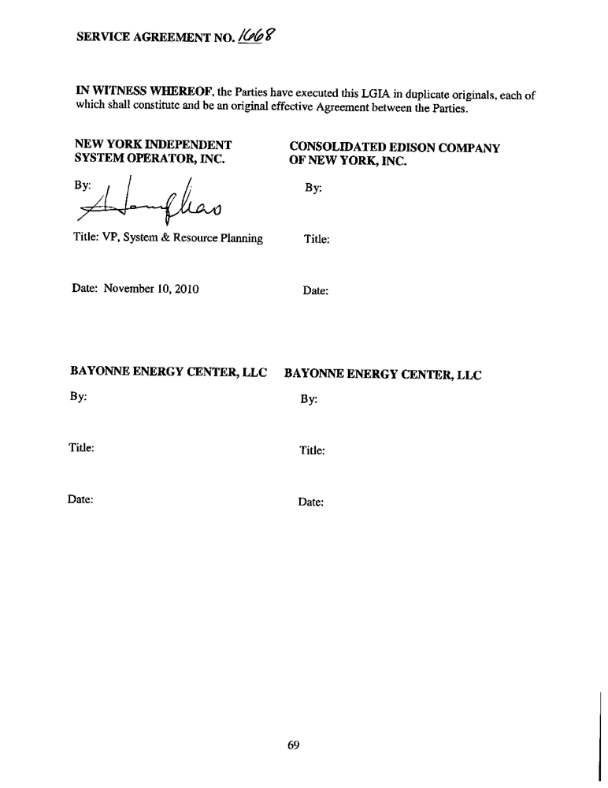

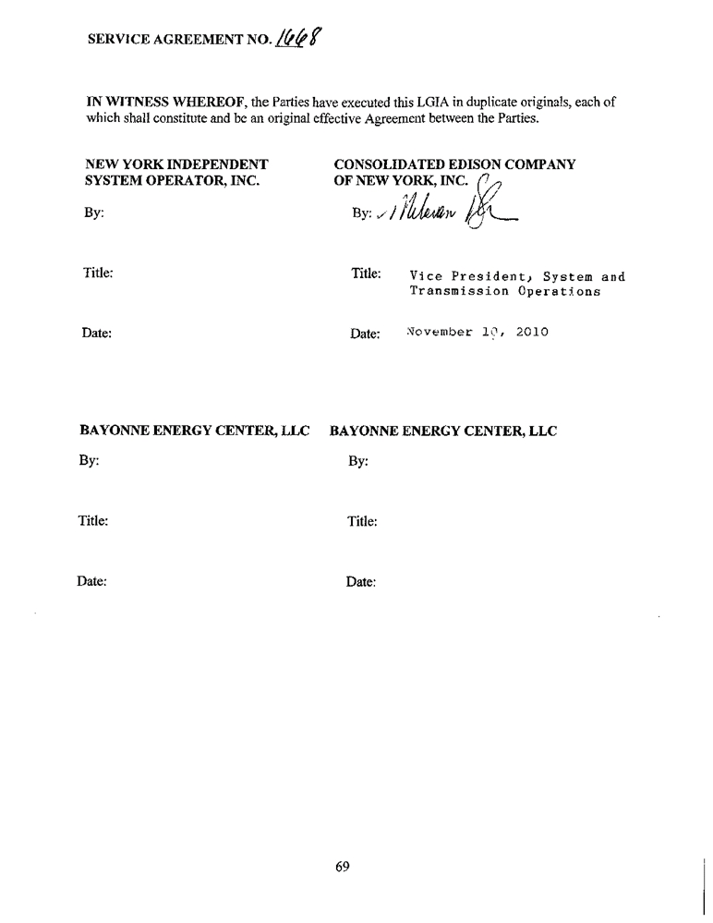

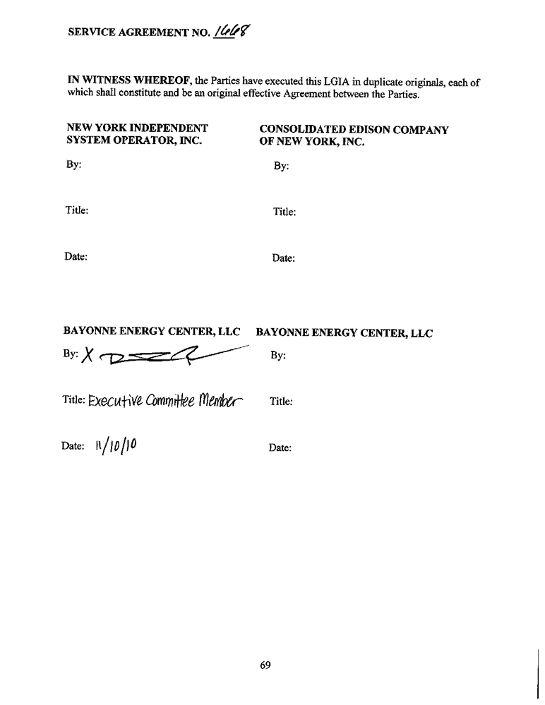

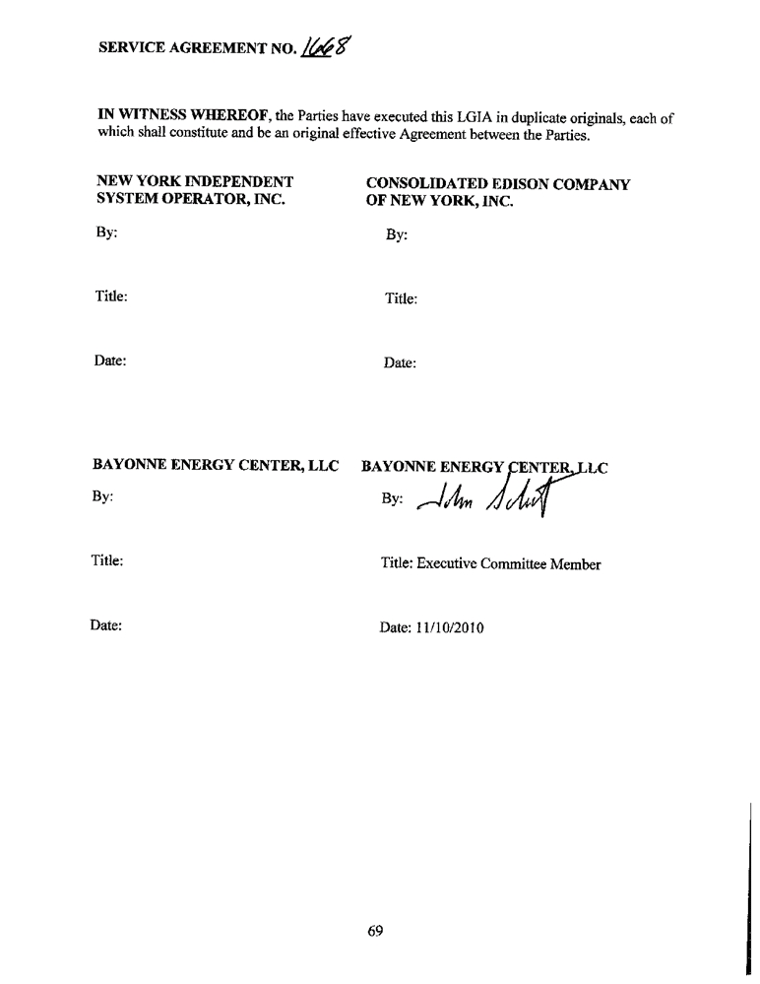

SERVICE AGREEMENT NO. 1668

APPENDICES

Appendix A
Attachment Facilities and System Upgrade Facilities and System Deliverability Upgrades

Appendix B
Milestones

Appendix C
Interconnection Details

Appendix D
Security Arrangements Details

Appendix E
Commercial Operation Date

Appendix F
Addresses for Delivery of Notices and Billings

Appendix G
Interconnection Requirements for a Wind Generating Plant

Appendix H
Gowanus 345 kV Substation Reconfiguration Project Principles

70

SERVICE AGREEMENT NO. 1668

APPENDIX A

ATTACHMENT FACILITIES AND SYSTEM DELIVERABILITY UPGRADES
1. Attachment Facilities:
(a) Developer’s Attachment Facilities (“DAF”):
The DAF consist of the following: (i) approximately 6.75 miles of a single circuit, three-phase,
345 kV solid dielectric cable extending from the Large Generating Facility in Bayonne, New
Jersey, to and including the potheads to be used by Developer in the Gowanus Substation; (ii) all
terminations, splices and appurtenances as necessary to connect the cable to the CTOAFs; (iii) an
interface cabinet, containing fiber optic and cable monitoring equipment, raceways, and
terminations; and (iv) two physically separate communications routes in accordance with CTO’s
design specification.
The DAF include the following equipment:
• A 138 kV five breaker ring bus, 345-138 kV step up transformer, and 345 kV circuit
breaker to facilitate connection of each generator step-up transformer (GSU) to the transmission cable leading to Gowanus substation
• One (1) three phase, two winding, 138/345 kV delta-wye step-up transformer rated
366/488/610 MVA (ONAN/ODAF/ODAF), with specified impedance of 14.5% @ 366 MVA
• Four (4) three phase, three winding, 138/13.8 kV/13.8 kV wye-delta-delta, GSU
transformers rated 96/128/160 MVA (ONAN/ONAF/ONAF), with specified impedance of 9% @96 MVA
• Two (2) three phase, two winding, 13.8-4.16 kV delta-wye, Unit Auxiliary
transformers rated 12/16 MVA (ONAN/ONAF), with specified impedance of 6.5%
@ 12 MVA
• One (1) SF6 345 kV 3000 A, 63 kA, circuit breaker
• Five (5) SF6 138 kV 3000 A, 63 kA, circuit breakers
• Eight (8) Vacuum 13.8 kV 4000A, 63 kA circuit breakers
• One (1) 345 kV, 3000A, three phase manual/group operated disconnect switch
• Ten (10) 138 kV, 3000A, three phase manual/group operated disconnect switches
• Four (4) 138 kV, 1600A, three phase manual/group operated disconnect switches
• Three (3) 253 kV MCOV surge arrestors on the incoming line at Bayonne Switchyard

A-1

SERVICE AGREEMENT NO. 1668

• Three (3) 253 kV MCOV surge arrestors on the step-up transformer primary
• Three (3) 98 kV MCOV surge arrestors on the step-up transformer secondary
• Twelve (12) 98 kV MCOV surge arrestors on the GSU primaries
• Twenty-Four (24) 15 kV Class (TBD) MCOV surge arrestors on the generator circuit
breaker line side
• Bus Structures, Bus Conductor, and Associated Foundations
• Communications and Monitoring-RTU and redundant communications to Con
Edison’s ECC and AECC, Automatic ring down phone to Con Edison’s ECC and
RTU-RTU communications between BEC and Gowanus for limited local status and
information
• Metering/Equipment - Revenue metering will be located in Gowanus Substation on
the incoming G27 cable connection
• Protection Systems - Interfaces with GSU protection, bus protection, 345-138 kV
transformer protection (NPCC Bulk Power System compliant) and G27 cable
protection (also interface with Gowanus end) (NPCC Bulk Power System compliant)
• 345kV Lines (submarine and underground cables) 6.75 mile, 345 kV land/submarine
cable line between Bayonne and Gowanus substations; Land cable is 3000kCmil Cu
XLPE; Submarine cable is 1750 kCmil Cu XLPE
• Concrete encased duct banks
• Fiber optic cables and associated interface cabinets
• 345kV Pothead and associated terminal facilities

(b) Connecting Transmission Owner’s Attachment Facilities (“CTOAF”)
The Point of Change of Ownership (“PCO”) and Point of Interconnection (“POI”) are designated on Figure A-1. The CTOAF are depicted on Figure A-1 to this Appendix A and consist of the following equipment located between the PCO and POI:
• One (1) - 345 kV, 3000 A motor-operated disconnect switch and 345 kV grounding
switch
• Grounding materials
• 345kV Bus work located between the potheads and the ring bus

A-2

SERVICE AGREEMENT NO. 1668

• 345kV Bus Structures located between the potheads and the ring bus
• Three (3) coupling capacitor voltage transformers and three (3) surge arresters
• Metering units (combination CT and VT) -- three (3) 345 kV, revenue quality,
including support structure, foundation and associated grounding for metering
Developer-delivered power
2. System Upgrade Facilities (“SUFs”)
CTO’s Gowanus 345kV substation is presently configured as two air-insulated buses, known as a
North Bus and South Bus, each with a circuit breaker, transformer, phase angle regulator
(“PAR”), shunt reactor and three feeder circuit connections. The two buses are electrically
independent of each other and are not interconnected. Circuit breaker 2, transformer 2, PAR R2
and shunt reactor R6 are located on the North Bus with connections to Farragut Substation
(feeder 41T), Goethals Substation (feeder 25) and Greenwood Substation (feeder 42231). Circuit
breaker 14, transformer 14, PAR R14 and shunt reactor R18 are located on the South Bus with
connections to Farragut Substation (feeder 42T), Goethals Substation (feeder 26) and Greenwood
Substation (feeder 42232).
(a) Stand-Alone System Upgrade Facilities (“Stand-Alone SUFs”)
The Stand-Alone SUFs identified under this Agreement are located within the Gowanus
Substation. The Gowanus Substation will be reconfigured to an eight breaker ring bus, as shown in Figure A-1 to Appendix A, to accommodate the interconnection of the Large Generating
Facility. The design basis for the Gowanus Substation is a double ring configuration, with each ring having 12 breakers. The ring bus configuration will require the addition of six (6) circuit breakers, associated disconnect switches, buswork, protection devices, and associated structures. There is adequate space in the Substation to accommodate the expansion of the North and South Bus into the proposed eight breaker ring depicted in Figure A-1.
The Stand-Alone SUFs consist of the following major electrical and physical equipment:
• Six (6) 345kV, 3000A, 63kA, dead tank, SF6 circuit breakers with pre-insertion
resistors
• Eighteen (18) 345 kV, 3000 A, three-phase, motor operated disconnect switches with
manually operated ground blades, including ground switches, support structure,
foundation, and associated grounding
• Twenty-one (21) 345 kV Coupling Capacitor Voltage Transformers
• Thirty (30) 345 kV station class Surge Arresters, including support structures,
foundations and hardware
• Ten (10) bus sections including support structures, foundations and hardware

A-3

SERVICE AGREEMENT NO. 1668

• Electrical relocation of Shunt Reactor R6 and R18 connections to bus positions
associated with feeders 41 and 42, respectively, including installation of one (1)
345kV, 3000A three phase motor operated disconnect switch. (This is in addition to the 19 DS listed above under CTOAFs and Stand-Alone SUFs, making a total of 20 DS for the entire project, plus any identified from detailed engineering.)
• One (1) Control Building in the substation yard. The Control Building will include
the following main areas and equipment systems:
 control room,
 new station automation control system,  Protective System Test (PST) room,  two (2) relay protection rooms,
 Thirty-two (32) new protection panels and associated equipment for two (2)
lines of NPCC bulk power system protection (where required),
 two (2) battery rooms,
 two (2) rectifier areas,
 two (2) electrical rooms, including two (2) A/C load boards, and two (2) DC
load boards.
 security system room,
 building fire detection and station security system,  two (2) communication rooms,
 HVAC systems, including Building Management System (BMS).
• One (1) lightning protection system
• One (1) grounding system.
• Protective Relay Equipment: relay protection equipment at the Gowanus Substation
for purposes of interconnecting the Large Generating Facility and controlling flows to adjacent substations, including:
 Two (2) fully independent and physically separated lines of protection,  One (1) line 1 protection system with hard-wired CT and PT connections
between devices in the yard and the control house, and relays,
 One (1) line 2 protection system with fully functional implementation of IEC-
61850 communication and relays, including a HardFiber Process Bus System
with Bricks, fiber interface cabinets, and an Air Blown Fiber system,
 One (1) Digital Fault Recorder,

A-4

SERVICE AGREEMENT NO. 1668

 Equipment for communication with remote end relays at Goethals and
Farragut, consisting of two (2) RFL IMUX units and two (2) RFL GARD 8000 units.

(b) Other System Upgrade Facilities (“Other SUFs”)
Other System Upgrade Facilities (“Other SUFs”) will be located at CTO’s Goethals and Farragut substations. Those SUFs include the following relay protection equipment:

Farragut
First Line Protection:

• The existing LCB II relay will be replaced with a new relay matching what is being
installed on feeder 41 at Gowanus.
• The existing LCB II relay will be replaced with a new relay matching what is being
installed on feeder 42 at Gowanus.

• Mounting plates will be used if needed to interface new relays with existing panel
cutouts.
• Relay replacements will be made on existing panels and interface with existing panel
wiring.

Second Line Protection:
• The existing DLS relay will be replaced with a new relay matching what is being
installed on feeder 41 at Gowanus.

• Existing DLS relay will be replaced with a new relay matching what is being installed
on feeder 42 at Gowanus.
• Mounting plates will be used if needed to interface new relays with existing panel
cutouts.

• Relay replacements will be made on existing panels and interface with existing panel
wiring.

Common:
• Common RFL equipment will be retrofitted in the Route #1 and Route #2 audio tone
cabinets.

A-5

SERVICE AGREEMENT NO. 1668

Goethals

First Line Protection:
• The existing LCB II relay will be replaced with a new relay matching what is being
installed on feeder 25 at Gowanus.

• The existing LCB II relay will be replaced with a new relay matching what is being
installed on feeder 26 at Gowanus.
• Mounting plates will be used if needed to interface new relays with existing panel
cutouts.
• Relay replacements will be made on existing panels and interface with existing panel
wiring.

Second Line Protection:

• The existing DLS relay will be replaced with a new relay matching what is being
installed on feeder 25 at Gowanus.
• The existing DLS relay will be replaced with a new relay matching what is being
installed on feeder 26 at Gowanus.

• Mounting plates will be used if needed to interface new relays with existing panel
cutouts.
• Relay replacements will be made on existing panels and interface with existing panel
wiring.

Common:
• Common RFL equipment will be retrofitted in the Route #1 and Route #2 audio tone
cabinets.

A-6

SERVICE AGREEMENT NO. 1668

3. Cost Estimates
The Large Generating Facility is, as of the Effective Date, a member of Class Year 2009. The
Interconnection Facility Study for that Class Year is not complete as of the Effective Date.
However, CTO has provided Developer and the NYISO with the following draft cost estimates,
totaling $72,193,690 for the CTOAFs, Stand-Alone SUFs, and Other SUFs identified in Sections
1(b), 2(a) and 2(b) of this Appendix A, as input to the Class Year 2009 Interconnection Facilities
Study:
CTOAFs $ 1,241,431
SUFs
Stand-Alone SUFs (including 69,747,723
relocation of shunt reactors at
Gowanus)
Other SUFs
Goethals 618,246
Farragut 586,290
TOTAL for SUFs $70,952,259
The final cost estimate will be reported in the final Class Year 2009 Interconnection Facilities
Study.
4. Security
Developer and CTO have executed a Security Agreement simultaneously with this Agreement. That Security Agreement implements the provisions of Attachment S of the NYISO OATT relating to Security with respect to the Stand-Alone SUFs and Other SUFs identified in this Appendix A. Accordingly, the Security Agreement is not subject to or affected by Article 29.6 of this Agreement relating to contemporaneous or other agreements.
5. Required Additional Facilities and Conditions to Operations
At the request of Developer, this Agreement was executed prior to the completion of the Class Year 2009 Interconnection Facilities Study. As a result, the interconnection and operation of the Large Generating Facility may require the construction of CTOAFs, System Deliverability
Upgrades (“SDUs”) and/or SUFs in addition to the CTOAFs, Stand-Alone SUFs, and Other
SUFs identified in this Appendix A.
If the CTOAFs, SDUs or SUFs for Developer’s Large Generating Facility identified in the Class
Year 2009 Interconnection Facilities Study differ in any material way from the facilities
identified in the Appendices to this Agreement, the Parties shall amend this Agreement after
Developer has accepted its Project Cost Allocation for Class Year 2009, pursuant to Articles
29.11 and 29.12 to reflect the CTOAFs, SDUs and SUFs identified in the Class Year 2009
Interconnection Facilities Study and the responsibility to design, engineer, procure and construct such facilities and any necessary cost responsibility and security requirements, as agreed to by CTO and Developer.

A-7

SERVICE AGREEMENT NO. 1668

Developer may not supply Unforced Capacity to the New York Control Area from the Large
Generating Facility until Developer has complied with the deliverability requirement pursuant to Attachment S of the NYISO OATT, including acceptance of any cost allocation for SDUs and the posting of associated security or payments.
Before undertaking Trial Operation of the Large Generating Facility, the Developer must accept the cost allocated to the Large Generating Facility for SUFs and SDUs through the 2009 Class Year Interconnection Facilities Study, and post any security or make any payment required, pursuant to Attachment S of the NYISO OATT.
If any of the SUFs are not reasonably expected to be completed prior to the Initial
Synchronization Date of the Developer’s Large Generating Facility, NYISO shall, upon the
request and at the expense of Developer, in conjunction with the CTO, perform operating studies
(including possible updating of the EMTP Study) on a timely basis to determine whether and the
extent to which the Developer’s Large Generating Facility, the DAFs and the CTOAFs may
commence Trial Operation prior to the completion of the SUFs consistent with Applicable Laws
and Regulations, Applicable Reliability Standards (excluding CTO’s Transmission Planning
Criteria), Good Utility Practice, and this Agreement. CTO and NYISO shall permit Developer to
operate the Developer’s Large Generating Facility, the DAFs and the CTOAFs during Trial
Operation in accordance with the results of such studies and the NYISO’s testing procedures and
requirements.

A-8

Page A-9 contains CEII and has been removed from this version

SERVICE AGREEMENT NO. 1668

APPENDIX B

MILESTONES

1. Selected Option Pursuant to Article 5.1

Developer has elected the Option to Build under Article 5.1.3 of the Agreement with respect to the Stand-Alone SUFS and the CTOAFs, except for the functions identified in Appendix H that will be performed by the CTO, which the CTO will perform in accordance with the Standard Option under Article 5.1.1.

2. Milestones

The following milestones shall apply to the construction and interconnection of the Large Generating Facility.
The times projected for the milestones are non-binding estimates. The actual dates for
completion of the milestones are highly dependent upon lead times for the procurement of
equipment and material, the availability of labor, outage scheduling, receipt of regulatory
approvals, and the results of equipment testing. The completion and results of the NYISO Class Year 2009 Interconnection Facilities Study, environmental remediation of the site, and other unforeseen events could also affect the achievement of the milestones.
Item Milestone Responsible Party Due Date
(a) Notice to Proceed from Developer to Developer Completed 2/23/10
commence certain Engineering and
Procurement activities as per the
Engineering and Procurement
Agreement
(b) Submit proof of insurance coverage Developer At least three
in accordance with Article 18.3 of Business Days prior
this Agreement to the start of
construction
(c) Completion of engineering packages CTO Initial package
for the CTOAF and SUF completed
5/17/2010; Final package by
12/1/2011
(d) Commence construction of the DAF, Developer November 8, 2010
CTOAF, and SUF

B-1

SERVICE AGREEMENT NO. 1668

(e) Con Edison Outage Schedule:¹ Developer (for Finish Dates:
Outage # 1 construction March 19, 2011
Outage # 2 activities) April 30, 2011
Outage # 3 and November 20, 2011
Outage # 4 CTO (for the February 22, 2012
Outage # 5 scheduling of March 16, 2012
Outage # 6 outages and tasks April 30, 2012
outlined in
Appendix H)

(f) Submittal of initial, updated and
final specifications for the DAF (including System Protection
Facilities) shall be as provided in
Section 5.10.1 of this Agreement,
unless the Parties agree otherwise.
(g) Complete Development of Pre-
Energization Checklist Form,
including procedures for Trial
Operation. Items on checklist must be completed prior to Initial
Synchronization Date for each Generating Facility unit
Developer April 17, 2011 for
initial
specifications; July 16, 2011 for final specifications.

Developer and CTO September 1, 2011
(i.e., 60 days prior
to the In-Service
Date).

(h) Complete construction and testing of Developer and CTO November 24, 2011

DAFs and CTOAFs (if required)

(i) In-Service Date ² Developer November 25, 2011

(j) Initial Synchronization Date (if Trial Developer November 26, 2011⁴

Operation is permitted without fully

completed SUFs)³

(k) Complete construction and testing of Developer and CTO April 30, 2012

the SUFs

(l) Submit “as-built” drawings,
information and vendor test
documents for DAF, CTOAF and
SUF and Large Generating Facility
to CTO.

(m) Initial Synchronization Date (if Trial
Operation is not permitted without fully completed SUFs)
(n) Complete testing of Generating
Facility and SUF.
(o) Commercial Operation Date
Developer and CTO Within 120 calendar
days after
completion of
construction and
testing of each
category of facilities
Developer May 1, 2012

Developer and CTO May 1, 2012

Developer May 2, 2012

B-2

SERVICE AGREEMENT NO. 1668

1

2

3

4

Developer shall procure and coordinate with CTO delivery of equipment to Gowanus Substation that is required to complete the work necessary for each outage.
Prior to energizing the Large Generating Facility for backfeed, Developer shall comply
with NYISO Procedures and request and obtain written approval for energization from
CTO. If the facility is ready for energization, CTO shall grant such approval within ten
(10) days of receiving the request.
Prior to synchronizing each generating unit for the first time, Developer shall comply
with NYISO Procedures and request and obtain written approval for synchronization
from CTO. If the unit is ready for synchronization, CTO shall grant such approval within ten (10) days of receiving the request.
Whether Trial Operation is permitted prior to the completion of the SUFs shall be determined in accordance with the results of the operating studies performed under Section 5 of Appendix A.

B-3

SERVICE AGREEMENT NO. 1668

APPENDIX C

INTERCONNECTION DETAILS
1. Description of the Large Generating Facility including Point of Interconnection
The Large Generating Facility is a nominal 512 MW multi-unit, simple-cycle natural gas-fired (with ultra low sulfur diesel oil as a backup fuel) Large Generating Facility to be located in
Bayonne, New Jersey. The Large Generating Facility has a net summer capability of 500 MW at 95º F, and a net winter capability of 500 MW at 10º F. The Large Generating Facility will not deliver in excess of 500 MW to the Point of Interconnection at any time.
The Large Generating Facility will consist of eight 64 MW generating units connecting to a 138 kV ring bus via four 13.8-13.8-138 kV three winding step-up transformers (GSU). From the ring bus, power will be delivered to Con Edison’s Gowanus 345 kV Substation via a two winding, 138-345 kV switchyard step up transformer (SSU) and a 6.75 mile AC land/submarine cable. The Point of Interconnection will be between Breakers #20 and #22 of the 345kV ring bus to be developed, at Gowanus, as a result of this project; see Figure A-1 of Appendix A. The major Equipment within the Large Generating Facility includes:
• Eight (8) Combustion Turbine Generator Packages (CTGs): Each unit consist of a
Rolls Royce Trent 60 Dual Fuel WLE Simple Cycle, Aeroderivitive Combustion
Turbine with a 2 pole, 60 Hz, Open Air Cooled Siemens Generator, rated at 75.3
MVA, 64 MW, .85 PF lagging / .95 PF leading, operating at a nominal terminal
voltage of 13.8 kV.
• CTG Step Up Transformers: Four (4) three winding, three phase, (delta-delta-wye)
transformers 13.8-13.8 kV-138 kV, 96/128/160 MVA (ONAN/ONAF/ONAF), and
specified impedance at 9%@96MVA
• Switchyard Step Up Transformer: One (1) two winding, three phase, (delta-wye)
transformer 138-345 kV kV, 366/488/610 MVA (ONAN/ODAF/ODAF), and
specified impedance at 14.5%@366MVA
2. Operating Requirements
(a) NYISO Requirements
Developer shall comply with all applicable provisions of NYISO tariffs and procedures, as amended from time to time.
(b) Connecting Transmission Owner Requirements
Developer shall comply with CTO operating instructions and generator interconnection
requirements, which requirements shall include the dedicated data circuits to be maintained by
Developer in accordance with Article 8.1 of this Agreement. Operating instructions will be

C-1

SERVICE AGREEMENT NO. 1668

communicated by telephone, or such other means of communication as the Parties may agree
upon.
An operating procedure will be developed by CTO and Developer to coordinate the operation of their interconnected equipment and to provide applicable contact information.
(c) Power Factor Design Criteria
Developer shall design the Large Generating Facility to maintain an effective power delivery at
maximum capability at the Point of Interconnection at a power factor to be measured at the point
at Gowanus where power from the Large Generating Facility is metered within the range of 0.93
lagging (vars to CTO) to 0.95 leading (vars from CTO). This capability will be available to the
CTO’s system as requested by CTO or NYISO, subject to the actual voltage at the Point of
Interconnection and the voltage schedule given in Section 2(d) below. Developer and CTO will
review DAF transformer tap settings as may be needed to optimize operation for changes in
transmission system conditions, on a seasonal basis, and implement such changes to optimize the
tap settings with CTO approval.
(d) Voltage Schedules
Once the Developer has synchronized the Large Generating Facility with the New York State
Transmission System, NYISO shall require Developer to operate the Large Generating Facility
to transmit the reactive power within the design capability set forth in Article 9.5.1 (Power
Factor Design Criteria), provided that the voltage at the Point of Interconnection is within the
range of 346 kV to 362 kV in accordance with CTO’s engineering specification EP-7000. When
the voltages are outside of the range specified in EP-7000 due to conditions outside the control of
CTO and the NYISO, the Developer shall also provide assistance consistent with Good Utility
Practice within the full capability of the Large Generating Facility in restoring the voltage at the
Point of Interconnection to the normal range as may be directed by the CTO or NYISO
operators. If the Large Generating Facility is unable to provide the requested assistance, or
maintain the specified power factor, it shall promptly notify both the CTO and NYISO operators.
(e) Trial Operation
In addition to other applicable requirements, including those stated in Article 5.2 and Appendix A, Section 5 of this Agreement, Developer shall satisfy the following conditions before
commencing Trial Operation of the Large Generating Facility:
• Sixty (60) days prior to the Initial Synchronization Date for each generating unit,
Developer and CTO will develop and agree on a pre-energization checklist and startup procedures, specifying the tasks that must be completed prior to the Initial
Synchronization Date for that generating unit.
• Developer shall complete all of the non-unit-specific checklist tasks prior to initially
energizing the Large Generating Facility, and unit-specific tasks prior to initial
synchronization of each generating unit.

C-2

SERVICE AGREEMENT NO. 1668

• Trial Operation shall continue to the extent consistent with NYISO Procedures,
OATT and Market Services Tariff requirements, but in no event shall any operation continue beyond October 31, 2012 if all SUFs are not completed, unless otherwise agreed by the Parties.
(f) Station Power
Prior to the In-Service Date, Developer will obtain station power from a third party via a
connection between the Large Generating Facility and the Public Service Electric and Gas
Company (“PSE&G”) system. Commencing on the In-Service Date, that connection will be opened and will be closed only when the interconnection of the Large Generating Facility to the Gowanus Substation is interrupted. Developer shall submit for CTO’s review and approval its proposed procedure or equipment to ensure that the emergency connection does not inadvertently connect CTO’s and PSE&G’s systems. At no time shall Developer operate the facilities so that the PSE&G and CTO electric systems are connected in parallel.
Commencing on the In-Service Date, Developer may receive station power pursuant to available procedures. Unless CTO and Developer agree otherwise in the future, CTO will not sell station power to Developer.

(g) Additional Agreements

The Developer and the Connecting Transmission Owner have entered into the agreements
identified as (i) the License Agreement dated July 29, 2010, and (ii) the Grant of Easement
dated August 6, 2010 (the “Additional Agreements”), each as it may be amended from time to
time. It is the belief and intention of the Parties that nothing in this Agreement conflicts in any
material way with those Additional Agreements. Nevertheless, if a Party becomes aware of a
conflict, it shall notify the other Parties promptly so that the Parties can discuss what, if any,
amendment of this Agreement would be appropriate under the circumstances.

C-3

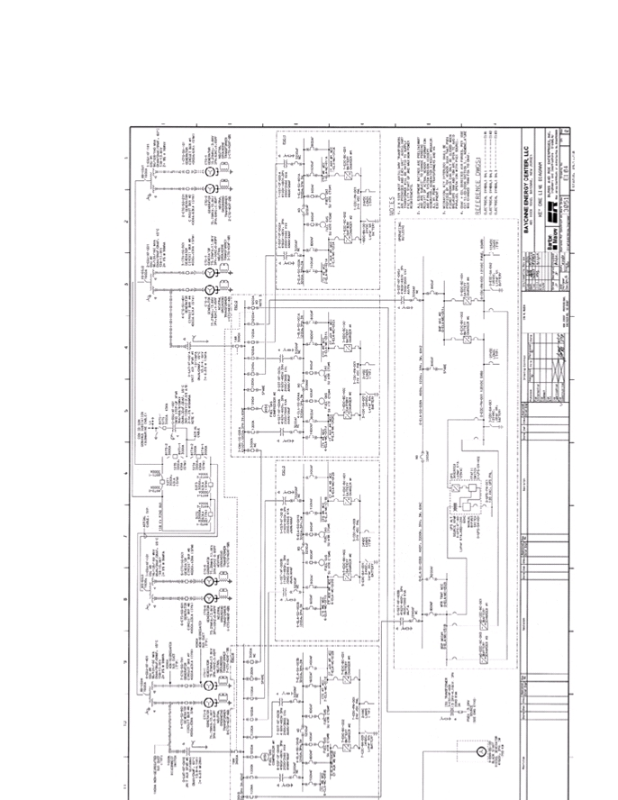

SERVICE AGREEMENT NO. 1668

ATTACHMENT C-1 TO APPENDIX C
BAYONNE ENERGY CENTER PLANT ONE-LINE DIAGRAM

C-4

SERVICE AGREEMENT NO. 1668

APPENDIX D

SECURITY ARRANGEMENTS

Infrastructure security of New York State Transmission System equipment and operations and control hardware and software is essential to ensure day-to-day New York State Transmission System reliability and operational security. The Commission will expect the NYISO, all
Transmission Owners, all Developers and all other Market Participants to comply with the recommendations offered by the President’s Critical Infrastructure Protection Board and,
eventually, best practice recommendations from the electric reliability authority. All public utilities will be expected to meet basic standards for system infrastructure and operational security, including physical, operational, and cyber-security practices.

D-1

SERVICE AGREEMENT NO. 1668

APPENDIX E

COMMERCIAL OPERATION DATE

[Date of Letter]

New York Independent System Operator, Inc.
3890 Carman Road
Schenectady, N.Y. 12303
Attn: Vice President, Operations

Re: _____________ Large Generating Facility

Dear __________________:

Consolidated Edison of New York, Inc.
4 Irving Place
New York, NY 10003
Attn: Senior Vice President, System and Transmission Operations
Fax: (212) 460 - 1252

On [Date] [Developer] has completed Trial Operation of Unit No. ___. This letter confirms that [Developer] commenced Commercial Operation of Unit No. ___ at the Large Generating Facility, effective as of [Date plus one day].

Thank you.

[Signature]

[Developer Representative]

E-1

SERVICE AGREEMENT NO. 1668

APPENDIX F

ADDRESSES FOR DELIVERY OF NOTICES AND BILLINGS

Notices:

NYISO:

Before the Commercial Operation Date of the Large Generating Facility

New York Independent System Operator, Inc.
Attn: Vice President, System and Resource Planning
10 Krey Boulevard
Rensselaer, N.Y. 12144
Phone: (518) 356-6000
Fax: (518) 356-6118
After Commercial Operation Date of the Large Generating Facility
New York Independent System Operator, Inc.
Attn: Vice President, Operations
3890 Carman Road
Schenectady, N.Y. 12303
Phone : (518) 356-6000
Fax: (518) 356-6118

Connecting Transmission Owner:

Consolidated Edison of New York, Inc.
4 Irving Place
New York, NY 10003
Attn: Vice President,
System and Transmission Operations Phone: (212) 460-1210
Fax: (212) 460-1252

Copy to:
Consolidated Edison of New York, Inc.
4 Irving Place
New York, NY 10003
Attn: General Counsel
Phone: (212) 460-2432
Fax: (212) 677-5850

F-1

SERVICE AGREEMENT NO. 1668

Developer:

Bayonne Energy Center, LLC 401 Hook Road
Bayonne, NJ 07002
Attn: Plant Manager
Phone:
Fax:

Bayonne Energy Center, LLC c/o Hess Corporation
1 Hess Plaza
Woodbridge, NJ 07095
Attn: John Gartman, BEC Executive Committee Phone: (732) 750-6650
Fax: (732) 750-6670

Bayonne Energy Center, LLC
c/o ArcLight Capital Partners, LLC 200 Clarendon Street, 55th Floor Boston, MA 02117
Attn: Jake Erhard, BEC Executive Committee Phone: (617) 531-6338
Fax: (617) 531-4698

Billing and Payments:
Connecting Transmission Owner:

Consolidated Edison of New York, Inc.
4 Irving Place
New York, NY 10003
Attn: Vice President,
System and Transmission Operations Phone: (212) 460-1210
Fax: (212) 460-1252
Developer:

Bayonne Energy Center, LLC 401 Hook Road
Bayonne, NJ 07002
Attn: Plant Manager
Phone:
Fax:

F-2

SERVICE AGREEMENT NO. 1668

Alternative Forms of Delivery of Notices (telephone, facsimile or email):
NYISO:

Before the Commercial Operation Date of the Large Generating Facility

New York Independent System Operator, Inc.
Attn: Vice President, System and Resource Planning
10 Krey Boulevard
Rensselaer, N.Y. 12144
Phone: (518) 356-6000
Fax: (518) 356-6118
After Commercial Operation Date of the Large Generating Facility
New York Independent System Operator, Inc.
Attn: Vice President, Operations
3890 Carman Road
Schenectady, N.Y. 12303
Phone : (518) 356-6000
Fax: (518) 356-6118
Connecting Transmission Owner:
Consolidated Edison of New York, Inc.
4 Irving Place
New York, NY 10003
Attn: Vice President,
System and Transmission Operations Phone: (212) 460-1210
Fax: (212) 460-1252

Developer:

Bayonne Energy Center, LLC 401 Hook Road
Bayonne, NJ 07002
Attn: Plant Manager
Phone:
Fax:

Bayonne Energy Center, LLC c/o Hess Corporation
1 Hess Plaza
Woodbridge, NJ 07095

F-3

SERVICE AGREEMENT NO. 1668

Attn: John Gartman, BEC Executive Committee Phone: (732) 750-6650
Fax: (732) 750-6670

Bayonne Energy Center, LLC
c/o ArcLight Capital Partners, LLC 200 Clarendon Street, 55th Floor Boston, MA 02117
Attn: Jake Erhard, BEC Executive Committee Phone: (617) 531-6338
Fax: (617) 531-4698

F-4

SERVICE AGREEMENT NO. 1668

APPENDIX G
INTERCONNECTION REQUIREMENTS FOR A WIND GENERATING PLANT

Appendix G sets forth requirements and provisions specific to a wind generating plant.
All other requirements of this LGIA continue to apply to wind generating plant interconnections.

A. Technical Standards Applicable to a Wind Generating Plant
i. Low Voltage Ride-Through (LVRT) Capability
A wind generating plant shall be able to remain online during voltage disturbances up to the time periods and associated voltage levels set forth in the standard below. The LVRT
standard provides for a transition period standard and a post-transition period standard.

Transition Period LVRT Standard
The transition period standard applies to wind generating plants subject to FERC Order
661 that have either: (i) interconnection agreements signed and filed with the Commission, filed
with the Commission in unexecuted form, finally executed as conforming agreements, or filed
with the Commission as non-conforming agreements between January 1, 2006 and December 31,
2006, with a scheduled in-service date no later than December 31, 2007, or (ii) wind generating
turbines subject to a wind turbine procurement contract executed prior to December 31, 2005, for
delivery through 2007.

1. Wind generating plants are required to remain in-service during three-phase faults with
normal clearing (which is a time period of approximately 4 - 9 cycles) and single line to
ground faults with delayed clearing, and subsequent post-fault voltage recovery to prefault
voltage unless clearing the fault effectively disconnects the generator from the system.

G-1

SERVICE AGREEMENT NO. 1668

The clearing time requirement for a three-phase fault will be specific to the wind
generating plant substation location, as determined by and documented by the Connecting
Transmission Owner for the Transmission District to which the wind generating plant will
be interconnected. The maximum clearing time the wind generating plant shall be
required to withstand for a three-phase fault shall be 9 cycles at a voltage as low as 0.15
p.u., as measured at the high side of the wind generating plant step-up transformer (i.e. the
transformer that steps the voltage up to the transmission interconnection voltage or
“GSU”), after which, if the fault remains following the location-specific normal clearing
time for three-phase faults, the wind generating plant may disconnect from the
transmission system.

2. This requirement does not apply to faults that would occur between the wind generator
terminals and the high side of the GSU or to faults that would result in a voltage lower than 0.15 per unit on the high side of the GSU serving the facility.

3. Wind generating plants may be tripped after the fault period if this action is intended as
part of a special protection system.

4. Wind generating plants may meet the LVRT requirements of this standard by the
performance of the generators or by installing additional equipment (e.g., Static VAr Compensator, etc.) within the wind generating plant or by a combination of generator performance and additional equipment.

5. Existing individual generator units that are, or have been, interconnected to the network
at the same location at the effective date of the Appendix G LVRT Standard are exempt
from meeting the Appendix G LVRT Standard for the remaining life of the existing

G-2

SERVICE AGREEMENT NO. 1668
generation equipment. Existing individual generator units that are replaced are required to meet the Appendix G LVRT Standard.

Post-transition Period LVRT Standard
All wind generating plants subject to FERC Order No. 661 and not covered by the transition period described above must meet the following requirements:

1. Wind generating plants are required to remain in-service during three-phase faults with
normal clearing (which is a time period of approximately 4 - 9 cycles) and single line to
ground faults with delayed clearing, and subsequent post-fault voltage recovery to
prefault voltage unless clearing the fault effectively disconnects the generator from the
system. The clearing time requirement for a three-phase fault will be specific to the wind
generating plant substation location, as determined by and documented by the Connecting
Transmission Owner for the Transmission District to which the wind generating plant
will be interconnected. The maximum clearing time the wind generating plant shall be
required to withstand for a three-phase fault shall be 9 cycles after which, if the fault
remains following the location-specific normal clearing time for three-phase faults, the
wind generating plant may disconnect from the transmission system. A wind generating
plant shall remain interconnected during such a fault on the transmission system for a
voltage level as low as zero volts, as measured at the high voltage side of the wind GSU.

2. This requirement does not apply to faults that would occur between the wind generator

terminals and the high side of the GSU.

G-3

SERVICE AGREEMENT NO. 1668

3. Wind generating plants may be tripped after the fault period if this action is intended as
part of a special protection system.

4. Wind generating plants may meet the LVRT requirements of this standard by the
performance of the generators or by installing additional equipment (e.g., Static VAr Compensator) within the wind generating plant or by a combination of generator performance and additional equipment.

5. Existing individual generator units that are, or have been, interconnected to the network
at the same location at the effective date of the Appendix G LVRT Standard are exempt from meeting the Appendix G LVRT Standard for the remaining life of the existing
generation equipment. Existing individual generator units that are replaced are required to meet the Appendix G LVRT Standard.

ii. Power Factor Design Criteria (Reactive Power)

A wind generating plant shall maintain a power factor within the range of 0.95 leading to
0.95 lagging, measured at the Point of Interconnection as defined in this LGIA, if the ISO’s
System Reliability Impact Study shows that such a requirement is necessary to ensure safety or reliability.
The power factor range standards can be met using, for example without limitation,
power electronics designed to supply this level of reactive capability (taking into account any
limitations due to voltage level, real power output, etc.) or fixed and switched capacitors if
agreed to by the Connecting Transmission Owner for the Transmission District to which the
wind generating plant will be interconnected, or a combination of the two. The Developer shall

G-4

SERVICE AGREEMENT NO. 1668
not disable power factor equipment while the wind plant is in operation. Wind plants shall also be able to provide sufficient dynamic voltage support in lieu of the power system stabilizer and automatic voltage regulation at the generator excitation system if the System Reliability Impact Study shows this to be required for system safety or reliability.

iii. Supervisory Control and Data Acquisition (SCADA) Capability
The wind plant shall provide SCADA capability to transmit data and receive instructions from the ISO and/or the Connecting Transmission Owner for the Transmission District to which the wind generating plant will be interconnected, as applicable, to protect system reliability. The Connecting Transmission Owner for the Transmission District to which the wind generating
plant will be interconnected and the wind plant Developer shall determine what SCADA
information is essential for the proposed wind plant, taking into account the size of the plant and its characteristics, location, and importance in maintaining generation resource adequacy and
transmission system reliability in its area

G-5

SERVICE AGREEMENT NO. 1668

APPENDIX H

GOWANUS SUBSTATION RECONFIGURATION
PROJECT PRINCIPLES

1. Construction Option Pursuant to Article 5.1

Developer and CTO shall be responsible for engineering, procurement and construction of the
DAFs, CTOAFs, Stand-Alone SUFs and Other SUFs identified in Appendix A as set forth in the matrix below. Except for engineering work performed by CTO under the Transaction Form 3
Agreement described in Section 2 of this Appendix H and designated “CTO/TF-3” in the matrix below, the responsibilities assigned to CTO for procurement and construction shall be referred to as “CTO Functions.”
The respective responsibilities are:
Interconnection Engineering Procurement Construction Testing
Work Element
Developer Developer Developer Developer Developer
Attachment
Facility

CTO CTO/TF-3 Developer Developer CTO
Attachment
Facility
Stand-Alone CTO/TF-3 Developer Developer CTO
SUF
Other SUF CTO/TF-3 Developer CTO CTO

CTO will perform the CTO Functions in accordance with Article 5.1.1 of this Agreement with reference to the dates set forth in Appendix B. CTO will coordinate the work on the Other SUFs with the work on the Stand-Alone SUFs at the Gowanus Substation.

Notwithstanding the cost estimates in Appendix A and the cost overrun provisions in Section
25.8.6 of Attachment S, Developer shall bear the actual costs of (i) the procurement and
construction of CTOAFs and Stand-Alone SUFs identified in Appendix A assigned to the
Developer in the matrix above; (ii) the engineering, procurement and construction of any
CTOAFs or Stand-Alone SUFs not currently identified in Appendix A that are identified through the detailed engineering and which would not be required but for the Large Generating Facility; and (iii) the procurement related to the Other SUFs identified in Appendix A assigned to the Developer in the matrix above, and (iv) the testing of CTOAF, Stand-Alone SUFs, and Other SUFs assigned to CTO in the matrix above.

H-6

SERVICE AGREEMENT NO. 1668

Developer shall be responsible as required by Attachment S (including the cost overrun
provisions in Section 25.8.6) for the costs of (i) the construction of the Other SUFs identified in Appendix A, and (ii) the engineering, procurement and construction of any Other SUFs not currently identified in Appendix A that are identified through the detailed engineering.
Developer will reimburse CTO for the labor and material costs CTO incurs in performing the CTO Functions and testing functions assigned in the matrix above. CTO’s labor costs shall be based on the time expended by category and the Rates for Accommodation Services set forth in Attachment H-1, as adjusted annually.
2. Engineering, Design and Procurement
Pursuant to Section 9 of Attachment X of the NYISO OATT, CTO and Developer agreed that CTO would provide engineering and procurement services prior to the execution of this
Agreement. The terms of that agreement are set forth in the Master Services Agreement (dated 8/29/08) and Transaction Form 3 (Engineering and Procurement Agreement, dated 8/28/09), which documents are appended as Attachment H-2 to this Appendix.
Developer subsequently directed Con Edison to suspend its procurement function with respect to
the CTOAFs and Stand-Alone SUFs, and Developer will perform that function as provided in
Section 1 of this Appendix H. Developer will procure materials and equipment from CTO-
approved vendors. Such equipment must comply with CTO equipment specifications, which
CTO has supplied together with specific information related to the Gowanus Substation work.
CTO has completed a substantial portion of the engineering work as of the date of this
Agreement, and it will continue and complete the engineering work specified in Transaction Form 3 in accordance with the terms set forth therein.
Engineering for CTOAFs or SUFs not identified in Appendix A for which Developer is responsible under Attachment S shall be covered by the LGIA, not the Transaction
Form 3 Agreement.
3. Construction
(a) CTO Attachment Facilities and Stand Alone System Upgrade Facilities
1. Developer will acquire all permits and easements necessary for the
construction of the CTOAFs and Stand-Alone SUFs on CTO’s property and will construct the CTOAFs and Stand-Alone SUFs within CTO’s
property boundaries consistent with CTO’s Standard Terms for
Construction Projects, Reference Number BEC-22324-06, dated October 26, 2010, to the extent that those Standard Terms are not inconsistent with the terms of this Agreement.
2. The construction of the CTOAFs and the Stand-Alone SUFs shall conform
to the engineering packages issued by the CTO pursuant to the
Transaction Form 3 Agreement described in Section 2 of this Appendix H.
CTO and Developer shall coordinate the work and the equipment testing

H-7

SERVICE AGREEMENT NO. 1668

to support such Milestone Dates. In performing such construction, Developer will use contractors and subcontractors that have been previously approved by CTO.
3. Developer will construct the CTOAF and the Stand-Alone SUF up to the
point when they are ready for connection to CTO’s existing facilities.
Promptly after Developer has completed that construction, CTO will (i)
make the final connection of the CTOAFs and SUFs to its existing
facilities and (ii) complete any agreed-upon remaining construction work
required for the CTOAFs and Stand-Alone SUFs. The Stand-Alone SUFs
will be constructed in several segments. Developer and CTO shall
coordinate their respective work on each segment. If the work on the
Stand-Alone SUFs progresses ahead of schedule or is delayed, CTO will
endeavor to reschedule the remaining outages in accordance with the
NYISO Procedures, taking into consideration system outages and
conditions on the system, in an attempt to complete the project
expeditiously.
4. The Stand-Alone SUFs will be constructed and energized in segments.
5. Developer will develop and provide as-built drawings as each segment of
the work is completed, consistent with CTO’s formatting requirements. Developer will provide sets of as-built drawings to CTO for its files and archives within the time period specified in Appendix B.
6. Developer shall provide and install that relay protection equipment and
corresponding equipment at the Large Generating Facility with which the
Gowanus equipment will interface. Developer shall coordinate the
procurement, installation, and testing of such relay protection equipment
with CTO. CTO will make all connections of relay protection equipment
to the live panels and will test all relay protection equipment at the
Gowanus Substation. The requirements in Article 9.6.4.6 of this
Agreement, that Developer and CTO perform tests of the System
Protection Facilities by certain dates and at certain intervals, will be
satisfied by the performance of such tests in a manner and at intervals
consistent with CTO’s standard practice for performing such tests, and in
accordance with NERC and NPCC compliance requirements.
7. The commissioning and testing of the protective relaying system will be
done by CTO’s Protective System Testing group (“PST”). PST will also
perform the functional testing of the substation automation system and
acceptance testing with respect to primary equipment, including, but not
limited to, the following: circuit breakers, disconnect switches, instrument
transformers, surge arrestors, and light and power transformers. All
disconnection or connection in any live or existing relay cabinets and
corresponding equipment will be performed by CTO’s Electric

H-8

SERVICE AGREEMENT NO. 1668

Construction Bureau (“ECB”). Work at remote-end substations is also required and will be performed by CTO personnel.
8. Developer shall perform any punch list activities for the CTOAF and SUF
that it can perform without affecting the day-to-day operation of the New
York State Transmission System. CTO shall perform the remainder of the
punch list items.
(b) Developer Attachment Facilities
1. Developer will acquire all permits and easements necessary for the
construction of the DAFs on Con Edison’s property and will construct the DAFs within CTO’s property boundaries consistent with CTO’s Standard Terms for Construction Projects.
2. Developer shall coordinate with CTO to ensure proper interface of the
DAF with the termination stand, its accessories, and CTOAFs.
3. Developer will develop and provide as-built drawings for the DAF and the
Large Generating Facility as the work is completed. Developer will
provide sets of as-built drawings to CTO for its files and archives within a time period specified in Appendix B.
4. CTO shall provide AC and DC station service to the interface cabinets for
the DAFs listed in Appendix A, if needed.
(c) Project Management and General Responsibilities
1. CTO and Developer will create a joint steering committee, consisting of
representatives of affected departments, to oversee all aspects of the
scoping, engineering, design, construction and commissioning associated
Large Generating Facility and the reconfiguration of the Gowanus 345 kV
substation (“Project Steering Committee”). The Project Steering
Committee will include the CTO’s Project Manager and Project Engineer
and such other members as Developer and CTO will appoint. The Project
Steering Committee will conduct conference calls on a bi-weekly basis (or
more frequently, as needed) and will convene meetings on a monthly basis
(or more frequently, as needed). The Project Steering Committee will
develop a project management plan that will outline members’
responsibilities, communication protocol, submittal of project status
reports, etc.
2. CTO and Developer will work together to develop specific facility outage
sequencing and cutover procedures. Work requiring an equipment outage
will be performed in accordance with the NYISO’s and CTO’s system
operations and outage scheduling practices and procedures. The project’s
outage schedule and construction activities are contingent upon NYISO

H-9

SERVICE AGREEMENT NO. 1668

outage scheduling requirements, system conditions of CTO’s bulk power system and applicable regulatory requirements.
3. Developer shall arrange with CTO for the provision of on-site power
needed for the construction of the CTOAFs and Stand-Alone SUFs.
Developer will specify the voltage and load of the electric load needed and will provide all wiring and equipment consistent with electrical codes and safety practices.
4. Developer will be responsible for arranging for use of existing, or supply
of temporary water and sanitary facilities that may be needed during
construction.
5. Developer will be responsible for site access control of its vehicles and
personnel during working hours at designated access points to the
Gowanus Substation in coordination with designated CTO personnel. Developer will be responsible for security of its stored material and temporary offices at all times. Although CTO will be responsible for overall substation security at all times, CTO is not responsible for Developer’s materials and tools.

6. In accordance with Article 24 of this Agreement, Developer and CTO
shall submit to each other and the NYISO a monthly status report on the
construction and installation of the CTOAFs and SUFs for which each
Party is responsible per this Attachment H. Such monthly reports shall be
provided on the 20th of every month (or next calendar day if the 20th falls
on Holiday or weekend) after the Effective Date of this Agreement.
(d) Operation and Maintenance of CTOAFs
CTO shall operate, test and maintain the Metering Equipment identified in
Appendix A that Developer installs at the Gowanus Substation in accordance with Article 7.1 of this Agreement. The Metering Equipment shall be modified, as necessary and at Developer’s expense, to comply with revisions to the NYISO requirements, as may occur from time to time.
Such Metering Equipment shall be tested annually or, at the NYISO’s or
Developer’s request, more frequently than annually. CTO will provide
operational data on power flow, voltage and circuit breaker positions to NYISO, consistent with NYISO operating data requirements in the NYISO Revenue
Metering Requirements Manual (Manual 25) and in Section 3.2 of NYISO
Control Center Requirements Manual (Manual 21). CTO shall also provide the following data to Developer: meter readings, bus Section 22 voltage, and breaker positions for Breaker Nos. 20 and 22.
Developer shall reimburse CTO on an annual basis in accordance with Article 12
for (i) the property taxes CTO has paid on the CTOAFs during the preceding year,

H-10

SERVICE AGREEMENT NO. 1668

and (ii) the actual costs CTO has reasonably incurred to operate and maintain the
CTOAFs consistent with Articles 9.2 and 10 of this Agreement and Good Utility
Practice.
(e) Ownership of the CTOAF and Stand Alone SUFs
1. The Stand-Alone SUFs shall be constructed in Segments as identified in
the Table below. The construction work on the Stand-Alone SUFs that is
completed, tested as required and accepted by Con Edison as of the time
of each designated Segment Completion Event specified in the Table shall
be transferred and conveyed to Con Edison as provided in this Section
3(e). For purposes of testing, equipment that is not placed in service at the
time of the Service Completion Event shall be component tested, and
equipment that is placed in service at the time of the Segment Completion
Event shall be functionally tested with the system to determine fitness for
commercial operation.

SEGMENT
NUMBER SEGMENT COMPLETION EVENT

1 Security Posting Date Under Attachment S
2 At or about end of Outage 2
3 Completion of Control Building
4 At or about end of Outage 3 (partial ring bus)
Completion of Ring Bus and payment of all costs of
5
Stand-Alone SUFs
2. Developer shall notify CTO upon completion of the construction of the
CTOAF and shall identify the Stand-Alone SUFs that it believes are
complete and ready for acceptance by Con Edison at the time of each
Segment Completion Event. Thereafter, the two Parties shall inspect and
test those facilities to confirm their compliance with the specifications by
which they were designed and constructed. Promptly after those matters
have been confirmed to CTO’s reasonable satisfaction, CTO shall provide
written notification to Developer that the CTOAF and the affected Stand
Alone SUFs are acceptable. Developer shall then provide CTO with a bill
of sale in the form attached hereto as Attachment H-3, reflecting transfer
and conveyance of the affected facilities to CTO, free and clear of any
liens or encumbrances, as of the date on which the bill of sale is provided (the “Conveyance Date”) in consideration for $1.

H-11

SERVICE AGREEMENT NO. 1668

3. CTO assumes ownership of the CTOAF and/or a Segment of the Stand-
Alone SUFs as of the Conveyance Date for the facilities involved. Prior to a Conveyance Date, Developer shall own and shall bear the risk of loss of, the equipment to be installed as the CTOAF and Stand Alone SUFs being conveyed. As of the Conveyance Date, the ownership and risk of loss for the conveyed equipment shall pass to CTO.
4. If CTO requires FERC approval under Section 203 of the Federal Power
Act to acquire the CTOAF and Stand Alone SUFs, it shall file an
application with FERC as soon as practicable after the date of this
Agreement requesting such authorization. Subject to the issuance of that authorization, ownership of the CTOAF and SUFs shall transfer from Developer to CTO as provided in Paragraph 1 above.
5. Developer shall use Reasonable Efforts to obtain warranties from vendors
and contractors with respect to materials, equipment, and services
pertaining to the CTOAF and Stand-Alone SUF that are assignable to
CTO. As soon as possible after the Conveyance Date, Developer shall
assign to CTO all warranties received from vendors and contractors
pertaining to the CTOAF and Stand-Alone SUF to the extent that such
warranties are assignable. To the extent that such warranties are not
assignable, upon the request of CTO, Developer shall use Reasonable
Efforts to enforce any such warranties for the benefit of CTO. CTO shall reimburse Developer for any third-party costs associated with
implementing this requirement.

H-12

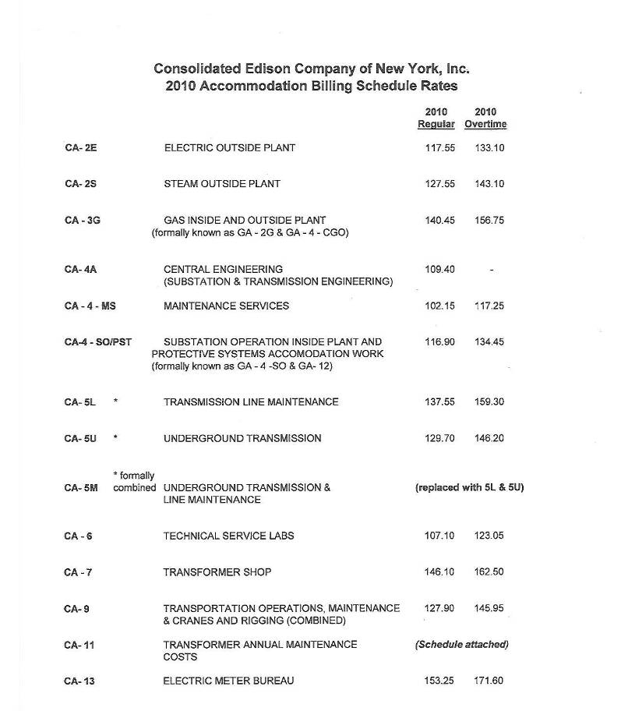

SERVICE AGREEMENT NO. 1668

ATTACHMENT H-1 TO APPENDIX H
RATES FOR ACCOMMODATION SERVICES

H-13

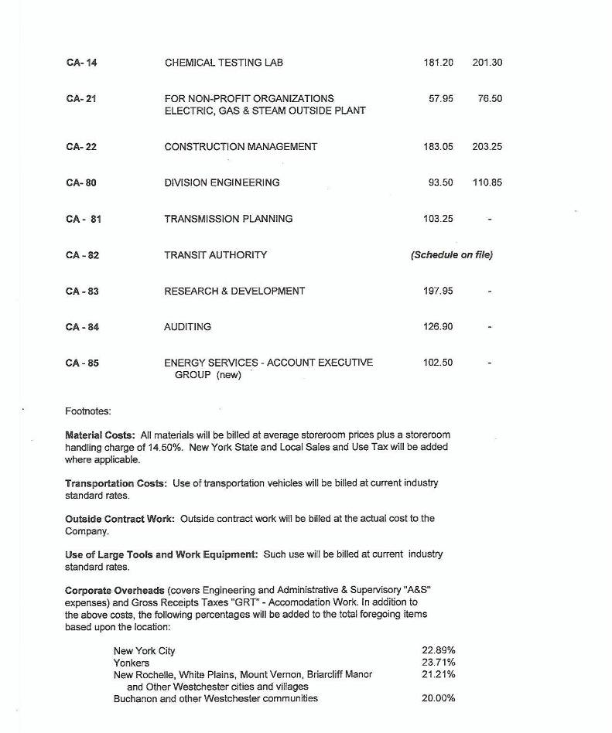

S

H-14

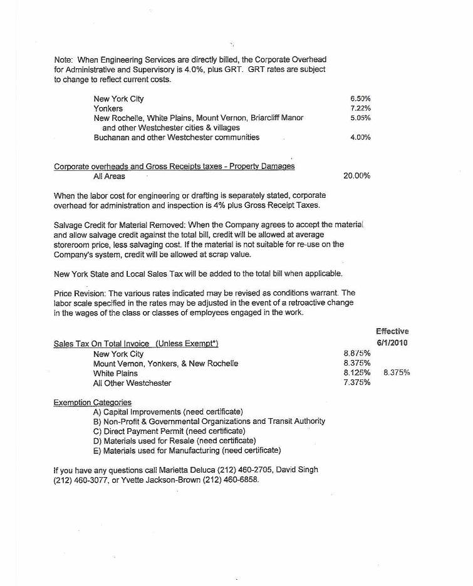

S

H-15

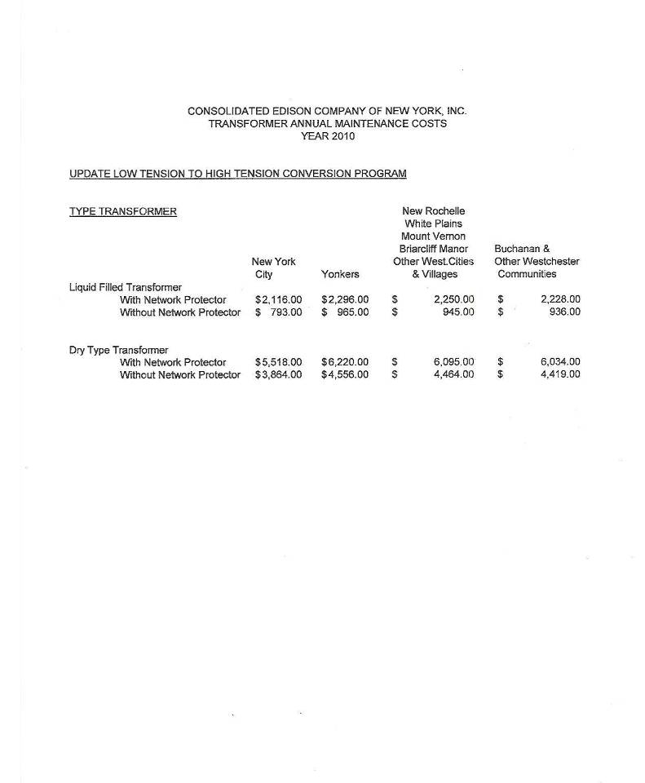

S

H-16

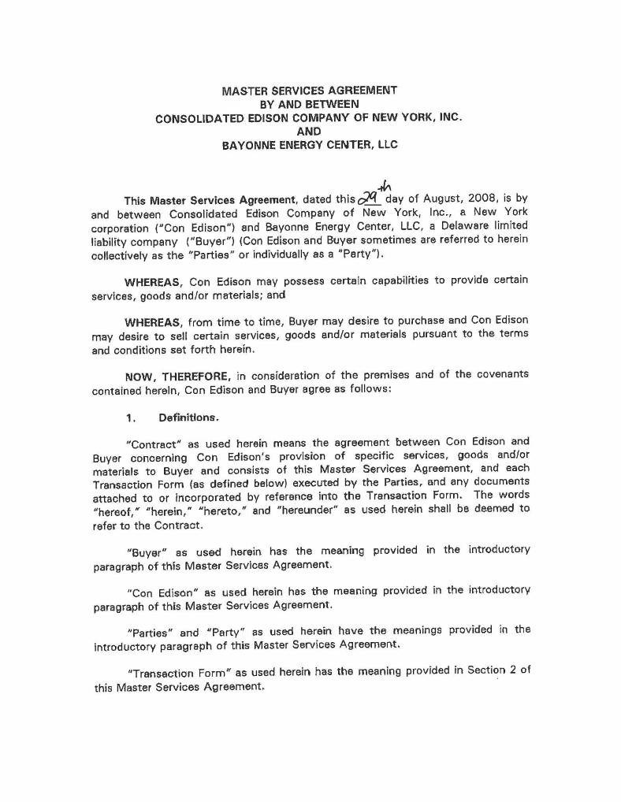

SERVICE AGREEMENT NO. 1668

ATTACHMENT H-2A TO APPENDIX H
MASTER SERVICE AGREEMENT
TRANSACTION FORM 3

H-17

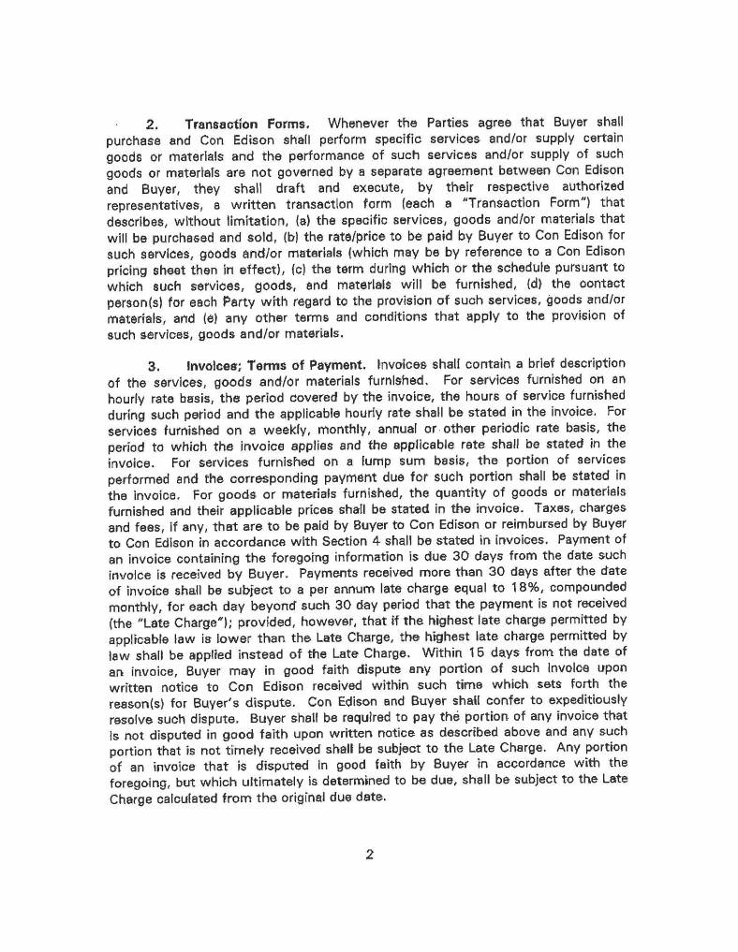

S

H-18

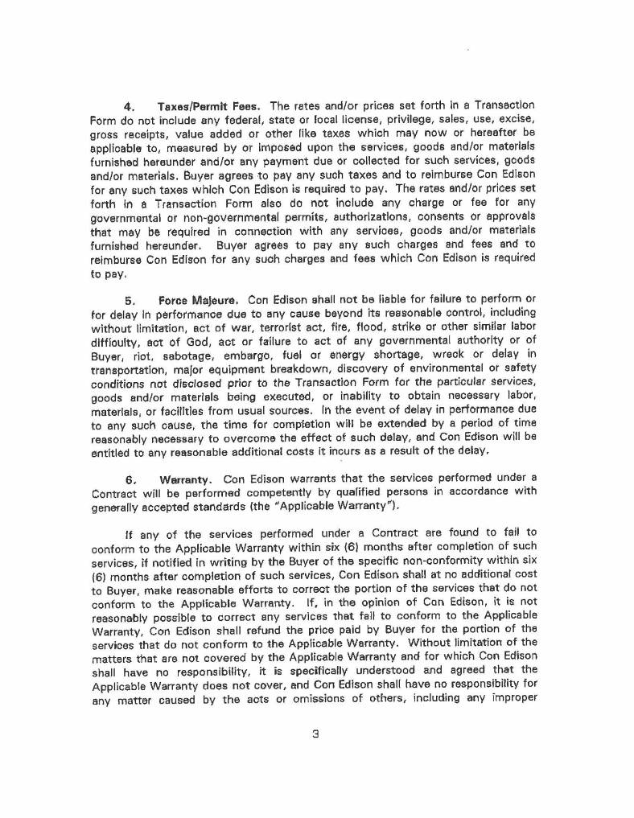

S

H-19

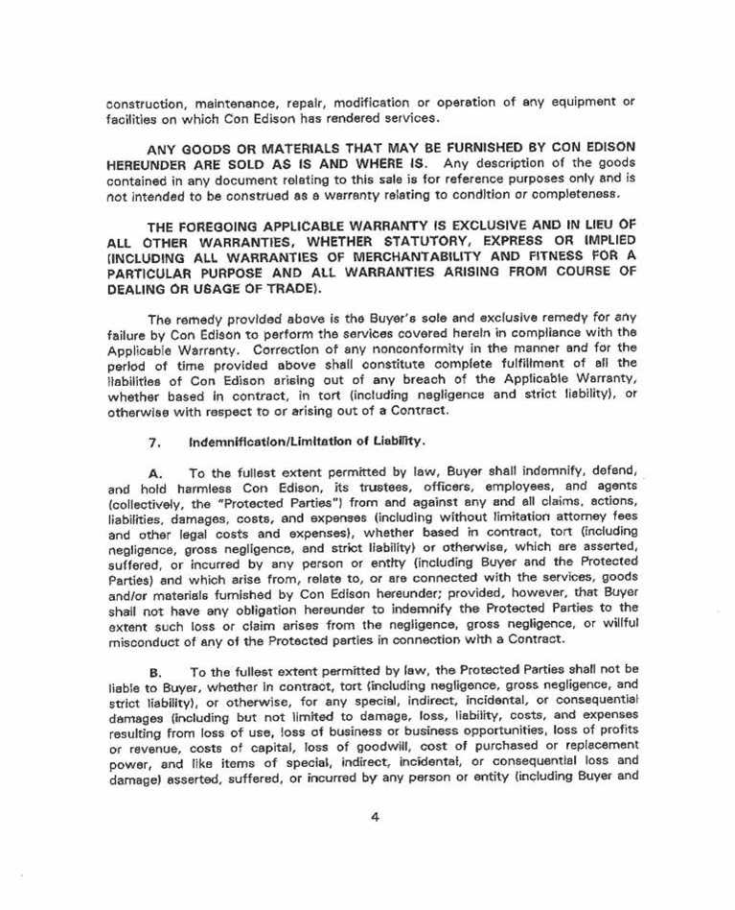

S

H-20

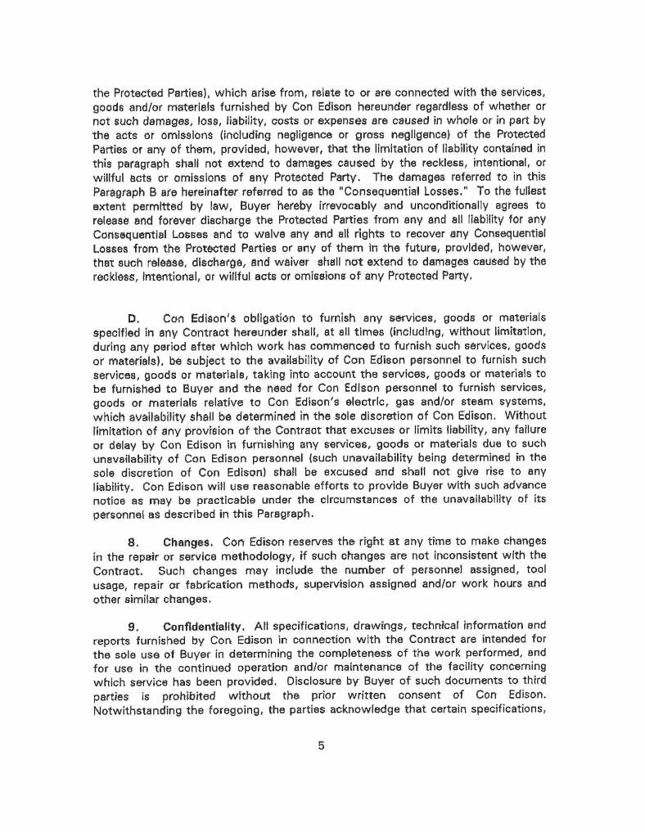

S

H-21

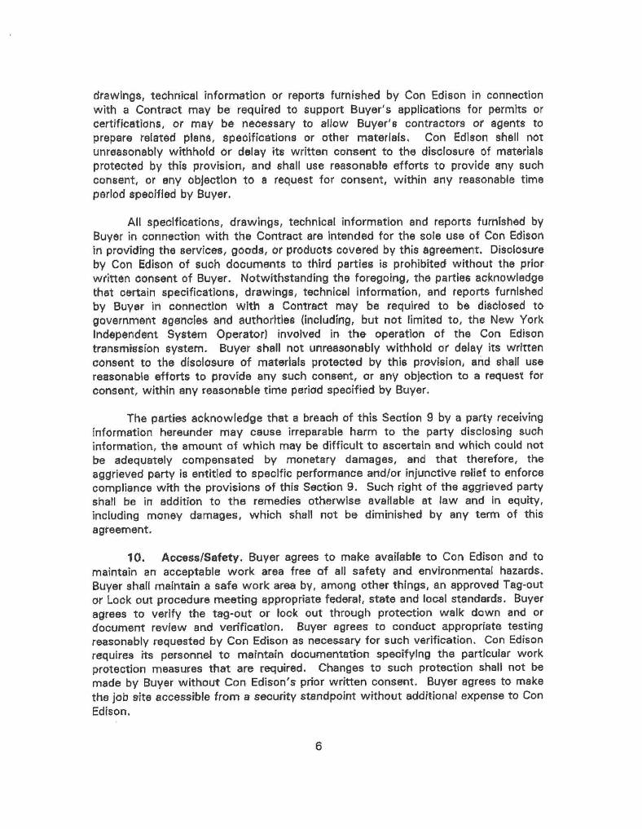

S

H-22

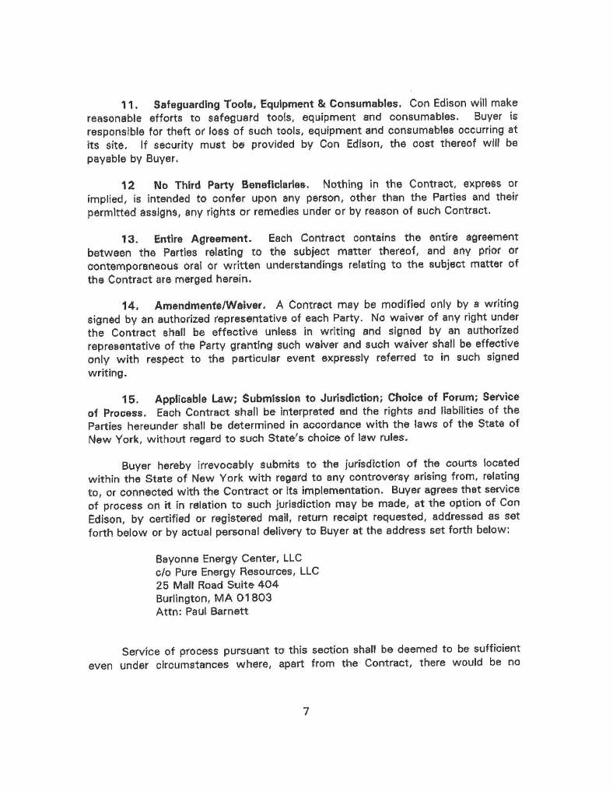

S

H-23

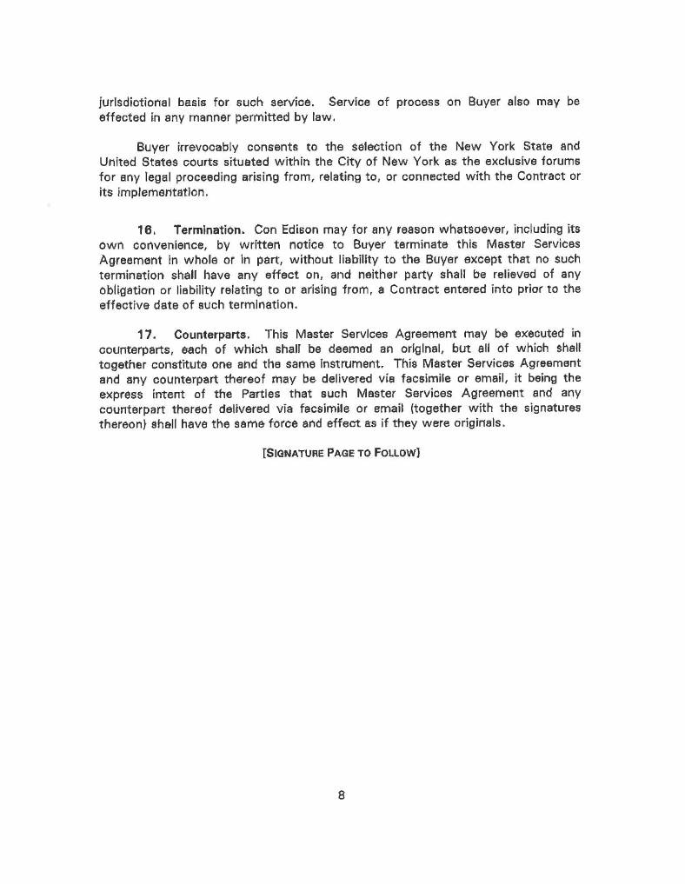

S

H-24

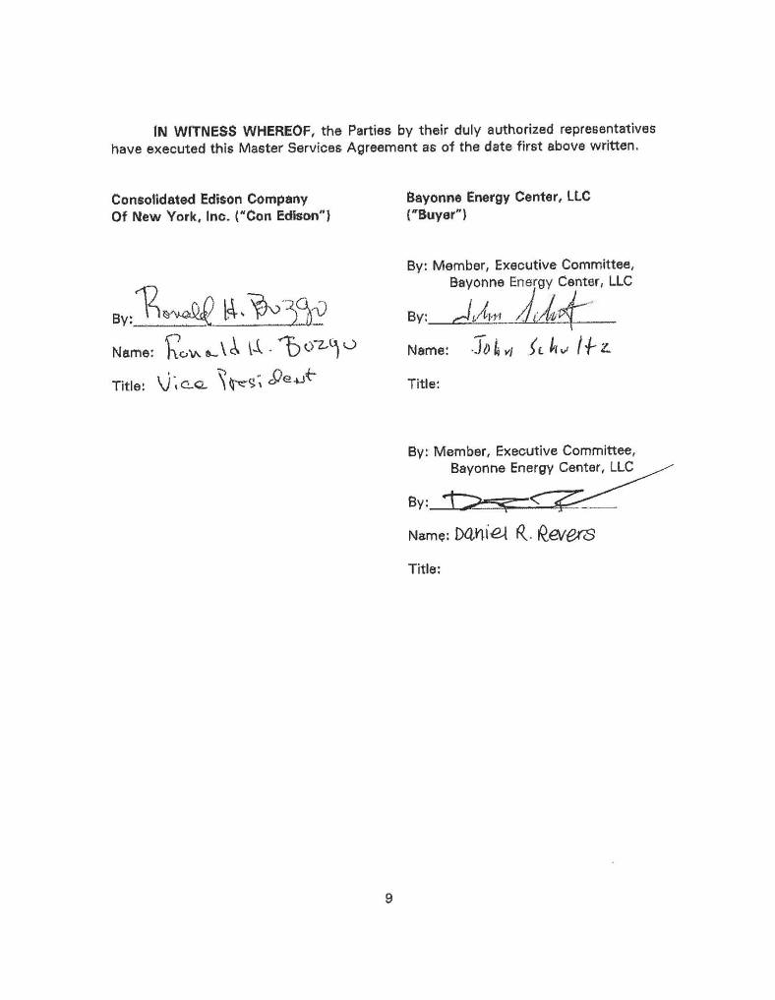

S

H-25

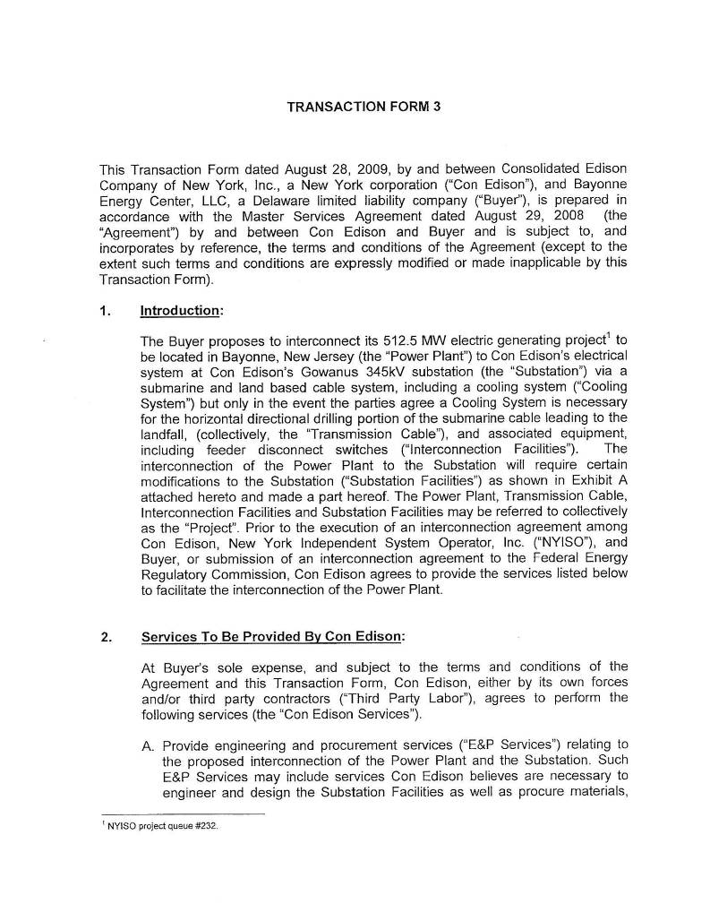

S

ATTACHMENT H-2B TO APPENDIX H
TRANSACTION FORM 3

H-26

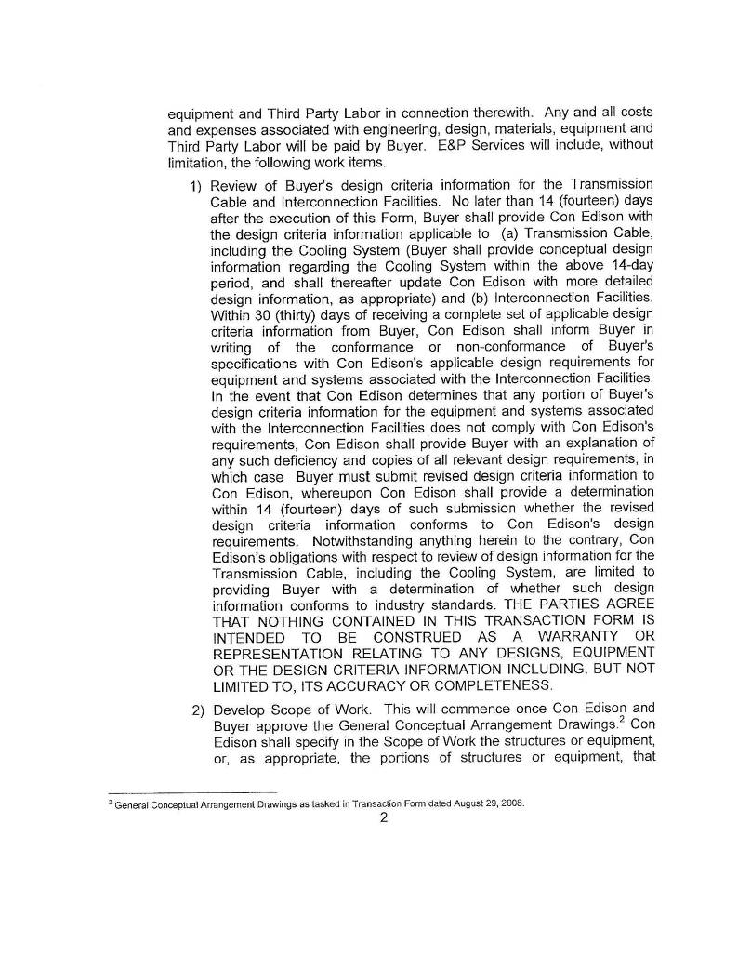

S

H-27

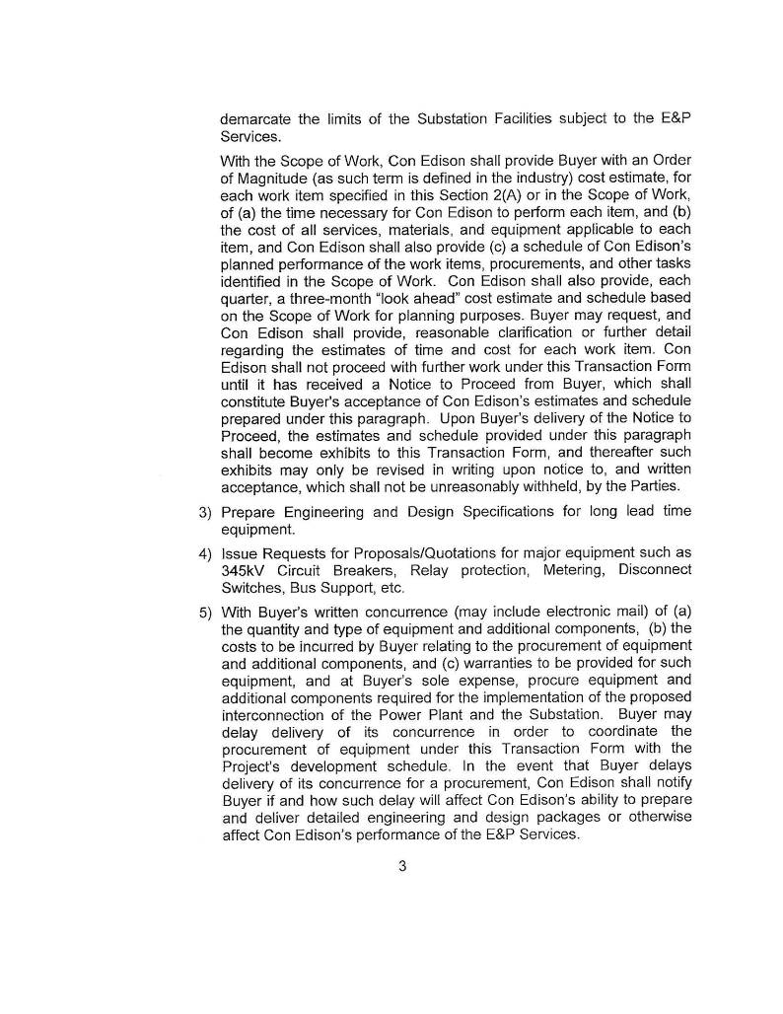

S

H-28

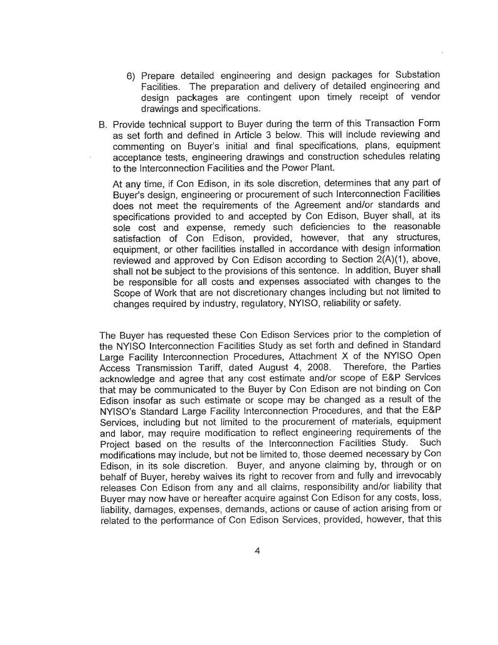

S

H-29

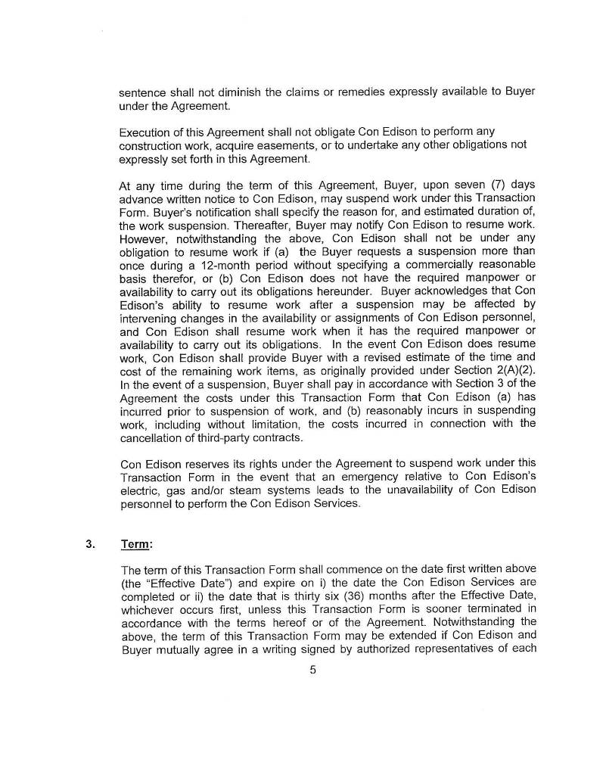

S

H-30

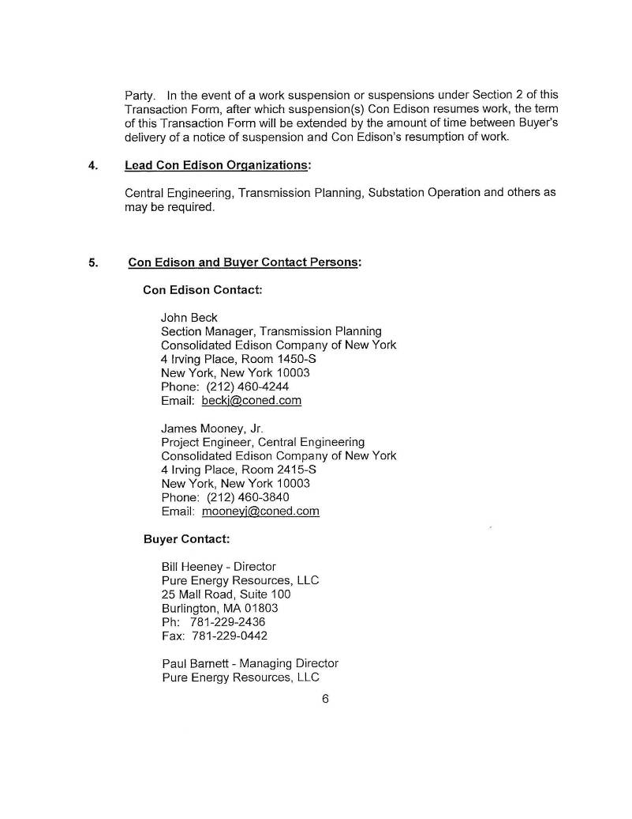

S

H-31

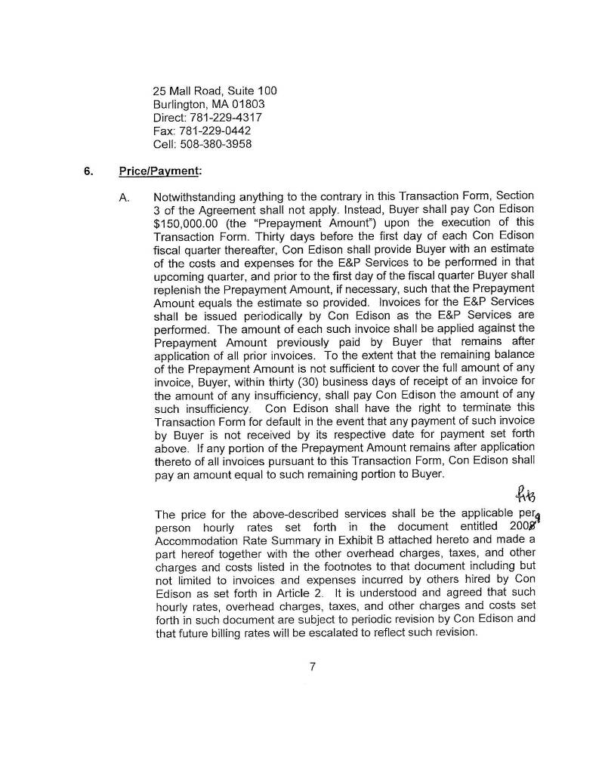

S

H-32

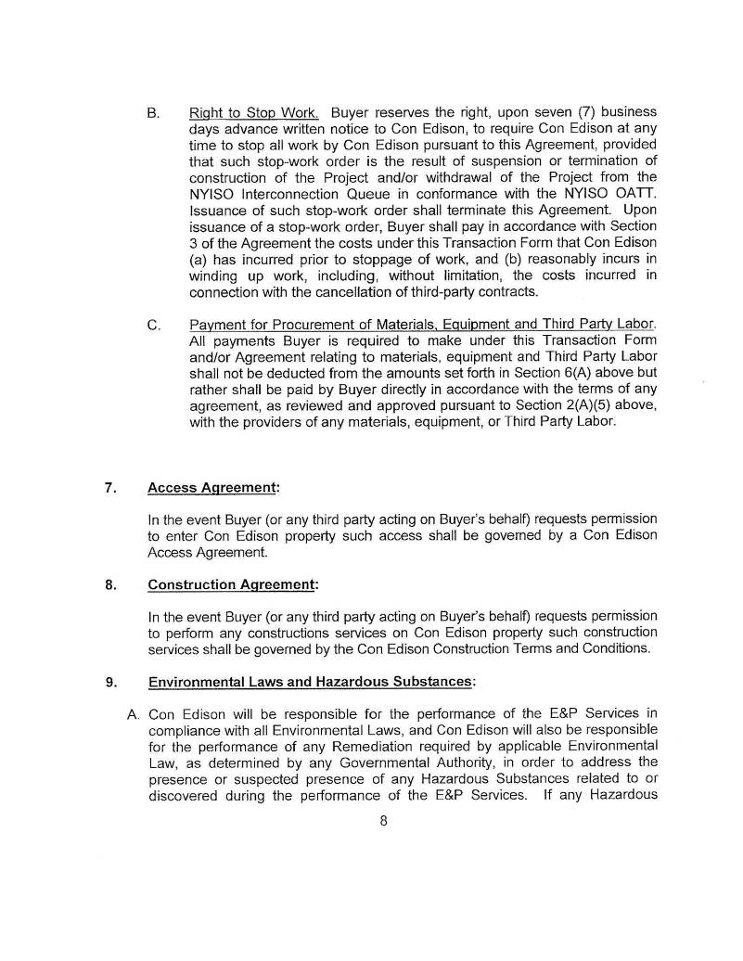

S

H-33

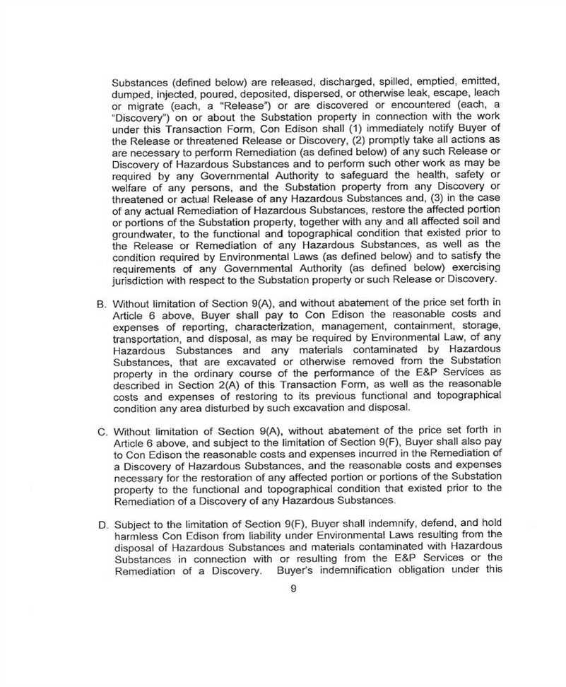

S

H-34

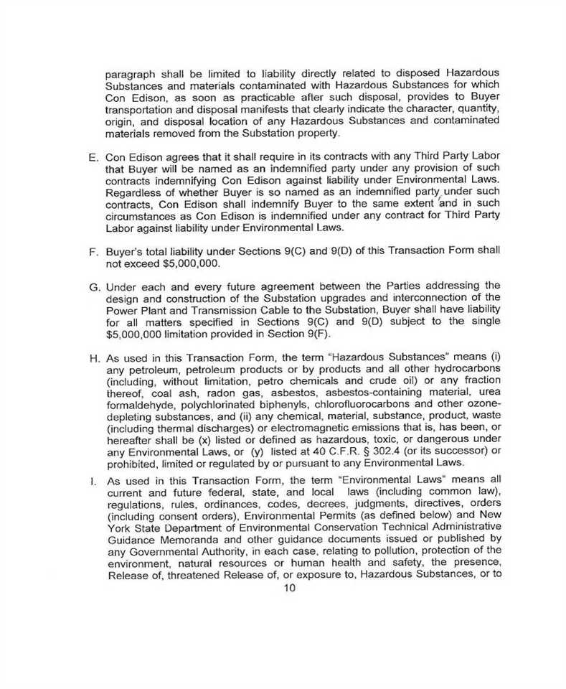

S

H-35

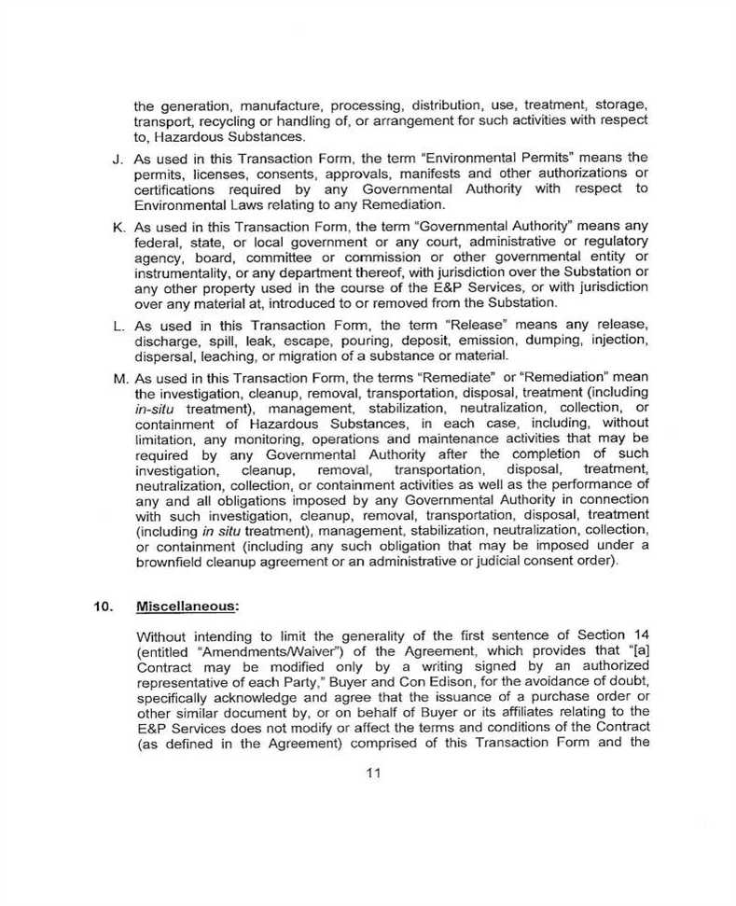

S

H-36

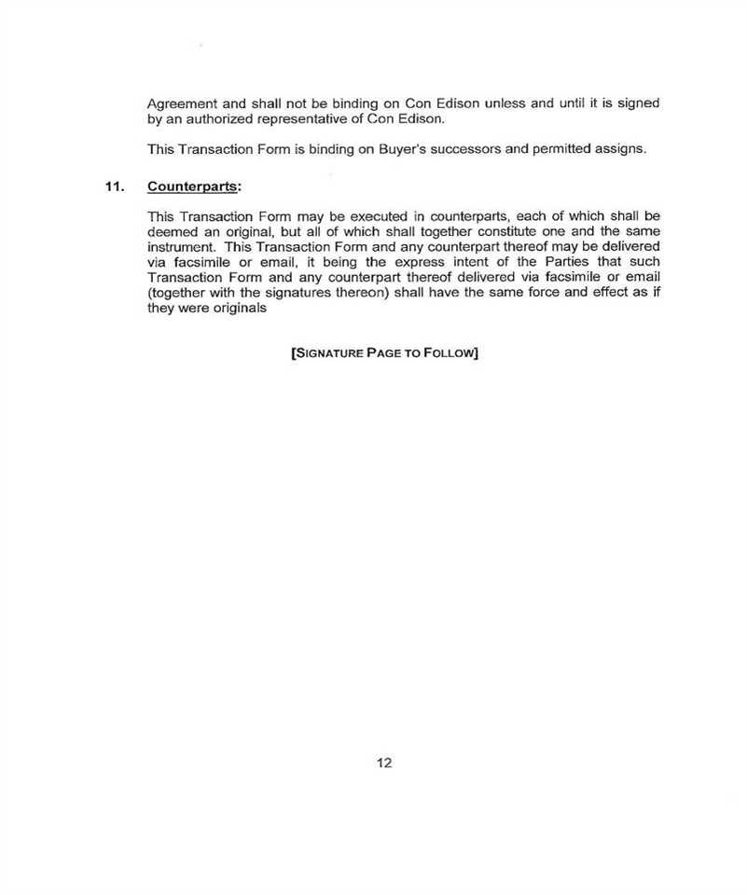

S

H-37

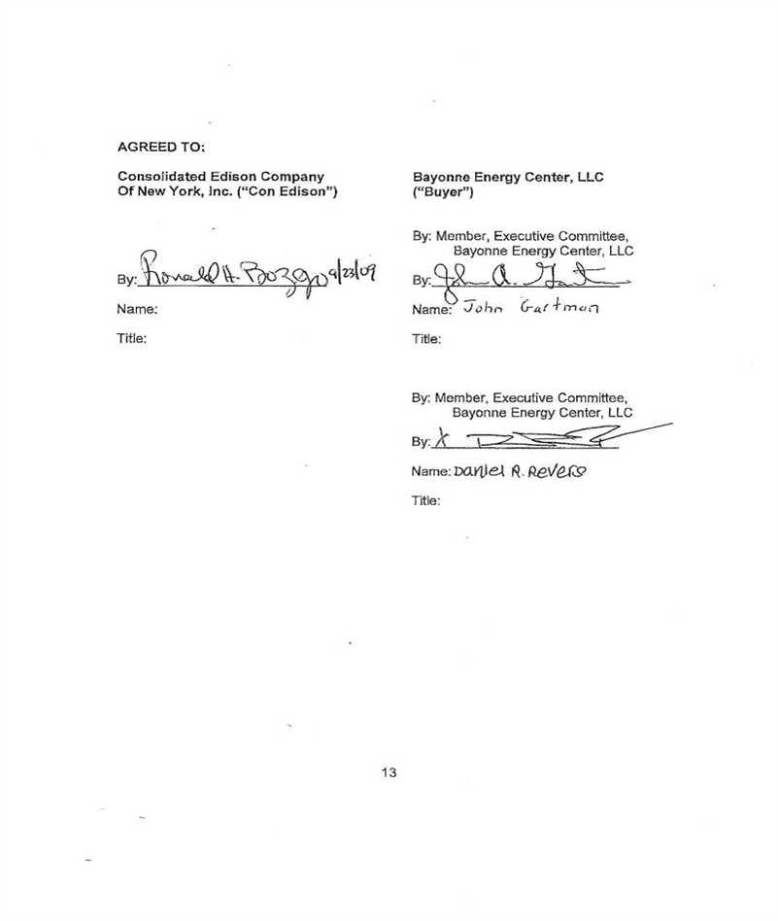

S

H-38

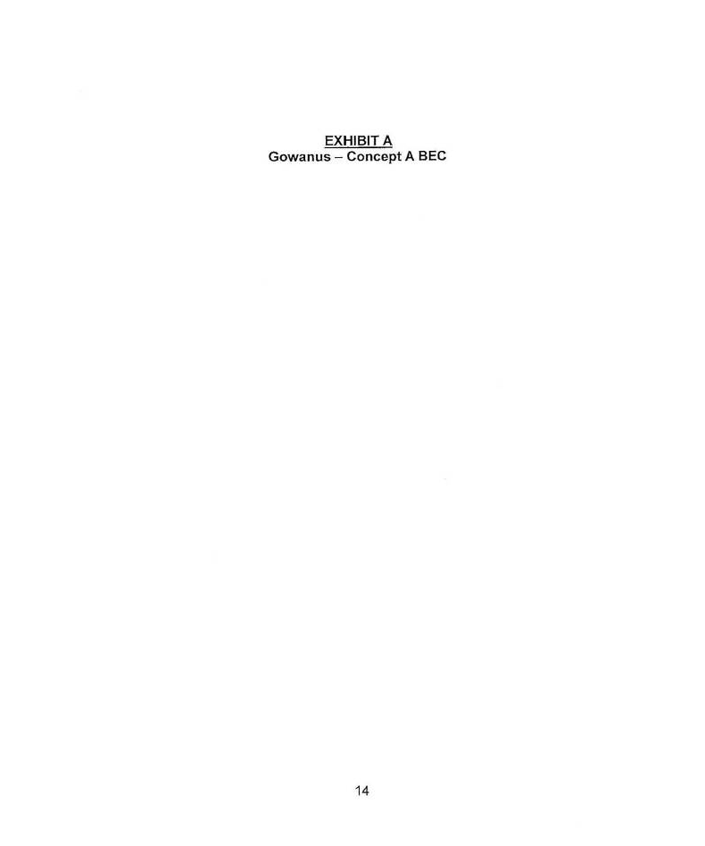

S

H-39

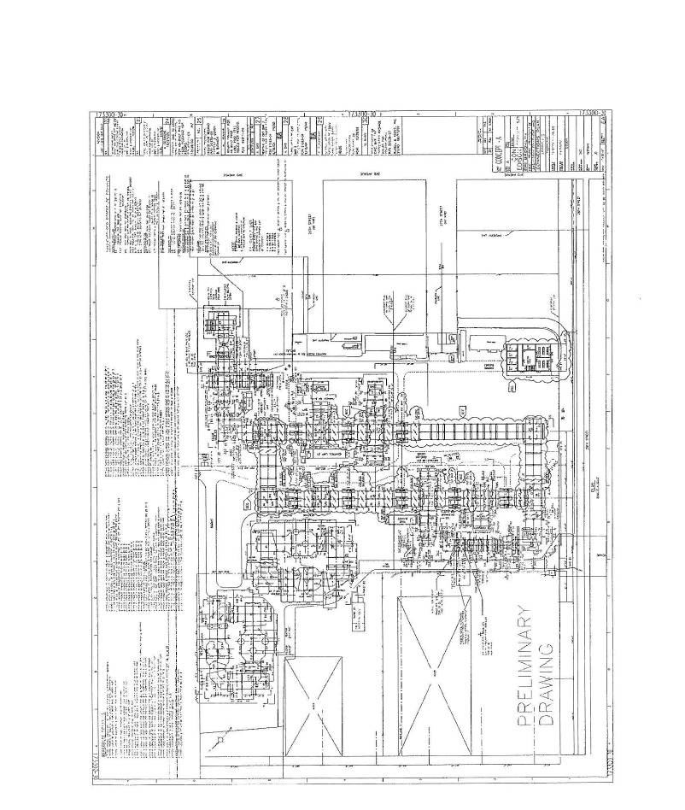

S

H-40

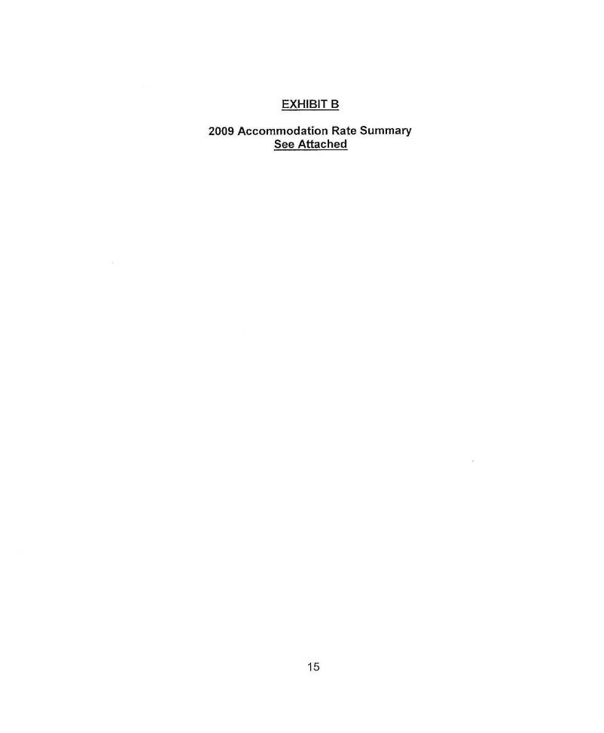

S

H-41

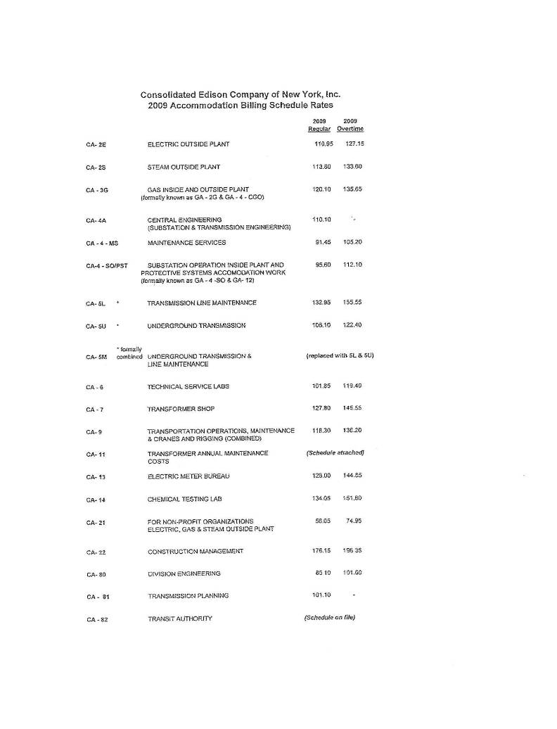

S

H-42

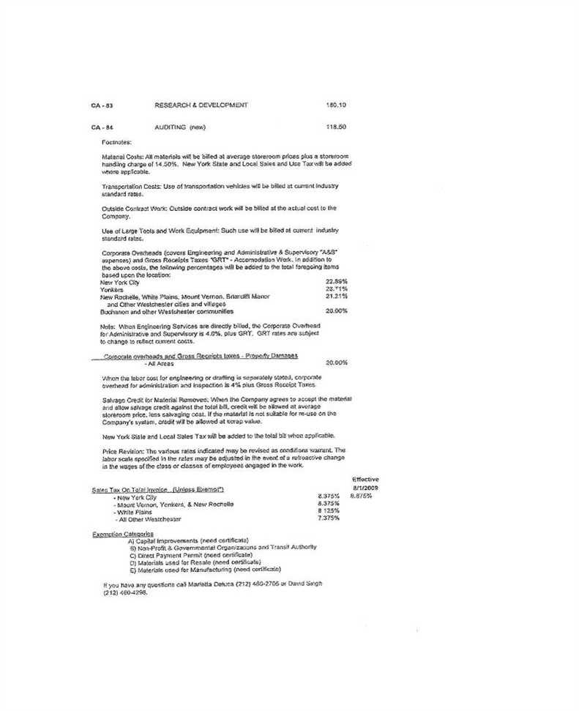

S

H-43

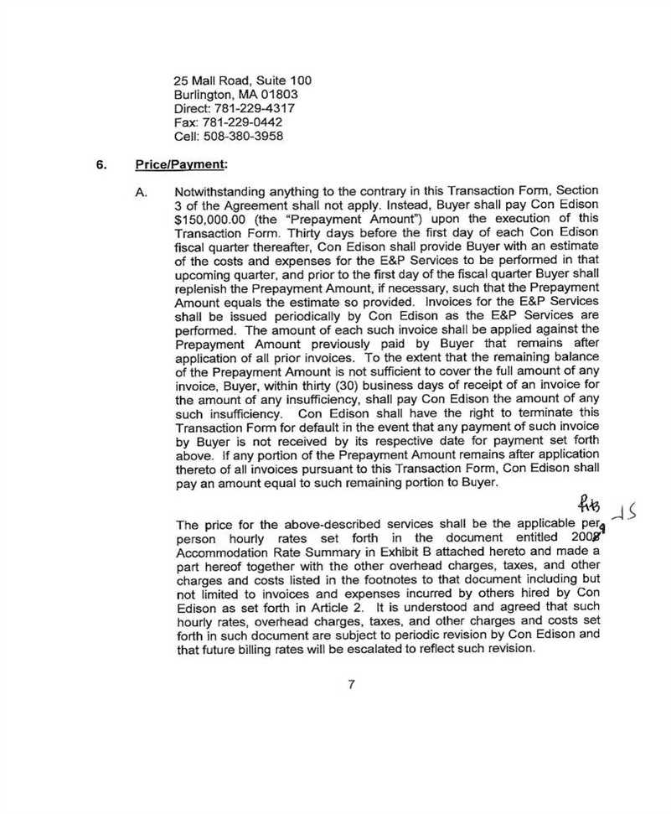

S

H-44

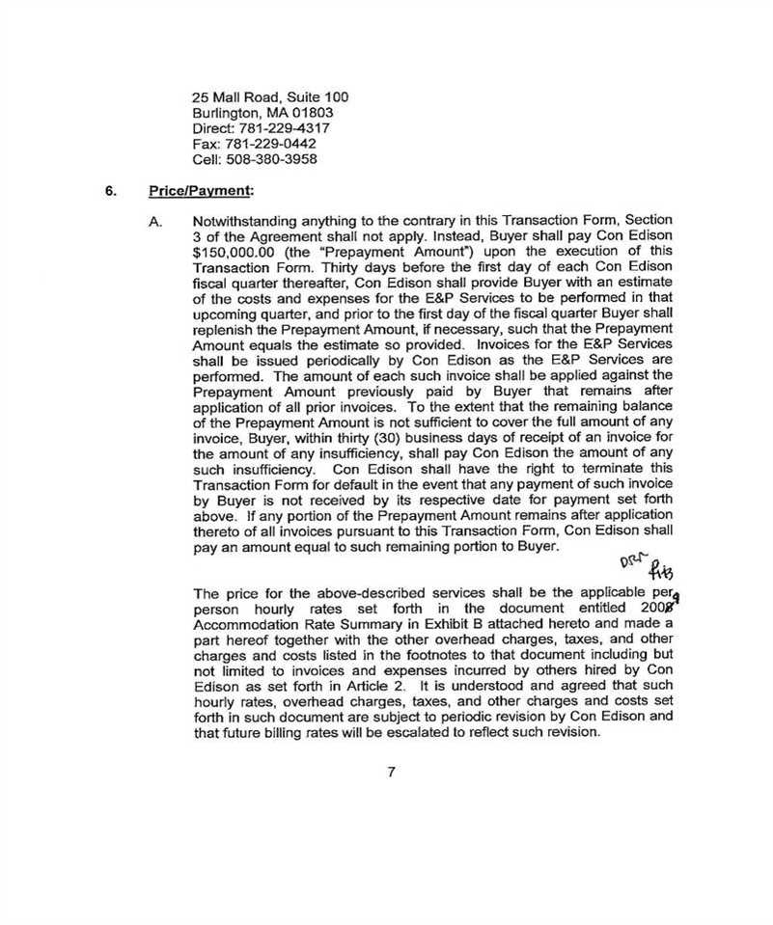

S

H-45

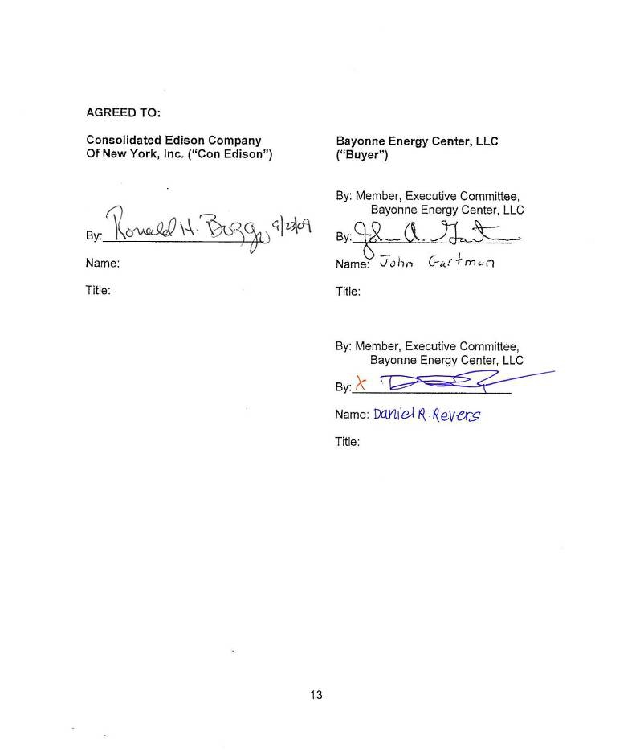

S

H-46

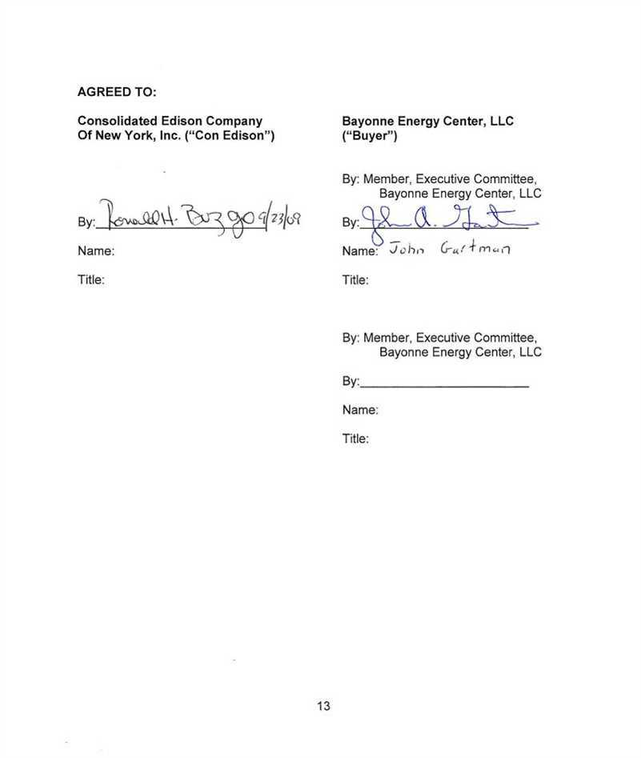

S

H-47

SERVICE AGREEMENT NO. 1668

ATTACHMENT H-3 TO APPENDIX H
PRO FORMA BILL OF SALE

BILL OF SALE

This Bill of Sale, made, executed, and delivered on ________ __, 201_, is by and
between Consolidated Edison Company Of New York, Inc., a New York corporation (“Con Edison”) and Bayonne Energy Center, LLC, a limited liability corporation organized and existing under the laws of the State of ________ (“Developer”).

WITNESSES:

Whereas, Con Edison and Developer, together with the New York Independent System
Operator, Inc., are parties to a Large Generator Interconnection Agreement, dated October _,
2010 (the “LGIA”), which provides for (i) the interconnection to Con Edison’s transmission
system of an electrical generator that Developer is constructing and (ii) the construction by
Developer of certain System Upgrade Facilities and Connecting Transmission Owner
Attachment Facilities within the Gowanus Substation which is owned by Con Edison;
Whereas, the LGIA provides that the System Upgrade Facilities will be constructed in Segments and connected to the existing substation sequentially;
Whereas, the LGIA further provides that, upon completion of each Segment, Developer will convey ownership of that Segment to Con Edison; and
Whereas, the construction and required testing of Segment No. __ have been completed;
Now, therefore, in consideration of $1.00, the receipt and sufficiency of which are
hereby acknowledged, Developer, subject to the provisions of the Agreement, does hereby sell,
convey, and transfer ownership of Segment No. __ of the System Upgrade Facilities to Con
Edison, all as more fully described in Exhibit A hereto, free and clear of all liens and
encumbrances.
[OPTIONAL TERMS FOR CTO ATTACHMENT FACILITIES. In lieu of the last three recitals and conveyance language above, insert the following:
Whereas, the construction and required testing of the Connecting Transmission Owner Attachment Facilities have been completed;
Now, therefore, in consideration of $1.00, the receipt and sufficiency of which are
hereby acknowledged, Developer, subject to the provisions of the Agreement, does hereby sell,
convey, and transfer ownership of the Connecting Transmission Owner Attachment Facilities to

H-48

SERVICE AGREEMENT NO. 1668

Con Edison, all as more fully described in Exhibit A hereto, free and clear of all liens and encumbrances.]
This Bill of Sale shall be binding upon and shall inure to the benefit of the respective successors and assigns of Developer and Con Edison.
In the event that any provision of this Bill of Sale is construed to conflict with a provision in the LGIA, the provision in the LGIA shall be deemed to be controlling.
This Bill of Sale shall be construed and enforced in accordance with the laws (other than the rules regarding the conflict of laws) of the State of New York.
This Bill of Sale may be executed in one or more counterparts, each of which shall be deemed an original but all of which together will constitute one and the same instrument.

In Witness Whereof, Generator and Con Edison have duly executed this Bill of Sale as of the date first above written.

BAYONNE ENERGY CENTER, LLC CONSOLIDATED EDISON COMPANY
OF NEW YORK, INC.

By: By:
Name: Name:
Title: Executive Committee Member Title:
BAYONNE ENERGY CENTER, LLC
By:
Name:
Title: Executive Committee Member

H-49

SERVICE AGREEMENT NO. 1668

EXHIBIT A TO BILL OF SALE
List of Facilities Being Conveyed

H-50

