FERC rendition of the electronically filed tariff records in Docket No.
Filing Data:
CID: C000038
Filing Title: Con Edison NYPA restated OM Agreement No. 2013 Company Filing Identifier: 864
Type of Filing Code: 10
Associated Filing Identifier: na
Tariff Title: NYISO Agreements
Tariff ID: 58
Payment Confirmation: N
Suspension Motion:

Tariff Record Data:
Record Content Description: Agreement No. 2013
Tariff Record Title: O&M Agreement No. 2013 Between Con Edison and NYPA Record Version Number: 0.0.0
Option Code: A
Tariff Record ID: 135
Tariff Record Collation Value: 7071600
Tariff Record Parent Identifier: 2
Proposed Date: 2014-04-23
Priority Order: 500
Record Change Type: New
Record Content Type: 2
Associated Filing Identifier: na

Public Version

AMENDED AND COMPOSITE AGREEMENT
BETWEEN
CONSOLIDATED EDISON COMPANY OF NEW YORK, INC.
AND
THE NEW YORK POWER AUTHORITY
FOR THE OPERATION AND MAINTENANCE OF THE FACILITIES ASSOCIATED WITH
ASTORIA ANNEX SUBSTATION
345 KV GAS-INSULATED SUBSTATION

TABLE OF CONTENTS
ARTICLE I: DEFINITIONS 4

ARTICLE II: EFFECTIVE DATE, O&M COMMENCMENT DATE, TERM 8
AND TERMINATION
ARTICLE III: REGULATORY COMPLIANCE 9
ARTICLE IV: CONDITIONS PRECENDENT TO THE SCOPE OF WORK; O&M 12
SERVICES; EXCLUDED/LIMITATIONS ON O&M SERVICES
ARTICLE V: SERVICES/UTILITIES 20
ARTICLE VI: COMPENSATION 21
ARTICLE VII: REPORTING AND INVOICING 24
ARTICLE VIII: TAXES/PERMIT FEES 25
ARTICLE IX: PAYMENT 25
ARTICLE X: WASTE MANAGEMENT 26
ARTICLE XI: STORM WATER MANAGEMENT FOR POST-CONSTRUCTION 27
WATER QUALITY CONTROL
ARTICLE XII: ENVIRONMENTAL PROVISIONS 27
ARTICLE XIII: SF6 GAS EQUIPMENT 31
ARTICLE XIV: COMPLIANCE MODIFICATIONS AND UPGRADES 32
ARTICLE XV: SUPERSEDENCE 33
ARTICLE XVI: FORCE MAJEURE 33
ARTICLE XVII: DEFAULT 33
ARTICLE XVIII: INSURANCE 34
ARTICLE XIX: INDEMNIFICATION, NO CONSEQUENTIAL DAMAGES, 36
OUTAGES
ARTICLE XX: NO WARRANTY/ DISCLAIMERS 39
ARTICLE XXI: CONFIDENTIALITY 40
ARTICLE XXII: RIGHT TO INSPECT/ OBSERVE TESTING 40

ARTICLE XXIII:
ARTICLE XXIV:
ARTICLE XXV:
ARTICLE XXVI:
ARTICLE XXVII:
ARTICLE XXVIII:
ARTICLE XXIX:
ARTICLE XXX:
ARTICLE XXXI:
ARTICLE XXXII:
ARTICLE XXXIII:
EXHIBIT A:
EXHIBIT B:
EXHIBIT C:
EXHIBIT D:
EXHIBIT E:
EXHIBIT F:
APPENDIX A:
APPENDIX B:

APPENDIX C:
APPENDIX D:
APPENDIX E:
APPENDIX F:

ACCESS 41
AMENDMENTS 41
ASSIGNMENTS; SUCCESSORS 41
ENTIRE AGREEMENT 42
CONFLICTING DOCUMENTS 42
GOVERNING LAW; SEVERABILITY 42
HEADINGS 42
NO THIRD PARTY RIGHTS 43
NOT PARTNERS 43
NOTICES 43
WAIVER 44 List of Equipment For O&M Services
SF6 Equipment Tracking Cylinder Log
Power Authority Terms and Requirements
“Minor Spare Parts”, “Major Spares”, and “Other Parts and Equipment”
Survey for Easement Agreement
Good Faith Estimate of Preparatory Work and Services Con Edison SSO specification 0100-0022/06
Con Edison Specification EO-4022 Testing of Acc Feeders Operating at 69kv through 345kv
Con Edison ES-1003 Installation and Test Specification for Oil Immersed Power Transformers, Reactors and Regulators
Con Edison ES-1000 Preventative Maintenance (PMP) Con Edison 2010 Accommodation Services Charges Power Authority Prompt Payment Policy

AMENDED AND COMPOSITE AGREEMENT (this “Composite Agreement”) made on the ___ day ofJanuary, 2013 by and between Consolidated Edison Company of New York, Inc. (“Con
Edison”), a corporation organized and existing under the law of the State of New York and having its
principal place of business at 4 Irving Place in the City of New York, New York, and the New York
Power Authority (“the Power Authority”), a corporate municipal instrumentality and political
subdivision of the State of New York having an office at 123 Main Street in the City of White Plains,
New York. Con Edison and the Power Authority are sometimes collectively referred to herein as the
“Parties” and, individually, as a “Party”.
WHEREAS, Astoria Energy II LLC (“Astoria Energy II”) was responsible for the construction
of an approximate 500 Megawatt second power block to the electric generating facility at 17-10
Steinway Street, Astoria, NY (the “Second Power Block”) pursuant to the easement agreement between
Con Edison and Astoria Energy II dated July 2, 2009 all as more particularly described therein (the
“Easement Grant”);
WHEREAS, Con Edison owns a certain parcel of real property in the City of New York, County of Queens, known as Tax Lot 1, in Block 850, on the Tax Map of the City of New York, County of Queens (“Con Edison Lands”);
WHEREAS, Astoria Energy II interconnected the Second Power Block to the Power
Authority’s existing Q35L & Q35M 345 kV transmission lines, which start at “Con Edison’s East 13th
Street Substation” (as defined in Article I) (and which have associated dielectric oil cooling lines that
enter the “15th Street PURS” and the “15th Street Pressurization Plant” (both as defined in Exhibit A))
and then such transmission and dielectric lines travel under and across the East River and enter and
extend under, through and across the Con Edison Lands to manhole 19717 (at which manhole, a portion
of the dielectric oil cooling lines extend back onto the Power Authority Property to connect to the
“Astoria PURS” and the “Astoria Pressurization Plant” (both as defined in Exhibit A) and, at which
manhole, a new extension of the Q35L & Q35M 345 kV transmission lines (and the associated
dielectric oil cooling lines) extend, under, through and across the Con Edison Lands (the
“Extension”), and end at, and connect to, a new 345-kilovolt SF6 gas-insulated substation (the “Astoria
Annex Substation”), constructed by Astoria Energy II on a portion of the Con Edison Lands pursuant to
the Easement Grant; the Q 35L and Q 35M 345 kV transmission lines and the associated dielectric oil
cooling lines between East 13th Street Substation and the Astoria Annex Substation, which includes the
Extension, are hereinafter referred to collectively as the “Q35L & Q35M Transmission Lines”;

WHEREAS, on February 1, 2011, Con Edison and Power Authority entered into an Agreement relating to the operation and maintenance of the Astoria Annex Substation, as more particularly
described therein (the “Original Agreement”);

WHEREAS, Astoria Energy II was to operate, monitor, inspect, repair, perform preventative,
corrective and routine maintenance, testing, and protection system operations assessment to the Astoria
Annex Substation and other transmission facilities until the “O&M Commencement Date” (as defined
in Section 2.1 of the Original Agreement), which was to be the later of March 1, 2011 or the first date
that Power Authority satisfied all “Conditions Precedent” (as defined in Section 4.1 of the Original
Agreement, which Section 4.1 is partially updated by this Composite Agreement and Revised First
Amendment);
WHEREAS, at a certain point after its construction and prior to the O&M Commencement Date, Astoria Energy II transferred ownership of the Facility to Power Authority, so that the Power Authority was the owner of the Astoria Annex Substation, the Extension, and other transmission
facilities and all of the equipment/facilities identified in Exhibit A, attached hereto and made a part hereof (“Equipment”); the Astoria Annex Substation, the Q35L and Q35M Transmission Lines and the Equipment are hereinafter referred to collectively as the “Facility,”
WHEREAS, the Facility did not include any portion of the overhead transmission line and related appurtenances which connect the Second Power Block to the first disconnect switch of the Astoria Annex Substation (“Astoria Energy II’s Generator Leads”); and
WHEREAS, after March 1, 2011, the Power Authority requested that Con Edison operate and maintain the Facility for the Power Authority pursuant to the terms and conditions of the Original
Agreement, prior to Power Authority’s satisfaction of those certain Conditions Precedent (as defined in Section 4.1 of the Original Agreement); and

WHEREAS, on June 23, 2011, the Original Agreement was amended by a First Amendment
(“First Amendment”) wherein Con Edison agreed to commence “O&M Services” (as originally defined in Section 4.2 of the Original Agreement) prior to the satisfaction of the Conditions Precedent as
defined in the Original Agreement and based upon the substantive terms and conditions of the Original Agreement, as revised by the First Amendment all as more particularly set forth in that First
Amendment, which is now the Composite Agreement, at, but not limited to, Section 4.2 and the terms and conditions of the Revised First Amendment;

WHEREAS, on April 25, 2012, the Parties entered into a Second Amendment to the Original
Agreement (“Second Amendment”), all as more particularly described in the Second Amendment;

WHEREAS, pursuant to Section 205 of the Federal Power Act and 18 C.F.R. Section 35.12, Con Edison is required to file the Original Agreement, First Amendment and Second Amendment with the Federal Energy Regulatory Commission (“Commission”);

WHEREAS, pursuant to its Order No. 614, the Commission requires that any amendments to a
filed agreement be integrated into the agreement prior to its filing, so that the filing consists of one
composite agreement that includes all effective terms and excludes non-effective and superseded
language;
WHEREAS, the Parties intend to fully integrate the Second Amendment into this Composite
Agreement; but because some terms of the First Amendment cannot be integrated without affecting the
rights and obligations of the Parties, the Parties intend to integrate the First Amendment into this

Composite Agreement to the extent possible and to execute a First Amendment to this Composite
Agreement (“Revised First Amendment”) to cover the provisions of the First Amendment that cannot be integrated;

WHEREAS, the Parties have no intention to amend the substance of any of the terms of the Original Agreement, the First Amendment or the Second Amendment, but merely seek to comply with the Commission’s integration requirement;
NOW THEREFORE, in consideration of the premises, mutual obligations and undertakings set forth herein, the Parties hereto agree as follows:
ARTICLE I
DEFINITIONS

Whenever used in this Composite Agreement with initial capitalization, the following terms
shall have the meanings specified in this Article. Terms used in this Composite Agreement with initial
capitalization that are not defined in this Article shall have the meanings specified in this Composite
Agreement.
“Applicable Legal Requirements” shall mean all duly promulgated applicable federal, state
and local laws, regulations, rules, ordinances, codes, decrees, judgments, directives, or judicial or
administrative orders, permits and other duly authorized actions of any Governmental Authority,
including but not limited to “Environmental Law”, “Environmental Permits”, and “Permits” (each as
defined herein). In the performance of the “O&M Services” (as defined in Section 4.2), Power
Authority will comply with all New York City laws, rules and regulations that are applicable to the
Power Authority and/or Con Edison. The Power Authority’s compliance with New York City laws,
rules and regulations is for the purpose of safeguarding the health, safety and welfare of any persons,
the Con Edison Lands and any improvements thereon or there under, and is not to be construed as
submission by the Power Authority to jurisdiction by New York City over the Power Authority.
“Backfeed” shall mean the supplying or transporting of electrical energy from the Con Edison's transmission/distribution system to the Second Power Block.
“Breach” shall mean the failure of a Party to perform or observe any material term or condition of this Composite Agreement.
“Breaching Party” shall mean a Party that is in Breach of this Composite Agreement.
“Business Day” shall mean Monday through Friday, excluding federal holidays.
“Calendar Day” shall mean any day including Saturday, Sunday or a federal holiday.
“Con Edison Standards” means: all Con Edison instructions, specifications, rules, programs, guidelines, policies, practices, and procedures issued by Con Edison, both orally and in writing, in the ordinary course of its business, as may be amended from time to time.

“Con Edison’s East 13th Street Substation” shall mean the Con Edison substation and
associated appurtenances between Avenue C and the FDR (East River) Drive and between 13th and 14th Streets in New York City, NY.
“Date of Energization” means the first date that any of the following Equipment is connected to the Con Edison transmission system (the “Energized Components”);
a. The Extension (of the two 345 kV transmission feeders Q35L & Q35M) into the Astoria Annex Substation.
b. All new 345 kV SF6 substation bus, circuit breakers and associated equipment associated with the new Astoria Annex Substation.
c. All new 345 kV open air bus, circuit breakers and associated equipment associated with the Astoria Annex Substation.
d. The relocated 345 kV Shunt Reactors (as defined in Exhibit A) in the Astoria Annex Substation.
e. The overhead 345 kV generator leads connecting the new Astoria Annex Substation to
the Second Power Block up to and including the generators’ synchronizing circuit breakers located in the generation plant site.
f. Any other electrical equipment, including but not limited to, generator lead revenue meters.
“Environmental Laws” means: all current and future federal, state and local laws (including
common law), treaties, regulations, rules, ordinances, codes, decrees, judgments, directives, orders
(including consent orders), Environmental Permits, and obligations and other requirements imposed by any “Governmental Authority” (as defined herein), including New York State Department of
Environmental Conservation (“NYSDEC”) Technical Administrative Guidance Memoranda and other guidance documents issued or published by any Governmental Authority, in each case, relating to
pollution, protection of the environment, natural resources, or protection of human health and safety
from conditions in the environment, the presence, “Release” (as defined herein) of, threatened Release of, or exposure to, “Hazardous Substances” (as defined herein), or to the generation, manufacture,
processing, distribution, use, treatment, storage, transport, recycling or handling of, or arrangement for such activities with respect to, Hazardous Substances.
“Environmental Liabilities” means: all liabilities, obligations, damages, losses, claims,
actions, suits, judgments, orders, fines, penalties, fees, expenses, and costs, relating to environmental
conditions or activities, including (i) Remediation costs, engineering costs, environmental consultant
and expert fees, laboratory fees, permitting fees, investigation costs, defense costs, and reasonable
attorneys’ fees and expenses; (ii) any claims, demands, and causes of action relating to or resulting
from any personal injury (including wrongful death), property damage (real or personal) or natural
resource damage; and (iii) any penalties, fines or costs associated with the failure to comply with any
Environmental Law.

“Environmental Permits” means: the permits, licenses, consents, approvals, manifests and
other authorizations or certifications required by any Governmental Authority having jurisdiction with
respect to Environmental Laws relating to the “Remediation” (as defined herein), construction,
operations and activities of Con Edison and/or the Power Authority for the Facility and the Con Edison
Lands.
“Good Industry Practice” means: any of the applicable acts, practices, rules, policies,
regulations, or methods from time to time required by any “Governmental Authority” (defined below) or any organization with jurisdiction or authority in respect of the Con Edison Lands whether or not the party whose conduct is at issue is a member thereof, or by any other person acting pursuant to the
authority of any such organization. If there are no such applicable acts, practices, rules, policies,
regulations, or methods, then Good Industry Practice means: any of the applicable acts, practices, rules, policies regulations, or methods engaged in or approved by a significant portion of the electric utility industry in the United States at the relevant time, including, but not limited to, reliability, operating, planning, and engineering specifications, the Northeast Power Coordinating Council (“NPCC”), the North American Electric Reliability Corporation ("NERC"), the New York State Reliability Council (“NYSRC”), and the New York Independent System Operator (“NYISO”).
“Governmental Authority” means: any federal, state, or local government, or any court, board, agency, commission, office, or other authority of any nature whatsoever for any governmental unit
(federal, state, county, district, municipal, city, or otherwise), specifically excluding the Power
Authority, and in all cases whether now or hereafter in existence.
“Hazardous Substances” means: (i) any petroleum, petroleum products or byproducts, and all other regulated hydrocarbons (including without limitation, petrochemicals and crude oil), or any
fraction thereof, coal ash, radon gas, asbestos, asbestos-containing material, urea formaldehyde,
polychlorinated biphenyls, chlorofluorocarbons, and other ozone-depleting substances; and (ii) any
chemical, material, substance, product or waste (including thermal discharges and hazardous waste) that is prohibited, limited, or regulated by or pursuant to any Environmental Law.
“Manufacturer’s Specifications and Instructions” means: any written vendor /manufacturer standards, specifications, documents, manuals, handbooks, and instructions for all or any portion of the Facility provided by applicable vendor/manufacturer.
“NERC Reliability Standards” means: the reliability standards that are promulgated by the NERC, approved by the Federal Energy Regulatory Commission, and implemented by the NPCC, as may be amended from time to time.
“NPCC Criteria Requirements” or “NPCC Directories” means: the specific reliability requirements that are promulgated and implemented by the NPCC, for the design, operation and protection of the bulk power system, as may be amended from time to time.
“NPCC Regional Reliability Standards” means: the reliability standards that are promulgated and implemented by NPCC for the design, operation and protection of the bulk power system, as may be amended from time to time.

“Power Authority Property” means: except for the property interests covered by the Easement Grant, as may be amended from time to time, all property interests, both real and personal, at the
Astoria Complex located at 31-01 20th Avenue, Astoria, New York 11105, which are owned by the
Power Authority, including but not limited to Block 850, Lot 100 and those property interests within
the Con Edison Lands.
“Permits” means: all certificates, permits, licenses, consents, approvals, and other governmental authorizations (other than Environmental Permits) relating primarily to construction, operations and activities of Con Edison and/or the Power Authority for the Facility and the Con Edison Lands.
“Power Authority’s Contractors” means: except for Con Edison, any and all of the Power
Authority’s contractors, subcontractors, agents, invitees, and any other person or entity working for or acting on behalf of the Power Authority in connection with excluded services under this Composite Agreement or services outside the scope of this Composite Agreement.
“Preparatory Work and Services” shall have the meaning ascribed to it in Section 4.2.4
“Release” means: any actual or threatened release, spill, emission, emptying, escape, leaking, dumping, injection, pouring, deposit, disposal, discharge, dispersal, leaching, or migration into the environment or within any building, structure, facility, or fixture and/or the exacerbation of any preexisting condition of Hazardous Substances.
“Remediation” means: the investigation (including any feasibility studies or reports), cleanup,
removal, abatement, transportation, disposal, treatment (including in-situ treatment), management,
stabilization, neutralization, collection, or containment of Hazardous Substances and any Release(s),
that may be required to satisfy Environmental Laws, in each case, including, without limitation, any
closure, restoration or monitoring, operations and maintenance activities, including any engineering or
institutional controls, that may be required by any Government Authority after the completion of such
investigation, study, cleanup, removal, transportation, disposal, treatment, neutralization, collection, or
containment activities as well as the performance of any and all obligations imposed by any
Governmental Authority in connection with such investigation, cleanup, removal, transportation,
disposal, treatment (including in situ treatment), management, stabilization, neutralization, collection,
or containment (including any such obligation that may be imposed pursuant to an Environmental
permit or a consent order).
“Scope of Work” shall have the meaning ascribed to it in Section 4.2.5.

ARTICLE II
EFFECTIVE DATE, O&M COMMENCEMENT DATE, TERM AND TERMINATION

2.1 (a) Effective Dates of the Composite Agreement and the Revised First Amendment. This
Composite Agreement shall become effective on the “Commission Effective Date,” which shall be the date on which this Composite Agreement and Revised First Amendment are accepted or deemed to be effective by the Commission.
The Original Agreement, First Amendment and Second Amendment shall remain in effect until
the “Commission Effective Date”. On and after the Commission Effective Date, the Original
Agreement, First Amendment and Second Amendment shall no longer be of any force and
effect and shall be superseded by the Composite Agreement and the Revised First Amendment.

The rights and obligations of the Parties that accrue prior to the Commission Effective Date
shall be governed by the Original Agreement, the First Amendment and the Second
Amendment. After the Commission Effective Date, the rights and obligations of the Parties
shall be governed by this Composite Agreement, as amended by the Revised First Amendment.
(b) O&M Commencement Date. Under the Original Agreement, Con Edison’s obligation to
perform the “Scope of Work” as defined in Section 4.2.5 of the Original Agreement was not to
commence until the later of: (i) March 1, 2011, or (ii) the first date that the Power Authority
satisfies all of the “Conditions Precedent” (as defined in Section 4.1 of the Original Agreement)
(“Original O&M Commencement Date”). However, following Power Authority’s request that
Con Edison commence “O&M Services” (as originally defined in Section 4.2 of the Original
Agreement) prior to the satisfaction of the Conditions Precedent as defined in the Original
Agreement, and subject to the terms and conditions of the Original Agreement as amended by
the First Amendment, Con Edison agreed to change the Original O&M Commencement Date
and commence O&M Services on June 23, 2011 (the “O&M Commencement Date”). The
O&M Services are now defined in Section 4.2 of this Composite Agreement as amended by the
Revised First Amendment.

(c) Term of Agreement. This Composite Agreement shall remain in effect for a period (the
“Term”) of twenty (20) years from February 1, 2011 (which is the date the Original Agreement
was executed and effective), with the option to extend for ten (10) year periods by agreement of
the Parties, unless this Composite Agreement is terminated prior to such time in accordance
herewith.

2.2 Termination.
2.2.1 Written Notice. This Composite Agreement may be terminated, in whole or in part, by
either Party upon at least one year advance written notice without liability to the other
Party for any reason whatsoever, including its own convenience except that no such
termination shall have any effect on, and neither Party shall be relieved of, any

obligation or liability relating to or arising from this Composite Agreement prior to the effective date of such termination.
2.2.1 End of Term Transition. In the event that either Party, in whole or in part, terminates
this Composite Agreement on written notice and/or assigns its rights and obligations
under this Composite Agreement in accordance with the terms herein, and/or this
Composite Agreement terminates pursuant to Article XVII - Default, then, at the Power
Authority’s sole cost and expense, Con Edison shall : (i) turn over test equipment to the
Power Authority, and (ii) provide reasonable training to the Power Authority’s proposed
new operator, pursuant to a commercially reasonable schedule, as agreed upon by Con
Edison and the Power Authority, (iii) turn over applicable data and procedures in
accordance with and as permitted by the provisions of Article XXI - Confidentiality and
(iv) turn over all Minor Spare Parts located within the Astoria Annex Substation to the
Power Authority.
2.2.2 Default. Either Party may terminate this Composite Agreement in accordance with
Article XVII Default.

2.3 Survival. This Composite Agreement shall continue in effect after termination to the extent
necessary to provide for costs incurred hereunder; including final billings and payments
pursuant to this Composite Agreement; to permit the determination and enforcement of liability
and indemnification obligations arising from acts or events that occurred while this Composite
Agreement was in effect, and for survival of those provisions which specifically survive
termination of this Composite Agreement, including, but not limited to, Article XII -
Environmental Provisions, Article XIX, Indemnification, and Article XX - No
Warranty/Disclaimers.

ARTICLE III
REGULATORY COMPLIANCE

3.1 NERC Reliability Standards Compliance. NERC Reliability Standards, NPCC Reliability
Standards, NPCC Directories and NPCC Criteria Requirements compliance shall be managed pursuant to the following:

3.1.1 The Power Authority represents and warrants that all previous entities owning or
operating the Astoria Annex Substation from the Date of Energization to the O&M
Commencement Date were registered with the NERC as Transmission Owners (TO)
and, if required, as Transmission Operators (TOP).
3.1.2 The Power Authority further represents and warrants that all previous entities owning or
operating the Astoria Annex Substation from the Date of Energization to the O&M
Commencement Date have complied with all applicable regulatory requirements,
including but not limited to the NERC Reliability Standards, NPCC Reliability

Standards, NPCC Directories and NPCC Criteria Requirements, as may be amended
from time to time, and the Power Authority agrees to provide Con Edison a written
confirmation/certification that the Power Authority is in compliance as the Transmission Owner (TO) with any such regulatory requirements, including but not limited to the
NERC Reliability Standards, NPCC Reliability Standards, NPCC Directories and NPCC Criteria Requirements.

3.1.3 It is expressly understood that the responsibility for managing compliance and the
accountability for compliance violations and penalties, if any, related to all NERC Reliability Standards, NPCC Reliability Standards, NPCC Directories and NPCC Criteria Requirements applicable to the ownership or operation of the Astoria Annex Substation shall be the exclusive responsibility of the Power Authority, as a registered entity, until such time as Con Edison assumes that responsibility and accountability as the registered entity, as set forth in Section 3.1.4.

3.1.4 In accordance with Article XIX (Indemnification), the Power Authority will indemnify
and hold Con Edison harmless, to the extent allowed by law, for all such NERC
obligations and penalties, if any, until Con Edison performs the specific test or analysis
required by each individual applicable NERC Reliability Standard, NPCC Reliability
Standards, NPCC Directories and NPCC Criteria Requirements for the Astoria Annex
Substation (hereinafter referred to as the “Compliance Transfer Periods”). It is expressly
understood that each individual NERC Reliability Standard, NPCC Reliability
Standards, NPCC Directories and NPCC Criteria Requirements contains a specific
timeframe when such retesting or analysis must occur. After the Compliance Transfer
Periods, Con Edison will assume the responsibility for managing compliance for the
specific NERC Reliability Standard, NPCC Reliability Standards, NPCC Directories -
and NPCC Criteria Requirements in question and the accountability for compliance
violations and penalties, if any, for such individual applicable NERC Reliability
Standard, NPCC Reliability Standards, NPCC Directories and NPCC Criteria
Requirements. For the individual NERC Reliability Standards, NPCC Reliability
Standards, NPCC Directories and NPCC Criteria Requirements that the Power
Authority has responsibility for managing compliance, maintaining documentation, and
the accountability for compliance violations and penalties, during the Compliance
Transfer Periods, Con Edison shall provide the Power Authority with documentary
evidence required to demonstrate compliance, as identified and requested by the Power
Authority, with any and all applicable NERC Reliability Standards, NPCC Reliability
Standards, NPCC Directories and NPCC Criteria Requirements.
3.1.5 Con Edison agrees to provide Power Authority with all documentation that establishes
compliance with any and all such NERC Reliability Standards, NPCC Reliability
Standards, NPCC Directories and NPCC Criteria Requirements, after the Compliance Transfer Periods, and at predetermined time intervals. These intervals may be modified by the Power Authority, upon thirty (30) day notice.

3.1.6 Con Edison (and its third party agents) agrees to comply with all requirements applicable
to any and all NERC Reliability Standards, NPCC Reliability Standards, NPCC
Directories and NPCC Criteria Requirements, as may be amended from time to time, after the Compliance Transfer Periods.

3.1.7 Management of Critical Infrastructure Protection (CIP) Standards:
a. Prior to the O&M Commencement Date, NYPA will determine whether the Astoria
Annex Substation is a Critical Asset and determine the existence of Critical Cyber
Assets. If Power Authority determines that the Astoria Annex Substation is a
Critical Asset with Critical Cyber Assets, then compliance required by CIP-003
through CIP-009 shall be applied and any required changes to the existing design and
operation of the Facility shall be the Power Authority’s sole responsibility and
performed at the Power Authority’s sole cost and expense. In addition, all such
design and operational changes required to comply with the obligations of being a
Critical Cyber Asset must be completed at least sixty (60) days prior to the O&M
Commencement Date. After any and all design and operation changes are
completed, Con Edison shall be required to adhere to Con Edison’s policies and
procedures, and Con Edison shall perform all functional activities related to NERC
CIP compliance and shall provide the Power Authority with documentary evidence
required to demonstrate compliance, as identified and requested by the Power
Authority. After the Compliance Transfer Periods, Con Edison will assume
responsibility for managing those protections, maintaining the required compliance
evidence, and managing compliance audits in accordance with Con Edison’s
processes.
b. If the protections required by CIP-002 through CIP-009 are determined by Power
Authority, in its sole discretion, to not be necessary until after the O&M
Commencement Date, then at Power Authority’s direction, Con Edison shall be
responsible at Power Authority’s sole cost and expense, for establishing and
managing the protections required by CIP-002 through CIP-009, and all functional tasks related to NERC CIP Standards. NYPA, as the registered Transmission Owner for the Astoria Annex Substation, will retain responsibility for the determination of whether the Astoria Annex Substation is a Critical Asset and determining the
existence of Critical Cyber Assets. Any changes required to upgrade the Facility
shall be at the Power Authority’s sole cost and expense.
3.2 Backfeed Requirements. Prior to any Backfeed, and at the Power Authority’s sole cost and
expense, the Power Authority will ensure that appropriate revenue meters are installed at
appropriate locations in the Facility and that Astoria Energy II has taken all appropriate steps to become a retail electric customer of Con Edison during backfeed.
3.3 Energization Component Requirements. Prior to the O&M Commencement Date, the Power
Authority shall be solely responsible to insure that the use and/or operation of any or all of the

Energized Components do not adversely impact the safe and reliable operation of the Con
Edison’s transmission systems. In addition, each Energized Component must meet all
applicable regulatory requirements including but not limited to the NERC Reliability Standards,
NPCC Reliability Standards, NPCC Directories and NPCC Criteria Requirements and any other
regulations/requirements that govern the design and operation of the bulk electric/power
systems

3.4 Permits. In accordance with Article VIII- Taxes/Permit Fees, the Power Authority shall be
solely responsible pursuant to Applicable Legal Requirements and Good Industry Practice, at
its sole cost and expense, to obtain, procure, maintain and update all rights, approvals, consents,
Permits and Environmental Permits from Governmental Authority or otherwise, and any other
items needed for or relating to the operation and maintenance of the Facility, the O&M
Services, and the performance of any obligation of the Power Authority hereunder. Con Edison
shall cooperate in good faith with the Power Authority in the processing of Permit and
Environmental Permit applications that require signature on behalf of Con Edison or
information available only to Con Edison, and, the Power Authority shall reimburse Con
Edison for all reasonable out-of-pocket (i.e., third party) expenses incurred by Con Edison.

3.5 Survival: The Parties obligations under this Article III shall survive the expiration or earlier
termination of this Composite Agreement.

ARTICLE IV
CONDITIONS PRECENDENT TO THE SCOPE OF WORK; O&M SERVICES;
EXCLUDED/LIMITATIONS ON O&M SERVICES
4.1 Conditions Precedent to the Scope of Work. Notwithstanding anything to the contrary in
this Composite Agreement or the attachments hereto, Con Edison’s obligations to perform the Scope of Work shall not commence unless and until all of the following conditions precedent are met to the good faith satisfaction of Con Edison (“Conditions Precedent”), and the Power Authority shall continue to adhere to the Conditions Precedent, as appropriate, throughout the Term of this Composite Agreement.
4.1.1 Ownership. The Power Authority shall be the titled owner and registered Transmission
Owner (TO) of the Facility, and, the Grantee, as a successor and assign, to the Easement
Grant in accordance with the terms of the Easement Grant.

4.1.2 Accepting the Facility. The Power Authority hereby acknowledges Con Edison’s
recommended use of its own services to perform all commissioning and testing of the Astoria Annex Substation prior to O&M Commencement Date and prior to the date that Astoria Energy II hired a third party agent to perform all testing and commissioning of the Astoria Annex Substation.

4.1.2.1 The Power Authority shall accept all components of the Facility from Astoria
Energy II in accordance with Substation Operation (SSO) Specification 0100-
0022/06 and E0- 4022 (“Acceptance Procedures”), attached hereto as
(Appendix A & Appendix B respectively) and incorporated by reference herein, except that the information required to be “verified” therein shall be verified by Astoria Energy II, rather than “SSO”. In the event that any additional work is required for the Power Authority to accept the Facility from Astoria Energy II in accordance with the Acceptance Procedure, the Power Authority, at its sole cost and expense, shall perform such required work in order for the Facility to meet the Acceptance Procedure requirements.

4.1.2.2 After the Power Authority accepts the Facility from Astoria Energy II, and prior
to the O&M Commencement Date, Con Edison shall accept all components of the Facility from the Power Authority in accordance with the Acceptance
Procedures and the “Additional Acceptance Requirements for the Shunt
Reactors” as defined below and the terms herein.

4.1.2.3 Prior to Con Edison’s acceptance of the Shunt Reactors, Power Authority shall,
at its sole cost and expense, (i) comply with Con Edison Standard CE-ES-1003
(attached hereto as Appendix C ), (ii) replace all U type bushings therein, (ii)
reassemble the shunt reactors with all new gaskets, (iii) perform a dissolved gas
in oil analysis (“DGOA”), which shall include but not be limited to, Con
Edison and Power Authority’s joint review of any prior history of gassing, and
(iv) perform a joint review of any maintenance records for the shunt reactors
(the “Additional Acceptance Requirements for the Shunt Reactors”).

4.1.2.4 In the event that any additional work is required for Con Edison to accept the
Facility from the Power Authority in accordance with the Acceptance
Procedure and/or the Additional Acceptance Requirements for the Shunt
Reactors, the Power Authority, at its sole cost and expense, shall perform any such work.

4.1.2.5 Con Edison shall not be obligated to accept the Shunt Reactors if Con Edison is
not reasonably satisfied with Power Authority’s compliance with the Additional
Acceptance Requirements for the Shunt Reactors. Except for the Shunt
Reactors, Con Edison shall not be obligated to accept any other components of
the Facility if Con Edison, in good faith, is not satisfied with the compliance of
the Acceptance Procedure by either Astoria Energy II or the Power Authority.
This process shall be repeated until such time as Con Edison accepts each
component of the Facility from the Power Authority in accordance herein.

4.1.3 Commissioning. Prior to the O&M Commencement Date, all high voltage components
of the Facility and their associated auxiliary equipment shall be fully commissioned.

4.1.4 Inspection. At least thirty (30) days prior to the O&M Commencement Date, Con
Edison shall inspect the Facility to evaluate whether it was constructed and installed in accordance with the Easement Grant. In the event Con Edison determines that the
Facility as constructed and installed does not comply with the Easement Grant, the
Power Authority, at its sole cost and expense, shall perform such required work in order for the Facility to meet the Easement Grant requirements (“Additional Work”). Within thirty (30) days after notice from the Power Authority that the Additional Work has been completed, Con Edison shall re-inspect the Facility to confirm that the Facility complies with the Easement Grant. This process shall be repeated until such time as Con Edison determines that the Facility complies with the Easement Grant.
4.1.5 SPCC Plan. At least thirty (30) days prior to the O&M Commencement Date, the
Power Authority shall provide Con Edison with a draft Spill Prevention, Control, and
Countermeasure (“SPCC”) Plan for Con Edison’s review and comment. Provisions
relating to Con Edison’s implementation of the SPCC Plan, or any subsequent
modification of implementation provisions, are subject to Con Edison’s approval.

4.1.6 Certificate of Occupancy. Prior to the O&M Commencement Date, Power Authority
shall be required to provide Con Edison a valid temporary Certificate of Occupancy (“TCO”) issued by the New York City Department of Buildings and Power Authority shall be solely responsible, at its sole cost and expense, to renew such TCO until the Power Authority obtains, at its sole cost and expense, a permanent Certificate of
Occupancy issued by the New York City Department of Buildings.

4.1.7 Con Edison Knowledge of the Facility. The Power Authority shall provide to Con
Edison two hard copies and an electronic copy of any and all of (i) a System Description
procedure, which shall be subject to Con Edison’s review and comment, (so that Con
Edison may draft alarm response procedures); (ii) plans developed for operating and
maintaining the Facility prior to the O&M Commencement Date for Con Edison’s
reference only, (iii) plans developed for commissioning and testing of the Facility prior
to O&M Commencement Date, including, but not limited to, archived configuration of
the protection and automation system, configuration files of the relays, Intelligent
Electronic Devices (“IEDs”) and Remote Terminal Units (“RTUs”), relay protection
system setting sheets, baseline commissioning data for the Facility, including but not
limited to, gas insulated switchgear (“GIS”), the reactors, disconnect switches and circuit
breakers; (iv) approved commissioning data, (v) as-left settings files or configuration
files for the protective relays, IEDs, RTUs, Human Machine Interface (HMI), IMUX,
(vi) a Facility Plan/Physical Layout, (vii) two complete paper sets and an electronic copy
(formatted for entry on Con Edison’s metaphase system) of as-built construction
drawings, which shall also include, but not be limited to, the schematics and wiring

prints for all relay protection, automation, ABB GIS, AC/DC load boards, emergency
generator, back up design calculations, (viii) Manufacturer’s Specifications and
Instructions for the Facility, including but not limited to the Shunt Reactors and the
“PURS”(as defined in Exhibit A); and (ix) the Power Authority’s NERC Compliance
criteria.
4.1.8 Training. At Con Edison’s request, the Power Authority shall be solely responsible to
coordinate, provide and pay for all costs relating to operation, maintenance, reliability, troubleshooting, and modification training for supervisors, mechanics, operators and technicians in Con Edison’s Substation Operations Department who Con Edison
anticipates to be working at any portion of the Facility (including but not limited to all Equipment listed in Appendix A).

4.1.9 Preventative Maintenance Procedures. At least sixty (60) days prior to the O&M
Commencement Date, Con Edison shall provide the Power Authority a copy of its
current preventative maintenance procedures (“PMP”) for the Facility, including but not
limited to CE-ES-1000 (attached hereto as Appendix D), which shall be subject to the
Power Authority’s review, comment, and approval. Con Edison and the Power
Authority shall work in good faith to review and finalize the PMP (“Finalized PMP”) at
least 30 days prior to the O&M Commencement Date. The Power Authority has the
final authority with regard to extending and/or reducing the periodicity of maintenance
and testing beyond the time periods as long as it is consistent with all regulatory
requirements, including but not limited to the NERC Reliability Standards, NPCC
Reliability Standards, NPCC Directories and NPCC Criteria Requirements. The Power
Authority retains the right but is not limited to request modifications to the Finalized
PMP throughout the Term of this Composite Agreement on sixty (60) days prior written
notice to Con Edison (“PMP Proposal”).

4.1.9.1 The Parties shall work in good faith to review and finalize any PMP Proposal
(“Updated PMP”) within sixty (60) days of receipt of the PMP Proposal. The
Power Authority has the final authority with regard to extending the
periodicity of maintenance and/or testing beyond the time periods outlined in
the Finalized PMP, or if there is no existing procedure for periodicity of
maintenance and/or testing, any rejection of or modification to Con Edison’s
recommendations.

4.1.9.2 The Power Authority assumes all risk with regard to any modifications it
requests and/or requires to the PMPs, the Finalized PMPs, the PMP Proposals
and/or the Updated PMP, including, but not limited to, rejections of Con
Edison’s recommendations and/or any modifications to the PMPs, the
Finalized PMPs, the PMP Proposals and/or the Updated PMP,
notwithstanding any discussions and/or acceptance by Con Edison.

4.1.9.3 All Finalized PMPs and Updated PMPs shall be consistent with any and all
Applicable Legal Requirements, including but not limited to the NERC Reliability Standards.
4.1.10 Insurance. The Power Authority will procure all insurance as required by Article
XVIII- Insurance herein and fully pay all such premiums.

4.2 O&M SERVICES. The Preparatory Work and Services and the Scope of Work shall be
referred to collectively in this Composite Agreement as the “O&M Services”. Con Edison shall
perform the O&M Services, at the Power Authority’s sole cost and expense, in accordance with
Con Edison Standards, which are consistent with, NERC Reliability Standards, NPCC
Reliability Standards, NPCC Directories and NPCC Criteria Requirements, the Finalized PMPs,
any Updated PMPs and the Power Authority’s specific terms as set forth in Exhibit C, with
persons who are skilled and trained to perform the O&M Services to the Facility and its
components.

4.2.1 In the event of a conflict between Con Edison Standards and either the Finalized PMPs,
any Updated PMPs, and/or Power Authority’s specific terms as set forth in Exhibit C, the Finalized PMPs, any Updated PMPs and/or Power Authority’s specific terms as set forth in Exhibit C shall take precedence and control. In the event of a conflict between any Finalized PMP or any Updated PMPs and Power Authority’s specific terms as set forth in Exhibit C, the Finalized PMPs or any Updated PMPs shall take precedence and control. In the event of a conflict between a Finalized PMP and any Updated PMP, the Updated PMP shall take precedence and control.

In the event that Con Edison subcontracts any portion of the O&M Services subject to
the Power Authority’s approval, and in accordance with Section 4.2.6, Con Edison shall
provide such subcontractor(s) with any applicable Con Edison Standards, Finalized
PMPs, Updated PMPs and as permitted by the provisions of Article XXI -
Confidentiality.

4.2.2 Access to and Use of the Power Authority Property. The Power Authority hereby
authorizes Con Edison (and any applicable subcontractor) to access and use any portion
of the Power Authority Property required by Con Edison, upon reasonable notice to
perform the O&M Services, except that no prior notice shall be required in cases of
emergency, as determined in Con Edison’s sole discretion. Such access and use shall be
permitted 24 hours a day, 7 days a week, 365 days of the year. Con Edison and any
applicable subcontractor will be required to comply with the Power Authority’s site
access requirements for security, escort and Power Authority shall cooperate with Con
Edison and any applicable subcontractor to ensure Power Authority’s compliance with

the preceding sentence. In the event of emergency, Con Edison and/or its subcontractors must immediately notify the NYPA ECC.

4.2.3 Best Available Retrofit Technology (BART). Con Edison (and any applicable
subcontractor) shall comply with 6 NYCRR Part 248 - Diesel Emissions Reduction Act and Best Available Retrofit Technology (BART).

4.2.3.1 All diesel-powered Heavy Duty Vehicles (HDVs), greater than 8500 GVW,
owned by, operated by, or leased by Con Edison personnel and/or
subcontractor(s) personnel and used in the performance of the O&M work, shall
be powered by Ultra Low Sulfur Diesel Fuel (ULSD) and shall utilize BART.

4.2.3.2 Con Edison and any applicable subcontractor(s) shall submit proof of
compliance with 6 NYCRR Part 248, including a complete HDV
inventory/equipment list of all vehicles, equipment, etc. subject to review and
approval by the Authority for submission to the NYSDEC. Power Authority
will provide to Con Edison an inventory template, which Con Edison, at its sole
discretion, may choose to use. Con Edison shall be solely responsible for all
such costs and expenses which resulting from violations and/or fines from the
NYSDEC.

4.2.4 Preparatory Work and Services. Con Edison shall undertake all work reasonably
required to prepare to accept responsibility for the Scope of Work prior to the O&M
Commencement Date (the “Preparatory Work and Services”). The Preparatory Work
and Services shall include, but not be limited to, Facility inspections, , acceptance of the
Facility and any portions thereof, review of materials submitted by the Power Authority,
manufacturers and vendors, preparing an Engineering Description of the Astoria Annex
Substation, which shall include, but not be limited to, the automation design, the GIS,
AC/DC load boards, emergency diesel generator, and the relay system design, training,
preparing PMPs, review of the Power Authority’s submissions under this Composite
Agreement, including but not limited to the comments to the PMPs, PMP Proposals, the
SPCC plan, and initial inclusion, modification and maintenance of any and all drawing
and design basis information in the Con Edison document control systems.

4.2.5 Scope of Work. Except as limited by the “Excluded Services/Limited Services” (as
defined in Section 4.3) and subject to the “Conditions Precedent” (as defined in Section
4.1), commencing on the O&M Commencement Date, the “Scope of Work” shall mean
that Con Edison shall be responsible to operate, monitor, inspect, and perform ordinary,
preventative and corrective maintenance, testing, and protection system operations
assessment to the Facility in accordance with the terms of this Composite Agreement.
4.2.6 Subcontracting. At Power Authority’s sole cost and expense, Con Edison may
subcontract any portion of the performance of the O&M Services without the prior
written approval of the Power Authority as to the work to be subcontracted and/or the

subcontractor, which includes, but is not limited to, general maintenance of the Facility,
landscaping, minor building repairs, except that Con Edison may not subcontract the
portion of the O&M Services that involves operation of Equipment without the prior
written approval of the Power Authority as to the work to be subcontracted and/or the
subcontractor, except that Con Edison, in its sole discretion, may hire the
manufacturer/vendor of any portion of the Facility, to perform O&M Services,
including, but not limited to, periodic and corrective maintenance (one-off equipment/
major equipment) of the Facility, and the Power Authority shall be solely responsible for
all such costs and expenses.

4.2.7 Operating Communications- Astoria Annex Substation/ Energy Control Center. In
accordance with Article V - Services and Utilities, the Power Authority shall install and
maintain, at its sole cost and expense, two dedicated communication lines between the
Astoria Annex Substation and the Con Edison Energy Control Center (“Con Edison
ECC”) and such other communication lines as are necessary to operate any required fire
detection and alarm systems. Con Edison shall maintain continuous communication 24
hours a day, 7 days a week, and 365 days of the year, only through the Con Edison ECC.
Con Edison ECC shall notify the designated the Power Authority Energy Control Center
(“NYPA ECC”) dispatcher, of any emergency situation at the Astoria Annex Substation
as soon as practicable. In addition, the Power Authority shall install and maintain, at its
sole cost and expense, a regular phone line for all outside calls. The Power Authority
shall provide a Con Edison substation frequency band radio system for communication
between the Astoria Annex Substation operators and the Con Edison ECC.

4.3 EXCLUDED SERVICES/ LIMITED SERVICES:
4.3.1 Construction Defects. The O&M Services shall not include any operation, monitoring,
inspection, preventative or corrective maintenance, testing, or protection system
operations assessment relating to construction defects of the Facility, as reasonably
determined by Con Edison, except Con Edison will take any immediate action necessary
to protect persons and property from harm. The Power Authority shall be solely
responsible to promptly correct any such construction defects at its sole cost and
expense.
4.3.2 Capital Expenditures. The O&M Services shall not include any operation, monitoring,
inspection, preventative or corrective maintenance, testing, or protection system
operations assessment that requires a capital expenditure, including but not limited to
design changes in accordance with Section 4.3.3.
4.3.3 Design Changes. The Power Authority acknowledges that portions of the 15th Street
and Astoria Pressurization Plants, 15th Street and Astoria PURS and Shunt Reactors are
near end of service life and may require future capital upgrades. Con Edison shall use
commercially reasonable efforts to perform corrective maintenance to such equipment;

however, the Power Authority acknowledges that a capital expenditure may be required.
In the event a design change is required, the Power Authority shall submit such design
change to Con Edison for its review and comment. The Power Authority shall be solely
responsible to pay for any costs relating to designing, constructing, installing and
implementing the design change. This shall apply to any and all such design changes.
4.3.4 Revenue Metering. Maintenance and calibration of the revenue metering
instrumentation, and Phase 1 Back-up Analog Telemetry equipment to the NYISO will be performed by the Power Authority. Con Edison shall be notified at least two business days prior to such scheduled calibrations and Con Edison reserves the right to witness the work pursuant to the Article XXII - Right to Inspect/Observe Testing.

4.3.5 RTUs. Con Edison shall operate and maintain the Power Authority’s “Data and Control
RTU” and the Power Authority’s “Data Only RTU”.
4.3.6 Spare Parts. The Power Authority assumes sole responsibility to purchase, procure,
stock and restock any and all spare parts, including, but not limited to the “Major Spare
Parts” listed in Exhibit D, so that there is at least one spare for each major component
and other long lead items in use at the Facility at all times, and also including, but not
limited to, minor spare parts and regular consumables (“Minor Spare Parts”) as indicated
in Exhibit D, and “Other Parts and Equipment” as defined in Section 4.3.6.2. Except for
Minor Spare Parts and Other Parts and Equipment, both of which Con Edison shall
maintain in the Astoria Annex Substation, the Power Authority shall be solely
responsible to maintain any and all spare parts not stored at the Astoria Annex
Substation. The Power Authority may ship the Minor Spare Parts and Other Parts and
Equipment directly to Con Edison. All title and risk of loss to any Minor Spare Parts and
Other Parts and Equipment shall remain with the Power Authority until delivery to the
Astoria Annex Substation. Con Edison will review and use reasonable efforts to define
the required Minor Spare Parts needed to support the day-to-day operation of the
Facility.
4.3.6.1 The Power Authority shall be solely liable for any loss to any third party and/or
any loss or failure to the Facility arising from or relating to any failure to procure
and provide to Con Edison any and all spare parts, including Minor Spare Parts,
on a timely basis. Without limiting the generality of the preceding sentence, in
the event of an emergency, the Power Authority authorizes Con Edison to utilize
any installed spares in the Facility, including circuit breakers and disconnect
switches.

4.3.6.2 “Other Parts and Equipment” shall be any and all test equipment specified by
Con Edison’s SSO Department. The Power Authority shall be solely responsible for all costs and expenses for the future repairs or replacement of the test
equipment as required.

4.3.6.3 Con Edison may request, by written notice to the Power Authority, to modify the
inventory of Minor Spare Parts and/or Other Parts and Equipment to be
maintained at the Astoria Annex Substation, and the Power Authority shall
respond in writing within thirty (30) days of its receipt of Con Edison’s request.
In the event the Power Authority does not respond within the time provided, such
request shall be deemed to be granted by the Power Authority.
4.3.6.4 All spare parts purchased by the Power Authority for the Facility shall be held at
the Power Authority’s Warehouse in Astoria, for exclusive use on Facility
equipment. Con Edison shall not use these items for Con Edison equipment
unless Con Edison obtains the Power Authority’s prior written approval. If Con
Edison uses any of the Power Authority spare parts for something other than the
Facility, Con Edison must promptly replace such spare parts at its own cost. Con
Edison shall be solely liable for any loss to any third party and/or any loss or
failure to the Facility arising from or relating to the use of the spare parts by Con
Edison. At Power Authority’s sole cost and expense, Con Edison assumes sole
responsibility for maintaining the Minor Spare Parts and Other Parts and
Equipment stored at the Astoria Annex Substation.

4.3.7 Performance of Excluded Services/ Limited Services. For any excluded or limited
services, the Power Authority shall be solely responsible, at its sole cost and expense, to
take such prompt action as may be required to ensure the continued regular operation of
the Facility.
4.3.7.1 In the event that Con Edison chooses to perform work or to provide equipment or
services which are not part of the O&M Services, it shall be at the Power
Authority’s sole cost and expense and subject to a separate written agreement
negotiated between the Parties.
4.3.7.2 In the event that the Power Authority hires a third party to perform work or to
provide equipment or services to the Facility which are not part of the O&M
Services, it shall be at the Power Authority’s sole cost and expense. In addition,
the Power Authority and the Power Authority Contractors shall comply with Con
Edison’s Standards, including but not limited to, Con Edison’s “General Rules
and Regulations,” “General Instructions Governing Work on System Electrical
Equipment” and the rules and procedures of Con Edison’s SSO and STO
Departments, including, but not limited to, a Con Edison employee holding all
substation work permits and e-HASP requirements.

ARTICLE V
SERVICES AND UTILITIES
5.1 Con Edison shall, subject to the terms and conditions of a separate License Agreement and/or
amendment to the Easement Grant, in a form acceptable to Con Edison in its sole discretion,

allow the Power Authority to use and occupy certain land at the Con Edison Lands, as
preliminarily shown on the Survey, attached hereto as Exhibit E, as required to permit
subsurface and/or aerial rights for telecommunications facilities, including phone lines and
communication lines, water lines, for potable water protection, two (2) 27 kV feeder(s) for
light and power, which shall be owned by Power Authority from the Y connection of the Con
Edison System to the Astoria Annex Substation, power supply from the Power Authority’s
transformers to the PURS, and the extension of dielectric oil cooling lines for the Q35L &
Q35M Transmission Lines. In obtaining the light and power for the Facility, Power Authority
shall obtain and pay for unbundled delivery service from Con Edison. Con Edison shall
provide the unbundled delivery service to the Power Authority under Con Edison’s Delivery
Service Rate Schedule, PASNY No. 4, as it may be revised or superseded from time to time.
The charges for the Con Edison delivery services referenced herein shall be based on quantities
of electricity that are delivered to the Facility and that are metered at the revenue meters. All
such utility/services facilities shall be owned by the Power Authority and shall be maintained
by Con Edison pursuant to the terms and conditions of this Composite Agreement.

5.2 Prior to the O&M Commencement Date, the Power Authority shall install, at its sole cost and
expense, (i) its own water meter at the Astoria Annex Substation, (ii) its own revenue/electric
meters for equipment in the Astoria Annex Substation, (iii) its own revenue/electric meter for
the PURS and Pressurization Plants at the Power Authority Property associated with Q35L &
Q35M Transmission Lines and (iv) at other locations as Con Edison reasonably requests for the
Facility. On or before the O&M Commencement Date, ownership of all such revenue meters
shall be transferred to Con Edison. The Power Authority shall establish accounts for any
services/utilities, including services, specified in Section 5.1 as applicable, in its own name.
The Power Authority shall be solely responsible to pay for any and all such services directly to the provider of such services.

ARTICLE VI
COMPENSATION
6.1 Costs and Expenses. The Power Authority will reimburse Con Edison for all costs and
expenses associated with its O&M Services, including, but not limited to, its Preparatory Work and Scope of Work and related services, equipment, materials, expenses , and any work,
services, or materials Con Edison provides in an emergency without the Power Authority’s
request in accordance with Con Edison’s accommodation services charges that are established in accordance with the Public Service Commission tariff, as such tariff may be amended or
superseded. The accommodation services charges in effect as of the Effective Date of this
Composite Agreement are included hereunder Appendix E. Upon request, Con Edison shall provide the Power Authority courtesy copies of its tariff prior to the O&M Commencement
Date and upon the Power Authority’s request thereafter.
6.1.1 Prior to the O&M Commencement Date, Con Edison will provide the Power Authority
a good faith estimate of the anticipated costs and expenses for the Preparatory Work and

Services, which is attached hereto as Exhibit F.

Prior to the O&M Commencement Date, Con Edison will provide the Power Authority
a good faith estimate of the anticipated costs and expenses for the Scope of Work (on a
monthly and/or annual basis), which shall assume ordinary operating conditions for the
first calendar year of O&M Services. Following the first calendar year of its O&M
Services, and not later than June 30 of each year thereafter, Con Edison shall endeavor to
provide the Power Authority with a budget and work plan/schedule for the upcoming
calendar year.

The parties agree that a good faith estimate of the anticipated operation and maintenance costs for the Astoria Annex Substation is Thirty Thousand Dollars ($30,000) per month for the first ten years of the Term (“Initial Monthly Estimate”). The parties agree that the Initial Monthly Estimate is only an estimate and does not include any unanticipated, out of the ordinary expenses, or expenses relating to an emergency nor does it limit
Power Authority’s obligation in Section 6.1 to reimburse Con Edison for all costs and expenses associated with the O&M Services.

Power Authority acknowledges that any estimates, preliminary budget information,
and/or budgets provided hereunder are subject to change due to various factors within or
outside of Con Edison’s control, including but not limited to, system conditions, storms,
equipment failure, inadvertent failure to include costs, changes to Applicable Legal
Requirements, and/or changes to the O&M Services as service progresses.
Accordingly, notwithstanding Con Edison’s provision of any estimate, preliminary
budget information and/or budget, the Power Authority shall reimburse Con Edison for
all of the costs and expenses that Con Edison incurs in providing the the O&M Services,
which includes, but is not limited to, the cost of labor, materials, and third-party services.
For corrective maintenance and for system conditions, which may not be foreseeable, all
labor hours are to be billed at the “Accommodation Billing Rate” (defined below).

6.1.2 Following the first calendar year of O&M Services, Con Edison shall endeavor to
provide the Power Authority with a five (5) year work plan/schedule for the Facility for the upcoming five (5) years, including preliminary budgeting information.

6.2 Labor. Con Edison uses a fully-costed rate called an accommodation billing rate
(“Accommodation Billing Rate”) to invoice outside customers for actual labor hours worked.
The Accommodation Billing Rate includes, but is not limited to, vacations and other permitted
absences (non-productive time), premium payments for overtime, allowance for pension and
health insurance costs, payroll taxes and all other payroll related benefits, worker’s
compensation insurance costs and administration costs. The Accomodation Billing Rate uses
the internal “man-hour” rate as a basis for the above calculation. In addition, reasonable and
customary administrative overheads (“A&G”) and gross receipt taxes are charged in accordance

with established tariffs. Upon request, annually or with each change, Con Edison shall provide the Power Authority courtesy copies of the Accommodation Billing Rate schedules and the
Fringe Benefits rate, as such rates may change from time to time. Con Edison’s A&G as
approved in the New York State Public Service Commission Tariff (“NYS PSC Tariff”) is 4.0% and is subject to change.
6.2.1 In order to meet the Power Authority’s invoice scheduling constraints under other
agreements between the Parties, Con Edison has historically invoiced the Power
Authority using an equivalent accommodation rate by manually adding established
provisions for overheads and indirects to the man-hour rate. This practice has been
agreeable to both parties and is preferred in some cases because it allows for full
disclosure of components of the Accomodation Rate.
6.2.2 During the term of this Composite Agreement, it is anticipated that Con Edison will
implement a new invoicing software that will enable automated invoicing at
Accommodation Billing Rates and it will no longer be necessary or feasible to continue
the manual practice currently referenced in Section 6.2.1 above, to calculate equivalent
rates. Upon implementation of this software, Con Edison will provide the Power
Authority with a supplemental schedule that clearly indentifies the various components
of each Accommodation Billing Rate to a substantially similar level of detail that exists
in the billing practices between the Parties as of the date of this Composite Agreement.
Upon request, annually or with each change, Con Edison shall provide the Power
Authority courtesy copies of this supplemental schedule.

6.3 Materials. Current replacement cost, actual invoice cost, or Con Edison Unit Cost as
applicable, Con Edison’s stores and handling rate (if applicable) as approved in the NYS PSC
Tariff is 14.50%. Upon request, Con Edison shall provide the Power Authority courtesy copies
of the tariff. Con Edison’s rate for storage and handling is subject to change from time to time.

6.4 Con Edison Vehicles. Con Edison’s hourly accommodation billing rates in effect at the time of
use.
6.5 Other Equipment or Services. Other equipment, services, janitorial services, grounds
keeping, security, gate repair and other ancillary services, and any outside contractors required for performance of the work, Con Edison’s actual cost or billing rates, as applicable, plus the A&G rate, if applicable, as such rates are changed from time to time.

6.6 Con Edison Engineering and Design. Hours taken to make initial inclusion, modification and
maintenance of any and all drawing and design basis information in the Con Edison document control systems.

6.7 Sales Taxes. The Power Authority is exempt from New York State sales tax and vendors should
be instructed to not include sales tax in their invoice charges.

6.8 Equipment Failure. In the event of equipment failure or any failure at the Facility, the Power
Authority shall be solely responsible to pursue any applicable claims for warranty and/or
reimbursement from the manufacturer, vendor, contractors who built the Facility or otherwise. The Power Authority shall not delay payment of a Con Edison invoice during the pendency of any such claim.

ARTICLE VII
REPORTING AND INVOICING

7.1 Con Edison will submit invoices for O&M Services performed by Con Edison within thirty
days following the end of each calendar month for the work performed and costs incurred during the month.

7.2 For the performance of any O&M Services that Con Edison typically tracks on its work
management system (Maximo), Con Edison, by its Substation Operations Department, shall
generate and electronically deliver to the Power Authority such Maximo reports within thirty
(30) days after such work is performed. The Power Authority representative identified to
receive these reports is Robert Schwabe, Robert.schwabe@nypa.gov, 914-287-3794.

7.3 Invoices, either on their face or by attachment, will show:
7.3.1 Direct charges; the cost of Con Edison labor, including hours worked; the cost of Con
Edison supplied materials and supplies.
7.3.2 With regard to contracted services used, within ninety days after Con Edison receives the
invoices and any other supporting documentation from the contractors, Con Edison shall
provide the Power Authority the cost of contracted services used, including any invoices
and other supporting documentation.
7.3.3 A&G overheads that are included in direct charges, including the rate applied and the
calculation of the overhead amount.
7.3.4 Fringe Benefits overheads that are included in direct charges, including the rates applied
and the calculation of the Fringe Benefit overhead components.

7.3.5 Invoices will be submitted to the Power Authority at the following address:

Accounts Payable Department
123 Main Street
White Plains, New York 10601
RE: Astoria Annex Substation

cc: SENY Transmission Asset Manager

7.4 With reasonable advance notice, the Power Authority will have the right, within two (2) years
after charges have been invoiced, to examine Con Edison’s books and records to verify the accuracy of the charges under this Composite Agreement.
ARTICLE VIII
TAXES/PERMIT FEES
8.1 The rates and/or prices set forth in this Composite Agreement do not include any federal, state
or local license, privilege, sales, use, excise, gross receipts, value added or other like taxes
which may now or hereafter be applicable to, measured by or imposed upon the services, goods and/or materials furnished hereunder and/or any payment due or collected for such services,
goods and/or materials. Con Edison will notify Vendors that the Power Authority is exempt
from taxes; the Power Authority agrees to reimburse Con Edison for any such taxes which the Power Authority is responsible to pay. The rates and/or prices set forth in this Composite
Agreement also do not include any charge or fee for any Permits, Environmental Permits,
governmental or non-governmental authorizations, consents or permits, approvals that may be required in connection with any services, goods and/or materials furnished hereunder. The
Power Authority agrees to pay any such charges and fees and to reimburse Con Edison for any such charges and fees which Con Edison is required to pay.

ARTICLE IX
PAYMENT

9.1 Payment of each invoice will be due from the Power Authority within thirty (30) calendar days
after receipt.
9.2 All payments shall be made in the form of immediately available funds by wire transfer to a
bank account specified by Con Edison or in such other form as may be reasonably requested by Con Edison. The wired funds will be deemed timely paid if received by the bank by close of business on or before the due date of the payment.

9.3 All invoices that the Power Authority fails to pay when due will be subject to interest. Interest
will be computed from the date payment was due at the rate specified in Section 2880 of the
Public Authorities Law between the dates payment is due and is made. If the due date for any
payment falls on a national or the Power Authority holiday or on a Saturday or Sunday, payment
will be accepted as timely on the following business day; however, if payment is not received on
the following business day, interest will be computed from the day payment was due, the Power
Authority’s Prompt Payment Policy attached hereto as Appendix F, as may be amended from
time to time, shall apply. Upon the Power Authority’s request, Con Edison shall provide the
Power Authority with affidavits stating that the invoices for labor, equipment, services and
materials have been paid in full. The Power Authority may withhold payment to Con Edison
pending receipt of satisfactory affidavits.

ARTICLE X
WASTE MANAGEMENT

10.1 Within sixty (60) days of the effective date of this Composite Agreement, Con Edison shall
submit a Waste Management Plan that identifies the routine maintenance wastes that are
expected to be generated from O&M activities at the Astoria Annex Substation and the
approximate frequency and quantities of such waste generation. Con Edison shall provide the name of a designated contact person for notification purposes for the management and handling of wastes from the Astoria Annex Substation. The Power Authority shall provide the name of a designated contact person for notifications regarding such waste.

10.2 The Power Authority shall be responsible for obtaining an EPA identification number for the
Astoria Annex Substation, if required. Con Edison shall provide and execute any documents
requested by the Power Authority in support of obtaining an EPA identification number for the Astoria Annex Substation operations.

10.3 Con Edison shall manage wastes generated from O&M activities in accordance with
Environmental Laws. Only wastes generated from the Astoria Annex substation O&M
operations may be stored on-site. Con Edison shall notify the Power Authority within seven (7)
days of waste generation to enable the Power Authority to make the appropriate arrangements
for off-site transportation and disposal of wastes. The Power Authority shall arrange for
transportation and disposal of the waste within thirty (30) days of being notified by Con Edison
of waste generation.

10.4 In the event of a scheduled maintenance activity that is expected to generate a large amount of
waste that cannot be staged on-site due to space constraints, Con Edison shall notify the Power Authority at least thirty (30) days prior to the scheduled date, so that the Power Authority can make necessary arrangements for transportation and disposal of the waste. Wastes generated from this type of activity shall be coordinated with the Power Authority in such manner as to allow that shipment to be made using a Part 364 transporter to a the Power Authority-approved TSDF, and the Power Authority contact person to be present on-site at the time of shipment to sign the manifest, bill of lading, or other shipping paper.

10.5 Con Edison shall provide the Power Authority with the Hazardous Waste Emergency Response
Preparedness information required in 6 NYCRR Part 372.2 (a) (8) (iii) (e), (emergency phone
numbers, location of nearest fire extinguisher, spill kit, alarms, etc.) for the Astoria Annex
Substation, and shall maintain a current and updated posting of this information on-site adjacent
to the designated hazardous waste storage area, if required. Con Edison shall maintain spill kits
and other emergency response equipment, if necessary, at the Astoria Annex Substation. In the
event of a Release of hazardous waste, Con Edison shall take immediate action to contain and
control the Release, and will promptly notify the Power Authority of the Release and the actions
taken.

ARTICLE XI
STORM WATER MANAGEMENT FOR POST-CONSTRUCTION WATER QUALITY
CONTROL
Notice of Intent (NOI) forms and Storm Water Pollution Prevention Plans (SWPPP) are
prepared and submitted to NYSDEC for regulated facilities in order to obtain a NYSDEC SPDES
Multi-Sector General Permit for Storm Water Discharges Associated with Industrial Activities (GP-0-
06-002). Separate substations, those not associated with a steam electric generating facility, are not a
designated regulated sector by NYSDEC and are therefore not required to obtain coverage nor prepare
such documents. Additionally, there is no point source discharge of pollutants to Waters of the State or
a Municipal Separate Storm Sewer System (MS4). Post construction storm water controls are achieved
by passive measures (natural infiltration) for non-containment areas. Notwithstanding the foregoing, in
the event of changes in Applicable Legal Requirements relating to storm water, non-point source, or
point source discharges, Power Authority shall take all necessary steps to comply at its sole cost and
expense.
ARTICLE XII
ENVIRONMENTAL PROVISIONS

12.1 Release Reporting Requirements:
(a) The Parties agree that in the event that either Party discovers on or about the Easement
Area (as defined in the Easement Grant, as may be amended) or the Facility any condition or incident reasonably believed to trigger any of the reporting obligations set forth in Section 12.1 (b), the
discovering Party shall use commercially reasonable efforts to provide relevant information as quickly as practicable to the other Party by telephone or email, followed by written confirmation.
(b) The Power Authority shall report to the proper Governmental Authorities any reportable
Releases within the time required by applicable federal, state, local, and Environmental Laws, or Power
Authority requirements, provided that if Con Edison is the discovering party, it provides the Power
Authority with relevant information regarding such Release within sufficient time for the Power
Authority to make such notification. In the event that Con Edison does not receive confirmation and
documentation (e.g. by e-mail or facsimile) that the Power Authority has reported such reportable
Release within the time required by applicable federal, state, local, and Environmental Laws, or Power
Authority requirements, Con Edison may report such Release. If any penalties are assessed against
Con Edison by a Governmental Authority due to the Power Authority’s failure to report the Release
within the time required under applicable Environmental Law, the Power Authority shall indemnify
Con Edison for any such assessed penalties pursuant to Section 12.5 of this Composite Agreement.
(c) In the event that Con Edison discovers on or about the Easement Area or the Facility any
condition or incident reasonably believed to trigger any of the reporting obligations set forth above,
Con Edison shall promptly take all actions reasonably necessary to control and contain the release as
are consistent with applicable federal, state, local, and Environmental Laws, or Power Authority
requirements and the Spill Prevention, Control and Countermeasure Plan, and as necessary to safeguard
the health, safety or welfare of any persons, the Con Edison Lands and any improvements thereon or

there under (including the Facility), from any such conditions. This Section 12.1 (c) does not change any rights or obligations of the Parties with respect to Remediation under Section 12.2.
12.2 Remediation:
(a) The Power Authority shall be responsible for the performance of any Remediation
required under applicable federal, state, local, and Environmental Laws, or Power Authority
requirements or as determined by any Governmental Authority, in order to address (i) the existence or
suspected existence of Hazardous Substances in, on, or under the Easement Area that are discovered or
encountered as a result of the Power Authority’s ownership or operation of the Facility or the
performance of O&M Services under this Composite Agreement (each, a “Discovery”); and (ii) any
Release or threatened Release in, on, under, over or migrating to, from or through the Con Edison
Lands or the Facility caused by or relating to the Power Authority’s ownership or operation of the
Facility or the performance of the O&M Services under this Composite Agreement (the “Required
Remediation”). The Power Authority shall promptly take all actions as are necessary to perform (a)
Remediation of any such Release or Discovery, and (b) such other work as may be required by any
Governmental Authority to safeguard the health, safety or welfare of any persons, the Con Edison
Lands and any improvements thereon or there under (including the Facility), from any Release or
threatened Release or Discovery. In the case any Remediation is required, the Power Authority shall be
responsible for restoring the affected portion or portions of the Con Edison Lands, together with any
and all affected soil and groundwater, to the functional and topographical condition that existed prior to
the Release and Remediation, as well as to the condition required by Environmental Laws, and as
necessary to satisfy the requirements of any Governmental Authority exercising jurisdiction with
respect to the Con Edison Lands for such Release or Discovery.
(b) Any Remediation required to be performed by the Power Authority pursuant to Section
12.2 (a) above, may be performed by Con Edison if: (i) the Parties agree that Con Edison shall perform some or all of such Remediation; or (ii) Con Edison is required to perform the Remediation by a
Governmental Authority.
(c) In the event that Con Edison performs any Required Remediation, the Power Authority shall pay to Con Edison 100% of all of its costs and expenses associated with such Remediation.
(d) In connection with any Required Remediation, the Party performing the Remediation
shall provide the non-performing Party with copies of all work plans required by a Governmental
Authority. In addition, the performing Party shall keep the non-performing Party apprised of the status
of any such Remediation. The Parties will each use commercially reasonable efforts to cooperate with
each other in order to minimize each Party’s costs related to any Required Remediation necessary to
satisfy applicable Environmental Law obligations and securing closure of any such obligations.
12.3 SPCC Plans:
(a) The Power Authority shall be responsible for: (i) Preparing, submitting and maintaining
the SPCC Plan for the Facility as set forth in Section 4.1.4; (ii) Ensuring that the SPCC Plan is kept
current with Environmental Laws; (iii) Assuring that the permanent oil containments comply with

Environmental Laws; and (iv) Conducting periodic inspections of the Facility to monitor compliance with the SPCC Plan.
(b) Con Edison shall be responsible for implementation of the SPCC Plan so long as Con
Edison has had an opportunity to review and approve the implementation sections of the SPCC Plan as
set forth in Section 4.1.4. Con Edison shall inspect potential spill areas on a weekly basis and keep a
permanent log of such inspections which log will be available for inspection by the Power Authority.
12.4 Community Right to Know

(a) Chemical Inventory: Con Edison shall develop and maintain an inventory of all
chemicals and hazardous substances, subject to reporting requirements under the Community Right To Know Law, stored or used at the facility by [insert date]. Con Edison shall notify the Power Authority within five (5) business days whenever a new such chemical or hazardous substance is brought on to the facility or whenever such chemical or hazardous substance is removed from the facility.

(b) Risk Management Plan: The Power Authority shall be responsible for:

i. Preparing, submitting, and maintaining the Risk Management Plan (“RMP”) for
the Facility in compliance with Environmental Laws; and
ii. Conducting periodic inspections of the Facility to monitor compliance with the
RMP.
At least thirty (30) days prior to the O&M Commencement Date, the Power Authority shall provide Con Edison with a draft RMP for Con Edison's review and comment. Provisions relating to Con Edison's implementation of the RMP, or any subsequent modification of implementation
provisions, are subject to Con Edison's approval.

Con Edison shall be responsible for the implementation of the RMP so long as Con Edison has had an opportunity to review and approve the implementation sections of the RMP.

(c) Material Safety Data Sheets: The Power Authority shall obtain and submit Material Safety Data Sheets (“MSDS”) for any Extremely Hazardous Substance (“EHS”) present at the facility in an amount equal to or greater than its Threshold Planning Quantity (“TPQ”) or any OSHA hazardous substance present at the facility in an amount equal to or greater than 10,000 pounds to the State
Emergency Response Commission (“SERC”), the Local Emergency Planning Committee (“LEPC”), and the local fire department within three (3) months of their acquisition.
(d) Emergency Coordinator: The Power Authority shall appoint an Emergency Coordinator and shall notify the SERC and the LEPC of such appointment within 60 days of an EHS being present at the facility in an amount equal to or greater than such EHS’s TPQ.

(e) Facility Inventory Forms and 209-U Forms: After the O&M Commencement Date, the
Power Authority shall be responsible for the filing of all Facility Inventory Forms (“FIF"), 209-U forms and any other forms relating to the disclosure of hazardous substances that may be required under
Applicable Law and for the payment of all associated filing fees, and shall provide: Con Edison with a copy of each such filing. Con Edison shall be responsible for providing Power Authority with
information related to the chemical inventory under Con Edison's custody and control at the Facility in sufficient time to allow Power Authority to complete the required forms.

12.5 Environmental Indemnification:

(a) The Power Authority shall indemnify, defend, and hold harmless Con Edison, its
affiliates and their respective directors, officers, shareholders, and employees (collectively, the “Con
Edison Indemnified Parties”) for any and all Environmental Liabilities arising out of or in connection
with (i) the existence of or any actual or threatened Release or Discovery on, over, above, under or
around the Easement Area and any migration of such Hazardous Substances on, to or through the Con
Edison Lands; (ii) any initial control and containment of a Release in the Easement Area; (iii) Required
Remediation; and (iv) the transportation and disposal of any and all wastes from the Facility and the
Easement Area, as well as any and all wastes subject to Required Remediation on the Con Edison
Lands that occurs from the date of the Power Authority ownership of the Associated Equipment
forward. This obligation shall include the burden and expense of defending all claims, suits and
administrative proceedings and conducting all negotiations of any description, and paying and
discharging, when and as the same become due, any and all judgments, penalties or other sums due
against the Con Edison Indemnified Parties.
12.6 Environmental Notices:
(a) Except as expressly provided in this Article XII, all notices and other communications
required or contemplated under this Article XII shall be in writing and shall be delivered by United
States Postal Service, by Federal Express or other private courier service or hand delivered, or e-mailed
to:
If to the New York Power Authority:
Name: John Kahabka
Address: 123 Main Street
White Plains, NY 10601-3170
E-mail: John.Kahabka@nypa.gov
Telephone: 914-681-6308

If to Con Edison:
Name: Con Edison SSO Manager

Address: Consolidated Edison Company of New York, Inc.
4 Irving Place, New York, NY 10003
E-mail: Hudmana@coned.com
Telephone: 212-460-6564

12.7 Survival: The Parties obligations under this Article XII shall survive the termination or
expiration of this Composite Agreement.

ARTICLE XIII
SF6 GAS EQUIPMENT

13.1 Certain Power Authority-owned equipment at the Facility will contain sulfur hexafluoride
(“SF6”) gas (the “SF6 Gas Equipment”). During the construction or commissioning of the
Facility, any leakage of SF6 gas from the equipment or otherwise, shall be calculated by the
Power Authority’s vendor or contractor and reported to the proper Governmental Authority by
the Power Authority. Prior to Con Edison’s acceptance of the Facility, the Power Authority
will certify that all SF6 Gas Equipment is free of leaks and that any SF6 emissions that
occurred during construction or commissioning of the Facility have been reported to the proper
Governmental Authority. Con Edison shall have the right to conduct its own check of the
equipment and Facility to ensure that the SF6 equipment has been delivered free of leaks. Con
Edison shall report any leaks that are discovered to the Power Authority and Con Edison will be
responsible for fixing the leaks.

13.2 Responsibilities of the Parties with respect to SF6 Gas Equipment

13.2.1.1 The Power Authority’s Responsibilities
As set forth in detail on Exhibit C, the Power Authority shall be responsible for: (i) supplying
all equipment that is necessary to maintain, test and replace any SF6 Gas Equipment at the
Facility; (ii) pursuant to Section 4.1.8 above, provide all training it requires for the handling of
SF6 Gas Equipment to Con Edison personnel at the Power Authority’s sole cost and expense;
and (iii) reporting to the proper Governmental Authorities all releases and losses of SF6 gas to
the environment.
13.2.2 Con Edison’s Responsibilities
As set forth in detail on Exhibit C, Con Edison shall be responsible for (i) handling all SF6 gas
and SF6 Gas Equipment at the Facility in a manner that minimizes releases; and (ii) for tracking
SF6 gas usage and releases at the Facility; and (iii) for reporting such usage and releases of SF6
gas to the environment to the Power Authority. Con Edison will only permit personnel who are

the aware of the risks associated with SF6 gas and the need to minimize leaks and releases of SF6 gas to work on the SF6 Gas Equipment.

ARTICLE XIV
COMPLIANCE MODIFICATIONS AND UPGRADES

14.1 In the event that the Facility requires any construction, alteration, modification to comply with
Applicable Legal Requirements (“Compliance Modifications and Upgrades”), the Power
Authority at its sole cost and expense, shall engineer, procure equipment, and perform the
construction, alteration and modification for the Compliance Modifications and Upgrades in accordance with Good Utility Practice, Con Edison Standards and other reasonable conditions required by Con Edison.

14.2 The Power Authority shall provide for coordination for Con Edison review of plans,
construction oversight, and reimbursement to Con Edison for all such costs and expenses.

14.3 The Power Authority shall deliver to Con Edison “as built” drawings, plans, information, and
any other documents that are reasonably required by Con Edison, and provide, at the Power Authority’s sole cost and expense, all training to assure that Con Edison is equipped and prepared to perform the Scope of Work hereunder.

14.4 Con Edison shall approve and accept for operation and maintenance the Compliance
Modifications and Upgrades to the extent engineered, procured, and constructed in accordance
with this Article XIV- Compliance Modifications and Upgrades; thereafter, the Power Authority
shall transfer operation and maintenance of the Compliance Modifications and Upgrades to Con
Edison and operation and maintenance of such Compliance Modifications and Upgrades shall
be included within Con Edison’s Scope of Work, except to the extent limited in writing by the
Parties.
ARTICLE XV
SUPERSEDENCE

15.1 So long as this Composite Agreement shall remain in effect it supersedes any applicable,
conflicting portions of the Astoria Unit 6 Operating Composite Agreement dated January 9, 1981 and any subsequent amendments.

ARTICLE XVI
FORCE MAJEURE
16.1 Except for obligations to make payments when due, each party shall be excused from
performance under this Composite Agreement to the extent the party is prevented from or
delayed in performing for any reason beyond its reasonable control, including, but not limited
to, acts of God, acts or failures to act of any governmental authority or of the other party,
accidents, strikes or other labor disputes, declared or undeclared wars, riots, inclement weather,
fires, floods, failures or delays of sources of supply and failures or delay in transportation.

ARTICLE XVII
DEFAULT

17.1 General. No Breach shall exist where such failure to discharge an obligation (other than the
payment of money) is the result of Force Majeure as defined in this Composite Agreement or
the result of an act or omission of the other Party. Upon a Breach, the non-Breaching Party
shall give written notice of such to the Breaching Party. The Breaching Party shall have thirty
(30) Calendar Days from receipt of the Breach notice within which to cure such Breach;
provided however, if such Breach is not capable of cure within thirty (30) Calendar Days, the
Breaching Party shall commence such cure within thirty (30) Calendar Days after notice and
continuously and diligently complete such cure within ninety (90) Calendar Days from receipt
of the Breach notice; and, if cured within such time, the Breach specified in such notice shall
cease to exist.

17.2 Right to Terminate. If a Breach is not cured as provided in this Article XVII, or if a Breach is
not capable of being cured within the period provided for herein, the non-Breaching Party shall
thereafter have the right to declare a Default and terminate this Composite Agreement by
written notice at any time until cure occurs, and be relieved of any further obligation hereunder
and, whether or not the Parties terminate this Composite Agreement, to recover from the
Breaching Party all amounts due hereunder, plus all other damages and remedies to which they
are entitled at law or in equity. The provisions of this Article will survive termination of this
Composite Agreement.
ARTICLE XVIII
INSURANCE
18.1 The Power Authority shall procure and maintain the following insurance at its own expense
throughout the Term of this Composite Agreement, with at least the monetary limits specified. The insurance shall be placed with insurance companies acceptable to Con Edison. Policy
deductibles and/or self insured retentions on any insurance required by this Article XVIII shall be permitted only if such deductibles and/or self insured retentions are commensurate with
Good Utility Practice. The Power Authority shall be required to notify Con Edison in writing of any increase in policy deductible and/or self insured retention at least thirty (30) days prior to the effective date of any such policy deductibles/self insured retention so that Con Edison can give the Power Authority notice of any objection(s). The parties shall work in good faith to
resolve any such objection(s) to the proposed policy deductibles.
18.1.1 Commercial General Liability Insurance, including contractual liability (“CGL”) with
limits of $35,000,000 on a claims first made policy. The Authority may elect, at its
option, to self insure the first $2 million in coverage. The insurance shall contain no
exclusions for explosion, collapse of a building or structure, or underground hazards.
The insurance policy or policies shall name Con Edison and Consolidated Edison, Inc. as
additional insureds.

18.1.2 Comprehensive Automobile Liability Insurance (“CAL”), covering all owned, non-
owned and hired automobiles used by the Contractor or any Subcontractors, with limits of $1,000,000 per occurrence for bodily injury or death and $500,000 per occurrence for property damage or a combined single limit of $1,000,000 per occurrence.
18.1.3 Statutory workers’ compensation insurance as required by all applicable laws and
employer’s liability insurance, including in respect of accidents and occupational diseases, with a limit of not less than $1 million per accident for each person and a policy limit of not less than $1 million for each occupational disease.

18.1.4 For all of the insurance required by this Article XVIII, except workers’ compensation
and CAL, Power Authority shall name both Consolidated Edison, Inc. and Consolidated Edison Company of New York, Inc. as additional insureds for the full specified limits
required herein, and such insurance shall be primary and non-contributory coverage as to such additional insureds. All insurance policies of the Power Authority required herein shall include waivers of subrogation in favor of Consolidated Edison, Inc. and
Consolidated Edison Company of New York, Inc.

18.1.5 Power Authority shall, or Power Authority cause Astoria Energy II to, procure and
maintain Builders Risk Insurance, including boiler and machinery coverage, covering the Astoria Annex Substation on an all risk basis, including flood and earth movement
coverage, on a full replacement cost value basis until final completion, successful testing and acceptance of the Second Power Block and the Astoria Annex Substation.
18.1.6 The Power Authority shall procure and maintain Property Insurance, including boiler
and machinery coverage, covering the Astoria Annex Substation on an all risk basis,
including flood and earth movement coverage, on a full replacement cost value basis to
cover the Astoria Annex Substation for the Term of this Composite Agreement;

18.2 At least thirty (30) days prior to the O&M Commencement Date, the Power Authority shall
furnish Con Edison with Certificate(s) of Insurance covering all required insurance, signed by the insurer or its authorized representative, certifying that the required insurance has been
obtained. Such certificates shall state that the policies have been issued and are effective, show their expiration dates, and state that Con Edison is an additional insured with respect to all
coverage’s enumerated in paragraph 18.1 above. Power Authority shall provide Con Edison with at least fifteen (15) days' written notice prior to the effective date of cancellation of the insurance or of any changes in policy limits or scope of coverage.

18.3 Con Edison shall have the right to require the Power Authority and, as applicable, to cause the
Power Authority to request Power Authority’s Contractors to provide reasonable increases to the policy limits of all CGL insurance and CAL insurance provided that no such increases shall be made within the first four (4) years of the Term of this Composite Agreement.

18.4 The Power Authority agrees that this is an insured contract. The insurance required herein is
intended to cover Con Edison for its own liability (except for liability stemming from Con
Edison’s own sole gross negligence) or any other cause of action in any claim or lawsuit for
bodily injury or property damage arising out of the O&M Services and/or this Composite
Agreement.
18.5 For purposes of interpretation or determination of coverage of any policy of insurance or
endorsement thereto, Power Authority shall be deemed to have assumed tort liability for any
injury to any Power Authority Contractors, Con Edison or any contractors hired by Con Edison arising out of the performance of the work, including injury caused by the partial or sole
negligence of Con Edison (except for liability stemming solely from Con Edison’s own gross
negligence) and notwithstanding any statutory prohibition or limitation of Power Authority’s
obligations hereunder.
18.5.1 The Power Authority’s Contractors shall be required to procure and maintain Workers’
Compensation and Employer’s Liability insurance, CAL with limits not less than
$1,000,000 per occurrence and CGL with limits not less than $5,000,000 per occurrence
and such insurance may be satisfied through primary and excess policies and must name
Con Edison and Consolidated Edison Inc as additional insureds. The Power Authority’s
contractors and subcontractors must name Con Edison and Consolidated Edison Inc. as
additional insured’s. Con Edison’s contractors and subcontractors hired for any portion
of the performance of the O & M Services shall be required to procure and maintain
Workers’ Compensation and Employer’s Liability insurance, CAL with limits not less
than $1,000,000 per occurrence and CGL with limits not less than $5,000,000 per
occurrence and such insurance may be satisfied through primary and excess policies and
must name the Power Authority as an additional insured. Con Edison’s and NYPA’s
contractors and subcontractors’ insurance will be primary and non-contributory to any
insurance carried by NYPA or the Con Edison or Consolidated Edison, Inc.. All
insurance policies of the Power Authority’s Contractors and Con Edison’s contractors
and subcontractors’ shall include waivers of subrogation in favor of the Power Authority,
Consolidated Edison, Inc. and Consolidated Edison Company of New York, Inc.

18.6 Certificates of insurance identifying the Insurance required by this Article XIX shall be sent to:

Consolidated Edison Company of New York, Inc.
4 Irving Place, New York, NY 10003
Attention: Insurance/ Risk Manager’s Department, 2nd Floor

New York the Power Authority
123 Main Street
White Plains, New York 10601

Attention: Insurance/Risk Management, 16th Floor

ARTICLE XIX
INDEMNIFICATION, NO CONSEQUENTIAL DAMAGES, OUTAGES
19.1 Indemnification/Limitation of Liability. To the fullest extent permitted by law, the Power
Authority shall indemnify, defend, and hold harmless Con Edison, its trustees, officers,
employees, and agents (collectively, the “Protected Parties”) from and against any and all direct
claims, actions, liabilities, damages, costs, and expenses (including without limitation attorney
fees and other legal costs and expenses), whether based in contract, tort or otherwise, which are
asserted, suffered, or incurred by any person or entity (including the Power Authority and the
Protected Parties) and which arise from, relate to, or are connected with (i) the services, goods
and/or materials furnished by Con Edison hereunder or performed by contractors hired by Con
Edison, including, but not limited to, the O&M Services (ii) any act or omission of the Power
Authority and/or the Power Authority’s Contractors, (iii) (iv) Compliance Modifications and
Upgrades, and/or (v) any and all violations of NERC Reliability Standards, NPCC Reliability
Standards, FERC, NPCC Directories and/or NPCC Criteria Requirements that occurred prior to
the O&M Commencement Date and/or during the Term, until Con Edison has assumed the
obligation to comply with each individual NERC Reliability Standard, as provided for in
section 3.1 herein, and (vi) a breach of this Composite Agreement by the Power Authority, including but not limited to, any breach of Power Authority’s warranties and representation contained herein .

To the fullest extent permitted by law, the Power Authority hereby irrevocably and
unconditionally agrees to release and forever discharge the Protected Parties from any and all
liability for any violations of NERC Reliability Standards, NPCC Reliability Standards, FERC,
NPCC Directories and/or NPCC Criteria Requirements and to waive any and all rights to
recover any costs, fines and/or penalties from the Protected Parties or any of them in the future
for the period prior to Con Edison assuming the obligation to comply with such NERC
Reliability Standards.
19.2 No Consequential Damages. To the fullest extent permitted by law, neither the Protected
Parties nor the Power Authority shall be liable, whether in contract, tort (including negligence,
gross negligence, and strict liability), or otherwise, for any special, indirect, incidental, or
consequential damages (including but not limited to damage, loss, liability, costs, and expenses
resulting from loss of use, loss of business or business opportunities, loss of profits or revenue,
costs of capital, loss of goodwill, claims of customers, claims of unrelated companies and other
third parties, cost of purchased or replacement power, and like items of special, indirect,
incidental, or consequential loss and damage) asserted, suffered, or incurred by any person or
entity (including the Power Authority and the Protected Parties), which arise from, relate to or
are connected with the services, goods and/or materials furnished by Con Edison hereunder
regardless of whether or not such damages, loss, liability, costs or expenses are caused in whole
or in part by the acts or omissions (including negligence, gross negligence or willful acts) of the

Protected Parties or any of them. The damages referred to in this Paragraph 19.2 are hereinafter
referred to as the "Consequential Losses." To the fullest extent permitted by law, the Power
Authority hereby irrevocably and unconditionally agrees to release and forever discharge the
Protected Parties from any and all liability for any Consequential Losses and to waive any and
all rights to recover any Consequential Losses from the Protected Parties or any of them in the
future. To the fullest extent permitted by law, the Protected Parties hereby irrevocably and
unconditionally agree to release and forever discharge the Power Authority from any and all
liability for any Consequential Losses and to waive any and all rights to recover any
Consequential Losses from the Protected Parties or any of them in the future.

19.3 If a court of competent jurisdiction determines that any provision or application of any
provision of 19.1 or 19.2 of this Article XIX is unenforceable, the cumulative liability of the
Protected Parties with respect to anything done in connection therewith (whether such liability
is based on contract, tort (including negligence, gross negligence, and strict liability) or
otherwise, shall not exceed the price of the services, goods and/or materials on which such
liability is based. If a court of competent jurisdiction determines that any provision 19.1 or 19.2
of this Article XIX or the preceding sentence of this Paragraph 19.3 is unenforceable, such
court shall limit the operation of such provision so as to give it the effect intended to the fullest
extent permitted by law.

19.4 Manpower Limitations/ Con Edison Emergencies. Con Edison’s obligation to furnish the
O&M Services shall, at all times (including, without limitation, during any period after which
work has commenced to furnish such services, goods or materials), be subject to the availability
of Con Edison personnel to furnish such services, goods or materials, taking into account the
services, goods or materials to be furnished to the Power Authority and the need for Con Edison
personnel to furnish services, goods or materials relative to Con Edison’s electric, gas and/or
steam systems, which availability shall be determined in the sole discretion of Con Edison.
Without limitation of any provision of this Composite Agreement that excuses or limits
liability, any failure or delay by Con Edison in furnishing any services, goods or materials due
to such unavailability of Con Edison personnel (such unavailability being determined in the
sole discretion of Con Edison) shall be excused and shall not give rise to any liability. Con
Edison will endeavor to provide the Power Authority with such advance notice as may be
practicable under the circumstances of the unavailability of its personnel as described in this
Paragraph.

19.5 Outages. Since actual scheduled outages to perform work at the Facility are subject to NYISO
approval, such approval is beyond the control of Con Edison, and Con Edison shall not in any
fashion be liable to the Power Authority or any third parties for any delay in the NYISO’s
approval of such Facility scheduled outages. If an emergency situation (including without
limitation, a blackout or facility outage that could result in load loss) should occur on its system
that would require diversion of the personnel performing the O&M Services, then such
emergency will be deemed a Force Majeure event and treated in accordance with the Force
Majeure provisions of this Composite Agreement. In addition, Con Edison will not be liable

for any delay or NYISO outage denial that is related to the Power Authority’s responsibilities under this Composite Agreement or otherwise. the Power Authority acknowledges and agrees that any outage may be cancelled by Con Edison on little or no notice, or for any reason
whatsoever, with Con Edison having no liability
19.6 Coordination and Communication with the NYISO.

19.6.1 Removal of equipment from service and coordination of scheduled outages. All
scheduled work at the Facility shall be scheduled utilizing Con Edison’s Outage
Scheduling System. Such outages will be coordinated by Con Edison Substation
Operations’ Planning Department. If regular and routine maintenance requires a full or
partial outage of the Facility, Con Edison shall use reasonable efforts to schedule such
work to reasonably coincide with planned plant or Facility outages. Con Edison shall
notify the NYISO of all scheduled, forced or emergency outages at the Facility on behalf
of the Power Authority as outlined in the Outage Scheduling Policy section of the
NYISO Outage Scheduling Manual. Con Edison shall notify the Power Authority, either
verbally or in writing, of all upcoming scheduled outage work at the Facility.

19.6.2 Generator Derates and Basepoints. Con Edison shall adhere to standard
communication protocols between the NYISO and Astoria Energy II via the Con Edison
Energy Control Center as established by the NYISO communication protocols for
communication between generating facilities and the NYISO, as may be amended from
time to time.
19.6.3 Additional Third Party Generators. At the point when the Power Authority
reasonably determines that it is likely that a third party generator may interconnect to the Astoria Annex Substation, the Power Authority shall provide Con Edison prompt written notice of same and Con Edison shall be allowed to participate, at reasonable intervals, in the discussions between the Power Authority and any such third party Generator. In addition, at reasonable intervals, Power Authority shall provide written notice of the status of negotiations between the Power Authority and the proposed interconnection of any third party generator to the Astoria Annex Substation.

19.7 Notwithstanding anything to the contrary in this Article XIX, Power Authority and Con Edison
agree that Article XII of this Composite Agreement, rather than Article XIX, shall govern the
matters that are the subject of such Article XII in accordance with the terms set forth in Article
XII.

19.8 The provisions and obligations of this Article XIX shall survive the expiration or earlier
termination or of this Composite Agreement.

ARTICLE XX
NO WARRANTY/ DISCLAIMERS

20.1 Con Edison shall have no responsibility for any matter caused by the acts or omissions of others,
including any improper installation, construction, testing, maintenance, repair, modification or
operation of the Facility or any portion thereof on which Con Edison has rendered O&M
Services.
20.2 ANY GOODS OR MATERIALS THAT MAY BE FURNISHED BY CON EDISON
HEREUNDER ARE SOLD AS IS AND WHERE IS. Any description of the goods contained in any document relating to this sale is for reference purposes only and is not intended to be construed as a warranty relating to condition or completeness.

20.3 THE FOREGOING APPLICABLE WARRANTY IS EXCLUSIVE AND IN LIEU OF ALL
OTHER WARRANTIES, WHETHER STATUTORY, EXPRESS OR IMPLIED
(INCLUDING ALL WARRANTIES OF MERCHANTABILITY AND FITNESS FOR PARTICULAR PURPOSE AND ALL WARRANTIES ARISING FROM COURSE OF DEALING OR USAGE OF TRADE), ALL OF WHICH OTHER WARRANTIES ARE HEREBY DISCLAIMED.

20.4 Notwithstanding anything contained herein to the contrary, any inspection of the Facility or
acceptance of the Facility by Con Edison, either before, during or after construction or
installation thereof, does not constitute any representation, warranty, or assumption of liability
by Con Edison, or any release of the Power Authority’s obligations or warranties hereunder, or
under the Easement Grant or any other contract, with respect to any aspect thereof whatsoever.
20.5 Approval by Con Edison of any document, plan, design, including but not limited to, SPCC
plans, SWPPP, Permits, Environmental Permits, remediation plans, or any other item, shall not in any way release the Power Authority or the Power Authority’s Contractors from its or their own responsibilities and obligations required by this Composite Agreement or otherwise,
including but not limited to, Applicable Legal Requirements, Environmental Laws,
Environmental Permits, Good Industry Practice, or other good and reasonable professional
conduct, nor shall such approval by Con Edison constitute an assumption by Con Edison of any responsibility in any way, shape, or form.

20.6 All questions concerning interpretation of the Con Edison Standards shall be referred to the
appropriate Con Edison Department, whose determination shall be conclusive.

ARTICLE XXI
CONFIDENTIALITY

21.1 All specifications, drawings, technical information, reports, estimates, preliminary budget
information and budgets furnished by Con Edison and/or third parties retained by Con Edison

or the Power Authority in connection with this Composite Agreement are intended for the sole
use of the Power Authority in determining the completeness of the work performed and for use
in the continued operation and/or maintenance of the Facility. Except as required by law,
disclosure by the Power Authority to third parties of documents created by Con Edison and/or
third parties retained by Con Edison is prohibited without the prior written consent of Con
Edison. All specifications, drawings, technical information and reports furnished by the Power
Authority or its contractors in connection with this Composite Agreement are intended for the
sole use of Con Edison in connection with its performance under this Composite Agreement.
Disclosure by Con Edison of such documents to third parties is prohibited without the prior
written consent of the Power Authority.

ARTICLE XXII
RIGHT TO INSPECT/ OBSERVE TESTING
22.1 The Power Authority shall notify Con Edison at least two (2) business days in advance of its
maintenance and calibration of the revenue metering equipment, and Con Edison shall have the right to observe such work.

22.2 Con Edison may exercise these rights from time to time as it deems necessary upon reasonable
notice to the Power Authority. The exercise or non-exercise by Con Edison of any such rights
shall not be construed as an endorsement or confirmation of any element or condition of the
Facility.
22.3 The Power Authority may exercise these rights from time to time as it deems necessary upon
reasonable notice to Con Edison. The exercise or non-exercise by the Power Authority of any
such rights shall not be construed as an endorsement or confirmation of any element or
condition of the Facility (witness of testing or process management, i.e.; NERC, EPA, RGGI,
etc.).
ARTICLE XXIII
ACCESS

23.1 Access. The Power Authority’s or the Power Authority’s Contractors’ access to the Con
Edison Lands and the Facility shall be subject to Con Edison’s control and security
requirements, including but not limited to identification cards, OSHA cards, etc..
ARTICLE XXIV
CHANGES

24.1 Con Edison reserves the right at any time to make changes to its O&M Services if such changes
are not inconsistent with this Composite Agreement. Such changes may include increases in periodicity of the PMPs, changes to repair or service methodology, the number of personnel assigned, tool usage, repair or fabrication methods, supervision assigned and/or work hours and other similar changes.

ARTICLE XXV
AMENDMENTS

25.1 No amendment to this Composite Agreement shall be valid or binding unless in writing and
signed by authorized representatives of the Parties.

ARTICLE XXVI
ASSIGNMENTS; SUCCESSORS
26.1 This Composite Agreement shall bind, and inure to benefit of, the respective successors and
assigns of the parties hereto. This Composite Agreement may not be assigned or transferred by
either party, in whole or in part, without the written consent of the other, not to be unreasonably
withheld. Any purported assignment or transfer without such consent shall be void. It shall be
a condition of any assignment that the assignee agree in writing to perform the obligations of
the assignor under the Composite Agreement. Assignment shall not relieve the assignor of
responsibility for the performance of its obligations or liabilities incurred prior to the date of
assignment.

ARTICLE XXVII
ENTIRE AGREEMENT

27.1 This Composite Agreement, as it may be amended in accordance with Article XXV hereof
together with the Easement Grant, contains the entire agreement and understanding of the
Parties with respect to the subject matter hereof. Except as provided in Section 2.1, any other prior or contemporaneous understandings oral or written affecting the subject matter of this Composite Agreement are merged into this Composite Agreement.

ARTICLE XXVIII
CONFLICTING DOCUMENTS

28.1 Conflicting Documents. Solely with respect to the Parties’ obligation with respect to this
Composite Agreement, to the extent, if any, that this Composite Agreement and any
specifications, plans, drawings and other documents that may be incorporated herein conflict
with the Easement Grant, the terms of this Composite Agreement and any specifications, plans, drawings and other documents that may be incorporated herein shall take precedence and
govern. All rights and remedies provided by this Composite Agreement and the Easement Grant, shall, unless otherwise specified herein, be deemed to be cumulative so as to exist in addition to one another and to any other rights and remedies provided by law.
ARTICLE XXIX
GOVERNING LAW; SEVERABILITY

29.1 This Composite Agreement shall be governed by and constructed in accordance with the laws of
the State of New York. If any provision or portion thereof of this Composite Agreement, of the

application thereof to any persons or circumstances, shall to any extent be invalid or
unenforceable, the remainder of this Composite Agreement, or the application of said provision or portion thereof to any other persons or circumstances, shall not be affected thereby, and each provision of this Composite Agreement shall be valid and enforceable to the fullest extent
permitted by the law.
ARTICLE XXX
HEADINGS

30.1 The Article and Section headings herein are for convenience and reference only, and in no way
define or limit the scope and content of this Composite Agreement of in any way affect it
provisions.

ARTICLE XXXI
NO THIRD PARTY RIGHTS
31.1 Nothing in this Composite Agreement, express or implied, is intended to confer on any person,
other than the parties hereto, their successors or assigns, any rights or remedies under or by reason of this Composite Agreement.

ARTICLE XXXII
NOT PARTNERS

32.1 Con Edison shall be an independent contractor in the performance of the O&M Services
hereunder. Nothing contained in this Composite Agreement shall be construed to make the parties partners or joint ventures or to render either party liable for the debts or obligations of the other. No right of supervision, inspection, requirement or approval or other provision of this Composite Agreement and no conduct of the parties shall be construed to create a
relationship of principal and agents, partners or joint ventures between the parties, or joint employers of the Power Authority’s Contractors.

ARTICLE XXXIII
NOTICES
33.1 Except where otherwise specifically provided in this Composite Agreement, including but not
limited to Article XII, Envrionmental Notices, any notice, demand or request required or
authorized by this Composite Agreement shall be in writing and will be deemed to have been duly given if mailed by United States registered or certified mail (return receipt requested), postage prepaid, if to Con Edison, to:

Consolidated Edison Company of New York, Inc.
4 Irving Place New York, New York 10003
Attention: Vice President Substation Operations
And: Vice President System & Transmission Operations

With a courtesy copy to:

Consolidated Edison Company of New York, Inc.
4 Irving Place New York, New York 10003
Attention: General Counsel

And if to the Power Authority, to:
New York Power Authority Clark Energy Center
6520 Glass Factory Road P/O Box 191
Marcy, NY 13403
Attention: Senior Vice President-Transmission

With a courtesy copy to:
New York Power Authority 123 Main Street
White Plains, New York 10601
Attention: General Counsel

The addresses and persons to be notified may be changed at any time by similar notice.
ARTICLE XXXIV
WAIVER

34.1 No delay or omission by either party to exercise any right or power accruing upon a non-
compliance or failure of performance by the other party shall impair that right or power or be
construed to be a waiver thereof. A waiver by either party of any of the covenants, conditions
or agreements hereof to be performed by the other party shall not be construed to be a waiver of
any subsequent breach hereof or of any covenant or condition contained in this Composite
Agreement.

IN WITNESS THEREOF, the parties have executed this Composite Agreement by their duly authorized representatives as of the date first written above.

CONSOLIDATED EDISON COMPANY

OF NEW YORK, INC.

By: ________________________________
Name: Aubrey Braz
Title: Vice President Substations Operations

NEW YORK POWER AUTHORITY

By:________________________________
Name:
Title: Senior Vice President Transmission

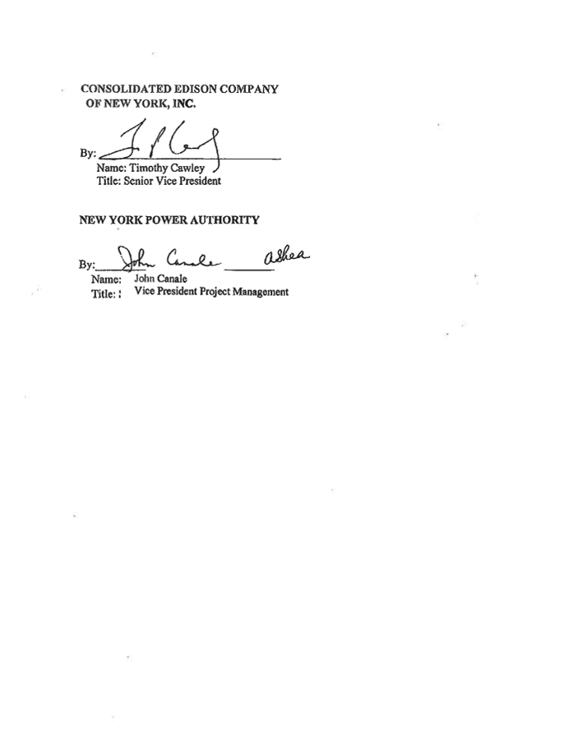

Exhibit A:
List of Equipment* for O&M Services

Equipment list contains CEII material and has been deleted from the document.

Exhibit B:
SF6 Equipment Tracking Cylinder Log
Location:_________________________________

Date Cylinder Actual weight Actual weight Gas added to Equipment
Serial # before maint.(lbs) after maint.(lbs) equipment description
(A) (B) (A-B)

Exhibit C:
Power Authority Terms and Requirments
Terms Relating to the O&M Services
Pursuant to Power Authority’s request, the Astoria Annex Substation shall be generally kept unstaffed and Con Edison shall provide any staffing at the Astoria Annex Substation for its O&M Services as required by Article IV of this Agreement.
Terms Relating to the Tracking and Reporting of SF6 Gas Usage and
Emissions at the Facility
The Astoria Annex Substation will contain Sulfur Hexafluoride (SF6) gas. Due to the Power
Authority’s commitment to the Climate Registry and in anticipation of the Environmental Protection
Agency’s proposed mandatory gas reporting rule, the Power Authority recognizes the need to track the
SF6 gas inventory, additions and losses of SF6 gas to the Power Authority equipment. Accordingly,
Con Edison will be responsible for tracking the inventory, additions and losses of SF6 gas in the Power
Authority equipment, in connection with the Astoria Annex Substation on the following terms and
conditions:
1. Con Edison shall handle all SF6 gas and SF6 Gas Equipment in a manner to minimize releases.
2. Only personnel who are familiar with the risks and the need to minimize leaks and releases of FS6
gas will be permitted to work on SF6 Gas Equipment.
3. As provided in Section 4.1.7 above, the Power Authority shall provide to a selected group of Con
Edison mechanics and supervisors training required by the Power Authority for personnel working with SF6 Gas Equipment.
4. Con Edison shall weigh the Power Authority-owned SF6 gas containing cylinders, using certified
scales purchased by the Power Authority for Con Edison’s use, by the end of the first quarter of the then current year to establish a beginning year weight.
5. Con Edison shall weigh the SF6 gas containing cylinders before and after each maintenance
activity, and record the weights, and such additional information as is agreed between the Power Authority and Con Edison, in Con Edison’s work management system, Maximo. The report will be presented in a form similar to the example attached as Exhibit B.
6. The Power Authority shall purchase and provide for Con Edison’s use a weight scale that is
accurate to within 1%. Thereafter, Con Edison shall be responsible for ensuring that the weight
scale is re-calibrated according to the manufacturer’s recommendations, or at least annually. In
the event a new scale has to be purchased, it shall be at the Power Authority’s sole cost and
expense.

7. Con Edison shall submit to the Power Authority on a monthly basis the cylinder log(s) and a
summary of the weight of SF6 gas added to and/or removed from the Power Authority equipment as recorded in the Maximo work management system. This submission is required by the 15th of the following month.
8. Subject to Con Edison’s prior review and approval, the Power Authority shall provide inspection
and maintenance specifications for the maintenance of the Power Authority-owned SF6 Gas
Equipment which Con Edison will implement. Con Edison shall retain documentation recording any leaks found on the SF6 Gas Equipment.
9. The Power Authority shall purchase and provide the SF6 gas cart subject to Con Edison’s prior
review and approval, for exclusive use at the Power Authority’s Facility or otherwise as specified
by the Power Authority the Power Authority shall provide inspection and maintenance
specifications for maintenance on the Power Authority-owned SF6 gas cart which Con Edison
will implement.

10. To aid in the detection of leaks of SF6 gas from the Power Authority Gas Equipment, Con Edison
shall be aware that the Power Authority owns and can and provide to Con Edison for use, an SF6 camera that is designed to function in indoor applications. The Power Authority will make this equipment available within 24 hours of a request. Con Edison will retain documentation
evidencing that the gas SF6 Gas Equipment and cart is not leaking.
11. Con Edison shall ensure that all SF6 gas-containing spare equipment is kept under positive
pressure and not leaking. If the positive pressure is from SF6 gas, these items will need to be part of the SF6 inventory.

12. Con Edison shall not intentionally or knowingly release SF6 gas to the atmosphere, except as
necessary in connection with sampling for chemical analysis of the SF6 gas.

13. Monday through Friday, Con Edison shall notify the Power Authority within 24 hours of a release
of more than 100 pounds of SF6 to the atmosphere by contacting: [the Power Authority to provide name, email and telephone number of contact person].
14. Alarms on all SF6 Gas Equipment will be connected to the Con Edison Energy Control Center
and to the Power Authority Generating Station.
15. Con Edison shall submit to the Power Authority by January 31 of each given year, the sum total
of SF6 gas added to the Power Authority-owned SF6 Gas Equipment during the preceding year. If no SF6 gas was added, that shall be stated explicitly on the submission.

Exhibit D:
“Minor Spare Parts”, “Major Spare Parts”, and “Other Parts and
Equipment”

Spare parts list contains CEII material and has been deleted from the
document.

EXHIBIT E:
Survey for Easement Agreement

Survey contains CEII material and has been deleted from the document

EXHIBIT F:
Good Faith Estimate of Preparatory Work and Services

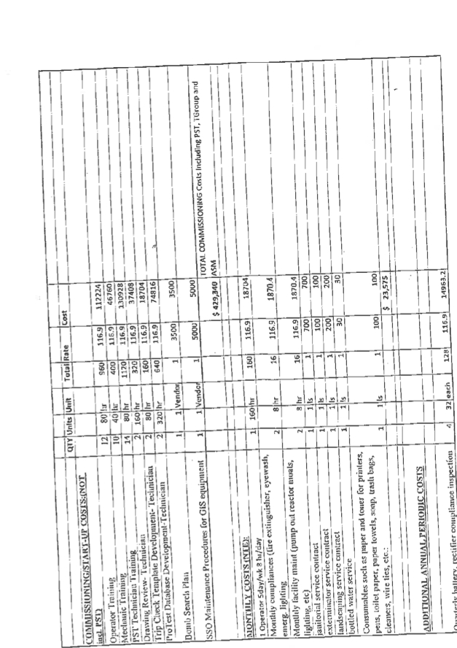

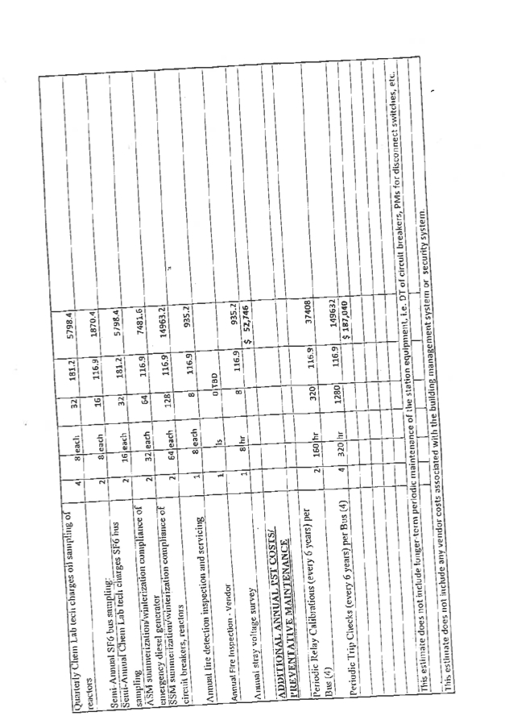



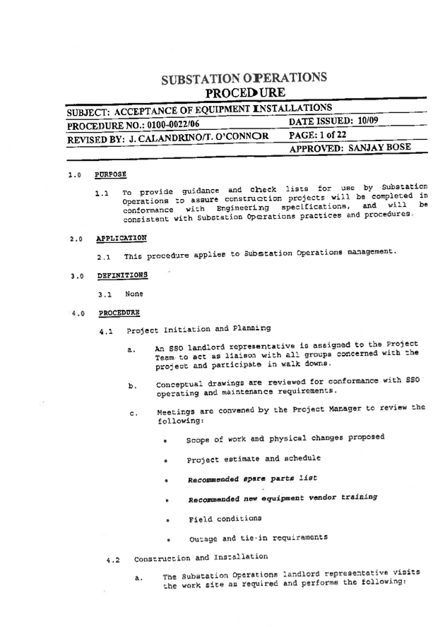

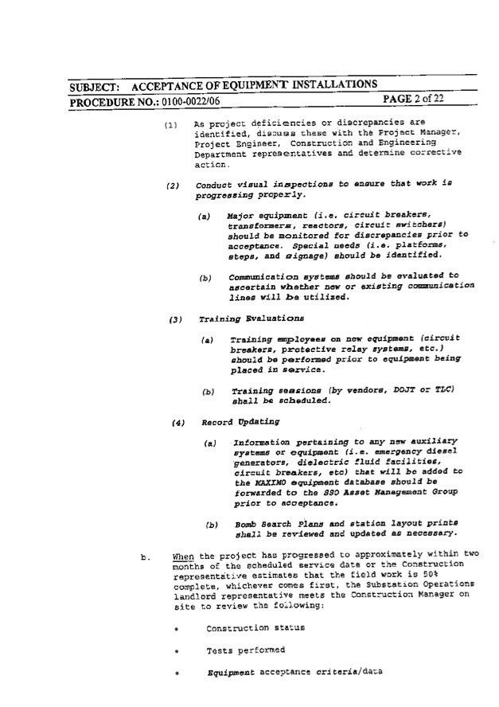

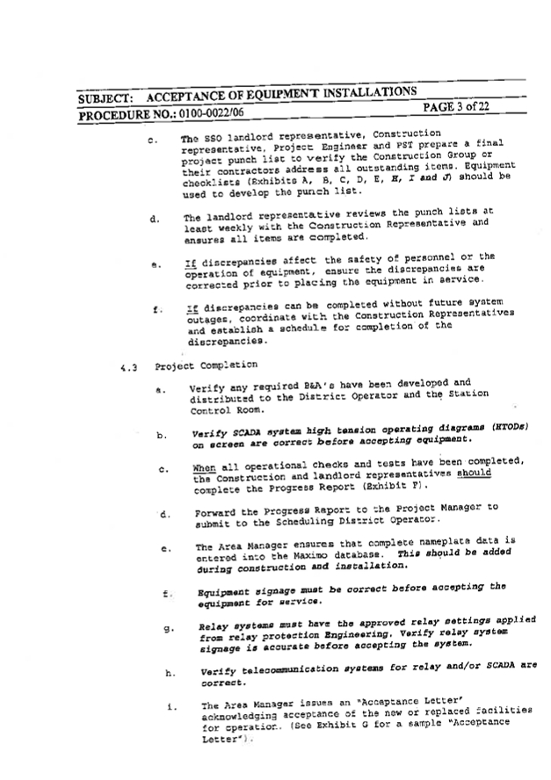

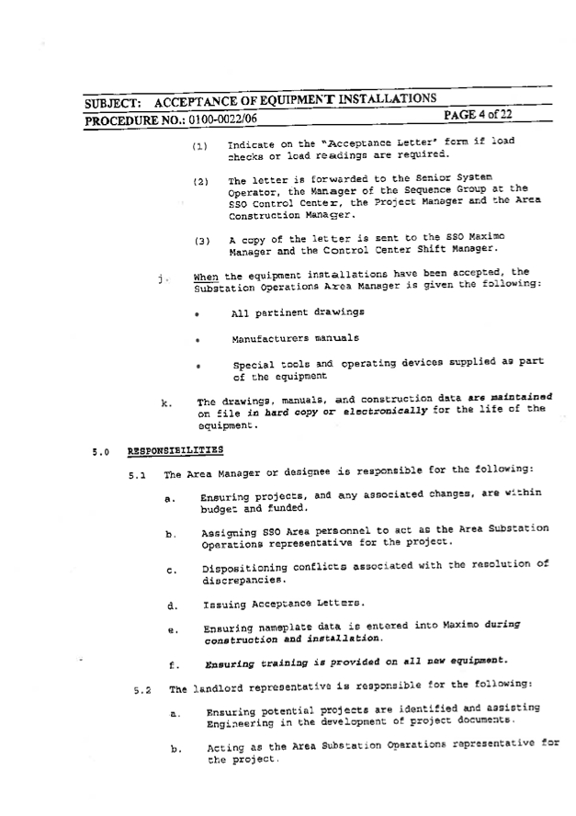

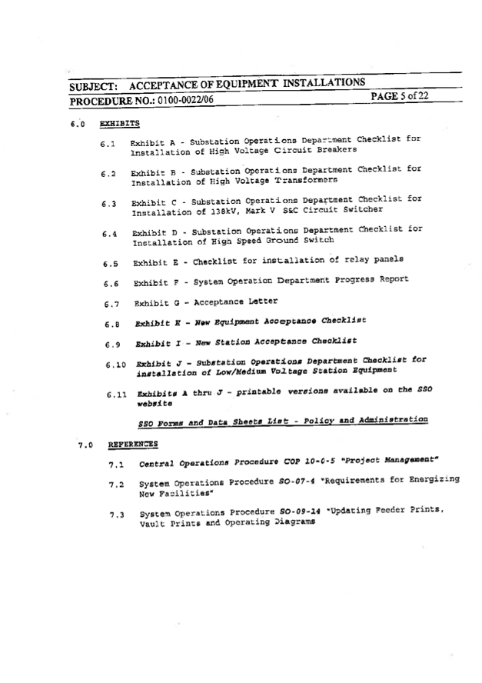

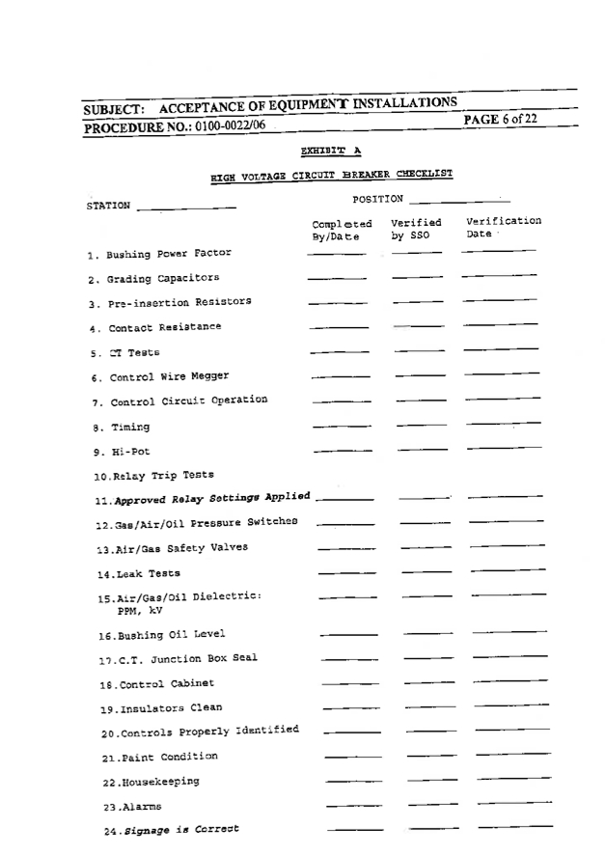

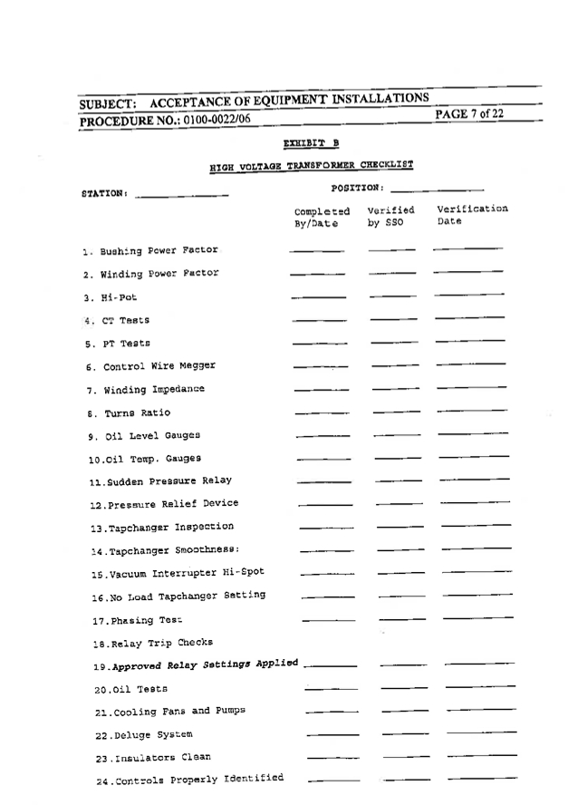

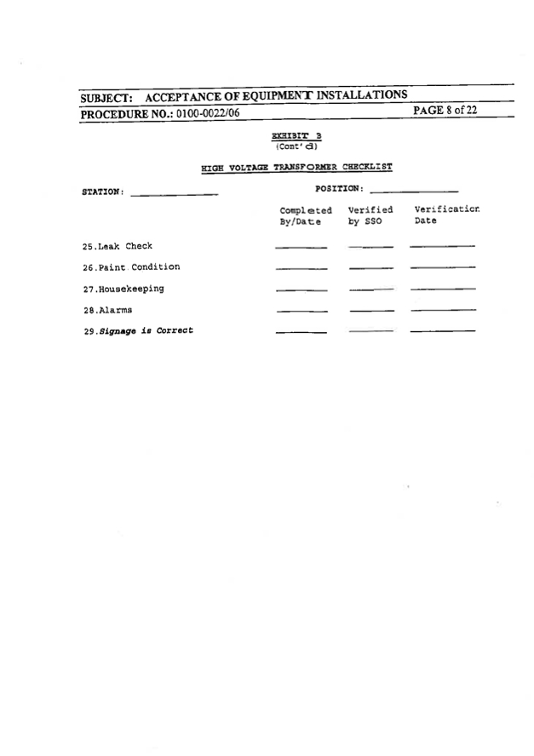

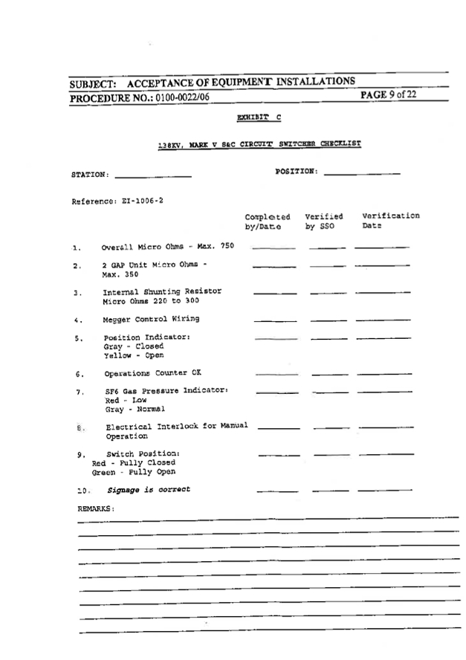

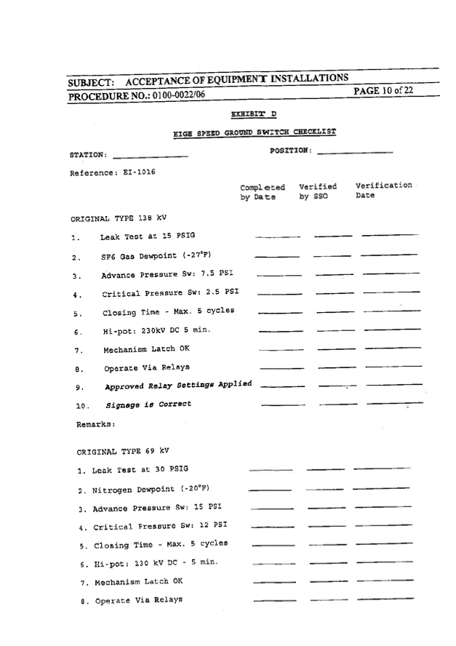

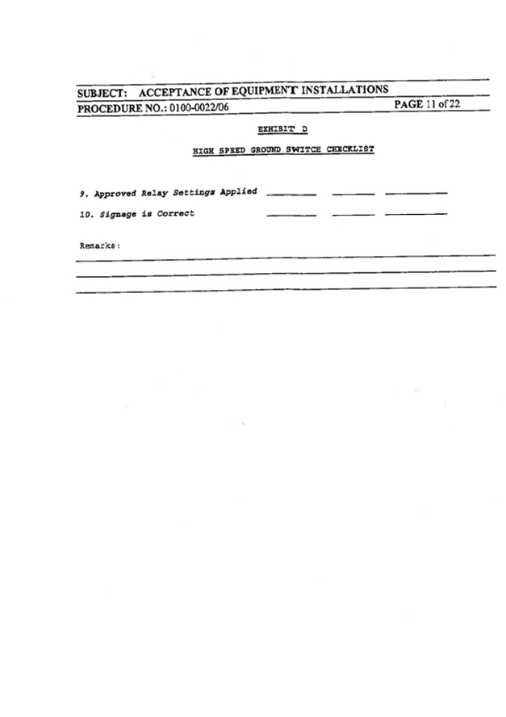

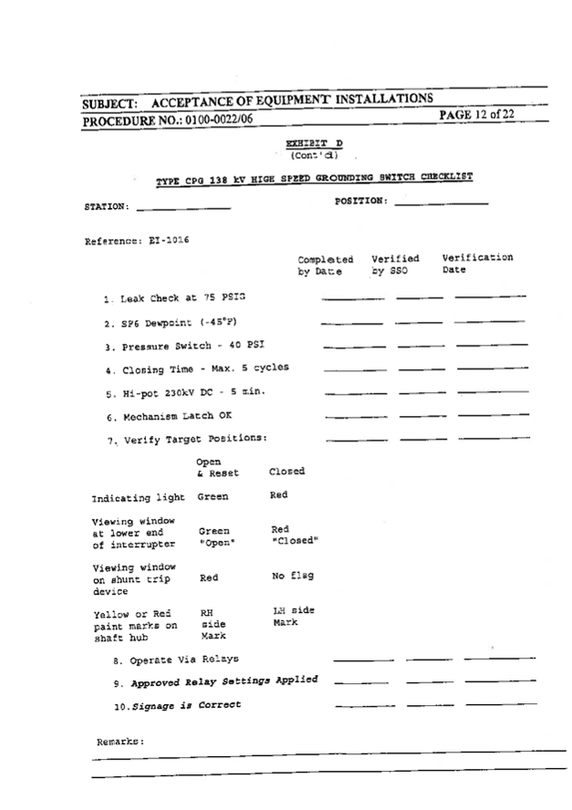

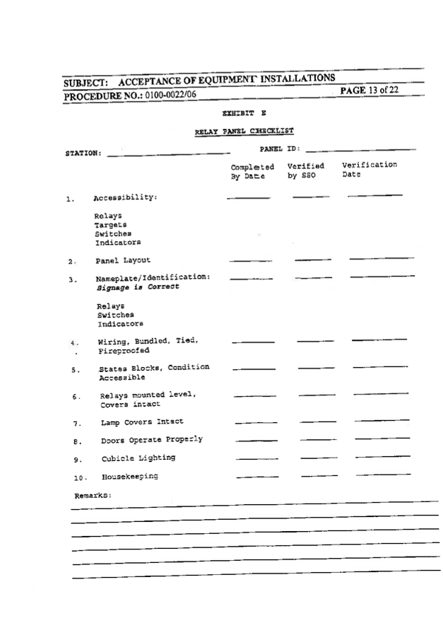

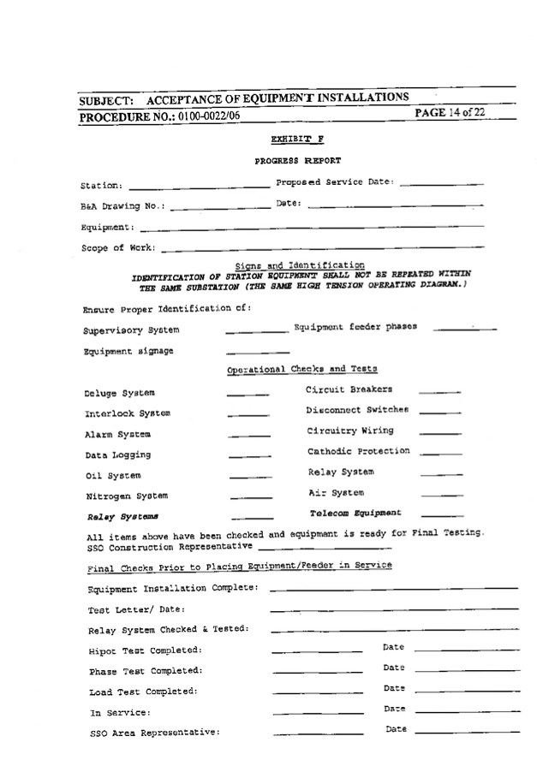

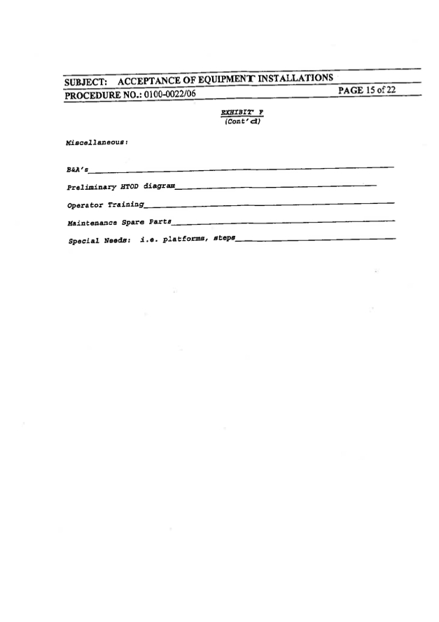

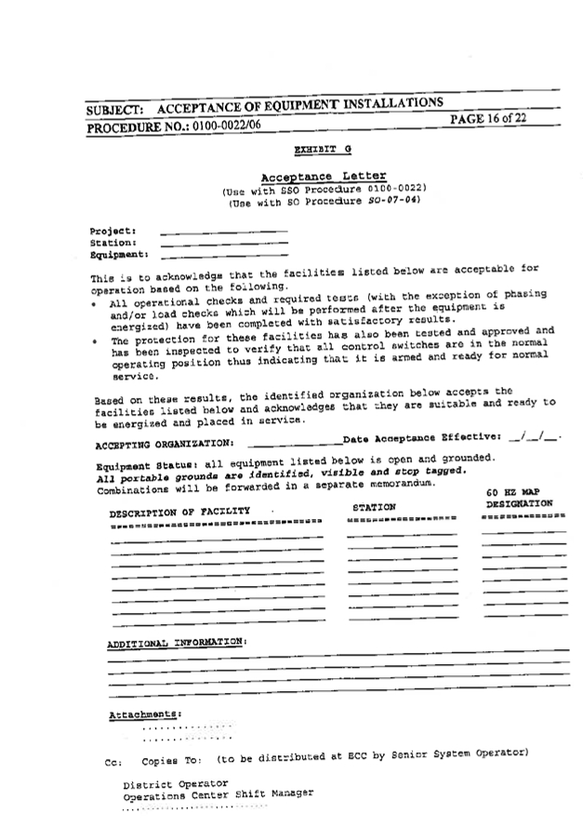

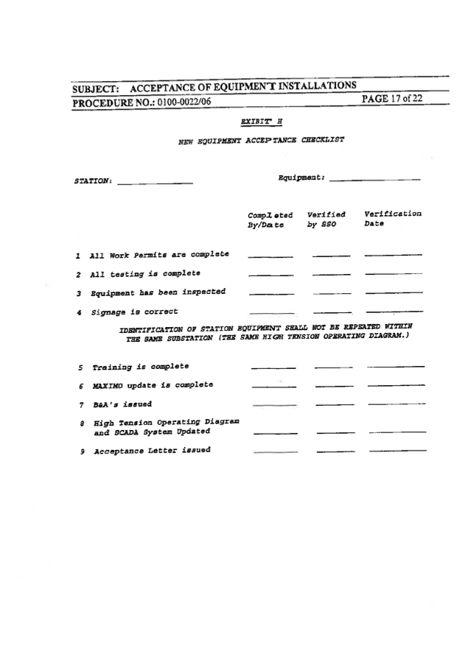

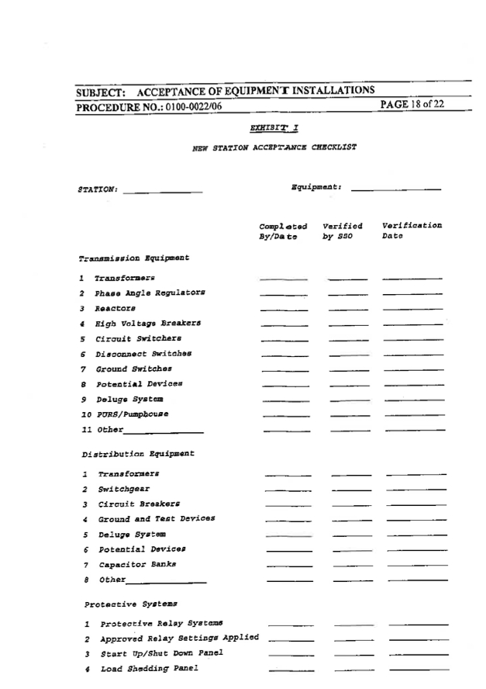

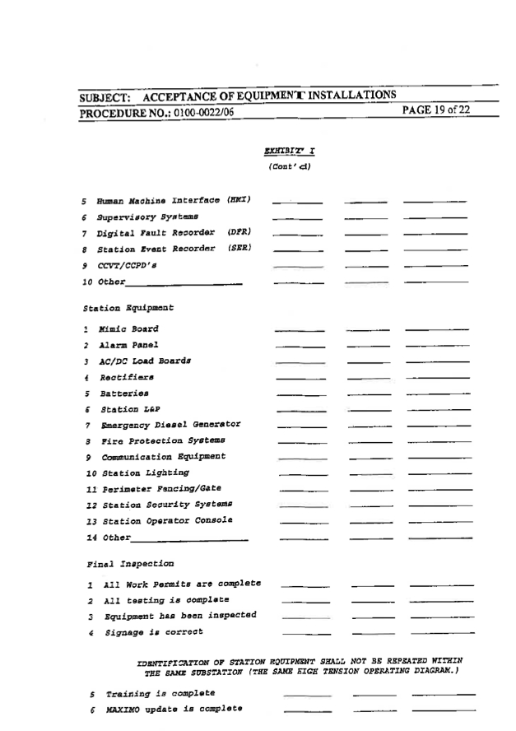

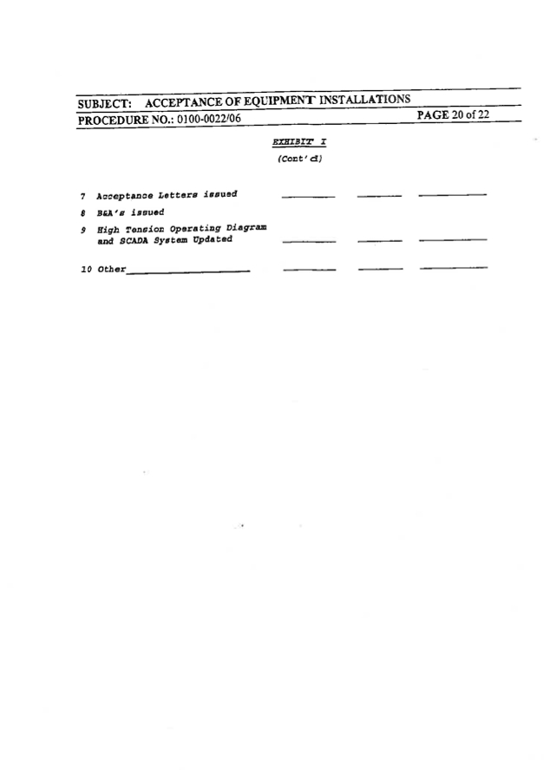

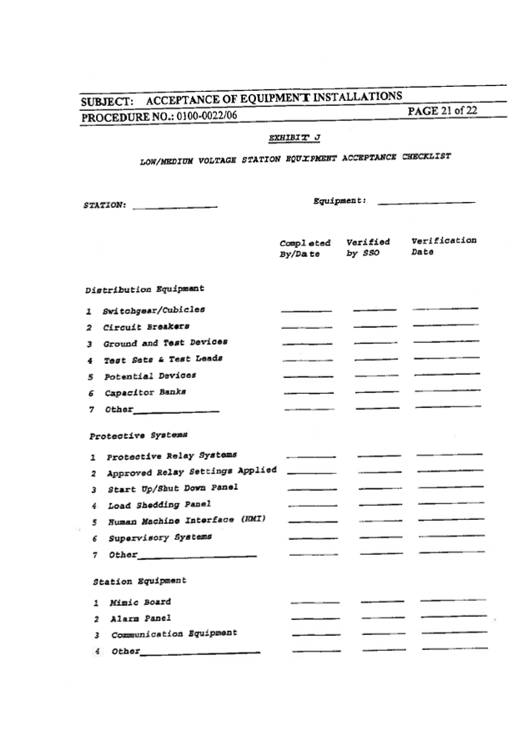

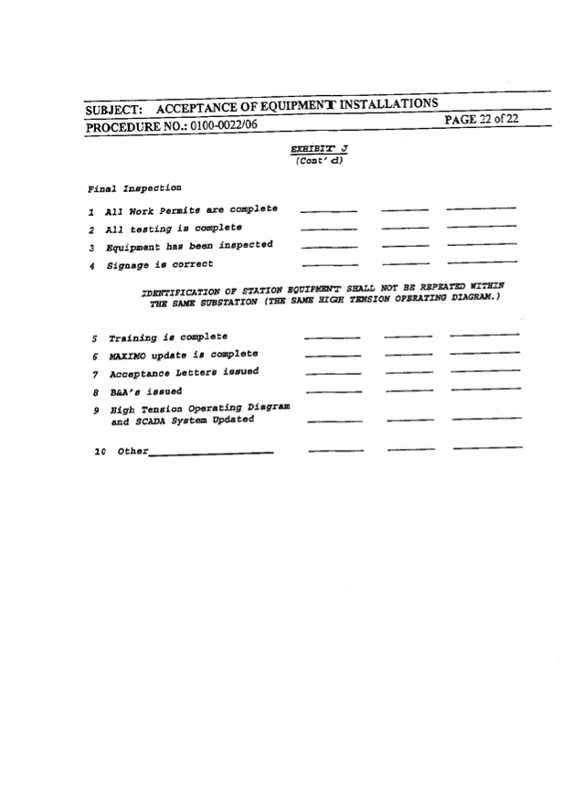



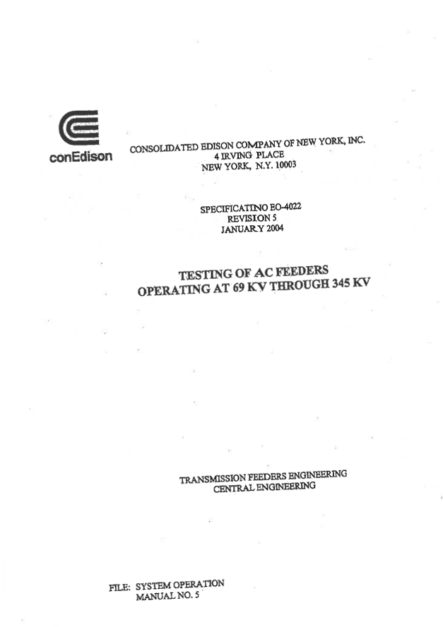

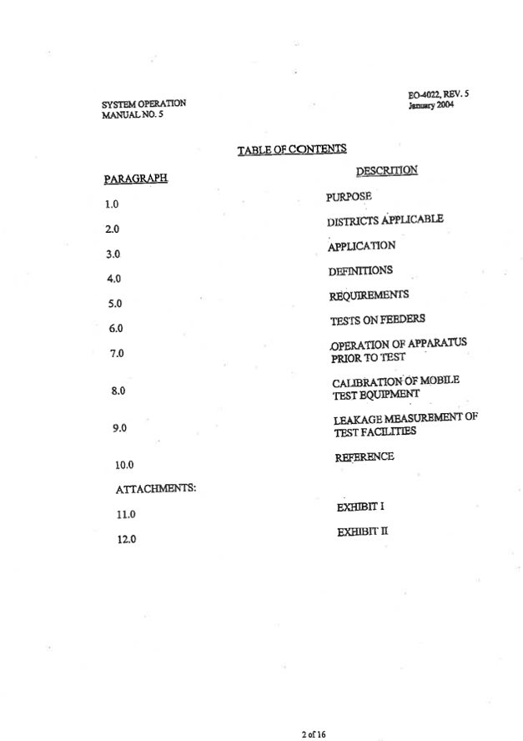

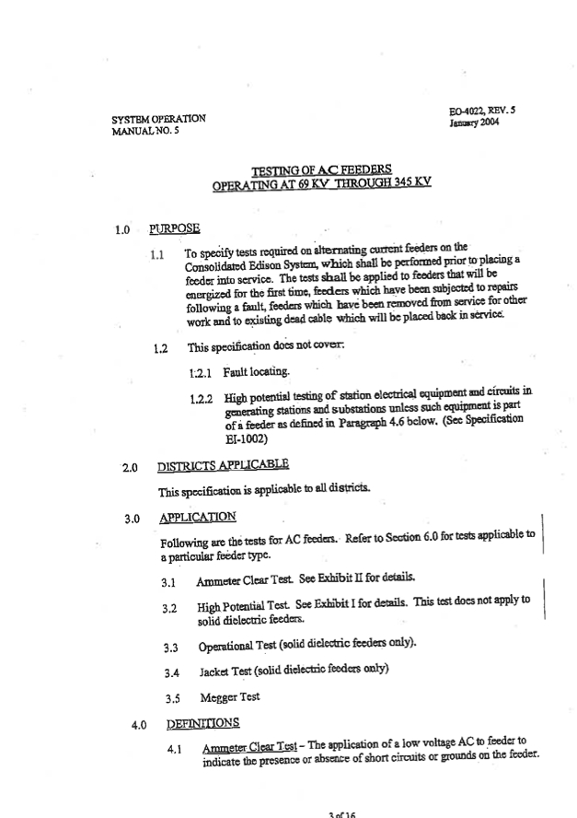

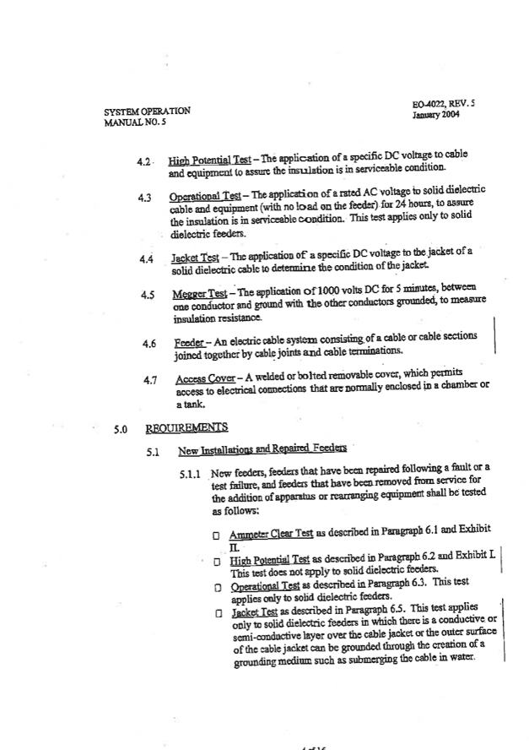

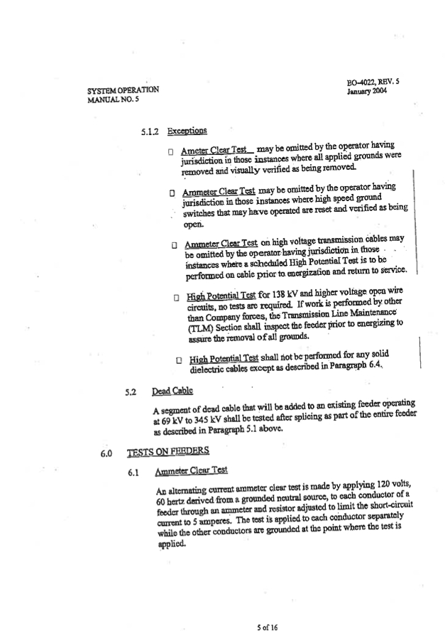

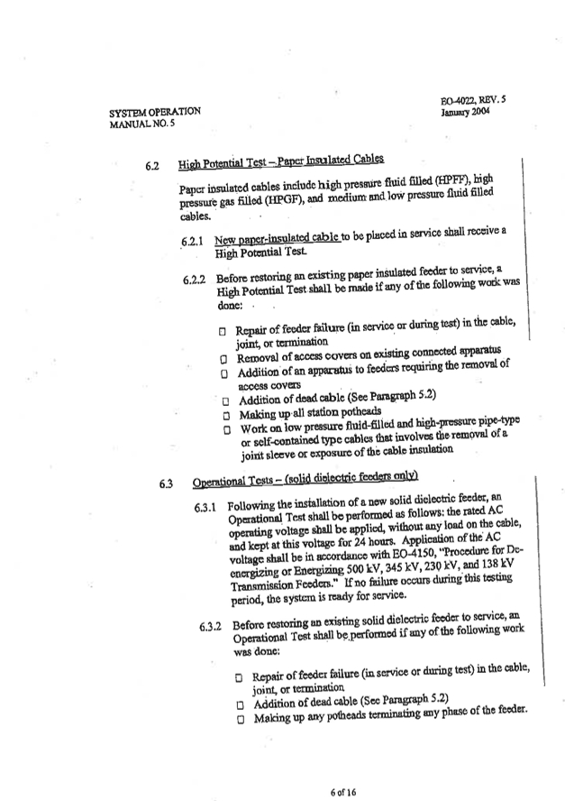

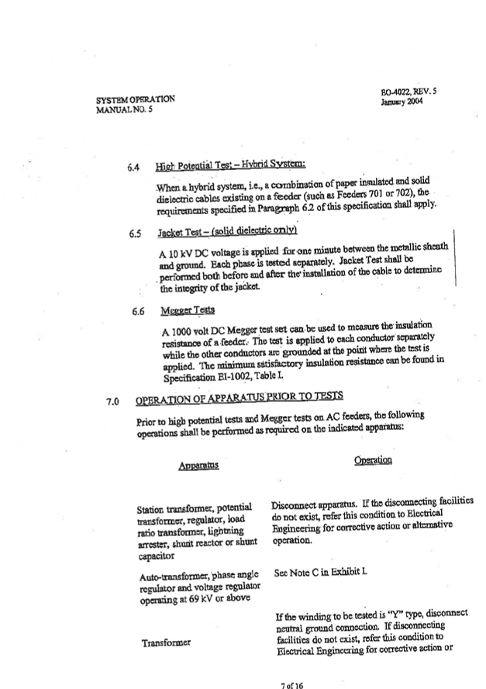

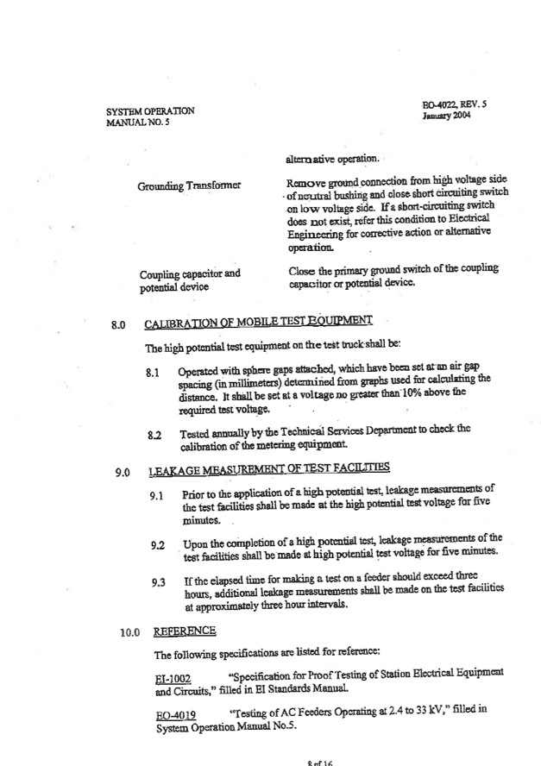

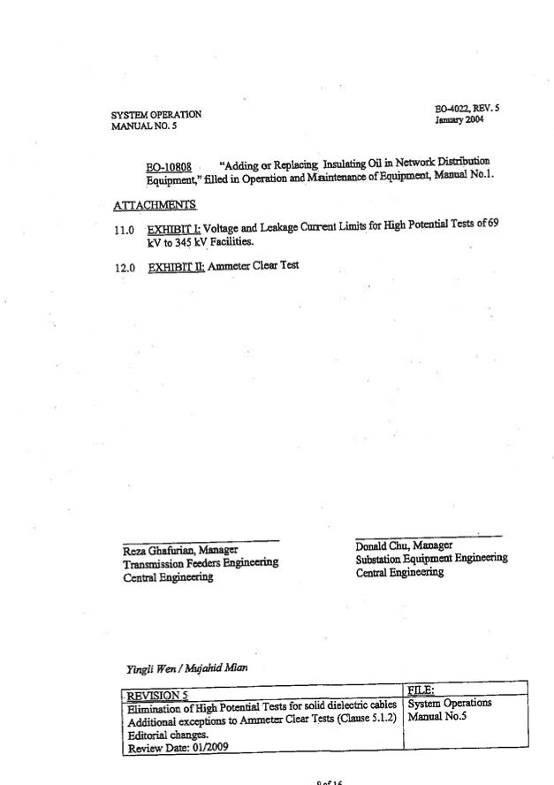

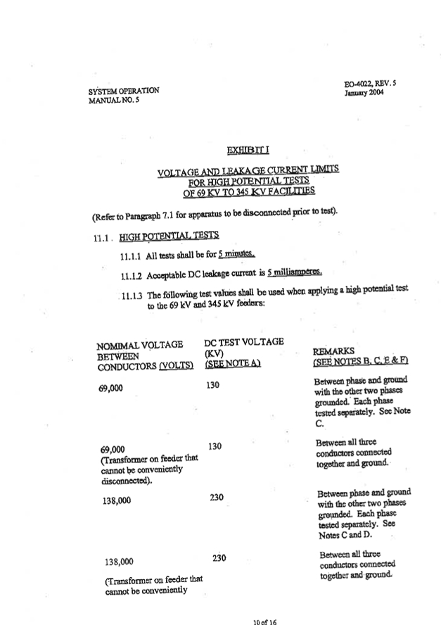

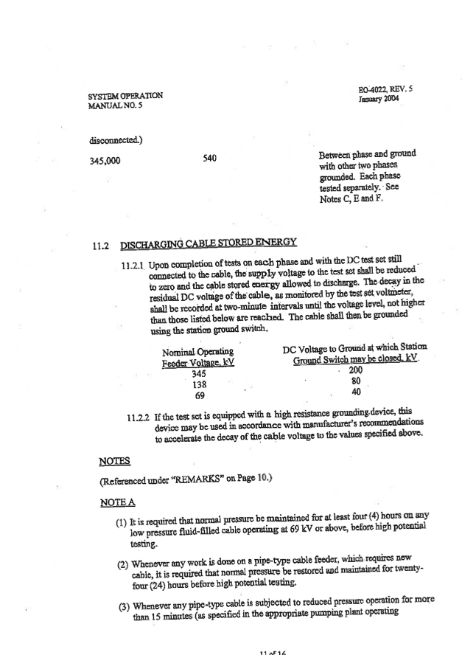

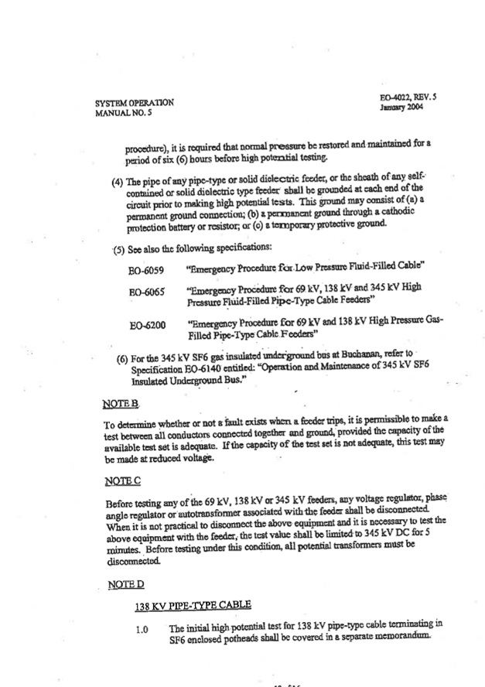

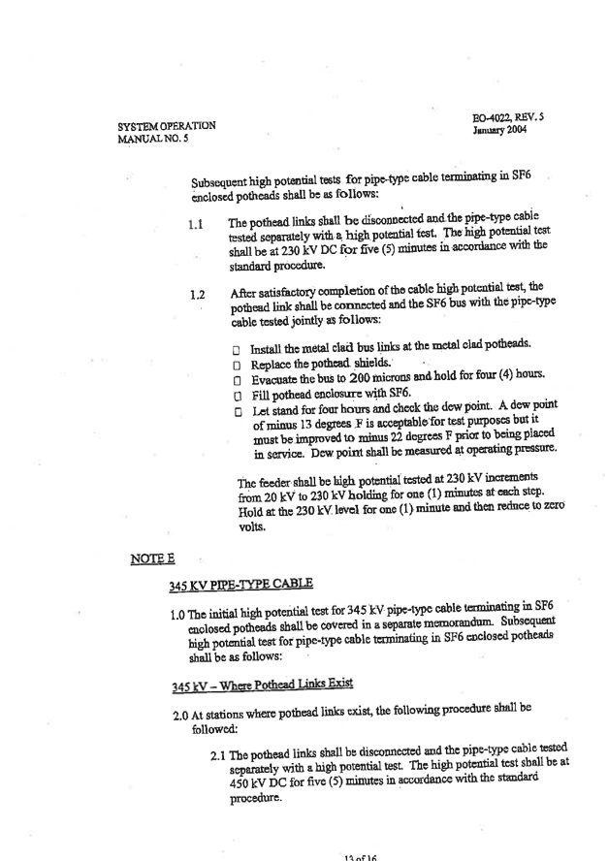

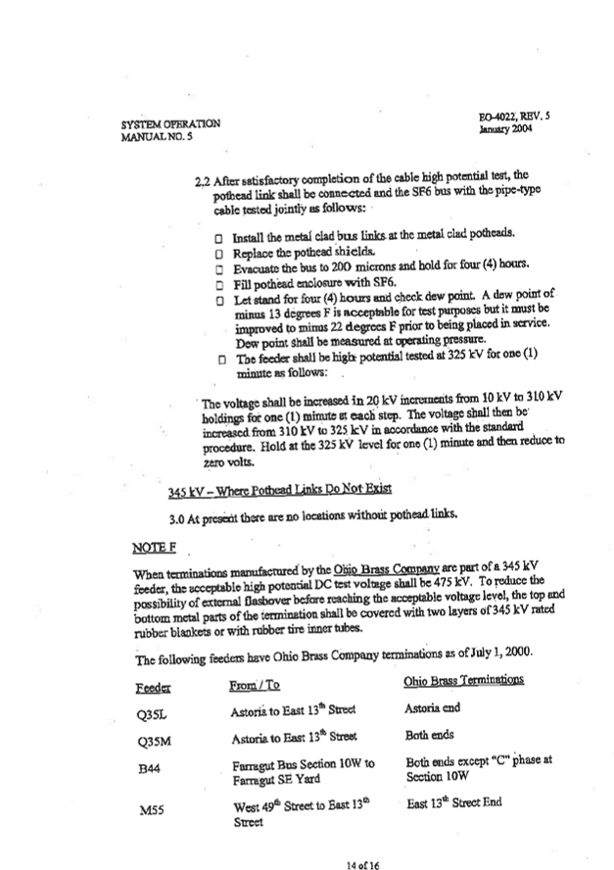

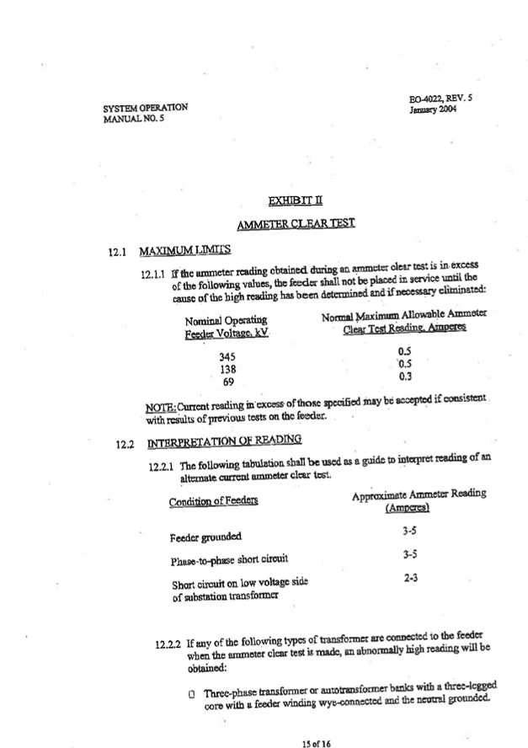

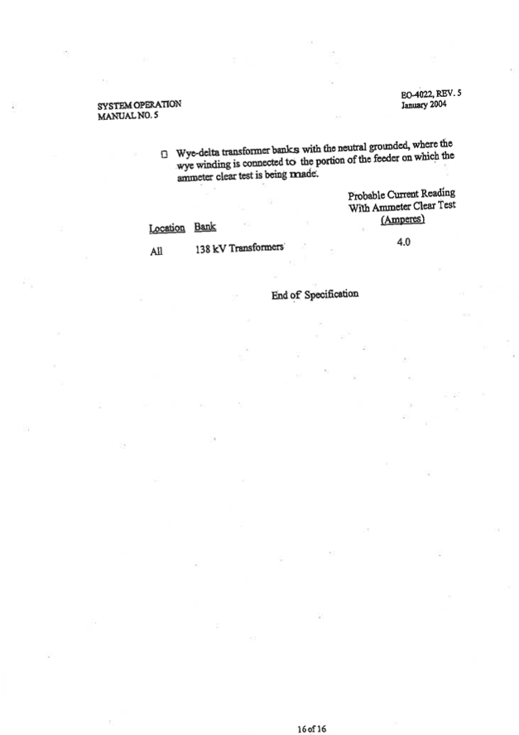



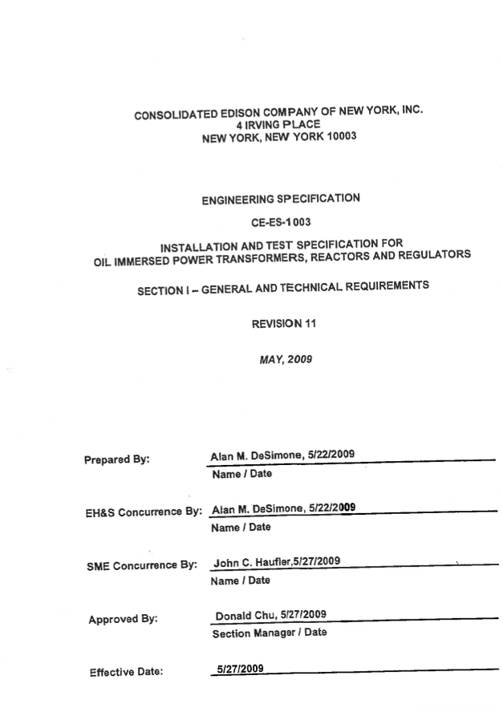

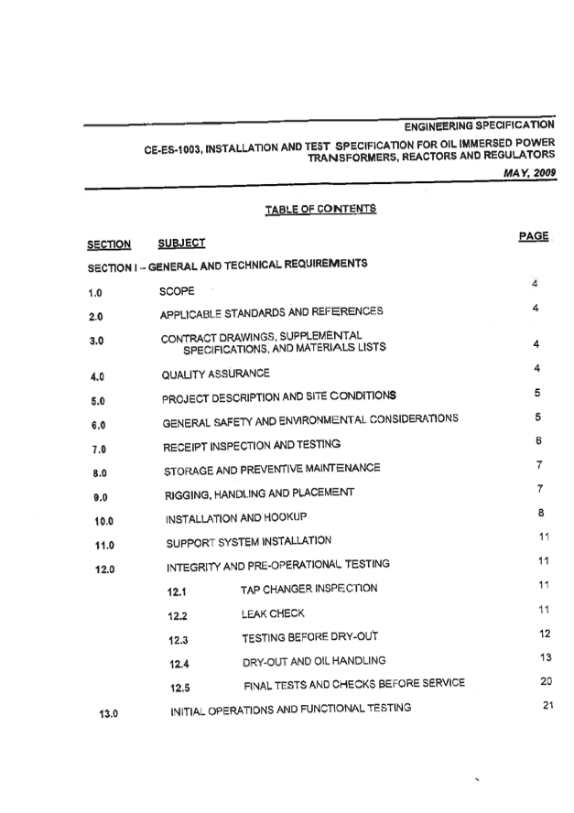

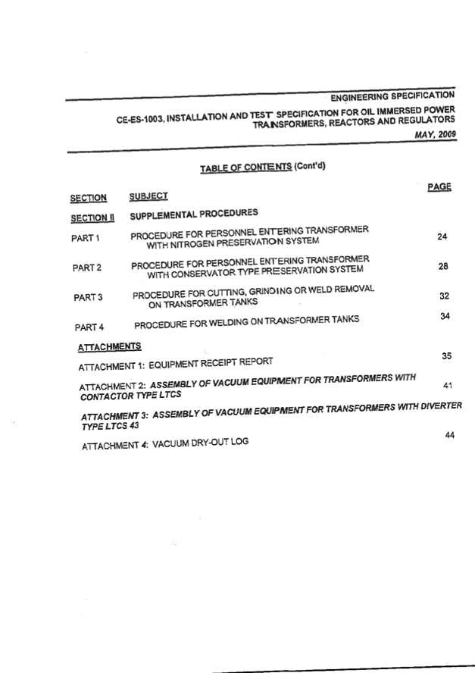

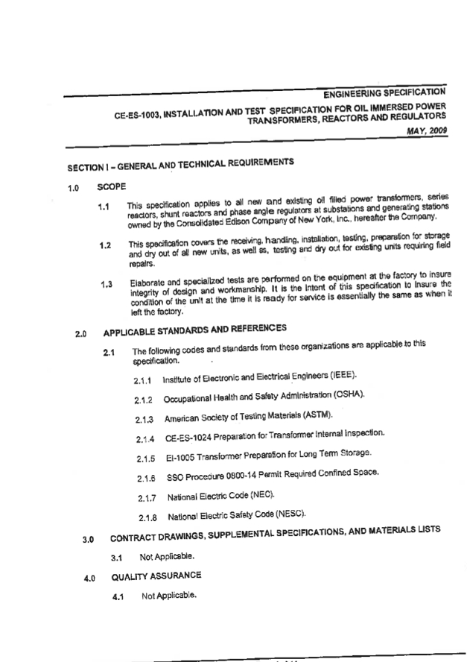

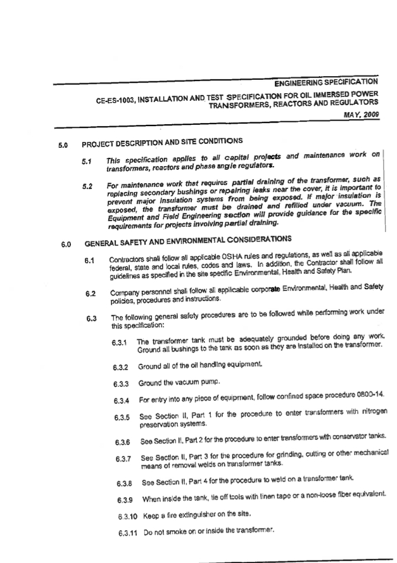



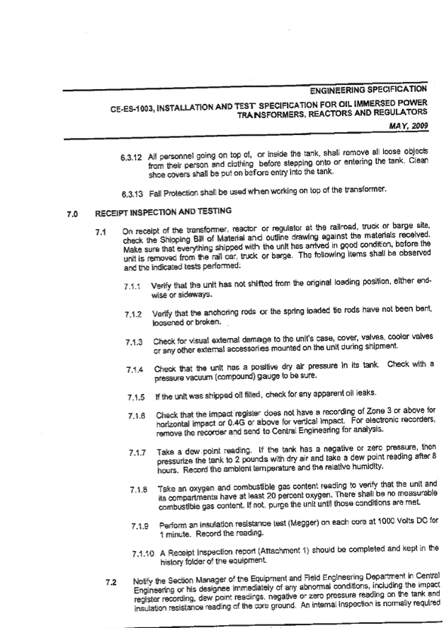

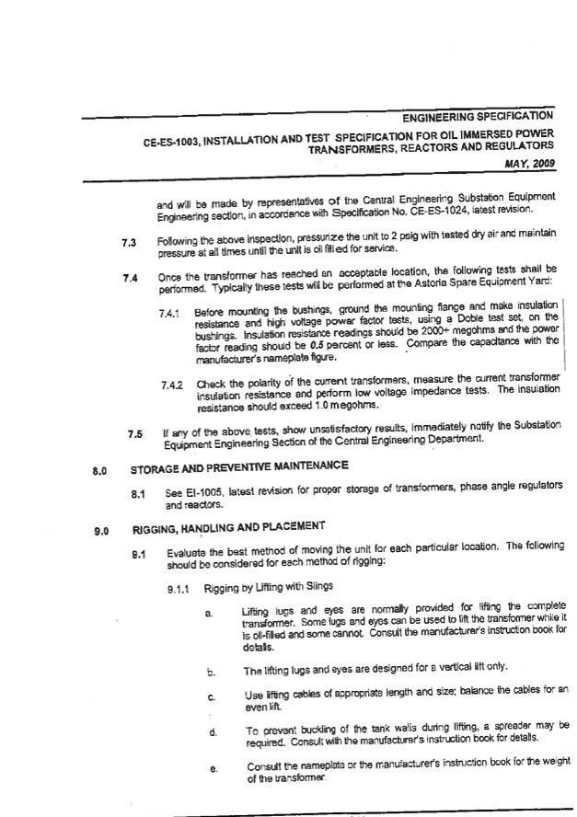

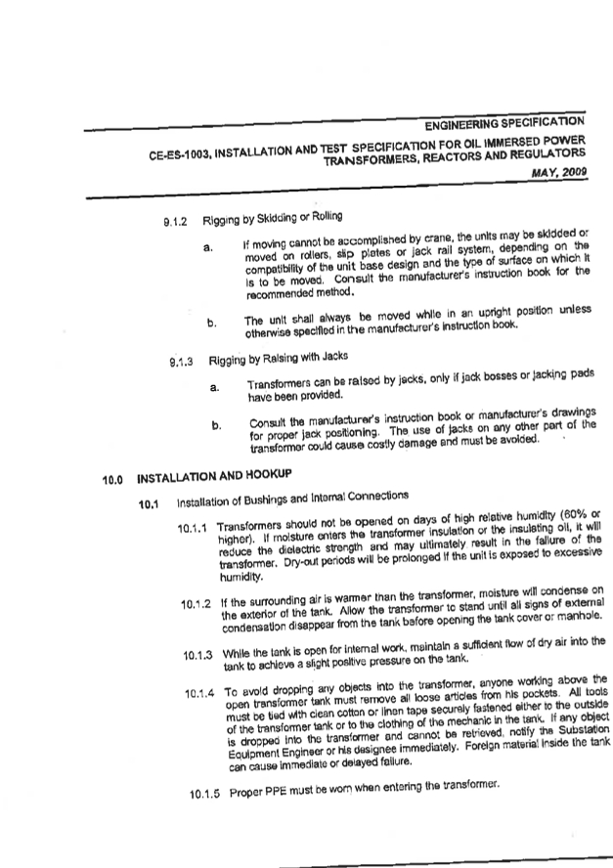

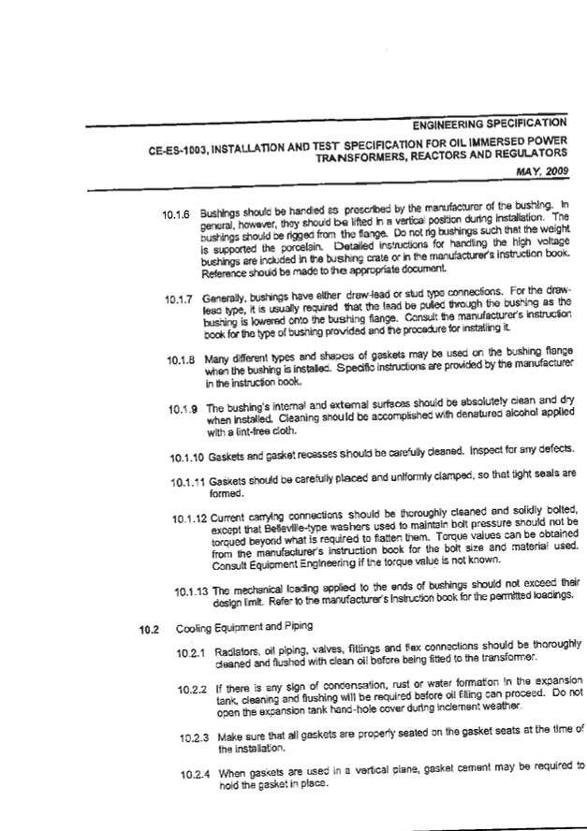

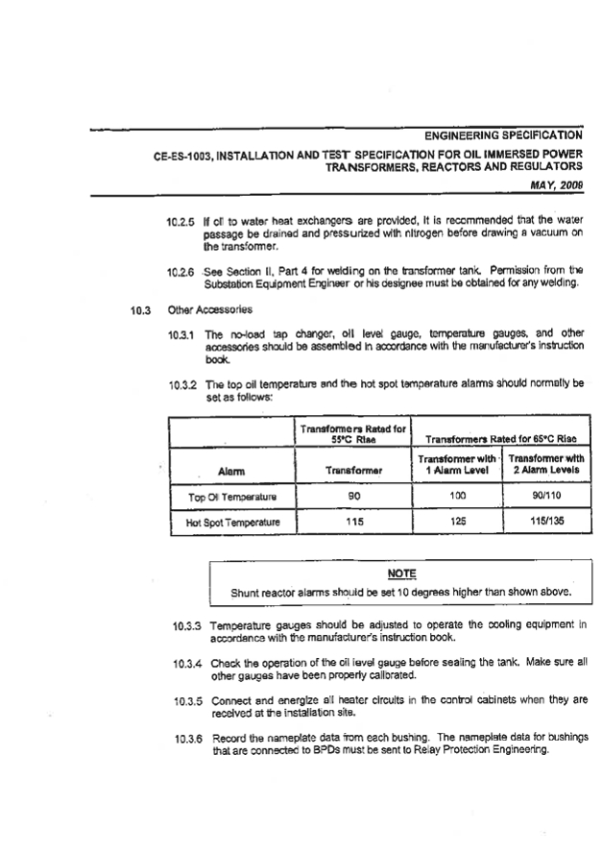

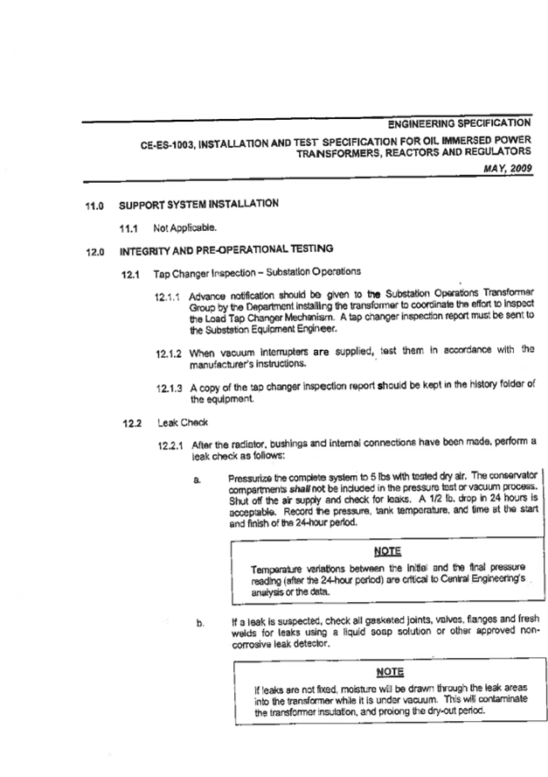

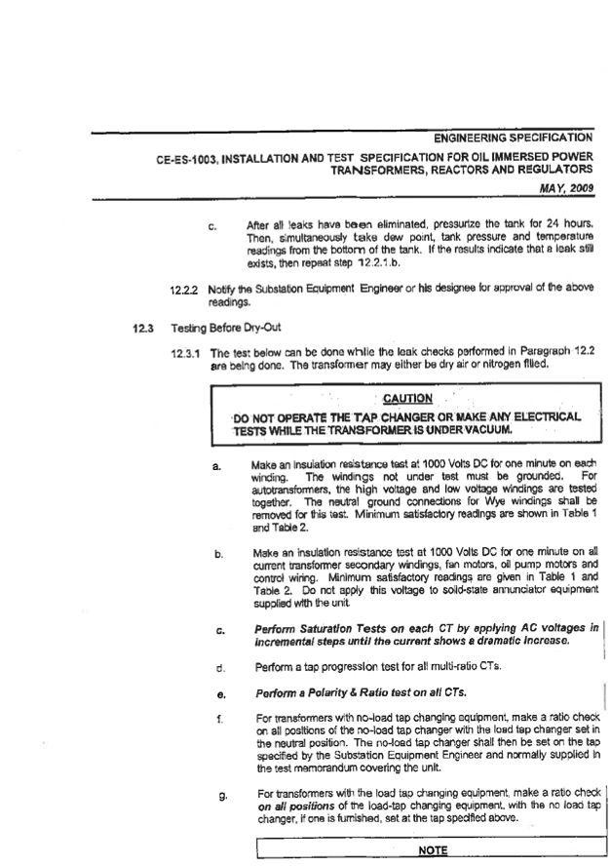

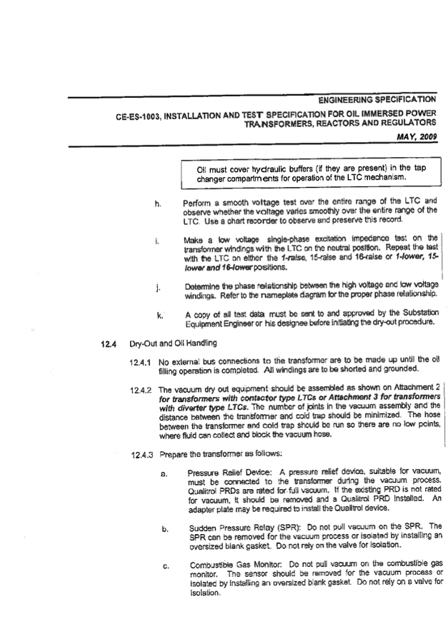

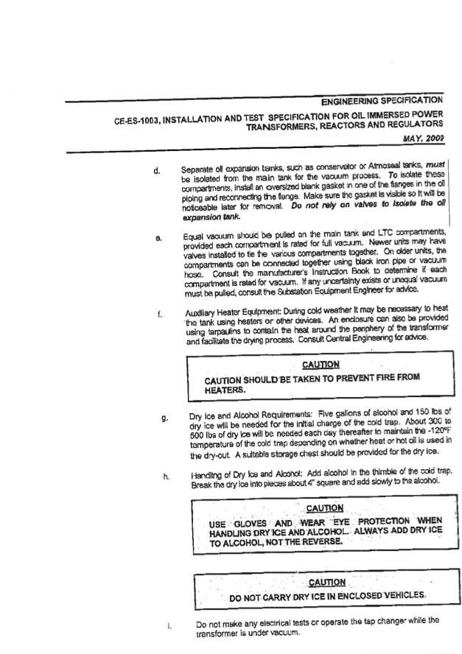

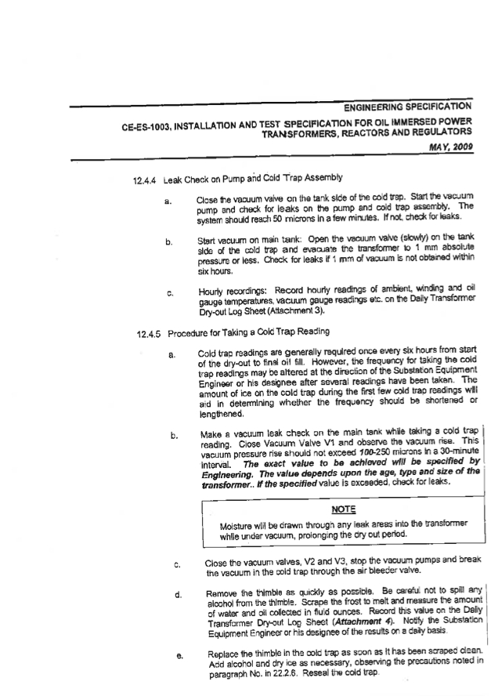

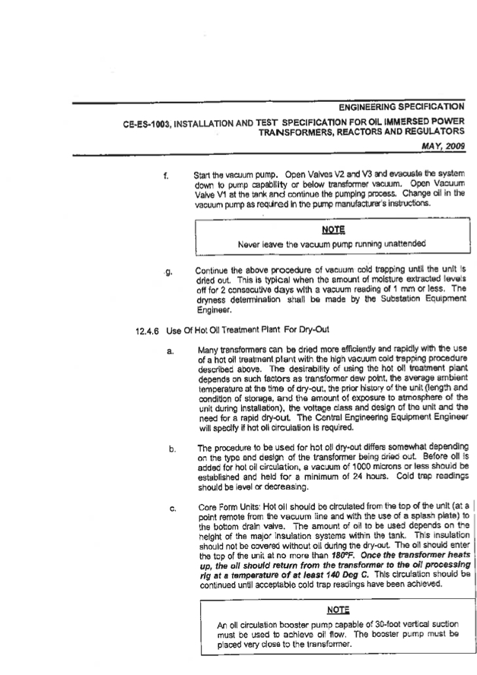

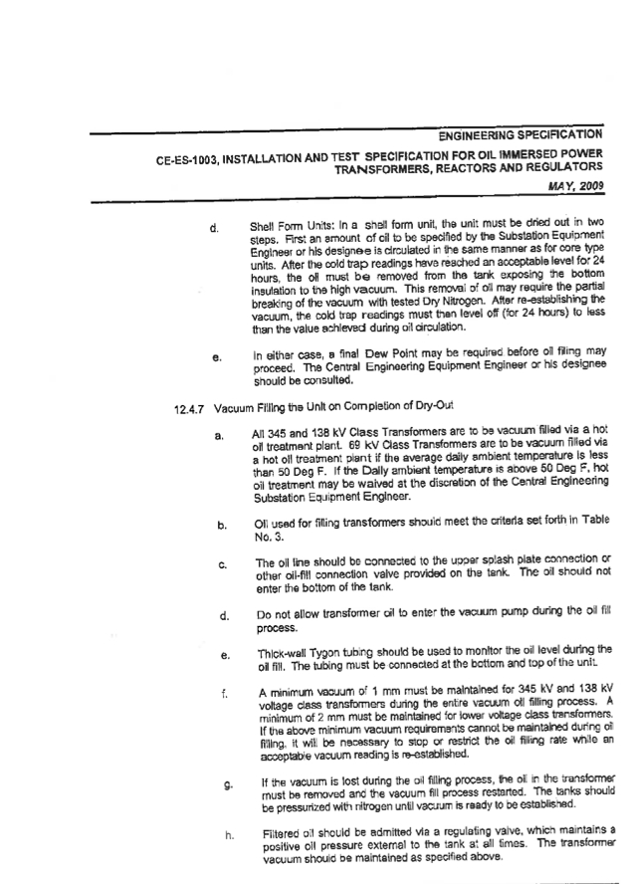

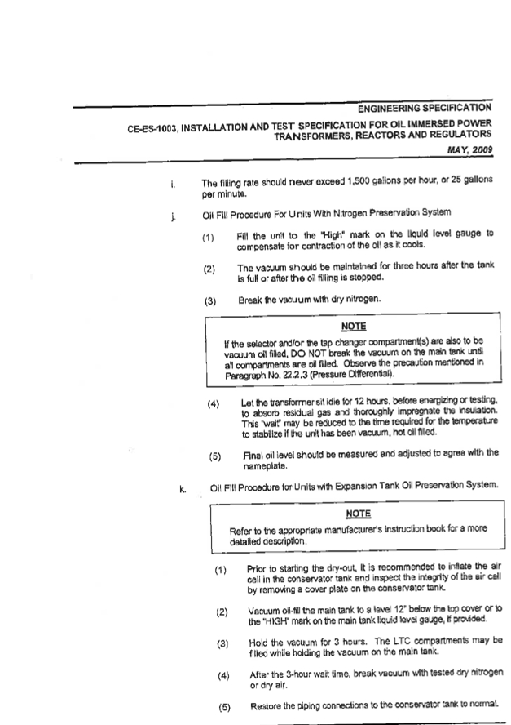

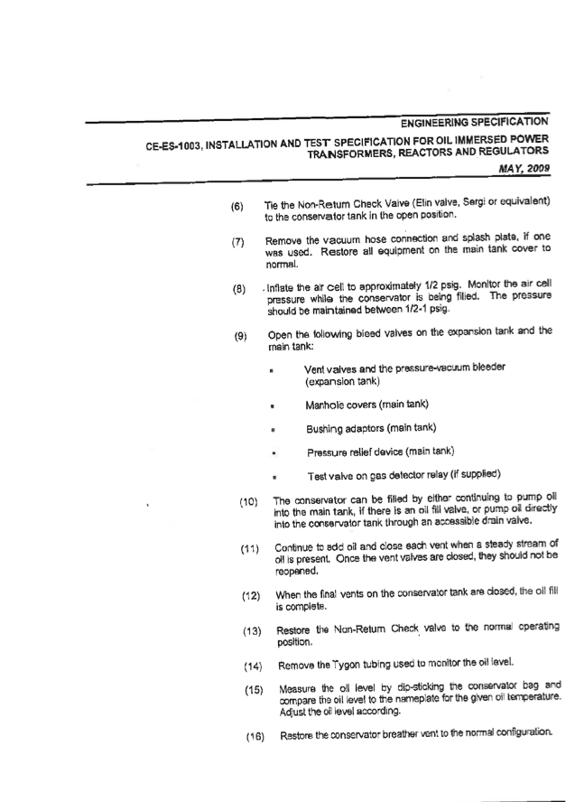

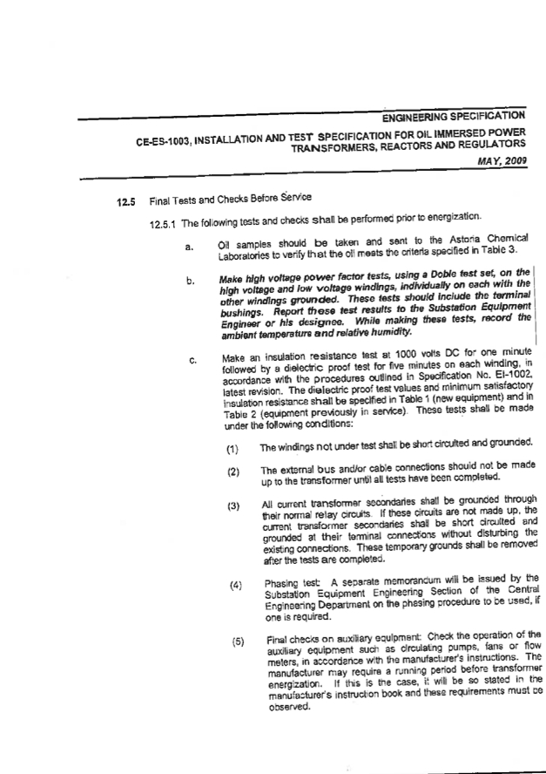

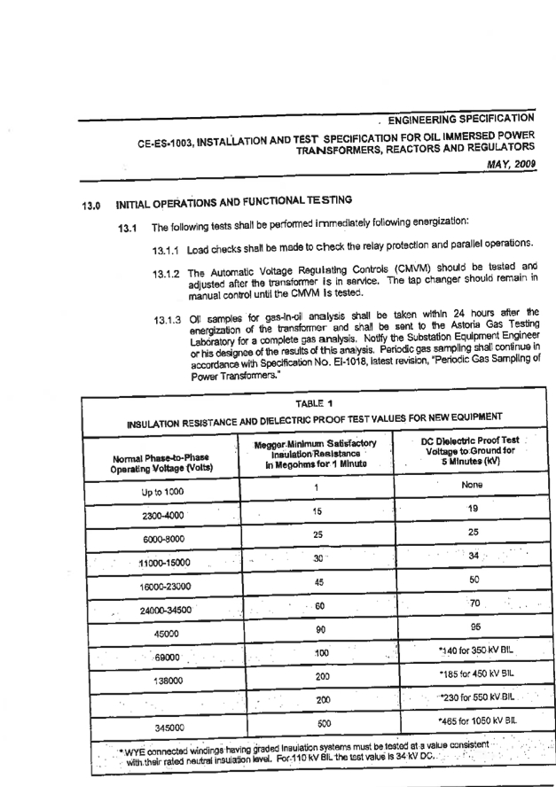

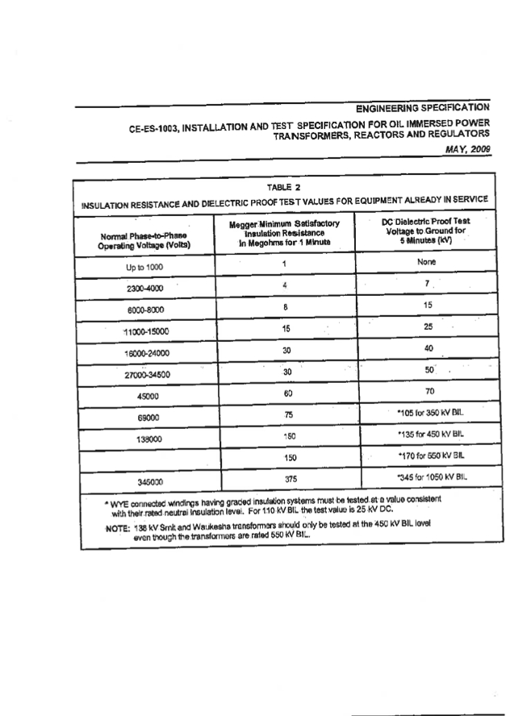

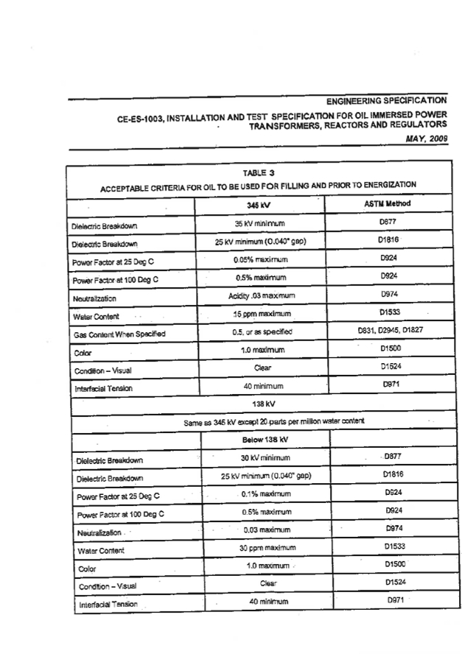

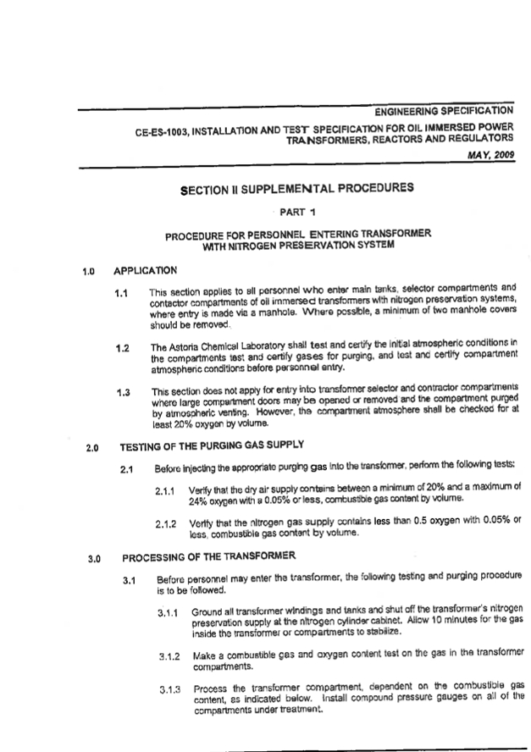

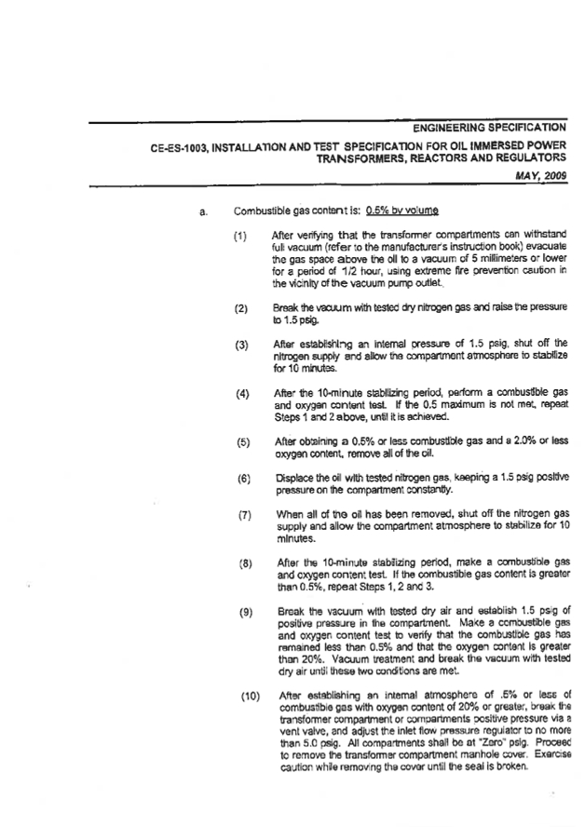

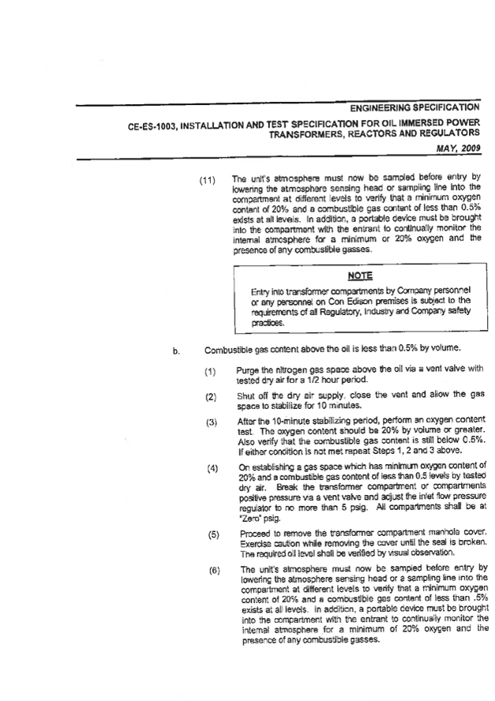

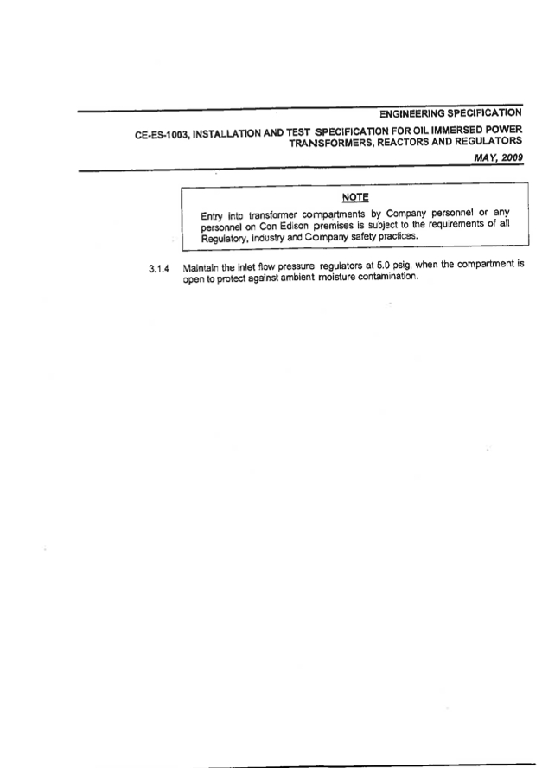

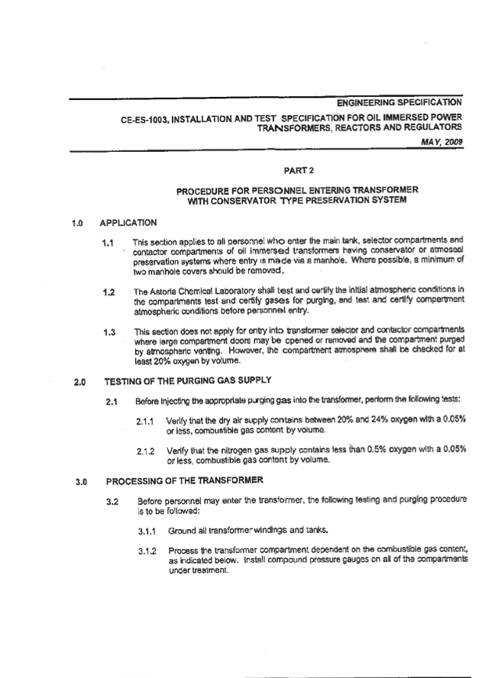

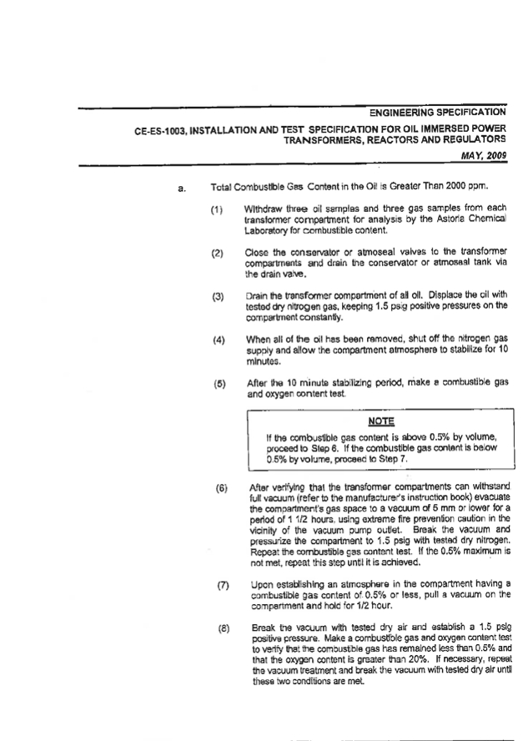

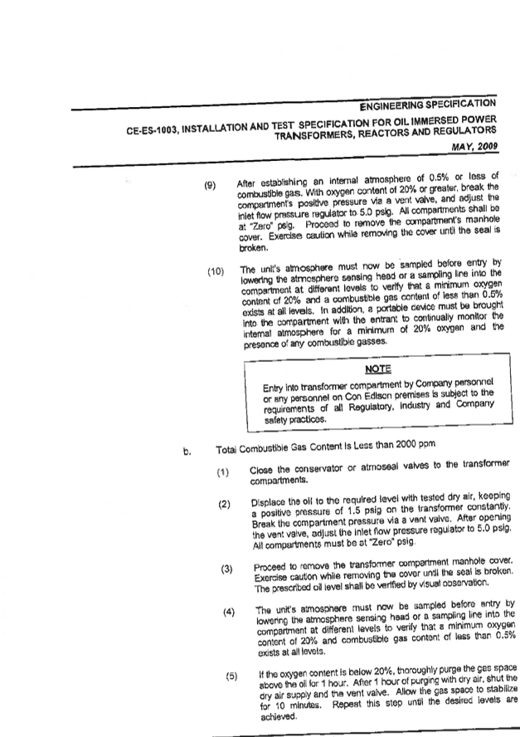

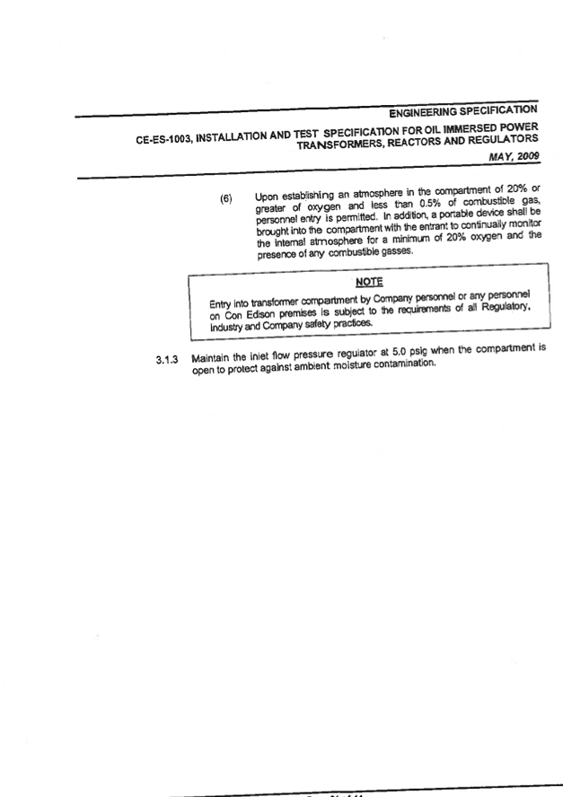

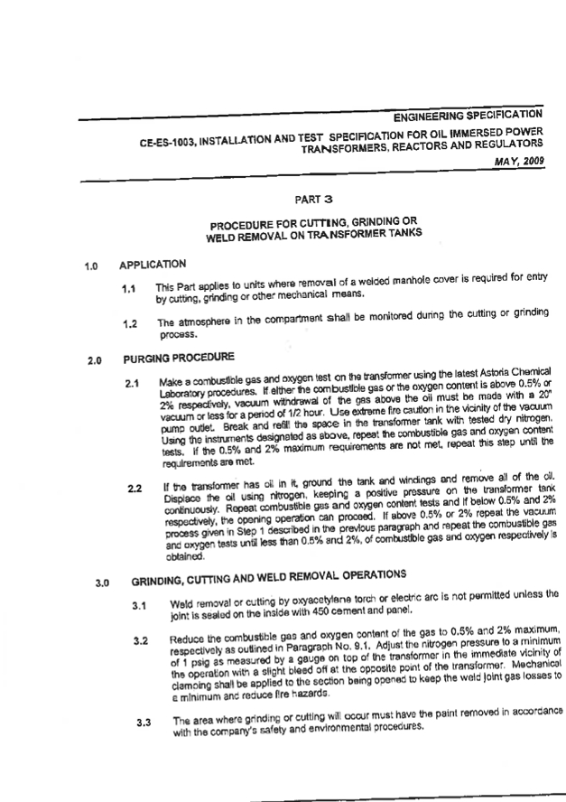

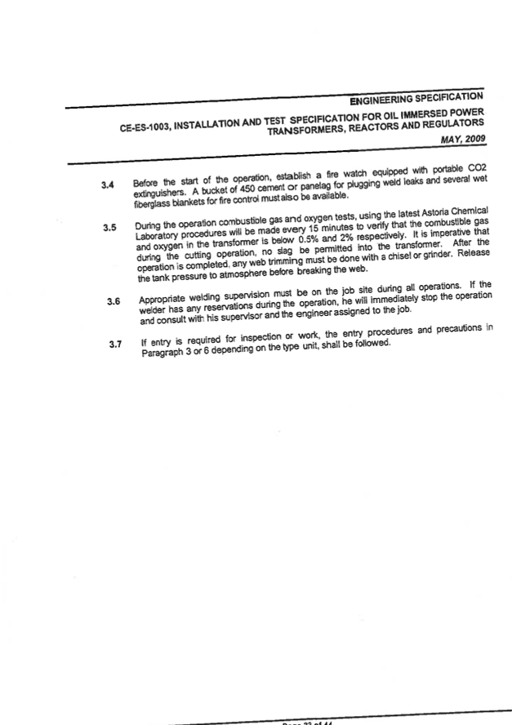

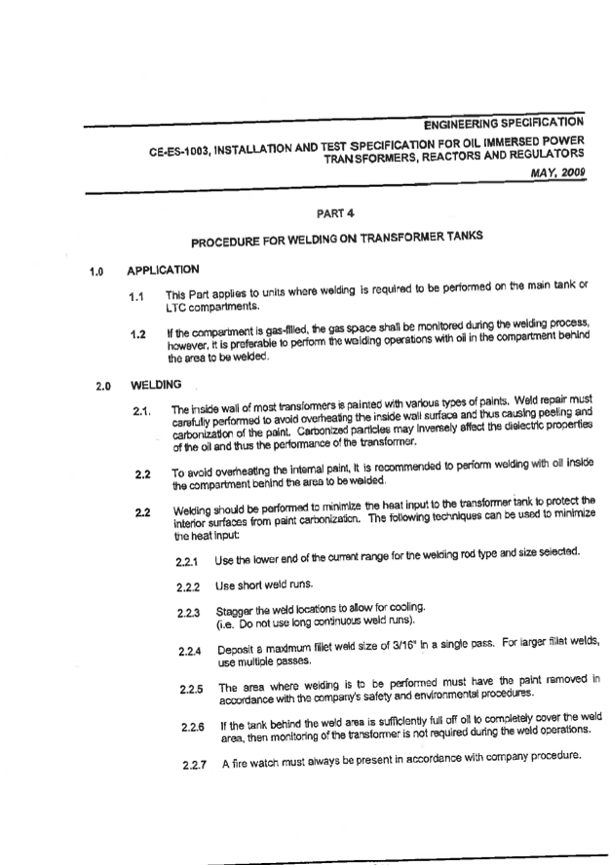

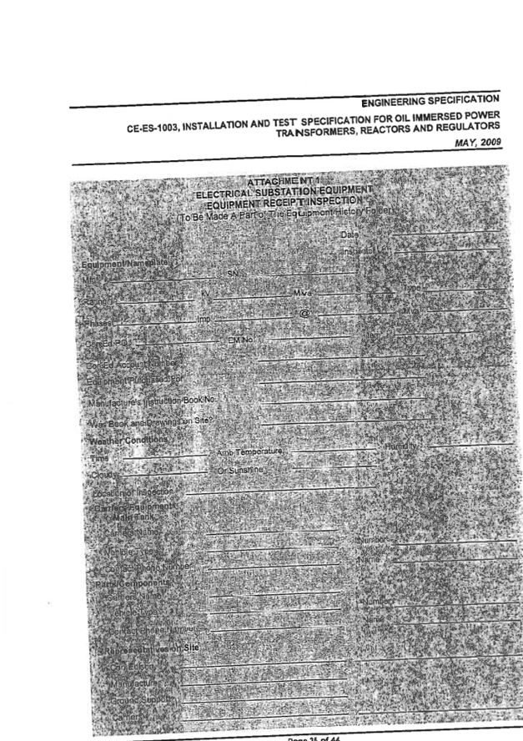

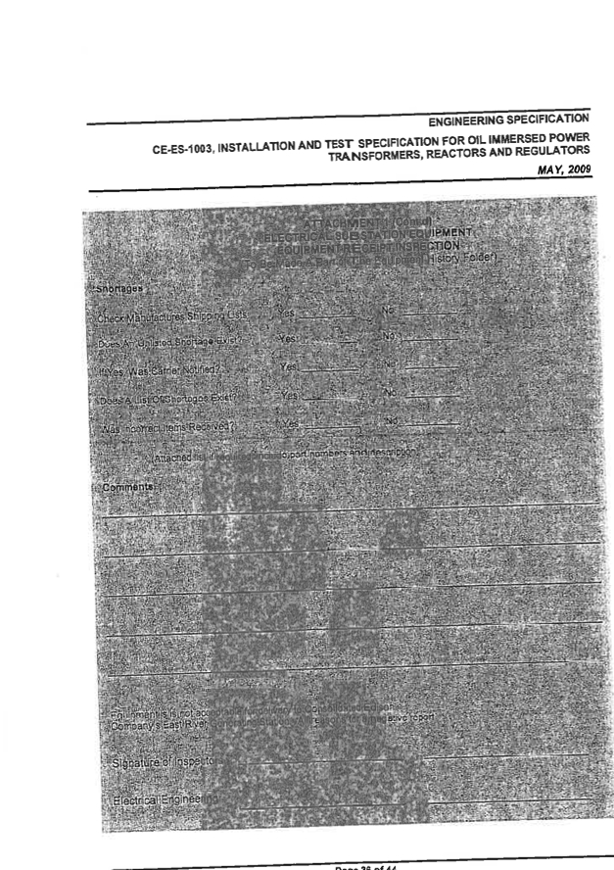

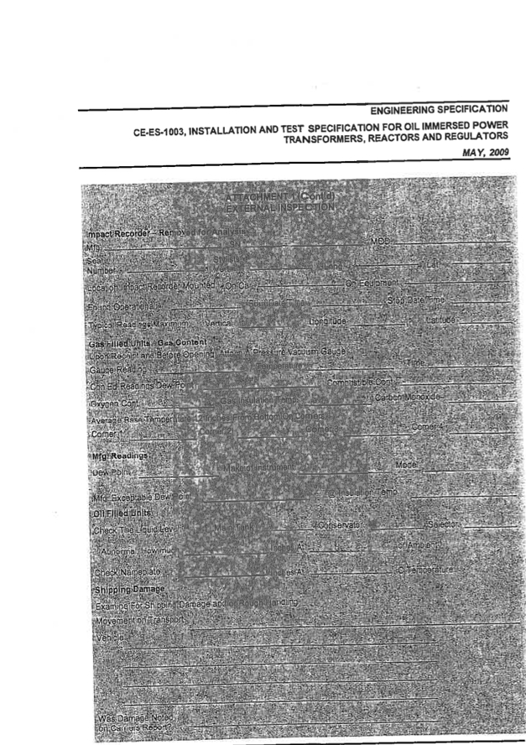

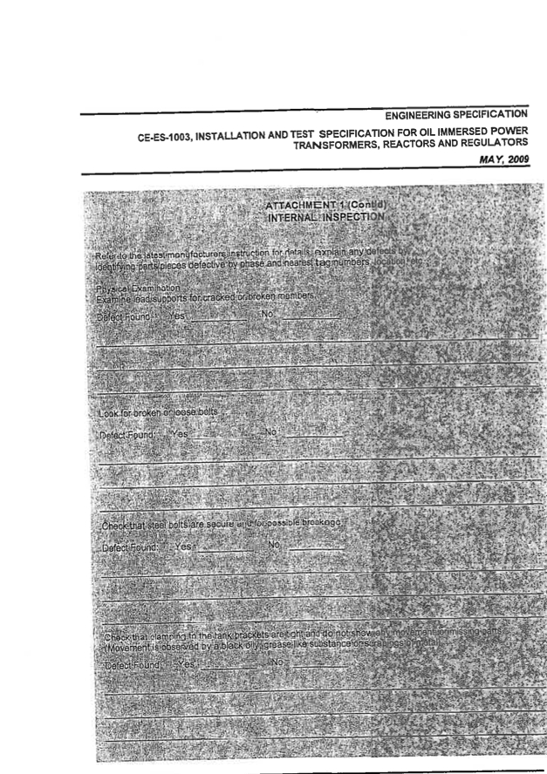

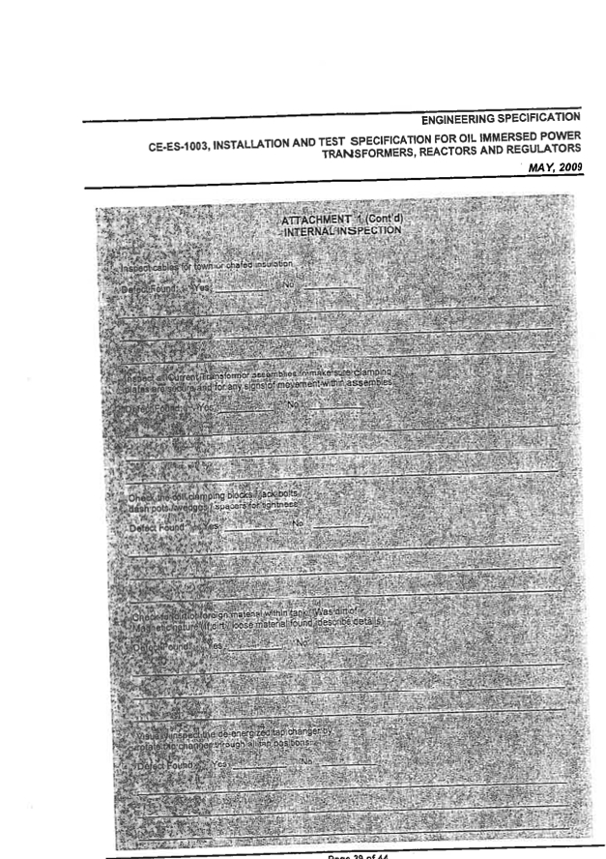

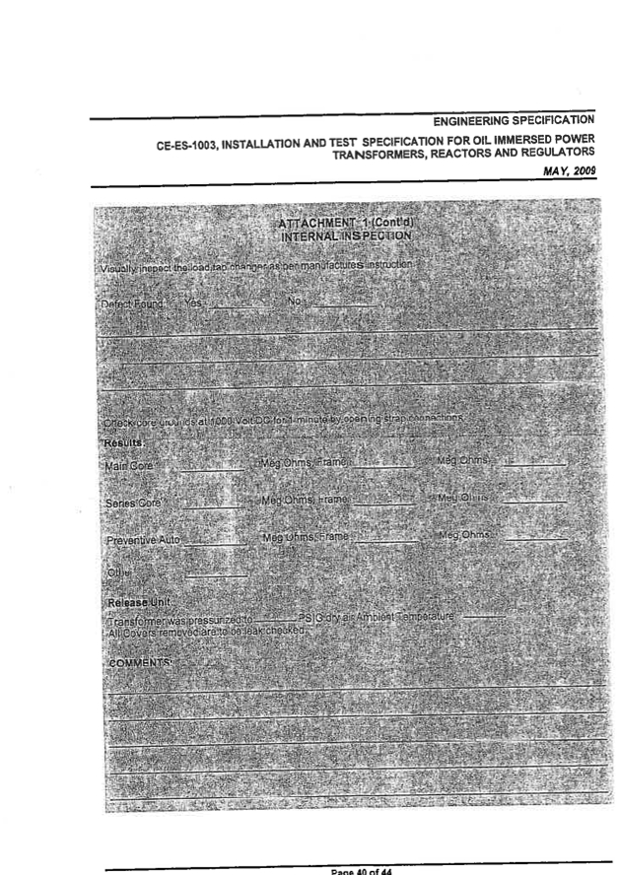

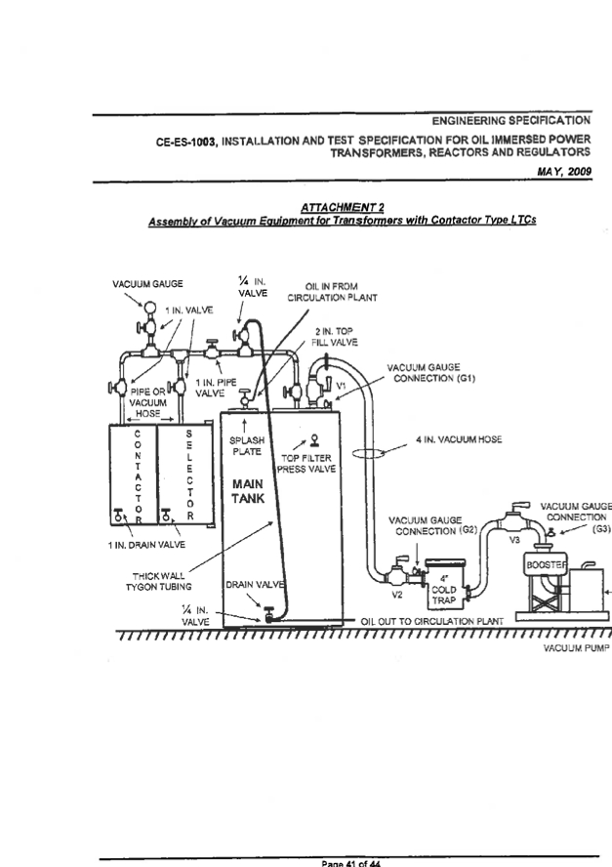

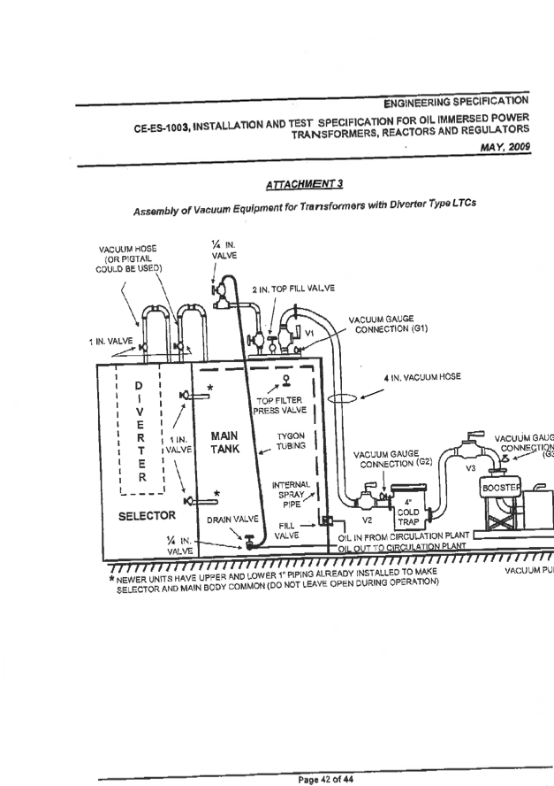

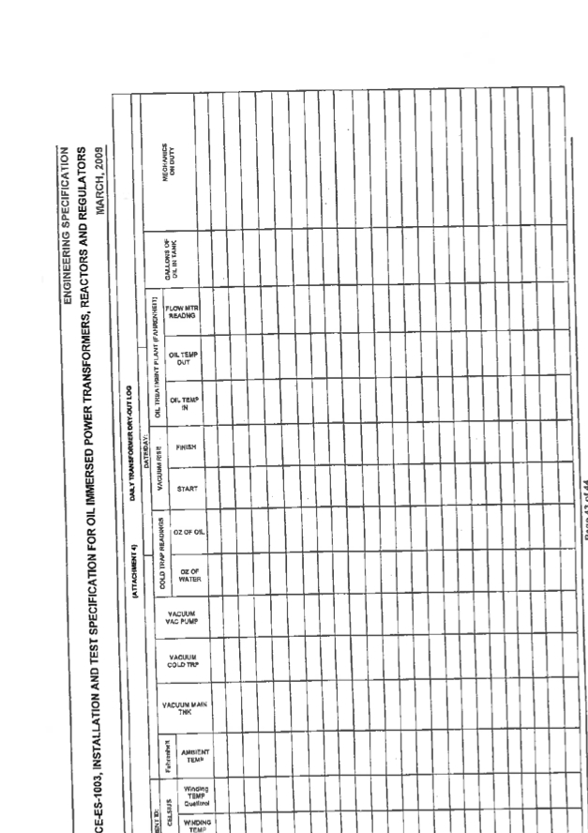

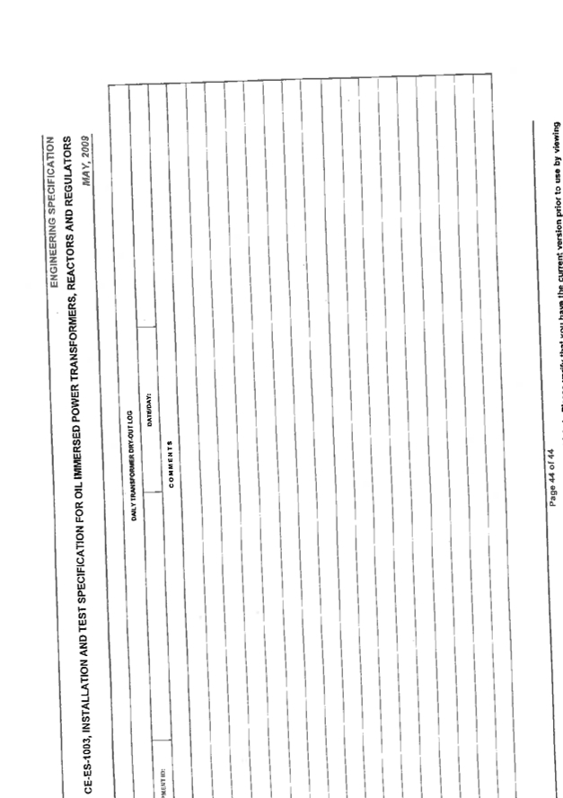



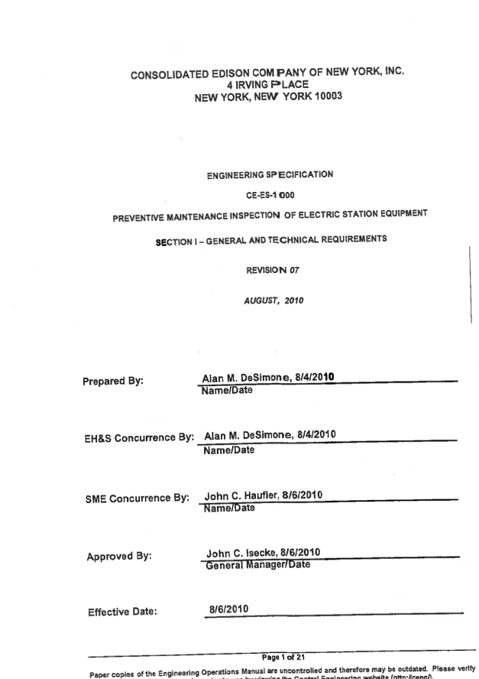

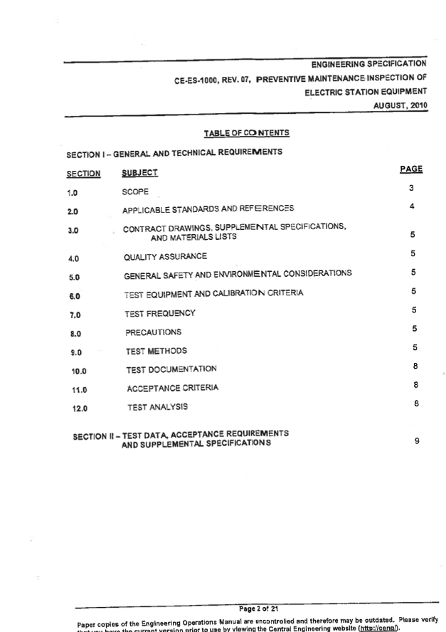

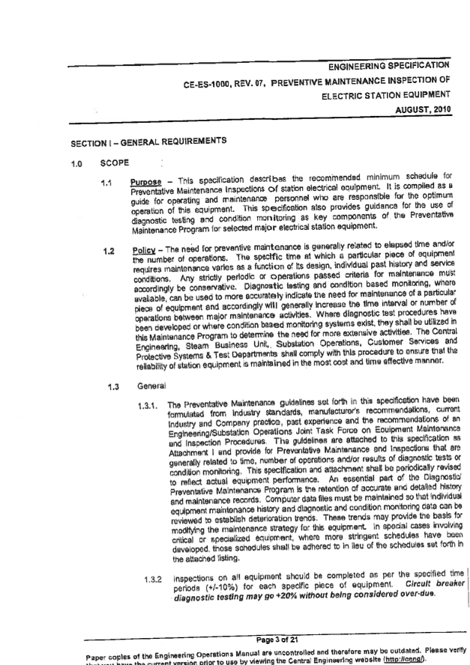

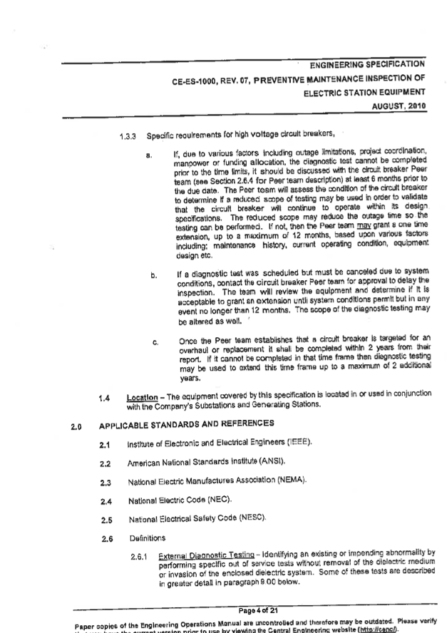

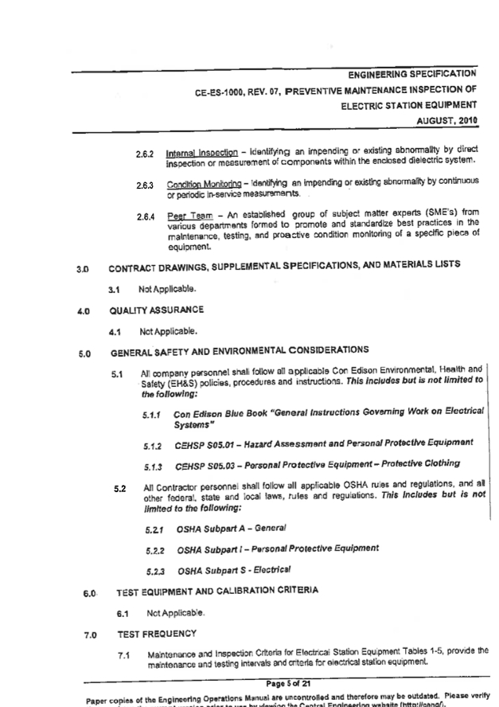

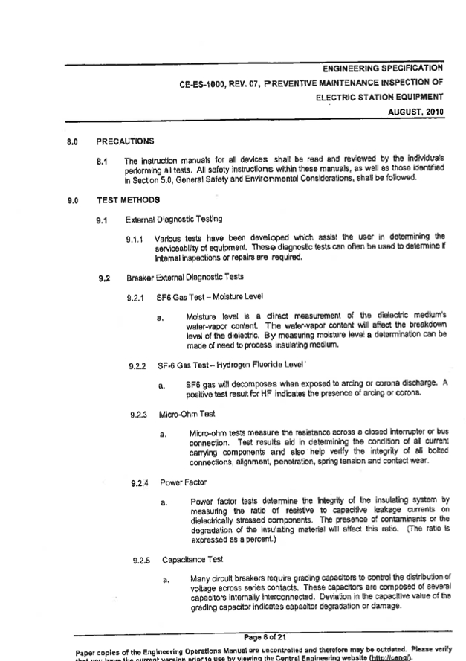

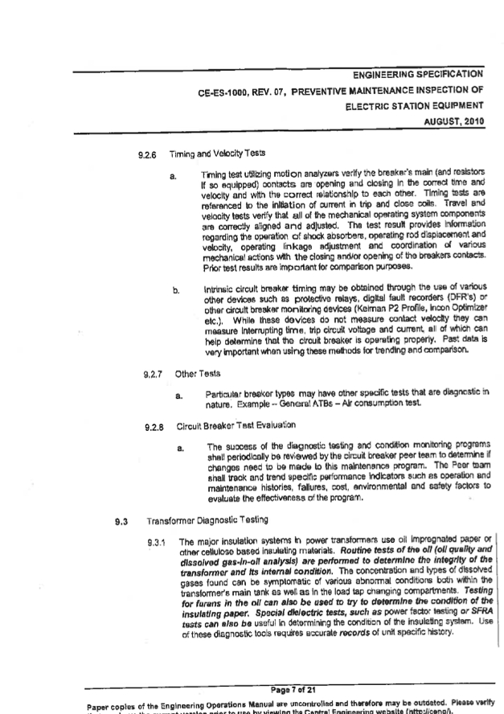

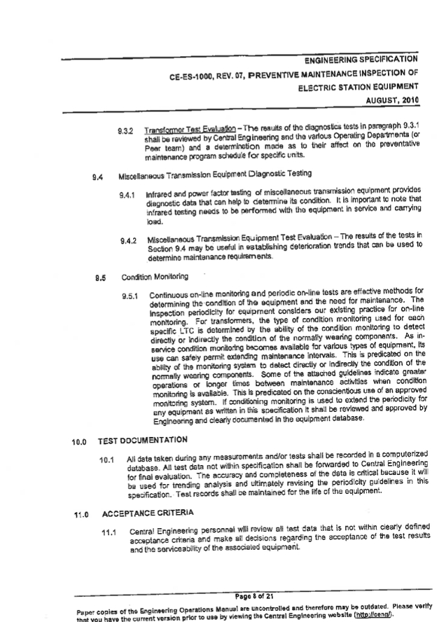

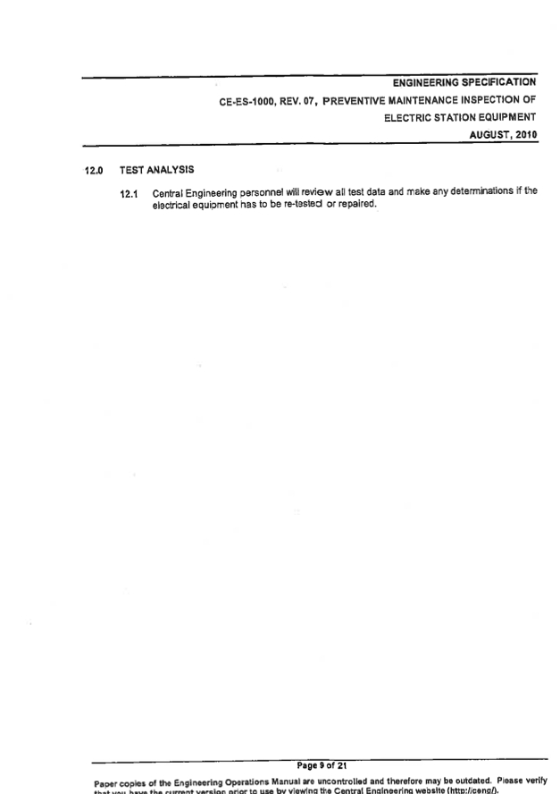

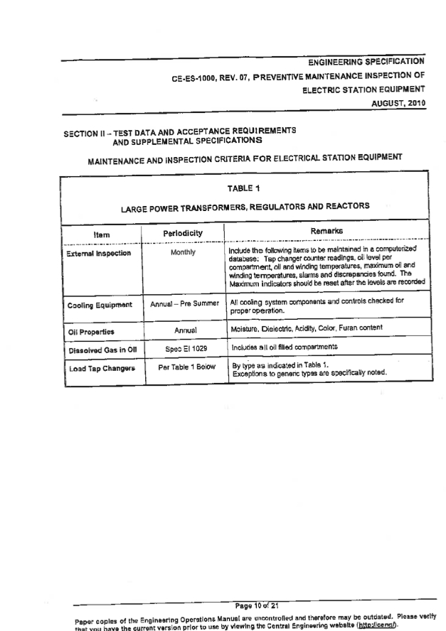

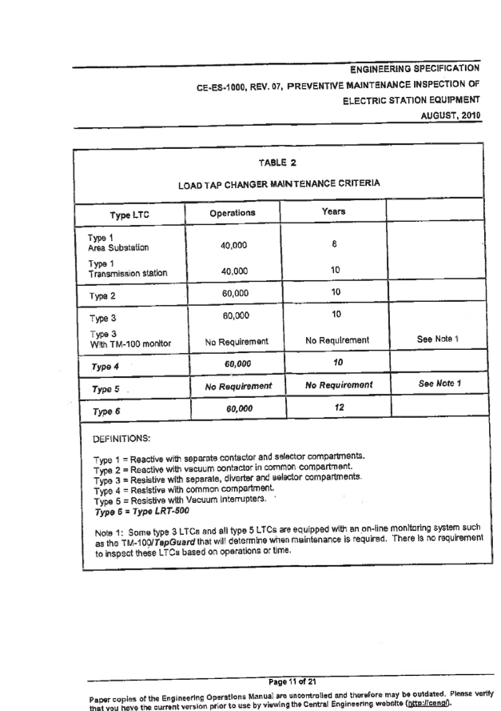

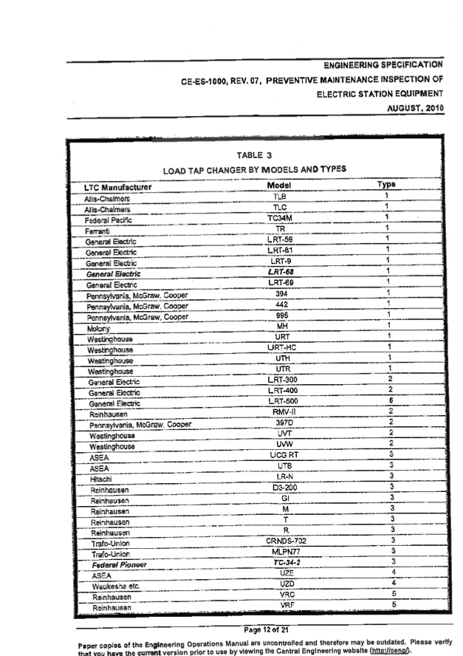

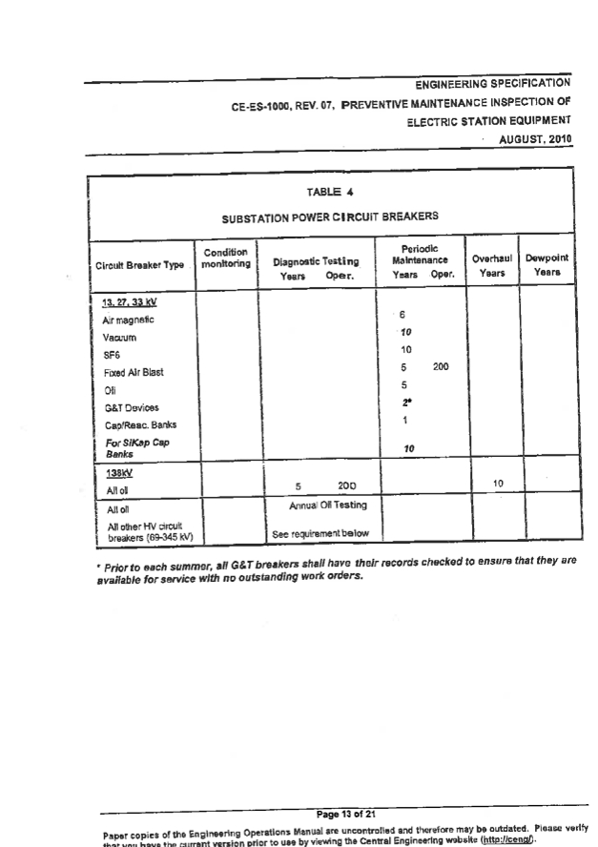

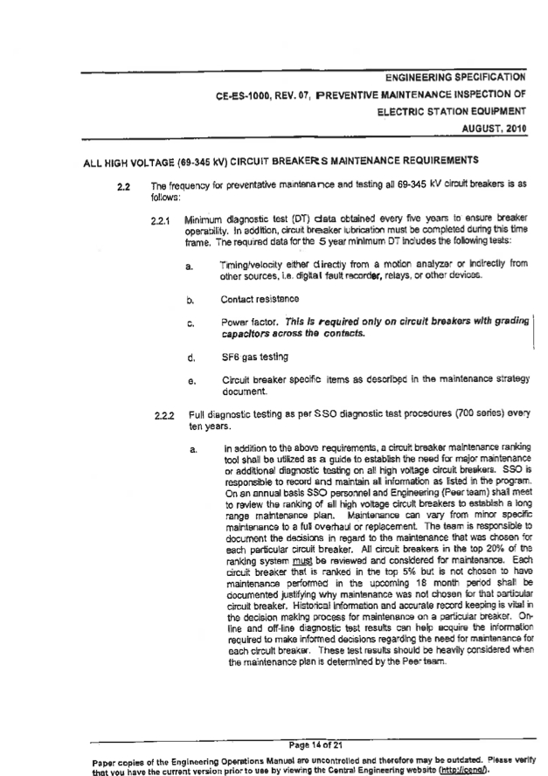

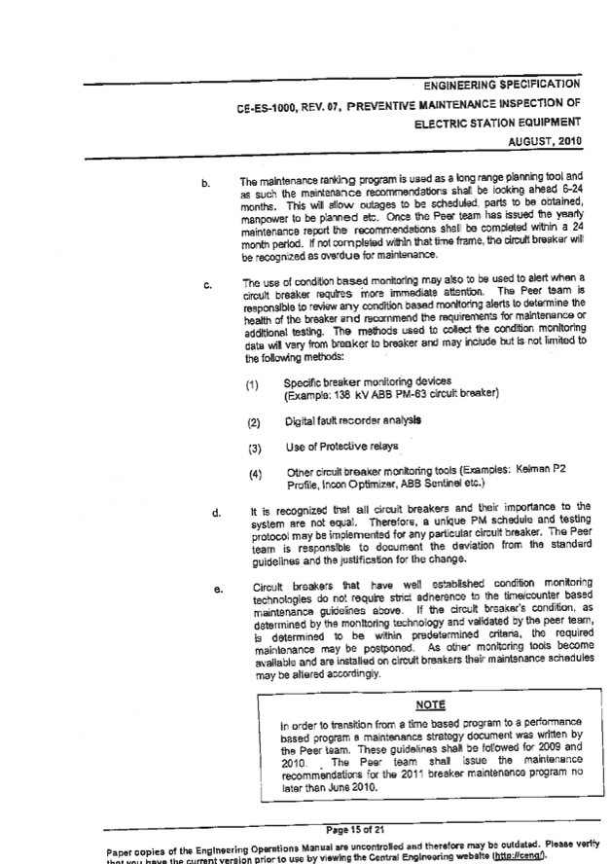

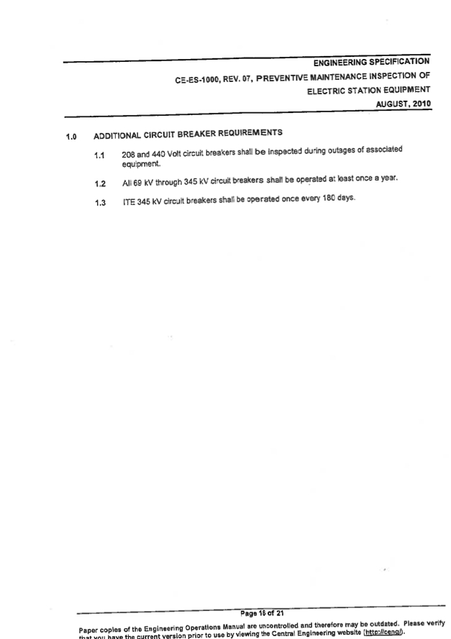

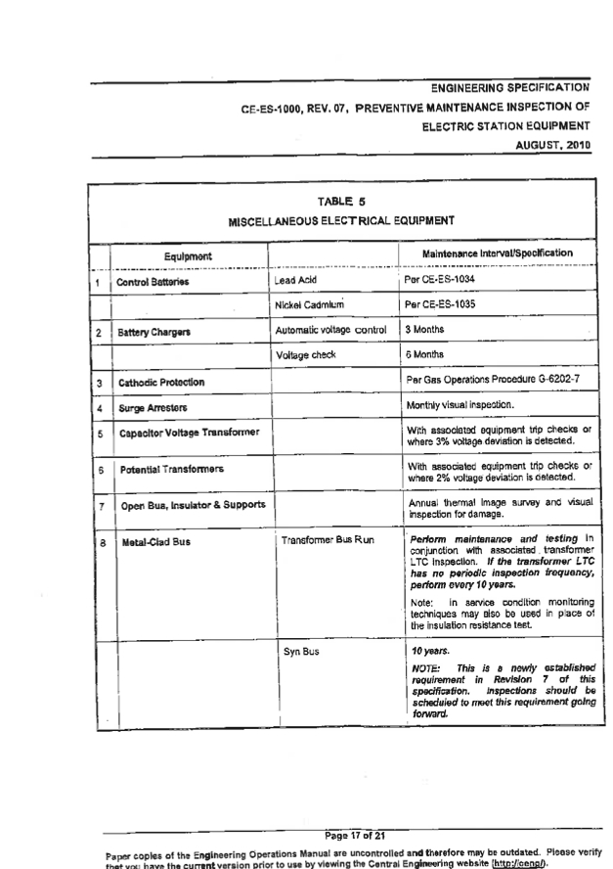

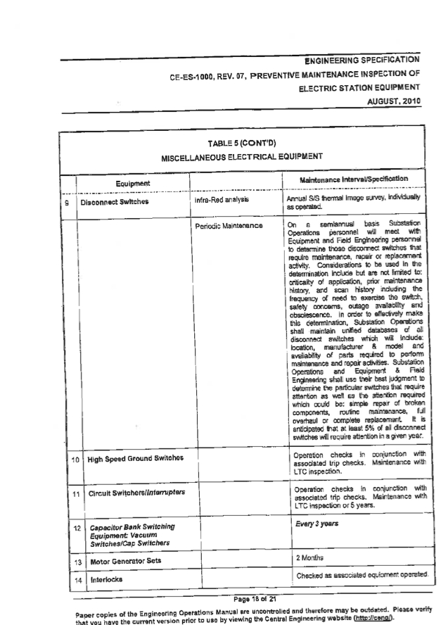

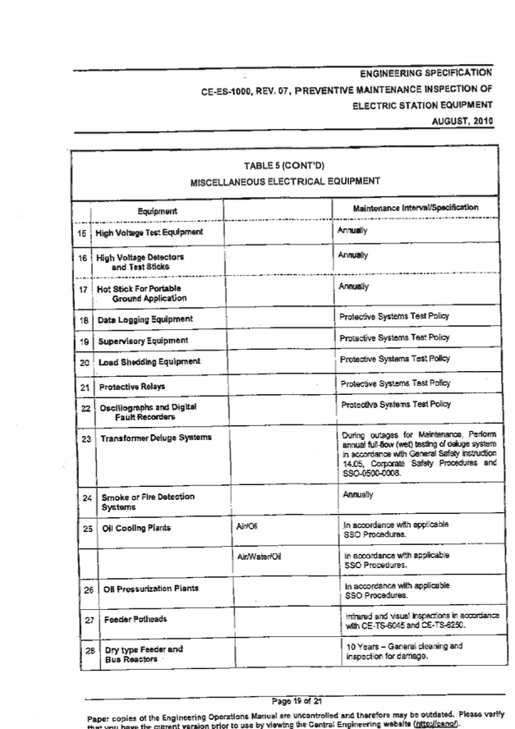

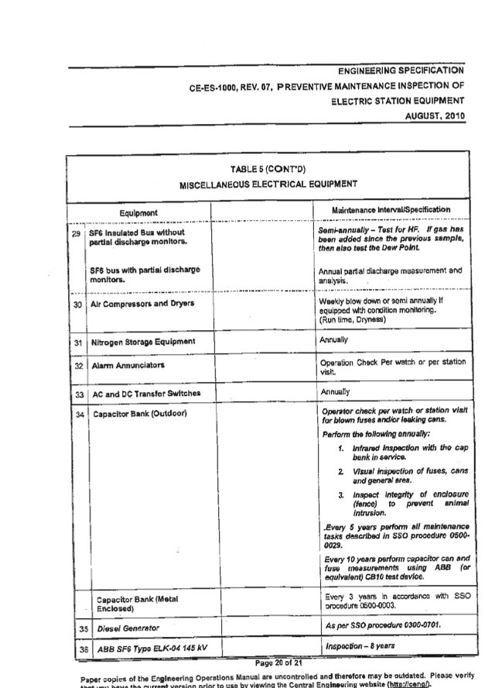

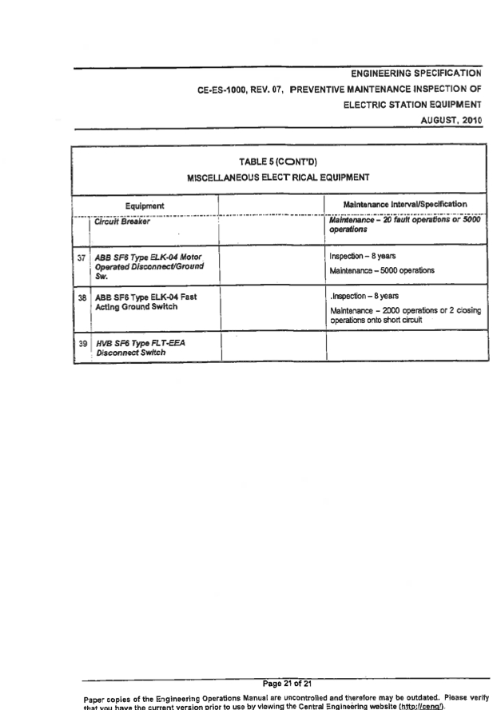



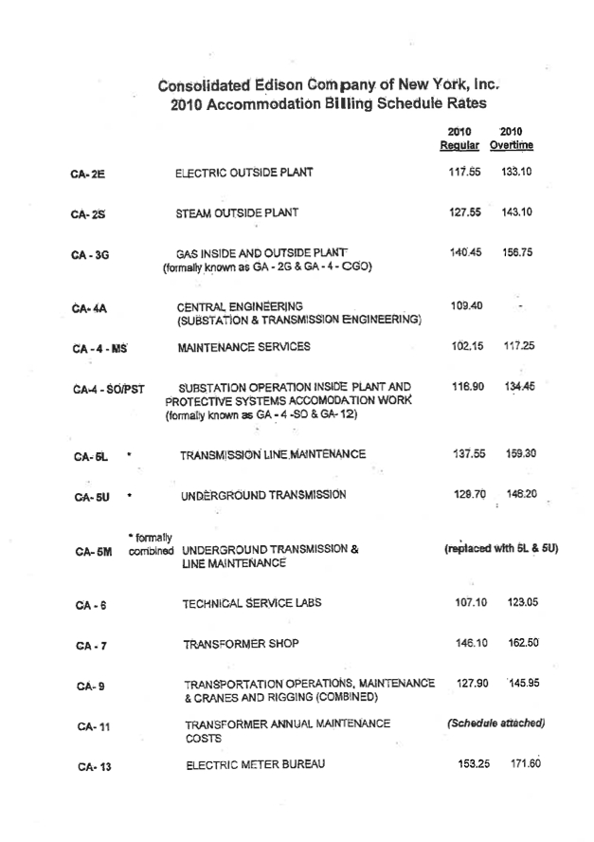

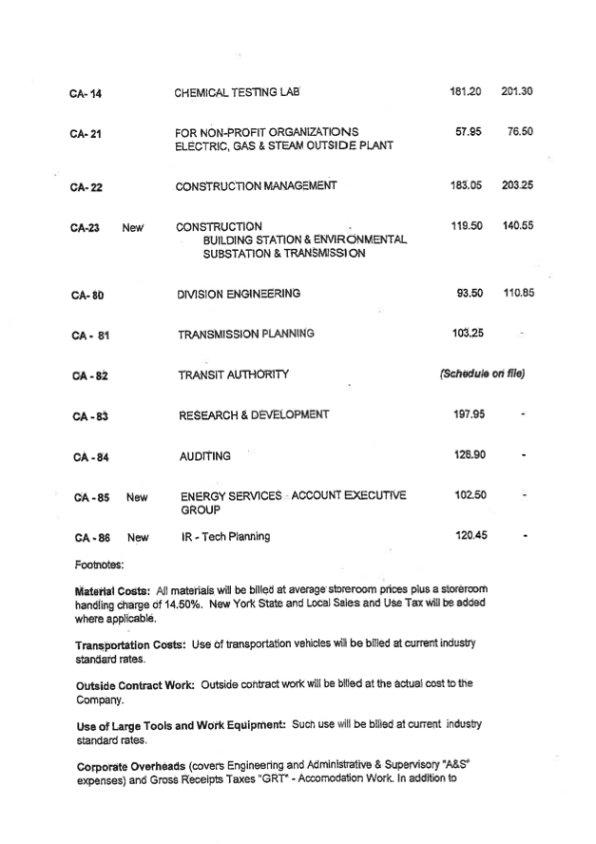

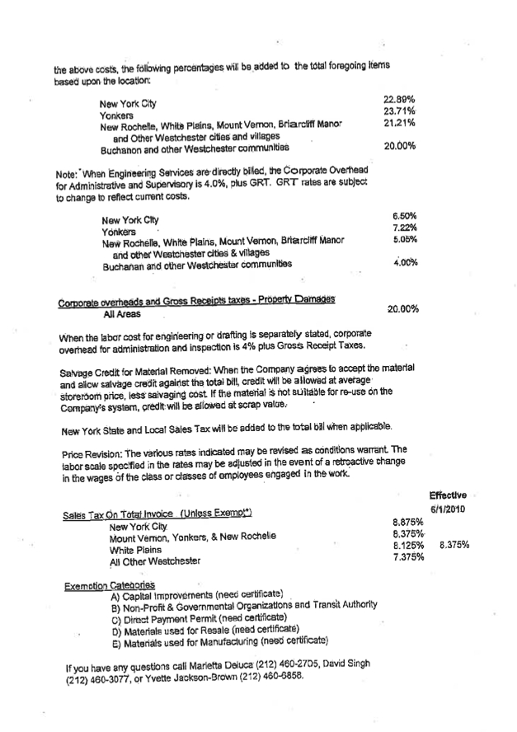



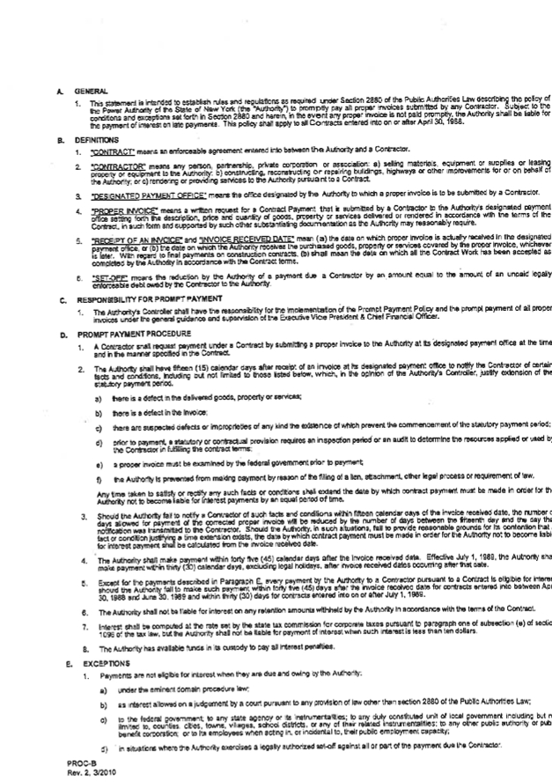

APPENDIX A
Con Edison SSO specification 0100-0022/06

APPENDIX B
Con Edison Specification EO-4022 Testing of Acc Feeders Operating at 69kv
through 345kv

APPENDIX C
Con Edison ES-1003 Installation and Test Specification for Oil Immersed
Power Transformers, Reactors and Regulators

APPENDIX D

Con Edison ES-1000 Preventative Maintenance (PMP)

APPENDIX E

Con Edison 2010 Accommodation Services Charges

APPENDIX F

Power Authority Prompt Payment Policy

