Filing Data:

CID: C000038

Filing Title: SGIA 1988 between Niagara Mohawk and WM Renewable Energy Company Filing Identifier: 694

Type of Filing Code: 10

Associated Filing Identifier:

Tariff Title: NYISO Agreements Tariff ID: 58

Payment Confirmation: N   
Suspension Motion:

Tariff Record Data:

Record Content Description: Agreement No. 1988

Tariff Record Title: SGIA No. 1988 between Niagara Mohwak and WM Renewable Energy Record Version Number: 0.0.0

Option Code: A

Tariff Record ID: 124

Tariff Record Collation Value: 7069000

Tariff Record Parent Identifier: 2 Proposed Date: 2013-06-23 Priority Order: 500

Record Change Type: New   
Record Content Type: 2   
Associated Filing Identifier:

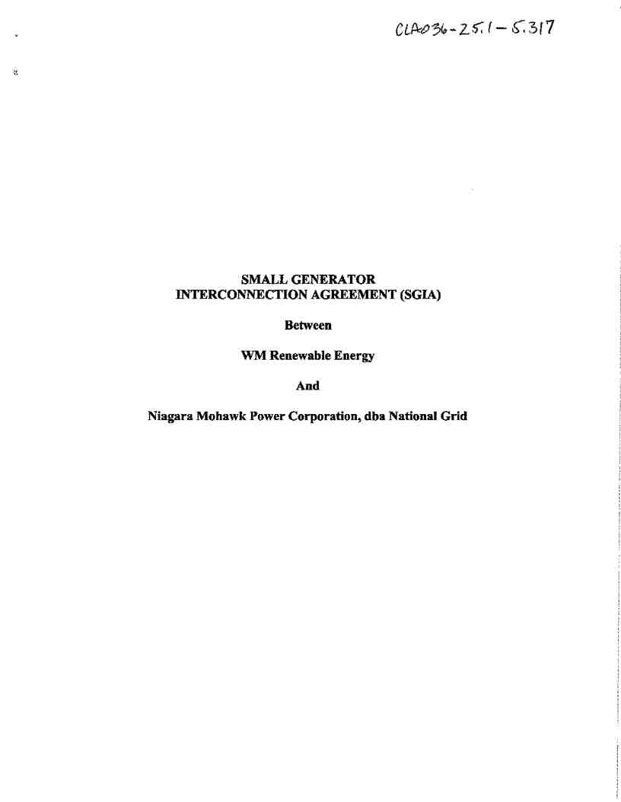

Service Agreement No. 1988

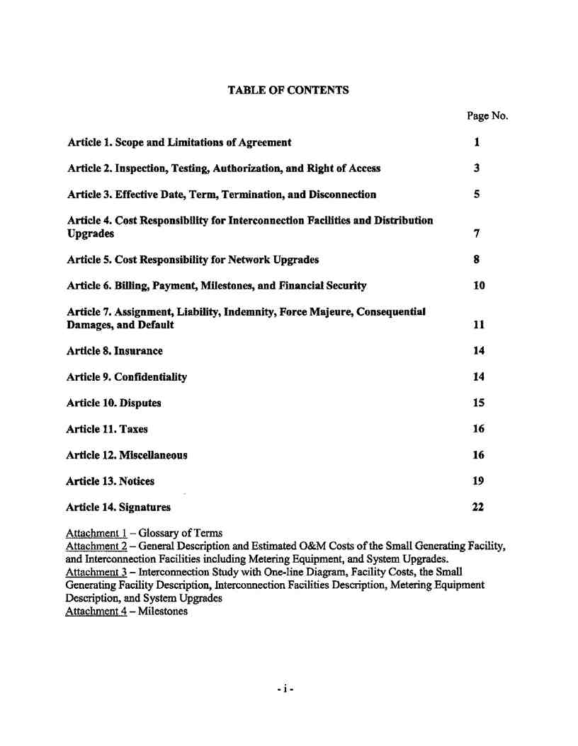

Service Agreement No. 1988

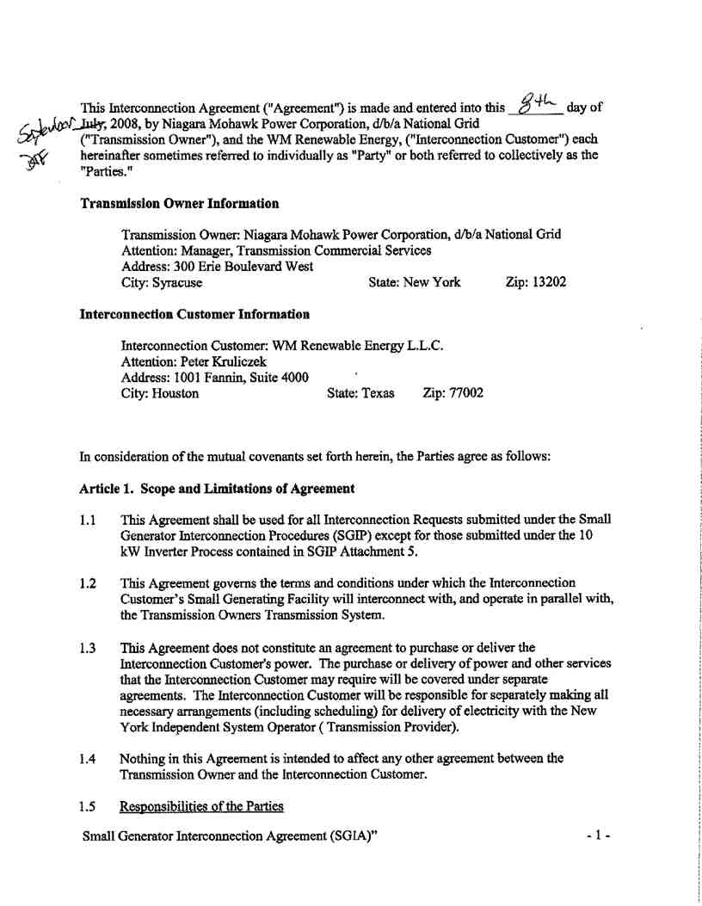

Service Agreement No. 1988

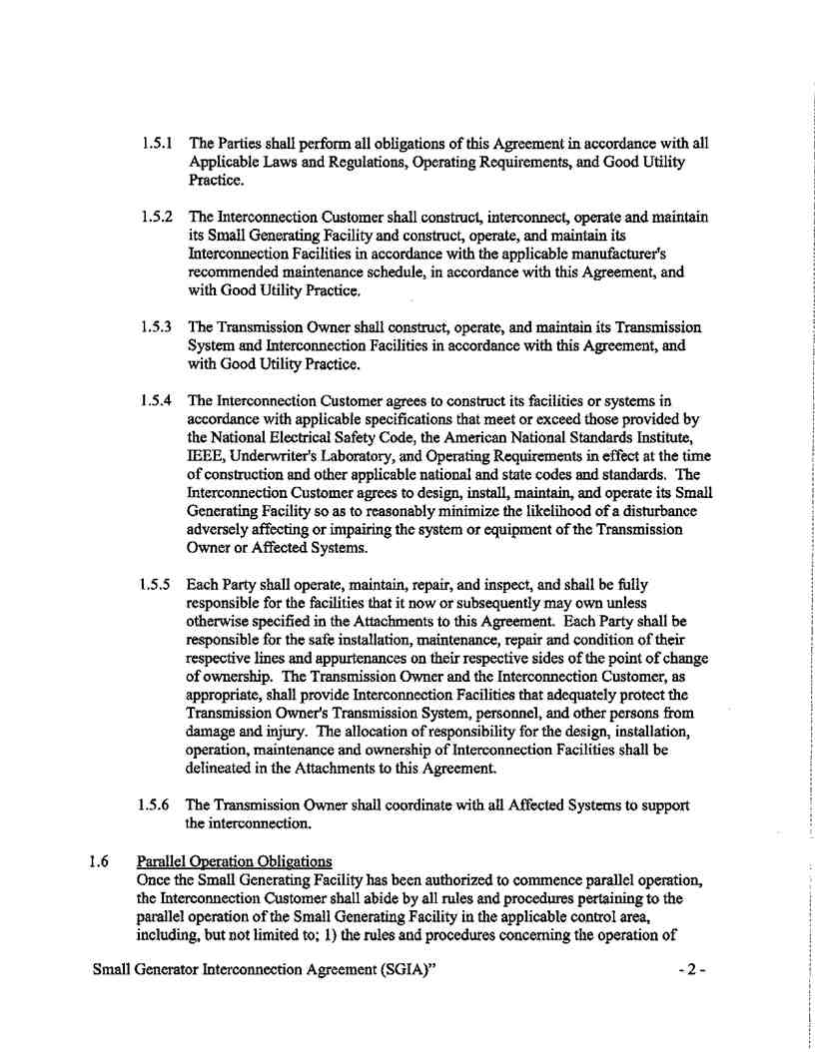

Service Agreement No. 1988

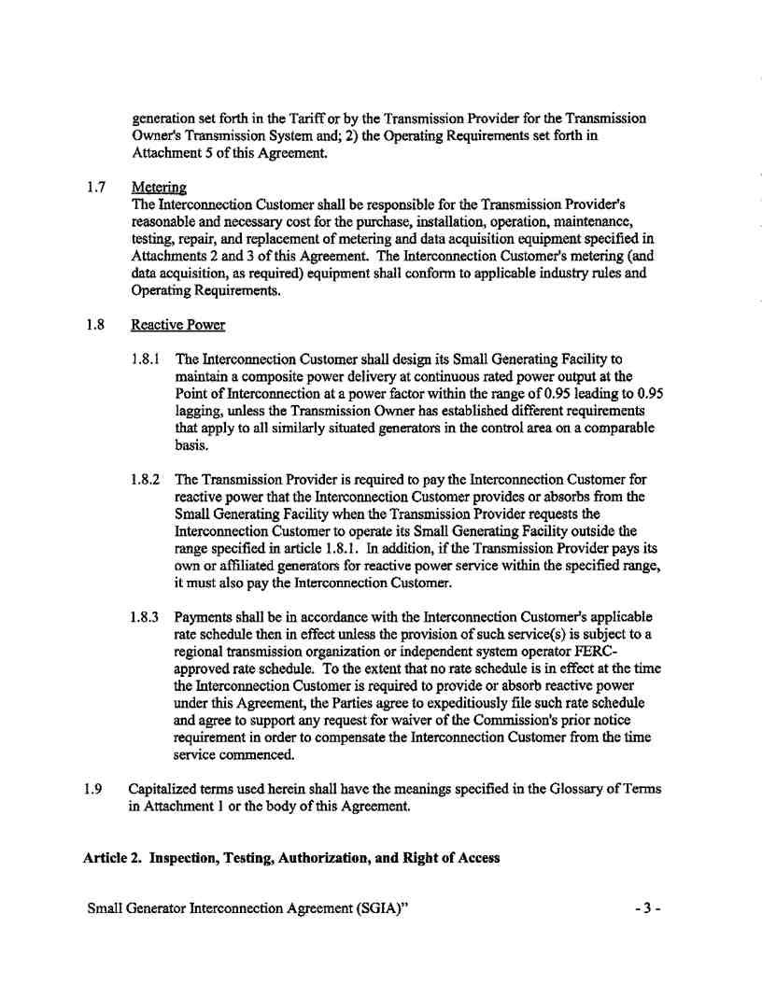

Service Agreement No. 1988

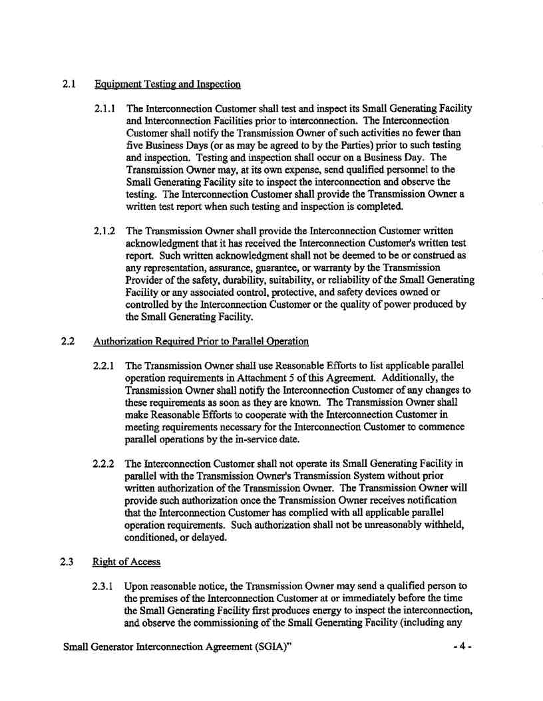

Service Agreement No. 1988

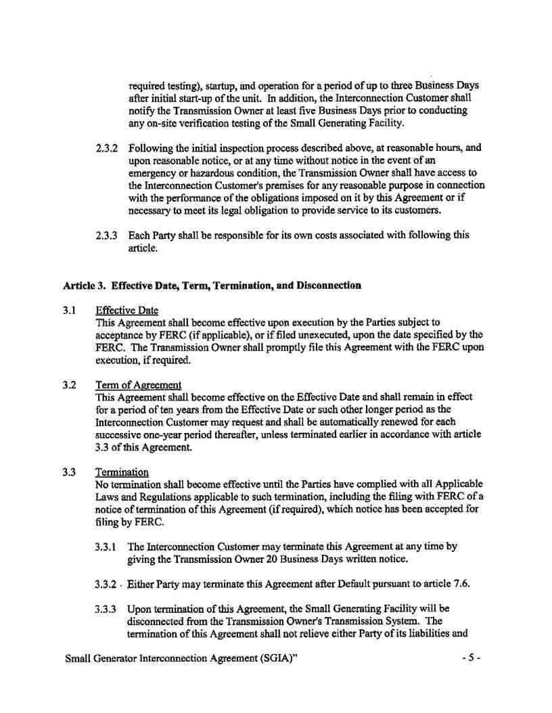

Service Agreement No. 1988

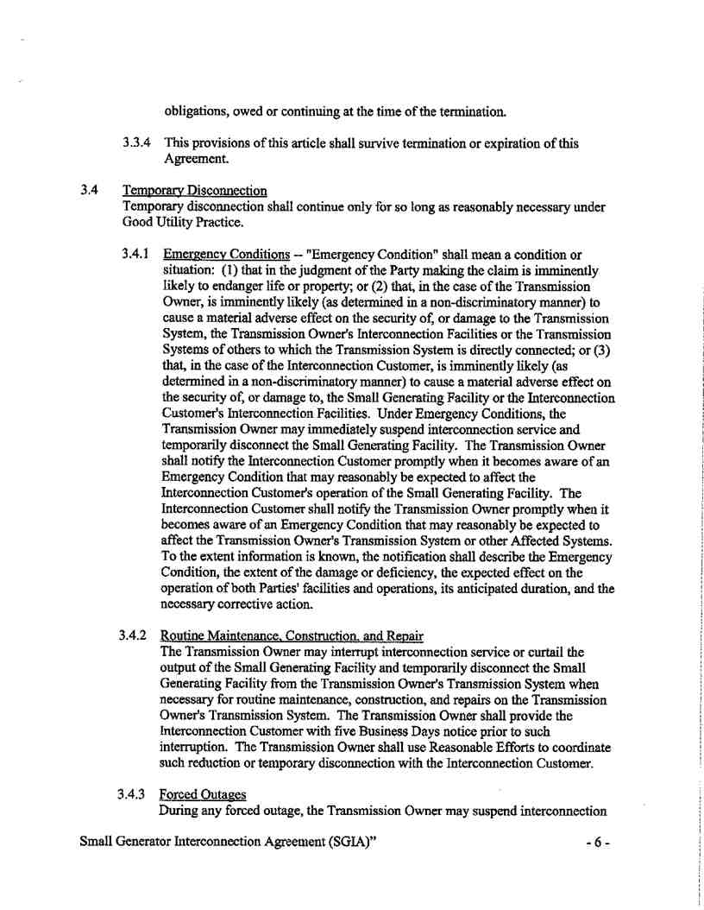

Service Agreement No. 1988

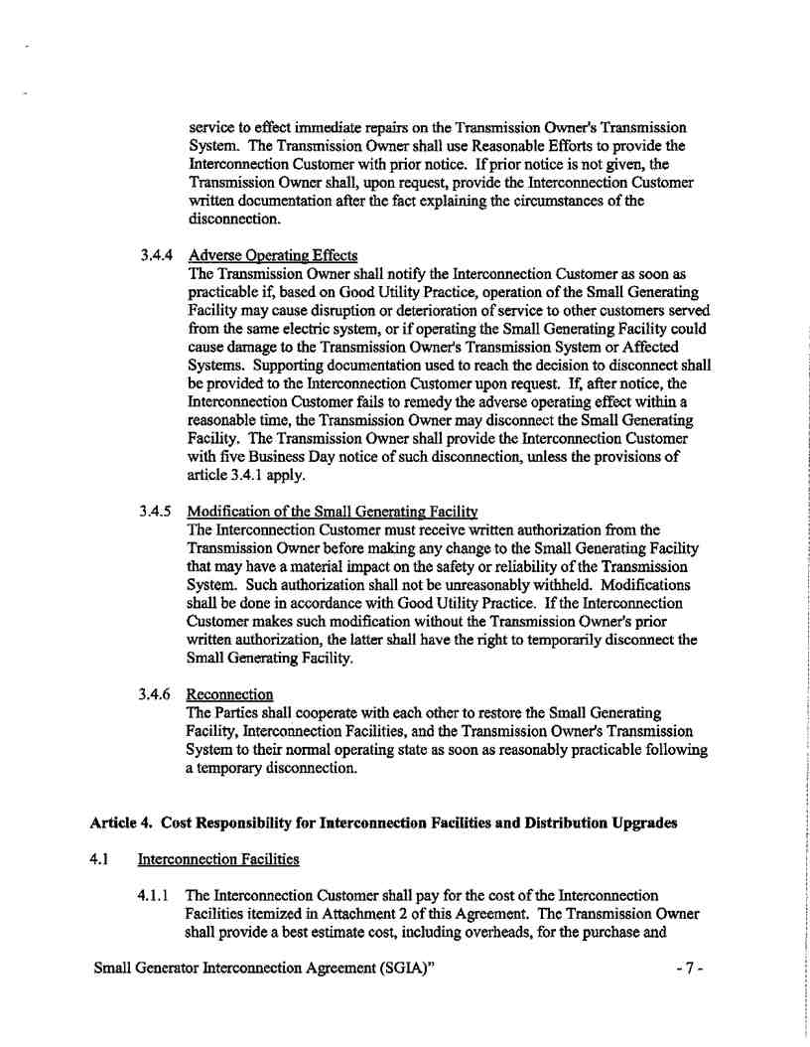

Service Agreement No. 1988

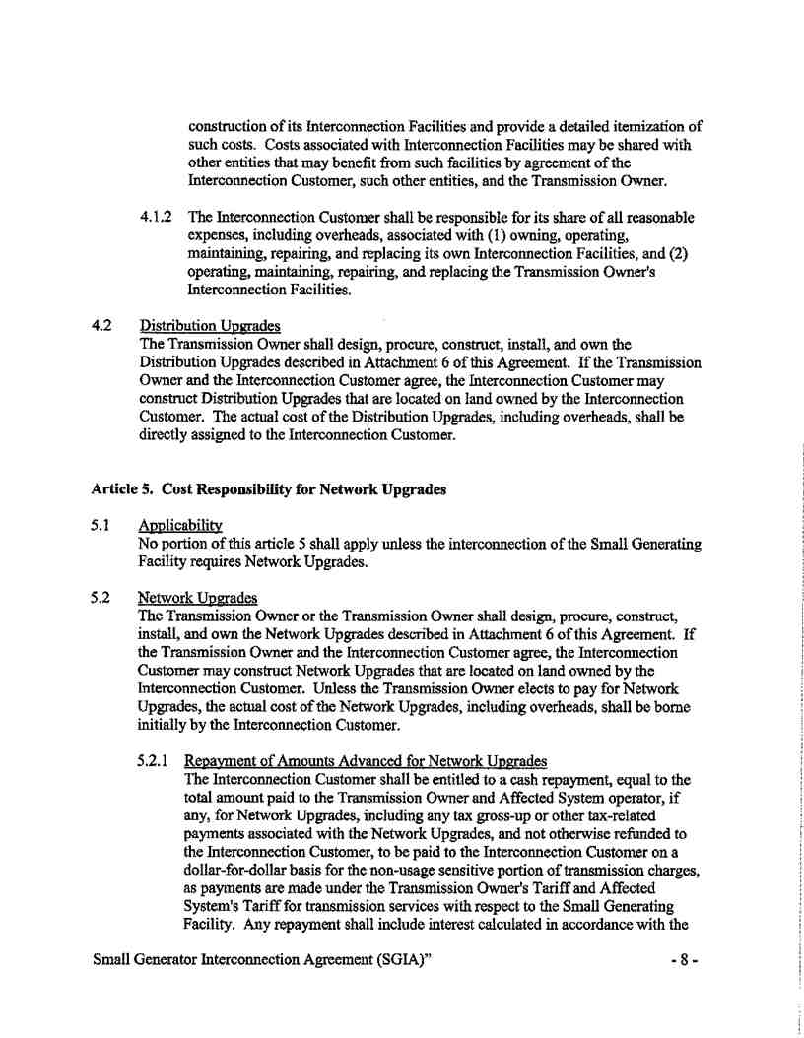

Service Agreement No. 1988

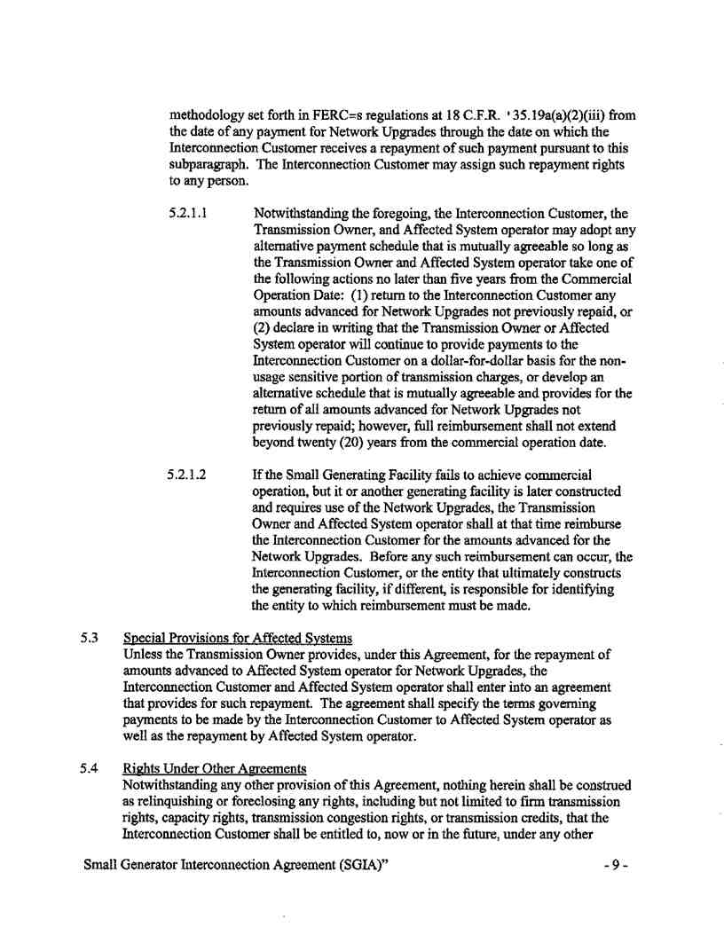

Service Agreement No. 1988

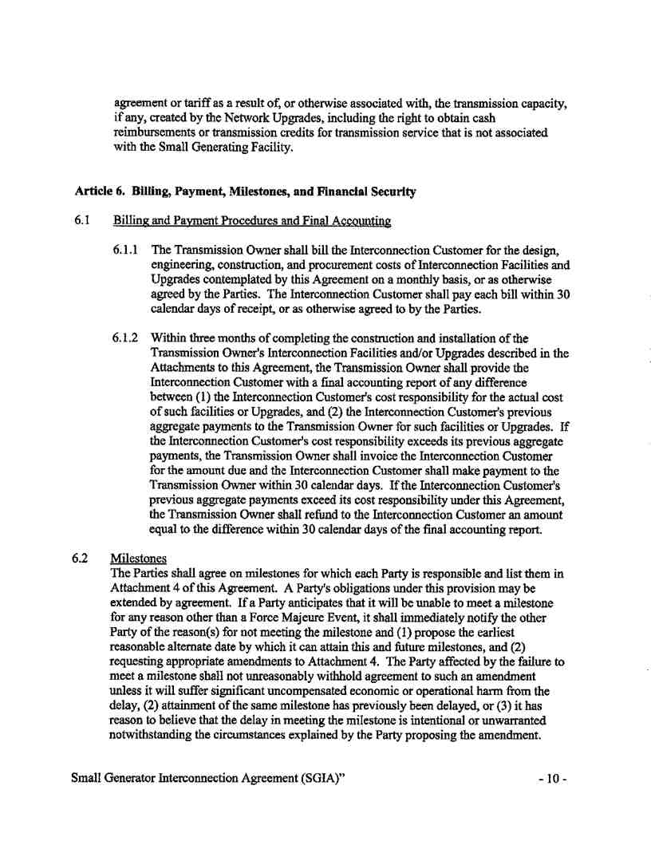

Service Agreement No. 1988

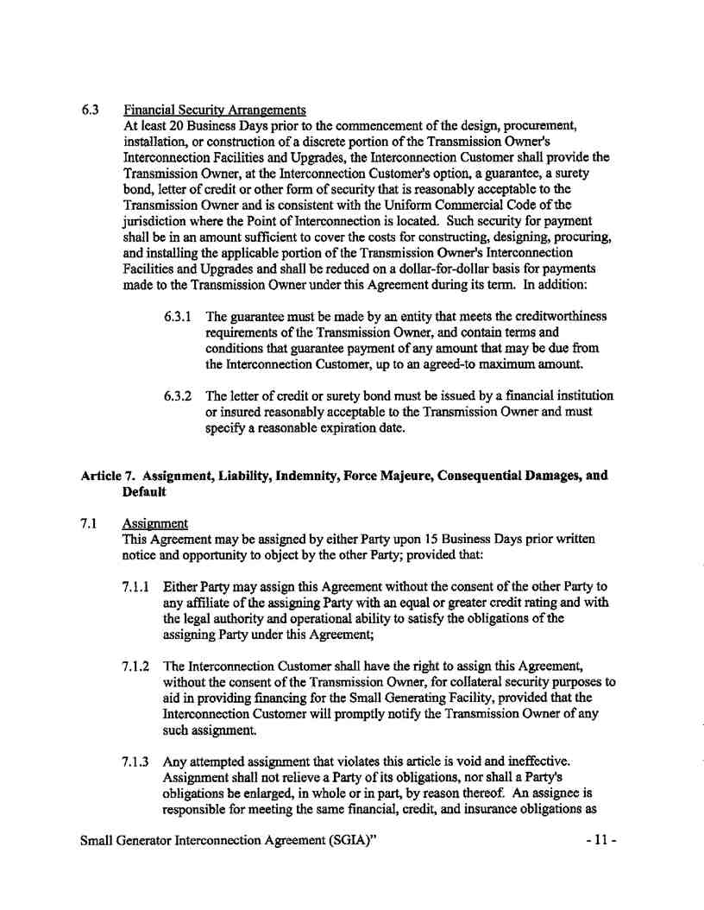

Service Agreement No. 1988

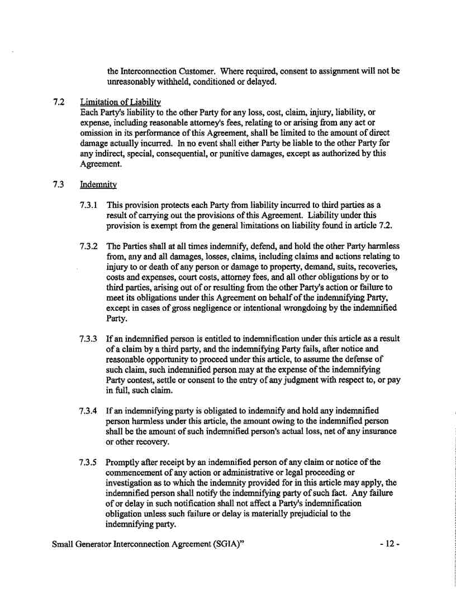

Service Agreement No. 1988

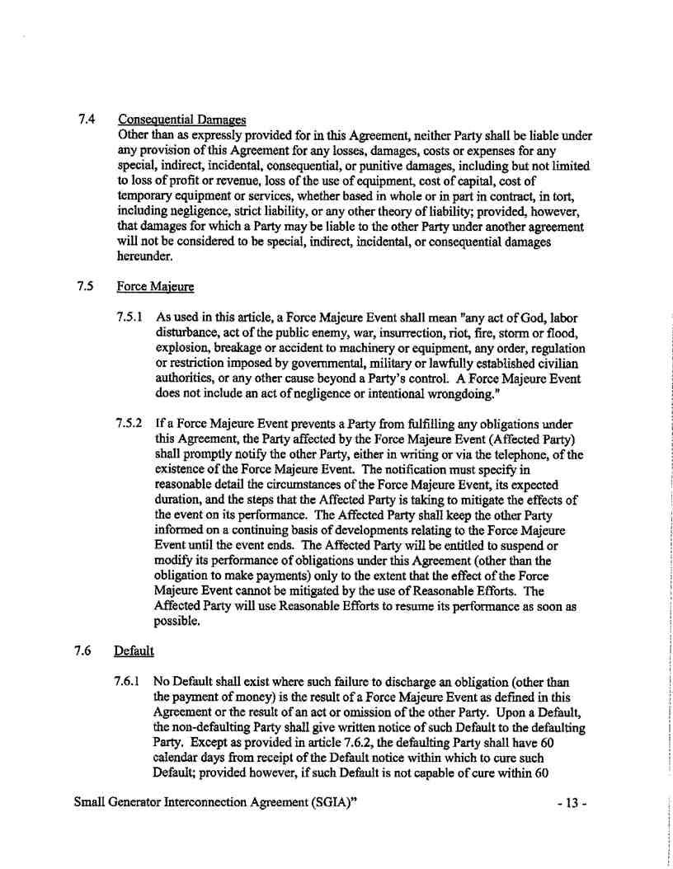

Service Agreement No. 1988

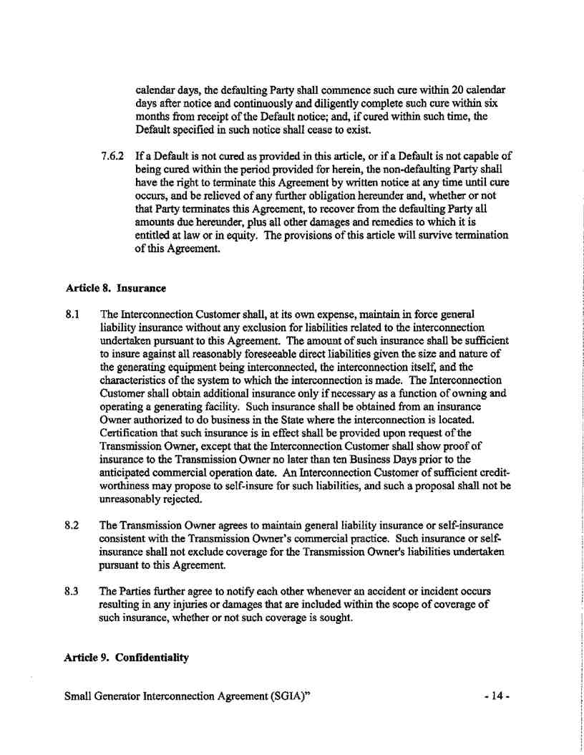

Service Agreement No. 1988

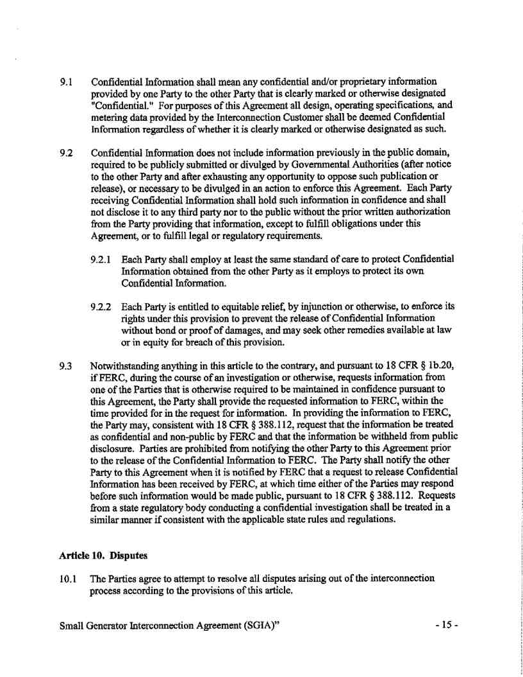

Service Agreement No. 1988

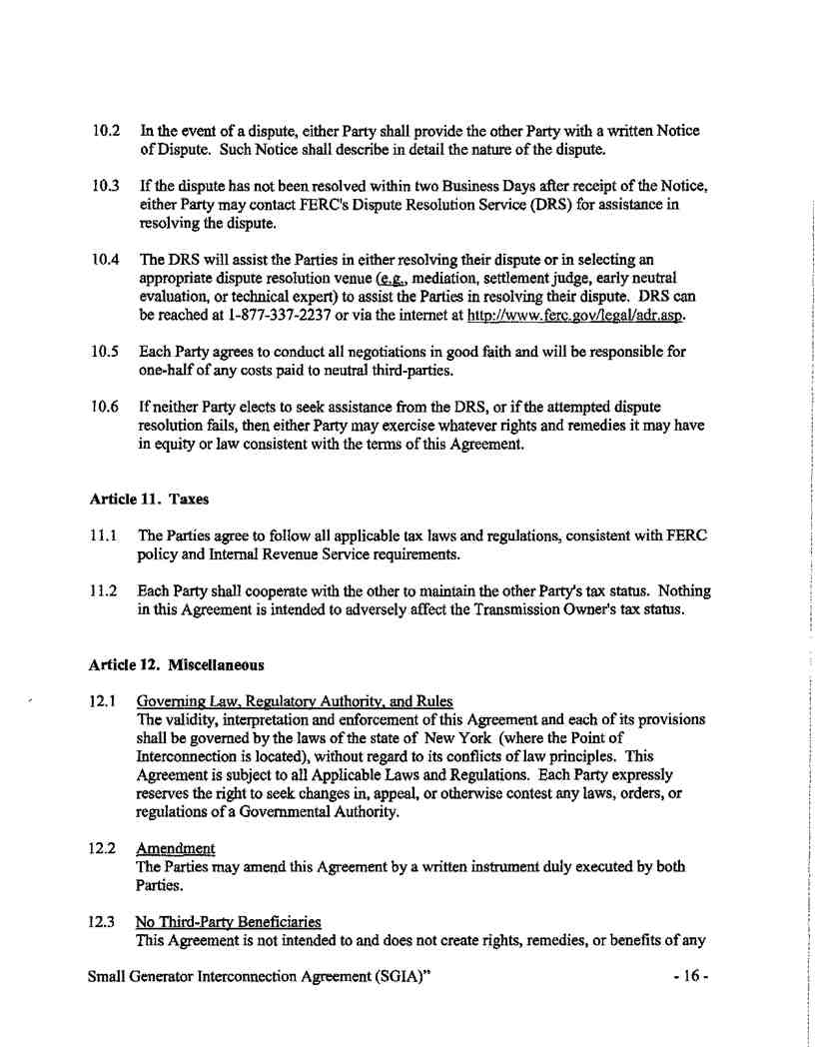

Service Agreement No. 1988

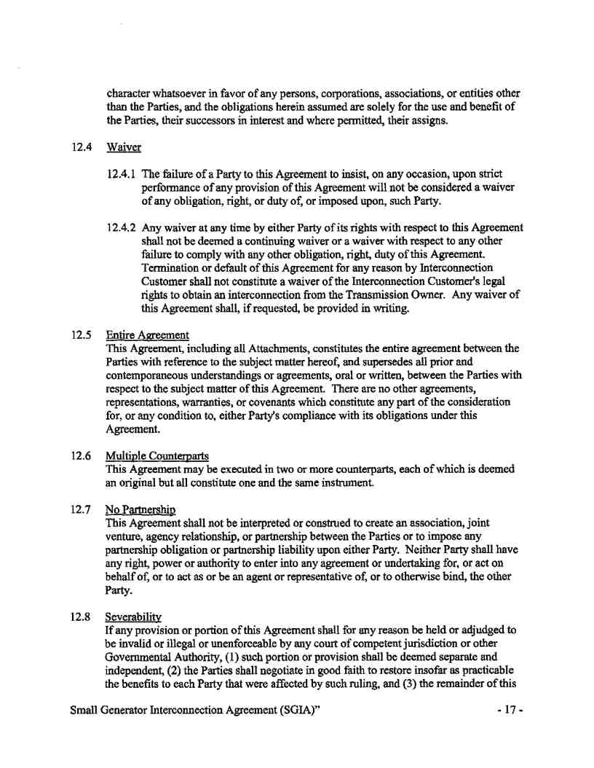

Service Agreement No. 1988

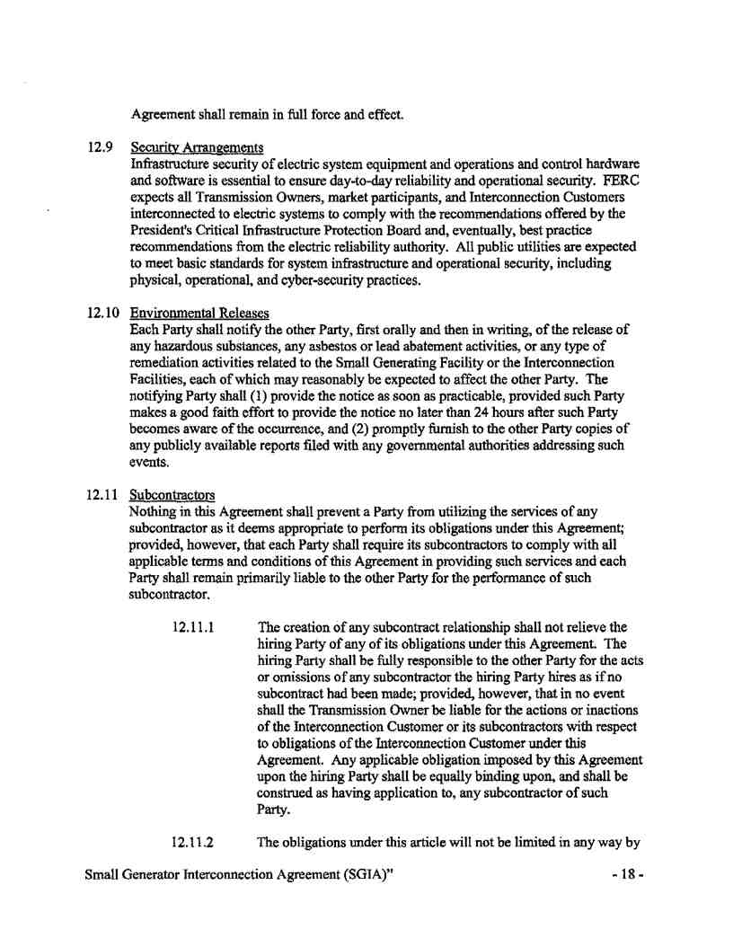

Service Agreement No. 1988

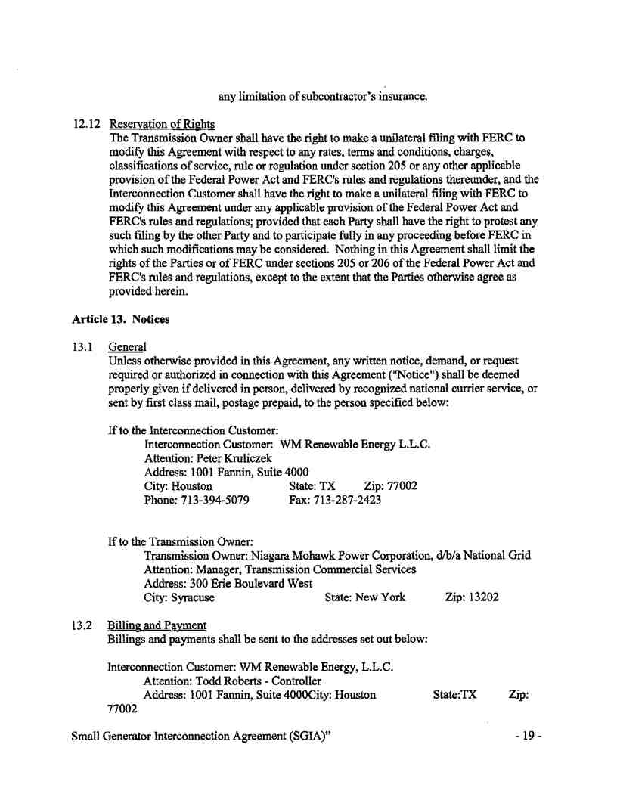

Service Agreement No. 1988

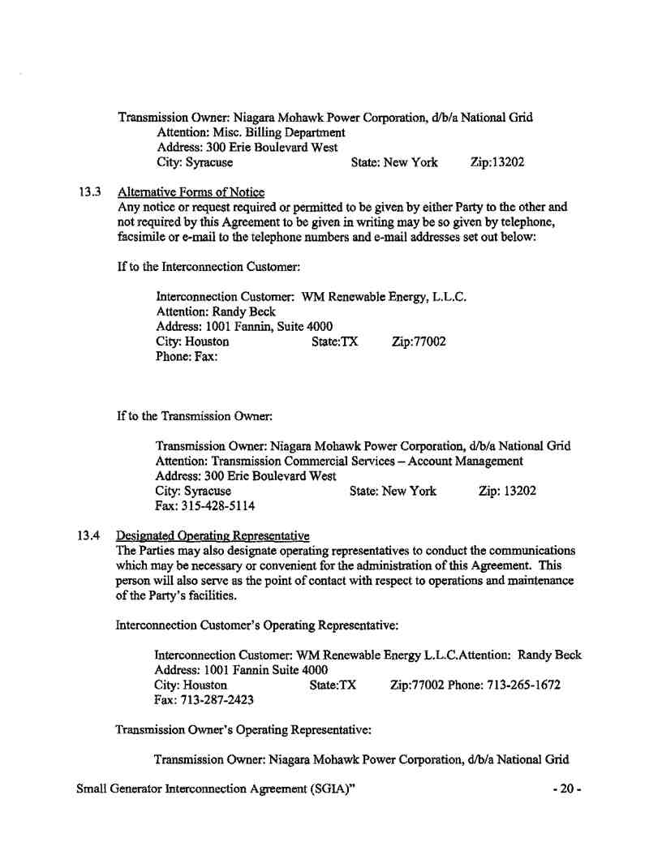

Service Agreement No. 1988

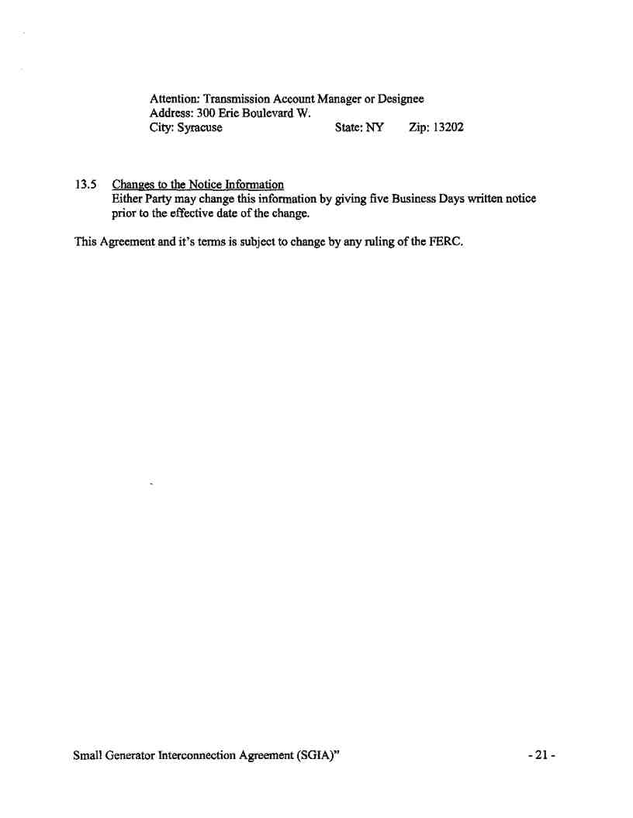

Service Agreement No. 1988

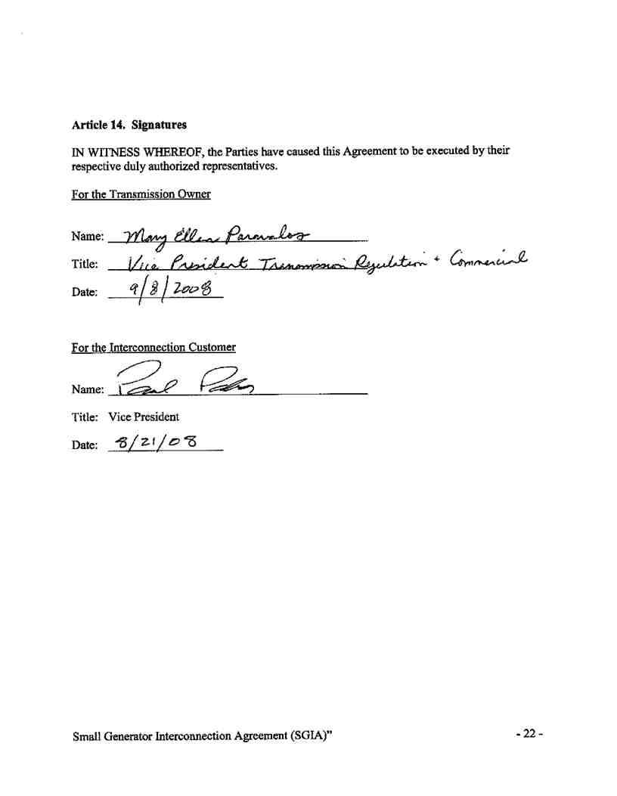

Service Agreement No. 1988



Service Agreement No. 1988

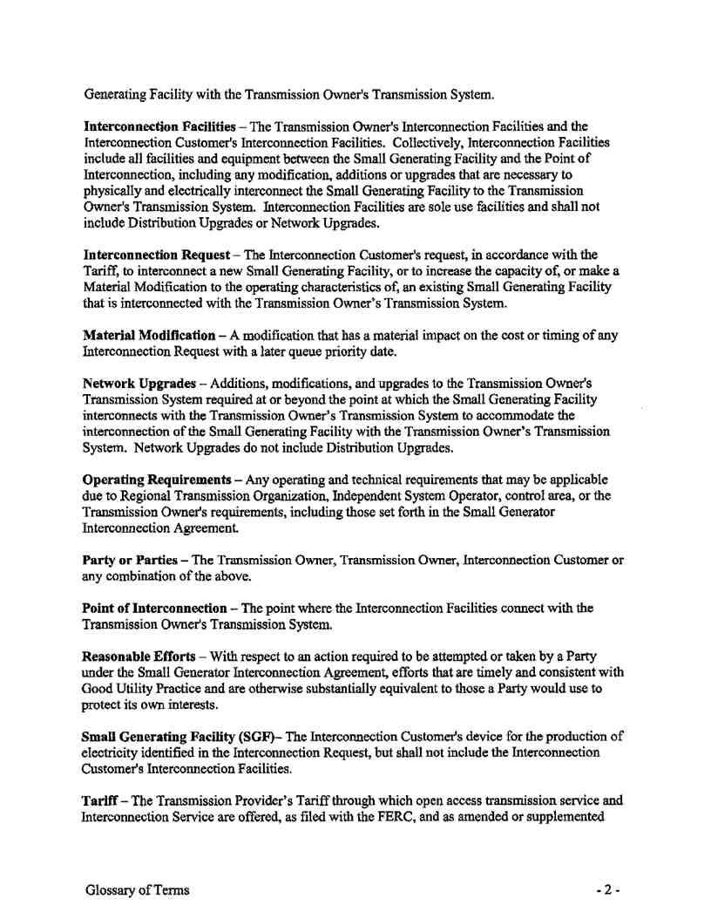

Service Agreement No. 1988

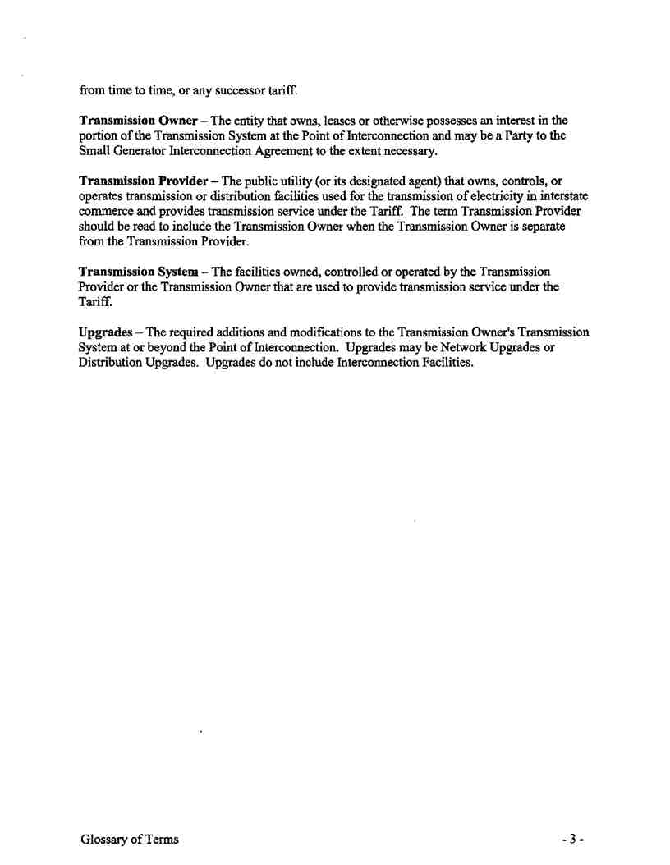

Service Agreement No. 1988

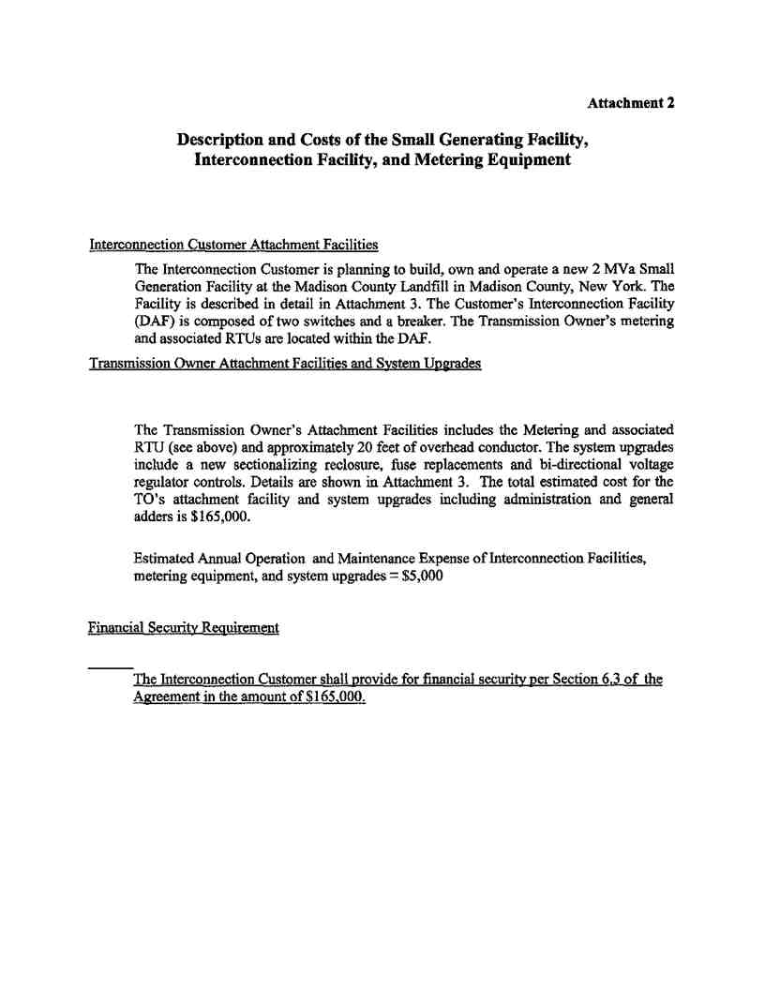

Service Agreement No. 1988

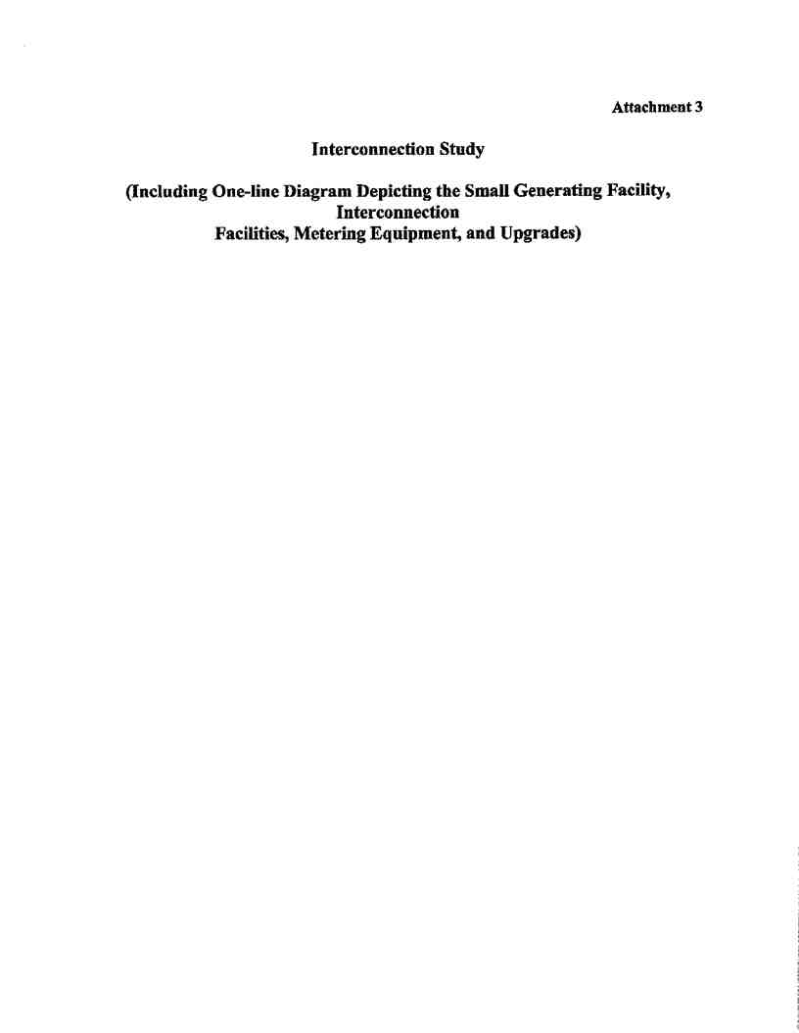

Service Agreement No. 1988



Service Agreement No. 1988

Interconnection Study:   
WM Renewable Energy -

Madison County Landfill Gas to Energy

2,000 kVA Small Generating Facility   
Buyea Road in the Town of Lincoln, NY

Prepared by:

National Grid

300 Erie Blvd. West

Syracuse, NY 13202-4250

November 21, 2008

(Supersedes issue dated May 12, 2008)

Page 1 of 15

Service Agreement No. 1988

Interconnection Study: Madison County Landfill Gas to Energy 2 MVA Small Generating Facility

GENERAL CONTENT

Section

1. INTRODUCTION

2. PROJECT DESCRIPTION

3. STUDY SCOPE

4. THERMAL AND VOLTAGE ANALYSIS

5. GROUNDING REQUIREMENTS AND SYSTEM PROTECTION

6. INTERCONNECTION METHOD CONCLUSION AND ALTERNATIVES

7. CONCEPTUAL COST ESTIMATE

8. SCHEDULING

9. CONCLUSIONS

10. APPLIED REFERENCE REQUIREMENTS

ATTACHMENT A - COMPANY MILESTONE REQUIREMENTS for GENERATOR-OWNER PROJECT   
 SCHEDULE

1. INTRODUCTION

WM Renewable Energy, the interconnect customer, has made application for a new Small Generator Facility having a total capacity of 2MVA. In February 2008, the Developer (interconnect customer) WM Renewable Energy, 1001 Fannin, Suite 4000, Houston, TX, 77002 entered into a Support Services Agreement with National Grid (Company) to evaluate the feasibility of a 13.2kV interconnection for their Madison County Landfill Gas to Energy Small Generator Facility project. The requested in service date is between December 2008 and February 2009.

This report presents the analysis results for WM Renewable Energy’s study in accordance with   
Attachment Z, Small Generator Interconnection Procedures (SGIP), of the NYISO OATT. The intent of   
this report is to assess the project’s feasibility and determine its impact on the existing power system.

The study was performed in accordance with applicable NERC, NPCC, National Grid/NMPC reliability and design standards, and in accordance with applicable NYISO and NMPC study guidelines, procedures and practices. In addition to assessing the project impact on the power system, the study includes a list of the facilities required to interconnect the project physically to the power network, as well as non-binding good faith cost estimates to construct those facilities.

The report included steady state (thermal and voltage) and short circuit analysis for summer peak loading conditions. Further, a sensitivity study (steady state only) was conducted to assess the impact of the project during light load conditions. Analysis was performed on models with and without the project, in order to evaluate the impact of the project on the bulk and local power network.

2. PROJECT DESCRIPTION

WM Renewable Energy has proposed to connect 2MVA of generation from their new facility located at the Madison County Landfill Facility in the Town of Lincoln, NY off Buyea Road to the National Grid 3-phase, 4-wire, 13.2kV distribution system. The interconnect point is approximately 9.1 miles indirect to Oneida Station from the generation site with a delivery point at the 13.2kV line side of the small generator facility’s main disconnect switch #503 (See Figure 1 for general interconnection configuration and location map).

The proposed Madison County Landfill Gas to Energy Small Generator Facility project   
(“project”), as specified, will consist of one Caterpillar model 3520 methane burning engine driving a   
2MVA generator at 0.8 p.f. (1.6MW). This generator data is as submitted in the NYISO Attachment Z -  
Appendix 2 Small Generator Interconnection Request dated Dec. 6, 2007. The fuel for the engine will be   
produced on site. The output will be stepped up to 13.2kV through a single 4.16-13.2kV, 2/2.2MVA   
OA/FA transformer at an assumed 6.5% impedance. Also, the one-line diagram submitted for the project   
is drawing E002, revision 3. See Figure 1B for the small generator facility’s general configuration.

Madison County LFGTE Interconnection Study rev11 21 2008.doc

Page 2 of 15

rev. Nov. 21, 2008

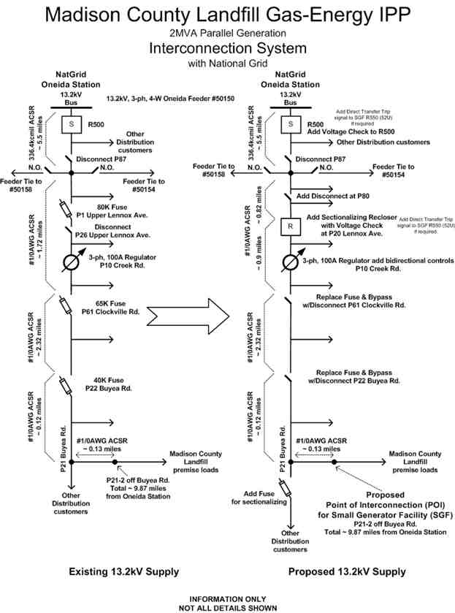

Service Agreement No. 1988

Interconnection Study: Madison County Landfill Gas to Energy 2 MVA Small Generating Facility

Figure 1

Figure 1A - General 13.2kV Interconnection Configuration

Madison County LFGTE Interconnection Study rev11 21 2008.doc

Page 3 of 15

rev. Nov. 21, 2008

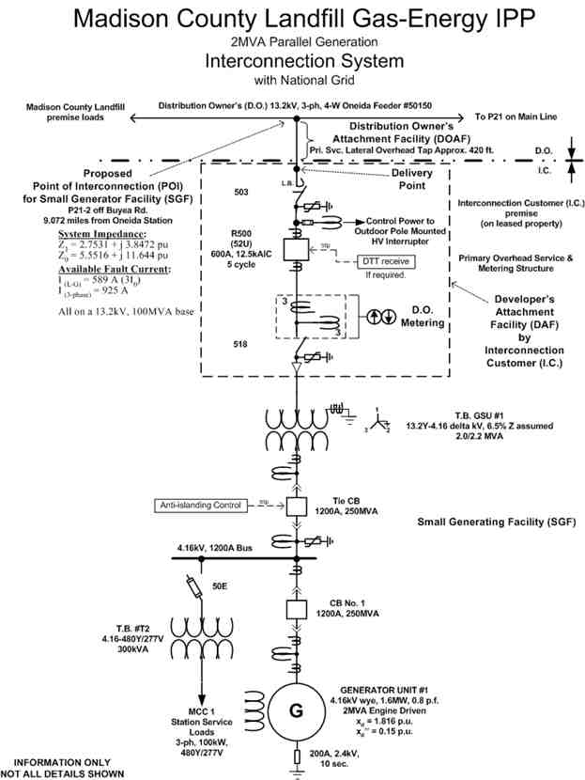

Service Agreement No. 1988

Interconnection Study: Madison County Landfill Gas to Energy 2 MVA Small Generating Facility

Figure 1B - General Small Generator Facility Configuration

Madison County LFGTE Interconnection Study rev11 21 2008.doc

Page 4 of 15

rev. Nov. 21, 2008

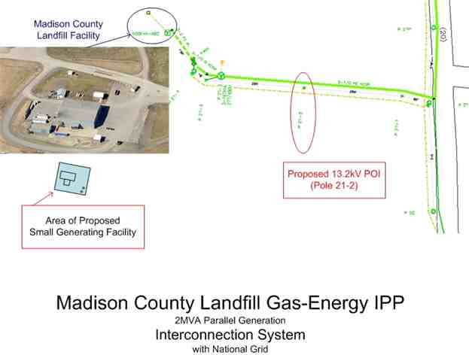

Service Agreement No. 1988

Interconnection Study: Madison County Landfill Gas to Energy 2 MVA Small Generating Facility

Figure 1C - General Project Location Map

3. STUDY SCOPE

The scope of this study is limited to evaluating the project’s impact on the following four items as   
listed in Section 6.0 of Appendix 6 of Attachment Z: 6.1-Initial identification of circuit breaker short   
circuit capability limits; 6.2-Initial identification of thermal overload or voltage limit violations; 6.3-  
Initial review of grounding requirements and system protection; and, 6.4-Description and non-binding   
estimated cost of facilities required to interconnect the proposed Small Generator Facility and to address   
the identified short circuit and power flow issues. The scope of this study provides the results of:

• Initial identification of thermal overload or voltage limit violations (steady state) for summer and   
 winter peak loading conditions

• Sensitivity study (steady state only) to assess the impact of the project during light load conditions

• Analysis on models with and without the project, in order to evaluate the impact of the project on the   
 bulk and local power network

• Available 13.2kV system characteristics on a 100MVA base at each 13.2kV delivery point to each of   
 the 3 customer service locations

• Recommended interconnection configuration with a list of system upgrades required

• Initial identification of circuit breaker short circuit capability limits

• Initial review of system protection requirements to be included for the Company’s system and those   
 at the generation facility/customer service points

• List of system protection upgrades required

Madison County LFGTE Interconnection Study rev11 21 2008.doc

Page 5 of 15

rev. Nov. 21, 2008

Service Agreement No. 1988

Interconnection Study: Madison County Landfill Gas to Energy 2 MVA Small Generating Facility

4. THERMAL AND VOLTAGE ANALYSIS

The results of the thermal and voltage study to determine the project’s impact on the Company’s Electric Power System (EPS) and the need for any resulting mitigating actions are as follows.

4.1 Summary

National Grid can accept 2MVA of generation from the Project on the Oneida 115-13.2kV distribution substation under specified conditions.

To keep the voltage within acceptable parameters and minimize losses, the Project will be required to be normally interconnected to Oneida 13.2kV Feeder #50150. The Company’s existing ties to other feeders that are normally opened, should not pose voltage or thermal concerns if operated under emergency or maintenance operations. A voltage regulator at pole 10 on Creek Road in the feeder system will require bidirectional control.

The possibility of islanding the Local EPS, Oneida Feeder #50150, by the station breaker or present in line feeder fuses will require the following:

1. Remove fuses and install 600A disconnects at existing fuse locations on pole 61 on Clockville Road

and pole 22 on Buyea Road. This suggests the installation of a sectionalizing recloser and a fuse

beyond the Madison County Landfill tap point for reliability of the feeder’s customers.

2. Anti-islanding protection of the Small Generating Facility (SGF) on the Local EPS for this situation   
 shall be made by the Project by either:

a. The SGF is certified to pass an applicable non-islanding test according to IEEE 1547 and IEEE   
 1547.1.

b. The SGF contains other non-islanding means, such as:

(1) forced frequency or voltage shifting (according to the interconnection response criteria in   
 IEEE 1547), or

(2) a special protection system (SPS), such as Direct Transfer Trip.

The protective devices for either of these means would become part of the Local EPS designated control devices. If under-frequency relays do not trip on a fault and the DG islands the Local EPS, then the SPS is required.

If it is identified that items 2.a and 2.b(1) cannot be met through the Developer’s protection of the   
SGF as reviewed by the Company for acceptance, then the installation of Direct Transfer Trip (DTT) will   
be necessary; however, further evaluation of this SPS will be necessary outside the scope of this study.

4.2 Power Flow Model Development and Calibration

4.2.1 System Limits

Thermal Overload/Voltage Limits on Oneida Feeder #50150 to the Project are not exceeded by the generation.

4.2.2 2006/2007 Load Calibrations

The light load condition sensitivity study results in the following: (feeder load at minimum and generation at maximum)

• The Project’s capacity exceeds one-third of the minimum load or is in excess of 25% of the peak load   
 of the Local EPS (Oneida Feeder #50150).

• On Oneida Feeder #50150, the maximum output from the Project’s generation is not anticipated to   
 backfeed into the 115kV power network due to the other distribution feeder loads at Oneida station.

4.3 Power Flow Analysis Procedure and Results

4.3.1 Analysis Procedure and Contingencies

No contingencies were modeled due to the radial nature of the system. The analysis is made based on normal connection to the Oneida Feeder #50150.

Madison County LFGTE Interconnection Study rev11 21 2008.doc

Page 6 of 15

rev. Nov. 21, 2008

Service Agreement No. 1988

Interconnection Study: Madison County Landfill Gas to Energy 2 MVA Small Generating Facility

4.3.2 2006/2007 Power Flow and Contingency Analysis Results

The bus at the Oneida substation shall be maintained at its present voltage levels for National   
Grid to hold regulated voltage to its <600V distribution customers within +2.5%/-5% as NY State PSC   
obligated. The Project will need to hold their 13.2kV point of interconnection (POI) to a 13.2kV+2.5%/-  
5% voltage level.

The maximum inrush current allowed at the 13.2kV POI without contribution of the Small   
Generating Facility’s equipment (e.g. transformer, motor, cable impedance’s...etc.) is 22.4 amperes

(0.51MVA). Attention is called to Sections 8.0 and 11.0 of ESB 750-2002 regarding motor starting requirements and mitigation of disturbances.

4.4 Impact on Local EPS Reliability

The site is approximately 9.1 miles indirect (as one follows the feeder) from National Grid’s Oneida 115-13.2kV distribution station to the Project’s proposed 13.2kV point of interconnection (POI). The feeder is entirely an overhead pole and open conductor system at 13.2kV operating voltage.

The reliability as of May 2008 for the existing 13.2kV Oneida Feeder #50150 distribution circuit,   
excluding planned and major storm events, is 1 sustained and 12 momentary interruptions for a 5-year   
period at the station feeder breaker. In addition, two occurrences of feeder fuses were blown that would   
affect this Project POI. This is not a prediction of future performance of the Company’s supply system.

Fuses located on pole 61 on Clockville Road and pole 22 on Buyea Road in the main feeder to the   
Project POI will not coordinate with the Small Generating Facility (SGF) and could present a possibility   
of islanding small portions of the Local EPS, Oneida Feeder #50150. These fuses will need to be   
removed and replaced with 600A disconnects. Removing these fuses will degrade the present reliability

of the feeder and will suggest the installation of a sectionalizing recloser approximately 5.5 miles from the Oneida substation to ensure that all 3 phases are interrupted to avoid problems with the SGF or problems to the Company’s other customers from the SGF. This will sectionalize the largely loaded part of the feeder from the remaining predominant rural radial loads. It is noted that sectionalizing reclosers with infeed may not be capable of Direct Transfer Trip (DTT) controls and if DTT is determined necessary according to Section 4.1.2 above, then special equipment will need to be evaluated outside the scope of this study. In addition, fuses will be required around pole 20 on Buyea Road beyond the Madison County Landfill’s tap point to sectionalize other distribution customers.

The 100 ampere 3-phase Voltage Regulator at pole 10 on Creek Road will need to be capable of   
reverse power flows. At this time, a new set of regulator bidirectional controls will be planned for   
installation.

5. GROUNDING REQUIREMENTS AND SYSTEM PROTECTION

5.1 Grounding Requirements

The maximum desired ground grid resistance for the project’s 13.2kV substation ground grid is

23 ohms for an 8,000V ground potential rise. Or, the ground grid resistance shall be no greater than that which would exceed the step and touch voltage limits of E step = 3134 volts and E touch = 885 volts according to IEEE Std. 80 for a supply system clearing time of 30 cycles as a minimum.

The Generator-Owner is responsible to limit the ground potential rise (GPR) for communication conductors entering their substation that must be safeguarded and mitigate the zone of influence (ZOI) for point where the GPR is 300 volts peak asymmetrical of the voltage variations on the surface of the earth considering all systems connected having earth return paths. The Generator-Owner should consider the effects of lightning when designing surge protection for the telecommunications equipment.

Refer to IEEE Std. 80 for design of a substation ground grid. The Generator-Owner shall provide the results of the ground grid design calculations and the test results for the ground grid resistance according to ESB’s 752 and 753. The Company recommends the 4-point Fall-of-Potential Method of testing; refer to IEEE Std. 81 for testing method standards.

Madison County LFGTE Interconnection Study rev11 21 2008.doc

Page 7 of 15

rev. Nov. 21, 2008

Service Agreement No. 1988

Interconnection Study: Madison County Landfill Gas to Energy 2 MVA Small Generating Facility

5.2 System Protection Analysis

5.2.1 Short circuit analysis was performed on busses in the area to determine if any circuit breaker ratings were exceeded with the addition of the project and none were identified.

The following are National Grid’s estimated 13.2kV system characteristic maximum values on a 100MVA base at the Project’s proposed 13.2kV point of interconnection (POI) without any GeneratorOwner equipment contribution. Future system or load growth may require the service equipment to have a larger interrupting rating. Any costs associated with changes to Generator-owned equipment shall be borne by the Generator-Owner. The Generator-Owner’s interconnection facilities and equipment shall be suitable for the maximum fault current available at its supply.

Assuming Interconnection to Pole #21-2 off Buyea Road, Town of Lincoln (from Oneida Station):

System Impedance: Available Fault Current:

Z1 = 2.7531 + j 3.8472 pu I (L-G) = 589 A (3I0)

Z0 = 5.5516 + j 11.644 pu I (3-phase) = 925 A

Please note that the Generator-Owner shall refer to Section 1.7 of the Company's ESB 750-2002   
and ESB 755 regarding their responsibility for their electric service operating and maintenance   
requirements. Also, NFPA 70E provides information where to find work safety practices for premises   
wiring.

Disclaimer

The Company shall not be liable for any errors, inaccuracies or delays in content, or for any

actions taken in reliance thereon. The Company expressly disclaims all warranties, expressed or implied, as to the accuracy of any the content provided, or as to the fitness of the information for any purpose.

Although the Company makes every reasonable effort to obtain reliable information and proper   
calculations, the Company provides no warranty, expressed or implied, as to the accuracy, reliability or   
completeness of furnished data past the time of gathering data for the calculations to be made. The   
Company’s electric power system is dynamic that changes from moment to moment as demands are made to   
the system. Furthermore, permanent changes to the system are common which will change the information   
provided.

5.2.2 A preliminary coordination study was performed with the project added to the National Grid Oneida Station 13.2kV bus. The project shall conform to National Grid’s ESB 756 Appendix A for protection requirements.

5.2.2.1 Supply System Protection

The existing feeder relay for Oneida Feeder #50150 (G.E. IAC77) will detect phase faults up to   
the point of interconnection (POI). The relay is set at the Company’s standard 720 amps pickup.

However, the clearing time for three lines-to-ground fault at the POI is 6.4 seconds. Analysis of this clearing time for acceptance on the distribution system will need further evaluation upon the Developer’s preliminary design submittal for Company acceptance review. If a faster clearing time is needed, the phase relay setting may be lowered; however, it must be set above load on that feeder as well as coordinated with the protective device downstream on that feeder.

The existing feeder relay for Oneida Feeder #50150 (G.E. IAC 53) will not detect ground faults at the POI. The relay is set at the Company’s standard 480 amps pickup. The setting can be lowered but this will need to be coordinated with the downstream protective device. Further evaluation upon the Developer’s preliminary design submittal for Company acceptance review will need to be made if it is necessary to change the feeder setting.

5.2.2.2 Supply System Reclosing

The Generator-Owner is responsible to ensure their generation source is disconnected before the   
Company’s feeder breaker or line sectionalizer recloses for protecting against faults on the 13.2kV   
distribution system. The Company’s reclose time for Feeder #50150 is 15 sec. [This means that the   
system will reclose in 15 sec whether the generation is off or on]. Note that the Company would have to   
lose 3 lines and the tie breaker at Oneida Substation. [The only time that would happen is on a bus fault

or a breaker failure of the tie breaker, therefore, the Project can ignore the reclosing times on the 115 kV.]

Madison County LFGTE Interconnection Study rev11 21 2008.doc

Page 8 of 15

rev. Nov. 21, 2008

Service Agreement No. 1988

Interconnection Study: Madison County Landfill Gas to Energy 2 MVA Small Generating Facility

The Company assumes no liability for the Generator-Owner’s system if this is not observed by   
the generator protective controls. The Generator-Owner needs to understand that if the Company’s   
system recloses and they are still online, the systems will most likely be out of synch and the Generator-  
Owner’s generation could sustain major damage and damage to other customer connected equipment may   
occur. Additionally, if the Generator-Owner’s generator causes disturbances to others, then they are   
subject to disconnection per ESB 756 Appendix A Section 5.2, ESB 750 Sections 3 and 11, and the   
Company's tariff, PSC No. 207. Subsequently, the Generator-Owner may be responsible to compensate   
for any damages. As changes occur to the Company’s system these reclose settings are subject to change   
by the Company according to its utility practice. The Generator-Owner is responsible for maintaining   
their own equipment coordination with the Company’s system at their cost. There is no notification   
requirement in place for the Company’s changes of reclosing settings. The Generator-Owner needs to   
communicate with the Company upon their relay coordination maintenance schedule (see ESB 755) for   
information necessary to update their studies.

There are serious safety concerns such as, if the station breaker is manually opened, it is possible that the generation would continue to energize the circuit while utility personnel may assume that the circuit is de-energized and safe. Also, if the Small Generating Facility (SGF) is able to island with the connected load, there will be an out of synch close condition on the Oneida Station feeder breaker when trying to close. The station breaker cannot be closed until the SGF has been tripped off. Currently there is no synchronism or voltage check on the Oneida Station breaker, R500, for closing conditions. It is recommended for this project to include adding at least a voltage check relay to the station breaker and at the new feeder recloser (item 4.1.1 above) for close supervision.

5.2.2.3 Small Generating Facility Protection Coordination

Upon the Company’s review of the submitted preliminary design dated 11-26-07, it is noted that   
the Generator-Owner is providing two SEL-351-A microprocessor based multi-function relays that will   
trip their main 13.2kV breaker R500 (52U). This provides for meeting the Company’s requirement for   
redundant protection schemes with microprocessor based relays. In addition, microprocessor relays shall   
have ABB FT-1, or equivalent, test switches isolating all inputs and outputs of the relay meeting the   
following requirements:

• AC Inputs: Each relay shall have its own AC test

switch. DC inputs or outputs are not permitted on AC test switches.

• DC Inputs and Outputs:

o For relays designated by the Company as   
 necessary to protect its electric system, it is

required that each individual relay have its own DC test switch that isolates the positive and negative DC for each input and output.

o For relays required to protect Customer   
 equipment, it is preferred that each relay have its

own DC test switch for inputs and outputs. For   
ease of maintenance testing and troubleshooting,

it is preferred to isolate the positive and negative DC of the input and output, however, it is permissible to isolate the negative side only in Company approved situations.

• Groups of relays that protect the same piece of   
 equipment, such as a transformer or a feeder, may

share a DC test switch under the following conditions:

o The individual blades of the test switch shall   
 be grouped by relay.

o A permanent label shall be affixed to the relay   
 panel identifying the use of each blade.

Protection will be determined by the Generator-Owner’s NYS licensed professional engineer.

1. The Project is required to have the setting of the voltage and frequency relays within the requirements

of. Section 4.5.2.8 in ESB 756 Appendix A. The Small Generating Facility will be required to coordinate with the Company’s underfrequency load shedding relays at Oneida station. The Company will not be providing any compensatory load shedding.

2. In order to sense ground faults on the Company’s system, a 51G utility grade relay located on the

neutral of the high voltage side of the transformer will be required.

3. Device 51V relays shall be added at the Project’s SGF station to trip their generation off for phase

faults on National Grid’s 115kV Oneida breakers R20 and R50.

4. The Company will review for acceptance the Generator-Owner’s proposed settings of those relays

that the Company’s Protection Engineering Dept. designates as being required to satisfy the Company

Madison County LFGTE Interconnection Study rev11 21 2008.doc Page 9 of 15 rev. Nov. 21, 2008

Service Agreement No. 1988

Interconnection Study: Madison County Landfill Gas to Energy 2 MVA Small Generating Facility

protection practices. Any relay setting issued by the Company shall not be changed or modified at any time without the prior written consent of the Company. The manufacturer and model of the relay protection shall be shown on the one line diagram. The proposed relay protection and settings shall be submitted for the Company’s acceptance review along with AC 3-line and DC elementary control drawings. These Company-designated devices will be witness-tested/verified by the Company’s personnel prior to energization.

5. The Generator-Owner is solely responsible for the protection of their plant equipment. The   
 Generator-Owner is required to provide electrical equipment and relays with ranges and rating that   
 will allow proper Generator-Owner relay system coordination with Company protection systems.   
 Coordination margins and parameters will be determined by the Company.

6. The Generator-Owner shall ensure the duty rating of the service equipment and overcurrent devices   
 meet the requirements of the latest edition of the National Electrical Code enforced by the authority   
 having jurisdiction (AHJ).

5.2.2.4 Other Small Generator Equipment Protection Requirements

All high voltage 13.2kV equipment up to the transformer HV winding’s bushing shall be rated at   
110kV BIL outdoors to match the BIL of the distribution supply line. The 13.2kV surge arresters   
required to protect the Company’s revenue metering instrument transformers shall be rated 8.4kV MCOV   
Distribution Class and located between the main disconnect switch and main overcurrent device. Surge   
arrester MCOV ratings for the transformer(s) shall be as recommended by the Generator-Owner’s   
transformer manufacturer.

The project will require a grounded wye primary winding step up transformer at 13.2kV. The transformer manufacturer’s test data sheet to be submitted to the Company by the Generator-Owner shall include the ratings information, guaranteed losses and no-load-losses in kW, and the transformer impedance in % on its own base.

5.3 System Operating Impact

The Generator-Owner will need to abide by the power factor requirements in Section 4.4.1.3 of ESB 756 Appendix A.

If the project absorbs vars from National Grid, then they will need to compensate their generation output according to power factor requirements in ESB 756. As a minimum, the Project will need to maintain at least a 0.95 p.f. at their point of interconnection (POI).

This interconnection study does not address the future operations and maintenance (O&M)   
associated with the distribution feeder and associated additions and modifications to National Grid’s   
system.

The Company’s Peterboro station’s feeders (Nos. 51455, 51456, or 51458) may be used at various points for possible connection under contingency operations during Oneida Feeder #50150 restoration or maintenance situations. However, this Project’s normal interconnection is with Oneida #50150. For these reasons on a radial distribution feeder, the Company has an operating requirement for remote control of the Project’s main 13.2kV overcurrent device R500 through a Company-provided EMSRTU point. This is to avoid dropping multiple customers from the distribution feeder because of a generator facility problem when the Company is performing emergency feeder switching. To accomplish this, the Small Generating Facility will require instrumentation control cabling from the main 13.2kV overcurrent device R500 and the Company’s EMS-RTU.

6. INTERCONNECTION METHOD CONCLUSION AND ALTERNATIVES

The results in Sections 4 and 5 herein for this proposed project has identified changes necessary   
to the existing Company distribution system to accommodate the Generator-Owner’s 2MVA

interconnection. The interconnection requirement specifically identified in Figure 1 and Sections 4.1,

4.4, 5.2, and 5.3 is feasibly offered and may be expected to require Company management approval if the parties desire to proceed with the project.

Madison County LFGTE Interconnection Study rev11 21 2008.doc

Page 10 of 15

rev. Nov. 21, 2008

Service Agreement No. 1988

Interconnection Study: Madison County Landfill Gas to Energy 2 MVA Small Generating Facility

As shown in Figures 1A and 1B, this configuration provides the interconnection within the   
Generator-Owner’s proposal expectation. The Project will be required to be normally interconnected to   
Oneida 13.2kV Feeder #50150 with all the protection requirements identified in this study and installed   
according to the Company’s applicable ESB’s 750, 752, 753, and 756 Appendix A. Based on Sections 4   
and 5 above, in brief the following are the Company distribution system changes and additions for this   
interconnection:

Feeder #50150:

• Add voltage check on the Oneida Station breaker, R500.

• Remove and replace fuses with 600A disconnects at existing fuse locations on pole 61 on

Clockville Road and pole 22 on Buyea Road.

• Install sectionalizing recloser approximately 5.5 miles from Oneida substation with voltage

check.

• Install sectionalizing fuses near pole 20 on Buyea Road after the Madison County Landfill tap   
 point.

• Install bidirectional controls on voltage regulator at pole 10 on Creek Road.

• Overhead 13.2kV tap to the Project’s SGF primary overhead service and metering structure.

This excludes any changes as may be necessary for a special protection system (SPS) that could result   
from the evaluation of the Developer’s preliminary design proposal for anti-islanding protection or   
other.

Other alternatives such as an express feeder from a new breaker position made at Oneida   
substation approximately 9 miles away may be considered to avoid operating concerns associated with   
using an existing encumbered feeder discussed above. Also, a 34.5kV interconnection point

approximately 1.75 direct miles away to Whitman Station could be considered. However, these alternatives will be more costly to provide upon initial installation.

At the Generator-Owner’s point of interconnection (POI) with the Company’s system, the

following are some other concerns observed in this study.

1. The Generator-Owner is responsible for securing the right-of-way for the Company’s 13.2kV primary   
 overhead tap.

2. The parallel generator installation shall comply with the Company’s ESB 750 series requirements.

3. Since the Company’s distribution supply line is overhead construction and the Generator-Owner is   
 required to have a main breaker, R500 (52U), to coordinate with the 13.2kV supply, the Generator-  
 Owner will need a 13.2kV primary overhead service and metering structure.

4. No future increase in generation output beyond 2MVA for this 13.2kV interconnection has been

studied. Any increase is subject to a new study.

7. CONCEPTUAL COST ESTIMATE

The following are general descriptions of, and non-binding good faith estimated costs for, the

Interconnection Facility components that are determined to be required by the project:

UTILITY METERING - The conceptual cost for 13.2kV outdoor metering CT’s and PT’s and meters at

the project location is estimated at $26,400 +/-25%. This excludes telecommunications circuit costs.

RTU - It has been determined that the NYISO will be administering the revenues for this Project’s 2MVA small generating facility and a Company EMS-RTU will be required. The conceptual cost for the Company’s EMS-RTU provision is estimated at $115,700 +/-25%.

SERVICE LATERAL (DISTRIBUTION OWNER ATTACHMENT FACILITY) - The conceptual cost   
which is based on 420 feet of 13.2kV overhead primary with pole and guying and without encumbrances

would be $100,500 +/-25%. This cost would not include right-of-way, which would be the project’s

responsibility.

DISTRIBUTION SYSTEM UPGRADES - The conceptual cost of additions and modifications of the

Madison County LFGTE Interconnection Study rev11 21 2008.doc

Page 11 of 15

rev. Nov. 21, 2008

Service Agreement No. 1988

Interconnection Study: Madison County Landfill Gas to Energy 2 MVA Small Generating Facility

National Grid Oneida 13.2kV Feeder #50150 identified above, including materials; engineering, design,

and construction labor; and overhead costs, will be $198,900 +/-25%. This includes:

• Add voltage check on the Oneida Station breaker, R500 at $108,400+/-25%.

• Remove and replace fuses with 600A disconnects at existing fuse locations on pole 61 on Clockville

Road and pole 22 and install sectionalizing fuses near pole 20 on Buyea Road at $12,700+/-25%.

• Install sectionalizing recloser approximately 5.5 miles from Oneida substation at $58,300+/-25%.

• Install bidirectional controls on voltage regulator at pole 10 on Creek Road at $19,500+/-25%.

LINE EXTENSION - None anticipated at this time based on this study.

COMMUNICATIONS CIRCUITS & EQUIPMENT - An estimate is not identified at this time; however,   
it is expected that communications circuits will be required at least for the revenue metering and the

EMS-RTU

ENGINEERING REVIEW & COMPLIANCE VERIFICATION OF THE GENERATOR-OWNER’S FACILITIES - The conceptual cost to review the project’s designs and installation according to the applicable National Grid Electric System Bulletins is $9,100 +/-25%.

COMPLIANCE VERIFICATION OF GENERATOR-OWNER’S STATION FUNCTIONAL TESTING

- The conceptual cost to field verify the project’s installation for functional compliance according to the applicable National Grid Electric System Bulletins is $1,400 +/-25%.

TOTAL = $452,000 +/-25%.

NOTES:

1. These conceptual estimated costs are based upon the results of this study and subject to change upon

receipt of the Generator-Owner’s decision to proceed with preliminary design. It is important to note   
that the Company will reconcile the charges after project completion, and the Generator-Owner will   
be responsible for all final charges, which may be higher or lower than estimated according to this

interconnection study, the Interconnection Agreement, and NMPC PSC No. 207.

2. The conceptual cost estimate provided in this plan is according to the Company’s rates and schedules

in effect and will be deemed withdrawn if not accepted by the Generator-Owner within 90 days. The estimate includes sales tax and contingency on direct labor and material costs.

3. The conceptual cost estimates provided do not include:

• interconnection study costs,

• application fees,

• applicable surcharges,

• property and income taxes,

• future operation and maintenance costs,

• project management costs,

• recurring monthly communications circuits’ charges responsible by the Generator-Owner to the   
 communications utility,

• provisions for communications circuits, if needed, as responsible by the Generator-Owner to the   
 communications utility,

• allowance for funds used during construction (AFUDC) assuming Customer upfront payment,

• adverse field conditions such as rock, water, weather, and Generator-Owner electrical equipment   
 obstructions,

• extended construction hours to minimize outage time or National Grid’s public duty to serve,

• the cost of any temporary construction service, or

• any required permits.

4. Cost adders estimated for overtime would be based on 1.5 and 2 times labor rates if required for work

beyond normal business hours. Meals and equipment are also extra costs incurred for overtime labor.   
5. Payments in accordance with the Interconnection Agreement between the Developer and the Company.

Madison County LFGTE Interconnection Study rev11 21 2008.doc Page 12 of 15 rev. Nov. 21, 2008

Service Agreement No. 1988

Interconnection Study: Madison County Landfill Gas to Energy 2 MVA Small Generating Facility

8. SCHEDULING

The Company is aware that the Generator-Owner desires a December 2008-February 2009 in-  
service date. This date may not be achievable, depending upon receipt of funds and notification to proceed,   
weather, equipment delivery, public opposition to right-of-way and untimely Developer design submittals   
that may affect this schedule. Close coordination is required to sequence construction and planned   
interruption events. As a result, any final schedule requires mutual agreement and would be subject to   
change.

• Refer to Attachment A for the Company’s items to be considered in the Generator-Owner’s Project   
 Schedule.

• The Generator-Owner is required to submit a project schedule that includes the necessary coordination   
 activities to both themselves and the Company to provide for the design, installation, compliance   
 verification, and energization of the Generator-Owner’s interconnection to the Company’s distribution   
 system.

• Based on this study, the Company requires a 6-month lead time from receipt of necessary funding   
 and written commitment to proceed. The lead time required to complete the installation of phone   
 circuits, if required, is unknown and is dependent upon the local communications provider.

9. CONCLUSIONS

Based on the available data and the analysis performed, the following conclusions have been reached based on the recommended modifications and additions to the existing 13.2kV overhead feeder, Oneida #50150:

1. The generation did not cause any thermal or voltage problems at peak or light load conditions.

2. For normal operating conditions, the proposed generating station is feasible.

3. Under light load conditions, protection from anti-islanding is required for the proposed small   
 generating facility with the Oneida substation’s Feeder #50150.

4. No National Grid circuit breakers exceed their short circuit ratings because of the project.

5. Fuse replacement with disconnects and the addition of a recloser and fuse are necessary for feeder

reliability.

6. A voltage regulator will require bidirectional controls.

7. Voltage check will need to be added on the Oneida Station breaker, R500.

8. An EMS-RTU will be needed at the proposed generating station for administering sales to the

NYISO and control under emergency feeder switching operations.

9. Total conceptual cost to interconnect the project for National Grid’s impact is approximately

$452,000 +/-25% excluding possible additional costs noted in Section 7, note 3.

10. APPLIED REFERENCE REQUIREMENTS

The following National Grid electric service bulletins apply to the project for submittal of service installation designs for National Grid’s review and acceptance.

• ESB No. 750 - Specifications for Electrical Installations

• ESB No. 752 - Service above 15,000 Volts

• ESB No. 753 - Primary Meter Pole Service

• ESB No. 755 - Operation & Maintenance Requirements for Services Above 600 Volts

• ESB No. 756 Appendix A - Requirements for Parallel Generation Connected to National Grid   
 Facilities in New York

• ESB 750 series Errata and Change Revision List

Note: All ESB’s are available at [http://www.nationalgridus.com/electricalspecifications](http://www.nationalgridus.com/electricalspecifications/)

Other related references:

• PSC No. 207 - Niagara Mohawk Power Corporation Electricity Tariff

<<[http://www.nationalgridus.com/niagaramohawk/non_html/rates_psc207.pdf](http://www.nationalgridus.com/niagaramohawk/non_html/rates_psc207.pdf/)>>

Madison County LFGTE Interconnection Study rev11 21 2008.doc

Page 13 of 15

rev. Nov. 21, 2008

Service Agreement No. 1988

Interconnection Study: Madison County Landfill Gas to Energy 2 MVA Small Generating Facility

• New York Independent System Operator, Inc. FERC Electric Tariff Original Volume No. 1   
 Attachment Z - SMALL GENERATOR INTERCONNECTION PROCEDURES (SGIP)   
 (Applicable To Generating Facilities No Larger Than 20 MW)

<<[http://www.nyiso.com/public/webdocs/services/planning/links_to_tariff_attachments/att_z.pdf](http://www.nyiso.com/public/webdocs/services/planning/links_to_tariff_attachments/att_z.pdf/)>>

• New York State Consolidated Laws, Public Service, Article 4, Section 65.

<<[http://public.leginfo.state.ny.us/menugetf.cgi?COMMONQUERY=LAWS then select “PBS”](http://public.leginfo.state.ny.us/menugetf.cgi?commonquery=laws%20then%20select%20)>>

• Regarding unqualified persons approaching the area of work: Laws of New York - Labor -  
 Article 7 § 202-h. High-voltage proximity.

<<<http://www.labor.state.ny.us/workerprotection/safetyhealth/sh57.shtm>>>

Madison County LFGTE Interconnection Study rev11 21 2008.doc

Page 14 of 15

rev. Nov. 21, 2008



Service Agreement No. 1988

Interconnection Study: Madison County Landfill Gas to Energy 2 MVA Small Generating Facility

ATTACHMENT A

Company Milestone Requirements for Generator-Owner Project Schedule

These are Company items to be considered in the Generator-Owner’s Project Schedule per §3.C.2.0 in ESB 756 Appendix A.

ID Activity Description ESB 756 App. A § ref.

Project Definition & Conceptual Analysis Phase

 1 Developer Technical Submittal w/prelim. design received 2.2.2

 2 Company Interconnection Study 2.1.5 & 2.3

 3 Company Service Plan or Specification for Elec. Installation 1.3, 3.0 & 4.0

 4 Company Interconnection Agreement 2.1.5

Final Design Review Phase

 5 Developer Executed Interconnection Agreement received 2.1.5.3 & 2.3.1.3

6 Developer's funding received 2.3.1.1

7 Developer's project schedule received 2.3.2

8 Company Functional Specification (where required) provided to Developer 1.3.2, 1.5.1, & 2.1.2

9 Developer's final design & spec's received per ESB 750 & 752 or 753 or 758 2.2.2.1.2 & 3

10 Company reviews Developer’s design & returns comments per ESB 752 or 753 or 758 2.4

Installation Progress Review Phase

11 Developer’s corrected design, test reports & settings received per ESB 752 or 753 or 758 1.3.1.3

12 Company reviews Developer’s design & returns comments per ESB 752 or 753 or 758 1.3.1.3

13 Company field audit of Developer’s installation progress 2.4

Installation Compliance Verification Phase

14 Developer’s 6-week advance notice of functional testing received per ESB 755 & 752 or 753 4.5.3

or 758

15 Company witness of Developer’s functional testing 4.5.3

16 3rd Party Inspection Agency certification approval received per ESB 750 & 752 or 753 or 758 2.4

17 Developer’s acknowledgement of satisfactory wiring & relay tests received per ESB 755 & 2.4, 4.5.3

752 or 753 or 758

18 Company field audit of Developer’s service per ESB 750 series 2.4

19 Developer resolves open items

Energization & Synchronization Phase

20 Developer’s communication circuits available from Telco. 4.1 & 2

21 Company’s metering installation complete 3.3

22 Company’s telemetering installation complete (where required) 4.1

23 Company’s supply system interconnection complete

24 Company review/acceptance of Developer’s resolved open items

25 Developer’s energization sequence plan received per ESB 755 & 752 or 753 or 758

26 Company proceeds with energization

Project Closeout Phase

27 Developer’s as-built design drawings received within 90 days 2.4

28 Company reconciliation of project costs with Developer 2.3.1.1

For all National Grid NY Operations Specifications for Electrical Installations, ESB 750 series bulletins, see:

[http://www.nationalgridus.com/electricalspecifications](http://www.nationalgridus.com/electricalspecifications/)

Madison County LFGTE Interconnection Study rev11 21 2008.doc

Page 15 of 15

rev. Nov. 21, 2008

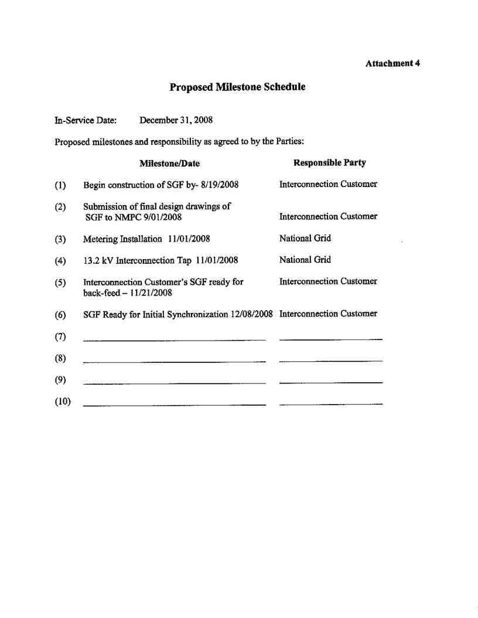

Service Agreement No. 1988