EXHIBIT B

Conceptual Report - Redundant Athens SPS

EXHIBIT B

Conceptual Report - Redundant SPS

Objective

This document describes the preliminary requirements and investment grade estimate required to design and construct a Redundant Special Protection System (SPS) for the Athens   
Generating Station (Athens Plant).

Background

In 2007/2008 a Special Protection System (SPS) was designed and constructed between Leeds Station - Athens Station - Athens Plant. The purpose of the SPS was to allow increased   
generation levels at Athens Generating Station while avoiding post contingency overloads on the 345kV transmission lines 91 (LN91) or 92 (LN92) for loss of either the LN91 or the LN92. By rejecting Athens generation the Athens SPS system has allowed the LN91 and the LN92 to be operated at post contingency loading levels up to the STE rating of each line.

Proposed Project

Protection Engineering New York and Substation Engineering & Design New York have been   
requested by Transmission Planning to provide an investment grade cost estimate for design   
and installation of a redundant Athens SPS system. With no additional requirements identified   
in the request this document was developed to clarify what redundancy is and provide an   
investment grade estimate to design and construct a second (redundant) Athens SPS.

The intent of adding a redundant Athens SPS is to prevent an element failure or an out of

service element of the existing or redundant SPS from impacting the functionality of the Athens SPS as described in the Background description above. The redundant Athens SPS is to utilize independent diverse power sources, inputs, and outputs from the original SPS. Since the   
equipment and communication method selected for the original SPS provides the most reliable and secure system possible there is no intent in the design of the redundant equipment to use components from an alternate manufacturer or technology, however the latest models will be utilized which minimizes common mode failure due to manufacturing flaws.

Identification of the Redundant SPS (Athens SPS "A")

Since the original Athens SPS is connected to "B" protection Current Transformers, “B” Station Batteries and uses the "B" Fiber Optic Routing Path it will be identified in the future as the   
Athens SPS "B" package. Since the redundant Athens SPS will be connected to "A" protection Current Transformers, “A” Station Batteries and will use the existing "A" Fiber Optic Routing Path it will be identified in the future as the Athens SPS "A" package. To support this   
nomenclature, print and labeling changes must be made to the existing SPS scheme to reflect its new designation as Athens SPS “B”.

Athens SPS "A" Package Communication Equipment

The existing Athens SPS "B" package uses the "B" Fiber Optic Routing Path from Leeds Station   
to Athens Station. The "B" Fiber Optic Routing Path is buried in the ROW and along part of Rt

74. The existing protection "A" Fiber Optic Routing Path is along the ROW on Fiber Optic

Shield Wire (OPGW). The "A" path will provide a diverse route for the Athens SPS "A" package and has been identified to have spare fibers that will provide this function. The new Athens SPS "A" package will also require an alternate diverse route for fiber communication between the Athens Station and the Athens Plant. It is assumed that there is spare conduit with spare fiber optic cable to support this. IF this turns out to be false then the cost to install such a   
diverse path will need to be added to the estimate provided in this document.

Overview of Athens SPS "A" Package Equipment

Figure 1 shows a one line diagram of the proposed redundant Athens SPS "A" package

equipment. Note that this will be the same as the as the existing SPS "B" package equipment.

National Grid Athens Station

The following equipment will be designed and installed at the Athens Station by National Grid to support the Athens SPS "A":

1. New relay panel for SPS “A” equipment.

2. Schweitzer SEL-351-6 Microprocessor Overcurrent Relay for inputs and logic   
 control.

3. Three position selector switch for “Summer LTE”, “Winter LTE”, and “OFF”.

4. Inputs from breakers R9162 & R9163 on LN91 breaker status and line current.

5. Utilize spare fiber optic cables between Athens and Leeds substations on the "A"   
 fiber optic path.

6. Utilize spare fiber optic cables between Athens Station and Athens Generating   
 Station. It needs to be determined that this diverse alternate path exists or the cost   
 must be added to the estimate.

National Grid Leeds Station

The following will be will be designed and installed at the Leeds Station by National Grid to support the Athens SPS "A".

1. New Relay panel for SPS "A" equipment

2. Schweitzer SEL-351-6 Microprocessor Overcurrent Relay for inputs and logic   
 control.

3. Inputs from breakers R92 & R9293 on LN92 breaker status and line current.

4. Use of spare "A" fiber optic cables (OPGW) between Athens and Leeds Stations.

National Grid Transmission Control Center

The following will be displayed and / or controlled from National Grid TCC via EMS:

1. SPS "A" actuation indication.

2. SPS "A" selector switch position.

3. Displayed value of the active logic setting group (SUMMER, WINTER, or OFF) of   
 the SPS "A" relays at Leeds and Athens Stations.

Athens Plant

The following will be acquired and employed at the Athens Plant by New Athens Generating Facility to support the Athens SPS "A":

1. Schweitzer SEL-2100 logic processor.

2. Three (3) Schweitzer SEL-2506 I/O modules.

3. Selectable generator rejection sequence switch.

4. SPS "A" actuation indication.

5. Displayed value of the active logic setting group (SUMMER, WINTER, or OFF) of   
 the SPS "A" relays at Leeds and Athens Stations.

6. Use of spare fiber optic cables between Athens Station and Athens Plant. It needs   
 to be determined that this alternate path exists or the cost must be added to the   
 estimate.

Investment Grade Cost Estimate

Table 1 and 2 identify an investment grade estimate for the addition of a redundant SPS

(Athens SPS "A") as described in this document. Table 1 is the estimate for the work at National   
Grid’s substations while Table 2 is the estimate for the work at the Athens Plant. The estimates   
assume that the spare diverse contacts, power sources, communication routing, annunciator   
windows, and CTs confirmed thru drawing reviews are available. It was also confirmed via   
drawing reviews that space is available in the Leeds and Athens Stations for additional panels.

Table 1: Investment Grade Estimate (Work at NG Substations)

Conceptual / Facility Study $45k

Materials $60k

Engineering (design) $145k

Construction $255k

TOTAL: $505k 1

Note 1: Estimate does not include AFUDC, assumed to be upfront payment per E&GSB 120. Estimate based upon

actual costs incurred for installation of the original SPS.

Table 2: Investment Grade Estimate (Work at Athens Plant)

Materials $30k

Engineering (design) $45k

Construction $90k

TOTAL: $165k 2

Note 2: Assumed to be designed and installed by others. Estimate developed from estimate provided by HMT for the original SPS. National Grid has no actuals to compare the estimate against.

Prepared 4/29/2011/Revised 1/19/2012

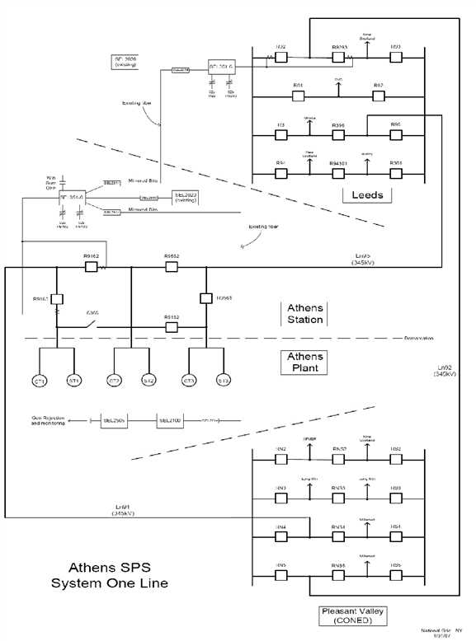

Figure 1: Athens SPS "A" - System One Line