**Exhibit A**

Description of Interconnection Facilities for Mathews Avenue Substation:

Mathews Avenue is an electrical substation owned by the Village of Solvay with a maximum rating of 144 MVA located at Mathews Avenue, Village of Solvay, New York.

National Grid Interconnection Facilities:

Line #12 tap – All facilities on the line (jaw) side of the switch located on structure #8-1 up to and including the insulators on the station take-off structure at National Grid’s Geres Lock substation

Line #8 tap – All facilities on the line (jaw) side of the switch located on structure #454.5-1 up to and including the insulators on National Grid structure #454.5 on National Grid’s transmission line #8.

Solvay Interconnection Facilities:

Line #12 tap – Includes the switch and switch pole structure #8-1 and all facilities on the station side of that switch back to Solvay’s Mathews Avenue Substation.

Line #8 tap – Includes the switch and switch pole structure #454.5-1 and all facilities on the station side of that switch back to Solvay’s Mathews Avenue Substation.

One-Line Diagram for Mathews Avenue Substation:

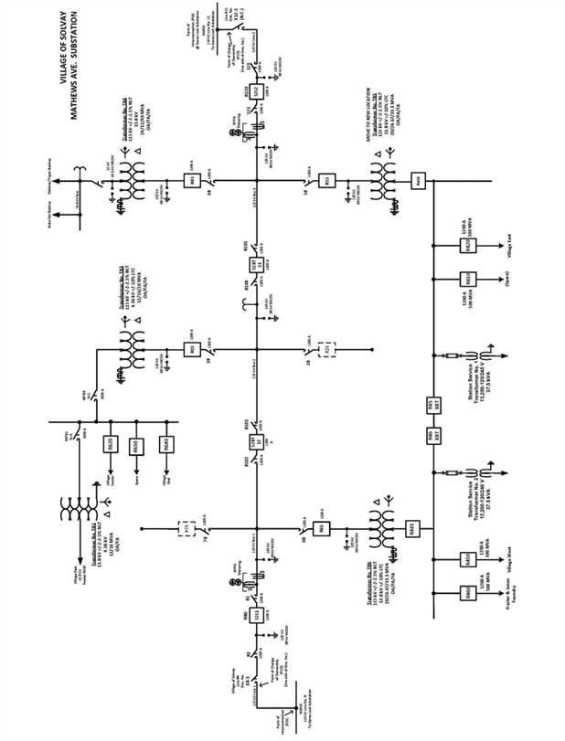

Description of Interconnection Facilities for Lakeland Substation:

Lakeland substation is an electrical substation owned by the Village of Solvay with a maximum rating of 20 MVA and located in the Town of Geddes, County of Onondaga, New York.

National Grid Interconnection Facilities:

All facilities including the dead-end insulators on the line (jaw) side of the switching structure up to and including the dead-end insulators at the Interconnection Point on National Grid’s #4 transmission line.

Solvay Interconnection Facilities:

All facilities on the station side of the Delivery Point from and including the disconnect switch and switch pole on the tap line feeder back to Solvay’s Lakeland Substation.

One-line Diagram for Lakeland Substation:

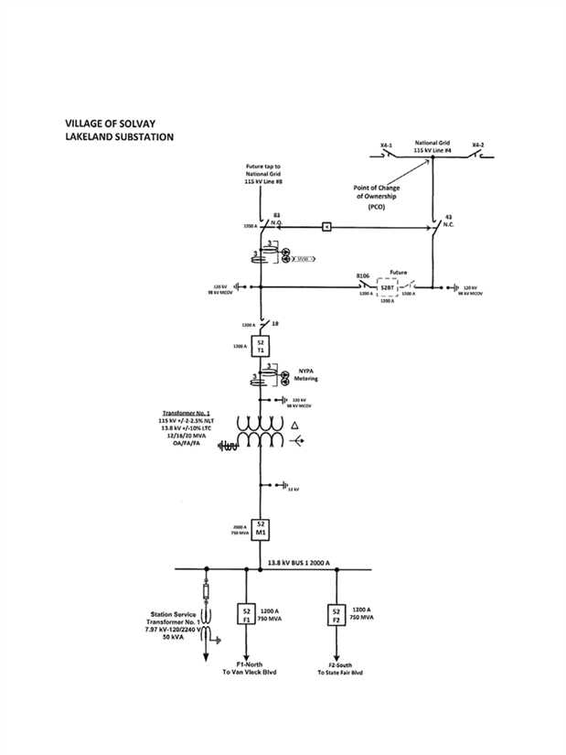

Description of Interconnection Facilities for Industrial Substation:

Industrial substation is an electrical substation owned by the Village of Solvay with a maximum rating of 120 MVA located at Bridge Street, Village of Solvay, New York.

National Grid Interconnection Facilities:

Line #14 tap - All facilities up to and including the dead-end insulators on the line (jaw) side of switch X14-2 on switch pole #1-1 (Delivery Point) back to the dead-end insulators at the Interconnection Point (Pole #1) on National Grid’s Line #14.

Line #2 tap – All facilities on the line side of switch X2-1 from and including the switch and switch pole #459-3 (Delivery Point) back to the dead-end insulators at the Interconnection Point (Pole #459) on National Grid’s Line #2.

Solvay Interconnection Facilities:

Line #14 feeder – All facilities on the station side of the Delivery Point from and including switch X 14-2 and switch pole #1-1 back to Solvay’s Industrial Station.

Line #2 – All facilities up to and including the dead-end insulators on the station side of the Delivery Point, not including the National Grid owned switch or switch pole, back to Solvay’s Industrial Station.

One-line Diagram for Industrial Substation:

