**Agreement Regarding Treatment of Allocations of New York Power Authority Expansion Power and Replacement Power Beginning January 1, 2012 and Thereafter**

WHEREAS, certain agreements pertaining to the delivery rates and delivery terms and conditions of New York Power Authority Replacement Power (“RP”) and certain agreements pertaining to the delivery rates and delivery terms and conditions for New York Power Authority Expansion Power (“EP”), as defined in the April 21, 2004 Settlement Agreement in Federal Energy Regulatory Commission (“FERC”) Docket Nos. ER03-989-000, ER03-991-000, ER03-992-000 and ER03-990-000,[1] will expire by their terms on December 31, 2011 and June 30, 2013, respectively; and

WHEREAS, the parties hereto, who are the New York Power Authority (“NYPA”), a corporate municipal instrumentality and a political subdivision of the State of New York (the “State”), existing under Title 1 of Article 5 of the New York Public Authorities Law (“PAL”), Niagara Mohawk Power Corporation d/b/a National Grid (“Company” or “National Grid”), Power for Economic Prosperity, a coalition of large EP and RP customers (“PEP”), and Multiple Intervenors, an unincorporated association of large commercial and industrial consumers with facilities located, inter alia, in the National Grid service territory (“MI”) (collectively, “Parties”), desire to provide certainty to the EP and RP customers regarding sales and delivery service provisions, change certain terms and conditions related to the billing arrangements for EP and RP customers, and phase-in increases to the delivery rates that will apply after the expiration of the current EP and RP agreements; and

WHEREAS, the Parties intend this Agreement (defined below) to apply, except where designated otherwise, to all Allocations of EP and RP, including Existing, Additional and New Allocations of EP, as well as or Existing and New Allocations of RP (“Allocations”), all as defined in the April 21, 2004 Settlement Agreement filed with, and accepted by, FERC; and

WHEREAS, the Parties intend the provisions of Paragraph 1 of this Agreement to apply only to Existing Allocations of EP and RP; and

WHEREAS, (i) in accordance with PAL § 1005(5)(g), the rates, services and practices of the companies engaged in the transmission and distribution of NYPA hydropower used to supply EP and RP (*e.g.* National Grid) are governed by the provisions and principles established by contract, (ii) the retail transmission of EP and RP is currently governed by the FERC, and (iii) NYPA is willing to agree for purposes of this Agreement that the delivery services for such hydropower shall be determined in accordance with the provisions of this Agreement, some of which are subject to PSC or FERC approval, provided that NYPA’s agreement does not constitute a waiver of any jurisdictional arguments based on PAL § 1005(5)(g) for purposes of any future agreements or proceedings;

NOW, THEREFORE, the Parties hereby enter into this Agreement Regarding Treatment of Allocations of Expansion Power and Replacement Power Beginning January 1, 2012 and Thereafter (“Agreement”), and intending to be legally bound, agree to the following terms and conditions:

1. Subject to Paragraph 2 below, beginning January 1, 2012, all Existing EP and Existing RP customers’ delivery charges will be based on a percentage discount off of standard tariff delivery rates in effect at the time as provided for by Section Five of the New York Independent System Operator’s (“NYISO”) Open Access Transmission Tariff (“OATT”) and Service Classification Number 4 of the National Grid’s PSC No. 220 Electricity, Niagara Mohawk Power Corporation d/b/a National Grid Schedule for Electric Service Applicable in All Territory Served by this Company (“PSC 220” or “Retail Tariff”), and as determined by the customers’ otherwise applicable parent delivery service classifications and voltage delivery levels as provided in the Retail Tariff, and will transition to full standard tariff delivery rates in accordance with the phase-in schedules set forth in Paragraphs 1(a) and 1(b) below.
   1. For customers with:(i) Primary voltage delivery levels (2.2-15 kV) whose parent delivery service classification is Service Classification 3 and for whom non-NYPA electric demand accounted for more than 15% of their total electric demand during the time period July 1, 2010 through June 30, 2011, (ii) Primary voltage delivery levels (2.2-15 kV) whose parent delivery service classification is Service Classification 3-A; (iii) Subtransmission voltage delivery levels (22-50 kV); and (iv) Transmission voltage delivery levels (over 60 kV), the following discounts off of the full standard tariff rates that are otherwise in effect at each date noted below, will go into effect on the following dates:
      1. January 1, 2012: 20% discount off of applicable standard tariff rates in effect at that time. No other changes to the billing methodology for EP and RP will be made as of January 1, 2012.
      2. January 1, 2013: 15% discount off of applicable standard tariff rates in effect at that time.
      3. January 1, 2014: 15% discount off of applicable standard tariff rates in effect at that time.
      4. January 1, 2015: 10% discount off of applicable standard tariff rates in effect at that time.
      5. January 1, 2016: Then-existing delivery rates will be increased to the same level as the then-existing applicable standard tariff rates in effect at that time.
   2. For customers served at Primary voltage delivery levels (2.2-15 kV) whose parent delivery service classification is Service Classification 3 and for whom non-NYPA electric demand accounted for 15% or less of their electric demand during the time period July 1, 2010 through June 30, 2011, the following discounts off of the full standard tariff rates that are otherwise in effect at each date noted below, will go into effect on the following dates:
      1. January 1, 2012: 65% discount off of applicable standard tariff rates in effect at that time. No other changes to the billing methodology for EP and RP will be made as of January 1, 2012
      2. January 1, 2013: 55% discount off of applicable standard tariff rates in effect at that time.
      3. January 1, 2014: 45% discount off of applicable standard tariff rates in effect at that time.
      4. January 1, 2015: 35% discount off of applicable standard tariff rates in effect at that time.
      5. January 1, 2016: 25% discount off of applicable standard tariff rates in effect at that time.
      6. January 1, 2017: 15% discount off of applicable standard tariff rates in effect at that time.
      7. January 1, 2018: Then-existing delivery rates will be increased to the same level as the then-existing applicable standard tariff rates in effect at that time.
2. Surcharges or surcharge exemptions with respect to delivery rates for all Allocations, including but not limited to exemption from the Legacy Transition Charge and proposed Temporary Deferral Recovery Surcharge, will be subject to any applicable orders of the appropriate regulatory authority issued and in effect from time to time. Prior to January 1, 2016, the Company will take no position in opposition to the existing exemptions from the System Benefit Charge, Renewable Portfolio Surcharge, Energy Efficiency Portfolio Standard surcharge, Transmission Revenue Adjustment Charge and Legacy Transition Charge, but will advance exemptions from the Temporary Deferral Recovery Surcharge for EP and RP customers, as proposed in its Compliance Filing dated July 29, 2011, in Case 10-E-0050.
3. Beginning July 1, 2013, National Grid will:
   1. Eliminate the previous 11 month maximum used in the load factor sharing billing methodology applicable to EP and RP billing for all Allocations during the phase-in period to full standard tariff delivery rates (subject to Paragraph 2) and continuing for as long as these customers pay full standard tariff delivery rates (subject to Paragraph 2) for their Existing Allocations. The Company agrees to modify its Retail Tariff provisions governing the Service Classification No. 4 service class (“SC-4”) and/or three-party sales agreements, as necessary, to effectuate this provision.
   2. Base EP and RP transmission and distribution billing on customers’ metered demand instead of their contract demands for all Allocations during the phase-in period to full standard tariff delivery rates (subject to Paragraph 2) and continuing for as long as these customers pay full standard tariff delivery rates (subject to Paragraph 2) for their Existing Allocations. The Company agrees to file to modify its tariff provisions governing the SC-4 service classification and/or three-party sales agreements, as necessary, to effectuate this provision.
   3. Notwithstanding language to the contrary in sub-paragraphs 3.a and 3.b, the provisions of those sub-paragraphs shall apply to customers whose retail delivery rates are discounted pursuant to their Service Classification 12 contracts under the Retail Tariff unless their contracts dictate otherwise.
   4. Change loss factors for Existing EP and RP Allocations to standard Retail Tariff loss factors, so that standard Retail Tariff loss factors apply to all EP and RP Allocations.
   5. File to amend the Retail Tariff to provide for direct sale of NYPA commodity by NYPA to EP and RP customers.
   6. The provisions of this Paragraph 3 will remain in effect until at least June 30, 2020, and thereafter until modified by the appropriate regulatory authority. Any of the Parties may file a request for modification of these provisions to be effective at any time after June 30, 2020.
4. Beginning July 1, 2013, total load, including all EP and RP demands, will be used in determining the customers’ respective parent delivery service classifications, during the phase-in period to full standard tariff delivery rates and continuing for as long as these customers pay full standard tariff delivery rates, subject to Paragraph 2, on their Existing Allocations of EP or RP; provided, by way of clarification, that the terms of this Paragraph 4 also shall apply to customers whose retail delivery rates are discounted pursuant to their Service Classification 12 contracts under the Retail Tariff.
5. PEP, MI, NYPA, PEP on behalf of the members of PEP, and MI on behalf of participating hydropower members of MI, agree not to challenge the phase-in to standard tariff delivery rates or to advocate for a separate delivery rate or service classification for EP and RP Allocations until after the phase-ins to standard tariff delivery rates for the customers’ respective parent delivery service classifications and voltage delivery levels pursuant to this Agreement are complete (as set forth in Paragraph 1 of this Agreement), provided that nothing herein shall be read as preventing any Party or the EP or RP customers from opposing (either during the phase-in period or thereafter) proposed increases to the standard delivery rates to which the discounts provided for in this Agreement apply.

The Parties acknowledge and agree that when used in this Agreement, “participating hydropower members of MI” shall mean MI members with Allocations of RP and EP in the National Grid service territory whose identities have previously been disclosed to National Grid.

1. The Company will continue to provide and deliver supplemental power to EP and RP customers and, where applicable, to perform load-splitting functions in order to render appropriate delivery service bills, as currently provided for in the Company’s Retail Tariff. Either the Company, an Energy Service Company (“ESCO”) or the Customer itself can serve as the Customer’s Load Serving Entity (“LSE”)[2] for the Customer’s non-NYPA load. As part of its next PSC general rate case filing, the Company will propose to continue to (a) provide the current default, or supplemental, commodity service to RP and EP customers if the customer does not procure its non-NYPA supply from a third party or act as its own LSE and (b) where applicable, perform the current load-splitting functions. The Company will not charge a separate fee for the administrative and billing services that it continues to provide to NYPA, and EP and RP customers. The provisions of this Paragraph 6 will remain in effect until at least June 30, 2020, and thereafter until modified by the appropriate regulatory authority. Any of the Parties to this Agreement may file a request for modification of any of the applicable rules or regulations affecting this Paragraph 6 to be effective at any time after June 30, 2020.
2. Current practices regarding historic demand for EP and RP Allocations will continue to be in effect, but shall be reviewed in the Company’s next general rate case, and the Parties reserve any rights they may have to address the issue at that time or thereafter.
3. Buy-Sell Structure, Supplemental Service and Direct Sales: To the extent consistent with relevant regulatory requirements, the Company will retain the current buy-sell structure and supplemental service for both EP and RP through and until June 30, 2013. As provided for in Paragraph 11 of this Agreement, NYPA and the Company will extend Contract RP-1 through and until June 30, 2013, after the expiration of the “Amended and Restated Agreement for The Retail Transmission of Replacement Power Between Niagara Mohawk Power Corporation and the Power Authority of The State of New York,” previously designated Niagara Mohawk Power Corporation, FERC Electric Tariff Rate Schedule 19, First Revised Volume No. 1 (“RS 19”)[3] on December 31, 2012. The Parties will make the filings with the PSC and/or FERC as may be necessary to retain the buy-sell structure for RP for the period January 1, 2013 through June 30, 2013. If the relevant regulatory agency(ies) do(es) not approve an extension of the current buy-sell structure for that period, then the Parties will implement the direct sales provisions of this Agreement for RP on January 1, 2013, instead of July 1, 2013. As provided for in Paragraph 11 of this Agreement, the Company will file to terminate RS 19 effective December 31, 2012, after which time all retail transmission deliveries of RP will be governed by the NYISO OATT. Notwithstanding the foregoing, beginning July 1, 2013, NYPA will sell EP and RP hydropower directly to customers with EP and RP Allocations, and will bill such customers directly for this power and for associated NYISO charges imposed by NYISO and incurred by NYPA as LSE for the portion of the customers’ load supplied by NYPA. Prior to July 1, 2013, NYPA and the customers will meet to discuss the methodology for how the NYISO charges will be billed. To the extent that a customer’s NYPA allocations cover its entire load, NYPA will act as such customer’s LSE, provided however that nothing in this Agreement shall require NYPA to perform the LSE function related to electric supply required by such customer in excess of the customer’s NYPA allocations. The provisions of this Paragraph 8 will remain in effect until at least June 30, 2020, and thereafter until modified by the appropriate regulatory authority. Any of the Parties to this Agreement may file a request for modification of the provisions of the Company’s governing FERC documents or the Retail Tariff, or successor tariffs, addressed in this Paragraph 8 to be effective at any time after June 30, 2020.
4. First Through the Meter (“FTM”)[4] and RP Rate II[5] Services: The Company will: (a) extend and support the extension of the FTM and Rate II billing methodologies for all customers currently receiving such arrangements through and until June 30, 2013 with NYPA’s consent; and (b) extend, with NYPA’s consent, the FTM and Rate II billing methodology for all customers currently receiving such arrangements through the term of the customer’s “Agreement for the Sale of Expansion and/or Replacement Power and Energy,” which agreements will become effective on July 1, 2013. The FTM provisions of this Paragraph 9 currently are further subject to the requirements of Service Classification No. 12 (SC-12) in the Retail Tariff, which limits the terms of SC-12 contracts to five years without PSC approval. The Company will work with customers currently receiving the FTM billing methodology on extensions of their FTM billing methodology via extended or new SC-12 contracts or by other appropriate means. The provisions of this Paragraph 9 will remain in effect until the expiration dates of the agreements referenced in sub-paragraph 9.b above.
5. Intentionally left blank.
6. To effectuate this Agreement, NYPA, PEP and MI further agree, in exchange for the commitments contained herein, which will be implemented through the Company’s Retail Tariff starting on January 1, 2012, as follows:
   1. The Company will file this Agreement with the PSC for approval, and will make tariff filings in order to implement the terms of the Agreement. On or before November 1, 2011, the Company will file (i) an application with FERC to modify the delivery rates in RS 19 and in the “Amended and Restated Agreement for The Retail Transmission of Expansion Power Between Niagara Mohawk Power Corporation and the Power Authority of The State of New York,” previously designated Niagara Mohawk Power Corporation, FERC Electric Tariff Rate Schedule 159, First Revised Volume No. 1 (“RS 159”)[6] for the year 2012 in accordance with the provisions of this Agreement, to which NYPA will consent, and (ii) an application with FERC to extend RS 19 as a rate schedule through the end of 2012. The Company will make a compliance filing with the PSC in order to implement any changes made by FERC pursuant to the Company’s filings with FERC, and that may require a conforming amendment to the Company’s Retail Tariff.
   2. The Company will file an application with FERC to modify the delivery rate in RS 159 for the period January 1, 2013 through June 30, 2013, in accordance with the terms of this Agreement. The Company will make a compliance filing with the PSC in order to implement any changes made by FERC pursuant to the Company’s filing with FERC, and that may require a conforming amendment to the Company’s Retail Tariff.
   3. The Company will make a filing with the PSC and/or FERC to implement provisions in Paragraphs 3 and 4of this Agreement for EP and RP customers effective July 1, 2013.
   4. The Company will file to (i) terminate RS 19 effective December 31, 2012, and (ii) terminate RS 159 effective June 30, 2013.
   5. The Company will make any other filings with the PSC and with FERC necessary to implement the provisions of this Agreement.
   6. The Company, NYPA, PEP and MI will make any filings with the appropriate regulatory authorities that would assist the Company in securing approval of the provisions of this Agreement.
   7. On or before November 1, 2011, NYPA and the Company will amend and restate Contract RP-1 regarding the purchase and resale of RP associated with New Allocations in order to extend the term of that Contract RP-1 beyond December 31, 2011 through and including June 30, 2013 and to expand its scope to include, effective January 1, 2013, Existing as well as New Allocations of RP.
7. The Company also notes that pursuant to the January 24, 2011 Order in the Company’s last retail electric rate case before the PSC, Case No. 10-E-0050 (“Order”), the PSC ordered that it would set the Company’s Return on Equity (ROE) at 9.3% so long as the Company refrains from filing new base rates prior to January 1, 2012; otherwise, the Company’s ROE will be set at 9.1%. The parties agree that the purpose of this Agreement is to extend and modify the agreements relating to the delivery of RP and the rates, terms and conditions of EP and RP and that it affects only a limited number the Company’s customers. Accordingly, the parties believe that the changes to the Company’s Retail Tariff provided for in this Agreement do not constitute a filing of new base rates. If the Company is advised, either formally or informally, by the PSC that the PSC believes that this Agreement or any part thereof violates the Commission's Order, the Company shall have the right to wait to move forward with its obligations under this Agreement until January 1, 2012 or thereafter, provided that nothing contained in this Paragraph 12 shall postpone the Company’s obligation to make, on or before November 1, 2011, the filing required in Paragraph 11.a.ii and the contract amendment required in Paragraph 11.g.
8. This Agreement is subject to any necessary approvals from FERC and the PSC.
9. The Parties will support this Agreement and any filings made to implement the provisions of this Agreement, and will seek to obtain approval of this Agreement and the filings to implement this Agreement as quickly as possible. The members of PEP and the participating hydropower members of MI will not oppose this Agreement or any filings made to implement the provisions of this Agreement. PEP and MI represent, on behalf of the members of PEP and MI, that the members of PEP and the participating hydropower members of MI will not oppose this Agreement or any filings made to implement the provisions of this Agreement.
10. The provisions of this Agreement are the result of compromise by the Parties hereto and are not intended to create any binding precedent, and the provisions of this Agreement shall not be cited as a precedent binding upon any Party hereto in any future proceeding.
11. This Agreement is conditioned upon the PSC’s approval and FERC’s acceptance of all provisions hereof without change or condition. In the event that the PSC does not approve by order or FERC does not accept the Agreement in its entirety, and without change or condition, each Party shall have the right to withdraw from the Agreement upon written notice to the other Parties, and to the PSC or to FERC, within 30 days of the regulatory agency orders being issued. If any Party gives such notice, this Agreement shall be deemed withdrawn, and it shall be null and void and not be in effect or be used for any other purpose.
12. If either (i) the PSC refuses to approve this Agreement without modification or condition within one hundred and twenty (120) days of filing thereof; or (ii) the FERC refuses to accept this Agreement for filing without modification or condition within one hundred and twenty (120) days of the filing thereof, and, as a result, any Party thereafter exercises its right to withdraw from this Agreement, nothing contained in this Agreement, in such filing or any Service Agreement made pursuant thereto shall affect or be construed as affecting in any way the Company’s right to unilaterally make application to FERC for a change in rates, the terms and conditions, charges, classification of service, Service Agreement, rule or regulation of RS 19 or RS 159, or any other tariff or rate schedule under Section 205 of the Federal Power Act and pursuant to the FERC's rules and regulations promulgated thereunder and, provided further, that the other Parties reserve all of their rights with respect to responding to any filing made by the Company pursuant to this Paragraph 17.

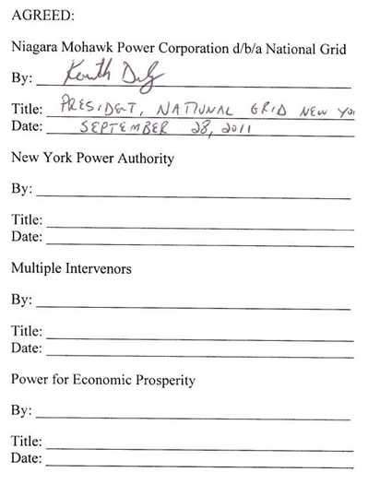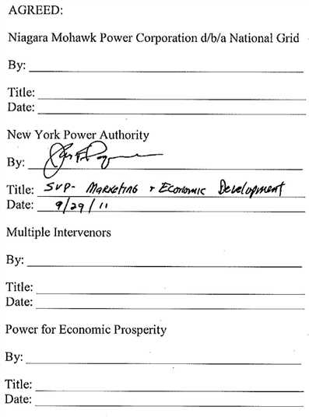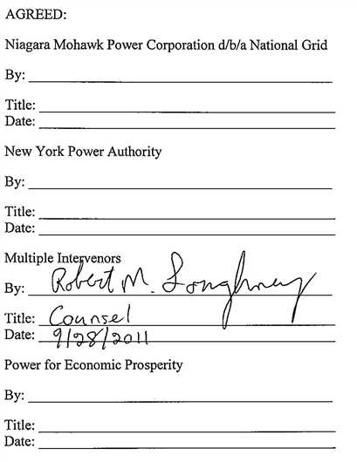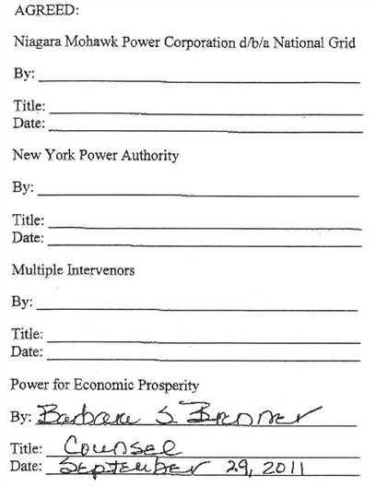

1. Settlement Agreement in FERC Docket Nos. ER03-989-000, ER03-991-000, ER03-992-000 and ER03-990-000, among Niagara Mohawk Power Company d/b/a National Grid, the New York Power Authority, Multiple Intervenors, Occidental Chemical Corporation, and ISG Lackawanna Inc. (“April 21, 2004 Settlement Agreement”).
2. As defined in the NYISO OATT, or successor tariffs.
3. Pursuant to FERC Order No. 714, this agreement has been designated First Revised Service Agreement No. 1742, under the New York Independent System Operator, Inc. (“NYISO”) Open Access Transmission Tariff (“OATT”), FERC Electric Tariff, Original Volume No. 1 (“SA 1742”).
4. FTM refers to the “first-through-the-meter” billing methodology.
5. Rate II refers to NYPA’s sale of RP for certain Existing Allocations at 100% load factor as may be prescribed by contract.
6. Pursuant to FERC Order No. 714, this agreement has been designated First Revised Service Agreement No. 1743, under the New York Independent System Operator, Inc. (“NYISO”) Open Access Transmission Tariff (“OATT”), FERC Electric Tariff, Original Volume No. 1 (“SA 1743”).