Exhibit No. PA-102, INDEX

INDEX
NEW YORK POWER AUTHORITY
TRANSMISSION REVENUE REQUIREMENT

Name Description

Cost-of-Service Summary Schedule A1
Schedule A2
Schedule B1
Schedule B2
Schedule B3
Schedule C1
Schedule D1
Schedule D2
Schedule E1
Schedule F1
Schedule F2
Schedule F3
Work Paper-AA
Work Paper-AB
Work Paper-AC
Work Paper-AD
Work Paper-AE
Work Paper-AF
Work Paper-AG
Work Paper-AH
Work Paper-AI
Work Paper-BA
Work Paper-BB
Work Paper-BC
Work Paper-BD
Work Paper-BE
Work Paper-BF
Work Paper-BG
Work Paper-BH
Work Paper-BI
Work Paper-CA
Work Paper-CB
Work Paper-DA
Work Paper-DB
Work Paper-EA
Work Paper-AR-IS
Work Paper-AR-BS
TRANSMISSION REVENUE REQUIREMENT SUMMARY OPERATION & MAINTENANCE EXPENSE SUMMARY ADMINISTRATIVE AND GENERAL EXPENSES
ANNUAL DEPRECIATION AND AMORTIZATION EXPENSES ADJUSTED PLANT IN SERVICE
DEPRECIATION AND AMORTIZATION RATES
TRANSMISSION - RATE BASE CALCULATION
CAPITAL STRUCTURE AND COST OF CAPITAL
PROJECT SPECIFIC CAPITAL STRUCTURE AND COST OF CAPITAL LABOR RATIO
PROJECT REVENUE REQUIREMENT WORKSHEET INCENTIVES
PROJECT TRUE-UP
O&M AND A&G SUMMARY
O&M AND A&G DETAIL
STEP-UP TRANSFORMERS O&M ALLOCATOR FACTS O&M ALLOCATOR
MICROWAVE TOWER RENTAL INCOME
POSTRETIREMENT BENEFITS OTHER THAN PENSIONS (PBOP) PROPERTY INSURANCE ALLOCATION
INJURIES & DAMAGES INSURANCE EXPENSE ALLOCATION PROPERTY INSURANCE ALLOCATOR
DEPRECIATION AND AMORTIZATION EXPENSES (BY FERC ACCOUNT) EXCLUDED PLANT IN SERVICE
PLANT IN SERVICE DETAIL
MARCY-SOUTH CAPITALIZED LEASE AMORTIZATION AND UNAMORTIZED BALANCE FACTS PROJECT PLANT IN SERVICE AND ACCUMULATED DEPRECIATION
GENERATOR STEP-UP TRANSFORMERS BREAKOUT
RELICENSING/RECLASSIFICATION EXPENSES ASSET IMPAIRMENT
COST OF REMOVAL
MATERIALS AND SUPPLIES
ESTIMATED PREPAYMENTS AND INSURANCE WEIGHTED COST OF CAPITAL
LONG-TERM DEBT AND RELATED INTEREST CALCULATION OF LABOR RATIO
STATEMENT OF REVENUES , EXPENSES, AND CHANGES IN NET POSITION STATEMENT OF NET POSITION

Work Paper-AR-Cap AssetsCAPITAL ASSETS
Work Paper-ReconciliationsRECONCILIATIONS BETWEEN ANNUAL REPORT & ATRR

Exhibit No. PA-102, SCH - Summary

NEW YORK POWER AUTHORITY
TRANSMISSION REVENUE REQUIREMENT
YEAR ENDING DECEMBER 31, ____

TRANSMISSION REVENUE REQUIREMENT SUMMARY

Line No A. OPERATING EXPENSES TOTAL $ SOURCE/COMMENTS
(1) (2)

1 Operation & Maintenance Expense - Schedule A1, Col 5, Ln 17

2 Administration & General Expenses - Schedule A2, Col 5, Ln 22

3 Depreciation & Amortization Expense - Schedule B1, Col 6, Ln 26

4 TOTAL OPERATING EXPENSE - Sum lines 1, 2, & 3

5 B. RATE BASE - Schedule C1, Col 5, Ln 10

6 Return on Rate Base - Schedule C1, Col 7, Ln 10

6a Total Project Specific Return Adustment - Schedule D2, Col 3, Ln A

7 TOTAL REVENUE REQUIREMENT - Line 4 + Line 6 + Line 6a

8 Incentive Return - Schedule F1, page 2, line 2, col. 13

9 True-up Adjustment - Schedule F3, page 1, line 3, col. 10

10 NET ADJUSTED REVENUE REQUIREMENT - Line 7 + line 8 + line 9

Breakout by Project

11 NTAC Facilities - Schedule F1, page 2, line 1a, col. 16
11a Project 1 - Marcy South Series Compensation - Schedule F1, page 2, line 1b, col. 16
11b Project 2 - Schedule F1, page 2, line 1c, col. 16
11c - -
… - - -

12 Total Break out - Sum lines 11

Note 1 The revenue requirements shown on lines 11 and 11a et seq. and annual revenue requirements. If the first year is a partial
year, 1/12 of the amounts should be recovered for every month of the Rate Year.
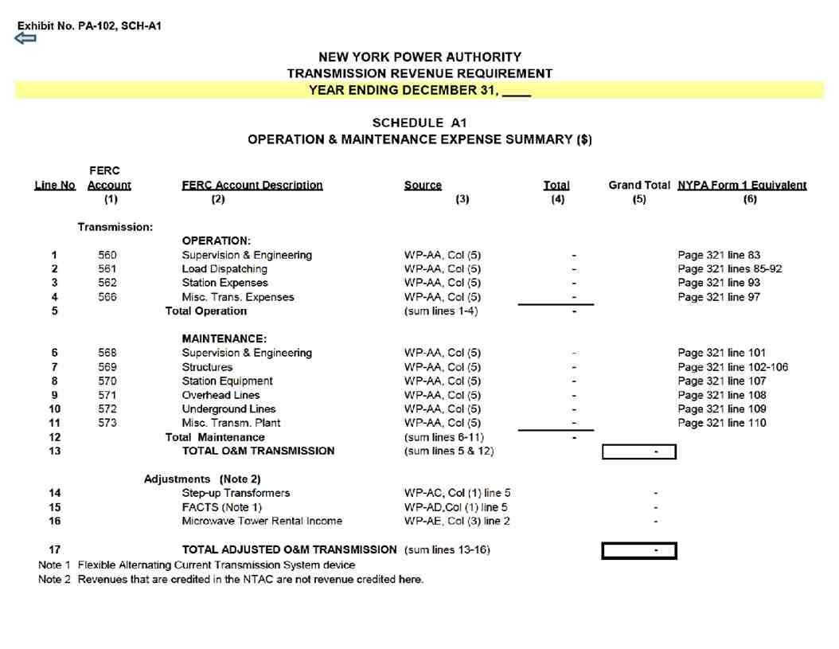

Exhibit No. PA-102, SCH-A2
NEW YORK POWER AUTHORITY
TRANSMISSION REVENUE REQUIREMENT
YEAR ENDING DECEMBER 31, ____

SCHEDULE A2
ADMINISTRATIVE AND GENERAL EXPENSES

FERC Unallocated Transmission Allocated to
Line No.Account FERC Account Description Source A&G ($) Labor Ratio Transmission ($) Source/Comments NYPA Form 1 Equivalent
(1) (2) (3) (4) (5) (6) (7)

Administrative & General Expenses
1 920 A&G Salaries WP-AA, Col (5) - Page 323 line 181
2 921 Office Supplies & Expenses WP-AA, Col (5) - Page 323 line 182
3 922 Admin. Exp. Transferred-Cr WP-AA, Col (5) - Page 323 line 183
4 923 Outside Services Employed WP-AA, Col (5) - Page 323 line 184
5 924 Property Insurance WP-AA, Col (5) - - See WP-AG; Col (3) ,Ln 4 Page 323 line 185
6 925 Injuries & Damages Insurance WP-AA, Col (5) - - See WP-AH; Col (3) ,Ln 4 Page 323 line 186
7 926 Employee Pensions & Benefits WP-AA, Col (5) - Page 323 line 187
8 928 Reg. Commission Expenses WP-AA, Col (5) - - See WP-AA; Col (3), Ln 2x Page 323 line 189
9 930 Obsolete/Excess Inv WP-AA, Col (5) - Page 323 line 190.5
10 930.1 General Advertising Expense WP-AA, Col (5) - Page 323 line 191
11 930.2 Misc. General Expenses WP-AA, Col (5) - Page 323 line 192
12 930.5 Research & Development 2/ - - 2/ Page 323 line 192.5
13 931 Rents WP-AA, Col (5) - Page 323 line 193
14 935 Maint of General Plant A/C 932 WP-AA, Col (5) - Page 323 line 196
15 TOTAL (sum lines 1-14) -

16 Less A/C 924 Less line 5 - Page 323 line 185
17 Less A/C 925 Less line 6 - Page 323 line 186
18 Less EPRI Dues 1/ -
19 Less A/C 928 Less line 8 - Page 323 line 189
20 Less A/C 930.5 Less line 12 - 3/
21 PBOP Adjustment WP-AF -
22 TOTAL A&G Expense (sum lines 16 to 21) - - - - Allocated based on
transmission labor
23 NET A&G TRANSMISSION EXPENSE (sum lines 1 to 22) - allocator (Schedule E1)

1/ NYPA does not pay EPRI dues
2/ Column 5 is populated as 0 (zero) for data pertaining to calendar years ____ and 2015. It is populated as a sum of Transmission R&D Expense [Workpaper WP-AA Col (3) ln(2ab)] plus the portion of
Admin & General allocated to transmission [Workpaper WP-AA Col (4) ln (2ab) multiplied by Workpaper E1-Labor Ratio Col (3) ln (2)] for data pertaining to calendar years 2016 and later.
3/ Populated as 0 (zero) for data pertaining to calendar years ____ and 2015. Populated as WP-AA Col (3) for data pertaining to calendar years 2016 and later.
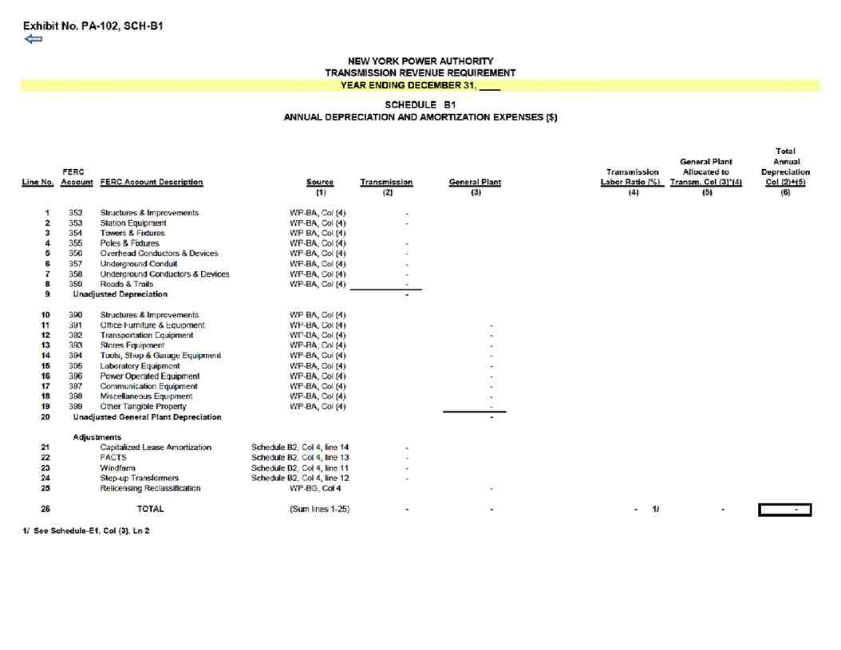

Exhibit No. PA-102, SCH- B2

NEW YORK POWER AUTHORITY
TRANSMISSION REVENUE REQUIREMENT
YEAR ENDING DECEMBER 31,

SCHEDULE B2
ADJUSTED PLANT IN SERVICE

____ ____ ____ - ____ Average
Net
Line Plant in Accumulated Plant in Depreciation Plant in Accumulated Plant in Depreciation Plant in Accumulated Plant in
No. Service ($) Depreciation ($) Service - Net ($) Expense ($) Service ($) Depreciation ($) Service - Net ($) Expense ($) Service ($) Depreciation ($) Service ($)
(1) (2) (3) (4) (5) (6) (7) (8) (9) (10) (11)
NYPA Form 1 Equivalent
Plant in Service
PRODUCTION Source (p. 204-207 column (g)) Depreciation (p.219)
1 Production - Land WP-BC ln. 8 + ln. 27 + ln. 37 - - - - - - - - - - -
2 Production - Hydro WP-BC ln. 35 - ln. 27 ln. 22 - Cost of Removal 5/ - - - - - - - - - - -
3 Production - Gas Turbine / Combined Cycle WP-BC ln. 16 + ln. 45 + ln. 100.5 - ln. 8 - ln. 37 ln. 20 + ln. 23 - - - - - - - - - - -
4 - - - - - - - - - - -

TRANSMISSION
5 Transmission - Land WP-BC ln. 48 - - - - - - - - - - -
6 Transmission WP-BC ln. 58 + ln. 100.6 - ln. 48 ln. 24 - Cost of Removal 5/ - - - - - - - - - - -
7 - - - - - - - - - - -

8 Transmission - Cost of Removal 1/ WP-BC - - - - - - - - - - -

9 Excluded Transmission 2/ WP-BB - - - - - - - - - - -

Adjustments to Rate Base
10 Transmission - Asset Impairment WP-BC - - - - - - - - - - -
11 Windfarm WP-BC - - - - - - - - - - -
12 Generator Step-ups WP-BF - - - - - - - - - - -
13 FACTS WP-BE - - - - - - - - - - -
14 Marcy South Capitalized Lease 3/ - -
15 Total Adjustments - - - - - - - - - - -
16
17 Net Adjusted Transmission - - - - - - - - - - -

-
GENERAL
18 General - Land WP-BC ln. 86 - - - - - - - - - - -
19 General WP-BC ln. 99 - ln. 86 ln. 27 - Cost of Removal 5/ - - - - - - - - - - -
20 ln. 99 - - - - - - - - - - -
Adjustments to Rate Base
21 General - Asset Impairment - - - - - - - - - - -
22 General - Cost of Removal WP-BC - - - - - - - - - - -
23 Relicensing WP-BG - - - - - - - - - - -
24 Excluded General 4/ WP-BC - - - - - - - - - - -
24 Total Adjustments - - - - - - - - - - -

25 Net Adjusted General Plant - - - - - - - - - - -

Notes
1/ Cost of Removal: Bringing back to accumulated depreciation cost of removal which was reclassified to regulatory liabilities in annual report.
2/ Excluded Transmission: Assets not recoverable under ATRR, FERC Accounts 350 and 352-359 for 500 MW, AEII, Poletti, SCPPs, Small Hydro, and Flynn. 3/ Marcy South Capitalized Lease amount is added separately to the Rate Base.
4/ Excluded General: Assets not recoverable under ATRR, FERC Accounts 389-399 for 500 MW, AEII, Poletti, SCPPs, Small Hydro, and Flynn.
SCPPs include Brentwood, Gowanus, Harlem River, Hell Gate, Kent, Pouch and Vernon. Small Hydro includes Ashokan, Crescent, Jarvis and Vischer Ferry.
5/ The difference between the Accumulated Depreciation contained in the NYPA Form 1 Equivalent and the amount contained here is equal to the Cost of Removal.

Exhibit No. PA-102, SCH-B3

Schedule B3 - Depreciation and Amortization Rates
NEW YORK POWER AUTHORITY
Based on Plant Data Year Ending December 31, 2015 (as filed with FERC in 2017 and as modified by settlement filed in Docket Nos. EL17-67, et al.)

Line No. FERC Account FERC Account Description Rate (Annual) Percent 1/
TRANSMISSION PLANT Headquarters St. Lawrence/FDR Niagara Blenheim-Gilboa J. A. FitzPatrick Massena-Marcy Marcy-South Long Island Sound Cable 2/ New Project
1 350 Land Rights
2 352 Structures and Improvements 1.34% 1.22% 1.05% 1 30% 3 33% 1 60%
3 353 Station Equipment 1.51% 1.62% 1.75% 1.48% 1.55% 3 33% 1 87%
4 354 Towers and Fixtures 3.20% 2.04% 1.72% 1.06% 1 89% 2.04% 2 06%
5 355 Poles and Fixtures 2.22% 1.98% 1.30% 1.45% 1.77% 2 06%
6 356 Overhead Conductor and Devices 2.50% 1.95% 1.36% 0.97% 2.14% 1.74% 1 88%
7 357 Underground Conduit 0.18% 1.23% 3 33% 1.40%
8 358 Underground Conductor and Devices 0.17% 1.29% 3 33% 1.75%
9 359 Roads and Trails 0.55% 0.28% 0.64% 0.13% 0.73% 0.90% 1 00%
GENERAL PLANT
10 390 Structures & Improvements 1.14% 1.45% 0.97% 1.50% 1 34% 3.45% 1 67%
11 391 Office Furniture & Equipment 5 56% 5.56% 5.56% 5.56% 5 56% 9 08% 5 56%
12 391.2 Computer Equipment 5 yr 2000% 20.00% 20.00% 20.00% 2000% 2000%
13 391.3 Computer Equipment 10 yr 1000% 10.00% 10.00% 10.00% 1000% 1000%
14 392 Transportation Equipment 2 56% 4.49% 2.96% 5.03% 4.48% 1304% 1000%
15 393 Stores Equipment 2.65% 3/ 3.21% 3 33% 3.15% 3 33%
16 394 Tools, Shop & Garage Equipment 2 88% 6.45% 4.14% 3.67% 1 20% 4 94% 5 00%
17 395 Laboratory Equipment 4 82% 5.48% 1.57% 2.30% 1 52% 4.43% 5 00%
18 396 Power Operated Equipment 5.47% 6.51% 7.23% 4 81% 3/ 9 33% 8 33%
19 397 Communication Equipment 6 67% 6.67% 6.67% 6.67% 6 67% 6.67% 6 63% 6 67%
20 398 Miscellaneous Equipment 4/ 0.002% 11.04% 0.86% 3.67% 0 02% 5 94% 5 00%
21 5 Year Property 2000% 20.00% 20.00% 20.00% 20.00% 2000% 20.00% 2000% 2000%
22 10 Year Property 1000% 10.00% 10.00% 10.00% 10.00% 1000% 10.00% 1000% 1000%
23 20 Year Property 5 00% 5.00% 5.00% 5.00% 5.00% 5 00% 5.00% 5 00% 5 00%
24 399 Other Tangible Property 6.67% 6.67% 6.67% 6 67%

INTANGIBLE PLANT
25 303 Miscellaneous Intangible Plant
26 5 Year Property 2000% 20.00% 20.00% 20.00% 20.00% 2000% 20.00% 2000% 2000%
27 7 Year Property 1429% 14.29% 14.29% 14.29% 14.29% 1429% 14.29% 1429% 1429%
28 10 Year Property 1000% 10.00% 10.00% 10.00% 10.00% 1000% 10.00% 1000% 1000%
29 Transmission facility Contributions in Aid of Construction 5/

Notes
1/ Where no depreciation rate is listed for a transmission or general plant account for a particular project (other than the Long Island
Sound Cable), NYPA lacks depreciable plant as of 12/31/2015 (or all plant has been fully depreciated). If new plant corresponding to these
accounts is subsequently added for the relevant projects, the “New Project” depreciation rate for the relevant account will apply.
2/ This schedule does not contain updated depreciation rates for the Long Island Sound Cable, an asset not included in the NYPA
Depreciation Study filed at FERC in 2017. NYPA recovers the cost of the cable from the Long Island Power Authority through
debt service, and consistent with past practice NYPA uses a 30-year depreciable life for the cable based on the 30-year term of
of the bonds purchased to construct the facility in 1991.
3/ Fully accrued. If plant added to Marcy-South Account 396, 8.33% rate applies; if plant added to Niagara Account 393, 3 33% rate applies. 4/ For Headquarters Account 398, plant nearly fully accrued. If plant is added to this account, 5.00% rate applies.
5/ In the event a Contribution in Aid of Construction (CIAC) is made for a transmission facility, the transmission
depreciation rates above will be weighted based on the relative amount of underlying plant booked to the accounts
shown in lines 1-9 above and the weighted average depreciation rate will be used to amortize the CIAC. The life of a
facility subject to a CIAC will be equivalent to the depreciation rate calculated above, i.e., 100% ÷ deprecation rate = life in years. The estimated life of the facility or rights associated with the facility will not change over the life of a CIAC
without prior FERC approval.

These depreciation rates will not change absent the appropriate filing at FERC.

Exhibit No. PA-102, SCH-C1

NEW YORK POWER AUTHORITY
TRANSMISSION REVENUE REQUIREMENT
YEAR ENDING DECEMBER 31, ____
SCHEDULE C1
TRANSMISSION - RATE BASE CALCULATION

TRANSM. GENERAL PLANT
LABOR ALLOCATED TO TOTAL RATE OF RETURN ON
RATE BASE TRANSMISSION TOTAL RATIO TRANSMISSION ($) TRANSMISSION ($) RETURN RATE BASE
PLANT ($) GENERAL PLANT ($) [Schedule E1] (2) * (3) (1) + (4) [Schedule D1] (5) * (6)
(1) (2) (3) (4) (5) (6) (7)

1 A) Net Electric Plant in Service - 1/ - 2/ - - -

2 B) Rate Base Adjustments

3 * Cash Working Capital (1/8 O&M) - 3/ -
4 * Marcy South Capitalized Lease - 4/ -
5 * Materials & Supplies - 5/ - -
6 * Prepayments - 6/ - -
7 * CWIP - 7/
8 * Regulatory Asset - 7/
9 * Abandoned Plant - 7/

10 TOTAL (sum lines 1-9) - - - - - - -
1/ Schedule B2; Net Electric Plant in Service; Ln 17
2/ Schedule B2; Net Electric Plant in Service; Ln 25
3/ 1/8 of (Schedule A1; Col 5, Ln 17 + Schedule A2; Col 5, Ln 22) [45 days] 4/ WP-BD; Average of Year-end Unamortized Balances, Col 5
5/ Average of year-end inventory Materials & Supplies (WP-CA). NYPA Form 1 Equivalent, page 227, Ln 12, average of columns b and c. 6/ WP-CB; Col 3, Ln 3
7/ CWIP, Regulatory Asset and Abandoned Plant are zero until an amount is authorized by FERC as shown below. CWIP amount is shown in the NYPA Form 1 Equivalent, page 216, line 1
Docket Number Authorized Amount

Exhibit No. PA-102, SCH-D1

NEW YORK POWER AUTHORITY
TRANSMISSION REVENUE REQUIREMENT
YEAR ENDING DECEMBER 31, ____

SCHEDULE D1
CAPITAL STRUCTURE AND COST OF CAPITAL

CAPITALIZATION RATIO COST RATE WEIGHTED
Line No. TITLE from WP-DA 1/ from WP-DA 2/ AVERAGE SOURCE/COMMENTS
(1) (2) (3) (4)

1 LONG-TERM DEBT 0.00% - - Col (1) * Col (2)

2 COMMON EQUITY 0.00% 9.45% - Col (1) * Col (2)

3 TOTAL CAPITALIZATION 0.00% - Col (3); Ln (1) + Ln (2)

Notes
1/ The Common Equity share listed in Col (1) is capped at 50%. The cap may only be changed pursuant to an FPA Section 205 or 206 filing to FERC.
The Long-Term Debt share is calculated as 1 minus the Common Equity share.
2/ The ROE listed in Col (2) Ln (2) is the base ROE plus 50 basis-point incentive for RTO participation. ROE may only be changed pursuant to an FPA
Section 205 or 206 filing to FERC.

Exhibit No. PA-102, SCH-D2

NEW YORK POWER AUTHORITY
TRANSMISSION REVENUE REQUIREMENT
YEAR ENDING DECEMBER 31, ____

SCHEDULE D2
PROJECT SPECIFIC CAPITAL STRUCTURE AND COST OF CAPITAL 3/ 4/

CAPITALIZATION RATIO COST RATE WEIGHTED
Line No. TITLE from WP-DA from WP-DA AVERAGE SOURCE/COMMENTS
(1) (2) (3) (4)

Project 1 - Marcy South Series Compensation - Capital Structure
1 LONG-TERM DEBT - 1/ - - Col (1) * Col (2)

2 COMMON EQUITY - 1/ 9.45% 2/ - Col (1) * Col (2)

3 TOTAL CAPITALIZATION - - Col (3); Ln (1) + Ln (2)

4 PROJECT NET PLANT -

5 PROJECT BASE RETURN - Col (3) Ln (4) * WP-DA Col (7) Ln (4)

6 PROJECT ALLOWED RETURN - Col (3); Ln (3) * Ln (4)

A PROJECT SPECIFIC RETURN ADJUSTMENT - Col (3); Ln (6) - Ln (5)

ProjectX

Notes

1/ The MSSC Common Equity share listed in Col (1) is capped at 53%. The cap may only be changed pursuant to an FPA Section 205 or 206 filing to FERC.
The MSSC Long-Term Debt share is calculated as 1 minus the Common Equity share.
2/ The MSSC ROE listed in Col (2) Ln (2) is the base ROE plus 50 basis-point incentive Congestion Relief Adder. ROE may only be changed pursuant to an FPA
Section 205 or 206 filing to FERC.
3/ Additional project-specific capital structures added to this Schedule D2 must be approved by FERC. The cost of long-term debt and common equity
for any such project shall reflect the cost rates in Col (2), Lns (1) and (2) unless a different cost rate is approved by FERC.
4/ The AC Project Segment A cost containment impacts, if any, will be computed on a workpaper and provided as supporting documentation for each applicable Annual Update
consistent with the NYPA Protocols. The ROE listed in Col (2) for AC Project Segment A is inclusive of a 50 basis point ROE Risk Adder per the Commission's approval in Docket No. EL19-88.

Exhibit No. PA-102, SCH-E1

NEW YORK POWER AUTHORITY
TRANSMISSION REVENUE REQUIREMENT
YEAR ENDING DECEMBER 31, ____
SCHEDULE E1
LABOR RATIO

Line LABOR AMOUNT ($) ALLOCATED TO SOURCE/
NYPA Form 1
No. DESCRIPTION From WP-EA RATIO TRANSMISSION COMMENTS Equivalent
(1) (2) (3) (4) (5)
1 PRODUCTION - - Page 354 lines 17, 20, 24

2 TRANSMISSION - - - Col (1); Ln (2) / Ln (3) Page 354 line 21

3 TOTAL LABOR - -

Exhibit No. PA-102, SCH-F1
Page 1 of 2

Schedule F1
Project Revenue Requirement Worksheet
NEW YORK POWER AUTHORITY
YEAR ENDING DECEMBER 31,

Line
No. Item Page, Line, Col. Transmission ($) Allocator
(1) (2) (3)

1 Gross Transmission Plant - Total Schedule B2, line 17, col 9 (Note A) -
1a Transmission Accumulated Depreciation Schedule B2, line 17, col 10 -
1b Transmission CWIP, Regulatory Asset and Abandoned Plant Schedule C1, lines 7, 8, & 9 (Note B) -
2 Net Transmission Plant - Total Line 1 minus Line 1a plus Line 1b -

O&M TRANSMISSION EXPENSE
3 Total O&M Allocated to Transmission Schedule A1, line 17, col 5 and Schedule A2, line 22, Col 5 -

GENERAL DEPRECIATION EXPENSE
5 Total General Depreciation Expense Schedule B1 line 26, col 5 -

6 Annual Allocation Factor for Expenses ([line 3 + line 5] divided by line 1, col 2) - -

RETURN
7 Return on Rate Base Schedule C1 line 10, col 7 -

8 Annual Allocation Factor for Return on Rate Base (line 7 divided by line 2 col 2) - -

Exhibit PA-102, SCH-F1 Page 2 of 2
Schedule F1
Project Revenue Requirement Worksheet
NEW YORK POWER AUTHORITY

(1) (2) (3) (4) (5) (6) (7) (8) (9) (10) (11) (12) (13) (14) (14a) (15) (16) (17)

PROJECT
SPECIFIC
Annual Project Annual Incentive CAPITAL
Annual Allocation Depreciation/A Revenue Return in STRUCTURE Total Annual Net Revenue
Line Project Gross Project Accumulated Annual Allocation Allocation for Project Net Plant Factor for mortization Requirement basis Incentive Return AND COST OF Revenue True Up Requirement
No. Project Name and # Type Plant ($) Depreciation ($) Factor for Expenses Expenses ($) ($) Return Annual Return Charge ($) Expense ($) ($) Points ($) Discount CAPITAL Requirement ($) Adjustment ($) ($)

Per FERC (Schedule F2, Line
(Sum Col. 6, 9 order (Note 10 * (Col. 12/100)* (Sum Col. 11 + Sum Col. 15 +
(Note C) Page 1 line 6 Col. 3 * Col. 5 (Note D) (Page 1, line 8) (Col. 7 * Col. 8) (Note E) & 10) H) Col. 7) (Note I) Schedule D2 13 + 14 +14a) (Note F) 16

1a NTAC Facilities - - - - - - - - - - - - -
1b - - - - - - - - - - - -
1c - - - - - - - - - - - - -
1d - - - - - - - - - - - - -
1e - - - - - - - - - - - - -
1f - - - - - - - - - - - - -
1g - - - - - - - - - - - - -
1h - - - - - - - - - - - - -
1i - - - - - - - - - - - - -
1j - - - - - - - - - - - - -
1k - - - - - - - - - - - - -
1l - - - - - - - - - - - - -
1m - - - - - - - - - - - - -
1n - - - - - - - - - - - - -
1o - - - - - - - - - - - - -
- - - - - - - - - - - - -
- - - - - - - - - - - - -
- - - - - - - - - - - - -
- - - - - - - - - - - - -
-
2 Total - - - - - -

Note
Letter
A Gross Transmission Plant that is included on Schedule B2, Ln 17, Col 5.
B Inclusive of any CWIP, Unamortized Regulatory Asset or Unamortized Abandoned Plant balances included in rate base when authorized by FERC order.
C Project Gross Plant is the total capital investment for the project calculated in the same method as the gross plant value in page 1, line 1 . This value includes subsequent capital investments required to maintain the fac lities to their original capabi ities.
Gross plant does not include CWIP, Unamortized Regulatory Asset or Unamortized Abandoned Plant.
D Project Net Plant is the Project Gross Plant Ident fied in Column 3 less the associated Accumulated Depreciation in page 2, column 4. Net Plant includes any FERC approved CWIP, Unamortized Abandoned Plant and Regulatory Asset.
E Project Depreciation Expense is the amount in Schedule B1, Ln 26, Col. 2 that is associated with the spec fied project. Project Depreciation Expense includes the amortization of Abandoned Plant and any FERC approved Regulatory Asset.
However, if FERC grants accelerated depreciation for a project the depreciation rate authorized by FERC will be used instead of the rates shown on Schedule B3 for all other projects.
F Reserved
G The Total General and Common Depreciation Expense excludes any depreciation expense directly associated with a project and thereby included in page 2 column 8.
H Requires approval by FERC of incentive return applicable to the specified project(s). A negative number of basis points may be entered to reduce the ROE applicable to a project if a FERC order specifies a lower return for that project.
I The discount is the reduction in revenue, f any, that NYPA agreed to, for instance, to be selected to build facilities as the result of a competitive process and equals the amount by which the annual revenue requirement is reduced from the ceiling rate

Exhibit No. PA-102, SCH-F2

Schedule F2
Incentives
NEW YORK POWER AUTHORITY
YEAR ENDING DECEMBER 31, ____
Line
No. Item Reference $

1 Rate Base Schedule C1, line 10, Col. 5 -

2 100 Basis Point Incentive Return $
Weighted
% Cost Cost
3 Long Term Debt (Schedule D1, line 1) - - -
Cost = Schedule E, line 2, Cost
4 Common Stock (Schedule D1, line 2) plus .01 - 0.1045 -
5 Total (sum lines 3-4) -
6 100 Basis Point Incentive Return multiplied by Rate Base (line 1 * line 5) -

7 Return (Schedule C1, line 10, Col. 7) -
8 Incremental Return for 100 basis point increase in ROE (Line 6 less line 7) -
9 Net Transmission Plant (Schedule C1, line 1, col. (1) -
10 Incremental Return for 100 basis point increase in ROE divided by Rate Base (Line 8 / line 9) -

Notes:
A Line 5 includes a 100 basis point increase in ROE that is used only to determine the increase in return and income taxes associated with
a 100 basis point increase in ROE. Any actual incentive is calculated on Schedule F1 and must be approved by FERC.
For example, if FERC were to grant a 137 basis point ROE incentive, the increase in return and taxes for a 100 basis point
increase in ROE would be multiplied by 137 on Schedule F1, Col. 13.

Exhibit No. PA-102, SCH-F3
Page 1 of 2

Schedule F3
Project True-Up
Incentives
YEAR ENDING DECEMBER 31, ____
($)

(1) (2) (3) (4) (5) (6) (7) (8) (9) (10)
Actual True-Up Applicable True-Up
NTAC ATRR Net Adjustment Interest Adjustment Total
Line Project or Project Actual Revenues Revenue Principal Prior Period Rate on Interest True-Up
No. Name Number Received (Note 1) Requirement (Note 2) Under/(Over) Adjustment Under/(Over) Under/(Over) Adjustment

(Note A) (Col. (6) + Col. (7)) x Col. (6) + Col. (7)
Received for Schedule F2 Using Actual Cost
Transmission Service Data Col. (5) - Col. (4) Line 25, Col. (e) Line 24 Col. (8) x 24 months + Col. (9)

1a NTAC Facilities - - - - - - - -
1b - - - - - - - -
1c - - - - - - - -
1d - - - - - - - - -
1e - - - - - - - - -

2 Subtotal - - -

3 Under/(Over) Recovery -

Notes:
1) For all projects and NTAC ATRR, the Actual Revenues Received are the actual revenues NYPA receives from the NYISO in that calendar year. If NYISO does not break out the revenues per project,
the Actual Revenues Received will be allocated pro rata to each project based on their Actual Net Revenue Requirement in col (5).
2) Schedule F1, Page 2 of 2, col (16).

Exhibit No. PA-102, SCH-F3
Schedule F3 Page 2 of 2
Project True-Up
Incentives

FERC Refund Interest Rate

Interest Rates under Section
4 Interest Rate (Note A): Year 35.19(a)
5 January - -
6 February - -
7 March - -
8 April - -
9 May - -
10 June - -
11 July - -
12 August - -
13 September - -
14 October - -
15 November - -
16 December - -
17 January - -
18 February - -
19 March - -
20 April - -
21 May - -
22 June - -
23 July - -
-
24 Avg. Monthly FERC Rate - -

Prior Period Adjustments
(a) (b) (c) (d) (e)
Project or Adjustment Amount Interest Total Adjustment
Schedule 1 A Description of the Adjustment In Dollars (Note A) Col. (c) + Col. (d)
25 - - - - -
25a - - - - -
25b - - - - -
25c -
-
-
26 Total -

Notes: A Prior Period Adjustments are when an error is discovered relating to a prior true-up or refunds/surcharges ordered by FERC. The interest on the Prior Period Adjustment excludes interest for
the current true up period, because the interest is included in Ln 25 Col (d).

Exhibit No. PA-102, WP-AA

NEW YORK POWER AUTHORITY
TRANSMISSION REVENUE REQUIREMENT
YEAR ENDING DECEMBER 31, ____

WORK PAPER AA
Operation and Maintenance Summary

(1) (2) (3) (4) (5) (6)
OVERALL Major
Line No Amount ($) PRODUCTION TRANSMISSION ADMIN & GENERAL RESULT Category

1a 555 - OPSE-Purchased Power - - - - -
1b 501 - Steam Product-Fuel - - - - -
1c 565 - Trans-Xmsn Elect Oth - - - -
… - - - - - -
2a 506 - SP-Misc Steam Power - - - -
2b 535 - HP-Oper Supvr&Engrg - - - -
2c 537 - HP-Hydraulic Expense - - - -
2d 538 - HP-Electric Expenses - - - -
2e 539 - HP-Misc Hyd Pwr Gen - - - -
2f 546 - OP-Oper Supvr&Engrg - - - -
2g 548 - OP-Generation Expens - - - -
2h 549 - OP-Misc Oth Pwr Gen - - - -
2i 560 - Trans-Oper Supvr&Eng - - - -
2j 561 - Trans-Load Dispatcng - - - -
2k 562 - Trans-Station Expens - - - -
2l 566 - Trans-Misc Xmsn Exp - - - -
2n 905 - Misc. Customer Accts. Exps - - - -
2m Contribution to New York State - -
2o 916 - Misc. Sales Expense - - - -
2p 920 - Misc. Admin & Gen'l Salaries - - - -
2q 921 - Misc. Office Supp & Exps - - - -
2r 922 - Administrative Expenses Transferred - - - -
2s 923 - Outside Services Employed - - - -
2t 924 - A&G-Property Insurance - - - -
2u 925 - A&G-Injuries & Damages Insurance - - - -
2v 926 - A&G-Employee Pension & Benefits - - - -
2w 926 - A&G-Employee Pension & Benefits(PBOP) - - - -
2x 928 - A&G-Regulatory Commission Expense - - - -
2y 930 - Obsolete/Excess Inv - - - -
2z 930.1-A&G-General Advertising Expense - - - -
2aa 930.2-A&G-Miscellaneous & General Expense - - - -
2ab 930.5-R & D Expense - - - -
2ac 931 - Rents - - - -
2ad 935 - A&G-Maintenance of General Plant - - - - Operations
… - - - - - -
3a 545 - HP-Maint Misc Hyd Pl - - - -
3b 512 - SP-Maint Boiler Plt - - - -
3c 514 - SP-Maint Misc Stm Pl - - - -
3d 541 - HP-Maint Supvn&Engrg - - - -
3e 542 - HP-Maint of Struct - - - -
3f 543 - HP-Maint Res Dam&Wtr - - - -
3g 544 - HP-Maint Elect Plant - - - -
3h 551 - OP-Maint Supvn & Eng - - - -
3i 552 - OP-Maint of Struct - - - -
3j 553 - OP-Maint Gen & Elect - - - -
3k 554 - OP-Maint Oth Pwr Prd - - - -
3l 568 - Trans-Maint Sup & En - - - -
3n 569 - Trans-Maint Struct - - - -
3m 570 - Trans-Maint St Equip - - - -
3o 571 - Trans-Maint Ovhd Lns - - - -
3p 572 - Trans-Maint Ungrd Ln - - - -
3q 573 - Trans-Maint Misc Xmn - - - - Maintenance
… - - - - - -
4a 403 - Depreciation Expense - - - -
… - - - - - -

5 TOTALS - - - - -

Exhibit No. PA 102, WP AB
NEW YORK POWER AUTHORITY
TRANSMISSION REVENUE REQUIREMENT
YEAR ENDING DECEMBER 31,

WORK PAPER AB
Operation and Maintenance Detail

FERC by accounts and profit center
(1) (2) (3) (4) (5) (6) (7) (8) (9) (10) (11) (12) (13) (14) (15) (16) (17) (18) (19) (12)

Amount ($)
0100/105 0100/110 0100/115 0100/120 0100/122 0100/125 0100/130 0100/135 0100/1 0 0100/1 5 0100/15 0100/155 0100/156 0100/157 0100/158 0100/159 0100/160 0100/161
Line No. FERC G/L Accounts B enheim-Gilboa St. Lawrence Niagara Poletti Astoria Energy II Flynn Jarvis Crescent Vischer Ferry Ashokan Kensico Hell Gate Harlem River Vernon Blvd. 23rd & 3rd (Gowanus)N 1st &Grand (Kent) Pouch Terminal Brentwood

1a 03 - Deprecia ion Expense
b 501 - Steam Product-Fuel
1c 506 - SP-Misc Steam Power
d 512 - SP-Maint Boi er Plt
e 51 - SP-Maint Misc Stm Pl
1f 535 - HP-Oper Supvr&Engrg
1g 537 - HP-Hydrau ic Expense
h 538 - HP-Electric Expenses
1i 539 - HP-Misc Hyd Pwr Gen
1j 5 1 - HP-Maint Supvn&Engrg
1k 5 2 - HP-Maint of Struct
1l 5 3 - HP-Maint Res Dam&W tr
n 5 - HP-Maint Elect Plant
1m 5 5 - HP-Maint M sc Hyd Pl
o 5 6 - OP-Oper Supvr&Engrg
p 5 8 - OP-Generation Expens
q 5 9 - OP-Misc Oth Pwr Gen
1r 551 - OP-Maint Supvn & Eng
1s 552 - OP-Maint of Struct
1t 553 - OP-Maint Gen & Elect
u 55 - OP-Maint Oth Pwr Prd
1v 555 - OPSE-Purchased Power
1w 560 - Trans-Oper Supvr&Eng
1x 561 - Trans-Load Dispatcng
1y 562 - Trans-Station Expens
1z 565 - Trans-Xmsn Elect Oth
1aa 566 - Trans-M sc Xmsn Exp
1ab 568 - Trans-Maint Sup & En
1ac 569 - Trans-Maint Struct
1ad 570 - Trans-Maint St Equip
1ae 571 - Trans-Maint Ovhd Lns
1af 572 - Trans-Maint Ungrd Ln
1ag 573 - Trans-Maint Misc Xmn
1ah 905 - Misc. Customer Accts. Exps
1ai 916 - Misc. Sales Expense
1ak 920 - Misc. Admin & Gen'l Salaries
1al 921 - Misc. Office Supp & Exps
1am 922 - Administrative Expenses Transferred
1an 923 - Outside Serv ces Employed
1ao 92 - A&G-Property Insurance
1ap 925 - A&G-Injuries & Damages Insurance
1aq 926 - A&G-Employee Pension & Benefits(PBOP)
1ar 926 - A&G-Employee Pension & Benefits
1as 928 - A&G-Regulatory Commiss on Expense
1at 930 - Obsolete Excess Inv
1au 931 - Rents
1av 930.5-R & D Expense
1aw 930.1-A&G-General Advertising Expense
1ax 930.2-A&G-Miscellaneous & General Expense
1ay 935 - A&G-Maintenance of General Plant
1az
… -
2 Contribution to New York State

3 Overall Result - - - - - - - - - - - -

Exhibit No. PA 102, WP AB Page 1 of 2 Page 2 of 2

FERC by accounts and profit cen
(1) (2) (20) (21) (22) (2 ) (24) (25) (26) (27) (28) (29) ( 0) (31) (32) (33) (34) (35) (36) (37) (38)

0100/165 0100/205 0100/210 0100/215 0100/220 0100/225 0100/230 0100/235 0100/2 0 0100/2 5 0100/255 0100/30 0100/310 0100/320 0100/321 0100/ 10 0100/600 … Overall Result
FERC G/L Accounts 500MW Combined Cycle BG Trans JAF Trans IP3/Pol Trans Marcy/Clark Trans Marcy South Trans Niagara Trans Sound Cable ST Law Trans 765 KV Trans HTP Trans DSM Headquarters Power for Jobs Recharge NY JAF SENY -

03 - Depreciation Expense
501 - Steam Product-Fuel
506 - SP-Misc Steam Power
512 - SP-Maint Boi er Plt
51 - SP-Maint Misc Stm Pl
535 - HP-Oper Supvr&Engrg
537 - HP-Hydraulic Expense
538 - HP-Electric Expenses
539 - HP-Misc Hyd Pwr Gen
5 1 - HP-Maint Supvn&Engrg
5 2 - HP-Maint of Struct
5 3 - HP-Maint Res Dam&W tr
5 - HP-Maint Elect Plant
5 5 - HP-Maint M sc Hyd Pl
5 6 - OP-Oper Supvr&Engrg
5 8 - OP-Generation Expens
5 9 - OP-Misc Oth Pwr Gen
551 - OP-Maint Supvn & Eng
552 - OP-Maint of Struct
553 - OP-Maint Gen & Elect
55 - OP-Maint Oth Pwr Prd
555 - OPSE-Purchased Power
560 - Trans-Oper Supvr&Eng
561 - Trans-Load Dispatcng
562 - Trans-Station Expens
565 - Trans-Xmsn Elect Oth
566 - Trans-Misc Xmsn Exp
568 - Trans-Maint Sup & En
569 - Trans-Maint Struct
570 - Trans-Maint St Equip
571 - Trans-Maint Ovhd Lns
572 - Trans-Maint Ungrd Ln
573 - Trans-Maint Misc Xmn
905 - Misc. Customer Accts. Exps
916 - Misc. Sales Expense
920 - Misc. Admin & Gen'l Salaries
921 - Misc. Office Supp & Exps
922 - Administrative Expenses Transferred
923 - Outside Services Employed
92 - A&G-Property Insurance
925 - A&G-Injur es & Damages Insurance
926 - A&G-Employee Pension & Benefits(PBOP)
926 - A&G-Employee Pension & Benefits
928 - A&G-Regulatory Commission Expense
930 - Obsolete/Excess Inv
931 - Rents
930.5-R & D Expense
930.1-A&G-General Advertising Expense
930.2-A&G-Miscellaneous & General Expense
935 - A&G-Maintenance of General Plant

-
Contribution to New York State -

Overall Result - - - - - - - - - -
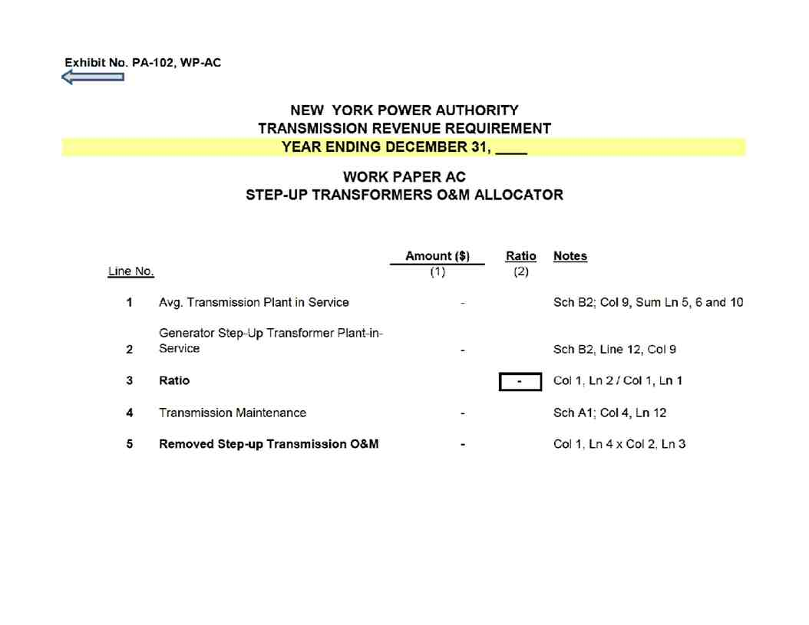
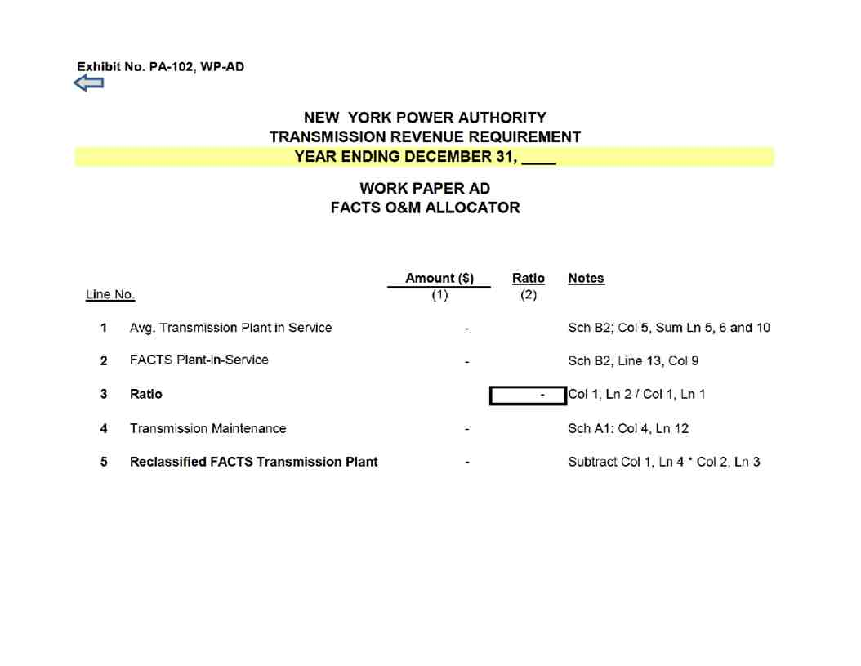

Exhibit No. PA-102, WP-AE

NEW YORK POWER AUTHORITY
TRANSMISSION REVENUE REQUIREMENT
YEAR ENDING DECEMBER 31, ____

WORK PAPER AE
MICROWAVE TOWER RENTAL INCOME

(1) (2) (3)

Posting Income
Line No. Date Account Amount ($)
1a
1b
1c
1d
1e
1f
1g
1h
1i
1j
1k
1l
1n
…
2 -

Exhibit No. PA-102, WP-AF

NEW YORK POWER AUTHORITY
TRANSMISSION REVENUE REQUIREMENT
YEAR ENDING DECEMBER 31, ____
WORK PAPER AF
POSTRETIREMENT BENEFITS OTHER THAN PENSIONS (PBOP)
(1) (2)
Line No. Item Amount ($)

1 Total NYPA PBOP

2 PBOP Capitalized

3 PBOP contained in Cost of Service Line 1 less line 2 -

4 Base PBOP Amount 35,797,785

5 PBOP Adjustment Line 4 less line 3 -

This work paper includes total NYPA PBOP which is allocated to transmission by labor ratio as shown on Schedule A2.

Exhibit No. PA-102, WP-AG

NEW YORK POWER AUTHORITY
TRANSMISSION REVENUE REQUIREMENT
YEAR ENDING DECEMBER 31, ____
WORK PAPER AG
PROPERTY INSURANCE ALLOCATION

Allocated
Insurance
Expense -
Line No. Site Amount ($) Ratio Transmission ($) Notes
(1) (2) (3) (4)
1a
1b
1c
1d
…
Allocated based on transmission gross plant ratio
2 Subtotal (Gross Transmission Plant Ratio) - - - from Work Paper AI
3a
3b
…

4 Subtotal (Full Transmission) - 100.00% -

5 Grand Total -

Exhibit No. PA-102, WP-AH

NEW YORK POWER AUTHORITY
TRANSMISSION REVENUE REQUIREMENT
YEAR ENDING DECEMBER 31, ____
WORK PAPER AH
INJURIES & DAMAGES INSURANCE EXPENSE ALLOCATION

Allocated
Injury/Damage
Insurance
Expense -
Line No. Site Amount ($) Ratio (%) Transmission ($) Notes
(1) (2) (3) (4)
1a
1b
1c
1d
…
Allocated based on transmission labor ratio
2 Subtotal - - - from Schedule E1

3a

…

- 100.00 -

4 Grand Total -
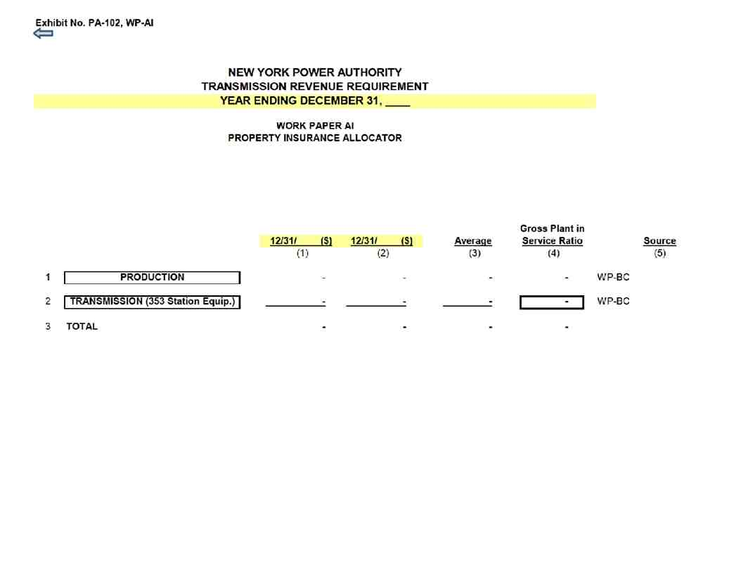
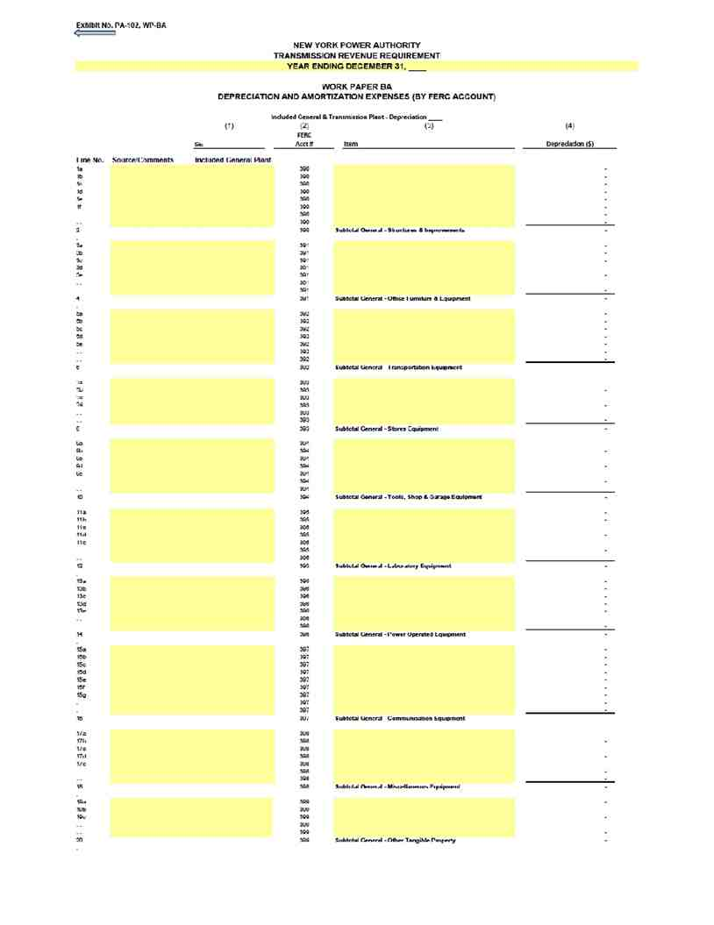
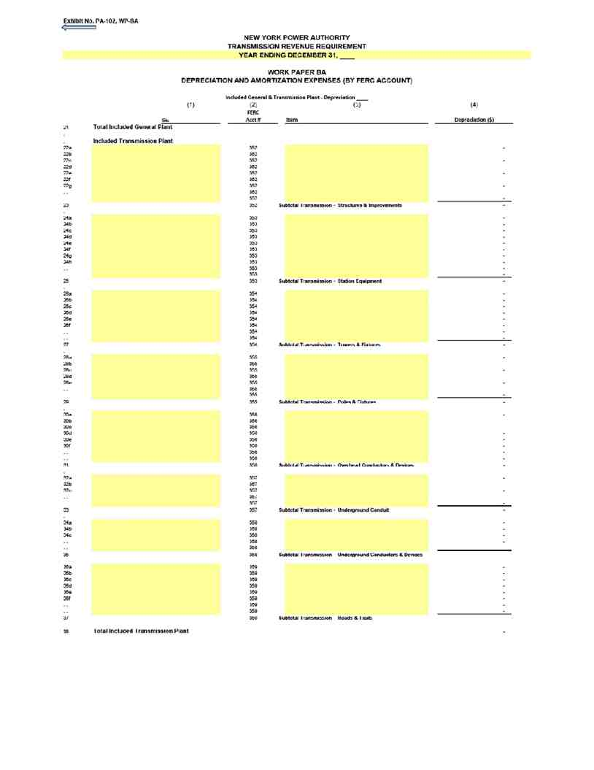

Exhibit No. PA 102, WP BB

NEW YORK POWER AUTHORITY
TRANSMISSION REVENUE REQUIREMENT
YEAR ENDING DECEMBER 31,
WORK PAPER BB
- EXCLUDED PLANT IN SERVICE
(1) (2) (3) (4) (5) (6) (7) (8) (9) (10) (11)

____ ____

Electric Electric Electric Electric
Plant in Accumulated Plant in Depreciation Plant in Accumulated Plant in Depreciation
Service ($) Depreciation ($) Service (Net $) Expense ($) Service ($) Depreciation ($) Service (Net $) Expense ($)
Line No. Source/Comments EXCLUDED TRANSMISSION
1
1a - - - - - - - -
… - - - - - - - -

2 SUBTOTAL 500mW C C at Astoria
3
3a - - - -
3b - - - - - - - -
3c - - - - - - - -
3d - - - - - - - -
3e - - - - - - - -
3f - - - - - - - -
3g - - - - - - - -
3h - - - -
3i - - - - - - - -
… - - - - - - - -

4 SUBTOTAL Astoria 2 (AE II) Substation
5
5a - - - - - - - -
5b - - - - - - - -
5c - - - - - - - -
… - - - - - - - -

6 SUBTOTAL Small Hydro
7
7a - - - - - - - -
… - - - - - - - -

8 SUBTOTAL FLYNN (Holtsville)
8a - - - - - - - -
8b - - - - - - - -
8c - - - - - - - -
8d - - - - - - - -
8e - - - - - - - -
… - - - - - - - -

9 SUBTOTAL Poletti
10
10a - - - - - - - -
10b - - - - - - - -
10c - - - - - - - -
10d - - - - - - - -
10e - - - - - - - -
10f - - - - - - - -
10g - - - - - - - -
… - - - - - - - -

11 SUBTOTAL SCPP

12
… - - - - - - - -

13 TOTAL EXCLUDED TRANSMISSION

Exhibit No. PA 102, WP BB

NEW YORK POWER AUTHORITY
TRANSMISSION REVENUE REQUIREMENT
YEAR ENDING DECEMBER 31,
WORK PAPER BB
- EXCLUDED PLANT IN SERVICE
(1) (2) (3) (4) (5) (6) (7) (8) (9) (10) (11)

____ ____

Electric Electric Electric Electric
Plant in Accumulated Plant in Depreciation Plant in Accumulated Plant in Depreciation
Service ($) Depreciation ($) Service (Net $) Expense ($) Service ($) Depreciation ($) Service (Net $) Expense ($)

14 EXCLUDED GENERAL
14a - - - - - - - -
14b - - - - - - - -
14c - - - - - - - -
14d - - - - - - - -
14e - - - - - - - -
14f - - - - - - - -
… - - - - - - - -

15 SUBTOTAL 500Mw CC
16
16a - - - - - - - -
16b - - - - - - - -
… - - - - - - - -

17 SUBTOTAL Small Hydro
18
18a - - - - - - - -
18b - - - - - - - -
18c - - - - - - - -
18d - - - - - - - -
18e - - - - - - - -
18f - - - - - - - -
18g - - - - - - - -
18h - - - - - - - -
… - - - - - - - -

19 SUBTOTAL Flynn
20
20a - - - - - - - -
20b - - - - - - - -
20c - - - - - - - -
20d - - - - - - - -
20e - - - - - - - -
20f - - - - - - - -
20g - - - - - - - -
20h - - - - - - - -
20i - - - - - - - -
20j - - - - - - - -
20k - - - - - - - -
… - - - - - - - -

21 SUBTOTAL Poletti

Exhibit No. PA 102, WP BB

NEW YORK POWER AUTHORITY
TRANSMISSION REVENUE REQUIREMENT
YEAR ENDING DECEMBER 31,
WORK PAPER BB
- EXCLUDED PLANT IN SERVICE
(1) (2) (3) (4) (5) (6) (7) (8) (9) (10) (11)

____ ____

Electric Electric Electric Electric
Plant in Accumulated Plant in Depreciation Plant in Accumulated Plant in Depreciation
Service ($) Depreciation ($) Service (Net $) Expense ($) Service ($) Depreciation ($) Service (Net $) Expense ($)

22
22a - - - - - - - -
22b - - - - - - - -
22c - - - - - - - -
22d - - - - - - - -
22e - - - - - - - -
22f - - - - - - - -
22g - - - - - - - -
22h - - - - - - - -
22i - - - - - - - -
22j - - - - - - - -
22k - - - - - - - -
22l - - - - - - - -
22n - - - - - - - -
… - - - - - - - -

23 SUBTOTAL SCPP - - - - - - - -

24
… - - - - - - - -

25 TOTAL EXCLUDED GENERAL - - - - - - - -

Exhibit No. PA-102, WP-BC

NEW YORK POWER AUTHORITY
TRANSMISSION REVENUE REQUIREMENT
YEAR ENDING DECEMBER 31, ____
WORK PAPER BC
PLANT IN SERVICE DETAIL

____ ____

(1) (2) (3) (4) (5) (6) (7) (8) (9) (10) (11) (12)

Electric Plant in Accumulated Electric Plant in Depreciation Electric Plant in Service Accumulated Electric Plant in Depreciation
P/T/G Plant Name A/C Description Service ($) Depreciation ($) Service (Net $ ) Expense ($) ($) Depreciation ($) Service (Net $) Expense ($)

Capital assets, not being depreciated

1 Land
1a
1b
1c
1d
1e
1f
1g
1h
1i
1j
1k
1l
1n
1m
1o
1p
1q
1r
1s
1t
1u
1v
1w
1x
1y
1z
1aa
1ab
1ac
1ad
1ae
1af
1ag
1ah
1ai

2 Land Total - - - - - - - -

3 Construction in progress
3a Adjustments CWIP
4 Construction in progress Total - - - - - - - -

5 Total capital assets not being depreciated - - - - - - - -

Capital assets, being depreciated

Exhibit No. PA-102, WP-BC

NEW YORK POWER AUTHORITY
TRANSMISSION REVENUE REQUIREMENT
YEAR ENDING DECEMBER 31, ____
WORK PAPER BC
PLANT IN SERVICE DETAIL

____ ____

(1) (2) (3) (4) (5) (6) (7) (8) (9) (10) (11) (12)

Electric Plant in Accumulated Electric Plant in Depreciation Electric Plant in Service Accumulated Electric Plant in Depreciation
P/T/G Plant Name A/C Description Service ($) Depreciation ($) Service (Net $ ) Expense ($) ($) Depreciation ($) Service (Net $) Expense ($)

6 Production - Hydro
6a
6b
6c
6d
6e
6f
6g
6h
6i
6j
6k
6l
6n
6m
6o
6p
6q
6r
6s
6t
6u
6v
6w
6x
6y
6z
6aa
6ab
6ac
6ad
6ae
6af
6ag

7 Production - Hydro Total - - - - - - - -

8 Production - Gas turbine/combined cycle
8a
8b
8c
8d
8e
8f
8g
8h
8i
8j
8k
8l

Exhibit No. PA-102, WP-BC

NEW YORK POWER AUTHORITY
TRANSMISSION REVENUE REQUIREMENT
YEAR ENDING DECEMBER 31, ____
WORK PAPER BC
PLANT IN SERVICE DETAIL

____ ____

(1) (2) (3) (4) (5) (6) (7) (8) (9) (10) (11) (12)

Electric Plant in Accumulated Electric Plant in Depreciation Electric Plant in Service Accumulated Electric Plant in Depreciation
P/T/G Plant Name A/C Description Service ($) Depreciation ($) Service (Net $ ) Expense ($) ($) Depreciation ($) Service (Net $) Expense ($)
8n
8m
8o
8p
8q
8r
8s
8t
8u
8v
8w
8x
8y
8z
8aa
8ab
8ac
8ad
8ae
8af
8ag
8ah
8ai
8ak
8al
8am
8an
8ao
8ap
8aq
8ar
8as
8at
8au
8av
8aw
8ax
8ay
8az
8ba
8bb
8bc
8bd

Production - Gas
9 turbine/combined cycle Total - - - - - - - -

10 Transmission
10a
10b
10c

Exhibit No. PA-102, WP-BC

NEW YORK POWER AUTHORITY
TRANSMISSION REVENUE REQUIREMENT
YEAR ENDING DECEMBER 31, ____
WORK PAPER BC
PLANT IN SERVICE DETAIL

____ ____

(1) (2) (3) (4) (5) (6) (7) (8) (9) (10) (11) (12)

Electric Plant in Accumulated Electric Plant in Depreciation Electric Plant in Service Accumulated Electric Plant in Depreciation
P/T/G Plant Name A/C Description Service ($) Depreciation ($) Service (Net $ ) Expense ($) ($) Depreciation ($) Service (Net $) Expense ($)
10d
10e
10f
10g
10h
10i
10j
10k
10l
10n
10m
10o
10p
10q
10r
10s
10t
10u
10v
10w
10y
10z
10aa
10ab
10ac
10ad
10ae
10af
10ag
10ah
10ai
10ak
10al
10am
10an
10ao
10ap
10aq
10ar
10as
10at
10au
10av
10aw
10ax
10ay
10az
10ba
10bb
10bc
10bd
10be
10bh

Exhibit No. PA-102, WP-BC

NEW YORK POWER AUTHORITY
TRANSMISSION REVENUE REQUIREMENT
YEAR ENDING DECEMBER 31, ____
WORK PAPER BC
PLANT IN SERVICE DETAIL

____ ____

(1) (2) (3) (4) (5) (6) (7) (8) (9) (10) (11) (12)

Electric Plant in Accumulated Electric Plant in Depreciation Electric Plant in Service Accumulated Electric Plant in Depreciation
P/T/G Plant Name A/C Description Service ($) Depreciation ($) Service (Net $ ) Expense ($) ($) Depreciation ($) Service (Net $) Expense ($)
10bi
10bk
10bl
10bm
10bn
10bo
10bp
10bq
10br
10bs
10bt
10bu
10bv
10bw

11 Transmission Total - - - - - - - -
-

12 General
12a
12b
12c
12d
12e
12f
12g
12h
12i
12j
12k
12l
12n
12m
12o
12p
12q
12r
12s
12t
12u
12v
12w
12x
12y
12z
12aa
12ab
12ac
12ad
12ae
12af
12ag

Exhibit No. PA-102, WP-BC

NEW YORK POWER AUTHORITY
TRANSMISSION REVENUE REQUIREMENT
YEAR ENDING DECEMBER 31, ____
WORK PAPER BC
PLANT IN SERVICE DETAIL

____ ____

(1) (2) (3) (4) (5) (6) (7) (8) (9) (10) (11) (12)

Electric Plant in Accumulated Electric Plant in Depreciation Electric Plant in Service Accumulated Electric Plant in Depreciation
P/T/G Plant Name A/C Description Service ($) Depreciation ($) Service (Net $ ) Expense ($) ($) Depreciation ($) Service (Net $) Expense ($)
12ah
12ai
12ak
12al
12am
12an
12ao
12ap
12aq
12ar
12as
12at
12au
12av
12aw
12ax
12ay
12az
12ba
12bb
12bc
12bd
12be
12bh
12bi
12bk
12bl
12bm
12bn
12bo
12bp
12bq
12br
12bs
12bt
12bu
12bv
12bw
12bx
12by
12bz
12ca
12cb
12cc
12cd
12ce
12cf
12cg
12ch
12ci
12ck
12cl
12cm
12cn

Exhibit No. PA-102, WP-BC

NEW YORK POWER AUTHORITY
TRANSMISSION REVENUE REQUIREMENT
YEAR ENDING DECEMBER 31, ____
WORK PAPER BC
PLANT IN SERVICE DETAIL

____ ____

(1) (2) (3) (4) (5) (6) (7) (8) (9) (10) (11) (12)

Electric Plant in Accumulated Electric Plant in Depreciation Electric Plant in Service Accumulated Electric Plant in Depreciation
P/T/G Plant Name A/C Description Service ($) Depreciation ($) Service (Net $ ) Expense ($) ($) Depreciation ($) Service (Net $) Expense ($)
12co
12cp

13 General Total - - - - - - - -

14 Total capital assets, being depreciated - - - - - - - -

15 Net value of all capital assets - - - - - - - -

Exhibit No. PA-102, WP-BD

NEW YORK POWER AUTHORITY
TRANSMISSION REVENUE REQUIREMENT
YEAR ENDING DECEMBER 31, ____
WORK PAPER BD
MARCY-SOUTH CAPITALIZED LEASE AMORTIZATION
AND UNAMORTIZED BALANCE

Beginning Current Year
Unamortized Ending Capitalized Average
Lease Asset/ Unamortized Lease Unamortized
Line No. Year Obligation ($) Lease/Asset ($) Amortization ($) Balance
(1) (2) (3) (4) (5)

1 1988 - - -
2 1989 - - -
3 1990 - - -
4 1991 - - -
5 1992 - - -
6 1993 - - -
7 1994 - - -
8 1995 - - -
9 1996 - - -
10 1997 - - -
11 1998 - - -
12 1999 - - -
13 2000 - - -
14 2001 - - -
15 2002 - - -
16 2003 - - -
17 2004 - - -
18 2005 - - -
19 2006 - - -
20 2007 - - -
21 2008 - - -
22 2009 - - -
23 2010 - - -
24 2011 - - -
25 2012 - - -
26 2013 - - -
27 2014 - - - -
28 2015 - - -
29 2016 - - -
30 2017 - - -
31 2018 - - -
32 2019 - - -
33 2020 - - -
34 2021 - - -
35 2022 - - -
36 2023 - - -
37 2024 - - -
38 2025 - - -
39 2026 - - -
40 2027 - - -
41 2028 - - -
42 2029 - - -
43 2030 - - -
44 2031 - - -
45 2032 - - -
46 2033 - - -
47 2034 - - -
48 2035 - - -
49 2036 - - -
50 2037 - - -

51 Total -

Exhibit No. PA-102, WP-BE

NEW YORK POWER AUTHORITY
TRANSMISSION REVENUE REQUIREMENT
YEAR ENDING DECEMBER 31, ____

WORK PAPER BE
FACTS PROJECT PLANT IN SERVICE, ACCUMULATED DEPRECIATION AND DEPRECIATION EXPENSE

____ ____
(1) (2) (3) (4) (5) (6) (7) (8)
Electric Electric Electric Electric
Plant in Accumulated Plant in Depreciation Plant in Accumulated Plant in Depreciation
LN Cap.Date Asset Description Service ($) Depreciation ($) Service (Net $) Expense ($) Service ($) Depreciation ($) Service (Net $) Expense ($)

2 Total Plant - - - - - - - -

3 Year-Over-Year Accumulated Depreciation -

Note: The FACTS project data is based on NYPA's financial records with adherence to FERC's Uniform System of Accounts and U.S. generally accepted accounting principles.

Exhibit No. PA-102, WP-BF

NEW YORK POWER AUTHORITY
TRANSMISSION REVENUE REQUIREMENT
YEAR ENDING DECEMBER 31, ____
WORK PAPER BF
GENERATOR STEP-UP TRANSFORMERS BREAKOUT

Electric Electric
Plant in Accumulated Electric Plant Depreciation Plant in Accumulated Electric Plant Depreciation
Asset No. Service ($) Depreciation ($) (Net $) Expense ($) Service ($) Depreciation ($) (Net $) Expense ($)
1 (1) (2) (3) (4) (5) (6) (7) (8)
1a
1b
1c

- - - - - - - -

2
2a
2b
2c
2d
2e
2f
2g
2h

- - - - - - - -

3a

- - - - - - - - -

4a

- - - - - - - -

5
5a
5b
5c

- - - - - - - -

6a

- - - - - - - -

7 Grand Total - - - - - - - -

8 Adjusted Grand Total (Excludes 500MW C - C at Astoria) - - - - - -

Exhibit No. PA-102, WP-BG

NEW YORK POWER AUTHORITY
TRANSMISSION REVENUE REQUIREMENT
YEAR ENDING DECEMBER 31, ____

WORK PAPER BG
RELICENSING/RECLASSIFICATION EXPENSES

____ ____
Plant in Accumulated Plant in Depreciation Plant in Accumulated Plant in Depreciation
NIAGARA Service ($) Depreciation ($) Service (Net $) Expense ($) Service ($) Depreciation ($) Service (Net $) Expense ($)
(1) (2) (3) (4) (5) (6) (7) (8)
1a
1b
1c
…
1 - - - - - - - -

ST. LAWRENCE
2a
2b
2c
2d
2e
2f
2g
…
2 - - - - - - - -

-
3a
…
…
…
3 - - - - - - - -

4 Total Expenses - - - - - - - -

Exhibit No. PA-102, WP-BH

NEW YORK POWER AUTHORITY
TRANSMISSION REVENUE REQUIREMENT
YEAR ENDING DECEMBER 31, ____

WORK PAPER BH
ASSET IMPAIRMENT

(1) (2) (3) (4) (5)

Posting Cost Impairment
Date Center Account Amount ($) Facility
1a
1b
1c
1d
1e
1f
1g
…
2 -

3 Total Impairment - Production -
4 Total Impairment - Transmission -
5 Total Impairment - General Plant -

Exhibit No. PA-102, WP-BI

NEW YORK POWER AUTHORITY
TRANSMISSION REVENUE REQUIREMENT
YEAR ENDING DECEMBER 31, ____
WORK PAPER BI
COST OF REMOVAL

Cost of Removal to Regulatory Assets - Depreciation:

(1) (2) (3)
____ ____
Amount ($) Amount ($)

1 Production
2 Transmission
3 General
4 Total - -

Note: The Cost of Removal data is based on NYPA's
accounting records under the provisions of FASB Accounting Standards Codification Topic 980.

Exhibit No. PA-102, WP-CA

NEW YORK POWER AUTHORITY
TRANSMISSION REVENUE REQUIREMENT
YEAR ENDING DECEMBER 31, ____
WORK PAPER CA
MATERIALS AND SUPPLIES

(1) (2) (3) (4) (5) (6) (7)
Total M&S Total M&S Avg. M&S
NYPA Inventory ($) Inventory ($) Inventory Transmission Allocated
Acct # Facility 12/31/____ 12/31/____ ____-14 Allocator M&S ($)
1a 1100 NIA
1b 1200 STL
1c 3100 POL
1d 3200 Flynn
1e 1300 B/G
1f 3300 500MW
1g 2100 CEC
… - -
2 Facility Subtotal - -

3a Reserve for Degraded Materials
3b Reserve for Excess and Obsolete Inventory
… - -
4 Reserves Subtotal - -

5 Total - - - - -

Exhibit No. PA-102, WP-CB

NEW YORK POWER AUTHORITY
TRANSMISSION REVENUE REQUIREMENT
YEAR ENDING DECEMBER 31, ____
WORK PAPER CB
ESTIMATED PREPAYMENTS AND INSURANCE

(1) (2) (3)

Property Other
Date Insurance ($) Prepayments ($)

1 12/31/____ -

2 12/31/____ -

3 Beginning/End of Year Average - -

Exhibit No. PA-102, WP-DA

NEW YORK POWER AUTHORITY
TRANSMISSION REVENUE REQUIREMENT
YEAR ENDING DECEMBER 31, ____

WORK PAPER DA
WEIGHTED COST OF CAPITAL

(1) (2) (3) (4) (5) (6) (7)
Actual Equity Applied Cost Weighted
Component Amount ($) Share Cap Share Rate Cost

1 Long-Term Debt - 6/ - 50.00% - - 2/ -

2 Preferred Stock - - - - - 3/ -

3 Common Equity - 1/ - 50.00% - 4 9.45% 5/ -

4 Total - - 100% - -

Notes
1/:
5 Total Proprietary Capital - Workpaper WP-DB Ln (5), average of Col (2) and (3)
6 less Preferred
7 less Acct. 216.1
8 Common Equity -

2/:
9 Total Long Term Debt Interest - Workpaper WP-DB Col (2) Ln (2)
10 Net Proceeds Long Term Debt - Workpaper WP-DB Ln (4), average of Col (2) and (3)
11 LTD Cost Rate - 7/

3/:
12 Preferred Dividends -
13 Preferred Stock -
14 Preferred Cost Rate -

15 4/: The capital structure listed in Col (3) is calculated based on he total capitalization amount listed in column (2). The Equity Cap in Col (4) Ln (3)
is fixed and cannot be modified or deleted absent an FPA Sec ion 205 or 206 filing to FERC. The Applied Equity Share in Col (5) Ln (3) will be the
actual common equity share, not to exceed the Equity Cap in Col (4) Ln (3). The debt share is calculated as 1 minus the equity share.

16 5/: The ROE listed in Col (6), Ln (3) is the base ROE plus 50 basis-point incentive for RTO par icipation. ROE may only be changed pursuant to an
FPA Section 205 or 206 filing to FERC.

17 6/: The Long-Term Debt Amount ($) in Col (2) Ln (1) is the Gross Proceeds Outstanding Long Term Debt, the average of WP-DB Ln (3e), Col
(2) and (3).

18 7/: The Long-Term Debt Cost Rate is calculated as the Total Long Term Debt Interest [Workpaper WP-DB Col (2) Ln (2)] divided by the Net Proceeds
Long Term Debt [Workpaper WP-DB row (4), average of Col (2) and (3)].

Exhibit No. PA-102, WP-DB

NEW YORK POWER AUTHORITY
TRANSMISSION REVENUE REQUIREMENT
YEAR ENDING DECEMBER 31, ____

WORK PAPER DB
CAPITAL STRUCTURE
LONG-TERM DEBT AND RELATED INTEREST

(1) (2) (3) (4)

NYPA Form 1
____ Amount ($) ____ Amount ($) Equivalent

1 Long Term Debt Cost
1a Interest on Long-Term Debt p. 117 ln. 62 c,d
1b Amort. of Debt Disc. and Expense p. 117 ln. 63 c,d
1c Amortization of Loss on Reacquired Debt p. 117 ln. 64 c,d
1d (Less) Amort. of Premium on Debt p. 117 ln. 65 c,d
1e (Less) Amortization of Gain on Reacquired Debt p. 117 ln. 66 c,d

2 Total Long Term Debt Interest - -

3 Long Term Debt

3a Bonds p. 112 ln. 18 c,d
3b (Less) Reacquired Bonds p. 112 ln. 19 c,d
3d Other Long Term Debt p. 112 ln. 21 c,d

3e Gross Proceeds Outstanding LT Debt - -

3f (Less) Unamortized Discount on Long-Term Debt p. 112 ln. 23 c,d
3g (Less) Unamortized Debt Expenses p. 111 ln. 69 c,d
3h (Less) Unamortized Loss on Reacquired Debt p. 111 ln. 81 c,d
3i Unamortized Premium on Long-Term Debt p. 112 ln. 22 c,d
3k Unamortized Gain on Reacquired Debt p. 113 ln. 61 c,d

4 Net Proceeds Long Term Debt - -

5 Net Position - -
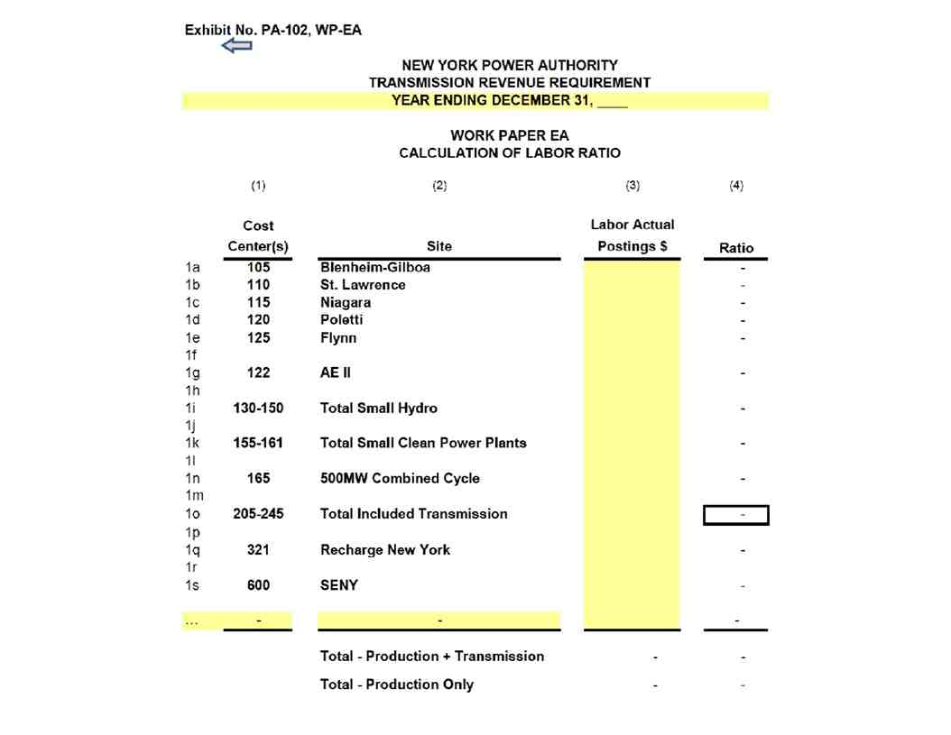

Exhibit No. PA-102, WP-AR-IS

NEW YORK POWER AUTHORITY
TRANSMISSION REVENUE REQUIREMENT
YEAR ENDING DECEMBER 31, ____

WORK PAPER AR- IS
STATEMENT OF REVENUES, EXPENSES AND CHANGES IN NET POSITION
($ Millions)

Actual Actual
Description ____ ____
(1) (2) (3)

1 Operating Revenues
1a Power Sales
1b Transmission Charges
1c Wheeling Charges
… -
2 Total Operating Revenues - -

3 Operating Expenses
3a Purchased Power
3b Fuel Oil and Gas
3c Wheeling
3d Operations
3e Maintenance
3f Depreciation
… -
4 Total Operating Expenses - -

5 Operating Income - -

6 Nonoperating Revenues
6a Investment Income
6b Other
… -
7 Investments and Other Income - -

8 Nonoperating Expenses
8a Contribution to New York State
8b Interest on Long-Term Debt
8c Interest - Other
8d Interest Capitalized
8e Amortization of Debt Premium
… -
9 Investments and Other Income - -

10 Net Income Before Contributed Capital - -

11 Contributed Capital - Wind Farm Transmission Assets
… -
- -

13 Change in net position - -

14 Net position at January 1

15 Net position at December 31 - -

Exhibit No. PA-102, WP-AR-BS

NEW YORK POWER AUTHORITY
TRANSMISSION REVENUE REQUIREMENT
YEAR ENDING DECEMBER 31, ____
WORK PAPER AR-BS
STATEMENT OF NET POSITION
($ Millions)

DESCRIPTION DECEMBER ____ DECEMBER ____
(1) (2) (3)
1 Assets and Deferred Outflows
1a Current Assets:
1b Cash and cash equivalents
1c Investment in securities
1d Receivables - customers
1e Materials and supplies, at average Cost:
1f Plant and general
1g Fuel
1h Miscellaneous receivables and other
… -

2 Total current assets - -

3 Noncurrent Assets:
3a Restricted funds:
3b Cash and cash equivalents
3c Investment in securities
… -

4 Total restricted assets - -

5 Capital funds:
5a Cash and cash equivalents
5b Investment in securities
… -

6 Total capital funds - -

7 Capital Assets
7a Capital assets not being depreciated
7b Capital assets, net of accumulated depreciation
… -

8 Total capital assets - -

9 Other noncurrent assets:
9a Receivable - New York State
9b Notes receivable - nuclear plant sale
9c Other long-term assets
… -

10 Total other noncurrent assets - -

11 Total noncurrent assets - -

12 Total assets - -

13 Deferred outflows:
13a Accumulated decrease in fair value of hedging derivatives
… -
14 Total Deferred outflows - -

Exhibit No. PA-102, WP-AR-BS

NEW YORK POWER AUTHORITY
TRANSMISSION REVENUE REQUIREMENT
YEAR ENDING DECEMBER 31, ____
WORK PAPER AR-BS
STATEMENT OF NET POSITION
($ Millions)

15 Total assets and deferred outflows - -

1/ Source: Annual Financial Statements

Exhibit No. PA-102, WP-AR-BS

NEW YORK POWER AUTHORITY
TRANSMISSION REVENUE REQUIREMENT
YEAR ENDING DECEMBER 31, ____
WORK PAPER AR-BS
STATEMENT OF NET POSITION
($ Millions)

DESCRIPTION DECEMBER ____ DECEMBER ____

16 Liabilities, Deferred Inflows and Net Position
16a Current Liabilities:
16b Accounts payable and accrued liabilities
16c Short-term debt
16d Long-term debt due within one year
16e Capital lease obligation due within one year
16f Risk management activities - derivatives
… -

17 Total current liabilities - -

18 Noncurrent liabilities:
18a Long-term debt:
18b Senior:
18c Revenue bonds
18d Adjustable rate tender notes
18e Subordinated:
18f Subordinated Notes, Series 2012
18g Commercial paper
… -

19 Total long-term debt - -

20 Other noncurrent liabilities:
20a Capital lease obligation
20b Liability to decommission divested nuclear facilities
20c Disposal of spent nuclear fuel
20d Relicensing
20e Risk management activities - derivatives
20f Other long-term liabilities
… -

21 Total other noncurrent liabilities - -

22 Total noncurrent liabilities - -

23 Total liabilities - -

24 Deferred inflows:
24a Cost of removal obligation
… -
- -
25 Net position:
25a Net investment in capital assets
25b Restricted
25c Unrestricted
… -

26 Total net position - -
27 Total liabilities, deferred inflows and net position - -

Exhibit No. PA-102, WP-AR-BS

NEW YORK POWER AUTHORITY
TRANSMISSION REVENUE REQUIREMENT
YEAR ENDING DECEMBER 31, ____
WORK PAPER AR-BS
STATEMENT OF NET POSITION
($ Millions)
1/ Source: Annual Financial Statements

Exhibit No. PA-102, WP-AR-Cap Assets

NEW YORK POWER AUTHORITY
TRANSMISSION REVENUE REQUIREMENT
YEAR ENDING DECEMBER 31, ____
WORK PAPER AR-Cap Assets
CAPITAL ASSETS - Note 5 ($ Millions)

New York Power Authority
Capital Assets - Note 5
____ Annual Report
12/31/____ 12/31/____
Ending Ending
balance Additions Deletions balance
(1) (2) (3) (4) (5)

1 Capital assets, not being depreciated:
1a Land -
1b Construction in progress -
… - -

2 Total capital assets not being depreciated - - - -

3 Capital assets, being depreciated:
3a Production - Hydro -
3b Production - Gas
3c turbine/combined cycle -
3d Transmission -
3e General -
… - -

4 Total capital assets being depreciated - - - -

5 Less accumulated depreciation for:
5a Production - Hydro -
5b Production - Gas
5c turbine/combined cycle -
5d Transmission -
5e General -
… - -

6 Total accumulated depreciation - - - -

7 Net value of capital assets being depreciated - - - -

8 Net value of all capital assets - - - -

Exhibit No. PA-102, WP-Reconciliations

NEW YORK POWER AUTHORITY
TRANSMISSION REVENUE REQUIREMENT
YEAR ENDING DECEMBER 31, ____
WORK PAPER Reconciliations
RECONCILIATIONS BETWEEN ANNUAL REPORT & ATRR
Line
No.
(1) (2) (3) (4) (5) (6) (7) (8) (9)

1 OPERATION & MAINTANANCE EXPENSES
Operations Maintenance Total O&M

1a Operations & Maintenance Expenses - as per Annual Report - - -
1b Excluded Expenses
1c Production - - -
1d A&G in FERC Acct 549 - OP-Misc Oth Pwr Gen - - -
1e FERC acct 905 (less contribution to New York State) - - -
1f FERC acct 916 - Misc Sales Expense - - -
1g A&G allocated to Production and General - - -
1h Adjustments -
1i Less A/C 924 - Property Insurance - - -
1j Less A/C 925 - Injuries & Damages Insurance - - -
1k Less EPRI Dues - - -
1l Less A/C 928 - Regulatory Commission Expense - - -
1n PBOP Adjustment - - -
1m 924 -Property Insurance as allocated - - -
1o 925 - Injuries & Damages Insurance as allocated - - -
1p Step-up Transformers - - -
1q FACTS - - -
1r Microwave Tower Rental Income - - -
1s Reclassifications (post Annual Report) - - -
Operations & Maintenance Expenses - as per ATRR - - -
check - - -

2 ELECTRIC PLANT IN SERVICE & DEPRECIATION

Electric Plant in Accumulated Electric Plant in Depreciation Electric Plant in Accumulated Electric Plant in Depreciation
Service ($) Depreciation ($) Service - Net ($) Expense ($) Service ($) Depreciation ($) Service - Net ($) Expense ($)

2a As per Annual Report
2b Capital Assets not being depreciated - - - - - - 0 0
2c Capital Assets being depreciated - - - - - - 0 0
2d Total Capital Assets - - - - - - 0 0
2e Less CW P - - - - - - 0 0
2f Total Assets in Service - - - - - - 0 0
2g Adjustments for ATRR
2h Cost of Removal (note 1)
2i Transmission - - - - - - 0 0
2j General - - - - - - 0 0
2k Total - - - - - - 0 0
2l Excluded (note 2)
2n Transmission - - - - - - 0 0
2m General - - - - - - 0 0
2o Total - - - - - - 0 0
2p Adjustments to Rate Base (note 3)
2q Transmission - - - - - - 0 0
2r General - - - - - - 0 0
2s Total - - - - - - 0 0
2t
2u Total Assets in Service - As per ATRR - - - - - - 0 0
2v Comprising:
2w Production - - - - - - 0 0
2x Transmission - - - - - - 0 0
2y General - - - - - - 0 0
2z Total - - - - - - 0 0
2aa check differences due to rounding - - - - - - 0 0

Notes
2ab 1 Cost of Removal: Bringing back to accumulated depreciation cost of removal which was reclassified to regulatory liabilities in annual report
2ac 2 Excluded: Assets not recoverable under ATRR
2ad 3 Adjustments to Rate Base: Relicensing, Windfarm, Step-up transformers, FACTS & Asset Impairment

3 MATERIALS & SUPPLIES

3a As per Annual Report
3b Plant and General - -
3c As per ATRR - -
3d check - -

4 CAPITAL STRUCTURE

Long -Term Debt Common Equity Long -Term Debt Common Equity
4a As per Annual Report
4b Long-Term - -
4c Short-Term - -
4d Total - - - -
4e As per ATRR - - - -
4f check - - - -

5 INTEREST ON LONG-TERM DEBT

5a As per Annual Report
5b Interest LTD (including Swaps, Deferred Refinancing) - -
5c Debt Discount/Premium - -
5d Total - -
5e As per ATRR
5f Interest LTD (including Swaps, Deferred Refinancing) - -
5g Debt Discount/Premium - -
5h Total - -
5i check - -

6 REVENUE REQUIREMENT

6a As per Annual Report -
6b SENY load (note 4)
6c FACTS revenue (note 5)
6d Timing differences

7a Total (sum lines 64-66) -
7b FERC approved ATRR (line 63 - line 67) -
7c check -

Notes
7d 4 Amount that NYPA will credit to its ATRR assessed to the SENY customer load. These revenues are included in the Annual Report within Production Revenues.
7e 5 Compensation for FACTS through the NYISO’s issuance of Transmission Congestion Contract (“TCC”) payments

8 OTHER POSTEMPLOYMENT BENEFIT PLANS

8a As per Annual Report
8b Annual OPEB Cost -
8c As per ATRR
8d Total NYPA PBOP -
8e check -

