NYSEG/NORTHLAND POWER E&P Agreement No. 2616

ENGINEERING & PROCUREMENT AGREEMENT

This Engineering & Procurement Agreement (“Agreement”), dated as of February 17, 2021   
(the “Effective Date”), is made by and between Bluestone Wind, LLC, a Delaware limited liability   
company having its principal place of business at 30 St. Clair Avenue West, Suite 1200, Toronto,   
ON M4V 3A1 Canada (“Customer” or “Developer”), and New York State Electric & Gas

Corporation (“NYSEG” or the “Company”), a New York corporation with an office located in 18 Link Dr, Binghamton, New York 13904. The Customer and the Company shall each be referred to as a “Party”, and shall be referred to collectively as the “Parties”.

RECITALS

WHEREAS, the Parties desire to set forth the terms, conditions, and costs for conducting certain engineering and procurement activities specified in Attachment A to this Agreement (“Engineering & Procurement”) related to the interconnection of the Customer’s electric generating facility located in Broome County, New York (the “Generating Facility”);

NOW, THEREFORE, in consideration of the mutual promises and agreements set forth herein, and other good and valuable consideration, the receipt and sufficiency of which are hereby acknowledged by the Parties, the Parties, intending to be legally bound, agree as follows:

1. Information Requirements and Scope of Engineering & Procurement.

1.1 The Customer agrees to provide all information, documents and technical data

required by the Company and deemed necessary by the Company to perform the Engineering &   
Procurement. Such information, documentation, and technical data required has been provided by   
the Customer as of the Effective Date, and the Company acknowledges receipt of such   
information, documentation, and technical data as of the Effective Date to commence the   
Engineering & Procurement. After execution of this Agreement, Customer will continue to   
provide the remainder of the information specified in Attachment A, on a schedule to be mutually   
agreed by the Customer and the Company, and will also provide any additional information,   
documentation, or technical data that is determined by the Company to be required for its   
performance of the Engineering & Procurement (collectively, the “Additional Information and   
Data”). The Company shall provide notice to the Customer of Customer’s failure to provide   
Additional Information and Data in accordance with this Section 1.1, and the Customer shall   
provide such Additional Information and Data within fifteen (15) days following its receipt of such   
notice from the Company. If the Customer fails to provide the Additional Information and Data   
within fifteen (15) days following its receipt of such notice from the Company, the Company may,   
at its option and upon prior written notice to the Customer, suspend the Engineering &   
Procurement until such Additional Information and Data is received. Notwithstanding the   
foregoing, if all or a portion of Additional Information and Data requested by Company is not   
available within the fifteen (15) day period, Customer shall notify Company of that fact and will   
provide a good faith estimate of the date upon which such Additional Information and Data will   
be provided. If the Customer fails to provide the Additional Information and Data within ninety

(90) days following its receipt of the fifteen (15) day notice from the Company, the Company may,   
at its option and upon prior written notice to the Customer, terminate this Agreement; provided,   
however, that if all or a portion of Additional Information and Data requested by Company is not



available within the ninety (90) day period, Customer shall (i) notify Company of that fact and   
provide a good faith estimate of the date upon which such Additional Information and Data will   
be provided; and (ii) use commercially reasonable efforts to supply Additional Information and   
Data as it becomes available. So long as Customer is in compliance with clauses (i) and (ii) of the   
preceding sentence, this Agreement shall remain in full force and effect, but Company shall retain   
the right to suspend the Engineering & Procurement until such Additional Information and Data   
is received.

1.2 The scope of the Engineering & Procurement to be performed by the Company (“Scope of Engineering & Procurement”) shall be as described in this Agreement in Attachment A.

1.3 In performance of the Engineering & Procurement hereunder, the Company:

shall at all times perform in a good and workmanlike manner consistent with

applicable best professional practices and standards in the industry for performing similar services;

shall at all times perform in material compliance with all applicable federal,

state and local laws and ordinances and all lawful orders, rules and regulations of any governmental authority; and

represents and warrants that it and any subcontractor(s) has all necessary

permits, licenses, and other forms of documentation, and its personnel have received all necessary   
training including, but not limited to, health and safety training required to perform services   
hereunder.

1.4 All capitalized terms not otherwise defined in this Agreement shall have the meanings ascribed to such terms in the NYISO's Open Access Transmission Tariff inclusive of Attachment X thereto.

1.5 This Agreement shall be superseded by the Large Generator Interconnection   
Agreement executed by both Parties (“LGIA”). Notwithstanding the foregoing, Sections 4.5, 9.1,

9.2 and 16, and Article 8, survive expiration or termination of this Agreement (“Surviving Provisions”). In the event of any conflict between a Surviving Provision of this Agreement and the LGIA, the Surviving Provision of this Agreement shall control.

2. Representatives.

All work pertaining to the Engineering & Procurement that is the subject of this Agreement will be approved by and coordinated only through designated and authorized representatives of the Company and the Customer. Each Party shall inform the other in writing of its designated representative(s). The designated representatives of the Parties shall not have the right to amend this Agreement, except as provided in Section 4.2.

3. Engineering & Procurement Duration and Results.

3.1 The Company’s estimated schedule for completing the Engineering & Procurement

is specified in Attachment A. The Customer understands and agrees that the completion dates in

2

Attachment A are only estimates, and that the Company makes no representations or warranties, either express or implied, that the Engineering & Procurement will be completed within these time periods. The Company agrees to provide to the Customer periodic reports on the status of the Engineering & Procurement at intervals as agreed by the Parties, and also shall provide status reports upon the reasonable request of the Customer.

4. Estimated Costs and Payment Terms.

4.1 The Company’s estimated cost for completion of the Engineering & Procurement

is specified in Attachment A (the “Estimated Cost”). The Estimated Cost constitutes the Company’s good faith estimate of the cost for the Engineering & Procurement services through to the execution of an LGIA, pursuant to this Agreement. The actual costs to be paid by the Customer will be the actual costs incurred by the Company, which may vary from the Estimated Cost, as described in Section 4.3 below. Any costs for the Engineering & Procurement in excess of the Estimated Cost are “Additional Costs”. Typically, under NYSEG’s E&P Agreement, NYSEG requires the customer to provide payment security such as a letter of credit to guaranty NYSEG receives payment for the work NYSEG will undertake. In this instance, NYSEG has arranged the payment schedule so that NYSEG will not be required to perform work until the funding to pay for that work has been received. By arranging the payments this way, the Customer will not be required to submit security such as a letter of credit. The intention of this provision is to be clear that the Company shall only expend funds toward the payment of Engineering and Procurement if sufficient funds have first been received from the Customer.

a. The Estimated Cost is four hundred thousand dollars ($400,000.00), which includes, but is not limited to equipment and installation cost of the scope described in Attachment A hereto;

b. The payment of four hundred thousand dollars ($400,000.00) is due on the date of execution of this Agreement by both parties (the “Effective Date”);

c. All payments by Customer shall be made by certified or bank check, or wire transfer.

4.2 The Company will commence with the full Engineering & Procurement described   
in Attachment A hereto upon receipt of the first payment. The estimated four hundred thousand   
dollars ($400,000) for the NYSEG scope is intended to cover services through to execution of an   
LGIA contract. In the event the LGIA is not executed prior to the funding running out, an   
amendment to this Agreement will be required to provide additional funds in order to continue   
providing services.

4.3 Once the Company has commenced performance of the Engineering &   
Procurement, the Company shall have the right to propose changes to the Scope of Engineering &   
Procurement by providing written notice (each an “EP Change Notice”) to the Customer, which   
notice shall include an estimate of the Additional Cost associated with the change in the Scope of   
Engineering & Procurement. The Customer, through its designated representative, shall, within   
five (5) business days after the Customer receives an EP Change Notice, either (a) authorize the   
change in the Scope of Engineering & Procurement in a written notice to the Company and include   
payment for the Additional Cost associated with the change, or (b) dispute the necessity, in writing,

3

for or the cost of the change described in the EP Change Notice. If the Customer chooses option

(b), then the Company shall not undertake any work associated with the EP Change Notice until   
such dispute is resolved; provided, however, that if the dispute is not resolved within ninety (90)   
days from the date the Customer receives the EP Change Notice, either Party shall have the right   
to terminate this Agreement upon written notice to the other. If the Customer chooses option (a),   
then payment of the Additional Costs described in any EP Change Notice is required in advance   
of the Company undertaking to perform the change in the Scope of Engineering & Procurement   
and the Customer shall be responsible for the actual costs associated with the change in the Scope   
of Engineering & Procurement.

4.4 The Company shall, in writing, advise the Customer in advance of performing any   
Engineering & Procurement work that is not subject to an EP Change Notice as described in   
Section 4.2, if the Additional Costs for such work are equal to or greater than ten percent (10%)   
of the Estimated Cost (each notice an “Increased Cost Notice”). Upon receiving an Increased Cost   
Notice, the Customer, through its designated representative, shall, within ten (10) days, either (a)   
make payment for the Additional Cost, or (b) dispute the Additional Cost described in the   
Increased Cost Notice. If the Customer chooses option (b), the Company may, at its option and   
upon notice to the Customer suspend performance under this Agreement until the dispute is   
resolved and the required payment for the Additional Cost is made, or if the dispute is not resolved   
within ninety (90) days from the date the Customer receives the Increased Cost Notice, terminate   
this Agreement.

4.5 Within thirty (30) days after the expiration or any earlier termination of this   
Agreement: (a) the Company shall refund to the Customer any portion of the paid Estimated Costs   
or paid Additional Costs that the Company did not expend in performing its obligations under this   
Agreement, and (b) the Customer shall pay to the Company any outstanding amount due under   
this Agreement. Notwithstanding the foregoing, the Company may retain any amounts due to   
Customer under (a) above until such time as there is final settlement of any dispute between the   
Parties over amounts due under this Agreement, including any indemnification or other liability   
obligations under this Agreement. This Section 4.5 shall survive any termination or expiration of   
this Agreement.

5. Term and Termination.

5.1 This Agreement shall be effective, as of the Effective Date, upon its execution by

both Parties and payment of the first payment by Customer, and shall remain in effect until the LGIA is executed, unless terminated earlier pursuant to its terms.

5.2 If a Party breaches any material term or condition of this Agreement and fails to   
cure the same within fifteen (15) business days after receiving notice from the other Party   
specifying such material breach, the non-breaching Party may (a) terminate this Agreement   
immediately upon notice to the breaching Party, or (b) agree in writing that the breaching party is   
diligently pursuing a cure, and extend the cure period at its sole discretion, subject to immediate   
termination upon notice.

4

5.3 In addition to any other termination rights provided in this Agreement, the

Customer may terminate this Agreement at any time upon ten (10) days’ prior written notice to the Company.

5.4 For termination pursuant to Sections 5.2 and 5.3, the terminating Party shall pay to   
the non-terminating Party, in addition to any amounts required pursuant to Section 4.4, any   
reasonable and verifiable costs, fees, penalties and charges incurred by the non-terminating Party   
as a result of such termination; provided, however, that the remedy specified in this Section 5.4   
shall not be the non-terminating Party’s exclusive remedy in the event of such termination.

6. Notice.

Any notices, requests, or other correspondence and communication given under this   
Agreement shall be in writing and must be sent (a) by hand delivery, if the signature of recipient   
is requested, (b) by registered or certified mail, return receipt requested, (c) by a reputable national   
overnight courier service, postage prepaid, or (d) by facsimile transmission, addressed to a Party   
at its address or telephone facsimile number set forth below, with the original of such facsimile to   
be delivered within two (2) business days thereafter by one of the other means set forth in this   
Article 6. For purposes of this Agreement, notices sent by hand delivery, overnight courier or   
facsimile (if followed by the original as required by this Article 6) shall be deemed given upon   
receipt and notices sent by registered or certified mail shall be deemed given three (3) business   
days following the date of mailing. Either Party may give notice, as herein provided, specifying a   
different person, address or facsimile number than that which is listed below.

For Company: For Customer:

New York State Electric & Gas Bluestone Wind, LLC

Corporation c/o Northland Power Inc.

Manager - Programs/Projects 30 St. Clair Avenue West, Suite 1200

Electric Transmission Services Toronto, ON M4V 3A1

18 Link Drive Attn: Luke Kupczyk

Binghamton, NY 13902-5224 Email:

Phone: (585) 484-6306 luke.kupczyk@northlandpower.com

Fax: (607) 762-8666

Email: j_mahoney@nyseg.com With a copy to:

Northland Power Inc.

30 St. Clair Avenue West, Suite 1200 Toronto, ON M4V 3A1

Attn: General Counsel

Email: legal@northlandpower.com

7. Confidentiality.

7.1 Unless otherwise required by applicable law, rule or regulation, the Company and

the Customer agree to maintain the confidentiality of this Agreement and any and all information   
and data provided by a Party hereunder, including the Engineering & Procurement results (the

5

“Confidential Information”), during the term of this Agreement and for a period of two (2) years following the expiration or any termination of this Agreement, except that the Company and Customer may disclose any and all Confidential Information provided by a Party hereunder on a need-to-know basis to its employees, agents, representatives, and affiliates (and its affiliates’ employees, agents and representatives) who have first been advised of the confidentiality provisions of this Agreement.

7.2 Each Party hereby acknowledges and agrees (a) that the Confidential Information   
of the other Party is a valuable trade secret of the other Party and that any unauthorized disclosure   
thereof could cause irreparable harm and loss to the other Party, and (b) that money damages would   
not be a sufficient remedy for any breach or threatened breach of this Agreement and that each   
Party shall be entitled to specific performance and/or injunctive relief as a remedy for any such   
breach or threatened breach. Such remedy shall not be deemed to be the exclusive remedy for any   
such breach of this Agreement but shall be in addition to all other remedies available at law or in   
equity.

7.3 No license or right to any trade secret, business method, patent (now issued or hereafter issuing), trade mark, trade name, copyright or any other intellectual property of a disclosing Party is granted by this Agreement.

8. Indemnification.

Each Party (each, an “Indemnitor”) agrees to indemnify, hold harmless and defend the other Party and its affiliated companies (collectively “Affiliates”), and the trustees, directors, officers, employees, and agents of each of them (each, an “Indemnitee”), from and against any and all damages, costs, expenses (including attorney’s fees), fines, penalties and liabilities, in tort, contract, or otherwise resulting from claims of third parties arising, or claimed to have arisen, as a result of any acts or omissions of the Indemnitor under this Agreement. Indemnification shall include all costs, including attorney's fees, reasonably incurred in pursuing indemnity claims under or enforcement of this Agreement. This Article 8 shall survive the expiration or any termination of this Agreement, including the incorporation of this Agreement into the LGIA to be entered into and executed by the Company and Customer.

9. Disclaimer of Damages/Limitation of Liability.

9.1 Except with respect to the indemnity liability described in Article 8, neither Party

shall be liable to the other Party for any indirect, consequential, exemplary, special, incidental or   
punitive damages, including without limitation loss of use or lost business, revenue, profits or   
goodwill, arising in connection with this Agreement, the Engineering & Procurement performed   
hereunder, and/or the intended use thereof, under any theory of tort, contract, warranty, strict   
liability or negligence. This Section 9.1 shall survive the expiration or any termination of this   
Agreement.

9.2 Without limitation of the provisions of Section 9.1 above, the total liability of the   
Company to the Customer in connection with this Agreement shall be limited to the lesser of: (a)   
direct damages proven by the Customer; or (b) the amount paid by the Customer to the Company   
pursuant to the payment terms of this Agreement. With the exception of (i) claims that are subject

6

to indemnification under Article 8, or (ii) the grossly negligent or willful misconduct of the Company in performing its obligations under this Agreement, the foregoing limitation applies to all other causes of actions and claims, including, without limitation, breach of contract, breach of warranty, negligence, strict liability, misrepresentation and other torts. This Section 9.2 shall survive the expiration or any termination of this Agreement.

10. Force Majeure.

Any delay in or failure of performance under this Agreement (other than a failure to comply   
with a payment obligation) shall not be considered a breach of this Agreement if and to the extent   
caused by events (each, a “Force Majeure Event”), beyond the reasonable control of the Party   
affected, including but not limited to acts of God, embargoes, governmental restrictions, strikes,   
riots, wars or other military action, civil disorders, rebellion, fires, floods, vandalism or sabotage.   
Market conditions and/or fluctuations (including a downturn of any Party’s business) shall not be   
deemed Force Majeure Events. The Party whose performance is affected by a Force Majeure   
Event shall promptly notify the other Party, giving details of the Force Majeure Event, and the   
obligations of the Party giving such notice shall be suspended to the extent caused by the Force   
Majeure Event and for so long as the Force Majeure Event continues, and the time for performance   
of the affected obligation hereunder shall be extended by the time of the delay caused by the Force   
Majeure Event. During the continuation of the Force Majeure Event, the nonperforming party   
shall (a) exercise commercially reasonable due diligence to overcome the Force Majeure Event;

(b) to the extent it is able, continue to perform its obligations under this Agreement; and (c) cause the suspension of performance to be of no greater scope and no longer duration than the Force Majeure Event requires.

11. Applicable Law.

When not in conflict with or preempted by federal law, including, without limitation, Part II of the Federal Power Act, 16 U.S.C. §§824d, et seq., and Part 35 of Title 18 of the Code of Federal Regulations, 18 C.F.R. §§35, et seq., each as may be modified from time to time, this Agreement shall be construed and governed in accordance with the law of the State of New York without giving effect to any choice or conflict of law rule that would cause the application of the law of any jurisdiction other than the State of New York.

12. Amendments.

All amendments to this Agreement shall be in written form executed by the Parties.

13. Assignment; Successors and Assigns.

13.1 Neither Party shall assign this Agreement to any third party without the express

written consent of the other Party, which consent shall not be unreasonably withheld, conditioned   
or delayed; provided, however, that either Party (a) may assign all or part of this Agreement to any   
other entity controlled by, controlling, or under common control with, the assigning Party, and (b)   
may assign all or part of this Agreement to any other entity providing financing to such Party (as   
collateral or otherwise); provided further, however, that the assigning must provide fifteen (15)   
days prior notice to the non-assigning Party of such an assignment and the assigning Party shall

7



not be released from its obligations and liabilities under this Agreement following such an assignment.

13.2 This Agreement shall be binding on the successors and permitted assigns of both

Parties.

13.3 In the event of a permitted assignment, the assigning Party shall provide prior notice

to the other Party.

13.4 In the event of a permitted assignment, assignee shall assume all obligations of assignor and assignor shall not be released from liability following an assignment.

14. Severability.

If any term or provision of this Agreement is held illegal or unenforceable by a court with jurisdiction over this Agreement, all other terms in this Agreement will remain in full force, the illegal or unenforceable provision shall be deemed struck. In the event that the stricken provision materially affects the rights, obligations or duties of either Party, the Company and the Customer shall substitute a provision by mutual agreement that preserves the original intent of the Parties as closely as possible under applicable law.

15. Merger.

This Agreement, including all exhibits, schedules and attachments, embodies the entire   
agreement between the Company and the Customer. The Parties shall not be bound by or liable   
for any statement, writing, representation, promise, inducement or understanding not set forth   
herein.

16. Representations and Warranties of Authority.

Each Party represents and warrants to the other that:

it has full power and authority to execute, deliver and perform its obligations

under this Agreement;

the execution, delivery and performance of this Agreement have been duly

and validly authorized by all necessary action by such Party; and

the execution and delivery of this Agreement by such Party and the

performance of the terms, covenants and conditions contained herein will not violate the articles of incorporation or by-laws of such Party, or any order of a court or arbitrator, and will not conflict with and will not constitute a material breach of, or material default under, the provisions of any material contract by which either Party is bound.

These representations and warranties shall survive the expiration or termination of this Agreement.

8

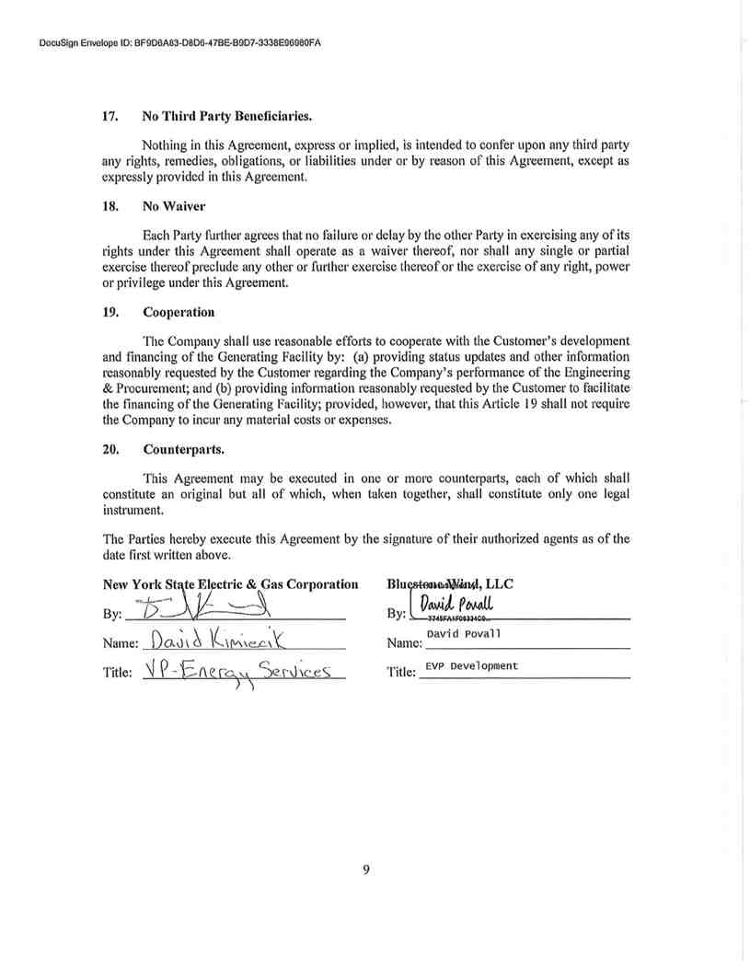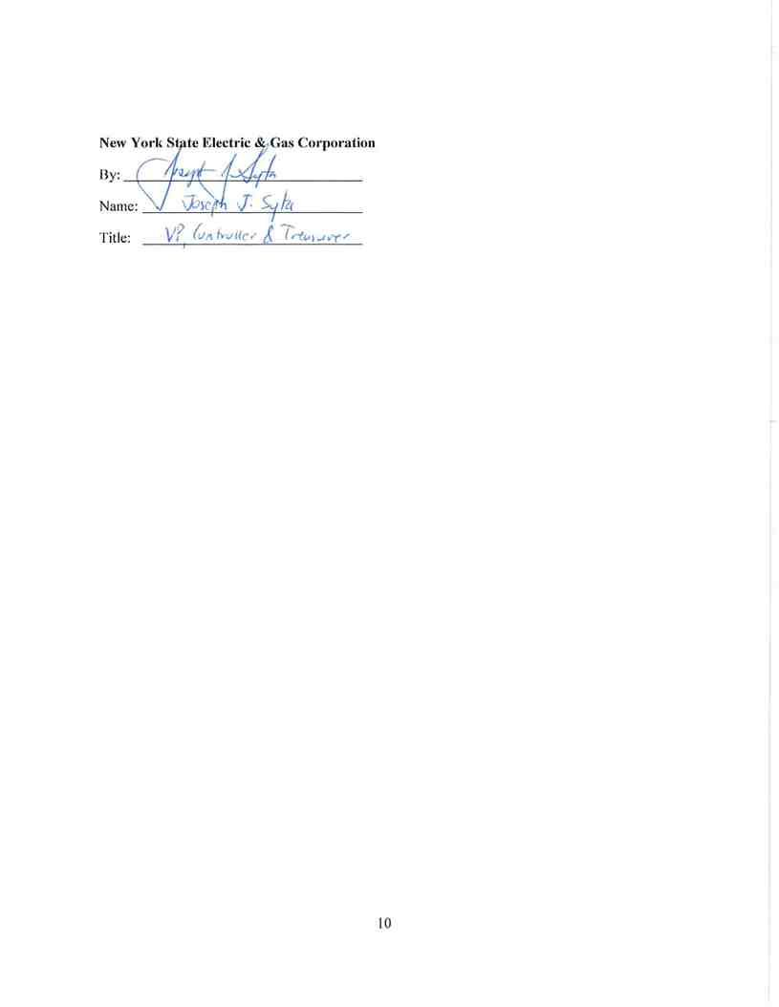

ATTACHMENT A

Scope of Engineering & Procurement

I. NYSEG Scope of Work

The Developer is electing to construct the project with oversight from NYSEG. NYSEG will place into service the new Company-owned and/or operated facilities, and the modifications to existing Company-owned and/or operated facilities.

NYSEG will provide Owner’s Engineer (“OE”) services to review the Developer’s engineering, design, construction, testing and commissioning of the new Bluestone Wind facility as described in Section II below.

NYSEG OE scope may include civil and electrical review of the above and below ground   
engineering and design, protection and control engineering and design review, field construction   
management to oversee, but not direct, the construction work, and Testing and Commissioning of   
the project.

II. Developer scope of work is to engineer, permit, procure, construct, and commission:

A new 115 kV three-breaker ring-bus POI station will be constructed adjacent to the existing

NYSEG 115 kV L954 between NYSEG Afton and Stilesville Substations with remote terminals   
at NYSEG Jennison and Hancock Substations. It is assumed that the new POI station will be   
directly adjacent to the existing NYSEG 115 kV ROW to minimize the length of new 115 kV   
transmission construction between L954 and the new POI station. Substation Upgrade Facilities   
are required at the existing L954 terminals at Jennison and Hancock Substations. Major   
components include:

• NEW 115 kV POI STATION

• (3) 115kV class circuit breakers with bushing current transformers

• (10) 115kV motor-operated switches, breaker disconnect

• (9) 115kV CCVTs

• (6) 115kV line surge arresters

o 115kV station service transformer

o 115kV combination VT/CT metering units

• New control building with Protection & Control equipment, SCADA, communications,   
 AC/DC facilities, etc.

• Steel structures, bus, insulators, trench, conduits, control cable, grounding, fence, site   
 development, foundations, etc.

• TRANSMISSION LINE CONSTRUCTION

• New steel poles, conductor, and insulators to break into existing L954 and construct two new   
 115kV connections to the POI transmission line terminal structures.

• SUBSTATION UPGRADE FACILITIES AT REMOTE ENDS OF L954

• Protection, control, SCADA, and communication modifications at Jennison and Hancock   
 Substations to coordinate with the new POI substation.

Assumptions/Clarifications:

• Cost for real estate is not included.

• Cost for environmental licensing and permitting is not included.

• Assumes the new POI station is not classified as a Bulk Power Station per NPCC   
 Document A-10 or a station per NERC Bulk Electric System.

• No costs included for the Developer’s Collector Station and other required facilities

III. Project Cost Estimates

The estimated four hundred thousand dollars ($400,000) for the NYSEG scope is intended to

cover services through to execution of an LGIA contract. In the event the LGIA is not executed prior to the funding running out, an amendment to this Agreement will be required to provide additional funds in order to continue providing services.

IV. Project Schedule

Upon receipt of payment, the Parties shall develop and agree upon the schedule of the Engineering and Procurement taking into account the Customer’s anticipated schedule for submittal of information to the Company. The Company agrees to provide comments or approvals within fifteen (15) business days of receipt of such information from the Customer.

129874.00107/6767485v.1