FERC rendition of the electronically filed tariff records in Docket No. [include if docket no. exists]
Filing Data:
CID: C000038
Filing Title: National Grid and Rochester Gas and Electric Corporation Cost Reimbursement Agreement Company Filing Identifier: 1036
Type of Filing Code: 10
Associated Filing Identifier: [if applicable]
Tariff Title: NYISO Agreements
Tariff ID: 58
Payment Confirmation: N
Suspension Motion:

Tariff Record Data:
Record Content Description: Service Agreement No. 2135
Tariff Record Title: Cost Reimbursement Agreement between National Grid & RG&E Record Version Number: 1.0.0
Option Code: A
Tariff Record ID: 142
Tariff Record Collation Value: 7071900
Tariff Record Parent Identifier: 2
Proposed Date: 2015-05-29
Priority Order: 600
Record Change Type: Change Record Content Type: 2
Associated Filing Identifier: [Source - if applicable]

COST REIMBURSEMENT AGREEMENT
Between
NIAGARA MOHAWK POWER CORPORATION
d/b/a National Grid

and
ROCHESTER GAS AND ELECTRIC CORPORATION
(NYISO OATT Service Agreement No. 2135)

COST REIMBURSEMENT AGREEMENT
This COST REIMBURSEMENT AGREEMENT (the “Agreement”), is made and entered into as of March 31, 2014 (the “Effective Date”), by and between ROCHESTER GAS AND ELECTRIC CORPORATION, a utility organized and existing under the laws of NEW York State, having an office and place of business at 89 East Avenue Rochester, NY 14604 (“Customer” or “RG&E”) and NIAGARA MOHAWK POWER CORPORATION d/b/a National Grid, a corporation organized and existing under the laws of the State of New York, having an office and place of business at 300 Erie Boulevard West, Syracuse, New York 13202 (the “Company” or “National Grid”). Customer and Company may be referred to hereunder, individually, as a “Party” or, collectively, as the “Parties”.

WITNESSETH

WHEREAS, Customer has requested that Company perform certain Work with respect
to Mortimer Station, Station 251 and related portions of transmission lines/circuits and
equipment located inside the property line of the impacted National Grid Stations as described herein; and

WHEREAS, Company is willing to perform the Work, subject to reimbursement by Customer of all Company costs and expenses incurred in connection therewith;

NOW, THEREFORE, in consideration of the premises and the mutual covenants set forth herein, the Parties agree as follows:

1.0 Certain Definitions
Wherever used in this Agreement with initial capitalization, whether in the singular or the plural, these terms shall have the following meanings:
“Affiliate” means any person or entity controlling, controlled by, or under common control with, any other person; “control” of a person or entity shall mean the ownership of, with right to vote, 50% or more of the outstanding voting securities, equity, membership interests, or equivalent, of such person or entity.
“Agreement” means this Cost Reimbursement Agreement, including all annexes, appendices, attachments, schedules, and exhibits and any subsequent written amendments or modifications thereto, as may be mutually agreed to and executed by the Parties.

“Applicable Requirements” shall mean all applicable federal, state and local laws,
regulations, rules, ordinances, codes, decrees, judgments, directives, or judicial or
administrative orders, permits and other duly authorized actions of any federal, state, local or
other governmental regulatory or administrative agency, court, commission, department,
board, or other governmental subdivision, legislature, rulemaking board, tribunal, or other

governmental authority having jurisdiction, NYISO, NPCC, and NYSRC requirements, and any applicable reliability standards.
“Balance Amount” shall have the meaning set forth in Section 8.1 of this Agreement. “Breaching Party” shall have the meaning set forth in Section 21.1 of this Agreement. “CEII” shall have the meaning set forth in Section 25.4 of this Agreement.
“Company Reimbursable Costs” means the actual costs and expenses incurred by Company
and/or its Affiliates in connection with performance of the Work or otherwise incurred by
Company and/or its Affiliates in connection with the Project or this Agreement, and
including, without limitation, any such costs that may have been incurred by Company
and/or its Affiliates prior to the Effective Date. These Company Reimbursable Costs shall
include, without limitation, the actual expenses for labor (including, without limitation,
internal labor), services, materials, subcontracts, equipment or other expenses incurred in the execution of the Work or otherwise in connection with the Project, all applicable overhead, all federal, state and local taxes incurred (including, without limitation, all taxes arising from amounts paid to Company that are deemed to be contributions in aid of construction), all costs of outside experts, consultants, counsel and contractors, all other third-party fees and costs, and all costs of obtaining any required permits, rights, consents, releases, approvals, or authorizations, including, without limitation, the Required Approvals.
“Damages” shall have the meaning set forth in Section 12.1 of this Agreement.
“Day” means a calendar day, provided, that, if an obligation under this Agreement falls due
on a Saturday, Sunday or legal holiday, the obligation shall be due the next business day
worked.
“Disclosing Party” shall mean the Party disclosing Proprietary Information. “Dollars” and “$” mean United States of America dollars.
“Effective Date” shall have the meaning specified in the preamble of this Agreement.
“Environment” shall mean soil, surface waters, groundwaters, land, stream sediments, surface or subsurface strata, and ambient air.

“Environmental Law” shall mean any environmental or health-and-safety-related law, regulation, rule, ordinance, or by-law at the federal, state, or local level, whether existing as of the Effective Date, previously enforced or subsequently enacted, or any judicial or administrative interpretation thereof.

“FERC” shall mean the Federal Energy Regulatory Commission.
“Force Majeure Event” shall have the meaning set forth in Section 23.1 of this Agreement.

“Good Utility Practice” means any of the practices, methods, and acts engaged in or
approved by a significant portion of the electric utility industry during the relevant time
period, or any of the practices, methods, and acts which, in the exercise of reasonable
judgment in light of the facts known at the time the decision was made, could have been
expected to accomplish the desired result at a reasonable cost consistent with good business
practices, reliability, safety, and expedition. Good Utility Practice is not intended to be
limited to the optimum practice, method, or act, to the exclusion of all others, but rather to
refer to acceptable practices, methods, or acts generally accepted in the region in which the
Project is located. Good Utility Practice shall include, but not be limited to, NERC, NPCC,
NYSRC, and NYISO criteria, rules, guidelines, and standards, where applicable, and as they
may be amended from time to time, including the rules, guidelines, and criteria of any
successor organization to the foregoing entities.

“Hazardous Substances” means any pollutant, contaminant, toxic substance, hazardous material, hazardous waste, or hazardous substance, or any oil, petroleum, or petroleum product, as defined in or pursuant to the Federal Clean Water Act, as amended, the Comprehensive Environmental Response, Compensation and Liability Act, as amended, 42 U.S.C. Section 9601, et seq., the Resource Conservation and Recovery Act, as amended, 42 U.S.C. Section 6901, et seq., or any other Environmental Law.
“Indemnified Party” and “Indemnified Parties” shall have the meanings set forth in Section
12.1 of this Agreement.
“Indemnifying Party” shall have the meaning set forth in Section 12.1 of this Agreement.
“Initial Prepayment” shall have the meaning set forth in Section 7.1 of this Agreement.
“Monthly Report” shall have the meaning set forth in Section 7.3 of this Agreement.
“NPCC” shall mean the Northeast Power Coordinating Council, Inc. (a reliability council under Section 202 of the Federal Power Act) or any successor organization.
“NERC” shall mean the North American Electric Reliability Corporation or any successor organization.
“Non-Breaching Party” shall have the meaning set forth in Section 21.1 of this Agreement.
“Non-Disclosure Term” shall have the meaning set forth in Section 25.3.4 of this Agreement.
“NYISO” shall mean the New York Independent System Operator, Inc. or any successor organization.

“NYPSC” shall mean the New York Public Service Commission.
“NYSRC” shall mean the New York State Reliability Council or any successor organization.

“Party” and “Parties” shall have the meanings set forth in the preamble to this Agreement.

“Projected Milestone Schedule” shall have the meaning set forth in Section 5.3 of this Agreement.
“Project” means the Work to be performed under this Agreement by the Company.

“Project Manager” means the respective representative of the Customer and the Company appointed pursuant to Section 27.1 of this Agreement.
“Proprietary Information” means (i) all financial, technical and other non-public or
proprietary information which is furnished or disclosed by the Disclosing Party or its
Affiliates (or its or its Affiliates’ agents, servants, contractors, representatives, or employees)
to the Receiving Party or its Representative(s) in connection with this Agreement and that is
described or identified (at the time of disclosure) as being non-public, confidential or
proprietary, or the non-public or proprietary nature of which is apparent from the context of
the disclosure or the contents or nature of the information disclosed, (ii) any market sensitive
information (including, without limitation, outages scheduled on generators or transmission
lines of Company or any third party), (iii) all CEII and (iv) all memoranda, notes, reports,
files, copies, extracts, inventions, discoveries, improvements or any other thing prepared or
derived from any information described in subparts (i) through (iii) preceding.

“Receiving Party” shall mean the Party receiving Proprietary Information.
“Reimbursement Amount” shall have the meaning set forth in Section 8.1 of this Agreement.

“Release” shall mean any releasing, spilling, leaking, contaminating, pumping, pouring, emitting, emptying, discharging, injecting, escaping, leaching, disposing or dumping of any Hazardous Substances into the Environment.
“Representatives” shall, for the purposes of Article 25 of this Agreement, mean the Affiliates of a Party and such Party’s and its Affiliates’ officers, directors, employees, contractors, counsel and representatives.
“Requesting Party” shall have the meaning set forth in the Real Property Standards.
“Required Approvals” shall have the meaning set forth in Section 27.12 of this Agreement. “Resources” shall have the meaning set forth in Section 23.1 of this Agreement.
“Threat of Release” shall mean a substantial likelihood of a Release that requires action to prevent or mitigate damage to the Environment that may result from such Release.

“Site” shall mean Luther Forest Station.

“Subcontractor” means any organization, firm or individual, regardless of tier, which Company retains in connection with the Agreement.
“Total Payments Made” shall have the meaning set forth in Section 8.1 of this Agreement.
“Work” shall have the meaning specified in Section 3.1 of this Agreement.
“Work Cost Estimate” shall have the meaning set forth in Section 6.1 of this Agreement.
2.0 Term
2.1 This Agreement shall become effective as of the Effective Date and shall remain
in full force and effect until performance has been completed hereunder, or until
terminated in accordance with the terms of this Agreement, whichever occurs
first, provided, however, that this Agreement shall not expire or terminate until all
amounts due and owing hereunder have been paid in full as contemplated by this
Agreement.

3.0 Scope of Work
3.1 The scope of work is set forth in Exhibit A of this Agreement, attached hereto and
incorporated herein by reference (the “Work”).

3.2 Company shall use commercially reasonable efforts to perform the Work in
accordance with Good Utility Practice. Prior to the expiration of one (1) year
following completion of the Work, Customer shall have the right to notify the
Company of the need for correction of defective Work that does not meet the
standards of this Section 3.2. If the Work is defective within the meaning of the
prior sentence, the Company shall promptly complete, correct, repair or replace
such defective Work, as appropriate. The remedy set forth in this Section is the
sole and exclusive remedy granted to Customer for any failure of Company to
meet the performance standards or requirements set forth in this Agreement.

4.0 Changes in the Work
4.1 Prior to commencement of the Work, each Party shall provide a written notice to
the other Party containing the name and contact information of such Party’s Project Manager.

4.2 If Customer wishes to request a change in the Work, such request shall be
submitted to the Company in writing. If, as a result of any such request, the Parties agree to a change in the Work, the agreed change will be set forth in a written document signed by both Parties specifying such change. The Projected Milestone Schedule and the Work Cost Estimate shall be adjusted and/or extended as mutually agreed by the Parties to reflect any such agreed change to the Work. Any additional costs arising from such change shall be paid by the Customer as part of Company Reimbursable Costs when invoiced by the Company in accordance with Section 7.2 of this Agreement.
4.3 Notwithstanding the above, Company may make any reasonable changes in the
Work to ensure the completion of the Project or prevent delays in the schedule. Company shall provide Customer with written notice of any such changes to the Work within fifteen (15) business days after such changes are implemented. The Projected Milestone Schedule and the Work Cost Estimate shall be adjusted accordingly and any additional costs shall be paid by the Customer as part of Company Reimbursable Costs when invoiced by the Company in accordance with Section 7.2 of this Agreement.

The foregoing notwithstanding, the Company is not required to obtain the consent
of the Customer for any change to the Work if such change is made in order to
comply with any Applicable Requirement(s) or Good Utility Practice or to enable
Company’s utility facilities to continue, commence or recommence commercial
operations in accordance with all applicable legal and regulatory requirements and
all applicable industry codes and standards. The Projected Milestone Schedule
and the Work Cost Estimate shall be adjusted accordingly and any additional
costs shall be paid by the Customer as part of Company Reimbursable Costs when
invoiced by the Company in accordance with Section 7.2 of this Agreement.

5.0 Performance and Schedule; Conditions to Proceed
5.1 The Company shall use commercially reasonable efforts to have any Work
performed by its direct employees performed during normal working hours. The
foregoing notwithstanding, if Work is performed outside of normal working hours,
Customer shall be responsible for paying all actual costs incurred in connection
therewith, including, without limitation, applicable overtime costs, as part of
Company Reimbursable Costs. The Company shall provide the Customer with
prior notification when work outside of normal working hours is required.
5.2 If Customer requests, and the Company agrees, to work outside normal working
hours due to delays in the Project schedule or for other reasons, Company shall be entitled to recover all resulting costs as part of Company Reimbursable Costs.

5.3 The Projected Milestone Schedule is set forth in Exhibit B, attached hereto and
incorporated herein by reference. The Projected Milestone Schedule is a
projection only and is subject to change. Both Parties shall make reasonable
efforts to adhere to the Projected Milestone Schedule. Neither Party shall be liable

for failure to meet the Preliminary Milestone Schedule, any milestone, or any other
projected or preliminary schedule in connection with this Agreement or the
Project.

5.4 Anything in this Agreement to the contrary notwithstanding, Company shall not be
obligated to proceed with any Work until all of the following conditions have been
satisfied:
(i) all Required Approvals for the Work have been received, are in
form and substance satisfactory to the Parties, have become final
and non-appealable and commencement of the Work is permitted
under the terms and conditions of such Required Approvals, and
(ii) all Company Reimbursable Costs invoiced to date have been paid
in full to Company.

6.0 Estimate Only; Customer Obligation to Pay Company Reimbursable Costs.
6.1 The current good faith estimate of the Company Reimbursable Costs, exclusive of
any applicable taxes, is One Million Three Hundred Thousand Dollars ($1,300,000) (the “Work Cost Estimate”). The Work Cost Estimate is an estimate only and shall not limit Customer’s obligation to pay Company for all Company Reimbursable Costs actually incurred by Company or its Affiliates.

7.0 Payment
7.1 Customer shall pay or reimburse Company for all Company Reimbursable Costs.
The Company has previously invoiced Customer for, and Customer has paid, an
initial prepayment of One Hundred Fifty Thousand dollars ($150,000) (the “Prior
Prepayment”). Company shall invoice Customer for an additional prepayment of
Five Hundred Thousand Dollars ($500,000) (the “Additional Prepayment”, and,
together with the Prior Prepayment, the “Initial Prepayment”) and Customer shall
pay the Additional Prepayment to Company within thirty (30) Days of the invoice
due date. Company shall not be obligated to commence or continue Work under
this Agreement, as amended, prior to receiving payment in full of the Initial
Prepayment.
7.2 Company may periodically invoice Customer for Company Reimbursable Costs
incurred. Each invoice will contain reasonable detail sufficient to show the
invoiced Company Reimbursable Costs incurred by line item. Company is not
required to issue periodic invoices to Customer and may elect, in its sole
discretion, to continue performance hereunder after the depletion of the Initial
Prepayment or any subsequent prepayment, as applicable, and invoice Customer
at a later date. Except as otherwise expressly provided for in this Agreement, all
invoices shall be due and payable thirty (30) Days from date of invoice. If any
payment due under this Agreement is not received within thirty (30) Days after
the applicable invoice due date, the Customer shall pay to the Company interest

on the unpaid amount at an annual rate equal to two percent (2%) above the prime
rate of interest from time to time published under “Money Rates” in The Wall
Street Journal (or if at the time of determination thereof, such rate is not being
published in The Wall Street Journal, such comparable rate from a federally
insured bank in New York, New York as the Company may reasonably
determine), the rate to be calculated daily from and including the due date until
payment is made in full. In addition to any other rights and remedies available to
Company, if any payment due from Customer under this Agreement is not
received within thirty (30) Days after the applicable invoice due date, Company
may suspend any or all Work pending receipt of all amounts due from Customer;
any such suspension shall be without recourse or liability to Company.

7.3 Each month during the term of this Agreement, the Company shall provide
Customer with a report (each, a “Monthly Report”) containing (i) unless invoiced,
the Company’s current estimate of the Company Reimbursable Costs incurred in
the prior calendar month, and (ii) the Company’s current forecast (20% to 40%
variance) of the Company Reimbursable Costs expected to be incurred in the next
calendar month, provided, however, that such Monthly Reports (and any
forecasted or estimated amounts reflected therein) shall not limit Customer’s obligation to pay Company for all Company Reimbursable Costs actually incurred by Company or its Affiliates.

7.4 If Customer claims exemption from sales tax, Customer agrees to provide
Company with an appropriate, current and valid tax exemption certificate, in form
and substance satisfactory to National Grid, relieving National Grid from any
obligation to collect sales taxes from Customer ("Sales Tax Exemption
Certificate"). During the term of this Agreement, Customer shall promptly
provide National Grid with any modifications, revisions or updates to the Sales
Tax Exemption Certificate or to Customer's exemption status. If Customer fails
to provide an acceptable Sales Tax Exemption Certificate for a particular
transaction, National Grid shall add the sales tax to the applicable invoice to be
paid by Customer.

7.5 Company shall maintain reasonably detailed records to document the Company
Reimbursable Costs. So long as a request for access is made within six (6)
months of completion of the Work, Customer and its chosen auditor shall, during
normal business hours and upon reasonable advanced written notice of not less
than ten (10) days, be provided with access to such records for the sole purpose of
verification by Customer that the Company Reimbursable Costs have been
incurred by Company.
7.6 Company’s invoices to Customer for all sums owed under this Agreement shall be
sent to the individual and address specified below, or to such other individual and
address as Customer may designate, from time to time, by written notice to the
Company :

Name: Mr. David Fingado
Address: RG&E
1300 Scottsville Road
Rochester, NY 14624
7.7 All payments made under this Agreement shall be made in immediately available
funds. Payments to the Company shall be made by wire transfer to:
Wire Payment: JP Morgan Chase
ABA#: 021000021
Credit: National Grid USA
Account#: 77149642

8.0 Final Payment
8.1 Following completion of the Work, the Company shall perform an overall
reconciliation of the total of all Company Reimbursable Costs to the invoiced
costs previously paid to Company by Customer under this Agreement (“Total
Payments Made”). If the total of all Company Reimbursable Costs is greater than
the Total Payments Made, the Company shall provide a final invoice to Customer
for the balance due to the Company under this Agreement (the “Balance
Amount”). If the Total Payments Made is greater than the total of all Company
Reimbursable Costs, Company shall reimburse the difference to Customer
(“Reimbursement Amount”). The Reimbursement Amount or Balance Amount, as
applicable, shall be due and payable upon final reconciliation but no later than
sixty (60) Days after such reconciliation. Any portion of the Balance Amount or
Reimbursement Amount, as applicable, remaining unpaid after that time shall be
subject to interest as calculated pursuant to Section 7.2 of this Agreement.
9.0 Customer’s Responsibilities
9.1 If and to the extent applicable or under the control of the Customer, Customer
shall provide complete and accurate information regarding requirements for the Project and the Site(s), including, without limitation, constraints, space requirements, underground or hidden facilities and structures, and all applicable drawings and specifications.
9.2 Customer shall prepare, file for, and use commercially reasonable efforts to obtain
all Required Approvals necessary to perform its obligations under this
Agreement.
9.3 Customer shall reasonably cooperate with Company as required to facilitate
Company’s performance of the Work, including, without limitation, performance
of any work or tasks to be performed by Customer as contemplated by Exhibit A
of this Agreement.

10.0 Meetings

10.1 Each Party’s Project Manager shall attend Project meetings at times and places
mutually agreed to by the Parties, which meetings shall be held at least monthly
by teleconference or in person as agreed to by the Project Managers.

11.0 Disclaimers
11.1 THE COMPANY IS NOT IN THE BUSINESS OF PERFORMING DESIGN,
ENGINEERING OR CONSTRUCTION SERVICES FOR PROFIT AND IS
NOT RECEIVING ANY FEE OR PROFIT (AS CONTRASTED WITH COST
REIMBURSEMENT) FOR ITS PERFORMANCE OF THE WORK
HEREUNDER. THE EXCLUSIVE REMEDY GRANTED TO CUSTOMER
FOR ANY ALLEGED FAILURE OF COMPANY TO MEET THE
PERFORMANCE STANDARDS OR REQUIREMENTS CONTAINED IN
THIS AGREEMENT IS AS SET FORTH IN SECTION 3.2. COMPANY
MAKES NO WARRANTIES, REPRESENTATIONS, OR GUARANTEES IN
CONNECTION WITH THIS AGREEMENT, ANY PROJECT, OR ANY WORK
OR SERVICES PERFORMED IN CONNECTION THEREWITH, WHETHER
WRITTEN OR ORAL, STATUTORY, EXPRESS OR IMPLIED, INCLUDING,
WITHOUT LIMITATION, THE IMPLIED WARRANTIES OF
MERCHANTABILITY AND FITNESS FOR A PARTICULAR PURPOSE,
ALL OF WHICH ARE HEREBY EXPRESSLY EXCLUDED AND
DISCLAIMED. CUSTOMER ACKNOWLEDGES AND AGREES THAT ANY
WARRANTIES PROVIDED BY ORIGINAL MANUFACTURERS,
LICENSORS, OR PROVIDERS OF MATERIAL, EQUIPMENT, SERVICES
OR OTHER ITEMS PROVIDED OR USED IN CONNECTION WITH THE
WORK, INCLUDING ITEMS INCORPORATED IN THE WORK (“THIRD
PARTY WARRANTIES”), ARE NOT TO BE CONSIDERED WARRANTIES
OF THE COMPANY AND THE COMPANY MAKES NO
REPRESENTATIONS, GUARANTEES, OR WARRANTIES AS TO THE
APPLICABILITY OR ENFORCEABILITY OF ANY SUCH THIRD PARTY
WARRANTIES.

11.2 Notwithstanding any other provision of this Agreement, this Article shall survive
the termination, cancellation or expiration of this Agreement.

12.0 Liability and Indemnification
12.1 To the fullest extent permitted by applicable law (including, without limitation,
the applicable provisions of any governing federal or state tariff), Customer shall
indemnify and hold harmless, and at Company’s option, defend Company, its
parents and Affiliates and their respective contractors, officers, directors, servants,
agents, representatives, and employees (each, individually, an “Indemnified
Party” and, collectively, the “Indemnified Parties”), from and against any and all
liabilities, damages, losses, costs, expenses (including, without limitation, any and
all reasonable attorneys' fees and disbursements), causes of action, suits, liens,
claims, damages, penalties, obligations, demands or judgments of any nature,
including, without limitation, for death, personal injury and property damage,
economic damage, and claims brought by third parties for personal injury and/or
property damage (collectively, “Damages”), incurred by any Indemnified Party to
the extent caused by (i) any breach of this Agreement by Customer, its Affiliates,
third-party contractors, or their respective officers, directors, servants, agents,
representatives, or employees, or (ii) the negligence, unlawful act or omission, or
intentional misconduct of Customer, its Affiliates, third-party contractors, or their
respective officers, directors, servants, agents, representatives, and employees,
arising out of or in connection with this Agreement, the Project, or any Work,
except to the extent such Damages are directly caused by the gross negligence,
intentional misconduct or unlawful act of the Indemnified Party or its contractors,
officers, directors, servants, agents, representatives, or employees.

12.2 Customer shall defend, indemnify and save harmless Company, its parents and
Affiliates and their respective contractors, officers, directors, servants, agents, representatives, and employees, from and against any and all liabilities, losses, costs, counsel fees, expenses, damages, judgments, decrees and appeals resulting from any charge or encumbrance in the nature of a laborer’s, mechanic’s or materialman’s lien asserted by any of Customer’s subcontractors or suppliers in connection with the Work or the Project.
12.3 Customer shall also protect, indemnify and hold harmless the Company and its
Affiliates from and against the cost consequences of any tax liability imposed
against or on Company and/or its Affiliates as the result of payments, and/or real
or personal property transfers, made in connection with this Agreement, as well as
any related interest and penalties, other than interest and penalties attributable to
any delay directly caused by Company or the applicable Company Affiliate.

12.4 The Company’s total cumulative liability to Customer for all claims of any kind,
whether based upon contract, tort (including negligence and strict liability), or
otherwise, for any loss, injury, or damage connected with, or resulting from, this
Agreement, the Project or the Work, shall not exceed the aggregate amount of all
payments made to Company by Customer as Company Reimbursable Costs under
this Agreement.

12.5 Neither Party shall be liable to the other Party for consequential, indirect, special,
incidental, multiple, or punitive damages (including, without limitation, attorneys’ fees or litigation costs) in connection with or related to this Agreement, including, without limitation, damage claims based on causes of action for breach of contract, tort (including negligence), or any other theory of recovery, whether or not (i) such damages were reasonably foreseeable or (ii) the Parties were advised or aware that such damages might be incurred.
12.6 Neither Party shall be liable to the other Party for claims or damages for lost
profits, delays, loss of use, business interruption, or claims of customers, whether
such claims are categorized as direct or consequential damages, or whatever the
theory of recovery, and whether or not (i) such damages were reasonably
foreseeable or (ii) the Parties were advised or aware that such damages might be incurred.
12.7 Anything in this Agreement to the contrary notwithstanding, neither Party shall be
responsible for any failure or inability to perform hereunder to the extent such failure or inability is caused by the acts or omissions of the other Party (including any contractor of such Party or any person or entity for whom such Party is legally responsible) or of any third party (other than a subcontractor of the Party that is unable or failing to perform hereunder).

For the avoidance of doubt: neither Party, as applicable, shall have any
responsibility or liability under this Agreement for any delay in performance or
nonperformance to the extent such delay in performance or nonperformance is
caused by or as a result of (a) the inability or failure of the other Party or its
contractors to cooperate or to perform any tasks or responsibilities contemplated
to be performed or undertaken by such other Party under this Agreement, (b) any
unforeseen conditions or occurrences beyond the reasonable control of the Party
(including, without limitation, conditions of or at the Site, delays in shipments of
materials and equipment and the unavailability of materials), (c) the inability or
failure of Customer and Company to reach agreement on any matter requiring
their mutual agreement under the terms of this Agreement, or (d) any valid order
or ruling by any governmental agency or authority having jurisdiction over the
subject matter of this Agreement.
12.8 Anything in this Agreement to the contrary notwithstanding, if any Party’s
liability in connection with this Agreement is limited or capped pursuant to any applicable law, statute, rule or regulation, then the other Party hereto shall be entitled to elect an identical liability limitation and/or cap as if such law, statute, rule or regulation were applicable to such Party.

12.9 Notwithstanding any other provision of this Agreement, this Article shall survive
the termination, cancellation or expiration of this Agreement.

13.0 Employee Claims; Insurance
13.1 The Company elects to self-insure to maintain the insurance coverage amounts set
forth in Exhibit C of this Agreement.
13.2 Prior to commencing Work on the Project and during the term of the Agreement,
the Customer, at its own cost and expense, shall procure and maintain insurance in form and amounts set forth in Exhibit C of this Agreement, or Customer may self-insure to the extent authorized or licensed to do so under the applicable laws of the State of New York. Customer hereby elects to self-insure to maintain the insurance coverage amounts set forth in Exhibit C of this Agreement.

13.3 Except to the extent Customer self-insures in accordance with Section 13.2
hereof, the Customer shall have its insurer furnish to the Company certificates of insurance, on forms approved by the Insurance Commissioner of the State of New York, evidencing the insurance coverage required by this Article, such certificates to be provided prior to commencement of Work.

13.4 Each Party shall be separately responsible for insuring its own property and
operations.

14.0 Assignment and Subcontracting
14.1 Either Party may assign this Agreement, or any part thereof, to any of its
Affiliates provided such assignee Affiliate agrees in writing to be bound by the
terms and conditions of this Agreement. Any assignment of this Agreement in
violation of the foregoing shall be voidable at the option of the non-assigning
Party. Each Party has the right to subcontract some or all of the work to be
performed by such Party under the terms of this Agreement. Each Party may also
use the services of its Affiliates in connection with its performance under this
Agreement. Customer agrees that the costs and expenses of such Affiliates or
contractors charged to or incurred by Company shall be paid by Customer as part
of the Company Reimbursable Costs.

15.0 Independent Contractor; No Partnership; No Agency; No Utility Services
15.1 Company and Customer shall be independent contractors. This Agreement shall
not be interpreted or construed to create an association, joint venture, agency
relationship, or partnership between the Parties or to impose any partnership
obligation or partnership liability upon any Party. No Party shall have any right,
power or authority to enter into any agreement or undertaking for, or act on behalf
of, or be an agent or representative of, or to otherwise bind, the other Party. This
Agreement is not an agreement to provide or take utility services of any kind,
including, without limitation, interconnection or other electric transmission
services.

16.0 Examination, Inspection and Witnessing
16.1 Subject to Customer’s and its representatives’ compliance with Company’s
security, safety, escort and other access requirements, the Customer and/or its
representatives shall have the right to inspect and examine the Work, or witness
any test with respect to the Work, from time to time, when and as mutually agreed
by the Parties, at Customer’s sole cost and expense, and with reasonable prior
notice to Company. Unless otherwise agreed between the Parties, such
inspections, examinations and tests shall be scheduled during normal business
hours.

17.0 Safety
17.1 Each Party shall be solely responsible for the safety and supervision of its own
employees, representatives and contractors involved with the Work or any other
activities contemplated by this Agreement. In connection with the activities
contemplated by this Agreement, each Party shall, and shall require its
representatives, contractors, and employees to, comply with all applicable
Federal, state and local health and safety requirements, rules, regulations, laws
and ordinances, including without limitation, the safety regulations adopted under
the Occupational Safety and Health Act of 1970 (“OSHA”), as amended from
time to time. While on the property (including, without limitation, easements or
rights of way) of, or accessing the facilities of, the other Party, each Party’s
employees and/or contractors and agents shall at all times abide by the other
Party’s safety standards and policies, switching and tagging rules, and escort and
other applicable access requirements. The Party owning or controlling the
property or facilities shall have the authority to suspend the other Party’s access,
work or operations in and around such property or facilities if, in its sole
judgment, at any time hazardous conditions arise or any unsafe practices are being
followed by the other Party’s employees, agents, representatives or contractors.

18.0 Approvals, Permits and Easements
18.1 The actual cost of obtaining all Required Approvals obtained by or on behalf of
the Company shall be paid for by Customer as part of Company Reimbursable
Costs.

19.0 Environmental Protection; Hazardous Substances or Conditions

19.1 The Company shall in no event be liable to Customer, its Affiliates or contractors,
their respective officers, directors, employees, agents, servants, or representatives,
or any third party with respect to, or in connection with, the presence of any
Hazardous Substances which may be present at or on any Customer or third party
owned, occupied, used, or operated property or facility (including, without
limitation, easements, rights-of-way, or other third-party property) or which the
Company, its Affiliates or contractors, their respective officers, directors,

employees, agents, servants, or representatives may discover, release, or generate
at or on such properties or facilities through no negligent or unlawful act of the
Company, and Company hereby disclaims any and all such liability to the fullest
extent allowed by applicable law. Customer agrees to hold harmless, defend, and
indemnify the Company, its Affiliates and contractors, and their respective
directors, officers, agents, servants, employees and representatives from and
against any and all claims and/or liability in connection with, relating to, or
arising out of (i) the presence, discovery, release, threat of release or generation of
Hazardous Substances, or (ii) the breach of any Federal, state, or local laws, rules,
regulations, codes, or ordinances relating to the environment, including, without
limitation, the Comprehensive Environmental Response, Compensation and
Liability Act, as amended, 42 U.S.C. §§ 9601 et seq., the Resource Conservation
and Recovery Act, as amended, 42 U.S.C. §§ 6901 et seq., except to the extent
such presence, discovery, release, threat of release, generation or breach is or are
directly and solely caused by the negligent or unlawful act of the Company or of
any person or entity for whom the Company is legally responsible. The
obligations under this Section shall not be limited in any way by any limitation on
Customer’s insurance or by any limitation of liability or disclaimer provisions
contained in this Agreement. The provisions of this Section shall survive the
expiration, cancellation or earlier termination of this Agreement.
19.2 Customer shall promptly inform the Company, in writing, of any Hazardous
Substances, or unsafe, dangerous, or potentially dangerous, conditions or
structures, whether above-ground or underground, that are present on, under,
over, or in Customer- owned, occupied, used, managed or operated facilities or
property (including, without limitation, easements, rights-of-way, or other third-
party property) to be used or accessed in connection with the Work or this
Agreement. Prior to Company’s commencement of the Work, Customer shall be
obligated to use its best efforts (including, without limitation, the use of
DIGSAFE or other similar services) to adequately investigate the presence and
nature of any such Hazardous Substances, or unsafe, dangerous, or potentially
dangerous, conditions or structures, and to promptly, fully, and in writing,
communicate the results thereof to the Company. Customer’s provision to the
Company of the information contemplated in this Section shall in no event give
rise to any liability or obligation on the part of the Company, nor shall Customer’s
obligations under this Agreement, or under law, be decreased or diminished
thereby.

20.0 Suspension of Work
20.1 Subject to Section 20.2, below, Customer may interrupt, suspend, or delay the
Work by providing written notice to the Company specifying the nature and expected duration of the interruption, suspension, or delay. Company will use commercially reasonable efforts to suspend performance of the Company Work as requested by Customer. Customer shall be responsible to pay Company (as part of Company Reimbursable Costs) for all costs incurred by Company that arise as a result of such interruption, suspension or delay.
20.2 As a precondition to the Company resuming the Work following a suspension
under Section 20.1, the Projected Milestone Schedule and the Work Cost Estimate shall be revised as mutually agreed by the Parties to reflect the interruption, suspension, or delay. Adjustments to the Company Reimbursable Costs shall include any costs or expenses the Company incurs as a result of the interruption, suspension, or delay.

21.0 Right to Terminate Agreement
21.1 If either Party (the “Breaching Party”) (a) fails to pay any amount when due
under the terms of this Agreement or fails to comply with or perform, in any
material respect, any of the other terms or conditions of this Agreement; (b) sells
or transfers all or substantially all of its assets; (c) enters into any voluntary or
involuntary bankruptcy proceeding or receivership; or (d) makes a general
assignment for the benefit of its creditors, then the other Party (the “Non-
Breaching Party”) shall have the right, without prejudice to any other right or
remedy and after giving five (5) Days’ written prior notice to the Breaching Party
and a reasonable opportunity for cure (not to exceed thirty (30) Days in the case
of a failure to pay amounts when due), to terminate this Agreement, in whole or in
part, and thereupon each Party shall discontinue its performance hereunder to the
extent feasible and make every reasonable effort to procure cancellation of
existing Work- and/or Project- related commitments, orders and contracts upon
terms that are reasonably expected to minimize all associated costs. However,
nothing herein will restrict Company’s ability to complete aspects of the Work
that Company must reasonably complete in order to return its facilities and the
Sites to a configuration in compliance with Good Utility Practice and all
Applicable Requirements. The Non-Breaching Party shall also have the right to
pursue any and all rights it may have against the Breaching Party under applicable
law, subject to other applicable terms and conditions of this Agreement
(including, without limitation, any applicable limitations on liability contained
herein).
21.2 In the event of any early termination or cancellation of the Work as contemplated
in this Agreement, Customer shall pay Company for:

(i) all Company Reimbursable Costs for Work performed on or before the
effective date of termination or cancellation;

(ii) all other Company Reimbursable Costs incurred by Company in
connection with the Work prior to the effective date of termination or
cancellation, including, without limitation, for materials, equipment, tools,
construction equipment and machinery, engineering and other items,
materials, assets or services which cannot reasonably be avoided, mitigated or
cancelled;
(iii) all Company Reimbursable Costs incurred to unwind Work that was
performed prior to the effective date of termination or cancellation to the
extent reasonably necessary to return Company’s facilities to a configuration
in compliance with Good Utility Practice and all Applicable Requirements;
(iv) all Company Reimbursable Costs arising from cancellation costs relating to orders or contracts entered into in connection with the Work prior to the effective date of termination or cancellation; and

(v) all Company Reimbursable Costs arising from demobilization expenses incurred by Company which cannot be reasonably avoided or mitigated.
22.0 [Reserved]
23.0 Force Majeure
23.1 A “Force Majeure Event” shall include fire, flood, windstorm, adverse weather
conditions, emergencies, explosion, terrorism, riot, war, sabotage, acts of God,
strikes or labor slow-downs, court injunction or order, federal and/or state law or
regulation, delays by governmental authorities in approving regulatory, license
and permit requests necessary in connection with the Work or Project, or order by
any federal or state regulatory agency, or other causes, conditions or
circumstances beyond the affected Party’s reasonable control. Without limiting
the foregoing, a “Force Majeure Event” shall also include unavailability of
personnel, equipment, supplies, or other resources (“Resources”) due to diversion of such Resources for other utility-related duties in connection with an emergency or other similar contingency, including, without limitation, storms or other adverse weather conditions.
If a Force Majeure Event should occur and impair the ability of either or both
Parties to perform its, or their respective, obligations hereunder, then, to the extent
affected by such Force Majeure Event, the performance of this Agreement, with
the exception of payment obligations, shall be suspended for the duration of such
Force Majeure Event. At the conclusion of a Force Majeure Event, the price and
time for performance under this Agreement shall be adjusted as reasonably
necessary to overcome the effect of the delay occasioned by such Force Majeure
Event. The foregoing notwithstanding and with the exception of payment

obligations, if, as the direct or indirect result of any Force Majeure Event, the
Parties’ continued performance hereunder becomes irreparably impaired or
prevented, the Parties may mutually agree to terminate this Agreement, in whole
or in part, with no further obligation or liability; provided, however, that,
notwithstanding any such termination, Customer shall pay the Company all of the
Company’s Company Reimbursable Costs in accordance with Section 21.2 of this
Agreement.

23.2 Within thirty (30) Days after the termination of any delay occasioned by a Force
Majeure Event, the affected Party shall give written notice to the other Party specifying the estimated impact of the delay.

23.3 For the avoidance of doubt: to the extent any Party has a payment obligation
pursuant to the terms of this Agreement, such payment obligation shall not be
subject to or conditioned upon such Party receiving funding or reimbursement
from any third party (and any failure to secure such funding or reimbursement
shall not constitute a Force Majeure Event), nor shall any such obligation be
conditioned upon the other Party executing any certificates or other instruments
not expressly and specifically required by the terms of this Agreement.

24.0 [Reserved]
25.0 Proprietary and Confidential Information
25.1 Each Party acknowledges that, in the course of the performance of this
Agreement, it may have access to Proprietary Information of the other Party.

25.2 General Restrictions. Upon receiving Proprietary Information, the Receiving
Party) and its Representative shall keep in strict confidence and not disclose to
any person (with the exception of the Representatives of the Receiving Party, to
the extent each such Representative has a need to know in connection herewith)
any of the Disclosing Party’s Proprietary Information except as otherwise
provided by the terms and conditions of this Agreement. The Receiving Party and
its Representatives shall not use such Proprietary Information except for the
purposes identified herein without the prior written approval of the Disclosing
Party. The Receiving Party shall be solely liable for any breach of this Section to
the extent caused by its Representatives. Customer agrees that any Proprietary
Information will be used solely for the Project and will not be used, either directly
or indirectly, for the Customer's financial gain and/or commercial advantage or in
violation of any applicable laws, rules or regulations.
25.3 Exceptions. Subject to Section 25.4 hereof, the Receiving Party shall not be
precluded from, nor liable for, disclosure or use of Proprietary Information that:

25.3.1 is in or enters the public domain, other than by a breach of this
Section; or

25.3.2 is known to the Receiving Party or its Representatives at the time
of first disclosure hereunder, or thereafter becomes known to the Receiving Party or its Representatives subsequent to such disclosure without similar restrictions from a source other than the Disclosing Party, as evidenced by written records; or

25.3.3 is developed by the Receiving Party or its Representatives
independently of any disclosure under this Agreement, as evidenced by written records; or
25.3.4 is disclosed more than three (3) years after first receipt of the
disclosed Proprietary Information, or three (3) years after the
termination or expiration of this Agreement, whichever occurs later (the “Non-Disclosure Term”); or
25.3.5 is disclosed following receipt of the Disclosing Party’s written
consent to the disclosure of such Proprietary Information; or

25.3.6 is necessary to be disclosed, in the reasonable belief of the
Receiving Party or its Representatives, for public safety reasons, provided, that, Receiving Party has attempted to provide as much advance notice of the disclosure to the Disclosing Party as is practicable under the circumstances.
Anything in this Article or the Agreement to the contrary notwithstanding, the
Receiving Party or its Representative(s) may disclose Proprietary Information of
the other Party to the extent the Receiving Party or its Representative(s) is
required to do so by law, by a court, or by other governmental or regulatory
authorities; provided, however, that, if permitted to do so by applicable law, the
Receiving Party shall give the Disclosing Party written notice of any such
required disclosure prior to such disclosure being made so that the Disclosing
Party may seek a protective order with respect to such Proprietary Information.
Receiving Party will reasonably cooperate with the Disclosing Party’s efforts to
obtain such protective order.
25.4 Each Party acknowledges that information and/or data disclosed under this
Agreement may include “critical energy infrastructure information” under
applicable FERC rules and policies (“CEII”). Receiving Party shall, and shall
cause its Representatives to, strictly comply with any and all laws, rules and
regulations (including, without limitation, FERC regulations, rules, orders and
policies) applicable to any such CEII disclosed by or on behalf of Disclosing
Party or that relates to any of Disclosing Party’s or Disclosing Party’s Affiliates’
facilities.

Neither the Receiving Party nor its Representatives shall divulge any such CEII to
any person or entity, directly or indirectly, unless permitted to do so by law and
unless the Receiving Party has first obtained, in each case, the express specific
written consent of the Disclosing Party and any affected Affiliate of the
Disclosing Party. In any event, to the extent that the Receiving Party or any of its
Representatives seeks or is ordered to submit any such CEII to FERC, a state
regulatory agency, court or other governmental body, the Receiving Party shall, in
addition to obtaining the Disclosing Party’s and its Affiliate’s prior written
consent (as applicable), seek a protective order or other procedural protections to
ensure that such information is accorded CEII status and is otherwise treated as
confidential.

In the case of any Proprietary Information that is CEII, Receiving Party’s
obligations and duties under this Article shall survive until (i) the expiration of the
Non-Disclosure Term, or (ii) the date on which such CEII is no longer required to
be kept confidential under applicable law, whichever is later. With respect to
CEII, in the event of any conflict or inconsistency between this Section and any
other term or provision of this Agreement, this Section shall govern in connection
with such CEII.
25.5 Notwithstanding any provision of this Agreement to the contrary, all assets,
equipment and facilities procured or constructed by or on behalf of Company, and all plans, designs, specifications, drawings and other materials and documents created or prepared by or for Company, in connection with the Work, and all title, copyright, intellectual property and other rights therein, shall be and remain the sole property of Company.

25.6 This Article shall survive any termination, expiration or cancellation of this
Agreement.

26.0 Governing Law; Effect of Applicable Requirements
26.1 This Agreement is made and shall be interpreted, construed, governed, and
enforced in accordance with the laws of the State of New York, without reference to such State’s conflict-of-laws doctrine. The Company and Customer agree to submit to the personal jurisdiction of the courts in the State of New York, or the Federal District courts in the State of New York, as permitted by law, with respect to any matter or dispute arising out of this Agreement.
26.2 If and to the extent a Party is required or prevented or limited in taking any action
or performance with respect to this Agreement by any Applicable Requirement(s), such Party shall not be deemed to be in breach of this Agreement as a result of such compliance with the Applicable Requirement(s).

27.0 Miscellaneous
27.1 Project Managers. Promptly following the Effective Date, each Party shall
designate a Project Manager and shall provide the other Party with a written
notice containing the name and contact information of such Project Manager.
Whenever either Party is entitled to approve a matter, the Project Manager for the
Party responsible for the matter shall notify the Project Manager of the other Party
of the nature of such matter. The Project Managers shall discuss such matter, and
each Project Manager shall confer on such matter on behalf of his/her Party. The
foregoing notwithstanding, in no event shall any Project Manager be authorized to
amend or modify the provisions of this Agreement. Each Party may change its
Project Manager, from time to time, by written notice to the other Party.

27.2 Dispute Resolution. Any dispute arising under this Agreement shall be the
subject of good-faith negotiations between the Parties. Each Party shall designate
one or more representatives with the authority to negotiate the matter in dispute
for the purpose of participating in such negotiations. Unless a Party identifies
exigent circumstances reasonably requiring expedited resolution of the dispute by
a court or agency with jurisdiction over the dispute, any dispute that is not
resolved through good-faith negotiations after a negotiation period of not less than
thirty (30) days may be submitted by either Party for resolution to a court or to an
agency with jurisdiction over the dispute. Notwithstanding the foregoing, any
dispute arising under this Agreement may be submitted to non-binding arbitration
or any other form of alternative dispute resolution upon the agreement of both
Parties to participate in such an alternative dispute resolution process.
27.3 Compliance with Law. Each Party shall comply, at all times, with all Applicable
Requirements in connection with this Agreement and performance hereunder. Such compliance shall include, among other things, compliance with all applicable wage and hour laws and regulations and all other laws and regulations dealing with or relating to the employment of persons, and the payment of contributions, premiums, and taxes required by such laws and regulations. For the avoidance of doubt: neither Party shall be required to undertake or complete any action or performance under this Agreement that is inconsistent with such Party’s standard safety practices, its material and equipment specifications, its design criteria and construction procedures, its labor agreements, Good Utility Practice and/or any Applicable Requirement(s).

27.4 Form and Address. All notices, invoices and other communications from either
Party to the other hereunder shall be in writing and shall be deemed received (i)
upon actual receipt when personally delivered, (ii) upon acknowledgment of
receipt if sent by facsimile, (iii) upon the expiration of the third (3rd) business Day
after being deposited in the United States mails, postage prepaid, certified or
registered mail, or (iv) upon the expiration of one (1) business Day after being
deposited during the regular business hours for next-day delivery and prepaid for
overnight delivery with a national overnight courier, addressed to the other Party.
Each Party may change its address by giving the other Party notice thereof in
conformity with this Section. Any payments made under this Agreement, if made
by mail, shall be deemed to have been made on the date of receipt thereof.
27.5 Exercise of Right. No failure or delay on the part of either Party in exercising
any right, power, or privilege hereunder, and no course of dealing between the Parties, shall operate as a waiver thereof; nor shall any single or partial exercise of any right, power, or privilege hereunder preclude any other or further exercise thereof or the exercise of any other right, power, or privilege.

27.6 Headings. The descriptive headings of the several Articles, sections, and
paragraphs of this Agreement are inserted for convenience only and do not constitute a part of this Agreement. Such headings shall not in any way define or affect the meaning, construction, or scope of any of the provisions hereof.

27.7 Incorporation of Schedules and Exhibits. The schedules, attachments and
exhibits referenced in and attached to this Agreement shall be deemed an integral
part hereof to the same extent as if written in whole herein. In the event that any
inconsistency exists between the provisions of this Agreement and any schedules,
attachments or exhibits attached hereto, the provisions of this Agreement shall
supersede the provisions of any such schedules, attachments or exhibits.
27.8 Prior Agreements; Modifications. This Agreement and the schedules,
attachments and exhibits attached hereto constitute the entire agreement between
the Parties with respect to the subject matter hereof, and supersede all previous
understandings, commitments, or representations concerning such subject matter.
Each Party acknowledges that the other Party has not made any representations
other than those that are expressly contained herein. This Agreement may not be
amended or modified in any way, and none of its provisions may be waived,
except by a writing signed by an authorized representative of the Party against
whom the amendment, modification, or waiver is sought to be enforced. The
Project Managers shall not be authorized representatives within the meaning of
this Section.

27.9 Severability. Whenever possible, each provision of this Agreement shall be
interpreted in such manner as to be effective and valid under applicable law, but if any provision hereof shall be prohibited by, or determined to be invalid under, applicable law, such provision shall be ineffective to the extent of such prohibition or invalidity, without invalidating the remainder of such provision or the remaining provisions of this Agreement.
27.10 Nouns and Pronouns. Whenever the context may require, any pronouns used in
this Agreement shall include the corresponding masculine, feminine, or neuter
forms, and the singular forms of nouns and pronouns shall include the plural, and
vice versa.

27.11 No Third Party Beneficiaries. Nothing in this Agreement is intended to confer
on any person, other than the Parties, any rights or remedies under or by reason of this Agreement.
27.12 Validity; Required Regulatory Approvals.
(a) Each Party hereby represents that the provisions of this Agreement
constitute valid and legally binding obligations of such Party and are enforceable in accordance with their terms.

(b) Subject to Section 23.3 of this Agreement, the obligations of each Party
under this Agreement are expressly contingent upon (i) each Party receiving all
licenses, permits, permissions, certificates, approvals, authorizations, consents,
franchises and releases from any local, state, or federal regulatory agency or other
governmental agency or authority (which may include, without limitation and as
applicable, the NYISO and the NYPSC) or any other third party that may be
required for such Party in connection with the performance of such Party’s
obligations under or in connection with this Agreement (the “Required
Approvals”), (ii) each Required Approval being granted without the imposition of
any modification or condition of the terms of this Agreement or the subject
transactions, unless such modification(s) or condition(s) are agreed to by both
Parties in their respective sole discretion, and (iii) all applicable appeal periods
with respect to the Required Approvals having expired without any appeal having
been made or, if such an appeal has been made, a full, final and non-appealable
determination having been made regarding same by a court or other
administrative body of competent jurisdiction, which determination disposes of or
otherwise resolves such appeal (or appeals) to the satisfaction of both Parties in
their respective sole discretion.

(c) Subject to Section 23.3 of this Agreement, if any application or request is
made in connection with seeking any Required Approval and is denied, or is
granted in a form, or subject to conditions, that either Party rejects, in its sole
discretion, as unacceptable, this Agreement shall terminate as of the date that a
Party notifies the other Party of such denial or rejection, in which event the
obligations of the Parties under this Agreement shall cease as of such date and this
Agreement shall terminate, subject to Customer’s obligation to pay Company in
accordance with the terms of this Agreement (including, without limitation,
Section 21.2 hereof) for all Company Reimbursable Costs. All of the Company’s actual costs in connection with seeking Required Approvals shall be included within the meaning of the term Company Reimbursable Costs and shall be paid for by Customer.

27.13 Notices All formal notices, demands, or communications under this Agreement
shall be submitted in writing either by hand, registered or certified mail, or
recognized overnight mail carrier to:

To Customer: David Fingado
Manager, Capital Delivery
RG&E

To Company: Mr. William Malee
Director, Transmission Commercial Niagara Mohawk Power Corporation d/b/a National Grid
40 Sylvan Road
Waltham, MA 02451 (781) 907-2422
27.14 Counterparts. This Agreement may be executed in multiple counterparts, each
of which shall be considered an original. The exchange of copies of this
Agreement and of signature pages by facsimile or other electronic transmission
(including, without limitation, by e-mailed PDF) shall constitute effective
execution and delivery of this Agreement as to the Parties and may be used in lieu
of the original Agreement for all purposes. Signatures of the Parties transmitted
by facsimile or other electronic means (including, without limitation, by e-mailed
PDF) shall be deemed to be their original signatures for all purposes.

[Signatures are on following page.]
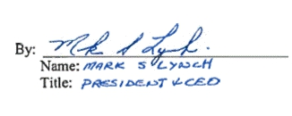
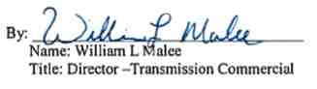

IN WITNESS WHEREOF, each Party has executed this Agreement by its duly authorized representative as of the Effective Date.

ROCHESTER GAS & ELECTRIC CORPORATION

NIAGARA MOHAWK POWER CORPORATION d/b/a National Grid

LIST OF EXHIBITS
Exhibit A Scope of Work
Exhibit B Projected Milestone Schedule
Exhibit C Insurance Requirements
Exhibit D Cost Breakdown

Exhibit A: Scope of Work
COMPANY shall perform the following Work under this Agreement:

1. Design, engineer, procure, construct, test and place into service the new
Company-owned and/or operated facilities, and the modifications to existing
Company-owned and/or operated facilities, as contemplated in the “STATION
251 & CIRCUIT 901 PROJECT DESCRIPTION" attached as Annex 1 to this
Exhibit.
2. Design, engineer, procure, construct, test and place into service the new
Company-owned and/or operated facilities, and the modifications to existing
Company-owned and/or operated facilities, to upgrade the Mortimer Substation to
allow it to handle 400 MVA Summer normal and 640 MVA long time emergency
(“LTE”) rating due to the re-conductoring of line 901 (line 901 is being upgraded
by Customer to 2-1192.5MCM ACSR Bunting conductors.) This upgrade would
include, without limitation, replacing Circuit Breaker R104, disconnect switches
SW100, 102 and 106, and upgrading the bus work to a 3000 amp rating,
modifying the 115kV take off structure to handle the new 2-1192.5 conductors on
line 901, and replacing the bushing potential device with a CVT, all as more
specifically referenced in Technical Scope Document for Substations “Mortimer -
Protection and Station upgrades for line 901 re-conductoring” attached as Annex
2 to this Exhibit.

3. Perform engineering review and field verifications as required on the facilities
referred to in Paragraphs 1 and 2 of this Exhibit.
4. Prepare, file for, and use commercially reasonable efforts to obtain any Required
Approvals that must be obtained by Company to enable it to perform the work
and any other of its obligations contemplated by this Exhibit and this Agreement.
5. Inspect, review, witness, examine and test, from time to time, Company’s work
contemplated herein and conduct other project management, administration and
oversight activities in connection with the work contemplated by this Exhibit.
6. Review, from time to time, permitting, licensing, real property, and other
materials relating to the work contemplated herein.

7. Retain and use outside experts, counsel, consultants, and contractors in
furtherance of the work contemplated herein.
8. Perform any other reasonable tasks necessary or advisable in connection with the
work contemplated by this Exhibit (including, without limitation, any changes
thereto).

For the avoidance of doubt: the Company shall not have any responsibility for seeking or acquiring any real property rights in connection with the Work or the Project including, without limitation, licenses, consents, permissions, certificates, approvals, or authorizations, or fee, easement or right of way interests. Neither this Agreement nor the Company’s Work include securing or arranging for Customer or any third party to have access rights in, through, over or under any real property owned or controlled by the Company.

NOTE: COMPANY’s specifications for electrical requirements referenced for this Agreement include: ESB-750; ESB-752; ESB-755 and ESB-756, Appendix A as such may be amended, modified and superseded from time to time. See:
https://www.nationalgridus.com/niagaramohawk/construction/3_elec_specs.asp

Annex 1 to Exhibit A
STATION 251 & CIRCUIT 901
PROJECT DESCRIPTION
Mortimer Station-RG&E Line 901 Re-conductor protection and R104 upgrades
Project Funding Number: C056410
Work order number: 10017980563 Link to documentum:

http://docuweb3:8080/webtop/drl/objectId/0b0017c3805b73c8

Mortimer Line 901 Technical Scope Document 12/17 tech review meeting comments

• Added no thermal limiting component statement
• Section 1.5.6 deleted Syracuse
• Section 3.1.1 added statement that around grid analysis not substantially impacted by
circuit breaker change out
• Section 4.9 added reference to replacing surge arrestors per SMP 419..01.2 by Substation
Maintenance
• Section 4.4.1 changed hook stick switch SW102 gang operated
• Section 2.9.2 change structure for switch SW102 and 106 to accept gang operated switch
(make box structure)
• Section 10.2.2 and 10.2.3 deleted
• Section 14.1.3 added switch SW 100 to list of retirements
• Section 16.12 change the date of EDC to 12/15 one-month delay also changed line item
17, 18, 19 and 21 to 12/15.
• Section 16.7 C &I section added item number 7 HMI annunciator and item number 8
Telebyte communication signal converter.
• Attachment #7 - updated to add SAM - 900 HMI

Annex 2 to Exhibit A
Technical Scope Document for Substations
(Mortimer - Protection and Station upgrades for
line 901 re-conductoring)
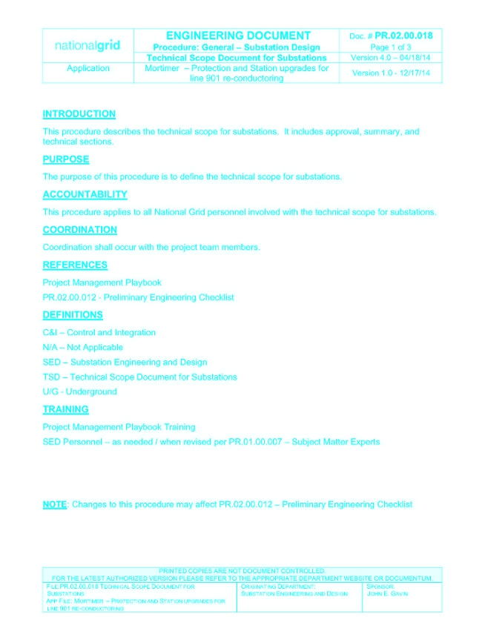
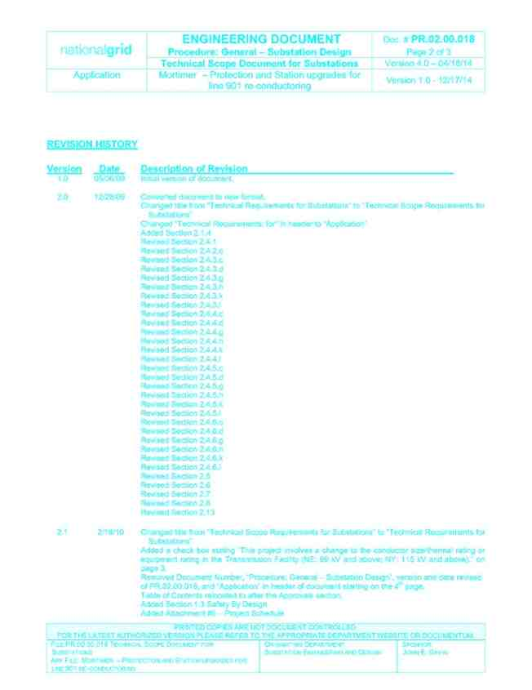
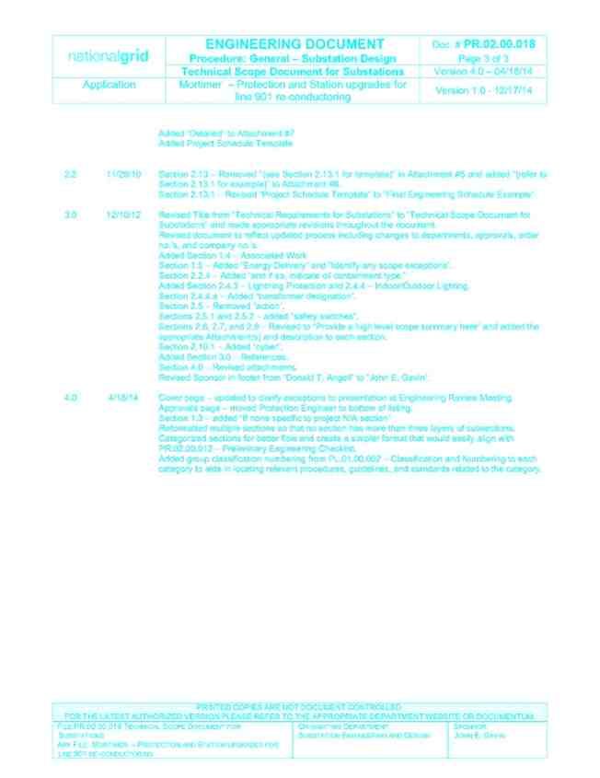
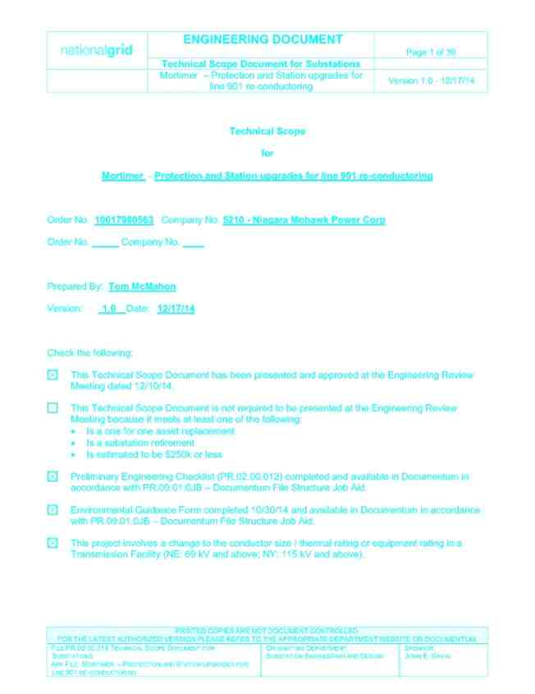
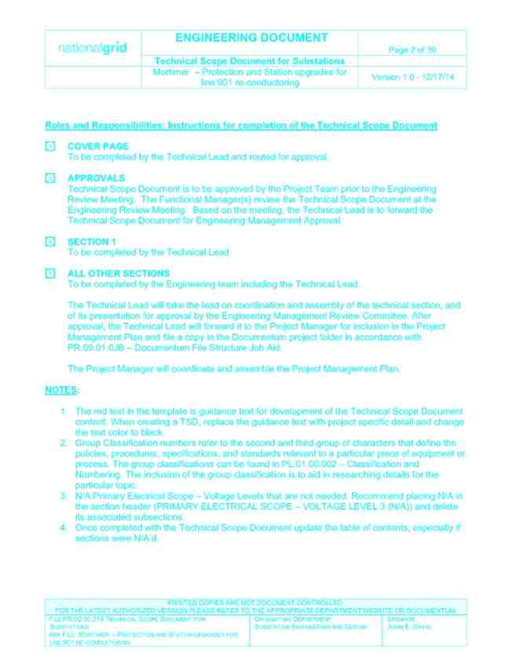
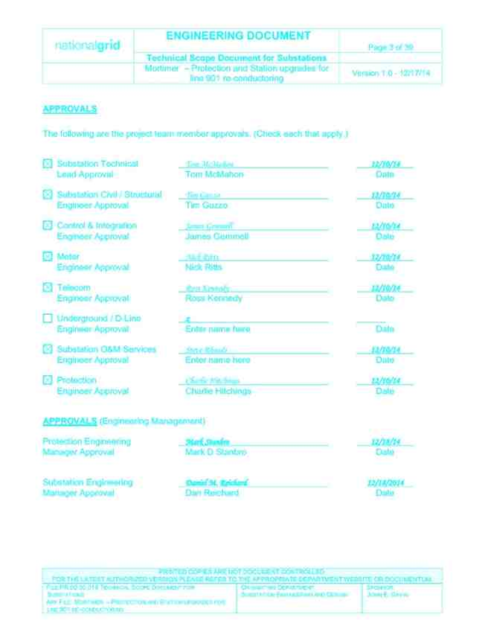
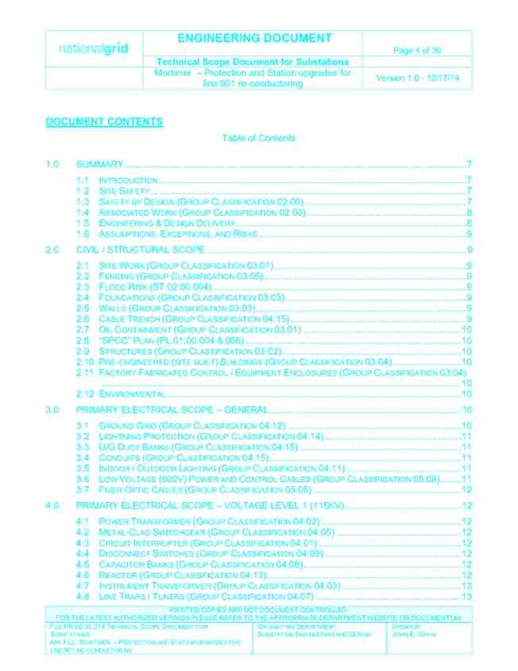
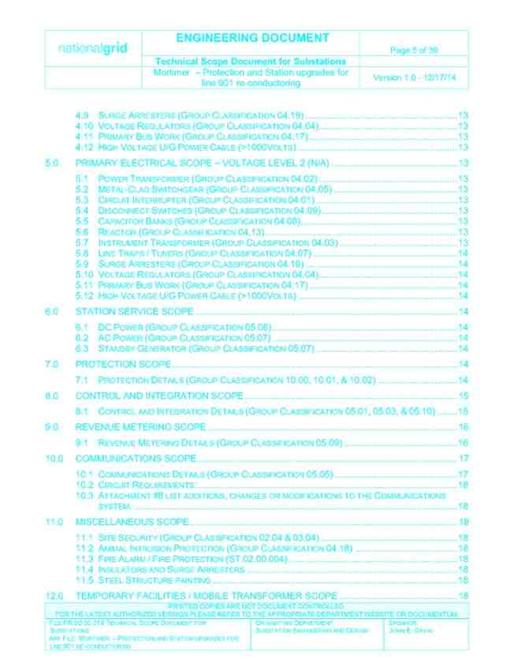
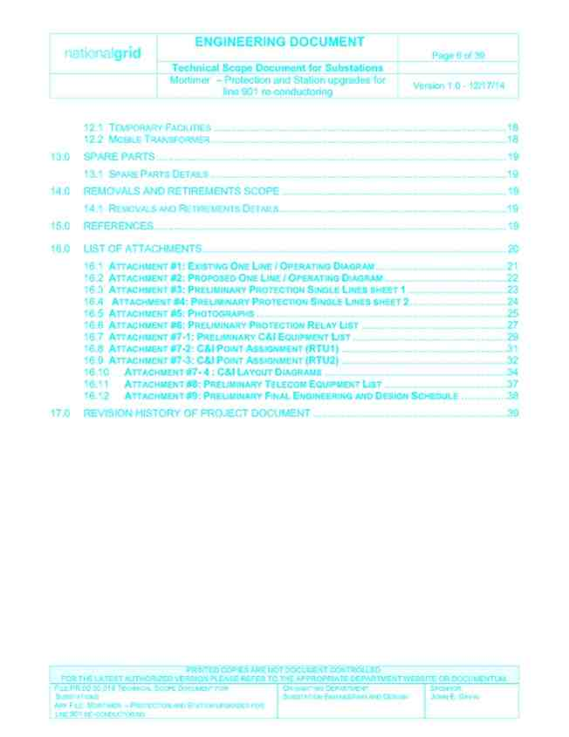
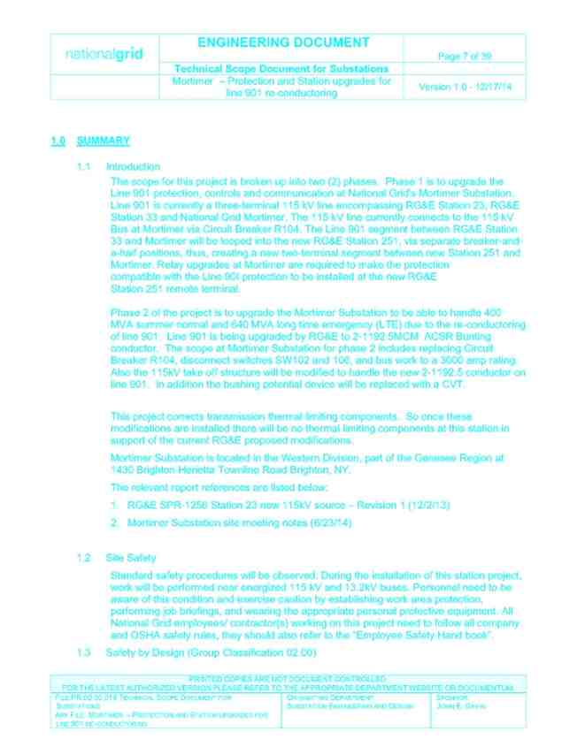
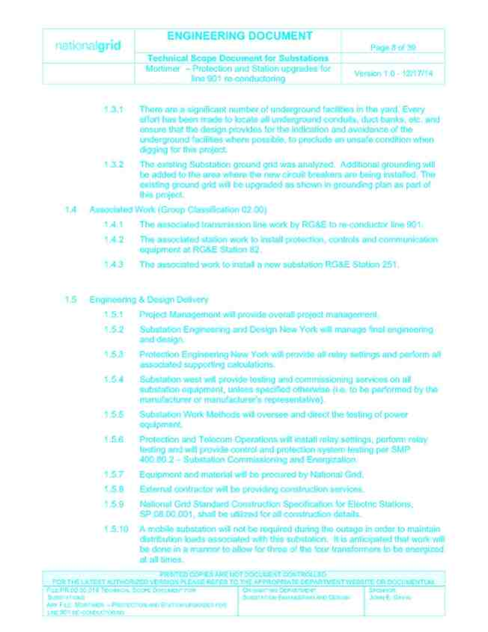
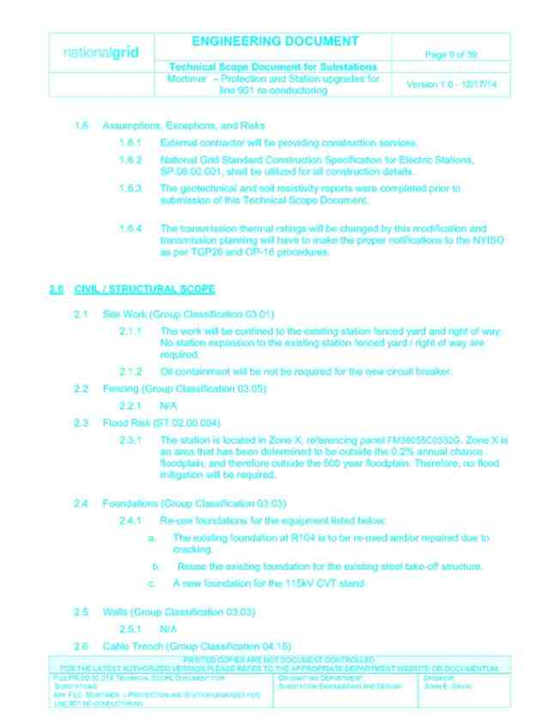
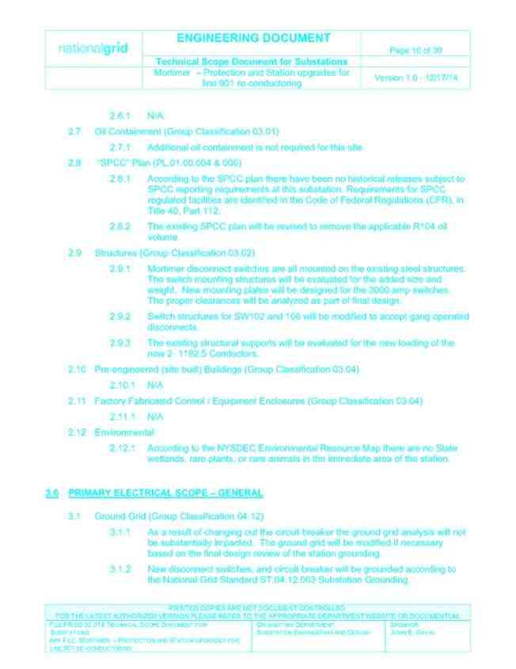
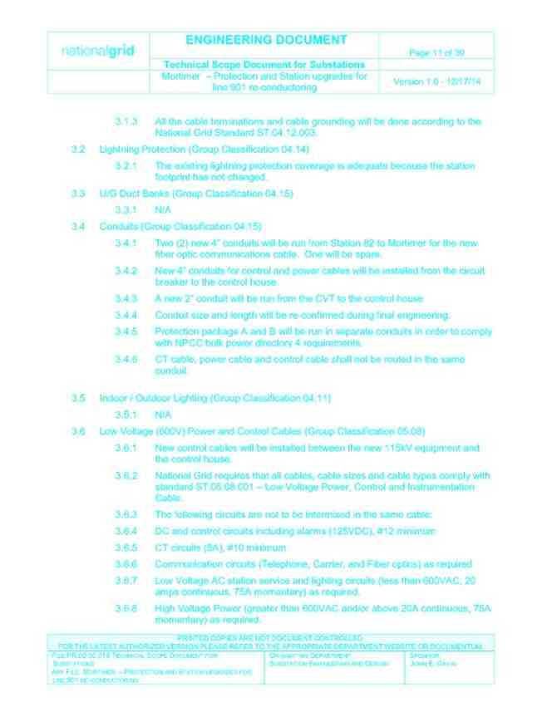
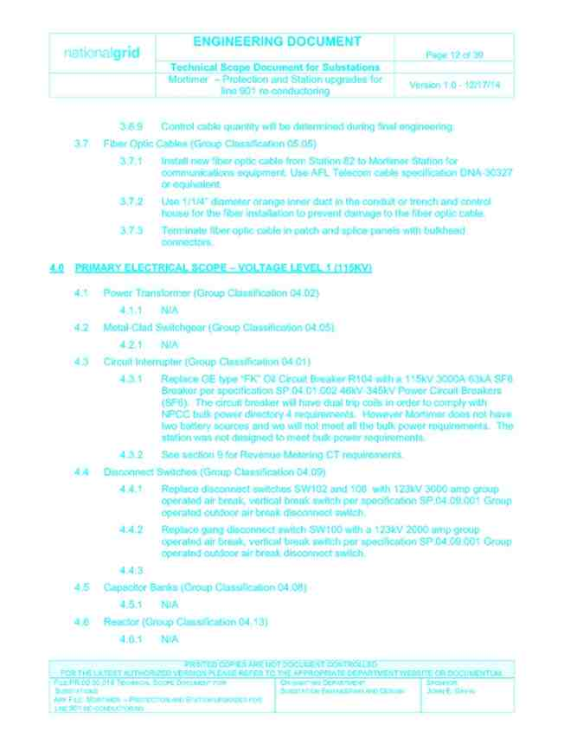
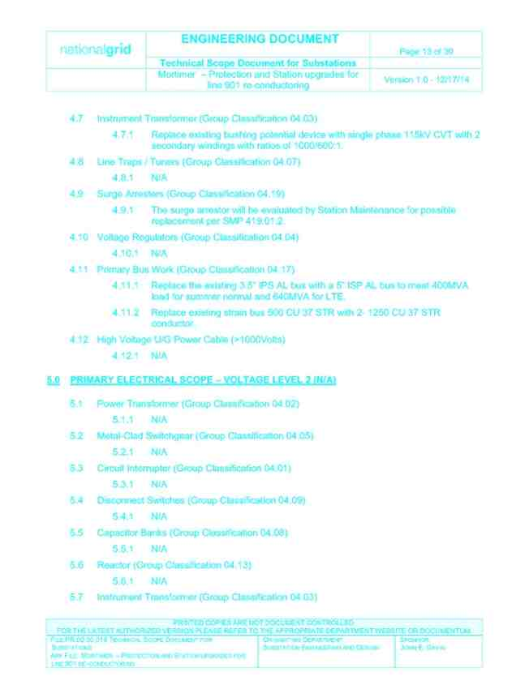
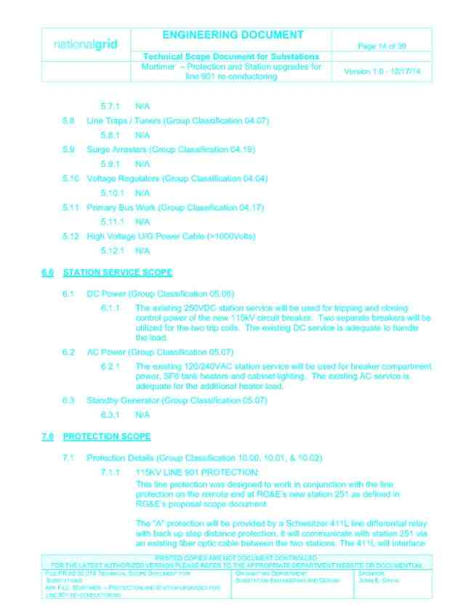
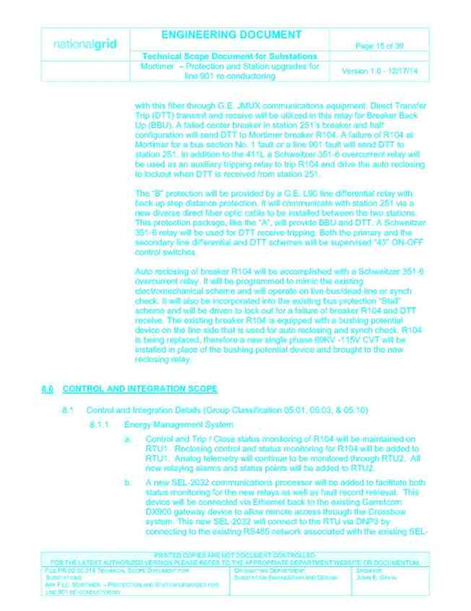
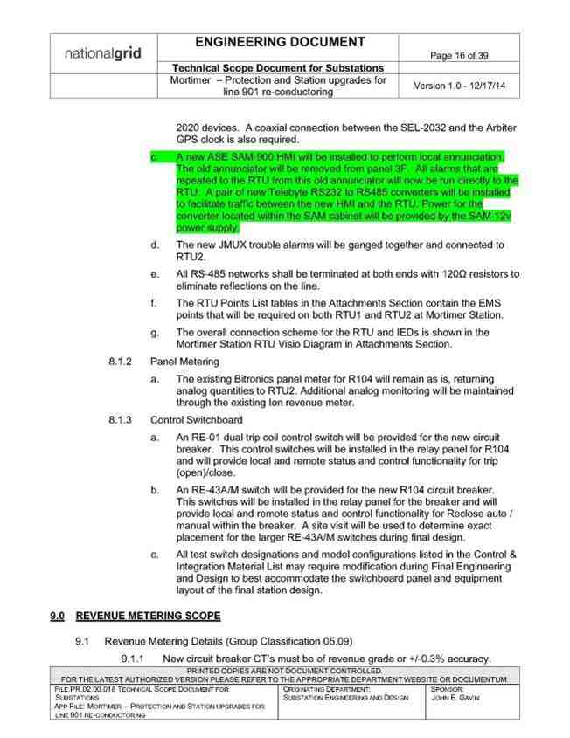
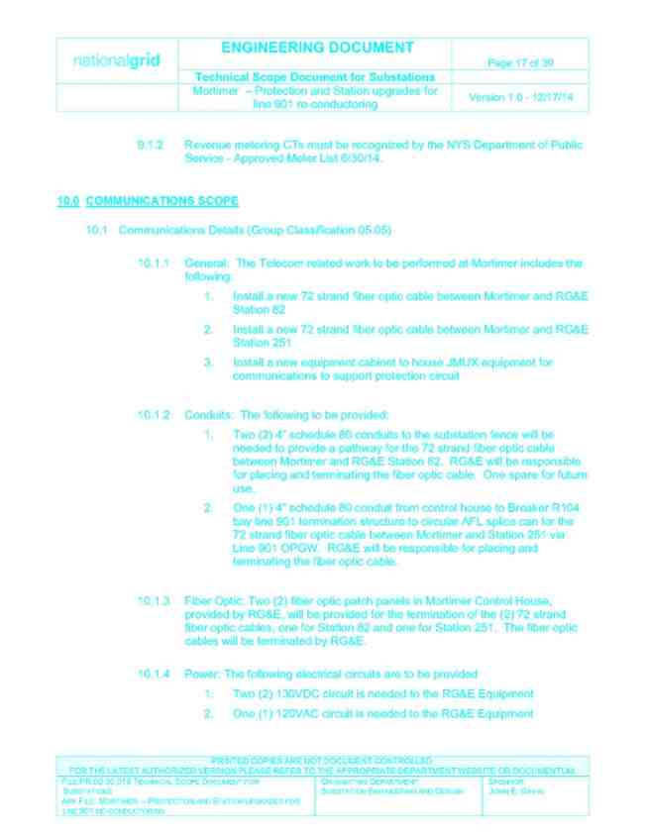
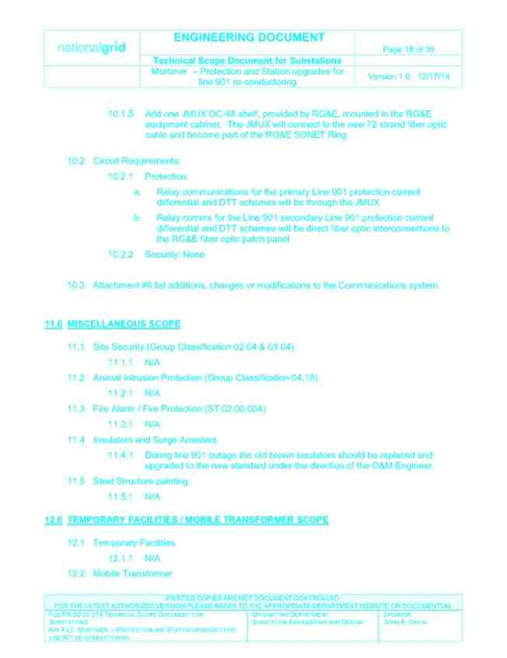
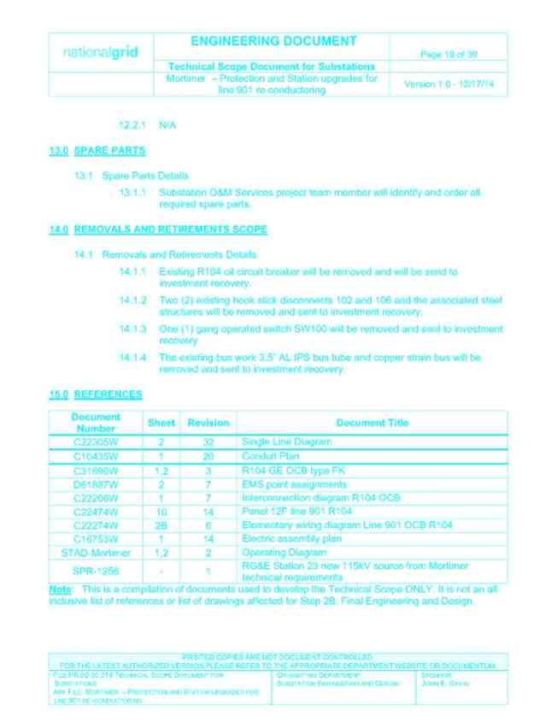
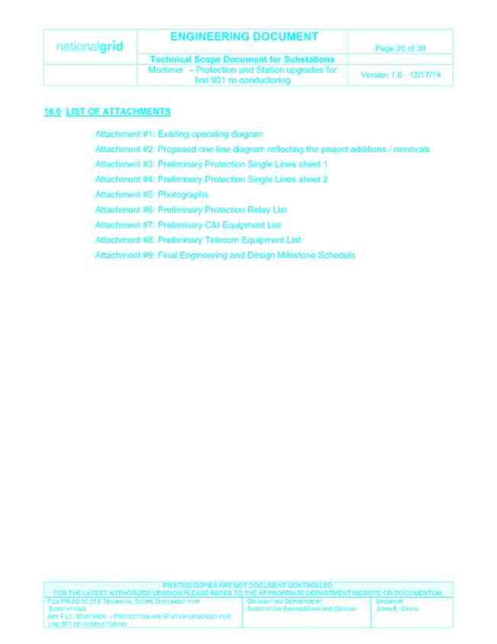
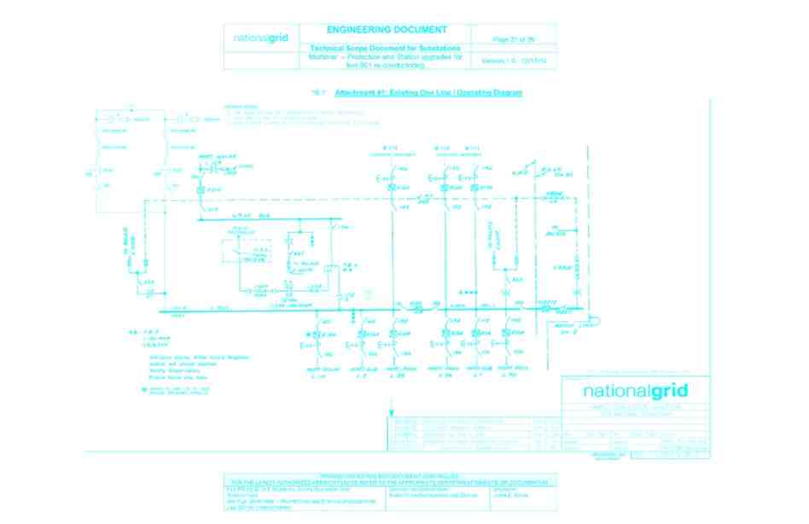
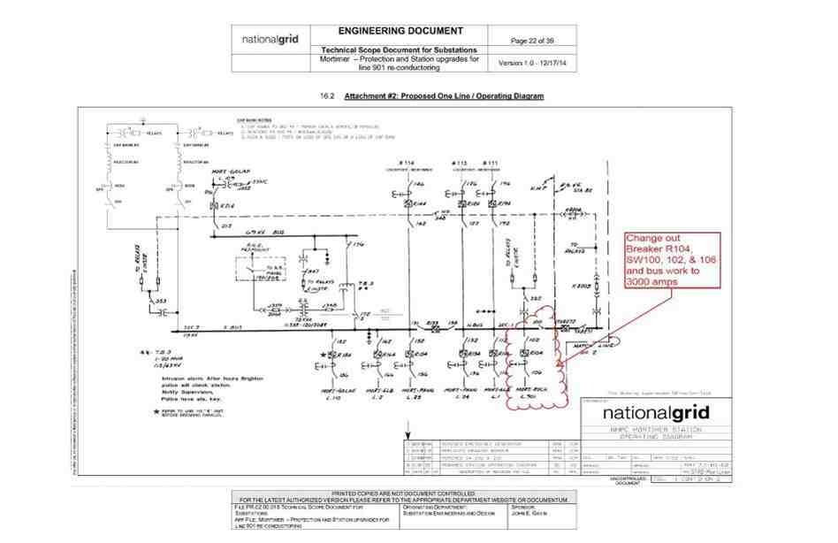
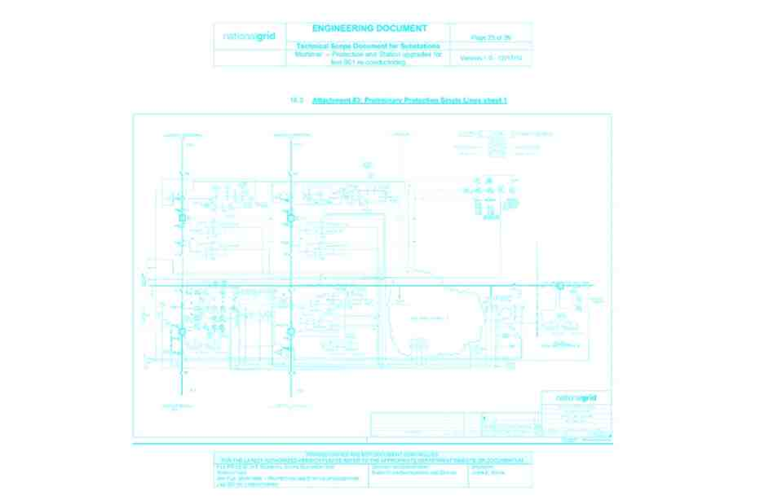
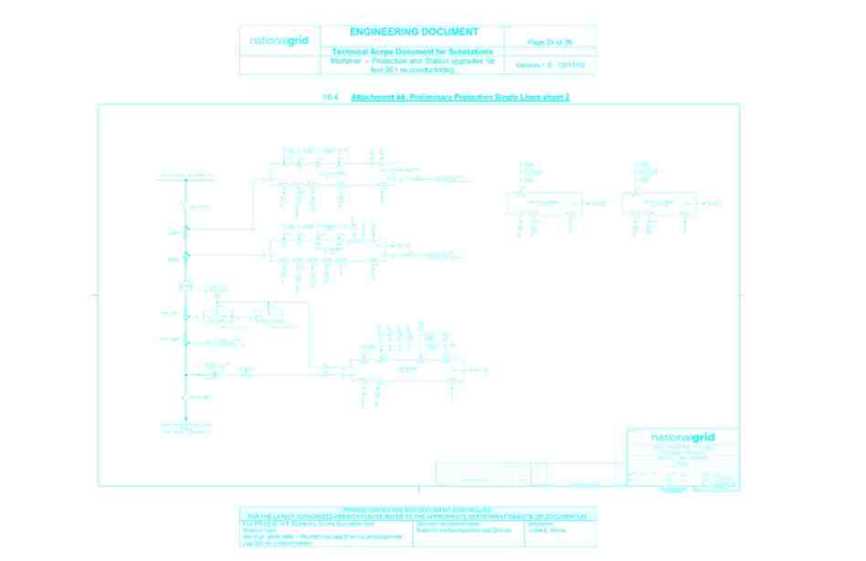
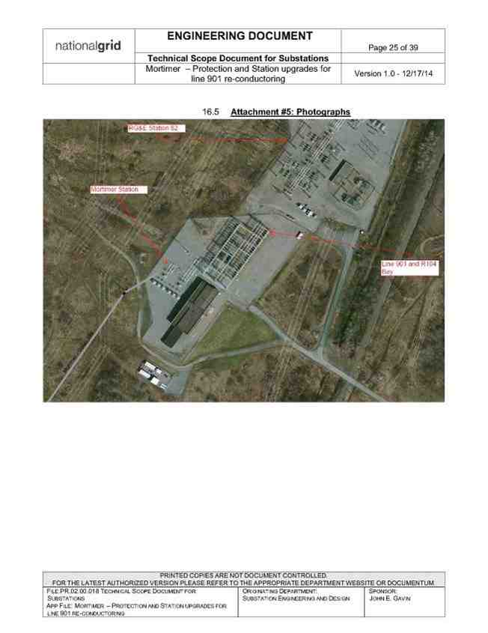
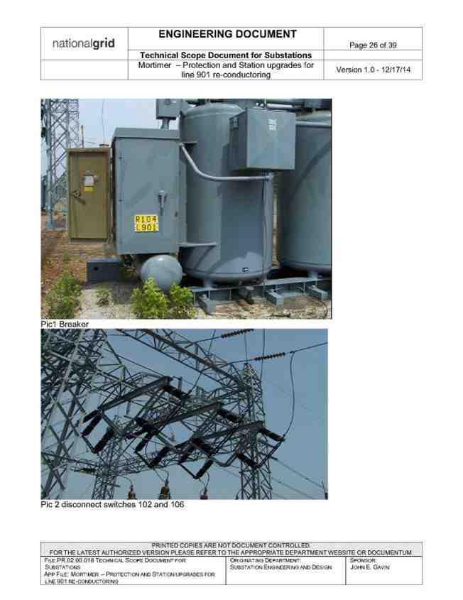
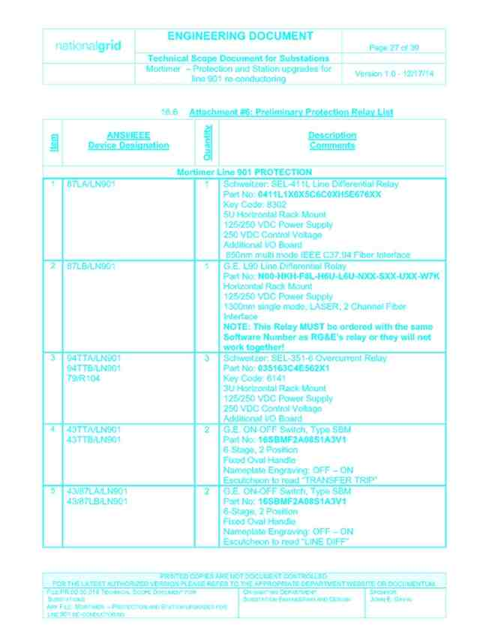
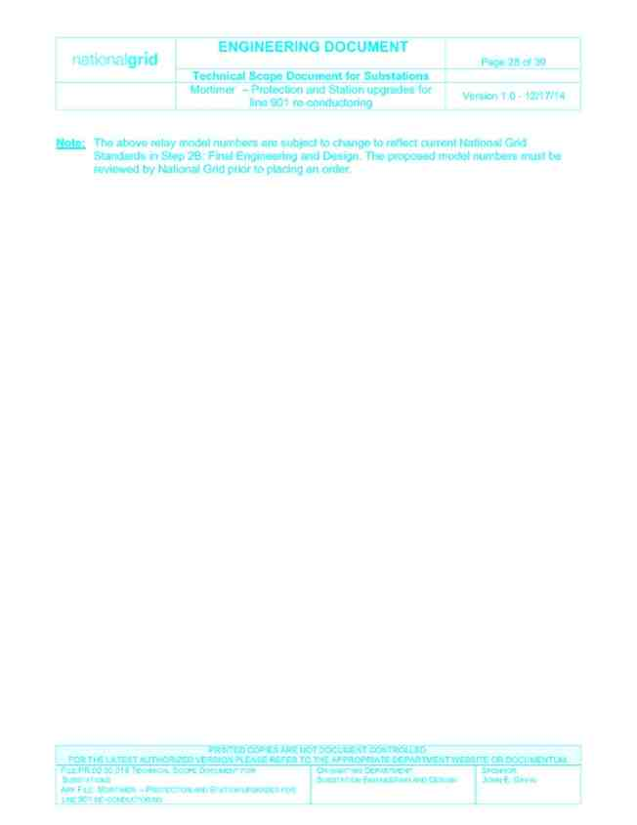
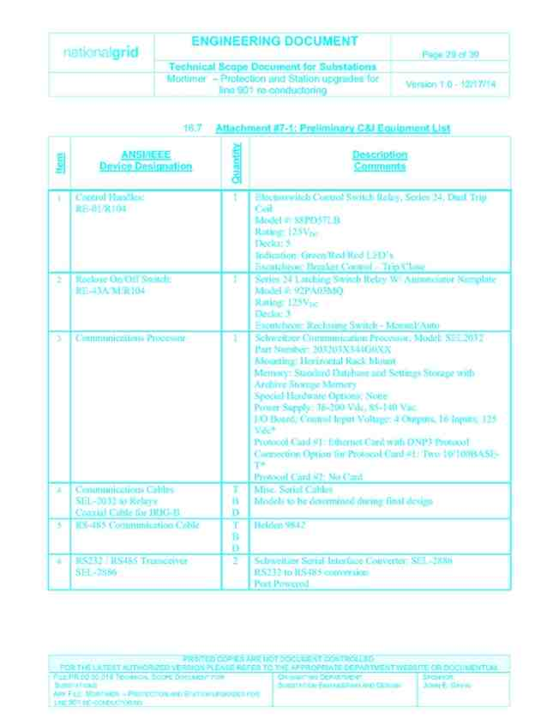
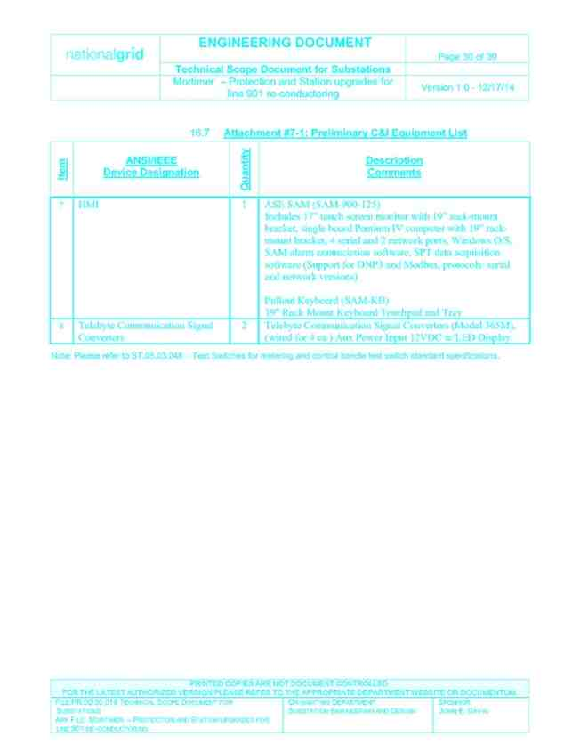
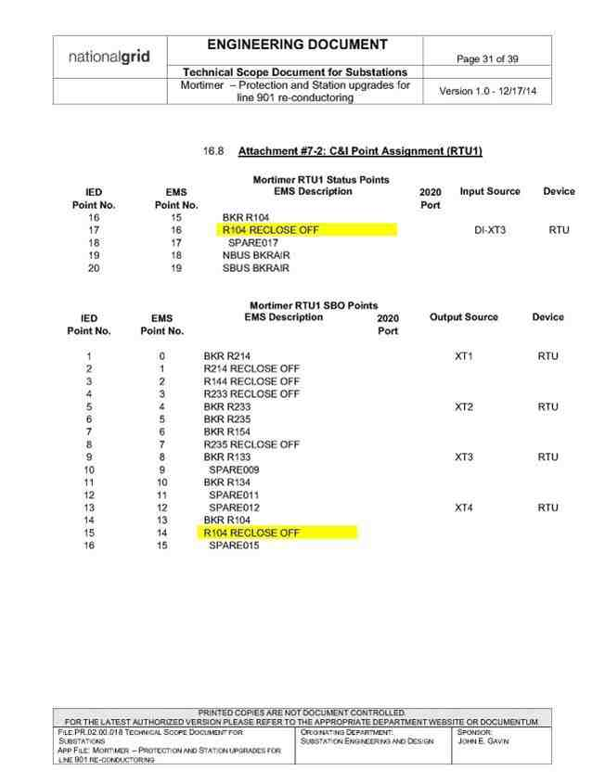
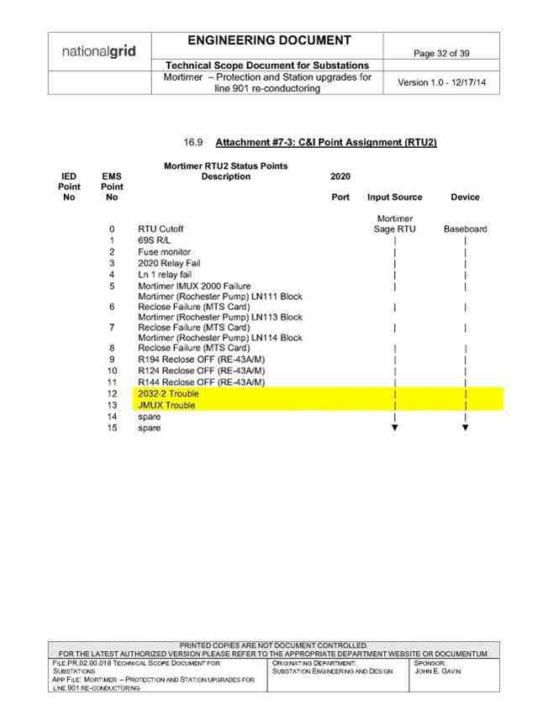
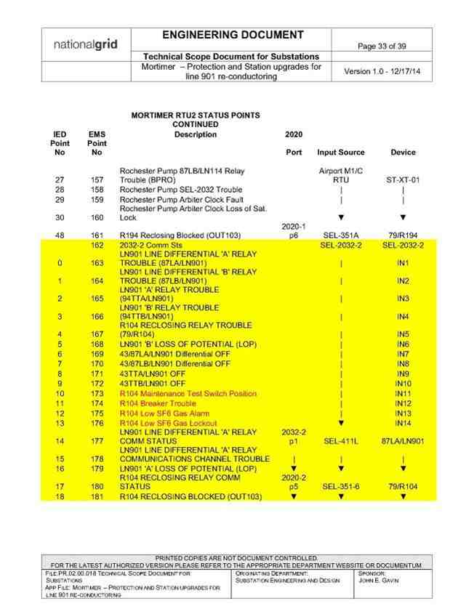
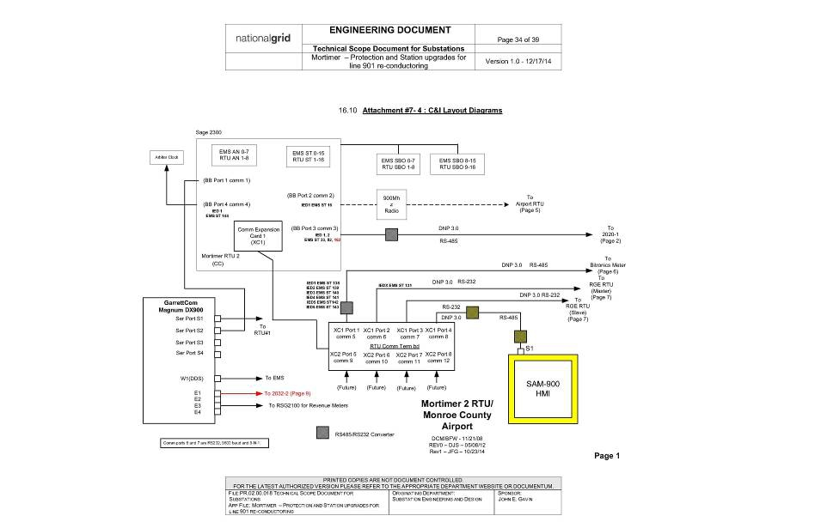
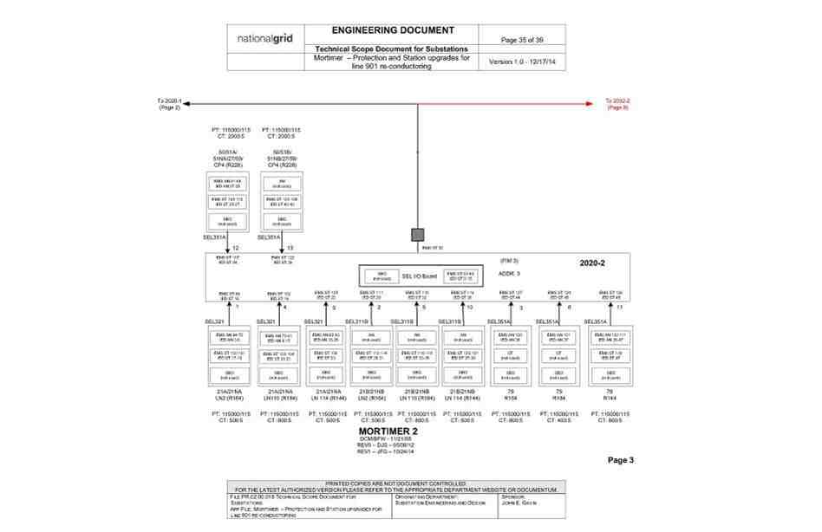
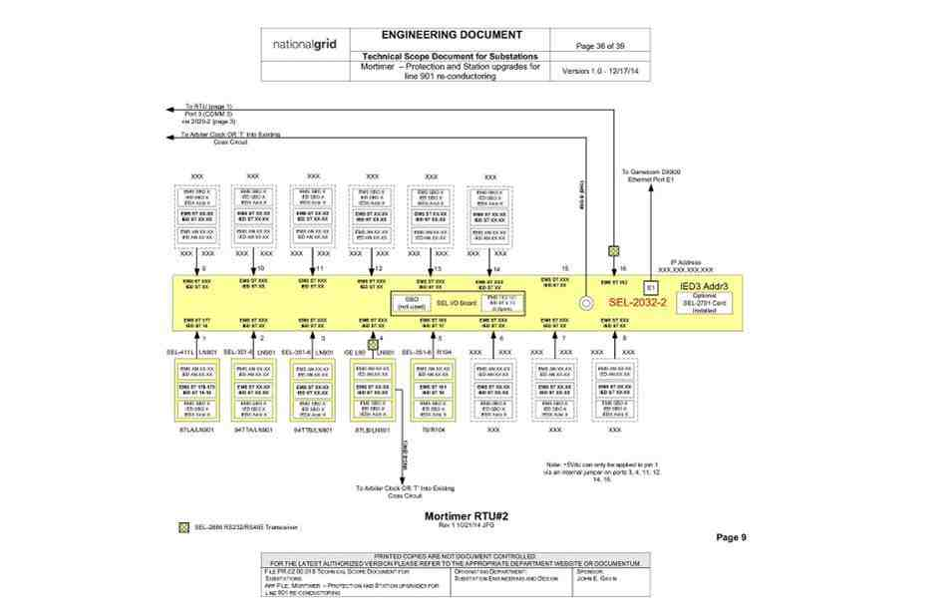
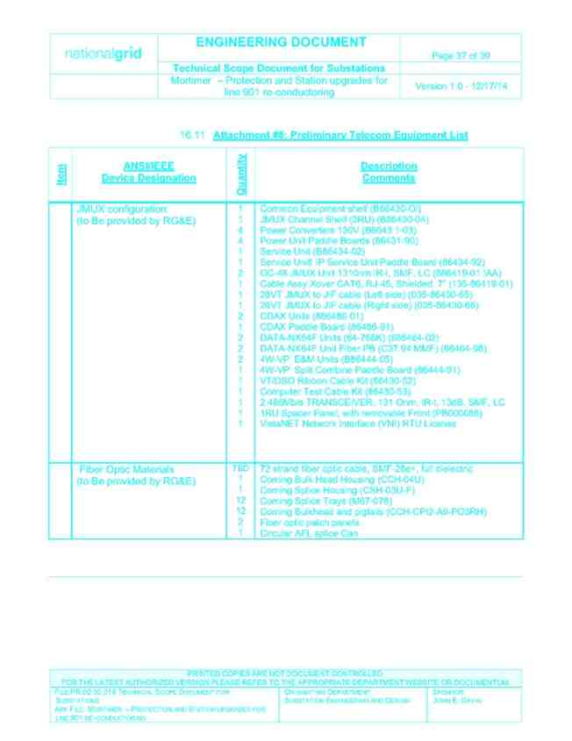
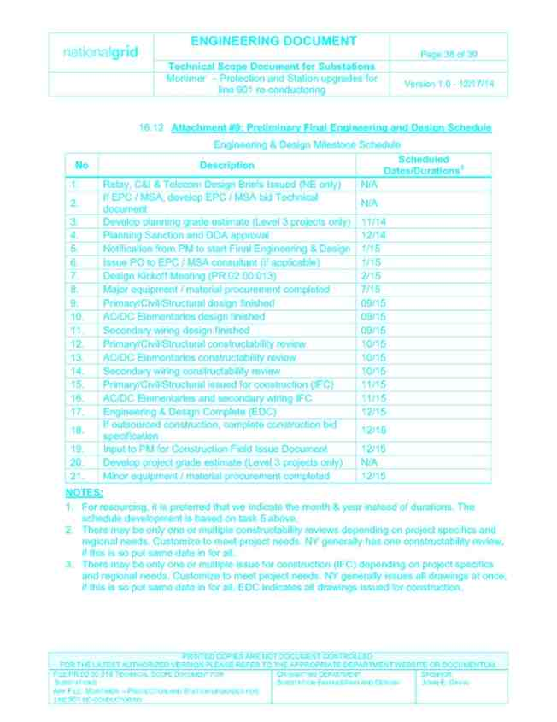
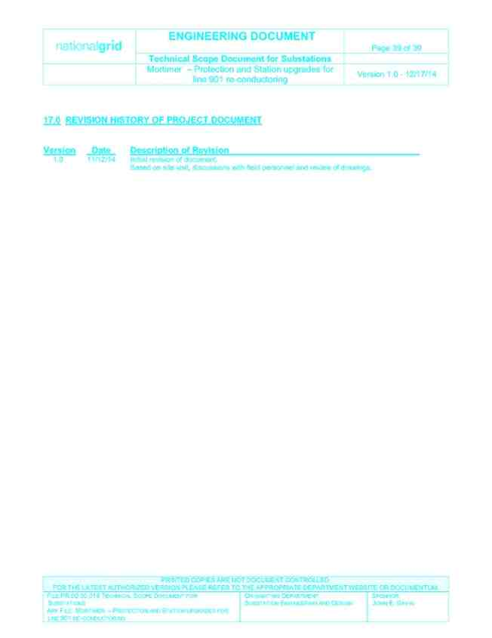

Exhibit B: Projected Milestone Schedule

PROJECTED MILESTONE SCHEDULE

Task

1.

2.

3.

4.

5

Milestone

Preliminary
Engineering

Final Design

Material & Equipment Procurement

Construction

Close Out

Date
Complete as of the
Amendment Effective
Date. Technical
Scope Document
issued.
10 Months after
Amendment Effective
Date
10 Months after
Amendment Effective
Date
13 Months after
Amendment Effective
Date
16 Months after
Amendment Effective
Date

Responsible Party

Customer/Company

Customer/Company

Company

Company

Customer / Company

The dates above represent the Parties’ preliminary schedule, which is subject to adjustment,
alteration, and extension. Neither Party shall be liable for failure to meet the above Preliminary Milestone
Schedule, any milestone, any in-service date, or any other projected or preliminary schedule in connection
with this Agreement, the Work or the Project. National Grid does not and cannot guarantee or covenant
that any outage necessary in connection with the Work will occur when presently scheduled or on any
other particular date or dates and shall have no liability arising from any change in the date or dates of such
outages.

Exhibit C: Insurance Requirements

• Workers Compensation and Employers Liability Insurance as required by the State of New
York. If required, coverage shall include the U.S. Longshore and Harbor Workers’
Compensation Act and the Jones Act.
• Public Liability (Including Contractual Liability), covering all activities and operations to
be performed by it under this Agreement, with the following minimum limits:

(A) Bodily Injury - $1,000,000/$1,000,000
Property Damage - $1,000,000/$1,000,000
OR
(B) Combined Single Limit - $1,000,000
OR
(C) Bodily Injury and Property Damage per Occurrence - $1,000,000
General Aggregate & Product Aggregate - $2,000,000 each

• Umbrella or Excess Liability, coverage with a minimum limit of $ 4,000,000.
1. Upon request, either Party shall promptly provide the requesting Party with either evidence of
insurance or certificates of insurance evidencing the insurance coverage above. Customer shall provide such certificates or evidence of insurance to Company at the following address:

To: National Grid c/o NIAGARA MOHAWK POWER CORPORATION
Attention: Risk Management, A-4
300 Erie Boulevard West
Syracuse, NY 13202

Company shall provide such certificates or evidence of insurance to Customer at the following
address:

To: RG&E
Attention: David Fingado
1300 Scottsville Road
Rochester, NY 14624

2. Should any of the above-described policies be cancelled before the expiration date thereof, notice will
be delivered in accordance with the policy provisions.
3. If a party fails to secure or maintain any insurance coverage, or any insurance coverage is canceled
before the completion of all services provided under this Agreement, and such party fails immediately
to procure such insurance as specified herein, then the non-defaulting party has the right but not the
obligation to procure such insurance and, at its option, either bill the cost thereof to the defaulting
party or deduct the cost thereof from any sum due the defaulting party under this Agreement.

4. To the extent requested, both Parties shall furnish to each other copies of any accidents report(s) sent
to the Party’s insurance carriers covering accidents or incidents occurring in connection with or as a
result of the performance of the Work for the Project under this Agreement.
5. Each Party shall comply with any governmental and/or site-specific insurance requirements even if
not stated herein.

6. By the date that such coverage is required, each Party represents to the other that it will have full
policy limits available and shall notify each other in writing when coverages required herein have
been reduced as a result of claim payments, expenses, or both.

7. Customer shall name the Company as an additional insured for all coverages except Workers’
Compensation and Employers Liability Insurance in order to provide the Company with protection
from liability arising out of activities of Customer relating to the Project and associated Work.

Exhibit D: Estimated Cost Breakdown

Project Description Project Engineer Cost Component Total Cost
Modifications to Mortimer line
901 phase II replace R104 Hours 43000
along with disconnects,
upgrade bus to 3000 amps Tom McMahon
Straight Time Rate $40.00
Labor Dollars $172,000
Labor OH Rate 0.9409
Project Risk Labor Overhead Dollars $161,835
Low Materials - Inventory $552,398
Stores Handling Rate 0.12
Stores Handling Dollars $65,928
Comments/Assumptions Materials - Vendor $130,000

Per pending Contract Approval
by RG&E Contractors $110,000
Transportation rate 0.3407
Transportation dollars $58,600
CAD Transmission rate 0.1100
Capital Overhead Dollars $31,820
Tax Rate 0.08
Tax total $19,200
Total Estimated Cost $1,300,000

For the avoidance of doubt: this Exhibit provides an estimated cost breakdown of the Work Cost Estimate; the Work Cost Estimate and this Exhibit are estimates only and shall not limit Customer’s obligation to pay Company for all Company Reimbursable Costs actually incurred by Company or its Affiliates.

