FERC rendition of the electronically filed tariff records in Docket No.

Filing Data:

CID: C000038

Filing Title: NYISO 205 filing Executed Non-Conforming Interconnection Facilities Study Agrmnt Company Filing Identifier: 1011

Type of Filing Code: 10

Associated Filing Identifier:

Tariff Title: NYISO Non-conforming Interconnection Study Agreements Tariff ID: 58

Payment Confirmation: N   
Suspension Motion:

Tariff Record Data:

Record Content Description: Study Agreement Est Rvr1

Tariff Record Title: Increased CRIS CY2015 FSA East River1 Record Version Number: 0.0.0

Option Code: A

Tariff Record ID: 172

Tariff Record Collation Value: 1500600

Tariff Record Parent Identifier: 164

Proposed Date: 4/23/2015

Priority Order: 500

Record Change Type: New   
Record Content Type: 2   
Associated Filing Identifier:

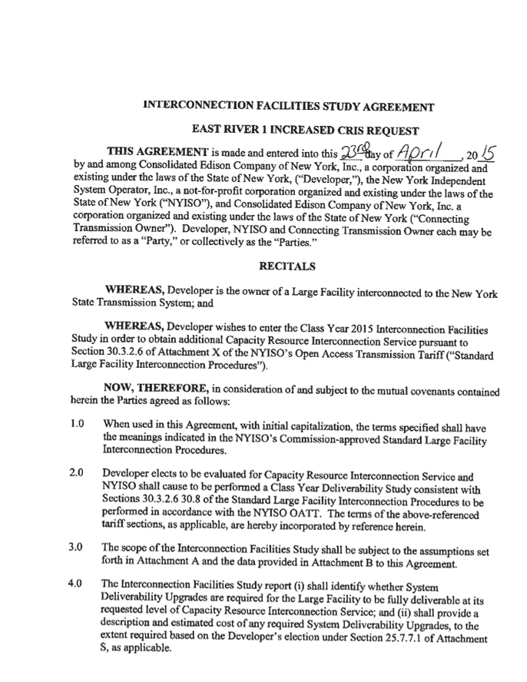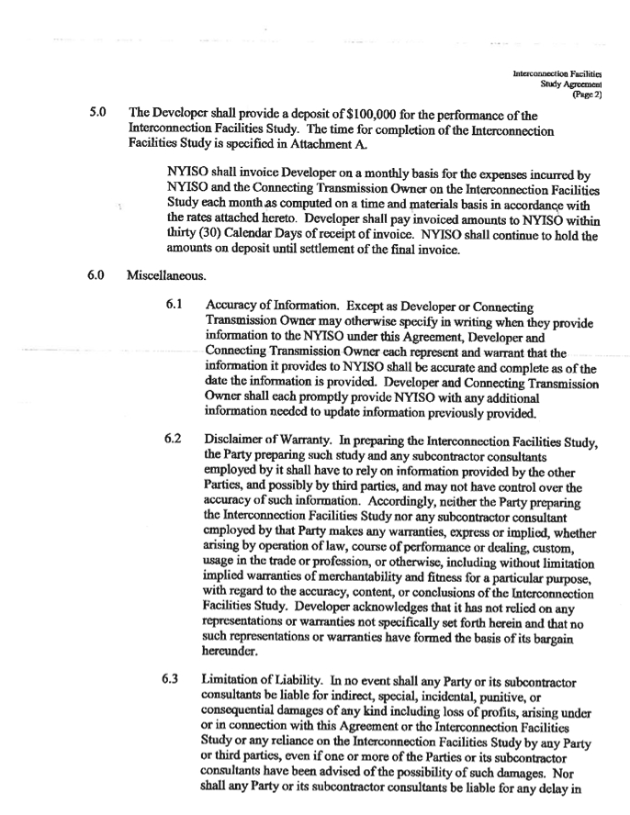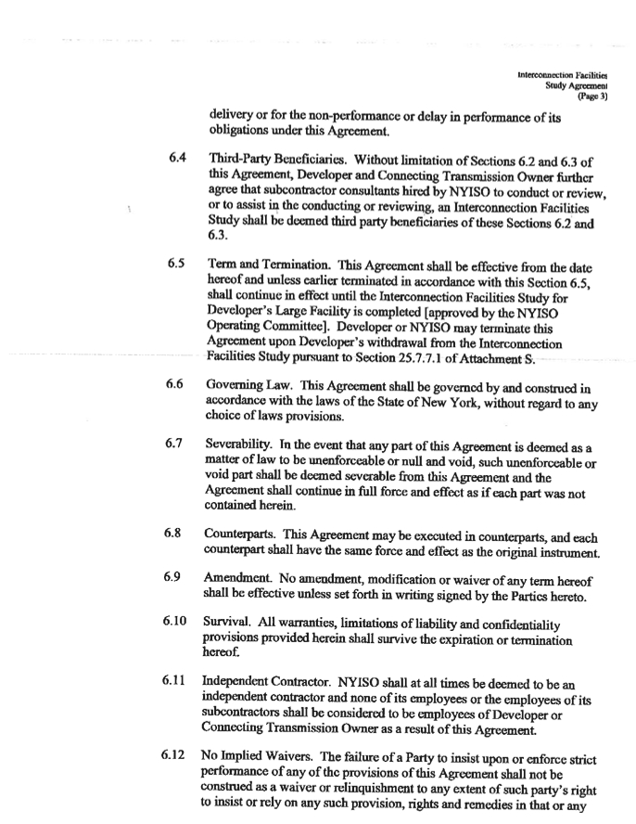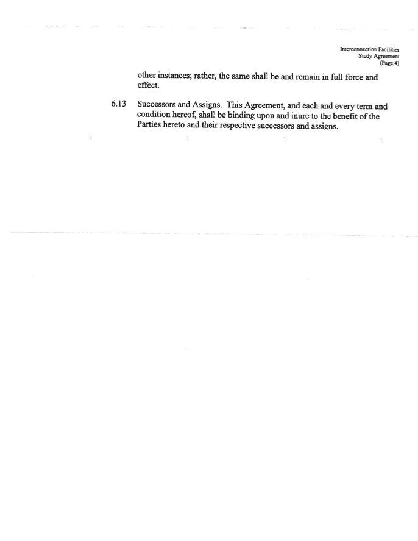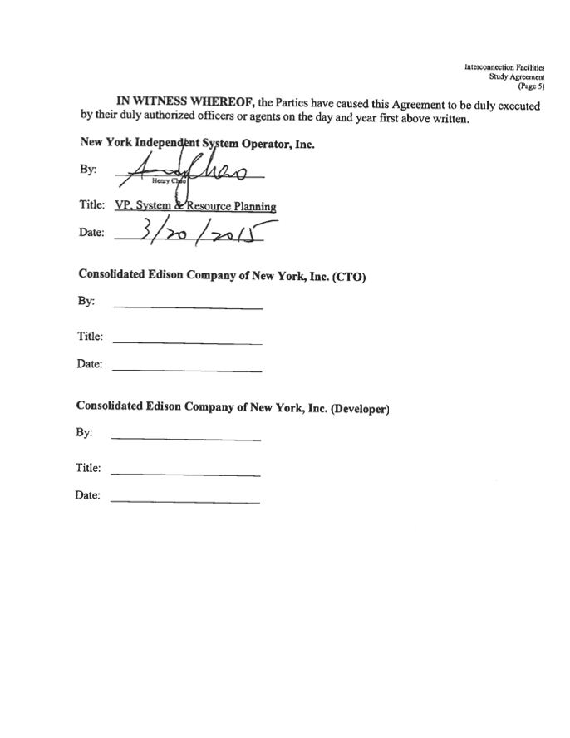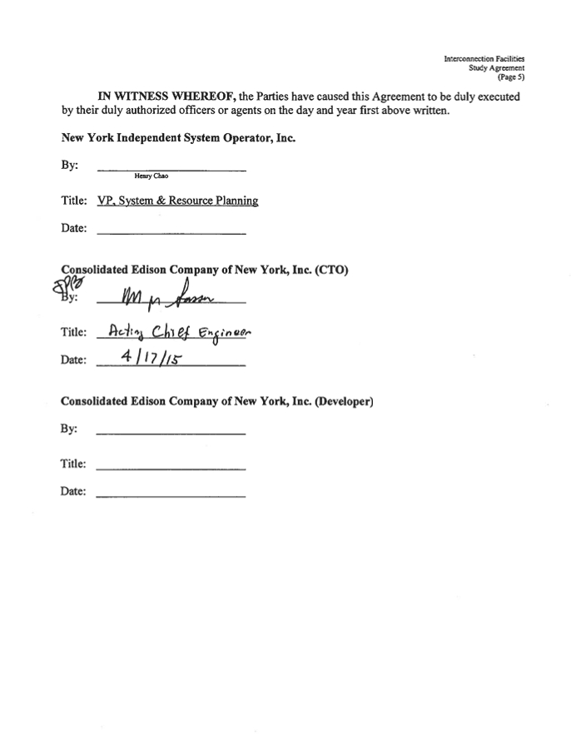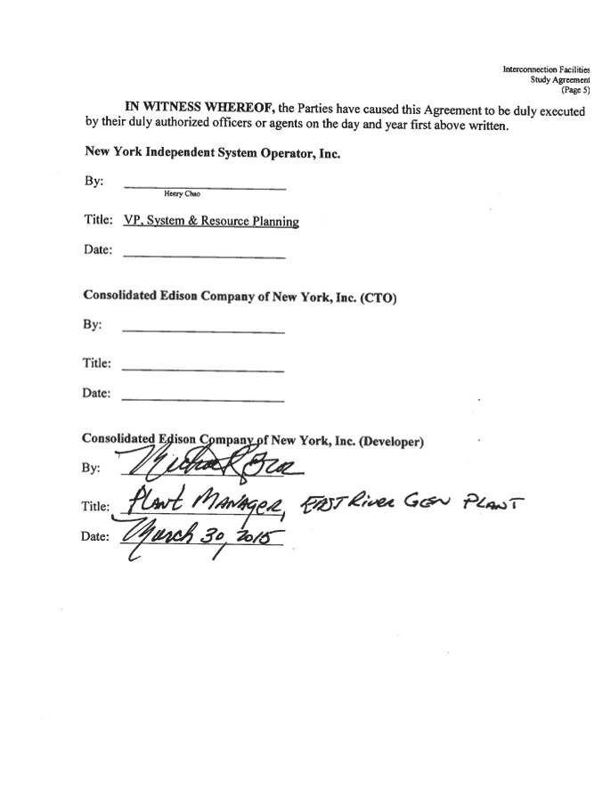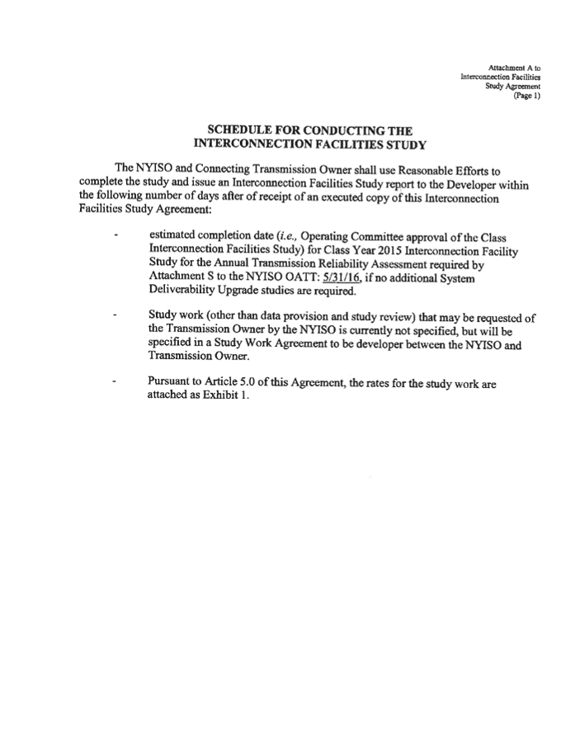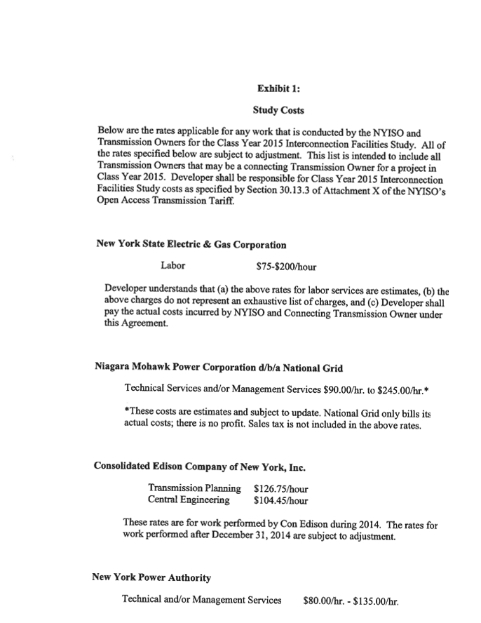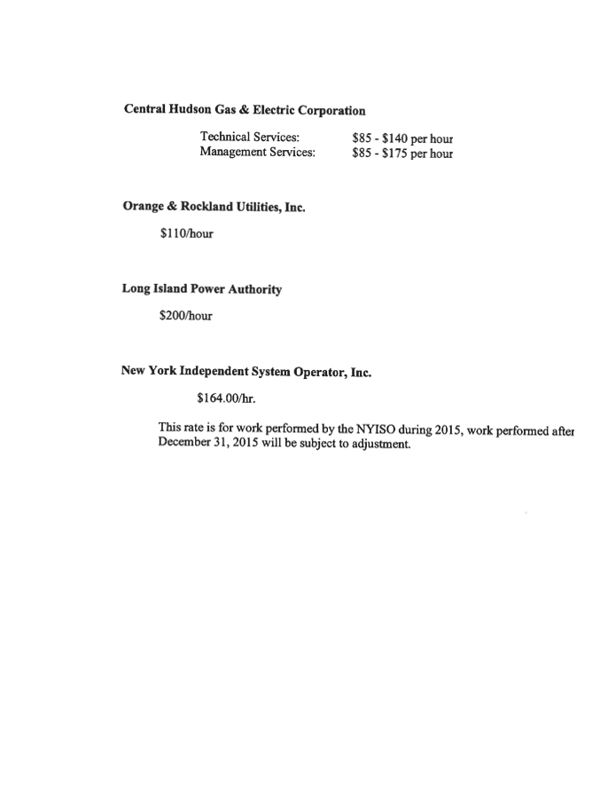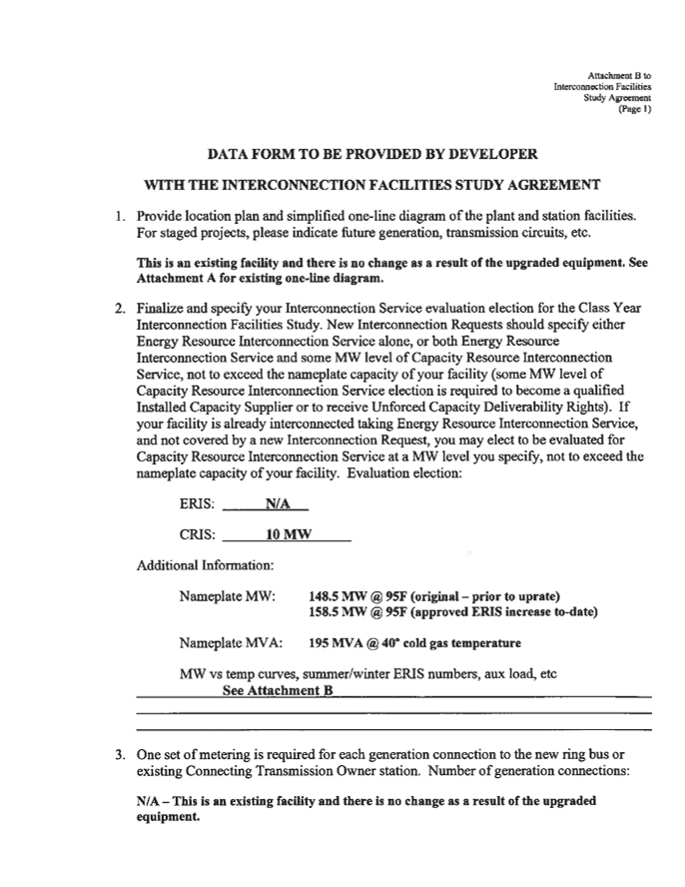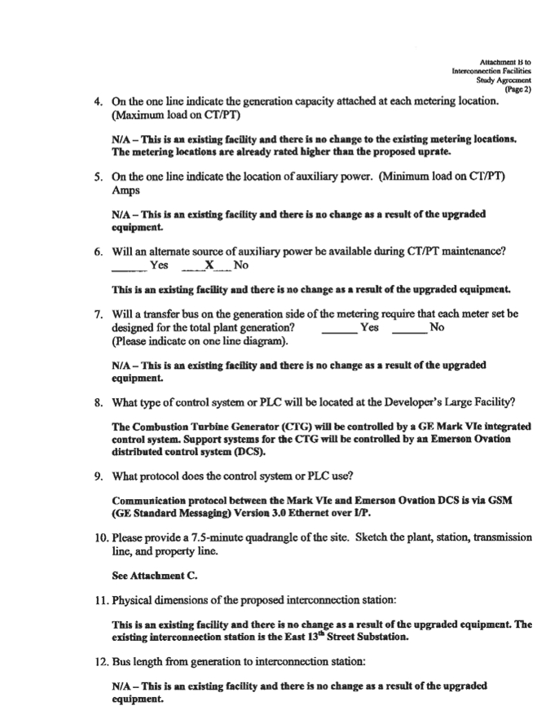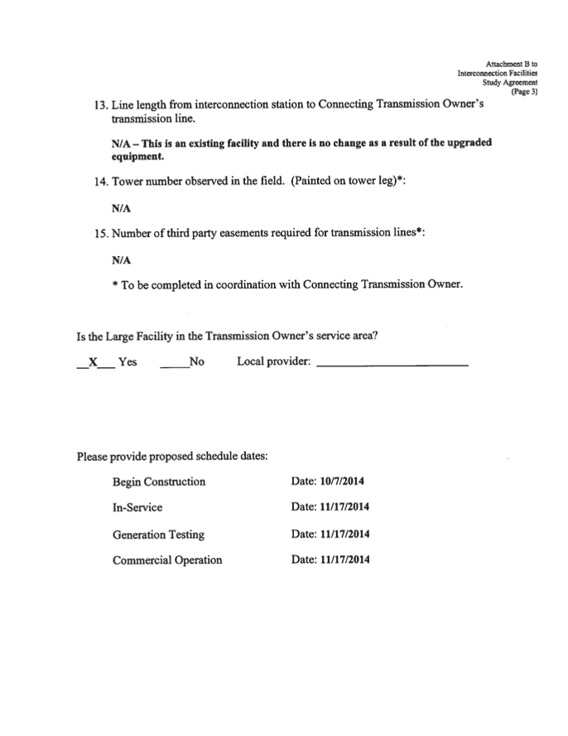

This page contains Critical Energy Infrastructure Information "CEII"   
 and has been removed fromt the public version

