FERC rendition of the electronically filed tariff records in Docket No.
Filing Data:
CID: C000038
Filing Title: NYISO 205 filing Executed Non-Conforming Interconnection Facilities Study Agrmnt Company Filing Identifier: 1011
Type of Filing Code: 10
Associated Filing Identifier:
Tariff Title: NYISO Study Agreements Tariff ID: 58
Payment Confirmation: N
Suspension Motion:

Tariff Record Data:
Record Content Description: SA CRIS Only Marble River Tariff Record Title: CRIS Only CY2015 FSA Marble River Record Version Number: 0.0.0
Option Code: A
Tariff Record ID: 166
Tariff Record Collation Value: 1500100
Tariff Record Parent Identifier: 164
Proposed Date: 4/28/2015
Priority Order: 500
Record Change Type: New
Record Content Type: 2
Associated Filing Identifier:
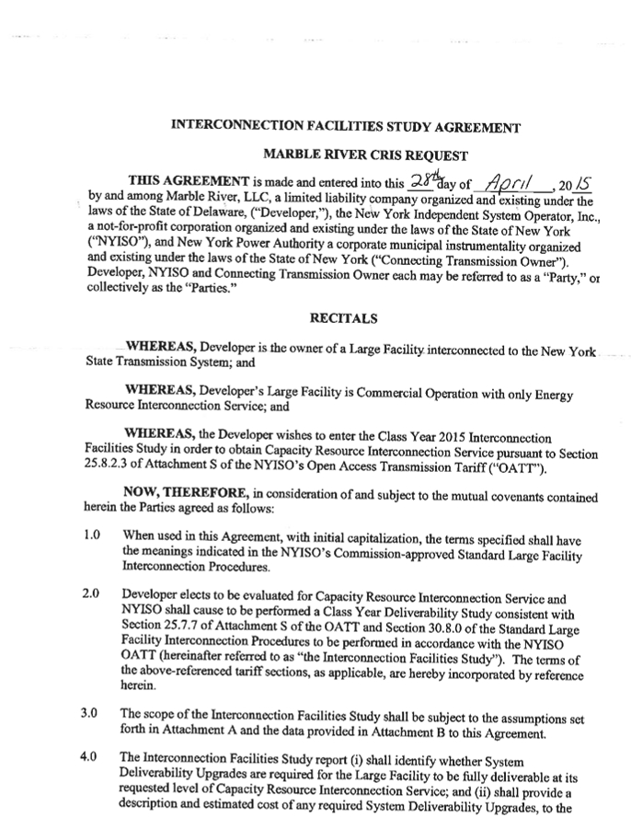
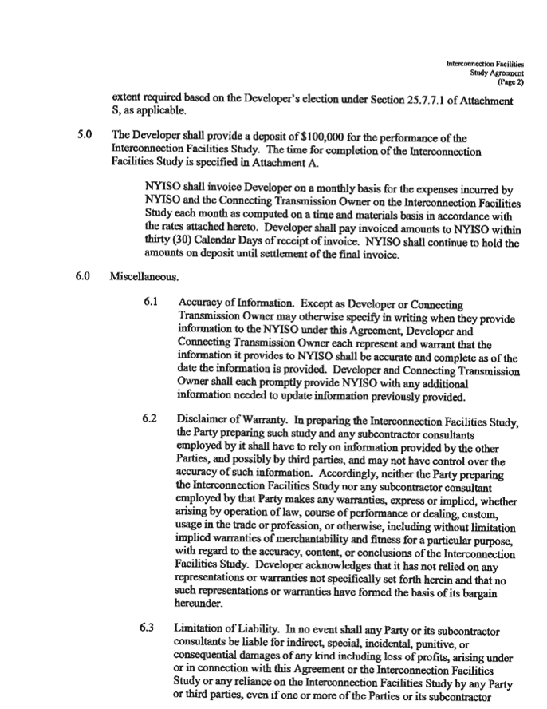
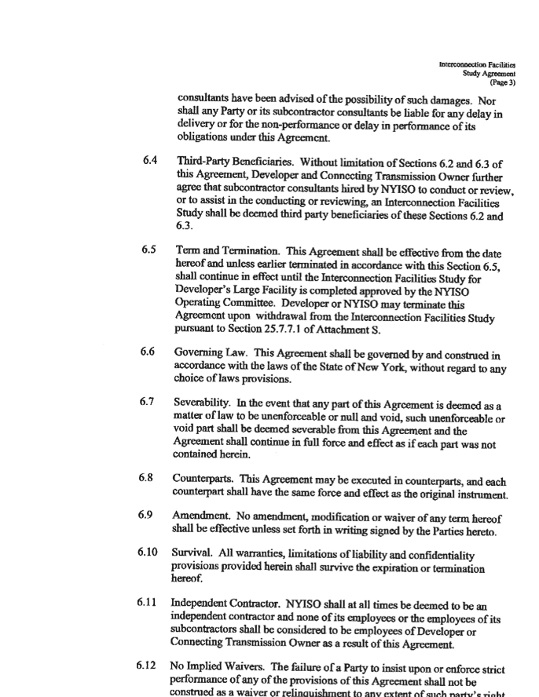
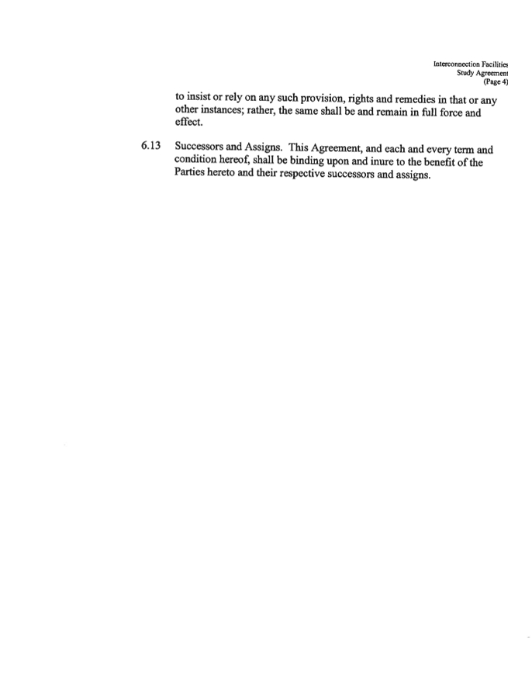
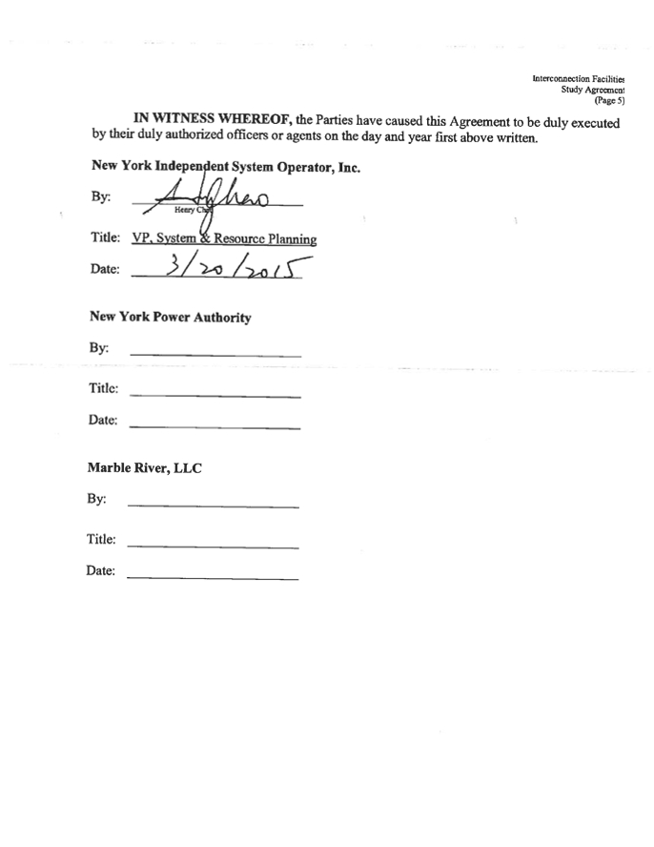
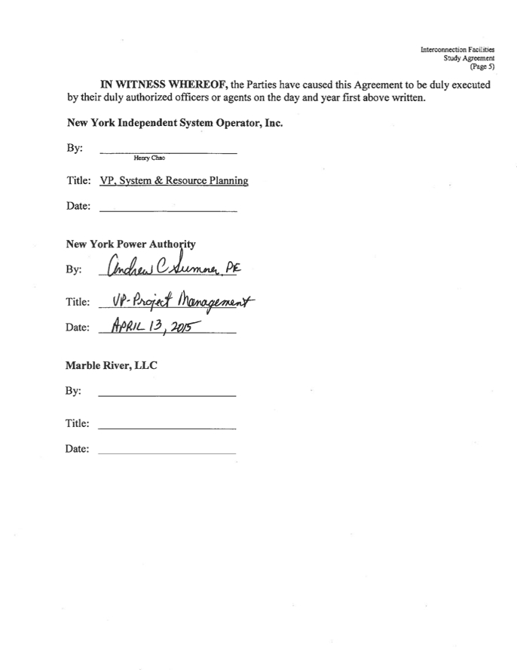
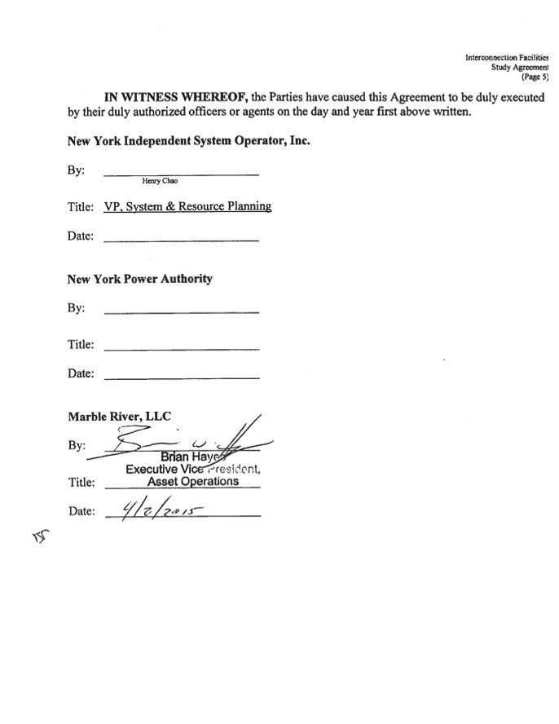
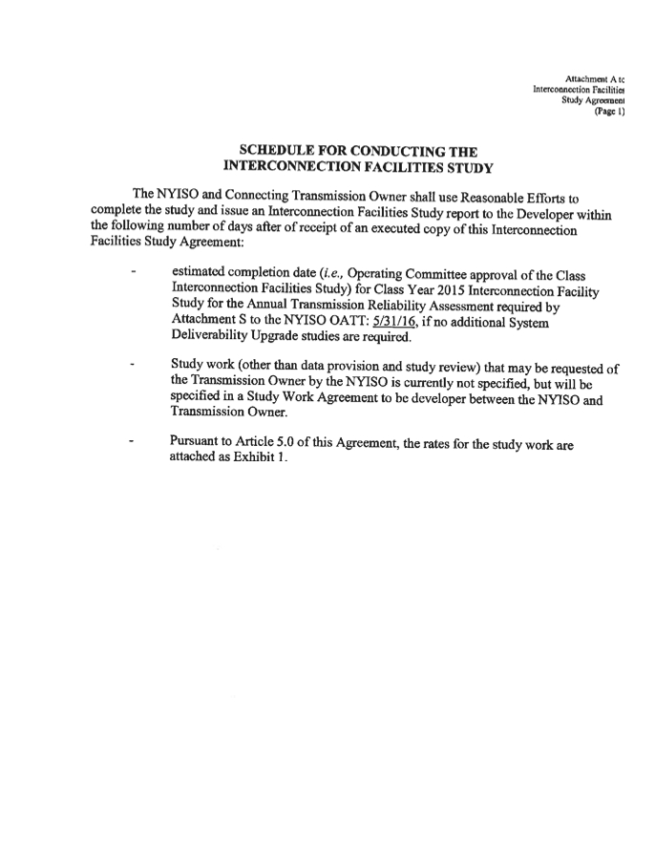
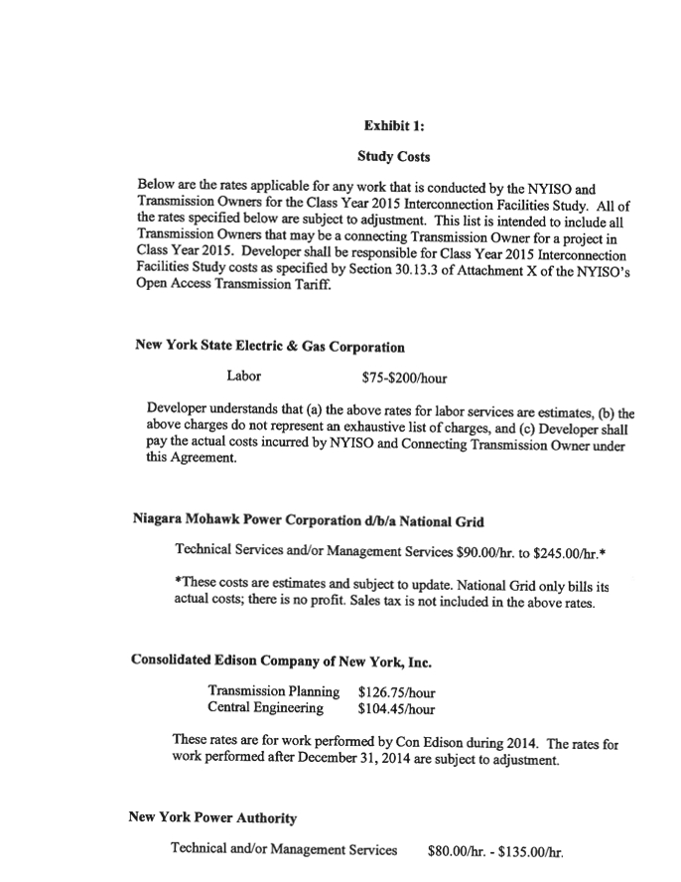
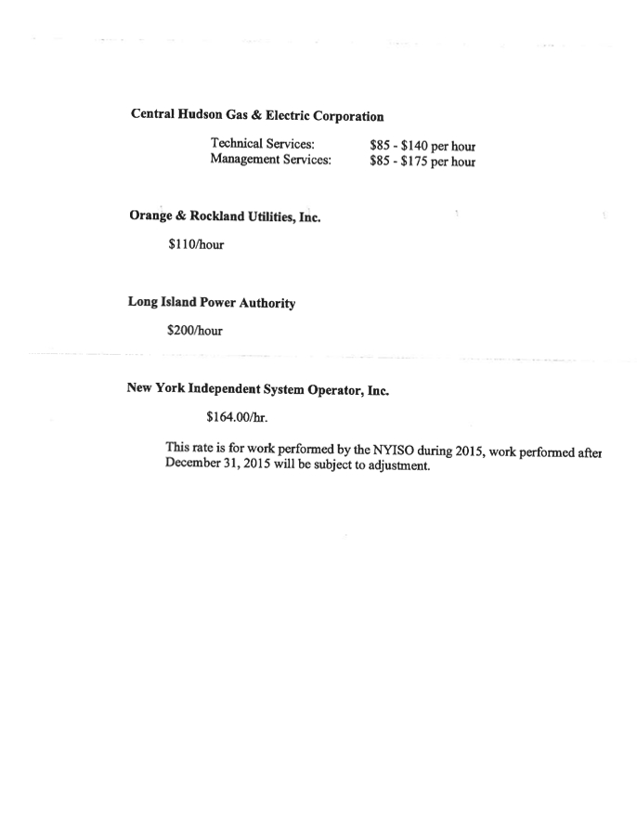
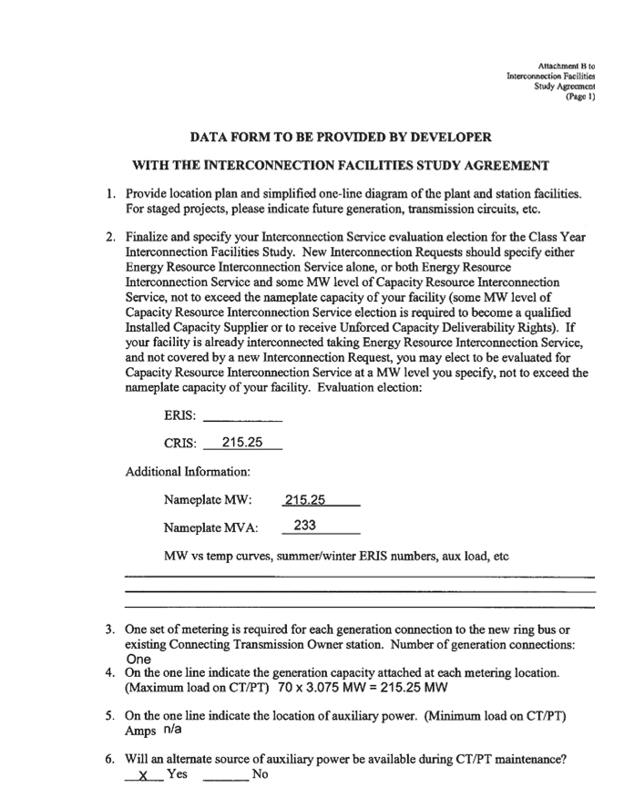
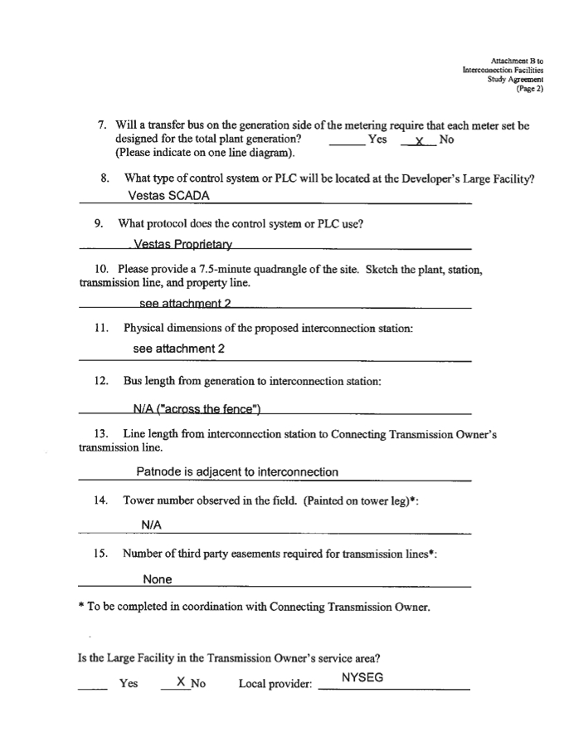
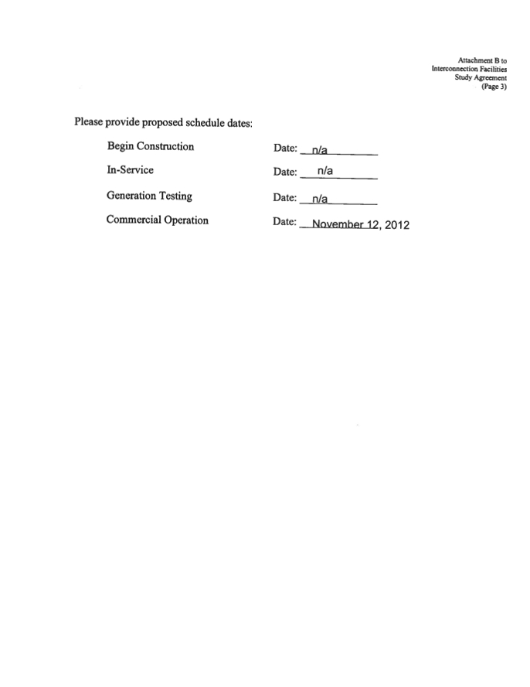


This page contains Critical Energy Infrastructure Information "CEII"
and has been removed fromt the public version


This page contains Critical Energy Infrastructure Information "CEII"
and has been removed fromt the public version
