

10 Krey Boulevard Rensselaer, NY 12144

June 30, 2011

By Electronic Delivery
Honorable Kimberly D. Bose, Secretary Federal Energy Regulatory Commission 888 First Street, NE
Washington, DC 20426
Re: Notice of Termination of Service Agreement No. 1586 to the New York
Independent System Operator, Inc. Open Access Transmission Tariff,
Docket No. ER10-1507-000
Dear Ms. Bose:
Pursuant to Sections 35.9 and 35.15 of the Commission’s Regulations,¹ the New York Independent System Operator, Inc. (“NYISO”) hereby tender for filing and acceptance a Notice of Termination related to a Large Generator Interconnection Agreement (“LGIA”) among the NYISO, Niagara Mohawk Power Corporation d/b/a National Grid (“National Grid) as the
Connecting Transmission Owner, and Jordanville Wind, LLC as the Developer.² The LGIA is designated as Service Agreement No. 1586 under the NYISO’s OATT. National Grid has
indicated to the NYISO that it supports this filing.

I. Background

The LGIA was submitted to the Commission for acceptance in a joint filing made by the
NYISO and National Grid dated June 21, 2010 in the above-referenced docket. The Commission
accepted the LGIA in a letter order dated August 17, 2010. The LGIA contains several minor
non-confirming provisions to accommodate the unique operational control of the Transmission
Owner Attachments Facilities and Transmission Owner Stand Alone System Upgrade Facilities.
The LGIA was negotiated for the purpose of interconnecting a new wind facility to a National
Grid transmission line between National Grid’s Porter and Rotterdam Substations.

Section 2.3.1 of the LGIA provides that the LGIA may be terminated by the Developer upon giving the NYISO and the Connecting Transmission Owner ninety (90) Calendar Days advance written notice. Pursuant to this section, on June 7, 2011, the Developer sent a letter to the NYISO and to National Grid requesting termination of the LGIA.³

¹ 18 C.F.R. §§ 35.9, 35.15 (2008).
² Capitalized terms not otherwise defined in this letter have the meaning set forth in Attachments S, X and Z of the NYISO’s Open Access Transmission Tariff (“OATT”).
³ A copy of this letter is included as Attachment I to this filing.

Honorable Kimberly D. Bose June 30, 2011
Page 2

II. Communications and Correspondence
Communications regarding this filing should be directed to the following persons, whose names should be entered on the official service list maintained by the Secretary for the docket established with respect to this filing:

Robert E. Fernandez, General Counsel
Karen Georgenson Gach, Deputy General Counsel *Sara B. Keegan, Senior Attorney
New York Independent System Operator, Inc.
10 Krey Boulevard
Rensselaer, NY 12144
Tel: (518) 356-6000
Fax: (518) 356-4702
rfernandez@nyiso.com
kgach@nyiso.com
skeegan@nyiso.com
*Designated to receive service.
III. Notice of Termination
Pursuant to the Developer’s letter of June 7, 2011 (enclosed as Attachment A to this filing) and Section 2.3.1 of the LGIA, the NYISO tenders for filing a Notice of Termination concerning Service Agreement No. 1586.
IV. Requested Effective Date
The NYISO respectfully requests that the Commission approve the Notice of
Termination of Service Agreement No. 1586 to the NYISO OATT, effective September 6, 2011 to coincide with the requested termination date included in the Developer’s Notice of
Termination. The Developer submitted its notice to the NYISO and Connecting Transmission Owner ninety (90) days prior to the requested termination date.
V. Documents Submitted
The NYISO submits the following documents:
• this filing letter;

• Developer’s written notice of termination of the LGIA dated June 7, 2011
(Attachment I); and

Honorable Kimberly D. Bose June 30, 2011
Page 3

• Notice of Termination of Service Agreement No. 1586 to the NYISO OATT
(Attachment II).
VI. Service
The NYISO will send an electronic link to this filing to the official representative of each
of its customers, to each participant on its stakeholder committees, to the New York Public
Service Commission, and to the New Jersey Board of Public Utilities. In addition, a complete
copy of the Public documents included with this filing will be posted on the NYISO’s website at
www.nyiso.com.
VII. Conclusion
Wherefore, the NYISO respectfully requests that the Commission accept this Notice of Termination and grant an effective date of September 6, 2011.

Respectfully submitted,

/s/ Sara B. Keegan
Sara B. Keegan
Counsel for the
New York Independent System Operator, Inc.

CERTIFICATE OF SERVICE
I hereby certify that I have this day served the foregoing document upon each person
designated on the official service list compiled by the Secretary in this proceeding in accordance with the requirements of Rule 2010 of the Rules of Practice and Procedure, 18 C.F.R. §385.2010.
Dated at Rensselaer, NY this 30th day of June, 2011.

/s/ Joy Zimberlin
Joy Zimberlin
New York Independent System Operator, Inc
10 Krey Blvd.
Rensselaer, NY 12114 (518) 356-6207

Attachment I
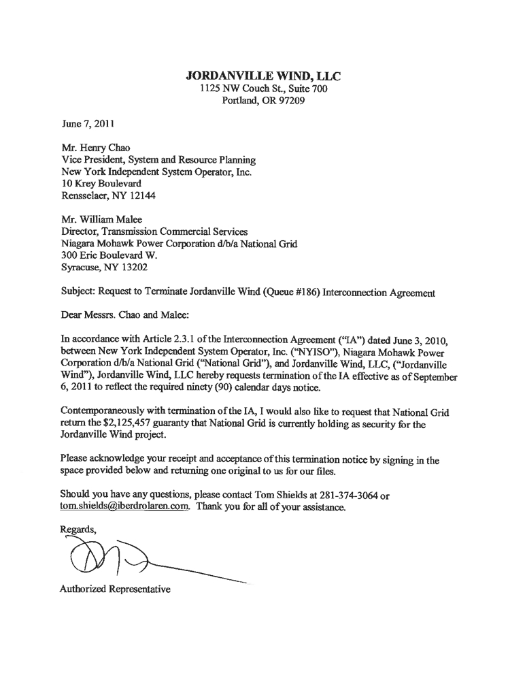
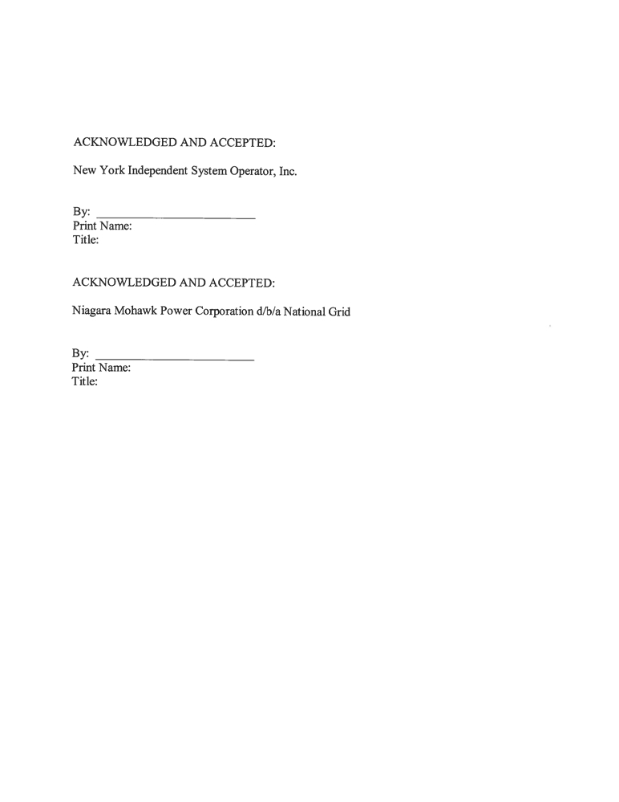

Attachment II

UNITED STATES OF AMERICA
BEFORE THE
FEDERAL ENERGY REGULATORY COMMISSION
)
New York Independent System Operator, Inc. ) Docket No. ER10-1507-000
)

NOTICE OF TERMINATION
Notice is hereby given that effective September 6, 2011, Service Agreement No. 1586, effective
June 3, 2010, and filed with the Federal Energy Regulatory Commission by the New York Independent
System Operator, Inc. and Niagara Mohawk Power Corporation d/b/a National Grid in Docket No. ER10-
1507-000, is to be terminated. Notice of the proposed termination has been served upon the New York
Public Service Commission and all entities that are on the official service list for Docket No. ER10-1507-
000.

New York Independent System Operator, Inc.

By: /s/ Henry Chao
Henry Chao, Vice President
System & Resource Planning

