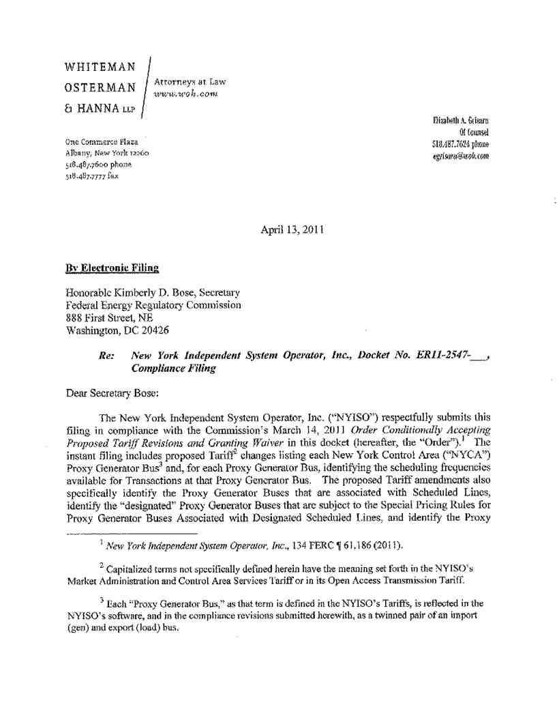

Honorable Kimberly D. Bose April 13, 2011
Page 2
Consistent with the Commission’s instructions, the attached revisions also “indicate what rules will apply if flexible scheduling is unavailable.”

Because the NYISO is not yet able to state with precision when it will implement
dynamic or variable scheduling at any particular Proxy Generator Bus, the NYISO has followed
the Commission’s suggestion in Paragraph 17 of the Order and submits a timetable for the
extension of these enhancements to its Proxy Generator Buses, with an explanation of the steps
the NYISO proposes to take in order to implement dynamic (five minute) or variable (fifteen
minute) scheduling at its external Proxy Generator Buses in the most efficient and expeditious
manner possible.

I. Documents Submitted
1. This filing letter;
2. A clean version of the proposed revisions to the NYISO’s Market Administration and
Control Area Services Tariff (“Services Tariff”) and to its Open Access Transmission
Tariff (“OATT”) (“Attachment I”); and
3. A black lined version of the proposed revisions to the NYISO’s Services Tariff and
its OATT (“Attachment II”).

II. Requirements of the Order
The NYISO proposed in a Section 205 filing submitted on December 28, 2010 to implement more frequent real-time scheduling of interregional transactions at the borders of the NYCA. The NYISO indicated it would introduce intra-hour transactions over time, with the feature being first made available at the Chateauguay interface with Hydro Quebec.⁴ The NYISO also proposed revisions to the pricing rules applicable at its borders to support the implementation of more frequent scheduling.⁵
The Commission conditionally accepted the NYISO’s proposals but directed the NYISO to
provide additional information and to clarify some of its proposed Tariff revisions.⁶ In
Paragraph 16 of the Order the Commission instructed the NYISO to file revised tariff sheets

⁴ New York Independent System Operator, Inc., Proposed Tariff Revisions to Support Enhanced Interregional Transaction Coordination, Docket No. ER11-2547-000 (December 28, 2010), at 8.
⁵ Id. at 4.

⁶ The Commission also granted the NYISO’s request for a waiver of implementation of the new tariff provisions, based on difficulties the NYISO experienced with the necessary software.

Honorable Kimberly D. Bose April 13, 2011
Page 3
“identifying the generator proxy bus or buses for which intra-hour scheduling and new pricing
rules will apply and be made available when the proposed tariff revisions come into effect.”
Paragraph 17 of the Order contained a series of instructions. First, the Commission required the
NYISO to address in this compliance filing whether or not intra-hour scheduling will be
available at the New York/Ontario border. Second, the Commission instructed the NYISO to file
Tariff revisions “addressing when and how each of the remaining border generator proxy
buses…will become subject to intra-hour scheduling and new pricing rules” or, alternatively, to
submit a plan with a timeline “detailing the steps it will take to incorporate this information into
its tariff.” ⁷ Third, the Commission directed the NYISO to file tariff language to specify the
type of scheduling available at each Proxy Generator Bus. Fourth, the Commission instructed
the NYISO to submit Tariff revisions that identify the Proxy Generator Buses that are associated
with Scheduled Lines. Fifth, the Commission instructed the NYISO to identify the Proxy
Generator Buses that have been designated Non-Competitive Proxy Generator Buses, or that are
subject to the Special Pricing Rule for Scheduled Lines. Finally, the Commission instructed the
NYISO to indicate the pricing rules that will apply when dynamic or variable scheduling is not
available.

III. Description of Proposed Tariff Changes

The present filing addresses each of the Commission’s directives. The NYISO believes
that the Commission’s concerns about specifying the locations at which dynamic or variable
scheduling will be available, and the pricing rules that will apply at those locations, can best be
addressed by including a table in the Market Services Tariff that consolidates all of the required
information at a single location. The proposed table, which the NYISO plans to add to the
Services Tariff in a new section 4.4.4, will list all the Proxy Generator Buses at which inter-
regional transactions may be scheduled. The table indicates (1) the interface with which each
Proxy Generator Bus is associated; (2) whether the Proxy Generator Bus is a Non-Competitive
Proxy Generator Bus;⁸ (3) whether the Proxy Generator Bus is associated with a Scheduled Line;
(4) whether the Scheduled Line is a “designated” Scheduled Line that is subject to the Special
Pricing Rule for Proxy Generator Buses Associated with Designated Scheduled Lines; and (5)
the scheduling frequencies that are available at each location, whether five minute, fifteen
minute, or hourly.⁹ The NYISO believes this proposed table will provide a convenient reference

⁷ Id. at P 17.

⁸ Proxy Generator Buses that are not specifically identified as being Non-Competitive are competitive.

⁹ As the NYISO noted in its December filing, Market Participants will continue to have the option to schedule Transactions on an hourly basis after the introduction of dynamic or variable scheduling at a Proxy Generator Bus.

Honorable Kimberly D. Bose April 13, 2011
Page 4
for Market Participants interested in understanding the scheduling options available at the NYISO’s external interfaces.

As shown in the proposed table submitted with this compliance filing, the only
scheduling frequency currently available to Market Participants at the NYISO’s external Proxy
Generator Buses is hourly. The NYISO will continue to offer hourly scheduling at all Proxy
Generator Buses even as more frequent scheduling options are introduced. The NYISO expects
that variable scheduling will first become available at the Chateauguay interface with Hydro
Quebec, in accordance with the implementation plan set forth below. Consistent with the
language proposed in section 4.4.4 of the Services Tariff, the NYISO will introduce a dynamic or
variable scheduling option at a Proxy Generator Bus only after providing notice to its Market
Participants at least two weeks in advance of the planned implementation date. The NYISO will
simultaneously submit a compliance filing in this docket to update the table set forth in section
4.4.4 of the Services Tariff to reflect the addition of the new scheduling option. Unless the Commission acts on the NYISO’s compliance filing before the NYISO’s proposed implementation date, the NYISO will proceed to implement the new scheduling option on the date proposed in its compliance filing.

To address the Commission’s instruction that the NYISO indicate the rules that will apply if variable or dynamic scheduling options are not available, the proposed table clarifies that hourly scheduling will continue to apply and be available to bidders at all Proxy Generator Buses. In addition, the NYISO clarifies in the text following the table that the ISO may revert to establishing only hourly schedules using all available External Transaction Bids at a Proxy Generator Bus that is identified as a Dynamically or Variably Scheduled Proxy Generator Bus when the ISO or a neighboring Balancing Authority is not able to implement schedules as expected, or when necessary to ensure or preserve system reliability.
The NYISO also proposes modifications to Services Tariff, Attachment B, sections
17.1.6.2, 17.1.6.3, and 17.1.6.4, which set forth the pricing rules applicable to real-time LBMP calculations at Proxy Generator Buses. Changes to these sections cross-reference the Proxy Generator Bus designations that will be consolidated in Services Tariff section 4.4.4. The proposed revisions will enable users of the Services Tariff to easily determine the pricing rules that apply at a particular Proxy Generator Bus.

In addition, the NYISO proposes minor changes to the definitions of “Dynamically
Scheduled Proxy Generator Bus,” “Variably Scheduled Proxy Generator Bus,” “Non-
Competitive Proxy Generator Bus,” and “Scheduled Line,” which will link these terms to the information provided in the table at section 4.4.4 of the Services Tariff. The NYISO proposes to make these changes in both the OATT and the Services Tariff.

Honorable Kimberly D. Bose April 13, 2011
Page 5

IV. Proposed Implementation Plan.
The NYISO offers an overview of the steps it plans to undertake and the timetable it
intends to follow in expanding intra-hour scheduling to the remaining Proxy Generator Buses at
the NYCA borders. Extension of variable or dynamic scheduling requires the NYISO to work
closely with each neighboring Control Area Operator to design, test, and implement both
software and real-time operational changes. The NYISO cannot offer variable or dynamic
scheduling until its neighbors are also prepared to do so. Each Control Area Operator must work
with its market participants and regulators to approve any required modifications to its governing
tariff or other documents, and to design, test, and implement all necessary software and changes
to existing operating practices. Thus, the plan outlined here is contingent on the cooperation and
schedules of the NYISO’s neighbors. The timeframes suggested here are those that the NYISO
believes are achievable, based on its discussions to date with the neighboring entities, but cannot
be guaranteed.

The NYISO’s current implementation plan is as follows:
Hydro Quebec - The NYISO currently expects to complete work on the software and
operational procedures needed to support variable scheduling at the HQ Proxy Generator Buses
that represent the Chateauguay Interface by May 11, 2011. Hydro Quebec has indicated that it
plans to finish its corresponding software automation and operational procedures by the end of
May, 2011. The NYISO proposes to submit a compliance filing seeking permission to
implement variable scheduling once Hydro Quebec has confirmed that it is ready to proceed.
Consistent with the proposed revisions to section 4.4.4 of the Services Tariff described above,
the NYISO proposes to notify its Market Participants of the availability of variable scheduling at
the Hydro Quebec Chateauguay Interface Proxy Generator Buses no later than two weeks before
the date the two Control Area Operators determine as the “go live” date. The NYISO proposes
to simultaneously file an updated Services Tariff section 4.4.4 table with the Commission as a
compliance filing in this Docket.
PJM - The NYISO is currently designing procedures and enhancements to its operational
tools in order to support variable scheduling at the PJM Proxy Generator Buses. The NYISO
plans to complete this phase of the work in the first quarter of 2012. The NYISO and PJM will
collaboratively develop a schedule for the introduction of variable scheduling capability onto all
of the NYISO-PJM Proxy Generator Buses. No later than two weeks before PJM and the
NYISO determine they are ready to implement variable scheduling at a Proxy Generator Bus, the
NYISO will notify its Market Participants of the upcoming availability of this feature and will
submit an updated Services Tariff section 4.4.4 to the Commission as a compliance filing in this
Docket.

Ontario - The Independent Electricity System Operator of Ontario (“IESO”) recently
embarked on a stakeholder review of its overall market design. IESO refers to this effort as its
Electricity Market Forum. The forum is made up of members with representation from the

Honorable Kimberly D. Bose April 13, 2011
Page 6
various classes of participants in Ontario and its purpose is to produce a report with recommendations for the design of Ontario’s market. The review will include consideration of enhanced scheduling at Ontario’s interfaces. IESO expects the report to be issued at the end of this year. Representatives of IESO have informed NYISO staff that they will be in a better position to determine when Ontario would be prepared to move forward on variable or dynamic scheduling at its interties after the final report is issued.

ISO-New England - The NYISO and ISO-New England are currently working on a joint market-based solution for more optimal scheduling of interchange at their common border, and anticipate that achieving this objective will require additional amendments to their tariffs (beyond the revisions proposed in this Docket). The NYISO and ISO-New England have engaged their stakeholders in discussions on the conceptual design for more efficient/more frequent scheduling between the two Control Areas. The NYISO and ISO-New England expect to file the tariff language needed to support the chosen concept by the end of 2011. The NYISO targets implementation of these programs with ISO-New England for 2013.

IV. Service
The NYISO will post this filing on the NYISO’s website at www.nyiso.com. In addition,
the NYISO will e-mail an electronic link to this filing to the official representative of each party
to this proceeding, to each of its customers, to each participant on its stakeholder committees, to
the New York Public Service Commission, and to the New Jersey Board of Public Utilities.

VI. Conclusion

Wherefore, for the foregoing reasons, the New York Independent System Operator, Inc. respectfully requests that the Commission accept the compliance filing of the proposed tariff revisions attached hereto with an effective date of March 15, 2011, subject to the waiver granted by the Commission in the Order.

Respectfully submitted,
/s/ Elizabeth A. Grisaru

Elizabeth A. Grisaru
Whiteman Osterman & Hanna
Counsel to the New York Independent System Operator, Inc.
One Commerce Plaza
Albany, New York 12260
mailto:egrisaru@woh.com

Honorable Kimberly D. Bose April 13, 2011
Page 7

cc: Michael A. Bardee
Gregory Berson
Connie Caldwell
Anna Cochrane
Lance Hinrichs
Jeffrey Honeycutt
Michael Mclaughlin
Kathleen E. Nieman
Rachel Spiker
John Yakobitis

