UNITED STATES OF AMERICA
BEFORE THE
FEDERAL ENERGY REGULATORY COMMISSION

)
New York Independent System ) Docket Nos. ER08-1281-005
Operator, Inc. ) ER08-1281-006
) ER08-1281-___
)

REQUEST FOR REHEARING OF THE
NEW YORK INDEPENDENT SYSTEM OPERATOR, INC.
Pursuant to Section 313 of the Federal Power Act (“FPA”), 16 U.S.C. § 825l, and Rule 713 of the Rules of Practice and Procedure of the Federal Energy Regulatory
Commission (“FERC” or “Commission”), 18 C.F.R. § 385.713 (2010), the New York
Independent System Operator, Inc. (“NYISO”) respectfully submits the following request for rehearing (“Request”) of the Commission’s Order on Rehearing and Compliance, 133 FERC ¶ 61,276 (2010) (the “Order”).
I. Background
The NYISO has been working with PJM Interconnection, LLC (“PJM”), the
Midwest Independent Transmission System Operator, Inc. (“Midwest ISO”), the Ontario
Independent Electricity System Operator (“IESO”) and ISO New England (“ISO-NE”) to
develop Broader Regional Market (“BRM”) solutions to Lake Erie loop flow. In January
of 2010 the NYISO submitted a set of four proposed solutions that had been jointly
developed by the ISOs and RTOs. The proposed solutions are:
Buy-Through of Congestion (“BTC”), provides entities that schedule transactions that result in unscheduled parallel path flows in Control Areas that are not part of the “contract path” the opportunity to “buy through” the parallel path impact that their
transaction has on affected parallel path Control Areas, and avoid possible curtailment or

- 1 -

removal via the North American Electric Reliability Company’s (“NERC’s”)
Transmission Loading Relief (“TLR”) process. The Commission instructed the NYISO
to de-prioritize BTC in its Order. The NYISO is not seeking rehearing of that aspect of
the Order.
Enhanced Interregional Transaction Coordination (“EITC”) will enable
interregional transactions that are currently economically evaluated and scheduled on an
hourly basis to be re-evaluated on a more frequent (15 minute or 5 minute) basis. More
frequent evaluation will enhance efficiency by better tailoring the interchange schedule to
reflect the costs that neighboring control areas are experiencing. Potomac Economics’
evaluation indicated that EITC is expected to enhance interregional economic efficiency
significantly more than any of the other proposed BRM solutions.¹ As the Commission
stated in P 8 of the Order, the NYISO’s EITC proposal is currently pending before the
Commission in Docket No. ER11-2547-000.² The Order did not propose to alter the
NYISO’s implementation priority for EITC.³ However, as explained in greater detail

below, it is not possible for the NYISO to meet the Commission’s schedule for
implementing Market-to-Market Coordination (“Market-to-Market”). In order to attempt to meet the schedule that the Commission imposed for Interface Pricing Revisions

¹ See slides 13 and 19 of the Analysis of Broader Regional Market Initiatives that Dr. Patton presented at
the September 27, 2010 technical conference in Philadelphia (“the largest source of benefits are the
efficiency savings achievable by fully utilizing the inter-RTO interfaces…. net scheduled interchange (or
intra-hour scheduling) would likely capture most of the savings”). Link to Dr. Patton’s analysis on the
NYISO’s web site:
http://www.nyiso.com/public/webdocs/committees/bic_miwg/meeting_materials/2010-09-
27/BRM_Analysis_Presentation_to_RTOs_9-27-10.pdf
² In addition to the EITC proposal that is pending before the Commission in Docket No. ER11-2547, the NYISO and ISO-NE are engaged in a joint stakeholder process to overhaul their interchange scheduling protocol and to greatly enhance the efficiency of the scheduling outcomes between their two markets. The New York/New England Inter-Regional Interface Scheduling (“IRIS”) proposal is expected to deliver substantial benefits to the interconnected markets.
³ Order at n 28.

- 2 -

(“Interface Pricing”) the NYISO will be forced to defer implementation of EITC and
other high-value projects that are not directly tied to a regulatory compliance obligation.
Interface Pricing will ensure that the jurisdictional ISOs and RTOs around Lake Erie use similar methods to price interregional transactions, so that differences in pricing methods do not create “seams” that can be exploited. If the Ontario/Michigan PARs are effective in conforming actual power flows to scheduled power flows at the
Ontario/Michigan border, then the NYISO believes it will be necessary to have two
distinct sets of pricing rules. One set of pricing rules that will apply when the
Ontario/Michigan PARs are effective in conforming actual power flows to scheduled
power flows, and a different set of pricing rules that will apply when the
Ontario/Michigan PARs are not effective in conforming actual power flows to scheduled
power flows.
Paragraph 31 of the Order instructed that “interface pricing revisions be
completed concurrently for the Commission-jurisdictional RTO/ISOs by the second
quarter of 2011.” The NYISO is working to develop new external proxy bus pricing
rules that recognize the distribution of power flows around Lake Erie based on the
physical configuration of the transmission network.⁴ The NYISO anticipates using the
new proxy bus pricing rules it is developing at times when the PARs are not effective in
conforming actual power flows to scheduled power flows at the Ontario/Michigan border.
The ISOs and RTOs around Lake Erie have begun discussing the need to use a uniform method of determining when the PARs are controlling for purposes of

⁴ See BRM Interface Pricing presentation by Mr. Robert Pike to the NYISO’s Business Issues Committee on June 2, 2010. Link to presentation:
http://www.nyiso.com/public/webdocs/committees/bic/meeting_materials/2010-06-
02/Agenda_09_BIC_Interface_Price_Revisions.pdf

- 3 -

identifying the correct proxy bus pricing rules to use. The ISOs and RTOs also discussed the problems that would be posed if the method used to determine interface prices was permitted to “flip” frequently, or if the trigger mechanism wasn’t uniform. The NYISO anticipates that the four Lake Erie ISOs/RTOs will determine how to address these
concerns in the upcoming months.⁵
For reasons that are explained below, based on available resources and preexisting regulatory compliance obligations, it is not possible for the NYISO to complete Interface Pricing by the end of the second quarter of this year without significant delays to its
implementation of EITC and other projects that are important for both reliability and
efficiency reasons. The NYISO requests rehearing of this aspect of the Order, and
instead proposes to complete its Interface Pricing software by the end of 2011, for
implementation in January of 2012.
Market-to-Market permits neighboring ISOs and RTOs to use the most cost
effective resource to solve transmission constraints, regardless of whether the resource is
located in the transmission constrained ISO, or in a neighboring ISO or RTO. In order to
implement Market-to-Market, participating ISOs and RTOs need to use consistent
mechanisms to report and calculate market flows, that produce similar, if not identical,
results.
The NYISO proposed waiting for the NERC Parallel Flow Visualization tool
(“PFV”) to be completed, so that the same method of calculating market flows could be
used by all participating ISOs and RTOs. In the Order, the Commission determined that

⁵ It isn’t clear to the NYISO at this very preliminary point what, if anything, IESO intends to do with regard to its interface pricing. The pricing methods employed by the jurisdictional ISOs and RTOs needs to take into account the pricing method(s) that IESO employs.

- 4 -

waiting for the PFV to be completed was unnecessary,⁶ and instructed the NYISO to
construct its own tools “on the existing framework developed and implemented by the
Midwest ISO and PJM.”⁷ The Order instructed the ISOs and RTOs to complete Market-
to-Market by the end of the second quarter of 2011.⁸ The Commission apparently based
its decision on statements by Monitoring Analytics, LLC, PJM’s independent market
monitor (“PJM IMM”). As the NYISO explains below, several of the PJM IMM’s
comments were not accurate with regard to the NYISO, and the Commission cannot
reasonably rely on comments by the PJM IMM to reach a decision regarding the
timeframe in which the NYISO can develop and implement Market-to-Market.
In order to achieve the fastest possible implementation of Market-to-Market, the NYISO is focusing its efforts on implementing Market-to-Market with PJM. PJM will ensure that its implementation of Market-to-Market with New York is coordinated with PJM’s implementation of Market-to-Market with the Midwest ISO.
The NYISO and PJM have already begun work to comply with this aspect of the Commission’s Order. However, the NYISO must start largely from scratch in
constructing its own, market-specific, market flow calculator to replicate the functionality
that PJM and the Midwest ISO have in place. Because the NYISO’s ABB-based market
software is fundamentally different from the Areva-based market software employed by
the Midwest ISO and PJM, it is not possible to purchase and modify either of the existing

⁶ Order at P 28 (“While the parallel flow visualization tool will provide additional data for analyzing loop flows, it is merely an update to the Interchange Distribution Calculator (IDC); it is not a new technology. Indeed, some of the data required to address these problems can already be obtained from the existing IDC. Nothing in the record demonstrates that the NYISO cannot take advantage of the existing technology and data. Therefore, we find that NYISO can implement a congestion management/market-to-market
coordination agreement prior to finalization of the parallel flow visualization tool.”).
⁷ Id. at P 32.
⁸ Id.

- 5 -

market flow calculation and reporting tools in order to speed the Market-to-Market implementation process.
The market flow calculators and protocols that the NYISO and PJM implement
must be enhanced to recognize the effectiveness of Phase Angle Regulators (“PARs”) at
modifying power system flows. These enhancements are necessary due to the substantial
number of PARs at the NYISO/PJM border in the New Jersey/New York City area. This
heavy configuration of PARs devices is not present at the PJM/Midwest ISO border, so it
has not previously been incorporated into the PJM/Midwest ISO market flow calculator
protocols.
The NYISO’s implementation will also incorporate verification and audit

processes and tools to assist the NYISO’s efforts to perform the audit and verification
functions that PJM and the Midwest ISO describe in their proposed settlement in Docket
Nos. EL10-45, EL10-46 and EL10-60. In addition to the time needed to develop Market-
to-Market, significant post-deployment testing will be necessary to ensure that the PJM
and NYISO tools produce nearly identical, accurate results prior to implementation.
The resource constraints and preexisting regulatory compliance obligations that affect the NYISO’s ability to implement Interface Pricing also limit the NYISO’s ability to implement Market-to-Market. It is not possible for the NYISO and PJM to complete Market-to-Market by the end of the second quarter of this year. Below, the NYISO
requests rehearing of this aspect of the Order, and instead proposes to complete Marketto-Market with PJM by the end of 2012.

- 6 -

II. Documents Submitted
1. This Request;
2. The Affidavit of Mr. Rana Mukerji, the NYISO’s Senior Vice President of
Market Structures (Attachment A); and
3. The Affidavit of Dr. David Patton, President of the NYISO IMM
(Attachment B).

III. Specifications of Error and Statement of Issues
Pursuant to Rule 713(c)(1) and (c)(2) of the Commission’s Rules of Practice and Procedure, 18 C.F.R. § 385.713(c)(1), (2) (2010), the NYISO respectfully submits the following specifications of error and statement of issues:
1. The Commission’s decision to require the NYISO to implement Interface
Pricing by the end of the second quarter of 2011 is arbitrary and
capricious, and not supported by substantial evidence. Courts of review
will vacate or reverse the Commission’s orders when they are “arbitrary,
capricious, an abuse of discretion, or otherwise not in accordance with
law.” 5 U.S.C. § 706 (2006); Midwest Indep. Trans. System Operator, Inc.
v. FERC, 373 F.3d 1361, 1368 (D.C. Cir. 2004). Courts of review will
accept the Commission’s factual findings only if supported by substantial
evidence (16 U.S.C. § 825l(b)), and will affirm the Commission’s orders
only if the Commission “examined the relevant data and articulated a
satisfactory explanation for its action, including a rational connection
between the facts found and the choice made.” Motor Vehicle Mfrs. Ass’n
v. State Farm Mut. Auto. Ins. Co., 463 U.S. 29, 43 (1983). See also Pub.
Serv. Comm’n v. FERC, 813 F.2d 448, 451 (D.C. Cir. 1987); Associated
Gas Distribution v. FERC, 824 F.2d 981, 1016 (D.C. Cir. 1987), cert
denied, 485 U.S. 1006 (1998) (citations omitted). The Commission must
engage in reasoned decision- making, which includes “an examination of
the relevant data and a reasoned explanation supported by a stated
connection between the facts found and the choice made.” Burlington
Truck Lines v. United States, 371 U.S. 156 (1962); Memphis Light, Gas
and Water Division v. FPC, 504 F.2d 225, 230 (D.C. Cir. 1974); 16
U.S.C. § 825l (2006). Arbitrary and capricious simply means
unreasonable. Detroit Typographical Union No. 18 v. NLRB, 216 F.3d
109, 118 (D.C. Cir. 2000); Association of Data Processing Serv. Orgs.,
Inc. v. Board of Governors of the Fed. Reserve Sys., 745 F.2d 677, 684
(D.C. Cir. 1984).

- 7 -

The Commission’s reliance on unsupported statements by the PJM IMM and a schedule that only addressed the time necessary to complete the
conceptual market design to determine that the NYISO could implement Interface Pricing by the end of the second quarter of 2011 is error. The
PJM IMM is not an expert on the operation of the New York markets, the PJM IMM does not have access to, or any expertise in the hardware or
software that is used to operate the New York markets, and the PJM IMM did not consider the NYISO’s existing compliance obligations at the time it offered its comments to the Commission.
Following its completion of the conceptual design for Interface Pricing the
NYISO integrated the implementation of this BRM solution into its 2011
project plan. The NYISO’s project plan accounts for both resource
constraints and compliance obligations. In developing its 2011 project
schedule, the NYISO also considered the relative benefits that each of the
BRM solutions are expected to provide, and prioritized the
implementation of EITC, a project that is expected to provide greater
benefits to the interconnected markets than Interface Pricing.

In his attached affidavit Dr. David Patton, the President of the NYISO’s
IMM, explains that paragraph 27 of the Commission’s Order incorrectly
concludes that the NYISO IMM’s study addressing the expected benefits
of BRM included Interface Pricing. As Dr. Patton explains, the NYISO
IMM’s study did not consider the Interface Pricing solution in assessing
the expected benefits of BRM. Dr. Patton’s affidavit also explains that the
NYISO IMM expects EITC to provide greater benefits to the
interconnected markets than Interface Pricing, and recommends that EITC
be implemented first based on the efficiencies that EITC is expected to
provide.
2. The Commission’s decision to require the NYISO to implement
Market-to-Market Coordination by the end of the second quarter of
2011 is arbitrary and capricious, and not supported by substantial
evidence. Courts of review will vacate or reverse the
Commission’s orders when they are “arbitrary, capricious, an
abuse of discretion, or otherwise not in accordance with law.” 5
U.S.C. § 706 (2006); Midwest Indep. Trans. System Operator, Inc.
v. FERC, 373 F.3d 1361, 1368 (D.C. Cir. 2004). Courts of review
will accept the Commission’s factual findings only if supported by
substantial evidence (16 U.S.C. § 825l(b)), and will affirm the
Commission’s orders only if the Commission “examined the
relevant data and articulated a satisfactory explanation for its
action, including a rational connection between the facts found and
the choice made.” Motor Vehicle Mfrs. Ass’n v. State Farm Mut.
Auto. Ins. Co., 463 U.S. 29, 43 (1983). See also Pub. Serv.

- 8 -

Comm’n v. FERC, 813 F.2d 448, 451 (D.C. Cir. 1987); Associated
Gas Distribution v. FERC, 824 F.2d 981, 1016 (D.C. Cir. 1987),
cert denied, 485 U.S. 1006 (1998) (citations omitted). The
Commission must engage in reasoned decision- making, which
includes “an examination of the relevant data and a reasoned
explanation supported by a stated connection between the facts
found and the choice made.” Burlington Truck Lines v. United
States, 371 U.S. 156 (1962); Memphis Light, Gas and Water
Division v. FPC, 504 F.2d 225, 230 (D.C. Cir. 1974); 16 U.S.C. §
825l (2006). Arbitrary and capricious simply means unreasonable.
Detroit Typographical Union No. 18 v. NLRB, 216 F.3d 109, 118
(D.C. Cir. 2000); Association of Data Processing Serv. Orgs., Inc.
v. Board of Governors of the Fed. Reserve Sys., 745 F.2d 677, 684 (D.C. Cir. 1984).

The Commission’s reliance on unsupported statements by the PJM
IMM to determine what the NYISO can and cannot do by the end
of the second quarter of 2011 was error. The PJM IMM is not an
expert on the operation of the New York markets, the PJM IMM
does not have access to, or any expertise in the hardware or
software that is used to operate the New York markets, and the
PJM IMM did not consider the NYISO’s existing compliance
obligations at the time it offered its comments to the Commission.

The Commission’s statement in P 32 of its Order that the NYISO
proposed to implement Market-to-Market in the third quarter of
2010 is not accurate. The NYISO proposed to implement Market-
to-Market by the third quarter of 2011 in the proposed
implementation timeline that appeared on page 19 of its January
12, 2010 Report (the “January 12 Report”). However, the
proposed date was explicitly premised on the completion and
implementation of the PFV by the end of 2010, or on the ability of
the ISOs and RTOs to develop an alternative tool in that same
timeframe.⁹ The January 12 Report including a commitment to
review the state of the PFV initiative by June 1, 2010 and validate
the viability of the PFV solution. The ISOs/RTOs performed that
review and agreed that, as of the date of the review, PFV was
substantially on schedule. The ISOs and RTOs agreed there was
no need to pursue alternative solutions at that time.
Although the ISOs and RTOs later became aware that the NERC
PFV effort was falling behind schedule, the cross-complaints filed
by PJM and the Midwest ISO regarding their implementation of
Market-to-Market in March and April of 2010 (including damages

⁹ See NYISO January 12, 2010 Report at pp. 5, 10 (n 9) and 19.

- 9 -

claims in excess of $160 million) made the NYISO hesitant, in the absence of explicit Commission guidance, to begin developing its own, unique, market flow calculation tool.

The December 30, 2010 Order makes clear that the Commission
expects the NYISO to move forward with developing its own
market flow calculation tool, rather than waiting for the NERC
PFV’s completion. Consistent with the Commission’s instructions,
the NYISO and PJM are working expeditiously and collaboratively
to develop the NYISO’s market-specific, market flow calculation
tool and to implement Market-to-Market. However, even if the
NYISO were to completely re-focus its resources to attempt to
comply with the Order, it is not possible for the NYISO to both
develop a market flow calculator by the end of the second quarter
of 2011 and achieve implementation of Market-to-Market with
PJM in 2011.
The NYISO’s decision to wait for the PFV, in light of the
circumstances presented and in the absence of Commission
guidance, was reasonable. The Commission should grant
rehearing of this aspect of its Order and accept the proposed fourth quarter 2012 implementation date that the NYISO proposes in this Request, and that PJM supports.

IV. Requests for Rehearing
A. Commission’s Reliance On the PJM IMM’s Comments
While the PJM IMM may be knowledgeable about PJM’s ability to implement new market rules and the time that PJM would need to implement a new rule, the PJM IMM is not an expert on the markets that the NYISO administers, the hardware and
software that the NYISO relies on to operate its markets, or on the NYISO’s outstanding regulatory compliance obligations. It is error for the Commission to rely on unsupported statements by the PJM IMM to determine what the NYISO can or cannot do, or to
determine the timeframe in which the NYISO can complete its implementation of a new market rule or of a change to its market design.

- 10 -

The PJM and New York markets operate on fundamentally different market
platforms. PJM’s market platform was produced by Areva, Inc., the NYISO’s by the

ABB Group. Suggestions that PJM software can simply be adapted for use by New
York, or vice-versa, are not credible. Regardless of the platform used to operate Marketto-Market, the software infrastructure required to coordinate flowgate re-dispatch,
accurately settle the resulting outcome, and validate the results, needs to be developed and implemented within the NYISO’s infrastructure.
Setting aside the platforms PJM and the NYISO use to run their markets, there are
also significant differences between the existing New York and PJM market rules that are
relevant to implementation of measures such as Market-to-Market and Interface Pricing.
These include the NYISO’s use of financial evaluation to determine real-time schedules,
as opposed to the largely “physical” nature of ramp reservations and external transaction
scheduling in PJM, and the NYISO’s simultaneous co-optimization of energy and
ancillary service schedules. The NYISO needs to carefully consider potential market rule
interactions that may not be present, or that have already been addressed, in the PJM
market.
The fact that implementing Market-to-Market will present complications in New York that are not present in PJM should come as no surprise to the Commission. PJM has been working with the Midwest ISO to develop, integrate and improve Market-to-
Market since at least 2004. The NYISO is incorporating this design element into its
markets for the first time.
The attached attestation of Mr. Rana Mukerji, the NYISO’s Senior Vice President of Market Structures, attesting to the accuracy of certain factual assertions in this

- 11 -

Request, directly refute the applicability of the comments offered by the PJM IMM in this proceeding to the timeframe within which the NYISO is capable of implementing Market-to-Market and Interface Pricing.
B. NYISO’s Existing Compliance Obligations and List of Projects that
Would Need to be Re-Prioritized In Order to Expedite Interface Pricing and Market-to-Market
The Commission issued its Order on the January 12 Report and the NYISO’s
August 16, 2010 responses on December 30, 2010. Over the period between the
NYISO’s submission of its January 12 Report and the Commission’s issuance of its
Order, the NYISO developed its project plan for 2011. Many of the NYISO’s 2011
projects must be completed to achieve compliance with Commission orders, rules, or
regulations. One initiative is necessary to comply with the terms and conditions under
which the Department of Energy awarded $75.7 million to New York to implement smart
grid related technologies. Regulatory/legal compliance-related projects (other than
Market-to-Market and Interface Pricing) that the NYISO must undertake in 2011 are
listed below:
• Buyer Side Installed Capacity Mitigation Rules Implementation
o Deploy in second quarter of 2011
o Required to comply with Commission order in Docket No. ER10-3043

• Demand-Side Ancillary Service Provider Aggregation
o Deploy in 3rd quarter of 2011
o Required to comply with Commission order in Docket No. ER09-1142

• Consolidated Invoice Redesign
o Deploy in August of 2011
o Required to comply with Commission Order No. 741, Credit Reforms in
Organized Wholesale Markets
o Includes shortening the NYISO’s settlement cycle to 7 days or less
effective October 1, 2011

- 12 -

• Multi-Duration/Non-Historic Fixed Price Transmission Congestion Contracts
o Must follow Consolidated Invoice Redesign (dependency)
o Deploy in second quarter of 2012 (significant work needs to be done in
2011 to meet the required deployment date)
o Required to comply with Commission order in Docket No. ER07-521

• Demand Response in Real-Time Energy Market
o Architectural design specifications in third quarter of 2011; deployment
date has yet to be determined
o Required to comply with Commission order in Docket Nos. EL09-68 and
RM10-17

• Department of Energy Smart Grid Investment Grant Project schedule
o Phasor Measurement Unit (PMU) Enhanced State Estimator
▪ Deployment: Q2 2012
o Visualization (Situational Awareness) Applications
▪ Deployment: Q4 2012
o Voltage Stability Monitoring Applications
▪ Deployment: Q1 2013
o Phasor Measurement Network Architecture / Integration of PDAC
▪ Deployment: Q2 2013
o Consistent with its grant award (Award No. DE-OE0000368) the NYISO
must complete its obligations (other than an ongoing reporting obligation)
by June 30, 2013.
If the Commission rejects this Request, the NYISO will work expeditiously to
attempt to complete Market-to-Market and Interface Pricing by the end of the second
quarter of this year. However, as explained below, the NYISO cannot complete Market-
to-Market by the Commission’s deadline, and would only be able to complete Interface
Pricing if it delayed implementation of EITC, which both the NYISO and its IMM expect
will provide greater efficiency benefits to the interconnected markets, and other important
projects.
Projects that are not regulatory compliance obligations, but that are expected to
require significant NYISO resources to complete, and that would likely have to be de-

- 13 -

prioritized or displaced in order to make resources available to work on Interface Pricing and Market-to-Market include:
1. Upgrading hardware platform on which the NYISO runs its markets. The
NYISO’s Day-Ahead and real-time unit commitment and dispatch software runs on
leased hardware. The NYISO’s lease expires in November of 2011 and the NYISO
needs to migrate off this hardware to a new, faster, more robust and more flexible
platform that the NYISO has already purchased and begun testing. The transition to the
new hardware platform is scheduled for implementation in the second quarter of 2011.
Putting off the transition would require the NYISO to continue running its markets on
existing equipment, while brand new hardware upgrades sit idle at the NYISO’s Power
Control Center and Krey Corporate Center. Retaining the existing equipment beyond the
conclusion of the current lease would have additional financial consequences.
Until this project is complete, it is expected to require a significant amount of NYISO staff resources. Delaying this project in order to speed implementation of
Market-to-Market would impose both reliability and efficiency concerns.
2. EITC with Hydro Quebec Transenergie and PJM. The NYISO’s IMM has

determined that the EITC BRM enhancement provides the greatest market efficiency

benefits of all of the BRM enhancements.¹⁰ Deployment of EITC at the NYISO’s
interface with Hydro Quebec is scheduled to be completed in the first quarter of 2011. A
phased deployment at the New York/PJM border, starting with Scheduled Lines (Neptune
and Linden VFT), then proceeding to the PJM-New York A/C interface is scheduled to
commence in the fourth quarter of 2011. Successful deployment and operation at the

¹⁰ See the attached Affidavit of Dr. David Patton (Attachment B).

- 14 -

Hydro Quebec interface is a prerequisite to deployment at the NYISO’s interfaces with
PJM.
Because EITC uses many of the same resources as Interface Pricing, requiring the
NYISO to complete Interface Pricing by the end of the second quarter of 2011 will push
the deployment of EITC at the PJM interface into 2012. By disrupting the NYISO’s
2011 project plan (which schedules the use of critical path resources), the revised
schedule will likely result in more time being required to complete the two projects
collectively.
3. Market design and software specifications for EITC (called Inter-Regional

Interchange Scheduling or “IRIS”) with ISO-NE. Again, the NYISO’s IMM has

determined that the interchange scheduling enhancement provides the greatest market
efficiency benefits of the BRM enhancements. The NYISO and ISO-NE have asked their stakeholders to consider further/additional enhancements that could achieve even broader benefits than EITC. A white paper describing the proposal that ISO-NE and the NYISO have jointly developed is available on the NYISO’s web site at:
http://www.nyiso.com/public/webdocs/committees/bic_miwg/meeting_materials/
2011-01-21/Agenda_05_-_IRIS_White_Paper.pdf
4. Data Center Migration. Following the completion of its new data center, the NYISO is scheduled to relocate its data center in 2012. This effort will require
intermittent outages of the NYISO’s production and testing environments and is expected to impact testing and development efforts for all 2012 projects.
If the Commission requires the NYISO to prioritize Interface Pricing and Market-
to-Market over the projects listed above, the NYISO’s overall efficiency in completing

- 15 -

projects in 2011 will be compromised because it will be forced to depart from its
carefully constructed 2011 project schedule, which takes into account the availability of
key resources, including “sandboxes” for testing, programmers, and quality assurance
testers. The Commission should grant rehearing of its Order and accept the dates and
schedules for completion of Market-to-Market and Interface Pricing that the NYISO
proposes below.
C. Proposed Plan and Schedule for Implementing Market-to-Market
with PJM
The NYISO and PJM have discussed a proposed Market-to-Market
implementation schedule and both entities agree that it isn’t possible to complete Marketto-Market by the date specified in the Order.¹¹ While PJM is capable of implementing Market-to-Market sooner than the NYISO is, due to its familiarity with the process and ability to rely on existing software functionality and tariff rules, PJM recognizes that a six month implementation timeframe isn’t feasible.
PJM and the NYISO have met and agreed upon several key Market-to-Market
implementation issues, including the method that will be used to determine Market-to-
Market entitlements. PJM and the NYISO have agreed to establish entitlements on a
“forward” basis and to revisit their entitlement determinations on a periodic basis.
The following proposed Market-to-Market implementation schedule is aggressive,
but feasible, and that the Commission should grant rehearing of its determination that
Market-to-Market must be completed by the end of the second quarter of 2011, and
instead adopt the Market-to-Market implementation schedule proposed below. The

¹¹ PJM has reviewed a substantially complete draft of this Request prior to its submission, and has committed to file comments on this Request setting forth its position.

- 16 -

proposed schedule takes into account the efforts that will be necessary to enhance the NYISO’s software capabilities and operating procedures to successfully administer the Market-to-Market protocol.
Proposed Market-to-Market Coordination Implementation Timeline

Task Delivery by End of
• Market Flow Calculator 3rd QTR - 2011
o Includes specification, development, testing,
and implementation of calculation engine,
incorporating common treatment for PAR
operational requirements and model
representation
• Joint Operating Agreement 4th QTR - 2011
o Includes defining entitlements and filing for
Commission review
• Software Specifications 3rd QTR - 2011
o Completion of documentation defining
changes necessary to administer real-time
constraint coordination, settlement
administration, audit and validation
• Software Development 2nd QTR - 2012
o Completion of software tools necessary to
administer and settle Market-to-Market
outcomes, and validate the results
• Software Ready 4th QTR - 2012
o Completion of software validation, including
finalized software development, software
performance and completeness testing,
process validation and operator training
• Implementation 4th QTR - 2012
Again, the NYISO respectfully requests that the Commission grant rehearing of its determination that Market-to-Market must be completed by the end of the second quarter of 2011, and instead adopt the Market-to-Market implementation schedule
proposed by the NYISO, and supported by PJM.

- 17 -

D. Proposed Plan and Schedule for Completing Interface Pricing
Revisions

Interface Pricing is already on the NYISO’s project schedule for 2011. The

NYISO proposes to complete software development on this project by the end of the
fourth quarter of 2011, and to deploy the new Interface Pricing functionality in January of 2012. Unless the NYISO delays or defers its implementation of EITC with Hydro
Quebec, PJM and ISO-New England, the NYISO will not be able to accelerate its
implementation of Interface Pricing to complete it by the end of the second quarter of 2011, or even by the end of the third quarter of 2011.
In his attached affidavit Dr. David Patton, the President of the NYISO’s IMM,
explains that paragraph 27 of the Commission’s Order incorrectly concludes that the
NYISO IMM’s study addressing the expected benefits of BRM included Interface
Pricing. As Dr. Patton explains, the NYISO IMM’s study did not consider the Interface
Pricing solution in assessing the expected benefits of BRM. The affidavit also explains
that the NYISO IMM expects EITC to provide greater benefits to the interconnected
markets than Interface Pricing, and recommends that EITC be implemented first from a
market efficiency perspective.
The NYISO respectfully requests that the Commission reconsider its decision to
require the NYISO to accelerate its proposed implementation of Interface Pricing by six
months, and instead permit the NYISO to complete its software development in 2011 and
deploy Interface Pricing in January of 2012, in accordance with the following proposed
schedule that the NYISO developed with input from PJM, and that PJM supports:

- 18 -

Proposed Interface Pricing Revisions Implementation Timeline
Task Delivery by End of
• Software Design 1st QTR - 2011
• Software Development 3rd QTR - 2011
• Tariff Development and Stakeholder Review 3rd QTR - 2011
• Testing and Validation 4th QTR - 2011
• Implementation January - 2012
In addition to permitting the NYISO to follow its 2011 project schedule, the brief
delay (compared to the Commission’s second quarter 2011 requirement) should also
provide time for the ISOs and RTOs to (1) review the actual, real-time operating
effectiveness of the Ontario/Michigan PARs, (2) determine if and when it will be
necessary to switch pricing regimes to reflect the PARs effectiveness in conforming
actual power flows to scheduled power flows at the Ontario/Michigan border, and
(3) develop procedures to ensure the interconnected markets use consistent pricing methods.
V. Conclusion
The NYISO respectfully requests that the Commission grant rehearing of its
Order and accept the schedules for implementing Market-to-Market and Interface Pricing proposed in this Request.

Respectfully submitted,
/s/ Alex M. Schnell
Robert E. Fernandez, General Counsel Alex M. Schnell
New York Independent System Operator, Inc.
10 Krey Boulevard
Rensselaer, NY 12144
Tel: (518) 356-8707
Fax: (518) 356-7678
aschnell@nyiso.com
January 31, 2011

- 19 -

CERTIFICATE OF SERVICE
I hereby certify that I have this day served the foregoing document upon each
person designated on the official service list compiled by the Secretary in this proceeding
in accordance with the requirements of Rule 2010 of the Rules of Practice and Procedure,
18 C.F.R. § 385.2010 (2010).

Dated at Rensselaer, New York this 31st day of January, 2011.

By: /s/ Alex M. Schnell
Alex M. Schnell
New York Independent System Operator, Inc.
10 Krey Boulevard
Rensselaer, NY 12144 (518) 356-8707

Attachment A

Affidavit of Mr. Rana Mukerji
Senior Vice President of Market Structures
New York Independent System Operator, Inc.
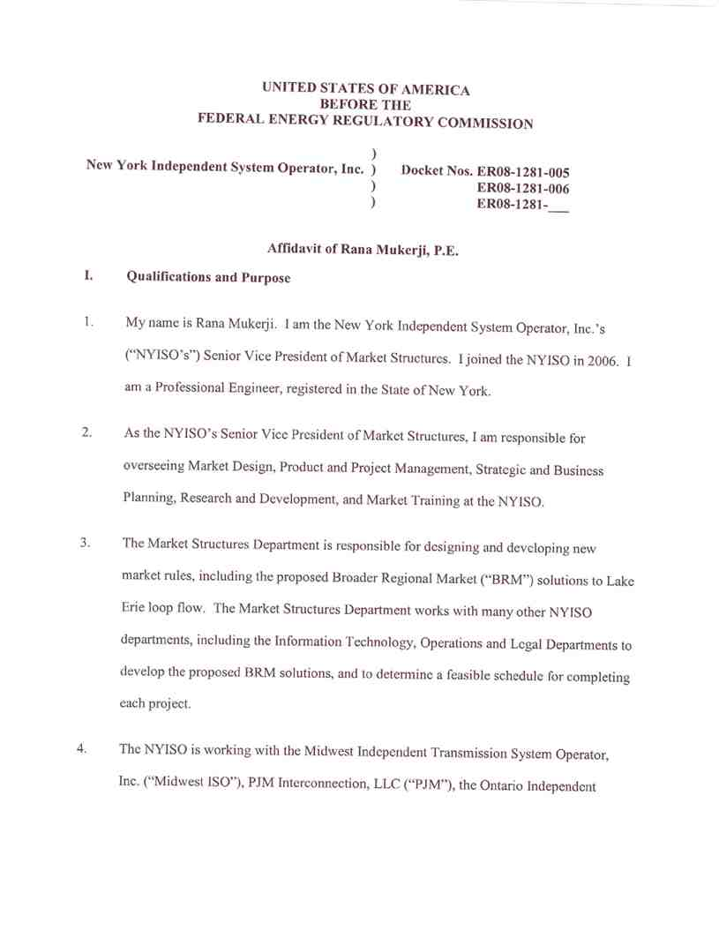
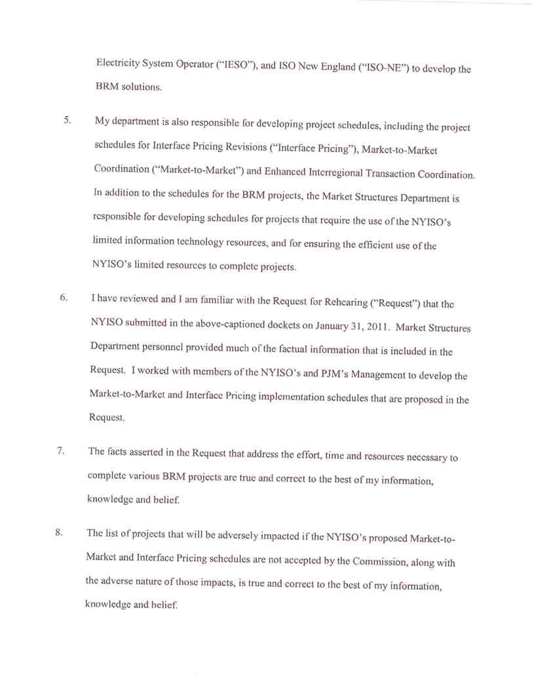
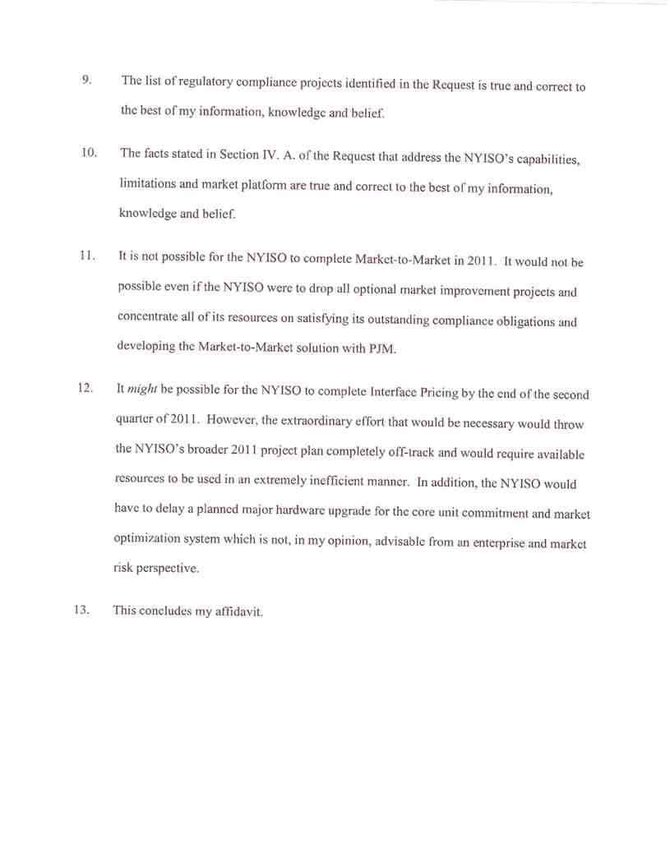
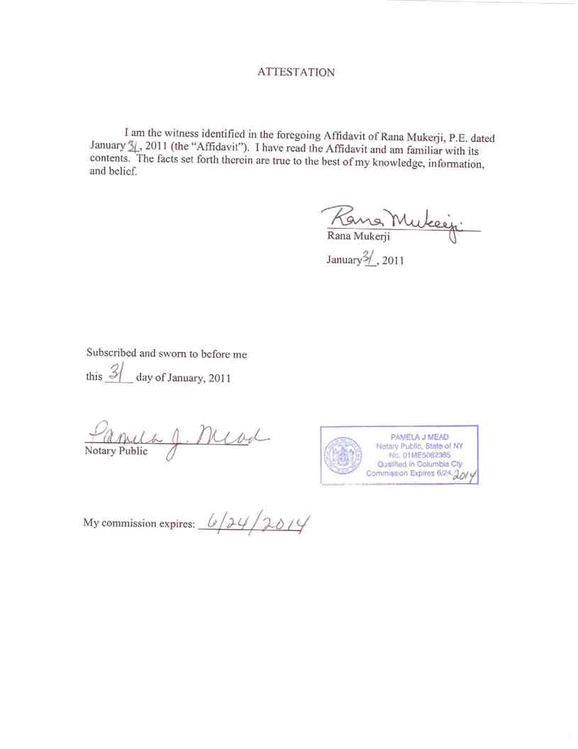

Attachment B

Affidavit of Dr. David Patton
President of Potomac Economics
External Market Monitoring Unit to the
New York Independent System Operator, Inc.

UNITED STATES OF AMERICA
BEFORE THE
FEDERAL ENERGY REGULATORY COMMISSION

)
New York Independent System Operator, Inc. ) Docket Nos. ER08-1281-005
) ER08-1281-006
) ER08-1281-___

Affidavit of David B. Patton, Ph.D.

I. Qualifications and Purpose

1. My name is David B. Patton. I am an economist and President of Potomac Economics.
Our offices are located at 9990 Fairfax Boulevard, Fairfax, Virginia 22030. Potomac
Economics is a firm specializing in expert economic analysis and monitoring of wholesale
electricity markets. Potomac Economics currently serves as the Market Monitoring Unit
(“MMU”) for the New York Independent System Operator, Inc. (“NYISO”), as the
External Market Monitor for the ISO New England Inc (“ISO-NE”), and the Independent
Market Monitoring Unit for the Midwest ISO. I am responsible for assessing the
competitive performance of the markets administered by the ISOs, including assisting in
the implementation of monitoring plans to identify and remedy market design flaws and
abuses of market power. I also provide recommendations regarding market mitigation
measures and other market rules.

2. I have worked as an energy economist for nineteen years, focusing primarily on the
electric utility and natural gas industries. I have provided strategic advice, analysis, and
expert testimony in the areas of electric power industry restructuring, pricing, mergers,

Page 1

and market power. I have also advised other existing and prospective RTOs on
transmission pricing, market design, and congestion management issues. With regard to competitive analysis, I have provided expert testimony and analysis regarding market power issues in a number of mergers and market-based pricing cases before the Federal Energy Regulatory Commission (“FERC” or the “Commission”), state regulatory
commissions, and the U.S. Department of Justice.

3. Prior to my experience as a consultant, I served as a Senior Economist in the Office of
Economic Policy at the Federal Energy Regulatory Commission, advising the Commission on a variety of policy issues including transmission pricing, open-access and electric
utility mergers.

4. Before joining the Commission, I worked as an economist for the U.S. Department of
Energy. During this time, I helped develop and analyze policies related to investment in oil and gas exploration, electric utility demand side management, residential and
commercial energy efficiency, and the deployment of new energy technologies. I hold a Ph.D. and M.A. in Economics from George Mason University and a B.A. in Economics with a minor in Mathematics from New Mexico State University.

5. On January 12, 2010 the NYISO filed with the Commission, on behalf of the ISOs and
RTOs around Lake Erie (NYISO, Midwest ISO, PJM and the Ontario Independent
Electricity System Operator (“IESO”)) and ISO-NE, a “Report” (including several
attachments, which I consider to be components of the NYISO’s Report) in which the
ISOs and RTOs proposed several Broader Regional Market solutions to Lake Erie loop
flow. As the MMU for several of the ISOs and RTOs that participated in developing the
Page 2

Report, we support the Broader Regional Market solutions that were jointly developed by the ISOs and RTOs.

6. Potomac Economics was also commissioned by the NYISO to study the expected benefits
of implementing the Broader Regional Market (“BRM”) solutions to Lake Erie loop flow.
The “final” version of Potomac Economics Analysis of Broader Regional Market
Initiatives (“Benefits Assessment”) was shared with interested stakeholders and FERC
Staff at a technical conference that was held in Philadelphia, Pennsylvania on September
27, 2010. The NYISO later formally submitted Potomac Economics’ Analysis in the
above-captioned Docket.

7. The purpose of this affidavit is to address the Commission’s December 30, 2010 Order

and the NYISO’s January 2011 Rehearing Request. In particular, I address an apparent
misunderstanding regarding the scope of the Analysis that Potomac Economics performed, and I explain why I believe the NYISO should be instructed to continue to prioritize the
Enhanced Interface Transaction Coordination (“EITC”) BRM solution over the Interface Pricing Revisions (“Interface Pricing”) and Market-to-Market Coordination (“Market-to-
Market”) BRM solutions.

8. First, paragraph 27 of the Commission’s Order suggests or infers that the analysis
Potomac Economics performed with regard to the expected benefits of “External Interface
Utilization” incorporated proposed changes to make the methods used to develop prices at
the interfaces between ISOs and RTOs more consistent. The External Interface Utilization
portion of Potomac Economics’ Analysis was focused on ensuring that price differentials
between markets are efficiently arbitraged. In other words, estimating the benefits of fully

Page 3

utilizing the interface to schedule power from the lower priced ISO/RTO to the higher
priced ISO/RTO. Potomac Economics’ External Interface Utilization analysis relied on
the LMPs or LBMPs that were in place for each market during the time period studied to
identify the potential benefits of more efficiently utilizing the interfaces between ISOs and
RTOs. Hence, it does not estimate the benefits of modifying the interface pricing
methodology.

9. With regard to the Commission’s request for “all of the studies it has done regarding loop
flow issues”, the only studies that exist regarding these loop flow issues are the analysis we performed in 2008 to evaluate the circuitous scheduling patterns and the Benefits
Assessment of the Broader Regional Market initiatives that has already been provided. However, based on paragraphs 25 and 27 of the Commission’s Order, I now recognize that additional explanation of Potomac Economics’ Benefits Assessment will be of
assistance to both the Commission and the parties to this proceeding. Hence, Potomac Economics is in the process of developing additional supporting materials that the NYISO proposes to file with the FERC on February 28, 2011.

10. In paragraphs 31 and 32 of its Order the Commission instructs the NYISO, along with the
other jurisdictional ISOs and RTOs, to complete Interface Pricing and Market-to-Market by the end of the second quarter of this year.

11. Our Benefits Assessment indicates that EITC is expected to provide the greatest economic
efficiency benefits to the interconnected markets. The first EITC project will address the
borders with Hydro Quebec Transenergie and PJM. The second, broader, effort addresses

Page 4

the New York/New England border. The New York/New England effort is referred to as Inter-Regional Interchange Scheduling (“IRIS”).

12. The NYISO has informed me that it is impossible for it to complete Market-to-Market by
the Commission’s deadline, but that it could attempt to timely complete Interface Pricing if it suspends work on both of its EITC and IRIS projects in 2011.

13. The NYISO has informed me that prioritizing both Market-to-Market and Interface
Pricing over EITC and IRIS would, effectively, require software development work on the EITC and IRIS projects to be suspended until late 2012.

14. Potomac Economics recommends that the Commission accept the schedules for

implementing Market-to-Market and Interface Pricing that the NYISO proposes in its
Rehearing Request because those proposed schedules will permit the NYISO to continue to actively pursue and prioritize the EITC and IRIS projects.

15. The expected efficiency benefits to the interconnected markets of EITC and IRIS are
substantially greater than the expected benefits of Interface Pricing and Market-to-Market. A comparison of the expected benefits of the EITC solution to the Market-to-Market
solution appear on slide 13 of the Benefits Assessment. Although the Benefits
Assessment didn’t address the expected benefits of the BRM Interface Pricing solution, I expect the benefits of optimizing the interchange between the markets to vastly exceed the benefits that will be achieved by increasing the consistency of the price calculation
methods used by the interconnected markets.

Page 5

16. Therefore, Potomac Economics supports the Interface Pricing and Market-to-Market
implementation schedules proposed in the NYISO’s rehearing request.

17. This concludes my affidavit.

Page 6
