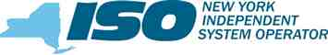

August 21, 2019

By Electronic Delivery
Honorable Kimberly D. Bose, Secretary Federal Energy Regulatory Commission 888 First Street, NE
Washington, DC 20426
Re: New York Independent System Operator, Inc., Filing to Supplement the
Record; Docket No. ER19-2665-000
Dear Secretary Bose:
On August 21, 2019, the New York Independent System Operator, Inc. (“NYISO”) filed,
with the Federal Energy Regulatory Commission (“Commission”), an executed Large Generator
Interconnection Agreement entered into by the NYISO, National Grid, as the Connecting
Transmission Owner, and Ball Hill Wind Energy, LLC. The Interconnection Agreement is
labeled as Service Agreement No. 2473 under the NYISO’s Open Access Transmission Tariff.
The NYISO submits this filing to supplement the record with a signature page that was inadvertently omitted from the earlier filing (Attachment IV).
I. Service
The NYISO will send an electronic link to this filing to the official representative of each
party to this proceeding, to the official representative of each of its customers, to each participant
on its stakeholder committees, to the New York Public Service Commission, and to the New
Jersey Board of Public Utilities. In addition, the complete filing will be posted on the NYISO’s
website at www.nyiso.com.

10 Krey Boulevard, Rensselaer, New York 12144 | www.nyiso.com

Honorable Kimberly D. Bose August 21, 2019
Page 2

II. Conclusion
The NYISO respectfully requests that the Commission accept this filing to supplement its
earlier filing in the above captioned proceeding. The requested effective date of the
Interconnection Agreement remains the same as that proposed in the earlier filing in this
proceeding.
Respectfully submitted,
Sara B. Keegan
Sara B. Keegan
Counsel for the
New York Independent System Operator, Inc.

cc: Anna Cochrane
James Danly
Jignasa Gadani
Jette Gebhart
Kurt Longo
John C. Miller
David Morenoff
Daniel Nowak
Larry Parkinson
Douglas Roe
Frank Swigonski
Gary Will

Attachment IV
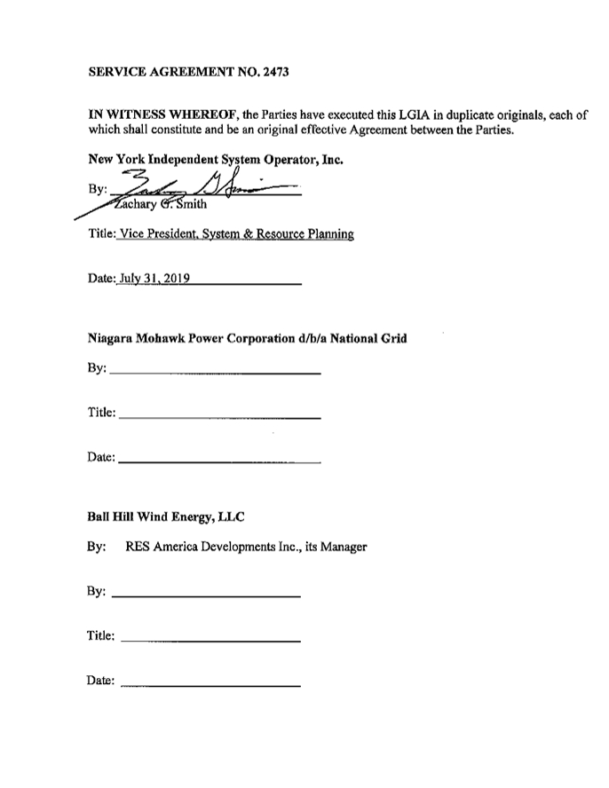

CERTIFICATE OF SERVICE
I hereby certify that I have this day served the foregoing document upon each person
designated on the official service list compiled by the Secretary in this proceeding in accordance with the requirements of Rule 2010 of the Rules of Practice and Procedure, 18 C.F.R. §385.2010.
Dated at Rensselaer, NY this 21st day of August 2019.

By: /s/ John C. Cutting
John C. Cutting
New York Independent System Operator, Inc.
10 Krey Blvd.
Rensselaer, NY 12144 (518) 356-7521

