

Amanda C. Downey
Senior Counsel

April 28, 2017

The Honorable Kimberly D. Bose Secretary
Federal Energy Regulatory Commission 888 First Street, NE
Washington, DC 20426
Re: New York Independent System Operator, Inc.
Docket No. ER11-2402-001
Compliance Filing

Dear Secretary Bose:
Niagara Mohawk Power Corporation (“Niagara Mohawk”) hereby submits its filing to comply with the letter order issued by the Commission in this proceeding on February 10, 2011.¹

In the letter order, the Commission conditionally accepted a Large Generator
Interconnection Agreement (“LGIA”) between Niagara Mohawk and WPS Syracuse
Generation, LLC (“WPS Syracuse”),² subject to Niagara Mohawk’s submittal of a
compliance filing within 30 days after the letter order was issued. The Commission
directed that in the compliance filing, Niagara Mohawk must either: (1) revise Appendix
H to the LGIA with WPS Syracuse to remove Section 5.8 (entitled Information
Exchange) from the list of sections of the LGIA to which Niagara Mohawk and WPS
Syracuse believe the NYISO pro forma Large Generator Interconnection Agreement is
not applicable; or (2) explain why Section 5.8 should continue to be listed in Appendix
H.
Niagara Mohawk regrets the oversight in not submitting this compliance filing
earlier. Due to an administrative issue that arose when the WPS Syracuse LGIA was
submitted to the Commission, NYISO representatives were listed on the Commission’s e-
mail service list but Niagara Mohawk representatives were not. NYISO representatives recently pointed out the outstanding compliance obligation to Niagara Mohawk.

¹

²

Commission letter order, Docket No. ER11-2402-000 (Feb. 10, 2011).
The LGIA with WPS Syracuse is designated as Service Agreement No. 316 under the New York

Independent System Operator Inc.’s (“NYISO”) Open Access Transmission Tariff, with an effective date of February 15, 2011.

40 Sylvan Road, Waltham, MA 02451
■ T: 781-907-2136  F: 781-296-8092  amanda.downey@nationalgrid.com  www.nationalgrid.com

The Honorable Kimberly D. Bose April 28, 2017
Page 2

In the instant compliance filing, Niagara Mohawk has revised the Appendices to
the LGIA with WPS Syracuse to remove Section 5.8 from the list of inapplicable
provisions in Appendix H. Niagara Mohawk notes that the delay in removing Section 5.8
from the list did not result in any harm. Section 5.8 addresses the exchange of design
information about Attachment Facilities prior to their construction so that the parties can
work “in good faith to make any necessary design changes.” No new Attachment
Facilities associated with the WPS Syracuse facility have been designed or constructed
since 2011.

The clean version of the revised Appendices to the LGIA with WPS Syracuse is provided in Attachment A hereto, and the revision to Appendix H of the Appendices is shown in red-line format in Attachment B hereto.

Please contact the undersigned with any questions. Thank you.

Respectfully submitted,

/s/ Amanda C. Downey
Amanda C. Downey
Senior Counsel
National Grid USA
Service Company, Inc.
40 Sylvan Road
Waltham, MA 02451
Attorney for Niagara Mohawk Power Corporation

CERTIFICATE OF SERVICE
I hereby certify that I have this day caused the foregoing document to be served
upon each person designated on the official service list compiled by the Secretary in this
proceeding.
Dated at Washington, DC, this 28th day of April, 2017.

/s/ Daniel Klein
Daniel Klein
Alston & Bird LLP

Attachment A

Appendix A
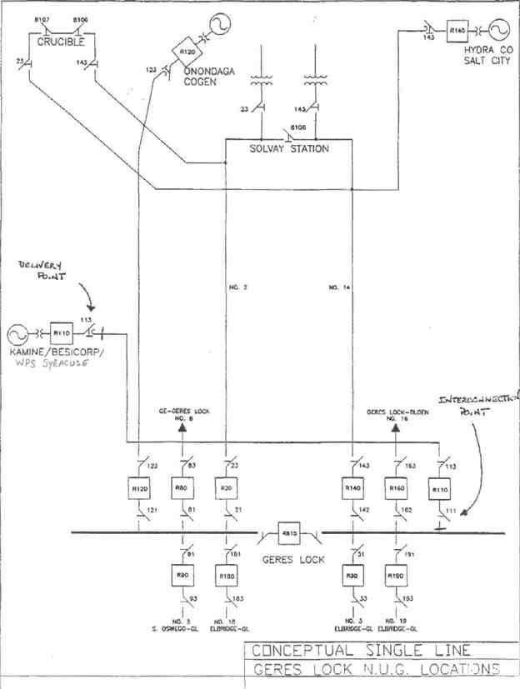

Appendix B

Milestones

Appendix C

Interconnection Details
1. Owner:
Project:
Point of Interconnection: (refer to one-line diagram that should be attached in Appendix A)
2. Electrical Equipment Requirements: The installation of electrical equipment and operation
of the facility must meet or exceed the requirements of Niagara Mohawk's Electric System
Bulletin No.ESB 756.
3. Metering Requirements: Electricity transferred to the transmission system shall be measured
by electric watt-hour meters of a type approved by the Public Service Commission of the State
of New York. The meter and installation costs shall be borne by WPS Syracuse Generation
LLC. The meters shall be maintained with the rules set forth in 16 NYCRR Part 92.
4. Reference:
5. Reference:

Appendix D

Security Arrangements Details

Infrastructure security of New York State Transmission System equipment and operations and control hardware and software is essential to ensure day-to-day New York State Transmission System reliability and operational security. The Commission will expect the NYISO, all Transmission Owners, all Developers and all other Market Participants to comply with the recommendations
offered by the President's Critical Infrastructure Protection Board and, eventually, best practice
recommendations from the electric reliability authority. All public utilities will be expected to
meet basic standards for system infrastructure and operational security, including physical,
operational, and cyber-security practices.

Appendix E

Commercial Operation Date

For purposes of this Agreement, the Commercial Operation Date shall be treated as 10/20/92.

Appendix F

Addresses for Delivery of Notices and Billings Notices:
NYISO:
New York Independent System Operator Attn: Vice President, Operations
3890 Carman Rd.
Schenectady, NY 12303
Transmission Owner:
Vice President , Transmission Commercial Services National Grid
40 Sylvan Road
Waltham, MA 02451
Phone: (781) 907-5706
Email: mary.ellen.paravalos@us.ngrid.corn
Developer:
Contract Administration
WPS Syracuse Generation, LLC 1716 Lawrence Drive
DePere, WI 54115

Billings and Payments:
Transmission Owner:
Vice President , Transmission Commercial Services National Grid
40 Sylvan Road
Waltham, MA 02451
Phone: (781) 907-5706
Email: mary.ellen.paravalos@us.ngrid.com
Developer:
Contract Administration
WPS Syracuse Generation, LLC 1716 Lawrence Drive
DePere, WI 54115
Alternative Forms of Delivery of Notices (telephone, facsimile or email): NYISO:
New York Independent System Operator Attn: Vice President, Operations
3890 Carman Rd.
Schenectady, NY 12303

Transmission Owner:
Vice President Transmission Commercial Services National Grid
40 Sylvan Road
Waltham, MA 02451
Phone: (781) 907-2422
Email: mary.ellen.paravalos@us.ngrid.com
Developer:
Contract Administration
WPS Syracuse Generation, LLC 1716 Lawrence Drive DePere, WI 54115

APPENDIX G

INTERCONNECTION REQUIREMENTS FOR A WIND GENERATING PLANT

Appendix G sets forth requirements and provisions specific to a wind generating plant.
All other requirements of this LG1A continue to apply to wind generating plant interconnections.
A. Technical Standards Applicable to a Wind Generating Plant

Low Voltage Ride-Through (LVRT) Capability
A wind generating plant shall be able to remain online during voltage disturbances up to the time periods and associated voltage levels set forth in the standard below. The LVRT standard provides for a transition period standard and a post-transition period standard.

Transition Period LVRT Standard
The transition period standard applies to wind generating plants subject to FERC Order 661
that have either: (i) interconnection agreements signed and filed with the Commission, filed with the
Commission in unexecuted form, finally executed as conforming agreements, or filed with the
Commission as non-conforming agreements between January 1, 2006 and December 31, 2006, with a
scheduled in-service date no later than December 31, 2007, or (ii) wind generating turbines subject
to a wind turbine procurement contract executed prior to December 31, 2005, for delivery through
2007.

1. Wind generating plants are required to remain in-service during three-phase faults with
normal clearing (which is a time period of approximately 4 - 9 cycles) and single line to
ground faults with delayed clearing, and subsequent post-fault voltage recovery to prefault
voltage unless clearing the fault effectively disconnects the generator from the system. The
clearing time requirement for a three-phase fault will be specific to the wind generating
plant substation location, as determined by and documented by the Transmission Owner for
the Transmission District to which the wind generating plant will be interconnected. The
maximum clearing time the wind generating plant shall be required to withstand for a
three-phase fault shall be 9 cycles at a voltage as low as 0.15 p.u., as measured at the high

side of the wind generating plant step-up transformer (i.e. the transformer that steps the
voltage up to the transmission interconnection voltage or "GSU"), after which, if the fault
remains following the location-specific normal clearing time for three-phase faults, the wind generating plant may disconnect from the transmission system.
2. This requirement does not apply to faults that would occur between the wind generator terminals
and the high side of the GSU or to faults that would result in a voltage lower than 0.15 per unit on the high side of the GSU serving the facility.

3. Wind generating plants may be tripped after the fault period if this action is intended as part of
a special protection system.

4. Wind generating plants may meet the LVRT requirements of this standard by the performance
of the generators or by installing additional equipment (e.g., Static VAr Compensator, etc.)
within the wind generating plant or by a combination of generator performance and additional equipment.

5. Existing individual generator units that are, or have been, interconnected to the network at the
same location at the effective date of the Appendix G LVRT Standard are exempt from meeting
the Appendix G LVRT Standard for the remaining life of the existing generation equipment.
Existing individual generator units that are replaced are required to meet the Appendix G
LVRT Standard.
Post-transition Period LVRT Standard
All wind generating plants subject to FERC Order No. 661 and not covered by the transition period described above must meet the following requirements:
1. Wind generating plants are required to remain in-service during three-phase faults with
normal clearing (which is a time period of approximately 4 - 9 cycles) and single line to
ground faults with delayed clearing, and subsequent post-fault voltage recovery to prefault
voltage unless clearing the fault effectively disconnects the generator from the system. The
clearing time requirement for a three-phase fault will be specific to the wind generating plant
substation location, as determined by and documented by the Transmission Owner for the
Transmission District to which the wind generating plant will be interconnected. The

maximum clearing time the wind generating plant shall be required to withstand for a
three-phase fault shall be 9 cycles after which, if the fault remains following the
location-specific normal clearing time for three-phase faults, the wind generating plant may disconnect from the transmission system. A wind generating plant shall remain
interconnected during such a fault on the transmission system for a voltage level as low as zero volts, as measured at the high voltage side of the wind GSU.

2. This requirement does not apply to faults that would occur between the wind generator terminals
and the high side of the GSU.

3. Wind generating plants may be tripped after the fault period if this action is intended as part of a
special protection system.

4. Wind generating plants may meet the LVRT requirements of this standard by the performance
of the generators or by installing additional equipment (e.g., Static VAr Compensator) within the
wind generating plant or by a combination of generator performance and additional equipment.
5. Existing individual generator units that are, or have been, interconnected to the network at the
same location at the effective date of the Appendix G LVRT Standard are exempt from meeting
the Appendix G LVRT Standard for the remaining life of the existing generation equipment.
Existing individual generator units that are replaced are required to meet the Appendix G
LVRT Standard.

i.i Power Factor Design Criteria (Reactive Power)

A wind generating plant shall maintain a power factor within the range of 0.95 leading to
0.95 lagging, measured at the Point of Interconnection as defined in this LGIA, if the ISO's System
Reliability Impact Study shows that such a requirement is necessary to ensure safety or reliability.

The power factor range standards can be met using, for example without limitation, power
electronics designed to supply this level of reactive capability (taking into account any limitations
due to voltage level, real power output, etc.) or fixed and switched capacitors if agreed to by the
Transmission Owner for the Transmission District to which the wind generating plant will be
interconnected, or a combination of the two. The Developer shall not disable power factor equipment
while the wind plant is in operation. Wind plants shall also be able to provide sufficient dynamic

voltage support in lieu of the power system stabilizer and automatic voltage regulation at the generator excitation system if the System Reliability Impact Study shows this to be required for system safety or reliability.

iii. Supervisory Control and Data Acquisition (SCADA) Capability
The wind plant shall provide SCADA capability to transmit data and receive instructions from
the ISO and/or the Transmission Owner for the Transmission District to which the wind generating
plant will be interconnected, as applicable, to protect system reliability. The Transmission Owner
for the Transmission District to which the wind generating plant will be interconnected and the wind
plant Developer shall determine what SCADA information is essential for the proposed wind plant,
taking into account the size of the plant and its characteristics, location, and importance in
maintaining generation resource adequacy and transmission system reliability in its area.

Appendix H

List of Non-Applicable Pro-Forma LGIA Provisions

Transmission Owner and Developer are already interconnected, pursuant to a pre-existing
interconnection agreement. Therefore, certain terms of the pro-forma New York ISO LGIA are not applicable to this LGIA, because they relate solely to new interconnections. The parties to this LGIA have nevertheless agreed to use the pro-forma New York ISO LGIA with almost no modifications, in accordance with FERC policy promoting the use of pro-forma interconnection agreements wherever possible. The parties, however, believe that the following provisions of the pro-forma New York ISO LGIA are not applicable to the current LG IA:
Section 5.1 (Option), including all subsections thereof
Section 5.2 (General Conditions Applicable to Option to Build) Section 5.3 (Liquidated Damages)
Section 5.5 (Equipment Procurement), including all subsections thereof
Section 5.6 (Construction Commencement), including all subsections thereof Section 5.7 (Work Progress)
Section 5.9 (Limited Operation)
Section 5.10 (Developer Attachment Facilities), including all subsections thereof
Section 5.11 (Transmission Owner Attachment Facilities), including all subsections thereof Section 5.14 (Permits)
Section 5.15 (Early Construction of Base Case Facilities)
Section 6.1 (Pre Commercial Operation Date Testing and Modification)
Section 11.4 (Special Provisions for Affected Systems)
Section 11.5 (Provision of Security), including all subsections thereof
Section 12.2 (Final Invoice)
Section 24.1 (Information Acquisition)
Section 24.2 (Information Submission by Transmission Owner) Section 24.3 (Updated Information Submission by Developer) Section 24.4 (Information Supplementation)

Section 25.4.1 (Audit Rights Period for Construction Related Accounts)
Appendix B (Milestones)
Appendix G (Interconnection Requirements for a Wind Generating Plant)

Attachment B

Appendix A
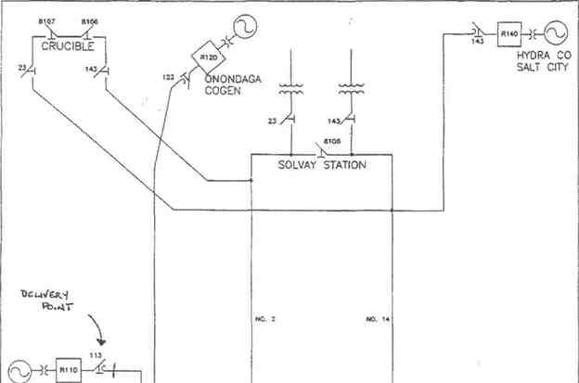
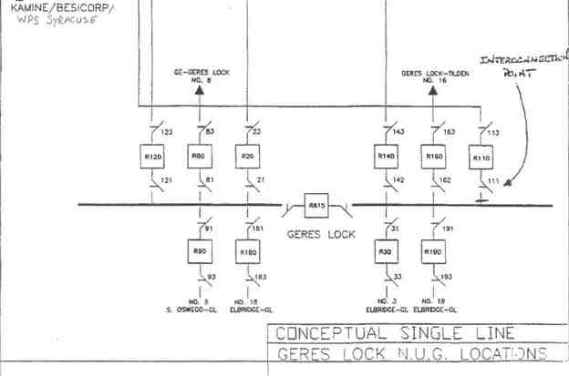

Appendix B

Milestones

Appendix C

Interconnection Details
1. Owner:
Project:
Point of Interconnection: (refer to one-line diagram that should be attached in Appendix A)
2. Electrical Equipment Requirements: The installation of electrical equipment and
operation of the facility must meet or exceed the requirements of Niagara Mohawk's Electric System Bulletin No.ESB 756.
3. Metering Requirements: Electricity transferred to the transmission system shall be
measured by electric watt-hour meters of a type approved by the Public Service Commission
of the State of New York. The meter and installation costs shall be borne by WPS Syracuse
Generation LLC. The meters shall be maintained with the rules set forth in 16 NYCRR Part
92.
4. Reference:
5. Reference:

Appendix D

Security Arrangements Details

Infrastructure security of New York State Transmission System equipment and operations and control hardware and software is essential to ensure day-to-day New York State Transmission System reliability and operational security. The Commission will expect the NYISO, all
Transmission Owners, all Developers and all other Market Participants to comply with the
recommendations offered by the President's Critical Infrastructure Protection Board and,
eventually, best practice recommendations from the electric reliability authority. All public
utilities will be expected to meet basic standards for system infrastructure and operational security, including physical, operational, and cyber-security practices.

Appendix E

Commercial Operation Date

For purposes of this Agreement, the Commercial Operation Date shall be treated as 10/20/92.

Appendix F

Addresses for Delivery of Notices and Billings Notices:
NYISO:
New York Independent System Operator Attn: Vice President, Operations
3890 Carman Rd.
Schenectady, NY 12303
Transmission Owner:
Vice President , Transmission Commercial Services National Grid
40 Sylvan Road
Waltham, MA 02451
Phone: (781) 907-5706
Email: mary.ellen.paravalos@us.ngrid.corn
Developer:
Contract Administration
WPS Syracuse Generation, LLC 1716 Lawrence Drive
DePere, WI 54115

Billings and Payments:
Transmission Owner:
Vice President , Transmission Commercial Services National Grid
40 Sylvan Road
Waltham, MA 02451
Phone: (781) 907-5706
Email: mary.ellen.paravalos@us.ngrid.com
Developer:
Contract Administration
WPS Syracuse Generation, LLC 1716 Lawrence Drive
DePere, WI 54115
Alternative Forms of Delivery of Notices (telephone, facsimile or email): NYISO:
New York Independent System Operator Attn: Vice President, Operations
3890 Carman Rd.
Schenectady, NY 12303

Transmission Owner:
Vice President Transmission Commercial Services National Grid
40 Sylvan Road
Waltham, MA 02451
Phone: (781) 907-2422
Email: mary.ellen.paravalos@us.ngrid.com
Developer:
Contract Administration
WPS Syracuse Generation, LLC 1716 Lawrence Drive DePere, WI 54115

APPENDIX G

INTERCONNECTION REQUIREMENTS FOR A WIND GENERATING PLANT

Appendix G sets forth requirements and provisions specific to a wind generating plant.
All other requirements of this LG1A continue to apply to wind generating plant interconnections.
A. Technical Standards Applicable to a Wind Generating Plant

Low Voltage Ride-Through (LVRT) Capability
A wind generating plant shall be able to remain online during voltage disturbances up to the time periods and associated voltage levels set forth in the standard below. The LVRT standard provides for a transition period standard and a post-transition period standard.

Transition Period LVRT Standard
The transition period standard applies to wind generating plants subject to FERC Order
661 that have either: (i) interconnection agreements signed and filed with the Commission, filed with
the Commission in unexecuted form, finally executed as conforming agreements, or filed with the
Commission as non-conforming agreements between January 1, 2006 and December 31, 2006, with a
scheduled in-service date no later than December 31, 2007, or (ii) wind generating turbines
subject to a wind turbine procurement contract executed prior to December 31, 2005, for delivery
through 2007.

1. Wind generating plants are required to remain in-service during three-phase faults with
normal clearing (which is a time period of approximately 4 - 9 cycles) and single line to
ground faults with delayed clearing, and subsequent post-fault voltage recovery to
prefault voltage unless clearing the fault effectively disconnects the generator from the
system. The clearing time requirement for a three-phase fault will be specific to the wind
generating plant substation location, as determined by and documented by the
Transmission Owner for the Transmission District to which the wind generating plant will
be interconnected. The maximum clearing time the wind generating plant shall be required
to withstand for a three-phase fault shall be 9 cycles at a voltage as low as 0.15 p.u., as

measured at the high side of the wind generating plant step-up transformer (i.e. the
transformer that steps the voltage up to the transmission interconnection voltage or "GSU"),
after which, if the fault remains following the location-specific normal clearing time for
three-phase faults, the wind generating plant may disconnect from the transmission system.
2. This requirement does not apply to faults that would occur between the wind generator terminals
and the high side of the GSU or to faults that would result in a voltage lower than 0.15 per unit on the high side of the GSU serving the facility.

3. Wind generating plants may be tripped after the fault period if this action is intended as part
of a special protection system.

4. Wind generating plants may meet the LVRT requirements of this standard by the performance
of the generators or by installing additional equipment (e.g., Static VAr Compensator, etc.)
within the wind generating plant or by a combination of generator performance and additional equipment.

5. Existing individual generator units that are, or have been, interconnected to the network at the
same location at the effective date of the Appendix G LVRT Standard are exempt from meeting
the Appendix G LVRT Standard for the remaining life of the existing generation equipment.
Existing individual generator units that are replaced are required to meet the Appendix G
LVRT Standard.
Post-transition Period LVRT Standard
All wind generating plants subject to FERC Order No. 661 and not covered by the transition period described above must meet the following requirements:
1. Wind generating plants are required to remain in-service during three-phase faults with
normal clearing (which is a time period of approximately 4 - 9 cycles) and single line to
ground faults with delayed clearing, and subsequent post-fault voltage recovery to prefault
voltage unless clearing the fault effectively disconnects the generator from the system. The
clearing time requirement for a three-phase fault will be specific to the wind generating plant
substation location, as determined by and documented by the Transmission Owner for the
Transmission District to which the wind generating plant will be interconnected. The

maximum clearing time the wind generating plant shall be required to withstand for a threephase fault shall be 9 cycles after which, if the fault remains following the location-specific normal clearing time for three-phase faults, the wind generating plant may disconnect from the transmission system. A wind generating plant shall remain interconnected during such a fault on the transmission system for a voltage level as low as zero volts, as measured at the high voltage side of the wind GSU.

2. This requirement does not apply to faults that would occur between the wind generator terminals
and the high side of the GSU.

3. Wind generating plants may be tripped after the fault period if this action is intended as part of
a special protection system.

4. Wind generating plants may meet the LVRT requirements of this standard by the
performance of the generators or by installing additional equipment (e.g., Static VAr
Compensator) within the wind generating plant or by a combination of generator performance and additional equipment.
5. Existing individual generator units that are, or have been, interconnected to the network at the
same location at the effective date of the Appendix G LVRT Standard are exempt from
meeting the Appendix G LVRT Standard for the remaining life of the existing generation equipment. Existing individual generator units that are replaced are required to meet the Appendix G LVRT Standard.

i.i Power Factor Design Criteria (Reactive Power)

A wind generating plant shall maintain a power factor within the range of 0.95 leading to
0.95 lagging, measured at the Point of Interconnection as defined in this LGIA, if the ISO's System
Reliability Impact Study shows that such a requirement is necessary to ensure safety or reliability.
The power factor range standards can be met using, for example without limitation, power
electronics designed to supply this level of reactive capability (taking into account any
limitations due to voltage level, real power output, etc.) or fixed and switched capacitors if agreed
to by the Transmission Owner for the Transmission District to which the wind generating plant
will be interconnected, or a combination of the two. The Developer shall not disable power factor

equipment while the wind plant is in operation. Wind plants shall also be able to provide
sufficient dynamic voltage support in lieu of the power system stabilizer and automatic voltage regulation at the generator excitation system if the System Reliability Impact Study shows this to be required for system safety or reliability.

iii. Supervisory Control and Data Acquisition (SCADA) Capability
The wind plant shall provide SCADA capability to transmit data and receive instructions from the ISO and/or the Transmission Owner for the Transmission District to which the wind
generating plant will be interconnected, as applicable, to protect system reliability. The
Transmission Owner for the Transmission District to which the wind generating plant will be
interconnected and the wind plant Developer shall determine what SCADA information is
essential for the proposed wind plant, taking into account the size of the plant and its
characteristics, location, and importance in maintaining generation resource adequacy and
transmission system reliability in its area.

Appendix H

List of Non-Applicable Pro-Forma LGIA Provisions

Transmission Owner and Developer are already interconnected, pursuant to a pre-existing
interconnection agreement. Therefore, certain terms of the pro-forma New York ISO LGIA are not applicable to this LGIA, because they relate solely to new interconnections. The parties to this LGIA have nevertheless agreed to use the pro-forma New York ISO LGIA with almost no modifications, in accordance with FERC policy promoting the use of pro-forma interconnection agreements wherever possible. The parties, however, believe that the following provisions of the pro-forma New York ISO LGIA are not applicable to the current LG IA:
Section 5.1 (Option), including all subsections thereof
Section 5.2 (General Conditions Applicable to Option to Build) Section 5.3 (Liquidated Damages)
Section 5.5 (Equipment Procurement), including all subsections thereof
Section 5.6 (Construction Commencement), including all subsections thereof Section 5.7 (Work Progress)
Section 5.8 (Information Exchange)
Section 5.9 (Limited Operation)
Section 5.10 (Developer Attachment Facilities), including all subsections thereof
Section 5.11 (Transmission Owner Attachment Facilities), including all subsections thereof Section 5.14 (Permits)
Section 5.15 (Early Construction of Base Case Facilities)
Section 6.1 (Pre Commercial Operation Date Testing and Modification)
Section 11.4 (Special Provisions for Affected Systems)
Section 11.5 (Provision of Security), including all subsections thereof
Section 12.2 (Final Invoice)
Section 24.1 (Information Acquisition)
Section 24.2 (Information Submission by Transmission Owner) Section 24.3 (Updated Information Submission by Developer) Section 24.4 (Information Supplementation)

Section 25.4.1 (Audit Rights Period for Construction Related Accounts)
Appendix B (Milestones)
Appendix G (Interconnection Requirements for a Wind Generating Plant)

