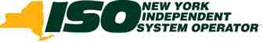

10 Krey Boulevard  Rensselaer, NY 12144

February 19, 2016
By Electronic Delivery

Honorable Kimberly D. Bose, Secretary Federal Energy Regulatory Commission 888 First Street, NE
Washington, DC 20426

Re: Notice of Termination of Small Generator Interconnection
Agreement Among the New York Independent System Operator,
Inc., Niagara Mohawk Power Corporation d/b/a National Grid
and Green Power Energy LLC, Service Agreement No. 1483
under the NYISO Open Access Transmission Tariff, Docket No.
ER16- -000
Dear Secretary Bose:

Pursuant to Section 205(d) of the Federal Power Act and Sections 35.9 and 35.15 of the Commission’s Regulations,¹ the New York Independent System Operator, Inc. (“NYISO”) and Niagara Mohawk Power Corporation d/b/a National Grid (“National Grid” or “Connecting
Transmission Owner”) jointly submit for Commission acceptance this Notice of Termination of the Small Generator Interconnection Agreement (“SGIA”) among the NYISO, National Grid, and Green Power Energy LLC (“Green Power” or Interconnection Customer”).²

Pursuant to Article 3.3 of the SGIA, the NYISO and National Grid respectfully request
that the Commission accept this notice of termination and issue an order within 60 days of the
date of this filing, accepting the notice of termination for filing effective as the date the
Commission issues an order accepting this notice of termination, because Green Power is in
default of its obligation to timely pay amounts invoiced to it for costs associated with the
engineering, procurement, and construction of the interconnection facilities and upgrades for
which Green Power is responsible under the SGIA, as Green Power has received written notice
of this breach of the SGIA but has not cured the breach within the time permitted by the SGIA.

I. Background
This notice of termination comes after years of delays by the Interconnection Customer.
The Interconnection Customer entered the NYISO interconnection queue in 2005 with a
proposed wind generating facility with a total planned capacity of 10 MW to be owned and

¹ 18 C.F.R. §§ 35.9, 35.15 (2016).
² The SGIA is designated as Service Agreement No. 1483 under the NYISO Open Access Transmission Tariff (“OATT”).

Honorable Kimberly D. Bose February 19, 2016
Page 2

operated by Green Power and located in Madison County, New York (“Green Power Project”). The Green Power Project went through the NYISO’s Small Generator Interconnection
Procedures (“SGIP”) as a “transition project” under Section 32.1.7 of the SGIP, with queue
position number 180A. As a transition project, it had completed some of its interconnection
studies with the Connecting Transmission Owner prior to the effective date of the SGIP. The
Interconnection Facilities Study was completed pursuant to the SGIP on May 27, 2009.
Subsequently, on August 20, 2009, the NYISO, National Grid and Green Power executed an
SGIA for the project. The SGIA - Service Agreement No 1483 - was filed with the Commission as a non-conforming SGIA in Docket Number ER09-1693 and was accepted for filing by the
Commission by letter order issued on October 13, 2009. ³

The Green Power Project has not been built. According to the original SGIA schedule,
the Green Power Project was to be in commercial operation by October 2010. By mutual
agreement, the parties to the SGIA later extended the Commercial Operation Date three times,
the third extension being to December 2013. After Green Power failed to meet the December
2013 Commercial Operation Date, Green Power submitted to the NYISO—and the NYISO
initially denied—a request for further extension of the Commercial Operation Date to December
2014, and the NYISO removed the Green Power Project from its interconnection queue. In April
2014, Green Power filed with the Commission a request for waiver of the Commercial Operation
date requirements of Attachments X and Z to the NYISO OATT to extend the Commercial
Operation Date for the Green Power Project to no later than 15 months from the date of a
Commission order granting the requested waiver, and to direct the NYISO to restore Green
Power’s position in the NYISO interconnection queue. The Commission granted Green Power’s
requests in an order issued on April 30, 2014.⁴ Thus, the 15-month period for achieving
commercial operation pursuant to the waiver expired on July 31, 2015. On July 30, 2015, the
NYISO granted an extension of the Commercial Operation Date to the date currently shown on
the NYISO website, July 2016.⁵

Article 4 and Attachment 2 of the SGIA set forth the responsibility of Green Power, as the Interconnection Customer, for costs (including contingency costs) associated with the
engineering, design, construction, testing, operation and maintenance, and project coordination and management of interconnection facilities and distribution upgrades under the SGIA, and
Article 5 and Attachment 6 of the SGIA set forth Green Power’s responsibility for costs
(including contingency costs) associated with the engineering, design, construction, testing,
energization, and project coordination and management of system upgrade facilities and system deliverability upgrades under the SGIA.
Article 6 of the SGIA sets forth a process under which National Grid invoices Green
Power for the cost of interconnection facilities and upgrades designed, constructed, and

³ See Commission letter order, Docket No. ER09-1693-000 (Oct. 13, 2009).
⁴ Green Power Energy LLC, 147 FERC ¶ 61,084 (2014).
⁵ See http://www.nyiso.com/public/markets_operations/services/planning/planning_resources/index.jsp (at listing of
Green Power Project (queue position no. 180A) in the NYISO interconnection queue).

Honorable Kimberly D. Bose February 19, 2016
Page 3

maintained by National Grid, as the Connecting Transmission Owner, for which Green Power is
responsible. Article 6.1.1 requires Green Power to pay each invoice within 30 calendar days
after it receives the invoice. Article 6.1.3 states that, if Green Power disputes an amount to be
paid, Green Power will pay the disputed amount to National Grid or into an interest-bearing
escrow account, pending resolution of the dispute in accordance with Article 10 of the SGIA.

The SGIA defines a breach of the SGIA as the failure of a party to perform or observe
any material term or condition of the SGIA.⁶ Article 7.6.1 of the SGIA states that, upon a
breach, the non-breaching party must give written notice of such breach to the breaching party,
and that the breaching party will have 60 calendar days from receipt of the breach notice to cure
the breach.
The SGIA defines a default under the SGIA as the failure of party in breach of the SGIA to cure such a breach.⁷ Article 7.6.2 of the SGIA states that, if a breach is not cured within the relevant period described in Article 7.6.1, or if a breach is not capable of being cured within the relevant period, a default will exist and the non-defaulting parties acting together will thereafter have the right to terminate the SGIA in accordance with Article 3.3 of the SGIA, by written
notice to the defaulting party at any time until cure occurs, and be relieved of any further
obligation under the SGIA and, whether or not the non-defaulting parties terminate the SGIA, to recover from the defaulting party all amounts due under the SGIA, plus all other damages and remedies to which they are entitled at law or in equity.
Article 3.3.2 of the SGIA states that any party may terminate the SGIA after default
pursuant to Article 7.6. Article 3.3 of the SGIA states that no termination will become effective until the parties have complied with all applicable laws and regulations applicable to such
termination, including the filing with the Commission of a notice of termination of the SGIA (if required), which notice has been accepted for filing by the Commission.

II. Notice of Termination
Commission precedent supports acceptance of a notice of termination of an agreement if the applicant demonstrates that the proposed termination is not unjust, unreasonable, unduly discriminatory, or preferential, or if it is consistent with the public interest.⁸ Pursuant to this standard, the Commission should accept this notice of termination because Green Power is in default of its obligation to pay amounts invoiced to it under the SGIA.

On September 14, 2015, National Grid invoiced Green Power pursuant to Article 6 of the
SGIA for costs associated with the engineering, procurement, and construction of the
interconnection facilities and upgrades required to interconnect the Green Power Project for

⁶ SGIA, Attachment 1 (Glossary of Terms), definition of “Breach”.
⁷ SGIA, Attachment 1, definition of “Default”.
⁸ Midcontinent Indep. Sys. Operator, Inc., 147 FERC ¶ 61,198, at P 28 (2014) (citing Commission precedent).

Honorable Kimberly D. Bose February 19, 2016
Page 4

which Green Power is responsible under the SGIA, in the amount of $253,641.51.⁹ Green Power
failed to pay the invoiced amounts within 30 days of receiving the invoice as required by Article
6.1.1. Further, Green Power did not dispute the invoiced amounts pursuant to Article 10. Even if Green Power had disputed the invoiced amounts, it still would have been obligated to pay such disputed amounts pursuant to Article 6.1.3. (Green Power has also failed to pay subsequent
invoices submitted in October 2015, which came to $46,446.73 in principal owed, and in
November 2015, which came to $22,793.89 in principal owed, pursuant to Article 6 of the SGIA for costs Green Power is obligated to pay under the SGIA. National Grid has given an additional written notice of breach to Green Power regarding those overdue amounts .¹⁰)
Green Power’s failure to pay the amounts shown on the September 14 invoice within 30
days of receiving the invoice constituted a breach of the SGIA. In accordance with Article 7.6.1
of the SGIA, National Grid gave written notice of the breach to Green Power by a letter dated
November 16, 2015, which is provided in Attachment A to this filing.¹¹ The letter included an
attachment that itemized the overdue invoiced amounts, which came to $253,641.51 in principal
owed and $686.94 in interest owed at the Commission rate at that time, for a total overdue
amount of $254,328.45.¹² The letter stated that if Green Power did not cure the breach within the 60-calendar-day period required by Article 7.6.1 of the SGIA, i.e., by January 18, 2016, the nondefaulting parties—the NYISO and National Grid—would be entitled to exercise all remedies for the breach as provided for or contemplated in the SGIA, including, without limitation,
termination of the SGIA.¹³
Green Power has not cured its breach by paying the total overdue amount referenced in
the November 16 notice and therefore is in default of the SGIA.¹⁴ Green Power did not respond
to the November 16 notice of breach within the 60-calendar -day period required by Article
7.6.1 of the SGIA. Consequently, pursuant to Articles 3.3 and 7.6.2 of the SGIA, the NYISO
and National Grid have the right to terminate the SGIA in accordance with Article 3.3, upon

⁹ Specifically, National Grid issued invoices to Green Power for the following costs: engineering, engineering
review, design, procurement, construction, project management, field verification, legal work, testing and
energization.
¹⁰ The October and November 2015 invoices were for the following costs: engineering, engineering review, design, procurement, construction, project management, field verification, legal work, testing and energization.
¹¹ The letter also noted in a footnote that Green Power’s breach was capable of cure within 60 calendar days.
¹² Interest on the overdue principal amount continues to accrue at the Commission rate.
¹³ This is the second notice of breach issued to Green Power under the SGIA. On July 13, 2015, National Grid
issued a notice of breach to Green Power for failure to timely pay invoices totaling $152,460.53 (“July 2015
breach”). Green Power cured the July 2015 breach within the time period permitted by Article 7.6.1 of the SGIA.

¹⁴ Due to Green Power’s failure to pay the outstanding September 14, 2015 invoice, as of February 19, 2016 (the
date of this filing), the total principal amount owed is $253,641.52 and the interest owed at the current Commission rate is $2,747.78, for a total overdue amount of $256,389.30. Attachment B to this filing is an itemization of the overdue invoice amounts and applicable FERC interest rate.

Honorable Kimberly D. Bose February 19, 2016
Page 5

Commission acceptance of this notice of termination for filing.¹⁵ The NYISO and National Grid
have provided Green Power written notice of default and termination by letter dated February 1,
2016, which is provided in Attachment C to this filing. The February 1, 2016 letter constitutes
the written notice to the defaulting party required by Article 7.6.2. Although not obligated to do
so by the SGIA, National Grid indicated that it would not file to terminate the SGIA if Green
Power fully cured its breach by February 18. Green Power failed to cure its breach even with
this additional time allowed.

III. Effective Date

Pursuant to Article 3.3 of the SGIA, the NYISO and National Grid respectfully request that the Commission accept this notice of termination of the SGIA effective as of the date the Commission issues an order accepting this filing.

IV. Communications and Correspondence
Communications and correspondence regarding this filing should be addressed to the following individuals:

For the NYISO
Robert E. Fernandez, General Counsel
Karen Georgenson Gach, Deputy General Counsel Raymond Stalter, Director of Regulatory Affairs *Sara B. Keegan, Senior Attorney
New York Independent System Operator, Inc.
10 Krey Boulevard
Rensselaer, NY 12144
Tel: (518) 356-6000
Fax: (518) 356-4702
skeegan@nyiso.com

For Niagara Mohawk d/b/a National Grid
*Kathryn Cox-Arslan *Amanda C. Downey
Director, Transmission Commercial Counsel for National Grid USA
National Grid Service Company, Inc.
40 Sylvan Road 40 Sylvan Road
Waltham, MA 02451 Waltham, MA 02451

¹⁵ See, e.g., Pacific Gas and Elec. Co., 146 FERC ¶ 61,120 (2014) (accepting notice of termination of generator
interconnection agreement due to default of interconnection customer in failing to provide financial security as
required by that agreement); Midcontinent Indep. Sys. Operator, Inc., 147 FERC ¶ 61,198 (accepting notice of
termination of generator interconnection agreement due to default of interconnection customer in failing to pay trueup costs of facilities as required by that agreement).

Honorable Kimberly D. Bose February 19, 2016
Page 6

Tel: (781) 907-2406 Tel: (781) 907-2136
kathryn.cox@nationalgrid.com amanda.downey@nationalgrid.com

V. Documents Submitted
The NYISO and National Grid submit the following documents:

• This filing letter;

• Notice of Breach of the SGIA dated November 16, 2015 (Attachment A);

• Itemization of the overdue amounts owed by Green Power pursuant to the September
14, 2015 invoice (Attachment B); and

• Notice of Default and Termination of the SGIA dated February 1, 2016
(Attachment C).

VI. Service
The NYISO will send an electronic link to this filing to the official representative of each
of its customers, to each participant on its stakeholder committees, to the New York Public
Service Commission, and to the electric utility regulatory agency of New Jersey. In addition, a
complete copy of the Public documents included with this filing will be posted on the NYISO’s
website at www.nyiso.com.

VII. Conclusion

For the reasons stated above, the NYISO and National Grid respectfully request that the Commission accept this notice of termination of the SGIA effective as of the date the
Commission issues an order accepting the notice of termination for filing.

Respectfully submitted,

/s/Sara B. Keegan
Counsel for
New York Independent System Operator, Inc.

/s/ Amanda C. Downey
Amanda C. Downey
Counsel for Niagara Mohawk Power Corporation d/b/a National Grid

Attachment A
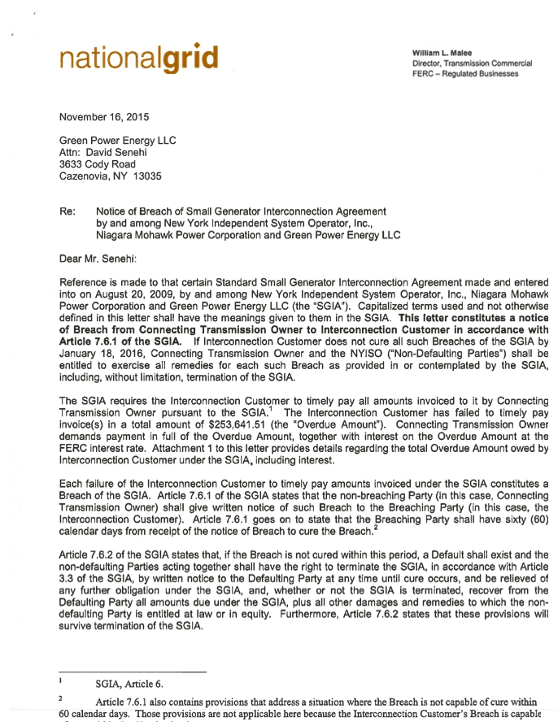
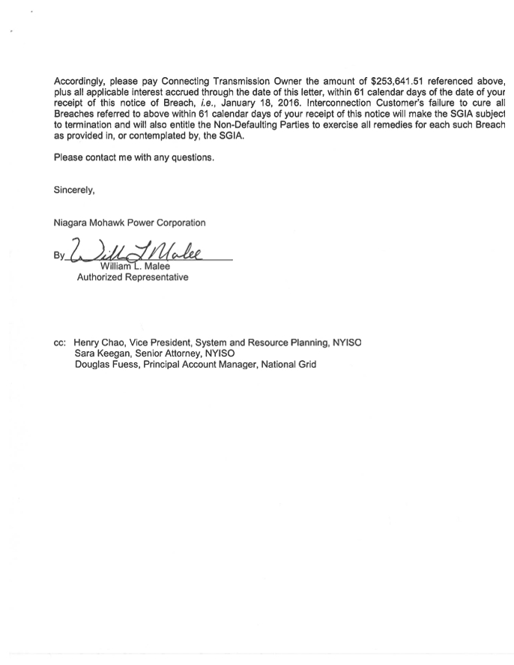
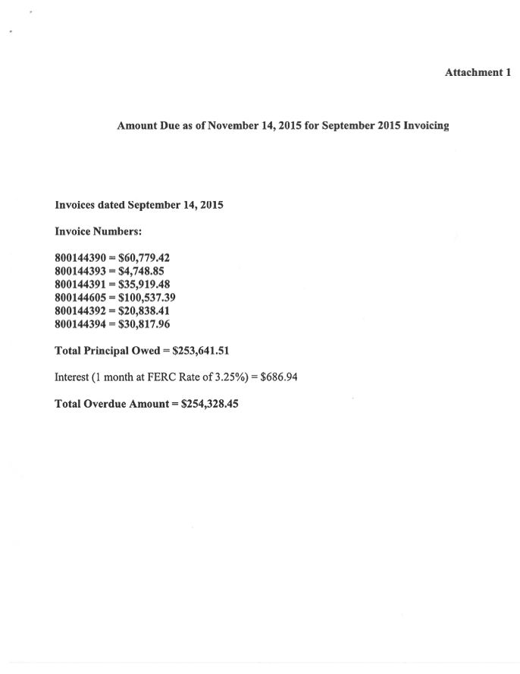

Attachment B

Attachment B

Amount Due as of November 14, 2015 for September 2015 Invoicing

Invoices dated September 14, 2015
Invoice Numbers:

800144390 = $60,779.42
800144393 = $4,748.85
800144391 = $35,919.48
800144605 = $100,537.39
800144392 = $20,838.41
800144394 = $30,817.96

Total Principal Owed = $253,641.51
Interest (4 month at FERC Rate of 3.25%) = $2,747.78

Total Overdue Amount = $256,389.29

Attachment C
