2015 ISO/RTO Metrics Report

The California Independent System Operator Corporation (CAISO), ISO New England, Inc. (ISO-NE), Midcontinent Independent System Operator, Inc. (MISO), New York Independent System Operator (NYISO), PJM Interconnection, L.L.C. (PJM), and Southwest Power Pool, Inc. (SPP) assisted in the preparation of this report.

Table of Contents
Executive Summary 9
ISO/RTO Geography and Operations Statistics 11
Performance Metrics and Other Information
Section 1 – Descriptions
ISO/RTO Bulk Power System Reliability
Dispatch Operations 12
Load Forecast Accuracy 13
Wind Forecasting Accuracy 14
Unscheduled Flows 14
Transmission Outage Coordination 15
Transmission Planning 15
Generation Interconnection 16
Interconnection / Transmission Service Requests 17
Special Protection Schemes 18
ISO/RTO Coordinated Wholesale Power Markets
Market Competitiveness 19
Market Pricing 21
Unconstrained Energy Portion of System Marginal Cost 22
Energy Market Convergence 22
Congestion Management 22
Resources 23
Fuel Diversity 23
Renewable Resources 23
ISO/RTO Organizational Effectiveness
ISO/RTO Administrative Costs 25
Customer Satisfaction 25
Billing Controls 26
Section 2 – California ISO Performance Metrics 27
A. California ISO Bulk Power System Reliability
Dispatch Operations 34
Load Forecast Accuracy 36
Wind Forecasting Accuracy 38
Unscheduled Flows 39
Transmission Outage Coordination 41
Transmission Planning 44
Generation Interconnection 45
Interconnection / Transmission Service Requests 50
Special Protection Schemes 53
B. California ISO Coordinated Wholesale Power Markets
Market Competitiveness 54
Market Pricing 58
Unconstrained Energy Portion of System Marginal Cost 60
Energy Market Convergence 61
Congestion Management 63
Generator Availability 64
Fuel Diversity 65
Renewable Resources 67
C. California ISO Organizational Effectiveness
ISO/RTO Administrative Costs 70
Customer Satisfaction 72
Billing Controls 72
D. California ISO Specific Initiatives 73
Section 3 – ISO New England (ISO-NE) 75
A. ISO New England Bulk Power System Reliability
Dispatch Operations 78
Load Forecast Accuracy 80
Wind Forecasting Accuracy 83
Unscheduled Flows 85
Transmission Outage Coordination 86
Transmission Planning 89
Generation Interconnection 93
Interconnection / Transmission Service Requests 103
Special Protection Schemes 108
B. ISO New England Coordinated Wholesale Power Markets
Market Competitiveness 112
Market Pricing 118
System Marginal Cost 123
Energy Market Convergence 124
Congestion Management 126
Resources 128
Fuel Diversity 133
Renewable Resources 135
C. ISO New England Organizational Effectiveness
ISO/RTO Administrative Costs 143
Customer Satisfaction 145
Billing Controls 148
D. ISO New England Specific Initiatives 149

Section 4 – MISO 155
A. MISO Bulk Power System Reliability
Dispatch Operations 159
Load Forecast Accuracy 161
Wind Forecasting Accuracy 163
Unscheduled Flows 164
Transmission Outage Coordination 167
Transmission Planning 170
Generation Interconnection 174
Interconnection / Transmission Service Requests 180
Special Protection Schemes 183
B. MISO Coordinated Wholesale Power Markets
Market Competitiveness 186
Market Pricing 190
Unconstrained Energy Portion of System Marginal Cost 194
Energy Market Convergence 195
Congestion Management 196
Resources 198
Fuel Diversity 203
Renewable Resources 204
C. MISO Organizational Effectiveness
ISO/RTO Administrative Costs 206
Customer Satisfaction 208
Billing Controls 209
D. MISO Specific Initiatives 210

Section 5 – New York ISO (NYISO) 212
A. NYISO Bulk Power System Reliability
Dispatch Operations 215
Load Forecast Accuracy 217
Wind Forecasting Accuracy 220
Unscheduled Flows 221
Transmission Outage Coordination 223
Transmission Planning 226
Generation Interconnection 228
Interconnection / Transmission Service Requests 236
Special Protection Schemes 241
B. NYISO Coordinated Wholesale Power Markets
Market Competitiveness 245
Market Pricing 249
Unconstrained Energy Portion of System Marginal Cost 253
Energy Market Convergence 254
Congestion Management 255
Resources 257
Fuel Diversity 259
Renewable Resources 261
C. NYISO Organizational Effectiveness
ISO/RTO Administrative Costs 265
Customer Satisfaction 268
Billing Controls 269
D. NYISO Specific Initiatives 272

Section 6 – PJM Interconnection (PJM) 278
A. PJM Bulk Power System Reliability
Dispatch Operations 283
Load Forecast Accuracy 284
Wind Forecasting Accuracy 286
Unscheduled Flows 287
Transmission Outage Coordination 289
Transmission Planning 291
Generation Interconnection 297
Interconnection / Transmission Service Requests 300
Special Protection Schemes 304
B. PJM Coordinated Wholesale Power Markets
Market Competitiveness 307
Market Pricing 312
Unconstrained Energy Portion of System Marginal Cost 316
Energy Market Convergence 317
Congestion Management 320
Resources 322
Fuel Diversity 324
Renewable Resources 326
C. PJM Organizational Effectiveness
ISO/RTO Administrative Costs 330
Customer Satisfaction 333
Billing Controls 334
D. PJM Specific Initiatives 335

Section 7 – Southwest Power Pool (SPP) 340
A. SPP Bulk Power System Reliability
Dispatch Operations 343
Load Forecast Accuracy 345
Wind Forecasting Accuracy 347
Unscheduled Flows 347
Transmission Outage Coordination 348
Transmission Planning 350
Generation Interconnection 355
Interconnection / Transmission Service Requests 357
Special Protection Schemes 359
B. SPP Coordinated Wholesale Power Markets
Market Competitiveness 361
Market Pricing 365
Unconstrained Energy Portion of System Marginal Cost 368
Energy Market Convergence 369
Congestion Management 370
Resources 371
Fuel Diversity 372
Renewable Resources 374
C. SPP Organizational Effectiveness
ISO/RTO Administrative Costs 376
Customer Satisfaction 379
Billing Controls 380
D. SPP Specific Initiatives 384

Executive Summary

The following report has been prepared by the independent system operators (ISOs) and regional transmission organizations (RTOs) that are regulated by the Federal Energy Regulatory Commission (FERC). The report provides information on various data points common to each of the system operators, and has been prepared at FERC’s direction following the process described below.
The information included, similar to FERC Form 1 information, may be useful to the FERC, stakeholders and the public at large in compiling information and tracking certain data points that are relevant to ISO and RTO performance in the areas of reliability, wholesale electricity market performance and organizational effectiveness. That said, this report does not definitively measure ISO and RTO performance or supplant the various mechanisms already in place to measure performance. These mechanisms include FERC’s triennial market-based rate analysis under Order No. 697, the respective State of the Market Reports for each ISO/RTO, FERC’s State of the Market Report, or regional initiatives such as the “value proposition” and other measures developed by ISOs and RTOs.
Moreover, the information provided herein must be assessed in the proper context. For example, the report includes tables comparing forecast accuracy at each of the ISOs and RTOs. However, a number of factors influence the data and could result in variations among the ISOs/RTOs, including the time of day at which the forecast is made, the region’s weather variability, data points selected (i.e., hour to hour) and the geographic diversity of the control area. Where possible, and to the extent practicable, this context has been provided along with the data. Absent this context, the data tell an incomplete story.

History of the Initiative
This report originated with a review undertaken by the United States Government Accountability Office in 2008 at the request of the U.S. Senate Committee on Homeland Security and Governmental Affairs. To more effectively analyze ISO/RTO benefits and performance, the Government Accountability Office recommended that the FERC work with ISOs/RTOs, stakeholders and other interested parties to standardize measures that track the performance of ISO/RTO operations and markets, and to report the performance results to Congress and the public.
Accordingly, FERC staff worked with a team composed of personnel from FERC-jurisdictional ISOs and RTOs to develop the performance metrics that form the basis for this report. As part of this process, FERC held meetings with industry stakeholders for their input and established an open comment period on the proposed metrics, which will track the performance of ISO/RTO operations, markets, and organizational effectiveness.
In response to the staff initiative, the FERC jurisdictional ISOs and RTOs have submitted two reports. The first report, submitted on December 5, 2010, provided information on performance metrics for the 2005-2009 period. The second report, submitted on August 31, 2011, provided information on the performance metrics for the 2006-2010 period.
The ISOs and RTOs are submitting this Report in response to the Commission's issuance of a "Request for Information on Common Performance Metrics for RTOs and ISOs and Utilities Outside RTO and ISO Regions" in Docket AD14-15-000, issued on August 17, 2015. This Report includes both the 30 Common Metrics as well as the "Other Metrics Specific to ISO and RTO Performance" identified in the Commission Staff "Common Metrics Report" issued on August 26, 2014.

Information Provided
Following a brief summary of the operations and geographic scope of the reporting ISOs and RTOs, this report provides information responsive to each of the FERC-proposed metrics. When applicable, the data and information are presented for the period 2010 through 2014.
These metrics were organized by the FERC, and are presented here, in the categories of reliability, markets, and organizational effectiveness. The reliability metrics provide information on compliance with and violations of national and regional reliability standards; dispatch behavior; load forecast accuracy; long-term generation and transmission planning; and planned outage coordination. Market metrics include pricing; rates for generator availability and forced outages; statistics on congestion management charges and the amount of charges hedged through congestion management markets; demand-response amounts as capacity and ancillary services; and the percentage of total electric energy provided by renewable resources. Organizational effectiveness metrics include ISO/RTO administrative charges to members compared to budgeted administrative charges and as cents per megawatt hour (¢/MWh) of load served; customer satisfaction; and the scope and results of audits of billing controls.
Each ISO/RTO provides a brief overview of their region, their data on the FERC metrics and information to the extent applicable and available, and additional information on key initiatives specific to their regional activities.

Emerging Themes
The information provided in this report reinforces the value of ISOs and RTOs. The report illustrates the transparency of ISO/RTO operations and reinforces the value of ISO/RTO operation of the grid and administration of wholesale electricity markets. Specifically, this report shows that:
- Balancing authority areas operated by ISO/RTOs function reliably;
- ISO/RTO organized markets are efficient;
- ISO/RTOs are advancing public policy energy objectives;
- ISOs/RTOs enable demand response and energy efficiency; and
- ISO/RTO operations and markets enable changing resource mixes in response to economic price signals as well as environmental requirements.

ISO/RTO Geography and Operations Statistics

The map and data below show the location and breadth of operations for the ISOs/RTOs contributing to this report. These reference points will facilitate understanding some of the similarities and differences amongst the information of the ISOs/RTOs in this report.
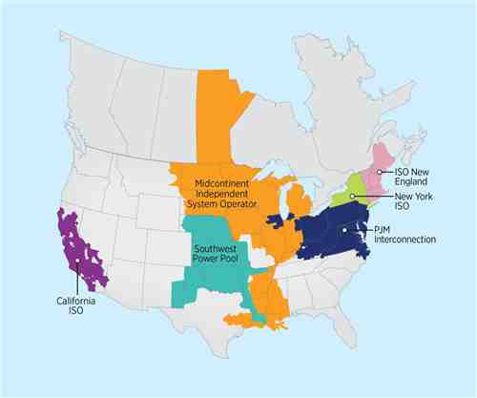

The table below summarizes the miles of transmission lines, installed generation, and population in each ISO/RTO region at the end of 2014.
ISO/RTO | Headquarters | Installed  Generation  (in megawatts) | Miles of Transmission  Lines | Population  (in millions)
CAISO | Folsom, CA | 57,124 | 26,000 | 30
ISO-NE | Holyoke, MA | 31,000 | 8,600 | 14
MISO | Carmel, IN | 180,006 | 65,800 | 48
NYISO | Rensselaer, NY | 39,039 | 11,086 | 20
PJM | Valley Forge, PA | 183,604 | 62,556 | 61
SPP | Little Rock, AR | 58,982 | 50,575 | 15

Section 1 – Descriptions of Performance Metrics and Other Information

A. ISO/RTO Bulk Power System Reliability
All ISOs and RTOs are responsible for compliance with North American Electricity Corporation (NERC) mandatory standards and any mandatory standards for the Regional Entities (RE) that apply in the region where the ISO/RTO is located and are subsequently adopted by NERC. The mandatory reliability standards only apply to ISO/RTOs based on the NERC functional model categories for which each ISO/RTO has registered.
Therefore, different reliability standards apply to different ISOs and RTOs. For example, each region may have reliability standards that apply only within that region, given the particular infrastructure, resource mix, topographical and other differences that exist within the region. The main differences between the ISO/RTO applicable standards are the Regional Entity standards. Each region develops standards applicable for their infrastructure, environment and any other regional differences. Each ISO/RTO may also be registered for different functions, causing them to comply with different reliability standards.
Violations of such standards may be identified by an ISO/RTO and self-reported or may be identified by a NERC and/or Regional Entity audit of the ISO’s/RTO’s standards compliance. Such violations can then be classified as low, medium or high severity. This metric is a quantification of all NERC and Regional Reliability Organization (RRO) reliability standards violations that have been identified during an audit or as a result of an ISO/RTO self-report and have been published as part of that process.

Dispatch Operations
Compliance with CPS-1 and CPS-2
Each Balancing Authority (BA) is responsible for helping maintain the steady-state frequency in their interconnection within defined limits. The BAs do this by balancing power demand and supply in real-time. Under NERC standard BAL-001-0.1a – Real Power Balancing Control Performance, NERC has established standard measurements against which to monitor BA performance in meeting this responsibility. Each Balancing Authority (BA) shall achieve a minimum compliance of 100% for Control Performance Standard 1 (CPS1) (rolling annual average) and a minimum compliance of 90% for CPS2 (monthly average).
CPS-1 (Control Performance Standard 1) is a statistical measure of ACE (Area Control Error) variability. This standard measures ACE in combination with the interconnection’s frequency error. It is based on an equation derived from frequency-based statistical theory. CPS-2 (Control Performance Standard 2) is a statistical measure of ACE magnitude. The standard is designed to limit a control area’s unscheduled power flows.
An alternative method of measurement is using the BAAL (Balancing Authority ACE Limit). The purpose of the BAAL standard is to maintain interconnection frequency within a predefined frequency profile under all conditions, to prevent frequency-related instability, unplanned tripping of load or generation, or uncontrolled separation or cascading outages that adversely impact the reliability of the interconnection. This standard requires the balancing authority to demonstrate real-time monitoring of ACE and interconnection frequency against associated limits and to balance its resources and demands in real-time so that its ACE does not exceed the BAALs for greater than 30 minutes. In addition, this standard limits the recovery period to no more than 30 minutes for a single event.
Energy Management System Availability
The Energy Management System (EMS) at each ISO/RTO performs the real-time monitoring and security analysis functions for the entire ISO/RTO region and includes inputs from portions of adjacent control areas. It includes a full complement of monitoring, generation control, state estimation and security analysis software. This metric measures the percentage of minutes each year that the ISO’s/RTO’s EMS was operationally available for use by the ISO’s/RTO’s dispatch operations staff.

Load Forecast Accuracy
A load forecast is an informed estimate of the future electrical demand on the ISO’s/RTO’s system. Accurately forecasting load is critical because the forecast drives the commitment of generation and/or demand response for future periods. Inaccurate forecasting can manifest itself in either reliability problems (due to under-commitment of resources) or in additional costs (due to either over-commitment of resources or inefficient commitment of short lead-time resources).
Each of the ISOs/RTOs generates load forecasts in a number of different periods ranging from years ahead to minutes ahead of the actual load period. This report focuses on the day-ahead load forecast for each ISO/RTO, as defined by that ISO/RTO. While the time of day that each company creates its day-ahead load forecast varies somewhat, the use of the forecasts is similar in making day-ahead unit commitments of resources.
Generally speaking, higher forecasting accuracy is good because it means that the actual load was closer to the forecast load. The ISOs/RTOs are striving to improve load forecast accuracy. The mean absolute percentage error (MAPE) is commonly used in quantitative forecasting methods because it produces a measure of relative overall precision; the lower the MAPE, the more precise the forecast. However, comparisons between regions can be difficult because the load drivers vary significantly between regions. Also, results can change from one year to the next because of varying weather conditions and patterns of customer usage across all sectors of the economy. A sampling of the regional variations includes the following:
Weather Patterns – Certain regions experience more extreme weather variations (e.g., storms patterns, temperature swings). Generally, regions with more extreme weather variations would be expected to have less accuracy in their load forecasts.
Industrial Loads – Certain regions have higher concentrations of variable industrial loads which can impact the load forecasts. Generally, regions with variable industrial loads would be expected to have less accuracy in their load forecasts.
Geography Diversity – Broader ISO/RTO geographies can lead to netting of potential forecast inaccuracies in the ISO/RTO region for a more accurate total ISO/RTO region load forecast.
Presented in this section are load forecasting accuracy metrics and MAPE for the yearly average for all hours, the yearly average for the peak hour (the highest load hour) of each day, and the yearly average for the valley hour (the lowest load hour) of each day. In each case, the metric is based on the simple average of the absolute difference between the forecasted load and the actual load divided by the forecasted load for all relevant hours.

Wind Forecasting Accuracy
This metric measures the accuracy of the wind generation forecast. The electric power industry will continue to see a significant increase in reliance on largely variable energy resources, such as wind and solar generating facilities. This transformation will impose challenges to operating the bulk power system because the magnitude and timing of variable energy resources’ output is significantly less predictable than conventional generation. The ability to accurately forecast the output from variable energy resources, therefore, becomes critical for managing uncertainty and maintaining bulk power system reliability by facilitating the timely commitment and dispatch of sufficient supplemental resources. Wind forecasting is inherently less accurate than energy forecasting because the wind resource has much higher intrinsic variability than the factors that determine energy usage.
The objective of the chart in this section is to quantify the percentage accuracy of the actual wind generation availability compared with the forecasted wind generation availability as of the close of the prior day’s day-ahead market.

Unscheduled Flows
Unscheduled flows are energy flows on each ISO’s/RTO’s transmission interface (interties), defined as the difference between net actual interchange (actual measured power flow in real time), and the net scheduled interchange (planned or prescheduled use of transmission). Unscheduled flow may consist of a combination of inadvertent interchange and parallel flows.
Inadvertent interchange is relevant at the ISO/RTO level, not at the individual tie level. Inadvertent interchange is the difference between net actual interchange (actual power flow measured in real time) for all interties connecting the ISO/RTO with other Balancing Authority Areas within the interconnection.
Parallel flow (occasionally referred to as loop flow) is actual power flow within an interconnection generated within one Balancing Authority Area for delivery directly to load within a second Balancing Authority Area along a specified contract transmission path. In real time, “parallel” transmission lines through a third-party Balancing Authority Area may partially be used because of the interconnection’s operating configuration, line resistance, and physics. Parallel flow typically results in an unscheduled flow of power, in on one intertie and out on another intertie through the third-party Balancing Authority Area. Thus, parallel flow is a subset of unscheduled flow because it uses unscheduled transmission capacity on the respective interties.
Whether or not such unscheduled flow is detrimental to operations or market administration depends on the direction of prevailing scheduled power flow on each intertie and the direction of the unscheduled flow. Unscheduled flow can cause path overloads if the power flow contributes to, rather than counters, the scheduled flow. Unscheduled flows in the same direction as actual power flow in excess of the system operating limit adversely impacts the scheduled use of the grid, resulting in the need to curtail schedules on the specific intertie and return actual path flows within the system operating limit.
To summarize, unscheduled flow typically has two components: inadvertent energy and parallel flows. Therefore, unscheduled flow is not necessarily attributable to the ISO/RTO that has had its transmission used in an unscheduled manner by another entity due to system resistance, physics, and operating configuration. Parallel flow manifests as unscheduled flow on a tie-by-tie basis; however, parallel flow “nets out” when considering a total Balancing Authority’s summation of all ties, and does not contribute to inadvertent interchange. Inadvertent interchange measures a Balancing Authority’s ability to properly “cover” its load in real time, by regulating with internal generation or scheduled imports and holding its planned net scheduled interchange through the operating period.
The unscheduled flow charts included in this section reflect the absolute value of the total terawatt hours (TWh) of unscheduled flows for each ISO/RTO and the absolute value of the total terawatt hours of unscheduled flows for each ISO/RTO as a percentage of total terawatt hours of flows. This section also includes tables reflecting the terawatt hours of unscheduled flows for the top five interfaces (or fewer if at least five interfaces do not exist) for each ISO/RTO. Negative amounts represent unscheduled flows out of the ISO/RTO, and positive amounts represent unscheduled flows into the ISO/RTO over the noted interface, except with respect to California ISO and ISO-NE, which have an opposite-sign convention with imports being negative and exports being positive.

Transmission Outage Coordination
Centralized transmission outage coordination is an important function of ISOs/RTOs. Each ISO/RTO has procedures by which planned transmission outages should be noticed to the ISO/RTO by the transmission owner. Then, the ISO/RTO studies the planned transmission outage to determine whether such an outage request would create any reliability concerns. Even after approving a transmission outage request, an ISO/RTO can cancel a planned transmission outage if system conditions have changed, such that an outage may create a reliability issue.
The four metrics in this section measure how promptly ISOs/RTOs are receiving planned transmission outage requests, how effective each ISO/RTO is at processing transmission outage requests, how often each ISO/RTO cancels previously approved transmission outages, and the level of unplanned transmission outages in each ISO/RTO region. Each of these measures addresses transmission lines greater than or equal to 200 kilovolts (kV).

Transmission Planning
ISOs/RTOs take a long-term (generally 10 years or more) analytical approach to bulk power system planning with broad stakeholder participation to address reliability and economic benefits at intra- and interregional levels. By identifying system reliability and economic needs in advance, the planning process gives market participants time to propose either a market-based solution (e.g., a merchant transmission line, power plant, or demand response) or a regulated solution (e.g., a rate-based transmission line). Essential, large-scale transmission projects spanning the service territories of multiple transmission system owners have been completed or initiated in every ISO/RTO in the last 10 years. Supply-side resources and demand response, which are effectively integrated into the system, can sometimes assist in the resolution of transmission reliability issues, thereby potentially allowing the deferral of transmission solutions. However, creating new transmission solutions may be necessary to prevent supply-side resources or demand resources from compromising the deliverability of other existing resources.
The identified transmission planning metrics indicate the progress made to address reliability needs or economic opportunities early enough to engage a broad set of stakeholders and successfully carry the projects to completion.

Generation Interconnection
One important role ISOs/RTOs have is to facilitate unbiased and open access to all potential electric power grid users. This function closely aligns with the transmission planning process, as ISOs/RTOs manage the analytical and administrative processes of generation and transmission facility interconnections. This entails receiving interconnection requests; conducting impartial, diligent technical analyses of the impact of the interconnections, both individually and collectively, on system reliability; and determining and allocating the costs of transmission upgrades to connect these facilities to the power system.
Average Generation Interconnection Request Processing Time
Generation interconnection is the process of connecting a generator to the electrical grid. When an entity is proposing to build a new generation unit or upgrade an existing unit, they apply to the ISO/RTO that manages the transmission access in that region to assess the availability of transmission capacity to export the energy from that new or upgraded generation facility. This performance metric measures the processing time for generation interconnection requests from the time of receipt of an application, through the study period, to the delivery of the final requirements for connecting the proposed units—including any proposed transmission upgrade requirements and associated costs. This metric is calculated as the simple average of the number of days between when a generation interconnection application is received and when the final application response is provided to the requestor—for all responses provided during the calendar year.
Generally speaking, a shorter average study period is preferred. However, wide variation is expected between ISOs/RTOs on this metric. This variation is driven by several factors, including the following:
- Number of Applications – The number of generation interconnection applications within different regions varies widely. In the past few years, wind-rich regions have received large numbers of applications from wind generation developers. The number of applications has far outpaced any prior period and as a result has driven the redesign of the application and study processes within these regions.
- Complexity of Applications – Applications requesting system upgrades to support the integration of renewable resources increase the complexity of the application and thus increase the time required to complete the technical studies. Also, some wind generator manufacturers have been routinely changing their products, which can induce delays in the technical study process.
- Tariff Requirements – The various ISO/RTO tariffs contain different interconnection study processes, which can have a significant impact on study period requirements. In addition, the ISO/RTOs continue to evolve and enhance these processes in consultation with ISO/RTO stakeholders to meet regional needs.
Planned and Actual Reserve Margins 2010 – 2014
Across the various ISO/RTO regions, generation planning reserve margin requirements are set by a variety of entities (e.g., the ISO/RTO, the regional reliability organization, the state utility commission) and are typically based on a loss-of-load study for the region. Once the standard is established, the capacity resources required to meet that standard are either contractually committed (by the load-serving entities in the region) or acquired (via capacity auction by the ISO/RTO). This metric compares the planned reserve margin to the actual reserve margin for each region.
Generally speaking, an actual reserve margin at or slightly above the planned reserve margin is desired. An actual reserve margin less than the planned reserve margin indicates an increase in potential reliability issues during peak periods or periods of operational emergencies. Some ISOs/RTOs have implemented capacity markets, which use a variable resource requirement curve to procure capacity in advance of the year for which it is required.
This section also discusses the participation of demand response resources in ISO/RTO capacity markets.
Percentage of Generation Outages Cancelled by ISO/RTO
Some ISOs/RTOs do not have the authority to approve planned generation outages, though California ISO does evaluate and approve all planned generation outages. However, each ISO/RTO may cancel a planned generation outage if the ISO/RTO assesses a reliability concern associated with commencing the generation outage. This measure reflects the percentage of planned generation outages reported to each ISO/RTO that were cancelled by that ISO/RTO.
Generation Reliability Must Run Contracts
Periodically, a generation owner may notify an ISO/RTO that a generating unit is going to retire or be mothballed. The ISO/RTO will complete a reliability assessment of that retirement request. If the results of that study indicate that the unit’s retirement will compromise the system or subarea reliability, certain ISOs/RTOs may place the generating unit under a reliability-must-run (RMR) contract until some combination of new generation and transmission upgrades can be built to alleviate the reliability concerns. The information under this topic reflects the number of generating units and the nameplate capacity of all generation units under RMR contracts.

Interconnection / Transmission Service Requests
ISOs/RTOs perform engineering studies of proposed new or upgraded generation to assess the potential transmission system upgrades required for the incremental capacity to reliably interconnect to the transmission system. Also, ISOs/RTOs have the responsibility to review and approve or reject, based on the anticipated impacts to reliability, requests for new transmission service.
The data in this section reflect the number of interconnection and transmission service requests received and completed, as well as the average age of incomplete interconnection and transmission service requests, along with the average time the ISO/RTO took to complete each study. This section also includes the average costs incurred by each ISO/RTO to complete each type of engineering study associated with an interconnection or transmission service request. As noted above, significant variations can be expected for these metrics due to the differences among the ISOs’/RTOs’ interconnection procedures required to meet regional needs.

Special Protection Schemes
The North American Electric Reliability Corporation defines a special protection system (SPS) as an automatic protection system designed to detect abnormal or predetermined system conditions, and take corrective actions other than or in addition to the isolation of faulted components to maintain system reliability. Such action may include changes in demand, generation output, or system configuration to maintain system stability, acceptable voltage, or power flows. An SPS does not include (1) underfrequency or undervoltage load shedding, (2) fault conditions that must be isolated, or (3) out-of-step relaying (not designed as an integral part of an SPS). A special protection system is also referenced as a remedial action scheme.
In comparison with planning and constructing new transmission facilities, SPSs can be placed in service relatively quickly and inexpensively to increase power transfer capability. The identified SPS metric provides an indication as the extent to which SPSs are relied upon in RTO regions, either on a permanent or interim basis until a transmission planning solution can be implemented. This metric also indicates the effectiveness of SPS operations by indicating the number of SPS activations in which the SPS operated as expected as well as number of SPS activations that were not intended.

B. ISO/RTO Coordinated Wholesale Power Markets
Organized markets offer diverse power products and services, as well as an array of markets that can be used to hedge against price risks. Because average real-time energy prices correlate to short-term forward bilateral prices, ISO/RTO markets foster forward contracting that can stabilize prices. Increased and more accurate price transparency means better contract pricing.
By using advanced technologies and market-driven incentives, the commitment and dispatch of the generators within regional markets is more efficient than those absent regional markets. The centralized market commitment and dispatch allows the most cost-effective unit in the region to be fully utilized before the next-most-cost effective unit, etc. Also the market incentives motivate generation owners to keep their plants available particularly during peak periods.
Security-constrained economic dispatch of generators performed by ISOs/RTOs also allows the transmission system to be more fully utilized and congestion to be managed on an economic basis as opposed to the strict “rights-based” transmission-loading-relief methodology. ISOs/RTOs are well equipped to analyze and actively manage the reliability and economic considerations of congestion on the power grid and identify more efficient investment opportunities for upgrades and new facilities.
Market Competitiveness
Each ISO’s/RTO’s independent market monitor (IMM) analyzes measures of market structure, participant conduct, and market performance to assess the competitiveness of the ISO’s/RTO’s markets. A subset of such measures monitored by the IMMs is included in this section of the report – price cost markup, generator net revenues, and required mitigation.
Price-Cost Markup
Price-cost markup percentages represent the load weighted average markup component of dispatched generation divided by the load-weighted average price of dispatched generation. The markup component of price is based on a comparison between the price-based offer and the cost-based offer of each actual marginal unit on the system. Relatively low price-cost markup percentages are strong evidence of competitive behavior and competitive market performance.
Generator Net Revenues
Net revenue quantifies the contribution to total fixed costs received by generators from ISO/RTO energy, capacity, and ancillary service markets and from the provision of black-start and reactive services. For ISOs without central capacity markets, these revenues do not include any revenues from bilateral capacity contracts. Net revenue is the amount that remains, after short-run variable costs have been subtracted from gross revenue, to cover total fixed costs, which include a return on investment, depreciation, taxes, and fixed operation and maintenance expenses. Total fixed costs, in this sense, include all but short-run variable costs.
Compared to total fixed costs, net revenue indicates the profitability of generation investment and thus is a measure of overall market performance as well as a measure of the incentive to invest in new generation and in existing generation to serve ISO/RTO markets. Net revenue quantifies the contribution to total fixed costs received by generators from all markets in an ISO/RTO.
Although, in the long run, in a competitive market, net revenue from all sources can be expected to cover the total fixed costs of investing in new generating resources when a market-based need exists, including a competitive return on investment, actual results are expected to vary year to year. Wholesale energy markets, like other markets, are cyclical. When the markets are long, prices will be lower, and when the markets are short, prices will be higher.
As available for each ISO/RTO, the data in this section reflect the estimated generator net revenues per megawatt year (MW-year) for a new entrant combustion turbine unit fueled by gas and for a new entrant combined-cycle plant fueled by natural gas.
Mitigation

The approach to market power mitigation in ISOs/RTOs has focused on market designs that promote competition (a structural basis for competitive outcomes) and on limiting market power mitigation to instances where the market structure is not competitive and thus where market design alone cannot mitigate market power. In ISO/RTO energy markets, this occurs generally in the case of local market power. When a transmission constraint creates the potential for local market power, the ISO/RTO applies a structural test to determine if the local market is competitive, applies a behavioral test to determine if generator offers exceed competitive levels, and applies a market performance test to determine if such generator offers would affect the market price.
ISOs/RTOs have clear rules limiting the exercise of local market power. The rules provide for the capping of offers when conditions on the transmission system create a structurally noncompetitive local market (generally measured by the three-pivotal-supplier test), when units in that local market have made noncompetitive offers and when such offers would set the price above the competitive level in the absence of mitigation. Offer caps are set at the level of a competitive offer. Offer-capped units receive the higher of the market price or their offer cap. Thus, if broader market conditions lead to a price greater than the offer cap, the unit receives the higher market price. The rules governing the exercise of local market power recognize that units in certain areas of the system would be in a position to extract uncompetitive profits, if not for these rules.
The metric in this section reflects the percentage of generator unit hours prices were capped in the respective ISO’s/RTO’s real-time energy market due to mitigation.
Market Pricing
Market pricing includes three separate metrics: the average annual load-weighted wholesale energy prices for each of the ISOs/RTOs, the fuel-adjusted wholesale prices, and a breakdown of the components of wholesale total power costs.
The first chart in this section shows the average annual load-weighted wholesale electricity energy spot prices in ISOs/RTOs with no adjustment for fuel-cost changes or for different fuel mixes in different regions. These prices frequently do not reflect the prices utilities and other load-serving entities actually pay to purchase power because the purchase prices may be set by longer-term contracts. The prices are the spot prices paid for power not covered by such contracts or supplied by the load-serving entities’ own generation. Also, these prices do not reflect all costs incurred to meet electric load because load-serving entities may need to pay additional amounts for ancillary services and capacity market charges, or they may need to recover the cost of the generation they own and use to meet all or a portion of their load.
The second chart in this section shows the average annual load-weighted wholesale electricity energy spot prices, adjusted for changes in fuel costs. Fuel costs comprise the majority of the costs of providing power. These data are useful for comparing spot prices within a given ISO/RTO over time but not for comparisons across ISOs/RTOs. Because the various ISOs/RTOs began operations at different points in time, they have different base years for the fuel adjustments, making the figures non-comparable across ISOs/RTOs. The different ISOs/RTOs also use different fuels or fuel mixes for the fuel adjustment based on their different markets and generation mixes.

Changes in fuel-adjusted power prices within ISO/RTO areas, relative to the levels that would otherwise have prevailed, reflect a number of factors, including the cost reductions made possible through security-constrained economic dispatch; incentives for improved generator availability; investments in new, more efficient generating units; changes in relative fuel prices; changes in demand levels; and retirement of uneconomic facilities. Fuel-adjusted price models are not complex and do not discount the impacts of fuel-price changes for normalizing costs. For instance, small changes in fuel-adjusted prices from year to year may be the result of uncertainty in the methodology rather than changes in the market fundamentals. In addition, the models and methodology used in each of the regions, while applied consistently in each region, are unique. As such, the tables included in each of the chapters are incomparable across the regions. The actions of individual market participants, acting under the decentralized incentives of wholesale market pricing, have resulted in higher power-plant availability, lower outage rates, the development of demand response programs, and new plant construction when and where needed, all of which have contributed to lower power prices.
The last chart in this section breaks down the components of the wholesale power costs relative to the various tariffs administered by each ISO/RTO. The breakdown may include the cost of energy, transmission, capacity, ancillary products and the administrative costs of the ISO/RTO, and regulatory fees depending on the regional tariff structure. Energy is typically the largest component, sometimes accounting for more than 70% of the wholesale cost.
Unconstrained Energy Portion of System Marginal Cost
The average, non-weighted, unconstrained energy portion of the system marginal cost measures the marginal energy price in dollars per megawatt hour exclusive transmission constraints and transmission losses.
Energy Market Price Convergence
Good convergence between the day-ahead and real-time prices is a sign of a well-functioning day-ahead market. Since the day-ahead market facilitates most of the energy settlements and generator commitments, good price convergence with the real-time market helps ensure efficient day-ahead commitments that reflect real-time operating needs. In general, good convergence is achieved when participants submit price-sensitive bids and offers in the day-ahead market that accurately forecast real-time conditions. The two charts below reflect the absolute value and percentage of the average annual difference between real-time energy market prices and the day-ahead energy market prices.
Better convergence is indicated by a smaller dollar spread or a smaller percentage difference. Although day-ahead and real-time price differences can be large on an hourly or daily basis, it is more valuable to evaluate convergence over longer timeframes. Participants’ day-ahead market bids and offers should reflect their expectations of market conditions on the following day, but a variety of factors can cause real-time prices to be significantly higher or lower than expected. While a well-performing market may not result in prices converging on a daily basis, it should lead prices to converge well on an annual basis.
Differences between ISO/RTO regions can be driven by several factors, including differences in transmission congestion, market rules, virtual market participation, and concentration of intermittent resources.
Congestion Management
Congestion occurs when the physical limits of a line, or inter-tie, prevent load from being served with the least cost energy. The costs associated with congestion can be hedged by load serving entities with financial rights available through an ISO/RTO. To assess the performance of an ISO/RTO with respect to the cost of congestion it is important to first quantify the total costs with respect to load served in the system and second to quantify the percentage of congestion costs hedged by load served in the system.
The first congestion measure is calculated as the annual congestion costs of each ISO/RTO region divided by the megawatt hours of load served in that ISO/RTO. The second measure is calculated as the percentage of congestion revenues paid divided by the actual congestion charges. While nominal congestion charges may vary from year-to-year, congestion hedging rights at ISOs/RTOs provide an opportunity for market participants to hedge their exposure to congestion charges before such congestion occurs.
Resources
Generator Availability
Competitive wholesale power markets have provided incentives for generation owners to take actions to achieve higher power plant availability and lower forced-outage rates. This has reduced the overall cost of producing electricity. The first chart in this section shows the actual average annual generator availability for each ISO/RTO calculated as one minus the Equivalent Demand Forced Outage Rate (EFORd). This is a measure of generator availability when the generator owner has indicated the generation is available for dispatch.
Another advantage of ISO/RTO coordinated wholesale power markets is that accurate data on unit availability (along with scheduled and forced outage) is required to develop reliability assessments and participate in capacity markets or associated constructs. This includes rigorous testing and measurement and verification (M&V) data for units that traditionally have not had to provide such data. This increased scrutiny of data accuracy is needed to ensure an “apples-to-apples” comparison among the ISOs/RTOs.
Demand Response Availability
A tool available to ISOs/RTOs to balance customer demand and available generation is to call on demand-response measures to reduce customer demand in response to capacity deficiencies or in response to high prices. Some ISOs/RTOs have begun to test the availability and performance of demand-response resources, even if the ISO/RTO did not dispatch these resources. The second chart in this section shows what percentage of demand-response resources were either available when dispatched by the ISO/RTO or via performance testing by the ISO/RTO.
Fuel Diversity
Fuel Diversity is the term used to identify the mix of capacity (and fuel types) to produce electric energy within each ISO/RTO. The breakdown among ISOs/RTOs is expected to vary widely because of the varying availability of natural resources (e.g., oil, gas, water) in the different areas, along with political, economic, and environmental factors associated with producing electricity from various fuel types.
Renewable Resources
ISOs/RTOs accommodate the development and integration of renewable resources, including wind, solar, hydro, geothermal, biomass, and others. In recent years, many states within ISO/RTO regions have established Renewable Portfolio Standards (RPSs) that stimulate investment in renewable generation. Several ISOs/RTOs have experienced rapid development of “intermittent” renewable resources, such as wind or solar generation. Further development is expected as the state renewable requirements ramp up and gain further momentum when federal requirements are implemented. ISOs/RTOs facilitate the integration of renewable resources through advances in system planning, system operations, and market operations.
Key benefits that ISOs/RTOs provide for the integration of renewable resources, such as wind generation, are one-stop shopping for interconnection to the system; access to a spot market for energy; reliance on financial mechanisms, such as financial transmission rights and day-ahead market schedules to define transmission system entitlements; and coordination of dispatch over a broad region with many dispatchable resources.
This performance metric measures the renewable capacity as a percentage of total installed capacity (MW) and renewable energy production as a percentage of total annual energy (MWh). For purposes of the charts in this section, renewables are defined to include wind, wood, methane, refuse, solar, and other types.
Some jurisdictions allow hydroelectric power to be categorized as renewable generation, and some also distinguish between small and large hydroelectric capacity. Data on total energy produced from hydroelectric generation (including pumped storage) is included in the charts in this section.
The renewable and hydroelectric capacity data are based on either nameplate capacity, which is the maximum-rated output of a generator under conditions designated by the manufacturer, or based on (seasonal) ratings as a result of capability audits mandated by the regional ISO/RTO. Also included in this section are charts showing data on capacity both from renewable and hydroelectric power resources.
The tabulation of renewable capacity between ISOs/RTOs is expected to vary widely because the growth of renewable resources in each region will be driven largely by the availability of fuel sources in the area, the economics associated with harnessing that resource, and the value of that resource in the electric power market.

C. ISO/RTO Organizational Effectiveness
The members and market participants of ISOs/RTOs are looking for services to be rendered by the ISO/RTO in a cost effective manner while addressing members’ needs and billing transactions accurately. The data in this section reflect those three aspects of how well each ISO/RTO is managing these objectives.
ISO/RTO Administrative Costs
Administrative costs are costs associated with carrying out the services and responsibilities to members and customers under each entity’s FERC-approved tariff. The ISO/RTO is entitled to recover 100% of its total expenses through this charge up to specified caps per megawatt hour for all service under the tariffs, or a dollar cap for the total revenue requirement in the case of the California ISO.
The costs comprise budgeted capital investment (capital charges, debt service, interest expense, depreciation expense), as applicable to each ISO’s/RTO’s budgeting practice and operating and maintenance expenses, net of miscellaneous Income. The metrics compare annual actual costs incurred by the ISO/RTO to the approved administrative fees and budgeted costs (net revenue requirement). Generally speaking, a percentage of actual expenses to budgeted expenses as close to 100% as possible is favorable. On an annual basis, a small variance from 100% means that the ISO/RTO is forecasting the financial needs of the organization and effectively managing the business to the budget. Taking a longer-term view will provide a trend analysis that indicates the relative stability of the organizations’ cost performance.
The first chart in this section reflects each ISO’s/RTO’s actual noncapital expenses as a percentage of its respective approved budgets. Specifically, the comparison includes compensation, nonemployee labor, technology expenses, etc. but excludes depreciation, interest, and debt service costs.
The second chart in this section reflects each ISO’s/RTO’s actual recovery of capital investment costs as a percentage of its respective approved budgets for capital investment costs. The majority of ISO/RTO capital investment relates to the hardware and software used to support ISO/RTO reliability and market administration functions.
The third chart in this section includes each ISO’s/RTO’s total administrative charges per megawatt hour of load served.
Customer Satisfaction
Customer satisfaction is a standard indicator of performance used in most industries, including the electric power industry and by each ISO/RTO. Customer satisfaction indicators are used by the ISOs/RTOs to better understand the customer satisfaction landscape and to develop specific actions in response to customer feedback. Although numerical customer satisfaction indicators are useful in determining general areas for possible improvements, the detailed responses provided by each ISO/RTO member afford the greatest information for developing action plans. It is this action-planning phase where the value lies in any customer satisfaction program, not simply in the numerical assessment of overall performance. This is why each ISO/RTO asks its own set of unique questions of its customers.
Billing Controls
One significant ISO/RTO function is processing and issuing timely and accurate bills to its members for transmission service, market transactions and associated fees. To enhance customer confidence in the ISO/RTO controls surrounding these billing processes and to assist public companies that are ISO/RTO members, each ISO/RTO in this report has committed to independent audits of their billing functions under Statement of Auditing Standard 70 (SAS 70).
There are two types of SAS 70 audits: Type 1 audits which assess the adequacy of the control design and Type 2 audits which review both the adequacy of the control design and whether the controls are being followed. The table in this section summarizes the type of SAS 70 audit undertaken by each ISO/RTO and what type of opinion was issued by the independent auditor for each year’s SAS 70 audit.
Statement on Standards for Attestation Engagements (SSAE) No. 16, Reporting on Controls at a Service Organization, was finalized by the Auditing Standards Board of the American Institute of Certified Public Accountants in January 2010. SSAE 16 effectively replaces SAS 70 as the authoritative guidance for reporting on service organizations and became effective on June 15, 2011.
An unqualified opinion indicates that the independent auditor found the control objectives for each of the areas covered by the audit to be adequately designed and operated for the audit period. A qualified opinion means the independent auditor found the design and/or the operation of one or more of the control objectives inadequate. Specific inadequate control objective(s) are identified; the remaining control objectives covered by the audit are deemed adequate.

California Independent System Operator Corporation

CAISO Performance Metrics
The California Independent System Operator Corporation (CAISO) has adopted a strategic vision to identify opportunities facing California and the West as part of the ongoing transition to a low-carbon electric grid. This vision outlines three over-arching strategies: (1) lead the transition to a low carbon grid; (2) reliably manage the grid during the energy industry transformation; and (3) expand collaboration to unlock regional benefits.
To meet carbon reduction goals, the CAISO will continue to integrate renewable generation and distributed energy resources, examine way to increase reliance on energy efficiency, and encourage investment in the infrastructure necessary to support zero-emission vehicles. The interconnected nature of the grid, however, requires the CAISO to develop cost-effective ways to improve reliability while reducing emissions, not just for California but for the entire western grid.
The CAISO’s nodal market, implemented in 2009, allows the CAISO to optimize energy and ancillary services markets at the same time finding the most cost-effective way to use each resource’s capacity. Since implementing this market, the CAISO has worked to operate the grid in an efficient manner while at the same time implementing state environmental objectives that include increases in renewable output and retirement or repowering of conventional resources along California’s coastline and estuaries that use once through cooling technology. In the face of this transformation of the electricity grid, the CAISO has enhanced its operation practices to integrate variable energy resources such a wind and solar. The CAISO has also implemented enhanced modeling processes to gain better situational awareness and reflect power flows across in the western interconnection that impact the CAISO grid. The CAISO has made comprehensive changes to its transmission planning and interconnection processes to facilitate development of renewable resources and expedite the timeframe to interconnect a resource. In 2014, the CAISO implemented a 15-minute market that allows, among other things, the CAISO to reflect intra-hour scheduling changes of variable energy resources like wind and solar. The CAISO has also worked to enhance its energy markets and resource adequacy rules to ensure it secures adequate flexible capabilities to meet ramping needs and integrate demand response, energy storage and distributed energy resources into wholesale markets. These and other efforts are helping to map a low carbon energy future in California.
In 2014, the CAISO also implemented an Energy Imbalance Market (EIM) with PacifiCorp that extends the CAISO’s real-time market platform to PacifiCorp’s balancing authorities and will further enhance the ability to integrate renewable resources by balancing their output over a larger geographic footprint. NV Energy plans to join the EIM later this year and Puget Sound Energy as well as Arizona Public Service plan to join in 2016. In addition, PacifiCorp has entered into a memorandum of understanding to examine whether to join the CAISO as a participating transmission owner. The CAISO is working with PacifiCorp and stakeholders to examine the steps necessary to integrate PacifiCorp as a participating transmission owner into the CAISO’s balancing authority area.
The CAISO recognizes the need for performance metrics in assessing the effectives of its market and planning roles. Beyond the metrics tracked in this report, the CAISO develops corporate goals each year to measure its performance in meeting its strategic vision and ensure that the organization is reliability operating the electric grid under its control and effectively meeting the needs of its stakeholders. These corporate goals inform operations and planning activities as well as the market and infrastructure policy initiatives that the CAISO undertakes. Finally, the CAISO continuously works in collaboration with state and federal authorities as to ensure its operations appropriately align with the objectives of policy makers. These efforts provide the CAISO with ongoing feedback and help shape the direction of the organization.

A. CAISO Bulk Power System Reliability

Reliability Standards Compliance
The North American Electric Reliability Corporation (NERC) Reliability Functional Model defines the functions that must be performed by entities to ensure the reliability of the Bulk Electric System. The CAISO is registered with NERC for four functions – Balancing Authority, Transmission Operator, Transmission Service Provider and Planning Authority. All reliability standards that apply to these four functions are applicable to the CAISO, with some operational exceptions.

NERC Functional Model Registration | California ISO
Balancing Authority
Interchange Authority
Planning Authority
Reliability Coordinator
Resource Planner
Transmission Operator
Transmission Planner
Transmission Service Provider
Regional Entity | WECC

Table A reflects the number of CAISO self-reported reliability standard violations in the year in which NERC/FERC posted and made the notice of penalty public. The year made public does not reflect the year in which the CAISO self-reported the violation.

Table A – CAISO Self-Reported Reliability Standard Violations

Year Made Public | Number of Violations (Self-Reported)
2010 | 1
2011 | 7
2012 | 0
2013 | 6
2014 | 1

Table B reflects the number of violations identified by audit findings in the year in which NERC/FERC posted and made the notice of penalty public. The year made public does not reflect the year in which the ISO was subject to audit.
Table B – CAISO Reliability Standard Violations Identified by Audit

Year Made Public | Number of Violations (Audit Findings)
2010 | 0
2011 | 2
2012 | 0
2013 | 1
2014 | 0

Table C reflects the total number of violations made public by NERC/FERC and includes the number of violations made public that were self-reported plus the number of violations that were made public as a result of an audit finding or as a result of the settlement of a NERC or FERC inquiry or investigation. This metric reflects the year in which the violations were made public, not the year in which the event originated.
Table C – Total CAISO Reliability Standard Violations

Year Made Public | Total Number of Violations
2010 | 1
2011 | 9
2012 | 4
2013 | 11
2014 | 3

Since 2007, the naming conventions of severity levels have changed. In recent years, WECC has stopped identifying severity levels of violations, and they are not included for violations identified as a result of a NERC/FERC investigation. Table D represents the severity levels for the public violations identified by WECC.
Table D – Severity Level of CAISO Reliability Standard Violations

Severity Level | Level 1 | Level 2 | Level 4 | Lower | Moderate | Severe
2010 | 0 | 0 | 1 | 0 | 0 | 0
2011 | 1 | 1 | 1 | 3 | 2 | 1
2012 | 0 | 0 | 0 | 0 | 0 | 0
2013 | 0 | 0 | 0 | 0 | 0 | 4
2014 | 0 | 0 | 0 | 0 | 0 | 0

Table E reflects the number reliability standard violations listed in Tables A, B and C that constitute a violation of BAL-002, specifically requirements R1, R3 or R6 as they relate to operating reserves or contingency resources. The CAISO is subject to the WECC regional standard BAL-002-WECC (now BAL-002-WECC-2), which is more restrictive than the NERC BAL-002 standard.
Table E – CAISO Violations of BAL-002-WECC

Year Made Public | Number of Operating Reserve Violations
2010 | 0
2011 | 0
2012 | 0
2013 | 0
2014 | 0

The CAISO has had three instances where load-shedding (unserved energy) occurred that relate to the record period of this report. The first instance of load shedding, on November 7, 2008, was to maintain reliability after a 500kv line was forced out of service due to a fire in a capacitor bank. The load shedding was implemented to correct the resulting system operating level (SOL) exceedance. The CAISO, however, self-reported the event as a violation of the regional reliability standard in effect at the time, which allowed 20 minutes to return the system below the limit, because the exceedance lasted 24 minutes. After an investigation by NERC, the CAISO entered into a settlement agreement, which was then approved by FERC. The second load shedding event was on April 1, 2010 where an ISO operator incorrectly believed that load shedding was necessary to get under an import limit. While that this load-shedding was not caused by a violation, after an investigation, FERC asserted reliability standards violations. CAISO entered into a settlement of the matter. The third instance of unserved energy was in connection with the September 8, 2011 Pacific Southwest outage. After a joint FERC and NERC inquiry, various standards violations were alleged. While the CAISO does not believe it contributed in any way to the cause of the outage, and that it did not violate any reliability standards, it entered into a settlement with FERC and NERC to avoid the risk and expense of litigation.
Dispatch Operations
Balancing authority areas must maintain interconnection frequency within defined limits by balancing power demand and supply in real time. This requirement is measured by Control Performance Standards 1 and 2. Balancing authority areas are required to maintain compliance of at least 100 percent for CPS-1 over a 12-month period. The CAISO has established compliance with CPS-1 as a corporate goal to maintain reliability, has complied with CPS-1 for each of the calendar years from 2010 through 2014, having exceeded the reliability standard score in each of the five years during this period.
CAISO CPS-1 Compliance 2010 – 2014
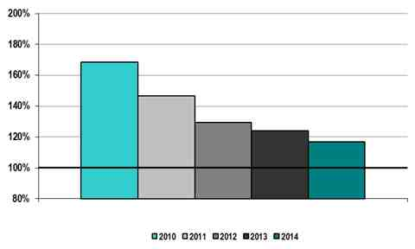
Balancing authority areas are also required to maintain compliance of at least 90% for CPS-2 during each month in a 12-month period. Effective March 1, 2010, the CAISO began participating in the Reliability Based Control proof-of-concept field trial that includes a waiver from CPS-2 requirements.
The field trial is still in place and will end upon implementation of BAL-001-2 (replacing BAL-001-1 that is currently in effect). BAL-001-2 will no longer require BAs to maintain a monthly CPS-2 metric. Rather, BAL-001-2 will now require each BA to maintain Area Control Error (ACE) within its Balancing Authority ACE Limit (BAAL) range (and not to exceed the BAAL for more than 30 consecutive minutes). BAL-001-2 will go into effect on 7/1/2016.

The CAISO maintains an energy management system to perform real-time monitoring. Availability is measured as the percentage of hours that the energy management system is operationally available.
CAISO Energy Management System (EMS) Availability 2010 – 2014
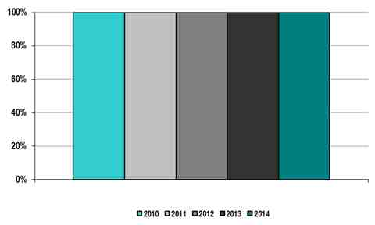

Load Forecast Accuracy
A significant portion of the load in California is centered along the coast in the areas around San Francisco, Los Angeles and San Diego. During the summer period, particularly during peaks, these regions can experience significant changes in temperature from what was predicted in the day-ahead timeframe because of the sudden and intense marine influence of the Pacific Ocean or desert monsoonal flow. On average, the CAISO day-ahead load forecast from a reference point of 8 a.m. is 98 percent accurate. Prior to the nodal market that started on April 1, 2009, the load forecast was not used by the ISO to make market commitments and therefore the results are not reported. The data structure prior to that date was also different so the results are not directly comparable.
CAISO Average Load Forecasting Accuracy 2010 – 2014
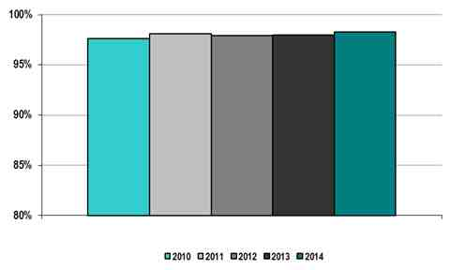

CAISO Peak Load Forecasting Accuracy 2010 – 2014
This metric calculates the average of the deviation for the peak load hour. The metric uses the day-ahead hourly load forecast created each day around 8 a.m.
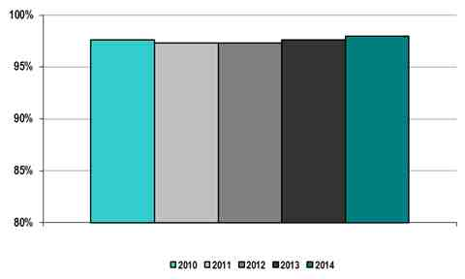
CAISO Valley Load Forecasting Accuracy 2010 – 2014
This metric calculates the averages of the deviation for the lowest load hour or the valley. The metric uses the day-ahead hourly load forecast created each day around 8 a.m.

Wind Forecasting Accuracy
The CAISO has forecasted output from wind resources since 2007 and improved its wind forecast accuracy to manage increasing penetration of these resources to meet California’s renewables portfolio standard. The data reported below for 2010 through 2014 uses the mean absolute error method, commonly used throughout the renewable energy industry.
CAISO Average Wind Forecasting Accuracy 2010 – 2014
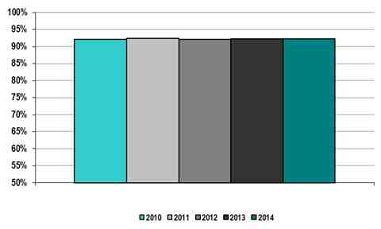

Unscheduled Flows
The CAISO transmission system is part of the Western Interconnection, which is a geographically large, 345/500 kV AC system that inherently has loop flow attributable to the use of contract path historical transmission rights as opposed to a power flow solution dispatch methodology. The absolute value of unscheduled flow as a percentage of total flows reported by the CAISO remains at a low level such that it does not register on the second chart below.
CAISO Absolute Value of Total Unscheduled Flows 2010 – 2014
(Gigawatt hours)
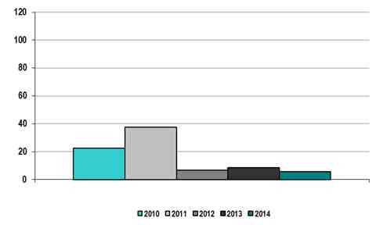
CAISO Absolute Value of Unscheduled Flows as a Percentage of Total Flows 2010 – 2014
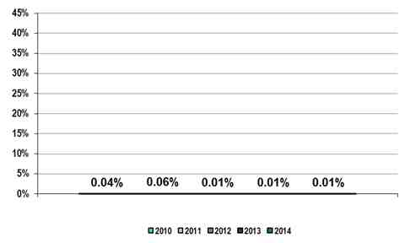

The table below reflects terawatt hours of unscheduled flows for the top five CAISO interfaces. Positive amounts represent unscheduled flows out of the CAISO and negative amounts represent unscheduled flows into the CAISO, which is the standard in the Western Interconnection.
CAISO Unscheduled  Flows by Interface | (terawatt hours)
CAISO Unscheduled  Flows by Interface | 2010 | 2011 | 2012 | 2013 | 2014
Arizona Public Service | (4) | (1) | (1) | (3) | (7)
Los Angeles Department of Water and Power | (9) | (8) | (9) | (7) | (5)
Nevada Power Company | 2 | 2 | 2 | 2 | 1
Salt River Project | 4 | 3 | 2 | 2 | 4
Western Area Power Administration, Lower Colorado Region | 5 | 4 | 5 | 5 | 5

Transmission Outage Coordination
This group of metrics assesses whether long duration outages are submitted well in advance so the CAISO may better plan for reliable and efficient operations. There are many variables involved in performing an outage study. Most studies can be performed in the time allowed for planned outage submission, but some outages and combinations of outages can result in more complex studies that require additional time to complete and validate. Therefore, not having 100 percent of the planned outages studied within established timeframes is not necessarily indicative of a failure.
CAISO timeframes for approving outages changed with the introduction of the new market design in April 2009. Since that time, outages need to be studied prior to the day-ahead market. In addition, several of the metrics reference a specific voltage level for the outage that could not be systematically determined until an advanced grid topology tool was put in place concurrent with the new market. On August 13, 2012, the CAISO tariff was modified to require entities to submit outages seven calendar days prior the outage. In 2015, the ISO implemented a new outage management system to improve business practices associated with planned and forced outages of transmission elements.
The first metric measures transmission owner performance, not CAISO performance.
CAISO Percentage of > 200kV planned outages of 5 days or more that are submitted to ISO/RTO at least 1 month prior to the outage commencement date 2010 – 2014
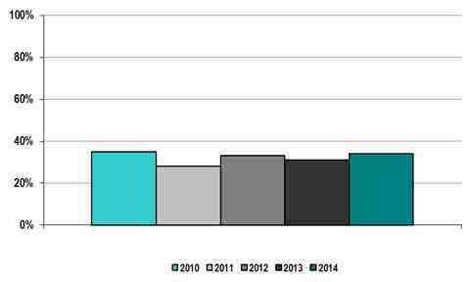

The second metric measures compliance with established timeframes; however, as discussed above, the study of a planned outage involves numerous factors and the failure to meet established timeframes in any specific instance does not necessarily equate with any shortcoming. For this metric, the CAISO has not specified a voltage level.
CAISO Percentage of planned outages studied in the respective ISO/RTO Tariff/Manual established timeframes 2010 – 2014
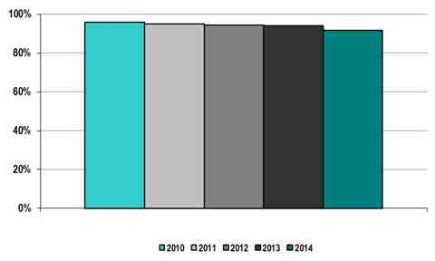
The third metric measures how frequently the CAISO cancelled previously approved transmission outages. Cancellations may occur only if there has been some system or unforeseen weather event in which an approved transmission outage would cause a reliability concern. It may also indicate whether approval of an outage was based on inaccurate or incomplete information.
CAISO Percentage of > 200 kV outages cancelled by ISO/RTO after having been previously approved 2010 – 2014
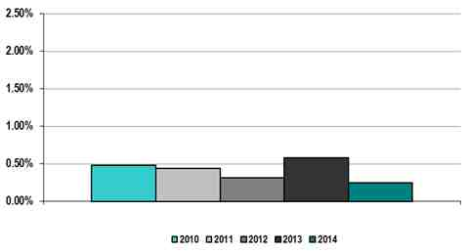
The fourth metric measures the frequency of unplanned outages. CAISO data for unplanned outages only includes outages where the outage start time is prior to the reporting time, and therefore does not include imminent outages where the outage reporting time is prior to the outage start time. The CAISO also considers such an occurrence to be an unplanned outage.
CAISO Percentage of unplanned > 200kV outages 2010 – 2014
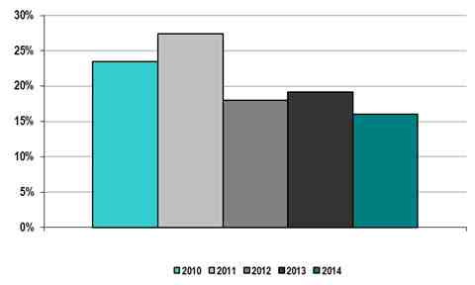
Transmission Planning
The CAISO conducts transmission planning based on a compliant Order No. 890 and Order No. 1000 processes and adherence to NERC, WECC, and CAISO planning standards. Annually, the CAISO performs a variety of technical studies, such as short and long-term reliability assessments, economic planning assessments, policy assessments and other key studies that are needed to support the market, state and federal requirements or directives and to ensure a reliable and secure transmission infrastructure.
CAISO Number of Transmission Projects Approved for Reliability Purposes
2010 – 2014
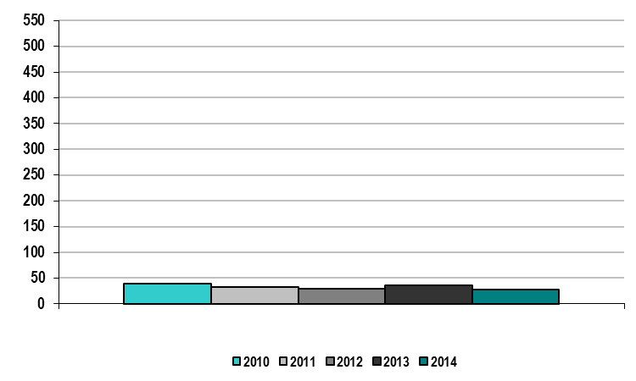
CAISO Percentage of Approved Construction Projects Completed and Projects On-Schedule per Original In-Service Date 2010 – 2014
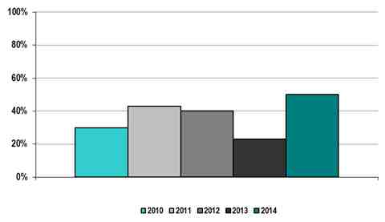
Generation Interconnection
The CAISO uses a cluster study approach to complete the majority of its generator interconnection studies. This approach allows the CAISO and participating transmission owners to evaluate the large volume of interconnection requests more quickly and to assign costs for network upgrades on a pro rata basis. The process includes one cluster window each year for submitting interconnection requests and a two-phased interconnection study process. The annual data below reflects the number of days required to complete interconnection requests in the CAISO’s interconnection queue.
CAISO Average Generation Interconnection Request Processing Time 2010 – 2014
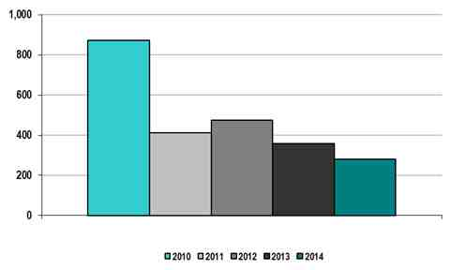

Reserve Margin
Planning reserve margin measures the amount of generation capacity available to meet expected demand in a planning horizon from a long term perspective, usually over one year while operating reserve margin is used to measure the amount of capacity available to meet expected demand from a short term perspective within one year. The CAISO performs its summer assessment on an annual basis, and uses the operating reserve margin to measure its system reliability in a short term. The CAISO’s 15 percent reserve margin requirement is based on the California Public Utilities Commission’s resource adequacy program requirement. This program requires load-serving entities to demonstrate they have acquired sufficient capacity needed to serve the forecast peak load plus a 15 percent reserve margin on a year-ahead and monthly basis at a system and local level. As part of this program, the CAISO accounts for the California Public Utilities Commission’s approved monthly demand response amounts as capacity resources.
CAISO Reserve Margin 2010 – 2014
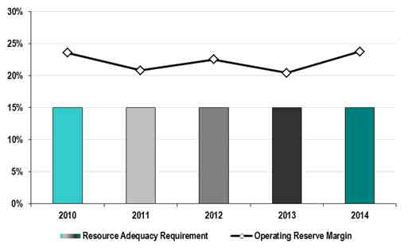
Bars Represent Reserve Margin Requirement

Demand Response Capacity
The CAISO uses the California Public Utilities Commission’s methodology for determining the resources that count as demand response capacity, and the performance expected from such resources when called.
CAISO Demand Response Capacity as Percentage of Total Installed Capacity 2010 – 2014
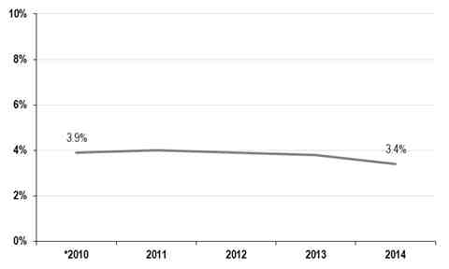
* In the FERC Common Metrics Report submitted in 2011, the "Demand Response percentage of Total Capacity" was erroneously submitted as 4.3%. The correct value for 2010 is 3.9%.

Generation Outages Cancelled by ISO/RTO
The percentage of generation outages cancelled by the CAISO has remained relatively constant for the reporting years. For the reporting years 2010-2014, the CAISO has included generation outages cancelled by CAISO itself and generation outages cancelled as a result of action by applicable participating transmission owners in its balancing authority.
Percentage of Generation Outages Cancelled by CAISO ⁽¹⁾
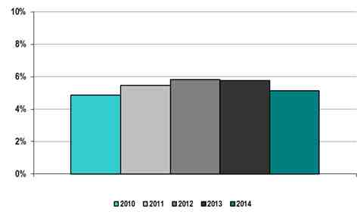
- CAISO data includes both, outages cancelled by PTO’s and by the CAISO.

Generation Reliability Must Run Contracts
The capacity procured under resource adequacy provides the CAISO with much of the local capacity needed for reliability purposes. The amount of Reliability Must-Run RMR capacity continues to decline as existing RMR units retire after being replaced with new units or electrical system improvements. In 2010, the ISO noticed the termination of RMR contracts for 2011 with both the South Bay Power Plant in San Diego, California and Potrero Power Plant in San Francisco, California.
These changes have allowed the California ISO to further reduce costs by releasing a significant amount of generation under RMR contracts without undermining local reliability. Following retirement of the San Onofre Nuclear Generating Station (SONGS), the CAISO added two synchronous condensers at the Huntington Beach Power Plant under an RMR contract. The CAISO has included these units in the 2013 and 2014 reporting years.

CAISO Number of Units under RMR Contracts
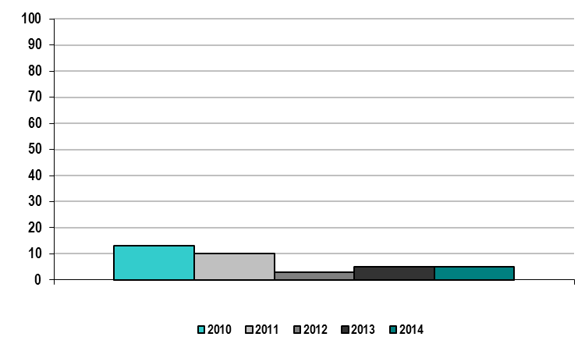

CAISO Capacity (MW) under RMR Contracts
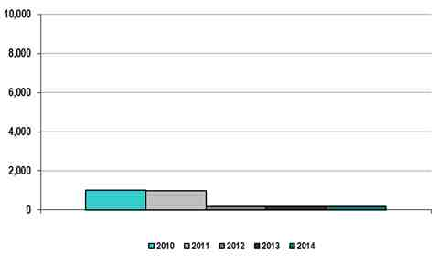

Interconnection / Transmission Service Requests
The following tables reflect the number of studies requested and how many were completed, as well as the average aging of studies and the time required to complete studies within the generator interconnection process.
CAISO Number Studies Requested 2010 – 2014
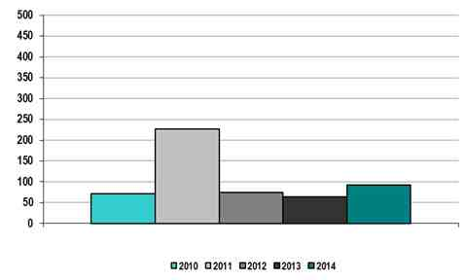

CAISO Number of Studies Completed 2010 – 2014
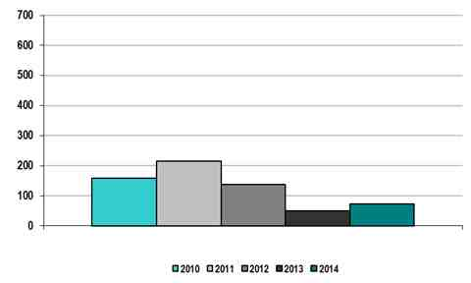

CAISO Average Aging of Incomplete Studies 2010 –2014⁽¹⁾
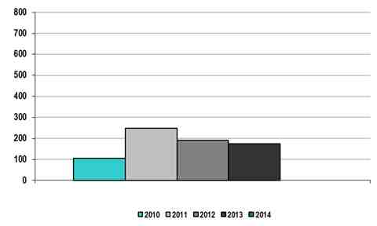
- All studies were completed on time in 2014.
CAISO Average Time to Complete Studies within the Interconnection Process 2010 – 2014
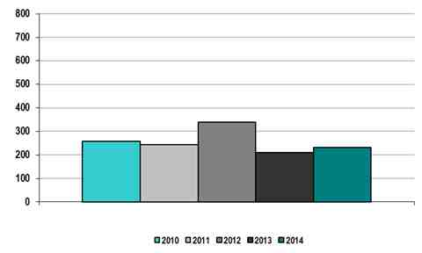

The types of generation interconnection studies the CAISO conducts are Feasibility, System Impact, and Facilities studies for serial study processes and Phase I, Phase II, and Reassessment studies for cluster study processes. The total costs per year are reflected below.
CAISO Total Cost of Competed Studies 2010 – 2014⁽¹⁾
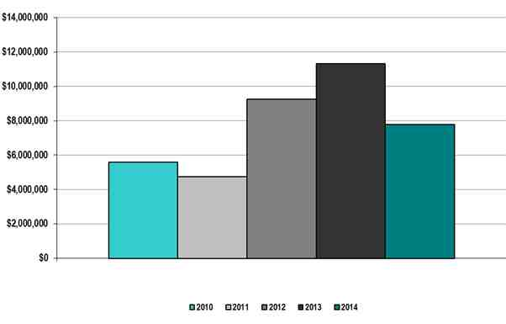
- The chart reflects total costs that the CAISO expended in each calendar year and may include costs for work done in prior years as the Participating Transmission Owners may not be able to submit their portion of the study costs to the CAISO in the actual year the studies were completed.

Special Protection Schemes
As part of the voluntary reporting of performance metrics, FERC has requested information on the following: (1) the number of valid, i.e. correct, operations of RAS/SPS; and (2) the number of invalid, i.e. incorrect, operations of RAS/SPS. The CAISO has included the total number of RAS/SPS that operated during each reporting year in this performance metric report in the chart below.
Number of RAS/SPS Operations 2010-2014 in the CAISO Balancing Authority Area
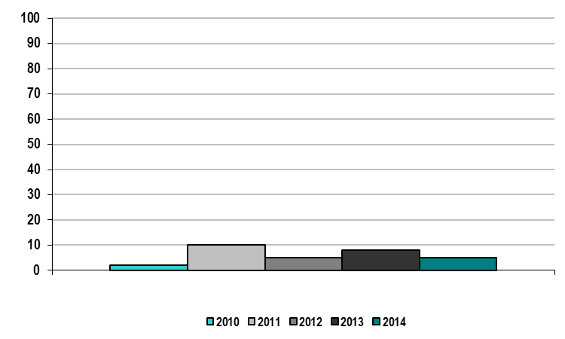
In accordance with Section 8 of the CAISO Transmission Control Agreement, participating transmission owners have the sole responsibility to design and maintain all RAS/SPS. NERC Reliability Standard PRC – 016 Requirement 1 requires that RAS/SPS owners determine whether an operation of a specific RAS/SPS was incorrect and maintain appropriate records. While the CAISO’s participating transmission owners report the operation of a RAS/SPS for transmission facilities that are under the operational control of the CAISO, they do not submit a report regarding whether the RAS/SPS operated correctly or incorrectly. Absent additional study, it may not be possible to determine with high confidence whether or not the RAS/SPS operated correctly. Consistent with section 8 of the Transmission Control Agreement, any study is the responsibility of the participating transmission owner to perform and they must often complete additional after-the-fact analyses to determine that a given RAS/SPS operation was correct or incorrect.

B. CAISO Integrated Wholesale Power Markets

Market Competitiveness
The CAISO’s market relies upon a high level of self-supply and forward-contracting by load-serving entities as a means of mitigating system-level market power. This is consistent with California policies designed to ensure that the state’s major utilities hedge a large portion of their energy supply needs. The potential for market power on a system level basis is addressed by an energy bid cap. The maximum energy bid price has been $1,000 per MWh since 2011.
Ownership of resources within most transmission constrained load pockets of the system remains concentrated under one or two major suppliers. Therefore, the market design includes more stringent provisions for mitigation of local market power. Under this approach, resources that must be dispatched to provide additional incremental energy to relieve transmission constraints deemed to be non-competitive may have their market bids lowered based on a default energy bid, which reflects the unit’s actual marginal operating costs.
CAISO Price Cost Markup
The CAISO estimates the price-cost mark-up for its wholesale market by comparing total estimated wholesale energy costs to costs that would result under competitive baseline prices. The CAISO estimates these competitive baseline prices by re-simulating market outcomes after replacing market bids for gas-fired generation with bids reflective of the unit’s actual marginal costs.
The table below summarizes the results for the period 2010-2014. CAISO’s wholesale markets have been very competitive during this period with a slight negative price-cost mark-up in all years. In 2012, the mark-up was effectively $0. In 2014, the price-cost mark-up was negative 4.8 percent. Negative mark-ups can occur because default energy bids include a 10 percent mark-up. Many resources choose to bid below their default levels by small amounts in order to remain competitive in the market especially as more renewable generation has come online over the past several years. In addition, unscheduled renewable generation in the day-ahead market contributes to increasing the competitive baseline, as well as reducing real-time prices relative to the day-ahead market. Both of these effects can also apply downward pressure on mark-ups.

CAISO Price-Cost Mark-up 2010 – 2014
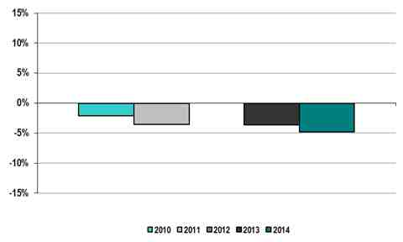
CAISO Generator Net Revenues
Results for a typical new combined cycle and combustion turbine unit are shown below. Revenue estimates are taken from the CAISO energy markets assuming hypothetical dispatch. The 2013 and 2004 cost estimates are based on data from the California Energy Commission’s (CEC) March 2013 CEC Workshop on the Cost of New Renewable and Fossil-Fueled Generation in California, whereas costs in earlier years are based on data presented in the CEC’s 2009 Comparative Costs of California Central Station Electricity Generation Technologies report.
The results for a typical new combined cycle unit show an increase in net revenues beginning in 2012. These net revenue estimates for a hypothetical combined cycle unit fall substantially below the $176/kW-yr annualized fixed cost estimated from the CEC data. The increase in net revenues can be attributed to multiple factors in different years including the outage and retirement of the San Onofre Nuclear Generating Station units in Southern California in 2012 and 2013, respectively, decreasing output from hydroelectric generation due to severe drought conditions, increasing load, and implementation of the state’s cap-and-trade program covering electric generation in 2013. Even through new combined cycle units burn produce greenhouse gases, they are often more efficient than the marginal price setting resource and because they emit less greenhouse gases on a per megawatt basis than older gas units or less efficient combined cycle generators. As a result, revenues for new combined cycle generation increased after implementation of the cap-and-trade program.

CAISO New Entrant Gas-Fired Combustion Turbine (CT) Net Generation Revenue 2010 – 2014
(Dollars per installed megawatt year)
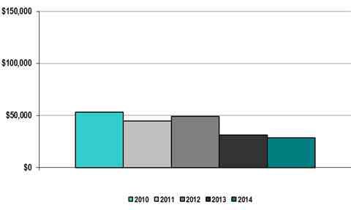
CAISO New Entrant Gas-Fired Combined Cycle (CC) Net Generation Revenues 2010 – 2014
(Dollars per installed megawatt year)
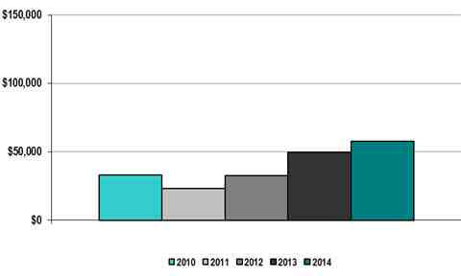

CAISO Bid Mitigation
Mitigation of a unit’s market bids occurs only when a unit is actually required to operate or run at a higher level due to network constraints deemed non-competitive. If a unit is subject to bid mitigation, the unit’s original market bids are compared to its default energy bid and the competitive locational marginal price, which includes congestion on paths that have been deemed competitive and may be adjusted downwards so that the unit’s bid curve does not exceed the higher of its default energy bid or the competitive locational marginal price. The unit’s resulting mitigated bid curve is used in the final energy market run.
In the real-time market, bid mitigation frequency decreased from 2011 to 2014, and is now a third less frequent than in 2011. The overall impact of bid mitigation remains low in the real-time market. This is likely related to significant changes to the real time process during this period. The CAISO’s automated local market power mitigation procedures were enhanced in April 2012 to more accurately identify and mitigate resources with the ability to exercise local market power in the day-ahead and hour-ahead markets. The real-time mitigation procedures were further enhanced in May 2013. As part of these changes, the CAISO adopted a new, in-line dynamic approach to the competitive path assessment. This new approach uses actual market conditions and produces a more accurate and less conservative assessment of transmission competitiveness.
CAISO Real-Time Energy Market Percentage of Unit Hour Bids Mitigated due to Mitigation
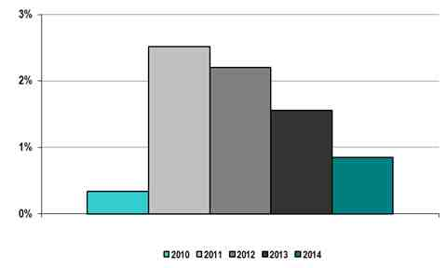

Market Pricing
Since the CAISO implemented the new market in April, the overall performance of the new day-ahead and real-time markets have been highly efficient with energy prices following patterns of well-functioning competitive markets, reflecting production costs, and trending generally with the price of natural gas, the most prevalent fuel for marginal resources on the system. The load-weighted energy prices trended upward since 2010, mainly driven by higher fuel cost, the loss of a base load supply and the greenhouse gas (GHG) cost adder.
CAISO Average Annual Load-Weighted Wholesale Energy Prices 2010 – 2014
($/megawatt-hour)
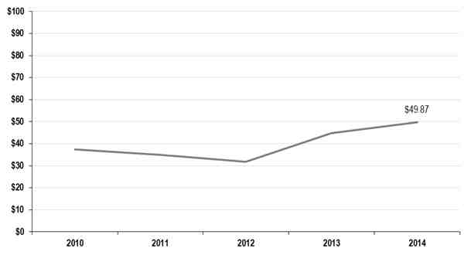
CAISO Average Annual Load Weighted
Fuel Adjusted Wholesale Spot Energy Prices 2010 – 2014⁽¹⁾
($/megawatt-hour)
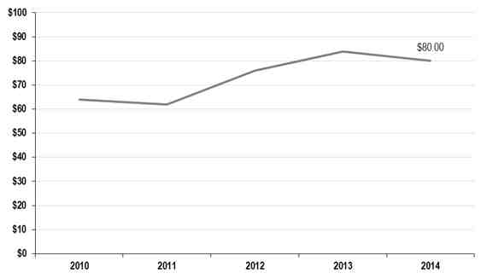
- CAISO base for fuel costs references 2008 gas prices.

CAISO Wholesale Power Cost Breakdown 2010 – 2014
($/megawatt-hour)
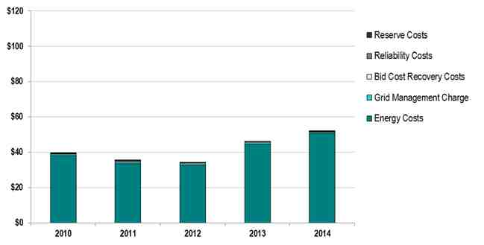

Unconstrained Energy Portion of System Marginal Cost
System lambda is the average, non-weighted, unconstrained energy portion of the system marginal cost, which measures the marginal energy price in dollars per megawatt hour exclusive transmission constraints and transmission losses.
CAISO Annual Average Non-Weighted, Unconstrained
Energy Portion of the System Marginal Cost 2010 – 2014
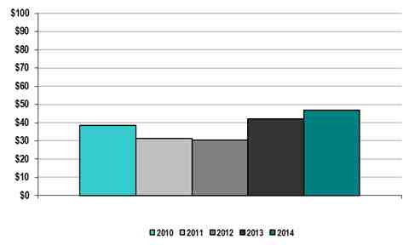

Energy Market Price Convergence
Price convergence improved from 2011-2014 compared with 2010. Form 2011-2014, the average day-ahead and real-time price difference was below $3 and the percentage difference was above 95 percent for each year. In 2011, the price spikes in five-minute market decreased over the course of the year and this contributed to the substantial improvement of price convergence in 2011. One key factor affecting price convergence is price spikes in five-minute market. The CAISO has taken numerous actions to improve price convergence such as improving load forecast accuracy, implementing flexible ramping constraint, and 15-minute market.
Average price differences between day-ahead and real-time prices in the CAISO have been larger than most other ISOs due to unique circumstances within the CAISO markets. Notably, real-time prices exceeded day-ahead prices by more than $3/MWh in 2010. Real-time prices during this period were frequently affected by short-term limitations in system ramping capability. While these limitations would typically be resolved within 5 to 15 minutes, prices during these periods would be set by the offer cap, which is currently set to $1,000/MWh. As a result of this divergence, the CAISO implemented new tools, including the load bias limiter and the flexible ramping constraint, to help address real-time ramping limitations. Because operators do not know exactly how much system ramp is available during any 5-minute interval, the load bias limiter was designed to keep operator actions from exceeding system ramping capabilities. The flexible ramping constraint was designed and implemented to address unanticipated movements in demand and supply, particularly from variable resources. Together, these new software features helped the CAISO model address short term ramping limitations.
In 2013 and 2014, price divergence between day-ahead and real-time prices in the CAISO exceeded $2/MWh. However, in these years, day-ahead prices exceeded real-time prices. Unlike 2010, real-time ramping limitations were fewer and did not play as significant role in price formation. Instead, additional generation in real time not included in the day-ahead market caused prices to decline in real-time relative to the day-ahead. While this additional generation included reliability related commitments, the majority of the additional generation in real time was from unscheduled renewable resources, particularly from wind and solar. The CAISO does not include must bid rules for renewable generation and, as a result, market participants have frequently under bid their renewable resources in the day-ahead market. While virtual bids are intended to arbitrage away this and other supply and demand differences between the real-time and day ahead markets, net virtual supply positions have not always sufficiently offset the volume of physical supply/demand gaps between real-time and day-ahead markets, including unscheduled renewable resources in the real-time markets. The CAISO now posts information on its website that shows the hourly schedules in addition to forecasts of renewable resources in an effort to provide more transparency on renewable scheduling. The CAISO may consider further options going forward.

CAISO Day-Ahead and Real-Time Energy Market Price Convergence 2010 – 2014⁾
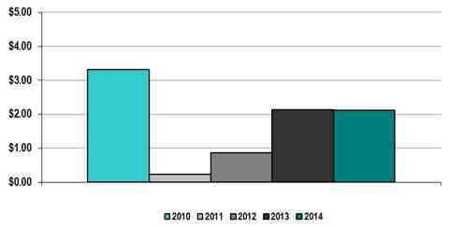

CAISO Percentage of Day-Ahead and Real-Time Energy Market Price Convergence 2010 – 2014
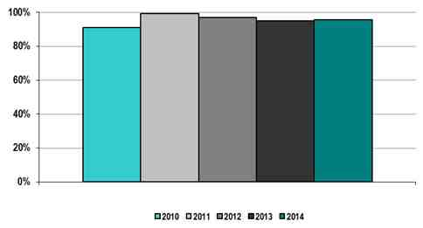
Congestion Management
Market participants can acquire congestion revenue rights through a CAISO allocation and auction process to hedge the cost of congestion on the transmission system. The objective of the first metric below is to quantify the hourly average congestion cost per megawatt of load served. The second metric quantifies the congestion cost hedged with congestion revenue rights by dividing the amount of net revenue the market receives by total congestion costs. In 2010, holders of congestion revenue rights paid relatively more for these rights in the auction than they did in the other years. And the net revenue received by the market was smaller than the other years. Real time congestion in 2010 was also less negative than 2011-2014. Therefore, the percentage of congestion costs hedged in 2010 was low. The congestion cost per megawatt trended upward since 2010, driven by increasing congestion costs.
CAISO Annual Congestion Costs per Megawatt Hour of Load Served 2010 – 2014
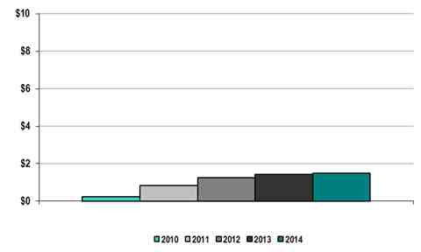
Percentage of Congestion Dollars Hedged Through CAISO Congestion
Management Markets 2010-2014
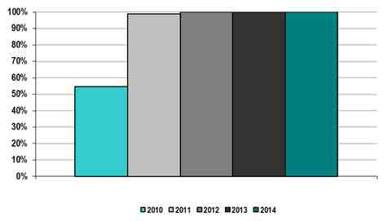
Generator Availability
The CAISO average annual generator availability calculation is the total generation megawatts (MW) unavailable due to forced outages for the year compared to the maximum generation capacity within the CAISO. For 2010-2014, the CAISO used a new data source to track forced outages.
CAISO Annual Generator Availability 2010 – 2014
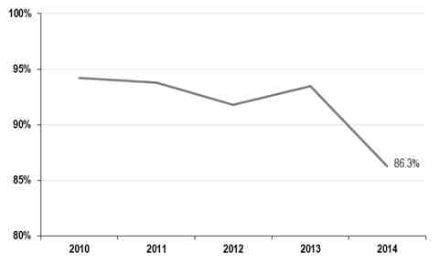

Fuel Diversity
Generation in the CAISO balancing authority area is made up of natural gas, large hydro, renewable resources, nuclear, oil and coal. Natural gas generation remains the predominant fuel source in the CAISO’s balancing authority area. Generation capacity operating on hydro and renewable fuel was the second largest source at 27 percent, nuclear resources followed at approximately eight percent. Solar generation from resources directly connected to the ISO grid more than doubled in 2014 compared to 2013, increasing its overall share of generation to about five percent. Hydro-electric generation provided approximately five percent of supply in 2014, a decrease from almost eight percent in 2013.
CAISO Fuel Diversity 2010 – 2014
CAISO Installed Capacity 2010 – 2014 | CAISO Generation Output 2010 – 2014
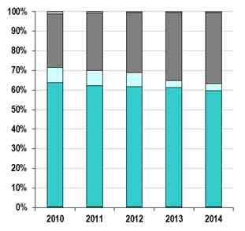 | 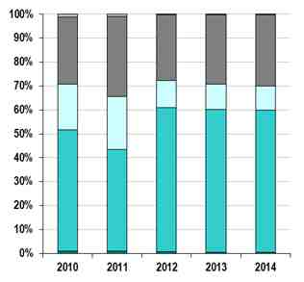
Coal Gas Nuclear Oil
Hydro and Renewables Other

Demand Response Participation in Synchronized Reserve Markets
The CAISO uses the California Public Utilities Commission methodology for determining the resources that count as demand response, and the performance expected from such resources when called upon. Prior to October 2014, demand response as a percentage of ancillary services reflected awards or self-provision of non-spinning reserve. However, after implementation of BAL-002-WECC-02 the ISO has the opportunity to use demand resources for other reserve products. The ISO is taking steps to increase participation by demand response in its wholesale markets through various initiatives to redesign ancillary services and the development of the proxy demand resource product.
CAISO Demand Response as a Percentage of Reserve Market 2010 – 2014
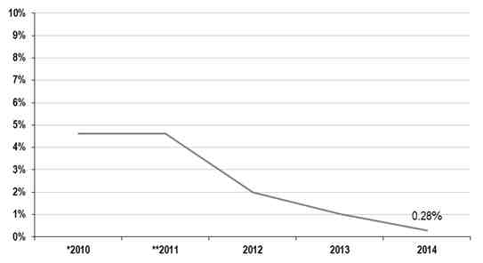
Note: The decrease in Demand Response as a percentage of the Reserve Market is due to a decrease in bid submission for AS by participating load.
* The 2010 value was submitted in the 2011 FERC Common Metrics Report and was not changed for this report.
** The 2011 value only represents data from September 17th to December 31st of 2011.

Renewable Resources
The CAISO data for renewables reflects resources eligible to satisfy California’s renewables portfolio standard, such as wind, solar, geothermal, biomass, biogas and small hydroelectric generating units. However, the figures reported here do not include renewable resources external to the CAISO balancing authority area, internal renewable resources not connected to the CAISO controlled grid, or the renewable resources to which the ISO does not otherwise have telemetry even though some of these resources ultimately may count towards the renewable portfolio standard. As a result, this metric does not depict the entire scope of renewable resources operating in the California CAISO’s balancing authority area. From 2010 to 2014, renewable energy increased as a percentage of total system energy. California law requires load serving entities to increase procurement from eligible renewable energy resources to 20 percent of retail sales by December 31, 2013; 25 percent of retail sales by December 31, 2016; and 33 percent of retail sales by December 31, 2020. California has recently increased its renewable portfolio standard to 40 percent by December 31, 2024, 45 percent by December 31, 2027, and 50 percent by December 31, 2030. The CAISO, accordingly, expects that its renewable energy will continue to grow as a percentage of total system energy.
CAISO Renewable Megawatt Hours as a Percentage of Total Energy 2010 – 2014
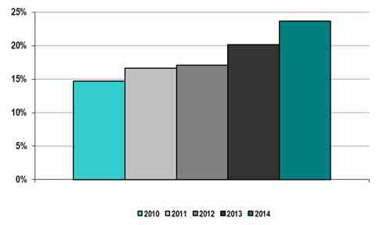
*Large hydro generation are not counted in the renewables portfolio standard.
The renewable and hydroelectric capacity data on the next two charts is based on generator nameplate capacity, which is the maximum rated output of a generator under conditions designated by the manufacturer.
CAISO Renewable Megawatts as a Percentage of Total Capacity 2010 – 2014
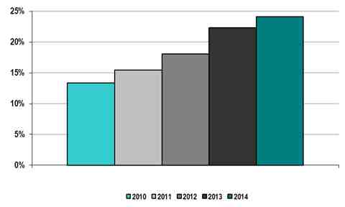

CAISO Hydroelectric Megawatts as a Percentage of Total Capacity 2010 – 2014
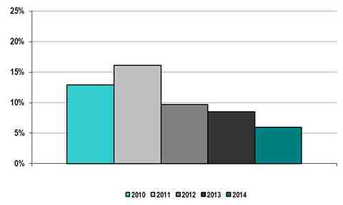
Data on total energy from hydroelectric power (including small resources, large resources, and pumped storage) is included in the chart below. The large hydroelectric capacity as a percentage amount of total capacity ranged between 16 to 17 percent from 2006 to 2010, while large hydroelectric energy as a percentage of total energy varied from six to 14 percent.

CAISO Hydroelectric Megawatt Hours as a Percentage of Total Capacity 2010 – 2014
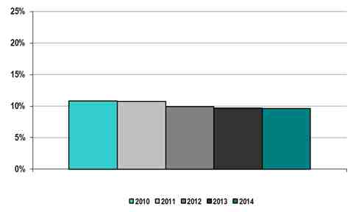

C. CAISO Organizational Effectiveness

Administrative Costs
The CAISO did not have any material variances between its approved budgets and its actual costs from 2010 through 2014. The administrative charge is currently made up of three primary billing components and five fees, with weather, customer activity and other factors affecting the revenue billed and collected. If collections exceed budgeted costs, the difference is credited to the following year’s CAISO revenue requirement and vice versa. Additionally, the CAISO may adjust the administrative charge quarterly to maintain its budget over or under collections. Administrative costs per megawatt hour of load served should be reviewed in the context of the varying levels of annual load served by each ISO/RTO.
CAISO Annual Actual Costs 2010-2014
Non-Capital Costs  (%) |  |  |  |  |  | Capital Recovery Costs  (%)
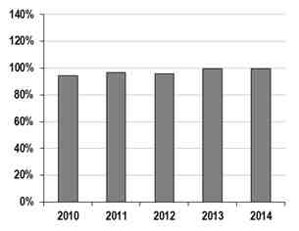 |  |  |  |  |  | 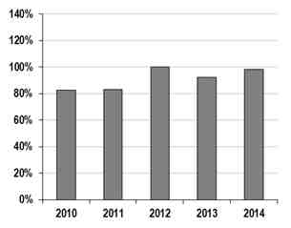
Budget | $149.80 | $153.30 | $150.70 | $155.90 | $157.48 | Budget | $25.70 | $19.60 | $23.40 | $18.02 | $23.60
Bars Represent % of Actual Costs to Approved Budgets; Dollar Amounts Represent Approved Budgets (in millions)

CAISO Annual Administrative Charges per Megawatt Hour of Load Served 2010-2014
($/megawatt-hour)
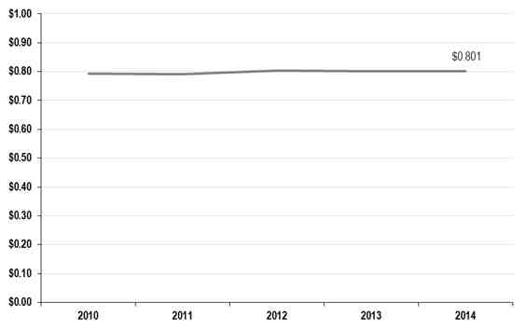

ISO/RTO | 2014 Annual Load Served
CAISO | 240.4 terawatt hours

Customer Satisfaction
Instead of using a single client satisfaction metric for developing business improvement initiatives, the CAISO uses a variety of survey instruments to test stakeholder satisfaction. Among these instruments are “transactional surveys” to gauge stakeholder satisfaction with specific projects or stakeholder processes, “corporate surveys” to annually sample senior-level stakeholders across multiple ISO business areas, and “touch point mapping exercises” in which the CAISO seeks to better understand business interactions with its customers. Although these surveys yield no single stakeholder satisfaction score, the CAISO asks if “Overall the service provided by the ISO is valuable to your organization” within the annual corporate survey. The graphic below presents the scores for the past four years where surveys were conducted (note: the CAISO did not conduct a survey in 2013 because the time available to perform the survey did not align with developing corporate goals).
CAISO Percentage of Satisfied Members 2010-2014
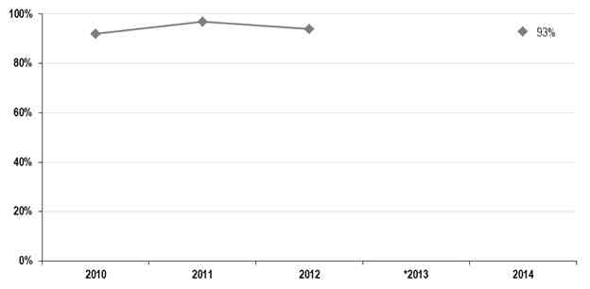
* No Survey was conducted in 2013

Billing Controls
The CAISO received unqualified opinions from 2010 through 2014. This is a testament to the completeness and accuracy of the controls the CAISO has in place. The auditing standards were changed in 2011 and the SAS 70 audit became the SSAE 16 audit.
ISO/RTO | 2010 | 2011 | 2012 | 2013 | 2014
California ISO | Unqualified SAS 70 Type 2 Audit Opinion | Unqualified SSAE 16 Type 2 Audit Opinion | Unqualified SSAE 16 Type 2 Audit Opinion | Unqualified SSAE 16 Type 2 Audit Opinion | Unqualified SSAE 16 Type 2 Audit Opinion
D. California ISO Specific Initiatives
As referenced in the introduction to this report, the CAISO has adopted a strategic vision to identify opportunities facing California and the West as part of the ongoing transition to a low-carbon electric grid. This vision outlines three over-arching strategies: (1) lead the transition to a low carbon grid; (2) reliably manage the grid during the energy industry transformation; and (3) expand collaboration to unlock regional benefits. Consistent with this vision, the CAISO plans to undertake several initiatives that will advance the topics of reliability, markets and organization effectiveness identified in this report.
Reliability
During the transformation of the electric industry, the CAISO will continue to reliably manage the grid consistent with reliability standards and at reasonable cost. This change will require us to develop mechanisms to manage high levels of variability. Already, we have developed modeling enhancements to more effectively balance the grid with external balancing authority areas and improve reliability and accuracy of the CAISO’s market solution. The CAISO continues to examine how to more accurately forecast variable energy resource production in the day-ahead timeframe, including encouraging scheduling coordinators to schedule the output of their variable energy resources in the day-ahead timeframe. More accurate production forecasts will help the CAISO position remaining resources in the fleet to serve net load
The CAISO is also embarking on a high level scope of work to study the impacts of distributed energy resources on the CAISO’s controlled grid. This study includes potential changes to the utilization of the transmission system with increasing levels of distributed energy resources, which may cause operational changes resulting from the distributed level of visibility and control of such resources, and potentially stranding elements of the transmission system.
With current penetration levels of wind and solar photovoltaic resources, the CAISO has already identified increasing need for flexibility in the existing resource fleet to meet net load ramps. Our studies reflect (1) the potential for over-generation conditions and negative prices in the middle of the day prior to longer and steeper evening ramps; (2) multiple intra-day upward and downward ramps; (3) increased intra-hour load-following capacity requirements; and (4) increased regulation capacity requirements.
We have also discovered that planning studies for transmission maintenance must consider new congestion patterns that will result from power flows created by a new low-carbon fleet. While transmission providers typically have planned maintenance of transmission elements during shoulder months, this action has sometimes exacerbated over-generation conditions and negative prices within localized areas.
Markets
The CAISO had multiple efforts underway to enhance market processes to help integrate renewables and distributed energy resources. For example, the CAISO is working with stakeholders to develop a flexible ramping product to obtain both upward and downward ramping capabilities. This ramping product is an important step to ensure the CAISO has sufficient ramping capability to accommodate the increased variability accompanying increasing amounts of variable energy resources. The CAISO also plans to examine mechanisms to incentivize resources to operate at lower minimum load and adjust market rules to encourage exports. The CAISO has also sought to minimize the use of self-schedules and incentivize more economic bidding. With the Commission’s approval, we have already lowered our bid floor to encourage more economic bidding by all resources, including variable energy resources, to reduce their output during over-generation conditions. We will continue to explore mechanisms to obtain more economic bids from variable energy resources so that the CAISO market optimization can dispatch them when appropriate.
The CAISO will continue to looks for means to foster the participation of energy storage and demand response resource in its markets including incentivizing shifting loads to periods when there is excess supply from periods of peak net demand. The CAISO is also exploring how increased demand from electrification of transportation or water conveyance and desalination complement increased output from variable energy resources.
The Energy Imbalance Market implemented by the CAISO and PacifiCorp in November 2014 already demonstrates that optimizing across a broader footprint in real-time can help address over generation conditions. Increased regional collaboration, including optimizing resource portfolios in the day-ahead timeframe, is a more efficient means to integrate increasing volumes of variable energy resources both in the CAISO and across other balancing authorities because it does not involve significant capital investments and will cause more efficient electric system operations while reducing carbon emissions. With the adoption of a 50 percent renewable portfolio standard, the CAISO is undertaking efforts to examine transformation of the CAISO into a regional organization.
Organizational Effectiveness
Beyond cost and customer satisfaction measures, the CAISO will continue to focus on developing its people, business processes and technology capabilities. These enabling activities are essential to meet stakeholders’ expectations while maintaining a reasonable operating cost. The CAISO has developed and launched programs to advance leadership and employee engagement as well as technical training programs to develop critical skills to manage a more complex grid. Human Resources has implemented a comprehensive strategy to ensure the organizational alignment and to ensure employees recognize how their core job responsibilities advance the CAISO’s strategic vision. We continue to enhance our technology platforms to meet organization’s needs, from records management, corporate preparedness, and compliance training and monitoring.

ISO New England (ISO-NE)

Section 3 – ISO-NE Performance Metrics and Other Information

ISO New England is a regional transmission organization (RTO), serving Connecticut, Maine, Massachusetts, New Hampshire, Rhode Island, and Vermont. ISO New England meets the electricity demands of the region's economy and people by fulfilling three primary responsibilities:
- Minute-to-minute reliable operation of New England's electric power system, providing centrally dispatched directions for the generation (i.e., supply) and flow of electricity across the region's interstate high-voltage transmission lines and thereby ensuring the constant availability of electricity for New England's residents and businesses.
- Development, oversight, and fair administration of New England's wholesale electricity marketplace, through which electric power has been bought, sold, and traded since 1999. These competitive markets provide positive economic and environmental outcomes for consumers and improve the ability of the power system to efficiently meet the ever-increasing demand for electric power.
- Management of comprehensive planning processes for the electric power system and wholesale markets for addressing New England's electricity needs well into the future.
ISO New England is an independent, not-for-profit corporation. To carry out its charge effectively, the company, its board of directors, and its more than 550 employees have no financial interest or ties to any company doing business in the region's wholesale electricity marketplace.
The New England regional electric power system serves 14 million people living in a 68,000-square-mile area. Approximately 350 generating units, representing approximately 31,000 MW of total generating capacity, produce electric energy in the region. Most of these facilities are connected through more than 8,600 miles of high-voltage transmission lines. Thirteen tie lines interconnect New England with neighboring New York State and the provinces of New Brunswick and Québec, Canada. Demand resources now play a significant role in operating the New England power system. In 2014, demand resources totaling 2,300 MW were part of the regional power system, and approximately 2,803 MW are expected by 2018.

A. ISO New England Bulk Power System Reliability
The table below identifies which NERC Functional Model registrations ISO-NE submitted as of the end of 2013. The regional entity for ISO-NE is the Northeast Power Coordinating Council (NPCC). A link to the website for the specific NPCC reliability standards applicable to ISO-NE is included at the end of the table. For the reporting period 2010 to 2014, ISO-NE settled one self-report (NP13-52); had two self-reports resolved through NERC’s Find, Fix, and Track program (RC12-11 and RC12-13); and had one matter identified through a Compliance Audit resolved through NERC’s FFT as of December 30, 2014. ISO-NE regularly reports to stakeholders about the monthly operation of the system.
NERC Functional Model Registration | ISO-NE
Balancing Authority
Interchange Authority
Planning Authority
Reliability Coordinator
Resource Planner
Transmission Operator
Transmission Planner
Transmission Service Provider
Regional Entity | Northeast Power Coordinating Council (NPCC)

Standards that have been approved by the NERC Board of Trustees are available at http://www.nerc.com/page.php?cid=2|20.
Additional standards approved by the NPCC Board are available at https://www.npcc.org/Standards/SitePages/ApprovedStandardsList.aspx.

Dispatch Operations
Compliance with Frequency Control Performance Metrics (CPS1 and CPS2)
As the registered balancing authority (BA) for New England, ISO-NE is responsible for dispatching the region’s generation to meet its load (or demand) and the scheduled interchange with its neighboring BAs (i.e., the agreed-to level of flow over the tie lines between two BAs). In real time, the area control error (ACE) determines the effectiveness of ISO-NE’s dispatch, or control, performance. The ACE is a measurement of the difference between the net scheduled interchange and the net actual interchange, with an additional adjustment to support system frequency. Overgeneration will result in a positive ACE, and undergeneration will result in a negative ACE. To control the ACE so that it is sufficiently close to zero and in compliance with industry standards, ISO-NE dispatches resources selected for automatic generation control (AGC). These resources regulate their power output based on control signals they receive from the ISO every four seconds. The regulation requirements are based on balancing the need to satisfy the Control Performance Standard (CPS) with the need to minimize regulation procurement and, ultimately, consumer costs. The CPS sets the limits of a balancing authority’s ACE over specified periods.
Control Performance Standard No. 1 (CPS1) and Control Performance Standard No. 2 (CPS2) are designed to maintain interconnection steady-state frequency within defined limits by balancing real power demand and supply in real time. NERC Standard BAL-001-0.1a, Real Power Balancing Control Performance, defines CPS1 and CPS2 as follows:
- CPS1 is the 12-month rolling average limit for the impact of a BA’s area control error on system frequency. To be compliant with CPS1, BAs must achieve a score of at least 100% to avoid an adverse impact on system frequency.
- CPS2 compares the BA’s integrated ACE value for clock 10-minute periods (six nonoverlapping periods per hour) during a calendar month against a NERC-assigned limit (L10). Compliance requires being within this limit for greater than 90% of the clock 10-minute periods in every month. ISO-NE has an internal goal of managing CPS2 within a monthly average of between 92% and 97%.
ISO-NE monitors CPS compliance every hour of every day. Further, ISO-NE reviews CPS1 and CPS2 performance on a monthly basis. In addition, ISO-NE reviews CPS compliance annually to determine whether its regulation requirements, specified as a function of month, day type, and hour, need to be adjusted or modified. Since 2005, regulation requirements have decreased as a result of more efficient and effective generation dispatch and new operational tools, such as electronic dispatch and very short-term load forecasting. The system operators also have ensured compliance with CPS2 by carefully monitoring real-time economic dispatch and those resources providing regulation service. Consequently, lower amounts of regulation are needed to provide the required regulation service and subsequently meet the CPS2 target.
ISO-NE was compliant with CPS1 and CPS2 for each of the calendar years from 2010 to 2014, as shown in the following graphs.
ISO-NE CPS1 Compliance, 2010–2014
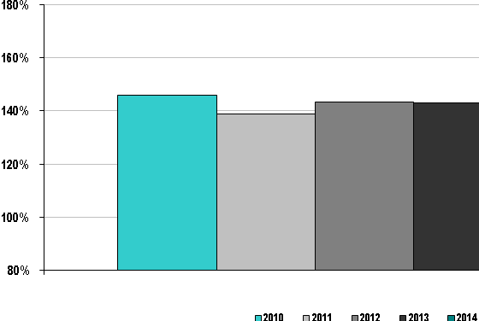

ISO-NE CPS2 Compliance, 2010–2014
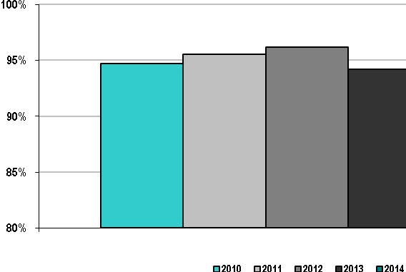

ISO New England Energy Management System Availability, 2010–2014
The availability of the Energy Management System (EMS), as shown in the next figure, is the key to reliable monitoring of the electric power transmission system. For the past five years, ISO New England’s EMS has been available 99.98% or more of all hours in each year.
ISO-NE Energy Management System Availability, 2010–2014
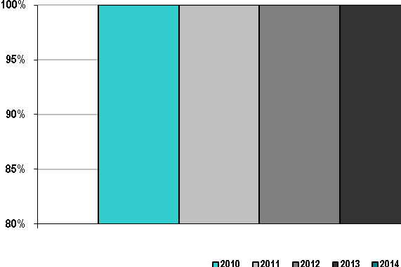

Load Forecast Accuracy
The principal factor affecting load forecast error is the accuracy of weather forecasts, with 60% of the load forecast error driven by weather forecast error. To minimize weather forecast error, ISO-NE uses three weather vendors to provide regional weather forecasts for eight New England cities. These data are used to calculate a load-weighted New England average weather forecast.
ISO-NE forecasters also use three types of short-term load forecast models to produce the day-ahead load forecast (before 10:00 a.m.), the seven-day load forecast, and an update of the current (intra) day load forecast. One type of forecast model is an advanced neural network (ANN) model that uses weather inputs and historical data to produce a short-term load forecast for the upcoming seven days. The ANN-Regular model weighs past load and weather data evenly, whereas the ANN-Fast model relies more heavily on the most recent weather data. The ANN-Fast model is particularly helpful during daylight-savings-time changes or seasonal holidays. Both ANN models are “retrained” annually. The second type, the MetrixND model, is solely dependent on weather inputs. The third type is the Similar Day historic model, which allows the forecaster to view a range of past “similar” days for possible use in the next-day forecast. The Similar Day model is based on predefined time and load criteria.
ISO-NE is currently developing a Metrix Zonal load forecast. The zonal model will provide Operations and local control centers hourly forecasts for seven days out on a zonal level for the eight ISO-NE load zones. These zonal forecasts will also be rolled up to yield an ISO-NE system load forecast total. The model will provide the forecasts both in megawatts and as a percentage of the total system load for current-day and future-day short-term reliability analysis.
ISO-NE proactively monitors the performance of the individual load forecast models and regularly communicates with its weather vendors and the local National Weather Service office to discuss unusual weather conditions or forecasts.
ISO-NE’s load forecasting accuracy is shown in the following table and figures.
 | Load Forecasting Accuracy Reference Point
ISO-NE | 10:00 a.m. prior day

ISO-NE Average Load Forecasting Accuracy, 2010–2014
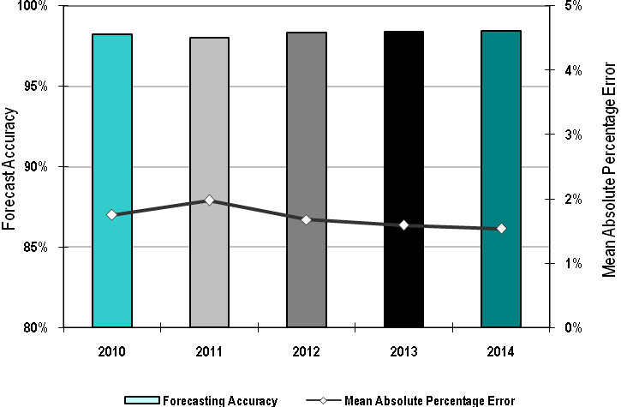
ISO-NE Peak Load Forecasting Accuracy, 2010–2014
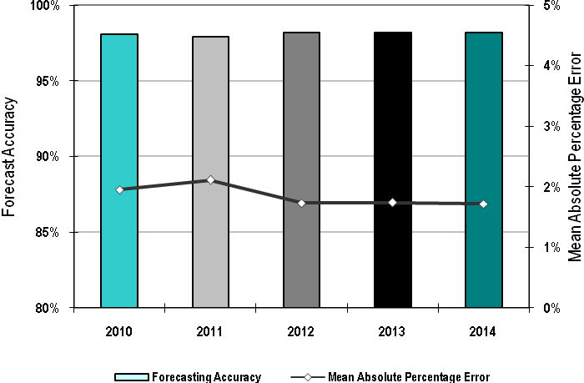

ISO-NE Valley Load Forecasting Accuracy, 2010–2014
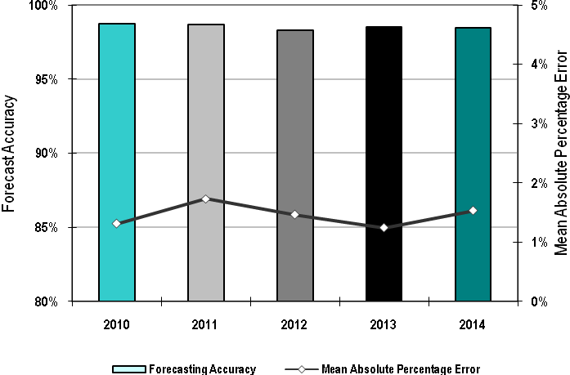

Wind Forecasting Accuracy
Wind generation capacity in ISO-NE experienced little growth, with approximately 710 MW of transmission-connected, installed, and commercially operational capacity at the beginning of 2015. The rapid early growth in wind power, along with the recommendations developed during the New England Wind Integration Study (NEWIS), has led ISO-NE to implement a centralized wind power forecasting service. The Wind Power Forecast Integration Project (WPFIP) is being implemented in two phases. Phase 1, completed at the beginning 2014, involved setting up the communications and database systems for exchanging data relevant to wind power forecasting between wind plants throughout ISO-NE and the wind power forecaster service. This phase also involved developing situational awareness displays and functions to enhance ISO operators’ situational awareness for wind power and incorporating the forecasts into the day-ahead and periodic unit-commitment refinement processes. In 2012, Germanischer Lloyd/Garrad Hassan began to develop a suite of wind power forecast services for ISO-NE. These services include intraday, day-ahead, and week-ahead deterministic and probabilistic forecasts with corresponding event-type forecasts and a daily updated forecast narrative.
The first year ISO-NE has wind power forecast statistics is 2014. As indicated in the bar chart below, the year-to-date mean absolute error (MAE) for wind power forecasts over the 24- to 46-hour-ahead timeframe (i.e., consistent with the close of the Day-Ahead Energy Market) is 10% (in the bar chart, the accuracy is 1-MAE).
ISO-NE Average Wind Forecasting Accuracy 2010-2014
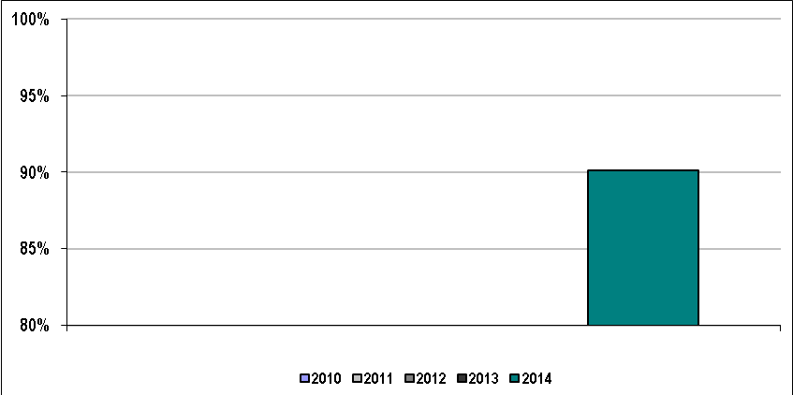
The figure below presents the industry standard 2014 year-to-date accuracy statistics for the wind power forecast across the hour-ahead to week-ahead timeframes. As shown in the top graph of the figure, the mean absolute error (normalized by nameplate) of the fleet increased from approximately 7% at the hour-ahead horizon to approximately 15% at the 168-hour-ahead (i.e. week-ahead) horizon. As shown in the bottom graph, the bias error (normalized by nameplate) of the fleet is relatively symmetrically centered about zero and within 5% across the entire hour-ahead to week-ahead forecast horizon.
Industry Standard 2014 Year-to-Date Accuracy Statistics for the ISO-NE Wind Power Forecast
across the Hour-Ahead to Week-Ahead Timeframes
Mean Absolute Error (top chart); Bias Error (bottom chart)
As a precursor to the WPFIP, ISO-NE Operating Procedure 14F, Wind Plant Operator Guide, was developed and implemented through a collaborative effort among ISO-NE, New England wind power stakeholders, and leaders in the wind power forecasting community. This ISO-NE operating procedure primarily includes requirements for reporting real-time and static-type data that will facilitate accurate wind power forecasting over the intraday, day-ahead, and week-ahead timescales. It also includes requirements for data used to enhance ISO operator situational awareness. ISO-NE OP-14F is based on the recommendations from the NEWIS study, which strongly recommended conducting wind power forecasting and recommended specific data requirements to facilitate this forecasting. The operating procedure was further enhanced with the latest industrial and academic research regarding wind power forecasting and further refined with input from the New England wind power stakeholder community and the leading international providers of wind power forecasting services.
Phase 2 of the WPFIP, scheduled to be implemented in the 2016 timeframe, will make it possible to dispatch wind plants in a manner similar to that of other ISOs that have integrated wind power into their dispatch process. For integrating wind power into real-time dispatch, wind plants will submit economic offers and be able to set price at their local bus, and congestion will be managed in a transparent and automated process (compared with the typically manual process currently used for real-time self-scheduled resources). Phase 2 of the WPFIP also will include closer coordination with the short-term outage scheduling process and will publish the aggregate week-ahead wind power forecast (similar to the publishing of the week-ahead load forecasts). This will assist market participants in incorporating this information into their decision-making processes and market strategies.

Unscheduled Flows
Because of its geographical and electrical relationship with other systems in the Eastern Interconnection, and based on the New England congestion management system specified in the ISO-NE Open Access Transmission Tariff (OATT) filed and approved by FERC, ISO-NE does not use the transmission-loading relief (TLR) procedures for managing congestion on the interbalancing authority “interchange” transactions. ISO-NE is not subject to parallel flows within its footprint because of the radial interconnection with the remainder of the Eastern Interconnection. When necessary, transmission scheduling software, in conjunction with security-constrained dispatch, is used for ISO-NE-initiated curtailments to meet all reliability requirements. These curtailments can be completed and executed in real time according to the rules specified in the ISO-NE OATT. ISO-NE does monitor and will respond to TLRs called throughout the Eastern Interconnection by other reliability entities where ISO-NE transactions may be a contributing factor.

Transmission Outage Coordination
ISO-NE coordinates transmission and generation facility outages under the authority granted in the Transmission Operating Agreements (TOAs) and market rules that define the ISO’s responsibilities and obligations to operate the New England transmission system. ISO-NE also operates in accordance with all related governing documents, including FERC, national and regional reliability standards, and ISO-NE operating documents. ISO-NE’s role in outage coordination is multifaceted with several aims, as follows:
- Maintain overall system reliability
- Minimize congestion and thereby reduce overall costs to New England consumers
- Provide timely and accurate information to minimize conditions that would impede the ability of generators to participate in the wholesale electricity markets
- Effectively coordinate and communicate outage schedules with neighboring reliability coordinators (RCs) and balancing authorities
ISO-NE coordinates all the transmission and generation outages with New England transmission owners (TOs), local control centers (LCCs), adjacent RCs, and New England generation owners/operators (GOs). This includes conducting reliability assessments of the transmission system and operable capacity margins, evaluating congestion cost impacts, and rescheduling outages when conflicts or violations could occur. In addition, ISO-NE and TO senior management meet frequently to monitor progress made in coordinating transmission equipment outages and provide direction and feedback to operations.
The ISO, TOs, LCCs, and GOs have continually evolved in improving outage coordination within the region, which has focused on the following:
- Establishing a set of broad performance-based outage-coordination metrics to allow all parties to assess their performance regarding transmission outage coordination
- Enhancing the coordination process and procedures through cooperation by all entities (ISO-NE, TOs, LCCs, GOs, and adjacent RCs) to implement best business practices
- Increasing communications, both through conference calls and face to face, among TOs, LCCs, GOs, and adjacent RCs to better coordinate and facilitate outage requests
- Emphasizing outage-coordination plans during discussions at the quarterly meetings with nuclear power stations
- Ensuring that all contributors to the outage process at all levels (project management, engineering, field, and operations personnel) are aware of the benefits of a broad coordination approach to the planning and scheduling of transmission and generator equipment outages
- Improving advanced notification to the New England stakeholders of upcoming transmission outages by way of the publicly distributed Long-Term and Short-Term Outage Reports
- Increasing emphasis on the coordination of major transmission element (MTE) outage planning through improving outage-coordination metrics
- Improving outage-coordination metrics that provide incentives to all parties to move toward longer lead times (90-day minimum) for the outage requests that will have the most impact on system reliability and market efficiency
- Presenting seasonal assessments of the New England electric system that convey forecasted system capacity and anticipated transmission reliability among TOs, LCCs, GOs, and adjacent RCs to further increase operation readiness and better coordinate and facilitate outage requests
The efforts to improve outage coordination have been primarily focused on greater coordination and improved communication in transmission and generation outage requests resulting from the effects of substantial transmission build-out by the TOs. As the metrics indicate, ISO-NE, collaboratively with the TOs and LCCs, has continually focused on improving the lead time of request submissions, reducing last-minute cancellations, and minimizing unplanned outages, while managing a considerable volume of outage requests over the past five years.
The following figures show ISO-NE transmission outage information for 2010 through 2014. The first figure reflects ISO-NE’s percentage of >200 kV planned outages of five days or more submitted to ISO-NE at least one month before the outage-commencement date. The second figure shows the percentage of planned outages studied in the timeframes established in ISO-NE’s tariff and manuals. The third figure shows the percentage of >200 kV outages previously approved but cancelled by ISO-NE, and the last figure shows the percentage of unplanned >200 kV outages.

Percentage of >200 kV Planned Outages of Five Days or More Submitted to ISO-NE
at Least One Month Before the Outage Commencement Date, 2010–2014
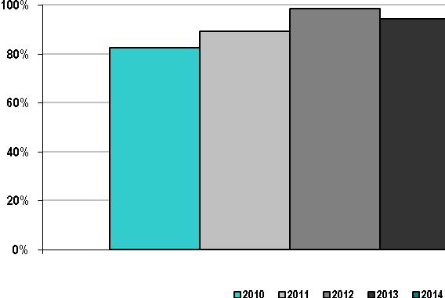

Percentage of Planned Outages Studied in ISO-NE’s Tariff/Manual-Established Timeframes,
2010–2014
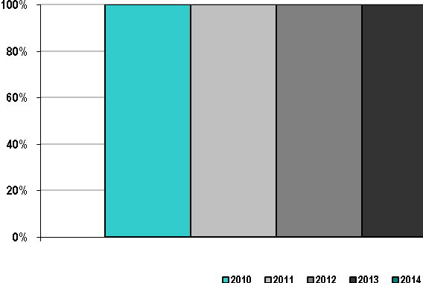

Percentage of >200 kV Outages Previously Approved but Cancelled by ISO-NE, 2010–2014
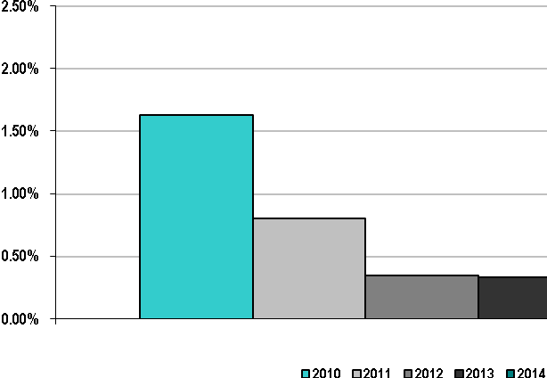

ISO-NE Percentage of Unplanned >200 kV Outages, 2010–2014
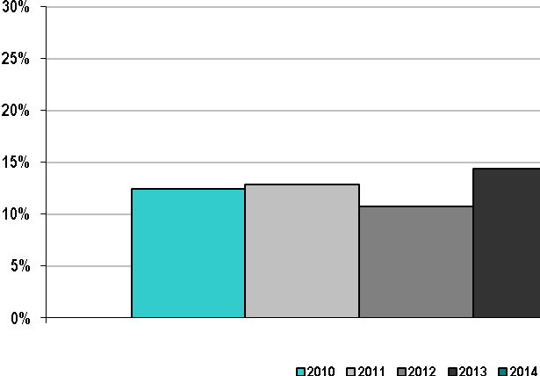

Transmission Planning
This ISO/RTO performance category includes several transmission planning metrics. The metric for the number of facilities approved to be constructed for reliability purposes was determined using the ISO-NE Regional System Plan (RSP) Project List. The RSP Project List is a summary of transmission projects for the region and includes information on project status and cost estimates. Some of these projects are proposed for regional reliability; others are proposed for market efficiency or are merchant transmission projects. The RSP Project List is compiled at least three times per year and is reviewed by the ISO-NE Planning Advisory Committee (PAC). The projects on the list are classified as follows, according to their progress through the study and stakeholder planning processes:
- Concept
- Proposed
- Planned
- Under construction
- In service
- Cancelled
A transmission project is considered “planned” when ISO-NE has approved it under Section I.3.9 of the ISO New England Tariff. Transmission projects with a status of “under construction” or “in service” have received approval by ISO-NE under Section I.3.9 of the tariff.
The information used for calculating the number of facilities approved in each year, as shown in the next graph, was based on the status of each project within the ISO-NE RSP Project List. In each year, transmission projects that progressed to “planned,” “under construction,” or “in service” were included, as reflected in the following graphs. The second graph below, depicting completed projects with ISO-NE approval, was created by comparing the number of projects that either were “under construction” or “in service” with the number of projects that were “approved.”
Number of ISO-NE Transmission Projects Approved for Construction for Reliability Purposes, 2010–2014
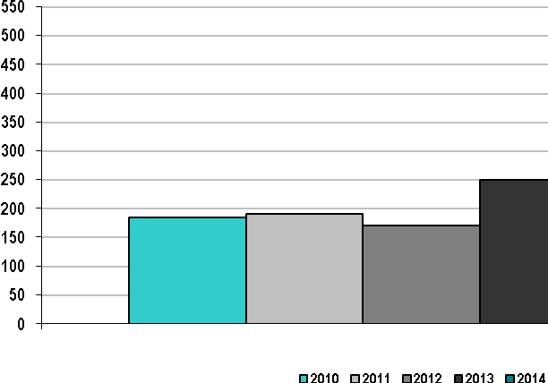
Percentage of ISO-NE Approved Construction Projects Completed by December 31, 2014
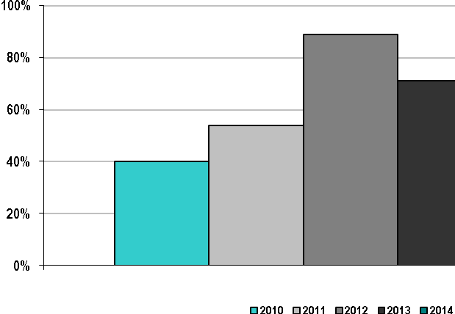
In recent years, New England has placed a substantial amount of new transmission projects in service. All approved transmission projects are progressing through the implementation process and are anticipated to be constructed and placed in service unless system conditions change in a way that affects the overall need for a project. Because of new resources coming on line and changes in the demand forecast, the need for some projects in New England are under review.
This ISO/RTO performance metric identifies the completion of FERC Order 890 reliability studies. An assessment and transmission plan update of New England’s pool transmission facilities (PTFs) has been conducted annually for 2010 through 2014. ISO-NE has demonstrated compliance with NERC standards and NPCC criteria and directories in each of these years.
On an ongoing basis, ISO-NE, in coordination with the participating transmission owners and the Planning Advisory Committee, assesses the adequacy of the regional transmission system (i.e., the pool transmission facilities) to maintain the reliability of these facilities, in whole or in part, while promoting the operation of efficient wholesale electricity markets within New England. These “needs assessments” analyze whether each PTF within New England’s transmission system complies with the following requirements:
- Meets applicable reliability standards
- Has adequate transfer capability to support local, regional, and interregional reliability
- Supports the efficient operation of the wholesale electricity markets
- Is sufficient to integrate new resources and demands on a regional basis
- Has otherwise various satisfactory aspects of performance and capability.
These needs assessments also identify the following:
- The location and nature of any potential problems with respect to the PTF
- Situations or scenarios that significantly affect the reliable and efficient operation of the PTF, along with any critical time constraints for addressing the needs of the PTF to develop market responses or to pursue regulated transmission solutions
In conjunction with the proponents of regulated transmission solutions and other interested or affected stakeholders, ISO-NE conducts and participates in “solutions studies” (i.e., mitigation plans) to develop and refine regionally cost-effective regulated transmission solutions to meet the PTF system needs identified in the needs assessments. Each proposed transmission solution is then individually and comprehensively evaluated to ensure that it meets the established need(s) and is sufficiently robust to prevent adverse impacts on the reliability, stability, or operating characteristics of the existing or future power system. All studies are conducted in an organized and coordinated manner, with many individual studies performed under the direction of ISO-NE. The aggregate result is a complete annual assessment of the New England PTFs and an update of the Regional System Plan to address these various needs.
Market responses—for example, demand-side projects, distributed generation, and merchant transmission facilities—are reflected in needs assessments as long as they have a contractual obligation through the Forward Capacity Market, or have contracted with a third party, such as a state-sponsored request for proposal. Demand response and other types of resources may assist in resolving reliability issues and possibly defer transmission solutions, provided they are adequately integrated into the system.
For demand response to be truly effective in some locations, without compromising the ability to operate other resources or demand response in other locations, additional transmission may be needed. To date, demand response has had varying impacts on the need for continued transmission infrastructure investment in New England. Transmission projects have been reviewed as new demand response has been obtained. In many cases, the quantity of these resources has been insufficient, or the projects could not be implemented in locations granular enough to address a specific reliability concern. In other cases, the addition of demand response has either aided in deferring some transmission needs.
ISO-NE has started a new initiative to begin evaluating new, innovative technologies because these technologies may be a partial or full solution for certain reliability issues, and could potentially defer or eliminate the need for transmission solutions. Technologies such as flywheels, battery and thermal storage, vehicle-to-grid (V2G), and various other smart grid technologies are being evaluated for integration into the power system. New England is implementing several smart grid projects in line with the vision established in the Energy Independence and Security Act of 2007.
In response to FERC Order No. 890 regarding the provision of regulation and frequency services by nongenerating resources, ISO-NE conducted a FERC-approved Alternative Technology Regulation (ATR) Pilot Program. The goal of the ATR Pilot Program was to identify alternative technologies with new and unique performance characteristics that previously may have been unable to participate in the Regulation Market. Another aim of the program was for the owners of these ATR resources to evaluate the technical and economic suitability of their technologies as market sources of regulation service. The pilot program terminated on March 31, 2015, when the ISO implemented changes in the Regulation Market to comply with FERC Order 755. Resources that participated in the pilot program can now participate in the Regulation Market, subject to meeting a 1 MW minimum size requirement and associated eligibility requirements.
Since 2007, ISO-NE has performed annual economic studies as part of its long-term planning process in compliance with FERC Order No. 890. Stakeholders are invited to submit study requests by April 1 of each year. ISO-NE then designates up to three economic studies to be performed. Study requests dealing with a specific project proposal or suggesting a specific policy position are not considered appropriate and are not performed. All other economic study requests have been incorporated into recent study efforts as the subject of primary investigation or as a sensitivity case to another effort, either directly or through analysis of a comparable “generic” or “sister” project. The following table shows the number of economic studies requested and conducted during 2010 to 2014. In 2014, ISO-NE did not receive any request to perform economic studies.
Number of Economic Studies Requested and Conducted in ISO-NE, 2010–2014
Year | Number of Requests Received |  | Number of Economic Studies Conducted | Number of Requests Addressed
2010^{(a)} | 3 | 1 |  | 3
2011^{(a)} | 3 | 1 |  | 3
2012^{(b)} | 3 | 1 |  | 2
2013^{(c)} | 1 | 1 |  | 1
2014 | 0 | 0 |  | 0
- ISO-NE received three requests in both 2010 and 2011, which it merged into one study for each year that addressed the needs of all the requests. ISO-NE, Preliminary Results for 2010 Economic Study Request, Planning Advisory Committee presentation (February 16, 2011), http://www.iso-ne.com/static-assets/documents/committees/comm_wkgrps/prtcpnts_comm/pac/mtrls/2011/mar162011/2010_economic_study.pdf. ISO-NE, 2011 Economic Study (March 31, 2014), http://www.iso-ne.com/static-assets/documents/committees/comm_wkgrps/prtcpnts_comm/pac/reports/2014/2011_eco_study_final.pdf.
- In 2012, stakeholders submitted three requests for economic studies but one request was quickly and completely withdrawn. ISO-NE, 2012 Economic Study (April 2014), http://www.iso-ne.com/static-assets/documents/committees/comm_wkgrps/prtcpnts_comm/pac/reports/2014/a9_2012_economic_study_final.pdf.
- ISO-NE 2013 Economic Study (October 30, 2014), http://www.iso-ne.com/static-assets/documents/2014/10/2013_economic_study_final.pdf.

Generation Interconnection
The metric for the processing time for generation interconnection requests (IRs), as shown on the following figure, was calculated using the date of an interconnection request as the start date. The end date was either the date an interconnection agreement (IA) was executed or the date the interconnection request was withdrawn. In each year, projects that executed an interconnection agreement or that withdrew are included in the average processing time for that year.
ISO-NE Average Generation Interconnection Request Processing Time, 2010–2014
(Calendar Days)
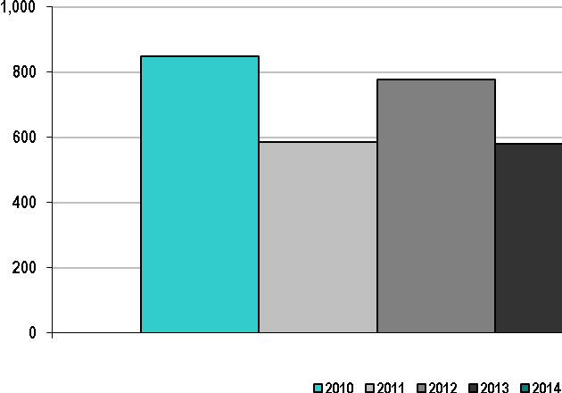
With the exception of the Maine portion of the system (which has experienced a back log of mostly wind interconnection requests), substantially all the generator interconnection requests made through 2014 have completed the system impact study phase or have moved to the Interconnection Agreement and commercialization phases. For wind projects in Maine and other projects, the following table shows the number of ISO-NE active interconnection requests from pre-2012 to 2014 with completed system impact studies, and from 2012 to 2014 without completed system impact studies.

Number of ISO-NE Active Interconnection Requests from Pre-2012 to 2014
with Completed System Impact Studies, and from 2012 to 2014 without Completed System Impact Studies,
for Wind Projects in Maine and for Projects Other than Wind Projects in Maine
Type of Project | Year of Original Request
Type of Project | Pre-2012 |  | 2012 |  | 2013 |  | 2014
Type of Project | Completed Impact Study |  | Completed Impact Study |  | Completed Impact Study |  | Completed Impact Study
Type of Project | Without | With | Without | With | Without | With | Without | With
Wind projects in Maine | 0 | 7 | 3 | 1 | 4 | 0 | 12 | 0
Projects other than wind projects in Maine | 0 | 8 | 0 | 4 | 1^{(a)} | 3 | 1^{(b)} | 11
(a) This project is in a portion of the system where the generator shares several common upgrades with significant, recently identified, area reliability projects.
(b) The interconnection request for this project, a wind project in Vermont, was submitted in December 2014.

Processing time encompasses a number of tasks, as follows:
- Interconnection request review and validation
- Scoping meeting
- Study agreement development
- Study agreement execution by the interconnection customer
- Feasibility studies
- System impact studies
- Facilities studies
- Interconnection agreement development
The types of IRs that undergo these tasks include generation interconnection requests, elective transmission upgrade requests, and requests for transmission service that require study. The data do not include generator interconnection requests that did not fall under FERC’s jurisdiction.
Several older projects, which either were capacity upgrades or equipment replacements associated with existing generators, did not result in any changes to the existing interconnection agreements. In these cases, the date of the approval of the proposed plan was used as the end of the process. Several projects withdrew after executing an interconnection agreement. In these cases, the execution of the interconnection agreement was considered the end of the process.
In general, a shorter processing time is preferred. The factors that contribute to the year-to-year variations in processing time include (1) the number of IRs or project withdrawals received each year, (2) the (inter)dependence of later-queued projects on earlier-queued projects, and (3) tariff requirements allowing customers to waive or combine study phases of the interconnection process.
Initiating and performing meaningful wind interconnection studies continues to be challenging. Wind manufacturers have been slow to provide sufficiently accurate electrical models to allow for the expeditious completion of interconnection studies. Complex control interactions have become a factor in wind interconnection studies as well as a risk because of the nature of electronic controls on most wind power plants and the location of many wind plants in remote, and often weak, locations on the transmission system. This has created the potential need for even more detailed modeling from the manufacturers, which further increases the study time.

Planned and Actual Reserve Margins, 2010–2014
This ISO/RTO performance metric compares ISO-NE’s actual reserve margins (ARMs) with planned reserve margins (PRMs), in megawatts and percentages. A discussion of the results and findings for New England is provided below. The following figure shows the PRMs (bars) and the ARMS (line) from 2010 to 2014.
ISO-NE Planned and Actual Reserve Margins, 2010–2014
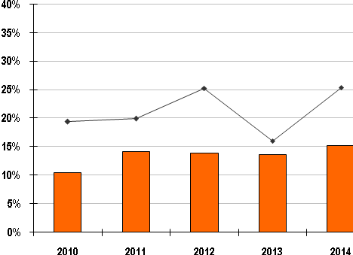
Note: The bars in the figure represent PRMs, and the line represents ARMs.
Actual Reserve Margin: The ARM is based on data published annually within ISO-NE’s Forecast Report of Capacity, Energy, Loads, and Transmission (CELT Report). The sources for the data used to calculate the ARM for a particular year include the “Capacity Based on Seasonal Claimed Capability (SCC)” and the “Capacity Based on Supply Obligations” reported in the CELT Report for the reporting year.
Planned Reserve Margin: The PRM is based on the net Installed Capacity Requirement (NICR), which ISO-NE sets annually for the region. The value for a particular year can be obtained by applying the following formula using the NICR (August value, if monthly NICR values are published) and the forecasted annual peak load published in ISO-NE’s CELT Report for that year:
PRM MW = (NICR MW) – (Forecast Annual Peak Load MW)
The PRM also can be expressed as a percentage of the forecasted annual peak load using the following formula:
[(PRM MW) / (Forecast Annual Peak Load MW)] x 100

The following table compares ISO-NE’s ARMs and PRMs for 2010 through 2014.

ISO-NE Actual and Planned Reserve Margins, 2010–2014
Year | Reserve Margin Type | Reserve Margin (MW) | Reserve Margin (%)
2010 | Actual  Planned | 5,270  2,950 | 19.4  10.5
2011 | Actual  Planned | 5,655  3,892 | 19.9  14.1
2012 | Actual  Planned | 6,872  3,915 | 25.3  13.9
2013 | Actual  Planned | 4,660  3,787 | 16.0  13.6
2014 | Actual  Planned | 6,644  4,298 | 25.4  15.2
The lowest ARM occurred in 2013 at 4,660 MW and 16.0%, and the highest was in 2012 at 6,872 MW and 25.3%. The lowest PRM occurred in 2010 at 2,950 MW and 10.5%, and the highest was in 2014 at 4,298 MW and 15.2%.
ISO-NE’s FCM began on June 1, 2010. Each annual Forward Capacity Auction (FCA) procures capacity resources to meet the region’s projected resource adequacy requirement three years into the future. Resources procured within an FCA have a capacity supply obligation (CSO). Additional resources or portions of resources without a CSO may participate in the energy and reserves markets and also may provide additional installed capability as part of ISO-NE Operating Procedure No. 4 (OP 4), Action during a Capacity Deficiency, where a variable amount of resources on any given day can be called on as part of Step 7 of OP 4 procedures, “Request Generating Resources Not Subject to a Capacity Supply Obligation to Voluntarily Provide Energy for Reliability Purposes.”
The quantity of resources procured within the FCA is determined by the net ICR value calculated for the relevant capacity commitment period (CCP) (e.g., June 1 to May 31). The ICR is a measure of the installed capacity resources projected to be necessary to (1) meet the total forecast demand requirements for the New England Balancing Authority Area, and (2) maintain sufficient reserve capacity to meet reliability standards. More specifically, the ICR is the quantity of resources needed to meet the reliability requirements defined for the New England Balancing Authority Area of disconnecting noninterruptible customers no more than one time in 10 years, also stated as 0.1 loss-of-load expectation (LOLE).
In 2014, the PRM increased from the 2013 value of 13.6% to 15.2%. The PRM is expected to change slightly every year due to changes in expected system conditions. However, it should stay within the 10% to 15% range during the next several years.
ISO-NE develops the demand forecast primarily through the methodology it has used for a number of years. However, the forecast continues to reflect incremental improvements to the methodology itself, as well as economic and demographic assumptions reviewed periodically and supported by the New England Power Pool (NEPOOL) Load Forecast Committee (LFC). The ISO updates the methodology when necessary in consultation with the NEPOOL LFC. The peak load forecasts of the entire New England Balancing Authority Area are a major input into the calculation of the ICR, and the peak load forecasts for the individual load zones are used to develop the associated local sourcing requirements (LSRs) from import-constrained load zones and maximum capacity limits (MCLs) from export-constrained load zones. LSR and MCL requirements limit the amount of capacity that can be procured within an import- or export-constrained load zone, respectively.
The FCM is designed to address changes in (1) the demand forecast, (2) resource availability, and (3) load and capacity relief assumed obtainable from OP 4 actions during the three-year period between the applicable FCA and the corresponding CCP. For each CCP, ISO-NE conducts three annual reconfiguration auctions (ARAs) during the interim period that adjusts the amount of regional capacity procured within the FCA to reflect changes in the ICR calculated for each ARA.
To calculate the ICR for each ARA, ISO-NE uses the most recent version of the demand forecast, as published in the most current CELT Report. By accounting for fluctuations in the demand forecast, resource availability, and OP 4 actions, the development of the ICR for each ARA ultimately ensures system reliability through the procurement of the amount of regional capacity needed to meet the ICR and locational requirements.
Within the FCM, demand-side and supply-side resources each can provide capacity. While demand response has participated in the ISO-NE markets since 1998, the number of demand resources providing capacity to the region has changed considerably, primarily associated with changes in market rules defining what can qualify as demand-response capacity. Since the ISO-NE capacity market opened up to demand-side resources in 2006 (at nearly 500 MW), the amount of demand response in the region has grown to approximately 1,326 MW in 2010 and then decrease to approximately 700 MW in 2013. The following graph shows the percentage of compensated capacity during summer (peak) months that was categorized as (active) demand response.
ISO-NE Demand-Response Capacity as a Percentage of Total Installed Capacity, 2010–2014
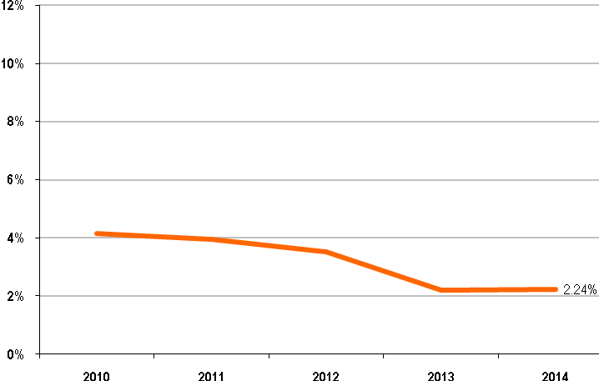
To achieve further operational benefits from the decline in regional demand resources, ISO-NE recently implemented improvements to the software and communications infrastructure used between demand resources and the ISO during real-time operations. New dispatch rules have been in place since June 2011 to allow operators to call on demand resources where, when, and in the amount they are needed.
Percentage of Generation Outages Cancelled by ISO-NE
ISO-NE may cancel a planned generation outage if it assesses a potential transmission reliability or system capacity concern arising from the outage. The following graph shows the percentage of planned generation outages ISO-NE had previously approved and ultimately cancelled from 2010 to 2014, which has never been greater than 1%.
ISO-NE Percentage of Generation Outages Cancelled, 2010–2014
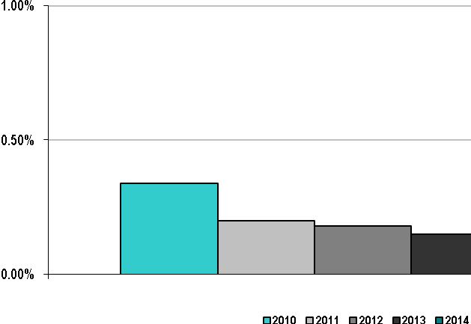

Generation Must-Run Contracts
The following table provides details about the Reliability Agreements in place with units within the New England Balancing Authority Area during 2010. Through its planning processes, ISO-NE developed generation must-run transmission alternatives in the form of cost-of-service agreements to ensure continued reliability of the power system and forecasted resource capacity requirements to meet forecast demands. As a result of the Forward Capacity Market and transmission system improvements, all “must-run” generation contracts were terminated as of May 31, 2010.
ISO-NE “Must-Run” Generation Contracts, 2010
Year | Number of Agreements | Number of Units | Total MW (Summer SCC)^{(a)} | Percentage of Systemwide Capacity (Summer SCC)^{(a)} | Total Reliability Payments
Jan 2010 to May 2010 | 9 | 17 | 2,711 | 9.0% | $10,898,731
(a) SCC stands for seasonal claimed capability, a generator's maximum dependable load carrying ability during the summer months (June to September).

Forward Capacity Market Delist Bids
In the Forward Capacity Market, beginning on June 1, 2010, existing generating resources may submit a delist bid, which details the price below which the resource wishes to opt its capacity out of the Forward Capacity Market. The ISO can deny a delist bid, for one auction or permanently, if it deems the associated capacity necessary for reliability. Depending on the type of delist bid denied, these resources may be compensated either at the denied delist bid price or through a cost-of-service agreement. The following table provides details about the resources “retained for reliability,” including payments paid to resources with denied delist bids in the Forward Capacity Market.
ISO-NE FCM Delist Bid Reliability Payments, 2010–2014
Year | Number of Units | CSO MW | Percentage of Systemwide Capacity (CSO) | Total Reliability Payments
Jun 2010 to Dec 2010 | 1 | 162 | 0.5% | $1,978,830
Jan 2011 to May 2011 | 1 | 162 | 0.5% | $1,413,450
Jun 2011 to May 2012 | 0 | 0 | 0.0% | $0
Jun 2012 to May 2013 | 2 | 581 | 1.8% | $19,480,200
Jun 2013 to May 2014 | 2 | 587 | 1.8% | $17,519,344
Jun 2014 to May 2015 | 0 | 0 | 0.0% | $0

In 2011, in response to FERC Order No. 745, the ISO developed two price-responsive demand (PRD) market designs. The first, a transition design, was implemented on June 1, 2012. This design replaced the existing demand-response programs to comply with the requirements outlined in Order No. 745. The second is a fully integrated design that allows demand-response resources to participate directly in the Day-Ahead and Real-Time Energy Markets starting on June 1, 2017 (i.e., the eighth capacity commitment period). Additionally, this design allows demand-response resources to provide operating reserves and participate in the Forward Reserves Market. In October 2014, the ISO filed tariff changes with FERC to fully integrate demand-response resources into the energy and reserves markets. FERC accepted these changes on January 9, 2015.
In 2011, the Electric Power Supply Association (EPSA) petitioned the US Court of Appeals for the District of Columbia Circuit to review Order No. 745, and in 2014, the D.C. Circuit issued a decision to vacate the order. In January 2015, the solicitor general and FERC filed a petition with the US Supreme Court to review the D.C. Circuit Court’s decision. The Supreme Court granted the petition in May 2015 and will likely issue a decision by June 2016.
The ensuing legal process has created uncertainty regarding the full integration of demand-response resources in the energy and reserves markets. As of the publication of this report, FERC Order No. 745 is still in effect, and until the legal process concludes, the ISO will administer the current terms and conditions of the tariff, including all provisions affecting demand response. However, the ISO will request a one-year delay in the implementation of the fully integrated design, from June 1, 2017, to June 1, 2018, given the uncertainty in the outcome of the legal and regulatory processes.
The following figure shows the percentage of ancillary services (defined as an hourly total 30-minute reserve requirement) supplied by demand-response resources for 2010 to 2014. The data for 2010 reflects that in the first half of 2010— through June— ISO-NE conducted the final part of a Demand-Response Reserves Pilot Program. The zero values for 2011 to 2014 indicate that demand response has not provided any ancillary services since the end of the pilot program. No market rules will be in place to allow demand response to provide reserves until the full integration of these resources in 2017 or 2018, as stated above.
ISO-NE Demand Response as a Percentage of Total Hourly Reserve Requirement, 2010–2014
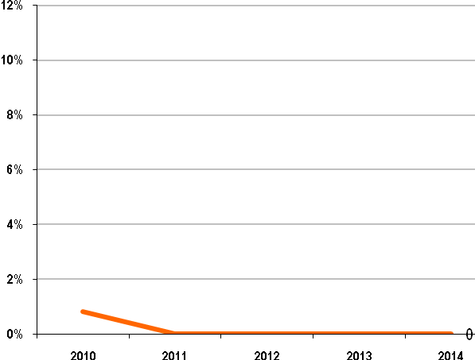

Interconnection/Transmission Service Requests
This ISO/RTO performance metric identifies the number of requests to ISO-NE for interconnection service or transmission service. The metric for the number of requests for 2010 to 2014, as shown in the following graph, was calculated by summing the number of requests ISO-NE received in each calendar year. The majority of the projects are associated with generation interconnection requests, while only a handful of projects are associated with elective transmission upgrade requests and requests for transmission service that require study for infrastructure build out. Factors affecting the number of interconnection study requests include standards resulting from FERC’s Orders 2003 and 2006, the implementation of New England’s Forward Capacity Market, state requests for proposals for generation resources, and state policies regarding treatment of renewable resources. To limit the number of interconnection requests based on speculative project proposals that caused a backlog in the ISO’s Generator Interconnection Queue, in 2009, FERC accepted amendments to ISO-NE’s tariff, which increased the deposit structure for large generating facilities seeking interconnection. ISO-NE understands formal complaints to mean Section 206 complaints, and no entity has filed such a formal complaint against ISO-NE.
ISO-NE Number of Interconnection Study Requests, 2010–2014
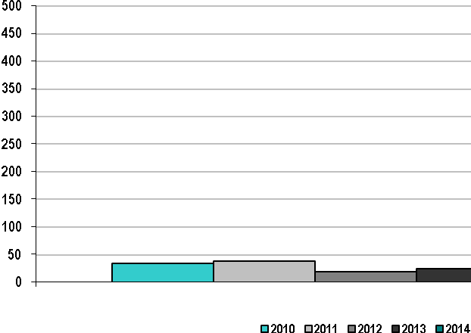

The indices in the next graph were calculated by totaling the number of studies completed in each calendar year. The studies included feasibility, system impact, and facilities studies for generation interconnection requests; elective transmission upgrade requests; and requests for transmission service that require study. These indices do not include studies for generator interconnection requests that did not fall under FERC’s jurisdiction. Projects queued later may be electrically dependent on the results from earlier-queued projects. This limits the number of studies that can be conducted simultaneously.
ISO-NE Number of Studies Completed, 2010–2014
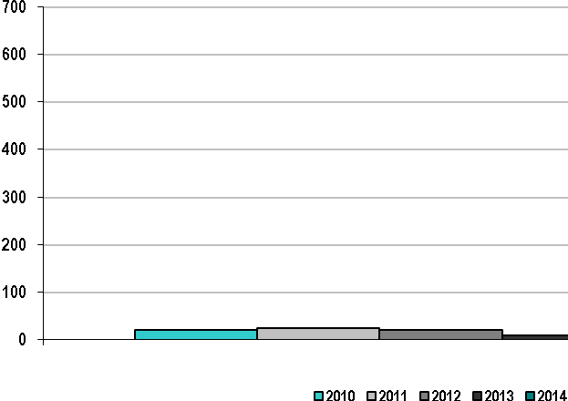
The indices in the graph below were calculated by summing the age of incomplete studies as of December 31 of each calendar year. To determine the age of a study, the start date used was the date on which the study agreement was fully executed. The studies included feasibility, system impact, and facilities studies for generation interconnection requests; elective transmission upgrade requests; and requests for transmission service that require study. These indices do not include studies for generator interconnection requests that did not fall under FERC’s jurisdiction.
ISO-NE Average Age of Incomplete Studies, 2010–2014(Calendar Days)
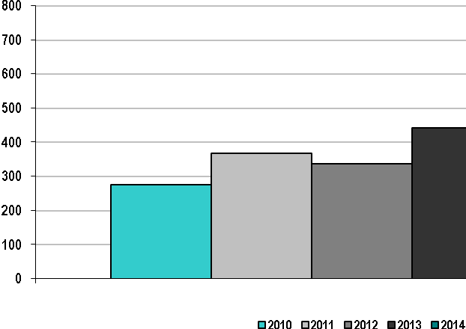
ISO-NE conducts studies in the order they enter the interconnection queue. Thus, the start of one study can be delayed if it is dependent on the results of another study with an earlier queue position.
The indices in the next graph were calculated by summing the ages of studies completed in a calendar year. To determine the age of a study, the start date used was the date on which the study agreement was fully executed. The studies included feasibility, system impact, and facilities studies for generation interconnection requests; elective transmission upgrade requests; and requests for transmission service that require study. The indices do not include studies for generator interconnection requests that did not fall under FERC’s jurisdiction.
ISO-NE Average Time to Complete Studies, 2010–2014
(Calendar Days)
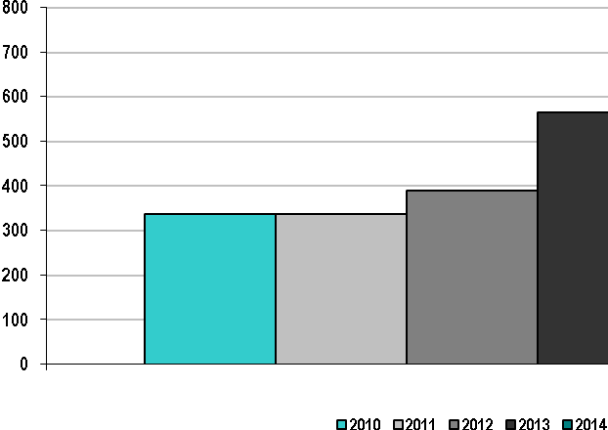

Average Cost of Each Type of Study Completed
To determine the cost of a study, the annual expenses for a project were summed and counted in the year the study was completed. These expenses were then averaged for projects completed during a given year. The studies included feasibility, system impact, and facilities studies for generation interconnection requests; elective transmission upgrade requests; and requests for transmission service that require study. The indices do not include studies for generator interconnection requests that did not fall under FERC’s jurisdiction.
Several issues affect the calculated indices:
- Average study costs may include costs incurred by the respective transmission owners performing the requested and necessary studies, which were then submitted to ISO-NE for direct billing back to the requesting customer.
- Under the ISO-NE tariff, the interconnection feasibility study may be conducted as part of the interconnection system impact study or as a separate study.
- The cost of developing an interconnection agreement typically is included in the cost of a system impact study, which increases the cost of system impact studies.
- In several cases, a system impact study has been completed, but the development of the interconnection agreement is continuing into 2015.
- Facilities studies may be waived under ISO-NE’s tariff. This accounts for the low number of facility studies.
The calculated indices are shown in the following tables.

Number of Completed Feasibility Studies by ISO-NE, 2010–2014

Year | Number of Completed Feasibility Studies | Number of Completed Feasibility Studies With Cost Data | Average Cost of Studies Completed in Calendar Year
2010 | 8 | 8 | $94,960
2011 | 4 | 4 | $88,237
2012 | 7 | 7 | $98,582
2013 | 1 | 1 | $148,307
2014 | 4 | 4 | $63,044

Number of Completed System Impact Studies by ISO-NE, 2010–2014

Year | Number of Completed System Impact Studies | Number of Completed System Impact Studies  With Cost Data | Average Cost of Studies Completed in Calendar Year
2010 | 11 | 11 | $121,363
2011 | 19 | 19 | $102,468
2012 | 13 | 13 | $131,287
2013 | 9 | 9 | $135,500
2014 | 14 | 14 | $175,409

Number of Completed Facilities Studies by ISO-NE, 2010–2014

Year | Number of Completed Facilities Studies | Number of Completed Facilities Studies  With Cost Data | Average Cost of Studies Completed in Calendar Year
2010 | 1 | 1 | $131,692
2011 | 0 | 0 | $0
2012 | 1 | 1 | $20,404
2013 | 0 | 0 | $0
2014 | 1 | 1 | $18,973
The following trends have been observed for the analysis periods:
- More wind projects have been subject to Material Modification Determinations because of project proponents’ changing of the type of wind turbines used in their project(s) after the system impact study has commenced and, in some cases, after the system impact study has been completed.
- Several projects have requested to come on line with limited operation because of network upgrades unable to be completed in time for their requested commercial operation date.
- More projects are in proximity to each other and directly competing with other projects within the interconnection queue. This is leading to study delays because of earlier-queued project dependencies.
- Wind interconnection studies are becoming more involved and detailed, in part because of the complex interactions of the electronic controls of wind generators and other equipment, especially in the weaker parts of the transmission system where the largest interest in development is occurring.
- The introduction of new wind resources that do not have the robust electrical behavior of the resources they are displacing is degrading overall system performance, further complicating interconnection studies for subsequent wind projects.
- Projects withdrawing from the interconnection process have generally indicated business reasons for the withdrawal rather than difficulty within the interconnection process itself.
- More projects are having difficulty securing Power Purchase Agreements. In many areas of New England, the state’s Public Utilities Commission must approve these agreements, and construction cannot begin until a project receives this approval.
- An increasing number of projects are being issued a Notice of Withdrawal because they are not meeting their contractual or technical obligations under ISO-NE’s interconnection procedures. Most projects have been able to resolve their deficiencies.
- State requests for proposals are leading to new projects submitting Interconnection Requests.
- Most of the proposed new generation interconnection requests are for gas turbine or combined-cycle projects. The following figure shows the resources in the ISO-NE Generator Interconnection Queue, by state and fuel type, as of April 1, 2014. The 56 active projects in the queue total 6,915 MW.

Resources in the ISO-NE Generator Interconnection Queue,
by State and Fuel Type, as of April 1, 2014 (MW and %)

Special Protection Systems
The New England transmission system has a number of special protection systems (SPSs). An SPS is a protection system designed to detect abnormal system conditions and take corrective actions other than the isolation of faulted elements. Such actions may include changes in load, generation, or system topology to maintain system stability, acceptable voltages, or power flows. These systems are designed and maintained in accordance with the NPCC Directory 7 and ISO-NE Planning Procedure No. 5-5, Special Protection Systems Application Guidelines. The NPCC identifies three types of SPSs, depending on the potential impact to the interconnected and local systems:
- NPCC Type I SPSs recognize or anticipate abnormal system conditions resulting from design and operating criteria contingencies. The misoperation of a Type I SPS or its failure to operate would have a significant adverse impact outside the local area, will result in a violation of a NERC system operating limit (SOL), and will likely result in a violation of an interconnection-reliability operating limit (IROL). The corrective action taken by these SPSs, along with the actions taken by other protection systems, is intended to return power system parameters to a stable and recoverable state.
- NPCC Type II SPSs recognize or anticipate abnormal system conditions resulting from extreme contingencies or other extreme causes. The misoperation or failure to operate of Type II SPSs also would have a significant adverse impact outside of the local area (i.e., will likely result an IROL violation).
- NPCC Type III SPSs are those with the potential to create local impacts only, if they fail to operate or misoperate, and result in a violation of an SOL only.
Because of the potential impacts of Type I SPSs on the interconnected system, NPCC and ISO-NE criteria require full redundancy of all components of the SPS (i.e., the SPS shall be designed with sufficient redundancy such that the SPS can perform its intended function while itself experiencing a single failure). NPCC retains the authority to review and concur on all new SPS proposals or changes to existing SPSs. There are four categories of SPS operation:
- Normal Operation: the SPS successfully operated as designed for the initiating system event for which it was intended to provide protection.
- Failure to Operate: the SPS did not operate as designed for the initiating system event for which it was intended to provide protection.
- Unintended or Inadvertent Operation: the SPS successfully operated for an unrelated initiating system event for which it was not intended to take action.
- Misoperation: the SPS did not successfully operate as designed (partial operation) for the initiating system event for which it was intended to take action.
Currently, five Type I, two Type II, and 20 Type III SPSs are installed in New England. One Type III was retired during 2014. The following graph summarizes the number of installed SPSs within New England during 2014.
Number of ISO-NE Type I, Type II, and Type III Special Protection Schemes, 2014
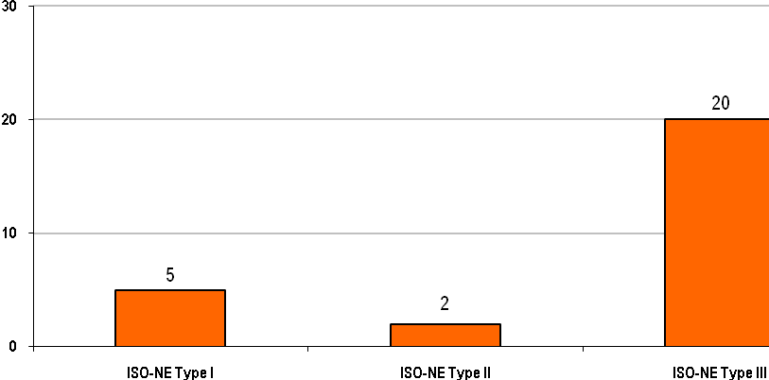
One Type I SPS operated as intended to maintain system reliability in 2014. This Type I SPS is designed to trip transmission and generation in northern Maine for the loss of one of two key 345 kV lines. The operation of the SPS successfully tripped the appropriate transmission and generation in New England, separating the Bangor Hydro and the Maritimes from the interconnected system in a controlled manner as designed.

B. ISO New England Coordinated Wholesale Power Markets
For context, the table below categorizes the $12.6 billion that ISO-NE billed in 2014 for the primary types of charges its members incurred for their market and transmission service transactions.
ISO-NE Market Transaction Charges, 2014
 | 2014 Dollars Billed  Millions | Percentage of  2014 Dollars Billed
Energy Markets | $9,079 | 72.3%
Capacity | $1,056 | 8.4%
Transmission Tariff | $1,819 | 14.5%
Reserve Markets | $207 | 1.7%
Net Commitment-Period Compensation (NCPC)^{(a)} | $167 | 1.3%
FTR Auction Revenues | $32 | 0.3%
Regulation Market | $29 | 0.2%
ISO-NE Administrative Expenses | $171 | 1.3%
Total | $12,561 | 100.0%

(a) NCPC provides payments to market participants with resources dispatched out of economic-merit order for reliability purposes when the costs of providing energy or reserves from the resources would otherwise exceed the revenue paid to the market participant.
ISO-NE focuses on the accuracy of both finalized prices and billing amounts to ensure that participants have confidence in the bill amounts included in their invoices. The following table shows ISO-NE’s percentage of error-free reporting hours for 2010 to 2014.
ISO-NE Percentage of Error-Free Reporting Hours, 2010 to 2014
Year | % Error-Free Reporting Hours
2010 | 99.68
2011 | 99.70
2012 | 99.72
2013 | 99.18
2014 | 99.35

ISO-NE’s billing protocols include an initial settlement and a “data-reconciliation process” settlement conducted about 90 days after the initial settlement for its billable hourly and monthly market services. Beginning in October 2008, ISO-NE began deriving a metric that reflects both the number and dollar magnitude of the changes to the initial settlement. Most changes are attributable to more accurate metering information submitted by market participants. In 2014, the change in billing amounts between the initial settlement and the data-reconciliation settlement averaged approximately $103,000 per month, or 0.01% of the total market value billed for the year.

Market Competitiveness
Two types of measures can be used to assess the competitiveness of electric energy markets: structural measures, which analyze the concentration of generation resource ownership in the New England markets; and price-based measures, which compare wholesale market prices with the estimated cost of providing electric energy. First, this section discusses the Herfindahl-Hirschman Index (HHI), which is a commonly accepted measure of market concentration. The section then covers the Lerner Index, which measures price distortion, and a comparison of the price of natural gas (the dominant marginal fuel) with electricity prices to support the results of the Lerner Index. Natural gas and wholesale electricity prices continue to be strongly correlated.
Herfindahl-Hirschman Index
The HHI is calculated by squaring the market share of each firm competing in the market and then summing the resulting numbers. Market shares of each market participant and HHIs in the Real-Time Energy Market were calculated using cleared megawatts for each real-time pricing interval.
The HHI calculation presented here is conservative because it uses the gross generation of each participant rather than its net generation (i.e., a participant’s generation minus its load obligation). HHIs based on estimates of market share that accounted for each participant’s net generation and load position would be lower than or equal to those calculated and presented herein.
The table below summarizes the results of the HHI analysis. Using the Department of Justice’s Horizontal Merger Guidelines, the Real-Time Energy Market in New England is not concentrated.
ISO-NE Average/Median Hourly Energy Market Herfindahl-Hirschman Index (HHI), 2010 to 2014^{[a]}
Year | Median
2010^{(b)} | 626
2011 | 712
2012 | 745
2013 | 742
2014 | 638
(a) Values are median values calculated for the daily peak hour only for 2011 to 2014.
(b) The HHI for 2010 is calculated as an average of HHI values for each month.
Lerner Index
This section analyzes market competitiveness and shows that the Day-Ahead Energy Market was competitive in 2014.
For this analysis, the IMM calculated the Lerner Index, which measures price distortion by estimating the component of the price that is a consequence of offers above cost. Because price is the principle means of coordinating short-run production and consumption decisions, when either profits or prices are distorted as a result of the exercise of uncompetitive behavior (i.e., bids above marginal cost), short- and long-term resource-allocation decisions can be distorted and increase overall costs. In a perfectly competitive market, all participants’ offers would equal their marginal costs. The analysis shows that competition among suppliers limited their ability to offer substantially above marginal cost.
To calculate the Lerner Index, the IMM simulated the Day-Ahead Energy Market clearing for two scenarios:
- Scenario 1 is an offer case that uses the actual offers market participants submitted for the Day-Ahead Energy Market.
- Scenario 2 is a marginal cost case that assumes that all market participants offer at the IMM’s estimate of the participant’s short-run marginal cost.
The IMM then calculated the percentage difference between the annual generation-weighted average locational marginal prices (LMPs) for the offer case and the marginal cost case simulations. The Lerner Index (L) is calculated as follows:
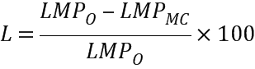
Where:
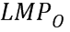is the annual generation-weighted average LMP for the offer case.
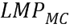is the annual generation-weighted average LMP for the marginal cost case.
A larger L means that a larger component of the price is the result of marginal offers above the participant’s marginal cost. A change in an inframarginal resource’s marginal cost or market share does not change the Lerner Index; only the offers of marginal units have an impact on this measure.
For 2014, offers above marginal cost added no more than approximately 9% to the Day-Ahead Energy Market price. The table below shows the summary results of the Lerner Index. These results are within normal year-to-year system and modeling variability for this measure.
Lerner Index for ISO-NE, 2010 to 2014 (%)^{(a)}
Year | Lerner Index
2010 | 13.7
2011 | 10.2
2012 | 9.9
2013 | 4.3
2014 | 9.0
- The methodology used to calculate the Lerner Index was enhanced beginning in 2012. For instance, from 2012, the index has been calculated by modeling the Day-Ahead Energy Market in which the majority of generation clears, rather than the Real-Time Energy Market, which was the basis of the values before 2012. As a result, comparisons between prior-year values and those listed beginning in 2012 should be made with a degree of caution.
To put these results in context, in constrained areas, the IMM’s offer-mitigation rules allow participants to submit offers the lesser of $25/MWh or 50% above reference levels without review. In unconstrained areas, the rules allow offers that are the lesser of $100/MWh or 300% above reference levels without review.
The size of these threshold limits allow for inaccuracies due to estimation errors and simplifications that must be made as part of the IMM’s method of estimating each resource’s marginal costs. If the market were not competitive, the profit-maximizing strategy, at least some of the time, would be for participants to submit offers $25/MWh to $100/MWh above their marginal costs, depending on system conditions. If this strategy were viable, instead of the marginal resources adding 9% on average to their offers, the market would observe a much larger adder above marginal cost on the typical offer.
In addition, the IMM has reviewed the bidding behavior of all market participants as part of its monitoring and mitigation functions. While the IMM mitigated the offers of some resources, in 2014, the IMM did not identify behavior that suggested a more systematic attempt to using pricing power to manipulate market outcomes, either via economic or physical withholding.
Gross Margins and Net Revenues Earned by Natural Gas Units
The following table presents the results of an analysis that estimates yearly gross margins (potential energy revenues minus fuel costs) earned by proxy gas-fired combined-cycle (CC), combined-cycle gas turbine (CCGT), and combustion turbine (CT) units during hours in which they were likely to run in the New England wholesale energy market. The hourly Hub real-time locational marginal price was used to imply revenue, and the margin estimated for CCs reflect “on-peak hours” only. The margin summarized for CTs reflects only those on-peak hours when the prevailing real-time Hub LMP exceeded the resource’s fuel cost. The analysis assumes that these proxy resources are available in all hours and thus may tend to overestimate the margins earned by actual units, which are subject to outages. The analysis assumes an aggregate natural gas price at a Massachusetts delivery point, a 7,800 Btu/kWh combined-cycle heat rate and an 11,000 Btu/kWh combustion turbine heat rate.
ISO-NE Yearly Estimates of the Gross Margin Earned by Proxy CT and CCGT Units
in New England, 2010 to 2014
Year | Natural Gas Index  ($/MMBtu)^{(a)} | Real-Time LMP  ($/MWh) | Gross Margin CT  ($/kW-mo) | Gross Margin CCGT  ($/kW-mo)
2010 | $5.31 | $56.34 | $2.54 | $5.10
2011 | $5.04 | $52.34 | $1.95 | $4.42
2012 | $3.96 | $41.26 | $1.85 | $3.54
2013 | $6.97 | $64.19 | $2.56 | $3.35
2014 | $8.21 | $74.90 | $2.77 | $3.70
- MMBtu stands for millions of British thermal units.
Gross margins for efficient gas units can be lower in the winter months (relative to summer). This is because constraints on the natural gas pipelines raise the cost of natural gas, sometimes to levels that exceed the price of oil, resulting in efficient gas resources setting the price and, at times, being extramarginal. The gross margins for CCs seen during 2012 to 2014 in the analysis were lower than during 2010 to 2011 and were closer to those of less-efficient combustion gas turbines. This trend is attributable to the growing gas pipeline constraints experienced in New England over the past three winters—and particularly over the past two winters—when the production cost of gas resources exceeded those of oil resources on an increasing number of days.
The following figures show the net generation revenues for hypothetical gas-fired combustion turbines and combined-cycle units for 2010 to 2014. The data show the same trend in graphical form as the previous table but on a $/MW basis.
ISO-NE Proxy Gas-Fired Combustion-Turbine Net Generation Revenues, 2010 to 2014
($ per installed megawatt-year)
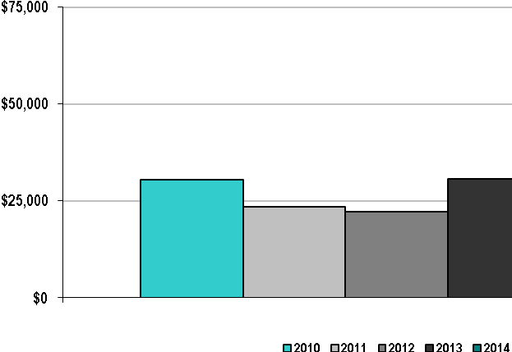

ISO-NE Proxy Gas-Fired Combined-Cycle Net Generation Revenues, 2010 to 2014
($ per installed megawatt-year)
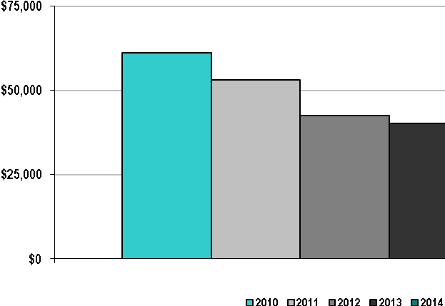

In addition to energy revenues, many CC resources earn revenues for providing real-time reserve and regulation service. They may also receive make-whole compensation (uplift) for periods in which they experience revenue shortfalls relative to their offer costs while operating at the ISO's request. All resources are eligible to receive capacity revenues, and fast-start resources, such as CT units, may participate in and receive Forward Reserve Market (FRM) revenues.
Mitigation
Mitigation is a largely automated process that prevents noncompetitive offers from affecting the market price. The market rules governing the mitigation process use three tests: structure, conduct, and impact. The IMM does the following:
- Evaluates the structure of the competition the generator faces (e.g., whether it is in a load pocket—or import-constrained area of the system—and faces less competition)
- Evaluates the generator’s offer (i.e., its conduct) against a reference level prepared by the IMM
- After the evaluations, estimates the impact that the generator’s offer will have on market outcomes
A generator’s energy offer that is less than the applicable reference level plus the appropriate threshold is deemed competitive and is not evaluated further for potential mitigation, while an energy offer that exceeds the applicable reference level plus the appropriate threshold is evaluated for mitigation. This comparison of an energy offer against the reference level plus a threshold is performed for all resources across the system. For generators facing less competition (i.e., those within import-constrained areas of the system), the thresholds used in the comparison against an energy offer price are lower than the thresholds used for generators facing competition from all generators in New England. Generator energy offers are mitigated only when they exceed the applicable reference level plus the appropriate threshold and the offer price raises the market price (e.g., the LMP) by a specific impact threshold.
Another set of mitigation rules applies to commitment costs, primarily start-up, no-load, and energy costs at economic minimum (also known as a generators “low-load cost”) that do not affect a market price. Commitment costs may instead result in out-of-market (OOM) Net Commitment-Period Compensation (NCPC). Mitigation rules that apply to generators committed for reliability have smaller thresholds than the general energy mitigation rules because units committed for reliability often face no competition and could offer significantly above their costs. Because the calculation of LMPs does not use commitment costs, mitigation of commitment costs does not include a review of their impact on LMPs.
The energy market offer flexibility (EMOF) changes now provide market participants with the opportunity to submit offers that vary by hour of a day and to change offers very near real time. These changes, which went into effect on December 3, 2014, required modifications to the mitigation rules, including the following provisions:
- Developing hourly reference levels rather than reference levels fixed for an operating day
- Modifying commitment mitigation conduct tests so that they account for the low-load cost over the commitment period
- Modifying the duration of mitigation such that commitment mitigation is in effect for the duration of the commitment period and energy mitigation is in effect until structural market power or market impact are no longer detected. Under the pre-EMOF rules, mitigation remained in effect until at least the end of the operating day.
- Introducing limits based on fuel prices to the amount that start-up fees and no-load fees may be increased in real time
- Implementing mechanisms to permit market participants to enter fuel-price adjustments to resource reference levels to reflect hourly changes in fuel costs
- Eliminating the requirement that market participants with dual-fuel resources submit offers based on the resource’s least-cost fuel under certain conditions
The table below shows the percentage of real-time mitigated hours from the implementation of automated mitigation (April 18, 2012) through 2014. Mitigation in the real-time market was infrequent before automated mitigation because it was a manual process. Therefore, mitigations are not reported before April 2012, and in any case, they would not be comparable. The table shows that less than 1% of all possible intervals were mitigated in all three years.
ISO-NE Percentage of Mitigated Hours in the Real-time Market Imposed under Market Rule 1,
Appendix A, Section 5, 2012–2014
Year | Occurrences
2012 (beginning April 18) | 0.2%
2013 | 0.1%
2014 | 0.1%

Market Pricing
Since March 2003, the wholesale electric energy markets administered by ISO-NE have used LMPs for their transactions. These values, computed every five minutes at nearly 1,000 nodal locations, are combined using a load-weighted average to calculate zonal average LMPs for the eight load zones within the New England Balancing Authority Area. With limited exceptions, load pays the hourly zonal price at its location. For the following figure, the hourly zonal price for every hour in the year indicated was multiplied by its zonal load obligation in the real-time market. These load-weighted average hourly prices were computed and then arithmetically averaged over the year, as shown in the figure.
ISO-NE Average Annual Load-Weighted Wholesale Energy Prices, 2010–2014
($/MWh)
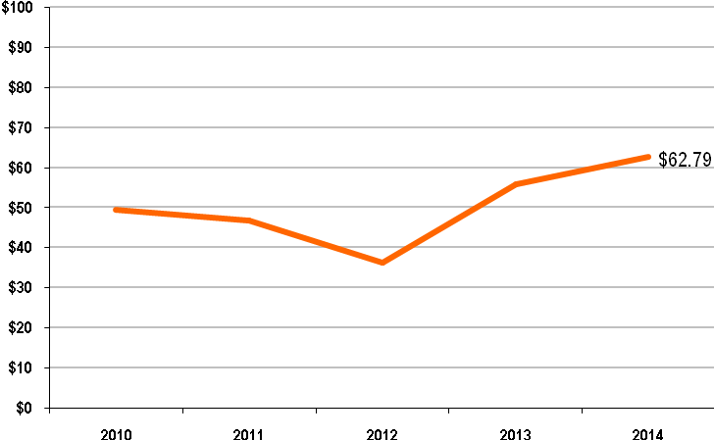
The yearly average real-time LMP has trended upward in New England since 2012. Pricing is influenced by underlying input fuel prices (primarily natural gas), which have driven the historical price trajectory. The increased prices in 2014 were caused by increases in natural gas prices during the year. The pricing trends for peak periods (on-peak hours), also strongly influenced by fuel prices, followed the same trend observed in the exhibit above. The 2010 on-peak yearly average Hub LMP was $56.34/MWh, followed by decreases during 2011 and 2012. The 2013 on-peak yearly average Hub LMP increased to $64.19. The highest on-peak yearly average Hub LMP during the period was $74.90/MWh during 2014. The following figure shows nominal fuel costs in the United States from 2010 to 2014.
Nominal Fuel Costs in the United States, 2010–2014
($ per Million Btu)
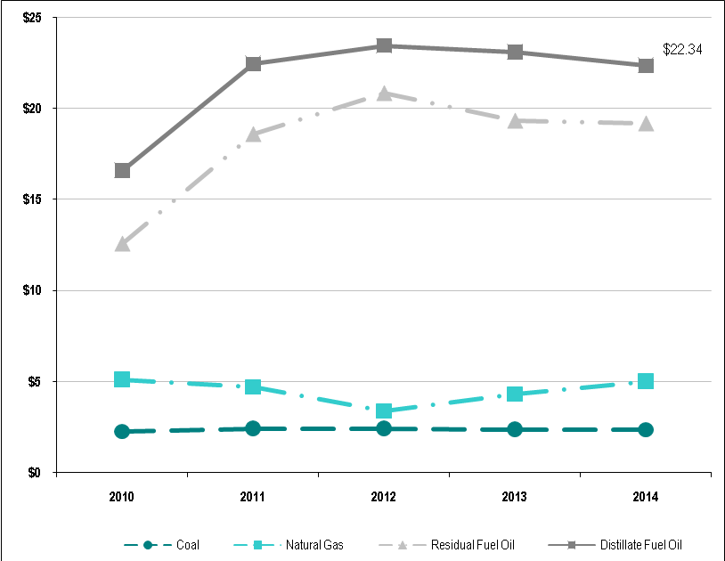
Source: US Energy Information Administration, “Table 2. US Energy Prices, Short-Term Energy Outlook—May 2015, http://www.eia.gov/forecasts/steo/tables/pdf/2tab.pdf; for 2014: coal, 2.36; nat gas, 4.98; res fuel oil, 19.18; dist fuel oil, 22.34; prior- year reports and tables available at http://www.eia.gov/forecasts/steo/tables/?tableNumber=8#).
In the past, ISO-NE calculated the fuel-adjusted electricity price by adjusting the marginal LMPs by the ratio of the daily fuel prices to the average monthly fuel prices of the corresponding market intervals and marginal fuel types in the base year. The result of this approach illustrated the impact of fuel prices on electricity prices. While informative, this methodology provided only a rough estimate because it did not account for the impact that changes in relative fuel prices, load growth, and resource mix had on system dispatch and pricing.
Impacts of Demand-Response Programs on Locational Marginal Prices
Every six months from February 2003 to March 2012, ISO-NE filed status reports with FERC regarding the ISO’s participation in and impacts of ISO-NE-administered demand-response programs. These status reports included estimates of the effects of demand-response programs on real-time LMPs. Using the information from the status reports, the following table shows the effects of ISO-NE’s demand-response programs on real-time LMPs for the New England region for January 2010 through March 2012. The ISO-NE demand-response programs (i.e., Real-Time Price-Response Program and Day-Ahead Load-Response Program) expired on May 31, 2012. As a result, ISO-NE has not conducted any further analysis of the impacts and effects of demand-response programs on LMP.
Estimated Effects of All Demand-Response Program Interruptions
on New England’s Real-Time LMPs, 2010–2012
Reporting Period | Interrupted MWh | Observed Average  Real-Time LMP ($/MWh) | Average Real-Time  LMP Decrease ($/MWh)
Jan to Mar 2010 | 2,773 | 76.40 | 0.13
Apr to May 2010^{(a)} | 5,099 | 62.27 | 0.61
Jun to Sep 2010^{(a, b)} | 110,620 | 82.62 | 1.72
Oct to Dec 2010 | 38,590 | 63.47 | 0.51
Jan to Mar 2011 | 30,404 | 82.43 | 1.01
Apr to Jun 2011 | 6,371 | 62.66 | 3.76
Jul to Sep 2011 | 30,354 | 84.16 | 4.32
Oct to Dec 2011 | 12,735 | 49.30 | 0.12
Jan to Mar 2012^{(c)} | 3,669 | 54.22 | 0.66
(a) For April to September 2010, the price impacts are averaged over time periods of other than three months: April through May, when the reliability programs (Real-Time 30-Minute Demand-Response Program, Real-Time Two-Hour Demand-Response Program, and Real-Time Profiled-Response Program) were still active, and June through September (after the reliability programs ended), representing the impacts of the Real-Time Price-Response Program and of assets participating in Day-Ahead Load-Response Program. Refer to ISO-NE’s 2010 Annual Markets Report (June 3, 2011) for additional information about these programs, http://www.iso-ne.com/markets/mkt_anlys_rpts/annl_mkt_rpts/2010/amr10_final_060311.pdf.
(b) The significant increase in interrupted amounts from June to September 2010 corresponds to a substantial increase in the number of assets that participated and cleared in the Day-Ahead Load-Response Program.
(c) The ISO’s demand-response programs expired on May 31, 2012.
The following graph reflects the average annual wholesale power costs for load purchasing from the New England wholesale energy markets. The costs are categorized into the major charge components ISO-NE administers, converted to $/MWh of load served. Because of the various ways in which participants may transact business within the New England markets, not all load-serving entities are subject to all the charge categories. Of note during 2013 was the increase in energy-market–related charges, primarily stemming from increased input fuel prices. Capacity charges have declined since 2010, influenced by the commencement of the Forward Capacity Market on June 1, 2010. This market implementation marked the termination of the FERC-approved transition period for capacity payments that encompassed the period December 2006 through May 2010.
ISO-NE Wholesale Power Cost Breakdown, 2010–2014 ($/MWh)
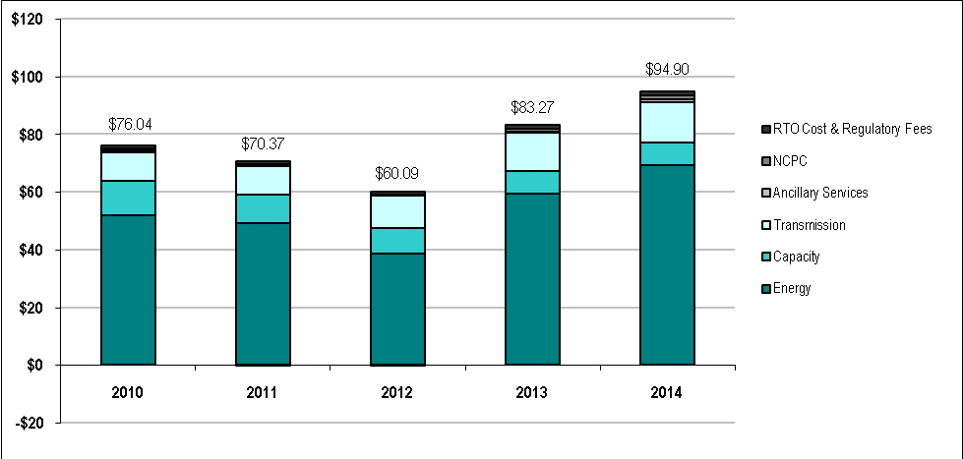
Note: NCPC refers to Net Commitment-Period Compensation. Refer to the ISO-NE Market Transaction Charges table above.
Over the reporting period, ISO/RTO costs and regulatory fees have remained approximately 1% of overall costs. In 2014, the costs for ancillary services increased as part of the total cost because Forward Reserve Market payments increased significantly during the year. Forward Reserve Market payments increased approximately $94.5 million in 2013, to $207.5 million in 2014 due to an increase in the 10-minute nonspinning reserve (TMNSR) requirement. The quantity of required replacement reserves increased, as well. These two factors increased the overall reserve requirement, leading to significantly higher clearing prices in the summer 2014 forward-reserve auction. The cost for electric energy also increased during 2014 from its 2013 values, as a result of fuel price movements. Transmission costs have increased over the same period, reflecting infrastructure improvements placed in service.
From 2010 to 2014, ISO-NE’s net revenue requirements recovered through the self-funding tariff grew at an average rate of 5.7% per year, from $137.2 million to $171.2 million. The ISO-NE net revenue requirements reflect the FERC-approved budgets adjusted for prior-year over/under collections. The increases largely reflect expanded levels of service with regard to the Forward Capacity Market, demand-response integration, system planning, increased compliance-management activities, and improvements stemming from the Strategic Planning Initiative (SPI). The SPI improvements include changes relevant to fuel security, the timing of the Day-Ahead Energy Market, and planning for the introduction of hourly markets.
Transmission costs increased at an average rate of 8% per year from 2010 to 2014. This increase in costs reflects upgrades and additions to pool transmission facilities, including major transmission projects such as the Maine Power Reliability Program and New England East–West Solution.
Net Commitment-Period Compensation averaged approximately $118 million per year from 2010 to 2014, representing on average approximately 1.6% of the value of the energy market. Comparatively, NCPC in the prior five-year period (2005 to 2009) was almost twice as much ($215.9 million, 2.2% of energy market). While the larger NCPC paid in 2005 to 2009 was primarily attributable to second-contingency payments associated with constrained transmission in the northeastern Massachusetts/southeastern Massachusetts (i.e., NEMA/SEMA) area, the $118 million during 2010 to 2014 were paid primarily to units committed to ensure system capacity in the event of the loss of the system’s first-largest contingency. These payments were caused by a variety of separate, yet sometimes concurrent, operating conditions that included high loads, the generation-clearing results in the day-ahead market, operational uncertainties due to fuel-availability issues, volatile fuel prices, the loss of generating capacity between the day-ahead and real-time markets, and major storms or periods of extreme weather heavily affecting the transmission system. First-contingency payments were most heavily concentrated during winter 2013/2014, totaling $118.1 million between December 2013 and March 2014 (with $69.9 million in January alone).
On the extreme weather days that drove high NCPC payments, high-cost, oil-fired generators were supplementally committed to ensure that generating capacity was sufficient to meet the forecasted load and reserve requirements over the peak hour. Because of their high costs and inflexible intertemporal operating parameters (notification times, start times, response rates, and minimum run time), these resources generally do not clear in the day-ahead market. When committed as part of the resource adequacy assessments leading into and during the operating day, these resources generally operate at levels near their economic minimum in most hours of their commitments. They are only dispatched above their minimum operating levels during the peak hours of the day. Consequently, the total cost of running these units exceeded their total revenues collected through the energy market—the difference being paid as first-contingency NCPC.
During extreme cold weather, fuel-cost inversions (i.e., when gas is more expensive than oil) create additional operational challenges due to gas pipeline constraints, and also fuel availability and delivery issues for both gas and oil-fired resources, most noteworthy during the 2013/2014 winter.

System Marginal Cost
In the next graph, the hourly system price (consistent with ISO-NE’s FERC Form 714 filing) for every hour in 2010 through 2014 was averaged over the entire year. Pricing in the New England wholesale markets is heavily influenced by underlying fuel prices. The values in the figure reflect the movements in the underlying increases in fuel prices, especially during 2013 and 2014.
ISO-NE Annual Average Nonweighted System Marginal Cost, 2010–2014
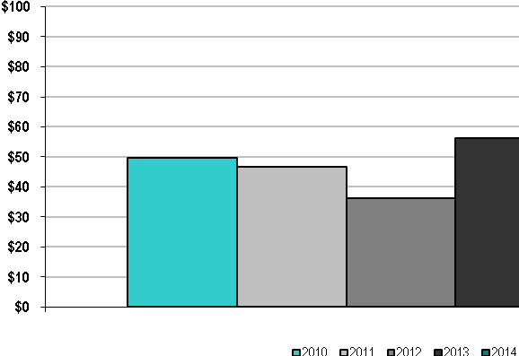

Energy Market Price Convergence
Good convergence between day-ahead and real-time prices is a sign of a well-functioning day-ahead market that helps ensure efficient day-ahead commitments and reflect real-time operating needs. The day-ahead market reflects most of the energy settlements and generator commitments in New England. Convergence between day-ahead and real-time electric energy prices depends on participants submitting price-sensitive bids and offers in the day-ahead market that accurately forecast next-day real-time conditions. Real-time conditions that depart from day-ahead expectations negatively affect this convergence. The following two graphs reflect the absolute value and percentage of the average annual difference between Real-Time Energy Market prices and Day-Ahead Energy Market prices.
ISO-NE Day-Ahead and Real-Time Energy Market Price Convergence (Absolute Value), 2010–2014

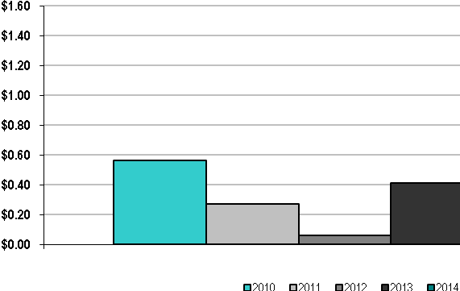

ISO-NE Percentage of Day-Ahead and Real-Time Energy Market Price Convergence, 2010–2014
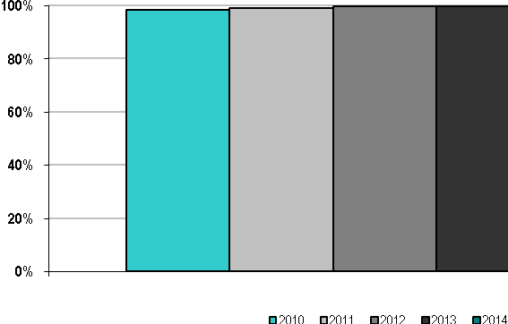

ISO-NE’s Day-Ahead Energy Market to Real-Time Energy Market average price, while declining during 2014, remained high over the five-year period from 2010 to 2014, averaging over 98%. Make-whole costs assigned to deviations from day-ahead schedules in the Real-Time Energy Market continue to have had a negative effect on day-ahead to real-time convergence during the last several years
Two events likely explain the decrease in price convergence during 2014. First, extremely cold winter weather and resultant gas pipeline constraints resulted in unprecedented price volatility during the first quarter of the year. Price convergence was relatively low during this period, as shown below, in the 30-day rolling average of the difference between day-ahead and real-time LMPs during 2014. The graph shows that price convergence improved after the winter period and remained reasonable until the implementation of the Energy Market Flexibility Project on December 3, 2014. Second, convergence decreased during December of 2014, likely due to a learning period associated with the new market construct. Preliminary 2015 results indicate price convergence has returned to previous levels as the market has adapted to the introduction of hourly offers.
ISO-NE 30-Day Rolling Average Price Difference, Day-Ahead LMPs Compared with RT LMPs, 2014
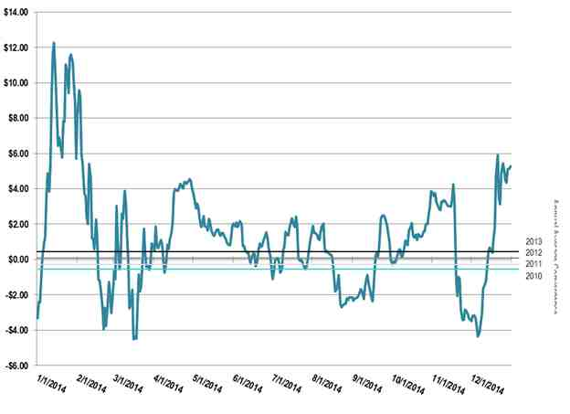

Congestion Management
Transmission congestion occurs when constraints on the transmission system prevent the reliable transfer of lower-cost energy to serve an area. During the planning process, ISO-NE uses information obtained from system needs assessments to identify possible solutions to transmission congestion. These solutions can include merchant transmission or market resource alternatives, such as generation, demand reduction, or other promising technologies. If the market does not respond, a regulated, robust transmission solution is developed to meet existing and future system requirements.
The transmission system in New England has evolved significantly over the past several years. From 2002 through 2014, more than 300 transmission projects will have been placed in service, with additional projects under construction or well into the siting process. In addition to system reliability improvements, these transmission upgrades have supported marketplace efficiency by helping reduce congestion costs and other out-of-merit charges, such as second-contingency and voltage-control payments. From 2010 through 2014, NCPC in New England has averaged about $117 million per year (i.e., an average of 1.6% of the value of the energy market).
Recent experience has demonstrated that the regional transmission system in New England has little congestion. In its August 2014 Draft National Electric Transmission Congestion Study, the US Department of Energy (DOE) recognized the contribution of the region’s generation and transmission additions, in addition to lower demand as result of aggressive energy efficiency and demand response in lowering overall congestion.
Transmission congestion, when it occurs, is reflected in the congestion component of the LMP. In the New England system, most of the congestion occurs in the day-ahead market and is low. The figure below shows the cost of congestion per megawatt-hour of load served.
ISO-NE Annual Congestion Cost per Megawatt-Hour of Load Served, 2010–2014
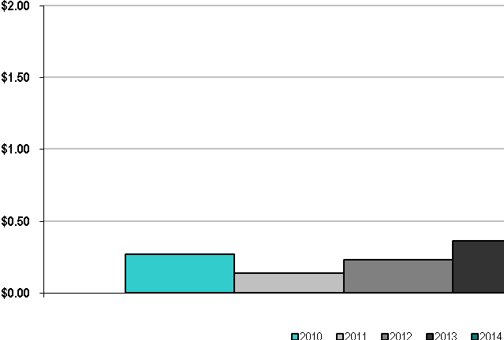

Congestion revenue from the settlement of the Day-Ahead Energy Market and Real-Time Energy Market is accumulated in the Congestion Revenue Fund. Holders of congestion instruments (in New England, Financial Transmission Rights, or FTRs) share in the refund of these collections in proportion to the congestion experienced on their specific FTR paths. These are called positive target allocations. Conversely, because New England FTRs are obligations, counter-flow congestion (which results in so-called negative target allocations) may require a contract holder to contribute to the Congestion Revenue Fund.
The following graph shows the extent to which the sum of day-ahead and real-time congestion revenue and negative target allocations were sufficient to fund the transmission-hedge instruments (primarily FTRs) each year. Over the five-year period, FTR holders in the New England markets have been able to hedge on average over 99% of day-ahead market congestion in each year, with FTR congestion-revenue adequacy ranging from 100% in 2010, 2011, 2012, and 2013, to just over 96% in 2014. The shortfall in FTR revenue adequacy during 2014 was caused by outages and limits that were not accounted for in the FTR auction processes due to timing constraints, which subsequently caused FTRs to be oversold. (FTR market congestion-revenue adequacy reflects the relationship of actual FTR congestion revenues to the target allocations for all FTR holders taken together.)
ISO-NE Percentage of Congestion Dollars Hedged through ISO/RTO Congestion Management Markets,
2010–2014
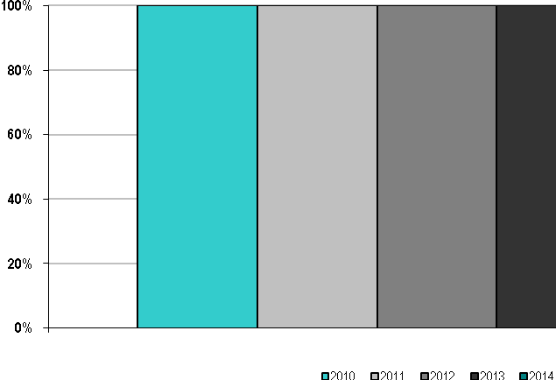

Excess congestion is collected until the end of the year and then distributed pro rata to any shortfall amounts that occurred during the year. This ensures that all shortfalls have equal opportunity for funding regardless of the month in which the shortfall occurred.

Resources
Market rules detail capacity ratings within the ICR and locational requirement calculations. The ratings currently include all existing generating capacity resources and demand resources, as well as import capacity resources backed by multiyear contracts to provide capacity into the New England Balancing Authority area. To model these resources within the ICR, the ISO calculates unit-specific resource availability. The calculation is based on historical forced and scheduled outages of generating resources, transmission-related outages/constraints, corresponding class-average generator outages for resource-backed imports, and the historical performance and availability of demand resources. The availability of each of the generator types and demand resources is discussed below.
Generator Availability
This ISO/RTO performance metric calculates ISO-NE’s calendar-year generating unit availability using equivalent forced outage rate demand (EFORd). Generating availability is defined as one minus EFORd, calculated using data from the NERC Generating Availability Data System (GADS). The industry has used the EFORd availability metric for more than 30 years to describe the probability that a generator will not meet its demand periods for generating requirements. EFORd is shown on an annual basis:
Generating Availability = (1 − EFORd), where:
EFORd is calculated for resources that submitted monthly GADS data for the specified period, based on NERC Appendix F—Performance Indexes and Equations GADS Data Reporting Instruction. As shown in the figure below, the performance of New England’s generating units declined from a high of approximately 96% in 2010 to a low of approximately 91% in 2012. The performance of New England’s generating units improved in 2013 and 2014 to over 96%
ISO-NE Annual Generator Availability, Power Year 2010–2014
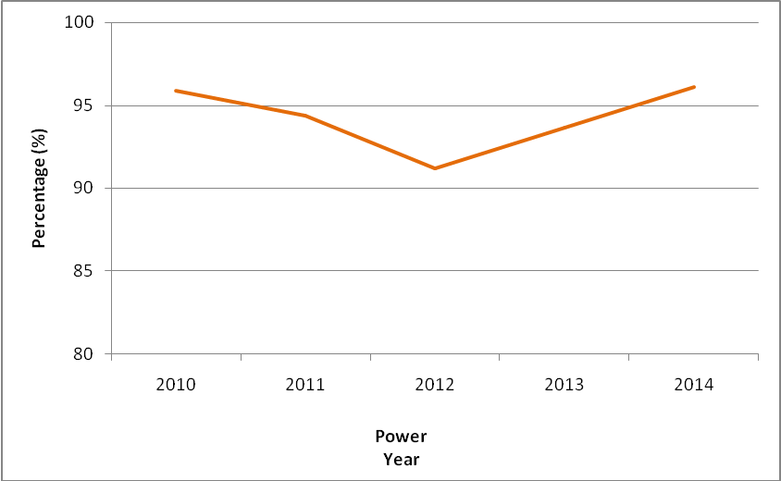

A five-year average of generating resource availability by type of resources is shown in the table below. ISO-NE has not determined a specific quantitative relationship between generator availability and the wholesale cost of electricity. Trends in out-of-merit dispatch and progress made toward reducing out-of-merit dispatch and improving market efficiency are discussed above in the sections on generation must-run contracts, the ISO-NE wholesale power cost breakdown, and congestion management.
Five-Year Weighted Average Availability by Resource Category, ISO-NE, 2010–2014 (%)(a)
Generating Resource Category | 2010 | 2011 | 2012 | 2013 | 2014^{(b)}
Combined cycle | 95.8 | 95.9 | 96.1 | 96.4 | DNA
Fossil | 92.3 | 93.1 | 90.1 | 85.1 | DNA
Nuclear | 98.2 | 98.2 | 97.4 | 96.9 | DNA
Hydro  (Includes pumped storage) | 97.0 | 96.5 | 94.9 | 95.4 | DNA
Combustion turbine | 93.3 | 92.4 | 91.5 | 90.5 | DNA
Diesel | 93.3 | 93.2 | 92.2 | 93.5 | DNA
Miscellaneous | 85.6 | 85.6 | 84.2 | 85.8 | DNA
Total system | 94.9 | 95.1 | 94.1 | 93.3 | DNA
(a) These are five-year average EFORd values, calculated with the most recent available EFORd data at the time of the ICR calculation. These EFORd values are weighted by the summer capacity ratings of the resources in each category.
(b) DNA refers to “data not available.”
ISO-NE also assesses expected availability of capacity resources as an input in determining the ICR. The expected availability of resources in a future capacity commitment period is based on the historical performance of capacity resources in response to dispatch instructions.
Demand-Response Availability
New England demand resources are either passive demand resources or active demand resources. Passive demand resources, which include programs such as energy efficiency and conservation, are assumed to always be “in service” and, subsequently, 100% available within the ICR calculations.
The table below shows the availability of the passive demand resources in both the on-peak and seasonal-peak categories by load zone, as modeled in the 2018/2019 ICR calculation (FCA #9).
Passive Demand-Resource Availability Modeled in the ISO-NE 2018/2019 ICR Calculation
Load Zone | On Peak |  | Seasonal Peak
Load Zone | Summer MW | Availability % | Summer MW | Availability $
Maine | 164.811 | 100% | - | -
New Hampshire | 101.215 | 100% | - | -
Vermont | 120.090 | 100% | - | -
Connecticut | 78.815 | 100% | 371.437 | 100%
Rhode Island | 197.599 | 100% | - | -
Southeast Massachusetts | 292.685 | 100% | - | -
West Central Massachusetts | 293.340 | 100% | 49.645 | 100%
Northeast Massachusetts and Boston | 548.466 | 100% | - | -
Total New England | 1,797.021 | 100% | 421.082 | 100%

The expected availability of active demand resources, such as real-time demand response and real-time emergency generating resources, is based on the historical performance of such resources during OP 4 event hours and audits conducted by ISO-NE.
To calculate the historical availability of active demand resources, the verified commercial capacity of each resource and its monthly net capacity supply obligation (CSO) are compared. These data show that the capacity-weighted average availability of both real-time demand response and real-time emergency generation resources was 88%.
Active Demand-Resource Availability Modeled in the ISO-NE 2018/2019 ICR Calculation (FCA #9)
Load Zone | Real-Time Demand Response |  | Real-Time Emergency Gen
Load Zone | Summer MW | Availability % | Summer MW | Availability $
Maine | 207.892 | 99 | 11.802 | 93
New Hampshire | 18.707 | 88 | 14.022 | 99
Vermont | 37.007 | 92 | 2.866 | 82
Connecticut | 254.510 | 82 | 138.338 | 85
Rhode Island | 57.595 | 85 | 33.540 | 90
Southeast Massachusetts | 38.785 | 84 | 15.962 | 84
West Central Massachusetts | 91.799 | 89 | 27.798 | 89
Northeast Massachusetts and Boston | 50.189 | 81 | 26.099 | 89
Total New England | 756.484 | 88 | 270.427 | 88

The following table shows the overall average availability of all active and passive demand resources modeled in the ICR calculations for 2015/2016 to 2019/2020 using historical demand-resource performance data through the years shown. The overall average availability of all active and passive demand resources modeled in the 2019/2020 ICR calculation was estimated to be 97%.
Average Percentage Availability of All Active and Passive Demand Resources
Modeled in the ISO-NE ICR Calculations, 2010 to 2014
Year | ICR Calculation Commitment Period | Availability (%)
2010 | 2015/2016 | 86
2011 | 2016/2017 | 92
2012 | 2017/2018 | 94
2013 | 2018/2019 | 96
2014 | 2019/2020 | 97

Fuel Diversity
This ISO/RTO performance metric identifies the fuel diversity of ISO-NE’s installed capacity. To develop the information for this metric, ISO-NE compiled the installed summer capacity values for 2010 to 2014 of all generating units under ISO-NE’s dispatch control and summarized their aggregate capacity (MW) by each unit’s reported primary fuel type. This information for 2014 was then categorized into the following fuel types:
- Natural gas (13,452 MW at 43.1%)
- Nuclear (4,641 MW at 14.9%)
- Coal (2,116 MW at 6.8%)
- Oil, heavy and light (6,565 MW at 21.1%)
- Hydroelectric (1,517 MW at 4.9%) and other renewables (1,163 MW at 3.7%)
- Pumped storage (1,719 MW at 5.5%)
The fuel types themselves are self-explanatory, except for the “other renewables” category, which in New England includes capacity from landfill gas (LFG), other biomass gas, refuse (municipal solid waste), wood and wood-waste solids, wind, solar, black liquor, and tire-derived fuels. In addition, this information does not contain, nor has it been adjusted for, historical firm imports or exports of capacity. The annual installed summer capacity values by primary fuel type are shown in the following graph.
ISO-NE Fuel Diversity (Summer Capacity MW), 2010–2014
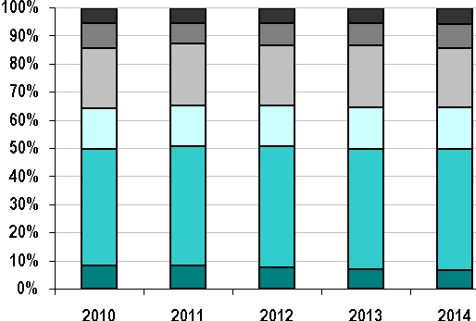
Coal Gas Nuclear Oil
Hydro and Other Renewables Pumped Storage

Data observations:
- Average annual summer installed capacity over the five-year period, 2010 through 2015, was approximately 31,781 MW.
- The lowest amount of installed summer capacity occurred in 2014 at 31,173 MW.
- The highest amount of installed summer capacity occurred in 2011 at 32,037 MW.
- The difference between the highest and lowest amounts of installed summer capacity is only 864 MW.
- The top three installed capacity values in the region are natural gas-fired generation (13,452 MW), oil-fired generation (burning both heavy and light fuels) (6,565 MW), and nuclear generation (4,641 MW). Fossil-fueled generating capacity (gas, oil, coal) had the lowest amount in 2014 at 22,133 MW to the highest amount in 2011 at 23,407 MW, averaging approximately 22,891 MW, or approximately 72.0% of the entire generation fleet over the five-year period.
- The New England generation fleet is predominantly natural gas-fired, with the largest portion of installed summer capacity in each year ranging from a low of 13,452 MW at 43.1% in 2014 to a high of 13,764 MW at 43.0% in 2012. More than 50% of the installed capacity within the region can burn natural gas as a primary, secondary, start-up, or stabilizing fuel source.
The next ISO/RTO performance metric is fuel diversity with respect to historical energy production. To develop the information for this metric, ISO-NE compiled the 2010 to 2014 historical energy production of all generating units under the dispatch control of ISO-NE and summarized their annual energy output by each unit’s reported primary fuel type. This information for 2014 was then categorized into the following fuel types:
- Natural gas (46,612 GWh at 43.0%)
- Nuclear (36,838 GWh at 34.0%)
- Coal (5,055 GWh at 4.7%)
- Oil, heavy and light (1,789 GWh at 1.6%)
- Hydroelectric (7,304 GWh at 6.7%) and other renewables (9,356 GWh at 8.7%)
- Pumped storage (1,403 GWh at 1.3%)
This information does not contain, nor has it been adjusted for, historical imports of electric energy, although the production of energy to support exports is reflected within the annual energy production amounts. The following graph shows the diversity of fuels for generating electric energy in New England for 2010 to 2014.
ISO-NE Fuel Diversity (Energy GWh), 2010–2014
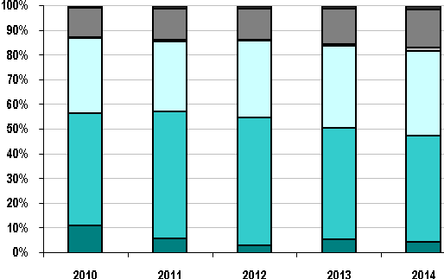
Coal Gas Nuclear Oil
Hydro and Other Renewables Pumped Storage
Data observations:
- Average annual electric energy production over the five-year period was approximately 116,867 GWh.
- The highest annual energy production occurred in 2010 at 126,383 GWh.
- The lowest annual energy production occurred in 2014 at 108,356 GWh.
- In 2014, the top three fuels to produce electric energy within New England were natural gas, nuclear, and renewables; the annual energy contribution from natural gas was 43%.
- The New England gas-fired generation fleet had the largest portion of annual energy production in each year, ranging from a percentage low of 43% in 2014 to a percentage high of 51.8% in 2012.
- The overall production of electric energy from using both heavy and light oil products increased slightly over the five-year period, from 0.4% (545 GWh) in 2010 to 1.6% (1,789 GWh) in 2014.
- The overall production of electric energy from coal varied over the five-year period, from a high of 11.2% (14,131 GWh) in 2010 to a low of 3.2% (3,701 GWh) in 2012.
- The overall production of electric energy from renewables, hydroelectric, and pumped storage stations remained relatively constant over the five-year period.
Renewable Resources
ISO-NE Electric Energy Produced by Renewables
This ISO/RTO performance metric compares ISO-NE’s annual amount of electric energy produced by renewable resources with the total amount of annual energy produced. To develop the information for this metric, ISO-NE compiled the historical energy production of all generating units for 2010 through 2014 and summarized their annual energy output by each unit’s reported primary fuel type. All the “other renewables” energy information was then categorized into the annual renewable energy category, shown in the following table, along with the total annual amount of energy produced and the percentage of total energy produced by renewables for each assessment year.
ISO-NE Electric Energy Produced by Renewables, 2010–2014
Year | Annual Energy Produced by Renewables (GWh) | Total Annual Energy Produced (GWh) | Percentage of Total Annual Energy Produced by Renewables
2010 | 7,683 | 126,383 | 6.1%
2011 | 7,263 | 120,612 | 6.0%
2012 | 7,878 | 116,942 | 6.7%
2013 | 8,715 | 112,040 | 7.8%
2014 | 9,356 | 108,356 | 8.7%

Although hydroelectric energy generation is shown within previous metrics, it was categorized separately and not included within the “other renewables” category, primarily because it may not be defined universally as a “renewable” resource across the country. In addition, this information does not contain, nor has it been adjusted for, historical imports of renewable energy, although the production of energy to support exports is reflected within the annual energy production amounts. The following graph shows ISO-NE’s annual energy produced by renewables as a percentage of total energy produced annually for 2010 through 2014, and does not include energy produced from hydroelectric resources.
Energy Produced by Renewables in ISO-NE as a Percentage of Total Energy Produced, 2010–2014
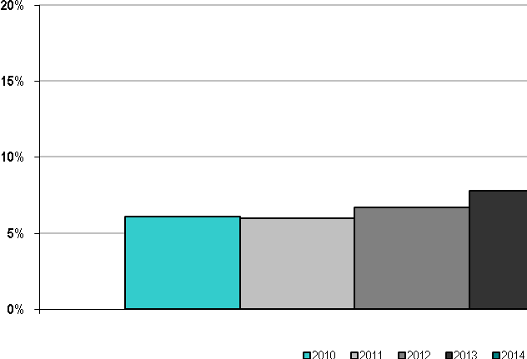

Data observations:
- The average annual electric energy produced by renewables over the five-year period was approximately 8,719 GWh.
- The highest amount of annual electric energy produced by renewables occurred in 2014 at 9,356 GWh, 8.7% of the total amount of energy produced systemwide, at 108,356 GWh.
- The lowest amount of annual electric energy produced by renewables occurred in 2011 at 7,263 GWh, 6.0% of the total amount of energy produced systemwide, at 120,612 GWh.
- Five of the New England states have Renewable Portfolio Standards (RPSs), and Vermont has a goal for increasing energy usage from renewable resources. These RPSs represent state policy targets for retail competitive suppliers who may choose to meet some or all of their obligations using renewable resources within the ISO-NE balancing authority area, resources from adjacent balancing authority areas, and small “behind-the-meter” projects. Affected suppliers also can meet RPS shortfalls by paying an alternative compliance payment (ACP), which acts as an administrative cap on the cost of renewable sources of electric energy. ACP funds are used for the development of new renewable resources and energy efficiency in the region.
ISO-NE Hydroelectric Energy Produced
This performance metric compares ISO-NE’s annual production of hydroelectric energy with the total annual amount of energy produced. To develop the information for this metric, ISO-NE compiled the historical electric energy production of all hydroelectric generating units for 2010 to 2014. The following table shows the total amount of “hydroelectric” energy produced in 2010 through 2014, the total amount of annual electric energy produced for these years, and hydroelectric’s percentage of the total amount of energy produced annually for each year.
ISO-NE Hydroelectric Energy (GWh) Produced, 2010–2014
Year | Annual Hydroelectric Energy Produced (GWh) | Total Annual Energy Produced (GWh) | Percentage of Total Annual Hydroelectric Energy Produced
2010 | 7,226 | 126,383 | 5.7%
2011 | 8,252 | 120,612 | 6.8%
2012 | 6,805 | 116,942 | 5.8%
2013 | 7,177 | 112,040 | 6.4%
2014 | 7,304 | 108,356 | 6.7%

The following graph shows ISO-NE’s annual hydroelectric energy produced as a percentage of the total energy produced annually for 2010 through 2014.
ISO-NE Hydroelectric Energy Produced as a Percentage of Total Energy Produced, 2010–2014
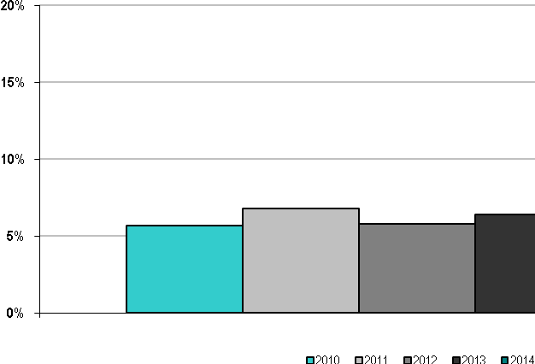
Data observations:
- The average amount of hydroelectric energy produced annually over the five-year period was 7,356 GWh.
- The highest amount of hydroelectric energy produced annually occurred in 2011 at 8,252 GWh, or 6.8% of the total amount of energy produced systemwide, 120,612 GWh.
- The lowest amount of hydroelectric energy produced annually occurred in 2012 at 6,805 GWh, or 5.8% of the total amount of electric energy produced systemwide, 116,942 GWh.
ISO-NE Summer Capacity Provided by Renewables
The next performance metric compares renewable summer capacity with total summer capacity. All the “other renewables” capacity information is categorized into the “renewable” capacity category, shown in the following table, along with total capacity and the percentage of total capacity provided by renewables for each assessment year:
ISO-NE Summer Capacity (MW) Provided by Renewables, 2010–2014
Year | Summer Capacity Provided by Renewables (MW) | Total Summer Capacity (MW) | Percentage of Total Summer Capacity Provided by Renewables
2010 | 1,142 | 31,965 | 3.6%
2011 | 982 | 32,037 | 3.1%
2012 | 1,017 | 31,969 | 3.2%
2013 | 1,071 | 31,759 | 3.4%
2014 | 1,163 | 31,173 | 3.7%

The following graph compares ISO-NE’s summer capacity provided by renewables as a percentage of total summer capacity for 2010 to 2014, not including hydroelectric capacity.

ISO-NE Summer Capacity Provided by Renewables as a Percentage of Total Summer Capacity, 2010–2014
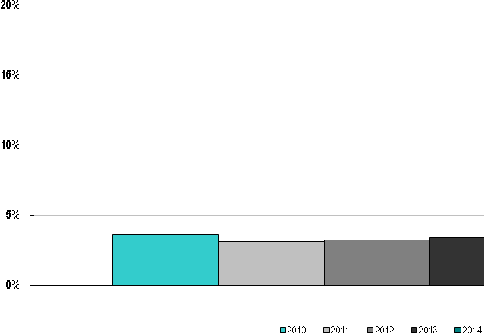

The following metric shows ISO-NE’s estimated (annual average) renewable capacity factors for 2010 to 2014. This estimated capacity factor information is representative of the “annual average” from numerous types of renewable production facilities, which include energy from landfill gas, other biomass gas, refuse (municipal solid waste), wood and wood-waste solids, wind, solar, black liquor, and tire-derived fuels, and does not represent the capacity factor of any single renewable production facility.
ISO-NE Estimated (Annual Average) Renewable Capacity Factors, 2010–2014
Year | Total Renewable Capacity (MW) | Total  Annual Renewable Energy (GWh) | Estimated  (Annual Average) Renewable  Capacity Factor (%)
2010 | 1,142 | 7,683 | 76.8%
2011 | 982 | 7,263 | 84.4%
2012 | 1,017 | 7,878 | 88.4%
2013 | 1,071 | 8,715 | 92.9%
2014 | 1,163 | 9,356 | 91.8%

Data observations:
- The average summer capacity provided by renewables over the five-year period was approximately 1,075 MW.
- The highest amount of summer capacity provided by renewables occurred in 2014 at 1,163 MW, or 3.7% of the total installed summer capacity of 31,173 MW.
- The lowest amount of summer capacity provided by renewables occurred in 2011 at 982 MW, or 3.1% of the total installed summer capacity of 32,037 MW.
- Five of the six New England states classify hydroelectric capacity as some form of renewable resource, mostly depending on the size of the unit and its compliance with state and federal fish-passage requirements. Currently, only Maine allows pumped-storage units to be classified as a renewable resource, as long as the unit uses a new renewable (Class I) resource or an eligible (Class II) resource to serve all its pumping requirements.
- The estimated (annual average) renewable capacity factors range from a low of 76.8% in 2010 to a high of 92.9% in 2013, with the five-year average annual capacity factor at 86.9%. The high capacity factors are representative of the majority of the renewable capacity on the system, which primarily were small, thermal stations fueled by wood, biomass, or refuse, for example. These renewable power stations typically are baseload, nondispatchable units and were classified as “must-run” or self-scheduled generation.
ISO-NE Hydroelectric Capacity
This metric shows ISO-NE’s hydroelectric summer capacity as a percentage of total summer capacity for 2010 to 2014. The following table shows all the “hydroelectric” capacity and total capacity for 2010 to 2014 and hydroelectric’s percentage of total capacity for each assessment year. Note that the overall decrease in hydroelectric capacity from 2010 to 2011 was driven by a new hydroelectric capacity rating methodology, which went from using “80/20” to “50/50” historical stream flow information.
ISO-NE Hydroelectric Summer Capacity, 2010–2014
Year | Hydroelectric Summer Capacity (MW) | Total Summer Capacity (MW) |  | Percentage of Hydroelectric Summer Capacity to Total Capacity
2010 | 1,712 |  | 31,965 | 5.4%
2011 | 1,341 |  | 32,037 | 4.2%
2012 | 1,483 |  | 31,969 | 4.6%
2013 | 1,374 |  | 31,759 | 4.3%
2014 | 1,517 |  | 31,173 | 4.9%

The next metric shows ISO-NE’s hydroelectric capacity as a percentage of total capacity for 2010 through 2014.
ISO-NE Hydroelectric Summer Capacity as a Percentage of Total Summer Capacity, 2010–2014
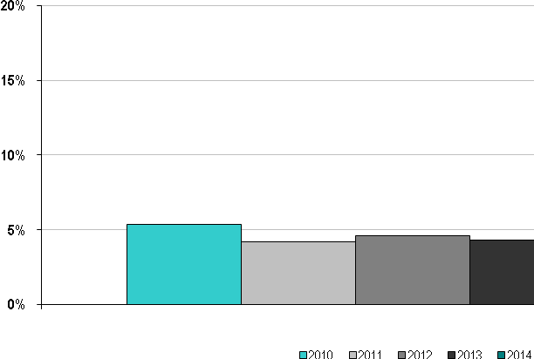

The following metric shows ISO-NE’s estimated (annual average) hydroelectric capacity factors for 2010 to 2014. This estimated capacity factor information is representative of the “annual average” from numerous types of hydroelectric production facilities (i.e., conventional [pondage] hydroelectric, weekly- and daily-cycle hydroelectric, run-of-river, and settlement-only hydroelectric) and does not represent the capacity factor of any single hydroelectric facility.
ISO-NE Estimated (Annual Average) Hydroelectric Capacity Factors, 2010–2014
Year | Total Hydroelectric Capacity (MW) | Total Annual Hydroelectric Energy (GWh) | Estimated Annual  Hydroelectric  Capacity Factor (%)
2010 | 1,712 | 7,226 | 48.2%
2011 | 1,341 | 8,252 | 70.2%
2012 | 1,483 | 6,805 | 52.4%
2013 | 1,374 | 7,177 | 59.6%
2014 | 1,517 | 7,304 | 55.0%

Data observations:
- The average hydroelectric summer capacity over the five-year period was approximately 1,485 MW.
- The highest amount of hydroelectric summer capacity occurred in 2010 at 1,712 MW, or 5.4% of the total installed summer capacity of 31,965 MW.
- The lowest amount of hydroelectric summer capacity occurred in 2011 at 1,341 MW, or 4.2% of the total installed summer capacity of 32,037 MW.
- The estimated (annual average) hydroelectric capacity factors range from a low of 48.2% in 2010 to a high of 70.2% in 2011, with the five-year average annual capacity factor at 57.1%. High capacity factors are representative of most of the larger types of hydroelectric capacity on the system, which are river-based hydroelectric stations with significant pondage or storage capability. These hydroelectric power stations typically are dispatchable but also can be self-scheduled generation. Because of the prior capacity rating methodology ISO-NE used for these types of hydro facilities, the capacity values are indicative of the amount of nameplate capacity that can be provided over a short period, usually a 2- to 4-hour demonstration window. Combined with a large watershed behind it, this methodology is the primary reason for the relatively high capacity factors for these facilities.

C. ISO New England Organizational Effectiveness

Administrative Costs
The following figures show ISO-NE’s actual annual noncapital costs and capital investment recovery costs as a percentage of budgeted costs for 2010 to 2014.
Actual Annual ISO-NE Costs as a Percentage of Budgeted Costs, 2010-2014
Noncapital Costs |  |  |  |  |  |  | Capital Investment Recovery Costs
Budget | $106 | $115 | $122 | $133 | $138 | Budget |  | $27 | $29 | $29 | $31 | $32
Note: The bars represent percentage of actual costs to approved budgets; dollar amounts represent approved budgets (in millions).
The metric for noncapital costs identifies ISO-NE’s administrative cost budget performance. The ISO-NE budgets reflect the resource allocations based on the establishment of regional objectives through the stakeholder process. These objectives and priorities, including resource allocations, are discussed with the stakeholders throughout the budget cycle. The primary categories of costs in each year reported comprise salaries and associated overhead and outside consulting support. On average from 2010 to 2014, these costs represent approximately 80% of the total budget. The next-largest categories include computer services and communication costs, which average 8% per year. Regional entity dues, on average, make up approximately 4% of the costs each year.
The primary underspend in each year is the underutilization of contingencies contained in each budget. ISO-NE’s annual budgets contain a board-contingency expense, which in 2010 was $1 million and in 2011 through 2014 was $700,000. The board contingency is in place to fund unplanned activities and their associated expenses. Normally, such expenses would be funded through a company’s equity or reserves. However, ISO-NE has neither. In the years reported here, and in all prior years, ISO-NE has not had to use this contingency fund. Therefore, the variance for each of the years shown also includes a savings against the board’s contingency budget.
Data on ISO-NE expenses for 2010 through 2014 are as follows:
- In 2010, ISO-NE’s expenses were 3% lower than budgeted as a result of a higher staffing vacancy rate and lower pension and post-retirement benefits costs. The reduced pension and post-retirement benefit costs were a result of better-than-projected investment returns in the second half of 2009.
- In 2011, ISO-NE’s expenses were 3% lower than budgeted for savings realized as a result of reduced legal costs. The budget for legal fees covered the costs to supplement internal legal counsel, including for potentially significant issues that could arise during the year. No issues arose during 2011 that required significant time by external legal counsel, which resulted in the under spending.
- In 2012, ISO-NE’s expenses were 1% lower than budget, which was driven by reduced legal fees and outside consultant costs. Consistent with 2011, in 2012, no significant issues arose that required significant time by external legal counsel. Additionally, outside consulting reductions were realized across a number of areas for various reasons, including management of the budget to absorb increases in salaries and overhead costs. The salaries and overhead increases were a result of an increase in pension expenses due to a drop in the effective discount rate used to calculate this expense, in addition to a lower staffing vacancy rate.
- In 2013, ISO-NE’s expenses were 3% lower than budget, which was driven by lower salary and overhead cost, as well as lower legal fees compared with budget. The lower salary and overhead cost was a result of a higher staffing vacancy rate and the lower salaries of new hires brought on during the year. In 2013, legal fees were under budget because no significant issues arose that required external legal counsel and because of the cost effectiveness of internal legal staff additions made over the past several years compared with using external legal counsel.
- In 2014, ISO-NE’s expenses were 3% lower than budget, which was driven by lower salary and overhead cost, as well as lower legal fees compared with budget. The lower salary and overhead cost was due to lower pension and post-retirement benefit costs as a result of an increase in the discount rate, higher employee time allocated to internal capital development, and a higher staffing vacancy rate. In 2014, legal fees were under budget because no significant issues arose that required external legal counsel.
ISO-NE capital investment recovery costs include depreciation, amortization, interest expense, and loss on disposal of assets. Data on ISO-NE’s costs for 2010 to 2014 are as follows:
- In 2010, 2011, 2012, 2013, and 2014, capital investment expenses were 8%, 5%, 7%, 10%, and 8% below budget, respectively. For all years, the decrease was because of lower capital project costs and shifts in project in-service dates for various capital projects, resulting in lower depreciation expense. In addition, the interest expense for 2011 was reduced because of a drop in interest rates, as well as lower borrowing on the company’s line of credit. For 2014, it was reduced primarily due to an additional month of budgeted interest on the expired $39 million debt, as well as favorable interest rates.
The administrative costs per megawatt-hour of load served shown in the following graph should be reviewed in the context of the widely varying levels of annual load served by each ISO/RTO, with ISO-NE’s data shown in the table below. Year-to-year changes in load may reflect economic conditions, weather patterns, demand-response penetration, and energy-efficiency gains. As such, the data are used as a reference point because many of ISO-NE’s costs are fixed, and load reductions may reflect regional objectives.
ISO-NE Annual Administrative Charges per Megawatt Hour of Load Served, 2010–2014
($/MWh)

Note: The administrative charges in the above chart are budget amounts that include prior-year collection true-ups.

ISO-NE Annual Load Served, 2014

ISO/RTO | 2014 Annual Load Served (Actual)  (in TWh)
ISO-NE | 127

Note: The annual load amount is historical, and administrative charges are budget amounts that include prior-year collection true-ups.

Customer Satisfaction
This ISO/RTO performance metric identifies customer satisfaction within the ISO-NE footprint. Since 1999, through an independent third-party opinion-research organization, ISO-NE has measured customer satisfaction with respect to its overall performance, as well as satisfaction with its performance on service dimensions associated with FERC objectives for ISOs/RTOs.
The consultant has used quota sampling to ensure that overall performance ratings are representative of the full population of customers. Respondents are placed in segments, or mutually exclusive subgroups, according to the ISO-NE area of primary contact. The customer segments are as follows:
- NEPOOL Committees
- System Operations
- System Planning
- Settlement and Finance
- Market Administration
- Customer Service and Training
For 2013 and 2014, all respondents were asked a common core of questions to gauge customer satisfaction overall. Each respondent was then asked a set of questions specific to its segment to gauge satisfaction with the specific services ISO-NE provided to that segment. Customers were given the opportunity to state separately what ISO New England could do to improve their satisfaction overall and their satisfaction with segment-specific services.
Satisfaction with overall performance is measured two ways, first using a six-point scale composed of “extremely satisfied,” “moderately satisfied,” “marginally satisfied,” “marginally dissatisfied,” “moderately dissatisfied,” and “extremely dissatisfied.” For overall performance on the six-point scale, ISO-NE achieved a net positive satisfaction rating of 93% in 2014 from respondents that had an opinion. The overall ratings for 2009 to 2013 were as follows:
- 2010: 96%
- 2011: 98%
- 2012: 96%
- 2013: 93%
- 2014: 93%
For the second measure, respondents graded their level of satisfaction on a scale of zero to 100, with a score of 70 being passing. The average report card rating for each year from 20109 to 2014 was as follows:
- 2010: 87.4%
- 2011: 86.8%
- 2012: 86.4%
- 2013: 83.4%
- 2014: 84.2%
The consultant noted that the drops in satisfaction are not statistically significant and that a change from a telephone survey to a less intrusive online survey may have contributed to the less positive 2013 and 2014 evaluations (because respondents may be more forthright with web responses than with telephone responses). Nevertheless, ISO-NE analyzed the written comments very carefully to understand customer sentiment better. The written comments revealed increased dissatisfaction with the stakeholder process and market design, reflecting the contentious issues debated during 2013 and 2014.
The following graph illustrates, for 2010 to 2014, the net positive customer satisfaction with ISO-NE’s overall performance for respondents that expressed an opinion and the report card rating.
Net Positive Customer Satisfaction with ISO-NE’s Overall Performance
and the “Report Card” Rating, 2010–2014
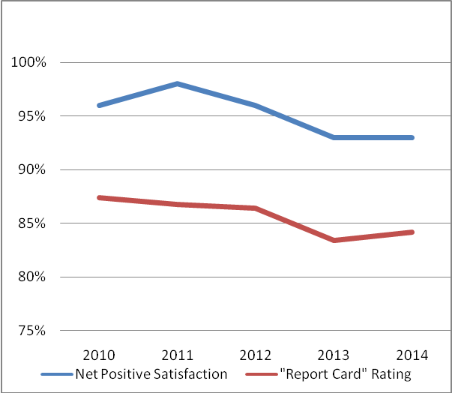

Based on questions asked all respondents, similar report card ratings were achieved for the areas of communications (82.4%), system operations (88.1%), market operations (83.5%), and system planning (82.4%). Similar net positive satisfaction ratings were achieved for customer support center responsiveness (94%), ISO Express data feed (89%), and quarterly and annual market reports (97%).
After the set of common questions, each respondent was asked a series of questions about the services provided by the ISO-NE area of primary contact. A summary of these responses is as follows:
- New England Power Pool (NEPOOL) committee members—NEPOOL committee members were generally satisfied with a series of committee meeting attributes. Net positive satisfaction ranged from 77% for the capability of teleconference and WebEx service to provide for remote participation, to 93% for the availability of committee meeting materials and minutes.
- System Operations—System Operations respondents were asked whether they are satisfied that ISO-NE is dispatching resources in accordance with market rules, operating procedures, and manuals. The overall net positive satisfaction was 95% of these respondents who expressed an opinion.
- System Planning—With respect to whether the regional system planning process allows for broad stakeholder input in developing regional solutions, the net positive satisfaction was 98% among the System Planning respondents who expressed an opinion.
- Settlement and Finance—When asked about their satisfaction with ISO-NE’s settlement of the New England markets, the net positive satisfaction was 99% among Settlement and Finance respondents who expressed an opinion. With respect to the administration of the Financial Assurance Policy, the net positive satisfaction was 86% among these respondents who expressed an opinion.
- Market Administration—The net positive satisfaction with ISO-NE’s administration of the energy markets, Financial Transmission Rights, and Forward Reserve Market was 95% among Market Administration respondents who expressed an opinion.
- Customer Service and Training—Among Customer Service and Training respondents who expressed an opinion, the net positive satisfaction was 96% for classroom training, 93% for web conference training, and 96% for web-based training tutorials.
The consultant concluded, “Our experience with customer satisfaction measurement in a variety of industries indicates that overall satisfaction levels in excess of 90% are difficult to achieve and maintain because of the complex relationship between an organization and its customers that impacts overall performance ratings. However, ISO continues to be successful in its efforts to maintain a high level of overall customer satisfaction.”

Billing Controls
This ISO/RTO performance metric identifies some of ISO-NE’s billing controls. Since 2004, ISO-NE has engaged an external audit firm to review the description of controls, evaluate the effectiveness of controls design, and test operating effectiveness of the controls for the ISO-NE “bid-to-bill” processes. These processes include market operations, settlements, market services, and finance processes, as well as supporting IT applications and processes. Overall performance is measured by an external auditor, whose opinion of “unqualified” (i.e., clean) or “qualified” is stated in an SOC 1/SAS 70 Type 2 Audit Report made available to NEPOOL participants. The results of the ISO-NE audits for 2010 to 2014 are shown in the following table.
ISO-NE SOC 1/SAS 70 Type 2 Audit Results, 2010–2014
ISO/RTO | 2010 | 2011 | 2012 | 2013 | 2014
ISO-NE | Unqualified  SAS 70  Type 2 Opinion | Unqualified  SOC 1  Type 2 Opinion | Unqualified  SOC 1  Type 2 Opinion | Unqualified  SOC 1  Type 2 Opinion | Unqualified  SOC 1  Type 2 Opinion

In 2010, four billing disputes were submitted to ISO-NE that resulted in billing adjustments of $65,759. No billing disputes were granted in 2011. In 2012, nine billing disputes submitted to ISO-NE resulted in $437,392 in billing adjustments. No billing disputes were submitted to ISO-NE in 2013. No billing disputes were granted in 2014. A billing dispute for $659,193, which was denied has been appealed, and arbitration is pending.
The total value each year from 2010 to 2014 of the wholesale electricity markets administered by ISO-NE was as follows: in 2010, $9.2 billion; in 2011, $7.6 billion; in 2012, $8.2 billion; in 2013, $8.8 billion; and in 2014, $10.5 billion. All requests for billing adjustments (RBAs) are reported to stakeholders.

D. ISO New England Specific Initiatives
The New England power system provides electricity to a diverse region across six states, ranging from rural agricultural areas to densely populated urban areas, using widely dispersed power system resources. ISO New England has a longstanding history of reliably operating the power system on a daily basis; running a competitive, efficient marketplace for wholesale electricity; successfully conducting long-term system planning for meeting New England’s future needs; and developing creative solutions for regional challenges. This section is a broad overview of current efforts to enhance grid reliability and the efficient operation of the region’s marketplace in the face of economic and environmental-policy factors affecting generator performance, fuel adequacy, and price stability.

Adjusting to a Generation Fleet in Transition
Over the last 15 years, the region’s generation fleet has been undergoing a pronounced transformation as the result of two principal drivers: First, the relatively low price of natural gas (and ease of siting) has made this fuel an attractive option for generators in the region, while rendering coal and oil plants uneconomic in the energy market for most of the year. Second, a greater number of power plants are facing retirement, not just due to remaining idle for much of the year, but also for several other economic factors. Compliance with environmental regulations aimed at reducing air and water emissions may not be economic for some thermal power plants, and competition in the energy market with zero-cost fuels may not be economic for others. Key results of the transformation
- Increasing Reliance on Natural Gas—In 2014, nearly half of New England’s electricity was produced with natural gas; in 2000, just 15% was. The availability of this fuel, especially in the winter, now has an impact on grid reliability and production costs. Because New England’s natural gas infrastructure has not kept pace with the growth in demand from both power and heating sectors, pipelines often reach maximum capacity during very cold periods. This has driven New England gas prices to record levels over several recent winters, with corresponding volatility in the wholesale electricity markets.
- Exodus of Nongas Resources—Currently, the region’s coal- and oil-fired power plants typically operate only in the winter when gas-fired generators become uneconomic or cannot get fuel and during the summer when electricity demand is highest. The combined use of coal and oil was just 6% in 2014, compared with 40% in 2000. The result of this infrequent operation has been major retirements of these resources: 10% (about 3,500 MW) of New England’s nongas generating capacity either has retired since 2013, or will retire through 2018; another 6,000 MW of coal- and oil-fired power are at risk of retirement by 2020.
- Influx of Renewable Resources—Wind and solar photovoltaic (PV) energy has been expanding dramatically in New England, spurred by state-sponsored programs, federal subsidies, tax credits, and falling technology costs. Wind power supplies only about 1% of the region’s annual electricity needs now, but makes up about 36% of proposed new generation (as of April 2015). Nameplate PV is expected to nearly triple within a decade from 900 MW at the end of 2014 to about 2,500 MW by 2024. However, the operating characteristics of wind and solar resources (i.e., intermittent output, limited ability to serve peak load, etc.) increase reliance on natural gas generators, which are typically the units that can act as fast-start reserve capacity to balance the variable energy’s output. Increasing amounts of PV connected “behind-the-meter” pose reliability issues for ISO-NE because these resources are generally not visible to ISO bulk system operations, nondispatchable, and may follow inconsistent interconnection requirements. The region will also need to invest in additional electric power transmission to deliver more northern wind energy to areas of greatest demand in southern New England.
Greater wind and solar penetration is also likely to hasten retirements of older plants, as well as shift the new generation mix toward resources dependent on capacity market revenues, such as gas-fired peaking units. This shift is due to an anticipated decline in energy market revenues for all resources when wind and solar resources are generating because they generally produce zero (or even negative) marginal-cost energy. The impact will be significant on baseload resources whose primary revenue source is the energy market.

Improving Gas-Electric Coordination
To maximize the use of existing natural gas infrastructure, in light of the region’s reliance on natural gas and pipeline constraints, ISO-NE and the natural gas sector have improved the coordination of their activities. Of note, ISO-NE accelerated the Day-Ahead Energy Market and Reserve Adequacy Analysis timelines in 2013 to more closely align the timing of the wholesale electricity and natural gas markets. The changes have decreased the number of day-ahead committed units unavailable in real time due to gas-procurement issues. In 2014, ISO-NE also increased communications with gas pipeline operators (assisted by FERC Order No. 787) to verify whether natural gas generators scheduled to run will be able to obtain fuel, thereby giving system operators better information on which to base their decisions.
On April 16, 2015, FERC issued a final rule revising natural gas scheduling practices used by interstate pipelines to better align the natural gas and wholesale electricity markets. In the rule, FERC kept the start of the natural gas day at 9:00 a.m. Central Time but changed the timing of the Timely Nomination Cycle deadline to 1:00 p.m. Central Time (from 11:30 a.m.) and added an additional intraday nomination opportunity to the gas operating day. The ISO is fully compliant with FERC’s directives, as summarized in the filing. The revised regulations also provide additional contracting flexibility to firm natural gas transportation customers through the use of multiparty transportation contracts.

Developing Tools to Accommodate Renewable Resources
To help system operators manage resources with swings in output, ISO-NE has been creating more sophisticated forecasting and dispatch tools. ISO-NE publishes daily, week-long wind power forecasts that provide greater situational awareness and allow for the more efficient use of wind resources. By the end of 2015, ISO-NE plans to add functionality to incorporate wind and hydro resources into real-time dispatch and wind power forecasts into the reserves scheduling and procurement processes. ISO-NE is also developing improved short-term forecasting tools to anticipate real-time output from solar facilities.
ISO-NE developed the nation’s first annual long-term multistate forecasts to capture the effects of installed energy efficiency (EE) measures and solar photovoltaic resources in New England, launched in 2012 and 2014, respectively. The EE forecast is used in the annual long-term system planning process for meeting the region’s needs. The ISO currently uses the PV forecast in its transmission planning studies and is exploring how to reflect forecasted PV in the long-term regional load forecast, as well.

Refining the Markets
ISO-NE has been focusing significant efforts on refining New England’s suite of wholesale electricity markets to address regional challenges. Improved price formation and performance incentives have been two underlying goals. The most impact is expected from the major changes to the energy and capacity markets, summarized here.
Energy Market Offer Flexibility (EMOF)
Implemented in December 2014, this revision of energy-market rules and ISO-NE systems allows generators to reflect fuel costs in their wholesale energy market offers as these costs change throughout the day. The improvement to real-time price formation assures that resources receive appropriate compensation for the costs they incur to operate, providing them the incentive to perform. In addition, this project expands the dispatchable range of many resources, enabling energy prices to be set more competitively—particularly helpful during low-demand conditions.
Changes in the Forward Capacity Market
Several refinements to the Forward Capacity Market went into effect with the ninth Forward Capacity Auction (FCA #9) in February 2015. The principal change, known as pay-for-performance (PFP), incentivizes investments that help ensure strong resource performance, in that poor performance can now lead to forfeiture of capacity payments. Other FCM changes help reduce revenue volatility for suppliers and attract new resources in the most valuable locations. These include a new two-step process for developing capacity zones for each FCA; the use of an auction approach that yields smaller swings in capacity prices (i.e., a systemwide downward-sloping demand curve); and a longer lock-in period for capacity prices to provide market certainty for attracting new investment. PFP will begin to take effect in the capacity commitment period starting June 2018, but it will not reach full effectiveness until the end of the seven-year phase-in period for the new performance payment rate.
With the potential for heavy saturation of wind- and solar-powered resources in the energy markets, nuclear, coal, and other baseload resources are likely to increase their reliance on the capacity market for a stable revenue stream to maintain their viability. Some of the FCM changes, as well as existing rules, ensure that the FCM is equipped to maintain reliability and market efficiency in the face of the anticipated shifting resource mix and associated declining energy market revenues for some resources.

Addressing Interim Winter Fuel Adequacy
Until PFP is effective, the region may be challenged to meet power demand any time pipeline capacity is constrained. For this reason, ISO-NE has proposed to FERC a program to address fuel-adequacy concerns for winter 2015/2016 through 2017/2018. The previous winter reliability programs for 2013/2014 and 2014/2015 played pivotal roles by incentivizing generators to arrange for adequate fuel supplies, among other measures.

Shoring Up Cybersecurity
ISO-NE is engaged at the regional and national levels in developing grid cyberdefenses and is pursuing a three-year initiative to improve corporate cybersecurity tools, procedures, and processes. To increase responsiveness to potential cyberevents, ISO-NE is creating a new 24-hour cybersecurity operations center in 2015. Furthermore, in the past two years, ISO-NE took part in the year-long process of creating the National Institute of Standards and Technology’s (NIST’s) voluntary cybersecurity standards; contributed to creating the recently FERC-approved Physical Security Reliability Standard; and participated in the GridEx II cybersecurity exercise spearheaded by the US Department of Homeland Security.

Investing in the Smart Grid
ISO-NE efforts of note include bringing data from phasor measurement units (PMUs or synchrophasors) into operations in 2015. The 40 PMUs were installed in 2013 and sample power conditions about 30 times per second, in contrast to the current four-second interval. This project has enabled new monitoring of system dynamics, fast and accurate post-event analysis, and validation of improved power system models.

Improving ISO-NE Customers’ Experience with a New Website
In August 2014, ISO-NE launched a redesigned website and data portal. With a reorganized site structure, more efficient navigation, and a new content management system, the website helps market participants, stakeholders, and other site visitors more easily and quickly access the wide variety of data, information, and other tools that ISO-NE makes available.

Activating a New Backup Control Center
In early 2014, ISO-NE’s new backup control center (BCC) became operational. The new BCC’s size and closer location to ISO headquarters allows for full and quick activation and staffing by critical ISO staff following a required evacuation of the Master Control Center. This ensures continuous reliable operation of all critical functions for the region, including operations, markets, and settlements, and satisfies FERC and NERC requirements that specify a BCC should resume operations within two hours and be capable of prolonged operation in compliance with all reliability standards.

Improving Interregional Trade
ISO-NE expects to wrap up a major initiative to update systems to support the Coordinated Transaction Scheduling (CTS) project by about late 2015. The associated tariff will allow ISO-NE and the New York Independent System Operator to improve scheduling of wholesale electricity sales between the neighboring regions. CTS will increase the frequency of scheduling energy transactions, making more efficient use of the transmission lines connecting New England and New York; enable the two grid operators to coordinate selection of the most economic transactions and reduce price disparity; and remove several fees that may impede efficient trade between regions. CTS has the potential to save millions of dollars annually on the wholesale level and will improve the ability of market participants to access the lowest-cost source of power within the regions.

Implementing FERC Order No. 1000
In mid-2015, ISO-NE began implementing changes to the region’s transmission planning process, as directed by FERC in Order No. 1000. While the order preserves both proposed and planned projects on the ISO-NE Regional System Plan Project List as of May 18, 2015, it makes material changes to the planning process going forward. Most significantly:
- ISO-NE will continue to perform system needs assessments and select the most cost-effective option to meet the identified needs. However, for those needs that extend past three years, ISO-NE will no longer develop regional transmission solution alternatives with the input of transmission owners and the Planning Advisory Committee. (The order eliminated a transmission owner’s exclusive right to build and own transmission for reliability projects.) Instead, ISO-NE will issue a request for proposals (RFP), and promising proposals will be advanced for further evaluation, after which ISO-NE will select the most cost-effective proposal. (For projects needed within three years, ISO-NE retains backstop authority.)
- The order also requires ISO-NE to evaluate the solutions offered after a public policy transmission need is identified and to select the more cost-effective or efficient project for inclusion in the Regional System Plan. For such projects, 70% of costs will be allocated to the entire region on a load-weighted basis, and 30% will be allocated to the states with the public policies driving the project.

Continuing Strong Collaboration
ISO-NE collaborates with stakeholders in all areas of its work, which continues to be a critical factor driving the region’s success in developing power system infrastructure and a competitive suite of wholesale markets. ISO-NE’s stakeholders represent a wide variety of constituencies and interests. They include New England Power Pool participants; state regulators who form the New England Conference of Public Utilities Commissioners; state and federal legislators, attorneys general, and environmental regulators; the Consumer Liaison Group, made up of state consumer advocates, consumer representatives, and other end users; and the six governors, primarily through the Coalition of Northeastern Governors and the New England States Committee on Electricity. With respect to the six governors, the ISO is serving as a resource—providing data and analyses to facilitate informed decision making—as they explore various mechanisms to drive investment in additional gas pipeline, LNG storage, and renewable energy in the region.

Midcontinent Independent System Operator (MISO)*

* Formerly known as the Midwest Independent Transmission System Operator, Inc.

Section 4 – MISO Performance Metrics and Other Information

On December 19, 2001, the Midcontinent Independent System Operator, Inc. (MISO) became the nation’s first permanent Regional Transmission Organization to be approved by the Federal Energy Regulatory Commission (FERC). Currently, MISO has 51 transmission owners with approximately 65,800 miles of transmission lines and generation owners with almost 180,000 megawatts of electrical generation that are participating in MISO’s energy markets.

On December 15, 2001, MISO began providing reliability coordination services to the transmission-owning members of MISO and their customers. On the same date, MISO also began providing operations planning, generation interconnection, maintenance coordination, long-term regional planning, market monitoring, and dispute resolution services. On February 1, 2002, MISO began providing regional transmission service under its FERC-accepted Tariff. On April 1, 2005, MISO began operating a market-based, congestion management system which included Day-Ahead and Real-Time energy markets and a Financial Transmissions Rights market. On January 6, 2009, MISO began operating a market for ancillary services and became a NERC-certified Balancing Authority.

On December 19, 2013, MISO expanded into Mississippi, Louisiana, Arkansas and Texas, collectively referenced as the South Region. The expansion included the integration of 33 new market participants, 10 new transmission owners and six local balancing authorities. Integration of the South Region into the existing MISO footprint should be considered when reviewing MISO performance metric trends for the period 2010 through 2014.
MISO’s Value Proposition demonstrates the quantifiable value we deliver to our region driven by enhanced reliability, more efficient use of the region’s existing transmission and generation assets, and a reduced need for new assets. Our 2014 Value Proposition showed that MISO delivered an estimated economic benefit of $2.7 billion to the region.
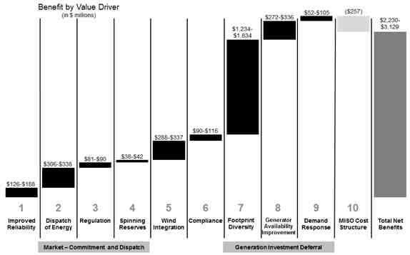
A. MISO Bulk Power System Reliability
As of December 31, 2014, MISO was registered with NERC and operating in four Regional Entity (RE) areas. The table below identifies the NERC Functional Model registrations MISO submitted effective as of December 31, 2014. Additionally, the REs for MISO are noted below in the table and links to the specific reliability standards for each RE as well as NERC are provided.
Violations of the reliability standards linked below are subject to penalty or administrative citation by the REs, the FERC, and/or NERC. Violations could be identified via an investigation, self-report, self-certification or audit. Each of these identification methods has a defined process by which NERC or the RE validates or dismisses a potential violation. If a potential violation is validated by the RE or NERC, these entities notify the FERC of the validated violation.

NERC Functional Model Registration | MISO
Balancing Authority | *
Interchange Authority
Load Serving Entity | *
Planning Authority
Reliability Coordinator
Resource Planner | *
Transmission Operator | *
Transmission Planner | *
Transmission Service Provider
Regional Entities | ReliabilityFirst, MRO, SERC, SPP
*MISO is party to a Coordinated Functional Registration (CFR) for these and only performs a subset of the functions.

Links to the specific reliability standards

Standards that have been approved by the NERC Board of Trustees are available at:
http://www.nerc.net/standardsreports/standardssummary.aspx

Additional standards approved by the ReliabilityFirst Board are available at:
https://rfirst.org/standards/Pages/ApprovedStandards.aspx

Additional standards approved by the MRO Board are available at:
https://www.midwestreliability.org/assurance/StandardsandRules/Pages/default.aspx

Additional standards approved by the SERC Board are available at:
https://serc.centraldesktop.com/standardhomepage/doc/10285789/w-SercRegionalStandards

Additional standards approved by the SPP Board are available at:
http://www.spp.org/section.asp?pageID=98

No MISO audit-identified reliability standard violation was published by NERC or FERC during 2010. In 2011, MISO self-reported compliance issues to ReliabilityFirst Corporation that resulted in zero penalties. In 2012-2013, MISO self-reported and self-certified compliance issues to ReliabilityFirst Corporation along with audit findings which resulted in penalties totaling $75,000. In 2014, MISO self-reported one compliance issue to ReliabilityFirst Corporation that is still pending.

MISO Compliance History from 2010 to 2014
Discovery Method | Self-Reported | Audit | Total Number of Violations
2010 | 0 | 0 | 0
2011 | 6 | 0 | 6
2012 | 13 | 2 | 15
2013 | 1 | 7* | 8
2014 | 1 | 0 | 1
*Resulting from the 2012 NERC CIP Audit

MISO has had no violations of applicable operating reserve standards nor has MISO shed any load in the MISO region due to a standards violation.

Dispatch Operations
MISO CPS-1 Compliance 2010-2014
Each Balancing Authority is responsible for complying with CPS-1 standards. Compliance with CPS-1 requires at least 100% throughout each rolling 12-month period. MISO was in compliance with CPS-1 for the period 2010-2014.
MISO CPS-2 Compliance 2010-2014
Each Balancing Authority is responsible for complying with CPS-2 standards or alternatively for participating in the Balancing Authority Ace Limit (BAAL) field trial which is currently being conducted by NERC as a potential replacement for CPS-2. MISO is participating in the NERC BAAL field trial and hence monitors against that proposed standard and is therefore exempt from compliance with CPS-2 per a waiver from NERC. For 2010-2014, MISO did not exceed the proposed BAAL limits for any periods greater than 30 minutes, which would have indicated a violation of the proposed standard.

MISO Energy Market System Availability 2010-2014
Availability of the Energy Management System (EMS) is key to reliable monitoring of the electric transmission system in the MISO region. MISO’s EMS has been available 100% of all hours in each year of the 2010 to 2014 period.

Load Forecast Accuracy
MISO monitors load forecasting accuracy for several different time reference points. MISO’s load forecasting accuracy has been relatively steady over the last 5 years. The day-ahead load forecasting accuracy for the data shown below is 3:30 p.m. EST of the prior day.
The day-ahead load forecast does not account for the impact of interruptible load and demand response resources (DRR). Interruptible loads and DRR have an immaterial effect on the forecast, considering the size of MISO’s load.
MISO Average Load Forecasting Accuracy 2010-2014

MISO Peak Load Forecasting Accuracy 2010-2014

While MISO does not procure capacity on behalf of Load Serving Entities (LSE), the peak demand forecasts created and submitted by each LSE directly determines the amount of capacity that each LSE must designate (potentially procure if short) to meet their planning resource obligations. If a LSE under forecasts its peak demand, this would result in the LSE under designating (or procuring) capacity, which could result in potential reliability issues. Alternatively, if an LSE over forecasts its peak demand, it will over designate (or procure) its capacity. This results in inefficient capacity procurement.
MISO Valley Load Forecasting Accuracy 2010-2014

Wind Forecasting Accuracy
MISO Average Wind Forecasting Accuracy 2010-2014
Wind forecasting accuracy is calculated using an industry-wide methodology called Mean Absolute Error (MAE). The MAE is the average of the absolute value of the difference between forecasted and actual wind power output and is expressed as a percent of installed wind nameplate capacity. The wind forecasting accuracy is represented as one minus MAE.
The wind forecasting calculation methodology differs from the calculation methodology used for the load forecasting accuracy metric because the wind forecasting calculation methodology expresses the absolute error value as a percent of installed wind nameplate capacity whereas the load forecasting calculation methodology expresses the absolute error value as a percent of total forecasted load. The wind forecasting calculation methodology used is a common practice within the industry.
MISO is continuing to explore methods for improving the accuracy of its wind forecasting, but our current accuracy appears to be consistent with the accuracy obtained in other regions throughout the world.

Unscheduled Flows
MISO Absolute Value of Total Unscheduled Flows 2010-2014
(terawatt-hours)

In 2014, MISO had 43 terrawatt-hours (TWh) of unscheduled flows across 15 interfaces. The change in unscheduled flow totals between 2013 and 2014 is a result of the increase in MISO’s footprint due to the “Southern Region Integration”, which included Entergy, South Mississippi Electric Power Association, Louisiana Generating LLC, Lafayette Utilities System, Louisiana Energy and Power Authority, and Cleco Power LLC. Also, MISO changed the methodology for this metric compared to the methodology used in the 2011 ISO/RTO Metrics Report, which covered data from 2006 to 2010. MISO is now calculating the unscheduled flows on an hourly basis, while previously MISO was utilizing a monthly aggregate unscheduled flows calculation.
MISO Absolute Value of Unscheduled Flows As a Percentage of Total Flows 2010-2014
Unscheduled flows for the top five interfaces are shown in the table below:
MISO Unscheduled Flows by Interface (TWh) | 2010 | 2011 | 2012 | 2013 | 2014
PJM | (5) | (5) | (10) | (11) | (14)
Tennessee Valley Authority | 4 | 4 | 1 | 2 | 13
Electric Energy, Inc. | 5 | 5 | 6 | 3 | 3
Ohio Valley Electric Cooperative | (7) | (7) | 0 ⁽¹⁾ | 0 ⁽¹⁾ | 0 ⁽¹⁾
Entergy | (3) | 0 | 3 | 1 ⁽²⁾ | 0 ⁽²⁾
(1) Ohio Valley Electric Cooperative was no longer an interface as of January 1, 2012, due to Duke Energy – Kentucky and Duke Energy - Ohio integrating with PJM
(2) Entergy integrated with MISO on December 19, 2013

Note: A positive value denotes unscheduled flows into the ISO/RTO; a negative value denotes unscheduled flows out of the ISO/RTO.

Parallel flows are a function of the interconnection’s operating configuration, the resistance and physics. Another characteristic of parallel flows is that they sum to zero when all interfaces between a Balancing Authority (BA) and all neighboring BAs are considered. While parallel flows from outside entities may create additional transmission system losses on a system, the real concern is the congestion the parallel flows create and the costs that are incurred when parallel flows cause facilities to exceed their limits. Parallel flows from outside entities are not limited to neighboring BAs. MISO experiences parallel flows from other BAs that do not have an interconnection with MISO.

MISO has two methods to deal with congestion caused by parallel flows. The first method, the Transmission Loading Relief (TLR) approach, was developed by NERC and aims to reduce the harmful impacts of parallel flows by curtailing transactions between areas. The second method, the Congestion Management Process (CMP) approach, assigns firm flowgate rights among seams entities that are used when congestion occurs and redispatch obligations are made based on flowgate curtailment priorities. For 2014, seams agreements that contain CMPs existed between MISO, PJM, SPP, and Manitoba Hydro. Several MAPP entities took Part II Seams Service under Module F.

In 2012, the phase angle regulators (PARs) on the Ontario-Michigan interface became operational to control Lake Erie loop flows. In January 2014, MISO, PJM and Independent Electricity System Operator for Ontario (IESO) completed an evaluation of the PARs on the Ontario-Michigan interface and their ability to maintain actual flow within a 200 MW bandwidth of scheduled flow and produced an Evaluation Report. The Evaluation Report follows from the Regional Power Control Device Coordination (“RPCDC”) Study report published in 2011 as a joint effort among IESO, MISO, NYISO, and PJM.

Transmission Outage Coordination
The impact of transmission outages on generation availability and on declared emergencies is mitigated by provisions in the MISO Tariff and Outage Operations Business Practices. MISO’s transmission owners are required to request advance approval of transmission outages associated with scheduled maintenance. MISO is required to study and approve or disapprove those requests within certain time periods prior to implementing outages. Generally, generation outage requests are required to be submitted prior to submission of transmission outage requests. Transmission outage requests are then analyzed and approved or rescheduled to maintain transmission system reliability and minimize impact on generation availability. Transmission outage requests are also analyzed, approved or cancelled to ensure that the outage does not result in a declared emergency.
The following metrics reflect the performance of the parties with respect to transmission outage coordination.
MISO Percentage of > 200kV planned outages of 5 days or more that are submitted to ISO/RTO at least 1 month prior to the outage commencement date 2010-2014
MISO Percentage of planned outages studied in the respective ISO/RTO Tariff/Manual established timeframes 2010-2014
MISO’s business practices allow for exceptions (i.e., extensions) to its planned outage study timeframe in prescribed situations. However, MISO does not track those extensions in a centralized location. Therefore, MISO statistics shown above do not account for these prescribed extensions and represent lower than actual performance.

MISO Percentage of > 200 kV outages cancelled by ISO/RTO after having been previously approved 2010-2014
MISO has the authority to cancel or reschedule previously-approved planned transmission outages if such outages would jeopardize system reliability conditions. However, MISO has only needed to cancel or reschedule a very small percentage of transmission outages that it had previously approved.
MISO Percentage of Unplanned > 200kV outages 2010-2014
Unplanned transmission outages may occur due to equipment malfunctions on the transmission line or an adjacent substation. They can also occur due to weather conditions that cause a transmission facility to trip out of service. Over the 2010 – 2014 time period, 23 – 25% of the outages of transmission assets in the MISO Region with 200 kV or higher voltages have been unplanned.

Transmission Planning
MISO develops an annual regional expansion plan, the MISO Transmission Expansion Plan (MTEP), that combines a top-down and bottom up approach to planning with generation interconnection and policy need assessment to address reliability, economic, and public policy driven transmission issues. The MTEP planning process, in conjunction with a coordinated open stakeholder process, focuses efforts on identifying issues and opportunities to strengthen the transmission system, developing alternatives for consideration, and evaluating those options to determine effective solutions. The goal is to identify transmission projects:
- Ensuring the reliability of the transmission system
- Providing economic benefit, such as increasing market efficiency
- Facilitating public policy objectives, such as the integration of renewable energy
- Addressing other issues or goals identified through the stakeholder process
The overall MTEP planning approach has two key parts. First, MISO runs a reliability screen of the entire footprint, and then works with the transmission owners to include and then optimize the bottom-up approach discussed in the next paragraph. Second, MISO’s Value-Based Planning approach, discussed later in this document, looks out fifteen or more years into the future to find transmission needs under a number of different, plausible scenarios.
As part of the bottom-up (local) process, transmission owners in MISO are responsible for submitting their transmission construction plans to MISO for evaluation and possible inclusion in Appendix A of the MTEP. After thorough analysis, projects identified as the best solution for a particular issue or opportunity are included in Appendix A of the MTEP report and recommended for approval by the MISO Board of Directors (BOD). Once approved by the BOD, the transmission owner (or the selected transmission developer, in periods after the effective date of tariff revisions relating to Order No. 1000) is required to make a good faith effort to complete the project. The following metrics give insight into the process and its results.
MISO Number of Transmission Projects Approved to be Constructed for Reliability Purposes 2010-2014

MISO Percentage of Approved Facilities In-Service by December 31, 2014 (Reliability Only)

Projects that have been validated by MISO as the preferred solution to address an identified need, but do not yet need to be recommended are assigned to Appendix B. If still justified or optimized through a subsequent MTEP planning cycle, projects in Appendix B will move to Appendix A for BOD approval and subsequent construction.
Value Based Planning Process
MISO, in collaboration with its transmission owners and other stakeholders, also develops plans to enhance market efficiency and enable state/federal public energy policies while maintaining system reliability through the top-down value based planning process.
The uncertainties surrounding future policy decisions create challenges for those involved in the planning function and cause hesitancy for those with the resources to undertake transmission expansion projects. To minimize the risk in building a system under such conditions, the planning process must consider transmission projects in the context of all potential outcomes. The goal is to develop the most robust plan under a wide variety of economic and policy conditions, resulting in the least amount of future regrets in areas such as cost incurred, right of way used, and benefits achieved. This Value Based Planning Process seeks to meet this challenge through the execution of seven steps, including:
- Defining potential future energy policy outcomes
- Identifying generation capacity expansions that must occur in order to meet the objectives of each future scenario
- Modeling the potential location of generation
- Designing a conceptual transmission plan under each future
- Robustness testing to identify projects that perform well under most—if not all—future scenarios
- Testing the transmission plan against reliability criteria
- Determining cost allocation
In addition to the seven step process above, which serves to build the business case for new investment, additional conditions need to be met in order to develop transmission investment driven by public policy needs. There needs to be relative consensus around the public policy needs that are being addressed. Broad adoption of renewable portfolio standards and increased regulation from the Environmental Protection Agency are two examples of such areas of public policy. There also needs to be a cost allocation and recovery mechanism in place that includes investment driven by public policy or other regional or inter-regional economic and reliability needs.
The best fit projects developed through this seven step process are submitted for potential Appendix A inclusion in the current MTEP planning cycle.
Demand response and energy efficiency programs and their impacts are currently reflected in the cumulative demand and energy growth rates. If a particular combination of Demand Side Management (DSM) programs is found to be economically viable, then the DSM programs will be included in the transmission planning and economic models as future generation units, and a lower demand will be reflected due to the energy efficiency programs. This in turn will have an impact on preliminary transmission portfolio design and affect—to greater or lesser degrees—the overall robust transmission overlay that will be proposed. The degree of DSM’s impact on the regional plan, although dependent on many variables, may be substantially lessened if the transfer capability of the system is too low. If the transfer limits of the system are insufficient, DSM resources that may be the most economic may become trapped behind a transmission constraint.
Demand response may also be considered as a solution to an identified transmission issue. In order for demand response to be used as a solution, it must be evaluated in the MISO planning process, found to be the most effective solution and have benefits that are equivalent in certainty to those of alternative projects. This equivalent certainty will most likely be in the form of a legally binding contract that will the demand response solution enforceable, similar to the conditions required for an MTEP Appendix A transmission project.
With the addition of significant amounts of intermittent resources such as wind turbines to the transmission grid, the ability to store large amounts of energy for use during high demand times is becoming more important. Energy storage is becoming economical through the implementation of new technologies such as large-scale battery systems, flywheels, modifying the dispatch of wind generation to supply ancillary service products, and compressed air energy storage. MISO is currently investigating the feasibility of energy storage as another transmission alternative in the MTEP planning process.
MISO has been assessing evolving environmental policies since 2008 to lay the foundation for investigation into carbon regulation impacts. The most recent study effort currently underway is the Clean Power Plan impact analysis to help better understand the potential impacts of carbon reduction on transmission system operation.

MISO Performance of Order No. 890 Planning Process
A key element of the Order No. 890 Planning Requirements is the involvement of transmission customers early and throughout the MTEP planning process. Subregional Planning Meetings (SPMs) are held in the West, Central, East, and South planning regions of MISO. These SPMs provide forums for stakeholders to obtain information and to provide feedback on transmission projects proposed in the current cycle. Additionally, Technical Study Task Force (TSTF) meetings are convened as needed to discuss analytical results in greater detail or when these results are Critical Energy Infrastructure Information (CEII).
In accordance with Order No. 890 and NERC standards, MISO completed the following reliability studies in 2014: AC contingency, dynamic stability, voltage stability, load deliverability, generation deliverability, transfer capability assessment, nuclear plant assessment, and long-term transmission rights. MISO also completed studies in 2014 to exploit the potential for economically justified projects through Market Congestion Planning studies for both North/Central and South regions. In an effort to enhance interregional coordination and plan transmission more efficiently and cost effectively, MISO and PJM completed a two-year Joint Planning study in 2014 to evaluate seams congestion issues and potential transmission solutions, and MISO and SPP are in the process of conducting a Coordinated System Plan study convened in June 2014. The results of these studies can be found in the MTEP 2014 report.
The MTEP 2014 report is available at www.misoenergy.org.

Generation Interconnection
MISO Average Generation Interconnection Request Processing Time 2010-2014
(calendar days)
The metric for processing time for generation interconnection requests was calculated using the date an interconnection request entered the MISO generator interconnection queue as its start date. The end date was either the date an Interconnection Agreement (IA) was achieved or the date the interconnection date was withdrawn.
After FERC approval in 2012, MISO’s revisions to its interconnection process created separate paths – System Planning and Analysis (SPA) and Definitive Planning Phase (DPP) – based on project readiness in an effort to remove the uncertainty caused by projects withdrawing late in the interconnection process. These revisions have resulted in an overall lower queue volume in terms of the number of interconnection requests and cumulative megawatts. Since the revisions took effect there have been fewer projects withdrawing after completing or nearly completing the full set of interconnection studies. However, withdrawing projects that had already completed the interconnection study process prior to the latest process revisions have caused several restudies that have affected interconnection requests that proceeded through the study process over the last 3 years.
As further elaborated in the Interconnection Service Requests section of this report, the Tariff revisions and other process efficiencies MISO has been working on have continued to decrease the time and cost of interconnection studies. MISO expects the overall processing time of interconnection requests, above, to move in a downward trend over the next several years as the process improvements that have already been implemented continue to mature.
MISO Planned and Actual Reserve Margins 2010-2014
MISO’s resource adequacy mechanism was established in 2009. Prior to that time reserve margins were set by the Regional Reliability Organizations in the area. In 2013, MISO moved from a monthly resource adequacy framework to an annual construct with a location-specific approach. In both instances, MISO cleared capacity to the level required based on planned reserve margin, meaning that the actual committed capacity was equal to the reserve margin. This approach is designed to provide efficient price signals to encourage the appropriate resources to participate in locations where they provide the most benefit and creates a variety of options for LSEs to obtain the resources required, including Fixed Resource Adequacy Plans, bilateral transactions, self-scheduling, capacity deficiency payments, and through MISO’s voluntary Planning Resource Auction (PRA). Demand response and behind-the-meter generation (BTMG) are defined as planning resources in the MISO resource adequacy mechanism and are called Load Modifying Resources (LMR). LMR are required to meet specific criteria established by Module E-1 of the MISO Tariff in order to be registered and eligible to be used to meet LSEs’ capacity requirements.

MISO Demand Response Capacity as Percentage of Total Installed Capacity 2010-2014
MISO changed the methodology for this metric compared to the methodology used in the 2011 ISO/RTO Metrics Report which covered data from 2006 to 2010. MISO is now calculating the demand response available in the peak month, while previously MISO was including demand response for all months.
MISO fosters demand response in the region through dynamic pricing and direct load control/interruptibles. As a result, generation infrastructure investment is deferred by reducing load during times of system peaks. Demand Response provided close to 5 GW of capacity for the peak month of each year in the period. The deferral of generation infrastructure investment represents theoretical savings of $52 million to $105 million in 2014 with the anticipation that savings will increase in future years.
In 2013, MISO instituted a Resource Adequacy Construct which allows Load Serving Entities (LSE) to procure capacity to meet reserve requirements through bilateral contracts, self-supply, or the PRA. Individual LSE reserves are based on monthly peak load forecasts. These peak forecasts do not sum to the system coincident peak because they are reported based solely on the entity’s own peak, which could occur at a different time than the system peak. To account for this diversity within the system, a reserve margin was calculated for application to individual LSE peaks utilizing a diversity factor. This resulted in an individual LSE reserve level that is reduced from what would otherwise be a higher reserve without accounting for diversity.
The reduced reserve level delays the need for new capacity. The MISO 2014 Value Proposition calculated a benefit of $1.2 billion to $1.8 billion assuming no excess capacity based on the cost of building new combustion turbine capacity. The benefit is the avoided annual revenue requirement of that avoided capacity.
There are numerous factors that impact the adequacy of the actual reserve margin vis-à-vis the projected reserve margin, including load forecasts and energy efficiency trends. When MISO calculates the Planning Reserve Margin (PRM), there are a number of key factors that impact the results:
- Congestion: Changes in the amount of transmission congestion on the MISO system. Congestion incorporates the notion of aggregate deliverability impact and a quantifiable MW capacity impact upon Loss of Load Expectation (LOLE) achieved.
- Load Forecast Uncertainty: MISO utilizes the summation of the NERC Variances method to calculate the load forecast uncertainty value. This method produces a sigma value. The summation of the NERC Variances method has a solid methodology and the NERC Load Forecasting Working Group has consistent input from MISO membership. More forecast error is introduced for example due to the recent economic downturn.
- Forced Outage Rates: Forced outage rates are adjusted to exclude certain outage types, deemed as outside of management control, and account for the time when a unit was in demand. These adjustments to the forced outage rates yielded an Effective Forced Outage Rate Demand (EFORd) that excluded certain outages which is known as XEFORd.
- External Support: MISO determines the level of support the external systems can provide based on historical total transmission flows and contractual flows. That applicable external support level is held to the same reliability level as the internal system.
- Membership Changes: The impact of the entrance and departure of members from MISO market and reliability systems are factored into the PRM determination.
- Modeling Improvements: As MISO compiles more accurate and comprehensive data on modeling factors such as generator performance, outages, and load shapes, the data improves the accuracy of the modeling results.

MISO Percentage of Generation Outages Cancelled by ISO/RTO 2010-2014
The chart above includes cancelled generation outages that were denied or revoked by MISO.
MISO Generation Reliability Must Run Contracts 2010-2014
When a generating unit that wishes to retire or be mothballed is required to continue to operate for reliability purposes, it is known in MISO as a System Support Resource (SSR). MISO had no units under these types of contracts in 2010 or 2011. The following charts provide details about the System Support Resource (SSR) Agreements in place with units within MISO for 2012-2014. Through its planning processes, MISO has either developed or is developing permanent reinforcements such that MISO will be able to terminate these agreements while continuing to ensure reliability of the transmission system.
MISO Number of Generating Units under SSR Agreements*
MISO Capacity (MW) under SSR Contracts*
* SSR Agreements may not be effective for entire calendar year
Interconnection / Transmission Service Requests
As a result of the 2012 queue reform, MISO saw an immediate decrease in the volume of interconnection requests in the active queue in terms of the number and size (in megawatts). The process changes were designed to reduce the uncertainty caused by project withdrawals late in the interconnection process by creating two paths depending on a projects readiness to proceed. As a result, projects must either proceed through the Definitive Planning Phase (DPP) or proceed through the System Planning and Analysis (SPA) phase.These process changes have resulted in fewer withdrawals during the final stages of the interconnection process or after an Interconnection Agreement (IA) was issued. However, the withdrawal of interconnection requests that were processed prior to the implementation of the 2012 queue reform has resulted in several restudies over the last 3 years. As the number of requests that can trigger this behavior continues to decline, MISO expects the occurrence and scope of impact of restudies to also continue to decline.
Over the last 3 years, MISO has seen a downward trend in the average time to complete studies, which has also resulted in a lower average cost of performing studies. This downward trend is the result of the tariff revisions and ongoing process improvements to MISO’s business practices and tools that continue to be implemented.
MISO Number of Study Requests 2010-2014
This metric calculates the number of interconnection requests MISO received each year. Each interconnection request may have several studies performed (Feasibility, System Impact Study, Facilities Study).

MISO Number of Studies Completed 2010-2014
MISO’s generation interconnection process includes three potential types of studies – Feasibility Studies, System Impact Studies (SPA or DPP), and Facilities Studies. For this metric, MISO has accumulated all study types.

MISO Average Aging of Incomplete Studies 2010-2014
(calendar days)
This metric demonstrates the average age of each incomplete or active study at the end of each calendar year, including Feasibility, System Impact, and Facilities Studies. The average age of incomplete studies is calculated differently than average aging of incomplete interconnection requests.
MISO Average Time to Complete Studies 2010-2014
(calendar days)
This metric is calculated by taking the study end dates minus the study start dates for each year and averaging it. It calculates the average duration for all study types completed each year, including Feasibility, System Impact, and Facilities Studies. For the year 2014, Feasibility Studies averaged 11 days, SPA System Impact Studies averaged 254 days, Optional Studies averaged 149 days, DPP System Impact Studies averaged 338 days, and Facilities Studies averaged 198 days. The combined average for all completed studies in 2014 was 62 days.
MISO Average Cost of Studies Completed 2010-2014

This metric captures the average total study cost, including all study types (Feasibility, System Impact, Optional, and Facility Studies) for completed interconnection requests.

Special Protection Schemes
MISO Number of Special Protection Schemes 2014

MISO had 35 special protection schemes (SPS) in 2014. Of the 35 SPSs, MISO’s Central Region had 10; the North Region had 24 SPSs; and the South Region had 1. There were no misoperations of SPSs and no intended or unintended activations of SPSs during 2014.

B. MISO Coordinated Wholesale Power Markets
For context, the table below represents the split of the $38.7 billion dollars billed by MISO in 2014 into the primary types of charges its members incurred for their transactions.
(dollars in millions) | 2014 Dollars Billed | Percentage of 2014 Dollars Billed
Energy | $ 31,957.8 | 82.7%
FTR | 4,114.6 | 10.6%
Transmission Service | 2,003.5 | 5.2%
Administrative Costs | 246.7 | 0.6%
Resource Adequacy | 145.0 | 0.4%
Contingency Reserves | 92.6 | 0.2%
Regulation Market | 86.6 | 0.2%
Other | 32.9 | 0.1%
Total | $ 38,679.7 | 100.0%

MISO Demand Response as a Percentage of Synchronized Reserve Market 2010-2014

MISO Demand Response as a Percentage of Regulation Market 2010-2014
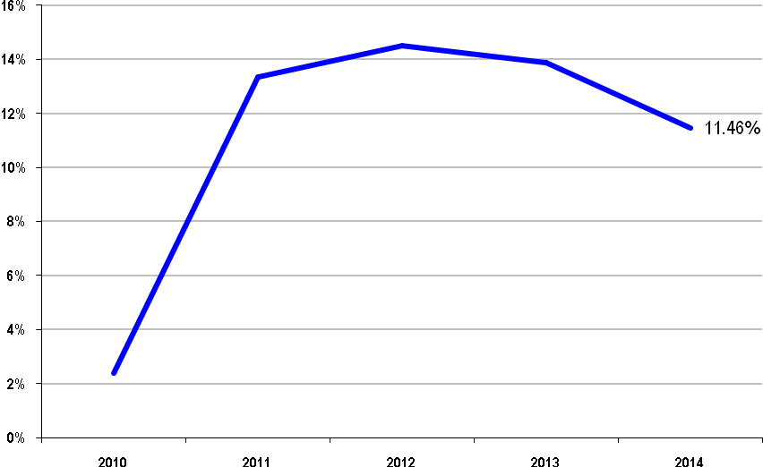

Market Competitiveness
MISO Energy Market Price Cost Markup 2010-2014
MISO calculates price cost markup by comparing the system marginal price based on actual offers to a simulated system marginal price based on assuming suppliers had all submitted offers at their estimated marginal costs.
The overall price cost markup percentages over the past five years support the conclusion that prices in MISO are set, on average, by marginal units operating at or close to their marginal costs.
MISO New Entrant Gas-Fired Combustion Turbine (CT) Net Generation Revenues 2010-2014
(dollars per installed megawatt year)
MISO New Entrant Gas-Fired Combined Cycle (CC) Net Generation Revenues 2010-2014
(dollars per installed megawatt year)
In 2014, MISO markets would not have supported investment in either gas CT or CC generation units based on their annualized costs of new investment. The MISO footprint has a capacity surplus that prevents significant periods of shortage, particularly at reduced load levels.

MISO Real-Time Energy Market Percentage of Unit Hours Offer Capped due to Mitigation 2010-2014
MISO’s mitigation measures are intended to preclude abuses of locational market power while minimizing interference with the market when the market is workably competitive. MISO only imposes mitigation measures when suppliers’ conduct exceeds well-defined conduct thresholds and when the effect of that conduct on market outcomes exceeds well-defined market impact thresholds. By applying these conduct and impact tests, the mitigation measures are designed to allow prices to rise efficiently to reflect legitimate supply shortages, while effectively mitigating inflated prices associated with artificial shortages that result from physical or economic withholding in transmission-constrained areas.
In the years 2010 to 2014, total unit hours mitigated in a year ranged from 53 hours to 231 hours. Consequently, the unit hours offer capped due to mitigation is extremely small when calculated as a percentage of total unit hours.
Potomac Economics, MISO’s Independent Market Monitor, provides a competitive assessment of MISO markets in its 2014 State of the Market Presentation that includes a review of potential market power indicators, an evaluation of participants’ conduct, and a summary of the imposition of mitigation measures in 2014.
Regarding market concentration as measured by the Herfindahl-Hirschman Index (HHI), Potomac Economics states the market concentration of the entire MISO region is relatively low although they are considerably higher in the WUMS and South regions. Potomac Economics continues by pointing out that the HHI measure is only a general indication of market conditions. HHI does not consider demand, network constraints, or load obligations.
Potomac Economic states that a better metric for evaluating competitive issues in electricity markets is determining if a supplier is “pivotal”. A supplier is “pivotal” when its resources are needed to meet load demand or alleviate a constraint.
Potomac Economics conducted a pivotal supplier analysis for individual transmission constraints in periods during which the constraints were active. The analysis showed that 94% of Broad Constrained Areas (BCAs) had a pivotal supplier in 2014, up from 88% in 2013. The results indicate that while local market power is most commonly associated with the Narrow Constrained Areas (NCA) constraints, a large share of Broad Constrained Areas (BCA) constraints in 2014 created significant potential for local market power, particularly during the summer months. BCA and NCA mitigation continues to be essential. However, Potomac Economics states, “While substantial local market power exists, there was little evidence of attempts to physically or economically withhold resources to exercise market power.”
MISO’S 2014 State of the Market Report states that market power mitigation in the MISO’s energy and ancillary services market occurs pursuant to automated conduct and impact tests that utilize clearly-specified criteria. Because conduct has largely been competitive, market power mitigation has been infrequent. However, Potomac Economics identified a competitive concern associated with commitments to satisfy local reliability needs that warrant an expansion in the mitigation measures. Specifically, provisions need to provide greater flexibility in identifying NCAs and amend formulas to capture transitory congestion events.
With respect to price volatility, MISO’s 2014 State of the Market Report states:
- “Despite the decline in 2014, MISO historically has had greater price volatility than its neighboring RTOs because MISO runs a true five-minute real-time market (producing a new real-time dispatch every five minutes).”
- “MISO has made significant efforts to improve the commitment, dispatch, and pricing of units in recent years. The efficiency of real-time commitments improved with the introduction of a Look-Ahead Commitment (LAC) tool. MISO is currently developing a “Ramp Capability” product, set for implementation in 2016, which will result in the real-time market holding additional ramp capability when the projected benefits exceed its cost. This product should improve MISO’s ability to manage the system’s ramp demands. We believe this product will be beneficial and continue to recommend its adoption. We also support MISO’s decision to evaluate the incremental benefits of a Look-Ahead Dispatch tool after deployment of the ramp product.”

Market Pricing
MISO Average Annual Load-Weighted Wholesale Energy Prices 2010-2014
($/megawatt-hour)
The average annual load-weighted wholesale energy prices substantially reflect the changes in fuel costs. These trends are supported by the chart below that shows the trends in the costs of key fuel sources for generation units in the U.S. electricity industry.
Day-ahead and real-time LMPs at the annual MISO system peak load hour show the strong correlation between the load and prices. The LMPs from 2010 through 2012 moved in the same direction as the changes in real-time load, with an exception for real-time prices in 2010. Real-time peak prices in 2010 were suppressed by wind output of 4 to 5 GW combined with significant surplus capacity. In 2013, LMPs are influenced by lower fuel costs and decline in weather induced electric demand due to relatively milder weather. In 2014, the peak load increased due to addition of the MISO South region. When adjusted for membership, system peak load decreased by 6.2% compared to the peak in 2013. Day-ahead and real-time LMPs at the peak load hour decreased by 25.6% and 41.7%, respectively. Lower fuel prices, surplus reserve capacity and decreased weather-sensitive demand in the Central Region contributed to lower 2014 prices.

U.S. Nominal Fuel Costs 2010-2014
($ per million Btu)

Source: U.S. Energy Information Administration, Independent Statistics and Analysis, US Electricity, Fuel Costs

MISO Average Annual Load-Weighted
Fuel-Adjusted Wholesale Spot Energy Prices 2010-2014⁽¹⁾
($/megawatt-hour)

- MISO’s base year for fuel-cost references is 2009.
MISO Wholesale Power Cost Breakdown 2010-2014
($/megawatt hour)
On an annual basis, energy costs have comprised 90% – 92% of MISO’s total wholesale power costs for the past five years. All other components of MISO’s wholesale power cost per megawatt hour account for less than 8% – 10% of the total costs per megawatt hour. In particular, the operating reserve costs (sometime referred to as uplift) vary from year to year, but represent on average $0.50 per megawatt hour of the total wholesale power cost in the MISO Region. In 2010 through 2014, such uplift costs represented 0.3% – 1.4% of the total wholesale power cost per megawatt hour during that five-year period.

Impacts of Demand Response on Market Prices

MISO continues to enhance the ability of demand response to participate in its markets, including energy, ancillary services, and capacity. Efforts are ongoing to identify potential barriers and to provide solutions that encourage Market Participants to include demand response in their market portfolios. While the footprint has been long in capacity for some time, demand response has demonstrated its long-term potential during certain periods. For example, during the August 1, 2006 event, approximately 3,000 MW’s of demand response responded for ten hours. Corresponding clearing prices during this window declined by $100/MWh - $200/MWh for gross participant savings of over $3 million. Market participants benefitted from the reduction in energy prices as well as from the reliability assistance provided to the system.
Unconstrained Energy Portion of System Marginal Cost

MISO Annual Average Non-Weighted, Unconstrained
Energy Portion of the System Marginal Cost 2010-2014⁽¹⁾
- Using the marginal energy component of LMP is consistent with how MISO publishes System Lambda in FERC Form No. 714.

Pricing in the MISO wholesale markets is heavily influenced by underlying fuel prices. The values in the table above reflect the fuel price decreases experienced from 2010 to 2012 as well as the fuel price increases in 2013 and 2014.

Energy Market Price Convergence
MISO Day-Ahead and Real-Time Energy Market Price Convergence 2010-2014

The data in the chart above reflects significant convergence between day-ahead and real-time prices in MISO’s energy markets for the period 2010 through 2014.

MISO Percentage of Day-Ahead and Real-Time Energy Market Price Convergence
2010-2014

Congestion Management
MISO Annual Congestion Costs per Megawatt Hour of Load Served 2010-2014
In 2014, MISO continued its market congestion planning study (MCPS). The analysis primarily identifies system congestion trends from both historical market data and forecasted future congestion patterns based on out-year production cost model simulations.
In the MISO North/Central MCPS, a total of 135 transmission solution ideas were proposed and studied. MISO evaluated these solution ideas in conjunction with North/Central stakeholders and formulated 27 preliminary project candidates for further transmission evaluation to ensure both economic and reliability needs will be met. Of the 27 preliminary project candidates, seven were selected as best-fit project candidates with a weighted net present value (NPV) benefit to cost ratio above 1.25. All seven best-fit project candidates were then carried forward into 2015 MCPS study for further evaluation.
In the MISO South MCPS, a total of 82 transmission solution ideas were proposed and studied. MISO evaluated these solution ideas and formulated 21 preliminary project candidates for further robustness testing, in conjunction with South region stakeholders. Of the 21 preliminary project candidates, 10 were selected by MISO with stakeholder inputs as best-fit project candidates that produced a weighted NPV benefit-to-cost ratio greater than 1.25. Of these 10 selected best-fit project candidates, three project candidates met the Market Efficiency Project (MEP) criteria based on future weighted benefit-to-cost ratios.

MISO Percentage of Congestion Dollars Hedged Through ISO/RTO Congestion Management Markets
The relationship between congestion revenues collected by MISO and congestion payments to Financial Transmission Right (FTR) holders is correlated with, but not equal to, congestion cost incurred by Load Serving Entities (LSE). FTR value is paid to FTR holders whether or not the generator source used to serve LSE load matches an FTR source. Under least-cost regional dispatch, generation from sources other than the FTR source will be utilized when it is cost effective. As a result, FTR value may exceed congestion costs incurred for a particular FTR source and sink path. In addition, FTR holders receive revenues to offset congestion costs from sources other than FTRs. Specifically, in addition to FTR revenues realized from the day-ahead market, LSEs receive an allocation of FTR/ARR auction revenue.
Resources
MISO began using Generating Availability Data System (GADS) information for Resource Adequacy in the June 2009 – May 2010 resource Planning Year. Since the last ISO/RTO report was issued, MISO has continued to use the same type of GADS information to calculate the forced outage rates that are used to determine generator Unforced Capacity (UCAP) values. These values determine how much a generator can be relied upon for Resource Adequacy. Annual generator availability values are provided below. It is important to note that significant changes in membership occurred during the period. Specifically, FirstEnergy and Duke Energy of Ohio and Kentucky exited in 2011 and the South Region joined in 2013.
MISO Annual Generator Availability 2010-2014
MISO’s 2014 Value Proposition quantifies the benefit of improved generator availability using the Equivalent Availability Factor. MISO’s wholesale power market has resulted in power plant availability improvements of 1.9%, delaying the need to construct generation infrastructure. The deferral of generation infrastructure investment represents savings of $272 million to $336 million in 2014.

Reduction of market constraints / market congestion planning analysis
In an effort to enhance market efficiency, MISO planning evaluates transmission needs, historical binding constraints as well as forecasted future congestion patterns, and identifies efficient and cost effective transmission solutions to address market congestion through the Market Congestion Planning Study as part of the annual MISO Transmission Expansion Plan (MTEP) report. For example, in the MTEP 2014 report, Section 5.3 (Market Congestion Planning Study) describes the analysis of market congestion planning studies for MISO North/Central and South regions. Refer to the 2014 MTEP report for additional details, which can be found at www.misoenergy.org.
Improving market efficiency
Through collaborative effort via the MISO stakeholder process, MISO is always seeking ways to improve overall market efficiency. On March 1, 2015 Extended Locational Marginal Pricing (ELMP) has been successfully implemented in MISO’s market, which allows MISO to better ensure that the true cost of energy is represented in the market. The Parallel Operations were conducted in 2014. By incorporating commitment costs for fast-start resources and utilizing off-line fast start resources in price formation for scarcity conditions and constraint management, ELMP is able to provide a more stable, dependable price signal and reduce uplift charges.
MISO enhanced its real-time commitment capabilities with the implementation of the Look-Ahead Commitment (LAC) Tool in April 2012. The LAC tool enables improved efficiencies through optimized resource commitment over the near-term future period. Since implementation, LAC has been utilized by Intra-Day Reliability Assessment Commitment (IRAC) personnel to commit resources when needed for capacity, as well as to minimize the system’s overall production cost.
With the discontinuation of constraint relaxation for non-market-to-market constraints and a single step marginal value limit in place in 2012, some undesirable and potentially inefficient market outcomes have been observed. Transient price spikes have occurred for small exceedances of transmission power flow over the binding limit. In 2013, MISO implemented a multi-step transmission constraint demand curve which mitigates undesirable market outcomes and manages transmission constraints in a more economical manner.

Demand Response Availability

Load Modifying Resources (LMR) are demand resources that are only available under emergencies. MISO has not experienced the need to deploy LMRs in an emergency (such as via Emergency Operating Procedures [EOP-002]). Consequently, MISO does not have a record of LMR performance since the launch of the new Resource Adequacy construct in 2009. Despite this, MISO continues to work with stakeholders and industry organizations on a number of key areas of demand response availability. All approaches being developed by MISO and its stakeholders shall take into account any applicable state regulatory, Reliability Entities (RE), or other non-jurisdictional entities requirements regarding duration, frequency, and notification processes for the candidate Demand Resources.
MISO Demand Response Enhancements
MISO is pursuing or has pursued many improvements to evolve demand response resource participation in the region. These enhancements include:
- Extended Locational Marginal Pricing (ELMP): On March 1, 2015, this new methodology for determining energy prices went into effect. ELMP will allow, among other market benefits, emergency demand response (‘EDR’) resources to set the market price when called upon to reduce demand.
- Price Responsive Demand (PRD): MISO is currently working to develop, with stakeholder participation, appropriate methods to allow for PRD in its real-time energy markets. Already able to participate in the day-ahead markets and also in MISO’s Resource Adequacy construct, PRD’s inclusion in real-time markets could significantly impact the amount of other reserves required to reliably operate the system.
- Aggregators of Retail Customers (ARC): MISO has the ability to allow for the aggregation of demand response resources by non-Load Serving Entities. Internal systems are in-place for this new service per FERC Order No. 719.
- “Batch-load” demand response: Large-scale industrial processes are sometimes forced to interrupt their use of electricity for very brief time spans (less than 10 minutes). These industrial processes normally use large amounts of electricity and are able to reduce their use (from normal levels) for several hours at a time, but have been reluctant to register their resources because of measurement and verification (M&V) issues related to the brief interruptions that could significantly impact the calculation of the benefit of such reduction. MISO is currently investigating the clarification of the M&V that would enable the economically efficient incorporation of these demand response resources.
- Demand Response Availability Data System (DADS): MISO continues to evaluate the potential to incorporate DADS data into the reliability processes.
- Demand Response / Energy Efficiency (DR/EE): MISO has incorporated DR/EE in both its enhanced resource adequacy construct and long-term planning process (MTEP). Additionally, a second study is underway to update longer term (forecasted) Demand Response, Energy Efficiency and Distributed Energy Resources within the footprint.
- Phase II NAESB Standards: MISO has incorporated the NAESB standards for demand response M&V into the MISO Tariff.
- Load Modifying Resources (LMR) deliverability: The deliverability of LMR may have long-term implications for reserves, as potential LMR providers weigh the benefits and restrictions of providing LMR services to the wholesale market. MISO has implemented this design element as part of the Resource Adequacy annual Planning Resource Auction.
- Barriers to Demand Response: MISO continues to seek ways to reduce and eliminate barriers to demand response participation in all of its markets. Barriers to demand response take a variety of forms, often related to the historical precedence of generation. That is, current wholesale markets are based on the primacy of generation, with rules and procedures that were designed to fit generation resources. Demand response resources are often subject to the same requirements or limitations that are appropriate for generation, but are more onerous for demand response. Examples include:
  - Definitions of contractual relationships between ARCS, LSEs, and electric distribution companies
  - Definitions of physical/economic withholding, as it applies to ARCs
  - Metering and forecasting standards and requirements
  - Energy market issues involving day-ahead and real-time requirements for reserve offers
  - Inability of demand response resources (DRR) to control the amount of their offer in energy and ancillary services markets
- DRR (Demand Response Resource) Tool: The efficient use of demand response resources requires a support system that enables participants and administrators to input, track, and report on those resources. The DRR Tool, developed by MISO specifically for demand response, provides a state-of-the-art, web-enabled system to accomplish both basic and advanced tasks including registration, double-counting avoidance, automatic reporting and alert features, and measurement and verification reports. In 2014, the DRR Tool’s functionality was expanded to include the same benefits for LMRs.
- DRR Spin Services: Widespread agreement is being reached that the most efficient (and economic) use of demand response resources lies in the provision of reserve services. MISO has consistently pursued the goal of allowing DRRs to participate in any and all markets based not on a programmatic approach – susceptible to prevailing political winds – but rather based on the physical capabilities of the resources. Market design and existing software capabilities often combine to discourage or preclude DRRs from participation in reserve markets despite their physical ability to provide such services. MISO was able to add spinning reserve service to those available to DRR during 2009, albeit with a 10% cap on the total MW allowed. In 2014, the 10% cap on DRR providing Spinning Reserves was increased to 30% and will continue to be reviewed going forward.
- MISO has automated its LMR process via the MISO Communication System. This new process allows Market Participants to provide MISO with real time (hourly) LMR availability and insight into whether these resources have been self-scheduled by the owner. It offers MISO the ability to utilize this data to accurately request the needed LMR “supply” during Emergencies and provide the market participant with the ability to communicate back to MISO with the resources being deployed to meet the required MW levels.
- Compliance with FERC Order No. 745: MISO has completed the requirements contained in FERC Order No. 745. This Order directs that when a DRR has the capability to balance supply and demand as an alternative to a generation resource, and when dispatching and paying LMP to that DRR is shown to be cost-effective as determined by the net benefits test, payment by an RTO or ISO of LMP to these resources will result in just and reasonable rates for ratepayers. The Commission emphasized that it is appropriate to require compensation at the LMP for the service provided by DRRs participating in the organized wholesale energy markets only when two conditions are met:
  - The DRR has the capability to provide the service, i.e., the DRR must be able to displace a generation resource in a manner that serves the RTO or ISO in balancing supply and demand.
  - Payment of LMP for the provision of the service by the DRR must be cost-effective, as determined by the net benefits test.
MISO continues to monitor any changes in the status of Order No. 745 as it progresses through court challenges.
Fuel Diversity
Installed Capacity | Generation Output
Coal Gas Nuclear Oil
Hydro and Renewables Gas/Oil Combined Cycle Other
MISO Fuel Diversity 2010-2014
- “Hydro and Renewables” includes pumped storage.
In the MISO region in 2014, installed generation capacity was 38% coal, 42% gas and oil, 8% nuclear, and 12% renewables. However, based on production costs in the region, security-constrained economic dispatch actually resulted in energy being produced approximately 54% from coal, 23% from gas and oil, 15% nuclear, and 8% renewables.
Renewable Resources
MISO Renewable Megawatt Hours as a Percentage of Total Energy 2010-2014⁽¹⁾
(1) Renewables exclude hydroelectric energy production.
MISO’s renewable energy produced as a percentage of total energy rose from 3.8% in 2010 to 7.3% in 2013. The addition of the South Region in December 2013 diluted the percentage of renewable energy in 2014.
MISO Hydroelectric Megawatt Hours as a Percentage of Total Energy 2010-2014⁽¹⁾
- Hydroelectric energy includes pumped storage.
Hydroelectric’s contribution to total energy remained relatively steady at 1% from 2010 to 2014.
MISO Renewable Megawatts as a Percentage of Total Capacity 2010-2014⁽¹⁾
- Renewable capacity excludes hydroelectric capacity.

MISO’s renewable energy capacity as a percentage of total capacity decreased in 2013, diluted by the addition of the South Region in December of that year. Total renewable capacity excluding hydro increased from 9,422 MW in 2010 to 13,892 MW in 2014. During the same period, the average annual capacity factor of wind units ranged from a low of 28.5% in 2010 to a high of 33.6% in 2014.

MISO Hydroelectric Megawatts as a Percentage of Total Capacity 2010-2014⁽¹⁾
- Hydroelectric capacity includes pumped storage.

Hydroelectric’s contribution to total capacity remained relatively steady at 4% from 2010 to 2014.

C. MISO Organizational Effectiveness
Administrative Costs
MISO Annual Actual Costs as a Percentage of Budgeted Costs 2010-2014
Non-Capital Costs | Capital Recovery Costs
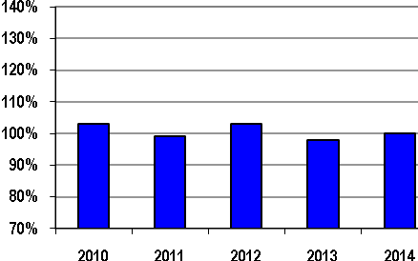 | 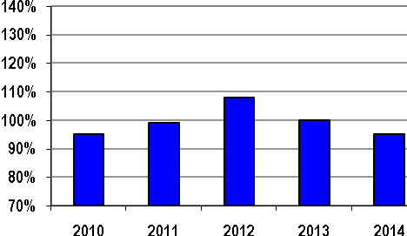

Budget | $167 | $170 | $169 | $177 | $199 | Budget | $94 | $92 | $61 | $57 | $62
Bars Represent % of Actual Costs to Approved Budgets; Dollar Amounts Represent Approved Budgets (in millions)

MISO uses a structured, multi-stage approach to corporate planning that encompasses both short and long-term timeframes. Components of the process include development and refinement of longer-term strategic plans, shorter-term operating plans and budgets that support those plans.
MISO’s corporate planning process is designed to:
- Establish a sound business rhythm to plan and operate our business and meet strategic objectives
- Maintain and improve our current operations while achieving strategic scale / scope expansion goals
- Allocate constrained resources (dollars and expertise) in accordance with corporate priorities
- Establish standards of performance and measurement of ongoing performance
The corporate plan and budget established by MISO in collaboration with its stakeholders is consistent with the mission, vision, value proposition, and strategy of the organization. The budget provides good stewardship of members’ funds, while providing for long-term operational and financial sustainability. The below guidelines are the principles MISO follows during the corporate planning process:
- Strategy: Fund projects and initiatives that are identified and prioritized in the budget that further MISO strategy, mission, vision, and value proposition
- Risks: Provide sufficient resources to manage risks of the organization
- Workforce: Provide competitive compensation and benefit plans to develop and maintain a viable, effective, skilled, and professional workforce and organization
- Flexibility: Allow for sufficient flexibility to deal with changing circumstances (e.g., regulation, business environment changes, stakeholder needs)
- Efficiencies: Continually seek efficiency gains through best practices and process improvement
MISO did not have any material variances between its approved budgets and its actual costs from 2010 to 2014 for non-capital costs. Non-capital costs represent base operating costs, net of miscellaneous income.
MISO’s capital investment expenses associated with financing and recovery of capital costs include interest expense, as well as depreciation and amortization expense. The variances within capital investment expenses relative to budget for 2012 and 2014 are due to timing of capital spending. All other years’ interest expense and depreciation were on budget.
MISO Annual Administrative Charges per Megawatt Hour of Load Served 2010-2014
($/megawatt-hour)

The data on administrative costs per MWhs of load served in the chart above should be viewed in the context of the widely-varying levels of annual load served by each ISO/RTO as noted in the table below.
ISO/RTO | 2014 Annual Load Served  (in terawatt hours)
MISO | 678

The 2014 administration rate reflects the Entergy/South Region integration.

Customer Satisfaction
MISO Percentage of Satisfied Members 2010-2014
MISO’s current survey asks 86 questions on a wide variety of subjects ranging from transmission planning to market operations. In 2011, the survey underwent a redesign to more accurately reflect the support that MISO provides to member organizations. The chart above shows the percentage of respondents that were satisfied—providing a rating of 5 or higher on a 7 point scale—across MISO’s key functional areas. This overall customer satisfaction rating is an average of a subset of survey questions that measure satisfaction with a number of specific functions—such as market reliability operations, transmission planning and operations, and customer support services—and general satisfaction with the services that MISO provides. The respondents to the survey include transmission owners, market participants, industry regulators, and other MISO stakeholders. An independent firm, Opinion Dynamics Corporation, administers the annual customer survey. MISO uses the results to enhance products and services, in addition to responding to key issues that the survey identifies.

Billing Controls
ISO/RTO | 2010 | 2011 | 2012 | 2013 | 2014
MISO | Unqualified SAS 70 Type 2 Audit Opinion | Unqualified SSAE 16 SOC 1 Type 2 Review Opinion | Unqualified SSAE 16 SOC 1 Type 2 Review Opinion | Unqualified SSAE 16 SOC 1 Type 2 Review Opinion | Qualification for One Control Objective in SSAE 16 SOC 1 Type 2 Review
In 2014, one control objective was qualified for part of the review year (10/01/14 – 06/30/15) related to configuring and monitoring information systems.
MISO focuses on the accuracy of both prices posted and amounts billed to ensure members can rely on prices for transacting and have confidence in the amounts included in their MISO invoices.
Market Implementation Errors (MIE)
- In 2010, MISO had one MIE. There was no associated dollar impact.
- From 2011 to 2014, MISO had no MIEs.
Settlement Errors
- For 2010, MISO made seven adjustments because of settlement errors. The total net amount adjusted for 2010 was $5,002,043. The largest adjustment of $5,023,383 related to an amount paid to PJM as a result of a modeling problem on PJM’s system that caused an initial market-to-market settlement with a flowgate that was not being constrained. Without this adjustment, the total net amount adjusted for 2010 would have been -$21,340.
- For 2011 to 2014, MISO Market Settlements has not had any exceptions related to the SSAE 16 audits. Market Settlement statements were determined to be 99.998% accurate by dividing the number of granted disputes by the number of statements posted.

D. MISO Specific Initiatives
As MISO views its contributions to the region, our commitment to operational excellence is evidenced by our continued effort to develop and refine our own Value Proposition metrics. MISO has collaborated with its stakeholders since implementing its energy market in 2005 to create and enhance this meaningful and effective set of tools to measure the value that MISO provides. The Value Proposition metrics, which are available to the public on MISO’s website, are updated regularly to provide feedback on the effectiveness of MISO operations.
The Value Proposition breaks MISO’s business model into certain recognized categories of benefits to the footprint as a whole and calculates a range of dollar values for each defined category. Our 2014 Value Proposition showed annual net economic benefits between $2.2 billion to $3.1 billion to our region. These benefits are illustrated and described below:
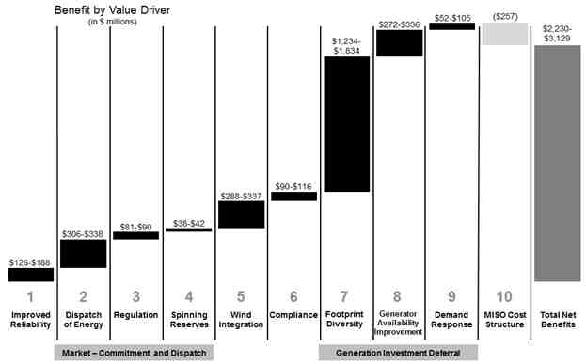
Quantitative Benefits
- Improved Reliability: MISO’s broad regional view and state-of-the-art reliability tool set improved reliability for the region as measured by transmission system availability.
- Dispatch of Energy: MISO’s real-time and day-ahead energy markets use security constrained unit commitment and centralized economic dispatch to optimize the use of all resources within the region based on bids and offers by market participants.
- Regulation: With MISO’s Regulation Market, the amount of regulation required within the MISO footprint dropped significantly. This is the outcome of the region moving to a centralized common footprint regulation target rather than several non-coordinated regulation targets.
- Spinning Reserves: Starting with the formation of the Contingency Reserve Sharing Group and continuing with the implementation of the Spinning Reserves Market, the total spinning reserve requirement declined, freeing low-cost capacity to meet energy requirements.
- Wind Integration: MISO’s regional planning enables more economic placement of wind resources in the region. Economic placement of wind resources reduces the overall capacity needed to meet required wind energy output.
- Compliance: Before MISO, utilities in the MISO footprint managed FERC and NERC compliance. With MISO, many of these compliance responsibilities have been consolidated. As a result, member responsibilities decreased, saving them time and money.
- Footprint Diversity: MISO’s large footprint increases the load diversity, allowing for a decrease in regional planning reserve margins from 18.1% to 15.0%. This decrease defers the need to construct new capacity.
- Generator Availability Improvement: MISO’s wholesale power market improved power plant availability by 1.9%, deferring the need to construct new capacity.
- Demand Response: MISO enables demand response through transparent market prices and market platforms. MISO-enabled demand response defers the need to construct new capacity.
- MISO Cost Structure: MISO expects administrative costs to remain relatively flat and to represent a small percentage of the benefits.

Qualitative Benefits
In addition to the quantitative benefits, MISO also demonstrates significant qualitative benefits that wholesale market participants receive from the operation of MISO, including:
  - Price/Informational Transparency
  - Planning Coordination
  - Seams Management

New York Independent System Operator (NYISO)

Section 5 – NYISO Performance Metrics and Other Information
The New York Independent System Operator, Inc. (“NYISO”) is a not-for-profit corporation responsible for operating the New York State bulk electricity grid, administering New York’s competitive wholesale electricity markets, conducting comprehensive long-term planning for the state’s electric power system, and advancing the technological infrastructure of the electric system serving the Empire State.
The creation of the NYISO was authorized by the Federal Energy Regulatory Commission (“FERC”) in 1998. In November 1999, New York State’s competitive wholesale electricity markets were opened to utility and non-utility suppliers and consumers as the NYISO began its management of the bulk electricity grid. The formal transfer of the grid operation responsibilities from the New York Power Pool to the NYISO took place on December 1, 1999.
The NYISO monitors a network of more than 11,000 circuit-miles of high-voltage transmission lines and serves in excess of 400 market participants. NYISO market transactions annually average $7.5 billion.
In 2014, the total resource capability in the New York Control Area (“NYCA”) was 41,297 megawatts (MW). This total includes in-state generating capacity (37,978 MW), demand response resources from the NYISO Special Case Resource program (1,189 MW), and long-term purchases and sales with neighboring control areas (2,130 MW).
The NYISO’s all-time record summer peak of 33,956 MW occurred on July 19, 2013. The NYISO record winter peak of 25,738 MW occurred on January 7, 2014.
The NYISO is governed by an independent Board of Directors and a committee structure comprised of a diverse array of stakeholder representatives. The members of the NYISO’s 10-member Board of Directors have backgrounds in electricity systems, finance, academia, information technology, communications, and public service. The members of the Board, as well as all employees, have no business, financial, operating, or other direct relationship to any market participant or stakeholder. NYISO stakeholder committees are comprised of representatives of market sectors that include transmission owners, generation owners, other suppliers, end-use consumers, public power, and environmental parties.
The mission of the NYISO, in collaboration with its stakeholders, is to serve the public interest and provide benefit to consumers by:
- Maintaining and enhancing regional reliability;
- Operating open, fair, and competitive wholesale electricity markets;
- Planning the power system for the future; and
- Providing factual information to policy makers, stakeholders and investors in the power system.

A. NYISO Bulk Power System Reliability

The table below identifies which North American Electric Reliability Corporation (“NERC”) Functional Model registrations the NYISO has submitted as effective as of the end of 2014. In addition, the Regional Reliability Organization (“RRO”) for the NYISO (i.e., Northeast Power Coordinating Council “NPCC”) is noted at the end of the table with a web site link to the specific reliability standards.
- For the reporting period 2010 to 2014, NYISO had one NERC reliability standard self-report resolved through NERC’s Find, Fix and Track program in 2012 and one NERC reliability standard self-report resolved as a NERC Compliance Exception in 2014.
- The NYISO has not shed any load in the New York Control Area (“NYCA”) due to a standards violation.
NERC Functional Model Registration | NYISO
Balancing Authority
Interchange Authority
Planning Authority
Reliability Coordinator
Resource Planner
Transmission Operator
Transmission Planner
Transmission Service Provider
Regional Entity | NPCC

Standards that have been approved by the NERC Board of Trustees are available at:
http://www.nerc.com/page.php?cid=2|20
Additional standards approved by the NPCC Board are available at:
http://www.npcc.org/regStandards/Approved.aspx
In addition, section 215 of the Federal Power Act, as amended by the Energy Policy Act of 2005, allows the State of New York to “establish rules that result in greater reliability within the state.” The NYISO is, therefore, also responsible for complying with rules established by the New York State Reliability Council, L.L.C ("NYSRC"), whose mission is to promote and preserve the reliability of electric service on the New York power system by developing, maintaining, and updating the Reliability Rules which shall be complied with by the NYISO and all entities engaging in electric transmission, ancillary services, energy and power transactions on the New York power system.
The NYRSC and the Reliability Rules they administer are available at: http://www.nysrc.org

Dispatch Operations
In addition to the ongoing review of control performance by NYISO System Operations, a daily review of performance occurs by NYISO Operations staff each business day. The NYISO incorporates Control Performance Standard (“CPS”) compliance in its analysis and establishment of regulation requirements, which are specified by season and hour. The NYISO updated its regulation requirements to reflect findings of the 2010 Wind Study, which analyzed the net variability of load, and wind. Regulation is co-optimized along with energy and reserves within the NYISO's Day-Ahead and Real-Time markets, allowing the most efficient resources to provide the regulation needed to maintain Control Performance. The NYISO's current regulation requirements can be found at the following location:
http://www.nyiso.com/public/webdocs/market_data/reports_info/nyiso_regulation_req.pdf
NYISO CPS-1 Compliance 2010-2014
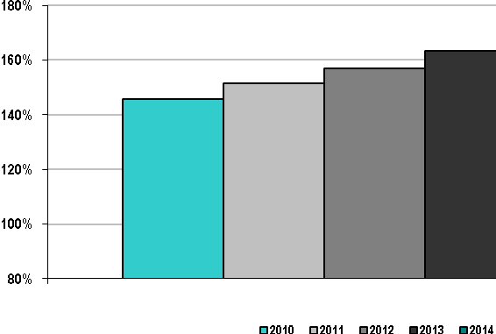
Compliance with CPS-1 requires at least 100% throughout a 12-month period. The NYISO was in compliance with CPS-1 for each of the calendar years from 2010 through 2014.
NYISO CPS-2 Compliance 2010-2014
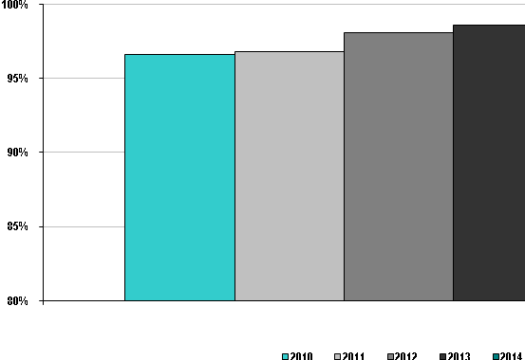
Compliance with CPS-2 requires 90% for each month in a 12-month period. The NYISO was in compliance with CPS-2 from 2010 through 2014.

NYISO Energy Management System Availability 2010-2014
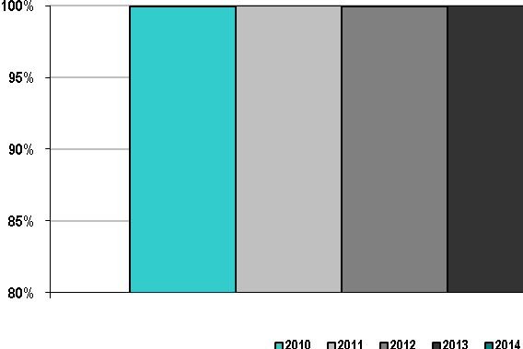
Availability of the Energy Management System (“EMS”) is an important factor that enables reliable monitoring of the electric transmission system in the NYCA. Given that a State Estimator (“SE”) solution is required for the EMS applications, the NYISO availability statistics are based on the number of solved SE cases as compared to the total number of SE runs. For the past five years, NYISO’s EMS has shown excellent performance and has been available more than 99% of all hours in each year.

Load Forecast Accuracy
The NYISO's load forecasting model is a unified system that uses a series of equations, drivers, and historical information specific to each of the eleven locational based marginal price (“LBMP”) zones in New York. It uses a combination of Advanced Neural Network ("ANN") and regression models to generate its forecasts. The ANN analysis takes a non-linear approach to the estimation of the model's parameters. The regression models are linear models estimated using ordinary least squares.
The load forecasting model uses historical load and weather data information for each of the NYISO's eleven zones to develop zonal load forecast models. These models are then used together with zonal weather forecasts to develop an independent load forecast for each zone. The zonal forecasts are summed to produce a forecast for the NYCA as a whole. The model develops the hourly load forecasts for the current day and the next six days, a total of up to 168 hours. The NYISO reviews and re-estimates its day-ahead forecasting models prior to June of each year to keep them up to date.
The load forecasting model uses proprietary weather data and forecasts from the NYISO's weather information vendor. The hourly weather data provided by the vendor include dry bulb temperature, wind speed, cloud cover, dew point, and wet bulb temperature. The data from the stations is aggregated in a manner that best represents each zone.
The day-ahead load-forecasting model does not currently incorporate economic assumptions or economic forecast data since these variables are virtually constant from one day to the next.

ISO/RTO | Load Forecasting Accuracy Reference Point
NYISO | 5:00 a.m. prior day

NYISO Average Load Forecasting Accuracy 2010-2014

NYISO Peak Load Forecasting Accuracy 2010-2014

NYISO Valley Load Forecasting Accuracy 2010-2014

The three charts above show the percent accuracy and the Mean Absolute Percentage Error (“MAPE”) of NYISO load forecasting for average daily load, peak load, and valley load from 2010 to 2014. The decrease in the MAPE from 2010 to 2014 indicates an increase in accuracy, since the error has been reduced. The NYISO's unified load forecasting approach is applied to each of the LBMP zones in the NYCA. Continuous forecasting system process improvements have increased forecasting accuracy and a commensurate decrease in the MAPE. The high level of accuracy contributes to efficient operation of the bulk power system and wholesale electricity markets, which provides economic benefit to consumers. During the 2010-2014 period, the NYISO activated its demand response program on only a small number of days to curtail peak demand. As a result, the exclusion of the impact of the programs on the metric is negligible.

Wind Forecasting Accuracy
NYISO Day-Ahead Average Wind Forecasting Accuracy 2010-2014
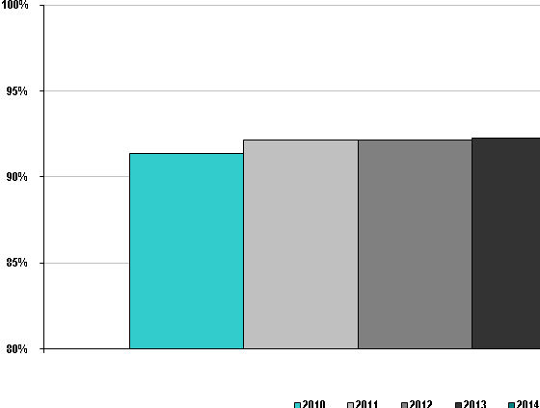
In mid-2008, the NYISO instituted one of the first state-of-the-art wind forecasting systems in the United States incorporating wind power forecasts into Day-Ahead (“DAM”) and Real-Time Market tools to improve commitment and scheduling of resources. The centralized system enables the NYISO to better utilize and accommodate wind energy by forecasting the availability and timing of wind-powered generation. The real-time forecasts are updated every 15-minutes and integrated into the NYISO’s real-time Security Constrained Dispatch. Day-Ahead forecasts are updated twice daily and are integrated into the DAM during the reliability evaluation. In 2009, the NYISO became the first grid operator to dispatch wind power fully balancing the reliability requirements of the power system with the use of the least costly power available via an economic dispatch.
The values presented in the graph above are 1 - Mean Absolute Error (MAE), which represents the statistic in terms of accuracy rather than error. The Day-Ahead wind forecast statistics are based on the forecast updated at 4AM the day prior to the operating day and used in the DAM evaluation.
The NYISO develops forecasts for variable energy resources when there is an operational need for the information. Due to the limited amount of non-wind variable energy resources, the NYISO does not currently require forecast data for these resources.

Unscheduled Flows
NYISO Absolute Value of Unscheduled Flows 2010-2014 (terawatt hours)

For context, the table below notes the number of NYISO’s external interfaces. The NYISO has free flowing interfaces with PJM, Ontario, and ISO-NE and the other six interfaces are controllable line interfaces. Unscheduled flows vary in both magnitude and direction and occur primarily on the Ontario and PJM interfaces. These two interfaces reflect the same flows (the numerical conventions are such that a negative flow on the PJM interface corresponds to a positive flow on the Ontario flow).

ISO/RTO | Number of External Interfaces
NYISO | 9

NYISO Absolute Value of Unscheduled Flows as a Percentage
of Total Flows 2010-2014

NYISO Unscheduled Flows by Interface
(in terawatt hours)
 | 2010 | 2011 | 2012 | 2013 | 2014
Ontario Independent Electricity System Operator | 3.2 | 0.0 | 0.0 | 0.0 | 0.0
PJM | 3.4 | 2.17 | 1.73 | 1.22 | 1.22
ISO-NE | -- | 0.35 | 0.31 | 0.35 | 0.34

Prior to 2011, the NYISO experienced a larger percentage of unscheduled flows, compared to some of its neighboring market areas due to the direct impact from Lake Erie loop flows, as well as the lower volume of total scheduled flows and limited number of interfaces. The NYISO’s ongoing collaboration with its neighboring market areas to improve regional market efficiency through the Broader Regional Markets initiatives was initiated in part to address the impacts produced by the unscheduled Lake Erie Loop Flows as well as to remove barriers to more efficient interregional trading in order to improve the volume of trading. The various components of that regional collaboration have resulted in significant reductions in unscheduled flows during the reporting period.
Transmission Outage Coordination
The NYISO coordinates all requests for transmission outages based on their potential impact on system reliability and is not aware of any unexpected generator availability impacts or declared emergencies associated with uncoordinated transmission outages.
NYISO Percentage of > 200kV planned outages of 5 days or more that are submitted to ISO/RTO
at least 1 month prior to the outage commencement date 2010 – 2014
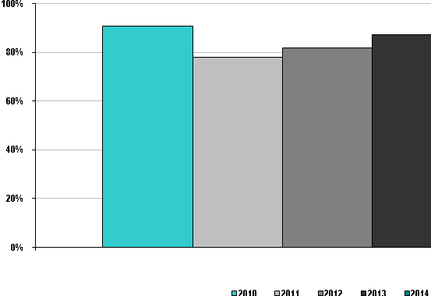
NYISO data for the metric, “Percentage of > 200 kV planned outages of 5 days or more that are submitted to ISO/RTO at least 1 month prior to the outage commencement date,” are based on outage data that includes inter-control area tie lines and internal NYCA lines and transformers greater than 200 kV.
The NYISO requires that Transmission Owners submit outage requests for facilities expected to impact system transfer capability of the NYISO secured system "no later than 30 days prior to first of the operative Transmission Congestion Contract month," with a few exceptions allowed to address reliability needs or outages with limited impact.
The percentages for the years 2011 and 2012 trend lower due to conductor clearance mitigation effects not allowing for either proper lead times nor advanced notifications.
Percentage of planned outages studies in the respective ISO/RTO Tariff/Manual established timeframes
This metric is not applicable to NYISO. The NYISO does not have established timeframes to study planned outages in its Services Tariff. All outages are included as part of the DAM evaluation for consideration prior to the operating day.

NYISO Percentage of > 200 kV outages cancelled by ISO/RTO after having been previously
approved 2010 – 2014
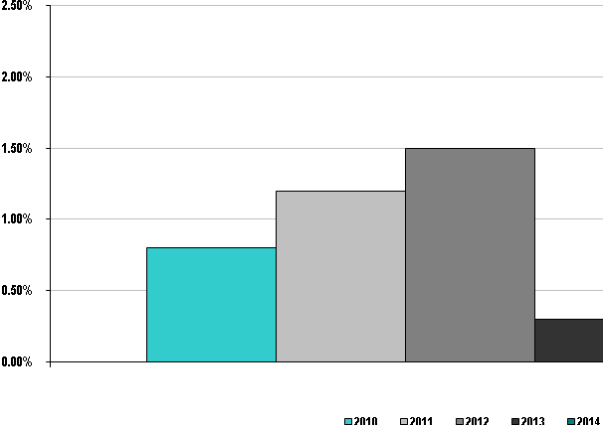
NYISO data for the metric, “Percentage of > 200 kV outages cancelled by ISO/RTO after having been previously approved,” demonstrates that on average, less than one percent of outages were cancelled during the 2010-2014 time frame.
NYISO Percentage of unplanned > 200kV outages 2010-2014
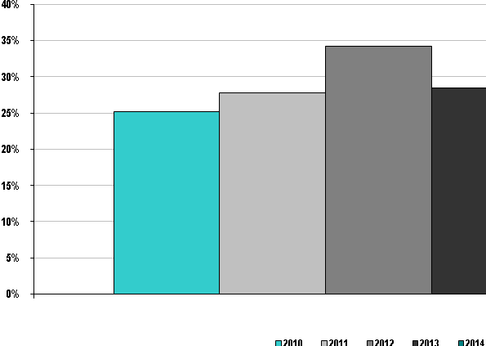
It is necessary to have outages submitted and verified in advance of the DAM evaluation in order to be considered planned by the NYISO. The NYISO classifies outages with less than two days’ notice as unplanned. As a result, the NYISO statistics for "Percentage of unplanned > 200kV outages" may appear higher as compared to other areas. The NYISO data are also based on the following criteria: unplanned outages of at least 1 hour duration including inter-control area tie lines, internal NYCA lines, and transformers > 200kV. In 2012, this metric was slightly elevated due to forced outages resulting from Hurricane Sandy.
NYISO Percentage of Generator Outages Cancelled by ISO/RTO 2010-2014

 | 2010 | 2011 | 2012 | 2013 |  | 2014
Percentage of Generator Outages Cancelled | 0.00% | 0.03% | 0.20% | 0.06% | 0.00%

The NYISO has the authority to approve planned generation outages with approval also required from the local Transmission Owner. The NYISO provides the approved generator outage schedules for the upcoming calendar year by December 1 of the prior year. Provisions allow outage scheduling on a shorter timeframe only if it is mutually acceptable to all involved parties. The NYISO rarely cancels approved planned outages.

Transmission Planning
Markets and Investment Enhance Reliability
Until FERC issued Order 1000, the NYISO’s market-based approach to the transmission planning process was significantly different from any other regions’ transmission planning processes. Consistent with the NYISO’s Transmission Owner (“TO”) Agreement and Open Access Transmission Tariff (“OATT”), the NYISO did not "approve" or "require" facilities to be constructed for reliability purposes. The NYISO’s role was to evaluate and monitor the reliability of the system, assess reliability needs, and solicit market-based as well as regulated solutions, which may include generation, transmission or demand response resources. The market and the Responsible Transmission Owners proposed solutions to meet identified reliability needs, and the New York State Public Service Commission (“NYPSC”) determined which resources were to be financed, built, and operated.
Since 2000 this market-based approach has resulted in over 11,600 MW of new generation being constructed by public power authorities and private developers, with 80 percent of that capacity sited in the southeastern region of the State, where electricity demand is greatest. In addition to new generation, more than 2,300 megawatts of transmission capability has been added to bring more power to the southeastern New York region from out of state when it is more economic to do so. This pattern of development has mitigated the need for transmission solutions to meet the reliability needs of the New York bulk electric system.
In 2011, FERC issued Order No. 1000 expanding upon previous orders related to transmission planning and cost allocation to further reduce barriers to transmission system investment. Among its components, the Order required all jurisdictional transmission providers, including ISOs and RTOs, to revise their planning processes to include consideration of transmission needs driven by public policy requirements, to include cost allocation for such transmission facilities and to further revise their processes to include interregional planning and cost allocation with their neighboring regions.
The NYISO public policy planning process began following the issuance of the 2014 Reliability Needs Assessment. Based on a planning process that provides for fulfillment of reliability needs first, in August 2014, the NYISO issued a letter inviting stakeholders and interested parties to submit proposed transmission needs driven by public policy requirements. In NYISO’s process, such transmission needs are identified by the NYPSC Commission, and transmission projects that fulfill such public policy requirements may be eligible for cost recovery through the NYISO’s tariff, if they are selected by the NYISO as the more efficient or cost-effective solution. Based upon their review of the proposed transmission needs submitted in response to the NYISO’s process, the NYPSC on July 13, 2015 issued an Order declaring transmission needs in western New York State to be a Public Policy Requirement and directed the NYISO to solicit and evaluate potential solutions.
NYISO Comprehensive System Planning Process
The NYISO’s transmission planning process is known as the Comprehensive System Planning Process (“CSPP”). It is an ongoing market-based process that identifies needs and evaluates proposed solutions to meet both reliability, economic and public policy needs, coordinates the NYISO’s assessments with neighboring Control Areas, and provides cost allocation methodologies and recovery mechanisms for regulated reliability and economic projects that meet tariff criteria.
The NYISO’s CSPP (1) is market-based and strives to achieve market-based solutions to reliability, economic and public policy needs on the bulk electric system when possible; (2) is open and transparent, engaging regulators, Market Participants and other stakeholders in accordance with NYISO’s shared governance process; (3) considers all resources as potential solutions to identified needs, including transmission, generation and demand response; (4) provides for the allocation of costs of proposed solutions to identified reliability, economic and public policy needs to project beneficiaries; (5) does not include a right of first refusal for incumbent transmission owners for transmission projects to address regional needs; (6) results in a regional transmission plan that evaluates solutions for identified reliability, economic and public policy needs in the region; (7) fully complies with FERC Order No. 890 transmission planning principles; and (8) fully complies with FERC Order No. 1000 principles and requirements.
NYISO Number of Transmission Projects Approved to be Constructed for Reliability Purposes 2010-2014
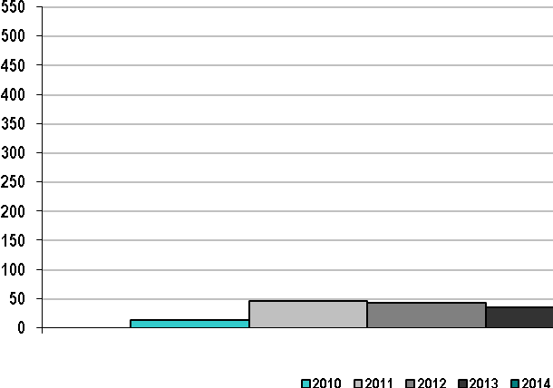
The transmission projects in this chart include projects developed by New York Transmission Owners (“NYTOs”) through their local transmission planning processes, these projects have been included in NYISO’s reliability planning base cases. For the period 2010-2014, the NYISO reliability planning process, discussed above, did not find any reliability needs due to an increase in available resources and the expansion of energy efficiency programs in the state.

NYISO Percentage of Approved Construction Projects Completed by December 31, 2014

 | 2010 | 2011 | 2012 | 2013 | 2014
Percentage of completed projects | NA | NA | 16% | 71% | 48%

For the period 2012-2014, a significant number of approved transmission projects have been constructed. The majority of them have been built in response to economic opportunities identified through market signals and local needs, and serve to essentially negate the need for “reliability” transmission projects.

Generation Interconnection
Overview of the Study Process and Changes Since 2009
At the end of 2009, NYISO had two interconnection procedures:
- Standard Large Facility Interconnection Procedures (“LFIP”) contained in Section 30 Attachment X of the NYISO OATT; and
- Small Generator Interconnection Procedures (“SGIP”) contained in Section 32 Attachment Z of the NYISO OATT.
Initially implemented in 2004, the LFIP applies to generating facilities that exceed 20 MW and to Merchant Transmission Facilities. The process consists of three studies: Interconnection Feasibility Study (“FES”), Interconnection System Reliability Impact Study (“SRIS”), and Class Year Facilities Study (“CYFS” or “CY Study”). The FES and SRIS are generally performed on an individual project basis, whereas the CYFS is performed for a group (or cluster) of projects that have satisfied the Class Year (“CY”) entry requirements and elected to enter a given CY Study. The LFIP, which originally offered only one category of interconnection service, was significantly modified in 2008 to offer two categories of interconnection service: Energy Resource Interconnection Service (“ERIS”), required for minimum interconnection, and Capacity Resource Interconnection Service (“CRIS”), elective but required to participate in the NYISO Capacity Market. The 2008 modifications expanded the scope of the CYFS to include a CY Deliverability Study to evaluate deliverability for projects for which CRIS was requested and, if necessary, identify System Deliverability Upgrades (“SDUs”) for requested CRIS to be deliverable.
The SGIP, which was initially implemented in 2007, applies to generating facilities no larger than 20 MW. This process also includes three basic studies: Feasibility Study (“FES”), System Impact Study (“SIS”) and Facilities Study. Compared to the LFIP (which only allows the possibility to forgo the FES by mutual agreement of the three parties: Developer, NYISO and the Connecting Transmission Owner, but otherwise requires all three studies), the SGIP generally provides more flexibility to perform or forgo the three studies depending on the circumstances of each project. For the Facilities Study, small generator projects were origially required to undergo the CYFS (the same as large generating facilities), but that has changed as described below in the 2011 queue improvement changes.
Although the fundamental structure of the LFIP and SGIP have remained the same, significant modifications have been made to both since 2009 in NYISO’s ongoing efforts to improve the interconnection processes and address developer and other stakeholder concerns through the stakeholder process. The process improvements made since 2009 include:
- Changes to the LFIP In 2010:
  - Modifications to base case assumptions for Feasibility Studies, SRISs and SISs to improve technical quality of the studies and to improve efficiency;
  - Modifications to CY entry and re-entry rules to provide flexibility to Developers while at the same time tightening the overall process to address “queue squatting” by projects making no reasonable progress toward commercial operation;
  - Addition of a non-refundable application fee and revised study deposits to discourage pre-mature or speculative projects from entering the queue and to reduce risk of default on study costs.
- Changes to the LFIP and SGIP in 2011:
  - Modifications of the SGIP to allow small generator projects to undergo a simpler Small Generator Facilities Study (“SGFS”) rather than the CYFS if only Local System Upgrade Facilities (“SUFs”) are indicated to be needed;
  - Modifications to the allocation of CYFS study costs in both the SGIP and LFIP to address perceived inequity in the former cost allocation.
- Changes to the CYFS process in 2013:
  - Modification of the March 1st fixed calendar start date, replacing it with alternate start dates to allow CY studies to proceed in a “head-to-tail” fashion (thus addressing the untenable situation of Class Years overlapping each other resulting in unrecoverable delays in the overall process);
  - Addition of CY study milestones to provide clear expectations for completing CYFS evaluations;
  - Modifications that provide Developers options and decisional flexibility to pursue or not pursue evaluation of an SDU in order to receive full amount of requested CRIS;
  - Modificaitons that provide Developers with additional options at the SRIS stage – specifically, whether to include a preliminary deliverability analysis;
  - Modifications to streamline the CY decision and settlement process (to eliminate unwarranted iterations and gaming in the process).
  - Modifications to allow Developers more flexibility in satisfying Headroom obligations;
  - Modifications to allow security for SUFs to be reduced afer discrete portions of such facilities are complete; and
  - Modifications intended to encourage projects to move through the interconnection process without unnecessary delays (including, for example, limitations on permissible extensions of Commercial Operation Dates).
- Changes to the LFIP and SGIP in 2014: Modifications to permit de minimis increases in the energy capability of existing facilities without requiring a new Interconnetion Request.
Review of Processing Time
Although the above changes have been well received and have rectified certain inefficiencies in the process and, therefore, undoubtedly will improve overall queue management and have rectified certain inefficiencies in the process, the changes have not yet resulted in a measurable reduction in the overall processing time for Interconnection Requests for projects that enter and remain in the queue through the end of the process. For example, the full benefit of the CYFS process changes made in 2013 are only now taking effect and are not yet reflected in process statistics. The most recently completed CY Study – CY 2012 – was fully completed on January 13, 2015. CY 2012 formally started (by tariff) on March 1, 2012, and was the last CY Study to start prior to the 2013 process changes. Because the previous CY Study – CY 2011 – was not fully completed until October 15, 2013, for practical purposes, the CY 2012 was effectively delayed from starting until mid-October 2013, more than 19 months after its formal start date. Likewise, the CY 2011 study that formally started on March 1, 2011, was delayed from practically starting until CY 2010 fully completed on November 30, 2011, about nine months after CY 2011’s formal start date. In light of this inefficient and unintended outcome of the fixed calendar schedule, the NYISO and its stakeholders, convinced that the CYFS process has many advantages, particularly in providing resolution of cost allocation for interconnection facilities, worked together to develop the more efficient and flexible head-to-tail schedule. Under this new schedule, CY 2015, the first CY Study to start on the new schedule, was formally started on March 1, 2015. And the next CY Study, presumably CY 2016, will not formally start until CY 2015 has finished. How much impact the CYFS process changes will have on overall Interconnection Request processing remains to be seen, but at least the statistics will no longer reflect delays caused by CY studies overlapping each other. The annual average processing time for generation and merchant transmission Interconnection Requests completed in the 2010 – 2014 period of this update report are shown in the chart below.
NYISO Average Generation Interconnection Request Processing Time 2010-2014
(calendar days)

As these numbers show, average processing time was exceptionally low in 2012, and exceptionally high in 2013 (for reasons discussed below). The numbers for the other three years indicate an overall average processing time of about 1,285 calendar days or about 3.5 years, which is indicative of the recent experience of Interconnection Requests that have undergone and completed the full interconnection study process.
The previous metrics report indicated average processing times for years 2006 through 2009 in the range of about 550 to 750 days with an overall average of about 625 calendar days or about 1.7 years. The updated numbers indicate an increase in average processing time of about 1.8 years, or roughly double in recent years compared to the prior reporting period. There are two primary reasons for this apparent increase in processing time: one real and one artificial.
The artificial reason for the apparent increase is simply a change in how processing time was measured in the two reports. For this update report, the processing time for each completed Interconnection Request was simply measured as the number of calendar days between the date the Interconnection Request was received (IR Date) to the date the interconnection study process was fully completed, which for most projects is the date of completion of the Final Decision Round of the CY Study process. In the previous report, the average processing time was measured as the sum of the actual study time (from Study Start Date to Study Completion Date) for each of the studies of the process, which excludes the non-study process time that precedes each of the studies. The non-study processing time includes: 25 to 30 calendar days between the IR Date and the Scoping Meeting, 30 calendar days allowed for Developers to execute each study agreement, wait time between completion of the SRIS and the start of the next CY Study, which can range widely from less than a month to more than three years. Much of the non-study process time is due to the legitimate options and actions of customers and Developers. For example, under the 2010 changes LFIP, once a project has met the eligibility requirements for entering a CY Study, Developers have the option to enter up to two of the next three successive Class Years, which means the Developer may skip the first CY Study for which they are eligible, and even skip the second CY Study if they wish. Electing to skip a CY Study adds at least a year to the overall process time for that project. Analysis was not performed to quantify the effect of non-study time on the overall process time, but it’s estimated that the impact of this factor alone accounts for roughly half the apparent increase in overall average process time. The primary reason that process time actually increased was the addition of the Class Year Deliverability Study to the CY Study process in 2008, and more specifically, the additional time needed to identify, study, and develop the cost estimate and cost allocation for a new SDU. CY 2007, which was fully completed in June 2009, was the first CY Study to include deliverability, and CY 2007 did not identify a need for an SDU. However, each of the next four CY Studies (CY 2008, CY 2009, CY 2010 and CY 2011) identified the need for one or more SDUs to address a particular deliverability issue, and additional study time was needed, especially in CY 2008 and CY 2009 (which were completed on February 1, 2010 and November 30, 2011, respectively) to address the SDU. The addition of a deliverability test and the additional time needed to evaluate an SDU accounts for most of the small increase in average process time from 2008 to 2009, and the larger increase indicated between 2009 and 2010, the first year included in this update report.
For the period of this update, 2010 through 2014, the year-by-year variation in average processing time is again largely explainable by the circumstances of the CY Study process and the composition of projects in each CY Study. The average process time for 2010 largely reflects the process time for projects that completed the CY 2008 Study, which as explained above, was the first CY Study that required additional time to evaluate an SDU. The 2011 average process time reflects the process time for projects in both CY 2009 and CY 2010, which were both completed on November 30, 2011. (The CY 2009 and CY 2010 Studies were performed in the same time frame in a special “catch up” process in an attempt to reset the CY Study process on its originally intended annual cycle. However, because additional time was needed to evaluate an SDU as explained above, this attempt to reset the CY process on schedule was unsuccessful.) The attempt to perform two CY Studies in the same time frame accounts for the relatively small increase in average process time between 2010 and 2011.
A CY Study was not completed in 2012. The 2012 average process time is based on two small generator projects that each completed a small generator facilities study and were not required to undergo the CY Study process, which explains the exceptionally low average process time for that year. (Those projects benefited from the changes made to the SGIP in 2011.)
The average process time for 2013 reflects the process time for projects that completed CY 2011, which was completed on October 15, 2013. The average process time was exceptionally high that year for two main reasons. First, one of the five CY 2011 projects had previously undergone a CY Study, but had rejected its cost allocation in that prior CY, so CY 2011 was the second time through the CY Study process for that project. (Under NYISO’s process, projects may enter and undergo up to two CY Studies without losing its queue position.) The second reason was that one of the CY 2011 projects presented the unique circumstance of proposing to interconnect to a 345 kV tie-line between NYISO and a neighboring ISO, which was the first time for that situation to occur in NYISO’s experience. The unique location and circumstances of that project resulted in the identification of the need for unusually substantive SUFs. Significant additional time was needed during CY 2011 to conduct the necessary analysis relative to those SUFs, including performance of coordinated studies with ISO-NE and the affected New England transmission owner.
A CY Study was not fully completed in 2014. The 2014 average process time is based on three small generator projects that each completed a small generator facilities study and were not required to undergo the CY Study process. Since the circumstances of 2014 were similar to 2012, one might expect the average processing time for 2014 to be similar to 2012, but the 2014 average – although the second lowest in the 5-year period – was significantly higher than 2012 average. The difference between 2014 and 2012 was due to the unusually long processing time (nearly 5 years) for one of the three small generator projects in that year. In that case, the customer performed the studies for that project, and the process was marked by a number of stops and starts and resets by the customer along the way. Excluding that outlier, the average processing time for 2014 would have been about the same as 2012.
In summary, the variations in annual average process times are largely due to the circumstances of each of the CY Studies. Significant changes to the CY Study process were implemented in 2013, but some of those changes are still taking effect and not yet reflected in the process time numbers in the 2010 – 2014 update period.

NYISO Planned and Actual Reserve Margins 2010 – 2014
The Installed Reserve Margin (IRM), is determined annually by the NYSRC, and is subject to final regulatory approval by the FERC and the NYPSC. The statewide IRM for the 2015/2016 capability year is 17.0 percent. Based on the IRM, the NYISO has determined the installed capacity requirement total to be 39,297 MW. The total capacity available to the state is expected to be roughly 41,298 MW, which includes 37,979 MW of in-state resources, an additional 1,189 MW Special Case Resources (a NYISO Demand Response program), and 2,130 MW of net purchases from neighboring regions.
The period of 2010 through 2014 shows a planned reserve requirement of approximately 17%. The planned reserve requirement has been relatively consistent because of competing factors. For example, the availability of the NYCA power plants has improved, which would have resulted in a downward trend in the planned reserve requirement had it not been offset by factors such as the addition of intermittent resources, mainly wind generation. Although any resource added to a system improves reliability, it does not necessarily lower the IRM. Since the IRM is an indication of how much capacity is needed to meet a peak load, the amount needed is dependent on the availability of the resources. If the resources have good performance during peak conditions, then less of them would be needed (lowering IRM). If the resources have poor performance, then more of those resources would be needed (raising IRM). Intermittent resources tend to exhibit lower availability than conventional resources during peak load periods. As the percentage of intermittent resources increases, there is an upward trend in the IRM.

NYISO Demand Response Capacity as Percentage of Total Installed Capacity 2010-2014
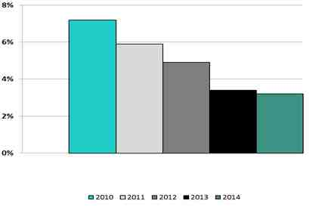
Regarding the metric, Demand Response Capacity as Percentage of Total Installed Capacity, the chart includes the sum of the following: ICAP Special Case Resources (“ICAP/SCR”), Emergency Demand Response Program (“EDRP”), and Day-Ahead Demand Response MWs. Load relief expected from demand response resources is not necessarily the sum of all the programs, due to rules that allow simultaneous participation in multiple demand response programs.
In July 2014, two of the NYISO’s major demand response programs, the EDRP and the ICAP/SCR, had a total of 4,022 end-use locations enrolled providing over 1,210.7 MW of demand response capability. The demand response resources in NYISO reliability programs represent 4.1 percent of the 2014 Summer Capability Period peak demand of 29,782 MW.
When New York set a new record for peak demand in July 2013, demand response helped to shave the peak by nearly 1,000 megawatts.
NYISO Generation Reliability Must Run Contracts 2010-2014
In 2013 and 2014, there were three generating units, with a total capacity of 406 MW, operating under Reliability Support Services Agreements (“RSSA”) established under state procedures.
These RSSAs are of limited duration to allow the construction of transmission facilities at the local level which will eliminate the need for such agreements. All three existing RSSAs are scheduled to expire between 2015 and 2017.

During the period from 2010-2014, and currently, there are no Reliability Must Run (“RMR”) contracts under the NYISO tariff.

Interconnection / Transmission Service Requests
Data represented in this section include all generation, transmission, and transmission-connected load projects in the NYISO Interconnection Queue and under study during the five-year period of 2010 through 2014.
NYISO Number of Study Requests 2010-2014

NYISO received 29 new study requests in 2009, the last year included in the previous report. As shown in the above chart, the number of new study requests received in 2010 and 2011 were significantly less than 2009, probably due to general economic conditions during those years. The number of new requests received in 2012 and 2013 increased over the previous years, largely due to an influx of transmission-related study requests prompted by the NY State’s Energy Highway initiative and the NYPSC’s related AC Transmission Proceeding, which called for proposals to significantly increase the transfer capability between the Upstate and Southeastern NY areas. The number of new requests in 2014 increased over the prior two years, largely due to an influx of solar energy projects in response to new federal and state incentives intended to encourage the development of solar energy. Overall, the number of new study requests was down in 2010 – 2014 compared to 2006 – 2009, but ended with an upward trend.
NYISO Number of Studies Completed 2010-2014

The above chart shows the number of interconnection studies and transmission study requests completed during each year. The completion date for various types of studies was based on the following:
- Interconnection Feasibility Studies (“FESs”) – date of the study results meeting is the completion date in most cases. In some cases, the date of the final study report was used if substantive comments were discussed at the results meeting and addressed in the final report after the meeting. (FESs are not subject to Operating Committee (“OC”) approval.)
- System Reliability Impact Studies (“SRISs”) and transmission System Impact Studies (“SISs”) – These studies are subject to OC approval. The date of OC approval is the completion date for these studies.
- Small generator SISs and Facilities Studies (“SGFSs”) –The date of the study results meeting is the completion date in most cases, but the date of the final report was used in some cases. (Small generator SISs are not subject to OC approval.)
- Class Year Facilities Studies (“CYFSs”) – These studies are subject to OC approval. The date of OC approval was used as the completion date for each Class Year (CY) Study, with the exception of the CY 2008 Study, which was approved by the OC in November 2009 (outside the period of this report), but was not fully completed (including completion of the Final Decision Period) until February 1, 2010 (within the period of this report). Therefore, the later date was used as the completion date for the CY 2008 Study (otherwise the CYFSs completed during 2010 would have been a null set). Also, because the CY Study involves a group of project, when a CY Study is completed, each project included in the Study is counted as a completed study. (e.g., A CY Study that includes five projects is counted as five Facilities Studies.)
In the previous metrics report, the annual number of completed studies was in the high 40s for 2006 through 2008 and then dropped to 27 in 2009. As shown in the above chart, the annual number of completed studies in 2010 – 2014 was about the same as 2009 for three of the years, but was significantly lower in 2012 and 2014. The main reason for the lower number in 2012 is that a CY Study was not completed during the year (CY 2011 was in progress throughout 2012, but was not completed until 2013). Only a few SGFs were completed that year. The drop in studies completed in 2014 was due to a drop in the number of FESs, SRISs and SISs completed that year and was partly due to a prolonged delay in the NYPSC AC Transmission Proceeding, which caused several FESs for merchant transmission interconnection proposals in the NYISO process to be delayed.
A main reason for the reduction in completed studies in years since 2008 compared to the prior three years (2006 – 2008) is that the NYISO queue was predominantly wind farm projects in that earlier period, so the studies in that period were more similar and repetitive due to the relatively homogeneous composition of projects in the queue during that period. Since 2008, the composition of projects in the queue has become more diverse in terms of the technologies and types of projects, which introduces more variation in the studies performed for various projects, making the studies a bit less similar and repetitive, which generally translates into requiring more time to complete studies.
NYISO Average Aging of Incomplete Studies 2010-2014
(calendar days)

The above chart shows the average age of interconnection studies and requested transmission studies that were in progress at the end of each year. For this report, the date of execution of the study agreement was used as the start date for all studies, including projects included in CY Studies. (A study agreement is executed for every study, and a separate study agreement is executed for each queue project included in a CY Study.) For the previous metrics report, the date of the “kick-off meeting” was used as the start date for all projects included in that CY Study. However, as the CY Study process has evolved, projects in the same CY Study execute their study agreements at significantly different times and certain portions of the CYFS can proceed forward on an individual-project basis, although portions of the CYFS that involve or effect cost allocation must be performed collectively. Therefore, for this update report, the date of execution of the study agreement was determined to be a better start date of the CY Study for individual projects included in the CY Study.
The above chart indicates that the average age of studies in the period of 2010 – 2014 was generally higher than in the previous report for the period of 2006 – 2009. Part of this increase in average study age is simply due to the change to the date used as the start date for projects included in CY Studies described above. The “kick-off meeting” date as the start date for all projects in a CY Study results in lower age numbers. The last two years, 2013 and 2014 appear to be more in line with 2009, the last year of the previous report.
NYISO Average Time to Complete Studies 2010-2014
(calendar days)

The above chart shows the average time to complete studies for studies that were completed in each year. The average time to complete studies during 2010 – 2014 was generally higher than the period of 2006 – 2009 covered in the previous report, largely due to the changes in scope and circumstances of CY Studies previously described in this report. The average completion time for 2013 was adversely affected by a single study that caused the average to be nearly 50 days higher than without that outlier. That study involved a transmission project, and the study was performed by the customer, who made a number of changes to the plans for the project during the study. The average completion time in 2014 was also affected by an outlier involving a study performed by the customer, but was more significantly affected by the circumstances of the CY 2012 Study, which was the last CY Study that formally started on the fixed calendar date schedule (March 1, 2012), but was not completed (approved by the OC) until November 13, 2014. CY 2012 was the most significant case affected by the change to use the date of execution of the study agreement as the start date (which was May 2012 for three of the original four projects in the CY 2012 Study) rather than the “kick-off meeting” date, which occurred in November 2013, adding about 18 months to the indicated completion time for the CY Study for those three projects. Using the kick-off meeting date as the start date for CY Studies would have resulted in a significantly lower average study time in 2014, and other years in this update period, but would understate the completion times experienced from the customer or Developer’s perspective. The changes made to the CY Study process in 2013 should result in study completion times that are more indicative of actual time to perform studies, and less “wait time” in the CY Study process.
Average Cost of Each Type of Study Completed
 | 2010 | 2011 | 2012 | 2013 | 2014
Avg. Cost FESs | $31,820 | $50,280 | $58,600 | $43,540 | $33,800
Avg. Cost SISs/SRISs | $43,650 | $53,410 | $66,513 | $45,940 | $118,430
Avg. Cost Facility Studies (per project) | N/A | $200,000 | $52,630 | $318,805 | $319,530

The average cost of studies for 2010 – 2014 is higher than in the prior four years (2006 – 2009). The large jump in the average cost of SISs and SRISs in 2014 reflects the fact that NYISO, rather than the Developer, was responsible for the performance of the studies billed in 2014, meaning that NYISO either performed the studies, or hired a consultant to perform the studies. The significantly lower average costs in prior years reflect that NYISO allowed Developers to hire consultants to perform the studies in those years, so the average costs shown only reflect NYISO’s cost to review the studies performed by the Developers’ consultants, and excludes the Developers cost to hire a consultant to perform the study. For a number of years, NYISO allowed Developers to hire consultants to perform the studies. However, experience showed that practice to be inefficient, and due to other concerns, NYISO instituted a policy change to not allow Developers to perform their own studies unless specifically permitted by the limited circumstances detailed in the tariff.
The average cost of Facilities Studies was low in 2012 because a CY Study was not billed in that year, so the average cost that year only reflects the completion of a couple of small generator Facilities Studies. The higher average cost of Facilities Studies in 2013 and 2014 was largely due to the unique circumstances of one project that was included in both the CY 2011 Study (completed in 2013) and the CY 2012 Study (completed in 2014). The unique circumstance of that project is that it proposed to interconnect to a 345 kV tie-line between NYISO and ISO-NE, resulting in complications and increased study costs as previously described in this report.
From 2010 - 2014, a total of 25 projects completed the NYISO interconnection or transmission study process and went into service. This is somewhat less than the 35 projects that completed NYISO studies and went into service in the prior four years from 2006 – 2009. Of the 25 projects that went in-service over the last five years, two generation projects totaling about 1,076 MW were added in New York City and a 660 MW DC transmission project was connected to New York City. The 25 projects also included a large solar energy project (about 32 MW) installed on Long Island, eight new wind farm projects, five small generator methane gas landfill projects, and three small hydro power projects.

Special Protection Schemes
NYISO Number of Special Protection Schemes 2010-2014

Over the period 2010-2014, fourteen Special Protection Schemes (“SPS”) were in place within NYISO. During that period there were no SPS activations in response to design system conditions and there were no uninstructed SPS activations in the NYISO.
Over the period 2010-2014, one SPS package was installed, one SPS package was retired, and two existing protection schemes were designated as SPSs.

B. NYISO Coordinated Wholesale Power Markets
In May 2015, Potomac Economics, the NYISO’s Independent Market Monitor, issued the 2014 State of the Markets Report: New York ISO. That report summarizes the NYISO market outcomes, evaluates the market efficiency, and makes recommendations on market enhancements.
Day-ahead and real-time markets jointly optimize energy, operating reserves, and regulation. These markets lead to:
        - Prices that reflect the value of energy at each location on the network;
        - The lowest cost resources being started each day to meet demand;
        - Delivery of the lowest cost energy to New York’s consumers to the maximum extent allowed by the transmission network; and
        - Efficient prices when the system is in shortage.
Capacity markets that ensure that the NYISO markets produce efficient long-term economic signals to govern decisions to:
        - Invest in new generation, transmission, and demand response; and
        - Maintain existing resources.
The market for transmission rights allows participants to hedge the congestion costs associated with using the transmission network.
In addition, the report says:
The performance of the New York markets is enhanced by a number of attributes that are unique to the NYISO:
- Implementation of Coordinate Transaction Scheduling (“CTS”) with PJM which is a novel market design leading to production cost savings.
- Implementation of the New Capacity Zone (known as “G-J Locality”) combined with improvements to the market power mitigation measures
- Initiated gas-electric coordination program
Several market design initiatives, enhancing pricing efficiency under system shortage conditions are in development (i.e., Comprehensive Shortage Price and Scarcity Pricing, Graduated Transmission Demand Curve, among others.)
For more information, please see:
http://www.nyiso.com/public/webdocs/markets_operations/documents/Studies_and_Reports/Reports/Market_Monitoring_Unit_Reports/2014/NYISO2014SOMReport__5-13-2015_Final.pdf

NYISO Market Volumes Transacted in 2014
For context, the table below represents the split of the $10.75 billion billed by the NYISO in 2014 into the primary types of charges its Market Participants incurred for their transactions:
(dollars in millions) | 2014 Dollars Billed | Percentage of 2014 Dollars Billed
Energy Markets | $5,023 | 47%
Installed Capacity | $3,222 | 30%
Transmission Congestion | $1,198 | 11%
Transmission Losses | $478 | 4%
TCC - Billed Fiscal Year | $391 | 4%
Market-wide charges | ($4) | 0%
Administrative Costs | $161 | 1%
Transmission Service | $105 | 1%
Ancillary Services | $171 | 2%
Other | $4 | 0%
Total | $10,749 | 100%

The 2014 data presented above reflect the winter 2013-2014 cold snap, which increased electric load during polar vortex conditions. However, New York State electricity usage decreased from an average load of 448 gigawatt-hours per day (GWh/day) in 2013 to 438 GWh/day in 2014 due to milder weather for the remainder of the year. The increased levels of power consumption in the first quarter of 2014 due to the unusually cold temperatures, combined with sharply higher prices in natural gas, resulted in higher-than-average electricity prices. In 2014, the average cost of electricity in New York was $69.31 per megawatt-hour (MWh), up approximately 17% from the 2013 average of $59.13 per MWh. The lowest average cost of electricity in the NYISO’s fifteen-year history was $45.28 per MWh in 2012, nearly 55% lower than the 2014 average.
NYISO Demand Response as a Percentage of Spinning Reserve Market 2010-2014
Demand response resources are eligible to participate in NYISO’s Regulation and Operating Reserve Markets. During 2014, demand side resources eligible to provide operating reserves accounted for 19.30% of the total 10-minute spinning reserve requirements. Changes to DSASP to allow aggregations to participate became effective in April 2013.

Market Competitiveness
NYISO Energy Market Price Cost Markup 2010-2014

2010 | 2011 | 2012 | 2013 | 2014
0% | 6% | 5% | -2% | -2%

The Energy Market Price Cost Markup is useful in evaluating the competitive performance of the market. Competitive markets tend to produce small markups, because suppliers in such markets have an incentive to offer at about their marginal cost. The NYISO estimates that the average annual markup was 1.51 percent over the reporting period. Many factors, particularly real time changes in fuel costs, can cause reference levels to vary slightly from suppliers’ true marginal costs; thus, one would not expect to see a markup exactly equal to zero. The NYISO has implemented a variety of software enhancements over the past several years to reduce distortions in reference levels that reflect changes in market prices between the time references are set and the time that offers are made. Relatively low markups (on the order of 5 percent or less) ~5% (abs) suggest that the markets have performed competitively.

NYISO New Entrant Gas-Fired Combustion Turbine (CT)
Net Generation Revenues 2010-2014
(dollars per installed megawatt year)
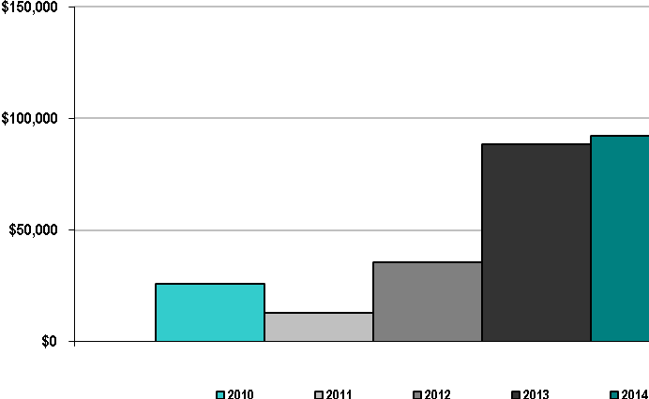

NYISO New Entrant Gas-Fired Combined Cycle (CC)
Net Generation Revenues 2010-2014
(dollars per installed megawatt year)

The above charts report the calculated net revenues for new units located in New York’s Hudson Valley Zone. The parameters of the new units (1X1 combined cycle and combustion turbine) are based on the 2013 ICAP Demand Curve Model. These parameters were revised and enhanced from what was used previously. Over this five-year period, there were great variations in revenues by technology and by location. On average, net revenues ranged, roughly, from $102,000/MW-year in the Capital Zone to $213,000/MW-year in New York City for a CC and from $51,000/MW-year in the Capital Zone to $149,000/MW-year in New York City for a CT. The Zone West net revenue levels have risen since 2012 partly because of increased intra-zonal congestion and thus increased energy prices. Net revenue levels rose notably in 2013 and 2014 in most regions due to higher capacity and energy prices. The capacity prices rose as a result of retirement and mothballing of generating units, higher peak load forecast, higher ICAP requirements, and the creation of a new capacity zone for the G-J Locality. Natural gas prices rose sharply in the winters of 2013 and 2014 due to unusually tight winter conditions, which led to higher energy prices. However, net revenues could fall in the future as a result of the evolution of the energy and capacity markets, as well as changes in fuel availability such as upgrades to the gas pipeline system that will mitigate congestion on the gas system. Therefore, it is unlikely to induce new investment in the short run if developers believe high net revenues are temporary. (See the NYISO Market Monitor’s 2014 State of the Market Report presentation for more information:
http://www.nyiso.com/public/webdocs/markets_operations/documents/Studies_and_Reports/Reports/Market_Monitoring_Unit_Reports/2014/NYISO2014SOMReport__5-13-2015_Final.pdf
NYISO Real-Time Energy Market Percentage of Unit Hours Offer Capped
due to Mitigation 2010-2014

The New York markets include market power mitigation measures that are intended to mitigate abuses of market power while minimizing interference with the market when the market is workably competitive. In certain constrained areas, most of which are in New York City, some suppliers have local market power because their resources are needed to manage congestion or satisfy local reliability requirements. In these cases, however, the market power mitigation measures effectively limit their ability to exercise market power or impact prices. See the NYISO Market Monitor’s 2014 State of the Market Report presentation for more information:
http://www.nyiso.com/public/webdocs/markets_operations/documents/Studies_and_Reports/Reports/Market_Monitoring_Unit_Reports/2014/NYISO2014SOMReport__5-13-2015_Final.pdf
The Automated Mitigation Procedure applies to Day-Ahead and Real-Time (“RT”) energy, startup, and minimum generation bids in the New York City zone. The preceding chart shows the RT market mitigation. In most years, there was more mitigation in the DAM than in the RT market. The decline in mitigation over time reflects a decline in congestion in New York City due to system changes, including new units in New York City and new transmission capacity from New Jersey to Long Island.
There was an increase in mitigation during 2011, particularly in July, when a record temperature of 104 degrees was set in New York City during a five day heat wave, which broke the 101 degree recorded temperature record set in July of 1957.
Market Pricing
Similar to the other ISOs/RTOs, the annual variability in the load-weighted wholesale energy prices is accounted for by the variability of natural gas prices, which can be seen in the next five charts. Adjusted for the variation in natural gas prices, the annual average real time wholesale energy prices have remained essentially flat over the past five years. This same variability can be seen in the breakdown of annual wholesale power costs. Because energy comprises the largest component of wholesale power costs, the effect of fuel price variability can be seen in the wholesale cost variability from 2010 to 2014. The final chart isolates the unconstrained energy portion of the system marginal cost and shows the same effects of fuel price volatility, unadjusted for fuel price volatility.
Demand response programs, cultivated in the competitive market environment, have grown significantly since the start of the New York wholesale electricity markets.
The NYISO offers two demand response programs that support reliability: the EDRP and the ICAP/SCR. In addition, demand response resources may participate in the NYISO’s energy market through the Day-Ahead Demand Response Program (“DADRP”), or the Ancillary Services market through the Demand-Side Ancillary Services Program (“DSASP”).
EDRP provides demand response resources with the opportunity to earn the greater of $500/MWh or the prevailing LBMP for energy consumption curtailments when the NYISO calls on the resource. There are no consequences for enrolled EDRP resources that fail to curtail. Resources participate in EDRP through Curtailment Service Providers (“CSPs”), which serve as the interface between the NYISO and resources.
The NYISO provides a semi-annual informational report (Docket ER01-3001 and ER03-647) regarding Demand Response resources. The last report filed on June 1, 2015 identifies that DADRP enrollment has been static for several years and enrolled resources have shown no activity in the energy market for more than four years. Therefore, there were no price impacts from DADRP in years 2010 through 2014.
The NYISO DSASP, introduced in June 2008, provides demand response resources that meet telemetry and other qualification requirements an opportunity to bid their load curtailment capability into the DAM and RT Market to provide Operating Reserves and Regulation Service. As of June 1, 2015, DSASP resources represented 126.5 MW of capability to provide Operating Reserves and had an average performance of 143% during the analysis period of November 2014 through April 2015.
NYISO Average Annual Real Time Load-Weighted Wholesale Energy Prices 2010-2014
($/megawatt-hour) 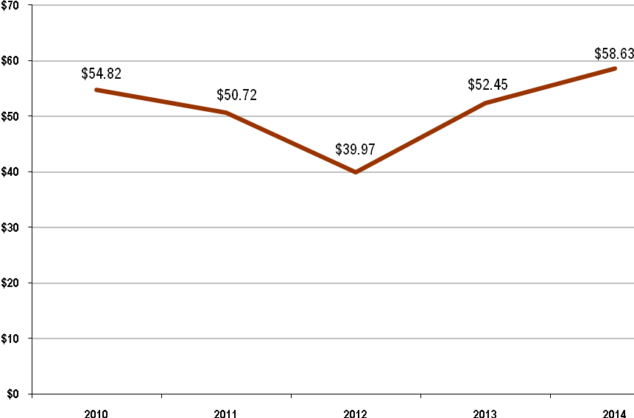
U.S. Nominal Fuel Costs 2010-2014 ($ per million Btu)
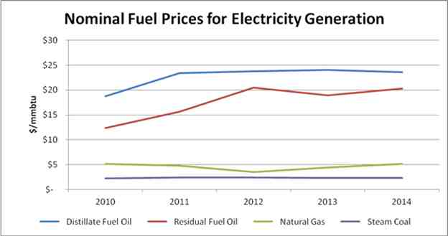
Source: U.S. Energy Information Administration, Independent Statistics and Analysis
NYISO Average Annual Load-Weighted Installed Capacity and
Fuel-Adjusted Wholesale Spot Energy Prices 2010-2014
($/megawatt-hour)
NYISO’s base day for fuel-cost references is January 1, 2000.

NYISO Wholesale Power Cost Breakdown 2010-2014
($/megawatt hour)
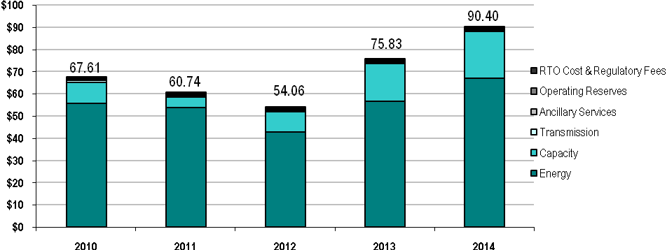The “Transmission” charge in the above chart represents the New York Power Authority (“NYPA”) Transmission Adjustment Charge (“NTAC”), which is a surcharge on all Energy Transactions assessed to all statewide load as well as Wheel Through and Export transactions. The NTAC recovers any residual NYPA transmission revenue requirements and is billed and collected by the NYISO. Additional transmission charges, not included in the above figure, are billed and collected by each transmission owner from both wholesale and retail customers. The capacity component is based on spot capacity prices times the capacity obligations in each area, divided by the real-time energy consumption.
The Capacity component is the total requirements and purchased excess MWs in the spot auctions valued at the Installed Capacity spot market prices.

Unconstrained Energy Portion of System Marginal Cost
NYISO Annual Average Non-Weighted, Unconstrained Energy Portion
of the System Marginal Cost 2010-2014
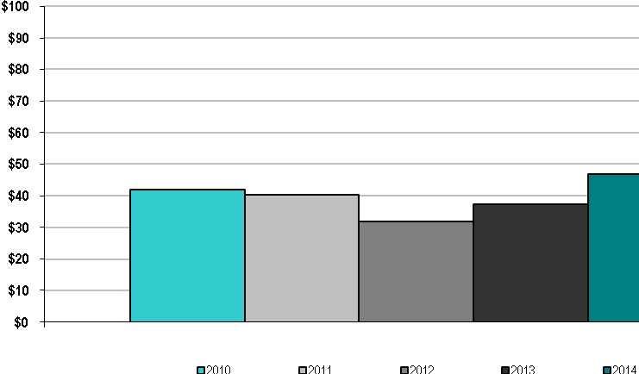
Similar to other ISOs/RTOs, the annual variability in the load-weighted wholesale energy prices is accounted for by the variability of natural gas prices. Adjusted for the variation in natural gas prices, the annual average wholesale energy prices have remained essentially flat over the past five years. This same variability can be seen in the breakdown of annual wholesale power costs. Since energy comprises the largest component of wholesale power costs, the effect of fuel price variability can be seen in the wholesale costs from 2010 to 2014.
Energy Market Price Convergence
NYISO Day-Ahead and Real-Time Energy Market Price Convergence 2010-2014
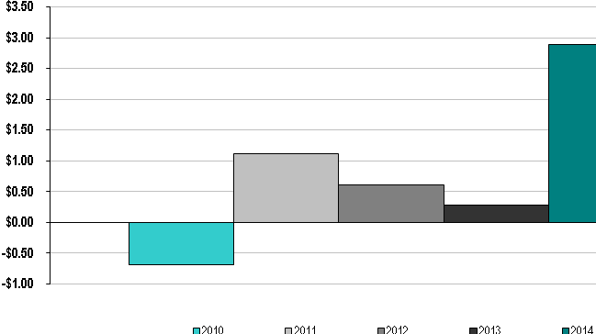
NYISO Percentage of Day-Ahead and Real-Time Energy Market Price Convergence
2010-2014
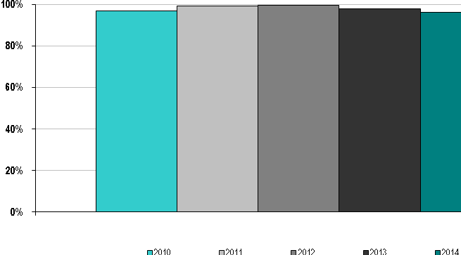
Convergence between day-ahead and real-time LBMPs has varied between 96 to 99 percent in recent years, while convergence measured in dollars has been more variable. This annual variation is driven by both real-time events and the cost of natural gas. This metric is the annual index based on the deviation of the annual average load weighted Real-Time Dispatch (“RTD”) price from the annual average of the absolute divergence of the RTD prices from the DAM prices, over annual average load weighted RTD price. Due to extreme cold weather, known as the Polar Vortex, and tight natural gas conditions, the 1st quarter of 2014 experienced an increase in real-time premiums.

Congestion Management
NYISO Annual Congestion Costs per Megawatt Hour of Load Served 2010-2014
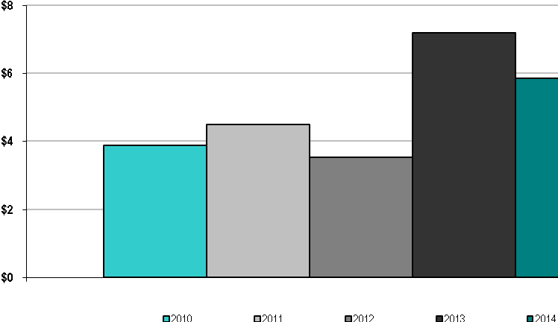

NYISO Percentage of Congestion Dollars Hedged Through ISO/RTO Congestion
Management Markets 2010-2014
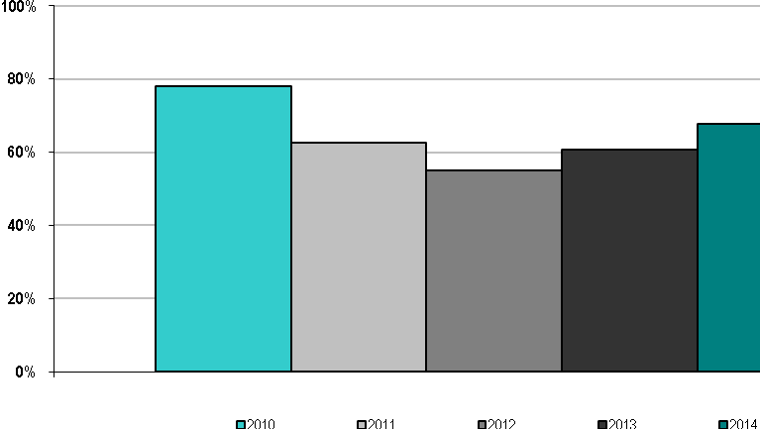

The annual congestion costs per MWh of load served vary with fuel costs and system conditions. The increase in the annual congestion costs in 2014, compared to 2010-2012, is partially accounted for by the increase cost of fossil fuel that year. The increase in the annual congestion costs in 2013 is partially accounted for by the larger spread in natural gas prices between Eastern and Western New York; as well as the changes in transmission line operation on the Ontario-Michigan border in Zone West. The percent of congestion dollars hedged through the NYISO markets is the total annual revenue collected from the hedging contracts purchased through the Transmission Congestion Contract auctions divided by the total annual congestion cost and has varied over time. Congestion hedges are generally used when loads, located in high congestion areas, are using generation located in less congested parts of the state to meet their loads. New York City, Long Island, and the G-J Locality have reliability based local generation installed capacity requirements (85%, 107%, and 88% in New York City, Long Island, and the G-J Locality, respectively, for the capability year that started in May 2014) and so may have less of a need for a congestion hedge. In addition, there is also an active market in over-the-counter contracts-for-differences, which provide a different instrument to hedge congestion.

Resources
NYISO Annual Generator Availability 2010 – 2014
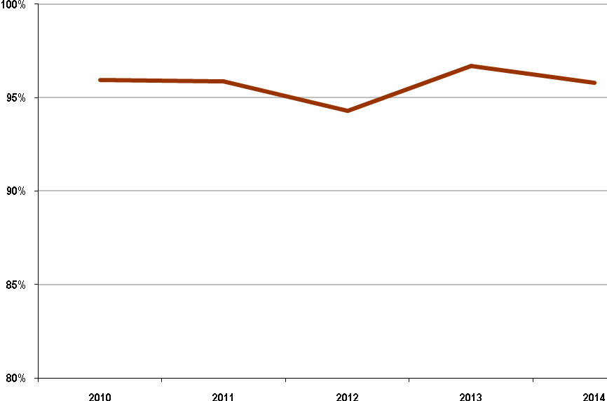
The decline in generator availability in 2012 can be attributed to Hurricane Sandy, which caused significant generator outages. Hurricane Sandy was responsible for 38% of the difference in generator availability between 2011 and 2012, accounting for a .59% drop in generator availability.
NYISO Annual Demand Response Availability 2010 – 2014
The data in the graph above represents the DR event performance data for Special Case Resources for all mandatory demand response events from 2010 through 2013. The overall program performance factor, which reflects test performance for both summer and winter, was used for 2014 because there were no demand response events in 2014.
It is important to note that event performance reflects two important aspects of demand response: the demand response resources deployed in the events (not all demand resources are deployed in every event) and the impact of market rule changes. In 2010, both factors contributed to the availability: only one zone was deployed and the baseline used for performance overstated the resources’ actual capacity. New baseline rules went into effect before the summer of 2011 which, as shown above, better reflected the availability of the demand response resources when deployed. Market rules regarding the use of behind the meter generation in the baseline affected availability in 2012. Due to the methodology used for the metric in this report, the cumulative effect of more events in zones with underperforming resources reduced the overall performance of event response in 2013. Detailed event response information is reported under Docket No. ER01-3001-000.

Fuel Diversity
Competitive markets have resulted in a more efficient, environmentally sound bulk electric power system for New York. The NYISO’s ability to optimize all system resources, the addition of cleaner, more efficient power plants, aggressive energy efficiency programs, the development of renewable power resources, and improved demand-side management have combined to “green the grid.”
Since 2000, power plants with generating capacity totaling 2,069 MW have retired. Of that total, 2,060 MW were powered by fossil fuels, including 987 MW of coal-fired generation. The new power plants built since the inception of electricity markets in New York run primarily on cleaner-burning natural gas, which is helping to reduce emissions that contribute to global climate change. In addition, New York has seen an increase in output from nuclear plants, which are virtually emission-free. The production of cleaner power is an important component in the state’s efforts to meet newly enacted environmental standards.
Based on available emissions data from the U.S. Environmental Protection Agency, power plant emission rates have significantly improved since 2000. From 2000 through 2014, sulfur dioxide (SO₂) emissions rates dropped 94 percent. The emission rates for nitrogen oxides (NOX) and carbon dioxide (CO₂) declined by 78 percent and 39 percent, respectively, during that period. Open access to the state’s electricity grid has also increased the number of existing and planned projects powered by renewable resources. Commercial power production from renewable resources, predominantly hydroelectric power projects, currently totals more than 5,600 MWs. Nearly two dozen private sector energy service companies now offer customers the option to purchase green power. More than 1,700 MW of wind power has been added in recent years and over 2,000 MW of additional wind power projects are proposed for development in the state.
The NYISO has taken steps that, according to FERC, “will benefit, and encourage, wind and other intermittent generators.” Those steps include a centralized wind-forecasting initiative, unique market rules for wind projects, and proposals to enhance the dispatch of wind power on New York’s bulk electricity grid.
New York State government policies are vigorously pursuing conservation and energy efficiency programs to control the growth in power consumption. These programs contribute to better power management, particularly during extreme weather conditions when electricity use is highest. They also help to lower consumer costs.
NYISO Fuel Diversity 2010-2014
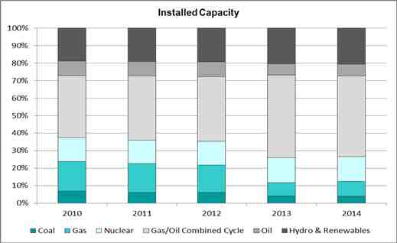
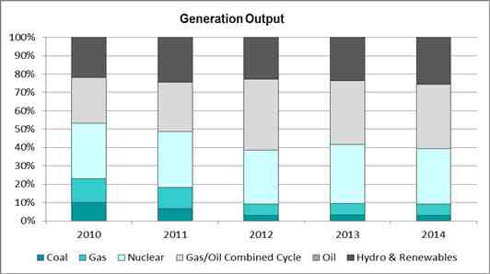

The NYCA’s electric generation has become increasingly dependent on natural gas and dual-fuel (seen above as “Gas/Oil Combined Cycle”) generating units. High efficiency and low emissions make them especially attractive to being located in densely populated areas such as New York City and Long Island. However, the limited capacity of the natural gas distribution system in New York City has resulted in the adoption of a local reliability rule often requiring the use of oil as the fuel source, despite being less economic and creating higher emissions.
Renewable Resources
Open access to the grid and competitive wholesale electric markets have facilitated the increased development of renewable energy projects. New York has been a leader in the integration of renewables, pioneering key policies and programs that have encouraged a significant growth in renewable sources of energy helping to meet environmental goals, and diversifying the array of fuels used to generate electricity. In 2014, electricity produced by hydropower, wind power, and other renewable resources totaled 25.5 percent of New York’s generation.
In 2008, the NYISO instituted one of the first state-of-the-art wind forecasting systems in the United States. The centralized system enables the NYISO to better utilize and accommodate wind energy by forecasting the availability and timing of wind-powered generation. In 2009, the NYISO became the first grid operator to dispatch wind power fully balancing the reliability requirements of the power system with the use of the least costly power available. Including wind power in the economic dispatch allows more efficient management of the resources and minimizes the duration of wind power curtailments. From 2010 to 2014, wind capacity increased from 1,274MW to 1,730 MW. In 2014, some 2,000 MW of additional wind power has been proposed for interconnection with the New York bulk electric system.
Generating facilities using renewable resources, such as wind, tend to be sited in locations distant from population centers. As a consequence, transmission upgrades or expansion may be required to effectively supply the power demands of New York State with this renewable power.
A 2010 study of wind power in New York State by the NYISO also examined the impact of wind resources on system variability and operations, installed capacity requirements, transmission infrastructure, production costs, and emissions.
The study concluded that wind generation can supply clean energy at a very low cost of production. This energy can result in significant savings in overall system production costs, yield reductions in “greenhouse” gases and other emissions, as well as result in an overall reduction in wholesale electricity prices. Wind plants as variable resources present challenges to power system operation. However, the study found that NYISO systems and procedures (which include economic dispatch and the other operational practices available to accommodate wind resources) should allow for the integration of as much as 8,000 MW of wind generation without adverse reliability impacts.
The study also determined that almost 9% of the potential upstate wind energy production would be “bottled” or not deliverable because of local transmission limitations. The study identified feasible sets of transmission facility upgrades to eliminate the transmission limitations. These upgrades were evaluated to determine how much of the wind energy that was undeliverable would be deliverable if the transmission limitations were removed. Additional alternatives were suggested and evaluated to address the significant levels of resource bottling that occurs in the Watertown, NY vicinity. The suggested transmission upgrades and alternatives require detailed physical review and economic evaluation before a final set of recommendations can be determined. The full study is available at: http://www.nyiso.com/public/webdocs/newsroom/press_releases/2010/GROWING_WIND_-_Final_Report_of_the_NYISO_2010_Wind_Generation_Study.pdf.
New York State Renewable Portfolio Standard
The NYPSC, in September 2004, issued its “Order Approving Renewable Portfolio Standard Policy” (“RPS”) that calls for an increase in renewable energy used in New York State from the then current level of approximately 19 percent to 25 percent by the year 2013. In December 2009, the NYS PSC increased the RPS goal to 30 percent and extended the target date to 2015. Currently, hydropower is the largest renewable resource (as defined by the NY RPS) in the state’s energy mix. The definition of “renewable” included existing large-scale hydropower, but limited the inclusion of hydroelectric power going forward to new run of river (non-storage) hydroelectric facilities of 30MW or less. The capacity of wind resources rose from 1,274 MW in 2010 to 1,730 MW in 2014, an increase of more than 35%.
The information presented here is consistent with New York’s RPS definition.
Under the definition of the NYS RPS, the calculated Total Energy (all renewable resources, including qualified hydropower) for this report period is: 2010 – 21.9%; 2011 – 24.3%; 2012 – 22.5%; 2013 – 23.5%; and for 2014 – 25.5%.
NYISO Non-Hydroelectric Renewable Megawatt Hours as a Percentage of Total Energy 2010-2014

NYISO Hydroelectric Renewables Megawatt Hours as a Percentage of Total Energy 2010-2014

Under the definition of the NY RPS the calculated Total Capacity (all renewable resources, including qualified hydropower) for this report period is: 2010 – 18.8%; 2011 – 19.0%; 2012 – 19.3%; 2013 – 20.4%; and for 2014 – 20.7%
.NYISO Non-Hydroelectric Renewable Megawatts as a Percentage of Total Capacity 2010-2014

The capacity of wind resources rose from 1274 MW in 2010 to 1730 MW in 2014, an increase of more than 35%.
NYISO Hydroelectric Renewables Megawatts as a Percentage of Total Capacity 2010-2014

Future NYISO Enhancements:
Moving the electricity produced by wind generation to areas of high consumer demand will require substantial investment in the state’s transmission infrastructure. Decisions on location financing new transmission facilities will be crucial to New York State’s ability to meet renewable power policy goals. The NYISO has facilitated the integration of renewable resources and complementary energy storage with innovative grid operation, market design, planning initiatives and technological advances. Ongoing NYISO activities related to renewable resources include the study of the potential of solar energy resources and evaluating the impact of solar-powered generation on load forecasting and grid operations.

C. NYISO Organizational Effectiveness
Administrative Costs
NYISO Annual Actual Costs as a Percentage of Budgeted Costs 2010-2014
Non-Capital Costs

Budget $129 $124 $127 $132 $134

Capital Recovery Costs
Budget $9 $11 $12 $17 $14
Bars Represent % of Actual Costs to Approved Budgets, Dollar Amounts Represent Approved Budgets (in millions)
*NYISO’s budget includes the annual assessment of fees from the FERC. In contrast, other ISOs and RTOs invoice such FERC fees within their market settlement charges and do not include FERC fees within their approved budgets. In order to ensure comparability of NYISO’s budget with other ISOs and RTOs, the charts reflecting “NYISO Annual Actual Costs as a Percentage of Budgeted Costs” and “NYISO Annual Administrative Charges per Megawatt Hour of Load Served” exclude FERC fees.
The NYISO develops its annual budget through its shared governance process in consultation with the Budget and Priorities Working Group (“BPWG”), which is open to participation by all NYISO Market Participants. The BPWG is responsible for developing and monitoring NYISO’s budgetary spending and providing guidance regarding prioritization and funding of strategic initiatives. Annually, the BPWG presents a recommended budget to the NYISO Management Committee, consisting of Market Participant membership from transmission owner, generation owner, other suppliers, end-use consumers, and public power/environmental sectors. The Management Committee votes on whether to recommend the proposed budget to the NYISO Board of Directors for approval. During the period 2010-2014, the NYISO’s proposed budgets were consistently supported by the Management Committee and approved by the NYISO Board of Directors.
In addition to the review and recommendations for NYISO’s annual budget, the BPWG meets regularly throughout the year to review budget vs. actual results for all NYISO line items and to monitor progress on projects’ scope, cost and schedules.
NYISO’s budget consists of Capital investments, Operating Expenses (excluding depreciation expense), FERC fees, Debt Service Costs (net of current year debt proceeds), offset by miscellaneous sources of income. NYISO’s budget is approved and spending is managed based on the totality of that respective year’s budget. In a given year, NYISO could overspend Capital while underspending Non-Capital (or underspend Capital while overspending Non-Capital); however, budget total spend is ultimately managed within the total overall NYISO budget. An example of this occurred during 2010 when NYISO’s Capital Recovery costs exceeded budget because anticipated long-term financing to proceed with infrastructure modifications was not approved during the calendar year of 2010. NYISO funded the cost of these Capital improvements with spending under-runs on the Non-Capital Costs portion of its annual budget recoveries. The non-capital costs metric identifies NYISO’s administrative and operational budget performance against the planned resource allocations to meet the NYISO’s objectives as discussed and vetted during the stakeholder process described above. The main categories of costs included in the non-capital costs metric include salaries and benefits, external professional fees, and computer services (hardware/software maintenance and licenses to support the NYISO operations and markets). Collectively, these three components of the non-capital costs metric approximate over 80% of the total NYISO annual cash budget.
During 2010-2014, NYISO’s actual spending was less than or equal to the approved budget in each respective year with minor variances from budget generally noted (budget underruns of 1% in 2010, 1% in 2011, 0% in 2012, 3% in 2013 and 2014).
NYISO’s most significant variance from budget occurred during 2013 and 2014, as the NYISO worked to achieve its essential responsibilities with continued efficiency and financial prudence. NYISO experienced cost savings in external legal fees, other professional fees, telecommunications, and building services in both years.
NYISO Annual Administrative Charges per Megawatt Hour of Load Served 2010-2014
($/megawatt-hour)
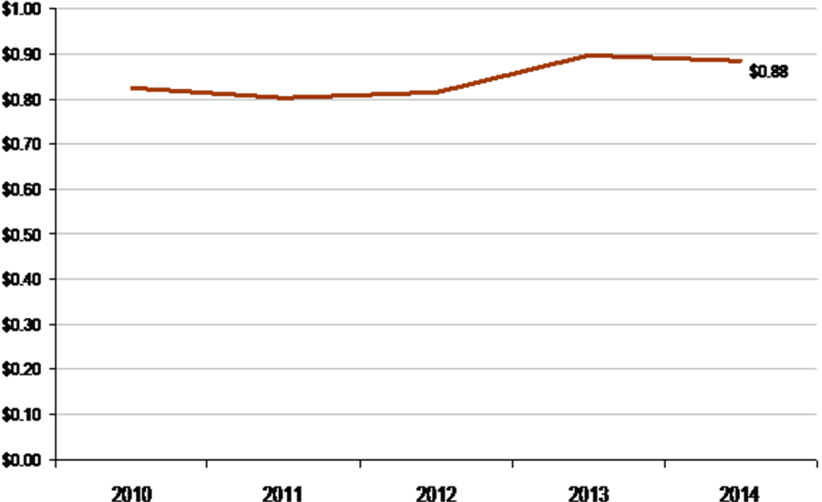
ISO/RTO | 2014 Annual Load Served  (in terawatt hours)
NYISO | 167

Customer Satisfaction
NYISO Percentage of Satisfied Members 2006-2014
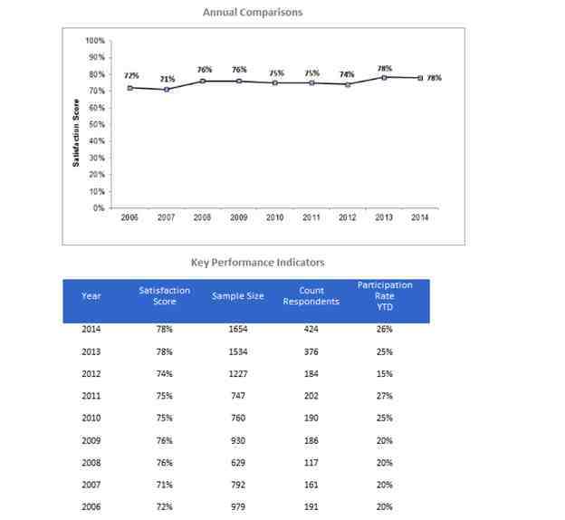
The NYISO is committed to transparency in how it carries out its duties, in the information it provides, and in its roles as the impartial administrator of the state’s wholesale electricity markets, operator of the high-voltage transmission system, and provider of comprehensive electric system planning. The NYISO actively involves stakeholders, regulators, public officials, consumer representatives, environmentalists, and energy experts who provide vital input from a variety of viewpoints. The NYISO’s shared governance process actively builds consensus for changes in market rules and operating procedures. As part of these efforts, the NYISO conducts a multi-channel feedback process that includes an annual survey, a CEO/Sr. executive survey, an ongoing performance assessment, and the opportunity to provide feedback after every customer inquiry. In response to past surveys, the NYISO has implemented transparency measures including a redesign of its website for greater ease in obtaining market and operational data. The NYISO strives for continuous improvement in customer service through our Stakeholder Services and Member Relations Departments with strategic investments in the people, processes, and tools. For example, the NYISO added a new search engine to its website, interactive chat to assist with navigation, and additional tools for Market Participants to enter and track inquires. The NYISO has also invested heavily in assisting new entrants into our markets by creating a welcome packet, expanding outreach, and working to automate the registration process. Market training resources have also been expanded, with instructional hours increased and web-based training options added. Overall, the average number of working days required to address all customer inquiries dropped from 5.5 days in 2009 to 3.2 days in 2010, to less than 0.5 days in 2013 and 2014.
In 2013, NYISO began migration from the single channel annual survey to the current multi-channel feedback process that composes the Customer Satisfaction Index (CSI). As of June 30, 2015, the CSI is 84.2. The NYISO had a CSI of 81.1 in 2013, and 82.8 in 2014. In an effort to show historical trends related to data provided in previous FERC Metric reports, the annual survey results are broken out from the CSI and shown in the chart above. The questions and scoring scales that the NYISO has used to measure satisfaction have evolved throughout NYISO’s fifteen year history. Currently the NYISO uses a 1-10 scale and computes a sector weighted average score on the annual survey. Data in previous years has been normalized to fit the current scale.

Billing Controls
ISO/RTO | 2010 | 2011 | 2012 | 2013 | 2014
NYISO | Unqualified SAS 70 Type 2 Audit Opinion | Unqualified SOC 1 Type 2 Audit Opinion | Unqualified SOC 1 Type 2 Audit Opinion | Unqualified SOC 1 Type 2 Audit Opinion | Unqualified SOC 1 Type 2 Audit Opinion

In 2014, the NYISO received an unqualified Service Organization Control (“SOC”) 1 Type 2 audit opinion in accordance with the Statement on Standards for Attestation Engagements (SSAE) No. 16 for the twelfth consecutive year (Statement of Auditing Standard 70 Type 2 in 2010). The SOC 1 Type 2 audit, conducted by an external audit firm, scrutinizes the controls related to the NYISO’s processes and systems for bidding, accounting, billing, and settlements of energy, regulation, capacity, transmission, reserves, and related services for processing user entities’ transactions. The external audit firm reviews the NYISO’s description of controls, and verifies that those controls are designed appropriately and operating effectively over a 12-month period. The SOC 1 report is designed for use by management of the NYISO, NYISO Market Participants, and Independent Auditors of the NYISO Market Participants.
Pricing Accuracy
The Pricing Accuracy performance metric identifies NYISO's level of real-time pricing accuracy. NYISO follows a rigorous price validation process for ensuring timeliness and accuracy in pricing outcomes. The results from 288 five-minute real-time dispatch cases per day, on average, with approximately 500 pricing points are posted in real-time through an automated system. Each day the prices are reviewed for accuracy and corrected, if necessary, within three calendar days as per the tariff.
In 2014, real-time prices in 99.63% of total hours were accurately set based on the NYISO's tariffs, with price corrections required in only 32 out of 8,760 hours. The following table shows, for years 2010-2014, the percentage of hours in which there were no corrections in the real-time energy or ancillary services prices at any active nodal or zonal price location in the NYISO administered markets.
NYISO's focus on price certainty has resulted in significant improvements since 2005. The primary driver for the completed improvements and the high level of price accuracy achieved is due to the integration of Intelligent Source Selection (“ISS”). ISS allows for improved data integrity by identifying and removing metering errors that otherwise would have impacted the real-time markets.
NYISO | Error-Free Hours
2010 | 99.79%
2011 | 99.70%
2012 | 99.50%
2013 | 99.73%
2014 | 99.63%

Billing Accuracy
The Market Settlement Billing Accuracy metric includes all settlements on NYISO Invoices from the Initial Monthly Bill through Final Bill Closeout. The values represent the percentage of the total Final Bill Settlement that was invoiced, on average, at the various invoice intervals until the requisite billing month was closed out. Weekly invoicing was introduced in 2011. The primary driver of differences between the initial bill and 4 Month True-up is metering updates that occur throughout the true-up process in accordance with the NYISO tariff.
Billing Accuracy
% of dollars settled during billing cycles 2010-2014
Year | Invoice | 4 Month Rebill | True-ups & Close Out
2010 | 94.63% | 4.96% | 0.41%
2011 | 95.99% | 3.72% | 0.29%
2012 | 95.63% | 4.06% | 0.31%
2013 | 94.67% | 4.92% | 0.40%
2014* | 96.11% | 3.49% | 0.41%
Five-Year Average | 95.41% | 4.23% | 0.36%
*Through September 2014
NYISO Market Participants are engaged in the Billing Issues process on a regular basis through the Billing and Accounting Working Group (“BAWG”). The BAWG meetings include standing agenda items that cover highlights of the most recently issued invoices, as well as information on any open billing issue and its planned resolution strategy and timeline. In addition to this information, the Billing Issues Report includes information on upcoming code deployments, bill challenges, and pertinent FERC filings that may impact the invoice process or individual invoices.
D. New York ISO Specific Initiatives
Prior to the restructuring of New York State’s electric system, a set of eight investor-owned electric utility companies and public power authorities owned and operated the generation, transmission and distribution infrastructure serving New York State. With the onset of New York’s competitive marketplace for electricity, a diverse array of private power producers, energy service providers, and others entered the market. Today, more than 400 organizations participate in NYISO’s wholesale electric markets. This abundance of competitors has enhanced the efficiency of New York’s electric system, promoted innovation and delivered significant benefits for consumers, the economy and the environment of New York State.
NYISO Market Benefits – Improved Fuel Efficiency
From 2000 to 2013, the “fuel efficiency” (kilowatt-hours produced per BTU) of New York’s power generation has improved by more than 27 percent. In comparison, the fuel efficiency in the nation’s electric system improved 8.25 percent. In New York, the increased efficiency reduced fuel costs by $6.4 billion from 2000 through 2013.
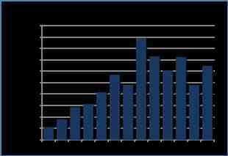
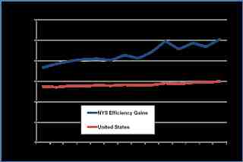
NYISO Market Benefits – New Generation & Transmission
In 2000, soon after the NYISO was established, New York State faced a widening generation gap, with projections that available generation would be incapable of reliably serving increasing levels of electricity use, particularly in the downstate Metropolitan New York region.
Since 2000, private power producers and public power authorities have added more than 11,600 megawatts of generating capacity in New York State. The added generation represents more than one-quarter of New York State’s power needs.
Over 80 percent of the new generation is located in New York City, on Long Island and in the Hudson Valley (NYISO Zones F-K), the regions of New York State where power demand is greatest. The NYISO’s wholesale electricity market design, which includes LBMP and the regional capacity requirements, encourages investment where the demand for electricity is greatest.
In addition to new generation, more than 2,300 megawatts of transmission capability has been added to bring more power to the southeastern New York region from out of state when it is more economic to do so.
In the market environment introduced by the NYISO, power producers have invested in new generation and upgrades to existing facilities. Consumers have benefited through prices that are lower than they might have been otherwise. Environmental quality has been enhanced by the addition of new, lower-emission generation additions, more emission-free, renewable power resources and enhanced power plant efficiencies that have contributed to reduced emission rates.
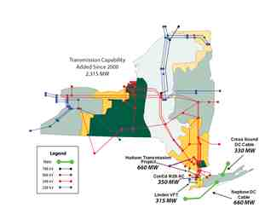
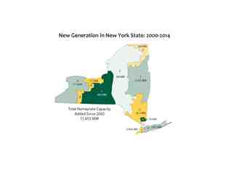
NYISO Market Benefits – Reduced Reserve Requirements
Prior to the establishment of the competitive wholesale electricity market, New York State’s electric system typically maintained a 22 percent IRM above the forecasted peak demand. Since 2000, IRM standards have been set by the NYSRC consistent with Northeast Power Coordinating Council standards. The IRM has averaged approximately 17 percent above peak demand levels since 2000. Improved efficiencies in the electric system have enabled reductions in the reserve requirements, saving an estimated $540 million in consumer costs from 2000-2014, while still meeting reliability requirements.
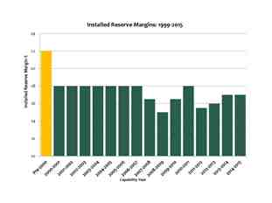
NYISO Market Benefits – Improved Production from Existing Units
Competitive markets have encouraged New York’s generation facilities to increase their production substantially. The nuclear fleet, in particular, has produced on average 12,600 gigawatt-hours more energy each year in New York’s competitive electricity markets than during the years prior to establishment of the NYISO. This increased production from existing facilities is approximately the equivalent of adding 1,400 MW of new generation.
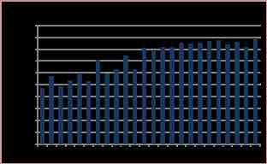
NYISO Market Benefits – Emission Reductions
Encouraged by market competition, improved power plant operating efficiencies have complemented environmental regulations designed to promote improved air quality. Based on available emissions data from the U.S. Environmental Protection Agency, power plant emission rates have significantly improved since 2000. From 2000 through 2014, sulfur dioxide (SO₂) emissions rates dropped 94 percent. The emission rates for nitrogen oxides (NO_{X}) and carbon dioxide (CO₂) declined by 78 percent and 39 percent, respectively, during that period.
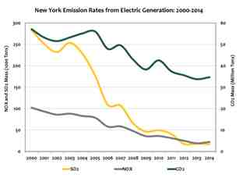
NYISO Market Benefits – Renewable Resources
Wholesale electricity markets and open access to the grid provided by the NYISO, facilitate the development of renewable resources. Open access enables any resource to interconnect to the grid and transmit power if it does not adversely affect system reliability.
The NYISO shared governance system, which guides market evolution, provides a forum for Market Participants and stakeholders to collaborate on market changes that address new technologies. The design of NYISO’s wholesale electricity markets has been revised to address the unique characteristic of wind power by:
- Recognizing wind in 2006 as a variable energy resource and revising market rules to exempt it from undergeneration penalties that apply to conventional generation;
- Establishing a centralized wind forecasting system in 2008 to better utilize and accommodate wind energy by forecasting the availability and timing of wind-powered generation; and
- Pioneering the economic dispatch of wind power in 2009 to fully balance the reliability requirements of the power system with the use of the least costly power available.
Electricity generated by wind power increased from 103 gigawatt-hours in 2003 to 3,986 gigawatt-hours in 2014. The nameplate capacity of wind-powered projects in New York grew from 48 megawatts in 2003 to 1,730 megawatts in 2014.
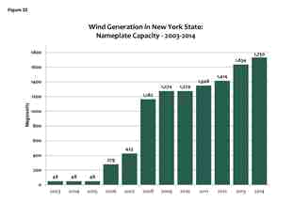
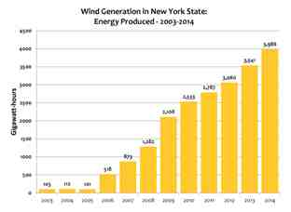
NYISO Market Benefits – Demand Response
Prior to the establishment of wholesale electricity markets, New York’s electric system generally addressed growth in peak demand with comparable increases in generating capacity. Demand response programs developed by the NYISO have helped alleviate the need for more generation by focusing on consumers to assist in reducing the use of electricity. Large power customers and aggregated groups of smaller consumers participate in several demand response programs developed in the NYISO markets. In summer 2014, the programs involved more than 4,022 end-use locations providing a total of 1,210 megawatts of load reduction capacity, representing 4.1 percent of the 2014 summer peak demand. When New York set a new record for peak demand in July 2013, demand response helped to “shave” the peak by nearly 1,000 megawatts.
NYISO Market Benefits – Broader Regional Markets
The Broader Regional Markets initiative is a collaborative, cross-boundary effort involving the PJM Interconnection, L.L.C (“PJM”), ISO New England, Inc. (“ISO-NE”), Midcontinent Independent System Operator, Inc. (“MISO”), Ontario’s Independent Electricity System Operator, and Hydro Quebec. Several components of the ongoing, multi-faceted initiative have been implemented. In 2014, the NYISO and PJM enhanced their 15-minute scheduling protocol (called Interregional Transaction Coordination) with a new Coordinated Transaction Scheduling function. That protocol—which lowers overall system operating costs, provides system operators with additional resource flexibility, and increases the efficiency of real-time markets—is expected to come online between the NYISO and ISO-NE in 2015, as well. Enhanced coordination with PJM is expected to create annual production cost savings between $9 million and $26 million, and between $9 million and $11 million with ISO-NE. In 2013, the NYISO and PJM launched Market-to-Market Congestion Relief Coordination, enabling joint management of the transmission limits that occur near the borders of their control areas. Enhanced Interregional Transaction Coordination was implemented by the NYISO with Hydro Quebec in 2011 and with PJM in 2012. Overall, the Broader Regional Markets initiatives were preliminarily projected to yield production cost savings of up to $362 million a year throughout the region.

NYISO Market Benefits – Advanced Technology & Smart Grid
Under provisions of the American Reinvestment and Recovery Act of 2009, the U.S. Department of Energy (“DOE”) Smart Grid Investment Grant (“SGIG”) program provided funding to system operators, transmission companies, and utilities across the United States to install more than 800 networked phasor measurement units. In New York, the NYISO and New York’s transmission-owning utilities and power authorities have completed power grid upgrades that are part of a statewide $75 million smart grid initiative, supported by $37.8 million in SGIG funds from DOE. The NYISO’s partners in the statewide smart grid initiative include: Consolidated Edison; National Grid; Orange and Rockland; Rochester Gas & Electric; Central Hudson Gas & Electric; New York State Electric & Gas; the New York Power Authority; and the Long Island Power Authority.
NYISO’s new control center, which became operational in December 2013, incorporates the capabilities of the SGIG project with an array of advanced technologies to power New York’s future, supporting greater coordination with neighboring regions, improving coordination between gas pipelines and the power grid, and facilitating the integration of renewable resources.

NYISO Market Benefits - Expanded Interregional Planning
Since 2009, NYISO has been a leader in the creation and governance of the Eastern Interconnection Planning Collaborative (“EIPC”) -- the first organization founded to foster interstate transmission coordination across the eastern portion of North America. From 2010 through 2012 the EIPC, with the support of U.S. DOE funding, identified and analyzed various resource expansion scenarios, reflecting different “energy futures”. These included a national renewable energy standard implemented on a regional basis, a nation-wide carbon emission reduction requirement implemented primarily via emission reductions in the electric utility sector, and a “business as usual” scenario reflecting current and expected environmental and renewable energy requirements. The analysis found that the reliability plans of electric system planners in the Eastern Interconnection integrate well to meet the reliability needs of the Eastern Interconnection. During 2013 through 2015 as an extension of the DOE grant, the EIPC conducted the Gas-Electric System Interface Study, which provided a comprehensive analysis of the region’s natural gas delivery infrastructure and its ability to support the growing use of natural gas for electric power production.
The results of these EIPC analyses provide a wealth of information to state and federal policy makers, EIPC members and other stakeholders as they consider critical energy initiatives to ensure an adequate, safe and efficient supply of electric energy to meet the future needs of consumers.

PJM Interconnection (PJM)

Section 6 – PJM Performance Metrics and Other Information

PJM Interconnection is a regional transmission organization that coordinates the movement of wholesale electricity in all or parts of Delaware, Illinois, Indiana, Kentucky, Maryland, Michigan, New Jersey, North Carolina, Ohio, Pennsylvania, Tennessee, Virginia, West Virginia and the District of Columbia.
- A neutral, independent organization, PJM has been designated by the Federal Energy Regulatory Commission to manage the high-voltage electric grid to ensure reliable service for more than 61 million people.
- PJM also administers the world’s largest competitive wholesale electricity market, where nearly 800 billion kilowatt-hours were bought and sold in 2014.
- PJM’s long-term regional planning process provides a broad, multi-state perspective over a 15-year horizon that identifies the most effective and cost-efficient improvements to the grid to ensure reliability and economic benefits.
- An independent board of directors with diverse professional backgrounds provides oversight on behalf of PJM’s 900+ members. Through effective governance and a collaborative stakeholder process, PJM is guided by its vision: “To be the electric industry leader – today and tomorrow – in reliable operations, efficient wholesale markets and infrastructure planning.”
Founded in 1927 as a power pool, PJM opened its first bid-based energy market on April 1, 1997. Later that year, the Federal Energy Regulatory Commission approved PJM as an independent system operator. (ISOs operate, but do not own, transmission systems in order to provide open access to the grid for non-utility users.) PJM became a regional transmission organization in 2001, as FERC encouraged the formation of RTOs to operate the transmission system in multi-state areas as a means to advance the development of competitive wholesale power markets.
Beginning in 2002, PJM integrated a number of utility transmission systems into its operations. They included: Allegheny Power (2002); Commonwealth Edison, American Electric Power and Dayton Power & Light (2004); Duquesne Light and Dominion (2005); American Transmission Systems, Inc., (2011) and, in 2012, Duke Energy Ohio, Inc. and Duke Energy Kentucky, Inc. (2012) and East Kentucky Power Cooperative (2013). These integrations expanded the number and diversity of resources available to meet consumer demand for electricity and increased the benefits of PJM’s wholesale electricity market.
Currently, PJM administers numerous markets to facilitate the reliable and cost-effective delivery of electricity, including markets for day-ahead energy, real-time energy and a capacity market that procures capacity three years in advance of the need. Other PJM electricity markets include: financial transmission right congestion hedging, synchronized reserves, day-ahead scheduling reserves and regulation services.
PJM ensures sufficient black start service to supply electricity for system restoration in the unlikely event that the entire grid would lose power. PJM also administers demand response programs that help increase operational efficiency and improve resource diversity, which in turn can reduce wholesale prices and customer costs.
A. PJM Bulk Power System Reliability
The table below identifies which NERC Functional Model registrations PJM has submitted effective as of December 2014. Additionally, the Regional Entities for PJM are noted below the table with a link to the websites for the specific reliability standards for each.
NERC Functional Model Registration | PJM
Balancing Authority
Interchange Authority
Planning Authority
Reliability Coordinator
Resource Planner
Transmission Operator
Transmission Planner
Transmission Service Provider
Regional Entities | ReliabilityFirst and SERC

Standards that have been approved by the NERC Board of Trustees are available at:
http://www.nerc.com/page.php?cid=2|20
Additional standards approved by the ReliabilityFirst Board are available at:
https://www.rfirst.org/standards/pages/approvedstandards.aspx
Additional standards approved by the SERC Board are available at:
http://www.serc1.org/program-areas/standards-regional-criteria
All ISOs and RTOs are responsible for compliance with North American Electricity Corporation (NERC) mandatory standards and any mandatory standards for the Regional Entities (RE) that apply in the region where the ISO/RTO is located and are subsequently adopted by NERC. The mandatory reliability standards only apply to ISO/RTOs based on the NERC functional model categories for which each ISO/RTO has registered.
Therefore, different reliability standards apply to different ISOs and RTOs. For example, each region may have reliability standards that apply only within that region, given the particular infrastructure, resource mix, topographical and other differences that exist within the region. The main differences between the ISO/RTO compliance programs are the result of differences in functional model registration as based upon long standing operating practices and agreements that pre-date mandatory compliancy.
Violations of such standards may be identified by an ISO/RTO and self-reported or may be identified by a NERC and/or Regional Entity audit, spot-check, and/or event investigation of the ISO’s/RTO’s compliance to the applicable standards. In accordance with the Compliance Monitoring and Enforcement Program (CMEP), NERC and/or Regional Entities can then classify violations as low, medium or high severity.
The table below reflects all NERC violations that have been identified during CMEP activity or as a result of a PJM self-report and have been published as part of that process. As evidenced by the table below, PJM’s culture of compliance is evident by the significant ratio of self reports to violations found through other CMEP activities. PJM’s Board and Senior Leadership regard self reports as evidence of strong controls identifying and mitigating possible issues before these same issues could pose a threat to the reliability and/or security of the bulk electric system. PJM’s culture of compliance was recognized by FERC staff in their 2011-2014 FERC Performance Audit. Similar recognition of PJM’s compliance culture was evident in ReliabilityFirst’s (RF) granting PJM logging privileges to certain standards after RF’s Reliability Assurance Initiative (RAI) Pilot assessment of particular PJM controls (February 2014).
 | 2010 | 2011 | 2012 | 2013 | 2014 | TOTAL
Self Reports
CIP Self Reports | 6 | 4 | 16 | 8 | 4 | 38
Non-CIP Self Reports | 1 | 1 | 3 | 1 | 0 | 6
TOTAL | 7 | 5 | 19 | 9 | 4 | 44
CMEP (Audit, Spot Check)
CIP Reports | 3 | 0 | 2 | 2 | 0 | 7
Non-CIP Reports | 1 | 0 | 3 | 0 | 0 | 4
TOTAL | 4 | 0 | 5 | 2 | 0 | 11
Ratio of Self Reports to CMEP Findings | 7:4 | 5:0 | 19:5 | 9:2 | 4:0 | 4:1
Note: Dates indicate when a possible violation was reported versus when enforcement actions were settled or completed.
In the 2010 to 2014 timeframe, PJM shed load on two days to protect system reliability and in by doing so has also been compliant to applicable operating requirements. The table below highlights these events and links the applicable PJM report to the event. In each case PJM was very transparent with its regulators and the industry in its sharing of lessons learned.
EVENT/Location | DATE | MW SHED | PJM REPORT
AEP Pigeon River,  Southern MI, close to IN | Sept. 9, 2013 | 3.1 | http://pjm.com/~/media/documents/reports/20131223-technical-analysis-of-operational-events-and-market-impacts-during-the-september-2013-heat-wave.ashx
AEP Pigeon River,  Southern MI, close to IN | Sept. 10, 2013 | 5 | http://pjm.com/~/media/documents/reports/20131223-technical-analysis-of-operational-events-and-market-impacts-during-the-september-2013-heat-wave.ashx
FE Tod,  Warren, OH | Sept. 10, 2013 | 16 | http://pjm.com/~/media/documents/reports/20131223-technical-analysis-of-operational-events-and-market-impacts-during-the-september-2013-heat-wave.ashx
Penelec Erie South (FE),  Erie, PA | Sept. 10, 2013 | 105 | http://pjm.com/~/media/documents/reports/20131223-technical-analysis-of-operational-events-and-market-impacts-during-the-september-2013-heat-wave.ashx
AEP Summit,  Fort Wayne, IN | Sept. 10, 2013 | 25 | http://pjm.com/~/media/documents/reports/20131223-technical-analysis-of-operational-events-and-market-impacts-during-the-september-2013-heat-wave.ashx

Dispatch Operations
PJM CPS-1 Compliance 2010-2014
Compliance with CPS-1 requires a performance level of at least 100 percent throughout a 12-month period. PJM was in compliance with CPS-1 for each of the calendar years from 2010 through 2014. PJM began participating in a field trial to replace CPS-2 as a performance measure in August 2005 and was granted a waiver from the CPS-2 measure at that time. This new control performance measure is the Balancing Authority ACE Limit (BAAL). The BAAL performance measure combines the CPS-1 performance measure with a specific limit known as a Frequency Trigger Limit (FTL). In order to be compliant with the BAAL standard, a Balancing Authority must recover from a FTL excursion within a 30-minute period of time. PJM was in compliance with the BAAL performance standard for each calendar year from 2010 to 2014.
PJM Energy Market System Availability 2010-2014
The availability of the Energy Management System (EMS) is key to the reliable monitoring of the electric system in the PJM region. In November 2011, PJM implemented a second control center with dual independent data communication links to the EMS systems at each control center. These enhancements helped to increase the availability of the PJM EMS to 99.96 percent since 2011.

Load Forecast Accuracy
ISO/RTO | Load Forecasting Accuracy Reference Point
PJM | Noon prior day

PJM Average Load Forecasting Accuracy 2010-2014

PJM Peak Load Forecasting Accuracy 2010-2014

PJM Valley Load Forecasting Accuracy 2010-2014

PJM has maintained its approximate 98 percent load forecasting accuracy for the aggregate PJM region for the years 2010 – 2014. This accuracy level is consistent for the average, peak and valley load forecasting during those years. This means that PJM is forecasting the total generation needs, as well as the daily maximum and minimum generation requirements, for the PJM region within an approximate two percent variance to the actual needs.

Wind Forecasting Accuracy
PJM Average Wind Forecasting Accuracy 2010-2014
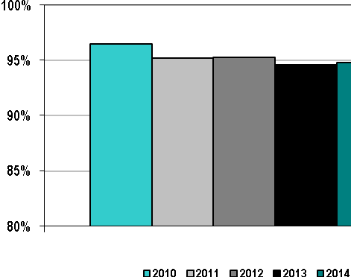
PJM began tracking wind forecasting accuracy during December 2009. The potential output from a wind generation resource can be impacted by its geographic location, hub height, turbine type, turbine capacity, manufacturer’s power curve, ambient temperature operating limits and accurate turbine outage reporting.
PJM’s approach to wind forecasting focuses on gathering the operating and historical data for each wind generation resource and incorporating that information in a model that forecasts anticipated generation output based on predicted future operational and weather conditions. PJM’s objective is to improve its wind forecasting accuracy as it gathers more historical data and experience with the current wind generators in the PJM footprint.
PJM initiated a Wind Power Forecasting request for proposal process in the 1st Quarter of 2015 to assure that the current PJM wind power forecasting vendor is providing the most accurate, reliable and cost effective service, resulting in the selection of the incumbent vendor. During the 3rd Quarter of 2015, PJM began an initiative to investigate Solar Power Forecasting services.
Unscheduled Flows
Unscheduled flows, also referred to as loop flows, are the difference between actual and scheduled power flows at specific interfaces. Unscheduled flows can exist at the same time that inadvertent interchange is zero. For example, actual imports could exceed scheduled imports at one interface and actual exports could exceed scheduled exports at another interface by the same amount. The result is loop flow, despite the fact that system actual and scheduled power flow net to a zero difference. All data and analysis of Unscheduled Flows in this report reflects PJM’s geography and external interfaces as of December 31, 2014.
PJM Absolute Value of Total Unscheduled Flows 2010-2014
(terawatt hours)

For context, the table below notes the number of external interfaces in 2014 over which PJM may have experienced unscheduled flows.
ISO/RTO | Number of External Interfaces
PJM | 20

PJM Absolute Value of Unscheduled Flows
as a Percentage of Total Flows 2010-2014

PJM’s unscheduled flows in both absolute terms and as a percentage of total flows have been consistent over the past few years.
PJM Unscheduled Flows  by Interface | (in terawatt hours)
PJM Unscheduled Flows  by Interface | 2010 | 2011 | 2012 | 2013 | 2014
Progress Energy Carolinas | (7) | (6) | (7) | (6) | (6)
MISO | 5 | 5 | 10 | 11 | 12
Ohio Valley Electric Cooperative | 4 | 4 | (3) | (4) | (3)
Tennessee Valley Authority | (4) | (4) | 1 | (3) | (4)
Duke Energy Carolinas | 3 | 2 | 1 | 1 | 2
NYISO | (3) | (2) | (2) | (1) | (1)

PJM’s list of the highest magnitude unscheduled flows by interface demonstrates the primary unscheduled flow patterns involving the PJM region – flows from west of PJM through PJM and then out to the regions south of PJM.

Transmission Outage Coordination
PJM Percentage of > 200kV Planned Outages of 5 Days or More that are Submitted to ISO/RTO
at least 1 Month Prior to the Outage Commencement Date 2010-2014
PJM requires transmission owners to provide advance notice of a planned transmission outage for 200 kV or higher transmission facilities. In general, transmission outages should be reported to PJM at least one month prior to the target outage commencement date. As noted in the preceding chart, a significant portion of the planned 200 kV or higher outages of 5 days or more in the PJM region have been reported to PJM at least one month prior to the start of the outage.
PJM Percentage of Planned Outages Studied in the PJM Tariff/Manual established timeframes 2010-2014
The data in the preceding chart indicates its members’ substantial compliance with the PJM’s advance notification requirement. The advance notification allows PJM to study the proposed transmission facility outage for potential reliability implications before the transmission outage commences. The outages not reported to PJM according to the advance notification requirement will only be approved by PJM if that requested outage does not cause increased congestion or have any adverse reliability impacts.
PJM Percentage of > 200 kV Outages Cancelled by PJM After Having Been Previously Approved 2010-2014
PJM has the authority to cancel or reschedule previously-approved planned transmission outages if such outages would jeopardize system reliability conditions at the time the outage is ready to commence. As such, an outage that would require an emergency procedure will be cancelled and rescheduled. When a transmission outage would impact generation availability, PJM endeavors to schedule the transmission outage at a time where the impact is mitigated (such as when the generation would be on a maintenance outage). Historically, PJM has only needed to cancel a very small percentage of transmission outages that it had previously approved.

PJM Percentage of Unplanned > 200kV Outages 2010-2014
Unplanned transmission outages may occur due to equipment malfunctions on the transmission line or an adjacent substation. They can also occur due to weather conditions that cause a transmission facility to trip out of service. Historically, 19 – 26 percent of the outages of transmission assets in the PJM region with 200 kV or higher voltages have been unplanned, though only a small portion of those outages were due to lines tripping.

Transmission Planning
PJM Number of Transmission Projects Approved to be Constructed for Reliability Purposes 2010-2014
PJM Percentage of Approved Construction Projects In-Service by December 31, 2014
PJM’s Regional Transmission Expansion Plan identifies transmission system additions and improvements needed to keep the lights on for more than 61 million people throughout 13 states and the District of Columbia. PJM addresses transmission expansion planning from a regional perspective, spanning transmission owner (TO) zonal boundaries and state boundaries to address system-wide impacts caused by a range of upgrade drivers: for example, long-term load growth, impacts of generator deactivations caused by environmental public policy, broader generation development patterns driven by Marcellus and Utica shale natural gas supply and generating resources driven by wind, solar and other renewables.
PJM’s RTEP process encompasses a comprehensive assessment of system compliance with the thermal, reactive, stability and short circuit NERC and regional standards over a 15-year horizon. Five-year-out planning enables PJM to assess and recommend transmission upgrades to meet forecasted near-term load growth and to ensure the safe and reliable interconnection of new generation and merchant transmission projects. PJM’s 15-year planning horizon permits consideration of long-lead-time transmission options. These options often comprise larger magnitude transmission facilities that more efficiently and globally address the aggregate effects of many system trends.

Transmission projects that improve reliability can also improve economics, and vice versa. PJM’s RTEP process examines market efficiency to identify transmission enhancements that lower costs to consumers by relieving congested lines, allowing lower cost power to flow to consumers. Market Efficiency studies entail production cost analysis to evaluate transmission enhancements for their economic value based on their ability to relieve persistent congestion. Those that equal or exceed a 1.25 benefit-to-cost threshold are assessed further for any additional system impacts.

The RTEP process culminates in one recommended plan for the entire RTO as submitted to PJM’s independent Board periodically throughout the year. Once the PJM Board approves transmission upgrades – new facilities and upgrades to existing ones – they formally become part of RTEP. Board approval obligates designated entities to construct those upgrades. The Board also considers PJM recommendations to remove upgrades from the RTEP if need no longer exists.

Recent RTEP Upgrades Summary
Since 1999, and through December 31, 2014, the PJM Board has approved transmission system enhancements totaling nearly $25.6 billion to ensure compliance with NERC and regional planning criteria. This includes $21.5 billion of baseline transmission upgrades throughout the RTO and $4.1 billion of additional facilities to enable the interconnection of more than 60,000 MW of new generating resources.
RTEP upgrades include a range of power system elements: circuit breaker replacements to accommodate higher current interrupting duty cycles; new reactive devices including shunt capacitors and static VAR compensation to enhance reactive support and improve generating unit stability; and, new lines, transformers, existing line reconductoring and bus reconfigurations to accommodate increased power flows.
Until recently, conventional PJM RTEP near-term analysis comprised a five-year-out baseline study focused on summer peak load emergency system conditions. However, a single set of baseline and market assumptions are simply not sufficiently flexible to consider all possible impacts of system drivers to their fullest extent. PJM’s RTEP process has continued to adapt to assess the effects of many system planning trends. More recently, public policy drivers – generator deactivations due to environmental policies, for example – coupled with generator operator fuel-of-choice shifts from coal and oil to natural gas, are dramatically shifting the scope and magnitude of upgrades recommended to the PJM Board for approval.
Shifting Baseline Upgrade Drivers
Approved baseline upgrades expected to be needed by 2019 reflect a new PJM reality characterized by flatter load growth and a generation fleet shift from coal to natural gas-fired units. PJM’s 2015 Load Forecast Report now projects its RTO summer normalized peak to grow 1.0 percent annually over the next 10 years, down from 1.3 percent annually in the 2013 forecast. PJM’s load forecasting model methodology incorporates economic factors, weather conditions and calendar effects.
PJM continued to receive deactivation notifications throughout 2014, totaling 4,291 MW, down from 7,745 MW in 2013 and 14,444 MW in 2012. For perspective, PJM received and studied deactivation requests for nearly 11,000 MW during the eight years ending November 1, 2011. Generator deactivations alter power flows that often yield transmission line overloads and, given reductions in system reactive support from those generators, can undermine voltage support. Holistically, the need for new large-scale baseline upgrades – long-distance transmission lines, for example – driven by these factors has diminished. However, this may only be temporary. PJM has begun to assess the potential impacts of recent EPA carbon regulations which may cause additional coal-fired generator deactivation requests and consequent need for related transmission system upgrades. Those regulations target coal-fired generation by calling for a 30 percent reduction in carbon emissions from 2005 levels by 2030.
Generation owners weigh investments and operational costs against anticipated revenues from PJM markets and existing power purchase agreements to determine economic viability. Costs to address environmental regulatory requirements and unit age put plants at-risk, particularly with regard to the ability to clear a capacity auction. These resources face competition from more efficient plants, renewable energy resources and demand response programs.
Demand Resource Programs
Demand resource programs across PJM have emerged under the aegis of various state initiatives. Sound planning practices, though, require PJM to ensure reliability such that the system effects of load management are only considered once they have cleared an RPM three-year-forward capacity market auction and satisfied all related, attendant obligations. Demand resources can defer the need for new generation and transmission resources.
A concern has arisen though because providers have bought out a significant portion of their RPM auctions demand resource positions or replaced it with other capacity resources prior to the start of the delivery year. The impact has been that PJM has assumed the availability of more demand resources in its planning studies than actually commits to PJM when the delivery year arrives. Additional uncertainty has also arisen out of recent D.C. Circuit Court and FERC proceedings that call into question demand resource eligibility to participate in any wholesale electricity market, including RPM auctions. Recently, demand resources totaling between 11,000 and 15,000 MW have cleared PJM auctions. The loss of these megawatts could have serious implications for PJM reliability.
Status of Approved Backbone Transmission Lines
The status of backbone transmission line facilities (345kV and above) approved by the PJM Board but were not yet in-service by the end of 2014, include the following:
- Susquehanna-Roseland 500 kV Line: Approved by the PJM Board in June 2007, the Susquehanna-Roseland 500 kV line (Susquehanna- Lackawanna-Hopatcong-Roseland) had a required in-service date of June 1, 2012. Regulatory process delays have pushed the expected in-service out to June 1, 2015. The line was approved by the Pennsylvania Public Utility Commission in February 2010 and by the NJ BPU in April 2010. The line received final approval from the National Park Service (NPS) who issued a Record of Decision on October 2, 2012, affirming the route chosen by PP&L and PSE&G; the NPS issued a Special Use (Construction) Permit on December 12, 2012. The Hopatcong-Roseland portion of the line was energized on March 31, 2014. The Susquehanna-Lackawanna portion of the line was energized on September 23, 2014. The remainder of the line was placed in service May 15, 2015.
- Cloverdale-Lexington 500 kV Line: In October 2013, the PJM Board approved PJM’s upgrade recommendation to reconductor the AEP portion of the Cloverdale-Lexington 500 kV line, including replacement of eleven tower structures. This follows December 2011 PJM Board approval to reconductor the Dominion portion of the Cloverdale-Lexington 500 kV circuit to resolve NERC criteria Category C N-1-1 violations. AEP and Dominion have coordinated plans underway to rebuild their respective portions of the 44-mile line in order to increase its operational limit. The Virginia State Corporate Commission released its final order approving Dominion’s 7.4-mile portion of the line on September 7, 2012. Dominion began construction in late spring of 2013 with completion in December 2013. AEP filed its application to reconductor their 37.1-mile portion of the line in late 2013 with an expected completion date of November 1, 2016.
- Dooms-Lexington 500 kV Line: Dominion filed an application with the Virginia State Corporate Commission on November 19, 2012. On May 16, 2013 the SCC granted a Certificate of Public Convenience and Necessity (CPCN) authorizing the rebuild project. The project is expected to be completed by December, 2015.
- Mount Storm-Doubs 500 kV Line: The PJM Board approved the rebuild of the Mount Storm-Doubs line in October 2010 with a required in-service date of June 2020. The Virginia State Corporation Commission issued a CPCN for the line on September 1, 2011. The West Virginia PSC issued a ruling on December 16, 2010 that the project is an ordinary extension of an existing system in the usual course of business and does require a CPCN. The Maryland PSC issued a CPCN on July 7, 2013. The project was placed in-service on June 1, 2014.
- Surry-Skiffes Creek 500 kV Line: The PJM Board approved the rebuild of the Mount Storm-Doubs line in April 2012 with a June 1, 2015 required in-service date for the 500 kV portion of the project and a June 1, 2016 required in-service date for the 230 kV portion of the project. The Virginia State Corporation Commission approved Dominion’s request to build the project on November 26, 2013. The project is awaiting the permit from the US Army Corps of Engineers to begin construction. The project is expected to be completed by April, 2017.
- Loudoun-Brambleton Area: PJM’s RTEP includes two 500 kV projects in this area. First, a project that encompasses a rebuild of the Mosby-Brambleton-Pleasant View-Goose Creek portion of the Loudoun-Doubs 500 kV line as approved by the PJM Board in October 2011. The project is expected to be completed by Dominion by June 1, 2016. PJM’s RTEP also includes a new, second 500 kV line from Loudoun to Brambleton, as approved by the PJM Board in December 2013. This new line is expected to be in service by May, 2017.
- Northern New Jersey 345 kV Upgrades (Bergen to Linden Corridor Upgrade Project): This series of transmission facility line upgrades from 138 kV to 345 kV in northern New Jersey was approved by the PJM Board in December 2013 with a required in-service date of June 2015. According to PSE&G, Phase 1 of the project will focus upon work to be performed within the PSE&G Hudson-Bergen/Marion-Bergen 230 kV and 138 kV overhead transmission corridor and the Bergen, North Bergen, Homestead, Penhorn and Marion stations. Construction of Phase 1 is expected to commence in the third quarter of 2015, with an anticipated in-service date of June 2016. Phase 2 will focus upon work to be performed within the PSE&G Linden-Bayway 138 kV overhead transmission corridor, and the Linden and Bayway stations, with an anticipated in-service date of June 2017. Phase 3 will focus on work to be performed upon the facilities interconnected by underground cable, looping together the Bayway, North Avenue, Newark Airport, Bayonne and Marion stations, with an anticipated in-service date of June 2018. The underground system will serve to loop together the facilities upgraded in Phase 1 and Phase 2 of the project.
- Byron-Wayne 345 kV Line (Grand Prairie Gateway): The Byron-Wayne 345 kV line was approved by the PJM Board in October 2012, with a requested in-service date of June 1, 2017. The Illinois Commerce Commission (ICC) issued ComEd a CPCN on October 22, 2014, authorizing ComEd to construct, operate and maintain the Grand Prairie Gateway Project. Other permits or approvals from other federal, state and local entities may be required for the construction of the project, such as a wetland permit from the U.S. Army Corps of Engineers. ComEd will obtain all required permits in advance of construction and continue coordinating with agencies, as required, during and after construction. ComEd is preparing for right-of-way acquisition along the approved route. Construction is anticipated to start as early as the summer of 2015 and is scheduled to be in service in June 2017.
- Mansfield-Northfield (Glen Willow) 345 kV line: The Mansfield-Northfield 345 kV line was approved by the PJM Board in April 2012 with a requested in-service date of June 1, 2015. FirstEnergy received approval for the Glenwillow-Bruce Mansfield project from the Ohio Power Siting Board in February 2013. Construction began in fall 2013. The Mansfield-Glen Willow project was placed in service May 31, 2015.

RTEP Process Windows
The landscape in which PJM conducts regional planning changed when the FERC issued Order No. 1000 on July 21, 2011, requiring, in addition to cost allocation and interregional reforms, regional transmission planning processes that evaluate alternative upgrade solution proposals. New RTEP procedures provide opportunity for non-incumbent transmission developers to submit project proposals through a “proposal window” and be considered for project construction, ownership, operation and financial responsibility. During each window PJM seeks transmission proposals to address one or more identified needs – reliability, market efficiency, operational performance and public policy, for example. Once a window closes, PJM proceeds with specific company, analytical and constructability evaluations to assess the proposals submitted and recommend a solution to the Board. Baseline analyses in 2014 prompted RTEP proposal windows to resolve identified criteria violations and alleviate congestion identified in market efficiency studies.
Interregional Planning
PJM has engaged in successful, collaborative interregional studies for decades, many under the auspices of NERC. In recent years, PJM’s interregional planning responsibilities have grown in parallel with the evolution of broader organized markets and interest at the state and federal level in favor of increased interregional coordination. PJM’s RTEP process integrates interregional planning initiatives that have become increasingly more complex and expansive in light of emerging public policy issues and market dynamics. Interregional planning activities over the past several years encompassed continuing study efforts with systems across the U.S. Eastern Interconnection, as well as with MISO, ISO-NE, NYISO and North Carolina Transmission Planning Collaborative.
For example, Eastern Interconnection Planning Collaborative (EIPC) study efforts continue to assess transmission impacts from public policy driven by state, provincial and federal governmental bodies. Results from these studies – gas-electric coordination, in particular – will provide important insights for PJM’s own regional studies examining such issues. Other interregional studies are examining loop flow impacts of PJM Base Residual Auction units on North Carolina transmission facilities, system impacts of generator interconnection requests near the PJM / NYISO border and the potential for upgrades along the PJM/MISO seam.

Generation Interconnection
PJM Average Generation Interconnection Request Processing Time 2010-2014
(calendar days)
PJM processes three different types of generation interconnection studies. During the 2010 – 2014 timeframe, the processing times for feasibility studies and system impact studies did not vary materially. The processing time for facilities studies more than doubled in that same time period based primarily on a small number of facilities studies that took more than two years to complete as a result of changing developer requests and the timing required to get updated data from transmission owners to complete those facilities studies.
PJM Planned and Actual Reserve Margins 2010 – 2014
Bars Represent Planned Reserve Margins | Lines Represent Actual Reserves Procured
A significant change in the distribution of unit types within the PJM footprint is likely as natural gas fired units continue to be developed and steam units continue to be retired. As reported to PJM, 26,700 MWs of generating capacity has been, or is planned to be, retired between 2011 and 2019, with all but 2,100 MW planned to be retired by the end of 2015. While approximately 2,000 MWs of coal fired steam capacity are currently in the queue, 9,200 MWs of coal fired steam capacity are slated for deactivation. Most of these retirements, 7,900 MWs, took place by June 1, 2015, in large part due to the EPA’s Mercury and Air Toxics Standards (MATS). In contrast, 43,700 MWs of gas fired capacity are in the queue, while less than 2,000 MWs of natural gas units are planned to retire. The replacement of steam units by units burning natural gas could significantly affect future congestion, the role of firm and interruptible gas supply, and natural gas supply infrastructure.
PJM Demand Response Capacity as Percentage of Total Installed Capacity 2010-2014
In 2012, PJM’s market rules changed such that 8,731 MWs of Interruptible Load for Reliability (ILR) could no longer participate as ILR. For the 2012/2013 Deliver Year and forward, end use customers may only participate as Demand Resources (DR) which are required to clear in a Reliability Pricing Model auction to be included in this metric.
The PJM capacity market has attracted more participation from demand response (DR) resources than existed prior to its implementation. The commitment of DR resources for resource adequacy results in less required investment in physical generation resources. Multiplying a conservative estimate of the increase in DR that has resulted from PJM’s implementation of the Reliability Pricing Model times the 20-year levelized cost of installing a new combined cycle unit yields an annual potential savings of $287 million.
Percentage of Generation Outages Cancelled by PJM 2010-2014
Less than one percent of planned generation outages, in terms of number of outages and megawatts of outages, were cancelled by PJM from 2010 through 2014. This low cancellation rate allows generation owners to complete maintenance as they have planned without incurring rescheduling costs or delays due to PJM cancellation.
PJM Generation Reliability Must Run Contracts 2010-2014
PJM did not have any generating units under Reliability Must Run (RMR) contracts from 2006 through 2008. During 2009, PJM placed one 383 MW nameplate capacity generation station under an RMR that expired during December 2011 after which the unit deactivated. No additional units were placed under RMR contracts in 2010.
In June 2011, PJM placed two units under RMR contracts, one unit at 201 MW and another unit at 309 MW. The RMR contract for the 201 MW unit terminated December 2011 after which the unit deactivated. The 309 MW unit’s RMR contract terminated May 2012 after which the unit deactivated.
In September 2012, PJM placed five units under RMR contracts, totaling 885 MWs – one unit at 244 MWs, three units at 132 MWs each, and one unit at 245 MWs. The RMR contracts for the latter four of these units expired in September 2014, after which the generation owner elected to keep those units in service until deactivating them in April 2015. The 244 MW unit remained under an RMR contract until it was deactivated in April 2015.

Interconnection / Transmission Service Requests
PJM Number of Study Requests 2010-2014

PJM Number of Studies Completed 2010-2014

PJM Average Aging of Incomplete Studies 2010-2014
(calendar days)

PJM Average Time to Complete Studies 2010-2014
(calendar days)
PJM’s generation interconnection process includes three potential types of studies – feasibility studies, system impact studies and facility studies. Feasibility studies assess the practicality and cost of transmission system additions or upgrades required to accommodate the interconnection of the generating unit or increased generating capacity with the transmission system. System impact studies provide refined and comprehensive estimates of cost responsibility and construction lead times for new transmission facilities and system upgrades that would be required to allow the new or increased generating capacity to be connected to the transmission system in the PJM region. Facility studies develop the transmission facilities designs for any required transmission system additions or upgrades due to the interconnection of the generating unit or increased generating capacity.
From 2010 through 2014, PJM received nearly 1,300 study requests from companies interested in adding new generation or upgrading current generation output in the PJM region and completed more than 2,200 studies. (Adding applications for merchant transmission, ARRs and long-term firm transmission raises the study request total to 1700.) On average, for the period 2010 through 2014, 18 percent of megawatts from all potential projects reached execution of an interconnection service agreement for new generating capacity; 26% are still under study and 56% have withdrawn from the generation interconnection queue.
From 2010 through 2014, study requests have been geographically diverse: 19 percent in PA, ten percent in OH, 38 percent in NJ, five percent in IL, 6 percent in VA, and two percent in IN. In terms of megawatts of potential new generating capacity active in PJM queues, more than 80 percent of PJM’s year-end 2014 interconnection queues was powered by natural gas; with an additional 24 percent powered by wind and solar projects. PJM notes that the total potential new generating capacity active in PJM’s year-end 2014 interconnection queues totals nearly 54,800 MWs representing nearly 30 percent of the year-end 2014 generating capacity installed in the PJM region.
In 2010 and 2011, PJM focused efforts on the feasibility and system impact study processes to improve timeliness. The PJM Average Aging of Incomplete Studies chart shows 2012, 2013 and 2014 improvements with the average age of incomplete studies trending downward, indicating that the current study backlog is mainly comprised of recently backlogged studies that are then issued shortly after the due date. During the five years 2010 – 2014, the average aging of incomplete feasibility and system impact studies decreased more than 35 percent. Facility study average aging increased approximately 17 percent during that same time period due to the complexity of facilities studies and the interdependence among multiple companies for data required to complete these studies. PJM has been meeting with these companies to improve facilities study processing which did yield improvements in the average aging of incomplete facilities studies in 2013 and 2014.
From 2010 to 2014, the number of incomplete studies has been more than cut in half with improvements in the backlogs of all three types of studies.
PJM generally combines feasibility and system impact studies, when accelerating studies for small generation requests. Combined studies typically take one to two months longer than a standard feasibility study. However, the combined study is delivered to new service customers five to six months faster than the Tariff requirement for completion of system impact studies.
The table below reflects the average costs incurred by PJM for each type of generation interconnection study. These costs are billed to and collected from the entities requesting each type of study, not included in PJM’s administrative costs charged to its members.
 | Average Cost of Each Type of Study
 | 2010 | 2011 | 2012 | 2013 | 2014
Feasibility Studies | $3,700 | $5,000 | $6,700 | $7,600 | $5,000
System Impact Studies | $10,800 | $7,100 | $13,100 | $16,600 | $11,300
Facility Studies | $44,800 | $36,200 | $30,300 | $22,900 | $22,800
The complexity of each proposed generation project impacts the costs of completing generation interconnection studies, the average cost of which has varied accordingly in the past five years.

Special Protection Schemes
PJM Number of Special Protection Schemes 2010 – 2014
At the end of 2014, there were 44 Special Protection Schemes (SPSs) in place in the PJM region. These SPSs are automatic protection systems designed to maintain system reliability by detecting abnormal or predetermined system conditions and isolating selected equipment. All SPSs in the PJM region must be reviewed and approved by PJM to ensure they support all applicable reliability standards. Those SPSs are established throughout the PJM region as a source of automatic system protection that is in addition to the manual system adjustments available to PJM system operators.
For the 2010-2014 period, there were a total of nine intended SPS operations, eight of which were on the Warren-Falconer 115 kV tie line with NYISO. This is an overcurrent relay which trips the Warren-Falconer line when the loading exceeds the trip setting. This line is frequently opened for overload control. The remaining intended SPS operation occurred at the Carolina Substation 22 line in September 2010. This was also an overcurrent relay which tripped the Carolina-Kerr Dam (Line 22) 115kV line in the Dominion zone. There were no unintended or misoperations of SPS’s during 2010-2014.
B. PJM Coordinated Wholesale Power Markets
For context, the table below represents the split of the $50.0 billion dollars billed by PJM in 2014 into the primary types of charges its members incurred for their transactions.
(dollars in millions) | 2014 Dollars Billed | Percentage of 2014 Dollars Billed
Energy Markets | $ 30,573 | 61%
Capacity | 7,735 | 15%
Transmission Service | 3,241 | 6%
Transmission Congestion | 2,572 | 5%
Transmission Losses | 1,677 | 3%
Transmission Enhancement | 961 | 2%
FTR Auction Revenues | 960 | 2%
Operating Reserves | 918 | 2%
Reactive Supply | 280 | 1%
PJM Administrative Expenses | 274 | 1%
Regulation Market | 258 | 1%
Other | 581 | 1%
Total | $ 50,030 | 100%

PJM’s dispatch process enables electric energy to be exchanged economically and automatically when less-expensive resources in one area can be used to meet consumer electricity demand in another area.
- Prior to the expansion of the PJM footprint a decade ago, energy usually was exchanged between areas only when energy sales transactions were scheduled between two suppliers.
- Without the operation of the centralized market structure that exists today, economic energy exchanges occurred much less frequently and efficiently.
- Simulations of the economic dispatch and energy exchange before and after the PJM market expansion show that operating the larger market creates production cost savings of $375 million a year.
PJM also has increased the efficiency of its dispatch processes through the Perfect Dispatch initiative.
- Perfect Dispatch compares the actual dispatch each day against the hypothetical optimum dispatch that day to spur improvements in performance.
- The average savings since Perfect Dispatch implementation in 2008 are $150 million a year.
PJM Demand Response as a Percentage of Synchronized Reserve Market 2010-2014
Demand response resources are eligible to participate in PJM’s Regulation and Synchronized Reserve Markets. During 2014, demand side responders earned $698 million through PJM energy markets ($18 million economic, $43 million emergency), capacity market ($631 million), and ancillary services markets ($6 million).
Market Competitiveness
Note: The data in this Market Competitiveness section was obtained from the 2010 – 2014 State of the Market Reports issued by PJM’s independent market monitor.
PJM Energy Market Price Cost Markup 2010-2014
The markup component of price is the difference between the system price, when the system price is determined by the active offers of the marginal units, whether price or cost-based, and the system price, based on the cost-based offers of those marginal units.
The markup conduct of individual owners and units has an identifiable impact on market prices. In the PJM Real-Time Energy Market in 2014, the adjusted markup component of LMP increased from $1.16 per MWh, or 3.0 percent of LMP, to $3.32 per MWh, or 6.2 percent of the PJM real-time, load-weighted average LMP. Although markups increased substantially in 2014, participant behavior was evaluated as competitive because marginal units generally make offers at, or close to, their marginal costs.
PJM New Entrant Gas-Fired Combustion Turbine (CT) Net Generation Revenues 2010-2014
(dollars per installed megawatt year)
New entrant CT plant energy market net revenues were higher in 2014 in significant part as a result of higher energy market prices in January which more than offset the higher fuel prices. The net revenue increase in January was the result of an increase in profitable run hours and a number of very high price hours.
PJM New Entrant Gas-Fired Combined Cycle (CC) Net Generation Revenues 2010-2014
(dollars per installed megawatt year)
New entrant CC plant energy market net revenues were higher in 2014 in significant part as a result of higher energy market prices in January which more than offset the higher fuel prices. The net revenue increase in January was the result of an increase in profitable run hours and a number of very high price hours.
The net revenue results illustrate some fundamentals of the PJM wholesale power market. CTs are generally the highest incremental energy cost units and therefore tend to be marginal in the energy market, when load requires them, and set prices in the energy market, when they run. When this occurs, CT energy market net revenues are small and there is little contribution to fixed costs. High demand hours result in less efficient CTs setting prices, which results in higher net revenues for more efficient CTs. Scarcity revenues in the energy market also contribute to covering fixed costs, when they occur, but scarcity revenues are not a predictable and systematic source of net revenue. In the PJM design, the balance of the net revenue required to cover the fixed costs of peaking units comes from the capacity market.
However, there may be a lag in capacity market prices which either offsets the reduction in energy market revenues or exacerbates the reduction in energy market revenues. Capacity market prices are a function of a three year historical average net revenue offset which is generally an inaccurate estimate of actual net revenues in the current operating year and an inaccurate estimate of expected net revenues for the forward capacity market. Capacity market prices and revenues have a substantial impact on the profitability of investing in CTs and CCs. In 2014, zonal energy net revenues increased for CCs and CTs, while capacity market prices increased over 2013 in the western zones. The higher net revenues in the western zones resulted from increases in net revenues from both capacity and energy markets.
Coal units (CP) are marginal in the PJM system for a substantial number of hours. When this occurs, CP energy market net revenues are small and there is little contribution to fixed costs. The same is true when efficient CCs are on the margin. However, when CTs or less efficient coal units are on the margin net revenues are higher for more efficient coal units.
Market Concentration
The concentration ratio used here is the Herfindahl Hirschman Index (HHI), calculated by summing the squares of the market shares of all firms in a market. Hourly PJM Energy Market HHIs were calculated based on the real-time energy output of generators, adjusted for hourly net imports by owner (Table 3-2). Hourly HHIs were also calculated for baseload, intermediate and peaking segments of generation supply. Hourly energy market HHIs by supply curve segment were calculated based on hourly energy market shares, unadjusted for imports.
PJM Average Hourly Energy Market HHI 2010-2014
The “Merger Policy Statement” of the Federal Energy Regulatory Commission states that a market can be broadly characterized as:
- Unconcentrated. Market HHI below 1000, equivalent to 10 firms with equal market shares;
- Moderately Concentrated. Market HHI between 1000 and 1800; and
- Highly Concentrated. Market HHI greater than 1800, equivalent to between five and six firms with equal market shares.
Calculations for hourly HHI indicate that by the FERC standards, the PJM Energy Market during 2014 was moderately concentrated. Analyses of supply curve segments indicate moderate concentration in the baseload segment, but high concentration in the intermediate and peaking segments.
This relationship between supply and demand, regardless of the specific market, balanced by market concentration, is referred to as supply-demand fundamentals or economic fundamentals. While the market structure does not guarantee competitive outcomes, overall the market structure of the PJM aggregate Energy Market remains reasonably competitive for most hours.
PJM Real-Time Energy Market Percentage of Unit Hours Offer Capped due to Mitigation 2010-2014
In the PJM Energy Market, offer capping occurs as a result of structurally noncompetitive local markets and noncompetitive offers in the Day-Ahead and Real-Time Energy Markets. PJM also uses offer capping for units that are committed for reliability reasons, specifically for providing black start and reactive service as well as for conservative operations. There are no explicit rules governing market structure or the exercise of market power in the aggregate Energy Market. PJM’s market power mitigation goals have focused on market designs that promote competition and that limit market power mitigation to situations where market structure is not competitive and thus where market design alone cannot mitigate market power.
The three pivotal supplier test is applied every time the PJM market system solution indicates that incremental relief is needed to relieve a transmission constraint. While every system solution that requires incremental relief to transmission constraints will result in a test, not all tested providers of effective supply are eligible for capping. Only uncommitted resources, which would be started as a result of incremental relief needs, are eligible to be offer capped. Already committed units that can provide incremental relief cannot, regardless of test score, be switched from price to cost offers.
Overall, the results confirm that the three pivotal supplier test results in offer capping when the local market is structurally noncompetitive and does not result in offer capping when that is not the case. Local markets are noncompetitive when the number of suppliers is relatively small.
Market Pricing
PJM Average Annual Load-Weighted Wholesale Energy Prices 2010-2014
($/megawatt-hour)
The PJM average load-weighted wholesale energy prices varied during the 2010 – 2014 period due in part to weather fluctuations, relatively flat load growth following a peak in 2010, and variances in underlying fuel costs.
The summer of 2010 was one of persistent heat. While no individual day marked a new electricity demand peak, the aggregate impact was significant. While individual summer months in 2011 and 2012 recorded higher peak temperatures and energy usage, the overall summer of 2010 saw energy usage in the PJM region that was 2.5 percent higher than the summer of 2011, the next highest summer in the 2010-2014 time period, and nearly 12 percent higher than the summer of 2014, the lowest summer in the 2010-2014 time period.
Conversely, while the summer of 2014 was very mild, the winter of 2014, January in particular, experienced temperatures that were nearly 22 percent colder and energy usage that was over 11 percent higher than a typical January. While not as cold as January, February 2014 also experienced abnormally low temperatures and higher than average energy usage. The resulting average load-weighted wholesale energy prices in these two months alone, which were two to three times the average for the 2010- 2014 time period, account for the overall increase seen from 2013 to 2014.

The PJM average load-weighted wholesale energy prices for the 2010 to 2014 time period follow a similar pattern to overall energy usage for the same period. After peaking in 2010, overall annual energy usage declined approximately 1.7 percent from 2010 to 2011 and 1.8 percent from 2011 to 2012. Since 2012, energy usage has remained relatively flat, increasing less than half a percent in both 2013 and 2014.
The chart below from the U.S. Energy Information Administration is a visual representation of the fuel cost inputs from 2010 – 2014 that influenced the energy prices in the PJM region. The consistency in the trends between the preceding chart and several of the fuel cost trends on the chart on the following page are significant, because they illustrate the high correlation between wholesale energy prices and underlying fuel costs. Of particular importance is the relationship between average load-weighted wholesale energy prices and natural gas prices as the prevalence of natural gas generation in PJM has increased in response to the abundance of inexpensive shale gas.
U.S. Nominal Fuel Costs 2010-2014
($ per million Btu)

Source: U.S. Energy Information Administration, Independent Statistics and Analysis. “Table 2. U.S. Energy Prices, EIA/Short-Term Energy Outlook—January 2015,” http://www.eia.gov/forecasts/steo/tables/?tableNumber=8#startcode=2010

PJM Average Annual Load-Weighted
Fuel-Adjusted Wholesale Spot Energy Prices 2010-2014
($/megawatt-hour)

For the four-year period ended December 31, 2013, the load-weighted fuel-adjusted wholesale spot energy prices in the PJM region decreased 12 percent from $23.87 to $20.97 and remained relatively flat from 2011 until 2013. Then, the load-weighted fuel-adjusted wholesale spot energy prices increased 24% from 2013 to 2014, primarily driven by high demand and high generator forced outages in PJM during the severe weather during winter 2014.
PJM’s base year for fuel cost references is 1999 as this is the first full year that PJM administered both spot and day-ahead energy prices.

The 2014 wholesale power cost of $70.40/MWh is higher due to very high energy prices in January and February. Had these two months experienced more typical demand and prices, the annual wholesale power cost for 2015 could have been in the $55-60/MWh range.
On an annual basis, energy costs have comprised 70 – 75 percent of PJM’s total wholesale power costs for the past five years. PJM implemented its three-year forward capacity market, the Reliability Pricing Model (RPM), in 2007. If combined, the energy plus capacity components represent more than 85 percent of total power costs per megawatt hour for each of the five years in the period 2010 – 2014.
Fuel costs drive approximately 70 percent of wholesale electricity price changes in the PJM region. So, it is logical that the trends in total wholesale power costs in the PJM region have moved consistently with fuel cost trends.
All other components of PJM’s wholesale power cost per megawatt hour, exclusive energy and capacity, account for less than 15 percent of the total costs per megawatt hour. The largest additional component is transmission which represented 6 – 10% of PJM’s total power costs from 2010 through 2014.
Unconstrained Energy Portion of System Marginal Cost
PJM Annual Average Non-Weighted, Unconstrained
Energy Portion of the System Marginal Cost 2010-2014

The unconstrained energy portion of system marginal cost is the marginal price of maintaining power balance in the economic dispatch in the PJM region ignoring transmission limitations. This trend chart reflects the annual average marginal price of energy across the PJM region over all hours. The trend closely follows the trend of aggregate fuel prices from 2006 through 2010, which illustrates the fact that marginal energy price fluctuations are primarily driven by fuel prices and demand.
Energy Market Price Convergence
PJM Day-Ahead and Real-Time Energy Market Price Convergence 2010-2014

PJM Percentage of Day-Ahead and Real-Time Energy Market Price Convergence
2010-2014

The price difference between the Real-Time and the Day-Ahead Energy Markets results in part, from conditions in the Real-Time Energy Market that are difficult, or impossible, to anticipate in the Day-Ahead Energy Market.
PJM’s nominal difference between day-ahead and real-time prices was highest in 2013 and 2014 when there was greater volatility in real-time prices, reflecting high constraint levels in fall 2013 when weather remained hot in the PJM region as the fall transmission maintenance season commenced and the multiple peak usages reached in winter 2014. However, the percentage of day-ahead and real-time price convergence in the PJM electricity markets averaged nearly 99 percent from 2010 through 2014.
To improve reliability and reduce potential seams issues, PJM and its neighbors have developed, and continue to work on, joint operating agreements. These agreements are in various stages of development and include implemented operating agreements with MISO and the NYISO, an implemented reliability agreement with TVA, an operating agreement with Duke Energy Progress, Inc., a reliability coordination agreement with VACAR South, a balancing authority operations agreement with the Wisconsin Electric Power Company (WEC) and a Northeastern planning coordination protocol with NYISO and ISO New England.
In 2014, the direction of the average hourly flow was consistent with the real-time average hourly price difference between the PJM/MISO Interface and the MISO/PJM Interface. In 2014, the PJM average hourly real-time LMP at the PJM/MISO border was $37.27 while the MISO real-time LMP at the border was $37.46, a difference of $0.19. While the average hourly LMP difference at the PJM/MISO border was $0.19, the average of the absolute values of the hourly differences was $12.36. The average hourly flow in 2014 was -1,837 MW. (The negative sign means that the flow was an export from PJM to MISO, which is consistent with the fact that the average MISO price was higher than the average PJM price.)
The direction of flow was consistent with price differentials in 54.6 percent of the hours in 2014. When the MISO/PJM interface price was greater than the PJM/MISO interface price, the average difference was $11.55. When the PJM/MISO interface price was greater than the MISO/PJM interface price, the average difference was $13.34. In 2014, when the MISO/ PJM interface price was greater than the PJM/MISO interface price, and when the power flows were from PJM to MISO, the average price difference was $10.52. When the MISO/PJM interface price was greater than the PJM/MISO interface price, and when the power flows were from MISO to PJM, the average price difference was $23.41. When the PJM/MISO interface price was greater than the MISO/PJM interface price, and when power flows were from MISO to PJM, the average price difference was $43.28. When the PJM/MISO interface price was greater than the MISO/PJM interface price, and when power flows were from PJM to MISO, the average price difference was $9.96.
In 2014, the day-ahead PJM average hourly LMP at the PJM/MISO border was $38.74 while the MISO LMP at the border was $39.94, a difference of $1.20 per MWh.
In 2014, the relationship between prices at the PJM/NYISO Interface and at the NYISO/PJM proxy bus and the relationship between interface price differentials and power flows continued to be affected by differences in institutional and operating practices between PJM and the NYISO. In 2014, the direction of the average hourly flow was inconsistent with the average price difference between PJM/NYISO Interface and at the NYISO/PJM proxy bus. In 2014, the PJM average hourly LMP at the PJM/NYISO border was $51.78 while the NYISO LMP at the border was $49.36, a difference of $2.43. While the average hourly LMP difference at the PJM/NYISO border was $2.43, the average of the absolute value of the hourly difference was $19.72. The average hourly flow in 2014 was -372 MW. (The negative sign means that the flow was an export from PJM to NYISO, which is inconsistent with the fact that the average PJM price was higher than the average NYISO price.) The direction of flow was consistent with price differentials in 56.3 percent of the hours in 2014.
In 2014, when the NYISO/ PJM proxy bus price was greater than the PJM/NYISO interface price, the average difference was $19.25. When the PJM/NYISO interface price was greater than the NYIS/PJM proxy bus price, the average difference was $20.13. In 2014, when the NYISO/PJM interface price was greater than the PJM/NYISO interface price, and when the power flows were from PJM to NYISO, the average price difference was $19.56. When the NYISO/ PJM interface price was greater than the PJM/NYISO interface price, and when the power flows were from NYISO to PJM, the average price difference was $18.10. When the PJM/NYISO interface price was greater than the NYISO/PJM interface price, and when power flows were from NYISO to PJM, the average price difference was $20.74. When the PJM/NYISO interface price was greater than the NYISO/PJM interface price, and when power flows were from PJM to NYISO, the average price difference was $19.75.
In 2014, the day-ahead PJM average hourly LMP at the PJM/NYISO border was $54.78 while the NYISO LMP at the border was $52.53, a difference of $2.25.
Congestion Management
PJM Annual Congestion Costs per Megawatt Hour of Load Served 2010-2014
Congestion costs in the PJM region are impacted by weather, energy prices, fuel costs, and available transmission system capacity. Lower fuel prices and lower demand were the major factors that resulted in the reduction in congestion prices from 2010 through 2013. In 2014, the Polar Vortex contributed to the increased congestion as it accounted for about half the total congestion.
PJM’s Regional Transmission Expansion Plan (RTEP), through the reliability and market efficiency cycles, continues to build transmission solutions that are projected to decrease congestion costs. In 2015, the 500 kV transmissions line connecting Susquehanna – Lackawanna – Hopatcong – Roseland was built and is expected to provide both reliability and congestion benefits to PJM. In addition, PJM expects future congestion benefits from the approved Grand Prairie Gateway Transmission line connecting Byron to Wayne 345 kV Substations in the Commonwealth Edison transmission zone. This transmission line will also improve transmission congestion rights feasibility and financial transmission rights (FTR) revenue adequacy.
PJM Percentage of Congestion Dollars Hedged Through PJM’s Congestion Management Markets 2010-2014
PJM’s financial transmission rights (FTR) are financial instruments that entitle the holder to a stream of revenues (or charges) based on the hourly congestion price differences across a transmission path in the day-ahead energy market. FTRs provide a hedging mechanism that can be traded separately from transmission service. Market participants are able to hedge against their congestion costs by acquiring FTRs that are consistent with their energy deliveries. Participants use PJM’s FTR market tool to post their FTRs for bilateral trading as well as to participate in the scheduled monthly, annual and long-term (three-year) FTR auctions.
PJM’s FTR Revenue adequacy declined from 2010 to 2014 because of reasons such as increased transmission outages, external RTO flows on the PJM system, market-to-market constraints, and uncontrollable circumstances such as forced outages, voltage/thermal surrogates, real-time switching, and NERC de-rates. FTR revenue inadequacy, and in particular the uncontrollable circumstances, resulted in PJM staff using a more conservative model for the 2014/2015 FTR planning period. The conservative model resulted in less allocated rights to physical customers. The combination of this conservative model, transmission upgrades, enhanced market tools, increased PJM/MISO coordination, and various stakeholders changes have contributed to the improved FTR Revenue adequacy for the second half of 2014 and 2015.
Resources
Balancing customer demand and available resources can be achieved by a combination of changing generation output and/or reducing the total customer demand. The charts and discussion below reflect PJM’s history with the availability of generation and demand response resources when called upon by PJM to revise output or usage levels.

PJM Annual Generator Availability 2010 – 2014
Generator availability in the PJM Region has decreased more than 2% over the last five years. The downturn in 2014 is primarily due to that winter’s Polar Vortex event which resulted in widespread gas delivery interruptions and generator start-up failures with the unforced outage rate as high as 22%. The PJM system average forced outage rate increased from 7.2% in 2013 to 9.4% in 2014. Declining winter generator availability, as highlighted during the Polar Vortex, was one of the drivers behind PJM’s recent implementation of the Capacity Performance model, which will provide stronger incentives for generators to perform during critical peak load periods.
PJM Annual Demand Response Availability 2010 – 2014
Historically, load serving entities in PJM have had the ability to meet their capacity requirements through the commitment of demand side resources. With the advent of the Reliability Pricing Model, demand side resources were able to participate in the capacity procurement process as demand resources. Nearly 80 PJM members or affiliates operate as a Curtailment Service Provider and over one million end use customers across almost every segment (residential, commercial, industrial, government, education, agricultural, etc.) participate as Load Management resources. The data is the chart above represents the DR test performance data for 2010 as there were no actual DR events that year and actual DR event performance for 2011 through 2014.
Demand Response participation in the capacity market will change significantly over the next five years. PJM will sunset the existing Limited DR, Extended Summer, and Annual DR capacity products and migrate to base capacity and Capacity Performance products which are more consistent with generator requirements. The base capacity product, which only requires a resource to be available in the summer, will only be eligible for two more years (2018/2019 Deliver Year and 2019/2020 Delivery Year).
There will only be one capacity product available for all resources effective in the 2020/2021 Delivery Year. Capacity Performance will require a demand response resource to be available 365 days a year for the majority of the hours during the day with no limit on the number of times the resource may be dispatched. This is a change for demand resources that predominately that have participated as Limited DR to date, which only required the DR to be available to be dispatched ten times during the summer months for up to six hours each time.
Fuel Diversity
PJM Fuel Diversity 2010-2014
Installed Capacity | Generation Output
Coal Gas Nuclear Oil
Hydro and Renewables Gas/Oil Combined Cycle Other

The installed generating capacity in the PJM region is roughly 40 percent coal, 31 percent gas and 18 percent nuclear. Over the past five years, there has been a gradual shift to a higher percentage of installed generation being fueled by gas. PJM has identified approximately 12,000 to 19,000 MW of coal-fired generation that may be at risk of retirement due to potential environmental policy considerations. This range of potential generation at risk represents 7 – 12 percent of the installed generation capacity in the PJM region. PJM is examining the issue so that reliability may continue to be maintained at the lowest possible cost. Based on these planned coal unit retirements reported to PJM and primarily gas-fired units being under construction, the shift in installed generation capacity from coal units to gas units in the PJM region will become more pronounced in the next few years.
Based on the costs of running the generators in the PJM region, security-constrained economic dispatch actually results in the energy for the PJM region being comprised of approximately 45 percent coal, 34 percent nuclear, 17% percent gas and less than 5 percent from all other fuel sources. The percentage contribution from nuclear units has remained steady for the past 5–10 years, while there has been a net shift from coal units being on the margin and setting energy market prices to gas units setting those prices an increasing percentage of hours.
PJM’s RTEP process continues to address the need to strengthen the nation’s electrical grid to accommodate the retirement of generating resources not able to meet environmental regulations, including those regarding NO_{X}, SO_{X}, CO₂ emissions and water quality. Whether taken individually, or addressing their collective impact all such policy decisions necessarily impact transmission planning decisions.
At-risk generators face the real possibility of deactivation given the economic impacts of such factors as increasing operating costs associated with unit age (some more than 40 years old) and changing environmental public policy, particularly with regard to carbon emissions and water quality.
Costs related to a range of factors drive the ability of a plant to reap consistent revenue streams from PJM’s energy, capacity and ancillary service markets. In addition to the issues raised by public policy and aging units, a potential at-risk indicator is a plant’s inability to clear an RPM capacity auction given its costs compared to other resources offered into the auction, such as:
- other more efficient plants
- renewable energy resources
- demand resources
- energy efficiency programs
Even with the additional revenue stream provided by RPM, generating resources may still be revenue-deficient given higher capital costs or operating and maintenance costs.

Renewable Resources
PJM Renewable Megawatt Hours as a Percentage of Total Energy 2010-2014
PJM Renewable Megawatts as a Percentage of Total Capacity 2010-2014
PJM Hydroelectric Megawatt Hours as a Percentage of Total Energy 2010-2014

PJM Hydroelectric Megawatts as a Percentage of Total Capacity 2010-2014
Energy and installed capacity contributions from renewable resources has been growing in the PJM region in the past few years, with tens of thousands of megawatts of potential renewable capacity currently being studied for potential future construction. PJM’s operating, planning and market rules enable the incorporation of renewable resources into the electric system in the PJM region and into the markets administered by PJM. As of December 31, 2014, PJM had over 6,600 MWs of wind generating resources and 317 MW of solar resources participating in the PJM wholesale markets.
During 2014, PJM’s commitment to enabling renewable resources was demonstrated by:
- The continued trend of increasing renewable and demand resources in competitive wholesale markets, with Reliability Pricing Model (RPM) auction procuring 10,795 MWs of demand response, 1,339 MWs of energy efficiency and 920 MWs of wind and solar energy for 2017/2018;
- Publishing the PJM Renewable Integration Study Final Report in March 2014. At the request of its stakeholders, PJM commissioned a study in May 2011 to understand the impacts to grid operations if renewable energy goals over the next 15 years are achieved or exceeded. Ten scenarios were chosen, ranging from a business-as-usual reference case with wind and solar resources at 2011 levels, to a scenario with 30-percent of energy over a year provided by wind and solar resources. The study’s main conclusion is that the PJM system, with adequate transmission expansion (up to $13.7 billion) and additional regulation reserves (up to an additional 1,500 MW), would not have any significant reliability issues operating with up to 30 percent of its energy (as distinct from capacity) provided by wind and solar generation; and
- Reforming the PJM Intermittent Resource Task Force as a Subcommittee, reporting to the PJM Market Implementation Committee, to provide a continuing forum for PJM stakeholders to discuss issues related to variable energy resources.
Also in 2014, PJM worked with its stakeholders to develop new interconnection standards for inverter-based resources like wind and solar. PJM proposed the standards, and FERC approved them depending on PJM addressing some minor issues. Inverters convert direct current to alternating current, which is the current transmitted through local distribution lines. However, typically the inverters for intermittent energy sources have not been required to provide voltage and frequency support. Enhanced inverters enable intermittent generators to provide some of the same essential grid support functions as the conventional generators. The new standards require generators to have inverters that can provide voltage support and ride-through voltage and frequency disturbances. The standards apply to new variable energy resources requesting an interconnection to the PJM grid as of May 1, 2015. The standards do not affect existing generators, nor do they apply to projects with a capacity less than 10 kilowatts.
PJM’s robust power market has attracted over 394,000 MW of nameplate energy interconnection requests from generation developers – both traditional utility players and non-utility entities. These generator interconnection requests constitute a significant driver of regional transmission expansion needs. Over 21,000 MW of new generating resources were under construction as of December 31, 2014, with over 41,800 MW actively under study. Seventy-five wind projects totaling over 12,000 MW and 159 solar projects totaling nearly 2,500 MW are under construction or actively under study. Installed hydroelectric capacity in the PJM region has increased by 251 MW’s since 2010, and hydroelectric plant capacity increases totaling 258 MWs are under construction or actively under study. A summary of interconnection requests for generating resources with renewable fuel types is shown in the table below.
PJM Interconnection Requests by Renewable Fuel Type (MW, Nameplate Energy, December 31, 2014)
 | Active |  | Under Construction |  | Total
 | MW | # of projects | MW | # of projects | MW | # of projects
Wind | 9,158 | 56 | 3,490 | 19 | 12,647 | 75
Solar | 1,668 | 73 | 831 | 86 | 2,499 | 159
Hydro | 73 | 8 | 185 | 7 | 259 | 15
Methane | 52 | 8 | 32 | 11 | 84 | 19
Wood | 16 | 1 | 62 | 1 | 78 | 2
Biomass | 20 | 2 | 2 | 1 | 22 | 3
Total | 10,987 | 148 | 4,602 | 125 | 15,589 | 273

The Renewable Energy Dashboard at www.green.pjm.com illustrates a user-friendly snapshot of the amount and type of generation that currently provides power to the 61 million people in the PJM region. The dashboard also features a map indicating where proposed renewable energy projects are planned and a summary of how much electricity has been produced by renewable sources since 2005.
The amount of renewable energy proposed changes throughout the year as new projects are added and some are withdrawn from the process. The dashboard reflects PJM’s on-going commitment to examine energy-related issues and provide information as it relates to the power grid and wholesale power market to help inform public policy discussions.

C. PJM Organizational Effectiveness
Administrative Costs
PJM Annual Actual ISO/RTO Costs as a Percentage of Budgeted Costs 2010-2014
Non-Capital Costs |  |  |  |  |  | Capital Recovery Costs
Budget | $185 | $207 | $211 | $221 | $218 | Budget | $43 | $45 | $58 | $56 | $58
Bars Represent % of Actual Costs to Approved Budgets; Dollar Amounts Represent Approved Budgets (in millions)
PJM’s actual total costs for 2010 through 2014 averaged 93 percent of the approved budgets, without exceeding the total approved budget in any of those years. As represented in the chart below, PJM’s 2010 through 2014 costs were primarily comprised of compensation, non-employee labor and technology expenses. These cost components are consistent with a service organization that utilizes significant people, hardware, software and telecommunications resources to serve its customers.
PJM develops its annual expense and capital budget in consultation with the PJM Finance Committee. The PJM Finance Committee is comprised of two member representatives elected by each of the five member voting sectors plus two members of the PJM Board of Managers. PJM’s Chief Financial Officer acts as the non-voting chair of the PJM Finance Committee. PJM’s Finance Committee reviews and provides feedback on PJM’s preliminary expense and capital budgets during August each year. Then, after PJM management incorporates feedback, the sector-elected representatives to PJM’s Finance Committee issue a written recommendation letter to the PJM Board of Managers on the subsequent year’s proposed expense and capital budgets. The PJM Board of Managers includes these recommendations in their consideration of the proposed expense and capital budgets no later than October 31 of the year prior to which the proposed budgets apply.
PJM’s annual expense and capital resource allocations are based on its service obligations to its members and new initiatives, regulatory directives, industry standards and market rules to be implemented. Prior to the PJM Board of Managers considering the proposed expense and capital budgets, the proposed initiatives and projects are reviewed with several stakeholder committees to ensure the alignment of priorities between the proposed budget resource allocations and the annual plans for those stakeholder committees.
In addition to the recurring review and recommendations on the annual proposed expense and capital budgets, the PJM Finance Committee meets at least quarterly to discuss actual costs compared with approved budgets and the most recent forecast of expenses and capital expenditures for the current year. The PJM Finance Committee is also consulted and asked to provide recommendations regarding (a) proposed multi-year capital projects estimated to cost $25 million or more, and (b) any potential changes to PJM’s administrative cost recovery and rates in its Tariff.
PJM recovers its administrative expenses through stated rates applicable to market participants’ transaction volumes, such as megawatt hours of load served, generation sold and FTRs held. PJM is not authorized to charge its members rates higher than these stated rates without a FERC-approved rate filing. The stated rates act as long-term ceilings on the charges PJM can charge members for the administrative costs of their transactions. PJM refunds revenue collections in excess of costs on a quarterly basis.
The majority of the 2010 and 2011 variances in capital recovery costs were due to a change in the go-live date of PJM’s second control center. The 2010 budget had assumed those assets would go into service in latter 2010, but, during 2010, the second control go-live date was revised to 2011 thus decreasing 2010 depreciation and interest expense. With the completion of PJM’s second control center in 2011, PJM’s capital recovery costs increased from 2011 forward to reflect the depreciation and interest expenses associated with that approximate $165 million capital investment.
PJM Annual Administrative Charges per Megawatt Hour of Load Served 2010-2014
($/megawatt-hour)
The administrative costs per MWh of load served data in the chart above should be reviewed in the context of the PJM annual load served noted in the table below.
ISO/RTO | 2014 Annual Load Served  (in terawatt hours)
PJM | 838

From 2012 forward, PJM’s annual administrative rates have been approximately three cents per MWh of load served higher reflecting the recovery of the investments in (1) a second control center and (2) new reliability and markets software and hardware that commenced in November 2011.

Customer Satisfaction
PJM Percentage of Satisfied Members 2010-2014
PJM’s stakeholder survey requests anonymous feedback to an independent firm on levels of satisfaction and stakeholder value derived from numerous PJM functions. Starting in 2011, PJM began taking stakeholder surveys biannually to enable PJM staff a year to implement additional functionality and addressed recommendations highlighted in the previous year’s survey.
Based on feedback received during PJM’s 2013 customer satisfaction survey, PJM implemented the following improvements during 2014:
- Enhanced stakeholder engagement management tool providing stakeholders with greater self-service options;
- Implemented Phase 1 of the Markets and Operations Simulator Project – Created a working system model appropriate for the training environment and incorporate it into versions of PJM’s day-ahead market tools; piloted day-ahead market tools and produce results that are consistent with PJM market rules and course curriculum; and
- Improved efficiency of member interactions through Declaration of Authority function utilizing unique Internet tools.
Billing Controls
ISO/RTO | 2010 | 2011 | 2012 | 2013 | 2014
PJM | Unqualified SAS 70 Type 2 Audit Opinion | Unqualified SSAE 16 Audit Opinion | Unqualified SSAE 16 Audit Opinion | Unqualified SSAE 16 Audit Opinion | Unqualified SSAE 16 Audit Opinion

In 2014, PJM’s market settlement billing controls passed the stringent Statement of Standards for Attestation Engagements 16 (SSAE 16) audit for the fourteenth consecutive year. In keeping with governance rules, such as those in the Sarbanes‐Oxley Act of 2002, PJM’s SSAE 16 report is designed to provide an understanding of its internal controls to the auditors of the companies that use the organization’s services, i.e. PJM’s members. PJM’s internal controls and processes related to all billing line items are included in the scope of testing completed during each twelve-month SSAE audit period.
PJM focuses on the accuracy of both prices posted and amounts billed to ensure members can rely on prices for transacting and have confidence in the amounts included in their PJM invoices.
- In the five years ended December 31, 2014, PJM reposted hourly LMPs (energy prices) five times in 2010, six times in 2011, two times in 2012, four times in 2013, and seven times in 2014. The LMP corrections applied to either 14 or fewer pricing nodes or 2 or fewer hours, with the exception of 1 reposting which affected most pricing nodes and all 24 hours of the day. For the five-year period ended December 31, 2014, PJM achieved 99.3725 percent LMP posting accuracy. Of the days that were reposted, only 6 days exhibited changes in energy price. Energy prices were revised from -5.93 percent to 2.14 percent for the impacted hours in these days. For the five-year period ended December 31, 2014, PJM achieved 99.9287 percent energy price posting accuracy.
- For the five-year period 2010 through 2014, PJM’s billing accuracy based on dollars of billing adjustments divided by total dollars billed averaged 99.9 percent.
D. PJM Interconnection Specific Initiatives
Perfect Dispatch: PJM’s Perfect Dispatch metric measures the actual daily scheduling of generation against the hypothetical “perfect” performance. In identifying improvement opportunities, Perfect Dispatch helps optimize the dispatch of traditional and renewable generating resources. The average savings since Perfect Dispatch implementation in 2008 are $150 million a year.
Forward Capacity Market / Capacity Performance: PJM implemented the Reliability Pricing Model (RPM), a forward capacity market, in 2007. The three-year forward RPM capacity price signals have attracted significant generation investment in PJM.
New Generation by Fuel Type
Since RPM Implementation in 2007
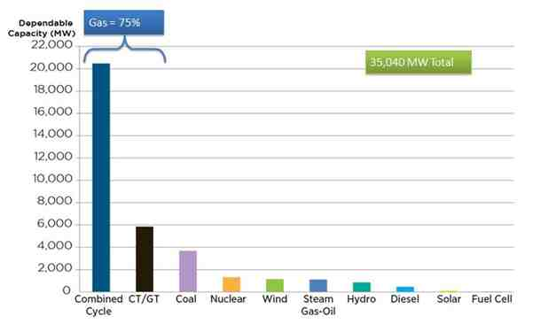
The January 2014 Polar Vortex highlighted the need to bolster further investment in new and existing generation resources in the PJM footprint for greater availability in peak usage periods. Although power continued to flow without interruption on the high-voltage transmission system when PJM experienced eight out of its ten highest winter peaks ever, there was an unusually high rate of outages among generators, problems with natural gas deliveries for certain power plants, significant pricing impacts and inflexible unit-scheduling conditions. Working with stakeholders over an intense five-month period, PJM developed and filed at the FERC “Capacity Performance” incentives to promote investment to build or upgrade generation resources, reward energy storage and new technologies for power production, and ensure a robust, reliable generation fleet that can deliver energy whatever the conditions. The FERC approved PJM’s proposed Capacity Performance construct in June 2015.
The first PJM capacity auction to include the new Capacity Performance requirement attracted a strong response from capacity resources prepared to meet the new pay-for-performance standards. The resources that qualified as Capacity Performance units ensure that a reliable electric supply will be available during extreme weather or other system emergencies.
PJM 2018-2019 Delivery Year Base Residual Auction Capacity Clearing Prices
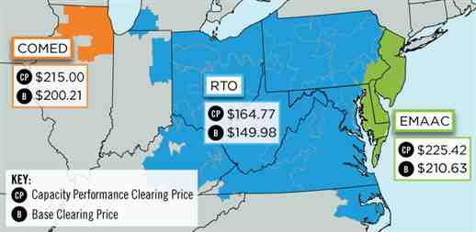
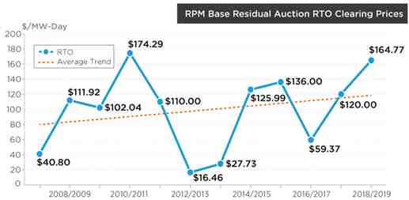
Overall, the auction procured 166,837 megawatts of capacity, which represents a 19.8 percent reserve margin. One megawatt is enough to power about 1,000 homes. The auction attracted over 3,500 megawatts of new generation, including more than 2,900 MW of new generating units and over 500 MW of uprates to existing generating units.
A total of 11,084 MW of demand response was procured for 2018-2019, 1,484 MW of which is Capacity Performance. Energy efficiency totaled 1,247 MW, with 887 MW being Capacity Performance. Renewables resources – wind, solar and hydroelectric – clearing in the auction totaled 14,347 MW (nameplate).
Gas / Electric Coordination: With the lesson learned from winter 2013/2014 clearly in mind, PJM established a formalized gas commitment process for long-lead time generation and provisions for generators to change cost schedules with a single day to reflect their costs more accurately. To improve gas / electric coordination over the long-term, the FERC has issued rules to bring the timing of the markets and operating days of the gas and electricity industries closer together. Scheduling and operating day differences between natural gas and electricity industries cause inefficiencies in both markets, creating a reliability concern because of the growing use of natural gas in power generation. PJM is working with its stakeholders on changes to PJM’s energy market bid windows and cleared results posting times to comply with the new FERC rules.
Energy Market Uplift: Given the increased magnitude and volatility of energy market uplift charges, an effort to examine and revise the entire Operating Reserve construct was undertaken since spring 2014. The scope of this work includes reviewing the sources of energy market uplift charges and the allocation methodology. The Energy Market Up-lift Senior Task Force has been tasked with creating new methodologies that have the potential to minimize uplift costs while ensuring market prices are consistent with operational reliability needs, decrease charge rates, and reduce transaction risk due to variable fees while maintaining and preserving key principles that underlie current market mechanisms:
- Transparency of Locational Marginal Pricing;
- Alignment of the Day-Ahead results with the Real-Time Market;
- Commitment in the least costly manner, subject to maintaining reliability in the PJM footprint;
- Accurate representation of actual real-time operating conditions in the Day-Ahead Energy Market;
- Equitable allocation of costs consistently between markets based on cost causation/benefit principles; and
- Simplification and transparency of the calculations and methodologies for both PJM and its stakeholders.
The changes PJM has implemented to date have improved the level of energy uplift charges to its members.
Monthly Uplift
(Dollars per Megawatt Hour of Load Served)
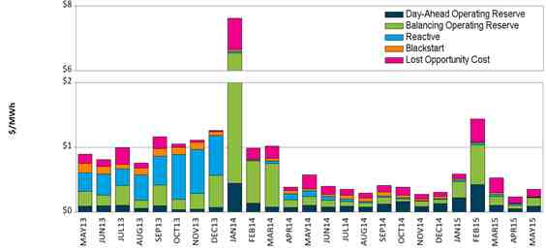

PJM Value Proposition: PJM Interconnection’s operation of the high-voltage electric grid and wholesale electricity market provides significant value to the region it serves totally $2.8 – $3.1 billion a year.
PJM’s regional grid and market operations produce annual savings in ensuring reliability, providing the needed generating capacity and reserves, managing the output of generation resources to meet demand, and procuring specialized services that protect grid stability. The following summarizes the efficiencies and cost savings PJM produces in delivering these vital services to the region.
Reliability Savings: $475 million annually

Managing Transmission Limits
PJM manages the high-voltage electric system over a large geographic area encompassing 13 states and the District of Columbia. Based on forecasts of how much electricity will be needed each day, PJM accepts offers from electricity producers and determines how to meet the demand in the most cost-effective way. This process takes into account the ability of the transmission system to deliver power. PJM reacts to changes in demand in real time, adjusting generation to be in balance with demand and maintain the transmission system at safe operating levels.
PJM seeks to manage transmission constraints – limitations on the ability of the transmission system to move power – by adjusting the output of generators whenever possible to promote efficiency. This is more efficient than the traditional method – transmission loading relief – which curtails power sales between areas or suppliers to manage overloaded lines or other transmission constraints.
Managing the transmission system using fewer transmission loading relief operations saves PJM market participants about $100 million a year.
Regional Planning Efficiencies
PJM’s regional planning process assesses the need for transmission upgrades to ensure reliability, increase efficiency and support public-policy goals. PJM’s large footprint makes the transmission planning process more effective by considering the region as a whole, rather than individual states or separate transmission-owner territories, in determining transmission needs. The transmission upgrades for the 2014, 2015 and 2016 planning years will reduce congestion costs by an average of $375 million a year.
Generation Investment Savings: $1.1 – 1.4 billion annually
The fact that PJM plans for resource adequacy over a large region results in a lower reserve margin than otherwise would be necessary. Resource adequacy means having enough generating resources available to meet the demand for electricity, plus a reserve to cover emergencies.
There is considerable diversity in electrical use patterns in the large PJM footprint; not all areas peak at the same time of the year. As a result, resources in one area of the system are available to help serve other areas at peak times, and a smaller reserve is required.
PJM’s Reliability Pricing Model capacity market promotes competition between traditional generation and alternative resources such as demand response, renewable energy and energy efficiency. With more cost-effective alternatives to maintain adequate power supplies, less investment is needed in new generation. The reduced reserve margin requirement produces a potential savings in new generation investment of $1.1 billion to $1.4 billion a year.
Integrating More Efficient Resources: $600 million annually
PJM’s efficient generation interconnection process combined with the competitive Reliability Pricing Model (RPM) capacity market has enabled less efficient, generation resources to retire and to be replaced with more efficient, less-costly generation.
From the annual RPM auction in 2011 through the 2014 auction, more than 15,000 megawatts of new, natural gas combined-cycle generation either has already commenced operation or has committed to be built through the RPM auctions. These resources operate more efficiently, with lower heat rates and in most cases lower fuel costs, than the older, less efficient resources they have replaced through retirement.
Simulations of the increased cost that would be associated with continuing to operate the retired resources instead of the new, more efficient units demonstrate annual savings of $600 million.
Energy Production Cost Savings: $525 million annually

Expanded Dispatch Area
PJM’s dispatch process enables electric energy to be exchanged economically and automatically when less-expensive resources in one area can be used to meet consumer electricity demand in another area. Prior to the expansion of the PJM footprint a decade ago, energy usually was exchanged between areas only when energy sales transactions were scheduled between two suppliers.
Without the operation of the centralized market structure that exists today, economic energy exchanges occurred much less frequently and efficiently. Simulations of the economic dispatch and energy exchange before and after the PJM market expansion show that operating the larger market creates production cost savings of $375 million a year.

Perfect Dispatch Initiative
PJM also has increased the efficiency of its dispatch processes through the Perfect Dispatch initiative. Perfect Dispatch compares the actual dispatch each day against the hypothetical optimum dispatch that day to spur improvements in performance. The average savings since Perfect Dispatch implementation in 2008 are $150 million a year.

Grid Services
PJM operates markets for two grid services, regulation and synchronized reserve, which help ensure the stability of the power system. Regulation service corrects for short-term changes in electricity use, adjusting generation output to maintain the desired electrical frequency. Synchronized reserve service supplies electricity on short notice if the grid has an unexpected need for more power.
As a result of the scope of its market, PJM can carry less of these services than was necessary when individual utilities operated on their own. In addition, market procurement of these services is more efficient. In the case of regulation, market procurement has reduced the total quantity of the service needed. The total savings stemming from both the reduced quantity of these services required and the reduced cost of their procurement are $100 million a year.

Southwest Power Pool (SPP)

Section 7 – SPP Performance Metrics and Other Information
Southwest Power Pool, Inc. (SPP) is a regional transmission organization (RTO) that coordinates the movement of electricity in a fourteen state region: Arkansas, Iowa, Kansas, Louisiana, Minnesota, Missouri, Montana, Nebraska, New Mexico, North Dakota, Oklahoma, South Dakota, Texas and Wyoming.
Services provided by SPP include:
- Reliability Coordination: SPP monitors power flow throughout our footprint and coordinates regional response in emergency situations or blackouts.
- Tariff Administration: SPP provides “one-stop shopping” for use of the region’s transmission lines and independently administers an Open Access Transmission Tariff with consistent rates and terms. SPP processes more than 4,887 member transmission service requests per month; 2014 transmission service transactions totaled $1.5 billion.
- Regional Scheduling: SPP ensures the amount of power sent is matched with power received.
- Transmission Expansion: SPP’s planning processes seek to identify system limitations, develop transmission upgrade plans, and track project progress to ensure timely completion of system reinforcements.
- Market Operations: The Integrated Marketplace launched in 2014, replacing the Energy Imbalance Service (EIS) market. It includes a Day-Ahead Market with Transmission Congestion Rights, a Reliability Unit Commitment process, a Real-Time Balancing Market replacing the EIS market, and the incorporation of price-based Operating Reserve procurement. An initial analysis indicates the Integrated Marketplace will yield its more than 115 participants an additional $131 million in annual net savings during its first year of operation (in addition to $170 million in net savings from the EIS market).
- Compliance: The SPP Regional Entity enforces compliance with federal and regional reliability standards for users, owners, and operators of the region’s bulk power grid.
- Training: SPP offers continuing education for operations personnel at SPP and throughout the region. SPP’s 2014 training program delivered over 24,000 training hours to 75 organizations and awarded 13,120 hours of continuing education to 31 member organizations.
Southwest Power Pool dates to 1941, when 11 regional power companies joined to keep an Arkansas aluminum factory powered around the clock to meet critical defense needs. After the war, SPP's Executive Committee decided the organization should be retained to maintain electric reliability and coordination.
SPP incorporated as an Arkansas not-profit organization in January 1994. The Federal Energy Regulatory Commission (FERC) approved SPP as a Regional Transmission Organization in 2004 and a Regional Entity in 2007.

A. SPP Bulk Power System Reliability
The table below identifies which NERC Functional Model registrations SPP has submitted as effective as of the end of 2014. Additionally, the Regional Entity for SPP is noted at the end of the table with a link to the website for the specific reliability standards.
NERC Functional Model Registration | SPP
Balancing Authority
Interchange Authority
Planning Authority
Reliability Coordinator
Reserve Sharing Group
Resource Planner
Transmission Operator
Transmission Planner
Transmission Service Provider
Regional Entity | SPP; SERC is the CEA

Standards that have been approved by the NERC Board of Trustees are available at:
http://www.nerc.com/page.php?cid=2|20
Additional standards approved by the SPP Board are available at:
http://www.spp.org/section.asp?pageID=98

Dispatch Operations
SPP CPS-1 Compliance 2010-2014
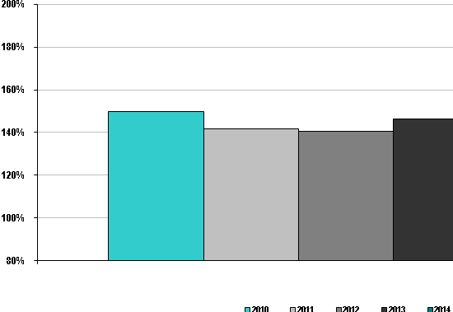
Compliance with CPS-1 requires at least 100% throughout a 12-month period. SPP was in compliance with CPS-1 for each of the calendar years from 2010 through 2014.
SPP CPS-2 Compliance 2010-2014
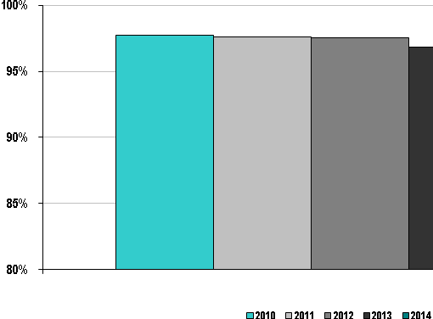
Compliance with CPS-2 requires 90% for each month in a 12 month period. SPP was in compliance with CPS-2 for each of the calendar years from 2010 to 2014.
Beginning with implementation of the Integrated Marketplace, and SPP’s Consolidated Balancing Authority, on March 1, 2014, Balancing Authority ACE Limit (BAAL) is now used. The BAAL performance measure combines the CPS-1 performance measure with a specific limit known as a Frequency Trigger Limit (FTL). In order to be compliant with the BAAL standard, a Balancing Authority must recover from a FTL excursion within a 30-minute period of time. SPP was in compliance with the BAAL performance standard in 2014.

SPP Energy Market System Availability 2010-2014
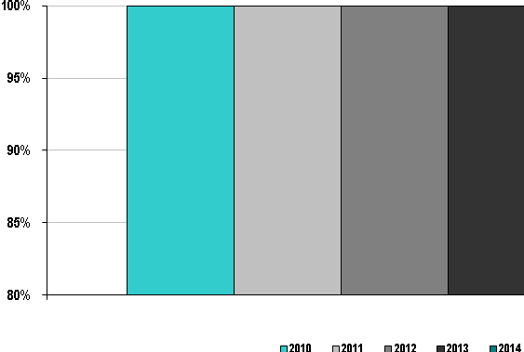

Availability of the Energy Management System (EMS) is key to reliable monitoring of the electric transmission system in SPP. Since 2010, the SPP EMS has been available at least 99.98% of all hours in each year, with the last four years at 100%.
Load Forecast Accuracy
ISO/RTO | Load Forecasting Accuracy Reference Point
SPP | 11:00 a.m. prior day

SPP Average Load Forecasting Accuracy 2010-2014
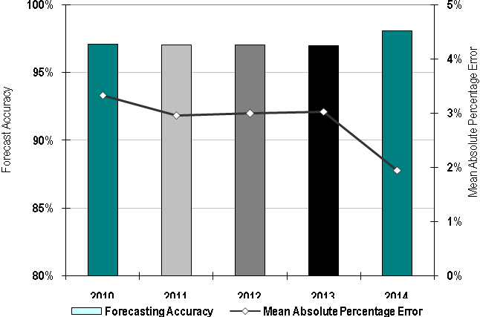

SPP Peak Load Forecasting Accuracy 2010-2014
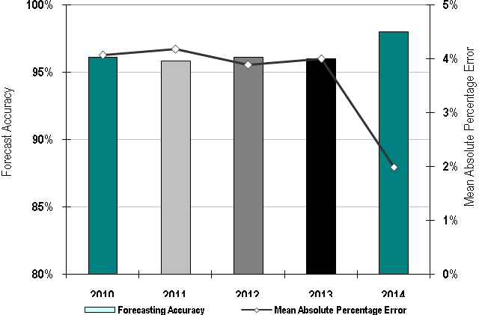

SPP Valley Load Forecasting Accuracy 2010-2014
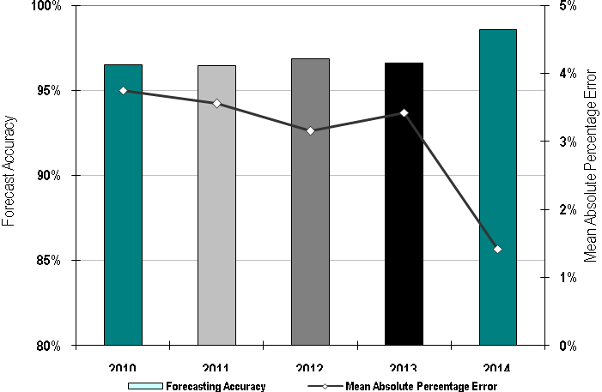

Prior to the implementation of the Integrated Marketplace on March 1, 2014, the prior day’s medium term load forecast (MTLF) is used as the load forecast accuracy reference point since there was not a day-ahead market. Since SPP then did not have a consolidated Balancing Authority, a forecast is calculated for each of the SPP BAs. Overall, the average load forecasting accuracy for SPP has been right around 97% since the start of the EIS Market in February 2007. Upon implementation of the Integrated Marketplace, the overall load forecasting accuracy increased to just over 98% for the last ten months of 2014.

Wind Forecasting Accuracy
ISO/RTO | Wind Forecasting Accuracy Reference Point
SPP | 11:00 a.m. prior day

SPP Average Wind Forecasting Accuracy 2010-2014
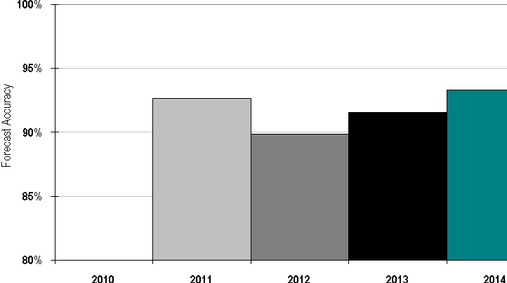
SPP implemented an RTO-wide wind forecasting system in 2011. Data for 2011 represents only the last three months of the year. This metric uses the day-ahead forecast created at 11 am for all hours of the next day and compares this to the actual output using the following formula: 1 - abs(actual - DA forecast)/Capacity.

Unscheduled Flows

Data not available at the time of report publication.

Transmission Outage Coordination
The SPP OATT does not outline specific timeframes and guidelines for Transmission Outages and Coordination. The OATT states that “the Transmission Provider will provide the projected status of transmission outage schedules above 230 kV over the next twelve (12) months or more if available. This data shall be updated no less than once daily for the full posting horizon and more often as required by system conditions. The data will include current, accurate and complete transmission facility maintenance schedules, including the “outage date” and “return date” of a transmission facility from a scheduled or forced outage. If the status of a particular transmission facility operating at voltages less than 230 kV is critical to the determination of TTC and ATC/AFC of the neighboring transmission provider, the status of this facility will also be provided,” and “consistent with the SPP Membership Agreement, Transmission Owners are required to coordinate with the Transmission Provider for all planned maintenance of Tariff Facilities. The Transmission Provider shall notify a Transmission Owner of the need to change previously reviewed planned maintenance outages.”

SPP Percentage of > 200kV planned outages of 5 days or more that are submitted to ISO/RTO at least 1 month prior to the outage commencement date 2010-2014
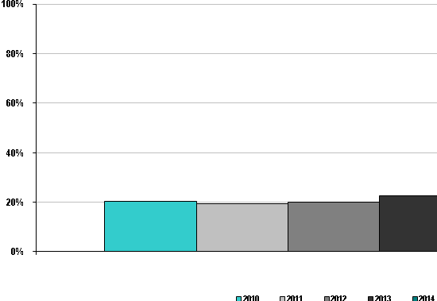

SPP Percentage of planned outages studied in the respective ISO/RTO Tariff/Manual established timeframes 2010-2014

SPP does not have established timeframes in which planned outages must be studied.

SPP Percentage of unplanned > 200kV outages 2010-2014
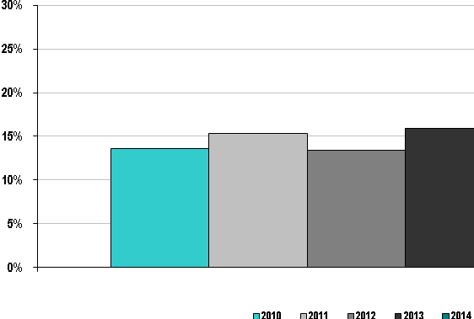

The SPP Market Monitoring Unit indicated in the 2009 Annual State of the Market Report that “SPP should move to standardize categories accounting for transmission outages which would allow for the easy reporting of extent, causes, and location of such outages. At a minimum, this type of reporting alleviates concerns of market power abuses and can enhance SPP’s transmission planning and real-time operations.”
SPP fully implemented its CROW outage (transmission and generation) tracking system in late 2012. This system provides generation and transmission operators a systematic method to submit outages to the SPP Reliability Coordinator and SPP Balancing Authority. Outage submissions can then be shared with other Reliability Coordinators, Transmission Operators and Balancing Authorities via the NERC System Data Exchange (SDX) and will be used for the assessing real-time and future reliability of the Bulk Electric System.
SPP Percentage of > 200kV outages cancelled by ISO/RTO after having been previously approved 2010-2014
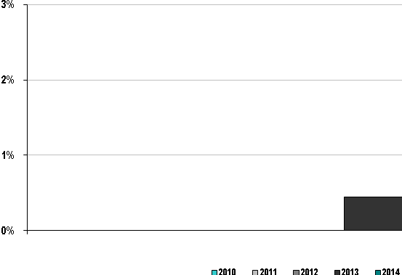

Data is only available from 2013 forward from the implementation of the CROW outage tracking system.
Transmission Planning
SPP Number of Transmission Projects Approved to be Constructed for Reliability Purposes 2010-14
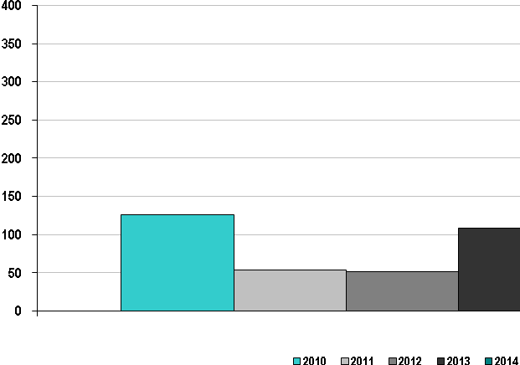

SPP Percentage of Approved Construction Projects Completed by December 31, 2014
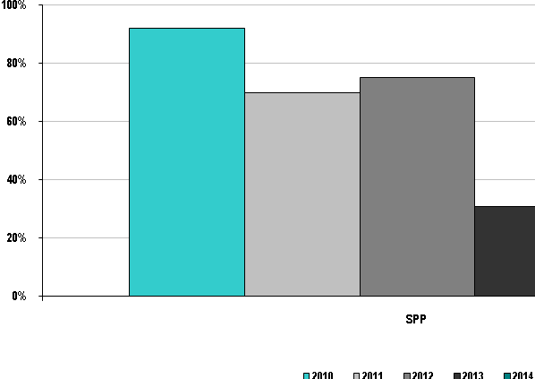

SPP Transmission Expansion Plan
The SPP Transmission Expansion Plan (STEP) is a comprehensive listing of all transmission projects in SPP for the 20-year planning horizon. Projects in the STEP include:
- Upgrades required to satisfy requests for Transmission Service;
- Upgrades required to satisfy requests for Generation Interconnection;
- Approved projects from the 10-Year and Near Term Assessments;
- Approved Balanced Portfolio upgrades;
- Approved High Priority upgrades; and
- Endorsed Sponsored upgrades.
Transmission Service
Transmission Service studies are conducted as a result of customer-submitted long-term firm transmission service requests to determine if the SPP transmission system can accommodate transmission service above what is currently in use. Using the Aggregate Transmission Service Study (ATSS) process, the Transmission Provider will combine all requests received during an open season into a single study to develop a more efficient expansion of the transmission system that provides the necessary ATC to accommodate all such requests at the minimum total cost.
SPP Tariff Attachments AQ defines a process through which delivery point additions, modifications, or abandonments can be studied without having to go through the Aggregate Study process. Delivery points submitted through the process are examined in an initial assessment to determine if a project is likely to have a significant effect on the transmission system. If necessary, a full study is then performed on the requested delivery points to determine any necessary upgrades.
Attachment AR defines a screening process used to evaluate potential Long-Term Service Request (LTSR) options or proposed Delivery Point Transfers (DPT). The LTSR option provides customers with a tool to assess possible availability of transmission service. The DPT screening study option enables customers to implement a DPT via issuance of a service agreement more expediently pending the results of the screening. Both of these screening tools allow for a more streamlined Aggregate Study process by reducing the number of requests in the studies.
Generation Interconnection
A Generation Interconnection (GI) study is conducted pursuant to Attachment V of the SPP Tariff whenever a request is made to connect new generation to the SPP transmission system. GI studies are conducted by SPP in collaboration with affected Transmission Owners to determine the required modifications to the transmission system, including cost and scheduled completion date required to provide the service.
Integrated Transmission Planning
The Integrated Transmission Planning (ITP) process is Southwest Power Pool’s iterative three-year study process that includes 20-Year, 10-Year, and Near Term Assessments.
The 20-Year Assessment (ITP20), performed once every three (3) years, identifies transmission projects, generally above 300 kV, needed to develop a grid flexible enough to provide benefits to the region across multiple scenarios.
The 10-Year Assessment (ITP10), performed once every three (3) years, focuses on facilities 100 kV and above to meet system needs over a 10-year horizon. The approved portfolio includes projects ranging from comprehensive regional solutions to local reliability upgrades to address the expected reliability, economic, and policy needs of the studied 10-year planning horizon.
The Near Term Assessment (ITPNT), performed annually, assesses system upgrades, at all applicable voltage levels, required in the near-term planning horizon to address reliability needs. The ITPNT assesses: (a) regional upgrades required in maintaining reliability in accordance with the NERC TPL Reliability Standards and SPP Criteria in the near-term horizon; (b) zonal upgrades required to maintain reliability in accordance with more stringent individual Transmission Owner planning criteria in the near-term horizon; and (c) coordinated projects with neighboring Transmission Providers.
Along with the Highway/Byway cost allocation methodology, the ITP process promotes transmission investment that will meet reliability, economic, and public policy needs intended to create a cost-effective, flexible, and robust transmission network which will improve access to the region’s diverse generating resources and facilitate efficient market processes.
Balanced Portfolio
The SPP Board of Directors approved the Balanced Portfolio projects in April 2009 and directed staff to finalize the Balanced Portfolio Report in accordance with the SPP Tariff and then issue Notifications to Construct (NTC). The NTCs were issued in June 2009.
The Balanced Portfolio was an initiative to develop a group of economic transmission upgrades benefitting the entire SPP region and to allocate those project costs regionally. The benefits of this group of 345 kV transmission upgrades have been demonstrated by model analysis to outweigh the costs, and the regional cost sharing creates balance across the SPP region.
High Priority
Attachment O, Section IV.2, of SPP’s Tariff describes the process for which high priority studies may be requested by stakeholders and performed by SPP as the Transmission Provider. Stakeholders may request high priority studies, including a request for the Transmission Provider to study potential upgrades or other investments necessary to integrate any combination of resources, whether demand resources, transmission, or generation, identified by the stakeholders. For each high priority study the Transmission Provider shall publish a report, including but not limited to, the study input assumptions, the estimated cost of the upgrades, any third party impacts, the expected economic benefits of the upgrades, and identify reliability impacts, if any, of the upgrades. The Transmission Provider may recommend, based on the results of a high priority study, a high priority upgrade for inclusion in the SPP Transmission Expansion Plan in accordance with the approval process set forth in Section V of SPP’s Tariff.
In 2010, the SPP Board of Directors and Members Committee approved for construction a group of "priority" high voltage electric transmission projects estimated to bring benefits of at least $3.7 billion to the SPP region over 40 years. The projects will improve the regional electric grid by reducing congestion, better integrating SPP‟s east and west regions, improving SPP members‟ ability to deliver power to customers, and facilitating the addition of new renewable and non-renewable generation to the electric grid.
Southwest Power Pool’s High Priority Incremental Load Study (HPILS) evaluated transmission needs resulting from significant incremental load growth expectations in certain parts of SPP. HPILS was completed and a draft report issued in March of 2014. The HPILS report included an explanation of study processes and assumptions, an identification of projects needed over the 10-year study horizon to reliably meet load growth expectations, and a list of projects recommended for construction.
Endorsed Sponsored
Sponsored upgrades are Network Upgrades requested by a Transmission Customer or other entity which do not meet the definition of any other category of Network Upgrades. Any entity may request a Sponsored Upgrade. SPP will evaluate the impact of any Sponsored upgrade on transmission system reliability and identify any necessary mitigation of these impacts. The proposed Sponsored upgrades will be submitted to the Markets and Operations Policy Committee and the SPP Board of Directors for endorsement.
The Project Sponsor must be willing to assume the cost of the Sponsored upgrade, study costs, and any cost associated with necessary mitigation.
Interregional Planning
SPP continues to enhance and refine coordination with its neighbors during SPP’s regional planning studies, including the ITP study processes. The goal of the enhanced coordination is to better ensure that the planning along the SPP seams is as robust as the transmission planning in the middle of the SPP footprint. To accomplish this, SPP’s seams coordination objective was to coordinate with SPP’s neighbors at every milestone of the planning process and on the same schedule as SPP staff coordinates with SPP stakeholders. SPP also participates in two different joint planning processes. SPP’s respective Joint Operating Agreements (JOA) with AECI and MISO outline the requirements for joint and coordinated planning procedures and the resulting product of a Coordinated System Plan (CSP).
FERC Order 1000
FERC issued Order 1000 on June 17, 2010. Order 1000 requires the removal of federal right of first refusal (ROFR) for certain transmission projects under the SPP Tariff. To comply with this requirement, SPP developed the Transmission Owner Selection Process (TOSP) to competitively solicit proposals for projects that no longer have ROFR. The TOSP is outlined in Attachment Y of the SPP Tariff. For the ITP process, once the applicable ITP study scope has been approved and the needs assessment performed, SPP shall notify stakeholders of the identified transmission needs and provide a transmission-planning response window of 30 calendar days. During this response window, any stakeholder may submit a Detailed Project Proposal (DPP) pursuant to Section III.8.b. of Attachment O of the SPP Tariff. In addition, SPP Business Practice 7650 outlines the specific DPP processes associated with Order 1000.
Transmission Facilities that meet the criteria contained in Attachment Y, Section I.1 of the SPP Tariff and are approved for construction or endorsed by the SPP Board of Directors after Jan. 1, 2015 are known as Competitive Upgrades. SPP will solicit proposals for Competitive Upgrades from Qualified RFP Participants (QRPs) utilizing the TOSP.
A QRP is an entity that wants to participate in the TOSP. Each entity must submit a QRP application and supporting materials to demonstrate that it satisfies the qualification criteria, as defined in Attachment Y, Section III of the Tariff. All QRP applications must be received no later than June 30 of the year prior to the calendar year in which the applicant wishes to begin participation in the TOSP. Only approved QRPs can participate in the TOSP.
A Request for Proposal (RFP) will be published for each Competitive Upgrade which is approved for construction or endorsed by the SPP Board of Directors after Jan. 1, 2015. Any QRP may submit a response to an RFP within 90 days of the publication of the RFP. All RFP submissions will be reviewed and evaluated by an Industry Expert Panel (IEP). After completing the RFP evaluation, the IEP will recommend an RFP proposal for each Competitive Upgrade to the SPP Board of Directors.
If the Competitive Upgrade was submitted as a DPP during the ITP study process, the submitting QRP may be eligible to receive incentive points pursuant to the eligibility requirements described in Section III.2.f.iv of Attachment Y of the SPP Tariff. Any entity may submit a DPP during the 30-day transmission planning response window occurring after the needs assessment is published during the ITP 3-year planning cycle.
Stakeholders
There are opportunities for stakeholder involvement throughout the SPP planning processes. All planning processes are open and transparent assessments of study assumptions, upgrade recommendations, and applicable cost allocation impacts. Its implementation is only successful through the commitment of SPP members, regulators, and other stakeholders. Input from the regulators assists SPP in the development of realistic transmission expansion projects and alternatives to meet rate payer needs, as well as those of neighboring regions.
In adherence to the SPP Tariff and Business Practice 7060, SPP issues Notifications to Construct (NTCs) to Designated Transmission Owners (DTOs) to commence the construction of Network Upgrades that have been approved or endorsed by the SPP Board of Directors intended to meet the construction needs of the STEP, SPP Tariff, or Regional Transmission Organization (RTO). SPP reports the progress of all STEP projects approved either directly by the SPP Board of Directors or through a FERC filed service agreement under the SPP Tariff. Table 1 below summarizes the current Project Tacking Portfolio. Table 2 below provides the current status and historical data for NTCs issued for each of the study types that have issued NTCs since 2006.

Generation Interconnection
SPP Average Generation Interconnection Request Processing Time 2010-2014
(calendar days)

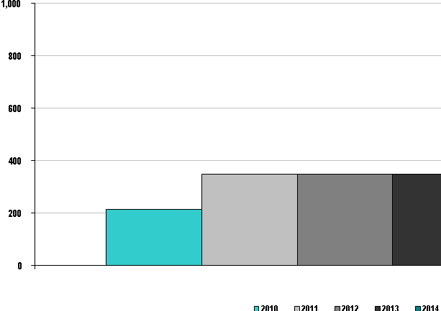

SPP Planned and Actual Reserve Margins 2010-2014
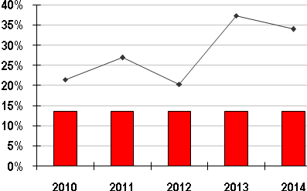
Bars Represent Planned Reserve Margins | Lines Represent Actual Reserves Procured

SPP Percentage of generation outages cancelled by ISO/RTO after having been previously approved
2010-2014
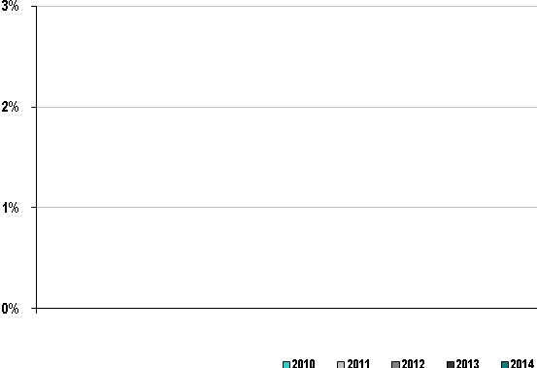
Data is only available from 2013 forward from the implementation of the CROW outage tracking system. No generation outages were cancelled after approval in 2013 or 2014.

SPP Number of Reliability Must Run Contracts 2010-2014
SPP has no Reliability Must Run contracts, but uses Op (Operating) Guides for situations or instances that may include Reliability Must Run.
Interconnection / Transmission Service Requests
SPP Number of Study Requests 2010-2014
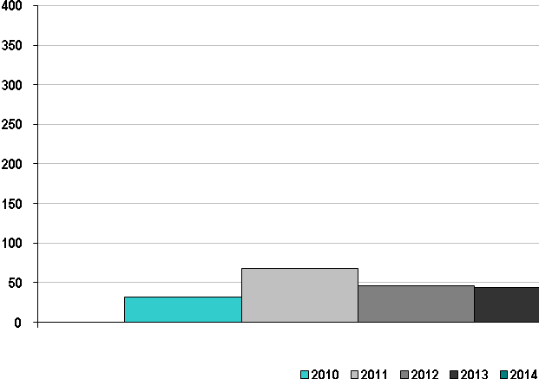

SPP Number of Studies Completed 2010-2014
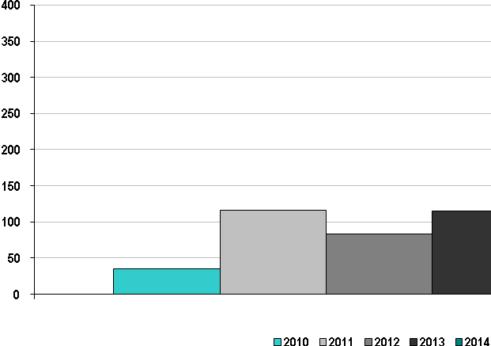

SPP Average Aging of Incomplete Studies 2010-2014
(calendar days)
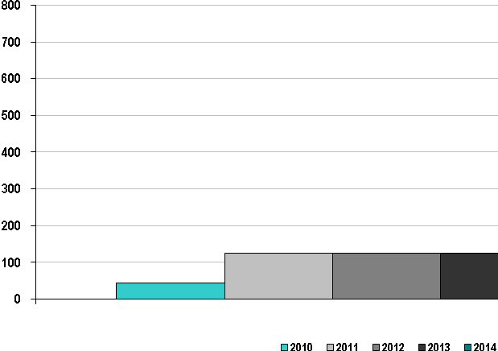

SPP Average Time to Complete Studies 2010-2014
(calendar days)
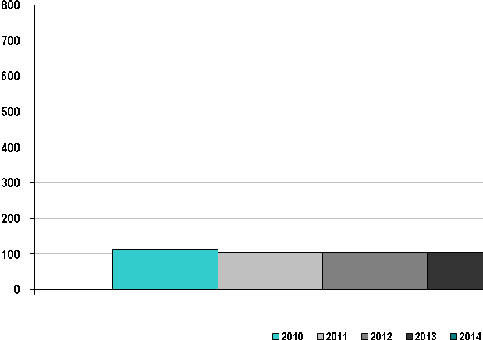
The generation interconnection process includes three potential types of studies – feasibility studies, system impact studies and facility studies. Feasibility studies assess the practicality and cost transmission system additions or upgrades required to accommodate the interconnection of the generating unit or increased generating capacity with the transmission system. System impact studies provide refined and comprehensive estimates of cost responsibility and construction lead times for new transmission facilities and system upgrades that would be required to allow the new or increased generating capacity to be connected to the transmission system in SPP. Facility studies develop the transmission facilities designs for any required transmission system additions or upgrades due to the interconnection of the generating unit and/or increased generating capacity.
 | Average Cost of Each Type of Study
 | 2010 | 2011 | 2012 | 2013 | 2014
Feasibility Studies | $2,976 | $6,667 | $11,039 | $7,563 | $6,456
System Impact Studies | $15,655 | $20,623 | $18,428 | $25,232 | $20,009
Facility Studies | $14,998 | $4,255 | $1,953 | $2,853 | $2,596

Special Protection Schemes
SPP Number of Special Protection Schemes 2014
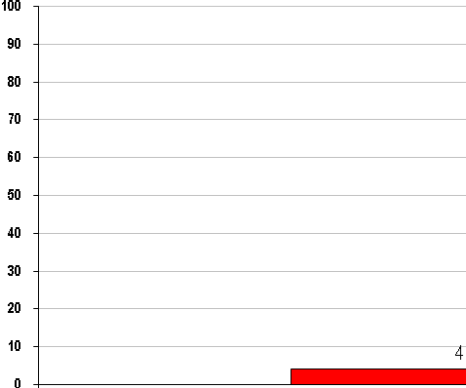
The SPSs in the SPP Region represent four long-term schemes. A Special Protection Systems (SPS) or Remedial Action Scheme (RAS) is designed to detect abnormal system conditions and take automatic pre-planned, coordinated, corrective action (other than the isolation of faulted elements) to provide acceptable system performance. SPS actions include among others, changes in demand (e.g., load shedding), generation, or system configuration to maintain system stability, acceptable voltages, or acceptable facility loadings. All reviews of facilities shall be for those used to monitor and control transmission facilities operated at 100kV or above.
There were no misoperations of SPSs in 2014 in SPP.

B. SPP Coordinated Wholesale Power Markets

The table below shows the split of the just over $10.5 billion that was invoiced by SPP in 2014.
(dollars in millions) | 2014 Dollars Billed | Percentage of 2014  Dollars Billed
Energy Imbalance Market | $ 295 | 2.8%
Integrated Marketplace | 7,458 | 70.5%
TCR | 1,165 | 11.0%
Transmission | 1,506 | 14.2%
SPP Admin Fee | 149 | 1.4%
Total | $10,573 | 100.0%

The SPP Energy Imbalance Market was in operation through February 28, 2014; and was thus replaced by the Integrated Marketplace on March 1, 2014. Figures above represent those billed in the EIS Market for the first two months of the year, and for the Integrated Marketplace and TCR for the last ten months of 2014. Transmission and SPP Admin Fee cover the entire year of 2014.

Market Competitiveness
SPP Energy Market Price Cost Markup 2010-2014
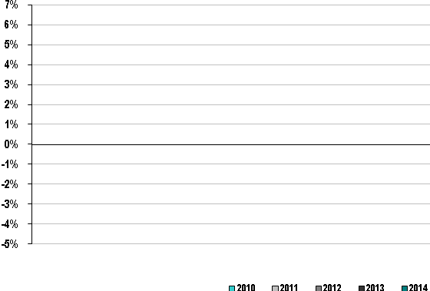

Data for this metric is only available beginning with the implementation of the Integrated Marketplace on March 1, 2014. Therefore data is only available for 2014 for the above graph and represents the period from March through December of 2014.
With an overall price cost markup of under 5%, indicates that prices in SPP are set, on average, by marginal units operating close to their marginal costs. Generally, markups between +/-5% indicate that the market performs competitively.

SPP New Entrant Gas-Fired Combustion Turbine (CT) Net Generation Revenues 2010-2014
(dollars per installed megawatt year)
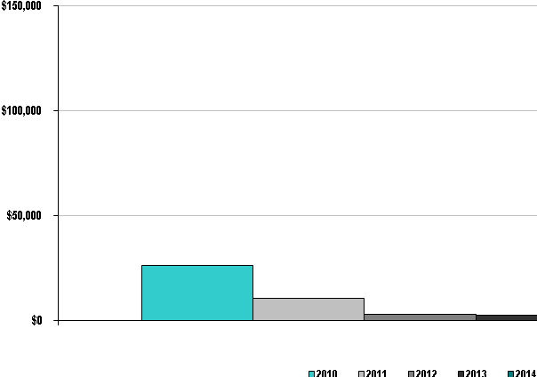

SPP New Entrant Gas-Fired Combined Cycle (CC) Net Generation Revenues 2010-2014
(dollars per installed megawatt year)
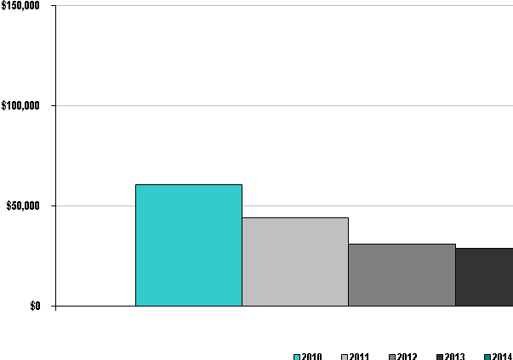
Net revenues in all years were not adequate to cover the fixed costs of either a combined cycle or a combustion turbine power plant in SPP.
From the SPP 2014 State of the Market Report
Other RTOs have experienced a “missing money problem” in energy markets, where net revenues do not support needed new investments. SPP had a high, 48%, resource margin for 2014, so the MMU does not expect net revenue to cover the cost of new investment. SPP prices for the first year of the Integrated Marketplace were high enough to support ongoing operation and maintenance of new efficient generators dispatched economically. The MMU expects the market to signal the retirement of inefficient generation. Aging of the fleet and increased environmental restrictions may change the resource margin such that higher net revenue price signals become increasingly important. The ability of market forces to provide these incentives and long run price signals is a strong benefit of the Integrated Marketplace.

SPP Real-Time Energy Market Percentage of Unit Hours Offer Capped due to Mitigation 2010-2014
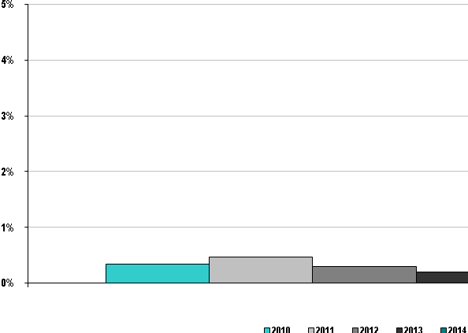
Data from 2013 and prior represents the SPP Energy Imbalance Service market. The figure for 2014 is for Energy Offers in the Integrated Marketplace. Mitigation also occurs for start-up, no-load and operating reserve offers, but those figures are not included in the chart above.
From the SPP 2014 State of the Market Report:
Resources’ energy, start-up, no-load, and operating reserve offers are subject to the conduct and impact mitigation plan, and mitigation is applied when the following three circumstances occur simultaneously in a market solution:
1) The offer has failed the Conduct Test. Resources submit two offers for each product; a mitigated offer representing the competitive baseline costs that must adhere to the Mitigated Offer Development Guidelines, and a second offer, generally referred to a market-base or strategic offer. An offer fails the conduct test when the market-based offer exceeds the Mitigated Offer by more than the allowed threshold;
2) The resource potentially has local market power due to transmission congestion or the potential for cost recovery manipulation is present due to a local reliability issue;
3) The application of mitigation impacts market prices or make whole payments by more than the allowed threshold.
The mitigation frequency varies across products and markets.
In addition, Market Competitiveness, as measured by the Herfindahl-Hirschmann Index (HHI), is discussed in the 2014 Annual State of the Market Report:
Figure 6–3 depicts the hourly RTBM HHI for the first year of the Integrated Marketplace along with a ranked HHI duration curve. The hourly HHI ranges from 800 to about 1,200 during the course of the year, with higher concentration levels in the fall and winter months.
Market structure conditions in SPP change with the fuel mix of online resources. Base load (coal, nuclear, and wind) generation produced about 80% of SPP’s energy for the year and these resources often set the marginal price, especially during off-peak hours. Prices rise and the market structure becomes more favorable for the potential exercise of market power with natural gas fired generation on the margin, especially when the marginal cost spread between natural gas and coal is larger.
The system wide HHI analysis discussed in this section is only relevant when the market is uncongested. When there is congestion in the market, limited transmission capacity restricts competition resulting in significant localized market power.
Herfindahl – Hirschman Index
2010 954
2011 916
2012 858
2013 797
2014* 1002
*represents March-December 2014 (from start of the Integrated Marketplace)
The HHI has declined as more Market Participants have been added to the EIS Market footprint up through February 2014. Upon Implementation of the Integrated Marketplace, HHI has increased due to the fact that less excess generation is online in the Integrated Marketplace than in the EIS Market (which is part of the market design), and the fact the some market participants are representing additional generation through the registration process in the Integrated Marketplace.
HHI values at these levels indicate that no individual Market Participant can dominate the market and that the overall market is very competitive. This does not preclude the possibility of localized market power concerns, but does indicate that an individual participant is unlikely to successfully manipulate the system by withholding capacity.
Market Pricing
SPP Average Annual Load-Weighted Wholesale Energy Prices 2010-2014
($/megawatt-hour)
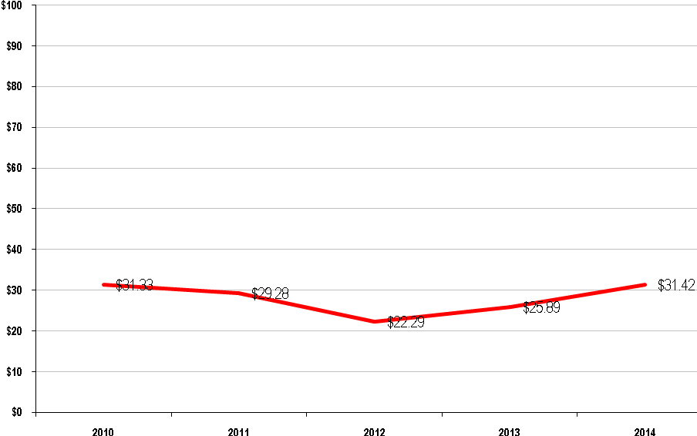
The SPP average load-weighted energy prices from 2010-2014 varied, due in most part to variances in fuel costs. For years 2013 and prior, the amount reported represents the load-weighted LIP for the Energy Imbalance Market. For 2014, the load-weighted LIP from the EIS market is used for the first two months of 2014, while the Real-Time load-weighted LMP from the Integrated Marketplace is used for the last ten months of the year.
The chart on the following page from the U.S. Energy Information Administration is a visual representation of the fuel cost inputs from 2010-2014 that influenced the energy prices in SPP. The consistency in the trends between the preceding chart and several of the fuel cost trends on the chart on the following page are significant, because they illustrate the high correlation between wholesale energy prices and underlying fuel costs.
U.S. Nominal Fuel Costs 2010-2014
($ per million Btu)
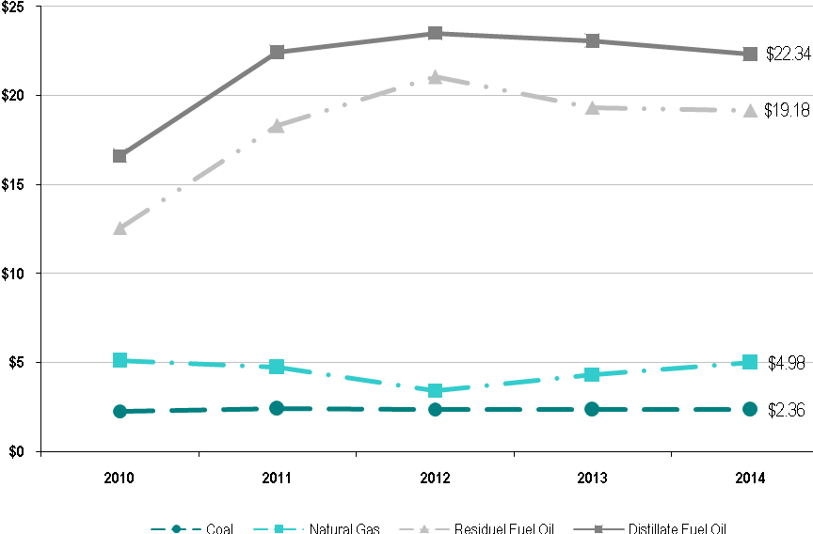
Source: U.S. Energy Information Administration, Independent Statistics and Analysis

SPP Average Annual Load-Weighted
Fuel-Adjusted Wholesale Spot Energy Prices 2010-2014
($/megawatt-hour)
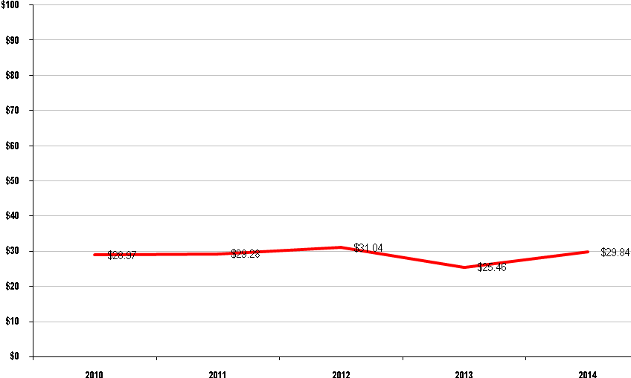
SPP’s base year for fuel-cost references is 2007 as the SPP EIS Market launched on February 1, 2007.
SPP Wholesale Power Cost Breakdown 2010-2014
($/megawatt hour)
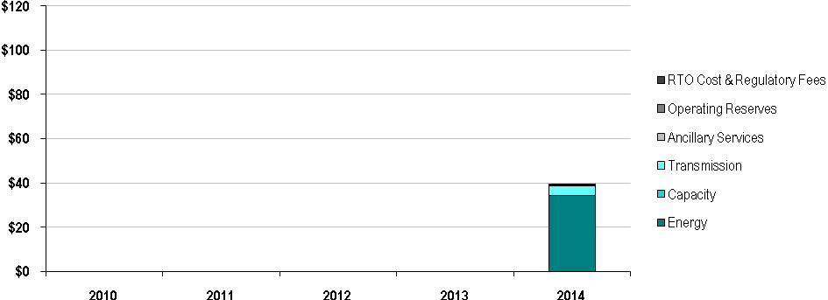
Data for this metric is only available beginning with the implementation of the Integrated Marketplace on March 1, 2014. Therefore data is only available for 2014 for the above graph and represents the period from March through December of 2014.
Unconstrained Energy Portion of System Marginal Cost
SPP Annual Average Non-Weighted, Unconstrained
Energy Portion of the System Marginal Cost 2010-2014
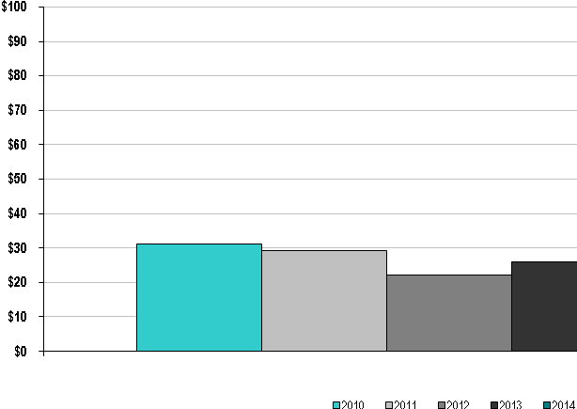
For years 2013 and prior, the amount reported represents the system marginal cost for the Energy Imbalance Market. For 2014, the Real-Time marginal energy cost from the Integrated Marketplace is used for the period from March – December.
The unconstrained energy portion of system marginal cost is the marginal price of maintaining balance in the economic dispatch ignoring transmission limitations. This trend chart shows the annual average marginal price of energy across SPP over all hours. The trend closely follows the trend of aggregate fuel prices from 2010 through 2014 which illustrates the fact that marginal energy price fluctuations are primarily driven by fuel prices.
Energy Market Price Convergence
Convergence between day-ahead and real-time electric energy prices is achieved when participants submit price-sensitive bids and offers in the day-ahead market that accurately forecast real-time conditions for the next day. Convergence between day-ahead and real-time prices is a sign of a well-functioning day-ahead market. Good price convergence between the day-ahead and real-time markets helps ensure efficient day-ahead commitments that reflect real-time operating needs.
SPP Day-Ahead and Real-Time Energy Market Price Convergence 2010-2014
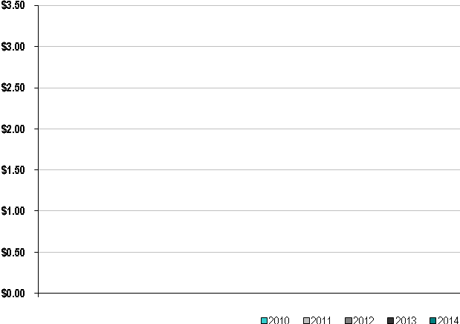
SPP Percentage of Day-Ahead and Real-Time Energy Market Price Convergence 2010-2014
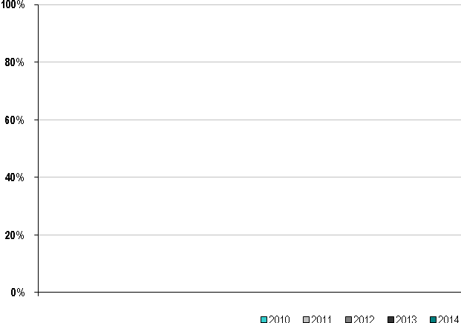
The Day-Ahead Market in SPP began with the implementation of the Integrated Marketplace on March 1, 2014, therefore data is only available for 2014 for the above two graphs and represents the period from March through December of 2014.
Congestion Management
SPP Annual Congestion Costs per Megawatt Hour of Load Served 2010-2014
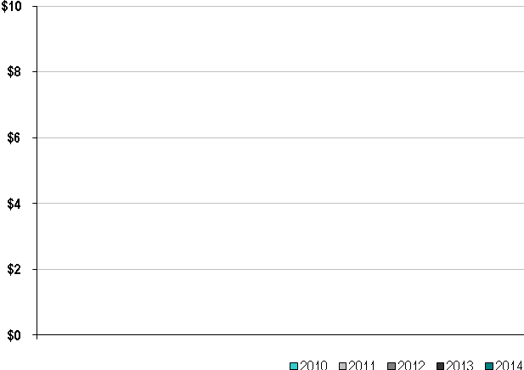
SPP Percentage of Congestion Dollars Hedged Through Congestion Management Markets 2010-2014

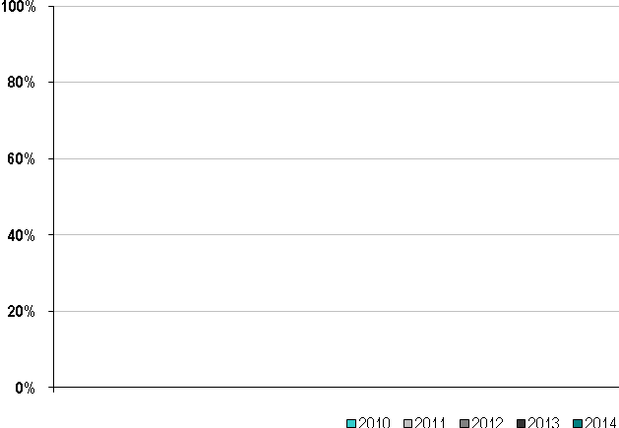
The Congestion Management Market in SPP began with the implementation of the Integrated Marketplace on March 1, 2014, therefore data is only available for 2014 for the above two graphs and represents the period from March through December of 2014.

Resources
SPP Annual Generator Availability 2010-2014
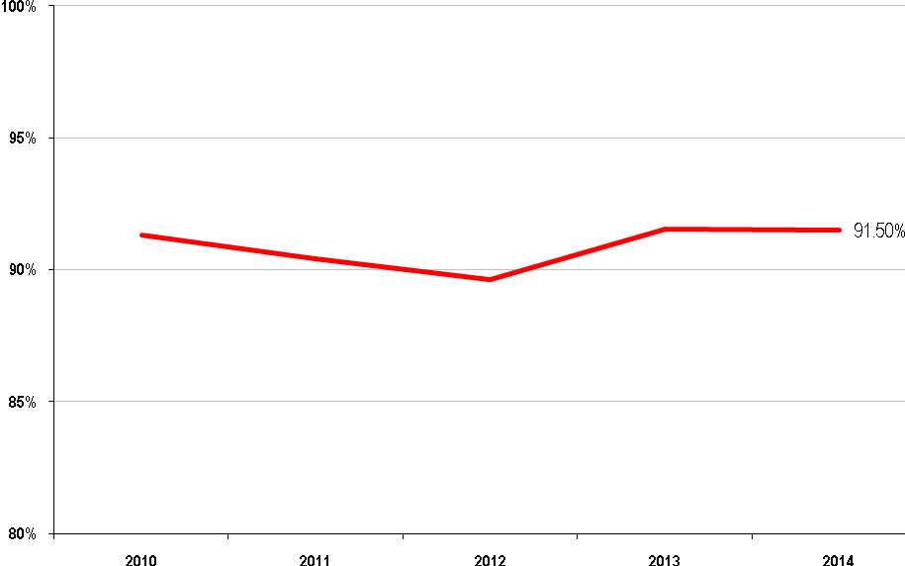
Since the implementation of the Energy Imbalance Service market in February 2007, SPP generator availability remains very consistent, hovering right around 90%. Upon implementation of the Integrated Marketplace in 2014, generator availability is calculated differently than previously in the EIS market, however generator availability remains the same as historic levels. Outages categorized as Urgent, Emergency or Forced are included in this calculation.
Fuel Diversity
SPP Fuel Diversity 2010-2014
Installed Capacity  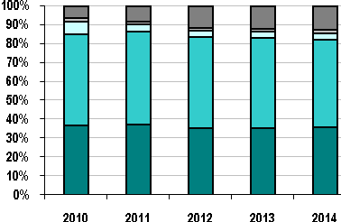 | Generation Output  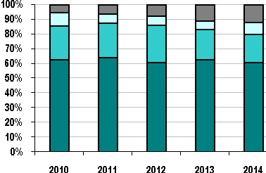
Coal Gas Nuclear Oil
Hydro and Renewables Gas/Oil Combined Cycle Other

Installed generation capacity in SPP at the end of 2014 is approximately 35% coal, 47% gas, 3% nuclear, 13% wind, hydro and other renewables, and less than 1% from all other fuel sources. Actual generation output from baseload units (generally coal or nuclear) totals just over 68%, gas accounts for 19%, wind, hydro and renewables for approximately 13%, and less than 1% for other sources of fuel.
Demand Response
SPP Demand Response Capacity as Percentage of Total Installed Capacity 2010-2014
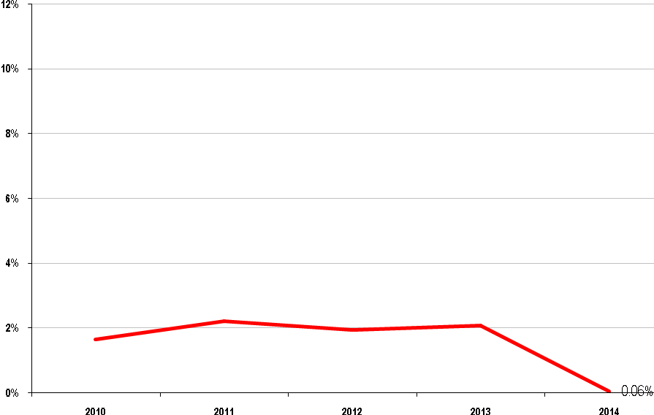
Renewable Resources
SPP Renewable Megawatt Hours as a Percentage of Total Energy 2010-2014
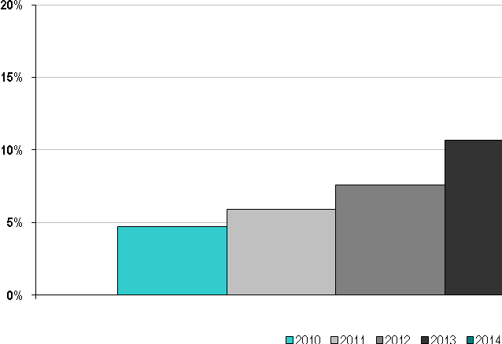
SPP Hydroelectric Megawatt Hours as a Percentage of Total Energy 2010-2014
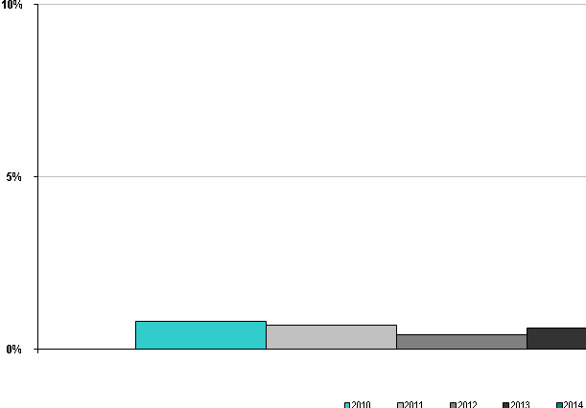
SPP Renewable Megawatts as a Percentage of Total Capacity 2010-2014
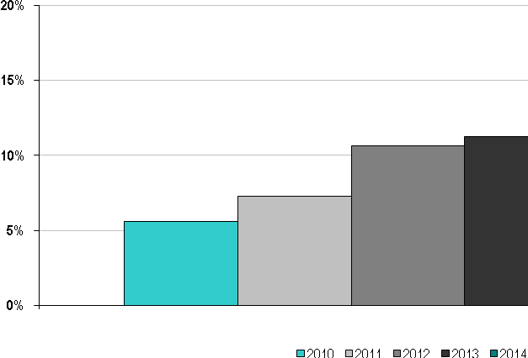

SPP Hydroelectric Megawatts as a Percentage of Total Capacity 2010-2014
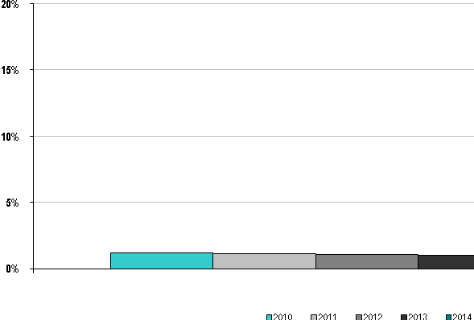
Energy capacity and production from renewable sources has been growing in SPP over the last several years, especially in wind renewables. Wind capacity has increased nearly six-fold since the implementation of the EIS market in February 2007, growing from just over 1,500 MW to nearly 9,000 MW of nameplate capacity at the end of 2014. Production by hydro and renewable sources has grown from 3% of total generation at the start of the EIS market to nearly 13% at the end of 2014, with the bulk of the growth in generation coming from wind resources.

C. SPP Organizational Effectiveness
Administrative Costs
SPP Annual Actual Costs as a Percentage of Budgeted Costs 2010-2014
Non-Capital Costs  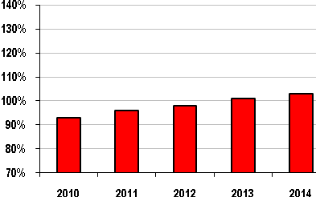 |  |  |  |  |  | Capital Cost Recovery  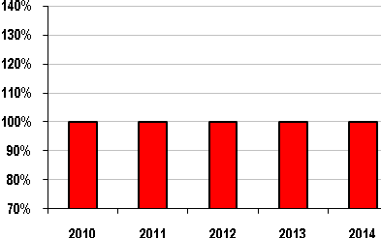
Budget | $68 | $79 | $90 | $122 | $133 | Budget | $9 | $13 | $11 | $13 | $23
Bars Represent % of Actual Costs to Approved Budgets; Dollar Amounts Represent Approved Budgets (in millions)

SPP is a strong proponent of stakeholder involvement in the establishment and monitoring of its operating and capital budgets and the monitoring of its financial affairs. This level of involvement dates back to the start as a tight power pool and continues through today as a member-driven Regional Transmission Organization.
SPP’s annual budget process culminates with the presentation of the budget to the Board of Directors. Providing some background, the SPP Board of Directors meets and acts in public, open sessions for all items except personnel issues and legal issues. Additionally, the SPP Board of Directors always meets in the presence of the Members Committee which is comprised of 15 representatives from SPP’s membership. Finally, prior to all votes, the Members Committee is asked to indicate their position on each issue through a non-binding straw vote. This vote provides the Board with direct insights as to the positions of the membership on any issue.
The chair of the SPP Finance Committee presents the budget to the SPP Board of Directors in open session at the Board’s October meeting. Following the presentation of the budget, the Board of Directors solicits comments regarding the budget from all in attendance (even those who are not members of SPP have the ability to share their position on the budget). Following the dialogue, and assuming there is a motion to approve the budget and a second of that motion, the Board will ask the Members Committee representatives to vote through a show of hands either “yes”, “no”, or “abstain”. Then, the Board members will enter their votes (the votes of the individual board members are via secret ballot and not shared individually).
SPP’s budget has a long history prior to arriving at the SPP Board of Directors for action. The budget starts informally at the grassroots of the organization through the work of numerous stakeholder groups that define the products and services they desire SPP to perform. Major changes to SPP’s products and services and business practices are approved at the Markets and Operations Policy Committee (“MOPC”). The MOPC is a full representation committee comprised of one representative from each member of SPP. The MOPC meets in open session and reports directly to the SPP Board of Directors.
Coincident with the grassroots efforts of SPP’s Working Groups and MOPC, SPP’s Strategic Planning Committee meets to determine the strategic direction of SPP. The Strategic Planning Committee is comprised of three members of the SPP Board of Directors and eight representatives from SPP’s membership. The Strategic Planning Committee meets in open session and reports directly to the SPP Board of Directors.
SPP staff compiles the directions from the MOPC, Strategic Planning Committee, Board of Directors, and other groups to determine the direction of the company during the next fiscal year and the two years beyond. SPP staff determines the resources required to meet the goals of the organization and ultimately prepares a budget designed to meet those needs. This budget is formally presented to the SPP Finance Committee. The SPP Finance Committee is comprised of two members of the SPP Board of Directors and four representatives from the SPP membership. The Finance Committee meets in open sessions and actively seeks input from the stakeholder representatives on the Committee as well as from other interested parties. The Finance Committee diligently reviews the budget proposed by staff to ensure the resources identified are consistent with the goals and objectives of the organization and also are prudent and just. Once satisfied that the budget meets the needs of the organization the Finance Committee presents the budget to the SPP Board of Directors for approval.
SPP Annual Administrative Charges per Megawatt Hour of Load Served 2010-2014
($/megawatt-hour)
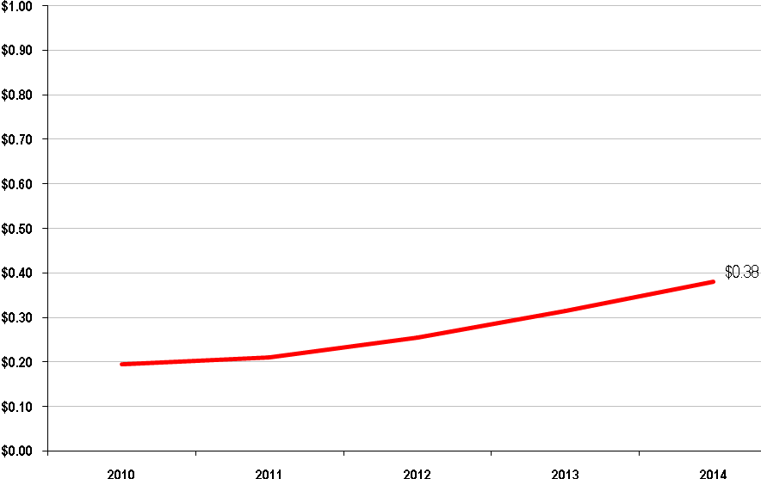
The administrative costs per MWhr of load served data in the chart above should be reviewed in the context of the SPP annual load served as noted in the table below.
ISO/RTO | 2014 Annual Load Served  (in terawatt hours)
SPP | 351

Customer Satisfaction
SPP Percentage of Satisfied Members 2010-2014
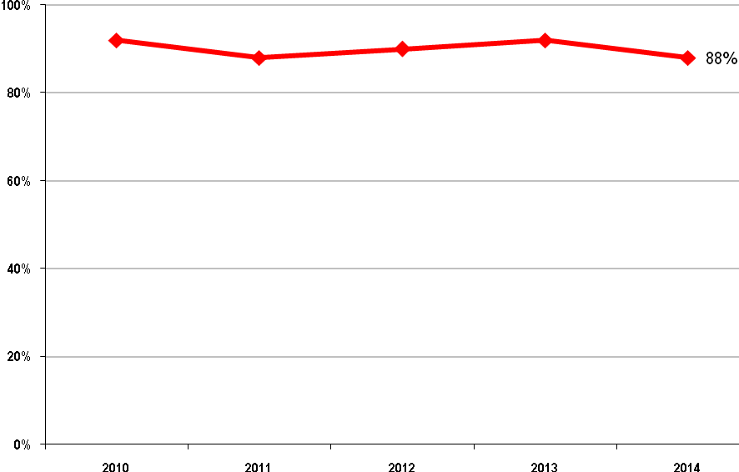
The percentage of satisfied members in SPP remains strong and hovers right around 90% over the last five years. The lowest year for member satisfaction was 2007, which is the year the Energy Imbalance Market was launched, with the percentage of satisfied members just under 84%.

Billing Controls
ISO/RTO | 2010 | 2011 | 2012 | 2013 | 2014
SPP | Unqualified  SAS 70 Type 2 Audit Opinion | Unqualified SSAE 16 Type 2 Audit Opinion | Unqualified SSAE 16 Type 2 Audit Opinion | Unqualified SSAE 16 Type 2 Audit Opinion | Unqualified SSAE 16  Type 1 and 2 Audit Opinions

From the SPP 2014 Annual Report:
Simply put, 2014 was a remarkable year of results for our organization in numerous ways. Most notably, our Integrated Marketplace (a day-ahead market with financial hedging, a regulation market, and a consolidated balancing authority) went live March 1 on schedule, on budget, and with a high degree of quality – as evidenced by nearly a full year of operation with stable prices, tremendous regional savings, and practically no settlement disputes.
We also completed detailed controls audits of the new functionality with unqualified opinions and no noted exceptions. We’re told this is a first in the world of organized electricity markets, and we count this as a testament to the value of a governance structure focused on active stakeholder participation.
The SSAE 16 Type I audit, conducted by KPMG, scrutinized controls related to SPP’s Integrated Marketplace and Transmission Service Settlements system for bidding, accounting, billing, and settlement of energy, regulation, transmission, reserves, and related market transactions for processing user entities’ transactions. KPMG found that SPP’s controls were suitably designed as of March 1, 2014.
The SSAE 16 Type II audit, conducted by KPMG, scrutinized controls related to SPP’s Integrated Marketplace and Transmission Service Settlements system for bidding, accounting, billing, and settlement of energy, regulation, transmission, reserves, and related market transactions for processing user entities’ transactions. KPMG found that SPP’s controls were suitably designed and operating effectively to meet its control objectives from March 1, 2014 to October 31, 2014.
SPP Energy Market Price Posting Accuracy 2010-2014
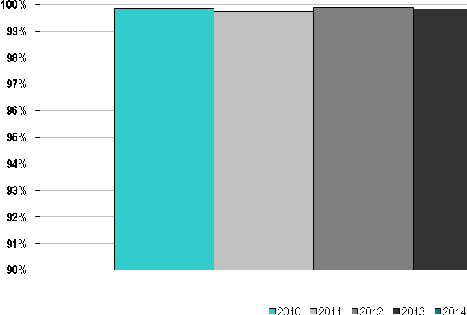Figures for 2013 and prior are from the SPP Energy Imbalance Service Market, while 2014 includes data from January and February from the EIS Market, and March through December from the Integrated Marketplace. Price posting accuracy is determined by dividing the number of intervals re-priced during the year by the total number of intervals in the year. As expected, a slight increase in the number of intervals re-priced occurred with the implementation of the Integrated Marketplace on March 1, 2014 due the complexity of the new systems and markets.
SPP Average Billing Accuracy 2010-2014
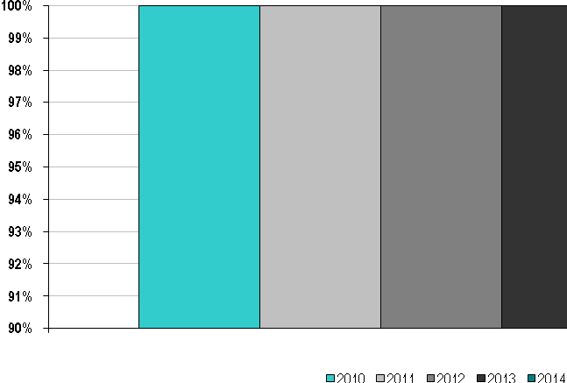
Figures for 2013 and prior are from the SPP Energy Imbalance Service Market, while 2014 includes data from January and February from the EIS Market, and March through December from the Integrated Marketplace. Billing accuracy is determined by taking the total dollar of disputes filed (not necessarily granted) and dividing by the total dollars billed.
After averaging over 99.9% accuracy for the last four years of the Energy Imbalance Market, it was expected that the number of disputes would increase due to the complexity of the Integrated Marketplace on March 1, 2014, with the total accuracy for 2014 totaling just over 99.4%.
D. Southwest Power Pool Specific Initiatives

SPP Member Value Statement
Southwest Power Pool, Inc. (SPP) ensures the reliable operation of and fair and open access to the high voltage transmission system in its footprint. SPP’s services further ensure reliable least-cost delivered energy to consumers in its footprint. SPP is mandated by the Federal Energy Regulatory Commission to ensure reliable supplies of power, adequate transmission infrastructure, and competitive wholesale electricity prices. In 2015, SPP is expected to provide the eight-state region between $1.2 and $1.9 billion in annual benefits. This range of benefits yields between a 9-to-1 and 14-to-1 return on the annual cost of providing these federally-mandated services. At the proposed 39.0 cents per MWh administrative fee, a residential customer using 1,000 kWh per month would, on average, receive $79 in benefits per year from SPP’s services for only $8 in costs.
Another way to view the value SPP provides is to consider SPP’s net revenue requirement of $141.2 million as an investment that will yield a $1.56 billion return for the year (midpoint of the range of annual benefits), or an 11.0 times return. That $141.2 million investment provides value in the following areas:
- $775 million in Operations and Reliability Services
- $379 million in Region-Wide Transmission Planning
- $315 million in Open Transparent Energy Market Operations
- $93 million in Leveraged, Centralized Services
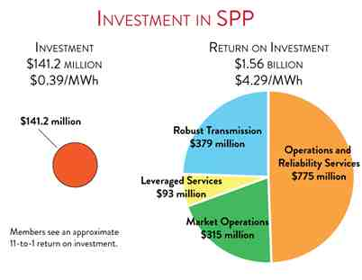
SPP’s services create the opportunity to realize the benefits associated with planning and operating over a larger region. Prior to SPP’s evolution to the Regional Transmission Organization (RTO), utilities in the region operated in a decentralized, bilateral market environment. Bilateral power transactions were characterized by physical transmission constraints managed through mechanisms that at times limited the availability of transmission, increased transaction costs, and decentralized unit commitment and dispatch. SPP’s market mechanisms now utilize security-constrained, economic dispatch to optimize the use of all the market participants’ resources within the region. The resources in the region provide more options and better efficiency to meet the needs of electric customers, both reliably and affordably. SPP’s marketplace provides cost savings and enhanced reliability, as well as independent oversight of the region’s transmission and generation facilities.
The analytical framework for this estimation of value compared the current state versus the hypothetical state that would exist if SPP members operated on a standalone basis without collaboration of any sort. The estimate was created by the collaboration of SPP members and SPP staff planning to create regional level value from pooled investments and the provision by SPP of centralized, leveraged services (e.g., Integrated Marketplace, Training Services, etc.)
This $141.2 million investment also enables SPP to:
- Reduce overall costs by operating as a region
- Provide reliability assurance and predictable operations of the bulk electric system
- Facilitate effective transmission planning processes that result in building and maintaining an economically optimized transmission system
- Offer an open and transparent marketplace with economic benefits
- Optimize market efficiencies and transmission expansion along the seams of other markets and the emerging seam associated with natural gas supply
- Ensure fair and equitable allocation of transmission expansion costs
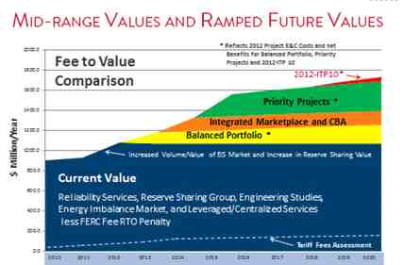

Electricity Restructuring: FERC Could Take Additional Steps to Analyze Regional Transmission Organizations’ Benefits and Performance, United States Government Accountability Office, Report to the Committee on Homeland Security and Governmental Affairs, U.S. Senate (September 22, 2008), GAO-08-987 (http://www.gao.gov/new.items/d08987.pdf).
A copy of the CAISO’s 2015 Strategic Vision is available at the following website: http://www.caiso.com/about/Pages/Publications_Financials/Default.aspx
The cost of actual new generators varies significantly due to factors such as ownership, location and environmental constraints. More detailed information can be found: http://www.energy.ca.gov/2013_energypolicy/documents/index.html#03072013 and http://www.energy.ca.gov/2009publications/CEC-200-2009-017/CEC-200-2009-017-SF.PDF.
The 2,300 MW of ISO demand resources do not include behind-the-meter photovoltaic resources and energy efficiency provided by other customer-based programs outside the ISO markets or are otherwise unknown to the ISO.
For ISO-NE’s calculation of the accuracy of the load forecast for 2010 to 2014, the actual loads were reconstituted for load-relief estimates resulting from the dispatch of demand response because of emergency operating procedures invoked by ISO-NE.
GE Energy, New England Wind Integration Study, final report (December 5, 2010), http://www.iso-ne.com/static-assets/documents/committees/comm_wkgrps/prtcpnts_comm/pac/reports/2010/newis_report.pdf.
ISO New England Operating Procedure No. 14, Technical Requirements for Generators, Demand Resources, and Asset-Related Demands—Appendix F, Wind Plant Operator Guide (September 9, 2011), http://www.iso-ne.com/static-assets/documents/rules_proceds/operating/isone/op14/op14f_rto_final.pdf.
ISO New England Open Access Transmission Tariff, Section II of ISO-NE’s Transmission, Markets, and Services Tariff (ISO tariff) (2015), http://www.iso-ne.com/participate/rules-procedures/tariff.
The current RSP Project List is located at http://www.iso-ne.com/system-planning/system-plans-studies/rsp.
This part of the ISO tariff covers the review of participants’ proposed plans; see http://www.iso-ne.com/regulatory/tariff/sect_1/sect_i.pdf.
The graphs reflect many project components accounted for individually that are part of larger projects.
FERC, Order No. 890, Preventing Undue Discrimination and Preference in Transmission Service, final rule (February 16, 2007), http://www.ferc.gov/whats-new/comm-meet/2007/021507/E-1.pdf.
The NPCC website is located at http://www.npcc.org.NERC’s website is located at http://www.nerc.com/.
ISO-NE’s energy-efficiency forecast ensures that the impacts from the region’s large investments in energy efficiency are reflected appropriately in regional transmission decisions.
US Congress, Energy Independence and Security Act of 2007 (January 4, 2007); http://frwebgate.access.gpo.gov/cgi-bin/getdoc.cgi?dbname=110_cong_bills&docid=f:h6enr.txt.pdf.
FERC, Frequency Regulation Compensation in the Organized Wholesale Power Markets, final rule, 137 FERC ¶ 61,064 (October 20, 2011), http://www.ferc.gov/whats-new/comm-meet/2011/102011/E-28.pdf.
The queue refers to the list of interconnection requests for the New England Balancing Authority Area, which includes the requests submitted by generators to interconnect to the ISO New England electric power system.
The ISO-NE CELT Report, 2014–2023 Forecast Report of Capacity, Energy, Loads, and Transmission (May 1, 2014), is available at http://www.iso-ne.com/static-assets/documents/trans/celt/report/2014/2014_celt_report_rev.pdf (CELT Report, 2014–2023).
NICR = ICR – HQICC (Hydro-Québec Installed Capacity Credit). (See more below on the ICR.)
In the ISO-NE system, a capacity supply obligation is a requirement for a resource to provide capacity, or a portion of capacity, to satisfy a portion of the ISO’s Installed Capacity Requirement acquired through a Forward Capacity Auction, a reconfiguration auction, or a CSO bilateral contract through which a market participant may transfer all or part of its CSO to another entity. ISO-NE Operating Procedure No. 4, Action during a Capacity Deficiency (August 12, 2014), http://www.iso-ne.com/static-assets/documents/rules_proceds/operating/isone/op4/op4_rto_final.pdf.
The methodology for calculating the ICR is set forth in Section III.12 of Market Rule 1. The ICR is eventually reviewed and approved by FERC.
NEPOOL is a voluntary association of the participants in New England’s wholesale electricity marketplace.
The ISO-NE’s website contains more detailed information on short-run and long-run forecast methodologies; models and inputs; weather normalization; forecasts of regional, state, and subarea annual electric energy use and peak loads; high- and low-forecast bandwidths; and retail electricity prices. This information is located at http://www.iso-ne.com/markets-operations/system-forecast-status, http://www.iso-ne.com/system-planning/system-forecasting, and http://www.iso-ne.com/system-planning/system-plans-studies/celt.
Within ISO-NE’s FCM, both active (demand response) and passive (energy efficiency) demand-side resources are allowed to be treated as capacity to serve regional load. Past and future nonmarket demand response and energy efficiency are not reflected within the ICR calculation. Thus, in turn, they are not reflected in the ARM or PRM.
These values are calculated from the annual CELT Report for 2010–2014 (summer capacity) as follows: (active demand-response capacity) divided by (total summer seasonal claimed capability).
The outages represent those that the ISO previously approved and then cancelled, not outages denied before ISO approval.
FERC, Demand-Response Compensation in Organized Wholesale Energy Markets. Order No. 745, final rule (March 15, 2011), http://www.ferc.gov/EventCalendar/Files/20110315105757-RM10-17-000.pdf, and Order No. 745 Compliance Filing, Docket No. ER11-4336-005, letter order (May 29, 2012), http://www.iso-ne.com/static-assets/documents/regulatory/ferc/orders/2012/may/er12_4336_005_5_29_12_ltr_ord_accept_order_745_filing.pdf.
ISO New England Inc. and New England Power Pool, Docket No. ER15-257-000, Market Rule 1 Changes to Integrate Price-Responsive Demand into Reserve Markets, FERC filing (October 31, 2014), http://www.iso-ne.com/static-assets/documents/2014/10/er15-257-000_mr1_chg_10-31-2014.pdf. FERC, Order Accepting Tariff Provisions, Docket Nos. ER15-257-000, ER15-257-001, and ER15-257-002 (January 9, 2015), .http://www.iso-ne.com/static-assets/documents/2015/01/er15-257-000-001-002_1-9-15_order_accept_rev_integrate_prd.pdf.
FERC, Order Accepting Tariff Revisions, 150 FERC ¶ 61,007 (January 9, 2015), http://www.iso-ne.com/static-assets/documents/2015/01/er15-257-000-001-002_1-9-15_order_accept_rev_integrate_prd.pdf.
Electric Power Supply Association v. FERC, 753 F.3d 218. (D.C. Cir. 2014).
Supreme Court of the United States, Federal Energy Regulatory Commission, Petitioner v. Electric Power Supply Association et al., webpage (accessed June 4, 2015), http://www.supremecourt.gov/search.aspx?filename=/docketfiles/14-840.htm.
FERC, Standardization of Generator Interconnection Agreements and Procedures, final rule, 104 FERC ¶ 61,103 (July 24, 2003), http://www.ferc.gov/legal/maj-ord-reg/land-docs/order2003.asp. FERC, Standardization of Small Generator Interconnection Agreements and Procedures, final rule (May 12, 2005), http://www.ferc.gov/EventCalendar/Files/20050512110357-order2006.pdf.
NPCC Regional Reliability Reference Directory # 7, Special Protection Systems (July 9, 2013), https://www.npcc.org/Standards/Directories/Directory%207_SPS_%20clean_20150331_GJD.pdf. ISO-NE Planning Procedure No. 5-5, Special Protection Systems Application Guidelines (June 22, 2009), http://www.iso-ne.com/static-assets/documents/rules_proceds/isone_plan/pp05_5/pp5_5.pdf.
NERC defines an SOL as the value (such as MW, MVAR, amperes, frequency, or volts) that satisfies the most limiting of the prescribed operating criteria for a specified system configuration to ensure operation within acceptable reliability criteria. It defines an IROL as a system operating limit that, if violated, could lead to instability, uncontrolled separation, or cascading outages that have an adverse impact on the reliability of the bulk electric system.
Note that 386 New England SPSs retired in 2013.
For example, see Figures 2-7 and 2-8 on page 28 of the IMM’s 2014 Annual Market Report (May 20, 2015), http://www.iso-ne.com/static-assets/documents/2015/05/2014-amr.pdf.
The Department of Justice defines markets with an HHI below 1,500 points to be unconcentrated.
The IMM uses the PROBE, or “Portfolio Ownership and Bid Evaluation,” simulation model for this analysis. The software simulates the day-ahead LMP-based market clearing. See http://www.power-gem.com/PROBE.htm.
The IMM’s estimates of marginal cost may understate or overstate actual costs. Also, the simulations are subject to modeling error.
Automated mitigation was implemented on April 18, 2012. Before this time, mitigation was a manual process.
A reference level generally reflects either the actual cost to the resource of generating electricity or, most frequently, in the case of hydroelectric units, the opportunity cost of producing electricity now compared with storing it and generating electricity later.
NCPC payments are made to market participants with resources dispatched out of economic-merit order for reliability purposes when the costs of providing energy or reserves from the resources would otherwise exceed the revenue paid to the market participant. Economic NCPC, also referred to as first-contingency NCPC, arises when the total cost of committing and operating a generating resource exceeds the revenues it earns from the sale of energy at the LMP.
ISO New England Inc. and New England Power Pool, Docket No. ER 13-1877-000, Energy Market Offer Flexibility Changes, FERC filing (July 1, 2013) http://www.iso-ne.com/static-assets/documents/regulatory/ferc/filings/2013/jul/er13_1877_000_mkt_offer_flex_7_1_2013.pdf.
ISO New England, Inc., et al., Order on Tariff Filing, 102 FERC ¶ 61,202 at p 19 (February 25, 2003). Also see the ISO’s semiannual reports on load-response programs and other ISO documents that discuss the programhttp://www.iso-ne.com/search?query=Semi-Annual%20Status%20Report%20on%20Load%20Response%20Programs%20of%20ISO%20New%20England%20Inc.
ISO-NE. Semi-Annual Status Report on Load-Response Programs of ISO New England Inc., Docket No. ER03-345-____ (June 29, 2012), http://www.iso-ne.com/regulatory/ferc/filings/2012/jun/er03-345-6-29-12_19th_semi-annual_load_response.pdf. Because all the programs that were the subject of FERC’s February 25, 2003, November 14, 2003, and May 19, 2004, orders have expired, this was ISO-NE’s final semiannual load-response program report.
Information on ISO-NE’s funding mechanisms is available at http://www.iso-ne.com/participate/rules-procedures/tariff.
Information on the ISO-NE Strategic Planning Initiative is available at http://www.iso-ne.com/committees/key-projects/strategic-planning-initiative.
Refer to the FERC website, “Form No. 714 - Annual Electric Balancing Authority Area and Planning Area Report” (August 10, 2012), http://www.ferc.gov/docs-filing/forms/form-714/elec-subm-soft.asp.
For a detailed discussion, see the ISO’s 2011 Annual Markets Report (May 15, 2011), Section 3.1.2.5, at http://www.iso-ne.com/markets/mkt_anlys_rpts/annl_mkt_rpts/2011/2011_amr_final_051512.pdf.
See ISO-NE’s Regional System Plan (November 6, 2014); http://www.iso-ne.com/static-assets/documents/2014/11/rsp14_110614_final_read_only.docx..
National Interest Electric Transmission Corridors and Congestion Study documents are available at http://energy.gov/oe/services/electricity-policy-coordination-and-implementation/transmission-planning/national-2. The National Electric Transmission Congestion Study, draft for public comment (August 2014), is available at http://energy.gov/oe/services/electricity-policy-coordination-and-implementation/transmission-planning/national.
NERC, Appendix F—Performance Indexes and Equations GADS Data Reporting Instruction (January 2014), http://www.nerc.com/pa/rapa/gads/pages/data%20reporting%20instructions.aspx, April 28, 2014.
The discussions of demand-resource availability are documented at http://www.iso-ne.com/committees/comm_wkgrps/relblty_comm/pwrsuppln_comm/mtrls/2013/jun32013/2013_dr_availability_icr_revised_082013.pdf.
The dual-fuel units in the region are reported under natural gas or oil, depending on what fuel they claim as their primary fuel type within the monthly settlement period.
These installed summer capacity quantities and percentages of total installed summer capacity are for 2014 only.
LFG is produced by decomposition of landfill materials and is collected, cleaned, and used for generation or it is vented or flared. Black liquor is a by-product (alkaline spent liquor) of the paper-production process and can be used as a source of energy.
The dual-fuel units in the region are reported under natural gas or oil, depending on what fuel they claim as their primary fuel type within the monthly settlement period.
This statement applies to all ISO-NE metrics that discuss, compare, or reference historical energy production either in aggregate or by (primary) fuel type.
The “other renewables” category includes energy from landfill gas, other biomass gas, refuse (municipal solid waste), wood and wood-waste solids, wind, solar, black liquor, and tire-derived fuels.
Daily cycle hydro capability calculations use daily mean river-flow-rate data over a 20-year historical period, accounting for the effects of natural stream flow, pondage, and eligible upstream storage. The flow duration data are constructed from the most relevant United States Geological Survey flow gage, with appropriate scaling to account for differences in drainage area. The monthly flow rate used is the 50th percentile value of the full set of daily mean values for that month over the 20-year historical period (i.e., the value exceeded 50% of the time during the month). The previous method used the 80th percentile flow (i.e., the value exceeded 20% of the time). The use of the 50/50 historical stream flow data within the hydroelectric rating methodology generally worked to slightly decrease the overall capacity ratings of most facilities.
The challenges and solutions are described in more detail in ISO-NE’s 2015 Regional Electricity Outlook (2015), http://www.iso-ne.com/static-assets/documents/2015/02/2015_reo.pdf.
2014 Regional System Plan (November 6, 2014), http://www.iso-ne.com/static-assets/documents/2014/11/rsp14_110614_final_read_only.docx.ISO-NE, Discussion Paper on New England’s Capacity Markets and a Renewable Energy Future (June 3, 2015), http://www.iso-ne.com/static-assets/documents/2015/06/iso_ne_capacity_mkt_discussion_paper_06_03_2015.pdf (June 2015 Discussion Paper).
Natural gas prices were less volatile overall during winter 2014/2015 but still high on many days in February 2015. See “New England power system performed well through winter 2014/2015,” ISO Newswire article (April 7, 2015), http://isonewswire.com/updates/2015/4/7/new-england-power-system-performed-well-through-winter-20142.html.
ISO-NE, June 2015 Discussion Paper.
ISO New England, Informational Filing of the Day-Ahead Energy Market and Reserve Adequacy Analysis Timing Report, Docket No. ER13-895-000 (May 23, 2014), http://www.iso-ne.com/regulatory/ferc/filings/2014/may/er13-895-___-5-23-14_dam_timing_rpt.pdf.
ISO New England, Pipeline Information-Sharing Changes, Docket No. ER14-970-000 (January 10, 2011), http://www.iso-ne.com/static-assets/documents/regulatory/ferc/filings/2014/jan/er14_970_000_1_10_2014_pipe_inf_sharing.pdf.
FERC, Coordination of the Scheduling Processes of Interstate Natural Gas Pipelines and Public Utilities, final rule, Order No, 809, 151 FERC ¶ 61,049 (April 16, 2015),http://www.ferc.gov/whats-new/comm-meet/2015/041615/M-1.pdf and http://www.ferc.gov/media/news-releases/2015/2015-2/04-16-15-M-1.asp.
ISO New England Inc. et al., Docket No. EL14-23-000 Filing to Show Cause Why Tariff Changes to Adjust Timing of Day-Ahead Energy Market Results and Reliability Unit Commitment Process are Not Necessary, FERC compliance filing (July 23, 2015), http://www.iso-ne.com/static-assets/documents/2015/07/el14-23-000.pdf.
FERC, Order Initiating Investigation into ISO and RTO Scheduling Practices and Establishing Paper Hearing Procedures (March 20, 2014), http://www.ferc.gov/whats-new/comm-meet/2014/032014/M-2.pdf.
The EE and PV forecasts are available at http://www.iso-ne.com/system-planning/system-forecasting/energy-efficiency-forecast and http://www.iso-ne.com/system-planning/system-forecasting/distributed-generation-forecast.
More details can be found in “Energy Pricing Enhancements: A Roadmap,” available at http://www.iso-ne.com/static-assets/documents/2014/12/ISO-NE_EPE_Roadmap-Dec_2014.pdf. Market design changes are tracked in the Wholesale Markets Project Plan and discussed in the Regional Electricity Outlook, available at http://www.iso-ne.com/markets-operations/markets-development/wholesale-markets-project-plan and http://www.iso-ne.com/about/corporate-governance/financial-performance, respectively.
More details can be found in the ISO-NE’s June 2015 Discussion Paper.
National Institute of Standards and Technology, Framework for Improving Critical Infrastructure Cybersecurity (February 12, 2014), http://www.nist.gov/cyberframework/upload/cybersecurity-framework-021214-final.pdf. Physical Security Reliability Standard. 79 Fed. Reg. 70069-70085 (November 25, 2014), http://www.gpo.gov/fdsys/pkg/FR-2014-11-25/pdf/2014-27908.pdf.
The ISO-NE website is available at http://www.iso-ne.com. The data portal, ISO Express, is available at http://www.iso-ne.com/isoexpress.
ISO New England, Revisions to FCM Rules Related to De-List Bids, Docket No. ER12-1154-000 (February 24, 2012), http://www.iso-ne.com/static-assets/documents/regulatory/ferc/filings/2012/feb/er12_1154_000_02_24_2012_fcm_delist.pdf.
FERC, Order on Compliance Filings, 151 FERC ¶ 61,133 (May 14, 2015), http://www.iso-ne.com/static-assets/documents/2015/05/er13-1957-000_et_al_5-14-15_Order_on_Ordr__1000_compliance_filing.pdf, and Order on Rehearing and Compliance, 150 FERC ¶ 61,209 (March 19, 2015), http://www.iso-ne.com/static-assets/documents/2015/03/er13-193_er13-193_order_on_rehearing_and_order_no_1000_compliance_filings.pdf.
The current RSP Project List is available at http://www.iso-ne.com/system-planning/system-plans-studies/rsp (filters: Regional System Plan document type; XLS file type).
Small generator projects greater than 2 MW that request CRIS are required to undergo the CY Deliverability Study, but not the full CYFS.
A major benefit of the new “head-to-tail” CY schedule is that it extends the period for projects to meet the CY entry requirements for the next CY until it is actually ready to start, thus providing an opportunity for projects to enter the new CY Study that would have been excluded under the former process.
The NYISO does not use Transmission Service Requests to determine whether or not the existing transmission system can accommodate a new project, as do most other ISO/RTO areas. As a result, a very limited number of such requests are reported in the data presented below. The NYISO Interconnection process assumes that proposed projects can be accommodated on the NYCA bulk power system. NYISO interconnection studies focus on the potential need for upgrades to allow for the safe and reliable interconnection of a proposed project and the cost allocation of any necessary facilities upgrades.
http://www.nyiso.com/public/webdocs/markets_operations/committees/bic_icapwg/meeting_materials/2013-08-13/Demand%20Curve%20FINAL%20Report%208-2-13.pdf
http://www.nyiso.com/public/markets_operations/documents/studies_reports/index.jsp
More can be found in the Market Monitoring Unit’s 2013 State Of the Market Report: https://www.potomaceconomics.com/uploads/nyiso_reports/NYISO_2013_SOM_Report.pdf

