UNITED STATES OF AMERICA
BEFORE THE
FEDERAL ENERGY REGULATORY COMMISSION

Consolidated Edison Company of New York, Inc., Orange and Rockland Utilities, Inc.,
New York State Electric and Gas Corp.,
Rochester Gas and Electric Corp., and
Central Hudson Gas and Electric Corp.,

Complainants
v.
New York Independent System Operator,
Respondent

)
)
)
)
)
)
)
) Docket No. EL15-26-000
)
)
)
)
)

ANSWER OF NEW YORK INDEPENDENT SYSTEM OPERATOR, INC.
IN SUPPORT OF COMPLAINT
In accordance with Rule 213 of the Commission’s Rules of Practice and Procedure¹ and
the December 19, 2014 Notice of Extension of Time, the New York Independent System
Operator, Inc. (“NYISO”) respectfully submits its answer to the Complaint of the Consolidated
Edison Company of New York, Inc., Orange and Rockland Utilities, Inc., New York State Electric
and Gas Corporation, Rochester Gas and Electric Corporation, and Central Hudson Gas and
Electric Corporation (“Complaint”). As set forth below, the NYISO supports the creation of a
competitive entry exemption from its buyer-side capacity market power mitigation measures
(“BSM Rules”).² The exemption should be available through prospectively applicable tariff
rules that include clear and transparent eligibility criteria. With a few minor exceptions, the
Complaint’s proposed tariff language includes such criteria. Accordingly, the NYISO supports

¹ 18 C.F.R. § 385.213 (2014).
² The BSM Rules are set forth in the NYISO’s Market Administration and Control Area Services Tariff (“Services Tariff”) Section 23.4.5.7, et seq.

the Complaint but recommends certain limited modifications to the Complaint’s proposed tariff revisions.
Specifically, the NYISO asks that the Commission: (i) replace certain proposals in the
Complaint with alternatives previously advanced by the NYISO in its stakeholder process; and
(ii) direct the NYISO to adopt additional tariff language that will be needed if the competitive
entry exemption is to be legally effective and practicably implementable. The necessary
adjustments to the Services Tariff are discussed in Section II.C.2 below.
In addition, the NYISO respectfully asks that the Commission act promptly to grant the Complaint (with the modifications proposed by the NYISO). The timely establishment of a
competitive entry exemption will facilitate economic investments while reducing uncertainty for
developers and Market Participants. Prompt Commission action should also obviate the need for
a developer that might anticipate it will be a competitive entrant (as described herein) to seek an
ad hoc exemption from the BSM Rules. In particular, it would eliminate the need for the
Commission to act on the pending Complaint and Request for Fast Track Processing and
Shortened Comment Period of TDI USA Holdings Corp. (“TDI”) in Docket No. EL15-33-000
(the “TDI Proceeding”).³
I. BACKGROUND
On December 4, 2014, the Consolidated Edison Company of New York, Inc., Orange and Rockland Utilities, Inc., New York State Electric and Gas Corporation, Rochester Gas and
Electric Corporation, and Central Hudson Gas and Electric Corporation (collectively, the

³ The NYISO’s support for the Complaint, and for a generally applicable competitive entry
exemption does not mean that it necessarily supports any particular current or future project’s request for an exemption. Concurrent with this filing, the NYISO is submitting an answer in the TDI Proceeding that asks that the Commission grant the Complaint in this proceeding so that TDI may seek an exemption
under a generally applicable tariff-based rule.

2

“Complainants”) filed a Complaint pursuant to Sections 206 and 306 of the Federal Power Act
(“FPA”). Complainants request that the NYISO be directed to amend the BSM Rules to
introduce a competitive entry exemption for generators and UDR facilities.⁴ The BSM Rules
currently apply to all new entrants into New York City and the G-J Locality.⁵ Unless determined
to be exempt pursuant to one of two tests, new entrants are subject to an Offer Floor⁶ on capacity
sales.⁷
The NYISO and the independent Market Monitoring Unit (“MMU”) have long supported the creation of a competitive entry exemption. The NYISO has previously informed the
Commission that an exemption for capacity projects that are not receiving support outside of competitive markets” would improve the NYISO’s capacity market.⁸ The NYISO reiterated its support for a competitive entry exemption at the Joint Technical Conference on New York
Markets & Infrastructure sponsored by the Commission and the New York State Public Service Commission on November 5, 2014 in Docket No. AD14-18-000.⁹

⁴ The Complaint, and therefore this Answer, addresses the BSM Rules that apply to generators
and controllable transmission projects that might request Unforced Capacity Deliverability Rights (“UDR projects”). This Answer should not be construed as pertaining to the BSM Rule sections that apply only to Special Case Resources.
⁵ Capitalized terms that are not otherwise defined in this Answer shall have the meaning specified in the Services Tariff, and if not defined therein, then as defined in the NYISO’s Open Access
Transmission Tariff (“OATT”). The G- J Locality encompasses Load Zones G, H, I (collectively
sometimes referred to as the lower Hudson Valley) and Load Zone K (New York City).
⁶ Services Tariff Section 23.4.5.7.
⁷ Complaint at 19.
⁸ Post-Technical Conference Comments of the New York Independent System Operator, Inc. at
13, Docket No. AD13-7-000 (filed Jan. 18, 2014) (“NYISO Post-Technical Conference Comments”).
⁹ Written Statement of Emilie Nelson, Vice President - Market Operations, on Behalf of the New York Independent System Operator, Inc. at 28-29, Docket No. AD14-18-000 (Nov. 5, 2014).

3

Similarly, the independent MMU supported a competitive entry exemption in its State of the Market Reports for 2012 and 2013.¹⁰ The independent MMU again highlighted this
recommendation at the November 5 joint technical conference.¹¹
The NYISO initiated a stakeholder process to develop a competitive entry exemption in December 2012.¹² Throughout 2013 and 2014, the NYISO brought multiple revisions of the
proposal to its ICAP Working Group.¹³ Each new version responded to stakeholder input. In May 2014, motions before the NYISO’s Business Issues Committee and Management
Committee to adopt the competitive entry exemption did not obtain the requisite super-majority of stakeholder support¹⁴ required under the NYISO’s shared governance model for the NYISO to file the proposal under Section 205 of the FPA.

¹⁰ See 2013 State of the Market Report for the New York ISO Markets (May 2014) (“2013 SOM Report”) at xii, 25-26, 95, available at:
˂https://www.potomaceconomics.com/uploads/nyiso_reports/NYISO_2013_SOM_Report.pdf˃. See also
2012 State of the Market Report for the New York ISO Markets at vii, 23-24, 80 (April 2013), available at:
˂https://www.potomaceconomics.com/uploads/nyiso_reports/NYISO_2012_SOM_Report_2013-04-
17.pdf and Comments of MMU on the 2014 Reliability Needs Assessment˃ (Aug. 13, 2014), available at:
˂http://www.nyiso.com/public/webdocs/markets_operations/committees/mc/meeting_materials/2014-08-
27/MMU%20Review%20of%202014%20RNA_final.pdf˃.
¹¹ See Written Statement of Dr. David B. Patton, Market Monitoring Unit for the New York
Independent System Operator at 7, Docket No. AD14-18-000 (Nov. 5, 2014) (“We have proposed
granting an exemption to suppliers engaged in purely private investment would allow merchant investors to make investment decisions based on their own expectations of the increased capacity revenues that would occur if additional retirements occur (beyond those that have been noticed to the PSC).”).
¹² See, e.g., Proposed ICAP Buyer Side Mitigation Competitive Entry Exemption (Dec. 3, 2012) at 3, available at:
˂http://www.nyiso.com/public/webdocs/markets_operations/committees/bic_icapwg/meeting_materials/2
012-12-03/Competitive_EntryExemptionFINAL12042012.pdf˃.
¹³ See the ICAP Working Group home page at:
˂http://www.nyiso.com/public/markets_operations/committees/meeting_materials/index.jsp?com=bic_ica
pwg˃ for the NYISO’s presentations on its competitive entry exemption proposals on December 3, 2012, January 30, 2013; March 11, 2013; May 28, 2013; June 18, 2013; August 1, 2013; December 10, 2013; February 19, 2014; March 3, 2014; April 28, 2014; and May 7, 2014.
¹⁴ The NYISO proposed for a vote, and the stakeholder Business Issues Committee and
Management Committee voted on, a package of revisions to the BSM Rules. The package included a
competitive entry exemption, a revision to the Offer Floor, an exemption that applied to certain renewable
generators, and an exemption for certain municipal utility and cooperative utility generators. See Final
4

The NYISO has previously expressed its view that the recent difficulty securing

stakeholder support for revisions to its BSM Rules is attributable in part to stakeholders’

disparate views and priorities in the complex area of buyer-side capacity market power
mitigation. The difficulty also appears to be partially attributable to pending, and possibly to
anticipated, litigation, over related issues. Such concerns can impede productive stakeholder
discussions.¹⁵ In any event, the NYISO believes that its shared governance process generally
works well and that market design issues should be addressed with stakeholders in the first
instance. But the stakeholder process regarding the competitive entry exemption issues has been
exhausted.
II. ANSWER
A. The NYISO Strongly Supports a Competitive Entry Exemption Tariff Rule
in the General Form Specified in the Complaint
The NYISO strongly supports the Complaint. As discussed below in Section II.C, the
NYISO believes that certain modifications should be made to the tariff language proposed in the Complaint. But the need for these changes in no way detracts from the NYISO’s support for a competitive entry exemption with the core features proposed by the Complaint.
1. The BSM Rules Should Include a Generally Applicable Tariff-Based
Competitive Entry Exemption from Offer Floor Mitigation as Proposed by the Complaint
The Commission has stated that the purpose of the BSM Rules is to deter uneconomic
entry, not economic entry. The rules are not intended to protect market participants from

Motions, Business Issues Committee Meeting (May 12, 2014), available at:
˂http://www.nyiso.com/public/webdocs/markets_operations/committees/bic/meeting_materials/2014-05-
12/051214%20BIC%20Final%20Motions.pdf˃; Final Motions, Management Committee Meeting (May 28, 2014), available at:
˂http://www.nyiso.com/public/webdocs/markets_operations/committees/mc/meeting_materials/2014-05-
28/052814_MC_Final_Motions.pdf, and Exhibit C to Complaint˃.
¹⁵ NYISO Post-Technical Conference Comments at 10.

5

genuine competition. The NYISO believes that the BSM Rules provide necessary protections to
the market and that adding a competitive entry exemption would be entirely consistent with their
purpose.
The Complaint explains that the BSM Rules should not apply to “unsubsidized,

competitive entrants who have no incentive to inappropriately suppress capacity market
prices.”¹⁶ It discusses how the BSM Rules should allow investors to “enter the capacity markets
based on their own forecasts of market conditions at the time of entry” and not subject them to a
test of whether their proposed facilities are economic if they have not received an inappropriate
subsidy.¹⁷ The NYISO agrees with those principles. Moreover, as discussed in Section II.A
below, the NYISO also agrees that these principles should be embodied in clear and generally
applicable tariff rules and that the tariff revisions proposed in the Complaint are just and
reasonable.
Uneconomic entry supported by subsidies or other non-market-based advantages can
result in artificial price suppression. Capacity market mitigation rules exist to protect capacity
markets from artificial price suppression, not to protect competitive entrants¹⁸ from making
investment mistakes that might incidentally result in lower capacity market clearing prices. Nor should competitive entrants be prohibited from taking the risk of entry based on their projections of future capacity prices, and thus of whether their projects will be economic.
As the Commission explained in an order accepting a form of competitive entry
exemption in PJM Interconnection, LLC,

¹⁶ Complaint at 2.
¹⁷ Id.
¹⁸ As discussed below references to “competitive entrants” in this Answer are meant to apply to entrants that would qualify for the competitive entry exemption proposed by the
Complaint (with the NYISO’s recommended modifications.)

6

The economics of a merchant resource, however, differ markedly from a resource
built pursuant to a state contract. Because a purely merchant generator places its
own capital at risk when it invests in a new resource, any such resource will have
a strong incentive to bid its true costs into the auction, and it will clear the market
only when it is cost effective. As such, a bid from a merchant project below Net
CONE likely represents the economics of that resource, and if it does not, the
resource will not be able to recover its costs. The purpose of the . . . [buyer side mitigation rules] . . , however, is not to protect a merchant resource from making a poor investment decision with its own capital. By contrast, a resource built pursuant to a state contract will likely remain indifferent to actual . . . [capacity auction] . . .clearing prices because of its guaranteed revenue stream from the state, and such a resource can therefore remain in the market long-term even if its sell offer does not reflect its competitive costs.¹⁹
The NYISO has previously described to the Commission that “[n]ew entrants that satisfy
specified criteria defining truly competitive entrants are unlikely to serve as vehicles for artificial
price suppression.”²⁰ Creating an exemption for competitive entrants “would allow capacity
project developers that have a different view of future market developments than an ISO/RTO
forecasts to enter in a competitive market environment.”²¹ An exemption could also “establish
clear parameters that would allow state-sponsored or state-mandated procurements to not be
subject to mitigation measures if it is the result of a procurement that is competitive and non-
discriminatory.”²²
As noted above, the independent MMU has long supported the adoption of a competitive entry exemption for similar reasons. The NYISO understands that the independent MMU will be submitting its own pleading in support of the Complaint.
Finally, adding a competitive entry exemption to the BSM Rules is justified even though
the NYISO is currently pursuing in the stakeholder process improvements that should ameliorate

¹⁹ PJM Interconnection, LLC, 143 FERC ¶ 61,090 at P 57 (2013).
²⁰ See NYISO Post-Technical Conference Comments at 13.
²¹ Id.
²² Id.

7

Complainants’ concerns regarding the forecasts used under the BSM Rules.²³ Entities that
satisfy specified tariff criteria defining competitive entrants should be exempt from Offer Floor mitigation even after the NYISO’s forecast improvements have been made.
2. Complainants’ Proposed Tariff Revisions Are Just and Reasonable
Complainants’ proposed competitive entry exemption is very similar to the one that the
NYISO developed through its stakeholder²⁴ process, and it uses many of the same concepts and
terms. The core features of Complainants’ proposal are reasonable and were fully supported by
the Complaint. Establishing a competitive entry exemption with these features would prevent
potentially harmful over-mitigation²⁵ of competitive entrants without encouraging uneconomic
entry that could artificially suppress capacity prices. The proposed exemption would thus be
consistent with policy and precedent requiring the NYISO to seek a balance between the
extremes of under- and over-mitigation.²⁶
It is preferable to add a generally applicable exemption to the Services Tariff rather than introduce the uncertainty that might result from individual project requests for exemptions. A rule-based approach would provide all developers and Market Participants with consistency, and greater certainty and predictability. A valid rule should specify, as Complainants’ proposal does, clear criteria that can be administered consistently to identify competitive entrants.
Proposed Section 23.3.4.5.7.8.1.1 of the Services Tariff establishes clear and reasonable
eligibility criteria. It specifies that both new generation and “UDR projects,” i.e., entities that

²³ See
˂http://www.nyiso.com/public/webdocs/markets_operations/committees/bic_icapwg/meeting_materials/2
014-12-12/EnhancementsICAPEnergyFrcstBSM_ICAPWG_12-12-2014.pdf˃. See Complaint at 9-10.
²⁴ See Complaint, Exhibit B.
²⁵ See New York Independent System Operator, Inc., 143 FERC ¶ 61,217 (2013) (addressing the potential harms of over-mitigation).
²⁶ See Complaint at 13-14.

8

would hold Unforced Capacity Deliverability Rights, may qualify for an exemption from Offer Floor Mitigation if they are a member of a NYISO Class Year subsequent to Class Year 2012. In order to qualify for an exemption, an applicant must have no “non-qualifying contractual relationships” with “Non-Qualifying Entry Sponsors,”²⁷ i.e., any New York electric distribution company, Municipal Utility, or any New York state or local governmental entity, prior to the date that they first generate or transmit energy (the “Entry Date”).²⁸
Complainants’ proposed Section 23.4.5.7.8.1.2 provides specific examples of the kinds of
arrangements that would constitute both direct and indirect “non-qualifying contractual
relationships.” The list includes known arrangements that have the potential to support
uneconomic entry and result in artificial price suppression. But the provision does not preclude
the NYISO from identifying other potentially problematic relationships with Non-Qualifying
Entry Sponsors. This flexibility is a necessary safeguard to foreclose gaming the exemption.
At the same time, proposed Section 23.4.5.7.8.1.3 identifies numerous arrangements with Non-Qualifying Entry Sponsors that would not be treated as non-qualifying contractual
relationships. These include necessary arrangements that developers must enter into with Non-
Qualifying Entry Sponsors, e.g., standard facility interconnection agreements or gas
transportation contracts, other routine arrangements that are universally available, or are offered
at fair market value, and typical governmental economic development incentives. None of these
potential arrangements represent viable vehicles for subsidizing uneconomic entry.

²⁷ Except for non-qualifying contractual relationships that fall under the de minimis exception in proposed Section 23.4.5.7.8.1.3 (discussed below).
²⁸ Section 23.4.5.7.8.1.1(a) of the proposed draft Services Tariff revisions that the NYISO
presented to the Business Issues Committee and Management Committee in May 2014, see n.14 above, defined “Entry Date” for purposes of qualifying for the exemption, as the date “that the Generator first produces or the UDR project first transmits energy ”
9

Similarly, proposed Section 23.4.5.7.8.1.4 adds an exception so that entering into
arrangements identified in Section 23.4.5.7.8.1.2 will not disqualify an entrant from obtaining a
competitive entry exemption so long as the arrangement is of de minimis value. The exception in
23.4.5.7.8.1.4 is necessary to avoid an overly mechanical application of the general rule in
23.4.5.7.8.1.2 that would unreasonably subject competitive entrants to Offer Floor mitigation due
to contractual relationships too minor to plausibly support uneconomic entry.²⁹
Consistent with other provisions in the BSM Rules, proposed Section 23.4.5.7.8.1.5
establishes that the NYISO will make the exemption determination in consultation with the
independent MMU (with standard cross-references to other market power mitigation related
tariff provisions).
Proposed Section 23.4.5.7.8.1.6 requires entities seeking an exemption to certify that they do not have non-qualifying contractual relationships above the permissible de minimis value.³⁰ Such a requirement is hardly burdensome for applicants and is necessary to guard against
applications founded on inaccurate or false information. Having such a requirement also
provides a basis for, and reasonable notice to applicants that they will be subject to, potential
sanctions for false submissions.³¹
Proposed Section 23.4.5.7.8.3.1 requires that a certification be included along with a
request for competitive entry exemption, empowers the NYISO to require additional
certifications at any time prior to the Entry Date, and requires a final up-to-date certification to

²⁹ As discussed below, in Section II.C.1.a, the NYISO is calling for certain adjustments to the specific test used to identify such de minimis arrangements but it agrees in principle that such an
exception is just and reasonable.
³⁰ As discussed below, in Section II.C.1.c, the NYISO is proposing that the Commission restore the broader certification requirement that the NYISO developed in its stakeholder process.
³¹ As discussed below, in Section II.C.1.b, the NYISO is proposing that the Commission restore a specific penalty provision for false submissions.

10

be made upon the Entry Date. Section 23.4.5.7.8.3.2 specifies when requests for competitive
entry exemptions must be submitted and when the NYISO will make the determinations. As
with other provisions under the BSM Rules, these timing requirements are closely integrated
with the NYISO’s Class Year process under Attachment S to the OATT. Proposed Section
23.4.5.7.8.3.3 establishes a mechanism for applicants to withdraw exemption requests if they enter into a prohibited non-qualifying contractual relationship.
Proposed Section 23.4.5.7.8.4 specifies that the NYISO shall post an up-to-date list of
competitive entry exemption applications and shall post the outcomes of exemption
determinations. It also specifies that the independent MMU will concurrently post a report on
the NYISO’s determination. These requirements conform to previously accepted posting rules
related to determinations under the BSM Rules and provide market participants with appropriate
transparency.
B. The Commission Should Act Promptly to Establish a Competitive Entry
Exemption
As noted above, the NYISO strongly supports its shared governance process. The
NYISO has consistently opposed, and will continue to oppose, unilateral stakeholder attempts to
make “end-runs” around that process. The Complaint, however, does not represent an
impermissible end-run. The competitive entry issue has been fully vetted by stakeholders in the
NYISO’s ICAP Working Group and other stakeholder committees. Stakeholders have had
numerous opportunities to review and comment on the proposal, and the NYISO has previously
considered all of their input. In short, the stakeholder process has been exhausted.³² Therefore,
the Commission should not treat the Complaint with the disfavor that ordinarily applies to
³² Compare Niagara Mohawk v. New York State Reliability Council and New York Independent System Operator, Inc., 114 FERC ¶ 61,098 at PP 1, 21-22 (2006) (finding a complaint to be premature because, among other things, the complainant had not exhausted the remedies available through the NYISO and NYSRC stakeholder processes.)

11

“unilateral” stakeholder proposals. Instead, it should approve the Complaint because it is

meritorious, well-supported, and proposes tariff revisions that will improve the BSM Rules.
Moreover, the Commission should do so promptly in order to provide certainty to the market and to obviate any need for action in the TDI Proceeding. A new Class Year is commencing March 1, 2015 and the NYISO will need to review the projects in it under the BSM Rules. Prompt
Commission action granting this Complaint and accepting tariff revisions filed in compliance with a Commission directive would provide an opportunity for a competitive entry exemption to be available to those projects. If projects are eligible, then prompt action would avoid over-
mitigation and its negative effects on the market.
C. Proposed Modifications to Complainants’ Tariff Revisions
As noted above, the NYISO strongly supports the Complaint. At the same time, it
respectfully asks that, when the Commission issues an order granting the Complaint, it also
direct the NYISO to include the following tariff revisions in a compliance filing. Such a
directive would be well within the scope of this proceeding because the NYISO’s proposed
modifications simply make necessary adjustments to, Complainants’ proposal.
1. The Commission Should Direct the NYISO to Include in a
Compliance Filing Certain Provisions that Were Developed in the
NYISO’s Stakeholder Process, in Place of Complainants’ Substituted
Version
The NYISO does not support certain changes that the Complainants’ would make to the
most recent version of the NYISO’s competitive entry proposal. Instead of accepting those
departures, the Commission should direct the NYISO to make a compliance filing that includes

12

the core features of Complainants’ proposal with the adjustments discussed below and shown for informational purposes in Attachments 3, 4, and 5.³³
a. The “De Minimis” Exception
The NYISO had proposed a clear bright line exception under which de minimis “non-
qualifying contractual relationships” would not disqualify an entrant from the competitive entry
exemption. As the Complaint notes, the NYISO proposed that a project’s contracts not
disqualify it from an exemption if the total value of the non-qualifying contracts, “defined as the
greater of the total payment to the Generator or UDR project or the fair market value of the
contract, collectively, does not exceed five percent of the total levelized cost of all capital and
fixed operation and maintenance costs of the proposed ‘new’ project.”³⁴ The Complaint
proposes to revise the exception so that contracts would not be “deemed to be non-qualifying
contractual relationships to the extent that their subsidy value, defined as the benefit provided by
the Non-Qualifying Entry Sponsor for the commodity or service as compared to an arms-length

³³ Attachments 3 and 4 contain mark-ups of Section 23.4.5.7.8 of the Services Tariff, i.e., the
proposed competitive entry exemption, for the Commission’s information and convenience. Attachment
3 is an excerpt from the NYISO’s May 2014 proposed package of tariff revisions that was presented to
the Management Committee. With one exception, it excludes provisions that were included in the
package but that are unrelated to the competitive entry exemption and that are not necessary to the
implementation of the exemption. The exception is a reference in Section 23.4.5.7.2 to two other
previously proposed exemptions that were not accepted by stakeholders, that are not addressed by the
Complaint, and that the NYISO is not asking the Commission to address at this time. Attachment 4
shows the NYISO’s recommended changes to the Complainants’ proposed competitive entry exemption,
as set forth in Exhibit B to the Complaint. That is, Attachment 4 shows: (i) the NYISO’s recommended
re-insertion of provisions that were presented to the Management Committee in May 2014 but deleted by
the Complainants; (ii) and the NYISO’s recommended deletion of certain changes proposed by
Complainants. If ordered by the Commission to include competitive entry exemption provisions to the
Services Tariff through a compliance filing in this proceeding, the NYISO reserves the right to propose
any necessary minor changes at that time. Note that Attachment 5 also shows additional NYISO-
recommended revisions to Services Tariff Sections 23.4.5.7 and 23.4.5.7.2 that are discussed separately
below in Sections C.1.b and C.2.
³⁴ Complaint at 14.

13

transaction, does not exceed five percent of the total levelized cost of all capital and fixed operation and maintenance costs of the proposed new Generator or UDR project ”³⁵
Complainants believe that “the five percent should be focused on the subsidy value of the contract . . . because the purpose of the exemption is to deter inappropriate subsidization of new entrants.”³⁶ Even if this were true in principle, the Complaint does not specify, and the NYISO cannot imagine how it could practicably determine, the “subsidy value” of new entrants’
contracts. The difficulties posed by Complainants’ proposal would be exacerbated by the
number and variety of contracts to be evaluated.
In short, the NYISO believes that there should be a de minimis exception to the general
rule against non-qualifying contractual relationships but that the Complainants’ version is
administratively unworkable. In contrast, the five percent limit developed through the
stakeholder process creates an objective and administrable standard. Accordingly, it would be
just and reasonable for the Commission to replace Complainants’ proposed exception with the
language (quoted above) from the NYISO’s earlier proposal. For reference, Attachment 4
includes a mark-up of Section 23.4.5.7.8.1.4 that shows the NYISO’s recommended removal of
Complainants’ revision and restoration of the language presented to the Management Committee
in May 2014.
b. Penalties for False, Misleading, or Inaccurate Submissions
The NYISO’s version of the competitive entry exemption included penalties for the
submission of false, misleading or inaccurate information in a request for a competitive entry

³⁵ Id. (emphasis added).
³⁶ Complaint at 14; Miller Affidavit at P 32, and Exhibit B to the Complaint, Proposed Section
23.4.5.7.8.1.4.

14

exemption.³⁷ As discussed in the attached affidavit of NYISO Senior Vice President Rana
Mukerji, the NYISO believes that such penalties are necessary to deter misuse of the exemption and protect the ICAP market from uncompetitive entry.³⁸ Otherwise, there would not be an express, automatic, and immediately applicable sanction in the Services Tariff for submitting false information pertaining to a competitive entry exemption request, despite the likely lasting detrimental market consequences of such conduct.
Under the NYISO’s proposal, a project that provided false, misleading or inaccurate
information as part of its certification would have its exemption revoked and a financial penalty
would be imposed unless it were determined that the exemption would still have been granted if
complete and accurate information had been submitted. The financial penalty would be equal to
1.5 times the maximum capacity revenue that the project would have earned in the ICAP Spot
Market Auction for the capacity it transacted in the NYISO’s market. This formula is similar to
the currently effective formula used to calculate penalties under another part of the BSM Rules.³⁹
The NYISO would refund any penalties collected to ICAP Suppliers that, at the time of
collection, are in the same Mitigated Capacity Zone(s) as the penalized project on a basis that is
proportionate to the amount of megawatts sold by the ICAP Supplier during the relevant time
period.⁴⁰
The NYISO recognizes that Market Participants are prohibited from making false
statements to the NYISO by the Commission’s market-behavior rules,⁴¹ and that this

³⁷ This provision would be set forth in a new section of the Services Tariff and is included for reference in Attachment 4 hereto at Section 23.4.5.7.8.5.
³⁸ See Affidavit of Rana Mukerji. Attachment 2 (the “Mukerji Affidavit”), at PP 4, 12-17.
³⁹ See Section 23.4.3.3.2 of the Services Tariff; see also Mukerji Affidavit at P 16.
⁴⁰ See Mukerji Affidavit at P 11.
⁴¹ See 18 C.F.R. § 35.41(b).

15

requirement is incorporated into market-based rate tariffs.⁴² In addition, a violation of the
existing Commission market behavior rule would appear to be a violation of Section 4.1.7 of the Services Tariff.
Nevertheless, the potential market harm of uneconomic entry can be very significant and difficult to remedy after it occurs. The misuse of the competitive entry exemption could result in uneconomic entry in a Mitigated Capacity Zone, which could inflict serious and long-lasting damage on the market. Such a danger warrants special safeguards.⁴³ As Mr. Mukerji explains, “if an exemption were granted based on false information capacity payments to all capacity
resources could be depressed. The result would be distorted long-term market signals that would undermine market efficiency and, ultimately, hurt consumers.”⁴⁴
Accordingly, the NYISO is proposing a specific and automatic penalty provision to be
included in the Services Tariff. The penalty would be a strong and immediate deterrent to
attempts to abuse the competitive entry exemption. It would reinforce and complement, not
supplant, the Commission’s existing market manipulation requirements and authority.⁴⁵ There
would be minimal risk that the penalty would have adverse market impacts, such as potentially
chilling investment, because it would penalize bad conduct that is contrary to a clear rule. In
addition, not revoking an exemption that would have been granted if complete and accurate

⁴² See, Market-Based Rates for Wholesale Sales of Electric Energy, Capacity and Ancillary
Services by Public Utilities, Order No. 697, Appendix C, FERC Stats. & Regs. ¶ 31,252, order on reh’g, Order No. 697-A at P 388, 73 FR 25832 (May 7, 2008), FERC Stats. & Regs. ¶ 31,268 (2008).
⁴³ See Mukerji Affidavit at P 13.
⁴⁴ Id.
⁴⁵ See Id. at PP 10, 14. The NYISO’s proposal that its tariff-based penalty not be applicable to
entrants that would have received an exemption if they had provided complete and accurate information is not intended to, and legally could not, preclude the Commission from exercising its enforcement authority against any entity that makes false, misleading, or inaccurate submissions. Similarly, it is not intended, and the NYISO does not believe that it would have the legal effect, of preventing the NYISO or the
independent MMU from referring such submissions to the Commission.
16

information were provided would protect the market against unreasonable mitigation that could unreasonably increase capacity prices.⁴⁶
The NYISO’s proposal is fully consistent with Commission policy and precedent
dictating that penalties directly administered by ISOs/RTOs be clearly articulated in tariffs and expressly define specific sanctions for specific violations.⁴⁷ The Commission should therefore direct the NYISO to adopt the penalty provision included in Attachment 4 to this Answer when it grants the Complaint. Also included in Attachment 4 is a necessary revision to Section 23.4.5.7 that explains how Offer Floors would be applied in the event that a competitive entry exemption is revoked pursuant to the penalty provision.
c. Certifications
Complainants’ proposed certification requirement is narrower and less complete than the
version the NYISO developed in its stakeholder process. The NYISO’s version would not
impose unreasonable burdens and would better protect the market from the risk that applicants
might inappropriately secure competitive entry exemptions. Accordingly, the Commission
should direct the NYISO to adopt the certification tariff provisions included in Attachment 4
hereto, which is the same as the NYISO proposed in its stakeholder process.
Similarly, Complainants proposed to “streamline” the certification form developed by the NYISO in its stakeholder process⁴⁸ and to incorporate it into the Services Tariff.⁴⁹ But this is not warranted under the Commission’s “Rule of Reason” precedent.⁵⁰ The form’s provisions are

⁴⁶ Id. at P 10.
⁴⁷ See, e.g., New York Independent System Operator, 129 FERC ¶ 61,164 at P 98 (2009).
⁴⁸ See Complaint at 14; Miller Affidavit at P 32.
⁴⁹ See Exhibit B to the Complaint, Proposed Section 23.4.5.7.8.2.1.
⁵⁰ City of Cleveland v. Federal Energy Regulatory Comm’n, 773 F.2d 1368, 1376 (1985) (noting
that the rule of reason requires that only provisions that significantly affect rates, terms, and conditions of
17

too far removed from the rates or the terms or conditions of jurisdictional service to necessitate their review by the Commission. The form is simply intended to implement the tariff
requirements that a generator or UDR facility must satisfy to qualify for this exemption initially and through the date of entry. Such details should be left for the NYISO to establish with
stakeholder input. Posting such a document on the NYISO website would provide developers and Market Participants with transparency while also leaving the NYISO with flexibility to make any adjustments that might be needed over time. Thus, the Commission should decline to rule on the Complainants’ version of the proposed form.
2. Miscellaneous Necessary Tariff Adjustments
The proposed competitive entry exemption language included in the Complaint omitted
various additional provisions that were developed through the NYISO stakeholder process.
Some of this omitted language is necessary in order for the tariff to contain all of the provisions
needed for a competitive entry exemption to be clearly operative and implementable. Other
omitted language addresses implementation details, clarifies the relationship between the
competitive entry exemption and other tariff provisions, or provides for consistency with other
BSM determinations. The NYISO has included the omitted language in Attachment 5⁵¹ to this
Answer and explains the need for it below. The Commission should require that these tariff

service must be filed for Commission approval). See also Astoria Generating Company, L.P. v. New York Independent System Operator, Inc., 139 FERC ¶ 61,244 at P 44, n.57 (2012) (emphasizing that not all of the details related to the implementation of the BSM Rules should be included in the Services Tariff)
citing New York Indep. Sys. Operator, Inc., 122 FERC ¶ 61,064 at P 47 (2008).
⁵¹ The omitted language is shown in Attachment 5 for the Commission’s information and
convenience. The Attachment shows tariff revisions that the NYISO previously filed with, and that are pending before, the Commission in single underline. The omitted language that the NYISO recommends the Commission restore is shown in bold double underline. The base tariff language onto which the
proposed changes are shown in blackline is the current eTariff version of these sections. The omitted
language is the same as was presented to the NYISO’s Management Committee in May 2014. If ordered by the Commission to include these provisions a compliance filing, the NYISO reserves the right to
propose any necessary minor changes at that time.

18

revisions be added to the Services Tariff and OATT when it accepts the Complaint, with the modifications and additions described herein.
First, the Complaint omitted a necessary revision to Section 23.4.5.7.2 that expressly
authorizes the NYISO to exempt competitive entrants from the Offer Floor if they qualify for the competitive entry exemption. Without this language the NYISO would not have a clear tariff basis for implementing the proposed competitive entry exemption. Thus, it should be included in the Services Tariff if the Commission decides to grant the Complaint.
Second, the Commission should direct the NYISO to revise the Services Tariff to
include:

• A change to Section 30.4.6.2.12 to reflect the addition of the competitive entry exemption
provisions in tariff language governing reports prepared by the independent MMU.
• Changes to Section 30.6.2.2.5 to allow the NYISO to request information needed to
determine the availability of the competitive entry exemption; and
• An addition to OATT Section 12.4 to clarify that information disclosures authorized
under the competitive entry exemption provisions are consistent with OATT rules
regarding the disclosure of Confidential Information.
III. COMMUNICATIONS
Communications regarding this proceeding should be addressed to:
Robert E. Fernandez, General Counsel * Ted J. Murphy
Raymond Stalter, Director of Regulatory Affairs Hunton & Williams LLP
* Gloria Kavanah, Senior Attorney 2200 Pennsylvania Avenue
New York Independent System Operator, Inc. Washington, D.C. 20037
10 Krey Boulevard Tel: (202) 955-1588
Rensselaer, NY 12144 Fax: (202) 778-2201
Tel: (518) 356-6103 tmurphy@hunton.com
Fax: (518) 356-7678
rfernandez@nyiso.com *Noelle J. Coates⁵²
rstalter@nyiso.com Hunton & Williams LLP
gkavanah@nyiso.com 1100 Brickell Ave.

⁵² The NYISO respectfully requests waiver of the Commission’s regulations (18 C.F.R. §
385.203(b)(3)(2014) to the extent necessary to permit service on counsel for the NYISO in both Miami and Washington, D.C.
19

Miami, FL 33131
Tel: (305) 536-2734
Fax: (305) 810-1635
ncoates@hunton.com
*Designated for receipt of service.
IV. COMPLIANCE WITH RULE 213(c)(2)(i)
Attachment 1 to this Answer addresses the formal requirements of Commission Rule 213(c)(2).
V. CONCLUSION
The NYISO respectfully requests that the Commission: (i) grant the Complaint; and (ii) direct the NYISO to make a compliance filing to revise the BSM Rules to establish a competitive entry exemption from buyer-side mitigation as proposed by the Complaint with the revisions and additions discussed in this Answer.
Respectfully submitted,
/s/ Ted J. Murphy Counsel for
the New York Independent System Operator, Inc.

January 15, 2015

cc: Michael Bardee
Gregory Berson
Anna Cochrane
Jignasa Gadani
Morris Margolis
David Morenoff
Daniel Nowak
Jamie Simler

20

Attachment 1

Attachment 1
Compliance with Commission Rule 213(c)(2)
A. Specific Admissions and Denials of Material Allegations
In accordance with Commission Rule 213(c)(2)(i), to the extent practicable and to the best of the NYISO’s knowledge and belief at this time, the NYISO admits or denies below the factual
allegations in the Complaint.¹ To the extent that any fact or allegation in the Complaint is not
specifically admitted below, it is denied. Except as specifically stated below, the NYISO does not admit any facts in the form or manner stated in the Complaint.
1. Denials
• The NYISO strongly supports the Complaint but denies that certain of the Complainants’
proposed modifications to the competitive entry exemption proposal developed by the NYISO
in its stakeholder process are appropriate. The Commission should direct the NYISO to file the
tariff revisions proposed in the Complaint, revised to include and replace certain proposals in
the Complaint with the version previously advanced by the NYISO and described in the
Answer.
2. Admissions
• The NYISO admits that the BSM Rules should be modified to include a generally applicable,
tariff-based competitive entry exemption, with clear and transparent eligibility criteria that can
be administered consistently, in order to prevent over-mitigation by permitting truly
competitive entrants (generally, as described therein) to take the risk of investing in projects
that the NYISO forecasts to be economic without being subject to an Offer Floor. Complaint at
3.
• The NYISO admits that it is the entity responsible for providing open access transmission
service, maintaining reliability and administering non-discriminatory competitive wholesale
markets for electricity, capacity and ancillary services in New York State, and for
implementing mitigation measures pursuant to the provisions of the Services Tariff. Complaint
at 17.
• The NYISO admits that it administers the ICAP market, which is designed to provide economic
signals to procure sufficient capacity to meet New York’s peak demand plus its planning
reserve margin, and that it runs the monthly spot auctions in which suppliers sell capacity for the upcoming month. Complaint at 4.
• The NYISO admits that it administers both buyer and seller market power mitigation rules,
which the Commission approved in 2008, pursuant to Section 23 of its Services Tariff. Complaint at 5.

¹ Capitalized terms that are not otherwise defined in this Attachment or the Answer shall have the meaning specified in the Services Tariff, and if not defined therein, then as defined in the NYISO’s Open Access Transmission Tariff.

Attachment 1

• The NYISO admits that the BSM Rules are intended to avoid artificially depressed prices and
to assure that the market clearing capacity prices reflect competitive outcomes. Complaint at 2,
5.
• The NYISO admits that the BSM Rules are applicable to each proposed new generating unit or
UDR project that seeks to sell capacity into a Mitigated Capacity Zone. Complaint at 5.
• The NYISO admits that a new entrant in a Mitigated Capacity Zone must offer capacity at a
price no lower than the applicable Offer Floor, unless it is exempt under the “Part A” or “Part B” tests in the BSM Rules. Complaint at 6.
• The NYISO admits that, pursuant to the BSM Rules, it conducts the mitigation exemption tests
for a unit based on a Mitigation Study Period (as defined in the BSM Rules) that commences
three years from the start of the year of the Class Year, and that the Part A and Part B tests are
based on a forecast of market prices during that Mitigation Study Period. Complaint at 9.
• The NYISO admits that its forecasts cannot account for all future market conditions but notes
that improvements to the forecast used in the buyer-side mitigation determinations are being developed through its stakeholder process. Complaint at 9, 10.
• The NYISO admits that its MMU (and the NYISO) recognized the need for a competitive entry
exemption in 2012 (or earlier). Complaint at 7, 10, 11.
• The NYISO admits that it has proposed a competitive entry exemption but that its proposals
were not approved by the supermajority of the NYISO’s stakeholders, as was required to
submit the rule changes to the Commission under Section 205 of the FPA. Complaint at 3, 7, 10, 12, 13.
• The NYISO admits that, under its proposal, eligibility for the exemption would not be limited if
an entrant had certain arrangements with Non-Qualifying Entity Sponsors, such as fair market value leases or sale agreements for land, standardized interconnection agreements,
developmental grants and service agreements for natural gas, and that certain non-qualifying contractual relationships would be allowed up to a de minimis amount of 5% of the project’s expected capital costs. Complaint at 12.
B. Defenses
Commission Rule 213(c)(2)(ii) requires answers to set forth every defense “to the extent
practicable.” The NYISO supports the Complaint and urges the Commission to grant it promptly with limited modifications.
C. Proposed Resolution Process
Commission Rule 213(c)(4) states that an answer “is also required to describe the formal or
consensual process it proposes for resolving the complaint.” As explained in the Complaint and in the Answer, the NYISO and its stakeholders have been discussing the implementation of a competitive entry exemption to the BSM Rules for over two years. The NYISO exhausted the stakeholder process without resolution and does not believe that further stakeholder discussions will result in a viable
competitive entry exemption proposal.
2

Attachment 2

Attachment 2

UNITED STATES OF AMERICA
BEFORE THE
FEDERAL ENERGY REGULATORY COMMISSION

Consolidated Edison Company of New York,
Inc.,
Orange and Rockland Utilities, Inc.,
New York State Electric and Gas Corp.,
Rochester Gas and Electric Corp., and
Central Hudson Gas and Electric Corp.,
Complainants
v.
New York Independent System Operator,
Respondent

)
)
)
)
)
)
)
)
) Docket No. EL15-26-000
)
)
)
)
)

AFFIDAVIT OF RANA MUKERJI

Mr. Rana Mukerji declares:
1. I have personal knowledge of the facts and opinions in this affidavit and if called to

testify could and would testify competently to those facts and opinions.
2. I am Rana Mukerji, Senior Vice President Market Structures, of the New York

Independent System Operator (NYISO).

3. The purpose of this affidavit is to support a specific aspect of the NYISO’s Answer in
Support of the Complaint of the Consolidated Edison Company of New York, Inc., Orange and Rockland Utilities, Inc., New York State Electric and Gas Corporation, Rochester Gas and Electric Corporation, and Central Hudson Gas and Electric
Corporation (“NYISO Answer”).
4. Specifically, I believe that, when a competitive entry exemption is established in the
NYISO’s rules, it must include provisions that penalize the submission of false, misleading, or inaccurate information in support of an exemption request.

Attachment 2

A. Background
5. The Complaint asks the Commission to order the NYISO to amend the NYISO’s buyer-
side capacity market power mitigation rules (“BSM Rules”) to introduce a competitive entry exemption.
6. The Complaint’s proposed competitive entry exemption is very similar to the one that the
NYISO developed through its stakeholder process. The Complaint’s proposal uses many of the same concepts and terms. But it differs from the NYISO’s proposal in certain
significant ways.
7. In particular, the Complaint omitted provisions from the NYISO’s proposal that
established penalties for the submission of false, misleading, or inaccurate information in

a request for a competitive entry exemption.

B. The Need for Penalty Provisions
8. The NYISO’s Answer supports the Complaint, but calls for certain modifications,

including the addition of penalty provisions.
9. The NYISO’s version of the competitive entry exemption proposal would add a new
Section 23.4.5.7.8.5 to the NYISO’s Market Administration and Control Area Services Tariff (“Services Tariff”) to establish penalties for the submission of false, misleading, or inaccurate information in a request for a competitive entry exemption. It is described in Section II.C.1.b of the Answer.
10. Under the NYISO’s proposal, a project that provided false, misleading, or inaccurate
information as part of its exemption request and review process would have its exemption
revoked and a penalty would be imposed unless it were determined that the exemption
would still have been granted if complete and accurate information were submitted. The
financial penalty would be equal to 1.5 times the maximum capacity revenues that it
2

Attachment 2

would have earned in the Spot Market for the capacity it transacted in the NYISO’s
market. Limiting the proposed penalty’s application to only instances where a project
would not have been eligible for an exemption would protect the market from over-
mitigation, which could artificially increase prices. The limitation, however, is not
intended to limit the Commission’s authority to take enforcement action against entities
that make false, misleading, or inaccurate submissions. Nor would it prevent the NYISO
or the independent Market Monitoring Unit from making a referral to the Commission if
it identifies a developer which provided false, misleading, or inaccurate information.
11. The NYISO would refund any penalties collected to Installed Capacity (“ICAP”)
Suppliers that, at the time of collection, are in the same Mitigated Capacity Zone as the penalized project on a basis that is proportionate to the amount of megawatts sold by the ICAP Supplier during the relevant time period.
12. I recognize that Market Participants are already prohibited from making false statements
to ISOs/RTOs by the Commission’s market-behavior rules, that this requirement is
incorporated into market-based rate tariffs, and that violating the existing Commission rule could also be a violation of Section 4.1.7 of the Services Tariff.
13. Nevertheless, the potential market harm of uneconomic entry is both very great and very
difficult to remedy after it occurs. The danger that uneconomic entry in a Mitigated
Capacity Zone could inflict serious and long-lasting damage on the market warrants
special safeguards. If an exemption were granted based on false information capacity
payments to all capacity resources could be depressed. The result would be distorted
long-term market signals that would undermine market efficiency and, ultimately, hurt
consumers.

3

Attachment 2

14. I therefore believe that a specific and automatic penalty for providing false information
pertaining to a request for a competitive entry exemption request should be included in the Services Tariff. Such a penalty would provide a strong deterrent that should
eliminate any possible incentive for entrants to try to abuse the competitive entry
exemption. Additionally, it would prevent the project from suppressing prices in any future auction. It would reinforce and complement, not supplant, the Commission’s existing market manipulation requirements and authority.
15. I believe that the penalty proposed in the NYISO Answer will provide the desired
additional deterrent. I do not believe that there is any risk that the proposed penalty

provision would have adverse effects, such as potentially chilling investment or
competitive behavior. The conduct that it would penalize, i.e., submitting false,
misleading, or inaccurate information pertaining to a competitive entry exemption, would be contrary to a clear rule.
16. It is my understanding that the NYISO’s proposal is fully consistent with the

Commission’s policy that penalties directly administered by ISOs/RTOs be clearly
articulated in tariffs and expressly define specific sanctions for specific violations. The
proposed penalty formula is also similar to the currently effective formula used to
calculate deficiency charges for ICAP shortfalls under Section 5.14.2.1 of the Services
Tariff.¹

¹ In addition, the BSM Rules currently include capacity market penalties based on a “1.5 times” multiplier in Sections 23.4.5.4.2 (regarding External Sale UCAP) and 23.4.5.6 (regarding physical
withholding tied to decisions to retire or remove capacity) of the Services Tariff.

4

Attachment 2

17. I therefore believe that the Commission should grant the Complaint with the
modifications proposed in the Answer, including the NYISO’s proposed penalty

provision.

This concludes my Affidavit.

5
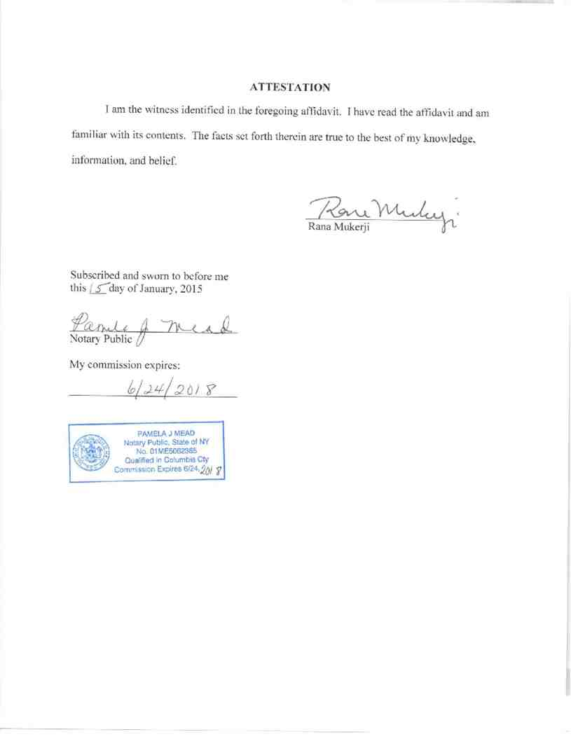

Attachment 3
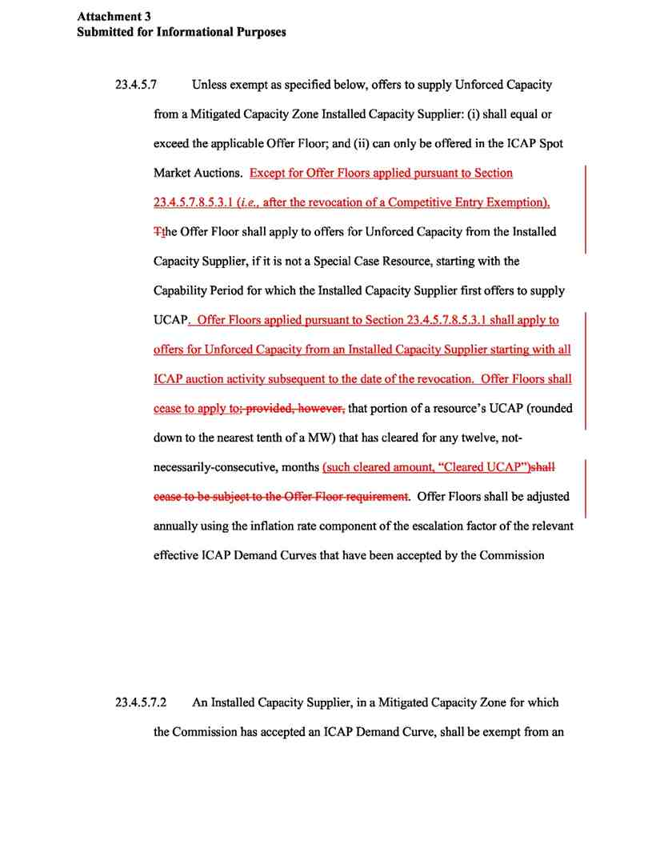
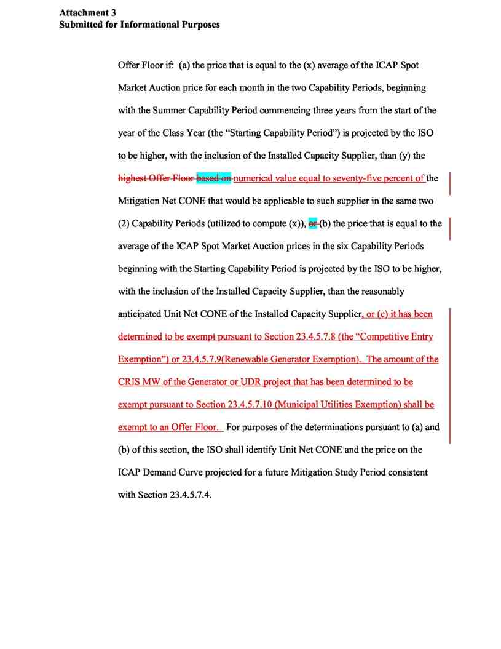
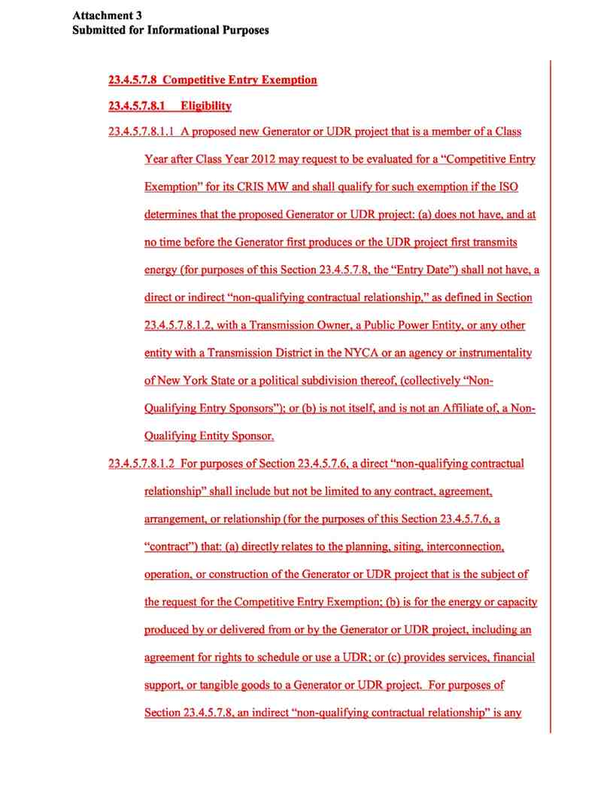
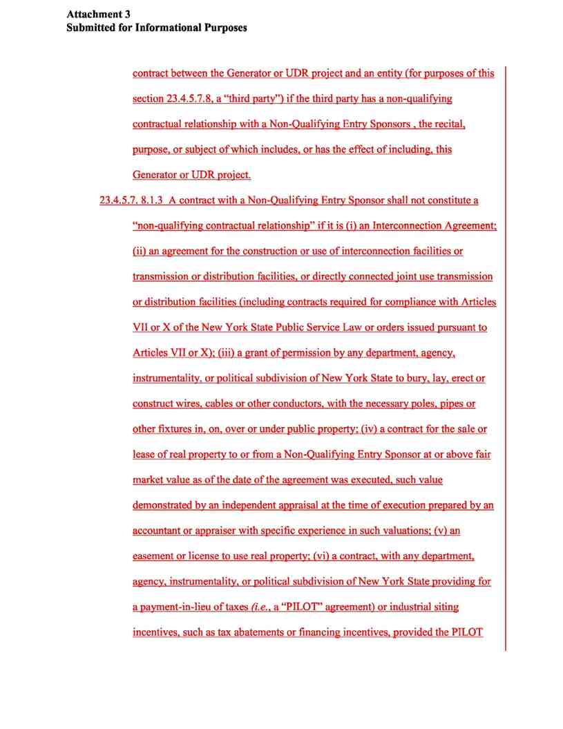
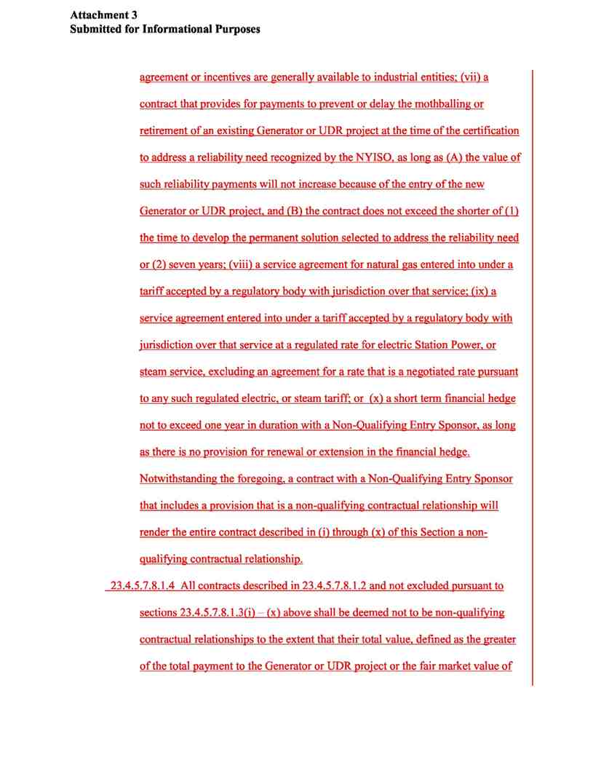
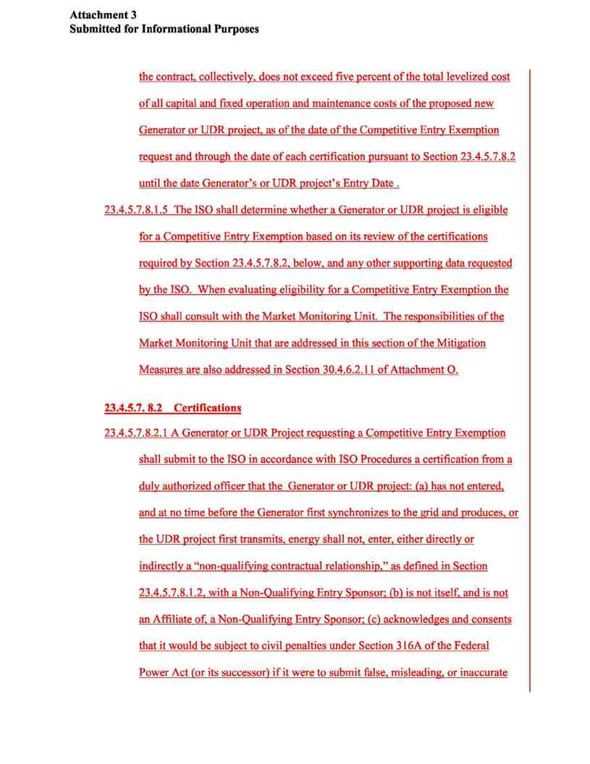
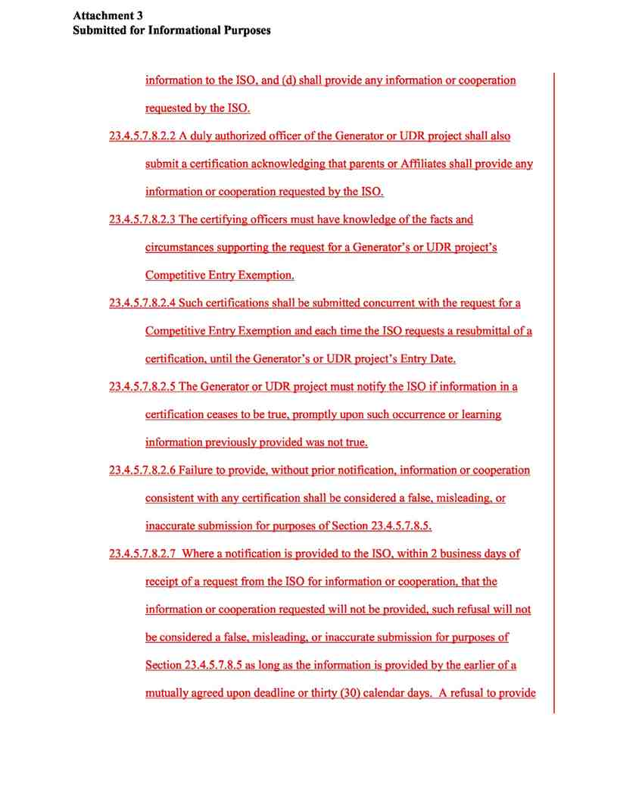
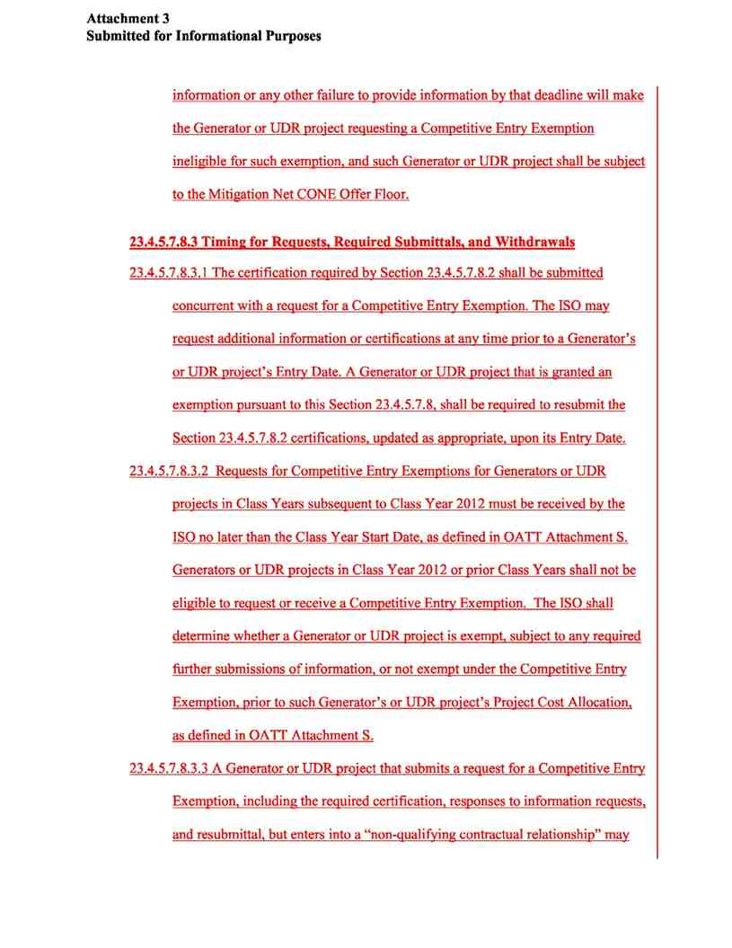
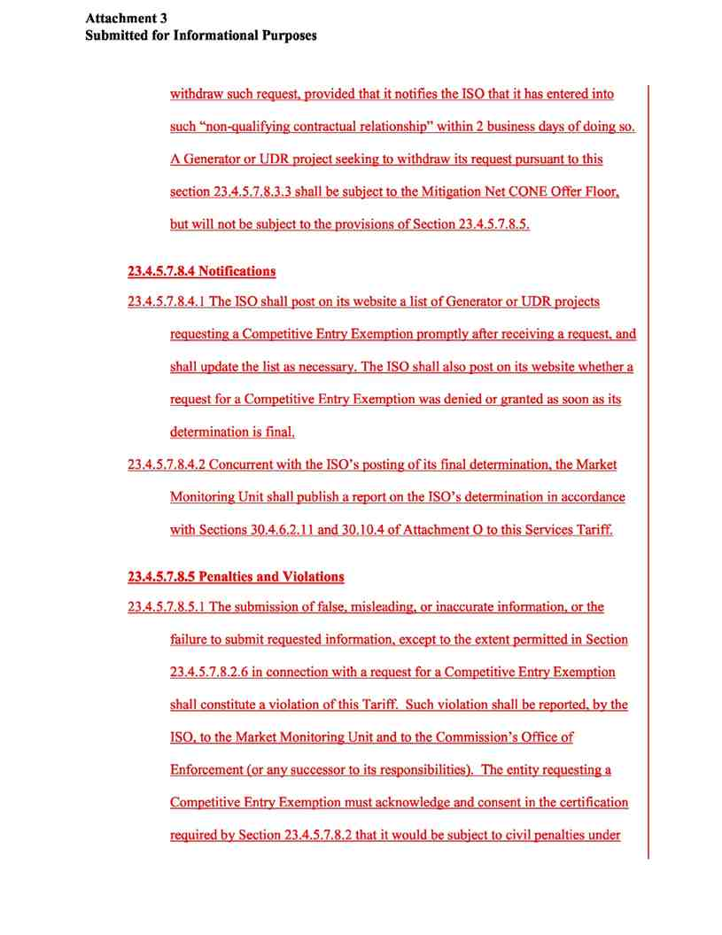
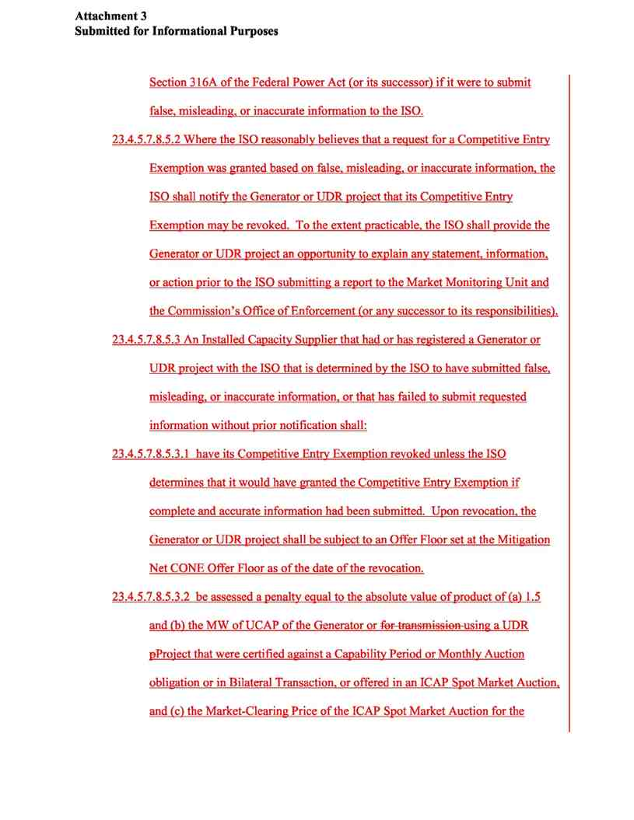
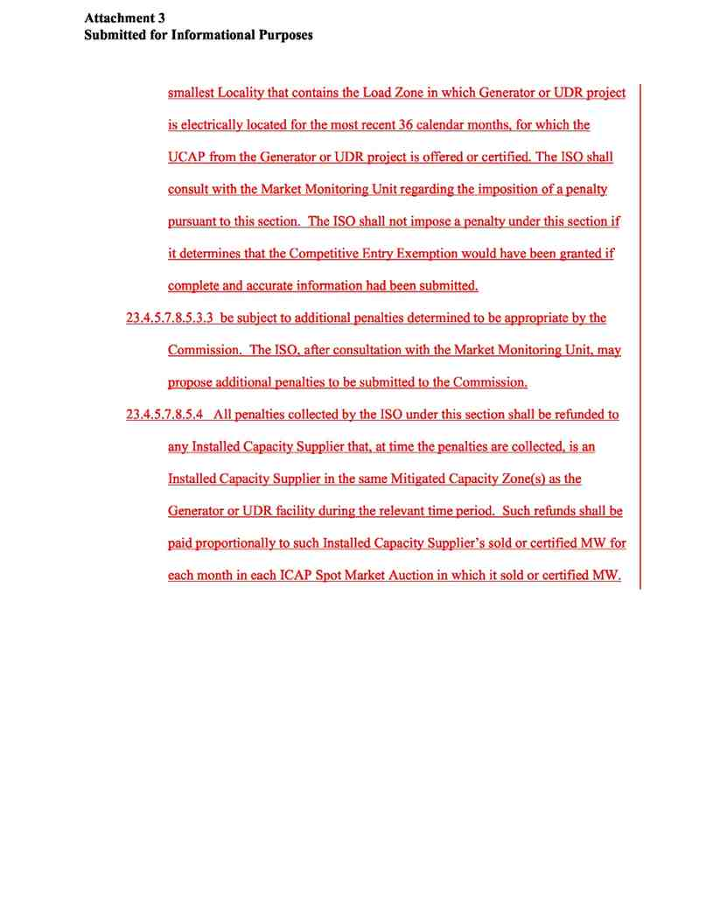

Attachment 4

Attachment 4
Submitted for Informational Purposes

This Attachment 4 utilizes Complaint Exhibit B with the alterations shown in green text. The Green text shows the insertions and deletions that the NYISO recommends comprise the proposed CEE rules.

23.4 Mitigation Measures
23.4.5.7 Unless exempt as specified below, offers to supply Unforced Capacity
from a Mitigated Capacity Zone Installed Capacity Supplier: (i) shall equal or
exceed the applicable Offer Floor; and (ii) can only be offered in the ICAP Spot
Market Auctions. Except for Offer Floors applied pursuant to Section
23.4.5.7.8.5.3.1 (i.e., after the revocation of a Competitive Entry Exemption),
Tthe Offer Floor shall apply to offers for Unforced Capacity from the Installed
Capacity Supplier, if it is not a Special Case Resource, starting with the
Capability Period for which the Installed Capacity Supplier first offers to supply
UCAP. Offer Floors applied pursuant to Section 23.4.5.7.8.5.3.1 shall apply
to offers for Unforced Capacity from an Installed Capacity Supplier starting
with all ICAP auction activity subsequent to the date of the revocation. Offer
Floors shall cease to apply to ; provided, however, that portion of a resource’s
UCAP (rounded down to the nearest tenth of a MW) that has cleared for any
twelve, not-necessarily-consecutive, months (such cleared amount, “Cleared
UCAP”) shall cease to be subject to the Offer Floor requirement. Offer
Floors shall be adjusted annually using the inflation rate component of the
escalation factor of the relevant effective ICAP Demand Curves that have been
accepted by the Commission.

page 1

Attachment 4
Submitted for Informational Purposes

23.4.5.7.2 An Installed Capacity Supplier, in a Mitigated Capacity Zone for which
the Commission has accepted an ICAP Demand Curve, shall be exempt from an
Offer Floor if: (a) the price that is equal to the (x) average of the ICAP Spot
Market Auction price for each month in the two Capability Periods, beginning
with the Summer Capability Period commencing three years from the start of the
year of the Class Year (the “Starting Capability Period”) is projected by the ISO
to be higher, with the inclusion of the Installed Capacity Supplier, than (y) the
highest Offer Floor based on numerical value equal to seventy-five percent of
the Mitigation Net CONE that would be applicable to such supplier in the same
two (2) Capability Periods (utilized to compute (x)), or (b) the price that is equal
to the average of the ICAP Spot Market Auction prices in the six Capability
Periods beginning with the Starting Capability Period is projected by the ISO to
be higher, with the inclusion of the Installed Capacity Supplier, than the
reasonably anticipated Unit Net CONE of the Installed Capacity Supplier; or (c)
it has been determined to be exempt pursuant to Section 23.4.5.7.8 (the
“Competitive Entry Exemption”). For purposes of the determinations pursuant
to (a) and (b) of this section, the ISO shall identify Unit Net CONE and the price
on the ICAP Demand Curve projected for a future Mitigation Study Period
consistent with Section 23.4.5.7.4.

page 2

Attachment 4
Submitted for Informational Purposes

23.4.5.7.68 Competitive Entry Exemption
23.4.5.7. 68.1 Eligibility
23.4.5.7. 68.1.1 A proposed new Generator or UDR project that is a member of a Class Year after
Class Year 2012 may request to be evaluated for a “Competitive Entry Exemption” for its
CRIS MW and shall qualify for such exemption if the ISO determines that the proposed
Generator or UDR project: (a) does not have, and at no time before the Generator first
produces or the UDR project first transmits energy (for purposes of this Section 23.4.5.7.8,
the “Entry Date”) shall not have, a direct or indirect “non-qualifying contractual
relationship,” as defined in Section 23.4.5.7.8.1.2, with a Transmission Owner, a Public
Power Entity, or any other entity with a Transmission District in the NYCA or an agency or
instrumentality of New York State or a political subdivision thereof, (collectively “Non-
Qualifying Entry Sponsors”); or (b) is not itself, and is not an Affiliate of, a Non-Qualifying
Entity Sponsor.
23.4.5.7. 68.1.2 For purposes of Section 23.4.5.7.68, a direct “non-qualifying contractual

relationship” shall include but not be limited to any contract, agreement, arrangement, or
relationship (for the purposes of this Section 23.4.5.7.68, a “contract”) that: (a) directly
relates to the planning, siting, interconnection, operation, or construction of the Generator or
UDR project that is the subject of the request for the Competitive Entry Exemption; (b) is for
the energy or capacity produced by or delivered from or by the Generator or UDR project,
including an agreement for rights to schedule or use a UDR; or (c) provides services,
financial support, or tangible goods to a Generator or UDR project. For purposes of Section
23.4.5.7.8, an indirect “non-qualifying contractual relationship” is any contract between the
Generator or UDR project and an entity (for purposes of this section 23.4.5.7.68, a “third
party”) if the third party has a non-qualifying contractual relationship with a Non-Qualifying

page 3

Attachment 4
Submitted for Informational Purposes
Entry Sponsors, the recital, purpose, or subject of which includes, or has the effect of including, this Generator or UDR project.
23.4.5.7.68.1.3 A contract with a Non-Qualifying Entry Sponsor shall not constitute a “non-

qualifying contractual relationship” if it is (i) an Interconnection Agreement; (ii) an
agreement for the construction or use of interconnection facilities or transmission or
distribution facilities, or directly connected joint use transmission or distribution facilities
(including contracts required for compliance with Articles VII or X of the New York State
Public Service Law or orders issued pursuant to Articles VII or X); (iii) a grant of permission
by any department, agency, instrumentality, or political subdivision of New York State to
bury, lay, erect or construct wires, cables or other conductors, with the necessary poles, pipes
or other fixtures in, on, over or under public property; (iv) a contract for the sale or lease of
real property to or from a Non-Qualifying Entry Sponsor at or above fair market value as of
the date of the agreement was executed, such value demonstrated by an independent appraisal
at the time of execution prepared by an accountant or appraiser with specific experience in
such valuations; (v) an easement or license to use real property; (vi) a contract, with any
department, agency, instrumentality, or political subdivision of New York State providing for
a payment-in-lieu of taxes (i.e., a “PILOT” agreement) or industrial siting incentives, such as
tax abatements or financing incentives, provided the PILOT agreement or incentives are
generally available to industrial entities; (vii) a contract that provides for payments to prevent
or delay the mothballing or retirement of an existing Generator or UDR project at the time of
the certification to address a reliability need recognized by the NYISO, as long as (A) the
value of such reliability payments will not increase because of the entry of the new Generator
or UDR project, and (B) the contract does not exceed the shorter of (1) the time to develop
the permanent solution selected to address the reliability need or (2) seven years; (viii) a

page 4

Attachment 4
Submitted for Informational Purposes

service agreement for natural gas entered into under a tariff accepted by a regulatory body

with jurisdiction over that service; (ix) a service agreement entered into under a tariff
accepted by a regulatory body with jurisdiction over that service at a regulated rate for
electric Station Power, or steam service, excluding an agreement for a rate that is a negotiated rate pursuant to any such regulated electric or steam tariff; or (x) a short term financial hedge not to exceed one year in duration with a Non-Qualifying Entry Sponsor, as long as there is no provision for renewal or extension in the financial hedge. Notwithstanding the foregoing, a contract with a Non-Qualifying Entry Sponsor that includes a provision that is a non-
qualifying contractual relationship will render the entire contract described in (i) through (x) of this Section a non-qualifying contractual relationship.
23.4.5.7. 68.1.4 All contracts described in 23.4.5.7. 68.1.2 and not excluded pursuant to sections
23.4.5.7.8.1.3(i) - (x) above shall be deemed not to be non-qualifying contractual

relationships to the extent that their total value subsidy value, total value defined as the
greater of the total payment to the Generator or UDR project or the fair market value
of the contract, collectively, benefit provided by the Non-Qualifying Entry Sponsor for
the commodity or service as compared to an arms-length transaction, greater of the
total payment to the Generator or UDR project or the fair market value of the contract,
collectively, does not exceed five percent of the total levelized cost of all capital and fixed
operation and maintenance costs of the proposed new Generator or UDR project, as of the
date of the Competitive Entry Exemption request and through the date of each certification
pursuant to Section 23.4.5.7.8.2 until the date Generator’s or UDR project’s Entry Date.
23.4.5.7. 68.1.5 The ISO shall determine whether a Generator or UDR project is eligible for a
Competitive Entry Exemption based on its review of the certifications required by Section

23.4.5.7.8.2, below, and any other supporting data requested by the ISO. When evaluating

page 5

Attachment 4
Submitted for Informational Purposes

eligibility for a Competitive Entry Exemption the ISO shall consult with the Market
Monitoring Unit. The responsibilities of the Market Monitoring Unit that are addressed in this section of the Mitigation Measures are also addressed in Section 30.4.6.2.11 of
Attachment O.
23.4.5.7. 68.2 Certifications
23.4.5.7. 68.2.1 A Generator or UDR Project requesting a Competitive Entry Exemption shall submit
to the ISO in accordance with ISO Procedures a certification from a duly authorized officer
that the Generator or UDR project: (a) has not entered, and at no time before the
Generator first synchronizes to the grid and produces, or the UDR project first
transmits, energy shall not, enter, either directly or indirectly a “non-qualifying
contractual relationship,” as defined in Section 23.4.5.7.68.1.2, with a Non-Qualifying
Entry Sponsor; (b) is not itself, and is not an Affiliate of, a Non-Qualifying Entry
Sponsor; (c) acknowledges and consents that it would be subject to civil penalties under
Section 316A of the Federal Power Act (or its successor) if it were to submit false,
misleading, or inaccurate information to the ISO, and (d) shall provide any information
or cooperation requested by the ISO.
23.4.5.7.68.2.2 A duly authorized officer of the Generator or UDR project shall also submit a
certification acknowledging that parents or Affiliates shall provide any information or
cooperation requested by the ISO.
23.4.5.7.68.2.3 The certifying officers must have knowledge of the facts and circumstances
supporting the request for a Generator’s or UDR project’s Competitive Entry
Exemption.
to the best of his/her knowledge and having conducted due diligence that is current as of the
date of the Certification, the corporate entity developing the Project has either (A) not

page 6

Attachment 4
Submitted for Informational Purposes
executed contracts that are direct or indirect non-qualifying contractual relationships with a “Non-Qualifying Entry Sponsor,” as those terms are defined in Section
23.4.5.7.68.1.2.; or (B) has executed contracts that are direct or indirect non-qualifying
contractual relationships with a “Non-Qualifying Entry Sponsor” and that all such
contracts are listed on the Certification and the total of all such contracts evaluated at
the greater of the subsidy value of the contracts, collectively, other than contracts
described in (i) through (viii) in Section 23.4.5.7.8.1.2, do not exceed five percent of the
total levelized cost of all capital and fixed operation and maintenance costs of the
proposed new Generator or UDR project, calculated consistently with corporate
standards and accepted accounting principles, pursuant to Section 23.4.5.7.8.1.2.
the Generator or UDR project: (a) has not entered, and at no time before the Generator
first synchronizes to the grid and produces, or the UDR project first transmits, energy
shall not, enter, either directly or indirectly a “non-qualifying contractual relationship,”
as defined in Section 23.4.5.7.8.1.2, with a Non-Qualifying Entry Sponsor; (b) is not
itself, and is not an Affiliate of, a Non-Qualifying Entry Sponsor; (c) acknowledges and
consents that it would be subject to civil penalties under Section 316A of the Federal
Power Act (or its successor) if it were to submit false, misleading, or inaccurate
information to the ISO, and (d) shall provide any information or cooperation requested
by the ISO.
23.4.5.7.8.2.2 A duly authorized officer of the Generator or UDR project shall also submit a
certification acknowledging that parents or Affiliates shall provide any information or cooperation requested by the ISO.

page 7

Attachment 4
Submitted for Informational Purposes
23.4.5.7.8.2.3 The certifying officers must have knowledge of the facts and circumstances
supporting the request for a Generator’s or UDR project’s Competitive Entry
Exemption.
23.4.5.7.8.2.4 Such certifications shall be submitted concurrent with the request for a Competitive
Entry Exemption and each time the ISO requests a resubmittal of a certification, until the
Generator’s or UDR project’s Entry Date.
23.4.5.7.8.2.5 The Generator or UDR project must notify the ISO if information in a
certification ceases to be true, promptly upon such occurrence or learning information previously provided was not true.
23.4.5.7.8.2.6 Failure to provide, without prior notification, information or cooperation
consistent with any certification shall be considered a false, misleading, or inaccurate submission for purposes of Section 23.4.5.7.8.5.
23.4.5.7.8.2.7 Where a notification is provided to the ISO, within 2 business days of receipt of a
request from the ISO for information or cooperation, that the information or
cooperation requested will not be provided, such refusal will not be considered a false,
misleading, or inaccurate submission for purposes of Section 23.4.5.7.8.5 as long as the
information is provided by the earlier of a mutually agreed upon deadline or thirty (30)
calendar days. A refusal to provide information or any other failure to provide
information by that deadline will make the Generator or UDR project requesting a
Competitive Entry Exemption ineligible for such exemption, and such Generator or
UDR project shall be subject to the Mitigation Net CONE Offer Floor.
23.4.5.7.8.2.5 The Generator or UDR project must notify the ISO if information in a
certification ceases to be true, promptly upon such occurrence or learning information previously provided was not true.

page 8

Attachment 4
Submitted for Informational Purposes

23.4.5.7.8.2.6 Failure to provide, without prior notification, information or cooperation
consistent with any certification shall be considered a false, misleading, or inaccurate submission for purposes of Section 23.4.5.7.8.5.
23.4.5.7.8.2.7 Where a notification is provided to the ISO, within 2 business days of receipt of a
request from the ISO for information or cooperation, that the information or
cooperation requested will not be provided, such refusal will not be considered a false,
misleading, or inaccurate submission for purposes of Section 23.4.5.7.8.5 as long as the
information is provided by the earlier of a mutually agreed upon deadline or thirty (30)
calendar days. A refusal to provide information or any other failure to provide
information by that deadline will make the Generator or UDR project requesting a
Competitive Entry Exemption ineligible for such exemption, and such Generator or
UDR project shall be subject to the Mitigation Net CONE Offer Floor.
23.4.5.7. 68.3 Timing for Requests, Required Submittals, and Withdrawals
23.4.5.7. 68.3.1 The certification required by Section 23.4.5.7.8.2 shall be submitted concurrent with
a request for a Competitive Entry Exemption. The ISO may request additional information or
certifications at any time prior to a Generator’s or UDR project’s Entry Date. A Generator or
UDR project that is granted an exemption pursuant to this Section 23.4.5.7.8, shall be
required to resubmit the Section 23.4.5.7.8.2 certifications, updated as appropriate, upon its
Entry Date.
23.4.5.7. 68.3.2 Requests for Competitive Entry Exemptions for Generators or UDR projects in Class
Years subsequent to Class Year 2012 must be received by the ISO no later than the Class
Year Start Date, as defined in OATT Attachment S. Generators or UDR projects in Class
Year 2012 or prior Class Years shall not be eligible to request or receive a Competitive Entry
Exemption. The ISO shall determine whether a Generator or UDR project is exempt, subject

page 9

Attachment 4
Submitted for Informational Purposes
to any required further submissions of information, or not exempt under the Competitive Entry Exemption, prior to such Generator’s or UDR project’s Project Cost Allocation, as defined in OATT Attachment S.
23.4.5.7.8.3.3 A Generator or UDR project that submits a request for a Competitive Entry
Exemption, including the required certification, responses to information requests, and
resubmittal, but enters into a “non-qualifying contractual relationship” may withdraw such
request, provided that it notifies the ISO that it has entered into such “non-qualifying
contractual relationship” within 2 business days of doing so. A Generator or UDR project
seeking to withdraw its request pursuant to this section 23.4.5.7.8.3.3 shall be subject to the
Mitigation Net CONE Offer Floor, but will not be subject to the provisions of Section
23.4.5.7.8.5.
23.4.5.7. 68.4 Notifications
23.4.5.7. 68.4.1 The ISO shall post on its website a list of Generator or UDR projects requesting a
Competitive Entry Exemption promptly after receiving a request, and shall update the list as
necessary. The ISO shall also post on its website whether a request for a Competitive Entry
Exemption was denied or granted as soon as its determination is final.
23.4.5.7. 68.4.2 Concurrent with the ISO’s posting of its final determination, the Market Monitoring
Unit shall publish a report on the ISO’s determination in accordance with Sections
30.4.6.2.11 and 30.10.4 of Attachment O to this Services Tariff.

23.4.5.7.8.5 Penalties and Violations
23.4.5.7.8.5.1 The submission of false, misleading, or inaccurate information, or the failure
to submit requested information, except to the extent permitted in Section
23.4.5.7.8.2.6 in connection with a request for a Competitive Entry Exemption shall
constitute a violation of this Tariff. Such violation shall be reported, by the ISO, to

page 10

Attachment 4
Submitted for Informational Purposes
the Market Monitoring Unit and to the Commission’s Office of Enforcement (or any
successor to its responsibilities). The entity requesting a Competitive Entry
Exemption must acknowledge and consent in the certification required by Section
23.4.5.7.8.2 that it would be subject to civil penalties under Section 316A of the Federal Power Act (or its successor) if it were to submit false, misleading, or inaccurate information to the ISO.
23.4.5.7.8.5.2 Where the ISO reasonably believes that a request for a Competitive Entry
Exemption was granted based on false, misleading, or inaccurate information, the
ISO shall notify the Generator or UDR project that its Competitive Entry
Exemption may be revoked. To the extent practicable, the ISO shall provide the
Generator or UDR project an opportunity to explain any statement, information, or
action prior to the ISO submitting a report to the Market Monitoring Unit and the
Commission’s Office of Enforcement (or any successor to its responsibilities).
23.4.5.7.8.5.3 An Installed Capacity Supplier that had or has registered a Generator or
UDR project with the ISO that is determined by the ISO to have submitted false,
misleading, or inaccurate information, or that has failed to submit requested
information without prior notification shall:
23.4.5.7.8.5.3.1 have its Competitive Entry Exemption revoked unless the ISO determines
that it would have granted the Competitive Entry Exemption if complete and
accurate information had been submitted. Upon revocation, the Generator or UDR
project shall be subject to an Offer Floor set at the Mitigation Net CONE Offer
Floor as of the date of the revocation.

page 11

Attachment 4
Submitted for Informational Purposes

23.4.5.7.8.5.3.2 be assessed a penalty equal to the absolute value of product of (a) 1.5 and
(b) the MW of UCAP of the Generator or using a UDR Project that were certified
against a Capability Period or Monthly Auction obligation or in Bilateral
Transaction, or offered in an ICAP Spot Market Auction, and (c) the Market-
Clearing Price of the ICAP Spot Market Auction for the smallest Locality that
contains the Load Zone in which Generator or UDR project is electrically located
for the most recent 36 calendar months, for which the UCAP from the Generator or
UDR project is offered or certified. The ISO shall consult with the Market
Monitoring Unit regarding the imposition of a penalty pursuant to this section. The
ISO shall not impose a penalty under this section if it determines that the
Competitive Entry Exemption would have been granted if complete and accurate
information had been submitted.
23.4.5.7.8.5.3.3 be subject to additional penalties determined to be appropriate by the
Commission. The ISO, after consultation with the Market Monitoring Unit, may propose additional penalties to be submitted to the Commission.
23.4.5.7.8.5.4 All penalties collected by the ISO under this section shall be refunded to any
Installed Capacity Supplier that, at time the penalties are collected, is an Installed
Capacity Supplier in the same Mitigated Capacity Zone(s) as the Generator or UDR
facility during the relevant time period. Such refunds shall be paid proportionally to
such Installed Capacity Supplier’s sold or certified MW for each month in each
ICAP Spot Market Auction in which it sold or certified MW.

page 12

Attachment 5

Attachment 5
Submitted for Informational Purposes

Services Tariff Section 30.4 Market Monitoring Unit
30.4.6.2.112 When evaluating a request by a Developer or Interconnection Customer
pursuant to Section 23.4.5.7 of the Market Mitigation Measures, the ISO shall
seek comment from the Market Monitoring Unit on matters relating to the
determination of price projections and cost calculations. As required by Section
23.4.5.7.8 of Attachment H to this Services Tariff, the Market Monitoring Unit
shall prepare a written report confirming whether the ISO’s Offer Floor and
exemption determinations and calculations conducted pursuant to Sections
23.4.5.7.2 and 23.4.5.7.8 of the Market Mitigation Measures were conducted in
accordance with the terms of the Services Tariff, and if not, identifying the flaws
inherent in the ISO’s approach. This report shall be presented concurrent with the
ISO’s posting of its mitigation exemption determinations. Pursuant to Section
23.4.5.7.7 of the Market Mitigation Measures, the ISO shall also consult with the
Market Monitoring Unit when evaluating whether any existing or proposed
Generator or UDR project in a Mitigated Capacity Zone, except New York City,
shall be exempted from an Offer Floor under that Section. Prior to the ISO
making an exemption determination pursuant to Section 23.4.5.7.7, the Market
Monitoring Unit shall provide the ISO a written opinion and recommendation.
The Market Monitoring Unit shall also provide a public report on its assessment
of an ISO determination that an existing or proposed Generator or UDR project is
exempt from an Offer Floor under Section 23.4.5.7.7. See Market Mitigation
Measures Section 23.4.5.7.

page 1

Attachment 5
Submitted for Informational Purposes

Services Tariff Section 30.6 Data Collection and Disclosure
30.6.2.2.5 Other Cost and Risk Data Supporting Reference Levels or Mitigation
Exemption Determinations or Going-Forward Costs - All data or information
not specifically identified above that: (i) supports or relates to a Market Party’s
claimed, requested, or approved reference levels or Going-Forward Costs (as that
term is defined in the Market Mitigation Measures) for a particular resource; or
(ii) are necessary for the ISO to make a mitigation exemption determination
under Services Tariff Section 23.4.5.7, including data or information: (a)
necessary to determine a Market Party’s Unit Net CONE (as that term is
defined in the Market Mitigation Measures) for a particular resource; or (b)
required to evaluate a Market Party’s eligibility for a mitigation exemption
determination, including information from a Market Party’s Affiliates, as
appropriate.

page 2

Attachment 5
Submitted for Informational Purposes

OATT Section 12.4 Treatment of Confidential and Transmission System Information
This section deals with Confidential Information, including Transmission System

Information. Confidential Information consists of: (1) data designated as such in NYPP
Operating Policy OP-18 (or its successor); (2) any commercially sensitive information including, without limitation, trade secrets, equipment specific information (e.g., Generator specific data
such as heat rates, etc.), and business strategies, affirmatively designated as Confidential
Information by its supplier or owner; and (3) Transmission System Information (“TSI”) that has not yet been posted on the OASIS or provided in some public forum such as a FERC filing. TSI is information: (1) that is commercially valuable and (2) access to which is necessary to buy, sell or schedule Energy, Capacity, Ancillary Services or Transmission Service. Examples of TSI
include, but are not limited to, the following:
• Available Transfer Capability;

• Total Transfer Capability;

• Information regarding physical Curtailments and Interruptions;

• Information regarding Ancillary Services;

• Pricing for Transmission Service; and

• Discounts offered.
In the course of responding to requests for Energy, Capacity, Transmission Services or Ancillary Services, the ISO shall not disclose Confidential Information to any Market
Participant. The ISO shall disclose data that is not Confidential Information, and information required to be disclosed by FERC, by posting the information on the OASIS. If an ISO
Employee improperly discloses TSI to any Market Participant, the ISO shall immediately post the information on the OASIS and notify the Commission.

page 3

Attachment 5
Submitted for Informational Purposes
ISO Employees shall also report all improper disclosures of Confidential Information to the ISO compliance officer (as described in Section 12.10) or its designee immediately. In the case of an Emergency, the ISO may disclose such TSI, and then notify the Commission, posting the information on the OASIS as soon as practicable but no later than twenty-four (24) hours after the information is disclosed.
The procedures described in this section does not apply to the following:
(1) communication of TSI between the ISO and the Transmission Owner’s control

centers, and other power pools or ISOs;

(2) communication of non-public, operational information concerning natural gas-
fueled generation from resources located within the New York Control Area
between the ISO and the operating personnel of an interstate natural gas pipeline
company for the purpose of promoting reliable service or operational planning;
(3) communication of non-public, operational information concerning natural gas-
fueled generation from resources located within the New York Control Area
between the ISO and the operating personnel of natural gas local distribution
companies (“LDCs”) and/or intrastate natural gas pipeline companies operators
for the purpose of promoting reliable service or operational planning, provided
that if such party has acknowledged, in writing, that it is prohibited from
disclosing—or using anyone as a conduit for disclosure of—non-public,
operational information received from the ISO to: (a) an employee other than
operating personnel of that LDC and/or intrastate natural gas pipeline company,
(b) a affiliate or third party, or (c) any affiliate except for (i) the operating
personnel of an affiliated interstate natural gas pipeline company, or (ii) the

page 4

Attachment 5
Submitted for Informational Purposes

operating personnel of an intrastate pipeline which has a non-disclosure
agreement with the ISO. The operating personnel of an affiliated interstate

natural gas pipeline company accepting non-public operational information

pursuant to this section shall agree to comply with 18 CFR 284.12(b)(4)(ii).
Unless otherwise authorized by the Commission, for purposes of this section LDC
or intrastate pipeline “operating personnel” shall exclude employees engaged in
marketing functions as defined by 18 CFR 358.3(c) or who make sales of natural
gas;
(4) communication of information from a Market Participant to the ISO;
(5) information that is no longer Confidential Information because it was made public
by posting it on the OASIS; or it was legally disclosed by a third party in good faith and without violating a trade secret, secrecy agreement or employment contract with a non-disclosure clause; or it was made public by a government agency, court or other process of law;
(6) requests by a Market Participant for a report regarding the status of that Market
Participant’s particular contracts or transactions. The ISO shall provide all Market Participants requesting a report the same type and level of detail of information; and
(7) information that is not listed in NYPP OP-18 and has not been designated by the
supplier or owner as Confidential Information; and

(8) disclosures by the ISO that are authorized under ISO Services Tariff
Attachment H Section 23.4.5.7 and its subsections (except as restricted in section 23.4.5.7.3.2).

page 5

CERTIFICATE OF SERVICE
I hereby certify that I have this day served the foregoing document upon each person
designated on the official service list compiled by the Secretary in this proceeding in accordance with the requirements of Rule 2010 of the Rules of Practice and Procedure, 18 C.F.R. §385.2010.
Dated at Rensselaer, NY this 15th day of January, 2015.

/s/ Joy A. Zimberlin

Joy A. Zimberlin
New York Independent System Operator, Inc.
10 Krey Blvd.
Rensselaer, NY 12144 (518) 356-6207

