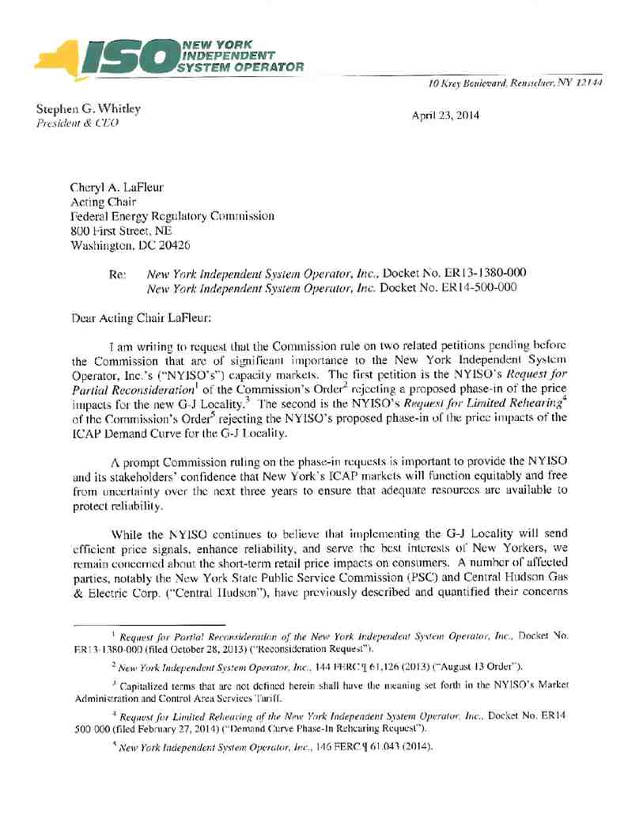
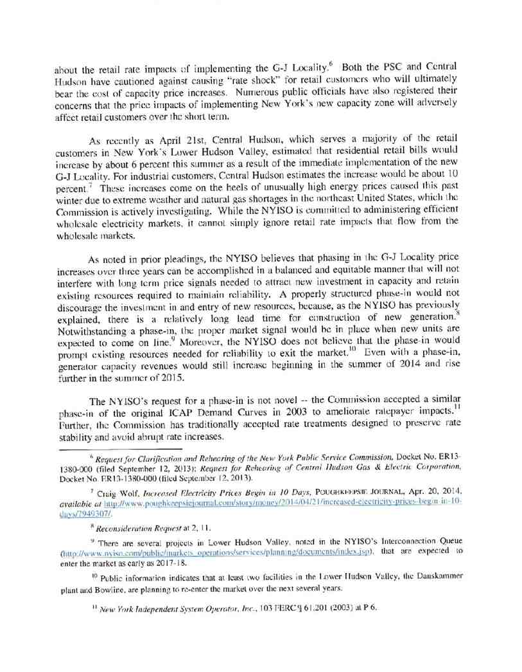
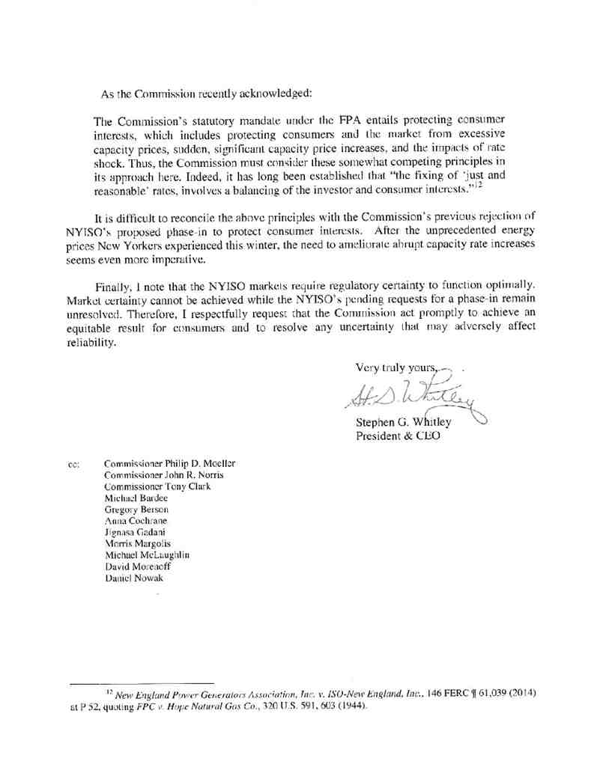

CERTIFICATE OF SERVICE
I hereby certify that I have this day served the foregoing document upon each person
designated on the official service list compiled by the Secretary in this proceeding in accordance with the requirements of Rule 2010 of the Rules of Practice and Procedure, 18 C.F.R. §385.2010.
Dated at Rensselaer, NY this 23rd day of April, 2014.

/s/ Joy A. Zimberlin

Joy A. Zimberlin
New York Independent System Operator, Inc.
10 Krey Blvd.
Rensselaer, NY 12144 (518) 356-6207

