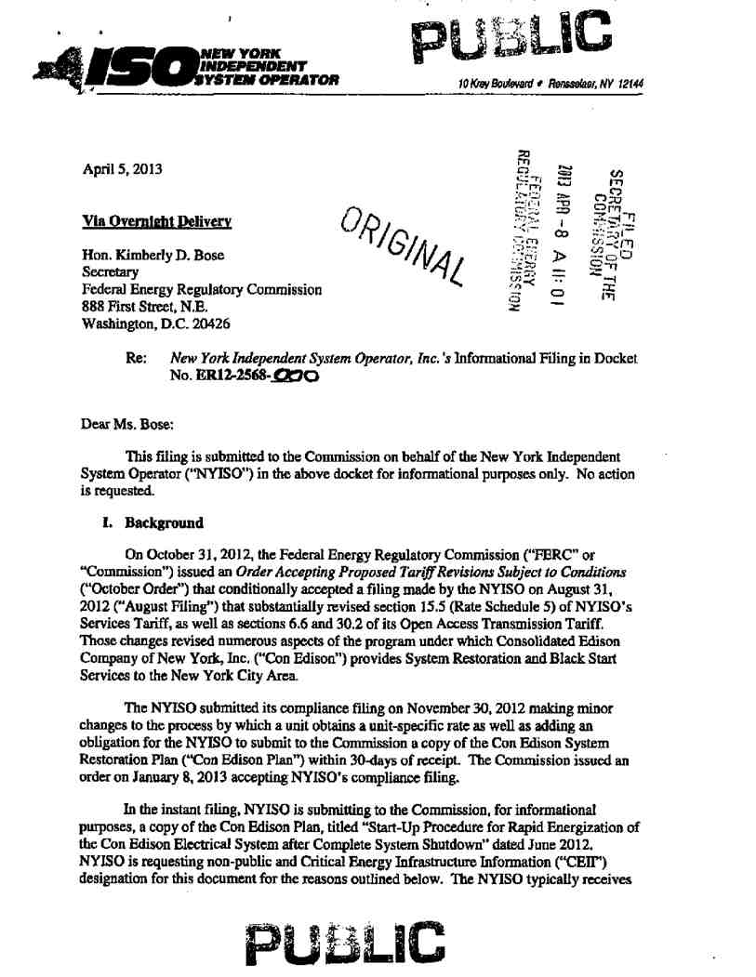
20130415-0002 FERC PDF (Unofficial) 04/08/2013
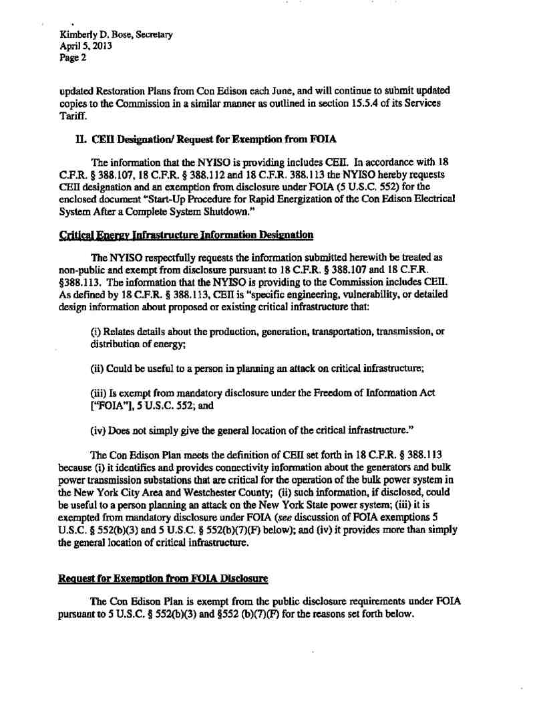
20130415-0002 FERC PDF (Unofficial) 04/08/2013
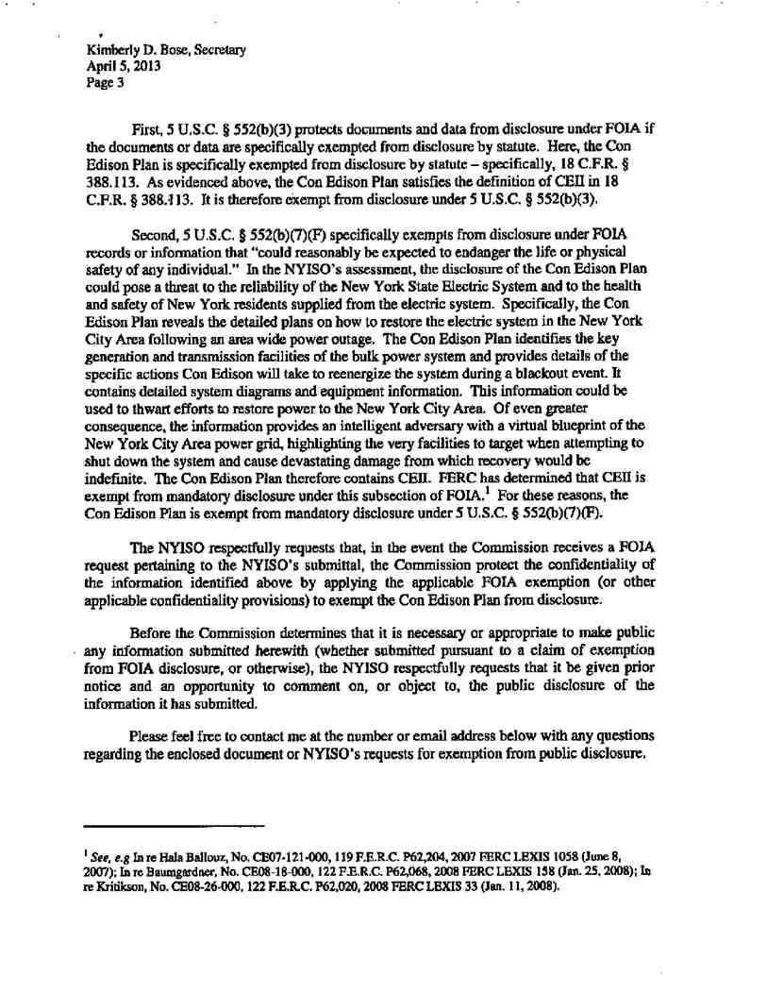
20130415-0002 FERC PDF (Unofficial) 04/08/2013
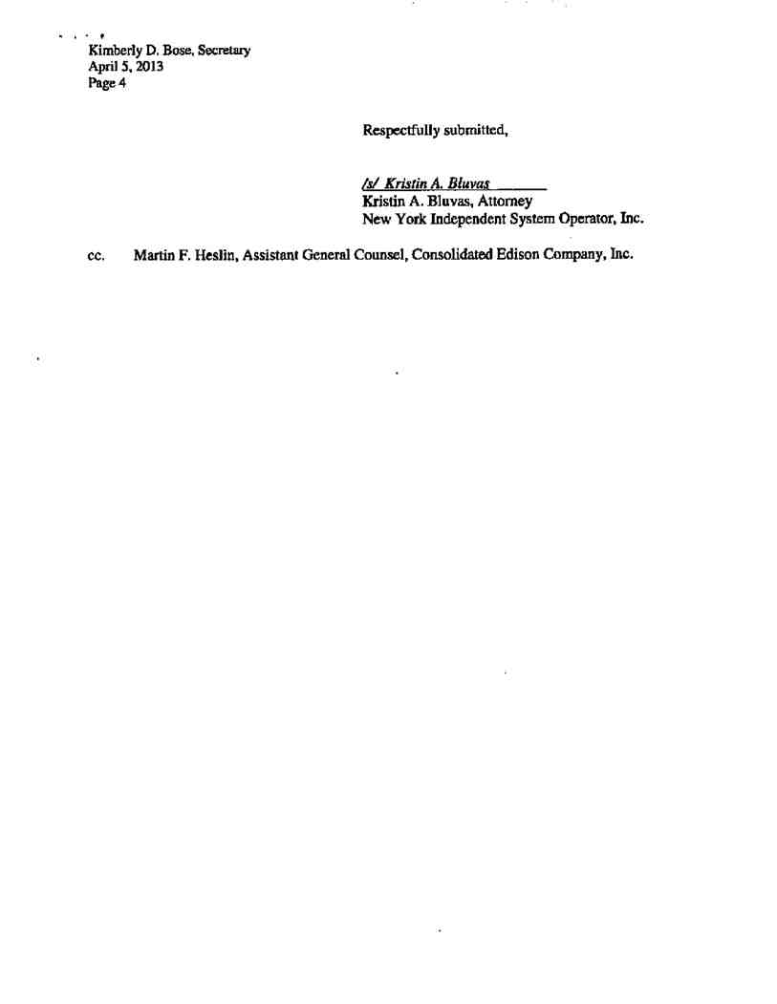
20130415-0002 FERC PDF (Unofficial) 04/08/2013
20130415-0002 FERC PDF (Unofficial) 04/08/2013
Document Content(s)
13233353.tif 1-4

