

10 Krey Boulevard Rensselaer, NY 12144

October 1, 2012

ELECTRONICALLY SUBMITTED

Kimberly D. Bose
Secretary
Federal Energy Regulatory Commission 888 First Street, N.E.
Washington, D.C. 20426

Re: New York Independent System Operator, Inc.’s Fourth Informational Report on
Efforts to Develop Rules Addressing Compensation to Generators that Are
Determined to be Needed for Reliability; Docket No. ER10-2220-000.
Dear Secretary Bose:

In accordance with paragraph 54 and ordering paragraph “(C)” of the Federal Energy
Regulatory Commission’s (“Commission’s”) October 12, 2010, Order On Proposed Mitigation Measures in Docket No. ER10-2220-000 (“Order”),¹ the New York Independent System
Operator, Inc. (“NYISO”), hereby submits this Fourth Informational Report on Efforts to
Develop Rules Addressing Compensation to Generators that Are Determined to be Needed for Reliability (“Informational Report”). The NYISO submitted its Third Informational Report on Efforts to Develop Rules Addressing Compensation to Generators that Are Determined to be
Needed for Reliability on April 4, 2012, (“April 2012 Informational Report”). In footnote 44 of its Order the Commission stated that it does not intend to issue public notices, accept
comments, or issue orders on this Informational Report.

Paragraph 54 of the Order stated, in part, as follows:

Because fixed cost recovery issues do not go to whether NYISO’s mitigation
proposal is in itself just and reasonable, this proceeding is not the appropriate
forum in which to raise such issues. Further, commenters do not present factual
evidence that demonstrates that market participants generally will be unable to

¹New York Independent System Operator, Inc., 133 FERC ¶ 61,030.

Kimberly D. Bose, Secretary October 1, 2012
Page 2

recover their costs due to application of the proposed mitigation provisions. We
note, however, that the NYISO Board of Directors, in its July 29, 2010 decision
on the appeal of the NYISO Management Committee’s adoption of the instant
mitigation proposal, directed NYISO management to work with stakeholders to
examine the generation owners’ claims that existing cost recovery mechanisms
are inadequate and to review the process that evaluates permanent solutions to
reliability problems. Accordingly, we believe the better course is to await the
outcome of the stakeholder process as directed by the NYISO Board of Directors. In this regard, we direct NYISO to file status reports every 180 days beginning 180 days from the date of this order for informational purposes only.⁴⁴

⁴⁴ The Commission does not intend to issue public notices, accept comments, or issue orders on such informational filings.

In compliance with the cited sections of the Order, the NYISO submits this Informational
Report.

I. Documents Submitted
1. This Informational Report;
2. An April 16, 2012 presentation titled Alternative Reliability Resource
Compensation Proposal by John Buechler, of NYISO, to a joint meeting of the NYISO’s Electric System Planning Working Group, Market Issues Working Group and ICAP Working Group (“Attachment A”);

3. Two sets of comments on the Alternative Reliability Resource Compensation
Proposal included in Attachment A that were submitted by the IPPNY, and Multiple Intervenors (“Attachment B”);

4. A July 12, 2012 presentation titled Alternative Reliability Resource Compensation
Proposal by John Buechler, of NYISO, to a joint meeting of the NYISO’s
Electric System Planning Working Group, Market Issues Working Group and ICAP Working Group (“Attachment C”);

5. A July 12, 2012 New York State Department of Public Service (“DPS”)
presentation on proposed retirement compensation timeline and process, to a joint meeting of the NYISO’s Electric System Planning Working Group, Market Issues Working Group and ICAP Working Group (“Attachment D”);

Kimberly D. Bose, Secretary October 1, 2012
Page 3

II. Informational Report

A. Summary of the April 2012 Informational Report
On December 6, 2011, the NYISO presented a new proposal to compensate generators
that are planning to retire but are necessary for reliability at a joint Market Issues Working Group
(“MIWG”)/Electric System Planning Working Group (“ESPWG”)/ICAP Working Group
(“ICAPWG”) meeting. The Proposal provided that a generator required for reliability would be
able to recover its going forward avoidable costs (“GFACs”) for the period in which it was
required to meet a reliability need. Under the proposal, the NYISO’s tariff would be revised so
that a generator may request that the NYISO, in collaboration with the local Transmission Owner
(“TO”), perform a confidential reliability study. Notice of the confidential request would be
provided to the New York Public Service Commission (“PSC”). If the generator is found to be
required for reliability, the proposal would entitle the generator to a potential payment (referred
to as “Reliability Resource Compensation”) based on its GFACs. The NYISO and stakeholders
engaged in a robust discussion of the Proposal at the December 6, 2011 joint stakeholder
meeting.

B. April 16, 2012 and July 12, 2012 Joint ESPWG/MIWG/ICAP Working Group
Meetings
On April 16, 2012 and July 12, 2012, the NYISO presented an Alternative Reliability
Resource Compensation (“RRC”) proposal at a joint MIWG/ESPWG/ICAPWG meeting.
Similar to the December 6, 2011 proposal, the alternative proposal would require generators to
fund a confidential reliability study by the NYISO and associated Transmission Owner, and for
the New York State Public Service Commission (“PSC”) to receive confidential notice of the
study. These two proposals included enhancements of the prior proposals that the NYISO
believes better align the study with the existing Comprehensive Reliability Planning Process
(“CRPP”) contained in Attachment Y of the NYISO’s Open Access Transmission Tariff
(“OATT”). Once a reliability need has been determined and the PSC has selected the generator
as the appropriate solution, compensation negotiations between the PSC and/or Transmission
Owner and the generator may commence immediately after the generator submits its retirement
notice.

The Alternative RRC proposal element of DPS-negotiated compensation would eliminate the need for the NYISO administered GFAC compensation previously proposed in the NYISO’s December 6, 2011, RRC presentation.

At the July 12, 2012, joint MIWG/ESPWG/ICAPWG meeting, a representative of the
DPS presented a DPS staff proposal for a retirement compensation timeline and process. The
proposed timeline was generally consistent with the existing six month notice period for
retirement of generators in excess of 80MW. The DPS staff proposal acknowledged that the
“timeframe, including compensation, could be expedited in the event the NYISO and affected
[Transmission Owner(s)] have performed reliability assessments prior to the Generation Owner

Kimberly D. Bose, Secretary October 1, 2012
Page 4

formally filing their notice of retirement with the PSC, and those assessments remain valid and do not identify any adverse impacts.” See Attachment D.
During the April and July 2012 meetings, there was significant discussion among
stakeholders of all sectors. The NYISO also received written comments from IPPNY and
Multiple Intervenors. See Attachments A and B (as described in “Documents Submitted” item number 2).
Based on comments received, significant challenges remain to achieving stakeholder support for the RRC or the Alternate RRC proposals, as presently formulated. For example, certain capacity suppliers are seeking a NYISO tariff provision that specifies the path to
Commission-regulated compensation, which is not included in either proposal. They also are seeking compensation during the PSC-mandated notice period if needed for reliability while certain transmission owners and consumer representatives have expressed opposition to
compensating generators during this PSC notice period.

C. Additional Market Activity
In order to provide the Commission with a full view of the manner in which some
NYISO stakeholders may be evaluating proposals, the NYISO provides the following
information on a matter that involved certain NYCA resources. The PSC recently issued an
order that approved a mechanism for a transmission owner to compensate specific generating
units that were seeking to retire but were determined to be necessary to address a reliability
need.² The subject of the order was a proposal for the transmission owner (Niagara Mohawk
Power Corp. d/b/a/ National Grid) to compensate the generator owner (Dunkirk Power LLC,
“Dunkirk”) for “reliability support services” (“RSS”) provided by certain of its units. National
Grid filed its contract with Dunkirk for RSS with the PSC for approval and cost recovery. Prior
to entering into a term sheet (which preceded the RSS contract) that was the subject of the PSC
proceeding, Dunkirk filed with the Commission a proposed, but unexecuted, reliability must-run
agreement for compensation for these units.³ Dunkirk subsequently requested that the
Commission “extend indefinitely the date for Commission action” “to provide time for execution
of a final contract and any NYSPSC order to become final and nonappealable.”⁴ Dunkirk’s
request and the proceeding are still pending before the Commission.

While the approach taken for the Dunkirk units is not dispositive of further consideration of cost recovery mechanisms or the sole means in which reliability needs should be addressed, it may inform the views of stakeholders on the RRC or Alternative RRC proposals.

² NYPSC Case No. 12-E-0136, Order Deciding Reliability Issues and Addressing Cost Allocation and Recovery (issued August 16, 2012). Order may be retrieved from
<http://documents.dps.ny.gov/public/Common/ViewDoc.aspx?DocRefId={34D25567-D7B7-41EA-
822F-6585B344BC0E}>
³ Docket No. ER12-2237-000, Dunkirk Power LLC.
⁴ Docket No. ER12-2237-000, August 21, 2012 filing at 1.

Kimberly D. Bose, Secretary October 1, 2012
Page 5

D. Next Steps
The NYISO believes that further progress towards consensus among stakeholders is
possible. The NYISO continues to assess if there is a compromise that can be reached among the stakeholders within the framework of the two existing proposals. The NYISO is evaluating
enhancements to the current proposal as well as alternate approaches that may result in a new RRC proposal in the next few months.

III. Service

The NYISO will send an electronic link to this Informational Report to the official
representative of each of its customers, to each participant on its stakeholder committees, to the
New York Public Service Commission, to all parties listed on the Commission’s official service
list in this Docket and to the New Jersey Board of Public Utilities. In addition, the complete
filing will be posted on the NYISO’s website at www.nyiso.com.
IV. Conclusion
The NYISO respectfully submits this Informational Report in compliance with the
Commission’s Order. For the reasons explained above, the NYISO is hopeful that it will be able to develop and submit for the Commission’s consideration tariff revisions that have been
approved in the NYISO’s stakeholder governance process. The NYISO’s next informational report is due on April 1, 2013.

Respectfully submitted,

/s/ James H. Sweeney
Rana Mukerji, Senior Vice President of Market Structures Robert E. Fernandez, General Counsel
James H. Sweeney, Attorney
New York Independent System Operator, Inc.

CERTIFICATE OF SERVICE
I hereby certify that I have this day served the foregoing document upon each person
designated on the official service list compiled by the Secretary in this proceeding in accordance with the requirements of Rule 2010 of the Rules of Practice and Procedure, 18 C.F.R. §385.2010.
Dated at Rensselaer, NY this 1st day of October, 2012.

/s/ Joy A. Zimberlin
Joy A. Zimberlin
New York Independent System Operator, Inc.
10 Krey Blvd.
Rensselaer, NY 12144 (518) 356-6207

Attachment A
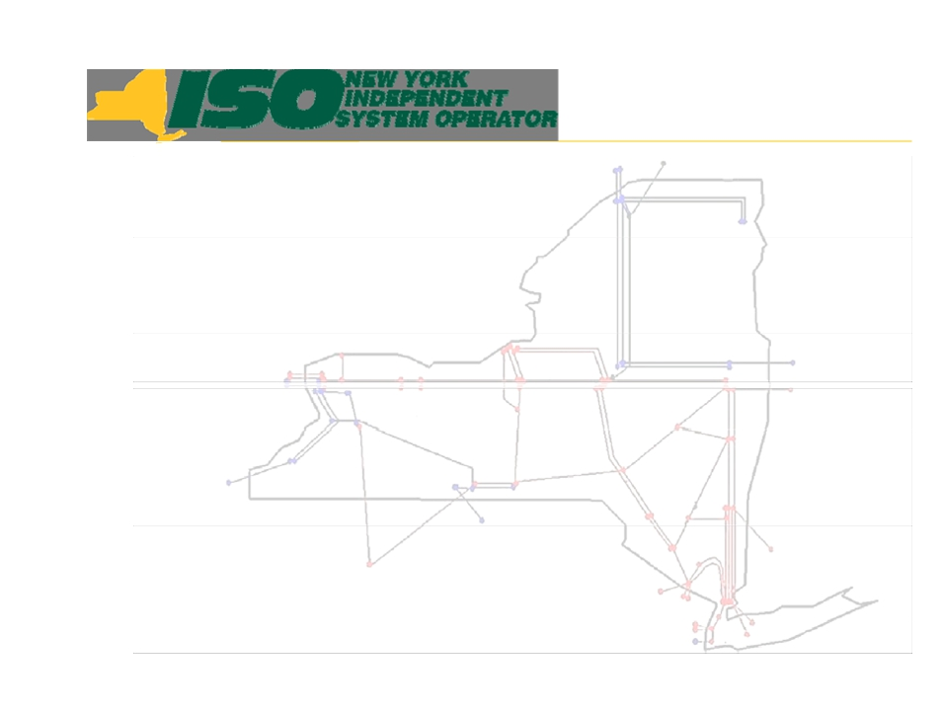

Alternative Reliability
Resource Compensation
Proposal

John Buechler
Executive Regulatory Policy Advisor
NYISO Joint ICAPWG/ESPWG/MIWG Meeting New York Independent System Operator
April 16, 2012

© 2012 New York Independent System Operator, Inc. All Rights Reserved.

DRAFT - FOR DISCUSSION PURPOSES ONLY 1



Outline
Š Key Factors
Š Potential Alternative Proposal
Š Next Steps

© 2012 New York Independent System Operator, Inc. All Rights Reserved.

DRAFT - FOR DISCUSSION PURPOSES ONLY 2

Key Factors
Š PSC’s existing authority and responsibility for
reliability and resource adequacy as that relates to
generator retirements
Š NYISO obligations and concerns with ensuring
reliability
Š Maintain consistency with the existing NYISO
reliability planning process
Š Generators’ concerns with “six month” PSC
retirement review process
Š DPS Staff/TOs/MI concerns about the proposed
GFAC payment mechanism
Š “Retirements” used herein also includes mothball &
protective layup

© 2012 New York Independent System Operator, Inc. All Rights Reserved. DRAFT - FOR DISCUSSION PURPOSES ONLY 3

Potential Alternative Proposal
Š Modify the existing NYISO reliability planning
process (CRPP - Attachment Y) to provide for an
explicit process to request a confidential reliability
analysis of a potential generator retirement.
(Similar to the existing “study request” process in
Attachment Y)
§ DPS and relevant TO will be notified by the NYISO and involved
in the study
§ This request in advance of the generator’s submission of a
retirement notice to the PSC
§ Generator pays for the study
§ A generator must follow this procedure if it wants the ability to
receive compensation within the 6-month PSC notification
period
§ Generator will provide information to the DPS regarding its
costs of operation

© 2012 New York Independent System Operator, Inc. All Rights Reserved. DRAFT - FOR DISCUSSION PURPOSES ONLY 4

Potential Alternative Proposal
Š Provide for an expedited study process
including the interconnecting TO and the
DPS
§ At the conclusion of this process, the generator and the
DPS will know whether the generator is needed for
reliability as an interim solution, while alternative
solutions are being identified and analyzed.

© 2012 New York Independent System Operator, Inc. All Rights Reserved.

DRAFT - FOR DISCUSSION PURPOSES ONLY 5

Potential Alternative Proposal
Š The DPS and/or TO to negotiate a compensation mechanism
with generator immediately upon submission of a formal retirement notice from the generator-- if necessary to maintain reliability. The agreement could
§ Be executed and effective as soon as negotiations are complete, before
the end of the 6-month period, so that payment and the obligation to
remain in service/not retire could commence at that time
§ Provide that, after the rate is accepted:
• for the generator MW not subject to an Offer Floor, the generator must certify the Unforced
Capacity agreed to as part of the compensation mechanism (bilateral power purchase
agreement with the TO) to the NYISO no later than the monthly certification deadline for
the ICAP spot auction
• for the generator MW subject to an offer floor, the generator must offer into the NYISO
ICAP spot market at (not above) the Offer Floor
Š NYISO GFAC payment mechanism is not required under this
proposal.

© 2012 New York Independent System Operator, Inc. All Rights Reserved. DRAFT - FOR DISCUSSION PURPOSES ONLY 6

Potential Alternative Proposal
Š Acknowledge the PSC’s authority and
responsibility to select the appropriate solution
(consistent with the existing CRPP process and
the PSC’s Policy Statement)
§ If a regulated transmission solution is selected for a bulk
electric system reliability need, cost allocation/recovery is
presently available under the NYISO Tariff (Attachment Y and Rate Schedule 10)
§ If a generator or DR is selected as the solution, cost
allocation/recovery is via retail rates (consistent with existing DPS practice)
§ If a transmission solution is selected for a local reliability need,
cost allocation/recovery is via retail rates (consistent with
existing DPS practice)

© 2012 New York Independent System Operator, Inc. All Rights Reserved.

DRAFT - FOR DISCUSSION PURPOSES ONLY 7

Next Steps
Š Request stakeholders provide feedback on
this proposal.
Š NYISO to update the proposal based on the
feedback
Š Please submit any additional comments in
writing to Leigh Bullock by April 30, 2012
to: lbullock@nyiso.com

© 2012 New York Independent System Operator, Inc. All Rights Reserved.

DRAFT - FOR DISCUSSION PURPOSES ONLY 8

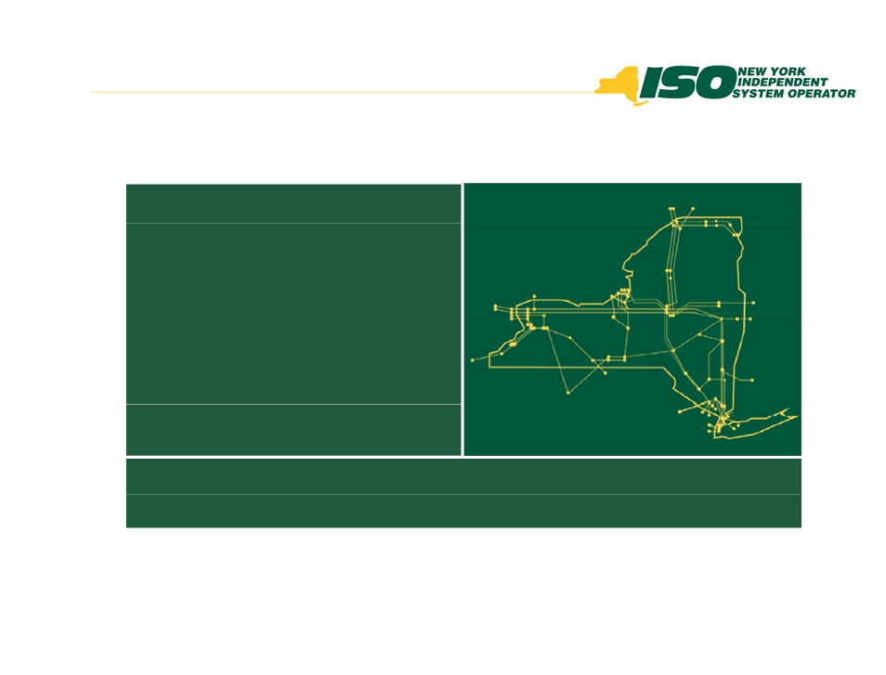

The New York Independent System
Operator (NYISO) is a not-for-profit
corporation responsible for operating the state’s bulk electricity
grid, administering New York’s competitive wholesale electricity markets, conducting comprehensive long-term planning for the state’s
electric power system, and
advancing the technological
infrastructure of the electric system
serving the Empire State.
www.nyiso.com

© 2012 New York Independent System Operator, Inc. All Rights Reserved.

DRAFT - FOR DISCUSSION PURPOSES ONLY 9

Attachment B


INDEPENDENT POWER PRODUCERS OF NEW YORK, INC

Independent Power Producers of New York, Inc.
19 Dove Street, Suite 302, Albany, NY 12210
P: 518-436-3749 F:518-436-0369
www.ippny.org
Christopher@ippny.org
To: Randy Wyatt
From: Chris LaRoe
Date: 4/30/12
Re: IPPNY Comments on NYISO Reliability Resource Compensation Proposal
As requested during the joint ESPWG, MIWG, and ICAPWG meeting held on April 16,
2012, IPPNY submits the following comments on the NYISO’s latest “Reliability
Resource Compensation” proposal. IPPNY would begin by referring the NYISO to the
countless requests made by its members during meetings on this subject as well as
IPPNY’s past submissions, including e.g., the comments IPPNY provided on the
previous NYISO proposal (submitted on 1/4). Throughout this process, IPPNY and its
individual members repeatedly have raised concerns with the NYISO’s numerous
proposals failing to reflect a generator’s right to file for, and receive, cost-of-service rates
in proceedings before the Federal Energy Regulatory Commission (FERC). That same
concern continues to apply to the NYISO’s latest proposal. While the latest proposal
provides for a reliability study prior to the potential submission of a retirement notice -
an element of the proposal that IPPNY supports albeit a right that generators already have
today - the proposal only references negotiation of a “compensation mechanism” with
the Department of Public Service (DPS) and/or the relevant Transmission Owner (TO).
It wholly fails to recognize that a generator needed for reliability retains its right under
FPA Section 205 to seek cost-based rates at FERC.
While generators currently have this right, other market participants have indicated that
they disagree and would oppose a generator that attempts to utilize this right. IPPNY
made this point clear to the NYISO during stakeholder discussions and at the annual
sector meetings. At those sector meetings, senior NYISO staff confirmed that it is the
NYISO’s opinion that generators do have such a right and that it would be reflected in
future NYISO proposals. Notwithstanding that assurance, however, the NYISO’s latest
proposal still did not include this core principle. Unless and until that right is clearly
reflected, IPPNY cannot and will not support this or any other NYISO proposal.

With the expectation that the NYISO will follow through on its commitment to reflect a
generator’s right to file FPA Section 205 cost of service rate filings in future proposals
(which could be incorporated into Slide 6 of the latest proposal, e.g.), IPPNY offers the

following comments on other aspects of the current proposal in the interest of reaching a resolution on this issue within the stakeholder process.

- Slide 4:
- DPS staff should only be involved in the study at the request of the generator. A
transmission owner should only be involved in the study to the degree that a
potential local reliability issue may be involved. In that event, the NYISO should
confirm that the TO representatives that are involved do not have any market
function.
- The NYISO should define deadlines to complete these studies. The lack of a
defined deadline is a shortcoming in the current process which should be rectified through this initiative.
- At no point during the study process should a generator be compelled to provide
cost information to either DPS staff or the TO. In the event that a generator
submits a retirement notice and enters into negotiation with DPS staff for
compensation, the generator may elect to provide cost information at that time.
- Slide 6:
- IPPNY supports the commitment made at the April 16 meeting for NYISO and
DPS staff to provide more information concerning the process that the PSC would
follow to negotiate compensation with a generator that is determined is needed for
reliability.
- IPPNY supports the premise identified by the NYISO during the meeting that, at a
minimum, no component of the NYISO’s proposal modifies the Attachment H
capacity market bidding requirements of either Pivotal Suppliers or new entrants -
- i.e. the Pivotal Supplier would continue to be permitted to bid at the higher of
the UCAP Offer Reference Level or its Going Forward Costs and the new entrant
would continue to be required to bid at the Offer Floor unless exempt -- and
requests that the NYISO clarify its proposal to that effect consistent with the
NYISO’s statements during the April 16th joint meeting. In addition, to ensure
that any other otherwise uneconomic unit that is needed for reliability and is given
a contract sends the correct market signal, the NYISO should specify that the
capacity of such unit must be removed from the capacity market auctions to
prevent the unit from artificially suppressing the market clearing prices.
- Slide 7:
- Nothing within the NYISO’s proposal (or IPPNY’s proposal) would alter the
PSC’s ability to select either a gap solution or a reliability solution (either a
regulated backstop solution or an alternative regulated solution) as defined in the NYISO’s tariffs. However, IPPNY maintains its position that it is FERC that will define the appropriate rate for that solution if it a generation resource.
- If a compensation arrangement is reached under this newly proposed process,
IPPNY does not have an opinion on the cost allocation methodology that must be applied for the reliability services being provided by the generator.

- Again, during the period of negotiations and/or if an agreement is not reached, the
generator has the right to file under FPA Section 205 to obtain cost-based rates from FERC.

COUCH WHITE
counselors and attorneys at law

VIA E-MAIL
Ms. Leigh Bullock
Committee Support

Couch White, LLP 540 Broadway
P.O. Box 22222
Albany, New York 12201-2222 (518) 426-4600

April 30, 2012

Michael B. Mager
Partner
Direct Dial: (518) 320-3409
Telecopier: (518) 320-3498
E-Mail: mmager@couchwhite.com

New York Independent System Operator, Inc.
10 Krey Boulevard
Rensselaer, New York 12144

Re: New York Independent System Operator, Inc. - April 16, 2012 “Alternative
Reliability Resource Compensation Proposal”
Dear Leigh:

At the request of the New York Independent System Operator, Inc. (“NYISO”), Multiple
Intervenors hereby submits these comments on the April 16, 2012 NYISO presentation by John
Buechler, entitled, “Alternative Reliability Resource Compensation Proposal.” Multiple
Intervenors is an unincorporated association of over 55 large industrial, commercial and
institutional energy consumers with manufacturing and other facilities located throughout New York State. These comments may be shared with other stakeholders and should not be considered confidential.
Initially, Multiple Intervenors notes that in addition to verbal comments provided in
numerous NYISO stakeholder committee meetings, it already has provided the NYISO, at the
NYISO’s request, with five sets of written comments on reliability resource compensation issues.
Those comments are dated January 4, 2012, August 31, 2011, March 15, 2011, July 28, 2010,
and March 11, 2010. Multiple Intervenors remains very interested in reliability resource
compensation issues, and would like to see a broadly-supported proposal voted on and approved
by stakeholders.

The NYISO’s latest proposal reflects greater efforts to maintain consistency with the existing reliability planning process, which Multiple Intervenors appreciates and supports. The proposal, however, is not complete and, consequently, it is premature for Multiple Intervenors to indicate whether it would support or oppose the proposal in its current form.

Offices in: Albany, Malta, New York City and Saratoga Springs, New York; Washington, D.C. and Farmington, Connecticut

April 30, 2012
Page 2

Quite frankly, in its proposal the NYISO essentially defers to the New York State Public
Service Commission (“Commission”) the resolution of compensation issues related to a retiring
generation resource needed for reliability purposes. There apparently would be some form of a
Commission process to address those compensation issues, but neither the NYISO nor
Commission representatives have described how that process would operate. Absent such
description, it probably will be difficult for any stakeholder to endorse an unknown and
undefined process.
Among the questions left unresolved by the NYISO’s presentation to date include, but are
not limited to: (a) the parties to the compensation proceeding (e.g., whether end-use consumers
will be accorded the opportunity to participate meaningfully in the process); (b) whether such
proceeding will rely solely on negotiations and/or include some form of evidentiary process; (c)
how the appropriate level of compensation will be decided; (d) whether the process will be
“open” or conducted behind “closed doors”; (e) whether the Commission will calculate the
appropriate compensation if there is no settlement on that amount; (f) the timing of the various
procedural steps constituting the Commission proceeding; (g) how the “start” and “end” dates for
the compensation will be determined; and (h) how the costs of the compensation ultimately will
be recovered.

Multiple Intervenors looks forward to attending a more complete presentation on the NYISO’s alternative proposal, preferably reflecting the input of the Commission and/or New York State Department of Public Service Staff, particularly with respect to those matters outside of the NYISO’s shareholder process.

Very truly yours,

COUCH WHITE, LLP
Michael B. Mager

Michael B. Mager
MBM/cgw
S:\DATA\Client2 9000-11399\09588\corres\Bullock 04-30-12.docx

Attachment C

Alternative Reliability
Resource Compensation
Proposal

John Buechler
Executive Regulatory Policy Advisor
NYISO Joint ICAPWG/ESPWG/MIWG Meeting New York Independent System Operator
July 12, 2012

© 2012 New York Independent System Operator, Inc. All Rights Reserved.

DRAFT - FOR DISCUSSION PURPOSES ONLY 1

Outline
Š Key Factors
Š Potential Alternative Proposal
Š Next Steps

© 2012 New York Independent System Operator, Inc. All Rights Reserved.

DRAFT - FOR DISCUSSION PURPOSES ONLY 2

Key Factors
Š PSC’s existing authority and responsibility for
reliability and resource adequacy as that relates to
generator retirements
Š NYISO obligations and concerns with ensuring
reliability
Š Maintain consistency with the existing NYISO
reliability planning process
Š Generators’ concerns with “six month” PSC
retirement review process
Š DPS Staff/TOs/MI concerns about the proposed
GFAC payment mechanism
Š “Retirements” used herein also includes mothball &
protective layup

© 2012 New York Independent System Operator, Inc. All Rights Reserved. DRAFT - FOR DISCUSSION PURPOSES ONLY 3

Potential Alternative Proposal
Š Modify the existing NYISO reliability planning process (CRPP -
Attachment Y) to provide for an explicit process to request a
confidential reliability analysis of a potential generator retirement.
(Similar to the existing “study request” process in Attachment Y)
§ DPS and relevant TO will be notified by the NYISO and involved in the study
§ Study to be requested in advance of the generator’s submission of a retirement
notice to the PSC
§ Generator pays for the study
§ NYISO and TO will endeavor to provide its evaluation within 3 months of request
and study agreement
§ This proposal does not alter any existing market mitigation provisions, including
withholding and data submission requirements.
Š Generator must follow this procedure if it wants the ability to
receive compensation within the 6-month PSC notification period
Š Generator may provide information to the DPS regarding its costs
of operation in an effort to accelerate compensation negotiations

© 2012 New York Independent System Operator, Inc. All Rights Reserved. DRAFT - FOR DISCUSSION PURPOSES ONLY 4

Potential Alternative Proposal
Š Provide for an expedited study process
including the interconnecting TO and the
DPS
§ At the conclusion of this process, the generator and the
DPS will know whether the generator is needed for
reliability as an interim solution, while alternative
solutions are being identified and implemented.

© 2012 New York Independent System Operator, Inc. All Rights Reserved.

DRAFT - FOR DISCUSSION PURPOSES ONLY 5

Potential Alternative Proposal

Š The DPS and/or TO to negotiate a compensation mechanism with generator
immediately upon submission of a formal retirement notice from the generator-- if necessary to maintain reliability. The TO - generator agreement could
§ Be executed and effective as soon as negotiations are complete, before the end of the 6-month
period, so that payment and the obligation to remain in service/not retire could commence at
that time
§ Provide that, after the rate is accepted:
• for the generator MW not subject to an Offer Floor, the generator must certify the Unforced
Capacity agreed to as part of the compensation mechanism (bilateral power purchase
agreement with the TO) to the NYISO no later than the monthly certification deadline for
the ICAP spot auction
• for the generator MW subject to an offer floor, the generator must offer into the NYISO
ICAP spot market at (not above) the Offer Floor
• RRC capacity not subject to an Offer Floor must be offered in as price taker to ensure that
such capacity clears in the market.
Š NYISO GFAC payment mechanism is not required under this alternative
proposal.

© 2012 New York Independent System Operator, Inc. All Rights Reserved. DRAFT - FOR DISCUSSION PURPOSES ONLY 6

Potential Alternative Proposal
Š Acknowledge the PSC’s authority and responsibility to select
the appropriate solution (consistent with the existing CRPP process and the PSC’s Policy Statement)
§ If a regulated transmission solution is selected for a bulk electric
system reliability need, cost allocation/recovery is presently available under the NYISO Tariff (Attachment Y and Rate Schedule 10)
§ If a generator or DR is selected as the solution, cost allocation/recovery
is via retail rates (consistent with existing DPS practice)
• A mothballed generator that can timely return to service could be a candidate solution as
well
§ If a transmission solution is selected for a local reliability need, cost
allocation/recovery is via retail rates (consistent with existing DPS
practice)
Š Nothing in this proposal shall affect the Commission’s
jurisdiction over the sale and transmission of electric energy
subject to the jurisdiction of the Commission

© 2012 New York Independent System Operator, Inc. All Rights Reserved. DRAFT - FOR DISCUSSION PURPOSES ONLY 7

Next Steps
Š Identify changes that impact the tariff
Š Advance the proposal to a vote

© 2012 New York Independent System Operator, Inc. All Rights Reserved.

DRAFT - FOR DISCUSSION PURPOSES ONLY 8

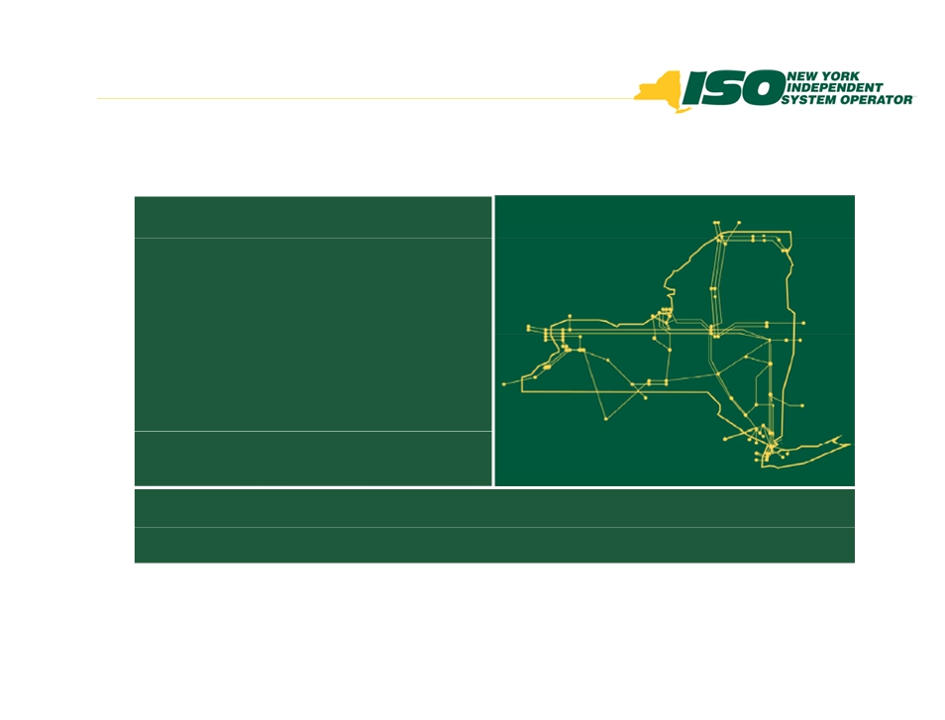

The New York Independent System
Operator (NYISO) is a not-for-profit
corporation responsible for operating the state’s bulk electricity
grid, administering New York’s competitive wholesale electricity markets, conducting comprehensive long-term planning for the state’s
electric power system, and
advancing the technological
infrastructure of the electric system
serving the Empire State.
www.nyiso.com

© 2012 New York Independent System Operator, Inc. All Rights Reserved.

DRAFT - FOR DISCUSSION PURPOSES ONLY 9

Attachment D

DPS Draft for Discussion Purposes July 12, 2012

STEP and TIMING
1. Date X

2. X + 5 days
(or earlier)
3. X + 30 days
(or earlier)

4. X + 35 days
(or earlier)

ACTIVITY(IES)
Generation Owner formally notifies the
PSC/NYISO/Affected NYTO(s) of proposed
generation unit retirement(s) at least 180 days in advance.
DPS Staff requests an analysis of the
potential reliability impacts from the NYISO and Affected TO(s).
NYISO and Affected TO(s) provide DPS Staff with an analysis of any potential adverse local and/or bulk reliability impacts, or notify Staff if more time is required to complete the analysis.
If no adverse impacts are identified, the process proceeds to Step 4.
If an adverse impact is identified, the process proceeds to Step 5.
If the Affected TO(s) and the NYISO do not
identify any potential adverse reliability
impacts, the PSC or its designee advises the
Generation Owner that it may retire prior to
the expiration of the 180-day period, subject to any other obligations.

Note: The PSC would need to revisit its Order Adopting Notice Requirements for Generation Unit Retirements (Case 05-E-0889) to
establish this process for waiving the 180-
day notice period.

- 1 -

DPS Draft for Discussion Purposes July 12, 2012

5. X + 60 days
(or earlier)

6. X + 110
days (or
earlier)

7. X + 115 days
(or earlier)

8. x + 130 days
(or earlier)
9. x + 135 days
(or earlier)

If the Affected TO(s) and/or the NYISO have identified a potential adverse reliability impact, the Affected TO(s) advise the NYISO and DPS Staff on the proposed solution(s), and the status of such solution(s).

If the reliability issues will be addressed prior to the expiration of the 180-day notice period, without the involvement of the
generation unit proposed to retire, the PSC or its designee notifies the Generation Owner when its generation unit(s) may be retired
(See Note in Step 4 above).

Alternatively, if the solution involves the generation unit remaining in operation beyond the 180-day notice period, the Affected TO(s) and the Generation Owner begin to negotiate an agreement. DPS Staff prepares a SAPA
notice for issuance identifying the proposed PSC rulemaking proceeding. The process
proceeds to Step 6.

If the TO(s) and Generation Owner have
reached an agreement, the provisions for
maintaining operation, including a proposed
cost allocation/recovery mechanism, are filed
with the PSC by the TO(s). If the provisions
have not been agreed upon between the TO(s)
and the Generation Owner, each entity will
file proposed provisions with the PSC. The TO(s) would also provide a proposed cost
allocation/recovery mechanism.
PSC issues a notice soliciting comments on the proposed provisions.
Note: Issues regarding confidentiality would need to be addressed.
Interested parties file initial comments with the PSC.
Interested parties file reply comments with the PSC.

- 2 -

DPS Draft for Discussion Purposes July 12, 2012

10. Next
PSC Session (no later
than x + 180 days)

PSC issues an order providing for generator compensation/cost allocation and recovery; subject to refund if further PSC
administrative process is needed.
Compensation would continue until alternate solutions are in place.

Note 1: This timeframe, including compensation, could be
expedited in the event the NYISO and affected TO(s) have
performed reliability assessments prior to the Generation Owner formally filing their notice of retirement with the PSC, and
those assessments remain valid and do not identify any adverse impacts. Note 2: These timeframes would need to be significantly compressed for the 90-day notice period related to generation
units sized less than 80 MW.

- 3 -

