

10 Krey Boulevard Rensselaer, NY 12144

April 4, 2012

ELECTRONICALLY SUBMITTED

Kimberly D. Bose
Secretary
Federal Energy Regulatory Commission 888 First Street, N.E.
Washington, D.C. 20426

Re: New York Independent System Operator, Inc.’s Third Informational Report on
Efforts to Develop Rules Addressing Compensation to Generators that Are
Determined to be Needed for Reliability; Docket No. ER10-2220-___.

Dear Secretary Bose:
In accordance with paragraph 54 and ordering paragraph “(C)” of the Federal Energy
Regulatory Commission’s (“Commission’s”) October 12, 2010 Order On Proposed Mitigation
Measures in Docket No. ER10-2220-000 (“Order”),¹ the New York Independent System
Operator, Inc. (“NYISO”), hereby submits this Third Informational Report on Efforts to Develop Rules Addressing Compensation to Generators that Are Determined to be Needed for Reliability (“Informational Report”). The NYISO submitted its Second Informational Report on Efforts to Develop Rules Addressing Compensation to Generators that Are Determined to be Needed for
Reliability on October 7, 2011 (“October Informational Report”). In footnote 44 of its Order
the Commission stated that it does not intend to issue public notices, accept comments, or
issue orders on this Informational Report.
Paragraph 54 of the Order stated, in part, as follows:

Because fixed cost recovery issues do not go to whether NYISO’s mitigation
proposal is in itself just and reasonable, this proceeding is not the appropriate
forum in which to raise such issues. Further, commenters do not present factual
evidence that demonstrates that market participants generally will be unable to
recover their costs due to application of the proposed mitigation provisions. We

¹New York Independent System Operator, Inc., 133 FERC ¶ 61,030.

Kimberly D. Bose, Secretary April 4, 2012
Page 2

note, however, that the NYISO Board of Directors, in its July 29, 2010 decision
on the appeal of the NYISO Management Committee’s adoption of the instant
mitigation proposal, directed NYISO management to work with stakeholders to
examine the generation owners’ claims that existing cost recovery mechanisms
are inadequate and to review the process that evaluates permanent solutions to
reliability problems. Accordingly, we believe the better course is to await the
outcome of the stakeholder process as directed by the NYISO Board of Directors. In this regard, we direct NYISO to file status reports every 180 days beginning 180 days from the date of this order for informational purposes only.⁴⁴

⁴⁴ The Commission does not intend to issue public notices, accept comments, or issue orders on such informational filings.

In compliance with the cited sections of the Order, the NYISO submits this Informational
Report.

I. Documents Submitted
1. This Informational Report;

2. A December 6, 2011 presentation titled Reliability Resource Compensation
Proposal by Randy Wyatt, of NYISO, to a joint meeting of the NYISO’s Electric System Planning Working Group, Market Issues Working Group and ICAP
Working Group (“Attachment A”);
3. Three sets of comments on the Reliability Resource Compensation Proposal
proposal included in Attachment A that were submitted by the IPPNY, New York
Transmission Owners, LIPA and NYPA, and Multiple Intervenors (“Attachment
B”).
II. Informational Report

A. Summary of the October Informational Report
On July 18, 2011, IPPNY presented a revised proposal at a joint Market Issues Working
Group (“MIWG”)/Electric System Planning Working Group (“ESPWG”) meeting. IPPNY
proposed that Attachment Y to the NYISO’s OATT be amended to expressly incorporate a right
for a generator that is needed for reliability, but chooses to retire, to file a cost-of-service
agreement at FERC under section 205 of the Federal Power Act. The majority of the discussion
at the July 18 meeting occurred between stakeholder representatives. Representatives of New
York loads (industrial, municipal and Transmission Owners) and the New York State
Department of Public Service (“DPS”) Staff again participated actively in the stakeholder
discussion; asking questions about and commenting on IPPNY’s proposal.

Kimberly D. Bose, Secretary April 4, 2012
Page 3

B. December 6, 2011 Joint ESPWG/MIWG/ICAP Working Group
On December 6, 2011, the NYISO presented to stakeholders a new proposal to
compensate generators that are planning to retire but are necessary for reliability. The proposal
was presented to a joint meeting of the MIWG/ESPWG/ICAP Working Group (“Proposal”).
The Proposal provided that a generator required for reliability would be able to recover its going
forward avoidable costs (“GFACs”) for the period in which it was required to meet a reliability
need. Under the proposal, the NYISO’s tariff would be revised so that a generator may request
that the NYISO, in collaboration with the local Transmission Owner (“TO”), perform a
confidential reliability study. Notice of the confidential request would be provided to the New
York Public Service Commission (“PSC”). If the generator is found to be required for
reliability, the Proposal would entitle the generator to a potential payment (referred to as
“Reliability Resource Compensation”) based on its GFACs. However, the generator would have
to first submit its notice of retirement to the PSC in order to receive RRC payments. Generators
receiving RRC payments would be required to offer into the ICAP spot market as a price taker
(i.e., at $0.00). The Proposal also contemplates that, concurrent with the RRC payments, the
PSC would consider other market-based and regulated solutions to the reliability need, which, if
implemented, would allow the generator to retire. The RRC payments would continue only until
the reliability need is otherwise satisfied. The Proposal also specifies that RRC payments must
be returned to the NYISO if a generator receives RRC payments and fails to retire when the
reliability need ends.
The NYISO and stakeholders engaged in a robust discussion of the Proposal at the
December 6, 2011 joint stakeholder meeting. Stakeholders actively involved in the dialogue at the meeting included representatives of New York Loads (end users, municipal utilities, Load Serving Entities), the City of New York, New York Power Authority, Long Island Power
Authority, and the New York State Department of Public Service staff. Subsequent to the meeting, the NYISO received written comments from IPPNY, Multiple Interveners, and a joint response from the TOs, NYPA, and LIPA.

C. Next Steps
The NYISO evaluated the comments from stakeholders and plans to present an alternative proposal at a joint stakeholder meeting later this month.

III. Service
The NYISO will send an electronic link to this Informational Report to the official
representative of each of its customers, to each participant on its stakeholder committees, to the
New York Public Service Commission, to all parties listed on the Commission’s official service
list in this Docket and to the New Jersey Board of Public Utilities. In addition, the complete
filing will be posted on the NYISO’s website at www.nyiso.com.

Kimberly D. Bose, Secretary April 4, 2012
Page 4

IV. Conclusion
The NYISO respectfully submits this Informational Report in compliance with the
Commission’s Order. For the reasons explained above, the NYISO is hopeful that it will be able to develop and submit for the Commission’s consideration tariff revisions that have been
approved in the NYISO’s stakeholder governance process. The NYISO’s next informational report is due on October 1, 2012.
Respectfully submitted,

/s/ James H. Sweeney
Rana Mukerji, Senior Vice President of Market Structures Robert E. Fernandez, General Counsel
James H. Sweeney, Attorney
New York Independent System Operator, Inc.

Attachment A
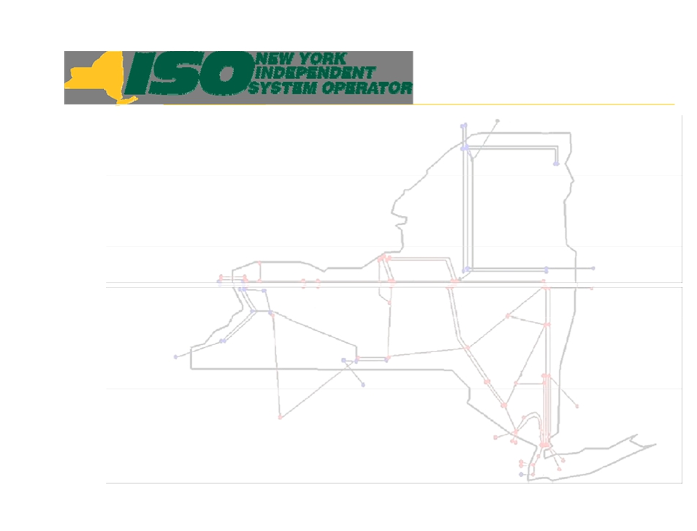

Reliability Resource
Compensation

Randy Wyatt
Manager Capacity Market Products
New York Independent System Operator
NYISO Joint ESPWG/MIWG/ICAPWG Meeting
December 6, 2011

© 2011 New York Independent System Operator, Inc. All Rights Reserved.

DRAFT - FOR DISCUSSION PURPOSES ONLY 1



Agenda
 Background
 Details of Proposal
▪ Qualification
▪ Compensation
 Transparency
 Questions, Concerns, Recommendations
 Next Steps

© 2011 New York Independent System Operator, Inc. All Rights Reserved.

DRAFT - FOR DISCUSSION PURPOSES ONLY 2

Background
 July 07, 2010 NYISO MIWG/ESPWG presentation
 NYISO ROS reliability mitigation filing
 BOD comments for NYISO to investigate fixed
costs
 FERC response to ROS filing
 February 10, 2011 NYISO MIWG/ESPWG
proposal
 July 18, 2011 IPPNY MIWG/ESPWG Proposal

© 2011 New York Independent System Operator, Inc. All Rights Reserved.

DRAFT - FOR DISCUSSION PURPOSES ONLY 3

Current process

  6 months advanced notice of retirement
 Notice kicks off NYISO/TO retirement studies
 NYISO may find an imminent threat to reliability and
consult with NYDPS and TO regarding gap solution
 No reliability payment during the notice period for the
generator
 Generator may not be able to cover going forward
avoidable costs (GFACs) in the market
▪ if a generator is not recovering GFAC, an economically rational
investor would retire the unit during the notice period, and not make investments necessary to meet the reliability need.

© 2011 New York Independent System Operator, Inc. All Rights Reserved.

DRAFT - FOR DISCUSSION PURPOSES ONLY 4

Purpose Statement
 Compensate* a generator that is needed for
reliability, providing for its continued
availability during the applicable PSC
retirement notice period, and for any
additional period until the reliability issue is
addressed through an Attachment Y process,
or is otherwise resolved

“A Bridge to the Gap”

* Compensation determination may not always result in a reliability payment.

© 2011 New York Independent System Operator, Inc. All Rights Reserved.

DRAFT - FOR DISCUSSION PURPOSES ONLY 5

Elements of NYISO Proposal
 Generator requests NYISO & TO to conduct a reliability evaluation
▪ Evaluations are anticipated to be complete within 6 months of request / study
scope agreement
▪ If a generator submits multiple units for reliability evaluation, generator will be
required to rank units in the order in which they would plan on retiring them.
▪ Cost of study borne by the Generator (May be recovered if needed for reliability)
 NYISO & TO determine if the generator is needed for reliability for
the next 2 capability periods
▪ If an imminent threat to system reliability is found, the NYISO board, after
consultation with the NYDPS, may request the appropriate TO, to propose a gap solution outside the normal planning process (section 31.2.5.9.2 of Att. Y)
 If generator is needed for reliability, Generator is offered Reliability
Resource Compensation (RRC) until the reliability need is
eliminated, or for up to 12 months, whichever occurs first
▪ Period may be extended if reliability need still exists

© 2011 New York Independent System Operator, Inc. All Rights Reserved.

DRAFT - FOR DISCUSSION PURPOSES ONLY 6

RRC Compensation
+ Going forward avoidable costs (defined for RRC purposes)
- Net revenues (energy, ancillary services, other?) + Capped project investment (PI)
Reliability Resource Compensation (RRC)

 RRC payment analogous to energy market BPCG, paid to units
needed for reliability

Underlying premise is that if a generator is not recovering GFACs, an economically rational investor would retire this unit during the notice period, and not make investments necessary to meet the
reliability need.

© 2011 New York Independent System Operator, Inc. All Rights Reserved.

DRAFT - FOR DISCUSSION PURPOSES ONLY 7

Elements of NYISO Proposal
  If generator accepts offer for RRC:
▪ Generator must submit notification of planned retirement [mothball] to NYDPS
▪ Generator must offer into the ICAP spot auction as price taker
• Generator is paid RRC in exchange for sustaining the Reliability Resource
• Generator is only paid RRC, and does not get additional revenues even if the ICAP Spot
Market Clearing price is higher than the RRC
• Generator retains all the obligations of a unit clearing in the ICAP Market
▪ NYISO shall consult with the NYDPS & TO with regard to whether a Gap
Solution is necessary and appropriate
▪ NYISO will remove the resource from the RNA base case
▪ Generator will be obligated to refund RRC payments and incur a penalty if
Generator does not retire according to the retirement plan
 If generator declines offer for RRC:
▪ Generator continues to offer into the market as usual, subject to all the rules
and obligations of a participant in the ICAP market; or
▪ Generator may elect to file its retirement notice with the PSC

© 2011 New York Independent System Operator, Inc. All Rights Reserved. DRAFT - FOR DISCUSSION PURPOSES ONLY 8

Additional elements of the proposal
  Reliability evaluation will be coordinated with the PSC so that
transmission or other alternatives are identified for a long term solution
 This proposal augments the current unit retirement notification
process (described in TB 185)
▪ Allows reliability assessment and GFAC determination without submitting a
retirement notice
▪ Provides payment during the PSC’s applicable retirement notice period
  The RC payment is a guarantee payment for reliability for the
shorter of 12 months, or until the reliability need is eliminated
▪ If reliability need still exists at end of 12 months, re-evaluate and renew the RRC
for shorter of the next 12 months, or until the reliability need is eliminated
  Cost for RRC payments accrue to the capacity zone(s) receiving
the benefit
▪ NYCA wide cost allocation for NYCA reliability needs
▪ Local reliability costs will be allocated to the locality

© 2011 New York Independent System Operator, Inc. All Rights Reserved. DRAFT - FOR DISCUSSION PURPOSES ONLY 9

Transparency
 NYISO will notice the marketplace
when a generator accepts the RRC
payment offer for reliability services

© 2011 New York Independent System Operator, Inc. All Rights Reserved.

DRAFT - FOR DISCUSSION PURPOSES ONLY

10

Questions, Comments, Concerns

 Please Submit Feedback in Writing to
Leigh Bullock by January 4 :
lbullock@nyiso.com
 Next joint Meeting to be Scheduled in
February

© 2011 New York Independent System Operator, Inc. All Rights Reserved.

DRAFT - FOR DISCUSSION PURPOSES ONLY

11

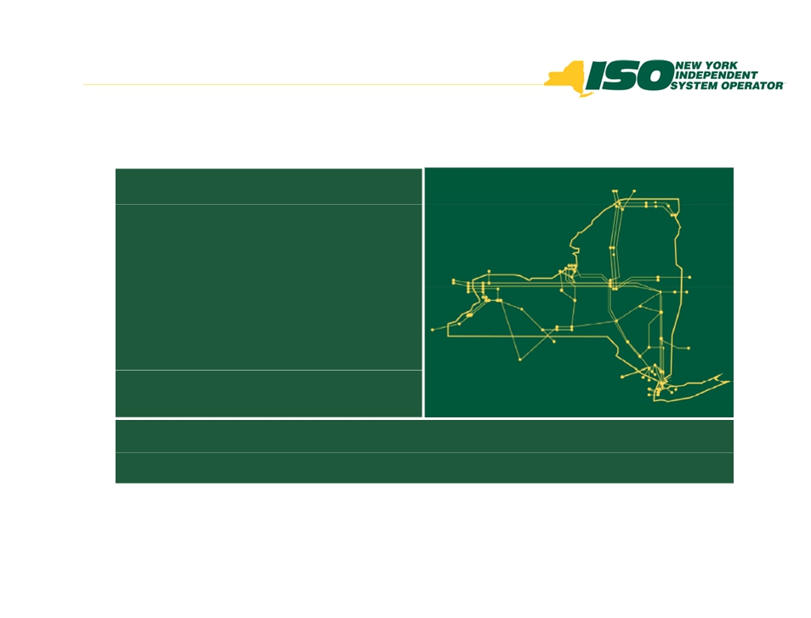

The New York Independent System
Operator (NYISO) is a not-for-profit
corporation responsible for operating the state’s bulk electricity
grid, administering New York’s competitive wholesale electricity markets, conducting comprehensive long-term planning for the state’s
electric power system, and
advancing the technological
infrastructure of the electric system
serving the Empire State.
www.nyiso.com

© 2011 New York Independent System Operator, Inc. All Rights Reserved.

DRAFT - FOR DISCUSSION PURPOSES ONLY

12

Attachment B


INDEPENDENT POWER PRODUCERS OF NEW YORK, INC

Independent Power Producers of New York, Inc.
19 Dove Street, Suite 302, Albany, NY 12210
P: 518-436-3749 F:518-436-0369
www.ippny.org
Christopher@ippny.org
To: Randy Wyatt
From: Chris LaRoe
Date: 1/4/12
Re: IPPNY Comments on NYISO Reliability Resource Compensation Proposal
As requested during the joint ESPWG, MIWG, and ICAPWG meeting held on December 6, 2011, IPPNY submits the following comments on the NYISO’s “Reliability Resource Compensation” proposal. IPPNY appreciates that the NYISO, through its proposal,
recognizes that existing processes relating to retirements and reliability determinations
create circumstances where a generator needed for reliability can be compelled to remain in the market for a period of at least six months without adequate compensation. The
NYISO’s proposal, though flawed, at least acknowledges that additional compensation is warranted in these circumstances.

As you are aware, IPPNY has proposed a different process to provide compensation to
generators that wish to retire but are needed for reliability. Unlike the NYISO proposal,
IPPNY’s proposal provides generators with compensation equivalent to what a “Gap” or
“Reliability Backstop” solution is entitled to following selection by the Public Service
Commission because, essentially, all reliability resources are providing the same service.
IPPNY is unable to support the NYISO proposal because it falls short of providing the
cost-of-service rate that is necessary and appropriate. Unless and until that core issue is
modified in the NYISO proposal, IPPNY sees no value in offering feedback on other
aspects of the proposal.

1/13/12
COMMENTS ON THE NYISO’S RELIABILITY RESOURCE COMPENSATION PROPOSAL
SUBMITTED ON BEHALF OF
THE NEW YORK TRANSMISSION OWNERS, LIPA AND NYPA

The following comments on the NYISO's presentation on Reliability Resource
Compensation at the joint ESPWG/ICAPWG meeting on December 6, 2011 are
submitted on behalf of the New York Transmission Owners, LIPA and NYPA (the
NYTOs). These comments are submitted at the request of the NYISO and do not indicate
that a decision has been made by the NYTOs, as a group or individually, to support or
oppose this or any other proposal to provide out-of-market compensation to a generator
needed for reliability. The NYTO comments also address the proposal made by IPPNY
on July 18, 2011 and the need for clarification of the objectives of the IPPNY proposal.
Relevant NYISO Tariff Provisions and PSC Rulings
First, it is important to review the existing NYISO tariff provisions for the
identification and solution of reliability needs, and relevant New York Public Service
Commission rulings, including the Commission's Order Adopting Requirements for
Generation Unit Retirements (PSC Retirement Order)¹ and the Commission's Policy
Statement on Backstop Project Cost Recovery and Allocation (PSC Policy Statement).²
The NYISO should explain the need for its proposal given the existing tariff provisions
and PSC rulings and also clarify the relationship of its proposal to these tariff provisions
and PSC rulings.
The relevant provisions in Attachment Y of the NYISO's OATT include the following: Section 31.2.5.9 Gap Solutions
31.2.5.9.1 If the NYISO determines that neither market-
based proposals nor regulated proposals can satisfy a
reliability need in a timely manner, the NYISO will set
forth its determination that a Gap Solution is necessary in
the CRPP. The NYISO will also request the Responsible
Transmission Owner to seek a Gap Solution. Gap
Solutions may include a generation, transmission or
demand-side resources.

¹ Case 05-E-0889, December 20, 2005.
² Case 07-E-1507, February 18, 2009.

31.2.5.9.2 If there is an imminent threat to the reliability of
the New York power system, the NYISO Board, after
consultation with the NYDPS, may request the appropriate
Transmission Owner or Transmission Owners to propose a
Gap Solution outside the normal planning cycle.

31.2.5.9.3 Upon the NYISO’s determination of the need
for a Gap Solution, pursuant to either sections 31.2.5.9.1 or
31.2.5.9.2 above, the Responsible Transmission Owner will propose such a solution as soon as reasonably possible, for consideration by the NYISO and the NYDPS.

31.2.5.9.4 Any party may submit an alternative Gap
Solution proposal to the NYISO and NYDPS for their
consideration. The NYISO shall evaluate all Gap Solution
proposals and determine whether they will meet the
Reliability Need or imminent threat. The NYISO will
report the results of its evaluation to the party making the
proposal as well as to the NYDPS and/or other appropriate
governmental agency(ies) and/or authority(ies) for
consideration in their review of the proposals. The
appropriate governmental agency(ies) and/or authority(ies)
with jurisdiction over the implementation or siting of Gap
Solutions will determine whether the Gap Solution or an
alternative Gap Solution will be implemented to address the
identified Reliability Need.

Section 31.4.4.3 Costs related to regulated non-
transmission reliability projects will be recovered by
Responsible Transmission Owners, Transmission Owners and Other Developers in accordance with the New York Public Service Law, New York Public Authorities law, or other applicable state law. …

PSC Retirement Order
In its Retirement Order, the PSC stated that: "an appropriate regulatory mechanism is
needed to address the possibility that generation unit retirements might undermine

2

electric system reliability and render service unsafe or inadequate" (Retirement Order,
p.13). The Commission noted that the six month notice period for larger generators
equates with the minimum period that the NYISO indicated as adequate to identify and
resolve reliability concerns. The Commission required that generators proposing to retire
serve their notice on the PSC Secretary, the NYISO, and any affected T&D utility and
that those entities will be involved in conducting an analysis of the impact of a retirement
and in devising a solution in the event the retirement adversely affects reliability. The
Commission requested that the NYISO notify its market participants of any retirement
notices it receives, in order to apprise those potentially-affected parties. The Order stated
that if a bulk-system need is identified, the NYISO should request that the responsible
T&D utility develop a gap solution, similar to the one envisioned in the CRPP, for
consideration by the NYISO and Commission staff. If a local reliability concern is
identified, the appropriate T&D utility was expected to coordinate a solution with NYISO
and the PSC.

PSC Policy Statement on Backstop Project Cost Recovery and Allocation
In its Policy Statement, the Commission clearly asserted jurisdiction over the cost
recovery and cost allocation for non-transmission (i.e., generation and demand response)
regulated reliability projects; and rejected proposals that would have placed the cost
recovery for such projects under the NYISO's tariff (Policy Statement, pp. 9 & 10).
With respect to the mechanism for cost recovery, the Commission adopted the Model
1proposal supported by its staff (Model 1is set forth in the All Parties Report appended to
the Policy Statement). Under Model 1, the proponent of a generation or demand-based
reliability project would file the project costs with the PSC for recovery authorization.
Model1 also proposed a master contract between project proponent and the beneficiaries
of the project as the cost recovery mechanism. The Commission adopted as its policy an
approach to cost recovery that is consistent with Model 1, but did not adopt the specific
cost recovery mechanism proposed by its staff to the exclusion of all others. The
Commission stated that cost recovery mechanisms will be developed depending on the
specific circumstances "to allow regulated reliability project costs to be collected in
accordance with the Public Service Law in a fair, equitable, an non-discriminatory
manner, and with due consideration of existing competitive markets" (Policy Statement,
p. 10).
Suggested Revisions to NYISO Proposal

At the outset, we note that the adoption of a forward capacity market would generally
provide more advance warning concerning possible resource adequacy needs including
potential generator retirements and the need to resolve possible reliability issues.
In view of the current provisions in the NYISO tariff and the PSC rulings, the NYTOs
believe that the NYISO has yet to demonstrate that the current Attachment Y process is
inadequate and requires revision, e.g., the NYISO has failed to demonstrate the need for
compensation during the retirement notice period (we note that there are RTOs that do
3

not provide supplemental compensation during the notice period). Notwithstanding the
foregoing, and in response to the NYISO's request, the NYTOs submit the proposals set
forth below to clarify and/or revise the NYISO's proposal for providing compensation
during the notice period. In making these comments, we also recommend that that any
compensation proposed here be available, but not limit, the supplemental compensation
that may be necessary to temporarily keep a generator in operation after the end of the
notice period. As noted above, the submission of these comments does not indicate that
the NYTOs, as a group or individually, have decided to support or oppose any proposal
to provide out-of-market payments to a generator needed for reliability.

- In order to be considered for any out-of- market payment, a generator would have to
submit a retirement notice, as required by the PSC Retirement Order.

- The NYISO and the appropriate TO, in consultation with PSC staff, would conduct
an analysis of the potential impact of the proposed retirement on the reliability of the NYS power system.
- If the retirement or mothballing of a generator would result in a reliability need, and
the generator certifies to the NYISO with appropriate documentation that it is
unlikely that it will be able to recover its net going forward costs, the generator may have the opportunity to request out-of-market payments limited to its net going
forward costs at least over the course of the retirement notice period. The generator may have the opportunity to request additional out-of-market payment for the period of time subsequent to the retirement notice period

- The appropriate TO and other parties would be able to suggest alternative solutions
to the reliability need identified by the NYISO. These solutions would potentially eliminate the need to provide the generator with out-of-market payments .
- Net going forward costs would be specifically defined and would be limited to the
costs actually incurred by the generator that it would have avoided if it had retired or been mothballed, net of related expense reductions and revenue increases. It would not include any capital costs except as set forth below. Net going forward costs would be calculated after the conclusion of the retirement notice period. Any
revenues in excess of the generator’s verifiable going-forward costs would be
transferred to the NYISO and credited to the appropriate TO(s) and other LSE’s responsible for funding the out-of-market payments.
- Any capital investments that may be required for the generator to operate during the
retirement notice period would be clearly identified and quantified and would be considered by the NYISO, the appropriate TO and the PSC staff in determining whether such investments are indeed required in order for the generator to operate during the retirement notice period is appropriate. In addition, all other alternative means for enabling the generator to remain in operation should be exhausted (e.g., temporary relief from environmental regulations).
4

- A request to the appropriate regulatory agency for authorization to provide the
generator with an out-of market-payment would be made jointly by the NYISO and
the retiring generator, and supported by NYISO determinations that: (1) the
retirement of the generator would cause a reliability problem; (2) the generator is
unlikely to recover its going forward costs during the retirement/mothball notice
period and an out-of-market payment is justified after considering all relevant
circumstances; and (3) the NYISO has identified no better option for securing
reliability during the retirement notice period. If the reliability need is a local
reliability need, the appropriate TO would be the filing party. As noted above, under
the NYISO tariff, cost recovery for a non-transmission regulated reliability project is
subject to state law.
- The generator receiving these payments would be required to participate in the ICAP
market as a price taker during the relevant period. These generators actually provide capacity, so excluding them from the ICAP market would be inefficient. It would
cause the price of ICAP to be higher than it should be, given the amount of capacity being provided, which could lead to the procurement of excessive capacity in the
long term, as prices would not fall as much as they should when there is over-
supply. It could also expose the market to gaming by giving generator owners an
incentive to claim that economically viable units may retire or be mothballed, as
misclassifying such units would increase ICAP prices and could boost portfolio
revenues without increasing reliability.

- The retiring generator could submit a proposal to serve as a gap or permanent
solution to the reliability need, subject to the relevant provisions of Attachment Y, which requires consideration of all solutions, generation, transmission and demand side management.

- At the end of the retirement notice period, the tariff provisions with respect to a gap
or permanent reliability solution would be implemented. As currently provided in the Attachment Y, cost recovery for a regulated transmission solution would be under the NYISO tariff, and cost recovery for a non-transmission solution would be in accordance with state law
- NYISO should remove any remaining reference to allocating cost for Reliability
Resource Compensation (RRC) payments to existing capacity zones, and instead
the costs should be allocated statewide or to applicable Subzone(s) depending on
whether the need for the unit arises from bulk or local transmission constraints.
IPPNY Proposal

The NYTOs also would like to comment on the need for IPPNY to clarify the objectives
of its proposal. As noted in the NYTO comments on the IPPNY proposal submitted on
August 31, 2011, the rationale provided in support of the IPPNY proposal is that a
5

generator that has given notice of retirement may be forced to operate at a loss during the
PSC's retirement notice period. However, the IPPNY proposal is not limited to
addressing those circumstances. Instead, it appears that the proposal seeks to establish a
right for a generator to make a Section 205 filing with FERC for a cost of service rate,
without submitting a retirement notice. Furthermore, the IPPNY proposal does not
address the current tariff provisions that provide that cost recovery for a non-transmission
regulated reliability project is subject to state law, or the PSC Policy Statement in which
the PSC rejected proposals for the recovery of such costs under the NYISO tariff rather
than under state law, and reserved the right to determine whether a non-transmission
regulated reliability solution should be implemented to address a reliability need
identified by the NYISO.
In order for the stakeholder process to intelligently consider the IPPNY proposal, it is necessary for IPPNY to clearly explain its objectives and how those objectives are
compatible with the current FERC-approved NYISO tariff provisions and applicable
rulings by the PSC.

6

COUCH WHITE
counselors and attorneys at law

VIA E-MAIL
Mr. Randy Wyatt
Manager, Capacity Market Products

Couch White, LLP 540 Broadway
P.O. Box 22222
Albany, New York 12201-2222 (518) 426-4600

January 4, 2012

Michael B. Mager
Partner
Direct Dial: (518) 320-3409
Telecopier: (518) 320-3498
email: mmager@couchwhite.com

New York Independent System Operator, Inc.
10 Krey Boulevard
Rensselaer, New York 12144
Re: December 6, 2011 Reliability Resource Compensation Proposal Dear Randy:
Pursuant to your request, this letter provides Multiple Intervenors’ comments on the
Reliability Resource Compensation Proposal (the “Proposal”) presented by the New York
Independent System Operator, Inc. (“NYISO”) at the December 6, 2011 joint meeting of the
Electric System Planning Working Group, the Installed Capacity Working Group, and the
Market Issues Working Group. As you probably are aware, Multiple Intervenors is an
unincorporated association of approximately 55 large industrial, commercial and institutional
energy consumers with manufacturing and other facilities located throughout New York State.

Initially, Multiple Intervenors has submitted written comments to the NYISO on various
reliability resource compensation issues on four prior occasions. Those comments, dated (i)
March 11, 2010, (ii) July 28, 2010, (iii) March 15, 2011, and (iv) August 31, 2011, are
incorporated herein and attached for your convenience. Additionally, with respect to the
Proposal, Multiple Intervenors provided the NYISO with extensive verbal comments thereon at
the December 6th meeting and, generically, prior to that meeting. Thus, the remainder of this
letter simply summarizes, briefly, Multiple Intervenors’ primary positions with respect to the
Proposal.

1. Multiple Intervenors understands the need for and, if structured properly, can
support the availability of cost-based, out-of-market compensation to generators that otherwise would retire but which are directed to continue operating to maintain reliability.

2. The rules governing reliability resource compensation need to be equitable and
consistent with the NYISO’s existing planning processes and the notice requirements adopted by the New York State Public Service Commission (“PSC”) governing the retirement of generation facilities.

Offices in: Albany, New York City, Washington, D.C. and Farmington, Connecticut

January 4, 2012
Page 2

3. Thus far, New York has avoided the myriad of issues and problems associated
with other regions’ reliance on “Reliability Must Run” (or “RMR”) contracts. The necessity to provide out-of-market compensation to a retiring generator needed for reliability purposes has yet to be demonstrated in New York. Accordingly, even if, arguendo, such necessity is demonstrated in the future, the payment of such compensation pursuant to RMR contracts should be the rare exception and not the norm.
4. Multiple Intervenors fundamentally objects to providing - or even offering - out-
of-market compensation to a generator that has not first filed a retirement notice
with the PSC. While a generator may request the NYISO and the relevant
Transmission Owner(s) to conduct a reliability evaluation - to be funded by the
generator (unless an RMR contract is necessitated) - no out-of-market
compensation should be offered to the generator unless (i) it is needed for
reliability, and (ii) it has filed the requisite retirement notice. As indicated above,
there may be rare occasions when out-of-market compensation is required for a
generator needed for reliability purposes that otherwise would retire.
Significantly, however, the only way to determine conclusively that the generator
“otherwise would retire” is for it to file the required retirement notice.
5. Multiple Intervenors fundamentally objects to providing out-of-market
compensation to a generator needed for reliability until the PSC-mandated
retirement notice has expired. For instance, if, arguendo, there is a 180-day notice
requirement applicable to the retirement of a hypothetical generation facility and
that facility submits the PSC-required retirement notice exactly 180 days prior to
its desired retirement date, then that facility should be entitled to market-based
compensation for the first 180 days following its retirement notice. Out-of-
market compensation would be triggered only if that facility is directed to remain
in operation - instead of retire - due to an unresolved reliability need. For this
hypothetical facility, such trigger would occur on the 181st day following the
retirement notice. Moreover, one of the primary purposes of the retirement notice
requirements is to allow the PSC and impacted Transmission Owner(s), in
coordination with the NYISO, to identify and resolve potential reliability issues.
It may be possible that a gap solution can be implemented within the 180-day
notice period, thereby obviating any need for the retiring facility to remain in
operation (or to provide that facility with out-of-market compensation).

6. Transparency should be a fundamental element of any reliability resource
compensation proposal. Importantly, however, transparency is lacking in the
Proposal presented on December 6th. Pursuant to the Proposal, neither the public
nor NYISO stakeholders apparently would be advised of: (i) the conducting of a
reliability evaluation; (ii) the results of the reliability evaluation; (iii) the

January 4, 2012
Page 3

generator’s possible plans to retire absent out-of-market compensation; (iv) the
amount of compensation offered to a generator shown to be needed for reliability
that otherwise would retire; and (v) the cost bases for the compensation offered.
In fact, according to the Proposal, the goal of transparency purportedly would be
satisfied merely by providing the marketplace of notice whenever an out-of-
market compensation proposal is accepted by a generator needed for reliability.
Such “notice” is woefully inadequate in the context of a cost-based, out-of-market
compensation scheme where consumers are asked to fund the continuing
operation of an otherwise retiring generator due to a market failure.

7. The aspects of the Proposal (i) offering compensation that includes “Capped
project investment,” and (ii) imposing penalties if the generator does not retire
according to its retirement plan, are not well-defined and require clarification
before being ripe for comment. If, arguendo, a reliability resource compensation
proposal is advanced that adopts Multiple Intervenors’ positions
regarding, inter alia, (i) the necessity of a retirement notice prior to the offering of
any out-of-market compensation, and (ii) the expiration of the retirement notice
before any payment of such compensation, then Multiple Intervenors would be
willing to consider - and, if equitable, support - the availability of more
“traditional” cost-based compensation schemes than that advanced in the Proposal.

As indicated at the December 6th meeting, Multiple Intervenors does not support the Proposal, as advanced. Indeed, given the strong opposition to the Proposal from virtually every sector of stakeholders, Multiple Intervenors does not believe that further consideration of the Proposal - at least in its present form - is likely to be productive.

Please contact me if you have any questions concerning and/or would like to discuss these comments. Multiple Intervenors has no objections if the NYISO elects to share these comments with other market participants.

Very truly yours,
COUCH WHITE, LLP
Michael B. Mager

Michael B. Mager
MBM/cgw
Attachments
cc: Ms. Leigh Bullock (via E-Mail; w/attachments)
Mr. Tariq Niazi (via E-Mail; w/attachments)

January 4, 2012
Page 4

S:\DATA\Client2 9000-11399\09588\corres\Wyatt 01-04-12.docx

CERTIFICATE OF SERVICE
I hereby certify that I have this day served the foregoing document upon each person
designated on the official service list compiled by the Secretary in this proceeding in accordance with the requirements of Rule 2010 of the Rules of Practice and Procedure, 18 C.F.R. §385.2010.
Dated at Rensselaer, NY this 4th day of April, 2012.

/s/ Joy A. Zimberlin
Joy A. Zimberlin
New York Independent System Operator, Inc
10 Krey Blvd.
Rensselaer, NY 12114 (518) 356-6207

