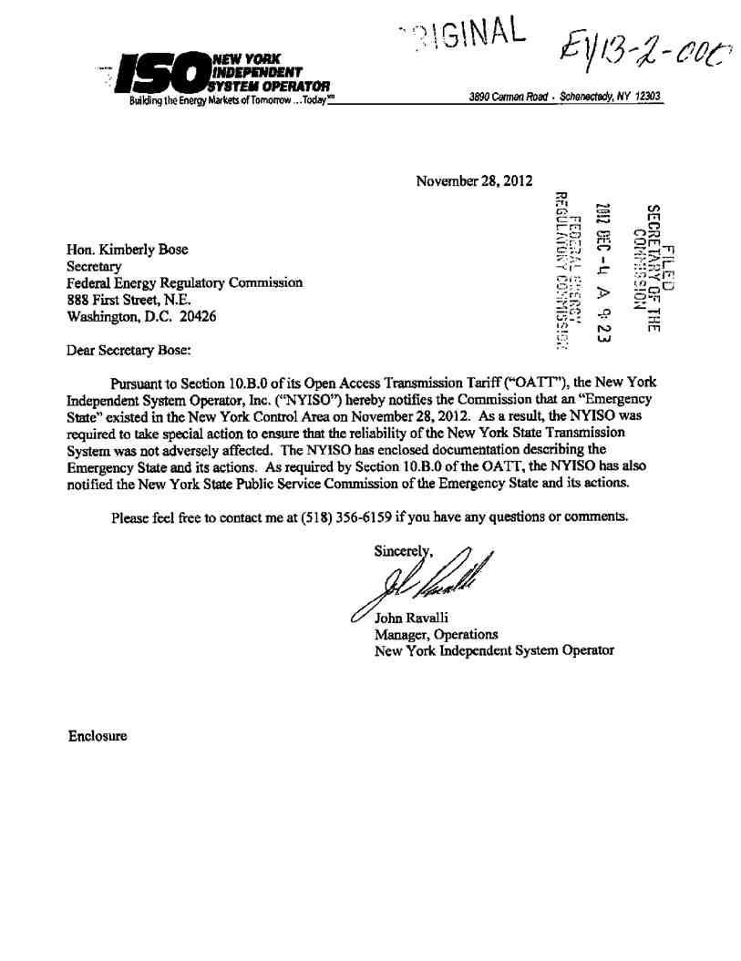
20121205-0200 FERC PDF (Unofficial) 12/04/2012
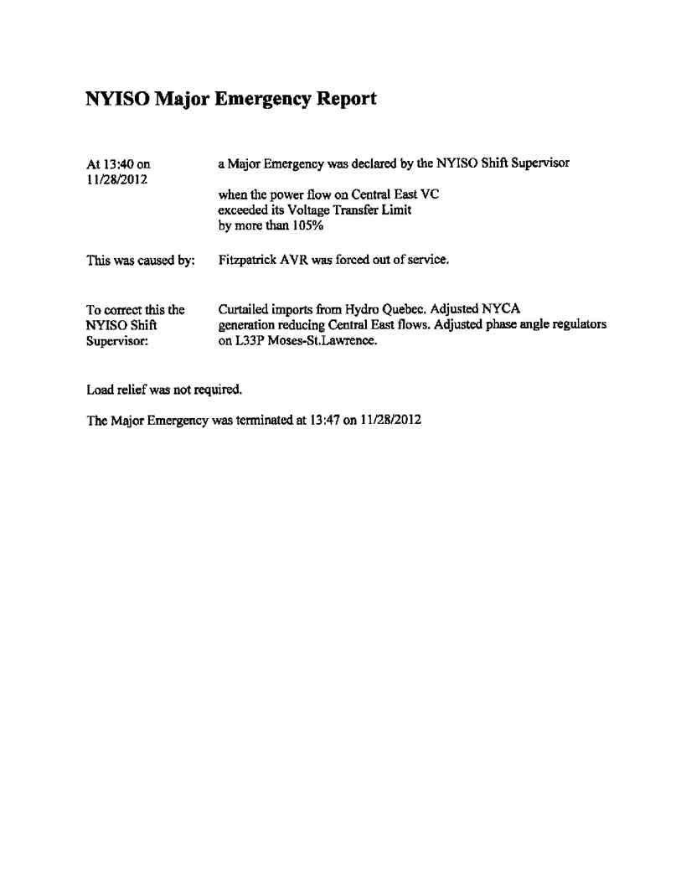
20121205-0200 FERC PDF (Unofficial) 12/04/2012
20121205-0200 FERC PDF (Unofficial) 12/04/2012
Document Content(s)
13124785.tif 1-2

