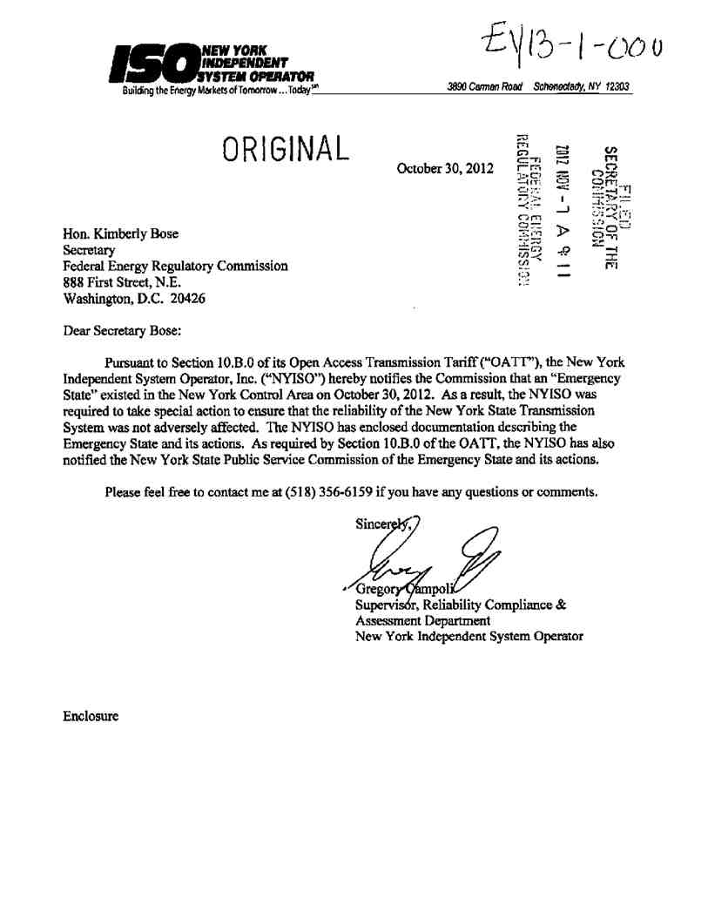
20121107-0201 FERC PDF (Unofficial) 11/07/2012
20121107-0201 FERC PDF (Unofficial) 11/07/2012
Document Content(s)
13104679.tif 1-1

