

10 Krey Boulevard Rensselaer, NY 12144

October 7, 2011

ELECTRONICALLY SUBMITTED

Kimberly D. Bose
Secretary
Federal Energy Regulatory Commission 888 First Street, N.E.
Washington, D.C. 20426
Re: New York Independent System Operator, Inc.’s Second Informational Report on
Efforts to Develop Rules Addressing Compensation to Generators that Are
Determined to be Needed for Reliability; Docket No. ER10-2220-___.
Dear Secretary Bose:

In accordance with paragraph 54 and ordering paragraph “(C)” of the Federal Energy
Regulatory Commission’s (“Commission’s”) October 12, 2010 Order On Proposed Mitigation
Measures in Docket No. ER10-2220-000 (“Order”),¹ the New York Independent System
Operator, Inc. (“NYISO”), hereby submits this Second Informational Report on Efforts to
Develop Rules Addressing Compensation to Generators that Are Determined to be Needed for
Reliability (“Informational Report”). The NYISO submitted its First Informational Report on
Efforts to Develop Rules Addressing Compensation to Generators that Are Determined to be
Needed for Reliability on or about April 11, 2011 (“April Informational Report”). In footnote
44 of its Order the Commission stated that it does not intend to issue public notices, accept comments, or issue orders on this Informational Report.

Paragraph 54 of the Order stated, in part, as follows:

Because fixed cost recovery issues do not go to whether NYISO’s mitigation
proposal is in itself just and reasonable, this proceeding is not the appropriate
forum in which to raise such issues. Further, commenters do not present factual
evidence that demonstrates that market participants generally will be unable to
recover their costs due to application of the proposed mitigation provisions. We
note, however, that the NYISO Board of Directors, in its July 29, 2010 decision
on the appeal of the NYISO Management Committee’s adoption of the instant
mitigation proposal, directed NYISO management to work with stakeholders to

¹New York Independent System Operator, Inc., 133 FERC ¶ 61,030.

Kimberly D. Bose, Secretary October 7, 2011
Page 2

examine the generation owners’ claims that existing cost recovery mechanisms
are inadequate and to review the process that evaluates permanent solutions to
reliability problems. Accordingly, we believe the better course is to await the
outcome of the stakeholder process as directed by the NYISO Board of Directors.
In this regard, we direct NYISO to file status reports every 180 days beginning
180 days from the date of this order for informational purposes only.⁴⁴

⁴⁴ The Commission does not intend to issue public notices, accept comments, or issue orders on such informational filings.
In compliance with the cited sections of the Order, the NYISO submits this Informational
Report.

I. Documents Submitted
1. This Informational Report;
2. A July 18, 2011 presentation titled IPPNY Reliability Compensation Proposal by
Chris LaRoe, of IPPNY, to a joint meeting of the NYISO’s Market Issues
Working Group and Electric System Planning Working Group (“Attachment A”);
and
3. A written outline titled IPPNY Reliability Compensation Proposal submitted by
IPPNY for discussion during the July 18, 2011 presentation (“Attachment B”);
4. Two sets of comments on the IPPNY proposal included in Attachment B that
were submitted by the New York State Department of Public Service Staff and Multiple Intervenors (“Attachment C”).
II. Informational Report

A. Summary of the April Informational Report
The NYISO shared an initial proposal for temporarily compensating generators that are planning to retire, but are needed for reliability, with its stakeholders at a Market Issues Working Group (“MIWG”) meeting on February 10, 2011. Following the MIWG discussions, the NYISO received comments (from both load and suppler representatives) that were critical of the proposal for several reasons. IPPNY submitted an alternative draft proposal to the NYISO that it believed addressed many of the concerns expressed.

The NYISO presented IPPNY’s proposal and its response at the March 31, 2011 MIWG
meeting. The discussion at this meeting, primarily occurring among stakeholder representatives,
was a constructive effort by divergent interests (suppliers and loads) to arrive at a common
ground.

Kimberly D. Bose, Secretary October 7, 2011
Page 3

B. July 18, 2011 Joint MIWG/Electric System Planning Working Group
On July 18, 2011, IPPNY presented a revised proposal at a joint MIWG/Electric System
Planning Working Group (“ESPWG”) meeting. IPPNY proposed that Attachment Y to the
NYISO’s OATT be amended to expressly incorporate a right for a generator that is needed for
reliability, but chooses to retire, to file a cost-of-service agreement at FERC under section 205 of
the Federal Power Act. Additionally, IPPNY proposed that the New York State Public Service
Commission amend its retirement provisions to allow a generator that has already been found not
to be needed for reliability to exit the market immediately upon submittal of its retirement notice.

The majority of the discussion at the July 18 meeting occurred between stakeholder
representatives. Representatives of New York loads (industrial, municipal and Transmission
Owners) and the New York State Department of Public Service (“DPS”) Staff again participated
actively in the stakeholder discussion; asking questions about and commenting on IPPNY’s
proposal. The NYISO also received written comments from DPS Staff and Multiple Intervenors,
which are attached to this filing. While stakeholder representatives continued to express
concerns with IPPNY’s proposal, NYISO Staff believes further progress is possible because the
discussions continue to focus on better understanding the other side’s concerns, rather than
restating past arguments.

C. Next Steps
During the July 18, 2011 MIWG/ESPWG meeting load-side representatives expressed an
interest in developing a counter-proposal to IPPNY’s proposal for discussion and IPPNY
committed to consider the comments it received at the meeting. To date the NYISO has only
received the two sets of comments that are attached to this filing. The NYISO is working to
schedule a stakeholder meeting to further discuss compensation for generators that are needed
for reliability.

III. Service
The NYISO will send an electronic link to this Informational Report to the official
representative of each of its customers, to each participant on its stakeholder committees, to the
New York Public Service Commission, to all parties listed on the Commission’s official service
list in this Docket and to the New Jersey Board of Public Utilities. In addition, the complete
filing will be posted on the NYISO’s website at www.nyiso.com.

Kimberly D. Bose, Secretary October 7, 2011
Page 4

IV. Conclusion
The NYISO respectfully submits this Informational Report in compliance with the
Commission’s Order. For the reasons explained above, the NYISO is hopeful that it will be able to develop and submit for the Commission’s consideration tariff revisions that have been
approved in the NYISO’s stakeholder governance process. The NYISO’s next informational report is due on or about April 11, 2012.
Respectfully submitted,
/s/ Alex M. Schnell
Alex M. Schnell
Rana Mukerji, Senior Vice President of Market Structures Robert E. Fernandez, General Counsel
Shaun Johnson, Manager of Energy Market Products New York Independent System Operator, Inc.

CERTIFICATE OF SERVICE
I hereby certify that I have this day served the foregoing document upon each person
designated on the official service list compiled by the Secretary in this proceeding in accordance with the requirements of Rule 2010 of the Rules of Practice and Procedure, 18 C.F.R. §385.2010.
Dated at Rensselaer, NY this 7th day of October, 2011

/s/ Mohsana Akter

Mohsana Akter
Regulatory Affairs Associate
New York Independent System Operator, Inc
10 Krey Blvd.
Rensselaer, NY 12114 (518) 356-7560

IPPNY Reliability Compensation
Proposal
Joint ESPWG/MIWG
July 18, 2011

Background

• Currently, the New York Public Service Commission
requires generators that wish to retire to continue
operating for at least six months and potentially longer.
• PSC requirement that generator operate against its will
is a “taking” under the US Constitution.
• Reliability determinations are not made until a
generator submits a formal retirement notice, which
can trigger financial consequences such as foreclosures
and cash sweeps, as well as result in potential labor
and pension issues. Furthermore, retirement requests
can negatively affect a facility’s ground leases,
equipment rentals, taxes, and tax abatements.

Background Cont’d

• Attachment Y, however, does not provide for any compensation to a
generator owner between the time the owner wishes to retire its
generator and a gap solution begins operation to resolve the
reliability need. Nor does Attachment Y provide a deadline for
when a gap solution must be chosen and implemented.
• Attachment Y provides just and reasonable compensation to
owners who generators are selected as a regulated “gap solution.”
Attachment Y states that such owners are “entitled to full recovery
of all reasonably incurred costs, including a reasonable return on
investment and any applicable incentives, related to the
development, construction, operation and maintenance” of their
projects. Such compensation is not currently provided to generators
operating for reliability prior to the selection of the gap solution.

Solution

• IPPNY proposes that Attachment Y be amended
to codify the right in the NYISO’s tariff that a
generator may file for cost of service contract
with the NYISO at FERC under section 205 of the
Federal Power Act.
• Additionally, IPPNY proposes the PSC amend its
retirement provisions to allow a generator
already found not to be needed for reliability to
exit the market immediately upon submittal of its
retirement notice.

IPPNY Proposal

• Amend Attachment Y to state that a generator may request a confidential
reliability study from the NYISO for purposes of determining whether the
generator is needed to maintain reliability.
• The study would be funded by the generator and should remain
confidential. The NYISO will reimburse the generator if the generator is found to be needed for reliability.
• The DPS Staff and relevant transmission owners would be involved in the
study process to determine whether the retirement would cause any local
reliability concerns.
• Once the study is performed and the NYISO/DPS Staff concludes that a
generator’s retirement poses no threat to reliability, the generator should be able to retire immediately with no further notice requirements. IPPNY recognizes that the PSC’s Retirement Order would need to be amended to clarify the generator’s right to retire under this circumstance.

IPPNY Proposal

• If the study determines that the generator is needed for reliability
but the generator chooses to retire, Attachment Y would state that
the generator may file a cost‐of‐service contract under Section 205
of the FPA with FERC immediately. At the same time, the study
would be made available to market participants.
• Attachment Y would state that the cost of service contract would
provide full recovery of all reasonably incurred costs, including a
reasonable return on investment and any applicable incentives,
related to the development, construction, operation and
maintenance of the generator. The contract would specify that it
would expire the date the NYISO issues a written determination
that the generator is no longer needed to maintain reliability.
• Both the PJM and ISO New England tariffs provide the opportunity
for generators to seek approval of cost‐of‐service contracts from
FERC.

IPPNY RELIABILITY COMPENSATION PROPOSAL

Independent Power Producers of New York, Inc. (“IPPNY”) hereby proposes
amendments to Attachment Y of the NYISO’s Open Access Transmission Tariff (“Attachment
Y”) to provide a cost recovery mechanism for the limited circumstance when a generator owner
is ordered to operate its generator for reliability but is unable to recover its costs from the market. As discussed in further detail below, a cost recovery mechanism is needed because the New
York Public Service Commission’s (“PSC”) generator retirement order¹ requires a generator
owner that wishes to retire its generator to continue operating for at least six months and
potentially longer even if the generator is operating at a loss. If the PSC requires a generator to
operate against the will of the generator’s owner and at a loss, it is confiscatory and is a “taking” under the Fifth Amendment to the United States Constitution. The Fifth and Fourteenth
Amendments to the United States Constitution provide that private property may not be “taken”
by state government without just compensation.
Attachment Y provides just and reasonable compensation to owners whose generators are
selected as a regulated “gap solution” to meet an imminent reliability need.² Attachment Y
states that such owners are “entitled to full recovery of all reasonably incurred costs, including a
reasonable return on investment and any applicable incentives, related to the development,
construction, operation and maintenance” of their projects. Attachment Y, however, does not
provide for any compensation to a generator owner between the time the owner wishes to retire
its generator and a gap solution begins operation to resolve the reliability need. Nor does
Attachment Y provide a deadline for when a gap solution must be chosen and implemented.

¹ Case 05-E-0889, Order Adopting Notice Requirements for Generation Unit Retirements (2005)(“Retirement
Order”).
² A gap solution is defined as “[a] solution to a Reliability Need that is designed to be temporary and to strive to be compatible with permanent market-based proposals.” OATT, Attachment Y, Section 2.0.

Thus, Attachment Y must be amended to ensure that owners that are required by the PSC to operate their generators beyond the date they wish to retire receive just and reasonable
compensation until they are no longer required to operate. Attachment Y should provide that generator owners have the right under Section 205 of the Federal Power Act (“FPA”) to file with the Federal Energy Regulatory Commission (“FERC”) a cost of service contract with the NYISO if the NYISO determines that the generator is needed for reliability.
PSC Retirement Order
The PSC’s Retirement Order was intended to remedy a perceived lack of regulatory
mechanisms in place to address the retirement of electric generating units in New York State.
Under the Retirement Order, generators sized equal to or greater than 80 MW are required to
provide written notice of a proposed retirement at least 180 days prior to the time the retirement
is effectuated. Generators sized under 80 MW have a minimum 90 day notice requirement,
while generators sized 2.0 MW and under are exempted from the notice requirement. Generators
proposing to retire are required to serve their notice on the PSC, the NYISO, and any affected
transmission owner and are subject to sanctions if they fail to make a timely filing.³ The PSC
did not address how generator owners would be compensated if it required generators to continue
operating at a loss. Indeed, the PSC stated in its Retirement Order that “[a]ccording to New
York Utilities, the issue of paying additional compensation to generators to forestall a retirement
should be deferred for consideration in the NYISO stakeholder process.”

³ See, Case No. 10-E-0533, Project Orange Associates, LLC - Petition Providing Notice of Generation Unit
Retirement and Requesting Waiver of Certain Notification Requirements, Order Accepting Notice of Retirement
and Making Other Findings (December 21, 2010) at 3-4 (ruling “[t]hat declining to pursue sanctions against Project Orange is warranted under these peculiar circumstances, however, is not precedent that other owners of generation units owners may rely upon if they fail to meet deadlines for providing notice of retirements. Those other owners of generation units are reminded that they remain subject to the enforcement mechanisms of the PSL, including PSL §24 and §25, if they do not give timely notice of generation unit retirements.”).

2

The PSC’s notice requirements were intended to complement the NYISO's
Comprehensive Reliability Planning Process (“CRPP”) by providing useful information that may
be reflected in the NYISO's Reliability Needs Assessment (“RNA”) and may be considered in
devising a solution to identified reliability needs. Time permitting, any proposed retirement is to
be included in the RNA base case developed through the CRPP. Where there is insufficient
time, such that bulk system reliability needs cannot be addressed through the ordinary RNA
planning cycle, the expectation is that, when a retirement notice is received, the NYISO and
responsible transmission owner would work together, in consultation with DPS Staff, to
determine if the retirement will result in a bulk and/or local system reliability need.
The NYISO CRPP Process
The CRPP assigns to the NYISO lead responsibility for evaluating the bulk power system over a ten year horizon and identifying any violations or potential violations of the applicable reliability rules. The results of this evaluation are published after stakeholder review and vote and approval by the NYISO Board in the annual RNA.
In the event the NYISO projects a reliability need, the responsible transmission owner is
required to submit a proposal for a backstop regulated solution to the NYISO for evaluation.
Merchant project developers are at the same time invited to submit proposals for solutions to the
needs identified in the RNA. Other developers can also develop regulated proposals for
generation, demand side alternatives and other solutions. Following screening by the DPS Staff,
such alternative regulated proposals that satisfy the PSC Staff may be submitted to the NYISO
for review. The NYISO then evaluates the proposals and presents them in a yearly
Comprehensive Reliability Plan ("CRP") for stakeholder review and approval by the NYISO

3

Board. The Board approved CRP reflects the NYISO's assessment of the adequacy of both
market and regulated proposals to meet the reliability concerns identified in the RNA.
The CRPP also provides a means of addressing time-critical reliability needs through "gap solutions." Gap solutions are intended to be temporary solutions that will not adversely impact any market-based proposals. The NYISO calls for, and evaluates, such solutions to determine whether they will meet the reliability need, and works with the transmission owners and the DPS Staff as appropriate to ensure that emergency reliability needs are addressed. The appropriate transmission owner offers a gap solution and any other party may submit an
alternative gap solution proposal to the NYISO and the DPS staff for their consideration. The appropriate governmental agency with jurisdiction over the implementation or siting of gap
solutions will determine whether the gap solution or an alternative gap solution will be
implemented to address the identified reliability need.
The cost recovery section of Attachment Y provides that owners of gap solutions are
“entitled to full recovery of all reasonably incurred costs, including a reasonable return on
investment and any applicable incentives, related to the development, construction, operation and
maintenance” of their projects. In the NYISO’s September 4, 2009 filing to FERC in Docket
No. ER09-1682-000, the NYISO’s Market Monitoring Unit (“MMU”), Potomac Economics,
expressly recognized that suppliers providing necessary reliability services to the system may not
be recovering their fixed costs. The MMU stated that FERC has relied on contractual solutions
customized to address the situation in the past and such an approach would be reasonable here.⁴
In the same docket, the NYISO stated that the “gap solution” process in Attachment Y would

⁴ Docket No. ER09-1682-000, New York Independent System Operator, Inc.'s Filing Requesting Authority to
Prospectively Apply New Mitigation Rules to Three Specifically Identified Generators, Requesting Limited Waivers of the NYISO's Tariff and of the Commission's Regulations, Seeking Expedited Commission Action, and
Requesting Shortened Notice and Comment Periods, Attachment B, Affidavit of Dr. David Patton at ¶ 42.

4

provide cost recovery for a generator that is needed to meet “an imminent threat to the reliability
of the New York power system” but is unable to otherwise stay in business due to its inability to
recover its legitimate going-forward costs. The NYISO cited to Section 13.6 of Attachment Y,
which it stated “provides for the recovery of the costs of Gap Solutions that are not transmission
projects; such as the funding of a reliability must-run arrangement with a given Generator in
appropriate circumstances.”⁵ There is nothing in Attachment Y, however, that provides a
generator that is ordered to operate to address an identified reliability need prior to the
implementation of a gap solution an adequate opportunity to recover its costs, and thus, to ensure
just and reasonable rates under Section 205 of the FPA. Nor is there anything in Attachment Y
that provides a timeline or deadline for when a gap solution is chosen and implemented.
Discussion
Attachment Y only provides for a process to be started to find a gap solution if a
reliability need is identified that results in an imminent threat to the reliability of the system. It
does not contain a clear and transparent cost-of-service mechanism for generators that are
ordered to continue operating to secure payment for necessary compensation. Attachment Y
must be amended to ensure that owners that are required by the PSC to operate their generators
beyond the date they wish to retire receive just and reasonable compensation until they are no
longer required to operate. Attachment Y should provide that generator owners have the right
under Section 205 of FPA to file with FERC a cost of service contract with the NYISO if the
NYISO determines that the generator is needed for reliability. The PSC mandated retirement
notice requirement forces a generator to operate at a loss for a minimum of 6 months while the
retirement’s impact on the system is evaluated. If the generator is determined to be needed to

⁵ Docket No. ER09-1682-000, Motion For Leave To Respond, And Response of The New York Independent System Operator, Inc., October 13, 2009 Filing at 12.

5

continue operating to maintain reliability, the generator could be required to continue operating at a loss much longer than six months because the process for choosing, permitting and
constructing a gap solution could take years to complete. During this period, the generator has no defined recourse to recover its costs.
The Attachment Y process is also cumbersome because it requires that a generator
formally request retirement before the provisions of Attachment Y can be triggered. This
requirement is unnecessarily onerous and fraught with numerous negative consequences. A
retirement request can trigger financial consequences such as foreclosures and cash sweeps, as
well as result in potential labor and pension issues. Furthermore, retirement requests can
negatively affect a facility’s ground leases, equipment rentals, taxes, and tax abatements.
While IPPNY believes that generators have the right to file for cost-of-service rates under Section 205 of the FPA, certain load interests claimed in the stakeholder process that led to the NYISO’s filing in Docket No. ER09-1682-000 that generators do not have the ability to make such a Section 205 filing. Once a reliability need determination is made and a generator is
ordered to remain operating, Attachment Y must indicate clearly that generators have a right to
seek FERC’s approval of a cost-of-service contract with the NYISO under Section 205 to avoid
delay and unnecessary litigation on this point. Both the PJM and ISO New England tariffs
provide the opportunity for generators to seek approval of cost-of-service contracts from the
Commission and include detailed rules to achieve this goal.

IPPNY Proposal
1. Amend Attachment Y to state that a generator may request a confidential reliability
study from the NYISO for purposes of determining whether the generator is needed

6

to maintain reliability. The NYISO is optimally equipped to perform such studies as
it performs them routinely in connection with new interconnection requests, the
yearly planning process, etc. The study would be funded by the generator and should
remain confidential.⁶ As discussed above, a retirement request can trigger adverse
financial consequences for the generator. Further, no market participant would be
prejudiced as a result of the study being confidential. The DPS Staff and relevant
transmission owners would be involved in the study process to determine whether the
retirement would cause any local reliability concerns. Once the study is performed
and the NYISO/DPS Staff concludes that a generator’s retirement poses no threat to
reliability, the generator should be able to retire immediately with no further notice
requirements. IPPNY recognizes that the PSC’s Retirement Order would need to be
amended to clarify the generator’s right to retire under this circumstance.
2. If the study determines that the generator is needed for reliability but the generator
chooses to retire, Attachment Y would state that the generator may file a cost-of-
service contract under Section 205 of the FPA with FERC immediately. At the same
time, the study would be made available to market participants. Attachment Y would
state that the cost of service contract would provide full recovery of all reasonably
incurred costs, including a reasonable return on investment and any applicable
incentives, related to the development, construction, operation and maintenance of the
generator. The contract would specify that the generator would bid energy into the
energy market at no less than its marginal costs. This would ensure that the
generator’s continued operation does not distort market prices because its costs are

⁶ If study determines that the generator is needed for reliability, the generator will be compensated for its costs of the study because the generator should not be in any worse position than if it filed a retirement notice with the PSC. Generators that file retirement notices with the PSC do not pay for reliability studies.
7

not reflected in the energy market. The contract would also specify that it would expire the date the NYISO issues a written determination that the generator is no longer needed to maintain reliability. The gap solution process would proceed as already specified in Attachment Y.

8
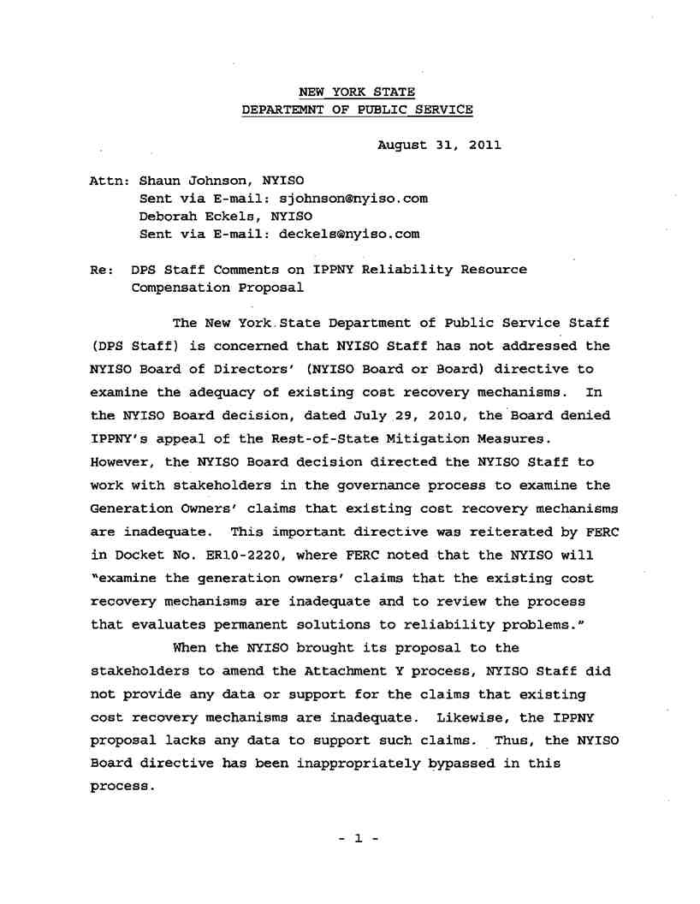
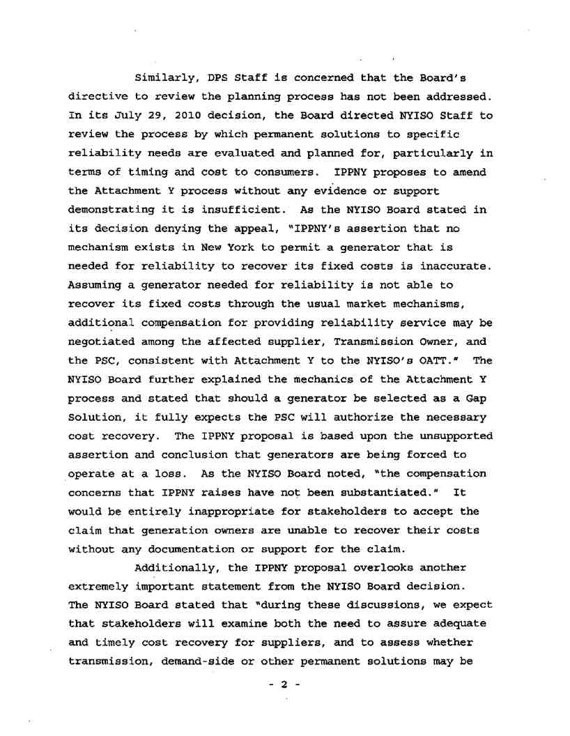
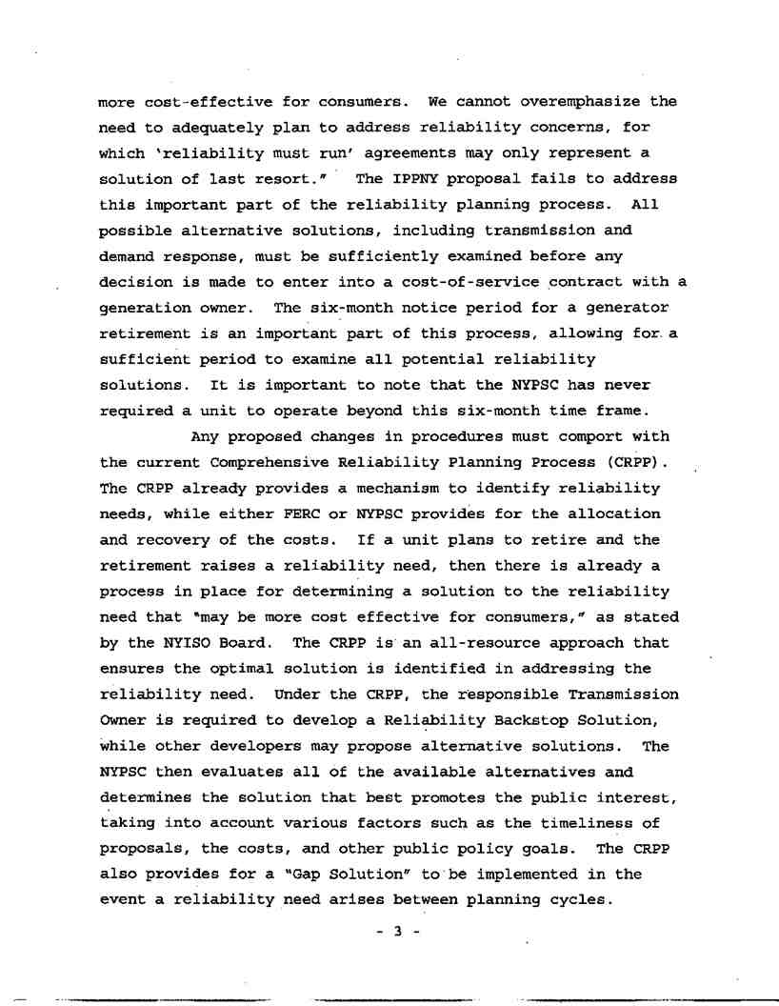
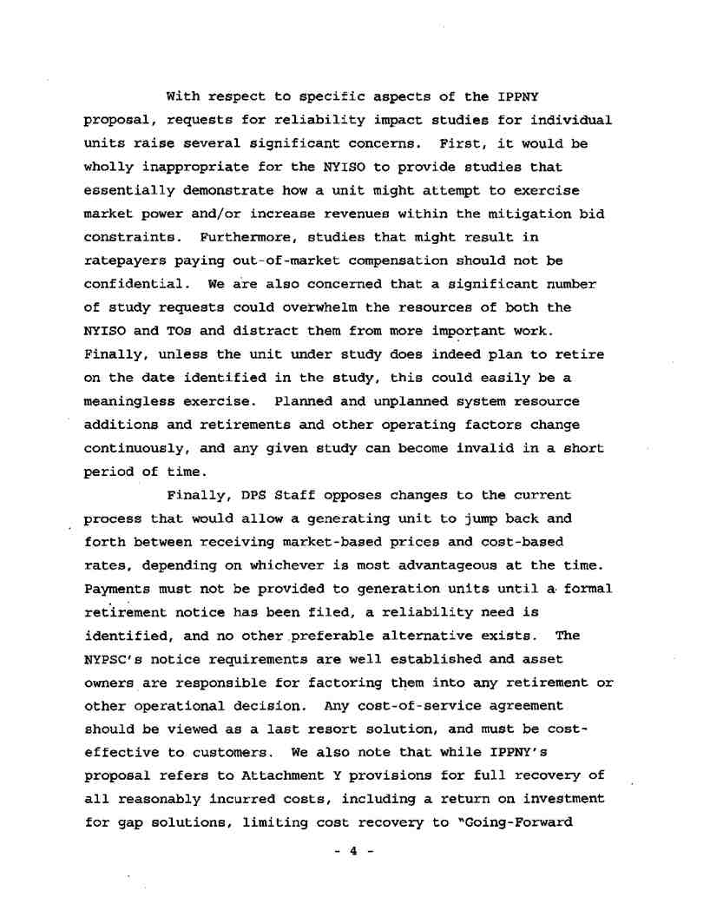
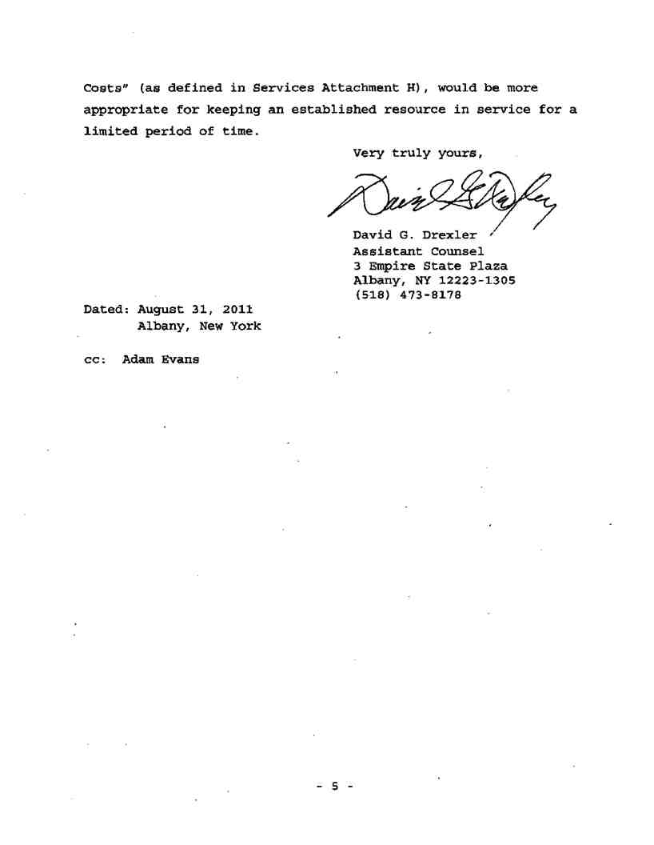

COUCH WHITE
counselors and attorneys at law

VIA E-MAIL
Mr. Shaun Johnson
Manager, Energy Markets Products

Couch White, LLP 540 Broadway
P.O. Box 22222
Albany, New York 12201-2222 (518) 426-4600

August 31, 2011

Michael B. Mager
Partner
Direct Dial: (518) 320-3409
Telecopier: (518) 320-3498
email: mmager@couchwhite.com

New York Independent System Operator, Inc.
10 Krey Boulevard
Rensselaer, New York 12144
Re: Reliability Resource Compensation Dear Shaun:
Pursuant to the request of the New York Independent System Operator, Inc. (“NYISO”), Multiple Intervenors hereby submits its comments on the Reliability Compensation Proposal (the “Proposal”) advanced by the Independent Power Producers of New York, Inc. (“IPPNY”) at the July 18, 2011 joint Electric System Planning Working Group/Market Issues Working Group meeting.¹ For the reasons set forth below, IPPNY’s Proposal should not be adopted in its current form. With certain modifications and clarifications, however, the Proposal would warrant further consideration by stakeholders.

GENERAL POSITION

Multiple Intervenors understands the need for, and can, if structured properly, support the
availability of cost-based, out-of-market compensation to generators that otherwise would retire
but which are directed to continue operating to maintain reliability. Significantly, however, the
rules governing any such compensation need to be equitable and consistent with the NYISO’s
existing planning processes and the notice requirements adopted by the New York State Public
Service Commission (“Commission”) governing the retirement of generation facilities. Multiple
Intervenors previously has opposed, for various reasons, different reliability resource
compensation proposals that did not satisfy such prerequisites. Additional copies of letters

¹ Multiple Intervenors is an unincorporated association of approximately 55 large
industrial, commercial and institutional energy consumers with manufacturing and other facilities located throughout New York State. Through four of its members, Multiple Intervenors participates actively in the NYISO’s Management and Business Issues Committees and selected subcommittees and working groups.

Offices in: Albany, New York City, Washington, D.C. and Farmington, Connecticut

August 31, 2011
Page 2

submitted by Multiple Intervenors commenting in opposition to prior reliability resource compensation proposals, dated March 11, 2010, July 28, 2010, and March 15, 2011, are available upon request.
Multiple Intervenors recognizes that IPPNY’s Proposal attempts to address concerns expressed previously by Multiple Intervenors and other stakeholders. Accordingly, Multiple Intervenors hereby limits the instant comments to the Proposal. One general comment, however, is in order. Thus far, New York has avoided the myriad of issues and problems associated with other regions’ reliance on “Reliability Must Run” (“RMR”) contracts. The necessity to provide out-of-market compensation to a retiring generator needed for reliability purposes has yet to be demonstrated in New York. Accordingly, even if, arguendo, such necessity is demonstrated in the future, the payment of such compensation pursuant to RMR contracts should be the exception (and a limited one at that), not the norm.
SPECIFIC COMMENTS AND CONCERNS

Initially, Multiple Intervenors does not agree with IPPNY that compliance with, or enforcement of, the Commission’s well-established retirement notice requirements applicable to electric generating facilities represent an unconstitutional taking under either the Fifth or Fourteenth Amendments to the United States Constitution. (See Proposal at 1.) It is unnecessary to engage IPPNY in legal argument on this issue at this time and, therefore, Multiple Intervenors simply notes its disagreement with IPPNY for the sake of clarity.
IPPNY then asserts that while Attachment Y to the NYISO’s Open Access Transmission
Tariff provides for cost-based compensation for regulated “gap solutions” to meet imminent
reliability needs, it does not: (a) “provide for any compensation to a generator owner between the
time the owner wishes to retire its generator and a gap solution begins operation to resolve the
reliability need”; or (b) “provide a deadline for when a gap solution must be chosen and
implemented.” (Id.; emphasis in original.) IPPNY asserts further that generation owners should have the right to file with the Federal Energy Regulatory Commission (“FERC”) a proposed cost-of-service contract if the NYISO determines that the generator is needed for reliability purposes. (Id. at 2.)
Multiple Intervenors does not oppose IPPNY’s proposal that FERC determine the amount
of cost-based, out-of-market compensation that should be paid to owners of electric generation
facilities that otherwise would retire but which are needed for reliability purposes. Significantly,
however, Multiple Intervenors opposes the commencement of such compensation prior to
satisfaction of the Commission’s retirement notice requirements. If a generation facility is
needed for reliability purposes, it still is entitled to market-based compensation, similar to other
facilities. Any entitlement to out-of-market compensation, however, only should be triggered
when that facility otherwise would retire (i.e., after compliance with the Commission’s
established requirements). IPPNY’s concern regarding an apparent lack of deadline for choosing

August 31, 2011
Page 3

and implementing gap solutions appears reasonable and should be addressed. Where a reliability need has been identified and is not cured by a market-based solution, then a regulated solution -
and, if necessary, a gap solution - should be selected and implemented on a timely basis.
For instance, if, arguendo, there is a 180-day notice requirement applicable to the
retirement of a hypothetical generation facility and such facility submits the Commission-
required notice exactly 180 days prior to its desired retirement date, then that facility should be
entitled to market-based compensation for the first 180 days following its retirement
announcement. Out-of-market compensation should be triggered only if that generation facility
is forced to remain in operation - instead of retire - due to a reliability need. For this
hypothetical facility, such trigger would occur on the 181st day following the retirement notice. Moreover, one of the primary purposes of the retirement notice requirements is to allow the Commission and impacted transmission owners, in coordination with the NYISO, to identify and resolve potential reliability issues. It may be possible that a gap solution can be implemented within the 180-day notice period, thereby obviating any need for the retiring facility to remain in operation (or to provide that facility with out-of-market compensation).
In its Proposal, IPPNY states that:
The PSC mandated retirement notice requirement forces a
generator to operate at a loss for a minimum of 6 months while the
retirement’s impact on the system is evaluated. If the generator is
determined to be needed to continue operating to maintain
reliability, the generator could be required to continue operating at
a loss much longer than six months because the process for
choosing, permitting and constructing a gap solution could take
years to complete. During this period, the generator has no defined
recourse to recover its costs.
(Id. at 5-6.) Multiple Intervenors disagrees with - but need not rebut here - IPPNY’s criticism of the Commission’s well-established retirement notice requirements. Multiple Intervenors agrees with IPPNY, however, that a retiring generator directed to continue operating for reliability purposes after the applicable notice requirement has been satisfied and beyond its desired retirement date specified in the Commission-required notice should not be forced to operate at a loss while a gap solution is implemented. In that circumstance, the process should ensure that cost-based, out-of-market compensation is instituted immediately upon expiration of both the notice period and the generator’s specified retirement date.
Turning to the specific elements of the Proposal, Multiple Intervenors hereby comments as follows.

August 31, 2011
Page 4

First, IPPNY proposes that: (a) generators be able to request a confidential study from the NYISO for the purpose of determining whether they are needed for reliability purposes; (b) said study would be paid for by the generator, unless it is determined that the generator is needed for reliability purposes; and (c) if the generator is not needed for reliability purposes, it should be allowed to retire immediately with no further notice requirements. (Id. at 6-7.)

Multiple Intervenors understands that generators currently are able to request that the
NYISO conduct certain reliability studies. Accordingly, Multiple Intervenors has no objections
to memorializing such practice, provided that: (a) the NYISO is responsible for how the study is
conducted; and (b) the requesting generator is responsible for the cost of the study. Multiple
Intervenors still is considering - and believes further discussion is warranted on - whether and
under what conditions the study should be kept confidential (although IPPNY’s proposal - as
further discussed below - to make the study results public if the generator seeks out-of-market
compensation alleviates Multiple Intervenors’ primary concern in this regard). IPPNY argues
that if a generator is needed for reliability purposes, it should not have to pay for the reliability
study “because the generator should not be in any worse position than if it filed a retirement
notice with the PSC. Generators that file retirement notices with the PSC do not pay for
reliability studies.” (Id. at 7, n.6.) Multiple Intervenors agrees, provided that the generator files
its retirement notice within a short period (e.g., 30 days) following completion of the study. Thus, the generator requesting the reliability study would be treated similarly to retiring generators - no worse and no better. Finally, allowing generators to retire prior to expiration of the Commission’s applicable retirement notice requirement is not a matter that can be decided by the NYISO or its stakeholders at this time; it requires an order from the Commission modifying the existing requirements. While some advance notice of retirements still may be needed for administrative and other purposes, Multiple Intervenors agrees that a relaxation of the current requirements may be reasonable where the NYISO confirms that a retiring generator is not needed to maintain reliability. Such a decision, however, rests ultimately with the Commission, not the NYISO or its shared governance process.
Second, IPPNY proposes that: (a) a generator shown to be needed for reliability purposes
that wishes to retire may seek cost-based compensation from FERC; (b) in that instance, the
reliability study would be made available to market participants; (c) generators would be
authorized to seek compensation for all reasonably-incurred costs, including a reasonable return on investment, plus any applicable incentives; (d) the out-of-market contract would specify that the generator would bid energy into the energy market at no less than its marginal costs; and (e) the contract would specify that it expires when the generator no longer is needed to maintain reliability. (Id. at 7-8.)
Multiple Intervenors does not oppose allowing a generator to seek cost-based, out-of-
market compensation from FERC provided that: (a) it has announced plans to retire, consistent
with the Commission’s notice requirements; and (b) the generator is needed to maintain
reliability. Multiple Intervenors continues to oppose proposals that would provide generators

August 31, 2011
Page 5

with out-of-market compensation prior to, or in the absence of, the filing of a notice of
impending retirement and expiration of the Commission’s required prior notice period. Multiple
Intervenors agrees that any studies relied upon to seek out-of-market compensation should be
made available to market participants. Multiple Intervenors is unaware of any incentives
available to existing generation owners; that part of IPPNY’s proposal warrants further
discussion. Conceptually, Multiple Intervenors agrees that a generator directed to continue
operating after it had planned to retire (following satisfaction of the Commission’s retirement
notice requirements) should be entitled to seek cost-based, out-of-market compensation in lieu of
(not in addition to) market-based compensation. Such cost-based compensation presumably
would include an opportunity to earn a reasonable return on investment. Multiple Intervenors
does not oppose IPPNY’s proposal that out-of-market generators be required to bid into the
NYISO’s energy markets at no less than their marginal costs, provided that such bids also are no
greater than marginal costs (as established and enforced by the NYISO). Finally, Multiple
Intervenors agrees that the out-of-market contract should expire as soon as the generator no
longer is needed to maintain reliability, regardless of the reason for which such need lapses.

Multiple Intervenors appreciates the opportunity to comment on IPPNY’s Proposal, and
looks forward to further discussions regarding same in the appropriate NYISO working groups.
Multiple Intervenors has no objections if the NYISO wishes to circulate its comments to other
stakeholders.

Very truly yours,
COUCH WHITE, LLP
Michael B. Mager

Michael B. Mager

MBM/cgw
S:\DATA\Client2 9000-11399\09588\corres\Johnson 08-31-11.docx

