AMENDED AND RESTATED SPECIAL PROTECTION SYSTEM ENGINEERING, CONSTRUCTION AND IMPLEMENTATION AGREEMENT

between
Niagara Mohawk Power Corporation d/b/a National Grid
And
New Athens Generating Company, LLC

ARTICLE 1. DEFINITIONS 2
ARTICLE 2. TERM AND TERMINATION OF AGREEMENT 5
2.1 Term 5
2.2 Effect of Termination of Agreement on Liabilities and Obligations 5
2.3 Approvals 5
ARTICLE 3. Project Description 6
3.1 Project Scope 6
3.2 Projected Project Milestone Schedule 7
3.3 Implementation of the SPS 8
3.4 Permanent Physical Reinforcement (PPR) 8
ARTICLE 4. SPS COSTS AND BILLING 9
4.1 SPS Construction Completion and Cost 9
4.2 Invoices and Payments 10
ARTICLE 5. TCCs 11
ARTICLE 6. DEFAULTS AND REMEDIES 11
ARTICLE 7. NOTICES AND REPRESENTATIVES OF THE PARTIES 12
7.1 Notices 12
7.2 Addresses of the Parties 12
ARTICLE 8. INSURANCE, INDEMNIFICATION AND LIMITATION OF LIABILITY 13
8.1 Indemnification 13
8.2 Limitation of Liability; Disclaimer of Warranty 14

ARTICLE 9. FORCE MAJEURE 14

ARTICLE 10. COMPLIANCE WITH LAW; PERMITS; APPROVALS 15
10.1 Applicable Laws and Regulations 15
10.2 Approvals, Permits, Etc. 15
ARTICLE 11. DISPUTE RESOLUTION 15
11.1 Internal Dispute Resolution Procedures 15
11.2 Continued Performance 15
11.3 Arbitration 16
11.4 Procedures 16
11.5 Confidentiality 17
ARTICLE 12. REPRESENTATIONS AND WARRANTIES 17
12.1 Athens' Representations and Warranties 17
12.2 NGrid's Representations and Warranties 17
ARTICLE 13. MISCELLANEOUS PROVISIONS 18
13.1 Severability 18
13.2 Modifications 18
13.3 Prior Agreements Superseded 18
13.4 Counterparts 19
13.5 Relationship of Parties/No Third-Party Beneficiaries 19
13.6 Confidentiality of Information 19
13.7 Interpretation; Applicable Law 20
13.8 Successors, Assigns and Assignments 20
13.9 Waivers 21

EXHIBIT A “System Impact Study for the Special Protection System for the Athens Power
Plant” report dated October 16, 2006 and submitted to Transmission Planning Advisory
Subcommittee

EXHIBIT B Conceptual Report - Redundant Athens SPS

AMENDED AND RESTATED SPECIAL PROTECTION SYSTEM ENGINEERING, CONSTRUCTION AND IMPLEMENTATION AGREEMENT

THIS AMENDED AND RESTATED SPECIAL PROTECTION ENGINEERING, CONSTRUCTION AND IMPLEMENTATION AGREEMENT (the "Agreement") is made and entered into as of the Effective Date between Niagara Mohawk Power Corporation d/b/a National Grid ("NGrid") and New Athens Generating Company, LLC ("Athens"). NGrid or Athens each may be referred to as a "Party" or collectively as the "Parties."

RECITALS

WHEREAS, Athens owns and operates an approximately 1,080 MW electric generation facility located in Athens, New York (the "Athens Plant") that is interconnected to the transmission system owned by NGrid; and

WHEREAS, the Parties have an existing Interconnection Agreement governing the interconnection dated May 15, 2001 ("Interconnection Agreement"); and an existing Special Protection System Engineering, Construction, and Implementation Agreement effective December 14, 2006 between NGrid and Athens (the “December 14, 2006 Agreement”); and

WHEREAS, pursuant to the December 14, 2006 Agreement, a Special Protection System, (as defined in the December 14, 2006 Agreement) was installed and has been operating since January 2008 and has produced improved deliverability for the Athens Plant; and

WHEREAS, Athens continues to have an interest in maintaining the improved deliverability of the Athens Plant; and

WHEREAS, although certain types of permanent physical reinforcements or upgrades of the transmission system (“PPR”) would increase the deliverability of energy from the Athens Plant when the Athens Plant is operating and remove the need for the SPS, any such PPR has yet to be developed and will not reasonably be implemented for several years; and

WHEREAS, as an additional interim step to maintain the improved Athens Plant deliverability and further the reliability of the SPS, the Parties agreed to design and install redundant capability to the SPS in accordance with the terms set forth in this Agreement; and further have agreed that nothing in this Agreement is intended to modify any provisions of the Interconnection Agreement;

NOW, THEREFORE, in consideration of and subject to the mutual covenants contained herein, it is agreed:

ARTICLE 1.
DEFINITIONS

Whenever used in this Agreement, the following terms shall have the following meanings:

1.1 "Athens" has the meaning set forth in the preamble of this Agreement, including its permitted successors or assignees.

1.2 "Athens Financing" means (a) one or more loans and/or debt issues, together with all modifications, renewals, supplements, substitutions and replacements thereof, the proceeds of which are used to finance or refinance the costs of the Athens Plant, any alteration, expansion or improvement to the Athens Plant, the purchase and sale of the Athens Plant or the operations at the Athens Plant or (b) a power purchase agreement pursuant to which Athens' obligations are secured by a mortgage or other lien on the Athens Plant.

1.3 "Athens Finance Holder" means (a) any holder, trustee or agent for holders, of any component of the Athens Financing or (b) any purchaser of power from the Athens Plant to which Athens has granted a mortgage or other lien as security for some or all of Athens' obligations under the corresponding power purchase agreement.

1.4 "Athens Plant" has the meaning set forth in the recitals to this Agreement.

1.5 "Affiliate" means, with respect to a corporation, partnership or other entity, each such other corporation, partnership or other entity that directly or indirectly, through one or more intermediaries, controls, is controlled by, or is under common control with, such corporation, partnership or other entity.

1.6 "Agreement" has the meaning set forth in the preamble of this Agreement, including all appendices, attachments and any amendments hereto.

1.7 "Applicable Laws and Regulations" means all applicable federal, state and local laws, ordinances, rules and regulations, and all duly promulgated orders and other duly authorized actions of any Governmental Authority having jurisdiction over the Parties and/or their respective facilities.

1.8 "Business Day" means any day other than a Saturday, Sunday, or other day on which commercial banks in New York are authorized or required by law to be closed.

1.9 "Commercially Reasonable Efforts" means, with respect to any action required to be made, attempted or taken by a Party under this Agreement, such efforts as a reasonably prudent business would undertake for the protection of its own interest under the conditions affecting such action.

1.10 "DPS" means the New York State Department of Public Service

1.11 "Effective Date" means March 31, 2013.

1.12 “Estimated Cost Amount” has the meaning set forth in Section 3.1(a) of this Agreement.

1.13 "Event" has the meaning set forth in Section 8.1(a) of this Agreement.

1.14 "Event of Default" has the meaning set forth in Article 6 of this Agreement.

1.15 "Facility Study" means study performed pursuant to the December 14, 2006 Agreement consistent with the requirements of Section 19.4 of the NYISO open access transmission tariff on file with and accepted by the.

1.16 “December 14, 2006 Agreement” has the meaning set forth in the recitals to this Agreement.

1.17 "FERC" means the Federal Energy Regulatory Commission, or any successor thereto.

1.18 "Force Majeure" means any act of God, labor disturbance, act of public enemy, war, insurrection, riot, storm or flood, explosion, breakage or accident to machinery or equipment, any order, regulation or restriction imposed by governmental, military or lawfully established civilian authorities, or any other act or cause beyond a Party's reasonable control. A Force Majeure event does not include acts of negligence or intentional wrongdoing by the Party claiming Force Majeure.

1.19 "Good Utility Practice(s)" means any of the practices, methods and acts engaged in or approved by a significant portion of the electric utility industry during the relevant time period, or any of the practices, methods and acts which, in the exercise of reasonable judgment in light of the facts known at the time the decision was made, could have been expected to accomplish the desired result at a reasonable cost consistent with good business practices, reliability, safety and expedition. Good Utility Practice is not intended to be limited to the optimum practice, method, or act to the exclusion of all others, but rather to be acceptable practices, methods, or acts generally accepted in the region. Good Utility Practice shall include, but not be limited to compliance with Applicable Laws and Regulations, the criteria, rules, and standards promulgated by NERC, the National Electric Safety Code, NPCC, NYSRC, NYISO and the National Electrical Code, as they may be amended from time to time, including the criteria, rules and standards of any successor organizations.

1.20 "Governmental Authority" means any federal, state, local or municipal governmental body; any governmental, regulatory or administrative agency, commission, body or other authority exercising or entitled to exercise any administrative, executive, judicial, legislative, policy, regulatory or taxing authority or power; or any court or governmental tribunal .

1.21 "Indemnitee" has the meaning set forth in Section 8.1(b) of this Agreement.

1.22 "Indemnitor" has the meaning set forth in Section 8.1(b) of this Agreement.

1.23 "Interconnection Agreement" has the meaning set forth in the recitals to this Agreement.

1.24 "Operational Period" has the meaning set forth in Section 3.4 of this Agreement.

1.25 "Party" has the meaning set forth in the preamble of this Agreement, including its permitted successors or assignees.

1.26 “Physical Removal Notice” shall have the meaning set forth in Section 2.3 of this Agreement.

1.27 "PPR" has the meaning set forth in the recitals to this Agreement.

1.28 "Project Scope" has the meaning set forth in Section 3.1 of this Agreement.

1.29 "NERC" means the North American Electric Reliability Corporation, including any successor thereto or any regional reliability council thereof.

1.30 "NPCC" means the Northeast Power Coordinating Council, Inc., including any successor thereto.

1.31 "NYISO" means the New York Independent System Operator, Inc., including any successor thereto.

1.32 "NYSRC" means the New York State Reliability Council, including any successor thereto.

1.33 “Redundant SPS Configuration” has the meaning set forth in Section 3.1(a) of this Agreement.

1.34 “Redundant SPS Configuration Study” has the meaning set forth in Section 3.1(a) of this Agreement.

1.35 “Second Operational Period” has the meaning set forth in Section 3.4 of this Agreement.

1.36 "SPS" means a special protection system intended to increase the deliverability of energy from the Athens Plant when the Athens Plant is operating by permitting post-contingency loading of either of lines 91 or 92 on the Transmission System up to its short term emergency rating, as established by the NYISO, following the contingent loss of either line 91 or line 92 and that will automatically cause a reduction in generation output at the Athens Plant within two (2) minutes to a level that reduces the loading of the remaining line to below its long term emergency rating as established by the NYISO and includes the systems installed pursuant to the December 14, 2006 Agreement and this Agreement, including, without limitation, the Redundant SPS Configuration.

1.37 "TCCs" means Transmission Congestion Contracts as that term is defined in the NYISO's open access transmission tariff on file with and accepted by FERC.

1.38 "Transmission System" means the transmission facilities owned by NGrid.

ARTICLE 2.
TERM AND TERMINATION OF AGREEMENT

2.1 Term

This Agreement shall become effective as of the Effective Date, and shall continue in full force and effect until one of the following occurs: (i) the Parties agree to mutually terminate this Agreement; (ii) Athens terminates the Agreement by providing NGrid written notice at least five (5) Business Days before the termination date contained in such notice; (iii) NGrid terminates this Agreement by providing Athens written notice (x) at least five (5) Business Days before the termination date contained in such notice or (y) following permanent physical removal of the SPS equipment by NGrid in accordance with the terms of this Agreement, or (iv) the Agreement terminates as otherwise permitted or provided for under this Agreement. Nothing in this Agreement is intended to suggest that any termination or removal of the SPS necessarily would be inconsistent with Good Utility Practice.

2.2 Effect of Termination of Agreement on Liabilities and Obligations

Except as otherwise provided for in this Agreement, expiration or termination of this Agreement shall not relieve the Parties of any liabilities or obligations arising hereunder prior to the date that termination becomes effective. The applicable provisions of this Agreement will continue in effect after termination to the extent necessary to provide for final billings, billing adjustments, and the determination and enforcement of liability and indemnification obligations arising from acts or events that occurred while this Agreement was in effect.

2.3 Approvals

Each Party shall use Commercially Reasonable Efforts to obtain in a timely manner applicable federal, state, NYISO or other consents, approvals, certifications, filings or orders, if any, that may be required for it to perform under, or that otherwise is required in connection with, this Agreement. Furthermore, following the Effective Date, each Party shall use Commercially Reasonable Efforts to implement the Redundant SPS Configuration consistent with Section 3.2.

Without limiting the foregoing, NGrid may permanently physically remove the SPS equipment if its own reliability reviews undertaken in accordance with Section 3.4 identify a reliability risk, whether imminent or not, to the Transmission System attributable to the SPS. If NGrid intends to permanently physically remove the SPS equipment from the transmission system based on its own reliability review, NGrid shall provide Athens, the NYISO, the DPS, and the NYSRC with prior written notice (“Physical Removal Notice”) before implementing such permanent physical removal of the SPS equipment. NGrid shall provide the Physical Removal Notice not less than ninety (90) days prior to the implementation date for such physical removal of the SPS equipment, provided, however, that, NGrid may provide less than such ninety (90) days’ notice if earlier physical removal of the SPS equipment is required to remain in compliance with (i) Applicable Laws and Regulations, (ii) any applicable reliability or other rules, codes or standards promulgated by NERC, the NYISO, the NPCC, the NYSRC, or any of their respective successors, or (iii) any applicable requirements of the National Electrical Code or the National Electric Safety Code, in which case NGrid shall provide the Physical Removal Notice as soon as practicable under the circumstances. Only one Physical Removal Notice is required from NGrid to the extent the implementation date as described above is delayed for any reason past the ninety (90) day period. The foregoing notwithstanding, NGrid may permanently physically remove the SPS equipment at any time after the end of the Operational Period or, if applicable, the Second Operational Period (as such terms are defined in Section 3.4 of this Agreement.)

Each Party shall support the Agreement before any regulatory agency having jurisdiction, and shall not protest or contest the Agreement or any part of it before any such agency, except as might otherwise be provided for in this Agreement. The terms and conditions of this Agreement are expressly contingent upon approval(s) of any regulatory agency having jurisdiction without material modification or condition, unless such modification(s) or condition(s) are agreed to by the Parties in writing.

ARTICLE 3.
PROJECT DESCRIPTION

3.1 Project Scope

The scope of implementation is as follows ("Project Scope"):

(a) Redundant SPS Configuration Study: NGrid shall perform pursuant to this Agreement a detailed engineering and cost analysis (the “Redundant SPS Configuration Study”) that describes the redundant SPS equipment, controls, communications and other configuration elements (the “Redundant SPS Configuration”) and that specifies a non-binding estimate of the actual cost of the Redundant SPS Configuration, including, without limitation, the estimated actual cost of designing, engineering, procuring equipment for, constructing, installing, testing and commissioning the Redundant SPS Configuration (the “Estimated Cost Amount”). The Parties agree to operate the SPS in accordance with the operational criteria established in the Facility Study and the Redundant SPS Configuration Study.

(b) SPS Design and Procurement: NGrid, following receipt of written permission from Athens to proceed to final design, shall perform the final design and procure the necessary equipment for the Redundant SPS Configuration.

(c) SPS Installation, Testing and Start-up: NGrid, with Athens' assistance at its communication interfaces, will install, calibrate and test the Redundant SPS Configuration.

(d) Acceptance and Commissioning: Upon acceptance and commissioning by both Parties, the SPS in the Redundant SPS Configuration will be considered fully operational.

3.2 Tentative Project Milestone Schedule

The Parties shall use Commercially Reasonable Efforts to install the Redundant SPS Configuration in accordance with Section 3.1 and the following schedule:

Six (6) months after approval of this Agreement by FERC – NGrid provides the Redundant SPS Configuration Study for review and approval by Athens (the approval of Athens shall not be unreasonably withheld, conditioned or delayed).

Two (2) months after Athens’ receipt of the Redundant SPS Configuration Study – The Redundant SPS Configuration Study is accepted by Athens, and final design and equipment/materials procurement can begin.

Six (6) months after Athens’ acceptance of the Redundant SPS Configuration Study – NGrid completes final design of the Redundant SPS Configuration.

Six (6) months after the completion of the final design of the Redundant SPS Configuration – SPS in the Redundant SPS Configuration is energized and commissioned.

Parties shall not be responsible for any delays in the above schedule caused by the actions or inactions of the other Party or of any third parties.

3.3 Implementation of the SPS

(a) Subject to the terms of this Agreement NGrid’s obligation to use Commercially Reasonable Efforts and any NGrid rights specified in this Agreement to remove the SPS from operational service or to permanently physically remove the SPS equipment, NGrid shall design, install, own, operate, and maintain the SPS in compliance with Good Utility Practice and applicable NYISO requirements. The configuration of the SPS shall be as set forth in the (1) “System Impact Study for the Special Protection System for the Athens Power Plant” report dated October 16, 2006 as submitted to the Transmission Planning Advisory Subcommittee, attached hereto as Exhibit A, and (2) the “Conceptual Report –Redundant SPS” attached hereto as Exhibit B, as supplemented by the Redundant SPS Configuration Study.

(b) If requested by Athens, NGrid shall inform Athens at such times as Athens reasonably requests, e.g., monthly, of the status of the design, construction and installation of the SPS, including, but not limited to, the following information: progress to date; a description of scheduled activities for the next period; the delivery status of all equipment ordered; and the identification of any event which NGrid reasonably expects may delay construction or commissioning, or increase the cost, of the Redundant SPS Configuration.

(c) If the Parties agree to a change to the Project Scope subsequent to the approval of the Redundant SPS Configuration Study, any such change shall be in writing and signed by authorized representatives of the Parties and shall contain such schedule adjustments and/or extensions and cost adjustments as may be mutually agreed upon by the Parties ("Change Agreement"). All additional work contemplated by any such change to the Project Scope shall be performed in accordance with this Agreement and the related Change Agreement.

(d) Any system upgrade facility costs incurred in connection with the electric delivery systems of NGrid or others due to the construction and/or implementation of the SPS, including, without limitation, the Redundant SPS Configuration, shall be the responsibility of Athens.

3.4 Permanent Physical Reinforcement (PPR)

(a) The SPS shall continue to be operational for ten (10) years from the date that the Redundant SPS Configuration is commissioned in accordance with Section 3.1(d), or until a PPR is installed and operational, whichever period is shorter (the “Operational Period”). During this Operational Period, Athens shall cooperate in the identification of, and in conducting discussions with, third parties that may reasonably be expected to fund a PPR.

(b) During the Operational Period, NGrid will conduct periodic reliability reviews of the Redundant SPS Configuration at Athens’ expense, provided, that, Athens’ obligation to pay such expenses shall not exceed $100,000 per reliability review. The first such reliability review will be completed following the end of the first year of the Operational Period; additional reliability reviews will be conducted every two years thereafter during the Operational Period. A copy of each reliability review will be provided to Athens. If any reliability review identifies a reliability risk, whether imminent or not, to the Transmission System attributable to the SPS, NGrid shall have the right to remove the SPS from operational service. NGrid shall have the right to permanently physically remove the SPS equipment at the end of the Operational Period without prior notice.

(c) Within six (6) months prior to the completion of the initial Operational Period, Athens has the option to request in writing to extend operation of the SPS for an additional operational period ending (a) ten (10) years from the termination date of the initial Operational Period, or (b) on the date a PPR is installed and operational, whichever period is shorter (the “Second Operational Period”), subject to the terms contained in paragraph (b) above. During the Second Operational Period, Athens shall cooperate in the identification of, and in conducting discussions with, third parties that may reasonably be expected to fund a PPR.

(d) The foregoing notwithstanding, (i) NGrid shall have the unilateral right to operate or not operate the SPS at any time if, in its reasonable judgment, NGrid determines that operation of the SPS creates an immediate or near term risk to Transmission System reliability, (ii) NGrid shall have the right to permanently physically remove the SPS equipment pursuant to Section 2.3 of this Agreement and (iii) NGrid shall have the right to permanently physically remove the SPS equipment at any time after the end of the Operational Period (or after the end of the Second Operational Period, if applicable).

ARTICLE 4.
SPS COSTS AND BILLING

4.1 SPS Construction Completion and Cost

(a) In accordance with the terms of this Agreement, Athens shall pay to NGrid all of the actual costs NGrid incurs in connection with performing the Project Scope and any other work, procurement or services contemplated by this Agreement.

(b) Athens shall have the right to receive, and NGrid shall provide upon Athens'
request, such cost and other information as is reasonably necessary to verify the cost of the Redundant SPS Configuration or any other cost that Athens pays NGrid hereunder. Athens shall have the right, during normal business hours, at its sole expense and upon prior reasonable notice, to audit NGrid's accounts and records pertaining to this Agreement at the offices where such accounts and records are maintained.

(c) NGrid shall render to Athens invoices pursuant to the payment schedule as follows for the estimated costs of the Redundant SPS Configuration.

(1) Agreement Execution: $ 100,000 ("Initial Invoice").

(2) Acceptance of Redundant SPS Configuration Study: Any study or design related costs set forth in the Redundant SPS Configuration Study to the extent not already paid pursuant to Section 4.1(c)(1).

(3) Completion of Final Design: the Estimated Cost Amount, to the extent not already paid pursuant to Section 4.1(c)(2).

(4) Subject to Section 4.1(a), within sixty (60) days after the date that the SPS is energized and commissioned, NGrid shall provide to Athens an invoice for the final remaining unpaid actual costs of the Redundant SPS Configuration and the amount due from Athens net of all amounts paid pursuant to Section 4.1(c) ("Post-IO Invoice").

(d) Athens shall make payments of such invoices in accordance with Section 4.2 below. To the extent that the estimated costs already paid by Athens to NGrid exceed the final, actual cost of the SPS specified in the Post-I0 Invoice, NGrid shall refund to Athens an amount equal to such excess amount within thirty (30) days of the issuance of the Post-IO Invoice. If such refund is overdue, such overdue amount shall accrue interest in accordance with Section 4.2(a) below from the due date of such unpaid amount until the date paid.

4.2 Invoices and Payments

(a) The Initial Invoice shall be payable on the Effective Date. Subject to Section 4.2(b) below, Athens shall make payment of the amount shown under all other invoices rendered pursuant to Section 4.1(d) above to be due to NGrid by wire transfer to an account specified by NGrid not later than the thirty-fifth (35th) day after issuance of the invoice, unless such day is not a Business Day, in which case Athens shall make payment on the next Business Day after the thirty-fifth (35) day after issuance of such invoice. All such payments shall be deemed to be made when said wire transfer is received by NGrid. Overdue payments by either Party hereunder shall accrue interest daily at the then current prime interest rate (the base corporate loan interest rate) published in the Money and Investing section of the Wall Street Journal, or, if no longer so published, in any mutually agreeable publication, plus 2% per annum, from the due date of such unpaid amount until the date paid.

(b) In the event Athens fails, to make payment of any undisputed amount to NGrid on or before the due date as described above, and such failure of payment is not corrected within forty-five (45) calendar days of the applicable original due date, an Event of Default by Athens shall be deemed to exist. In the event that Athens disputes a portion of any invoiced amount in good faith, and provides written notice of such dispute together with a reasonable description of the reason therefor (all prior to the applicable due date), NGrid will continue to perform its responsibilities under this Agreement during the pendency of such dispute, provided, that, Athens continues to pay all amounts not in dispute when such amounts are due. A dispute with respect to a subset or portion of an invoice or invoiced amount shall not excuse payment on the original due date of any undisputed portion or subset of the invoice or invoiced amount.

(c) In the event adjustments or corrections to an invoice are required as a result of errors in computation or billing, NGrid shall promptly re-compute amounts due hereunder and correct any errors in such invoice. If the total amount, as recomputed, due from Athens is less than the total amount due as previously computed, and payment of the previously computed amount has been made, the difference shall be paid to Athens within thirty (30) days after correction of the erroneous invoice(s), together with interest calculated in accordance with the methodology specified in Section 4.2(a); if the total amount, as recomputed, due from Athens is more than the total amount due as previously computed, and payment of the previously computed amount has been made, the difference shall be invoiced to Athens according the methodology specified in Section 4.2(a); provided, however, that no adjustment for any invoice or payment will be made unless objection to the accuracy thereof was made prior to the lapse of ninety (90) days from the receipt thereof; and provided further that this Article 4 will survive any termination of the Agreement for a period of one (1) year from the date of such termination for the purpose of resolving such invoice and payment issues.

(d) Payment of invoices by any Party will not constitute a waiver of any right or claims such Party may have under this Agreement or under law.

ARTICLE 5.
TCCs

To the extent that TCCs or other rights or benefits are created by or attributable to the SPS, such TCCs or other rights or benefits will be the property of and allocated to the entity(ies) that fund the SPS in proportion to the amount funded by such entity(ies). If TCCs attributable to the SPS are created, and if Athens is unable to meet its generation obligations, then Athens will be responsible financially for any resulting congestion rent shortfall cost directly chargeable to TCC holders under the NYISO open access transmission tariff.

ARTICLE 6.
DEFAULTS AND REMEDIES

It shall be an "Event of Default" in respect of a Party under this Agreement, if such Party shall (a) fail to make payment of any amount hereunder when due, or (b) fail in any material respect to comply with, observe or perform, or default in the performance of, any other material covenant or obligation under this Agreement, or if any representation or warranty made herein by such Party shall fail to be true and correct in all material respects, and after receipt of written notice, such failure shall continue for a period of thirty (30) days, provided, however, if such failure is not a failure to pay amounts when due and is not capable of cure within thirty (30) days, the Party in default shall commence such cure within thirty (30) days after notice and continuously and diligently complete such cure within ninety (90) days of receipt of such notice. Each Athens Finance Holder will have the right, but not the obligation, to cure any default by Athens. If an Event of Default shall occur and continue for more than ninety (90) days from the date the notice of default is received, the non-defaulting Party may terminate this Agreement. In addition to the rights and remedies described in this Agreement and subject to the limitations set forth in this Agreement, the non-defaulting Party may exercise, at its election, any right or remedy it may have at law or in equity, including but not limited to compensation for monetary damages, injunctive relief and specific performance.

ARTICLE 7.
NOTICES AND REPRESENTATIVES OF THE PARTIES

7.1 Notices

Any notice, demand or request required or authorized by this Agreement to be given by one Party to the other Party shall be in writing. It shall either be personally delivered, transmitted by electronic mail, telecopy or facsimile equipment (with receipt verbally and electronically confirmed), sent by overnight courier or mailed, postage prepaid, to the other Party at the address designated pursuant to this Article 7. Any such notice, demand or request so delivered or mailed shall be deemed to be given when so delivered or three (3) days after mailed.

7.2 Addresses of the Parties

(a) Notices and other communications by Athens to NGrid shall be addressed to:

Niagara Mohawk Power Corporation
Attn: Director. Transmission Commercial Services
300 Erie Boulevard West
Syracuse, New York 13202
Phone: 781-907-2422
Facsimile: 781-907-5707

(b) Notices and other communications by NGrid to Athens shall be addressed to:

New Athens Generating Company, LLC
Attn. Plant Manager
9300 U.S. Highway 9W
P.O. Box 349
Athens, New York 12015
Phone: 518-945-3844
Facsimile: 518-945-3751

With an additional copy to:

Competitive Power Ventures, Inc
Attn. Plant Asset Manager
35 Braintree Hill Office Park
Suite 400
Braintree, MA 02184
Phone: 781-848-5387
Facsimile: 781-848-5804

(c) Either Party may change its address by written notice to the other in accordance with this Article 7.

ARTICLE 8.
INSURANCE, INDEMNIFICATION AND LIMITATION OF LIABILITY

8.1 Indemnification

(a) Athens hereby agrees to indemnify and hold harmless NGrid, its affiliates, and its and its affiliates' directors, officers, agents, representatives, and employees from and against any and all claims, demands, civil penalties, causes of action, losses, liabilities (including without limitation, reasonable attorneys' fees) and damages (collectively, “Damages”) to the extent that such Damages are caused by (i) Athens' performance or non-performance of its obligations under this Agreement or (ii) during the period in which the SPS is in operation, the operational failure of the SPS or the failure of Athens to sufficiently reduce the output of the Athens Plant within fifteen (15) minutes following an opening of either Lines 91 or 92 of the Transmission System (each, an "Event"); provided however, the provisions of this Section 8.1(a) shall not apply to the extent that such claims, demands, penalties, causes of action, losses or liabilities are attributable to the gross negligence or intentional misconduct of NGrid or any of its affiliates, and, further provided, that Athens' liability with respect to item (ii) above shall not exceed $5 million per Event.

(b) When making a claim for indemnification under Section 8.1(a), NGrid (the "Indemnitee"), shall notify Athens (the "Indemnitor") of the claim in writing promptly after receiving notice of any action, lawsuit, proceeding, investigation or other claim against it (if by a third party), describing the claim, the amount thereof (if known and quantifiable) and the basis thereof. The Indemnitor shall be entitled to participate in the defense of such action, lawsuit, proceeding, investigation or other claim giving rise to an Indemnitee's claim for indemnification at such Indemnitor's expense, and at its option shall be entitled to assume the defense thereof by appointing a reputable counsel reasonably acceptable to the Indemnitee to be the lead counsel in connection with such defense; provided that the Indemnitor shall continue to be entitled to assert any limitation on any claims contained herein; provided further the Indemnitee shall be entitled to participate in the defense of such claim and to employ counsel of its choice for such purpose; provided however, that the fees and expenses of such separate counsel shall be borne by the Indemnitee. If the Indemnitor shall control the defense of any such claim then the Indemnitor shall be entitled to settle such claim; provided, that, the Indemnitor shall obtain the prior written consent of the Indemnitee (which consent shall not be unreasonably withheld, conditioned or delayed) before entering into any settlement of a claim or ceasing to defend such claim if, pursuant to or as a result of such settlement or cessation, injunctive or other equitable relief will be imposed against the Indemnitee or if such settlement does not expressly and unconditionally release the Indemnitee from all liabilities and obligations with respect to such claim.

8.2 Limitation of Liability: Disclaimer of Warranty

Except to the extent required by Section 8.1(a) of this Agreement, in no event shall either Party, with respect to any claim arising out of this Agreement, whether based on contract, tort (including the negligence of such Party, whether sole or joint and concurrent with the negligence of such other Party or some third-party's gross negligence, willful misconduct, or strict liability) or otherwise, be liable for any indirect, special, incidental, punitive, exemplary, or consequential damages, including, but not limited to, delays, lost profits, business interruptions, and claims of suppliers and customers, whether or not (i) such damages were reasonably foreseeable or (ii) such Party was advised or aware that such damages might be incurred.

NGrid's total cumulative liability for all claims of any kind, whether based upon contract, tort (including negligence and strict liability), or otherwise, for any loss, injury, or damage connected with, or resulting from, this Agreement, shall not exceed the aggregate amount of all payments made to NGrid by Athens pursuant to Section 4.1(a) of this Agreement and/or that were paid pursuant to the December 14, 2006 Agreement.

THE WARRANTIES AND REPRESENTATIONS SET FORTH IN ARTICLE 12 ARE EXCLUSIVE AND NEITHER PARTY MAKES ANY OTHER WARRANTIES, REPRESENTATIONS, OR GUARANTEES IN CONNECTION WITH THIS AGREEMENT, WHETHER STATUTORY, ORAL, WRITTEN, EXPRESS, OR IMPLIED, INCLUDING, WITHOUT LIMITATION, WARRANTIES OF MERCHANTABILITY AND FITNESS FOR A PARTICULAR PURPOSE; ALL SUCH WARRANTIES, REPRESENTATIONS, AND GUARANTEES ARE EXPRESSLY DISCLAIMED. THIS DISCLAIMER SHALL SURVIVE ANY CANCELLATION, COMPLETION, TERMINATION OR EXPIRATION OF THIS AGREEMENT. ANY WARRANTIES PROVIDED BY ORIGINAL MANUFACTURERS', LICENSORS', OR PROVIDERS' OF MATERIAL, EQUIPMENT, OR OTHER ITEMS PROVIDED OR USED IN CONNECTION WITH THIS AGREEMENT ("THIRD PARTY WARRANTIES") ARE NOT TO BE CONSIDERED WARRANTIES OF EITHER PARTY AND NO PARTY MAKES ANY REPRESENTATIONS, GUARANTEES, OR WARRANTIES AS TO THE APPLICABILITY OR ENFORCEABILITY OF ANY SUCH THIRD PARTY WARRANTIES.

ARTICLE 9.
FORCE MAJEURE

Except for the obligation to make any payments under this Agreement, each Party shall be excused from performing its respective obligations under this Agreement and shall not be liable in damages or otherwise if and to the extent that it is unable to so perform or is prevented from performing by a Force Majeure, provided that (i) the non-performing Party, as promptly as practicable after the occurrence of the Force Majeure, but in no event later than fourteen (14) days thereafter, gives the other Party written notice describing the particulars of the occurrence; (ii) the suspension of performance is of no greater scope and of no longer duration than is reasonably required by the Force Majeure; (iii) the non-performing Party uses all Commercially Reasonable Efforts to remedy its inability to perform; and (iv) neither Party shall be required to settle any strike, walkout, lockout or other labor dispute on terms which, in the sole judgment of the Party involved in the dispute, are contrary to its interest, it being understood and agreed that the settlement of strikes, walkouts, lockouts or other labor disputes shall be entirely within the discretion of the Party having such dispute.

ARTICLE 10.
COMPLIANCE WITH LAW; PERMITS; APPROVALS

10.1 Applicable Laws and Regulations

This Agreement and all rights, obligations, and performances of the Parties hereunder are subject to Applicable Laws and Regulations and the Parties shall discharge their obligations under this Agreement in accordance with Good Utility Practice and all Applicable Laws and Regulations.

10.2 Approvals, Permits, Etc.

Each Party shall give all required notices, and, subject to the above terms, shall use Commercially Reasonable Efforts to procure and maintain all necessary governmental approvals, permits, licenses and inspections necessary for its performance of this Agreement, and shall pay all charges and fees in connection therewith.

ARTICLE 11.
DISPUTE RESOLUTION

11.1 Internal Dispute Resolution Procedures

Each Party shall appoint a representative who shall be responsible for administering this Agreement on behalf of such Party and for representing the Party's interests in disagreements. Any dispute that is not resolved between the Parties' representatives within ten (10) Business Days of when the disagreement is first raised by written notice by either Party to the other Party shall be referred by the Parties' representatives in writing to the senior management of the Parties for resolution. In the event the senior management are unable to resolve the dispute within ten (10) Business Days (or such other period as the Parties may agree upon), each Party may pursue resolution of the dispute only through the other dispute resolution provisions set forth in this Article 11 of this Agreement. All negotiations pursuant to this Section 11.1 for the resolution of disputes will be confidential, and shall be treated as compromise and settlement negotiations for purposes of the Federal Rules of Evidence and any State Rules of Evidence.

11.2 Continued Performance

The Parties shall continue to perform their respective obligations under this Agreement during the pendency of any dispute including a dispute regarding the effectiveness or the purported termination of this Agreement.

11.3 Arbitration

(a) If any claim or dispute arising hereunder is not resolved within sixty (60) days after notice thereof to the other Party, the Parties may agree in writing to the submission of the dispute to binding arbitration in New York City, New York or other mutually agreed upon location and shall be heard by one mutually agreed-to neutral arbitrator under the American Arbitration Association's Commercial Arbitration Rules ("Arbitration Rules"); provided, however, that, in the event of a conflict between the Arbitration Rules and the terms and provisions of this Article 11, the terms and provisions of this Article 11 shall govern. If the Parties fail to agree upon a single arbitrator within five (5) Business Days, each Party shall have an additional three (3) Business Days to choose one arbitrator who shall sit on a three-member arbitration panel. The two arbitrators so chosen shall, within ten (10) Business Days after their selection, select a third arbitrator to chair the arbitration panel. Each Party shall be responsible for its own costs incurred during the arbitration process and for one half the costs of the single arbitrator jointly chosen by the Parties, or in the alternative the cost of the arbitrator chosen by the Party to sit on the three member panel and one half of the cost of the third arbitrator chosen.

(b) Unless otherwise agreed, the arbitration process shall be expeditiously concluded no later than three (3) months after the date that it is initiated and the award of the arbitrator shall be accompanied by a reasoned opinion if requested by either Party. The arbitrator(s) shall have no authority to award punitive or other damages inconsistent with the terms of this Agreement. The arbitrator(s) shall have the authority only to interpret and apply the terms and conditions of this Agreement and shall have no power to modify or change any such term or condition. The arbitrator(s) shall be required to follow all Applicable Laws and Regulations. The arbitration shall be conducted as a common law arbitration and the decision of the arbitrator(s) rendered in such a proceeding shall be final; provided, however, that such decision may be challenged solely on grounds that the conduct of the arbitrator(s) or the decision itself violates the standards set forth in the Federal Arbitration Act. Judgment may be entered upon it in any court having jurisdiction.

11.4 Procedures

(a) The procedures for the resolution of disputes set forth in this Agreement shall be the sole and exclusive procedures for the resolution of disputes; provided, however, that a Party may seek a preliminary injunction or other preliminary judicial relief if in its judgment such action is necessary to avoid irreparable damage or to preserve the status quo. All applicable statutes of limitations and defenses based upon the passage of time shall be tolled while the procedures specified herein are pending. The Parties will take such action, if any, required to effectuate such tolling. Each Party is required to continue to perform its undisputed obligations under this Agreement pending final resolution of a dispute.

(b) Notwithstanding any other provision in this Agreement, either Party may file a petition or complaint with the FERC with respect to any claim or dispute over which the FERC has jurisdiction and nothing in this Agreement shall constitute a waiver of any such right.

11.5 Confidentiality

The existence, contents, or results of any arbitration proceeding conducted under this Article 11 may not be disclosed without the prior written consent of both Parties; provided, however, that either Party may (a) make such disclosures as may be necessary to (1) satisfy regulatory obligations to any regulatory authority having jurisdiction, or (2) seek or obtain from a court of competent jurisdiction judgment on, confirmation, or vacation of an arbitration award; (b) inform its lenders, affiliates, auditors, and insurers, as necessary, under pledge of confidentiality; and (c) consult with experts as required in connection with the arbitration proceeding under pledge of confidentiality. If either Party seeks a preliminary injunctive relief from any court to preserve the status quo or avoid irreparable harm pending arbitration, the Parties agree to use Commercially Reasonable Efforts to keep the court proceedings confidential, to the maximum extent permitted by law.

ARTICLE 12.
REPRESENTATIONS AND WARRANTIES

12.1 Athens' Representations and Warranties

Athens makes the following representations and warranties:

(a) Athens is duly formed, validity existing and in good standing under the laws of its state of formation, and is in good standing under the laws of the state of its formation.

(b) Athens has the right, power and authority to enter into this Agreement, to become a party hereto and to perform its obligations hereunder and this Agreement is a legal, valid and binding obligation of Athens enforceable in accordance with its terms, except as limited by laws of general applicability limiting the enforcement of creditor's rights or by the exercise of judicial discretion in accordance with general principles of equity.

(c) The execution, delivery and performance of this Agreement does not violate or conflict with the organizational or formation documents, or bylaws or operating agreement, of Athens, or any judgment, license, permit or order or material agreement or instrument applicable to or binding upon Athens or any of its assets.

(d) Athens has sought or obtained, or, in accordance with, and subject to, the terms of this Agreement will seek or obtain, each consent, approval, authorization or order of, or acceptance of a filing with, or notice to, any Governmental Authority with jurisdiction concerning this Agreement, in connection with the execution, delivery and performance of this Agreement.

12.2 NGrid's Representations and Warranties

NGrid makes the following representations and warranties:

(a) NGrid is duly organized or formed, as applicable, validity existing and in good
standing under the laws of its state of organization or formation, and is in good standing under the laws of the state of its organization.
(b) NGrid has the right, power and authority to enter into this Agreement, to become
a party hereto and to perform its obligations hereunder and this Agreement is a legal, valid and binding obligation of NGrid enforceable in accordance with its terms, except as limited by laws of general applicability limiting the enforcement of creditor's rights or by the exercise of judicial discretion in accordance with general principles of equity.
(c) The execution, delivery and performance of this Agreement does not violate or conflict with the organizational or formation documents, or bylaws or operating agreement, of NGrid, or any judgment, license, permit or order or material agreement or instrument applicable to or binding upon NGrid or any of its assets.
(d) NGrid has sought or obtained, or, in accordance with, and subject to, the terms of this Agreement will seek or obtain, each consent, approval, authorization or order of, or acceptance of a filing with, or notice to, any Governmental Authority with jurisdiction concerning this Agreement, in connection with the execution, delivery and performance of this Agreement.
ARTICLE 13.
MISCELLANEOUS PROVISIONS
13.1 Severability
If any provision or provisions of this Agreement shall be held invalid, illegal, or unenforceable, the validity, legality, and enforceability of the remaining provisions, or the application of such provision to persons or circumstances other than those as to which it is held to be invalid or unenforceable, shall in no way be affected or impaired thereby.
13.2 Modifications
No waiver of a Party's rights hereunder shall be binding unless it shall be in writing and signed by the Party against which enforcement is sought. This Agreement may be amended by and only by a written instrument duly executed by each of the Parties hereto.
13.3 Prior Agreements Superseded
This Agreement constitutes the entire agreement between the Parties relating to the subject matter hereof and shall supersede the December 14, 2006 Agreement and all other previous agreements, discussions, communications and correspondence with respect to such subject matter, provided, that, this Agreement shall replace and supersede the December 14, 2006 Agreement only with effect from and after the Effective Date. In the event of any inconsistency between this Agreement and the Exhibits attached hereto and made a part hereof, this Agreement shall control.
13.4 Counterparts

This Agreement may be executed in any number of counterparts, and each executed counterpart shall have the same force and effect as an original instrument.

13.5 Relationship of Parties/No Third-Party Beneficiaries

(a) Nothing in this Agreement shall be construed as creating any relationship between the Parties, including any partnership or joint venture, other than that of independent contractors.

(b) This Agreement is not intended to, and does not, confer upon any Person other than the Parties hereto and their respective successors and permitted assigns, any rights, benefits, or remedies hereunder.

13.6 Confidentiality of Information

(a) All information disclosed by a Party in connection herewith and considered by such Party to be confidential, proprietary or of a competitive value shall be kept confidential by the other Party so long as such information is marked "confidential" or "proprietary" at the time of disclosure, or if disclosed orally, the receiving Party confirms promptly in writing that such information is to be treated as confidential for purposes of this Agreement ("Confidential Information"). All information which concerns the cost, design or operation of the Athens Plant, whether exchanged orally or in written or electronic form, and all information that is metered or telemetered with respect to the Athens Plant shall be deemed to be Confidential Information of Athens without any requirement for marking. All information which concerns the cost, design or operation of the NGrid Transmission System, whether exchanged orally or in written or electronic form, and all information that is metered or telemetered with respect to such Transmission System shall be deemed to be Confidential Information of NGrid without any requirement for marking. Each Party shall only be permitted to disclose Confidential Information of the other Party to its Affiliates and its and its Affiliates' officers, directors, employees, agents, consultants, and contractors who need to know such Confidential Information for the purpose of implementing, enforcing, or interpreting this Agreement (but only so long as the disclosure of such information to such persons and the use of such Confidential Information thereby complies with the requirement of applicable FERC standards or codes of conduct). Each Party agrees to notify such persons of the confidential nature of such Confidential Information and to be responsible for any unauthorized disclosure of such Confidential Information by such persons in violation of the terms of this Agreement. Confidential Information shall not be deemed to subject to the restriction contained in this Section 13.6 if it (i) was in the public domain prior to the date hereof, (ii) becomes publicly available after the date hereof other than as a result of the unauthorized disclosure thereof by a Party or by an officer, director, employee,
agent or Affiliate of a Party in violation of the terms of this Agreement, or (iii) becomes available
to a Party, its Affiliates, or its or its Affiliates' officers, directors, employees, agents, consultants, or contractors on a non-confidential basis from a source other than the other Party if such source was not subject to any prohibition against transmitting the Confidential Information. Anything in this Agreement to the contrary notwithstanding, each Party, its Affiliates, or its or its Affiliates' officers, directors, employees, agents, consultants, or contractors may disclose Confidential Information to the extent it is required to do so by law, by a court or by other governmental or regulatory authorities. Notwithstanding anything contained in this Agreement, Confidential Information may be disclosed to the NYISO, NERC and any governmental, judicial or regulatory authority, requiring such Confidential Information, provided that, prior to disclosure, the disclosing Party shall promptly inform the other party of the substance of any inquiries so that the other Party may take whatever action it deems appropriate including intervention in any proceeding and the seeking of an injunction to prohibit such disclosure. The restrictions with respect to Confidential Information contained in this Section 13.6 shall expire three (3) years from the date on which such Confidential Information was originally disclosed hereunder.

(b) Each Party may utilize Confidential Information of the disclosing Party in any proceeding or dispute under Article 11 or in an administrative agency or court of competent jurisdiction addressing any dispute arising under this Agreement, subject to a confidentiality agreement with all participants (including, if applicable, any arbitrator) or a protective order.

13.7 Interpretation; Applicable Law

The words "include" or "including" shall mean including without limitation based on the item or items listed. Except as otherwise stated, reference to Articles, Sections, Schedules, Appendices and Exhibits mean the Articles, Sections, and Exhibits of this Agreement. The Appendices are hereby incorporated by reference into and shall be deemed a part of this Agreement. All indices, titles, subject headings, section titles and similar items in this Agreement are provided for the purpose of reference and convenience only and are not intended to be inclusive or definitive or otherwise to convey or affect the meaning of the contents, scope, or any provision of this Agreement.

This Agreement shall be interpreted and enforced according to the laws of the State of New York, and not those laws determined by application of New York's conflicts of law principles.

13.8 Successors, Assigns and Assignments

(a) This Agreement shall inure to the benefit of, and be binding upon, the Parties and their respective successors and permitted assigns.

(b) Notwithstanding anything herein to the contrary, neither Party shall assign or otherwise transfer all or any of its rights or obligations under this Agreement without the prior written consent of the other Party, such consent not to be unreasonably withheld or delayed, except that a Party may assign or transfer its rights and obligations under this Agreement without the prior written consent of the other Party, in the following cases, provided, however, no such assignment or transfer shall relieve the assigning or transferring Party of its obligations under this Agreement:

(i) any such assignment or transfer is to an Affiliate of the Party;

(ii) to any entity that purchases or otherwise acquires, directly or indirectly, all or substantially all of the assets of the assigning or transferring Party; or

(iii) to any Athens Finance Holder as security for amounts payable under any Athens Financing.

(c) Except as specifically provided for in Section 13.8(b), any assignment or transfer of this Agreement or any rights, duties or interests hereunder by any Party without the written consent of the other Party, such consent not to be unreasonably withheld, shall be void and of no force or effect.

(d) Lender Security

NGrid agrees, if requested by Athens, to enter into an agreement (in form and substance reasonably acceptable to NGrid) with any Athens Finance Holder(s) (a “Collateral Assignment Consent”), pursuant to which NGrid will acknowledge the creation of security over Athens' rights under this Agreement and agree that, upon breach of this Agreement or any loan documents by Athens, such Athens Finance Holder shall:

(i) have the right within a reasonable period of time as specified therein to cure any breach of this Agreement complained of, provided the Athens Finance Holder agrees to perform Athens' obligations under the Agreement during the cure period; and

(ii) have the right, upon payment of all outstanding amounts due and payable to NGrid, to assume (or cause its designee to assume) all the rights and obligations of Athens under this Agreement.

The foregoing notwithstanding, NGrid shall not be obligated to enter into any Collateral Assignment Consent that amends or purports to amend any term or condition of this Agreement, or that imposes or seek to impose any obligations or responsibilities on NGrid, other than as specifically set forth in (i) and (ii), above

13.9 Waivers

The failure of either Party to insist in any one or more instance upon strict performance of any of the provisions of this Agreement or to take advantage of any of its rights under this Agreement shall not be construed as a general waiver of any such provision or the relinquishment of any such right, but the same shall continue and remain in full force and effect, except with respect to the particular instance or instances.

(Signatures Follow on Next Page)

IN WITNESS WHEREOF, this Agreement has been duly executed by the Parties hereto.

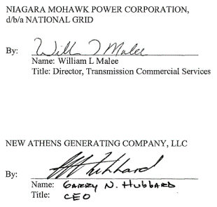

EXHIBIT A

System Impact Study for the Special Protection System for the Athens Power Plant” report dated
October 16, 2006

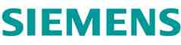

R64-06

System Impact Study for the Special
Protection System for the Athens Power
Plant

Prepared for
New Athens Generation Company,
LLC

Submitted by:
James W. Feltes, Senior Manager
Xiaokang Xu, Senior Staff Consultant Lengcheng Huang, Consultant

October 16, 2006

Siemens PTI Project P/21-113051

Siemens Power Transmission & Distribution, Inc. Power Technologies International
1482 Erie Boulevard • P.O. Box 1058
Schenectady, New York 12301-1058 US
Tel: 518-395-5000 • Fax: 518-346-2777
www.usa.siemens.com/PTI

This page intentionally left blank.

Contents

Legal Notice iii

Executive Summary v

Section 1 Introduction 1-1

Section 2 Project Discription and Study Data 2-1
2.1 Project Description 2-1
2.2 Load Flow Data 2-2
2.3 Dynamic Simulation Data 2-2

Section 3 Criteria, Methodology, Assumptions 3-1
3.1 Study Scope 3-1
3.2 Study Area 3-1
3.3 Methodology 3-1
3.4 Study Cases 3-2
3.5 Assumptions 3-2

Section 4 Power Flow Analysis 4-1
4.1 Analysis of the System Condition Following SPS Operation 4-1
4.2 Analysis of Voltage Constraints 4-9

Section 5 Impact on Transfer Limits 5-1
5.1 Thermal Analysis 5-1
5.1.1 Methodology 5-1
5.1.2 Criteria 5-1
5.1.3 Model Development 5-2
5.1.4 Results 5-2
5.2 Voltage Analysis 5-2
5.2.1 Methodology 5-2
5.2.2 Criteria 5-3
5.2.3 Model Development 5-4

Siemens Power Transmission & Distribution, Inc.
Power Technologies International i

Contents

5.2.4 Results 5-4
5.3 Stability Analysis 5-7
5.3.1 Methodology 5-7
5.3.2 Criteria 5-7
5.3.3 Model Development 5-8
5.3.4 Results 5-8

Section 6 Extreme Contingency Analysis 6-1

Section 7 SPS Misoperation and Failed Operation Analysis 7-1
7.1 SPS Misoperation 7-1
7.2 Failure of the SPS to Operate 7-11
7.3 Potential for Interaction with Other Existing New York Special Protection Systems7-11

Section 8 SPS Type Analysis 8-1

Section 9 Conclusions 9-1

Appendix A SIS Scope A-1

Appendix B Results of Analysis of Voltage Constraints B-1

Appendix C Detailed Results of Thermal Transfer Limit Analysis C-1
C.1 Benchmark Case without SPS C-1
C.2 Case with SPS C-2

Appendix D Stability Simulation Plots D-1
D.1 Case A (Benchmark Case without the SPS, UPNY-Con Ed Transfer at 4032 MW)D-2
D.2 Case B0 (Case with the SPS, UPNY-Con Ed Transfer at 4330 MW) D-25
D.3 Case B (Case with the SPS, UPNY-Con Ed Transfer at 4550 MW) D-48

Siemens Power Transmission & Distribution, Inc.
ii Power Technologies International

Legal Notice

This document was prepared by Siemens Power Transmission & Distribution, Inc., Power Technologies International (Siemens PTI), solely for the benefit of New Athens Generation Company, LLC. Neither Siemens PTI, nor parent corporation or its or their affiliates, nor New Athens Generation Company, LLC, nor any person acting in their behalf (a) makes any
warranty, expressed or implied, with respect to the use of any information or methods
disclosed in this document; or (b) assumes any liability with respect to the use of any
information or methods disclosed in this document.
Any recipient of this document, by their acceptance or use of this document, releases
Siemens PTI, its parent corporation and its and their affiliates, and New Athens Generation Company, LLC from any liability for direct, indirect, consequential or special loss or damage whether arising in contract, warranty, express or implied, tort or otherwise, and irrespective of fault, negligence, and strict liability.

Siemens Power Transmission & Distribution, Inc.
Power Technologies International iii

Legal Notice

This page intentionally left blank.

Siemens Power Transmission & Distribution, Inc.
iv Power Technologies International

Executive Summary

New Athens Generating Company (“Athens”) is proposing to install a Special Protection
System (SPS) and other system reinforcements to reduce the frequency of Athens
curtailments by the NYISO due to system constraints during transmission system peak power flow conditions. Athens proposes to allow the NYISO to secure the jointly owned National
Grid and Con-Edison Leeds-Pleasant Valley transmission lines (Lines 91 and 92 ) for loss of one or the other, with the subsequent rejection of its Athens’ generating facility and
subsequent NYISO’s control area re-dispatch. As such, the SPS would require an exception to the NYSRC Reliability Rules. Athens further proposes an SPS that will allow the
generation rejection to be completed within a two minute time frame following an initiating
event. The planned in-service date of the SPS is 2007.
The SPS will be operational only during periods of heavy transfer across the UPNY-Con Ed
interface. The operation of the SPS will allow post-contingency loading of either the Leeds to
Pleasant Valley or Athens to Pleasant Valley 345 kV lines (Lines 91 and 92) up to their STE
ratings for outage of the other line. Generation at Athens will be automatically tripped to
reduce the flow on the remaining circuit to less than its LTE rating. Under worst case
conditions, this will require trip of two combined cycle trains (one gas turbine and one steam
turbine each) with a full load value of 720 MW. Trip of two combined cycle trains may not be
required under other conditions.
Siemens Power Transmission & Distribution, Inc., Power Technologies International
(Siemens PTI) has performed a System Impact Study (SIS) for the SPS for the Athens Power Plant. The purpose of the SIS is to demonstrate the improvement in the UPNY-Con Ed
interface transfer capability that would result from the installation and operation of the SPS and other possible associated mitigative measures such as the installation of shunt capacitive compensation at one or more Con Edison substations.
NYISO provided a PSS™E power flow base case representing the summer peak operating conditions for 2006 and used for RNA analysis, and a separate power flow base case for stability simulations and corresponding set of stability setup files. NYISO also provided a full contingency list, a subsystem file and a monitor file for thermal analysis.
The base case models the Athens Power Plant dispatched with two combine cycle trains (one gas turbine and one steam turbine each) on at a total power output of 700 MW. This case is referred to as the Benchmark Case without SPS.
Siemens PTI developed a case with the SPS. In this case, Athens was increased to its full
capacity i.e., 1080 MW in three combine cycle trains, to increase flow on the Athens-Pleasant Valley and Leeds-Pleasant Valley (Lines 91 and 92) path. The additional Athens generation was dispatched against existing units in Con Ed.
For stability simulations, flow on the UPNY-Con Ed interface was further stressed to 11% higher than its transfer limit determined in the steady-state analysis in both the Benchmark Case without the SPS and the Case with the SPS.

Siemens Power Transmission & Distribution, Inc.
Power Technologies International v

Executive Summary

The study shows that the SPS is effective. With the SPS, the transfer across the UPNY-Con Ed Interface can be increased by 466 MW while abiding by applicable reliability rules and
criteria. This allows the Athens plant to be dispatched at full capacity, i.e., 1080 MW, during peak load conditions.
The operation without and with the SPS was analyzed using thermal, voltage and stability
analysis. The thermal analysis shows that with Athens dispatched at full capacity and the
SPS, the UPNY-Con Ed thermal transfer limit is increased by 466 MW, from 3633 MW to
4099 MW. Both without and with the SPS, the transfer is limited by flow on the Leeds to
Pleasant Valley 345 kV line due to loss of the Athens to Pleasant Valley 345 kV line. Without
the SPS, the post-contingency flow is limited to the line’s LTE rating of 1538 MW while the
SPS increases the allowable post-contingency flow to the line’s STE rating of 1724 MW. The
operation of the SPS reduces the line flow to below the LTE rating within a period of two
minutes.
The thermal transfer limit on the UPNY-SENY interface was also analyzed. The analysis
shows that with Athens dispatched at full capacity and the SPS, the UPNY-SENY thermal
transfer limit is increased by 466 MW, from 4502 MW to 4968 MW. Both without and with the SPS, the limiting element is the same as that for the UPNY-Con Ed interface.
The voltage analysis indicated that transfer across the UPNY-Con Ed interface would be
limited by the pre-contingency voltage limit of 348 kV at four lower Hudson Valley 345 kV
buses. Therefore a 240 MVAr capacitor bank was modeled at Millwood which is sufficient to maintain the steady-state pre-contingency voltage at these stations above 348 kV. Millwood was selected as the potential location for the capacitor back due to concerns that space may be limited in other possible stations.
The voltage contingency analysis indicated that with Athens dispatched at full capacity and the SPS in-service, there was no significant incremental impact on bulk system voltages compared to operation without the SPS. The voltages on several 115 kV buses decreased by less than 1% under certain contingencies.
Two contingencies may trigger the SPS, loss of the Athens to Pleasant Valley 345 kV (Line 91) and the Leeds to Pleasant Valley 345 kV line (Line 92). The loss of Line 91 is slightly more severe. For the peak load level and system dispatch modeled in the power flow case supplied by the NYISO, this contingency would require the trip of two Athens combined cycle trains, for a total of 720 MW. The loading on Line 92 after this contingency and SPS
operation would be 1520 MW, lower than the LTE rating of 1538 MW.
The P-V analysis showed that with Athens dispatched at full capacity and the SPS, the
voltage-based UPNY-Con Ed transfer limit is increased by 245 MW. The voltage-based
transfer limits for both without and with the SPS are higher than the respective thermal limits, as follows:

Siemens Power Transmission & Distribution, Inc.
vi Power Technologies International

Executive Summary

Case Case
UPNY-Con Ed Transfer Without SPS With SPS Change
Pre-Contingency Low 3880^{A} 4125^{A} 245
Post-Contingency Low 4279^{B} 4383^{B} 104
95% Voltage Collapse (5% MW 4092^{C} 4190^{C} 98
Margin)
Voltage-Based Transfer Limit 3880^{A} 4125^{C} 245
Thermal Transfer Limit 3633^{D} 4099E 466
A Pre-contingency voltage at Dunwoodie 345 kV
B Post-contingency voltage at Pleasant Valley 345 kV for loss of tower Coopers Corners-Rock Tavern 34/42
C 95% of voltage collapse criteria limit for loss of tower Coopers Corners-Rock Tavern 34/42
D Limited by Leeds - Pleasant Valley 345 kV (LTE: 1538 MW) for loss of Athens-Pleasant Valley 345 kV
E Limited by Leeds - Pleasant Valley 345 kV (STE: 1724 MW) for loss of Athens-Pleasant Valley 345 kV

Stability analysis was performed. All stability simulations exhibited a stable response with positive damping. Stability is thus not the limiting constraint on the transfer level on the UPNY-Con Ed interface either without or with the SPS.
The extreme contingency analysis demonstrates that the case with SPS shows incremental overload and voltage impacts on several 115 kV facilities. Additionally, for the case with the SPS, the loss of the Right-of-Way of Lines 91 & 92 would overload the Leeds to Hurley 345 kV line by 1%. There are no widespread overloads or voltage violations found on the bulk power system under the extreme contingencies tested.
The analysis demonstrates that misoperation of the SPS will not result in severe system
problems or widespread effects on the system, that is, it does not cause a significant adverse impact outside of the local area.
Failure of the SPS to operate under maximum transfer conditions would result in Line 91 or
92 being loaded above its LTE rating following the outage of the other, but below its STE
rating. For the peak condition analyzed, all other elements are within post-contingency limits. Since the STE rating is a 15 minute rating, there is ample time for manual operator action to either manually trip generation at Athens or perform other actions.
The study results demonstrate that the misoperation or failed operation of this SPS would not have a significant adverse impact outside of the local area, that is, there are no widespread
overloads or voltage violations found outside the local area. Thus the SPS should be
classified as a Type III SPS according to the NPCC Special Protection System Criteria
(NPCC Document A-11).
The NYISO will calculate the actual Transmission Congestion Contracts (TCCs) awarded as a result of this proposed SPS. However, the results of this SIS indicate a potential TCC
award estimate of 466 MW for the Athens' SPS.

Siemens Power Transmission & Distribution, Inc.
Power Technologies International vii

Executive Summary

This page intentionally left blank.

Siemens Power Transmission & Distribution, Inc.
viii Power Technologies International

Section
1
Introduction
New Athens Generating Company (“Athens”) is proposing to install a Special Protection
system (SPS) and other system reinforcements to reduce the frequency of Athens
curtailments by the NYISO due to system constraints during transmission system peak power flow conditions. Athens proposes to allow the NYISO to secure the jointly owned National
Grid and Con-Edison Leeds-Pleasant Valley transmission lines (Lines 91 and 92 ) for loss of one or the other, with the subsequent rejection of its Athens’ generating facility and
subsequent NYISO’s control area re-dispatch. As such, the SPS would require an exception to the NYSRC Reliability Rules. Athens further proposes an SPS that will allow the
generation rejection to be completed within a two minute time frame following an initiating
event. The planned in-service date of the SPS is 2007.
Siemens Power Transmission & Distribution, Inc., Power Technologies International
(Siemens PTI) has performed a System Impact Study (SIS) for the SPS for the Athens Power
Plant. The purpose of the SIS is to demonstrate the improvement in the UPNY-Con Ed
interface transfer capability that would result from the installation and operation of the SPS
and other possible associated mitigative measures such as the installation of shunt capacitive
compensation at one or more Con Edison substations. The objectives of the SIS are to:
1. Analyze the thermal transfer limit on the UPNY-Con Ed Interface and the UPNY-
SENY Interface, without and with the SPS.
2. Analyze voltage constraints on the transfer limit on the UPNY-Con Ed Interface,
without and with the SPS.
3. Conduct P-V analysis on the UPNY-Con Ed interface, without and with the SPS.
4. Evaluate the effectiveness of the SPS under extreme contingencies.
5. Analyze the type and the effect of misoperation or failed operation of the SPS.
The SIS was performed using Siemens PTI’s proprietary, commercial software PSS™E and
PSS™MUST, in accordance with the requirements of the NYISO Open Access Transmission
Tariff Sections 19.1 through 19.3 and Attachment D as well as applicable NPCC, NYSRC,
NYISO and Transmission Owner’s (TO) reliability criteria, rules and design standards.
The Scope of the SIS was approved by the NYISO Operating Committee on October 12, 2006 and is included in Appendix A of this report.

Siemens Power Transmission & Distribution, Inc.
Power Technologies International 1-1

Introduction

This page intentionally left blank.

Siemens Power Transmission & Distribution, Inc.
1-2 Power Technologies International

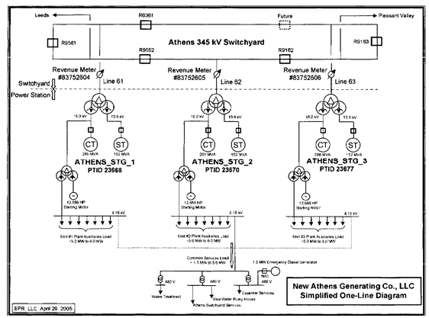

Section
2
Project Discription and Study Data

2.1 Project Description
The Athens Power Plant (“Athens”) is comprised of three combined cycle trains (GT/CT sets) with a total capacity of 1080 MW. A one-line of the power system in the area of the Athens plant is shown in Figure 1-1. The proposed SPS will be operational only during periods of
heavy transfer across the UPNY-Con Ed interface. The operation of the SPS will allow postcontingency loading of either the Leeds to Pleasant Valley or Athens to Pleasant Valley 345 kV lines (Lines 91 and 92) up to their STE ratings for outage of the other line. Generation at Athens will be automatically tripped to reduce the flow on the remaining circuit to less than its LTE rating. Under worst case conditions, this will require trip of two combined cycle trains
(one gas turbine and one steam turbine each) with a full load value of 720 MW. Trip of two combined cycle trains may not be required under other conditions.

Figure 2-1: One-Line Diagram of Athens Plant

Siemens Power Transmission & Distribution, Inc.
Power Technologies International 2-1

Project Discription and Study Data

2.2 Load Flow Data
NYISO provided a PSS™E power flow base case representing the summer peak operating conditions for 2006 and used for RNA analysis. NYISO also provided a full contingency list and a subsystem file and monitor file for thermal analysis.
The base case models Athens dispatched with two GT/CT sets on at a total power output of 700 MW. This case is referred to as the Benchmark Case without SPS.
Siemens PTI developed a case with the SPS. In this case, Athens was increased to its full
capacity i.e., 1080 MW, to increase flow on the Athens-Pleasant Valley and Leeds-Pleasant
Valley (Lines 91 and 92) path. The additional Athens generation was dispatched against
existing units in Con Ed. In setting up this case, tap settings of phase angle regulators and
autotransformers were adjusted, within their capabilities, to regulate power flow and voltage.
Similarly, switched shunt capacitors and reactors were allowed to regulate voltage.
Additionally, the Leeds SVC, Frasier SVC and Marcy FACTS device were held near zero
output.

2.3 Dynamic Simulation Data
NYISO provided a separate power flow base case for stability simulations and a set of
stability setup files. In this power flow case, Athens was dispatched at 800 MW on three
CT/GT sets. For consistency with the case used in steady-state analysis, Siemens PTI
reduced the dispatch of the Athens plant from 800 MW to 700 MW on two CT/GT sets. The MW reduction was balanced by units in Ontario. This case is referred to as the Benchmark Case without SPS.
Siemens PTI developed a stability power flow case with the SPS using the same approach
as that in Section 2.1. In this case, Athens was increased to its full capacity i.e., 1080 MW, to
increase flow on the Athens-Pleasant Valley and Leeds-Pleasant Valley (Lines 91 and 92)
path. The additional Athens generation was dispatched against existing units in Con Ed.
In both cases, flow on the UPNY-Con Ed interface was stressed to 11% higher than its transfer limit determined in the steady-state analysis. Details of the stressed cases are discussed in detail in Section 5.
The dynamic model for stability simulation was obtained from the NYISO stability database and setup files.

Siemens Power Transmission & Distribution, Inc.
2-2 Power Technologies International

Section
3
Criteria, Methodology, Assumptions

3.1 Study Scope
The scope of the SRIS, which is included in Appendix A, was approved by the NYISO Operating Committee on October 12, 2006.

3.2 Study Area
The study area focused on the Bulk Power System in South-Eastern New York between Albany and New York City, and voltages underlying systems at 115 kV and above in the lower Hudson Valley (Zones G, H & I).
In the PSS™E power flow base case provided by NYISO, facilities rated at 115 kV and
above in PSS™E designated areas 6 through 11 are monitored in the study. These areas
are:
• Capital District
• Hudson
• Millwood
• Dunwoodie
• Con Ed
• Long Island
3.3 Methodology
NYISO provided a PSS™E power flow base case representing the summer peak operating conditions for 2006 and used for RNA analysis. The base case models Athens dispatched with two GT/CT sets on at a total power output of 700 MW. This case is referred to as the Benchmark Case without SPS. Siemens PTI developed a case with the SPS. In this case, Athens was increased to its full capacity i.e., 1080 MW in three combine cycle trains, to
increase flow on the Athens-Pleasant Valley and Leeds-Pleasant Valley (Lines 91 and 92) path. Steady state and stability analyses were performed to develop a comparative
assessment of the system state without and with the SPS. The following analyses were conducted and are further described in later sections of the report:
Power flow and contingency analyses to assess and compare branch loadings and
bus voltages in the study area for the cases without and with the SPS.
Stability analysis to determine system performance within the study area for the
cases without and with the SPS.

Siemens Power Transmission & Distribution, Inc.
Power Technologies International 3-1

Criteria, Methodology, Assumptions

Transfer limit analysis to determine thermal and voltage transfer limits of the UPNY-
Con Ed and UPNY-SENY interfaces for the cases without and with the SPS.
Extreme contingency assessment to evaluate the system performance within the
study area under representative extreme contingencies for the cases without and with the SPS.
Evaluation of the type and the effect of misoperation or failed operation of the SPS.

3.4 Study Cases
The analysis summarized in this report used the power flow cases described below. When
setting up the cases, tap settings of phase angle regulators and autotransformers were
adjusted, within their capabilities, to regulate power flow and voltage. Similarly, switched
shunt capacitors and reactors were switched were allowed to regulate voltage. Additionally,
the Leeds SVC, Frasier SVC and Marcy FACTS device were held near zero output.
The effectiveness of the SPS has been evaluated for summer peak load for two base system conditions described below.
Case 1 - Benchmark Case without the SPS. In this case, Athens was dispatched with two GT/CT sets on at a total power output of 700 MW.
Case 2 - Case 1 with the SPS modeled. In this case, Athens was increased to its full
capacity i.e., 1080 MW in three combine cycle trains to increase flow on the Athens-Pleasant Valley and Leeds-Pleasant Valley (Lines 91 and 92) path. Additionally, a 240 MVAr capacitor bank was added to maintain the voltages at the Pleasant Valley, Millwood, Sprain Brook and Dunwoodie stations above below 348 kV (a recently updated pre-contingency low voltage
limit for these stations).
It is noted that Dunwoodie has the lowest voltage in the base case with the SPS. The
capacitor bank could be installed at Dunwoodie or Sprain Brook but there are concerns that
space may be limited in those two stations. Therefore, Millwood was chosen to be the
installation location and the capacitor bank size was installed to maintain the steady-state
pre-contingency voltage at the four stations above 348 kV while keeping the Athens
generator scheduled voltage 1.04 pu as modeled in the Benchmark case without the SPS.

3.5 Assumptions
Generation redispatch for transfers are performed according to the standard proportions used
in NYISO operating studies. Athens will be dispatched at full output for the case with the
SPS.
Phase angle regulators (PARs) are modeled according to the standard NYISO practice for operating studies as regulating pre-contingency and free-flowing, post-contingency.

The Leeds SVC, Frasier SVC and Marcy FACTS device are set to zero pre-contingency and allowed to operate to full range post-contingency.

Siemens Power Transmission & Distribution, Inc.
3-2 Power Technologies International

Section
4
Power Flow Analysis

4.1 Analysis of the System Condition Following SPS Operation
The operation of the SPS will allow post-contingency loading of either the Leeds to Pleasant Valley or Athens to Pleasant Valley 345 kV lines (Lines 91 and 92) up to their STE ratings for outage of the other line. The system condition following SPS operation can be illustrated by comparing load flow results representing two conditions:
1. Operation without the SPS (Benchmark Case without SPS). This is the base case
supplied by the NYISO and has Athens dispatched at 700 MW
2. Operation with the SPS (Case with SPS). This case has Athens dispatched at 1080
MW, and other changes as described below.
In the case with the SPS, the redispatch performed to increase flow on the Athens-Pleasant
Valley and Leeds-Pleasant Valley (Lines 91 and 92) path to determine the thermal transfer
limit first increased Athens to full power output. The subsequent generation shifts were
performed from Ontario to Con Ed to increase the transfer level on the interface concerned.
The generation shifts are show in Table 4-1. In addition, the SPS permits the allowable post
contingency loading on the 91/92 lines to go to STE. All other lines use their standard (LTE)
post-contingency ratings.
A 240 MVAr capacitor bank was added at the Millwood 345 kV bus in the case with the SPS.
Without this capacitor bank, the voltages at the Pleasant Valley, Millwood, Sprain Brook and
Dunwoodie stations are below 348 kV (a recently updated pre-contingency low voltage limit
for these stations). Dunwoodie has the lowest voltage. The capacitor bank could be installed
at Dunwoodie or Sprain Brook but there are concerns that space may be limited in those two
stations. Therefore, Millwood was chosen to be the installation location and the capacitor
bank size was installed to maintain the steady-state pre-contingency voltage at the four stations above 348 kV while keeping the Athens generator scheduled voltage 1.04 pu as modeled in the Benchmark case without the SPS.
Table 4-2 shows power transfer levels on the NYISO interfaces of UPNY-Con Ed, UPNY-
SENY, Central East and Total East, for the Benchmark Case without SPS and the Case with
SPS.

Siemens Power Transmission & Distribution, Inc.
Power Technologies International 4-1

Power Flow Analysis

Table 4-1: Generation Shifts for Thermal Transfer Limits
Increase Athens Generation from 700 MW to 1080 MW
Case w/ Case w/o
SPS SPS
Bus (Step 1) Change
Number Bus Name (MW) (MW) (MW)
78706 [ATHENSC116.0] 250 239.8 10.2
78707 [ATHENSS113.8] 110 110.2 -0.2
78708 [ATHENSC216.0] 250 243.1 6.9
78709 [ATHENSS213.8] 110 106.9 3.1
78710 [ATHENSC316.0] 250 0 250
78711 [ATHENSS313.8] 110 0 110
74705 [AST 4 20.0] 250 350 -100
74706 [AST 5 20.0] 243 333 -90
74707 [RAV 1 20.0] 240 330 -90
74907 [NRTPTG2 22.0] 268 368 -100
Additional Generation Shifts from Ontario to Downstate NY
Case w/ Case w/
SPS SPS
Bus (Step 2) (Step 1) Change
Number Bus Name (MW) (MW) (MW)
74705 [AST 4 20.0] 210 250 -40
74706 [AST 5 20.0] 223 243 -20
74707 [RAV 1 20.0] 220 240 -20
74907 [NRTPTG2 22.0] 248 268 -20
81425 [LENNOXG420.0] 145 125 20
81767 [NANTICG422.0] 495 475 20
81769 [NANTICG222.0] 495 475 20
81770 [NANTICG122.0] 252 232 20
81771 [NANTICG822.0] 495 475 20
Step 1: Perform generation shifts by dispatching Athens at full capacity.
Step 2: With Athens at full capacity, perform additional generation shifts.

Table 4-2: Power Transfers Across NYISO Interfaces in the Base Cases (MW)

Case Case
Interface Without SPS With SPS
UPNY-Con Ed 3630 4096
UPNY-SENY 4507 4974
Central East 2398 2423
Total East 4297 4410

Siemens Power Transmission & Distribution, Inc.
4-2 Power Technologies International

Power Flow Analysis

The steady state condition following the operation of the SPS was calculated for two contingencies that may trigger it, i.e.:
1. Loss of Line 91
2. Loss of Line 92
Loss of Line 95 would not cause the loadings on Lines 91 & 92 (1080 MW and 1244 MW
respectively) to exceed the LTE rating of 1538 MW and therefore would not trigger the SPS.
Loss of Line 92 would increase the flow on Line 91 to 1693 MW which is higher than the LTE
rating of 1538 MW but lower than the STE rating of 1724 MW. However, the worst
contingency is loss of Line 91, which would increase the flow on Line 92 to its STE rating
1724 MW. This contingency requires rejecting two Athens generation trains, for a total of 720
MW. The loading of Line 92 after this contingency and rejection of 720 MW is 1520 MW,
which is lower than the LTE rating of 1538 MW. Tripping only one set and 300 MW from the
second set (total 660 MW), the loading of Line 92 is 1538.2 MW, or basically at the LTE
rating. This calculation is based on the load flow case where the UPNY-Con Ed interface
value is initially at the thermal limit, about 4099 MW as determined in the thermal analysis
described in Section 5. The calculation uses an inertial redispatch to replace the lost Athens
generation and LTC transformer taps, phase shifters, and switched shunts are held at their
pre-contingency settings, per NYISO practice. All other line flows and bus voltages are within
their respective post-contingency limits.
Figures 4-1 to 4-5 show flows on Lines 91, 92 & 95, the Athens generation dispatches and
some of the surrounding system, without and with the SPS under normal and contingency
conditions:
Figure 4-1: Benchmark Case without SPS
Figure 4-2: Benchmark Case Following Line 91 Contingency Figure 4-3: Case with SPS, All Equipment In-Service
Figure 4-4: Case with SPS Following Line 91 Contingency but before SPS Operation Figure 4-5: Case with SPS Following Line 91 Contingency and SPS Operation
In similar manner, rejection of two Athens generation trains for a total of 720 MW would also bring the flow on Line 91 back below its LTE ratings following the loss of Line 92.

Siemens Power Transmission & Distribution, Inc.
Power Technologies International 4-3

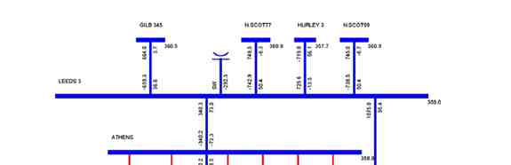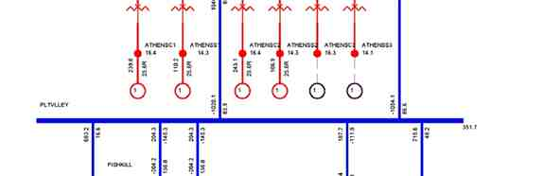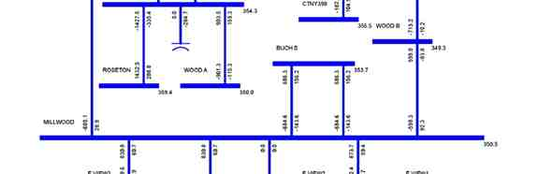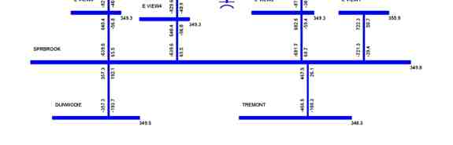

Power Flow Analysis

Figure 4-1: Benchmark Case without SPS

Siemens Power Transmission & Distribution, Inc.
4-4 Power Technologies International

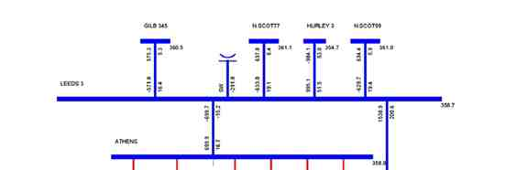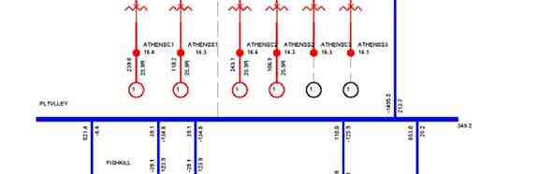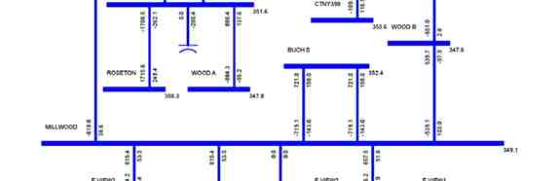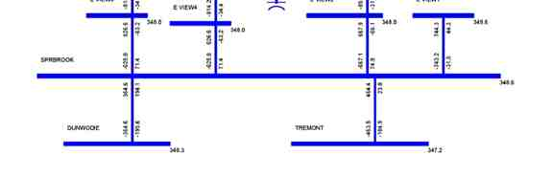

Power Flow Analysis

Figure 4-2: Benchmark Case Following Line 91 Contingency

Siemens Power Transmission & Distribution, Inc.
Power Technologies International 4-5

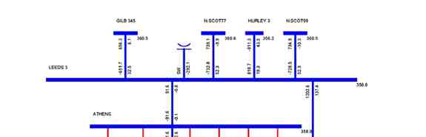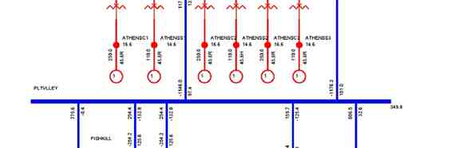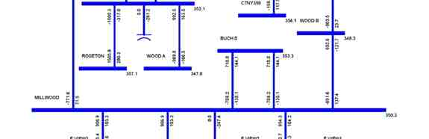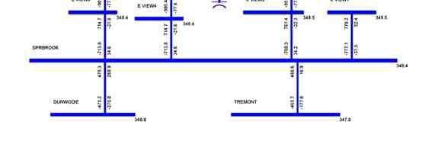

Power Flow Analysis

Figure 4-3: Case with SPS, All Equipment In-Service

Siemens Power Transmission & Distribution, Inc.
4-6 Power Technologies International

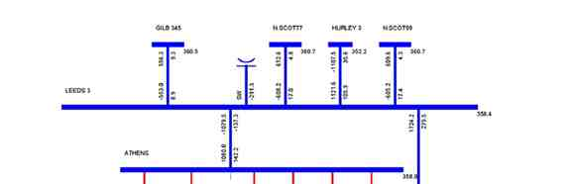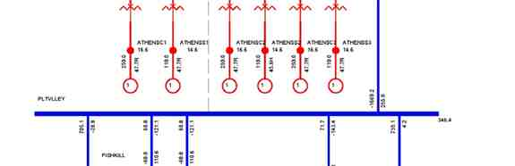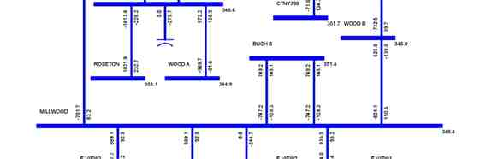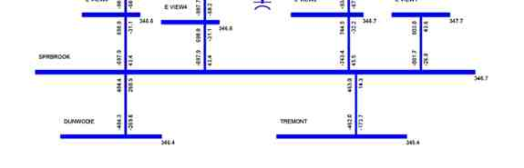

Power Flow Analysis

Figure 4-4: Case with SPS Following Line 91 Contingency but before SPS Operation

Siemens Power Transmission & Distribution, Inc.
Power Technologies International 4-7

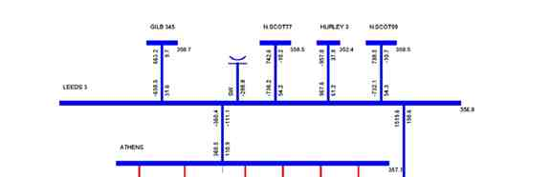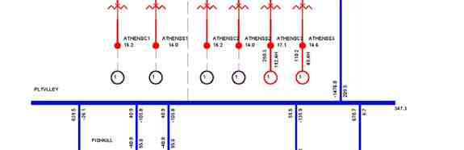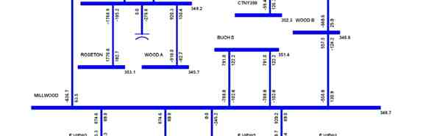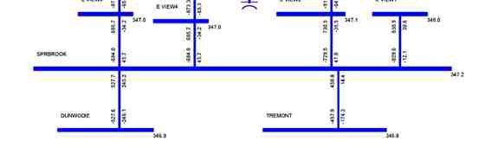

Power Flow Analysis

Figure 4-5: Case with SPS Following Line 91 Contingency and SPS Operation

Siemens Power Transmission & Distribution, Inc.
4-8 Power Technologies International

Power Flow Analysis

4.2 Analysis of Voltage Constraints
Voltage contingency analysis was performed for the Benchmark Case without the SPS and
the Case with the SPS with the UPNY-Con Ed interface at the normal thermal transfer limit,
i.e., 3633 MW and 4099 MW respectively, as determined in the thermal analysis described in
Section 5. The Case with the SPS has a 240 MVAR capacitor bank added at Millwood as
described above.
The full contingency set provided by the NYISO were simulated and bus voltages were
monitored for violations of the limits in Exhibit A-3 of the NYISO Emergency Operation
Manual and for bus voltages on the 115 kV system in the Lower Hudson area less than 95%
of nominal. Taps and phase shifter positions were fixed for the post-contingency calculation.
The Leeds and Fraser SVCs and Marcy FACTS devices are held at or near zero output in
the pre-contingency power flows, but are allowed to regulate voltage, within their capabilities, in the post-contingency power flows.
The detailed voltage analysis results are included in Appendix B. It is noted that with Athens dispatched at full capacity and the SPS, the voltages of several 115 kV buses decrease by less than 1%. The case with the SPS does not have significant incremental impact on the voltage at any other bus.

Siemens Power Transmission & Distribution, Inc.
Power Technologies International 4-9

Power Flow Analysis

This page intentionally left blank.

Siemens Power Transmission & Distribution, Inc.
4-10 Power Technologies International

Section
5
Impact on Transfer Limits
Transfer limit analysis was performed to determine and compare thermal, voltage and
stability limits of the UPNY-Con Ed and UPNY-SENY interfaces for the cases without and
with the SPS. Analysis of the UPNY-SENY interface is limited to thermal conditions only.
This analysis was performed for the summer peak condition per the SIS scope.

5.1 Thermal Analysis

5.1.1 Methodology
Thermal analysis was performed using the PSS™E subsystem, contingency and monitor
files provided by the NYISO, to determine the incremental impact of the SPS on the normal
transfer limit of the UPNY-Con Ed and UPNY-SENY interfaces. The full contingency set, as
supplied by the NYISO, was used in the analysis. The normal transfer limit of the UPNY -
Con Ed and UPNY-SENY interfaces was determined for the following two cases:
1. Case without SPS (Benchmark) with Athens dispatched at 700 MW
2. Case with SPS with Athens dispatched at 1080 MW
The redispatch performed to increase flow on the Athens-Pleasant Valley and Leeds-
Pleasant Valley (Lines 91 and 92) path to determine the thermal transfer limit first increased Athens to full power output with subsequent generation shifts from Ontario to Con Ed to increase the transfer level on the interface concerned as shown in Table 4-1. The SPS
permits the allowable post contingency loading on the 91/92 lines to go to STE. All other lines use their standard (LTE) post-contingency ratings.

5.1.2 Criteria
In accordance with NPCC criteria and NYSRC Reliability rules, several types of contingencies were simulated for this analysis:
1. Opening of lines connected between buses with base voltage greater than 100 kV
2. Multiple element
3. Generator
4. Common structure
5. HVDC
6. Stuck circuit breaker

Siemens Power Transmission & Distribution, Inc.
Power Technologies International 5-1

Impact on Transfer Limits

Phase angle regulators maintain scheduled power flow in pre-contingency conditions but are fixed at pre-contingency angle in post-contingency conditions.
The normal transfer limit is the transfer level at which:
a branch has reached its normal rating for pre-contingency conditions, or
a branch has reached its LTE rating following a contingency, except that the SPS will
allow post-contingency loading of either the Leeds to Pleasant Valley or Athens to
Pleasant Valley 345 kV lines (Lines 91 and 92) up to their STE ratings for outage of
the other line.

5.1.3 Model Development
Thermal transfer limits were calculated for summer peak load conditions without and with the
SPS. The cases without the SPS (Case 1) and with the SPS (Case 2) are described in
Section 3.4.

5.1.4 Results
Normal thermal transfer limits are summarized in Table 5-1. The detailed results are included in Appendix C.

It is noted from the table that the operation of the SPS increases UPNY-Con Ed and UPNYSENY thermal transfer limits by 466 MW respectively.

Table 5-1: Thermal Normal Transfer Limits (MW)

Case Case
Interface Without SPS With SPS Change
UPNY-Con Ed 3633^{A} 4099^{B} 466
UPNY-SENY 4502^{A} 4968^{B} 466
A Limited by Leeds - Pleasant Valley 345 kV (LTE: 1538 MW) for loss of Athens-Pleasant Valley 345 kV
B Limited by Leeds - Pleasant Valley 345 kV (STE: 1724 MW) for loss of Athens-Pleasant Valley 345 kV

5.2 Voltage Analysis

5.2.1 Methodology
Voltage transfer limit analysis (or P-V analysis) was performed for the UPNY-Con Ed
interface. Voltage-constrained limits were evaluated in accordance with the NYISO
Transmission Planning Guideline #2-0 and with consideration of the voltage criteria in Exhibit A-3 of the NYISO Emergency Operation Manual.

P-V curves were produced to examine the UPNY-Con Ed power transfers versus voltage at the New Scotland, Leeds, Pleasant Valley, Millwood, Dunwoodie and Sprainbrook 345kV stations for the two cases:
1. Case without SPS (Benchmark) with Athens dispatched at 700 MW

Siemens Power Transmission & Distribution, Inc.
5-2 Power Technologies International

Impact on Transfer Limits

2. Case with SPS with Athens dispatched at 1080 MW and a 240 MVAr capacitor bank
installed at Millwood

A series of power flow cases were created with increasing transfer levels on Leeds -
Pleasant Valley using generation shifts similar to those used for the thermal analysis.
Contingencies were simulated on each case to identify violations of the voltage criteria.

5.2.2 Criteria
Per the SIS scope, the following contingencies were simulated on each case to identify violations of the voltage criteria:
Leeds - Athens #95
Athens - Pleasant Valley #91 Leeds - Pleasant Valley #92 Leeds - Hurley #301
New Scotland - Leeds #93 (or #94)

(Tower) Coopers Corners - Rock Tavern 34 and 42

The voltage criteria use the limits in Exhibit A-3 of the NYISO Emergency Operation Manual
with the following 345 kV stations using an updated limit of 348 kV as a pre-contingency low
voltage limit:
Pleasant Valley Millwood
Sprain Brook
Dunwoodie
Tap settings of phase angle regulators and autotransformers are adjusted (within their
capabilities) to regulate power flow and voltage in the pre-contingency power flows but are fixed at their corresponding pre-contingency settings in the post-contingency power flows. Similarly, switched shunt capacitors and reactors are switched according to their defined
setup in the pre-contingency power flows but are held at their corresponding pre-contingency position in the post-contingency power flows. The reactive power of generators is regulated, within the reactive capabilities of the units, to hold scheduled voltage in both the pre-
contingency and post-contingency power flows.
In accordance with the NYISO operating practice, the Leeds and Fraser SVCs and Marcy
FACTS devices are held at or near zero output in the pre-contingency power flows, but are
allowed to regulate voltage, within their capabilities, in the post-contingency power flows.
Inertial pickup is assumed for contingencies involving a loss of generation or HVDC.
The voltage-constrained transfer limits of the UPNY-Con Ed interface are determined in
accordance with the NYISO Transmission Planning Guideline #2-0. As the transfer across
an interface is increased, the voltage-constrained transfer limit is determined as the lesser of
(a) the pre-contingency power flow at which the post contingency voltage falls below the post-

Siemens Power Transmission & Distribution, Inc.
Power Technologies International 5-3

Impact on Transfer Limits

contingency limit, or (b) 95% of the pre-contingency power flow at the "nose" of the postcontingency voltage vs. pre-contingency flow curve.

5.2.3 Model Development
Voltage transfer limits were calculated for summer peak load conditions without and with the
SPS. The cases without the Project (Case 1) and with the Project (Case 2) are described in
Section 3.4.

5.2.4 Results
Voltage transfer limits are summarized in Table 5-2. The P-V curves for the Benchmark
Case and the Case with the SPS are plotted in Figures 5-1 and 5-2. There are three potential limiting conditions:
1. Pre-contingency (base case) voltage limits
2. Post-contingency voltage limits
3. Voltage collapse (limit is 95% of the interface flow at which collapse occurs.)
For both the cases without the SPS and with the SPS, the pre-contingency voltage transfer
limit on the UPNY-Con Ed interface is the lowest, 3880 MW and 4125 MW respectively in
both cases.
Comparing with the thermal analysis results, it is noted that the voltage-based transfer limits
are higher than the corresponding thermal transfer limits on the UPNY-Con Ed interface.

Table 5-2: Approximate Voltage Transfer Limit on UPNY-Con Ed (MW)

Case Case
UPNY-Con Ed Transfer Without SPS With SPS Change
Pre-Contingency Low 3880^{A} 4125^{A} 245
Post-Contingency Low 4279^{B} 4383^{B} 104
95% Voltage Collapse (5% MW 4092^{C} 4190^{C} 98
Margin)
Voltage-Based Transfer Limit 3880^{A} 4125^{C} 245
Thermal Transfer Limit 3633^{D} 4099E 466
A Pre-contingency voltage at Dunwoodie 345 kV
B Post-contingency voltage at Pleasant Valley 345 kV for loss of tower Coopers Corners-Rock Tavern 34/42
C 95% of voltage collapse criteria limit for loss of tower Coopers Corners-Rock Tavern 34/42
D Limited by Leeds - Pleasant Valley 345 kV (LTE: 1538 MW) for loss of Athens-Pleasant Valley 345 kV
E Limited by Leeds - Pleasant Valley 345 kV (STE: 1724 MW) for loss of Athens-Pleasant Valley 345 kV

Siemens Power Transmission & Distribution, Inc.
5-4 Power Technologies International

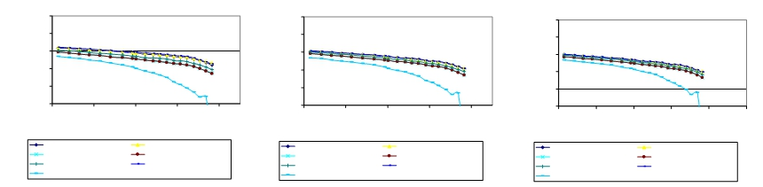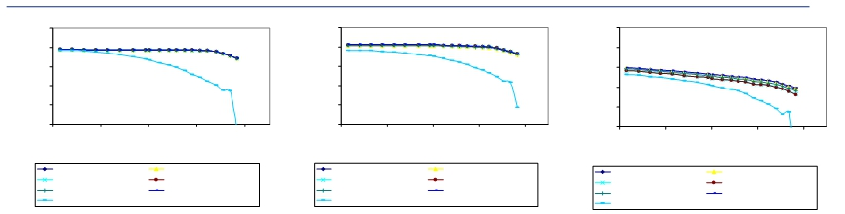

Impact on Transfer Limits

370

360

350

340

330

320
3600 3800 4000 4200 4400
UPNY-CONED MW

PRE-FAULT L/O LEEDS-ATHENS #95
L/O ATHENS-PLEASANT V. #91 L/O LEEDS-PLEASANT V. #92
L/O LEEDS-HURLEY #301 L/O N. SCOTLAND-LEEDS #93 TWR C. CORNERS-R. T. 34 & 42

370

360

350

340

330

320
3600 3800 4000 4200 4400
UPNY-CONED MW

PRE-FAULT L/O LEEDS-ATHENS #95
L/O ATHENS-PLEASANT V. #91 L/O LEEDS-PLEASANT V. #92
L/O LEEDS-HURLEY #301 L/O N. SCOTLAND-LEEDS #93 TWR C. CORNERS-R. T. 34 & 42

370

360

350

340

330

320
3600 3800 4000 4200 4400
UPNY-CONED MW

PRE-FAULT L/O LEEDS-ATHENS #95
L/O ATHENS-PLEASANT V. #91 L/O LEEDS-PLEASANT V. #92
L/O LEEDS-HURLEY #301 L/O N. SCOTLAND-LEEDS #93 TWR C. CORNERS-R. T. 34 & 42

370

360

350

340

330

320
3600 3800 4000 4200 4400
UPNY-CONED MW

PRE-FAULT L/O LEEDS-ATHENS #95
L/O ATHENS-PLEASANT V. #91 L/O LEEDS-PLEASANT V. #92
L/O LEEDS-HURLEY #301 L/O N. SCOTLAND-LEEDS #93 TWR C. CORNERS-R. T. 34 & 42

Figure 5-1: P-V Curves for the Case without SPS

370

360

350

340

330

320
3600 3800 4000 4200 4400
UPNY-CONED MW

PRE-FAULT L/O LEEDS-ATHENS #95
L/O ATHENS-PLEASANT V. #91 L/O LEEDS-PLEASANT V. #92
L/O LEEDS-HURLEY #301 L/O N. SCOTLAND-LEEDS #93 TWR C. CORNERS-R. T. 34 & 42

370

360

350

340

330

320
3600 3800 4000 4200 4400 4600
UPNY-CONED MW

PRE-FAULT L/O LEEDS-ATHENS #95
L/O ATHENS-PLEASANT V. #91 L/O LEEDS-PLEASANT V. #92
L/O LEEDS-HURLEY #301 L/O N. SCOTLAND-LEEDS #93 TWR C. CORNERS-R. T. 34 & 42

Siemens Power Transmission & Distribution, Inc.

Power Technologies International 5-5
LEEDS 345 KV VOLTAGE
PLEASANT V. 345 KV
VOLTAGE
N. SCOTLAND 345 KV
VOLTAGE
MILLWOOD 345 KV
VOLTAGE
DUNWOODIE 345 KV
VOLTAGE
SPRAINBROOK 345 KV
VOLTAGE

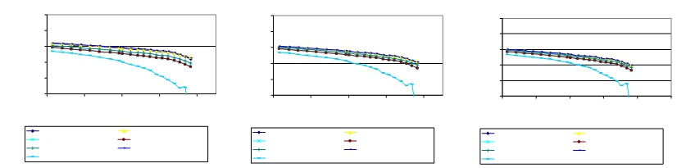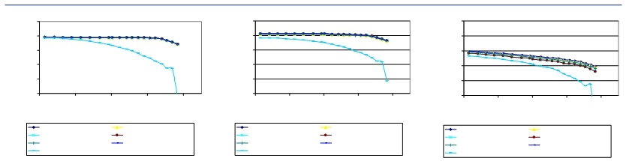

Impact on Transfer Limits

370 370 370

360 360 360

350 350 350
340 340 340

330 330 330

320 320 320
3600 3800 4000 4200 4400 3600 3800 4000 4200 4400 3600 3800 4000 4200 4400
UPNY-CONED MW UPNY-CONED MW UPNY-CONED MW

PRE-FAULT L/O LEEDS-ATHENS #95 PRE-FAULT L/O LEEDS-ATHENS #95 PRE-FAULT L/O LEEDS-ATHENS #95
L/O ATHENS-PLEASANT V. #91 L/O LEEDS-PLEASANT V. #92 L/O ATHENS-PLEASANT V. #91 L/O LEEDS-PLEASANT V. #92 L/O ATHENS-PLEASANT V. #91 L/O LEEDS-PLEASANT V. #92
L/O LEEDS-HURLEY #301 L/O N. SCOTLAND-LEEDS #93 L/O LEEDS-HURLEY #301 L/O N. SCOTLAND-LEEDS #93 L/O LEEDS-HURLEY #301 L/O N. SCOTLAND-LEEDS #93
TWR C. CORNERS-R. T. 34 & 42 TWR C. CORNERS-R. T. 34 & 42 TWR C. CORNERS-R. T. 34 & 42

370 370 370

360 360 360

350 350 350

340 340 340

330 330 330

320 320 320
3600 3800 4000 4200 4400 3600 3800 4000 4200 4400 3600 3800 4000 4200 4400 4600
UPNY-CONED MW UPNY-CONED MW UPNY-CONED MW

PRE-FAULT L/O LEEDS-ATHENS #95 PRE-FAULT L/O LEEDS-ATHENS #95 PRE-FAULT L/O LEEDS-ATHENS #95
L/O ATHENS-PLEASANT V. #91 L/O LEEDS-PLEASANT V. #92 L/O ATHENS-PLEASANT V. #91 L/O LEEDS-PLEASANT V. #92 L/O ATHENS-PLEASANT V. #91 L/O LEEDS-PLEASANT V. #92
L/O LEEDS-HURLEY #301 L/O N. SCOTLAND-LEEDS #93 L/O LEEDS-HURLEY #301 L/O N. SCOTLAND-LEEDS #93 L/O LEEDS-HURLEY #301 L/O N. SCOTLAND-LEEDS #93
TWR C. CORNERS-R. T. 34 & 42 TWR C. CORNERS-R. T. 34 & 42 TWR C. CORNERS-R. T. 34 & 42

Figure 5-2: P-V Curves for the Case with SPS

Siemens Power Transmission & Distribution, Inc.
5-6 Power Technologies International
LEEDS 345 KV VOLTAGE
PLEASANT V. 345 KV
VOLTAGE
N. SCOTLAND 345 KV
VOLTAGE
MILLWOOD 345 KV
VOLTAGE
DUNWOODIE 345 KV
VOLTAGE
SPRAINBROOK 345 KV
VOLTAGE

Impact on Transfer Limits

5.3 Stability Analysis

5.3.1 Methodology
Stability transfer limits were tested for the UPNY-Con Ed interface. Stability analysis was performed in accordance with the NYISO Transmission Planning Guideline #3-0 to confirm that the UPNY-Con Ed power transfer level is not restricted by a stability constraint due to operation of the SPS.

5.3.2 Criteria
Per the SIS scope, stability simulations were performed for the buses/substations associated
with the SPS as well as a couple of other stability tests requested. The contingencies include
three-phase faults on all 345 kV buses in the Leeds, Athens and Pleasant Valley substations
and also stuck breaker faults on each bus section. The contingencies simulated are shown in
Table 5-3.

Table 5-3: Stability Contingency List
Location Type Line Stuck Breaker Additional Equipment Lost
Leeds 3 Phase 95
3 Phase 92
3 Phase 301
3 Phase 93
1 Phase 95 R95 Capacitor Bank
1 Phase 95 R395 GL-3 to Gilboa
1 Phase 92 R92 Capacitor Bank
1 Phase 92 R9293 93 to New Scotland

Athens 3 Phase 95
3 Phase 91
1 Phase 95 R9561
1 Phase 95 R9562 Athens 2
1 Phase 91 R9163
1 Phase 91 R9162 Athens 2

Pleasant Valley 3 Phase 91
3 Phase 92
1 Phase 91 RN4
1 Phase 91 RNS4 F31/W81 to Millwood
1 Phase 92 RN5
1 Phase 92 RNS5 F30/W80 to Millwood

Ravenswood 3 Phase Loss of Ravenswood 3

Marcy South LLG Marcy-Coopers & Edic-Fraser

Siemens Power Transmission & Distribution, Inc.
Power Technologies International 5-7

Impact on Transfer Limits

5.3.3 Model Development
The contingencies shown in Table 5-3 were simulated for the cases without and with the
SPS.
1. Case without SPS (Benchmark) with Athens dispatched at 700 MW
2. Case with SPS with Athens dispatched at 1080 MW and a 240 MVAr capacitor bank
installed at Millwood
In preparing the above cases, Siemens PTI used a power flow base case provided by the
NYISO, which differed somewhat from the case used in the steady state analysis. In the
power flow case provided for stability analysis, Athens was dispatched at 800 MW on three
combined cycle trains. For consistency with the case used in steady-state analysis, Siemens
PTI reduced Athens dispatch from 800 MW to 700 MW on two combined cycle trains. The
MW reduction was balanced by units in Ontario. This case is referred to as the Benchmark
Case without SPS.
Then, Siemens PTI developed a stability power flow case with the SPS. In this case, Athens was increased to its full capacity i.e., 1080 MW, to increase flow on the Athens-Pleasant Valley and Leeds-Pleasant Valley (Lines 91 and 92) path. The additional Athens generation was dispatched against existing units in Con Ed. For consistency with the case used in
steady-state analysis, a 240 MVAR capacitor was added at Millwood.
Consistent with NYISO practice, the UPNY - Con Ed interface flow was further stressed by increasing it to 11 % higher than that determined in the steady state analysis (Table 5-1), that is, 4032 (3633*1.11) MW for the Benchmark case without SPS and 4550 MW (4099*1.11) for the case with SPS. The interface loadings were accomplished using the same generation shifts as used the steady-state analysis.
However, the load flow case with the SPS would not converge at the 4550 MW transfer level due to voltage collapse. The highest achievable UPNY-Con Ed interface flow is 4330 MW before the case fails to converge. This value is higher than the voltage-based transfer limit 4125 MW as determined in the steady-state analysis (Table 5-2).
To overcome this collapse problem, an “artificial” 350 Mvar capacitor was added at
Dunwoodie. With this capacitor, the case converges and the transfer level of 4550 MW on the UPNY-Con Ed interface is reached. This is necessary to allow for the stability analysis to be performed at the prescribed 11% higher transfer. This approach is consistent with NYISO practice (NYISO Transmission Planning Guideline #3-0).

5.3.4 Results
Stability simulations were performed on the contingencies in Table 5-3 for the three transfer
levels:

Case A: 4032 MW (111% of the transfer limit in the Benchmark case without the
SPS)
Case B0: 4330 MW (Highest achievable voltage-constrained transfer in the case with
the SPS)

Siemens Power Transmission & Distribution, Inc.
5-8 Power Technologies International

Impact on Transfer Limits

Case B: 4550 MW (111% of the transfer limit in the case with the SPS and an
“artificial” reactive compensation of 350 Mvar added at Dunwoodie)
Simulations were performed to address the two periods of interest. First, a simulation was
performed at the higher loading resulting from the presence of the SPS. Second, after it was
verified that the simulation of the contingency was stable, the post-contingency steady state
condition (using NYISO post-contingency calculation methodology) was used as the initial
condition to simulate the operation of the SPS to show the effect of the loss of generation on
the system.
All the simulated contingencies exhibited a stable response with positive damping. Stability is thus not the limiting constraint either without or with the SPS.
Figures 5-3 to 5-6 show comparative machine rotor angels at Athens, voltages at Athens and Pleasant Valley, and branch flow on Line 92 following a 3-phase fault at Athens with normal clearing and tripping of Line 91, for the three cases (4032 MW, 4330 MW and 4550 MW) during the first period of time, i.e., before the operation of the SPS.

Figures 5-7 to 5-10 show the same quantities compared for the 4330 MW and 4550 MW cases during the second period of time, i.e., after the operation of the SPS.
All other stability plots of representative machine quantities and other system quantities are included in Appendix D.

Siemens Power Transmission & Distribution, Inc.
Power Technologies International 5-9

Impact on Transfer Limits

0.0 3.0000
1.5000 4.5000

6.0000 9.0000 12.000
7.5000 10.500
TIME (SECONDS)

15.000
13.500
WED, AUG 16 2006 9:03
ATHENS RELATIVE ANGLES

Figure 5-3: CT Machine Angle at Athens Following Fault, Pre-SPS Operation

Siemens Power Transmission & Distribution, Inc.
5-10 Power Technologies International

Impact on Transfer Limits

0.0 3.0000
1.5000 4.5000

6.0000 9.0000 12.000
7.5000 10.500
TIME (SECONDS)

15.000
13.500
THU, MAY 25 2006 8:54
ATHENS 345 KV VOLTAGE

Figure 5-4: Voltage at Athens Following Fault, Pre-SPS Operation

Siemens Power Transmission & Distribution, Inc.
Power Technologies International 5-11

Impact on Transfer Limits

0.0 3.0000
1.5000 4.5000

6.0000 9.0000 12.000
7.5000 10.500
TIME (SECONDS)

15.000
13.500
THU, MAY 25 2006 8:54
PLEASANT VALLEY VOLTAGE

Figure 5-5: Voltage at Pleasant Valley Following Fault, Pre-SPS Operation

Siemens Power Transmission & Distribution, Inc.
5-12 Power Technologies International

Impact on Transfer Limits

0.0 3.0000
1.5000 4.5000

6.0000 9.0000 12.000 15.000
7.5000 10.500 13.500
TIME (SECONDS)

THU, MAY 25 2006 8:54
LINE 92 FLOW

Figure 5-6: Branch Flow on Line 92 Following Fault, Pre-SPS Operation

Siemens Power Transmission & Distribution, Inc.
Power Technologies International 5-13

Impact on Transfer Limits

0.0 3.0000
1.5000 4.5000

6.0000 9.0000 12.000
7.5000 10.500
TIME (SECONDS)

15.000
13.500
FRI, JUN 02 2006 9:22
ATHENS RELATIVE ANGLES

Figure 5-7: Machine Angle at Athens Following SPS Operation

Siemens Power Transmission & Distribution, Inc.
5-14 Power Technologies International

Impact on Transfer Limits

0.0 3.0000
1.5000 4.5000

6.0000 9.0000 12.000
7.5000 10.500
TIME (SECONDS)

15.000
13.500
THU, MAY 25 2006 12:40
ATHENS 345 KV VOLTAGE

Figure 5-8: Voltage at Athens Following SPS Operation

Siemens Power Transmission & Distribution, Inc.
Power Technologies International 5-15

Impact on Transfer Limits

0.0 3.0000
1.5000 4.5000

6.0000 9.0000 12.000
7.5000 10.500
TIME (SECONDS)

15.000
13.500
THU, MAY 25 2006 12:40
PLEASANT VALLEY VOLTAGE

Figure 5-9: Voltage at Pleasant Valley Following SPS Operation

Siemens Power Transmission & Distribution, Inc.
5-16 Power Technologies International

Impact on Transfer Limits

0.0 3.0000
1.5000 4.5000

6.0000 9.0000 12.000 15.000
7.5000 10.500 13.500
TIME (SECONDS)

THU, MAY 25 2006 12:40
LINE 92 FLOW

Figure 5-10: Branch Flow on Line 92 Following SPS Operation

Siemens Power Transmission & Distribution, Inc.
Power Technologies International 5-17

Impact on Transfer Limits

This page intentionally left blank.

Siemens Power Transmission & Distribution, Inc.
5-18 Power Technologies International

Section
6
Extreme Contingency Analysis
Certain extreme contingencies were analyzed to assess the effect of the increased flow on
the UPNY-Con Ed interface on the system steady state performance. The assessment was
performed on the cases at the UPNY- Con Ed interface limit without and with the SPS, as
determined in the steady state analysis (Table 5-1), that is, 3633 MW and 4099 MW
respectively. Loading on a branch was calculated as a percent of its short term emergency
(STE) rating for post contingency system conditions. The following extreme contingencies
were analyzed:
Contingency Name Contingency Description
EC18 Loss of New Scotland Substation
EC19 Loss of Leeds Substation
EC16 Loss of Fraser Substation
EC91&92 Loss of 91/92 ROW
EC92&95 Loss of 92/95 ROW
EC27 Loss of Astoria Substation

For EC91&92 and EC92&95 which may or may not trigger the SPS depending on the event sequence, pre-SPS and post-SPS branch flows and bus voltages were calculated.
Table 6-1 and Table 6-2 show branch loading and voltage differences under extreme
contingencies for the cases without and with the SPS. It is noted that the case with SPS
shows incremental overload and voltage impacts on several 115 kV facilities. Additionally, for the case with the SPS, the loss of the Right-of-Way of Lines 91 & 92 would overload the
Leeds to Hurley 345 kV line by 1%. There are no widespread overloads or voltage violations found on the bulk power system under the extreme contingencies tested.

Siemens Power Transmission & Distribution, Inc.
Power Technologies International 6-1

Extreme Contingency Analysis

Table 6-1: Branch Loading Differences under Extreme Contingencies
Case With SPS Case Without SPS
Monitored Branch Pre-SPS Operation Post-SPS Operation
** From bus * To bus ** STE Extreme Delta
CKT Rating MW flow Loading% MW flow Loading% Contingency MW flow Loading% Flow (%)
78757 BOC 2T 115 74040 N.CAT. 1 115 2 145 189 130.3 N/A N/A EC19 185.6 128 2.3
75435 CHURC115 115 78739 BL STR E 115 120 150.4 125.4 N/A N/A EC19 146.6 122.2 3.2
78731 JMC1+7TP 115 78740 BLUECIRC 115 145 174.5 120.4 N/A N/A EC19 171.1 118 2.4
78755 HUDSON 115 78799 VALKIN 115 159 165.8 104.3 N/A N/A EC19 162.2 102 2.3
78757 BOC 2T 115 78760 JMC2+9TP 115 145 194.7 134.3 N/A N/A EC19 190.9 131.7 2.6
78766 N.SCOT1 115 78798 UNVL 7TP 115 145 199.7 137.7 N/A N/A EC19 196 135.2 2.5
78769 OW CRN E 115 78798 UNVL 7TP 115 145 199.7 137.7 N/A N/A EC19 196 135.2 2.5
78769 OW CRN E 115 78806 BOC 7T 115 145 197.8 136.4 N/A N/A EC19 194.2 133.9 2.5
78701 LEEDS 3 345 74000 HURLEY 3 345 1870 1900.5 101.6 NV NV EC91&92 1689.2 90.3 11.3
78766 N.SCOT1 115 78798 UNVL 7TP 115 145 168.6 116.3 161.8 111.6 EC91&92 159.3 109.9 6.4
78769 OW CRN E 115 78798 UNVL 7TP 115 145 168.6 116.3 161.8 111.6 EC91&92 159.3 109.9 6.4
78769 OW CRN E 115 78806 BOC 7T 115 145 166.7 115 159.9 110.2 EC91&92 157.4 108.6 6.4
78766 N.SCOT1 115 78798 UNVL 7TP 115 145 148.6 102.5 155.1 107 EC92&95 146.3 100.9 1.6
78769 OW CRN E 115 78798 UNVL 7TP 115 145 148.6 102.5 155.1 107 EC92&95 146.3 100.9 1.6
78769 OW CRN E 115 78806 BOC 7T 115 145 146.6 101.1 153.1 105.6 EC92&95 144.4 99.6 1.5

Note: "N/A" means SPS does not operate under those contingencies
Note: "NV" means there is no violation.

Siemens Power Transmission & Distribution, Inc.
6-2 Power Technologies International

Extreme Contingency Analysis

Table 6-2: Voltage Differences under Extreme Contingencies

Case With SPS Case Without
Pre-SPS Post-SPS SPS
Operation Operation
Contingent Contingent Extreme Contingent Voltage
Bus # Bus Name KV Voltage Voltage Contingency Voltage Difference
74040 N.CAT. 1 115 0.941 N/A EC18 0.9466 -0.0055
79124 CENTER-S 115 0.940 N/A EC18 NV N/A
79127 CLINTON 115 0.944 N/A EC18 NV N/A
79141 MARSH115 115 0.944 N/A EC18 NV N/A
79155 ST JOHNS 115 0.945 N/A EC18 NV N/A
79156 STONER 115 0.941 N/A EC18 NV N/A
79159 TAP T79 115 0.949 N/A EC18 NV N/A
79161 VAIL TAP 115 0.942 N/A EC18 NV N/A
79162 VAIL 115 115 0.939 N/A EC18 0.9492 -0.0100
74040 N.CAT. 1 115 0.881 N/A EC19 0.8924 -0.0113
78702 N.SCOT77 345 1.051 N/A EC19 1.0535 0.0026
78703 N.SCOT99 345 1.051 N/A EC19 1.0534 0.0026
78742 BLUES-8 115 0.944 N/A EC19 NV N/A
78756 INDC+BKL 115 0.937 N/A EC19 0.9459 -0.0092
74040 N.CAT. 1 115 0.906 0.921 EC91&92 0.923 -0.0171
75492 PAWLN115 115 0.949 NV EC91&92 NV N/A
74040 N.CAT. 1 115 0.934 0.931 EC92&95 0.9376 -0.0037
74040 N.CAT. 1 115 0.944 N/A EC27 0.9475 -0.0036
74040 N.CAT. 1 115 0.938 N/A EC28 0.944 -0.0058

Note: "N/A" means SPS does not operate under those contingencies or comparison is not available.
Note: "NV" means there is no violation.

Siemens Power Transmission & Distribution, Inc.
Power Technologies International 6-3

Extreme Contingency Analysis

This page intentionally left blank.

Siemens Power Transmission & Distribution, Inc.
6-4 Power Technologies International

Section
7
SPS Misoperation and Failed Operation
Analysis

7.1 SPS Misoperation
The Athens SPS is designed to operate only for post-contingency conditions, namely the loss
of Line 91 with subsequent flow on line 92 exceeding its LTE rating or alternately loss of Line
92 with subsequent flow on line 91 exceeding its LTE rating. Operation of the SPS will trip Athens generation to bring the post-contingency flows below the line’s LTE rating.
There are several potential misoperation scenarios, not all of which may actually be able to occur depending on the design details of the actual equipment and logic involved:
Failure to operate when it should
Operation without the initiating event, i.e., a false trip
Partial operation, i.e., not tripping enough generation
Overtripping, i.e., tripping too much generation
Failure of the SPS to operate when it should is covered in the following subsection.
Operation without the initiating event, that is, a false trip of two Athens combined cycle trains
(720 MW at full load) is not an insignificant event, but does not result in system conditions
outside post-contingency limits. The effect of this misoperation was evaluated by both load
flow calculation and stability simulation. Figure 7-1 shows the local system conditions
following the loss of 720 MW at Athens. Loadings on all lines are below LTE rating and all
bulk system voltages with-in post-contingency limits. Figures 7-2 to 7-5 show results of a
stability simulation of the trip of 720 MW of Athens generation. A stable response is exhibited
with positive damping.
Partial operation, that is tripping for example one combined cycle train instead of two, would result in an intermediate condition between normal operation and failure to operate. The system condition would be stable, but manual operator action to adjust generation at Athens may be required to reduce the flow on the 91 or 92 line to below LTE rating.
The fourth possibility is overtripping. The effect of this misoperation was evaluated by both
load flow calculation and stability simulation. Figure 7-6 shows the local system conditions
following the trip of line 91 and misoperation of the SPS with trip of all generation (1080 MW)
at Athens. Loadings on all lines are below LTE rating and all bulk system voltages within
post-contingency limits. Figures 7-7 to 7-8 show results of a stability simulation of the trip of

Siemens Power Transmission & Distribution, Inc.
Power Technologies International 7-1

SPS Misoperation and Failed Operation Analysis

1080 MW of Athens generation following the line outage. A stable response is exhibited with positive damping.
This analysis demonstrates that misoperation of the SPS will not result in severe system
problems or widespread effects on the system, that is, it does not cause a significant adverse impact outside of the local area.

Siemens Power Transmission & Distribution, Inc.
7-2 Power Technologies International

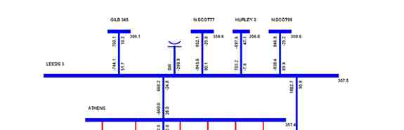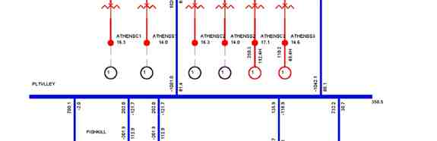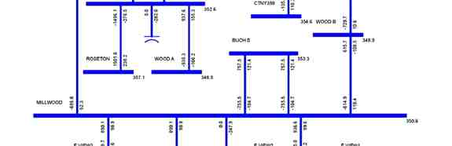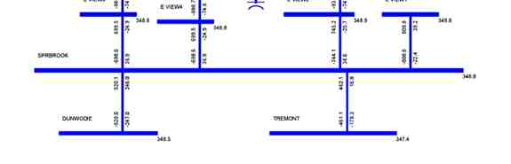

SPS Misoperation and Failed Operation Analysis

Figure 7-1: Branch Loadings with Misoperation of SPS,
Tripping 2 Combined Cycle Trains at Athens.

Siemens Power Transmission & Distribution, Inc.
Power Technologies International 7-3

SPS Misoperation and Failed Operation Analysis

0.0 3.0000
1.5000 4.5000

6.0000 9.0000 12.000
7.5000 10.500
TIME (SECONDS)

15.000
13.500
WED, MAY 31 2006 9:13
ATHENS RELATIVE ANGLES

Figure 7-2: Athens Machine Angle with Misoperation of SPS, Tripping 2 Combined Cycle Trains at Athens

Siemens Power Transmission & Distribution, Inc.
7-4 Power Technologies International

SPS Misoperation and Failed Operation Analysis

0.0 3.0000
1.5000 4.5000

6.0000 9.0000 12.000
7.5000 10.500
TIME (SECONDS)

15.000
13.500
WED, MAY 31 2006 9:13
ATHENS POWER OUTPUTS

Figure 7-3: Athens Machine Power with Misoperation of SPS, Tripping 2 Combined Cycle Trains at Athens

Siemens Power Transmission & Distribution, Inc.
Power Technologies International 7-5

SPS Misoperation and Failed Operation Analysis

0.0 3.0000
1.5000 4.5000

6.0000 9.0000 12.000 15.000
7.5000 10.500 13.500
TIME (SECONDS)

THU, MAY 25 2006 12:56
345 KV VOLTAGES

Figure 7-4: 345 kV Voltages at Leeds, Athens, Pleasant Valley, Dunwoodie, Millwood and New Scotland,
with Misoperation of SPS, Tripping 2 Combined Cycle Trains at Athens

Siemens Power Transmission & Distribution, Inc.
7-6 Power Technologies International

SPS Misoperation and Failed Operation Analysis

0.0 3.0000
1.5000 4.5000

6.0000 9.0000 12.000
7.5000 10.500
TIME (SECONDS)

15.000
13.500
THU, MAY 25 2006 12:56
LINE 91,92,&95 MW FLOW

Figure 7-5: Flows on 91, 92 & 95 with Misoperation of SPS, Tripping 2 Combined Cycle Trains at Athens

Siemens Power Transmission & Distribution, Inc.
Power Technologies International 7-7

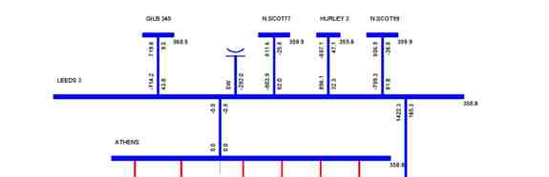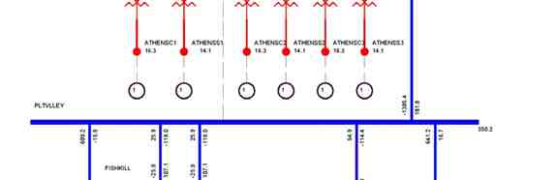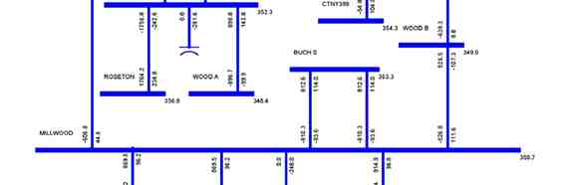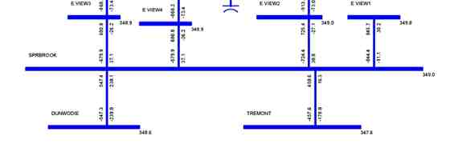

SPS Misoperation and Failed Operation Analysis

Figure 7-6: Branch Loadings Following Line 91 Outage, with Misoperation
of SPS Tripping 3 Combined Cycle Trains at Athens

Siemens Power Transmission & Distribution, Inc.
7-8 Power Technologies International

SPS Misoperation and Failed Operation Analysis

0.0 3.0000
1.5000 4.5000

6.0000 9.0000 12.000
7.5000 10.500
TIME (SECONDS)

15.000
13.500
THU, JUN 01 2006 11:22
LINE 91,92,&95 MW FLOW

Figure 7-7: Flows on Lines 91, 92 & 95 Loadings Following Line 91 Outage,
with Misoperation of SPS Tripping 3 Combined Cycle Trains at Athens

Siemens Power Transmission & Distribution, Inc.
Power Technologies International 7-9

SPS Misoperation and Failed Operation Analysis

0.0 3.0000
1.5000 4.5000

6.0000 9.0000 12.000 15.000
7.5000 10.500 13.500
TIME (SECONDS)

WED, MAY 31 2006 16:46
345 KV VOLTAGES

Figure 7-8: 345 kV Voltages at Leeds, Athens, Pleasant Valley, Dunwoodie, Millwood
and New Scotland with Misoperation of SPS Tripping 3 Combined Cycle Trains at Athens

Siemens Power Transmission & Distribution, Inc.
7-10 Power Technologies International

SPS Misoperation and Failed Operation Analysis

7.2 Failure of the SPS to Operate
The effect of the failure of the SPS to operate to reduce generation at Athens for an outage of either Line 91 or 92 under heavy UPNY-Con Ed transfer can be determined from the analysis described in Section 6. This analysis looked at three time periods:
1. Pre-contingency steady state
2. Post-contingency, pre-SPS operation
3. Post-contingency, post-SPS operation
Operation of the SPS is expected to occur within two minutes following the outage of either
line 91 or 92 if the loading on the remaining line is over LTE. The outage of Line 91 is slightly
more severe than the outage of line 92 so will be discussed here, although the comments
also apply for the opposite scenario. The analysis in Section 6 demonstrated that for the
outage of line 91, except for line 92 on the same ROW, all other lines remain within their LTE
limits and all bulk system bus voltages within their post-contingency limits (time period 2).
The local area flows and voltages are shown in Figure 6-4. Following operation of the SPS,
all lines including line 92 are within their LTE limits and all bulk system bus voltages within
their post-contingency limits (time period 3). The local area flows and voltages are shown in
Figure 6-5.
If the SPS fails to operate, the system does not automatically transition from the second
condition to the third within two minutes. The system condition is such that one line is
overloaded above its LTE rating, but below its STE rating. All other elements are within postcontingency limits. Since the STE rating is a 15 minute rating, there is ample time for manual operator action to either manually trip generation at Athens or perform other actions.
Note that the likelihood of such a failure would be quite low due to the redundancy built into the SPS design and also the fact that the SPS will only be operational at periods of high transfer and will only operate for permanent faults (i.e., unsuccessful reclosing).

7.3 Potential for Interaction with Other Existing New York Special
Protection Systems
Consideration was given to the potential for interaction with other existing Special Protection Systems in New York. A listing of such Systems and procedures is given in Exhibit A-2 of the NYISO System Operation Procedures, Exception to Operating Criteria for Pre-Contingency & Post-Contingency Transmission Facility Flows and Voltages.
None of the exceptions listed in that document should have an interaction. The only three in the general vicinity of the Athens SPS are Exceptions 1, 3, and 5, each of which will be
addressed below.
Exception 1: The post-contingency flow on the Marcy-New Scotland 18 line is allowed
to exceed its LTE rating for the loss of the Edic-New Scotland 14 line by the amount
of relief that can be obtained by tripping the Gilboa pumping load as a single
corrective action. Also, the post-contingency flow on the Edic-New Scotland 14 line is
allowed to exceed its LTE rating for either the loss of the Marcy-New Scotland 18 line

Siemens Power Transmission & Distribution, Inc.
Power Technologies International 7-11

SPS Misoperation and Failed Operation Analysis

alone, or the double-circuit loss of the Marcy-New Scotland 18 and Adirondack-Porter
12 lines, by the amount of relief that can be obtained by tripping the Gilboa pumping load as a single corrective action.
This exception deals with time periods where Gilboa is in a pumping mode. The
Athens SPS is designed for heavy UPNY-Con Ed transfer periods such as during
peak load. These two conditions do not occur simultaneously as the Gilboa station
would not be pumping at peak load or under conditions requiring heavy UPNY-Con
Ed transfers.
Exception 3: The post-contingency flow on the NS-Leeds line is allowed to reach its STE rating for transfers to NE & SENY, with sufficient generation at Gilboa.
This exception is not an SPS but a generation runback procedure under operator control. Hence, since operator control is used and not automatic action, there is no possibility of interaction.

Exception 5: The post-contingency flow on the Gilboa-Leeds (GL-3) line is allowed to reach its STE rating with four generators on at Gilboa.

This exception is not an SPS but a generation runback procedure under operator control. Hence, since operator control is used and not automatic action, there is no possibility of interaction.
Thus these three Exceptions do not pose a concern of interaction with the Athens SPS.
Another point to note is that Exceptions 3 and 5 are examples of how operator actions can be applied in the 15 minute time period associated with the STE rating of a line, consistent with the ability of operator action to manually trip Athens generation in the unlikely event of an SPS failure as discussed above.

Siemens Power Transmission & Distribution, Inc.
7-12 Power Technologies International

Section
8
SPS Type Analysis

The NPCC Document A-11, Special Protection System Criteria defines three types of special protection Systems:
Type I - An SPS which recognizes or anticipates abnormal system conditions
resulting from design and operating criteria contingencies, and whose misoperation or
failure to operate would have a significant adverse impact outside of the local area.
The corrective action taken by the SPS along with the actions taken by other
protection systems are intended to return power system parameters to a stable and
recoverable state.
Type II - An SPS which recognizes or anticipates abnormal system conditions
resulting from extreme contingencies or other extreme causes, and whose
misoperation or failure to operate would have a significant adverse impact outside of the local area.
Type III - An SPS whose misoperation or failure to operate results in no significant adverse impact outside the local area.

The SPS in this study is designed to recognize abnormal system conditions resulting from design and operating criteria contingencies and therefore it is not a Type II SPS, which by definition recognizes or anticipates extreme contingencies.
The study results presented in the previous sections have shown that the misoperation or
failed operation of this SPS would not have a significant adverse impact outside of the local
area, that is, there are no widespread overloads or voltage violations found outside the local
area. Therefore the Athens SPS should be classified as a Type III SPS according to the
above criteria.

Siemens Power Transmission & Distribution, Inc.
Power Technologies International 8-1

SPS Type Analysis

This page intentionally left blank.

Siemens Power Transmission & Distribution, Inc.
8-2 Power Technologies International

Section
9
Conclusions
The purpose of this SIS is to demonstrate the improvement in the UPNY-Con Ed interface transfer capability that would result from the installation and operation of the SPS and other possible associated mitigative measures such as the installation of shunt capacitive
compensation at one or more Con Edison substations.
The study shows that the SPS is effective. With the SPS, the transfer across the UPNY-Con Ed Interface can be increased by 466 MW while abiding by applicable reliability rules and
criteria. This allows the Athens plant to be dispatched at full capacity, i.e., 1080 MW, during peak load conditions.
The operation without and with the SPS was analyzed using thermal, voltage and stability
analysis. The thermal analysis shows that with Athens dispatched at full capacity and the
SPS, the UPNY-Con Ed thermal transfer limit is increased by 466 MW, from 3633 MW to
4099 MW. Both without and with the SPS, the transfer is limited by flow on the Leeds to
Pleasant Valley 345 kV line due to loss of the Athens to Pleasant Valley 345 kV line. Without
the SPS, the post-contingency flow is limited to the line’s LTE rating of 1538 MW while the
SPS increases the allowable post-contingency flow to the line’s STE rating of 1724 MW. The
operation of the SPS reduces the line flow to below the LTE rating within a period of two
minutes.
Two contingencies may trigger the SPS, loss of the Athens to Pleasant Valley 345 kV (Line 91) and the Leeds to Pleasant Valley 345 kV line (Line 92). The loss of Line 91 is slightly more severe. For the peak load level and system dispatch modeled in the power flow case supplied by the NYISO, this contingency would require the trip of two Athens combined cycle trains, for a total of 720 MW. The loading on Line 92 after this contingency and SPS
operation would be 1520 MW, lower than the LTE rating of 1538 MW.
The thermal transfer limit on the UPNY-SENY interface was also analyzed. The analysis
shows that with Athens dispatched at full capacity and the SPS, the UPNY-SENY thermal
transfer limit is increased by 466 MW, from 4502 MW to 4968 MW. Both without and with the SPS, the limiting element is the same as that for the UPNY-Con Ed interface.
The voltage analysis indicated that transfer across the UPNY-Con Ed interface would be
limited by the pre-contingency voltage limit of 348 kV at four lower Hudson Valley 345 kV
buses. Therefore a 240 MVAr capacitor bank was modeled at Millwood which is sufficient to maintain the steady-state pre-contingency voltage at these stations above 348 kV. Millwood was selected as the potential location for the capacitor back due to concerns that space may be limited in other possible stations.
The voltage contingency analysis indicated that with Athens dispatched at full capacity and
the SPS in-service, there was no significant incremental impact on bulk system voltages

Siemens Power Transmission & Distribution, Inc.
Power Technologies International 9-1

Conclusions

compared to operation without the SPS. The voltages on several 115 kV buses decreased by less than 1% under certain contingencies.
The P-V analysis showed that with Athens dispatched at full capacity and the SPS, the
voltage-based UPNY-Con Ed transfer limit is increased by 245 MW. The voltage-based
transfer limits for both without and with the SPS are higher than the respective thermal limits, as follows:

Case Case
UPNY-Con Ed Transfer Without SPS With SPS Change
Pre-Contingency Low 3880^{A} 4125^{A} 245
Post-Contingency Low 4279^{B} 4383^{B} 104
95% Voltage Collapse (5% MW 4092^{C} 4190^{C} 98
Margin)
Voltage-Based Transfer Limit 3880^{A} 4125^{C} 245
Thermal Transfer Limit 3633^{D} 4099E 466
A Pre-contingency voltage at Dunwoodie 345 kV
B Post-contingency voltage at Pleasant Valley 345 kV for loss of tower Coopers Corners-Rock Tavern 34/42
C 95% of voltage collapse criteria limit for loss of tower Coopers Corners-Rock Tavern 34/42
D Limited by Leeds - Pleasant Valley 345 kV (LTE: 1538 MW) for loss of Athens-Pleasant Valley 345 kV
E Limited by Leeds - Pleasant Valley 345 kV (STE: 1724 MW) for loss of Athens-Pleasant Valley 345 kV

Stability analysis was performed. All stability simulations exhibited a stable response with positive damping. Stability is thus not the limiting constraint on the transfer level on the UPNY-Con Ed interface either without or with the SPS.
The extreme contingency analysis demonstrates that the case with SPS shows incremental overload and voltage impacts on several 115 kV facilities. Additionally, for the case with the SPS, the loss of the Right-of-Way of Lines 91 & 92 would overload the Leeds to Hurley 345 kV line by 1%. There are no widespread overloads or voltage violations found on the bulk power system under the extreme contingencies tested.
The analysis demonstrates that misoperation of the SPS will not result in severe system
problems or widespread effects on the system, that is, it does not cause a significant adverse impact outside of the local area.
Failure of the SPS to operate under maximum transfer conditions would result in Line 91 or
92 being loaded above its LTE rating following the outage of the other, but below its STE
rating. For the peak condition analyzed, all other elements are within post-contingency limits. Since the STE rating is a 15 minute rating, there is ample time for manual operator action to either manually trip generation at Athens or perform other actions.
The study results demonstrate that the misoperation or failed operation of this SPS would not have a significant adverse impact outside of the local area, that is, there are no widespread
overloads or voltage violations found outside the local area. Thus the SPS should be
classified as a Type III SPS according to the NPCC Special Protection System Criteria
(NPCC Document A-11).

Siemens Power Transmission & Distribution, Inc.
9-2 Power Technologies International

Conclusions

The NYISO will calculate the actual Transmission Congestion Contracts (TCCs) awarded as a result of this proposed SPS. However, the results of this SIS indicate a potential TCC
award estimate of 466 MW for the Athens' SPS.

Siemens Power Transmission & Distribution, Inc.
Power Technologies International 9-3

EXHIBIT B
Conceptual Report - Redundant Athens SPS

EXHIBIT B

Conceptual Report - Redundant SPS

Objective
This document describes the preliminary requirements and investment grade estimate required to design and construct a Redundant Special Protection System (SPS) for the Athens
Generating Station (Athens Plant).

Background
In 2007/2008 a Special Protection System (SPS) was designed and constructed between Leeds Station - Athens Station - Athens Plant. The purpose of the SPS was to allow increased
generation levels at Athens Generating Station while avoiding post contingency overloads on the 345kV transmission lines 91 (LN91) or 92 (LN92) for loss of either the LN91 or the LN92. By rejecting Athens generation the Athens SPS system has allowed the LN91 and the LN92 to be operated at post contingency loading levels up to the STE rating of each line.

Proposed Project
Protection Engineering New York and Substation Engineering & Design New York have been
requested by Transmission Planning to provide an investment grade cost estimate for design
and installation of a redundant Athens SPS system. With no additional requirements identified
in the request this document was developed to clarify what redundancy is and provide an
investment grade estimate to design and construct a second (redundant) Athens SPS.
The intent of adding a redundant Athens SPS is to prevent an element failure or an out of
service element of the existing or redundant SPS from impacting the functionality of the Athens SPS as described in the Background description above. The redundant Athens SPS is to utilize independent diverse power sources, inputs, and outputs from the original SPS. Since the
equipment and communication method selected for the original SPS provides the most reliable and secure system possible there is no intent in the design of the redundant equipment to use components from an alternate manufacturer or technology, however the latest models will be utilized which minimizes common mode failure due to manufacturing flaws.

Identification of the Redundant SPS (Athens SPS "A")
Since the original Athens SPS is connected to "B" protection Current Transformers, “B” Station Batteries and uses the "B" Fiber Optic Routing Path it will be identified in the future as the
Athens SPS "B" package. Since the redundant Athens SPS will be connected to "A" protection Current Transformers, “A” Station Batteries and will use the existing "A" Fiber Optic Routing Path it will be identified in the future as the Athens SPS "A" package. To support this
nomenclature, print and labeling changes must be made to the existing SPS scheme to reflect its new designation as Athens SPS “B”.
Athens SPS "A" Package Communication Equipment
The existing Athens SPS "B" package uses the "B" Fiber Optic Routing Path from Leeds Station
to Athens Station. The "B" Fiber Optic Routing Path is buried in the ROW and along part of Rt

74. The existing protection "A" Fiber Optic Routing Path is along the ROW on Fiber Optic
Shield Wire (OPGW). The "A" path will provide a diverse route for the Athens SPS "A" package and has been identified to have spare fibers that will provide this function. The new Athens SPS "A" package will also require an alternate diverse route for fiber communication between the Athens Station and the Athens Plant. It is assumed that there is spare conduit with spare fiber optic cable to support this. IF this turns out to be false then the cost to install such a
diverse path will need to be added to the estimate provided in this document.

Overview of Athens SPS "A" Package Equipment
Figure 1 shows a one line diagram of the proposed redundant Athens SPS "A" package
equipment. Note that this will be the same as the as the existing SPS "B" package equipment.
National Grid Athens Station

The following equipment will be designed and installed at the Athens Station by National Grid to support the Athens SPS "A":
1. New relay panel for SPS “A” equipment.
2. Schweitzer SEL-351-6 Microprocessor Overcurrent Relay for inputs and logic
control.
3. Three position selector switch for “Summer LTE”, “Winter LTE”, and “OFF”.
4. Inputs from breakers R9162 & R9163 on LN91 breaker status and line current.
5. Utilize spare fiber optic cables between Athens and Leeds substations on the "A"
fiber optic path.
6. Utilize spare fiber optic cables between Athens Station and Athens Generating
Station. It needs to be determined that this diverse alternate path exists or the cost
must be added to the estimate.
National Grid Leeds Station
The following will be will be designed and installed at the Leeds Station by National Grid to support the Athens SPS "A".
1. New Relay panel for SPS "A" equipment
2. Schweitzer SEL-351-6 Microprocessor Overcurrent Relay for inputs and logic
control.
3. Inputs from breakers R92 & R9293 on LN92 breaker status and line current.
4. Use of spare "A" fiber optic cables (OPGW) between Athens and Leeds Stations.

National Grid Transmission Control Center
The following will be displayed and / or controlled from National Grid TCC via EMS:
1. SPS "A" actuation indication.
2. SPS "A" selector switch position.
3. Displayed value of the active logic setting group (SUMMER, WINTER, or OFF) of
the SPS "A" relays at Leeds and Athens Stations.

Athens Plant
The following will be acquired and employed at the Athens Plant by New Athens Generating Facility to support the Athens SPS "A":

1. Schweitzer SEL-2100 logic processor.
2. Three (3) Schweitzer SEL-2506 I/O modules.
3. Selectable generator rejection sequence switch.
4. SPS "A" actuation indication.
5. Displayed value of the active logic setting group (SUMMER, WINTER, or OFF) of
the SPS "A" relays at Leeds and Athens Stations.
6. Use of spare fiber optic cables between Athens Station and Athens Plant. It needs
to be determined that this alternate path exists or the cost must be added to the
estimate.

Investment Grade Cost Estimate

Table 1 and 2 identify an investment grade estimate for the addition of a redundant SPS
(Athens SPS "A") as described in this document. Table 1 is the estimate for the work at National
Grid’s substations while Table 2 is the estimate for the work at the Athens Plant. The estimates
assume that the spare diverse contacts, power sources, communication routing, annunciator
windows, and CTs confirmed thru drawing reviews are available. It was also confirmed via
drawing reviews that space is available in the Leeds and Athens Stations for additional panels.

Table 1: Investment Grade Estimate (Work at NG Substations)
Conceptual / Facility Study $45k
Materials $60k
Engineering (design) $145k
Construction $255k

TOTAL: $505k ¹
Note 1: Estimate does not include AFUDC, assumed to be upfront payment per E&GSB 120. Estimate based upon
actual costs incurred for installation of the original SPS.
Table 2: Investment Grade Estimate (Work at Athens Plant)
Materials $30k
Engineering (design) $45k
Construction $90k

TOTAL: $165k ²
Note 2: Assumed to be designed and installed by others. Estimate developed from estimate provided by HMT for the original SPS. National Grid has no actuals to compare the estimate against.

Prepared 4/29/2011/Revised 1/19/2012

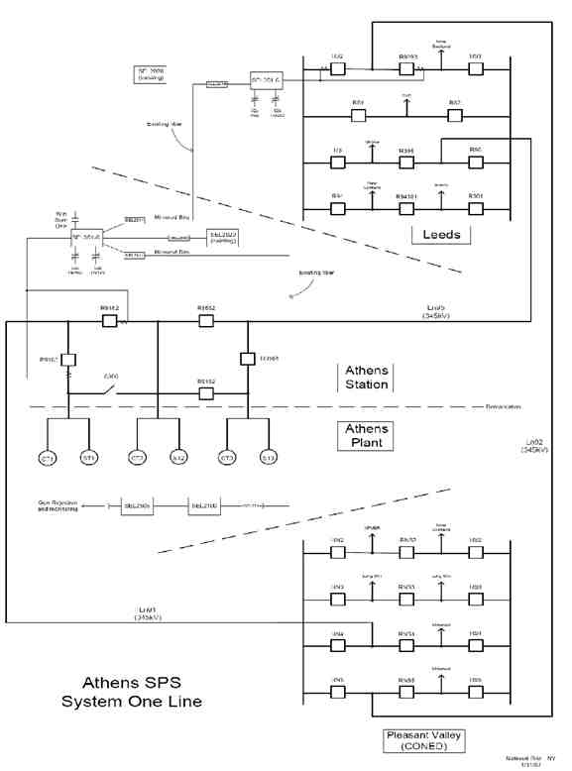

Figure 1: Athens SPS "A" - System One Line

