AN

INTERCONNECTION AGREEMENT

BETWEEN

NIAGARA MOHAWK POWER CORPORATION

AND

EMPIRE GENERATING CO, LLC

INTERCONNECTION AGREEMENT (the “Agreement”) is made as of January 15, 2004, between Niagara Mohawk Power Corporation, a National Grid company (“Niagara Mohawk”), a New York Corporation, and Empire Generating Co, LLC, a New York limited liability company (the “Producer”). (Collectively, Producer and Niagara Mohawk may be referred to as the “Parties”, or individually, as a “Party.”)
WHEREAS, the Producer is developing a power production facility to be located in the City of Rensselaer, County of Rensselaer, New York (the “Production Facility”);
WHEREAS, the Producer and Niagara Mohawk desire to provide for the interconnection of the Production Facility to Niagara Mohawk’s Transmission System under the terms and
conditions set forth herein; and,
WHEREAS, certain Upgrades to Niagara Mohawk’s system will be needed solely for Producer’s benefit and will not support any other transmission user.
NOW THEREFORE, in consideration of the mutual representations, covenants and agreements set forth herein, the Parties to this Agreement agree as follows:
ARTICLE I
DEFINITIONS
The following terms, when used herein with initial capitalization, shall have the meanings specified in this section.
1.1 “Agreement” shall mean this Interconnection Agreement between Niagara Mohawk and
the Producer, including all exhibits hereto, as the same may be amended, supplemented, revised, altered, changed, or restated in accordance with its terms.
1.2 “Bulletin No. 756” or “ESB 756” shall mean that certain internal Niagara Mohawk
document dated 2001, 2” printing June, entitled “Supplement to Specifications for
Electrical Installations; Parallel Generation Requirements” and designated Electric
System Bulletin No. 756 and its Appendix C, as amended or superseded, as available on Niagara Mohawk’s website.
1.3 “Commercial Operation Date” shall follow the Initial Synchronization Date and shall
mean the date after all pre-operational testing of the Interconnection Facility has been
completed to Niagara Mohawk’s satisfaction, the Interconnection Facility has been
energized, and the Producer has commenced selling energy or capacity into the
wholesale power market administered by the NYISO pursuant to the NYISO OATT.
Producer shall provide Niagara Mohawk written notice at least sixty (60) days in
advance of the Commercial Operation Date and will reaffirm this date, or provide notice
of a revised date, no less than twenty (20) days prior to the previously notified date.
1.4 “Commercially Reasonable Efforts” shall mean efforts which are designed to enable a
Party, directly or indirectly, to satisfy expeditiously a condition to, or otherwise assist in
1

the consummation of, the actions contemplated by this Agreement and which do not
require the performing Party to expend any finds or assume liabilities other than
expenditures and liabilities which are customary and reasonable in nature and amount in the context of the actions contemplated by this Agreement.
1.5 “Confidential Information” shall mean any plan, specification, pattern, procedure,
design, device, list, concept, policy or compilation relating to the present or planned
business of a Party which has not been released publicly by its authorized representatives
and which has been designated as “Confidential” by the Party asserting a claim of
confidentiality, whether such Confidential Information is conveyed orally, electronically,
in writing, through inspection, or otherwise. Confidential Information as used herein also
includes Confidential Information supplied by any Party to another Party prior to the
execution of this Agreement, and such Confidential Information shall be considered in
the same trimmer and be subject to the same treatment as the Confidential Information
made available after the execution of this Agreement. Confidential Information shall also
include Confidential Information observed by any Party while visiting the premises of
another Party.
1.6 “Delivery Point” shall mean the point at which the Interconnection Facility is connected
to the Transmission System as indicated on Exhibit A. This point shall be at the jaw side
of the disconnect switch (SW #599) connecting the Interconnection Facility, new breaker
and switches to the existing bus work at the Niagara Mohawk Reynolds Road Substation
1.7 “Electricity” shall mean electric capacity as measured in MW or kW, energy as measured
in MWh or kWh, and/or ancillary services.
1.8 “Emergency Condition” shall mean a condition or situation which is deemed imminently
likely to (i) endanger life, property, or public health; or (ii) adversely affect or impair the
Transmission System, the Production Facility, or the electrical or transmission systems
of others to which Niagara Mohawk’s electrical systems are directly or indirectly
connected.
1.9 “Facilities Study” shall mean the necessary studies performed by Producer, or its third
party designee, approved by Niagara Mohawk as set forth in Article IV, Section 4.1. The Facilities Study is attached hereto as Exhibit B.
1.10 “FERC” shall mean the United States of America’s Federal Energy Regulatory
Commission or any successor organization.
1.11 “Good Utility Practice” shall mean any of the practices, methods and acts engaged in or
approved by a significant portion of the electric utility industry during the relevant time
period, or any of the practices, methods and acts which, in the exercise of reasonable
judgment in light of the facts known at the time the decision was made, could have been
expected to accomplish the desired result at a reasonable cost consistent with good
business practices, reliability, safety and expedition. Good Utility Practice is not intended
to be limited to the optimum practice, method, or act, to the exclusion of all others, but
2

rather to be acceptable practices, methods, or acts generally accepted in the region in
which the Production Facility is located. Good Utility Practice shall include, but not be
limited to, NERC (defined below) criteria, rules, guidelines and standards, NPCC
(defined below) criteria, rules, guidelines and standards, New York State Reliability
Council (defined below) criteria, rules, guidelines and standards, and NYISO (defined
below) criteria, rules, guidelines and standards, where applicable, as they may be
amended from time to time including the rules, guidelines and criteria of any successor
organization to the foregoing entities. When applied to the Producer, the term Good
Utility Practice shall also include standards applicable to a utility generator connecting to
the distribution or transmission facilities or system of another utility.
1.12 “Greenbush #16 Line” shall mean the existing 115 kV circuit consisting of poles, wires,
insulators, conductors and other miscellaneous hardware between Rensselaer Cogen Facility and the existing Niagara Mohawk Greenbush Substation.
1.13 “Hazardous Substance(s)” shall mean those substances, materials, products or wastes
which are classified as hazardous or toxic under any applicable federal, state or local law,
or any regulations promulgated thereunder, effective as of the date of execution of this
Agreement, and the presence of which requires remediation, removal or cleanup under
this Agreement.
1.14 “Initial Energization Date” shall mean the date upon which construction of the
Interconnection Facility and Upgrades have been completed and have been determined by Niagara Mohawk to be completed in accordance with Power Control Order 6-1
(“PCO 6-1”) and the circuit breakers have been closed, thereby, permitting electricity to flow from Niagara Mohawk’s transmission system to the Production Facility.
1.15 “Initial Synchronization Date” shall mean a date that follows the Initial Energization
Date, and which date shall occur during the pre-operational testing of the Production
Facility and is the first date that Electricity flows from the Production Facility through
the Interconnection Facility to the Delivery Point without the need for any further major
repairs or testing as determined by Niagara Mohawk and in accordance with PCO 6-1
1.16 “Interconnection Facility” shall include all those facilities located between the
Interconnection Point and the Delivery Point necessary to effect the transfer of
Electricity produced at the Production Facility to the Transmission System, as such
facilities are described in more particularity in Article II and in Exhibit A to this
Agreement, and shall include any Modifications, replacements or upgrades made to the Interconnection Facility, and any communications and/or protection equipment installed for the operation of the Interconnection Facility.
1.17 “Interconnection Point” shall mean the point at which the Production Facility is
connected to the Interconnection Facility, as indicated on Exhibit A. This point will be at the jaw side of the disconnect switch used to connect the Production Facility to the
Interconnection Facility.

3

1.18 “Metering Point” shall mean that point at which the Electricity produced by the
Production Facility will be metered by Niagara Mohawk for purposes of billing and metering for NYISO transactions, as depicted in Exhibit A.
1.19 “Modification” shall mean any new construction, new facilities, additions,
reinforcements, alterations, improvements, appurtenances, replacements or upgrades
made to the Interconnection Facility, Upgrades, Transmission System, or the Production
Facility as required by the NYISO or revised reliability standards, after the Commercial
Operation Date. “Modification” as it applies to the Interconnection Facility, Upgrades or
Transmission System shall also include Modifications which are required to support the
operations of the Producer including those required by: (i) changes in the operations of
the Production Facility after the Effective Date as hereinafter defined, or (ii) changes in
the technology employed at the Production Facility after the Effective Date.
1.20 “NERC” shall mean the North American Electric Reliability Council or any successor
organization.
1.21 “New York Control Area” shall have the same meaning as in the Independent System
Operator Agreement establishing the New York ISO (as defined below).
1.22 “New York ISO” or “NYISO” shall mean the New York Independent System Operator,
Inc. or any successor thereto.
1.23 “Niagara Mohawk” shall mean Niagara Mohawk Power Corporation and its successors
and permitted assigns.
1.24 “Niagara Mohawk Properties” shall mean those parcels of and/or interest in real property
that Niagara Mohawk uses for its transmission facilities upon which portions of the Interconnection Facility will be constructed.
1.25 “NPCC” shall mean the Northeast Power Coordinating Council (a reliability council
under Section 202 of the Federal Power Act) or any successor organization.
1.26 “NYISO OATT” shall mean the FERC-approved Open Access Transmission Tariff for
the NYISO and/or the FERC-approved Service Tariff for the NYISO, as applicable, and as it may be amended from time to time.
1.27 “NYPSC” shall mean the New York Public Service Commission or any successor
thereto.
1.28 “NYSRC” shall mean the New York State Reliability Council or any successor
organization.
1.29 “Original Greenbush #16 Line” shall mean that portion of the Greenbush #16 Line to be
removed between the Rensselaer Cogen Facility generating facility and the existing Niagara Mohawk structure number 29.

4

1.30 “Permanent Greenbush #16 Line” shall mean that new portion of the Greenbush # 16
Line to be constructed and attached to the same structures supporting the Interconnection
Facility between the Rensselaer Cogen Facility generating facility and the existing
Niagara Mohawk structure number 29.
1.31 “Producer” shall mean Empire Generating Co, LLC, and its successors and permitted
assigns.
1.32 “Production Facility” shall mean Producer’s Electricity Production facility with a
maximum net Winter rating of 672 MW and with a maximum net Summer rating of 603 MW located in the City of Rensselaer, County of Rensselaer New York, to be owned, operated and maintained by Producer.
1.33 “Property” and “Properties” shall mean that aggregate real property interest necessary for
construction, operation and maintenance of the Interconnection Facility, which real
property interest may be acquired in fee ownership, via easement or option, or other
means of acquisition of property rights acceptable to Niagara Mohawk, or such real
property interest held by Niagara Mohawk to which Producer will be allowed access for the removal of the Original Greenbush #16 Line, construction and removal of the
Temporary Greenbush #16 Line, construction of the Permanent Greenbush #16 Line, and for other necessary modifications to the Greenbush #16 Line.
1.34 “Rensselaer Cogen Facility” shall mean the 79 MW Rensselaer Cogeneration Facility,
located at 39 Riverside Avenue, Rensselaer, New York 12144, currently owned and
operated by El Paso Merchant Energy, North America, or its successors or assigns.
1.35 “Retail Tariff” shall means Niagara Mohawk’s Retail Tariff, New York Public Service
Commission (“NYPSC”) No. 207 - Electricity as approved by the NYPSC and all subsequent revisions, as it may be amended from time to time.
1.36 “System Reliability Impact Study” or “SRIS” shall mean that study entitled
“Interconnection Study for the Empire State Newsprint Project,” authored by the
Washington Group and approved by the NYISO Operating Committee on November 14,
2001.
1.37 “Temporary Greenbush #16 Line” shall mean that new temporary portion of the
Greenbush #16 Line to be constructed between the Rensselaer Cogen Facility generating facility and the existing Niagara Mohawk structure number 29.
1.38 “Transmission System” shall mean the properties, structures, facilities, equipment,
devices, and apparatus wholly or partly owned or leased by, or under contract to, or under the control of Niagara Mohawk or its Affiliates, other than the Interconnection Facility, which are necessary to interconnect the Production Facility to the New York Control Area, or are necessary for purposes of providing transmission and Retail Tariff services, including services under the NYISO Tariff.

5

1.39 “Upgrades” shall mean the modifications, reinforcements and additions to Niagara
Mohawk’s Transmission System and distribution facilities required or recommended to
be constructed and installed prior to the Commercial Operation Date in order for Niagara
Mohawk to interconnect the Production Facility to the Transmission System in
accordance with NYISO Tariff rules and regulations, as identified in the Facilities Study
(Exhibit B to this Agreement), and pursuant to this Agreement, and that will be needed
solely for Producer’s benefit and will not support any other transmission user.
Interpretation. The following rules shall govern the interpretation of this Agreement, including its definitions. The terms “includes” or “including” shall not be limiting, whether or not
followed by the words “without limitation.” References to an article or section shall mean an
article or section of this Agreement unless the context requires otherwise. References to a given agreement or instrument shall be a reference to that agreement or instrument as modified,
amended, supplemented and restated.
ARTICLE II

AGREEMENT TO INTERCONNECT
DESCRIPTION OF INTERCONNECTION FACILITY
2.1 The Parties agree to interconnect the Production Facility to the Transmission System in
accordance with the terms of this Agreement.
2.2 Term: This Agreement shall become effective as of the date first above written (the
“EFFECTIVE DATE”), subject to its approval or acceptance for filing by the FERC, and
shall continue in effect for thirty (30) years thereafter and shall be automatically renewed
for each successive one-year period thereafter. This Agreement may be terminated by
the Producer after giving Niagara Mohawk ninety (90) Calendar Days advance written
notice, or by Niagara Mohawk notifying FERC after the Production Facility is retired..
2.3 The Interconnection Facility shall consist generally of those facilities, including but not
limited to a new 345 kV high voltage transmission line and all associated equipment and upon which said facilities are located, necessary to effect the transfer of electricity
produced at the Production Facility into the Transmission System. The Interconnection Facility shall connect with the Production Facility at the Interconnection Point and the Interconnection Facility shall connect with the Transmission System at the Delivery Point, as indicated on the one-line diagram in Exhibit A.
2.4 The Production Facility shall include all facilities and equipment up to and including the
Production Facility’s high side generator breaker, line-side disconnect switch jaws, as
indicated on Exhibit A. Producer agrees that the installation of the electrical equipment
and the operation of the Production Facility must meet or exceed the standards of Good
Utility Practice, all requirements of Bulletin No. 756 and the NYISO; provided, however,
that in the event of a conflict between the requirements, rules and regulations of the
6

NYISO and the requirements of Bulletin No. 756, the requirements, rules and regulations of the NYISO shall govern.
2.5 Producer recognizes that nothing in this Agreement or in the Producer’s financial support
of the Interconnection Facility confers upon the Producer any right to transmit electricity over the Transmission System. However, the interconnection of the Production Facility to the Transmission System contemplated herein will allow Producer to access the New York Control Area for purposes of Producer’s stated intent to participate in the wholesale market administered by the NYISO pursuant to the NYISO OATT.
2.6 Niagara Mohawk shall use Good Utility Practice to own, operate and maintain the
Interconnection Facility, Upgrades and Transmission System. Niagara Mohawk does not, however, guarantee or warrant uninterrupted availability of the Interconnection Facility, Upgrades or the Transmission System. Any curtailment of deliveries over the
Interconnection Facility, Upgrades or the Transmission System shall be governed by Good Utility Practice, the terms and conditions of the NYISO OATT, ESB 756 and any other tariffs, approved by a regulatory body having jurisdiction.
2.7 Niagara Mohawk, in accordance with the rates, terms and conditions of the Retail Tariff,
shall provide Producer with station service power, if so requested or authorized. Producer
agrees to complete all necessary applications and forms as required by the Retail Tariff.
2.8 Without limiting its rights hereunder, Niagara Mohawk reserves the right to operate the
primary means of disconnect on the Producer’s side of the Interconnection Point.
Niagara Mohawk shall exercise such right of disconnect (a) in accordance with Bulletin No. 756, (b) in the event of an Emergency Condition, (c) after giving Producer
reasonable notice under the circumstances, (d) in a non-discriminatory manner, and (e) in accordance with Good Utility Practice.
2.9 If the Producer relies on Niagara Mohawk’s system protection equipment and practices
for protection of the Production Facility or if the Producer relies on any other of Niagara Mohawk’s equipment for support of its operations, the Producer agrees to release,
indemnify, defend, and save harmless Niagara Mohawk, its agents and employees,
officers, directors, parent(s) and affiliates, against any and all claims, judgments, cost,
liability, damage, injury, penalties, fines (civil or criminal), or other costs arising from
any damage or loss to the Production Facility, as a result of such reliance, whether the
loss, damage or injury result to or be sustained by Producer or any other persons, firms or corporations. To the extent the Producer relies on any other of Niagara Mohawk’s
equipment for support of Producer’s operations, Producer shall agree to indemnify
Niagara Mohawk in accordance with this Section 2.9 except in the event of Niagara
Mohawk’s gross negligence or willful misconduct.

7

ARTICLE III
REPRESENTATIONS AND WARRANTIES OF PARTIES
3.1 Producer is a Corporation duly organized and validly existing under the laws of the State
of New York. Producer is qualified to do business under the laws of the State of New York, is in good standing under the laws of the State of New York, has the power and authority to own its properties, to carry on its business as now being conducted, and to enter into this Agreement and the transactions contemplated herein and perform and carry out all covenants and obligations on its part to be performed under and pursuant to this Agreement, and is duly authorized to execute and deliver this Agreement and
consummate the transactions contemplated herein.
3.2 Niagara Mohawk is a corporation duly organized, validly existing and qualified to do
business under the laws of the State of New York, is in good standing under its
certificate of incorporation and the laws of the State of New York, has the corporate authority to own its properties, to carry on its business as now being conducted, and to enter into this Agreement and the transactions contemplated herein and perform and carry out all covenants and obligations on its part to be performed under and pursuant to this Agreement, and is duly authorized to execute and deliver this Agreement and
consummate the transactions contemplated herein.
3.3 The Producer and Niagara Mohawk each represents that: (a) upon receipt of all
governmental permits, licenses and approvals required to construct and operate the
Production Facility, Producer is not prohibited from entering into this Agreement and
discharging and performing all covenants and obligations on its part to be performed
under and pursuant to this Agreement; (b) upon the acceptance of the terms of this
Agreement by FERC, the execution and delivery of this Agreement, the consummation
of the transactions contemplated herein including the fulfillment of and compliance with
the provisions of this Agreement will not conflict with or constitute a breach of or a
default under any of the terms, conditions or provisions of any law, rule or regulation,
any order, judgment, writ, injunction, decree, determination, award or other instrument
or legal requirement of any court or other agency of government, or any contractual
limitation, corporate restriction or outstanding trust indenture, deed of trust, mortgage,
loan agreement, lease, other evidence of indebtedness or any other agreement or
instrument to which it is a party or by which it or any of its property is bound and will
not result in a breach of or a default under any of the foregoing; and (c) unless this
Agreement is materially modified by any court or appropriate regulatory authority having
jurisdiction and subsequently terminated, this Agreement shall be a legal, valid and
binding obligation enforceable in accordance with its terms, except as limited by any
subsequent order of any court or appropriate regulatory authority having jurisdiction, or
by any applicable reorganization, insolvency, liquidation, readjustment of debt,
moratorium, or other similar laws affecting the enforcement of rights of creditors
generally as such laws may be applied in the event of a reorganization, insolvency,
liquidation, readjustment of debt or other similar proceeding of or moratorium applicable
to the Party and by general principles of equity (regardless of whether such enforceability
is considered in a proceeding in equity or at law.)
8

ARTICLE IV
FACILITIES STUDY
4.1 A Facilities Study attached hereto as Exhibit B shall be performed by Producer, or a third
party selected by the Producer subject to Niagara Mohawk’s approval. The Facilities
Study shall estimate the cost of the equipment, engineering, procurement and
construction and a preliminary schedule for the work needed to implement the
recommendations of the System Reliability Impact Study and, in accordance with Good
Utility Practice, to physically and electrically connect the Production Facility to the
Transmission System. The Facilities Study shall include those studies that, in the
judgment of Niagara Mohawk, are necessary to determine (a) an appropriate
Interconnection Point and Delivery Point, (b) equipment and the facilities necessary and
desirable for the construction and operation of any new or additional or modified
transmission and distribution facilities, including but not limited to the Interconnection
Facility and Upgrades, the electrical switching configuration of the connection
equipment, the transformer(s), switchgear, meters, and other station equipment, (c) the
interconnection voltage and operational constraints, (d) the estimated costs of facilities
and/or the costs for Niagara Mohawk’s and Producer’s design, review, assistance and
inspection of facilities to be designed and constructed by Producer and/or Niagara
Mohawk, (e) the estimated costs of any Upgrades, (f) the removal of the Original
Greenbush #16 Line and Temporary Greenbush #16 Line, and the design, engineering,
and construction of the Temporary Greenbush #16 Line, Permanent Greenbush #16 Line,
and other necessary modifications to the Greenbush #16 Line (g) the estimated time
required to complete construction, removal, and installation of such facilities, and (h) a
mutually agreed upon schedule and estimated budget for the activities contemplated
under this Agreement, including but not limited to, the design, engineering, procurement
activities and construction of the Interconnection Facility, Temporary Greenbush #16
Line, Permanent Greenbush #16 Line, other necessary modifications to the Greenbush
#16 Line and Upgrades, and the removal of the Original Greenbush #16 Line and
Temporary Greenbush #16 Line.
4.2 Niagara Mohawk shall review the Facilities Study as contracted and paid for by the
Producer. Niagara Mohawk retains the right to require modifications of any aspect of the
proposal for the Interconnection Point, Interconnection Facility, Delivery Point, and any
new or additional or modified transmission and distribution facilities, including, but not
limited to the Greenbush #16 Line, Original Greenbush #16 Line, Temporary Greenbush
#16 Line and Permanent Greenbush #16 Line, and Upgrades as presented in the Facilities
Study, prior to Niagara Mohawk’s approval of the Facilities Study. Construction of the
Interconnection Facility, Temporary Greenbush #16 Line, Permanent Greenbush #16
Line, other necessary modifications to the Greenbush #16 Line, and Upgrades, and
removal of the Original Greenbush #16 Line and Temporary Greenbush #16 Line, shall
proceed only following: (a) Niagara Mohawk’s approval of the Facilities Study, (b)
Producer’s satisfaction, as determined by Niagara Mohawk, of the pre-conditions set
forth in Article VII, (c) execution of this Agreement, (d) the receipt by Niagara Mohawk

9

of a written notice from Producer to proceed with such activities and, (e) receipt by Niagara Mohawk of a money deposit per Article XV of this Agreement.
4.3 The Parties recognize that as of the Effective Date of this Agreement the Interconnection
Facility has not been authorized by the NYPSC, and, therefore, is subject to a certificate
to be issued by the NYPSC pursuant to Article VII of the New York Public Service Law.
ARTICLE V
REAL PROPERTY
5.1 OBTAINING REAL PROPERTY INTERESTS, AND NECESSARY LICENSES,
PERMITS, AND APPROVALS
5.1.1 Producer will acquire all interests in real property that are necessary, in the
opinion of Niagara Mohawk, for the Producer and/or Niagara Mohawk, as
applicable, to construct, reconstruct, relocate, operate, repair, maintain, and
remove the Interconnection Facility, Greenbush #16 Line, Temporary Greenbush
#16 Line, and Permanent Greenbush #16 Line in accordance with the terms and
provisions of this Agreement. Such real property interests may be acquired by
Producer in the form of an option acceptable to both parties. Sueh options which
shall name Niagara Mohawk as the optionee and grantee of the real property
interests and shall be exercised by the Producer in favor of Niagara Mohawk to
provide permanent easements or fee title necessary for the construction,
reconstruction, relocation, operation, repair, maintenance and removal of the
Interconnection Facility, Greenbush #16 Line, Temporary Greenbush #16 Line,
and Permanent Greenbush #16 Line.
5.1.2 Niagara Mohawk shall authorize Producer to place applicable portions of the
Interconnection Facility on existing Niagara Mohawk real property interests. The
acreage and width of Niagara Mohawk’s fee-owned real property necessary for
the Interconnection Facility shall be subject to Niagara Mohawk’s approval.
5.1.3 Producer shall be responsible for preparing applications for and obtaining all
government permits, authorizations, licenses, certificates and approvals necessary
to construct, relocate, operate, repair, maintain, and remove the Interconnection
Facility, Temporary Greenbush #16 Line, Permanent Greenbush #16 Line, other
necessary modifications to the Greenbush #16 Line, and Upgrades on terms and
conditions acceptable to Niagara Mohawk. Said applications shall be prepared by
Producer for submittal by Niagara Mohawk and/or Producer, where appropriate.
Niagara Mohawk, at Producer’s expense, shall be responsible for maintaining in
full force and effect all permits, authorizations, licenses, certificates, and
approvals necessary to operate and maintain the Interconnection Facility and
Upgrades. Producer, at Producer’s expense, shall be responsible for maintaining
in full force and effect all permits, authorizations, licenses, certificates, and
approvals necessary to operate and maintain the Production Facility. Producer
and Niagara Mohawk agree to comply in all material respects with all federal,
10

state and local environmental and other laws, ordinances, rules, regulations,
permits, licenses, approvals, certificates and requirements thereunder as may
apply to each Party in connection with the activities each performs pursuant to
this Agreement.
5.1.4 Producer agrees that, prior to the transfer by Producer of any real property
interest to Niagara Mohawk under the terms of this Agreement, Producer shall
conduct, or cause to be conducted, and be responsible for all costs of sampling,
soil testing, and any other methods of investigation which would disclose the
presence of any Hazardous Substance which has been released on the Property or
which is present upon the Property by migration from an external source, and
which existed on the Property prior to the transfer, and shall notify Niagara
Mohawk in writing as soon as reasonably practicable after learning of the
presence of Hazardous Substance upon said Property interest. Producer agrees to
indemnify, defend, and save Niagara Mohawk, its agents and employees, officers,
directors, parents and affiliates, harmless from and against any loss, damage,
liability (civil or criminal), cost, suit, charge (including reasonable attorneys’
fees), expense, or cause of action, for the removal or management of any
Hazardous Substance and relating to any damages to any person or property
resulting from presence of such Hazardous Substance.
5.1.5 Prior to transfer of control of the Interconnection Facility from Producer to
Niagara Mohawk, Niagara Mohawk shall be given the opportunity to inspect,
perform final testing and approve the Interconnection Facility and review all
appropriate approvals, certificates, permits, and authorizations. Prior to transfer of
control of the Interconnection Facility from Producer to Niagara Mohawk,
Producer shall be responsible for correcting within thirty (30) days of discovery
any situations that are contrary, in Niagara Mohawk’s sole judgment, to Good
Utility Practice, Bulletin No. 756, Niagara Mohawk’s standards, procedures,
practices and functional specification requirements, standard Niagara Mohawk
environmental, construction, forestry, and right-of-way management practices
and procedures, Niagara Mohawk’s Standard Environmental Management and
Construction Plan Protection Measures and Niagara Mohawk’s Transmission
Right-of-Way Management Plans or any applicable NYISO, NYPSC, NYSRC,
NPCC, NERC, or FERC standards and criteria requirements, which such
requirements shall govern in the event of a conflict between NYISO, NYPSC,
NYSRC, NPCC, NERC or FERC and the requirements of Bulletin No. 756,
which, in Niagara Mohawk’s sole judgment, materially and adversely affect the
operability of the Interconnection Facility or are contrary to applicable laws or
permits, and for correcting any material deficiencies which could impede the
transfer of control of the Interconnection Facility to Niagara Mohawk pursuant to
this Agreement. Producer shall be responsible for the costs associated with
making such corrections.
5.2 ACCESS RIGHTS
11

5.2.1 Niagara Mohawk hereby grants to Producer access and licenses, as necessary for
Producer to construct the Interconnection Facility, Temporary Greenbush #16
Line, Permanent Greenbush #16 Line, other necessary modifications to the
Greenbush #16 Line, and to remove both the Temporary Greenbush #16 Line and
the Original Greenbush #16 Line.
5.2.2 Producer hereby grants to Niagara Mohawk all necessary access, and licenses,
including adequate and continuing rights of access to Producer’s property, as
necessary for Niagara Mohawk to construct, operate, maintain, replace, or
remove the Interconnection Facility and to read meters in accordance with the
terms of this Agreement and to exercise any other of its obligations under this
Agreement. Producer hereby agrees to execute such grants, deeds, licenses,
instruments or other documents as Niagara Mohawk may require to enable it to
record such rights of way, easements, and licenses.
5.3 RIGHT OF WAY ACQUISITION AND EXPENSE
5.3.1 Producer shall pay and be solely liable for all expenditures and paying for all
activities incurred or engaged in by Producer and Niagara Mohawk in acquiring
necessary real property interests and associated permits and authorizations
required for Producer and Niagara Mohawk, as appropriate, to construct,
reconstruct, relocate, operate, repair, maintain, as applicable, the Interconnection
Facility, Temporary Greenbush #16 Line, Permanent Greenbush #16 Lines, other
necessary modifications to the Greenbush #16 Line, and Upgrades, and to remove
the Original Greenbush #16 Line, and Temporary Greenbush #16 Line, as
required pursuant or related to this Agreement. Producer shall pay fair market
value for the real property interests acquired as determined by an appraiser
retained by Producer at Producer’s expense (a copy of the appraisal shall be
provided to Niagara Mohawk free of charge) or such other value as the Parties
may agree upon in writing. Producer shall pay and be solely liable for all costs
associated with the transfer of real property rights to Niagara Mohawk, including,
but not limited to, closing costs, subdivision costs, transfer taxes and recording
fees. Producer shall reimburse Niagara Mohawk for all costs Niagara Mohawk
incurs in connection with transfers of property and any associated permits and
authorizations and in carrying out Niagara Mohawk’s responsibilities as provided
in this Agreement, including but not limited to Article IX, except as to costs
related to encroachments on existing Niagara Mohawk property, if any, that
impede the siting or construction of facilities necessary to implement the
interconnection under this Agreement.
5.3.2 Producer shall be responsible for defending and shall indemnify and hold
harmless Niagara Mohawk, its directors, officers, employees, agents and
affiliates, from and against all liabilities, expense (including litigation costs and
attorney’s fees) damages, losses, penalties, claims, demands, actions and
proceedings of any nature whatsoever for construction delays, construction or
operations cessations, claims of trespass, or other events of any nature
12

whatsoever that arise from or are related to an issue as to the sufficiency of the
real property interests acquired or utilized by the Producer (including, but not
limited to, those real property interests from Niagara Mohawk) for the
construction, reconstruction, relocation, operation, repair, and maintenance of the
Interconnection Facility, Temporary Greenbush #16 Line, Permanent Greenbush
#16 Line, other necessary modifications to the Greenbush #16 Line, and the
removal of the Original Greenbush #16 Line and Temporary Greenbush #16
Line. In no event, shall Niagara Mohawk be held liable to Producer or third
parties for consequential, incidental or punitive damages arising from or any way
relating to an issue as to the sufficiency of the real property interests acquired or
utilized by the Producer (including, but not limited to, those real property
interests from Niagara Mohawk) for the construction, reconstruction, relocation,
operation, repair, and maintenance of the Interconnection Facility, Temporary
Greenbush #16 Lines, Permanent Greenbush #16 Line, other necessary
modifications to the Greenbush #16 Line, and removal of the Original Greenbush
#16 Line and Temporary Greenbush #16 Line.
5.4 CONVEYANCE OF PROPERTY RIGHTS AND FACILITIES CONSTRUCTED
5.4.1 The real property interests necessary for the construction, reconstruction,
relocation, operation, repair, and maintenance of the Interconnection Facility,
Permanent Greenbush #16 Line, Temporary Greenbush #16 Lines, other
necessary modifications to the Greenbush #16 Line, and Upgrades, and removal
of the Original Greenbush #16 Line and Temporary Greenbush #16 Line, that are
not already owned or controlled by Niagara Mohawk, shall be conveyed to
Niagara Mohawk in fee simple or by an easement approved by Niagara Mohawk,
with good and marketable title free and clear of all liens, encumbrances, and
exceptions to title for a sum of $1.00 at least thirty (30) days prior to the date
scheduled for the commencement of construction or removal, as applicable, of
any of the facilities described in Article VIII, Section 8.1 of this Agreement. With
respect to any approved conveyance of easements, Producer shall subordinate
pertinent mortgages to easement rights. Producer shall indemnify, defend, and
hold harmless Niagara Mohawk, its agents and employees, officers, directors,
parent(s) and affiliates, and successors in interest, from all liens and
encumbrances against the property conveyed. Producer further agrees to provide
to Niagara Mohawk a complete field survey with iron pin markers showing the
centerline of the entire Interconnection Facility right-of-way, and a 40-year
abstract of title, and a 10-year tax search for real property interests acquired by
the Producer from third parties. Prior to the execution of an option, Producer shall
be required to provide Niagara Mohawk a title insurance commitment with a
complete title report issued by a reputable and independent title insurance
company for any property rights, in fee or easement in the segment of the
Interconnection Facility from the Production Facility to Niagara Mohawk’s
existing fee-owned right-of-way, that are to be transferred to Niagara Mohawk.
At the time of the execution of an option by Producer, Producer shall provide a
13

title insurance policy naming Niagara Mohawk as the insured covering the real
property interest to be acquired for any property rights, in fee or easement in the
segment of the Interconnection Facility from the Production Facility to Niagara
Mohawk’s existing fee-owned right-of-way, that are to be transferred to Niagara
Mohawk.
5.4.2 Producer shall provide to Niagara Mohawk conformed copies of all necessary
real property interests, environmental, engineering, and other permits,
authorizations, licenses, certificates, permits, approvals and as-built drawings not otherwise prepared by or directly for, or issued to Niagara Mohawk.
5.4.3 Upon completion of removal of the Original Greenbush #16 Line and Temporary
Greenbush #16 Line and the construction and testing of the Interconnection
Facility, Permanent Greenbush #16 Line, other necessary modifications to the
Greenbush #16 Line, and 60 days prior to Initial Synchronization Date of the
Interconnection Facility, in accordance with the Schedule provided in the
Facilities Study, Producer shall convey and transfer the Interconnection Facility,
Permanent Greenbush #16 Line, and, as required, other necessary modifications
to the Greenbush #16 Line, to Niagara Mohawk for a sum of $1.00.
ARTICLE VI
PILOT PROGRAM
6.1 Subject to the terms and conditions of this Agreement, Niagara Mohawk shall be the
owner and sole operator of the Interconnection Facility contemplated in this Agreement.
The Production Facility may be subject to a Payment in Lieu of Taxes (“PILOT”)
program with the Rensselaer County Industrial Development Agency (“RCIDA”). Any
proposed RCIDA PILOT program by and between the RCIDA and the Parties shall
provide that Niagara Mohawk be the owner and sole operator of the Interconnection
Facility under this Agreement. Furthermore, such RCIDA PILOT program must be
acceptable to Niagara Mohawk and Producer must obtain Niagara Mohawk’s prior
written consent for a proposed RCIDA PILOT with respect to the Interconnection
Facility.
6.2 PILOT Expenses: All costs and expenses (including attorneys’ fees) incurred by
Producer and Niagara Mohawk in connection with obtaining the RCIDA PILOT shall be
paid by Producer. In the event that the PILOT is not acceptable to Niagara Mohawk, or
in the event that the PILOT is in effect and acceptable to Niagara Mohawk but the
PILOT terminates, Producer shall pay all applicable taxes under Section 15.2.3 of this
Agreement.

14

ARTICLE VII
PRE-CONDITIONS OF DESIGN, ENGINEERING, PROCUREMENT AND
CONSTRUCTION ACTIVITIES
7.1 PRE-CONDITIONS OF DESIGN, ENGINEERING, PROCUREMENT AND
CONSTRUCTION ACTIVITIES
Producer agrees to complete to Niagara Mohawk’s satisfaction and prior to Niagara
Mohawk’s or Producer’s, as the case may be, respective commencement of any design, engineering, procurement, or construction activities, including preparation for
construction, contemplated under this Agreement (a) all activities required in Articles IV (Facilities Study), V (Real Property), VI (PILOT Program), VIII (Section 8.1,
Construction Financing; Section 8.2.1.1, Agreement with owner of Rennselaer Cogen
Facility); (b) Niagara Mohawk and Producer have executed this Agreement; (c) Niagara Mohawk and Producer have established the Schedule, as required in Section 8.2.3; (d)
Niagara Mohawk has received a written notice from Producer to proceed with the
activities described in Article VIII, Section 8.2; and (e) Niagara Mohawk has received a money deposit per Article XV of this Agreement.
7.2 EFFECT OF FAILURE TO COMPLETE ALL PRE-CONDITIONS
In the event that Producer fails to timely and satisfactorily complete each of the pre-
conditions in this Article VII, Niagara Mohawk may terminate this agreement upon thirty
(30) days prior written notice to Producer subject to applicable NYISO and FERC requirements and Article XVII.
ARTICLE VIII
CONSTRUCTION
8.1 CONSTRUCTION FINANCING
Producer shall be responsible for arranging and securing all necessary construction
financing to support the construction activities contemplated under this Agreement.
Niagara Mohawk shall commence performance under this Agreement no earlier than the date of Producer’s closing on its construction loan financing in connection with activities related to or to be performed under this Agreement.
8.2 DESIGN, ENGINEERING AND CONSTRUCTION ACTIVITIES
8.2.1 At Producer’s expense, Producer shall design, engineer, and construct the
apparatuses, equipment and facilities located between the Production Facility and
the final 345 kV structure outside of the Reynolds Road Substation, as Depicted
in Exhibit A, and the Temporary Greenbush #16 Line, Permanent Greenbush #16
Line, other necessary modifications to the Greenbush #16 Line, and removal of
the Original Greenbush #16 Line and Temporary Greenbush #16 Line, and
procure all equipment, construction materials and other materials necessary for
15

the activities described above, all in accordance with, as applicable, (a) the
Facilities Study, (b) Good Utility Practice, (c) Niagara Mohawk’s standards, and
(d) agreement reached between Producer and the owner of the Rensselaer Cogen
Facility.
8.2.1.1 Producer, at Producer’s expense, shall negotiate and enter into an
agreement to secure the consent of the owner of the Rensselaer
Cogen Facility for Prouder to remove the Original Greenbush #16
Line and Temporary Greenbush #16 Line, construct the
Temporary Greenbush #16 Line, Permanent Greenbush #16 Line,
other necessary modifications to the Greenbush #16 Line, which
lines all are necessary for Niagara Mohawk to maintain the
interconnection between the Rensselaer Cogen Facility and the
Transmission System and for the payment by Producer to owner of
the Rensselaer Cogen Facility for any outage related costs for
which Niagara Mohawk would otherwise be responsible, if
applicable. Such new lines shall be satisfactory to the owner of the
Rensselaer Cogen Facility and shall, at a minimum, provide the
Rensselaer Cogen Facility with at least as much output capacity as
with the current interconnection facility. Producer shall provide
Niagara Mohawk a conformed, written executed copy of the
agreement Producer reaches with the owner of the Rensselaer
Cogen Facility no less than thirty (30) days prior to the
commencement of any removal or construction activities
involving the Greenbush #16 Line, Original Greenbush #16 Line,
Temporary Greenbush #16 Line or Permanent Greenbush #16
Line.
8.2.2 At Producer’s expense, Niagara Mohawk shall design, engineer, and construct the
apparatuses, equipment and facilities located between the final 345 kV structure
located outside of the Reynolds Road substation and the Delivery Point, as
depicted in Exhibit A, and all Upgrades necessary to facilitate the interconnection
of Producer’s Production Facility, and procure all equipment, construction
materials and other materials necessary for the activities described above, all in
accordance with (a) the Facilities Study, (b) Good Utility Practice and (c) Niagara
Mohawk’s standards.
8.2.3 Within forty-five (45) days of the Parties’ execution of this Agreement, the
Parties shall use Commercially Reasonable Efforts to determine a mutual
Schedule (hereinafter the “Schedule”) for their respective design, engineering and
construction responsibilities as set forth in the Facilities Study attached hereto as
Exhibit B. However, the Parties shall adjust the Schedule, as necessary, to
comply with the certificate issued by the NYPSC pursuant to Article VII of the
New York Public Service Law. Said Schedule may only be revised by mutual
written consent of both Parties. Completion of construction by either Party shall
be subject to the Force Majeure events as provided in Article XVII, Section 18.1.
16

All design, engineering, procurement, and construction activities for which
Producer or a third party selected by Producer, upon approval of Niagara
Mohawk, is responsible shall be performed in accordance with the Schedule
mutually agreed to by the Parties in advance of the commencement of such
activities as set forth in the Facilities Study attached hereto as Exhibit B.
Producer shall inform Niagara Mohawk, at the Producer’s expense, on the first
business day of each month of the status of all such design, engineering,
procurement, and construction activities, including, but not limited to, the
following information: progress to date; a description of upcoming scheduled
activities and events; the delivery status of all ordered equipment; and the
identification of any event which Producer reasonably expects may delay
construction of the Interconnection Facility Permanent Greenbush #16 Line,
Temporary Greenbush #16 Line, other necessary modifications to the Greenbush
#16 Line, and Upgrades, or removal of the Original Greenbush #16 Line, or the
Temporary Greenbush #16 Line.
8.2.4 Niagara Mohawk shall inform Producer on the first business day of each month
of the status of all such design, engineering, procurement, and construction
activities, including, but not limited to, the following information: progress to
date; a description of upcoming scheduled activities and events; the delivery
status of all ordered equipment; and the identification of any event which Niagara
Mohawk reasonably expects may delay Producer’s construction of the
Interconnection Facility, Permanent Greenbush #16 Line, Temporary Greenbush
#16 Line, other necessary modifications to the Greenbush #16 Line, or removal
of the Original Greenbush #16 Line, or the Temporary Greenbush #16 Line.
8.2.5 If, for an excused reason, Niagara Mohawk completes its design, engineering and
construction responsibilities after the completion dates shown in the Schedule, as
may be amended upon mutual written consent of the Parties, the Commercial
Operation Date shall be automatically extended by the same length of time by
which the scheduled completion dates of Niagara Mohawk’s responsibilities are
delayed with no penalty or additional cost owing the Producer from Niagara
Mohawk, and no penalty, additional cost owing Niagara Mohawk from Producer.
8.2.6 If Producer completes its design, engineering and construction responsibilities
after the completion dates shown in the Schedule, as may be amended upon
mutual written consent of the Parties, or if Niagara Mohawk’s completion dates cannot be met due to any revised or adjusted Schedule of the Producer’s design, engineering and construction responsibilities, Producer acknowledges and agrees to reimburse, in accordance with Article XV of this Agreement, Niagara Mohawk for all costs incurred by Niagara Mohawk, that cannot be avoided, due to
Producer’s delaying said work.
8.2.7 Producer shall, at Producer’s expense, (a) with Niagara Mohawk representatives
present, test the Interconnection Facility, Temporary Greenbush #16 Line,
Permanent Greenbush #16 Line, and other necessary modifications to the
17

Greenbush #16 Line, to ensure their safe and reliable operation in accordance
with Good Utility Practice and (b) correct, within thirty (30) days of testing, any situations contrary to Good Utility Practice.
8.2.8 Niagara Mohawk shall, at Producer’s expense, test the apparatuses, equipment
and facilities located between the final 345 kV structure located outside of the
Reynolds Road Substation and the Delivery Point as depicted in Exhibit A and
the Upgrades to ensure their safe and reliable operation in accordance with Good
Utility Practice and (b) correct, within thirty (30) days of testing, any situations
contrary to Good Utility Practice.
8.3 RISK OF LOSS
Producer shall bear all risk of loss with respect to the Interconnection Facility removal of
the Original Greenbush #16 Line and the Temporary Greenbush #16 Line, the
Temporary Greenbush #16 Line, Permanent Greenbush #16 Line, other necessary
modifications to the Greenbush #16 Line until completion of construction of the
Interconnection Facility and the Permanent Greenbush #16 Line, and other necessary
modifications to the Greenbush #16 Line and all title and interest in the Interconnection
Facility, Permanent Greenbush #16 Line, and other necessary modifications to the
Greenbush #16 Line have been transferred to Niagara Mohawk in accordance with the
terms and conditions of this Agreement and, until such transfer, Producer waives all
rights of recovery against Niagara Mohawk regarding such risk.
ARTICLE IX
OPERATION AND MAINTENANCE
9.1 OPERATION AND MAINTENANCE OF INTERCONNECTION AND OTHER
FACILITIES
9.1.1 At Producer’s expense, Niagara Mohawk shall own, operate, maintain (maintain
includes right-of-way vegetation management activities apportioned to the
Interconnection Facility) and repair (repair includes, but is not limited to,
replacement of existing equipment when required due to failure) the
Interconnection Facility in accordance with Good Utility Practice.
9.1.2 At Niagara Mohawk’s expense, Niagara Mohawk shall own, operate, maintain
and repair the Upgrades in accordance with Good Utility Practice.
9.1.3 The Producer, at its own expense, shall own, and be responsible for operating,
maintaining and repairing (repairing includes, but is not limited to, replacement
of existing equipment when required due to failure) the Production Facility and
other apparatuses, equipment and facilities located between the Production
Facility and the Interconnection Point as Depicted in Exhibit A in accordance
with Good Utility Practice. The Producer will notify in writing no later than
December 1 of each year Niagara Mohawk of the schedule for scheduled outages
18

of the Production Facility for the next calendar year in accordance with Bulletin
No. 756, Good Utility Practice, the Retail Tariff, NYISO practices and Niagara
Mohawk standard practices and, upon making any changes to such schedules
thereafter, shall promptly notify Niagara Mohawk of any such changes.
9.1.4 In furtherance of the Parties’ mutual objective to preserve and maintain the
reliability of the Transmission System, the Producer agrees, at the expense of the Producer, to coordinate with Niagara Mohawk, the planning and scheduling of any outages and any changes thereto in a manner that will preserve and maintain the reliability of, and minimize the effect on, the Transmission System, consistent with Good Utility Practice, Bulletin No. 756, the Retail Tariff, NYISO practices and Niagara Mohawk standard practices.
9.1.5 In furtherance of the Parties’ mutual objective to preserve and maintain the
reliability of the Transmission System, the Parties agree, at the expense of the
Producer, to coordinate the planning and scheduling of preventative and
corrective maintenance in a manner that will preserve and maintain the reliability
of the Transmission System. The Parties shall conduct, at the expense of the
Producer, preventative maintenance and corrective maintenance activities for the
Interconnection Facility and the Production Facility, as scheduled and planned, or
as they become necessary, consistent with Good Utility Practice. Niagara
Mohawk shall conduct, at Niagara Mohawk’s expense, preventative maintenance
and corrective maintenance activities for the Upgrades as scheduled and planned,
or as they become necessary, consistent with Good Utility Practice.
9.1.6 If the Producer requests that Niagara Mohawk perform maintenance during a time
period other than as scheduled by Niagara Mohawk, Niagara Mohawk will use
Commercially Reasonable Efforts to meet the Producer’s request as long as
meeting the request would not reasonably be expected, as determined by Niagara
Mohawk, to have an adverse impact upon Niagara Mohawk’s operations or the
operations of Niagara Mohawk’s customers. Notwithstanding the foregoing,
should the Producer request Niagara Mohawk to perform maintenance that
Niagara Mohawk in good faith determines may have an adverse impact on
Niagara Mohawk’s operations or the operations of Niagara Mohawk’s customers,
and if such maintenance may be delayed until after such period, Niagara Mohawk
may reject the Producer’s scheduling request. The Producer shall reimburse
Niagara Mohawk for all costs incurred by Niagara Mohawk in satisfying the
Producer’s request.
ARTICLE X
MODIFICATION OR RETIREMENT
10.1 MODIFICATION OF THE INTERCONNECTION FACILITY, UPGRADES OR
TRANSMISSION SYSTEM

19

10.1.1 Niagara Mohawk shall retain the discretion to determine whether, when, and in
what manner Modifications are required by Good Utility Practice and, as soon as reasonably practicable, shall advise Producer when it makes such a determination and whether performing the Modification, or the Modification itself, is expected to interrupt the flow of power over the Interconnection Facility. Niagara Mohawk shall provide Producer a written explanation of the need for Modifications,
together with a cost estimate.
10.1.2 If Modification is required to support the operations of the Producer, Niagara
Mohawk shall construct, operate, maintain and repair, at the Producer’s expense,
any such Modification, and the Producer shall reimburse Niagara Mohawk for all
actual costs and expenses of constructing operating and maintaining the
Modification.
10.1.3 Except in case of an Emergency Condition, the Producer shall give Niagara
Mohawk three months advance written notice of any planned Modifications to
the Production Facility that could reasonably be expected to affect the operations of the Transmission System or Interconnection Facility.
10.1.3.1 Such notice shall include plans, specifications, information and
operating instructions relating to the impact of planned
Modifications on the Transmission System, Interconnection
Facility, and Upgrades or on Niagara Mohawk’s electric
operations.
10.1.3.2 If Niagara Mohawk determines that such Modification would have
a material adverse effect upon Niagara Mohawk’s operations or
the operations of Niagara Mohawk’s customers, then Niagara
Mohawk shall so notify the Producer. In the event that the
Producer elects to continue with such Modification, Niagara
Mohawk shall be entitled to designate the earliest date upon which
the Producer may begin operation of the Modification, provided
however, that Niagara Mohawk shall not designate a beginning
date that is later than eighteen (18) months after receipt of the
notice mandated by subsection 10.1.3. The Producer shall be
responsible for all costs associated with such Modification,
including any costs incurred by Niagara Mohawk associated with
ensuring that the Transmission System, Upgrades and
Interconnection Facility would be compatible with such
Modification.
10.1.3.3 Notwithstanding the foregoing, should the Producer propose a
schedule for performing a Modification that Niagara Mohawk in
good faith determines may adversely affect Niagara Mohawk’s
operations or the operations of Niagara Mohawk’s customers,
Niagara Mohawk may reject such schedule; however, Niagara
20

Mohawk is amenable to working with Producer on developing a workable schedule.
10.1.4 All Modifications to the Production Facility, Interconnection Facility, Upgrades,
and Transmission System and any resulting effects on the Transmission System
shall meet the rules and requirements of NERC, NPCC, NYSRC, and the NYISO
or their respective successors, the standards of Good Utility Practice, the Retail
Tariff and the requirements of Bulletin No. 756; provided, however, that in the
event of a conflict between the rules and requirements of the NYISO and the
requirements of Bulletin No. 756, the rules and requirements of the NYISO shall
govern.
10.2 RELOCATION, REARRANGEMENT, ABANDONMENT OR RETIREMENT
10.2.1 If, during the term of this Agreement, Niagara Mohawk determines that it is
required by Good Utility Practice to relocate, rearrange, abandon, or retire the
Transmission System and such relocation, rearrangement, abandonment, or
retirement requires a change to the Interconnection Facility, Niagara Mohawk
shall use good faith efforts to give the Producer no less than one (1) year advance
written notice and shall, to the extent consistent with Good Utility Practice, defer
such action, to the extent reasonably practicable, so that the Producer’s operation
of the Production Facility may continue with minimal interruption.
10.2.2 If Niagara Mohawk is required or ordered by governmental authority or the
NYISO to relocate, rearrange, abandon, or retire the Transmission System and such relocation, rearrangement, abandonment, or retirement requires a change to the Interconnection Facility, Niagara Mohawk shall promptly give the Producer written notice of such requirement or order.
10.2.3 If relocation, rearrangement, abandonment, or retirement is required pursuant to
Paragraph 10.2.1 or .10.2.2 Niagara Mohawk shall perform or have performed, at
the Producer’s expense, the studies necessary to identify any Modifications to the
Interconnection Facility, or Upgrades necessary for the continued operation of the
Production Facility and shall inform the Producer of the estimated costs. The
Producer shall at its option either: (a) reimburse Niagara Mohawk for all actual
costs and expenses of such Modification, studies and estimates in accordance
with Section 10.1.2 of this Agreement; (b) construct, at its own expense, a new
Interconnection Facility subject to the terms of this Agreement; provided,
however, that design, engineering, and construction activities relating to the
existing Transmission System, Interconnection Facility, and Upgrades shall be
performed by Niagara Mohawk, or by a third party selected by Niagara Mohawk,
at the Producer’s expense; or (c) terminate this Agreement, upon no less than
sixty (60) days advance written notice to Niagara Mohawk.

21

ARTICLE XI
POWER DELIVERIES
11.1 METERING
11.1.1 Niagara Mohawk shall, at Producer’s expense, provide, own, and maintain
compatible revenue quality metering equipment at the Reynolds Road substation. Such metering equipment shall record the delivery of energy, including reactive power, in such a manner so as to measure total facility power output and
consumption. Niagara Mohawk shall provide suitable space within its facilities for installation of such metering equipment.
11.1.2 Niagara Mohawk shall provide, at Producer’s expense, all necessary
communication equipment and transmission mediums such as telephone lines and
any necessary protection for such communication equipment and related
equipment. Producer shall be responsible for, at Producer’s expense, all
communications required by Niagara Mohawk, the NYPSC or the NYISO. At
Producer’s own expense, Producer shall purchase, own and maintain all
telemetering equipment located at the Producer’s facilities required by Producer,
Niagara Mohawk, the NYPSC or the NYISO. Producer shall provide, install and
own Niagara Mohawk approved or specified test switches in the transducer
circuits that have been approved or specified by Niagara Mohawk. Producer shall
be responsible for any and all costs involved in the relocation of communication
circuits and transmission mediums that may be required from time to time by
Niagara Mohawk, the NYPSC, or the NYISO.
11.1.3 All metering equipment installed pursuant to this Agreement and associated with
the Production Facility may be routinely tested by Niagara Mohawk in
accordance with Good Utility Practice and applicable Niagara Mohawk, NYPSC
and NYISO criteria, rules and standards. Each Party shall have the right at all
reasonable times, upon giving not less than ten (10) days written notice to the
other Party for the purpose of permitting the other Party to be present at the
inspection, to inspect and test said meters and, if said meters or equipment are
found to be defective, Niagara Mohawk shall adjust, repair or replace the same at
the expense of the Producer, or if within one year of installation, at the expense of
Niagara Mohawk. Any test or inspection requested by a Party shall be at the
expense of that Party.
11.1.4 Electricity delivered to the Delivery Point by Producer hereunder shall be
measured by electric watt hour meters of a type approved by Niagara Mohawk
and the NYPSC. These metering facilities will be installed, owned, and
maintained by Niagara Mohawk and shall be sealed by Niagara Mohawk, with
the seal broken only upon occasions when the meters are to be inspected, tested
or adjusted and representatives of both Niagara Mohawk and Producer are
present. Producer shall pay all metering, testing and installation costs. The meters

22

shall be maintained in accordance with the rules set forth in 16 NYCRR Part 92, as amended from time to time, and with Good Utility Practice.
11.1.5 Niagara Mohawk will guarantee the installation of any meter and its accuracy for
a period of one (1) year from the date that meter is installed; provided, however,
that this guarantee does not cover any incidental or consequential damages that
the Producer may suffer as a result of the failure of a meter to which this
guarantee applies. Any repair or replacement, except for any repair or
replacement occasioned by the negligence or willful misconduct of Producer,
required during the initial year will be at the expense of Niagara Mohawk. In the
event that any meter is found to be inaccurate after the initial year, Niagara
Mohawk will repair or replace the same within a commercially reasonable time
period at the expense of Producer.
11.1.6 Producer may elect to install at Producer’s expense its own metering equipment
in addition to Niagara Mohawk metering equipment. Such metering equipment
shall meet the requirements of 16 NYCRR Part 92, as may be amended from time to time. Should any metering equipment installed by Niagara Mohawk fail to
register during the term of this Agreement, the Parties shall use Producer’s
metering equipment, if installed. On any day or days on which neither Party’s
metering equipment is in service, the quantity of energy delivered shall be
determined in such manner as the Parties agree. Niagara Mohawk’s meter(s) shall be read on a schedule compatible with Niagara Mohawk’s normal meter reading schedule consistent with NYISO requirements.
11.1.7 In the event the Producer desires access to Niagara Mohawk meter information
related to the Production Facility and Interconnection Facility, the Producer, at its own expense, shall be responsible for purchasing and installing software,
hardware and/or other technology that may be required to access such meter
information. The software, hardware and/or other technology installed for this purpose shall be in compliance with any applicable NYPSC and Niagara
Mohawk rules, requirements, or standards.
11.1.8 The Producer grants to the employees and agents of Niagara Mohawk the right of
access to Producer’s premises during regular business hours for purposes of the reading of Producer’s meters.
11.2 LOSSES
No loss calculations shall be necessary if the Metering Point is located in close proximity
to the Delivery Point, as depicted in Exhibit A. However, if the Metering Point(s) are
changed and the metering equipment and the Delivery Point are not at the same location,
the metering equipment shall record delivery of Electricity in a manner that accounts for
losses occurring between the Metering Point(s) and the Delivery Point(s), which shall be
calculated by Niagara Mohawk in accordance with mutually acceptable loss calculations.

23

In addition, Producer will be responsible for all costs associated with the change in Metering Point(s).
11.3 REACTIVE POWER SUPPORT
The Producer agrees to provide, at no cost to Niagara Mohawk, reactive capability to
regulate and maintain system voltage at the Delivery Points in conformance with Bulletin
No. 756 or any applicable NYISO tariff or agreement as they may be amended from time
to time.
11.4 ISLANDING
Niagara Mohawk reserves the right to require, allow or prevent, with reference to
Bulletin No. 756, the islanding of the Production Facility during an Emergency. This Agreement is not intended to impair or supersede any rights of the NYISO to allow or prevent the islanding of the Production Facility.
11.5 NYISO OR REGULATORY PENALTIES AND CHARGES
The Producer shall be solely responsible and liable for any penalties or charges imposed by the NYISO or by other regulatory bodies and payment thereof, for any products
derived or failures to provide such products from the Production Facility to the NYISO, or for any failures by the Producer to comply with the regulations, rules, or procedures of the NYISO or other regulatory bodies.
ARTICLE XII
INSURANCE PROVISIONS
12.1 By the date on which construction of the Interconnection Facility begins, each Party
agrees to maintain at its own expense insurance policies issued by reputable insurance companies reasonably acceptable to the other Party which provide insurance coverage which meets or exceeds the following requirements:
12.1.1 Workers Compensation and Employers Liability Insurance. Each Party shall
provide workers compensation and employers liability insurance coverages as
required by the State of New York. If required, such insurance coverage shall
include but not be limited to the levels of coverage required by the U.S.
Longshoremen’s Act, the Harbor Workers Compensation Act and the Jones Act.
12.1.2 Comprehensive Public Liability (Including Contractual Liability). Each Party
shall provide comprehensive public liability insurance, including contractual
liability insurance, covering all activities and operations to be performed by it
under this Agreement, with following minimum limits:
(A) Bodily Injury - $1,000,000/$1,000,000
Property Damage - $1,000,000/$1,000,000
OR
24

(B) Combined Single Limit - $1,000,000
OR
(C) Bodily Injury and Property Damage per Occurrence - $1,000,000
General Aggregate & Product Aggregate - $2,000,000 each
12.1.3 Umbrella or Excess Liability. Each Party shall provide umbrella or excess
liability insurance coverage with a minimum limit of $ 4,000,000.
12.2 Each Party may elect to self-insure any and/or all of the above insurance requirements. In
addition, each Party shall name the other Party as an additional insured for all coverages except Workers Compensation and Employers Liability Insurance in order to provide the other Party protection from liability arising out of activities of the insured Party relating to the Interconnection Facility, the Party’s side of the Interconnection Point, and/or the Upgrades, as the case may be.
12.3 In the event that a Party uses subcontractors in connection with this Agreement, that
Party shall require all subcontractors to provide the same insurance coverages set forth in paragraphs 12.1.1, 12.1.2 and 12.13.
12.4 Upon request by either Party, the other Party shall promptly provide the requesting Party
with either evidence of insurance or certificates of insurance evidencing the insurance coverage required under sections 12.1.1, 12.1.2, 12.1.3 and 12.2. If so requested,
Producer shall provide such certificates or evidence of insurance to Niagara Mohawk at the following address:
To: Niagara Mohawk Power Corporation
Attention: Risk Management, Bldg. A-1 300 Erie Boulevard West
Syracuse, NY 13202
If so requested, Niagara Mohawk shall provide such certificates or evidence of insurance to Producer at the following address:
To: Empire Generating Co, LLC
Attention: President
1151 Flatbush Road
Kingston, NY 12401
Such certificates, and any renewals or extensions thereof, shall provide that at least thirty
(30) days prior written notice shall be given to the other Party in the event of any
cancellation or diminution of coverage and shall outline the amount of deductibles or self-insured retentions which shall be for the account of the insured Party.
12.5 If Producer fails to secure or maintain any insurance coverage, or any insurance coverage
is cancelled before the completion of all services provided under this Agreement, and
25

Producer fails immediately to procure such insurance as specified herein (the “uninsured Party”), then Niagara Mohawk has the right to procure such insurance and, at its option, either bill the cost thereof to the Producer or deduct the cost thereof from any sum due the Producer under this Agreement.
12.6 To the extent reasonably requested, Producer shall furnish to Niagara Mohawk copies of
any accidents report(s) sent to the Producer’s insurance carriers covering accidents or incidents occurring in connection with or as a result of the performance of the work under this Agreement.
12.7 Each Party shall comply with any governmental and/or site specific insurance
requirements even if not stated herein.
12.8 By the date that such coverage is required, Producer represents that it will have full
policy limits available and shall notify Niagara Mohawk in writing when coverages
required herein have been reduced as a result of claim payments, expenses, or both.
12.9 Nothing contained in these insurance requirements is to be construed as (a) limiting the
extent, if any, to which either Party is responsible for payment of damages, or (b)
limiting, diminishing, or waiving the obligation of either Party to indemnify, defend and save harmless the other Party in accordance with this Agreement.
ARTICLE XIII
COMPLIANCE WITH LAWS AND REGULATIONS
13.1 Niagara Mohawk and Producer each agree to comply in all material respects with all
applicable federal, state and local laws, ordinances, rules, regulations, permits, licenses,
approvals, certificates, and requirements thereunder in connection with all its activities
performed pursuant to this Agreement, including, but not limited to all design,
environmental, regulatory, engineering, construction, and property acquisition activities.
13.2 If either Party observes that any requirement specified in this Agreement is at variance
with any governing laws, ordinances, rules, regulations, permits, licenses, approvals, certificates and requirements thereunder, such Party shall promptly notify the other in writing before incurring any further liability, expense or obligation. Niagara Mohawk and Producer shall in good faith attempt to reform this Agreement to comply with the aforementioned laws, ordinances, rules, regulations, permits, approvals, or certificates. If Niagara Mohawk and Producer are unable to do so, either Party may terminate this
agreement, subject to NYISO and FERC requirements.
13.3 Environmental Releases by Producer. The Producer shall notify Niagara Mohawk first
orally and then in writing, of the Release of Hazardous Substances by Producer or its
agents, that could reasonably be expected to enter upon Niagara Mohawk property, as
soon as possible but not later than twenty-four (24) hours after the incident, and shall
promptly furnish to Niagara Mohawk copies of any reports filed with any governmental
agencies addressing such events. If Hazardous Substances are released or reasonably
26

believed to have been released onto Niagara Mohawk property, the Producer, at its own
expense, shall conduct, or cause to be conducted, sampling, soil testing, and any other
methods of investigation which would disclose the presence and extent of contamination
by any Hazardous Substance which has been released onto Niagara Mohawk property
and shall notify Niagara Mohawk in writing as soon as reasonably practicable after
learning of the presence of any Hazardous Substance upon Niagara Mohawk property.
The Producer shall notify Niagara Mohawk immediately of any type of remediation
activities it plans to undertake. The Producer shall provide Niagara Mohawk thirty (30)
days written notice prior to conducting any asbestos or lead abatement activities on
Niagara Mohawk property, and shall promptly furnish to Niagara Mohawk (i) copies of
any reports filed with any governmental or regulatory agencies pertaining to such
abatement activities, (ii) copies of applications for permits to conduct abatement
activities, and (iii) copies of all permits authorizing abatement activities. Except for
Hazardous Substances released by Niagara Mohawk or its agents, the Producer agrees to
indemnify, defend, and save harmless Niagara Mohawk, its agents and employees, from
and against any loss, damage, liability (civil or criminal), cost, suit, charge (including
reasonable attorneys’ fees), expense, or cause of action, for the removal or management
of any Hazardous Substance and/or relating to any damages to any person or property
resulting from presence of such Hazardous Substance.
13.4 The Producer shall promptly provide to Niagara Mohawk, all relevant information,
documents, or data regarding the Production Facility which may reasonably be expected to pertain to the safety, security or reliability of the Transmission System. As may be necessary, the Parties agree to enter into a confidentiality agreement governing the
provision and use of such information, documents or data.
13.5 Niagara Mohawk shall file this Agreement with the appropriate regulatory authorities. If
any such regulatory body materially modifies the terms and conditions of this Agreement
and such modification(s) materially affect the benefits flowing to one or both of the
Parties, the Parties agree to attempt in good faith to negotiate an amendment or
amendments to this Agreement or take other appropriate action(s) so as to put each Party
in effectively the same position in which the Parties would have been had such
modification not been made. In the event that, within sixty (60) days or some other time
period mutually agreed upon by the Parties after such modification has been made, the
Parties are unable to reach agreement as to what, if any, amendments are necessary and
fail to take other appropriate action to put each Party in effectively the same position in
which the Parties would have been had such modification not been made, then either
Party shall have the right to unilaterally terminate this Agreement, subject to applicable
NYISO and FERC requirements.
13.6 In the event that it is determined that this Agreement is to be filed with the Federal
Energy Regulatory Commission or its successor, the Parties agree to support such filing
and that, absent the agreement of all parties to any proposed change to this Agreement,
the standard of review for changes to this Agreement proposed by a Party, a non-party or
the Federal Energy Regulatory Commission acting sua sponte shall be the “public
interest” standard of review set forth in United Gas Pipe Line Co. v. Mobile Gas Service
27

Corp., 350 U.S. 332 (1956) and Federal Power Commission v. Sierra Pacific Power Co., 350 U.S. 348 (1956) (the “Mobile-Sierra” doctrine).
ARTICLE XIV
CREDITWORTHINESS
14.1 Producer shall supply to Niagara Mohawk evidence of Producer’s compliance with the
“Creditworthiness Requirements for Customers” established by the NYISO in
Attachment K of NYISO’s FERC Electric Tariff, Original Volume No. 2, and with the
“Creditworthiness Requirements for Transmission Customers” established by the NYISO in Attachment W of NYISO’s FERC Electric Tariff, Original Volume No. 1, as such
requirements may be amended from time to time. The currently effective NYISO tariffs, including the aforementioned Attachment K and Attachment W, are available on the
NYISO Internet website.
14.2 Provision of Security. At least thirty (30) calendar days prior to the commencement of
the design, engineering, procurement, and construction of any of the facilities under this
Agreement, including but not limited to the Interconnection Facility, Upgrades,
Temporary Greenbush #16 Line, Permanent Greenbush #16 Line, other necessary
modifications to the Greenbush #16 Line and for the removal of the Original Greenbush
#16 Line and Temporary Greenbush #16 Line, Producer shall provide Niagara Mohawk,
satisfactory assurances of creditworthiness. Such assurances include, but are not limited
to, a minimum investment grade rating for senior securities issued by Producer of BBB-
by Standard & Poor’s Ratings Group or of Baa3 by Moody’s Investors Service, a
prepayment, a letter of credit in a form satisfactory to Niagara Mohawk, or a parent
guarantee from an entity deemed creditworthy by Niagara Mohawk, or any alternate
form of credit assurance, in an amount and form satisfactory to Niagara Mohawk.
Furthermore, if at any time during the period of construction up to the Commercial
Operation Date and for any Modifications made at the Producer’s expense after the
Commercial Operation Date, in addition to satisfactory assurances required hereunder, if
the Producer (i) makes an assignment or any general arrangement for the benefit of
creditors; (ii) default in the payment or performance of any obligation to the other party
under this Agreement; (iii) files a petition or otherwise commence, authorize, or
acquiesce in the commencement of a proceeding or cause under any bankruptcy or
similar law for the protection of creditors or have such petition filed or proceeding
commenced against it; (iv) otherwise become bankrupt or insolvent (however
evidenced); (v) is unable to pay its debts as they fall due or (vi) fail to give adequate
security for or assurance of its ability to perform its further obligations under this
Agreement within seventy-two (72) hours of a reasonable request by Niagara Mohawk,
Niagara Mohawk shall, upon written notice to Producer, have the right to either (i)
withhold or suspend performance under this Agreement upon three (3) days from the
date of such notice, or the beginning of the next month, whichever is earlier, or (ii)
terminate this Agreement, subject to NYISO and FERC requirements and the rights
provided under Section 22.1.1 of this Agreement in addition to any and all other
remedies available hereunder or pursuant to law or equity. Should the creditworthiness,
financial responsibility or ability to perform of Producer become unsatisfactory to
28

Niagara Mohawk at any time during the period of construction up to the Commercial
Operation Date and for any Modifications made at the Producer’s expense after the
Commercial Operation Date, satisfactory assurances in the form of security or additional
security may be required as a condition to further performance under the Agreement.
ARTICLE XV
COST PAYMENTS
15.1 Niagara Mohawk shall invoice Producer at the start of each calendar month in an amount
equal to Niagara Mohawk’s actual costs and expenses for which Niagara Mohawk is to be reimbursed under this Agreement. However, if and as requested by Niagara Mohawk, the Producer shall reimburse Niagara Mohawk for costs and expenses in advance of Niagara Mohawk incurring the aforementioned costs or expenses. In such case, Niagara Mohawk shall send Producer a Statement of Project Costs (“Statement”) specifying the required deposit for such estimated costs and expenses.
15.2 The Producer shall pay Niagara Mohawk within thirty (30) calendar days of Niagara
Mohawk invoicing or sending a Statement for all costs incurred or for costs estimated in
advance by Niagara Mohawk under this Agreement, including, but not limited to, the
cost of constructing Upgrades and Modifications; and the costs of relocations,
rearrangements, abandonments, retirements or removals; operation, maintenance, repair
and spare parts; metering, telemetering and communication media; and miscellaneous
studies, testing, documentation and items relating to the Interconnection Facility,
Upgrades and Modifications performed by Niagara Mohawk at the request of Producer.
15.2.1 The Producer shall be responsible for all actual costs of Niagara Mohawk,
including, but not limited to, capital costs, labor (direct and distributable); labor
fringe benefits and payroll taxes; invoices for material, contractors, consultants,
etc.; employee expenses; storeroom material and handling; any and all costs and
expenses resulting from damage to Niagara Mohawk property not otherwise
covered by insurance; sales and/or use taxes on invoices and material;
transportation; Accumulated Funds Used During Construction (“AFUDC”);
Capital Associated Distributable Charges (“CAD”); administrative and general
expense (“A&G”) at Niagara Mohawk’s current rate at the time of invoicing
applied to the total of all costs; and, unless Producer is exempt from such taxes
and provides Niagara Mohawk with documentation supporting such exemption,
state, county, local sales and use taxes applied to the total of all costs and
expenses associated with, but not limited to, the acquisition, ownership,
operation, maintenance, repair, spare parts, A&G, inspection, design review,
engineering, surveying, project management and coordination, testing of
electrical equipment and installation of energy management system remote
terminal units and revenue meters, construction, construction monitoring,
financing, maintenance, environmental and regulatory permitting and licensing
of, taxes and transfer of title of the Interconnection Facility, Upgrades and
Modifications, and any other cost or expense arising out of the Project.

29

15.2.2 The Producer shall be responsible for any and all costs or expenses that arc
incurred by Niagara Mohawk pursuant to this Agreement for the operation, and the maintenance and repair of the Interconnection Facility.
15.2.2.1 The Producer shall reimburse Niagara Mohawk on a monthly basis
for operation, maintenance, and repair costs and expenses.
However, if and as requested by Niagara Mohawk, the Producer shall reimburse Niagara Mohawk for operation, maintenance, and repair costs and expenses in advance of Niagara Mohawk
incurring the aforementioned costs or expenses.
15.2.2.2 Operation, maintenance and repair costs and expenses shall
include, but not be limited to, all actual costs and expenses
associated with operation, maintenance (maintenance includes
right-of-way vegetation management activities apportioned to the
Interconnection Facility), repair, spare parts, inspection,
engineering and legal services, contract administration, right-of-
way acquisition, A&G, working capital (including material adders,
overhead charges, and transportation charges), and allowed
earnings and/or rates of return approved by a regulatory body
having jurisdiction, as related to the Interconnection Facility.
15.2.3 Except to the extent Producer is exempt from any one or more of the following
and provides Niagara Mohawk with documentation supporting such exemption,
the Producer shall be responsible for any and all federal, state, local, and foreign
taxes levied or assessed upon Niagara Mohawk for payments made to Niagara
Mohawk by Producer for services provided under this Agreement including, but
not limited to, the following: transfer tax, property tax, federal income tax, and
New York State taxes, including New York income or gross receipts, sales and
use taxes; provided, however, that Niagara Mohawk shall pay any applicable
interest or penalty incurred as a result of Niagara Mohawk’s delay in paying such
taxes or seeking reimbursement from the Producer. If any form of tax, other than
income or excess profits tax, under any present or future federal, state or other
law different from or in addition to the taxes for which participation in or
payment by Producer is provided herein or elsewhere in this Agreement, is
required to be paid, levied or assessed against or incurred by Niagara Mohawk
with respect to any property, property right, commodity, or service involved in,
resulting from or accruing from Niagara Mohawk’s performance under this
Agreement, which such different or additional tax would not be required to be
paid by Niagara Mohawk in the absence of this Agreement and, with respect to
such different or additional tax, no obligation of Producer to participate or pay
would have attached under the provisions of this Agreement elsewhere than in
this subsection, then in such event Producer shall fully reimburse Niagara
Mohawk for the full amount of such different or additional tax paid by Niagara
Mohawk.

30

15.2.3.1 If Niagara Mohawk receives a refund from the taxing authorities
of any amounts paid by Producer, Niagara Mohawk shall refund to
Producer such amount refunded Niagara Mohawk (net of expenses
related to obtaining the refund) within thirty (30) days of receiving
such refund.
15.2.3.2 Notwithstanding the foregoing, Producer, at its own expense, shall
have the right to require Niagara Mohawk to seek a Private Letter
Ruling from the Internal Revenue Service on whether any of the
sums paid to Niagara Mohawk by Producer under the terms of this
Agreement for the construction of the facilities contemplated
herein are subject to U.S. federal taxation. To the extent that the
Private Letter Ruling concludes that any such sums are taxable to
Niagara Mohawk, Producer shall reimburse Niagara Mohawk for
all such taxes consequently imposed upon Niagara Mohawk in
accordance with the terms of this Agreement. Producer shall
reimburse Niagara Mohawk for all costs, including but not limited
to legal fees, associated with seeking the Private Letter Ruling.
15.2.4 Increased income tax to Niagara Mohawk arising from Producer’s payment or
reimbursement of tax under the preceding provisions will be addressed in the
following manner. Any net actual U.S. federal income tax or New York State tax
(collectively, for this subsection 13.2.4, “Tax”), if any, arising out of any
payment or reimbursement of any tax by Producer under this Article shall be
reimbursed to Niagara Mohawk. The amount reimbursed to Niagara Mohawk
under this subsection shall consist of (1) the Tax arising under this subsection
(the “First Amount”); plus (2) the net actual Tax imposed on the First Amount
(the “Second Amount”); plus (3) the net actual Tax imposed on the Second
Amount (the “Third Amount”); and plus (4) the net actual Tax imposed on the
Third Amount and on each succeeding amount until the final amount is less than
one dollar.
15.3 Niagara Mohawk agrees to cooperate with the Producer in attempting to minimize
Niagara Mohawk’s costs under this Article, provided the Producer reimburses Niagara
Mohawk for all costs incurred by Niagara Mohawk in connection with such cooperation,
including reasonable attorneys’ fees and expenses, and provided further that the Producer
shall indemnify, defend, and save harmless Niagara Mohawk, its agents and employees,
officers, directors, parent(s) and affiliates, against any and all penalties, judgments, fines
(civil or criminal), or other costs that may be imposed by any governmental authority as
a result hereof, but only to the extent that such penalties, judgments, fines, or other costs
are not attributable to Niagara Mohawk’s gross negligence or intentional misconduct.
15.4 Niagara Mohawk shall include with each invoice documentation supporting the costs,
expenses, and/or taxes incurred by Niagara Mohawk in the previous quarter, or to be
incurred in the next quarter, as provided for in Section 15.2.2.1. Niagara Mohawk will
provide such documentation from its standard accounting methods. Within thirty (30)
31

days from date of the invoice, Producer shall pay the invoice and/or notify Niagara
Mohawk that Producer disputes, in whole or in part, any of the costs, expenses, and/or
taxes reflected in the invoice and shall specify with particularity the reasons for such
dispute. If Producer disputes any invoice or portion thereof, the Producer shall
immediately place into an independent escrow account an amount equal to the portion of
the invoice it disputes. Such amount shall remain in escrow until the dispute between the
Parties is resolved in accordance with Article XXVI of this Agreement. If any portion of
any invoice the Producer has not disputed remains unpaid thirty (30) days from the
invoice date, Niagara Mohawk shall apply to the unpaid balance, and Producer shall pay,
a finance charge at the rate of one and one-half percent (1.5%) per month, but in no event
more than the maximum allowed by law.
15.5 Producer acknowledges and agrees that Producer and/or Niagara Mohawk has
undertaken to construct the Interconnection Facility in a particular configuration solely at
the request of the Producer and in reliance on the Producer’s commitment to pay all of
the costs of constructing and of maintaining the Interconnection Facility. Accordingly,
Producer and Niagara Mohawk agree that the Interconnection Facility and all of its
components shall at all times be classified as generator leads that may be directly
charged to Producer and not as improvements to Niagara Mohawk’s Transmission
System, except to the extent that Niagara Mohawk hereafter voluntarily elects to
reclassify those facilities as improvements to its Transmission System. Producer hereby
waives its right to challenge any of the provisions of this Section 15.5 under Section 206
of the Federal Power Act (“FPA”), and Producer and Niagara Mohawk hereby stipulate
and agree that the provisions of this Section 15.5 may only be modified by the FERC
under the public interest standard of Section 206 of the FPA. Nothing contained in this
Section 15.5 shall be construed as limiting Producer’s rights under Section 206 of the
FPA with respect to the appropriate treatment of costs attributable to any portion of the
Interconnection Facility that Niagara Mohawk may hereafter voluntarily reclassify as
improvements to its Transmission System rather than as generator leads.
ARTICLE XVI
NOTICES
16.1 All notices required or permitted under this Agreement shall be in writing and shall be
personally delivered or sent by certified or registered first class mail (return receipt
requested, postage prepaid), facsimile transmission, or overnight express mail or courier service addressed as follows:

32

To Producer: To Niagara Mohawk:
EMPIRE GENERATING NIAGARA MOHAWK POWER
CO, LLC CORPORATION
Attn: Chet Szymanski Attn: Vice President, Transmission
Plant Manager Commercial Services
75 Riverside Avenue 300 Erie Boulevard West
P.O. Box 350 Syracuse, NY 13202
Rensselaer, NY 12144 Tel: (315) 428-3159
Tel: (518) 694-8205 ext. 302 Fax: (315) 428-5114
cheseter.szymanski@naes.com
16.1.1 All notices required for billing purposes under this Agreement shall be in writing
and shall be delivered to the following address:

To Producer:
EMPIRE GENERATING CO, LLC Attn: Chet Szymanski
Plant Manager
75 Riverside Avenue P.O. Box 350
Rensselaer, NY 12144
Tel: (518) 694-8205 ext. 302
cheseter.szymanski@naes.com
To Niagara Mohawk:
NIAGARA MOHAWK POWER CORPORATION
Attn: Vice President, Transmission Commercial Services
300 Erie Boulevard West Syracuse, NY 13202
Tel: (315) 428-3159
Fax: (315) 428-5114

16.1.2 If given by electronic transmission (including telex, facsimile or telecopy), notice
shall be deemed given on the date received and shall be confirmed by a written
copy sent by first class mail. If sent in writing by certified mail, notice shall be
deemed given on the second business day following deposit in the United States
mails, properly addressed, with postage prepaid. If sent by same-day or overnight
delivery service, notice shall be deemed given on the day of delivery.
16.2 Either Party may change its address for notices by notice to the other in the manner
provided above.
16.3 Notwithstanding paragraph 16.1, any notice hereunder, with respect to an Emergency
Condition or other occurrence requiring prompt attention, shall be communicated in an expedited manner and may be made by telephone provided that such notice is confirmed in writing promptly thereafter.
16.4 The representatives noted in paragraph 16.1, or their designees, shall be authorized to act
on behalf of the Parties, and their instructions, requests, and decisions will be binding
upon the Parties as to all matters pertaining to this Agreement and the performance of the
Parties hereunder. Only these representatives shall have the authority to commit funds or
make binding obligations on behalf of the Parties. The Parties shall be permitted to
33

change their respective representatives by providing notice to the other Party of the change of representative.
ARTICLE XVII
DEFAULT AND TERMINATION
17.1 In the event either Party (the “Defaulting Party”) abandons its work or facilities under
this Agreement; becomes insolvent; or assigns or sublets this Agreement in a manner
inconsistent with this Agreement, or is violating any of the material conditions, terms,
obligations, or covenants of this Agreement, or is not performing this Agreement in good
faith, the Non-Defaulting Party may terminate this Agreement by providing written
notice. Before instituting proceedings before FERC to terminate the Agreement, Niagara
Mohawk must give Producer written notice of the reasons for termination. If, within a
period of ten (10) days of receiving such notice, Defaulting Party cures the default or
breach cited by the Non-Defaulting Party in such written notice, to the reasonable
satisfaction of the Non-Defaulting Party that provided such notice, and shall have
complied with the provisions of this Agreement, such notice shall become null and void
and of no effect. Otherwise, such notice shall remain in effect and, except to the extent
expressly provided for herein, the obligations of the Parties under this Agreement shall
terminate ten (10) days after such notice was provided, or in accordance with regulations
or rulings of FERC, whichever is later.
17.2 In the event of a billing dispute between Niagara Mohawk and the Producer, Niagara
Mohawk will not apply to remove the Interconnection Facility or any part of the
Transmission System from service or to terminate transmission service thereon as long as the Producer: (i) continues to make all undisputed payment amounts and (ii) adheres to the dispute resolution procedures set forth in Article XXVI of this Agreement and pays into an independent escrow account the portion of any invoice in dispute, pending
resolution of such dispute. If the Producer fails to meet these two requirements, then a default shall be deemed to exist, to which the procedures set forth in this Article XVII for the removal of the Interconnection Facility from service shall apply.
17.3 Termination of this Agreement shall not relieve Producer or Niagara Mohawk of any of
its liabilities and obligations arising hereunder prior to the date termination becomes
effective, and Producer or Niagara Mohawk may take whatever judicial or administrative
actions as appear necessary or desirable to enforce its rights hereunder. The rights
specified herein are not exclusive and shall be in addition to all other remedies available
to either Party, either at law or in equity, for default or breach of any provision of this
Agreement; provided, however, that in no event shall Niagara Mohawk or Producer be
liable for any incidental, special, indirect, exemplary or consequential costs, expenses, or
damages sustained by the other, as provided for in Article XXVII hereto.
17.4 If a Non-Defaulting Party provides to the Defaulting Party written notice of termination
pursuant to paragraph 17.1 and, in accordance therewith, such notice remains in effect
ten (10) days after such notice was provided, the Defaulting Party shall be liable to the
Non-Defaulting Party for all costs, expenses, liabilities and obligations, including
34

reasonable attorneys’ fees, incurred by the other Non-Defaulting Party resulting from or relating to the termination of this Agreement.
17.5 In the event of termination of this Agreement, Niagara Mohawk, at its sole option and at
the Producer’s expense, will physically disconnect the Production Facility from the
Transmission System, return the Transmission System to its original state prior to this
Agreement, and remove any or all of Niagara Mohawk’s Interconnection Facility
equipment.
ARTICLE XVIII
FORCE MAJEURE
18.1 Neither Party shall be considered to be in default or breach hereunder, and shall be
excused from performance hereunder, if and to the extent that it shall be delayed in or
prevented from performing or carrying out any provisions of this Agreement by reason
of flood, lightning strikes, earthquake, fire, epidemic, war, invasion, riot, civil
disturbance, sabotage, explosion, insurrection, military or usurped power, strikes,
stoppage of labor, labor dispute, failure of contractors or supplies of material, action of
any court or governmental authority, or any civil or military authority de facto or de jure,
change in law, act of God or the public enemy, or any other event or cause beyond such
Party’s control, including, without limitation, disconnection or limited operation of
Niagara Mohawk’s electric system, unscheduled repairs or maintenance, fuel or energy
shortages, or equipment breakdown resulting, in spite of Good Utility Practices, which
are beyond such Party’s reasonable control; provided, however, that neither Party may
claim force majeure for any delay or failure to perform or carry out any provision of this
Agreement to the extent that such Party has been negligent or engaged in intentional
misconduct and such negligence or intentional misconduct contributed to that Party’s
delay or failure to perform or carry out its duties and obligations under this Agreement.
18.2 The Party claiming force majeure shall give notice to the other Party of the occurrence of
force majeure no later than ten (10) business days after such occurrence and shall use due
diligence to resume performance or the provision of service hereunder as soon as
practicable.
ARTICLE XIX
INDEMNIFICATION
19.1 To the fullest extent allowed by law and to the extent not otherwise articulated in this
Agreement, each Party shall indemnify, defend, and save harmless the other Party, its
agents and employees, officers, directors, parent(s) and affiliates, from and against any
loss, damage, liability, cost, suit, charge, expense, or cause of action, whether
unconditionally certain or otherwise, as they exist on the effective date of this Agreement
or arise at anytime thereafter, (including but not limited to fees and disbursements of
counsel incurred by the indemnified Party in any action or proceeding between
indemnitor and the indemnified Party or between the indemnified Party and any third
party or otherwise) arising out of any damage or injury to its property or property of third
35

parties (including real property, personal property and environmental damages), persons,
(including injuries resulting in death), caused by or arising out of or in any way
connected with this Agreement, or the work performed hereunder, or any equipment,
property or facilities used by the other Party, its agents, employees, contractors, and
suppliers; provided however, each Party shall be liable for all claims of the Party’s own
employees arising out of any provision of the Workers’ Compensation Law.
19.2 Niagara Mohawk and Producer each agree to indemnify, defend, and save each other and
their agents and employees, officers, directors, parent(s) and affiliates, harmless from and
against any loss, damage, liability (civil or criminal), cost, suit, charge, expense
(including reasonable attorneys’ fees) or cause of action arising from violations by the
other Party of said laws, ordinances, rules, regulations, permits, licenses, approvals,
certificates and requirements thereunder. Niagara Mohawk and Producer each agree to
bear filly all civil and criminal penalties that may arise from its own activities or from its
own violations or from its own failure to comply with the aforementioned laws and
requirements, whether such penalties are assessed against Producer or Niagara Mohawk.
The provisions of this paragraph shall survive termination of this Agreement.
19.3 In the event that the claims, damages, losses, judgments, or settlements are the result of
the negligence of both Parties, each Party shall be liable to the extent or degree of their respective negligence, as determined by mutual agreement of both Parties, or in the absence thereof, as determined by the adjudication of comparative negligence.
19.4 The indemnifying Party shall initiate promptly action to defend and indemnify the other
Party against claims, actual or threatened, but in no event later than by the date the
indemnifying Party receives notice by the indemnified Party of the service on the
indemnified Party of notice, summons, complaint, petition to other service of process against the indemnified Party alleging damage, injury, liability, or expense attributed in any way to the Agreement, the work or acts, fault, negligence, equipment, materials,
properties, facilities, personnel, or property of the indemnifying Party, its agents,
employees, contractors or suppliers. The indemnifying Party shall defend any such claim or threatened claim, including as applicable, engagement of legal counsel, to respond to, defend, settle, or compromise any claim or threatened claim.
19.5 The indemnifying Party understands and agrees it is responsible for any and all costs and
expenses incurred by the indemnified Party to enforce this indemnification provision.
19.6 The obligations set forth in this Article shall survive the later of the completion of the
work, termination or expiration of the Agreement.
ARTICLE XX
RELATIONSHIP OF THE PARTIES
20.1 Nothing contained in this Agreement shall be construed or deemed to cause, create,
constitute, give effect to, or otherwise recognize Producer and Niagara Mohawk to be

36

partners, joint venturers, employer and employee, principal and agent, or any other business association, with respect to any matter.
20.2 Unless otherwise agreed to in writing signed by both Parties, neither Party shall have any
authority to create or assume in the other Party’s name or on its behalf any obligation, express or implied, or to act or purport to act as the other Party’s agent or legal
empowered representative for any purpose whatsoever.
20.3 Neither Party shall be liable to any third party in any way for any engagement,
obligation, commitment, contract, representation or for any negligent act or omission of the other Party, except as expressly provided for herein.
20.4 The rights and obligations of the Parties shall be limited to those expressly set forth
herein.
ARTICLE XXI
THIRD PARTY BENEFICIARY
21.1 No person or party shall have any rights or interests, direct or indirect, in this Agreement
or the services or facilities to be provided hereunder, or both, except the Parties, their successors, and authorized assigns.
21.2 The Parties specifically disclaim any intent to create any rights in any person or party as
a third-party beneficiary to this Agreement.
ARTICLE XXII
ASSIGNMENT
22.1 Except as provided for in paragraphs 22.1.1, 22.1.2 and 22.1.3, neither Party may assign
this Agreement or any of its rights, interests, or obligations hereunder without the prior
written consent of the other Party, which such consent shall not be unreasonably
withheld.
22.1.1 Producer may, upon prior written notice to Niagara Mohawk, assign, transfer,
pledge, or otherwise dispose of its rights and interests under this Agreement to
any lender or financial institution in connection with the financing or refinancing
of the Interconnection Facility, Production Facility or property acquisition
therefore. Niagara Mohawk hereby grants any such lender or financial institution
assignee the following under this Agreement:
(i) the right to cure occurrence of any event of default for the account
of Producer;
(ii) the same time period to cure any events of default granted to
Producer;

37

(iii) the option to assume Producer’s rights and obligations under the
and the right to maintain the Agreement by providing full
monetary compensation for any breach of Producer, which such
assignee cannot cure other than paying monetary damages;
(iv) the option to transfer the Interconnection Agreement to a new
owner of the Production Facility in a foreclosure proceeding, or
pursuant to a deed in lieu of foreclosure, which new owner shall
be recognized as a Part to the Interconnection Agreement in
replacement for Producer for all purposes under the
Interconnection Agreement provided that such owner and owner’s
creditworthiness is acceptable to Niagara Mohawk and new owner
assumes all obligations under the Interconnection Agreement.
22.1.2 Niagara Mohawk may, upon prior written notice to the Producer, assign, transfer,
pledge, or otherwise dispose of Niagara Mohawk’s rights and interests under this
Agreement to any lender or financial institution in connection with the financing
or refinancing of the Transmission System or property acquisition therefore.
22.1.3 Any company or entity which succeeds by purchase, merger or consolidation of
the properties and assets, substantially or entirely, of Niagara Mohawk shall be entitled to the rights and shall be subject to the obligations of Niagara Mohawk under this Agreement.
22.2 Each Party agrees to reimburse the other Party for any costs and expenses (including
reasonable attorneys’ fees) incurred in connection with the other Party’s review,
execution and delivery of instruments, agreements or documents necessary in connection
with the assigning Party’s assignment, transfer, sale or other disposition of this
Agreement or any interest in the Interconnection Facility or the Transmission System.
22.3 Any attempt to assign or assignment in violation of this Article XXII shall be considered
null and void from its inception and Niagara Mohawk reserves the right to terminate this
Agreement. Assignment contrary to the provisions of this Agreement shall make the
assigning Party the indemnitor of the other Party and its successors against any liabilities
and costs, including attorneys’ fees as to which the assigning Party’s transferee fails to
indemnify, defend, and hold harmless the other Party, its agents, employees and its
successors, from and against any loss, damage, liability, cost, suit, charge, expense
(including reasonable attorneys’ fees) or cause of action, incurred by the other Party as a
result of said assignment or as a result of any dispute between the assigning Party and its
transferees, or between any subsequent transferees, that arises from or relates to any
assignment by the assigning Party. The provisions of this paragraph shall survive
termination of this Agreement.
22.4 Any authorized assignment shall not relieve the assigning Party of the responsibility of
full compliance with the requirements of this Agreement, unless the other Party consents
and the assignee agrees in writing to be bound by all of the obligations and duties of the
38

assigning Party provided for in this Agreement and has provided written assurances to
the other Party of continued performance and protection against liability upon
assignment.
22.5 This Agreement shall bind and inure to the benefit of the Parties to this Agreement, their
successors and permitted assigns.
ARTICLE XXIII
WAIVER
23.1 No provision of this Agreement may be waived except by mutual agreement of the
Parties as expressed in writing and signed by both Parties.
23.2 Any waiver that is not in writing and signed by both Parties shall be null and void from
its inception.
23.3 No express waiver in any specific instance as provided in a required writing shall be
construed as a waiver of figure instances unless specifically so provided in the required
writing.
23.4 No express waiver of any specific default shall be deemed a waiver of any other default
whether or not similar to the default waived, or a continuing waiver of any other right or default by a Party.
23.5 The failure of either Party to insist in any one or more instances upon the strict
performance of any of the provisions of this Agreement, or to exercise any right herein, shall not be construed as a waiver or relinquishment for the future of such strict
performance of such provision or the exercise of such right.
ARTICLE XXIV
AMENDMENT AND MODIFICATION
24.1 This Agreement may be amended or modified only if the amendment or modification is
in writing and executed by both Parties. Any amendment or modification that is not in writing and signed by both Parties shall be null and void from its inception.
24.2 No express amendment or modification in any specific instance as provided herein shall
be construed as an amendment or modification of future instances, unless specifically so provided in the required writing.
24.3 Except as provided for in paragraph 9.5, nothing in this Agreement shall be construed as
affecting in any way the right of Niagara Mohawk to unilaterally make application to
FERC (or any successor agency) for a change in rates, terms and conditions, charges,
classifications of service, rule or regulation under Section 205, of the Federal Power Act
(“FPA”) and pursuant to FERC’s rules and regulations promulgated thereunder, provided
that Niagara Mohawk provides Producer with copies at the time they are submitted to

39

FERC of such applications that if approved would affect Producer’s rights under this
Agreement, and provided that Producer may intervene to oppose the proposed changes.
ARTICLE XXV
GOVERNING LAW
25.1 This Agreement and the rights and obligations of the Parties to this Agreement shall be
governed by and construed in accordance with the laws of the State of New York, without giving effect to the conflict of laws principles thereof.
25.2 Producer and Niagara Mohawk agree to submit to the jurisdiction of the courts in the
State of New York for the purposes of interpretation and enforcement of this Agreement.
25.3 Producer and Niagara Mohawk waive personal service by manual delivery and agree that
service of process on Producer or Niagara Mohawk in any action concerning or arising out of this Agreement may be made by registered or certified mail, return receipt
requested, delivered to Producer or Niagara Mohawk at the addresses set forth in Article XIV of this Agreement.
ARTICLE XXVI
DISPUTE RESOLUTION
26.1 Should a claim or dispute among the Parties arise under this Agreement, the Parties shall
continue, in good faith, to perform their respective obligations hereunder. Notice of any claim or dispute that any Party may have against another Party, arising out of the
Agreement shall be submitted in writing to the other Parties in a manner that clearly identifies the nature of the claim or dispute and requests that the Parties engage in
negotiations to resolve the claim or dispute.
26.2 Upon receipt of the notice of claim or dispute under section 24.1, the Parties shall use
Commercially Reasonable Efforts to resolve any such dispute without resorting to
judicial resolution, through good faith negotiations between representatives with
authority to resolve or settle the claim or dispute. The Parties agree to keep confidential any documents or materials exchanged and/or confidential information revealed in
furtherance of resolving or settling the claim or dispute under this Article XXVI of this Agreement and that such documents, materials, or information shall be considered
confidential settlement information and that, pursuant to Rule 408 of the Federal Rules of Evidence and parallel doctrines of state law, shall not be admissible as evidence in any subsequent judicial or regulatory proceeding.
26.3 If the dispute remains unresolved for more than sixty (60) days after receipt of the notice
of claim or dispute under paragraph 26.1, any Party may seek resolution of its rights and remedies under this Agreement through any available forum in law or equity.

40

ARTICLE XXVII
LIMITATION OF LIABILITY
27.1 Notwithstanding any other provision of this Agreement, neither Party shall be
responsible to the other for incidental, indirect, exemplary, special or consequential
damages (including punitive damages or loss of profits) in connection with this
Agreement, except in cases of intentional misconduct, unless otherwise stated in this
Agreement.
27.2 Third-Party Claims. Notwithstanding the provisions of Article XII as they may apply
with respect to an indemnifying Party’s responsibility for claims asserted against an
indemnified Party by a third-party, under no circumstances shall Niagara Mohawk, or its
directors, officers, employees, agents and Affiliates, be liable to the Producer, its
directors, officers, employees, agents or Affiliates, for third-party claims, actions or
causes of action for direct, indirect, incidental, punitive, special, exemplary, indirect,
treble, multiple or consequential damages of any kind (including attorneys’ fees,
litigation costs, losses or damages caused by reason of the unavailability of the
Production Facility, plant shutdowns or service interruptions, losses of use, profits or
revenue, inventory or use charges, costs of purchased or replacement power, interest
charges or costs of capital) resulting from or related to curtailments or interruptions of
deliveries of Electricity over the Transmission System, including any such damages
which are based upon causes of action for breach of contract, tort (including negligence
and misrepresentation), breach of warranty or strict liability, that are alleged, filed or
otherwise brought against Producer.
27.3 Survival. The provisions of this Article shall apply regardless of fault and shall survive
termination, cancellation, suspension, completion or expiration of this Agreement.
ARTICLE XXVIII
SEVERABILITY
28.1 If any term of this Agreement, or the interpretation or application of any term or
provision to any prior circumstance, is held to be unenforceable, illegal, or invalid by any
governmental agency or court of competent jurisdiction, the remainder of this
Agreement, or the interpretation or application of all other terms or provisions to persons
or circumstances other than those that are unenforceable, illegal, or invalid, shall not be
affected thereby and each term and provision shall be valid and be enforced to the fullest
extent permitted by law.
ARTICLE XXIX
HEADINGS
29.1 The headings in this Agreement are included herein for convenience of reference only
and shall not constitute a part of this Agreement for any other purpose, or limit or be used as an aid in construing the provisions of this Agreement.

41

ARTICLE XXX
INTEGRATION/MERGER/SURVIVABILITY
30.1 This Agreement sets forth the entire understanding and agreement of the Parties as to the
subject matter of this Agreement. This Agreement merges and supersedes all prior
agreements, commitments, representations, writings and discussions between the Parties
with respect to the Interconnection Facility except for those agreements, commitments,
representations, writings, or discussions which by their terms survive termination.
30.2 This Agreement shall not merge with or be terminated or superseded by any future
agreement between the Parties that does not specifically and in writing so provide.
ARTICLE XXXI
COMPLIANCE WITH GOOD UTILITY PRACTICE
31.1 The Parties shall comply with Good Utility Practice.
ARTICLE XXXII
COUNTERPARTS
32.1 This Agreement may be executed in two or more counterparts, each of which shall be
deemed an original but all of which together shall constitute one and the same
instrument.

42
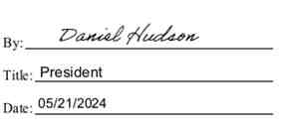
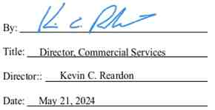

IN WITNESS WHEREOF, the Parties hereto have caused this instrument to be executed as of the day and year first above written.
Empire Generating Co, LLC Niagara Mohawk Power Corporation

43

Exhibit A
[One-Line Diagram]

44
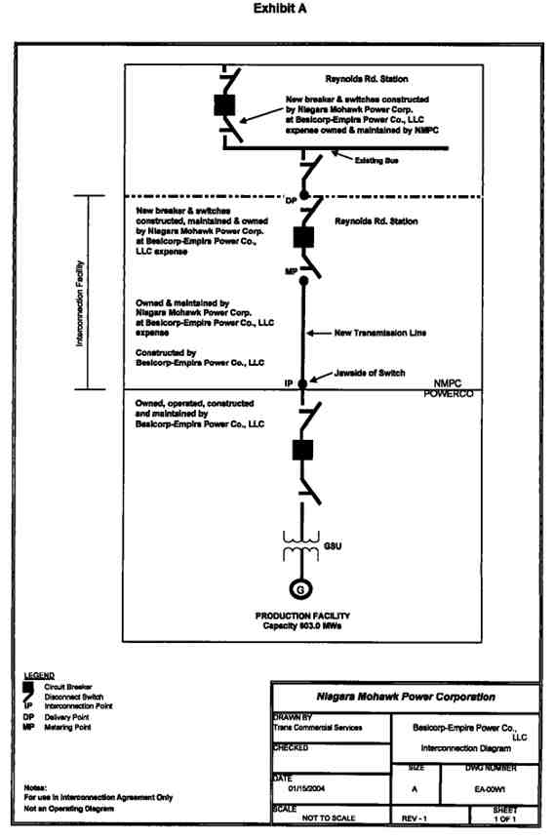

Exhibit B
[Facilities Study]

46

NIAGARA MOHAWK, A NATIONAL GRID COMPANY,

FACILITIES STUDY REPORT FOR

BESICORP - EMPIRE DEVELOPMENT COMPANY, LLC.

NM/NGRID UPGRADES ASSOCIATED WITH

THE 672 MW BESICORP - EMPIRE POWER COMPANY, LLC
COGENERATION POWER PLANT

IN RENSSELAER, NEW YORK

January 13, 2004

POWER CO. Project Initial facilities Study
Exhibit B to the Interconnection Agreement January 15, 2004

The Parties recognize that as of January 13, 2004, the Facilities Study has not been
finalized because the Interconnection Facility has not been authorized by the New York State Public Service Commission (“NYSPSC”) and, therefore, the scope of the Facility Study is subject to the certificate to be issued by the NYSPSC pursuant to Article VII of the New York Public Service Law and additional studies, as required.

This document was prepared by Niagara Mohawk Power Corporation.
It is made available to others upon express understanding that neither
NM/NGRID nor any of its affiliates, assumes any warranty or
representation with respect to the contents of this document or its accuracy
or completeness.
NIAGARA MOHAWK POWER CORPORATION
300 Erie Boulevard West
Syracuse, New York 13202

POWER CO. Project Initial facilities Study
Exhibit B to the Interconnection Agreement January 15, 2004

TABLE OF CONTENTS
1 SUMMARY 1
2 POWER CO. PLANT 3
2.1 POWER CO. Plant Interconnection 8
2.1.1 Special Protection Scheme 8
3 SUBSTATION FACILITIES 9
3.1 Reynolds Road Substation 9
3.1.1 345 kV Switchyard 9
3.1.2 115 kV switchyard 9
3.1.3 Foundations 9
3.1.4 Grounding System 9
3.1.5 Station Service 10
3.1.6 Controls and Protection 10
3.1.7 EMS System 10
3.1.8 Digital Fault Recorder System 10
3.1.9 Interfaces with Transmission 10
3.1.10 Review of Reynolds Road Distribution Feeds 11
3.1.11 POWER CO. Power Plant Revenue Metering 11
3.1.12 POWER CO. 345 kV Metering 11
3.2 Alps Substation 11
3.3 Greenbush Substation 11
3.4 Menands Substation 11
3.5 Riverside Substation 11
3.6 Arsenal Substation 12
3.7 Wynantskill Substation 12
3.8 Rensselaer Waste Water Substation 12
3.9 North Troy Substation 12
3.10 Stephentown Substation 12
3.11 Feura Bush Substation 12
3.12 LG&E / El Paso Substation 12
3.13 POWER CO. Substation 13
3.13.1 POWER CO. Special Protection Scheme 13
3.13.2 Station Service Metering 13
4 Substation Cost Estimates and Construction Schedules 14
4.1 Related Interface Work at POWER CO. Power Plant Station 15
4.2 Related Interface Work at the Alps Station 15
5 POWER CO. TRANSMISSION LINE 16
5.1 ROW Segment Descriptions 16
5.1.1 Segment 1 16
5.1.2 Segment 2 16
5.1.3 Segment 2A 17
5.1.4 Segment 3 17
5.2 General Description of the Proposed Transmission Line 26
5.3 Monopole Structure Types 26
5.4 Power Conductor 26

i
POWER CO. Project Initial facilities Study
Exhibit B to the Interconnection Agreement January 15, 2004

5.5 Monopole Structure Locations 26
5.6 Right-of-Way Width 26
5.7 Electric and Magnetic Fields 27
5.7.1 Evaluation Criteria 27
5.7.2 Methodology 27
5.7.3 Results 27
5.7.4 Conclusions 27
5.8 Construct Segment One Temporary 115 kV Line 41
5.9 Removal of Existing Greenbush #16 115 kV Circuit along Segment One 41
5.10 Construct Segment One 345 kV Line and 115 kV Line 41
5.11 Construct Segment Two 345 kV Line 42
5.12 Construct Segment Three 345 kV Line 42
5.13 Other Infrastructure 42
5.13.1 Existing Utilities 42
5.13.2 Industrial Facilities 43
6 Review of other transmission lines 44
6.1 Review Line #9 from Greenbush to Reynolds Road Stations 44
6.2 Review Line #4 from Riverside to Reynolds Road Station 44
7 Transmission Line Cost Estimate and Construction Schedule 45
8 APPROVALS AND PERMITS 46
8.1 Article X 46
8.2 Article VII 46
8.3 NYISO 46
8.4 ACOE 46
APPENDIX 1 - REYNOLDS ROAD THERMAL RATING SHEETS 48
APPENDIX 2 - REYNOLDS ROAD STATION WORK LIST 69
APPENDIX 3 - NMPC POWER CO. STATION WORK LIST 71
APPENDIX 4 - TRANSMISSION LINE WORK LIST 73
APPENDIX 5 - PROJECT SCHEDULES 75
APPENDIX 6 - SYSTEM RELIABILITY IMPACT STUDY 77

ii
POWER CO. Project Initial facilities Study
Exhibit B to the Interconnection Agreement January 15, 2004

LIST OF FIGURES
Page
FIGURE 2-1 PROPOSED TRANSMISSION LINE LOCATION 4
FIGURE 2-2 REYNOLDS ROAD STATION CONCEPTUAL LAYOUT 5
FIGURE 2-3 REYNOLDS ROAD STATION CONCEPTUAL PROFILE 6
FIGURE 2-4 2003 ANNUAL TRANSMISSION LOAD FLOW REVIEW 7
FIGURE 2-5 CONCEPTUAL POWER CO. PLANT CONFIGURATION 8
FIGURE 5-1 TYPICAL TUBULAR MONOPOLE (SEGMENTS 2 & 3) 18
FIGURE 5-2 TYPICAL TUBULAR STEEL LARGE ANGLE MONOPOLE 19
FIGURE 5-3 TYPICAL TUBULAR STEEL DOUBLE CIRCUIT MONOPOLE 20
FIGURE 5-4 TYPICAL MONOPOLE FOUNDATIONS 21
FIGURE 5-5 SEGMENT IA ROW CONFIGURATION 22
FIGURE 5-6 SEGMENT IB ROW CONFIGURATION 23
FIGURE 5-7 SEGMENT 2 ROW CONFIGURATION 24
FIGURE 5-8 SEGMENT 3 ROW CONFIGURATION 25
FIGURE 5-9 SEGMENT 1 ELECTRIC FIELD PROFILE 29
FIGURE 5-10 SEGMENT 1 MAGNETIC FIELD PROFILE 30
FIGURE 5-11 SEGMENT 2 ELECTRIC FIELD PROFILE 31
FIGURE 5-12 SEGMENT 2 MAGNETIC FIELD PROFILE 32
FIGURE 5-13 SEGMENT 3 ELECTRIC FIELD PROFILE 33
FIGURE 5-14 SEGMENT 3 MAGNETIC FIELD PROFILE 34
FIGURE 5-15 SEGMENT 1 2002 PEAK LOAD ELECTRIC FIELD PROFILE 35
FIGURE 5-16 SEGMENT 1 2002 PEAK LOAD MAGNETIC FIELD PROFILE 36
FIGURE 5-17 SEGMENT 2 2002 PEAK LOAD ELECTRIC FIELD PROFILE 37
FIGURE 5-18 SEGMENT 2 2002 PEAK LOAD MAGNETIC FIELD PROFILE 38
FIGURE 5-19 SEGMENT 3 2002 PEAK LOAD ELECTRIC FIELD PROFILE 39
FIGURE 5-20 SEGMENT 3 2002 PEAK LOAD MAGNETIC FIELD PROFILE 40
LIST OF TABLES
Page
TABLE 4-1 TOTAL NMPC ESTIMATED SUBSTATION COSTS 14
TABLE 5-1 ROW PARALLELED BY OR INTERSECTING THE PROPOSED
TRANSMISSION LINE 17
TABLE 5-2 RESULTS OF ELECTRIC AND MAGNETIC STUDIES 28
TABLE 7-1 TOTAL NMPC ESTIMATED TRANSMISSION LINE COSTS 45

iii
POWER CO. Project Initial facilities Study
Exhibit B to the Interconnection Agreement January 15, 2004

NIAGARA MOHAWK, A NATIONAL GRID COMPANY
FACILITIES STUDY REPORT FOR
BESICORP - EMPIRE DEVELOPMENT COMPANY, LLC:
NM/NGRID Upgrades Associated With The
672 MW POWER CO. Power Plant
in Rensselaer, New York
1 SUMMARY
Besicorp - Empire Development Company, LLC (“BEDCO”) has proposed the development of a cogeneration power plant in the City of Rensselaer, Rensselaer County, New York. The project will consist of three main components:
(1) The Besicorp - Empire Power Company, LLC (“POWER CO.”) cogeneration power
plant (“Plant”)
(2) The connection of the Plant into the New York transmission grid
(3) The replacement of other system elements due to the presence of the proposed Plant
The proposed Plant will be located in the City of Rensselaer, New York. The Plant will have two
161 MW gas-fired combined-cycle-generating units and one 297 MW steam turbine generators,
for a total capability of 619 MW (603 MW after supplying the Plant’s auxiliary load), plus duct
firing for a total of 672 MW (winter rating). The proposed plant will be adjacent to LG&E’s
(“LG&E” or “El Paso”), Rensselaer Co-generation plant and approximately 8.1 miles from the
Niagara Mohawk Power Corporation’s (“NMPC”) Reynolds Road Substation which will be
used as the interconnection point. The POWER CO. Plant will operate mainly as a merchant
plant with approximately 33 MW of electric energy and 160,000 lbs. of steam being supplied to
the Empire State Newsprint Plant (“ESNP”) on an hourly basis, located adjacent to the plant site.
The balance of the energy, its capacity and other ancillary services will be sold to the market.
The proposed transmission facilities will be designed according to NMPC and Northeast Power
Coordinating Council standards.
A System Reliability Impact Study (“SRIS”) identifying impacts to the NMPC system was
completed in November 2001.¹ This study was conducted by Washington Group International
(“WGI”) with coordinated input and review by NMPC, the New York Independent System
Operator (“NYISO”), as well as being reviewed by the ISO-New England due to the
interconnection at Reynolds Road, which is also directly connected to the transmission facilities
to New England. Additionally, the study also reviewed the impacts to the NMPC local
transmission system by the ESNP as purely a load on the NMPC transmission grid in the Capital
Zone of the NYISO. This Facility Study includes the scope of work for potential upgrades
associated with the surrounding NMPC transmission system and facilities resulting from the
addition of the POWER CO. Plant. Subsequent to the approval by the NYISO, POWER CO.

¹ Report on the Empire State Newsprint Project for the Besicorp — Empire Development Company’s 505 MW Plant

in Rensselaer, New York, dated November RELIABILITY IMPACT STUDY.

POWER CO. Project
Exhibit B to the Interconnection Agreement
2001. This report is included as APPENDIX 6 — SYSTEM
1
Initial facilities Study
January 15, 2004

also received confirmation from the Substation and Protection Engineering Group of New York
State Electric & Gas that the interconnection of the POWER CO. Plant would not over duty any
breakers or equipment on the NYSEG system with the interconnection at Reynolds Road.
This report documents preliminary engineering and conceptual design of modification and/or
additions to NMPC’s facilities to accommodate the interconnection of POWER CO.’s proposed
Plant based on a two-breaker 345 kV installation at the NMPC Reynolds Road Substation. The
following is a summary of the NMPC facilities requiring upgrade to incorporate the POWER
CO. Plant:
• Mitigation of the short circuit impact on the Reynolds Road Substation by the
replacement of the 115 kV breaker R63 at Reynolds Road with a new 50 kA
breaker. The addition of the POWER CO. Plant increases the short circuit levels of the R-63 115 kV breaker at the Reynolds Road Substation beyond its 40-kA rating requiring its replacement.
• Addition of one new 345 kV line breaker at the Reynolds Road Substation will be
required to accept the 345 kV generator leads from the POWER CO. substation switchyard to the Reynolds Road Substation.
• Addition of one new 345 kV bus breaker at the Reynolds Road Substation is
required to provide clearing capability for the loss of the 345 kV Reynolds Road
- Alps #1 transmission line, enabling the POWER CO. generators to remain connected to the 345 kV bus at Reynolds Road.
• Provide dual channel relaying at the Alps Substation. Extreme contingency
analysis results indicated that the POWER CO. Plant extends critical clearing
time of a three-phase fault at New Scotland on the New Scotland - Leeds circuit from 17 cycles to 19 cycles. This critical clearing time is considered acceptable because all 345 kV substations in the vicinity of the POWER CO. Plant, with the exception of Alps, have dual channel relaying, which provides backup clearing times comparable to primary clearing times.
• Modifications of the existing system protection schemes at Reynolds Road and
Alps 345 kV substations to adjust for network changes, increased transmission loading and critical clearing time requirements.

2
POWER CO. Project Initial facilities Study
Exhibit B to the Interconnection Agreement January 15, 2004

2 POWER CO. PLANT
The proposed site of the POWER CO. Plant is in the proximity of the LG&E/EI Paso Rensselaer
Generating Plant, in Rensselaer, NY. The plant is transmitting its output on the NMPC LG&E -
Greenbush #16 115 kV Circuit. The POWER CO. site is approximately 5 miles southwest of the
NMPC Reynolds Road Substation. The use of existing ROWs will require the construction of an
8.1 mile 345 kV transmission line to transmit the output power from the plant to the Reynolds
Road substation. The geographic area for location of the proposed POWER CO. Plant and the
Reynolds Road substation is shown in Figure 2-1. A conceptual drawing of the expanded
Reynolds Road substation is shown in Figure 2-2 and Figure 2-3. The summer 2003 annual
transmission review load flow study information sheet is also included as Figure 2-4.

3
POWER CO. Project Initial facilities Study
Exhibit B to the Interconnection Agreement January 15, 2004
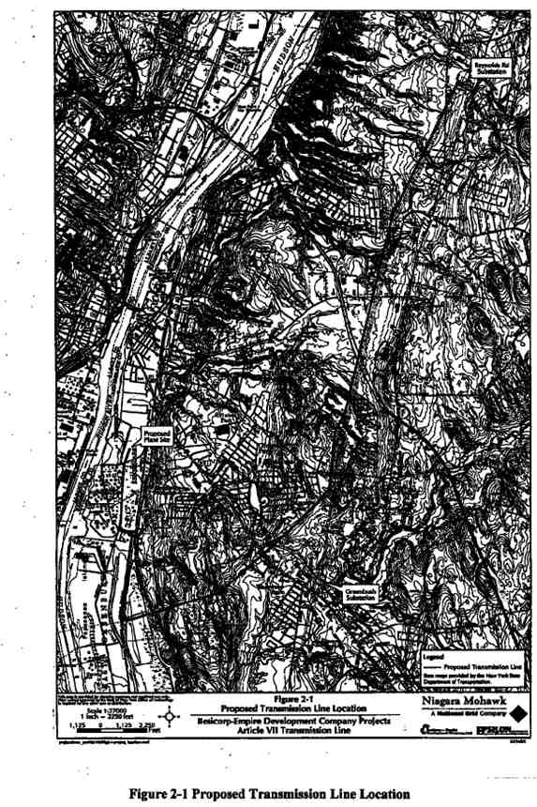

POWER CO. Project Initial facilities Study
Exhibit B to the Interconnection Agreement January 15, 2004

5
POWER CO. Project Initial facilities Study
Exhibit B to the Interconnection Agreement January 15, 2004
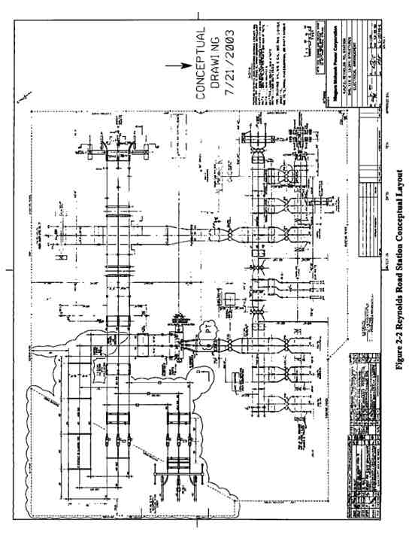

6
POWER CO. Project Initial facilities Study
Exhibit B to the Interconnection Agreement January 15, 2004
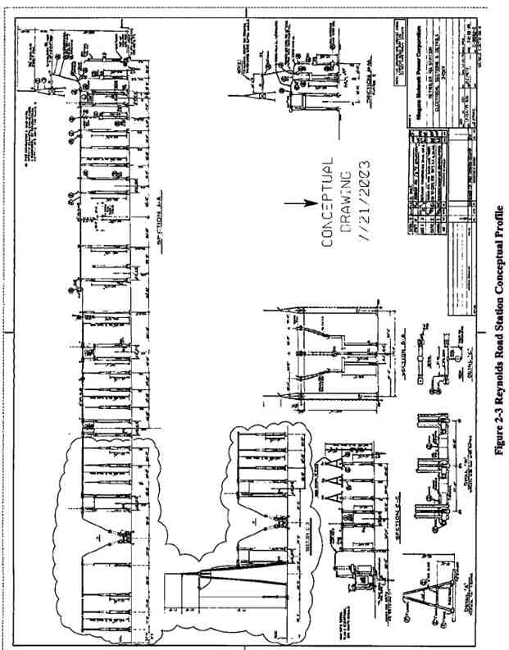

7
POWER CO. Project Initial facilities Study
Exhibit B to the Interconnection Agreement January 15, 2004
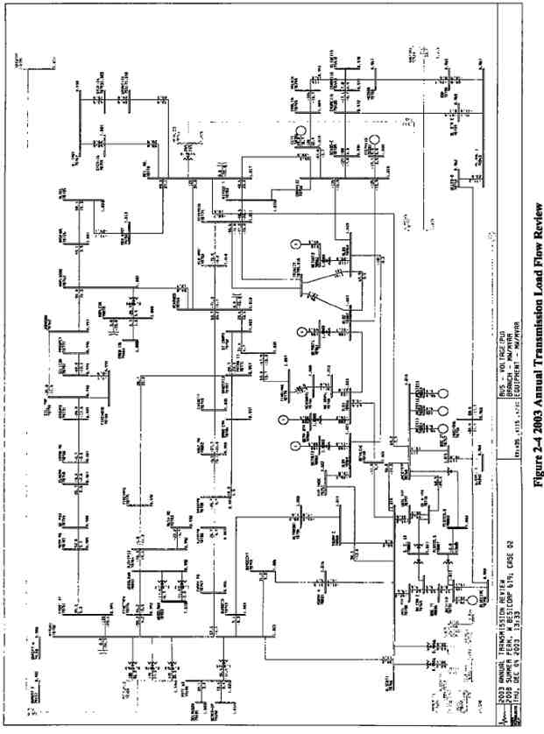

POWER CO. Project Initial facilities Study
Exhibit B to the Interconnection Agreement January 15, 2004
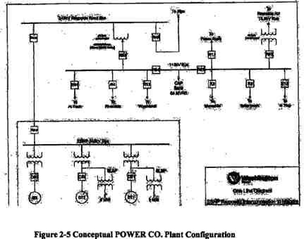

2.1. POWER CO. Plant Interconnection
Figure 2-5 illustrates the preliminary configuration to interconnect the proposed POWER CO.
Plant to the 345 kV transmission system with a generator lead which extends from the POWER
CO. Plant to the NMPC Reynolds Road Substation, through a single 345 kV breaker at Reynolds
Road. The current configuration at Reynolds Road requires that a second 345 kV breaker also be
installed as an isolation device such that the POWER CO. Plant can remain connected to the bus
at Reynolds Road in the event of a line fault on the Reynolds Road - Alps #1 345 kV Circuit.
The new 345 kV transmission line will be installed using 2-1192.5 kcmil ACSR conductors per
phase for the entire length between the POWER CO. switchyard and the Reynolds Road
Substation. NMPC will have the responsibility to design, install and test all necessary equipment
at the Reynolds Road to accommodate this interconnection. POWER CO. will have the
responsibility for all transmission line construction between these same two points. NMPC will
be responsible for the approval of the transmission line design prior to the beginning of
construction.
2.1.1. Special Protection Scheme
An NPCC Type 111 Special Protection System (“SPS”) will be required to detect a fault, line trip or failure on the Reynolds Road - Alps #1 345 kV circuit and automatically runback the POWER CO. Plant generators.

9
POWER CO. Project Initial facilities Study
Exhibit B to the Interconnection Agreement January 15, 2004

3 SUBSTATION FACILITIES
This section documents the necessary review and/or modifications required at the NMPC substations to accommodate the interconnection, including estimated costs and preliminary schedule for these modifications.
This listing of substations and the affected equipment within a given substation requires field verification of ratings and protection schemes. Therefore this section is considered preliminary, as is this document.
3.1. Reynolds Road Substation
The upgrades at the Reynolds Road Substation are associated with the interconnection of the
new 345 kV transmission facility, the installation of a second 345 kV isolation breaker, and the
upgrading of an existing 115 kV circuit breaker which has been determined through the SRIS to
be required to be replaced due to its current rating. The work at the Reynolds Road Substation
will include the following additions/modifications (Reference Plan View: Appendix!, Figure 1-
1).
3.1.1. 345 kV Switchyard
The 345 kV switchyard work mainly consists of creating a new 345 kV bay by the addition of a 345 kV circuit breaker, associated disconnects and bus work, along with the required
communications, controls and protection required for the interconnection. The following
equipment will be installed at the Reynolds Road 345 kV substation:
• Two (2) dead tank breakers (CB) rated 50 kA, 3000 continuous amps will be
installed;
• Three (3) Disconnect switches, with Motor Operators will be installed;
• One (1) Line 345 kV Grounding Switch will be installed;
• One (I) Line 345 kV Line Trap and Tuning Equipment will be installed;
• One (1) Set of metering CT / VT Units; and
• One (1) Potential Transformer (PT) will be installed
3.1.2. 115 kV switchyard
The 115 kV switchyard work mainly consists of the replacement of an existing 115 kV circuit breaker (R63) which was determined to be beyond its normal rating through the SRIS analysis performed for the interconnection of the POWER CO. Plant.
• One live tank breaker rated 40 kA will be replaced with a new 50 kA live tank
breaker (R-63)
3.1.3. Foundations

10
POWER CO. Project Initial facilities Study
Exhibit B to the Interconnection Agreement January 15, 2004

It is proposed that new foundations will be poured for all new 345 kV equipment in the
Reynolds Road Substation. Such foundations will be required for the two (2) 345 kV circuit breakers, the 345 kV Grounding Switch, metering transformers and the one (1) Potential Transformer. The existing building foundation will need to be expanded to accommodate the additional required building space.
3.1.4. Grounding System
The grounding system will consist of a ground conductor grid and driven ground rods. All ground conductors will be copperweld.
3.1.5. Station Service
Station Service at the Reynolds Road Substation is not anticipated to need modifications or
replacement in order to serve the additional facilities. Additional analysis may be required
following specific specifications on the equipment are determined. The Station Service consists
of two battery sets (125 VDC) and charger systems with _____AH batteries and a _____A
chargers.
3.1.6. Controls and Protection
Control and protection additions/replacements will include:
a) Controls and indication for 345 kV breaker (#TBD-B1) and motor operated disconnect
(#TBD-D1) for the line interconnection of the POWER CO. Plant.
b) Controls and indication for 345 kV breaker (#TBD-B2) and motor operated disconnect
(#TBD-D2) for the isolation breaker on the Alps #1 345 kV connection at Reynolds
Road.
c) Synchronism check and reclosing relays for the new 345 kV breaker (#TBD-B1) and
(#TBD-B2)
d) Spare points on the existing annunciators will be used for the new alarms.
e) Protection packages (system 1 & 2) for the 345 kV POWER CO. line will be installed.
System 1 will be directional comparison carrier blocking (with on/off, and FSK power line carrier equipment) relaying system. System 1 cabinet will be located next to the
existing panel ____. The new cabinet will be designated as #____. System 2 will be
permissive over-reach transfer trip (with POTT communication equipment) relay
system. System 2 cabinet will be located next to the existing panel . The new cabinet
will be designated as # ____.
f) High speed and standard 345 kV breaker failure relaying for breaker (#TBD-BI) and for
345 kV breaker (#TBD-B2).
g) 345 kV bus differential relays for 345 kV bus #____ (system 1 and system 2). System 1
will be mounted on panel #____ and system 2 will be on panel #____.
h) Communication processor.
i) Digital fault recorder will be installed on panel #____.
j) Protective and controls associated with the replaced 115 kV circuit breaker R63 will be
revised accordingly, if required.
11
POWER CO. Project Initial facilities Study
Exhibit B to the Interconnection Agreement January 15, 2004

3.1.7. EMS System
Harris RTU exists at the station to monitor and control the 345 kV facilities from NMPC
Dispatch Center at ____. It is equipped for ____ status, ____ control pairs, and ____ analog
points. Spare points available in the RTU will be used to accommodate additional status, control, and sequence inputs associated with the new substation facilities.
3.1.8. Digital Fault Recorder System
A new Digital Fault Recorder (“DFR”) system will need to be installed in the control building.
3.1.9. Interfaces with Transmission
Transmission engineering will undertake the following interface with the substation equipment:
• 2 - 1192.5 kcmil ACSR conductors drops will be made from the 345 kV line to the
appropriate 345 kV breaker disconnect switches for the (#TBD-B1) breaker.
3.1.10. Review of Reynolds Road Distribution Feeds
A complete short circuit analysis will be reviewed/conducted to analyze the 13.2 kV distribution circuits. Those circuits, which will be analyzed through this study, are the 33451, 33452, 33453, and 33454 - 13.2 kV distribution circuits.
3.1.11. POWER CO. Plant Revenue Metering
NMPC will be responsible for providing all required metering equipment for the POWER CO.
Plant revenue metering which will be installed at the Reynolds Road Substation. Such metering
equipment will be in accordance with NMPC and NYISO revenue metering specifications.
3.1.12. POWER CO. 345 kV Metering
The meters provided for the Reynolds Road 345 kV interconnection will be capable of providing
required billing quantities via dial-up telephone to the NMPC / POWER CO. or POWER CO.
and the NYISO, using a UTS MV-90 in their standard format and protocol. With the location of
the meters at Reynolds Road, there will be no need to be capable of being electronically
compensated to reflect losses in the transmission line facilities. Any losses on transmission will
be solely borne by POWER CO. The specific meters must also be capable of measuring bi-
directional energy flow.
3.2. Alps Substation
The SRIS review of system condition indicated that modifications of the existing system
protection schemes at the Alps 345 kV substation is required to adjust for network changes
caused by increased transmission loading and critical clearing time requirements. It is also
necessary to coordinate breaker tripping and reclosing schemes to take into account the inclusion of the POWER CO. Plant input to the NMPC system.
12
POWER CO. Project Initial facilities Study
Exhibit B to the Interconnection Agreement January 15, 2004

An NPCC Type III Special Protection System (“SPS”) will be required to detect and runback the Plant for a Reynolds Road - Alps #1 345 kV line failure or breaker trip.
3.3. Greenbush Substation
The SRIS review for the interconnection of the POWER CO. Plant to the NMPC Reynolds Road Substation concluded there were no impacts on the equipment at the Greenbush 115 kV
Substation. However, additional studies are required to look at the potential required
modifications to the protection scheme and station hardware.
3.4. Menands Substation
The SRIS review for the interconnection of the POWER CO. Plant to the NMPC Reynolds Road Substation concluded there were no impacts on the equipment at the Menands 115 kV
Substation. However, additional studies are required to look at the potential required
modifications to the protection scheme and station hardware.
3.5. Riverside Substation
The SRIS review for the interconnection of the POWER CO. Plant to the NMPC Reynolds Road Substation concluded there were no impacts on the equipment at the Riverside 115 kV
Substation. However, additional studies are required to look at the potential required
modifications to the protection scheme and station hardware.
3.6. Arsenal Substation
The SRIS review for the interconnection of the POWER CO. Plant to the NMPC Reynolds Road Substation concluded there were no impacts on the equipment at the Arsenal 115 kV Substation. However, additional studies are required to look at the potential required modifications to the protection scheme and station hardware.
3.7. Wynantskill Substation
The SRIS review for the interconnection of the POWER CO. Plant to the NMPC Reynolds Road Substation concluded there were no impacts on the equipment at the Wynantskill 115 kV
Substation. However, additional studies are required to look at the potential required
modifications to the protection scheme and station hardware.
3.8. Rensselaer Waste Water Substation
The SRIS review for the interconnection of the POWER CO. Plant to the NMPC Reynolds Road Substation concluded there were no impacts on the equipment at the Rensselaer Water Tap.
However, additional studies are required to look at the potential required modifications to the protection scheme and station hardware.
3.9. North Troy Substation

13
POWER CO. Project Initial facilities Study
Exhibit B to the Interconnection Agreement January 15, 2004

The SRIS review for the interconnection of the POWER CO. Plant to the NMPC Reynolds Road Substation concluded there were no impacts on the equipment at the North Troy 115 kV
Substation. However, additional studies are required to look at the potential required
modifications to the protection scheme and station hardware.
3.10. Stephentown Substation
The SRIS review for the interconnection of the POWER CO. Plant to the NMPC Reynolds Road Substation concluded there were no impacts on the equipment at the Stephentown 115 kV
Substation. However, additional studies are required to look at the potential required
modifications to the protection scheme and station hardware.
3.11. Feura Bush Substation
The SRIS review for the interconnection of the POWER CO. Plant to the NMPC Reynolds Road Substation concluded there were no impacts on the equipment at the Feura Bush 115 kV
Substation. However, additional studies are required to look at the potential required
modifications to the protection scheme and station hardware.
3.12. LG&E/ El Paso Substation
The SRIS review for the interconnection of the POWER CO. Plant to the NMPC Reynolds Road
Substation concluded there were no impacts on the equipment at the LG&E / El Paso 115 kV
Substation for the LG&E / El Paso Cogeneration Plant. However, additional studies are required
to look at the potential required modifications to the protection scheme and station hardware.
3.13. POWER CO. Substation
3.13.1. POWER CO. Special Protection Scheme
The SRIS review for the interconnection of the POWER CO. Plant has indicated that there will
be a need to install a NPCC Type 111 SPS equipment. This SPS equipment will automatically
runback the output of the generation units at the POWER CO. Plant to an approximate ____%
output, for the case of the loss of the Alps #1 345 kV Line between Reynolds Road and the Alps
Substation, or for the loss of its associated breaker (#TBDB2) at the Reynolds Road Substation.
• Installation of an audio-tone transmitter at Alps, with a receiver at POWER CO.
Plant.
• It may be possible to share communications paths and equipment for different SPSs.
3.13.2. Station Service Metering
Dual Station Service supply will be provided for the POWER CO. 345 kV switchyard in
accordance with NPCC requirements, in accordance with NPCC Document A-5, Section 3.6.
The physical bus arrangement of the POWER CO. 345 kV switchyard enables the station service
for the POWER CO. Plant to be supplied through the 345/13.8 kV step-down transformer, for a
14
POWER CO. Project Initial facilities Study
Exhibit B to the Interconnection Agreement January 15, 2004

complete shutdown of the cogeneration facility. A second source is being investigated using
nearby NMPC substation distribution or sub-transmission feeds. This second source may require modifications at the station selected as the source for the 2nd station service feed.

15
POWER CO. Project Initial facilities Study
Exhibit B to the Interconnection Agreement January 15, 2004
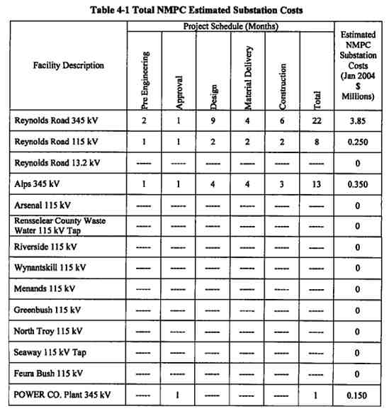

4 SUBSTATION COST ESTIMATES AND CONSTRUCTION
SCHEDULES
Project cost estimates (+/- 20% accuracy) for the substation work are summarized in Table 4-1.
These are based on present day dollars. All substation facilities identified in Table 4-1 are
considered Pool Transmission Facilities (“PTF”). No salvage value is included in the estimates.
The estimated project schedule for the POWER CO. substation is provided in Table 4-1. Project duration includes project commencement through completion for the additions/modifications detailed above for engineering, material delivery and construction of work. Costs associated with the POWER CO. Plant or the switchyard are not included. Only incremental costs
attributed to the POWER CO. projects are included.

16
POWER CO. Project Initial facilities Study
Exhibit B to the Interconnection Agreement January 15, 2004

4.1. Related Interface Work at POWER CO. Plant Station
This report does not cover the interface facilities (switchgear, metering, protection, and SCADA, etc.) required at the Plant for the interconnection. This needs to be addressed at a later date after the Plant electrical one-line is finalized.
4.2. Related Interface Work at the Alps Station
This report addresses the need for an SPS system installation at the Alps 345 kV Substation, but
does not address any interface facilities (switchgear, metering, other protection, and SCADA,
etc.) which may be required at this facility, until such time as the final electrical interconnection
is finalized.

17
POWER CO. Project Initial facilities Study
Exhibit B to the Interconnection Agreement January 15, 2004

5 POWER CO. TRANSMISSION LINE
This section will provide the details of the POWER CO. 8.1 mile transmission line
interconnection facility. Specifics along portions of the route vary according to the location; therefore the transmission line is described as three separate segments as follows:
• Segment One: POWER CO. Plant south approximately 1.7 miles along a 100-foot
NMPC ROW easement;
• Segment Two: From Segment One for approximately 2.3 miles (generally northeast)
along an existing 250-foot NMPC fee-owned ROW
• Segment Three: From Segment Two for approximately 4.1 miles (generally north)
along an existing 355-foot NMPC fee-owned ROW.
5.1. ROW Segment Descriptions
The following will describe the characteristics of the three segments of the Proposed Transmission Line.
5.1.1. Segment 1
The Proposed Transmission Line route starts at the proposed new POWER CO. Plant in the City
of Rensselaer and travels south, along an existing 100-foot wide NMPC ROW into the Town of
East Greenbush, to an intersection with another NMPC ROW, a distance of approximately 1.7
miles. This portion of the ROW contains an existing 115 kV transmission line (Greenbush #16
Circuit) for its entire length, and an 8-inch natural gas pipeline (NMPC Pipeline E-35) for 0.8
miles from the POWER CO. Plant to the crossing of Teller Road (Sun Oil Road). (The portion
of Segment 1 containing the natural gas line is referred to as Segment 1A.) The gas pipeline is
40 feet from the western edge of the ROW and the transmission line is 40 feet off the eastern
edge of the ROW, providing a 20-foot separation between the facilities. From Teller Road south
(referred to as Segment 1B), the existing 115 kV transmission line is located in the center of the
ROW.
For Segment 1, the Proposed Transmission Line route will be placed on double circuit steel
monopole structures within the existing ROW. The existing Greenbush #16 Circuit will be
placed on temporary structures on the western side of the ROW until the new steel monopoles
are in place on the eastern side of the ROW. The existing Greenbush #16 Circuit will then be
placed on the eastern side of the new monopoles. A cross section of the ROW is shown in Figure
5-5 and Figure 5-6.
5.1.2. Segment 2
The Proposed Transmission Line route then follows an existing ROW (New Scotland -
Reynolds Road) in a northeasterly direction for approximately 2.3 miles, where additional
circuits enter the ROW. The ROW followed by Segment 2 is a 250-foot wide corridor and the
Proposed Transmission Line will be located within the ROW along the northern side. The
corridor contains two existing sets of structures: the Feura Bush - Reynolds Road #17 115 kV
18
POWER CO. Project Initial facilities Study
Exhibit B to the Interconnection Agreement January 15, 2004

Circuit (constructed for 230 kV), and the Greenbush #16 115 kV Circuit. The Proposed
Transmission Line will be constructed on a new set of single circuit steel monopoles located on the northern side of the ROW. A cross section of the ROW is shown in Figure 5-7.
5.1.3. Segment 2A

This is a short section of NMPC ROW that connects to the Greenbush substation. It is 0.7 miles long and ranges from 100 to 250 feet wide. Initially there is one existing circuit (Greenbush #16) and then two additional circuits (Reynolds Road - Greenbush #9 Circuit and Riverside - Reynolds Road #4 Greenbush station tap).
5.1.4. Segment 3
The Proposed Transmission Line will then continue approximately 4.1 miles in a northerly direction following an existing NMPC ROW, and will terminate at the NMPC Reynolds Road substation. The new circuit will be constructed along the western side of this
combined 355-foot wide ROW. This portion of the ROW presently contains four electric circuits. These are (from east to west):
• Reynolds Road - Greenbush #9 115 kV Circuit;
• Riverside - Reynolds Road #4 115 kV Circuit;
• Distribution Circuit 13.2 kV (constructed for 34.5 kV); and
• Feura Bush - Reynolds Road #17 115 kV Circuit (constructed for 230 kV).

This ROW also accommodates a Dominion Telecom (formerly Telergy) fiber optic conduit, which enters the ROW north of 1-90 at MP 5.5 and exits just south of the Reynolds Road substation at MP 8. Also within this ROW are a Dominion Gas 12-inch natural gas pipeline and a NEON Communications fiber optic conduit. The Proposed Transmission Line will be constructed on a new set of single circuit steel monopoles (located on the western side of the ROW). A cross section of the ROW is shown in Figure 5-8.

19
POWER CO. Project Initial facilities Study
Exhibit B to the Interconnection Agreement January 15, 2004
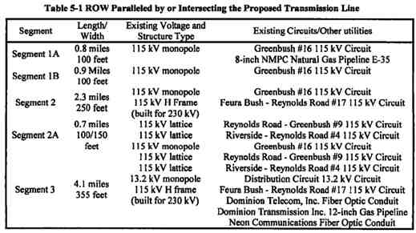

20
POWER CO. Project Initial facilities Study
Exhibit B to the Interconnection Agreement January 15, 2004
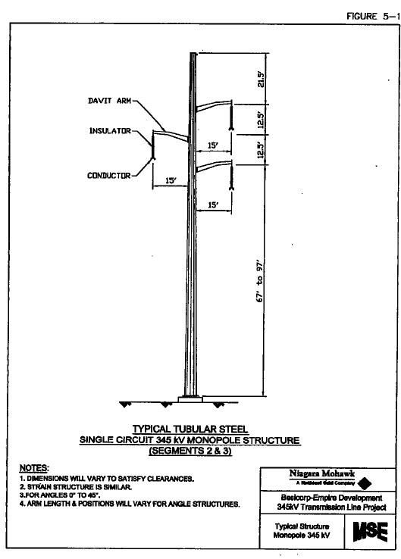

Figure 5-1 Typical Tabular Monopole (Segments 2 & 3)

21
POWER CO. Project Initial facilities Study
Exhibit B to the Interconnection Agreement January 15, 2004
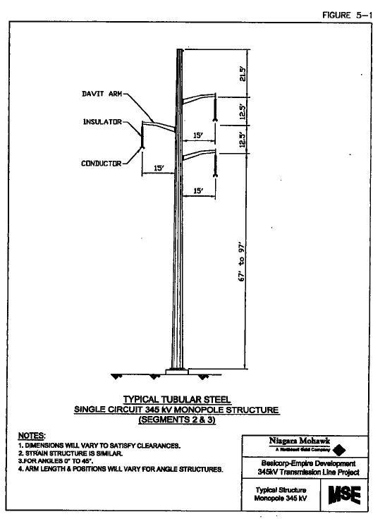

Figure 5-2 Typical Tabular Steel Large Angle Monopole

22
POWER CO. Project Initial facilities Study
Exhibit B to the Interconnection Agreement January 15, 2004
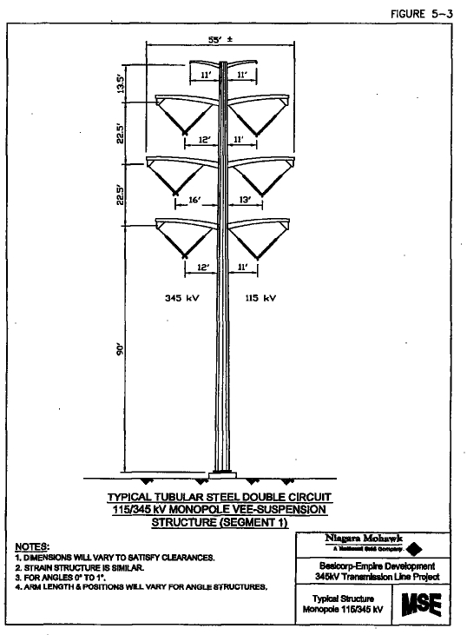

Figure 5-3 Typical Tabular Steel Double Circuit Monopole

23
POWER CO. Project Initial facilities Study
Exhibit B to the Interconnection Agreement January 15, 2004
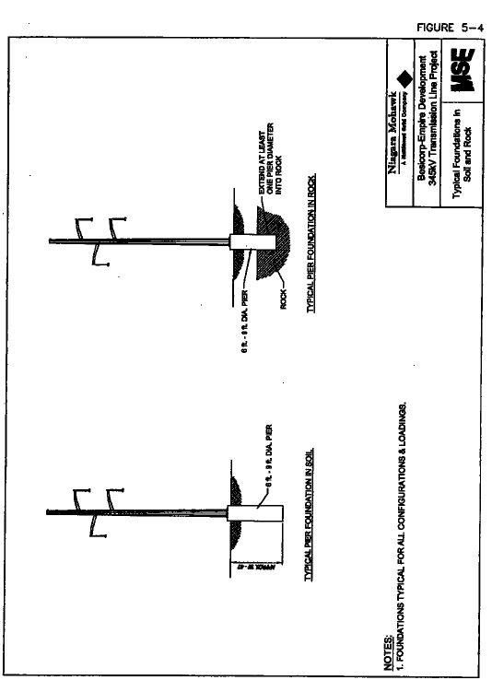

Figure 5-4 Typical Monopole Foundations

24
POWER CO. Project Initial facilities Study
Exhibit B to the Interconnection Agreement January 15, 2004
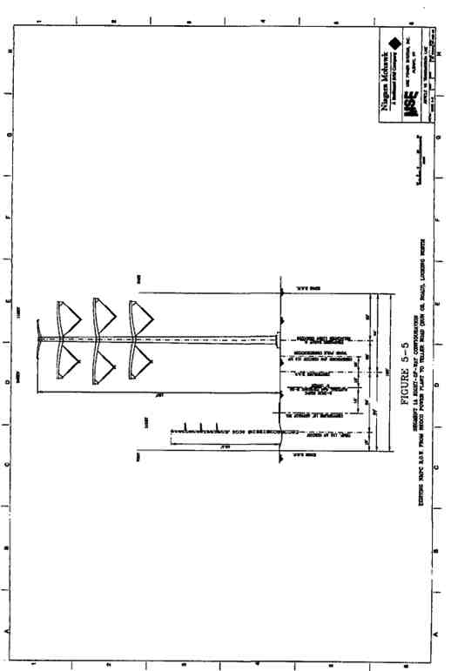

Figure 5-5 Segment 1A ROW Configuration

25
POWER CO. Project Initial facilities Study
Exhibit B to the Interconnection Agreement January 15, 2004
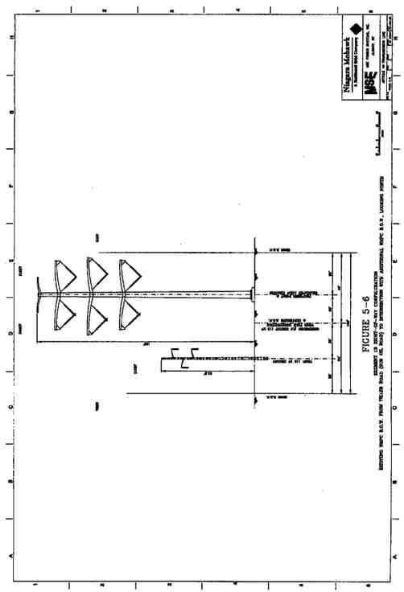

Figure 5-6 Segment 1B ROW Configuration

26
POWER CO. Project Initial facilities Study
Exhibit B to the Interconnection Agreement January 15, 2004
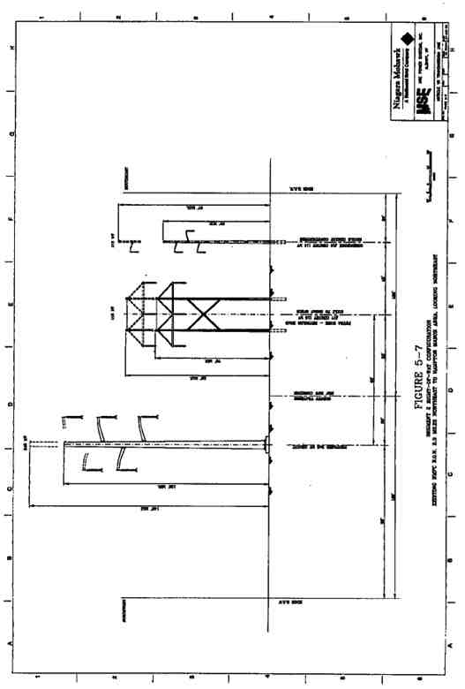

Figure 5-7 Segment 2 ROW Configuration

27
POWER CO. Project Initial facilities Study
Exhibit B to the Interconnection Agreement January 15, 2004

28
POWER CO. Project Initial facilities Study
Exhibit B to the Interconnection Agreement January 15, 2004
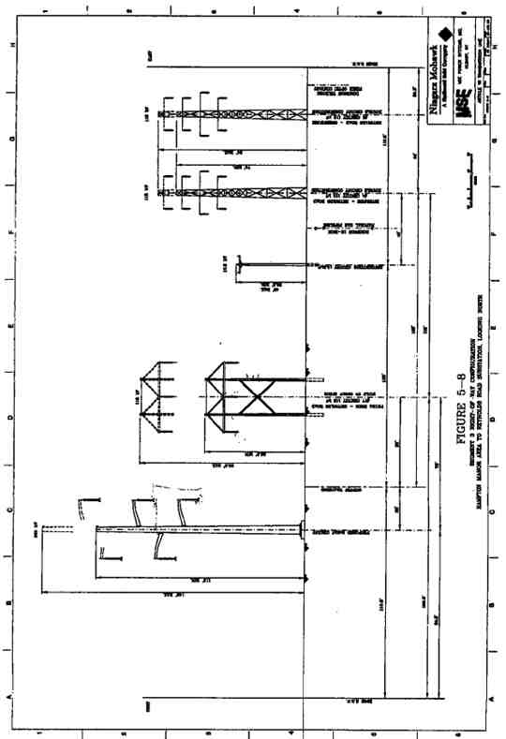

Figure 5-8 Segment 3 ROW Configuration

29
POWER CO. Project Initial facilities Study
Exhibit B to the Interconnection Agreement January 15, 2004

5.2. General Description of the Proposed Transmission Line
The NMPC proposed 345 kV transmission line will occupy existing NMPC ROWs for its entire length with one exception at the intersection of segments 1 & 2. The total length of the route is approximately 8.1 miles.
5.3. Monopole Structure Types
Steel monopole tubular structures are preferred for the Proposed Transmission Line. The
monopole structures will be approximately 112 feet to 160.5 feet in height and will be self-
supporting. The structures will be galvanized, and therefore neutral in color, with gray porcelain
insulators. The following figures illustrate the type of monopole structures that will be required:
• tubular steel single circuit monopole structure (Figure 5-1);
• tubular steel circuit monopole structure for large angles (Figure 5-2); and
• tubular steel double circuit 115/345 kV Vee-suspension monopole structure (Figure 5-
3).
A single, reinforced concrete pier is proposed as the typical monopole foundation. The piers will
be from 6 to 9 feet in diameter and nominally 30 to 40 feet in depth. Where solid rock is
encountered, the piers will extend at least one pier diameter into the rock. Typical pier
foundations in soil and rock are shown in Figure 5-4. The pier foundation size requirements will
be determined by a detailed geotechnical analysis as part of a project specific EM&CS&P Plan
that will be submitted to the NYSPSC for review and approval prior to construction.
5.4. Power Conductor
Two 1192.5 kcmil 45/7 ACSR power conductors will be used for each phase of the new 345 kV
circuit. Single 795.0 kcmil 26/7 ACSR will be used for each phase of the 115 kV circuit on
Segment 1.
5.5. Monopole Structure Locations
Exact monopole locations will depend on final design of the Proposed Transmission Line that will be provided in the EM&CS&P Plan. Structures will be approximately 600 to 1,000 feet apart. Actual spans will vary based on environmental factors, required clearance from the ground, and the adjacent transmission lines.
5.6. Right-of-Way Width
The Proposed Transmission Line will be constructed on existing ROWs for its entire length with
one exception. For Segment 1, the first 1.7 miles of the project, the monopole structures will be
placed within an existing 100-foot wide ROW. It is anticipated that additional ROW may be
acquired at the intersection of Segment 1 and 2 where the alignment joins an existing NMPC
ROW. For Segment 2, the next 2.3 miles of the Proposed Transmission Line, the structures will
be placed within an existing 250-foot wide ROW. For Segment 3, approximately 4.1 miles, the

30
POWER CO. Project Initial facilities Study
Exhibit B to the Interconnection Agreement January 15, 2004

monopole structures will be placed within an existing 355-foot wide ROW. The ROW
configurations proposed for each segment are shown in Figure 5-5 through Figure 5-8.
5.7. Electric and Magnetic Fields
This analysis demonstrates compliance with the NYSPSC Policy Statement dated September 11,
1990, concerning electric and magnetic fields (“EMF”). The EMF strengths along were
estimated along the edge of the existing NMPC ROW followed by the Proposed Transmission
Line. The methodology used to model EMF and a summary of the results are presented below.
5.7.1. Evaluation Criteria
The EMF limits established by the NYSPSC include the following criteria for all Proposed Transmission Line segments:
1. The maximum electric field at 1 meter above ground along the edge of the ROW
shall be less than 1.6 kilovolts per meter (kV/m).
2. The maximum electric field at 1 meter above ground over public roads shall be less
than 7.0 kV/m in accordance with NYSPSC Opinion No. 78-13.
3. The magnetic field at 1 meter above ground at all locations along the edge of the
ROW shall be less than 200 mG in accordance with NYSPSC Policy Statement dated September 11, 1990.
4. Electric fields meeting the above criteria shall be calculated at maximum system
overvoltage of 1.05 per unit (p.u.).
5. Magnetic fields meeting the above criteria shall be calculated at winter normal
conductor rating for each line.
5.7.2. Methodology
The EMF strengths were calculated utilizing the industry accepted computer program
“ENVIRO”, Version 3.51, developed by the Electric Power Research Institute (“EPRI”). The
existing circuits within each segment of the ROW were identified. The configurations are shown
in the cross sections presented in Figure 5-5 through Figure 5-8. Minimum conductor clearances
to ground surface per National Electric Safety Code (“NESC”) are used in the EMF calculations
for conservative results. A minimum vertical clearance of 37 feet is used for Segments 2 and 3
for the new 345 kV construction. For Segment 1, the minimum vertical clearance was set at 55
feet. All minimum clearances are assumed to take place at a maximum conductor operating
temperature of 257 degrees Fahrenheit. The winter normal conductor ampacities were obtained from the NMPC Transmission System Thermal Ratings Manual. Electric field calculations were performed for 1.05 p.u. overvoltage.
5.7.3. Results
Results of the EMF model runs are presented below in Table 5-2. Illustrations of the electric and
magnetic field profiles for each segment of the Proposed Transmission Line are presented in
Figure 5-9 through Figure 5-14. In addition to the conservative runs required by the NYSPSC,
NMPC has also evaluated the EMF that would be experienced in the field based on actual 2002
31
POWER CO. Project Initial facilities Study
Exhibit B to the Interconnection Agreement January 15, 2004

peak loading of the existing facilities and normal peak load for the Proposed Transmission Line.
Results from the peak load scenario are presented in Table 5-2. Illustrations of the EMF field
profiles for each segment at the peak load are presented in Figure 5-15 through Figure 5-20.
5.7.4. Conclusions
Based on the calculated results, the required criterion are satisfied:
1. In all cases the calculated maximum electric field at the edge of ROW is less than the
required 1.6 kV/m.
2. In all cases the calculated maximum electric field within the ROW is less than the
required 7.0 kV/m.
3. In all cases the calculated maximum magnetic field at the edge of ROW is less than
the required 200 mG.
The centerline of the Proposed Transmission Line is based on preliminary data. These results may be subject to change as the detailed design is finalized. Detailed design plans will be submitted in the EM&CS&P Plan.
Table 5-2 Results of Electric and Magnetic Studies

Maximum Electric
Field @ ROW Edge Maximum Electric Field Maximum Magnetic Field at
ROW Segment (kV/m) in ROW (kV/m) ROW Edge (mG)
Maximum Conductor Rating
Segment 1 1.4 2.8 191.6
Segment 2 0.7 4.7 158.8
Segment 3 . 0.8 4.2 196.2
Actual 2002 Peak Loading
Segment 1 1.4 2.7 147.3
Segment 2 0.7 4.0 72.6
Segment 3 1.4 6.7 77.5

32
POWER CO. Project Initial facilities Study
Exhibit B to the Interconnection Agreement January 15, 2004
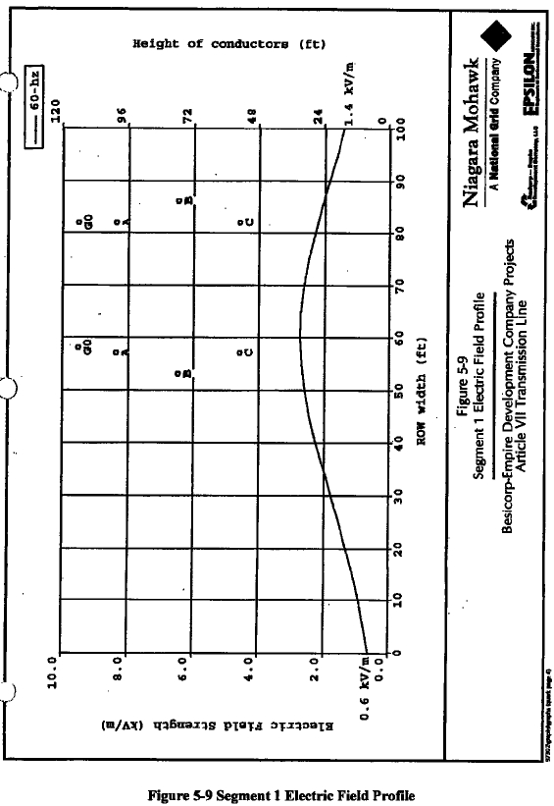

33
POWER CO. Project Initial facilities Study
Exhibit B to the Interconnection Agreement January 15, 2004

34
POWER CO. Project Initial facilities Study
Exhibit B to the Interconnection Agreement January 15, 2004
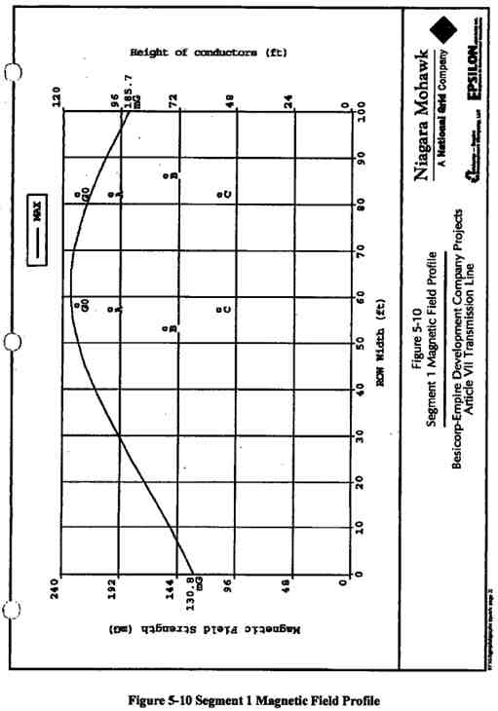

35
POWER CO. Project Initial facilities Study
Exhibit B to the Interconnection Agreement January 15, 2004
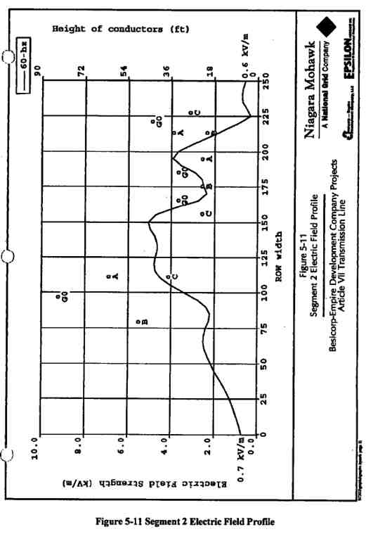

36
POWER CO. Project Initial facilities Study
Exhibit B to the Interconnection Agreement January 15, 2004
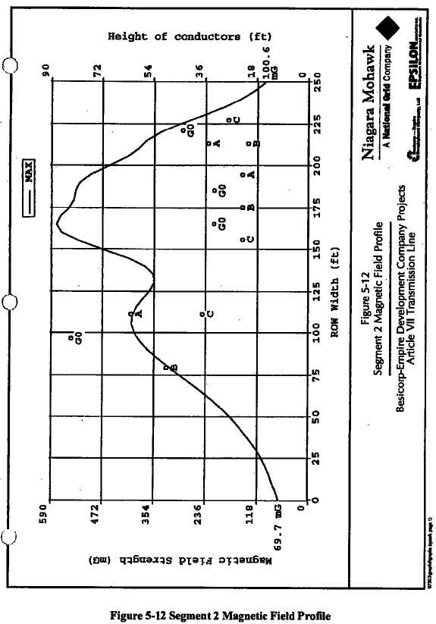

37
POWER CO. Project Initial facilities Study
Exhibit B to the Interconnection Agreement January 15, 2004

38
POWER CO. Project Initial facilities Study
Exhibit B to the Interconnection Agreement January 15, 2004
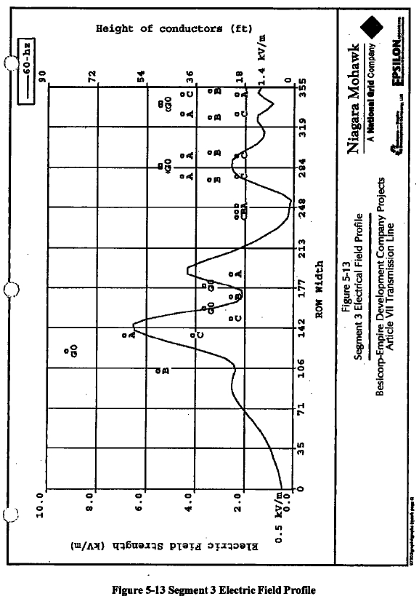

39
POWER CO. Project Initial facilities Study
Exhibit B to the Interconnection Agreement January 15, 2004

40
POWER CO. Project Initial facilities Study
Exhibit B to the Interconnection Agreement January 15, 2004
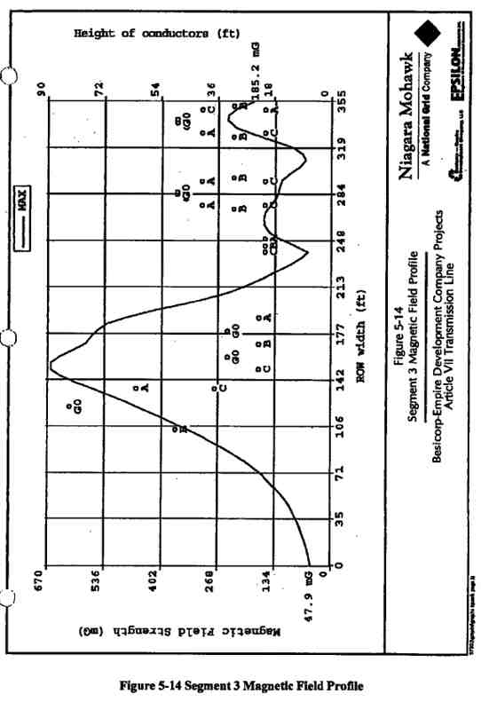

41
POWER CO. Project Initial facilities Study
Exhibit B to the Interconnection Agreement January 15, 2004

42
POWER CO. Project Initial facilities Study
Exhibit B to the Interconnection Agreement January 15, 2004
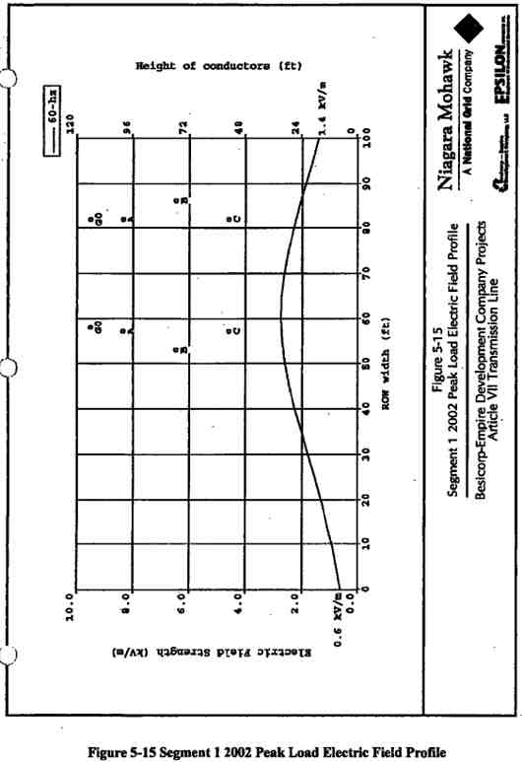

43
POWER CO. Project Initial facilities Study
Exhibit B to the Interconnection Agreement January 15, 2004
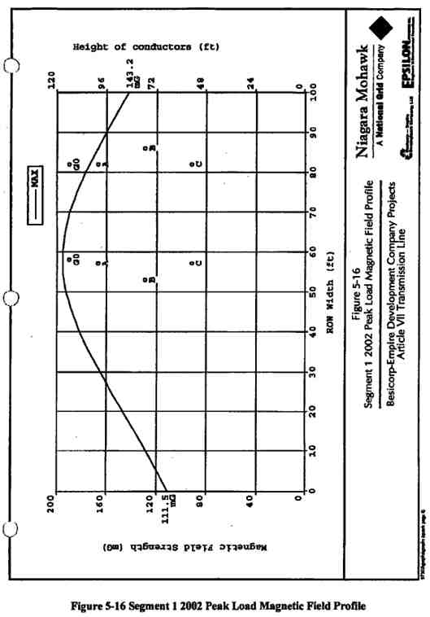

44
POWER CO. Project Initial facilities Study
Exhibit B to the Interconnection Agreement January 15, 2004
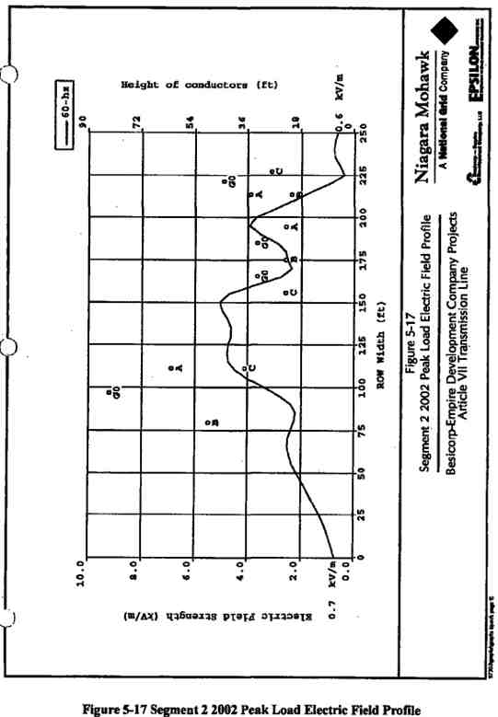

45
POWER CO. Project Initial facilities Study
Exhibit B to the Interconnection Agreement January 15, 2004
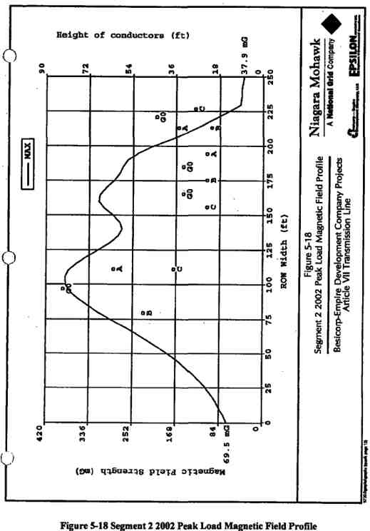

46
POWER CO. Project Initial facilities Study
Exhibit B to the Interconnection Agreement January 15, 2004
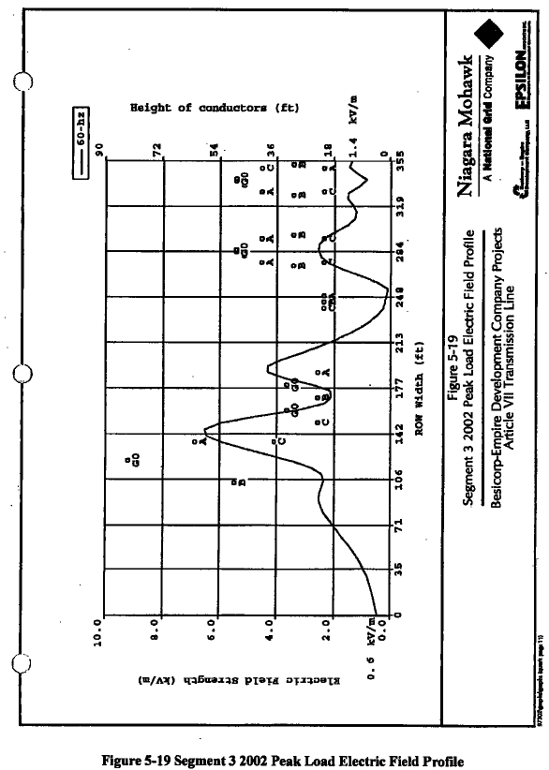

47
POWER CO. Project Initial facilities Study
Exhibit B to the Interconnection Agreement January 15, 2004

48
POWER CO. Project Initial facilities Study
Exhibit B to the Interconnection Agreement January 15, 2004
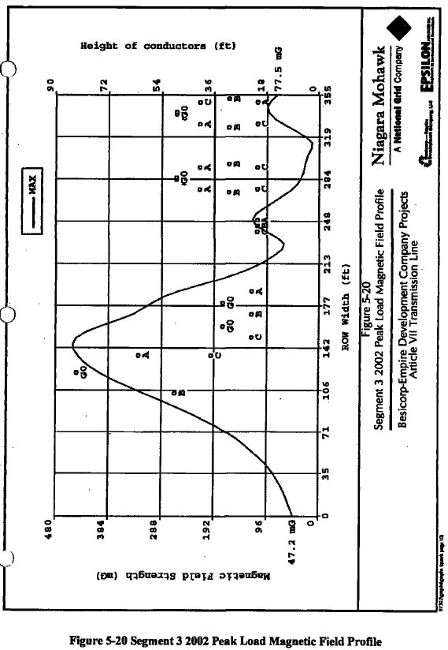

49
POWER CO. Project Initial facilities Study
Exhibit B to the Interconnection Agreement January 15, 2004

50
POWER CO. Project Initial facilities Study
Exhibit B to the Interconnection Agreement January 15, 2004

5.8. Construct Segment One Temporary 115 kV Line
POWER CO. will construct a temporary 115 kV circuit, consisting of engineered self-supporting
structures, rather than wood poles with guys, along the western edge of the existing easement.
Such structures will be placed within the current easement and so as not to interfere with the
existing macadam service roadway. This roadway exists along the northern portion of this
segment. On the southern portion, the self-supporting structures will be placed so as not to
interfere with an agricultural field, as will be indicated on EM&CS&P drawings being prepared
as part of the New York State Siting Board’s Article VII process. Installation of said temporary
line will be coordinated with the local fanner and his growing season and associated activity.
The temporary line will be designed and constructed in accordance with NMPC approved
standards or as modified and approved by the NMPC Transmission Design Engineering Group.
The temporary facilities will be installed in parallel to those currently existing between poles #4 and #29 along the Greenbush #16 115 kV Circuit. This temporary 115 kV circuit will be
constructed using 795 kcmil ACSR for its entire length.
Once this temporary line has been tested by NMPC personnel and declared ready for service,
NMPC personnel will perform the necessary disconnection and reconnection at both poles #4
and #29 from the existing structures, to the new temporary structures. At this point the
temporary circuit will be capable of being energized and available for use by the LG&E/EI Paso
Generating Plant.
5.9. Removal of Existing Greenbush #16115 kV Circuit along Segment One
Upon successful completion of NMPC’s transfer from the Original Greenbush #16 115 kV
Circuit to the Temporary Greenbush #16 115 kV Circuit facilities, POWER CO. will remove all existing poles, wires, insulators, guys, etc. which are currently used on the Original Greenbush #16 115 kV Circuit, between NMPC pole #4 and NMPC pole #29 on this Original Greenbush #16 Circuit. Caution will be used to not disturb the existing NMPC 8” natural gas line which exists in the northern portion of this ROW (between NMPC Greenbush #16 115 kV structure #4 and structure #14 in the vicinity of Teller Crossing Road (a.k.a. Sun Oil Road).
5.10. Construct Segment One 345 kV Line and 115 kV Line
POWER CO. will construct a series of steel monopole structures, designed in accordance with NMPC Standards or as modified and approved by NMPC Transmission Design Engineering Group, which will support both a 115 kV circuit to replace the Original Greenbush #16 115 kV Circuit, and a new 345 kV circuit for the transmission of the POWER CO. Plant output along this approximate 1.7 mile stretch of the transmission line.
A new three-pole structure will be constructed on the POWER CO. site to accommodate the
rerouting of the Original Greenbush #16 115 kV Circuit to the eastern side of the new NMPC
ROW on the POWER CO. site. The 115 kV New Greenbush #16 Circuit will be constructed by
POWER CO. on the eastern side of the new double-circuit steel monopole structures and will

51
POWER CO. Project Initial facilities Study
Exhibit B to the Interconnection Agreement January 15, 2004

consist of one 795-kcmil ACSR conductor per phase. Vee-string insulators will be installed to support the conductors.
The 345 kV circuit will be constructed on the western side of the structures and will consist of two bundled 1192.5 kcmil ACSR conductors per phase. Vee-string insulators will be installed to support the conductors.
Static wires will be installed to on either side of the monopole structures to protect each circuit individually. The 345 kV circuit protection will consist of __________ and the 115 kV circuit protection will consist of __________.
5.11. Construct Segment Two 345 kV Line
POWER CO. will construct a series of single-circuit steel monopole structures, designed in
accordance with NMPC Standards or as modified and approved by NMPC Transmission Design
Engineering Group, which will support a new 345 kV circuit for the transmission of the POWER
CO. output along this approximate 2.3 mile stretch of the POWER CO. transmission line.
The 345 kV circuit will be constructed on the northern side of the current New Scotland -
Reynolds Road 250-foot wide ROW. The new 345 kV circuit will consist of two bundled 1192.5 kcmil ACSR conductors per phase. Vee-string insulators will be installed to support the
conductors. In addition, __________ will be installed for system protection on this entire length of the transmission line.
5.12. Construct Segment Three 345 kV Line
POWER CO. will construct a series of single-circuit steel monopole structures, designed in
accordance with NMPC Standards or as modified and approved by NMPC Transmission Design
Engineering Group, which will support a new 345 kV circuit for the transmission of the POWER
CO. output along this approximate 2.3 mile stretch of the POWER CO. transmission line.
The 345 kV circuit will be constructed on the western side of the current New Scotland -
Reynolds Road 355-foot wide ROW. The new 345 kV circuit will consist of two bundled 1192.5 kcmil ACSR conductors per phase. Vee-string insulators will be installed to support the
conductors. In addition, __________ will be installed for system protection on this entire length of the transmission line.
5.13. Other Infrastructure
5.13.1. Existing Utilities
Construction of the Proposed Transmission Line could potentially interfere with existing utilities
in the ROW or utilities that cross the ROW at roads. The preliminary design completed for this
Application has determined methods to avoid interference with these utilities. The only direct
impact would be the relocation of a 1.7-mile section of an existing electric circuit (Greenbush
#16 115 kV Circuit). This temporary relocation has been designed to minimize the downtime for
the circuit to three-one weekend periods through construction of temporary structures within the
52
POWER CO. Project Initial facilities Study
Exhibit B to the Interconnection Agreement January 15, 2004

existing ROW. This circuit serves only one customer, the existing Coastal Power Plant and only
operates when it is economical and there is a demand for electricity. Typically, the Plant does
not operate on the weekends when electric demand is down. The type of disruption planned for
temporary relocation of the transmission line will not have a substantial effect on this customer
or any other NMPC customers. Development of the EM&CS&P Plan will include locating
existing utilities that cross the ROW. Design of the Proposed Transmission Line will avoid
conflicts with these existing utilities. The flexibility in the design will allow existing utilities to
be avoided by adjusting the monopole locations or heights. The proposed construction plan also
has limited excavation requirements that can easily avoid any underground utilities.
5.13.2. Industrial Facilities
Railroad Signals
The magnetic field produced by the Proposed Transmission Line produces a secondary electric field, generally referred to as the longitudinal electric field (“LEF”). Its magnitude is usually in the range of tens of millivolts (“mV”), about one million times smaller than the vertical electric field (“VEF”). The direction of this electric field is horizontal and parallel to the phase
conductors on the transmission lines.
This secondary electric field can be the cause of electrical interference to railroad signaling. The Proposed Transmission Line would cross railroad tracks at two separate locations on Segment 2. At each of these locations, existing electric circuits cross the railroad within the existing ROW. There are currently no problems with the railroad signals in this area. This new circuit will also be designed to avoid any adverse impact to railroad signals.
As a detailed design is completed through the development of the EM&CS&P Plan, NMPC will consult with CSX and Amtrak. NMPC will define the scope of work required to study any
potential impacts and seek to identify design solutions that avoid any impact to railroad signals prior to final design and construction.
Oil Tank Farm and Natural Gas Lines
The Proposed Transmission Line could affect the corrosion protection systems in the adjacent
tank farm and adjacent gas lines by inducing a voltage in these metal objects. The induced
voltages can compromise facility integrity and can be the source of corrosion activity for buried
facilities or facilities in contact with the soil. The adjacent facilities have existing corrosion
protection systems to prevent corrosion of the metal. The addition of the Proposed Transmission
Line will change the character of the electric field and may require adjustment of corrosion
protection systems.
NMPC has contracted with the same firm that completed the corrosion protection study for the installation of the Greenbush #16 115 kV Circuit to study the potential impact of the Proposed Transmission Line and issue recommendations to ensure protection of these facilities. The results will be included in the EM&CS&P Plan.
Radio Broadcast Signals
53
POWER CO. Project Initial facilities Study
Exhibit B to the Interconnection Agreement January 15, 2004

An additional potential effect of the Proposed Transmission Line includes interference with radio signals at certain frequencies.
6 REVIEW OF OTHER TRANSMISSION LINES
6.1.1. Review Line #9 from Greenbush to Reynolds Road Stations
The thermal analysis performed as part of the MS for this interconnection indicated that no
conductors would require replacement. As part of the final review of existing facilities along the POWER CO. transmission line corridor, the Reynolds Road - Greenbush #9 115 kV Circuit conductors will be reviewed to insure that there will be no adverse impact on the ratings of the circuit due to the final interconnection.
6.1.2. Review Line #4 from Riverside to Reynolds Road Station
The thermal analysis performed as part of the SKIS for this interconnection indicated that no
conductors would require replacement. As part of the final review of existing facilities along the POWER CO. transmission line corridor, the Reynolds Road - Greenbush #9 115 kV Circuit conductors will be reviewed to insure that there will be no adverse impact on the ratings of the circuit due to the final interconnection.

54
POWER CO. Project Initial facilities Study
Exhibit B to the Interconnection Agreement January 15, 2004
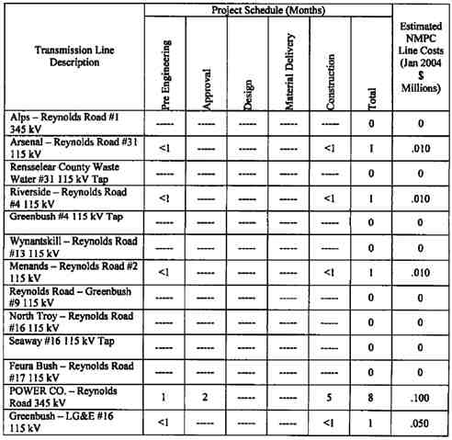

7 TRANSMISSION LINE COST ESTIMATE AND CONSTRUCTION
SCHEDULE
Project cost estimates (+/- 20% accuracy) for the transmission work is summarized in Table 7-1.
These are based on present day dollars. All transmission facilities identified in Table 4.1 are
considered Pool Transmission Facilities (“PTF”). No salvage value is included in the estimates.
The estimated project schedule for the NMPC Transmission Lines is also provided in Table 7-1. Project duration indicated includes project commencement through completion for the additions / modifications detailed above for preliminary engineering, material delivery and construction of work. Durations assume that the lines can be out of service for extended durations during
stringing work. Material deliveries will not be done concurrent with permitting activities, but after POWER CO. has notified NMPC of the right to proceed. Costs associated with the
POWER CO. switchyard are not included in this report.
Table 7-1 Total NMPC Estimated Transmission Line Costs

55
POWER CO. Project Initial facilities Study
Exhibit B to the Interconnection Agreement January 15, 2004

8 APPROVALS AND PERMITS

This section outlines the resource approvals and permit requirements for the transmission line replacement and installation.
8.1. Article X
On November 22, 2000, POWER CO. announced the filing of its Pre-Application for siting of a
505 MW Power Plant and the Empire State Newsprint Recycling Plant in the City of Rensselaer,
Rensselaer County, New York. On December 21, 2001, POWER CO. filed an Article X/SEQRA
Application with the State of New York. On May 29, 2002 the Siting Board of New York
determined the Application for the POWER CO. Plant was compliance with the regulations.
Culminating settlement discussions that began in October 2002, in June 2003, a Joint Settlement
Agreement was executed by POWER CO., New York State Department of Environmental
Conservation (“NYS DEC”), New York State Department of Health, the Rensselaer County
Environmental Management Council, the City of Rensselaer, the Sierra Club, and NMPC. Final
Siting Board and NYS DEC Commissioner’s decisions for permitting of the projects are
expected in February 2004.
8.2. Article VII
On April 29, 2003, NMPC filed the Article VII Application for the proposed POWER CO.
transmission line and all its components. On June 13, 2003, the New York State Public Service Commission (“NYS PSC”) deemed the Application to satisfy the minimum requirements under the Public Service Law 122. Public Statement hearings followed on July 14, 2003. On July 22, 2003, the Administrative Law Judge (“ALJ”) adopted a schedule whereby Reply Briefs are due by April 16, 2004. In October and November 2003, hearings on Direct Testimony occurred
before all interested parties.
8.3. NYISO
In November 2001, the NYISO Transmission Planning Advisory Subcommittee approved the SRIS for the Empire State Newsprint Project (now known as the Besicorp - Empire Power
Company’s POWER CO. Plant). Following this approval by the subcommittee, the NYISO staff presented the project to the Operating Committee for its approval. On November 14, 2001, the NYISO Operating Committee approved the SRIS for the POWER CO. Plant.
Subsequent to the approval by the NYISO, POWER CO. also received confirmation from the Substation and Protection Engineering Group of New York State Electric & Gas that the
interconnection of the POWER CO. Plant would not overduty any breakers or equipment on the NYSEG system with the interconnection at Reynolds Road.
In conjunction with this approval by the NYISO, POWER CO. and WGI representatives presented the interconnection to representatives from the NE-ISO as well.
8.4. ACOE

56
POWER CO. Project Initial facilities Study
Exhibit B to the Interconnection Agreement January 15, 2004

The Army Corps of Engineers (“ACOE”) application for permission to construct certain
components associated with the proposed recycled newsprint manufacturing facility and the
proposed Cogeneration facility were filed by POWER CO. on April 25, 2003. This application
relates to navigable waters and wetlands. Additional ACOE applications for the interconnection
of the electric and the gas transmission lines associated with these facilities was filed by NMPC
on July 3, 2003.

57
POWER CO. Project Initial facilities Study
Exhibit B to the Interconnection Agreement January 15, 2004

APPENDIX 1- REYNOLDS ROAD THERMAL RATING SHEETS

58
POWER CO. Project Initial facilities Study
Exhibit B to the Interconnection Agreement January 15, 2004
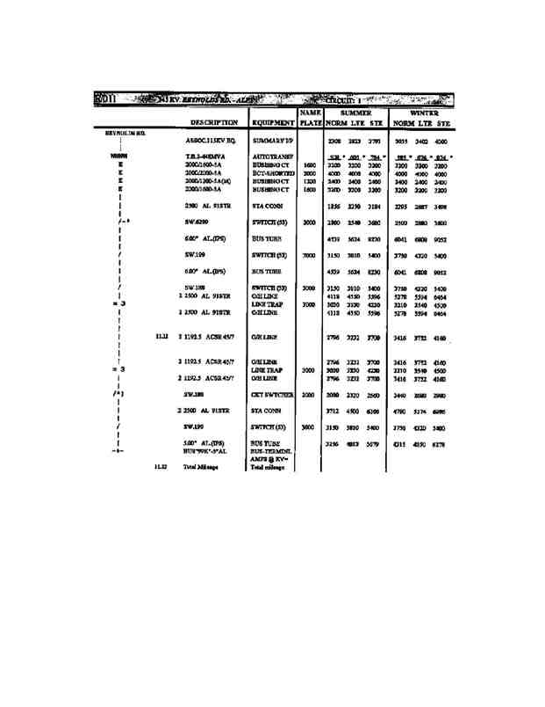

59
POWER CO. Project Initial facilities Study
Exhibit B to the Interconnection Agreement January 15, 2004
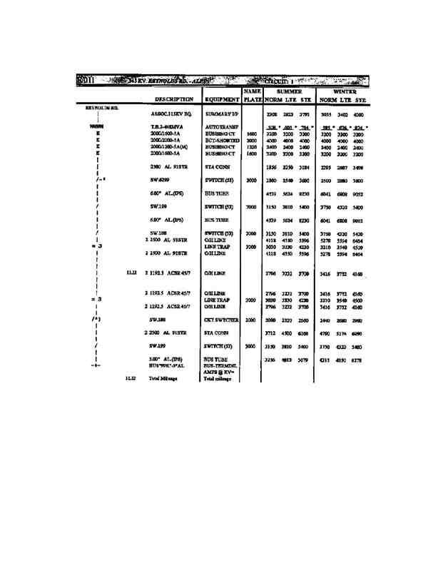
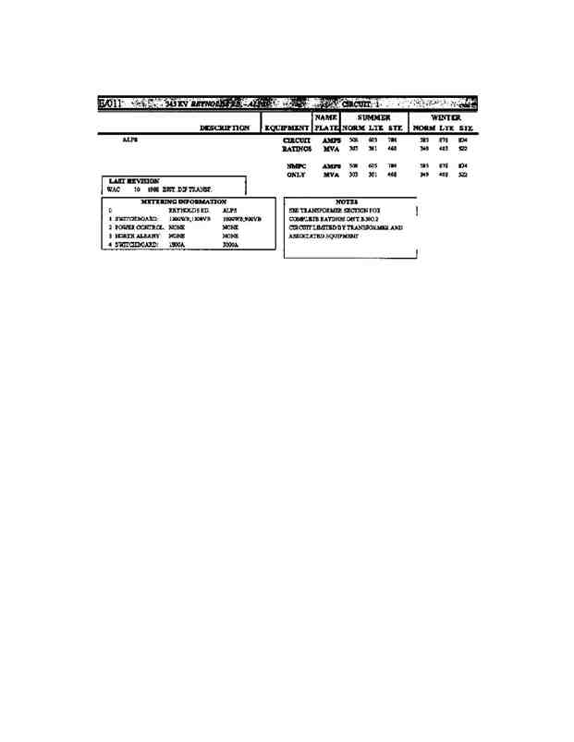

60
POWER CO. Project Initial facilities Study
Exhibit B to the Interconnection Agreement January 15, 2004

61
POWER CO. Project Initial facilities Study
Exhibit B to the Interconnection Agreement January 15, 2004
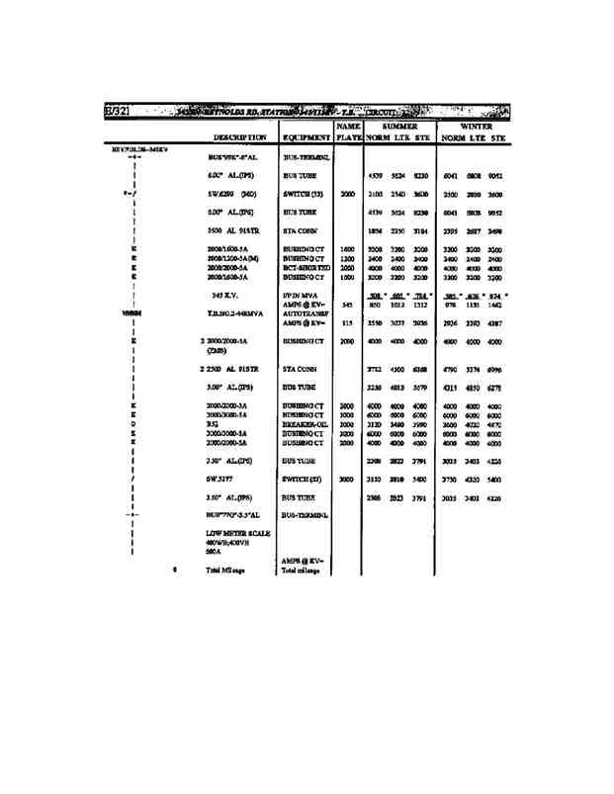

62
POWER CO. Project Initial facilities Study
Exhibit B to the Interconnection Agreement January 15, 2004
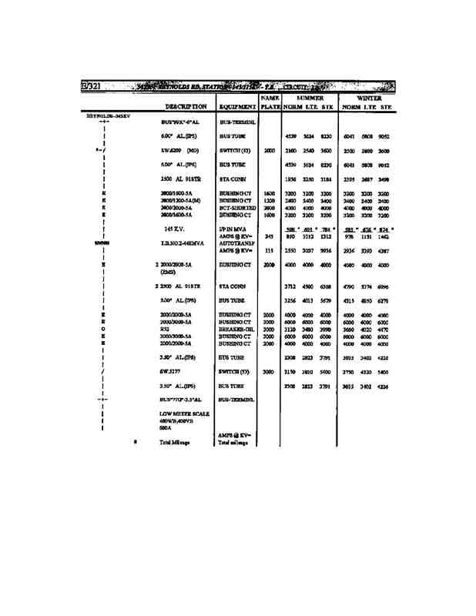
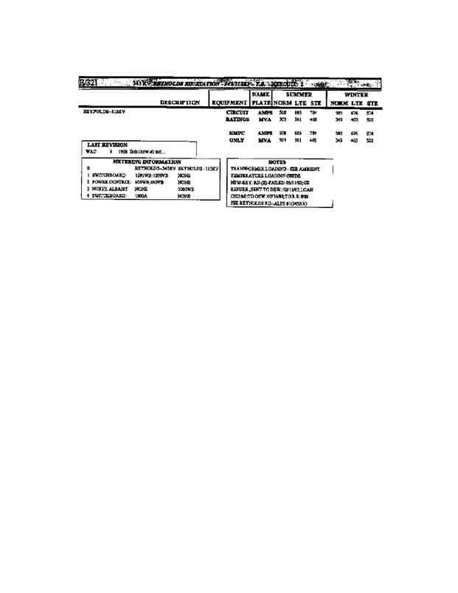

63
POWER CO. Project Initial facilities Study
Exhibit B to the Interconnection Agreement January 15, 2004

64
POWER CO. Project Initial facilities Study
Exhibit B to the Interconnection Agreement January 15, 2004
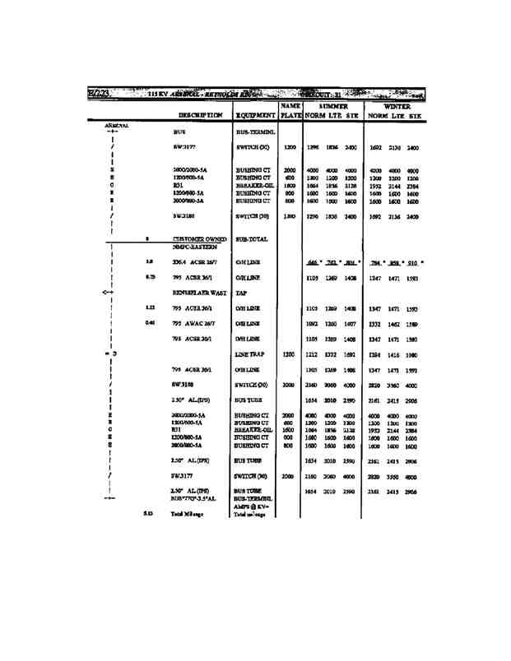

65
POWER CO. Project Initial facilities Study
Exhibit B to the Interconnection Agreement January 15, 2004
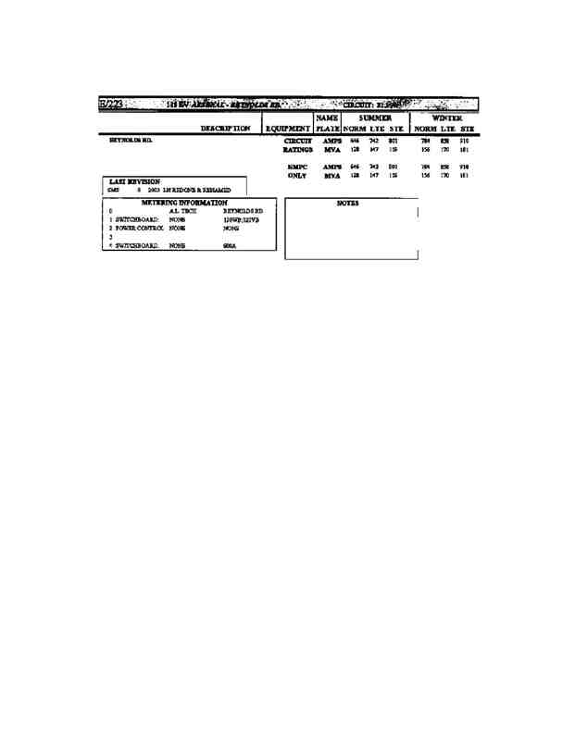

66
POWER CO. Project Initial facilities Study
Exhibit B to the Interconnection Agreement January 15, 2004
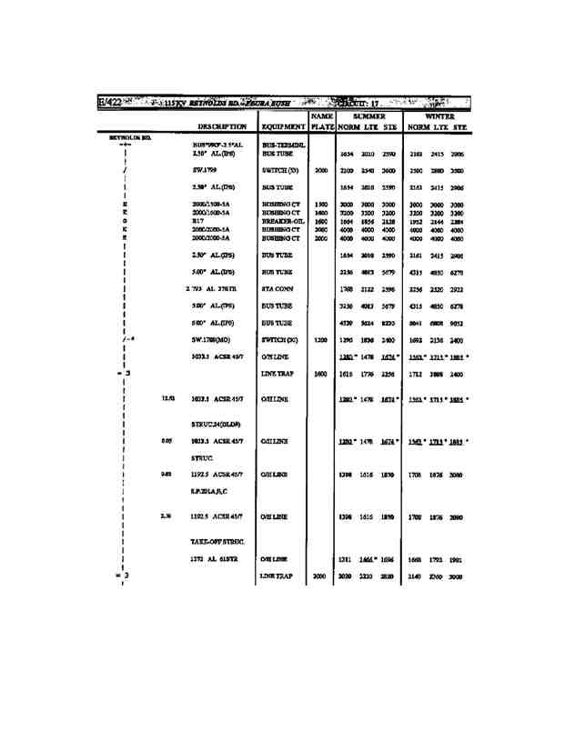

67
POWER CO. Project Initial facilities Study
Exhibit B to the Interconnection Agreement January 15, 2004
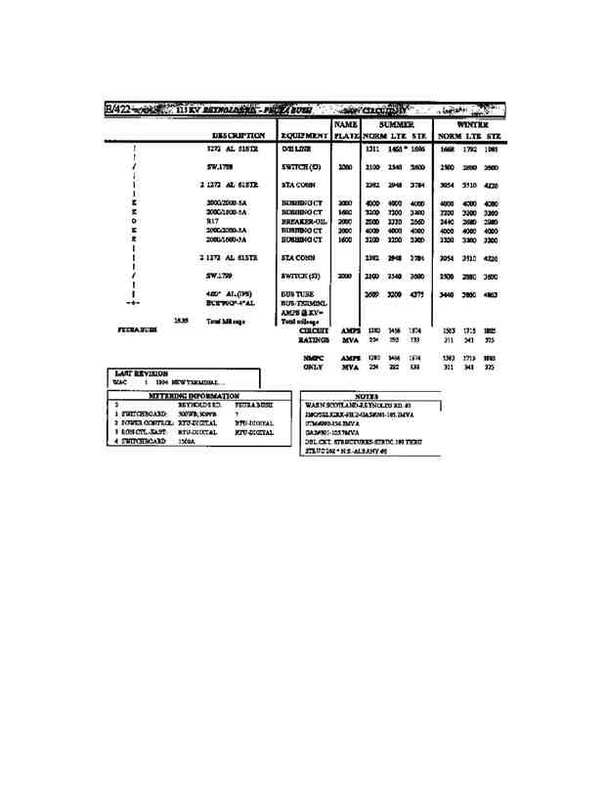

68
POWER CO. Project Initial facilities Study
Exhibit B to the Interconnection Agreement January 15, 2004
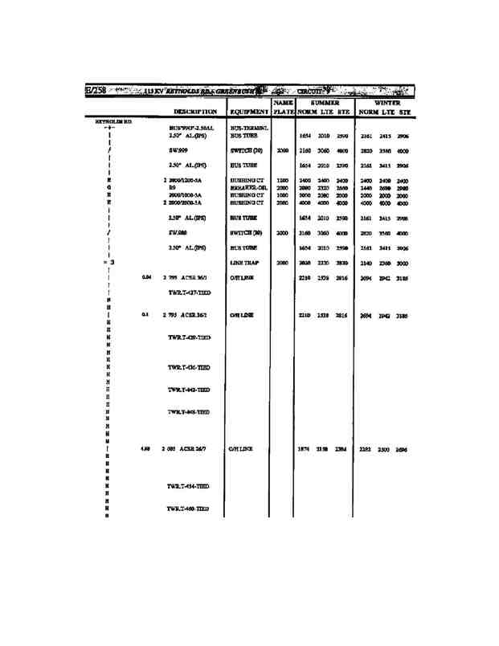

69
POWER CO. Project Initial facilities Study
Exhibit B to the Interconnection Agreement January 15, 2004
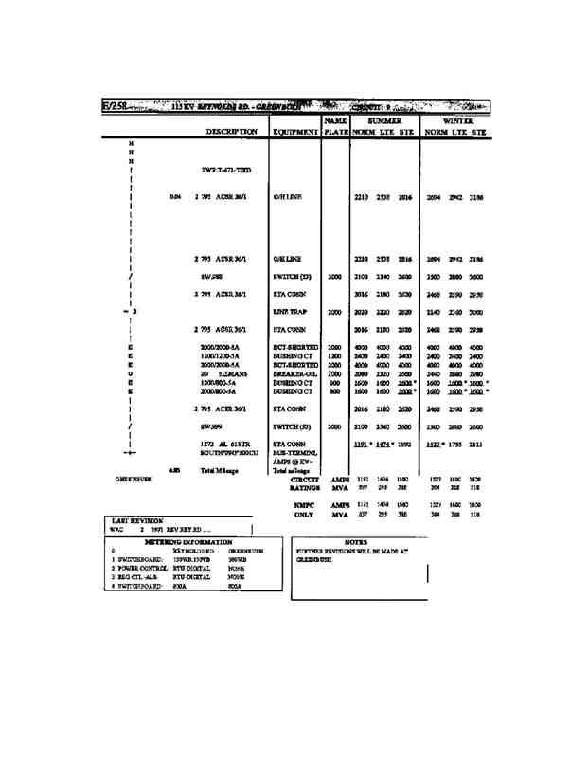

70
POWER CO. Project Initial facilities Study
Exhibit B to the Interconnection Agreement January 15, 2004
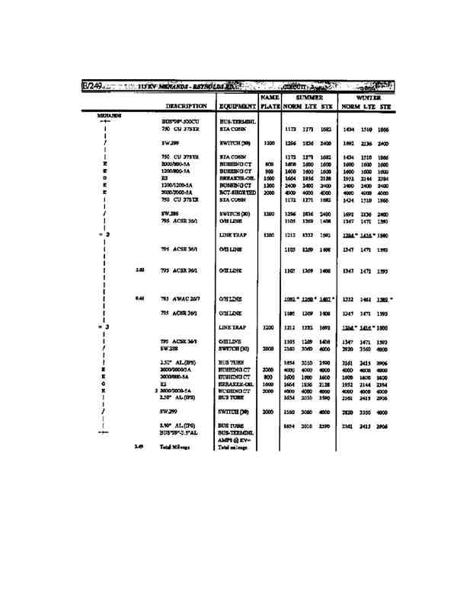

71
POWER CO. Project Initial facilities Study
Exhibit B to the Interconnection Agreement January 15, 2004
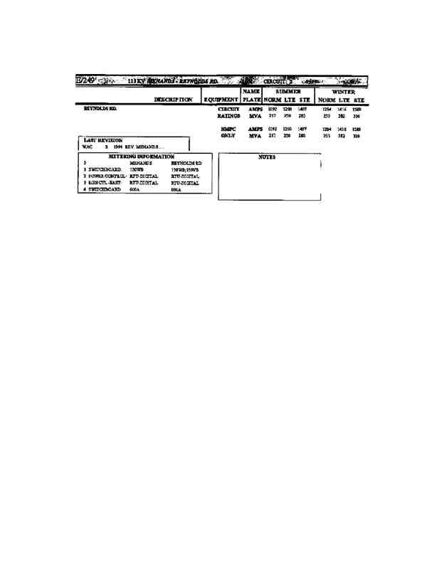

72
POWER CO. Project Initial facilities Study
Exhibit B to the Interconnection Agreement January 15, 2004

73
POWER CO. Project Initial facilities Study
Exhibit B to the Interconnection Agreement January 15, 2004
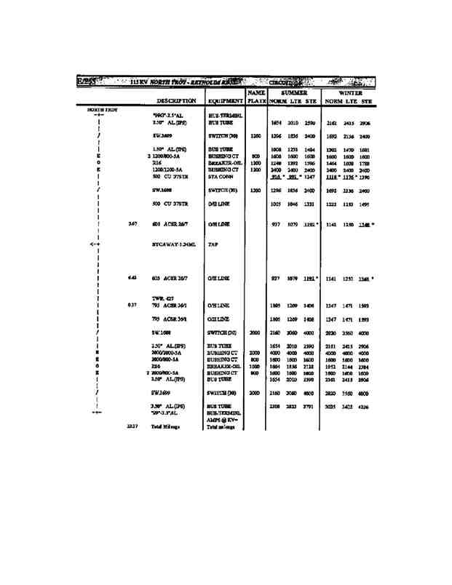

74
POWER CO. Project Initial facilities Study
Exhibit B to the Interconnection Agreement January 15, 2004
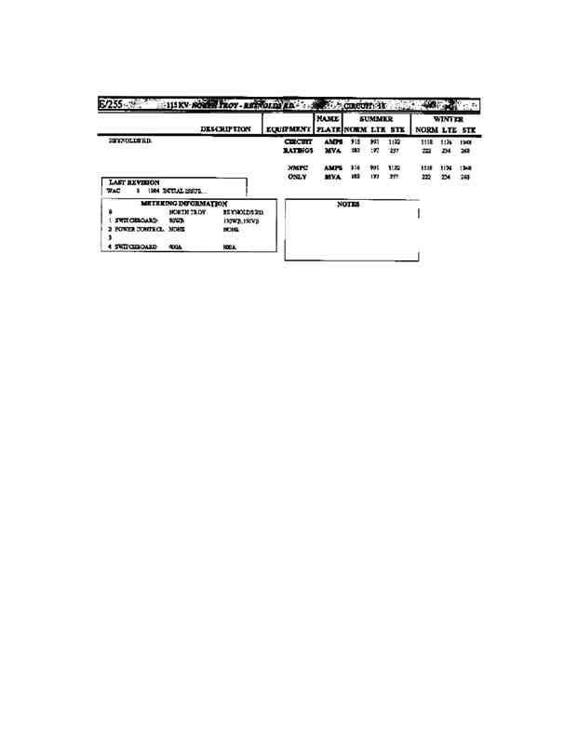

75
POWER CO. Project Initial facilities Study
Exhibit B to the Interconnection Agreement January 15, 2004
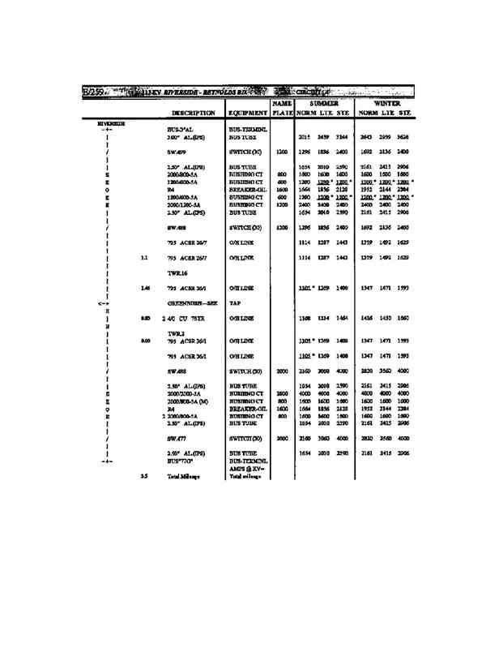

76
POWER CO. Project Initial facilities Study
Exhibit B to the Interconnection Agreement January 15, 2004
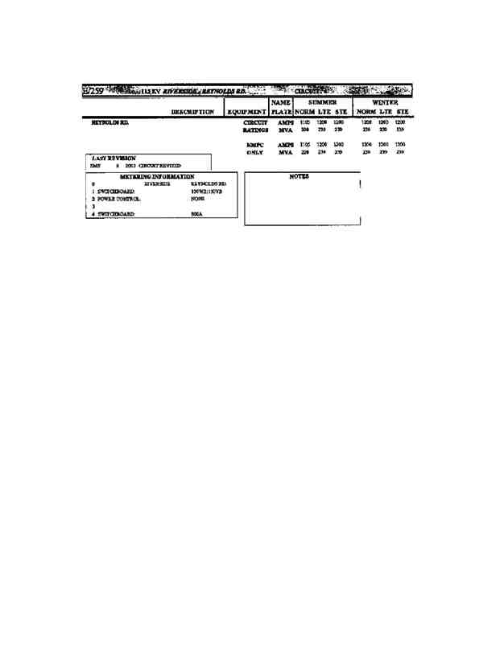

77
POWER CO. Project Initial facilities Study
Exhibit B to the Interconnection Agreement January 15, 2004
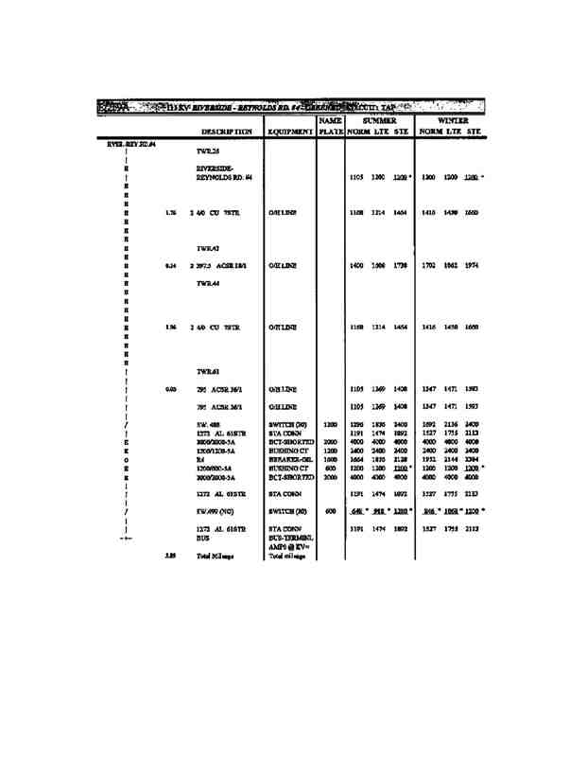

78
POWER CO. Project Initial facilities Study
Exhibit B to the Interconnection Agreement January 15, 2004

79
POWER CO. Project Initial facilities Study
Exhibit B to the Interconnection Agreement January 15, 2004
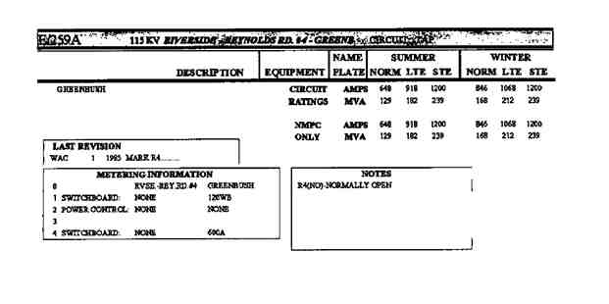

80
POWER CO. Project Initial facilities Study
Exhibit B to the Interconnection Agreement January 15, 2004

81
POWER CO. Project Initial facilities Study
Exhibit B to the Interconnection Agreement January 15, 2004
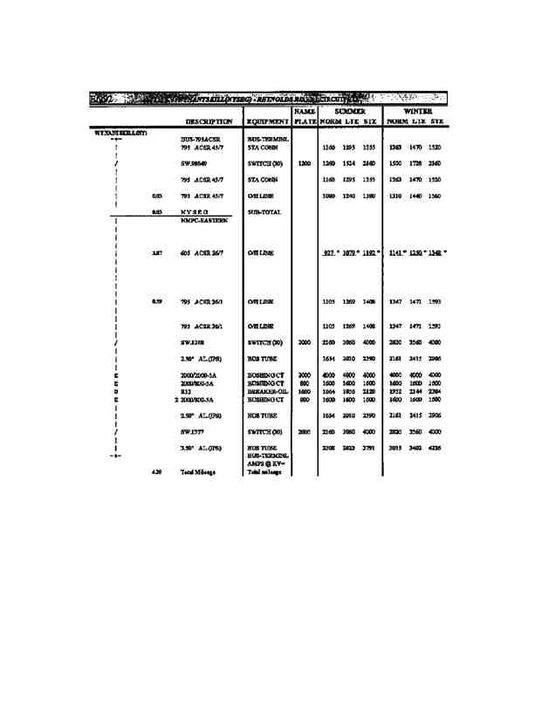
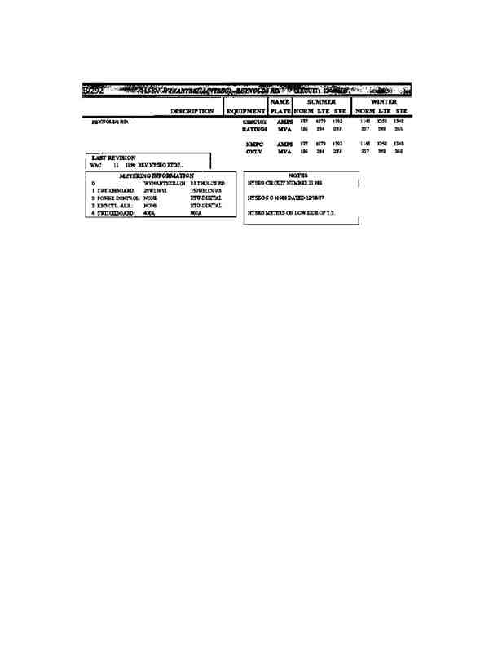
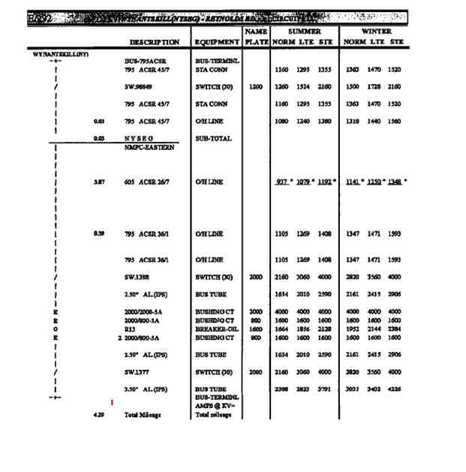

82
POWER CO. Project Initial facilities Study
Exhibit B to the Interconnection Agreement January 15, 2004

83
POWER CO. Project Initial facilities Study
Exhibit B to the Interconnection Agreement January 15, 2004
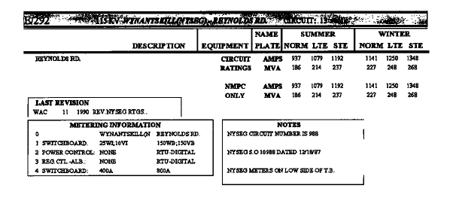

84
POWER CO. Project Initial facilities Study
Exhibit B to the Interconnection Agreement January 15, 2004

APPENDIX 2 - REYNOLDS ROAD STATION WORK LIST

85
POWER CO. Project Initial facilities Study
Exhibit B to the Interconnection Agreement January 15, 2004

APPENDIX 3 - NMPC POWER CO. STATION WORK LIST

86
POWER CO. Project Initial facilities Study
Exhibit B to the Interconnection Agreement January 15, 2004

APPENDIX 4 - TRANSMISSION LINE STATION WORK LIST

87
POWER CO. Project Initial facilities Study
Exhibit B to the Interconnection Agreement January 15, 2004

APPENDIX 5 - PROJECTS SCHEDULE

88
POWER CO. Project Initial facilities Study
Exhibit B to the Interconnection Agreement January 15, 2004

APPENDIX 6 - SYSTEM RELIABILITY IMPACT STUDY

89
POWER CO. Project Initial facilities Study
Exhibit B to the Interconnection Agreement January 15, 2004

Besicorp - Empire Development Company, LLC

Interconnection Study
For the Empire State Newsprint Project

Prepared by Dr. George A. Mulligan
Khin Swe
Reviewed by: Richard M. Bocci

November 2001

Washington Group International, Inc.
510 Carnegie Center
Princeton, NJ 08543

90
POWER CO. Project Initial facilities Study
Exhibit B to the Interconnection Agreement January 15, 2004

Table of Contents

EXECUTIVE SUMMARY V
1.0 INTRODUCTION 1

2.0 THE PROPOSED 2

FIGURE 1 - ONE LINE DIAGRAM- ESNP PROPOSED INTERCONNECTION
TO NIAGARA MOHAWK REYNOLDS ROAD SUBSTATION 4

3.0 STUDY METHODOLOGY AND ASSUMPTIONS 5
3.1 STUDY CASES 5
3.2 ANALYSES CONDUCTED 5
3.3 ASSUMPTIONS 6
4.0 ANALYSIS RESULTS 7
4.1 IMPACT ON BASE SYSTEM CONDITIONS 7
4.1.1 Impact on Generation Dispatch 7
4.1.2 Impact on Base Power Flows 8
4.1.3 Impact on Base Voltage Levels 8
4.1.4 Impact on PARS Settings 9
4.1.5 Impact on System Losses 9
4.2 IMPACT ON TRANSFER LIMITS 9
4.2.1 Thermal Analysis Results 10
4.22 Local Thermal Analysis Results 12
4.2.3 Voltage Analysis Results 13
4.2.4 Stability Analysis Results 14
4.2.5 Overall Impact on Transfer Limits 15
4.3 FAULT DUTY ANALYSIS 16
4.4 EXTREME CONTINGENCY ANALYSIS 16
5.0 CONCLUSIONS 17
6.0 REFERENCES 18

91
POWER CO. Project Initial facilities Study
Exhibit B to the Interconnection Agreement January 15, 2004

List of Tables

Table 4.1.1.51 Generation Redispatch for ESNP to SENY- Summer Peak Cases

Table 4.1.1.52 Generation Redispatch for ESNP to RIM - Summer Peak Cases

Table 4.1.1.33 Generation Redispatch for ESNP to NE - Summer Peak Cases

Table 4.1.1.W1 Generation Redispatch for ESNP to SENY - Winter Peak Cases

Table 4.1.1.W2 Generation Redispatch for ESNP to NM - Win Peak Cases

Table 4.1.1.W3 Generation Redispatch for ESNP to NE - Winter Peak Cases

Table 4.1.2.S Base System Conditions - Summer Peak Cases, Power Flows

Table 4.1.2.W Base System Conditions - Winter Peak Cases, Power Flows

Table 4.1.3.S Base system Conditions - Summer Peak Cases, Bus Voltages

Table 4.1.1W Base System Conditions - Winter Peak Cases, Bus Voltages

Table 4.1.4.5 Base System Conditions- Summer Peak Cases, Phase Angle Regulators

Table 4.1.4.W Base System Conditions - Winter Peak Cases, Phase Angle Regulators

Table 4.1.5 Summary System Losses for Summer and Winter Peak Cases

Table 4.2.1.51 NYCA Inter-Area Bulk Power System Normal Thal Transfer Limits- Summer Peak

Table 4.2.1.52 NYCA Inter-Area Bulk Power System Normal Thermal Transfer Limits- Summer Peak

Table 4.2.1.53 NYCA Intra-Area Bulk Power System Emergency Thermal Transfer Limits - Summer Peak

Table 4.2.1.54 NYCA Inter-Area Bulk Power System Emergency Thermal Transfer Limits - Winter Peak

92
POWER CO. Project Initial facilities Study
Exhibit B to the Interconnection Agreement January 15, 2004

Table 4.2.1.W1 NYCA Infra-Area Bulk Power System Normal Thermal Trawler Limits - Winter Peak

Table 4.2.1.W2 NYCA Inter-Area Bulk Poxes System Normal Thermal Transfer Limits - Winter Peak

Table 4.2.1.W3 NYCA lima-Area Bulk Power System Emergency Thermal Transfer Limits - Wirer Peak

Table 4.2.1.W4 NYCA Inter-Area Bulk Power System Emergency Thermal Transfer Limits - Witte Peak

Table 4.2.2.S1 Summer Peak 115 kV Line Flows - Case 1 (Without ESNP)

Table 4.2.2.S2 Summer Peak 115 kV Line Flows - Case 2 (ESNP to SENY)

Table 4.2.2.82 Summer Peak 115 kV Line Flows - Case 2 (ESNP to SENY)

Table 4.2.2.W1 Winter Peak 115 kV Line Flows - Case 1 (Without ESNP)

Table 4.2.2.W2 Winter Peak 115 kV Line Flows - Case 2 (ESNP to SENY)

Table 4.2.3 Voltage-Constrained Transfer Limit - Bus Voltages

Table 4.2A Design Requirement Stability Case List

Table 4.3 Sint Circuit Analysis

Table 4.4.1 Same Contingency Stability Case List

Table 4.4.2 Critical Clearing The from Stability Case List

93
POWER CO. Project Initial facilities Study
Exhibit B to the Interconnection Agreement January 15, 2004

Appendices

A. Study Scope (4 Sheets)
B. Load Flow Base Case One-Line Plots
B.1 Summer Peak (9 Sheds)
B.2 Winter Peak (9 Sheets)
C. Thermal Analysis TLTG Output
CA Summer Nouns’ (132 Sheds)
C.2 Summer Emergency (140 Sheds)
C.3 Winter Nomad (135 Sheets)
C.4 VAnter Emergency (124 Sheets)
D. Voltage Analysis Output (17 Sheds)

E. ESNP Plant Stability Data (4 Sheets)

F. Transient Stability System Response Plots (195 Sheets)
G. Interconnection Study for the Empire State Newsprint Project Newsprint
Manufacturing Plant Load

94
POWER CO. Project Initial facilities Study
Exhibit B to the Interconnection Agreement January 15, 2004

Executive Summary
Besicorp-Empire Development Company, LLC (Besicorp) engaged Washington Group
International, Inc. (WGI) to perform an Interconnection Study to assess the feasibility of
interconnecting a 603 MW net generating plant to be located at the BASF site in the city of
Rensselaer, N.Y. Besicorp expects to commence commercial operation of the plant in the Summer
of 2004.
The Empire State Newsprint Project (ESNP) is an integrated facility consisting of an electric
generating plant and a recycled newsprint manufacturing plant. The generating plant will cost of
two 161 MW gas turbine units and one 297 MW steam unit which will provide a net sumac
maximum output of 603 MW after supplying the generating plant auxiliary load. A portion of the
plant net output will tonally provide power to the newsprint manufacturing plant with a maxim
load of approximately 66 MW. The newsprint manufacturing plant load is represented as off in
these studies in order to model maximum output into the bulk power system. A separate analysis
of the newsprint manufacturing plant load corrected to the system without the power plant is
provided in Appendix G. The ESNP is proposed to be connected to the Niagara Mohawk Power
Corporation (NMPC) Reynolds Road 345 kV substation by an approximately 9 mile long
overhead 345 kV transmission line with two 1192 haul ACSR conductors per phase. The
interconnection plan includes the addition of two new 345 kV circuit breakers at the Reynolds
Road 345 kV substation.
This study evaluated the impact on the reliability of the bulk power system of the proposed
interconnection to the Reynolds Road 345 kV Substation. The propose of the report is to evaluate
the proposed interconnection and to recommend modifications, as may be required. The report
addresses intra-area and inter-area transfer limit issues including thermal, voltage, and stability
limits. The report also addresses local load flow, extreme contingency, and fault duty issues. WGI
performed these studies with the exception of the fault duty study, which was performed by NMPC
and provided to WGI for inclusion in this report. The studies evaluated the performance of the
system with and without the proposed project using the latest FERC Form 715 power flow summer
and winter peak base cases (filed by NYISO in April 2001) which are applicable to year 2004.
Representations for the baseline units, databases for thermal transfer limit analysis, and dynamics
databases were all provided by the New York Independent System Operator (NYISO).
When dispatched to Southeast New York (SENY), the impact of the ESNP Project on New Yolk
State summer normal and agency transfer capability is a reduction of 475 MW on Central East
and of 775 MW on Total East intakes. Upstate NY - Southeast NY (UPNY-SENY) intake transfer
capability is minimally affected with a reduction of 25 MW normal from 4250 MW to 4225 MW
and of 50 MW emergency from 4900 MW to 4850 MW. UPNY-Con Ed interface transfer
capability actually increases by 175 MW nominal from 4125 MW to 4300 MW and by 150 MW
emergency from 5975 MW to 6125 MW. The reductions in Central East and Total East at due to
the power distribution of the additional 603 MW on the bulk power transmission system. For
dispatches to SENY, approximately 12 percent (71 MV) of the additional generation from ESNP
flows west across the Central East interface and east across the Marcy South transmission
facilities. Approximately 51 percent (306 MW) of the additional generation from ESNP flows on

95
POWER CO. Project Initial facilities Study
Exhibit B to the Interconnection Agreement January 15, 2004

the New Scotland-Leeds 345 kV circuits which are the limiting elements for Central East and Total East.
The ESNP Project also impacts the Inter-Area transfer limits. The NY-NE summer limits increase by a range of 125 MW to 325 MW normal and by 150 MW to 300 MW emergency for the redispatch locations examined The NE-NY limits decrease byelaw of 150 MW to 250 MW normal and 150 MW to 275 MW allegory. The NY-PJM limits are unchanged for both normal and emergency conditions and the PJM-NY limits are affected by only a 25 MW increase under normal conditions for ESNP Project dispatched to PJM.
The winter Intra-area limits are higher than the simmer limits and are little changed by the addition of The ESNP Project Central East and Total East decrease by 125 MW and 50 MW, respectively, both normal and emergency for The ESNP Project dispatched to SENY, while UPNY/SENY and UPNY/Con Ed normal limits increase by 50 MW and 25 MW.
The transmission limitations may cause generators that contribute to the loading of the
transmission lines to operate at lower levels of dispatch than they would otherwise for some part
of the summer season. The ESNP Reject may at times have reduced output due to these transfer
limitations, but this depends on other factors, such as unit bid prices, that may cause the NYISO
to select other units to operate at reduced levels. This assumes that the plant will be operated in
accordance with the NYISO’s operational procedures and limits through its day-ahead Security
Constrained Unit Commitment (SCUC) and real time Security Constrained Dispatch (SCD). This
is designed to dispatch The ESNP Project and other plants in a manner that maximizes reliability
and minimizes energy costs.
The short circuit analysis performed shows a requirement to replace one 115 kV circuit breaker at Reynolds Road. All other circuit breakers remain within their rated capability.
This SRIS has been performed in accordance with all NYISO requirement All requited system
upgrades have been identified herein. Approval of this SRIS does not preclude the possibility of
figure conditions, as envisioned it NYISO requirements, which may, at times, limit output of the
ESNP Project or any other generating plant in the system so that system reliability and security
will be maintained.
This SRIS confirms that the ESNP Project results in no adverse material impact on the Niagara Mohawk transmission system or the New York Slate bulk power system. The conclusions, based on the results and assumptions of this analysis, are as follows:
1. The 345 kV interconnect into the NMPC Reynolds Road 345 kV substation ensures that
full output of the ESNP Project can be delivered to the New York State 345 kV system at Summer peak load. Of course, ESNP Project at other power plants may be subject to curtailment if NYISO Security Constrained Dispatch (SCD) attempts to optimize the Central East and Total East transfers during the summer peak load period. Additionally, the ESNP Project will be tripped for loss cite Reynolds Road-Alps 345 kV circuit to avoid overloading the Reynolds Road 345/115 kV bank.

96
POWER CO. Project Initial facilities Study
Exhibit B to the Interconnection Agreement January 15, 2004

2. The ESNP Project when dispatched to SENY reduces both summer normal and
emergency Central East transfer capability by 475 MW and decreases both the normal and emergency Total East transfer capability by 775 MW. The UPNY-SENY transfer capability is manually reduced by 25/50 MW normal/emergency, and the UPNY-Con Ed transfer capability is actually increased by 75 MW normal and decreased by 25 MW emergency. The impact of the ESNP Project on the Inter-Area transfer capabilities is less with NY-NE increasing by a range of 125 MW to 325 MW, NE-NY limit deafening by a range of 150 MW to 275 MW, and NY-PJM and NM-NY limits remaining unchanged (25 MW increase name in NM-NY for ESNP dispatched to NM).
3. Addition of the ESNP Project does not have any adverse impact to the transient stability
response of the overall transmission system.
4. The short circuit analysis shows that only one 115 kV circuit breaker at Reynolds Road
is required to be replaced.
5. The ESNP Project will not adversely impact bulk power system reliability, as the plant
will be operated in accordance with the NYISCPs operational procedures and limits through its day-ahead Security Constrained Unit Commitment (SCUC) and real time Security Constrained Dispatch (SCD). This conclusion also assumes that locational generation capacity requirements are met.

97
POWER CO. Project Initial facilities Study
Exhibit B to the Interconnection Agreement January 15, 2004

Interconnection Study
For the Empire State Newsprint Project
1.0 Introduction
This report presents the results of the thermal, stability, and voltage transfer limit analysis, local
load flow and stability analysis, fault day analysis, and extreme contingency analysis performed
by WGI for the proposed 603 MW (net) ESNP Project. The analysis is based on connection of
the ESNP Project into the NMPC Reynolds Road 345 kV substation. The purpose of the
analysis is to determine the impact of the ESNP Project on the reliability of the New York Bulk
Power System and to ensure that the resulting bulk power system will conform to all applicable
planning standards and design criteria including those of NYSRC[1], NPCC[2], NERC[3], and
NYPSC[4]. The SRIS has been performed in accordance with the NYISO System Reliability
Impact Study Criteria and Procedures [5]. The analysis included an assessment of the impact
of the proposed ESNP Project on NYISO intra-area and inter-area transfer limits. The basic
electrical system studies include load flow, thermal transfer limit, stability, voltage, and fault
duty studies.
The ESNP Project is scheduled for commercial operation in the summer of 2004. The study
evaluated the performance of the system with and without the proposed ESNP Project using the
FERC Form No. 715 load flow cases submitted by NYISO to FERC in April 2001. The FERC
filing contains representations of the Summer 2006 and Winter 2006,7 Peak Load conditions. It
was agreed with NMPC and NYISO to use these cases as representative of the 2004 system
conditions NYISO also provided representations for the baseline units, databases for thermal
transfix limit analysis, and dynamics databases for transit stability analysis. The PSS/E computer
program was used fix load flow, thermal transfer limit, voltage, and stability analysis. The fault
duty analysis was performed by NMPC and provided to WGI for inclusion in this report. The
Aspen One-Liner computer program was used for the fault duty analysis.
2.0 The Proposed Project
The proposed ESNP Project consists of two 161 MW gas turbine units and one 297 MW steam turbine unit to be located at the BASF site in Rensselaer, N.Y. The project will have and summer maximum output of 603 MW and a net winter maximum output of 660 MW, after providing the generating plant auxiliary load. A portion of the plant output will normally provide power to a recycled newsprint manufacturing plant with a maximum load of approximately 66 MW. This load is represented as 0 MW in all analyses to provide the maximum net output of 603 MW into the bulk power system. The plant is to be connected to the Reynolds Road substation by approximately 9 miles of overhead 345 kV line. A one-line diagram showing the planned interconnection scheme is shown on Figure 1. The input data for the ESNP Project, generator step-up transformers, and 345 kV overhead line are as follows:
Generator Data:
161 MW, 18 kV, 0.85 p.f. -Each of two gas turbine units.

98
POWER CO. Project Initial facilities Study
Exhibit B to the Interconnection Agreement January 15, 2004

297 MW, 18 kV, 0.85 p.f. - Steam turbine unit. Generator Step-up Transformer Data:
CT1 GSU: 120/160/200 MVA OA/FA/FA, 345-18 kV, Z=10% on 120 MVA base, X/R = 20.
Z - 0.00417 +j0.0833 p.u. on 100 MVA base.
CT2 GSU; 120/160/200 MVA OA/FA/FA, 345-18 kV, 1-10% on 120 MVA base, X/R = 20.
Z = 0.00417 +10.0833 p.u. on 100 MVA base.
Steam GSU: 200/266/332 MVA OA/FA/FA, 345-18 kV, Z=10% on 200 MVA base, X/R = 20.
Z = 0.0025 +j0.05 p.u. on 100 MVA base.
345 kV Overhead Line:
1192 kcmil ACSR, 2 conductors per phase, 1109 MVA, 9.1 miles.
Z = 0.00071 +j0.00706 p.u. on 100 MVA base. B - 0.12 p.u.
The above data is considered to be preliminary, as the proposed equipment has not yet been purchased.
The ESNP Project machine data for the stability analysis including machine, excitation system, and governor representations is provided in Appendix E.

99
POWER CO. Project Initial facilities Study
Exhibit B to the Interconnection Agreement January 15, 2004

3.0 Study Methodology and Assumptions
3.1 Study Cases
In accordance with the study scope, the impact of the proposed ESNP Project on the bulk power
system was analyzed using a baseline set of assumptions. The basic set of power flow cases
were:
Case 1 - Base Case without the ESNP Project The base case included the proposed
PG&E Athens Facility, Bethlehem Energy Center, Heritage Energy Facility, Ramapo
Energy Facility, Bowline Point Unit 3, Oakdale shunt capacitors/FACTS project,
Middletown Tap 345/138 kV substation, OH-Michigan Phase Shifters, 115 kV series reactor at North Catskill, and the CT-LI DC Tie-line. The Energy Facility is rot included as a baseline unit became it had not met regulatory milestones at the time this study began. The Article X Application had net been completed.
Case 2 - Case 1 with ESNP Project dispatched to SENY (80% to New Yak City and 20% to Long Island).
Case 3 - Case 1 with ESNP Project dispatched to PJM.
Case 4 - Case I with ESNP Project dispatched to New England.
The analyses were conducted under forecasted summer and winter peak load conditions.
Both the Summer and Winter Peak Load 2006 study cases were developed from the FERC Form No. 715 load flow case submitted by NYISO to FERC in April 2001. NYISO provided representations for the baseline units, which were added to form Case 1. NYISO provided necessary data bases for performing thermal transfer limit analysis and also provided the dynamics data base for performing transient wilily analysis. One-Ibee diagrams of the power flow eases teed in this study are provided in Appendix B.
3.2 Analyses Conducted
The analyses conducted for the SRLS included kernel, voltage, stability, and short circuit analyses. The PTI PSS/E software package was used for the thermal, voltage, and transient stability analyses, and Aspen One-Liner was used for the short circuit analyses.
The thermal, voltage and stability analyses were used to evaluate the performance of the bulk power system for the various study cases with respect to NYISO and NPCC criteria, and to determine the transfer limits for the cases. Thermal analysis was conducted on the Summer and Winter Peak Load cases using the PSS/E Power Flow and TLTO activity. The PSS/E Power Flow program was used to evaluate the base (pre-contingency) system conditions for all study cases. Voltage contingency analysis, also using the PSS/E Power Flow program, was conducted for the Summer Peak Load cases only. Stability analysis was also conducted for the Summer Peak Load cases only, using the PSS/E Dynamics program.

100
POWER CO. Project Initial facilities Study
Exhibit B to the Interconnection Agreement January 15, 2004

The short circuit analysis was conducted to determine whether the proposed ESNP Project would adversely impact the adequacy (e.g., exceed the capability) of existing circuit breakers in the area. The analysis assumed that all existing generators plus the facilities specifically noted in each case description of Section 3.1 were in-service. Additionally, the Glenville and Skygen’s Waterford projects were included in the short circuit analysis, although they are not included as baseline units in the Scope of Work. The generator impedances ate represented by their direct-axis subtransient reactance at rated voltage (X”dy), which mutes that the breaker duty levels are determined immediately after the occurrence of the fault at which time the garroter anent Contribution (into the fault) is at its maximum.
3.3 Assumptions
The study assumes that locational generation capacity requirements are met The ESNP Project adds generation to the system and it is, lathe, necessary to reduce generation output elsewhere to maintain the energy balance in the system. For each case of redispatch whether ESNP Project was dispatched to SENY, New England, or PJM the assumption used in the study was to reduce generation output according to the standard proportions used in the NYISO Operating Studies Task Force (OSTF) operating studies.
The other key assumptions used in this study include:
a) locations for increasing and decreasing generation to vary transfers across transmission
interfaces;
b) modeling of phase angle regulators (PARs) - All cases bad PARs maintained at the
scheduled MW as provided in the FERC load flow case; and
c) status of other proposed projects as discussed in the Study Scope contained in
Appendix A.
4.0 Analysis Results
4.1 Impact on Base System Conditions
Before considering contingencies, the impacts of the ESNP Project on base system conditions were evaluated by simply comparing various system parameters in the power flow cases used for the study. Summaries of these power flow cases for Summer and Winter peak load conditions are included in Appendix B.
4.1.1 Impact on Generation Dispatch
Tables 4.1.1.S1, 4.1.1.S2, and 4.1.1.S3 provide summaries of the assumed generation dispatch changes due to the ESNP Project for the Summer Peak Load cases. Tables 4.1.1.W1, 4.1.1.W2, and 4.1.1.W3 provide similar summaries for the Winter Peak Load cases.

101
POWER CO. Project Initial facilities Study
Exhibit B to the Interconnection Agreement January 15, 2004

4.1.2 Impact on Base Power Flows
Table 4.12.3 provides a summary of the normal ratings and base (pre-contingency) power flows of various transmission lines in the study area for the Summer Peak Load cases for comparison. Table 4.12.W provides a similar summary for the Winter Peak Load cases.
The summer table shows that the ESNP Project redispatched to SENY in Case 2, has little impact
on the flow on the Total East interface for the assumed generation redispatch since the projects
and the redispatched generation are located east of Total East. The distillation of flows on the
lines that comprise Total East are shifted somewhat, slightly reducing flow across Central East,
and increasing flow on the Marcy-South lines. The ESNP Project full output appears on the
UPNY-SENY and UPNY-Con Ed interfaces. The distribution of flows on the circuits comprising
these interfaces is acceptable and no circuit is overloaded There is no effect on the net flow
across the NY-NE interface, of course. However, the distribution of flows on lines comprising
the interface shifts somewhat, with decreased flow on the Pleasant Valley-Long Mountain tie
and decreased flow corning back into New York on the Alps-Berkshire tie.
The table shows that when the ESNP Project is dispatched to PJM as in Case 3, the Central East
and Total East transfers are reduced and loading on their circuits are reduced. In Case 4 with
ESNP Project dispatched to New England, the four intra-area interface transfers remain
relatively unchanged compared to Case 1. The circuits comprising these interfaces remain
acceptably loaded. Fifty seven percent (57%) or 342 MW of the ESNP Project output flows to
New England over the Alps/MANY-Berkshire tie and 28% or 167 MW flows over the Pleasant
Valley-Long Mountain tie.
4.13 Impact on Base Voltage Levels
Table 4.1.3.S provides a summary of the normal (pro-contingency) high and low voltage limit
and base voltage of various buses in the study area for the Summer Peak Load cases for
comparison. Table 4.1.1W provides a similar summary for the Winter Peak Load cases. These
tables show that wirer the ESNP Project is dispatched to SENY the result is a decrease in voltage
of about 1% at Pleasant Valley and other buses on the southern end of lines that makeup the
UPNY-SENY interface, for the Summer Peak Load case. The effect is even less when ESNP
Project is dispatched to PJM or New England with Pleasant Valley 345 kV bus having a decrease
of 0.5 to 1 kV, respectively.
4.1.4 Impact on PARS Settings
Table 4.1.4.S provides a summary of the tap ranges and tap positions of PARs in the study area for the Summer Peak Load cases for comparison. Table 4.1A.W provides a similar summary for the Winter Peak Load cases.
4.1.5 Impact on System Lessee
Table 4.1.5 provides a summary of the tap losses and changes in system losses due to the ESNP Project and the subsequent generation redispatch.

102
POWER CO. Project Initial facilities Study
Exhibit B to the Interconnection Agreement January 15, 2004

4.2 Impact on Transfer Limits
The planning study results reported in the following sections are based on individual interface limits (non-simultaneous). This optimization of the individual intake limits will be performed operationally under the NYISO security constrained dispatch procedures where system and economic impacts of generation dispatch are considered.
4.2.1 Thermal Analysis Results
Tables 42.1.S1, 4.2.1.S2, 4.2.1.W1, and 42.1.W2 provide summaries of the normal thermal
transfer limits determined for the intra-Area and inter-Area transmission interfaces for the Summer
and Winter Peak Load cases. Tables 4.2.1.S3 and 4.2.1.S4, 4.2.1.W3, and 4.2.1.W4 provide
summaries of the emergency transfer limits for the intra-Area and inter-Area interfaces. Light load
thermal analysis, although included in the scope of work provided in Appendix A, was not
performed. It was cleaned not necessary in discussion with NMFC due to generally lower transfers
that occur at light load Additional details regarding the thermal analysis results are provided in
Appendix C.
These tables show that ESNP Project when dispatched to SENY reduce both the summer normal
and emergency Central East trait capability by 475 MW to 2250 MW and 2525 MW respectively
and decrease the Total East normal and emergency transfer capability by 775 MW to 4350 MW
and 4875 MW, respectively. These changes are due to the power distribution of the additional 603
MW on the bulk power transmission system. For dispatches to Southeast New York,
approximately 12 percent (71 MW) of the additional generation from ESNP Project flows west
across the Central East intake and east across the Marcy South transmission facilities.
Approximately 51 percent (306 MW) of the additional generation from ESNP Project flows on
the New Scotland-Leeds 345 kV circuits, which am the limiting dements for Central East and
Total East. UPNY-SENY normal amen mobility is minimally affected with a normal reduction of
25 MW from 4250 MW to 4225 MW. UPNY-Con Ed normal transfer capability actually increases by 75 MW from 5350 MW to 5425 MW. The UPNY-SENY emergency transfer capability has a reduction of 50 MW from 4900 MW to 4850 MW, and the UPNY-Con Ed emergency trait capability has a reduction of 25 MW from 6275 MW to 6250 MW. Approximately 42 percent (253 MW) of the additional generation from ESNP Project flows on the Lads-Pleasant Valley 345 kV circuits which are the limiting dements fa UPNY-SENY.
These transmission limitations may cause generators that contribute to the loading of these lines to operate at lower levels of dispatch than they would otherwise for some part of the summer season. The ESNP Project may at times have reduced output due to these tender limitations, but this depends on other factors, such as unit bid prices, that may cause the NYISO to select other units to operate at reduced levels. This asserts that the plain WM be operated in accordance with the NYISCYs operational procedures and limits through its day-ahead Security Constrained Unit Commitment (SCUC) and real time Security Constrained Dispatch (SOD).
The four Intra-Area transfer limits remain about the same with ESNP Project dispatched to PJM
as for dispatch to SENY. The change is no more than 75 MW normal and 25 MW emergency.
With ESNP Project dispatched to New England, compared to SENY, the Central East transfer
103
POWER CO. Project Initial facilities Study
Exhibit B to the Interconnection Agreement January 15, 2004

capability increases by 300 MW normal and emergency. Total East increase by 450 MW normal and emergency. UPNY-SENY is reduced by 250 MW normal and 225 MW emergency. UPNYCon Ed is reduced by 75 MW normal and increased by 25 MW emergency.
In general the ESNP Project also has impact on the Inter-Area transfer limits. The inter-area limits
shown in the summary tables are based on direct tie-line equipment limitations. Equipment
limitations internal to NY, NE or NM can be found by examination of TLTG output in Appendix
C. The NY-NE limits increase by a range of 125 MW to 325 MW normal and by 150 MW to 300 MW emergency for the redispatch locations examined. The NE-NY limits decrease by a range of 150 MW to 250 MW normal and 150 MW to 275 MW emergency. With the exception of a 25 MW increase normal for ESNP dispatched to PJM, the NY-FSM limits are unchanged normal and emergency and the FSM-NY limits are also unchanged normal and emergency.
The four Intra-Area winter transfer limits are found to be higher than the corresponding summer
transfer lines and the impact of ESNP dispatched to SENY is small. Central East normal and
emergency transfer limits decrease by 125 MW and Total East decreases by 75 MW with ESNP
dispatched to SENY. The ESNP redispatch increases UPNY-SENY normal and emergency
transfer limits by 50 MW and UPNY-Con ED normal is unchanged and emergency decrease by
25 MW.
The NY-NE aid NM-NY winter transfer limits me higher than their summer limits and the NY-
NE limit is increased by 350 MW by the addition of The ESNP Project and the PJM-NY limit
is decreased by a small amount (25 MW). The NE-NY and NY-PJM winter transfer limits are
lower than their summer limits and NE-NY limit is decreased by 400 MW by the addition of
The ESNP Project and the NY-NM is increased by a small amount (25 MW). The Inter-Area
transfix limits am influenced by the dispatch and PAR settings provided in the FERC case.
These were left unchanged in the trait limit analyses Adjustment of the PAR settings or changes
in dispatch could be utilized to increase the NE-NY and NY-NM transfer limits.
4.2.2 Local Thermal Analysis Results
Tables 4.22.S1, 4.2.2.S2, 4.22.W1, and 42.2.W2 provide summaries of summer and winter post
contingency power flows for the Albany 115 kV transmission circuits for Cases 1 and 2. These
circuits am acceptably loaded in the base cases Three contingencies in the summer cases result
in a circuit loaded above long term emergency (LTE) rating in the base case without the ESNP
Project These are for loss of either Albany-Greenbush circuit, the other Albany- Greenbush
circuit mules 211 MW, which is in excess of its LTE rating of 197 MW. The other is for L/O
Albany-Krumkill, the Albany-Bethlehem circuit carries 298 MW which is in excess of its LTE
rating of 208 MW. With ESNP Project in service the loading of the Albany Greenbush circuit
decreases for the that two contingencies and for the third contingency the loading of the Albany-
Bethlehem circuit is the same. The overloads that occur are pre-existing conditions that are
either lessened by ESNP Project in service, or remain unchanged, and are therefore not the
responsibility of ESNP Project. Since the local flows are very similar in base Case 3 and 4
(redispatch to PJM and N.E., respectively), these contingencies are not repeated for Case 3 and
4.

104
POWER CO. Project Initial facilities Study
Exhibit B to the Interconnection Agreement January 15, 2004

The same three contingencies in the winter cases result in a circuit loaded above LTE rating in the base case without The ESNP Project. Two of the circuits are within LTE rating in the with ESNP case and the third has loading unchanged.
Additionally it is recognized that for loss of the Reynolds Road -Alps 345 kV circuit, all of the ESNP Project’s output would be on the Reynolds Road- 345/115 kV bank Wadi would overload. The ESNP Project and NMPC have agreed that the ESNP Project will be tripped for a fault on the Reynolds Road -Alps 345 kV circuit.
4.2.3 Voltage Analysis Results
Power flow analysis was conducted to evaluate the impact of the ESNP Project on the voltage performance of the men Appendix D provides one-line plots of the bulk power system without and with the ESNP Project.
The voltage analysis shows that the voltage limits for all for Inter-area transmission interfaces
tested are less constraining than the thermal limits for summer peak conditions. Voltage collapse
was tested without aid with the ESNP Project in-service for two contingencies. These were for the
loss of the Marcy-South double-circuit and the loss of the New Scotland #99 bus. The highest
transfer levels at which converged load flows resulted for these contingencies were determined.
Applying the 95% safety margin to these transfer levels, the following voltage constrained trait
limits were determined:
Case 1 Case 2
Central East 2783 MW 2434 MW
Total East 5169 MP/ 4462 MW
UPNY SENY 4405 MW 4439 MW
UPNY Con Ed 4192 MW 4482 MW

Load flow cases for Cases 1 and 2 were then examined for voltage violations at the voltage-
constrained transfer limits reported above for all lines in-service and for the two contingencies
described above. Table 4.2.3 provides voltages for various buses in the study area for these
cases. Examination of these bus voltages shows that all voltages at within their post-contingency
high and low voltage limits. Plots of these load flow cases are included in Appendix D.
The voltage-constrained transfer limits in all cases exceed the thermal transfer limits. Thus the thermal transfer limits predominate.
4.14 Stability Analysis Results
Stability testing was conducted for Cases 1 and 2 at the summer normal thermal transfer limits previously determined plus a 10% safety margin. The thermal trader limits plus 10% are shown in the following table.

105
POWER CO. Project Initial facilities Study
Exhibit B to the Interconnection Agreement January 15, 2004

Case (Normal Limits) Interface
Central-East Total East UPNY/SENY UPNY/CONED
1 - Base Case w/o ESNP Project 3010 MW 5638 MW 4768 MW 4413 MW

2 -ESNP Project In Service 2550 MW 4703 MW 4670 MW 4711 MW

Additional stability testing was conducted for Case 2 at the summer emergency thermal transfer
limit plus a 10% safety margin.

Case (Emergency Limits) Interface
Central-East Total East UPNY/SENY UPNY/CONED
2 -Ewe project in Service 2810 MW 5095 MW 4812 MW 4718 MW

System response plots for the following eight design requirement contingencies are provided in
Appendix F. A list of these cases is also provided in Table 4.2.4.
1. CE38 - LLG fault at Marcy, Marcy-Coopers/Edic-Fraser double circuit
2. TE32 - 3 Phase fault at New Scotland, New Scotland #77 bus fault
3. TE35 - 3 Phase fault at Leeds, Leeds-Athens #91
4. RottNscot - 3 Phase fault at Rotterdam 115 kV, Rotterdam-New Scotland 115 kV # 13
5. Nscot115 -3 Phase fault at New Scotland 115 kV, New Scotland-Bethlehem 115 kV #1
6. RottBsmp - 3 Phase fault at Rotterdam 230 kV, Rotterdam-Bear Swamp 230 kV #E205
7. NE10 - SLG at Northfield, Alps-Berkshire-Northfield 345 kV. Stuck 5T breaker, reject
Northfield #3 and #4.
8. Single phase fault at Leeds 345 kV Substation with stuck breaker. Backup cleared at 12
cycles.
All of the stability test were stable demonstrating that the thermal transfer limits we not strained by stability limits.
Auto-reclosing schemes are included in contingencies 1 and 2 above and the ESNP Project shows no adverse effect on the redosing schemes.
4.2.5 Overall Impact on Transfer Limits

106
POWER CO. Project Initial facilities Study
Exhibit B to the Interconnection Agreement January 15, 2004

It has been determined that thermal transfer limits are more constraining than either voltage or
stability limits for the four transmission interfaces tested both without and with the ESNP
Project.
As discussed in Section 4.1 1, Tables 4.2.1.1 and 42.12 show that the ESNP Project reduces the
summer normal Central East transfer capability by 475 MW and decreases the Total East normal
transfer capability by 775 MW. The UPNY-SENY normal transfer capability is minimally
reduced and the UPNY-Con Ed normal transfer capability is increased by 75 MW. The ESNP
Project will not adversely impact bulk power system reliability. The NYISO’s operational
procedures and limits through its day-ahead SCUC and real time SCD is designed to dispatch
the ESNP Project and other plants in a manner that maximizes reliability and minimizes energy
costs.
4.3 Fault Duty Analysis
Table 4.3 provides a summary of the short-circuit analysis results in the vicinity of Reynolds Road 345 kV and significant Eastern New York 115 and 345 kV substations The analysis indicates that the addition of the ESNP Project increases the short circuit levels of the R-63 115 kV breaker at the Reynolds Road substation beyond its 40 kA rating and should be replaced. All other existing NMPC breakers have sufficient capability to meet the additional short circuit currents due to the ESNP Project.
4.4 Extreme Contingency Analysis
Extreme Contingency analysis with the ESNP Project was performed in conformance with
NYSRC and NPCC criteria. Extreme contingency testing is done to understand the Units of the
power system. Problems identified in extreme tests do not require remediation, but, if possible,
low cost system improvements, generation dispatch impacts, or simple operating procedures
should be identified.
A list of extreme contingencies tested is included in Table 4.4.1. Cases tested included plant and substation outages and a three phase fault with stuck breaker at the Leeds 345 kV substation. All extreme contingency cases tested were stable.
Critical clearing time analysis was also performed for substations in the vicinity of the ESNP
Project. A list of critical clearing time cases is included in Table 4.4.2. The results of the
analysis indicate that the ESNP Project extends the critical clearing times of a three phase fault
at New Scotland on the New Scotland-Leeds 345 kV circuit from 17 cycles to 19 cycles (normal
clearing time would be less than 5 cycles). This is acceptable because all 345 kV substations
in the vicinity of the ESNP Project, except Alps, have dual channel relaying which provides
backup clearing times comparable to primary clearing times. The ESNP Project plans to
provide dual channel relaying at Alps. For a three phase lank on the Albany-Greenbush 115 kV
#1 circuit, the critical chiming time is 13 cycles with or without ESNP Project. For a three
phase fault on the Greenbush-Reynolds Road 115 kV circuit, the critical clearing time is 15
cycles with or without ESNP Project. For a three phase fault on the 115 kV side of the Reynolds
Road 345/115 kV bank, the critical clearing time is 17 cycles with or without the ESNP Project.
107
POWER CO. Project Initial facilities Study
Exhibit B to the Interconnection Agreement January 15, 2004

5.0 Conclusions
This study was undertaken to evaluate the impact of the proposed ESNP Project on the reliability of the bulk power system. Analysis was conducted to evaluate the impacts of the proposed ESNP Project on the New York infra-Area and inter-Area transfer limits. The conclusions, based on the results and assumptions of that analysis, are as follows:
1. The 345 kV interconnect into the NMPC Reynolds Road 345 kV substation ensures that
full output of the ESNP Project can be delivered to the NYISO 345 kV system at Summer peak load. Of course, ESNP Project and/or other power plants may be subject to curtailment if NYISO Security Constrained Dispatch (SCD) attempts to optimize the Canal East and Total East transfers dining the stunner peak load period. Additionally, the ESNP Project will be tripped for loss of the Reynolds Road-Alps 345 kV circuit to avoid overloading the Reynolds Road 345/115 kV bank.
2. The ESNP Project when dispatched to SENY reduces both summer normal and
emergency Central East transfer capability by 475 MW mid decreases both the normal
and emergency Total East transfer capability by 775 MW. The UPNY-SENY transfer
capability is minimally reduced by 25/50 MW normal/emergency and the UPNY-
Con Ed transfer capability is actually increased by 75 MW normal and decreased by
25 MW emergency. The impact of the ESNP Project on the Inter-Area transfer
capabilities is less with NY-NE increasing by a range of 125 MW to 325 MW, NE-NY
limits decreasing by a range of 150 MW to 275 MW, and NY-NM and NM-NY limits
remaining unchanged (25 MW increase normal in NM-NY for ESNP dispatched to
NM).
3. Addition of the ESNP Project does not have any abase impact on the transient stability
response of the overall transmission system. All eight design requitement cases that was tested was stable both without and with ESNP Project.
4. The short circuit analysis shows that only one 115 kV circuit breaker at Reynolds Road
is required to be replaced.
5. The ESNP Project will not adversely impact bulk power system reliability as the plant
will be operated in accordance with the NYISO’s operational procedures and limits
through its day-ahead Security Constrained Unit Commitment (SCUC) and real time
Security Constrained Dispatch (SCD). This is designed to dispatch ESNP Project and
other plants in a manner that maximizes reliability and minimizes energy costs.
The System Reliability Impact Study (SRIS) has been performed in accordance with all NYISO requirements. All required system upgrades have been identified herein. Approval of this SRIS does not preclude the possibility of future conditions, as envisioned under New York ISO requirements, which may, at fates, limit output of the ESNP Project or any other generating plant in the system and that system reliability and security will be maintained.
6.0 References

108
POWER CO. Project Initial facilities Study
Exhibit B to the Interconnection Agreement January 15, 2004

1. “Initial Ratability Rules For Planning and Operating the New York State Power System”,
New York State Reliability Council, September 10, 1999.
2. “Basic Criteria for Design and Operation of Interconnected Power Systems”; Northeast
Power Coordinating Council; August 9, 1995.
3. “NERC Planning Standards”; North American Electric Reliability Council; September
1997.
4. “Operating, Design, and Planning Criteria for Bulk Power Supply Systems of New York
State”; New York State Department of Public Service; March 4, 1981.
5. “System Reliability Impact Study Criteria and Procedures”, NYISO, July 19, 2000

109
POWER CO. Project Initial facilities Study
Exhibit B to the Interconnection Agreement January 15, 2004

TABLES

110
POWER CO. Project Initial facilities Study
Exhibit B to the Interconnection Agreement January 15, 2004
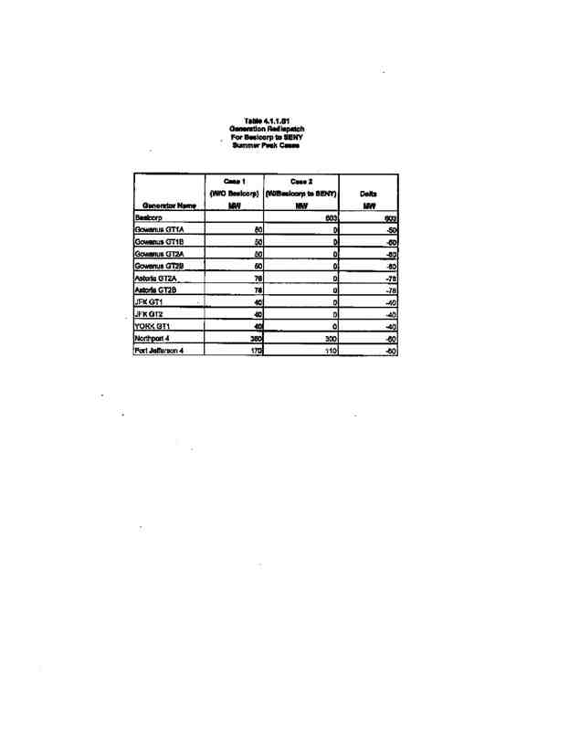

111
POWER CO. Project Initial facilities Study
Exhibit B to the Interconnection Agreement January 15, 2004
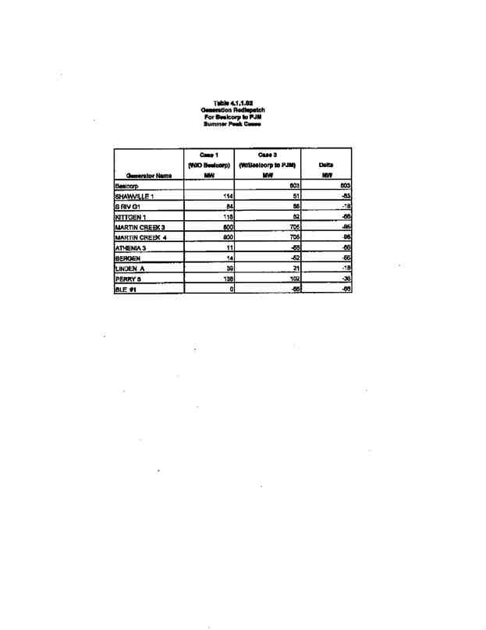

112
POWER CO. Project Initial facilities Study
Exhibit B to the Interconnection Agreement January 15, 2004
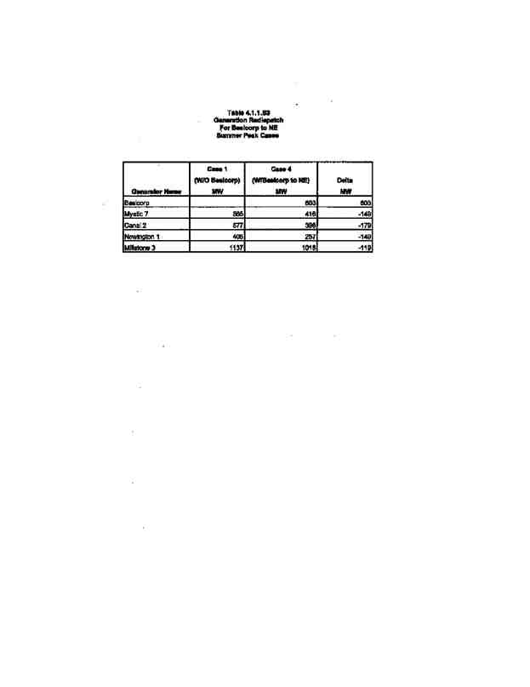

113
POWER CO. Project Initial facilities Study
Exhibit B to the Interconnection Agreement January 15, 2004
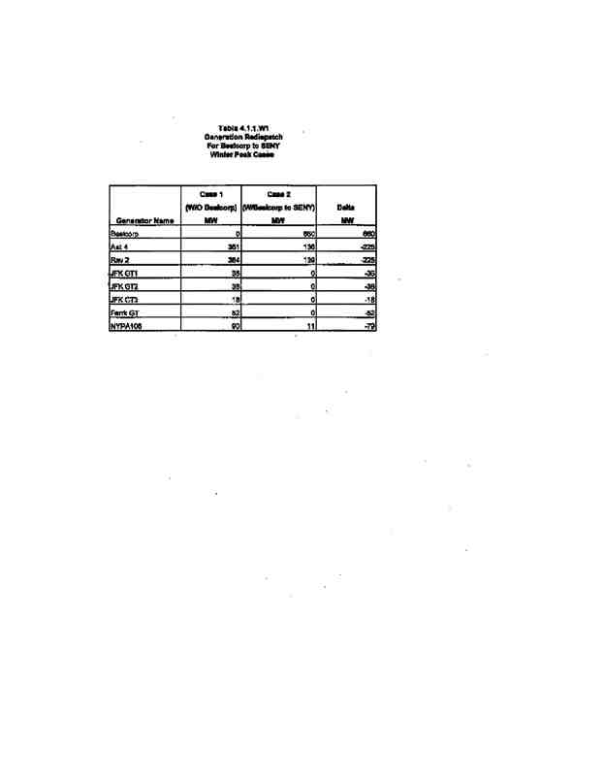

114
POWER CO. Project Initial facilities Study
Exhibit B to the Interconnection Agreement January 15, 2004
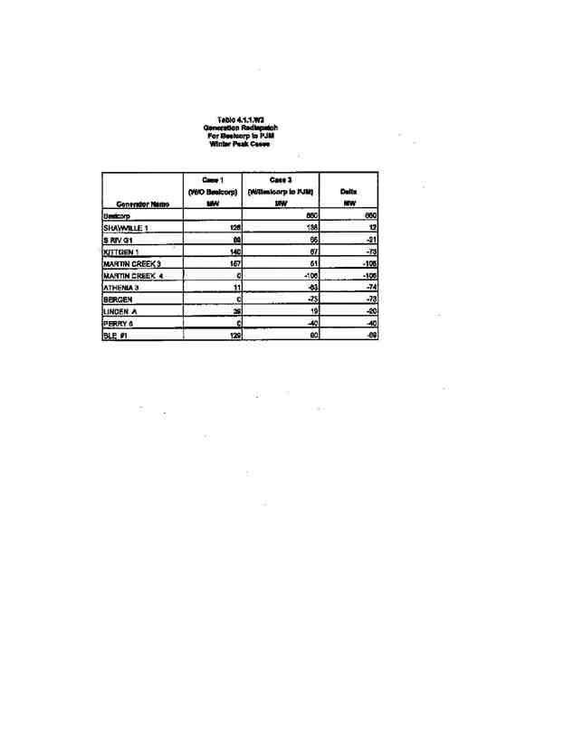

115
POWER CO. Project Initial facilities Study
Exhibit B to the Interconnection Agreement January 15, 2004
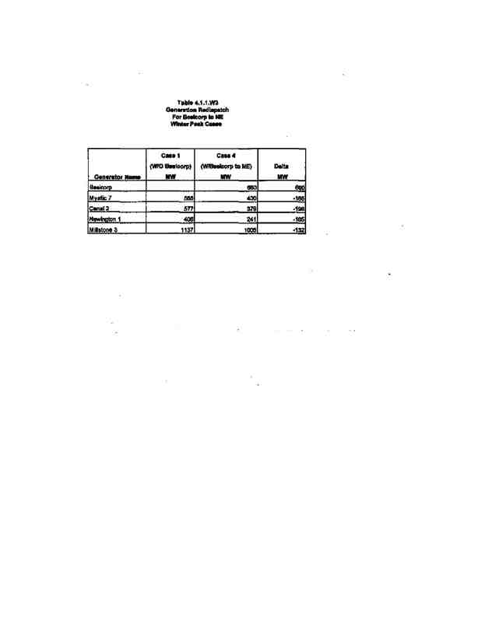

116
POWER CO. Project Initial facilities Study
Exhibit B to the Interconnection Agreement January 15, 2004
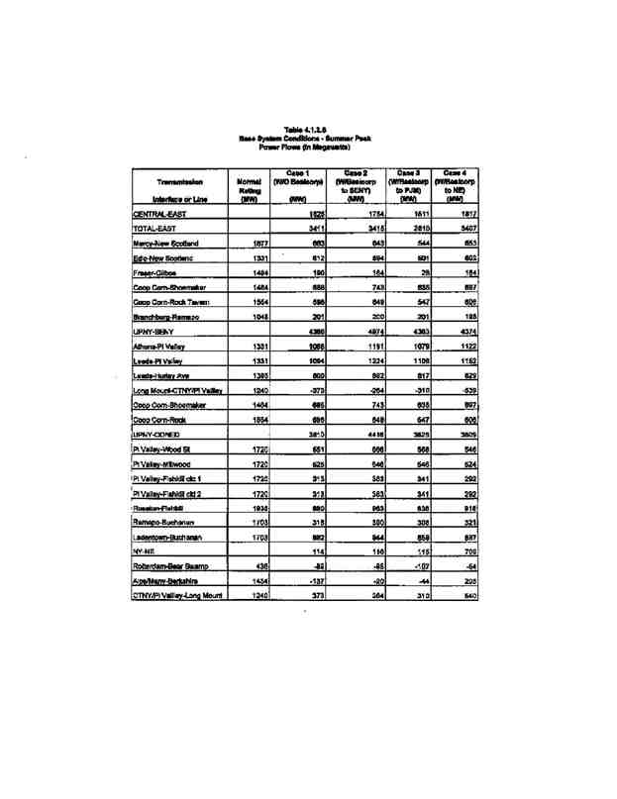

117
POWER CO. Project Initial facilities Study
Exhibit B to the Interconnection Agreement January 15, 2004
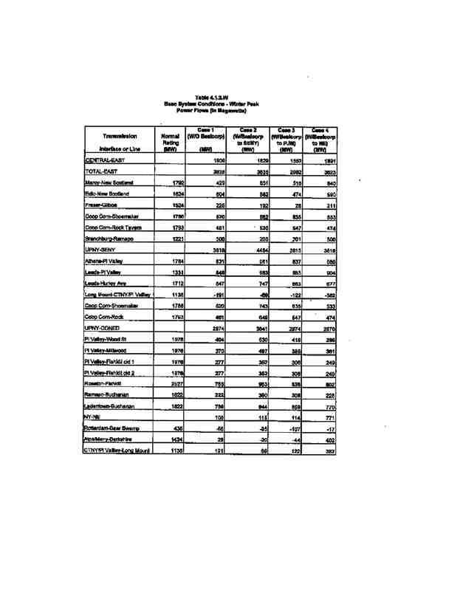

118
POWER CO. Project Initial facilities Study
Exhibit B to the Interconnection Agreement January 15, 2004
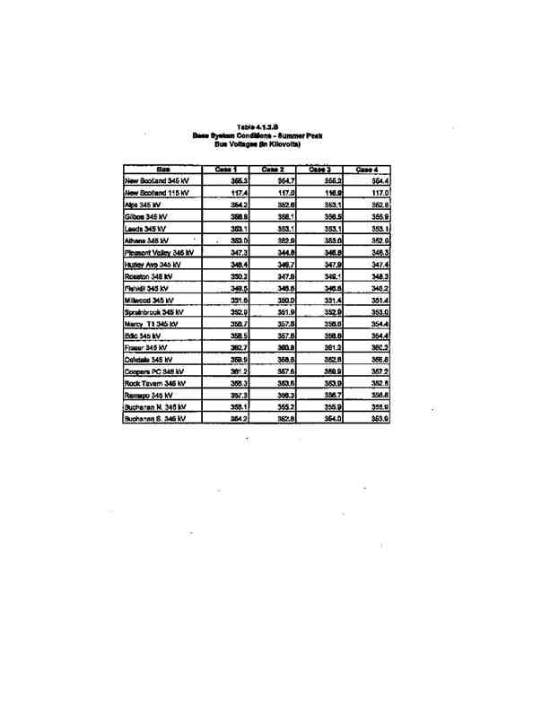

119
POWER CO. Project Initial facilities Study
Exhibit B to the Interconnection Agreement January 15, 2004
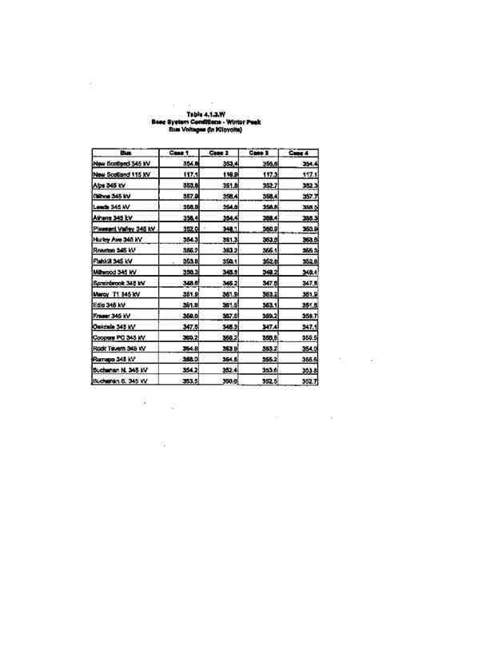

120
POWER CO. Project Initial facilities Study
Exhibit B to the Interconnection Agreement January 15, 2004
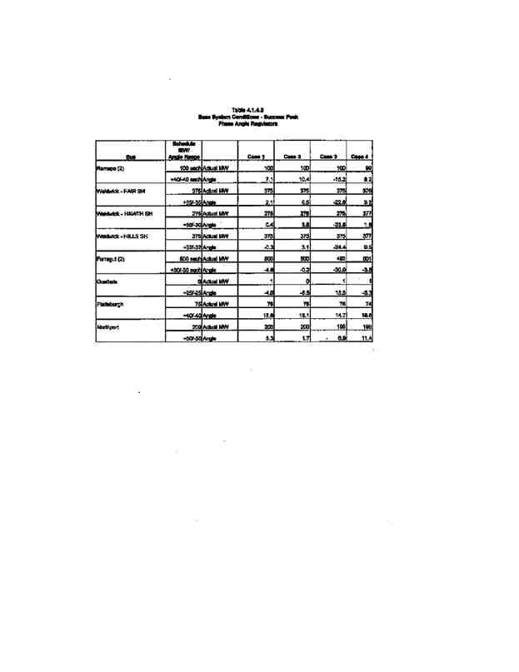

121
POWER CO. Project Initial facilities Study
Exhibit B to the Interconnection Agreement January 15, 2004
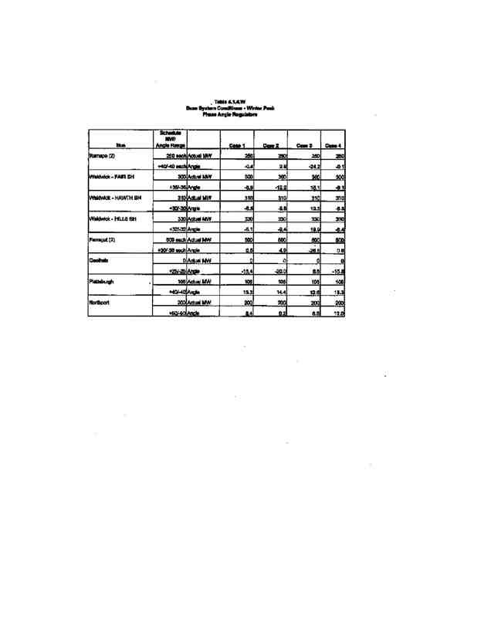

122
POWER CO. Project Initial facilities Study
Exhibit B to the Interconnection Agreement January 15, 2004
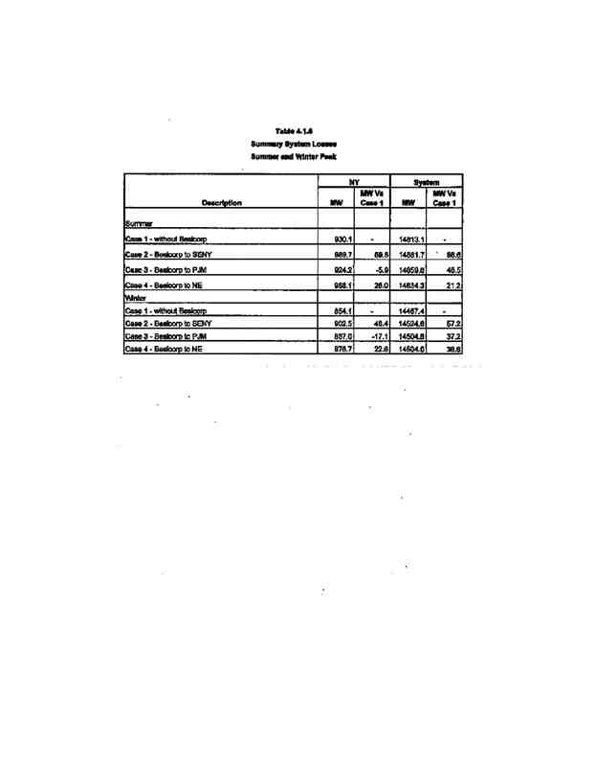

123
POWER CO. Project Initial facilities Study
Exhibit B to the Interconnection Agreement January 15, 2004
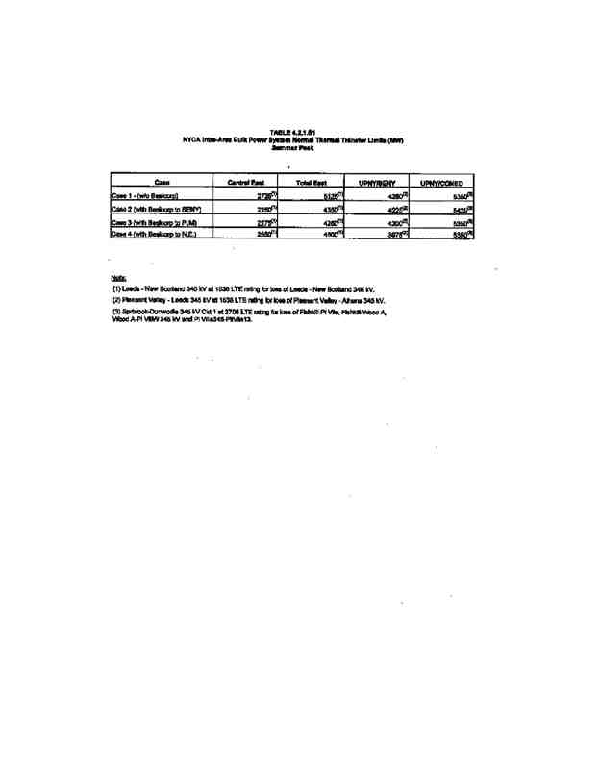

124
POWER CO. Project Initial facilities Study
Exhibit B to the Interconnection Agreement January 15, 2004
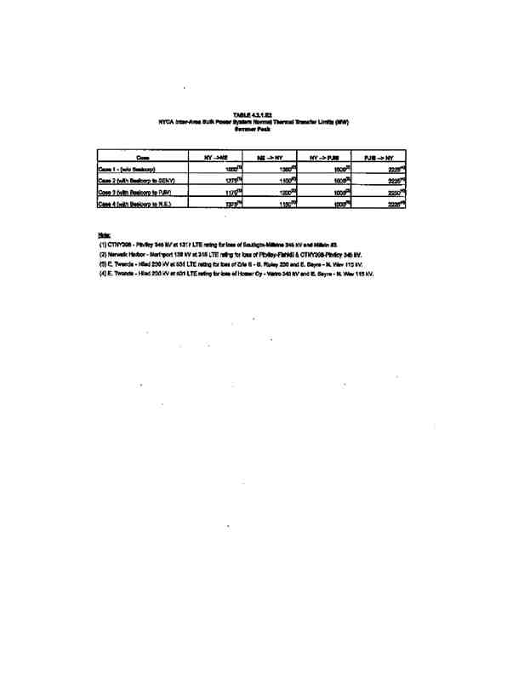

125
POWER CO. Project Initial facilities Study
Exhibit B to the Interconnection Agreement January 15, 2004
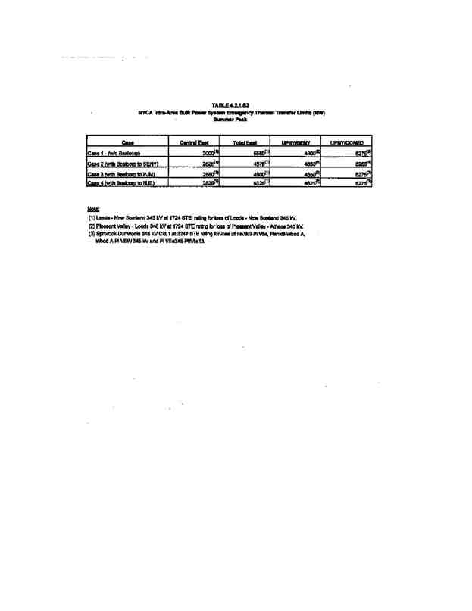

126
POWER CO. Project Initial facilities Study
Exhibit B to the Interconnection Agreement January 15, 2004
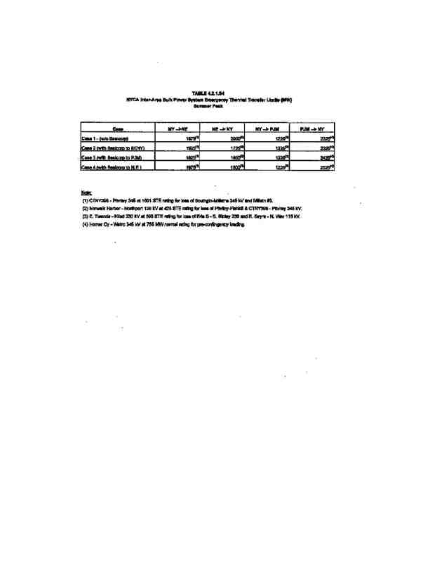

127
POWER CO. Project Initial facilities Study
Exhibit B to the Interconnection Agreement January 15, 2004
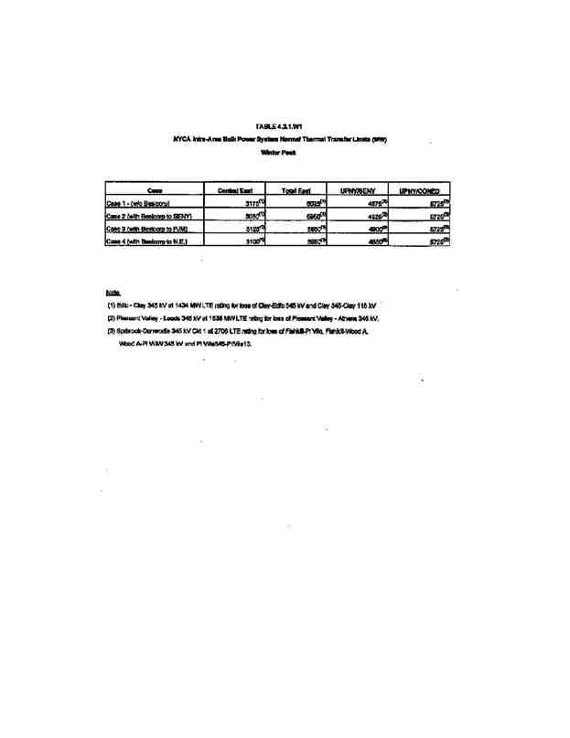

128
POWER CO. Project Initial facilities Study
Exhibit B to the Interconnection Agreement January 15, 2004
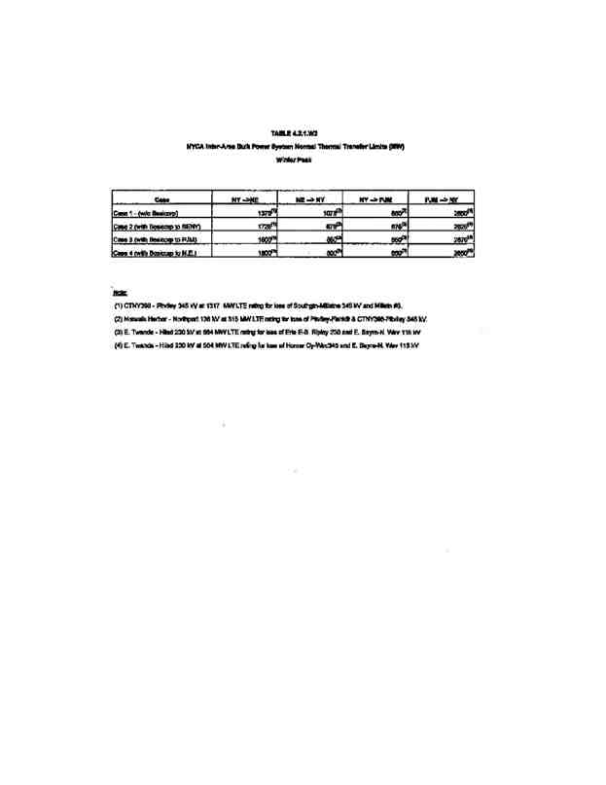

129
POWER CO. Project Initial facilities Study
Exhibit B to the Interconnection Agreement January 15, 2004
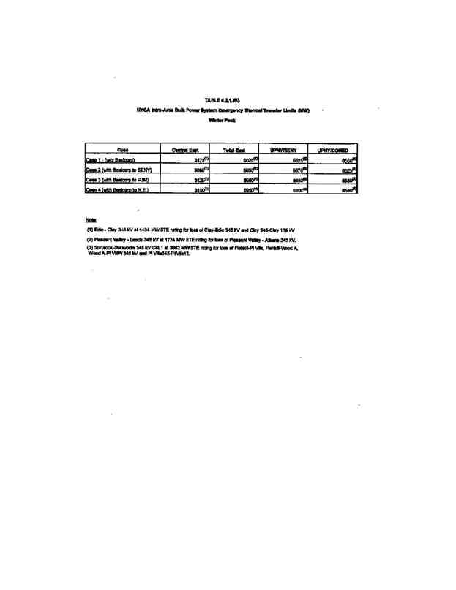

130
POWER CO. Project Initial facilities Study
Exhibit B to the Interconnection Agreement January 15, 2004
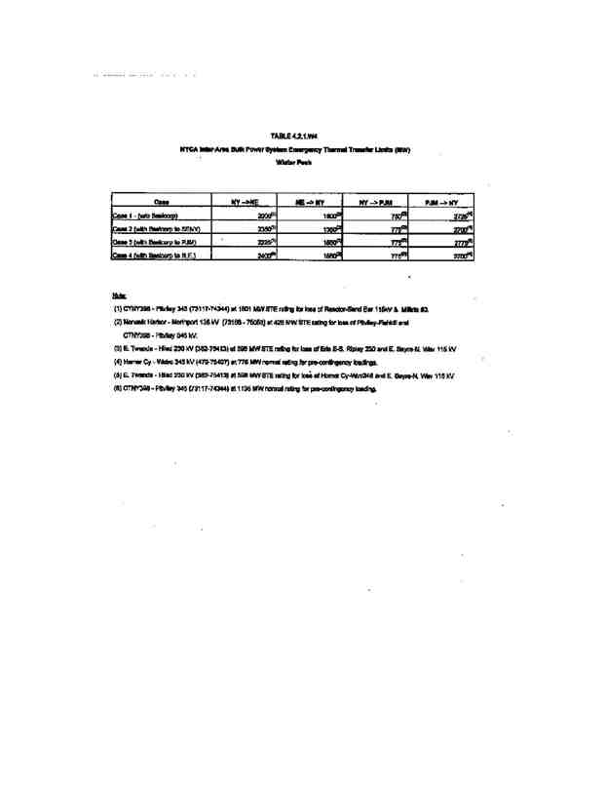

131
POWER CO. Project Initial facilities Study
Exhibit B to the Interconnection Agreement January 15, 2004
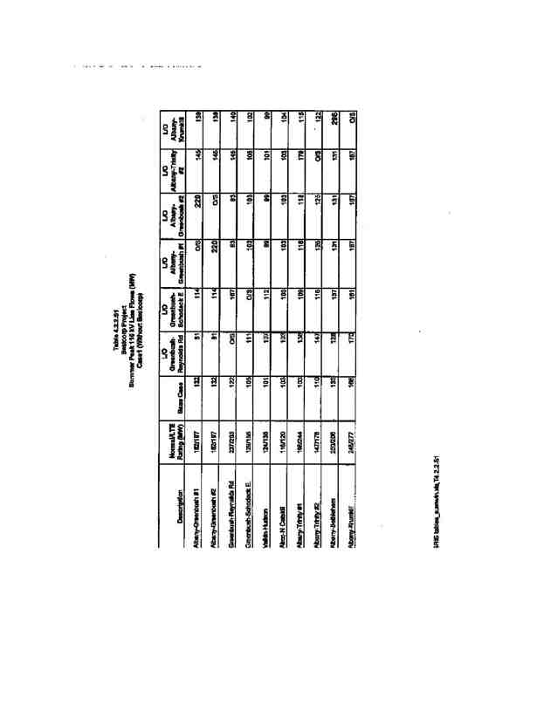

132
POWER CO. Project Initial facilities Study
Exhibit B to the Interconnection Agreement January 15, 2004
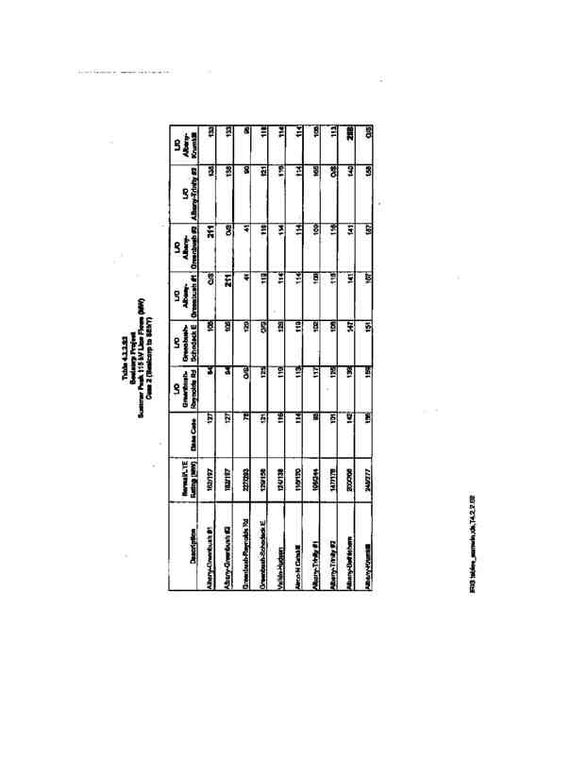

133
POWER CO. Project Initial facilities Study
Exhibit B to the Interconnection Agreement January 15, 2004
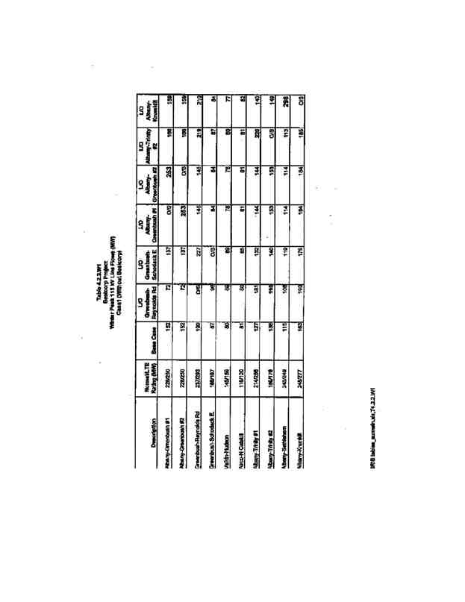

134
POWER CO. Project Initial facilities Study
Exhibit B to the Interconnection Agreement January 15, 2004
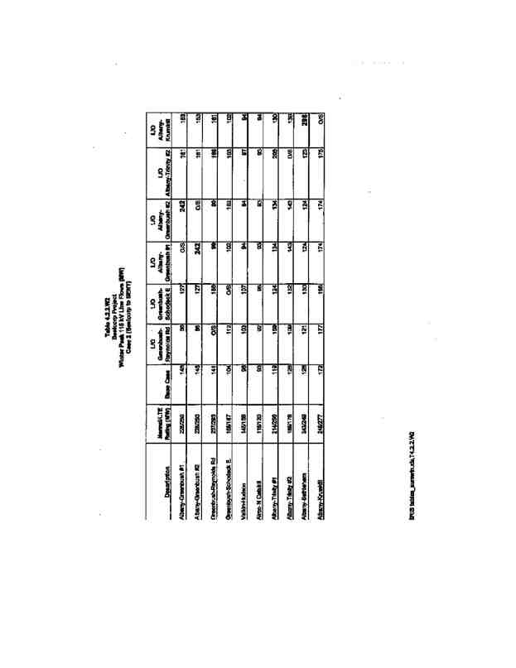

135
POWER CO. Project Initial facilities Study
Exhibit B to the Interconnection Agreement January 15, 2004
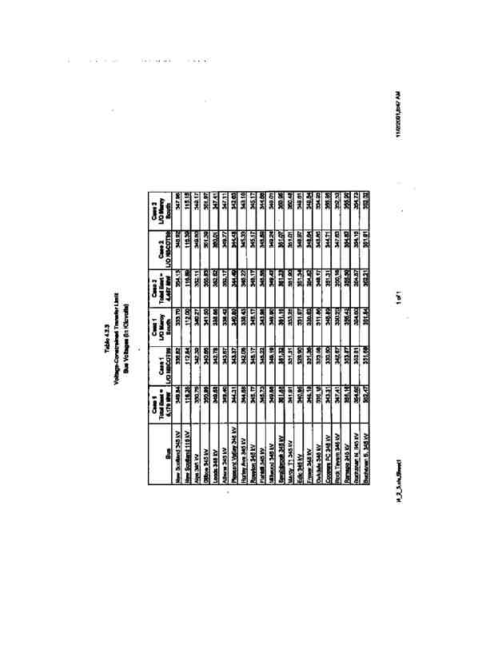

136
POWER CO. Project Initial facilities Study
Exhibit B to the Interconnection Agreement January 15, 2004
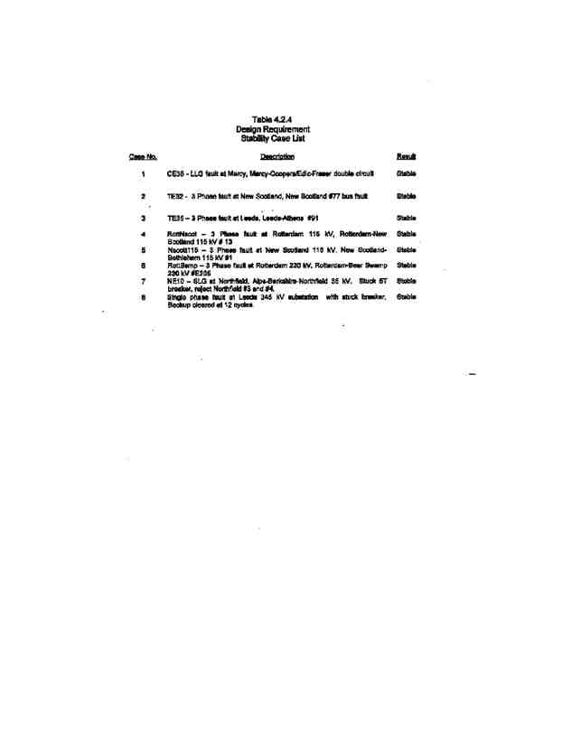

137
POWER CO. Project Initial facilities Study
Exhibit B to the Interconnection Agreement January 15, 2004
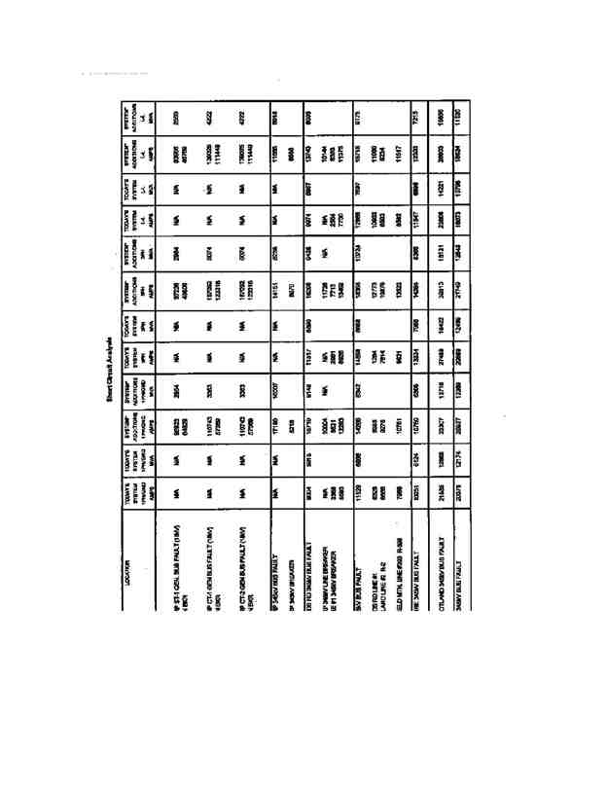

138
POWER CO. Project Initial facilities Study
Exhibit B to the Interconnection Agreement January 15, 2004
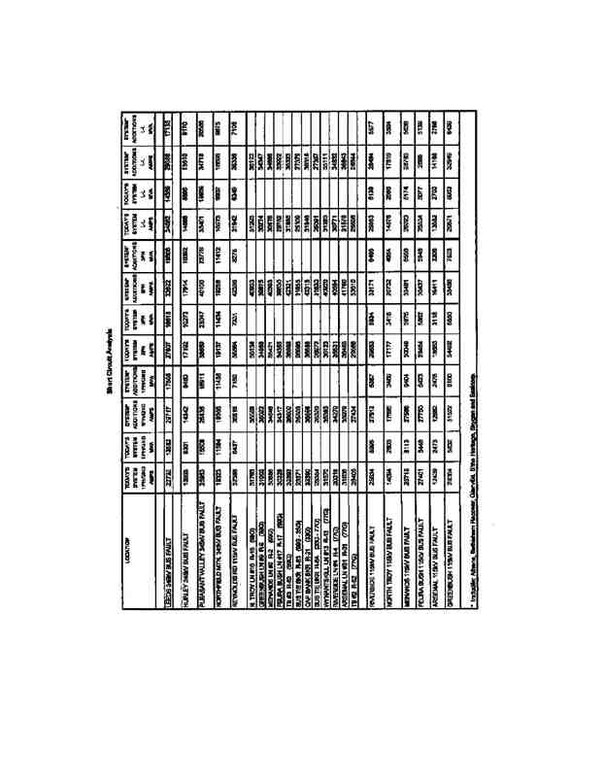

139
POWER CO. Project Initial facilities Study
Exhibit B to the Interconnection Agreement January 15, 2004
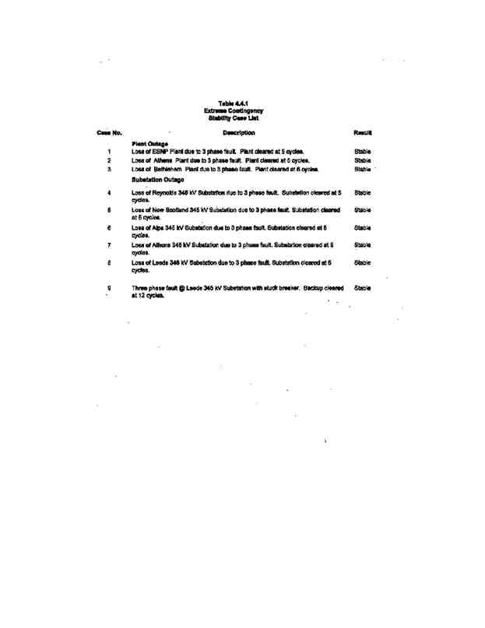

140
POWER CO. Project Initial facilities Study
Exhibit B to the Interconnection Agreement January 15, 2004
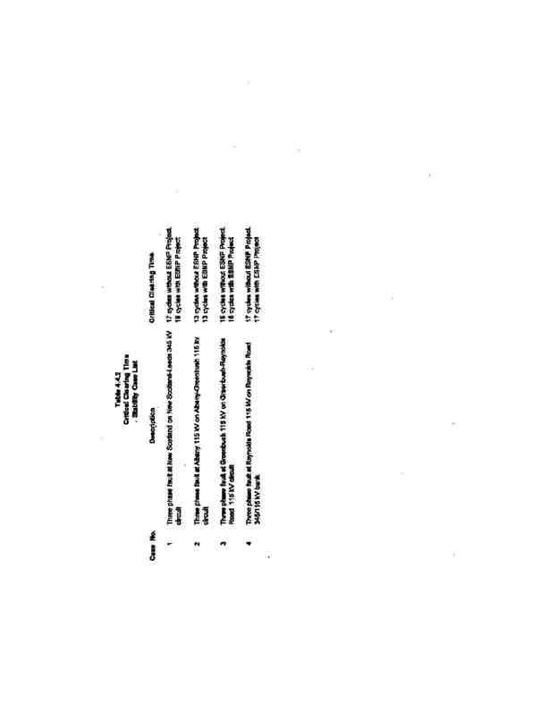

141
POWER CO. Project Initial facilities Study
Exhibit B to the Interconnection Agreement January 15, 2004
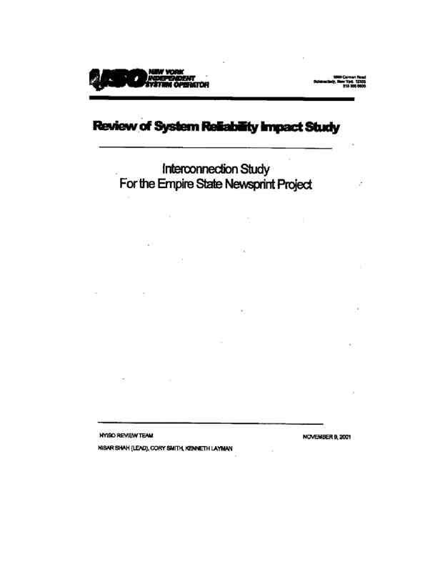

142
POWER CO. Project Initial facilities Study
Exhibit B to the Interconnection Agreement January 15, 2004

143
POWER CO. Project Initial facilities Study
Exhibit B to the Interconnection Agreement January 15, 2004
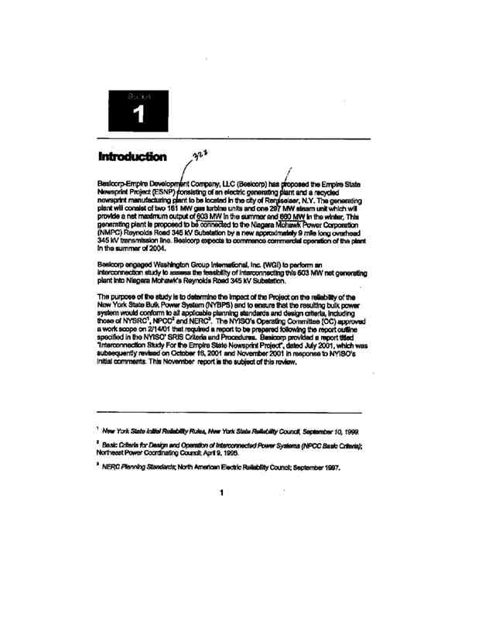

144
POWER CO. Project Initial facilities Study
Exhibit B to the Interconnection Agreement January 15, 2004
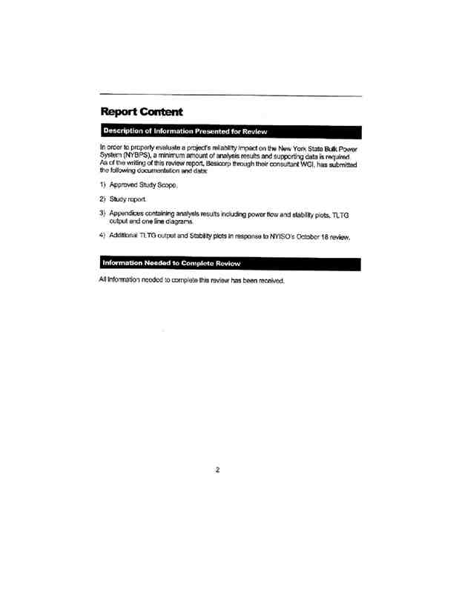

145
POWER CO. Project Initial facilities Study
Exhibit B to the Interconnection Agreement January 15, 2004
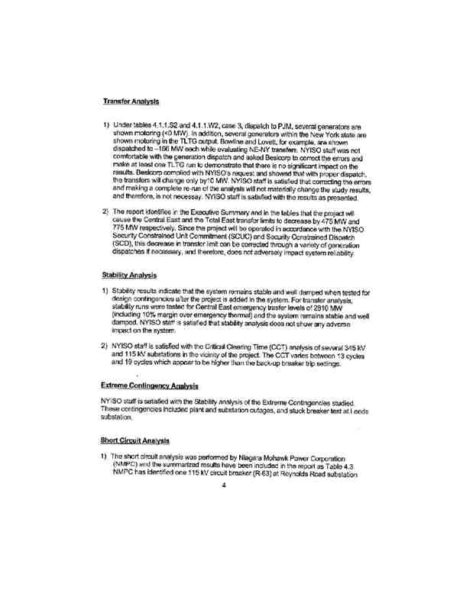

146
POWER CO. Project Initial facilities Study
Exhibit B to the Interconnection Agreement January 15, 2004
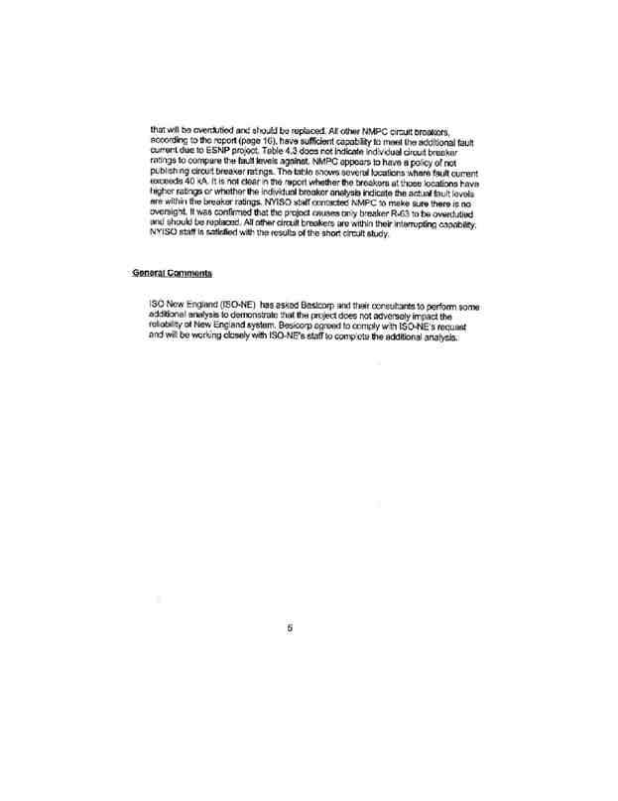

147
POWER CO. Project Initial facilities Study
Exhibit B to the Interconnection Agreement January 15, 2004
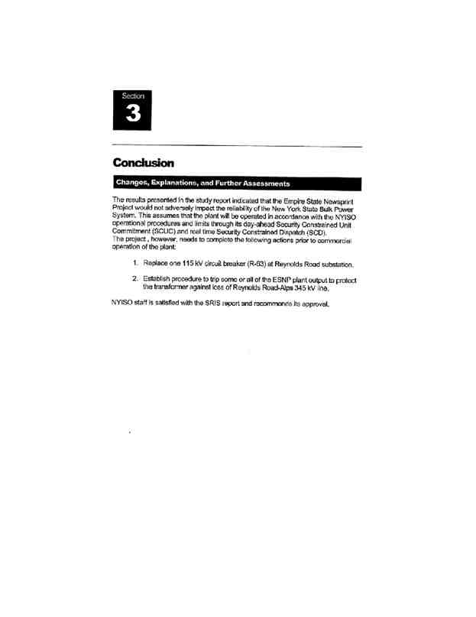

148
POWER CO. Project Initial facilities Study
Exhibit B to the Interconnection Agreement January 15, 2004

