FERC rendition of the electronically filed tariff records in Docket No. ER20- -000
Filing Data:
CID: C000038
Filing Title: Engineering Fees Reimbursement Agreement between NYSEG and Greenidge Generation Company Filing Identifier: 1538
Type of Filing Code: 10
Associated Filing Identifier: [if applicable]
Tariff Title: NYISO Agreements
Tariff ID: 58
Payment Confirmation: N
Suspension Motion:

Tariff Record Data:
Record Content Description: Agreement No. 2492
Tariff Record Title: Engineering Fees Reimbursement Agreement - NYSEG & Greenidge Record Version Number: 0.0.0
Option Code: A
Tariff Record ID: 257
Tariff Record Collation Value: 8086300
Tariff Record Parent Identifier: 2
Proposed Date: 2019-10-18
Priority Order: 500
Record Change Type: New
Record Content Type: 2
Associated Filing Identifier: [Source - if applicable]

Service Agreement No. 2492

CUI//CEII - REDACTED VERSION CUI//CEII - REDACTED VERSION
Service Agreement No. ___

ENGINEERING FEES
REIMBURSEMENT AGREEMENT
By and Between
NEW YORK ELECTRIC & GAS CORPORATION
AND
GREENIDGE GENERATION LLC

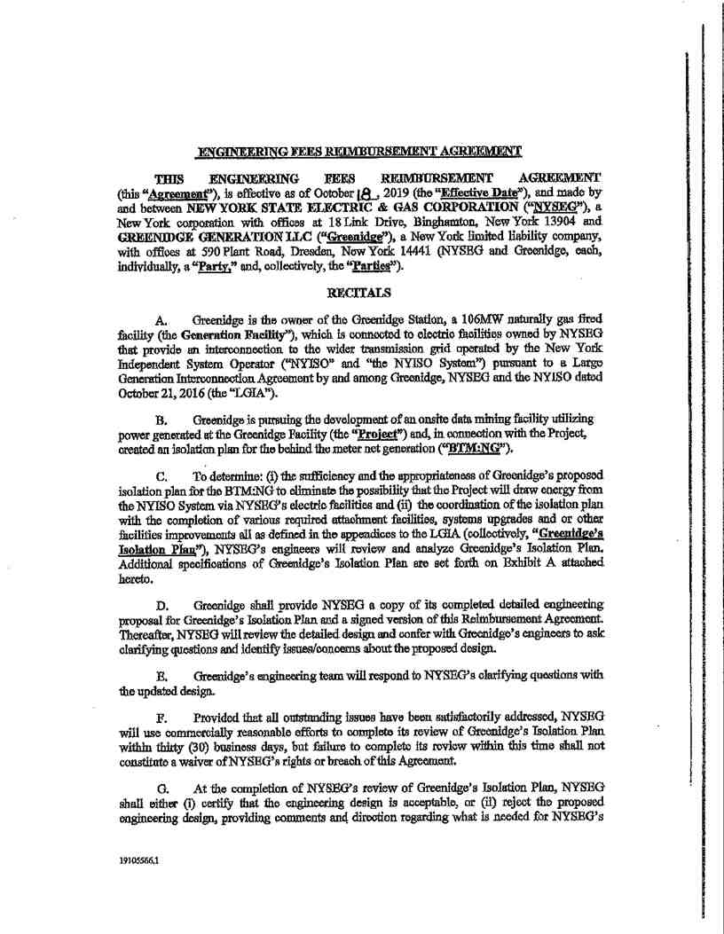Service Agreement No. 2492

Service Agreement No. 2492

H. Greenidge will reimburse NYSEG for the costs and expenses NYSEG incurs during NYSEG engineers’ review and analysis of Greenidge’s Isolation Plan.
I. The Parties acknowledge and agree that NYSEG’s review and certification of Greenidge’s Isolation Plan shall not be construed as confirming, endorsing, or providing a warranty as to the design, fitness, safety, durability or reliability of the Large Generating Facility, or Greenidge’s Isolation Plan. Greenidge shall make such changes to Greenidge’s Isolation Plan as may reasonably be required by the NYISO, in accordance with Good Utility Practice, to ensure it is compatible with the technical specifications, operational control, and safety requirements of NYSEG and the NYISO.
J. Each of the Parties, having done all things necessary to constitute this Agreement
a valid and binding agreement by and between them, and in all respects, having duly authorized
the creation, execution, and delivery of this Agreement, agrees to the terms and conditions of this
Agreement.
DEFINITIONS
1. “Appropriate Fees” means all reasonable engineering costs and expenses incurred by NYSEG to review Greenidges Isolation Plan and invoiced to Greenidge in compliance with this Agreement.
2. “Authorized Signatory” means the individual designated by NYSEG and the
individual designated by Greenidge to sign this Agreement on behalf of NYSEG and Greenidge,
respectively.
3. “Force Majeure Event” means any event outside the commercially reasonable
control of the Parties that prevents a Party from timely fulfilling its obligations pursuant to this
Agreement.
4. “Repayment Period” means the sixty (60)-calendar day period immediately following Greenidge’s receipt of a written invoice sent to Greenidge by NYSEG via by first class, United States mail seeking payment of accrued Appropriate Fees.
ARTICLE I.
REIMBURSEMENT OF ENGINEERING FEES
Section 1.01 The Recitals and Definitions, by reference, are part of this Agreement.
Section 1.02 NYSEG will provide proper documentation, including, but not limited to, receipts and descriptions of services rendered, with each invoice for Appropriate Fees.
Section 1.03 Greenidge acknowledges and accepts its obligation to reimburse NYSEG for any and all Appropriate Fees.

2

Service Agreement No. 2492

Section 1.04 Greenidge’s obligation to reimburse NYSEG for Appropriate Fees is not and will not be contingent or dependent on approval of or success of the Project.
Section1.05 Greenidge will reimburse NYSEG for Appropriate Fees within the Repayment Period.
Section 1.06 If Greenidge fails to reimburse NYSEG for the Appropriate Fees within
the Repayment Period, Greenidge is responsible for any collection fees incurred by NYSEG.
Section 1.07 Prior to referring any past due Appropriate Fees for collection, NYSEG
must give Greenidge thirty (30)-days’ prior written notice, which notice must clearly state the
amount of past due Appropriate Fees. If the past due Appropriate Fees remain outstanding after
the expiration of such thirty (30)-day period, NYSEG may refer the amounts for collection.

ARTICLE II.
TERM
This Agreement is effective as of the Effective Date and will remain in effect, unless terminated earlier by written consent of the Parties, until NYSEG completes its review of Greenidge’s Isolation Plan and no Appropriate Fees are outstanding.

ARTICLE III.
FORCE MAJEURE EVENT
Section 3.01 Neither Party will be in breach of this Agreement or liable for any delay in or failure of its performance under this Agreement to the extent such delay or failure is due to a Force Majeure Event as long as:
(a) The Party claiming Force Majeure provides the other Party written notice
as soon as practicable after the claiming Party becomes aware of the Force Majeure Event; and
(b) The Party claiming Force Majeure proceeds with commercially reasonable
efforts to overcome the Force Majeure Event, and, within a reasonable time after giving notice of
the Force Majeure Event, which may not exceed ten (10)-calendar days’, provides the
non-claiming Party written notice of those efforts and the estimated time for performance.
Section3.02 Any breach or other non-performance will be excused only for the duration of the Force Majeure Event plus seven (7) calendar days’.
[There is no further text on this page. The signature page follows.]

3

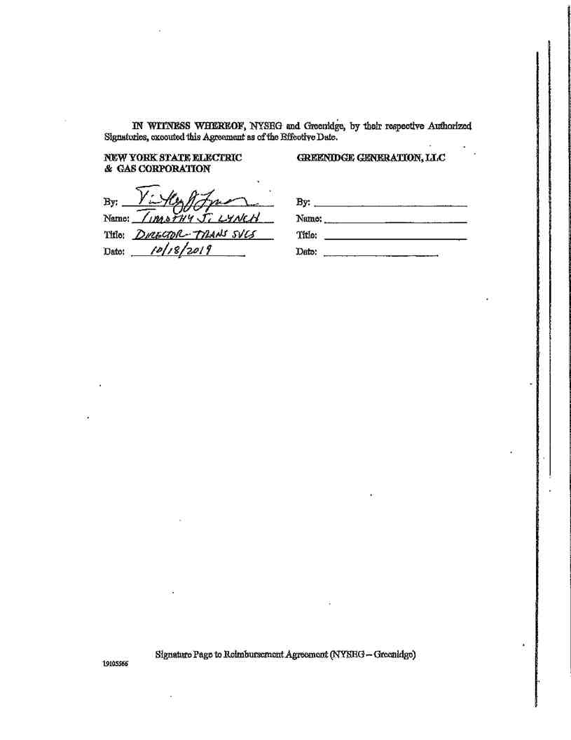Service Agreement No. 2492

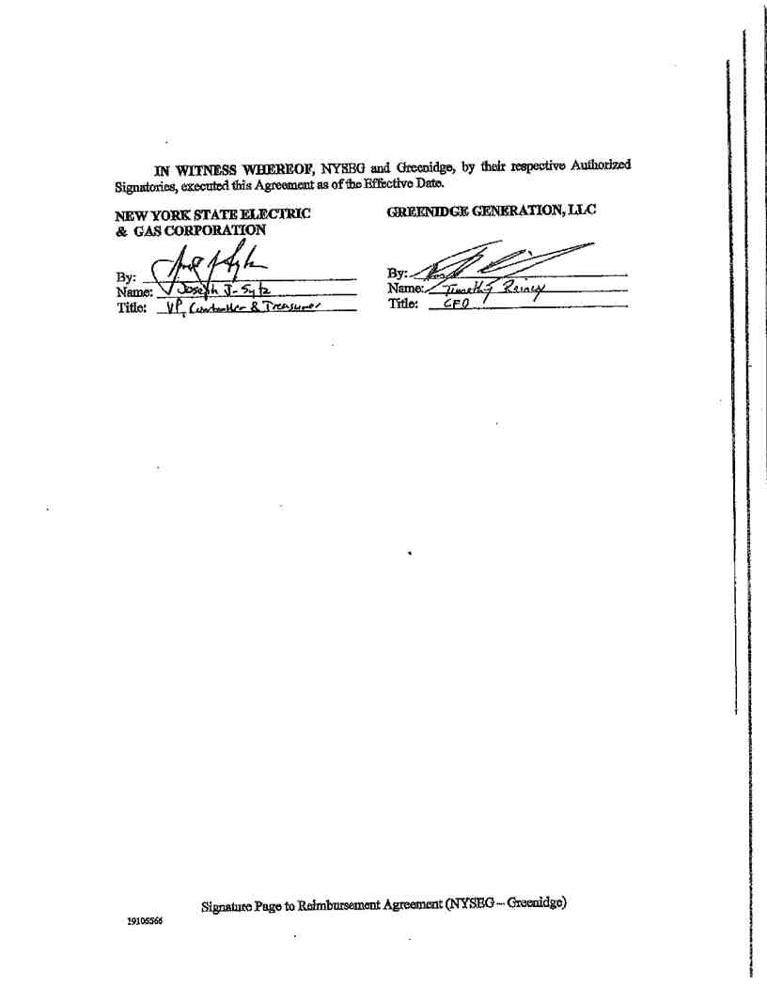Service Agreement No. 2492

Service Agreement No. 2492

EXHIBIT A
TO
REIMBURSEMENT AGREEMENT
Between
New York State Electric and Gas
And
Greenidge Generation LLC

5
19105566.1

Service Agreement No. 2492
"Exhibit A of this Engineering Fees
Agreement Contains Critical Energy
Infrastructure Information - Do Not
Distribute to Unauthorized Individuals"

Greenidge Generation: “Behind The Meter” Onsite Data Center

BACKGROUND
The Greenidge Generation LLC (“Greenidge”) plant located in Dresden, New York is a single
unit, 107MW natural gas generator. Greenidge Generation (“Greenidge”) has proposed to
for
the purpose of supplying additional, new onsite data center loads under the NYISO Behind the Meter Program.

The New York Independent System Operator (NYISO) has requested written confirmation from
NYSEG concerning Greenidge’s electrical system. NYISO would like NYSEG to approve of
the Greenidge isolation plan, where the plant would never operate the Behind the Meter Load
with power from the grid. This summary document is provided to NYSEG to explain the
protection and control applications in this modification that impact the NYSEG system. A Plant
One Line drawing depicting the Relay and Metering setup is provided along with this summary.

THE CONCEPTUAL PLAN
The existing isolated-phase bus (“ISO phase bus”) will be modified to allow a tap connection to supply the new switchgear station bus

6

Service Agreement No. 2492

"Exhibit A of this Engineering Fees
Agreement Contains Critical Energy
Infrastructure Information - Do Not
Distribute to Unauthorized Individuals"

The following
logic depicts how the onsite load data center is prevented from drawing power from the NYSEG
grid.

7

"Exhibit A of this Engineering Fees
Agreement Contains Critical Energy
Infrastructure Information - Do Not
Distribute to Unauthorized Individuals"
Service Agreement No. 2492

It should be noted that while the Greenidge “Behind The Meter” (“BTM”) project and the
NYSEG Relaying and Metering project are intended to be constructed within the same
timeframe, the two (2) projects are considered as separate except for the afore mentioned aspects.

In terms of the Behind-The-Meter project, two new meters will be installed. One will be installed on the high side of the existing station service transformer and the other will be installed on the switchgear feeder bus. From the NYSEG Interconnection project, a new meter was installed on the high side of the GSU. This metering scheme falls into the Option 2 category found in the NYISO Revenue Metering Requirements manual where the meter installed on the high side of the GSU is the net facility revenue meter and the meter installed on the station service and the new feeder bus will meter the gross load.
The meters that will be installed in the Behind-The-Meter project will be matched to the meter
that will be installed in the interconnection project, a TransData Mark V. These meters, along
with all CTs and VTs, were found in the New York State Public Service Commission (NYS
PSC) approved metering equipment manual. All equipment used for metering in this project will
fall under the revenue grade category as determined by the NYISO Revenue Metering
Requirements manual as well the NYS PSC approved metering equipment manual.

The metering scheme can be found in the
figures below.

8

"Exhibit A of this Engineering Fees Service Agreement No. 2492
Agreement Contains Critical Energy
Infrastructure Information - Do Not
Distribute to Unauthorized Individuals"

The highlighted sections in Figure 2 are the new meters installed for the interconnection project and the Behind-The-Meter project. The meter highlighted on the left of Figure 2 is the meter installed on the new gross load, the meter highlighted at the top is the meter installed on the high side of the station service transformer, and the meter highlighted on the right is the new meter installed on the high side of the GSU, confirming that the Behind-The-Meter project falls within Option 2 of the NYISO Revenue Metering Requirements.

9

