FERC rendition of the electronically filed tariff records in Docket No.
Filing Data:
CID: C000038
Filing Title: Con Edison and O&R Transco Agreements Company Filing Identifier: 1170
Type of Filing Code: 10
Associated Filing Identifier:
Tariff Title: NYISO Agreements Tariff ID: 58
Payment Confirmation: N
Suspension Motion:

Tariff Record Data:
Record Content Description: Agreement No. 2289
Tariff Record Title: I&R Agreement 2289, Con Edison, Transco, Ramapo substation Record Version Number: 0.0.0
Option Code: A
Tariff Record ID: 204
Tariff Record Collation Value: 8080900
Tariff Record Parent Identifier: 2
Proposed Date: 2016-05-27
Priority Order: 500
Record Change Type: New
Record Content Type: 2
Associated Filing Identifier:

ATTACHMENT D

INDEMNIFICATION AND REIMBURSEMENT AGREEMENT BETWEEN
CON EDISON AND TRANSCO FOR THE RAMAPO SUBSTATION

EXECUTION COPY

INDEMNIFICATION AND REIMBURSEMENT AGREEMENT

This INDEMNIFICATION AND REIMBURSEMENT AGREEMENT (as
the same may be amended in accordance with the terms hereof, this “Agreement”), dated as of
May 24, 2016 (the “Effective Date”), is by and between CONSOLIDATED EDISON
COMPANY OF NEW YORK, INC., a New York corporation having its principal offices at 4 Irving Place, New York, New York 10003 (“Con Edison”) and NEW YORK TRANSCO LLC, a New York limited liability company having its principal offices at c/o Consolidated Edison Transmission, LLC, 4 Irving Place, New York, New York 10003 (“Transco”; together with Con Edison, the “Parties” and each, a “Party”).
RECITALS
WHEREAS, on the date hereof, Con Edison sold to Transco and Transco acquired from Con Edison (the “Acquisition”), substantially all of the assets comprising the capital transmission project known as the “Second Ramapo to Rock Tavern” project (the “RRT Project”), pursuant to the terms of that certain Asset Purchase Agreement by and between the Parties dated January 7, 2016 (the “Acquisition Agreement”); and

WHEREAS, pursuant to the Acquisition, Transco also acquired the economic interest in certain attachment facilities and substation upgrade facilities (the “Ramapo SUF”) located at the substation located in Ramapo, New York (the “Ramapo Substation”) identified on Exhibit A hereto.

WHEREAS, the Parties desire to enter into this Agreement, to (i) evidence Con Edison’s acceptance of compliance responsibility as the registered Transmission Owner under all applicable reliability rules of North American Electric Reliability Corporation (“NERC”) with respect to the Ramapo SUF and (ii) provide for, among other things, (a) indemnification of Con Edison by Transco for NERC assessed penalties resulting from any failure of such compliance with respect to the Ramapo SUF, and (b) the payment by Transco of all operation and maintenance expenses allocable to the Ramapo SUF that are incurred by Con Edison, in each case on the terms and subject to the conditions of this Agreement; and

WHEREAS, the Parties also desire to acknowledge herein that payment by
Transco of its attributable share of costs that are identified in that certain lease agreement by and
between Con Edison and Transco, dated February 23, 2016 (the “Lease”), may be satisfied upon
payment thereof to Con Edison’s affiliate, Orange and Rockland Utilities, Inc. (“O&R”),
pursuant to the terms of that certain Operations and Maintenance Agreement by and between O&R and Transco of even date herewith (the “O&M Agreement”).

NOW, THEREFORE, in consideration of the foregoing, and of the mutual representations, warranties, covenants and agreements herein contained, and for other good and valuable consideration, the receipt and sufficiency of which are hereby acknowledged, the Parties, intending to be legally bound, do hereby agree as follows.
1. Assumption of NERC Compliance Responsibility: Con Edison shall be solely
responsible for complying, and hereby expressly agrees to assume sole responsibility to
comply, with all NERC Standards applicable to the Ramapo SUF. In furtherance of the
foregoing, Con Edison, as it relates to the Ramapo SUF, represents and warrants to, and
covenants and agrees with, Transco that Con Edison has, on or prior to the date hereof,
registered, and will at all times during the Term maintain such registration, as the
Transmission Owner and will not de-register as the Transmission Owner, with NERC of
the Ramapo SUF. The Parties agree to negotiate in good faith and enter into a separate
agreement among the Parties and O&R, to memorialize and set forth: (i) Transco’s
acceptance of compliance responsibility as the registered Transmission Owner under all
applicable reliability rules of NERC with respect to the Transmission Line (and Transco’s
representation that it has registered, and will at all times during the Term maintain such
registration, as the Transmission Owner and will not de-register as the Transmission
Owner, with NERC of the Transmission Line); and (ii) O&R’s acceptance of compliance
responsibility as the registered Transmission Owner under all applicable reliability rules
of NERC with respect to the southern portion of the Feeder 76 transmission line running
from the Sugarloaf substation to the Ramapo Substation (the “Southern Tier”) (and
O&R’s representation that it has registered, and will at all times during the Term
maintain such registration, as the Transmission Owner and will not de-register as the
Transmission Owner, with NERC of the Southern Tier). The Parties agree to execute the
separate compliance responsibility agreement prior to energization of the Transmission
Line.
2. Notice of Violation. In the event Con Edison receives a notice of possible violation (an
“NPV”) from Northeast Power Coordinating Council (“NPCC”) associated with the Ramapo SUF or if Con Edison identifies a possible violation associated with the Ramapo SUF for which it is self-reporting to NPCC, which carries the possibility of financial penalties as to which Con Edison would seek indemnification hereunder, Con Edison shall notify Transco of such NPV in writing (which may be via email) as soon as practicable. Transco may, in its sole discretion, participate in any investigation conducted by Con Edison to determine the cause of the NPV.

3. NERC Compliance Indemnification. To the fullest extent permitted by applicable Law
(as such term is defined in the O&M Agreement), Transco agrees to indemnify and hold
harmless Con Edison, its affiliates (other than Transco and its members), and its and their
respective members, trustees, directors, managers, officers, employees, agents and
representatives (collectively, “Con Edison Indemnitees”) from and against any and all
NERC assessed financial penalties (collectively, “Penalties”) suffered, sustained or
incurred by Con Edison or any Con Edison Indemnitee, together with defense costs
incurred by Con Edison or any Con Edison Indemnitee with respect thereto (including
attorneys’ fees and costs of experts (collectively, “Defense Costs”) to the extent arising
out of, relating to or resulting from any failure of compliance with any applicable NERC
reliability requirements with respect to the Ramapo SUF, except to the extent such

Penalties and Defense Costs (i) result solely from the grossly negligent, fraudulent, or
intentionally wrongful acts or omissions of Con Edison or any Con Edison Indemnitee, or
(ii) are attributable to a systemic issue not directly related to the Ramapo SUF. For
purposes of clarity, the indemnification herein provided in respect of violations or alleged
violations that affect both the Ramapo SUF and other Ramapo Substation assets shall be
apportioned based on how the number of Ramapo SUF impacted compares to the total
number of functionally equivalent Ramapo Substation assets impacted. Con Edison shall
assume the defense of any claim subject to indemnification hereunder with counsel
chosen by Con Edison and reasonably acceptable to Transco. Transco shall pay its pro-
rata costs of Con Edison’s counsel and experts and will have the opportunity to
participate in the defense of the claim with its own counsel and at its own expense;
provided, however, that if both Parties are named in the action and their joint
representation by the same counsel would be inappropriate due to a conflict of interest,
then each Party shall bear the costs of its own counsel.

4. Compliance Audit. Transco shall have the right, but not the obligation, to conduct audits
with respect to Con Edison’s compliance with NERC Standards applicable to the Ramapo
SUF. Con Edison agrees to cooperate with such audits and, upon request, provide
Transco (or Transco’s agents, subject to Con Edison’s reasonable approval) with access
to and/or copies of all records kept in connection with Con Edison’s compliance activities
with respect to the Ramapo SUF. Such audit and requests for records shall be subject to
30 days’ advance notice, unless otherwise required by NERC / NPCC or any unplanned external investigation that involves the Ramapo SUF.

5. Operation and Maintenance. Con Edison shall operate and maintain the Ramapo SUF in a
commercially reasonable manner, consistent with Good Utility Practice and in accordance with applicable Law. Without limiting the foregoing, Con Edison agrees that it will perform the same tasks and services (with equivalent quality and frequency) in relation to the Ramapo SUF as it performs in relation to other Con Edison-owned assets in the Ramapo Substation of like kind. Con Edison further agrees to allow Transco to witness the performance of any material task, including the conduct of any audit, spot check, test or repair (subject, in all cases, to Transco’s compliance with Con Edison’s security, safety, reliability and operational requirements).

6. Annual Maintenance Plan. Con Edison shall provide Transco, for its review, an Annual
Maintenance Plan for the operations and maintenance (“O&M”) of the Ramapo SUF. Such Annual Maintenance Plan shall be provided to Transco for its review no later than August 31 of each year of the Term. Transco shall have the right to request Con Edison perform additional operations and maintenance services in connection with the Ramapo SUF that Transco deems necessary to ensure NERC compliance, provided that Transco pays the costs incurred thereby pursuant to the further provisions of this Agreement. The Initial Maintenance Plan, which will govern the period commencing on the Effective Date through December 31, 2016, is attached as Exhibit B.

7. Annual Budget. During the Term, Con Edison shall prepare for Transco’s review and
approval a Budget for the operations and maintenance of the Ramapo SUF. The proposed
Budget shall be provided to Transco for its review and approval no later than August 31
of each year. The Initial Budget, which will govern the period commencing on the

Effective Date through December 31, 2016, is attached as Exhibit C.
8. Obligation to Pay O&M Expenses. During the Term, Transco shall pay all Direct Costs
and Indirect Costs (as defined in the O&M Agreement) incurred by Con Edison to operate and maintain the Ramapo SUF in accordance with this Agreement, including, without limitation, costs incurred to comply with applicable Law, including Environmental Law, and to conduct any Remediation, restoration or corrective action in connection with any Release or compliance with Environmental Law, in each case to the extent caused by or directly relating to the Ramapo SUF and first occurring on or after the Effective Date (each such capitalized term having the meanings ascribed thereto in the Lease) (the “O&M Expenses”).
9. Calculation of O&M Expense. Calculation of O&M Expenses payable by Transco
hereunder shall be determined based upon the costs incurred by Con Edison at the
Ramapo Substation to operate and maintain the Ramapo SUF; provided that (i) property
tax attributable to the Ramapo SUF will be based on the ratio of gross book value of the
Ramapo SUF compared to the gross book value of the Ramapo Substation (determined
by reference to Con Edison’s most recent filing with Office of Real Property Tax
Services) and (ii) property insurance attributable to the Ramapo SUF will be determined
as the product of electric property insurance cost multiplied by a fraction, the numerator
of which is the book value of the Ramapo SUF and the denominator of which is the book
value of total electric station and structure plant in service (as calculated from data
provided in Con Edison’s most recent FERC Form 1 report). The calculation of O&M
Expense payable by Transco from the Effective Date through December 31, 2016 is set
forth in the Initial Budget attached as Exhibit C.

10. Recovery of Costs from Con Edison. In the event any O&M Expense agreed to and paid
by Transco hereunder is determined by FERC to be unjust and unreasonable and not
eligible for rate recovery by Transco, Con Edison will specify a new rate, term or
condition that is just and reasonable and not unduly discriminatory or preferential and
that is thereafter to be used. Subject to any FERC order to the contrary, all prudently
occurring costs prior to a FERC decision are fully reimbursable.
11. Lease Costs. The Parties acknowledge that certain costs payable by Transco to Con
Edison under the Lease may be invoiced by O&R pursuant to the O&M Agreement. In
such event, payment by Transco of such invoices shall be deemed to satisfy Transco’s
payment obligations under the Lease. Capitalized terms used in this Section 11 and not
otherwise defined in this Agreement have the meanings given thereto in the Lease.

12. Invoicing and Payment. Con Edison shall invoice Transco monthly, in arrears or
otherwise in accordance with Con Edison’s normal billing practices, for all costs payable
hereunder. All invoices shall be in reasonable detail and shall be accompanied by all
reasonably necessary supporting documentation. Transco shall pay all conforming
invoices within thirty (30) days of receipt by wire transfer to an account designated in
writing by Con Edison, or by such other means as Con Edison shall specify. Undisputed
amounts not timely paid shall incur a finance charge accruing at the prime rate of interest
(as announced by the Wall Street Journal from time to time) plus 2% per year.

13. Financial Audit. Transco shall have the right, but not the obligation, to conduct an annual
audit with respect to the O&M Expenses. Con Edison agrees to cooperate with such
annual audit and, upon request, provide Transco or its agents with access to all records
and books kept in connection with the O&M Expenses.

14. Limitation of Liability. Con Edison shall not be liable to Transco hereunder except to the
extent of arising from or related to (i) the gross negligence, fraud or willful misconduct of
Con Edison or any of its affiliates (other than Transco, non-Con Edison controlled
members of Transco, and such members’ respective affiliates), and its and their
respective members, trustees, directors, managers, officers, employees, agents and
representatives (each, a “Con Edison Party”) and (ii) acts of discrimination, harassment,
retaliation, defamation or other intentional torts committed by Con Edison or any Con
Edison Party. In any event, Con Edison’s liability hereunder for each event giving rise to
such obligation shall be limited to the total of net payments received by Con Edison
during the 12 month period preceding the event giving rise to such liability. Neither Party
shall be liable to the other under this Agreement for any indirect, special, incidental,
special, lost profit, or other consequential damages arising from performance or lack of
performance hereunder, regardless of whether such damages are claimed based on
contract, warranty, tort (including negligence), strict liability or other legal or equitable
principle, or were reasonably foreseeable, or whether the Parties were advised of the
possibility of such damages.
15. Term. The term of this Agreement (the “Term”) shall commence upon the date hereof
and expire on the date on which Transco no longer has the Ramapo SUF investment in
rate base, unless earlier terminated by the mutual written agreement of the Parties.
Neither the expiration nor termination of this Agreement shall relieve the Parties of any
of its obligations accruing prior to such expiration or termination.
16. Dispute Resolution. In the event of a dispute hereunder, the Parties shall follow the
dispute resolution procedure set forth in Article XIV of the O&M Agreement, the
provisions of which are hereby incorporated by reference herein as though fully set forth
herein, provided that all references to “Provider” and “Owner” shall be read as Con
Edison and Transco, respectively.

17. Governing Law. This Agreement shall be governed by and construed and enforced in
accordance with the internal laws of the State of New York, without giving effect to any
choice of law rules or provisions that would cause the application of the laws of any
jurisdiction other than the State of New York and without regard to any rule requiring
construction against the Party drafting this Agreement.

18. Waiver of Trial by Jury; Jurisdiction. The Parties hereby waive trial by jury in any
action, proceeding or counterclaim brought by either of them against the other on any
matter arising out or related to this Agreement, and irrevocably submit to the jurisdiction
of the courts of the United States or of the State of New York located in the City and
County of New York in connection therewith. Each Party waives any objection to venue
in the State of New York.
19. Assignments. Neither Party may assign its rights or obligations under this Agreement

without the prior written consent of the other Party hereto, which consent shall not be unreasonably withheld, delayed or conditioned, except that either Party may assign its rights or obligations hereunder to a purchaser of all or substantially all of its assets who agrees in writing to assume and be bound by the provisions of this Agreement, provided, however, that in the case of an assignment by Transco, the proposed assignee is: (i) a reputable entity having a net worth computed in accordance with generally accepted accounting principles which evidences, in Con Edison’s reasonable discretion, the assignee’s financial ability to meet its obligations hereunder, and (ii) not entitled, directly or indirectly, to diplomatic or sovereign immunity and shall be subject to the service of process in, and the jurisdiction of the courts of, New York State, and (iii) is qualified to become and becomes a tenant under the Lease.
20. Headings. The descriptive headings used in this Agreement are for convenience of
reference only and do not constitute part of this Agreement.

21. Amendments; No Waiver. This Agreement may not be amended, nor shall any waiver be
effective, except by an instrument in writing signed by both Parties (or, in the case of a
waiver, the Party against whom the waiver is sought to be effective). No course of
dealing, or failure or delay by either Party in exercising any right provided for herein will
be deemed a waiver of such right or any subsequent right hereunder.

22. Entire Agreement. This Agreement, together with the other documents and agreements
referenced herein, constitute the entire agreement between Con Edison and Transco
concerning the subject matter hereof and supersede any and all prior agreements, written
or oral, with respect to such subject matter.

23. Severability. If any provision hereof is held by a court of competent jurisdiction to be
invalid or unenforceable, in whole or in part, then such determination shall not affect the
validity of the remaining portions hereof, which other portions shall continue in full force
and effect.

24. No Third Party Beneficiaries. This Agreement is for the sole benefit of the Parties and
their successors and permitted assigns and is not intended to and will not confer any
rights or benefits to any other Person, except that Con Edison Indemnitees are intended
third party beneficiaries of this Agreement for purposes of enforcing their rights under
Section 3.
25. Successors and Assigns. The agreements, terms, covenants and conditions herein shall
be binding upon, and inure to the benefit of, the Parties and their respective successors
and permitted assigns.

26. Counterparts. This Agreement may be executed in one or more counterparts (including
by facsimile or electronic transmission), each of which shall be an original and all of
which, taken together, shall constitute one and the same instrument.

27. Relationship of the Parties. This Agreement shall not be deemed to create any
partnership, agency, joint venture or trust, or to authorize any Party to act as agent,
servant or employee of the other. The Parties are independent contractors. Neither Party

shall have the power to bind the other without its express written consent.
28. Environmental Representation. To Con Edison’s Knowledge, no material Release or
material violation of Environmental Law exists with respect to the Ramapo SUF on the
Effective Date. "Con Edison’s Knowledge" means to the knowledge of Gregory E. Pryor
(Section Manager EH&S Operations), Fareed Abbassi (Area Manager - Staten Island
Substation Operations), and Kevin Donnelly (Area Manager - Westchester North
Substation Operations), based on their review of reasonably available documents and information. Transco shall have no liability for any violation of Environmental Law or Release with respect to the Ramapo SUF or the Ramapo Substation existing on or prior to the Effective Date.

Signature Page Follows

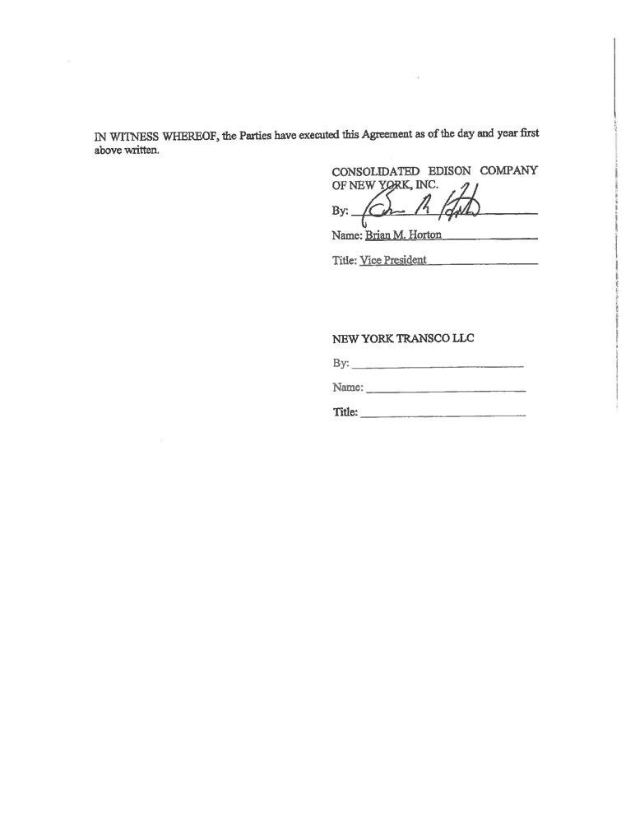

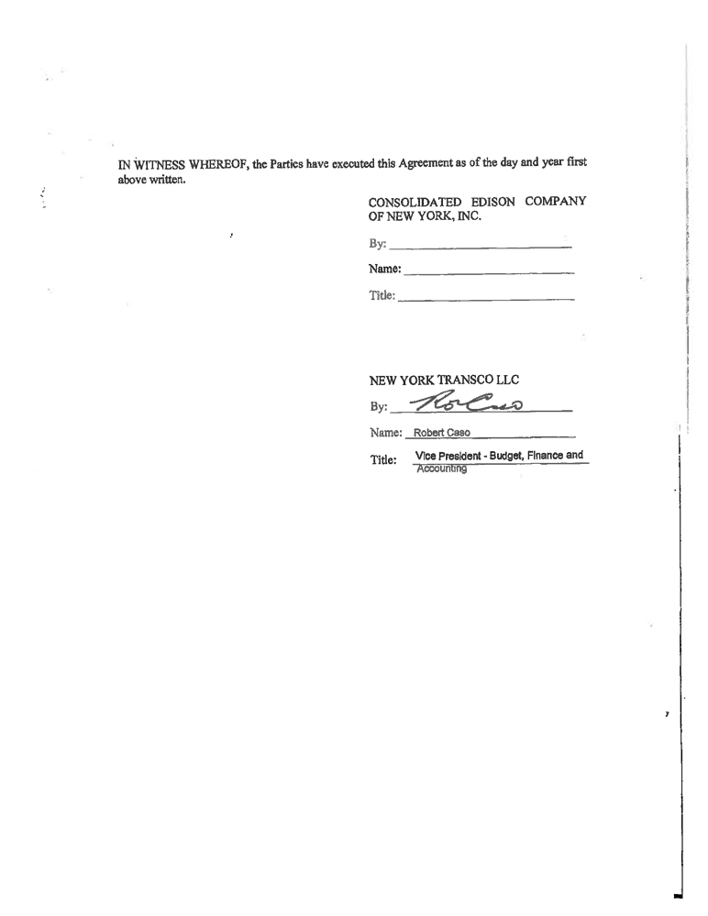

EXHIBIT A
RAMAPO SUF

The System Upgrade Facilities are the new bay expansion including the items listed below to be installed at the 345kV Ramapo Substation:
Four, 345 kV, Disconnect Switches with Associated Ground Switches rated at 3000 A nominal.

Two, 345 kV, Dead Tank Type SF6 Circuit Breakers rated at 3000 A nominal and 63 kA symmetrical fault current.
Control/Relay House extension or modification, as required. 345 kV H-frames with Lightning Arrestors, as required. 345 kV Take-off Structures, as required.
345 kV Air Insulated Rigid Aluminum Bus.
Associated components and relay protection.

EXHIBIT B
INITIAL ANNUAL MAINTENANCE PLAN
Refer to CE-ES-1000 revision 8, Pages 17-18 Table 4 item #25 for HVB SF6 insulated interrupter type.
Ramapo:
Maintenance for the rest of year:
• Monthly breaker compressor inspection: 1 hour x 2 bkrs x 7 months = 14 hours • 6 Month breaker compressor maintenance: 2 hours x 2 bkrs = 4 hours
• Breaker winterization: 4 hours x 2 bkrs = 8 hours
• Semi-annual infrared inspection: 2 hours

Total maintenance for remainder of 2016 = 28 hours
Annualized maintenance budget:
2 HVB 345kv breakers: PM= 70 hours/year CM=48 hours/year
PM Requirements (hours per breaker)
• Monthly breaker compressor inspection (1 hr.)
• 6 Month breaker compressor maintenance (2 hrs.)
• Annual Breaker winterization (4 hrs.)
• Diagnostic Testing 5 yr. minor (50 hrs.)
• Diagnostic Testing 10 yr. major (100 hrs.)
6 MO Disconnect Switches: PM=0 CM=12 hours
6 Surge Arrestors: PM=0 CM=0
7 Ground Switches: PM=0 CM=0
Semi-annual Infrared Inspections: 2 hours

Total maintenance hours/year = 132
Projected CM hours are based on equipment installed.

At Ramapo, the following is required for the newly installed equipment as per Protection Systems Maintenance Program (PSMP) 0400-0400 Rev 2.1.
Relay tests (previously known as Relay calibrations) - 6 years
This includes metering verification, settings comparison and verification of protective relay input/output contacts for both microprocessor relays, 1st and 2nd line.
Voltage and current sensing device testing - 6 years
This includes taking secondary load readings at all relays.
DC Control Circuit (previously known as Trip checks) - 4 years

Communication system testing - 12 years
Direct fiber (2 channels) and T1 line (2 channels) - Communication failure alarm must be tested for each channel.
Annualized PST budget per feeder:
FREQ HOURS
(YEARS) HOURS / FREQ
RELAY TESTS
1ST & 2ND LINE 6 32 5.3
BKR FAILURE, RECLOSURE 4 32 8.0
CT/PT CIRCUIT VERIFICATION
1ST & 2ND LINE 6 8 1.3
BKR FAILURE, RECLOSURE 4 16 4.0
DC CONTROL CIRCUIT TESTS 4 128 32
COMMUNICATION TESTS 12 16 1.3
52 HOURS/YEAR

PST does not anticipate any maintenance in 2016 since it is newly installed equipment.

EXHIBIT C

INITIAL BUDGET
Ramapo:
Maintenance for the rest of year:
• Monthly breaker compressor inspection: 1 hour x 2 bkrs x 7 months = 14 hours • 6 Month breaker compressor maintenance: 2 hours x 2 bkrs = 4 hours
• Breaker winterization: 4 hours x 2 bkrs = 8 hours
• Semi-annual infrared inspection: 2 hours

Total maintenance for remainder of 2016 = 28 hours
Using the 2016 accommodation rate for SSO & PST of $137.60 (straight time), cost for 2016 at Ramapo is $3,853.
Annualized maintenance budget:
2 HVB 345kv breakers: PM= 70 hours/year CM=48 hours/year
PM Requirements (hours per breaker)
• Monthly breaker compressor inspection (1 hr.)
• 6 Month breaker compressor maintenance (2 hrs.)
• Annual Breaker winterization (4 hrs.)
• Diagnostic Testing 5 yr. minor (50 hrs.)
• Diagnostic Testing 10 yr. major (100 hrs.)
6 MO Disconnect Switches: PM=0 CM=12 hours
6 Surge Arrestors: PM=0 CM=0
7 Ground Switches: PM=0 CM=0
Semi-annual Infrared Inspections: 2 hours

Total maintenance hours/year = 132
Using the 2016 accommodation rate for SSO & PST of $137.60 (straight time), average annual cost at Ramapo is approximately $18,163.
Annualized PST budget:
FREQ HOURS
(YEARS) HOURS / FREQ
RELAY TESTS
1ST & 2ND LINE 6 32 5.3
BKR FAILURE, RECLOSURE 4 32 8.0
CT/PT CIRCUIT VERIFICATION
1ST & 2ND LINE 6 8 1.3
BKR FAILURE, RECLOSURE 4 16 4.0
DC CONTROL CIRCUIT TESTS 4 128 32
COMMUNICATION TESTS 12 16 1.3
52 HOURS/YEAR

Using the 2016 accommodation rate for SSO & PST of $137.60 (straight time), average annual PST cost at Ramapo is approximately $7,155.

Ramapo
Maintenance 132
PST 52
184
30% contingency 55.2
Total Estimated
Maintenance 239.2
2016
accommodation
rate for SSO &
PST (straight time) $137.60
Estimated Annual
O&M Budget $32,914
Using the 2016 accommodation rate for SSO & PST of $137.60 (straight time), average annual cost at Ramapo is approximately $9,219.
Projected CM hours are based on similar equipment installed at each station.

EXHIBIT D
NOTICES
If to Owner, to:
Nabil Hitti
VP Operations
NY Transco LLC
Nabil.Hitti@nytransco.com 781-907-2657
With a copy to:
Kathleen Carrigan
General Counsel New York Transco LLC Carrigan & Associates LLC
P.O. 5905
6 Elm Street Unit C
Salisbury Ma. 01952
617-455-5329
Kathleen.Carrigan@NYTransco.com

If to Provider, to:
Brian Horton
VP System & Transmission Operations
Consolidated Edison Company of New York, Inc.
hortonb@coned.com
212.460.1210

With a copy to:

Michael Forte
Chief Engineer Transmission Planning
Consolidated Edison Company of New York, Inc.
fortem@coned.com
212.460.3416
and to:

Deputy General Counsel
Consolidated Edison Company of New York, Inc.
crayb@coned.com
212.460.3245

