**SERVICE AGREEMENT NO. 2510**

**SERVICE AGREEMENT NO. 2510**

**THIRD AMENDED AND RESTATED DEVELOPMENT AGREEMENT**

**BETWEEN THE**

**NEW YORK INDEPENDENT SYSTEM OPERATOR, INC.**

**AND**

**NEW YORK TRANSCO, LLC**

**Dated as of June 30, 2025**

**SERVICE AGREEMENT NO. 2510**



**TABLE OF CONTENTS**

Page ARTICLE 1. DEFINITIONS.........................................................................................................2

ARTICLE 2. EFFECTIVE DATE AND TERM...........................................................................6

2.1. Effective Date ......................................................................................................6

2.2. Filing....................................................................................................................7

2.3. Term of Agreement..............................................................................................7

ARTICLE 3. TRANSMISSION PROJECT DEVELOPMENT AND CONSTRUCTION..........7

3.1. Application for Required Authorizations and Approvals....................................7

3.2. Development and Construction of Transmission Project ....................................8

3.3. Milestones............................................................................................................9

3.4. Modifications to Required Project In-Service Date...........................................10

3.5. Modifications to Transmission Project..............................................................10

3.6. Billing and Payment...........................................................................................11

3.7. Project Monitoring.............................................................................................11

3.8. Right to Inspect..................................................................................................11

3.9. Exclusive Responsibility of Developer..............................................................11

3.10. Subcontractors....................................................................................................11

3.11. No Services or Products Under NYISO Tariffs.................................................12

3.12. Tax Status...........................................................................................................12

ARTICLE 4. COORDINATION WITH THIRD PARTIES.......................................................12

4.1. Interconnection Requirements for Transmission Project...................................12

4.2. Interconnection with Affected System...............................................................13

4.3. Coordination of Interregional Transmission Project..........................................13

ARTICLE 5. OPERATION REQUIREMENTS FOR THE TRANSMISSION PROJECT.......13

ARTICLE 6. INSURANCE.........................................................................................................13

ARTICLE 7. BREACH AND DEFAULT ..................................................................................16

7.1. Breach ................................................................................................................16

7.2. Default................................................................................................................16

7.3. Remedies............................................................................................................17

ARTICLE 8. TERMINATION....................................................................................................17

8.1. Termination by the NYISO................................................................................17

8.2. Reporting of Inability to Comply with Provisions of Agreement......................18

8.3. Transmission Project Transfer Rights Upon Termination.................................18

ARTICLE 9. LIABILITY AND INDEMNIFICATION.............................................................18

**SERVICE AGREEMENT NO. 2510**

9.1. Liability..............................................................................................................18

9.2. Indemnity...........................................................................................................19

ARTICLE 10. ASSIGNMENT......................................................................................................19

ARTICLE 11. INFORMATION EXCHANGE AND CONFIDENTIALITY..............................20

11.1. Information Access............................................................................................20

11.2. Confidentiality ...................................................................................................20

ARTICLE 12. REPRESENTATIONS, WARRANTIES AND COVENANTS ...........................21

12.1. General...............................................................................................................21

12.2. Good Standing ...............................................................................................21

12.3. Authority............................................................................................................21

12.4. No Conflict.........................................................................................................21

12.5. Consent and Approval........................................................................................21

12.6. Compliance with All Applicable Laws and Regulations...................................22

ARTICLE 13. DISPUTE RESOLUTION.....................................................................................22

ARTICLE 14. SURVIVAL ...........................................................................................................22

ARTICLE 15. MISCELLANEOUS ..............................................................................................22

15.1. Notices ...............................................................................................................22

15.2. Entire Agreement...............................................................................................23

15.3. Cost Recovery....................................................................................................23

15.4. Binding Effect....................................................................................................23

15.5. Force Majeure....................................................................................................23

15.6. Disclaimer..........................................................................................................24

15.7. No NYISO Liability for Review or Approval of Developer Materials .............24

15.8. Amendment........................................................................................................24

15.9. No Third Party Beneficiaries .............................................................................25

15.10. Waiver................................................................................................................25

15.11. Rules of Interpretation .......................................................................................25

15.12. Severability ........................................................................................................25

15.13. Multiple Counterparts........................................................................................26

15.14. No Partnership ...................................................................................................26

15.15. Headings ............................................................................................................26

15.16. Governing Law ..................................................................................................26

15.17. Jurisdiction and Venue.......................................................................................26

**SERVICE AGREEMENT NO. 2510**



APPENDICES

APPENDIX A Project Description

APPENDIX B Scope of Work

APPENDIX C Development Schedule

**SERVICE AGREEMENT NO. 2510**

**THIS THIRD AMENDED AND RESTATED DEVELOPMENT AGREEMENT**(“Agreement”) is made and entered into this 30th day of June 2025, by and between New YorkTransco, LLC, a limited liability company organized and existing under the laws of the State ofNew York (“Developer” or “Transco”), and the New York Independent System Operator, Inc., anot-for-profit corporation organized and existing under the laws of the State of New York(“NYISO”). Developer or NYISO each may be referred to as a “Party” or collectively referredto as the “Parties.”

**RECITALS**

**WHEREAS,** the NYISO administers the Comprehensive System Planning Process (“CSPP”) inthe New York Control Area pursuant to the terms set forth in Attachment Y of the NYISO’sOpen Access Transmission Tariff (“OATT”), as accepted by the Federal Energy RegulatoryCommission (“FERC”);

**WHEREAS,** as part of the CSPP, the NYISO administers a Public Policy TransmissionPlanning Process pursuant to which Public Policy Transmission Need(s) are identified; proposedsolutions to the identified need(s) are solicited by the NYISO; and the more efficient or cost-effective transmission solution to satisfy the identified need(s) is selected by the NYISO andreported in the NYISO’s Public Policy Transmission Planning Report;

**WHEREAS**, Transco and Niagara Mohawk Power Corporation d/b/a National Grid (“NationalGrid”) jointly proposed a Public Policy Transmission Project to satisfy an identified PublicPolicy Transmission Need (“Transmission Project”);

**WHEREAS**, the NYISO selected the Transmission Project as the more efficient or cost-effective transmission solution to satisfy an identified Public Policy Transmission Need anddirected Transco and National Grid to proceed with the Transmission Project;

**WHEREAS,** Transco and National Grid agreed to obtain the required authorizations andapprovals from Governmental Authorities needed for the Transmission Project, to develop andconstruct the Transmission Project, and to abide by the related requirements in Attachment Y ofthe OATT, the ISO Tariffs, and the ISO Procedures;

**WHEREAS,** Transco, National Grid, and the NYISO agreed to enter into a Public PolicyTransmission Planning Process Development Agreement pursuant to Section 31.4.12.2 ofAttachment Y of the OATT for the purpose of ensuring that the Transmission Project will beconstructed and in service in time to satisfy the Public Policy Transmission Need (“RequiredProject In-Service Date”);

**WHEREAS**, Transco and National Grid agreed to construct, and the NYISO has requested thatthe Developer proceed with construction of, the Transmission Project to address the identifiedPublic Policy Transmission Need by the Required Project In-Service Date;

**WHEREAS**, Transco, National Grid, and the NYISO fully executed a Public Policy Transmission Planning Process Development Agreement on January 12, 2020 (“Development

1

**SERVICE AGREEMENT NO. 2510**

Agreement”), which FERC accepted for filing in Docket No. ER20-865 on March 10, 2020 as Service Agreement No. 2510 under the OATT;

**WHEREAS**, National Grid assigned its rights and obligations under the DevelopmentAgreement to Transco, and the NYISO consented to such assignment on March 20, 2020pursuant to the terms of the Development Agreement;

**WHEREAS,** Transco, as the sole developer, has agreed to continue with the construction of theTransmission Project to address the identified Public Policy Transmission Need by the RequiredProject In-Service Date;

**WHEREAS**, the Transmission Project has been evaluated pursuant to the NYISO’sTransmission Interconnection Procedures located in Attachment P of the OATT and Transco hasentered into several Transmission Project Interconnection Agreements with NYISO and therelevant Connecting Transmission Owners (“Interconnection Agreements”) and several otherEngineering, Procurement, and Construction Agreements with affected systems (“EPCAgreements”);

**WHEREAS**, Transco notified the NYISO of certain modifications to the Transmission Projecton July 22, 2021, April 6, 2022, July 5, 2022, and August 5, 2022, which proposed modificationsthe NYISO reviewed and consented to in accordance with Article 3.5 of the DevelopmentAgreement;

**WHEREAS**, the Parties amended and restated the Development Agreement on January 17, 2023(“First Amended and Restated Development Agreement”): (i) to memorialize the assignment ofNational Grid’s rights and obligations under the Development Agreement to Transco and (ii) toincorporate the modifications to the Transmission Project;

**WHEREAS**, Transco notified the NYISO of delays to certain components of the TransmissionProject related to permitting and submitted a request, on November 21, 2023, to extend theRequired Project In-Service Date to June 30, 2025, which the NYISO reviewed and consented toin accordance with Article 3.4 of the First Amended and Restated Development Agreement;

**WHEREAS**, the Parties amended and restated the First Amended and Restated DevelopmentAgreement on December 15, 2023 (“Second Amended and Restated Development Agreement”)to incorporate the extension of the Required Project In-Service Date to June 30, 2025;

**WHEREAS**, Transco notified the NYISO of equipment supply-related delays to the completionof certain components of the Transmission Project and submitted a request, on May 5, 2025, tofurther extend the Required Project In-Service Date to December 31, 2025, which the NYISOreviewed and consented to in accordance with Article 3.4 of the Second Amended and RestatedDevelopment Agreement; and

**WHEREAS**, the Parties have determined to amend and restate the Second Amended andRestated Development Agreement to modify the Required Project In-Service Date in accordancewith Article 3.4 of that agreement.

2

**SERVICE AGREEMENT NO. 2510**

**NOW, THEREFORE,** in consideration of and subject to the mutual covenants contained herein, it is agreed:

**ARTICLE 1. DEFINITIONS**

Whenever used in this Agreement with initial capitalization, the following terms shall have themeanings specified in this Article 1. Terms used in this Agreement with initial capitalization thatare not defined in this Article 1 shall have the meanings specified in Section 31.1.1 ofAttachment Y of the OATT or, if not therein, in Article 1 of the OATT.

**Advisory Milestones** shall mean the milestones set forth in the Development Schedule in Attachment C to this Agreement that are not Critical Path Milestones.

**Affected System Operator** shall mean any Affected System Operator(s) identified in connection with the Transmission Project pursuant to Attachment P of the ISO OATT.

**Applicable Laws and Regulations** shall mean: (i) all duly promulgated applicable federal, stateand local laws, regulations, rules, ordinances, codes, decrees, judgments, directives, or judicial oradministrative orders, permits and other duly authorized actions of any Governmental Authority,and (ii) all applicable requirements of the ISO Tariffs, ISO Procedures, and ISO RelatedAgreements.

**Applicable Reliability Organizations** shall mean the NERC, the NPCC, and the NYSRC.

**Applicable Reliability Requirements** shall mean the requirements, criteria, rules, standards,and guidelines, as they may be amended and modified and in effect from time to time, of: (i) theApplicable Reliability Organizations, (ii) the Connecting Transmission Owner(s), and (iii) anyAffected System Operator; provided, however, that no Party shall waive its right to challenge theapplicability or validity of any requirement, criteria, rule, standard, or guideline as applied to it inthe context of this Agreement.

**Breach** shall have the meaning set forth in Article 7.1 of this Agreement.

**Breaching Party** shall mean a Party that is in Breach of this Agreement.

**Business Day** shall mean Monday through Friday, excluding federal holidays.

**Calendar Day** shall mean any day including Saturday, Sunday, or a federal holiday.

**Change of Control** shall mean a change in ownership of more than 50% of the membership orownership interests or other voting securities of the Developer to a third party in one or morerelated transactions, or any other transaction that has the effect of transferring control of theDeveloper to a third party.

**Confidential Information** shall mean any information that is defined as confidential by Article 11.2.

3

**SERVICE AGREEMENT NO. 2510**

**Connecting Transmission Owner** shall be the Connecting Transmission Owner(s) identified in connection with the Transmission Project pursuant to Attachment P of the ISO OATT.

**Critical Path Milestones** shall mean the milestones identified as such in the DevelopmentSchedule in Attachment C to this Agreement that must be met for the Transmission Project to beconstructed and operating by the Required Project In-Service Date.

**Default** shall mean the failure of a Party in Breach of this Agreement to cure such Breach in accordance with Article 7.2 of this Agreement.

**Developer** shall have the meaning set forth in the introductory paragraph.

**Development Schedule** shall mean the schedule of Critical Path Milestones and Advisory Milestones set forth in Appendix C to this Agreement.

**Effective Date** shall mean the date upon which this Agreement becomes effective as determined in Article 2.1 of this Agreement.

**FERC** shall mean the Federal Energy Regulatory Commission or its successor.

**Force Majeure** shall mean any act of God, labor disturbance, act of the public enemy, war,insurrection, riot, fire, storm or flood, explosion, breakage or accident to machinery orequipment, any order, regulation or restriction imposed by governmental, military or lawfullyestablished civilian authorities, or any other cause beyond a Party’s control. A Force Majeureevent does not include acts of negligence or intentional wrongdoing by the Party claiming ForceMajeure.

**Good Utility Practice** shall mean any of the practices, methods and acts engaged in or approvedby a significant portion of the electric industry during the relevant time period, or any of thepractices, methods and acts which, in the exercise of reasonable judgment in light of the factsknown at the time the decision was made, could have been expected to accomplish the desiredresult at a reasonable cost consistent with good business practice, reliability, safety andexpedition. Good Utility Practice is not intended to be limited to the optimum practice, method,or act to the exclusion of all others, but rather to delineate acceptable practices, methods, or actsgenerally accepted in the region.

**Governmental Authority** shall mean any federal, state, local or other governmental regulatoryor administrative agency, public authority, court, commission, department, board, or othergovernmental subdivision, legislature, rulemaking board, tribunal, or other governmentalauthority having jurisdiction over any of the Parties, their respective facilities, or the respectiveservices they provide, and exercising or entitled to exercise any administrative, executive, police,or taxing authority or power; *provided, however*, that such term does not include the NYISO, theDeveloper, the Connecting Transmission Owner(s), the Affected System Operator(s), or anyAffiliate thereof.

4

**SERVICE AGREEMENT NO. 2510**

**In-Service Date** shall mean the date upon which the Transmission Project is energizedconsistent with the provisions of the Transmission Project Interconnection Agreement andavailable to provide Transmission Service under the NYISO Tariffs.

**ISO/TO Agreement** shall mean the *Agreement Between the New York Independent SystemOperator and Transmission Owners*, as filed with and accepted by the Commission in *Cent.Hudson Gas & Elec. Corp*., *et al.*, 88 FERC ¶ 61,138 (1999) in Docket Nos. ER97-1523, *et al.*,and as amended or supplemented from time to time, or any successor agreement thereto.

**New York State Transmission System** shall mean the entire New York State electricaltransmission system, which includes: (i) the Transmission Facilities Under ISO OperationalControl; (ii) the Transmission Facilities Requiring ISO Notification; and (iii) all remainingtransmission facilities within the New York Control Area.

**NERC** shall mean the North American Electric Reliability Corporation or its successor organization.

**NPCC** shall mean the Northeast Power Coordinating Council or its successor organization.

**NYPSC** shall mean the New York State Public Service Commission or its successor.

**NYSRC** shall mean the New York State Reliability Council or its successor organization.

**OATT** shall mean the NYISO’s Open Access Transmission Tariff, as filed with the Commission, and as amended or supplemented from time to time, or any successor tariff thereto.

**Party or Parties** shall mean the NYISO, the Developer, or both.

**Point of Interconnection** shall mean the point or points at which the Developer’s Transmission Project will interconnect to the New York State Transmission System.

**Project Description** shall mean the description of the Transmission Project set forth inAppendix A to this Agreement that is consistent with the project proposed and evaluated in theNYISO’s Public Policy Transmission Planning Process and selected by the NYISO Board ofDirectors as the more efficient or cost-effective transmission solution to the identified PublicPolicy Transmission Need.

**Public Policy Transmission Planning Process Manual** shall mean the NYISO’s manualadopted by the NYISO stakeholder Operating Committee describing the NYISO’s procedures forimplementing the Public Policy Transmission Planning Process component of the NYISO’sComprehensive System Planning Process, as the manual is amended or supplemented from timeto time, or any successor manual thereto.

**Required Project In-Service Date** shall mean the In-Service Date by which the TransmissionProject must be constructed and operating, which date shall be: (i) the date by which the PublicPolicy Transmission Need must be satisfied as prescribed by the NYPSC in its order identifying

5

**SERVICE AGREEMENT NO. 2510**

the need or in a subsequent order, or (ii) if the NYPSC has not prescribed a date, the dateproposed by the Developer and reviewed and accepted by the NYISO, which date may be either:(A) the In-Service Date specified by the Developer in the project information it submitted underAttachment Y of the OATT for use by the NYISO in its selection of the Transmission Project asthe more efficient or cost-effective transmission solution to satisfy the Public PolicyTransmission Need, or (B) such other date accepted by the NYISO as reasonable in light of thePublic Policy Transmission Need. The Required Project In-Service Date is set forth in theDevelopment Schedule contained in Appendix C to this Agreement.

**Services Tariff** shall mean the NYISO’s Market Administration and Control Area Services Tariff,as filed with the Commission, and as amended or supplemented from time to time, or anysuccessor tariff thereto.

**Significant Modification** shall mean a Developer’s proposed modification to its TransmissionProject that: (i) could impair the Transmission Project’s ability to meet the identified PublicPolicy Transmission Need, (ii) could delay the In-Service Date of the Transmission Projectbeyond the Required Project In-Service Date, or (iii) would constitute a material change to theproject information submitted by the Developer under Attachment Y of the OATT for use by theNYISO in evaluating the Transmission Project for purposes of selecting the more efficient orcost-effective transmission solution to meet the identified Public Policy Transmission Need.

**Scope of Work** shall mean the description of the work required to implement the TransmissionProject as set forth in Appendix B to this Agreement. The Scope of Work shall be drawn fromthe Developer’s submission of the “Information for a Proposed Solution to a Public PolicyTransmission Need” and the “Data Submission for Public Policy Transmission Projects,” whichare set forth in Attachments B and C of the NYISO Public Policy Transmission Planning ProcessManual, as may be updated as agreed upon by the Parties. The Scope of Work shall include, butnot be limited to, a description of: the acquisition of required rights-of-ways, the work associatedwith the licensing, design, financing, environmental and regulatory approvals, engineering,procurement of equipment, construction, installation, testing, and commissioning of theTransmission Project; the relevant technical requirements, standards, and guidelines pursuant towhich the work will be performed; the major equipment and facilities to be constructed and/orinstalled in connection with the Transmission Project, and the cost estimates for the workassociated with the Transmission Project.

**Transmission Owner Technical Standards** shall mean the technical requirements andstandards (*e.g.,* equipment or facilities electrical and physical capabilities, design characteristics,or construction requirements), as those requirements and standards are amended and modifiedand in effect from time to time, of: (i) the Connecting Transmission Owner(s) and (ii) anyAffected System Operator.

**Transmission Project** shall mean the Developer’s proposed Public Policy Transmission Projectselected by the NYISO as the more efficient or cost-effective transmission solution to a PublicPolicy Transmission Need that is subject to this Agreement, as described in the ProjectDescription set forth in Appendix A to this Agreement.

6

**SERVICE AGREEMENT NO. 2510**

**ARTICLE 2. EFFECTIVE DATE AND TERM**

**2.1. Effective Date**

This Agreement shall become effective on the date it has been executed by all Parties;*provided, however*, if the Agreement is filed with FERC as a non-conforming or an unexecutedagreement pursuant to Section 31.4.12.2 of Attachment Y of the OATT, the Agreement shallbecome effective on the effective date accepted by FERC.

**2.2. Filing**

If the Agreement must be filed with FERC pursuant to Section 31.4.12.2 of AttachmentY of the OATT, the NYISO shall file this Agreement for acceptance with FERC within thetimeframe set forth for the filing in Section 31.4.12.2 of Attachment Y of the OATT. TheDeveloper shall cooperate in good faith with the NYISO with respect to such filing and provideany information requested by the NYISO to comply with Applicable Laws and Regulations.Any Confidential Information shall be treated in accordance with Article 11.2 of this Agreement.

**2.3. Term of Agreement**

Subject to the termination provisions in Article 8 of this Agreement, this Agreement shallremain in effect from the Effective Date until: (i) the Developer executes an operating agreementwith the NYISO, and (ii) the Transmission Project: (A) has been completed in accordance withthe terms and conditions of this Agreement, and (B) is in-service; *provided, however,* that theterms of this Agreement shall continue in effect to the extent provided in Article 14 of thisAgreement.

**ARTICLE 3. TRANSMISSION PROJECT DEVELOPMENT AND CONSTRUCTION**

**3.1. Application for Required Authorizations and Approvals**

The Developer shall timely seek and obtain all authorizations and approvals fromGovernmental Authorities required to develop, construct, and operate the Transmission Projectby the Required Project In-Service Date. The required authorizations and approvals shall belisted in the Scope of Work in Appendix B to this Agreement. The Developer shall seek andobtain the required authorizations and approvals in accordance with the milestones set forth inthe Development Schedule in Appendix C to this Agreement. The milestones for obtaining therequired authorizations and approvals shall be included in the Development Schedule as CriticalPath Milestones and Advisory Milestones, as designated by the Parties under Article 3.3.1. TheDeveloper shall notify the NYISO in accordance with the notice requirements in Article 3.3 if ithas reason to believe that it may be unable to timely obtain or is denied an approval orauthorization by a Governmental Authority required for the development, construction, oroperation of the Transmission Project, or if such approval or authorization is withdrawn ormodified.

7

**SERVICE AGREEMENT NO. 2510**

**3.2. Development and Construction of Transmission Project**

The Developer shall design, engineer, procure, install, construct, test and commission theTransmission Project in accordance with: (i) the terms of this Agreement, including, but notlimited to, the Project Description in Appendix A to this Agreement, the Scope of Work inAppendix B to this Agreement, and the Development Schedule in Appendix C to thisAgreement; (ii) Applicable Reliability Requirements; (iii) Applicable Laws and Regulations; (iv)Good Utility Practice; (v) the Transmission Owner Technical Standards, and (vi) anyinterconnection agreement(s) entered into by and among the NYISO, Developer, and ConnectingTransmission Owner(s) for the Transmission Project to interconnect to the New York StateTransmission System.

**3.3. Milestones**

3.3.1. The NYISO shall provide the Developer with the Required Project In-Service Date that is set forth in the Public Policy Transmission Planning Report in accordance with Section 31.4.11 of Attachment Y of the OATT. Prior to executing and/or filing this Agreement with FERC, the NYISO and the Developer shall agree to the Critical Path Milestones and Advisory Milestones set forth in the Development Schedule in Appendix C to this Agreement for the development, construction, and operation of the Transmission Project by the Required Project In-Service Date in accordance with Section 31.4.12.2 of Attachment Y of the OATT; provided that any such milestone for the Transmission Project that requires action by a Connecting Transmission Owner or Affected System Operator to complete must be included as an Advisory Milestone.

3.3.2. The Developer shall meet the Critical Path Milestones in accordance with the Development Schedule set forth in Appendix C to this Agreement. The Developer’s inability or failure to meet a Critical Path Milestone specified in the Development Schedule, as such Critical Path Milestone may be amended with the agreement of the NYISO under this Article 3.3, shall constitute a Breach of this Agreement under Article 7.1.

3.3.3. The Developer shall notify the NYISO thirty (30) Calendar Days prior to the date of each Critical Path Milestone specified in the Development Schedule whether, to the best of its knowledge, it expects to meet the Critical Path Milestone by the specified date; *provided, however*, that notwithstanding this requirement:

(i) the Developer shall notify the NYISO as soon as reasonably practicable, and no laterthan fifteen (15) Calendar Days, following the Developer’s discovery of a potential delayin meeting a Critical Path Milestone, including a delay caused by a Force Majeure event;and

(ii) the NYISO may request in writing at any time, and the Developer shall submit to theNYISO within five (5) Business Days of the request, a written response indicatingwhether the Developer will meet, or has met, a Critical Path Milestone and providing allrequired supporting documentation for its response.

8

**SERVICE AGREEMENT NO. 2510**

3.3.4. The Developer shall not make a change to a Critical Path Milestone without the prior written consent of the NYISO. To request a change to a Critical Path Milestone, the Developer must: (i) inform the NYISO in writing of the proposed change to the Critical Path Milestone and the reason for the change, including the occurrence of a Force Majeure event in accordance with Section 15.5, (ii) submit to the NYISO a revised Development Schedule containing any necessary changes to Critical Path Milestones and Advisory Milestones that provide for the Transmission Project to be completed and achieve its In-Service Date no later than the Required Project In-Service Date, and (iii) submit a notarized officer’s certificate certifying the Developer’s capability to complete the Transmission Project in accordance with the modified schedule. If the Developer: (i) must notify the NYISO of a potential delay in meeting a Critical Path Milestone in accordance with one of the notification requirements in Section 3.3.3 or (ii) is requesting a change to a Critical Path Milestone to cure a Breach in Section 7.2, the Developer shall submit any request to change the impacted Critical Path Milestone(s) within the relevant notification timeframe set forth in Section 3.3.3 or the cure period set forth in Section 7.2, as applicable. The NYISO will promptly review the Developer’s requested change. The Developer shall provide the NYISO with all required information to assist the NYISO in making its determination and shall be responsible for the costs of any study work the NYISO performs in making its determination. If the Developer demonstrates to the NYISO’s satisfaction that the delay in meeting a Critical Path Milestone will not delay the Transmission Project’s In-Service Date beyond the Required Project In-Service Date, then the NYISO’s consent to extending the Critical Path Milestone date will not be unreasonably withheld, conditioned, or delayed. The NYISO’s written consent to a revised Development Schedule proposed by the Developer will satisfy the amendment requirements in Article 15.8, and the NYISO will not be required to file the revised Development Schedule with FERC.

3.3.5. Within fifteen (15) Calendar Days of the Developer’s discovery of a potential delay in meeting an Advisory Milestone, the Developer shall inform the NYISO of the potential delay and describe the impact of the delay on meeting the Critical Path Milestones. The Developer may extend an Advisory Milestone date upon informing the NYISO of such change; *provided, however*, that if the change to the Advisory Milestone will delay a Critical Path Milestone, the NYISO’s written consent to make such change is required as described in Article 3.3.4.

**3.4. Modifications to Required Project In-Service Date**

3.4.1. The Developer shall not make a change to the Required Project In-Service Date without the prior written consent of the NYISO. To request a change, the Developer must: (i) inform the NYISO in writing of the proposed change to the Required Project In-Service Date and the reason for the change, including the occurrence of a Force Majeure event, (ii) submit to the NYISO a revised Development Schedule that provides for the Transmission Project to be completed and achieve its In-Service Date no later than the proposed, modified Required Project In-Service Date, and (iii) demonstrate that the Developer has made reasonable progress against the milestones set forth in the Development Schedule, and is capable of completing the Transmission Project in accordance with the modified schedule. If the Required Project In-Service Date is the

9

**SERVICE AGREEMENT NO. 2510**

date prescribed by the NYPSC in its order identifying the Public Policy TransmissionNeed or in a subsequent order, the Developer must also demonstrate that the NYPSC hasissued an order modifying its prescribed date.

3.4.2. The NYISO will promptly review Developer’s requested change to the Required Project In-Service Date. The Developer shall provide the NYISO with all required information to assist the NYISO in making its determination and shall be responsible for the costs of any study work the NYISO performs in making its determination. If the Developer fails to provide the NYISO with the information required to make its determination, the NYISO shall not be obligated to make this determination. The NYISO’s consent to extend the Required Project In-Service Date will not be unreasonably withheld, conditioned, or delayed if the Developer demonstrates to the NYISO’s satisfaction that: (i) its proposed modified Required Project In-Service Date is reasonable in light of the Public Policy Transmission Need, (ii) it has made reasonable progress against the milestones set forth in the Development Schedule, and (iii) its proposed modified date will not result in a significant adverse impact to the reliability of the New York State Transmission System. The Parties shall amend this Agreement in accordance with Article 15.8 to incorporate a revised Required Project In-Service Date and Development Schedule.

**3.5. Modifications to Transmission Project**

The Developer shall not make a Significant Modification to the Transmission Projectwithout the prior written consent of the NYISO, including, but not limited to, modificationsnecessary for the Developer to obtain required approvals or authorizations from GovernmentalAuthorities; *provided, however*, that a proposed Significant Modification that is a proposedmodification to the Required Project In-Service Date shall be addressed in accordance withArticle 3.4. The NYISO’s determination regarding a Significant Modification to theTransmission Project under this Agreement shall be separate from, and shall not replace, theNYISO’s review and determination of material modifications to the Transmission Project underAttachment P of the OATT. The Developer may request that the NYISO review whether amodification to the Transmission Project would constitute a Significant Modification. TheDeveloper shall provide the NYISO with all required information to assist the NYISO in makingits determination regarding a Significant Modification and shall be responsible for the costs ofany study work the NYISO must perform in making its determination. The NYISO’s consent tothe Significant Modification will not be unreasonably withheld, conditioned, or delayed if theDeveloper demonstrates to the NYISO’s satisfaction that its proposed Significant Modification:(i) does not impair the Transmission Project’s ability to satisfy the identified Public PolicyTransmission Need, (ii) does not delay the In-Service Date of the Transmission Project beyondthe Required Project In-Service Date, (iii) does not change the grounds upon which the NYISOselected the Transmission Project as the more efficient or cost-effective transmission solution tothe identified Public Policy Transmission Need, and (iv) will not result in a significant adverseimpact to the reliability of the New York State Transmission System. The NYISO’sperformance of this review shall not constitute its consent to delay the completion of any CriticalPath Milestone.

10

**SERVICE AGREEMENT NO. 2510**

**3.6. Billing and Payment**

The NYISO shall charge, and the Developer shall pay, the actual costs of: (i) any studywork performed by the NYISO or its subcontractor(s) under Articles 3.3, 3.4, and 3.5, or (ii) anyassessment of the Transmission Project by the NYISO or its subcontractor(s) under Article 3.8.The NYISO will invoice Developer on a monthly basis for the expenses incurred by the NYISOeach month, including estimated subcontractor costs, computed on a time and material basis.The Developer shall pay invoiced amounts to the NYISO within thirty (30) Calendar Days of theNYISO’s issuance of a monthly invoice. In the event the Developer disputes an amount to bepaid, the Developer shall pay the disputed amount to the NYISO, pending resolution of thedispute. To the extent the dispute is resolved in the Developer’s favor, the NYISO will net thedisputed amount, including interest calculated from Developer’s date of payment at ratesapplicable to refunds under FERC regulations, against any current amounts due from theDeveloper and pay the balance to the Developer. This Article 3.6 shall survive the termination,expiration, or cancellation of this Agreement.

**3.7. Project Monitoring**

The Developer shall provide regular status reports to the NYISO in accordance with themonitoring requirements set forth in the Development Schedule, the Public Policy TransmissionPlanning Process Manual and Attachment Y of the OATT.

**3.8. Right to Inspect**

Upon reasonable notice, the NYISO or its subcontractor shall have the right to inspect theTransmission Project for the purpose of assessing the progress of the development andconstruction of the Transmission Project and satisfaction of milestones. The exercise or non-exercise by the NYISO or its subcontractor of this right shall not be construed as an endorsementor confirmation of any element or condition of the development or construction of theTransmission Project, or as a warranty as to the fitness, safety, desirability or reliability of thesame. Any such inspection shall take place during normal business hours, shall not interferewith the construction of the Transmission Project and shall be subject to such reasonable safetyand procedural requirements as the Developer shall specify.

**3.9. Exclusive Responsibility of Developer**

As between the Parties, the Developer shall be solely responsible for all planning, design,engineering, procurement, construction, installation, management, operations, safety, andcompliance with Applicable Laws and Regulations, Applicable Reliability Requirements, andTransmission Owner Technical Standards associated with the Transmission Project, including,but not limited to, scheduling, meeting Critical Path Milestones and Advisory Milestones, timelyrequesting review and consent to any project modifications, and obtaining all necessary permits,siting, and other regulatory approvals. The NYISO shall have no responsibility and shall haveno liability regarding the management or supervision of the Developer’s development of theTransmission Project or the compliance of the Developer with Applicable Laws and Regulations,Applicable Reliability Requirements, and Transmission Owner Technical Standards. TheNYISO shall cooperate with the Developer in good faith in providing information to assist the

11

**SERVICE AGREEMENT NO. 2510**

Developer in obtaining all approvals and authorizations from Governmental Authorities requiredto develop, construct, and operate the Transmission Project by the Required Project In-ServiceDate, including, if applicable, information describing the NYISO’s basis for selecting theTransmission Project as the more efficient or cost-effective transmission solution to satisfy anidentified Public Policy Transmission Need.

**3.10. Subcontractors**

3.10.1. Nothing in this Agreement shall prevent a Party from using the services of any subcontractor as it deems appropriate to perform its obligations under this Agreement; *provided, however*, that each Party shall require, and shall provide in its contracts with its subcontractors, that its subcontractors comply with all applicable terms and conditions of this Agreement in providing such services; *provided, further,* that each Party shall remain primarily liable to the other Party for the performance of such subcontractor.

3.10.2. The creation of any subcontractor relationship shall not relieve the hiring Party of any of its obligations under this Agreement. The hiring Party shall be fully responsible to the other Party for the acts or omissions of any subcontractor the hiring Party hires as if no subcontract had been made.

**3.11. No Services or Products Under NYISO Tariffs**

This Agreement does not constitute a request for, nor agreement by the NYISO toprovide, Transmission Service, interconnection service, Energy, Ancillary Services, InstalledCapacity, Transmission Congestion Contracts or any other services or products established underthe ISO Tariffs. If Developer wishes to receive or supply such products or services, theDeveloper must make application to do so under the applicable provisions of the ISO Tariffs,ISO Related Agreements, and ISO Procedures.

**3.12. Tax Status**

Each Party shall cooperate with the other Party to maintain each Party’s tax status to theextent the Party’s tax status is impacted by this Agreement. Nothing in this agreement isintended to affect the tax status of any Party.

**ARTICLE 4. COORDINATION WITH THIRD PARTIES**

**4.1. Interconnection Requirements for Transmission Project**

The Developer shall satisfy all requirements set forth in the Transmission InterconnectionProcedures in Attachment P of the OATT applicable to a “Transmission Project” to interconnectthe Transmission Project to the New York State Transmission System by the Required ProjectIn-Service Date, including, but not limited to, submitting a Transmission InterconnectionApplication; participating in all necessary studies; executing, and/or requesting the NYISO tofile for FERC acceptance, a Transmission Project Interconnection Agreement; and constructing,or arranging for the construction of, all required Network Upgrade Facilities; *provided, however*,if the Developer began the interconnection process in Attachment X of the OATT or the

12

**SERVICE AGREEMENT NO. 2510**

transmission expansion process in Sections 3.7 or 4.5 of the OATT prior to the effective date ofthe Transmission Interconnection Procedures, the Developer shall satisfy the requirements of theTransmission Interconnection Procedures in accordance with the transition rules in Section

22.3.3 of Attachment P of the OATT.

If the NYISO determines that the proposed interconnection of a “Transmission Project”under Attachment P could affect the Transmission Project under this Agreement, the Developershall participate in the Transmission Interconnection Procedures as an Affected System Operatorin accordance with the requirements set forth in Section 22.4.4 of Attachment P. If the NYISOdetermines that the proposed interconnection of a “Large Generating Facility,” “SmallGenerating Facility,” or “Class Year Transmission Project” under Attachments X or Z of theOATT could affect the Transmission Project, the Developer shall participate in theinterconnection process as an Affected System Operator in accordance with the requirements setforth in Section 30.3.5 of Attachment X of the OATT. If the NYISO determines that a proposedtransmission expansion under Sections 3.7 and 4.5 of the OATT could affect the TransmissionProject, the Developer shall participate in the transmission expansion process as an affectedTransmission Owner in accordance with the requirements set forth in Sections 3.7 and 4.5 of theOATT.

**4.2. Interconnection with Affected System**

If part of the Transmission Project will affect the facilities of an Affected System asdetermined in Attachment P of the OATT, the Developer shall satisfy the requirements of theAffected System Operator for the interconnection of the Transmission Project.

**4.3. Coordination of Interregional Transmission Project**

If the Transmission Project is or seeks to become an Interregional Transmission Projectselected by the NYISO and by the transmission provider in one or more neighboringtransmission planning region(s) to address an identified Public Policy Transmission Need, theDeveloper shall coordinate its development and construction of the Transmission Project in NewYork with its responsibilities in the relevant neighboring transmission planning region(s) andmust satisfy the applicable planning requirements of the relevant transmission planningregion(s).

**ARTICLE 5. OPERATION REQUIREMENTS FOR THE TRANSMISSION PROJECT**

If the Developer is a Transmission Owner, the Developer shall comply with the operatingrequirements set forth in the ISO/TO Agreement. If the Developer is not a Transmission Owner,the Developer shall: (i) execute, and/or obtain a FERC accepted, interconnection agreement forthe Transmission Project in accordance with the requirements in Attachment P of the OATT; (ii)satisfy the applicable requirements set forth in the interconnection agreement and ISOProcedures for the safe and reliable operation of the Transmission Project consistent with theProject Description set forth in Appendix A by the In-Service Date, including satisfying allapplicable testing, metering, communication, system protection, switching, start-up, andsynchronization requirements; (iii) enter into required operating protocols as determined by theNYISO; (iv) register with NERC as a Transmission Owner, be certified as a Transmission

13

**SERVICE AGREEMENT NO. 2510**

Operator unless otherwise agreed by the Parties, and comply with all NERC ReliabilityStandards and Applicable Reliability Requirements applicable to Transmission Owners andTransmission Operators; and (v) prior to energizing the Transmission Project, execute anoperating agreement with the NYISO.

**ARTICLE 6. INSURANCE**

The Developer shall, at its own expense, maintain in force throughout the period of thisAgreement, and until released by the NYISO, the following minimum insurance coverages, withinsurers authorized to do business in the state of New York and rated “A- (minus) VII” or betterby A.M. Best & Co. (or if not rated by A.M. Best & Co., a rating entity acceptable to theNYISO):

**6.1** Workers’ Compensation and Employers’ Liability Insurance providing statutory benefitsin accordance with the laws and regulations of New York State under NCCI Coverage Form No.WC 00 00 00, as amended or supplemented from time to time, or an equivalent form acceptableto the NYISO; *provided, however*, if the Transmission Project will be located in part outside ofNew York State, Developer shall maintain such Employers’ Liability Insurance coverage with aminimum limit of One Million Dollars ($1,000,000).

**6.2** Commercial General Liability Insurance – under ISO Coverage Form No. CG 00 01(04/13), as amended or supplemented from time to time, or an equivalent form acceptable to theNYISO – with minimum limits of Two Million Dollars ($2,000,000) per occurrence/FourMillion Dollars ($4,000,000) aggregate combined single limit for personal injury, bodily injury,including death and property damage.

**6.3** Commercial Business Automobile Liability Insurance – under ISO Coverage Form No.CA 00 01 10 13, as amended or supplemented from time to time, or an equivalent formacceptable to the NYISO – for coverage of owned and non-owned and hired vehicles, trailers orsemi-trailers designed for travel on public roads, with a minimum, combined single limit of OneMillion Dollars ($1,000,000) per occurrence for bodily injury, including death, and propertydamage.

**6.4** Umbrella/Excess Liability Insurance over and above the Employers’ Liability,Commercial General Liability, and Commercial Business Automobile Liability Insurancecoverage, with a minimum combined single limit of Twenty-Five Million Dollars ($25,000,000)per occurrence/Twenty-Five Million Dollars ($25,000,000) aggregate.

**6.5** Builder’s Risk Insurance in a reasonably prudent amount consistent with Good Utility Practice.

**6.6** The Commercial General Liability Insurance, Commercial Business Automobile LiabilityInsurance and Umbrella/Excess Liability Insurance policies of Developer shall name the NYISOand its respective directors, officers, agents, servants and employees (“NYISO Parties”) asadditional insureds. For Commercial General Liability Insurance, Developer shall name theNYISO Parties as additional insureds under the following ISO form numbers, as amended orsupplemented from time to time, or an equivalent form acceptable to the NYISO: (i) ISO

14

**SERVICE AGREEMENT NO. 2510**

Coverage Form No. CG 20 37 04 13 (“Additional Insured – Owners, Lessees or Contractors –Completed Operations”) and (ii) (A) ISO Coverage Form No. CG 20 10 04 13 (“AdditionalInsured – Owner, Lessees or Contractors – Scheduled Person or Organization”), or (B) ISOCoverage Form No. CG 20 26 04 13 (“Additional Insured – Designated Person orOrganization”). For Commercial Business Automobile Liability Insurance, Developer shallname the NYISO Parties as additional insureds under ISO Coverage Form No. CA 20 48 10 13(“Designated Insured for Covered Autos Liability Coverage”), as amended or supplementedfrom time to time, or an equivalent form acceptable to the NYISO.

**6.7** All policies shall contain provisions whereby the insurers waive all rights of subrogationin accordance with the provisions of this Agreement against the NYISO Parties and providethirty (30) Calendar days advance written notice to the NYISO Parties prior to non-renewal,cancellation or any material change in coverage or condition.

**6.8** The Commercial General Liability Insurance, Commercial Business Automobile LiabilityInsurance and Umbrella/Excess Liability Insurance policies shall contain provisions that specifythat the policies are primary and shall apply to such extent without consideration for otherpolicies separately carried and shall state that each insured is provided coverage as though aseparate policy had been issued to each, except the insurer’s liability shall not be increasedbeyond the amount for which the insurer would have been liable had only one insured beencovered. The Developer shall be responsible for its respective deductibles or retentions.

**6.9** The Commercial General Liability Insurance, Commercial Business Automobile LiabilityInsurance and Umbrella/Excess Liability Insurance policies, if written on a Claims First MadeBasis in a form acceptable to the NYISO, shall be maintained in full force and effect for two (2)years after termination of this Agreement, which coverage may be in the form of an extendedreporting period (ERP) or a separate policy, if agreed by the Developer and the NYISO.

**6.10** The requirements contained herein as to the types and limits of all insurance to bemaintained by the Developer are not intended to and shall not in any manner, limit or qualify theliabilities and obligations assumed by the Developer under this Agreement.

**6.11** The Developer shall provide certification of all insurance required in this Agreement,executed by each insurer or by an authorized representative of each insurer: (A) within ten (10)days following: (i) execution of this Agreement, or (ii) the NYISO’s date of filing thisAgreement if it is filed unexecuted with FERC, and (B) as soon as practicable after the end ofeach fiscal year or at the renewal of the insurance policy and in any event within thirty (30) daysthereafter.

**6.12** Notwithstanding the foregoing, the Developer may self-insure to meet the minimuminsurance requirements of Articles 6.2 through 6.10 to the extent it maintains a self-insuranceprogram; *provided that*, the Developer’s senior debt is rated at investment grade, or better, byStandard & Poor’s and that its self-insurance program meets the minimum insurancerequirements of Articles 6.2 through 6.10. For any period of time that the Developer’s seniordebt is unrated by Standard & Poor’s or is rated at less than investment grade by Standard &Poor’s, the Developer shall comply with the insurance requirements applicable to it underArticles 6.2 through 6.11. In the event that the Developer is permitted to self-insure pursuant to

15

**SERVICE AGREEMENT NO. 2510**

this Article 6.12, it shall notify the NYISO that it meets the requirements to self-insure and thatits self-insurance program meets the minimum insurance requirements in a manner consistentwith that specified in Article 6.11.

**6.13** The Developer and the NYISO agree to report to each other in writing as soon aspractical all accidents or occurrences resulting in injuries to any person, including death, and anyproperty damage arising out of this Agreement.

**6.14** Notwithstanding the minimum insurance coverage types and amounts described in thisArticle 6, the Developer: (i) shall also maintain any additional insurance coverage types andamounts required under Applicable Laws and Regulations, including New York State law, andunder Good Utility Practice for the work performed by the Developer and its subcontractorsunder this Agreement, and (ii) shall satisfy the requirements set forth in Articles 6.6 through 6.13with regard to the additional insurance coverages, including naming the NYISO Parties asadditional insureds under these policies.

**ARTICLE 7. BREACH AND DEFAULT**

**7.1. Breach**

A Breach of this Agreement shall occur when: (i) the Developer notifies the NYISO inwriting that it will not proceed to develop the Transmission Project for reasons other than thoseset forth in Articles 8.1(i) through (iv); (ii) the Developer fails to meet a Critical Path Milestone,as the milestone may be extended with the agreement of the NYISO under Article 3.3.4 of thisAgreement, set forth in the Development Schedule in Appendix C to this Agreement; (iii) theDeveloper makes a Significant Modification to the Transmission Project without the priorwritten consent of the NYISO; (iv) the Developer fails to pay a monthly invoice within thetimeframe set forth in Article 3.6; (v) the Developer misrepresents a material fact of itsrepresentations and warranties set forth in Article 12; (vi) a Party assigns this Agreement in amanner inconsistent with the terms of Article 10 of this Agreement; (vii) the Developer fails tocomply with any other material term or condition of this Agreement; (viii) a custodian, receiver,trustee or liquidator of the Developer, or of all or substantially all of the assets of the Developer,is appointed in any proceeding brought by the Developer; or (ix) any such custodian, receiver,trustee, or liquidator is appointed in any proceeding brought against the Developer that is notdischarged within ninety (90) Days after such appointment, or if the Developer consents to oracquiesces in such appointment. A Breach shall not occur as a result of a Force Majeure event inaccordance with Article 15.5. A Breach shall also not occur as a result of a delay caused by aConnecting Transmission Owner or an Affected System Operator.

**7.2. Default**

Upon a Breach, the non-Breaching Party shall give written notice of the Breach to theBreaching Party describing in reasonable detail the nature of the Breach and, where known andapplicable, the steps necessary to cure such Breach, including whether and what such steps mustbe accomplished to complete the Transmission Project by the Required Project In-Service Date.The Breaching Party shall have thirty (30) Calendar Days from receipt of the Breach notice tocure the Breach, or such other period of time as may be agreed upon by the Parties, which

16

**SERVICE AGREEMENT NO. 2510**

agreement the NYISO will not unreasonably withhold, condition, or delay if it determines alonger cure period will not threaten the Developer’s ability to complete the Transmission Projectby the Required Project In-Service Date; *provided, however*, that if the Breach is the result of aDeveloper’s inability or failure to meet a Critical Path Milestone, the Developer may only curethe Breach if either: (i) it meets the Critical Path Milestone within the cure period anddemonstrates to the NYISO’s satisfaction that, notwithstanding its failure to timely meet theCritical Path Milestone, the Transmission Project will achieve its In-Service Date no later thanthe Required Project In-Service Date, or (ii) the Developer requests in writing within the cureperiod, and the NYISO consents to, a change to the missed Critical Path Milestone in accordancewith Article 3.3.4. If the Breach is cured within such timeframe, the Breach specified in thenotice shall cease to exist. If the Breaching Party does not cure its Breach within this timeframeor cannot cure the Breach in a manner that provides for the Transmission Project to be completedby the Required Project In-Service Date, the non-Breaching Party shall have the right to declarea Default and terminate this Agreement pursuant to Article 8.1.

**7.3. Remedies**

Upon the occurrence of an event of Default, the non-defaulting Party shall be entitled: (i)to commence an action to require the defaulting Party to remedy such Default and specificallyperform its duties and obligations hereunder in accordance with the terms and conditions hereof;and (ii) to exercise such other rights and remedies as it may have in equity or at law; *provided,however*, the defaulting Party’s liability under this Agreement shall be limited to the extent setforth in Article 9.1. No remedy conferred by any provision of this Agreement is intended to beexclusive of any other remedy and each and every remedy shall be cumulative and shall be inaddition to every other remedy given hereunder or now or hereafter existing at law or in equityor by statute or otherwise. The election of any one or more remedies shall not constitute awaiver of the right to pursue other available remedies. This Article 7.3 shall survive thetermination, expiration, or cancellation of this Agreement.

**ARTICLE 8. TERMINATION**

**8.1. Termination by the NYISO**

The NYISO may terminate this Agreement by providing written notice of termination tothe Developer in the event that: (i) the Developer notifies the NYISO that it is unable to or hasnot received the required approvals or authorizations by Governmental Authorities required todevelop, construct, and operate the Transmission Project by the Required Project In-ServiceDate; (ii) the Developer notifies the NYISO that its required approvals or authorizations byGovernmental Authorities have been withdrawn by the Governmental Authorities; (iii) theDeveloper cannot complete the Transmission Project by the Required Project In-Service Date forany reason: (A) including the occurrence of a Force Majeure event that will prevent theDeveloper from completing the Transmission Project by the Required Project In-Service Date,but (B) excluding a delay caused by a Connecting Transmission Owner or an Affected SystemOperator; or (iv) the NYISO declares a default pursuant to Article 7.2 of this Agreement.

If the NYISO identifies grounds for termination under Articles 8.1(iii) or (iv) or receivesnotice from the Developer under Articles 8.1(i) or (ii), the NYISO may, prior to providing a

17

**SERVICE AGREEMENT NO. 2510**

written notice of termination, take action in accordance with Section 31.4.12.3.1.3 of AttachmentY of the OATT to address the Public Policy Transmission Need and, notwithstanding theconfidentiality provisions in Article 11.2, may disclose information regarding the TransmissionProject to Governmental Authorities as needed to implement such action. If the NYISO decidesto terminate this Agreement under Article 8.1(i), (ii), (iii), or (iv), it will provide written notice oftermination to the Developer, which notice will specify the date of termination. If theAgreement was filed and accepted by FERC pursuant to Section 31.4.12.2 of Attachment Y ofthe OATT, the NYISO will, following its provision of a notice of termination to the Developer,promptly file with FERC for its acceptance a notice of termination of this Agreement.

In the event of termination under Articles 8.1 (i) or (ii), the Developer may be eligible forcost recovery under the OATT in the manner set forth in Attachment Y and Schedule 10 of theOATT. In the event of termination under Articles 8.1(iii) or (iv), cost recovery may be permittedas determined by FERC. In the event of termination for any reason under this Article 8.1, theDeveloper shall use commercially reasonable efforts to mitigate the costs, damages, and chargesarising as a consequence of termination and any transfer or winding up of the TransmissionProject.

**8.2. Reporting of Inability to Comply with Provisions of Agreement**

Notwithstanding the notification requirements in Article 3 and this Article 8 of thisAgreement, each Party shall notify the other Party promptly upon the notifying Party becomingaware of its inability to comply with any provision of this Agreement. The Parties agree tocooperate with each other and provide necessary information regarding such inability to comply,including the date, duration, reason for inability to comply, and corrective actions taken orplanned to be taken with respect to such inability to comply.

**8.3. Transmission Project Transfer Rights Upon Termination**

If the NYISO terminates this Agreement pursuant to Article 8.1, the NYISO shall havethe right, but shall not be required, to request an entity other than the Developer to complete theTransmission Project. The NYISO may exercise this right by providing the Developer withwritten notice within sixty (60) days after the date on which this Agreement is terminated. If theNYISO exercises its right under this Article 8.3 and Section 31.4.12.3.1.3 of Attachment Y ofthe OATT, the Developer shall work cooperatively with the NYISO’s designee pursuant to therequirements set forth in Section 31.4.12.3.1.4 of Attachment Y of the OATT to implement thetransition, including entering into good faith negotiations with the NYISO’s designee to transferthe Transmission Project to the NYISO’s designee. All liabilities under this Agreement existingprior to such transfer shall remain with the Developer, unless otherwise agreed upon by theDeveloper and the NYISO’s designee as part of their good faith negotiations regarding thetransfer. This Article 8.3 shall survive the termination, expiration, or cancellation of thisAgreement.

18

**SERVICE AGREEMENT NO. 2510**

**ARTICLE 9. LIABILITY AND INDEMNIFICATION**

**9.1. Liability**

Notwithstanding any other provision in the NYISO’s tariffs and agreements to thecontrary, neither Party shall be liable, whether based on contract, indemnification, warranty,equity, tort, strict liability, or otherwise, to the Other Party or any Transmission Owner, NYISOMarket Participant, third party or any other person for any damages whatsoever, including,without limitation, direct, incidental, consequential (including, without limitation, attorneys’ feesand litigation costs), punitive, special, multiple, exemplary, or indirect damages arising orresulting from any act or omission under this Agreement, except in the event the Party is foundliable for gross negligence or intentional misconduct in the performance of its obligations underthis Agreement, in which case the Party’s liability for damages shall be limited only to directactual damages. This Article 9.1 shall survive the termination, expiration, or cancellation of thisAgreement.

**9.2. Indemnity**

Notwithstanding any other provision in the NYISO’s tariffs and agreements to thecontrary, each Party shall at all times indemnify and save harmless, as applicable, the otherParty, its directors, officers, employees, trustees, and agents or each of them from any and alldamages (including, without limitation, any consequential, incidental, direct, special, indirect,exemplary or punitive damages and economic costs), losses, claims, including claims and actionsrelating to injury to or death of any person or damage to property, liabilities, judgments,demands, suits, recoveries, costs and expenses, court costs, attorney and expert fees, and all otherobligations by or to third parties, arising out of, or in any way resulting from this Agreement,*provided, however*, that the Developer shall not have any indemnification obligation under thisArticle 9.2 with respect to any loss to the extent the loss results from the gross negligence orintentional misconduct of the NYISO; *provided, further,* that the NYISO shall only have anindemnification obligation under this Article 9.2 with respect to any loss resulting from its grossnegligence or intentional misconduct to the same extent as provided in Section 2.11.3(b) of theISO OATT. This Article 9.2 shall survive the termination, expiration, or cancellation of thisAgreement.

**ARTICLE 10. ASSIGNMENT**

This Agreement may be assigned by a Party only with the prior written consent of the other Party; *provided that*:

(i) any Change of Control shall be considered an assignment under this Article 10 and shall require the other Party’s prior written consent;

(ii) an assignment by the Developer shall be contingent upon the Developer or assigneedemonstrating to the satisfaction of the NYISO prior to the effective date of theassignment that: (A) the assignee has the technical competence, financial ability, andmaterials, equipment, and plans to comply with the requirements of this Agreement andto construct and place in service the Transmission Project by the Required Project In-

19

**SERVICE AGREEMENT NO. 2510**

Service Date consistent with the assignor’s cost estimates for the Transmission Project;and (B) the assignee satisfies the requirements for a qualified developer pursuant toSection 31.4.4 of Attachment Y of the OATT; and

(iii) the Developer shall have the right to assign this Agreement, without the consent ofthe NYISO, for collateral security purposes to aid in providing financing for theTransmission Project and shall promptly notify the NYISO of any such assignment;*provided, however*, that such assignment shall be subject to the following: (i) prior to orupon the exercise of the secured creditor’s, trustee’s, or mortgagee’s assignment rightspursuant to said arrangement, the secured creditor, the trustee, or the mortgagee willnotify the NYISO of the date and particulars of any such exercise of assignment right(s),and (ii) the secured creditor, trustee, or mortgagee must demonstrate to the satisfaction ofthe NYISO that any entity that it proposes to complete the Transmission Project meetsthe requirements for the assignee of a Developer described in Article 10(ii).

For all assignments by any Party, the assignee must assume in a writing, to be provided tothe other Party, all rights, duties, and obligations of the assignor arising under this Agreement,including the insurance requirements in Article 6 of this Agreement. Any assignment under thisAgreement shall not relieve a Party of its obligations, nor shall a Party’s obligations be enlarged,in whole or in part, by reasons thereof, absent the written consent of the other Party. Whererequired, consent to assignment will not be unreasonably withheld, conditioned, or delayed. Anyattempted assignment that violates this Article 10 is void and ineffective, is a Breach of thisAgreement under Article 7.1 and may result in the termination of this Agreement under Articles

8.1 and 7.2.

**ARTICLE 11. INFORMATION EXCHANGE AND CONFIDENTIALITY**

**11.1. Information Access**

Subject to Applicable Laws and Regulations, each Party shall make available to the otherParty information necessary to carry out obligations and responsibilities under this Agreementand Attachment Y of the OATT. The Parties shall not use such information for purposes otherthan to carry out their obligations or enforce their rights under this Agreement or Attachment Yof the OATT.

**11.2. Confidentiality**

11.2.1. Confidential Information shall mean: (i) all detailed price information and vendor contracts; (ii) any confidential and/or proprietary information provided by one Party to the other Party that is clearly marked or otherwise designated “Confidential Information”; and (iii) information designated as Confidential Information by the NYISO Code of Conduct contained in Attachment F of the OATT; *provided, however*, that Confidential Information does not include information: (i) in the public domain or that has been previously publicly disclosed; (ii) required by an order of a Governmental Authority to be publicly submitted or divulged (after notice to the other Party); or (iii) necessary to be divulged in an action to enforce this Agreement.

20

**SERVICE AGREEMENT NO. 2510**

11.2.2. The NYISO shall treat any Confidential Information it receives in accordance with the requirements of the NYISO Code of Conduct contained in Attachment F of the OATT. If the Developer receives Confidential Information, it shall hold such information in confidence, employing at least the same standard of care to protect the Confidential Information obtained from the NYISO as it employs to protect its own Confidential Information. Each Party shall not disclose the other Party’s Confidential Information to any third party or to the public without the prior written authorization of the Party providing the information, except: (i) to the extent required for the Parties to perform their obligations under this Agreement, the ISO Tariffs, ISO Related Agreements, or ISO Procedures, or (ii) to fulfill legal or regulatory requirements, provided that if the Party must submit the information to a Governmental Authority in response to a request by the Governmental Authority on a confidential basis, the Party required to disclose the information shall request under applicable rules and regulations that the information be treated as confidential and non-public by the Governmental Authority.

**ARTICLE 12. REPRESENTATIONS, WARRANTIES AND COVENANTS**

**12.1. General**

The Developer makes the following representations, warranties, and covenants, which areeffective as to the Developer during the full time this Agreement is effective:

**12.2. Good Standing**

The Developer is duly organized, validly existing and in good standing under the laws ofthe state in which it is organized, formed, or incorporated, as applicable. The Developer isqualified to do business in the state or states in which the Transmission Project is located. TheDeveloper has the corporate power and authority to own its properties, to carry on its business asnow being conducted and to enter into this Agreement and carry out the transactionscontemplated hereby and to perform and carry out covenants and obligations on its part underand pursuant to this Agreement.

**12.3. Authority**

The Developer has the right, power, and authority to enter into this Agreement, tobecome a Party hereto, and to perform its obligations hereunder. This Agreement is a legal,valid, and binding obligation of the Developer, enforceable against the Developer in accordancewith its terms, except as the enforceability thereof may be limited by applicable bankruptcy,insolvency, reorganization, or other similar laws affecting creditors’ rights generally and bygeneral equitable principles (regardless of whether enforceability is sought in a proceeding inequity or at law).

**12.4. No Conflict**

The execution, delivery and performance of this Agreement does not violate or conflictwith the organizational or formation documents, or bylaws or operating agreement, of theDeveloper, or any judgment, license, permit, order, material agreement or instrument applicableto or binding upon the Developer or any of its assets.

21

**SERVICE AGREEMENT NO. 2510**

**12.5. Consent and Approval**

The Developer has sought or obtained, or, in accordance with this Agreement will seek orobtain, such consent, approval, authorization, order, or acceptance by any GovernmentalAuthority in connection with the execution, delivery and performance of this Agreement, and itwill provide to any Governmental Authority notice of any actions under this Agreement that arerequired by Applicable Laws and Regulations.

**12.6. Compliance with All Applicable Laws and Regulations**

The Developer will comply with all Applicable Laws and Regulations, including allapprovals, authorizations, orders, and permits issued by any Governmental Authority; allApplicable Reliability Requirements, and all applicable Transmission Owner TechnicalStandards in the performance of its obligations under this Agreement.

**ARTICLE 13. DISPUTE RESOLUTION**

If a dispute arises under this Agreement between, the Parties shall use the disputeresolution process described in Article 11 of the NYISO’s Services Tariff, as such process maybe amended from time to time. Notwithstanding the process described in Article 11 of theNYISO’s Services Tariff, the NYISO may terminate this Agreement in accordance with Article 8of this Agreement.

**ARTICLE 14. SURVIVAL**

The rights and obligations of the Parties in this Agreement shall survive the termination,expiration, or cancellation of this Agreement to the extent necessary to provide for thedetermination and enforcement of said obligations arising from acts or events that occurred whilethis Agreement was in effect. The remedies and rights and obligation upon terminationprovisions in Articles 7.3 and 8.3 of this Agreement, the liability and indemnity provisions inArticle 9, and the billing and payment provisions in Article 3.6 of this Agreement shall survivetermination, expiration, or cancellation of this Agreement.

**ARTICLE 15. MISCELLANEOUS**

**15.1. Notices**

Any notice or request made to or by any Party regarding this Agreement shall be made tothe Parties, as indicated below:

**New York Independent System Operator, Inc.**

Attn: Zachary G. Smith

Vice President, System and Resource Planning10 Krey Boulevard Rensselaer, NY 12144 Phone: (518) 356-6000 Fax: (518) 356-6118

22

**SERVICE AGREEMENT NO. 2510**

**Transco**

Attn: Victor MullinPresident

New York Transco One Hudson Center Hudson, New York 12534Phone: (518) 444-4684

Victor.Mullin@NYTransco.com

**With copy to:**

Attn: Kathleen CarriganGeneral Counsel New York Transco One Hudson Center Hudson, New York 12534Phone: (518) 444-4310

Kathleen.Carrigan@NYTransco.com

**15.2. Entire Agreement**

Except as described below in this Section 15.2, this Agreement, including all Appendicesattached hereto, constitutes the entire agreement between the Parties with reference to the subjectmatter hereof, and supersedes all prior and contemporaneous understandings of agreements, oralor written, between the Parties with respect to the subject matter of this Agreement. There are noother agreements, representations, warranties, or covenants that constitute any part of theconsideration for, or any condition to, either Party’s compliance with its obligation under thisAgreement.

Notwithstanding the foregoing, this Agreement is in addition to, and does not supersedeor limit the Developer’s and NYISO’s rights and responsibilities, under any interconnectionagreement(s) entered into by and among the NYISO, Developer, and Connecting TransmissionOwner(s) for the Transmission Project to interconnect to the New York State TransmissionSystem, as such interconnection agreements may be amended, supplemented, or modified fromtime to time.

**15.3. Cost Recovery**

The Developer may recover the costs of the Transmission Project in accordance with thecost recovery requirements in the ISO Tariffs.

23

**SERVICE AGREEMENT NO. 2510**

**15.4. Binding Effect**

This Agreement, and the rights and obligations hereof, shall be binding upon and shallinure to the benefit of the successors and permitted assigns of the Parties hereto.

**15.5. Force Majeure**

A Party that is unable to carry out an obligation imposed on it by this Agreement due toForce Majeure shall notify the other Party in writing as soon as reasonably practicable after theoccurrence of the Force Majeure event and no later than the timeframe set forth in Article

3.3.3(i) if the Force Majeure event will result in a potential delay for the Developer to meet aCritical Path Milestone. If the notifying Party is the Developer, it shall indicate in its noticewhether the occurrence of a Force Majeure event has the potential to delay its meeting one ormore Critical Path Milestones and/or completing the Transmission Project by the RequiredProject In-Service Date. If the Force Majeure will delay the Developer’s ability to meet one ormore Critical Path Milestones, the Developer shall request with its notice a change to theimpacted milestones in accordance with the requirements in Section 3.3.4 and must satisfy therequirements in Section 3.3.4 to change any Critical Path Milestones. A Party shall not beresponsible for any non-performance or considered in Breach or Default under this Agreement,for any failure to perform any obligation under this Agreement to the extent that such failure isdue to Force Majeure and will not delay the Developer’s ability to complete the TransmissionProject by the Required Project In-Service Date. A Party shall be excused from whateverperformance is affected only for the duration of the Force Majeure and while the Party exercisesreasonable efforts to alleviate such situation. As soon as the nonperforming Party is able toresume performance of its obligations excused because of the occurrence of Force Majeure, suchParty shall resume performance and give prompt notice thereof to the other Party. In the eventthat Developer will not be able to complete the Transmission Project by the Required Project In-Service Date because of the occurrence of Force Majeure, the NYISO may terminate thisAgreement in accordance with Section 8.1 of this Agreement.

**15.6. Disclaimer**

Except as provided in this Agreement, the Parties make no other representations,warranties, covenants, guarantees, agreements or promises regarding the subject matter of thisAgreement.

**15.7. No NYISO Liability for Review or Approval of Developer Materials**

No review or approval by the NYISO or its subcontractor(s) of any agreement, document,instrument, drawing, specifications, or design proposed by the Developer nor any inspectioncarried out by the NYISO or its subcontractor(s) pursuant to this Agreement shall relieve theDeveloper from any liability for any negligence in its preparation of such agreement, document,instrument, drawing, specification, or design, or its carrying out of such works; or for its failureto comply with the Applicable Laws and Regulations, Applicable Reliability Requirements, andTransmission Owner Technical Standards with respect thereto, nor shall the NYISO be liable tothe Developer or any other person by reason of its or its subcontractor’s review or approval of anagreement, document, instrument, drawing, specification, or design or such inspection.

24

**SERVICE AGREEMENT NO. 2510**

**15.8. Amendment**

The Parties may by mutual agreement amend this Agreement, including the Appendicesto this Agreement, by a written instrument duly executed by both of the Parties. If theAgreement was filed and accepted by FERC pursuant to Section 31.4.12.2 of Attachment Y ofthe OATT, the NYISO shall promptly file the amended Agreement for acceptance with FERC.

**15.9. No Third Party Beneficiaries**

With the exception of the indemnification rights of the NYISO’s directors, officers,employees, trustees, and agents under Article 9.2, this Agreement is not intended to and does notcreate rights, remedies, or benefits of any character whatsoever in favor of any persons,corporations, associations, or entities other than the Parties, and the obligations herein assumedare solely for the use and benefit of the Parties, their successors in interest and their permittedassigns.

**15.10. Waiver**

The failure of a Party to this Agreement to insist, on any occasion, upon strictperformance of any provision of this Agreement will not be considered a waiver of anyobligation, right, or duty of, or imposed upon, such Party. Any waiver at any time by eitherParty of its rights with respect to this Agreement shall not be deemed a continuing waiver or awaiver with respect to any other failure to comply with any other obligation, right, or duty of thisAgreement. Any waiver of this Agreement shall, if requested, be provided in writing.

**15.11. Rules of Interpretation**

This Agreement, unless a clear contrary intention appears, shall be construed andinterpreted as follows: (1) the singular number includes the plural number and vice versa; (2)reference to any person includes such person’s successors and assigns but, in the case of a Party,only if such successors and assigns are permitted by this Agreement, and reference to a person ina particular capacity excludes such person in any other capacity or individually; (3) reference toany agreement (including this Agreement), document, instrument or tariff means suchagreement, document, instrument, or tariff as amended or modified and in effect from time totime in accordance with the terms thereof and, if applicable, the terms hereof; (4) reference toany Applicable Laws and Regulations means such Applicable Laws and Regulations asamended, modified, codified, or reenacted, in whole or in part, and in effect from time to time,including, if applicable, rules and regulations promulgated thereunder; (5) unless expressly statedotherwise, reference to any Article, Section or Appendix means such Article of this Agreement,such Appendix to this Agreement, or such Section of this Agreement, as the case may be; (6)“hereunder”, “hereof’, “herein”, “hereto” and words of similar import shall be deemed referencesto this Agreement as a whole and not to any particular Article or other provision hereof orthereof; (7) “including” (and with correlative meaning “include”) means including withoutlimiting the generality of any description preceding such term; and (8) relative to thedetermination of any period of time, “from” means “from and including”, “to” means “to butexcluding” and “through” means “through and including”.

25

**SERVICE AGREEMENT NO. 2510**

**15.12. Severability**

Each provision of this Agreement shall be considered severable and if, for any reason,any provision is determined by a court or regulatory authority of competent jurisdiction to beinvalid, void, or unenforceable, the remaining provisions of this Agreement shall continue in fullforce and effect and shall in no way be affected, impaired, or invalidated, and such invalid, void,or unenforceable provision should be replaced with valid and enforceable provision or provisionsthat otherwise give effect to the original intent of the invalid, void, or unenforceable provision.

**15.13. Multiple Counterparts**

This Agreement may be executed in two or more counterparts, each of which is deemedan original, but all constitute one and the same instrument.

**15.14. No Partnership**

This Agreement shall not be interpreted or construed to create an association, jointventure, agency relationship, or partnership among the Parties or to impose any partnershipobligation or partnership liability upon any Party. No Party shall have any right, power, orauthority to enter into any agreement or undertaking for, or act on behalf of, or to act as or be anagent or representative of, or otherwise bind, any other Party.

**15.15. Headings**

The descriptive headings of the various Articles and Sections of this Agreement havebeen inserted for convenience of reference only and are of no significance in the interpretation orconstruction of this Agreement.

**15.16. Governing Law**

This Agreement shall be governed, as applicable, by: (i) the Federal Power Act, and (ii)the substantive law of the State of New York, without regard to any conflicts of laws provisionsthereof (except to the extent applicable, Sections 5-1401 and 5-1402 of the New York GeneralObligations Law).

**15.17. Jurisdiction and Venue**

Any legal action or judicial proceeding regarding a dispute arising out of or relating tothis Agreement or any performance by either Party pursuant thereto that: (i) is within the primaryor exclusive jurisdiction of FERC shall be brought in the first instance at FERC, or (ii) is notwithin the primary or exclusive jurisdiction of FERC shall be brought in, and fully and finallyresolved in, either, as applicable, the courts of the State of New York situated in Albany County,New York or the United States District Court of the Northern District of New York situated inAlbany, New York.

26

**SERVICE AGREEMENT NO. 2510**



**IN WITNESS WHEREFORE,** the Parties have executed this Agreement in duplicate originals, each of which shall constitute an original Agreement between the Parties.

**New York Independent System Operator, Inc.**

By:

Zachary G. Smith

Title: Senior Vice President, System & Resource Planning

Date:

**New York Transco, LLC**

By:

Victor Mullin Title: President

Date:

27

**SERVICE AGREEMENT NO. 2510**



**Appendix A**

**Project Description**

**1. Transmission Project Overview**

The transmission project is the New York Energy Solution Project (“TransmissionProject”) that was submitted by the Developer, evaluated as part of the NYISO’s Public PolicyTransmission Planning Process, and selected by the NYISO Board of Directors on April 8, 2019as the more efficient or cost-effective transmission solution to the need to increase theUPNY/SENY transfer capability, which constitutes Segment B of the AC Transmission PublicPolicy Transmission Needs identified by the New York State Public Service Commission(“NYPSC”) in its December 17, 2015 order in Case No. 12-T-0502. The Transmission Project,as described below, contains modifications that the Developer requested to make on July 22,2021, April 6, 2022, July 5, 2022, and August 5, 2022, and that the NYISO consented to inaccordance with Article 3.5 of the Agreement.

The Transmission Project will be mainly located in three counties (Rensselaer, Columbiaand Dutchess) in the northern and mid-Hudson Valley, New York and will consist of thecomponents described in Sections 2 and 3 below. The Transmission Project will be built entirelywithin existing transmission line corridors and property owned by the incumbent TransmissionOwners, including National Grid.

**2. Components of the Transmission Project**

a. **The Transmission Project consists of the following components**:

• A new 345 kV/115 kV double-circuit transmission line from a new Knickerbocker switching station to the existing Pleasant Valley substation, and the rebuild of approximately 2.1 miles of the 115 kV Blue Stores Tap;

• A new 345 kV Knickerbocker switching station at the proposed, greenfield site in Schodack, New York, which will house a two-step series compensator (33.3% and 16.67%) for the new 345 kV Knickerbocker to Pleasant Valley transmission line;

• Rebuild of the existing NYSEG Churchtown 115 kV switching station in Claverack,

New York, which will require decommissioning of the existing facility; and

• Two (2) new 135 MVAR 345 kV capacitor banks located in a new capacitor bank station (“Van Wagner Capacitor Bank Station”) that will bifurcate the Athens to Pleasant Valley 345 kV line (Line #91) and the Leeds to Pleasant Valley 345 kV Line (Line #92).

1

**SERVICE AGREEMENT NO. 2510**

The Transmission Project also includes additional upgrades to existing transmissionfacilities as identified by the NYPSC in its December 17, 2015, order identifying the ACTransmission Public Policy Transmission Needs—*i.e.*, upgrades to the Rock Tavern 345 kVsubstation and Coopers Corners substation and upgrades to the Shoemaker to Sugarloaf 138 kVfacilities. The Developer modified the upgrades identified by the NYPSC after performingengineering and design work, and such upgrades are generally referred to as the “Rock Tavern toSugarloaf component.” Specifically, the Rock Tavern to Sugarloaf component contains thefollowing facilities and related work:

• Terminal upgrades to the Rock Tavern 345 kV substation and Coopers Corners

substation;

• Rebuild of the existing 115 kV Sugarloaf switching station, located in Chester, New

York, as a four-breaker ring bus substation with a 115 kV/138 kV autotransformer;

• Replacement of an existing 12-mile overhead 115 kV transmission line with a new 115 kV transmission line, beginning at the existing 115 kV Rock Tavern substation, located in New Windsor, New York, and terminating at the rebuilt 115 kV Sugarloaf switching station; and

• A new 138 kV transmission line beginning at the existing, rebuilt 115 kV Sugarloaf switching station and terminating at the existing Orange and Rockland 138 kV Sugarloaf switching station.; and

• Terminal upgrades to the Orange and Rockland 138 kV Sugarloaf switching station to

accommodate the new 138 kV transmission line.

The Transmission Project has also been modified to include the installation of two (2)phase angle regulators (“PARs”) on the Cricket Valley – Long Mountain 345 kV line (Line#398), together with a spare PAR, that will be housed in a new substation to be located inDutchess County, New York. The new substation will be located approximately 400 feet southof Consolidated Edison Company of New York, Inc.’s right of way for its Line #398. The PARsand substation will be developed, constructed, and owned by the Developer. The PARs arerequired to address thermal degradation between the New York Control Area and New England,which need was originally identified in the System Impact Study for the Transmission Projectpursuant to the NYISO’s Transmission Interconnection Procedures under Attachment P and wascommon across the proposals to address Segment B of the AC Transmission Public PolicyTransmission Needs.

b. **Network Upgrade Facilities**:

The Transmission Project requires upgrades and expansions to existing transmissionfacilities owned by Transmission Owners that will be identified as Network Upgrade Facilitiesand addressed in Transmission Project Interconnection Agreements or engineering, procurement,and construction agreements, as described below:

2

**SERVICE AGREEMENT NO. 2510**

• Equipment replacements and/or additions at existing terminal facilities to interconnect the Transmission Project, which include, but are not limited to, the addition or replacement of circuit breakers, switches, metering equipment, and/or protective relay modifications. The following substations that will be modified by such Network Upgrade Facilities include, but are not limited to:

• 345 kV Alps,

• 345 kV New Scotland• 345 kV Pleasant Valley,• 345 kV Coopers Corners,• 345 kV Cricket Valley,• 345 kV Long Mountain,• 345 kV Rock Tavern,• 138 kV Sugarloaf,

• 115 kV Blue Stores,• 115 kV North Catskill,• 115 kV Milan,

• 115 kV Pleasant Valley,• 115 kV Rock Tavern,• 115 kV Hudson,

• 115 kV Schodack, • 115 kV LaFarge, • 115 kV Valkin,

• 115 kV Falls Park,• 115 kV Craryville,• 115 kV Klinekill,

• 115 kV Buckley Corners,• 115 kV ADM Milling,• 115 kV Greenbush, and• 115 kV Fort Orange.

• Removal of various 115 kV transmission lines will need to occur to accommodate the

construction of the new 345 kV/115 kV lines.

**3. Interconnection Facilities**

The Developer submitted an Interconnection Request for the Transmission Project to bestudied in the NYISO’s Transmission Interconnection Procedures under Attachment P to theNYISO’s Open Access Transmission Tariff (“OATT”). The NYISO assigned the TransmissionProject Queue No. 543. The NYISO evaluated the impact of the Transmission Project on theNew York State Transmission System through Transmission Interconnection Studies. Thesestudies determined that the interconnection and operation of the Transmission Project willrequire the construction of certain Network Upgrade Facilities identified in the Facilities Studyand include, but not be limited to, modifications to existing transmission facilities that theDeveloper proposed as a component of the Transmission Project in the Public Policy

3

**SERVICE AGREEMENT NO. 2510**

Transmission Planning Process identified in this Appendix A, Section 2. The identified facilitiesand associated responsibilities in designing, engineering, procuring, installing, constructing,testing, and commissioning are or will be addressed in the Transmission Project InterconnectionAgreements and associated engineering, procurement, and construction agreements among theDeveloper, the Connecting Transmission Owner(s) and/or the Affected System Operator(s), andthe NYISO. If there is a conflict between the Project Description in Appendix A or the Scope ofWork in Appendix B to this Agreement as it relates to Network Upgrade Facilities orinterconnection-specific details and any executed Interconnection Agreement and/or engineering,procurement, and construction agreement, the description of the Network Upgrade Facilities orinterconnection-specific details included in the executed Interconnection Agreements and/orengineering, procurement, and construction agreements shall control.

[REMAINDER OF PAGE INTENTIONALLY LEFT BLANK]

4

**SERVICE AGREEMENT NO. 2510**

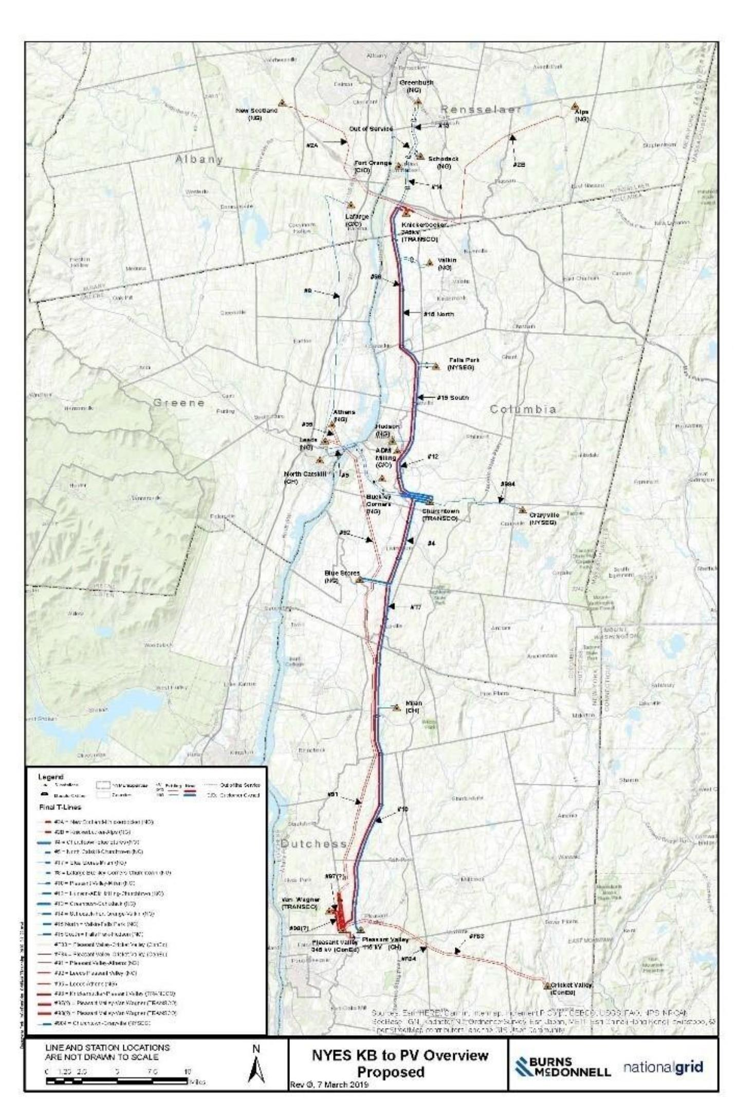

5

**SERVICE AGREEMENT NO. 2510**



**Appendix B**

**Scope of Work**

**1. Components of the Transmission Project and Network Upgrade Facilities:**

The Developer shall design, engineer, procure, install, construct, test, and commission theTransmission Project as described in Appendix A of this Agreement, and pursuant to thisAppendix B. Certain Network Upgrade Facilities, including those described in Appendix A,have been identified in the Transmission Interconnection Procedures and, while listed in thisScope of Work, are addressed in the Transmission Project Interconnection Agreements and/orassociated engineering, procurement, and construction agreements among the NYISO,Developer, and the Connecting Transmission Owner(s) and/or Affected System Operator(s).Based on a preliminary design, the components of the Transmission Project and NetworkUpgrade Facilities will consist of the following major electrical and physical equipment:

**(a) New Knickerbocker 345 kV switching station with a ring bus configuration and a two-step 33.3% and 16.67% series compensation system**

• Three (3) dead-tank gas circuit breakers, 362 kV, 4000 A;

• Eleven (11) disconnect switches, 362 kV, 4000 A continuous and three (3)

disconnect switches, 362 kV, 5000A continuous;

• Three (3) line traps, 362 kV, 5000A;

• Nine (9) coupling capacitor voltage transformers (CCVTs), 362 kV,

1800/3000:1;

• Three (3) line tuners;

• One (1) set of three (3) Metering Instrument Transformers (VT/CTs) in

accordance with NYPSC requirements;

• Twenty-four (24) surge arresters, 220 kV maximum continuously operating

voltage (MCOV);

• Two (2) station service voltage transformers (SSVT);

• A two-step 33.3% and 16.67% Series Compensation system with bypass switching rated 1.28% X PU, 15.23 Ohms, 681 MVAR at normal rating of 3862A;

• Structures, foundations, bus, insulators, grounding, trench, conduit and control

cable;

1

**SERVICE AGREEMENT NO. 2510**

• Site development, grading and fencing; and

• One (1) 65-ft x 16-ft (size to be finalized by the Developer in detailed engineering) control house, including: approximately twenty (20) panels for Protection, Control, Communications, Series Compensation system, Metering, Remote Terminal Unit (RTU), SCADA, Digital Fault Recorder (DFI), Human Machine Interface (HMI), Sequence of Events Recorder (SOER), Phasor Measurement Unit (PMU); two (2) battery banks; DC panelboards; AC panelboards; Automatic Transfer Switch (ATS). The actual number of protection panels will be determined by the Developer in the detailed engineering in conjunction with the Connecting Transmission Owner(s) and as approved in the NPCC approval process.

**(b) Rebuild of the Churchtown 115 kV switching station with breaker and a half configuration**

• Eight (8) dead-tank gas circuit breakers, 123 kV, 4000 A;

• Sixteen (16) disconnect switches, 123 kV, 4000 A and five (5) disconnect

switches 123 kV, 2000 A;

• Twenty-three (23) CCVTs, 115 kV;

• One (1) set of three (3) Metering Instrument Transformers (VT/CTs) in

accordance with NYPSC requirements;

• Seventeen (17) surge arresters, 96 kV MCOV;

• Two (2) station service voltage transformers (SSVT);• Structures, foundations, bus, insulators, grounding, conduit and control cable;• Site development, grading and fencing; and

• One (1) 66-ft x 15-ft (size to be finalized by Developer in detailed engineering) control house, including: approximately twenty-six (26) panels for Protection, Control, Communications, Metering, Security, Remote Terminal Unit (RTU), SCADA, Digital Fault Recorder (DFI), Human Machine Interface (HMI), Sequence of Events Recorder (SOER); two (2) battery banks; DC panelboards; AC panelboards; Automatic Transfer Switch (ATS). The actual number of protection panels will be determined by the Developer in the detailed engineering in conjunction with the Connecting Transmission Owner(s).

2

**SERVICE AGREEMENT NO. 2510**

**(c) Installation of two new 135 MVAR 345 kV capacitor banks at a new capacitor bank station (“Van Wagner Capacitor Bank Station”) that intercepts the Athens to Pleasant Valley 345 kV line (Line #91) and the Leeds to Pleasant Valley 345 kV Line (Line #92) with reconductoring of the existing feeder segments into Pleasant Valley 345 kV substation (redesignated as Y58 and Y59, respectively)**

• Two (2) 135MVAR, 345 kV capacitor banks with center tap VT and reactors;• Eight (8) dead-tank gas circuit breakers, 362 kV, 4000 A;• Eighteen (18) disconnect switches, 362 kV, 4000 A continuous;• Twenty (20) CCVTs, 362 kV, 1800/3000:1; • Twenty (20) surge arresters, 220 kV MCOV;

• Two (2) station service voltage transformers (SSVT);

• Reconductoring of the Y58 and Y59 transmission lines between Van Wagner and Pleasant Valley with Puffin conductor, double-bundled, 795 kcmil, 22/7 stranded aluminum conductor steel supported (ACSS) with E3X coating;

• Structures, foundations, bus, insulators, grounding, trench, conduit and control

cable;

• Site development, grading and fencing for Van Wagner Capacitor Bank Station

installation; and

• One (1) 16-ft x 42-ft (size to be finalized by Developer in the detailed engineering) control house addition, including approximately eight (8) panels for Line and Capacitor bank Protection, Control and Communications. The actual number of protection panels will be determined by the Developer in the detailed engineering in conjunction with the Connecting Transmission Owner(s) and as approved in the NPCC approval process.

**(d) New double-circuit 345/115 kV transmission line from a new Knickerbocker 345 kV switching station to Churchtown**

• Install a new double circuit 345 kV transmission line of approximately 21.9 miles on new steel structures in the existing right-of-way from the new Knickerbocker 345 kV switching station to Churchtown;

• Install Cardinal conductor, double-bundled, 954 kcmil, 54/7 stranded aluminum

conductor steel supported (ACSS);

• Install single shield wire 3/8” -7 stranded EHS steel; and

3

**SERVICE AGREEMENT NO. 2510**

• Install optical fiber ground wire with 36 fibers.

**(e) New double-circuit 345/115 kV transmission line from Churchtown to the existing Pleasant Valley substation**

• Install a new double-circuit 345 kV transmission line of approximately 32.3 miles on new steel structures in the existing right-of-way from Churchtown to Pleasant Valley substation;

• Install Cardinal conductor, double-bundled, 954 kcmil, 54/7 stranded aluminum

conductor steel supported (ACSS);

• Install single shield wire 3/8” -7 stranded EHS steel; and

• Install optical fiber ground wire with 36 fibers.

**(f) Rebuild of the 115 kV transmission line from Blue Stores Junction to Blue Stores substation**

• Rebuild 2.1 miles of the existing 115 kV transmission line from Blue Stores

Junction to Blue Stores substation;

• Install Drake conductor, 795 kcmil, 26/7 stranded aluminum conductor steel

reinforced (ACSR);

• Install single shield wire 3/8” -7 stranded EHS steel; and

• Install optical fiber ground wire with 36 fibers.

**(g) Decommissioning of existing infrastructure between Greenbush 115 kV substation and Pleasant Valley 115 kV substation**

• Remove 21.9 miles of the existing 115 kV #14 and #15 transmission lines;

• Remove 32.3 miles of the existing 115 kV #8, #10, #12 and #13 transmission

lines; and

• Disconnect #8, #10 and #12 circuits in the 115 kV Pleasant Valley substation.

**(h) Terminal work at the 345 kV Pleasant Valley substation**

• Build out of Bay 1 North and reconstruction of Bay 1 south, including installation of breakers, disconnect switches, structures, and buswork; relocation of the F83 and F84 transmission lines to Bay 1 north and Bay 2 north; termination of the Y57 transmission line into Bay 3 north; terminal upgrades to support the termination of the reconductored Y58 and Y59 transmission lines into Bay 4 north and Bay 5 north, relay and control upgrades; installation of separate control house enclosure; replacement of primary and back-up battery

4

**SERVICE AGREEMENT NO. 2510**

systems; and site work including foundations, grounding and conduitinstallation.

**(i) Terminal work at the 345 kV Coopers Corner substation**

• Modification of existing transformer tap settings, relay setting evaluation, and resetting, as necessary, to achieve a rating of 1464/1874/2258 MVA (Summer) on Coopers Corners to Middletown 345 kV line 34.

**(j) Terminal work at the 345 kV Rock Tavern substation**

• Replacement of conductor drops and relay setting evaluation and resetting, as necessary, to achieve a rating of 1793/1990/2195 MVA (Summer) on Dolson Ave. to Rock Tavern 345 kV line 44.

**(k) Terminal work at the 345 kV New Scotland substation**

• Relay and protection upgrades on the 345 kV Alps #2 transmission line to achieve new line ratings of 1423/1762/1912 (Summer), 1852/1912/1912 (Winter) on New Scotland to Knickerbocker 345 kV #2 transmission line.

**(l) Terminal work at the 345 kV Alps switching station**

• Relay and protection upgrades at the Alps switching station on the 345 kV

Knickerbocker to Alps #6 transmission line.

**(m)Terminal work at the 115 kV Pleasant Valley substation**

• The existing #12 transmission line to Hudson (ADM Milling), #13 transmission line to Churchtown (Blue Stores Tap), and #8 transmission line to LaFarge (Blue Stores Tap & Buckley Corners) will be de-terminated from the existing 115 kV Pleasant Valley Substation and existing conductor from the lattice tower line take-off structures will be removed. The existing #10 transmission line to Milan will be reconductored and connected to the existing R10 line terminal position.

**(n) Terminal work at the 115 kV Blue Stores substation**

• Install one (1) 115 kV circuit breaker, two (2) breaker disconnect switches, six (6) CCVTs, three (3) 115 kV CT/PT metering units, surge arresters, and new 16-ft x 42-ft control enclosure. The upgraded Blue Stores Substation will serve as the terminus for the new Churchtown #4 transmission line and the Milan #T7 transmission line.

**(o) Terminal work at the 115 kV North Catskill substation**

• Relay and protection upgrades for line protection and serve as terminus for the

Churchtown #5 transmission line and the Feura Bush #2 transmission line.

5

**SERVICE AGREEMENT NO. 2510**

**(p) Terminal work at the 115 kV Milan substation**

• Relay and protection upgrade for line protection and serve as terminus for the

Blue Stores #T7 transmission line and Pleasant Valley #10 transmission line.

**(q) Terminal work at the 115 kV Hudson substation**

• Relay and protection upgrades for line protection, installation of ADSS fiber from the Hudson tap to Hudson substation, surge arresters, and serve as terminus for the Churchtown #12 transmission line (ADM Milling tap) and newly configured Falls Park #20-731 transmission line.

**(r) Terminal work at the 115 kV Schodack substation**

• Install seven (7) 115 kV CCVTs, two (2) 115 kV circuit breakers, two (2) breaker disconnect switches, surge arresters, relay, and protection upgrades and serve as terminus for the Greenbush #13 transmission line and newly configured Valkin #14 transmission line.

**(s) Terminal work at the 115 kV Lafarge substation**

• Relay and protection upgrades, including installation of one (1) 115 kV CCVT and one (1) 115 kV line trap, and serve as terminus for the Longlane #6 transmission line and the Churchtown #8 line.

**(t) Terminal work at the 115 kV Valkin substation**

• Serve as terminus for the new Schodack #14 transmission line configuration and

new Falls Park #19-730 transmission line configuration.

**(u) Terminal work at the 115 kV Falls Park substation**

• Relay and protection upgrades for line protection and serve as terminus for the new Valkin #19-730 transmission line configuration and Hudson #20-731 transmission line.

**(v) Terminal work at the 115 kV Craryville substation**

• Install three (3) 115 kV CT/PT metering units and one (1) blocking line trap and

serve as terminus for Churchtown #984 transmission line.

**(w)Terminal work at the 115 kV Klinekill substation**

• Install one (1) 115 kV CCVT, one (1) line trap, relay, and protection upgrades

for line protection and serve as terminus for Churchtown #984 transmissionline.

6

**SERVICE AGREEMENT NO. 2510**

**(x) Terminal work at the 115 kV Buckley Corners substation**

• Installation of one (1) blocking line trap and re-route # 8 transmission line and

terminate it at the new Churchtown Switching Station.

**(y) Terminal work at the 115 kV ADM Milling substation**

• Re-route #12 transmission line and terminate it at the new 115 kV Churchtown

Switching Station.

**(z) Terminal work at the 115 kV Greenbush substation**

• Decommission #15 transmission line and terminal equipment. Relay and Protection upgrades to line protection and updating #13 transmission line settings.

**(aa) Terminal work at the 115 kV Fort Orange substation**

• Greenbush #15 transmission line terminal will be decommissioned. Fort Orange will tap reconductored #14 transmission line between Schodack and Valkin and include installation of disconnect switches at the Fort Orange tap.

**(bb) Installation of two (2) new 750 MVA 345 kV phase angle regulators (“PARs”) at a new station (“Dover Station”) that bifurcates the Cricket Valley – Long Mountain 345 kV line (Line #398)**

• Three (3) 345 kV, 4000 A line circuit breakers, 63 kA interrupting rating, 1300

kV BIL;

• Eight (8) 345 kV, 4000 A motor operated disconnect switches, double-sided

break style, 75 kA, 1300 kV BIL;

• Two (2) 345 kV, 4000 A motor operated disconnect switches, vertical break

style, 75 kA, 1300 kV BIL;

• Two (2) 345 kV 450/600/750 MVA +/- 40° PARs (maximum advance phase shift capability at 750 MVA = 32°) with a spare PAR of equivalent specifications;

• Twelve (12) 345 kV CCVTs, 199.2 kV – 115/69 V, 400 VA, 4000 pf, 63 kV

withstand rating, 1550 kV BIL;

• Six (6) 345 kV SSVTs, 199.2 kV – 240/120 V, 100 kVA, 63 kV withstand

rating, 1300 kV BIL;

• Twenty-one (21) line lightning arrestors 276 kV duty cycle, 220 MCOV;

7

**SERVICE AGREEMENT NO. 2510**

• Three (3) 345 kV metering VTs, 199.2 kV- 115/69 V ratio, 0.15 accuracy class,

400 VA thermal burden, 63 kA short circuit rating, 1300 kV BIL;

• One (1) pre-engineered control enclosure;

• One (1) new double circuit steel monopole dead-end structure (to be identified

as L62-2);

• One (1) new single circuit steel monopole dead-end structure (to be identified as

L62-3);

• Twin-bundled 795 kcmil ACSS Mallard conductor;

• Single shield wire 7#5 Alumoweld aluminum clad steel;

• One (1) OPGW with 72 fibers; and

• One (1) ADSS fiber optic cable with min 48 fibers.

**(cc) Terminal work at the 345 kV Cricket Valley substation**

• Relay and protection upgrades for the Y17 transmission line between Cricket

Valley and Dover.

**(dd) Terminal work at the 345 kV Long Mountain substation**

• Relay and protection upgrades for the #398 transmission line between Dover

and Long Mountain.

**(ee) Rock Tavern to Sugarloaf Component**

• Rebuild of the existing 115 kV Sugarloaf switching station as a four-breaker

ring bus substation with a 115 kV/138 kV autotransformer;

o Four (4) dead tank gas breakers, 123 kV, 4000 A and one (1) dead tank gas

breaker 145 kV 4000 A;

o Nine (9) disconnect switches 123kV, 4000 A, Three (3) disconnect

switches 123 kV, 2000 A and one (1) disconnect switch 145 kV 2000 A;

o Twelve (12) CCVTs 115 kV and three (3) CCVTs 138 kV;

o Twelve (12) surge arresters 96 kV MCOV and three (3) surge arresters 108

kV MCOV;

o Three (3) station service voltage transformers (SSVTs);

o One (1) 138/115/13.8 kV 168/223/280 MVA autotransformer with LTC

with a spare autotransformer of equivalent specifications;

8

**SERVICE AGREEMENT NO. 2510**

o Structures, foundations, bus, insulators, grounding, conduit and control

cable;

o Site development, grading and fencing; and

o One (1) 26-ft x 55-ft control house, including: approximately 19 panels for Protection, Control, Communications, Metering, Security, Remote Terminal Unit (RTU), SCADA, Digital Fault recorder (DFR), Human Machine Interface (HMI), Sequence of Event Recorder (SOER); two (2) battery banks; DC panelboards; AC panelboards; Automatic Transfer Switch (ATS).

• Replace an existing 12-mile overhead 115 kV transmission line with a new 115 kV transmission line, beginning at the existing 115 kV Rock Tavern substation, located in New Windsor, New York, and terminating at the rebuilt 115 kV Sugarloaf switching station;

o Install a new single-circuit 115kV transmission line of approximately 12 miles on new steel structures in the existing right-of-way from Rock Tavern to the rebuilt 115 kV Sugarloaf switching station;

o Install Lapwing conductor, 1590 kcmil, 45/7 stranded aluminum conductor

steel reinforced (ACSR); and

o Install optical fiber ground wire with 72 fibers.

• Install a new 138 kV transmission line beginning at the existing, rebuilt 115 kV Sugarloaf switching substation and terminating at the existing 138 kV Sugarloaf switching station; and

o Install a new single-circuit 138 kV transmission line of approximately 0.8 miles on new steel structures on utility owned property from the rebuilt Sugarloaf switching station to the existing 138 kV Sugarloaf switching station;

o Install Lapwing conductor, 1590 kcmil, 45/7 stranded aluminum conductor

steel reinforced (ACSR); and

o Install optical fiber ground wire with 72 strands.

• Replace the first structure (Structure 1241) outside of the existing, rebuilt 115

kV Sugarloaf switching station located on the SD and SJ lines.

o Replace one (1) double circuit structure on the SD and SJ lines just outside

the rebuilt 115 kV Sugarloaf switching station; and

o Reconductor one (1) span on the SD and SJ lines with Penguin conductor,

4/0, 6/1 stranded aluminum conductor steel reinforced (ACSR).

9

**SERVICE AGREEMENT NO. 2510**

**(ff) Terminal work at the 115 kV Rock Tavern substation**

• Install three (3) 115 kV CT/PT metering units, replacement of two (2) 115 kV disconnect switches, relay and protection upgrades to support the terminus of the rebuilt SL transmission line.

**(gg) Terminal work at the 138 kV Sugarloaf switching station**

• Install two (2) 145 kV 2000 A circuit breakers, six (6) 145 kV 2000 A disconnect switches, four (4) 138 kV potential transformers, three (3) surge arrester 108 kV MCOV, foundations, grounding, conduit, structures, buswork, control cable, and relay and control equipment to support the terminus of the new #30 transmission line.

**2. Permitting – Licensing, Environmental, and Regulatory Approvals**

In accordance with Section 3.9 of this Agreement, the Developer shall be responsible forapplying for and obtaining all necessary licensing, environmental, and regulatory approvals forthe Transmission Project. Such approvals may include the following:

(a) Public Service Law Article VII Certificate of Environmental Compatibility and

Public Need (“CECPN”);

(b) Certificate of Public Convenience and Necessity issued pursuant to Section 68 of the New York State Public Service Law;

(c) State Pollutant Discharge Elimination System (“SPDES”) General Permit from the New York State Department of Environmental Conservation (“NYSDEC”) for Stormwater Discharge during Construction Activities (GP-0-15-002);

(d) Utility Work Permit from the New York State Department of Transportation

(“NYSDOT”) (for highway crossings);

(e) Work Permit from New York State Thruway Authority (“NYSTA”) (for crossing of

New York State Thruway I-90), and utility crossings as needed;

(f) Environmental Management and Construction Plan (“EM&CP”) from the NYPSC

following issuance of the Article VII Certificate;

(g) NYSDEC freshwater wetland and stream disturbance permits;

(h) Section 401 Water Quality Certification from the NYSDEC;

(i) Section 10/404 permits from the U.S. Army Corps of Engineers (“USACE”);

(j) Municipal Stormwater (MS4) permit from all applicable municipalities;

10

**SERVICE AGREEMENT NO. 2510**

(k) Cultural Resources Information System (CRIS) determination from New York State

Historic Preservation Office (“NYSHPO”); and

(l) Endangered Species Act Section 7 (ESA), Migratory Bird Treaty Act and Bald and Golden Eagle Protection Act consultation and Special Use Permit, if applicable, from United States Fish and Wildlife Service (“USFWS”).

**3. Site Control / Rights of Way Acquisition**

The Developer is responsible for obtaining the necessary site control and/or rights of way(“ROWs”) for the construction of the Transmission Project in accordance with the milestones setforth in Appendix C of this Agreement.

**4. Financing**

The Developer is responsible for obtaining the necessary financing for the design,engineering, procurement, installation, construction, testing, commissioning, and operation of theTransmission Project in accordance with the milestone set forth in Appendix C of thisAgreement.

**5. Engineering and Design**

The Developer is responsible for preparing the engineering design work. All engineeringdesign work must comply with the Applicable Reliability Standards, in addition to all relevantguidelines and design standards, including, but not limited to:

• ANSI C2-2017 National Electrical Safety Code

• ASCE 48 Design of Steel Transmission Pole Structures

• IEEE Std. 524 Guide to the Installation of Overhead Transmission Line Conductors

• IEEE Std. 691 Guide for Transmission Structure Foundation Design and Testing

• NYPP Tie-Line Ratings Task Force 1995 Report

• ASCE Manual of Practice 113 Substation Structure Design Guide

• IEEE Std. 80 Guide for Safety in AC Substation Grounding

• ANSI C37, Standards Series for substations and circuit breakers

• ANSI C57, Standards Series for power and Instrument Transformers

• IEEE and ANSI standards for transmission lines and substations, as applicable.

• National Grid, Consolidated Edison Company of New York, Inc., Orange &

Rockland Utilities, Inc., Central Hudson Gas & Electric Corporation, New York

11

**SERVICE AGREEMENT NO. 2510**

State Electric & Gas Corporation, New York Power Authority, and AffectedTransmission Owners local transmission design criteria, as applicable.

**6. Estimated Cost**

The cost estimate (2018 U.S. dollars) for the Transmission Project is $479 million,including 30% contingency, consistent with the independent cost estimate used by the NYISO inthe evaluation and selection and as documented in the AC Transmission Public PolicyTransmission Planning Report, dated April 8, 2019. The estimated cost is not all inclusive anddoes not include, among other things, (i) the creation of the Van Wagner Capacitor Bank Stationto house the two new 135 MVAR 345 kV capacitor banks, (ii) the Rock Tavern to Sugarloafcomponent, (iii) the installation of two new 750 MVA 345 kV PARs at a new Dover station, (iv)real estate and land acquisition costs, facility acquisition and removal costs, and costs incurred asa result of the Connecting Transmission Owner(s) to the extent that the foregoing costs were notassumed in the NYISO’s evaluation and selection, and (v) project development costs incurred bythe Developer prior to selection of the Transmission Project by the NYISO Board of Directors.

12

**SERVICE AGREEMENT NO. 2510**

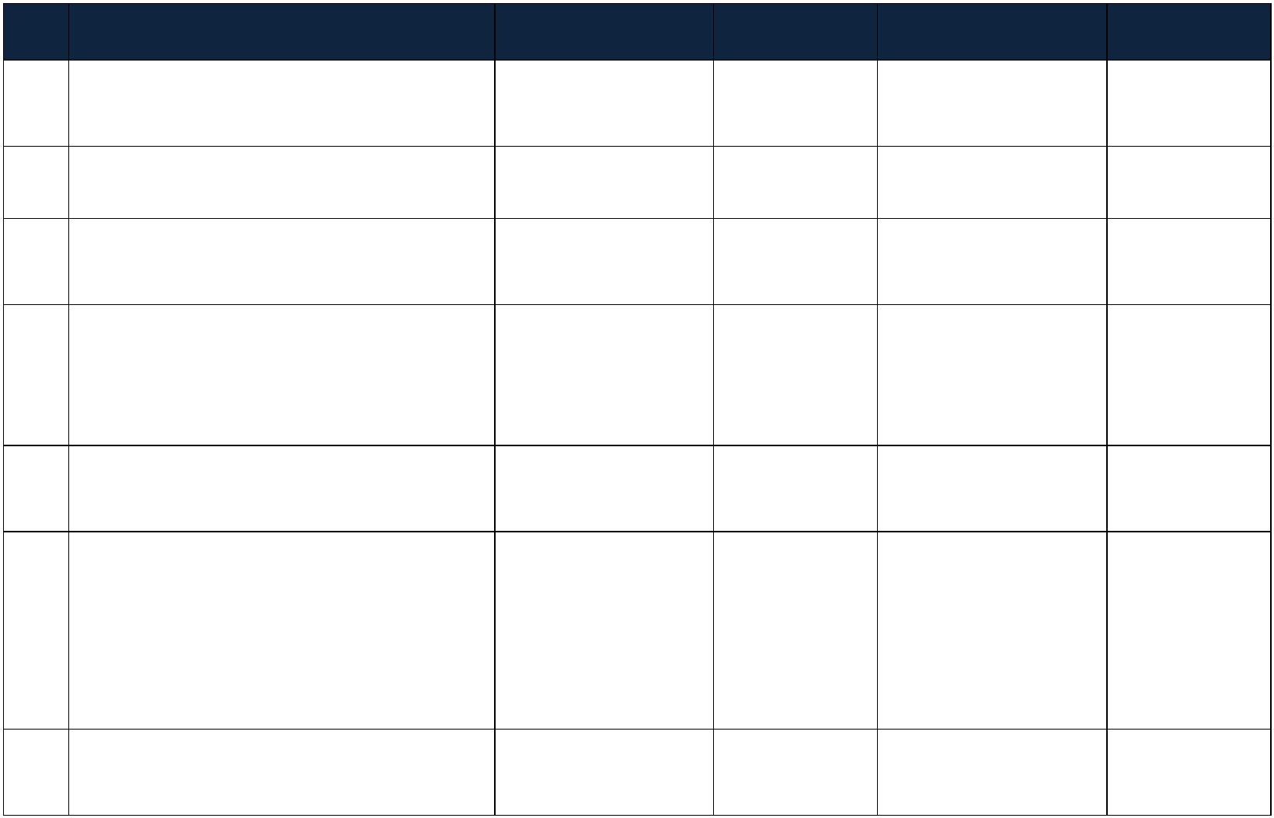

**Appendix C**

The Developer shall demonstrate to the NYISO that it timely meets the below CriticalPath Milestones and Advisory Milestones contained herein and that such milestones remain ingood standing.

**No. Milestone Description Responsible Party(ies) Type Due Date Status**

1 Commence Preliminary Engineering and

Design of Principal Project Component1 Developer Advisory Completed Completed

2 Commence Public Involvement Plan Developer Advisory Completed Completed

3 Commence Land Acquisition Activities

for the Transmission Project Developer Advisory Completed Completed

|  |  |  |  |  |  |
| --- | --- | --- | --- | --- | --- |
|  | 4 Commence Facilities Study for Q#543 |  | Developer  NYISO  Connecting  Transmission  Owner(s)2 |  | Advisory Completed Completed |

5 File Article VII CECPN Application for

Principal Project Component Developer Critical Completed Completed

|  |  |  |  |  |  |
| --- | --- | --- | --- | --- | --- |
|  | 6 Submit Proof of Insurance Pursuant to  Article 6 |  | Developer Advisory |  | Within ten (10) days  of the execution of  this Agreement or  the date on which  the Agreement is  filed with FERC |

Completed

7 Demonstrate Adequate Project

Financing to NYISO Developer Critical 2/1/2020 Completed

1 References to “Principal Project Component” in the milestones contained in this Appendix C shall include allof the components listed in Appendices A and B of this Agreement with the exception of (i) the Network UpgradeFacilities that will be refined and/or identified in the Facilities Study for Q#543 pursuant to Attachment P to theNYISO Open Access Transmission Tariff (“OATT”), and (ii) the PARs to be installed at a new Dover substation.Milestones related to the Rock Tavern to Sugarloaf component will be separately identified by referring to the“Rock Tavern to Sugarloaf.” Milestones related to the installation of PARs at a new Dover substation will beseparately identified by referring to the “Dover PAR Component.”

2 The Connecting Transmission Owners are Niagara Mohawk Power Corporation d/b/a National Grid(“National Grid”), Consolidated Edison Company of New York, Inc. (“Con Edison”), Orange and RocklandUtilities, Inc. (“Orange and Rockland”), and New York State Electric & Gas Corporation (“NYSEG”), which wereidentified in the System Impact Study for Q#543 and are listed in the milestones solely for informational purposes.Additional Connecting Transmission Owners may be identified in the Facilities Study for Q#543 under AttachmentP to the OATT.

1

**SERVICE AGREEMENT NO. 2510**



8 NYISO Quarterly Report3 Developer Advisory 3/16/2020 Completed

9 NYISO Quarterly Report Developer Advisory 6/15/2020 Completed

|  |  |  |  |  |  |  |  |  |
| --- | --- | --- | --- | --- | --- | --- | --- | --- |
| 10 Preliminary Detailed Engineering and  Design of Principal Project Component  Complete | | |  | Developer Advisory 6/30/2020 Completed | | | | |
| 11 Completion of TIP Facilities Study for  Q#5434 |  | NYISO  Connecting  Transmission  Owner(s) | | | | |  | Advisory 6/30/2020 Completed |
| 12 Article VII CECPN Application for  Principal Project Component Deemed  Complete | | | | |  | NYPSC Critical 7/30/2020 Completed | | |

13 Notification of Developer’s Plan for

Operation of the Transmission Project5 Developer Advisory 8/1/2020 Completed

14 NYISO Quarterly Report Developer Advisory 9/15/2020 Completed

|  |  |  |
| --- | --- | --- |
| 15 Apply for All Required Federal and  Other Permits or Approvals |  | Developer Advisory 10/15/2020 Completed |

16 NYISO Quarterly Report Developer Advisory 12/15/2020 Completed

17 File Article VII CECPN Application for

Rock Tavern to Sugarloaf Component Developer Critical 12/31/2020 Completed

|  |  |  |
| --- | --- | --- |
| 18 Execution of Asset Purchase  Agreement(s) with National Grid for real  property rights, license to access the  property, and/or transmission facilities  for the Principal Project Component |  | Developer  National Grid6 Critical 12/31/2020 Completed |

3 For purposes of the milestones in this Appendix C, the quarterly reports will be for the three-month periodending on the last day of the month prior to the due date contained in the milestone.

4 This milestone date is based upon the Facilities Study Agreement for Q#543, dated September 20, 2019,which identifies June 30, 2020 as the completion date of the Facilities Study using Reasonable Efforts as defined byAttachment P to the OATT.

5 For purposes of the milestones set forth in this Appendix C, the notification shall inform the NYISO as to theDeveloper’s plan for operating the Transmission Project. Such notification will include, but not limited to, whetherthe Developer intends to construct a new control center for the Transmission Project or enter into an agreement witha Connecting Transmission Owner to operate the Transmission Project from an NPCC-certified control center.

6 For purposes of this milestone, National Grid is not acting in its capacity as a Connecting TransmissionOwner or an Affected System Operator.

2

**SERVICE AGREEMENT NO. 2510**



with the Exception of the ChurchtownSwitching Station

|  |  |  |  |  |  |  |  |  |
| --- | --- | --- | --- | --- | --- | --- | --- | --- |
| 19 Execution of Asset Purchase  Agreement(s) or comparable  agreement(s) with NYSEG for real  property rights, license to access the  property, and/or transmission facilities  for the Churchtown Switching Station | | | | |  | Developer  NYSEG Advisory 12/31/2020 Completed | | |
| 20 File Section 70 Petitions for Principal  Project Components with NYPSC for  Approval |  | | Developer  National Grid  NYSEG | | | |  | Advisory 12/31/2020 Completed |
| 21 Preliminary Detailed Engineering and  Design of Rock Tavern to Sugarloaf  Component Complete | | | | |  | Developer Advisory 1/30/2021 Completed | | |
| 22 Execution of Transmission Project  Interconnection Agreement(s) for Q#543 | |  | | Developer  NYISO  Connecting  Transmission  Owner(s) | | |  | Advisory 3/1/2021 Completed |

23 NYISO Quarterly Report Developer Advisory 3/15/2021 Completed

24 Submit Construction Outage and

Restoration Coordination Plan Developer Advisory 5/1/2021 Completed

25 NYISO Quarterly Report Developer Advisory 6/15/2021 Completed

26 Approval of Section 70 Petitions Filed

by National Grid and NYSEG NYPSC Critical 6/30/2021 Completed

27 Article VII Certificate Issued for

Principal Project Component NYPSC Critical 6/30/2021 Completed

|  |  |  |
| --- | --- | --- |
| 28 Status Update Meeting to Discuss  Article VII CECPN and Section 68  Approvals |  | Developer  NYISO Advisory 7/31/2021 Completed |
| 29 Detailed Engineering and Design  Finalized for Principal Project  Component |  | Developer Critical 7/31/2021 Completed |
| 30 General Construction Contractor(s)  Agreements Fully Executed for Principal  Project Component |  | Developer Advisory 7/31/2021 Completed |
| 31 Completion of All Required  Environmental Field Studies for  Principal Project Component |  | Developer Advisory 8/1/2021 Completed |

3

**SERVICE AGREEMENT NO. 2510**



32 Submit EM&CP for Principal Project

Component Developer Advisory 8/1/2021 Completed

|  |  |  |  |  |
| --- | --- | --- | --- | --- |
| 33 Submit Proposed Protection for the BPS  Element to NPCC for Approval (if  applicable) of Principal Project  Component |  | Developer Advisory 8/31/2021 Not  Applicable | | |
| 34 Initiate NERC Certification and  Registration related to the Principal  Project Component |  | Developer Advisory 8/31/2021 |  | Not  Applicable |

35 NYISO Quarterly Report Developer Advisory 9/15/2021 Completed

|  |  |  |  |  |  |  |  |  |  |
| --- | --- | --- | --- | --- | --- | --- | --- | --- | --- |
| 36 Article VII CECPN Application for  Rock Tavern to Sugarloaf Component  Deemed Complete | | | | |  | NYPSC Advisory 9/30/2021 Completed | | | |
| 37 Obtain NPCC Approval of the  Protection for the BPS Element (if  applicable) for Principal Project  Component | | |  | Developer Advisory 10/30/2021 Not  Applicable | | | | | |
| 38 Approval of Construction Outage and  Restoration Coordination Plan for  Principal Project Component |  | NYISO  Connecting  Transmission  Owner(s) | | | | |  | Advisory 11/1/2021 |
| 39 Complete Procurement of Major  Electrical Equipment and Materials for  Principal Project Component7 | | |  | Developer Critical 11/1/2021 Completed | | | | | |

40 NYPSC Order Approving EM&CP for

Principal Project Component8 NYPSC Critical 12/1/2021 Completed

|  |  |  |
| --- | --- | --- |
| 41 All Required Federal and Other Permits  or Approvals Received for Construction  of Principal Project Component |  | Developer Advisory 12/1/2021 Completed |

7 For purposes of the milestones set forth in this Appendix C, “major electrical equipment and materials” shallinclude, but is not limited to, station service voltage transformers, disconnect switches, circuit breakers, shuntcapacitors, series capacitor, conductor, and towers. Further, “complete procurement” of major electric equipmentand materials shall mean that the Developer has a valid and effective purchase order, agreement, or commerciallyrecognized instrument with a vendor for the design, manufacture, and/or delivery of such equipment and materials,and the Developer has paid in full or made all applicable deposits for vendor to begin designing, manufacturing,and/or shipping such equipment and materials.

8 While there could be multiple, phased EM&CP approvals from the NYPSC for the various components of theTransmission Project, this Critical Path Milestone serves as the date by which the Developer must have all necessaryEM&CP approvals for the Principal Project Component.

4

**SERVICE AGREEMENT NO. 2510**



42 Construction Mobilization9 Developer Advisory 12/15/2021 Completed

43 NYISO Quarterly Report Developer Advisory 12/15/2021 Completed

|  |  |  |  |  |  |  |  |  |  |  |
| --- | --- | --- | --- | --- | --- | --- | --- | --- | --- | --- |
| 44 Commence Substantial Site Work10 in  accordance with EM&CP for  Churchtown Switching Station | | |  | Developer Advisory 12/31/2021 Completed | | | | | | |
| 45 Execution of Asset Purchase  Agreement(s) or comparable  agreement(s) with Orange and Rockland  for real property rights and/or license to  access the property for Rock Tavern to  Sugarloaf Component |  | Developer  Orange and  Rockland | | | | |  | Advisory 12/31/2021 Completed | | |
| 46 File Sections 68 and 70 Petitions for  Rock Tavern to Sugarloaf Component |  | Developer  Orange and  Rockland | | | | |  | Advisory 1/1/2022 Completed | | |
| 47 Finalize Local Control Center Facility  Plans11 Developer Advisory 1/1/2022 | | | | | | | | |  | Not  Applicable |
| 48 Detailed Engineering and Design  Finalized for Rock Tavern to Sugarloaf  Component | | |  | Developer Critical 01/30/2022 Completed | | | | | | |
| 49 Approval Section 68 Petition for  Principal Project Component | | | | |  | NYPSC Critical 1/31/2022 Completed | | | | |

50 Execute Amendment to NYISO/Transco

Operating Agreement Appendix A Developer Advisory 1/31/2022 N/A

|  |  |  |
| --- | --- | --- |
| 51 Start of Outage(s) Pursuant to Approved  Construction Outage and Restoration  Plan |  | Developer Critical 1/31/2022 Completed |

9 For purposes of this milestone, “construction mobilization” means activation of the contractor’s physical and workforce resources to the construction site of any portion of the Transmission Project.

10 For purposes of the milestones set forth in this Appendix C, “substantial site work” shall mean civil siteconstruction, such as tree cutting, site clearing and grading, construction of ingress and egress routes associated withany part of the Transmission Project in accordance with the approved EM&CP.

11 For purposes of finalizing the Local Control Center Facility Plans, if the Developer intends to operate theTransmission Project by constructing a new control center, the plan should detail the minimum needs in order toproperly size and site the local control center to operate the Transmission Project including, but not limited to,security concerns, local permitting requirements, ability to construct/lease facility, reliable distribution feed(s),reliable voice and data communication feed(s), physical security, computer system requirements, and backupgenerator/uninterruptible power supply (“UPS”) capacity.

5

**SERVICE AGREEMENT NO. 2510**



|  |  |  |
| --- | --- | --- |
| 52 Commence Substantial Site Work in  accordance with EM&CP for  Transmission Line Segment 112 |  | Developer Advisory 1/31/2022 Completed |

53 Commence Foundations for Churchtown

Switching Station Developer Advisory 2/1/2022 Completed

54 NYISO Quarterly Report Developer Advisory 3/15/2022 Completed

55 Commence Foundations for

Transmission Line Segment 1 Developer Advisory 3/31/2022 Completed

56 Commence Electrical Work13 for

Churchtown Switching Station Developer Advisory 4/1/2022 Completed

|  |  |  |
| --- | --- | --- |
| 57 Commence Substantial Site Work in  accordance with EM&CP for the 345 kV  Capacitor Banks |  | Developer Advisory 4/30/2022 Completed |
| 58 Commence Substantial Site Work in  accordance with EM&CP for the  Knickerbocker Switching Station |  | Developer Advisory 4/30/2022 Completed |
| 59 Commence Erection of Structures for  Transmission Line Segment 1 |  | Developer Advisory 6/1/2022 Completed |

60 NYISO Quarterly Report Developer Advisory 6/15/2022 Completed

|  |  |  |
| --- | --- | --- |
| 61 Approval of Section 68 and 70 Petitions  for Rock Tavern to Sugarloaf  Component |  | NYPSC Critical 6/30/2022 Completed |

62 Article VII Certificate Issued for Rock

Tavern to Sugarloaf Component NYPSC Critical 6/30/2022 Completed

63 Commence Foundations for 345 kV

Capacitor Banks Developer Advisory 7/31/2022 Completed

12 For purposes of the milestones set forth in this Appendix C, the construction of the transmission line for thePrincipal Project Component will be segmented and referred to as follows: “Transmission Line Segment 1” shall bethe portion of the transmission line from approximately Knickerbocker to Churchtown; “Transmission Line Segment2” shall be the portion of the transmission line from approximately Churchtown to Pleasant Valley; “TransmissionLine Segment 3” shall be the portion of the transmission line from approximately Bluestores to Churchtown/Milan;and “Transmission Line Segment 4” shall be the portion of the transmission line connecting the shunt capacitors toPleasant Valley.

13 For purposes of the milestones set forth in this Appendix C, “electrical work” shall mean work that is above-grade electrical construction including, but not limited to, installation of wiring, electrical bus, circuit breakers,disconnect switches, ground grid, relay protection, and or other components normally associated with an electricalsubstation.

6

**SERVICE AGREEMENT NO. 2510**

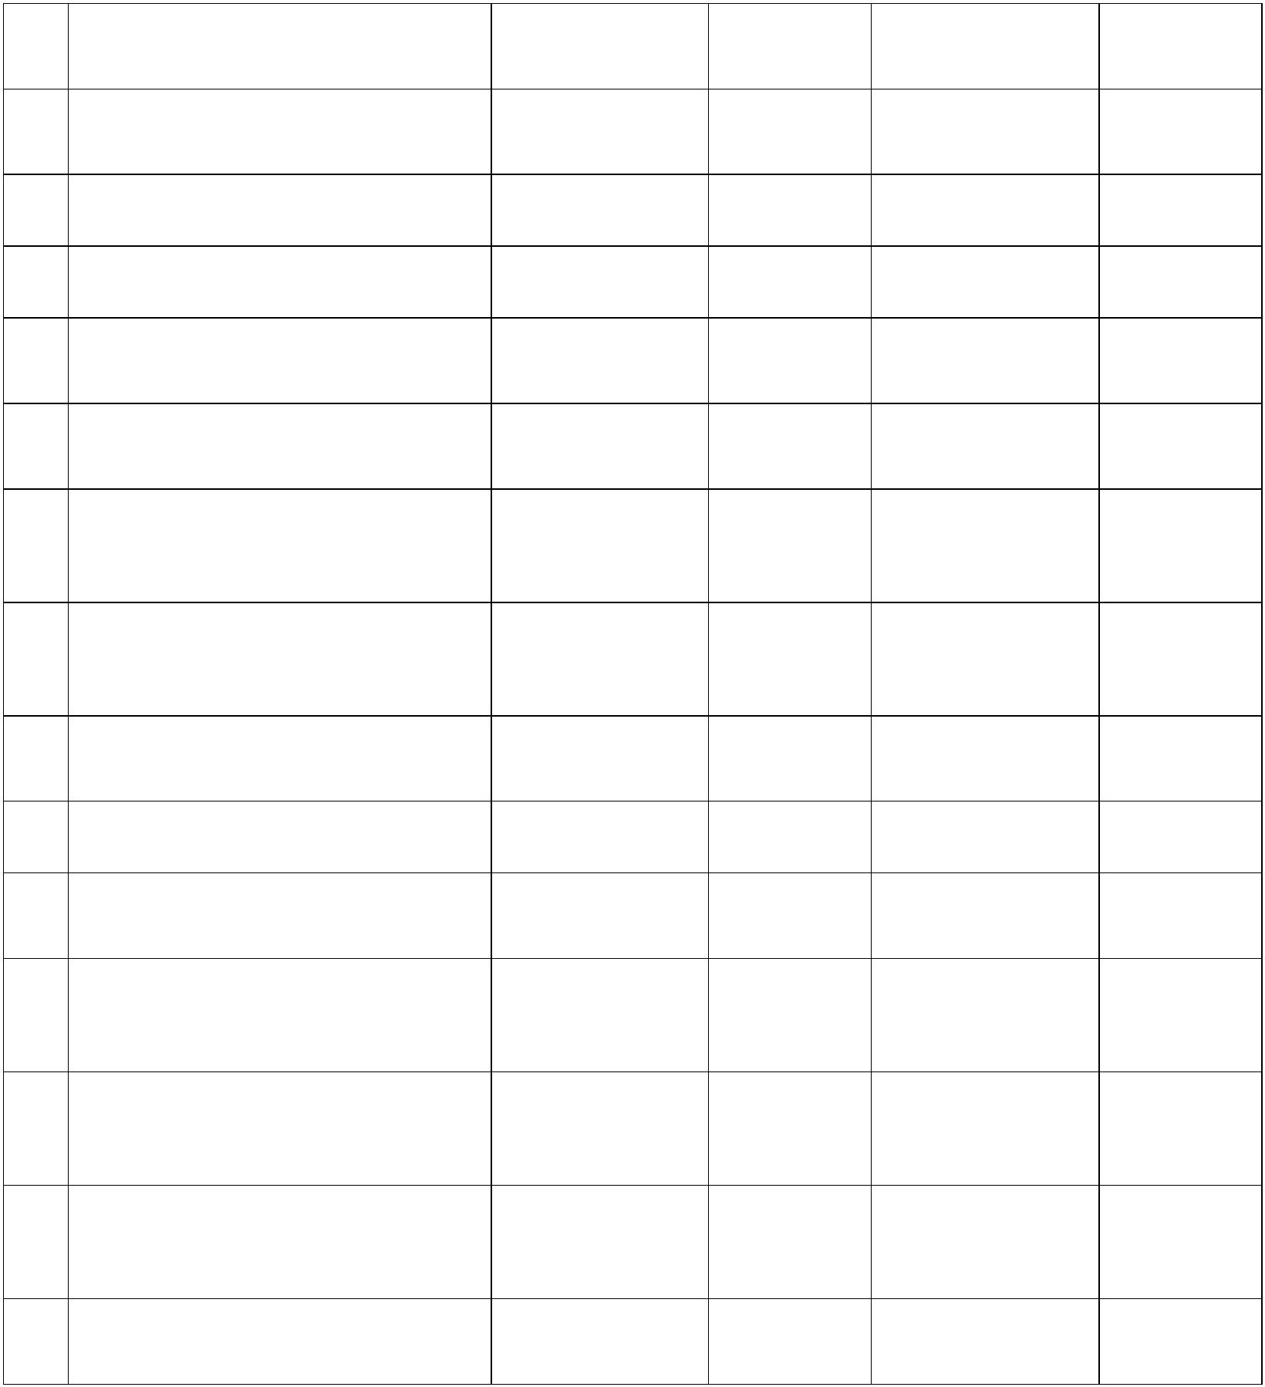

64 Commence Foundations for

Knickerbocker Switching Station Developer Advisory 7/31/2022 Completed

|  |  |  |
| --- | --- | --- |
| 65 Commence Conductoring for  Transmission Line Segment 1 |  | Developer Advisory 8/1/2022 Completed |

66 NYISO Quarterly Report Developer Advisory 9/15/2022 Completed

67 Churchtown Substation Complete Developer Advisory 10/31/2022 Completed

68 Commence Electrical Work for the 345

kV Capacitor Banks Developer Advisory 10/31/2022 Completed

|  |  |  |
| --- | --- | --- |
| 69 Commence Electrical Work for  Knickerbocker Switching Station |  | Developer Advisory 10/31/2022 Completed |
| 70 Commence Substantial Site Work in  accordance with EM&CP for  Transmission Line Segment 2 |  | Developer Advisory 11/1/2022 Completed |
| 71 Commence Substantial Site Work in  accordance with EM&CP for  Transmission Line Segment 3 |  | Developer Advisory 12/1/2022 Completed |

72 Commence Foundations for

Transmission Line Segment 2 Developer Advisory 12/1/2022 Completed

73 NYISO Quarterly Report Developer Advisory 12/15/2022 Completed

74 NYPSC Order Approving EM&CP for

Rock Tavern to Sugarloaf Component NYPSC Critical 11/30/2022 Completed

|  |  |  |
| --- | --- | --- |
| 75 Complete Procurement of Major  Electrical Equipment and Materials for  Rock Tavern to Sugarloaf Component |  | Developer Advisory 12/31/2022 Completed |
| 76 Commence Substantial Site Work in  accordance with Applicable EM&CP for  Rock Tavern to Sugarloaf Component |  | Developer Advisory 12/31/2022 Completed |
| 77 Execution of Operation and  Maintenance Agreement(s) (if  applicable)14 |  | Developer Advisory 1/31/2023 Completed |
| 78 Commence Erection of Structures for  Transmission Line Segment 2 |  | Developer Advisory 2/1/2023 Completed |

14 For purposes of this milestone, the Developer will, if applicable, enter into Operation and MaintenanceAgreements for the Transmission Project with a New York Transmission Owner for the operation of theTransmission Project consistent with the Developer’s plan.

7

**SERVICE AGREEMENT NO. 2510**

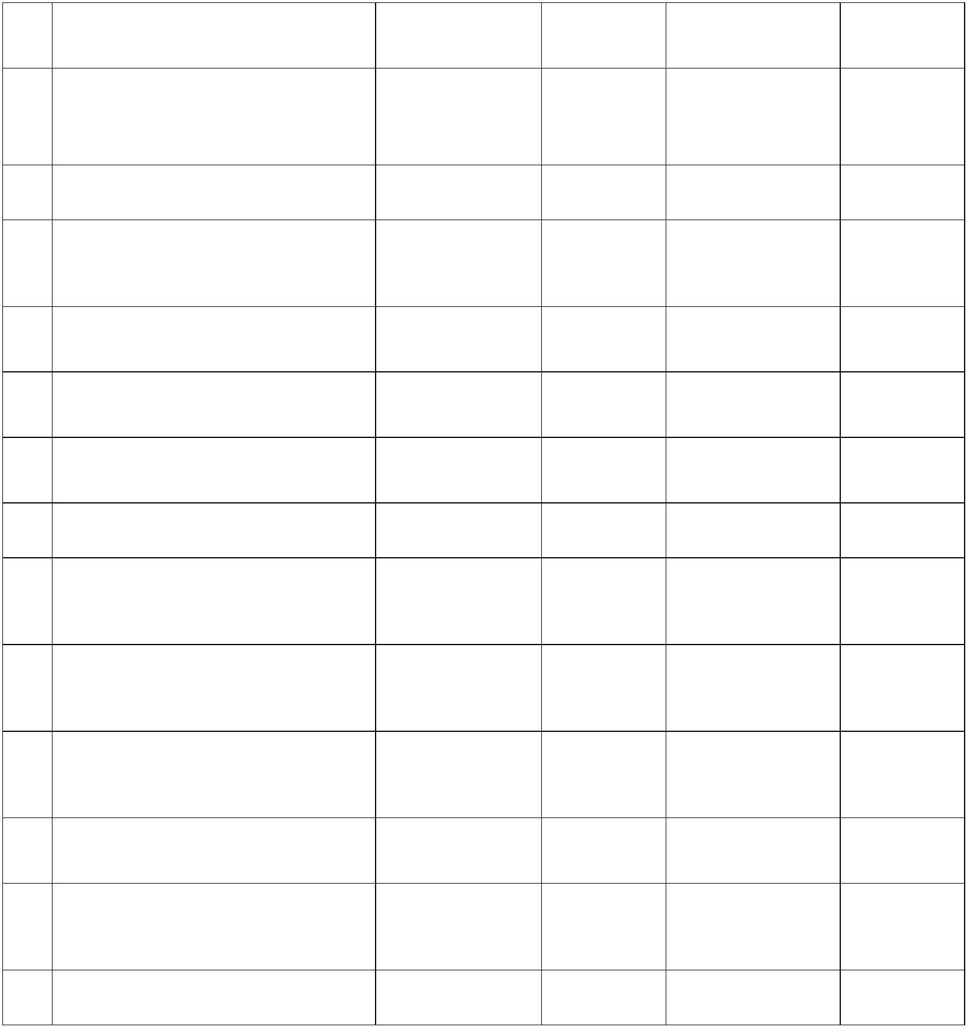

79 Commence Foundations for

Transmission Line Segment 3 Developer Advisory 2/1/2023 Completed

|  |  |  |  |  |
| --- | --- | --- | --- | --- |
| 80 Execution of Interconnection Agreement  for Dover PAR Component |  | NYISO  Connecting  Transmission  Owner(s) |  | Advisory 3/1/2023 Completed |

81 NYISO Quarterly Report Developer Advisory 3/15/2023 Completed

|  |  |  |
| --- | --- | --- |
| 82 Commence Substantial Site Work in  accordance with EM&CP for  Transmission Line Segment 4 |  | Developer Advisory 4/1/2023 Completed |
| 83 Commence Erection of Structures for  Transmission Line Segment 3 |  | Developer Advisory 4/3/2023 Completed |

84 Commence Conductoring for

Transmission Line Segment 2 Developer Advisory 4/1/2023 Completed

85 Commence Conductoring for

Transmission Line Segment 3 Developer Advisory 5/1/2023 Completed

86 NYISO Quarterly Report Developer Advisory 6/15/2023 Completed

|  |  |  |
| --- | --- | --- |
| 87 Commence Conductoring and/or  Electrical Work for Rock Tavern to  Sugarloaf Component |  | Developer Advisory 6/30/2023 Completed |
| 88 Commence Substation and Transmission  Line Site Prep for Dover PAR  Component |  | Developer Critical 5/1/2023 Completed |
| 89 All Major Equipment, Transmission  Line, and Materials for the Principal  Project Component are Available15 |  | Developer Critical 7/1/2023 Completed |

90 Commence Foundations for

Transmission Line Segment 4 Developer Advisory 8/1/2023 Completed

|  |  |  |
| --- | --- | --- |
| 91 Submit Final Energization Plan to  NYISO and Connecting Transmission  Owner(s) |  | Developer Advisory 8/31/2023 Completed |

92 NYISO Quarterly Report Developer Advisory 9/15/2023 Completed

15 For purposes of the milestones set forth in this Appendix C, major electrical equipment and materials shallbe “available” if they are (i) located on the appropriate construction site or designated marshalling yard(s) inreasonable proximity to the site where it will be installed, (ii) located in the Developer’s warehouse or otherinventory stocking location of the Developer, or (iii) on order from the vendor with a scheduled delivery date priorto the time scheduled for its use in the applicable transmission facility.

8

**SERVICE AGREEMENT NO. 2510**

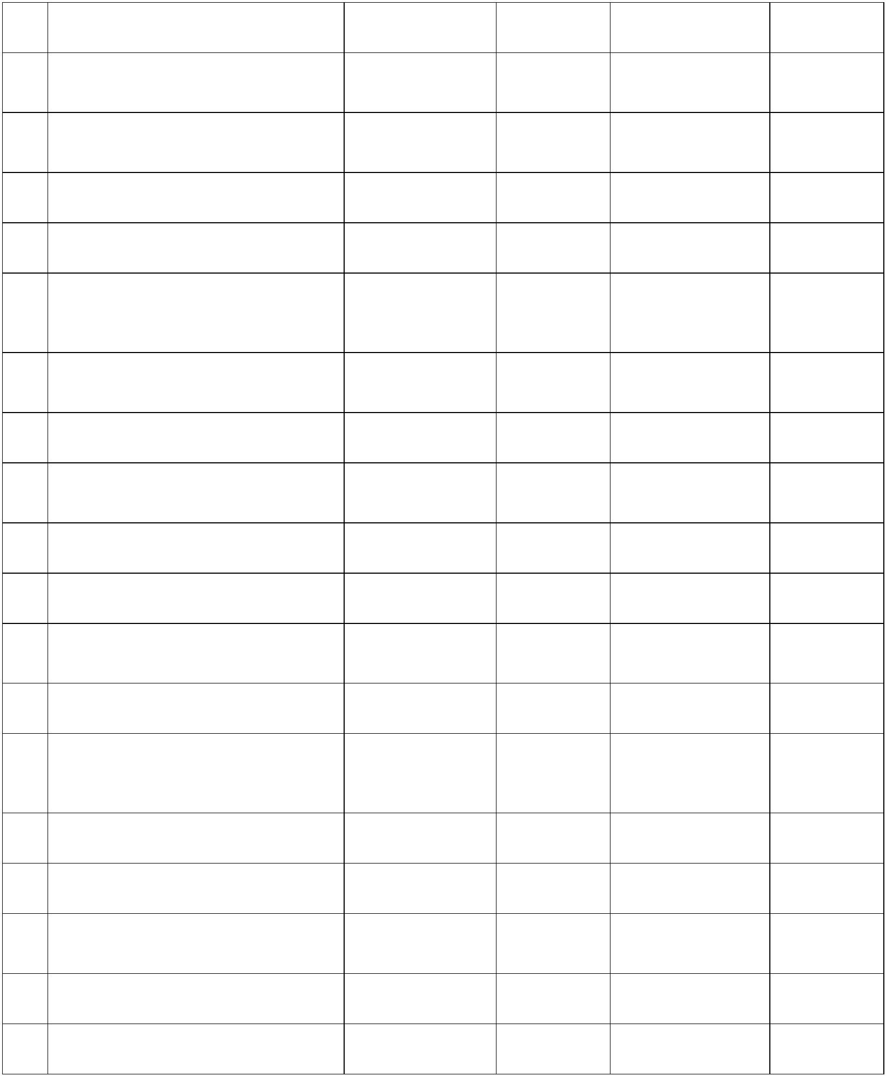

93 *Intentionally Omitted*

94 Commence Erection of Structures for

Transmission Line Segment 4 Developer Advisory 10/9/2023 Completed

95 Commence Conductoring for

Transmission Line Segment 4 Developer Advisory 10/16/2023 Completed

96 Knickerbocker Substation Complete Developer Advisory 10/31/2023 Completed

97 345 kV Capacitor Banks Complete Developer Advisory 10/31/2023 Completed

|  |  |  |  |
| --- | --- | --- | --- |
|  | 98 Network Upgrade Facilities for Principal  Project Component and Rock Tavern to  Sugarloaf Component Complete |  | Developer Advisory 10/31/2023 Completed |

99 Transmission Line of Principal Project

Component Complete Developer Advisory 11/30/2023 Completed

100 NYISO Quarterly Report Developer Advisory 12/15/2023 Completed

101 Rock Tavern to Sugarloaf Component

Complete Developer Critical 12/29/2023 Completed

102 *Intentionally Omitted*

103 NYISO Quarterly Report Developer Advisory 3/15/2024 Completed

|  |  |  |
| --- | --- | --- |
| 104 All Permitting Complete for Dover PAR  Component |  | Developer Critical 9/1/2024 Completed |

105 NYISO Quarterly Report Developer Advisory 6/15/2024 Completed

|  |  |  |
| --- | --- | --- |
| 106 Re-commence Substation and  Transmission Line Site Prep for Dover  PAR Component |  | Developer Advisory 10/1/2024 Completed |

107 NYISO Quarterly Report Developer Advisory 9/15/2024 Completed

108 NYISO Quarterly Report Developer Advisory 12/15/2024 Completed

109 All Major Equipment for Dover PAR

Component Is Available Developer Critical 12/31/2024 Completed

110 NYISO Quarterly Report Developer Advisory 3/15/2025 Completed

111 NYISO Quarterly Report Developer Advisory 6/15/2025 Completed

9

**SERVICE AGREEMENT NO. 2510**

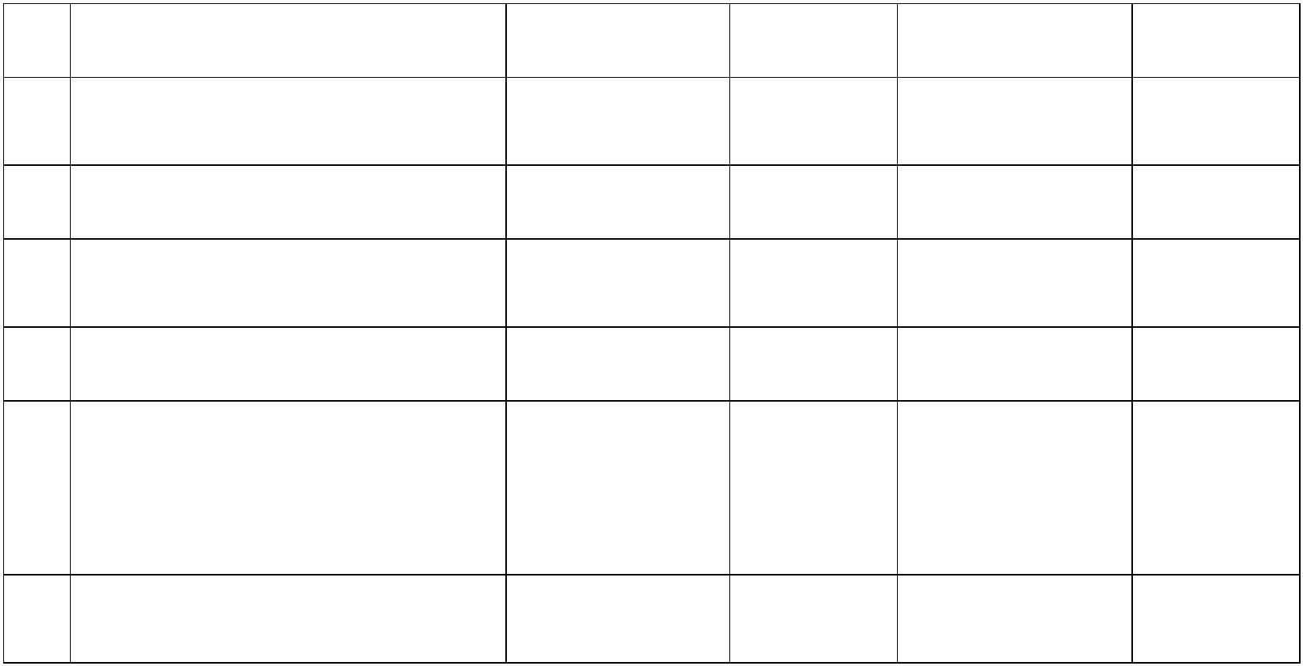

112 NYISO Quarterly Report Developer Advisory 9/15/2025

113 Completion of SCADA Testing with

Con Edison Control Centers Developer Advisory 11/30/2025

114 NYISO Quarterly Report Developer Advisory 12/15/2025

115 Network Upgrade Facilities for Dover

PAR Complete Developer Advisory 12/30/2025

116 Dover PAR Component Complete Developer Critical 12/30/2025

|  |  |  |
| --- | --- | --- |
| 117 Perform Final Connections to the New  York State Transmission System and  Complete Verification and Testing in  Accordance with the Final Energization  Plan16 |  | Developer Advisory 12/31/2025 |

118 Transmission Project Complete by

Required Project In-Service Date Developer Critical 12/31/2025

16 This milestone shall be completed in accordance with the Final Energization Plan but no later than the Transmission Project’s Required In-Service Date (*i.e.*, Milestone No. 118).

10