STANDARD SMALL GENERATOR
INTERCONNECTION AGREEMENT (SGIA)
between the
new york independent system operator, inc.
and
Rochester Gas and Electric Corporation
Dated as of January 27, 2012

(for the Browns Race Facility)

TABLE OF CONTENTS
Page No.

Article 1. Scope and Limitations of Agreement 2

1.1 Applicability 2
1.2 Purpose 2
1.3 Scope of Interconnection Service 2
1.4 Limitations 2
1.5 Responsibilities of the Parties 2
1.6 Parallel Operation Obligations 3
1.7 Metering 3
1.8 Reactive Power 4
1.9 Capitalized Terms 4

Article 2. Inspection, Testing, Authorization, and Right of Access 5

2.1 Equipment Testing and Inspection 5
2.2 Authorization Required Prior to Parallel Operation 5
2.3 Right of Access 5

Article 3. Effective Date, Term, Termination, and Disconnection 7

3.1 Effective Date 7
3.2 Terms of Agreement 7
3.3 Termination 7
3.4 Temporary Disconnection 7

Article 4. Cost Responsibility for Interconnection Facilities and
Distribution Upgrades 10

4.1 Interconnection Facilities 10
4.2 Distribution Upgrades 10

Article 5. Cost Responsibility for System Upgrade Facilities and System Deliverability Upgrades 11

5.1 Applicability 11
5.2 System Upgrades 11
5.3 Special Provisions for Affected Systems 11

Article 6. Billing, Payment, Milestone, and Financial Security 12

6.1 Billing and Payment Procedures and Financial Accounting 12
6.2 Milestones 12
6.3 Financial Security Arrangements 12

Article 7 Assignment, Liability, Indemnity, Force Majeure,
Consequential Damages, and Default 13

7.1 Assignment 13
7.2 Limitation of Liability 13
7.3 Indemnity 13
7.4 Consequential Damages 14
7.5 Force Majeure 15
7.6 Breach and Default 15

Article 8 Insurance 17

Article 9. Confidentiality 18

Article 10. Disputes 20

Article 11. Taxes 21

Article 12. Miscellaneous 22

12.1 Governing Law, Regulatory Authority, and Rules 22
12.2 Amendment 22
12.3 No Third-Party Beneficiaries 22
12.4 Waiver 22
12.5 Entire Agreement 22
12.6 Multiple Counterparts 23
12.7 No Partnership 23
12.8 Severability 23
12.9 Security Arrangements 23
12.10 Environmental Releases 23
12.11 Subcontractors 24
12.12 Reservation of Rights 24

Article 13. Notices 25

13.1 General 25
13.2 Billing and Payment 25
13.3 Alternative Forms of Notice 26
13.4 Designated Operating Representative 26
13.5 Changes to the Notice Information 27

Article 14. Signatures 28

Attachment 1 Glossary of Terms 1-1
Attachment 2 Detailed Scope of Work, Including Description and Costs of the
Small Generating Facility, Interconnection Facilities, and Metering
Equipment 2-1
Attachment 3 One-line Diagram Depicting the Small Generating Facility,
Interconnection Facilities, Metering Equipment, and Upgrades 3-1
Attachment 4 Milestones 4-1
Attachment 5 Additional Operating Requirements for the New York State
Transmission System, the Distribution System and Affected
Systems Needed to Support the Interconnection Customer’s Needs 5-1
Attachment 6 Connecting Transmission Owner’s Description of its Upgrades and Best
Estimate of Upgrade Costs 6-1
Attachment 7 Insurance Coverage 7-1

STANDARD SMALL GENERATOR INTERCONNECTION AGREEMENT

This Interconnection Agreement (“Agreement”) is made and entered into this 27th day of January 2012, by and between the New York Independent System Operator, Inc., a not-for-profit corporation organized and existing under the laws of the State of New York (“NYISO”), and Rochester Gas and Electric Corporation, a corporation organized and existing under the laws of the State of New York (“RG&E”), each hereinafter sometimes referred to individually as “Party” or referred to collectively as the “Parties.”
NYISO Information
New York Independent System Operator
Attention: Henry Chao
Vice President, System and Resource Planning
Address: 10 Krey Boulevard City: Rensselaer State: New York Zip: 12144
Phone: (518) 356-6000 Fax: (518) 356-6118

RG&E Information
Rochester Gas and Electric Corporation
Attention: Manager Programs/Projects
Electric Transmission Services
Address: 18 Link Drive
City: Binghamton State: New York Zip: 13902-5224
Phone: (607) 762-7606

Interconnection Customer Application No: 1829

In consideration of the mutual covenants set forth herein, the Parties agree as follows:

Article 1 Scope and Limitations of Agreement
1.1 Applicability

This Small Generator Interconnection Agreement (“SGIA”) shall be used for all Interconnection Requests submitted under the Small Generator Interconnection Procedures (“SGIP”) except for those submitted under the 10 kW Inverter Process contained in SGIP Attachment 5.

1.2 Purpose

This Agreement governs the terms and conditions under which RG&E’s Small Generating Facility will interconnect with, and operate in parallel with, the New York State Transmission System or the Distribution System.

1.3 Scope of Interconnection Service

1.3.1 NYISO will provide Capacity Resource Interconnection Service and Energy Resource Interconnection Service to RG&E at the Point of Interconnection, with Capacity Resource Interconnection Service subject to the provisions set forth in Attachment 5.

1.3.2 This Agreement does not constitute an agreement to purchase or deliver power. The purchase or delivery of power and other services that RG&E may require will be covered under separate agreements, if any, or applicable provisions of NYISO’s tariffs. RG&E will be responsible for separately making all necessary arrangements (including scheduling) for delivery of electricity in accordance with the applicable provisions of the NYISO OATT. The execution of this Agreement does not constitute a request for, nor agreement to, provide energy, any Ancillary Services or Installed Capacity under the NYISO Services Tariff. If RG&E wishes to supply or purchase energy, Installed Capacity or Ancillary Services, then RG&E will make application to do so in accordance with the NYISO Services Tariff.

1.4 Limitations

Nothing in this Agreement is intended to affect any other agreement by and between the NYISO and RG&E, except as otherwise expressly provided herein.

1.5 Responsibilities of the Parties

1.5.1 The Parties shall perform all obligations of this Agreement in accordance with all Applicable Laws and Regulations, Operating Requirements, and Good Utility Practice.

1.5.2 RG&E shall construct, interconnect, operate and maintain the Small Generating Facility and construct, operate, and maintain the Interconnection Facilities in accordance with the applicable manufacturer’s recommended maintenance schedule, and in accordance with this Agreement, and with Good Utility Practice.

1.5.3 RG&E shall construct, operate, and maintain the Upgrades covered by this Agreement in accordance with this Agreement, and with Good Utility Practice.

1.5.4 RG&E agrees to construct its facilities or systems in accordance with applicable specifications that meet or exceed those provided by the National Electrical Safety Code, the American National Standards Institute, IEEE, Underwriter’s Laboratory, and Operating Requirements in effect at the time of construction and other applicable national and state codes and standards. RG&E agrees to design, install, maintain, and operate its Small Generating Facility so as to reasonably minimize the likelihood of a disturbance adversely affecting or impairing the system or equipment of any Affected Systems.

1.5.5 RG&E shall operate, maintain, repair, and inspect, and shall be fully responsible for the safe installation, maintenance, repair and condition of the facilities that it now or subsequently may own unless otherwise specified in the Attachments to this Agreement. RG&E shall provide Interconnection Facilities that adequately protect the electric system, its personnel, and other persons from damage and injury. The allocation of responsibility for the design, installation, operation, maintenance and ownership of Interconnection Facilities shall be delineated in the Attachments to this Agreement.

1.5.6 The NYISO shall coordinate with all Affected Systems to support the interconnection. RG&E shall cooperate with the NYISO in these efforts.

1.6 Parallel Operation Obligations

Once the Small Generating Facility has been authorized to commence parallel operation, RG&E shall abide by all rules and procedures pertaining to the parallel operation of the Small Generating Facility in the applicable control area, including, but not limited to; (1) the rules and procedures concerning the operation of generation set forth in the NYISO tariffs or ISO Procedures or RG&E’s tariff; (2) any requirements consistent with Good Utility Practice or that are necessary to ensure the safe and reliable operation of the Transmission System or Distribution System; and (3) the Operating Requirements set forth in Attachment 5 of this Agreement.

1.7 Metering

RG&E shall be responsible for the purchase, installation, operation, maintenance, testing, repair, and replacement of metering and data acquisition equipment specified in Attachments 2 and 3 of this Agreement. RG&E’s metering (and data acquisition, as required) equipment shall conform to applicable industry rules and Operating Requirements.

1.8 Reactive Power

1.8.1 RG&E shall design its Small Generating Facility to maintain a composite power delivery at continuous rated power output at the Point of Interconnection at a power factor within the range 4.11 MVARS leading and lagging until NYISO has established different requirements that apply to all similarly situated generators in the New York Control Area on a comparable basis.

1.8.2 The NYISO is required to pay for reactive power, or voltage support service, that RG&E provides from the Small Generating Facility in accordance with Rate Schedule 2 of the NYISO Services Tariff.

1.9 Capitalized Terms

Capitalized terms used herein shall have the meanings specified in the Glossary of Terms in Attachment 1 or the body of this Agreement. Capitalized terms used herein that are not so defined shall have the meanings specified in Section 25.1.2 of Attachment S, or in Appendix 1 to Attachment Z, or in Section 30.1 of Attachment X of the NYISO OATT.

Article 2. Inspection, Testing, Authorization, and Right of Access

Equipment Testing and Inspection

2.1.1 RG&E shall test and inspect its Small Generating Facility and Interconnection Facilities prior to interconnection. RG&E shall notify the NYISO of such activities no fewer than five Business Days (or as may be agreed to by the Parties) prior to such testing and inspection. Testing and inspection shall occur on a Business Day. RG&E shall provide the NYISO a written test report when such testing and inspection is completed. The Small Generating Facility may not commence parallel operations if the NYISO finds that the Small Generating Facility has not been installed as agreed upon or may not be operated in a safe and reliable manner.

2.1.2 The NYISO shall provide RG&E written acknowledgment that it has received the written test report. Such written acknowledgment shall not be deemed to be or construed as any representation, assurance, guarantee, or warranty by the NYISO of the safety, durability, suitability, or reliability of the Small Generating Facility or any associated control, protective, and safety devices owned or controlled by RG&E or the quality of power produced by the Small Generating Facility.

2.2 Authorization Required Prior to Parallel Operation

2.2.1 The NYISO, in consultation with RG&E, shall use Reasonable Efforts to list applicable parallel Operating Requirements in Attachment 5 of this Agreement. Additionally, the NYISO shall notify RG&E of any changes to these requirements as soon as they are known. The NYISO shall make Reasonable Efforts to cooperate with RG&E in meeting requirements necessary to commence parallel operations by the in-service date.

2.2.2 RG&E shall not operate its Small Generating Facility in parallel with the New York State Transmission System or the Distribution System without prior written authorization of the NYISO. The NYISO will provide such authorization once the NYISO receives notification that RG&E has complied with all applicable parallel Operating Requirements. Such authorization shall not be unreasonably withheld, conditioned, or delayed.

2.3 Right of Access

2.3.1 Upon reasonable notice, the NYISO may send a qualified person to the premises of the Small Generating Facility at or immediately before the time the Small Generating Facility first produces energy to inspect the interconnection, and observe the commissioning of the Small Generating Facility (including any required testing), startup, and operation for a period of up to three Business Days after initial start-up of the unit. In addition, RG&E shall notify the NYISO at least five Business Days prior to conducting any on-site verification testing of the Small Generating Facility.

2.3.2 Following the initial inspection process described above, at reasonable hours, and upon reasonable notice, or at any time without notice in the event of an emergency or hazardous condition, the NYISO shall have access to the Small Generating Facility for any reasonable purpose in connection with the performance of the obligations imposed on it by this Agreement or if necessary to meet its other legal obligations.

2.3.3 Each Party shall be responsible for its own costs associated with following this article.

Article 3 Effective Date, Term, Termination, and Disconnection

3.1 Effective Date

This Agreement shall become effective upon execution by the Parties subject to acceptance by FERC (if applicable), or if filed unexecuted, upon the date specified by the FERC. The NYISO shall promptly file, or cause to be filed, this Agreement with FERC upon execution, if required. If the Agreement is disputed and RG&E requests that it be filed with FERC in an unexecuted form, the NYISO shall file, or cause to be filed, this Agreement and the NYISO shall identify the disputed language.

3.2 Term of Agreement

This Agreement shall become effective on the Effective Date and shall remain in effect for a period of twenty five years from the Effective Date or such other longer period as RG&E may request and shall be automatically renewed for each successive one-year period thereafter, unless terminated earlier in accordance with article 3.3 of this Agreement.

3.3 Termination

No termination shall become effective until the Parties have complied with all Applicable Laws and Regulations applicable to such termination, including the filing with FERC of a notice of termination of this Agreement (if required), which notice has been accepted for filing by FERC.

3.3.1 RG&E may terminate this Agreement at any time by giving the NYISO 20 Business Days written notice.

3.3.2 Any Party may terminate this Agreement after Default pursuant to article 7.6.

3.3.3 Upon termination of this Agreement, the Small Generating Facility will be disconnected from the New York State Transmission System or the Distribution System, as applicable. All costs required to effectuate such disconnection shall be borne by the terminating Party, unless such termination resulted from the non-terminating Party’s Default of this SGIA or such non-terminating Party otherwise is responsible for these costs under this SGIA.

3.3.4 The termination of this Agreement shall not relieve any Party of its liabilities and obligations, owed or continuing at the time of the termination.

3.3.5 The limitations of liability, indemnification and confidentiality provisions of this Agreement shall survive termination or expiration of this Agreement.

3.4 Temporary Disconnection

Temporary disconnection shall continue only for so long as reasonably necessary under Good Utility Practice.
3.4.1 Emergency Conditions
“Emergency Condition” shall mean a condition or situation: (1) that in the judgment of the Party making the claim is imminently likely to endanger life or property; or (2) that, in the case of the NYISO, is imminently likely (as determined in a non-discriminatory manner) to cause a material adverse effect on the security of, or damage to the New York State Transmission System or Distribution System, or the electric systems of others to which the New York State Transmission System or Distribution System is directly connected; or (3) that, in the case of RG&E, is imminently likely (as determined in a non-discriminatory manner) to cause a material adverse effect on the security of, or damage to, the Small Generating Facility or the Interconnection Facilities. Under Emergency Conditions, the NYISO or RG&E may immediately suspend interconnection service and temporarily disconnect the Small Generating Facility. The NYISO shall notify RG&E promptly when it becomes aware of an Emergency Condition that may reasonably be expected to affect the operation of the Small Generating Facility. RG&E shall notify the NYISO promptly when it becomes aware of an Emergency Condition that may reasonably be expected to affect the New York State Transmission System or Distribution System or any Affected Systems. To the extent information is known, the notification shall describe the Emergency Condition, the extent of the damage or deficiency, the expected effect on the operation of each Party’s facilities and operations, its anticipated duration, and the necessary corrective action.

3.4.2 Routine Maintenance, Construction, and Repair
The NYISO may interrupt interconnection service or curtail the output of the Small Generating Facility and temporarily disconnect the Small Generating Facility from the New York State Transmission System or Distribution System when necessary for routine maintenance, construction, and repairs on the New York State Transmission System or Distribution System. NYISO or RG&E shall provide five Business Days notice prior to such interruption. The NYISO and RG&E shall use Reasonable Efforts to coordinate such reduction or temporary disconnection.

3.4.3 Forced Outages

During any forced outage, the NYISO may suspend interconnection service to the Small Generating Facility to effect immediate repairs on the New York State Transmission System or the Distribution System. The NYISO shall use Reasonable Efforts to provide RG&E with prior notice. If prior notice is not given, the NYISO shall, upon request, provide RG&E written documentation after the fact explaining the circumstances of the disconnection.

3.4.4 Adverse Operating Effects
The NYISO shall notify RG&E as soon as practicable if, based on Good Utility Practice, operation of the Small Generating Facility may cause disruption or deterioration of service to other customers served from the same electric system, or if operating the Small Generating Facility could cause damage to the New York State Transmission System, the Distribution System or Affected Systems, or if disconnection is otherwise required under Applicable Reliability Standards or the NYISO OATT. Supporting documentation used to reach the decision to disconnect shall be provided to RG&E upon request. If, after notice, RG&E fails to remedy the adverse operating effect within a reasonable time, the NYISO may disconnect the Small Generating Facility. The NYISO shall provide RG&E with five Business Days notice of such disconnection, unless the provisions of article 3.4.1 apply.

3.4.5 Modification of the Small Generating Facility
RG&E must receive written authorization from the NYISO before making any change to the Small Generating Facility that may have a material impact on the safety or reliability of the New York State Transmission System or the Distribution System. Such authorization shall not be unreasonably withheld. Modifications shall be done in accordance with Good Utility Practice. If RG&E makes such modification without the prior written authorization of the NYISO, the NYISO shall have the right to temporarily disconnect the Small Generating Facility. If disconnected, the Small Generating Facility will not be reconnected until the unauthorized modifications are authorized or removed.

3.4.6 Reconnection
The Parties shall cooperate with each other to restore the Small Generating Facility, Interconnection Facilities, and the New York State Transmission System and Distribution System to their normal operating state as soon as reasonably practicable following a temporary disconnection.

Article 4. Cost Responsibility for Interconnection Facilities and Distribution Upgrades

4.1 Interconnection Facilities

4.1.1 RG&E shall pay for the cost of the Interconnection Facilities itemized in Attachment 2 of this Agreement. The NYISO shall provide a best estimate cost, including overheads, for the purchase and construction of the Interconnection Facilities and provide a detailed itemization of such costs. Costs associated with Interconnection Facilities may be shared with other entities that may benefit from such facilities by agreement of RG&E, such other entities, and the NYISO.

4.1.2 RG&E shall be responsible for all expenses, including overheads, associated with owning, operating, maintaining, repairing, and replacing the Interconnection Facilities, as set forth in Attachment 2 to this Agreement.

4.2 Distribution Upgrades

RG&E shall design, procure, construct, install, and own the Distribution Upgrades described in Attachment 6 of this Agreement. RG&E shall be responsible for the expenses, including overheads, associated with owning, operating, maintaining, repairing, and replacing the Distribution Upgrades, as set forth in Attachment 6 to this Agreement.

Article 5. Cost Responsibility for System Upgrade Facilities and System Deliverability Upgrades

5.1 Applicability

No portion of this article 5 shall apply unless the interconnection of the Small Generating Facility requires System Upgrade Facilities or System Deliverability Upgrades.

5.2 System Upgrades

RG&E shall procure, construct, install, and own the System Upgrade Facilities and System Deliverability Upgrades described in Attachment 6 of this Agreement. To the extent that design work is necessary in addition to that already accomplished in the Class Year facilities study for the Small Generating Facility, RG&E shall perform or cause to be performed such work.

5.2.1 As described in Section 32.3.5.3 of the SGIP in Attachment Z of the NYISO OATT, the responsibility of RG&E for the cost of the System Upgrade Facilities and System Deliverability Upgrades described in Attachment 6 of this Agreement shall be determined in accordance with Attachment S of the NYISO OATT, as required by Section 32.3.5.3.2 of Attachment Z. RG&E shall be responsible for all System Upgrade Facility costs as required by Section 32.3.5.3.2 of Attachment Z or its share of any System Upgrade Facilities and System Deliverability Upgrades costs resulting from the final Attachment S process, as applicable, and Attachment 6 to this Agreement shall be revised accordingly.

5.2.2 Pending the outcome of the Attachment S cost allocation process, RG&E may elect to proceed with the interconnection of its Small Generating Facility in accordance with Section 32.3.5.3 of the SGIP.

5.3 Special Provisions for Affected Systems

For the repayment of amounts advanced to Affected System Operator for System Upgrade Facilities or System Deliverability Upgrades, the Interconnection Customer and Affected System Operator shall enter into an agreement that provides for such repayment, but only if responsibility for the cost of such System Upgrade Facilities is not to be allocated in accordance with Attachment S of the NYISO OATT. The agreement shall specify the terms governing payments to be made by the Interconnection Customer to Affected System operator as well as the repayment by Affected System Operator.

Article 6. Billing, Payment, Milestones and Financial Security

6.1 Billing and Payment Procedures and Final Accounting

6.1.1 [omitted]

6.1.2 [omitted]

6.1.3 [omitted]

6.2 Milestones

Subject to the provisions of the SGIP, the Parties shall agree on milestones for which each Party is responsible and list them in Attachment 4 of this Agreement. A Party’s obligations under this provision may be extended by agreement. If a Party anticipates that it will be unable to meet a milestone for any reason other than a Force Majeure event, it shall immediately notify the other Party of the reason(s) for not meeting the milestone and (1) propose the earliest reasonable alternate date by which it can attain this and future milestones, and (2) requesting appropriate amendments to Attachment 4. The Party affected by the failure to meet a milestone shall not unreasonably withhold agreement to such an amendment unless it will suffer significant uncompensated economic or operational harm from the delay, (1) attainment of the same milestone has previously been delayed, or (2) it has reason to believe that the delay in meeting the milestone is intentional or unwarranted notwithstanding the circumstances explained by the Party proposing the amendment.

6.3 Financial Security Arrangements

6.3.1 [omitted]

6.3.2 [omitted]

6.3.3 [omitted]

Article 7. Assignment, Liability, Indemnity, Force Majeure, Consequential Damages, and Default

7.1 Assignment

This Agreement, and each and every term and condition hereof, shall be binding upon and inure to the benefit of the Parties hereto and their respective successors and assigns. This Agreement may be assigned by any Party upon 15 Business Days prior written notice and opportunity to object by the other Party; provided that:

7.1.1 A Party may assign this Agreement without the consent of the other Party to any affiliate of the assigning Party with an equal or greater credit rating and with the legal authority and operational ability to satisfy the obligations of the assigning Party under this Agreement, provided that the assigning Party notifies the other Party of any such assignment. A Party may assign this Agreement without the consent of the other Party in connection with the sale, merger, restructuring, or transfer of a substantial portion of all of its assets, including the Interconnection Facilities it owns, so long as the assignee in such a transaction directly assumes all rights, duties and obligation arising under this Agreement.

7.1.2 RG&E shall have the right to assign this Agreement, without the consent of the NYISO, for collateral security purposes to aid in providing financing for the Small Generating Facility.

7.1.3 Any attempted assignment that violates this article is void and ineffective. Assignment shall not relieve a Party of its obligations, nor shall a Party’s obligations be enlarged, in whole or in part, by reason thereof. An assignee is responsible for meeting the same financial, credit, and insurance obligations as the assigning Party. Where required, consent to assignment will not be unreasonably withheld, conditioned or delayed.

7.2 Limitation of Liability

Each Party’s liability to the other Party for any loss, cost, claim, injury, liability, or expense, including reasonable attorney’s fees, relating to or arising from any act or omission in its performance of this Agreement, shall be limited to the amount of direct damage actually incurred. In no event shall any Party be liable to the other Party for any indirect, special, consequential, or punitive damages.

7.3 Indemnity

7.3.1 This provision protects each Party from liability incurred to third parties as a result of carrying out the provisions of this Agreement. Liability under this provision is exempt from the general limitations on liability found in article 7.2.

7.3.2 Each Party (the “Indemnifying Party”) shall at all times indemnify, defend, and hold harmless the other Party (each an “ Indemnified Party”) from, any and all damages, losses, claims, including claims and actions relating to injury to or death of any person or damage to property, the alleged violation of any Environmental Law, or the release or threatened release of any Hazardous Substance, demand, suits, recoveries, costs and expenses, court costs, attorney fees, and all other obligations by or to third parties (any and all of these a “Loss”), arising out of or resulting from (i) the Indemnified Party’s performance under this Agreement on behalf of the Indemnifying Party, except in cases where the Indemnifying Party can demonstrate that the Loss of the Indemnified Party was caused by the gross negligence or intentional wrongdoing by the Indemnified Party or (ii) the violation by the Indemnifying Party of any Environmental Law or the release by the Indemnifying Party of a Hazardous Substance.

7.3.3 If a Party is entitled to indemnification under this article as a result of a claim by a third party, and the Indemnifying Party fails, after notice and reasonable opportunity to proceed under this article, to assume the defense of such claim, such Indemnified Party may at the expense of the Indemnifying Party contest, settle or consent to the entry of any judgment with respect to, or pay in full, such claim.

7.3.4 If an Indemnifying Party is obligated to indemnify and hold any Indemnified Party harmless under this article, the amount owing to the Indemnified Party shall be the amount of such Indemnified Party’s actual loss, net of any insurance or other recovery.

7.3.5 Promptly after receipt by an Indemnified Party of any claim or notice of the commencement of any action or administrative or legal proceeding or investigation as to which the indemnity provided for in this article may apply, the Indemnified Party shall notify the Indemnifying Party of such fact. Any failure of or delay in such notification shall not affect a Party’s indemnification obligation unless such failure or delay is materially prejudicial to the Indemnifying Party.

7.4 Consequential Damages

Other than as expressly provided for in this Agreement, no Party shall be liable under any provision of this Agreement for any losses, damages, costs or expenses for any special, indirect, incidental, consequential, or punitive damages, including but not limited to loss of profit or revenue, loss of the use of equipment, cost of capital, cost of temporary equipment or services, whether based in whole or in part in contract, in tort, including negligence, strict liability, or any other theory of liability; provided, however, that damages for which a Party may be liable to another Party under another agreement will not be considered to be special, indirect, incidental, or consequential damages hereunder.

7.5 Force Majeure

7.5.1 As used in this article, a Force Majeure Event shall mean “any act of God, labor disturbance, act of the public enemy, war, insurrection, riot, fire, storm or flood, explosion, breakage or accident to machinery or equipment, any order, regulation or restriction imposed by governmental, military or lawfully established civilian authorities, or any other cause beyond a Party’s control. A Force Majeure Event does not include an act of negligence or intentional wrongdoing.” For the purposes of this article, this definition of Force Majeure shall supersede the definitions of Force Majeure set out in Section 2.11 of the NYISO OATT.

7.5.2 If an event of Force Majeure prevents a Party from fulfilling any obligations under this Agreement, the Party affected by the Force Majeure event (Affected Party) shall promptly notify the other Party, either in writing or via the telephone, of the existence of the Force Majeure event. The notification must specify in reasonable detail the circumstances of the Force Majeure event, its expected duration, and the steps that the Affected Party is taking to mitigate the effects of the event on its performance. The Affected Party shall keep the other Party informed on a continuing basis of developments relating to the Force Majeure event until the event ends. The Affected Party will be entitled to suspend or modify its performance of obligations under this Agreement (other than the obligation to make payments) only to the extent that the effect of the Force Majeure event cannot be mitigated by the use of Reasonable Efforts. The Affected Party will use Reasonable Efforts to resume its performance as soon as possible.

7.6 Breach and Default

7.6.1 No Breach of this Agreement shall exist where such failure to discharge an obligation (other than the payment of money) is the result of a Force Majeure event or the result of an act or omission of the other Party. Upon a Breach, the non-breaching Party shall give written notice of such Breach to the Breaching Party. Except as provided in article 7.6.2, the Breaching Party shall have 60 calendar days from receipt of the Breach notice within which to cure such Breach; provided however, if such Breach is not capable of cure within 60 calendar days, the Breaching Party shall commence such cure within 20 calendar days after notice and continuously and diligently complete such cure within six months from receipt of the Breach notice; and, if cured within such time, the Breach specified in such notice shall cease to exist.

7.6.2 If a Breach is not cured as provided in this article, or if a Breach is not capable of being cured within the period provided for herein, a Default shall exist and the non-defaulting Party shall thereafter have the right to terminate this Agreement, in accordance with article 3.3 hereof, by written notice to the Defaulting Party at any time until cure occurs, and be relieved of any further obligation hereunder and, whether or not the non-defaulting Party terminates this Agreement, to recover from the Defaulting Party all amounts due hereunder, plus all other damages and remedies to which they are entitled at law or in equity. The provisions of this article shall survive termination of this Agreement.

7.6.3 In the event that RG&E elects to proceed under Section 32.3.5.3 of the SGIP, if the Interconnection Request is withdrawn or deemed withdrawn pursuant to the SGIP during the term of this Agreement, this Agreement shall terminate.

Article 8. Insurance

8.1 RG&E shall, at its own expense, maintain in force general liability insurance without any exclusion for liabilities related to the interconnection undertaken pursuant to this Agreement. The amount of such insurance shall be sufficient to insure against all reasonably foreseeable direct liabilities given the size and nature of the generating equipment being interconnected, the interconnection itself, and the characteristics of the system to which the interconnection is made. Such insurance coverage is specified in Attachment 7 to this Agreement. RG&E shall obtain additional insurance only if necessary as a function of owning and operating a generating facility. Such insurance shall be obtained from an insurance provider authorized to do business in New York State where the interconnection is located. RG&E may propose to self-insure for such liabilities, and such a proposal shall not be unreasonably rejected.

8.2 The NYISO agrees to maintain general liability insurance or self-insurance consistent with the existing commercial practice. Such insurance or self-insurance shall not exclude the liabilities undertaken pursuant to this Agreement.

8.3 The Parties further agree to notify one another whenever an accident or incident occurs resulting in any injuries or damages that are included within the scope of coverage of such insurance, whether or not such coverage is sought.

Article 9. Confidentiality

9.1 Confidential Information shall mean any confidential and/or proprietary information provided by one Party to the other Party that is clearly marked or otherwise designated “Confidential.” For purposes of this Agreement all design, operating specifications, and metering data provided by the Interconnection Customer shall be deemed Confidential Information regardless of whether it is clearly marked or otherwise designated as such. Confidential Information shall include, without limitation, information designated as such by the NYISO Code of Conduct contained in Attachment F to the NYISO OATT.

9.2 Confidential Information does not include information previously in the public domain, required to be publicly submitted or divulged by Governmental Authorities (after notice to the other Party and after exhausting any opportunity to oppose such publication or release), or necessary to be divulged in an action to enforce this Agreement. Each Party receiving Confidential Information shall hold such information in confidence and shall not disclose it to any third party nor to the public without the prior written authorization from the Party providing that information, except to fulfill obligations under this Agreement, or to fulfill legal or regulatory requirements.

9.2.1 Each Party shall employ at least the same standard of care to protect Confidential Information obtained from the other Party as it employs to protect its own Confidential Information.

9.2.2 Each Party is entitled to equitable relief, by injunction or otherwise, to enforce its rights under this provision to prevent the release of Confidential Information without bond or proof of damages, and may seek other remedies available at law or in equity for breach of this provision.

9.3 Notwithstanding anything in this article to the contrary, and pursuant to 18 CFR § lb.20, if FERC, during the course of an investigation or otherwise, requests information from one of the Parties that is otherwise required to be maintained in confidence pursuant to this Agreement, the Party shall provide the requested information to FERC, within the time provided for in the request for information. In providing the information to FERC, the Party may, consistent with 18 CFR § 388.112, request that the information be treated as confidential and non-public by FERC and that the information be withheld from public disclosure. Each Party is prohibited from notifying the other Party to this Agreement prior to the release of the Confidential Information to FERC. The Party shall notify the other Party to this Agreement when it is notified by FERC that a request to release Confidential Information has been received by FERC, at which time either of the Parties may respond before such information would be made public, pursuant to 18 CFR § 388.112. Requests from a state regulatory body conducting a confidential investigation shall be treated in a similar manner if consistent with the applicable state rules and regulations.

9.4 Consistent with the provisions of this article 9, the Parties to this Agreement will cooperate in good faith to provide each other, Affected Systems, Affected System Operators, and state and federal regulators the information necessary to carry out the terms of the SGIP and this Agreement.

Article 10. Disputes

10.1 The NYISO and RG&E agree to attempt to resolve all disputes arising out of the interconnection process according to the provisions of this article.

10.2 In the event of a dispute, the Parties will first attempt to promptly resolve it on an informal basis. If the Parties cannot promptly resolve the dispute on an informal basis, then any Party shall provide the other Party with a written Notice of Dispute. Such Notice shall describe in detail the nature of the dispute.

10.3 If the dispute has not been resolved within two Business Days after receipt of the Notice, any Party may contact FERC’s Dispute Resolution Service (DRS) for assistance in resolving the dispute.

10.4 The DRS will assist the Parties in either resolving their dispute or in selecting an appropriate dispute resolution venue (e.g., mediation, settlement judge, early neutral evaluation, or technical expert) to assist the Parties in resolving their dispute. The result of this dispute resolution process will be binding only if the Parties agree in advance. DRS can be reached at 1-877-337-2237 or via the internet at http://www.ferc.gov/legal/adr.asp.

10.5 Each Party agrees to conduct all negotiations in good faith and will be responsible for one-half of any costs paid to neutral third-parties.

10.6 If any Party elects to seek assistance from the DRS, or if the attempted dispute resolution fails, then any Party may exercise whatever rights and remedies it may have in equity or law consistent with the terms of this Agreement.

Article 11. Taxes

11.1 The Parties agree to follow all applicable tax laws and regulations, consistent with FERC policy and Internal Revenue Service requirements.

11.2 Each Party shall cooperate with the other Party to maintain the other Party’s tax status. Nothing in this Agreement is intended to adversely affect the tax status of any Party including the status of NYISO, or the status of RG&E with respect to the issuance of bonds including, but not limited to, Local Furnishing Bonds. Notwithstanding any other provisions of this Agreement, LIPA, NYPA and Consolidated Edison Company of New York, Inc. shall not be required to comply with any provisions of this Agreement that would result in the loss of tax-exempt status of any of their Tax-Exempt Bonds or impair their ability to issue future tax-exempt obligations. For purposes of this provision, Tax-Exempt Bonds shall include the obligations of the Long Island Power Authority, NYPA and Consolidated Edison Company of New York, Inc., the interest on which is not included in gross income under the Internal Revenue Code.

11.3 LIPA and NYPA do not waive their exemptions, pursuant to Section 201(f) of the FPA, from Commission jurisdiction with respect to the Commission’s exercise of the FPA’s general ratemaking authority.

11.4 Except where otherwise noted, all costs, deposits, financial obligations and the like specified in this Agreement shall be assumed not to reflect the impact of applicable taxes.

Article 12. Miscellaneous

12.1 Governing Law, Regulatory Authority, and Rules

The validity, interpretation and enforcement of this Agreement and each of its provisions shall be governed by the laws of the state of New York, without regard to its conflicts of law principles. This Agreement is subject to all Applicable Laws and Regulations. Each Party expressly reserves the right to seek changes in, appeal, or otherwise contest any laws, orders, or regulations of a Governmental Authority.

12.2 Amendment

The Parties may amend this Agreement by a written instrument duly executed by the Parties, or under article 12.12 of this Agreement.

12.3 No Third-Party Beneficiaries

This Agreement is not intended to and does not create rights, remedies, or benefits of any character whatsoever in favor of any persons, corporations, associations, or entities other than the Parties, and the obligations herein assumed are solely for the use and benefit of the Parties, their successors in interest and where permitted, their assigns. Notwithstanding the foregoing, any subcontractor of RG&E or NYISO assisting either of those Parties with the Interconnection Request covered by this Agreement shall be entitled to the benefits of indemnification provided for under Article 7.3 of this Agreement and the limitation of liability provided for in Article 7.2 of this Agreement.

12.4 Waiver

12.4.1 The failure of a Party to this Agreement to insist, on any occasion, upon strict performance of any provision of this Agreement will not be considered a waiver of any obligation, right, or duty of, or imposed upon, such Party.

12.4.2 Any waiver at any time by a Party of its rights with respect to this Agreement shall not be deemed a continuing waiver or a waiver with respect to any other failure to comply with any other obligation, right, duty of this Agreement. Termination or default of this Agreement for any reason by RG&E shall not constitute a waiver of RG&E’s legal rights to obtain an interconnection from the NYISO. Any waiver of this Agreement shall, if requested, be provided in writing.

12.5 Entire Agreement

This Agreement, including all Attachments, constitutes the entire agreement between the Parties with reference to the subject matter hereof, and supersedes all prior and contemporaneous understandings or agreements, oral or written, between the Parties with respect to the subject matter of this Agreement. There are no other agreements, representations, warranties, or covenants which constitute any part of the consideration for, or any condition to, any Party’s compliance with its obligations under this Agreement.

12.6 Multiple Counterparts

This Agreement may be executed in two or more counterparts, each of which is deemed an original but all constitute one and the same instrument.

12.7 No Partnership

This Agreement shall not be interpreted or construed to create an association, joint venture, agency relationship, or partnership between the Parties or to impose any partnership obligation or partnership liability upon any Party. No Party shall have any right, power or authority to enter into any agreement or undertaking for, or act on behalf of, or to act as or be an agent or representative of, or to otherwise bind, another Party.

12.8 Severability

If any provision or portion of this Agreement shall for any reason be held or adjudged to be invalid or illegal or unenforceable by any court of competent jurisdiction or other Governmental Authority, (1) such portion or provision shall be deemed separate and independent, (2) the Parties shall negotiate in good faith to restore insofar as practicable the benefits to each Party that were affected by such ruling, and (3) the remainder of this Agreement shall remain in full force and effect.

12.9 Security Arrangements

Infrastructure security of electric system equipment and operations and control hardware and software is essential to ensure day-to-day reliability and operational security. FERC expects the NYISO and RG&E to comply with the recommendations offered by the President’s Critical Infrastructure Protection Board and, eventually, best practice recommendations from the electric reliability authority. All public utilities are expected to meet basic standards for system infrastructure and operational security, including physical, operational, and cyber-security practices.

12.10 Environmental Releases

Each Party shall notify the other Party, first orally and then in writing, of the release of any hazardous substances, any asbestos or lead abatement activities, or any type of remediation activities related to the Small Generating Facility or the Interconnection Facilities, each of which may reasonably be expected to affect the other Party. The notifying Party shall (1) provide the notice as soon as practicable, provided such Party makes a good faith effort to provide the notice no later than 24 hours after such Party becomes aware of the occurrence, and (2) promptly furnish to the other Party copies of any publicly available reports filed with any governmental authorities addressing such events.

12.11 Subcontractors

Nothing in this Agreement shall prevent a Party from utilizing the services of any subcontractor as it deems appropriate to perform its obligations under this Agreement; provided, however, that each Party shall require its subcontractors to comply with all applicable terms and conditions of this Agreement in providing such services and each Party shall remain primarily liable to the other Party for the performance of such subcontractor.

12.11.1 The creation of any subcontract relationship shall not relieve the hiring Party of any of its obligations under this Agreement. The hiring Party shall be fully responsible to the other Party to the extent provided for in Sections 32.7.2 and 32.7.3 above for the acts or omissions of any subcontractor the hiring Party hires as if no subcontract had been made; provided, however, that in no event shall the NYISO be liable for the actions or inactions of RG&E or its subcontractors with respect to obligations of RG&E under this Agreement. Any applicable obligation imposed by this Agreement upon the hiring Party shall be equally binding upon, and shall be construed as having application to, any subcontractor of such Party.

12.11.2 The obligations under this article will not be limited in any way by any limitation of subcontractor’s insurance.

12.12 Reservation of Rights

Nothing in this Agreement shall alter the right of the NYISO or RG&E to make unilateral filings with FERC to modify this Agreement with respect to any rates, terms and conditions, charges, classifications of service, rule or regulation under Section 205 or any other applicable provision of the Federal Power Act and FERC’s rules and regulations thereunder which rights are expressly reserved herein; provided that each Party shall have the right to protest any such filing by another Party and to participate fully in any proceeding before FERC in which such modifications may be considered. Nothing in this Agreement shall limit the rights of the Parties or of FERC under Sections 205 or 206 of the Federal Power Act and FERC’s rules and regulations, except to the extent that the Parties otherwise agree as provided herein.

Article 13. Notices

13.1 General

Unless otherwise provided in this Agreement, any written notice, demand, or request required or authorized in connection with this Agreement (“Notice”) shall be deemed properly given if delivered in person, delivered by recognized national currier service, or sent by first class mail, postage prepaid, to the person specified below:
If to RG&E:

Rochester Gas and Electric Corporation
Attention: Hugh J. Ives
Address: 89 East Avenue City: Rochester State: New York Zip: 14649-0001
Phone: (585) 724-8209 Fax: (585) 724-8832

If to the NYISO:

Before Commercial Operation of the Small Generating Facility:

New York Independent System Operator
Attention: Vice President, System and Resource Planning
Address: 10 Krey Boulevard
City: Rensselaer State: New York Zip: 12144
Phone: (518) 356-6000 Fax: (518) 356-6118

After Commercial Operation:

New York Independent System Operator
Attention: Vice President, Operations
Address: 3890 Carman Road
City: Schenectady State: New York Zip: 12303
Phone: (518) 356-6000 Fax: (518) 356-6118

13.2 Billing and Payment

Billings and payments shall be sent to the addresses set out below:
RG&E:

Rochester Gas and Electric Corporation Attention: Hugh J. Ives
Address: 89 East Avenue
City: Rochester State: New York Zip: 14649-0001
Phone: (585) 724-8209 Fax: (585) 724-8832

13.3 Alternative Forms of Notice

Any notice or request required or permitted to be given by either Party to the other and not required by this Agreement to be given in writing may be so given by telephone, facsimile or e-mail to the telephone numbers and e-mail addresses set out below:
If to RG&E:
Rochester Gas and Electric Corporation
Attention: Hugh J. Ives
Address: 89 East Avenue City: Rochester State: New York Zip: 14649-0001
Phone: (585) 724-8209 Fax: (585) 724-8832

If to the NYISO:
New York Independent System Operator
Attention: Vice President, Operations Address: 3890 Carman Rd
City: Schenectady State: New York Zip: 12303
Phone: (518) 356-6000 Fax: (518) 356-6118

13.4 Designated Operating Representative

The Parties may also designate operating representatives to conduct the communications which may be necessary or convenient for the administration of this Agreement. This person will also serve as the point of contact with respect to operations and maintenance of the Party’s facilities.
RG&E’s Operating Representative:

Rochester Gas and Electric Corporation
Attention: Hugh J. Ives
Address: 89 East Avenue City: Rochester State: New York Zip: 14649-0001
Phone: (585) 724-8209 Fax: (585) 724-8832

NYISO’s Operating Representative:

New York Independent System Operator
Attention: Vice President, Operations
Address: 3890 Carman Rd
City: Schenectady State: New York Zip: 12303
Phone: (518) 356-6000 Fax: (518) 356-6118

13.5 Changes to the Notice Information

Either Party may change this information by giving five Business Days written notice prior to the effective date of the change.

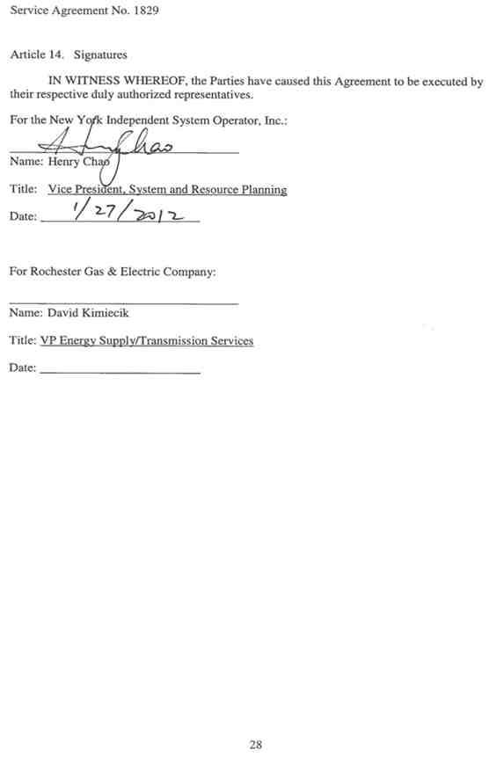
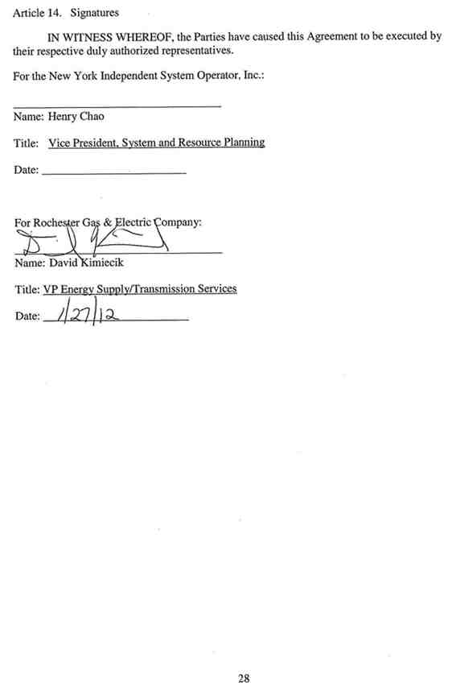

Attachment 1
Glossary of Terms
Affected System – An electric system other than the transmission system owned, controlled or operated by the Connecting Transmission Owner that may be affected by the proposed interconnection.
Affected System Operator – Affected System Operator shall mean the operator of any Affected System.
Affected Transmission Owner -- The New York public utility or authority (or its designated agent) other than the Connecting Transmission Owner that (i) owns facilities used for the transmission of Energy in interstate commerce and provides Transmission Service under the Tariff, and (ii) owns, leases or otherwise possesses an interest in a portion of the New York State Transmission System where System Deliverability Upgrades or System Upgrade Facilities are installed pursuant to Attachment Z and Attachment S to the NYISO OATT.
Applicable Laws and Regulations – All duly promulgated applicable federal, state and local laws, regulations, rules, ordinances, codes, decrees, judgments, directives, or judicial or administrative orders, permits and other duly authorized actions of any Governmental Authority, including but not limited to Environmental Law.
Applicable Reliability Standards – The criteria, requirements and guidelines of the North American Electric Reliability Council, the Northeast Power Coordinating Council, the New York State Reliability Council and related and successor organizations, or the Transmission District to which the Interconnection Customer’s Small Generating Facility is directly interconnected, as those criteria, requirements and guidelines are amended and modified and in effect from time to time; provided that no Party shall waive its right to challenge the applicability of or validity of any criterion, requirement or guideline as applied to it in the context of Attachment Z to the NYISO OATT and this Agreement. For the purposes of this Agreement, this definition of Applicable Reliability Standards shall supersede the definition of Applicable Reliability Standards set out in Attachment X to the NYISO OATT.
Base Case -- The base case power flow, short circuit, and stability data bases used for the Interconnection Studies by NYISO, Connecting Transmission Owner or Interconnection Customer; described in Section 30.2.3 of the Large Facility Interconnection Procedures.
Breach - The failure of a Party to perform or observe any material term or condition of this Agreement.
Business Day – Monday through Friday, excluding federal holidays.
Capacity Resource Interconnection Service -- The service provided by NYISO to interconnect the Interconnection Customer’s Small Generating Facility to the New York State Transmission System or Distribution System in accordance with the NYISO Deliverability Interconnection Standard, to enable the New York State Transmission System to deliver electric capacity from the Small Generating Facility, pursuant to the terms of the NYISO OATT.
Connecting Transmission Owner – RG&E.
Deliverability Interconnection Standard – The standard that must be met by any Small Generating Facility larger than 2MW proposing to interconnect to the New York State Transmission System or Distribution System and to become a qualified Installed Capacity Supplier, and must be met by any merchant transmission project proposing to interconnect to the New York State Transmission System and receive Unforced Capacity Delivery Rights. To meet the NYISO Deliverability Interconnection Standard, the Interconnection Customer must, in accordance with the rules in Attachment S to the NYISO OATT, fund or commit to fund the System Deliverability Upgrades identified for its project in the Class Year Deliverability Study.
Default – The failure of a Party in Breach of this Agreement to cure such Breach under the Small Generator Interconnection Agreement.
Distribution System – The facilities and equipment used to distribute electricity that are not under the operational control of the NYISO, and are subject to the SGIP under FERC Order No. 2006. For the purpose of this Agreement, the term Distribution System shall not include LIPA’s distribution facilities.
Distribution Upgrades – The additions, modifications, and upgrades to the Connecting Transmission Owner’s Distribution System at or beyond the Point of Interconnection to facilitate interconnection of the Small Generating Facility and render the transmission service necessary to effect the wholesale sale of electricity in interstate commerce. Distribution Upgrades do not include Interconnection Facilities or System Upgrade Facilities or System Deliverability Upgrades.
Energy Resource Interconnection Service – The service provided by NYISO to interconnect the Small Generating Facility to the New York State Transmission System or Distribution System in accordance with the NYISO Minimum Interconnection Standard, to enable the New York State Transmission System to receive Energy and Ancillary Services from the Small Generating Facility, pursuant to the terms of the NYISO OATT.
Force Majeure – Any act of God, labor disturbance, act of the public enemy, war, insurrection, riot, fire, storm or flood, explosion, breakage or accident to machinery or equipment, any order, regulation or restriction imposed by governmental, military or lawfully established civilian authorities, or any other cause beyond a Party’s control. A Force Majeure event does not include an act of negligence or intentional wrongdoing. For the purposes of this Agreement, this definition of Force Majeure shall supersede the definitions of Force Majeure set out in Section 2.11 of the NYISO Open Access Transmission Tariff.
Good Utility Practice – Any of the practices, methods and acts engaged in or approved by a significant portion of the electric industry during the relevant time period, or any of the practices, methods and acts which, in the exercise of reasonable judgment in light of the facts known at the time the decision was made, could have been expected to accomplish the desired result at a reasonable cost consistent with good business practices, reliability, safety and expedition. Good Utility Practice is not intended to be limited to the optimum practice, method, or act to the exclusion of all others, but rather to be acceptable practices, methods, or acts generally accepted in the region.
Governmental Authority – Any federal, state, local or other governmental regulatory or administrative agency, court, commission, department, board, or other governmental subdivision, legislature, rulemaking board, tribunal, or other governmental authority having jurisdiction over the Parties, their respective facilities, or the respective services they provide, and exercising or entitled to exercise any administrative, executive, police, or taxing authority or power; provided, however, that such term does not include the Interconnection Customer, NYISO, Affected Transmission Owner, Connecting Transmission Owner or any Affiliate thereof.
Interconnection Customer – Any entity, including the Transmission Owner or any of the affiliates or subsidiaries, that proposes to interconnect its Small Generating Facility with the New York State Transmission System or the Distribution System.
Interconnection Facilities – Interconnection Facilities include all facilities and equipment between the Small Generating Facility and the Point of Interconnection, including any modification, additions or upgrades that are necessary to physically and electrically interconnect the Small Generating Facility to the New York State Transmission System or the Distribution System. Interconnection Facilities are sole use facilities and shall not include Distribution Upgrades or System Upgrade Facilities.
Interconnection Request –RG&E’s request, in accordance with the Tariff, to interconnect a new Small Generating Facility, or to increase the capacity of, or make a material modification to the operating characteristics of, an existing Small Generating Facility that is interconnected with the New York State Transmission System or the Distribution System. For the purposes of this Agreement, this definition of Interconnection Request shall supersede the definition of Interconnection Request set out in Attachment X to the NYISO OATT.
Interconnection Study – Any study required to be performed under Sections 32.2 or 32.3 of the SGIP.
Material Modification – A modification that has a material impact on the cost or timing of any Interconnection Request with a later queue priority date.
Minimum Interconnection Standard – The reliability standard that must be met by any Small Generating Facility proposing to connect to the New York State Transmission System or Distribution System. The Standard is designed to ensure reliable access by the proposed project to the New York State Transmission System. The Standard does not impose any deliverability test or deliverability requirement on the proposed interconnection.
New York State Transmission System – New York State Transmission System shall mean the entire New York State electric transmission system, which includes (i) the Transmission Facilities under ISO Operational Control; (ii) the Transmission Facilities Requiring ISO Notification; and (iii) all remaining transmission facilities within the New York Control Area.
Operating Requirements – Any operating and technical requirements that may be applicable due to Regional Transmission Organization, Independent System Operator, control area, or the Connecting Transmission Owner’s requirements, including those set forth in the Small Generator Interconnection Agreement. Operating Requirements shall include Applicable Reliability Standards.
Party or Parties – The NYISO and RG&E or any combination of the two.
Point of Interconnection – The point where the Interconnection Facilities connect with the New York State Transmission System or the Distribution System.
Reasonable Efforts – With respect to an action required to be attempted or taken by a Party under this Agreement, efforts that are timely and consistent with Good Utility Practice and are otherwise substantially equivalent to those a Party would use to protect its own interests.
Small Generating Facility – RG&E’s device no larger than 20 MW for the production of electricity identified in the Interconnection Request, but not including the Interconnection Facilities.
System Deliverability Upgrades – The least costly configuration of commercially available components of electrical equipment that can be used, consistent with Good Utility Practice and Applicable Reliability Requirements, to make the modifications or additions to the existing New York State Transmission System that are required for the proposed project to connect reliably to the system in a manner that meets the NYISO Deliverability Interconnection Standard for Capacity Resource Interconnection Service.

System Upgrade Facilities – The least costly configuration of commercially available components of electrical equipment that can be used, consistent with good utility practice and Applicable Reliability Requirements to make the modifications to the existing transmission system that are required to maintain system reliability due to: (i) changes in the system, including such changes as load growth and changes in load pattern, to be addressed in the form of generic generation or transmission projects; and (ii) proposed interconnections. In the additions to the existing New York State Transmission System that are required for the proposed project to connect reliably to the system in a manner that meets the NYISO Minimum Interconnection Standard.

Tariff – The NYISO’s Open Access Transmission Tariff, as filed with the FERC, and as amended or supplemented from time to time, or any successor tariff.

Upgrades – The required additions and modifications to the Connecting Transmission Owner’s portion of the New York State Transmission System or the Distribution System at or beyond the Point of Interconnection. Upgrades may be System Upgrade Facilities, System Deliverability Upgrades or Distribution Upgrades. Upgrades do not include Interconnection Facilities.

Attachment 2

Detailed Scope of Work, Including
Description and Costs of the Small Generating Facility,
Interconnection Facilities, and Metering Equipment
Equipment, including the Small Generating Facility, Interconnection Facilities, and metering equipment shall be itemized and identified as being owned by RG&E, as applicable. The NYISO, in consultation with RG&E, will provide a best estimate itemized cost, including overheads, of its Interconnection Facilities and metering equipment, and a best estimate itemized cost of the annual operation and maintenance expenses associated with its Interconnection Facilities and metering equipment.
A. Small Generating Facility Description
The Small Generating Facility, also known as the RG&E Station 2 (“Browns Race”) hydroelectric generating facility, is located at the base of the High Falls on the Genesee River in Rochester, New York. The facility consists of one (1) Allis-Chalmers synchronous hydroelectric turbine-generator (“Unit 1”) with an original nameplate rating of 6.5 MW, 408 amperes, 11,500 volts and 0.80 power factor (leading/lagging), which calculates to 4.88 MVARs (reactive). In 2011, RG&E modified Unit 1 to uprate it as a Weir American Hydro-Monarch synchronous hydroelectric turbine-generator, serial #160203-U with a combined (turbine limited) nameplate of 8.5 MW, 474 amperes, 11,500 volts and 0.90 power factor (leading/lagging), which calculates to 4.11 MVARS (reactive).

The Point of Interconnection (“POI”) for the Small Generating Facility is at the RG&E Station 6 Substation, Breaker 65202 11.5kV bus tap, as indicated on Attachment 3.

B. Interconnection Facilities

All Interconnection Facilities are owned by RG&E. The Interconnection Facilities consist of the following cables, conduits, current transformers, voltage transformer, circuit breaker, linear couplers, and revenue meter.

      - Station 2 (Reference Attachment 3)

Two (2) sets of three (3) 600A Current Transformers (“CTs”) for Generator Protection Relay.

One (1) set of three (3) 600A CTs for Metering.

One (1) set of three (3) 600A CTs for Generator Line Protection Relay.

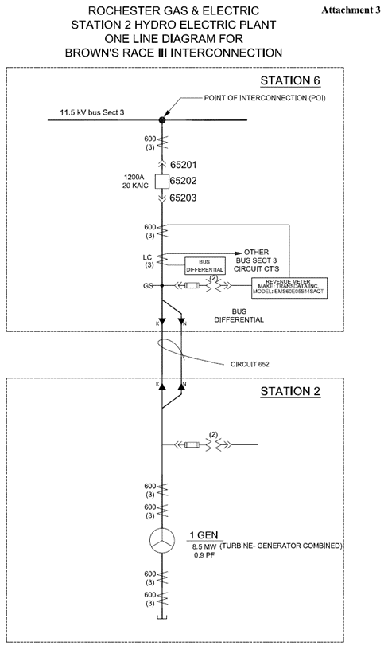
One (1) set of three (3) 13.8kV Voltage Transformers (“VTs”) for Metering.

      - Circuit 652 (Reference Attachment 3)

Approximately 8000 ft (2 circuits K and N, each 4000 feet) of UG cable, includes 500KCM,15kV and 350KCM, 15kV size, between Station 2 and Station 6. The nominal voltage of the circuit is 11.5kV.

      - Station 6 (Reference Attachment 3)
One (1) 13.8kV (11.5kV nominal), 1200 A 95 kVBIL, 20kAIC draw out circuit breaker (breaker 65202).

One (1) set of three (3) 600A CTs for Generator Line Protection Relay.

One (1) set of three (3) 600 A Meter Accuracy CTs.

One (1) set of two (2) 13.8kV Meter Accuracy VTs.

One (1) set of three (3) linear couplers.

One (1) revenue meter – Transdata Mark V Model EMS60E05S14SAQT.

C. Cost Estimates

Not applicable.

D. Operating and Maintenance Expenses
RG&E shall be responsible for the Operating and Maintenance (“O&M”) Expenses associated with the Interconnection Facilities, as provided in Section 4.1 of this Agreement.

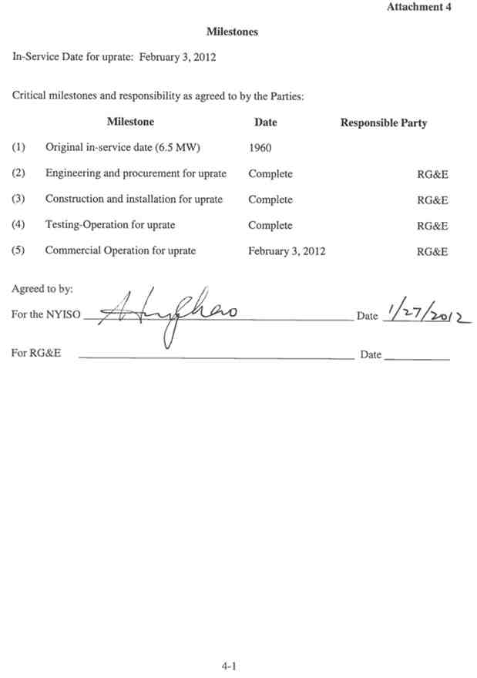
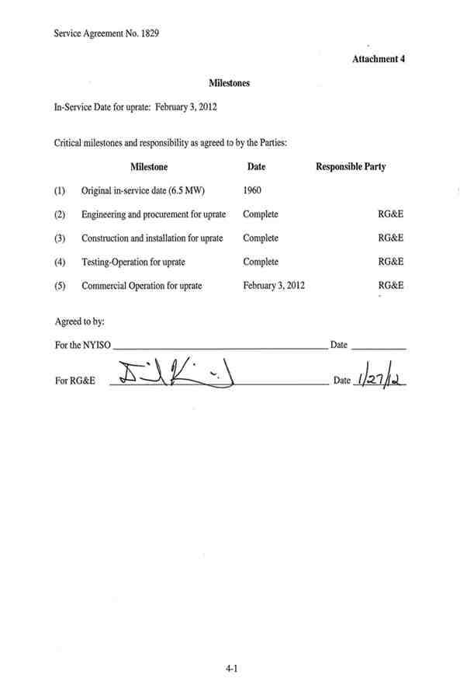

Attachment 5

Additional Operating Requirements for the New York State Transmission System, the Distribution System and Affected Systems Needed to Support
the Interconnection Customer’s Needs

The NYISO, in consultation with the Connecting Transmission Owner, shall also provide requirements that must be met by the Small Generating Facility prior to initiating parallel operation with the New York State Transmission System or the Distribution System.
RG&E must comply with all applicable NYISO tariffs and Procedures, as amended from time to time.

A. Power Factor Range
The power factor range is a requirement established in Section 6.1.6 of RG&E Bulletin 86-01, dated September 1, 2010, which may be superseded or amended from time to time, and which is incorporated by reference into this Agreement and attached as Appendix A to this Attachment 6 and is binding on the Parties. Section 6.1.6 of Bulletin 86-01 provides a power factor range of 0.9 (leading or lagging). RG&E’s Bulletin 86-01 also establishes other operating parameters, such as frequency and voltage.
B. Capacity Resource Interconnection Service (“CRIS”)
The Small Generating Facility has a CRIS value as of the Effective Date of 6.0 MW. RG&E did not elect to have the additional capacity created by the uprate evaluated for deliverability in the Class Year Facilities Study process. Therefore, the Small Generating Facility’s CRIS value will be limited to 6.0 MW unless and/or until the Small Generating Facility’s CRIS value is modified pursuant to applicable provisions of the NYISO’s OATT, including Section 32.4.10.1 of Attachment Z.

Attachment 6

Connecting Transmission Owner’s Description of its Upgrades
and Best Estimate of Upgrade Costs

The NYISO, in consultation with the Connecting Transmission Owner, shall describe Upgrades and provide an itemized best estimate of the cost, including overheads, of the Upgrades and annual operation and maintenance expenses associated with such Upgrades. The Connecting Transmission Owner shall functionalize Upgrade costs and annual expenses as either transmission or distribution related.
The cost estimate for System Upgrade Facilities and System Deliverability Upgrades shall be taken from the NYISO OATT Attachment S cost allocation process or applicable Interconnection Study, as required by Section 32.3.5.3.2 of Attachment Z. The cost estimate for Distribution Upgrades shall include the costs of Distribution Upgrades that are reasonably allocable to the Interconnection Customer at the time the estimate is made, and the costs of any Distribution Upgrades not yet constructed that were assumed in the Interconnection Studies for the Interconnection Customer but are, at the time of the estimate, an obligation of an entity other than the Interconnection Customer.
The cost estimates for Distribution Upgrades and System Upgrade Facilities and System Deliverability Upgrades are estimates. The Interconnection Customer is ultimately responsible for the actual cost of the Distribution Upgrades and System Upgrade Facilities and System Deliverability Upgrades needed for its Small Generating Facility, as that is determined under Attachments S and X and Z of the NYISO OATT.
No System Upgrade Facilties, System Deliverability Upgrades, Connecting Transmission Owner Upgrades or Distribution Upgrades are required for the Small Generating Facility.

Attachment 7

Insurance Coverage

Each Party shall, at its own expense, maintain in force throughout the period of this Agreement, the following minimum insurance coverage, with insurers authorized to do business in the State of New York:
Commercial General Liability Insurance including, but not limited to, bodily injury, property damage, products/completed operations, contractual and personal injury liability with a combined single limit of $1 million per occurrence, $2 million annual aggregate. In lieu of an actual general or public liability insurance policy either party may choose to self-insure the first $1,000,000 of any loss provided it can be shown that it has been a longstanding practice to maintain a high limit/deductible and the self-insurer can show proof of excess limits of at least $2,000,000.

