SERVICE AGREEMENT NO. 2685

ENGINEERING & PROCUREMENT OVERSIGHT AGREEMENT

This Engineering & Procurement Oversight Agreement ("Agreement"), dated as of

January 10 2022 (the "Effective Date"), is made by and between Watkins Glen Solar Energy Center, LLC, a Delaware limited liability company having its principal place of business at 700 Universe Blvd, Juno Beach, FL 33408 ("Customer" or "Developer"), and New York State Electric & Gas Corporation ("NYSEG" or the "Company"), a New York corporation with an office located in Kirkwood, New York. The Customer and the Company shall each be referred to as a "Party", and shall be referred to collectively as the "Parties".

RECITALS

WHEREAS, the Parties desire to set forth the terms, conditions, and costs for the Company to conducting certain oversight activities of the Customer's engineering and procurement activities specified in Attachment A to this Agreement ("Engineering & Procurement") related to the interconnection of the Customer's electric generating facility located in the Town of Watkins Glen in Schuyler and Chemung Counties, New York (the "Facility");

NOW, THEREFORE, in consideration of the mutual promises and agreements set forth herein, and other good and valuable consideration, the receipt and sufficiency of which are hereby acknowledged by the Parties, the Parties, intending to be legally bound, agree as follows:

1. Information Requirements and Scope of Engineering & Procurement Oversight.

1.1 The Customer agrees to provide all information, documents and technical

data required by the Company and deemed necessary by the Company to perform the Engineering &   
Procurement oversight. Such information, documentation, and technical data required has been   
provided by the Customer as of the Effective Date and the Company acknowledges receipt of such   
information, documentation, and technical data as of the Effective Date to commence the   
Engineering & Procurement oversight. After execution of this Agreement, Customer will continue to   
provide the remainder of the information specified in Attachment A on a schedule to be mutually   
agreed by the Customer and the Company, and will also provide any additional information,   
documentation, or technical data is determined by the Company to be required for its performance of   
the Engineering & Procurement oversight (collectively, the "Additional Information and Data"). The   
Company shall provide notice to the Customer of its failure to provide Additional Information and   
Data in accordance with this Section 1.1, and the Customer shall provide such Additional

Information and Data within fifteen (15) days following its receipt of such notice from the Company. If the Customer fails to provide the Additional Information and Data within fifteen (15) days following its receipt of such notice from the Company, the Company may, at its option and upon prior written notice to the Customer, suspend the Engineering & Procurement oversight until such Additional Information and Data is received. Notwithstanding the foregoing, if all or a portion of Additional Information and Data requested by Company is not available within the fifteen (15) day period, Customer shall notify Company of that fact and will provide a good faith estimate of the date upon which such Additional Information and Data will be provided. If the Customer fails to provide the Additional Information and Data within ninety (90) days following its receipt of the fifteen (15) day notice from the Company, the Company may, at its option and upon prior written notice to the Customer, terminate this Agreement; provided, however, that if all

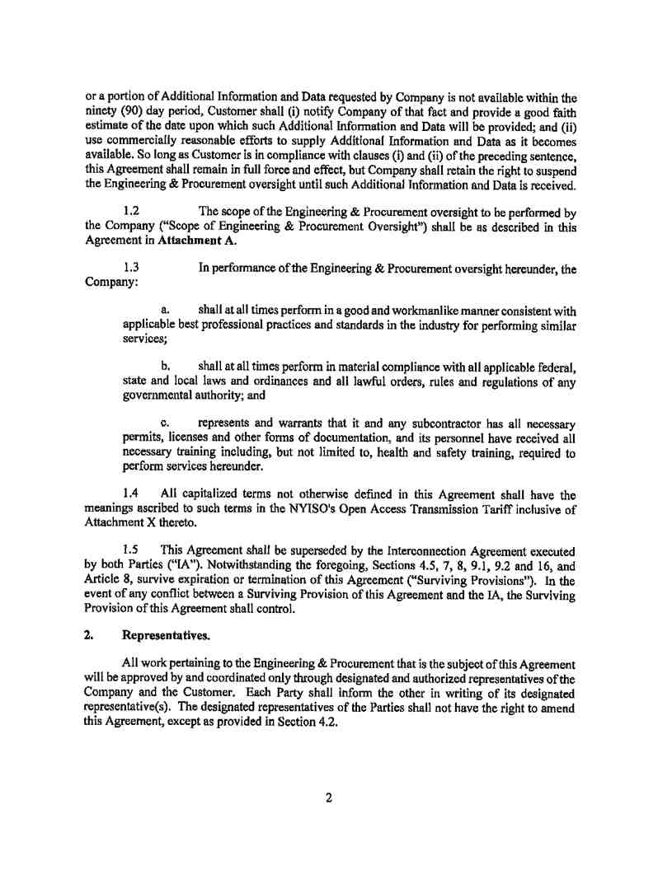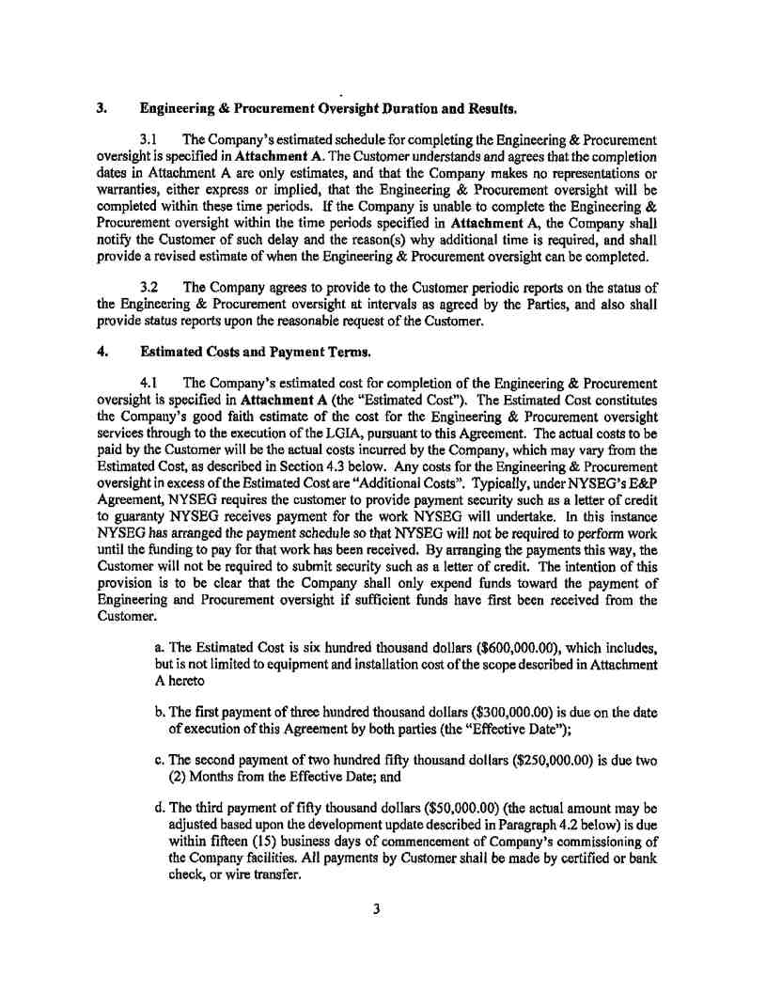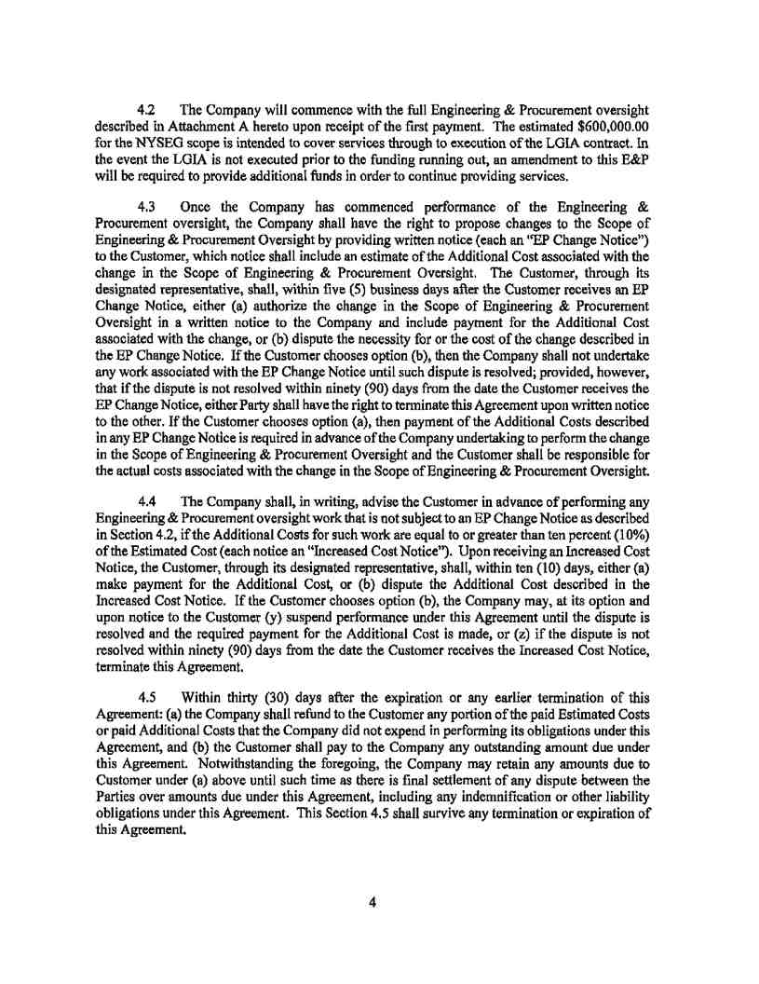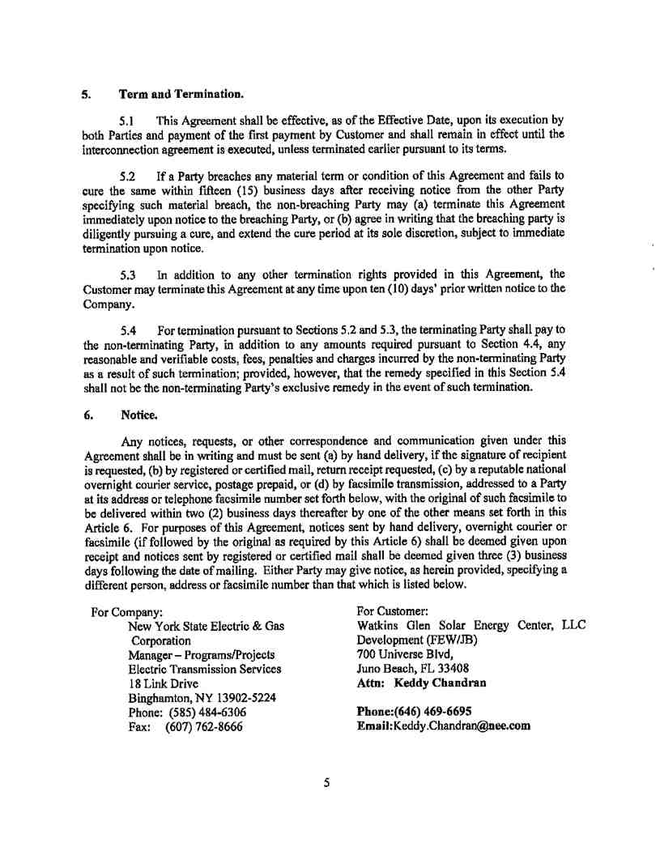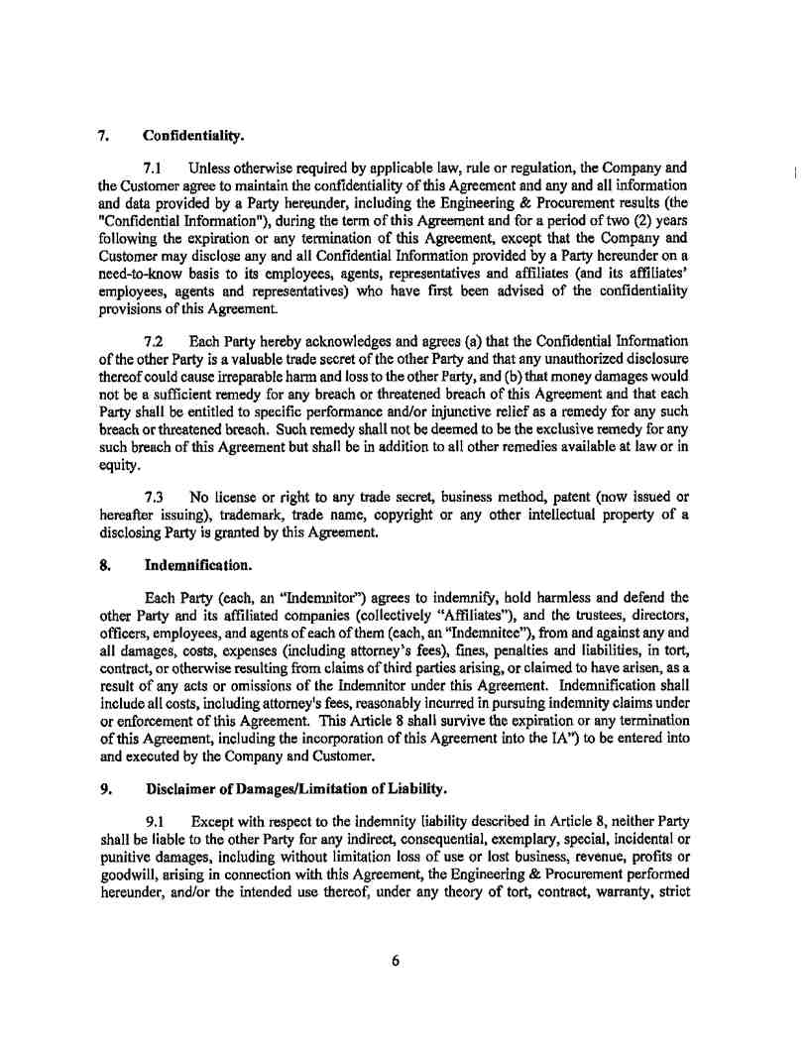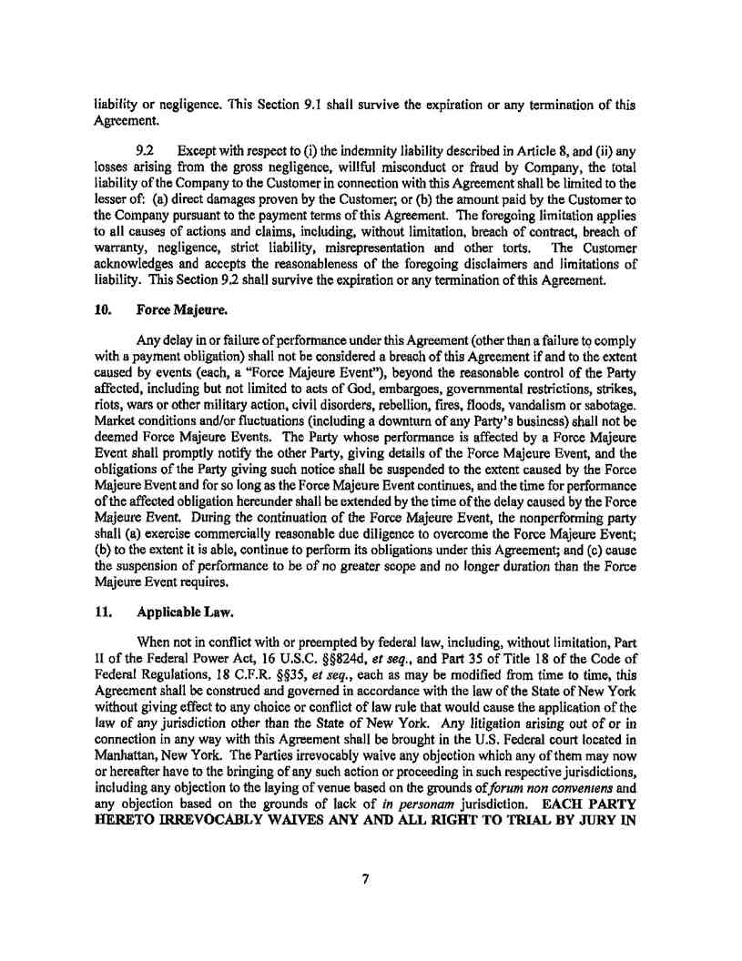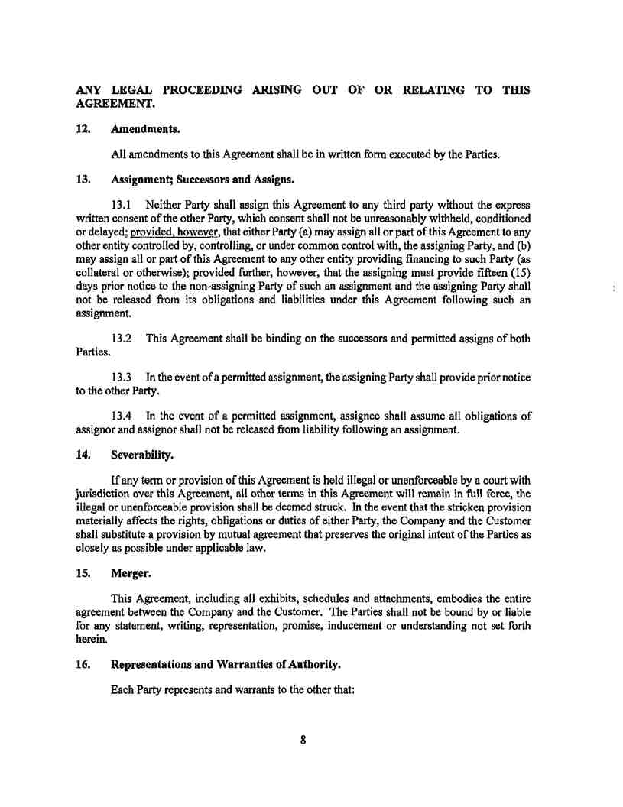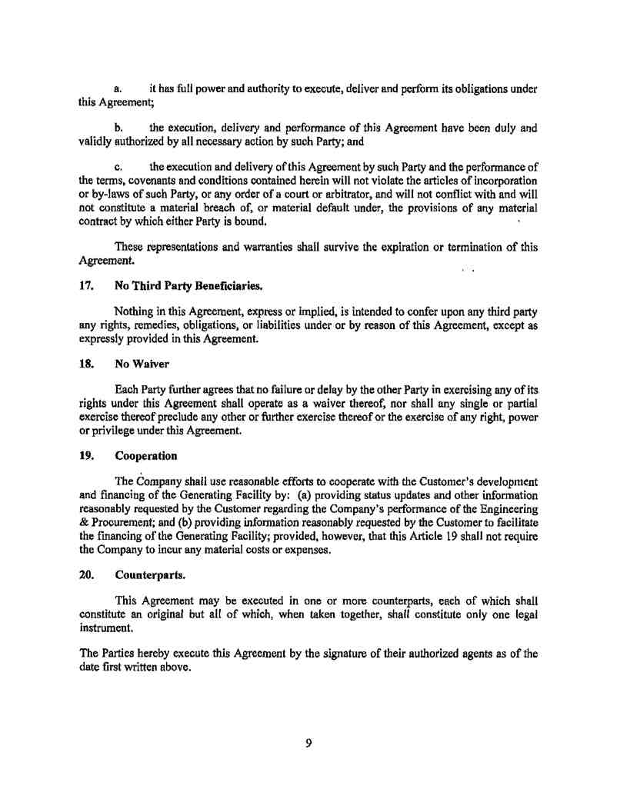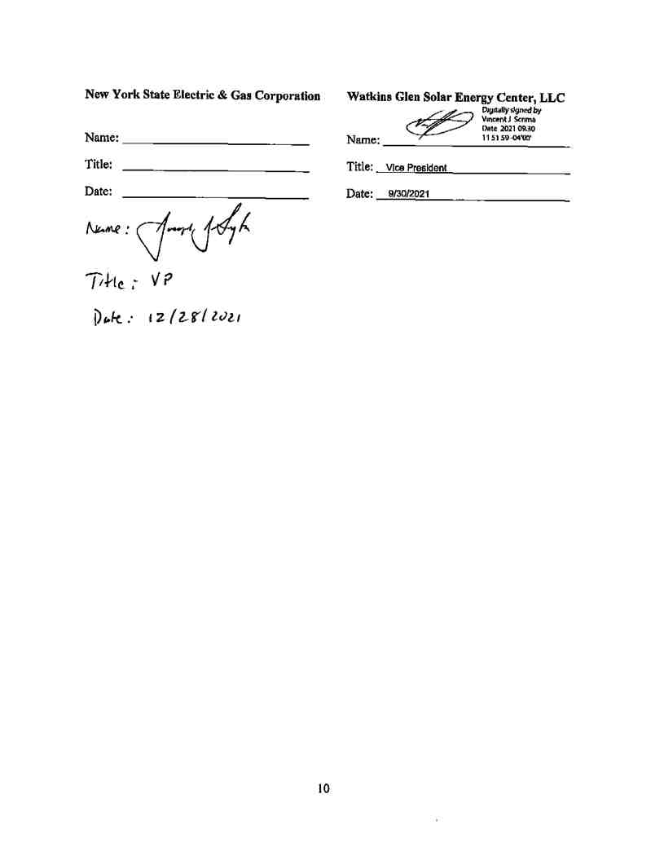

President and CEO   
January 10, 2022

